

MSTP_1

Mastering systems thinking in practice

About this free course
This free course is an adapted extract from the Open University course .
This version of the content may include video, images and interactive content that may not be optimised for your device.
You can experience this free course as it was originally designed on OpenLearn, the home of free learning from The Open University –
There you’ll also be able to track your progress via your activity record, which you can use to demonstrate your learning.
Unless otherwise stated, copyright © 2023 The Open University, all rights reserved.
Intellectual property
Unless otherwise stated, this resource is released under the terms of the Creative Commons Licence v4.0 http://creativecommons.org/licenses/by-nc-sa/4.0/deed.en_GB. Within that The Open University interprets this licence in the following way: www.open.edu/openlearn/about-openlearn/frequently-asked-questions-on-openlearn. Copyright and rights falling outside the terms of the Creative Commons Licence are retained or controlled by The Open University. Please read the full text before using any of the content.
We believe the primary barrier to accessing high-quality educational experiences is cost, which is why we aim to publish as much free content as possible under an open licence. If it proves difficult to release content under our preferred Creative Commons licence (e.g. because we can’t afford or gain the clearances or find suitable alternatives), we will still release the materials for free under a personal end-user licence.
This is because the learning experience will always be the same high quality offering and that should always be seen as positive – even if at times the licensing is different to Creative Commons.
When using the content you must attribute us (The Open University) (the OU) and any identified author in accordance with the terms of the Creative Commons Licence.
The Acknowledgements section is used to list, amongst other things, third party (Proprietary), licensed content which is not subject to Creative Commons licensing. Proprietary content must be used (retained) intact and in context to the content at all times.
The Acknowledgements section is also used to bring to your attention any other Special Restrictions which may apply to the content. For example there may be times when the Creative Commons Non-Commercial Sharealike licence does not apply to any of the content even if owned by us (The Open University). In these instances, unless stated otherwise, the content may be used for personal and non-commercial use.
We have also identified as Proprietary other material included in the content which is not subject to Creative Commons Licence. These are OU logos, trading names and may extend to certain photographic and video images and sound recordings and any other material as may be brought to your attention.
Unauthorised use of any of the content may constitute a breach of the terms and conditions and/or intellectual property laws.
We reserve the right to alter, amend or bring to an end any terms and conditions provided here without notice.
All rights falling outside the terms of the Creative Commons licence are retained or controlled by The Open University.
Head of Intellectual Property, The Open University

Contents
- Introduction and guidance
  - Introduction and guidance
  - What is a badged course?
  - How to get a badge
- Week 1: Systems thinking in practice
  - Introduction
  - 1 Who uses systems thinking?
  - 2 What are you hoping to learn?
  - 3 Learning by experience
  - 4 Something different
    - 4.1 The nature of systems thinking and systems practice
    - 4.2 Taking responsibility for your own learning
    - 4.2.1 Reflective learning
    - 4.3 Appreciating epistemological issues
  - 5 This week’s quiz
  - 6 Summary
- Week 2: Systems thinking and complexity
  - Introduction
  - 1 Distinctions between messy and difficult situations
    - 1.1 An important ambiguity
  - 2 Distinctions between rational and emotional reactions to situations
  - 3 Distinctions between hard and soft complexity
    - 3.1 Adding to the differences between difficulties and messes
  - 4 Choosing to distinguish between complex situations and complex systems
  - 5 Distinctions between systemic and systematic practice
  - 6 This week’s quiz
  - 7 Summary
- Week 3: Identifying systems of interest
  - Introduction
  - 1 Distinguishing and defining systems
    - 1.1 Building up a definition
  - 2 The language of systems
    - 2.1 Drawing boundaries
  - 3 The naming of systems
    - 3.1 Commonly recognised systems
    - 3.2 Explanatory systems
    - 3.3 Wider systems
    - 3.4 Identifying systems of interest
  - 4 Levels of systems
    - 4.1 Additional ways of identifying a system of interest
    - 4.2 Commonly used criteria
  - 5 Categories of systems
    - 5.1 Simple (purposive) and complex (purposeful) systems
  - 6 This week’s quiz
  - 7 Summary
- Week 4: Representing systems of interest
  - Introduction
  - 1 Setting the scene
  - 2 What are systems diagrams for?
  - 3 Drawing systems diagrams
  - 4 This week’s quiz
  - 5 Summary
- Week 5: Understanding multiple perspectives
  - Introduction
  - 1 Simplifying complexity
  - 2 Taking multiple partial views
  - 3 Perspectives on ‘managing’
  - 4 Perspectives on ‘researching’
  - 5 Collecting information as a ‘researcher’
  - 6 The practicalities of diagramming with other people
  - 7 Facilitating engagement with different perspectives
  - 8 Negotiating between different perspectives
  - 9 Teasing out accommodations
  - 10 This week’s quiz
  - 11 Summary
- Week 6: Key systems thinkers
  - Introduction
  - 1 The development of systems approaches
  - 2 Jay Forrester (1918–2016)
  - 3 Stafford Beer (1926–2002)
  - 4 Sir Geoffrey Vickers (1894–1982)
  - 5 Peter Checkland (b.1930)
  - 6 Russel Ackoff (1919–2009)
  - 7 This week’s quiz
  - 8 Summary
- Week 7: Systems thinking approaches
  - Introduction
  - 1 What are systems approaches?
  - 2 Purposeful and purposive behaviour
  - 3 Comparing two systems traditions
  - 4 Creating experience-action cycles
  - 5 From methodologies to tools
  - 6 Soft systems methodology
    - 6.1 The formal use of SSM
    - 6.2 Distinctions between Mode 1 and Mode 2
  - 7 This week’s quiz
  - 8 Summary
- Week 8: Becoming a systems (thinking in practice) practitioner
  - Introduction
  - 1 What does a systems practitioner do?
  - 2 Modes of managing systemically
  - 3 Clarifying purposefulness
  - 4 Managing for emergence and self-organisation
  - 5 The systems practitioner and systems of interest
  - 6 This week’s quiz
  - 7 Summary
  - Next steps in mastering systems thinking in practice
  - Tell us what you think
  - Acknowledgements
  - References
- Solutions

Introduction and guidance

Introduction and guidance
Welcome to this badged open course, Mastering systems thinking in practice.
The course lasts eight weeks, with approximately three hours of study each week. You can work through the course at your own pace, so if you have more time one week there is no problem with pushing on to complete another week’s study.
This course may present you with challenges. You may not have studied systems thinking in practice via distance learning before. You may also have your own personal expectations of what you want to achieve through studying this particular topic.
By studying this course, you shouldn’t expect to master systems thinking in practice, but it should give you an in-depth introduction and prepare you for further studies if that is what you are interested in doing.
Systems thinking can be taught to people of any age and some of the key ideas can be quite easy to understand but can be very difficult to put into practice as they depend on experiences. Part of that difficulty is that while those ideas can be easy to understand in principle they are counter to the predominant ways of knowing, thinking and acting in most societies. So, while you may be enthusiastic about thinking and acting systemically, those people you work for and with may be uninterested or even antagonistic to such an approach because it is different or because it challenges their own beliefs and assumptions.
Equally, you may currently be among the latter group and are seeking quick answers to ‘what is this systems thinking thing’ because it has been talked about and adopted by many people and organisations worldwide. But while there are particular tools and techniques that can be learned and deployed quickly to some effect, using systems thinking in practice requires a more profound approach to learning and to understanding the implications of particular ideas.
That is why this course uses many self-reflective activities where you can try to ground your studies within your own professional practice and experiences and also uses quizzes to test your basic understanding of key concepts, ideas and practices.
After completing this course you will be able to
- challenge systematic thinking and systematic approaches to understanding and working with complex situations
- explain how and why different systems of interest can be defined and described within complex situations
- recognise that each person brings with them their own perspective on a situation and to work with those multiple perspectives
- relate key ideas, techniques and approaches in systems thinking to professional practice when working with complex situations
- plan how to take the study of systems thinking in practice further for professional development.

Moving around the course
In the ‘Summary’ at the end of each week, you can find a link to the next week. If at any time you want to return to the start of the course, click on ‘Course content’. From here you can navigate to any part of the course. Alternatively, use the week links at the top of every page of the course.
It’s also good practice, if you access a link from within a course page (including links to the quizzes), to open it in a new window or tab. That way you can easily return to where you’ve come from without having to use the back button on your browser.

What is a badged course?
While studying Mastering systems thinking in practice you have the option to work towards gaining a digital badge.
Badged courses are a key part of The Open University’s mission to promote the educational well-being of the community. The courses also provide another way of helping you to progress from informal to formal learning.
To complete a course you need to be able to find about 24 hours of study time, over a period of about 8 weeks. However, it is possible to study them at any time, and at a pace to suit you.
Badged courses are all available on The Open University’s OpenLearn website and do not cost anything to study. They differ from Open University courses because you do not receive support from a tutor. But you do get useful feedback from the interactive quizzes.

What is a badge?
Digital badges are a new way of demonstrating online that you have gained a skill. Schools, colleges and universities are working with employers and other organisations to develop open badges that help learners gain recognition for their skills, and support employers to identify the right candidate for a job.
Badges demonstrate your work and achievement on the course. You can share your achievement with friends, family and employers, and on social media. Badges are a great motivation, helping you to reach the end of the course. Gaining a badge often boosts confidence in the skills and abilities that underpin successful study. So, completing this course should encourage you to think about taking other courses.


View alternative description - Uncaptioned Figure

How to get a badge
Getting a badge is straightforward! Here’s what you have to do:
- read each week of the course
- score 50% or more in the two badge quizzes in Week 4 and Week 8.
For all the quizzes, you can have three attempts at most of the questions (for true or false type questions you usually only get one attempt). If you get the answer right first time you will get more marks than for a correct answer the second or third time. Therefore, please be aware that for the two badge quizzes it is possible to get all the questions right but not score 50% and be eligible for the badge on that attempt. If one of your answers is incorrect you will often receive helpful feedback and suggestions about how to work out the correct answer.
For the badge quizzes, if you’re not successful in getting 50% the first time, after 24 hours you can attempt the whole quiz, and come back as many times as you like.
We hope that as many people as possible will gain an Open University badge – so you should see getting a badge as an opportunity to reflect on what you have learned rather than as a test.
If you need more guidance on getting a badge and what you can do with it, take a look at the OpenLearn FAQs. When you gain your badge you will receive an email to notify you and you will be able to view and manage all your badges in My OpenLearn within 24 hours of completing the criteria to gain a badge.
Get started with Week 1.

Week 1: Systems thinking in practice

Introduction
Welcome to this badged open course, Mastering systems thinking in practice.
In this first week of the course, you will be encouraged to reflect on your existing knowledge and assumptions about systems thinking in practice, and it will give you a grounding of what the course as a whole will cover.
First, watch the following video in which Andy Lane, the course author, introduces a visual metaphor to describe a systems practitioner.

Video content is not available in this format.
View transcript - Uncaptioned interactive content

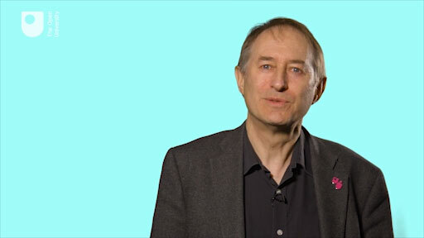

By the end of this week, you should be able to:
- describe how this course deals with the nature of systems thinking and systems practice and that these require you to take responsibility for your own learning and to question how you know about the world.
The Open University would really appreciate a few minutes of your time to tell us about yourself and your expectations for the course before you begin, in our optional start-of-course survey. Participation will be completely confidential and we will not pass on your details to others.

1 Who uses systems thinking?
Before turning to the question ‘Who uses systems thinking?’ read these words from some past systems students on what systems thinking has meant to them in practice:

Box 1 What systems thinking means to past systems students
Frances Chapman: ‘Systems thinking is important for me because it helps extend my apparently natural way of thinking, providing tools for handling the complexity more adequately and helping deepen understanding; particularly regarding interactions – where once I would have known they were there but remained unsure of quite how some were operating and affecting the basic ‘central’ scenario. Also, by understanding more of the complexity I find this aspect helps me to retain an open mind on most topics, aids reducing prejudice and helps me work to what I feel may be a more balanced viewpoint.’
John Robles: ‘It [systems thinking] allows me to tackle problems not only in a scientific way but in a holistic way which demonstrates a caring approach to all persons at all levels connected with the problem or system(s) involved.’
Paul Warren: ‘Systems thinking is important for me because it provides a formal recognised framework to explain organisational events, and other happenings, which hitherto had to be explained by vague notions of “common sense”.’
Sarah Smith: ‘Systems thinking is important for me because it has given me a new and better way to view complex situations, both in organisations and personally.’
Bob Saunders: ‘I recognise the need to take a holistic view of situations in my field of expertise – project management. So many projects fail because consideration of the human element is omitted, or badly covered by the project manager. “Systems” has helped me to grapple with the complexities.’

The question ‘Who uses systems thinking?’ depends where you are in the world and what search terms you use. A quick internet search on ‘systems thinking’ in the UK inevitably has a UK-centric look to it as it highlights The Association for Project Management, NESTA, Forum for the Future, and Oxfam among others. Further afield, in the US, there is the Waters Center for Systems Thinking, the Institute for Systemic Leadership, and the Donella Meadows Institute. While it also picks up several educational institutions, book publishers and reports such as this one from the World Health Organization.
On top of this, systems thinking is used in UK policy making at both local and national government, has influenced the work of the Ellen MacArthur Foundation on the Circular Economy and is thought to be an important facet of the Sustainable Development Goal 17 that deals with bringing the work on all other 16 goals together as part of a global partnership.
This looks impressive but a similar search on ‘systems practitioner’ tends to throw up items such as ‘systems safety practitioner’ or ‘systems security certified practitioner’ both of which are dealing with computer networks. This highlights both a strength and a weakness. Systems thinking is increasingly being used in practice across many domains and sectors of the economy as it can be applied to any complex situation but at the same time there is no professional body or explicit and widely understood conception of a systems practitioner as there might be for, say, a computer engineer or a professional health worker (in both cases there will be specialists as well as generalists). While there several are national and international bodies supporting systems thinking research such as the International Federation for Systems Research, the nearest practitioner example is the Systems Thinking Practitioner occupational standard approved by the Institute for Apprenticeships and Technical Education in the UK in 2020. So, systems thinking and systems practice are here to stay, but why is it becoming so important for so many?

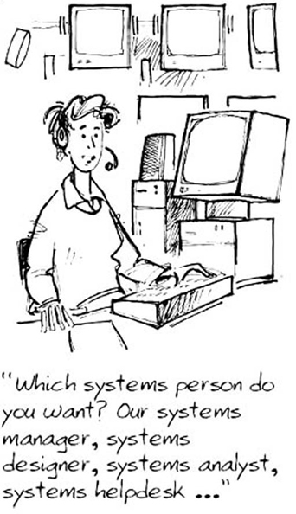
Figure 1 Which systems person do you want?
View description - Figure 1 Which systems person do you want?

2 What are you hoping to learn?
Anticipations and preconceptions are an important determinant of how people learn, so before you read on, you should record some of what you are experiencing now as you begin the course.

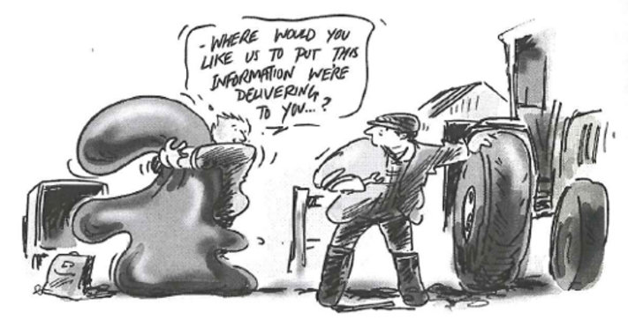
Figure 2 Delivering information.
View description - Figure 2 Delivering information.

It’s important to get these impressions noted down now, because new ideas and new impressions will quickly overlay the experience. What you are experiencing now will be re-interpreted as new understandings emerge. You are also likely to form some judgements about your expectations. So before any of that can happen, you are encouraged to make some notes on your responses to the questions in the activity below. You will need to keep referring back to them as the course progresses.
The notes you make for this and other activities will be important if you truly want to work towards becoming a systems practitioner rather than just someone using a systems tool or technique, so you should do them as conscientiously as possible. Their role in developing your skills will become more evident as you work through the course and will also be useful after you have completed it. Your notes should capture as many elements of your responses as possible. So do please keep a record in a journal – whether a physical notebook or a digital one of some form – as you work through the activities in this course, as they are an important aspect of reflective practice. Alternatively, you might like to record your answers to activities in their associated text boxes.

Activity 1 Why are you studying this course?
Allow approximately 15 minutes for this activity.

Fifteen minutes may seem like a large amount of time to spend on this activity, but thinking about the issues carefully is likely to take that long. Here are prompts to help you:
- What is your purpose in doing this course?
  - What do you hope to get from it?
  - What benefits do you expect?
  - What was it about the course or its descriptions that appealed to you?
  - What is it about you that the course appealed to?
  - Which specific items appeal to you?
  - Which specific items worry or concern you?

Provide your answer...

- How do you rate your overall capacity to succeed in this course?
You first need to decide what, for you, would constitute success.
  - Are there other criteria important to you?
  - What are they?
  - When will success become apparent?
  - What would it take to improve your prospects of success, measured by whatever criteria are important to you?
  - Can you act to improve your chances of success?

Provide your answer...

- When you make a judgement about how you rate your capacities, what are you basing it on?
  - Are you taking account of external factors such as the time you have or the circumstances in which you study?
  - Are you basing your judgement on your own evaluation of your intellectual capacities?
  - Do energy, enthusiasm and commitment come into the evaluation?

Provide your answer...
View comment - Part

3 Learning by experience
Learning by experience is a familiar idea but it implies two activities: learning and experiencing. Both activities need to happen if I am to say that learning from experience has happened. Experiencing seems to have two components. The first is the quality of attention that allows me to notice the experience and its components. The second is memory. Calling experience to mind allows me to examine the experience and to think about it in ways that were not possible at the time. Learning is what I take away from that process that influences my behaviour or thinking in the future.
But huge amounts of experience escape without being consciously experienced; I am insufficiently aware at the time to notice what’s going on. Later I am too busy to recall the experience and so little conscious learning takes place. Of course, it’s useful to carry out familiar activities ‘on auto-pilot’ – without conscious attention. It’s easy to miss out on important learning from unfamiliar activities too. I may become wrapped up in the activity itself or simply not notice the range and quality of the experience. Either way, a conscious attempt to recall the experience and to think about it, gives the opportunity to learn from the experience.

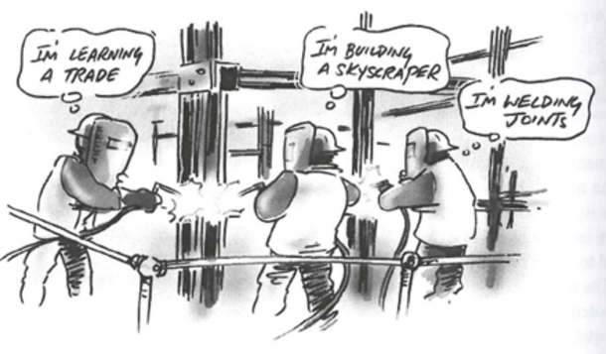
Figure 3 An iconic model of how different ‘actors’ ascribe different purposes to the same action.
View description - Figure 3 An iconic model of how different ‘actors’ ascribe different purposes to ...

So, what was the purpose of asking you to do Activity 1? It should have allowed you to experience the start of this course as richly as possible. You were asked questions that should have prompted you into awareness of what you were experiencing. It may be you discovered something new about yourself; your expectations of the course; what you hope to gain from studying it; or about your capacity to succeed in it as a result. If not, don’t worry. The point of the activity was raising awareness rather than discovery; and recording material that will be useful in future learning and reflection.

Activity 2 Self-directed learning
Allow approximately 5 minutes for this activity.

Make a note of the components of your previous self-directed learning experiences which you have enjoyed most? Why?

Provide your answer...
View comment - Activity 2 Self-directed learning

4 Something different
Perhaps it will not surprise you if I say you may experience this course as rather different to any you may have previously encountered. Like any course of study, you are likely to find surprising and interesting material in it but there are three specific ways this course may surprise and even challenge you.
These three ways are concerned with:
- The nature of systems thinking and systems practice.
- A style of learning where you have to take most of the responsibility for your own learning.
- The way you know about the world; interpret information about it; and construct mental models. These are epistemological issues. The basis for knowing about, and acting in, a situation is different to that encountered in most other courses.
Each of these is discussed briefly in the next sections.

4.1 The nature of systems thinking and systems practice
There are no simple definitions for either systems thinking or systems practice. It’s difficult to find definitions that capture all the perspectives that the ideas carry for people who think of themselves as systems thinkers and systems practitioners. Most systems practitioners seem to experience the same kind of difficulty in explaining what they do or what it means to be systemic in their thinking. Through experience I’ve developed some criteria by which I characterise systems thinking, but they seem to be quite loose in the sense that those characteristics are not always observable in what I recognise as systems thinking. In any case, they seem to be my list of characteristics, similar to, but not the same as, other people’s lists. This issue will be developed later but, for the moment, hold the idea that systems thinking and systems practice arise from particular ways of seeing the world.

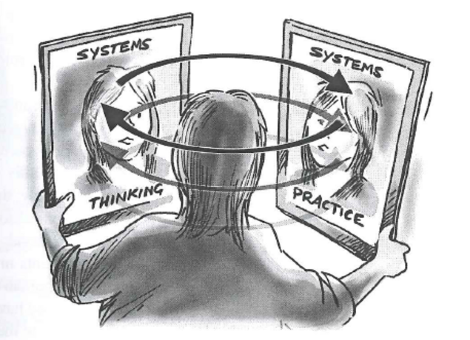
Figure 4 An image of the dynamic relationship between systems thinking and systems practice.
View description - Figure 4 An image of the dynamic relationship between systems thinking and systems ...

Through interacting with the course and asking yourself questions about your experiences, you should discover at least some of these characteristic ways of seeing the world. If you have previously studied systems courses, you will already have experienced forms of systems thinking and perhaps ‘caught’ it in some way. You may even have developed your own understanding of systems thinking and what it means. If you have not studied systems thinking before, you need to be aware this course cannot make you into a systems thinker or a systems practitioner. It can only provide you with a framework through which you can develop your own characteristic ways of being a systems thinker and a systems practitioner.
Gather up your ideas of what these central ideas are in the following activity.

Activity 3 Systems thinking
Allow approximately 10 minutes for this activity.

Make notes on what you think are the main features of systems thinking.
This is not a test question. There are no right or wrong answers. You are simply being invited to explore what you already understand about systems thinking. Try to make your answer as comprehensive as you can.
If you have already studied systems thinking, you may find this task quite demanding because you will have to abstract these general ideas from what may be quite detailed understandings. Don’t be afraid to spend slightly longer on this if you need to.
If your only experience of systems thinking is through any background reading you may have done, you may want to base your answers directly on your recent reading. That’s fine but try to ensure that, in doing this activity, you are building your understanding and not just abstracting a list from someone else’s ideas.
Your notes from this activity will form a powerful basis from which to build your understanding of, and capacity for, systems thinking. You will develop your own ways of working with the notes you take as you work through the course. I prefer not to throw away any note, even if it gets superseded. It provides me with a record of my developing understanding, especially if I note down what I now understand and why I now think the old understanding is unhelpful. Even notes I think are redundant can prove to be the anchors for new insights.

Provide your answer...
View comment - Activity 3 Systems thinking


Figure 5 Breaking situations down doesn’t always work.
View description - Figure 5 Breaking situations down doesn’t always work.

Systems thinking characteristically moves one’s focus in the opposite direction, working towards understanding the big picture – the context – as a way of making complexity understandable. Most people recognise they have been in situations where they ‘can’t see the wood for the trees’. Systems thinking is precisely about changing the focus of attention to the wood, so that you can see the trees in their context. Understanding the woodland gives new and powerful insights about the trees. Such insights are completely inaccessible if one concentrates on the individual trees. In other words, systems thinking provides a framework for reflecting on boundary judgements.

4.1.1 Systems practice
Systems thinking seems to come more naturally to some people than to others who have to learn to think systemically. People trying systems thinking for the first time find it quite tricky in the early stages. The temptation to break down the situation into smaller bits is strong. The systems approaches you will briefly encounter in Week 7 take account of this and are designed to enable you to capture the complexity before you move on to exploring it.
This is what this course is about. It is an invitation to engage with systems thinking in such a way that you are better able to address the situations, complexities and opportunities that you encounter as you engage with the nitty gritty of whatever you do. Systems thinking provides tools-for-thought and the opportunity for a powerful way of looking at the world, whatever the context. The contexts stretch all the way from international issues such as global warming to the day-to-day problems that arise in work, in domestic life and in the local community.
Systems practice in the context of this course refers to the practice of systems thinking within whatever profession or calling you follow. You can be a systemic medical practitioner, a systemic wood turner, a systemic technician or a systemic manager by applying systems thinking, insights and approaches to the complexity that you encounter in any of these or other domains.

4.2 Taking responsibility for your own learning
Not much of this course conforms to the traditional pattern mentioned earlier – the theory-example-exercise pattern. In particular, you will find you are expected to discover much of it for yourself. Why is this? This is a legitimate question and deserves a full answer.
One year, a student at a residential summer school complained I had not taught him properly. I was, he told me, an expert and so why did I not demonstrate how to tackle the problem he was working on and pass my expertise on to him. He felt the tutorial was ‘a wasted opportunity’. I could understand why he felt aggrieved. But I think he had missed an important feature of learning a skill such as systems thinking.
More and more, I’ve come to realise that whatever expertise I may have in systems thinking and practice, it is my expertise and it only works for me. In this I find myself in agreement with C.W. Churchman (1971), who was one of the first people to write about what systems thinking might mean in practice, when he said ‘there are no experts in a systems approach’. When I look at the people whom I believe to be experts in this area, I realise there are many ways of being good at systems thinking and many ways of being good at systems practice. Each systems thinker seems to be good in their own way. I believe this is because systems thinking in practice is about ways of experiencing the world, ways of thinking, and about ways of dealing with the complex situations I encounter.
Consequently, systems expertise is unique to each person. I cannot tell you how it’s going to work for you or how you should understand it. You have to find your own ways. All I can do is to invite you into experiences that are likely to help you create your own meanings from the material. As well as being the only logically consistent way of learning systems thinking, there is plenty of research evidence to show that understandings and knowledge that one acquires through discovery is retained and developed much more readily than the understandings one acquires through being told, or even shown.
Taking responsibility for your own learning in this way is challenging but it need not be difficult. It requires a preparedness to experiment with ideas and styles of learning that may not initially feel right or comfortable.

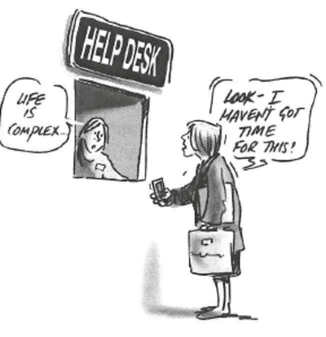
Figure 6 Life is complex.
View description - Figure 6 Life is complex.

4.2.1 Reflective learning
All this means learning systems thinking in practice is an intensely personal business. Don’t worry if you’re not used to reflective learning, you will be able to develop your capacities for learning this way, as you go. This is why it was important to think through what you want to achieve from the course. It can operate at a level beyond acquisition of skills and knowledge. Because it is about different styles of thinking, the process of thinking systemically can itself give rise to new forms of learning. It has the capability of bringing understanding into being from sources inside oneself. This is the process known as reflective learning.
For some people, systems thinking will be something they practice from time to time. It will be a set of tools-for-thought they use when the need arises. This is a powerful and important potential outcome from the course. The course can also lead you towards becoming systemic, as well as being about systems. You can use it to become a different sort of thinker.
Either way, I strongly urge you once again to do the activities. They are designed to enable you to discover your own learning by experience. They are much more important than the practice-makes-perfect quizzes which can only test ‘know what’ rather than ‘know how’ and ‘know why’. The activities will support you in making systems thinking and systems practice your own. Without them, systems thinking and systems practice remain ‘out there’ – something you may know about (description) but not know how to use (competence). This course has aspirations beyond that, which I hope you will come to share; to support you in becoming a systems thinker and a systems practitioner. This is why the activities so far appear to be focused on you. You might see them in terms of preparing the soil in which skills, competencies and confidence can grow.

4.3 Appreciating epistemological issues
Common sense tells me my experience and understanding of the world are limited. I am 185 cm in height. That limits my view of the world. It may not matter much that I cannot see what my house looks like from above but it does mean there will be things going on in the roof I may not notice until they impinge on areas that I can experience.
More significantly, there is a real limitation on understanding the experiences of other people. You might tell me about your experience but your description is likely to be only a partial representation and, however good your description, I cannot share your experience. I can only construct my own mental representation of what your experience might be like. But the limitations on my understanding of the world are even more fundamental than this.
My mental image of the world is a model. It is a partial representation of reality based on the partial knowledge I have of the external world. So, when I think I am thinking about the world I am thinking about my model of the world. This model of the world is built up in a way that is itself a model. So I am using a model, built by a model, to represent the world I think I see.
This has important implications. The model that represents the world tells me what I see and tells me what to see. The model both limits what I see and reinforces itself. When I think about the world, I am thinking about my own thinking; I have no direct access to the world at all.
Many people find this idea unsettling when they first meet it. It seems to defy common sense. It raises the question of how real the so-called real world really is.
Many people think of the brain as very similar to a computer. Both have a similarly large proportion of ‘processors’ operating on internally generated signals. But there is an important and absolutely fundamental difference. The computer does not create its own meanings. The computer, even if using artificial intelligence programmes, has no capacity for deciding, for example, which are its favourite paintings in the National Gallery. I do. I have a history of interacting with external stimuli that generate new ways of interacting with further stimuli and the internal structure of my brain changes as a result. The computer’s ways of dealing with data are not the result of its own self-production, but of its analysis of what has already been produced. The way the computer works remains the same, whether it is processing pictures from the National Gallery or large amounts of text to answer a query. The rules that relate input to output are constant over time.
The question of what I can know about the outside world is an ancient one and has always been central in philosophy under the theme of epistemology. Epistemology is the branch of philosophy that deals with knowledge and knowing: how do I know about the outside world? How do I know my senses are not fooling me? What constitutes evidence about the world?
Neither discussions about modelling, nor the insights of philosophy, can tell me how true my internal representations of the world are, but neurological studies seem to suggest the outside world is unknowable as it is. This course considers this important issue. Epistemology becomes a central concern. This contrasts sharply with many other courses where epistemology is never addressed. The world is assumed to be ‘out there’ and more-or-less as it appears.
Recognising the world is unknowable as it is presents me with a choice. How do I deal with the day-to-day observations and events that seem to emerge from it? Each person, once they become aware of this unknowability, is confronted with, and needs to make their own choice.
Each choice is individual but seems to cluster around three main poles:
- The first of these is to adopt a stance that the world is more-or-less as I see it, and to ignore the incompleteness of my viewpoints and my representations. This is equivalent to saying ‘there is no epistemological problem about the world as I see it’.
- The second is to decide that the world is more-or-less as I see it but to recognise that my viewpoint is limited and the view-from-here may be misleading because it is only partial – there is no view of the roof, to use my previous metaphor. This is a stance that accepts that I must be careful to explore the world as fully as I can because I cannot see everything and may be misled.
- The third pole is to take on fully the implications of the world’s unknowability. This stance demands that I always carry an awareness that I will never know the world and must therefore always be trying to account for my own role in my perceptions of the world.
Consciously making the choice between these poles, and all the variants between, is an act of epistemological awareness.


Figure 7 The dynamic between an explainer, an explanation and a listener (or reader).
View description - Figure 7 The dynamic between an explainer, an explanation and a listener (or rea ...

5 This week’s quiz
Check what you’ve learned this week by taking the end-of-week quiz.
Week 1 practice quiz
Open the quiz in a new window or tab then come back here when you’ve finished.

6 Summary
There has been a lot to read and reflect upon in this first week. You may have hoped for some more video clips, animations or diagrams to help explain or express the ideas that were covered. Don’t worry, other weeks will include these. You were told at the outset that the course will provide a challenge for you as it questions how you may currently think and act and words still remain a dominant medium by which we think and communicate about the world we experience.
In working through this week, you may have identified some of your initial expectations and what you think you will discover as you work through the course. It would be appropriate at this point to look at some of the questions you have been asked about your expectations again and for you to note ways your expectations have changed.
End this week by carrying out this reflective activity.

Activity 4 Expectations
Allow approximately 15 minutes for this activity.

Review your responses to this week’s activities and answer the following questions:
1. How have your expectations changed?

Provide your answer...

2. Have any new expectations emerged from reading this new section?

Provide your answer...

3. Do any of your expectations look less realistic now?

Provide your answer...

4. Do your previous expectations seem more, or less, likely to be met?

Provide your answer...

5. Do you feel able to adopt any of the attitudes that have been suggested?

Provide your answer...
View comment - Part

It may be you are unused to, or uncomfortable with, the focus on yourself and your own experience in an academic course of study. This need not inhibit your learning, provided you recognise your discomfort. If you stick with it, the unfamiliarity of this type of approach is likely to disappear. The payoff: you can become a person who can think and practice systemically. Without engagement with yourself, systems thinking in practice is likely to remain a collection of techniques that are never really your own. It would be unreasonable to expect you to instantly recognise this is an effective way of starting to study systems thinking in practice.
Remember the metaphor of the juggler I introduced in the video at the start of this week? Based on my experience, I claim that effective practice involves being aware that the four balls I labelled as B, E, C and M need to be juggled and that it takes active attention, and some skill, to keep them all in the air. Things start to go wrong if I let any one of them slip. To be an effective practitioner, I find I have to continuously think about, and act to maintain, four elements: the processes of being a practitioner, my appreciation of the situation I engage with, putting the approach taken into context and managing in the situation. The four verbs, the activities, I am drawing your attention to are: being, engaging, contextualising, and managing.
But metaphors conceal features of experience, as well as calling them to attention. The juggler metaphor conceals that the four elements of effective practice often seem to be related. I cannot juggle them as if they were independent of each other. I can imagine them interacting through gravitational attraction, or the juggler can juggle them differently as shown in this cartoon. This allows me to say that in effective practice the movements of the balls are not only interdependent but also dependent on my actions.
I will explicitly return to this metaphor in Weeks 7 and 8, but as you move through the weeks do note down which ball you think is the main focus of each week.
You should now be able to:
- describe how this course deals with the nature of systems thinking and systems practice and that these require you to take responsibility for your own learning and to question how you know about the world.
Next week you will explore the notion of perceived complexity within situations through the frames of messes and difficulties, emotional and rational reactions and systemic and systemic thinking.
You can now go to Week 2.

Week 2: Systems thinking and complexity

Introduction
In Week 1 it was claimed that systems thinking respects complexity and makes that complexity manageable by taking a broader perspective. This week you will explore these claims in more detail by focusing on the differences between messy and difficult situations, hard and soft complexity and systemic (holistic) and systematic (reductionist) thinking and practice that shape how we perceive and react to complexity in the situations we face. In essence any situation will consist of complicatedness (entities infinitely joined), complexity (people with perspectives on the entities and how they join together), and conflict (contrasting viewpoints/perspectives on situations). Systems thinking is about distinguishing a system of interest within messy and complex situations. As with Week 1 there are several reflective activities which will enrich your learning if you are able to do them fully.
First, watch the following video which examines what it means to understand the world in which we live.

Video content is not available in this format.
View transcript - Uncaptioned interactive content

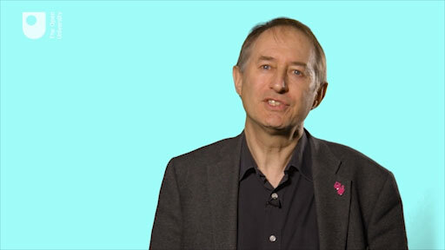

By the end of this week, you should be able to:
- explain the notion of perceived complexity within situations through the frames of messes and difficulties, emotional and rational reactions and systemic and systematic thinking.

1 Distinctions between messy and difficult situations
Situations we face vary enormously in their complexity and seriousness. They range from minor upsets through to near-catastrophes, from temporary hitches to persistent, gnawing ‘tangles’, ‘puzzles’ or ‘problems’ through to interesting ‘challenges’ and exciting ‘opportunities’. Just listing all these different words also highlights that the language we use or the metaphors we employ in conversation can colour our thinking about a situation.
Although there are these many different words that we use to describe situations, you may find it helpful to be introduced to a particular distinction: the course shall refer to simpler, more limited sorts of situations as difficulties, and the nastier more taxing ones as messes, a term first coined by Russell Ackoff (1974), who recognised that problems are taken up by, not given to, decision makers and that problems are extracted from unstructured states of confusion or complex situations (you will learn more about Russell Ackoff in Week 6). The reasons for making this distinction will become clear as you work on through the course, but in essence the reason is that messes aren’t just ‘bigger’ than difficulties; they have a number of features that make them qualitatively different. As a result the sort of activity needed to tackle them is very different.

Activity 1 Thinking critically about situations
Allow approximately 15 minutes for this activity.

The purpose of this activity is to help you think critically about the material that follows in relation to your own experience. But ‘your own experience’ is too vast and vague; so you should do some preliminary work selecting and reflecting on parts of it likely to be relevant to the discussion. If you tackle the questions posed below before you read on, it will help you to identify those aspects of your life that ‘cause you problems’; and it will provide you with material to help your studies. You should spend ten minutes on this first stage of the activity; you will need to return to your notes in other activities later in the week.
- Note down at least three simple situations you have faced recently; and then note down three (or more) of the most complex situations you have ever faced or been involved in tackling.

Provide your answer...

- List the ways in which the simple and complex situations differ. What are the characteristics of the major, nagging situations that distinguish them from the more limited ones? You should aim for a list of at least half a dozen points.

Provide your answer...

When you have finished writing out your lists watch the following video to compare your notes with my views on difficulties and messes discussed there.

Video content is not available in this format.
View transcript - Uncaptioned interactive content

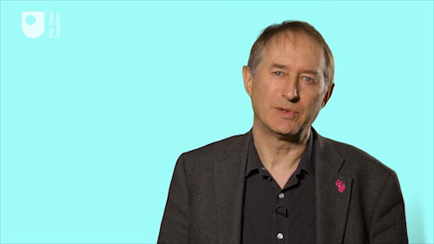

1.1 An important ambiguity
The suggestion that messy situations are in some significant respects unbounded is helpful, but it is also ambiguous on an important point. What has not been made explicit is whether this quality of being unbounded is a characteristic of one person’s experience of the situation, or is actually in the nature of the situation itself. In other words, is a messy situation one that someone can’t see how to disentangle from everything else; that appears to them to be unbounded – and hence for that person it is unbounded? Or does saying the situation is unbounded mean that the circumstances are such that the situation really does have very extensive ramifications?

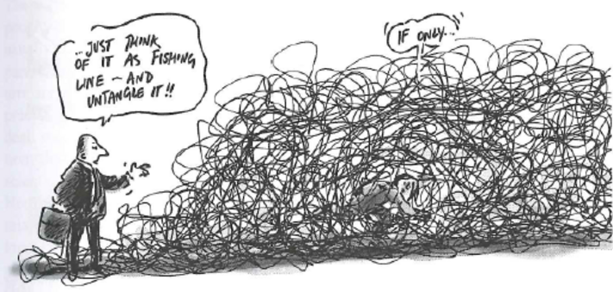
Figure 1Untangling messes can be tricky.
View description - Figure 1Untangling messes can be tricky.
View alternative description - Figure 1Untangling messes can be tricky.

The first of these possibilities is attractive. It amounts to saying that a messy situation is whatever the person concerned experiences as a messy situation, and it implies that you will understand the situation once you become more familiar with it. We have all experienced situations that seem immensely complicated at first, but that proved easy, ‘once one knew how’.
In general, a situation that appears very messy to one person might only be a difficulty to someone with lots of experience of tackling comparable situations. In such cases it’s tempting to say that the same situation is a mess for one person and a difficulty for another. But this position has a serious flaw: it may sound reasonable to define a mess as any situation I experience as a mess, but there is something decidedly unsatisfactory about the converse: ‘if I think it’s only a difficulty, then it is only a difficulty’. The trouble is that this definition implies that no one can ever be mistaken about whether they are dealing with a difficulty or a mess, and yet I talked earlier about being trapped in one’s way of thinking. Such mistakes are actually rather common. Indeed, it is often the failure of my efforts to resolve what I had assumed to be a difficulty that makes me realise I’m really tackling something much messier. (Happily, the opposite mistake sometimes occurs too: what I had thought was a really unmanageable situation, turns out as I get closer to it, to be something that can after all be satisfactorily tackled on a local basis in a straightforward way.)

Activity 2 Reviewing your notes on difficulties and messes
Allow approximately 10 minutes for this activity.

Reviewing Activity 1, compare your notes on the differences between difficulties and messes with those given in the video (repeated below). The following questions should help. You should definitely not be marking your list (‘I got that one’ or ‘I missed that one’). That is not the point of the activity. If anything, you should be marking my list in relation to your experience.
- Have you been using the term ‘messes’ in a completely different way to cover only unpleasant situations, for example? What I call messes, you may prefer to call challenges.
- Do you disagree with any of my points? Does it trouble you that I talk of problems that have no real solutions?
- Can you think of occasions when you have considered a mess as a difficulty, and vice versa? How do you account for the differences? In what other ways have you been aware of a discrepancy between how a mess appeared and how it turned out to be?
- Do the characteristics of messes shown in the video add to, or help you clarify, your understanding of what constitute for you ‘big complicated situations’? Or do you feel that somehow my discussion has so far missed essential aspects of the circumstances you find demanding and troublesome? Are you aware of important aspects not dealt with so far?

Video content is not available in this format.
View transcript - Uncaptioned interactive content

View comment - Activity 2 Reviewing your notes on difficulties and messes

2 Distinctions between rational and emotional reactions to situations
Conventionally, it is assumed that top people deal with the most serious situations and lowly staff deal with trivial ones. This is only true if the term ‘problem’ (which is the most common word we use for situations) is defined in a way that simply mirrors the different responsibilities of senior and junior positions, whether that be at work or at home. Further, whatever the position someone takes on a problem there is a tendency to focus on the rational aspects and leave aside, or even deliberately ignore, the emotional aspects of the situation. These aspects are discussed by Colin Eden and colleagues (1983):

We can usually give some sort of an answer to the question ‘What is the problem?’, but it may not be an answer that convinces us, and we often feel we have only been able to give a rather limited description. So it is quite common that the only descriptions we can find for problems are, without any way being intended as lies, not descriptions that we feel contain the most important truths about our problems.
Now this is a common feature of the experience of many people, that the step between feeling some sort of discomfort or dissatisfaction, feeling that there is some problem somewhere, and being able to say ‘The problem is such-and-such’ is a very big step. In fact quite often we find that if we can say what the problem is we have gone a long way towards solving it. This seems to be true with any kind of problem, whether it be some technically-oriented work problem, a relationship problem at home or anything in between.
One of the properties of problems with which helpers have found it quite hard to grapple is the extent to which all problems are personal; different persons see different problems in what other people would take to be the same situation. This is an important point in our argument, and is fairly well accepted in everyday ‘common sense’. This point does not seem to raise much difficulty when it is expressed theoretically, but it is often rather more difficult to bear it in mind and act upon in practice.
(Eden et al., 1983)

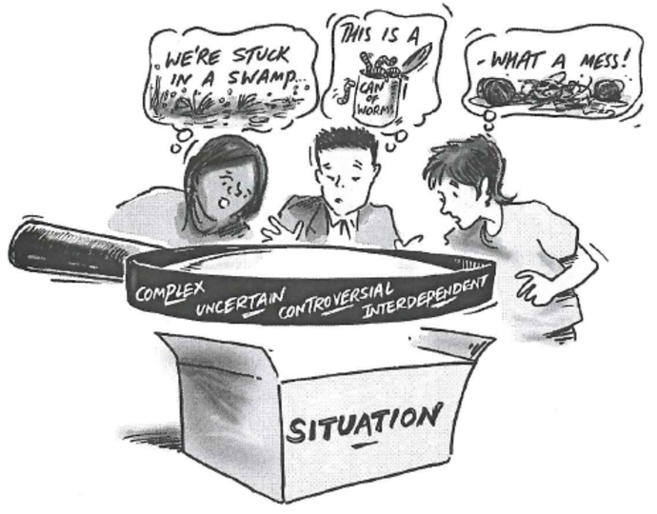
Figure 2 Choices that can be made about the nature of a situation such as water governance and catchment management situations (adapted from SLIM 2004).
View description - Figure 2 Choices that can be made about the nature of a situation such as water governance ...
View alternative description - Figure 2 Choices that can be made about the nature of a situation such as water governance ...

For practical purposes it is essential to remember that both the rational and the emotional aspects are important in comprehending a messy situation.

Activity 3 Emotional and rational aspects of situations
Allow approximately 10 minutes for this activity.

Turn back to your notes on messy situations from Activities 1 and 2. Add to them by considering the following questions:
- What ways were ‘interpersonal relationships’ (i.e. personal evaluations, likes and dislikes) a contributing factor in the situation as you saw it?
- How do you imagine the other people involved saw the situation - and saw you?
- What ‘political concerns’ were a contributing factor in the way that you saw the situation?
- What political concerns do you attribute to the other people involved? Were their concerns ‘legitimate’? Were yours?
- Were there multiple causes for any of the situations you listed earlier and what were they? How far does this help explain some of the disagreements?
- What important considerations in your messy situations could not be adequately represented in terms of hard information and demonstrable facts?

View comment - Activity 3 Emotional and rational aspects of situations

3 Distinctions between hard and soft complexity
Systems thinking is very helpful in dealing with messy situations, wicked problems or frustrating puzzles where the overall complexity involved appears overwhelming. But what do we actually mean by complexity in this context and how can we deal with it effectively?
John Casti, a mathematical modeller and writer on complex systems, says that:

… when we speak of something being complex, what we are doing is making use of everyday language to express a feeling or impression that we dignify with the label complex.
(Casti, 1994)

He also argues that the meaning we give to the term complex is dependent on the context. Complexity is not just a matter of there being many different factors and interactions to bear in mind, of uncertainty concerning some of them, of a multitude of combinations and permutations of possible decisions and events to allow for, evaluate and select. It is not only a technical or computational matter, such as what engineers and operational researchers deal with. Complexity is also generated by the very different constructions that can be placed on those factors, decisions and events. Complexity arises from the different perspectives within which they can be interpreted and the degree of emotional involvement people have in the situation. This is so important, and in my experience, so difficult to come to terms with - especially if you have a technical or engineering background - that it is worth discussing further.
It will help to put a label on these different aspects of perceived complexity. The first aspect, which I have referred to as generating difficult computational problems, can be called ‘hard complexity’, and is illustrated by the game of chess. With up to sixteen pieces on each side at any one time and many moves that could be made by each one, the range of possibilities is enormous: a vast number of move and counter-move sequences may have to be considered and assessed. It is, unquestionably, complicated. Nevertheless, the nature of the game, the moves of the pieces, the fundamental purposes of the players – all these are unproblematic.

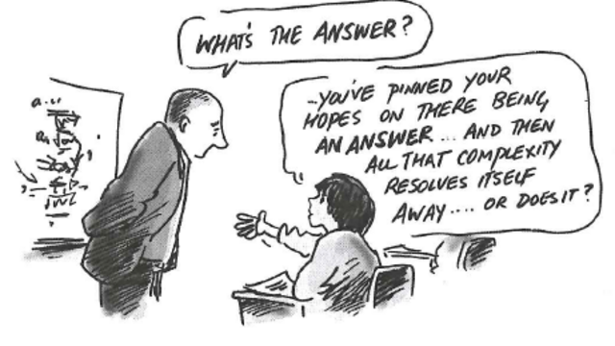
Figure 3 What’s the answer?
View description - Figure 3 What’s the answer?
View alternative description - Figure 3 What’s the answer?

By contrast consider the situation in a detective story at the end of the penultimate chapter when the detective is about to unravel the mystery. Once again, the situation is complicated, but in a quite different way. Usually the number of possible murderers is quite limited - perhaps only half a dozen. So on the face of it, choosing among them should be a fairly manageable task. But in this case the complexity arises not from the ‘facts’, but from the variety of quite different constructions that can be put on them. Such information as the author has given you may in principle be sufficient but it is seriously incomplete, and also contains much that will prove quite irrelevant or misleading. To solve the problem you have to recognise the significance of chance remarks and relate these to alternative explanations for behaviour or events. And very little can be taken for granted: it may not even have been a murder, but a suicide designed to incriminate someone else, or a case of a corpse disguised and disfigured to look like the person who has escaped with the loot to Paraguay and so on. Each reader will, before the final unravelling, have different hunches about who did what, how and why. The description of events is ambiguous, and deliberately so, while the reader’s degree of emotional involvement can also be high. Complexity of this sort can be called ‘soft complexity’. Figure 4 illustrates the distinctions and similarities of hard and soft complexity.

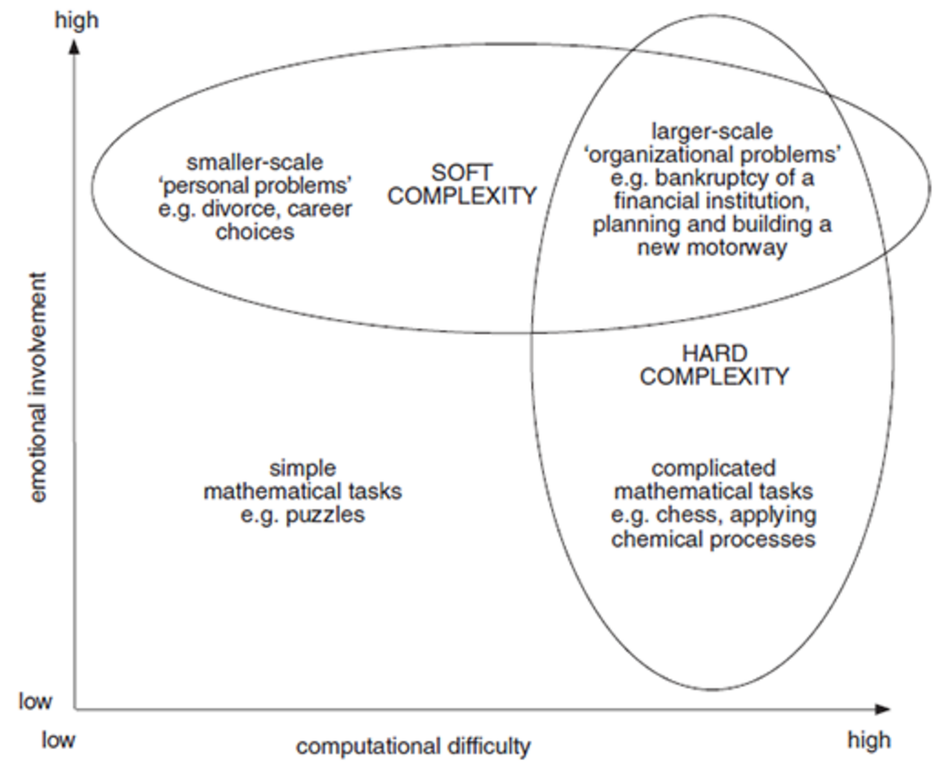
Figure 4 Characteristics of hard and soft complexity.
View description - Figure 4 Characteristics of hard and soft complexity.
View alternative description - Figure 4 Characteristics of hard and soft complexity.

3.1 Adding to the differences between difficulties and messes
Distinguishing between these two sorts of complexity further clarifies the difference between difficulties and messes.
- Difficulties, being well-defined and more limited situations, mainly involve hard complexity. Given a particular view of the matter, what is the best that can be done?
- Messes on the other hand are ill-defined; they include large measures of both hard and soft complexity. Of course this may not be obvious at first and some or all of those involved may fail to recognise the soft complexity: they may initially resent alternative viewpoints, perhaps seeing them as misguided or even wilful attempts to confuse the ‘real’ issue.
But ambiguities and different interpretations that can be overlooked or ignored when working on one’s own or with close colleagues are harder to avoid when more people are involved. Other people’s input will often help one see that the problem is messier than first thought (although not every difficulty is a mess in disguise). Indeed, only the most trivial difficulties involve no soft complexity at all. But the more soft complexity there is in a situation, the messier it is likely to be. Working out what to do with a mess is no longer a matter of thinking the situation through, but of rethinking or reframing it as well. Too often general principles and techniques (e.g. for project planning, work study, etc.) assume that the elements of soft complexity either don’t exist or can easily be resolved. That is, they assume you already know what sort of situation you are dealing with. If techniques help in recognising some tractable elements in a messy problem or a promising approach to aspects of it, then they are of considerable value. But equally a personal commitment to particular techniques can tie a person’s thinking to a narrow conception of the issues. In any event, by the time one is sure what principles or techniques to apply, the mess is already resolving itself into a set of related difficulties.

Activity 4 Hard and soft complexity
Allow approximately 10 minutes for this activity.

In the light of the discussion of hard and soft complexity, review your notes on the messy situations you have faced and answer these questions.
- What are the elements of both hard and soft complexity in the situations?
- In what ways does the discussion of soft complexity help in pinning down what for you distinguished the messes from the difficulties?
- If you have been thinking about your difficulties and messes only in terms of hard complexity, how do you account for this in terms of your particular work or your particular way of thinking?

Provide your answer...
View comment - Activity 4 Hard and soft complexity

There is no viewpoint or perspective that can appreciate the full variety of a situation (you will return to this issue in Week 5). It is from the recognition of these limitations that a range of systems approaches has been developed (which we deal with in Week 7). The notion of perceived complexity addresses one of the ways I experience the word complex. But are there other ways complexity is currently used? The short answer to this is: yes, lots.
The principal term under which complexity is addressed is complexity science which is broadly the scientific study of complex systems. This course does not cover these understandings of complexity other than to note the distinctions between complex situations (as has been done so far) and complex systems.

4 Choosing to distinguish between complex situations and complex systems
Within some of the lineages of systems thinking and practice (which we briefly look at in Week 6), the idea that complexity is a property of what is observed about some ‘real world’ system, is known as classical or type 1 complexity. Exploring type 1 complexity, Russell Ackoff (1981, pp. 26–33) claimed for a set of elements to be usefully viewed as a system, it was necessary that:
- the behaviour of each element of the set should have an effect on the behaviour of the whole set
- the behaviour of the elements, and their effects on the whole set, should be interdependent
- however subgroups of the elements are formed, each subgroup should have the same effect on the behaviour of the whole and none should be completely independent.
Following in the footsteps of Ackoff, and with others, Schoderbeck et al. (1985) described the complexity of what they regarded as a real or physical system as arising from the interaction of:
- the number of elements comprising the system, for example, the number of chips on a circuit board
- the attributes of the specified elements of the system, for example, the degree of proficiency of musicians in an orchestra
- the number of interactions among the specified elements of the system, for example, the number of neuronal connections in the brain
- the degree of organisation inherent in the system, for example, the social arrangements in a beehive or an ants’ nest.
They regarded systems as ranging from living organisms to individual families and governments.
Type 1 classification was subsequently regarded as insufficient by other practitioners because it excluded any complexity arising from culture and from human behaviour. Nor did it encompass the complexity arising from the properties of the observer, as discussed earlier (and as exemplified by the language used in the list above, these authors saw ‘systems’ as real entities existing in the world).
Systems theorists have in the past had to confront some of the same issues as complexity theorists began to confront during the 1990s. The issues they confronted can be put rather bluntly as a series of questions:
- Do systems exist ‘out there’ in the so-called ‘real world’?
- Do systems have certain properties, some of which can be described or classified as complex and some as simple?
- Are systems distinguished by an observer in a context? Is systemicity, the quality of being a system, a choice made by an observer when they perceive complexity in a ‘real world’ situation?
- What can you learn about a situation you experience as complex by engaging with the situation using a process of inquiry that formulates systems of interest?
These are not questions that have definitive answers. In essence they reflect the differences between the epistemological use of systems as noted in Week 1 and used throughout this course with a more ontological use of systems (ontology being the philosophical study of the nature of being, becoming, existence or reality as well as the basic categories of being and their relations) that features in systems science and discussion of complex adaptive systems.
The view I/you choose to adopt will, however, have implications for my/your systems thinking and my/your systems practice. Exploring these implications will assist in deciding what course of action will work best for any particular practitioner.
This issue of identifying and naming systems and of comparing such named systems in different ways is the subject of Week 3: Identifying systems of interest.

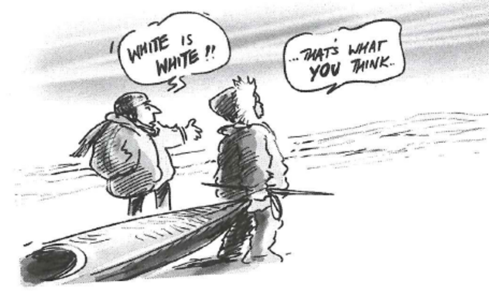
Figure 5 White is white.
View description - Figure 5 White is white.
View alternative description - Figure 5 White is white.

5 Distinctions between systemic and systematic practice
A tension has existed throughout the history of Western thought around whether to focus on parts or the whole. The practice that springs from this history carries the same tension. This tension has been particularly visible within science and philosophy for a long time and it gives rise to different approaches.
Emphasising the parts has been called mechanistic, reductionist or atomistic. An emphasis on the whole has been called holistic, organismic or ecological. As Fritjof Capra (1996) notes: ‘In twentieth century science the holistic perspective has become known as “systemic” and the way of thinking it implies as “systems thinking”.’ Capra also claims systems thinking is ‘contextual’ thinking; and since explaining things in their context means explaining them in relation to their environment, I can also say all systems thinking is environmental thinking.
Two adjectives arise from the word ‘system’. Systemic thinking, thinking in terms of wholes, may be contrasted with systematic thinking, which is linear, step-by-step thinking. Likewise, it is possible to recognise systemic practice and systematic practice.
Table 1 summarises some of the characteristics that distinguish between systemic and systematic thinking and action and you should study this carefully. You will return to many of these characteristics in the coming weeks.
Both systematic thinking and systemic thinking have their place. I am not in any way trying to set up an idea that systemic is good, systematic is bad. They are not in opposition in the hands of an aware practitioner and can be complementary in dealing with complex situations (a topic you will return to in Week 7). My own perspective, when managing or intervening in complex situations is that it is usually more appropriate to approach the task systemically. In other words, systemic thinking provides the context for systematic thinking and action. Thus my ideal, aware, systems practitioner is one who is able to distinguish between systemic and systematic thinking and is able to embody these distinctions in practice. This has implications for the initial starting conditions for any form of purposeful action – i.e. do I start out systemically or systematically?

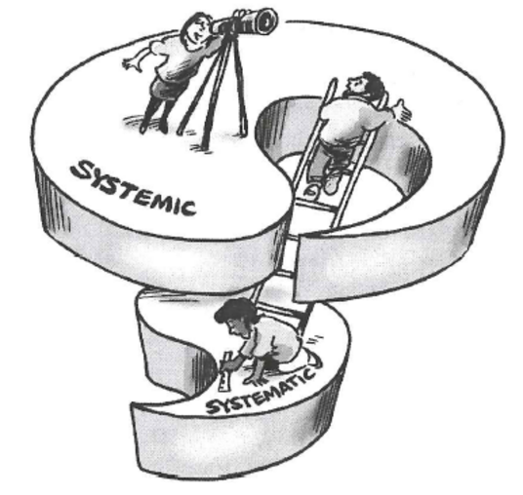
Figure 6 My understanding of the relationship between systemic and systematic, the two adjectives arriving from the word ‘system’ – the systematic is nested within the systemic or, in other words the systematic is a special case of the systemic; together systemic and systematic form a whole, a unity, known as a duality.

Of course, I am building an ideal model and day-to-day experience is different from this. No person can expect to become or embody that ideal overnight. It requires active engagement in a process of experiential learning. The other point I wish to make is that I am not equating the systems practitioner role with someone who is a professional consultant. This is a possible role, but in my idealised model the systems practitioner is anyone seriously interested in understanding and taking action in any context (although I return to this issue in Week 8).

Table 1 A summary of the characteristics that distinguish systemic thinking and action and systematic thinking and action
Systematic thinking | Systemic thinking
The whole can be understood by considering just the parts through linear cause-effect mechanisms. | Properties of the whole differ, they are said to emerge from their parts; e.g. the wetness of water cannot be understood in terms of hydrogen and oxygen.
Systems exist as concrete entities; there is a correspondence between the description and the described phenomenon. | Boundaries of systems are determined by the perspectives of those who participate in formulating them. The result is a system of interest.
Perspective is not important. | Individuals hold partial perspectives of the whole; when combined, these provide multiple partial perspectives.
Analysis is linear. | Systems are characterised by feedback; may be negative, i.e. compensatory or balancing; or positive, i.e. exaggerating or reinforcing.
A situation can be understood by step-by-step analysis followed by evaluation and repetition of the original analysis. | Systems cannot be understood by analysis of the component parts. The properties of the parts are not intrinsic properties, but can be understood only within the context of the larger whole through studying the interconnections.
Concentrates on basic building blocks. | Concentrates on basic principles of organisation.
There is a foundation on which the parts can be understood. | Systems are nested within other systems – they are multi-layered and interconnect to form networks.
Analytical. | Contextual.
Concerned with entities and properties. | Concerned with process.
The system can be reconstructed after studying the components. | The properties of the whole system are destroyed when the system is dissected, either physically or theoretically, into isolated elements.
Systematic action | Systemic action
The espoused role of the decision-maker is that of participant-observer. In practice, however, the decision-maker claims to be objective and thus remains ‘outside’ the system being studied. | The espoused role and the action of the decision-maker is very much part of an interacting ecology of systems. How the researcher perceives the situation is critical to the system being studied. The role is that of participant-conceptualiser.
Ethics and values are not addressed as a central theme. They are not integrated into the change process; the researcher takes an objective stance. | Ethics are perceived as being multi-levelled as are the levels of systems themselves. What might be good at one level might be bad at another. Responsibility replaces objectivity in whole-systems ethics.
The system being studied is seen as distinct from its environment. It may be spoken of in open system terms but intervention is performed as though it were a closed system. | It is the interaction of the practitioner and a system of interest with its context (its environment) that is the main focus of exploration and change.
Perception and action are based on a belief in a ‘real world’; a world of discrete entities that have meaning in and of themselves. | Perception and action are based on experience of the world, especially on the experience of patterns that connect entities and the meaning generated by viewing events in their contexts.
Traditions of understanding may not be questioned although the method of analysis may be evaluated. | There is an attempt to stand back and explore the traditions of understanding in which the practitioner is immersed.

6 This week’s quiz
Check what you’ve learned this week by taking the end-of-week quiz.
Week 2 practice quiz
Open the quiz in a new window or tab then come back here what you’ve finished.

7 Summary
This week you have looked at three sets of distinctions relevant to systems thinking in practice. These are the distinctions between difficulties and messes, between hard and soft complexity and between systematic and systemic. These distinctions differ for people depending on the traditions and practices they have experienced, with a fundamental distinction being whether people see situations (systems) as being real (out there) or constructs of our minds (in here) with the latter implying that these constructions will be different for everyone involved in that situation. Understanding and working with these distinctions is an important part of system thinking in practice.
This week, like the first week, has also used the phrase ‘real world’ to distinguish from the conceptual world, the world of thinking. In many ways this is an artificial distinction because the world I perceive to be the ‘real world’ is, in fact, my own conceptual model. What I perceive is conditioned by my conceptual models. So for me the real ‘real world’, is unknowable. My desire is to change the question from ‘what is the world’ to ‘how do I know the world’. So every time I use the term ‘real world’ you should remember that this is a short-hand for the process of coming to know the world.
You should now be able to:
- explain the notion of perceived complexity within situations through the frames of messes and difficulties, emotional and rational reactions and systemic and systematic thinking.
Next week you will look at appropriate language to define and distinguish systems of interest within complex situations as epistemological devices rather than actual ontological things.
You can now go to Week 3.

Week 3: Identifying systems of interest

Introduction
In Week 2 you looked at how we describe and talk about complex situations in general. You also learned about systems of interest as having perceived complexity and that people can perceive the same situation differently.
This week you will take these ideas further by examining again the language we use to name or define systems of interest and introducing ways that you can begin to identify different systems of interest within a complex situation. In other words how systems thinking in practice includes making explicit boundaries within situations where the prime boundary is one of purpose. You will use this identification of systems of interest again in Week 4, when you will be introduced to a key tool in the system practitioners’ toolkit – the use of diagrams to represent such systems of interest and also in Week 5 on multiple perspectives where you will include other people’s views.
Watch the following video which highlights what is involved in identifying a system of interest.

Video content is not available in this format.
View transcript - Uncaptioned interactive content

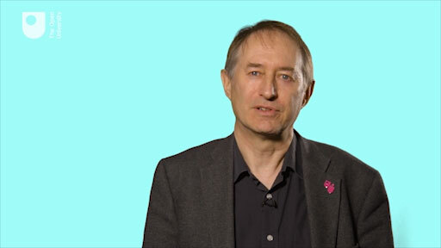

By the end of this week, you should be able to:
- use appropriate language to define and distinguish systems of interest within complex situations as epistemological devices rather than actual ontological things.

1 Distinguishing and defining systems
Everyone is involved with things called systems – information systems, financial systems, ecological systems, computer systems, education systems; and to this list you can add many things which are often called systems by professionals in a particular field. For example, doctors talk of the nervous system in the body, therapists of the family system to which each of us belongs, engineers of fail-safe systems in a car or power station. In general, the word ‘system’ can be used in a number of ways and all these things called systems seem complicated and can often be seen to behave in unpredictable ways.

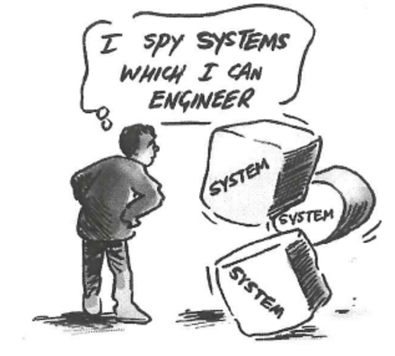
Figure 1A practitioner seeing systems in the world.
View description - Figure 1A practitioner seeing systems in the world.
View alternative description - Figure 1A practitioner seeing systems in the world.

At first sight, a computer system and the body’s respiratory system don’t seem to have much in common, nor do the world financial system and an ecological system. On the other hand, each of them is called a system, so they must have something in common.

1.1 Building up a definition
In Week 2 I compared systemic and systematic thinking. In doing so I noted that systemic thinking looks at wholes made up of components rather than focussing on the components and that each takes a different view on how the system relates to the world we experience. In particular there is a difference between talking about systems that we, as humans, have constructed (e.g. transport systems) and ‘natural’ systems we observe (e.g. respiratory systems). Nevertheless, these things we call systems consist of things (or elements, the term used by Ackoff (1981) in Week 2 or entities which I have also used) that interact with each other and which have a designed purpose (i.e. is purposeful) or can be said to have a purpose even if that has not been planned or designed (i.e. is purposive) as also noted in Week 2.
So my first attempt at a definition is that a system is ‘a set of things interconnected for a purpose’.
This definition needs a little elaboration. First, the ‘things’ may be physical objects – like cars, roads and railway lines – or they may be activities – like those needed to control traffic flows. They may even be ideas, such as those which make up a set of policies or code of practice. It is helpful to have a generic word which will cover all these possible ‘things’, and because that word suggests only physical objects, I’m going to use the word ‘components’ (rather than elements) instead.
So I want to redefine a system as ‘a set of components interconnected for a purpose’.
Next, I want to look again at the idea of ‘purpose’ in the definition. On the one hand, it is natural to use the word ‘system’ only when a set of components seems to have some purpose that we have ascribed to it – some aim or goal. So, the purpose of a car braking system is to enable us to stop the car, and the purpose of the respiratory system is to enable our bodies to take in oxygen. On the other hand, it may occur to you that there are some things called systems in common speech which don’t seem to have a purpose; most people would be lost for words if you asked them to describe the purpose of the solar system. In that case why not just drop this idea of purpose from the definition?
There is a good reason not to do so. When you are confronted with a set of components and you want to find ways of working with them, or making them work better, it is always useful to look at them as if they had a purpose. In other words, the interconnected set of components – the system – has been identified by someone as being of particular interest. An urban transport system may have grown up over the past fifty or more years, without any overall purpose; but if you want to re-plan or re-design it, it will always be helpful to look at it, say, as if it had the purpose of enabling people to move easily around the city. In other words, for practical purposes, this course is only going to be concerned with systems where those sets of interconnected components – whether ideas, objects or activities – can sensibly be described as if they had a purpose because ‘we’ have an interest in them.
I can now elaborate on my definition of a system of interest to include other aspects, namely:
- A system is an assembly of components connected together in an organised way.
- The components are affected by being in the system and the behaviour of the system is changed if they leave it.
- This organised assembly of components does something.
- This assembly as a whole has been identified by someone who is interested in it.
Note that I have changed from using set of components to an assembly of components as the word assembly also implies that the components are organised.

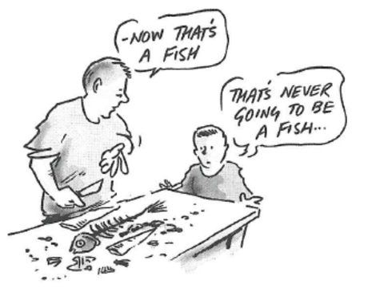
Figure 2 A fishy ‘system’.
View description - Figure 2 A fishy ‘system’.
View alternative description - Figure 2 A fishy ‘system’.

2 The language of systems
This is not the only definition of a system you will encounter in the literature but most encapsulate these same characteristics in one way or another. A colleague has used this very short definition: ‘A system is a collection of entities that are seen by someone and interacting together to do something’ (Morris, 2009). Whichever definition you prefer, the term system is closely, indeed logically, associated with two other terms: environment and boundary. The definition and essential meaning of these terms is straightforward. The environment of a system comprises those elements, activities, people, ideas, and so on that are not part of the system but which may nevertheless be important in understanding it. System is the foreground; environment is the background, the relevant context of the system. As for the term boundary, that is basically where the system ends and the environment begins. I can therefore add a fifth part to my definition:
- Putting a boundary around this organised assembly of components distinguishes it from its context or environment.
None of these ideas, in itself, should present any difficulty. However, their use in thinking about situations is both trickier and more rewarding than you might expect.
In Week 2 messes were distinguished from difficulties by their characteristic of being unbounded in important respects. Of course, if a problem is literally and completely unbounded it extends to include ‘Life, the Universe and Everything’. In practice things are usually not that bad. Nevertheless, there is a genuine and important dilemma: on the one hand one wants to avoid too limited and local an analysis; on the other hand, one really cannot rethink and change everything at once.
The area of interest extends in numerous directions. So in tackling messy situations there is a recurring dilemma: how much one bites off. Enough to deal with the hunger pangs, but not more than those concerned can chew. But how much is that and can such a mouthful actually be separated from what is not eaten?

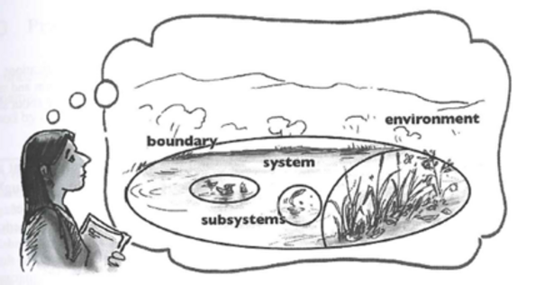
Figure 3 A system of interest comprising a system (with sub systems), boundary and environment is distinguished, by someone as they engage with a particular situation.
View description - Figure 3 A system of interest comprising a system (with sub systems), boundary and ...
View alternative description - Figure 3 A system of interest comprising a system (with sub systems), boundary and ...

The language of systems does not solve this problem, but it does provide a way of addressing it. The task is essentially one of finding a workable provisional boundary for the system containing the issue of interest, or at least a significant part of the issue. But in distinguishing between system and environment one accepts that the issue is not self-contained, that it can only be partially disentangled from its broader context.

2.1 Drawing boundaries
Drawing boundaries is a very common and familiar way of simplifying (and often a key feature of systems diagrams as you will see in Week 4); boundaries separate what is of direct interest and concern from what can be considered as wider, external influences. For example, the boundary of a National Park separates an area of countryside thought to be deserving of special protection from the more ordinary countryside around. Dictionary definitions set out boundaries between the meanings of words (and that is what is partly done here).
There are a lot of boundaries which are conventionally drawn and accepted as uncontroversial. For example, many firms have pretty rigid boundaries between different departments. But often they grew up for reasons which have passed into history, and the key functions which need to be carried out may now span two or more departments.
Sometimes boundaries are less tangible. For example until the 1980s computing was for experts – people trained as programmers. When microcomputers were first developed they were still designed for trained computer users because the designers had not recognised that they had implicitly drawn a boundary round those they considered to be the potential users, excluding those without special expertise. Those who developed personal computers re-drew that boundary.
Sometimes boundaries are very hard to spot. Most people assume that stocks and shares are part of a highly developed system of providing capital for companies, and do not consider them in any other light. But some investors realised that the investment of money can be part of a system to divert capital away from industries and enterprises which, in their opinion, are unethical towards the manufacture, for example, of environmentally safe products. It is clear that this novel view ‘makes sense’, but it is not a system that is publicly or commonly recognised. In one sense, it obviously exists ‘out there’; or rather, the various elements in the ‘system’ obviously exist. But the focusing on this particular purpose is simply a way of re-conceptualising the various elements and their relationships in a way that is of interest to the investors in this case.

3 The naming of systems
This leads to an important distinction between two ways in which the term ‘system’ is used depending on traditions and practices that we touched on in Week 2:
- commonly recognised systems
- explanatory systems
- in addition there is another distinction based on the level of description.

3.1 Commonly recognised systems
Firstly there are commonly recognised systems that are convenient to think of as existing ‘out there’. Such systems are widely acknowledged either because they are deliberately created (a stock control system, a computer system, for example); or because they are fairly discrete, naturally occurring phenomena that have long since been delineated and analysed by scientists (the nervous system and the solar system for example); or just because they are popularly referred to as systems in a vague though useful way (the legal system and the economic system are examples).
In general, such systems are based on widely shared perceptions. While this popular naming of recognised systems may be convenient and useful where the situation is merely complicated or its purpose is largely uncontroversial it can often hide the fact that the situation is very complex and that different people have very different perspectives on its purpose or indeed only have a partial view of one aspect of the wider system.

3.2 Explanatory systems
Secondly, there are explanatory systems, such as in the phrase ‘it’s the system for making the trains run on time’. The scope and components of these systems are much less clear and possibly more problematic to agree upon.
Indeed, if a system of this sort exists anywhere, it is in the mind of the individual(s) who conceives it. It is simply a particular way of thinking about selected aspects of the world and their interrelationships which is useful in relation to the individual’s concerns.
Systems of this second sort embody particular points of view and are useful to the extent that they offer some insight into what is puzzling or troublesome and by describing or ascribing a purpose to their system of interest they potentially make dealing with the complexity more tractable.

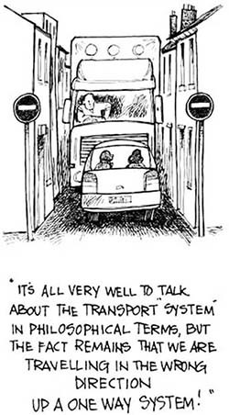
Figure 4A one-way system.
View description - Figure 4A one-way system.
View alternative description - Figure 4A one-way system.

3.3 Wider systems
The third general point is that systems are nested within other, wider systems. Saying that ‘this’ is the environment, ‘this’ is the system, and ‘these’ are the sub-systems, of which the system is constituted, reflects a choice of the level at which you will work. Russian dolls, which fit snugly one inside another, provide a useful analogy. No single one of them is ‘the doll’; each one fits inside a larger one. Instead of trying to identify ‘the system’ it is more helpful to think of a hierarchy of systems which fit inside each other from which you have to select the system-level at which you will work by exploring the most relevant ones.
The use of the Russian doll analogy is an example of a set of techniques that can be used to explore complex situations, others being the use of metaphors, diagrams, and models. We can build up our view of the ‘system’ being considered by wheeling in particular representations of various recognised systems and using them to highlight the presence or absence of particular interrelationships and patterns of behaviour within our explanatory ‘system of interest’. It is as if we display the raw complexity of the complex situation on an overhead projector slide and then superimpose different sorts of ‘systems of interest’ on it as overlays, to draw attention to different aspects of the way the ‘system of interest’ works and the way the ‘system of interest’ can be perceived by other people who are interested in it.
This is important because if thinking in terms of systems is to be of any use it must involve more than mentally grouping a number of components together and calling them a system. The whole point is that these components are interrelated, so it is important to be able to grasp the ways in which they characteristically combine and interact. An understanding of these interrelationships, of how certain components ‘hang together’, is likely to provide a basis for deciding what to include in the system in the first place.

3.4 Identifying systems of interest
Activity 1 will help you to begin identifying systems of interest.
If you have difficulty seeing what is required at any step, you can refer to my attempts to answer the questions in the ‘comment’ but you will get more from them if you follow the instructions through to the end before you refer to my answers.

Activity 1 Identifying systems of interest in a complex situation
Allow approximately 15 minutes for this activity.

Identify a complex situation or recognised system involving people which you find puzzling, awkward or unpredictable. Describe it briefly and then answer the following questions:
- Why does it present you with a problem?

Provide your answer...

- Whose purposes does this system serve?

Provide your answer...

- What is the system for? Write at least five answers to this question and any ideas or insights which it gives you.

It is a system for … | Ideas and insights
1. | Provide your answer...
2. | Provide your answer...
3. | Provide your answer...
4. | Provide your answer...
5. | Provide your answer...

- Do the answers you have written give you any ideas about changing the behaviour of the system?

Provide your answer...
View comment - Part

4 Levels of systems
You may have noticed that although I chose the ‘higher education system’ as my complex situation, the five systems of interest I have given of that situation are only parts of that complex situation. This relates back to my earlier comments about a hierarchy of (sub-) systems within systems. Kenneth Boulding (1956), an influential early systems theorist, suggested one such hierarchy for systems (or set of layered, nested or interdependent structures) with nine levels of ‘complexity’ as set out in Box 1.

Box 1 Boulding’s hierarchy of systems
- Static structural frameworks, such as bridges and crystals.
- Clock-works with pre-determined motion, such as wind-up toys or the solar system.
- Closed-loop control mechanisms, such as thermostats and automatic regulation in living organisms.
- Simple open systems that are self-maintaining such as living cells, or flames, or the vortex that forms as water flows down a plughole.
- Lower organisms such as plants that have separate organs but have little control over their own development.
- Animals that have a brain to guide behaviour and an ability to learn.
- Humans who exhibit language, self-consciousness, and conscious acquisition of knowledge.
- Socio-cultural systems whose members have different tasks but shared values, and which have a lot of internal communication.
- Transcendental systems such as the idea of God – inescapable unknowables.
Each level contains elements or components (sub-systems, sub-sub-systems, etc.) of all the other levels, but a new type of emergent property appears at that level. So you or I contain examples of all of levels 1-to-6, but also add on the special qualities of level 7. As you move up the hierarchy, complexity increases, in the sense that observers find it harder to predict what will happen. Boulding’s levels 1-5 are subdivisions of what can be called the rational-technical level. This level is often called the mechanistic level. Level 7 is roughly a personal level, 8 includes the wider environment level, and 9 the spiritual side to our lives.

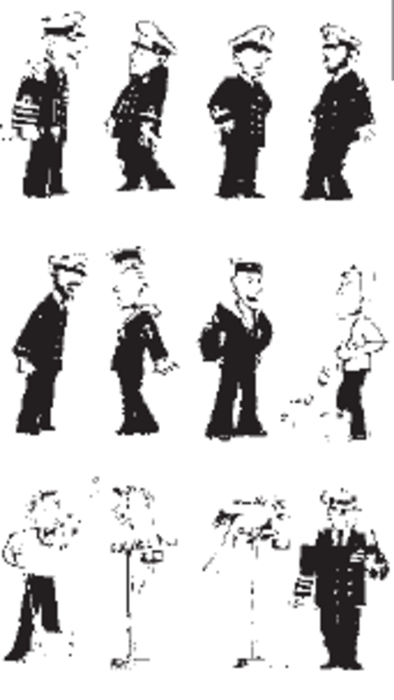
Figure 5 The complexity of hierarchies.
View description - Figure 5 The complexity of hierarchies.
View alternative description - Figure 5 The complexity of hierarchies.

4.1 Additional ways of identifying a system of interest
This is not the only way of describing hierarchies as it depends on the purpose behind the categorisation and the purpose we might ascribe to each (sub) system description (and Boulding’s descriptions are more recognised systems than explanatory systems as discussed earlier). However, there are additional ways of identifying a system of interest beyond that of ascribing a purpose to a system through a textual description using active verbs rather than passive nouns as I did in Activity 1. In Activity 2 you will explore another, visual, approach.

Activity 2 Identifying systems of interest – a visual approach
Allow approximately 10 minutes for this activity.

- Take an issue you are concerned about; one that puzzles or worries you and seems complicated.
- Take a piece of paper and write down a brief title to the puzzle or problem you face.
- Turn over the paper and on the other side jot down the first ten or so thoughts you have about the key features of the issue. Don’t write them down as a list, but write them as if they were in small boxes scattered at random on the page.
- Now see which of your thoughts have something in common, i.e. seem to be about the same point or problem, and draw a boundary round them. You may end up with two or three boundaries. Don’t include all your ideas just for the sake of it: if one or more seems to have no strong connection with any of the others, leave it without a boundary round it.
- For each set of thoughts enclosed in a boundary, write down the point or problem they have in common and then jot down any ideas you may have for dealing with that problem.
- Look at the brief title on the other side of the paper and see if what you have done has helped you to take a new view of the issue.

View comment - Activity 2 Identifying systems of interest – a visual approach

4.2 Commonly used criteria
In Activity 2 you were asked to draw a boundary round things that had something ‘in common’. That phrase was deliberately vague. You were not given any rules or guidelines for drawing boundaries, so you could see how you did it instinctively before you were given some commonly used criteria. For although these criteria can be very helpful, they can restrict ideas if used too rigidly. Often it is more helpful to draw the boundaries first and reflect on them afterwards, as in the exercise. But if this doesn’t generate new views, then try the following criteria:
- Interest and concern
The boundary separates those aspects which are vital to you and those of secondary importance, but which may still exert an influence. In applying this criterion, you will find that you will have to think quite hard about your purpose by drawing the boundary. This point was at least partly dealt with by the second stage of Activity 2 when you were asked to write a brief title to the puzzle or problem you faced.
- Influence and control
There are two ways in which this criterion can be used. First, boundaries can separate those aspects of the issue which are under the control of, or are strongly influenced by, separate people or groups. So, for example, this guideline can help you to become clear about the areas where you have power to make changes, and those which you have to accept as they are. Second, there will be times when there is a strong mutual influence between some aspects of the problem, but not others. Separating these two with a boundary will help to reveal that solutions to the problem will have to take account of the strong mutual influence.
- Time
Boundaries can be drawn round aspects of the issue which raise short-term problems and those which have longer and more pervasive effects. This can help to reveal the limitations of solutions which only address the former.
In essence Activity 2 was trying to get you to draw what is known as a systems map of a situation, which is one way of representing a system of interest and is the subject of Week 4.

5 Categories of systems
Before finishing this week you will now return to the issue of making distinctions between situations and systems. Table 1, which you will look at in the next section, has been constructed from the characteristics and examples Casti (1994) claims are exhibited by simple and complex systems, but in the case of Table 1 the headings have been revised to cover situations regarded as simple ‘purposive systems’ and situations regarded as complex ‘purposeful systems’ to reflect the view that systems are conceptual epistemological devices rather than actual ontological things.

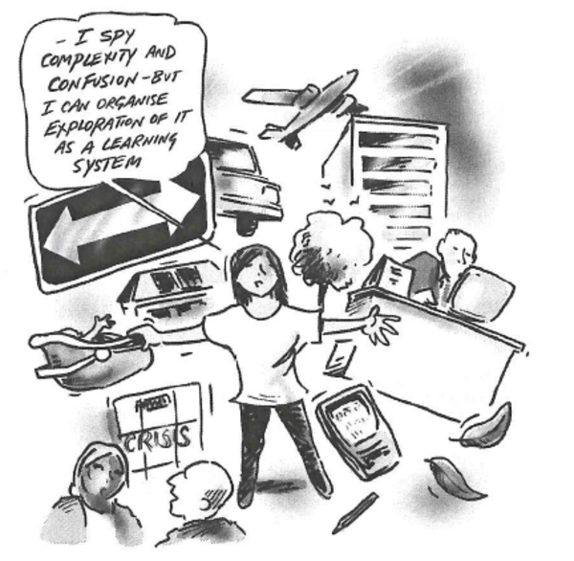
Figure 7A practitioner who understands ‘systems’ to be a means of inquiry about a situation.
View description - Figure 7A practitioner who understands ‘systems’ to be a means of inquiry about a ...

5.1 Simple (purposive) and complex (purposeful) systems
Spend a few minutes reading through the table and then do the activity that follows.

Table 1 Characteristics ascribed to situations regarded as simple (purposive) and complex (purposeful) systems
Situations regarded as simple ‘purposive systems’ | Situations regarded as complex ‘purposeful systems’
Have predictable behaviour; e.g. a fixed interest bank account. | Generate counterintuitive, seemingly acausal behaviour that is full of surprises; e.g. lower taxes and interest rates leading to higher unemployment.
Few interactions and feedback or feed forward loops; e.g. a simple barter economy with few goods and services. | A large array of variables with many interactions, lags, feedback loops and feed forward loops, which create the possibility that new, self-organising behaviours will emerge: e.g. most large organisations, life itself.
Centralised decision-making; e.g. power is concentrated among a few decision makers. | Decentralised decision-making – because power is more diffuse, the numerous components generate the actual system behaviour.
Are decomposable because of weak interactions; i.e. it is possible to look at components without losing properties of the whole. | Are irreducible – neglecting any part of the process or severing any of the connections linking its parts usually destroys essential aspects of the system behaviour or structure. There are dynamic changes in the system and the environment.
(Adapted from Casti, 1994, pp. 271–3)

Activity 3 Reflections on categorisations
Allow approximately 15 minutes for this activity.

In the original version of Table 1, Casti ascribed the terms simple and complex to the word systems. Write down your answers to the following questions:
- In what ways do you experience the terms ‘systems’ and ‘complex’ being used by Casti?

Provide your answer...

- What implications might these categories have for systems practice?

Provide your answer...

- How does the revision of the two categories alter in any way, if at all, your understandings of the terms ‘complexity’ and ‘systems’?

Provide your answer...
View comment - Part

The questions in Activity 3 are extremely interesting but at the same time potentially confusing. The word ‘complex’ is being used by Casti in some cases to mean the same as ‘system’, and some of the characteristics of complexity seem to be applied to system. The phrase ‘complex system’ is common, although the meaning attributed to it is often unclear. For example, it might be unclear whether Casti is using ‘system’ in its everyday sense or in the specific way it is used within the study of systems to mean a system of interest to someone.
When you consider the examples used in Table 1 there is something qualitatively different about a simple barter economy and the phenomenon of lower taxes and interest rates leading to higher unemployment other than whether they can be described as simple or complex. Indeed, you might question whether it would be helpful to consider a barter economy as simple. Considering the quality of relationships and trust that might be necessary to sustain a barter economy, it could be perceived as complex. This notion of quality of relationship is an important additional distinction that could be attributed to complexity over that provided in the earlier list of Schoderbeck et al. (1985) in Week 2 which tends to focus only on the quantity of variables or interactions.

6 This week’s quiz
Check what you’ve learned this week by taking the end-of-week quiz.
Week 3 practice quiz
Open the quiz in a new window or tab then come back here when you’ve finished.

7 Summary
The brief definition of a system of interest is a set of components interconnected for a purpose. There are epistemological differences between thinking that systems are ‘out there’, a position reinforced by the naming of ‘recognised’ systems in everyday language; and of seeing systems as useful mental constructs for helping to explain how complex situations work. There are reasons for being cautious in talking about the ontology – the categorisation – of systems in terms of the language we use and how that influences our perceptions.
The word ‘system’ has been used to make five points about thinking in terms of systems:
- Something cannot usefully be called a ‘system’ unless a systems practitioner has a stake or interest in it.
- The intangible elements, e.g. norms and assumptions, are essential factors in understanding how a system of interest works.
- The boundary of a system needs not correspond with recognised departmental, institutional or other ‘physical’ boundaries. Explanatory systems are identified in relation to the observer’s interests.
- Often one has to extend the boundary (take a helicopter view) in order to achieve a coherent understanding of a complex situation.
- A system at one level of analysis can be viewed instead as a sub-system in its environment at a higher level of analysis.
You should now be able to:
- use appropriate language to define and distinguish systems of interest within complex situations as epistemological devices rather than actual ontological things.
Next week you will consider the characteristics and purposes of a number of diagram types used to represent systems of interest by systems practitioners.
You can now go to Week 4.

Week 4: Representing systems of interest

Introduction
This course has talked about the characteristics of systems and how to think about them. But a big question is always: ‘How do I capture my and other people’s thinking in a useful way both for myself and to share with others?’ In other words how do I understand and engage with perspectives on complex situations? That task is central to systems practice and many techniques, approaches, methods and methodologies have been devised or applied by systems theorists and practitioners. For the purposes of this course you will only look at representing (or modelling) systems qualitatively by using visual means (most notably diagrams and language) and not through using mathematics (i.e. computer-based quantitative models).
The mathematical modelling of systems of interest is beyond the scope of this course but if you are interested in studying this aspect of systems thinking in practice then you should look at the free OpenLearn course, Systems modelling.
Watch the following video which introduces the idea of structuring complexity using diagrams.

Video content is not available in this format.
View transcript - Uncaptioned interactive content

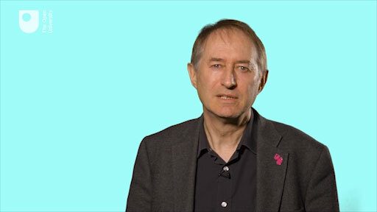

By the end of this week, you should be able to:
- describe the characteristics and purposes of a number of diagram types used to represent systems of interest by systems practitioners.

1 Setting the scene
You have already partly looked at using language to represent systems in Week 3 and will continue to do so but for this week the focus is on using diagrams to represent systems. Again this is a big topic in itself and a skill that takes time to develop but what I will do is to tell you something about how I, as a systems practitioner, use and draw diagrams and give you the chance to try drawing some for yourself. I will mainly do this through two videos and an audio track rather than in text as you will both see the diagrams and hear what I say about it at the same time.
First of all, I will assume that you have no experience of using diagrams and that you may also be apprehensive about ‘drawing’ them. But the type of diagrams I will talk about need no drawing skills as such, as they mainly involve the arrangement of words, phrases, lines or arrows on paper or on a screen as I did in my answer to the last activity in Week 3. There are some diagrams that invoke notions of drawing, such as the rich picture. While this is a very important diagram in systems practice I have chosen not to include it in this course as I could not cover everything, but again the successful use of such diagrams does not depend on drawing abilities but on how deeply you think and feel about the complex situation you are representing.

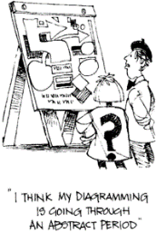
Figure 1Successful use of diagrams does not depend on drawing abilities.
View description - Figure 1Successful use of diagrams does not depend on drawing abilities.
View alternative description - Figure 1Successful use of diagrams does not depend on drawing abilities.

Secondly, if you do want to study this aspect of systems thinking in practice in more detail there are several other video and text based resources on OpenLearn for you to work through shown in Box 1, some of which include the rich picture!

Box 1 Free resources on diagramming from The Open University
There is a wealth of free material on systems diagramming and related diagramming techniques from The Open University that you can also study and this list provides the most prominent:
- The OpenLearn course Systems diagramming.
- A series of animated tutorials on the Systems Thinking Hub on OpenLearn
- A Guide to diagrams on OpenLearn.
- The OpenLearn courses Diagramming for development 1 - Bounding realities and Diagramming for development 2 - Exploring interrelationships

Lastly, you may already have encountered systems diagrams in some form before. However, we at The Open University use a fairly consistent set of conventions for particular diagram types which may be different to what you are used to. So even if you’ve used systems diagramming before, do work through the animated tutorial, if nothing else, as revision or a chance to practise a skill you may have not used for some time.

Activity 1 Your thoughts and feelings about diagramming
Allow approximately 5 minutes for this activity.

Make a note of your thoughts and feelings about drawing diagrams. Are you worried or excited? Do you feel confused as to why diagrams are a necessary part of systems thinking in practice or just accepting that they are?

Provide your answer...
View comment - Activity 1 Your thoughts and feelings about diagramming

2 What are systems diagrams for?
The audio track in this section provides an explanation of why diagrams are important tools in systems practice and some things to consider when drawing them. After you have listened to the audio track you are asked to draw a diagram that you may have encountered before – a spray diagram – to summarise the points that are made. So you need to be prepared to do this activity and I suggest that you gather together some sheets of paper of at least A4 size. You will also need either a softish pencil that is well sharpened and a soft rubber or a good pen before starting the video. I would advise against trying to draw diagrams on your computer or tablet until you have mastered the conventions and purpose of the diagram first. If you are unfamiliar with spray diagrams you can read the Diagram guidelines. Indeed, whatever your familiarity with spray diagrams I suggest you read these guidelines before starting the video.

Activity 2 Drawing a spray diagram about diagramming
Allow about 20 minutes

Once you have read the Diagram Guidelines on spray diagrams listen to the following audio track on ‘what are systems diagrams for?’ Take notes while listening and then try drawing a spray diagram that summarises much of what I have been saying about diagramming, adding any other points that you feel are relevant.
Before you start you may want to look again at the conventions for a spray diagram. Also you should start your diagram around the middle of the sheet of paper. I mention that because most people automatically start writing in the top left hand corner and that’s hopeless for diagrams. It’s important to break the habit and to spread your diagram out as far as possible. In addition, don’t be surprised if you want to add to or change your first attempt. So, you may want to start afresh on a new sheet if you find that helpful.

Audio content is not available in this format.
What are systems diagrams for?
View transcript - What are systems diagrams for?

View comment - Activity 2 Drawing a spray diagram about diagramming

3 Drawing systems diagrams
This section also mainly involves watching a video, albeit longer than others as it has to cover several different diagrams.
It should be viewed in one sitting but there are points when you may want to stop the video and think about what has been said or to refer again to the Diagram Guidelines to better understand the key features of each diagram type.
Two other things to note before you start:
Firstly, you will see on the video some diagrams prepared or collated by me but which have been redrawn to make them clearer to read. The originals were much scruffier and harder to read as these were diagrams I drew for myself to help me think about the complex situation I was investigating. So do not worry if your attempts at diagramming, whether done now or in the future, do not look as clean or as clear as those presented.
Secondly, these diagrams demonstrate different kinds of diagrams, mostly representations of a complex situation first presented as text. As you work through the video I will explain how I developed some of these diagrams and what I was thinking about at the time as tried to make sense of the article shown below.
As I noted earlier these diagrams have different purposes and are based on conventions. Before you watch the video on drawing diagrams you first need to study the purposes and conventions of the three types of systems diagram I will be using:
These are:
- systems maps
- influence diagrams
- multiple cause diagrams.
You can find information on these in:
- the Diagram Guidelines
- the article Beware of the human factor (which is the complex situation I am looking at).
You may find it helpful to make notes or draw a spray diagram to capture the key features of the situation described, which is what I do at the beginning of the video, so please do not look at the video until you have made some sense of the article for yourself.

Video content is not available in this format.
A deep dive into diagramming
View transcript - A deep dive into diagramming

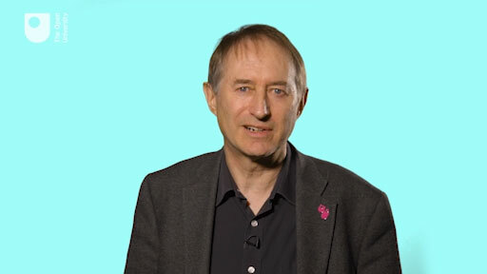

Activity 3 Have your thoughts and feelings changed?
Allow approximately 5 minutes for this activity.

Return to the notes you made for Activity 1 and note down whether and what has changed in your thoughts and feeling towards diagramming.

Provide your answer...
View comment - Activity 3 Have your thoughts and feelings changed?

4 This week’s quiz
Now it’s time to complete the Week 4 badge quiz. It is similar to previous quizzes but this time, instead of 5 questions, there will be 15.
Week 4 compulsory badge quiz
Open the quiz in a new window or tab then come back here when you’ve finished.

5 Summary
Diagrams can provide a clear and succinct summary, a review of a complicated situation or series of events. A diagram can show you an intricate pattern of relationships in a very direct way. As well as understanding interrelationships, diagrams are also a device for communicating, for engaging with perspectives. So diagrams are good for presenting an overview of an area or an overview of the sort of factors that combine to produce an event. It helps to prevent you, by yourself or with others, getting bogged down in the details of a problem and it can give you novel views and perspectives.
While the different types of diagram covered this week offer different framings of a complex situation, the diversity and richness of our thinking far exceeds the range of clearly recognisable diagram types with clear purposes and conventions. So often I find that when I have drawn a diagram I am not quite sure what type of diagram it is. Sometimes that is because it is a muddle and it helps me a lot to clarify it and turn it into one or more recognisable and readily comprehensible diagrams – but other times it is a perfectly clear diagram, it just is not obviously one particular type. So there are times when you simply have to ignore the conventions and do something different. That said, my experience of teaching diagramming over 30 years has shown that when developing your skill in drawing diagrams it helps a lot to start with a limited number of simple and distinctive types and to become really familiar with them before trying too much improvisation. It is perfectly true that in the end what counts is not whether it's this sort of diagram or that sort of diagram but whether it is clear to you and others you may share it with.

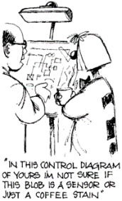
Figure 2Sharing diagrams can provoke conversations
View description - Figure 2Sharing diagrams can provoke conversations
View alternative description - Figure 2Sharing diagrams can provoke conversations

Diagramming can be difficult but remember the two different sources of difficulty I mentioned in the first video. One is the difficulty of drawing the diagram. The other difficulty is thinking clearly about the topic. Organising and expressing our thoughts about complicated matters is difficult however one does it. Hence, if you were using a diagram and finding it difficult do not assume it's because you’re not very proficient at drawing diagrams. It is the thinking that is hard work. But I find that the more I use them the more useful they are in my systems practice.
You should now be able to:
- describe the characteristics and purposes of a number of diagram types used to represent systems of interest by systems practitioners.
Next week you will learn how to take multiple perspectives of a complex situation yourself and how to find out the perspectives of others involved in that complex situation.
You are now half way through the course. The Open University would really appreciate your feedback and suggestions for future improvement in our optional end-of-course survey, which you will also have an opportunity to complete at the end of Week 8. Participation will be completely confidential and we will not pass on your details to others.
You can now go to Week 5.

Week 5: Understanding multiple perspectives

Introduction
So far in this course you have been asked to take new perspectives on complex situations but equally have noted how our traditions and experiences influence how we think and act. You will now revisit these aspects further by looking at situations where I am making sense of complex situations with other people rather than just making sense of it for my own benefit. If you are to be a systems practitioner then working with others is unavoidable, but as I also noted in Week 1 the ideas and practice of systems thinking may be unfamiliar and challenging for many people because of their own traditions and experiences influencing their own perspectives on situations they face.
Watch the following video which discusses what it means to experience systems practice.

Video content is not available in this format.
View transcript - Uncaptioned interactive content

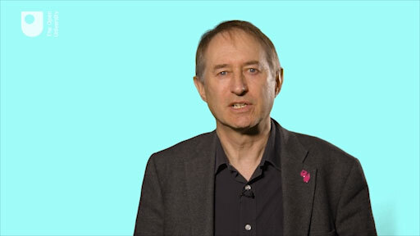

By the end of this week, you should be able to:
- explain how to take multiple perspectives of a complex situation yourself and how to find out the perspectives of others involved in that complex situation.

1 Simplifying complexity
I recall a story (told by a marketing person) about a group of professionals, each given a barometer and asked to find the height of a church tower. The physicist, who remembered that air pressure changes with height, took the barometer reading at the bottom and at the top of the tower to calculate the height. The engineer dropped the barometer and timed its descent to the ground to work out the tower’s height. The architect lowered the barometer on a piece of string till it touched the ground and measured the string. The surveyor measured the shadow cast by the upright barometer and by the tower and used the ratio so found to calculate the tower’s height. The marketing person went to the Sexton and said ‘If you tell me the height of the tower, I will give you this barometer’.
The story illustrates two important points. Firstly, as I noted above, that people and their viewpoints are part of the situations we normally have to deal with. Secondly, there is more than one way to handle any situation. I have also noted that systems thinking can simplify complexity by taking multiple partial views. That needs some explanation.

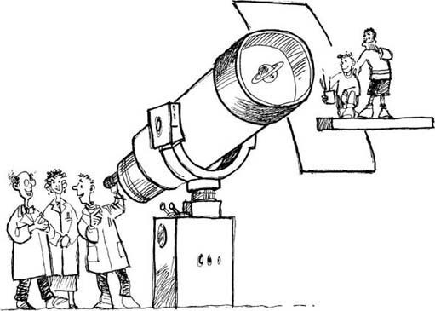
Figure 1A metaphorical account of the way theories (planet on telescope) determine what we see in the world. The mischief makers represent what happens implicitly with any theory.
View description - Figure 1A metaphorical account of the way theories (planet on telescope) determine ...
View alternative description - Figure 1A metaphorical account of the way theories (planet on telescope) determine ...

2 Taking multiple partial views
Imagine a theatre, with the stage set up for a concert by a symphony orchestra. Imagine too that the only way you can find out what the theatre is like is through sectional drawings of it; slices if you like, cut through it. Now if you cut through vertically very near the edge, you will learn something about it – the shape of the roof, for example – and you would be able to guess quite a lot more: that it might not be square, for example. If you took a horizontal slice, you could confirm the guess. Another slice might catch the edge of the stage, adding to the picture. Finally, if you are lucky, you might get a slice which goes right through the stage with some of the instruments on it and then you would know a great deal about the place and its particular state on that evening. The point of this analogy is that if you take the theatre as the whole, then each slice is a slice of the whole, but it is a simplification – a partial view. The more slices you have the more you will know about the whole. Notice too, that no slice is wrong or untrue – they are simply more or less helpful in understanding the whole.
Another way of taking multiple partial views of the theatre is to consider the perspectives or points of view of the people involved in its use. The commissionaires might notice the layout of the entrances and exits, and how quickly queues disperse; the acoustics engineer will see the drawbacks of the shape of the hall and how they might be remedied for better sound quality; the safety officer will see potential hazards, and so on. Once again, the more points of view you have, the more you will know about the whole. This much is obvious, but it does present a difficulty. If we each have our own perspective, how can we adopt or take account of different ones?
Note these three ways in which different perspectives can be gained and put together to get a helpful picture of the whole.

Being clear and explicit
The first is to be clear and explicit about your own point of view. This may seem obvious now that I have kept asking you to do so in the many activities in this course, but it is something we rarely do. People bring to any situation a whole host of beliefs, assumptions, values and interests, something known as their Worldview or Weltanschauung (this German word is often used because it is a much richer expression of the concept than the English word Worldview).

Using techniques such as diagramming
The second way of getting a different perspective is to use techniques such as diagramming as a way to gather and capture different views. In Week 4 you were taken through some diagramming techniques that you could use by yourself, but these techniques and others like them can also be drawn collectively with others involved in the complex situation, which I will return to later.

Consider different perspectives
The third way in which we can gain new and different perspectives of a system is to use particular systems approaches that in themselves force you to consider different perspectives through the different stages and techniques used.
However, there is another aspect that needs to be considered and that is the relationship that you have with both the complex situation you are investigating and the relationships you have with those involved in that complex situation. In essence, this is to do with shifting from the ontological use of systems ideas for capturing perspectives to the epistemological use of systems ideas for mediating perspectives.

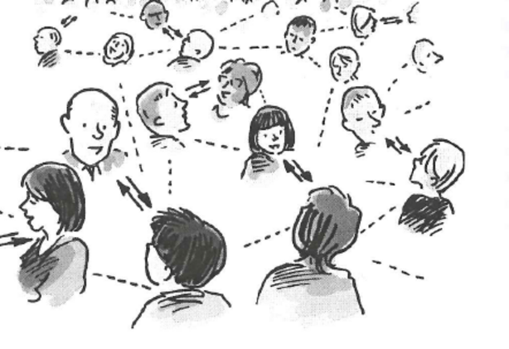
Figure 2 An unfolding network of conversation and relationships. ‘Managing’ involves maintaining a network of asynchronous relationships in the context of an ever-changing flux of events and ideas. As any manager engages in one conversation, others are engaged in different conversations. As individuals participate in different conversations a coherent network of conversations results (adapted from Winter, 2002, p. 67 and p. 83).
View description - Figure 2 An unfolding network of conversation and relationships. ‘Managing’ involves ...
View alternative description - Figure 2 An unfolding network of conversation and relationships. ‘Managing’ involves ...

3 Perspectives on ‘managing’
The focus in this section is on the diversity of activities that might constitute ‘managing’ – in particular working with others involved in a situation. More specifically, it is concerned with the type of managing a systems practitioner might undertake. In Week 2 you looked at some different meanings associated with the phrase ‘complexity’ but not directly on the matter of managing complexity.

Activity 1 Meanings of managing
Allow approximately 5 minutes for this activity.

Generate a list of all the verbs you associate with the word ‘managing’.

Provide your answer...

Sort through them and develop some categories that help you to group and make sense of your list.

Provide your answer...
View comment - Part

The concern in this section is with managing in all its manifestations and how these are embodied in a particular manager. It is not concerned with just management within organisations, important though that can be. When I think of a manager, I think of anyone in any context who is engaged in taking purposeful action. That includes you and me. Winter (2002) asks the question ‘Why not think of “managing” in more generic terms?’ and illustrates this in the form of Figure 3a. Later he casts the act of managing in terms of a process of relationship maintaining (Figure 3b).

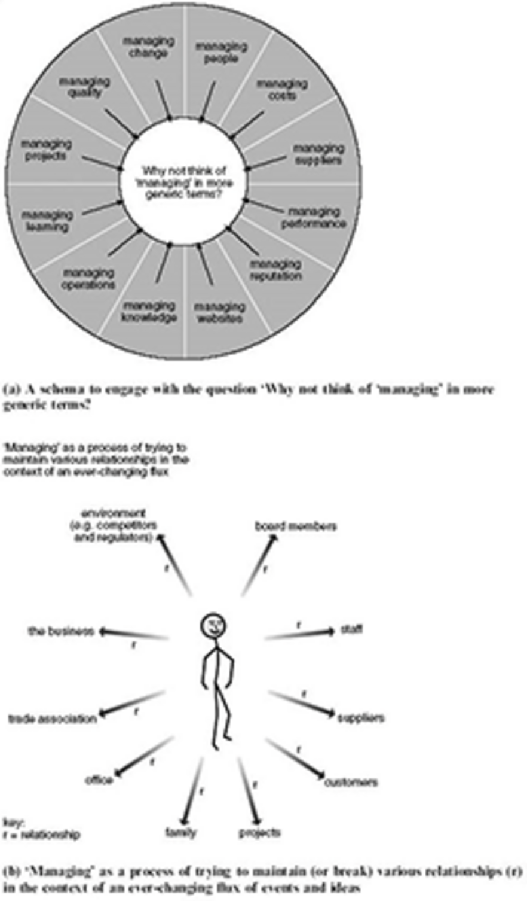
Figures 3 (a) and (b) Perspectives on managing (source: Winter, 2002, p. 67 and p. 83).
View description - Figures 3 (a) and (b) Perspectives on managing (source: Winter, 2002, p. 67 and p. ...
View alternative description - Figures 3 (a) and (b) Perspectives on managing (source: Winter, 2002, p. 67 and p. ...

The point here is that if I, as a manager, am faced with a complex situation that I am trying to improve then I need to identify key relationships and who else I might need to involve to get a better understanding of that complex situation. But I also need to recognise that I have both a rational and emotional involvement in that complex situation as will all the others involved. This will be different if I have no or very weak prior relationships with those involved in the situation.

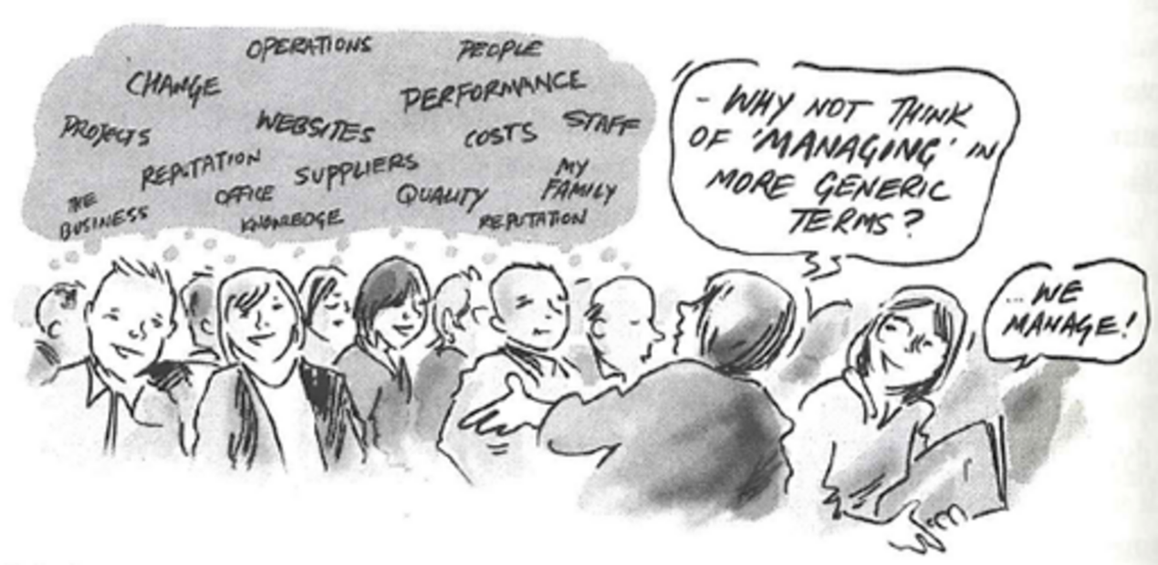
Figure 4 Perspectives on managing.
View description - Figure 4 Perspectives on managing.
View alternative description - Figure 4 Perspectives on managing.

4 Perspectives on ‘researching’
Systems practitioners may often work on complex situations to help others rather than themselves, and doing so as an observer of, rather than as a participant in the situation. Indeed many systems thinkers (some of whom you will be introduced to in Week 6) developed their ideas and practices around systems by researching and consulting work. And some of them devised specific approaches from these experiences (which you will hear about in Week 7) that can be taken and used by individuals to help with either ‘personal’ situations (one in which the individual(s) has (have) a clear stake or interest in the complex situation) or ‘private’ situations (one in which the individual(s) acts as a consultant or researcher for a client who has a clear stake or interest in the complex situation). This is particularly the case when we are looking at a purposeful system where there is a strong element of design or planning of the system of interest involved.


Figure 5Managing by doing action research: On us or with us? (Adapted from Wadsworth, 1991)
View description - Figure 5Managing by doing action research: On us or with us? (Adapted from Wadsworth, ...
View alternative description - Figure 5Managing by doing action research: On us or with us? (Adapted from Wadsworth, ...

You will look at aspects of purpose again in Week 7 in relation to systems approaches; here you should focus on ‘involvement’ in a system of interest. Churchman (1971) has identified nine conditions for assessing the adequacy of design of any system of interest. He argues that these conditions must be fulfilled for a system to demonstrate purposefulness. Churchman (1979, p. 79) later reordered these nine conditions into three groups or categories of three conditions; each group corresponding with a particular social role – client, decision maker, and planner. Each social role is associated with two allied categories which Werner Ulrich (1983) later termed role specific concerns and key problems. Ulrich also identified each category group with a term reflecting the primary source of influence – motivation, control, and expertise – for client, decision maker, and planner (or ‘designer’) respectively (Ulrich, 1983, p. 250). These groups of conditions, roles and influences are set out in Table 1.

Table 1 Categories of ‘involved’ in a purposeful system’s design
Churchman’s 1971 nine conditions for a purposeful system (S) | Churchman’s 1979 three groups of three categories for a purposeful system | Ulrich’s 1983 sources of influence informing a purposeful system
Group 1
Are the clients, the stakeholders of the system identified people whose interests and values will be served by the system? | social role: client | sources of motivation: whose purposes are served?
Is the system teleological? Does it exist to serve a purpose? (teleology means to have a purpose) | role specific concerns: purpose
Does the system have a measure of performance? Are expected performances identified and are relevant measurements available, and are they carried out? | key problems: measure of performance
Group 2
Does the system have identified designers who serve the interest and values of the stakeholders? How are these interests and values known to the designers? Who is involved in validating the design? | social role: decision maker | sources of control: who has the power to decide?
Does the system have teleological components that co-produce the expected performance of the system? Do these components have measures of performance that are related to the performance of the system? | role specific concerns: components
Is the system’s environment clearly defined? Is the relationship, the mutual interaction patterns between the system and its environment, defined? | key problems: environment
Group 3
Does the system have a decision-maker? (The client stakeholders, the designers, and the decision-makers can be the same.) | social role: planner/designer | sources of expertise: who has the know-how?
Do the designers intend to change the system so as to maximise its value to the client/stakeholder? Do they maintain fidelity between the preferred/ideal design and the operationalised design? | role specific concerns: implementation
Is there a guarantee that the designers’ intentions are realisable? | key problems: guarantor
(Adapted from Ulrich, 1983, pp. 245–50)

You will come back to these issues of who is involved in a systems investigation in Weeks 7 and 8 but now you will revisit the role of diagramming as technique for eliciting and capturing the perspectives of other people.

5 Collecting information as a ‘researcher’
If you are acting as a ‘researcher’ rather than a ‘manager’ your use of diagramming is for collecting information or gathering of ‘evidence’ from participants to be included in a broader systems investigation. In other words, a particular type of diagram is used to get participants to structure and capture their thinking about a given situation and that diagram alongside any notes made at the time (or even recordings) are one set of perspectives for grounding the systems investigation. I have found over the course of my research that the choice of diagram needs to fit with the purpose and objectives of the investigation. This does not mean that if I had used a different diagram with my participants I might not have gathered a similar data set of perspectives for analysis. And equally a different set of participants using the same diagram might not necessarily lead to different perspectives, but simply that this represents the thinking of these particular participants at that time. It does mean that as a ‘researcher’ you need to understand and acknowledge the limitations and constraints that a particular diagram brings to your study and to build in processes that ensure a reasonable degree of robustness to the information gathered and how it is analysed and reported. An example, if possible, is to have more than one group do the same exercise so that you have multiple sets of information to compare and contrast.
Lastly, it is necessary to think about the ethical issues involved in working on, for, or with others as part of a study and recognising your own part in the process. This may include agreeing how contributions are acknowledged, if acknowledged at all, so that sensitive comments are not attributable to one person but to the group as a whole. The latter is often done under the Chatham House Rule (basically information disclosed during a meeting may be reported by those present, but the source of that information may not be explicitly or implicitly identified).

6 The practicalities of diagramming with other people
As well as the ethical issues involved in diagramming with other people it is also necessary to pay attention to the practicalities involved. A major purpose of diagramming together is to build up a shared picture of a situation by combining the knowledge and perspectives of different people. All the advice given in Week 4 for drawing diagrams by yourself also applies to drawing diagrams in groups. The main difference is that you have to be aware of the dynamics of the group and ensure that you are working constructively together and not destructively.
The notes that follow deal with various aspects of this problem. But you will not learn how to deal with the problem just by reading the notes. This sort of learning is very much learning by experience, and the primary purpose of the notes is to encourage and help you to learn from your experience when you do face working on diagrams in a group.

Activity 2 Advice on diagramming
Allow approximately 5 minutes for this activity.

But before you read my notes on working with others spend five minutes noting down the key pieces of advice on diagramming which you looked at in Week 4.

Provide your answer...
View comment - Activity 2 Advice on diagramming

Involving others with diagrams comes in two main forms: co-creation of a collective diagram and using a diagram as the focus for a mediated discussion of the situation that the diagram represents. Both techniques can be very powerful in helping those involved to gain a shared understanding of a situation as it draws out the different perspectives they may have and also for developing a negotiated set of actions for moving on (although in many cases, the fact that thinking has been changed can lead to changed action and behaviour without the need for it to be made explicit in a set of written action points). An example of using a diagram as a focus for a mediated discussion is shown in the videos in the OpenLearn course Systems explained: diagramming.

7 Facilitating engagement with different perspectives
Most of the time, especially when a group is working hard and is not too large (i.e. six to eight people), everyone’s attention will be on the content of what is being discussed. This is fine, until something starts to go wrong. Then someone, and preferably more than one person, should switch their attention to the process that the group is using, in order to try to sort out what is occurring. Just being aware of the process will help enormously.
Members can contribute to the group process by:
- proposing new ideas
- seeking clarification
- providing information
- summarising what has been said
- providing support for other people’s ideas
- being open to other people’s arguments.
On the other hand, they might impede group effectiveness by:
- attacking other people’s suggestions
- being very defensive about their own suggestions
- talking at the same time as someone else
- talking aimlessly without adding to the discussion.
Alternatively, one of the group can be chosen as an observer or facilitator whose role is to support the others in the process of generating diagrams but not be directly involved in the content of the discussion and drafting.
Comments or reflections on individual contributions do not have to be profound and dramatic in order to be worthwhile and illuminating. Partly because we get so little practice at this sort of exercise, commenting in this way and learning from the comments are not at all easy.

8 Negotiating between different perspectives
If several people work together to produce a single product (such as a diagram) they have to find some way of agreeing. Ways of gaining agreement are essentially of two sorts:
- Those that aim to achieve functional, but superficial, conformity;
- Those that aim for a deeper consensus.
Conformity is achieved by such techniques as delegating authority to a chair, taking votes on issues or horse-trading. None of these are helpful for getting a shared view of a situation. True consensus is found where members of the group find ways of reformulating their views on a situation so that areas of apparently irresolvable conflict or difference in views can be by-passed, transformed, or replaced by better understanding, or even using conflict constructively as a source of creative thinking. So, ensuring everyone has a ’voice’ or opportunity to contribute through formal and informal negotiation is important.
Diagrams can help in this area because it can be easier for all to participate in some way in drawing the diagram, either by making suggestions for what to include or physically adding things, in a way that leaves a combined record that one person taking notes or minutes in a formal way rarely achieves. However this does mean that everyone needs their own pen or whoever has been chosen to hold the pen simply writes down the thoughts of the others. Alternatively, the group might decide that they will each draft their own diagram first and then compare or constructively criticise them before constructing a joint one based on all the individual contributions.

9 Teasing out accommodations
An important feature of working together on a diagram is the way in which members of the group relate to or give comments to each other for the purpose of constructing the diagram. The normal responses we give and receive, verbal and non-verbal, conscious and unconscious, are fairly limited and incomplete. You may misinterpret or fail to notice a signal of dissent, or you may not know why people have reacted in a particular way. The social constraints that restrict comment on other people’s behaviour exist for very good reasons (the comments can be very destructive) but they also have their price: we lose out on information that might enable us to conduct ourselves more effectively.
When individuals or members of a group make comments on each other’s behaviour (either explicitly or tangentially) it’s a sign that things are going either very well or very badly. The basic condition for the giving and receiving of personal feedback to be constructive is that it should occur within relationships of trust and mutual respect. This teasing out of accommodations through these collective and collaborative processes is very much at the heart of soft systems methodology, a systems approach you will learn more about in Week 7.

Activity 3 How do you work with others?
Allow approximately 15 minutes for this activity.

Note down how you normally work with others and whether your thoughts on this have changed following your study of this week. Also, look back at the metaphor of the juggler in the video introduction to Week 1 and note down how you relate what you have studied so far with what this metaphor is trying to represent.

Provide your answer...
View comment - Activity 3 How do you work with others?

10 This week’s quiz
Check what you’ve learned this week by taking the end-of-week quiz.
Week 5 practice quiz
Open the quiz in a new window or tab then come back here when you’ve finished.

11 Summary
Many complex situations involve lots of different people with different perspectives. Understanding multiple perspectives involves recognising and acknowledging your own worldview first. There are tools and techniques which can help you ‘imagine’ what other perspectives might be although this is hard to do for other people as we cannot truly experience or know their perspective on the world as they see it. However, we can use systems tools and approaches to bring out other people perspectives in ways that respect and represent their views. As a systems practitioner it is not enough to just reflect on your own worldview but also to reflect on the relationships you have with the other participants and to the complex situation itself.
If you want to take this aspect of systems thinking in practice further you should read Chris Blackmore’s book on Social Learning Systems and Communities of Practice that is one of four books associated with The Open University MSc in Systems Thinking in Practice.
You should now be able to:
- explain how to take multiple perspectives of a complex situation yourself and how to find out the perspectives of others involved in that complex situation.
Next week, you will look at the central ideas and practices that arose from the experiences and tradition of five key systems thinkers.
You can now go to Week 6.

Week 6: Key systems thinkers

Introduction
So far in this course, you have been introduced to various people and approaches that have respectively influenced and have been used by systems practitioners in previous weeks. Equally, if you have been searching for materials on systems thinking yourself you may have come across some names of systems thinkers or descriptions of systems thinking which may not fully align with what I have been saying. In part that simply reflects on the multiple perspectives from different people from different disciplines that were covered in Week 5. But in part it also reflects the nature of systems thinking in practice in that it is not one ‘thing’ but is a set of habits and practices within a broader philosophical framework; in other words the belief that the component parts of a system of interest can best be understood in the context of relationships between the other parts of that system of interest as well as the wider ‘system’ (also known as the ‘system environment’) rather than looking at that part in isolation. Thus, as I have stressed from the beginning of the course, your own experiences and backgrounds will inevitably influence the way in which you practise system thinking.
Watch the following video which introduces how traditions and experiences influence the practices of systems thinkers.

Video content is not available in this format.
View transcript - Uncaptioned interactive content

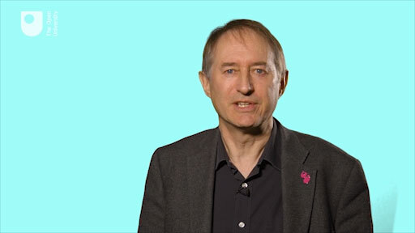

By the end of this week, you should be able to:
- describe the central ideas and practices that arose from the experiences and traditions of five key systems thinkers.

1 The development of systems approaches
Many well-known systems thinkers also had particular experiences, which led them to devote their lives to their particular forms of systems practice. So, within systems thinking and practice there are different traditions, which are perpetuated through lineages (see Figure 1). Some of these key systems thinkers mentioned in Figure 1 developed their forms of practice in terms of developing (and having their name associated with) formalised systems or systems-related approaches or methods, a topic you will be looking at again in more detail in Week 7.

Activity 1 Systems approaches – an overview
Allow approximately 10 minutes for this activity.

- Identify those blobs or phrases in Figure 1 which you have heard of or with which you are familiar. If you would find it helpful, list them in the box below.

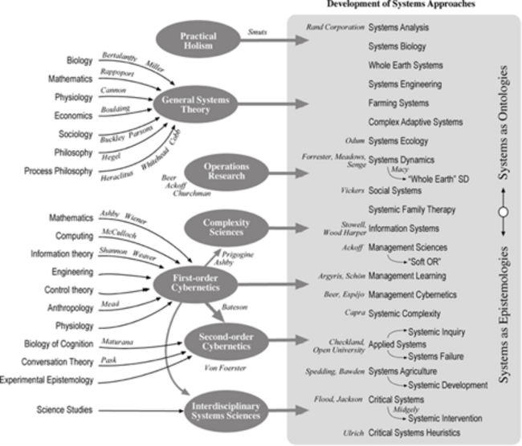
Figure 1Influences that have shaped contemporary systems approaches and the lineages from which they have emerged.

A larger version of Figure 1 is also available in PDF format: Week 6, Figure 1.

Provide your answer...

- Do a web search and bookmark some sites which relate to those blobs you have not heard about. Use any search engine to do this perhaps starting with the words or people named in Figure 1 as keywords.

Provide your answer...

There are too many names and traditions shown in Figure 1 to cover in any detail in this open course so you will concentrate on five systems thinkers because of the range of perspectives they have brought to system thinking in practice – Jay Forrester, Stafford Beer, Geoffrey Vickers, Peter Checkland and Russell Ackoff.
You will look briefly at each one and in three cases you can listen to them talking about their work. But if you are interested in following up in much greater detail on systems thinkers beyond what is covered here and what you found in your web search then you should consult the book Systems Thinkers by Ramage and Shipp (2009) which covers 30 people who have been influential in the field.
The five systems thinkers who you are introduced to here have been chosen on the basis of their interdisciplinary biographies and because they variously cover the three broad aspects of systems thinking in practice that you were introduced to in Week 1 – understanding inter-relationships, engaging with multiple perspectives and reflecting on boundary judgements. Thus Forrester and Beer focus on capturing inter-relationships; Vickers (and Checkland) on values and engaging with multiple perspectives and Checkland and Ackoff in boundary reflections and managing. Between them they represent the richness of traditions and histories that inform systems thinking in practice and also the four balls of the juggler you were introduced to in Week 1.

2 Jay Forrester (1918–2016)
In the 1950s, Jay Forrester, a systems engineer at MIT, was commissioned by the US company Sprague Electric to study the extreme oscillations of their sales and establish a means to correct them. From previous experience, Forrester knew the essence of the problem stemmed from the oscillations present in situations that contain inertia effects, or delays and reverse effects, or feedback loops as basic structural characteristics.
Subsequently, in 1961, Forrester published his report on industrial dynamics that marked the beginning of the Systems Dynamics (SD) technique based on the study and simulation of the behaviour of social systems.

Activity 2 Systems Dynamics
Allow approximately 5 minutes for this activity.

Refer back to Figure 1 and using the free response box below, identify how Ray Ison located systems dynamics in the various systems traditions.

Provide your answer...
View comment - Activity 2 Systems Dynamics

The experiences of Forrester that gave rise to the development of SD have been investigated in considerable detail by Brian Bloomfield (1986) as part of his PhD research with the Systems Group at The Open University. He describes the SD approach as:

[…] building a computer simulation model to describe the behaviour of any particular system under study, followed by experimentation with the model in order to derive suitable policy options for modifying the behaviour of the real system.
(Bloomfield, 1986, p. viii)

Bloomfield does not regard SD as mere technique, but as a systems philosophy because it embodies a theory about the nature of complex feedback systems. This theory holds that people live in a network of feedback structures, incorporating economic, political and ecological subsystems. The feedback structures determine many of the problems – from famine to overcrowding, and inflation and unemployment to ecological collapse – which have caused considerable public concern in recent times (e.g. Figure 2 models unemployment and profit).
Forrester has been and remains a powerful figure in the SD community, which is regarded by many as somewhat closed.
Forrester, an electrical engineer by initial training, spent the years of the Second World War at MIT where feedback theory was being developed for the control of military equipment. In 1947, Forrester took charge of the MIT digital computer laboratory, which developed one of the first high-speed digital computers. The second phase of Forrester’s career began in 1956 when he moved into the field of management science at MIT’s Sloan School of Management. At the time, the mathematical approach of operations research was restricted to linear relationships between variables. This was because non-linear relationships could not be solved analytically. In contrast, Forrester advocated a closed-loop approach in which a feedback loop is established between policy output and information input (Bloomfield, 1986, p. 4).
Forrester published World Dynamics in 1968 and this served as a basis for the Meadows and Meadows (1972) report to the Club of Rome entitled Limits to Growth. Francois (1997) suggests the report and the extensive controversy it provoked were actually responsible for popularising SD. The cultural background as well as some of the methodological assumptions of SD have been heavily criticised (e.g. Flood and Jackson, 1991). Flood (1999), for example, suggests SD practice is open to criticisms of being imprecise because it relies on extant data and the outputs are potentially very sensitive to initial starting conditions, including assumptions. Many however find it useful.

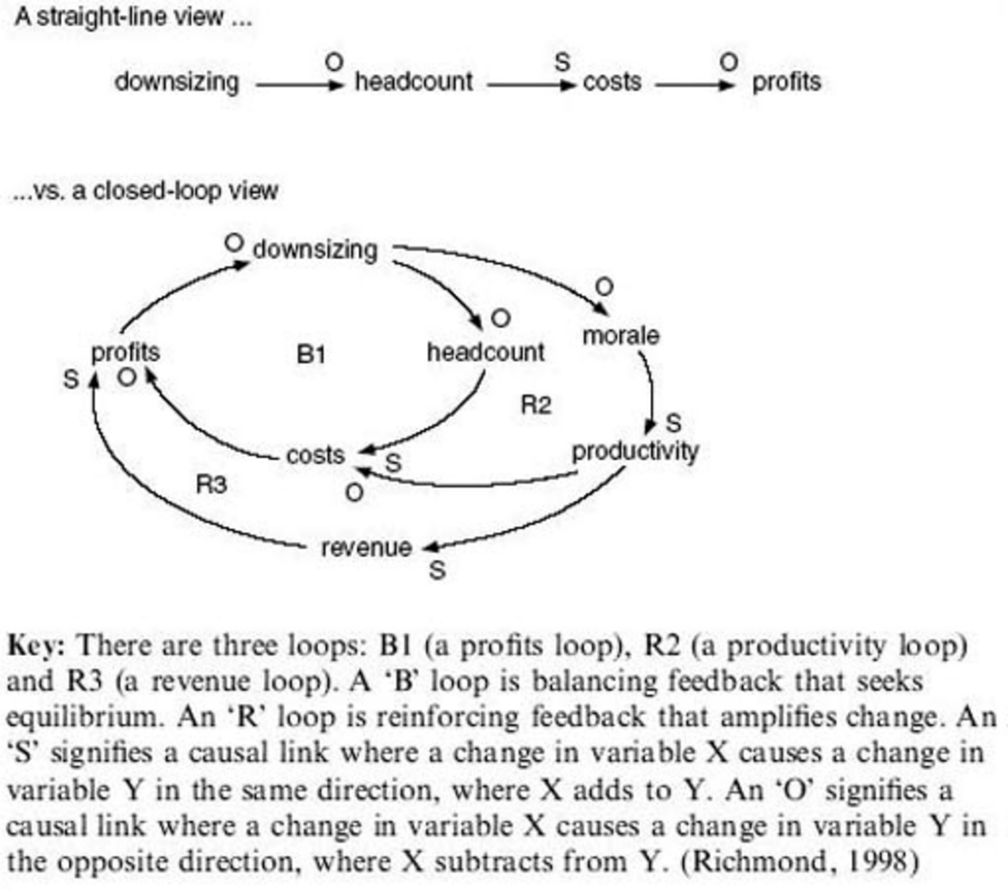
Figure 2 The contribution of systems dynamics is exemplified by showing that the inadequate diagram of one-way, straight-line thinking is only part of the story. The closed-loop diagram used in SD modelling raises awareness of unintended consequences. In this case, it suggests the laying off of workers causes demoralisation of remaining workers and reduces productivity. (Downsizing is a management term for cutting staff to reduce company costs and raise profits.)
View alternative description - Figure 2 The contribution of systems dynamics is exemplified by showing that the ...

The initial stages in making an SD model involve the description of ‘the system’, identification of elements and relationships followed by the construction of a causal loop diagram (see Figure 2). SD has also developed its own modelling language and symbols, which are shown in Figure 2. (These multiple cause diagrams were introduced in Week 4 and are similar in principle to causal loop diagrams but use different conventions. In fact causal loop diagrams are more similar to sign graphs – a diagram type that has not been mentioned in this course but which you may come across.) It is argued by some that when engaging with complex situations many SD practitioners enable participants to learn just as much from the process of developing causal loop diagrams as from the subsequent computer simulations.
The influence of Jay Forrester can be judged by the fact that there is a thriving Systems Dynamics Society.

3 Stafford Beer (1926–2002)
Stafford Beer is regarded as the founder of management cybernetics. With his books Cybernetics and Management (1959) and Decision and Control (1966) he laid the foundation for management cybernetics, thereby building on earlier works of Ross Ashby, Warren McCulloch, Norbert Wiener and Heinz von Foerster.

Activity 3 Management cybernetics
Allow approximately 5 minutes for this activity.

Refer back to Figure 1 and, using the free response box, make notes on how Ray Ison has located management cybernetics in the various systems traditions.

Provide your answer...
View comment - Activity 3 Management cybernetics

Beer’s contribution to systems thinking can be gauged from his obituary (Box 1).

Box 1 An obituary for Stafford Beer
World leader in the development of operational research, who combined management systems with cybernetics
Professor Stafford Beer, who has died aged 75, was a remarkable figure of British operational research (OR) – the study of systems that emerged from deploying newly invented radar in the late 1930s, and has since found extensive management applications.
A charismatic, even flamboyant, character, Beer founded two major pioneering OR groups; wrote some of the best books about it; and was a world leader in the development of systems ideas. He is widely acknowledged as the founder of management cybernetics, which he defined as ‘the science of effective organisation’.
His thinking on how decisions about complex social systems could best be made went through several phases. As an operational researcher he pioneered the idea of interdisciplinary teams to tackle problems in business, government and society. As a systems guru, he was concerned with designing appropriate feedback loops within social systems. More recently, he worked on participative methods to enable large groups to solve their own problems. What united these aspects of his work was his early and consistent commitment to a holistic approach.
He began a degree in philosophy and psychology at University College London, but in 1944 left it incomplete to join the army. He saw service as a company commander and in intelligence in India, and stayed there until 1947, leaving the army with the rank of captain in 1949.
He realised that OR, so successful during wartime, also had immense possibilities in peacetime. Appointed to a management position in a steel company, he soon persuaded it to set up an OR group, which he headed. The group grew to over 70 professionals, carrying out studies across United Steel.
In 1961 he left to launch SIGMA (Science in General Management Ltd), which he ran in partnership with Roger Eddison. This was the first substantial operational research consultancy in the UK. Its staff numbered some 50 before Beer left in 1966 to join the International Publishing Corporation (IPC), which had been a SIGMA client. IPC was then the largest publishing company in the world, and Beer was appointed development director. In this role, he pushed IPC into new technologies, many IT-based. He coined the term ‘data highway’, 30 years before ‘information highway’ came into vogue.
From 1970 he operated as an independent consultant. For over two years, until Chile’s President Allende was overthrown in 1973, Beer worked on a new cybernetics-based control system to be applied to the entire social economy of Chile. This was to be a real-time computerised system, an extremely ambitious project given the technology then available.
Although the Pinochet coup prevented the full realisation of the system, Beer later undertook commissions for the presidential offices of Mexico, Uruguay and Venezuela, answering directly to the president in the latter two. His recognition was always greater abroad than at home, where the British establishment was uncomfortable with his big vision and radical orientation.
From the publication of his first book, Cybernetics and Management (1959), a systems approach to the management of organisations was his central concern. In this he built on the foundations of cybernetics laid down by Norbert Wiener, Ross Ashby, and his mentor Warren McCulloch. A series of four books based on his Viable System Model were published during the 1970s, of which The Brain Of The Firm is the most celebrated.
In the 1990s he turned his attention to a complementary approach, introduced in his 1994 book Beyond Dispute: The Invention Of Team Syntegrity. Team Syntegrity is a participatory method for enlisting the creativity of substantial groups to develop solutions to shared issues. Non-hierarchical and democratic, it has been widely adopted, with a growing international network.
His impact on the way we think about management and systems was the result both of his magnetic personality, and the power of his writing. His prizewinning 1966 book Decision and Control charms the reader with its style as well as content. In this, as in his other writing, he takes an expansive view of his subject. His approach was always challenging, even subversive to conventional decision-making. Radically then, and unfashionably now, he believed in the benefits of a scientific approach, though he railed against reductionism. Unlike other management writers, he saw science as freeing thought and action, not trapping it in narrow procedures and techniques. It was his constant theme that the greatest possible autonomy of action should be maintained at all levels of the organisation, not just at the top.
Beer was a larger than life character. He was tall, broad, brimful of energy, and, in later years, bearded like an Old Testament prophet. His enthusiasm for life could be over-powering and quite non-Anglo-Saxon. Those who encountered him polarised between the group that was distrustful of what it saw as his showmanship, and those who were converted into permanent admirers. He was deeply loyal and affectionate to his friends.
(Martin and Rosenhead, 2002)

Beer was a member of the group of researchers who generated the fields of systems science, as it was then called, and cybernetics.

4 Sir Geoffrey Vickers (1894–1982)
Sir Geoffrey Vickers was seen to be a man ahead of his time. Born in 1884, he won the Victoria Cross for outstanding bravery during the First World War. He studied Classics at Oxford in 1923, and later became a lawyer where he became involved in international affairs. He had a varied life as a lawyer, a soldier, an economic intelligence officer and legal advisor. In the later years of his life he became a prolific writer and speaker on the subject of social systems analysis and the complex patterns of social organisation. Vickers is regarded as a systems practitioner rather than an academic. He introduced many of the basic systems thinking terms, and derived the concept of appreciative systems to describe human activity. He recognised that appreciation of systems requires the participation of not only the observer, but also that of the subject. Draft material and correspondence relating to his published works, articles and speeches is held at The Open University as the Geoffrey Vickers Collection.

Activity 4 System approaches – Sir Geoffrey Vickers
Allow approximately 15 minutes for this activity.

- Refer back to Figure 1 and, using the free response box below, make notes on how Ray Ison has located Sir Geoffrey Vickers in the various systems traditions.
- Now listen to this 10-minute interview filmed in 1978 where Sir Geoffrey Vickers explains how he approaches systems thinking. Make notes on key points and systems concepts that he talks about that have already been covered in this course and any that might appear new.

Audio content is not available in this format.
View transcript - Uncaptioned interactive content

Provide your answer...
View comment - Activity 4 System approaches – Sir Geoffrey Vickers

5 Peter Checkland (b.1930)
Systems thinking is multi-disciplinary and is associated with a well-established academic and practitioner community. It arose out of necessity. As society has become increasingly connected and the interactions between peoples have increased, traditional ways of operating have no longer sufficed. Through no clearly discernible reasons, projects overran budgets, communications systems between people broke down, and it became increasingly obvious that the human factor was playing a large role in these problems. Many of the early systems approaches did not model people as part of the equation – they were what has been described in this course as systematic rather than systemic.
One of the first people to recognise this was Peter Checkland, who subsequently became known as the creator of ‘soft systems methodology’, a once radical approach to management problem solving which is now used and taught world-wide and which he most notably wrote about in two versions of his book on Systems Thinking, Systems Thinking, Systems Practice (1981 and 1993) Soft Systems Methodology: A 30 Year Retrospective (1999). Checkland, originally from Birmingham, studied chemistry at Oxford in the 1950s and worked as a technologist and then a manager for ICI fibres. But when he made the move from research to management he found that little existed in the way of training and preparation for his new role.

Activity 5 Soft systems methodology
Allow approximately 20 minutes for this activity.

- Spend a few moments referring back to Figure 1 and, using the free response box below, make brief notes on how Ray Ison has located soft systems methodology in the various systems traditions.
- Listen to this 15-minute recording of Checkland’s thoughts on this change of role and make notes in your journal on key points and systems concepts that I have already covered in this course. Read the transcript of the recording as well and record any points you find yourself disagreeing with or that accord with your own experience.

Audio content is not available in this format.
View transcript - Uncaptioned interactive content

Provide your answer...
View comment - Activity 5 Soft systems methodology

6 Russel Ackoff (1919–2009)
Russell Ackoff was a multifaceted academic and business thinker and was the Anheuser-Busch Professor Emeritus of management science at the Wharton School, University of Pennsylvania at the time of his death.
Born in Philadelphia in 1919, Ackoff has been characterised as an architect, a philosopher, a city planner, behavioural scientist, trailblazer in the field of operations research, the pre-eminent authority on organisational systems theory, and best-selling author. Recognised internationally as a pragmatic academic, Russ, as he was known to all, devoted most of his professional life to dissolving complex societal and organisational problems by engaging all stakeholders in designing solutions. A founding member of the Institute of Management Sciences, his work in consulting and education involved more than 350 corporations and 75 government agencies in the United States and beyond. He has been ranked highly in lists of the world’s most influential business thinkers. But he is perhaps best known for making systems thinking understandable and accessible notably in two books Redesigning the Future (1974) and Creating the Corporate Future (1981).

Activity 6 Management science
Allow approximately 20 minutes for this activity.

- Refer back to Figure 1 and, using the free response box below, see how Ray Ison has located management science (and OR or operations research) in the various systems traditions.
- Make notes as you listen to the following audio recording in which Russell Ackoff reflects on some of the defining features of his life’s work but his studies began uneventfully.

Audio content is not available in this format.
View transcript - Uncaptioned interactive content

Provide your answer...
View comment - Activity 6 Management science

7 This week’s quiz
Check what you’ve learned this week by taking the end-of-week quiz.
Week 6 practice quiz
Open the quiz in a new window or tab then come back here when you’ve finished.

8 Summary
The capacity to put systems thinking into practice is based on the ability of the practitioner to appreciate their own traditions of understanding and to make connections with the history of particular systems thinkers and particular systems methods or methodologies, or to formulate their own. You have been exposed to the work and thoughts of some key systems thinkers so that you can experience something of the development of their ideas and practices and the different academic or professional disciplines they worked in. This should provide you with a foundation to next consider in more detail the differences in systems approaches and what that might mean for your own habits and practices.

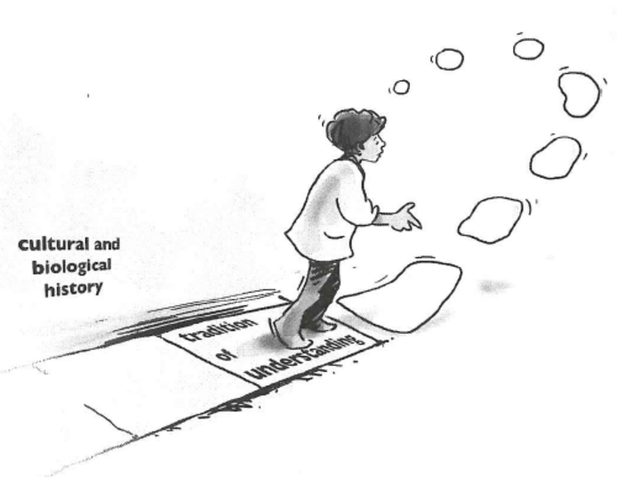
Figure 3 A conceptual model of a practitioner who brings forth their tradition of understanding as they lay down the path of their walking (doing). All humans have a personal history within a wider cultural and biological history. A systems practitioner, for example, will from some moment have a history of thinking, acting or understanding systemically.
View description - Figure 3 A conceptual model of a practitioner who brings forth their tradition of ...
View alternative description - Figure 3 A conceptual model of a practitioner who brings forth their tradition of ...

You should now be able to:
- describe the central ideas and practices that arose from the experiences and tradition of five key systems thinkers.
Next week, you will look at the role of methods, methodologies and approaches and tools, techniques and skills as applied to systems thinking in practice and exemplified by the soft systems methodology.
You can now go to Week 7.

Week 7: Systems thinking approaches

Introduction
In Week 6 you were introduced to the historical landscape of traditions and disciplines that have influenced systems thinking in practice and looked at the ideas and work of five prominent systems thinkers. Some of these systems thinkers developed their practices and approaches to system thinking into formalised methods or methodologies. I can only begin to briefly cover one of these methods or methodologies in this week and experiencing this one and others will take you much more time than you have in this course. What I will do is explore what is meant by terms such as approaches, methods and methodologies and do so in part by comparing and contrasting two approaches to soft systems methodology in the wider applied systems tradition. If you look back at Figure 1 in Week 6 that outlined systems traditions you will not find the words ‘soft systems methodology’ used but you will be familiar by now with an underlying aspect that distinguishes different approaches to investigating systems which is about purpose and how systems are perceived.
Watch the following video which highlights the differences between systemic and systematic approaches to engaging with systems.

Video content is not available in this format.
View transcript - Uncaptioned interactive content

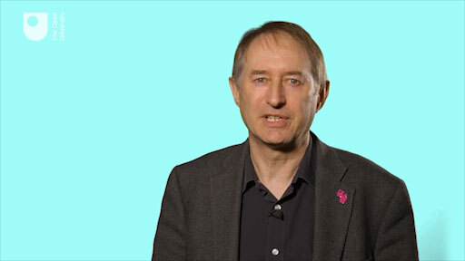

By the end of this week, you should be able to:
- explain the role of methods, methodologies and approaches and tools, techniques and skills as applied to systems thinking in practice and exemplified by the soft systems methodology.

1 What are systems approaches?
An approach is a way of going about taking action in a ‘real world’ situation. As outlined in earlier weeks, an observer has choices that can be made for coping with complexity. Think of the everyday ways we use adjectives to describe the word approach. Some that come to mind are:
- a scientific approach
- a reductionist approach
- an empirical approach
- a philosophical approach
- an experimental approach
- a spiritual approach
- a practical approach
- a critical approach.
You can probably think of more.
Some of these approaches to taking action seem to operate at different levels – both systems and science could be seen as meta-disciplines and different approaches could be taken in both (meta-) approaches by an aware practitioner.
There are certainly scientists who see themselves as systems biologists, for example, just as there are many scientists who take a reductionist approach and some who take a more spiritual approach. I have already claimed both a systemic and a systematic approach can be encompassed within a systems approach, by an aware practitioner. Please bear in mind here that I am saying these are choices to be made; I am neither commenting on the appropriateness, quality or efficacy of the options, nor am I saying they are exclusive options.
The question of choice is a bit like that hackneyed phrase ‘horses for courses’, although in practice it is more subtle than this. This is because taking a systems approach involves addressing the question of purpose, a topic which was talked about in Week 3 where I distinguished between purposeful and purposive systems and which you will now revisit in terms of purposeful and purposive behaviour.

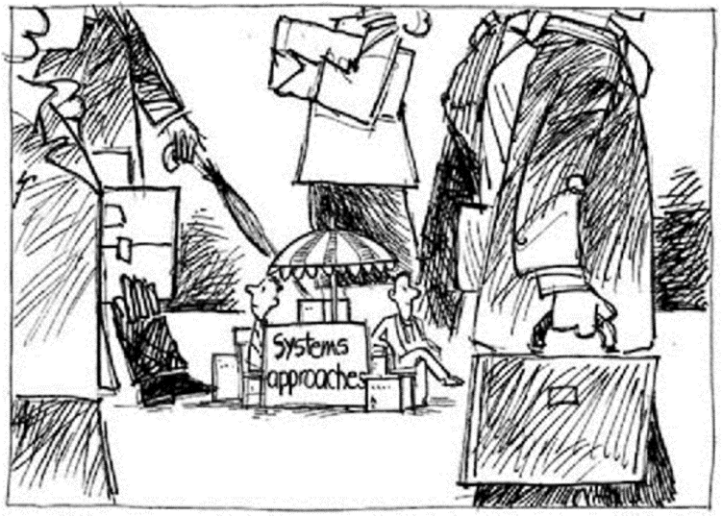
Figure 1 Systems approaches.
View description - Figure 1 Systems approaches.
View alternative description - Figure 1 Systems approaches.

2 Purposeful and purposive behaviour
It is possible, as observers, to ascribe a purpose to what we or others do, the actions we take. How particular actions, or activities are construed will differ between observers because of their different perspectives, which arise from their traditions of understanding. Even if we do not ascribe purposes to our own actions, another observer may infer our purposes by observing our actions and their outcomes, so that in their eyes we implicitly have a purpose to our actions. Ascribing purpose is an important process in taking a systems approach to managing complex situations. It also raises the question as to whether there is any relationship between what an observer can distinguish when he or she wishes to claim an overarching goal, a common purpose, a set of shared values, or a common ethic. When I think about these I see little difference, but each term means different things to different people, and each has a particular history of use in different intellectual traditions.
Within systems thinking, purpose is a contested notion. However, purpose is always attributed to a system by someone. Within systems practice the attribution of purpose can be a creative, learning process. I am reminded of Peter Checkland’s story of working to improve prison management and seeing purpose – and thus system – in terms of ‘rehabilitating criminals’; ‘training criminals’; ‘protecting society’; etc. Stafford Beer said: ‘the purpose of a system is what it does’. But for me this is too constraining as it runs the risk of objectifying ‘the system’. I would rather employ the notion of purpose in a process sense, within the process of inquiry. This would lead me to ask: what might we learn about the situation if we were to think of a prison as if it were a system to train criminals?
For me there is also a risk in reducing the notion of purpose to mean an objective or goal that can be achieved, and in some cases optimised. I make this distinction because the important aspect of systemic practice, compared with systematic practice, is exploring or inquiring of a situation: ‘What would I learn from attributing purpose to this situation?’ Alternatively the question might be posed as ‘In reflection what purpose do I attribute to my own actions in this situation?’
Thus two forms of behaviour in relation to purpose have also been distinguished. One is purposeful behaviour, which Checkland (1993) describes as behaviour that is willed – there is thus some sense of voluntary action and is particularly applicable to human activity systems. The other is purposive behaviour – behaviour to which an observer can attribute purpose, which can be ascribed to engineered or even natural systems. This is also at the heart of the difference between thinking about systems as ontological or epistemological devices.

3 Comparing two systems traditions
One of the key features attributed to purposeful systems is that the people in them can pursue the same purpose, sometimes called a what, in different environments by pursuing different behaviours, sometimes called a how. Note that I have deliberately not used the term goals, because of the current propensity to see goals as quite narrowly defined objectives. Certainly this was the way they were interpreted in the systems engineering tradition of the 1950s and 1960s and in the traditional Operations Research (OR) paradigm. Checkland and his co-workers, beginning in the late 1960s, reacted against the thinking in systems engineering and OR at that time and coined the terms ‘hard’ and ‘soft’ systems to distinguish the two traditions, but which I have relabelled as systematic and systemic to fit in with the more current thinking on this distinction as already presented in this course (Table 1). These distinctions will be discussed in more detail later.

Table 1 The ‘systematic’ and ‘systemic’ traditions of systems thinking compared
Systematic systems tradition: systems as ontological devices | Systemic systems tradition: systems as epistemological devices
oriented to goal seeking | oriented to learning
assumes the world contains systems that can be engineered | assumes the world is problematical but can be explored by using system models
assumes system models to be models of the world (ontologies) | assumes system models to be intellectual constructs (epistemologies)
talks in the language of ‘problems’ and ‘solutions’ | talks in the language of ‘issues’ and ‘accommodations’
Advantages | Advantages
allows the use of powerful techniques | is available to all stakeholders including professional practitioners; keeps in touch with the human content of problem situations
Disadvantages | Disadvantages
may lose touch with aspects beyond the logic of the problem situation | does not produce the final answers
 | accepts that inquiry is never-ending

This week you will be briefly introduced to soft systems methodology (SSM), one of a number of widely used systems approaches. Although there may be key thinkers behind a method, these methods, like any social technology, depend on many people working with it, developing and refining it, using it, taking it up, recommending it, and above all finding it useful. But not all technologies that succeed are the best – it depends on who builds the better networks, particularly of practitioners. As you experience the use of a particular systems method and strive to make it a methodology, reflect on it critically – judge it against criteria meaningful to you but above all judge it in relation to your practice of it. It will be your experience of using an approach in a situation to which it fits that matters, always being aware of the choices you have made.

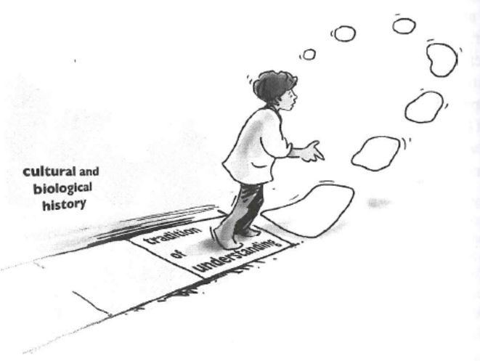
Figure 2 A conceptual model of a practitioner who brings forth their tradition of understanding as they lay down the path of their walking (doing). All humans have a personal history within a wider cultural and biological history. A systems practitioner, for example, will from some moment have a history of thinking, acting or understanding systemically.
View description - Figure 2 A conceptual model of a practitioner who brings forth their tradition of ...
View alternative description - Figure 2 A conceptual model of a practitioner who brings forth their tradition of ...

4 Creating experience-action cycles
Some systems practitioners have found the thinking associated with goal-oriented behaviour to be unhelpful when dealing with messes. This has resulted in a move away from goal-oriented thinking towards thinking in terms of learning. Some of these trends are depicted in Table 1 but also arise out of a cycle of activity such as that as described in Figure 3. If this cycle is completed, the purposeful action can be aimed at intended improvements; improvements that are judged by those who take the action. Those involved in this process learn their way to new understandings of the situation from which decisions about change can be made. Many systems approaches are designed to facilitate this cycle of learning.
If a system is conceptualised as a result of the purposeful behaviour of a group of interested observers, it can be said to emerge out of the conversations and actions of those involved. It is these conversations that produce the purpose, and hence the conceptualisation of the system. What it is and what its measures of performance are will be determined by the stakeholders involved.

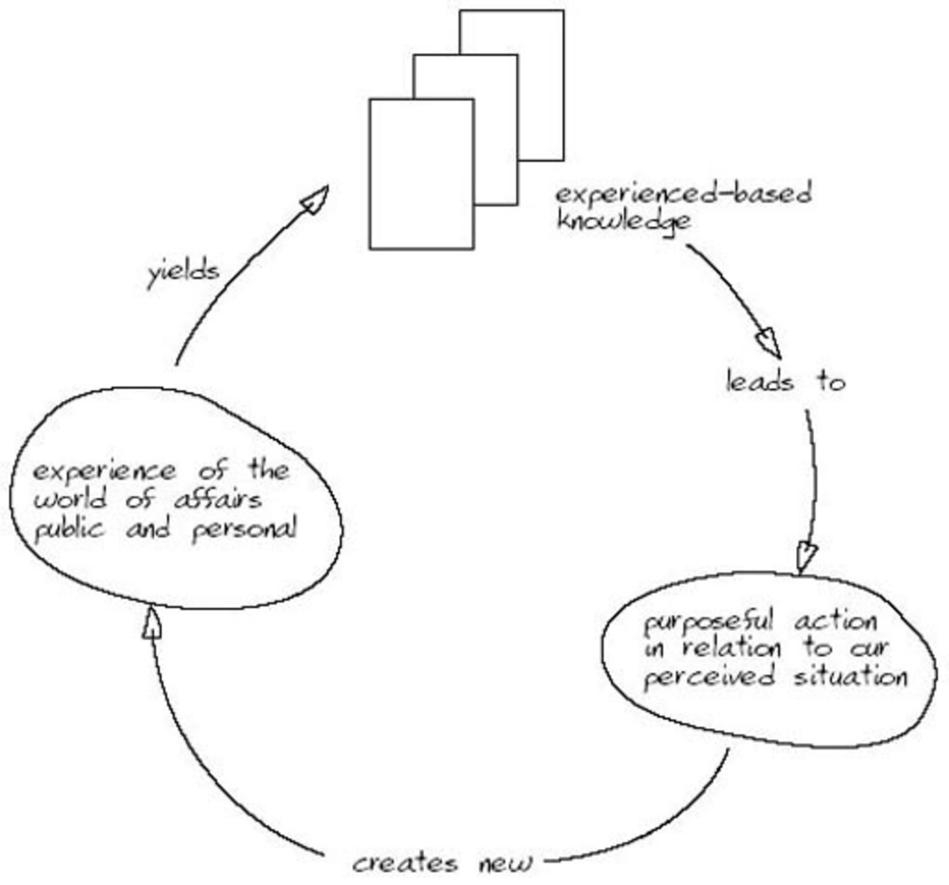
Figure 3An activity-sequence diagram of the experience-action cycle involving purposeful action (Checkland and Scholes, 1990).
View description - Figure 3An activity-sequence diagram of the experience-action cycle involving purposeful ...
View alternative description - Figure 3An activity-sequence diagram of the experience-action cycle involving purposeful ...

Sometimes there is no agreement on what the system of interest is or what purpose it is seen to have. This seems to me to be a common occurrence. For example, there is no shortage of experts, organisations, agencies, governments, and so on engaged in the definition and derivation of targets, principles, indicators and standards against which the achievement of the measures of performance of a supposed system might be evaluated, monitored and audited – but little agreement, or even discussion, about purpose. In other words many people have a propensity to pursue purposive behaviour that assumes both purpose and measures of performance rather than engaging stakeholders in a dialogue in which purpose is jointly negotiated. This can have unfortunate consequences.

5 From methodologies to tools
As you engage with systems thinking and practice you will become aware how different authors refer to systems methodologies, methods, techniques, and tools, as well as systems approaches and associated skill sets. Having just spent some time explaining what I mean by a systems approach, I now want to distinguish between methodology and method, and also tools, techniques and skills.

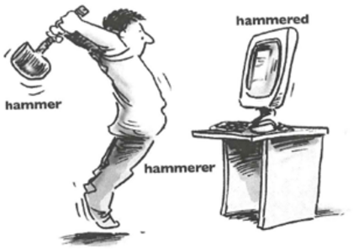
Figure 4Distinguishing between tools. When researchers and others talk about the need for new tools (e.g. a hammer) they usually fail to recognise that the situation of concern, and thus what they desire, is a relational dynamic between people (a hammerer), a tool, a practice (hammering) and a situation (frustration with a computer). The dynamic also produces something we can describe as a result or an effect, i.e. something is hammered!
View description - Figure 4Distinguishing between tools. When researchers and others talk about the ...
View alternative description - Figure 4Distinguishing between tools. When researchers and others talk about the ...

Within systems practice, a tool is usually something abstract, such as a diagram, used in carrying out a pursuit, effecting a purpose, or facilitating an activity. Technique is concerned with both the skill and ability of doing or achieving something and the manner of its execution, such as drawing a diagram in a prescribed manner and also applying it to a given situation. An example of technique in this sense might be drawing a flow diagram to a specified set of conventions. This can be exemplified by Figure 5, developed by The Open University’s Martin Reynolds, which uses a tool, a flow diagram. He uses the associated set of rules and conventions for flow diagrams: arrows to represent information transfer; open-ended boxes to represent transient information stores; closed boxes to represent either sources or destinations of information; and oval shapes to represent associated activities. It is up to you to decide if the use of this technique is appropriate for conveying the difference between tools, techniques and skills.

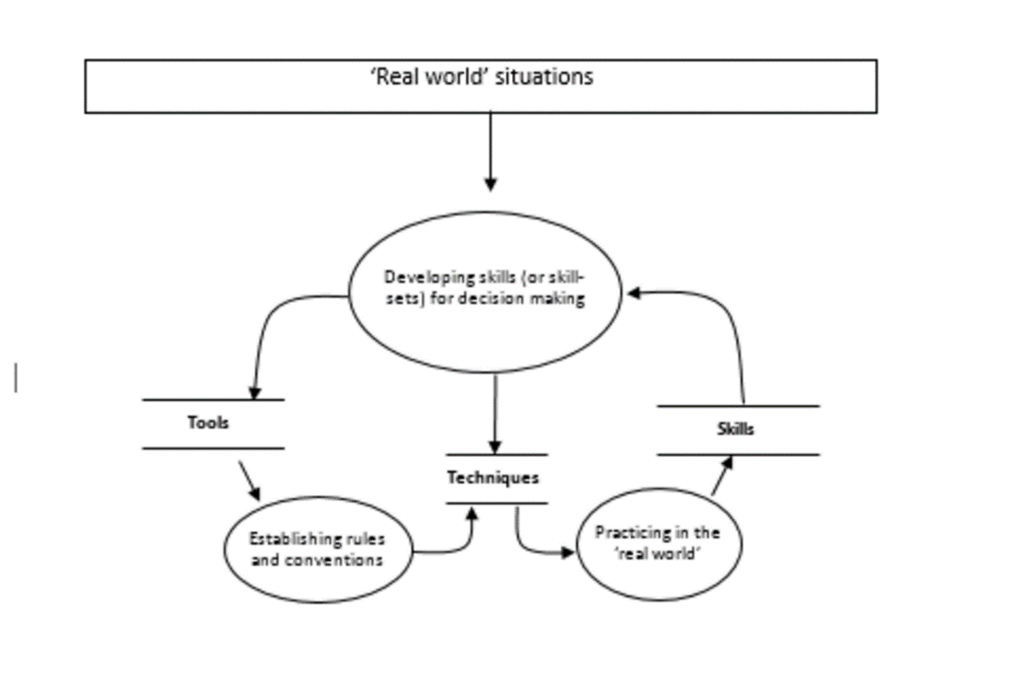
Figure 5The flow of ‘information’ between tools, techniques and skills.
View description - Figure 5The flow of ‘information’ between tools, techniques and skills.
View alternative description - Figure 5The flow of ‘information’ between tools, techniques and skills.

A similar set of distinctions as shown in Figure 5 might be made but at a different level of recursion for methods, approaches and methodologies. Methods are an elaboration of codified use of tools as ‘techniques’. An approach is more associated with a set of theories/assumptions that have informed the development of the methods associated with any one approach. The key thing though is that the methods are not ‘locked’ in to the paradigm of an approach; they are tools that can be used outside of any prescribed paradigmatic use.
Equally, several authors and practitioners have emphasised the significance of the term ‘methodologies’ rather than methods in relation to systems. Within the frameworks espoused here a method is used as a given, much like following a recipe in a recipe book whereas a methodology can be adapted by a particular user in a participatory situation. There is a danger in treating methodologies as reified entities – things in the world – rather than as a practice that arises from what is done in a given situation. A methodology in these terms is both the result of, and the process of, inquiry where neither theory nor practice take precedence (Checkland, 1985).
When speaking of SSM, Peter Checkland claims:

One feature never in doubt was the fact that SSM is methodology (the logos of method, the principles of method) rather than technique or method. This means that it will never be independent of the user of it, as is technique.
(Checkland and Scholes, 1990)

For me, a methodology involves the conscious braiding of theory and practice in a given context (Ison and Russell, 2000). An aware systems practitioner, aware of a range of systems distinctions (concepts) and having a toolbox of techniques at their disposal (e.g. drawing a systems map) as well as systems methods designed by others, is able to judge what is appropriate for a given context in terms of managing a process. This depends, of course, to a large extent on the nature of the role the systems practitioner is invited to play, or chooses to play. When braiding theory with practice, there are always judgements being made: ‘Is my action coherent with my theory?’ as well as, ‘Is my experience in this situation adequately dealt with by the theory?’ and, ‘Do I have the skills as a practitioner to contribute in this situation?’ There are also emotional feelings – ‘Does it feel right?’

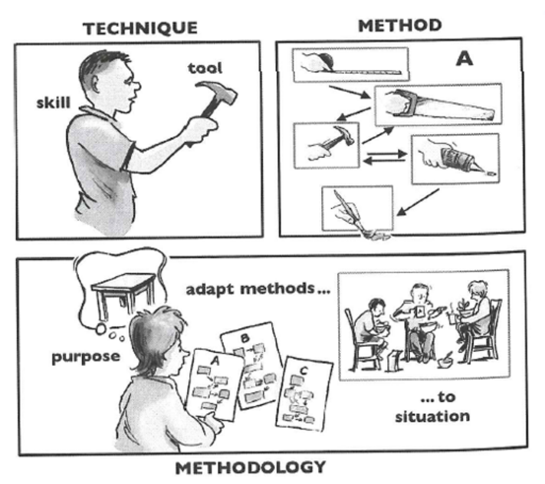
Figure 6 Some distinctions between tool, technique, method and methodology.
View description - Figure 6 Some distinctions between tool, technique, method and methodology.
View alternative description - Figure 6 Some distinctions between tool, technique, method and methodology.

There is nothing wrong with learning a method and putting it into practice. How it is put into practice will, however, determine whether an observer could describe it as methodology or method. If a practitioner engages with a method and follows it, recipe-like, regardless of the situation then it remains method. If the method is not regarded as a formula but as ‘guidelines to process’, and the practitioner takes responsibility for learning from the process, it can become methodology.

6 Soft systems methodology
SSM is one of the more widely used systems methods. The driving force behind its development and increasing application across many domains, but particularly information systems, has been Peter Checkland at The University of Lancaster in the UK (Checkland, 1993). You heard Peter Checkland talk about the reasons for developing SSM in Week 6 which I will not repeat here, but I will mention some of the underlying ideas which permeate soft system thinking in general, ideas that you have already encountered in this course.
First, soft system thinking does not assume that problems are out there in the world in a real sense. Working from a soft perspective there are no objectively given problems. This does not mean that the world is not full of difficult and complex issues which need to be managed but it is important to realise that different people may see different problems in the same situation and come to different conclusions as to their nature. It is, perhaps, misleading to talk of the context as though it were objectively agreed upon and accepted by all parties and stakeholders. Rather it is more appropriate with soft systems thinking to describe those involved in messy contexts as problem owners – this makes a clear relationship between the context and those who are experiencing it. A context is the combination of the external world together with the way it seems to the observers or participants, some of whom may not even see any problem at all in the given context.
Second, soft systems thinking assumes that problems are much less structured, and much messier than some users and advocates of reductionist science would accept. Indeed a key feature of many situations is that they are unbounded, unclear and uncertain and that the observer may be unsure if there is a ‘problem’ except for those within the situation believing something is ‘not right’. This is why the term ‘problem context’ or ‘problem situation’ – rather than just ‘problem’ – is used to describe what confronts that analyst.
A third consideration to keep in mind is that just as problem definition is a construct of our own creation, so are ‘solutions’. A group of people may agree on the nature of a given problem, yet disagree (violently in some cases) as to what constitutes a solution. The aim is to move from the present state of affairs to a desired state of affairs when no one has a map to work from.
Fourth, it is important that the situation is investigated and analysed before any decision on the desirability of a specific form of solution or medial activity is taken. In this sense the role of the systems analyst (the title usually ascribed to the person attempting to understand the nature of a systemic problem) can be viewed, at least initially, as much more akin to a therapist than a technical expert. The analyst encourages participants or stakeholders in the exiting context to examine their own perceptions of the context and its interconnections with others. Such a review will include an analysis of objectives, the role of the client within the context and the role of other stakeholders. SSM is concerned with what is meant by a problem and what action (new or pre-planned) would mean to those engaged in the context.
Having set out these basic features of SSM I now want to present to you two different pictorial descriptions of SSM as given by Checkland (and one of his colleagues) himself and as shown in Figures 7 and 8.

Activity 1 Two different models of SSM
Allow approximately 10 minutes for this activity.

Look at these two pictorial descriptions and use the free response box below to note down what you see as being clear distinctions between them in the light of what has been covered so far in this week, or indeed earlier weeks.

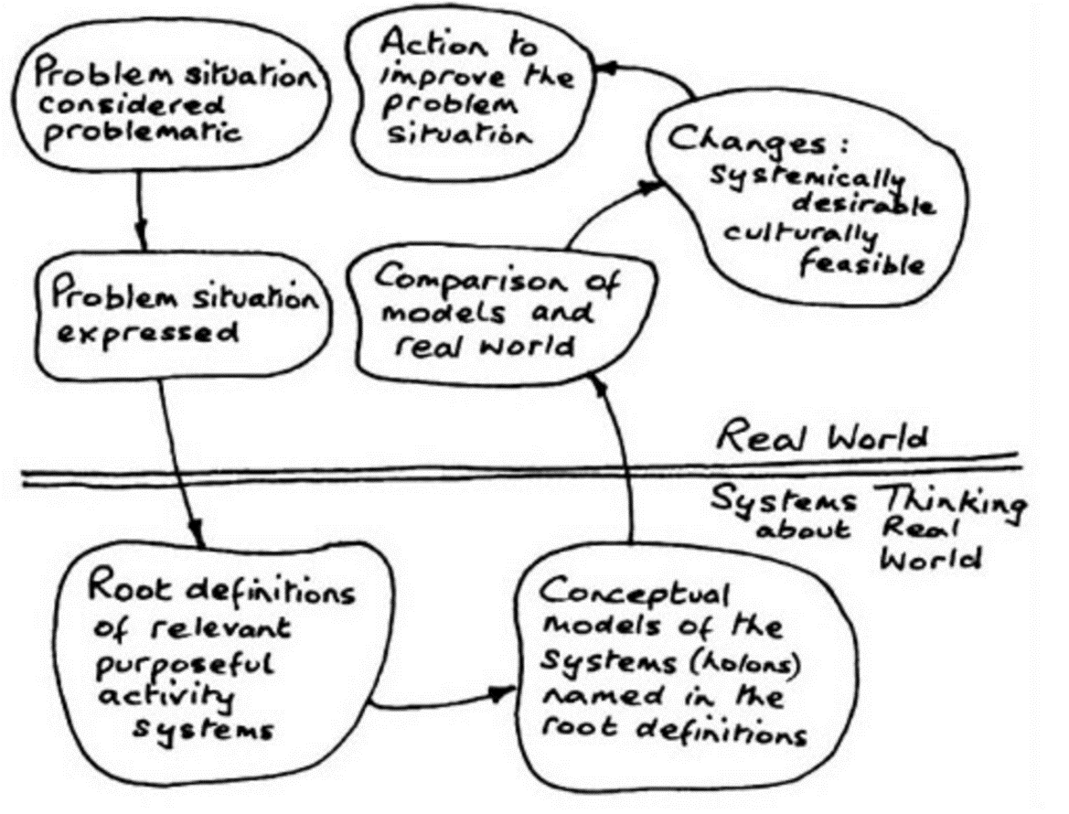
Figure 7The seven-step activity model of SSM as articulated in the 1980s (Checkland and Scholes, 1990, p. 27).
View description - Figure 7The seven-step activity model of SSM as articulated in the 1980s (Checkland ...
View alternative description - Figure 7The seven-step activity model of SSM as articulated in the 1980s (Checkland ...

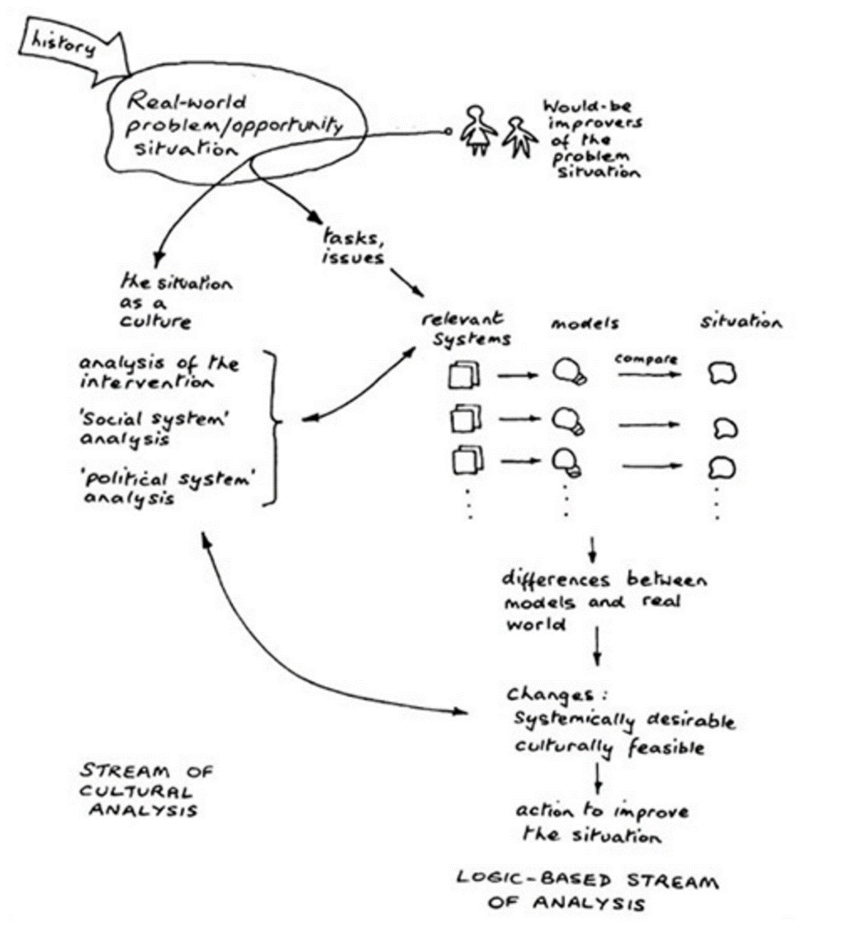
Figure 8An ‘iconic’ pictorial model of the process of SSM as articulated in the 1990s (Checkland and Scholes, 1990, p. 29).
View description - Figure 8An ‘iconic’ pictorial model of the process of SSM as articulated in the 1990s ...
View alternative description - Figure 8An ‘iconic’ pictorial model of the process of SSM as articulated in the 1990s ...

Provide your answer...
View comment - Activity 1 Two different models of SSM

6.1 The formal use of SSM
The original use of SSM as exemplified by Figure 7 was mainly in terms described by Peter Checkland as a ‘highlighted study’ which had an unconsidered and limiting model of intervention (in terms of this course a limiting model of engaging with complexity). This limiting model of intervention involved outsiders:
- entering problem situations
- doing work in it, or on it
- writing a report
- departing.
It is this series of activities which the seven-step (or stage) model has perpetuated and which resulted in many people using it systematically rather than more creatively or systemically. The formal use of the seven-stage version of SSM has been termed Mode 1 use by Checkland and Scholes.
When Jim Scholes, then a business planning and control manager, began using Checkland’s Mode 1 version of SSM in his day-to-day work he realised that his mode of use was very different to the intervention model described above. Subsequently the original, or Mode 1 use of SSM has been described as ‘using SSM to do a study’ (the four-step intervention using the seven-stage model) compared to ‘doing work using SSM in everyday situations’. The differences have practical implications. The former involves mentally starting with SSM and using it to structure what is done. In contrast, the latter involves mentally starting from what is to be done (the situation) and making sense of it by mapping it on to SSM, or making use of it through SSM (see Table 2).

Activity 2 Revisiting the juggler metaphor
Allow approximately 5 minutes for this activity.

Using the free response box below, describe how the different processes shown in Figures 7 and 8 relate to the different balls of the juggler metaphor that you were introduced to in Week 1’s introductory video.

Provide your answer...
View comment - Activity 2 Revisiting the juggler metaphor

6.2 Distinctions between Mode 1 and Mode 2
Table 2 sets out some distinctions which an observer might make between Mode 1 and Mode 2 use of SSM by a practitioner.

Table 2 Possible distinctions between Mode 1 and Mode 2 use of SSM by a practitioner
Mode 1 | Mode 2
Method-driven | Situation-driven
Intervention | Interaction
Sometimes used only as a linear sequence | Always iterative
SSM as an external recipe | SSM as an internalised model
(Adapted from Checkland and Scholes, 1990, p. A36)

Checkland and Scholes (1990) characterise Mode 2 as occurring when the systems practitioner interacts in the events (practices) and ideas (theories) which unfold over time. Another way of saying this is that the practitioner is a participant in the situation rather than being external to it (and it is for this reason that the history of the practitioner – called a tradition – was drawn to your attention). I have set these two modes of using SSM out as if they are two categories but Peter Checkland (personal communication) says that:
‘It ought to be made clear that Mode 1/Mode 2 are not two categories; they define a spectrum; they are ideal types; any actual study will be somewhere on the spectrum. The ‘Mode 2’ concept arose naturally as, with experience, two things came together:
- the ‘technology’ of SSM became internalised; it became tacit knowledge which we did not have to stop and think about; and
- the experience of the use of SSM convinced us that there was a need to pay attention to the process being enacted as much as the content which the process was addressing.
Mode 2 was thus an emergent development arising experientially not a designed development.’
Both the evolution of a method/methodology and its use in practice is a learning process flowing from experience in action outlined in Figure 3. SSM, like other approaches, is a learning process that can be mapped on to a learning cycle as Peter Checkland himself has done in Figure 9.

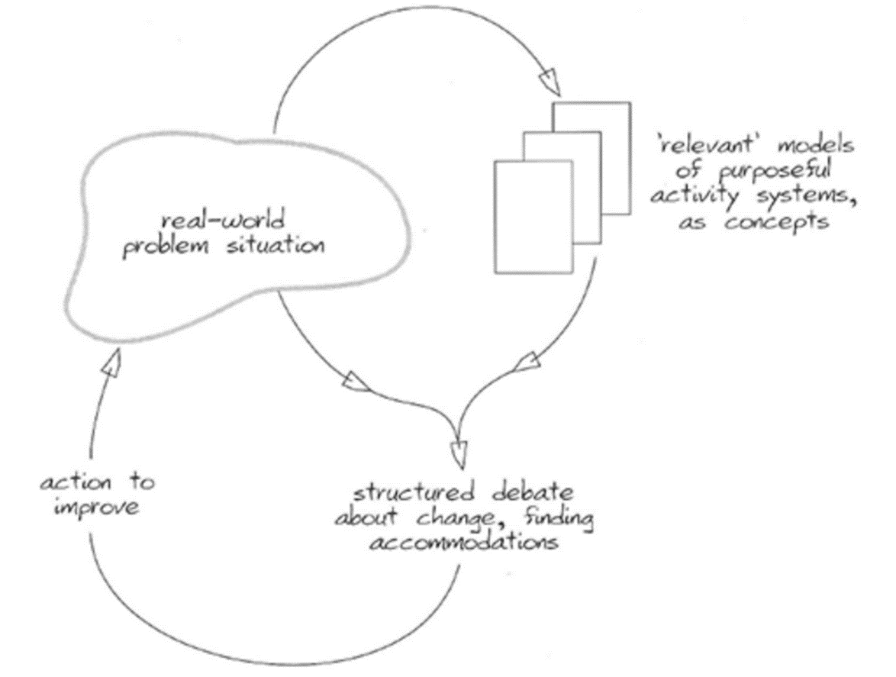
Figure 9SSM as a learning system
View description - Figure 9SSM as a learning system
View alternative description - Figure 9SSM as a learning system

7 This week’s quiz
Check what you’ve learned this week by taking the end-of-week quiz.
Week 7 practice quiz
Open the quiz in a new window or tab then come back here when you’ve finished.

8 Summary
The capacity to put any systems approach into context is based on the ability of a practitioner to appreciate their own traditions of understanding and to make connections with the history of particular systems methods or methodologies, or to formulate their own. Above all, there is a need to learn from using them and to achieve outcomes that are agreed by those involved as worthwhile. This is a level of systems practice to which you can aspire. Because most systems practice is carried out in some institutional setting your ability to contextualise an approach will also be helped if you appreciate it is not only people who have epistemologies but institutions as well. All institutions hold conceptions of what counts as legitimate knowledge, which determines how individuals are able to claim what they know. These epistemologies are built into institutional structures and practices.
What I hope is clear is that an aware systems practitioner does not force a method on to a context, a ‘real world’ situation, to which it is not suited.
You should now be able to:
- explain the role of methods, methodologies, approaches and tools, techniques and skills as applied to systems thinking in practice and exemplified by the soft systems methodology.
Next week, you will consider what form of systems thinking in practice you want to adopt and why you made that choice as well as how you intend to develop as a systems practitioner.
You can now go to Week 8.

Week 8: Becoming a systems (thinking in practice) practitioner

Introduction
Welcome to Week 8, and well done for getting to this final week of the course.
By now you should have a good idea of what systems thinking is and what putting it into practice might involve for yourself in your own context. You will also have gained some ideas about what is meant by a practitioner in general from the introductory videos to each week, and in particular the use of the juggler metaphor and the different balls that need to be handled. In this final week you will develop the notion of a systems practitioner, consider some of its implications and relate this to the four balls that need to be handled to develop your own systems thinking in practice.
Watch the following video which discusses developing systems practice over time.

Video content is not available in this format.
View transcript - Uncaptioned interactive content

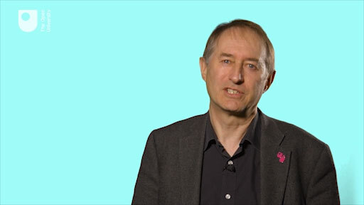

By the end of this week, you should be able to:
- decide for yourself what form of systems thinking in practice you want to adopt and why you made that choice as well as how you intend to develop as a systems practitioner.

1 What does a systems practitioner do?
The frequency with which we perceive mess or complexity is high, so it seems to make sense to envisage a role for the systems practitioner as someone engaged in managing. I do not have a new professional management elite in mind – though this could also exist – but more a citizenry enabled with systems thinking and practice. I am aware, for example, of the millions of people around the world who now engage in local and family history research. It seems many live with a passion for explaining who they are and where they have come from. I would describe all of these people as researchers. So, for me researchers are not just confined to laboratories and universities.
Research in this sense is willed action, done for a purpose, though the purpose may not be clear and involve a mix of emotion and intellect. At this stage of the course, I am going to suggest that taking purposeful action about an issue or situation experienced as complex is at the core of managing complexity.
The enactment of systems thinking in any particular systems approach by a systems practitioner is also an enactment of the experiential learning cycle. Experience, and learning from experience, is a major theme throughout this course. The model of experiential learning developed by David Kolb is increasingly well known and used as a conceptual basis for the design of all sorts of processes from curricula to consultancies (Figure 1). In itself, the model is powerful but it does not address what is meant by experience or learning. The history of Kolb's articulation of this cycle can be traced back to the work of Kurt Lewin shortly after the Second World War. Lewin is generally recognised as the originator of the notion of action research. When we connect with this history, it is possible to recognise the experiential learning model as a model for action research as well.

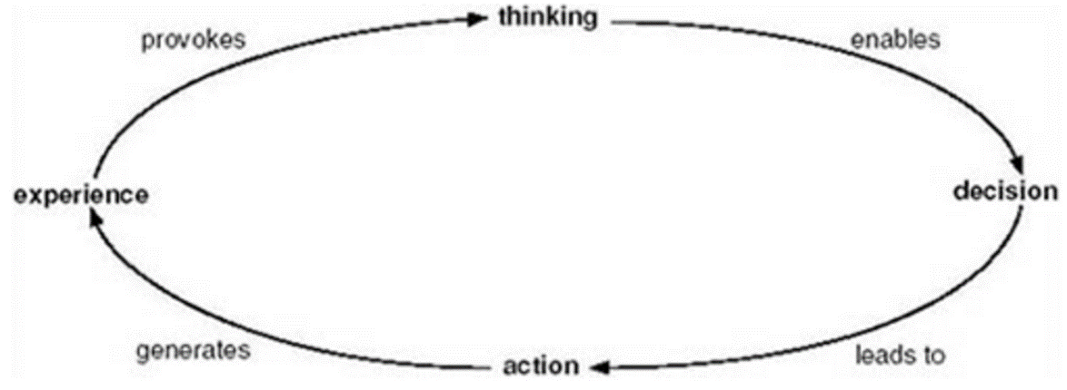
Figure 1 The experiential learning model adapted from Kolb which starts with experience.
View description - Figure 1 The experiential learning model adapted from Kolb which starts with exp ...
View alternative description - Figure 1 The experiential learning model adapted from Kolb which starts with exp ...

The idea of the systems practitioner as action researcher is central to the Masters programme in Systems Thinking in Practice at The Open University. These ideas also provide a conceptual framework to imagine what the life-long learner might be, this idealised person that has become so popular in recent discourse.
An aware practitioner-as-manager, having chosen to take a systems approach, will always face choices. One of the main choices is whether to formulate a system of interest as part of a process of understanding a situation experienced as complex, a systemic process of inquiry, or to see systems as operational parts of a taken for granted ‘real world’. This choice is depicted in Figure 2 with respect to the stick person cartoons used in the introductory videos for many of the weeks and also in the two other cartoon images you will have seen earlier in the course.

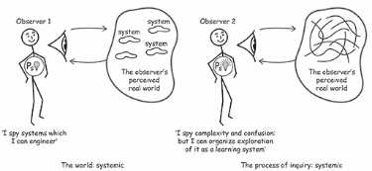
Figure 2 Seeing the world as containing systems (being systematic) and seeing the process of inquiry, of engaging with a situation, as systemic (being systemic) (adapted from Checkland, 1999).
View description - Figure 2 Seeing the world as containing systems (being systematic) and seeing the ...
View alternative description - Figure 2 Seeing the world as containing systems (being systematic) and seeing the ...

The systemic approach involves using systems thinking to construct an epistemological device as part of an inquiry process through which we can generate fresh and insightful explanations and which trigger new ways of taking purposeful action in the world.
Based on my experience, the systematic route is inherently conservative and likely to result in first-order change: doing the same thing more effectively or optimally (see Ison and Russell, 2000). This has its place. The systemic route opens up the possibility of second-order change that changes the ‘whole system’. An example here is encompassed by asking the following: what is the system to which the x (x being a particular intervention in a context) is the answer (the how)? The systemic exploration of this question enables new systems of interest to be formulated, which can be used by those in the situation to arrive at new understandings on which to base their actions.

Figures 3 and 4 The choices that can be made about ‘system’ and ‘situation’ that have implications for systems practice: practitioner 1 (top) situates systems in the world (i.e. conflates system and situation) whereas practitioner 2 (bottom) understands ‘systems’ to be a means of inquiry about situations (adapted from Checkland and Checkland and Poulter, Fig. 1.9, p. 2).
View description - Figures 3 and 4 The choices that can be made about ‘system’ and ‘situation’ that ...
View alternative description - Figures 3 and 4 The choices that can be made about ‘system’ and ‘situation’ that ...

2 Modes of managing systemically
Now I want to describe some of the possibilities I see as being available in the repertoire of an aware systems practitioner able to connect with the history of systems thinking and with the new theories of complexity.
David Robertson, in a presentation to the Society for Research into Higher Education in late 1998 entitled ‘What employers really, really want’ reported that, ‘Research on employers in a number of English-speaking countries (an elite survey with senior corporate people) showed the traditional skill set doesn't go far enough if graduates want to be employable internationally’. What's missing, he claimed are ‘complexity skills’. He said, ‘Graduates must understand that the world is not linear … They need the ability to manage ambiguity and connectivity and to be comfortable with ‘provisionality’ – making decisions when you don't really know what is going to happen, e.g. with ecommerce. They must also be comfortable with emergence’.
An employer’s assessment of graduates' skills in the English-speaking countries was: communication skills – okay; disciplinary knowledge – okay; interpersonal skills – okay; leadership – adequate; teamwork – okay; information technology skills – okay; but, understanding of the nature of globalisation, working with cross-cultural sensitivity and sensitivity to different ethical positions were not okay.
It seems there is recognition of the need for individuals with many of the skills I have attributed to the aware systems practitioner. For example, Geoff Mulgan (2001) identified seven factors that increased the relevance of systems thinking to policy making and to the functions of government. These were:
- the ubiquity of information flows, especially within government itself
- pressure on social policy to be more holistic
- the growing importance of the environment, especially climate change
- connectedness of ‘systems’ brings new vulnerabilities
- globalisation and the ways in which this integrates previously discrete ‘systems’
- need for ability to cope with ambiguity and non-linearity
- planning and rational strategy often lead to unintended consequences.
He concludes that ‘Out of all these factors has come a common understanding that we live in a world of complexity, of non-linear phenomena, chaotic processes, a world not easily captured by common sense, a world in which positive feedback can play a hugely important role as well as the more familiar negative feedback that we learn in the first term of economics’. He also recognises that, ‘So far remarkably little use has been made of systems thinking or of the more recent work on complexity’ and that in part this is ‘to do with the huge sunk investment in other disciplines, particularly economics’ (see Chapman, 2002).

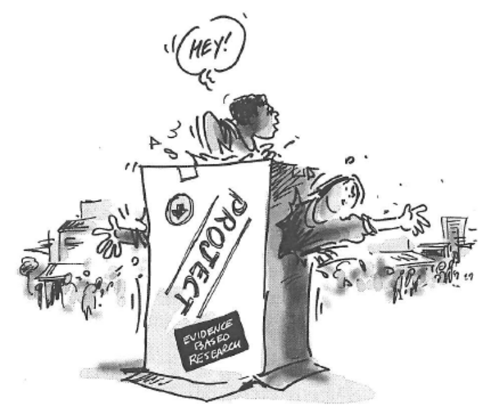
Figure 5 Evidence based research.
View description - Figure 5 Evidence based research.
View alternative description - Figure 5 Evidence based research.

In Week 5, in Section 3 on managing, I wrote of three categories I used to make sense of the brainstormed list of verbs associated with managing. These were ‘getting by’, ‘getting on top of’ and ‘creating the space for’. I interpret ‘getting by’ as managing our being, including our health, humour and emotional state – this is often neglected. ‘Getting on top of’ can have several meanings – the traditional meanings, I would suggest, are to do with control. For me, ‘creating the space for’ is the liberating and encompassing systemic category. Particularly because I associate it with the question: How can I create the space for emergence? I want to address this question in relation to the question of purposefulness and self-organisation.

3 Clarifying purposefulness
Research conducted by Ralph Stacey (1993) shows how business managers often behave in a way contrary to espoused policies and expectations. Rather than adhering to conventions of long-term planning, and accepted orthodoxies and procedures, they actually tend to make a succession of unrelated, adaptive responses to changing situations as the need arises. This is often, and rather disparagingly, labelled muddle-through or crisis management but can result in adaptive action and organisation.
In a study of nine companies, Stacey shows attempts to overcome ambiguity through planning, conflict, paradox and uncertainty failed completely except over short time periods. Yet, at least seven of the companies made significant shifts in how they operated despite the failure of their attempts to predict and plan. All change emerged unexpectedly and unintentionally. As Stacey observes, ‘The changes occurred, not because we were planning, but because we were learning in a manner provoked by the very ambiguity and conflict we were trying to remove.’ Managers have to strike an appropriate balance between too much and too little control. They have to balance two tendencies within their organisations, programmes, or projects. Too much control and blueprint-based planning leads to an inability to respond to change, or to an unexpected eventual ossification. Too little control, diversification, initiative, empowerment, client orientation, informal communication and so on, leads to fragmentation and disintegration. Success, it is argued, lies somewhere between these extremes.
Stacey's perspective is not a strategy for avoiding planning. It allows space for creative conflict, negotiation, interaction and learning wherein assumptions may be dashed but the seeds of new perspectives and formulations may be nurtured. Which seeds eventually develop and emerge depends on politics and negotiation and on the skills of those promoting, and inhibiting, the new perspectives. Systemic approaches in the hands of skilled and aware practitioners contribute to the surfacing of all of these issues.
I use these outcomes from Stacey's research to make clear that when I speak about purposeful behaviour I am not equating it with behaviour normally associated with blueprint planning or other forms of purely rational planning. Purposeful behaviour is willed behaviour and this may be triggered by actions, which on reflection, we regard as rational or emotional.
Another key point from Stacey's research is that too much control or attempts to intervene according to any pre-conceived view and necessarily partial view, or blueprint plan, stunts the process of self-organisation. Change and adaptation in human institutions occur through social interaction. Apparent fixes can inhibit the emergence of organisation and relationships that are most appropriate to any particular situation, such that solutions arrived at in this way are likely to be short-lived. It is in this sense that I see creating the space for spontaneous behaviour and emergent phenomena as a key element in managing for self-organisation.

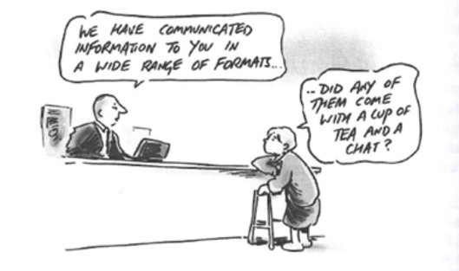
Figure 6Inhibiting the emergence of relationships.
View description - Figure 6Inhibiting the emergence of relationships.
View alternative description - Figure 6Inhibiting the emergence of relationships.

4 Managing for emergence and self-organisation
Self-organisation is the phenomenon associated with a system distinguished by an observer, which is able to construct and change its own behaviour or internal organisation. Computer simulations have shown, for example, the behaviour of a flock of flying birds can be understood from a few simple rules, which, if changed, results in the emergence of new patterns of behaviour. When applied to human activity, other features of self-organisation require attention. Self-organisation is also sometimes considered as the acquisition of variety by a system or the progressive emergence of novelty when removal of constraint or control releases capacity for autonomous action.

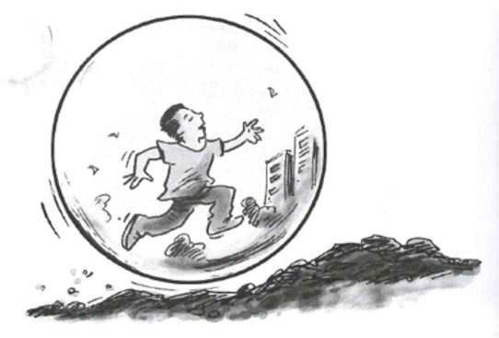
Figure 7 A metaphor for the technological framings of our existence from which it is sometimes difficult to escape.
View description - Figure 7 A metaphor for the technological framings of our existence from which it ...
View alternative description - Figure 7 A metaphor for the technological framings of our existence from which it ...

This perspective, it is claimed, builds on the study of non-linear feedback networks, complex adaptive systems and what Stacey and his colleagues now call 'complex responsive processes'. Stacey et al. (2002) say:

We seek to understand Complex Responsive Processes of relating… [as a process of personal transformation]. This means, for us, that the relational processes of communication, within which people accomplish joint action, are actively constructing the future as the living present and that [the] future is unknowable in advance. Throughout, the process is characterized by the paradox of the known-unknown and in it emerges the aims people formulate, the goals they set, the intentions they form and the choices they make. What is being expressed here is individual and collective identity at the same time.

An important notion from Stacey's perspective is that system and environment co-evolve; it is not a case of a system adapting to its environment. So what might managing be in this context? Patricia Shaw (1996) refers to consultants who operate from a complexity perspective; in contrast to what she claims is a traditional perspective (see Table 1).

Table 1 Contrasting perspectives that consultants may hold in undertaking interventions in an organisational setting
The consultant with a traditional perspective | The consultant with a complexity perspective
Designs and implements an educational strategy to realise planned change intended to improve the organisation's position in its environment. | Stimulates conditions of bounded instability in which the organisation co-evolves with its environment through self-organisation.
Understands organisational change in terms of temporary transitional instability between system-wide stable states. | Understands change dynamics as unfolding in the ongoing tension between stability and instability in which islands of order arise and dissolve.
Contracts to deliver a pre-determined objective or outcome. | Contracts for a step-by-step process of joint learning into an evolving and unknowable future.
Sees large scale project plans and political and ideological control strategies as useful only in circumstances closer to certainty and agreement. | Dissuades managers from using inappropriate forms of control to manage the anxieties raised when operating far from certainty and agreement.
Chooses an effective marginal or boundary position from which to diagnose the state of the system as a whole. | Becomes an active agent in the life of the organisation, by participating in its shadow and legitimate systems to engage in complex learning processes.
Tries to create an intended change in people's shared beliefs, values and attitudes. | Seeks to stimulate and provoke conditions in which people's mental models are continuously revised in the course of interaction.
Focuses on global, whole system change whether that of groups, individuals or organisations. | Focuses on feedback loops operating at a local level through which activity may be escalated up to system-wide outcomes.
Designs and facilitates off-site meetings to develop strategies and plans and build teams. | Intervenes in the ongoing conversational life in organisations in which people co-create and evolve their action-in contexts or contexts in action.
Collects data on generic system variables through surveys, interviews and other instruments to feedback the legitimate system. | Invites an exploration of the relationship between the system's formal agenda (what the legitimate system says it knows) and the multitude of informal narratives by which the organisation is working (what the shadow system knows). These feedback loops generate their own outcomes.
Emphasises the need for alignment and consensus around clear directions. | Amplifies existing sources of difference, friction and contention, so that complex learning might occur, provided people's anxiety in the face of such learning is well contained.
(Shaw, 1996, pp. 8–10)

Activity 1 Considering contrasting perspectives
Allow approximately 10 minutes for this activity.

Look through Table 1 now and consider the following two questions:
- Could you use these approaches in your context?
- Do the approaches have to be specific to the role of a consultant?
The table is here to provide some triggers to thinking. I am not suggesting either approach is right.

Provide your answer...

5 The systems practitioner and systems of interest
Systems practice may be carried out individually or as part of a team. In doing action research – which is a form of managing – an important question is: action research conducted on us or with us?

Figure 8 An unfolding network of conversation and relationships. ‘Managing’ involves maintaining a network of asynchronous relationships in the context of an ever-changing flux of events and ideas. As any manager engages in one conversation, others are engaged in different conversations. As individuals participate in different conversations a coherent network of conversations results (expanded from Winter, p. 67 and p. 83).
View description - Figure 8 An unfolding network of conversation and relationships. ‘Managing’ involves ...
View alternative description - Figure 8 An unfolding network of conversation and relationships. ‘Managing’ involves ...

The answer to the question, whether the action research is carried out by an individual or a group, leads to different modes of systems practice. These modes of practice are related to the choices the aware systems practitioner has at their disposal (Figure 9).
The mode of practice also relates to whether the systems practitioner attempts to take an objective stance, by standing outside the system of interest, or whether they see themselves as a co-creator of a system of interest with stakeholders. This is portrayed as the aware systems practitioner stepping into the so-called ‘real world’ situation with another stakeholder in Figure 9. The latter is the approach outlined by Patricia Shaw in her intervention from a complexity perspective. It is also the way in which the systems approaches mentioned in Week 7 can be contextualised.
One additional challenge you may face in developing your practice is to allow for the emergence of new insights from the use of systems methods in their entirety (i.e. as conceptualised by their developers) as opposed to picking and using parts of them. Based on my own experience I would argue for attempting them in their entirety first and until they begin to feel familiar, or embodied.

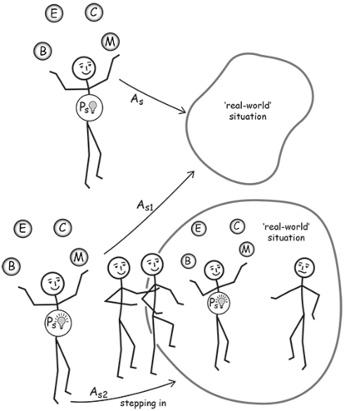
Figure 9 The choices available to the aware (with switched-on light-bulb) and non-aware (switched-off light-bulb) systems practitioner with the four balls that need to be juggled for effective practice. The non-aware practitioner always acts in the belief that they are outside the so-called ‘real world’ situation using a more systematic style of systems approach. In contrast the aware practitioner acts from an understanding that there is no position external to the ‘real world’ – i.e. they are always in the situation, usually with others. In addition they can also act as if it were possible to stand outside the situation in an awareness of the ethics of doing so, thus varying the systems approach (As1 and As2) to the context and to their own reflexivity.

Activity 2 Looking back
Allow approximately 5 minutes for this activity.

- Look back through the notes you have made over the course of Weeks 1–8. Which ball(s) is the focus of which week?

Week 1 Systems thinking in practice | Provide your answer...
Week 2 Systems thinking and complexity | Provide your answer...
Week 3 Identifying systems of interest | Provide your answer...
Week 4 Representing systems of interest | Provide your answer...
Week 5 Understanding multiple perspectives | Provide your answer...
Week 6 Key systems thinkers | Provide your answer...
Week 7 Systems thinking approaches | Provide your answer...
Week 8 Becoming a systems practitioner | Provide your answer...

View comment - Activity 2 Looking back

In Activity 3 you are going to think about your possible next steps in mastering systems thinking in practice.

Activity 3 Looking forward
Allow approximately 5 minutes for this activity.

Consider the following questions and note down your answers in the free response box.
- What are the most realistic steps you can take next to master systems thinking in practice?
- Are you excited or daunted by what you set out?
- Can you see what type of systems practitioner you would like to become?

Provide your answer...

6 This week’s quiz
You’re now ready to take the final quiz for your badge.
Week 8 compulsory badge quiz
Open the quiz in a new window or tab then come back when you’ve finished.

7 Summary
I started this course using the metaphor of a juggler to represent being a systems practitioner. I also noted how this juggler has four interconnected balls to keep in the air as they practise.
Being, the first ball, is concerned with embodiment, with our own awareness and thus our ethics of action, the responsibility we take as citizens. How a practitioner engages with a situation is not just a property of the situation. It is primarily a property of the background, experiences and prejudices of being the practitioner.
The second ball is the E ball – engaging with a ‘real world’ situation. It is an engagement that can be experienced as messy and complex, or experienced as a situation where there has been a failure or some other unintended consequence. Or the ‘real world’ could be experienced as simple, or complicated or as a situation or as a system. Because I am primarily concerned with situations that are experienced as complex, I have been calling this 'engaging with complexity'.
The third ball is concerned with how a systems practitioner puts particular systems approaches into context (i.e. contextualising) for taking action in the ‘real world’; that's the juggler's C ball. One of the main skills of a systems practitioner is to learn, through experience, to manage the relationship between a particular systems approach and the ‘real world’ situation she or he is using it in. Adopting an approach is more than just choosing one of the methods that already exists. This is why I use the phrase ‘putting into context’, to indicate a process of contextualisation involved in the choice of approach.
The final ball the effective practitioner juggles is that of managing (the M ball). This is concerned with juggling as an overall performance. The term ‘managing’ is often used to describe the process by which a practitioner engages with a ‘real world’ situation. Managing also introduces the idea of change over time, in both the situation and the practitioner.
Further to this I am thinking of juggling as a set of relationships, a juggler is a living human being, in a particular context, with their body positioned so as to be supported by the floor and in this case they have four balls to juggle. If any of these things are taken away, the juggler, the connection to the floor or the balls then juggling will not arise as a practice. In some situations an audience might also be important, especially if juggling for money. Taking away the audience would destroy this ‘system of interest’, the interconnected set of relationships being envisioned. But there's more to this set of relationships than meets the eye. Take the juggler for example, she or he is both a unique person and also part of a lineage of groups of organisms called 'living systems'. All living systems have an evolutionary past and a developmental past that is unique to each of us – a set of experiences which means that my world is always different to your world. We can never truly ‘share’ common experiences because this is biologically impossible. We can however communicate with each other about our experiences.

Next steps in mastering systems thinking in practice

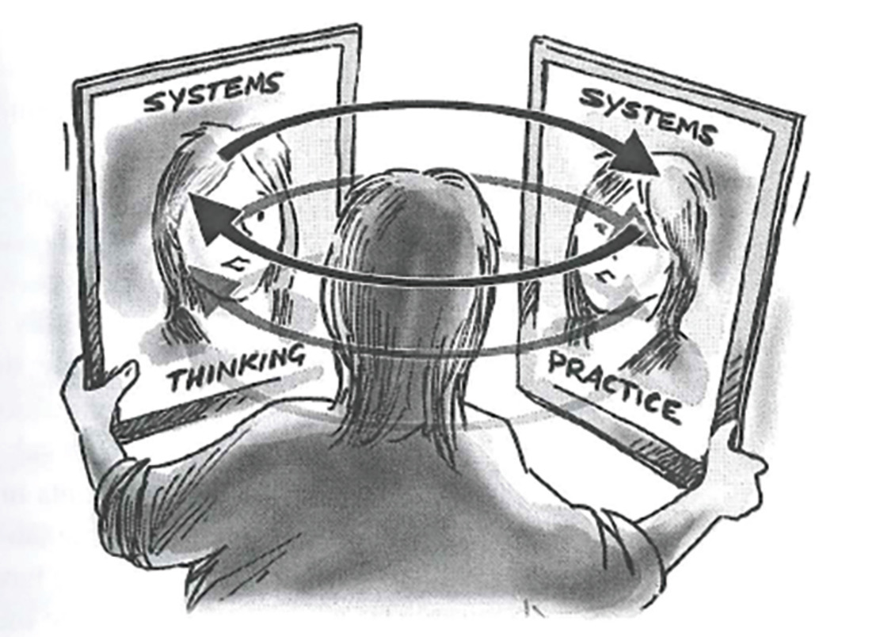
Figure 10An image of the dynamic relationship between systems thinking and systems practice.
View description - Figure 10An image of the dynamic relationship between systems thinking and systems ...
View alternative description - Figure 10An image of the dynamic relationship between systems thinking and systems ...

There are a number of next steps you could take on your journey to mastering systems thinking in practice. Here are some options.
You might be interested in looking at the following free courses on OpenLearn:
- Strategic planning: systems thinking in practice
- Systems diagramming
- Systems modelling
- Diagramming for development 1 – Bounding realities
- Diagramming for development 2 – Exploring interrelationships
These, and other free courses and resources can also be found through the Systems Thinking Hub on OpenLearn.
Another aspect to note here is that if you get the prior learning you have done here acknowledged by gaining the badge associated with this course, you can use this as evidence within the recognition of prior learning module U810 Continuing professional development in practice which is part of the Systems thinking in Practice programme.
One way to carry on that journey is to sign up for The Open University’s Systems Thinking in Practice programme that involves three nested qualifications:
- Postgraduate Certificate in Systems Thinking in Practice (60 credits)
- Postgraduate Diploma in Systems Thinking in Practice (120 credits)
- MSc in Systems Thinking in Practice (180 credits)
More details of this programme can be found at Systems thinking in practice page at The Open University.
And if you live and work in England then you may also be interested in the Systems Thinking Practitioner Apprenticeship available from The Open University.
The STiP postgraduate programme was initiated by members of the Applied Systems Thinking in Practice Group’s collaboration in the publication of four Systems books – co-published by the OU and Springer:
- Systems Thinkers by Magnus Ramage and Karen Shipp. You can also view some sample chapters.
- Systems Approaches to Managing Change: A Practical Guide edited by Martin Reynolds and Sue Holwell. You can also view some sample chapters.
- Systems Practice: How to Act in a Climate Change World by Ray Ison. You can also view some sample chapters.
- Social Learning Systems and Communities of Practice edited by Chris Blackmore. You can also view some sample chapters.
There is also a very active and self-organised Systems Thinking in Practice Alumni LinkedIn group which currently has over 1,500 members.

Tell us what you think
Now you've come to the end of the course, we would appreciate a few minutes of your time to complete this short end-of-course survey (you may have already completed this survey at the end of Week 4). We’d like to find out a bit about your experience of studying the course and what you plan to do next. We will use this information to provide better online experiences for all our learners and to share our findings with others. Participation will be completely confidential and we will not pass on your details to others.

Acknowledgements
This free course was written by Andy Lane.
Except for third party materials and otherwise stated (see terms and conditions), this content is made available under a Creative Commons Attribution-NonCommercial-ShareAlike 4.0 Licence.
The material acknowledged below is Proprietary and used under licence (not subject to Creative Commons Licence). Grateful acknowledgement is made to the following sources for permission to reproduce material in this free course:
Course image: © Peshkova/Getty Images Plus
Week 3
Table 1: adapted from Casti, J.L. (1994) Complexification: Explaining a Paradoxical World Through the Science of Surprise, London, Abacus.
Week 4
Text: Beware of the human factor: Downes, Samantha (1999) ‘Technology isn’t to blame for the Government’s recent computer problems’, The Independent, 6 September. © The Independent (1999).
Week 5
Figures 3(a) and (b): adapted from Winter, M.C. (2002) Management, Managing and Managing Projects: Towards an Extended Soft Systems Methodology, PhD Thesis, University of Lancaster, UK, pp. 67 and 83.
Table 1: adapted from: Ulrich, W. (1983) Critical Heuristics of Social Planning: A New Approach to Practical Philosophy, Stuttgart, Chichester; Haupt, John Wiley, pp. 245–50.
Week 6
Box 1: Martin, D. and Rosenhead, J. (2002) ‘Stafford Beer: world leader in the development of operational research, who combined management systems with cybernetics’, The Guardian, 4 September. © Dick Martin and Jonathan Rosenhead.
Figure 2: Richmond, B. (1998) ‘Closed loop thinking’, The Systems Thinker, vol. 9, no. 4, Pegasus Communications, Inc.
Week 7
Figures 3, 7 and 8: Checkland, P.B. and Scholes, J. (1990) Soft Systems Methodology in Action. Copyright © 1990 by John Wiley and Sons Ltd. Reprinted by permission of John Wiley and Sons Ltd
Table 2: adapted from adapted from: Checkland, P.B. and Scholes, J. (1990) Soft Systems Methodology in Action, New York, Wiley, p. A36.
Week 8
Figure 8: expanded from Winter, M.C. (2002) Management, Managing and Managing Projects: Towards an Extended Soft Systems Methodology, PhD Thesis, University of Lancaster, UK, pp. 67 and 83.
Table 1: adapted from Shaw, P. (1996) ‘Intervening in the shadow systems of organisations: consulting from a complexity perspective’, Complexity and Management Papers No 4, Complexity and Management Centre, University of Hertfordshire, pp. 8–10.
Every effort has been made to contact copyright owners. If any have been inadvertently overlooked, the publishers will be pleased to make the necessary arrangements at the first opportunity.
Don't miss out
If reading this text has inspired you to learn more, you may be interested in joining the millions of people who discover our free learning resources and qualifications by visiting The Open University – www.open.edu/openlearn/free-courses.

References
Churchman, C.W. (1971) The Design of Inquiring Systems, New York, Basic Books.
Ackoff, R.L. (1974) Redesigning the Future, New York, Wiley.
Ackoff, R.L. (1981) Creating the Corporate Future, New York, Wiley.
Capra, F. (1996) The Web of Life, London, HarperCollins.
Casti, J.L. (1994) Complexification: Explaining a Paradoxical World Through the Science of Surprise, London, Abacus.
Schoderbeck, P.P., Schoderbeck, C.G. and Kefalas, A.G. (1985) Management Systems: Conceptual Considerations, Plano, Texas, Business Publications Inc.
Ackoff, R.L. (1981) Creating the Corporate Future, New York, Wiley.
Boulding, K. (1956) ‘General systems theory: the skeleton of Science’, Management Science, April, pp. 197–208.
Casti, J.L. (1994) Complexification: Explaining a Paradoxical World Through the Science of Surprise, London, Abacus.
Morris, R. (2009) ‘Thinking about systems for sustainable lifestyles’, Environmental Scientist, vol. 18, no. 1, pp. 15–18.
Schoderbeck, P.P., Schoderbeck, C.G. and Kefalas, A.G. (1985) Management Systems: Conceptual Considerations, Plano, Texas, Business Publications Inc.
Buzan, A. (1974) Use your Head, London, BBC.
Blackmore, C. P. (ed.) (2010) Social Learning Systems and Communities of Practice, London, Springer.
Churchman (1971) The Design of Inquiring Systems, Basic Books, New York.
Ulrich, W. (1983) Critical Heuristics of Social Planning: A New Approach to Practical Philosophy, Stuttgart, Chichester; Haupt, John Wiley (paperback edition).
Winter, M.C. (2002) Management, Managing and Managing Projects: Towards an Extended Soft Systems Methodology, PhD Thesis, University of Lancaster, UK.
Ackoff, R.L. (1974) Redesigning the Future, New York, Wiley.
Ackoff, R.L. (1981) Creating the Corporate Future, New York, Wiley.
Beer, S. (1959) Cybernetics and Management, London, The English Universities Press.
Beer, S. (1966) Decision and Control: The Meaning of Operational Research and Management Cybernetics, Chichester, Wiley.
Bloomfield, B.P. (1986) Modelling The World: The Social Construction of Systems Analysts, Oxford, Basil Blackwell.
Checkland, P.B. (1985) ‘From optimizing to learning: a development of systems thinking for the 1990s’, Journal of the Operational Research Society, vol. 36, pp. 757–67.
Checkland, P.B. (1993) Systems Thinking, Systems Practice, Chichester, John Wiley & Sons. Published previously in 1981.
Checkland, P.B. (1999) Soft Systems Methodology: A 30 Year Retrospective, Chichester, John Wiley & Sons.
Flood, R.L. (1999) Rethinking ‘The Fifth Discipline’: Learning within the Unknowable, London, Routledge.
Flood, R.L. and Jackson, M.C. (1991) Creative Problem Solving: Total Systems Intervention, New York, Wiley.
Francois, C. (ed.) (1997) International Encyclopaedia of Systems and Cybernetics, Munchen, K. Sauer.
Ison, R. (2010) Systems Practice: How to Act in a Climate-Change World, London, Springer.
Martin, D. and Rosenhead, J. (2002) ‘Stafford Beer: world leader in the development of operational research, who combined management systems with cybernetics’, The Guardian, 4 September [Online]. Available at https://www.theguardian.com/news/2002/sep/04/guardianobituaries.obituaries (Accessed 17 July 2017).
Meadows, D.H., Meadows, D.L., Randers, J. and Behrens III, W.W. (1972) The Limits to Growth: A Report for the Club of Rome’s Project on the Predicament of Mankind, Universe Books.
Ramage, M. and Shipp, K. (1999) Systems Thinkers, London, Springer.
Checkland, P.B. (1985) ‘From optimizing to learning: a development of systems thinking for the 1990s’, Journal of the Operational Research Society, vol. 36, pp. 757–7
Checkland, P.B. (1993) Systems Thinking, Systems Practice, Chichester, John Wiley & Sons. Published previously in 1981
Checkland, P.B. (1999) Soft Systems Methodology: A 30 Year Retrospective, Chichester, John Wiley & Sons
Checkland, P.B. and Scholes, J. (1990) Soft Systems Methodology in Action, New York, Wiley
Reynolds, M. and Holwell, S. (eds) (2010) Systems Approaches to Managing Change, London, Springer
Chapman, J. (2002) System Failure. Why Governments Must Learn to Think Differently, London, Demos.
Ison, R.L. and Russell, D.B. (eds) (2000) Agricultural Extension and Rural Development: Breaking out of Traditions, Cambridge, Cambridge University Press.
Mulgan, G. (2001) ‘Systems thinking and the practice of government’, Systemist, vol. 23, pp. 22–8.
Shaw, P. (1996) ‘Intervening in the shadow systems of organisations: consulting from a complexity perspective’, Complexity and Management Papers No 4, Complexity and Management Centre, University of Hertfordshire.
Stacey, R. (1993) ‘Strategy as order emerging from chaos’, Long Range Planning, vol. 26, pp. 10–17.

Solutions

Activity 1 Why are you studying this course?

Part

Comment
Activity 1 is the first of several such activities. It is an example of a pattern of activities that constitute reflective practice or reflective learning. This style of learning is based on the notion that the understandings most useful to us, and that most readily become part of us, are learned by experience. The activities are designed to enable you to discover your own learning by experience. There will be a lot about reflective practice in this course but for now you will be introduced or re-introduced to some basic ideas about it.
Back to - Part

Activity 2 Self-directed learning

Comment
Some people enjoy the initial meeting with new material most. Others enjoy testing their newly acquired understandings in exercises. Still others enjoy their new perspectives on things quite external to the course that their new understandings give them. Do any of these match your previous experience? If not, what was it for you? You may also like to explore the question of what you didn’t like. Have you changed in ways that might make your experience of this unit different?
What were you, as the learner, expected to do as you worked through previous self-study courses?
Many courses follow a fairly steady pattern of a bit of theory, followed by an example of what the theory means in practice, followed by an exercise where the learner applies what they have just learned to another situation. Do you recognise this pattern? Have you experienced it? Have you experienced variations on this theme? What were they? Have you experienced alternative approaches? How successful have these patterns been for you?
Back to - Activity 2 Self-directed learning

Activity 3 Systems thinking

Comment
My own answer to this activity follows. You should not treat this as the right answer. You should certainly not make judgements about your own performance in light of my response. My notes arise from my experiences, yours arise from your own. I would like to think you and I were both engaged in an activity that gives rise to new experiences and thus builds our own understandings from our own experiences. So I would much rather you treated the following as if we were in a conversation and use my ideas to develop your own.
The important features of systems thinking, as I see them, are these.
- Systems thinking attends to the connections between things, events and ideas. It gives them equal status with the things, events and ideas themselves. So, systems thinking is fundamentally about relationship and process, a framework for understanding inter-relationships. It is often the relationships between things, events and ideas that give them their meaning. Patterns become important. The nature of the relationships between a given set of elements may be manifold. They may be causal (A causes, leads to, or contributes to, B); influential (X influences Y and Z); temporal (P follows Q); or relate to embeddedness (M is part of N). These relationships spring to mind immediately but there are many others, of course.
This attention to relationships between things, events and ideas means I can observe patterns of connection that give rise to larger wholes. This gives rise to emergence. Thinking systemically about these connections includes being open to recognising that the patterns of connection are more often web-like than linear chains of connection.
- Systems thinking respects complexity, it doesn’t pretend it’s not there. This means, among other things, I accept that sometimes my understanding is incomplete. It means when I experience a situation or an issue as complex, I don’t always know what’s included in the issue and what’s not. It means I have to accept my view is partial and provisional and other people will have a different view. It means I resist the temptation to try and simplify the issue by breaking it down. It also means I have to accept there is more than one way of understanding the complexity.
Complexity can be quite scary. But it need not be: complexity becomes frightening when I assume I ought to be able to ‘solve’ it. Systems thinking allows me to let go of this notion and allows me to use a multiplicity of interpretations and models to form views and ideas about the complexity, how to comprehend it, and how to act purposefully within it. Essentially it is about using practical frameworks for engaging with multiple perspectives.
- Systems thinking makes complexity manageable by taking a broader perspective. When I was studying science as an undergraduate, we were taught to break down situations into their component parts. This approach is so deeply entrenched in Western culture it seems natural and obvious to anyone brought up or educated in this culture that this is the way to tackle complex situations.
While this approach is powerful for some situations, it’s hopeless for others. For example, it now seems clear that climate change induced by human activity is likely to have major impacts on the planet, its physical environments, and its living organisms, including people. But all of these effects are so interdependent it is impossible to discover what the effects are likely to be by breaking the situation down.
Back to - Activity 3 Systems thinking

Activity 4 Expectations

Part

Comment
Most people move into and out of these attitudes. The difference being proposed is that you consciously try and adopt them as you improve your capacities as a systems thinker. Do you think these attitudes will be useful to you? Have you adopted them in doing this activity? How successfully? You may like to record some judgement about whether you like the idea of these attitudes. Notice that I referred previously to ‘a willingness to experiment with styles of learning that may not initially feel right or comfortable’. Does this reflect anything you are experiencing at this stage?
Notice your intuitive responses as well as your intellectual responses. Are you puzzled? Stimulated? Surprised? Excited? Hoping it will get somewhere? Eager to find out more? Suspending judgement? Frustrated?
Any or all of these responses, even if they are a little difficult to live with, are likely to enable you to make good use of what comes in the rest of this course.
Back to - Part

Activity 2 Reviewing your notes on difficulties and messes

Comment
That the characteristics of messes and difficulties are influenced by the perspectives of the observer may seem uncontroversial, but how much is this simply taking a rational approach to complex situations? Did you also have an emotional reaction when writing down your thoughts? Does this matter?
Back to - Activity 2 Reviewing your notes on difficulties and messes

Activity 3 Emotional and rational aspects of situations

Comment
In summary, difficulties and messes are broad terms and the distinction between them is not clear-cut and categorical. Rather they provide the opposite ends of a continuum, with many problems lying somewhere in between. The attributes that distinguish between difficulties and messes concern their scale and the uncertainty associated with them. There are also elements of rational and emotional complexity to be considered. Although no single characteristic provides an essential criterion, to describe a situation as messy, rather than just a difficulty, implies that in some important respects it is unbounded.
Back to - Activity 3 Emotional and rational aspects of situations

Activity 4 Hard and soft complexity

Comment
In summary, complexity, as understood in this course, has many different facets based on both rational and emotional factors. The rational factors tend to involve technical or computational complexity, otherwise known as ‘hard’ complexity. The emotional factors or ‘soft’ complexity includes the way people view and interact with the situation. These ideas also relate to those of difficulties and messes whereby difficulties involve more hard complexity and messes more soft complexity but most situations will probably involve both. Perceived complexity arises because of our cognitive limitations as well as characteristics of the situation. Our embodied ways of knowing – individuals and the explanations they accept have different traditions and histories – lead to only seeing aspects of a situation never the whole.
Back to - Activity 4 Hard and soft complexity

Activity 1 Identifying systems of interest in a complex situation

Part

Comment
Here are my answers to the questions, by way of an example.
The complex situation I have chosen is the ‘higher education system’.
- Why does it present you with a problem?
I find this puzzling at the moment, even though I work in a university, since there seems to be so many changes afoot as higher education policy and practice is also being discussed and debated around the world. This extends to what is the role and mission of universities; who pays for higher education; will massive open online courses make universities obsolete; how is research evaluated; how is teaching evaluated; and so on.
- Whose purposes does this system serve?
Well it does serve students and their teachers. It serves the government in that it contributes to a highly educated workforce and undertakes basic research. It also brings in export income from international students and reputation for the host country. It also serves companies in providing well educated employees and again research findings they can exploit. It serves the wider public by contributing ideas and debate around important issues. Through open educational resources such as this badged open course it provides benefits to anyone who can access them. In other words there are lots of groups who can be seen as stakeholders in the higher education system.
- What is the system for?
Here are five possibilities (out of many) I came up with.
  - A system for delaying school leavers from entering the job market. This is not a planned or designed system but it is a consequence of the higher education system. Delayed entry to the job market has further consequences such as pay levels, years taken to build up a pension, the possibility that some students never enter the job market. So taking this perspective starts to raise questions that may need to be addressed by policy makers.
  - A system for providing employment for researchers. This is more of a planned system in that funders of research and universities both have to take account of the careers and prospects of university employees who may be on research-only contracts as well as those on both teaching and research contracts. However many researchers are also employed in industry so this is also about the mobility of researchers and collaboration between universities and industry.
  - A system for creating media stars. Radio, television and the internet all provide means for experts in certain subjects to either be employed to present or appear on programmes or to gain ‘fame’ (if not fortune) by blogging or having their lectures recorded and put online by their university. These stars may then attract students to their university or attract people to embark on higher education who may not have done so without the inspiration of that star.
  - A system for supporting book publishers. Textbooks for university students are a big market, more so in some countries than others. Many of those textbooks are written by university academics and few get rich on the royalties they are paid as most books do not sell in large numbers; and it is academics who recommend the textbooks their students should read. So there is a mutually beneficial but some might say pernicious market where book publishers benefit the most.
  - A system for boosting the local economy. Universities can often be the largest employer in some host cities or towns and so the more successful they are in attracting students and research grants the more that will feed into the local economy. Local authorities are often very keen to support their existing university and lobby to have one established in their city/town because of the benefits it can bring.
- Do the answers you have written give you any ideas about changing the behaviour of the system?
Naming these different purposes has certainly highlighted different perspectives on a complex situation. I have not gone into such detail that it is easy to identify ways to change the behaviour of each system of interest. But for b. I could note that many of those on research contracts have their employment tied to external grant funding. When the grant money runs out so does their employment unless there is another grant. This means researchers can be changing jobs and employers very frequently. Perhaps funders and universities need to ensure such contracts are never less than, say, three years in duration to give more stability to those researchers. Further, for system d. perhaps governments need to intervene a bit in this market place by paying for/subsidising a guaranteed number of textbooks in core subjects that means textbooks are not too costly but that authors and publishers still get reasonable income from them.
Back to - Part

Activity 2 Identifying systems of interest – a visual approach

Comment
Once again I have decided to provide an example myself for you to compare yours with. Figure 6 is what I came up with when thinking about my untidy office and generally shows groupings according to influence and control in what is more of a difficulty than a mess (if you can excuse the pun!).

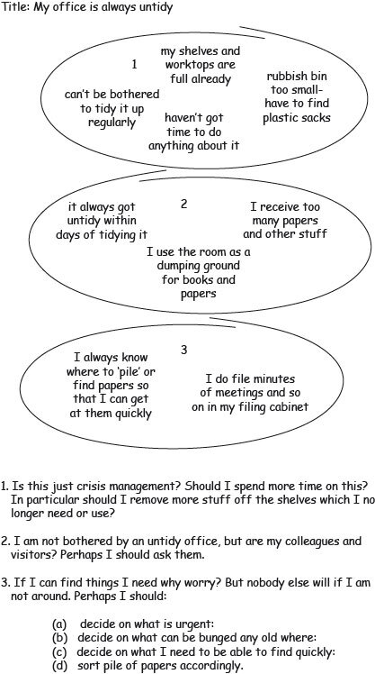
Figure 6A map of the features contributing to my office being untidy.
View description - Figure 6A map of the features contributing to my office being untidy.
View alternative description - Figure 6A map of the features contributing to my office being untidy.

Back to - Activity 2 Identifying systems of interest – a visual approach

Activity 3 Reflections on categorisations

Part

Comment
The purpose of this activity was to invite you to reflect on what it is that we do when we categorise anything. One way of reading this table is as a set of two categories each containing different category members. The mechanism employed in this categorisation is to add an adjective in front of the noun ‘system’. So they are different categories of system. This is the same process as developing a typology. Of course this is something we do all the time but I do not think we reflect very often on the implications of doing this! The implications for systems practice are discussed next.
Back to - Part

Activity 1 Your thoughts and feelings about diagramming

Comment
If you are worried or nervous, you are not alone. It is a common reaction because diagramming is equated with drawing. As I have already said an ability to draw is not important. Equally you may be aware how much information is now presented in a graphical form. Understanding some of the ins and outs of diagramming is a lesson in thinking and representing that thinking on paper or screen in ways that is not just linear text or spoken words.
Back to - Activity 1 Your thoughts and feelings about diagramming

Activity 2 Drawing a spray diagram about diagramming

Comment
I hope this activity has not proved too difficult. Certainly do not worry if your spray diagram contains less information than my example shown in the video. As with any skill it takes practice to improve and the main aim here is to show how a diagram can help with sense-making.

Video content is not available in this format.
Drawing a spray diagram about diagramming
View transcript - Drawing a spray diagram about diagramming

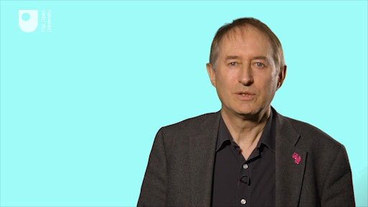

Back to - Activity 2 Drawing a spray diagram about diagramming

Activity 3 Have your thoughts and feelings changed?

Comment
Whether your thoughts and feeling have changed or not I hope you now appreciate that diagramming does not require drawing skills and that the diagrams I have introduced to you do help to make the connections between things, events and ideas more readily understandable, which I claimed in Week 1 as a key aspect of systems thinking.
Back to - Activity 3 Have your thoughts and feelings changed?

Activity 1 Meanings of managing

Part

Comment
Some of the verbs we (I did this with a colleague) thought of were

understanding,
surviving,
seeing,
visioning,
allocating,
optimising,
communicating,
commanding,
controlling,
helping,
defending,
leading,
supporting,
backing,
enabling,
coping,
informing,
modelling,
facilitating,
empowering,
encouraging,
delegating.

I identified three categories that helped me make sense of the list.
These were
- getting by;
- getting on top of; and
- creating space for.
I make no claim that this list is definitive; my categories are ones that I found useful at the time. Undoubtedly your list and categories will be different.
Back to - Part

Activity 2 Advice on diagramming

Comment
Here is my not necessarily exhaustive list.
- Most diagrams take several attempts to help your thinking and understanding. The whole point is to learn about the situation, so expect new insights and expect to have to redraw to incorporate these new insights.
- A diagram does not just use words and lines. It uses space as well. Cramped diagrams are always unclear. Spread them out.
- Don’t depart too far from recognisable diagram types, especially if you haven’t made much use of diagrams before. However, diagramming is not an exact science. It is a craft skill with a distinctly personal element, which develops through practice.
- The first thing to clarify in drawing a diagram is your own purpose: what aspects of the issues you are considering are you trying to represent? This is essential if you are to choose an appropriate type of diagram within which to work.
- Each diagram should have a title which describes what type of diagram it is and its purpose.
- If the meaning of lines and arrows is not fairly self-evident, use a key to explain different sorts of lines or label the arrows.
You may already be thinking when reading this list that some of these points may not be as easy to follow if there are several people all contributing to the development of a diagram as their knowledge of the technique, their disposition towards it and expectations of what will come from it will be different. Equally this all depends on the relationships involved and whether you are a ‘manager’ who is part of the situation or a ‘researcher’ who is an observer of the situation (you will return to this point in Weeks 7 and 8).
Back to - Activity 2 Advice on diagramming

Activity 3 How do you work with others?

Comment
As a systems practitioner it is important that I am always aware of, and attend to, how I relate to and work with others, the approaches I choose to use and also the situation under investigation. For the systems practitioner as juggler this touches on all four balls of being, engaging, contextualising and managing.
Back to - Activity 3 How do you work with others?

Activity 2 Systems Dynamics

Comment
Systems Dynamics was influenced by Operations Research and falls into the range of approaches that see systems as ontologies.
Back to - Activity 2 Systems Dynamics

Activity 3 Management cybernetics

Comment
Management cybernetics was influenced by (mainly) first order cybernetics which in turn was influenced by work across a wide range of subject disciplines. It tends to recognise systems as epistemologies.
Back to - Activity 3 Management cybernetics

Activity 4 System approaches – Sir Geoffrey Vickers

Comment
Vickers interest is in social systems and tends to see these as being ontologies rather than epistemologies. Equally he puts great store on what he calls appreciative systems, a description of the ongoing process of sense-making over time using a combination of concepts and values that equates more to an epistemology.
Back to - Activity 4 System approaches – Sir Geoffrey Vickers

Activity 5 Soft systems methodology

Comment
The work of Peter Checkland is influenced not only by his personal experiences but also by second-order cybernetics which itself was influenced by first-order cybernetics and some other subject disciplines. Because of this it falls very much into seeing systems as epistemologies.
Back to - Activity 5 Soft systems methodology

Activity 6 Management science

Comment
Russ Ackoff is noted for being a pioneer of the application of systems thinking to management and being responsible for many innovations in operations research, with the former eventually leading him to disavow classical OR and push for a broader, more strategic form known as soft OR that saw systems as epistemologies and not ontologies.
Back to - Activity 6 Management science

Activity 1 Two different models of SSM

Comment
My answer is influenced by having read about, studied and used SSM for many years and could cover many aspects you would not be aware of if you are new to SSM. So I confine myself to points which can be picked up from the depictions themselves. For me some of the main differences between the two depictions of SSM are:
- In the early depiction (Figure 7) there is a distinction between the real world and the conceptual world which is not made in the later version (Figure 8).
- The original purpose of the line was as an aid to distinguishing between the everyday world of the problem situation and the systems thinking about it. For me, the absence of this division in the later version means that one is always iterating between the so-called real world situation and the conceptual world of systems thinking about the situation.
- There is no clear division occurring in a sequence of steps (as conveyed, perhaps unwittingly by the original model). Of course the onus is on the systems practitioner to be aware of these distinctions as they practise.
- The early model has seven stages. Checkland (1999) describes this as happy chance, coinciding as it does with the research done which suggests we can only cope with 7± 2 concepts at a time. This means that it is easy enough to remember all the steps and not need to look them up in a book all of the time.
- The later model has two streams of analyses running concurrently – the cultural analysis which includes analysis of the intervention, the ‘social system’ and the ‘political system’ and the logic-based stream of analysis. The logic-based stream of analysis is much the same as depicted in the earlier version except it is presented in a linear format.
- Doing SSM is always cyclical and iterative but this is implicit rather than explicit in both depictions although the two-headed arrows between the cultural and logic streams of analysis in the latter figure show that there is constant iteration between these two streams and that both continue throughout the life of a project.
- The addition of the people icons to the later version make this depiction richer for me because it reminds me that there are systems practitioners and other stakeholders who engage with the problem or opportunity situation.
- The later version draws attention to the fact that the problem/opportunity ‘real world’ situation has a history. This history is amenable to analysis: the systems practitioner also has a history which I call a tradition of understanding.
- What has not changed between the two versions is the central place of constructing relevant systems, and activity modelling, the process being used to gain insights, to learn, about the real situation, not to model it as it ‘is’.
Back to - Activity 1 Two different models of SSM

Activity 2 Revisiting the juggler metaphor

Comment
Choosing between these two ways of using SSM is, for me, a very good example of how the systems practitioner juggles both the E (engaging) and C (contextualising) balls. But the act of choosing implies that we can always sit back and think rationally about our choices – my experience suggests that in the day-to-day flux of managing this is a rare luxury so I would propose that the issues that Scholes and Checkland have grappled with relate to how a practitioner juggles the B ball – their being as a systems practitioner. In both cases the systems practitioner needs to manage (the M ball) their involvement with the situation they are applying the approach to. It is the internal mental use of SSM as a thinking mode in everyday situations that is described as Mode 2 use of SSM (see Table 2 in the next section).
Back to - Activity 2 Revisiting the juggler metaphor

Activity 2 Looking back

Comment
Weeks 1–4 deal more with being (the B ball) though not exclusively, with a shift to engaging (the E ball) in Weeks 5 and 6, followed by contextualising and managing in Week 7 (the C and M balls), returning back to being a systems practitioner in Week 8.

Week 1 Systems thinking in practice | B ball
Week 2 Systems thinking and complexity | B ball
Week 3 Identifying systems of interest | B ball
Week 4 Representing systems of interest | B ball
Week 5 Understanding multiple perspectives | E ball
Week 6 Key systems thinkers | E ball
Week 7 Systems thinking approaches | C and M balls
Week 8 Becoming a systems practitioner | B ball

Back to - Activity 2 Looking back

Figure 1 Which systems person do you want?

Description
This shows a cartoon of a woman sitting at a desk with a computer, wearing a headset. The caption underneath reads ‘Which systems person do you want? Our systems manager, systems designer, systems analyst, systems helpdesk …’
Back to - Figure 1 Which systems person do you want?

Figure 2 Delivering information.

Description
This is a cartoon showing a man, on the left, holding an object. He is saying, to a farmer, ‘Where would you like us to put this information we’re delivering to you?’
Back to - Figure 2 Delivering information.

Figure 3 An iconic model of how different ‘actors’ ascribe different purposes to the same action.

Description
This is a cartoon showing three figures, all wearing visors and holding the same tool. The first figure is saying ‘I’m learning a trade’. The second is saying ‘I’m building a skyscraper’. The third is saying ‘I’m welding joints’.
Back to - Figure 3 An iconic model of how different ‘actors’ ascribe different purposes to the same action.

Figure 4 An image of the dynamic relationship between systems thinking and systems practice.

Description
This cartoon shows a woman holding up two picture frames. In the first frame is a drawing of a woman and the words ‘systems thinking’. In the second frame is a drawing of a woman and the words ‘systems practice’. There are arrows going back and forth between the two frames.
Back to - Figure 4 An image of the dynamic relationship between systems thinking and systems practice.

Figure 5 Breaking situations down doesn’t always work.

Description
This cartoon shows a person sitting in a missing part of a jigsaw. The word ‘Earth’ is shown in the jigsaw. The person is saying ‘Got a piece with “humans” on it?’. There is a speech bubble underneath saying ‘… not necessarily …’.
Back to - Figure 5 Breaking situations down doesn’t always work.

Figure 6 Life is complex.

Description
This cartoon shows a woman behind a helpdesk saying to a second woman ‘Life is complex’. The second woman responds with ‘Look, I haven’t got time for this’.
Back to - Figure 6 Life is complex.

Figure 7 The dynamic between an explainer, an explanation and a listener (or reader).

Description
This cartoon shows two people in conversation. To the left is a woman saying ‘This happens because …’. To the right is a man with a bubble showing his thoughts: ‘I accept this because: it fits with what I know; or she’s the expert; or I like the explanation’.
Back to - Figure 7 The dynamic between an explainer, an explanation and a listener (or reader).

Figure 1Untangling messes can be tricky.

Description
This cartoon shows a man looking at a large tangle of lines. He says ‘Just think of it as fishing line and untangle it’. There is then a speech bubble coming out of the tangled mess saying ‘If only’.
Back to - Figure 1Untangling messes can be tricky.

Figure 2 Choices that can be made about the nature of a situation such as water governance and catchment management situations (adapted from SLIM 2004).

Description
This cartoon shows three people peering into a box labelled ‘situation’ through a magnifying glass which contains the labels ‘complex’, ‘uncertain’, ‘controversial’ and ‘interdependent’. The person on the left is shown as thinking ‘we’re stuck in a swamp’, the middle as ‘this is a can of worms’ and the character on the right is thinking ‘what a mess!’.
Back to - Figure 2 Choices that can be made about the nature of a situation such as water governance and catchment management situations (adapted from SLIM 2004).

Figure 3 What’s the answer?

Description
This cartoon shows two characters talking to one another. The character on the left, who is standing, is saying ‘What’s the answer?’. The character on the right, who is seated, is saying ‘You’ve pinned your hopes on there being an answer … and then all that complexity resolves itself away … or does it?’.
Back to - Figure 3 What’s the answer?

Figure 4 Characteristics of hard and soft complexity.

Description
This figure is a graph: the x-axis is labelled ‘computational difficulty’ (from low at the left to high to the right) and the y-axis is labelled ‘emotional involement’ (low at the bottom and high at the top). In the top half of the graph is a circle with a heading ‘soft complexity’. To the left of that is the text ‘smaller-scale ‘personal problems’ e.g. divorce, career, choices’. To the right of that is the text ‘larger-scale ‘organisational problems’ e.g. bankruptcy of a financial institution, planning and building a new motoroway’. This text is also in a circle labelled ‘hard complexity’. Also in this circle is the text ‘complicated mathematical tasks e.g. chess, applying chemical processes’. Sitting outside of the two circles, and in the bottom left of the graph is the text ‘simple mathematical tasks e.g. puzzles’.
Back to - Figure 4 Characteristics of hard and soft complexity.

Figure 5 White is white.

Description
This cartoon shows two people holding a canoe and looking out towards the sea. The first character is saying ‘white is white!’ and the other character responds with ‘That’s what you think …’
Back to - Figure 5 White is white.

Figure 1A practitioner seeing systems in the world.

Description
This cartoon shows a man standing next to a number of objects labelled as ‘system’. He is shown to be thinking ‘I spy systems which I can engineer’.
Back to - Figure 1A practitioner seeing systems in the world.

Figure 2 A fishy ‘system’.

Description
This cartoon shows an adult and a child at a table on which there is a fish with just its bones and head. The adult is saying ‘now that’s a fish’ and the child is saying ‘that’s never going to be a fish’.
Back to - Figure 2 A fishy ‘system’.

Figure 3 A system of interest comprising a system (with sub systems), boundary and environment is distinguished, by someone as they engage with a particular situation.

Description
This cartoon shows a woman with a thought bubble showing an ecosystem and the labels ‘boundary’, ‘system’, ‘subsystem’ and ‘environment’.
Back to - Figure 3 A system of interest comprising a system (with sub systems), boundary and environment is distinguished, by someone as they engage with a particular situation.

Figure 4A one-way system.

Description
This cartoon shows a car driving the wrong way down a one-way street, facing a lorry driving the correct way. There is a caption which reads ‘It’s all very well to talk about the transport system in philosophical terms, but the fact remains that we are travelling in the wrong direction up a one-way system!’.
Back to - Figure 4A one-way system.

Figure 5 The complexity of hierarchies.

Description
This cartoon shows a number of figures in uniform. Some are clearer than others.
Back to - Figure 5 The complexity of hierarchies.

Figure 6A map of the features contributing to my office being untidy.

Description
At the top of this image is the title: ‘My office is always untidy’. There are then three circles. In the top circle (labelled as 1) are the phrases ‘can’t be bothered to tidy it up regularly’, ‘my shelves and worktops are full already’, ‘rubbish bin too small - have to find plastic sacks’ and ‘haven’t got time to do anything about it’. In the next circle (labelled 2), underneath the first, are the phrases ‘it always got untidy within days of tidying it’, ‘I receive too many papers and other stuff’ and ‘I use the room as a dumping ground for books and papers’. In the bottom circle (labelled 3) are the phrases ‘I always know where to ‘pile’ or find papers so that I can get at them quickly’ and ‘I do file minutes of meetings and so on in my filing cabinet’. Underneath the circules is the following text: 1. Is this just crisis management? Should I spend more time on this? In particular should I remove more stuff off the shelves which I no longer need or use? 2. I am not bothered by an untidy office, but are my colleagues and visitors? Perhaps I should ask them. 3. If I can find things I need why worry? But nobody else will if I am not around. Perhaps I should: a) decide on what is urgent b) decide on what can be bunged any old where c) decide on what I need to be able to find quickly d) sort piles of papers accordingly.
Back to - Figure 6A map of the features contributing to my office being untidy.

Figure 7A practitioner who understands ‘systems’ to be a means of inquiry about a situation.

Description
At the centre of this cartoon is a person. Around the person are various illustrations such as a person behind a desk, a plane, a tree and a highrise building. There is a speech bubble coming from the person which reads ‘I spy complexity and confusion - but I can organise exploration of it as a learning system’.
Back to - Figure 7A practitioner who understands ‘systems’ to be a means of inquiry about a situation.

Figure 1Successful use of diagrams does not depend on drawing abilities.

Description
This cartoon shows a picture on an easel containing various shapes and arrows. Two figures are looking at it and the caption underneath reads ‘I think my diagramming is going through an abstract period’.
Back to - Figure 1Successful use of diagrams does not depend on drawing abilities.

Figure 2Sharing diagrams can provoke conversations

Description
This cartoon shows two people looking at a diagram. The caption beneath reads: ‘In this control diagram of yours I’m not sure if this blob is a sensor or just a coffee stain’.
Back to - Figure 2Sharing diagrams can provoke conversations

Figure 1A metaphorical account of the way theories (planet on telescope) determine what we see in the world. The mischief makers represent what happens implicitly with any theory.

Description
This cartoon shows three scientists looking through a telescope. At the end of the telescope are two people, and it appears that they have drawn a planet onto the lense.
Back to - Figure 1A metaphorical account of the way theories (planet on telescope) determine what we see in the world. The mischief makers represent what happens implicitly with any theory.

Figure 2 An unfolding network of conversation and relationships. ‘Managing’ involves maintaining a network of asynchronous relationships in the context of an ever-changing flux of events and ideas. As any manager engages in one conversation, others are engaged in different conversations. As individuals participate in different conversations a coherent network of conversations results (adapted from Winter, 2002, p. 67 and p. 83).

Description
This cartoon shows a number of people who are connected by dotted lines or arrows.
Back to - Figure 2 An unfolding network of conversation and relationships. ‘Managing’ involves maintaining a network of asynchronous relationships in the context of an ever-changing flux of events and ideas. As any manager engages in one conversation, others are engaged in different conversations. As individuals participate in different conversations a coherent network of conversations results (adapted from Winter, 2002, p. 67 and p. 83).

Figures 3 (a) and (b) Perspectives on managing (source: Winter, 2002, p. 67 and p. 83).

Description
3a: The image shows a circle within a wider circle. In the inner circle is the text ‘Why not think of ‘managing’ in more generic terms?’. In the outer circle are the following phrases, with arrows pointing towards the question in the inner circle: managing change; managing people; managing costs; managing suppliers; managing performance; managing reputation; managing websites; managing knowledge; managing operations; managing learning; managing projects; managing quality. 3b: At the centre of this image is a stick figure. There are arrows pointing away from the figure, all labelled ‘r’, which the key tells us means relationship. At the ends of the arrows are the following words: board members; staff; suppliers; customers; projects; family; office; trade association; the business; environment (e.g. competitors and regulators).
Back to - Figures 3 (a) and (b) Perspectives on managing (source: Winter, 2002, p. 67 and p. 83).

Figure 4 Perspectives on managing.

Description
This cartoon shows a group of people, with two people at the front. Above the main group of people is a speech bubble containing words such as ‘change’, ‘performance’, ‘costs’ and ‘suppliers’. One of the people at the front is saying ‘Why not think of ‘managing’ in more generic terms’ and the person next to them responds with ‘… we manage!’.
Back to - Figure 4 Perspectives on managing.

Figure 5Managing by doing action research: On us or with us? (Adapted from Wadsworth, 1991)

Description
This cartoon shows three people. The person on the left is saying ‘I want to do some research’ and the two people to the right are saying ‘On us or with us?’.
Back to - Figure 5Managing by doing action research: On us or with us? (Adapted from Wadsworth, 1991)

Figure 3 A conceptual model of a practitioner who brings forth their tradition of understanding as they lay down the path of their walking (doing). All humans have a personal history within a wider cultural and biological history. A systems practitioner, for example, will from some moment have a history of thinking, acting or understanding systemically.

Description
This cartoon shows a person following a path. They are standing on the text ‘tradition of understanding’. The words ‘cultural and biological history’ appear next to them.
Back to - Figure 3 A conceptual model of a practitioner who brings forth their tradition of understanding as they lay down the path of their walking (doing). All humans have a personal history within a wider cultural and biological history. A systems practitioner, for example, will from some moment have a history of thinking, acting or understanding systemically.

Figure 1 Systems approaches.

Description
This cartoon shows two people sitting under a parasol with a sign saying ‘systems approaches’. Other people are walking around them.
Back to - Figure 1 Systems approaches.

Figure 2 A conceptual model of a practitioner who brings forth their tradition of understanding as they lay down the path of their walking (doing). All humans have a personal history within a wider cultural and biological history. A systems practitioner, for example, will from some moment have a history of thinking, acting or understanding systemically.

Description
This cartoon shows a person following a path. They are standing on the text ‘tradition of understanding’. The words ‘cultural and biological history’ appear next to them.
Back to - Figure 2 A conceptual model of a practitioner who brings forth their tradition of understanding as they lay down the path of their walking (doing). All humans have a personal history within a wider cultural and biological history. A systems practitioner, for example, will from some moment have a history of thinking, acting or understanding systemically.

Figure 3An activity-sequence diagram of the experience-action cycle involving purposeful action (Checkland and Scholes, 1990).

Description
This is a flow diagram. At the top is experience-based knowledge, which leads to purposeful action in relation to our perceived situation. This creates new experience of the world of affairs public and personal, and this yields experience-based knowledge, which completes the cycle.
Back to - Figure 3An activity-sequence diagram of the experience-action cycle involving purposeful action (Checkland and Scholes, 1990).

Figure 4Distinguishing between tools. When researchers and others talk about the need for new tools (e.g. a hammer) they usually fail to recognise that the situation of concern, and thus what they desire, is a relational dynamic between people (a hammerer), a tool, a practice (hammering) and a situation (frustration with a computer). The dynamic also produces something we can describe as a result or an effect, i.e. something is hammered!

Description
This cartoon shows a man (labelled as ‘hammerer’) holding a hammer (which is labelled as such). He is holding it above his head. In front of him is a desk with a computer labelled ‘hammered’.
Back to - Figure 4Distinguishing between tools. When researchers and others talk about the need for new tools (e.g. a hammer) they usually fail to recognise that the situation of concern, and thus what they desire, is a relational dynamic between people (a hammerer), a tool, a practice (hammering) and a situation (frustration with a computer). The dynamic also produces something we can describe as a result or an effect, i.e. something is hammered!

Figure 5The flow of ‘information’ between tools, techniques and skills.

Description
This is a flow diagram. At the top is a box labelled ‘Real world’ situations. There is then an arrow down to a circle, in which is the text ‘Developing skills (or skill-sets) for decision making’. from this circle is are arrows to ‘Tools’ and ‘Techniques’. From ‘Tools’ there is also an arrow going to a circle in which is the text ‘Establishing rules and conventions’. From here is an arrow to ‘Techniques’. From ‘Techniques’ there is an arrow going to a circle in which is the text ‘Practicing in the ‘real world’’. This then links to ‘Skills’. From here is an arrow going up to the main circle.
Back to - Figure 5The flow of ‘information’ between tools, techniques and skills.

Figure 6 Some distinctions between tool, technique, method and methodology.

Description
This cartoon is in three parts. In the first part, labelled ‘Technique’, there is a man, labelled ‘skill’ holding a hammer, which is labelled ‘tool’. In the second part, labelled ‘Method’, are a number of images of different tools, such as a hammer and a saw. In the third part, labelled ‘Methodology’, there is a person thinking, with a label ‘purpose’. They have in front of them a number of drawings (with a label of ‘adapt methods …’ and then there is a picture of three people sitting together, and the words ‘… to a situation’.
Back to - Figure 6 Some distinctions between tool, technique, method and methodology.

Figure 7The seven-step activity model of SSM as articulated in the 1980s (Checkland and Scholes, 1990, p. 27).

Description
This contains seven steps: Problem situation considered problematic; Problem situation expressed; Root definitions of relevant purposeful activity systems; Conceptual models of the systems named in the root definitions; Comparison of models and real world; Changes: systematically desirable and culturally feasible; Action to improve the problem situation.
Back to - Figure 7The seven-step activity model of SSM as articulated in the 1980s (Checkland and Scholes, 1990, p. 27).

Figure 8An ‘iconic’ pictorial model of the process of SSM as articulated in the 1990s (Checkland and Scholes, 1990, p. 29).

Description
This is a visual representation of the process of SSM as articulated in the 1990s.
Back to - Figure 8An ‘iconic’ pictorial model of the process of SSM as articulated in the 1990s (Checkland and Scholes, 1990, p. 29).

Figure 9SSM as a learning system

Description
This diagram shows the following labels all connected to each other: real-world problem situation; relevant models of purposeful activity systems, as concepts; structured debate about change, finding accommodations; action to improve.
Back to - Figure 9SSM as a learning system

Figure 1 The experiential learning model adapted from Kolb which starts with experience.

Description
This diagram is a cycle which shows the following message: Experience provokes thinking; tihnking enables decisions; decision leads to action; and action generates experience.
Back to - Figure 1 The experiential learning model adapted from Kolb which starts with experience.

Figure 2 Seeing the world as containing systems (being systematic) and seeing the process of inquiry, of engaging with a situation, as systemic (being systemic) (adapted from Checkland, 1999).

Description
This is a cartoon. On the left is Observer 1. He is saying ‘I spy systems which I can engineer’ and is seeing a number of systems referred to as ‘The observer’s perceived real world’. Underneath this is the label ‘The world: systemic’. On the right is Observer 2. He is saying ‘I spy complexity and confusion: but I can organise exploration of it as a learning system’ and is seeing a number of lines labelled ‘The observer’s perceived real world’. Underneath this is the label ‘The process of inquiry: systemic’
Back to - Figure 2 Seeing the world as containing systems (being systematic) and seeing the process of inquiry, of engaging with a situation, as systemic (being systemic) (adapted from Checkland, 1999).

Figures 3 and 4 The choices that can be made about ‘system’ and ‘situation’ that have implications for systems practice: practitioner 1 (top) situates systems in the world (i.e. conflates system and situation) whereas practitioner 2 (bottom) understands ‘systems’ to be a means of inquiry about situations (adapted from Checkland and Checkland and Poulter, Fig. 1.9, p. 2).

Description
This shows to cartoons. The first has a character with a thought bubble saying ‘I spy systems which I can engineer’. The second shows a figure with a thought bubble saying ‘I spy complexity and confusion, but I can organise exploration of it as a learning system’.
Back to - Figures 3 and 4 The choices that can be made about ‘system’ and ‘situation’ that have implications for systems practice: practitioner 1 (top) situates systems in the world (i.e. conflates system and situation) whereas practitioner 2 (bottom) understands ‘systems’ to be a means of inquiry about situations (adapted from Checkland and Checkland and Poulter, Fig. 1.9, p. 2).

Figure 5 Evidence based research.

Description
This is a cartoon with a two people coming out of a cardboard box. The box is labelled ‘Project. Evidence based research’.
Back to - Figure 5 Evidence based research.

Figure 6Inhibiting the emergence of relationships.

Description
This cartoon shows a man behind a desk saying ‘We have communicated information to you in a wide range of formats’. An older female character the other side of the desk responds with ‘Did any of them come with a cup of tea and a chat?’
Back to - Figure 6Inhibiting the emergence of relationships.

Figure 7 A metaphor for the technological framings of our existence from which it is sometimes difficult to escape.

Description
This cartoon shows a man running. He is contained in a bubble.
Back to - Figure 7 A metaphor for the technological framings of our existence from which it is sometimes difficult to escape.

Figure 8 An unfolding network of conversation and relationships. ‘Managing’ involves maintaining a network of asynchronous relationships in the context of an ever-changing flux of events and ideas. As any manager engages in one conversation, others are engaged in different conversations. As individuals participate in different conversations a coherent network of conversations results (expanded from Winter, p. 67 and p. 83).

Description
This cartoon shows a number of people connected by arrows and dotted lines.
Back to - Figure 8 An unfolding network of conversation and relationships. ‘Managing’ involves maintaining a network of asynchronous relationships in the context of an ever-changing flux of events and ideas. As any manager engages in one conversation, others are engaged in different conversations. As individuals participate in different conversations a coherent network of conversations results (expanded from Winter, p. 67 and p. 83).

Figure 10An image of the dynamic relationship between systems thinking and systems practice.

Description
This cartoon shows a woman looking at two images of herself, both labelled with the words ‘systems thinking’.
Back to - Figure 10An image of the dynamic relationship between systems thinking and systems practice.

Uncaptioned interactive content

Transcript
ANDY LANE
Welcome to this course on mastering systems thinking in practice. What do we mean by 'practice' in this course? Practice or practicing is something everyone does. The dictionary definition of "practice' is to carry out or perform habitually or constantly-- to carry out an action.
Almost everyone has some role or number of roles in which they regularly encounter issues that need dealing with, improving, or resolving. For example, I'm a practicing father as well as a practicing academic. So a practitioner is anyone involved in practice-- in regularly carrying out a number of actions.
If I reflect on my own practice, I'm aware that I experience myself as something of a juggler, trying to keep a number of balls in the air as I practise, as shown in this cartoon. More specifically, this course, first implicitly and then explicitly, employs the metaphor of the systems practitioner as juggler-- juggling four particular balls marked as B, E, C, and M in the cartoon-- that I think need to be kept in the air for any form of effective systems practice.
The metaphor of the juggler keeping the four balls in the air is a powerful way for me to think about what I do when I try to be effective in my systems practice. It matches with my experience. It takes concentration and skill to do it well and makes me think about the context in which I am practising. Now it is your turn to start reflecting on your existing knowledge and assumptions about systems thinking in practice.
Back to - Uncaptioned interactive content

Uncaptioned interactive content

Transcript
ANDY LANE
By the end of this course, you will have a greater understanding of being a systems practitioner having to deal with complexity. But what makes it possible to say, I understand something about the world in which I live? What is it that we would need to have observed in others or in ourselves for us to say that understanding systems practice had occurred?
In the language of this cartoon, I'm asking you to envisage the general idea of a practitioner as someone who engages with some messy real-world situation using selected approaches. Systems practice, modelled in this next cartoon, is a particular form of the general model of practice shown in the first cartoon. An effective systems practitioner is able to use systems approaches in managing complexity in the context of a perceived real-world situation.
I'm not overly concerned with other approaches to practice and will not be making any extravagant claims that a systems approach is better than other forms of practice. I will, however, develop arguments that enable me to make two claims-- firstly, systems practice has particular characteristics that make it qualitatively different to other forms of practice; and secondly, an effective systems practitioner can call on a greater variety of options for doing something about complex real-world situations than other practitioners do. These are important claims. They will structure most of the arguments made in the rest of the course, as you'll begin to explore this week.
Back to - Uncaptioned interactive content

Uncaptioned interactive content

Transcript
ANDY LANE
Although everyone expresses the differences between difficulties and messes in their own terms, the distinguishing features that people come up with can usually be grouped under one of two headings.
The first of these concerns the scale of the situation and covers all the ways in which messes tend to be ‘larger’ than difficulties with more serious implications. More people are likely to be involved. Messes usually have a longer time-scale, are more difficult to tackle, and more complicated.
The second group of key features come under the general heading of uncertainty: with messes there is much more about which one is simply unsure. In fact, this uncertainty starts with the situation itself: a difficulty is fairly clear cut; it’s quite easy to put a label on it, or to explain to someone else what the problem is. But a mess is hard to pin down; it’s difficult even to say what the problem actually is, and yet things are not right. With a difficulty I know roughly what a solution will look like; with a mess, I’m not at all sure about solutions. Indeed, with a mess it usually doesn’t make much sense to talk about ‘an answer’. It’s more a matter of coping with the circumstances as best one can.
With a difficulty I can take for granted the overall context and purpose of the activity; it’s simply a matter of how it can best be done. But a mess calls into question my priorities and assumptions; I am not sure how much weight to give to different considerations, whether particular goals are realistic or should be abandoned. Moreover, with a mess more aspects are beyond my direct control. With a difficulty I know what factors are part of the situation or relevant to it, and what aren’t: I can disentangle it from the broader context of my work and address it as a more or less discrete matter. But a mess is fuzzy; it’s hard to say who and what is involved in the problem and who and what isn’t because the different elements in it are closely tied to other areas of activity. Finally, with a difficulty I either know enough to tackle it or I know what I need to know. With a mess I don’t know enough and I’m uncertain even what I need to know.
The single idea that best captures the difference between difficulties and messes has associations of both scale and uncertainty: it is the idea that difficulties are bounded while messes are unbounded. In saying that a situation is bounded, one implies not just that it is fairly limited, but that one knows roughly where those limits are. By contrast an unbounded situation is more extensive, but quite how extensive one can’t say. Most of the qualities of difficulties and messes referred to earlier clearly relate to this bounded/unbounded distinction.
Back to - Uncaptioned interactive content

Uncaptioned interactive content

Transcript
ANDY LANE
Although everyone expresses the differences between difficulties and messes in their own terms, the distinguishing features that people come up with can usually be grouped under one of two headings.
The first of these concerns the scale of the situation and covers all the ways in which messes tend to be ‘larger’ than difficulties with more serious implications. More people are likely to be involved. Messes usually have a longer time-scale, are more difficult to tackle, and more complicated.
The second group of key features come under the general heading of uncertainty: with messes there is much more about which one is simply unsure. In fact, this uncertainty starts with the situation itself: a difficulty is fairly clear cut; it’s quite easy to put a label on it, or to explain to someone else what the problem is. But a mess is hard to pin down; it’s difficult even to say what the problem actually is, and yet things are not right. With a difficulty I know roughly what a solution will look like; with a mess, I’m not at all sure about solutions. Indeed, with a mess it usually doesn’t make much sense to talk about ‘an answer’. It’s more a matter of coping with the circumstances as best one can.
With a difficulty I can take for granted the overall context and purpose of the activity; it’s simply a matter of how it can best be done. But a mess calls into question my priorities and assumptions; I am not sure how much weight to give to different considerations, whether particular goals are realistic or should be abandoned. Moreover, with a mess more aspects are beyond my direct control. With a difficulty I know what factors are part of the situation or relevant to it, and what aren’t: I can disentangle it from the broader context of my work and address it as a more or less discrete matter. But a mess is fuzzy; it’s hard to say who and what is involved in the problem and who and what isn’t because the different elements in it are closely tied to other areas of activity. Finally, with a difficulty I either know enough to tackle it or I know what I need to know. With a mess I don’t know enough and I’m uncertain even what I need to know.
The single idea that best captures the difference between difficulties and messes has associations of both scale and uncertainty: it is the idea that difficulties are bounded while messes are unbounded. In saying that a situation is bounded, one implies not just that it is fairly limited, but that one knows roughly where those limits are. By contrast an unbounded situation is more extensive, but quite how extensive one can’t say. Most of the qualities of difficulties and messes referred to earlier clearly relate to this bounded/unbounded distinction.
Back to - Uncaptioned interactive content

Uncaptioned interactive content

Transcript
ANDY LANE
Many real-world situations can be experienced differently as either a difficulty or a mess, depending on the viewpoint of the observer. However, I could not call it a system unless I had tried to make sense of it using systems thinking and found or formulated a system of interest within it. This means I would need a purpose for engaging with the real-world situation. When I do not have such a purpose in mind, I'm using the word "system" in its everyday sense rather than its technical systems practice sense.
The act of making a distinction is quite basic to what it is to be human. When we make a distinction, we split the world into two parts-- this and that. We separate the thing from its context or a system from its environment. This is the same as drawing a circle on a sheet of paper. When the circle is closed, three different elements are brought forth at the same time-- an inside, an outside, and a boundary.
The fundamental choice that faces systems practitioners is choosing to see systems either as something that exists, that can be discovered, measured, and possibly modelled, manipulated, or maintained, as does the first system practitioner in this cartoon, who jumps to the conclusion that this is clearly a manufacturing system; or as something we construct, design, or experience because of the distinctions or theories we embody, as does the second systems practitioner, who is open to the complexity of the situation-- the factory, river, dairying-- and sees systems as mental constructs formulated as part of a systemic inquiry. You will now learn how to define and identify systems of interest for yourself.
Back to - Uncaptioned interactive content

Uncaptioned interactive content

Transcript
ANDY LANE
This week is about finding ways of representing your thinking about complex situations-- making sense of complexity. This is a process of discovery. It involves thinking about complexity in an orderly way that allows you to enter a deeper understanding of the complexity. It goes beyond immersion in and representation of complexity.
The invitation I'm making in this week is to move into the possibility of structuring complexity. Notice I'm not suggesting there is structure in the complexity I can discover. Rather, it is about discovering ways of structuring the complexity that make sense to you.
By structuring the complexity, I can think more effectively about it and possibly discover ways of improving the situation. And to discover ways of representing my thinking about the complexity, I'm going to use systems diagrams-- or, more fully, diagrams that enable practitioners to represent a systems of interest. Systems diagrams are particular lenses or frames through which we can study a complex situation, as shown by the different shapes in the cartoon. And just as I would use a microscope or telescope to help me see different things more clearly in the same landscape, I can use different types of diagram to highlight different types of structure and relationships within that complex situation-- or in other words, to identify different systems of interest that I can compare and contrast. In this week, you will learn the power of diagrams for representing your thinking about complex situations.
Back to - Uncaptioned interactive content

What are systems diagrams for?

Transcript
I want to begin with some very basic questions. What are systems diagrams? What can they do for you? Why do we use them? Good answers to these questions will give us a sound foundation for everything that follows.
First, a systems diagram is simply a special arrangement of words, symbols and lines of one sort or another that expresses someone’s thinking about what has happened or about how certain things are or about how they might be. It follows that in creating a diagram what I'm basically doing is attempting to express my thinking about some situation, some issue or whatever, through the use of words, symbols and lines, and the way these are arranged or spaced apart.
Now, the other main ways of expressing thinking are speech and writing. So it follows that these three are all different ways of doing basically the same thing and it should be possible to convert one to the other, which is indeed the case. However each way can highlight different aspects of the same thing.
The idea that creating a diagram is a way of expressing one's thinking has an important implication. It implies that in drawing a diagram you face two different and often difficult tasks. The first task is that of getting your thinking straight, of knowing what it is you want to express. The second task is that of choosing an appropriate way of representing those thoughts. In practice, the two tasks are usually intimately related.
Second, what can diagrams do for you? Well, a diagram can be something drawn for your own use, a simple representation of what you pick up from a situation in order to sort things out and get the hang of it - so it can be quite private. A diagram can be your statement about what you think and then it becomes a vehicle for explaining your thinking to other people by showing them the diagram and discussing it with them. Alternatively, a diagram can be created by several people working together. In the making of such a joint diagram it may well be that differing viewpoints emerge, conflicts can be discussed and the expert knowledge of different members can be harnessed.
Third, why do people draw and use diagrams at all? Well, to begin with, text is linear; it runs in only one dimension along the line of print. Complex branching of ideas needs complex grammar but complicated arrangements of words are hard to take in. Basically, you can only read or hear one phrase at a time, then the next and so on, trying to hold the structure of a description in your head. The many all-important interconnections are difficult to express and even harder to pick out. That is why text may contain lists, sub-sections, and tables even.
But a diagram can be really different from text. It is two dimensional for a start; complex connections are much easier to work out in your mind with the help of a diagram to look at. As a picture it's easily scanned. It gives a message to the eye through its shape even before you read it fully. Are the connections in a ring or a starburst form? Is something isolated on the edge? Does the situation fall as if it were into two halves with poor interconnection?
The layout of a diagram is as important as the composition of a picture, and like a picture you can use colour to differentiate between various kinds of things. And as you find out more about the situation and understand more you can add things in at the fringes of the diagram or in between existing components. In my view a diagram is never finished, but merely accepted as being the most useful representation so far. Always be prepared to redraw a diagram to get a better result by selecting the most important aspects.
A further advantage of a diagram over text is that the phrases on a diagram can be read in different sequences to trigger new insights, suggest creative viewpoints and make holistic interpretations. You can choose to start to read a diagram anywhere, even if you have been directed to one particular start point.
Any diagram is a compromise between breadth of scope, depth of information and clarity of presentation. Try to keep these in balance. It's easier to get carried away by putting everything into a diagram but losing the whole point of the exercise which is to say something and say it clearly and economically. For each diagram you use, you should try to focus on its purpose - what it is trying to achieve. And this is best done through adding a title that sets out what the diagram is all about.
Back to - What are systems diagrams for?

Drawing a spray diagram about diagramming

Transcript
ANDY LANE
You can see right away why this is called a spray diagram. You start at the centre with a topic that interests you or one that you need to be concerned with; write it in a blob or box, add some four to six related main ideas or thoughts branching outwards from the box. Move further outwards with branches setting out additional ideas in a fairly free style, finishing with twigs, dealing with detail.
If you now study my spray diagram more closely you will find that it says more than I have discussed so far. As it was drawn from my perspective I have added elements I find relevant such as the branch starting with the other diagramming materials on OpenLearn that I mentioned at the beginning of this week. I am sure that your diagram is different. That does not make it wrong as your diagram is to help you make sense of something from your perspective. Reading mine may make you think once again about yours if you were going to develop yours further. My example was a quick first pass to help me plan this session. I found it sufficient to help my thinking this time but in other situations I might want to draw it again.
Back to - Drawing a spray diagram about diagramming

A deep dive into diagramming

Transcript
ANDY LANE
I am sure your first reaction on reading this article was where do I start to make sense of that using diagrams? Fortunately I am not asking you to do that. Instead I will show you how, once you get going, and begin to understand what each type of diagram can be used for, things begin to fall into place. This takes some time so bear with me as I work through a number of different diagrams.
From drawing my spray diagram of the complex situation in the article I am certainly struck by the size of the branch at the bottom dealing with the possible causes of failure. The other feature that stands out for me is how many different organisations and government departments or agencies are involved over long time scales and involving so much money.
So far I have simply tried to produce a summary of the situation. I now want to move on to look at different aspects of it. The first is to look at the structural components of a possible system of interest. To do that I drew a systems map starting with the title.
The title should be a short description of what the diagram is trying to represent. It helps focus my attention on the most appropriate components. In this case I have gone for a rather straightforward look at all the organisational relationships involved. I have also abstracted up a level to show clusters of organisations such as ‘Government departments’ and ‘Commercial contractors’ rather than list all the specific ones mentioned in the article. In the end I have only got two subsystems as I thought for a while about where to place the public. Although not specifically mentioned in the article, many of us, the public, are being affected by this system but it is not clear that we are seen as being part of it. You may disagree, and that’s ok as long as you give your reasoning. The point is that this is my representation of the situation and it is already making me think more deeply about it.
However, I was dissatisfied with this systems map as it did not tell me too much that I did not get from just reading the article so I decided to draw another one that focused on the functions the different groups performed rather than the organisations themselves.
Looking at this second systems map notice that I have also changed the title to reflect my change in emphasis. This time I have 3 sub-systems which seem to cover the main functions as I see it of initiating, providing and using the new IT projects. Also the public are inside the system as users, in some form, of the IT projects. Perhaps I should not have left them outside in the last map. Training appears twice, once as training for the IT professionals and once as staff in the relevant user organisations needing to be properly trained. Outside the boundary I have elements which affect the system but are not necessarily affected by it. For instance, the state of the economy will influence how much tax payers’ money there is to spend and the drive to implement policies that require IT support. If those IT projects fail then there will be some impact on the economy but it will be negligible in nearly all cases.
This has certainly given me a new slant on the situation but I need to move on to other diagram types to investigate it further.
This is because maps of this kind are very useful when you want to get a quick overview of how the structure of a situation is perceived. However they don't describe flows and processes occurring over time nor the links between components and you have to make the judgements about how much detail to include. For example, in drawing my second system map I decided to leave out the different reasons for failure of the IT projects. That's because my purpose in drawing the map was to see the main features of the possible system for arriving at hopefully successful IT projects and not to investigate the process by which many have appeared to fail.
Nevertheless systems maps can often be usefully developed into a somewhat richer type of diagram by including lines or arrows to indicate where important relationships exist between particular blobs. Such diagrams are called influence diagrams and the next diagram shows one that I developed from my second systems map.
I want to make a number of general points about this influence diagram before discussing what I was thinking as I drew it.
First, though an influence diagram is often developed from a systems map, drawing it normally involves more than just adding lines or arrows to a systems map as it's important to keep the number of crossed lines to a minimum and to keep lines fairly short.
Second, you may well want to regroup and redefine some of the blobs to reduce the number of lines and to make their meaning more readily apparent. If you compare my second systems map and this influence diagram you will see several changes in the blobs but what you may be wondering is what do the arrows actually mean? Quite what an arrow means in an influence diagram would depend on the particular diagram and its content but in general terms it does mean influence although sometimes the term “influence” is pretty vague. For example, it's slightly odd in this influence diagram to read only of the impact of “choice of technology” on “software” as the latter does also influence the former. Nevertheless, I gathered the impression from the article that it was more often the technology that dictated which software was used rather than the other way round. I may be wrong but at least I have exposed it as an issue to look at further.
If it isn't clear to you what kind of relationship is implied by a particular arrow, it probably won't be clear to anyone else either, so the way to check a diagram is to read it back to yourself and ask: “Is that how I see things?” or “Does that correspond to the thinking I'm trying to represent?”.
Another point about drawing these influence lines is that you have to be very selective and make choices. Every blob in this influence diagram could legitimately have been linked to every other blob I dare say. For example, the “public” has occasionally influenced “policies” in some way, but putting in all the influence lines would clutter up the diagram, and you wouldn't tell what it was mainly about. So the general principle once again is a matter of representing the most important relationships, selecting and choosing, and that involves judgement. It is for all these reasons that I have dropped the sub-system boundary lines and slightly changed the wording in some of the blobs, in order to make it clearer to me. But this is just my first stab at an influence diagram. I then went on to produce this revised one.
Looking in detail at this revised influence diagram you will notice first of all that I have left off the systems boundary. I have done this because I am only looking at the elements within the system and I identified what was outside in the environment last time. I have also brought together elements of organisations from my first systems map and functions from my second systems map and used a thicker arrow to indicate stronger influences. Thus I see the government departments and the IT companies as strongly influencing the technology and software which then strongly influences the users or user needs. My impression, partly influenced from reading about IT failures elsewhere, is that either IT projects are foisted on the hapless users without enough consideration of what the user wants. Or a piece of technology or software originally developed for one purpose is then adapted for a new purpose and found to be wanting. It is not wrong to bring in these additional understandings as long as they are acknowledged or the reasoning for constructing the diagram this way is explained.
To review the system represented in the revised influence diagram you have to remember that it's no longer a simple translation of the text. It represents my thinking about the relationships which may exist amongst the various agencies and groupings.
That thinking took shape as I was drawing the diagram because I had to answer questions like “how much influence is this likely to have on that?” and “how can I simplify all this?” and “which things are the most important?” The result is a particular view of how the system might be. I've guessed at some things and I've guessed that some are more strongly linked than others. The point I'm making is that my thinking about the system of interest and how its components may be related developed as I was drawing the diagram. I reacted to my first draft by having additional ideas about what might be going on. This is another important lesson about the purpose of drawing diagrams. Just as with speech and writing, I usually don't know exactly what I think until I've expressed it.
Now that I have identified possible lines of influence I want to extend my investigation of the article to look more specifically at the causes of failed IT projects. To do that I have drawn a multiple cause diagram to represent part of the article.
To draw the multiple cause diagram I went back to my spray diagram. Starting with the end point of ‘failed IT projects’ I looked for likely chains of cause and effect that would lead up to this end point. Because the article gives various views and is not as detailed as I would like I have had to infer some of the links. That is not wrong. I am trying to create a model of the situation based on my thinking. When I have built it I then need to test it by checking through the logic of each link and chain and also seek supporting evidence. In other words, drawing the diagram enables me to ask more focused and pertinent questions when trying to diagnose what is happening in the situation portrayed. And if I am happy with my representation then I can start to ask myself what would be the consequences of intervening here or there.
Well, looking at my multiple cause diagram and re-reading the article I am not all that happy with it. First it says nothing about how projects fail. Some are cancelled, some are late, some even seem to have teething troubles but do eventually work and so on. Second there are more human factors and more groups of people involved. Where have the government departments and agencies gone for instance? However, I was struck at the lack of an obvious link back from ‘failed IT projects’ to anybody other than management. This may just be my representation but it could be a significant reason why there have been so many disasters.
So, I went back to my pen and paper to revise this multiple cause diagram.
This revised multiple cause diagram is verging on having too many components and links for clarity. There are also too many crossed lines. I can always improve on the presentation but for now it is the improved understanding I want to concentrate on. As I noted earlier, the definition of failure is actually varied and the expectations of what IT can deliver is important. That is why I have the small vicious circle at the top of the diagram running from ‘government policy’ to ‘many people affected’ through ‘high expectations’. I also feel that I have been trying to cover all possible reasons for failure and yet some are probably specific to certain projects. The common features appear to be to do with poor project management, the level of training skills among both the software developers and the users and matching needs with the software available.
To recap, I've introduced three simple, but powerful, types of diagram for representing a system of interest: a systems map, an influence diagram and a multiple cause diagram. I have also explained some of my thinking when I drew them. I hope that you have gained some valuable insights from this into how diagrams can be an essential tool in the system practitioner’s toolkit.
Back to - A deep dive into diagramming

Uncaptioned interactive content

Transcript
ANDY LANE
Appreciating a complex situation often requires understanding the perspectives of those involved with or within that situation, and that includes the systems practitioner. Systems practice may be carried out individually or as part of a team. But how do different people experience that systems practice?
In doing any systems investigation with a community or client group, which is a form of managing, an important question is, am I investigating the situation as if from the outside looking in, or am I working collaboratively with the other participants? The answer to the question leads to different modes of systems practice. These modes of practice are related to the choices the aware and non-aware systems practitioner make in relation to the four balls that need to be juggled for effective practice and their relationship with the situation being investigated.
The non-aware practitioner always acts in the belief that they are outside the so-called 'real world situation'. In contrast, the aware practitioner acts from an understanding that there is no position external to the real world. That is, they are always in the situation, usually with others. In addition, they can also act as if it were possible to stand outside the situation in an awareness of the ethics of doing so. Now you have the opportunity to learn techniques for understanding multiple perspectives.
Back to - Uncaptioned interactive content

Uncaptioned interactive content

Transcript
ANDY LANE
Many well-known systems thinkers had particular experiences which led them to devote their lives to their particular forms of systems practice. So within systems thinking and practice, just as in juggling, there are different traditions which are perpetuated through lineages and communities of practice. Appreciating these experiences and understanding these traditions is enhanced by listening to those systems thinkers speaking about how they have come to view systems thinking and systems practice based on their own experiences.
This cartoon names three out of the five systems thinkers I will introduce you to this week-- three thinkers who you will hear speaking about their own work and not through reading a synopsis provided by me or someone else. This second cartoon, which you first saw in Week 1, highlights three different jugglers handling their four balls in different ways, which itself is indicative of the different histories, emphases, and experiences that inform the differing systems thinking and practice employed by those thinkers. Learning from others is important. You now have the chance to learn about the experiences of some key systems thinkers.
Back to - Uncaptioned interactive content

Uncaptioned interactive content

Transcript
We can't help, I think, thinking chiefly when we think of systems of the kind of systems that most concern us, whether they be technological or biological, psychological, ecological, socio-political, cultural or what have you. Now my interest is at the far end of this spectrum. Having been a lawyer and an administrator, I'm interested in systems from the personal up to the very large, human, social systems. I'm also interested in those systems of concepts and values through which we see all the others which I like to call appreciative systems.
So I'm going to talk about the end of the spectrum that interests me, and of course it is of great general interest, because whatever else we may do, we all live in this psycho social world. And we, all of us (I think) also suffer from a good deal of semantic pollution and misplaced ideas, many of which have got carried over by illicit extension from the natural sciences. So the end of the spectrum that concerns me, I think, does really concerns us all.
World views
It's hard to plot what I mean and what we all of us understand by systems thinking. If you think what an educated school child of today ought to have as a world view, it is very different from what it was when I was a child, or even when my children were children. It goes something like this. The world is a complex of systems and sub-systems, a very complicated interaction. Some are arranged hierarchically like the cells and organs of the body and layers of government. Some are involved functionally and laterally like the organs and the partners in a business, some in this curious mixture of competition and co-operation which an ecologist finds when he looks under a paving stone or in the Amazon jungle.
Systems
These systems, certainly at the human end, are almost all extremely unstable. And they're mostly unstable because of the destabilising effect of this one element in the whole thing, man. And we destabilise them because the monstrous magnified powers of technology are not balanced and probably cannot be balanced by any corresponding understanding of the effect of what we're doing. So although we have enormous powers to change, we have very, very limited powers to change in a predictable way.
We probably can't know even in theory what those limits are. And the one limit we do begin to know is the opposite of what we thought we knew before.
Linear progress
And that is a belief in linear progress of any kind. Because what seems very clear now is that in any system of any sort no one element can change linearly and indefinitely without either limiting itself or reversing itself or reducing the entire system to collapse.
Well this is not only an ecological view but it applies also in the personal and the social world. And this imaginary child of ours, who is putting together a picture of the world in which it lives, would be constantly reminded of the fact that it was itself part of this complex of systems which it was trying to picture to itself and was, indeed itself, as complex a combination of systems and sub-systems as could well be.
Organisations
Now the second implication I want to talk about is organisations. Organisations have at last become respectable. It is not always openly admitted, but it seems to me an absolutely clear implication of systems theory, that at every level of organisation new laws appear which were not apparent, and could not even in theory have been deduced by the behaviour of the constituents of the system, before they were organised. This idea of new levels, new laws breaking in at new levels have, of course, always been very repugnant to a reductionist science. Fact is I think that it's now quite unavoidable and a very good thing too.
Even a few decades ago it was possible for well-informed people to argue whether an organisation could possibly be more than the sum of its parts. Well everyone knows today, or everyone should know, that any organisation is bound to be both more, and less, than the sum of its parts. It's less because its parts are constrained by being organised. There are things that they could do if they weren't organised that they can't do now. It's more because organised they can do not only what they couldn't do separately, but what they couldn't do together, unless they were not only together, but also organised. This idea of new laws emerging at different levels of organisation without, of course, defying the laws that are at the level below, but treating them as the boundary conditions within which they operate. This is an idea which, I think, has really been quite common to the human mind for a long time, but is very reluctantly accepted in scientific thinking.
The representations that we make of these systems are themselves human artefacts, and collective human artefacts. And that gives a new and very funny look to the idea of inter-subjectivity. For a long time now science has distinguished very sharply between the subjective and the objective and has had very little use for the subjective. Yet philosophers of science today find it very hard to find any validity for our views of reality other than that they are inter-subjectively agreed representations - not of what reality is, but of what we shall deem it to be. This consensus of what we shall deem it to be is a human artefact, created, maintained, changed, ultimately perhaps eliminated, by the consensus of human minds.
And one of the major criteria of whether it's acceptable, retained, changed or dropped is its systemic relationship with other parts of the field of understanding. I won't say just the cognitive field, because that too, I think, is a very inadequate way to describe our whole field of appreciation.
Science for a long time has assumed not only that the observer saw more of the game than the player, but that he saw everything that was worth seeing. The idea that the agent might see, and still less might be, something that the observer couldn't see, and be, has been another of those embarrassing notions that have got left out.
And yet if we're really going to take seriously the insight that we are ourselves part of most, in theory all, the things that we "observe". And in practice of all the most important ones, the ones that fall into the psycho-social field then you have to accept the fact that we need the experience of an agent just as much as we need the observations of an observer.
And that it is only by marrying the two that we make any sense of what we observe. Some social scientists have got into grotesque contortions, it seems to me, by trying to be completely objective about their own kind, and thus trying to exclude the direct knowledge they in fact have, ignoring the fact that half their vocabulary only has a meaning because their own personal experience has put it in.
Back to - Uncaptioned interactive content

Uncaptioned interactive content

Transcript
PETER CHECKLAND
When I became a manager I found it mysterious, that transition. I thought, "I need to know how to do this job." Management education was in a very rudimentary state at that time. ICI would send you on a 3 day course on discounted cash flow modelling and odd things like that but that was all. You learnt to be a manager by making mistakes, watching other people and following them and so on.
Managing Projects
I thought that the problem of managing a project which by definition would normally be a purposeful action which will cut across organisational boundaries was a very interesting problem both of a human and an intellectual kind. And what I sought was the opportunity to reflect and garner the lessons from real world experiences. And a post graduate department of systems engineering at Lancaster beckoned and seemed to offer an opportunity to do that.
NARRATOR
Checkland became aware of systems thinking and systems analysis through his project management work at ICI. When he made the move to Lancaster University, he set up an action research project to work outside the university tackling business problems. But one of these projects was bigger than he had anticipated.
How progress was made
PETER CHECKLAND
We made progress by making mistakes and finding that the systems engineering thinking that we were armed with intellectually was not rich enough to cope with the problematical situations that we were trying to deal with. And an early dramatic example for me was when we were invited by David Farrow who was a director of the British Aircraft Corporation which was the British part of the Anglo-French Concorde project to go into that project and see what good advice we could offer from a systems engineering viewpoint.
Everyone knew at the time that this project was years late and was costing millions more of taxpayers money than anticipated, so it was a very problematical situation and thinking like systems engineers, we asked, systems engineering questions: What is the System of Concern? The Concorde Project. What are its objectives?
Passenger jet scenario
To make the world's first supersonic passenger carrying jet aircraft within a certain time, at a certain cost, to meet a given technical specification and under various constraints such as that it mustn't unacceptably pollute the environment and it must get the airworthiness certificate, otherwise the public won't be allowed to fly in it. But of course we then quickly discovered the significance of the fact that this was the "Anglo-French" Concorde project. You had to take it as a political and a legal and an economic project as well as a technical engineering project. And that was the kind of experience that led me to think there is something "not rich enough" in the thinking of systems engineering as we tried to apply that approach to human management situations. And that initiated the rethink.
NARRATOR
His experience as a consultant on the Concord project made Checkland realise that the project was more than a technical enterprise. With humans involved, any project takes on social and cultural dimensions.
He realised that he needed to rethink the way in which projects were managed. And his solution involved looking at the effect of systemic thinking within managed projects, Systems Theory, Systems Practice, his groundbreaking book, published in 1981 elucidates the principles of SSM, soft systems methodology. It was a significant step away from conventional wisdom.
PETER CHECKLAND
I went back to the origins of the systems literature and the emergence of systems thinking fundamentally from biology and from the organismic biologists who argued that the object of concern in biology was the living organism as a whole and that the way to understand that was to look at the processes which characterise living organisms of any kind. And that was a set of ideas which began to resonate with the kind of experiences that we were having.
The fundamental idea that got us going was the thought that, whether we were working in the giant corporation on the Concord project or in a tiny small firm, whether we were in the public sector or the private sector, all of these human problem situations do have one thing in common, that they contain human beings trying to work together and trying to operate purposefully, trying to formulate intentions and then try to realise them.
And we thought, well, why don't we take the notion of a purposeful activity as a new systems concept? And when human beings talk about purposeful activity, they give very rich interpretations of it. They never give a basic account of it. They interpret it richly.
And we then realised the significance of the fact that one observer's terrorist is another observer's freedom fighter, though they're both talking about the same purposeful action and that we would have to take this into account, that we would never be making a purposeful activity model of a real world purposeful activity. We would have to make a whole set of models in order to try them out against the purposeful action that was underway in the real world.
The example which I always refer to on that, because he brings it home easily-- it's a dramatic example-- came from a project which we undertook one year for the home office, which was concerned with examining what kind of information systems you need to manage a prison. And if you start to think, well, what is a prison? It's obvious that if you ask people, what is a prison? Then the person who says it's a punishment system will be countered by someone who says no, it isn't. It's a rehabilitation or a re-education system.
And another person thinking laterally may well say, no, no. It's a system to protect society, looking at it from the other way around.
And the point is that there was no answer to the question, what is a prison? Any actual real world prison is a complex, changing mix of all of these perceptions. And so we ended up with the structure of what is now known as soft systems methodology in which we will entertain all of those different models and use them in a process in which we will rub the models up against the perceived reality and, in that comparison, learn our way to what are the actions which this particular group of people with their particular history in their particular situation could take to make things better in their eyes.
And that entailed another major piece of learning for me, which is to understand that in structuring a debate with those people in the problem situation using those purposeful activity models, what we were looking for in that debate were the accommodations between conflicting points of view which enable action to be taken.
So this takes the view that conflict deriving from different worldviews is endemic in human affairs, but that these systems ideas based on the concept of a purposeful activity system as a device for structuring debate can lead you into a learning process for finding the accommodations which enable action to be taken to improve things. And that is the fundamental nature of the learning cycle which is SSM.
NARRATOR
It was the realisation that individuals see the same concept from multiple perspectives that led Checkland to understand the complexity of perceived reality. But it also led him to understand that accommodating conflicting perspectives was a way to work towards solving the problem through purposeful action. Yet, the acceptance of a soft systems approach to problem solving does not necessarily mean that hard systems are no longer of value to the systemic thinker.
PETER CHECKLAND
Our experience in developing soft systems methodology is that the world is highly complex and mysterious and far more complex than any of our ways of notating it. And the best stance is to say, well, the world is highly problematical. Goodness knows what the world really consists of.
But we have said from our work the way of inquiring into it, the way of learning about it, the way of deciding how to take action to improve it can itself be organised as a system. And what I'm talking about here is the fundamental distinction between hard and soft systems thinking.
The hard systems thinker takes system as in everyday language to be a label word for complexity in the world. The soft systems thinker is perfectly happy make a conscious use of the hard systems ideas. Within a given study, we will frequently say, we will choose to take this bit of the world as if it were a system. But we know we are consciously making that choice for temporary purposes in that particular situation.
The fundamental stance is that the world is mysterious and complex, but that the way of inquiring into it, engaging with it can itself be organised as a learning system, so that the systemicity is in the process of inquiry not taken to exist in the world. And the soft systems stance is the one which has shifted systemicity from the world to that process of inquiry into the world. And that is a hard step for people to take, particularly because every day, in everyday language, we use the word system as if it were a description of some part of complexity in the world.
Soft systems methodology is very, very broadly relevant, not I think simply because of megalomania on my part but because of the ubiquity of human beings trying to act purposefully. So I would say that in principle, SSM, the soft systems thinking approach is in principle relevant to any human situation in which people are trying to take purposeful action.
Now, that rules out interesting areas of human life which are not purposeful, for example falling in love. And in that sense, if you see anyone acting purposely in the world you can do an analysis of what ideas must they be taken as given if they think that is a sensible action.
And so the ideas lead to the action. But in the end, that action is the only source of the ideas. And so there is a continuous cycle between the ideas and the action. And it is that cycle, which is the concern of our research. And it is that constant interaction with the real world that is the driving force.
NARRATOR
The cyclic relationship between purposeful action and the understanding of the ideas that are acted on is fundamental to Checkland's SSM. When asked to look back upon his experiences if its introduction, Checkland identifies four key ideas.
PETER CHECKLAND
The first one was to model purposeful activity, because that was a characteristic of all of the problem situations, would be purposeful activity. The second was that we could only model purposeful activity in relation to declared perspectives or worldviews. The third was that given that, inevitably, we ended up with these cyclic learning process using the models as devices to structure debate, not as descriptions.
The fourth was then that our activity models, which are sets of activities linked together in an adaptive whole to be purposeful, led us into work on information systems. And we've done a whole two decades of work in information systems, because we can turn our activity models into information models.
Back to - Uncaptioned interactive content

Uncaptioned interactive content

Transcript
RUSSEL ACKOFF
I started college in architecture and engaged in that field for five years and received a degree in it. At the end of those five years I was permitted to take some electives for the first time and I chose the electives in the philosophy of science, and that became a major interest to me. When I graduated in architecture I had a fellowship to continue graduate work in the field, but the philosophy department surprised me by offering me an instructorship in the department.
Russell Ackoff's situation in WWII
Then World War 2 intervened very early in my graduate work, and when I returned I was in a hurry to get finished with my degree, so I spent full time in the philosophy of science, and I was hooked. My first full time teaching job was at Wayne University in Detroit, where I spent four years, and then moved to Case Institute of Technology where I spent [another] thirteen. And then the University of Pennsylvania, Wharton School, where I spent almost 25 until I retired from there in 1986. I still teach there, but primarily in the Continuing Education programmes.
NARRATOR
The Second World War had a big effect on Ackoff's early career.
RUSSEL ACKOFF
Operational Research
I did not coin the term "operational research" as a matter of fact it was coined here in Britain during the war. But I was a partner with West Churchman in establishing the first academic programme in operations research, at Case Institute of Technology, where we gave a degree in the topic and conducted research for private and public organisations. We were trying to develop the field so that it was teachable as a graduate degree program and it led, within a few years to our producing our first textbook on the subject, called "An Introduction to Operations Research". And that started a flow of publications that enlarged on the field through the late forties, the fifties into the early sixties and then some fundamental changes began to occur.
Operational Research Development
The field of Operations Research, or Operational Research as it was called in England, was developed in connection with efforts to manage World War 2 more efficiently. In fact there was a book written in which the success of the allies was attributed to three technological developments. One was Radar, one was Sonar and the other was Operational Research. So at the end of the war for the first time it began to be employed outside the military, and that's where we played a major role.
NARRATOR
Operational research attempts to provide an objective and quantitative basis for the solution of managerial and administrative problems. It was one of the key tools used by allied forces in the war.
RUSSEL ACKOFF
Operational Research limitations
We came to the conclusion that Operations Research was limited for several reasons. We found first that the problems that we were solving tended to generate additional problems, they were better problems, and usually more problems were created by our solutions than the problems that we solved. We also found that the solution to one problem depended very critically on how other problems were being treated at the same time. And so we got to focus more on the way problems interacted and their solutions interacted, than we did on the problems taken separately. The natural model of inquiry is to "cut things down to size" but we were discovering gradually that you have to increase their size to make them tractable, when you’re dealing with systems that contain people.
Suggestions of change
We began to identify this change and suggest a diversion in Operations Research, the creation of another path for development. But Operational Research professionally rejected that proposal. And so in the late 60s we left operations research professionally to start Social Systems Sciences.
The difference between a Systems approach and Operations Research is very fundamental and it's multi-dimensional. So it's difficult to explain simply, but let me try.
Operational Research and analysis
Operations Research, like typical scientific research, proceeds analytically. Now analysis is a simple process, a process you can observe with any child when a child is given something that they've never seen before and they want to understand it. The first thing you do is to take it apart, and you try to understand the parts taken separately and then you try to assemble the understanding of the parts to an understanding of the whole.
So for example if you try understanding a business you have to first break it apart into production, marketing, finance and personnel. Understand each of them and assemble them into an understanding of the whole. All scientific research is essentially analytic, and it was a crusade in search of the ultimate part, the element. Because it was believed that when you understood the ultimate parts of things, you could then reach ultimate understanding of the whole of which they were a part.
Discovery in the 1940s and 1950s
What we discovered in the 1940s and 50s is that analysis cannot produce understanding of systems. A system is a whole whose characteristics derive out of the interactions of its parts. Not the actions of its parts taken separately, it's the way the parts interact. And therefore when a system is taken apart, like an automobile, if it's disassembled, it's no longer an automobile. It's not the sum of its parts, it's a product of the interaction of its parts.
So the automobile loses its characteristics when it's disassembled, and so do its parts. An automobile can't move without a motor. But if you take the motor out of the automobile it can't move anything. Now we discovered that when you tried to explain a system using analysis, the first step is, you take it apart, and of course it loses all of its characteristics. You cannot examine a system by looking at its parts, you must look at it as a part of a larger whole.
Analysis
So analysis, we discovered, yields information about the structure of something, and how it works, that's knowledge, know how. Explanations lie outside, that's synthetic thinking. Synthesis yields understanding, analysis yields knowledge, and it was that distinction that was critical for the emergence of the systems sciences. It uses both, but to understand systems, particularly those that involve people, synthetic thinking is required.
The way this point of view developed was not a result of what the psychologist calls an "ah ha" experience, where you suddenly have an insight, there's the thing and you see the big difference. It evolves, in my case it evolved out of practice.
Problems in social systems
I was continuously confronting problems in social systems that I found that traditional methods of Operations Research couldn't deal with. For example: Operations Research is largely the application of mathematics to the solution of managerial problems. Most of the problems in large systems, strategic problems, organisational problems, do not involve quantities, they involve qualities. So increasingly I had to worry about how to handle qualitative factors in systems as opposed to quantitative. And that raises questions about the effectiveness of the mathematical/analytical technique. The model in Operations Research had originally been to use the methods of Physics in the study of managerial problems. That became increasingly dysfunctional and we had to develop something to replace it. And that occurred over time, it was an evolution, not a solution.
Reception of systems thinking
The reception of Systems Thinking was very mixed. Many who are opposed to any type of change gave the typical responses "it's all old hat", "there's nothing new" and they continued to do what they had been doing without paying any attention to it. As long as we were dealing with simple things, the old system was fine. But if we're trying to understand the phenomena of a transformation of a social system, such as the Soviet Union went through, the mathematical equations won't give you the answers.
Fundamental changes in systems thinking
There's another very fundamental change that Systems Thinking had to take into account. In 1900 it is estimated that about 95% of the people employed in my country could not do their jobs as well as their bosses could. Now it's clear why, if you have a group of people operating drill presses and the foreman retires, then someone would look over the people operating the drill presses and pick the best one to be the foreman.
So he can now do drill pressing better than any of his subordinates. And people would rise as long as they were the best in the group into which they fell. They gave rise to the famous "Peters" principle that all managers rise to the level of their own incompetence. Now today it's estimated that over 95% of the people employed can do their jobs better than their bosses can. You cannot manage them the same way.
Managing subordinates
When you're managing subordinates who know how to do what they’re doing better than you do, you don't manage what they do, you manage the way they interact. That requires a different type of organization and a different type of management. Conventional management and conventional organisation will not do it.
What I've just described seems to make common sense and be obvious and so the most obvious question that I'm constantly confronted with is, "Why aren't more organisations doing it?". And that's a very fundamental question and it's very important to know the answer to that. Because you can't overcome the problem unless you understand it, so let me try to explain why this happens.
Learning by mistakes
You never learn by doing something right. 'Cause you already know how you do it. You only learn from making mistakes and correcting them.
Now there are two kinds of mistakes. You can do something you shouldn't have done. That's an error of co-mission, a corporation can buy another company it shouldn't have bought. The second sort of error is that you didn't do something you should have done. That's an error of omission. You didn't buy a company you should have bought.
Now of these two types of errors one is very much more important than the other, errors of omission. If you look at companies that fail or have trouble, if you take IBM in the 1980s, it was what it didn't do, it did not go to the smaller computers, that got it in trouble. Not what it did.
Accounting systems
Now if you look at accounting systems in your country and mine, only one of these two types of error are recorded. When you do something you shouldn't have done, it will eventually appear in the books. But when you don't do something you should have done it never appears in the books. Now you're in an organization that says "making a mistake is a bad thing."
But there's only one type of mistake you can be caught on. It's doing something you shouldn't have done. Therefore if you want to maximise personal security, what's the best strategy - don't do anything. Minimise the changes that you bring about, that will maximise personal security. So if we want to change, and that's part of what we are trying to do through organisational design, we have to start to record mistakes and systematically learn from them. That's part of systemic thinking.
But it also explains why most organisations are reluctant to change, because they are security seekers.
Conclusion
NARRATOR
Ackoff's attempt to elevate the subject helped to put O.R. on the intellectual map. But after working in the field for over 20 years, Ackoff felt that he had taken it as far as he could. For him, Systems Thinking was the only way of overcoming human-kind's natural resistance to change.
RUSSEL ACKOFF
I think that the principal problems that confronted us is how to make these ideas more acceptable to a larger number of people who were in the position of being able to do something about them. It's a very difficult task, because we're a very conservative culture, we're very satisfied, generally speaking, with where we are, and our principle attitude is "leave well enough alone," "don't rock the boat," "let nature take its course", rather than recognising that we are an aeroplane flying through a hurricane, and if we don't continuously adjust our position and direction we won't get there.
Back to - Uncaptioned interactive content

Uncaptioned interactive content

Transcript
ANDY LANE
An aware practitioner, having chosen to take a systems approach, will always face choices. One of the main choices is whether to formulate a system of interest as part of a process of understanding a situation experienced as complex-- a systemic process of inquiry-- or to see systems as operational parts of a taken-for-granted real world. This choice is depicted in the cartoon, which contrasts seeing the world as containing systems-- being systematic-- and seeing the process of inquiry or engaging with a situation as systemic-- being systemic. The systemic approach involves using systems thinking to construct an epistemological device as part of an inquiry process through which we can generate fresh and insightful explanations which trigger new ways of taking purposeful action in the world. Now you can learn more about the similarities and differences between systemic and systematic approaches.
Back to - Uncaptioned interactive content

Uncaptioned interactive content

Transcript
ANDY LANE
This week is all about becoming a systems practitioner. This cartoon depicts a person over time. As unique human beings, we are part of a lineage, and our history is a product of both ontogeny, which means biological growth and development, and social development. Together, these form what I will call a tradition. A tradition is the history of our being in the world. Traditions are important because our models of understanding grow out of traditions.
The various shapes in the clouds above the practitioner's head in the cartoon are used to depict how our models of understanding change over time. The light bulbs depict how, over time, we can become more aware of our embodied understandings, which in turn influences systems practice. I've portrayed a practitioner with a prior model of understanding and a current model of understanding in the cartoon. From their current models, it need not be one. The systems practitioner connects with a real-world situation and makes a distinction.
Based on this distinction, the practitioner can probe or construct the history of a situation. This cartoon displays a refinement of the processes of being and engaging, two of the balls from my juggler metaphor at the start of the course. But to be an effective systems practitioner also requires attention to how you contextualise your approaches to those real-world situations and the ways you manage your involvement with those situations.
Back to - Uncaptioned interactive content

Uncaptioned Figure

Alternative description
'Mastering systems thinking in practice' digital badge
Back to - Uncaptioned Figure

Figure 1Untangling messes can be tricky.

Alternative description
This cartoon shows a man looking at a large tangle of lines.
Back to - Figure 1Untangling messes can be tricky.

Figure 2 Choices that can be made about the nature of a situation such as water governance and catchment management situations (adapted from SLIM 2004).

Alternative description
This cartoon shows three people peering into a box labelled ‘situation’ through a magnifying glass
Back to - Figure 2 Choices that can be made about the nature of a situation such as water governance and catchment management situations (adapted from SLIM 2004).

Figure 3 What’s the answer?

Alternative description
This cartoon shows two characters talking to one another.
Back to - Figure 3 What’s the answer?

Figure 4 Characteristics of hard and soft complexity.

Alternative description
A graph with ‘computational difficulty’ on the x-axis and 'emotional involement' on the y-axis
Back to - Figure 4 Characteristics of hard and soft complexity.

Figure 5 White is white.

Alternative description
This cartoon shows two people holding a canoe and looking out towards the sea.
Back to - Figure 5 White is white.

Figure 1A practitioner seeing systems in the world.

Alternative description
A cartoon of a man's thought bubble: ‘I spy systems which I can engineer’.
Back to - Figure 1A practitioner seeing systems in the world.

Figure 2 A fishy ‘system’.

Alternative description
A cartoon of an adult and a child at a table on which there is a fish with its bones and head.
Back to - Figure 2 A fishy ‘system’.

Figure 3 A system of interest comprising a system (with sub systems), boundary and environment is distinguished, by someone as they engage with a particular situation.

Alternative description
A cartoon of a woman with a thought bubble showing an ecosystem.
Back to - Figure 3 A system of interest comprising a system (with sub systems), boundary and environment is distinguished, by someone as they engage with a particular situation.

Figure 4A one-way system.

Alternative description
A cartoon of a car driving the wrong way in a one-way street, while a lorry driving the correct way.
Back to - Figure 4A one-way system.

Figure 5 The complexity of hierarchies.

Alternative description
A cartoon of a number of figures in uniform.
Back to - Figure 5 The complexity of hierarchies.

Figure 6A map of the features contributing to my office being untidy.

Alternative description
An image titled ‘My office is always untidy’.
Back to - Figure 6A map of the features contributing to my office being untidy.

Figure 1Successful use of diagrams does not depend on drawing abilities.

Alternative description
A cartoon of a picture on an easel containing various shapes and arrows.
Back to - Figure 1Successful use of diagrams does not depend on drawing abilities.

Figure 2Sharing diagrams can provoke conversations

Alternative description
A cartoon of two people looking at a diagram.
Back to - Figure 2Sharing diagrams can provoke conversations

Figure 1A metaphorical account of the way theories (planet on telescope) determine what we see in the world. The mischief makers represent what happens implicitly with any theory.

Alternative description
A cartoon of three scientists looking through a telescope.
Back to - Figure 1A metaphorical account of the way theories (planet on telescope) determine what we see in the world. The mischief makers represent what happens implicitly with any theory.

Figure 2 An unfolding network of conversation and relationships. ‘Managing’ involves maintaining a network of asynchronous relationships in the context of an ever-changing flux of events and ideas. As any manager engages in one conversation, others are engaged in different conversations. As individuals participate in different conversations a coherent network of conversations results (adapted from Winter, 2002, p. 67 and p. 83).

Alternative description
A cartoon of people who are connected by dotted lines or arrows.
Back to - Figure 2 An unfolding network of conversation and relationships. ‘Managing’ involves maintaining a network of asynchronous relationships in the context of an ever-changing flux of events and ideas. As any manager engages in one conversation, others are engaged in different conversations. As individuals participate in different conversations a coherent network of conversations results (adapted from Winter, 2002, p. 67 and p. 83).

Figures 3 (a) and (b) Perspectives on managing (source: Winter, 2002, p. 67 and p. 83).

Alternative description
3a:An image of a circle within a wider circle. 3b: At the centre of this image is a stick figure.
Back to - Figures 3 (a) and (b) Perspectives on managing (source: Winter, 2002, p. 67 and p. 83).

Figure 4 Perspectives on managing.

Alternative description
A cartoon of a group of people, with two people at the front.
Back to - Figure 4 Perspectives on managing.

Figure 5Managing by doing action research: On us or with us? (Adapted from Wadsworth, 1991)

Alternative description
A cartoon of three people with thought bubbles.
Back to - Figure 5Managing by doing action research: On us or with us? (Adapted from Wadsworth, 1991)

Figure 2 The contribution of systems dynamics is exemplified by showing that the inadequate diagram of one-way, straight-line thinking is only part of the story. The closed-loop diagram used in SD modelling raises awareness of unintended consequences. In this case, it suggests the laying off of workers causes demoralisation of remaining workers and reduces productivity. (Downsizing is a management term for cutting staff to reduce company costs and raise profits.)

Alternative description
A SD model constructed of casual loop diagram
Back to - Figure 2 The contribution of systems dynamics is exemplified by showing that the inadequate diagram of one-way, straight-line thinking is only part of the story. The closed-loop diagram used in SD modelling raises awareness of unintended consequences. In this case, it suggests the laying off of workers causes demoralisation of remaining workers and reduces productivity. (Downsizing is a management term for cutting staff to reduce company costs and raise profits.)

Figure 3 A conceptual model of a practitioner who brings forth their tradition of understanding as they lay down the path of their walking (doing). All humans have a personal history within a wider cultural and biological history. A systems practitioner, for example, will from some moment have a history of thinking, acting or understanding systemically.

Alternative description
A cartoon of a person following a path.
Back to - Figure 3 A conceptual model of a practitioner who brings forth their tradition of understanding as they lay down the path of their walking (doing). All humans have a personal history within a wider cultural and biological history. A systems practitioner, for example, will from some moment have a history of thinking, acting or understanding systemically.

Figure 1 Systems approaches.

Alternative description
A cartoon shows two people sitting under a parasol with a sign saying ‘systems approaches’.
Back to - Figure 1 Systems approaches.

Figure 2 A conceptual model of a practitioner who brings forth their tradition of understanding as they lay down the path of their walking (doing). All humans have a personal history within a wider cultural and biological history. A systems practitioner, for example, will from some moment have a history of thinking, acting or understanding systemically.

Alternative description
A cartoon of a person following a path.
Back to - Figure 2 A conceptual model of a practitioner who brings forth their tradition of understanding as they lay down the path of their walking (doing). All humans have a personal history within a wider cultural and biological history. A systems practitioner, for example, will from some moment have a history of thinking, acting or understanding systemically.

Figure 3An activity-sequence diagram of the experience-action cycle involving purposeful action (Checkland and Scholes, 1990).

Alternative description
An activity-sequence diagram of the experience-action cycle involving purposeful action
Back to - Figure 3An activity-sequence diagram of the experience-action cycle involving purposeful action (Checkland and Scholes, 1990).

Figure 4Distinguishing between tools. When researchers and others talk about the need for new tools (e.g. a hammer) they usually fail to recognise that the situation of concern, and thus what they desire, is a relational dynamic between people (a hammerer), a tool, a practice (hammering) and a situation (frustration with a computer). The dynamic also produces something we can describe as a result or an effect, i.e. something is hammered!

Alternative description
A cartoon ofa man (labelled as ‘hammerer’) holding a hammer.
Back to - Figure 4Distinguishing between tools. When researchers and others talk about the need for new tools (e.g. a hammer) they usually fail to recognise that the situation of concern, and thus what they desire, is a relational dynamic between people (a hammerer), a tool, a practice (hammering) and a situation (frustration with a computer). The dynamic also produces something we can describe as a result or an effect, i.e. something is hammered!

Figure 5The flow of ‘information’ between tools, techniques and skills.

Alternative description
A flow diagram of ‘information’ between tools, techniques and skills.
Back to - Figure 5The flow of ‘information’ between tools, techniques and skills.

Figure 6 Some distinctions between tool, technique, method and methodology.

Alternative description
A cartoon shown in three parts.
Back to - Figure 6 Some distinctions between tool, technique, method and methodology.

Figure 7The seven-step activity model of SSM as articulated in the 1980s (Checkland and Scholes, 1990, p. 27).

Alternative description
The seven-step activity model of SSM as articulated in the 1980s
Back to - Figure 7The seven-step activity model of SSM as articulated in the 1980s (Checkland and Scholes, 1990, p. 27).

Figure 8An ‘iconic’ pictorial model of the process of SSM as articulated in the 1990s (Checkland and Scholes, 1990, p. 29).

Alternative description
An ‘iconic’ pictorial model of the process of SSM as articulated in the 1990s
Back to - Figure 8An ‘iconic’ pictorial model of the process of SSM as articulated in the 1990s (Checkland and Scholes, 1990, p. 29).

Figure 9SSM as a learning system

Alternative description
SSM as a learning system
Back to - Figure 9SSM as a learning system

Figure 1 The experiential learning model adapted from Kolb which starts with experience.

Alternative description
The experiential learning model adapted from Kolb which starts with experience.
Back to - Figure 1 The experiential learning model adapted from Kolb which starts with experience.

Figure 2 Seeing the world as containing systems (being systematic) and seeing the process of inquiry, of engaging with a situation, as systemic (being systemic) (adapted from Checkland, 1999).

Alternative description
A cartoon labelled ‘The process of inquiry: systemic’
Back to - Figure 2 Seeing the world as containing systems (being systematic) and seeing the process of inquiry, of engaging with a situation, as systemic (being systemic) (adapted from Checkland, 1999).

Figures 3 and 4 The choices that can be made about ‘system’ and ‘situation’ that have implications for systems practice: practitioner 1 (top) situates systems in the world (i.e. conflates system and situation) whereas practitioner 2 (bottom) understands ‘systems’ to be a means of inquiry about situations (adapted from Checkland and Checkland and Poulter, Fig. 1.9, p. 2).

Alternative description
Two cartoon characters with a thought bubbles.
Back to - Figures 3 and 4 The choices that can be made about ‘system’ and ‘situation’ that have implications for systems practice: practitioner 1 (top) situates systems in the world (i.e. conflates system and situation) whereas practitioner 2 (bottom) understands ‘systems’ to be a means of inquiry about situations (adapted from Checkland and Checkland and Poulter, Fig. 1.9, p. 2).

Figure 5 Evidence based research.

Alternative description
A cartoon with a two people coming out of a cardboard box.
Back to - Figure 5 Evidence based research.

Figure 6Inhibiting the emergence of relationships.

Alternative description
A cartoon of a man behind a desk.He is contained in a bubble.
Back to - Figure 6Inhibiting the emergence of relationships.

Figure 7 A metaphor for the technological framings of our existence from which it is sometimes difficult to escape.

Alternative description
A cartoon of a man running. He is contained in a bubble.
Back to - Figure 7 A metaphor for the technological framings of our existence from which it is sometimes difficult to escape.

Figure 8 An unfolding network of conversation and relationships. ‘Managing’ involves maintaining a network of asynchronous relationships in the context of an ever-changing flux of events and ideas. As any manager engages in one conversation, others are engaged in different conversations. As individuals participate in different conversations a coherent network of conversations results (expanded from Winter, p. 67 and p. 83).

Alternative description
A cartoon of a number of people connected by arrows and dotted lines.
Back to - Figure 8 An unfolding network of conversation and relationships. ‘Managing’ involves maintaining a network of asynchronous relationships in the context of an ever-changing flux of events and ideas. As any manager engages in one conversation, others are engaged in different conversations. As individuals participate in different conversations a coherent network of conversations results (expanded from Winter, p. 67 and p. 83).

Figure 10An image of the dynamic relationship between systems thinking and systems practice.

Alternative description
An image of the dynamic relationship between systems thinking and systems practice.
Back to - Figure 10An image of the dynamic relationship between systems thinking and systems practice.

