MST_1 Mathematics for science and technology

Mathematics for science and technology

About this free course
This free course is an adapted extract from the Open University course .
This version of the content may include video, images and interactive content that may not be optimised for your device.
You can experience this free course as it was originally designed on OpenLearn, the home of free learning from The Open University –
There you’ll also be able to track your progress via your activity record, which you can use to demonstrate your learning.
Copyright © 2019 The Open University
Intellectual property
Unless otherwise stated, this resource is released under the terms of the Creative Commons Licence v4.0 http://creativecommons.org/licenses/by-nc-sa/4.0/deed.en_GB. Within that The Open University interprets this licence in the following way: www.open.edu/openlearn/about-openlearn/frequently-asked-questions-on-openlearn. Copyright and rights falling outside the terms of the Creative Commons Licence are retained or controlled by The Open University. Please read the full text before using any of the content.
We believe the primary barrier to accessing high-quality educational experiences is cost, which is why we aim to publish as much free content as possible under an open licence. If it proves difficult to release content under our preferred Creative Commons licence (e.g. because we can’t afford or gain the clearances or find suitable alternatives), we will still release the materials for free under a personal end-user licence.
This is because the learning experience will always be the same high quality offering and that should always be seen as positive – even if at times the licensing is different to Creative Commons.
When using the content you must attribute us (The Open University) (the OU) and any identified author in accordance with the terms of the Creative Commons Licence.
The Acknowledgements section is used to list, amongst other things, third party (Proprietary), licensed content which is not subject to Creative Commons licensing. Proprietary content must be used (retained) intact and in context to the content at all times.
The Acknowledgements section is also used to bring to your attention any other Special Restrictions which may apply to the content. For example there may be times when the Creative Commons Non-Commercial Sharealike licence does not apply to any of the content even if owned by us (The Open University). In these instances, unless stated otherwise, the content may be used for personal and non-commercial use.
We have also identified as Proprietary other material included in the content which is not subject to Creative Commons Licence. These are OU logos, trading names and may extend to certain photographic and video images and sound recordings and any other material as may be brought to your attention.
Unauthorised use of any of the content may constitute a breach of the terms and conditions and/or intellectual property laws.
We reserve the right to alter, amend or bring to an end any terms and conditions provided here without notice.
All rights falling outside the terms of the Creative Commons licence are retained or controlled by The Open University.
Head of Intellectual Property, The Open University

Contents
- Introduction and guidance
  - Introduction and guidance
  - What is a badged open course?
  - How to get a badge
- Week 1: Powers and scientific notation
  - Introduction
  - 1 Powers
    - 1.1 Rule 1 – Multiplying with powers
    - 1.2 Rule 2 – Dividing with powers
    - 1.3 Rule 3 – Powers of powers
    - 1.4 Roots and fractional indices
    - 1.5 The power of zero
  - 2 Large quantities and small quantities – scientific notation
  - 3 This week’s quiz
  - 4 Summary of Week 1
- Week 2: Measurements
  - Introduction
  - 1 Units of measurement
  - 2 Scales of measurement
  - 3 The logarithmic scale
  - 4 How precise are the measurements?
  - 5 This week’s quiz
- Week 3: Introduction to algebra
  - Introduction
  - 1 Why use algebra?
  - 2 Simplifying algebraic expressions
    - 2.1 Sequence of arithmetical calculations
    - 2.2 Positive and negative numbers
    - 2.3 Brackets in mathematics
  - 3 Changing the subject of an equation
  - 4 Solving simple equations with one unknown
  - 5 Simultaneous equations
  - 6 This week’s quiz
  - 7 Summary of Week 3
- Week 4: Starting with trigonometry
  - Introduction
  - 1 Right angled triangles
  - 2 Sine, cosine and tangent
    - 2.1 Right angled triangles – one known side, and two known angles
    - 2.2 Right-angled triangles – two known values, and one unknown value
  - 3 Trigonometry in practice
  - 4 This week’s quiz
  - 5 Summary of Week 4
- Week 5: Logarithms
  - Introduction
  - 1 Logarithms to base 10
  - 2 Three log rules
  - 3 Natural logarithms
  - 4 Change of base
  - 5 This week’s quiz
  - 6 Summary of Week 5
- Week 6: Probability
  - Introduction
  - 1 Chance and probability
  - 2 Calculating probability
  - 3 Probability and common sense
  - 4 Ways of expressing probability
  - 5 Combining probabilities
  - 6 This week’s quiz
  - 7 Summary of Week 6
- Week 7: Statistics and repeated measurements
  - Introduction
  - 1 Types of data sets
  - 2 Repeated measurements
  - 3 The distribution of repeated measurements
  - 4 Mean and standard deviation for repeated measurements
  - 5 Using a calculator for statistical calculations
  - 6 This week’s quiz
  - 7 Summary of Week 7
- Week 8: Statistics and sampling
  - Introduction
  - 1 How likely are particular results?
    - 1.1 Different types of distribution
  - 2 Different types of ‘average’
  - 3 Samples and populations
  - 4 This week’s quiz
  - 5 Summary of Week 8
  - Where next?
  - Tell us what you think
- Acknowledgements
- Solutions

Introduction and guidance

Introduction and guidance
This free course will give you a better understanding of how algebra, scientific notation and trigonometry is used in science, and the world around us.
After studying this course, you should be able to:
- understand the SI system of measurements, scientific notation and significant figures
- understand basic algebra and solve maths equations
- apply the basic functions in trigonometry
- calculate probability of an outcome, the mean, mode, median and standard deviation for a set of data
- gain an understanding of logarithms.
Moving around the course
In the ‘Summary’ at the end of each week, you will find a link to the next week. If at any time you want to return to the start of the course, click on ‘Course content’. From here you can navigate to any part of the course. Alternatively, use the week links at the top of every page of the course.
It’s also good practice, if you access a link from within a course page (including links to the quizzes), to open it in a new window or tab. That way you can easily return to where you’ve come from without having to use the back button on your browser.
The Open University would really appreciate a few minutes of your time to tell us about yourself and your expectations for the course before you begin, in our optional start-of-course survey. Participation will be completely confidential and we will not pass on your details to others.

What is a badged open course?
While studying Mathematics for science and technology you have the option to work towards gaining a digital badge.
Badged courses are a key part of The Open University’s mission to promote the educational well-being of the community. The courses also provide another way of helping you to progress from informal to formal learning.
To complete a course you need to be able to find about 24 hours of study time, over a period of about 8 weeks. However, it is possible to study them at any time, and at a pace to suit you.
Badged courses are all available on The Open University's OpenLearn website and do not cost anything to study. They differ from Open University courses because you do not receive support from a tutor. But you do get useful feedback from the interactive quizzes.
What is a badge?
Digital badges are a new way of demonstrating online that you have gained a skill. Schools, colleges and universities are working with employers and other organisations to develop open badges that help learners gain recognition for their skills, and support employers to identify the right candidate for a job.
Badges demonstrate your work and achievement on the course. You can share your achievement with friends, family and employers, and on social media. Badges are a great motivation, helping you to reach the end of the course. Gaining a badge often boosts confidence in the skills and abilities that underpin successful study. So, completing this course should encourage you to think about taking other courses.

How to get a badge
Getting a badge is straightforward! Here’s what you have to do:
- read each week of the course
- score 50% or more in the two badge quizzes in Week 4 and Week 8.
For all the quizzes, you can have three attempts at most of the questions (for ‘true or false?’ type questions you usually only get one attempt). If you get the answer right first time you will get more marks than for a correct answer the second or third time. Therefore, please be aware that it is possible to get all the questions right but not score 50% and be eligible for the badge on that attempt. If one of your answers is incorrect you will often receive helpful feedback and suggestions about how to work out the correct answer.
For the badge quizzes, if you're not successful in getting 50% the first time, after 24 hours you can attempt the whole quiz, and come back as many times as you like.
We hope that as many people as possible will gain an Open University badge – so you should see getting a badge as an opportunity to reflect on what you have learned rather than as a test.
If you need more guidance on getting a badge and what you can do with it, take a look at the OpenLearn FAQs. When you gain your badge you will receive an email to notify you and you will be able to view and manage all your badges in My OpenLearn within 24 hours of completing the criteria to gain a badge.

Week 1: Powers and scientific notation

Introduction
This first week of the course covers two areas that will give you a firm foundation to build on for the next seven weeks. To start with you will learn the rules used to help manipulate values involving indices (or powers). These will be invaluable when you can to start your study of algebra in Week 3, and logarithms in 5. Leading on from this will be scientific notation, which is commonly used in science and technology. It uses powers of 10 to enable large and small numbers to be written in a way that makes them easier to read, and also work with. You’ll find that a good working knowledge of the rules of indices comes in handy as well.
There are activities to complete during the week to provide you with the opportunity to practice the new skills and knowledge that you acquire. With any subject practice is important but for most of us this is especially important with maths, so do attempt as many of the activities as you can.
By the end of this week you will have:
- gained an understanding of the rules for indices with the same base number
- applied the rules for indices in different situations
- gained an understanding of scientific notation
- written large and small values in scientific notation
- written values shown in scientific notation in decimal form.
The Open University would really appreciate a few minutes of your time to tell us about yourself and your expectations for the course before you begin, in our optional start-of-course survey. Participation will be completely confidential and we will not pass on your details to others.

1 Powers
In mathematics, you often need to find a shorthand way of representing information or data. Nowhere is this need more obvious than when you wish to represent something like the product of 2 multiplied by itself 2, 6, 10, 15 or even 20 times.
Instead of writing 2 × 2 × 2 × 2 × 2 × 2, we write 2⁶. This is read (and said) as ‘2 to the power 6’; 6 is the index or the power. In general, this means that

View alternative description - Uncaptioned Equation

where n is called the index, or the power, of a. Both a and n can be either positive or negative numbers; a^{−n} represents .
So, 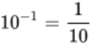 and MathJax failure: MathML - MathML must be formed by a single element.
From this simple definition, you can now go on to look at power notation, or index notation as it is often called, in more detail.

1.1 Rule 1 – Multiplying with powers
If you want to multiply a³ by a² this can be written as:

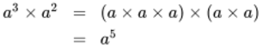
View alternative description - Uncaptioned Equation

Comparing the powers shows that the sum of the original powers (3 and 2) equals the power in the answer.
This works with any powers, both positive and negative, where the base number (a) is the same. So, the rule can be generalised as:

(Rule 1)
View alternative description - Uncaptioned Equation

Here’s an example with both positive and negative indices.

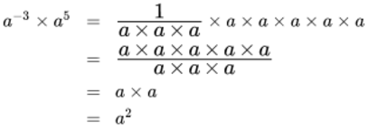
View alternative description - Uncaptioned Equation

Or using the rule 1:

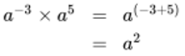
View alternative description - Uncaptioned Equation

This is a much quicker way to the answer.
This idea can be extended to include division, as you will see in the next section.

1.2 Rule 2 – Dividing with powers
This time let’s look at a⁵ divided by a², which can be written as:

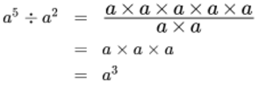
View alternative description - Uncaptioned Equation

This time the difference between the powers (5 and 2) is the same as the power in the final result – giving Rule 2:

(Rule 2)
View alternative description - Uncaptioned Equation

Thus 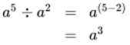
Here’s an example with both positive and negative indices.

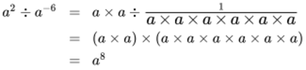
View alternative description - Uncaptioned Equation

(Note when you divide by a fraction it is the same as multiplying by the inverted fraction. If you want to revise fractions try another of our badged courses – Succeed with Maths Part 2).
Or using Rule 2:

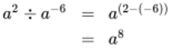
View alternative description - Uncaptioned Equation

It is important to remember that Rules 1 and 2 only work if the powers involve the same base number, for example, you can’t apply them to a³ × b² or a⁷ − b⁵.
There are occasions when you will encounter a power of a power – the next section looks at this situation.

1.3 Rule 3 – Powers of powers
You know that a² = a × a.
This can be extended to powers of powers.
So, 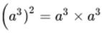
Using Rule 1 gives:

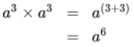
View alternative description - Uncaptioned Equation

This time the product (3 × 2) of the original powers is the same as the power in result. So, rule 3 can be stated as:

Rule 3
View alternative description - Uncaptioned Equation

Again, this rule works for positive and negative indices.
For example, 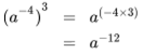
So far you have looked at powers that are all integers, however fractional powers are also very common. These will be the subject of the next section.

1.4 Roots and fractional indices
To see what fractional indices mean in practice a good place to start is with this example:

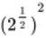
View alternative description - Uncaptioned Equation

Using Rule 3 and 1 this can be written as follows:

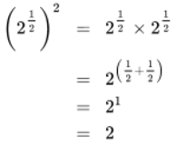
View alternative description - Uncaptioned Equation

This shows that 2^{1/2} is a way to represent the square root of 2. Since .
Extending this a^{1/3} is the cube root of a and can be written as . a^{1/4} is the fourth root of a, written as .

So it follows that:
a^{1/n} is the nth root of a and can be written as .
If you use Rule 3 to write a^{p/q} as 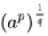, you should now be able to see that a^{p/q} is the qth root of a^{p} which is written as .
So, 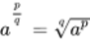
Rules 1, 2, and 3 all work with fractional indices.
Before moving on to another topic, you’ll learn what the power of zero means.

1.5 The power of zero
At first sight a power of zero wouldn’t seem to mean anything. However, by using Rule 2 (dividing with powers) you can show that anything to the power zero is 1.
Clearly 2 ÷ 2 = 1.
However, using Rule 3, and the fact that 2 = 2¹, you can re-write this as:
2¹ ÷ 2¹ = 2^{(1–1)} = 2⁰
Showing that 2⁰ = 1
This can be generalised to give: a⁰ = 1.
Note that you can now explain why 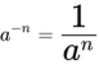.
By writing a^{−n} as a^{(0 − n)}
and, using Rule 2, this is the same as a⁰ ÷ a^{n}.
Since a⁰ = 1 this is then the same as:

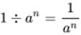
View alternative description - Uncaptioned Equation

In the same way, you can show that

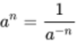
View alternative description - Uncaptioned Equation

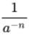can be written as 1 ÷ a^{–n}
So, using Rule 2 and a⁰ = 1 gives:

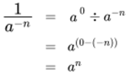
View alternative description - Uncaptioned Equation

Now try some examples.

Activity 1 Working with power rules
Allow about 15 minutes

Simplify each of the following examples. For a) and b) do this without a calculator initially.
- 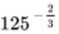
- 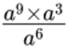
- 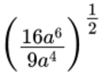

View discussion - Activity 1 Working with power rules

All the examples you have looked at in this section have a simple answer but this will not always be the case, particularly where the calculation relates to a situation modelled on the real world.
In the next section you will be able to put these ideas in to practice again, as you learn about how to use powers to represent very small and very large numbers.

2 Large quantities and small quantities – scientific notation
Scientists frequently deal with enormous quantities – and with tiny ones. For example, it is estimated that the Earth came into being about four and a half thousand million years ago. It took another six hundred million years for the first living things – bacteria – to appear. Bacteria are so small that they bear roughly the same proportion to the size of a pinhead as the size that pinhead bears to the height of a four-year old child!
Powers of ten provide a convenient way of writing down very large or very small numbers. For example,
10⁶ = 1 000 000 (a million) and 10⁻³ = 1/1000 = 0.001 (a thousandth)
This shorthand can be extended to any quantity, simply by multiplying the power of ten by a small number. For instance,
2 × 10⁶ = 2 × 1 000 000 = 2 000 000 (two million)
(The quantity on the left-hand side would be said as ‘two times ten to the six’.) Similarly,
3.5 × 10⁶ = 3 500 000 (three and a half million)
7 × 10⁻³ = 7/1000 = 0.007 (seven thousandths)
Scientists make so much use of this particular shorthand that it has come to be known as scientific notation (although in maths texts you may also find it referred to as ‘standard index form’ or ‘standard form’).
A quantity is said to be expressed in scientific notation if its value is written as a number multiplied by a power of ten. The number can be a single digit or a decimal number, but must be greater than or equal to 1 and less than 10.
Note the restriction: 75 × 10² is not in scientific notation and nor is 0.75 × 10⁴, though these are both equivalent to 7.5 × 10³ which is in scientific notation.
Scientific notation can be defined more succinctly by making use of some of the mathematical symbols denoting the relative sizes of quantities. These symbols are:

> | greater than (e.g. 3 > 2);
≥ | greater than or equal to (e.g. a ≥ 4 means that the quantity a may take the exact value 4 or any value larger than 4);
< | less than;
≤ | less than or equal to.

Note that:
- a≥ 4, and
- 4 ≤ a
convey exactly the same information about the quantity a.
Using these symbols, scientific notation may be defined as a notation in which the value of a quantity is written in the form a × 10^{n}, where n is an integer and 1 ≤ a < 10.
To move from scientific notation to integers or to decimal notation, first deal with the power of ten, then carry out the multiplication or division.
Look at this worked example and then have a go at the questions that follow yourself.

Worked example 1
Allow about 5 minutes

Express the following numbers as integers or in decimal notation:
- 4.53 × 10³ = 4.53 × 1000 = 4530
- 8.371 × 10²
- 6.4 × 10⁻³

View answer - Worked example 1

Note that, as in Worked example 1, a requirement to express a quantity in a different form simply involves taking the quantity and writing down its equivalent in the new form. You may do this in one step, or write down intermediate steps as was done in the worked example.
Now try this in the following activity.

Activity 2 Scientific notation to integers or decimal notation
Allow about 5 minutes

Without using your calculator, express the following numbers as integers or in decimal notation. Note that (a) and (b) are in scientific notation, while (c) is not.
- 5.4 × 10⁴
- 2.1 × 10⁻²
- 0.6 × 10⁻¹

View answer - Activity 2 Scientific notation to integers or decimal notation

Moving from an integer or decimal notation to scientific notation is equivalent to deciding what power of ten you need to multiply or divide by in order to convert the number you are starting with to a number that lies between 1 and 10. The following worked example shows you how to carry this out.

Worked example 2

Express the following numbers in scientific notation:
- 356 000
- 49.7 × 10⁴
- 0.831

View answer - Worked example 2

Now try this in the following activity.

Activity 3 An integer or decimal notation to scientific notation
Allow about 5 minutes

Without using your calculator, express the following numbers in scientific notation:
- 215
- 46.7
- 152 × 10³
- 0.0000876

View answer - Activity 3 An integer or decimal notation to scientific notation

It is only too easy to lose track of the sizes of things when using scientific notation, so you should make a habit of thinking carefully about what the numbers mean, bearing in mind that numbers may be positive or negative. For example:
- −1 × 10¹⁰ is a very large negative number;
- −1 × 10⁻¹⁰ is a very small negative number;
- 1 × 10⁻¹⁰ is a very small positive number.
Figure 1 places on the number line some numbers in scientific notation. You may find this helps you to visualise things.

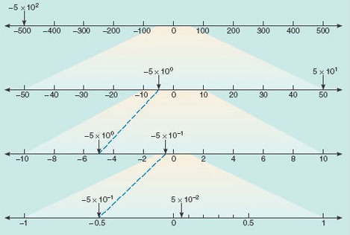
Figure 1 Portions of the number line, showing the positions of a few large and small numbers expressed in scientific notation
View description - Figure 1 Portions of the number line, showing the positions of a few large and small ...

You started this section thinking about the early Earth and the first appearance of life. Using scientific notation, the age of the Earth can be neatly expressed as 4.6 × 10⁹ years and the size of one type of those early bacteria as 1.2 × 10⁻⁶ metres. Of course, the value you come up with for such sizes will depend on the units in which we choose to make the measurements. If you were measuring the diameter of the Moon, you could elect to express it in metres or in kilometres, or even in miles.
Units of measurement will be covered next week. Before moving on to that it’s time to attempt the first short quiz.

3 This week’s quiz
Check what you’ve learned this week by taking the end-of-week quiz.
Week 1 practice quiz
Open the quiz in a new window or tab (by holding down Ctrl [or Cmd on a Mac] when you click the link) then come back here when you’ve finished.
To open in a new window, right click on the link above and select ‘Open in new window’.

4 Summary of Week 1
Now is a good time to revisit the learning outcomes for this week. Below is a summary of what you have covered.
- You have gained an understanding of the rules for indices with the same base number.
- You applied the rules for indices in different situations.
- You gained an understanding of scientific notation.
- You wrote large and small values in scientific notation.
- You wrote values shown in scientific notation in decimal form.
These ideas will appear again over the coming weeks, and will prove very useful next week when you turn your attention to measurement.

Week 2: Measurements

Introduction
In the UK, two systems of units are in use. Imperial measures for some things: milk is sold in pints and signposts indicate distances in miles. But for many other everyday measurements metric units have been adopted: petrol in litres and sugar in kilogram bags. However, this is, generally, not the case in science. In 1960 an international conference formally approved a standard set of scientific units, thus replacing at a stroke the many different systems of measurement that had been used up until then by scientists of different nationalities. This ‘universal’ system for scientific measurement is referred to as SI units (short for Système International d’Unités). The SI forms the basis for this week’s study.
By the end of this week you will have:
- gained an understanding of SI units and prefixes
- identified the order of magnitude of a value
- started to gain an understanding of logarithms
- considered the precision of measurements
- gained an understanding of rounding using significant figures.

1 Units of measurement
In SI, there are seven ‘base units’, which are listed in Box 1. Surprising as it may initially seem, every unit for every other kind of quantity (speed, acceleration, pressure, energy, voltage, heat, magnetic field, properties of radioactive materials, indeed whatever you care to name) can be made up from combinations of just these seven base units. For instance, speed is measured in metres per second. In this course you will work mainly with the familiar base units of length, mass, time and temperature, and some of their combinations, but it is worth knowing that the other base units exist as you may meet them elsewhere.

Box 1 The SI base units

Physical quantity | Name of unit | Symbol for unit
length | metre | m
time | second | s
mass | kilogram | kg
temperature | kelvin | K
amount of substance | mole | mol
electric current | ampere | A
luminous intensity | candela | cd

Most of these base units relate to physical descriptions that apply universally. The SI base unit of time, the second, is defined as the period over which the waves emitted by caesium atoms under specific conditions cycle exactly 9 192 631 770 times. Then the SI base unit of length, the metre, is defined by stating that the speed of light in a vacuum is exactly 299 792 458 metres per second.
The SI base unit of mass, the kilogram, is the only fundamental unit that is defined in terms of a specific object. The metal cylinder which constitutes the world's 'standard kilogram' is kept in France. Note that the kilogram is the standard unit of mass, not of weight. In scientific language, the weight of an object is the downward pull on that object due to gravity, whereas its mass is determined by the amount of matter in it.
The SI base unit of temperature is the kelvin, which is related to the everyday unit of temperature, the degree Celsius:
(temperature in kelvin) = (temperature in degrees Celsius) + 273.15
The amount of a pure substance is expressed in the SI base unit of the mole. Whatever the smallest particle of a given substance is, one mole of that substance will contain 6.022 1408 57(74) × 10²³ (known as Avogadro’s number) of those particles. A mole of graphite contains Avogadro’s number of carbon atoms. A mole of carbon dioxide (one carbon atom joined to two oxygen atoms), contains Avogadro’s number of these molecules.

It is important to realise that, although in everyday usage it is common to say that you 'weigh so many kilos', there are two things wrong with this usage from the scientific point of view. First, as noted in Box 1, the kilogram is not a unit of weight, but a unit of mass. Secondly, in scientific language, 'kilo' is never used as an abbreviation for kilogram. In science, kilo is always used as a prefix, denoting a thousand: one kilometre is a thousand metres, one kilogram is a thousand grams.
Another familiar prefix is 'milli', denoting a thousandth. One millimetre is one-thousandth of a metre; or put the other way round, a thousand millimetres make up a metre. There are many other prefixes in use with SI units, all of which may be applied to any quantity. Like kilo and milli, the standard prefixes are based on multiples of 1000 (i.e. 10³). The most commonly used prefixes are listed in Box 2.
Although scientific notation, SI units and the prefixes in Box 2 are universal shorthand for all scientists, there are a few instances in which other conventions and units are adopted by particular groups of scientists for reasons of convenience. For example, you have seen that the age of the Earth is about 4.6 × 10⁹ years. One way to write this would be 4.6 'giga years' but geologists find millions of years a much more convenient standard measure. They even have a special symbol for a million years: Ma. So, in Earth science texts you will commonly find the age of the Earth written as 4600 Ma.
A few metric units from the pre-SI era also remain in use. In chemistry courses, you may come across the ångström (symbol Å), equal to 10⁻¹⁰ metres. This was commonly used for the measurement of distances between atoms in chemical structures, although these distances are now often expressed in either nanometres or picometres. Other metric but non-SI units with which you are probably familiar are the litre (symbol l) and the ‘degree Celsius’ (symbol °C).

Box 2 Prefixes used with SI units

prefix | symbol | multiplying factor
tera | T | 10¹² | = 1000 000 000 000
giga | G | 10⁹ | = 1000 000 000
mega | M | 10⁶ | = 1000 000
kilo | k | 10³ | = 1000
- | - | 10⁰ | = 1
milli | m | 10⁻³ | = 0.001
micro | μ * | 10⁻⁶ | = 0.000 001
nano | n | 10⁻⁹ | = 0.000 000 001
pico | p | 10⁻¹² | = 0.000 000 000 001
femto | f | 10⁻¹⁵ | = 0.000 000 000 000 001
* The Greek letter μ is pronounced ‘mew’.

The following data may help to illustrate the size implications of some of the prefixes:
- the distance between Pluto (the furthest planet in the Solar System) and the Sun is about 6 Tm,
- a century is about 3 Gs,
- eleven and a half days contain about 1 Ms,
- the length of a typical virus is about 10 nm,
- the mass of a typical bacterial cell is about 1 pg.
There are also some prefixes in common use, which don’t appear in Box 2 because they don’t conform to the ‘multiples of 1000’ rule, but never the less produce convenient measures. One is centi (hundredth): rulers show centimetres (hundredths of a metre) as well as millimetres, and standard wine bottles are marked as holding 75 cl. One less commonly seen is deci (tenth), but that is routinely used by chemists in measuring concentrations of chemicals dissolved in water, or other solvents. Later this week you will also come across the decibel, which is used to measure the loudness of sounds.
Look at this worked example, and then try converting between units in the following activity.

Worked example 1
Allow about 5 minutes

Diamond is a crystalline form of carbon in which the distance between adjacent carbon atoms is 0.154 nm. What is this interatomic distance expressed in picometres?

View answer - Worked example 1

Now try this in the following activity.

Activity 1 Converting between units and scientific notation
Allow about 5 minutes

Using scientific notation, express:
- 3476 km (the radius of the Moon) in metres,
- 8.0 μm (the diameter of a capillary carrying blood in the body) in nm,
- 0.8 s (a typical time between human heartbeats) in ms.

View answer - Activity 1 Converting between units and scientific notation

When looking at the size of things sometimes all that you need to know is approximately how big, or small it is. You will explore this idea in the next section.

2 Scales of measurement
In thinking about the sizes of things, it is sometimes useful to do so in quite rough terms, just to the nearest power of ten. For example, 200 is nearer to 100 than it is to 1000, but 850 is nearer to 1000 than it is to 100. So, if you were approximating to the nearest power of ten you could say 200 was roughly 10², but 850 was roughly 10³. This process is called reducing the numbers to the nearest order of magnitude.
The approximate value of a quantity expressed as the nearest power of ten to that value is called the order of magnitude of the quantity.
The easiest way to work out the order of magnitude of a quantity is to express it first in scientific notation in the form a × 10^{n}. Then a if is less than 5, the order of magnitude is 10^{n}. But if a is equal to or greater than 5, the power of ten is rounded up by one, so the order of magnitude is 10^{n+1}. For example, the diameter of Mars is 6762 km. This can be written as 6.762 × 10³ km, and because 6.762 is greater than 5, the diameter of Mars is said to be ‘of order 10⁴ km’.
This is normally written as:
- diameter of Mars ~ 10⁴ km
where the symbol ~ denotes ‘is of order’.

Activity 2 Orders of magnitude
Allow about 5 minutes

1. What is the order of magnitude of the mass of the Earth, which is 6.0 × 10²⁴ kg?

View answer - Part

2. What is the order of magnitude of the mass of Jupiter, which is 1.9 × 10²⁷ kg?

View answer - Part

3. What is the order of magnitude of the average lifetime of unstable ‘sigma plus’ particles, which is 0.7 × 10⁻¹⁰ s?

View answer - Part

Worked example 2
Allow about 5 minutes

To the nearest order of magnitude, how many times more massive is Jupiter than the Earth?

View answer - Worked example 2

An idea related to order of magnitude is the logarithmic scale, and that is the subject of the next section.

3 The logarithmic scale
Sophisticated instrumentation now allows scientists to measure across 40 orders of magnitude, as shown in Figure 2. If you look back at Figure 1, you will see that the horizontal scale is quite different to that of the vertical scale in Figure 2. On each line of Figure 1, the interval between marked points was always the same with, on the top line for example, marked points at −100, 0, 100, 200, etc. In other words, each step from one division to the next on the scale represented the addition or subtraction of a fixed amount (100 in that case). This kind of scale is called linear. In Figure 2, on the other hand, each step up or down the scale involves multiplication or division by a fixed power of ten (10² in this case). As a result, the intervals between divisions are all different. This kind of scale is called logarithmic. Activity 3 allows you to investigate some of the properties of the scale used in Figure 2.

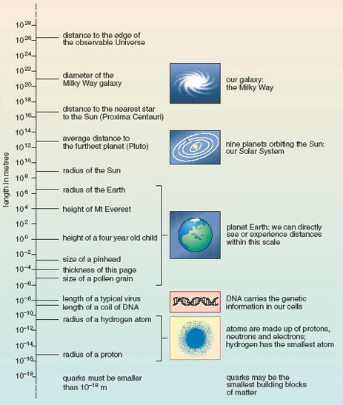
Figure 2 The scale of the known Universe
View description - Figure 2 The scale of the known Universe

Activity 3 The logarthimic scale
Allow about 10 minutes

(a) On Figure 2, what is the difference in value between:
- the tick marks at 10⁻² m and 10⁰ m;
- the tick marks at 10⁰ m and 10² m, and
- the tick marks at 10² m and 10⁴ m?

View answer - Part

(b) From Figure 2, calculate to the nearest order of magnitude:
- how many times taller than a child is Mount Everest;
- how many typical viruses laid end to end would cover the thickness of a piece of paper. (Hint: you may find it helpful to look back at Worked example 2.)

View answer - Part

In Figure 2, a logarithmic scale was used for the purposes of display, and the power of ten for the multiplying factor (10²) was chosen because it was the one that best fitted the page. In drawing diagrams and graphs you are always free to choose the scale divisions. However, logarithmic scales are used in certain fields to measure quantities that can vary over a very wide range. In such cases, an increase or decrease of one ‘unit’ always represents a ten-fold increase or decrease in the quantity measured. Box 3 gives two examples.

Box 3 Logarithmic scales in practice

Sound waves
The decibel (symbol dB) is the unit used to measure the relative loudness of sounds. The ‘intensity’ of a sound is related to the square of the variation in pressure as the sound wave passes through the air, and the range of intensities that people can detect is enormous. The sound that just causes pain is 10¹² times more intense than the sound that is just audible! To deal with this, a logarithmic scale for loudness was devised, according to which every 10 dB (or ‘1 bel’) increase in sound level is equivalent to a 10-fold increase in intensity. 1 dB is just within the limit of human hearing, and a change of 1 dB is about the smallest difference in sound that the ear can detect (see Figure 3).

Earthquakes
The Richter scale describes the magnitude of earthquakes and is a measure of the maximum ground movement caused by an earthquake. Some earthquakes can produce ground movements millions of times greater than the minimum detectable limit. To cope with this huge variation, the Richter scale is logarithmic: an increase of one unit on the scale implies a ten-fold increase in the maximum ground movement. A magnitude 3 earthquake produces 10 times more ground motion than a magnitude 2 earthquake.

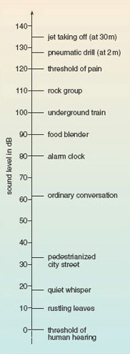
Figure 3 Some common sounds on the decibel scale of sound level
View description - Figure 3 Some common sounds on the decibel scale of sound level

Worked example 3
Allow about 10 minutes

A whisper corresponds to a sound level of about 20 dB, and a shout to a level of about 80 dB. How much greater is the intensity of a shout compared to that of a whisper?

View answer - Worked example 3

Now try this in the following activity.

Activity 4 Comparing logarithmic quantities
Allow about 5 minutes

How much more ground movement is there in an earthquake measuring 7 on the Richter scale compared to one measuring 3?

View answer - Activity 4 Comparing logarithmic quantities

With any measurement, whether based on a linear or logarithmic, it is important to know how precise they are. You will learn about precision in the next section.

4 How precise are the measurements?
Scientists and technologists are always trying to get better and more reliable data. One way of getting a more precise measurement might be to switch to an instrument with a more finely divided scale. Figure 4 shows parts of two thermometers placed side by side to record the air temperature in a room.

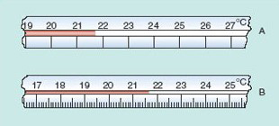
Figure 4 Parts of two thermometers A and B, measuring the air temperature in the same place
View description - Figure 4 Parts of two thermometers A and B, measuring the air temperature in the ...

The scale on thermometer A is quite coarse. The marked divisions represent integer numbers of degrees. On this scale you can see that the temperature is between 21 °C and 22 °C. You might estimate it as 21.7 °C, but somebody else could easily record it as 21.6 °C or 21.8 °C. So there is uncertainty in the first decimal place, and no way you could attempt to guess the temperature to two decimal places using this particular thermometer.
Thermometer B has a finer scale, with divisions marked every 0.1 °C. Now you can clearly see that the temperature is between 21.6 °C and 21.7 °C. You might read it as 21.63 °C, but a second person could plausibly read it as 21.61 °C or 21.65 °C. With this scale you are sure of the first decimal place but uncertain of the second.
When quoting the result of a measurement, you should never quote more digits than you can justify in terms of the uncertainty in the measurement. The number of significant figures in the value of a measured quantity is defined as the number of digits known with certainty plus one uncertain digit. With thermometer A you could be sure of the 21 (two digits), but were uncertain about the digit in the first decimal place, so you can quote a reading to three significant figures, as 21.7 °C. With thermometer B it was the fourth digit that was uncertain, so you can quote your reading to four significant figures, as, for example, 21.64 °C.
Get some practice with identifying the number of significant figures in a number in this activity.

Activity 5 How many significant figures?
Allow about 2 minutes

How many significant figures are quoted in each of the following quantities: 1221 m; 223.4 km; 1.487 km?

View answer - Activity 5 How many significant figures?

If you measured the length of something as 13 mm, you would want to maintain the precision of your result if it was converted to centimetres or metres. Whether you write 13 mm or 1.3 cm or 0.013 m you are expressing the measurement to two significant figures. Why is 0.013 m only two significant figures rather than four though? You know that the uncertainty in your result hasn’t changed, so this shows that leading zeroes in decimal numbers do not count as significant figures.
Another circumstance in which you have to be careful about not using unjustified precision occurs when the results of measurements are used as the basis for calculations.
Suppose you had measured the diameter of a circular pattern to two significant figures as 3.3 cm. To calculate the radius you would divide this by 2 and get 1.65 cm. But is that how you should state the radius, as 1.65 cm is shown to three significant figures? That implies that the radius is more precise than the measurement made of the diameter. This clearly does not make sense, so the radius can only be shown to the same number of significant figures as the diameter. This means rounding it up to 1.7 cm, since the 3rd significant figure is 5 or more. If the 3rd significant figure had been 4 or less, then the value would have been rounded down.
Similarly, in any calculation you should make sure that your answer is no more precise than the least precise data that you started with. If you calculated the area of a rectangular pond with sides measuring 2.34 m and 4.2 m, the area should only be shown to 2 significant figures since there are only two significant figures in the least-precisely known value used in the calculation, the 4.2 m.
You also need to take care with large numbers with trailing zeros, such as 50 000. It is not clear whether this an exact number, or has been rounded to five, four, three, two or one significant figures. This ambiguity can be cleared up by using scientific notation. For example, if a length is measured to just one significant figure as 8 m, how should the equivalent value in centimetres be expressed? It would be misleading to write 800 cm, since that could imply the value is known to three significant figures. However if you use scientific notation 800 cm can be written as 8 × 10² cm making it clear that the quantity is known only to one significant figure, in line with the precision of the original measurement.

Worked example 4
Allow about 5 minutes

The average diameter of Mars is 6762 km. What is this distance in metres, expressed to three significant figures?

View answer - Worked example 4

Activity 6 More practice with significant figures
Allow about 5 minutes

1. If the speed of light through glass is quoted as 2.0 × 10⁸ metres per second, how many significant figures are being given?

View answer - Part

2. Neon gas makes up 0.0018% by volume of the air around us. How many significant figures are being given in this percentage?

View answer - Part

3. Express the following temperatures to two significant figures:
- −38.87 °C
- −195.8 °C
- 1083.4 °C

View answer - Part

In your future studies of science and technology, you will be doing lots of calculations with numbers in scientific notation, and will also be expected to quote your results to appropriate numbers of significant figures.
Before completing this week you’ll now have the chance to practice the topics in the end-of-week quiz.

5 This week’s quiz
Check what you’ve learned this week by taking the end-of-week quiz.
Week 2 practice quiz.
Open the quiz in a new window or tab then come back here when you’ve finished.
To open in a new window, right click on the link above and select ‘Open in new window’.

Week 3: Introduction to algebra

Introduction
In mathematics, equations are used a great deal in arriving at a solution to a problem. This week, you will build skills to enable you to solve an equation, or equations, using algebraic techniques. You’ll start by looking at why algebra is so useful, before moving on to simplifying algebraic expressions and changing the subject of an equation. These are both important techniques in preparation for solving equations. In the final section, you will learn how to solve simultaneous equations – pairs of equations each with the same two unknowns. As usual you will have the opportunity to practice the techniques by completing the activities included this week.
By the end of this week you will have:
- gained an understanding of how to rearrange and simplify algebraic expressions
- learned how to solve for one unknown in an equation
- learned how to solve for two unknowns in simultaneous equations.

1 Why use algebra?
You may well have come across formulas before, such as:

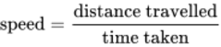
View alternative description - Uncaptioned Equation

This example allows you to calculate the speed for any distance travelled and associated time taken to travel that distance. Similarly, if you knew the speed and distance travelled by rearranging the equation you could calculate the time taken. This is a relatively simple example of how algebra can be used, and has been used for centuries.
Algebra is a powerful mathematical tool that enables generalisation – something may seem to be true for many sets of specific data values, but is it true for all such sets?
Before discussing equations in more detail, here’s one example of how algebra is used to generalise.

Generalisation using algebra
Find the sum of three consecutive whole numbers or integers. Divide your answer by 3. What do you notice? (You may need to try this for several sets until you find a pattern.) You should notice that the result appears to be divisible exactly by 3, and be the middle of the three consecutive numbers.
The pattern can be explained by working out a formula for this calculation. Suppose you call the first number n, that means as the three numbers are consecutive the second number can be written as n + 1, and the third as n + 2.
So, the sum of any three consecutive numbers is:
n + (n + 1) + (n + 2)
This can be simplified by carrying out the sum.
n + (n + 1) + (n + 2) = n + n + n + 3
Since there are 3 lots of n, this can be shown as 3n (3n = 3 × n).
Thus n + (n + 1) + (n + 2) = 3n + 3
The next instruction is to divide the sum by 3.
Dividing by 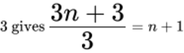
Therefore, the product of three consecutive numbers is always divisible by exactly by three, and n + 1 – the middle of the three numbers.
This example uses simplification to obtain the generalisation. You will cover this technique in the next section.

2 Simplifying algebraic expressions
Whenever you wish to solve an expression, you should first rearrange it to make it as simple as possible, then manipulate it. If you try to manipulate expressions in a complex form, you increase the possibility of making mistakes or becoming confused. Once the expression has been simplified, you can either solve it or state it in its most simplified form.
First, though, a quick reminder about the rules for order of mathematical operations.

2.1 Sequence of arithmetical calculations
You may be familiar with the acronym BIDMAS (or BODMAS or BEDMAS). This is a reminder that in any sum there is standard order in which to carry out the calculations.
That is:
- Brackets
- Indices
- Division
- Multiplication
- Addition
- Subtraction
To show how important these rules are look at this example.
4 + 2 × 7
Carrying this out from left to right, without considering BIDMAS gives:

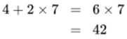
View alternative description - Uncaptioned Equation

And now using BIDMAS (multiplication must come before addition):

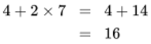
View alternative description - Uncaptioned Equation

Two very different answers – showing why the accepted order of operation, BIDMAS, is so vital.
To clarify the order, or change the order, that operations are carried out in you can use brackets.
Looking at 4 + 2 × 7 again. This can be written as:
4 + (2 × 7)
So, now the intended order of operation is clear.
If the brackets have been included to show (4 + 2) × 7 this would change the order of operation.
Just as with arithmetic algebra has rules and conventions in the way that it operates. In other words, there are things that you have to do (rules) and things that mean that mathematics is presented consistently (conventions). Conventionally, when there are no brackets, multiplication and division are done before addition and subtraction; most calculators will do this automatically.
Other useful conventions are:
- writing 4n instead of 4 × n; 4mn is 4 × m × n
- writing 4n rather than n4
- writing the product of multiplying x by itself as x² instead of xx
- writing x rather than 1x.
You will now look at some examples of simplifying expressions.

Worked example 1
Allow about 10 minutes

Simplify:
12t + 13t² – 4 – 6t + 3t²
There are three kinds of terms in this expression. Simple numbers like 4, terms like 12t and terms like 13t².
Two useful rules follow:
- when adding like terms, add the coefficients; for example, 2x + 5x = 7x
- don’t mix powers of the same variable – you can’t add x + 2x² to give a single term, as they represent different numbers; for example, when x = 2, x² = 4.
By convention, the terms with the highest power go at the start of the expression.
So, start by collecting all the terms that relate to t and t²together, and begin the statement with the terms that relate to t².

View alternative description - Uncaptioned Equation

Now, add like terms together, and simplify as far as possible.

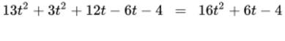
View alternative description - Uncaptioned Equation

Looking at 16t² + 6t – 4, you should be able to see that all the coefficients are divisible exactly by 2. So, the expression can be simplified further to:
16t² + 6t – 4 = 2(8t² + 3t – 2)
See how you get on with simplifying in this activity.

Activity 1 Simplifying expressions
Allow about 10 minutes

Simplify the following:
- 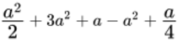

View answer - Activity 1 Simplifying expressions

Before looking in more detail at the use of brackets in mathematics the next section will revise operations involving positive and negative numbers.

2.2 Positive and negative numbers
Numbers which have a plus sign attached to them, such as + 7, are referred to as positive numbers. Numbers which have a minus sign attached to them, such as –5, are referred to as negative numbers. Similarly, the symbols used in algebra can also be positive or negative.
When carrying out operations with positive and negative numbers you need to remember these general rules.

Addition of numbers with the same sign
When adding numbers with the same sign, the sign of the sum is the same as the sign on each of the numbers.
– 5 + (–4) = –9
+ 5 + (+ 9) = + 14
When adding numbers with the same sign, you can omit the brackets and the + sign for the addition. When the first number is positive, it is usual to omit its + sign.
+ 5 + (+9) = + 14 can be written as 5 + 9 = 14
– 5 + (–4) = –9 can be written as –5 – 4 = –9

Addition of numbers with different signs
To add numbers whose signs are different, subtract the numerically smaller from the larger. The sign of the result is the same as the sign of the numerically larger number.
–12 + 6 = –6
11 – 16 = –5
When dealing with several numbers of different signs, separately add the positive and negative numbers together. The set of numbers then becomes two numbers, one positive and one negative, which you can add in the usual way.

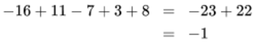
View alternative description - Uncaptioned Equation

Subtraction
To subtract numbers, change the sign of the number being subtracted and add the resulting number.

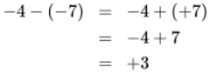
View alternative description - Uncaptioned Equation

Multiplication
The product of two numbers with the same signs is positive, while the product of two numbers with different signs is negative.
Negative × negative = positive
Positive × negative = negative
If you multiply any number by zero, the answer is always zero.

Division
When dividing numbers with the same signs this gives a positive answer and numbers with different signs give a negative answer.
For example, 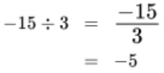
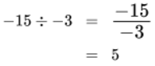
If you divide a number by zero, you will always get an error, as this is impossible.
Bear these rules in mind as you turn your attention to handling brackets in algebra in the next section.

2.3 Brackets in mathematics
As you have seen, brackets are used to indicate, and clarify, the order in which a numerical calculation should be carried out. This is also true when you are using symbols, as in algebra.
So, for example considering 2(2n + 5) you should first multiple out the brackets. This means that all of the expression inside the brackets is multiplied by the figure outside them – a crucial idea to remember.
Thus 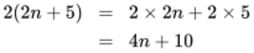
(Note, as a convention, 2(2n + 5) is preferable to (2n + 5)2, although, since it doesn’t matter what order you multiply two numbers in, they are equivalent.)
Here’s another example:

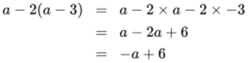
View alternative description - Uncaptioned Equation

The important point to note in this example is that everything in the bracket was multiplied by –2, not just 2.
Things become more complicated when you need to multiply two expressions both within brackets. For this you have to multiply each term, in both brackets by each other.
Let’s consider this example:
(a + 2)(b – 1)
It is easier to see the individual steps required by drawing lines between the terms in the expressions.

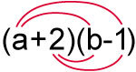

View alternative description - Uncaptioned Equation

If a = b
Then the expression becomes:
a² + a – 2
Now have a go yourself in this activity.

Activity 2 Removing brackets
Allow about 10 minutes

Expand each of the following expressions by removing the brackets. Then (if possible) collect like terms.
- 2(2x – y)
- 4(r + 6s) – (4s – r)
- x(2x – 3) – 2x(5 – 2x)
- (x – 2)(x + 3)
- (r + t)²
- (a – 4)(a + 4)
- 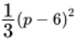

View answer - Activity 2 Removing brackets

You should now feel more confident with simplifying algebraic expressions – don’t worry if some of these felt quite complex. The more practice you get the easier this will get.
Now it is time to look at how to rearrange equations.

3 Changing the subject of an equation
You may wish to rearrange an equation, to change its subject as some equations may have more than one algebraic symbol that is an unknown. The equation may be expressed in terms of x, say x = y + 4. You may wish to know what the equation would look like if it were expressed in terms of y.
The critical thing with any equation is that you must always carry out the same operations on each side of the equation. If, for example, you subtract x from one side of the equation but not from the other, it changes the equation completely. Since the quantities on each side of an equation are the same, anything done to one side must be done to the other to maintain the equality.
Say you wish to rearrange x = y + 3 so that y becomes the subject of the equation.
You can subtract 3 from both sides of the equation, and simplify.

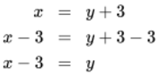
View alternative description - Uncaptioned Equation

Which would then be written as:
y = x – 3
to follow the convention to show the subject on the left.
As another example, say you wish to rearrange 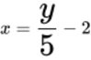 so that y becomes the subject of the equation.
First, multiply both sides by 5: 5x = y − 10
(Note everything on the right has been multiplied by 5 to maintain the equation)
Then add 10 to both sides: 5x + 10 = y
Finally re-write as:
y = 5x + 10
Now try some rearrangement exercises for yourself.

Activity 3 Rearranging equations
Allow about 10 minutes

In all cases, rearrange the equations to make x the subject of the equation.
- x – 5 = y
- 3x – 3 = y
- 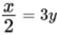
- 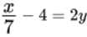
- 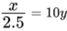
- 2x – 12 = 2y

View answer - Activity 3 Rearranging equations

Practicing simplifying and rearranging equations and expressions gives you the skills you need to move on to solving them.

4 Solving simple equations with one unknown
Consider the equation 4x = 24. As it is written x is the unknown and to solve this equation you need to find the value of x which makes the statement 4x = 24 true.
You may be able to see this straight away, but if not, divide both sides of the equation by 4, to get an answer for x.

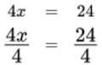
View alternative description - Uncaptioned Equation

The solution is, therefore, x = 6.
You can check the accuracy of your answer by substituting the value for x back into the original equation: 4 × 6 = 24.
Try this examples for yourself now.

Activity 4 Solving equations
Allow about 5 minutes

Now solve the following equations for x.
- 3x = 6
- 7x = 21
- 8x = 32
- x + 3 = 9
- x + 6 = 7
- x + 7 = 11

View answer - Activity 4 Solving equations

Now you’ve warmed up try some slightly more complex equations, which involve rearranging equations and multiplying out of brackets.

Activity 5 More complex equations
Allow about 15 minutes

Now solve the following equations for m.
- 2x – 1 = 7
- 5x – 8 = 2
- 3x + 8 = 5
- 3x – 8 = 5x – 20
- 3(x + 1) = 9
- 23 – x = x + 11
- 2(x – 3) – (x – 2) = 5
- 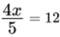
- 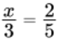
- 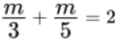
- 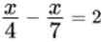

View answer - Activity 5 More complex equations

Rather than solving just one equation in the next section you will learn about pairs of equations with two unknowns.

5 Simultaneous equations
Simultaneous equations are pairs of equations that are both true (i.e. they are simultaneously true). They are both expressed as equations with two unknowns. By making one of these unknowns the subject of both equations, you can then substitute the subject in one equation and then solve for the other unknown. Then you can substitute back into the equation and solve for the first unknown.
This is easier to see in this example.
Here is a pair of simultaneous equations to solve for x and y.
- 2y = x + 7
- y = x + 2
First, you need to rearrange these equations to make either x or y the subject. The order doesn’t matter, as the answers that you will get must be the same. So, starting by making x the subject.

2y = x + 7 | subtract 7 from both sides | 2y − 7 = x + 7 − 7 | So, 2y − 7 = x
y = x + 2 | subtract 2 from both sides | y − 2 = x + 2 − 2 | So, y − 2 = x

Therefore, x = 2y − 7 and x = y − 2
Now there are two expressions for x, so the right-hand sides must be equal, and you can equate them:

So, 2y – 7 = y – 2 | deduct y from both sides | 2y – y – 7 = y – y – 2
So, y – 7 = –2 | add 7 to both sides | y – 7 + 7 = –2 + 7

Therefore, y = 5
You can then substitute this back into either of the original equations to find x.
2y = x + 7
So, 10 = x + 7
Therefore, x = 3
As a last check, make sure that this is true of the other equation.
x + 2 = y
x = y – 2 = 5 – 2 = 3
So the solution is x = 3, y = 5. Finally, check that these values satisfy both the original equations.
Have a go yourself in this final activity for the week.

Activity 6 Simultaneous equations
Allow about 10 minutes

Solve the following pairs of simultaneous equations.

(a) | y = x + 10 | 3y = 2x + 5
(b) | y = 4x | y = 3x + 5
(c) | y = 7x + 4 | 3y = x + 7
(d) | y = 2x + 4 | 3y = x + 7

View answer - Activity 6 Simultaneous equations

There has been a lot to take on board this week. As with any maths skill the more you practice the easier algebra will become, so before completing this week you’ll now have the chance to practice the topics in the end-of-week quiz.

6 This week’s quiz
Check what you’ve learned this week by taking the end-of-week quiz.
Week 3 practice quiz
Open the quiz in a new window or tab (by holding down Ctrl [or Cmd on a Mac] when you click the link) then come back here when you’ve finished.
To open in a new window, right click on the link above and select ‘Open in new window’

7 Summary of Week 3
In this week of the course you have looked at aspects of algebra. Below is a summary of other topics you’ve covered.
- Gained an understanding of how to rearrange and simplify algebraic expressions
- Learned how to solve for one unknown in an equation
- Learned how to solve for two unknowns in simultaneous equations.
Algebra is invaluable in science and technology, so the basic grounding you have gained this week will help you develop these skills further in future. Next week moves on to trigonometry and work with right-angled triangles.

Week 4: Starting with trigonometry

Introduction
Trigonometry is the area of maths that deals with triangles, and how their sides and internal angles are related. The trigonometric functions have very practical applications in science and technology, such as in navigation, bridge design and determining astronomical distances. This week you will work with the three basic functions of sine, cosine and tangent. It is important that you have access to a scientific calculator to carry out the activities. This does not have to be a hand-held calculator, you may be able to use a mobile phone, tablet or PC. You will just need to check the calculator has trig functions.
By the end of this week you will have:
- gained an understanding of the sine, cosine and tangent functions
- revised Pythagoras theory
- calculated unknown angles and the length of sides of triangles.

1 Right angled triangles
It is a triangle in which one of the angles is 90°, which is commonly referred to as a right angle. The sum of the angles in any triangle is 180°. So if the other two angles are α (alpha) and β (beta) as shown in Figure 1 then:

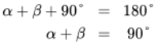
View alternative description - Uncaptioned Equation

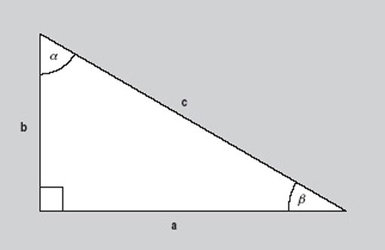
Figure 1 A right angle triangle
View description - Figure 1 A right angle triangle

Look at the angle β in Figure 1. The side of the triangle opposite to this is labelled b and is called the ‘opposite’. The side next to β is labelled a and is referred to as the ‘adjacent’. The side labelled c is the called the ‘hypotenuse’. The hypotenuse is always the side opposite the right angle.
Pythagoras’ Theorem states that the square of the length of the hypotenuse of a right angle triangle is equal to the sum of the squares of the lengths of the other two sides. Looking at the triangle in Figure 1 this gives:

View alternative description - Uncaptioned Equation

This formula, together with some knowledge of trigonometry enables us to calculate the angles and sides of the triangle in Figure 1 (given some other information).
Now look at a calculator and make sure that it is set in scientific mode if you are using a calculator on a mobile device or PC. Scientific calculators operate in at least two modes when dealing with angles. Before embarking on any of the examples please ensure that your calculator is in degree mode. This is usually the default option. To check that your calculator is set to degrees try this activity.

Activity 1 Calculator in degrees
Allow about 5 minutes

Use your calculator to work out the value of the following:
- sin 60
- cos 60
- tan 60
Whether you need to press the function button or enter the number first will depend upon the calculator you are using.

View answer - Activity 1 Calculator in degrees

The three functions that you used in this activity (sin, cos and tan) are the basic trigonometric (or ‘trig’) functions. These functions will be the subject of the remainder of the week.

2 Sine, cosine and tangent
Sin, cos and tan are the commonly used abbreviations for each function. So:
- Sin = sine
- Cos = cosine
- Tan = tangent
Sine is pronounced as ‘sign’ and cosine as ‘co-sign’.
Based on the triangle in Figure 2 these functions are defined as follows:

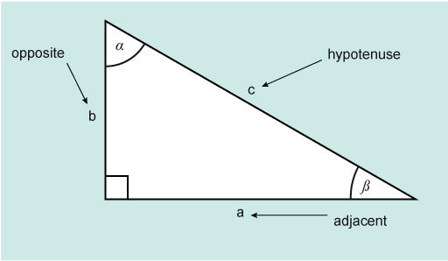
Figure 2 A right angle triangle
View description - Figure 2 A right angle triangle

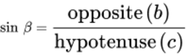
View alternative description - Uncaptioned Equation

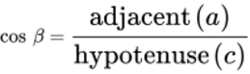
View alternative description - Uncaptioned Equation

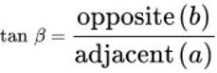
View alternative description - Uncaptioned Equation

There is an easy way to remember this: SOHCAHTOA (pronounced sock -ah- toe-a).
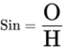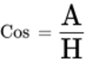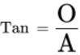
Using these functions, and Pythagoras theorem, if you know two sides or a side and an angle for a right-angled triangle, then you can find the other side, sides or angle as required.

Activity 2 Sine and cosine values between 0° and 90°
Allow about 5 minutes

Making sure that your calculator is still set to degrees, work out these values for sine and cosine.

1. | Sin 0°
2. | Cos 0°
3. | Sin 10°
4. | Cos 10°
5. | Sin 25°
6. | Cos 25°
7. | Sin 45°
8. | Cos 45°
9. | Sin 70°
10. | Cos 70°
11. | Sin 90°
12. | Cos 90°

Do you notice anything interesting about your answers?

View answer - Activity 2 Sine and cosine values between 0° and 90°

In fact, for any angle between 0° and 90° the values for sine and cosine lie between 0 and 1.
These two graphs (Figures 3 and 4) show the shape of the sine and cosine functions between 0 and 360°. From this you can see that both functions stay within –1 and +1.

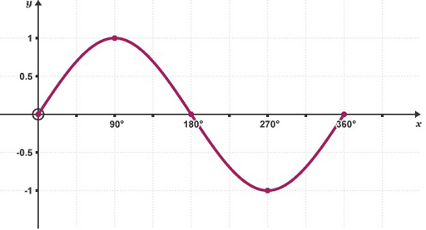
Figure 3 The sine function
View description - Figure 3 The sine function

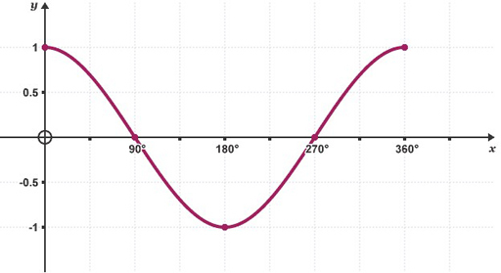
Figure 4 The cosine function
View description - Figure 4 The cosine function

As shown in Figure 5 the tangent function is not similar in the way that cosine and sine are but forms its own repeating pattern.

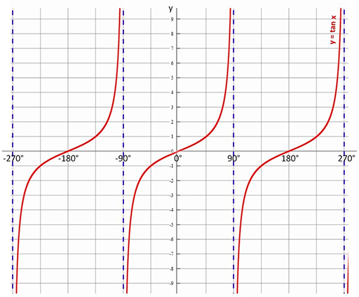
Figure 5 The tangent function
View description - Figure 5 The tangent function

Now it is time to see how you can use these functions with right-angled triangles.

2.1 Right angled triangles – one known side, and two known angles
Take a look at the following Worked example and Activity.

Worked example 1
Allow about 10 minutes

In the example in Figure 6 there are three unknown values, α, a and c, and three known values.

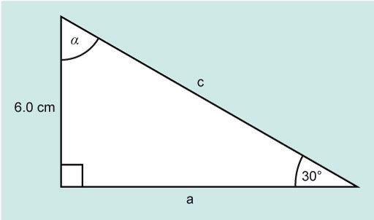
Figure 6 A right angle triangle for Example 1
View description - Figure 6 A right angle triangle for Example 1

The angle β is 30° and the side b is 6.0 cm. The right-angle is 90°.
The unknown angle α can be found using the fact that the sum of the internal angles of a triangle is 180°.

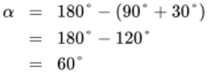
View alternative description - Uncaptioned Equation

Now calculate a, which is ‘adjacent’ to the angle β, which is 30°. The opposite side is 6.0 cm.
If you look at SOHCAHTOA, you will find that the function relating adjacent and opposite is tan.

View alternative description - Uncaptioned Equation

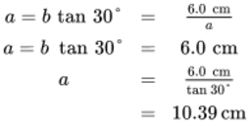
View alternative description - Uncaptioned Equation

The side a is 10.39 cm.
The value for a has shown to 4 significant figures, rather than rounded to 2 significant figures at this point, to avoid introducing rounding errors in the final answer.
The only remaining unknown is c and this can be found using Pythagoras Theorem.

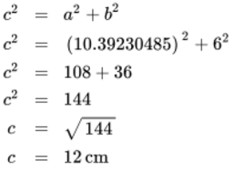
View alternative description - Uncaptioned Equation

The side c is 12 cm. Using the rules for a triangle, some basic trigonometry and Pythagoras, and knowing the length of one side and the size of one angle, the remaining angles and sides of the triangle have been found.
Now try this one yourself.

Activity 3 Find the unknown side
Allow about 7 minutes

Find the unknown side b and c and the angle α for Figure 7.

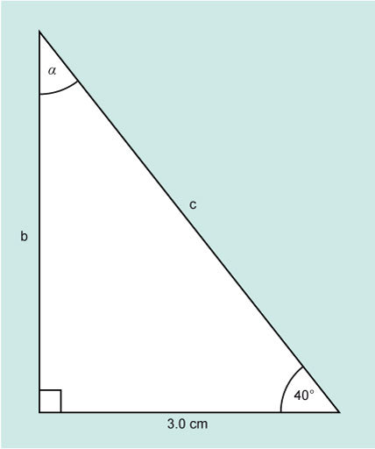
Figure 7 A right angle triangle for Activity 3
View description - Figure 7 A right angle triangle for Activity 3

View answer - Activity 3 Find the unknown side

The next section will consider the situation where angles α and β are unknown, but the length of two sides are known.

2.2 Right-angled triangles – two known values, and one unknown value
Take a look at the following Worked example and Activity.

Worked example 2
Allow about 15 minutes

Figure 8 shows a right-angled triangle where the length of two sides are known, and just one angle – the right angle.

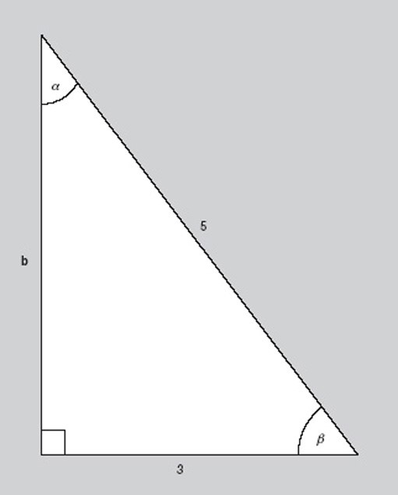
Figure 8 A right-angled triangle with one unknown side and two unknown angles.
View description - Figure 8 A right-angled triangle with one unknown side and two unknown angles.

The aim is to calculate the values of α, β and b.
This time the length of two sides are known. In relation to the angle β, they are the adjacent and the hypotenuse.
the hypotenuse.The trig function which relates these two sides is cosine.

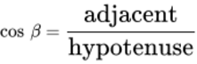
View alternative description - Uncaptioned Equation

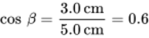
View alternative description - Uncaptioned Equation

This means that β is the angle for which cos is 0.6; this can be written as β = cos^{–1} (0.6).
Cos^{–1} is the opposite, or inverse, of taking the cosine of an angle and will give the angle (between 0 and 180°) with the cosine value of 0.6. Fortunately, your calculator also does this for you.
Look at your calculator again. You should see a key which has the word shift or the letters inv above it. This key enables you to use the inverse functions on a calculator. Look at your sin, cos and tan keys again. Above each you should see what are known as the inverse functions, sin^{–1}, cos^{–1} and tan^{–1}.
Again depending on the calculator, you have you will either need to key in the function first, or the number. Either way cos^{–1} (0.6) = 53.13010236. So, β = 53° (to 2 significant figures)
α can now be found as before:
α + β = 90°
α = 90° – β
α = 90° – 53.13010236°
α = 36° (to 2 significant figures)
The opposite side b can be found using Pythagoras.

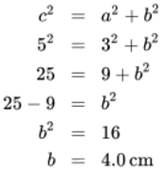
View alternative description - Uncaptioned Equation

So, the length of side b is 4.0 cm.
Now have a go yourself in this next activity.

Activity 4 Find the angles
Allow about 7 minutes

In the Figure 9, find the angles β and α and the length of side a.

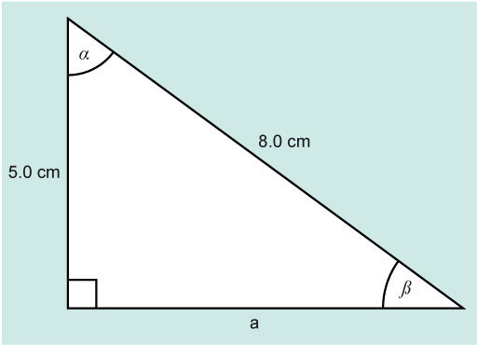
Figure 9 A right-angled triangle for Activity 4
View description - Figure 9 A right-angled triangle for Activity 4

View discussion - Activity 4 Find the angles

Practicing new ideas and skills you have learned in maths is important, so here is one more activity for you to complete.

Activity 5 Finding sides and angle
Allow about 7 minutes

Look at Figure 10 and find the sides a and b and the angle α.

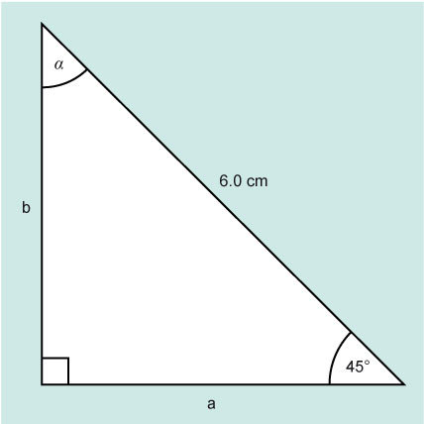
Figure 10 A right-angled triangle for Activity 5.
View description - Figure 10 A right-angled triangle for Activity 5.

View discussion - Activity 5 Finding sides and angle

Trigonometry is powerful mathematical tool and the next section, before the weekly quiz, provides an example of trigonometry in practice.

3 Trigonometry in practice
One application of trigonometry that you might come across in applied mathematics, physics or technology courses concerns the resolution of forces. This enables a force acting in a certain direction to be shown as two component forces, at right-angles to each other.

Worked example 3
Allow about 15 minutes

Consider the case of a father pulling his two young children along on a sledge (Figure 10a). He has a rope attached to the sledge which makes an angle α with the ground. Knowing that the force F on the rope is 50 N (newtons) and α is 25°, you can find the horizontal and vertical components of the force.
The force F acting in the rope may be considered as two component forces. The horizontal component can be called F_{h} and the vertical component F_{v} , as shown in Figure 11.

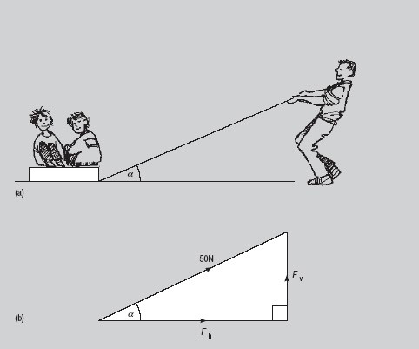
Figure 11 Using trigonometry to resolve forces
View description - Figure 11 Using trigonometry to resolve forces

Looking at Figure 11 and applying the trigonometry from earlier in this section, the following can be stated:
F_{h} is the adjacent, F_{v} is the opposite and 50 N is shown on the hypotenuse.

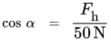
View alternative description - Uncaptioned Equation

and

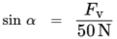
View alternative description - Uncaptioned Equation

Rearranging these two equations gives

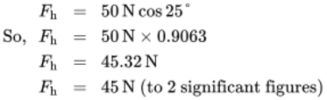
View alternative description - Uncaptioned Equation

The horizontal component of the force is 45.32 N.

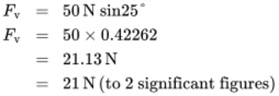
View alternative description - Uncaptioned Equation

The vertical component of the force is 21 N.
Checking this using Pythagoras should show that F_{h}² + F_{v}² = F²

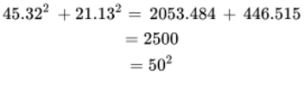
View alternative description - Uncaptioned Equation

This check gives extra confidence that the answer is correct.
Now here is an activity for you.

Activity 6 Calculating horizontal and vertical components
Allow about 10 minutes

Calculate the horizontal and vertical components of the force F in worked example 3 if:
- the angle α is reduced to 15°
- the angle α is increased to 45°.

View answer - Activity 6 Calculating horizontal and vertical components

Now look at the values you calculated in Activity 6.
Can you identify any relationship between the angle and the components of the forces?
As the angle α increases, the horizontal component of the force decreases and the vertical component increases. So, in order to maximise the effectiveness of the force in terms of horizontal motion, the angle α should be kept as small as possible.
The activities in this section have been designed to help you to use trigonometry in problem solving. As you continue your studies you will encounter other different applications.
Before completing this week you’ll now have the chance to practice the topics in the end-of-week quiz.

4 This week’s quiz
Now it’s time to complete the Week 4 badge quiz. It is similar to previous quizzes, but this time instead of answering five questions there will be fifteen.
Week 4 compulsory badge quiz
Remember, this quiz counts towards your badge. If you’re not successful the first time, you can attempt the quiz again in 24 hours.
Open the quiz in a new tab or window (by holding down Ctrl [or Cmd on a Mac] when you click the link) then come back here when you’ve finished.

5 Summary of Week 4
This week has built your knowledge and skills in working with right-angled triangles. Now, you should feel more confident that you can calculate unknown angles using a combination of trig functions and the fact that the internal angles for a triangle always add up to 180°
Below is a summary of what you have covered.
- You gained an understanding of the sine, cosine and tangent functions.
- You revised Pythagoras theory.
- You calculated unknown angles and the length of sides of triangles.
Next week you will look in more detail at logarithms and change of base.
You are now halfway through the course. The Open University would really appreciate your feedback and suggestions for future improvement in our optional end-of-course survey, which you will also have an opportunity to complete at the end of Week 8. Participation will be completely confidential and we will not pass on your details to others.

Week 5: Logarithms

Introduction
In Week 1 you learned about the rules for indices and in Week 2 you were introduced to logarithmic scales. This week uses ideas from both of these weeks, as you turn your attention to logarithms. These were invented in the seventeenth century by John Napier as a way to make calculations involving multiplication and division easier. Before electronic tools were cheaply and commonly available these were an invaluable aid, and this is still the case today. You have already seen how useful a logarithmic scale can be.
By the end of this week you will have:
- gained an understanding of logarithms and how they relate to powers
- gained an understanding of the three basic rules for tackling equations or expressions including logarithms
- simplified equations or expressions including logarithms
- learned about common and natural logarithms.

1 Logarithms to base 10
Logarithms are very closely related to powers and can have any base number. However, one of the most commonly used was the logarithm to base 10, also known as the common logarithm. The process of taking a log to base 10, is the inverse (opposite operation) of raising the base 10 to a power.
In the example 10³ = 1000, 3 is the index or the power to which the number 10 is raised to give 1000.
When you take the logarithm, to base 10, of 1000 the answer is 3.
This is written as:
Log₁₀ (1000) = 3
Hence, the logarithm is the index to which the base was raised. Or: log₁₀ 10^{n} = n
So, 10³ = 1000 and log₁₀ (1000) = 3 express the same fact but the latter is in the language of logarithms.
This idea can be generally defined as follows:

If a number y can be written in the form a^{x}, then the index x is called the logarithm of y to the base a.
If y = a^{x}
Then log_{a}y = x

Here are some more examples that provide some general logarithm rules.
Since 2 = 2¹, then log₂ (2) = 1
Similarly, log₃ (3) = 1, and log₁₀ (10) = 1, and as a = a¹, then log_{a} (a) = 1
Also, since 1 = 2⁰ then log₂ (1) = 0
Similarly, log₃ (1) = 0 and log₁₀ (1) = 0, and as 1 = a⁰, then log_{a} (1) = 0.
See how you get on in this activity.

Activity 1 Taking the log to base 10
Allow about 5 minutes

Without the use of a calculator, work out the values of:
- log₁₀ (10)
- log₁₀ (100)
- log₁₀ (0.01)
- log₁₀ (1 000 000)

View answer - Activity 1 Taking the log to base 10

This activity and preceding section allows the following basic observations about logs to be made.

The log of anything < 1 is a negative number.
The log of anything > 1 is a positive number.
The log of 1 is zero to any base.

Before the days of the electronic calculator, logarithms were used everyday for multiplication and division and involved the use of log tables, as shown in Figure 1.

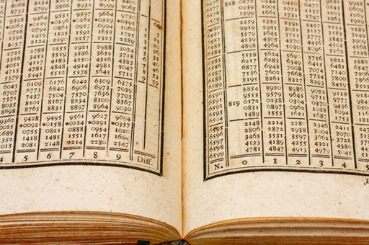
Figure 1 200 year old log tables
View description - Figure 1 200 year old log tables

Nowadays, logarithms are mainly used in calculus or to find a linear function from an exponential one. You’ll be glad to hear that you don’t need a book of log tables now to work with logarithms.
On your calculator you should have a key called log (with the inverse function as 10^{x} or similar). This key allows you to take the log in base 10 of any positive number.
Try now in this quick activity.

Activity 2 Using a calculator to take logs
Allow about 3 minutes

Use your calculator to take the log to base 10 of the following, showing your answers to 4 decimal places:
- log₁₀ (25)
- log₁₀ (1.5)
- log₁₀ (2500)
- log₁₀ (0.0032)

View answer - Activity 2 Using a calculator to take logs

In the next section, you’ll learn about three rules for operations involving logarithms.

2 Three log rules
The three log rules can be deduced from the rules of indices that you learned in Week 1.

View alternative description - Uncaptioned Equation

If you let log_{a} x = m and log_{a} y = n
This means that x = a^{m}and y = a^{n}
So xy = a^{m} × a^{n} = a^{(m + n)} (from Week 1: Rule 1).
Applying the definition of a logarithm gives:
log_{a} xy = log_{a} a^{(m + n)}
log_{a} xy = m + n
log_{a} xy = log_{a} x + log_{a} y
For example, log_{a} 21 = log_{a} 7 + log_{a} 3, since 7 and 3 are both factors of 21.

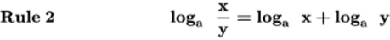
View alternative description - Uncaptioned Equation

Again, let log_{a}x = m and log_{a}y = n with x = a^{m} and y = a^{n}.

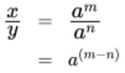
View alternative description - Uncaptioned Equation

(from Week 1: Rule 2)
Applying the definition of a logarithm gives:
log_{a} = log_{a}(a^{(m – n)})
log_{a} = m – n

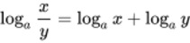
View alternative description - Uncaptioned Equation

For example, log_{a} 7 = log_{a} 14 – log_{a} 2.

View alternative description - Uncaptioned Equation

Let log_{a}x = n with x = a^{n}
Raising each side to the power r gives

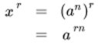
View alternative description - Uncaptioned Equation

(from Week 1: Rule 3)
Applying the definition of a logarithm gives:
log_{a}x^{r} = log_{a}(a^{rn})
For example, log₁₀ 1000 = log₁₀ 10³ = 3 log₁₀ 10 = 3 (because log₁₀ 10 = 1)
Use the rules in this next activity.

Activity 3 Using the three log rules
Allow about 10 minutes

- Simplify log 6 + log 3 – log 9
- Write 4 log x – ½ log y + 3 log z as a single logarithm
- log 64 ÷ log 2 (Note it can be useful to consider if a number can be written in the 2^{n})
- (log 27 − log 9) ÷ log 3

View discussion - Activity 3 Using the three log rules

In the next section you will learn about a special logarithm, called the natural logarithm.

3 Natural logarithms
The most frequently used bases for logarithms are 10 and the number ‘e’. Rather like , the irrational number ‘e’ occurs frequently in many branches of mathematics and its applications to science and engineering. Logarithms to base 10 are known as common logarithms and those to base ‘e’ are called natural or Napierian logarithms after the mathematician who discovered them.
Natural logarithms have the property that log_{e} e^{x} = x.
Natural logarithms are used to solve equations that contain the exponential function e^{x} where e is the irrational number 2.718281828 correct to ten significant figures. A graph of this function is shown in Figure 2.

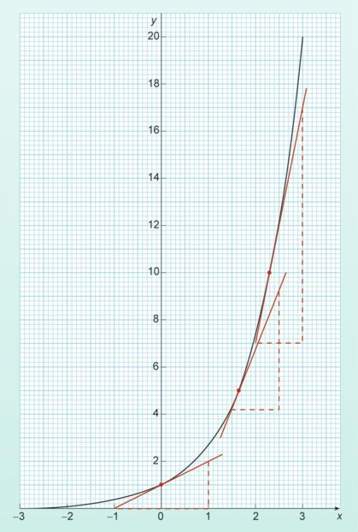
Figure 2 The exponential function e^{x}
View description - Figure 2 The exponential function ex

To work with natural logs on a calculator there is usually a button labelled log_{e} or ln, with the inverse e^{x} often accessed by the 2nd function key.
The value of the constant e can easily be found by calculating the value of e¹.
An example of an exponential function in science is radioactive decay. The half-life of a radioactive element is a constant value. This means that no matter how long the decay process has been continuing for it always takes the same time for the radioactivity to fall by half. If you compare Figure 2 to Figure 3 you should be able to see that they have similar shapes – although Figure 2 shows growth and Figure 3 decay.

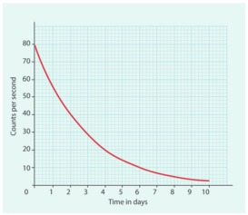
Figure 3 Radioactive decay curve
View description - Figure 3 Radioactive decay curve

When you work with logarithms to base 10 it is convention to drop the subscript and just write log x. Natural logarithms are written as In x. This means that the rules for logarithms, from section 2, can be written as follows for natural logarithms.

View alternative description - Uncaptioned Equation

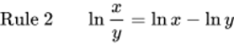
View alternative description - Uncaptioned Equation

View alternative description - Uncaptioned Equation

Activity 4 Solve the equations
Allow about 7 minutes

Solve the equations for x, showing your answers using natural logs. For example, 5 ln 3.
Remember that ln e^{x} = x.
- 15 = 3e^{2x}
- 2e^{–x/10} + 16 = 20

View discussion - Activity 4 Solve the equations

The final thing that you need to be able to do with logarithms is change the base.

4 Change of base
Suppose you have log_{a}x and you want to find log_{b}x.

View alternative description - Uncaptioned Equation

Taking logarithms to base a gives:

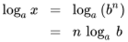
View alternative description - Uncaptioned Equation

Rearranging this, gives:

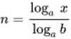
View alternative description - Uncaptioned Equation

So, 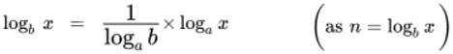
Thus, if you want to change between natural logarithms and logarithms to the base 10, you can use the following:

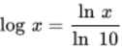
View alternative description - Uncaptioned Equation

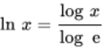
View alternative description - Uncaptioned Equation

Try putting this idea into practice now.

Activity 5 Finding logs
Allow about 4 minutes

Find log₉(x) given that log₃x = 12
Hint: Can you express any of the numbers in the form 3^{n}.

View answer - Activity 5 Finding logs

You may well have not come across logarithms in this way before, so don’t worry if you needed to take your time to work your way through this week. Practice is so often the key to success with maths, so the next section is your chance to check your understanding and application of these ideas.

5 This week’s quiz
Check what you’ve learned this week by taking the end-of-week quiz.
Week 5 practice quiz
Open the quiz in a new window or tab (by holding down Ctrl [or Cmd on a Mac] when you click the link) then come back here when you’ve finished.
To open in a new window, right click on the link above and select ‘Open in new window’.

6 Summary of Week 5
Now is a good time to revisit the learning outcomes for this week. Below is a summary of what you have covered.
- You gained an understanding of logarithms and how they relate to powers
- You gained an understanding of the three basic rules for tackling equations or expressions including logarithms
- You simplified equations or expressions including logarithms
- You learned about common and natural logarithms.
Next week will be the first of three weeks that consider descriptive statistics, starting with probability.

Week 6: Probability

Introduction
Statistical techniques offer ways of dealing with variability, and natural variability is something that scientists and engineers meet all the time. Each time an experiment or a measurement is repeated, a slightly different result may be obtained; in any group of people there will be a variation in height; the count of background radiation at any individual location fluctuates randomly from moment to moment. It is therefore very important to be able to decide with some measure of certainty whether a particular result could have been obtained simply by chance or whether it has some real significance, and the mathematics of chance and probability underpin all aspects of statistics. Probability is the subject for this week
By the end of this week you will have:
- gained an understanding of what probabilities can really tell you
- learned how to determine the probability of a particular outcome occurring
- gained an understanding of how to combine probabilities for more than one event
- calculated probabilities in specific circumstances.

1 Chance and probability

‘Probability is expectation founded upon partial knowledge. A perfect acquaintance with all the circumstances affecting the occurrence of an event would change expectation into certainty, and leave neither room nor demand for a theory of probabilities.’
(George Boole, 1815–1864)

In many branches of science it is not possible to predict with any certainty what the outcome of a particular event will be. There may be several possible outcomes and all the scientist can offer in the way of quantitative prediction is an assessment of the relative likelihood of each of these outcomes. For example, if a man and a woman both carry the cystic fibrosis gene without showing symptoms of the disease, the chances are 1 in 4 that their first child will suffer from the condition. Such assessments of probability are a routine part of genetics, nuclear physics, quantum physics and many other scientific disciplines.
In seeking to understand the nature and rules of probability it is often best to focus initially on everyday examples that are easily visualised. So Section 2 to Section 5 feature many examples of tossed coins and rolled dice. However, you will also get the opportunity to see how these ideas are applied to some genuine scientific problems: for example, what is the probability that two people planning to have a child will both turn out to be carriers of the cystic fibrosis gene?

2 Calculating probability
If a process is repeated in identical fashion a very large number of times, the probability of a given outcome is defined as the fraction of the results corresponding to that particular outcome.

(1)
View alternative description - Uncaptioned Equation

The nature of the fraction in Equation 1 shows that the probability of any given outcome cannot be smaller than 0 or larger than 1. A probability of 0 represents impossibility, while a probability of 1 represents inevitability. The closer the probability of a given outcome is to 1, the more likely that outcome is to occur. This is illustrated diagrammatically in Figure 1.

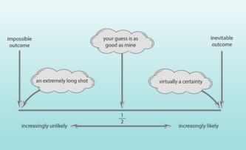
Figure 1 The scale of probabilities
View description - Figure 1 The scale of probabilities

When a coin is tossed fairly, the likelihood of it landing on heads is equal to the likelihood of it landing on tails. If it is tossed repeatedly a great many times, it will in theory come up heads half the time: the probability of tossing heads is . The theoretical probability of tossing tails is, of course, also . The sum of these two probabilities 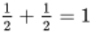; i.e. it is certain that when the coin is tossed it will land either on heads or on tails. This is an example of a general rule:
The sum of the probabilities of all possible outcomes is equal to 1. A probability of 1 represents certainty.
Dice games involve rolling six-sided dice (singular ‘die’). Each face of a die is marked with a different score: one, two three, four, five or six. If the die is not loaded and the rolling is done fairly, then all outcomes are equally likely, so the probability of any one of the six possible outcomes (for example scoring a three) is . Again, the sum of the probabilities of all the possible outcomes is 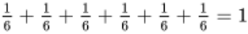
So on one roll of the die the probability of scoring a three is and the probability of not scoring a three is . Another way of expressing this is to say that on a single roll of the die there is only one way of scoring a three, but there are 5 ways of not scoring a three. Clearly, it is more likely than not that a number other than three will be scored. This is just one illustration of another general rule:
The most likely outcome is the one that can occur in the greatest number of ways.
Provided nothing biases the result to make one outcome inherently more likely than others, the definition given by Equation 1 can be rewritten to encompass the number of ways in which a particular outcome may come about:

(2)
View alternative description - Uncaptioned Equation

Use these ideas in this activity.

Activity 1 Calculating probability
Allow about 10 minutes

1. What would be the probability of throwing an odd number on one roll of a die?

View answer - Part

2.What is the probability of one card drawn at random from a shuffled pack of playing cards being: (a) a heart, (b) red, (c) an ace, (d) a picture card?
Note: if you are unfamiliar with playing cards, you need the following information. There are 52 cards in a pack, divided into four suits: hearts (red), diamonds (red), spades (black) and clubs (black). Each suit contains 13 cards, made up of one ace, nine ‘number’ cards (from 2 to 10 inclusive) and three picture cards (Jack, Queen, King).

View answer - Part

But what does a probability mean in real life?

3 Probability and common sense
The concept of probability is a purely theoretical one. Strictly speaking, no experiment measures a probability: all that you can measure is the fraction of times a particular outcome occurs in a finite number of attempts. In the infinitely long run this fraction is expected to approach the theoretical probability, but in practice you may never attain this limit. You could easily toss a fair coin four times and get four heads. You could even toss it 20 times and still get heads on every single toss, though that would be fairly unlikely. But the more tosses you made the more nearly the fraction
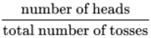would approach its theoretical value of .
A failure to appreciate the fact that the number of attempts needs to be extremely large before the probability of a particular outcome will reliably approach the theoretical value is at the root of many popular misconceptions about probabilities. One commonly held fallacy about coin tossing is that if the first ten tosses of a coin have produced several more heads than tails, then the eleventh toss is more likely than not to come up tails. This is not true. Although in the extremely long run the imbalance between heads and tails is expected to be negligible, on any one toss heads and tails are equally likely, irrespective of previous history. Coins have no memory!

4 Ways of expressing probability
According to Equation 1, probability is defined as a fraction. However a fraction such as may also be expressed as a decimal number or as a percentage:

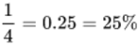
View alternative description - Uncaptioned Equation

The following statements:
- the probability of event A is ,
- the probability of A occurring is 0.25,
- there is a 25% probability of the outcome being A,
are therefore all equivalent.
In addition, particularly in spoken language, it is common to say,
- there is a 1 in 4 probability of the outcome being A,
and that too is equivalent to the other three statements.
For the rest of this week probabilities will usually be expressed as fractions.
Now it is time to move on to probabilities that are related to more than one process.

5 Combining probabilities
The probabilities described in Section 3 and Section 4 related to the outcomes of a single process, such as repeatedly tossing one coin. Now suppose you were to toss three separate coins simultaneously. What is the probability that they will show heads? One way of tackling this problem is to write all the possible combinations of results. There are in fact eight possible outcomes, all of which are equally likely, as the coins are assumed to be fair:

1 | H | H | H
2 | H | H | T
3 | H | T | H
4 | H | T | T
5 | T | H | H
6 | T | H | T
7 | T | T | H
8 | T | T | T

Figure 2 The possible comibination of results from tossing coins.
Of the eight combinations, only one – the top row – represents the desired outcome of three heads. On the basis of Equation 2, the probability of all three coins coming up heads is therefore .
The same result can be obtained using the ‘multiplication rule for probabilities’: the probability that the first coin will show heads is and the same is true for the second and third coins. The probability that all three will show heads is 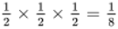. It is important to note that in this situation the coins are tossed simultaneously, and how one coin lands is no influence on how another lands.
The multiplication rule is expressed in its most general form by saying that:
If a number of outcomes occur independently of one another, the probability of them all happening together is found by multiplying their individual probabilities.
An example of how this rule applies in a common genetic disease is given below.

Probability and cystic fibrosis
Cystic fibrosis is the most common genetic disease in white European and American populations. The cystic fibrosis (CF) gene is described as recessive, which means that individuals with only one copy of the gene, so-called ‘carriers’, show no symptoms of the disease and may be unaware that they carry the gene. Individuals with two copies of the faulty CF gene will show the symptoms of the condition.
Among white Europeans, the probability of being a carrier is .
For a child whose parents are both carriers, the probability of inheriting a copy of the CF gene from both parents is . This is therefore the probability that the child of such parents will have symptoms of the disease.
Do this next activity using this information on cystic fibrosis probabilities.

Activity 2 Probability and cystic fibrosis
Allow about 5 minutes

- Assuming that the CF gene is equally likely to be carried by men and women, what is the probability that any two white Europeans planning to have a child together would both be carriers?

View answer - Part

- What is the probability of a child born to white European parents having cystic fibrosis?

View answer - Part

Activity 3 A pair of coins and dice
Allow about 7 minutes

Calculate the combined probability in both these cases, remembering that the coins and dice cannot influence each other.
- If you toss two coins at the same time, what is the probability of getting two tails?
- If you throw a pair of dice, what is the probability of getting a pair of sixes?

View answer - Activity 3 A pair of coins and dice

Another situation in which you might need to combine probabilities occurs when outcomes are mutually exclusive (i.e. cannot occur together). For example, what is the probability of getting either a three or a five on a single roll of a die? One way of working this out is to say that there are six possible outcomes altogether and two of them correspond to the desired outcome. So from Equation 2, the probability of the desired outcome is 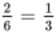. The same result can be obtained using the ‘addition rule for probabilities’. The probability of throwing a three is and the probability of throwing a five is also , so the probability of throwing either a three or a five is 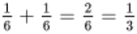. Again, this example illustrates a general rule:
If several possible outcomes are mutually exclusive, the probability of one or other of these outcomes occurring is found by adding their individual probabilities.

Worked example 1
Allow about 10 minutes

One card is drawn from a shuffled pack of 52. What is the probability of the card being either a heart or a diamond? (For a description of a standard pack of cards, see the comment with Activity 1.)

View answer - Worked example 1

Activity 4 The probability of mutually exclusive events
Allow about 3 minutes

If you were to draw one playing card from a pack of 52, what would be the probability of that card being either the Jack, Queen or King of diamonds?

View answer - Activity 4 The probability of mutually exclusive events

There are also cases in which both the addition and multiplication rules operate.

Worked example 2
Allow about 5 minutes

What is the chance that in a family of three children only one will be a boy?
Assuming that the sex of a child is independent of the sexes of its siblings, the probability that the first child is a boy is , the probability that the second is a girl is , and the probability that the third is also a girl is . So the probability of this particular combination (boy-girl-girl) is . But in a family with just one boy and two girls, the boy may be the eldest, the middle or the youngest child, and these possibilities are mutually exclusive. So the probability of the family consisting of a boy and two girls (born in any order) is

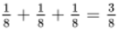
View alternative description - Uncaptioned Equation

(Note that in fact the assumption that a baby is just as likely to be a boy as a girl is not quite true. UK statistics show that for every 100 girls born, 106 boys are born.)
As with the coin-tossing example earlier, you may find that a table of the possibilities helps in visualizing the situation. Of the eight possible combinations of three children, only three – shown in bold text – comprise one boy and two girls.

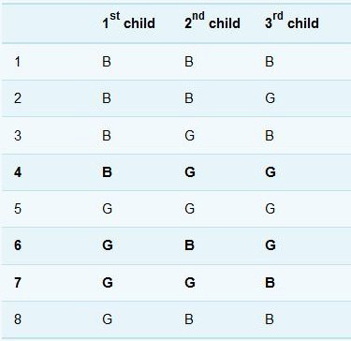
Figure 4 What is the chance of having a boy?
View description - Figure 4 What is the chance of having a boy?

Activity 5 Another example using coins
Allow about 5 minutes

If you toss two coins simultaneously, what is the probability of getting one head and one tail?

View answer - Activity 5 Another example using coins

Often with probabilities it is understanding how the events are linked, or not, that is the key to success. So, try and bear that in mind as you have a go at the quiz now.

6 This week’s quiz
Check what you’ve learned this week by taking the end-of-week quiz.
Week 6 practice quiz
Open the quiz in a new window or tab (by holding down Ctrl [or Cmd on a Mac] when you click the link) then come back here when you’ve finished.

7 Summary of Week 6
Below is a summary of what you have covered in Week 6 of this course.
- You gained an understanding of what probabilities can really tell you.
- You learned how to determine the probability of a particular outcome occurring.
- You gained an understanding of how to combine probabilities for more than one event.
- You calculated probabilities in specific circumstances.
Next week moves onto another area of statistics, which enables you to analysis data and describe this succinctly.

Week 7: Statistics and repeated measurements

Introduction
Statistical information is a familiar aspect of modern life, which features routinely in, for example, news reports, sports commentaries and advertising. Scientists who have collected large amounts of data by either counting or measuring quantities also rely on statistical techniques to help them make sense of these data. Suppose you had information collected from, say, three thousand patients, all with the same medical condition but undergoing a variety of treatments. First you would need techniques for organising and describing the data, so that you could present a summary by giving just a few numbers. This is the function of ‘descriptive statistics’, covered in this course. Then you might want to analyse the data in some way, perhaps to decide whether they supported the suggestion that treatment with one particular drug is more effective than other forms of medication.
By the end of this week you will have:
- gained an understanding of repeated measurements and samples
- considered systemic and random uncertainty and how these are related to accuracy and precision
- calculated the mean average for a set of data
- gained an understanding of standard deviation.

1 Types of data sets
Scientists collect many different types of information, but sets of data may be very loosely classified into two different types. In the first type, so-called ‘repeated measurement’, an individual quantity is measured a number of times. An astronomer wanting to determine the light output of a star would take many measurements on a number of different nights to even out the effects of the various possible fluctuations in the atmosphere that are a cause of stars ‘twinkling’. In the second type of investigation, so-called ‘sampling’, a proportion of the members of a large group are measured or counted. A botanist interested in the average size of Primrose plants in a wood would try to choose representative samples of plants from different parts of the wood and measure those.
You will look at how to handle both types of data sets in the next two weeks, starting with repeated measurements.

2 Repeated measurements
Scientists are always concerned with the reliability and precision of their data, and this is the prime reason for them to repeat measurements many times. Consider the photograph shown in Figure 1, which is the result of X-ray diffraction (see Box 1). To determine the atomic structure of the substance that produced this pattern, it would be necessary to measure the diameters of the fuzzy rings. At one time, this would probably have been done with an instrument called a travelling microscope; nowadays a computer would be involved. But whatever the method, there will always be a difficulty in being sure where to take the measurement within a fuzzy area, so the measurement of diameter of any one ring would need to be repeated a number of times.

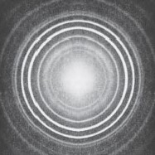
Figure 1 The X-ray diffraction pattern from a sample of zirconium oxide
View description - Figure 1 The X-ray diffraction pattern from a sample of zirconium oxide

Box 1 X-ray diffraction
X-ray diffraction is one of the most widely used techniques for the determination of the geometrical arrangement of atoms in crystalline materials, including those of biological origin and those with high technology credentials such as superconducting ceramics. The X-ray diffraction pattern in Figure 1, which was recorded on a relatively simple instrument, is for zirconium oxide, a substance which because of its extremely high melting point (2700 °C) is used in furnaces.

Generally the process of repeating measurements of a particular quantity would lead to a number of slightly different results being obtained. Measured values of one quantity that are scattered over a limited range like this are said to be subject to ‘random uncertainty’. Measurements for which the random uncertainty is small (i.e. for which the range over which the measurements are scattered is small) are described as precise. The ‘best’ estimate scientists could make of the diameter of each ring in Figure 1 would be some sort of average of all the measured values.
The scatter inevitably associated with raw data begs various questions. For instance,
- how close to the ‘true’ value is this calculated average value?
- how close to the ‘true’ value is one typical measurement likely to be?
- conversely, how probable is it that any given measurement will be close to the average value?
Matters will be further complicated if there is some inherent error or bias in the measuring instrument, such that all the readings are, say, too large by a fixed amount. Such measurements are said to have a ‘systematic uncertainty’. Note that unless measuring instruments can be constantly checked against one another, it is easy for quite large systematic uncertainties to creep unnoticed into measurements. Measurements for which the systematic uncertainty is small are described as accurate. Of course to get anywhere near to the ‘true’ value of a quantity, measurements have to be both accurate and precise!

3 The distribution of repeated measurements
As noted in the previous section, if the same quantity is measured repeatedly, the results will generally be scattered across a range of values. This is perhaps best illustrated using a real example. Table 1 shows 10 measurements of a quantity called the ‘unit cell constant’ for an industrial catalyst used in the refining of petrol; this is an important quantity which determines how well the catalyst works, and can be measured by X-ray diffraction techniques. Notice that the cell constant is very small and is measured in nanometres.

Table 1 Repeated measurements of the unit cell constant for a batch of industrial catalyst
Measurement | Cell constant/nm
1 | 2.458
2 | 2.452
3 | 2.454
4 | 2.452
5 | 2.459
6 | 2.455
7 | 2.464
8 | 2.453
9 | 2.449
10 | 2.448

It is always difficult to see patterns in lists or tables of numbers. However, if the data are put into the form of a histogram, the task becomes much easier. The histogram provides a visual representation of the way in which measurements are distributed across a range of values.
The following examples show four variations on a histogram, using the same core data: distributions for repeated measurements of the unit cell constant of a batch of industrial catalyst. ‘Click on ‘View interactive version’ to access the activity’. Open the interactive in a new tab or window (by holding down Ctrl [or Cmd on a Mac]. Select each tab in the interactive to compare the histograms. What happens when the number of measurements is increased?

Interactive content is not available in this format.

The distributions in these examples all give some impression of the spread of the measurements, and the way the results cluster at the peak of the distribution in examples c and d suggests that this peak might represent the average or 'best estimate' value. However, a scientist would want a more quantitative and succinct way to describe such results and to communicate them to other people working on similar problems. The mean and standard deviation are the measures most commonly used to summarise large sets of data.

4 Mean and standard deviation for repeated measurements
In everyday terms, everybody is familiar with the word ‘average’, but in science, technology and statistics there are actually several different kinds of average used for different purposes. In the kind of situation exemplified by Table 1, the sort to use is the mean (or more strictly the ‘arithmetic mean’). For a set of measurements, this is defined as the sum of all the measurements divided by the total number of measurements made.

Activity 1 Calculating the mean
Allow about 5 minutes

What is the mean of the results in Table 1?

Table 1 Repeated measurements of the unit cell constant for a batch of industrial catalyst
Measurement | Cell constant/nm
1 | 2.458
2 | 2.452
3 | 2.454
4 | 2.452
5 | 2.459
6 | 2.455
7 | 2.464
8 | 2.453
9 | 2.449
10 | 2.448

View answer - Activity 1 Calculating the mean

To turn this description of how to calculate a mean into a formula, each element has been allocated a symbol. So say that you have made n measurements of a quantity x. Then you can call the individual measurements x₁, x₂, x₃, … x_{n} (where x₁ is properly said either as x ‘subscript one’ or as ‘x sub one’, but also sometimes as ‘x one’ e:

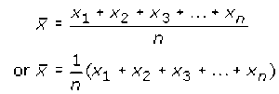
View alternative description - Uncaptioned Equation

However, the sum is tedious to write out, so a special ‘summation’ sign, Σ (capital Greek letter sigma), is used to denote the adding up process, and the mean of n measurements can be neatly written as:

View alternative description - Uncaptioned Equation

The i = 1 below the summation sign indicates that the first value for x_{i} in the sum is x₁, and the n above it indicates that the last value in the sum is x_{n}. In other words, all integer values of i (x﻿₁﻿, x﻿₂﻿, x﻿₃﻿, etc.) are to be included up to x_{n}. (The summation sign with the information attached to it is usually said as ‘sum of x sub i from one to n’.)
You now want a quantitative way of describing the spread of measurements, i.e. the extent to which the measurements ‘deviate’ from the mean. There are 5 steps required to do this, which are laid out below, and Table 2 shows the results of following this ‘recipe’ for the data in Table 1.

Step 1
Calculate the deviation of each measurement. The deviation d_{i} of any individual measurement is defined as the difference between that measurement and the mean of the set of measurements:

View alternative description - Uncaptioned Equation

Notice that the value of d_{i} may be positive or negative depending on whether a particular measurement is larger or smaller than the mean of the set of measurements.
At this stage the deviations have been expressed as decimal numbers.

Step 2
Calculate the squares of each of the deviations (i.e. d_{i}²). These will, of course, all have positive values.
By this stage the values have become very small so the column has been headed in such way that the numbers entered in the column represent the value of d_{i}² divided by 10^{–5}.

Step 3
Add together all the squares of the deviations i.e. 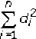

Step 4
Divide by the total number of measurements (i.e. n) to obtain the mean of all the square deviations. This may be written as:

View alternative description - Uncaptioned Equation

Step 5
Take the square root of this mean to obtain the ‘root mean square deviation’ s_{n}. It is this quantity s_{n} that is known as the standard deviation. Step 5 may be written as:

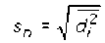
View alternative description - Uncaptioned Equation

or, substituting for d_{i}² from Equation 5, as:

View alternative description - Uncaptioned Equation

Since d_{i} was defined in Equation 4 as (x_{i}–x̅) one final substitution into Equation 6 gives s_{n} in its most easily used format:
The standard deviation s_{n} for n repeated measurements of the same quantity x is given by

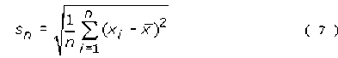
View alternative description - Uncaptioned Equation

At the end of this process, you can summarize all the data in Table 1 just by saying that the ten measurements had a mean of 2.4544 nm and standard deviation 0.0046 nm. The calculation of standard deviation is given in Table 2.
There are several things worth noting about this result and the data in Table 2.
First, all the quantities have units associated with them. The values of x_{i} were measured in nanometres, so deviations will also be in nanometres and the squares of the deviations in nm², as shown in the column headings in the table.

Table 2 Calculation of the standard deviation for the set of measurements originally given in Table 2
x_{i}/nm | d_{i}/nm | d_{i}²/10^{–5} nm²
2.458 | 0.0036 | 1.296
2.452 | –0.0024 | 0.576
2.454 | –0.0004 | 0.016
2.452 | –0.0024 | 0.576
2.459 | 0.0046 | 2.116
2.455 | 0.0006 | 0.036
2.464 | 0.0096 | 9.216
2.453 | –0.0014 | 0.196
2.449 | –0.0054 | 2.916
2.448 | –0.0064 | 4.096
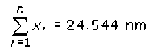 | 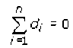 | 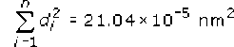
 |  | 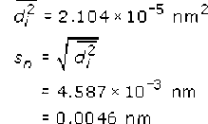

A second useful feature to notice is that the sum of all the deviations is equal to zero.

View alternative description - Uncaptioned Equation

If you are interested in knowing why this is always true, there is an explanation in Box 2 (though you do not need to work through the full explanation in order to make use of the result). At the end of Step 1 it is well worth adding up all the values you have calculated for the deviations to ensure that they do indeed total zero. If they don’t, you have made an arithmetic slip somewhere which needs to be put right before you proceed to Step 2.
Looking now at the details of the calculation, the original measurements of length were made to the nearest picometre (i.e. 0.001 nm), represented by 3 decimal places (i.e. 3 digits after the decimal point). More digits were carried in the calculations to avoid rounding errors. However, what is the appropriate number of digits to quote in the final answer? Well, when all the 10 results were added up in Table 1, this value was obtained

View alternative description - Uncaptioned Equation

(i.e. 5 digits in total). This sum was divided by an exact number (10) so it is appropriate to retain 5 digits in the result of this division, giving x̅ as 2.4544 nm. It is therefore valid to retain one more decimal place in the mean value than in each of the measurements individually. After all the whole point of repeating the measurement many times and averaging is to improve confidence in the final result! Having quoted the mean as x̅ as 2.4544 nm, it then makes sense to quote the standard deviation as 0.0046 nm.

Box 2 The sum of the deviations is always equal to zero
It is quite easy to work out from first principles the reason for the sum of the deviations being zero in the special case in which the set consists of just two measurements, x₁ and x₂. The mean would then be:

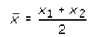
View alternative description - Uncaptioned Equation

so

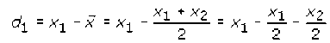
View alternative description - Uncaptioned Equation

And

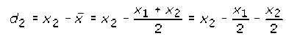
View alternative description - Uncaptioned Equation

Therefore

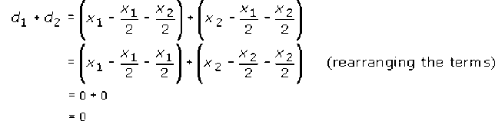
View alternative description - Uncaptioned Equation

This argument can be extended to any number of values of x; as an exercise in algebra you might like to try it for three measurements. However many values of x are chosen, it is always the case that the sum of the deviations is zero.

The fact that here the standard deviation is quite small in comparison to the mean shows why, in this context, it is more sensible to think in terms of places of decimals rather than significant figures. Because leading zeroes do not count as significant, the standard deviation is actually only given to 2 significant figures, whereas the mean is given to 5. In such circumstances, it is easier to think of the mean and the standard deviation as being expressed to the same number of decimal places (always assuming of course that they are given the same units).
In summary, the easiest procedure is to give the mean to one more decimal place (or one more significant figure) than was used for each of the individual measurements, and then to quote the standard deviation to the same number of decimal places as the mean.
Even with a small number of values in a data set it is easy to make arithmetical mistakes when calculating the mean and standard deviation by hand. Most experimental data will consist of many more than 10 observations. The next section looks at what the tools you can use.

5 Using a calculator for statistical calculations
Table 2 shows all the values for each step in the process of calculating a standard deviation, so that you can see what the operations encapsulated by Equation 7 actually entail, but you will probably be relieved to hear that it is not usually necessary to carry out such detailed calculations. Scientific and graphics calculators (or computer spreadsheets) can do most of the drudgery for you.

Activity 2 Statistics using a calculator
Allow about 10 minutes

You will need to consult the instructions for your own calculator in order to find out how to do this, but usually the process involves the following steps:

Step 1
Put the calculator into statistical mode.

Step 2
You should then be able to input all the data; sometimes these data are stored via a memory button, in other cases they can be entered and displayed as a list. Enter the following set of numbers:
8, 6, 9, 12, 10

Step 3
Having input the data, you can then get most calculators to tell you the number of items of data. If your calculator can do this, it should return the answer ‘5’ here. It doesn’t matter if your calculator doesn’t have this function, but if it does it’s well worth using this checking device. If you have to input a long string of data values, it’s quite easy to miss one out inadvertently!

Step 4
When you know you have the data correctly stored, find out how to display the mean; you should get the answer ‘9’ here.

Step 5
Now find out how to display the standard deviation. Many calculators use the symbol σ_{n} for standard deviation, rather than s_{n} (σ is the lower case version of the Greek letter sigma). Do be careful with this step: your calculator may also have a button labelled σ_{n–1} or s_{n–1}. Don't use it by mistake! You should get the answer ‘2’ here.

Once you are sure you know how to use your calculator to perform calculations of mean and standard deviation, apply this skill to Activity 3. To answer such questions, you could choose to work out a full table similar to Table 2, but that it is a very time-consuming process, so it is worth becoming confident in using the statistics buttons on your calculator.

Activity 3 Calculate mean and standard deviation
Allow about 10 minutes

A sample of a particular manufacturer’s ‘coarse round wire’ was measured at ten points along its length. The data are given in Table 3. Calculate the mean and standard deviation of these measurements.

Table 3 Repeated measurements of the diameter of a wire
Measurement | Diameter/mm
1 | 1.09
2 | 1.00
3 | 1.25
4 | 1.24
5 | 1.29
6 | 0.89
7 | 1.09
8 | 1.14
9 | 1.22
10 | 1.01

View answer - Activity 3 Calculate mean and standard deviation

Being able to use a calculator for statistical calculations, or even a spreadsheet, is a very useful skill to have. This does not take away at all from the understanding of these subjects that you have.
Now it is time to get some more practice in this week’s quiz.

6 This week’s quiz
Check what you’ve learned this week by taking the end-of-week quiz.
Week 7 practice quiz
Open the quiz in a new window or tab (by holding down Ctrl [or Cmd on a Mac] when you click the link) then come back here when you’ve finished.

7 Summary of Week 7
Now is a good time to revisit the learning outcomes for this week. Below is a summary of what you have covered.
- You gained an understanding of repeated measurements and samples.
- You considered systemic and random uncertainty and how these are related to accuracy and precision.
- You calculated the mean average for a set of data.
- You gained an understanding of standard deviation.
Next week, the final week of the course, will conclude with analysis of data from population samples.

Week 8: Statistics and sampling

Introduction
Week 8 continues your study of statistics, specifically data from population samples rather than repeated measurements. This type of data is very common in biology, and geography where data from large populations are analysed. In some cases, for sample data, the mean is not the most appropriate average, so you will learn about alternatives. However, the mean will still be important when you are calculating the sample standard deviation. Before exploring averages though, you’ll consider in more detail ways that data can be distributed.
By the end of this week you will have:
- gained an understanding of the different types of data distribution
- learned how to calculate the mode and median of a data set
- considered which average, the mean, mode or median, is most appropriate for a data set
- gained an understanding of, and calculated, the sample standard deviation.

1 How likely are particular results?
In real experiments, as opposed to hypothetical ones, it is very rare that scientists make a sufficiently large number of measurements to obtain a smooth continuous distribution like that shown in Figure 1.

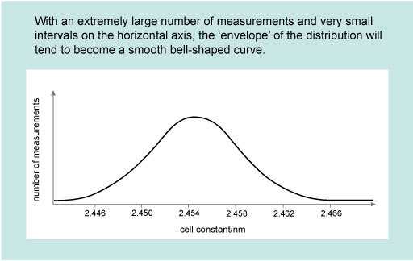
Figure 1 Distribution for repeated measurements of the unit cell constant of a batch of industrial catalyst.
View description - Figure 1 Distribution for repeated measurements of the unit cell constant of a batch ...

However, it is often convenient to assume a particular mathematical form for typically distributed measurements, and the form that is usually assumed is the normal distribution , so-called because it is very common in nature. The normal distribution corresponds to a bell-shaped curve which is symmetric about its peak, as illustrated in Figure 1. Repeated independent measurements of the same quantity (such as the breadth of an object, or its mass) approximate to a normal distribution. The more data are collected, the closer they will come to describing a normal distribution curve.
The peak of the normal distribution curve corresponds to the mean value of the distribution, as shown in Figure 2. This figure also illustrates how the standard deviation of a set of measurements is related to the spread. Although it is beyond the scope of this course to prove this, the area under a portion of a distribution curve within a certain range represents the number of measurements that lie within that range, as a proportion of the whole set. For a normal distribution, it turns out that 68% of the measurements lie within one standard deviation (i.e. within ±s_{n}) of the mean value. Conversely, 32% of the measurements will lie outside this range. If you make a single additional measurement, it is therefore just over twice as probable that this one measurement will fall within one standard deviation of the mean than that it will fall outside this range. For a normal distribution, it also turns out that 95% of measurements are likely to fall within two standard deviations of the mean and 99.7% within three standard deviations of the mean.

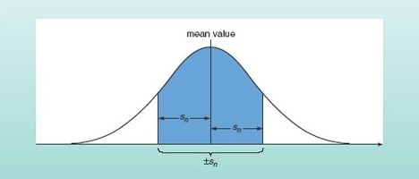
Figure 2 The shaded area under this normal distribution curve represents the measurements that lie within one standard deviation of the mean. This area is 68% of the total area under the curve, so 68% of the measurements are expected to fall within this range.
View description - Figure 2 The shaded area under this normal distribution curve represents the measurements ...

Remembering that precise measurements were defined in Week 7 as those for which the scatter was small, you will appreciate that the more precise a repeated set of the same number of measurements of a particular quantity, the more highly peaked the distribution curve and the smaller the standard deviation will be. A very broad distribution on the other hand, corresponds to measurements with considerable scatter and the standard deviation will be large. These trends are illustrated in Figure 3.

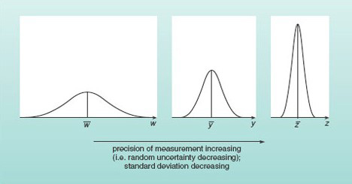
Figure 3 Normal distribution curves for three independent sets of measurements, with the same number of measurements in each set. The measurements of quantity w are subject to large random uncertainties, while those of quantity y are more precise and those of z more precise still.
View description - Figure 3 Normal distribution curves for three independent sets of measurements, with ...

1.1 Different types of distribution
Figure 2 showed that if the data have a normal distribution the mean value corresponds to the peak of the distribution. Normal distributions of data are very common in science, but are by no means universal. Figure 4 shows some other possible distributions, three of which are symmetric and one of which is skewed (i.e. not symmetric).

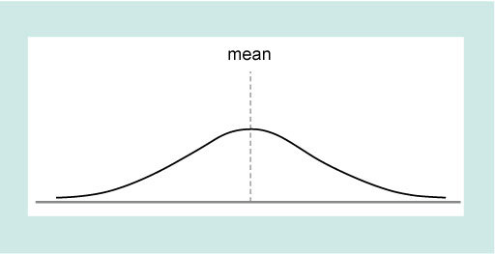

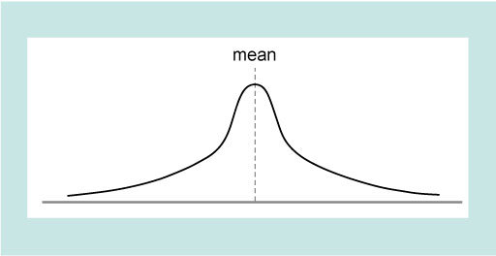

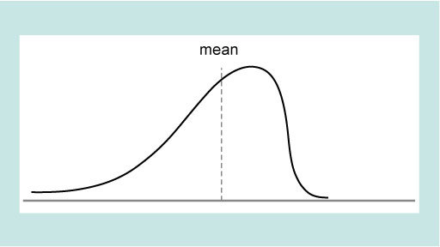

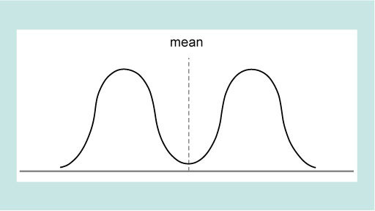
Figure 4 Graphs showing different types of distribution
View description - Figure 4 Graphs showing different types of distribution

As you will see in the next section these different types of distribution leads to consideration of what type of average best represents the data.

2 Different types of ‘average’
In many cases, especially if the distribution is skewed, the mean is not the best way of representing an average or typical value. Imagine for example a small company with a single owner who pays himself £900,000 a year and 10 employees who are each paid £10,000. The statement that the mean annual income of these 11 workers is more than £90,000 (i.e. £1000,000 divided by 11) – although true – is somewhat misleading! In such cases, two other quantities, the mode and the median, may represent the data more fairly.
The mode is the most frequently occurring value in the set of data. If the data are plotted on a histogram or a bar chart, the mode will be the value corresponding to the tallest bar.

Activity 1 Mode of small company earnings
Allow about 2 minutes

What is the mode of the earnings in the company described above?

View answer - Activity 1 Mode of small company earnings

Note that in some cases there may be more than one value for the mode; for example, that would be the case for the distribution shown in Figure 4, as there are two distinct equal size peaks.
The median is the middle value in a series when the values are arranged in order of size. 'This means that there are as many values bigger than the median as are smaller than the median. If there are an odd number of measurements, the median is the middle measurement; if there are an even number of measurements it is the mean of the middle two values.
To see how this works try this activity now.

Activity 2 Flowers: finding the mode
Allow about 7 minutes

- Ten plants of a particular species were chosen at random and the number of flowers on each plant were counted. The results were:
8; 7; 4; 8; 10; 7; 9; 7; 8; 7;
What is the mode for these data?

View answer - Part

- What is the median for these data?

View answer - Part

Box 1 illustrates a case in which the mode and median give a more representative summary of the data than the mean.

Box 1 Seabird migration
In a study of Storm Petrels (small seabirds), several thousand birds were marked with identifying rings when they were at their nests on a Shetland island. After nesting, the birds dispersed. Twenty-eight of the birds were subsequently reported as having been recovered in other areas, as shown in Table 1.
Taking all 28 observations into account, the mean distance from their nest site at which the birds have been recovered is 554.5 km. However, this is not a very useful way in which to summarize the data, because in fact 13 out of the 28 birds (i.e. nearly half) moved less than 100 km, and only two moved further than the mean distance.

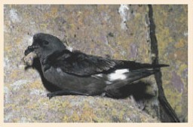
Figure 5 Storm Petrel bird
View description - Figure 5 Storm Petrel bird

Table 1 The recovery location of Storm Petrels ringed at their nests on one of the Shetland islands
Recovery place | Distance from nest site/km | Number of birds recovered
Shetland (Lerwick) | 49 | 8
Shetland (Foula) | 77 | 5
Fair Isle | 114 | 5
Orkney | 157 | 2
Sule Skerry | 248 | 3
Summer Isles | 382 | 1
St Kilda | 529 | 2
Cape Clear | 1114 | 1
South Africa (Durban) | 10568 | 1

The median distance is 114 km and this is a more typical value.
This example shows how the mean can be highly dependent on a small number of measurements that are a long way from the mode. In this case, the single recovery from South Africa has an enormous influence on the mean. But the median is ‘resistant’ to extreme values. Even if the bird recovered in South Africa had stopped in Morocco, or alternatively if it had gone to New Zealand, the median value would have remained 114 km.

In Week 7 you learned that loosely sets of data may be classified into two different types, ‘repeated measurement’ and sampling. Week 7 looked at descriptive statistics for repeated measurements, and in the next section you will turn your attention to sampling.

3 Samples and populations
It is no accident that the examples used to illustrate the statistics for repeated measurements of individual quantities were drawn from chemistry and physics. Experiments involving repeated measurements of some quantity are typical of the physical sciences. There are, however, many other types of scientific work in which a typical procedure is to collect data by measuring or counting the members of a sub-set of things which form part of a larger group, and the previous section contained several examples. In this type of work, the sub-set of members that are measured or counted is called the sample and the larger group is called a population. Although often employed in the context of biology to describe a group of organisms that might breed with one another, the term 'population' is used much more widely in statistics to mean an aggregate of things or events. Examples of statistical populations could include all the sand grains on a beach, all the leaves on a single tree, all the people in England with blood group AB, or all the visits made to the Science Museum in March.
It is generally the case that the members of any one population display some variability; for instance, not all the leaves on an oak tree will be exactly the same size. Furthermore, different populations often overlap with respect to whatever we might be measuring or counting. But despite this variability and overlap, what scientists often want to know is whether there seem to be systematic differences between the populations. Indeed, only if there do seem to be such differences do they accept that they really are dealing with more than one population. Failure to find evidence of systematic differences between the leaves of oak trees growing on sandy soil and those of oak trees growing on clay soil would suggest that the leaves (and trees) were members of the same population, or in other words that soil conditions have no overall effect on the leaves of oak trees. In order to make use of the statistical techniques used in looking for systematic differences between populations it is necessary to be able to summarize the data that have been collected. You saw that for repeated measurements data sets could be summarized by quoting just two quantities: the mean and the standard deviation. This is also true for samples drawn from populations, but the mean and the standard deviation take on slightly different meanings in this context.
It is normally the case that data cannot be collected on all members of a population. It would indeed be impractical to attempt to measure every leaf on an oak tree! By the same token, it is usually impossible to know the true mean of some quantity for a whole population. This ‘true mean’ (also known as the ‘population mean’) is given the symbol μ (the Greek letter ‘mew’), with the understanding that this quantity is generally not only unknown but unknowable. What we can easily calculate, however, is the mean of the quantity as measured for a sample drawn from the population. This is given the symbol and calculated using Equation 3, exactly as you did before. Provided the sample is unbiased, is the best estimate of μ that we can obtain.
As with the mean, the true standard deviation of a population can usually never be known with certainty. Again, the best estimate we can obtain must come from the distribution of values in a sample drawn from the population. However, this time it isn’t appropriate to use the formula for the standard deviation of repeated measurements of one quantity which was:

View alternative description - Uncaptioned Equation

Instead a slightly different formula is used, namely:

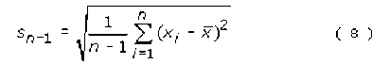
View alternative description - Uncaptioned Equation

s_{n–1} is often called the ‘sample standard deviation’ because it is calculated from data taken for a sample of the population.
The value determined for s_{n–1} provides the best estimate of the standard deviation of the population. It will not have escaped your notice that the only difference between the two formulae is that in Equation 8 you divide by (n–1), whereas in Equation 7 you divide by n. This means that s_{n–1} must always be larger than s_{n} (because we are dividing by a smaller number). This allows for the possibility that within the whole population there may be a few extremely high or low values of the measured quantity which will not necessarily be picked up in a sample drawn from that population.
s_{n–1} is also often called the ‘estimated standard deviation of the population’ because, provided the sample is chosen without bias, it is the best estimate that can be made of the true standard deviation of the population.
Check that you can use your calculator to determine the sample standard deviation s_{n–1} for a set of data by doing Activity 3.

Activity 3 Using a calculator to calculate the sample standard deviation
Allow about 5 minutes

Follow these five steps to calculate the sample standard deviation, using these numbers:
8, 6, 9, 12, 10
The first four steps are the same as before, only Step 5 will be different.

Step 1
Put the calculator into statistical mode.

Step 2
Input all the data.

Step 3
If your calculator can tell you the number of items of data, check that it gives the answer ‘5’ here.

Step 4
When you know you have the data correctly stored, display the mean; you should get the answer ‘9’ here.

Step 5
Now find out how to display the sample standard deviation. The appropriate button will probably be marked σ_{n–1} or s_{n–1}. You should get the answer ‘2.2’ here (to one decimal place). Don’t use the σ_{n} or s_{n} button by mistake!

While this example is useful to familiarize yourself with the process, it doesn’t represent a realistic scenario, not least because the hypothetical data set is so small. Because the aim is to estimate the mean and standard deviation for a whole population by carrying out measurements just on a sample, it is important to ensure that the sample is representative of the population as a whole and that usually requires it not only to be chosen without bias, but also to be reasonably large. In Activity 4, the sample consists of 20 plants.

Activity 4 Flowers: finding the mean
Allow about 10 minutes

Suppose that the number of flowers were counted on 20 orchid plants in a colony, and that the results were:
8; 8; 4; 8; 8; 7; 9; 7; 7; 5; 9; 10; 6; 9; 7; 4; 8; 5; 11; 5.
From these data, estimate to 3 significant figures the mean number, μ, of flowers per plant in the colony and the population standard deviation. You may if you wish construct a table similar to Table 2 in Week 7, but it will be much quicker simply to use your calculator.

View answer - Activity 4 Flowers: finding the mean

4 This week’s quiz
Congratulations on almost reaching the end of the course.
Now it’s time to complete the Session 8 badged quiz. It’s similar to previous quizzes, but this time instead of answering five questions there will be fifteen.
Week 8 compulsory badge quiz
Remember, this quiz counts towards your badge. If you’re not successful the first time, you can attempt the quiz again in 24 hours.
Open the quiz in a new window or tab then come back here when you’ve finished.

5 Summary of Week 8
This is what you covered in this final week of the course.
- You learned about how data sets may be best represented by different averages, depending upon the distribution of the data.
- You extended your knowledge of analysis of repeated measurement data to sample population data.
- You were introduced to a slight variation of the standard deviation calculation associated with these data.
These ideas are the basis for much statistical analysis, so has given you a strong foundation to build your statistical skills. This is important in many areas of science and technology, but particularly when dealing with experimental results and observations from nature on Earth and beyond.
This also brings you to end of the course, which has introduced to the basic skills and ideas underlying a few of the key topics in maths. Well done for completing the course, and the activities. Hopefully, you should now feel more confident to move on with your study of science and technology and maybe revived, or found, a new love of maths.
Other courses and content from OpenLearn
Succeed with maths – Part 1
Succeed with maths – Part 2
Starting with maths: Patterns and forumlas
Squares, roots and powers
Maths for energy interactive

Where next?
If you’ve enjoyed this course you can find more free resources on OpenLearn.
New to University study? You may be interested in our access courses.
Making the decision to study can be a big step and The Open University has 50 years of experience supporting its students through their chosen learning paths. You can find out more about studying with us by visiting our online prospectus.

Tell us what you think
Now you've come to the end of the course, we would appreciate a few minutes of your time to complete this short end-of-course survey (you may have already completed this survey at the end of Week 4). We’d like to find out a bit about your experience of studying the course and what you plan to do next. We will use this information to provide better online experiences for all our learners and to share our findings with others. Participation will be completely confidential and we will not pass on your details to others.

Acknowledgements
This course was written by Maria Townsend/The Open University STEM faculty. It was first published in October 2019.
Except for third party materials and otherwise stated (see FAQs), this content is made available under a Creative Commons Attribution-NonCommercial-ShareAlike 4.0 Licence.
The material acknowledged below is Proprietary and used under licence (not subject to Creative Commons Licence). Grateful acknowledgement is made to the following sources for permission to reproduce material in this free course:
Course image: ©Getty images/evgenyatamanenko
Every effort has been made to contact copyright owners. If any have been inadvertently overlooked, the publishers will be pleased to make the necessary arrangements at the first opportunity.
Don't miss out
If reading this text has inspired you to learn more, you may be interested in joining the millions of people who discover our free learning resources and qualifications by visiting The Open University – www.open.edu/ openlearn/ free-courses.

Solutions

Activity 1 Working with power rules

Discussion
- 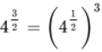which can be written as 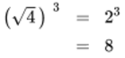

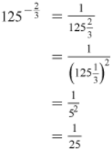

- 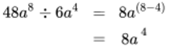
- 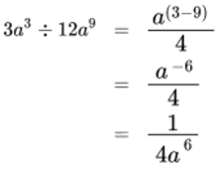
- 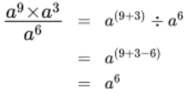
- 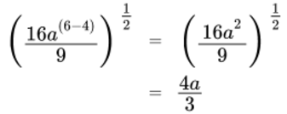
Although you may arrive at the answer to an activity in a different way from that given here (because the rules of indices can often be applied in a different order), you should always get the same final answer.
Back to - Activity 1 Working with power rules

Worked example 1

Answer
- 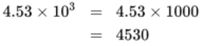
- 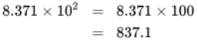
- 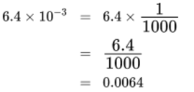
Back to - Worked example 1

Activity 2 Scientific notation to integers or decimal notation

Answer
- 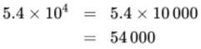
- 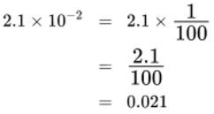
- 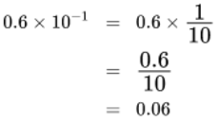
Back to - Activity 2 Scientific notation to integers or decimal notation

Worked example 2

Answer
- 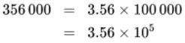
- 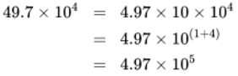
- 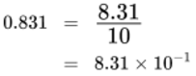
In this worked example, all the steps have been written out in full. You may be able to manage with fewer steps in your own calculations - just use as many or as few as you feel comfortable with in order to get the right answer!
Back to - Worked example 2

Activity 3 An integer or decimal notation to scientific notation

Answer
- 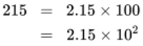
- 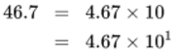
- 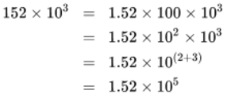
- 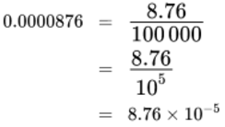
Another way to work out how to express numbers in scientific notation is to count how many positions you move the decimal point to help you find the power of 10. Moving it to the left increases the power of 10 by one for each position moved, while moving it to the right decreases the power of 10 by one for each position moved.
So, other possible solutions are:
(a) 215 can be written as 215. that is with the decimal point after the 5. To change to scientific notation, you have to move it 2 places to the left, and this gives 10 to the power +2, and hence 2.15 × 10².
Similarly for (c) 152. × 10³ (writing in the decimal point). It has to move 2 places to the left to be behind the first non-zero digit, the 2, and so the power of 10 increases by 2 to give 1.52 × 10⁵.
In (d) you have to move the decimal point to the right, and this decreases the power of 10, so making it a negative number here. It has to move 5 places left to be behind the first non-zero digit, the 8, and so we get 8.76 × 10^{–5}.
Back to - Activity 3 An integer or decimal notation to scientific notation

Worked example 1

Answer

View alternative description - Uncaptioned Equation

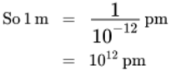
View alternative description - Uncaptioned Equation

View alternative description - Uncaptioned Equation

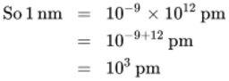
View alternative description - Uncaptioned Equation

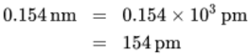
View alternative description - Uncaptioned Equation

Back to - Worked example 1

Activity 1 Converting between units and scientific notation

Answer
- A kilometre is 10 ³ times bigger than a metre, so
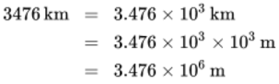
- A micrometre is 10³times bigger than a nanometre, so
8.0 μm = 8.0 × 10³ nm
- A second is 10³ times bigger than a millisecond, so
8.0 s = 0.8 × 10³ ms
To express this in scientific notation, we need to multiply and divide the right-hand side by 10:
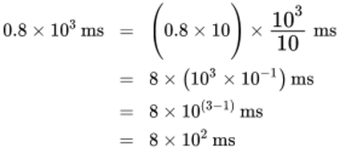
Back to - Activity 1 Converting between units and scientific notation

Activity 2 Orders of magnitude

Part

Answer
Mass of the Earth ~10²⁵kg (since 6.0 is greater than 5, the power of ten has been rounded up).
Back to - Part

Part

Answer
Mass of Jupiter ~10²⁷kg (since 1.9 is less than 5, the power of ten remains unchanged).
Back to - Part

Part

Answer
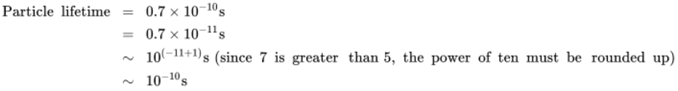
Back to - Part

Worked example 2

Answer
You had:
mass of Jupiter ~10²⁷ kg
and mass of Earth ~10²⁵ kg
So 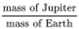 ~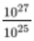 ~ ~
Jupiter is two orders of magnitude (i.e. roughly 100 times) more massive than the Earth.
Back to - Worked example 2

Activity 3 The logarthimic scale

Part

Answer
- 10⁻² m = 0.01 m and 10⁰ m = 1 m so the difference between them is (1 − 0.01) m = 0.99 m.
- 10⁰ m = 1 m and 10² m = 100 m, so the difference between them is 99 m.
- 10² m = 100 m and 10⁴ m = 10 000 m, so the difference between them is 9900 m.
It is quite clear that as one goes up the scale the interval between each successive pair of tick marks increases by 100 times.
Back to - Part

Part

Answer
- The height of a child is about 10⁰ m, i.e. 1 m. The height of Mount Everest is about 10⁴ m (actually 8800 m, but it is not possible to read that accurately from the scale on Figure 2). So Mount Everest is ~10⁴ times taller than a child.
- The length of a typical virus is 10⁻⁸ m and the thickness of the page is 10⁻⁴ m, so it would take ~10⁻⁴/10⁻⁸ = 10⁻⁴⁻⁽⁻⁸⁾ = 10⁻⁴⁺⁸ = 10⁴ viruses laid end to end to stretch across the thickness of the page.
Back to - Part

Worked example 3

Answer
The increase in sound level is
80 dB − 20 dB = 60 dB
This maybe expressed as (10 dB + 10 dB + 10 dB + 10 dB + 10 dB + 10 dB), and each 10 dB increase corresponds to multiplying the intensity by 10.
So the intensity of a shout is (10 × 10 × 10 × 10 × 10 × 10) = 10⁶ times greater than a whisper!
Back to - Worked example 3

Activity 4 Comparing logarithmic quantities

Answer
Magnitude 7 on the Richter scale represents four points more than magnitude 3, and each point increase represents a factor 10 increase in maximum ground movement. So a magnitude 7 earthquake corresponds to 10⁴ (i.e. 10 000) times more ground movement than a magnitude 3 earthquake.
Back to - Activity 4 Comparing logarithmic quantities

Activity 5 How many significant figures?

Answer
Each of the quantities is quoted to four significant figures.
Back to - Activity 5 How many significant figures?

Worked example 4

Answer
The only way to express this quantity unambiguously to fewer than the four significant figures originally given is to use scientific notation.

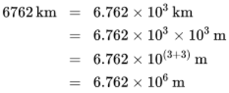
View alternative description - Uncaptioned Equation

The final digit is a 2, so no rounding up is required and the average diameter of Mars is 6.76 × 10⁶ m to three significant figures.
Back to - Worked example 4

Activity 6 More practice with significant figures

Part

Answer
Final zeroes are significant, so the speed is being given to two significant figures.
Back to - Part

Part

Answer
Leading zeroes are not significant, so this value is also being given to two significant figures.
Back to - Part

Part

Answer
- The third digit is an 8, so the second digit must be rounded up:
–38.87 °C = –39 °C to two significant figures
- There is no way of expressing a number greater than or equal to 100 unambiguously to two significant figures except by using scientific notation. The third digit is a 5, so again the second digit must be rounded up but as this is a 9 and rounds to 10, the 1st digit must be rounded up to 2.
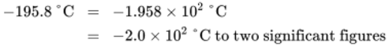
{Note that the final zero in the intermediate rounded answer of -200 ° C is not included in the answer, as this would mean it was shown to 3 significant figures.}
- Again, this quantity cannot be expressed unambiguously to two significant figures without using scientific notation. The third digit is an 8, so the second digit must be rounded up.
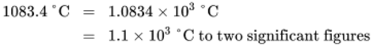
Back to - Part

Activity 1 Simplifying expressions

Answer

View alternative description - Uncaptioned Equation

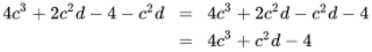
View alternative description - Uncaptioned Equation

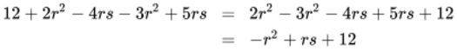
View alternative description - Uncaptioned Equation

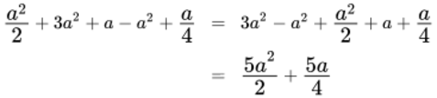
View alternative description - Uncaptioned Equation

Note: 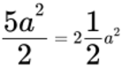 and 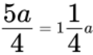
Back to - Activity 1 Simplifying expressions

Activity 2 Removing brackets

Answer
- 2(2x – y) = 4x – 2y
- –2(a + 2b – c) = –2a – 4b + 2c

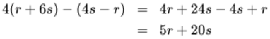
View alternative description - Uncaptioned Equation

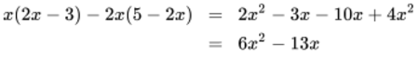
View alternative description - Uncaptioned Equation

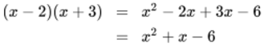
View alternative description - Uncaptioned Equation

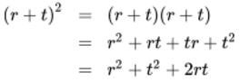
View alternative description - Uncaptioned Equation

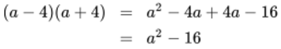
View alternative description - Uncaptioned Equation

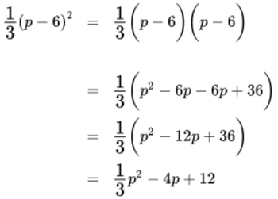
View alternative description - Uncaptioned Equation

Back to - Activity 2 Removing brackets

Activity 3 Rearranging equations

Answer
- x – 5 = y add 5 to both sides: x = y + 5
- 3x – 3 = y add 3 to both sides, then divide by 3: 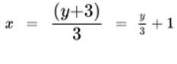
- multiply both sides by 2: x = 6y
- multiply both sides by 7: x – 28 = 14y add 28 to both sides : x = 14y + 28
- multiply both sides by 2.5: x = 25y
- 2x – 12 = 2y add 12 to both sides : 2x = 2y + 12 divide both sides by 2 : x = y + 6
Back to - Activity 3 Rearranging equations

Activity 4 Solving equations

Answer
- 3x = 6 divide both sides by 3: x = 2
- 7x = 21 divide both sides by 7: x = 3
- 8x = 32 divide both sides by 8: x = 4
- x + 3 = 9 subtract 3 from both sides : x = 6
- x + 6 = 7 subtract 6 from both sides : x = 1
- x + 7 = 11 subtract 7 from both sides : x = 4
Back to - Activity 4 Solving equations

Activity 5 More complex equations

Answer

 | Equation | Step 1 | Step 2 | Solution
a. | 2x – 1 = 7 | 2x – 8 |  | x = 4
b. | 5x – 8 = 2 | 5x = 10 |  | x = 2
c. | 3x + 8 = 5 | 3x = –3 |  | x = –1
d. | 3x – 8 = 5x – 20 | –8 = 5x – 3x – 20 | 12 = 2x | x = 6
e. | 3(x + 1) = 9 | 3x + 3 = 9 | 3x = 6 | x = 2
f. | 23 – x = x + 11 | 23 = 2x + 11 | 2x = 12 | x = 6
g. | 2(x – 3) – (x – 2) = 5 | 2x – 6 – x + 2 = 5 | x – 4 = 5 | x = 9
h. |  | 4x = 60 |  | x = 15
i. |  | 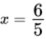 |  | x = 1.2
j. |  | 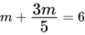 | 5m + 3m = 30 | m = 3.75
k. |  | 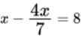 | 7x – 4x = 56 | x = 18.7 (to 1 decimal place)

Back to - Activity 5 More complex equations

Activity 6 Simultaneous equations

Answer

 | Equations | Step 1: rearrange  to make y the  subject for both  equations | Step 2: solve for x | Step 3: solve for y | Solution
(a) | y = x + 10 | y = x + 10 | 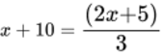 | y = x + 10 | x = –25
 | 3y = 2x + 5 | 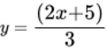 | 3x + 30 = 2x + 5 | y = –25 + 10 = –15 | y = –15
 |  |  | x = –25
(b) | y = 4x |  | 4x = 3x + 5 | y = 4x = 20 | x = 5
 | y = 3x + 5 |  | x = 5 |  | y = 20
(c) | y = 7x + 4 | y = 7x + 4 | 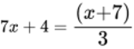 | y = 7x + 4 | x = –0.25
 | 3y = x + 7 | 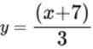 | 21x + 12 = x + 7 | y = –1.75 + 4 = 2.25 | y = 2.25
 |  |  | 20x = –5
 |  |  | x = –0.25
(d) | y = 2x + 4 | y = 2x + 4 | 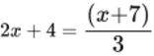 | y = 2x + 4 | x = –1
 | 3y = x + 7 |  | 6x + 12 = x + 7 | y = –2 + 4 = 2 | y = 2
 |  |  | 5x = – 5
 |  |  | x = –1

Back to - Activity 6 Simultaneous equations

Activity 1 Calculator in degrees

Answer
If your calculator is set in degrees your answers will be:
- sin 60 = 0.8660 (to 4 significant figures)
- cos 60 = 0.5
- tan 60 = 1.732 (to 4 significant figures)
If your calculator is set in radians your answers will be:
- sin 60 = –0.3048 (to 4 significant figures)
- cos 60 = –0.9524 (to 4 significant figures)
- tan 60 = 0.3200 (to 4 significant figures)
Make sure before you proceed that you change your calculator to degree mode. If you are unsure how to do this you can try searching the internet.
Back to - Activity 1 Calculator in degrees

Activity 2 Sine and cosine values between 0° and 90°

Answer

Angle/degrees | Sine | Cosine
0 | 0 | 1
10 | 0.1736 | 0.9848
25 | 0.4226 | 0.9063
45 | 0.7071 | 0.7071
70 | 0.9397 | 0.3420
90 | 1 | 0

Perhaps you noticed that all the values for sine and cosine seem to lie between 0 and 1 for angles between 0° and 90°.
You may have also observed that as the values for sine increase, the values for cosine decrease.
Back to - Activity 2 Sine and cosine values between 0° and 90°

Activity 3 Find the unknown side

Answer
You can start by finding angle α.
Since the right angle is 90°:
α + β = 90°
α = 90° – β
α = 90° – 40°
α = 50°
Now you can either find b or c.
Starting with c this time, which is the hypotenuse.
The function that links the adjacent (the known value) with the hypotenuse is cosine.

View alternative description - Uncaptioned Equation

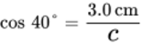
View alternative description - Uncaptioned Equation

Rerranging to make c the subject:
c × cos 40° = 3.0 cm
So, 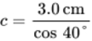
c = 3.916 cm
The opposite side b can be found using Pythagoras.

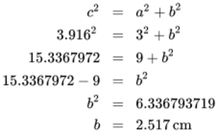
View alternative description - Uncaptioned Equation

The length of side b is 2.5 cm (to 2 significant figures) and c 3.9 cm (to 2 significant figures).
Rounding both to two significant figures matches the precision with which the known side was shown.
Back to - Activity 3 Find the unknown side

Activity 4 Find the angles

Discussion
The known sides are the opposite and hypotenuse. The trig function that links these is sine.

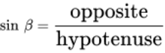
View alternative description - Uncaptioned Equation

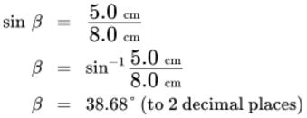
View alternative description - Uncaptioned Equation

and, since all the angles inside a triangle must add to 180°
α = 180° – (90° + 38.68°)
α = 51.32° (to 2 decimal places)
Now rounding to two significant figures to match the data in the question.
α = 51°
β = 39°
From Pythagoras:

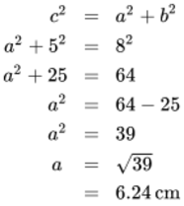
View alternative description - Uncaptioned Equation

The length of side a is 6.2 cm (to 2 significant figures).
So you know all the sides and all the angles in the triangle now.
Back to - Activity 4 Find the angles

Activity 5 Finding sides and angle

Discussion
The known sides are the opposite and hypotenuse. The trig function that links these is sine., but you still need to look for two known values related to one of the unknown values.
If you start by finding a (the adjacent), you need to use cosine as the adjacent and hypotenuse are related by that function.

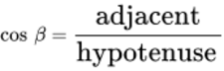
View alternative description - Uncaptioned Equation

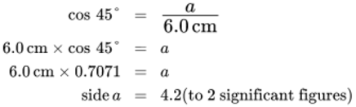
View alternative description - Uncaptioned Equation

You can now either use Pythagoras to work out b or the sine function.

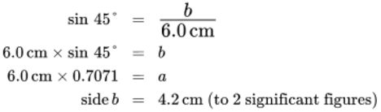
View alternative description - Uncaptioned Equation

You can check this using Pythagoras.

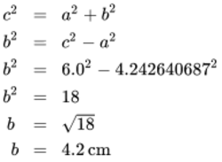
View alternative description - Uncaptioned Equation

This gives the same value as using sine as expected.
To find the other angle:

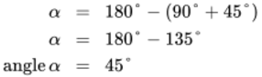
View alternative description - Uncaptioned Equation

This is a particular type of triangle where side a = side b and there are two equal angles.
This special sort of triangle is known as an isosceles triangle but is still also a right-angled triangle.
Back to - Activity 5 Finding sides and angle

Activity 6 Calculating horizontal and vertical components

Answer

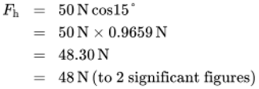
View alternative description - Uncaptioned Equation

The horizontal component of the force is 48 N.

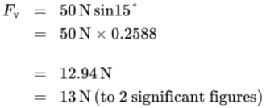
View alternative description - Uncaptioned Equation

The vertical component of the force is 13 N.

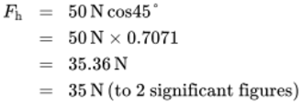
View alternative description - Uncaptioned Equation

The horizontal component of the force is 35 N.

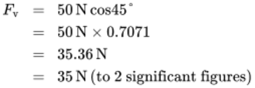
View alternative description - Uncaptioned Equation

The vertical component of the force is 35 N.
You can check these values using Pythagoras.
- 48.30² + 12.94² = 50²
- 35.36² + 35.36² = 50²
Back to - Activity 6 Calculating horizontal and vertical components

Activity 1 Taking the log to base 10

Answer
- log_{a}a = 1
So, log₁₀ (10) = 1
- log₁₀ (100)
10 raised to the power of what equals 100?
10² = 100
So, log¹⁰ (100) = 2
- log₁₀ (0.01)
10 raised to the power of what equals 0.01?
10^{–1} = 0.1 and 10^{–2} = 0.01
So, log₁₀ (0.01) = –2
- log₁₀ (1 000 000) = 6
Since, 10⁶ = 1 000 000
Back to - Activity 1 Taking the log to base 10

Activity 2 Using a calculator to take logs

Answer
- log₁₀ (25) = 1.3979
- log₁₀ (1.5) = 0.1761
- log₁₀ (2500) = 3.3979
- log₁₀ (0.0032) = –2.4949
You can check the answers are correct by raising 10 the power of value of the log.
Back to - Activity 2 Using a calculator to take logs

Activity 3 Using the three log rules

Discussion
- Using Rule 1: log (6) + log (3) = log (6 × 3)
Giving: log (18) – log (9)
Using Rule 2: log (18) – log (9) = log (2)
So, log (6) + log (3) = log (2)
- Using Rule 3: 4 log x – ½ log y + 3 log z = log x⁴ – log y^{½} + log z³
Then using Rule 2: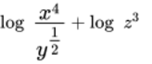
The Rule 3: 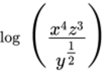
- 64 = 2⁶
log (64) ÷ log (2) = log (2⁶) ÷ log (2)
Using rule 3: log (2⁶) = 6 log (2)
log (2⁶) ÷ log (2) = 6 log (2) ÷ log (2)
= 6
- Using Rule 2: log (27) – log (9) = log (27 ÷ 9)

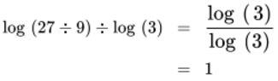
View alternative description - Uncaptioned Equation

Back to - Activity 3 Using the three log rules

Activity 4 Solve the equations

Discussion
- 15 = 3e^{2x}
Divide both sides by 3
5 = e^{2x}
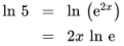
So, ln 5 = 2x as ln e = 1
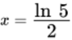
Remember that log_{a}a = 1, so ln e = 1.
- 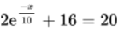
Subtract 16 from both sides
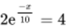
Divide both sides by 2
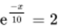
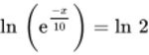
So, 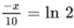
Multiply both sides by –10
Back to - Activity 4 Solve the equations

Activity 5 Finding logs

Answer
Using 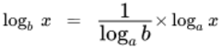

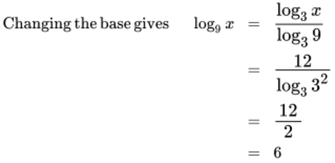
View alternative description - Uncaptioned Equation

Remember that log_{a}a = 1, so log₃3 = 1
Back to - Activity 5 Finding logs

Activity 1 Calculating probability

Part

Answer
There are three possible ways of getting an odd number (1, 3 or 5) and six possible outcomes in total, so Equation 2 shows that the probability of throwing an odd number is , which can be simplified to the equivalent fraction . An alternative way of arriving at this conclusion is to say that as three of the possible outcomes are even and three are odd, the chances of one throw resulting in an odd number are the same as of it resulting in an even number. Hence the probability of an odd number is .
Back to - Part

Part

Answer
- Of the 52 cards in the pack, 13 are hearts. So according to Equation 2, the probability of a card drawn at random being a heart is 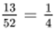
{This result also follows from noting that there are 4 suits, each with the same number of cards, so one-quarter will be hearts.}
- Of the 52 cards in the pack, 26 are red (13 hearts and 13 diamonds). So the probability of a card drawn at random being red is 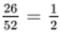
{Alternatively 2 of the 4 suits are red, so the probability is 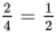.}
- Of the 52 cards in the pack, 4 are aces (one for each suit). So the probability of a card drawn at random being an ace is
- Of the 52 cards in the pack, 12 are picture cards (3 for each suit). So the probability of a card drawn at random being a picture card is
Back to - Part

Activity 2 Probability and cystic fibrosis

Part

Answer
The probability of both partners being carriers is 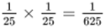
Back to - Part

Part

Answer
The probability that both parents are carriers is , and the probability that a child whose parents are both carriers will have the disease is . So the probability of a child born to white European parents having cystic fibrosis is:

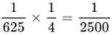
View alternative description - Uncaptioned Equation

Back to - Part

Activity 3 A pair of coins and dice

Answer
- There are four possible outcomes, all of which are equally likely:

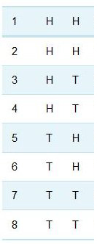
Figure 3 The possible combination of results tossing two coins.
View description - Figure 3 The possible combination of results tossing two coins.

- The outcome of two tails can occur in only one way, so the probability of getting two tails is .
This result can also be found from the multiplication rule:
the probability that the first coin will show tails is
the probability that the second coin will show tails is
so the probability of getting two tails is 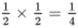.
- The probability of throwing a six with one die is . So the probability of getting a pair of sixes when throwing two dice is 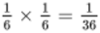.
Back to - Activity 3 A pair of coins and dice

Worked example 1

Answer
The card cannot be both a heart and a diamond: these outcomes are mutually exclusive.
The probability of the card being a heart is .
The probability of the card being a diamond is .
So the probability of the card being either a heart or a diamond is:

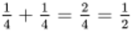
View alternative description - Uncaptioned Equation

(Note that since both diamonds and hearts are red suits, the question is equivalent to asking ‘what is the probability of a single card drawn from the pack being red?’ This was posed in Activity 1 and answered then by a different route, though of course the result was the same!)
Back to - Worked example 1

Activity 4 The probability of mutually exclusive events

Answer
The probability of drawing any one particular card from the pack is . This is true for each of the three named cards. So the probability of drawing the Jack of diamonds or the Queen of diamonds or the King of diamonds is 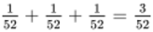.
Back to - Activity 4 The probability of mutually exclusive events

Activity 5 Another example using coins

Answer
As in Activity 3, there are four possible outcomes, all of which are equally likely:

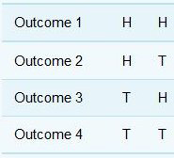
Figure 5 Tossing a coin for one head and one tail
View description - Figure 5 Tossing a coin for one head and one tail

The outcome of a head and a tail can occur in two ways, so the probability of getting a head and a tail is 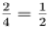.
This result can also be found from a combination of the multiplication and addition rules. For the combination of one head and one tail:
the probability that the coin on the left will be tails is ;
the probability that the coin on the right will be heads is ;
So the probability that the combination T H will occur is .
By similar reasoning, the probability that the combination H T will occur is also . These possibilities are mutually exclusive, so the probability of getting one head and one tails is 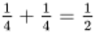.
Back to - Activity 5 Another example using coins

Activity 1 Calculating the mean

Answer
The sum of all the measurements is 24.544 nm. There are 10 results, so the mean value is 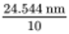, or 2.4544 nm to five significant figures. (The reason for giving the result to this number of significant figures will be discussed shortly.)
Back to - Activity 1 Calculating the mean

Activity 3 Calculate mean and standard deviation

Answer
For the 10 measurements in Table 3
mean = 1.122 mm
standard deviation s_{n} = 0.123 mm
Back to - Activity 3 Calculate mean and standard deviation

Activity 1 Mode of small company earnings

Answer
The mode is £10,000. This is certainly more representative of the typical earnings than the mean would be!
Back to - Activity 1 Mode of small company earnings

Activity 2 Flowers: finding the mode

Part

Answer
The best way of answering this is to compile a table showing the number of plants with particular numbers of flowers:

number of flowers | 4 | 7 | 8 | 9 | 10
number of plants | 1 | 4 | 3 | 1 | 1

The mode is 7 flowers as there are more plants with 7 flowers than with any other number of flowers.
Back to - Part

Part

Answer
To answer this, you have to order the data. In increasing numbers of flowers, the results obtained were:
4; 7; 7; 7; 7; 8; 8; 8; 9; 10.
With a sample of 10 plants, an even number, the median is the mean number of flowers on the 5th and 6th plants (counted in either ascending or descending order). In ascending order, the 5th plant has 7 flowers and the 6th has 8, so the median is 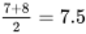.
Back to - Part

Activity 4 Flowers: finding the mean

Answer
The best estimate that can be made from these data of the mean number, μ, of flowers per plant in the colony is the mean of the sample, . In this case:
= 7.25 flowers
{Note that it is normal practice to quote means and medians in this way, even for quantities, such as numbers of flowers, which cannot really be fractional!}
The best estimate that can be made of the population standard deviation is the sample standard deviation s_{n–1}. In this case:
s_{n–1} = 1.94 flowers
That was the final activity of the week and the course. You now have a chance to practice your new knowledge and skills in the final quiz of the course.
Back to - Activity 4 Flowers: finding the mean

Figure 1 Portions of the number line, showing the positions of a few large and small numbers expressed in scientific notation

Description
Portions of the number line, showing the positions of a few large and small numbers expressed in scientific notation. There are four scales. Top scale has a range of -500 to 500; second scale shows -50 to 50; third scale shows -10 to 10; bottom scale is -1 to 1.
Back to - Figure 1 Portions of the number line, showing the positions of a few large and small numbers expressed in scientific notation

Figure 2 The scale of the known Universe

Description
The scale of the known Universe shown in graphic form. The scale begins at the top with ‘distance to the edge of the observable Universe’ down to ‘radius of the Sun’, ‘size of pinhead’, and ‘radius of a proton’.
Back to - Figure 2 The scale of the known Universe

Figure 3 Some common sounds on the decibel scale of sound level

Description
Some common sounds on the decibel scale of sound level. Range shown is 0 to 140. Examples given are ‘jet taking off at 30 metres’ nearer the top of the scale, and ‘quiet whisper’ towards the bottom.
Back to - Figure 3 Some common sounds on the decibel scale of sound level

Figure 4 Parts of two thermometers A and B, measuring the air temperature in the same place

Description
Parts of two thermometers A and B, measuring the air temperature in the same place. Thermometers are showing the same reading but have different scales. The bottom scale is more finely divided.
Back to - Figure 4 Parts of two thermometers A and B, measuring the air temperature in the same place

Figure 1 A right angle triangle

Description
A right angle triangle.
Back to - Figure 1 A right angle triangle

Figure 2 A right angle triangle

Description
A right angle triangle labelled with ‘adjacent’, ‘opposite’ and ‘hypotenuse’.
Back to - Figure 2 A right angle triangle

Figure 3 The sine function

Description
The sine function, shown in graph form.
Back to - Figure 3 The sine function

Figure 4 The cosine function

Description
The cosine function, shown in graph form.
Back to - Figure 4 The cosine function

Figure 5 The tangent function

Description
The tangent function, shown in graph form.
Back to - Figure 5 The tangent function

Figure 6 A right angle triangle for Example 1

Description
A right angle triangle for Example 1. The angle β is 30° and the side b is 6.0 cm. The right-angle is 90°.
Back to - Figure 6 A right angle triangle for Example 1

Figure 7 A right angle triangle for Activity 3

Description
A right angle triangle for Activity 3. The angle β is 40° and the side a is 3.0 cm. The right-angle is 90°.
Back to - Figure 7 A right angle triangle for Activity 3

Figure 8 A right-angled triangle with one unknown side and two unknown angles.

Description
A right-angled triangle with one unknown side and two unknown angles.
Back to - Figure 8 A right-angled triangle with one unknown side and two unknown angles.

Figure 9 A right-angled triangle for Activity 4

Description
A right-angled triangle for Activity 4.
Back to - Figure 9 A right-angled triangle for Activity 4

Figure 10 A right-angled triangle for Activity 5.

Description
A right-angled triangle for Activity 5.
Back to - Figure 10 A right-angled triangle for Activity 5.

Figure 11 Using trigonometry to resolve forces

Description
Using trigonometry to resolve forces. An illustartion which shows a man pulling two children who are sitting on a sledge. The sledge is being pulled using a rope or cable. The bottom section of the illustration shows a triangle.
Back to - Figure 11 Using trigonometry to resolve forces

Figure 1 200 year old log tables

Description
A book showing 200 year old log tables
Back to - Figure 1 200 year old log tables

Figure 2 The exponential function ex

Description
The exponential function e^{x} shown in a graph.
Back to - Figure 2 The exponential function ex

Figure 3 Radioactive decay curve

Description
Radioactive decay curve shown in a graph.
Back to - Figure 3 Radioactive decay curve

Figure 1 The scale of probabilities

Description
The scale of probabilities shown in a diagram. There are three main clouds, the first reads ‘an extremely long shot’ the second ‘your guess is as good as mine’ and a third ‘virtually a certainty’. The clouds are positioned on a scale which from left-to-right shows ‘impossible outcome’ to ‘inevitable outcome’.
Back to - Figure 1 The scale of probabilities

Figure 3 The possible combination of results tossing two coins.

Description
A table which shows following results: HH, HH, HT, HT, TH, TH, TT, TT.
Back to - Figure 3 The possible combination of results tossing two coins.

Figure 4 What is the chance of having a boy?

Description
What is the chance of having a boy? Possibilities are shown in table form for first child, second and third child.
Back to - Figure 4 What is the chance of having a boy?

Figure 5 Tossing a coin for one head and one tail

Description
Tossing a coin for one head and one tail. Outcomes given as HH, HT, TH, TT.
Back to - Figure 5 Tossing a coin for one head and one tail

Figure 1 The X-ray diffraction pattern from a sample of zirconium oxide

Description
A grey and black image. There is a central circular light-coloured image, which is surrounded by a series of circular images forming around it. The circles increase with size.
Back to - Figure 1 The X-ray diffraction pattern from a sample of zirconium oxide

Figure 1 Distribution for repeated measurements of the unit cell constant of a batch of industrial catalyst.

Description
Distribution for repeated measurements of the unit cell constant of a batch of industrial catalyst shgown in a graph. The left axis is ‘number of measurements’ and the bottom axis is ‘cell constant/nm.
Back to - Figure 1 Distribution for repeated measurements of the unit cell constant of a batch of industrial catalyst.

Figure 2 The shaded area under this normal distribution curve represents the measurements that lie within one standard deviation of the mean. This area is 68% of the total area under the curve, so 68% of the measurements are expected to fall within this range.

Description
Figure 2 The shaded area under this normal distribution curve represents the measurements that lie within one standard deviation of the mean. This area is 68% of the total area under the curve, so 68% of the measurements are expected to fall within this range.
Back to - Figure 2 The shaded area under this normal distribution curve represents the measurements that lie within one standard deviation of the mean. This area is 68% of the total area under the curve, so 68% of the measurements are expected to fall within this range.

Figure 3 Normal distribution curves for three independent sets of measurements, with the same number of measurements in each set. The measurements of quantity w are subject to large random uncertainties, while those of quantity y are more precise and those of z more precise still.

Description
Figure 3 Normal distribution curves for three independent sets of measurements, with the same number of measurements in each set. The measurements of quantity w are subject to large random uncertainties, while those of quantity y are more precise and those of z more precise still.
Back to - Figure 3 Normal distribution curves for three independent sets of measurements, with the same number of measurements in each set. The measurements of quantity w are subject to large random uncertainties, while those of quantity y are more precise and those of z more precise still.

Figure 4 Graphs showing different types of distribution

Description
Four graphs each with a different curve pattern and showing the mean.
Back to - Figure 4 Graphs showing different types of distribution

Figure 5 Storm Petrel bird

Description
A picture of a Storm Petrel. This is a relatively small bird with predominantly black feathers.
Back to - Figure 5 Storm Petrel bird

Uncaptioned Equation

Alternative description
a super n equals a multiplication a multiplication a multiplication a full stop full stop full stop full stop full stop full stop to n postfix times factors
Back to - Uncaptioned Equation

Uncaptioned Equation

Alternative description
multiline equation row 1 a cubed multiplication a squared equals left parenthesis a multiplication a multiplication a right parenthesis multiplication left parenthesis a multiplication a right parenthesis row 2 Blank equals a super five
Back to - Uncaptioned Equation

Uncaptioned Equation

Alternative description
a super m multiplication a super n equals a super left parenthesis m plus n right parenthesis
Back to - Uncaptioned Equation

Uncaptioned Equation

Alternative description
multiline equation row 1 a super negative three multiplication a super five equals one divided by a multiplication a multiplication a multiplication a multiplication a multiplication a multiplication a multiplication a row 2 Blank equals a multiplication a multiplication a multiplication a multiplication a divided by a multiplication a multiplication a row 3 Blank equals a multiplication a row 4 Blank equals a squared
Back to - Uncaptioned Equation

Uncaptioned Equation

Alternative description
multiline equation row 1 a super negative three multiplication a super five equals a super left parenthesis negative three plus five right parenthesis row 2 Blank equals a squared
Back to - Uncaptioned Equation

Uncaptioned Equation

Alternative description
multiline equation row 1 a super five division a squared equals a multiplication a multiplication a multiplication a multiplication a divided by a multiplication a row 2 Blank equals a multiplication a multiplication a row 3 Blank equals a cubed
Back to - Uncaptioned Equation

Uncaptioned Equation

Alternative description
a super m division a super n equals a super left parenthesis m minus n right parenthesis
Back to - Uncaptioned Equation

Uncaptioned Equation

Alternative description
multiline equation row 1 a squared division a super negative six equals a multiplication a division one divided by a multiplication a multiplication a multiplication a multiplication a multiplication a row 2 Blank equals left parenthesis a multiplication a right parenthesis multiplication left parenthesis a multiplication a multiplication a multiplication a multiplication a multiplication a right parenthesis row 3 Blank equals a super eight
Back to - Uncaptioned Equation

Uncaptioned Equation

Alternative description
multiline equation row 1 a squared division a super negative six equals a super left parenthesis two minus left parenthesis negative six right parenthesis right parenthesis row 2 Blank equals a super eight
Back to - Uncaptioned Equation

Uncaptioned Equation

Alternative description
multiline equation row 1 a cubed multiplication a cubed equals a super left parenthesis three plus three right parenthesis row 2 Blank equals a super six
Back to - Uncaptioned Equation

Uncaptioned Equation

Alternative description
left parenthesis a super m right parenthesis super n equals a super m times n
Back to - Uncaptioned Equation

Uncaptioned Equation

Alternative description
left parenthesis two super one divided by two right parenthesis squared
Back to - Uncaptioned Equation

Uncaptioned Equation

Alternative description
multiline equation row 1 left parenthesis two super one divided by two right parenthesis squared equals two super one divided by two multiplication two super one divided by two row 2 Blank equals two super left parenthesis one divided by two plus one divided by two right parenthesis row 3 Blank equals two super one row 4 Blank equals two
Back to - Uncaptioned Equation

Uncaptioned Equation

Alternative description
one division a super n equals one divided by a super n
Back to - Uncaptioned Equation

Uncaptioned Equation

Alternative description
a super n equals one divided by a super negative n
Back to - Uncaptioned Equation

Uncaptioned Equation

Alternative description
multiline equation row 1 one divided by a super negative n equals multiline equation line 1 a super zero division a super negative n row 2 Blank equals a super left parenthesis zero minus left parenthesis negative n right parenthesis right parenthesis row 3 Blank equals a super n
Back to - Uncaptioned Equation

Uncaptioned Equation

Alternative description
one pm equals 10 super negative 12 m
Back to - Uncaptioned Equation

Uncaptioned Equation

Alternative description
multiline equation row 1 So one m equals one divided by 10 super negative 12 pm row 2 Blank equals 10 super 12 pm
Back to - Uncaptioned Equation

Uncaptioned Equation

Alternative description
one nm equals 10 super negative nine m
Back to - Uncaptioned Equation

Uncaptioned Equation

Alternative description
multiline equation row 1 So one nm equals 10 super negative nine multiplication 10 super 12 pm row 2 Blank equals 10 super negative nine plus 12 pm row 3 Blank equals 10 cubed pm
Back to - Uncaptioned Equation

Uncaptioned Equation

Alternative description
multiline equation row 1 0.154 nm equals 0.154 multiplication 10 cubed pm row 2 Blank equals 154 pm
Back to - Uncaptioned Equation

Uncaptioned Equation

Alternative description
multiline equation row 1 6762 km equals 6.762 multiplication 10 cubed km row 2 Blank equals 6.762 multiplication 10 cubed multiplication 10 cubed m row 3 Blank equals 6.762 multiplication 10 super left parenthesis three plus three right parenthesis m row 4 Blank equals 6.762 multiplication 10 super six m
Back to - Uncaptioned Equation

Uncaptioned Equation

Alternative description
speed equals distance travelled divided by time taken
Back to - Uncaptioned Equation

Uncaptioned Equation

Alternative description
multiline equation row 1 four plus two multiplication seven equals six multiplication seven row 2 Blank equals 42
Back to - Uncaptioned Equation

Uncaptioned Equation

Alternative description
multiline equation row 1 four plus two multiplication seven equals four plus 14 row 2 Blank equals 16
Back to - Uncaptioned Equation

Uncaptioned Equation

Alternative description
12 times t plus 13 times t squared minus four minus six times t plus three times t squared equals sum with 3 summands 13 times t squared plus three times t squared plus 12 times t minus six times t minus four
Back to - Uncaptioned Equation

Uncaptioned Equation

Alternative description
multiline equation row 1 sum with 3 summands 13 times t squared plus three times t squared plus 12 times t minus six times t minus four equals 16 times t squared plus six times t minus four row 2 Blank Blank Blank
Back to - Uncaptioned Equation

Uncaptioned Equation

Alternative description
multiline equation row 1 six times y minus eight times y squared plus four times y squared minus two times y equals sum with 3 summands negative eight times y squared plus four times y squared plus six times y minus two times y row 2 Blank equals negative four times y squared plus four times y
Back to - Uncaptioned Equation

Uncaptioned Equation

Alternative description
multiline equation row 1 four times c cubed plus two times c squared times d minus four minus c squared times d equals four times c cubed plus two times c squared times d minus c squared times d minus four row 2 Blank equals four times c cubed plus c squared times d minus four
Back to - Uncaptioned Equation

Uncaptioned Equation

Alternative description
multiline equation row 1 12 plus two times r squared minus four times r times s minus three times r squared plus five times r times s equals sum with 3 summands two times r squared minus three times r squared minus four times r times s plus five times r times s plus 12 row 2 Blank equals sum with 3 summands negative r squared plus r times s plus 12
Back to - Uncaptioned Equation

Uncaptioned Equation

Alternative description
multiline equation row 1 sum with 3 summands a squared divided by two plus three times a squared plus a minus a squared plus a divided by four equals sum with 4 summands three times a squared minus a squared plus a squared divided by two plus a plus a divided by four row 2 Blank equals five times a squared divided by two plus five times a divided by four
Back to - Uncaptioned Equation

Uncaptioned Equation

Alternative description
multiline equation row 1 sum with 3 summands negative 16 plus 11 minus seven plus three plus eight equals negative 23 plus 22 row 2 Blank equals negative one
Back to - Uncaptioned Equation

Uncaptioned Equation

Alternative description
multiline equation row 1 negative four minus left parenthesis negative seven right parenthesis equals negative four plus left parenthesis prefix plus of seven right parenthesis row 2 Blank equals negative four plus seven row 3 Blank equals prefix plus of three
Back to - Uncaptioned Equation

Uncaptioned Equation

Alternative description
multiline equation row 1 a minus two times left parenthesis a minus three right parenthesis equals a minus two multiplication a minus two multiplication negative three row 2 Blank equals a minus two times a plus six row 3 Blank equals negative a plus six
Back to - Uncaptioned Equation

Uncaptioned Equation

Alternative description
a multiplication b plus a multiplication negative one plus two multiplication b plus two multiplication negative one equals a times b minus a plus two times b minus two
Back to - Uncaptioned Equation

Uncaptioned Equation

Alternative description
multiline equation row 1 four times left parenthesis r plus six times s right parenthesis minus left parenthesis four times s minus r right parenthesis equals four times r plus 24 times s minus four times s plus r row 2 Blank equals five times r plus 20 times s
Back to - Uncaptioned Equation

Uncaptioned Equation

Alternative description
multiline equation row 1 x times left parenthesis two times x minus three right parenthesis minus two times x times left parenthesis five minus two times x right parenthesis equals two times x squared minus three times x minus 10 times x plus four times x squared row 2 Blank equals six times x squared minus 13 times x
Back to - Uncaptioned Equation

Uncaptioned Equation

Alternative description
multiline equation row 1 left parenthesis x minus two right parenthesis times left parenthesis x plus three right parenthesis equals x squared minus two times x plus three times x minus six row 2 Blank equals x squared plus x minus six
Back to - Uncaptioned Equation

Uncaptioned Equation

Alternative description
multiline equation row 1 left parenthesis r plus t right parenthesis squared equals left parenthesis r plus t right parenthesis times left parenthesis r plus t right parenthesis row 2 Blank equals sum with 4 summands r squared plus r times t plus t times r plus t squared row 3 Blank equals sum with 3 summands r squared plus t squared plus two times r times t
Back to - Uncaptioned Equation

Uncaptioned Equation

Alternative description
multiline equation row 1 left parenthesis a minus four right parenthesis times left parenthesis a plus four right parenthesis equals a squared minus four times a plus four times a minus 16 row 2 Blank equals a squared minus 16
Back to - Uncaptioned Equation

Uncaptioned Equation

Alternative description
multiline equation row 1 one divided by three times left parenthesis p minus six right parenthesis squared equals one divided by three times left parenthesis p minus six right parenthesis times left parenthesis p minus six right parenthesis row 2 Blank Blank row 3 Blank equals one divided by three times left parenthesis p squared minus six times p minus six times p plus 36 right parenthesis row 4 Blank equals one divided by three times left parenthesis p squared minus 12 times p plus 36 right parenthesis row 5 Blank equals one divided by three times p squared minus four times p plus 12
Back to - Uncaptioned Equation

Uncaptioned Equation

Alternative description
multiline equation row 1 x equals y plus three row 2 x minus three equals y plus three minus three row 3 x minus three equals y
Back to - Uncaptioned Equation

Uncaptioned Equation

Alternative description
multiline equation row 1 four times x equals 24 row 2 four times x divided by four equals 24 divided by four
Back to - Uncaptioned Equation

Uncaptioned Equation

Alternative description
multiline equation row 1 sum with 3 summands alpha plus beta plus 90 degree equals 180 degree row 2 alpha plus beta equals 90 degree
Back to - Uncaptioned Equation

Uncaptioned Equation

Alternative description
equation left hand side c squared equals right hand side a squared plus b squared
Back to - Uncaptioned Equation

Uncaptioned Equation

Alternative description
sine beta equals opposite left parenthesis b right parenthesis divided by hypotenuse left parenthesis c right parenthesis
Back to - Uncaptioned Equation

Uncaptioned Equation

Alternative description
cosine beta equals adjacent left parenthesis a right parenthesis divided by hypotenuse left parenthesis c right parenthesis
Back to - Uncaptioned Equation

Uncaptioned Equation

Alternative description
tangent beta equals opposite left parenthesis b right parenthesis divided by adjacent left parenthesis a right parenthesis
Back to - Uncaptioned Equation

Uncaptioned Equation

Alternative description
multiline equation row 1 alpha equals 180 degree minus left parenthesis 90 degree plus 30 degree right parenthesis row 2 Blank equals 180 degree minus 120 degree row 3 Blank equals 60 degree
Back to - Uncaptioned Equation

Uncaptioned Equation

Alternative description
tangent beta equals opposite left parenthesis b right parenthesis divided by adjacent left parenthesis a right parenthesis
Back to - Uncaptioned Equation

Uncaptioned Equation

Alternative description
multiline equation row 1 a equals b postfix times tangent 30 degree equals 6.0 postfix times cm divided by a row 2 a equals b postfix times tangent 30 degree equals 6.0 postfix times cm row 3 a equals 6.0 postfix times prefix times times of cm divided by tangent times 30 degree row 4 Blank equals 10.39 cm
Back to - Uncaptioned Equation

Uncaptioned Equation

Alternative description
multiline equation row 1 c squared equals a squared plus b squared row 2 c squared equals vector element 1 10.39230485 squared plus six squared row 3 c squared equals 108 plus 36 row 4 c squared equals 144 row 5 c equals Square root of multiline equation line 1 144 row 6 c equals 12 cm
Back to - Uncaptioned Equation

Uncaptioned Equation

Alternative description
cosine beta equals adjacent divided by hypotenuse
Back to - Uncaptioned Equation

Uncaptioned Equation

Alternative description
cosine 40 degree equals 3.0 postfix times cm divided by c
Back to - Uncaptioned Equation

Uncaptioned Equation

Alternative description
multiline equation row 1 c squared equals a squared plus b squared row 2 3.916 squared equals three squared plus b squared row 3 15.3367972 equals nine plus b squared row 4 15.3367972 minus nine equals b squared row 5 b squared equals 6.336793719 row 6 b equals 2.517 cm
Back to - Uncaptioned Equation

Uncaptioned Equation

Alternative description
cosine beta equals adjacent divided by hypotenuse
Back to - Uncaptioned Equation

Uncaptioned Equation

Alternative description
cosine equation sequence part 1 beta equals part 2 3.0 cm divided by 5.0 cm equals part 3 0.6
Back to - Uncaptioned Equation

Uncaptioned Equation

Alternative description
multiline equation row 1 c squared equals a squared plus b squared row 2 five squared equals three squared plus b squared row 3 25 equals nine plus b squared row 4 25 minus nine equals b squared row 5 b squared equals 16 row 6 b equals 4.0 cm
Back to - Uncaptioned Equation

Uncaptioned Equation

Alternative description
sine beta equals opposite divided by hypotenuse
Back to - Uncaptioned Equation

Uncaptioned Equation

Alternative description
multiline equation row 1 sine beta equals 5.0 postfix times cm divided by 8.0 postfix times cm row 2 beta equals sine super negative one of 5.0 postfix times cm divided by 8.0 postfix times cm row 3 beta equals 38.68 degree left parenthesis to two decimal places right parenthesis
Back to - Uncaptioned Equation

Uncaptioned Equation

Alternative description
multiline equation row 1 c squared equals a squared plus b squared row 2 a squared plus five squared equals eight squared row 3 a squared plus 25 equals 64 row 4 a squared equals 64 minus 25 row 5 a squared equals 39 row 6 a equals Square root of 39 row 7 Blank equals 6.24 cm
Back to - Uncaptioned Equation

Uncaptioned Equation

Alternative description
cosine beta equals adjacent divided by hypotenuse
Back to - Uncaptioned Equation

Uncaptioned Equation

Alternative description
multiline equation row 1 cosine 45 degree equals a divided by 6.0 cm row 2 6.0 cm prefix multiplication of cosine 45 degree equals a row 3 6.0 cm prefix multiplication of 0.7071 equals a row 4 side a equals 4.2 left parenthesis to two significant figures right parenthesis
Back to - Uncaptioned Equation

Uncaptioned Equation

Alternative description
multiline equation row 1 sine 45 degree equals b divided by 6.0 cm row 2 6.0 cm prefix multiplication of sine 45 degree equals b row 3 6.0 cm prefix multiplication of 0.7071 equals a row 4 side b equals 4.2 cm left parenthesis to two significant figures right parenthesis
Back to - Uncaptioned Equation

Uncaptioned Equation

Alternative description
multiline equation row 1 c squared equals a squared plus b squared row 2 b squared equals c squared minus a squared row 3 b squared equals 6.0 squared minus 4.242640687 squared row 4 b squared equals 18 row 5 b equals Square root of 18 row 6 b equals 4.2 cm
Back to - Uncaptioned Equation

Uncaptioned Equation

Alternative description
multiline equation row 1 alpha equals 180 degree minus left parenthesis 90 degree plus 45 degree right parenthesis row 2 alpha equals 180 degree minus 135 degree row 3 angle alpha equals 45 degree
Back to - Uncaptioned Equation

Uncaptioned Equation

Alternative description
multiline equation row 1 cosine alpha equals cap f sub h divided by 50 cap n
Back to - Uncaptioned Equation

Uncaptioned Equation

Alternative description
multiline equation row 1 sine alpha equals cap f sub v divided by 50 cap n
Back to - Uncaptioned Equation

Uncaptioned Equation

Alternative description
multiline equation row 1 cap f sub h equals 50 postfix times cap n cosine 25 degree row 2 So comma cap f sub h equals 50 cap n prefix multiplication of 0.9063 row 3 cap f sub h equals 45.32 cap n row 4 cap f sub h equals 45 cap n left parenthesis to two significant figures right parenthesis
Back to - Uncaptioned Equation

Uncaptioned Equation

Alternative description
multiline equation row 1 cap f sub v equals 50 cap n sine 25 degree row 2 cap f sub v equals 50 multiplication 0.42262 row 3 Blank equals 21.13 cap n row 4 Blank equals 21 cap n left parenthesis to two significant figures right parenthesis
Back to - Uncaptioned Equation

Uncaptioned Equation

Alternative description
multiline equation line 1 45.32 squared postfix times prefix plus of 21.13 squared equals 2053.484 postfix times plus 446.515 line 2 equals 2500 line 3 equals 50 squared
Back to - Uncaptioned Equation

Uncaptioned Equation

Alternative description
multiline equation row 1 cap f sub h equals 50 cap n cosine 15 degree row 2 Blank equals 50 cap n prefix multiplication of 0.9659 cap n row 3 Blank equals 48.30 cap n row 4 Blank equals 48 cap n left parenthesis to two significant figures right parenthesis
Back to - Uncaptioned Equation

Uncaptioned Equation

Alternative description
multiline equation row 1 cap f sub v equals 50 cap n sine 15 degree row 2 Blank equals 50 cap n prefix multiplication of 0.2588 row 3 Blank equals 12.94 cap n row 4 Blank equals 13 cap n left parenthesis to two significant figures right parenthesis
Back to - Uncaptioned Equation

Uncaptioned Equation

Alternative description
multiline equation row 1 cap f sub h equals 50 cap n cosine 45 degree row 2 Blank equals 50 cap n prefix multiplication of 0.7071 row 3 Blank equals 35.36 cap n row 4 Blank equals 35 cap n left parenthesis to two significant figures right parenthesis
Back to - Uncaptioned Equation

Uncaptioned Equation

Alternative description
multiline equation row 1 cap f sub v equals 50 cap n cosine 45 degree row 2 Blank equals 50 cap n prefix multiplication of 0.7071 row 3 Blank equals 35.36 cap n row 4 Blank equals 35 cap n left parenthesis to two significant figures right parenthesis
Back to - Uncaptioned Equation

Uncaptioned Equation

Alternative description
Rule one log sub a x times y equals log sub a x plus log sub a y
Back to - Uncaptioned Equation

Uncaptioned Equation

Alternative description
Rule two log sub a x divided by y equals log sub a x plus log sub a y
Back to - Uncaptioned Equation

Uncaptioned Equation

Alternative description
multiline equation row 1 x divided by y equals a super m divided by a super n row 2 Blank equals a super left parenthesis m minus n right parenthesis
Back to - Uncaptioned Equation

Uncaptioned Equation

Alternative description
log sub a x divided by y equals log sub a x plus log sub a y
Back to - Uncaptioned Equation

Uncaptioned Equation

Alternative description
Rule three log sub a postfix times x super r equals r log sub a postfix times x
Back to - Uncaptioned Equation

Uncaptioned Equation

Alternative description
multiline equation row 1 multiline equation line 1 x super r equals left parenthesis a super n right parenthesis super r row 2 Blank equals multiline equation line 1 a super r times n
Back to - Uncaptioned Equation

Uncaptioned Equation

Alternative description
multiline equation row 1 log left parenthesis 27 division nine right parenthesis division log left parenthesis three right parenthesis equals log prefix of of left parenthesis three right parenthesis divided by log left parenthesis three right parenthesis row 2 Blank equals one
Back to - Uncaptioned Equation

Uncaptioned Equation

Alternative description
Rule one natural log x times y equals natural log x postfix plus natural log y
Back to - Uncaptioned Equation

Uncaptioned Equation

Alternative description
Rule two natural log x divided by y equals natural log x postfix minus natural log y
Back to - Uncaptioned Equation

Uncaptioned Equation

Alternative description
Rule three natural log x super r equals r natural log x
Back to - Uncaptioned Equation

Uncaptioned Equation

Alternative description
Let log sub b x equals n so that x equals b super n
Back to - Uncaptioned Equation

Uncaptioned Equation

Alternative description
multiline equation row 1 log sub a x equals log sub a left parenthesis b super n right parenthesis row 2 Blank equals n log sub a b
Back to - Uncaptioned Equation

Uncaptioned Equation

Alternative description
n equals log sub a x divided by log sub a b
Back to - Uncaptioned Equation

Uncaptioned Equation

Alternative description
log x equals natural log x divided by natural log 10
Back to - Uncaptioned Equation

Uncaptioned Equation

Alternative description
natural log x equals log x divided by log e
Back to - Uncaptioned Equation

Uncaptioned Equation

Alternative description
multiline equation row 1 cap c times h times a times n times g times i times n times g postfix times t times h times e postfix times b times a times s times e postfix times g times i times v times e times s postfix times log sub nine x equals log sub three x divided by log sub three nine row 2 Blank equals 12 divided by log sub three three squared row 3 Blank equals multiline equation line 1 12 divided by two row 4 Blank equals six
Back to - Uncaptioned Equation

Uncaptioned Equation

Alternative description
probability of a given outcome equals number of times that outcome occurs divided by total number of outcomes
Back to - Uncaptioned Equation

Uncaptioned Equation

Alternative description
probabi lity of a given outcome equals number of ways to get that particular outcome divided by total number of possible outcomes
Back to - Uncaptioned Equation

Uncaptioned Equation

Alternative description
equation sequence part 1 one divided by four equals part 2 0.25 equals part 3 25 percent
Back to - Uncaptioned Equation

Uncaptioned Equation

Alternative description
one divided by 625 multiplication one divided by four equals one divided by 2500
Back to - Uncaptioned Equation

Uncaptioned Equation

Alternative description
equation sequence part 1 one divided by four plus one divided by four equals part 2 two divided by four equals part 3 one divided by two
Back to - Uncaptioned Equation

Uncaptioned Equation

Alternative description
sum with 3 summands one divided by eight plus one divided by eight plus one divided by eight equals three divided by eight
Back to - Uncaptioned Equation

Uncaptioned Equation

Alternative description
Back to - Uncaptioned Equation

Uncaptioned Equation

Alternative description
Back to - Uncaptioned Equation

Uncaptioned Equation

Alternative description
Back to - Uncaptioned Equation

Uncaptioned Equation

Alternative description
Back to - Uncaptioned Equation

Uncaptioned Equation

Alternative description
Back to - Uncaptioned Equation

Uncaptioned Equation

Alternative description
Back to - Uncaptioned Equation

Uncaptioned Equation

Alternative description
Back to - Uncaptioned Equation

Uncaptioned Equation

Alternative description
Back to - Uncaptioned Equation

Uncaptioned Equation

Alternative description
Back to - Uncaptioned Equation

Uncaptioned Equation

Alternative description
Back to - Uncaptioned Equation

Uncaptioned Equation

Alternative description
Back to - Uncaptioned Equation

Uncaptioned Equation

Alternative description
Back to - Uncaptioned Equation

Uncaptioned Equation

Alternative description
Back to - Uncaptioned Equation

Uncaptioned Equation

Alternative description
Back to - Uncaptioned Equation

Uncaptioned Equation

Alternative description
Back to - Uncaptioned Equation

