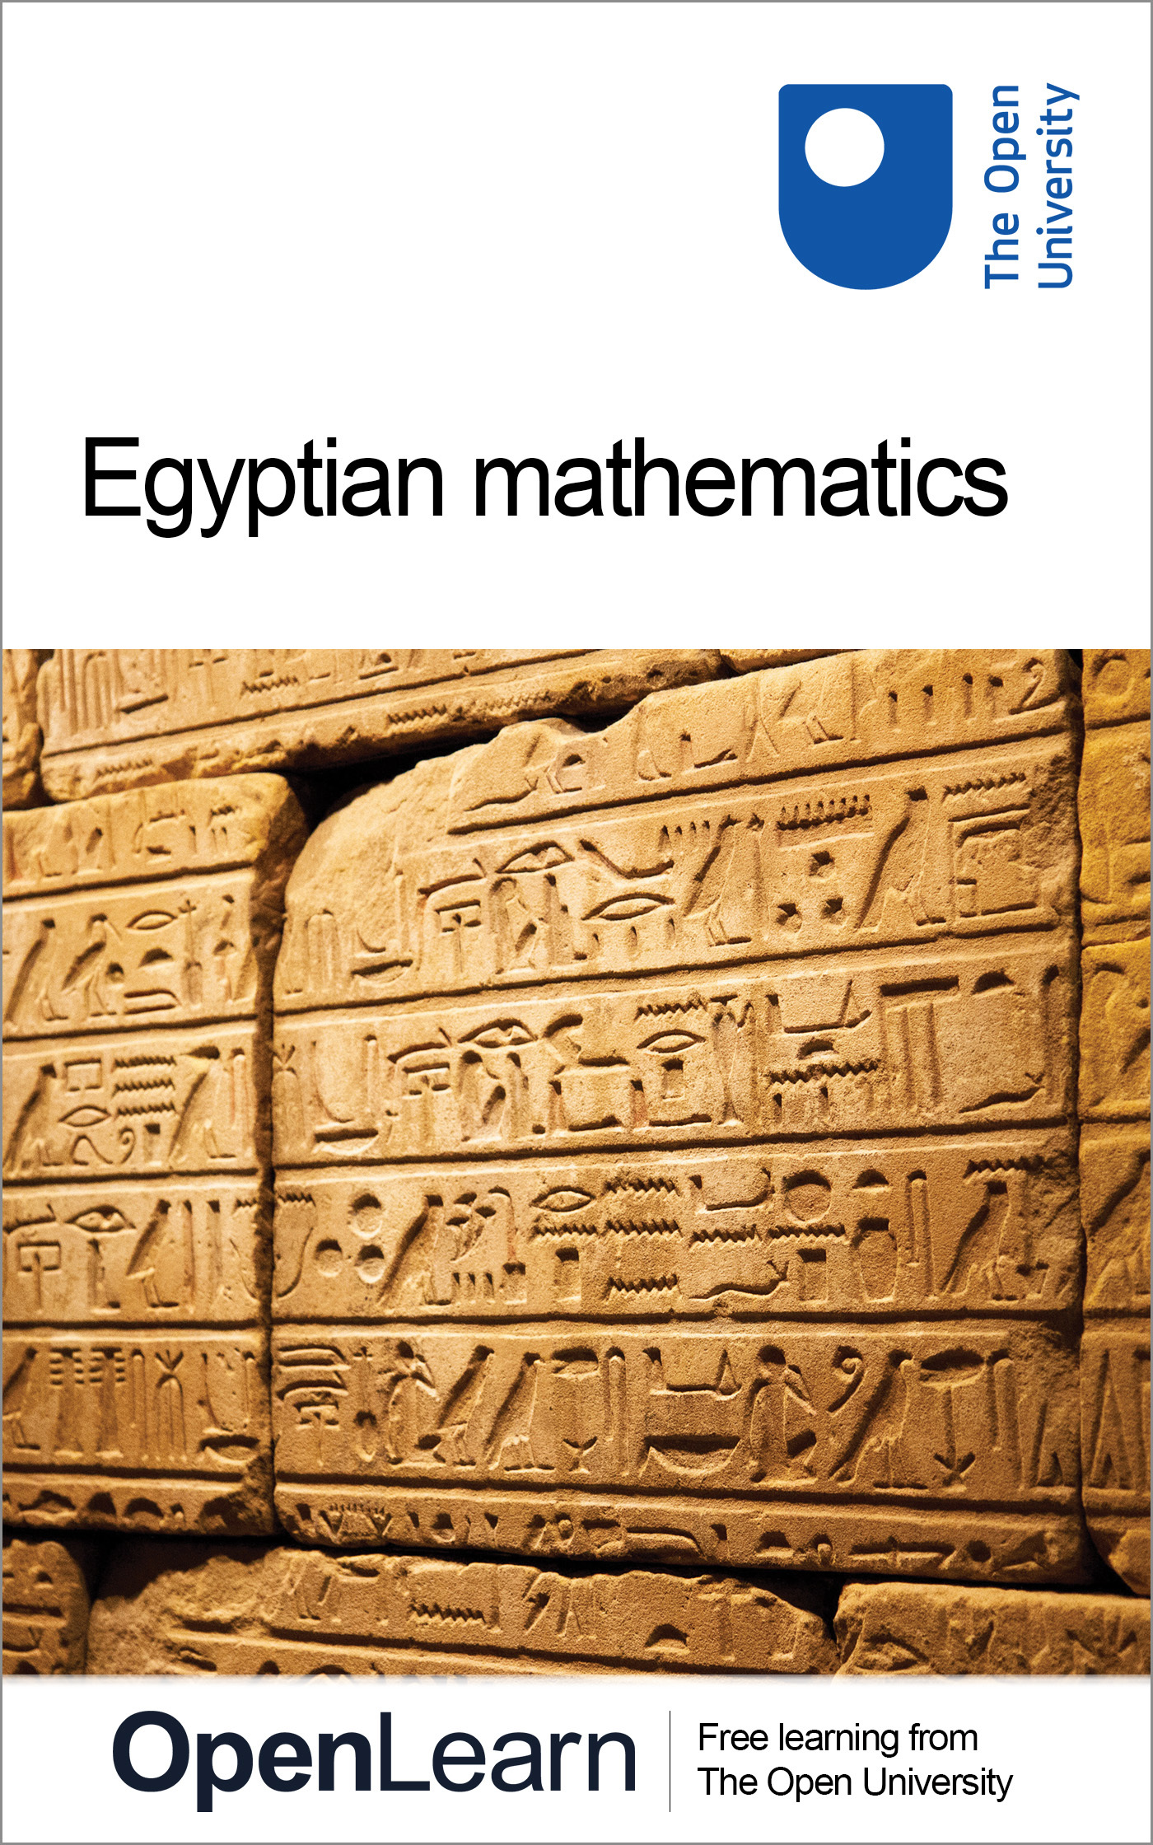

MA290_1 Topics in the History of Mathematics

Egyptian mathematics
About this free course
This free course provides a sample of Level 2 study in Mathematics: www.open.ac.uk/courses/find/mathematics
This version of the content may include video, images and interactive content that may not be optimised for your device.
You can experience this free course as it was originally designed on OpenLearn, the home of free learning from The Open University: www.open.edu/openlearn/science-maths-technology/mathematics-and-statistics/mathematics/egyptian-mathematics/content-section-0.
There you’ll also be able to track your progress via your activity record, which you can use to demonstrate your learning.
Copyright © 2016 The Open University
Intellectual property
Unless otherwise stated, this resource is released under the terms of the Creative Commons Licence v4.0 http://creativecommons.org/licenses/by-nc-sa/4.0/deed.en_GB. Within that The Open University interprets this licence in the following way: www.open.edu/openlearn/about-openlearn/frequently-asked-questions-on-openlearn. Copyright and rights falling outside the terms of the Creative Commons Licence are retained or controlled by The Open University. Please read the full text before using any of the content.
We believe the primary barrier to accessing high-quality educational experiences is cost, which is why we aim to publish as much free content as possible under an open licence. If it proves difficult to release content under our preferred Creative Commons licence (e.g. because we can’t afford or gain the clearances or find suitable alternatives), we will still release the materials for free under a personal end-user licence.
This is because the learning experience will always be the same high quality offering and that should always be seen as positive – even if at times the licensing is different to Creative Commons.
When using the content you must attribute us (The Open University) (the OU) and any identified author in accordance with the terms of the Creative Commons Licence.
The Acknowledgements section is used to list, amongst other things, third party (Proprietary), licensed content which is not subject to Creative Commons licensing. Proprietary content must be used (retained) intact and in context to the content at all times.
The Acknowledgements section is also used to bring to your attention any other Special Restrictions which may apply to the content. For example there may be times when the Creative Commons Non-Commercial Sharealike licence does not apply to any of the content even if owned by us (The Open University). In these instances, unless stated otherwise, the content may be used for personal and non-commercial use.
We have also identified as Proprietary other material included in the content which is not subject to Creative Commons Licence. These are OU logos, trading names and may extend to certain photographic and video images and sound recordings and any other material as may be brought to your attention.
Unauthorised use of any of the content may constitute a breach of the terms and conditions and/or intellectual property laws.
We reserve the right to alter, amend or bring to an end any terms and conditions provided here without notice.
All rights falling outside the terms of the Creative Commons licence are retained or controlled by The Open University.
Head of Intellectual Property, The Open University
978-1-4730-1554-8 (.kdl)
978-1-4730-0786-4 (.epub)

Contents
- Introduction
- Learning outcomes
- 1 Egyptian mathematics
  - 1.1 Mathematics in Egyptian history
- Conclusion
- Keep on learning
- References
- Acknowledgements

Introduction
For many centuries, ancient Egypt was seen as the source of wisdom and knowledge, about mathematics as well as other things. There was a long classical Greek tradition to this effect, and in later centuries the indecipherability of the hieroglyphs did nothing to dispel this belief. But since the early nineteenth century, when the deciphering of the Rosetta Stone by Young and Champollion enabled rapid progress to be made in translating extant Egyptian texts, the picture has changed to reveal a civilisation more pragmatic and down-to-earth. In this course, we shall investigate what we now know of Egyptian mathematics, and how we know it.
This OpenLearn course provides a sample of Level 2 study in Mathematics

Learning outcomes
After studying this course, you should be able to:
- demonstrate knowledge of how hieroglyphs were used to represent numbers and the nature of the problems that have survived
- understand that Egyptian calculation was fundamentally additive. Operations such as doubling and halving being used for multiplication and division
- appreciate the advanced understanding of mathematics in Ancient Egypt in relation to the manipulation of fractions
- consider some views of the mathematics of Ancient Egypt in relation to that of the Babylonians.

1 Egyptian mathematics

1.1 Mathematics in Egyptian history
Only a small number of the surviving Egyptian papyri are concerned with mathematical calculations – perhaps a dozen or so in all, of which the earliest dates from about 1850 BC and the most recent from AD 750. The two major ones are the Rhind Papyrus (named after the man who bought it on his holidays in Luxor in 1858), which you can see in the British Museum, and the Golenischev (or Moscow) Papyrus, which is in Moscow. They are dated at around 1650 BC and 1850 BC respectively. So here are authentic primary sources – that is, examples of the foundational artefacts upon which our knowledge of the history of mathematics is constructed.

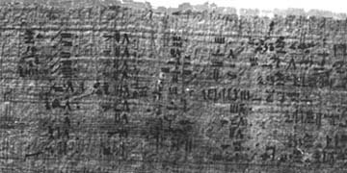
Figure 1 Rhind Papyrus, Problems 39 and 40

If you look at Figure 1, you will see at once that there is a problem; the text is not meaningful until it has been translated into something comprehensible to us. It will be instructive to spend a few minutes discovering what to do about this. It is not generally practicable for any of us to learn afresh each new language or script of cultures whose mathematics we might be interested in. We are reliant, in this case, on the knowledge of Egyptologists for the material on which we can start to build our own understanding. Even once a translation is provided there is still a process of interpretation to be gone through.

1.1.1 The Rhind papyrus
For a literate civilisation extending over some 4000 years, that of the ancient Egyptians has left disappointingly little evidence of its mathematical attainments. Even though the classical Greeks believed mathematics to have been invented in Egypt – though their accounts are far from unanimous on how this happened – there are now but a handful of papyri and other objects to convey a sense of Egyptian mathematical activity. The largest and best preserved of these is the Rhind papyrus (Extract 1), now in the British Museum, a copy made in about 1650 BC of a text from two centuries earlier. In Box 3 the Egyptologist Sir Alan Gardiner explains an initially puzzling feature of Egyptian arithmetic, the Egyptian concept of fraction or part. The commentaries given in Box 4 are contrasting perceptions of Egyptian mathematics, from the translator of the Rhind papyrus and from a historian of mathematics.
Extract 1 Two problems from the Rhind papyrus
(a) Problem 24
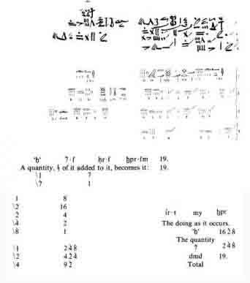
(b) Problem 40
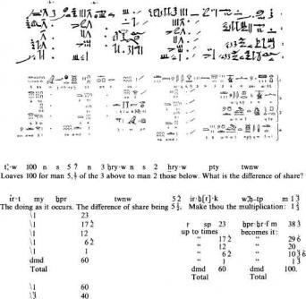

Question 1

Examine the extract from Chace's edition of the Rhind Papyrus, Extract 1(b), comparing it with the photograph shown in Figure 1. Try to work out what things the Egyptologist has done. Do you yet feel in a position to begin to understand what the Egyptian scribe was doing? (Do not worry if your answer to the last question is ‘no’!)

View discussion - Question 1

If we were to work through the calculation, it would be possible to infer what the question was. ‘Loaves 100 for man 5, ¹/₇ of the 3 above to man 2 those below. What is the difference of share?’ seems to be saying that a hundred loaves are to be divided between five men in a particular way. This is that each is to receive a different number of loaves so that the two men who receive the least end up with a seventh of what the other three men get between them. Further, it requires that the difference between what they receive is constant: each man receives a fixed number of loaves more than the next man. (So the number of loaves each receives is in what we would call an arithmetical progression.)
You may observe that the scribe's way of putting the problem had at least the virtue of succinctness! We shall leave the actual calculation for now, and return to it once we have looked at the more general principles governing the ways Egyptians handled numbers, as inferred from the evidence of the Rhind and other papyri. As already mentioned, evidence from papyri extends over a long period, although it is rather scanty and is reinforced by evidence from only a few other artefacts, such as bits of pot, tiles and stone inscriptions. From the limited evidence we have, however, the fundamental spirit and mathematical approach of Egyptian mathematics seem to have changed very little over three millennia.

1.1.2 Egyptian calculation

Box 1 A note on Egyptian scripts and numerals
The earliest Egyptian script was hieroglyphic, used from before 3000 BC until the early centuries AD. Initially an all-purpose script, it was eventually used only for monumental stone-carving and formal inscriptions. It had been superseded (by about 2000 BC) by a more fluid script called hieratic, used for more rapid writing on papyri. Later still, there developed a cursive, everyday script called demotic, that looks like a mad doctor's handwriting at the end of a bad day.
Most of the handful of extant mathematical papyri are written in hieratic. Because of the great variability of hieratic and demotic in the hands of different scribes, Egyptologists habitually transcribe all texts into the more legible and standardised hieroglyphic.
The representation of numerals in the different scripts shows an interesting development. Hieroglyphic numerals are formed on a straightforward decimal repetitive principle, each symbol for a power of ten being repeated as often as necessary. In hieratic, and even more so in demotic, new symbols were devised for each of two to nine, ten, twenty to ninety, and so on, so there was a great increase in the degree of cipherisation (having separate, concise, independent symbols for different numbers). Some historians have seen this as a significant step in the development of numeration.

Egyptian calculation was fundamentally additive. The most frequent operations were doubling (that is, adding a number to itself) and halving (that is, finding what number can be added to itself to make the number you started with). Here is a sample calculation for you to try (from the Rhind Papyrus problem 69); we start from the transcription into hieroglyphs so you can see the principles more readily.

Question 2

Given that in hieroglyphs | is 1, is 10, is 100 and is 1000, transcribe this calculation into our numerals and try to work out what is being done, and how.
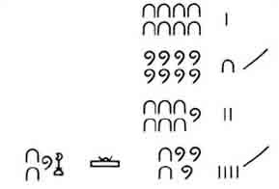

View discussion - Question 2

You can see from having tried this how it is possible to begin to make sense of Egyptian methods. Division turns out to be rather similar. The problem is seen in terms of discovering by what one number must be multiplied to make another. So, for instance, the calculation above could equally have stood for the division of 1120 by 80! One would scan down selected multiples of 80 to sec which would add up to 1120. This yields the answer 10 and 4 – that is, 14.
Of course, the answer to such an attempt at division may not always be exact if the calculation is restricted to whole numbers. Exploring what happens when a division does not yield a whole-number answer leads us to one of the most striking and influential features of Egyptian mathematics — their fractions.

Question 3

What has the scribe done to compute 19 divided by 8? (This is taken from Problem 24 of the Rhind Papyrus, transcribed into our numerals.)
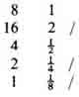

View discussion - Question 3

This, for the Egyptian scribe, is the answer: 2 ¹/₄ ¹/₈. (Or, rather, the equivalent of that in hieratic.) One important thing to notice is that he did not, as we might do, add the fractions together to produce 2³/₈. In Egyptian mathematics, only what we would call unit fractions, that is, ¹/₂, ¹/₃, ¹/₄, and so on, are used, together with the fraction we would write as ²/₃. Why there should have been what seems to us this strange restriction of Egyptian mathematics is an interesting question that we return to shortly.
In view of the importance of the principle of doubling, as well as of the use of unit fractions, it was necessary to know what was the result of doubling fractions. Nearly a third of one side of the Rhind Papyrus (which is some 18 feet long by about 1 foot wide) is taken up with calculating the doubles of the odd fractions ¹/₃, ¹/₅, ¹/₇, …, ¹/₉₉, ¹/₁₀₁, expressed in the equivalent form of dividing 2 by the odd numbers from 3 to 101. We shall write these as 2 : 3, 2 : 5, and so on. For instance:
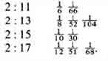
In modern notation, the first two results read: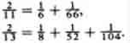

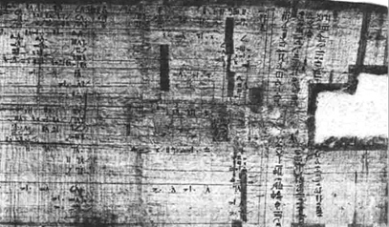
Figure 2 The beginning of the Rhind Papyrus Shown here are the divisions by 2 of the odd numbers from 3 to 27. preceded by the scribe's introduction.

We shall not pursue the details here of how these were calculated, but there is an example in Box 2 to illustrate the skill and ingenuity of Egyptian fraction-handling techniques.

Box 2 A note on how 2 : 17 was calculated
The instruction for this problem in the ancient Egyptian reads something like, ‘Get 2 by operating on 17’, which provides a clue to the guiding principle: do things to 17 until you arrive at 2.
The calculation is in two stages:
- carry on halving 17 (starting from its two-thirds part) until some number under 2 is reached;
- see what this leaves you with, to get back to 2 precisely.
Step 1 of the calculation goes
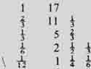
Thus ¹/₁₂ will be part of the answer; what is the rest?
For step 2 the scribe wrote down the difference between the number reached (1 ¹/₄ ¹/₆) and 2.
Remainder ¹/₃ ¹/₄
Question: How did the scribe know this?
Then, as a subsidiary computation, the scribe worked out what needed to be done to 17 to get this remainder.
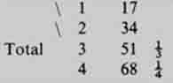
There seems to be a tight argument compressed into these figures; he has calculated that 3 times 17 is 51; and thus ¹/₅₁ times 17 is ¹/₃. Similarly 4 times 17 is 68; thus ¹/₆₈ of 17 is ¹/₄.
Since ¹/₃ ¹/₄ is the remainder we needed, as parts of 17 these are ¹/₅₁ ¹/₆₈.
The overall result, then is 2 : 17 = ¹/₁₂ ¹/₅₁ ¹/₆₈.
The one part of this calculation that is not explicitly written down is how the scribe arrived at the remainder, the difference between 2 and the number obtained at the end of the step (i) calculation, A method for doing this appears in other problems on the Rhind Papyrus, so we shall go through how it could have been done in this case.
We had reached 1 ¹/₄¹/₆ and wanted to know how far short this was of 2. The method involves an auxiliary calculation, set up as follows. Express the fractions you have as multiples of some other convenient fraction, say ¹/₁₂. Then ¹/₄ is 3 times ¹/₁₂, and ¹/₆ is 2 times ¹/₁₂. The numbers 3 and 2 are written down (in red ink, on the papyrus, the rest being in black) and added: 5. Now, how far short of 12 are we? 7. So, the remainder we want is however many times 12 goes into 7:
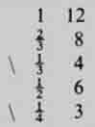
So ¹/₃ ¹/₄ is the remainder, as indeed the scribe wrote down.

Notice one thing, however, about the above results: what might seem to us the ‘obvious’ answer, for instance that 2 : 17 is ¹/₁₇ ¹/₁₇, was never the one reached. The possibility of repeating the fraction in order to double it just did not count as an answer, it seems, for the Egyptian scribe. This observation gives us a clue concerning the question raised earlier above, of why in Egyptian mathematics we find only unit fractions (and ²/₃).
The answer to this question is important and revealing, because thinking it through will inform us not only about Egyptian mathematics, but also about what studying history can involve. The question arose because it seemed to suggest itself from the source material, or from our efforts to understand it. We use fractions, the Egyptians also seemed to do so, yet only in a seemingly highly restricted way which drove them into subtle and complicated contrivances. Why did they not just use fractions as we do ? It would have saved them a lot of trouble! Now notice that the more the problem is spelled out, the more peculiar it begins to look. Imagine yourself asking the scribe, ‘Why do you only use unit fractions?’. His look of bewilderment will be explained if you go on to reflect that that question presupposes him to be making the deliberate choice of not using fractions in the way we do.
Expressed like that, it is surely an unreasonable presupposition. So how have we got into this problem, and how do we get out? The problem seems to have arisen partly conceptually and partly notationally. Conceptually, because the very use of the word fraction carries our set of expectations with it, whereas if we had used another word, such as reciprocal, say (for ¹/₇ can be thought of as ‘the reciprocal of 7’ as well as ‘one-seventh’), then no-one would have expected compound reciprocals. Notationally, the translation of the Egyptian symbol into ‘our’ fractions set up possibly unhelpful expectations. By looking again at the statement of Rhind Papyrus Problem 40 on the previous page, you will see that our ‘¹/₇’ was translating the hieroglyphic which in turn is equivalent to a hieratic squiggle with a dot on top. Translating these marks as , or by some people as , helps preserve better the awareness that Egyptian fractions were conceptually different from ours.
So the upshot of this argument is that our initial question, of why Egyptian fractional usage was ‘restricted’ to unit fractions, was badly posed. It need not arise if we reconsider the question as: what was the Egyptian concept for which we have hitherto used the word fraction? The Egyptian symbol for what we have been thinking of as ¹/₃, ¹/₄,… is better translated by the word part, as in the third part, the fourth part, and so on. The reason this is better is that to say one seventh or use the symbol ¹/₇ (say) invites the idea familiar to us of there being ‘two sevenths’ (²/₇), ‘three sevenths’ (³/₇) and so on, whereas the seventh part is unique. So this would explain why the result of doubling the eleventh part is not the eleventh and the eleventh; for there can be only one eleventh part. Or, to put it another way, to write 2 : 17 as ¹/₁₇ ¹/₁₇ would simply be a restatement of the problem, not an answer to it.
The Egyptian concept of part is explained more fully in the box below.

Box 3 Sir Alan Gardiner on the Egyptian concept of part
The commonest method of expressing fractions in Egyptian was by the use of the word r ‘part’, below which (or partly below it in the case of the higher numbers) was written the number described in English as the denominator. Thus , r-5 ‘part 5’ is equivalent to our ¹/₅, r-276 ‘part 276’ to our ¹/₂₇₆.
For the Egyptian the number following the word r had ordinal meaning; r-5 means ‘part 5’, i.e. ‘the fifth part’ which concludes a row of equal parts together constituting a single set of five. As being the part which completed the row into one series of the number indicated, the Egyptian r-fraction was necessarily a fraction with, as we should say, unity as the numerator. To the Egyptian mind it would have seemed nonsense and self-contradictory to write r-7 4 or the like for ⁴/₇; in any series of seven, only one part could be the seventh, namely that which occupied the seventh place in the row of seven equal parts laid out for inspection. Nor would it have helped matters from the Egyptian point of view to have written r-7( + )r-7( + )r-7( + )r-7, a writing which would likewise have assumed that there could be more than one actual ‘seventh’. Consequently, the Egyptian was reduced to expressing (e.g.) ⁴/₇ by ¹/₂( + )¹/₁₄ For more complex fractions even as many as five terms, all representing fractions with 1 as the numerator and with increasing denominators, might be needed; thus the Rhind mathematical papyrus, dating from the Hyksos period, gives as equivalent of our ²/₆₁ the following complex writing: r-40 r-244 r-488 r-610 ‘¹/₄₀ + ¹/₂₄₄ + ¹/₄₈₈ + ¹/₆₁₀’. It is generally known that the same cumbrous methods of expression were in common use with the Greeks and Romans. It would seem also that a relic of them survives in the use of English ordinals in the names of our fractions, though we speak of ‘one-third’ and ‘three-fifths’ without any qualms. […]
Though the Egyptians were unable to say ‘three-sevenths’ or ‘nine-sixteenths’, yet they made a restricted use of certain fractions which appear, at first sight, to stand on the same footing: a great rôle is played in Egyptian arithmetic by the fraction rwy 'the two parts’ (out of three), i.e. ²/₃, and a very rare sign r-3 (perhaps to be read mt rw) can be quoted for ‘the three parts’ (out of four), i.e. ³/₄. These ‘complementary fractions’ represent the parts remaining over when ‘the third’ or ‘the fourth’ is taken away from a set of three or four, and indeed their existence is practically postulated by the terms r-3, r-4. But we must be careful to note that in r-3=³/₄ the numeral is a cardinal, not an ordinal, and that the expression means ‘the three parts’ and was not construed, as with ourselves, as meaning ‘three fourths’. In ordinary arithmetic the only complementary fraction used was ²/₃. Compare in English ‘two parts full’, i.e. two-thirds full, doubtless a survival of the old Egyptian way of regarding the same fraction.

Thus equipped, we can more easily see how a calculational practice involving parts could form a coherent framework in itself, not needing the overtones of our concept of fractions. That it was a coherent framework is attested by its extraordinary longevity. Two millennia after the Rhind Papyrus, for instance, we find many of the results in Ptolemy's Almagest (c. AD 150), the greatest of Greek astronomical texts, presented in Egyptian fashion, as in this passage.

One [sighting] we made in the year 18 of Hadrian, Egyptianwise Pharmouthi 2–3, according to which the morning Venus was at its greatest elongation from the sun; and, sighted with the star called Antares, it was 11 + ¹/₂ + ¹/₃ + ¹/₁₂° within the Goat, while the mean sun was then 25¹/₂° within the Water Bearer. And so the greatest morning elongation was 43 +¹/₂ + ¹/₁₂°.
Ptolemy, Almagest Book X, ch.3, translated by R. Catesby Taliaferro. The ‘plus’ signs have been inserted by the translator.

Indeed the use of parts can still be found in European writers of the thirteenth and fourteenth centuries AD. Henceforth, we shall use for ¹/₇, and similarly for other parts.
Having absorbed, then, the idea that past mathematical procedures and concepts may actually be more difficult to understand unless we do our best to meet them on their own terms, let us turn back to Egyptian calculation methods. Here is an example of a procedure that was followed to solve a problem. We have chosen Rhind Papyrus Problem 24, as you have already studied one calculation from it (Question 3).
The problem is in Extract 1, so please study the extract briefly now before coming back to the offered explanation which follows.
The numbering of the problems, by the way, is that of a nineteenth-century German editor of the Rhind Papyrus — in the original, the problems are unnumbered.
The problem, ‘A quantity, ¹/₇ of it added to it, becomes it: 19’, can be seen to mean something like, ‘A quantity and the seventh part of it is nineteen. What is the quantity?’. The way this is solved is that the scribe produces the number 7, as a kind of trial guess perhaps, but one having the useful property that its seventh part is easy to determine:
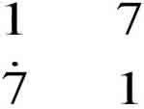
So we can see that had the quantity been seven, it and its seventh part would make 8; but what we want is for it and its seventh part to make 19; so if we knew how many times 8 goes into 19, we would know how many times 7 goes into the quantity we want. This part of the calculation, dividing 19 by 8, is what you did in Question 3, and the answer was 2 . So all that remains is to multiply that by 7 to get the answer, which is done by doubling.
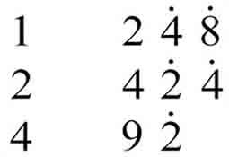
The sum of these is 16 , which is therefore the desired quantity. But just to make sure, the scribe checks the result — ‘The doing as it occurs’. He adds to the quantity its seventh part (2 ), to show that their sum is indeed 19 as required.
The strategy followed in this problem, namely choosing any convenient number and working out the solution in respect to it, then multiplying by the ratio of your answer to the answer you want, is quite a common one in Egyptian mathematics. Indeed, if we generalise this description of the strategy, and call it a systematic method of'trial and error’, then this seems characteristic of the Egyptian style of arithmetic. For example, if you look again at the way division was described (Question 3, Comment) you will notice that it can be seen in terms of getting close to the desired result and then seeing what needs to be done to make up the remainder. The strategy used in Problem 24 is a solution method in common use up to quite recent times, appearing under various names such as the method of false position or the rule of false.
We now return to Problem 40, with which we started. It provides another example of this strategy.

Question 4

Re-read the suggested explanation of what Problem 40 is about, which was given in the paragraph after Question 1, and see if you can work out how the scribe has solved it, in the way that we approached Problem 24. Use the English translation in Extract 1 to work from (unless your hieratic or hieroglyphic skills are especially well developed). It will save you time if you have two further pieces of information: is the symbol we use to denote ²/₃, and the scribe makes a guess or assumption about how many loaves the man who gets least receives, as well as about what the constant difference is.
(Do not spend any longer on this than you feel you want to — go on to read the Comment when you are ready.)

View discussion - Question 4

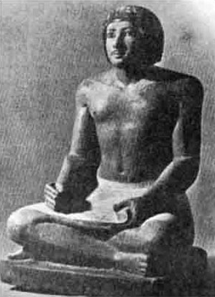
Figure 3 An Egyptian scribe, Ka-Irw-Khufu, who lived c. 2500 BC

This discussion has raised the question of who or what the Rhind Papyrus was for, that is, what the scribe's intention was. His opening words were, in Chace's free translation, ‘Accurate reckoning. The entrance into the knowledge of all existing things and all obscure secrets’, which is interesting, but does not really clarify for us whether this kind of thing was taught to schoolchildren, or whether the Rhind Papyrus represented quite an advanced theoretical work by Egyptian standards. In trying to understand this ancient mathematical activity, it is natural for us to ask how it compares with later mathematics. It would be interesting to know whether it were simply a collection of empirical computational techniques, brought together for applying to everyday practical problems, or whether there are visible traces of, say, the more abstract theoretical tone that you will be seeing in Greek mathematics. Historians have differed in the judgements they have reached on this question. For instance:

The Rhind and Moscow papyri are handbooks for the scribe, giving model examples of how to do things which were a part of his everyday tasks.… The sheer difficulties of calculation with such a crude numeral system and primitive methods effectively prevented any advance or interest in developing the science for its own sake. It served the needs of everyday life …., and that was enough.
G. J. Toomer.

A careful study of the Rhind Papyrus convinced me several years ago that this work is not a mere selection of practical problems especially useful to determine land values, and that the Egyptians were not a nation of shopkeepers, interested only in that which they could use. Rather I believe that they studied mathematics and other subjects for their own sakes.
A. B. Chace.

Question 5

Which of these views do you feel more applicable to what you have seen of the Rhind Papyrus (namely, Problems 24 and 40)?

View discussion - Question 5

Let us reflect on the situation where historians reach apparently contradictory views. How is this possible, and how do we decide which, if any, we agree with? Question 5 implied a response to the latter question, that it is immediately helpful to check out the judgements against whatever relevant source material you are aware of. We did not reach any very firm conclusion, though, either because we have not yet looked at enough evidence, or perhaps because moving from the evidence to a judgement upon that evidence is more difficult than appears at first sight. So we should go on to investigate more fully what evidence, and what arguments from that evidence, these historians used to reach their conclusions. (Note that what we are doing at present has more general import. Our interest is not only in the pros and cons of this particular question, bul also in trying to work towards a method which can apply in other contexts in order to evaluate historical judgement.) The fuller passages from which the above views of Chace and Toomer are taken are dealt with on the next page. You will also learn more about the contents of the Rhind Papyrus from these extracts.

1.1.3 More information about the Rhind papyrus

Box 4
Arnold Buffum Chace on Egyptian mathematics as pure science
A careful study of the Rhind papyrus convinced me several years ago that this work is not a mere selection of practical problems especially useful to determine land values, and that the Egyptians were not a nation of shopkeepers, interested only in that which they could use. Rather I believe that they studied mathematics and other subjects for their own sakes. In the Rhind papyrus there are problems of area and problems of volume that might be of use to the farmer who owns land and raises grain. There are pyramid problems that might furnish specifications to the builders, or enable an interested observer to determine the dimensions of a pyramid before him. Many of the arithmetical problems concern a division of loaves or of a quantity of grain among a certain number of men, or the relative values of different amounts of food or drink. But when we come to examine the conditions laid down and the numbers involved in these various problems as well as the purely numerical ones, we see that they are more like theoretical problems put in concrete form. In one (Problem 63) 700 loaves are divided among four men in shares that are proportional to the four fractions ²/₃, ¹/₂, ¹/₃ and ¹/₄, the first four terms of their fraction-series. In two (Problems 40 and 64) there is a dividing into shares that form an arithmetical progression, in Problem 67 the tribute for cattle is determined as ¹/₆ ¹/₁₈ of the herd and the problem asks for the number of the herd when the number of tribute cattle is given, and Problem 31 is a problem whose answer is
14 ¹/₄ ¹/₅₆ ¹/₉₇ ¹/₁₉₄ ¹/₃₈₈ ¹/₁₆₉ ¹/₇₇₆.
Such problems and such quantities were not likely to occur in the daily life of the Egyptians. Thus we can say that the Rhind papyrus, while very useful to the Egyptian, was also ‘an example of the cultivation of mathematics as a pure science, even in its first beginnings’ [H. Wieleitner, ‘Zur ägyptischen Mathematik’, Zeitschrift für mathematischen und naturwissenschaftlichen Unterricht, 56 (1925) pp. 129–137].
G. J. Toomer on Egyptian mathematics as strictly practical
The Rhind and Moscow papyri are handbooks for the scribe, giving model examples of how to do things which were a part of his everyday tasks. This is confirmed, if confirmation were needed, by a papyrus in the form of a satirical letter in which a scribe ridicules a colleague for his inability to do his job, and cites among other examples of his failures calculations of the rations of soldiers and of the number of bricks required for building a ramp of given dimensions. A further indication of the origin of these texts is the kind of expression used to introduce problems, for instance: ‘If a scribe says to you …, let him hear …’. The texts are in one respect similar to the Babylonian mathematical texts, in that these too are in the form not of treatises but of specific problems with solutions. But there the similarity ends: the cuneiform texts have a claim to be called mathematical in a fully scientific sense. The problems are only formally about the measurement of areas, determination of lengths, etc. Many of them are not of a kind which could conceivably ever occur in actual mensuration, and the whole point of them is the algebraic procedure involved. They are really ‘pure’ mathematics. However, this difference from the Egyptian texts is not the important one; mathematics can be applied to practical ends without losing any of its scientific quality. What really distinguishes Babylonian mathematics is the systematic development of intricate algebraic techniques which we can deduce from the working of the problems. These techniques could never have been created by mere empiricism, and we must posit an order of mathematical reasoning of which there is no trace in the Egyptian sources.
To illustrate the elementary and practical nature of Egyptian mathematics, we set out Problem 42 of the Rhind papyrus in full below.
Problem 42
Find the volume of a cylindrical granary of diameter 10 and height 10.
Take away ¹/₉ of 10, namely 1 ¹/₉ the remainder is 8 ²/₃ ¹/₆ ¹/₁₈ . Multiply 8 ²/₃ ¹/₆ ¹/₁₈ times 8 ²/₃ ¹/₆ ¹/₁₈; it makes 79 ¹/₁₀₈ ¹/₃₂₄. Multiply 79 ¹/₁₀₈ ¹/₃₂₄ times 10; it makes 790 ¹/₁₈ ¹/₂₇ ¹/₅₄ ¹/₈₁ cubed cubits. Add ¹/₂ of it to it; it makes 1185 ¹/₆ ¹/₅₄, its contents in khar. 1/20 of this is 59 ¹/₄ ¹/₁₀₈. 59 ¹/₄ ¹/₁₀₈ times 100 hekat of grain will go into it.
Method of working out:
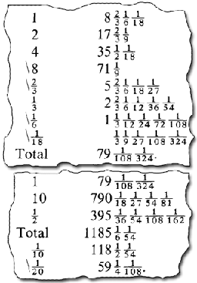
The problem is to determine the cubic content of a cylinder of diameter (D) 10 cubits and height (h) 10 cubits. This is complicated by the fact that for the Egyptian cubic content means how much it will hold of some specific thing, so an answer in cubic cubits is not satisfactory. It is therefore necessary to convert to hundreds of quadruple-hekat of corn by way of the equivalences:
1 cubic cubit = 1¹/₂ khar.
1 khar = 20 hundreds of quadruple-hekat.
In the working, some of the steps, which would require the use of auxiliary fractions, have certainly been omitted. But what is set down is enough to show that the real difficulty for the Egyptian scribe was the mastering of elementary arithmetical calculations; we can see how hemmed in he was by his numerical system, his crude methods, and his concrete mode of thought.
The truth is that Egyptian mathematics remained at much too low a level to be able to contribute anything of value. The sheer difficulties of calculation with such a crude numeral system and primitive methods effectively prevented any advance or interest in developing the science for its own sake. It served the needs of everyday life (it is only a relatively advanced technology, such as was never achieved in the ancient world, which demands more than the most elementary mathematics), and that was enough. Its interest for us lies in its primitive character, and in what it reveals about the minds of its creators and users, rather than in its historical influence.

Question 6

Do you now feel able lo form a view on which, if either, of these judgements on Egyptian mathematics is the better justified?

View discussion - Question 6

What this exercise has also shown is that the endeavour to understand past mathematics naturally leads to forming judgements about it, in much the same way as art history and criticism are cognate activities. There is a disappointment in the reaction of some historians that a civilisation favoured by the gods in so many ways did not contribute more advanced mathematics. There was perhaps no need for more sophisticated mathematical investigation, nor any perception of such a possibility. As the historian Otto Neugebaucr has agreeably remarked:

Of all the civilisations of antiquity, the Egyptian seems to me to have been the most pleasant. The excellent protection which desert and sea provide for the Nile valley prevented the excessive development of the spirit of heroism which must often have made life in Greece hell on earth.
The Exact Sciences in Antiquity (Dover, 1969) p. 71.

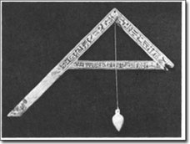
Figure 4 Set square with plumb-line, c.1300 BC

Conclusion
This free course provided an introduction to studying Mathematics. It took you through a series of exercises designed to develop your approach to study and learning at a distance and helped to improve your confidence as an independent learner.

Keep on learning



Study another free course
There are more than 800 courses on OpenLearn for you to choose from on a range of subjects.
Find out more about all our free courses.

Take your studies further
Find out more about studying with The Open University by visiting our online prospectus.
If you are new to university study, you may be interested in our Access Courses or Certificates.

What’s new from OpenLearn?
Sign up to our newsletter or view a sample.

For reference, full URLs to pages listed above:
OpenLearn – www.open.edu/openlearn/free-courses
Visiting our online prospectus – www.open.ac.uk/courses
Access Courses – www.open.ac.uk/courses/do-it/access
Certificates – www.open.ac.uk/courses/certificates-he
Newsletter – www.open.edu/openlearn/about-openlearn/subscribe-the-openlearn-newsletter

References
A.B. Chace (tr. and ed.), The Rhind Mathematical Papyrus, Mathematical Association of America, 1927.
A. Erman, The Literature of the Ancient Egyptians, Mathematical Association of America, 1927.
A. Gardiner, Egyptian Grammar, Oxford, 1957 (third edition), pp. 196-197.
Aristotle, Metaphysics 981^{b} 20-25; as 1.A1, p.195.
G.J Toomer, 'Mathematics and Astronomy', in J.R. Harris (ed.), The Legacy of Egypt, Oxford, 1971, pp. 37-40, 45.
Herodotus, History, II, 109; tr. A. D. Godley, Heinemann, 1920.
Plato, Phaedrus, 274 cd; tr. H. Cary, Bell & Daldy, 1872.
Proclus, On Euclid, I; tr. I. Thomas, Greek Mathematical Works I, Heinemann, 1939, pp. 145-147.

Acknowledgements
Except for third party materials and otherwise stated (see terms and conditions), this content is made available under a Creative Commons Attribution-NonCommercial-ShareAlike 4.0 Licence
Course image: Nathan Rupert in Flickr made available under Creative Commons Attribution-NonCommercial-ShareAlike 2.0 Licence.
Don't miss out:
If reading this text has inspired you to learn more, you may be interested in joining the millions of people who discover our free learning resources and qualifications by visiting The Open University - www.open.edu/openlearn/free-courses

Question 1

Discussion
You should have been able to notice, just from the look of the page, that it has three sections. The top one is a hand-written copy of the papyrus text itself, while the bottom section contains a rather literal English translation into our language and numerals. The middle section is a transcription of the text itself (which is written in a script called hieratic) into hieroglyphic, the standard script in which Egyptologists work, with an indication of the sounds and numeral values. (You may have noticed other features too, such as that hieroglyphic and the original hieratic-reads from right to left, so the ordering has been reversed in going from the middle to the bottom section.)
As to understanding the text, I would say that not only is the calculation of an unfamiliar kind — just what is going on there is far from clear – but also, even what the problem is has yet to be put in a form accessible to most of us.
Back to Session 1 Activity 1

Question 2

Discussion
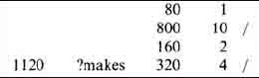
The sum looks like a multiplication of eighty by fourteen; the scribe has considered the latter as ten and four, multiplied eighty by each (to give the lines marked by /) and added the results, to obtain 1120. Notice that to multiply 80 by 4, he first doubled SO and then doubled it again. Notice too, that multiplying by ten is very easy in hieroglyphs, simply by changing each symbol into the next one in the ordered sequence of symbols for powers of ten.
Back to Session 1 Activity 2

Question 3

Discussion
He is trying to find by what 8 must be multiplied to give 19. So he doubles 8, to give 16 which is 3 short of 19; so he must find what multiplies 8 to produce this remaining 3. He halves the 8 (obtaining 4, which is still too much), then halves that and halves it again. Notice that the quarter of 8 and the eighth of S together will make up the 3 he wants. So his answer, as indicated by the / marks, is the sum of 2 and ¹/₄ and ¹/₈.
Back to Session 1 Activity 3

Question 4

Discussion
The scribe produces for the initial try a share difference of 5¹/₂, and the assumption that the last man receives 1 loaf. So the previous man got 6¹/₂, the one before him 12, then 17¹/₂, then 23. (This comes from adding 5¹/₂ each time.) Adding all of these together gives 60, so since it was actually 100 loaves to start with, another 40 (that is, the two-thirds part of 60) is needed. He says ‘Make thou the multiplication: 1²/₃’ and multiplies up each of his initial shares 23, 17¹/₂, 12, 6¹/₂ and 1 by 1²/₃, and finally checks that they do indeed total 100 by adding the results.
That is what appears on the papyrus. But in checking over what the scribe has done, and comparing it with the statement of the problem, it becomes clear that a substantive part of the solution has taken place off-stage, as it were. The shares do have the property they ought to, namely that the sum of the least two is one seventh of the sum of the largest three. But this is not something he shows, nor does he indicate how the initial ‘guesses’ were arrived at to ensure this. (Nor, indeed, does he explicitly give the answer to the question, ‘What is the difference of share?’.) We might conjecture that either something was left out during his copying the solution (at the start of the Rhind Papyrus the scribe says he is copying an earlier one), or else perhaps that it was only this application of the false position strategy he wanted lo show.
Back to Session 1 Activity 4

Question 5

Discussion
There is something to be said for Toomer's view: the problem of dividing loaves among a group of men could certainly have been an everyday task for the overseers of large building works, for instance; and your experience of Egyptian calculation may well have inclined you to the view that ‘crude’ and ‘primitive’ are understandable epithets.
But there are features of the problems which are harder to fit with everyday life in quite so straightforward a way. For instance, the circumstances under which real loaves are to be divided among a group of people in arithmetical progression are hard to imagine. Again, the fact that Problem 24 is posed in terms of'a quantity’ (the Egyptian word can also be translated as 'heap' – something rather unspecific) does imply a certain level of abstraction, a recognition that the same techniques and rules apply to any of a range of real-world objects. So there is some recognisable mathematical activity ‘for its own sake’, which was Chace's claim.
However, this does not quite resolve the matter. If the Rhind Papyrus were primarily a teaching document, and if it were the calculation methods that one wanted to teach, then the fact that Problem 40 is quite unrealistic may be a tribute to the scribe's imaginative teaching style as much as to an exploration of mathematics for its own sake. Quite what significance should be attached to the formulation of Problem 24 is problematical. Some historians have seen in this an early technique foreshadowing the later development of algebra, insofar as that is concerned with operating on unknown quantities. On the other hand, the level of abstraction in this problem could be seen as no greater than that implicit in the very use of numbers. That one can have things-numbers-that apply indifferently to a range of real-world objects is quite a sophisticated concept, but one reached long before the Egyptian records to which we have access.
Back to Session 1 Activity 5

Question 6

Discussion
My answer is ‘yes’ — I can now see better on what grounds the historians were putting forward their views, which helps me to decide which, if either, is preferable. In fact, I think neither can be endorsed wholeheartedly.
Chace's argument seems flawed by the point made in the previous Comment (Question 5), that unrealistic problems and answers do not in themselves imply a study of mathematics ‘for its own sake’,
Toomer's argument is difficult because he is making his judgement of Egyptian mathematics partly by means of a comparison with the Babylonians. Indeed, he seems engaged in a broader question than Chace does, one more to do with assessing how much the Egyptians contributed to the development or advance of mathematics, (This difference in the questions addressed by the two historians may go some way towards accounting for the difference in their conclusions.) It is also hard to separate out the validity of Toomer's judgement from the vigour of his language: ‘mere empiricism’, ‘hemmed in’, ‘crude methods’, ‘crude numeral system’, ‘primitive methods’, ‘primitive character’, leave us in no doubt about his feelings, certainly. In fact, Toomer's rhetoric is curiously stronger than that needed to make his point that the Egyptian influence on other cultures was not great. That might well be agreed independently of whether or not the Egyptians studied mathematics ‘for its own sake’.
Back to Session 1 Activity 6

