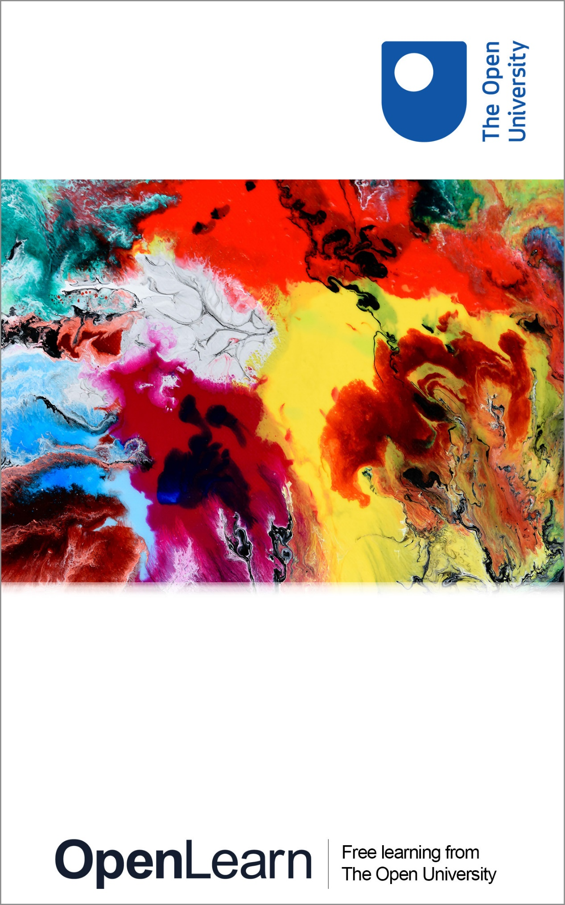

FSM_1_CYMRU Bringing Learning to Life: L1 Maths

Introduction and guidance

About this free course
This free course is an adapted extract from the Open University course .
This version of the content may include video, images and interactive content that may not be optimised for your device.
You can experience this free course as it was originally designed on OpenLearn, the home of free learning from The Open University –
There you’ll also be able to track your progress via your activity record, which you can use to demonstrate your learning.
Copyright © 2015 The Open University
Intellectual property
Unless otherwise stated, this resource is released under the terms of the Creative Commons Licence v4.0 http://creativecommons.org/licenses/by-nc-sa/4.0/deed.en_GB. Within that The Open University interprets this licence in the following way: www.open.edu/openlearn/about-openlearn/frequently-asked-questions-on-openlearn. Copyright and rights falling outside the terms of the Creative Commons Licence are retained or controlled by The Open University. Please read the full text before using any of the content.
We believe the primary barrier to accessing high-quality educational experiences is cost, which is why we aim to publish as much free content as possible under an open licence. If it proves difficult to release content under our preferred Creative Commons licence (e.g. because we can’t afford or gain the clearances or find suitable alternatives), we will still release the materials for free under a personal end-user licence.
This is because the learning experience will always be the same high quality offering and that should always be seen as positive – even if at times the licensing is different to Creative Commons.
When using the content you must attribute us (The Open University) (the OU) and any identified author in accordance with the terms of the Creative Commons Licence.
The Acknowledgements section is used to list, amongst other things, third party (Proprietary), licensed content which is not subject to Creative Commons licensing. Proprietary content must be used (retained) intact and in context to the content at all times.
The Acknowledgements section is also used to bring to your attention any other Special Restrictions which may apply to the content. For example there may be times when the Creative Commons Non-Commercial Sharealike licence does not apply to any of the content even if owned by us (The Open University). In these instances, unless stated otherwise, the content may be used for personal and non-commercial use.
We have also identified as Proprietary other material included in the content which is not subject to Creative Commons Licence. These are OU logos, trading names and may extend to certain photographic and video images and sound recordings and any other material as may be brought to your attention.
Unauthorised use of any of the content may constitute a breach of the terms and conditions and/or intellectual property laws.
We reserve the right to alter, amend or bring to an end any terms and conditions provided here without notice.
All rights falling outside the terms of the Creative Commons licence are retained or controlled by The Open University.
Head of Intellectual Property, The Open University

Contents
- Introduction and guidance
- [Untitled]
  - What is a badged course?
  - How to get a badge
- Session 1: Working with numbers
  - Introduction
  - 1 Whole numbers
    - 1.1 Positive numbers and place value
    - 1.2 Numbers with zeros
    - 1.3 Writing large numbers
    - 1.4 Negative numbers
    - 1.5 Working with whole numbers
    - 1.6 Add and subtract large numbers
    - 1.7 Multiplication
    - 1.8 Division
    - 1.9 A note on the four operations
  - 2 Rounding
    - 2.1 Estimating answers to calculations
  - 3 Fractions
    - 3.1 Using equivalent fractions
    - 3.2 Drawing fractions
    - 3.3 Simplifying fractions
    - 3.4 Fractions of amounts
  - 4 Decimals
    - 4.1 Approximations with decimals
    - 4.2 Rounding money
    - 4.3 Calculations using decimals
    - 4.4 Decimal problems
  - 5 Percentages
    - 5.1 Percentage increases and decreases
    - 5.2 Finding percentages using a calculator
  - 6 Equivalencies between fractions, decimals and percentages
  - 7 Ratios
  - 8 Proportion
  - 9 Word formulas
  - 10 A quick reminder: checking your work
  - 11 Session 1 quiz
  - 12 Session 1 summary
- Session 2: Units of measure
  - Introduction
  - 1 Using metric measurements: length
    - 1.1 Instruments of measure
    - 1.2 Measuring accurately
    - 1.3 Measuring in millimetres and centimetres
    - 1.4 Converting units
    - 1.5 Calculate using metric units of length
  - 2 Mileage charts
    - 2.1 Adding distances
  - 3 Using metric measurements: weight
    - 3.1 Instruments of measure
    - 3.2 Weighing things
    - 3.3 Converting metric units of weight
    - 3.4 Calculate using metric units of weight
  - 4 Capacity
    - 4.1 Instruments of measure
    - 4.2 Converting metric units of capacity
    - 4.3 Calculate using metric units of capacity
  - 5 Measuring temperature
    - 5.1 Reading temperatures
    - 5.2 Understanding temperature
  - 6 Time
    - 6.1 Calculate time difference
  - 7 Session 2 quiz
  - 8 Session 2 summary
- Session 3: Shape and space
  - Introduction
  - 1 Shapes
    - 1.1 Polygons
    - 1.2 Angles
    - 1.3 2D and 3D shapes
    - 1.4 Common 3D shapes
  - 2 Symmetry
  - 3 Around the edge
    - 3.1 Measuring the perimeter of irregular shapes
  - 4 Area
  - 5 Volume
  - 6 Scale drawings
  - 7 Maps
  - 8 End-of-course quiz
  - 9 Session 3 summary
- Solutions

Introduction and guidance
This free badged course, Everyday maths 1, is an introduction to Level 1 Essential Skills in maths. It is designed to inspire you to improve your current maths skills and help you to remember any areas that you may have forgotten. Working through the examples and interactive activities in this course will help you to, among other things, run a household or make progress in your career.
You can work through the course at your own pace. To complete the course you will need access to a calculator and a notepad and pen.
The course has four sessions, with a total study time of approximately 48 hours. The sessions cover the following topics: numbers, measurement, shapes and space, and data. There will be plenty of examples to help you as you progress, together with opportunities to practise your understanding.
The regular interactive quizzes form part of this practice, and the end-of-course quiz is an opportunity to earn a badge that demonstrates your new skills. You can read more on how to study the course and about badges in the next sections.
After completing this course you will be able to:
- understand practical problems, some of which are non-routine
- identify the maths skills you need to tackle a problem
- use maths in an organised way to find the solution you’re looking for
- use appropriate checking procedures at each stage
- explain the process you used to get an answer and draw simple conclusions from it.

Moving around the course
The easiest way to navigate around the course is through the ‘My course progress’ page. You can get back there at any time by clicking on ‘Back to course’ in the menu bar.
It’s also good practice, if you access a link from within a course page (including links to the quizzes), to open it in a new window or tab. That way you can easily return to where you’ve come from without having to use the back button on your browser.

[Untitled]

What is a badged course?
While studying Everyday maths 1 you have the option to work towards gaining a digital badge.
Badged courses are a key part of The Open University’s mission to promote the educational well-being of the community. The courses also provide another way of helping you to progress from informal to formal learning.
To complete a course you need to be able to find about 48 hours of study time. It is possible to study them at any time, and at a pace to suit you.
Badged courses are all available on The Open University’s OpenLearn website and do not cost anything to study. They differ from Open University courses because you do not receive support from a tutor. But you do get useful feedback from the interactive quizzes.

What is a badge?
Digital badges are a new way of demonstrating online that you have gained a skill. Schools, colleges and universities are working with employers and other organisations to develop open badges that help learners gain recognition for their skills, and support employers to identify the right candidate for a job.
Badges demonstrate your work and achievement on the course. You can share your achievement with friends, family and employers, and on social media. Badges are a great motivation, helping you to reach the end of the course. Gaining a badge often boosts confidence in the skills and abilities that underpin successful study. So, completing this course should encourage you to think about taking other courses, for example enrolling at a college for a formal qualification. (You will be given details on this at the end of the course.)

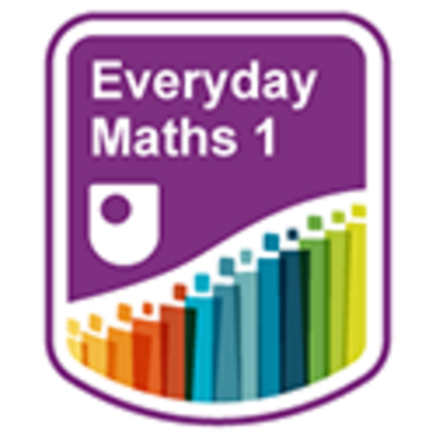

How to get a badge
Getting a badge is straightforward! Here’s what you have to do:
- read all of the pages of the course
- score 70% or more in the end-of-course quiz.
For all the quizzes, you can have three attempts at most of the questions (for true or false type questions you usually only get one attempt). If you get the answer right first time you will get more marks than for a correct answer the second or third time. Therefore, please be aware that for the end-of-course quiz it is possible to get all the questions right but not score 50% and be eligible for the OpenLearn badge on that attempt. If one of your answers is incorrect you will often receive helpful feedback and suggestions about how to work out the correct answer.
If you’re not successful in getting 70% in the end-of-course quiz the first time, after 24 hours you can attempt it again and come back as many times as you like.
We hope that as many people as possible will gain an Open University badge – so you should see getting a badge as an opportunity to reflect on what you have learned rather than as a test.
If you need more guidance on getting a badge and what you can do with it, take a look at the OpenLearn FAQs. When you gain your badge you will receive an email to notify you and you will be able to view and manage all your badges in My OpenLearn within 24 hours of completing the criteria to gain a badge.
Now get started with Session 1.

Session 1: Working with numbers

Introduction
It is very difficult to cope in everyday life without a basic understanding of numbers.
Calculators can be very useful, for example helping you to check your working out, or converting fractions to decimals.
To complete the activities in this course you will need some notepaper, a pen for taking notes and working out calculations and a calculator.
Session 1 includes many examples of numeracy from everyday life, with lots of learning activities related to them that involve whole numbers, fractions, decimals, percentages, ratios and proportion.
By the end of this session you will be able to:
- work with whole numbers
- use rounding
- understand fractions, decimals and percentages, and the equivalencies between them
- use ratios and proportion
- understand word formulas and function machines.

Video content is not available in this format.
View transcript - Uncaptioned interactive content

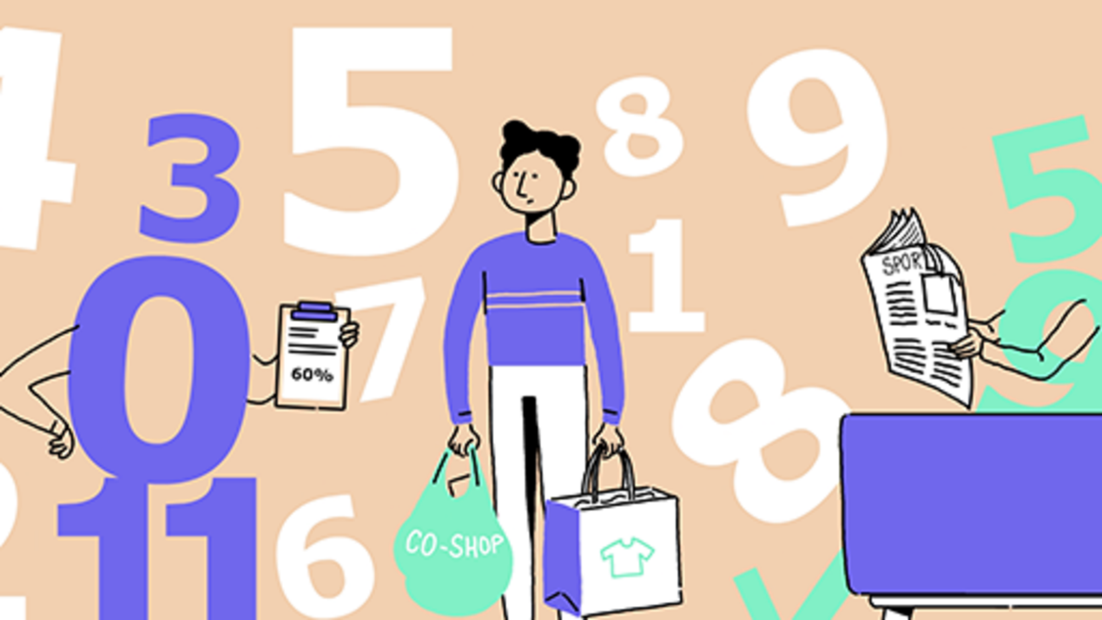

1 Whole numbers
What is a whole number? The simple answer is ‘any number that does not include a fraction or decimal part’.
So for example, 3 is a whole number, but 3 or 3.25 are NOT whole numbers.
Numbers can be positive or negative.
Positive numbers can be written with or without a plus (+) sign, so 3 and +3 are the same.
Negative numbers always have a minus (–) sign in front of them, such as –3, –5 or –2.

1.1 Positive numbers and place value

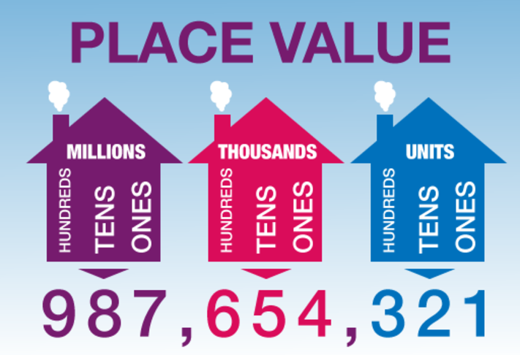
Figure 1 Place value
View description - Figure 1 Place value

Let’s look at positive numbers in more detail.
The place value of a digit in a number depends on its position or place in the number:

The value of 8 in 58 is 8 units.
The value of 3 in 34 is 3 tens.
The value of 4 in 435 is 4 hundreds.
The value of 6 in 6 758 is 6 thousands.

Activity 1: Working with place value

- Write 4 025 in words.

Th | H | T | U
4 | 0 | 2 | 5

View answer - Part

- Write six thousand, four hundred and seventy-two in figures.

Th | H | T | U
six | four | seven | two

View answer - Part

- Here are the results of an election to be school governor at Hawthorn School:
  - John Smith: 436 votes
  - Sonia Cedar: 723 votes
  - Pat Kane: 156 votes
  - Anjali Seedher: 72 votes
Who won the election?
Check your answer with our feedback before continuing.

View answer - Part

1.2 Numbers with zeros
The zero in a number plays a very important part in deciding its value.
Four hundred is written:

H | T | U
4 | 0 | 0

We need to put in the two zeros to show that it is four hundred and not just four.
Six hundred and seven is written:

H | T | U
6 | 0 | 7

We need the zero to show that there are no tens.

Activity 2: Place value

Fill in the boxes to show the value of each figure. The first two are done for you.

Number | Th | H | T | U
584 |  | 5 | 8 | 4
690 |  | 6 | 9 | 0
708 |  | Provide your answer... | Provide your answer... | Provide your answer...
302 |  | Provide your answer... | Provide your answer... | Provide your answer...
4 290 | Provide your answer... | Provide your answer... | Provide your answer... | Provide your answer...
5 060 | Provide your answer... | Provide your answer... | Provide your answer... | Provide your answer...
2 100 | Provide your answer... | Provide your answer... | Provide your answer... | Provide your answer...
3 009 | Provide your answer... | Provide your answer... | Provide your answer... | Provide your answer...

View answer - Activity 2: Place value

1.3 Writing large numbers
You may need to read numbers much larger than those we have looked at previously.
Take the number 9 046 251. The value of each digit is as follows:

9 millions
0 hundred thousands
4 ten thousands (or 40 thousand)
6 thousands
2 hundreds
5 tens
1 unit

To make large numbers easier to read, we put them in groups of three digits starting from the right:

6532 is often written as 6 532 (or 6,532).
25897 is often written as 25 897 (or 25,897).
596124 is often written as 596 124 (or 596,124).
7538212 is often written as 7 538 212 (or 7,538,212).

Using a place value grid can also help you to read large numbers. The place value grid groups the digits for you, making the whole number easier to read.
Look at the place value grid below. It only goes up to millions, but we can use place value to record numbers of any size, including numbers much greater than this.

Million | Thousand
Millions | Hundreds of thousands | Tens of thousands | Thousands | Hundreds | Tens | Units

You may also want to watch this clip to help you to understand place value with large numbers:

Watch the video at YouTube.com.

Example: Reading large numbers using a place value grid
How would you say the number in the place value grid?

Million | Thousand
Millions | Hundreds of thousands | Tens of thousands | Thousands | Hundreds | Tens | Units
7 | 4 | 0 | 6 | 8 | 9 | 4

Method
You need to say the number a section at a time:

Seven (7) million,
four hundred and six (406) thousand,
eight hundred and ninety-four (894).

So the number is seven million, four hundred and six thousand, eight hundred and ninety-four (7 406 894).

Now try the following activity, using the place value grid to help you if needed.

Activity 3: Large numbers

- Write the following numbers in words:
  - 765 228
  - 1 655 501
  - 3 487 887
- Write the following words in numbers:
  - Six hundred and eight thousand, nine hundred and ten.
  - Two million, seven hundred and eleven thousand, one hundred and six.
  - Eight million, nine hundred thousand, four hundred.
- Put the following numbers in size order, starting with the smallest:
  - 496 832
  - 1 260 802
  - 258 411
  - 482 112
  - 1 248 758
  - 1 118 233

View answer - Activity 3: Large numbers

1.4 Negative numbers

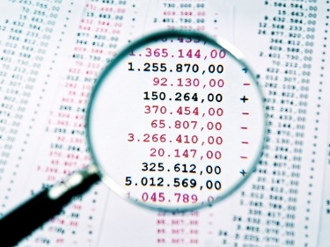
View description - Uncaptioned Figure

So far you have only looked at positive numbers, but negative numbers are just as important. Negative numbers have a minus sign (–) in front of them.
Some examples of where negative numbers will apply to real life is with temperatures and bank balances, although hopefully our bank balances will not display too many negatives!
Perhaps you’ve seen negative numbers in weather reports where a temperature is below freezing, for example –2°C, or you may have seen them on frozen food packets.
If you ever have an overdraft at the bank, you may see minus signs next to the figures. If a bank statement reads –£30, for example, this tells you how much you’re overdrawn. In other words, what you owe the bank!
Where have you seen negative numbers recently? Look at this thermometer:

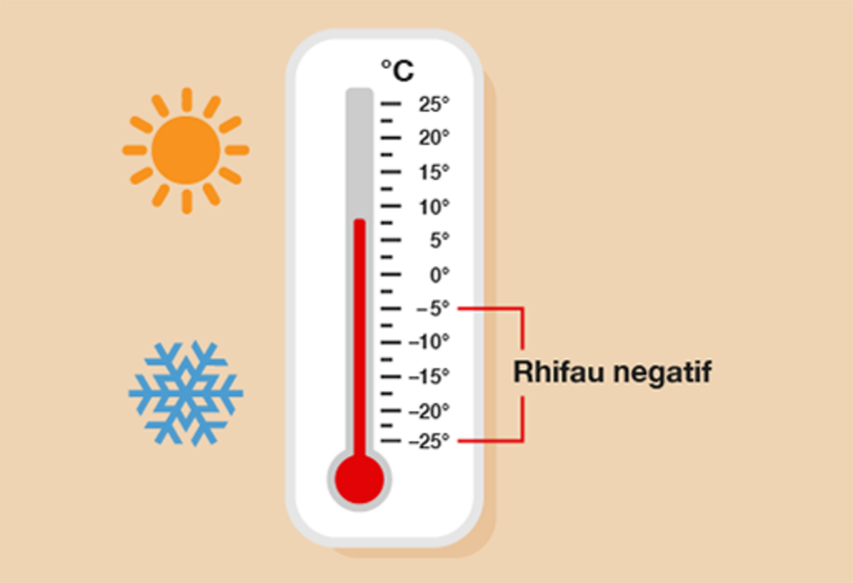
Figure 2 Negative numbers on a thermometer
View description - Figure 2 Negative numbers on a thermometer

It shows us that:
- –10°C is a lower temperature than –5°C
- –15°C is a lower temperature than –10°C.

Hint: ‘Lower’ means ‘less than’.

The lower the temperature, the colder it is.

Activity 4: Using negative numbers in everyday life

- The following table shows the temperatures in several cities on one day.

City | Temperature
A | –2°C
B | –5°C
C | –1°C
D | –8°C
E | –3°C

- Which are the coldest and warmest cities?

- A particular brand of ice cream includes the following note in its storing instructions:
  - For best results, store in temperatures between –10°C and –6°C
If your freezer’s temperature was –11°C, would it be OK to keep this ice cream in it?

View answer - Part

You have now seen how we use negative numbers in everyday life, for example bank balances and temperatures. Try practising using them when you are out and about. You will also use this skill within some simple questions that are coming up.

1.5 Working with whole numbers
The following activities cover everything in the whole numbers section. As you attempt the activities, look for key words to identify what the question is asking you to do.
Remember to check your answers once you have completed the questions.

Activity 5: Looking at numbers

- Look at this newspaper headline:

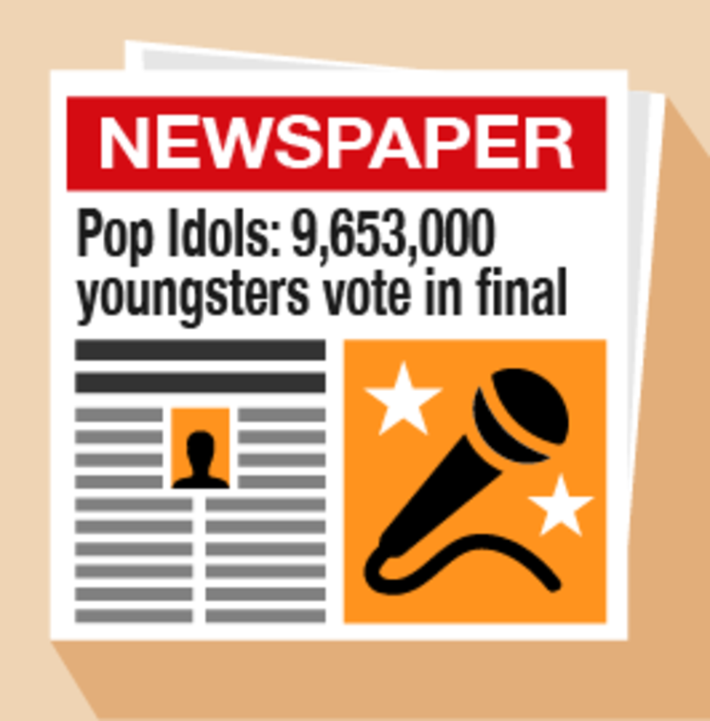
Figure 3 A newspaper headline
View alternative description - Figure 3 A newspaper headline

  - What number does the 9 represent in the newspaper headline?
  - How many thousands are there?
  - Look at the details below. Who won the Pop Idols competition?
  - Will: 4 850 000 votes
  - Gareth: 4 803 000 votes

- Look at the data in the following table. It gives the temperatures of five cities on a Monday in January.

City | Temperature
London | 0°C
Paris | –1°C
Madrid | 10°C
Delhi | 28°C
Moscow | –10°C

  - Which city was the coldest?
  - Which city was the warmest?
  - How many cities have a temperature below 5°C?

View answer - Part

1.6 Add and subtract large numbers

Addition
We add large numbers in the same way as we add smaller numbers:

Watch the video at YouTube.com.

Activity 6: Adding whole numbers

Complete the following tasks without using a calculator:
- 8 936 + 453
- 3 291 + 2 520
- 35 + 214 + 9 963
- 28 550 + 865
- 243 552 + 64 771
- 698 441 + 323 118
Remember you can check your calculations using the inverse method, which means using the opposite type of sum to check that your answer is correct. For example, you can use subtraction to check that an addition calculation is correct:

630 + 295 = 925 (addition)
925 – 295 = 630 (subtraction to check)

View answer - Activity 6: Adding whole numbers

Subtraction
There are different methods that can be used to subtract numbers. You need to find the method that works for you.

Decomposition method
For example:

843 – 266

Follow the following steps:
  - Start with the units: subtract 6 from 3. (This can’t be done.)
  - There are four tens in the tens column. One of these can be given to the units column.
  - If 10 is added to the original 3 we now have 13 in the units column: 13 – 6 = 7.
  - 7 is placed on the answer line in the units column.

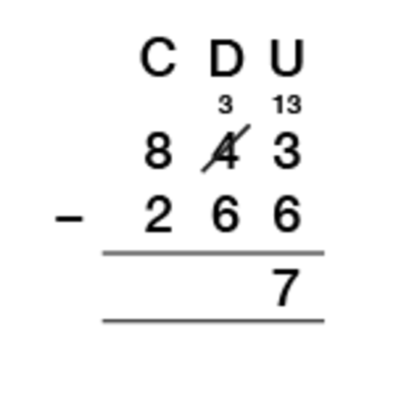
View description - Uncaptioned Figure

  - Now move on to the tens column: subtract 6 from 3. There are only three tens left, because one 10 was added to the units column. (This can’t be done.)
  - There are eight hundreds in the hundreds column. Taking one from the hundreds column and moving it to the tens column makes 13 in the tens column: 13 – 6 = 7.
  - 7 is placed on the answer line in the tens column.

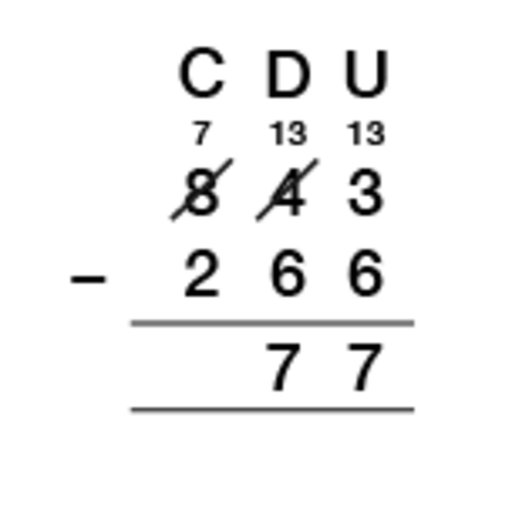
View description - Uncaptioned Figure

  - There is now a 7 in the hundreds column.
  - Subtract 3 from 7: 7 – 2 = 5.
  - This is placed on the answer line in the hundreds column.

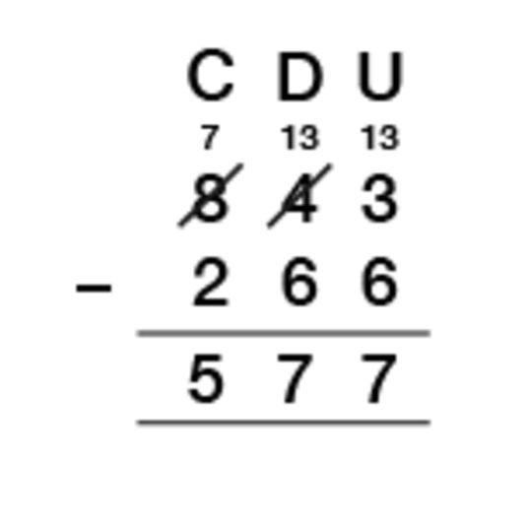
View description - Uncaptioned Figure

The final answer is 577.
You need to be careful when trying to subtract with zeros; for example, 800 – 427. The following video shows the decomposition method in full, including dealing with zeros:

Watch the video at YouTube.com.

‘Borrow and pay back’ method
For example:

765 – 39

Follow the following steps:
- Start with the units. You cannot subtract 9 from 5.
- You borrow 10 to make it 15.
- Now you have borrowed, you must ‘pay back’ by adding 1 to the tens column of the number that you are subtracting. This increases both numbers by ten (5 + 10 = 15 and 39 + 10 = 49). The difference stays the same.

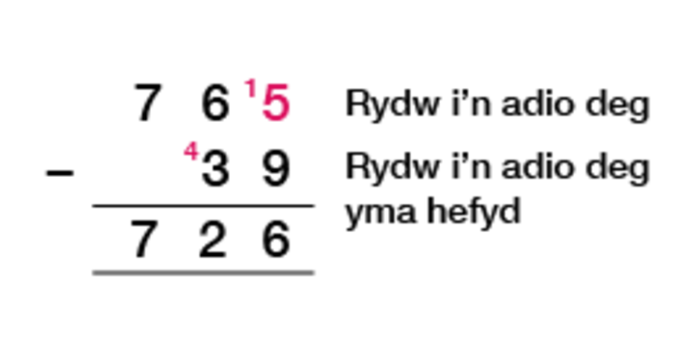
View description - Uncaptioned Figure

Activity 7: Subtracting whole numbers

Complete this activity using the subtraction method that you are most familiar with. Do not use a calculator.
- 9 965 – 742
- 8 163 – 7 481
- 27 364 – 9 583
- 600 987 – 4 500
- 975 046 – 74 308
- 587 342 – 369 453
Remember you can check your calculations using the inverse method, which means using subtraction to check that your answer to an addition calculation is correct. For example:

630 + 295 = 925 (addition)
925 – 295 = 630 (subtraction to check)

View answer - Activity 7: Subtracting whole numbers

1.7 Multiplication

Multiplication by 10, 100 and 1 000

×10
To multiply a whole number by 10, we write the number then add one zero on the end. For example:

2 × 10 = 20 (2 × 1 = 2, then add a zero)
6 × 10 = 60
10 × 10 = 100

×100
When we multiply a whole number by 100, we add two zeros to the end of the number. For example:

3 × 100 = 300
25 × 100 = 2 500
60 × 100 = 6 000

×1 000
When we multiply a whole number by 1 000, we add three zeros to the end of the number. For example:

4 × 1 000 = 4 000
32 × 1 000 = 32 000
50 × 1 000 = 50 000

Now try the following activity.

Activity 8: Multiplying whole numbers by 10, 100 and 1 000

Now try the following:
- 7 × 10
- 32 × 10
- 120 × 10
- 8 × 100
- 21 × 100
- 520 × 100
- 3 × 1 000
- 12 × 1 000
- 45 × 1 000
- Pens cost 31 pence each. How much would it cost for a pack of ten pens?
- A supermarket buys boxes of cereal in batches of 100. If they buy 19 batches, how many boxes is this?
- Seven people win £1 000 each on the lottery. How much money is this altogether?

View answer - Activity 8: Multiplying whole numbers by 10, 100 and 1 000

Multiples and square numbers
When dealing with multiplication, it is important to know the meaning of multiples and square numbers.

Multiples
A multiple of a number can be divided exactly by that number. So for example, 12 is a multiple of 2, 3, 4 and 6, because:

2 × 6 = 12
4 × 3 = 12

Activity 9: Looking for multiples

Look at the following row of numbers, and then answer the questions below.

12, 17, 24, 30, 39, 45, 52, 80

- Which of these numbers are multiples of 2?
- Which of these numbers are multiples of 3?
- Which of these numbers are multiples of 5?
- Which of these numbers are multiples of 10?

View answer - Activity 9: Looking for multiples

Square numbers
A square number is made when you multiply any whole number by itself. For example:

1 × 1 = 1
2 × 2 = 4
3 × 3 = 9

Hint: Square numbers are commonly shown as: 1² (meaning 1 × 1), 2² (meaning 2 × 2), 3² (meaning 3 × 3), etc.

Activity 10: Identifying square numbers

You have been given the square numbers up to 3. Following the pattern, what are the square numbers from 4 to 12?

View answer - Activity 10: Identifying square numbers

Multiplication methods
There are several ways to multiply, and each method will give you the correct answer as long as you use it correctly. The following videos show you the most common methods.

Standard multiplication

Watch the video at YouTube.com.

Grid method multiplication

Watch the video at YouTube.com.

Lattice method multiplication

Watch the video at YouTube.com.

Activity 11: Multiplying whole numbers

Choose the method you are most comfortable with and use it to calculate the following sums:
- 76 × 4
- 183 × 6
- 42 × 25
- 123 × 40
- 718 × 21
- 249 × 34
- 678 × 39
- A theatre has 85 rows of seats and there are 48 seats in each row. What is the total number of seats?
- A taxi driver travels 250 miles per day. How many miles are travelled in 15 days?
- 54 people go on a short coach holiday to Llandudno. They each pay £199. How much will they pay in total?
Now check your calculations with a calculator before revealing the answers.

View answer - Activity 11: Multiplying whole numbers

1.8 Division

Division by 10, 100 and 1 000

÷ 10
To divide a whole number by 10 (when the number ends in a zero), remove a zero from the end of the number to make it 10 times smaller. For example:

20 ÷ 10 = 2
60 ÷ 10 = 6
100 ÷ 10 = 10

÷ 100
To divide a whole number by 100 (when the number ends in at least two zeros), remove two zeros from the end of the number.

300 ÷ 100 = 3
2 500 ÷ 100 = 25
6 000 ÷ 100 = 60

÷ 1 000
To divide a whole number by 1000 (when the number ends in at least three zeros), remove three zeros from the end of the number.

4 000 ÷ 1 000 = 4
32 000 ÷ 1 000 = 32
50 000 ÷ 1 000 = 50

Activity 12: Dividing by 10, 100 and 1 000

Calculate the following:
- 70 ÷ 10
- 32 ÷ 10
- 120 ÷ 10
- 8 500 ÷ 100
- 2 100 ÷ 100
- 52 000 ÷ 100
- 34 000 ÷ 1 000
- 120 000 ÷ 1 000
- 450 000 ÷ 1 000
- Rulers are sold in boxes of ten. How many boxes will 350 rulers fill?
- There are 100 centimetres in 1 metre. What is 18 000 centimetres in metres?
- Ten people share a lottery win of £16 000. How much money does each person win?

View answer - Activity 12: Dividing by 10, 100 and 1 000

Short and long division

Short division
Watch the following video about short division to help you complete the activity:

Watch the video at YouTube.com.

Activity 13: Dividing whole numbers (short division)

Calculate the following:
- 969 ÷ 3
- 3 240 ÷ 8
- 7 929 ÷ 9
- 34 125 ÷ 5
- 14 508 ÷ 8
- 80 225 ÷ 4
- A syndicate of six people wins £135 000 on the lottery. How much will each person get?
- A factory packs 34 000 fish fingers into boxes of eight. How many boxes are filled?
Please note that some of the answers have remainders.

View answer - Activity 13: Dividing whole numbers (short division)

Long division
Watch the following video about long division to help you complete the activity:

Watch the video at YouTube.com.

Activity 14: Dividing whole numbers (long division)

Calculate the following:
- 648 ÷ 18
- 377 ÷ 29
- 298 ÷ 14
- 1 170 ÷ 18
- 42 984 ÷ 12
- Sian earns £12 540 a year. How much does she earn each month?
- Alun buys a car costing £8 550. He wants to pay for it over 15 months. How much will it cost each month?
Now check your calculations with a calculator before revealing the answers.

View answer - Activity 14: Dividing whole numbers (long division)

1.9 A note on the four operations
The four operations are addition, subtraction, multiplication and division. You will already be using these in your daily life (whether you realise it or not!). Everyday life requires us to carry out maths all the time – for example, checking you’ve been given the correct change, working out how many packs of cakes you need for the children’s birthday party and splitting the bill in a restaurant.
- Addition (+) is used when you want to find the total, or sum, of two or more amounts.
- Subtraction (−) is used when you want to find the difference between two amounts or how much of something you have left after a quantity is used. For example, if you want to find out how much change you are owed after spending an amount of money.
- Multiplication (×) is also used for totals and sums, but when there is more than one of the same number. For example, if you bought five packs of apples that cost £1.20 each, to find out the total amount of money you would spend the sum would be 5 × £1.20.
- Division (÷) is used when sharing or grouping items. For example, to find out how many doughnuts you can buy with £6 if one doughnut costs £1.50, you would use the sum £6 ÷ £1.50.

Checking calculations
You should always double-check your calculations using an alternative method. There are different methods you can use, and the one you choose will probably depend on the calculation.
One very good way of checking calculations is to carry out a reverse calculation, or an inverse calculation as it was called earlier in this session. This is where you use the opposite type of sum (or opposite operation) to check your answer:
- Addition (+) and subtraction (–) are opposite operations.
- Multiplication (×) and division (÷) are opposite operations.
If your check results in the same answer, it means that your original sum is correct too. For example, you may have made the following calculation:

200 – 168 = 32

A way of checking this would be:

32 + 168 = 200

Alternatively, if you wanted to check the following calculation:

80 × 2 = 160

A way of checking this would be:

160 ÷ 2 = 80

Summary
In this section you have:
- learned how to read, write, order and compare positive numbers
- looked at different ways of using negative numbers in everyday life
- carried out calculations
- learned how to use the inverse method to check answers.

2 Rounding
If you are out on a shopping trip, being able to quickly estimate the total cost of your shopping could help you to decide whether you have enough money to pay for it. Approximating answers to calculations is a very useful skill to have.
Remember the rounding rhyme that will help you:

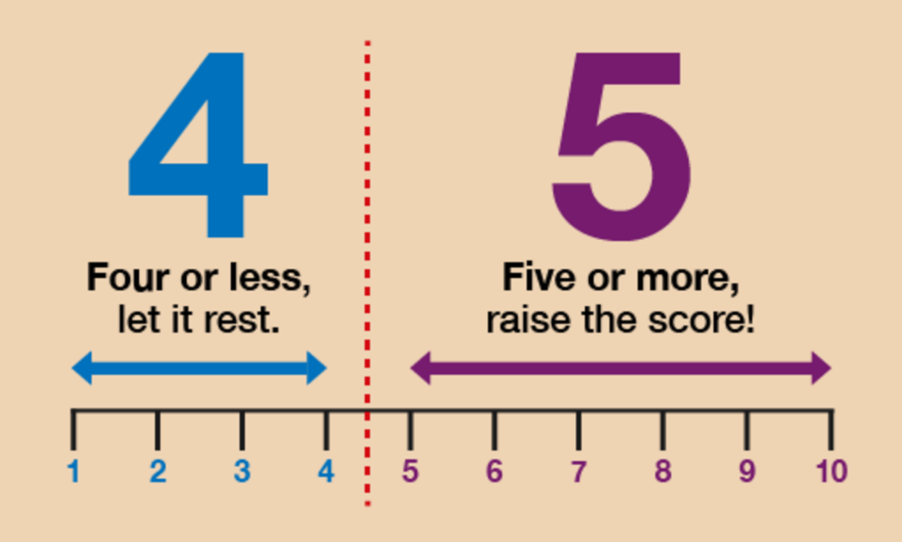
Figure 4 ‘Four or less, let it rest. Five or more, raise the score!’
View description - Figure 4 ‘Four or less, let it rest. Five or more, raise the score!’

Watch this video to refresh your knowledge on rounding. You should make notes throughout:

Watch the video at YouTube.com.

Now try the following activities. Remember to check your answers once you have completed the questions.

Activity 15: Rounding to 10, 100 and 1 000

- Round these numbers to the nearest 10:
  - 64
  - 69
  - 65
  - 648
  - 271
  - 587
Check with our suggestions before continuing.

View answer - Part

- Round these numbers to the nearest 100:
  - 325
  - 350
  - 365
  - 2 924
  - 1 630
  - 2 279
Check with our suggestions before continuing.

View answer - Part

- Round these numbers to the nearest 1 000:
  - 4 250
  - 4 650
  - 4 500
  - 4 060
  - 31 300
  - 13 781
  - 155 600

View answer - Part

We often round numbers in real life especially when shopping. Watch the video on the BBC Skillswise website to learn more about real-life examples of rounding.

Rounding to the nearest £
The rule is that if the amount ends in 50p or more, round up to the £ above, and if the amount ends in less than 50p, the £ stays the same.
For example:

£6.32 = £6 to the nearest £ (because 32p is less than 50p)
£42.51 = £43 to the nearest £ (because 51p is more than 50p)

Activity 16: Rounding to the nearest £

Round the following amounts to the nearest £:
- £5.20
- £1.70
- £7.35
- £13.13
- £23.51
- £128.85

View answer - Activity 16: Rounding to the nearest £

Activity 17: Bill’s shopping

- Bill has £20 to spend on his shopping. Here’s a list of the items he selects, along with how much they cost:

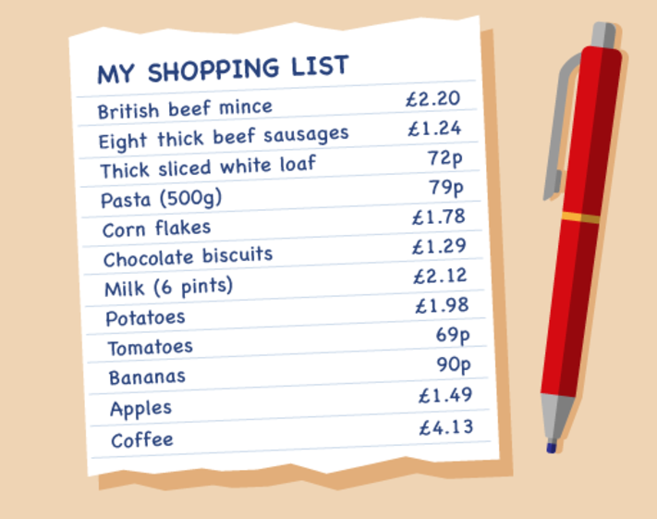
Figure 8 A shopping list
View description - Figure 8 A shopping list

Use your rounding skills to work out whether Bill has enough money to pay for all of his shopping.

Hint: In this activity you should round to the nearest pound, so £2.20 would be rounded to £2.

View answer - Part

- Can you total all of the items on the shopping list to see what the actual cost of Bill’s shopping is?

View answer - Part

2.1 Estimating answers to calculations
Throughout this course you will be asked to estimate or approximate an answer in a scenario. If you do not use rounding to provide an answer to this question your answer will be incorrect.
Try the following activity using rounding throughout. Pay particular attention to the language used.

Activity 18: Rounding

- The population of a city is 6 439 800. Round this number to the nearest million.
- Tickets to a concert cost £6 each. 6 987 tickets have been sold. Approximately how much money has been collected?
- 412 students passed their Maths GCSE this year at Longfield High School. 395 passed last year. Approximately how many students passed GCSE Maths over the last two years?
- Four armchairs cost £595. What is the approximate cost of one armchair?

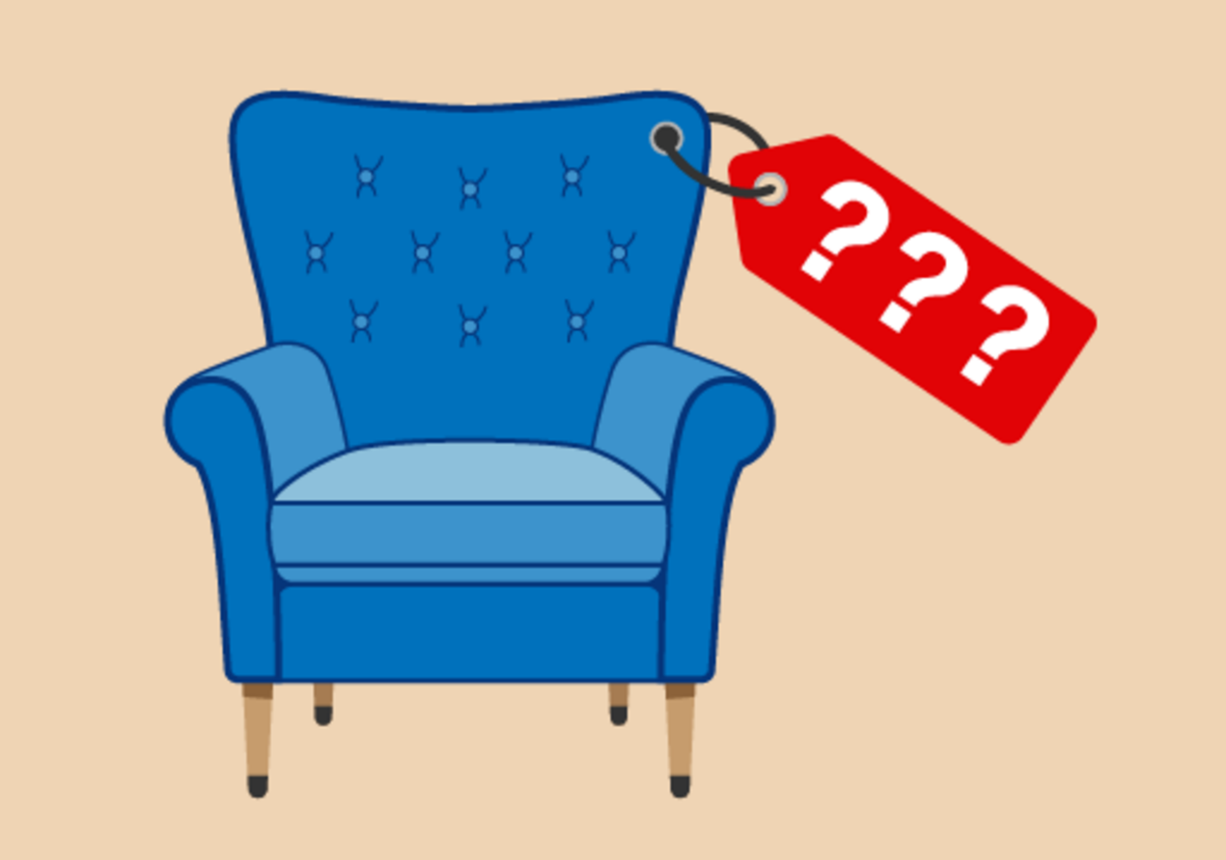
Figure 9 How much for one armchair?
View description - Figure 9 How much for one armchair?

- A box contains 18 pencils. A company orders 50 boxes. Approximately how many pencils is that?

View answer - Activity 18: Rounding

Summary
So far you have worked with negative numbers, whole numbers, estimation, multiples and square numbers. All of the practised skills will help you with everyday tasks such as shopping, working with a budget and reading temperatures. The objectives that you have covered are:
- the meaning of a positive and negative number
- how to carry out calculations with whole numbers
- how an approximate answer can help to check an exact answer
- multiples and square numbers.
Later in this course you will be looking at inverse calculations. This means reversing all operations to check that your answer is correct.

3 Fractions

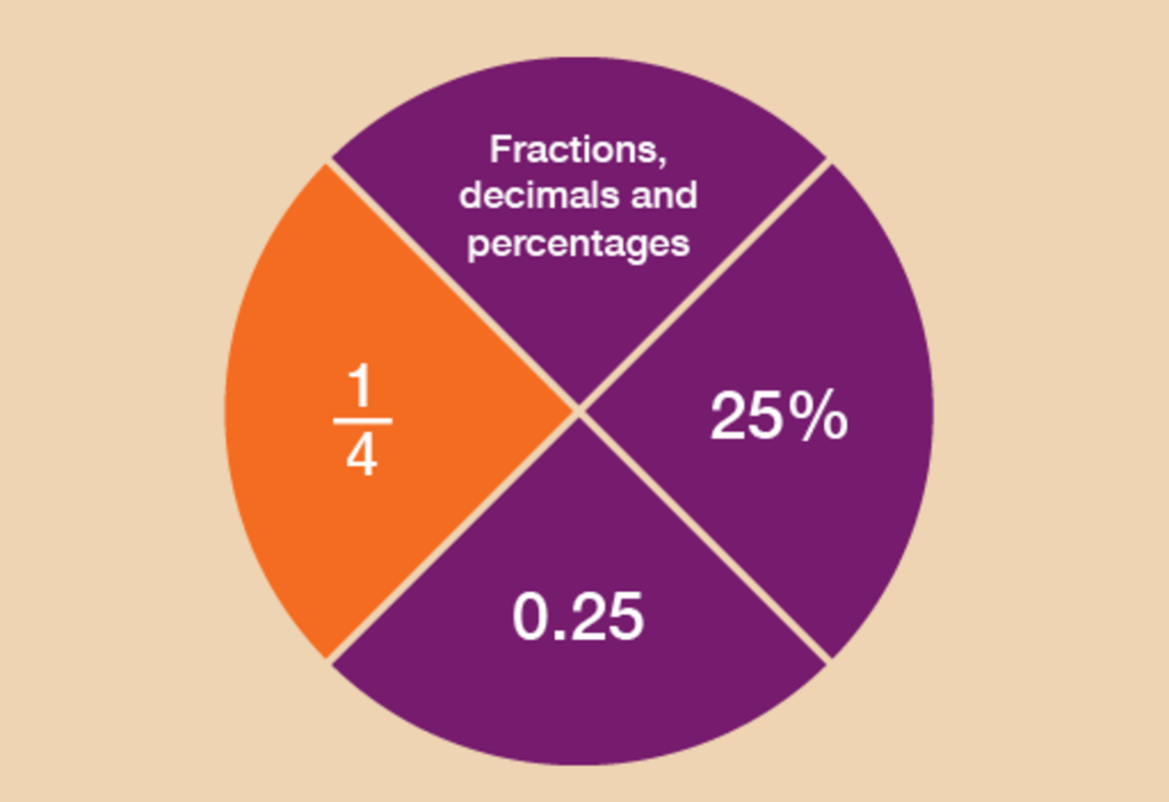
Figure 10 Looking at fractions
View description - Figure 10 Looking at fractions

What is a fraction?
A fraction is defined as a part of a whole. So for example , or ‘one third’, is one part of three parts, all of equal size.

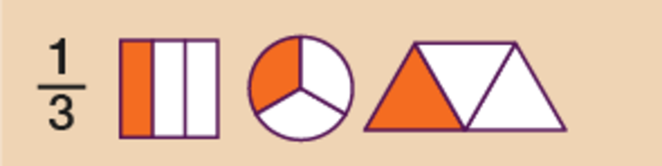
Figure 11 Presenting a fraction: one third
View description - Figure 11 Presenting a fraction: one third

Fractions are an important feature of everyday life. They could ensure that you get the best deal when shopping – or that you receive the largest slice of pizza! As you go through this section, you’ll see how fractions could be used when you are shopping or within the workplace.
Fractions are related to decimals and percentages, which you’ll look at in the sections that follow this one.
This section will help you to:
- order and compare fractions
- identify equivalencies between fractions
- calculate parts of whole quantities and measurements (e.g. calculate discounts in sales).
Please look at the following example before you carry out the activity:
A half can be written as , i.e. one of two equal parts.

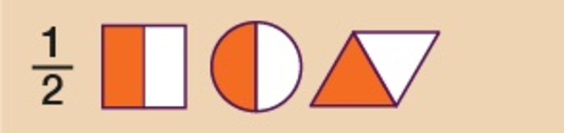
Figure 12 Presenting a fraction: one half
View description - Figure 12 Presenting a fraction: one half

A quarter can be written as , i.e. one of four equal parts.

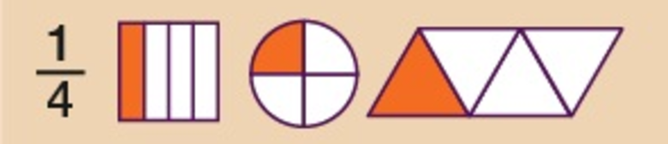
Figure 13 Presenting a fraction: one quarter
View description - Figure 13 Presenting a fraction: one quarter

An eighth can be written as , i.e. one of eight equal parts.

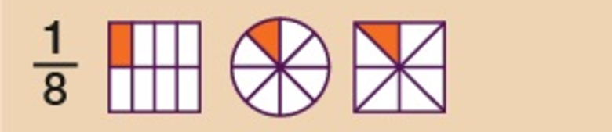
Figure 14 Presenting a fraction: one eighth
View description - Figure 14 Presenting a fraction: one eighth

Hint: The top of the fraction is called the numerator. The bottom of the fraction is called the denominator. Any fraction with a 1 on the top is called a ‘unit fraction’, so , and , for example, are all unit fractions.

A fraction may not have a 1 on the top. For example, means ‘two out of three parts’, or ‘two thirds’.

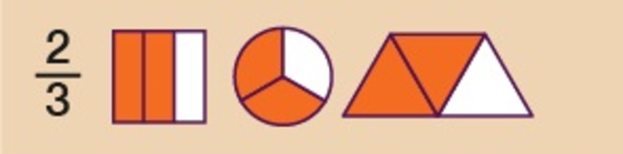
Figure 15 Presenting a fraction: two thirds
View description - Figure 15 Presenting a fraction: two thirds

Example: Where there’s a will, there’s a fraction
Lord Walton draws up a will to decide who will inherit the family estate. He proposes to leave of the estate to his son, to his daughter and to his brother.
- Who gets the biggest share?
- Who gets the smallest share?

Method
When numerators of fractions are all 1, the larger the denominator of the fraction, the smaller the fraction.
Looking at the example above, the fractions can be put in order of size starting from the smallest:

, ,

So:
- The biggest share () goes to his son.
- The smallest share () goes to his brother.

If you’re asked to arrange a group of fractions into size order, it’s sometimes helpful to change the denominators to the same number. This can be done by looking for the lowest common multiple – that is, the number that all of the denominators are multiples of.

3.1 Using equivalent fractions
Equivalent fractions are fractions that are the same as each other, but are expressed in different ways. The BBC Skillswise website has an explanation of equivalent fractions.
To make an equivalent fraction, you multiply or divide the numerator (top) and denominator (bottom) by the same number. The size of the fraction is not altered. For example:

In the fraction , the numerator is 4 and the denominator is 6.
4 × 2 = 8
6 × 2 = 12
So =

In the fraction , the numerator is 10 and the denominator is 15.
10 ÷ 5 = 2
15 ÷ 5 = 3
So =

Example: Looking at equivalent fractions
Arrange the following fractions in order of size, starting with the smallest:
- , ,

Method
You need to look at the bottom number in each fraction (the denominator) and find the lowest common multiple. In this case, the bottom numbers are 6, 3 and 12, so the lowest common multiple is 12:
- 6 × 2 = 12
- 3 × 4 = 12
- 12 × 1 = 12
Whatever you do to the bottom of the fraction you must also do to the top of the fraction, so that it holds the equivalent value. The third fraction, , already has 12 as its denominator, so we don’t need to make any further calculations for this fraction. But what about and ?
- 2 × means calculating (2 × 3 = 6) and (2 × 6 = 12), so the equivalent fraction is
- 4 × means calculating (4 × 1 = 4) and (4 × 3 = 12), so the equivalent fraction is
Now you can now see the size order of the fractions clearly:
- , ,
So the answer is:
- , ,

Use the examples above to help you with the following activity. Remember to check your answers once you have completed the questions.

Activity 19: Fractions in order of size

- Put these fractions in order of size, with the smallest first:
- , , , ,

View answer - Part

- What should you replace the question marks with to make these fractions equivalent?
- =
- =
- =
- =

View answer - Part

- Put these fractions in order of size, with the smallest first:
- , ,

View answer - Part

3.2 Drawing fractions

Example: Drawing the fractions
If you need to compare one fraction with another, it can be useful to draw the fractional parts.
Look at the mixed numbers below. (A mixed number combines a whole number and a fraction.) Say you wanted to put these amounts in order of size, with the smallest first:

2 , 3 , 1

Method
To answer this you could look at the whole numbers first and then the fractional parts. If you were to draw these, they could look like this:

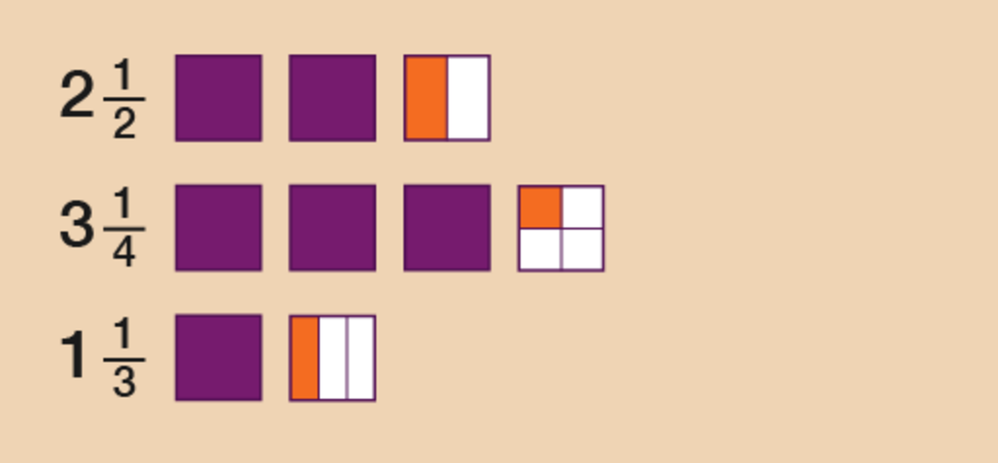
Figure 16 Drawing the fractions
View description - Figure 16 Drawing the fractions

So the correct order would be:

1 , 2 , 3

Use the example above to help you with the following activity. Remember to check your answers once you have completed the questions.

Activity 20: Putting fractions in order

- Put these fractions in order of size, smallest first:
- 5 , 6 , 2
- Put these fractions in order of size, smallest first:
- 2 , 1 , 2

View answer - Activity 20: Putting fractions in order

3.3 Simplifying fractions
You may need to simplify a fraction. The following terms may also be used for this:
- cancelling
- express in the lowest terms
- express in the simplest form.
For example, is equivalent to (the same as) , which is the simplest way of writing this fraction.

Example: Simplifying fractions
- Simplify .
- Simplify .

Method
To simplify a fraction, you need to divide the top and bottom numbers by the same value. You keep dividing down until you cannot get the fraction any smaller. Each time you divide, you must divide the top and bottom numbers by the same value.
- In order to simplify , you need to find out what number will divide into 5 and 20. The only number that will divide into both 5 and 20 is 5:
  - 5 ÷ 5 = 1
  - 20 ÷ 5 = 4
So = .
- There are different ways to simplify to the lowest form. For example, you can divide both numbers in by 2:
  - 20 ÷ 2 = 10
  - 30 ÷ 2 = 15
However, not the simplest form of the fraction. You can simplify the fraction further by dividing the top and bottom numbers by 5:
  - 10 ÷ 5 = 2
  - 15 ÷ 5 = 3
is the simplest form of .
However, you may have recognised that 10 will go into both 20 and 30, so you may have divided by 10 straightaway:
  - 20 ÷ 10 = 2
  - 30 ÷ 10 = 3
The answer is the same, but dividing by 10 would have got you to the answer more quickly.

Now try the following activity.

Activity 21: Simplifying fractions

Simplify the following fractions:

View answer - Activity 21: Simplifying fractions

3.4 Fractions of amounts
Have a look at the following examples, which demonstrate how you would find the fraction of an amount.

Example: Finding fractions

Sale

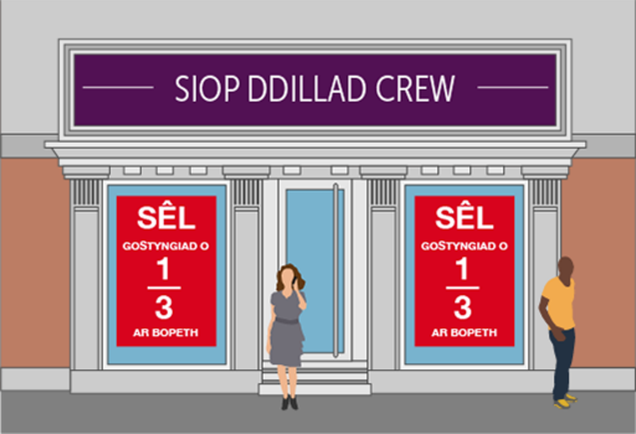
Figure 18 Fractions in a sale
View description - Figure 18 Fractions in a sale

Say you go into a shop to buy a dress. Usually it would cost £90, but today it’s in the ‘ off’ sale. How much would you get off?

Method
The basic rule for finding a unit fraction of an amount is to divide by how many parts there are (the number on the bottom of the fraction) and multiply the result by the number at the top of the fraction. To work out off £90 is the same as:

£90 ÷ 3 = £30

The sum £30 × 1 = £30, so you would get £30 off.

Survey
In a survey, of respondents said that they would like to keep the pound as the currency of the UK. If 800 people were surveyed, how many people wanted to keep the pound?

Method
Again, to find a fraction of an amount you need to divide by the number at the bottom of the fraction and then multiply that result by the number at the top of the fraction:
To answer this you need to first work out what of 800 people is.

of 800 = 800 ÷ 4 = 200

Then use the numerator (the top of the fraction) to work out how many of those unit fractions are needed:

of 800 = 3 × 200 = 600

So 600 people wanted to keep the pound.

Use the example above to help you with the following activity. Remember to check your answers once you have completed the questions.

Activity 22: Paying in instalments

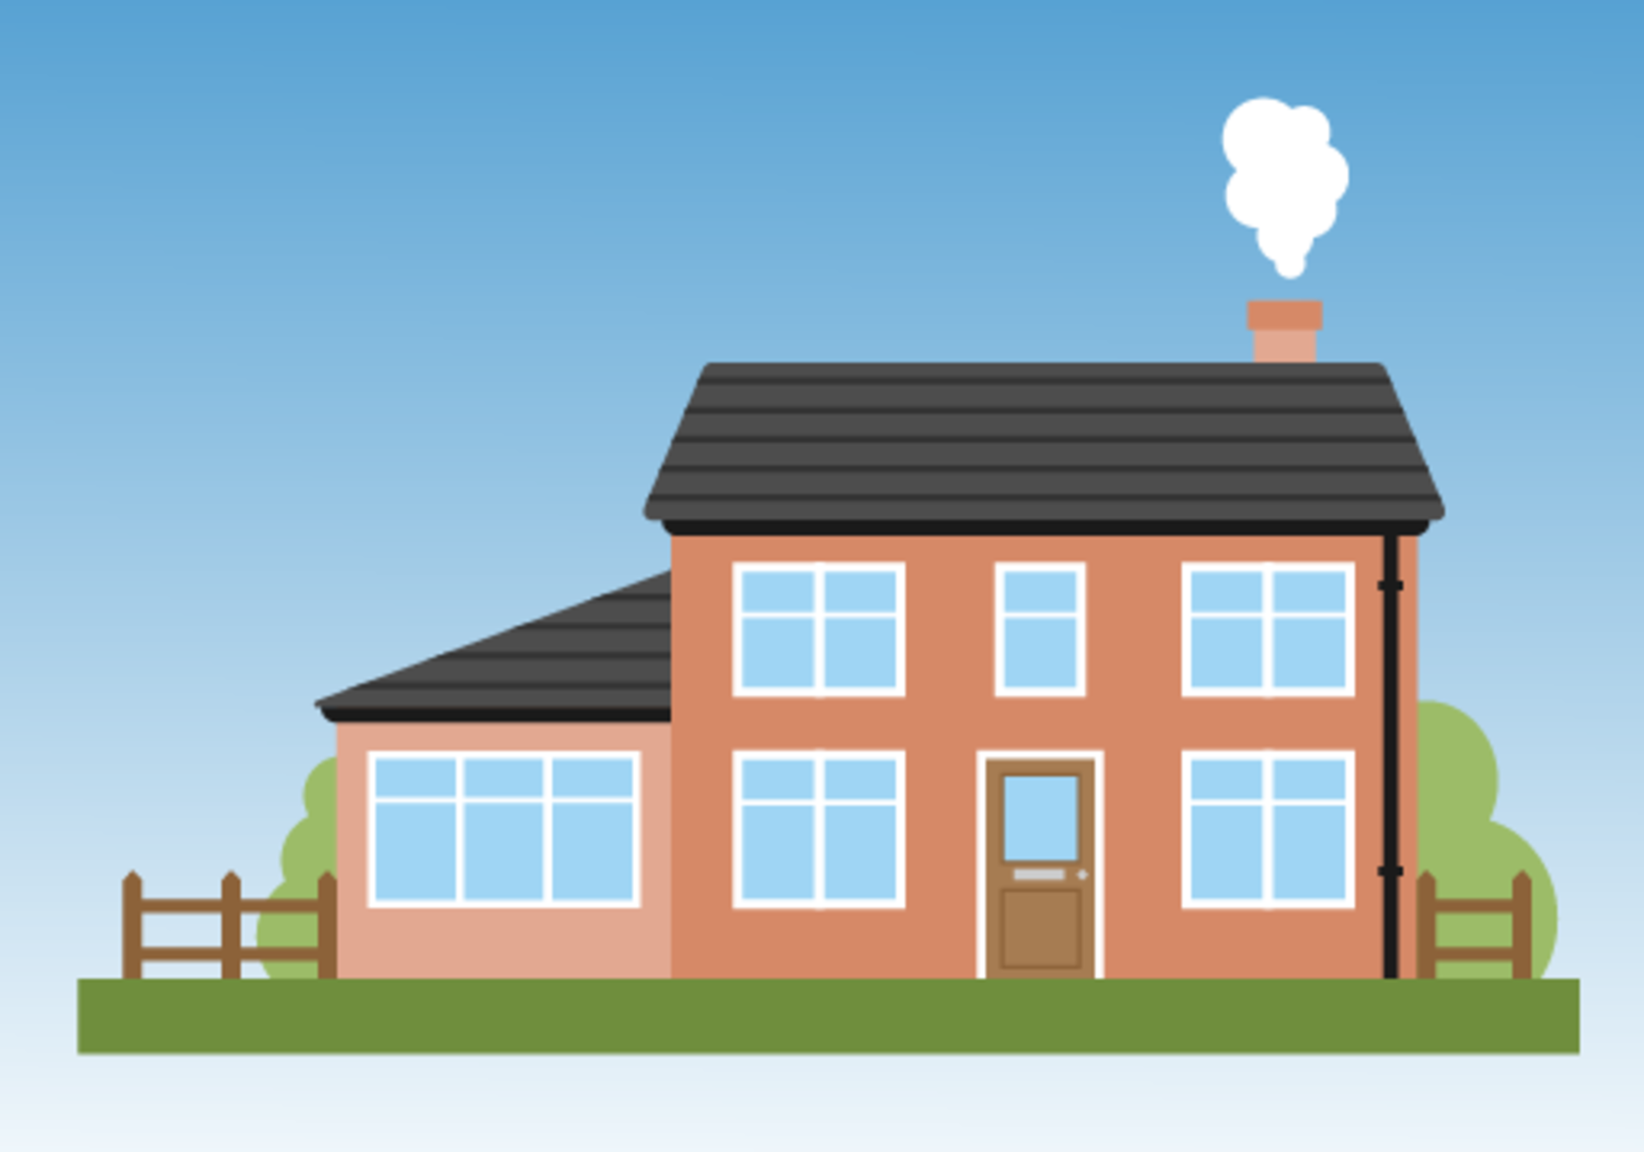
Figure 19 How much would an extension cost?
View description - Figure 19 How much would an extension cost?

A family plans to have its kitchen extended.
The cost of this project is £12 000.
The builder they have chosen to carry out this job has asked for the money to be paid in stages:
- of the money to be paid before starting the project.
- of the money to be paid a month later.
- The remainder to be paid when the extension has been built.
How much is the builder asking for during Stage 1 and Stage 2?

View answer - Activity 22: Paying in instalments

Summary
In this section you have learned how to:
- find equivalencies in fractions
- order and compare fractions
- find the fraction of an amount.
The skills listed above can be used when you are shopping and trying to get the best deal, or when you are splitting a cake or a pizza, say, into equal parts.
It’s important to be able to compare fractions, decimals and percentages in real-life situations. You’ll be looking at percentages later, but first you can look at decimals.

4 Decimals

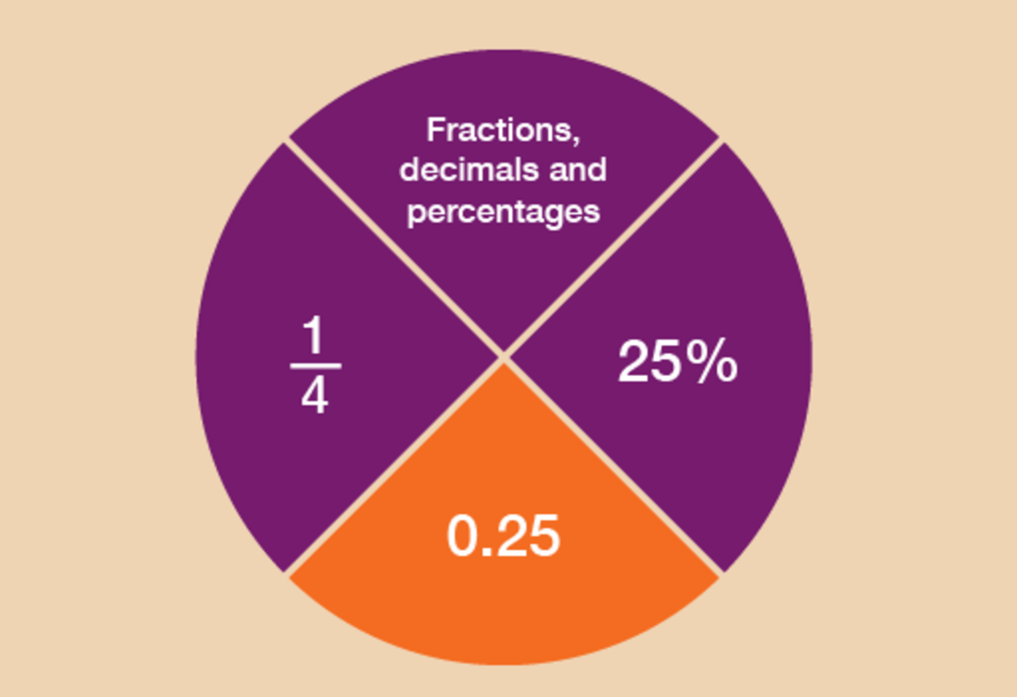
Figure 20 Looking at decimals
View description - Figure 20 Looking at decimals

Can you think of any examples of when you might come across decimal numbers in everyday life?
If you’re dealing with money and the decimal point is not placed correctly, then the value will be completely different, for example, £5.55 could be mistaken for £55.50.
Likewise with weights and measures: if the builder in the last activity made a wrong measurement, the whole kitchen extension could be affected.
This section will help you to understand:
- the value of a digit in a decimal number
- ways of carrying out calculations with decimal numbers
- approximate answers to calculations involving decimal numbers.
You looked at place value in the section on whole numbers. Now you’ll take a look at decimals.

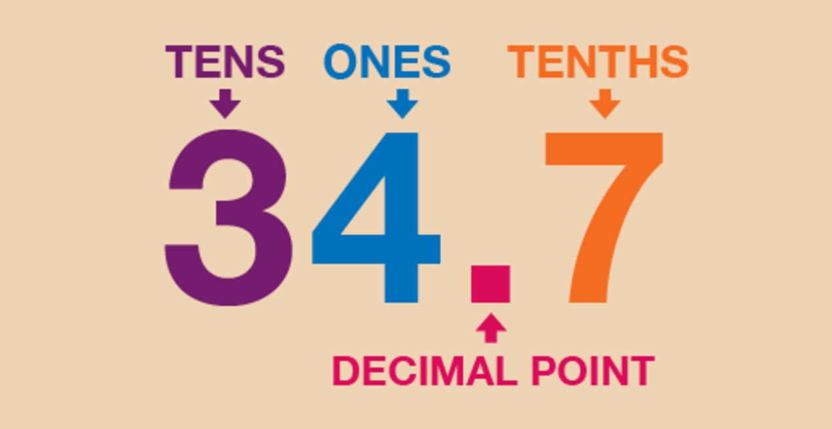
Figure 21 What is a decimal point?
View description - Figure 21 What is a decimal point?

So what is a decimal point?
It separates a number into its whole number and its fractional part. So in the example above, 34 is the whole number, and the seven – or 0.7, as it would be written – is the fractional part.
Each digit in a number has a value that depends on its position in the number. This is its place value:

Whole number part |  |  |  | . | Fractional part
Thousands | Hundreds | Tens | Units | . | Tenths | Hundredths | Thousandths
1000s | 100s | 10s | 1s | . | s | s | 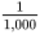s

Look at these examples, where the number after the decimal point is also shown as a fraction:

5.1 = 5 and
67.2 = 67 and
8.01 = 8 and

Example: Finding values
If you were looking for the place value of each digit in the number 451.963, what would the answer be?

Hundreds | Tens | Units | . | Tenths | Hundredths | Thousandths
4 | 5 | 1 | . | 9 | 6 | 3

So the answer is:

4 hundreds
5 tens
1 unit
9 tenths ()
6 hundredths ()
3 thousandths ()

Use the example above to help you with the following activity. Remember to check your answers once you have completed the questions.

Activity 23: Decimal dilemmas

- Four children are taken to the funfair. One of the rides, the Wacky Wheel, has the following notice on it:
  - For safety reasons, children must be over 0.95 m tall to go on this ride.
- Margaret is 0.85 m tall.
- David is 0.99 m tall.
- Suha is 0.89 m tall.
- Prabha is 0.92 m tall.
- Who is allowed to go on the ride?

- Six athletes run a race. Their times, in seconds, are as follows:

Sonia | 10.95
Anjali | 10.59
Anita | 10.91
Aarti | 10.99
Sita | 10.58
Susie | 10.56

- Who gets the gold, silver and bronze medals?

- In a gymnastics competition, the following points were awarded to four competitors. Who came first, second and third?

Janak | 23.95
Nadia | 23.89
Carol | 23.98
Tracey | 23.88

View answer - Part

4.1 Approximations with decimals
Now you have looked at the place value system for decimals, can you use your rounding skills to estimate calculations using decimals? This skill would be needed in everyday life to approximate the cost of your shopping.

Example: Approximations with decimals
Give approximate answers to these. Round each decimal number to the nearest whole number before you calculate.
- 2.7 + 9.1
- 9.6 cm – 2.3 cm
- 2.8 g × 2.6 g
- 9.6 ml × 9.5 ml

Method
- 2.7 lies between 2 and 3, and is nearer to 3 than 2.

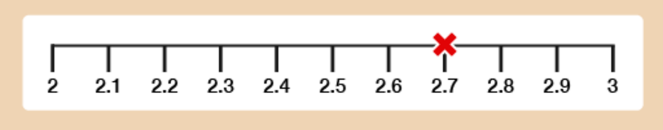
Figure 22 A number line
View description - Figure 22 A number line

9.1 lies between 9 and 10, and is nearer to 9 than 10.

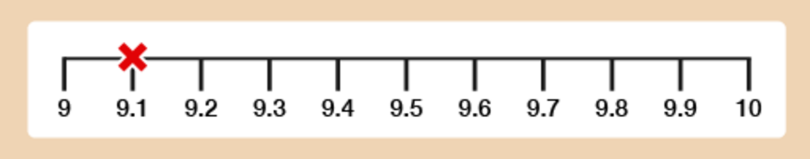
Figure 23 A number line
View description - Figure 23 A number line

So our approximate answer is:
  - 3 + 9 = 12
- Similarly, 9.6 cm lies between 9 cm and 10 cm and is nearer to 10 cm than 9 cm, and 2.3 cm is nearer to 2 cm than 3 cm. So our approximate answer is:
  - 10 cm – 2 cm = 8 cm
- 2.8 g is nearer to 3 g than 2 g, and 2.6 g is also nearer to 3 g than 2 g. So our approximate answer is:
  - 3 g × 3 g = 9 g
- 9.6 ml is nearer to 10 ml than 9 ml. 9.5 ml is exactly halfway between 9 ml and 10 ml. When this happens we always round up, meaning that 9.5 ml is rounded up to 10 ml. So our approximate answer is:
  - 10 ml × 10 ml = 100 ml

Example: Rounding to two decimal places
You may be asked to round a number to two decimal places. All this means is if you are faced with lots of numbers after the decimal point, you will be asked to only leave two numbers after the decimal point. This is useful when a calculator gives us lots of decimal places.
- Round 3.426 correct to two decimal places (we want two digits after the decimal point).

Method
Look at the third digit after the decimal point.
If it is 5 or more, round the previous digit up by 1. If it is less than 5, leave the previous digit unchanged.
The third digit after the decimal point in 3.426 is 6. This is more than 5, so you should round up the previous digit, 2, to 3.
So the answer is 3.43.
- Round 2.8529 to two decimal places.

Method
As in part (a) above, the question is asking you to round to two digits after the decimal point.
Look again at the third digit after the decimal point.
This is 2 (less than 5) so we leave the previous digit (5) unchanged.
The answer is 2.85.
- Round 1.685 to two decimal places.
Here, the third digit after the decimal point is 5, which means the previous digit (8) needs to be rounded up.
The answer is 1.69.

Use the example above to help you with the following activity. Remember to check your answers once you have completed the questions.

Hint: ‘Five or more, raise the score!’

Activity 24: Rounding

- Work out approximate answers to these by rounding each decimal number to the nearest whole number:
  - 3.72 + 8.4
  - 9.6 – 1.312
  - 2.8 × 3.4
  - 9.51 ÷ 1.5
- Round the following numbers to two decimal places:
  - 3.846
  - 2.981
  - 3.475

View answer - Activity 24: Rounding

4.2 Rounding money

Rounding money to the nearest 10p
We use rounding with money in real life when shopping on a budget or maybe checking a bill.
The rule is that if the amount ends in 5p or more, you round up to the next 10p above, and if the amount ends in less than 5p, the 10p digit remains unchanged. For example:

43p ends in 3 (it’s less than 5) so it can be rounded down to 40p
78p ends in 8 (it’s more than 5) so it can be rounded up to 80p

Activity 25: Rounding to the nearest 10p

Round the following amounts to the nearest 10p:
- 13p
- 26p
- 35p
- £4.72
- £8.63
- £14.85

View answer - Activity 25: Rounding to the nearest 10p

Rounding money to the nearest £
When rounding to the nearest £, the rule is that if the amount ends in 50p or more, round up to the £ above, and if the amount ends in less than 50p, the pound column remains unchanged. For example:

£3.42 ends in 42 (it’s less than 50) so it can be rounded down to £3
£56. 67 ends in 67 (it’s more than 50) so it can be rounded up to £57

Activity 26: Rounding to the nearest £

Round the following amounts to the nearest £:
- £6.30
- £9.70
- £0.50
- £13.12
- £26.17
- £52.50

View answer - Activity 26: Rounding to the nearest £

Summary
By completing this topic you have learned how to approximate answers to calculations involving decimal numbers.
You have also learned how to round a decimal number to two decimal places and round money to the nearest 10p or £.

4.3 Calculations using decimals
When you make any calculation with decimals – that is, addition, subtraction, multiplication and division – it is very important to make sure that the decimal point is in the correct place. If you don’t, you’ll get the wrong answer.

Adding and subtracting decimals
When we add or subtract decimals, it is important to line up the decimal points.
Calculate the following:
- 14.08 + 4.1
- 34.45 – 2.3

Method

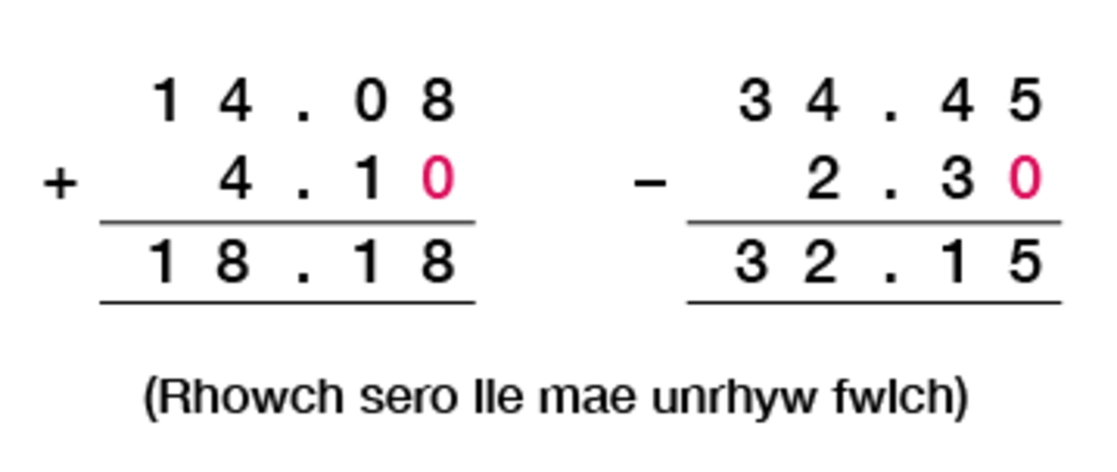
Figure 24 Calculating using decimals
View description - Figure 24 Calculating using decimals

Now try the following activity. Remember to check your answers once you have completed the questions.

Activity 27: Using decimals

Now try the following activity using written methods. Remember to check your answers once you have completed the questions.
- 4.2 + 3.7
- 6.7 – 5.1
- 42.19 + 13.5
- 74.8 – 24.3
- £163.25 + £27.12
- 2.1 m – 0.75 m

View answer - Activity 27: Using decimals

Multiplication

Multiplying decimals by 10, 100 and 1 000
When you multiply a decimal number by 10, all the numbers get 10 times bigger, so the decimal point moves one place to the right.
When you multiply by 100, all the numbers get 100 times bigger, so the decimal point moves two places to the right.
When you multiply by 1 000 all the numbers get 1 000 times bigger, so the decimal point moves three places to the right.
The following video shows you the correct method for multiplying decimal numbers by 10, 100 or 1 000:

Watch the video at YouTube.com.

Now try the following activity.

Activity 28: Multiplying decimals by 10, 100, 1000

Calculate the following:
- 16.3 × 10
- 5.27 × 10
- 82.05 × 100
- 673.2 × 100
- 48.851 × 1 000
- 59.24 × 1 000

View answer - Activity 28: Multiplying decimals by 10, 100, 1000

Multiplying decimals
When multiplying decimal numbers, you should ignore the decimal point and use your usual method to multiply the numbers you are given.
When you have your answer, count up the total number of decimal places (or ‘dp’) in both of the numbers you have multiplied.
Starting from the right-hand column of your answer, count the same number of decimal places (dp) to the left and place your decimal point.
Watch the following video for an explanation of multiplying decimal numbers:

Watch the video at YouTube.com.

Activity 29: Multiplying decimals

Complete this activity using the multiplication method you are most comfortable with. Show your answers to two decimal places (2 dp).
- 0.7 × 4
- 0.3 × 0.4
- 18.7 × 3
- 6.31 × 2.2
- 1.9 × 0.59
- 2.35 × 1.78
- Teabags cost £1.29 a box. How much will five boxes cost?
- Alun earns £8.95 an hour. How much does he earn for 37.5 hours?

View answer - Activity 29: Multiplying decimals

Division

Dividing decimals by 10, 100 and 1 000
When you divide a decimal number by 10, all the numbers get 10 times smaller, so the decimal point moves one place to the left.
When you divide by 100, all the numbers get 100 times smaller, so the decimal point moves two places to the left.
When you divide by 1 000, all the numbers get 1 000 times smaller, so the decimal point moves three places to the left.
Watch the following clip which will show you the correct method for dividing decimal numbers by 10, 100 or 1 000.

Watch the video at YouTube.com.

Now try the following activity.

Activity 30: Dividing decimals by 10, 100, 1 000

Calculate the following:
- 57.08 ÷ 10
- 6.09 ÷ 10
- 433.57 ÷ 100
- 51.2 ÷ 100
- 899.34 ÷ 1 000
- 67.51 ÷ 1 000

View answer - Activity 30: Dividing decimals by 10, 100, 1 000

Dividing a decimal number by a whole number
When you divide a decimal number by a whole number, you divide as normal and keep the decimal point in line.
The following video includes some examples:

Watch the video at YouTube.com.

Now try the following activity.

Activity 31: Dividing a decimal by a whole number

Calculate the following:
- 8.46 ÷ 6
- 79.9 ÷ 5
- 70.38 ÷ 9
- 423.06 ÷ 3
- 0.845 ÷ 5
- 301.14 ÷ 8
- If an electricity bill costs £527.40 per year, how much does it cost per month?
- A taxi bill costs £34.80. If this is shared by four friends, how much will each person pay?

View answer - Activity 31: Dividing a decimal by a whole number

Dividing a decimal number by another decimal number
When you divide a decimal number by another decimal number, you first have to change the number you are dividing by into a whole number. You do this by multiplying by either 10, 100 or 1 000.

Example: Dividing a decimal number by another decimal number
Calculate the following:

4.2625 ÷ 0.05

Method
The number you are dividing by is 0.05, so to make it a whole number you multiply by 100 (that is, move the decimal point two places to the right):

0.05 × 100 = 5

You then multiply the number you are dividing into by the same amount, in this example 100. The number you are dividing into is 4.2625, so:

4.2625 × 100 = 426.25

Note how you do not have to change the number that you are dividing into a whole number.
The calculation you now have is:

426.25 ÷ 5

Using the short division method, the calculation would be:

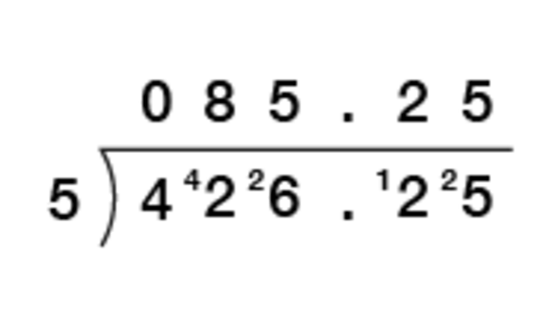
View description - Uncaptioned Figure

This could also be done using the long division method if this is the method you prefer to use:

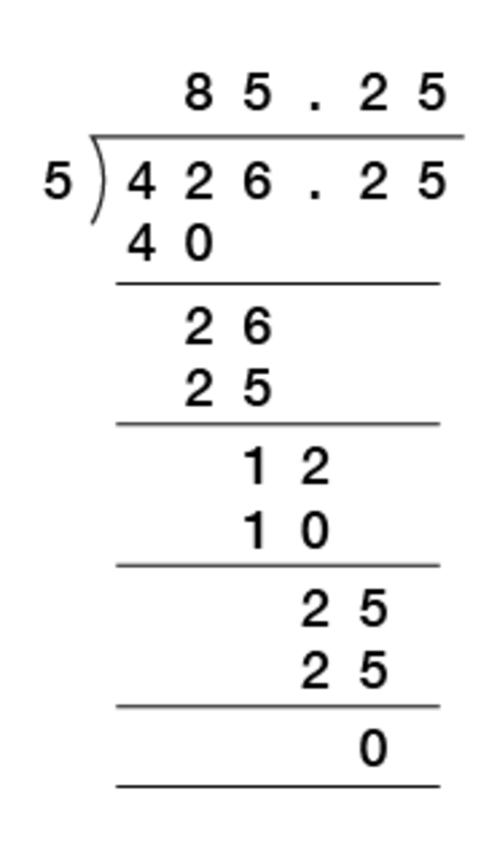
View description - Uncaptioned Figure

However you do the division, just make sure the decimal point goes in line in the answer with where it is in the number you are dividing.

Now try the following activity.

Activity 32: Dividing a decimal by a decimal

Calculate the following, showing your answers to 2 dp when not exact:
- 1.5 ÷ 0.5
- 10.8 ÷ 0.03
- 13.25 ÷ 0.5
- 2.5 ÷ 0.04
- 56.9 ÷ 3.1
- 5.75 ÷ 1.1
- If a tea urn holds 12.5 litres, how many 0.2 litre cups of tea will it provide?
- A garden path is 9.5 metres long and paving slabs are 0.25 metres long each. How many paving slabs will it take to cover the length of the path?

View answer - Activity 32: Dividing a decimal by a decimal

4.4 Decimal problems
Now try the following activity.

Activity 33: Using decimals

Solve these problems involving decimal numbers without using a calculator.

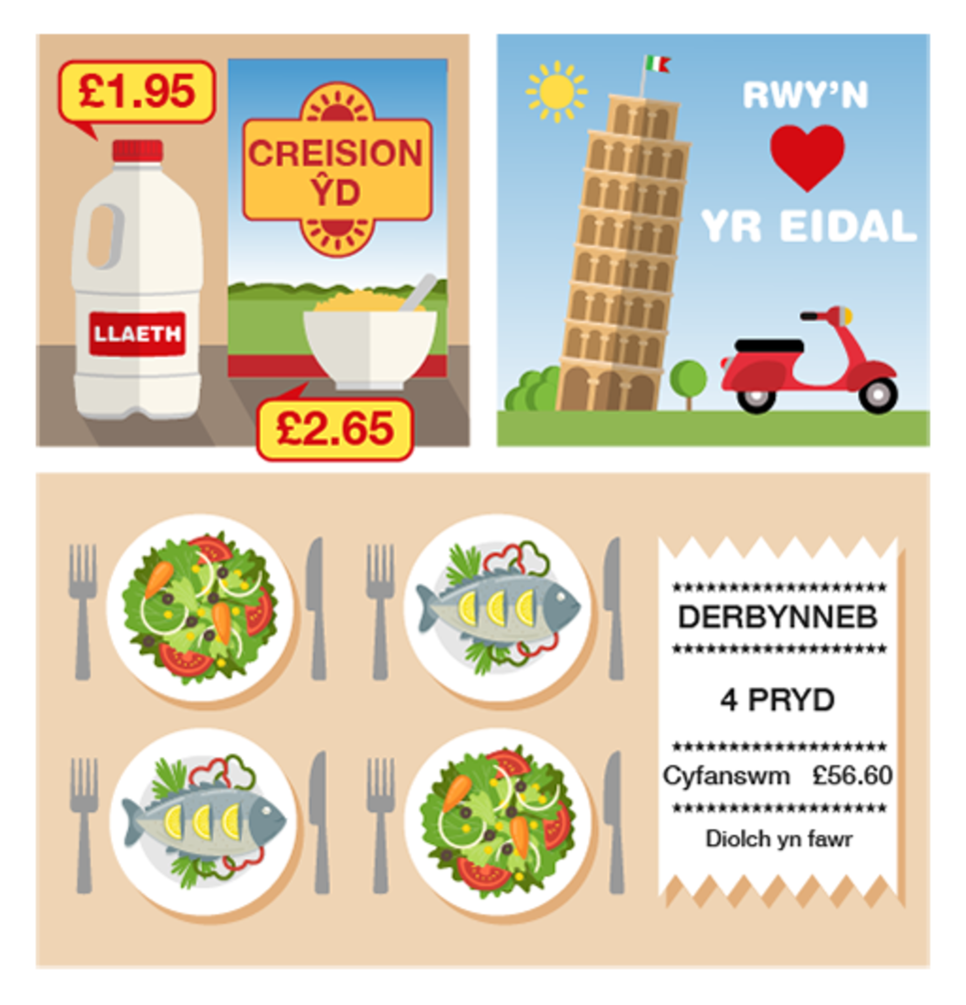
Figure 25 Using decimals
View description - Figure 25 Using decimals

- You buy a box of corn flakes for £2.65 and a bottle of milk for £1.98.
  - What is the total cost of these items?
  - You pay for them with a £5 note. How much change should you get?
- You go on holiday to Italy. The rate of exchange is £1 = €1.4. How many euros do you get for £8?
- You go out for a meal with three friends, and the total cost of the meal is £56.60. You decide to split the bill equally. How much does each of you pay?
- Convert 6.25 m to cm. (Remember that 100 cm = 1 m.)

View answer - Activity 33: Using decimals

Summary
In this section you have learned about how:
- the value of a digit depends on its position in a decimal number
- to approximate answers to calculations involving decimal numbers
- to add, subtract, multiply and divide using decimal numbers.
This will help when working with money and measurements.

5 Percentages

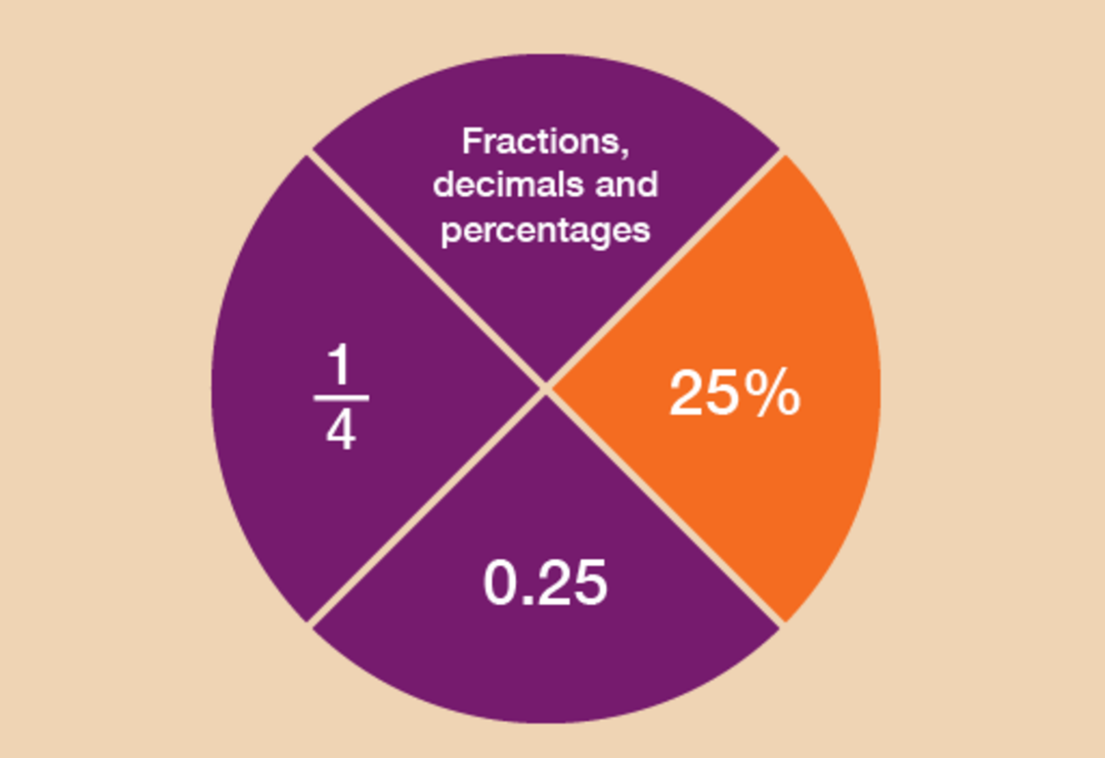
Figure 26 Looking at percentages
View description - Figure 26 Looking at percentages

Like fractions and decimals, you’ll see plenty of references to percentages in your everyday life. For example:

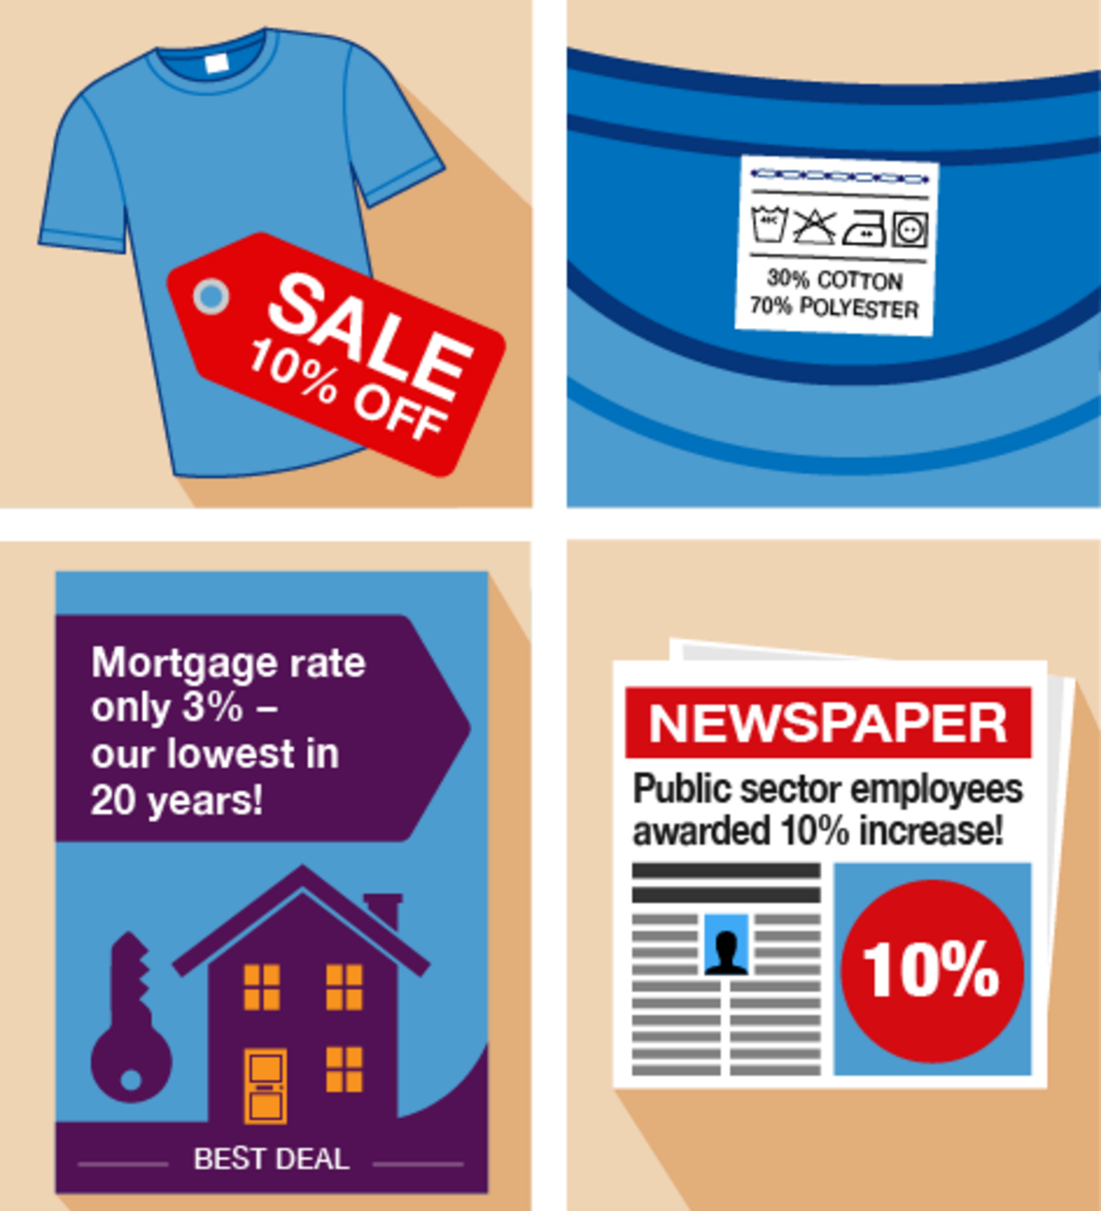
Figure 27 Examples of percentages
View description - Figure 27 Examples of percentages

This section will help you to:
- order and compare percentages
- work out percentages in different ways
- understand how percentages increase and decrease
- recognise common equivalencies between percentages, fractions and decimals.
So what is a percentage?
- It’s a number out of 100.
- 40% means ‘40 out of every 100’.
- The symbol for percentage is %.
- 100% means 100 out of 100. You could also say this as the fraction .
You may have seen examples of percentages on clothes labels. ‘100% wool’ means that the garment is made entirely of wool and nothing else. ‘50% wool’ means that the garment is half made of wool, half made of other materials.
The following example shows how to work out a percentage of an amount.

Example: How can you calculate percentage reductions?
An online shop offers a 10% discount on a television that usually costs £400. How much discount do you get?
A percentage is a number out of 100, so 10% means ‘10 out of 100’. This could also be put as , or 10 hundredths.
There are different ways that percentages can be worked out. The method that you choose really depends on the numbers that you are working with.
Here are two methods for solving this problem:

Method 1
We start with finding 1%.
To find 1% of an amount, divide by 100 (which you practised earlier in this session):

400 ÷ 100 = 4

Once we know 1% of an amount, we can find any percentage by multiplying by the percentage we want to find. So to find 10%, we multiply the 1% figure by 10:

4 × 10 = 40

The discount is £40.
If you think of 10% as a large fraction, , you use the rule of dividing by the denominator (the bottom number in a fraction) and multiplying by the numerator (the top number).
There is an alternative method for finding the answer.

Method 2
A percentage is a number out of 100, so 10% is , which is the same as saying .
If we want to find out 10% of £400, that’s the same as finding out of £400:

400 ÷ 10 = 40

This gives us the answer £40.
If you can work out 10% of an amount, you can find lots of other percentages. Say, for example, you wanted to find 30% of £60.
First you find 10%, by dividing by 10 (method 2):

60 ÷ 10 = 6

30% is three lots of 10%, so once you know 10%, you multiply the amount by 3:

6 × 3 = 18

So 30% of £60 is £18.

Tips
- To find 20%, find 10% first and then multiply by 2.
- To find 5%, find 10% first and then halve the answer (divide by 2).

Which method do you prefer?
- Method 1 will work for any percentage and is a good method to use to find percentages using a calculator.
- Method 2 can be used to work out percentages in your head if the numbers are suitable.
There are some other quick ways of working out certain percentages:

50% = , so you can halve the amount (divide the amount by 2)
25% = , so you can divide the amount by 4 (or you can halve and halve again)
75% = , so you can divide the amount by 4 and then multiply by 3 (or you can find 50% and 25% of the amount, and then add the two figures together).

Use whichever method you prefer to help you with the following activities. Remember to check your answers once you have completed the questions.

Activity 34: Finding percentages of amounts

- You need to pay a 20% deposit on a holiday that costs £800. How much is the deposit?

View answer - Part

- Work out the following using any preferred method without a calculator:
  - 50% of £170
  - 30% of £250
  - 25% of £120
  - 75% of £56
  - 80% of £95
  - 5% of £620

View answer - Part

5.1 Percentage increases and decreases
You’ll often see percentage increases and decreases in sales and pay rises.

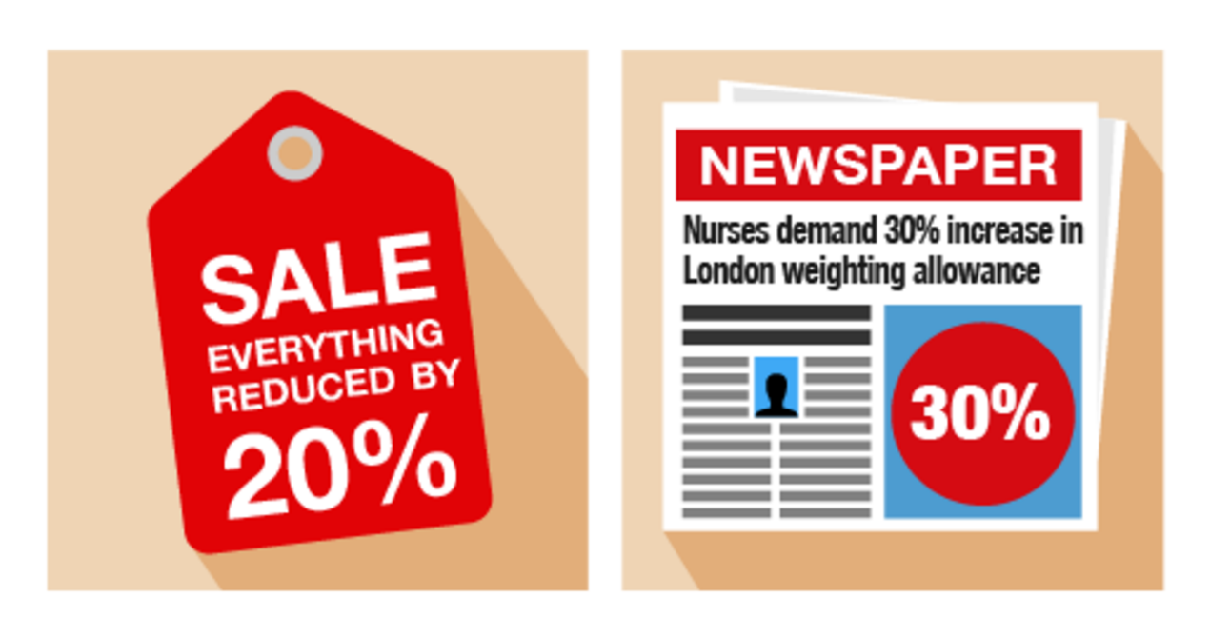
Figure 28 Increasing and decreasing percentages
View description - Figure 28 Increasing and decreasing percentages

Example: Anjali’s pay rise
Anjali earns £18 000 per year. She is given a 10% pay rise. How much does she now earn?

Method
In order to identify Anjali’s new salary, you need to find out what 10% () of £18 000 is. To do this, first you need to find out 1% () of £18 000:

18 000 ÷ 100 = 180

So 10% () of £18 000 is:

10 × 180 = 1 800

Alternatively, you could find 10% by dividing £18 000 by 10:

18 000 ÷ 10 = 1 800

Anjali’s pay rise is £1 800, so her new salary is:

£18 000 + £1 800 = £19 800

Example: A sale at the furniture shop
A furniture shop reduces all of its prices by 20%. How much does a £300 double bed cost in the sale?

Method
In order to identify the new price of the double bed, you need to find out what 20% () of £300 is. To do this, first you need to find out 1% () of £300:

300 ÷ 100 = 3

So 20% () of £300 is:

20 × 3 = 60

The discount is £60, so the sale price of the double bed is:

£300 – £60 = £240

Alternatively, you could find 20% of £300 by dividing by 10 (to find 10%) and then multiplying by 2:

300 ÷ 10 = 30
30 × 2 = 60

Use the examples above to help you with the following activity. Remember to check your answers once you have completed the questions.

Activity 35: Calculating percentage increases and decreases

- You buy a car for £9 000. Its value depreciates (decreases) by 25% annually. How much will the car be worth at the end of the first year?
- Since the start of the 21st century, the shares in the InstaBank have risen by 30%. If the price of one share was £10 in 2000, what is it worth now?
- The same diamond ring is being sold at different prices, and with different percentage discounts, in two different shops. Which shop offers the better deal?

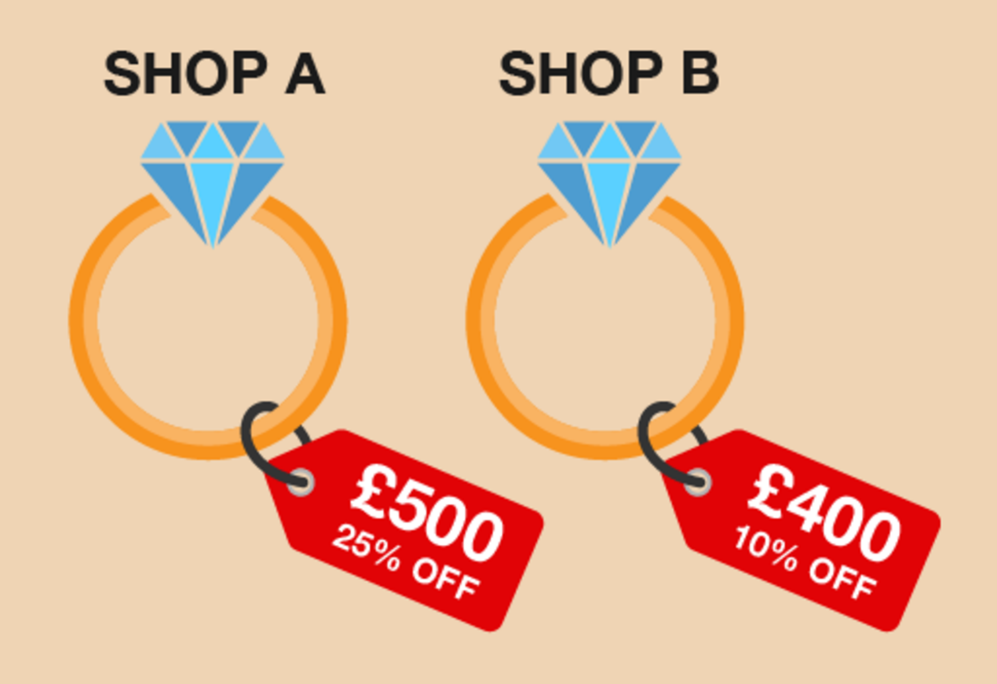
Figure 29 Comparing percentage discounts
View description - Figure 29 Comparing percentage discounts

View answer - Activity 35: Calculating percentage increases and decreases

Summary
In this section you have learned how to calculate percentage increases and decreases. This will be useful when working out the value of a pay increase or how much an item will cost in a sale. You have also seen that there are different ways of working out percentages. You need to use the method that works for you.You may use different methods for working out different percentages.

5.2 Finding percentages using a calculator
There are different ways to work out percentages on a calculator. You can work out any percentage on a calculator by dividing by 100 first (to find 1%) and then multiplying the amount by the percentage you need.
If you were asked to work out 20% of 80, you could do the following:

80 ÷ 100 = 0.8
0.8 × 20 = 16

However, most calculators (including those on a mobile phone) will often have a percentage button. The percentage button looks like this:

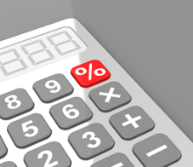
Figure 30 The percentage button on a calculator
View description - Figure 30 The percentage button on a calculator

To successfully use it when calculating percentages you would enter the sum into your calculator as follows.
If you were asked to find 20% of 80, on your calculator you would input:

80 × 20%

This would give you the following answer:

80 × 20% = 16

If you were asked to find 20% of 80, on your calculator you would input:

20% × 80

This would give you the following answer:

20% × 80 = 16

Different calculators may work in different ways so you need to familiarise yourself with how to use the % button on your calculator.

Summary
In this section you have learned how to solve problems using percentages, and how to calculate percentage increases and decreases.

6 Equivalencies between fractions, decimals and percentages
Fractions, decimals and percentages are different ways of saying the same thing. It’s an important skill to learn about the relationships (or ‘equivalencies’) between fractions, decimals and percentages to make sure you are getting the better deal.

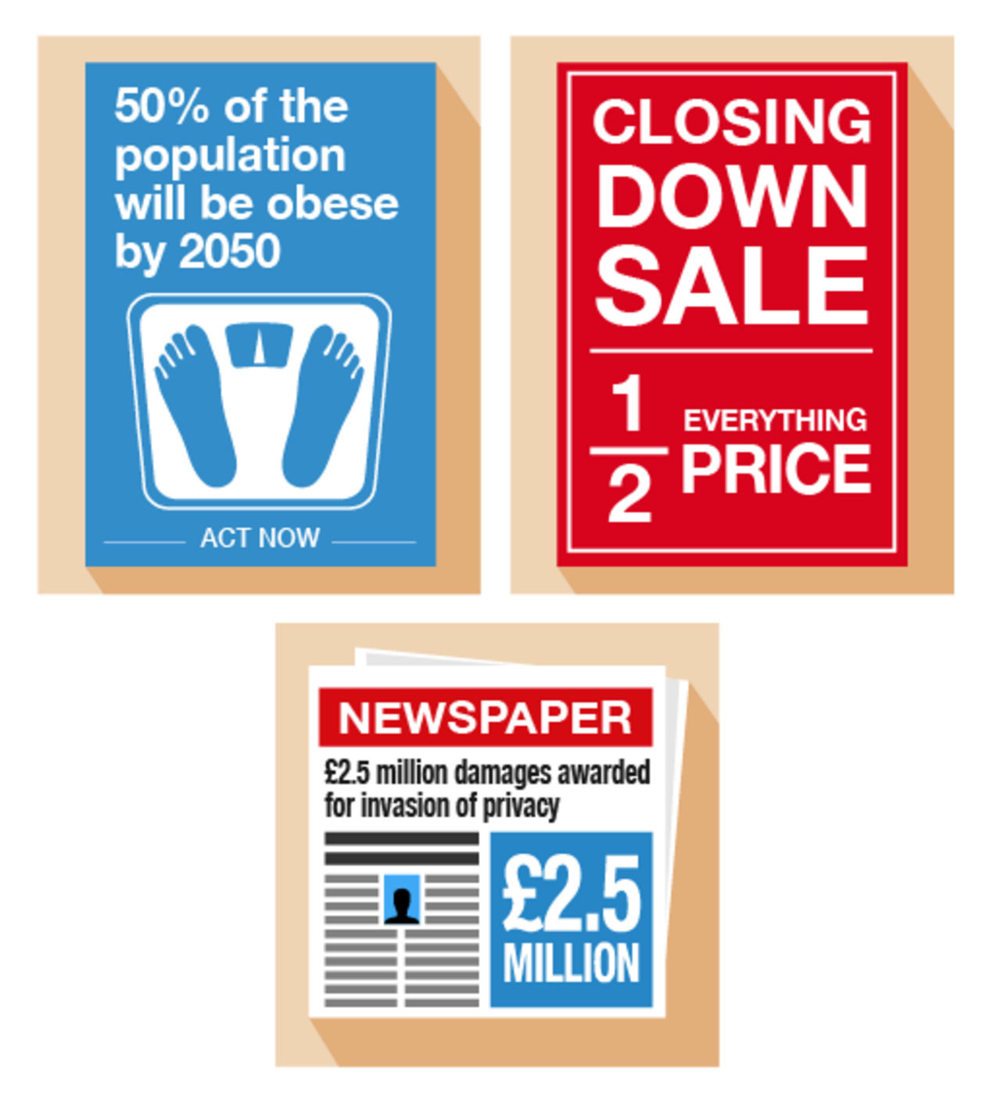
Figure 31 Looking at equivalencies
View description - Figure 31 Looking at equivalencies

Here are some common equivalencies. Try to memorise them – you will come across them a lot in everyday situations:

10% = = 0.1
20% = = 0.2
25% = = 0.25
50% = = 0.5
75% = = 0.75
100% = 1 = 1.0

Look at the following example. If you can identify equivalences, they’ll make it easier to make simple calculations.

Example: Mine’s a half
What is 50% of £200?

Method
Since 50% is the same as , so:

50% of £200 = of £200 = £100

Refer to the common equivalencies above (if you need to) to help you with the following activity. Remember to check your answers once you have completed the questions.

Activity 36: Looking for equivalencies

- What is 0.75 as a fraction?
- If you walked 0.25 km each day, what fraction of a kilometer have you walked?
- House prices have increased by in the last five years. What is this increase as a percentage?
- A DIY shop is holding a ‘50% off’ sale on kitchens. What is this discount as a fraction?
- You buy an antique necklace for £3 000. After ten years, its value increases by 20%. What is this increase as a decimal?
- A headline reads ‘Number of Welsh speakers predicted to rise by 10%’. What is this rise a fraction?
- What percentage of an hour is 15 minutes?

View answer - Activity 36: Looking for equivalencies

If you find that you are struggling to understand how to convert, please look at the following resource:

Video content is not available in this format.
View transcript - Uncaptioned interactive content

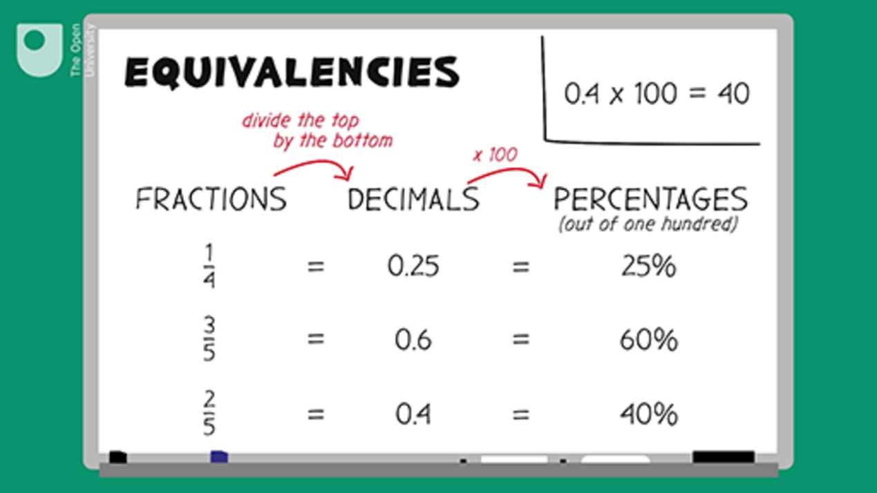

Summary
Knowing the common equivalencies between fractions, decimals and percentages is important when trying to compare discounts when shopping or choosing a tariff when paying your bills.

7 Ratios
Along with proportion (which you’ll look at in the next section), you use ratio in everyday activities such as gardening, cooking, cleaning and DIY.

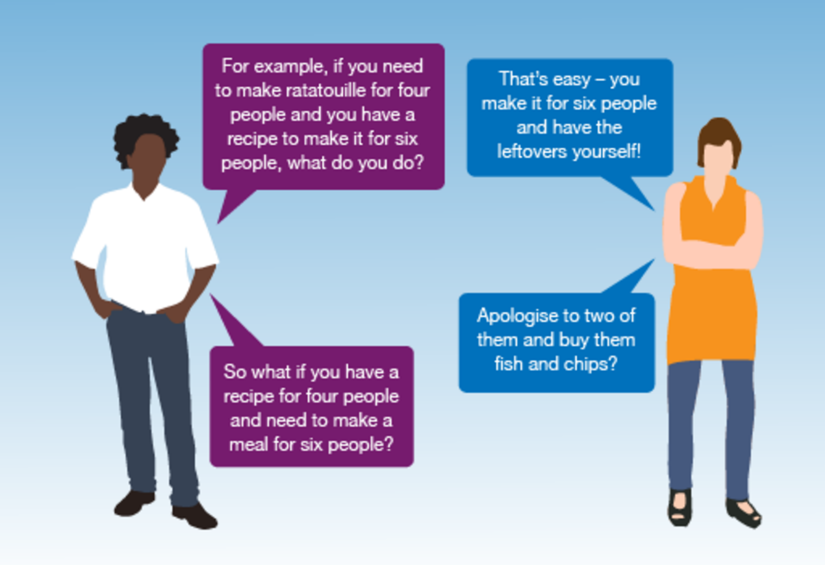
Figure 32 Talking ratios
View description - Figure 32 Talking ratios

Ratio is where one number is a multiple of the other. To find out more about ratios, read the following example.

Example: How to use ratios
Suppose you need to make up one litre (1 000 ml) of bleach solution. The label says that to create a solution you need to add one part bleach to four parts water.
This is a ratio of 1 to 4, or 1:4. This means that the total solution will be made up of:

One part + four parts = five parts

If we need 1 000 ml of solution, this means that one part is:

1 000 ml ÷ 5 = 200 ml

The solution needs to be made up as follows:

Bleach: one part × 200 ml = 200 ml
Water: four parts × 200 ml = 800 ml

So to make one litre (1 000 ml) of solution, you will need to add 200 ml of bleach to 800 ml of water.
You can check your answer by adding the two amounts together. They should equal the total amount needed:

200 ml + 800 ml = 1 000 ml

Use the example above to help you with the following activity. Remember to check your answers once you have completed the questions.

Activity 37: Using ratios

- There are 17 students in a class: ten are male and seven are female. Write the ratio of male to female students.
- The ratio of sand to cement required to make concrete is 3:1.
If you have 40kg of cement, how much sand should you have?
- Read the label from a bottle of wallpaper stripper:
  - Dilute: add 1 part wallpaper stripper to 7 parts water.
How much wallpaper stripper and water is needed to make 16 litres of solution?
- To make a solution of hair colourant you need to add one part of hair colourant to four parts of water. How much hair colourant and water is needed to make 400 ml of solution?

View answer - Activity 37: Using ratios

Summary
You have now learned how to use ratio to solve problems in everyday life. This could be when you are mixing concrete, hair colourant or screen wash. Can you think of any more examples where you might need to use ratio?

8 Proportion
Proportion is used to scale quantities up or down by the same ratio. This is shown in the following example – what happens if you want to adapt a favourite recipe to serve more people?

Example: Using proportion for more portions …

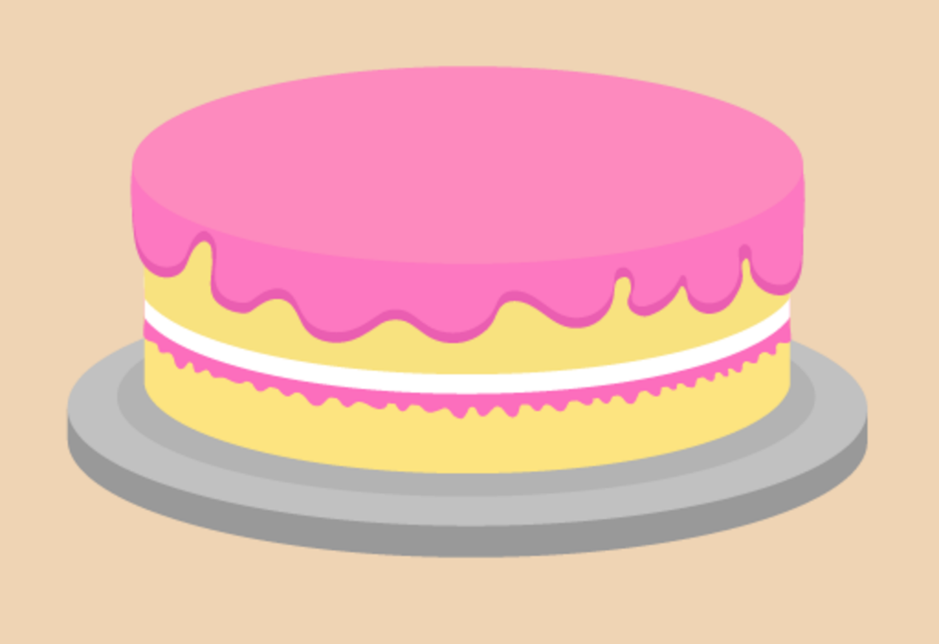
Figure 33 A cake
View description - Figure 33 A cake

Here is a recipe for making a sponge cake for four people:

4 oz self-raising flour
4 oz caster sugar
4 oz butter
2 eggs

How much of each ingredient is needed to make a cake for eight people?

Method
To make a cake for eight people you need twice the amount of each ingredient:

8 oz self-raising flour (4 × 2)
8 oz caster sugar (4 × 2)
8 oz butter (4 × 2)
4 eggs (2 × 2)

Use the example above to help you with the following activity. Remember to check your answers once you have completed the questions.

Activity 38: Scaling up recipes

- This recipe makes ten large cookies:
  - 220 g self-raising flour
  - 150 g butter
  - 100 g caster sugar
  - 2 eggs
How much of each ingredient is needed to make 20 cookies?
- This recipe makes four servings of strawberry milkshake:
  - 800 ml milk
  - 200 g strawberries
  - 4 scoops of ice cream
How much of each ingredient is needed for two people?
- This recipe makes dessert for two people:
  - 300 ml milk
  - 60 g powder
How much of each ingredient is needed to serve six people?

View answer - Activity 38: Scaling up recipes

Once you have checked your answers and have got them all correct, please have a go at the next activity.

Activity 39: Looking at ratio and proportion

Note: Calculators not allowed.
- A label on a bottle of curtain whitener says that you should add one part concentrated curtain whitener to nine parts water.
How much curtain whitener and water is needed to make up a 2 000 ml solution?
- Here is a recipe for a low-fat risotto for two people:
  - 200 g mushrooms
  - 175 g rice
  - 180 ml water
  - 180 ml evaporated milk
  - Salt and pepper
How much of each ingredient is needed if you want to cook enough risotto for six people?

View answer - Activity 39: Looking at ratio and proportion

Summary
In this section you have learned how to use proportion to solve simple problems in everyday life, for example when adapting recipes.

9 Word formulas
You see formulas in everyday life, but sometimes it can be tricky to spot one that’s written in words.
So what’s a formula? It’s a rule that helps you to work out an amount, you will see this when cooking, working out how much you are going to get paid or your household bills.
You use formulas a lot throughout a normal day, as the examples below show.

Example: A formula to calculate earnings
Daniel is paid £6.50 per hour. How much does he earn in ten hours?

Method
You’re told that ‘Daniel is paid £6.50 per hour’.
This is a formula. You can use it to work out how much Daniel earns in a given number of hours. The calculation you need to do is:

Daniel’s pay = £6.50 × number of hours

You’ve been asked how much Daniel earns in ten hours, so put ‘10’ into the calculation in place of ‘number of hours’:

£6.50 × 10 = £65.00

You can use the same formula to work out how much Daniel earns for any number of hours.

You will need to be able to use formulas that have more than one step. The next example looks at a two-step formula.

Example: A cooking formula
What are the two steps in word formulas? Watch the following video to find out.

Video content is not available in this format.
View transcript - Uncaptioned interactive content

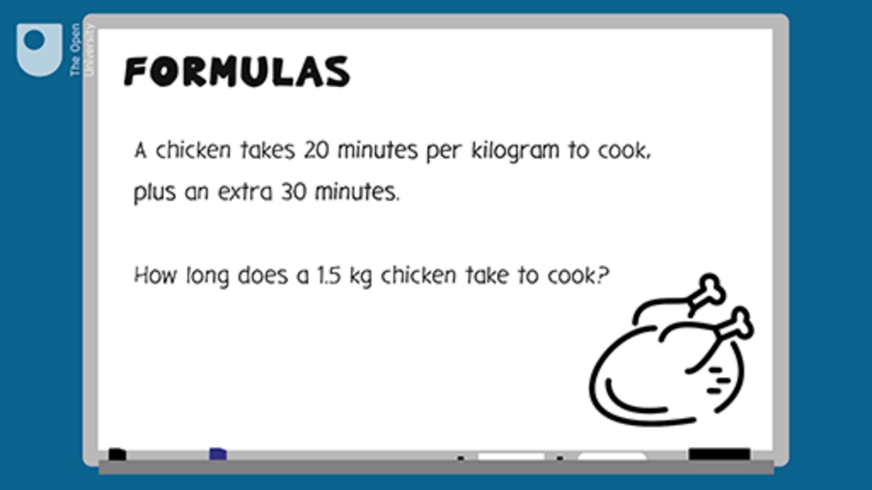

Now test your learning with the following word problems.

Activity 40: Using formulas

- Harvey earns £7.75 per hour. How much will Harvey earn in 8 hours?

View answer - Part

- A joint of pork takes 40 minutes per kilogram to cook, plus an extra 30 minutes to ensure the outside is crisp.
  - How long will it take for a 2 kg joint of pork to cook?
  - How long will it take for a 1.5 kg joint of pork to cook?

View answer - Part

- A mobile phone contract costs £15 a month for the first four months, then £20 a month after that. How much will the phone cost for one year?

View answer - Part

10 A quick reminder: checking your work
Next you can take a quiz to review what you have learned in this session. For this and later quizzes in the course you should check your answers. A check is an alternative method or reverse calculation – you may have heard this being called an inverse calculation. If the check results in a correct answer, it means that your original sum is correct too. For example, you may have made the following calculation:
- 20 – 8 = 12
A way of checking this would be:
- 12 + 8 = 20
Alternatively, if you wanted to check the following calculation:
- 80 × 2 = 160
A way of checking this would be:
- 160 ÷ 2 = 80
If you have carried out several calculations to get to your final answer, you only need to reverse one as a check.

11 Session 1 quiz
Now it’s time to review your learning in the end-of-session quiz.
Session 1 quiz.
Open the quiz in a new window or tab (by holding ctrl [or cmd on a Mac] when you click the link), then return here when you have done it.
Although the quizzes in this course do not require you to show your working to gain marks, real exams would do so. We therefore encourage you to practise this by using a paper and pen to clearly work out the answers to the questions. This will also help you to make sure you get the right answer.

12 Session 1 summary
You have now completed Session 1, ‘Working with numbers’. If you have identified any areas that you need to work on, please ensure you refer back to this section of the course and retry the activities.
You should now be able to:
- understand and use whole numbers, and understand negative numbers in practical contexts
- add, subtract, multiply and divide whole numbers using a range of strategies
- find fractions of whole numbers
- find common percentages of whole numbers and calculate percentage increases and decreases
- add, subtract, multiply and divide decimals up to two decimal places
- understand and use equivalences between common fractions, decimals and percentages
- solve simple problems involving ratio, where one number is a multiple of the other
- use simple formulas expressed in words for one- or two-step operations.
All of the skills above will help you with tasks in everyday life. Whether you are at home or at work, number skills are an essential skill to have.
You are now ready to move on to Session 2.

Session 2: Units of measure

Introduction
You come across problems requiring calculation every day. These problems could be related to money, time, length, weight, capacity and temperature. For example, if you were buying a new washing machine, you would measure the space where you want to put it under your worktop and make sure you chose a washing machine short enough to fit the space.
In this session of the course you will find out about measuring and calculating length, distance, weight, capacity (volume), temperature and time. You will learn how to use different metric measurements, such as kilometres, metres and centimetres, grams and kilograms, and litres.
By the end of this session you will be able to:
- measure and understand the sizes of objects
- read a mileage chart to find the distance between places
- find out how heavy things are and understand weights
- measure and understand volumes and capacities
- measure and compare temperatures
- express time using the 24-hour clock
- carry out calculations with time.

Video content is not available in this format.
View transcript - Uncaptioned interactive content

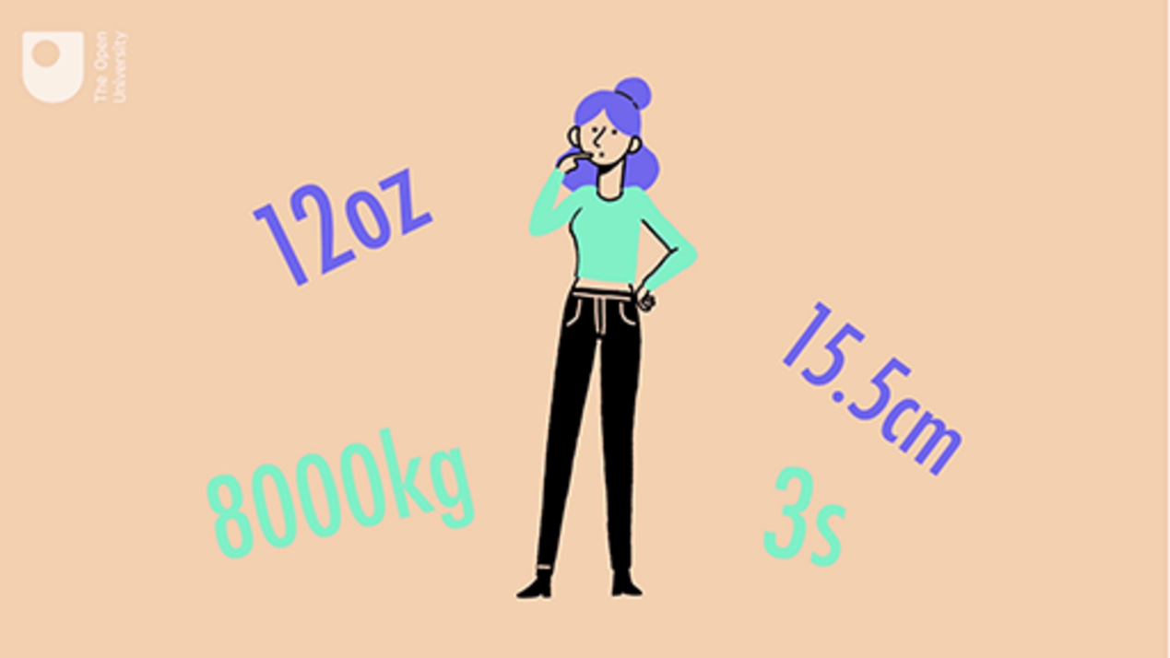

1 Using metric measurements: length
We can use different units to measure the length, width or height of items. We are going to focus on metric units.

Metric units of length
Metric unit | Abbreviation
millimetre | mm
centimetre | cm
metre | m
kilometre | km

A millimetre is the smallest metric unit used by most people to measure the length of something. You would commonly use millimetres to measure items that are really small or need to be measured very accurately; for example, the dimensions of a washing machine is usually measured in millimetres.
Centimetres and metres are also commonly used to measure items for everyday tasks.
Kilometres would be used to measure the distance between places. A runner may clock the distance that they have run in kilometres.

Activity 1: Which unit?

Which unit would you use to measure the following?
- A washing machine
- The distance between Wrexham and Cardiff
- A nail
- A kitchen
- A bus
- A park run
- Your waist
- A sofa
- An envelope
- A screw head

View answer - Activity 1: Which unit?

1.1 Instruments of measure
So what do you use to measure things? If you were to measure something small, such as a screw, you would probably use a ruler. To measure something bigger, like the length of a room or garden, you would probably use a tape measure.
You could try estimating the size of something before measuring it, which would help you to decide what tool you need to measure it. If you wanted to measure the walls of a room before redecorating, you’d get a more accurate measurement using a tape measure rather than a 30-centimetre ruler! After you’ve made an estimate you can check how accurate it is by measuring the object.
How long is a pen? Find a pen, make an estimate of how long you think it is and then measure it accurately using a ruler.

Hint: To help you to estimate the size of an item, consider it in relation to other items of known length:
- The eye of a needle is about 1 millimetre (mm) wide.
- The width of the fingernail on your little finger is about 1 centimetre (cm).
- A small ruler is 15 centimetres long.
- A large ruler is 30 centimetres long.
- A door frame is approximately 2 metres (m) high.
- It would take approximately 20 minutes to walk 1 kilometre (km).

Activity 2: How long?

Match the following items to the approximate measurement:

The height of a man
The length of a pen
The length of an A4 piece of paper
The height of a double-decker bus
The length of a swimming pool
The length of an eyelash
The length of a half marathon
175 cm
15 cm
30 cm
4 m
25 m
10 mm
20 km
View answer - Activity 2: How long?

1.2 Measuring accurately
To measure accurately, line up one end of the pen with the 0 mark on the ruler. If there is no 0 mark, use the end of the ruler. Hold the ruler straight against the pen. Which mark does the other end come to?

Hint: Be careful with the bit of ruler or tape measure that comes before the first mark! Make sure you line up whatever you’re measuring with the ‘zero’ mark.

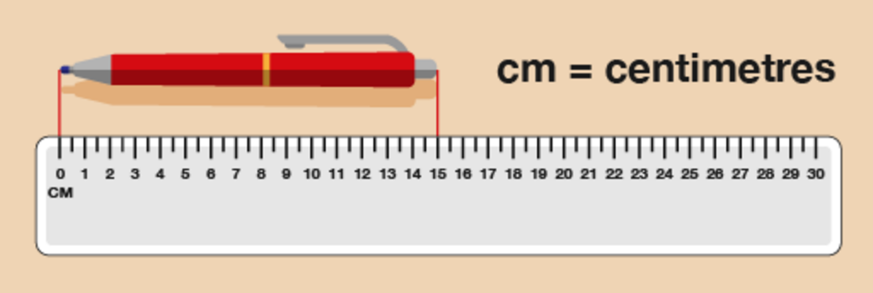
Figure 1 Measuring a pen
View description - Figure 1 Measuring a pen

You can see from this diagram that the pen is 15 cm long.
Now try the following activity. Remember to check your answers once you have completed the questions.

Activity 3: Building a shelf for DVDs

- You want to build a shelf to hold some DVDs. You need to make sure that it’s big enough! How tall is a DVD case?

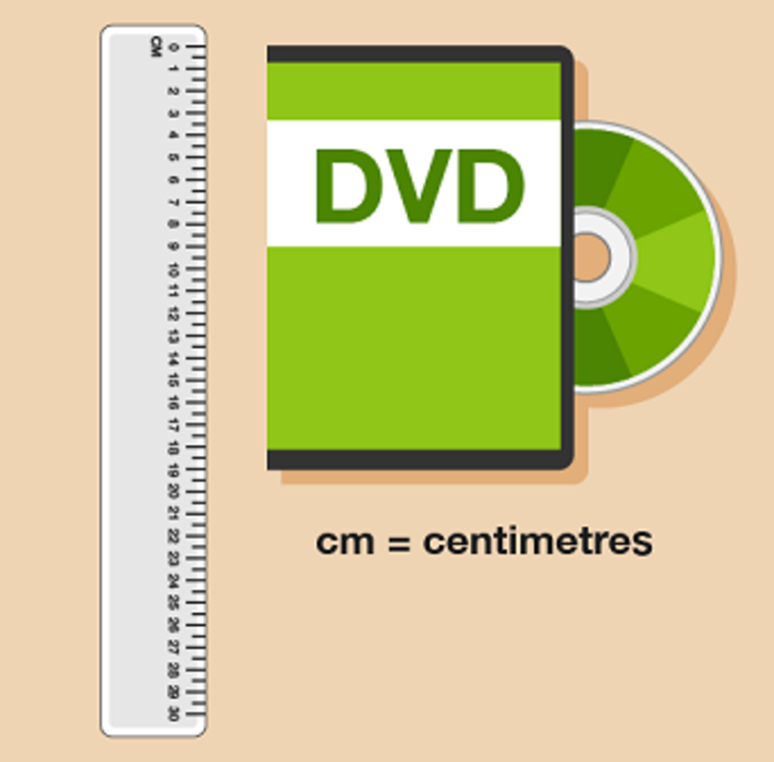
Figure 2 Measuring a DVD case
View description - Figure 2 Measuring a DVD case

- You have run out of screws. Before you go to buy some more, you need to measure the last screw you have to make sure you buy some more in the same size. How long is this screw?

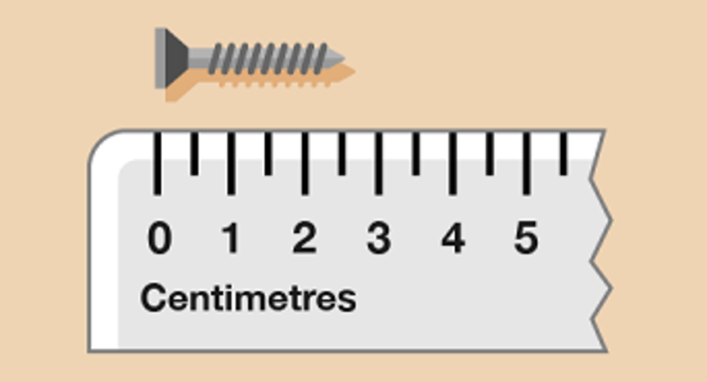
Figure 3 Measuring a screw
View description - Figure 3 Measuring a screw

- How far is it across the head of the screw?
Hint: Draw lines from the edge of the screw head down to the ruler to help you measure it.

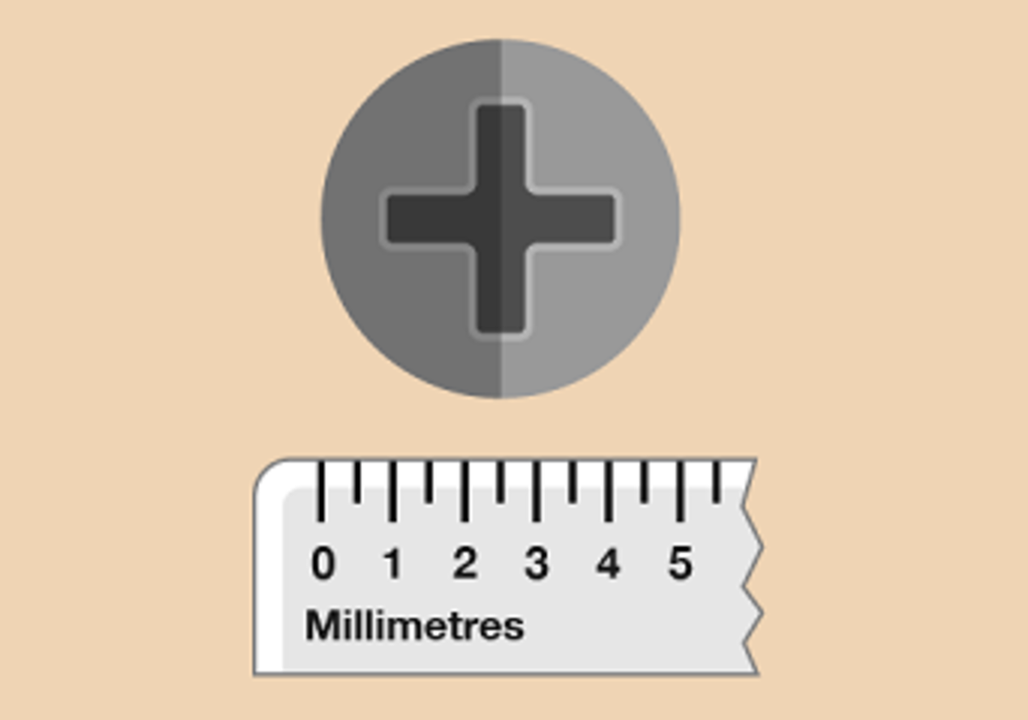
Figure 4 Measuring a screw head
View description - Figure 4 Measuring a screw head

View answer - Part

1.3 Measuring in millimetres and centimetres
When you’re measuring an item, you need to decide whether to measure it in millimetres, centimetres or metres. Often, your decision will be based on the size of the item, why you are measuring it and how accurate you need the measurement to be.
When you measure an item, you can actually express the same measurement in different ways. To help you to do this, you need to know some metric measure facts:

Facts
10 millimetres = 1 centimetre
100 centimetres = 1 metre
1 000 metres = 1 kilometre

Starting with the smallest, metric units of length are millimetres (mm), centimetres (cm) and metres (m).
Kilometres (km) are used to measure distance.

Example: Writing measurements in millimetres and centimetres
You can express a measurement in millimetres, centimetres or a combination of both. Look at the ruler below. What measurement is the arrow pointing to?

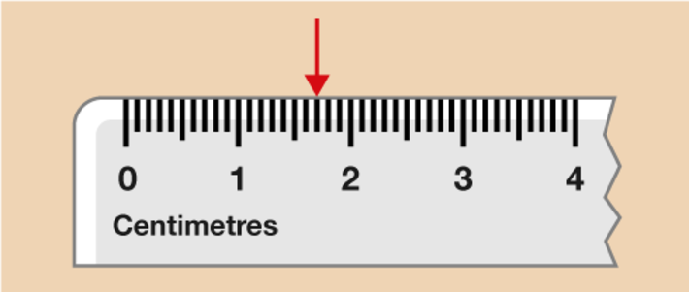
Figure 8 Measuring a pen
View description - Figure 8 Measuring a pen

Method
The numbers displayed on the ruler represent centimetres. Each line in between each whole centimetre is a millimetre; ten millimetres is equal to one centimetre. So you can say that the arrow is pointing to:

1 cm 7 mm

However, you could write it all in centimetres. The length is one whole centimetre plus seven additional millimetres, so you would write:

1.7 cm

Note how the decimal point separates the number of centimetres from the number of millimetres. Alternatively you could write this measurement in millimetres. One centimetre equals ten millimetres, so:

1 cm 7 mm = 10 mm + 7 mm = 17 mm

Now try the following activity.

Activity 4: Writing measurements in different ways

Complete the gaps in the table to show the same measurement written in three different ways. The first one has been done for you. Remember to check your answers.

Measurements
Centimetres and millimetres | Centimetres | Millimetres
1 cm 7 mm | 1.7 cm | 17 mm
8 cm 9 mm | Provide your answer... | Provide your answer...
Provide your answer... | 9.4 cm | Provide your answer...
Provide your answer... | Provide your answer... | 63 mm
12 cm 6 mm | Provide your answer... | Provide your answer...
Provide your answer... | Provide your answer... | 105 mm
Provide your answer... | 20.1 cm | Provide your answer...

View answer - Activity 4: Writing measurements in different ways

1.4 Converting units
You may often need to convert between different units of length. For example, if you were fitting a kitchen or measuring a piece of furniture, you might need to convert between millimetres and centimetres, or centimetres and metres.
Figure 9 shows you how to convert between metric units of length.

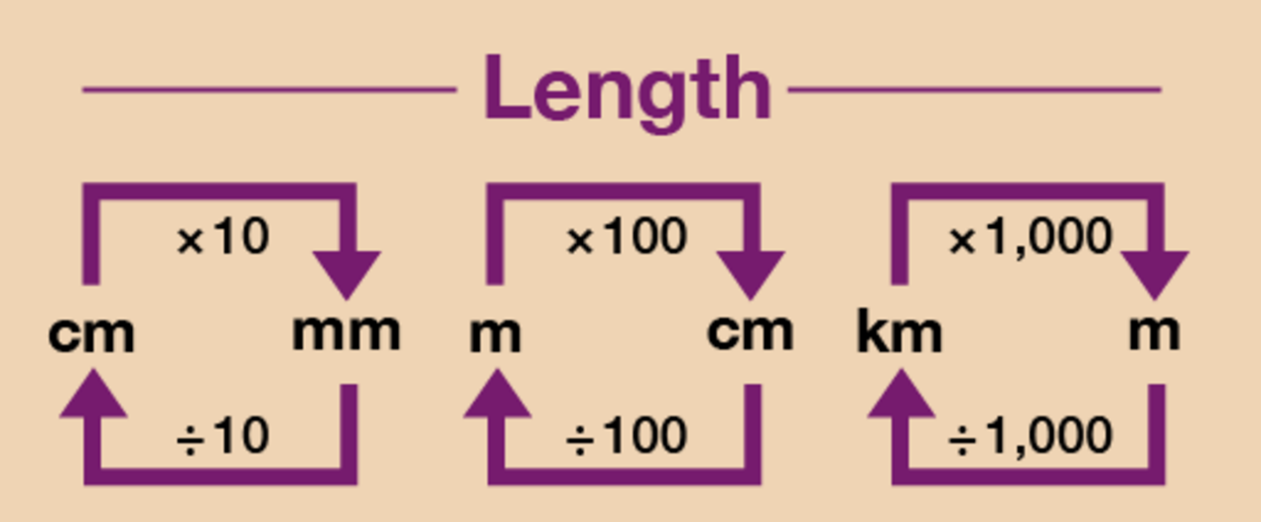
Figure 9 A conversion chart for length
View description - Figure 9 A conversion chart for length

Hint: To convert from a bigger unit to a smaller unit (such as cm to mm), you multiply. To convert from a smaller unit to a bigger unit (such as mm to cm), you divide.

Example: Converting units of length
- What is 8.5 metres in centimetres?
- What is 475 centimetres in metres?

Method
- Converting between metric units involves multiplying or dividing by 10, 100 or 1 000, which you will have practised in Session 1. As you can see from Figure 9, you need to multiply by 100 to convert from metres (m) to centimetres (cm). So converting 8.5 m into centimetres would be:
  - 8.5 m × 100 = 850 cm
- As you can see from Figure 9, you need to divide by 100 to convert from centimetres (cm) to metres (m). So converting 475 cm into metres would be:
  - 475 cm ÷ 100 = 4.75 m

Now try the following activities.

Activity 5: Converting lengths

Use Figure 9 above to help you with the following activity.
Please work these out without using a calculator. You may wish to look back at Session 1 first to remind you how to multiply and divide by 10, 100 and 1 000.
- 20 mm = ? cm
- 54 mm = ? cm
- 0.5 cm = ? mm
- 8.6 cm = ? mm
- 400 cm = ? m
- 325cm = ? m
- 12 m = ? cm
- 6.8 m = ? cm
- 450 mm = ? m (Hint: You will need to look at the chart for how to convert from millimetres to centimetres and then centimetres to metres)
- 2 m = ? mm
- 8 km = ? m
- 500 m = ? km
- I am 1.6 m tall. How tall am I in centimetres?
- You are fitting kitchen cabinets. The gap for the last cabinet is 80 cm. The sizes of the cabinets are shown in millimetres. Which size should you look for?
- You want to buy 30 cm of fabric. The fabric is sold by the metre. What should you ask for?

View answer - Activity 5: Converting lengths

Activity 6: Matching the same measurement

Match the following measurements:

500 cm
1.5 cm
15 cm
5 cm
500 m
1.5 m
1 500 cm
1 500 m
5 m
15 mm
150 mm
50 mm
0.5 km
150 cm
15 m
1.5 km
View answer - Activity 6: Matching the same measurement

1.5 Calculate using metric units of length
You may need to carry out calculations with length. This may require you to convert between metric units, either before you carry out the calculation or at the end.

Example: Bunting
Fran is putting up bunting. She has three lengths of bunting, measuring 160 cm, 240 cm and 95 cm. How many metres of bunting does she have?

Method
All of the units are given in centimetres, so you can add them together:

165 cm + 240 cm + 95 cm = 500 cm

The question asks for the answer in metres, so you need to convert 500 cm into metres:

500 cm ÷ 100 = 5 m

So Fran will have 5 m of bunting.

Example: Length of shelves
Dixie wants to put up a shelf in an alcove. The alcove is 146 cm wide. She has a plank of wood that is 2 m long. How much wood will she have left over?

Method
The plank of wood is in metres, so you need to convert this into centimetres:

2 m × 100 = 200 cm
200 cm – 146 cm = 54 cm

So Dixie will have 54 cm left over.

Now try the following activity.

Activity 7: Carrying out calculations with length

Calculate the answers to the following problems without using a calculator. You may double-check your answers with a calculator if you need to. Remember to check your answers once you have completed the questions.
- You are making Christmas cards for a craft stall. You want to add a bow, which takes 10 cm of ribbon, to each card. You plan to make 50 cards. How many metres of ribbon do you need?
- You want to make a garden planter that measures 1.5 m by 60 cm. How much wood will you need to buy? (Hint: you will need two planks of each length to make the planter.)
- Sally is making a pair of curtains. Each curtain requires 1.8 m of fabric plus 20 cm each for hemming. How many metres of fabric will she need?
- John wants to put shelving in his garage to hold storage boxes. Each storage box is 45 cm wide and John wants to be able to put four boxes on each shelf. He has seen some shelves that are 2 m wide. Would they be suitable?

View answer - Activity 7: Carrying out calculations with length

Summary
Throughout this section you have looked at measuring and calculating length. You have used different metric measurements, such as millimetres, centimetres, metres and kilometres. You can now:
- measure and understand the sizes of objects
- understand different units of length
- convert between different units of length
- carry out calculations with length.

2 Mileage charts
Can you think of a time when it is useful to be able to understand and work out distances between places? It’s useful to know how far apart places are if you’re planning a trip. If your job involves lots of travelling from place to place, you need to calculate how much mileage you do so that you can reclaim how much money you’ve spent on petrol.
How far is it from your home to the nearest shopping centre?
Your answer is probably something like ‘three miles’ or ‘ten kilometres’. Distances between places are often measured in either miles or kilometres. Road signs in the UK and USA use miles, whereas in Canada and Europe, for example, the road signs are in kilometres. What’s the difference between the two?
Kilometres are a metric measure of distance.
- 1 000 metres (m) = 1 kilometre (km)
Miles are an imperial measure of distance.
- 1 mile = 1 760 yards
One mile is a bit less than two kilometres.
Because most maps and road signs in the UK use miles, in this section you’ll work with miles.
If you have to plan a trip, it’s useful to look at a mileage chart. This shows you how far it is between places:

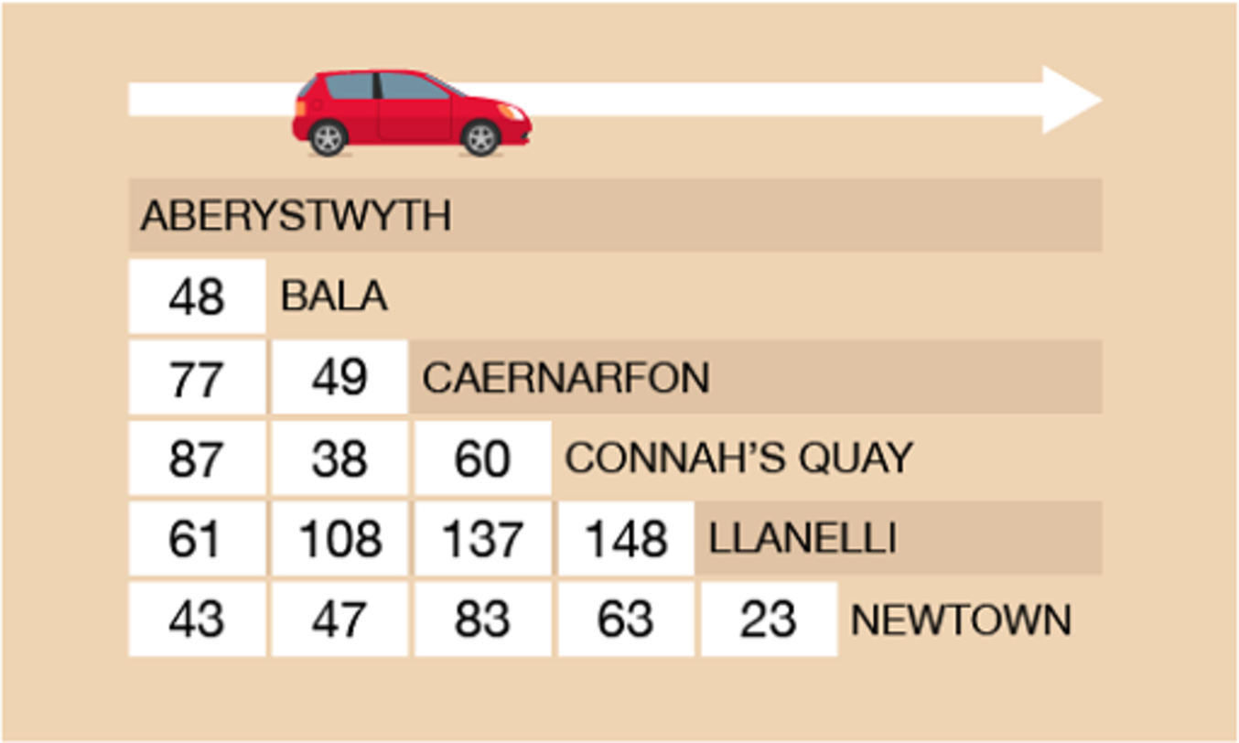
Figure 10 A mileage chart
View description - Figure 10 A mileage chart

To read the chart, find where you want to start from and where you want to go. Then follow the rows and columns until they meet.

Example: Finding the distance
How far is it from Aberystwyth to Llanelli?

Method
To calculate this, you need to find where Aberystwyth and Llanelli meet on the chart. As you can see from Figure 10, it is 61 miles from Aberystwyth to Llanelli.

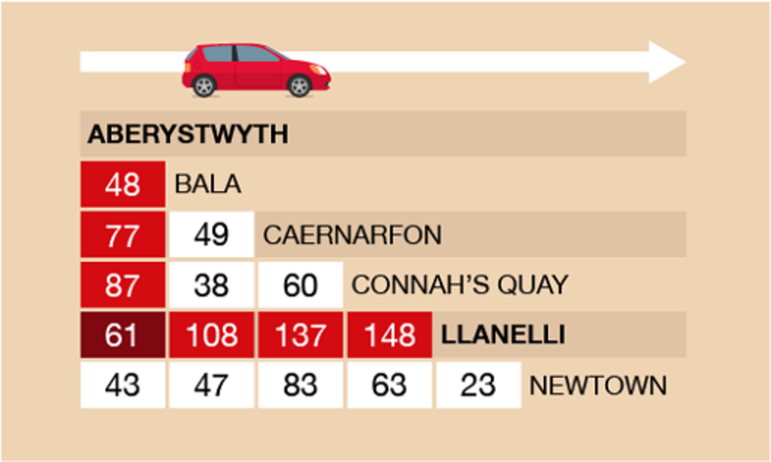
Figure 11 A mileage chart
View description - Figure 11 A mileage chart

Now try the following activity.

Activity 8: Reading a mileage chart

Now use the mileage chart in Figure 10 to answer the following questions. Remember to check your answers.
- What is the distance from Newtown to Bala?
- The Connah’s Quay Nomads’ next match in the Welsh Premier League is against Newtown. How far will supporters have to travel to watch the football match? (Hint: Don’t forget to calculate the distance for a return journey.)
- Which team’s home ground is the closest in distance to the ground of the Connah’s Quay Nomads?

View answer - Activity 8: Reading a mileage chart

Example: A European journey
Look at Figure 12. It has a different layout to the previous mileage chart.
Some European cities are listed down the left hand-side of the chart, and a series of ports are listed along the top.

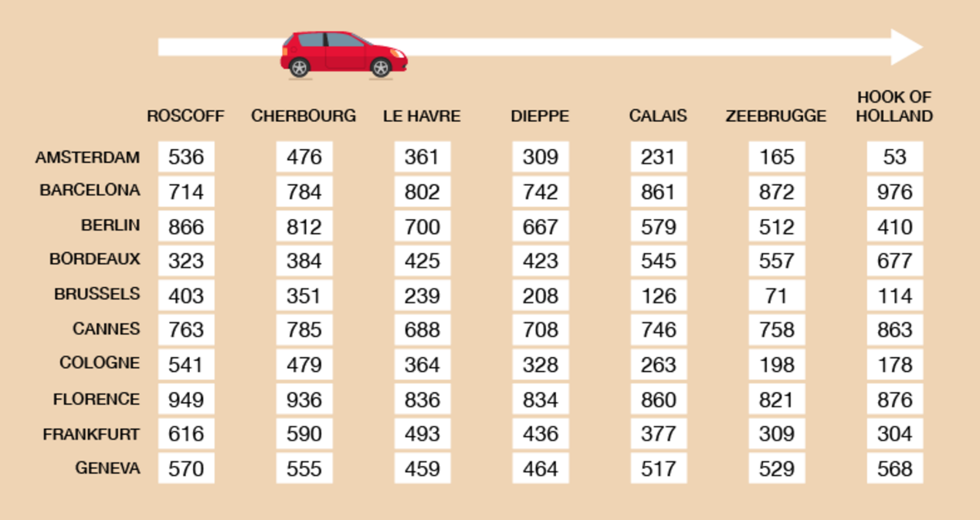
Figure 12 A mileage chart for a European tour
View description - Figure 12 A mileage chart for a European tour

Use the mileage chart to find the distance between Florence and Calais.

Method
To answer this, you need to find the row for Florence and go along it until it meets the column for Calais.

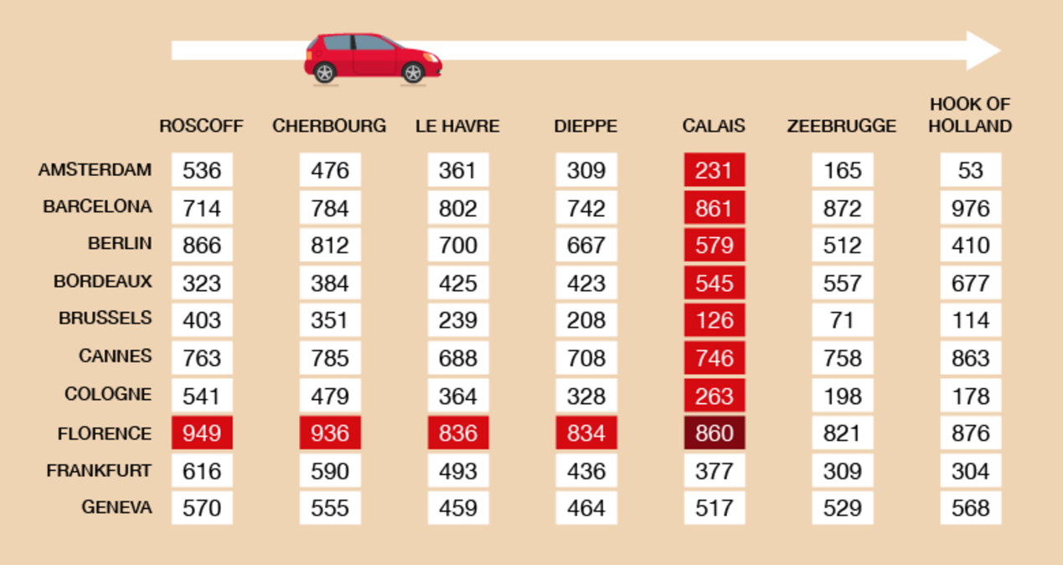
Figure 13 A mileage chart for a European tour (answer)
View description - Figure 13 A mileage chart for a European tour (answer)

The distance between Florence and Calais is 860 miles.

Now try the following activity.

Activity 9: A European journey

Now answer the following questions using Figure 12.
- Which port is closest to Florence?
- How far is it from Cologne to Dieppe?
- If you were staying in in Amsterdam, which would be your closest port?

View answer - Activity 9: A European journey

2.1 Adding distances
Many trips have more than one stop. To calculate how far you have to travel you need to add together the distances between stops.

Example: The sales trip
A sales rep has to travel from Edinburgh to York, then to London, and then back to Edinburgh. How far will they travel?

Method
Use the mileage chart to find the distances between Edinburgh and York, York and London, and London and Edinburgh.
The distance between Edinburgh and York is 186 miles.

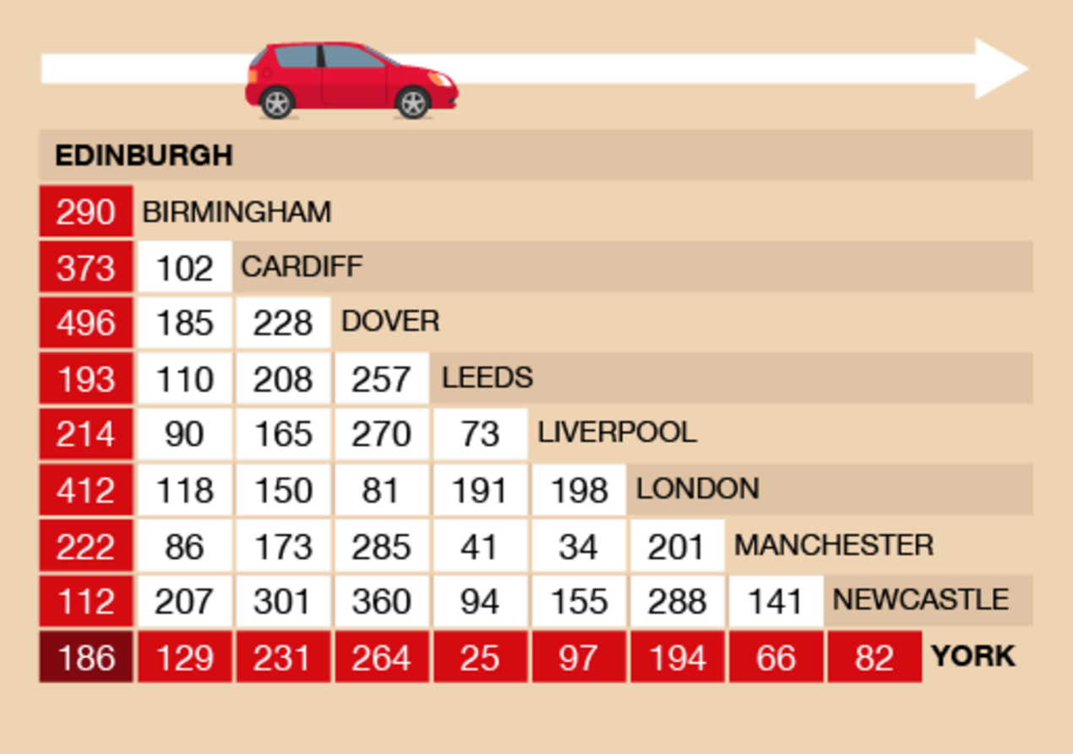
Figure 14 Edinburgh to York on a mileage chart
View description - Figure 14 Edinburgh to York on a mileage chart

York to London is 194 miles.

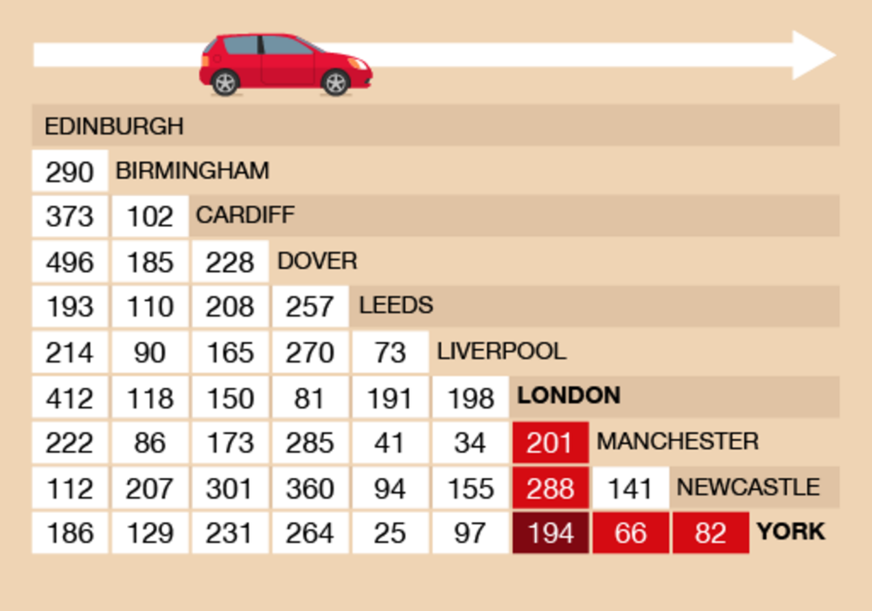
Figure 15 London to York on a mileage chart
View description - Figure 15 London to York on a mileage chart

Returning from London to Edinburgh is 412 miles.

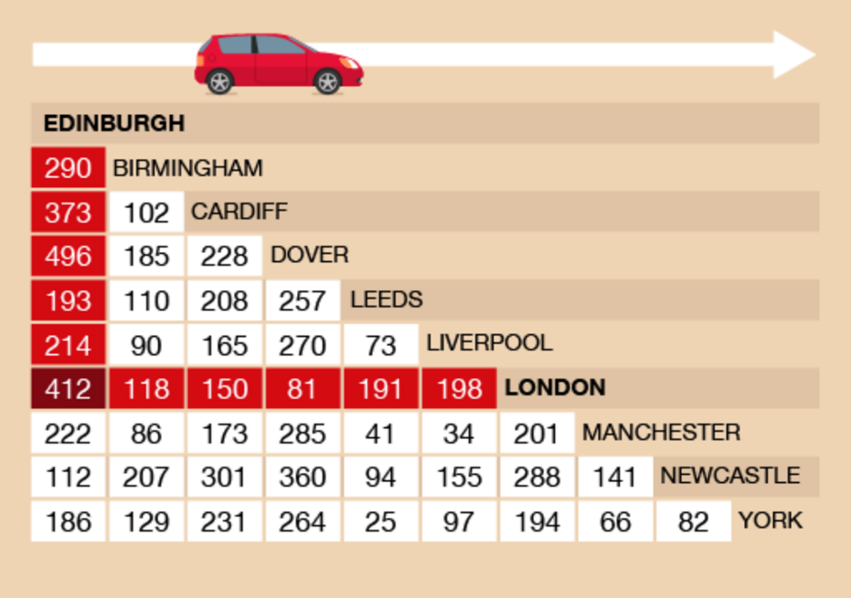
Figure 16 London to Edinburgh on a mileage chart
View description - Figure 16 London to Edinburgh on a mileage chart

The total distance of the trip is:
- 186 + 194 + 412 = 792 miles

Use the mileage table to help you with the following activity. Please make the calculations without using a calculator. You may double-check your answer with a calculator if you need to. Remember to check your answers once you have completed the questions.

Activity 10: Travelling across the UK

- You use a hire car to go from London to Cardiff, from Cardiff to Liverpool and then back to London. You pay 10p for each mile you drive.
  - How many miles must you pay for?
  - How much would this cost?
- You live Cardiff but are going to attend a conference in Manchester. Following your conference, you are driving straight on to York to stay for a few days before returning home to Cardiff. How far will your journey be in total?

View answer - Activity 10: Travelling across the UK

Summary
You have now completed the activities on using distance charts. This will help you with everyday life when you are planning a journey and/or claiming mileage when travelling for work.

3 Using metric measurements: weight
Weight – sometimes referred to as ‘mass’ – is a measurement of how heavy something is.
How much do you weigh?
You might have given your weight in kilograms (kg) or in pounds (lb), or pounds and stone (st). Kilograms are metric weights. Pounds and stones are imperial weights.
In the UK, both metric and imperial units may be used. We are going to focus on the metric units of weight here.

Metric units of weight
Metric unit | Abbreviation
milligram | mg
gram | g
kilogram | kg
tonne | (No abbreviation)

Milligrams (mg) are only used to weigh very small quantities or items, such as dosage on medication.
A tonne is a unit for weighing very heavy items, such as a lorry.
For everyday measuring tasks, the most common metric units of weight are grams (g) and kilograms (kg), so these are what you will focus on here.
- 1 g is approximately the weight of a paperclip
- 1 kg is the weight of a bag of sugar

Key fact: 1 000 grams (g) = 1 kilogram (kg)

Hint: If you are used to using the imperial system of measure, 1 kilogram is equivalent to about 2 pounds.

Many foods are sold by weight. For example:
- 10 g of a spice
- 30 g of crisps
- 100 g of chocolate
- 250 g of coffee
- 500 g of rice.
Heavier things are weighed in kilograms:
- 2 kg bag of potatoes
- 10 kg of chicken food
- 15 kg baggage allowance on a plane
- 25 kg bag of cement.
Note that if you bought ten packets of rice, you would say you had bought 5 kg rather than 5 000 g.

3.1 Instruments of measure
Scales show you how much something weighs. Digital scales show the weight as a display of numbers. Other scales have a dial or line of numbers and you have to read the weight from this.

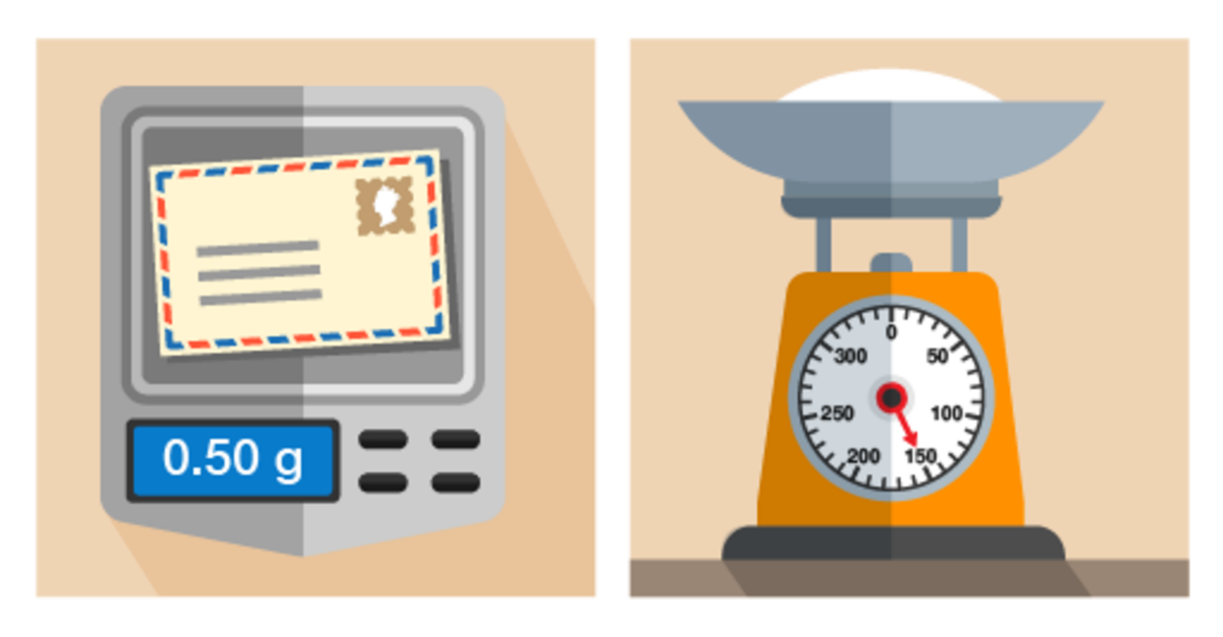
Figure 20 Using different scales for different objects
View description - Figure 20 Using different scales for different objects

You’ll notice that on the right-hand set of scales in the picture above, the needle points to 150 g. If you use scales like this, you need to know the divisions marked on the scales. You might have to count the marks between numbers.

Example: Identifying weights on scales
What is the weight of the flour in these scales?

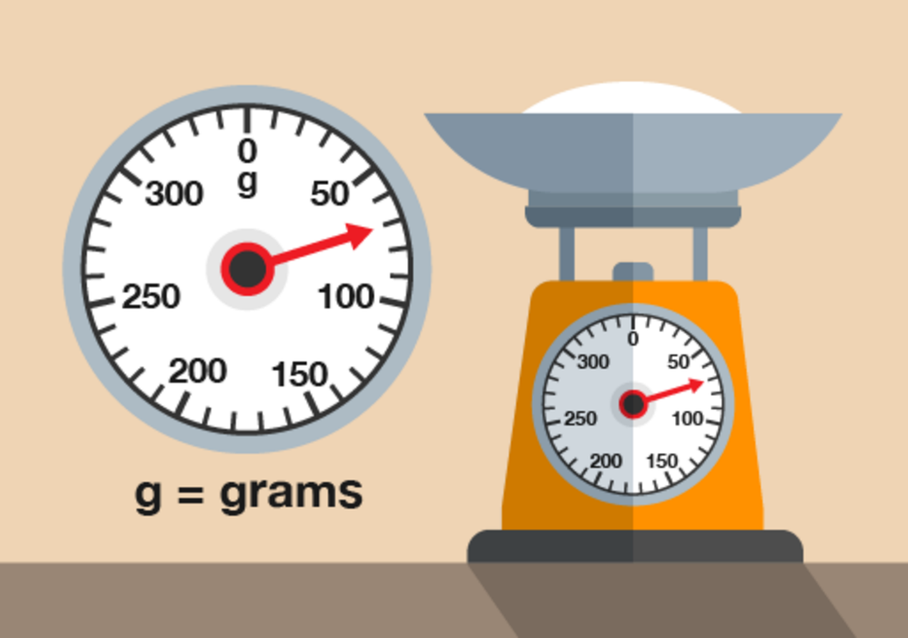
Figure 21 Weighing flour
View description - Figure 21 Weighing flour

(Note that scales like this are calibrated to weigh only the flour inside the bowl – the weight on the scales is just the flour, not the flour and the bowl.)

Method
There are four marks between 50 g and 100 g, each representing another 10 g. So the marks represent 60 g, 70 g, 80 g and 90 g. The needle is level with the second mark, so the weight is 70 g.

Now try the following activity. Remember to check your answers once you have completed the questions.

Activity 11: Reading scales

- How many grams of sugar are on the scales in the picture below?

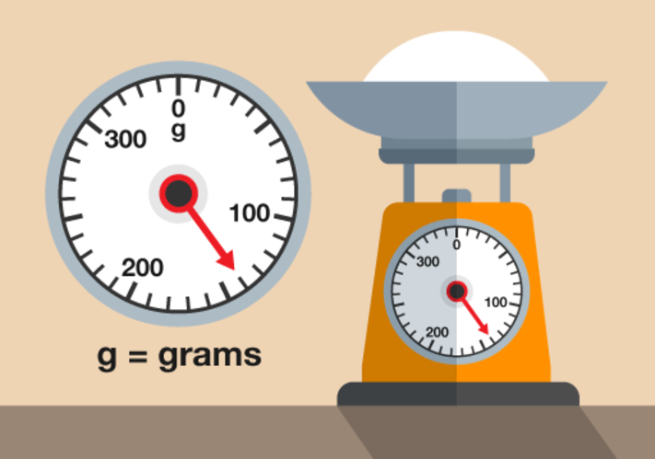
Figure 22 Weighing sugar
View description - Figure 22 Weighing sugar

- What is this person’s weight in kilograms?

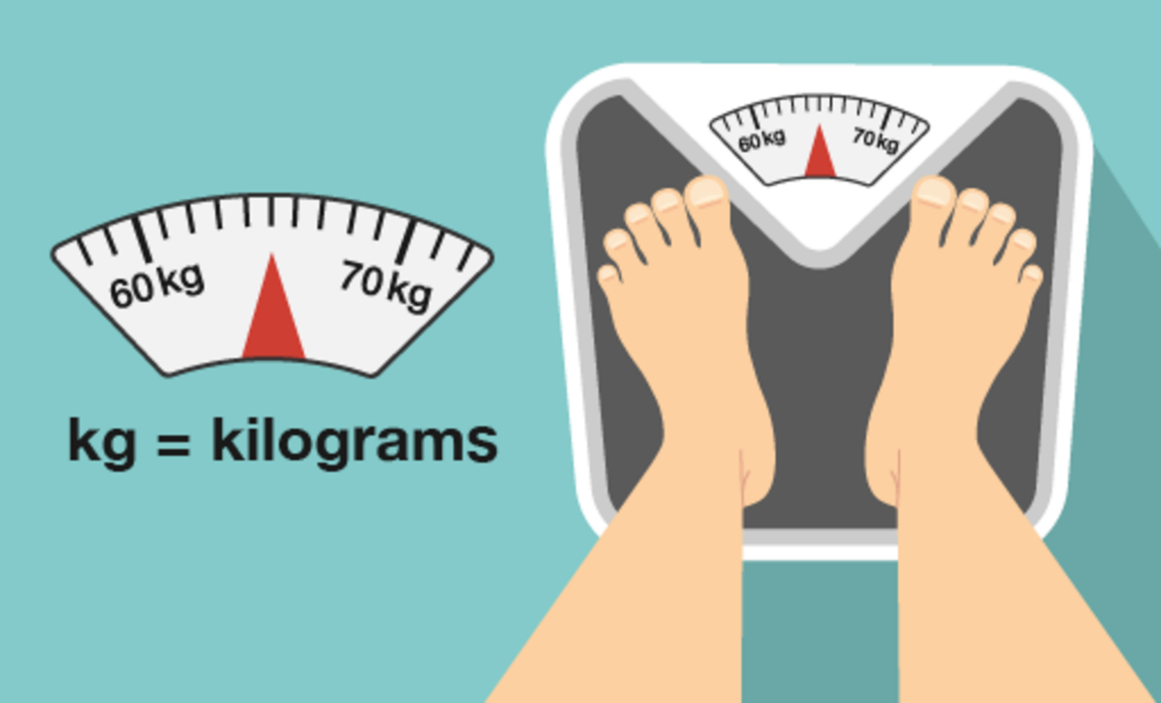
Figure 23 Weighing a person
View description - Figure 23 Weighing a person

- How much does the letter weigh?

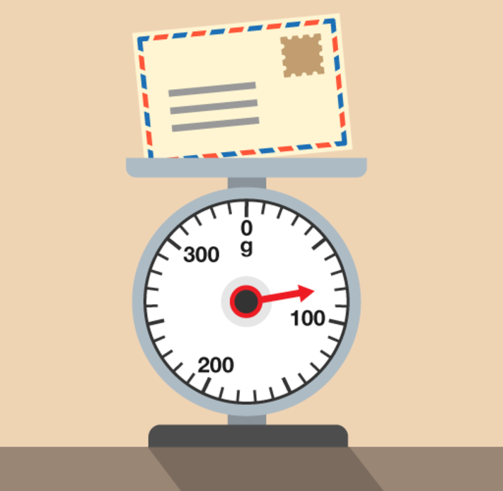
Figure 24 Weighing a letter
View description - Figure 24 Weighing a letter

View answer - Activity 11: Reading scales

3.2 Weighing things
It’s useful to have an idea of how much things weigh. It can help you to work out the weight of fruit or vegetables to buy in a market, for example, or whether your suitcase will be within the weight limit for a flight.
Try estimating the weight of something before you weigh it. It will help you to get used to measures of weight.

Hint: Remember to use appropriate units. Give the weight of small things in grams and of heavy things in kilograms.

Remember that:
- 1 g is approximately the weight of a paperclip.
- 1 kg is the weight of a bag of sugar.
- 1 kg = 1 000 g

Take a look at the example below before having a go at the activity.

Example: Weighing an apple
- Which metric unit would you use to weigh an apple?
- Estimate how much an apple weighs and then weigh one.
- How much would 20 of these apples weigh? Would you use the same units?

Method
- An apple is quite small, so it should be weighed in grams.
- How much did you estimate that an apple weighs? A reasonable estimate would be 100 g.
When we weighed an apple, it was 130 g.
- Twenty apples would weigh:
  - 130 × 20 = 2 600 g
This answer could also be expressed in kilograms. To convert from grams to kilograms, you need to divide the figure in grams by 1 000 (1 kg = 1 000 g) . So the weight of the apples in kilograms is:
  - 2 600 g ÷ 1 000 = 2.6 kg
We will look more at converting metric units of weight in the next section.

Activity 12: Weighing things

- How much do ten teabags weigh? Estimate and then weigh them.
- How heavy is a bottle of sauce? How much would a case of 10 bottles weigh?
Hint: The weight shown on the label is the weight of the sauce – it doesn’t include the weight of the bottle or jar that the sauce comes in. So for an accurate measurement, you need to weigh the bottle rather than read the label!
- How heavy is a book?

View discussion - Activity 12: Weighing things

3.3 Converting metric units of weight
There are occasions where you may have to convert between metric units of weight. Figure 25 shows you how to do this. In this section, we are only going to practise converting between grams (g) and kilograms (kg).

Hint: Weight is sometimes referred to as mass.

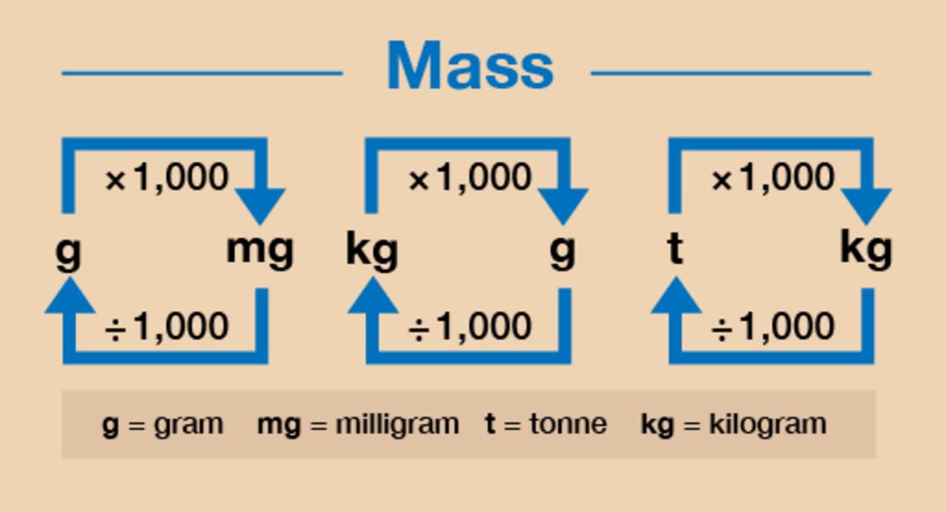
Figure 25 A conversion chart for weight
View description - Figure 25 A conversion chart for weight

Example: Converting units of weight
- Convert the following from kilograms into grams:
  - 4 kg = ? g
  - 6.5 kg = ? g
- Convert the following from grams into kilograms:
  - 8 000 g = ? kg
  - 1 250 g = ? kg

Method
- As you can see from Figure 25, to convert from kilograms (kg) to grams (g) you need to multiply by 1 000:
  - 4 kg × 1 000 = 4 000 g
  - 6.5 kg × 1 000 = 6 500 g
- If you want to convert from grams (g) to kilograms (kg) you need to divide by 1 000:
  - 8 000 g ÷ 1 000 = 8 kg
  - 1 250 g ÷ 1 000 = 1.25 kg

Now try the following activity.

Activity 13: Converting metric units of weight

Calculate the following without using a calculator. You may wish to look back at Session 1 to remind you how to multiply and divide by 1 000.
You may double-check your answer with a calculator if you need to. Remember to check your answers.
- Convert the following to kilograms:
  - 3 000 g
  - 9 500 g
  - 750 g
  - 10 000 g
- Convert the following to grams:
  - 4 kg
  - 1.5 kg
  - 7.6 kg
  - 2.25 kg

View answer - Activity 13: Converting metric units of weight

3.4 Calculate using metric units of weight
You may need to carry out other calculations with weight. This may require you to convert between metric units, either before you carry out the calculation or at the end.

Example: Weight of ingredients
If you were to buy 750g of flour, 500g of sugar and 250g of butter, what is the total weight of these ingredients in kilograms?

Method
As all of the measurements are given in grams, you can add them together:

750 g + 500 g + 250 g = 1 500 g

The question asks for the final weight in kilograms. Knowing that 1 kilogram equals 1 000 grams, you now need to convert the amount in grams:

1 500 ÷ 1 000 = 1.5 kg

Example: A block of cheese
A deli has a 1.4 kg block of cheese. Three pieces, each weighing 250 g, are cut from it. How much does the remaining block of cheese weigh?

Method
The main block of cheese is 1.4 kg, so you need to convert this into grams:

1.4 kg × 1 000 = 1 400 g

The three pieces of cheese weigh:

250 g × 3 = 750 g

Taking this away from the original weight of the block of cheese gives you the answer:

1 400 g – 750 g = 650 g

Now try the following activity.

Activity 14: Carrying out calculations with weight

Calculate the answers to the following problems without using a calculator. You may wish to look back at Session 1 to remind you about how to carry out calculations with whole numbers and decimals.
You may double-check your answers with a calculator if you need to. Remember to check your answers.
- Lily is making 3 kg of jam. The jam is made up of fruit and sugar. The weight of the fruit is 1 kg 800 g. How much sugar should she add to make the 3 kg of jam?
- Three parcels weigh 1.25 kg, 3.5 kg and 600g. What is the total weight of the parcels in kilograms?
- The hand luggage allowance is 7 kg for a particular airline. If you buy a cabin bag that weighs 3.1 kg, what is the maximum weight that you can pack?
- A puppy weighs 2.3 kg at seven weeks old. It puts on 800 g a week. How much will it approximately weigh at ten weeks old?

View answer - Activity 14: Carrying out calculations with weight

Summary
In this section you have learned how to:
- estimate and measure weight
- use metric units of weight
- know the relationship between grams and kilograms
- convert between grams and kilograms
- calculate using metric weights.

4 Capacity
Capacity (sometimes referred to as volume) is a measurement of how much space something takes up.
When you buy milk, how much is in each bottle or carton? What about when you buy juice?
Most people buy milk in cartons or bottles of one, two, four or six pints. Juice is usually sold in cartons or bottles of one litre.
Pints are an imperial measure of volume, and litres are a metric measure of volume. A litre is slightly less than two pints. We are going to focus on metric units here.

Metric units of length
Metric unit | Abbreviation
millilitre | ml
centilitre | cl
litre | l

You sometimes see capacity marked in centilitres (cl), such as on the side of a bottle of water, where the measurement may be shown as 50 cl or 500 ml. However, the most common metric units of capacity are millilitres and litres, so these are what we will focus on here.

Key fact: One litre (1 l) is the same as 1 000 millilitres (1 000 ml).

4.1 Instruments of measure
To measure a very small amount, you might use a teaspoon. This is the same as 5 millilitres (ml).

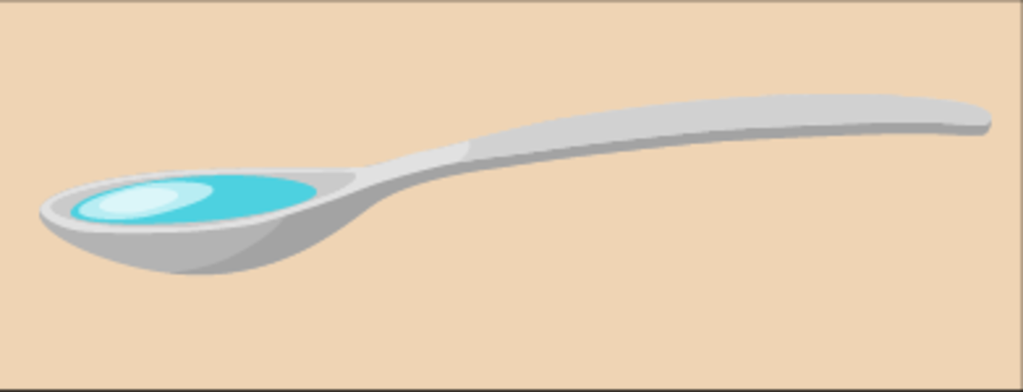
Figure 26 A teaspoon
View description - Figure 26 A teaspoon

To measure larger amounts, you would probably use a measuring jug of some kind. Measuring jugs are often labelled in millilitres, especially newer ones, and they can come in different sizes: some can measure up to 500 ml of liquid and others up to 1 litre (1 000 ml). Some may hold more or less than this.

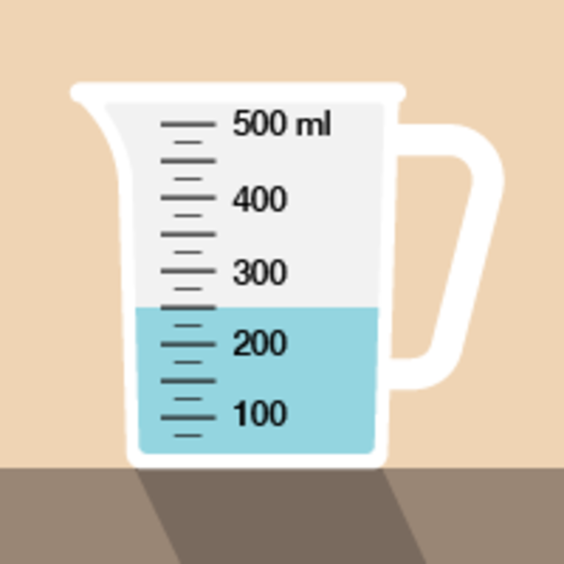
Figure 27 A measuring jug
View description - Figure 27 A measuring jug

Now take a look at the following example.

Example: Measuring liquids
If you had to measure out 350 ml of juice for a recipe, where would the liquid come to in this jug?

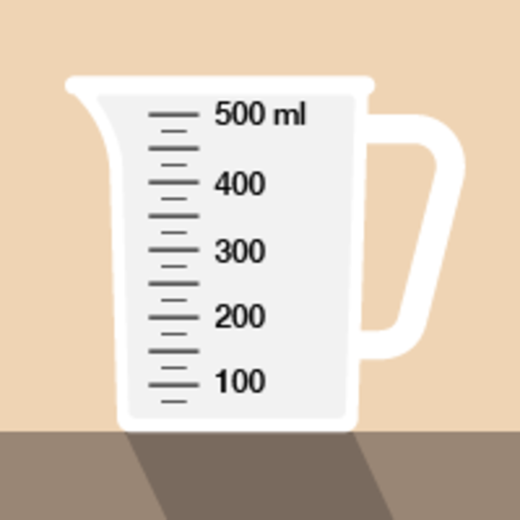
Figure 28 Measuring liquids in a measuring jug
View description - Figure 28 Measuring liquids in a measuring jug

Method
There are three marks on the jug between 300 ml and 400 ml. These mark 325, 350 and 375 ml. So you need to fill the jug to the middle mark (remember to look for the level where the liquid touches the scale). You may have to hold a jug up to eye level to measure the amount as accurately as you can.

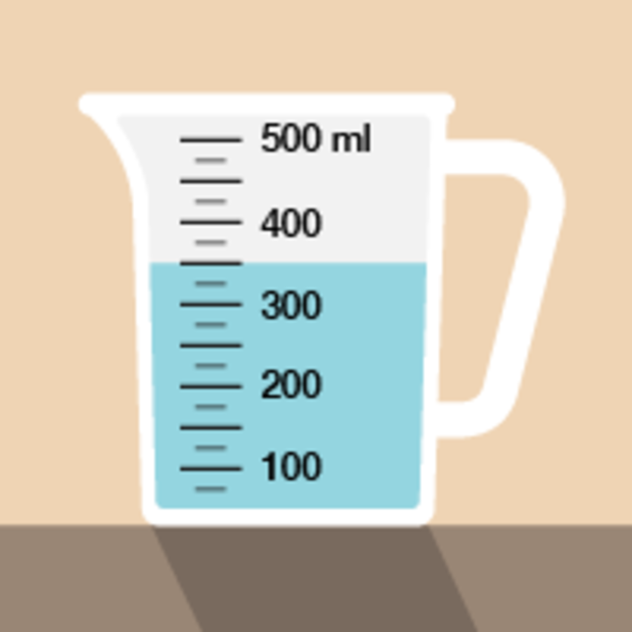
Figure 29 Measuring liquids in a measuring jug (answer)
View description - Figure 29 Measuring liquids in a measuring jug (answer)

Now try the following activity. Remember to check your answers once you have completed the questions.

Activity 15: Looking at capacity (volume)

Now that you have seen the example, have a go at the following activity;
- How much coffee or tea does a cup you usually drink out of hold? Estimate the volume first, and write down your estimate. Next, fill your cup with water and then pour the water into a measuring jug. (Hint: A standard bottle of water holds 500 ml. A can of of pop is 330 ml.)
- A scientist has to measure 2.8 ml of liquid in this syringe. Where should the liquid come to?

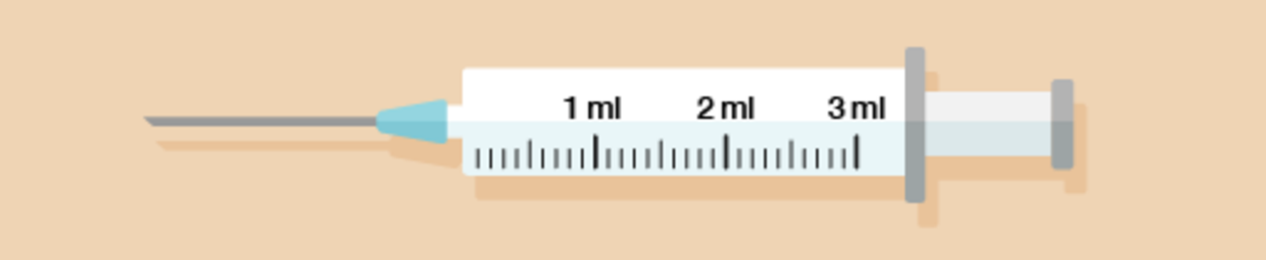
Figure 30 A syringe
View description - Figure 30 A syringe

- A plumber has drained water from a faulty central heating system into a set of measuring jugs. How many litres in total has the plumber drained from the system? Notice how on these measuring jugs, the scale is marked up in fractions of a litre rather than in millilitres.

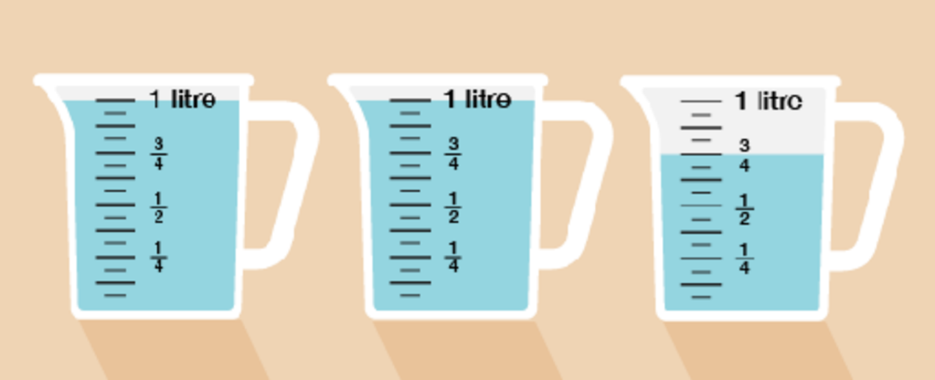
Figure 31 Three measuring jugs
View description - Figure 31 Three measuring jugs

View answer - Activity 15: Looking at capacity (volume)

4.2 Converting metric units of capacity
You will sometimes need to change between millilitres and litres. There are 1 000 millilitres in a litre.
Take a look at this metric conversion chart to refer to when you are carrying out the activity below.

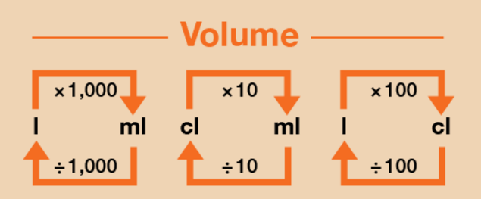
Figure 33 A conversion chart for volume
View description - Figure 33 A conversion chart for volume

As mentioned earlier, capacity/volume can be measured in centilitres (cl), but it is more common to use millilitres (ml) and litres (l), so we will focus on converting between these here.

Example: Converting units of capacity
- Convert the following from litres into millilitres:
  - 7 litres = ? ml
  - 8.5 litres = ? ml
- Convert the following from millilitres into litres:
  - 6 000 ml = ? litres
  - 2 750 ml = ? litres

Method
- As you can see from Figure 33, to convert from litres (l) to millilitres (ml), you need to multiply by 1 000:
  - 7 l × 1 000 = 7 000 ml
  - 8.5 l × 1 000 = 8 500 ml
- If you want to convert from millilitres (ml) to litres (l) then you need to divide by 1 000:
  - 6 000 ml ÷ 1 000 = 6 l
  - 2 750 ml ÷ 1 000 = 2.75 l

Now try the following activity.

Activity 16: Converting metric units of capacity

Calculate the following without using a calculator. You may wish to look back at Session 1 to remind you how to multiply and divide by 1 000. Remember to check your answers.
- What are the following measurements in litres?
  - 4 000 ml
  - 3 500 ml
  - 650 ml
  - 8 575 ml
- What are the following measurements in millilitres?
  - 9 litres
  - 2.5 litres
  - 4.8 litres
  - 8.95 litres

View answer - Activity 16: Converting metric units of capacity

4.3 Calculate using metric units of capacity
You may need to carry out calculations involving capacity. This may require you to convert between metric units, either before you carry out the calculation or at the end.

Example: Party food
You are cooking for a large party. The recipe you are using calls for 600 ml of milk to make enough for four people.
How many litres of milk will you need to make ten times as much?

Method
First you need to multiply the amount in millilitres by 10:
- 600 × 10 = 6 000 ml
However, the question asks for an amount in litres, not millilitres. To convert from millilitres to litres, you need to divide the figure in millilitres by 1 000. So the amount of milk you need in litres is:
- 6 000 ÷ 1 000 = 6 litres

Now try the following activity using the conversion diagram on the previous page to help you answer the questions. Remember to check your answers once you have completed the questions.

Activity 17: Carrying out calculations involving capacity

Calculate the answers to the following problems without using a calculator. You may double-check your answers with a calculator if you need to. Remember to check your answers.
- A nurse has to order enough soup for 100 patients on a ward. Each patient will eat 400 ml of soup. How many litres of soup must the nurse order?
- Twenty people working in a craft workshop have to share the last two-litre bottle of glue. How many millilitres of glue can each person use? What would this be in centilitres?
- Willow buys a two-litre carton of milk. She measures out 350 ml for a sauce, 25 ml for a cake and 100 ml for her toddler’s bedtime drink. How much milk is left in the carton? Express your answer in millilitres.
- Ben is having a party and he wants to make a non-alcoholic cocktail. He has found a recipe which states that he needs 500 ml of cranberry juice, 500 ml of grape juice, 250 ml of orange juice and 1 litre of sparkling water to serve eight people. There will be 24 people at the party.
How much of each ingredient will he need? Express your answers in litres.
Will an eight-litre drinks dispenser be big enough to hold his non-alcoholic cocktail?

View answer - Activity 17: Carrying out calculations involving capacity

Summary
In this section you have learned how to:
- identify the standard units for measuring volume or capacity
- measure volumes
- convert between metric units of capacity
- carry out calculations with metric units of capacity.

5 Measuring temperature

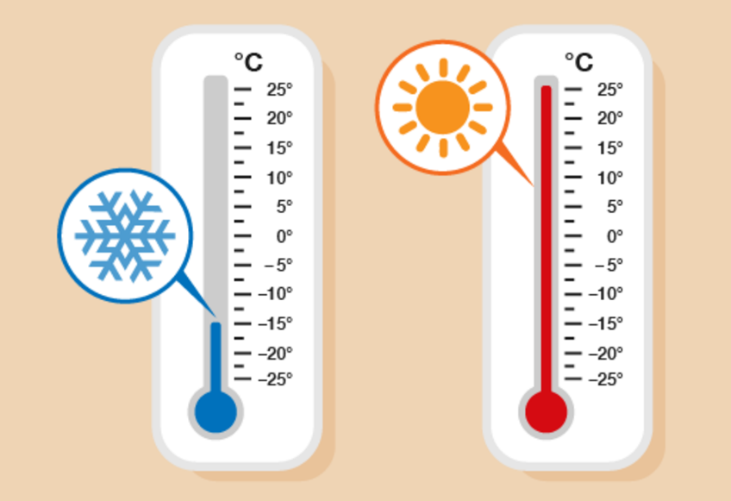
Figure 34 Comparing temperatures
View description - Figure 34 Comparing temperatures

Temperature tells us how hot or cold something is. You will see or hear temperatures mentioned in a weather forecast, and will also come across them in recipes or other instructions.
Temperature is sometimes given in degrees Celsius (°C) and sometimes in degrees Fahrenheit (°F).

Hint: You might sometimes see Celsius called ‘centigrade’. Note that Celsius and centigrade are the same thing, referring to the same scale of measurement.

Water freezes at 0° Celsius and boils at 100° Celsius. The temperature in the UK in the daytime is usually between 0° Celsius (0°C) on a cold winter’s day and 25° Celsius on a hot day in summer.

5.1 Reading temperatures
Many things have to be stored or used in a particular temperature range to be safe. Temperature is measured with a thermometer.
Thermometers for different uses show different ranges of temperatures.
Take a look at the following example, which shows two types of thermometer.

Example: Reading thermometers
What is the temperature shown on each thermometer below?

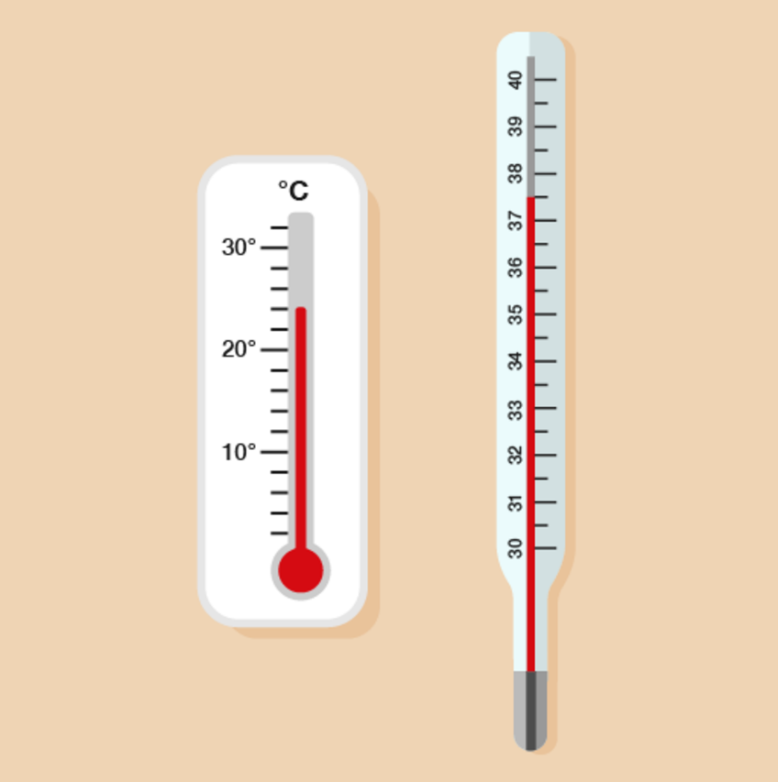
Figure 35 Reading the temperatures
View description - Figure 35 Reading the temperatures

Method
On the first thermometer, there are four divisions between 20 and 30, so the divisions mark every two degrees (22, 24, 26, 28). The reading is at the second mark after 20, so the temperature is 24°C.
On the second thermometer, the temperature is at the mark halfway between 37 and 38, so it’s 37.5°C.

What temperature do you think it is today? If you have a thermometer, check the temperature outside; if you don’t, you could use an online resource such as the BBC Weather pages or your mobile phone to find the temperature near you.
Now try the following activity. Remember to check your answers once you have completed the questions.

Activity 18: Reading thermometers

What temperature is shown on each of these thermometers?

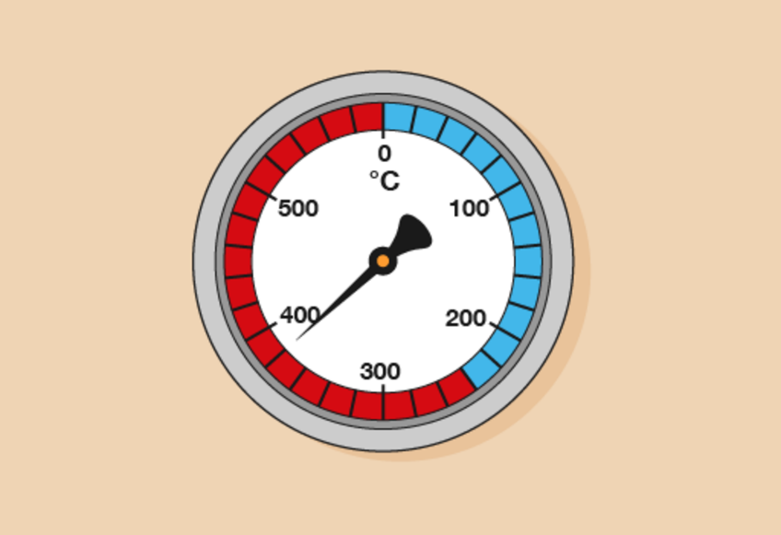
Figure 36 A thermometer
View description - Figure 36 A thermometer

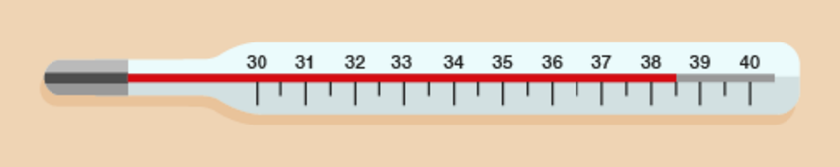
Figure 37 A thermometer
View description - Figure 37 A thermometer

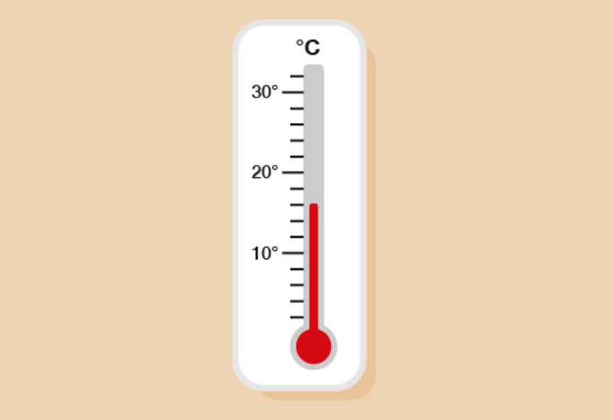
Figure 38 A thermometer
View description - Figure 38 A thermometer

View answer - Activity 18: Reading thermometers

5.2 Understanding temperature
Using the right temperature is often a matter of safety. Many things have to be stored or used in a particular temperature range to be safe. A piece of machinery may not be able to operate properly below a minimum temperature or above a maximum temperature, or a jar of tablets may include advice on its label about what temperature it should be stored at.

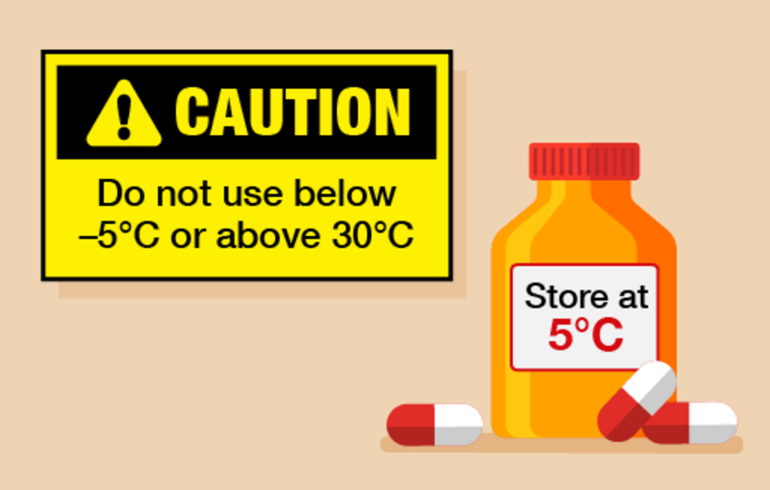
Figure 39 Warning labels
View description - Figure 39 Warning labels

Temperatures used to be shown in degrees Fahrenheit. You will still see these measures sometimes. For example:

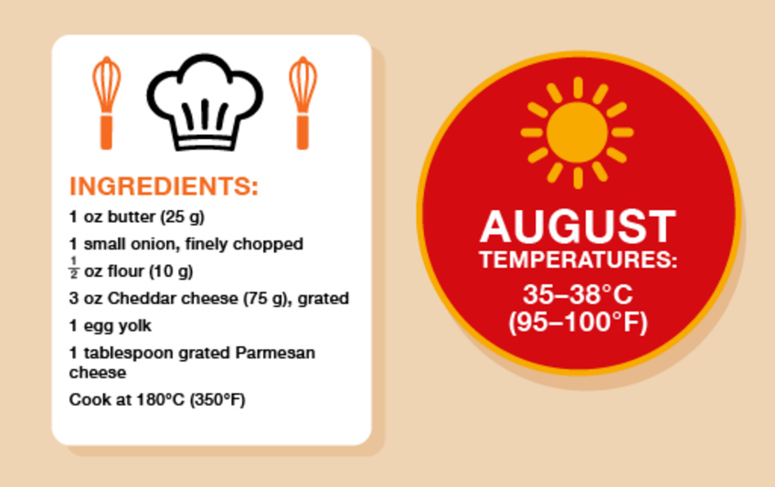
Figure 40 Temperatures in Celsius and Fahrenheit
View description - Figure 40 Temperatures in Celsius and Fahrenheit

Note: Fahrenheit is still used in the USA.

Here are some temperatures in Celsius and Fahrenheit:

Celsius | Fahrenheit
–18 | 0
0 | 32
10 | 50
20 | 68
30 | 86
40 | 104
50 | 122

Take a look at the example below for comparing temperatures.

Example: Safe storage
You have instructions with chemicals sent from the USA that they must be stored at between 50 and 70°F. The thermometer on the storage tank shows the temperature in degrees Celsius.

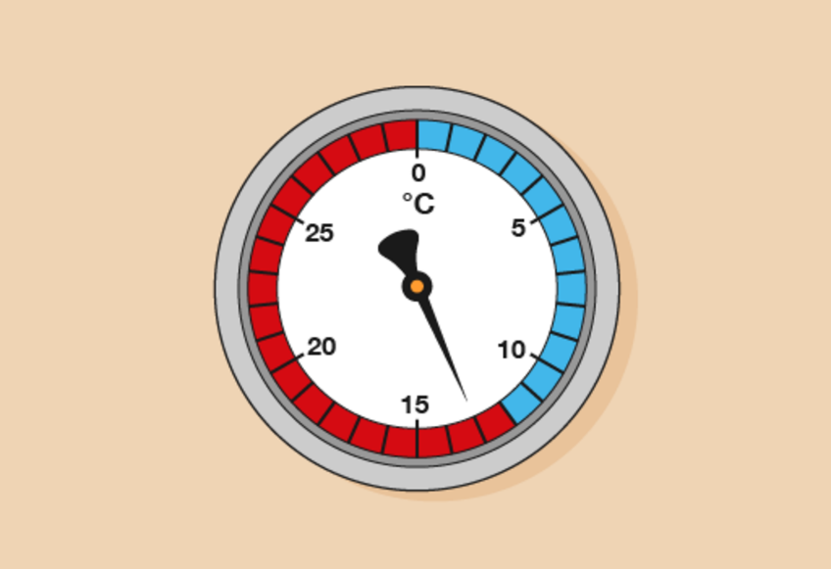
Figure 41 Using a thermometer in safe storage
View description - Figure 41 Using a thermometer in safe storage

Are the chemicals stored safely?

Method
Looking at the temperature comparison chart, 13°C falls in the following range:
- 10°C = 50°F
- 20°C = 68°F
13°C falls between 10°C and 20°C, meaning that it is also in the range between 50°F and 68°F. The chemicals are stored safely.

Now try the following activity. Remember to check your answers once you have completed the questions.

Activity 19: Celsius and Fahrenheit

- A recipe for meringue says you must cook it at 150°C. Your cooker shows temperatures in Fahrenheit. What should you set it to? (Use the conversion chart below to help you.)

Celsius | Fahrenheit
100 | 212
150 | 302
200 | 392
250 | 482
300 | 572
350 | 662

- The thermometer on an old freezer shows the temperature in degrees Fahrenheit.

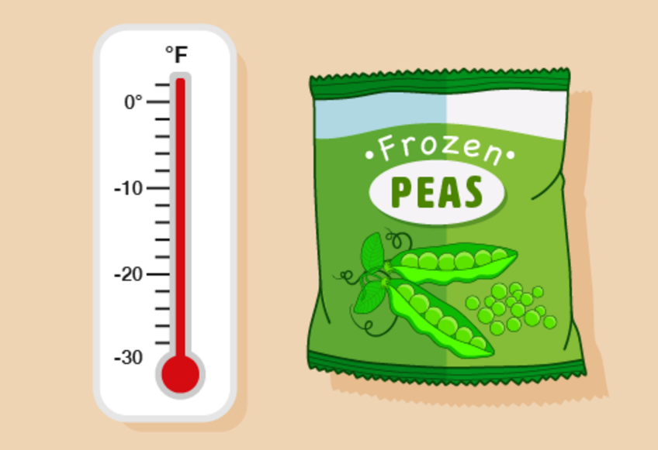
Figure 42 Converting temperatures on old thermometers
View description - Figure 42 Converting temperatures on old thermometers

A pack of food has a warning that it must be stored between –12°C and –25°C. Is the food stored safely? (Use the conversion chart below to help you.)

Celsius | Fahrenheit
–30 | –22
–20 | –4
–15 | 5
–10 | 14
–5 | 23
0 | 32
10 | 50

- A machine must be turned off if the temperature rises above 600°F. Using a Celsius thermometer, you find out that the temperature of the machine is:

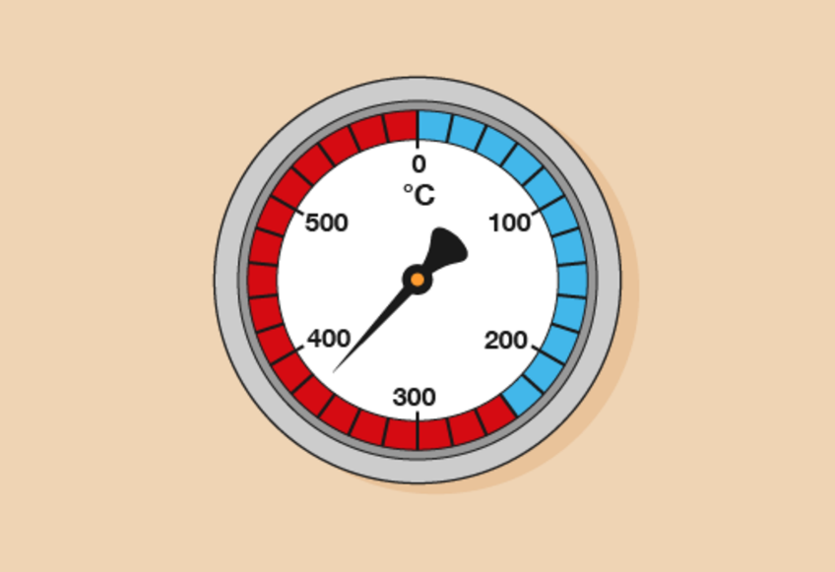
Figure 43 A thermometer
View description - Figure 43 A thermometer

Is it safe to leave it turned on? (Use the conversion chart below to help you.)

Celsius | Fahrenheit
0 | 32
50 | 122
100 | 212
150 | 302
200 | 392
250 | 482
300 | 572
350 | 662
400 | 752

View answer - Activity 19: Celsius and Fahrenheit

Summary
In this section you have identified and practised:
- how to solve problems requiring calculation incorporating temperature
- the correct way to read temperature and the difference between the units used.

6 Time
What’s the difference between the 12-hour clock and the 24-hour clock?

12-hour clock | 24-hour clock
The hours go from 12 to 12, twice a day  You must use ‘a.m.’ or ‘p.m.’: ‘a.m.’ means ‘before noon’ and ‘p.m.’ means ‘after noon’ | The hours go from 0 to 23  Time is always shown in four digits  You do not use ‘a.m.’ or ‘p.m.’  Commonly used in timetables, mobile phones and computers

Example: Converting times before noon
It is easy to change from the 12-hour clock to the 24-hour clock for times before noon (or times ending ‘a.m.’). So for example, ‘4:25 a.m.’ would be written as ‘04:25’. ‘11:35 a.m.’ would be ‘11:35’.
(Note that many timetables don’t show the colon in the 24-hour clock, so these times would be shown as ‘0425’ or ‘1135’.)
How would you write a quarter to eight in the morning as a 24-hour clock time?

Method
Fifteen minutes before eight o’clock is the same as 45 minutes past 7, so it is written as 07:45.

To change from the 12-hour clock to 24-hour clock for times after noon (ending ‘p.m.’), you usually need to add 12 hours.

Example: Converting times after noon
- How would you express 8:15 p.m. using the 24-hour clock?
- How would you write quarter to eight in the evening as a 24-hour clock time?

Method
- You need to add 12 hours:

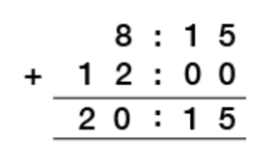
View description - Uncaptioned Figure

So 8:15 p.m. is 20:15 in a 24-hour clock.
- You add 12 hours:

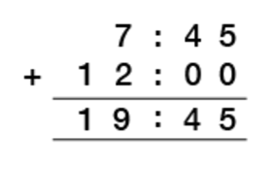
View description - Uncaptioned Figure

So 7:45 p.m. is 19:45 in a 24-hour clock.

Hint: Take care with times with the hour of 12. So quarter past midnight, or 12:15 a.m. is 00:15 in a 24-hour clock. Likewise quarter past midday, or 12:15 p.m., is 12:15 in a 24-hour clock.

Now try the following activity.

Activity 20: The 24-hour clock

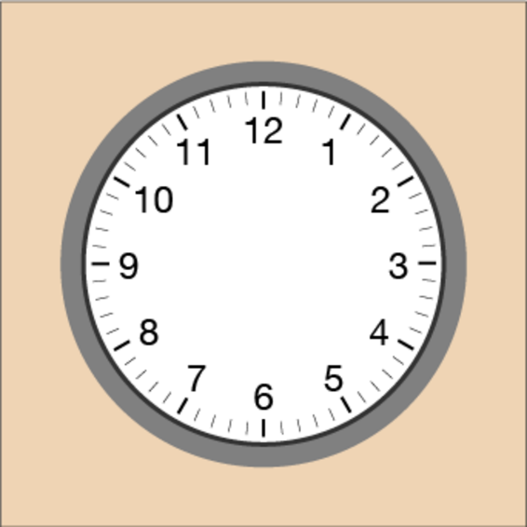
Figure 44 A clock face

Express the following times in the 24-hour clock. Remember, for some of the times you will need to use the method of adding on 12 hours to convert the time intothe 24-hour format. You could use Figure 44 to help you count on 12 hours.
- 8:15 a.m.
- 2:50 p.m.
- 5:40 a.m.
- 9:22 p.m.
- Ten to ten in the morning
- Five past six in the evening

View answer - Activity 20: The 24-hour clock

6.1 Calculate time difference
You may need to work out differences in time, e.g. to work out the length of a TV programme or journey time.
There are different ways to work out the difference in time. One of the easiest ways is to use the adding on method.

Example: Time difference by adding on
How long is it from 08:45 to 10:30?

Method
The start time is 08:45.
The number of minutes between 08:45 and the start of the next hour, 09:00, is 15 minutes.
The number of hours between 09:00 and 10:00 is one hour.
The number of minutes between 10:00 and 10:30 is 30 minutes.
So the time between 08:45 to 10:30 is:

15 minutes + 30 minutes + 1 hour = 1 hour 45 minutes

Now try the following activity.

Activity 21: Time difference

What is the length of time between the following times?
- 03:55 to 06:35
- 09:45 to 12:15
- 08:26 to 10:14
- 7:55 a.m. to 1:10 p.m.
- Midday to 15:50
- 3:15 am to midnight

View answer - Activity 21: Time difference

7 Session 2 quiz
Now it’s time to review your learning in the end-of-session quiz.
Session 2 quiz.
Open the quiz in a new window or tab (by holding ctrl [or cmd on a Mac] when you click the link), then return here when you have done it.

8 Session 2 summary
You have now completed Session 2, ‘Units of measure’. If you have identified any areas that you need to work on, please ensure you refer to this section of the course and retry the activities.
You should now be able to:
- solve problems requiring calculation with common measures, including time, length, weight, capacity and temperature
- convert units of measure in the same system.
All of the skills listed above will help you with tasks in everday life, such as measuring for new furniture or redesigning a room or garden. These are essential skills that will help you progress through your employment and education.
You are now ready to move on to Session 3.

Session 3: Shape and space

Introduction
How often do you have to work with flat shapes in an everyday situation? You may need to measure around an object or plan how you would like to lay out your room.
By the end of this session you will be able to:
- name common two-dimensional and three-dimensional shapes
- identify different types of angle
- work out how far it is around a shape
- work out the area of a shape
- work out the volume of a cube or cuboid
- use scale in drawings and maps.

Video content is not available in this format.
View transcript - Uncaptioned interactive content

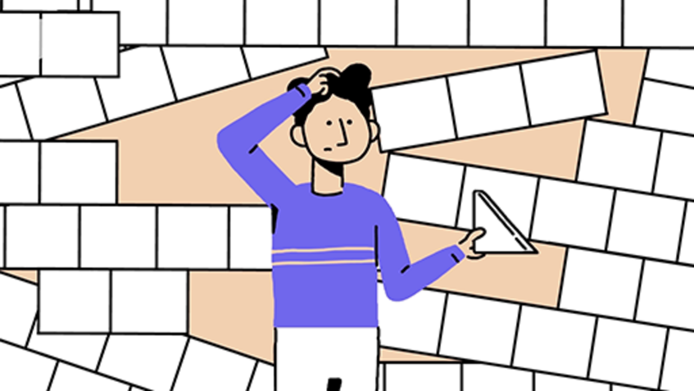

1 Shapes

1.1 Polygons
A polygon is simply a general term for a shape with straight sides.

Activity 1: Identifying polygons

Which of the following shapes are polygons?

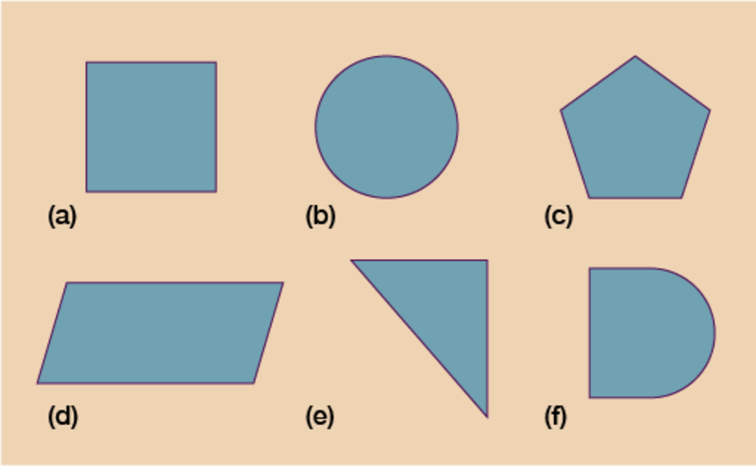
Figure 1 Six shapes
View description - Figure 1 Six shapes

View answer - Activity 1: Identifying polygons

A regular polygon is a shape with sides that are the same length and angles that are all the same size.
A polygon with six sides is a hexagon. The shapes in Figure 2 are both hexagons, but only one is a regular hexagon.

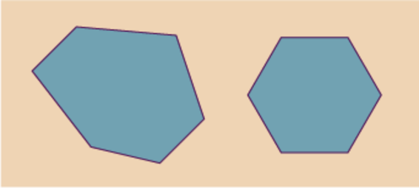
Figure 2 Two hexagons
View description - Figure 2 Two hexagons

1.2 Angles
An angle is formed where two straight lines (or sides) meet. Angles are measured in degrees, which is shown by using the symbol ° after the number of degrees. So for example, 45° means an angle of 45 degrees.

Note: Do not confuse these with degrees Celsius, centigrade or Fahrenheit, which are used to measure temperature.

There are 360° in a circle. There are 180° in a half-turn – that is, from north to south on a compass, or from 9 to 3 on a clock.
An angle of 90° is a quarter-turn – from north to east on a compass, or from 12 to 3 on a clock. These angles are also known as right angles. Right angles are shown like this:

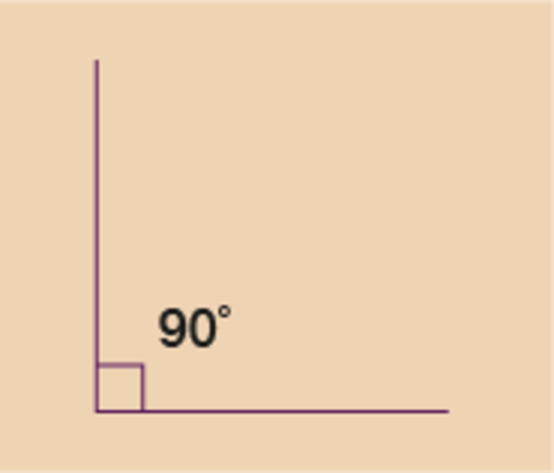
Figure 3 A right angle
View description - Figure 3 A right angle

Right angles are very common in everyday life. Look around you and see how many you can spot.
Here are a few examples of where you might have noticed a right angle:
- the corners of your screen (a corner is where two lines meet)
- corners of windows
- the corners of a book page
- where the walls meet the floor
- where the table legs meet the top.
Angles of less than 90° are called acute angles. Angles of more than 90° are called obtuse angles.

Activity 2: Angles

Which angles in Figure 4 are right angles, acute angles or obtuse angles?

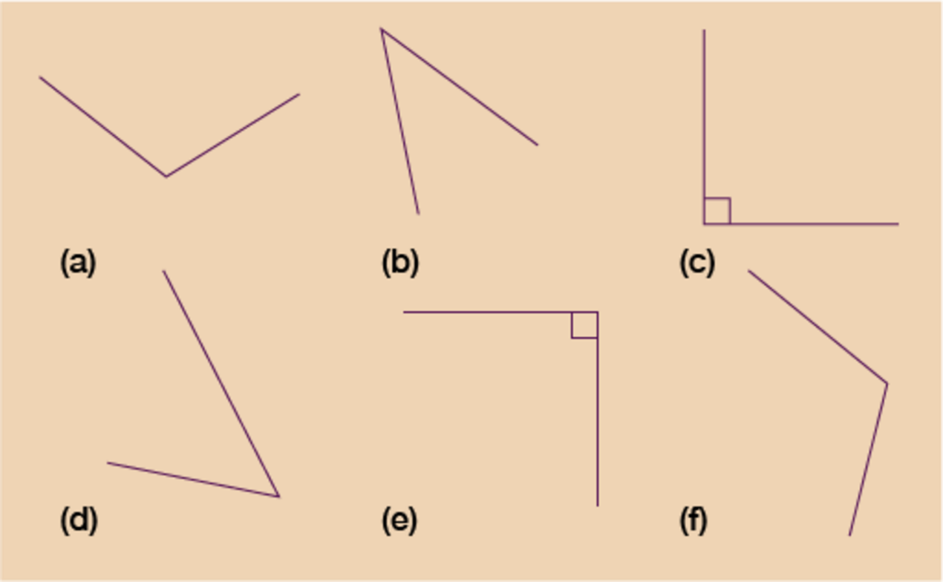
Figure 4 Angles
View description - Figure 4 Angles

View answer - Activity 2: Angles

1.3 2D and 3D shapes
‘2D’, or ‘two-dimensional’, simply means that the shape is flat. We can draw 2D shapes on paper. Common examples are shown in Figure 5.

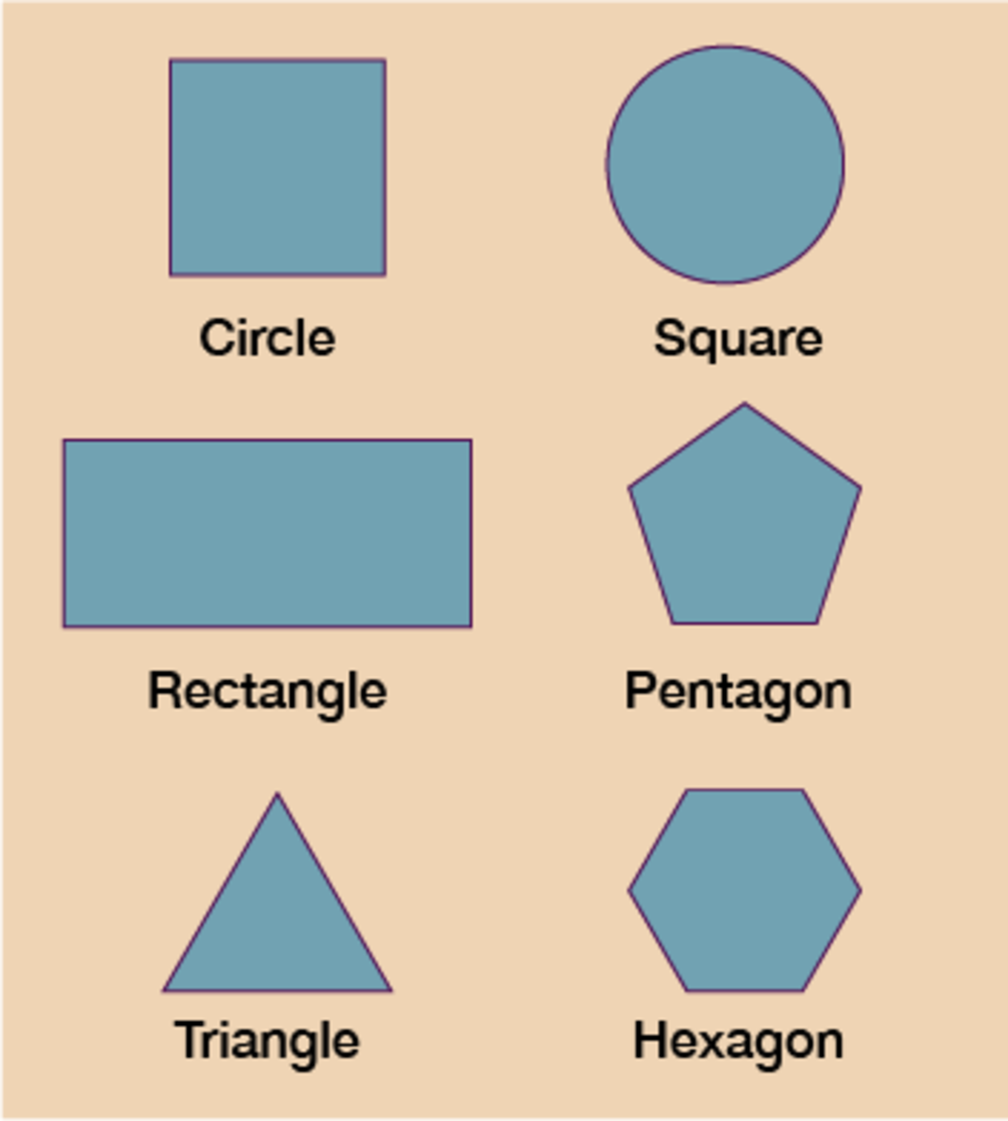
Figure 5 2D shapes
View description - Figure 5 2D shapes

A ‘3D’ (‘three-dimensional’) shape is a solid shape. It has three dimensions, that is, length, width and depth. An easy way of thinking about the difference between a 2D and a 3D shape is to think ‘If I shone a torch on the shape, would it have a shadow?’ 3D shapes cast a shadow but 2D shapes don’t.
Obviously the screen that you’re reading this on is 2D, so 3D shapes are represented using shading.

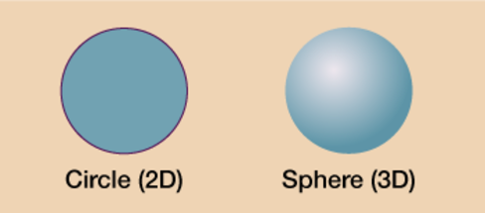
Figure 6 A 2D and 3D shape
View description - Figure 6 A 2D and 3D shape

Activity 3: 2D or 3D?

Say if the following shapes are 2D or 3D:
Which shapes in Figure 7 are 2D and which are 3D?

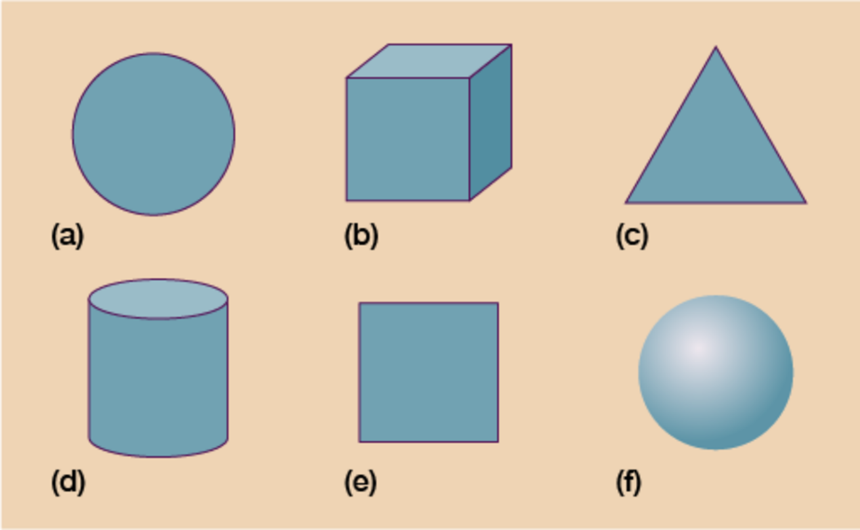
Figure 7 2D and 3D shapes
View description - Figure 7 2D and 3D shapes

View answer - Activity 3: 2D or 3D?

1.4 Common 3D shapes
You will be familiar with some common 3D shapes.

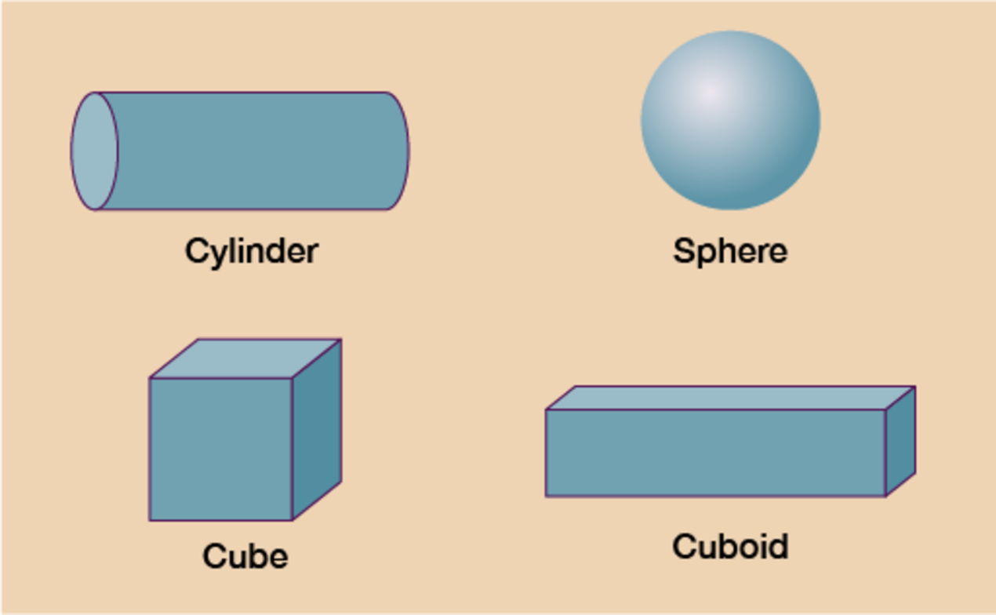
Figure 8 3D shapes
View description - Figure 8 3D shapes

Hint: Make sure you understand the difference between a cube (3D square) and a cuboid (3D rectangle).

Some other 3D shapes that you may come across are shown in Figure 9.

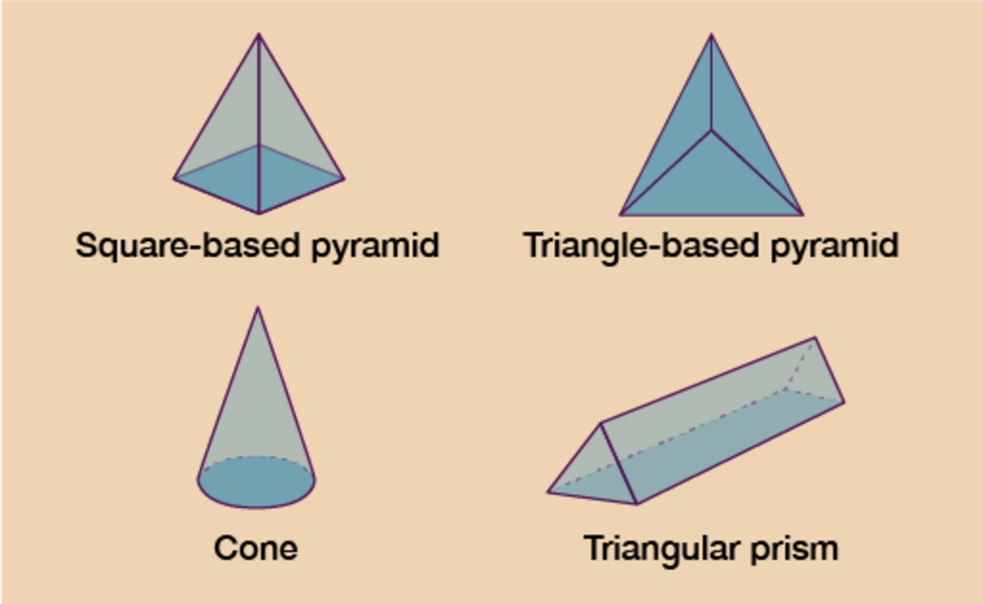
Figure 9 3D shapes
View description - Figure 9 3D shapes

Now try the following activity.

Activity 4: Properties of 3D shapes

- The sides of 3D shapes are known as faces. Complete the following table:

Shape | Number of faces
Cube | Provide your answer...
Square-based pyramid | Provide your answer...
Sphere | Provide your answer...
Cylinder | Provide your answer...
Cuboid | Provide your answer...
Cone | Provide your answer...
Triangular-based pyramid | Provide your answer...
Triangular prism | Provide your answer...

View answer - Part

- Complete the following table:

Shape | Number of edges | Number of vertices
Cube | Provide your answer... | Provide your answer...
Square-based pyramid | Provide your answer... | Provide your answer...
Sphere | Provide your answer... | Provide your answer...
Cylinder | Provide your answer... | Provide your answer...
Cuboid | Provide your answer... | Provide your answer...
Cone | Provide your answer... | Provide your answer...
Triangular-based pyramid | Provide your answer... | Provide your answer...
Triangular prism | Provide your answer... | Provide your answer...

View answer - Part

2 Symmetry
A 2D symmetrical shape can be folded in half so that both sides are the same. The fold is called a line (or lines) of symmetry.
The shapes in Figure 10 have one line of symmetry.

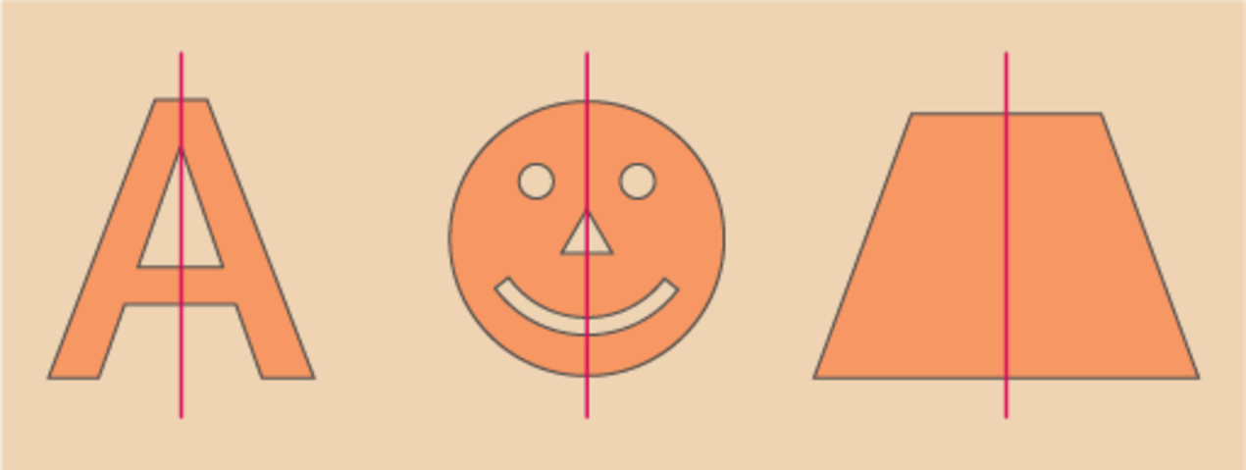
Figure 10 One line of symmetry
View description - Figure 10 One line of symmetry

Some shapes, such as the middle one above, will only have one line of symmetry because of the details included, like the eyes, nose and mouth. However, a circle with no added details has an infinite number of lines of symmetry!
The shapes in Figure 11 have multiple lines of symmetry.

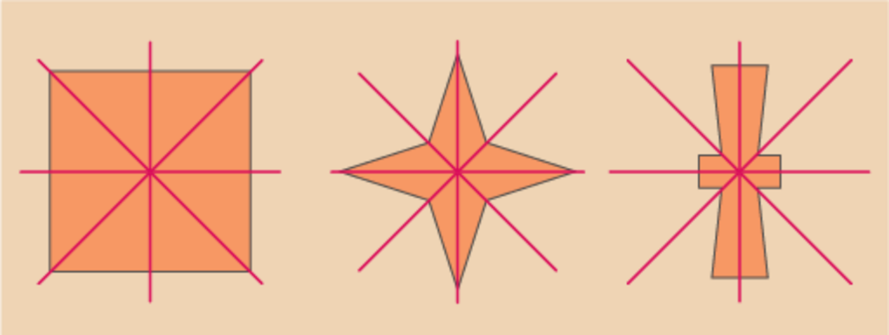
Figure 11 Multiple lines of symmetry
View description - Figure 11 Multiple lines of symmetry

Now try the following activity.

Activity 5: Lines of symmetry

How many lines of symmetry in Figure 12 does each of these letters have?

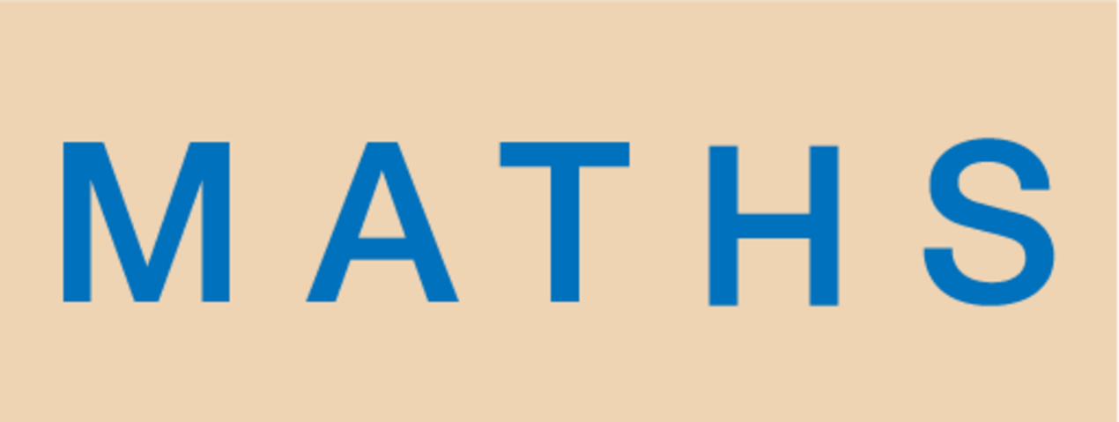
Figure 12 How many lines of symmetry?
View description - Figure 12 How many lines of symmetry?

View answer - Activity 5: Lines of symmetry

Activity 6: How many lines of symmetry?

Sometimes a line of symmetry is called a mirror line, because if you placed a mirror along the line the shape would look the same.
Try writing your name in capital letters and seeing how many lines of symmetry each letter has. You could use a mirror to check your answers.

3 Around the edge
When might you need to work out how far it is around a flat shape?
You will need to know how far it is around the edge of a shape when you want to put a border around something, such as a wallpaper border around a room, or a brick wall around a patio. You might have thought of different examples.
The distance around any shape is called the perimeter. You can work out the perimeter by adding up all of the sides. The sides are measured in units of length or distance, such as centimetres, metres or kilometres. When you calculate the perimeter of a shape, you need to make sure that all of the measurements are in the same units, converting if necessary.

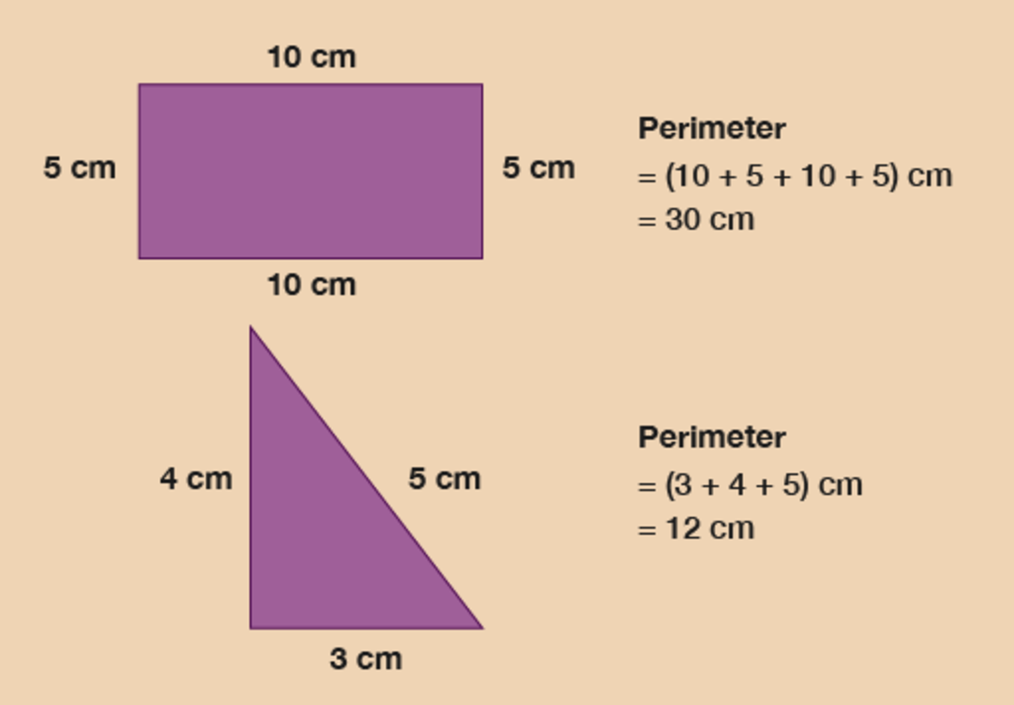
Figure 14 Looking at perimeters
View description - Figure 14 Looking at perimeters

Example: A length of ribbon
Have a look at Figure 15 to work out how much decorative ribbon you need to go around each shape.

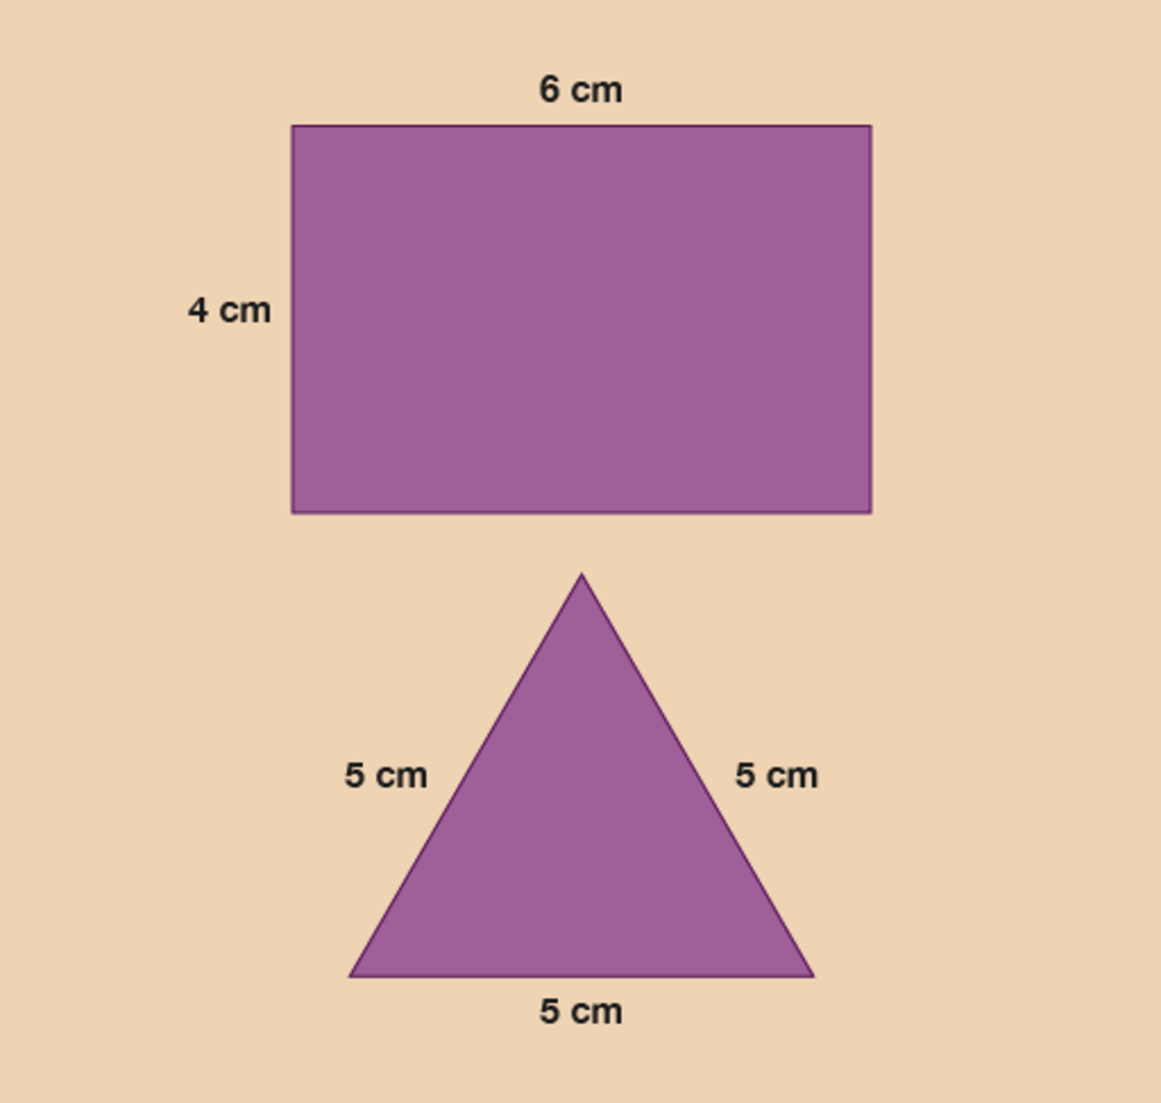
Figure 15 Calculating the length of ribbon
View description - Figure 15 Calculating the length of ribbon

Method
You need to measure all the sides and add them together.

Hint: Opposite sides of a rectangle are the same length.

The sides of the rectangular box are:

6 + 6 + 4 + 4 = 20 cm

You will need 20 cm of ribbon.
The sides of the triangular box are:

5 + 5 + 5 = 15 cm

You will need 15 cm of ribbon.

Example: Lawn edging
So far when you have been working out the perimeter of a rectangle you have added up all four sides. However, there is a quicker way of calculating the perimeter. You may have recognised that all rectangles have two equal short sides and two equal long sides. Therefore you can then work out the perimeter of a rectangle by using each number twice.

(2 × long side) + (2 × short side) = perimeter

The long side is the length. The short side is the width.
(A square is a type of rectangle where all four sides are the same length. So to find out the perimeter of a square, you need to multiply the length of one side by 4.)
How many metres of lawn edging do you need to go around this lawn?

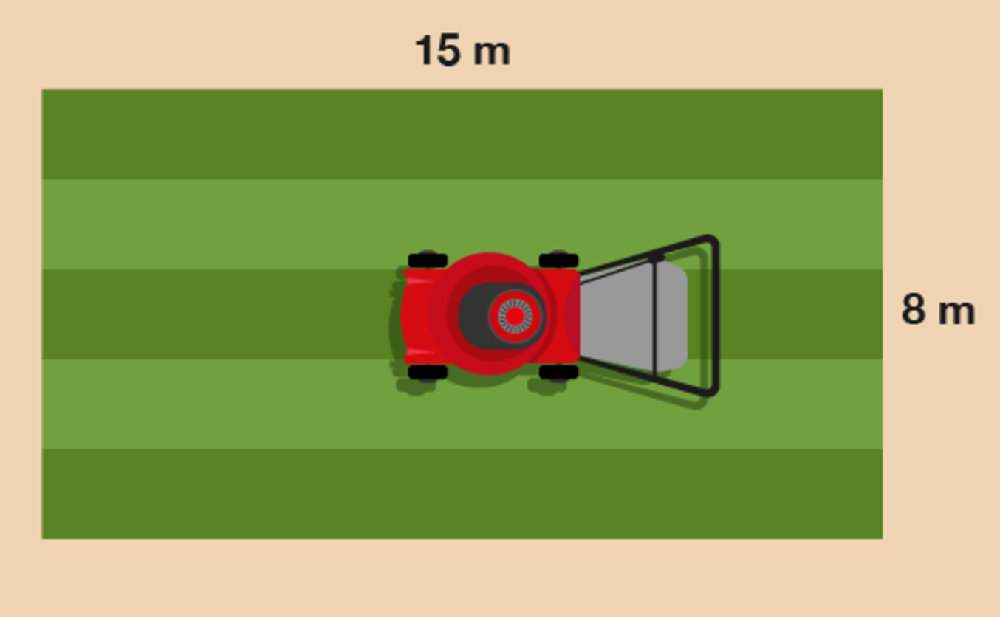
Figure 16 A lawn
View description - Figure 16 A lawn

Method
You need to work out twice the width, plus twice the length:

(2 × 15) + (2 × 8)

Once you’ve worked these out, it makes the answer to the question easier to get:

(2 × 15) + (2 × 8) = 30 + 16 = 46 m

Now try the following activity. Remember to check your answers once you have completed the questions.

Activity 7: Finding the perimeter

- You need to hang bunting around the tennis courts for the local championships. How much bunting do you need?

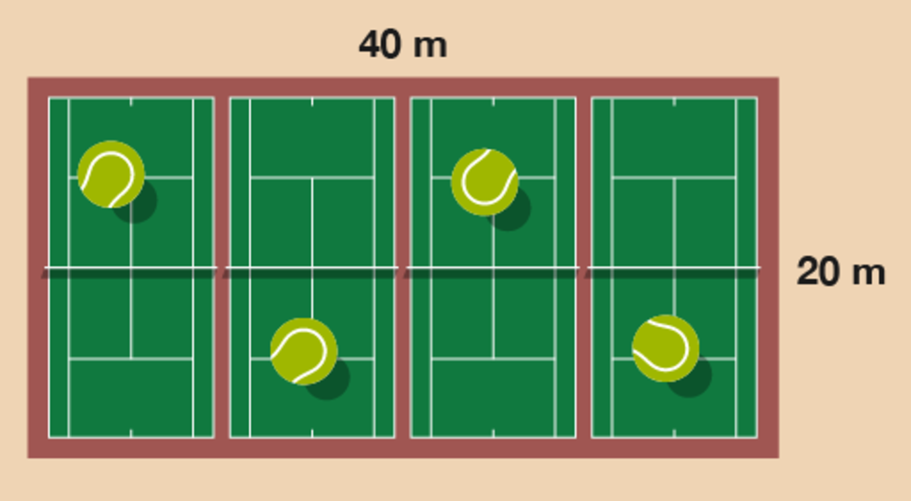
Figure 17 Four tennis courts
View description - Figure 17 Four tennis courts

- Jackie wants to put a fence around her vegetable garden. Her garden is rectangular in shape and is 5 metres long by 4 metres wide. What length of fence is needed?

View answer - Activity 7: Finding the perimeter

3.1 Measuring the perimeter of irregular shapes

Example: How to measure the perimeter of an irregular shape
How would you measure the perimeter of an irregular shape – an L-shaped room, for instance – if you didn’t have all of the measurements that you would need? Watch the following video to find out.

Video content is not available in this format.
View transcript - Uncaptioned interactive content

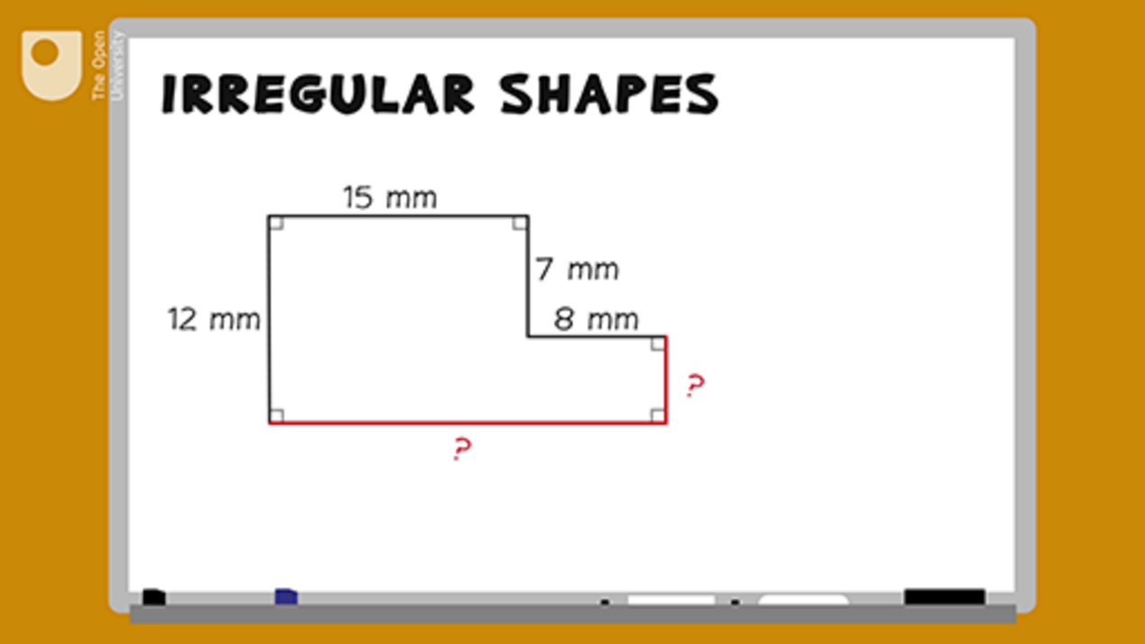

Now try the following activity. Remember to check your answers once you have completed the questions.

Activity 8: Finding the perimeter

Note that you can assume that all of the corners in the images in this activity are right angles.
- A gardener decides to lay a new path next to his lily pond. The drawing shows the dimensions of the path.

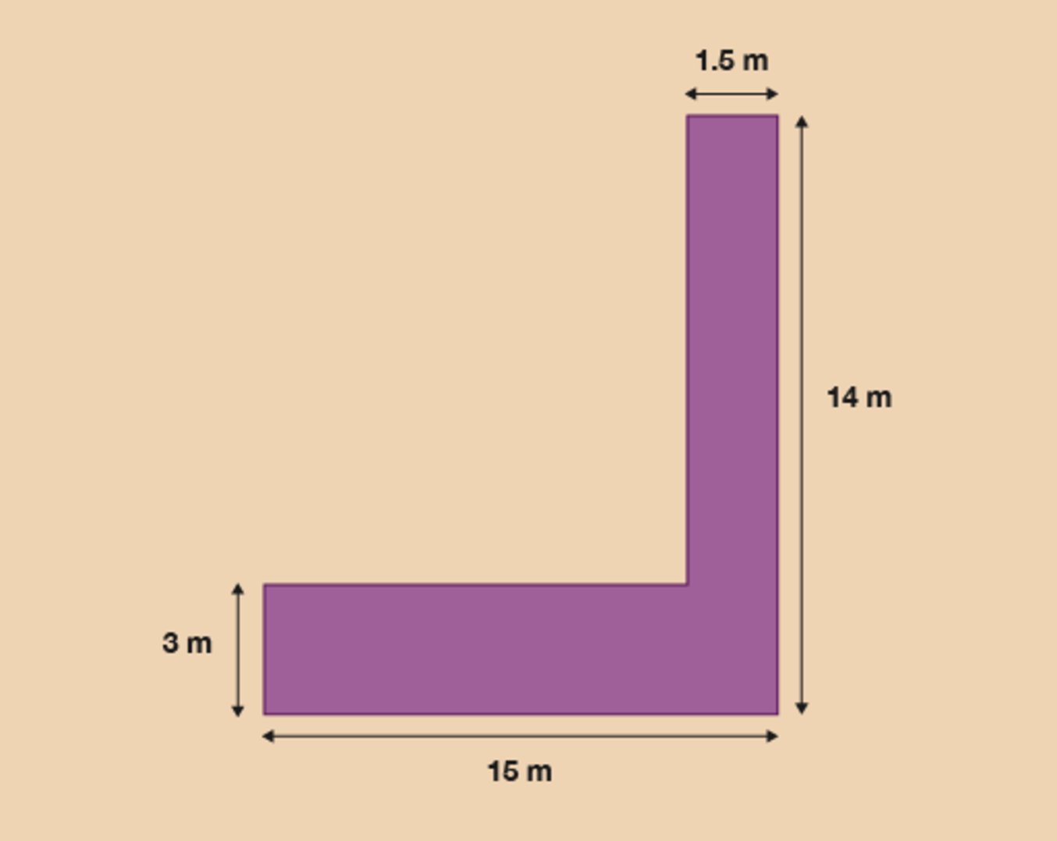
Figure 18 A pathway
View description - Figure 18 A pathway

The gardener decides to paint a white line around the perimeter of the path. What is the perimeter of the path?
- A tourist information centre has a new extension.

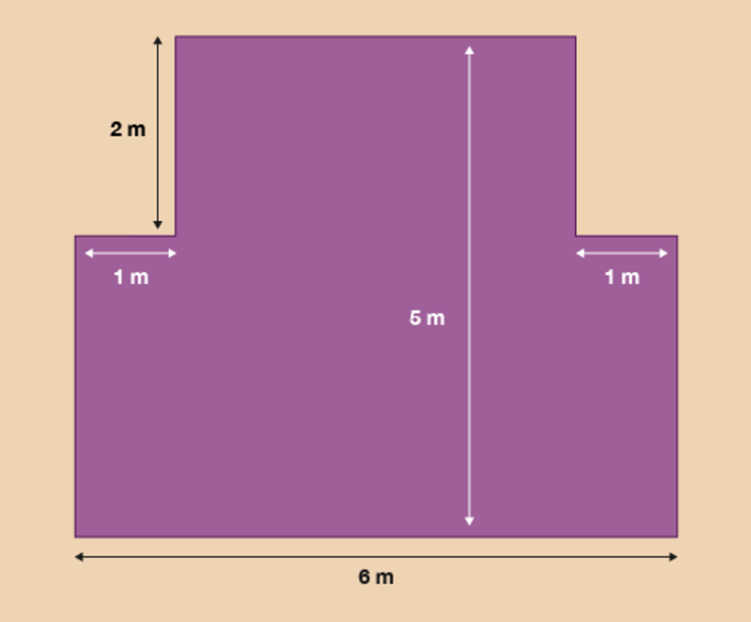
Figure 19 A new extension
View description - Figure 19 A new extension

The tourist board wants to attach a gold strip around the border of the floor of the building. What is the perimeter of the new extension?

View answer - Activity 8: Finding the perimeter

Summary
In this section you have learned how to work out the perimeter of both simple and irregular shapes.

4 Area
Area is the amount of space a flat shape takes up. You need to be able to calculate area if you ever need to order a carpet for your house, buy tiles for a kitchen or bathroom, or calculate how much paint to buy when redecorating.
This patio has paving slabs that are 1 metre square (each side is 1 metre). How many paving slabs are there on the patio?

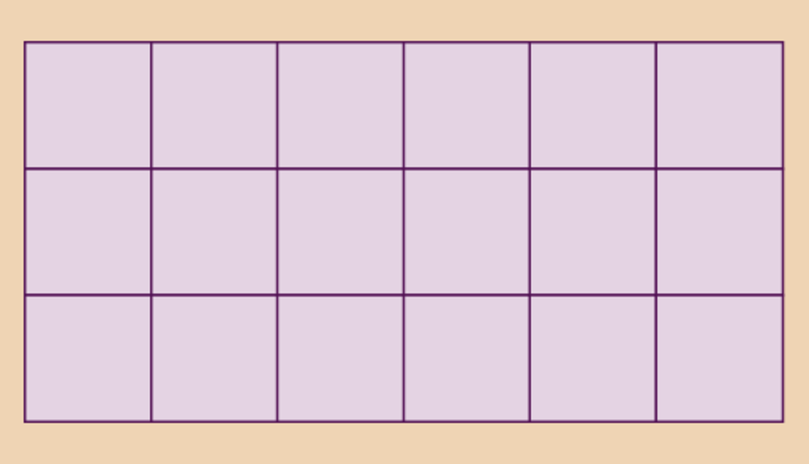
Figure 20 Paving slabs
View description - Figure 20 Paving slabs

Area is measured in ‘square’ units. This means that the area is shown as the number of squares that would cover the surface. So if a patio covered with 18 squares that are 1 metre by 1 metre, the area is 18 square metres.
(If you count them, you will find there are 18 squares.)
Smaller areas would be measured in square centimetres. Larger areas can be measured in square kilometres or square miles.
You can work out the area of a rectangle, like the patio above, by multiplying the long side by the short side:

width × length = area

The patio is:

6 × 3 = 18 square metres

‘Square metres’ can also be written ‘sq m’ or ‘m²’.

Example: The area of a table
Fran sees a rectangular dining table she likes. It measures 2 m by 1.5 m. What is the area of the table?

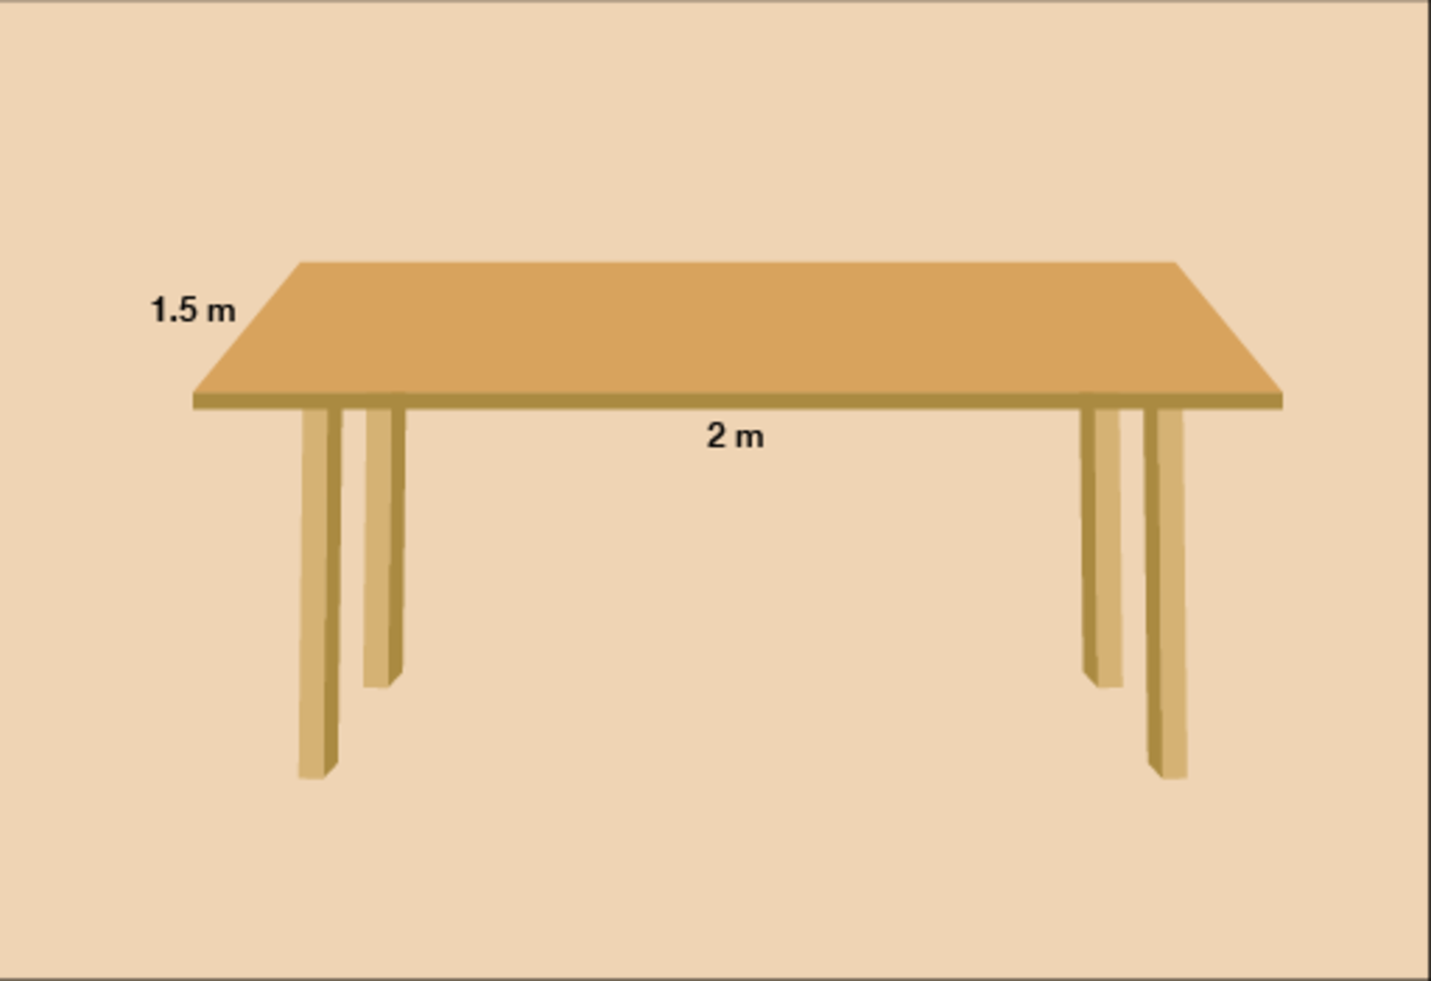
Figure 21 A dining table
View description - Figure 21 A dining table

Method
To find the area we need to multiply the length of the table by the width:

2 m × 1.5 m = 3 square metres

So the table is 3 m².

Activity 9: Area of a rectangle

Complete the following table by calculating the missing areas without using a calculator. You will have looked at methods for multiplying whole numbers and decimals in Session 1. Show your answers in correct square units.

Length | Width | Area in square units (centimetres, metres, kilometres)
80 cm | 30 cm | Provide your answer...
7 m | 4 m | Provide your answer...
2.5 km | 2 km | Provide your answer...
5.5 m | 2.4 m | Provide your answer...

View answer - Activity 9: Area of a rectangle

Hint: Always use the same units for both sides. Sometimes the length and width of the rectangle will be given in different units. They must be in the same unit before you can calculate area, so you may need to convert one side to the same units as the other side.

Example: The area of a rug
How much backing fabric is needed for this rug?

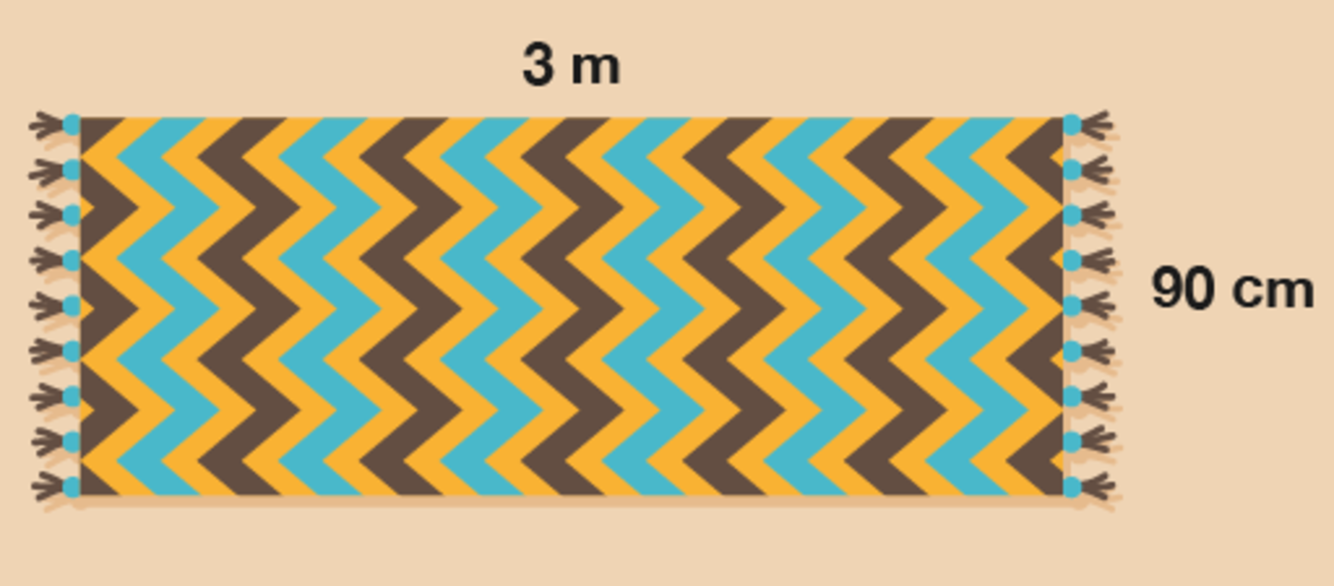
Figure 22 A rug
View description - Figure 22 A rug

Method
To find the answer, you need to work out the width multiplied by the length.
- 90 cm × 3 m = area
First, you need to convert the width to metres so that both sides are in the same units. 90 cm is the same as 0.9 m, so the calculation is:
- 0.9 × 3 = area = 2.7 m²

Now try the following activity. You need to carry out the calculations without a calculator, but you can double-check your answers on a calculator if needed. If you need a reminder about how to multiply whole numbers or decimal numbers without a calculator, please look back at Session 1 first.
Remember to check if you need to convert the measurements before calculating the area.

Activity 10: Finding the area

- How much plastic sheeting do you need to cover this pond for the winter?

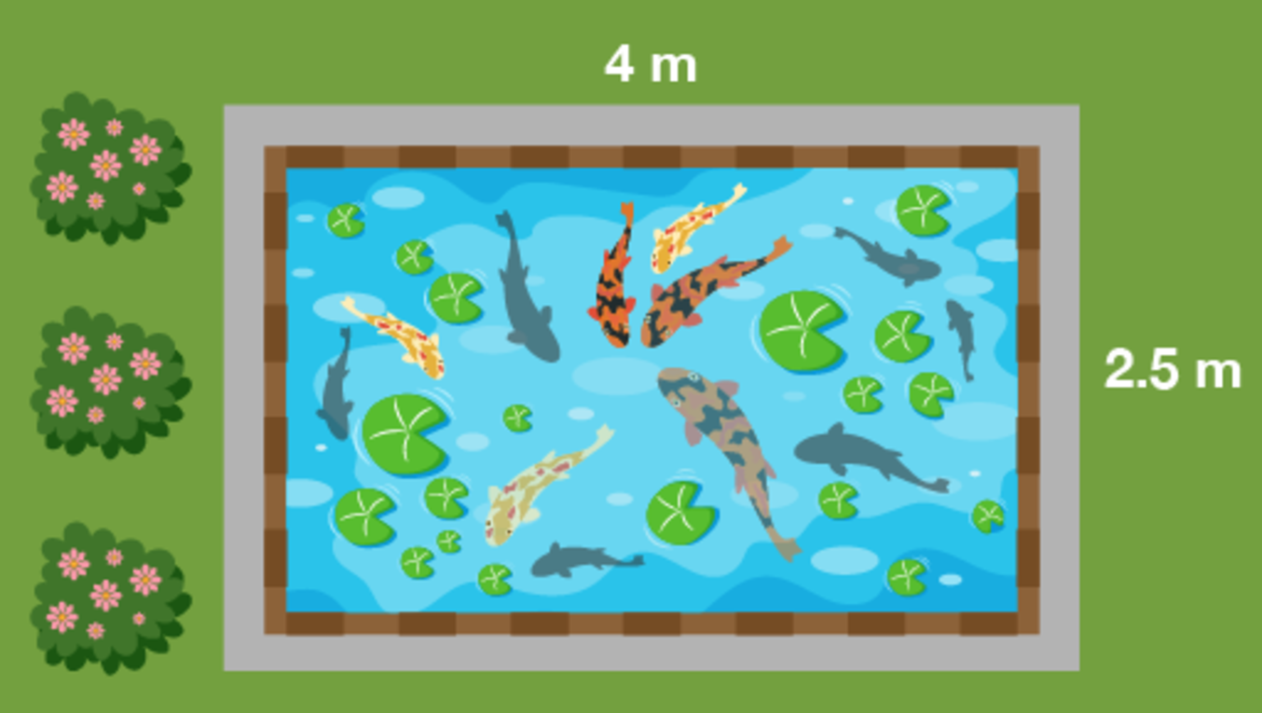
Figure 23 A pond
View description - Figure 23 A pond

- One bag of gravel will cover half a square metre of ground. How many bags do you need to cover this driveway?

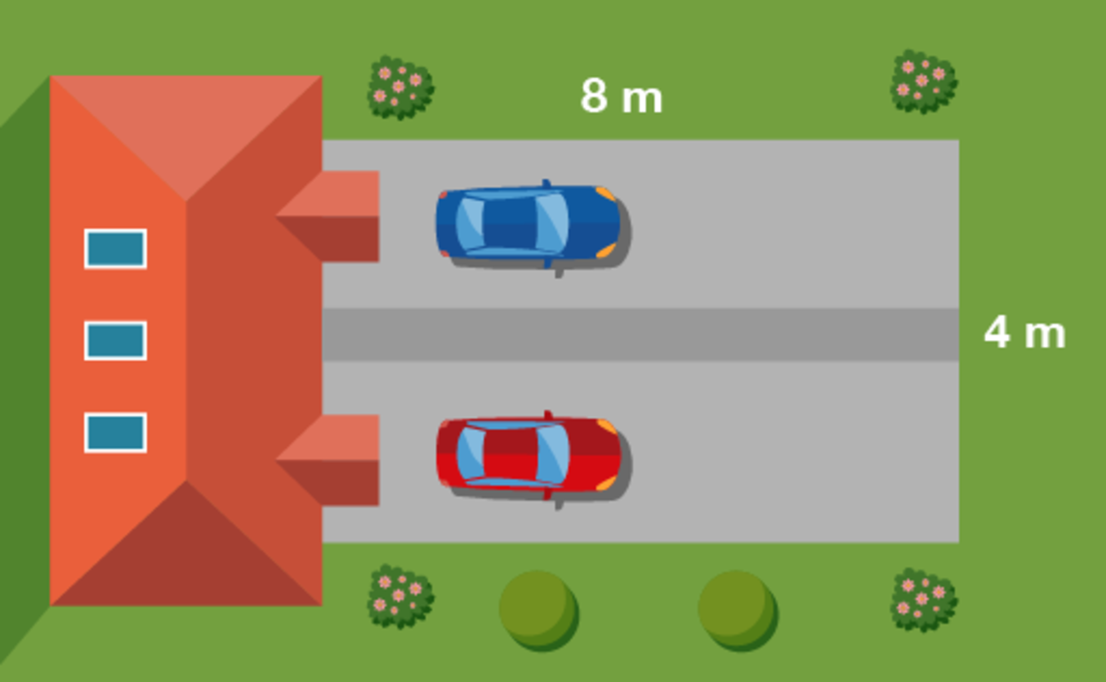
Figure 24 A driveway
View description - Figure 24 A driveway

- A biologist is studying yeast growth. In the sample area shown below in purple the biologist found 80 yeast. What would go in the missing spaces in her recording sheet, as marked with a question mark?

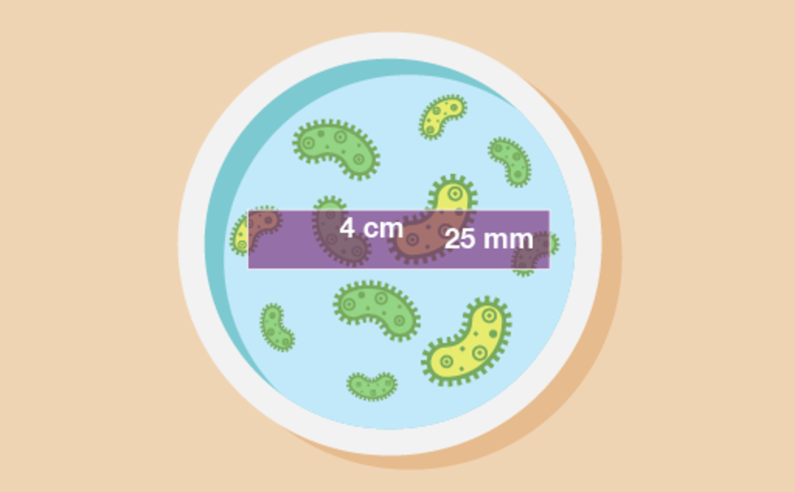
Figure 25 A petri dish
View description - Figure 25 A petri dish

Yeast count
Sample area no. | 21
Date | 17 October
Yeast count | 80
Sample dimensions | ? cm × ? cm
Sample area | ? cm²
Yeast/cm² | ?

- How large is this area of forestry land?

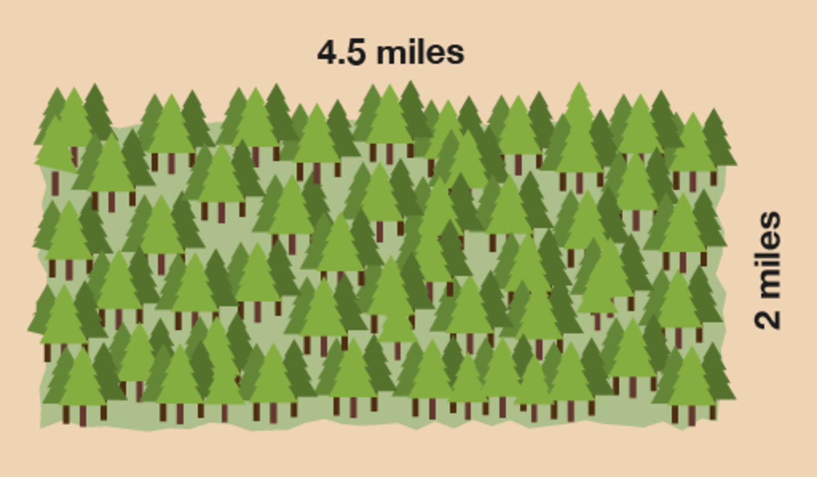
Figure 26 A forest
View description - Figure 26 A forest

View answer - Activity 10: Finding the area

Summary
In this section you have learned how to work out the area of a rectangular shape.

5 Volume
Volume is the measure of the amount of space inside of a solid (3D) object. The volume of a cube or cuboid is measured by multiplying length by width by height. It is always measured in cubic units, such as mm³, cm³, m³, etc.

Example: Volume of a cuboid
What is the volume of a box with a length of 8 cm, a width of 4 cm and a height of 2 cm?

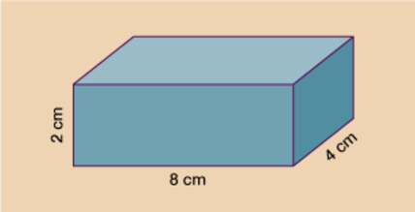
Figure 27 A box
View description - Figure 27 A box

Method
The volume is:

8 cm × 4 cm × 2 cm

You can also write this as:

32 cm (8 cm × 4 cm) × 2 cm = 64 cm³

Watch the following clip for some more examples:

Watch the video at YouTube.com.

Now try the following activity.

Activity 11: Calculating volume

- Calculate the volumes of the following:

Hint: As with perimeter and area, you may need to convert to make the units the same.

Length | Width | Height | Volume
6 m | 2 m | 3 m | Provide your answer...
10 mm | 10 mm | 10 mm | Provide your answer...
36 mm | 2 cm | 4 cm | Provide your answer...
9 m | 2 m | 180 cm | Provide your answer...

- A children’s sandpit is 1 m wide and 1.5 m long. What volume of sand would be needed to fill the sandpit to a depth of 10 cm? (Note that depth is the same as height but measured in a downward direction.)
- David has built a log store that measures 2 m × 1 m × 1 m. He wants to order some logs ready for the winter. The local supplier only delivers logs in 1.5 m³ loads. Will David’s store be big enough to hold one load?

View answer - Activity 11: Calculating volume

Summary
In this section you have calculated the volume of cubes and cuboids.

6 Scale drawings
Have you ever drawn a plan of a room in your house to help you work out how to rearrange the furniture? Or maybe you’ve sketched a plan of your garden to help you decide how big a new patio should be?
These pictures are called scale drawings. The important thing with scale drawings is that everything must be drawn to scale, meaning that everything must be in proportion – that is, ‘shrunk’ by the same amount.
All scale drawings must have a scale to tell us how much the drawing has been shrunk by.

Example: In the garden
Here is an example of typical scale drawing:

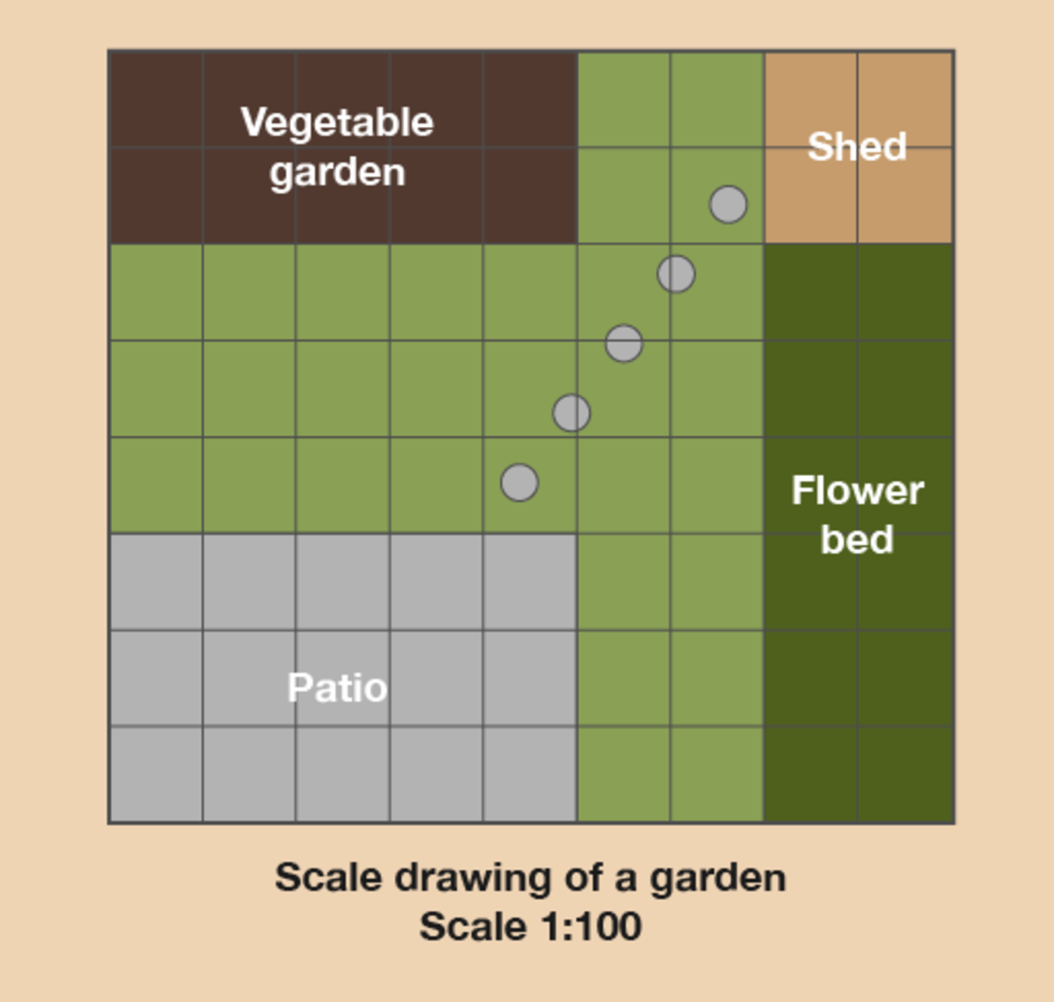
Figure 28 A scale drawing of a garden
View description - Figure 28 A scale drawing of a garden

What’s the width and length of the patio?

Hint: This scale drawing has been drawn on squared paper. This makes it easier to draw and understand. Each square is 1 cm wide and 1 cm long. So instead of using a ruler you can just count the squares and this will tell you the measurement in centimetres.

Method
The scale in this drawing is 1:100. This means that 1 cm on the scale drawing is equal to 100 cm, or 1 m, in real life. Once we know the scale, we can measure the distances on the drawing.
Using a ruler (or just counting the squares), we find that the patio is 5 cm long and 3 cm wide on the drawing. This means that in real life it is 5 metres long and 3 metres wide.
So when you’re working with scale drawings:
- Find out what the scale on the drawing is.
- Measure the distance on the drawing using a ruler (or count the number of squares, if that’s an option). The measurements may already be given on the drawing.
- Multiply the distance you measure by the scale to give the distance in real life.
- If you already know the real-life measurement and need to work out the measurement on the drawing, you divide by the scale.

Now try the following activity. Remember to check your answers once you have completed the questions.

Activity 12: Getting information from a scale drawing

- Let’s stay with this scale drawing of the garden.

Figure 29 A scale drawing of a garden
View description - Figure 29 A scale drawing of a garden

  - What is the actual width and length of the vegetable garden?
  - What is the actual width and length of the flower bed?
  - How far is the patio from the vegetable garden in real life?
  - Say you wanted to put a trampoline between the patio and the vegetable garden. It measures 3 m by 3 m in real life. Is there enough space for it?
- Tom is using a scale drawing to plan out a patio he is going to lay. He uses a scale of 1 cm : 50 cm. The patio on his drawing measures 4 cm by 8 cm. What are the dimensions of his actual patio?
- Amanda is drawing a plan of the ground floor of her house, using a scale of 1 cm: 2 m. Her actual kitchen measures 5 m by 6 m. What will the measurements be for her kitchen on the plan?

View answer - Activity 12: Getting information from a scale drawing

Summary
In this section you have learned how to use scale drawings.

7 Maps
A map gives you a detailed drawing of a place. They are used to find out how to get from one place to another. They use a scale that lets you calculate the actual distance from one place to the other.
If you look in a holiday brochure you will see lots of maps. They are often used to show how a resort is laid out. They show where a few important places are, such as local shops, hotels, the beach, swimming pools and restaurants.
It is important to understand how to read a map so that you do not end up too far from the places you want to be near – or too close to the places you want to avoid!

Example: Holiday map
Here is a typical example of a map you find in a holiday brochure.

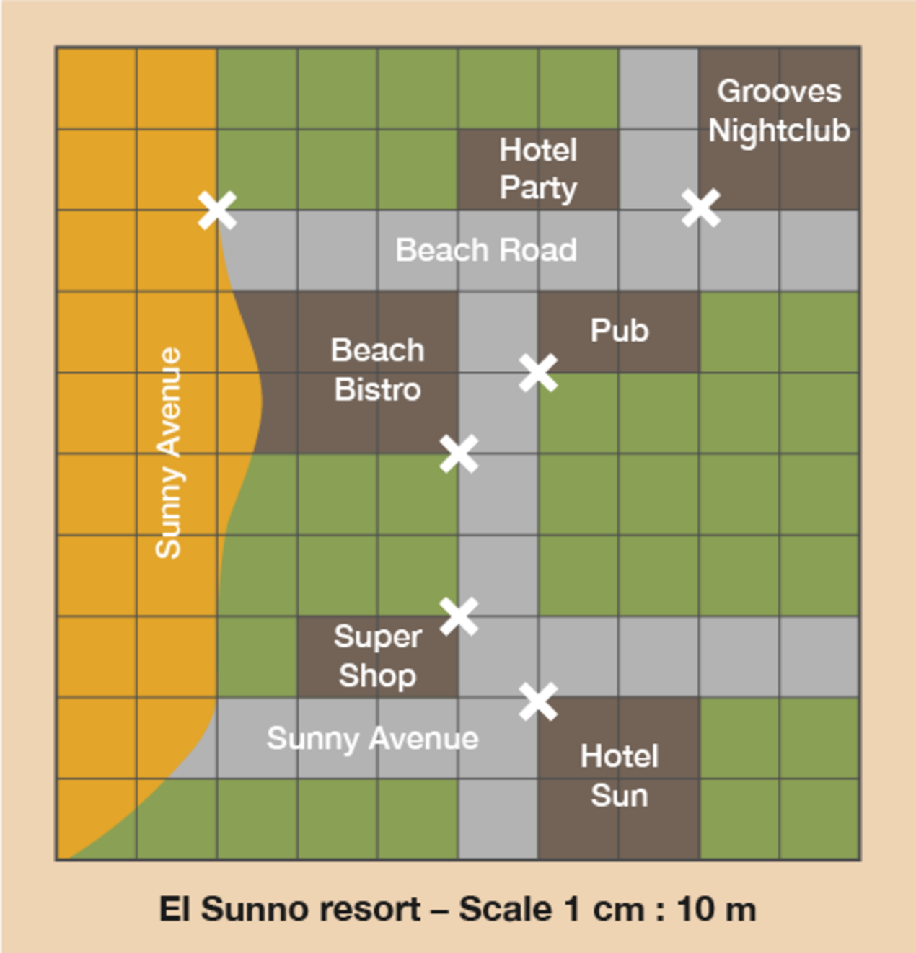
Figure 30 A scale drawing of a holiday resort
View description - Figure 30 A scale drawing of a holiday resort

How far apart is everything on this map? Each square measures 1 cm on the map.

Method
As with scale drawings, the thing you need to know before you can understand the map is the scale and how to read it.
This means that for every 1 cm square on the map there are 10 metres (10 m) in real life.
Using the scale, you can interpret the data on the map and work out how far different places are from one another.
To do this you need to measure the distances on the map and then multiply the distances in centimetres by 10 to get the actual distance in metres.
So on this map the Grooves Nightclub is 1 cm from Hotel Party. In real life that’s 10 m – not very far at all. Knowing this could affect whether you choose to stay at Hotel Party, depending on whether you like nightclubs or not.

Now try the following activity. Remember to check your answers once you have completed the questions.

Activity 13: Using a map to find distances

Let’s stay with the map of the holiday resort.

Figure 31 A scale drawing of a holiday resort
View description - Figure 31 A scale drawing of a holiday resort

Hint: The entrances to the buildings are marked with crosses on the map. You need to measure from these crosses.

- What is the distance in real life between the pub and Hotel Sun in metres?
- How far is it in real life from the Super Shop to the Beach Bistro in metres?
- What is the distance in real life from Grooves Nightclub to the beach in metres?
Now try these:
- A map has a scale of 1 cm to 5 km. On the map, the distance between two towns measures 6 cm. What is the actual distance between the two towns? Remember to show the units in your answer.
- A scale is given as 1 cm to 2 km. When measured on a map, the distance from the college to the bus station is 4.5 cm. What is the actual distance?

View answer - Activity 13: Using a map to find distances

Summary
In this section you have learned how to use maps.

8 End-of-course quiz
Now it’s time to review your learning in the end-of-session quiz.
Session 3 quiz.
Open the quiz in a new window or tab (by holding down the ‘Ctrl’ key [or ‘Cmd’ on a Mac] when you click the link), then return here when you have done it.

9 Session 3 summary
You have now completed Session 3, ‘Shape and space’. If you have identified any areas that you need to work on, please ensure you refer back to this section of the course.
You should now be able to:
- work out the perimeter of your garden for fencing
- find out how much carpet you need to re-carpet a room or floor
- work out how much gravel you need to cover a driveway
- work out the volume of a sandpit or storage room
- use a simple scale on a plan of a garden or holiday resort
- read maps to calculate distances from one place to another.
All of the skills above will help you with tasks in everyday life. Whether you are at home or at work, number skills are an essential skill to have.
You are now ready to move on to Session 4.

Solutions

Activity 1: Working with place value

Part

Answer
4 025 in words is four thousand and twenty-five.
Back to - Part

Part

Answer
Six thousand, four hundred and seventy-two in figures is 6 472.
Back to - Part

Part

Answer
The person who wins the election is the person who gets the most votes.
To find the biggest number we need to compare the value of the first digit in each number. If this is the same for any of the numbers, then we need to go on to compare the value of the second digit in each number and so on.
- The value of the first digit in 436 is 4 hundreds.
- The value of the first digit in 723 is 7 hundreds.
- The value of the first digit in 156 is 1 hundred.
- The value of the first digit in 72 is 7 tens.
Comparing the values of the first digit in each number tells us that the biggest number is 723, so Sonia Cedar is the winner of the election.
Back to - Part

Activity 2: Place value

Answer
The answers are as follows:

Number | Th | H | T | U
584 |  | 5 | 8 | 4
690 |  | 6 | 9 | 0
708 |  | 7 | 0 | 8
302 |  | 3 | 0 | 2
4 290 | 4 | 2 | 9 | 0
5 060 | 5 | 0 | 6 | 0
2 100 | 2 | 1 | 0 | 0
3 009 | 3 | 0 | 0 | 9

Back to - Activity 2: Place value

Activity 3: Large numbers

Answer
- The answers are as follows:
  - Seven hundred and sixty-five thousand, two hundred and twenty-eight.
  - One million, six hundred and fifty-five thousand, five hundred and one.
  - Three million, four hundred and eighty-seven thousand, eight hundred and eighty-seven.
- The answers are as follows:
  - 608 910
  - 2 711 106
  - 8 900 400
- The correct order is:
  - 258 411
  - 482 112
  - 496 832
  - 1 118 233
  - 1 248 758
  - 1 260 802
Back to - Activity 3: Large numbers

Activity 4: Using negative numbers in everyday life

Part

Answer
- City D is the coldest because it has the lowest temperature. City C is the warmest because it has the highest temperature.
- No, because –11°C is colder than the recommended range of between –10°C and –6°C. Keeping the ice cream in your freezer would probably damage the ice cream.
Back to - Part

Activity 5: Looking at numbers

Part

Answer
- The answers are as follows:
  - 9 million
  - 653 thousand
  - Will
- The answers are as follows:
  - Moscow
  - Delhi
  - London, Paris and Moscow
Back to - Part

Activity 6: Adding whole numbers

Answer
The answers are as follows:
- 9 389
- 5 811
- 10 212
- 29 415
- 308 323
- 1 021 559
Back to - Activity 6: Adding whole numbers

Activity 7: Subtracting whole numbers

Answer
The answers are as follows:
- 9 223
- 682
- 17 781
- 596 487
- 900 738
- 217 889
Back to - Activity 7: Subtracting whole numbers

Activity 8: Multiplying whole numbers by 10, 100 and 1 000

Answer
- 70
- 320
- 1 200
- 800
- 2 100
- 52 000
- 3 000
- 12 000
- 45 000
- 310 pence (or £3.10)
- 1 900 boxes of cereal
- £7 000
Back to - Activity 8: Multiplying whole numbers by 10, 100 and 1 000

Activity 9: Looking for multiples

Answer
- 12, 24, 30, 52 and 80 are multiples of 2.
  - 2 × 6 = 12
  - 2 × 12 = 24
  - 2 × 15 = 30
  - 2 × 26 = 52
  - 2 × 40 = 80
- 12, 24, 30, 39 and 45 are multiples of 3.
  - 3 × 4 = 12
  - 3 × 8 = 24
  - 3 × 10 = 30
  - 3 × 13 = 39
  - 3 × 15 = 45
- 30, 45 and 80 are multiples of 5.
  - 5 × 6 = 30
  - 5 × 9 = 45
  - 5 × 16 = 80
- 30 and 80 are multiples of 10.
  - 10 × 3 = 30
  - 10 × 8 = 80
Back to - Activity 9: Looking for multiples

Activity 10: Identifying square numbers

Answer
The answers are as follows:

4 × 4 = 16
5 × 5 = 25
6 × 6 = 36
7 × 7 = 49
8 × 8 = 64
9 × 9 = 81
10 × 10 = 100
11 × 11 = 121
12 × 12 = 144

Back to - Activity 10: Identifying square numbers

Activity 11: Multiplying whole numbers

Answer
- 304
- 1 098
- 1 050
- 4 920
- 15 078
- 8 466
- 26 442
- 4 080 seats
- 3 750 miles
- £10 746 in total
Back to - Activity 11: Multiplying whole numbers

Activity 12: Dividing by 10, 100 and 1 000

Answer
- 7
- 32
- 12
- 85
- 21
- 520
- 34
- 120
- 450
- 35 boxes
- 180 metres
- £1 600
Back to - Activity 12: Dividing by 10, 100 and 1 000

Activity 13: Dividing whole numbers (short division)

Answer
- 323
- 405
- 881
- 6 825
- 1 813 r4
- 20 056 r1
- £22 500 each
- 4 250 boxes
Back to - Activity 13: Dividing whole numbers (short division)

Activity 14: Dividing whole numbers (long division)

Answer
- 36
- 13
- 21 r4
- 65
- 3 582
- £1 045 a month
- £570 a month
Back to - Activity 14: Dividing whole numbers (long division)

Activity 15: Rounding to 10, 100 and 1 000

Part

Answer

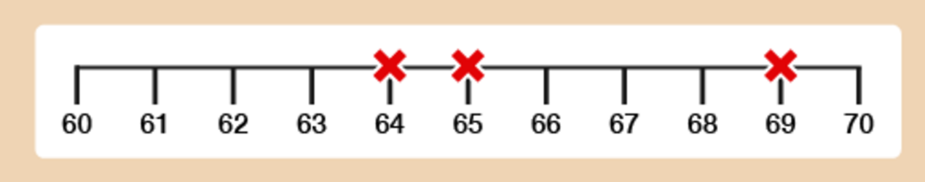
Figure 5 A number line
View description - Figure 5 A number line

You can see in Figure 5 that:
- 64 rounded to the nearest 10 is 60.
- 69 rounded to the nearest 10 is 70.
- 65 rounded to the nearest 10 is 70. (Remember: when a number is exactly halfway, you always round up. As the rhyme goes, ‘Five or more, raise the score!’)
The other answers are as follows:
- 648 rounded to the nearest 10 is 650.
- 271 rounded to the nearest 10 is 270.
- 587 rounded to the nearest 10 is 590.
Now practise rounding to the nearest 100. The rule is exactly the same.
Back to - Part

Part

Answer

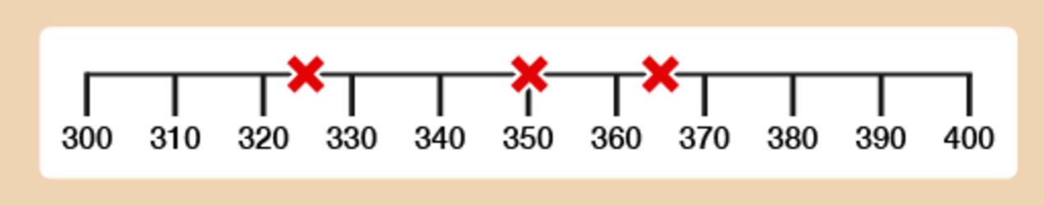
Figure 6 A number line
View description - Figure 6 A number line

You can see in Figure 6 that:
- 325 rounded to the nearest 100 is 300.
- 350 rounded to the nearest 100 is 400.
- 365 rounded to the nearest 100 is 400.
The other answers are as follows:
- 2 924 rounded to the nearest 100 is 2 900.
- 1 630 rounded to the nearest 100 is 1 600.
- 2 279 rounded to the nearest 100 is 2 300.
Now practise rounding to the nearest 1 000.
Back to - Part

Part

Answer

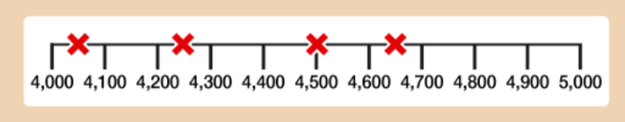
Figure 7 A number line
View description - Figure 7 A number line

You can see in Figure 7 that:
- 4 250 rounded to the nearest 1 000 is 4 000.
- 4 650 rounded to the nearest 1 000 is 5 000.
- 4 500 rounded to the nearest 1 000 is 5 000.
- 4 060 rounded to the nearest 1 000 is 4 000.
The other answers are as follows:
- 31 300 rounded to the nearest 1 000 is 31 000.
- 13 781 rounded to the nearest 1 000 is 14 000.
- 155 600 rounded to the nearest 1 000 is 156 000.
Back to - Part

Activity 16: Rounding to the nearest £

Answer
- £5
- £2
- £7
- £13
- £24
- £129
Back to - Activity 16: Rounding to the nearest £

Activity 17: Bill’s shopping

Part

Answer
Rounding all of the items should give you a total of £19 – so yes, Bill probably has enough money to pay for all of his shopping.
Back to - Part

Part

Answer
The total cost of all of the items on the shopping list comes to £19.33, which is very close to the answer you achieved through rounding.
Well done! You have now successfully rounded and carried out some basic number work. Can you see the importance of rounding? This is especially important when sticking to a budget.
Back to - Part

Activity 18: Rounding

Answer
- The population rounds to 6 000 000 (six million). This is because 6 439 800 is nearer to 6 million than 7 million.
- 6 987 rounded to the nearest 1 000 is 7 000. If each ticket costs £6, the approximate total amount of money collected is:
  - £6 × 7 000 = £42 000
- 412 to the nearest hundred is 400. 395 to the nearest hundred is also 400. So the total approximate number of students passing GCSE Maths is:
  - 400 + 400 = 800 students
- £595 to the nearest hundred is £600. So the approximate cost of one armchair is:
  - £600 ÷ 4 = £150
- 18 rounded to the nearest 10 is 20. So the approximate total number of pencils is:
  - 20 × 50 = 1 000 pencils
Note: 50 × 20 = 50 × 2 × 10 = 100 × 10 = 1 000.
Back to - Activity 18: Rounding

Activity 19: Fractions in order of size

Part

Answer
Remember that when the numerator of a fraction is 1, the larger the denominator, the smaller the fraction.
From smallest to largest, the order is:
- , , , ,
Back to - Part

Part

Answer
- =
- =
- =
- =
Back to - Part

Part

Answer
You need to change to equivalent fractions to compare like-for-like. To do this, you need to look at the bottom numbers of the fractions (3, 5 and 10) and find the lowest common multiple. The lowest common multiple of 3, 5 and 10 is 30:

3 × 10 = 30
5 × 6 = 30
10 × 3 = 30

Whatever you do to the bottom of each fraction, you must also do to the top:

With , you need to multiply the top and bottom numbers by 10 to make .
With , you need to multiply the top and bottom number by 6 to equal .
With , you need to multiply the top and bottom number by 3 to equal.

The order of the fractions from smallest to largest is therefore:

()
()
()

Back to - Part

Activity 20: Putting fractions in order

Answer
- The correct order would be:
- 2 , 5 , 6
- In this case, even though is bigger than and is bigger than , you need to look at the whole numbers first and then the fractions. The diagram illustrates this more clearly:

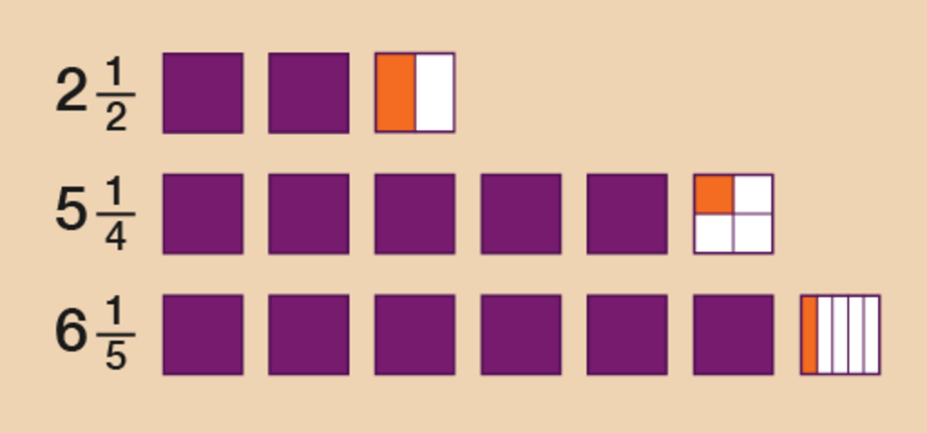
Figure 17 Drawing the fractions
View description - Figure 17 Drawing the fractions

- The correct order would be:
- 1 , 2 , 2
- Looking at the whole numbers, 1 would be the smallest because the other two mixed numbers are both greater than 2. To see which is bigger out of 2 or 2 , you need to compare the fraction part. Which is bigger: or ?
- To work this out, you could draw images as above, or you could use the method we looked at earlier where you change to equivalent fractions – the bottom numbers of the fractions are 5 and 2, and the lowest common multiple of 5 and 2 is 10:
- 5 × 2 = 10
- 2 × 5 = 10
- Whatever you do to the bottom, do to the top:
- If you mulitiply the top and bottom numbers in by 2, you make .
- If you mulitiply the top and bottom numbers in by 5, you make .
- () is smaller than (), so 2 is smaller than 2.
Back to - Activity 20: Putting fractions in order

Activity 21: Simplifying fractions

Answer
- = (the top and bottom numbers are divided by 5)
- = (the top and bottom numbers are divided by 5)
- = (the top and bottom numbers are divided 2)
- = (the top and bottom numbers are divided 2)
- = (the top and bottom numbers are divided 3)
Back to - Activity 21: Simplifying fractions

Activity 22: Paying in instalments

Answer
To work out of £12 000 you need to divide £12 000 by 5.
- 12 000 ÷ 5 = 2 400
Now multiply by the number on the top of the fraction:
- 2 400 × 1 = £2 400
So at Stage 1 the builder will need £2 400.
To work out of £12 000 you need to first work out of £12 000. To do this you need to divide £12 000 by 3.
- 12 000 ÷ 3 = 4 000
You now need to work out of £12 000 so you multiply by the number on the top of the fraction:
- 4 000 × 2 = 8 000
So at Stage 2 the builder will need £8 000.
Back to - Activity 22: Paying in instalments

Activity 23: Decimal dilemmas

Part

Answer
- Any child that is more than 0.95 m tall will be allowed on the ride. So to answer the question you need to compare the height of each child with 0.95 m.

 | Tenths | Hundredths
Margaret | 8 | 5
David | 9 | 9
Suha | 8 | 9
Prabha | 9 | 2

- Comparing the tenths tells us that only two children may possibly be allowed on the ride: David and Prabha.
- If we go on to compare the hundredths, we see that only David is taller than 0.95 m.
- So only David would be allowed on the Wacky Wheel.
- You need to compare the tens, units, tenths and hundredths, in that order.

 | Tens | Units | . | Tenths | Hundredths
Sonia | 1 | 0 | . | 9 | 5
Anjali | 1 | 0 | . | 5 | 9
Anita | 1 | 0 | . | 9 | 1
Aarti | 1 | 0 | . | 9 | 9
Sita | 1 | 0 | . | 5 | 8
Susie | 1 | 0 | . | 5 | 6

- All of the times have the same number of tens and units, so it is necessary to go on to compare the tenths.
- The three times with the lowest number of tenths are 10.59, (Anjali), 10.58 (Sita) and 10.56 (Susie). If we now go on to compare the hundredths in these three times, we see that the lowest times are (lowest first): 10.56, 10.58 and 10.59.
- So medals go to:
  - Susie (10.56 secs): gold
  - Sita (10.58 secs): silver
  - Anjali (10.59 secs): bronze
- Again, we need to compare the tens, units, tenths and hundredths, in that order.

 | Tens | Units | . | Tenths | Hundredths
Janak | 2 | 3 | . | 9 | 5
Nadia | 2 | 3 | . | 8 | 9
Carol | 2 | 3 | . | 9 | 8
Tracey | 2 | 3 | . | 8 | 8

- All the scores have the same number of tens and units. Looking at the tenths, two scores (23.95 and 23.98) have 9 tenths. If you compare the hundredths in these two numbers, you can see that 23.98 is bigger than 23.95.
- To find the third highest number, go back to the other two numbers, 23.89 and 23.88. Comparing the hundredths, you can see that 23.89 is the higher number. So the top three competitors are:
  - Carol (23.98)
  - Janak (23.95)
  - Nadia (23.89)
Back to - Part

Activity 24: Rounding

Answer
- The answers are as follows:
  - The nearest whole number to 3.72 is 4.
The nearest whole number to 8.4 is 8.
So our approximate answer is:
4 + 8 = 12
  - The nearest whole number to 9.6 is 10.
The nearest whole number to 1.312 is 1.
So our approximate answer is:
10 – 1 = 9
  - The nearest whole number to 2.8 is 3.
The nearest whole number to 3.4 is 3.
So our approximate answer is:
3 × 3 = 9
  - The nearest whole number to 9.51 is 10.
The nearest whole number to 1.5 is 2.
So our approximate answer is:
10 ÷ 2 = 5
- The answers are as follows:
  - To round to two decimal places, look at the third digit after the decimal point. This is more than 5, so round the previous digit (4) up to 5.
The answer is 3.85.
  - In this case, the third digit after the decimal point is less than 5, so leave the previous digit unchanged.
The answer is 2.98.
  - The third digit after the decimal point here is 5. Remember in this case we always round up.
The answer is 3.48.
Back to - Activity 24: Rounding

Activity 25: Rounding to the nearest 10p

Answer
- 10p
- 30p
- 40p
- £4.70
- £8.60
- £14.90
Back to - Activity 25: Rounding to the nearest 10p

Activity 26: Rounding to the nearest £

Answer
- £6
- £10
- £1
- £13
- £26
- £53
Back to - Activity 26: Rounding to the nearest £

Activity 27: Using decimals

Answer
- 7.9
- 1.6
- 55.69
- 50.5
- £190.37
- 1.35 m
Back to - Activity 27: Using decimals

Activity 28: Multiplying decimals by 10, 100, 1000

Answer
- 163
- 52.7
- 8 205
- 67 320
- 48 851
- 59 240
Back to - Activity 28: Multiplying decimals by 10, 100, 1000

Activity 29: Multiplying decimals

Answer
- 2.8
- 0.12
- 56.1
- 13.882 (13.88 to 2 dp)
- 1.121 (1.12 to 2 dp)
- 4.183 (4.18 to 2 dp)
- £6.45
- £335.625 (£335.63 to 2 dp)
Back to - Activity 29: Multiplying decimals

Activity 30: Dividing decimals by 10, 100, 1 000

Answer
- 5.708
- 0.609
- 4.3357
- 0.512
- 0.89934
- 0.06751
Back to - Activity 30: Dividing decimals by 10, 100, 1 000

Activity 31: Dividing a decimal by a whole number

Answer
- 1.41
- 15.98
- 7.82
- 141.02
- 0.169
- 37.6425
- £43.95 per month
- £8.70 each
Back to - Activity 31: Dividing a decimal by a whole number

Activity 32: Dividing a decimal by a decimal

Answer
- 3
- 360
- 26.5
- 62.5
- 18.35 (to 2 dp)
- 5.23 (to 2 dp)
- 62.5 cups
- 38 slabs
Back to - Activity 32: Dividing a decimal by a decimal

Activity 33: Using decimals

Answer
- The answers are as follows:
  - Add the cost of the two items:
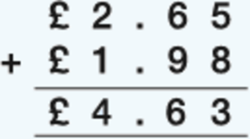
(Keep the decimal points in line.)
The total cost of the items is £4.63.
  - Take away the total cost from £5:
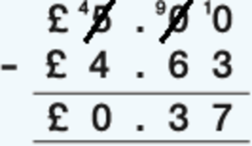
You should get 37p change from £5. You may have used a different method to work this out.
- Multiply the exchange rate in euros (€1.4) by the amount in pounds (£8):
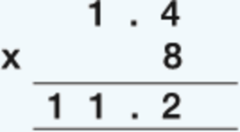
So £8 = €11.20. You may have used a different method to work this out.
- Divide the total cost (£56.60) by the number of people (4):
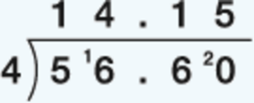
You would each pay £14.15.
- To convert 6.25 m into cm, you need to multiply the amount by 100.
  - 6.25 × 100 = 625
So the answer is 625 cm.
Back to - Activity 33: Using decimals

Activity 34: Finding percentages of amounts

Part

Answer

Method 1
In order to identify how much the deposit is, you need to find out what 20% () of £800 is. To do this, first you need to find out 1% () of £800:
- 800 ÷ 100 = 8
So 20% () of £800 is:
- 8 × 20 = 160
The deposit is £160.

Method 2
In order to calculate 10%, or , you need to divide the number by 10:
- 800 ÷ 10 = 80
You now have 10% and you need 20%. Therefore you need to multiply your 10% by 2:
- 80 × 2 = 160
The deposit is £160.
Back to - Part

Part

Answer
There are different ways you could have worked out the answers to these calculations. One method is suggested in brackets in each case, but you may have used a different method.
- £85 (170 ÷ 2 = 85)
- £75 (Finding 10% is 250 ÷ 10 = 25, so 30% = 3 × 25 = 75)
- £30 (120 ÷ 4 = 30)
- £42 (75% is ; 56 ÷ 4 = 14, and then 14 × 3 = 42)
- £76 (Finding 10% is 95 ÷ 10 = 9.50, so 80% = 8 × 9.50 = 76)
- £31 (Finding 10% is 620 ÷ 10 = 62, so 5% = 62 ÷ 2 = 31)
Back to - Part

Activity 35: Calculating percentage increases and decreases

Answer
- In order to identify how much the value of the car will decrease by, you need to find out what 25% () of £9 000 is. You can work this out in several different ways. Find 1% () first:
  - 9 000 ÷ 100 = 90
Then find 25% () by multiplying by 25:
  - 25 × 90 = 2 250
Alternatively, you could have found 25% of £9 000 by dividing 9 000 by 4 (25% = ):
  - 9 000 ÷ 4 = 2 250
- The car’s value depreciates by £2 250 in the first year, so the value of the car at the end of the first year will be:
  - £9 000 – £2 250 = £6 750
- It might be easier in this example to convert £10 into pence (£10 = 1 000p). In order to identify the new value of the share, you need to find out what 30% () of 1 000p is. To do this, first you need to find out 1% () of 1 000p:
  - 1 000 ÷ 100 = 10
- So 30% () of 1 000p is:
  - 30 × 10 = 300
So the price of one share has increased by 300p (£3.00), so the one share is now worth:
  - £10 + £3 = £13
Alternatively, you could have found 10% by dividing by 10:
  - 1 000 ÷ 10 = 100
You would then multiply by 3 to find 30%:
  - 3 × 100 = 300
- In order to identify Shop A’s discount, you need to find out what 25% () of £500 is. To do this, first you need to find out 1% () of £500:
  - 500 ÷ 100 = 5
So 25% () of £500 is:
  - 5 × 25 = 125
The discount is £125, so you would have to pay:
  - £500 – £125 = £375
You may have worked out 25% of £500 differently. Because 25% is the same as , you may have divided by 4:
  - 500 ÷ 4 = 125
Alternatively, you could have halved and halved again:
  - 500 ÷ 2 = 250
  - 250 ÷ 2 = 125
In order to identify Shop B’s discount, you need to find out what 10% () of £400 is. To do this, first you need to find out 1% () of £400:
  - 400 ÷ 100 = 4
So 10% () of £400 is:
  - 4 × 10 = 40
The discount is £40, so you would have to pay:
  - £400 – £40 = £360
You may have found 10% of £400 by dividing by 10:
  - 400 ÷ 10 = 40
Whichever method you used, Shop B offers the best deal.
Back to - Activity 35: Calculating percentage increases and decreases

Activity 36: Looking for equivalencies

Answer
- 0.75 as a fraction is .
- 0.25 is the same as , so you will have walked of a kilometre.
- is the same as 50%, so the increase is 50%.
- 50% is the same as , so the discount as a fraction is .
- 20% is the same as 0.2, so the increase as a decimal is 0.2.
- 10% is the same as , so according to the headline, the number is predicted to rise by .
- Think of this as a fraction first: 15 minutes is a quarter () of an hour. is the same as 25%, so 15 minutes is 25% of an hour.
Back to - Activity 36: Looking for equivalencies

Activity 37: Using ratios

Answer
- 10:7
- A ratio of 3:1 means three parts of sand to one part of cement, making four parts in total. If the cement (one part) is 40kg, then the sand (three parts) will be:
  - 3 × 40 kg = 120 kg
- A ratio of 1:7 means one part of wallpaper stripper to seven parts of water, making eight parts in total.
We need 16 litres of solution. If eight parts are worth 16 litres, this means that one part is worth:
  - 16 litres ÷ 8 = 2 litres
So 16 litres of solution requires:
  - Wallpaper stripper: one part × 2 litres = 2 litres
Water: seven parts × 2 litres = 14 litres
You can confirm that these figures are correct by adding them and checking that they match the amount needed:
  - 2 litres + 14 litres = 16 litres
- The ratio of 1:4 means one part hair colourant to four parts water, making five parts in total.
We need 400 ml of solution. If five parts are worth 400 ml, this means that one part is worth:
  - 400 ml ÷ 5 = 80 ml
So 400 ml of solution requires:
  - Hair colourant: one part × 80 ml = 80 ml
Water: four parts × 80 ml = 320 ml
You can confirm that these figures are correct by adding them and checking that they match the amount needed:
  - 80 ml + 320 ml = 400 ml
Back to - Activity 37: Using ratios

Activity 38: Scaling up recipes

Answer
- To make 20 cookies you need twice as much of each ingredient:
  - 440 g flour (220 × 2)
  - 300 g butter (150 × 2)
  - 200 g sugar (100 × 2)
  - 4 eggs (2 × 2)
- To make milkshakes for two people you need half as much of each ingredient:
  - 400 ml milk (800 ÷ 2)
  - 100 g strawberries (200 ÷ 2)
  - 2 scoops of ice cream (4 ÷ 2)
- To make dessert for six people you need three times the amount of each ingredient:
  - 900 ml milk (300 × 3)
  - 180 g powder (60 × 3)
Back to - Activity 38: Scaling up recipes

Activity 39: Looking at ratio and proportion

Answer
- A ratio of 1:9 means one part curtain whitener to nine parts water, making ten parts in total.
You need 2 000 ml of solution. If ten parts are worth 2 000 ml, this means that one part is worth:
  - 2 000 ml ÷ 10 = 200 ml
So 2 000 ml of solution requires:
  - Curtain whitener: one part × 200 ml = 200 ml
Water: nine parts × 200 ml = 1 800 ml
You can confirm that these figures are correct by adding them and checking that they match the amount needed:
  - 200 ml + 1 800 ml = 2 000 ml
- To make enough risotto for six people you need three times as much of each ingredient:
  - 600 g of mushrooms (200 × 3)
  - 525 g of rice (175 × 3)
  - 540 ml of water (180 × 3)
  - 540 ml of evaporated milk (180 × 3)
Back to - Activity 39: Looking at ratio and proportion

Activity 40: Using formulas

Part

Answer
To answer this you need to multiply the amount Harvey earns in an hour (£7.75) by the number of hours (eight):
- £7.75 × 8 = £62.00
Back to - Part

Part

Answer
- You need to use a two-step formula to answer each of these questions. To work out how long a 2 kg joint of pork takes to cook, you’ll need a formula with two steps:
  - Step 1: 40 minutes × number of kilograms
Step 2: Add 30 minutes
- Written as a formula, this is:
  - (40 × number of kilograms) + 30 = cooking time
So a 2 kg joint would take:
  - (40 × 2) + 30 = 110 minutes, or 1 hour and 50 minutes
- Using the same formula, a 1.5 kg joint would take:
  - (40 × 1.5) + 30 = 90 minutes, or 1 hour and 30 minutes
Back to - Part

Part

Answer
The information in the question gives you two formulas. To answer the question you need to find the answers to both formulas and add the results together.
The contract costs £15 a month for the first four months. So the formula for this part of the contract is:
- £15 × 4 = £60
After the first four months the contract is £20 a month. The question asks you the total cost of the phone contract for one year, so you need to calculate how much you would pay for another eight months:
- £20 × 8 = £160
So the total cost of the contract for one year is:
- £60 + £160 = £220
Back to - Part

Activity 1: Which unit?

Answer
Suggested answers:
- Centimetres or millimetres
- Kilometres
- Centimetres or millimetres
- Metres
- Metres
- Kilometres
- Centimetres
- Centimetres or metres
- Centimetres
- Millimetres
Back to - Activity 1: Which unit?

Activity 2: How long?

Answer
The correct matches are:
The height of a man
175 cm
The length of a pen
15 cm
The length of an A4 piece of paper
30 cm
The height of a double-decker bus
4 m
The length of a swimming pool
25 m
The length of an eyelash
10 mm
The length of a half marathon
20 km
Back to - Activity 2: How long?

Activity 3: Building a shelf for DVDs

Part

Answer
- The DVD case is 19 cm tall.

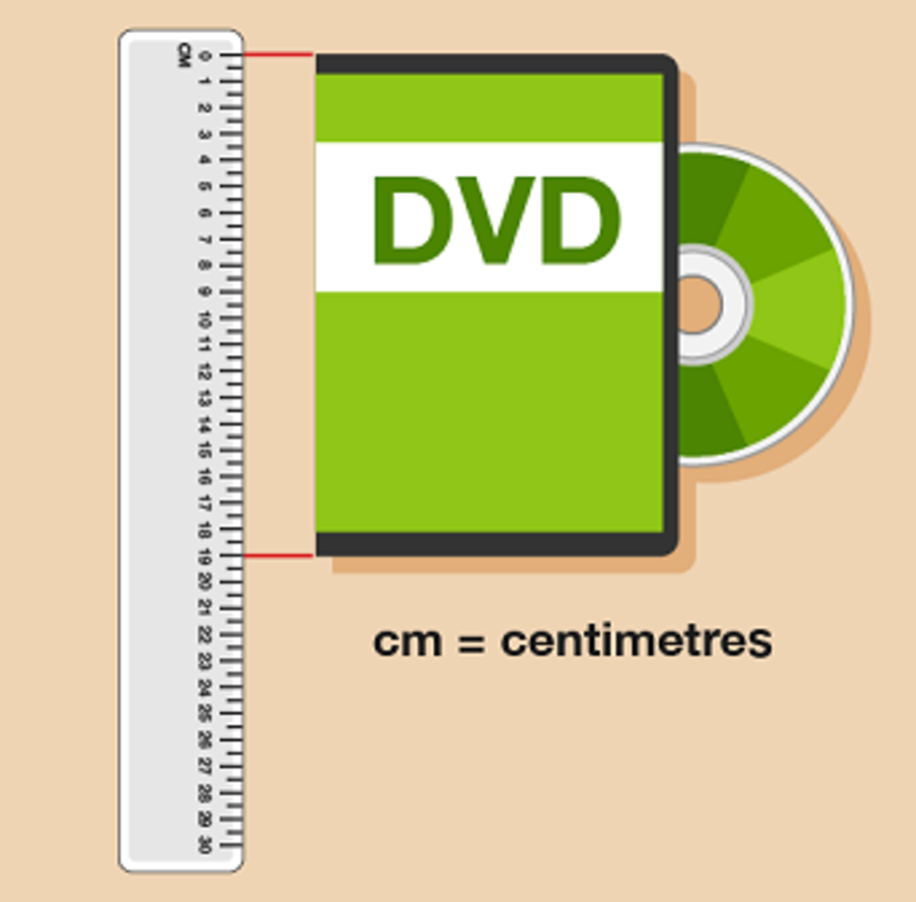
Figure 5 Measuring a pen (answer)
View description - Figure 5 Measuring a pen (answer)

- The end of the screw is halfway between 2 and 3 cm, so the screw is 2.5 cm (2 cm) long. Note here how the measurement is not a whole number. Often items have to be measured very precisely: when this is the case, it may not be appropriate to round off to the nearest centimetre, for instance.

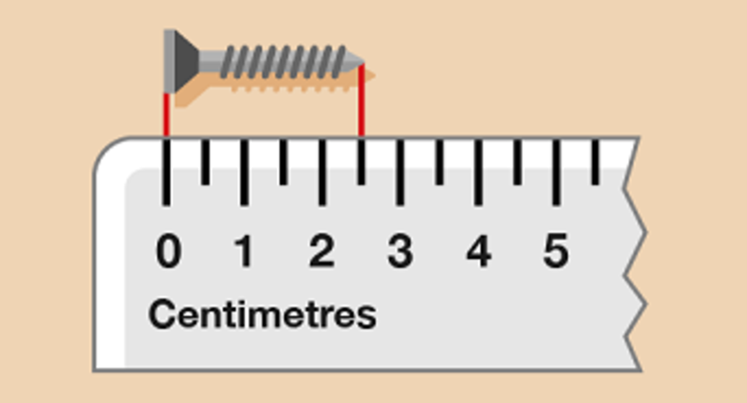
Figure 6 Measuring a screw (answer)
View description - Figure 6 Measuring a screw (answer)

- The screw head is 5 mm wide.

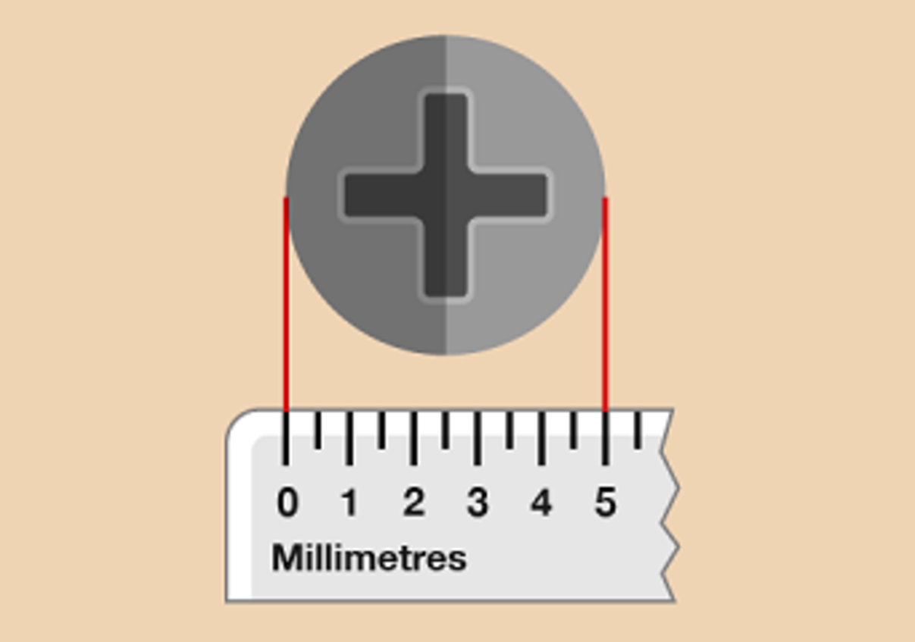
Figure 7 Measuring a screw head (answer)
View description - Figure 7 Measuring a screw head (answer)

Back to - Part

Activity 4: Writing measurements in different ways

Answer

Measurements
Centimetres and millimetres | Centimetres | Millimetres
1 cm 7 mm | 1.7 cm | 17 mm
8 cm 9 mm | 8.9 cm | 89 mm
9 cm 4 mm | 9.4 cm | 94 mm
6 cm 3 mm | 6.3 cm | 63 mm
12 cm 6 mm | 12.6 cm | 126 mm
10 cm 5 mm | 10.5 cm | 105 mm
20 cm 1 mm | 20.1 cm | 201 mm

Back to - Activity 4: Writing measurements in different ways

Activity 5: Converting lengths

Answer
- 20 mm ÷ 10 = 2 cm
- 54 mm ÷ 10 = 5.4 cm
- 0.5 cm × 10 = 5 mm
- 8.6 cm × 10 = 86 mm
- 400 cm ÷ 100 = 4 m
- 325 cm ÷ 100 = 3.25 m
- 12 m × 100 = 1 200 cm
- 6.8 m × 100 = 680 cm
- There are 10 mm in 1 cm, so divide by 10 first to convert 450 mm to 45 cm. There are 100 cm in 1 m, so divide 45 cm by 100 to get the answer, 0.45 m.
- There are 100 cm in 1 m, so multiply by 100 first to convert 2 m to 200 cm. There are 10 mm in 1 cm, so multiply 200 cm by 10 to get the answer, 2 000 mm.
- 8 km × 1 000 = 8 000 m
- 500m ÷ 1 000 = 0.5 km
- There are 100 cm in 1 m, so to convert from metres to centimetres you need to multiply by 100:
  - 1.6 m × 100 = 160 cm
- To convert from centimetres to millimetres, you need to multiply the figure in centimetres by 10. The size is 80 cm, so the answer is:
  - 80 × 10 = 800 mm
- To convert from centimetres to metres, you need to divide the figure in centimetres by 100. The length of fabric you need is 30 cm, so the answer is:
  - 30 ÷ 100 = 0.3 m
Back to - Activity 5: Converting lengths

Activity 6: Matching the same measurement

Answer
The correct matches are:
500 cm
5 m
1.5 cm
15 mm
15 cm
150 mm
5 cm
50 mm
500 m
0.5 km
1.5 m
150 cm
1 500 cm
15 m
1 500 m
1.5 km
Back to - Activity 6: Matching the same measurement

Activity 7: Carrying out calculations with length

Answer
You will have found it useful to refer to the metric conversion diagram for this activity.
- First you need to work out how many centimetres of ribbon you need:
  - 10 × 50 = 500 cm
Notice that the question asks how many metres of ribbon you need, rather than centimetres. So you need to divide 500 cm by 100 to find out the answer in metres:
  - 500 ÷ 100 = 5 m
- The measurements for the planters are in different units, so you need to convert everything into centimetres or metres first. The question does not specify whether your answer needs to be in centimetres or metres, so either will be OK.
Using Method 1, converting to centimetres, note that the length of the planter is 1.5 m:
  - 1.5 × 100 = 150 cm
The short sides are already in centimetres, so you can now add up the total for all four sides:
  - 150 cm + 60 cm + 150 cm + 60 cm = 420 cm
Using Method 2, converting to metres, the length of the planter is already in metres. The short sides are 60 cm, which you need to convert to metres:
  - 60 ÷ 100 = 0.6 m
You can now add up the total for the four sides:
  - 1.5 m + 0.6 m + 1.5 m + 0.6 m = 4.2 m
- The measurements for the curtains and the hem are given in different units. The question asks for the answer in metres, so you need to convert everything into metres first:
  - 20 cm ÷ 100 = 0.2 m
You can now add up the total amount of fabric needed for the curtains:
  - 1.8 m + 1.8 m + 0.2 m + 0.2 m = 4.0 m (4 m)
- The measurements for the storage boxes and shelves are given in different units, so you need to convert everything into centimetres or metres first. The question does not specify whether your answer needs to be in centimetres or metres, so either will be OK.
Using Method 1, converting to centimetres, the shelves are 2 m wide. First you need to convert this to centimetres:
  - 2 m × 100 = 200 cm
The storage boxes are already in centimetres, so you can now work out the width of four of them.
  - 45 cm × 4 = 180 cm
So the shelves would be suitable.
Using Method 2, converting to metres, the shelves are already in metres, but the boxes measure 45 cm.
  - 45 cm ÷ 100 = 0.45 m
I need four boxes:
  - 0.45 m × 4 = 1.80 m (1.8 m)
The shelves would be suitable. Another way of doing this is to work out how wide four boxes would be in centimetres and convert the answer to metres:
  - 45 cm × 4 = 180 cm
  - 180 cm ÷ 100 = 1.80 m (1.8 m)
Back to - Activity 7: Carrying out calculations with length

Activity 8: Reading a mileage chart

Answer
- The distance between Newtown and Bala is 47 miles.
- The distance from Connah’s Quay to Newtown is 63 miles, so the Nomads’ supporters would have to travel 126 miles (63 × 2).
- To calculate this, you must check the places to the right of Connah’s Quay in the table (Llanelli, 148 miles; Newtown, 63 miles) and the towns to the left of Connah’s Quay in the table (Caernarfon, 60 miles; Bala, 38 miles; Aberystwyth, 87 miles). So the home ground of Bala Town would be the closest to the Connah’s Quay Nomads.
Back to - Activity 8: Reading a mileage chart

Activity 9: A European journey

Answer
- The closest to Florence is Zeebrugge (821 miles).
- The distance between Cologne and Dieppe is 328 miles.
- If you were staying in Amsterdam, the closest port would be Hook of Holland (53 miles).
Back to - Activity 9: A European journey

Activity 10: Travelling across the UK

Answer
- The answers are as follows:
  - You need to look up all the distances and then add them together:
London to Cardiff is 150 miles.

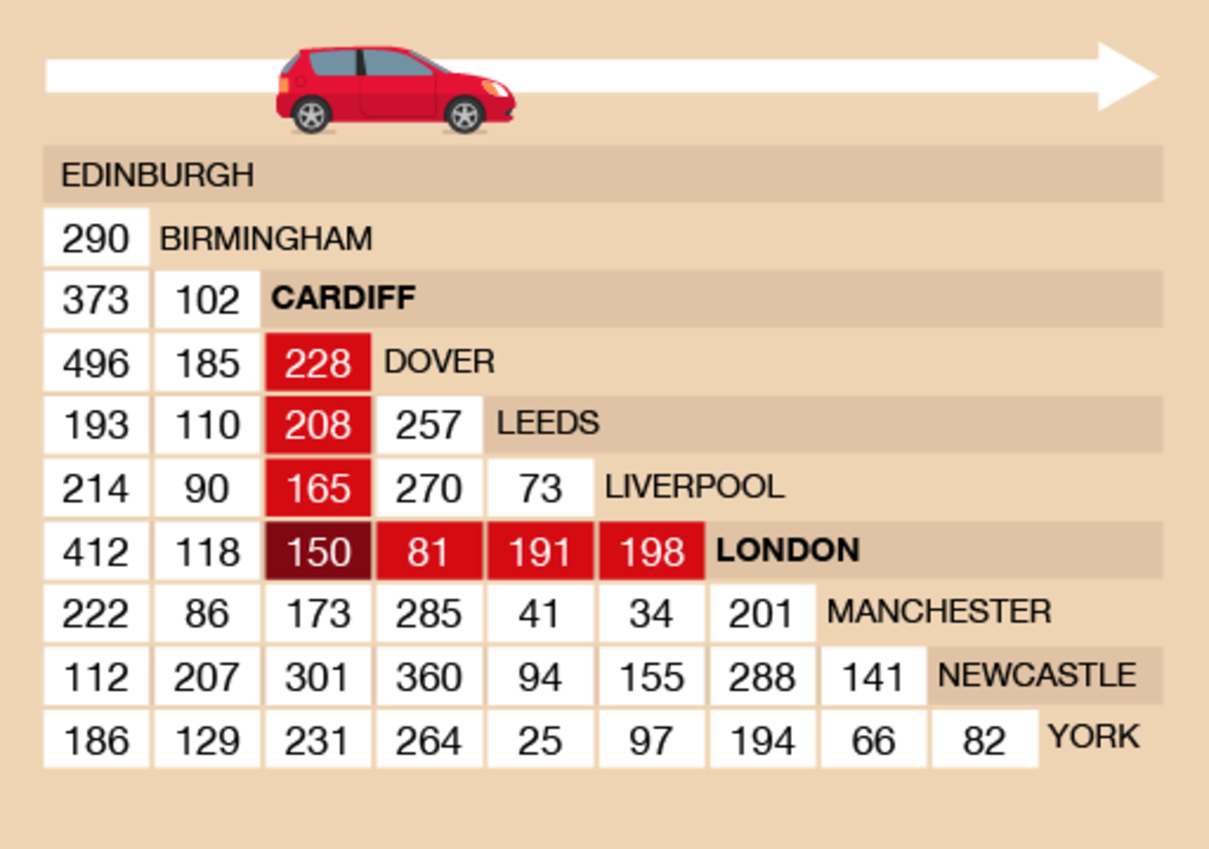
Figure 17 London to Cardiff on a mileage chart
View description - Figure 17 London to Cardiff on a mileage chart

Cardiff to Liverpool is 165 miles.

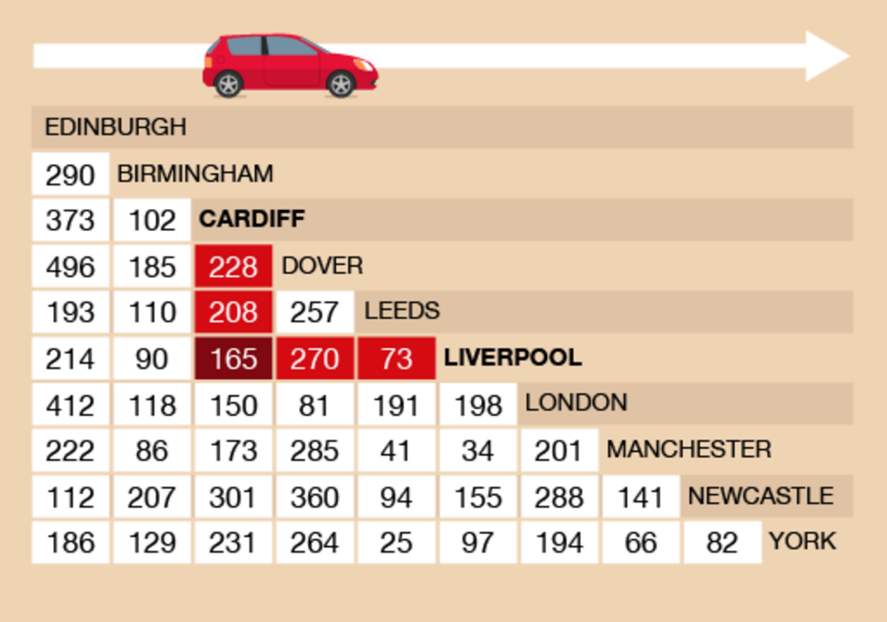
Figure 18 Cardiff to Liverpool on a mileage chart
View description - Figure 18 Cardiff to Liverpool on a mileage chart

Liverpool to London is 198 miles.

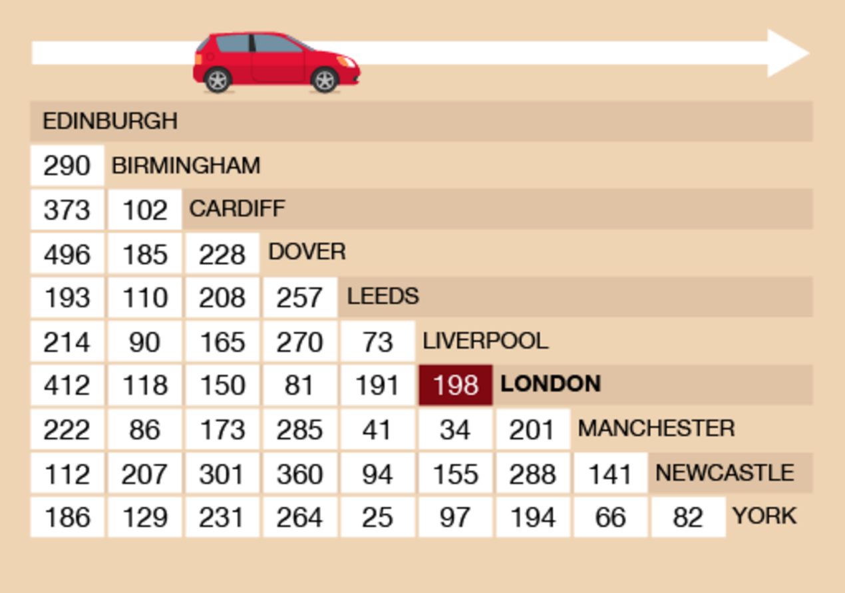
Figure 19 Liverpool to London on a mileage chart
View description - Figure 19 Liverpool to London on a mileage chart

So the total distance is:
  - 150 + 165 + 198 = 513 miles
  - The total distance is 513 miles and you pay 10p for each mile you drive. So you would pay:
  - 513 × 10 = 5 130p
  - You would not usually express an amount of money in this way, so let’s divide this total by 100 to find the amount in pounds:
  - 5 130 ÷ 100 = £51.30
- You need to look up all the distances and then add them together. Cardiff to Manchester is 173 miles; Manchester to York is 66 miles; and York to Cardiff is 231 miles. So the total distance is:
  - 173 + 66 + 231 = 470 miles
Back to - Activity 10: Travelling across the UK

Activity 11: Reading scales

Answer
- There are nine marks between 100 g and 200 g, so each mark represents 10 g. The needle is at the fourth mark after 100g, so there is:
  - 100 + 40 = 140 g of sugar
- The needle is halfway between 60 kg and 70 kg, so the person weighs 65 kg.
- There are nine marks between 0 g and 100 g, so there’s a mark at every 10 g. The needle is two marks before 100 g, so the letter weighs:
  - 100 – 20 = 80 g
Back to - Activity 11: Reading scales

Activity 12: Weighing things

Discussion
Our suggestions are shown in the table below. Your estimates and measured weights might be different, but they should be roughly similar.

Item | Estimated weight | Actual weight
Ten teabags | 25 g | 30 g
Bottle of sauce | 500 g | 450 g
Book | 900 g | 720 g

A case of ten bottles of sauce would weigh:
- 450 × 10 = 4 500 g
As previously noted, 1 000 g = 1 kg, so 4 500 g = 4.5 kg, which is how you would more usually express this weight.
If your book weighed more than ours, you might have given its weight in kilograms. If you chose a small book, it may have weighed a lot less.
Back to - Activity 12: Weighing things

Activity 13: Converting metric units of weight

Answer
- The answers are as follows:
  - 3 000 g ÷ 1 000 = 3 kg
  - 9 500 g ÷ 1 000 = 9.5 kg
  - 750 g ÷ 1 000 = 0.75 kg
  - 10 000 g ÷ 1 000 = 10 kg
- The answers are as follows:
  - 4 kg × 1 000 = 4 000 g
  - 1.5 kg × 1 000 = 1 500 g
  - 7.6 kg × 1 000 = 7 600 g
  - 2.25 kg × 1 000 = 2 250 g
Back to - Activity 13: Converting metric units of weight

Activity 14: Carrying out calculations with weight

Answer
- You need to decide whether to convert everything into grams or kilograms first. Using Method 1, converting everything into grams, the total weight of the jam in grams will be:
  - 3 kg × 1 000 = 3 000 g
The weight of the fruit is:
  - 1 kg × 1 000 = 1 000 g + 800 g = 1 800 g
Now you can take the weight of the fruit away from the total weight needed:
  - 3 000 g – 1 800 g = 1 200 g
If needed, you can convert to kilograms:
  - 1 200 g ÷ 1 000 = 1.2 kg
Using Method 2, expressing the weight of the fruit in kilograms, the weight of the fruit is 1 kg 800 g, which is 1.8 kg. If you take the weight of the fruit away from the total weight of the jam needed, the answer is:
  - 3 kg – 1.8 kg = 1.2 kg
- You need to decide whether to convert everything into grams or kilograms first. Using Method 1, converting everything to grams first:
  - Parcel 1: 1.25 kg × 1 000 = 1 250 g
Parcel 2: 3.5 kg × 1 000 = 3 500 g
Parcel 3: 600g
- Add the weights of the parcels in grams:
  - 1 250 g + 3 500 g + 600 g = 5 350 g
The question wants the answer in kilograms, you will need to convert:
  - 5 350 g ÷ 1 000 = 5.35 kg
Using Method 2, converting everything to kilograms first:
  - Parcel 1: 1.25 kg
Parcel 2: 3.5 kg
Parcel 3: 600 g ÷ 1 000 = 0.6 kg
Add the weights of the parcels in kilograms:
  - 1.25 kg + 3.5 kg + 0.6 kg = 5.35 kg
- If the maximum hand luggage is 7 kg and the case weighs 3.1 kg, then you can pack the following amount without going over the maximum limit:
  - 7 kg – 3.1 kg = 3.9 kg
You may have worked this out in grams:
  - Maximum weight: 7 kg × 1 000 g = 7 000 g
Weight of case: 3.1 kg × 1 000 = 3 100 g
Amount of luggage: 7 000 g – 3 100 g = 3 900 g
- To work out the answer, convert the puppy’s weight at seven weeks into grams first:
  - 2.3 kg × 1 000 = 2 300 g
The puppy puts on 800 g a week:
  - Week 8: 2 300 g + 800 g = 3 100 g
Week 9: 3 100 g + 800 g = 3 900 g
Week 10: 3 900 g + 800 g = 4 700 g
You may want to express you answer in kilograms:
  - 4 700 g ÷ 1 000 = 4.7 kg
Back to - Activity 14: Carrying out calculations with weight

Activity 15: Looking at capacity (volume)

Answer
- I estimated that my cup holds 400 ml. It actually holds 350 ml. Your answer may be quite different to this, depending on the size of the cup.
- The divisions are marked every 0.1 ml. The syringe should look like this:

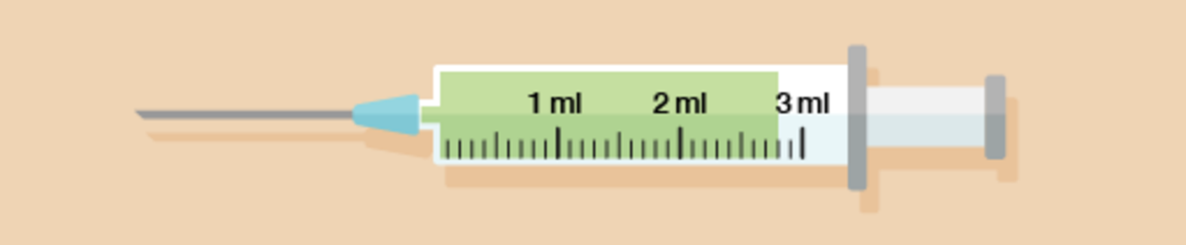
Figure 32 A syringe (answer)
View description - Figure 32 A syringe (answer)

- The plumber has drained two full one-litre jugs and three-quarters of another jug, making 2.75 litres in total. This could also be written as 2 750 ml or 2 litres 750 ml.
Back to - Activity 15: Looking at capacity (volume)

Activity 16: Converting metric units of capacity

Answer
- The answers are as follows:
  - 4 000 ml ÷ 1 000 = 4 litres
  - 3 500 ml ÷ 1 000 = 3.5 litres
  - 650 ml ÷ 1 000 = 0.65 litres
  - 8 575 ml ÷ 1 000 = 8.575 litres
- The answers are as follows:
  - 9 litres × 1 000 = 9 000 ml
  - 2.5 litres × 1 000 = 2 500 ml
  - 4.8 litres × 1 000 = 4 800 ml
  - 8.95 litres × 1 000 = 8 950 ml
Back to - Activity 16: Converting metric units of capacity

Activity 17: Carrying out calculations involving capacity

Answer
- First you need to work out how much soup you will need in millilitres:
  - 100 × 400 = 40 000 ml
To convert from millilitres to litres, you need to divide the figure in millilitres by 1 000. So the amount of milk you need in litres is:
  - 40 000 ÷ 1 000 = 40 litres
- First you need to work out how many millilitres are in 2 litres of glue:
  - 2 × 1 000 = 2 000 ml
This amount is then divided between the twenty people working in the shop:
  - 2 000 ÷ 20 = 100 ml each
To convert this into centilitres, you would divide this answer by 10:
  - 100 ÷ 10 = 10 cl each
- First add together the amount of milk Willow has used:
  - 350 ml + 25 ml + 100 ml = 475 ml
The carton holds two litres, which in millilitres is:
  - 2 litres × 1 000 = 2 000 ml
Now take the amount used away from the amount the carton holds:
  - 2 000 ml – 475 ml = 1 525 ml
So 1 525 ml is left in the carton.
- The quantities stated are enough to make the drink for eight people. If 24 people are invited to the party, Ben will need three times as much ingredients as stated in the recipe (8 × 3 = 24). So he will need:
  - 500 ml × 3 = 1 500 ml of cranberry juice (1 500 ÷ 1 000 = 1.5 litres)
500 ml × 3 = 1 500 ml of grape juice (1 500 ÷ 1 000 = 1.5 litres)
250 ml × 3 = 750 ml of orange juice (750 ÷ 1 000 = 0.75 litres)
1 litre × 3 = 3 litres of sparkling water (this is already in litres, so no conversion is needed)
- To see if the bowl will be big enough, we need to add the quantities expressed in litres together:
  - 1.5 litres + 1.5 litres + 0.75 litres + 3 litres = 6.75 litres
So the eight-litre drinks dispenser will be big enough.
Back to - Activity 17: Carrying out calculations involving capacity

Activity 18: Reading thermometers

Answer
- Each mark on the thermometer represents 20°C and the needle is at the mark below 400, so the temperature is 380°C.
- The reading is on the mark halfway between 38°C and 39°C, so the temperature is 38.5°C.
- Each mark represents 2°C, so the temperature is 16°C.
Back to - Activity 18: Reading thermometers

Activity 19: Celsius and Fahrenheit

Answer
- You will see on the conversion chart that 150°C is equivalent to 302°F. The oven would not be marked this accurately, so you should set it to 300°F.
- The thermometer shows 2°F, which you need to find the Celsius equivalent of. Five degrees Fahrenheit is –15°C; –4°F is –20°C. The temperature is between –15°C and –20°C, so the food is stored safely.
- You need to find 600°F on the chart. You will see that 300°C is 572°F, and that 350°C is more than 600°F. The temperature on the dial is even higher than this, at 370°C. The machine is therefore not safe and must be switched off.
Back to - Activity 19: Celsius and Fahrenheit

Activity 20: The 24-hour clock

Answer
- 08:15
- 14:50
- 05:40
- 21:22
- 09:50
- 18:05
Back to - Activity 20: The 24-hour clock

Activity 21: Time difference

Answer
- The start time is 03:55.
The number of minutes between 03:55 and the start of the next hour, 04:00, is 5 minutes.
The number of hours between 04:00 and 06:00 is two hours.
The number of minutes between 06:00 and 06:35 is 35 minutes.
So the time between 03:55 to 06:35 is:
  - 5 minutes + 35 minutes + 2 hours = 2 hours 40 minutes
- The start time is 09:45.
The number of minutes between 09:45 and the start of the next hour, 10:00, is 15 minutes.
The number of hours between 10:00 and 12:00 is two hours.
The number of minutes between 12:00 and 12:15 is 15 minutes.
So the time between 09:45 to 12:15 is:
  - 15 minutes + 15 minutes + 2 hours = 2 hours 30 minutes
Following the same method, you should have these answers for the other questions:
- 1 hour 48 minutes
- 5 hours 15 minutes
- 3 hours 50 minutes
- 20 hours 45 minutes
Back to - Activity 21: Time difference

Activity 1: Identifying polygons

Answer
Shapes (a), (c), (d) and (e) are polygons. Shapes (b) and (f) are not polygons because they have curved sides.
Back to - Activity 1: Identifying polygons

Activity 2: Angles

Answer
Angles (a) and (f) are obtuse angles (greater than 90°).
Angles (b) and (d) are acute angles (less than 90°).
Angles (c) and (e) are right angles (exactly 90°).
Back to - Activity 2: Angles

Activity 3: 2D or 3D?

Answer
Shapes (a), (c) and (e) are 2D.
Shapes (b), (d) and (f) are 3D.
Back to - Activity 3: 2D or 3D?

Activity 4: Properties of 3D shapes

Part

Answer

Shape | Number of faces
Cube | 6
Square-based pyramid | 5
Sphere | 1
Cylinder | 3
Cuboid | 6
Cone | 2
Triangular-based pyramid | 4
Triangular prism | 5

As well as faces, 3D shapes also have edges and vertices (corners):

Watch the video at YouTube.com.

Back to - Part

Part

Answer

Shape | Number of edges | Number of vertices
Cube | 12 | 8
Square-based pyramid | 8 | 5
Sphere | 0 | 0
Cylinder | 2 | 0
Cuboid | 12 | 8
Cone | 1 | 1
Triangular-based pyramid | 6 | 4
Triangular prism | 9 | 6
A sphere has just one curved face, so it has no edges or vertices.

Back to - Part

Activity 5: Lines of symmetry

Answer

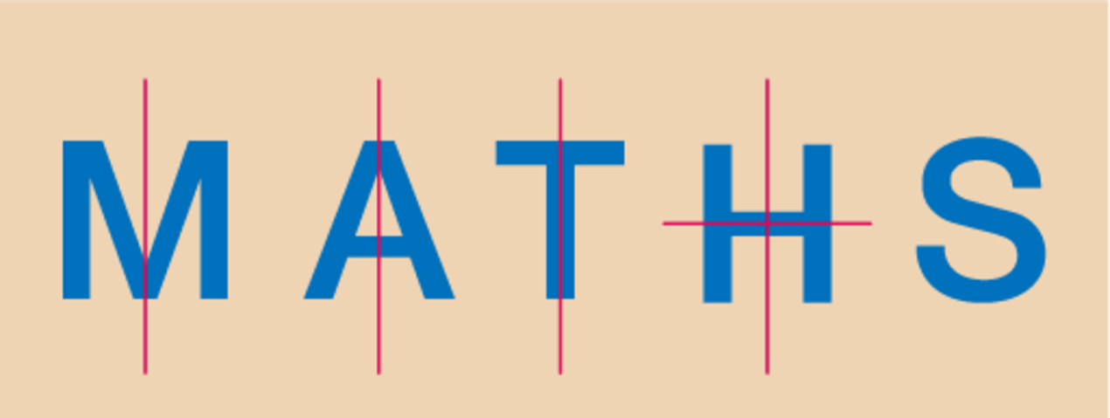
Figure 13 Lines of symmetry
View description - Figure 13 Lines of symmetry

‘M’, ‘A’ and ‘T’ have one line of symmetry.
‘H’ has two lines of symmetry.
‘S’ has no lines of symmetry.
Back to - Activity 5: Lines of symmetry

Activity 7: Finding the perimeter

Answer
- The sides of the tennis courts are 20 m and 40 m.
  - (2 × 20) + (2 × 40) = 40 + 80 = 120
So 120 m of bunting will be needed.
- The sides of the garden are 5 m and 4 m.
  - (2 × 5) + (2 × 4) = 10 + 8 = 18
So 18 m of fencing will be needed.
Back to - Activity 7: Finding the perimeter

Activity 8: Finding the perimeter

Answer
- To calculate the missing sides you should have carried out the following calculations:
  - 14 – 3 = 11
  - 15 – 1.5 = 13.5
Now that you have found the missing sides, you can add them all together:
  - 15 + 14 + 1.5 + 3 + 13.5 + 11= 58 m
- To calculate the missing sides you need to carry out the following calculations to calculate the perimeter:
  - 5 – 2 = 3
  - 6 – 2 = 4
Now that you have found the missing sides, you can add them all up together to calculate the perimeter:
  - 6 + 3 + 3 + 1 + 1 + 2 + 2 + 4 = 22 m
Back to - Activity 8: Finding the perimeter

Activity 9: Area of a rectangle

Answer

Length | Width | Area in square units (centimetres, metres, kilometres)
80 cm | 30 cm | 2 400 cm²
7 m | 4 m | 28 m²
2.5 km | 2 km | 5 km²
5.5 m | 2.4 m | 13.2 m²

Back to - Activity 9: Area of a rectangle

Activity 10: Finding the area

Answer
- The plastic sheeting needs to be:
  - 2.5 × 4 = 10 m²
- First you need to work out the area of the driveway:
  - 8 × 4 = 32 m²
If each bag covers half a square metre, you will need two bags for each square metre:
  - 32 × 2 = 64 bags
- First you need to change the width to centimetres. 25 mm is the same as 2.5 cm. Then you can work out the area:
  - 2.5 × 4 = 10 cm²
There are 80 yeast, so the amount of yeast per square centimetre (yeast/cm²) is:
  - 80 ÷ 10 = 8 yeast per cm²
The recording sheet should look like this:

Yeast count
Sample area no. | 21
Date | 17 October
Yeast count | 80
Sample dimensions | 2.5 cm × 4 cm
Sample area | 10 cm²
Yeast/cm² | 8

- The area of forestry land is:
  - 4.5 × 2 = 9 square miles
Back to - Activity 10: Finding the area

Activity 11: Calculating volume

Answer
- The answer is as follows:

Length | Width | Height | Volume
6 m | 2 m | 3 m | 36 m³
10 mm | 10 mm | 10 mm | 1 000 mm³
36 mm (convert to 3.6 cm) | 2 cm | 4 cm | 28.8 cm³
9 m | 2 m | 180 cm (convert to 1.8 m) | 32.4 m³

- First you need to convert 10 cm to metres – it’s 0.1 m. Then you can calculate area:
  - 1 m × 1.5 m × 0.1 m = 0.15 m³
- The volume of David’s store is 2 m × 1 m × 1 m = 2 m³, so it will be big enough to hold one load of the logs.
Back to - Activity 11: Calculating volume

Activity 12: Getting information from a scale drawing

Answer
- The answers are as follows:
  - The vegetable garden is 5 m long and 2 m wide.
  - The flower bed is 6 m long and 2 m wide.
  - The patio and vegetable garden are 3 m apart.
  - The distance between the patio and vegetable garden is 3 m and the trampoline is 3 m wide. So the trampoline would fit in the space, but it would be a bit of a squeeze.
- The scale is 1 cm : 50 cm. There are two measurements to work out, so you need to do one at a time. We will start with the width of 4 cm:
  - 1 cm : 50 cm
  - 4 cm : ? cm
You know what the measurement on the drawing is, so you need to multiply to find the real-life measurement:
  - 4 × 50 = 200 cm
You could then convert this measurement into metres. There are 100 cm in 1 metre, you need to divide by 100:
  - 200 ÷ 100 = 2 m
So the width of the actual patio is 2 m.
We will now work out the length of the actual patio. The scale is the same:
  - 1 cm : 50 cm
  - 8 cm : ? cm
Again, you know the measurement on the drawing, so you need to multiply to find the real-life measurement:
  - 8 × 50 = 400 cm
Again, we can divide this measurement by 100 to express it in metres:
  - 400 ÷ 100 = 4 m
So the length of the actual patio is 4 m.
- The scale is 1 cm : 2 m. There are two measurements to work out, so you need to do one at a time. We will start with the width of 5 m:
  - 1 cm : 2 m
  - ? cm : 5 m
As you know the real measurement, you need to divide to find the plan measurement:
  - 5 ÷ 2 = 2.5 cm
We will now work out the length. The scale is the same:
  - 1 cm : 2 m
  - ? cm : 6 m
Again, we need to work out the plan measurement, so we need to divide:
  - 6 ÷ 2 = 3 cm
So on the plan, her kitchen will measure 2.5 cm by 3 cm.
Back to - Activity 12: Getting information from a scale drawing

Activity 13: Using a map to find distances

Answer
- The distance on the map between the pub and Hotel Sun is 4 cm, and the scale is 1 cm : 10 m. Because you need to work out the real measurement, you need to multiply the map measurement by 10:
  - 4 cm × 10 = 40
The actual distance in real life between the pub and Hotel Sun is 40 m.
- The distance on the map is 2 cm. Using the same calculation, the actual distance in real life between the Super Shop and the Beach Bistro is 20 m.
- The distance on the map is 6 cm. Using the same calculation, the actual distance in real life between Grooves nightclub and the beach is 60 m.
- The scale is 1 cm to 5 km. The distance on the map is 6 cm, so multiply 6 × 5 km to give an answer of 30 km.
- The scale is 1 cm to 2 km. The distance on the map is 4.5 cm, so multiply 4.5 × 2 km to give an answer of 9 km.
Back to - Activity 13: Using a map to find distances

Figure 1 Place value

Description
An image illustrating place value with the number 987 654 321. 987 is labelled ‘millions’, where the 9 is in the hundreds column, the 8 is in the tens column and the 7 is in the ones column. 654 is labelled ‘thousands’, where the 6 is in the hundreds column, the 5 is in the tens column and the 4 is in the ones column. 321 is labelled ‘units’, where the 3 is in the hundreds column, the 2 is in the tens column and the 1 is in the ones column.
Back to - Figure 1 Place value

Uncaptioned Figure

Description
An image of a bank statement that features both positive and negative numbers.
Back to - Uncaptioned Figure

Figure 2 Negative numbers on a thermometer

Description
An illustration of a thermometer, showing that anying below 0°C is a negative number.
Back to - Figure 2 Negative numbers on a thermometer

Uncaptioned Figure

Description
The first step in calculating 843 – 266.
Back to - Uncaptioned Figure

Uncaptioned Figure

Description
The second step in calculating 843 – 266.
Back to - Uncaptioned Figure

Uncaptioned Figure

Description
The third step in calculating 843 – 266.
Back to - Uncaptioned Figure

Uncaptioned Figure

Description
Calculating 765 – 39.
Back to - Uncaptioned Figure

Figure 4 ‘Four or less, let it rest. Five or more, raise the score!’

Description
A rounding rhyme: ‘Four or less, let it rest. Five or more, raise the score!’
Back to - Figure 4 ‘Four or less, let it rest. Five or more, raise the score!’

Figure 5 A number line

Description
An illustration of a number line, with 64, 65 and 69 highlighted.
Back to - Figure 5 A number line

Figure 6 A number line

Description
An illustration of a number line, with 325, 350 and 365 highlighted.
Back to - Figure 6 A number line

Figure 7 A number line

Description
An illustration of a number line, with 4 060, 4 250, 4 500 and 4 650 highlighted.
Back to - Figure 7 A number line

Figure 8 A shopping list

Description
An illustration of a shopping list, featuring the following items and their prices: British beef mince, £2.20; eight thick beef sausages, £1.24, thick sliced white loaf, 72p; pasta (500g), 79p; corn flakes, £1.78; chocolate biscuits, £1.29; milk (6 pints), £2.12; potatoes, £1.98; tomatoes, 69p; bananas, 90p; apples, £1.49; coffee, £4.13.
Back to - Figure 8 A shopping list

Figure 9 How much for one armchair?

Description
An illustration of an armchair that has a price tag reading ‘???’.
Back to - Figure 9 How much for one armchair?

Figure 10 Looking at fractions

Description
A pie chart with four quarters. The top quarter reads ‘Fractions, decimals and percentages’. The other quarters read ‘’, ‘0.25’ and ‘25%’; ‘’ is highlighted.
Back to - Figure 10 Looking at fractions

Figure 11 Presenting a fraction: one third

Description
A variety of ways of illustrating one third.
Back to - Figure 11 Presenting a fraction: one third

Figure 12 Presenting a fraction: one half

Description
A variety of ways of illustrating one half.
Back to - Figure 12 Presenting a fraction: one half

Figure 13 Presenting a fraction: one quarter

Description
A variety of ways of illustrating one quarter.
Back to - Figure 13 Presenting a fraction: one quarter

Figure 14 Presenting a fraction: one eighth

Description
A variety of ways of illustrating one eighth.
Back to - Figure 14 Presenting a fraction: one eighth

Figure 15 Presenting a fraction: two thirds

Description
A variety of ways of illustrating two thirds.
Back to - Figure 15 Presenting a fraction: two thirds

Figure 16 Drawing the fractions

Description
An illustration that shows how to visualise 2 , 3 and 1 .
Back to - Figure 16 Drawing the fractions

Figure 17 Drawing the fractions

Description
An illustration that shows how to visualise 2 , 5 and 6 .
Back to - Figure 17 Drawing the fractions

Figure 18 Fractions in a sale

Description
An illustration of a shop with posters reading ‘Sale: off everything’ in its windows.
Back to - Figure 18 Fractions in a sale

Figure 19 How much would an extension cost?

Description
An illustration of a house.
Back to - Figure 19 How much would an extension cost?

Figure 20 Looking at decimals

Description
A pie chart with four quarters. The top quarter reads ‘Fractions, decimals and percentages’. The other quarters read ‘’, ‘0.25’ and ‘25%’; ‘0.25’ is highlighted.
Back to - Figure 20 Looking at decimals

Figure 21 What is a decimal point?

Description
An annotated illustration of the number 34.7. ‘3’ is labelled ‘tens’; ‘4’ is labelled ‘ones’; and ‘7’ is labelled ‘tenths’. The decimal point is also labelled.
Back to - Figure 21 What is a decimal point?

Figure 22 A number line

Description
An illustration of a number line, with 2.7 highlighted.
Back to - Figure 22 A number line

Figure 23 A number line

Description
An illustration of a number line, with 9.1 highlighted.
Back to - Figure 23 A number line

Figure 24 Calculating using decimals

Description
How to calculate 14.08 + 4.1 and 34.45 – 2.3, where any spaces are filled with a zero.
Back to - Figure 24 Calculating using decimals

Uncaptioned Figure

Description
Calculating 426.25 ÷ 5 using the short division method.
Back to - Uncaptioned Figure

Uncaptioned Figure

Description
Calculating 426.25 ÷ 5 using the long division method.
Back to - Uncaptioned Figure

Figure 25 Using decimals

Description
A montage of three illustrations: (top left) a bottle of milk, labelled £1.98, and a box of corn flakes, labelled £2.65; (top right) the Leaning Tower of Pisa, a moped and the label ‘I love Italy’; (bottom) four meals and a receipt totalling £56.60.
Back to - Figure 25 Using decimals

Figure 26 Looking at percentages

Description
A pie chart with four quarters. The top quarter reads ‘Fractions, decimals and percentages’. The other quarters read ‘’, ‘0.25’ and ‘25%’; ‘25%’ is highlighted.
Back to - Figure 26 Looking at percentages

Figure 27 Examples of percentages

Description
A montage of four illustrations: (top left) a T-shirt with a price tag reading ‘Sale: 10% off’; (top right) a clothes label reading ‘30% cotton, 70% polyester’; (bottom left) a bank advert labelled ‘Mortgage rate only 3% – our lowest in 20 years!’; (bottom right) a newspaper with the headline ‘Public sector employees awarded 10% increase!’.
Back to - Figure 27 Examples of percentages

Figure 28 Increasing and decreasing percentages

Description
A montage of two illustrations: (left) a price tag reading ‘Sale: everything reduced by 20%’; (right) a newspaper with the headline ‘Nurses demand 30% increase in London weighting allowance’.
Back to - Figure 28 Increasing and decreasing percentages

Figure 29 Comparing percentage discounts

Description
An illustration of two diamond rings. The ring from Shop A has a price tag of £500, with 25% off; the ring from Shop B has a price tage of £400, with 10% off.
Back to - Figure 29 Comparing percentage discounts

Figure 30 The percentage button on a calculator

Description
An illustration of a calculator, with the percentage button (%) highlighted.
Back to - Figure 30 The percentage button on a calculator

Figure 31 Looking at equivalencies

Description
A montage of three illustrations: (top left) a poster reading ‘50% of the population will be obese by 2050’; (top right) a price tag reading ‘Closing down sale: everything price; (bottom) a newspaper with the headline ‘£2.5 million damages awarded for invasion of privacy’.
Back to - Figure 31 Looking at equivalencies

Figure 32 Talking ratios

Description
An illustration of two people talking. Person A: ‘For example, if you need to make ratatouille for four people and you have a recipe to make it for six people, what do you do?’ Person B: ‘That’s easy – you make it for six people and have the leftovers yourself!’ Person A: ‘So what if you have a recipe for four people and need to make a meal for six people?’ Person B: ‘Apologise to two of them and buy them fish and chips?’
Back to - Figure 32 Talking ratios

Figure 33 A cake

Description
An illustration of a cake.
Back to - Figure 33 A cake

Figure 1 Measuring a pen

Description
An illustration of a pen held against a ruler. One end of the pen is level with 0 cm on the scale; the other end is level with 15 cm on the scale.
Back to - Figure 1 Measuring a pen

Figure 2 Measuring a DVD case

Description
An illustration of a DVD case held against a ruler. One end of the case is level with 0 cm on the scale; the other end is level with 19 cm on the scale.
Back to - Figure 2 Measuring a DVD case

Figure 3 Measuring a screw

Description
An illustration of a screw held against a ruler. One end of the screw is level with 0 cm on the scale; the other end is level with 2.5 cm on the scale.
Back to - Figure 3 Measuring a screw

Figure 4 Measuring a screw head

Description
An illustration of a screw head held against a ruler. One end of the screw is level with 0 mm on the scale; the other end is level with 5 mm on the scale.
Back to - Figure 4 Measuring a screw head

Figure 5 Measuring a pen (answer)

Description
An illustration of a DVD case held against a ruler. One end of the case is level with 0 cm on the scale; the other end is level with 19 cm on the scale.
Back to - Figure 5 Measuring a pen (answer)

Figure 6 Measuring a screw (answer)

Description
An illustration of a screw held against a ruler. One end of the screw is level with 0 cm on the scale; the other end is level with 2.5 cm on the scale.
Back to - Figure 6 Measuring a screw (answer)

Figure 7 Measuring a screw head (answer)

Description
An illustration of a screw head held against a ruler. One end of the screw is level with 0 mm on the scale; the other end is level with 5 mm on the scale.
Back to - Figure 7 Measuring a screw head (answer)

Figure 8 Measuring a pen

Description
An illustration of an arrow pointing at a measurement, on the seventh line between 1 cm and 2 cm.
Back to - Figure 8 Measuring a pen

Figure 9 A conversion chart for length

Description
A conversion chart for length
Length
cm × 10 for mm; mm ÷ 10 for cm
m × 100 for cm; cm ÷ 100 for m
km × 1 000 for m; m ÷ 1 000 for km
Back to - Figure 9 A conversion chart for length

Figure 10 A mileage chart

Description
A mileage chart showing the distances between Aberystwyth, Bala, Caernarfon, Connah’s Quay, Llanelli and Newtown.
Back to - Figure 10 A mileage chart

Figure 11 A mileage chart

Description
A mileage chart showing the distances between Aberystwyth, Bala, Caernarfon, Connah’s Quay, Llanelli and Newtown.
Back to - Figure 11 A mileage chart

Figure 12 A mileage chart for a European tour

Description
A mileage chart showing the distances between European cities (Amsterdam, Barcelona, Berlin, Bordeaux, Brussels, Cannes, Cologne, Florence, Frankfurt and Geneva) and Channel ports (Roscoff, Cherbourg, Le Havre, Dieppe, Calais, Zeebrigge and Hook of Holland).
Back to - Figure 12 A mileage chart for a European tour

Figure 13 A mileage chart for a European tour (answer)

Description
A mileage chart showing the distances between European cities (Amsterdam, Barcelona, Berlin, Bordeaux, Brussels, Cannes, Cologne, Florence, Frankfurt and Geneva) and Channel ports (Roscoff, Cherbourg, Le Havre, Dieppe, Calais, Zeebrigge and Hook of Holland). The distance between Florence and Calais is highlighted (860 miles).
Back to - Figure 13 A mileage chart for a European tour (answer)

Figure 14 Edinburgh to York on a mileage chart

Description
A mileage chart showing the distances between Edinburgh, Birmingham, Cardiff, Dover, Leeds, Liverpool, London, Manchester, Newcastle and York. The distance between Edinburgh and York is highlighted (186 miles).
Back to - Figure 14 Edinburgh to York on a mileage chart

Figure 15 London to York on a mileage chart

Description
A mileage chart showing the distances between Edinburgh, Birmingham, Cardiff, Dover, Leeds, Liverpool, London, Manchester, Newcastle and York. The distance between London and York is highlighted (194 miles).
Back to - Figure 15 London to York on a mileage chart

Figure 16 London to Edinburgh on a mileage chart

Description
A mileage chart showing the distances between Edinburgh, Birmingham, Cardiff, Dover, Leeds, Liverpool, London, Manchester, Newcastle and York. The distance between Edinburgh and London is highlighted (412 miles).
Back to - Figure 16 London to Edinburgh on a mileage chart

Figure 17 London to Cardiff on a mileage chart

Description
A mileage chart showing the distances between Edinburgh, Birmingham, Cardiff, Dover, Leeds, Liverpool, London, Manchester, Newcastle and York. The distance between Cardiff and London is highlighted (150 miles).
Back to - Figure 17 London to Cardiff on a mileage chart

Figure 18 Cardiff to Liverpool on a mileage chart

Description
A mileage chart showing the distances between Edinburgh, Birmingham, Cardiff, Dover, Leeds, Liverpool, London, Manchester, Newcastle and York. The distance between Cardiff and Liverpool is highlighted (165 miles).
Back to - Figure 18 Cardiff to Liverpool on a mileage chart

Figure 19 Liverpool to London on a mileage chart

Description
A mileage chart showing the distances between Edinburgh, Birmingham, Cardiff, Dover, Leeds, Liverpool, London, Manchester, Newcastle and York. The distance between Liverpool and London is highlighted (198 miles).
Back to - Figure 19 Liverpool to London on a mileage chart

Figure 20 Using different scales for different objects

Description
A montage of two illustrations: (left) a letter on a set of digital scales weighing 0.50 g; (right) sugar on a set of scales weighing 150 g.
Back to - Figure 20 Using different scales for different objects

Figure 21 Weighing flour

Description
An illustration of flour in a set of scales. There are four marks between 50 g and 100 g, each representing another 10 g. The needle is level with the second mark.
Back to - Figure 21 Weighing flour

Figure 22 Weighing sugar

Description
An illustration of sugar in a set of scales. There are four marks between 100 g and 150 g, each representing another 10 g. The needle is level with the fourth mark.
Back to - Figure 22 Weighing sugar

Figure 23 Weighing a person

Description
An illustration of someone standing on weighing scales. There are nine marks between 60 kg and 70 kg, each representing another 1 kg. The needle is level with the fifth mark.
Back to - Figure 23 Weighing a person

Figure 24 Weighing a letter

Description
An illustration of a letter on a set of scales. There are nine marks between 0 g and 100 g, each representing another 10 g. The needle is level with the eighth mark.
Back to - Figure 24 Weighing a letter

Figure 25 A conversion chart for weight

Description
A conversion chart for weight
g × 1 000 for mg; mg ÷ 1 000 for g
kg × 1 000 for g; g ÷ 1 000 for kg
t × 1 000 for kg; kg ÷ 1 000 for t
Back to - Figure 25 A conversion chart for weight

Figure 26 A teaspoon

Description
An illustration of a teaspoon.
Back to - Figure 26 A teaspoon

Figure 27 A measuring jug

Description
An illustration of a measuring jug.
Back to - Figure 27 A measuring jug

Figure 28 Measuring liquids in a measuring jug

Description
An illustration of a measuring jug. It has a scale on the side up to 500 ml.
Back to - Figure 28 Measuring liquids in a measuring jug

Figure 29 Measuring liquids in a measuring jug (answer)

Description
An illustration of a measuring jug. It has a scale on the side up to 500 ml. The water is level with 350 ml on the scale.
Back to - Figure 29 Measuring liquids in a measuring jug (answer)

Figure 30 A syringe

Description
An illustration of a syringe. The scale goes up to 3 ml, with nine marks between each millilitre.
Back to - Figure 30 A syringe

Figure 31 Three measuring jugs

Description
An illustration of three measuring jugs. The water is level with ‘1 litre’ on the first two jugs and with on the third.
Back to - Figure 31 Three measuring jugs

Figure 32 A syringe (answer)

Description
An illustration of a syringe filled to 2.8 ml.
Back to - Figure 32 A syringe (answer)

Figure 33 A conversion chart for volume

Description
A conversion chart for volume.
Volume
l × 1 000 for ml; ml ÷ 1 000 for l
cl × 10 for ml; ml ÷ 10 for cl
l × 100 for cl; cl ÷ 100 for l
Back to - Figure 33 A conversion chart for volume

Figure 34 Comparing temperatures

Description
An illustration of two thermometers, one showing –15°C, the other showing 25°C.
Back to - Figure 34 Comparing temperatures

Figure 35 Reading the temperatures

Description
An illustration of two thermometers. In the first, there are four marks between 20°C and 30°C, and the temperature is level with the second mark. In the second, there is one mark between 37°C and 38°C, and the temperature is level with this mark.
Back to - Figure 35 Reading the temperatures

Figure 36 A thermometer

Description
An illustration of a thermometer. There are four marks between 300°C and 400°C, and the temperature is level with the fourth mark.
Back to - Figure 36 A thermometer

Figure 37 A thermometer

Description
An illustration of a thermometer. There is one mark between 38°C and 39°C, and the temperature is level with this mark.
Back to - Figure 37 A thermometer

Figure 38 A thermometer

Description
An illustration of a thermometer. There are four marks between 10°C and 20°C, and the temperature is level with the third mark.
Back to - Figure 38 A thermometer

Figure 39 Warning labels

Description
An illustration of a label reading ‘Caution: do not use below –5°C or above 30°C’, and a label on a jar of tablets reading ‘Store at 5°C’.
Back to - Figure 39 Warning labels

Figure 40 Temperatures in Celsius and Fahrenheit

Description
An illustration of a list of ingredients with cooking instructions (‘Ingredients: 1 oz butter (25 g); 1 small onion, finely chopped; oz flour (10 g); 3 oz Cheddar cheese (75 g), grated; 1 egg yolk; 1 tablespoon grated Parmesan cheese; cook at 180°C (350°F)’), and a weather warning (‘August temperatures: 35–38°C (95–100°F)’.
Back to - Figure 40 Temperatures in Celsius and Fahrenheit

Figure 41 Using a thermometer in safe storage

Description
An illustration of a thermometer. There are four marks between 10°C and 15°C, and the temperature is level with the third mark.
Back to - Figure 41 Using a thermometer in safe storage

Figure 42 Converting temperatures on old thermometers

Description
An illustration of a thermometer and a bag of frozen peas. The temperature is level with 1°F.
Back to - Figure 42 Converting temperatures on old thermometers

Figure 43 A thermometer

Description
An illustration of a thermometer. There are four marks between 300°C and 400°C, and the temperature is halfway between the third and fourth mark.
Back to - Figure 43 A thermometer

Uncaptioned Figure

Description
Calculating 8:15 + 12:00.
Back to - Uncaptioned Figure

Uncaptioned Figure

Description
Calculating 7:45 + 12:00.
Back to - Uncaptioned Figure

Figure 1 Six shapes

Description
Six illustrations of sides, labelled (a) to (f). Shapes (a), (c), (d) and (e) have straight sides; shapes (b) and (f) have curved sides.
Back to - Figure 1 Six shapes

Figure 2 Two hexagons

Description
An illustration of two hexagons. One is a regular polygon because its sides are the same length and its angles are all the same size.
Back to - Figure 2 Two hexagons

Figure 3 A right angle

Description
An illustration of a right angle – that is, an angle of 90°.
Back to - Figure 3 A right angle

Figure 4 Angles

Description
Six illustrations of angles, labelled (a) to (f). Angles (a) and (f) are greater than 90°; angles (b) and (d) are less than 90°; angles (c) and (e) are exactly 90°.
Back to - Figure 4 Angles

Figure 5 2D shapes

Description
Six illustrations of 2D shapes: a circle, square, rectangle, pentagon, triangle and hexagon.
Back to - Figure 5 2D shapes

Figure 6 A 2D and 3D shape

Description
An illustration of a circle (2D) and a sphere (3D).
Back to - Figure 6 A 2D and 3D shape

Figure 7 2D and 3D shapes

Description
Six illustrations of 2D and 3D shapes.
Back to - Figure 7 2D and 3D shapes

Figure 8 3D shapes

Description
Four illustrations of 3D shapes: cylinder, sphere, cube and cuboid.
Back to - Figure 8 3D shapes

Figure 9 3D shapes

Description
Four illustrations of 3D shapes: square-based pyramid, triangle-based pyramid, cone and triangualr prism.
Back to - Figure 9 3D shapes

Figure 10 One line of symmetry

Description
Three illustrations of shapes with one line of symmetry.
Back to - Figure 10 One line of symmetry

Figure 11 Multiple lines of symmetry

Description
Three illustrations of shapes with multiple lines of symmetry.
Back to - Figure 11 Multiple lines of symmetry

Figure 12 How many lines of symmetry?

Description
An illustration of the word ‘MATHS’.
Back to - Figure 12 How many lines of symmetry?

Figure 13 Lines of symmetry

Description
An illustration of the word ‘MATHS’, with the lines of symmetry added.
Back to - Figure 13 Lines of symmetry

Figure 14 Looking at perimeters

Description
An illustration of an oblong and a right-angled triangle. The sides of both shapes are labelled with measurements. The oblong’s sides are 10 cm, 5 cm, 10 cm and 5 cm (totalling 30 cm), and the triangle’s sides are 4 cm, 5 cm and 3 cm (totalling 12 cm).
Back to - Figure 14 Looking at perimeters

Figure 15 Calculating the length of ribbon

Description
An illustration of an oblong and an equilateral triangle. The sides of both sides are labelled with measurements. The oblong’s sides are 6 cm (×2) and 4 cm (×2), and the triangle’s sides are 5 cm, 5 cm and 5 cm.
Back to - Figure 15 Calculating the length of ribbon

Figure 16 A lawn

Description
An illustration showing a lawn that measures 15 m by 8 m.
Back to - Figure 16 A lawn

Figure 17 Four tennis courts

Description
An illustration showing a row of four tennis courts that measures 40 m by 20 m.
Back to - Figure 17 Four tennis courts

Figure 18 A pathway

Description
An illustration showing an irregular shape. Not all of its horizontal and vertical medges are measured: of those that are, the horizontal edges measure 1.5 m and 15 m, and the vertical edges measure 3 m and 14 m.
Back to - Figure 18 A pathway

Figure 19 A new extension

Description
An illustration showing an irregular shape. Not all of its horizontal and vertical medges are measured: of those that are, the horizontal edges measure 1 m, 1 m and 6 m, and the vertical edges measure 2 m and 5 m.
Back to - Figure 19 A new extension

Figure 20 Paving slabs

Description
An illustration of three rows of six paving slabs.
Back to - Figure 20 Paving slabs

Figure 21 A dining table

Description
An illustration of a table measuring 2 m long by 1.5 m wide.
Back to - Figure 21 A dining table

Figure 22 A rug

Description
An illustration showing a rug that measures 3 m by 90 cm.
Back to - Figure 22 A rug

Figure 23 A pond

Description
An illustration showing a pond that measures 4 m by 2.5 m.
Back to - Figure 23 A pond

Figure 24 A driveway

Description
An illustration showing a driveway that measures 8 m by 4 m.
Back to - Figure 24 A driveway

Figure 25 A petri dish

Description
An illustration showing a petri dish with a highlighted section that measures 4 cm by 25 mm.
Back to - Figure 25 A petri dish

Figure 26 A forest

Description
An illustration showing a forest that measures 4.5 miles by 2 miles.
Back to - Figure 26 A forest

Figure 27 A box

Description
An illustration of a box with a length of 8 cm, a width of 4 cm and a height of 2 cm.
Back to - Figure 27 A box

Figure 28 A scale drawing of a garden

Description
An illustration of a scale drawing of a garden. It is drawn on square paper (nine squares wide, eight squares tall) and the scale is 1:100. In the top left corner is the vegetable garden, which is five squares wide and two squares high; in the top right corner is the shed, which is two squares wide and two squares high; in the bottom left corner is the patio, which is five squares wide and three squares high; in the bottom right corner is the flower bed, which is two squares wide and six squares high.
Back to - Figure 28 A scale drawing of a garden

Figure 29 A scale drawing of a garden

Description
An illustration of a scale drawing of a garden. It is drawn on scale paper and the scale is 1:100. In the top left corner is the vegetable garden, which is five squares wide and two squares high; in the top right corner is the shed, which is two squares wide and two squares high; in the bottom left corner is the patio, which is five squares wide and three squares high; in the bottom right corner is the flower bed, which is two squares wide and six squares high.
Back to - Figure 29 A scale drawing of a garden

Figure 30 A scale drawing of a holiday resort

Description
An illustration of a scale drawing of El Sunno resort. It is drawn on square paper (10×10) and the scale is 1:1 000. There are various attractions included on the map (the beach, Hotel Party, Grooves Nightclub, Beach Bistro, a pub, Super Shop and Hotel Sun). There are also crosses to mark entrances to buildings. The x,y coordinates of the entrances are as follows: the beach (2,8), Grooves Nightclub (8,8), Beach Bistro (5,5), a pub (6,6), Super Shop (5,3) and Hotel Sun (6,2).
Back to - Figure 30 A scale drawing of a holiday resort

Figure 31 A scale drawing of a holiday resort

Description
An illustration of a scale drawing of El Sunno resort. It is drawn on square paper (10×10) and the scale is 1:1 000. There are various attractions included on the map (the beach, Hotel Party, Grooves Nightclub, Beach Bistro, a pub, Super Shop and Hotel Sun). There are also crosses to mark entrances to buildings. The x,y coordinates of the entrances are as follows: the beach (2,8), Grooves Nightclub (8,8), Beach Bistro (5,5), a pub (6,6), Super Shop (5,3) and Hotel Sun (6,2).
Back to - Figure 31 A scale drawing of a holiday resort

Uncaptioned interactive content

Transcript
[MUSIC PLAYING]
Whether you’re out shopping, busy at work or even at home, numbers are everywhere.
It’s impossible to avoid them. From knowing what size clothes to shop for to working out how much money you have to spend, it’s hard to imagine a world without numbers.
A basic understanding of maths and numbers is important for so many decisions we make in our everyday lives. And whatever it is you’re shopping for, you will have to deal with fractions as well as percentages, which can be really useful when working out whether a special offer is, in fact, a bargain. If you’re mixing cement, the idea of ratio and proportion is really important, in just the same way as if you’re working out the correct quantities of ingredients you need for baking.
In everyday life, numbers don’t have to be a challenge. They can be useful in all sorts of ways.
Back to - Uncaptioned interactive content

Uncaptioned interactive content

Transcript
In this video, you’re going to look at equivalent fractions, decimals and percentages. First, let’s look at turning fractions into decimals. You have the fraction one quarter. To turn this into a decimal, you need to divide the top of the fraction by the bottom. 1 divided by 4 equals 0.25. Therefore, 0.25 is the equivalent decimal.
Let’s have a look at another fraction, three fifths. (Remember, divide the top of the fraction by the bottom.) 3 divided by 5 equals 0.6. So 0.6 is the equivalent decimal.
Now let’s try one last fraction see if you can calculate it before the answer is revealed! Two fifths: divide the top by the bottom. 2 divided by 5 equals 0.4. So the decimal is 0.4.
Now let’s use the decimals that we’ve calculated to find the percentage equivalent. A percentage is out of 100. Remember, ‘cent’ means 100. So to turn a decimal into a percentage, you need to multiply the decimal by 100.
For example, 0.25 times 100 equals 25. This is 25%.
0.6 times 100 equals 60, 60%.
0.4 times 100 equals 40. This is 40%.
Now, looking at the table, you can see how fractions, decimals and percentages relate to each other. You just need to remember the basic rules of turning a fraction into a decimal: you divide the top by the bottom, then, once you have the decimal, you can convert to per cent by multiplying by 100, remembering that ‘cent’ means 100.
Thank you for watching. Now you have a go.
Back to - Uncaptioned interactive content

Uncaptioned interactive content

Transcript
A chicken takes 20 minutes per kilogram to cook, plus an extra 30 minutes. So how long does a 1.5-kilogram chicken take to cook? The formula here is 20 minutes per kilogram, plus 30 minutes.
So to work out how long a 1.5-kilogram chicken takes to cook, you’ll need a formula with two steps.
Step 1: 20 minutes times number of kilograms.
Step 2: add 30 minutes.
So if you write this out as a formula: 20 times number of kilograms plus 30 equals cooking time. You don’t need to worry about why there are brackets in this formula. That’s how we know that we need to do this sum first before we add the 30 minutes.
Then you just need to put the numbers in the right place. In this case, you would replace number of kilograms with 1.5. 20 times 1.5 plus 30 equals 60 minutes. Your chicken will take one hour to cook.
Back to - Uncaptioned interactive content

Uncaptioned interactive content

Transcript
[MUSIC PLAYING]
Units of measure can come in many different types and sizes, which can be confusing.
If you’re planning a journey and trying to work out how long it’ll take or trying to fit a new piece of furniture into a room, or even trying to judge how much something might weigh, understanding units of measure can be vital.
Things like measuring your temperature, measuring length and distance are all vital to get right just like measuring weight.
And whatever you’re measuring, if you can get the measurements right first time, life will be a lot easier.
Back to - Uncaptioned interactive content

Uncaptioned interactive content

Transcript
[MUSIC PLAYING]
You’ll often find yourself working with flat shapes, whether it’s working out the most cost-effective way to tile a bathroom or judging how many tins of paint you’ll need while decorating it and how much detergent you’ll need to clean up afterwards!
Looking at shape and space will give you some very useful ways to think about the world, including how different designs can have different effects, like making rooms look bigger. All of this will help you in everyday tasks, as well as many areas in your studies and at work.
Back to - Uncaptioned interactive content

Uncaptioned interactive content

Transcript
Say you needed to find the perimeter of this shape, but two of the measurements are missing. How would you find them out? You can assume that all of the corners are right angles. You need to use the measurements that you do know.
So if you want to find out the missing side on the right, you know that the left-hand side opposite to this is 12 millimetres long. And there is another measurement on the same side in the middle of the shape that is 7 millimetres long.
The missing length must then be the difference between 7 and 12 millimetres. Here’s a sum to show this: 12 minus 7 equals 5 millimetres. So the answer for the right-hand side is 5 millimetres. You can check this by adding 5 and 7, which makes 12 millimetres, the same as the left-hand side.
To find out the length at the bottom of the shape, because you know that all of the corners are right angles, you can add together the other two parallel measurements that are given: 15 plus 8 equals 23 millimetres. So the bottom of the shape is 23 millimetres.
Now you know the measurements for all of the shape’s edges, you can measure the perimeter. 12 plus 15 plus 7 plus 8 plus 5 plus 23 equals 70 millimetres. So the perimeter is 70 millimetres.
Back to - Uncaptioned interactive content

Figure 3 A newspaper headline

Alternative description
A newspaper with the headline ‘Pop Idols: 9 653 000 youngsters vote in final’.
Back to - Figure 3 A newspaper headline

Uncaptioned InlineFigure

Alternative description
The sum £2.65 + £1.98 = £4.93.
Back to - Uncaptioned InlineFigure

Uncaptioned InlineFigure

Alternative description
The sum £5.00 – £4.63 = £0.37.
Back to - Uncaptioned InlineFigure

Uncaptioned InlineFigure

Alternative description
The sum 1.4 × 8 = 11.2.
Back to - Uncaptioned InlineFigure

Uncaptioned InlineFigure

Alternative description
The sum 56.60 ÷ 4 = 14.15.
Back to - Uncaptioned InlineFigure

