MU120_4M7 Open Mathematics

Geometry

About this free course
This free course provides a sample of level 1 study in Mathematics: www.open.ac.uk/courses/find/mathematics.
This version of the content may include video, images and interactive content that may not be optimised for your device.
You can experience this free course as it was originally designed on OpenLearn, the home of free learning from The Open University: www.open.edu/openlearn/science-maths-technology/mathematics-and-statistics/mathematics-education/geometry/content-section-0.
There you’ll also be able to track your progress via your activity record, which you can use to demonstrate your learning.
The Open University, Walton Hall, Milton Keynes, MK7 6AA
Copyright © 2016 The Open University
Intellectual property
Unless otherwise stated, this resource is released under the terms of the Creative Commons Licence v4.0 http://creativecommons.org/licenses/by-nc-sa/4.0/deed.en_GB. Within that The Open University interprets this licence in the following way: www.open.edu/openlearn/about-openlearn/frequently-asked-questions-on-openlearn. Copyright and rights falling outside the terms of the Creative Commons Licence are retained or controlled by The Open University. Please read the full text before using any of the content.
We believe the primary barrier to accessing high-quality educational experiences is cost, which is why we aim to publish as much free content as possible under an open licence. If it proves difficult to release content under our preferred Creative Commons licence (e.g. because we can’t afford or gain the clearances or find suitable alternatives), we will still release the materials for free under a personal end-user licence.
This is because the learning experience will always be the same high quality offering and that should always be seen as positive – even if at times the licensing is different to Creative Commons.
When using the content you must attribute us (The Open University) (the OU) and any identified author in accordance with the terms of the Creative Commons Licence.
The Acknowledgements section is used to list, amongst other things, third party (Proprietary), licensed content which is not subject to Creative Commons licensing. Proprietary content must be used (retained) intact and in context to the content at all times.
The Acknowledgements section is also used to bring to your attention any other Special Restrictions which may apply to the content. For example there may be times when the Creative Commons Non-Commercial Sharealike licence does not apply to any of the content even if owned by us (The Open University). In these instances, unless stated otherwise, the content may be used for personal and non-commercial use.
We have also identified as Proprietary other material included in the content which is not subject to Creative Commons Licence. These are OU logos, trading names and may extend to certain photographic and video images and sound recordings and any other material as may be brought to your attention.
Unauthorised use of any of the content may constitute a breach of the terms and conditions and/or intellectual property laws.
We reserve the right to alter, amend or bring to an end any terms and conditions provided here without notice.
All rights falling outside the terms of the Creative Commons licence are retained or controlled by The Open University.
Head of Intellectual Property, The Open University
Edited and designed by The Open University, using the Open University TEX System
Printed and bound in the United Kingdom by The Charlesworth Group, Wakefield
978 1 47300 073 5 (.kdl)
978 1 47300 168 8 (.epub)

Contents
- Introduction
- Learning outcomes
- 1 Angles
  - 1.1 Angles, notation and measurement
  - 1.2 How to measure an angle
  - 1.3 Angles, points and lines
  - 1.3.2 Angles on a line
  - 1.3.3 Drawing a pie chart
  - 1.3.4 Vertically opposite angles
  - 1.4 Parallel lines
  - 1.4.1 Corresponding angles
  - 1.4.2 Alternate angles
- 2 Shapes and symmetry
  - 2.1 Geometric shapes – triangles
  - 2.2 Geometric shapes – quadrilaterals
  - 2.3 Geometric shapes – circles
  - 2.4 Drawing circles
  - 2.5 Symmetry
  - 2.6 Line symmetry
  - 2.7 Rotational symmetry
  - 2.8 The angles of a triangle
  - 2.9 Similar and congruent shapes
- 3 Areas and volumes
  - 3.1 Areas of quadrilaterals and triangles
  - 3.2 Areas of circles
  - 3.3 Volumes
  - 3.4 Cylinders and shapes with a uniform cross-section
  - 3.5 Scaling areas and volumes
- 4 OpenMark quiz
- Conclusion
- Keep on learning
- Acknowledgements
- Solutions

Introduction
This free course looks at various aspects of shape and space. It uses a lot of mathematical vocabulary, so you should make sure that you are clear about the precise meaning of words such as circumference, parallel, similar and cross-section. You may find it helpful to note down the meaning of each new word, perhaps illustrating it with a diagram.
This OpenLearn course provides a sample of level 1 study in Mathematics.

Learning outcomes
After studying this course, you should be able to:
- understand geometrical terminology for angles, triangles, quadrilaterals and circles
- measure angles using a protractor
- use geometrical results to determine unknown angles
- recognise line and rotational symmetries
- find the areas of triangles, quadrilaterals and circles and shapes based on these.

1 Angles

1.1 Angles, notation and measurement
In everyday language, the word ‘angle’ is often used to mean the space between two lines (‘The two roads met at a sharp angle’) or a rotation (‘Turn the wheel through a large angle’). Both of these senses are used in mathematics, but it is probably easier to start by thinking of an angle in terms of the second of these – as a rotation.
The diagram below shows a fixed arm and a rotating arm (with the arrow), which are joined together at O, forming an angle between them. Imagine that the rotating arm, which is pivoted at O, initially rests on top of the fixed arm and that it then rotates in the direction of the arrow. Focus on the size of the marked angle between the arms.

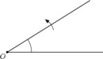

At first the angle is quite sharp, but it becomes less so. It then becomes a right angle, and subsequently gets much blunter until the two arms form a straight line. Then it starts to turn back upon itself, passing through a three-quarter turn and, when the rotating arm gets back to the start, it rests on top of the fixed arm again.
The most common unit for expressing angles is degrees, denoted by °, with a complete turn or revolution being equal to 360°. Angles can also be measured in radians, and you will meet this unit of measure if you study further maths, science or technology courses.

Acute angle
Any angle that is less than a quarter turn; that is, less than 90°. An example of an acute angle is the angle that a door makes with a doorframe when it is ajar.

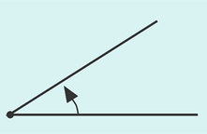
Figure ang1
View description - Figure ang1
View description - Figure ang1

Right angle
The angle that corresponds to a quarter turn; it is exactly 90°. The angles at the corners of most doors, books and windows are right angles.

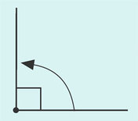
Figure ang2
View description - Figure ang2
View description - Figure ang2

Obtuse angle
Any angle that is between a quarter turn and a half turn; that is, between 90° and 180°. An example is the angle between the blades of a pair of scissors when they are open as wide as possible.

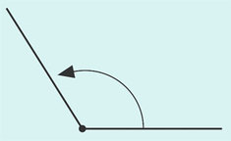
Figure ang3
View description - Figure ang3
View description - Figure ang3

Half turn (Straight angle)
This corresponds to a straight line; it is exactly 180°. The pages of an open book that is lying flat approximately describe a half turn.

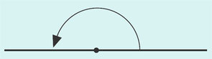
View description - Uncaptioned Figure
View description - Uncaptioned Figure

Reflex angle
Any angle that is between a half turn and a complete turn; that is, between 180° and 360°. When a box is opened and the hinged lid falls back so as to rest on the surface on which the box is standing, the angle that the lid turns through is a reflex angle.

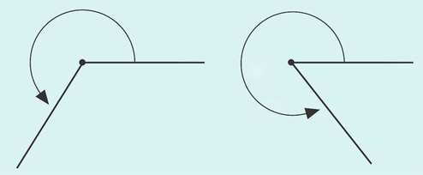
Figure ang5
View description - Figure ang5
View description - Figure ang5

Complete turn
This corresponds to a complete turn, or one revolution; it is exactly 360°. This is the angle that the minute hand of a clock turns through in an hour.

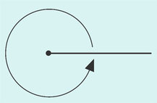
Figure ang6
View description - Figure ang6
View description - Figure ang6

Remember that if the angle between two straight lines is 90°, then the lines are said to be perpendicular to each other.
Sometimes it is necessary to refer to a turn that is more than one complete revolution, and so is greater than 360°. An example is the angle that the minute hand of a clock turns through in a period of 12 hours: each complete revolution of the minute hand amounts to 360°, so twelve revolutions amount to 12 × 360° = 4320°.
Several different notations are used for labelling angles. For example, the angle below can be referred to as ‘angle BAC’ and written as BC or BAC, or it can be referred to as the angle ‘theta’ and labelled θ.

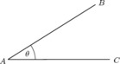
View description - Uncaptioned Figure

Alternatively, an angle may be denoted by the label on the vertex but with a hat on it. The vertex is another name for the ‘corner’ of an angle. For instance, the angle θ above may be denoted by , which is read as ‘angle A’.
This notation can be ambiguous if there is more than one angle at the vertex, as in the example below.

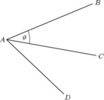

In such cases, θ can be specified as , , CAB or BAC – the middle letter indicates the vertex and the two outer letters identify the ‘arms’ of the angle.

Try some yourself

Question 1

What angles do the hour hand and the minute hand of a clock turn through in five hours?

View answer - Question 1

Question 2

Give an alternative notation for labelling each of these angles in the diagram below.
- (a) α
- (b) β
- (c)
- (d) ACD

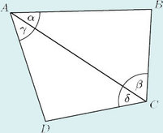

View answer - Question 2

1.2 How to measure an angle
To measure an angle you need a protractor. The protractor shown here is a semicircle that is graduated to measure angles from 0° to 180°. It is also possible to buy circular protractors that measure angles from 0° to 360°.

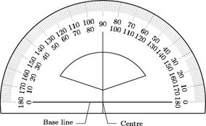

The diagram below indicates how the protractor should be positioned in order to measure an angle. Place the base line of the protractor on one arm of the angle, with the centre O on the vertex. The angle can then be read straight from the scale. Here = 40° (not 140°).

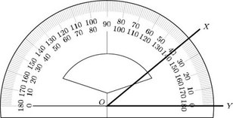

Be careful to use the correct scale. In this case the angle extends from the line OY up to the line OX, so use the scale that shows OY as 0° – the outer scale in this instance.
In the above example, one of the arms of the angle is horizontal. However, sometimes you may find that you need to position the protractor in an awkward position in order to measure an angle.

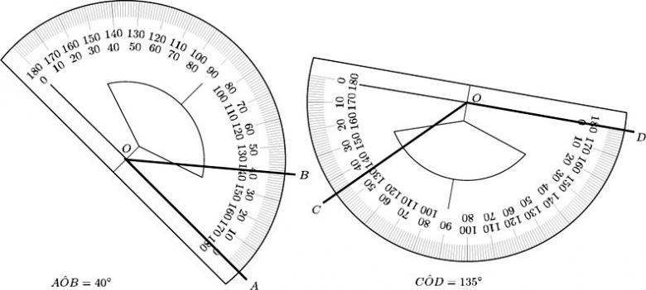

You can also use a protractor to construct an angle accurately, but once you have drawn the angle, be on the safe side and measure it to check that it is correct.

Try some yourself

Question 1

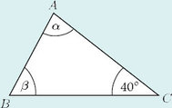

- (a) How would you refer to angle α in this triangle by means of the letters A, B and C?
- (b) Measure α with a protractor , if you have one, or otherwise estimate it.
- (c) What type of angle is α?
- (d) Find β without using a protractor using the fact that the three angles of a triangle always add up to 180°.

View answer - Question 1

Question 2

2 This pie chart shows the proportions of people voting for four parties in a local election.

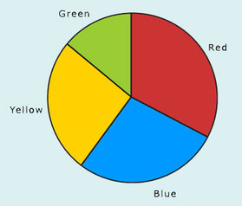

- (a) Measure the angles of the four slices of the pie with your protractor or estimate them if you don't have a protractor.
- (b) Check your measurements by ensuring that the angles add up to 360°.
- (c) Work out the percentage of the total vote polled by each of the four parties.

View answer - Question 2

1.3 Angles, points and lines
Very often, angles in a shape are determined by the geometric properties of that shape. For example, a square has four right angles. So, when you know a shape is a square, you do not need to measure its angles to know that they are 90°. The rest of this section will look at the properties of shapes that enable you to deduce and calculate angles rather than measure them. You may like to add these properties to your notes.

1.3.1 Angles at a point
Another useful property to remember is that one complete turn is 360°. This means that when there are several angles making up a complete turn, the sum of those angles must be 360°.
For instance, if the angles turned by a Big Wheel at a fairground as it picks up passengers were α, β, γ and δ as shown in the diagram below, then α + β + γ + δ = 360°.

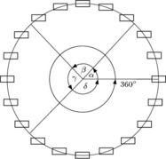

The sum of angles at a point is 360°.

Example 1
Calculate the angle between adjacent spokes of this wheel.

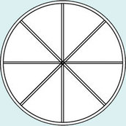

View answer - Example 1

Try some yourself

Question 1

Calculate all the angles at the centres of these objects.

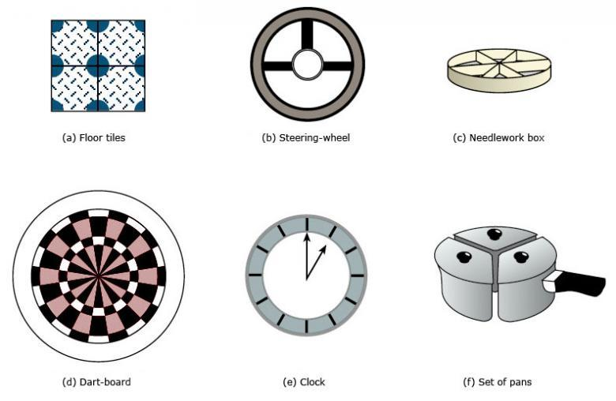

View answer - Question 1

1.3.2 Angles on a line
If several angles make up a half turn, then the sum of those angles must be × 360° = 180°. Therefore, in the following diagram, α + β + γ + δ = 180°.

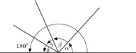

The sum of angles on a line is 180°.

(Note that different diagrams can be labelled with the same letters – α, β, γ, and δ in this case. The letters represent different angles here to those in the diagram in the preceding section.)
You can sometimes use these properties to determine unknown angles.

Example 2
Find α and β in the diagrams below. These are the types of diagram that might arise when plotting the course of a ship.

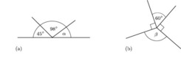

View answer - Example 2

Example 3
Students at an orienteering event follow a route round a set course in a clockwise direction. (Assume that the students run in straight lines and keep to the track.)

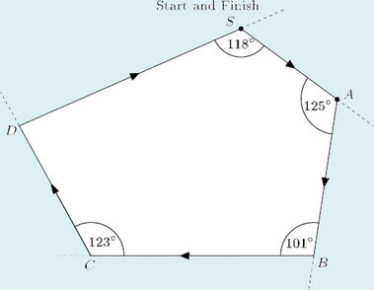

- (a) Through what angle do the students turn at A?
- (b) When they arrive at D, what is the total angle that they have turned through relative to their starting direction?
- (c) When they return to S, through what angle must they turn in order to face in the direction in which they started?
- (d) When they reach D, through what angle must they turn in order to return to the start?
View answer - Example 3

Try some yourself

Question 1

Find γ and δ in the following diagrams produced by a ship's navigator.

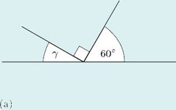

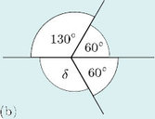

View answer - Question 1

1.3.3 Drawing a pie chart
You can use the fact that the sum of angles at a point is 360° to draw a pie chart.

Example 4
Over a five-year period a mathematics tutor found that 16 of her students gained distinctions, 32 gained pass grades and 12 failed to complete the course. Draw a pie chart to represent these data.
View answer - Example 4

Try some yourself

Question 1

A company carried out a survey, recording how staff in a particular office spent their working time. The table shows the average number of minutes spent in each hour on various activities.

Activity | Time taken on average in one hour/mins
Keyboarding | 35
Answering telephone | 12
Talking with colleagues | 10
Other | 3

The data is to be displayed as a pie chart. Work out the angle at the centre for each slice.

View answer - Question 1

1.3.4 Vertically opposite angles
When two straight lines cross, they form four angles. In the diagram below, these angles are labelled α, β, θ and φ and referred to as alpha, beta, theta and phi. The angles opposite each other are equal. They are called vertically opposite angles. Here α and β are a pair of vertically opposite angles, as are θ and φ. Although such angles are called ‘vertically opposite’, they do not need to be vertically above and below each other!

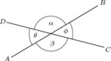
View description - Uncaptioned Figure

For two intersecting straight lines, vertically opposite angles are equal.

We can show that vertically opposite angles are equal as follows:

α and θ lie on a line.
So, α + θ = 180°
and α = 180° – θ
but β and θ also lie on a line.
So, β + θ = 180°
and β = 180° – θ.
Hence, α = β because they are both equal to 180° – θ.

Try Some Yourself

Question 1

Find all the remaining angles in each of the diagrams below.

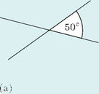

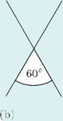

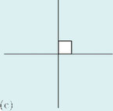

View answer - Question 1

1.4 Parallel lines
Two straight lines that do not intersect, no matter how far they are extended, are said to be parallel. Arrows are used to indicate parallel lines.

View description - Uncaptioned Figure

1.4.1 Corresponding angles
Look at the line l, which cuts two parallel lines m and n.

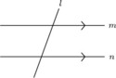
View description - Uncaptioned Figure

If you trace the lines at one of the intersections in the diagram below and place them over the lines at the other intersection, you will find that the two sets of lines coincide exactly. The four angles at each intersection also coincide exactly: thus α = a, β = b, γ = c and δ = d.

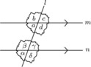

The pairs of angles that correspond to each other at such intersections are called corresponding angles.
In the diagram below, α and a are corresponding angles: they are equal because m and n are parallel.

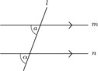

When a line intersects two parallel lines, corresponding angles are equal.

Example 5
This diagram represents the type of arrangement that occurs in a garden trellis or a wine rack (r and s are parallel lines, indicated by the single arrowheads; l and m are also parallel, indicated by the double arrowheads). Calculate the angles α and β.

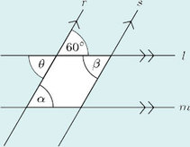

View answer - Example 5

1.4.2 Alternate angles
Other pairs of equal angles can be identified in Example 5. These pairs of angles occur in a Z-shape, as indicated by the solid line in the diagram below. Such angles are called alternate angles.

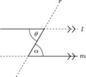
View description - Uncaptioned Figure

When a line intersects two parallel lines, alternate angles are equal.

To prove this result consider the diagram below:

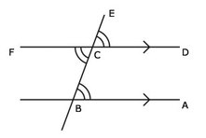

ABC = DCE (corresponding angles)
and DCE = FCB (vertically opposed angles)
So, ABC = FCB (both equal to DCE).
The other two angles are also equal and are also called alternate angles.

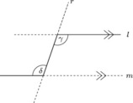

It is important to realise that you can find the sizes of unknown angles in many shapes by using a combination of the angle properties that have been outlined. To recap:

- Vertically opposite angles are equal.
- Angles at a point add up to 360°.
- Angles on a straight line add up to 180°.
- Corresponding angles on parallel lines are equal.
- Alternate angles on parallel lines are equal.

Example 6
Find α and β in the following diagram.

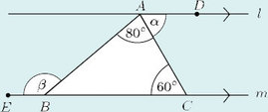

View answer - Example 6

These properties of corresponding and alternate angles mean that the opposite angles in a parallelogram are also equal.

Try some yourself

Question 1

Find α and β in each of the diagrams below.

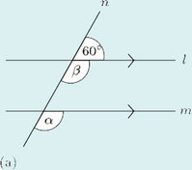

View answer - Question 1

Question 2

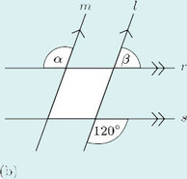

View answer - Question 2

Question 3

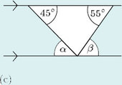

View answer - Question 3

Question 4

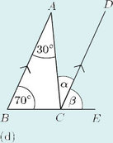

View answer - Question 4

Question 5

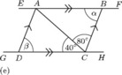

View answer - Question 5

Question 6

2 This diagram shows part of some bannister rails. The handrail makes an angle of 40° with the horizontal. Calculate angles α, β, γ and δ.

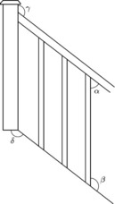

View answer - Question 6

Question 7

3 The arrows on the diagram below indicate the idealised path (ABCD) of a snooker ball on a snooker table. Assume that the angles between the cushion (the edge of the snooker table) and the path of the ball before and after it impacts with the cushion are equal. Calculate the sizes of the angles marked a, b, c, d, e and f.

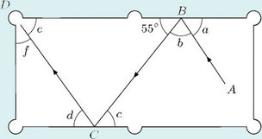

View answer - Question 7

2 Shapes and symmetry

2.1 Geometric shapes – triangles
This section deals with the simplest geometric shapes and their symmetries. All of the shapes are two-dimensional – hence they can be drawn accurately on paper.
Simple geometric shapes are studied in mathematics partly because they are used in thousands of practical applications. For instance, triangles occur in bridges, pylons and, more mundanely, in folding chairs; rectangles occur in windows, cinema screens and sheets of paper; while circles are an essential part of wheels, gears and plates.
By definition, triangles are shapes with three straight sides. However, there are various types of triangle:
An equilateral triangle is a triangle with all three sides of equal length. The three angles are also all equal.
An isosceles triangle is a triangle with two sides of equal length. The two angles opposite the equal sides are also equal to one another.
A right-angled triangle is a triangle with one angle that is a right angle.
A scalene triangle is a triangle with all the sides of different lengths. The angles are also all different.

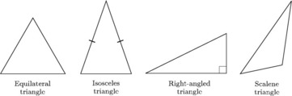

It is a general convention that equal sides are marked by drawing a short line, /, through them, and a right angle is marked by a square between the arms of the angle. If sides and angles are not marked, do not assume that they are equal, just because they look equal!

2.2 Geometric shapes – quadrilaterals

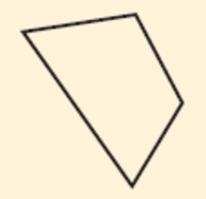
A quadrilateral is a shape with four straight sides.
View description - A quadrilateral is a shape with four straight sides.

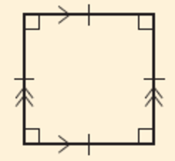
A square has four equal sides and four right angles. Opposite sides are parallel.
View description - A square has four equal sides and four right angles. Opposite sides are parallel ...

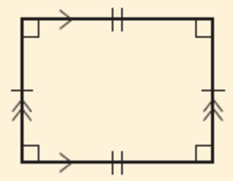
A rectangle has four right angles and opposite sides are equal and parallel.
View description - A rectangle has four right angles and opposite sides are equal and parallel.

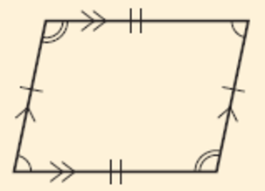
A parallelogram has opposite sides equal and parallel. Opposite angles are equal.
View description - A parallelogram has opposite sides equal and parallel. Opposite angles are equal ...

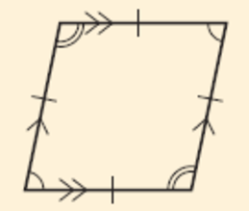
A rhombus has four equal sides. Opposite sides are parallel and opposite angles are equal.
View description - A rhombus has four equal sides. Opposite sides are parallel and opposite angles are ...

From the descriptions above, you can see that squares, rectangles and rhombuses are all special types of parallelogram.

2.3 Geometric shapes – circles
All circles are the same shape – they can only have different sizes.
In a circle, all the points are the same distance from a point called the centre. The centre is often labelled with the letter O.

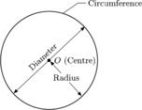
View description - Uncaptioned Figure

The outside edge of a circle is called the circumference. A straight line from the centre to a point on the circumference is called a radius of the circle (the plural of radius is radii).
A line with both ends on the circumference and passing through the centre is called a diameter. Any diameter cuts the circle into two halves called semicircles.

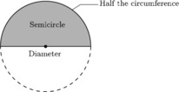
View description - Uncaptioned Figure

In the circle below, the lines labelled OA, OB, OC, OD and OE are all radii, and AD and BE are diameters. The points A, B, C, D and E all lie on the circumference.

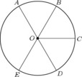

Although the terms ‘radius’, ‘diameter’ and ‘circumference’ each denote a certain line, these words are also employed to mean the lengths of those lines. So it is common to say, for example, ‘Mark a point on the circumference’ and ‘The circumference of this circle is 7.3 cm’. It is obvious from the context whether the line itself or the length is being referred to.

2.4 Drawing circles
Drawing circles freehand often produces very uncircle-like shapes! If you need a reasonable circle, you could draw round a circular object, but if you need to draw an accurate circle with a particular radius, you will need a pair of compasses and a ruler. Using the ruler, set the distance between the point of the compasses and the tip of the pencil at the desired radius; place the point on the paper at the position where you want the centre of the circle to be and carefully rotate the compasses on the point so that the pencil marks out the required circle.

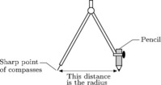

To draw a large circle, perhaps to create a circular flower bed, a similar set-up is needed. The essentials are a fixed central point (possibly a stake) and a means of ensuring a constant radius (possibly a string). To draw a circle on a computer or calculator screen, you may also need to fix the centre (maybe using coordinates) and the radius.
It is often necessary to label diagrams of geometric figures, such as circles or triangles, in order to make it easier to refer to specific parts of the figure. Usually points are labelled as A, B, C, … and lines as AB, BC, …, or a, b, c, … and using combinations of the letters, such as ‘triangle ABC’ (‘Triangle ABC’ is often written as ‘ΔABC’.). It is rather laborious to read, but unfortunately is unavoidable.
Note that, as in the case of words like ‘radius’ and ‘circumference’, AB may be used to mean the line from A to B or the length of the line itself.

2.5 Symmetry
Symmetry is a feature that has been used in the design of objects and patterns in many cultures throughout recorded history. From Greek vases and medieval windows to Victorian tiles and Native American decorations, symmetry has been seen as a way of achieving balance and beauty.

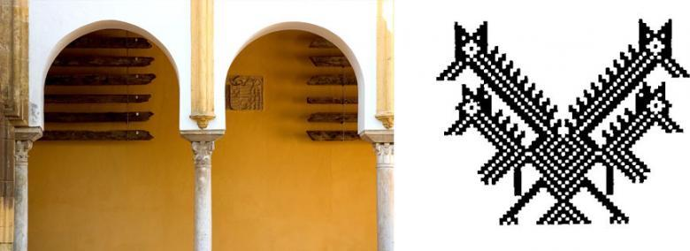

Symmetry can be described mathematically, and is a useful concept when dealing with shapes.

2.6 Line symmetry
Look at the shapes below. The symmetry of the shape on the left and its relationship to the shape on the right can be thought of in two ways:
- Fold the left-hand shape along the central line. Then one side lies exactly on top of the other, and gives the shape on the right.
- Imagine a mirror placed along the central dotted line. The reflection in the mirror gives the other half of the shape.

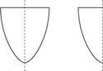
View description - Uncaptioned Figure

This type of symmetry is called line symmetry.
Any isosceles triangle has line symmetry.

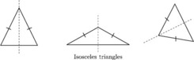

The dashed lines represent lines of symmetry, and each shape is said to be symmetrical about this line.
The following all have line symmetry:

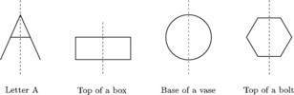

A shape can have more than one line of symmetry. Thus a rectangle has two lines of symmetry, an equilateral triangle has three lines of symmetry, and a square has four.

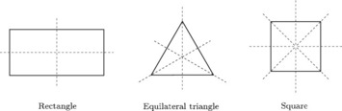

A circle has an infinite number of lines of symmetry since it can be folded about any diameter. Only eight of the possible lines of symmetry are indicated below.

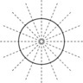

Some shapes, such as a scalene triangle, have no lines of symmetry – it is not possible to fold the shape about a line so that the two halves fit exactly on top of one another.

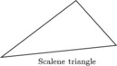
View description - Uncaptioned Figure

2.7 Rotational symmetry
There is another kind of symmetry which is often used in designs. It can be seen, for instance, in a car wheel trim.

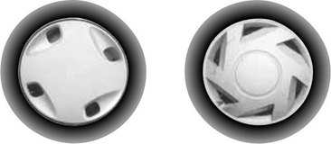
View description - Uncaptioned Figure

Look at the trim on the left. It does not have line symmetry but it has rotational symmetry. If the wheel is rotated through a quarter of a full turn, it will look exactly the same; likewise, if it is rotated through half a complete turn, or through three-quarters of a turn. There are four positions in which the wheel looks the same: hence the wheel is said to have rotational symmetry of order 4 or four-fold rotational symmetry.
The wheel trim on the right has rotational symmetry of order 6. In this case there are six positions in which the trim will look exactly the same. These occur when the wheel is rotated through one-sixth of a complete turn, two-sixths of a turn, and so on, to five-sixths of a turn and finally a complete turn (when, of course, the wheel is back in its original position).
The centre of the shape is the point about which the shape is rotated; it is called the centre of rotation.
A shape does not have to be round to have rotational symmetry. The following shapes have rotational symmetry of orders 3 and 4, respectively.

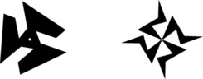

It is not difficult to create shapes with both line symmetry and rotational symmetry. The two designs below are examples.

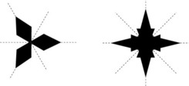

The design on the left has three lines of symmetry and rotational symmetry of order 3. The one on the right has four lines of symmetry and rotational symmetry of order 4.
A shape with no rotational symmetry, like the one below, is sometimes said to have ‘rotational symmetry of order 1’. This is because it will only fit on top of itself in one position – after a complete turn.

View description - Uncaptioned Figure

Try some yourself

Question 1

Draw a line of symmetry on each of the shapes below.

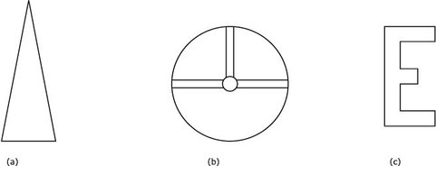

View answer - Question 1

Question 2

Mark all of the lines of symmetry on these shapes. For each shape, state the total number of lines of symmetry.

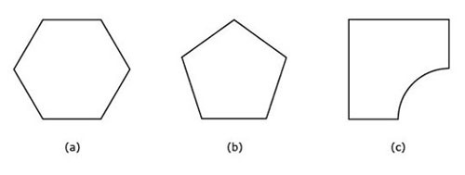

View answer - Question 2

Question 3

Which of these have rotational symmetry?

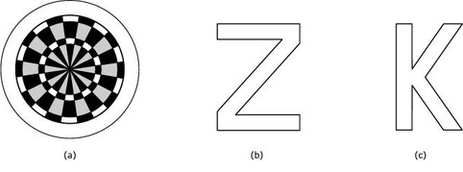

View answer - Question 3

Question 4

Mark the centre of rotation on each of the shapes below. For each, state the order of rotational symmetry.

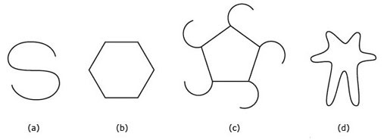

View answer - Question 4

Question 5

Describe the symmetry of each of these shapes. Mark all the lines of symmetry in each case. Also mark the centre of rotation, and state the order of rotational symmetry.

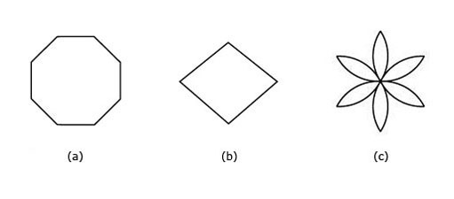

View answer - Question 5

2.8 The angles of a triangle
The sum of the angles of any triangle is 180°. This property can be demonstrated in several ways. One way is to draw a triangle on a piece of paper, mark each angle with a different symbol, and then cut out the angles and arrange them side by side, touching one another as illustrated.

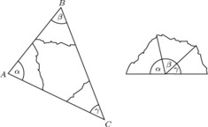

You can see why it is that the angles fit together in this way by looking at the triangle below. An extra line has been added parallel to the base. The angle of the triangle, , is equal to the angle β at the top (they are alternate angles), and similarly the angle of the triangle, , is equal to the angle γ at the top (they are also alternate angles). The three angles at the top (β, γ and the angle of the triangle, ) form a straight line of total angle 180°, and so the angles of the triangle must also add up to 180°.

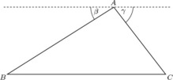

The sum of the angles of a triangle is 180°.

The fact that the angles of a triangle add up to 180° is another angle property that enables you to find unknown angles.

Example 7
Find α, β and θ in the diagram below.

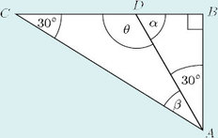

View answer - Example 7

It is possible to deduce more information about the angles in certain special kinds of triangles.
In a right-angled triangle, since one angle is a right angle (90°), the other two angles must add up to 90°. Thus, in the example below, α + β = 90°.

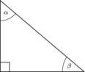

In an equilateral triangle, all the angles are the same size. So each angle of an equilateral triangle must be 180° ÷ 3 = 60°.
In an isosceles triangle, two sides are of equal length and the angles opposite those sides are equal. Therefore, α = β in the triangle below.
Such angles are often called base angles.

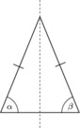
View description - Uncaptioned Figure

This means that there are only two different sizes of angle in an isosceles triangle: if the size of one angle is known, the sizes of the other two angles can easily be found. The next example shows how this is done.

Example 8
Find the unknown angles in these isosceles triangles, which represent parts of the roof supports of a house.

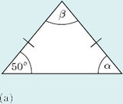

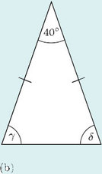

View answer - Example 8

The various angle properties can also be used to find the sum of the angles of a quadrilateral.

Example 9
The diagram below represents the four stages of a walk drawn on an Ordnance Survey map.
The figure ABCD is a quadrilateral. Find θ and φ, and thus the sum of all the angles of the quadrilateral.

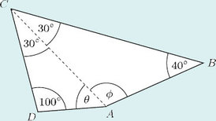

View answer - Example 9

In fact, you can find the sum of the four angles of a quadrilateral without calculating each angle as in Example 9. Look again at the quadrilateral: the dotted line splits it into two triangles, and the angles of these triangles together make up the angles of the quadrilateral. Each triangle has an angle sum of 180°, so the angle sum of the quadrilateral is 2 × 180° = 360°. This is true for any quadrilateral.

The sum of the angles of a quadrilateral is 360°.

Similarly, other polygons (that is, other shapes with straight sides) can be divided into triangles to find the sum of their angles.

Try some yourself

Question 1

Find the unknown angles in each of these diagrams, which represent part of the bracing structure supporting a marquee.

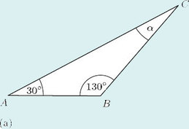

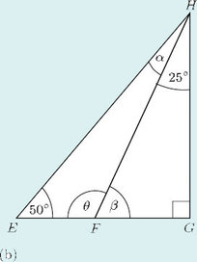

View answer - Question 1

Question 2

Deduce the value of α in the triangle below.

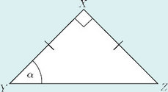

View answer - Question 2

Question 3

Find the unknown angles in the following isosceles triangles, which represent roof rafters.

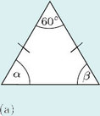

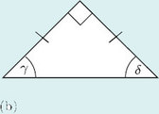

View answer - Question 3

2.9 Similar and congruent shapes
Two shapes are said to be similar if they are the same shape but not necessarily the same size. In other words, one may be an enlargement of the other. They may also have different orientations, as in the drawing below.

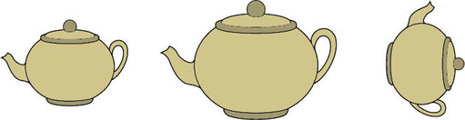

When a photograph is enlarged, the two images are similar.

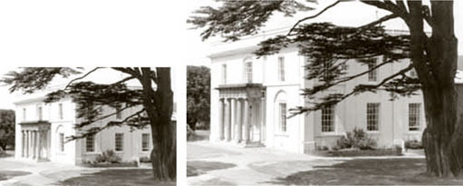

But if a photograph is stretched in only one direction, the resulting shape is not similar to the original.

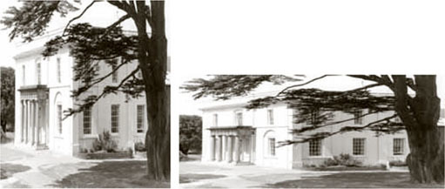

In effect, when two shapes are similar, one is a scaled up (or down) version of the other. Thus an accurate model and its original will be similar in this mathematical sense. If you measure the sides of the model, you will find that to produce the original, each side must be scaled up by the same amount. However, the angles remain the same in each version.
The simplest scaled shapes are similar triangles. In two similar triangles, angles in equivalent positions must be the same size. This provides a way of identifying similar triangles.
It is not necessary to calculate all the angles in two similar triangles. If two angles in one triangle match two angles in the other, then the third angle must also be the same in both, because in each case it will be 180° minus the sum of the other two angles.
Examples of similar triangles are set out below.

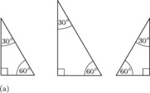

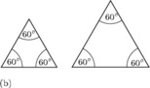

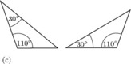

If two figures are the same shape and the same size, they are said to be congruent.

Example 10
This diagram shows, in simplified form, a wooden buttress supporting the wall of a medieval church.

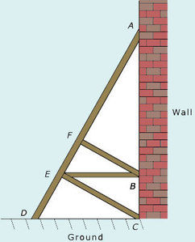
View description - Uncaptioned Figure

The angle between the ground and the buttress, , is 65°. By making appropriate assumptions, identify which triangles are similar. Calculate all the angles in the structure.
View answer - Example 10

You may have met other examples of similar shapes, for example, when using scale diagrams. The scale plan of a house is similar to the actual layout of the house.

Try some yourself

Question 1

Which of these triangles are similar?

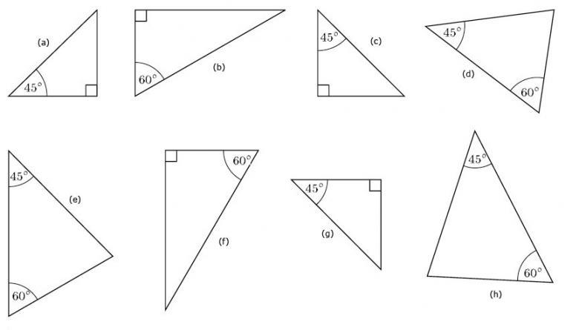

View answer - Question 1

Question 2

An aluminium ladder can be used in three different ways:

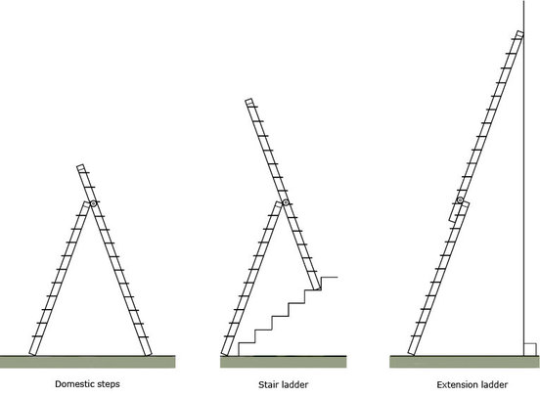

The manufacturer says that in use, each segment of the ladder should make an angle of 20° with the vertical.
For each diagram, add construction lines and labels so as to identify two similar triangles. Are any of the similar triangles also congruent?

View answer - Question 2

Question 3

This diagram shows the arrangement of the struts in a wall of a shed.

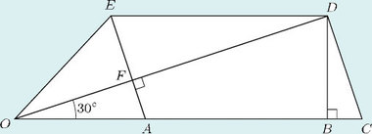
View description - Uncaptioned Figure

The lines OABC and DE are each horizontal. The struts EA and DC are parallel.
- (a) Which of these are right angles?
- (b) Write down two angles that are equal to
- (c) Several of the triangles formed by the struts are similar (that is, they are the same shape). Write down all the triangles that are similar to ΔOAF.

View answer - Question 3

3 Areas and volumes

3.1 Areas of quadrilaterals and triangles
You may like to add the area formulas in this section to your notes for future reference.
The simplest areas to find are those of rectangles. The area of a rectangle is its length multiplied by its breadth. Sometimes the dimensions of a rectangle are referred to as the base and the height, instead of the length and the breadth. The area is then expressed as the base multiplied by the height.

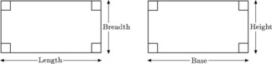

Area of a rectangle = length × breadth = base × height

A square is a special kind of rectangle in which the length is equal to the breadth. Hence its area is the length of one side multiplied by itself, or the length of one side squared.

Area of a square = length × length = length²

For example, the area of a square mirror with sides 50 cm long is 50 cm × 50 cm = 2500 cm².
Now consider parallelograms.

Area of a parallelogram = base × height

In the formula for the area of a parallelogram, the height is the perpendicular distance from the base to the opposite side. In order to avoid ambiguity it is sometimes called the perpendicular height rather than just the height. The height is not the length of the sloping side.

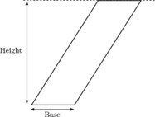

At first sight, the formula for a parallelogram is quite surprising: it is the same formula as that for a rectangle. Imagine the bottom side of the parallelogram is fixed, but the top side slides along a line, as in the diagram below. The top and bottom of the parallelogram remain the same length and the same distance apart, while the other two sides lengthen or shrink. The shape always remains a parallelogram. (Notice that in one position, the parallelogram will become a rectangle – its sides will be at right angles to the base.)

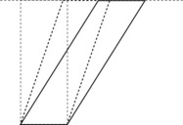

The area of the parallelogram stays the same as the parallelogram shifts: it is equal to the area of the rectangle (which, of course, is given by base × height). This is easy to see by looking at the next diagram. In this, the first figure consists of two identical triangles and a parallelogram. Imagine the left-hand triangle slides to the right: it will fit above the other triangle and leave a rectangle to the left. The second figure shows the same two triangles and the rectangle. Therefore the area of the parallelogram must be the same as the area of the rectangle.

Next think about the areas of triangles. Any triangle can be seen as half of a parallelogram.

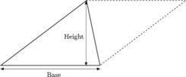

So the area of a triangle is half the area of a parallelogram.

Again, the height is the perpendicular height, which is now the distance from the base to the opposite corner, or vertex, of the triangle.
This formula is true for any triangle, because any triangle will be half of a parallelogram even when the perpendicular height lies outside the triangle, as below.

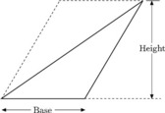

If a triangle does not have a side that is horizontal, it is not clear which side is ‘the base’. The beauty of the formula for the area is that it works no matter which side is called ‘the base’. Thus the area of the following triangle can be evaluated in three ways.

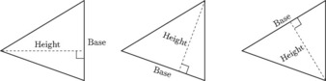

You can often use what you know about the areas of rectangles and triangles to find the areas of more complex shapes.

Example 11
The lawn shown below is trapezium-shaped. Find its area.

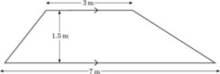
View description - Uncaptioned Figure

View answer - Example 11

Example 12
Suppose a friend of yours decides to lay crazy paving in his garden which measures 7 m by 5 m, but he wants to leave two rectangular areas, each 2 m by 1 m, for flowerbeds. What area of crazy paving will be needed?
View answer - Example 12

Try some yourself

Question 1

Find the area of each of these shapes.

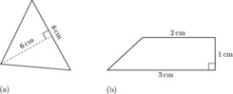

View answer - Question 1

Question 2

A girl is decorating a box by glueing wrapping paper on each face. She wants to put paper on the sides, the top and the bottom, and intends to cut out six pieces of paper and stick them on. Assuming no wastage, calculate what area of paper she will need.

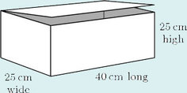

View answer - Question 2

Question 3

A rug measures 3 m by 2 m. It is to be laid on a wooden floor that is 5 m long and 4 m wide. The floorboards not covered by the rug are to be varnished.
- (a) What area of floor will need to be varnished?
- (b) A tin of varnish covers 2.5 m². How many tins will be required?

View answer - Question 3

Question 4

This diagram represents the end wall of a bungalow; the wall contains two windows. The wall is to be treated with a special protective paint. In order to decide how much paint is required, the owner wants to know the area of the wall. Divide the wall up into simple shapes and then find the total area.

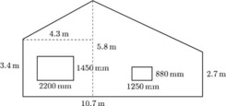

View answer - Question 4

Question 5

The diagram below shows the dimensions of a frame tent. Calculate the amount of canvas needed to make the tent, ignoring the door which is made of different material.

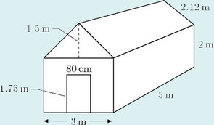
View description - Uncaptioned Figure

View answer - Question 5

3.2 Areas of circles
There are two very famous formulas for circles:

circumference of a circle = × diameter
and
area of a circle = × radius².

is the Greek letter for ‘p’ and it has the name ‘pi’. Its value is approximately 3.14. Most calculators have a key for which you can use when carrying out calculations.
Try measuring the circumference and diameter of some circular objects such as tins, bottles or bowls. For each object, divide the circumference by the diameter. You should find that your answer is always just over 3. In fact the ratio is the constant . Therefore:

Circumference of a circle = × diameter

Since the diameter is twice the radius, this formula can be written as
circumference = × 2 × radius = 2 × radius.
The formula for the area of a circle can be explained, as outlined below.
The circle here has been divided into equal ‘slices’ or sectors. The eight sectors can then be cut out and rearranged into the shape shown: this shape has the same area as the circle.

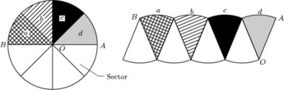

You can see that the total distance from A to B along the ‘bumps’ is the same as half the circumference of the circle, that is:
× 2 × radius = × radius. Also the length OA is the same as the radius of the circle.
Imagine dividing the circle into more and more sectors and rearranging them as described above. For example, dividing the circle into 16 equal sectors gives the following shape, whose area is still the same as that of the circle.

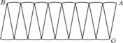

Again the total distance from A to B along the bumps is × radius, and the length of OA is the same as the radius.
Notice how the rearranged shape is beginning to look more like a rectangle. The more sectors, the straighter AB will become and the more perpendicular OA will be. Eventually it will not be possible to distinguish the rearranged shape from a rectangle. The area of this rectangle will be the same as that of the circle, and its sides will have the lengths × radius (for AB) and radius (for OA). So the following formula can be deduced:

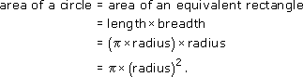

Area of a circle = × (radius)²

Example 13
A circular flowerbed is situated in the centre of a traffic roundabout. The radius of the flowerbed is 10 m. Find its circumference and its area.
View answer - Example 13

Example 14
A circular pond has a diameter of 7 m. A 1 m wide gravel path is to be laid around the pond. What is the area of the path?
View answer - Example 14

Try some yourself

Question 1

Find the area of a circle of (a) radius 8 cm, and (b) radius 15 m.

View answer - Question 1

Question 2

Calculate the areas of the following shapes:

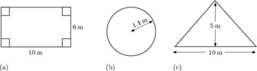

View answer - Question 2

Question 3

Use your answers to the previous question to find the area of turf needed for the proposed lawn shown below, which has a circular flowerbed in the middle. Round your answer to the nearest square metre.

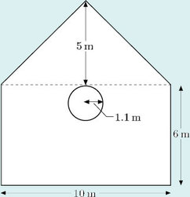

View answer - Question 3

Question 4

A manufacturer produces a patio kit consisting of 28 paving slabs which are shaped so that they fit together to form rings, as shown. The outside edge of each ring is a circle, and all three circles have the same centre. Circles with the same centre are called concentric circles. The slabs are of three sizes, one for each ring of the patio. All of the slabs in a particular ring are identical.

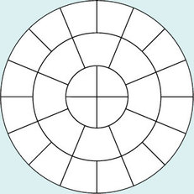

The radii of the three circles are 0.4 m, 0.8 m and 1.2 m.
Making appropriate assumptions, calculate which of the three types of slab is the heaviest and which the lightest.

View answer - Question 4

Hint
Try breaking the problem in question 4 down into steps and considering what you know about what you want to find out. You know the radii of the circles, so can find the area of each circle. That should help you to find the area of each ‘ring’ of slabs. Then count how may slabs are in each ring and use that to work out the area of each slab.

3.3 Volumes
What is a volume? The word usually refers to the amount of three-dimensional space that an object occupies. It is commonly measured in cubic centimetres (cm³) or cubic metres (m³).
A closely related idea is capacity; this is used to specify the volume of liquid or gas that a container can actually hold. You might refer to the volume of a brick and the capacity of a jug – but not vice versa. Note that a container with a particular volume will not necessarily have the same amount of capacity. For example, a toilet cistern will have a smaller capacity than its total volume because the overflow pipe makes the volume above the pipe outlet unusable. Some units are used only for capacity – examples are litre, gallon and pint; cubic centimetres and cubic metres can be used for either capacity or volume.
One of the simplest solid shapes is a cube; it has six identical square faces.

Volume of a cube = length × length × length = (length) ³

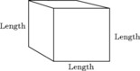

A cuboid (or rectangular box) has 6 rectangular faces as shown below.

Volume of a rectangular box = length × breadth × height

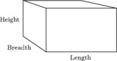

The length × breadth is the area of the bottom (or top) of the box, so an alternative formula is
volume of box = area of base × height.
The volume formula can also be written as
volume = area of end face × length
or
volume = area of front face × breadth

3.4 Cylinders and shapes with a uniform cross-section
An important idea when calculating volumes of simple shapes is that of a cross-section. In the case of the rectangular box considered above, it is possible to slice through the box horizontally so that the sliced area is exactly the same as the area of the base or top; in other words, the areas of the horizontal cross-sections are equal.

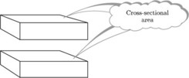

Likewise, you could slice through the box vertically in either of two different directions, producing cross-sections that are the same as either the end faces or the front and back faces.

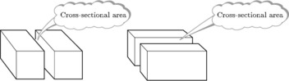

For objects that have a constant cross-sectional area, there is a very useful formula for the volume.

Volume = cross-sectional area × length
(length is measured at right angles to the cross section)

Notice that this fits with the formula for the volume of a rectangular box.
Bear in mind that many objects can only be sliced in one direction to produce a constant cross-sectional area. This bread bin is one example.

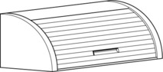

Another example is a cylinder. The formula at the top of the page can be used to find the volume of a cylinder because a cylinder has a constant cross-sectional area if it is sliced parallel to the circular face – the cross-sectional area is the area of the circle that forms the base of the cylinder, that is × (radius)². The following formula can then be deduced.

Volume of cylinder = × (radius)² × height

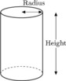

Example 15
Find the volumes of these objects.

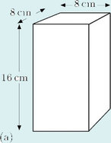

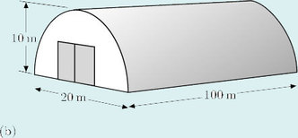

View answer - Example 15

Try some yourself

Question 1

Find the volumes of these objects.

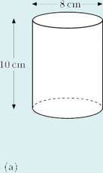

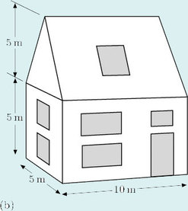

View answer - Question 1

Question 2

Two car manufacturers both claim that their models have an engine capacity of 2 litres. The two models have four-cylinder, four-stroke engines.
The table below shows the details of the four cylinders.

Car model | Cylinder diameter (bore)/mm | Cylinder height (stroke)/mm | Number of cylinders
A | 86 | 86 | 4
B | 92 | 75 | 4

By working out the total volume of the four cylinders for each model in cm³, find out if the manufacturers’ claims are true.
(Hint: 1 litre = 1000 cm³.)

View answer - Question 2

Question 3

The guttering pictured here has a semicircular cross-section. Find the volume of water that the guttering will hold when full.

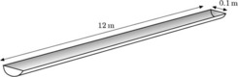

View answer - Question 3

3.5 Scaling areas and volumes
In OpenLearn course Diagrams, graphs and charts you saw how a scale is used on plans of houses and other structures. The scale makes it possible to take a length on the plan and calculate the corresponding length in reality. The scale can also be used to convert between areas on the plan and real areas. Moreover, if a three-dimensional scale model is made, it is possible to use the scale to convert between volumes in the model and the real volumes.

Example 16
Dudley's and June's hobby is constructing dolls' houses. They decide to make a model of their own house, using a scale in which 1 cm on the model represents 20 cm on their real house.
They are making the curtains for the model. The window in the real dining room measures 240 cm by 120 cm. What is the area of the real window and the area of the window in the model? How many times greater is the real area?
View answer - Example 16

This example has demonstrated a general result:

To scale areas, multiply or divide by the scale squared.

Example 17
Dudley and June have a cold-water tank in their loft, which has a capacity of 250 litres. If they make a scale model of the tank, what will its capacity be?
View answer - Example 17

This example illustrates a general result:

To scale volumes, multiply or divide by the scale cubed.

Try some yourself

Question 1

Calculate the area of a carpet in a model house if the real carpet has an area of 22 m². On the scale used, 1 cm represents 0.25 m.

View answer - Question 1

Question 2

A model steam engine that runs in a park is built to a scale such that 1 cm represents 0.2 m. On the model there is space in the tender for m³ of coal. What volume of coal could be carried in the real engine's tender?

View answer - Question 2

4 OpenMark quiz
Now try the quiz and see if there are any areas you need to work on.

Conclusion
This free course provided an introduction to studying Mathematics. It took you through a series of exercises designed to develop your approach to study and learning at a distance and helped to improve your confidence as an independent learner.

Keep on learning

Study another free course
There are more than 800 courses on OpenLearn for you to choose from on a range of subjects.
Find out more about all our free courses.

Take your studies further
Find out more about studying with The Open University by visiting our online prospectus.
If you are new to university study, you may be interested in our Access Courses or Certificates.

What’s new from OpenLearn?
Sign up to our newsletter or view a sample.

For reference, full URLs to pages listed above:
OpenLearn – www.open.edu/openlearn/free-courses
Visiting our online prospectus – www.open.ac.uk/courses
Access Courses – www.open.ac.uk/courses/do-it/access
Certificates – www.open.ac.uk/courses/certificates-he
Newsletter – www.open.edu/openlearn/about-openlearn/subscribe-the-openlearn-newsletter

Acknowledgements
Adapted from the works of Steve Jurvetson: [Details correct as of 8th July 2008]
Course image: Daniel Oines in Flickr made available under Creative Commons Attribution 2.0 Licence.
All other material contained within this course originated at The Open University.
Don't miss out:
If reading this text has inspired you to learn more, you may be interested in joining the millions of people who discover our free learning resources and qualifications by visiting The Open University - www.open.edu/openlearn/free-courses

Solutions

Question 1

Answer
Every hour the minute hand turns through 360°. It will have made five such revolutions in five hours. This amounts to 1800°.
The hour hand turns through 30° every hour ( of 360°). In five hours it will turn through 5 × 30° = 150°.
Back to - Question 1

Question 2

Answer
- (a) or CAB.
- (b) or BCA.
- (c) γ or DAC.
- (d) δ or .
Back to - Question 2

Question 1

Answer
- (a) Any of the following could be used: , , BAC, , CAB.
- (b) α = 80°.
- (c) Because α is less than 90°, it is an acute angle.
- (d) As the three angles of a triangle always add up to 180°,

- Therefore

Back to - Question 1

Question 2

Answer
- (a) Red party: 120°.
Blue party: 95°.
Yellow party: 95°.
Green party: 50°.
- (b) 120° + 95° + 95° + 50° = 360°.
- (c) Since 360° represents 100%, 1° will represent or .
- So the Red party polled

The Blue party and the Yellow party polled

The Green party polled

Back to - Question 2

Example 1

Answer
The eight spokes divide the circle up into eight equal parts. Therefore the angle required is found by dividing 360° by 8 to give 45°.
Back to - Example 1

Question 1

Answer
- (a) Each of the four angles is 360° ÷ 4 = 90°.
- (b) The two upper angles are both 180° ÷ 2 = 90°, and the lower angle is 180°.
- (c) Each of the six angles is 360° ÷ 6 = 60°.
- (d) Each of the twenty angles is 360° ÷ 20 = 18°.
- (e) The acute angle between the hands is 360° ÷ 12 = 30°; the reflex angle is 360° − 30° = 330°.
- (f) Each of the three angles is 360° ÷ 3 = 120°.
Back to - Question 1

Example 2

Answer
- (a) As the angles are on a line,

- (b) As the angles are at a point,

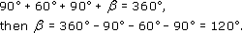

Back to - Example 2

Example 3

Answer
- (a) The angle turned through at A is 180° − 125° = 55°.
- (b) The angle turned through at B is 180° − 101° = 79°, and the angle turned through at C is 180° − 123° = 57°.
So the total angle that the students have turned through when they arrive at D is 55° + 79° + 57° = 191°.
- (c) The angle that the students need to turn through at S is 180° - 118° = 62°.
- (d) Suppose the students complete the whole course and, at the finish, face in the same direction as at the start, they will overall have made one complete turn, that is, 360°.
So

hence

Back to - Example 3

Question 1

Answer
- (a) γ = 180° − 90° − 60° = 30°.
- (b) δ = 360° − 130° − 60° − 60° = 110°.
Back to - Question 1

Example 4

Answer
First, calculate how many students there were altogether:
16 + 32 + 12 = 60 students.
The whole pie chart (360°) must, therefore, represent 60 students. This means that each student is represented by 360° ÷ 60 = 6°. So the angles for the three slices are

distinctions | 16 × 6 = 96°
pass grades | 32 × 6 = 192°
failed to complete | 12 × 6 = 72°

The pie chart can be constructed by carefully measuring these angles at the centre of a circle. The slices should be labelled, and an appropriate title given to the chart. The source of the data should also be stated.

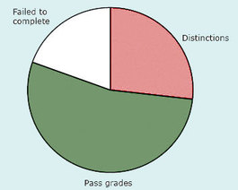
Pie chart showing results of 60 mathematics students over a five-year period (Source: Tutor's own records)
View description - Pie chart showing results of 60 mathematics students over a five-year period (Source: ...

Back to - Example 4

Question 1

Answer
Since one hour will be represented by 360° on the pie chart, 1 minute will be represented by 360° ÷ 60 = 6°.
So the required angles on the chart are:

How office staff spend their time (Source: Company survey)
Keyboarding | 35 × 6° = 210°
Answering telephone | 12 × 6° = 72°
Talking with colleagues | 10 × 6° = 60°
Other activities | 3 × 6° = 18°

Check: 210° + 72° + 60° + 18° = 360°.

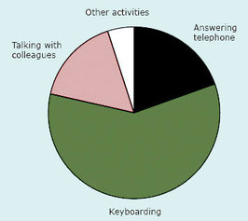

Back to - Question 1

Question 1

Answer
- (a) 130°, 50°, 130°.
- (b) 120°, 60°, 120°.
- (c) 90°, 90°, 90°.
Back to - Question 1

Example 5

Answer
Line l is parallel to line m, therefore α and the angle 60° are corresponding angles. So α = 60°.
The angles 60° and θ are vertically opposite angles. So θ = 60°.
Line r is parallel to line s, therefore θ and β are corresponding angles. So β = 60°.
Back to - Example 5

Example 6

Answer
Line l is parallel to line m, therefore and are alternate angles. So

Similarly, and are alternate angles. But

and hence

Back to - Example 6

Question 1

Answer
(a) Now so
But so
Back to - Question 1

Question 2

Answer
(b)

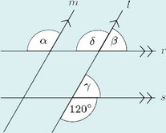

There are many ways of finding the sizes of these angles. This is only one of them:
As it follows that
But so
Similarly, so
But so
Back to - Question 2

Question 3

Answer
(c) α = 45° (alternate angles).
β = 55° (alternate angles).
Back to - Question 3

Question 4

Answer
(d) α = = 30° (alternate angles).
β = = 70° (corresponding angles).
Back to - Question 4

Question 5

Answer
(e) As it follows that
But β and are corresponding angles, so
Whereas α and are alternate angles, so
Back to - Question 5

Question 6

Answer
It is a good idea to sketch a diagram, adding some horizontal lines where necessary.

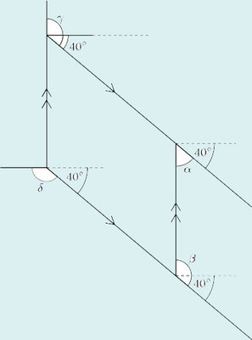

Assume the lines marked are pairs of parallel lines. Then, since the handrail makes an angle of 40° with the horizontal,

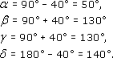

Back to - Question 6

Question 7

Answer

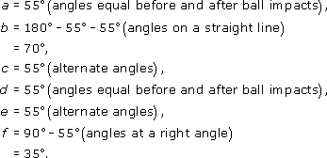

Back to - Question 7

Question 1

Answer
Each of the shapes has only one line of symmetry, so these are the only possible answers.

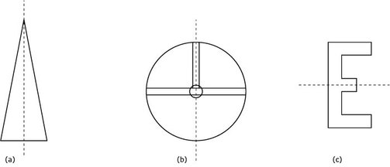

Back to - Question 1

Question 2

Answer

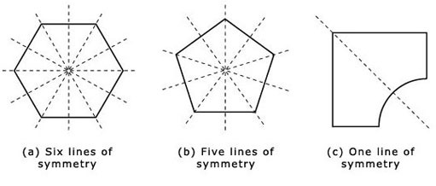

Back to - Question 2

Question 3

Answer
- (a) The dartboard has rotational symmetry.
- (b) The letter Z has rotational symmetry.
- (c) The letter K does not have rotational symmetry.
Back to - Question 3

Question 4

Answer

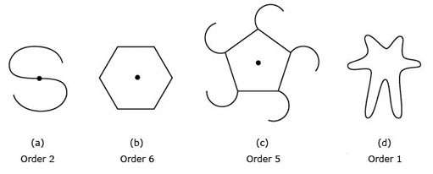

Notice that (d) has no rotational symmetry and no centre of rotation.
Back to - Question 4

Question 5

Answer

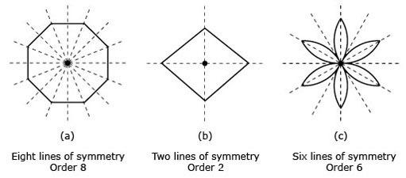

Back to - Question 5

Example 7

Answer
First, look at the angles of ΔABD: and
Then, by the angle sum property of triangles,

So

and

As CDB is a straight line and α = 60°, it follows that

Now consider the angles of ΔADC: and
Therefore

So

(Check for yourself that the angles of ΔABC also add up to 180°.)
Back to - Example 7

Example 8

Answer
- (a) As α and 50° are the base angles, α = 50°. By the angle sum property of triangles,

therefore

- (b) As γ and δ are the base angles, γ = δ. In this triangle,

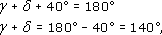

therefore

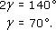

Back to - Example 8

Example 9

Answer
From ΔABC,

From ΔACD,

Then the sum of all the angles of the quadrilateral is

Back to - Example 9

Question 1

Answer
- (a) In ΔABC,

therefore

- (b) In ΔFGH,

therefore

As EFG is a straight line,

So

In ΔEFH,

Back to - Question 1

Question 2

Answer
Lines XY and XZ are of equal length. This means that the triangle is isosceles, so the base angles and are equal. Then
The third angle in the triangle is a right angle: .
Because the three angles in a triangle must add up to 180°,

Hence

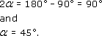

Back to - Question 2

Question 3

Answer
- (a) As this is an isosceles triangle, α = β.
So

Therefore

- (b) As this is an isosceles triangle, γ = δ.
So

Therefore

Back to - Question 3

Example 10

Answer
Assume that the wall is vertical, and that the ground and BE are both horizontal. Also assume that BF and CE are at right angles to AD.
Consider the angles of ΔACD: and
Then

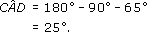

It is easiest to see which triangles are similar if you look at them in pairs.
In each diagram, the two triangles under consideration are emphasised by heavy lines.

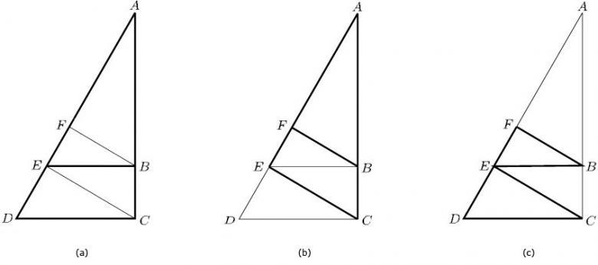

In (a), both the triangles that are outlined by heavy lines have the same angle at A, 25°, and both also have a right angle (at C and B, respectively). Therefore the third angle in the two triangles (at D and E) must also be the same. (You can confirm this by noticing that these are corresponding angles.) The size of these angles must be 180° − 25° − 90° = 65°.
In (b), both triangles have the same angle at A, 25°, and they both have a right angle (at E and F, respectively). Then the third angle in each will be the same size, 65°.
In (c), each triangle has a right angle (at E and F, respectively), and in the larger triangle is the same size as in the smaller triangle (they are corresponding angles). These corresponding angles are each 65°; hence the third angle must again be 25°.
This gives six triangles, each with angles of 25°, 90° and 65°, and so all are similar.
There is a seventh triangle that is also similar to the others, ΔBEC. This has a right angle, and its angle in ΔECD (they are alternate angles), and so is 25°. Its third angle must therefore be 65°.
Back to - Example 10

Question 1

Answer
Triangles a, c and g are similar since they have angles of 90°, 45° (and hence another angle of 45°).
Triangles b and f are similar since they have angles of 90°, 60° (and hence another angle of 30°).
Triangles d, e and h are similar since they have angles of 45° and 60° (and hence another angle of 75°).
Back to - Question 1

Question 2

Answer

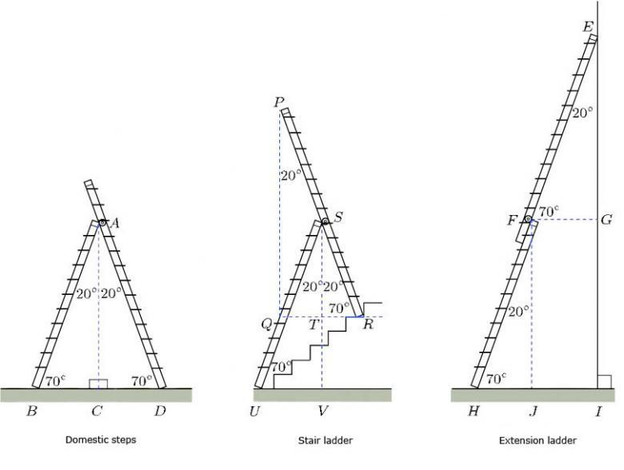

There are many alternative solutions.
Here are some similar triangles which are identified by using the labels given in the diagram above:

domestic steps | ΔACD and ΔACB,
stair ladder | ΔSTR, ΔSTQ, ΔPQR, ΔSVU,
extension ladder | ΔFJH, ΔEIH, ΔEGF.

Some congruent triangles are

domestic steps | ΔACD and ΔACB,
stair ladder | ΔQST and ΔSTR.

Back to - Question 2

Question 3

Answer
3
- (a) All four of the given angles are right angles.
- (b) (which is the same as ) is equal to . They are alternate angles.
(which is the same as ) is equal to . This is because ΔBCD and ΔOAF are similar: each has a right angle, and and are corresponding angles.
- (c) There are four triangles that are similar to ΔOAF: they are ΔOBD, ΔDEF, ΔOCD and ΔBCD.
Back to - Question 3

Example 11

Answer
Divide the lawn into three parts – a rectangle and two triangles. Then combine the two triangles into one.

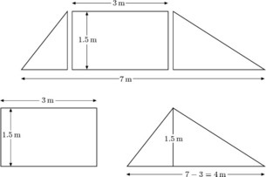

So

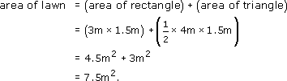

Back to - Example 11

Example 12

Answer
The first thing to do when tackling a problem like this is to draw a diagram, and to include on it all the information that has been given.

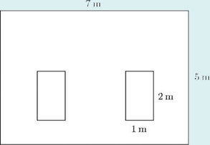

Note that, as the positions of the flowerbeds have not been specified, it does not matter where they are placed.
From the diagram,
area of garden = 7 m × 5 m = 35 m²,
area of one flowerbed = 2 m × 1 m = 2 m².
Therefore,

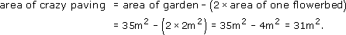

Back to - Example 12

Question 1

Answer
(a)

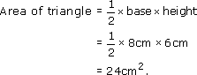

(b) The trapezium can be split into a triangle and a rectangle:

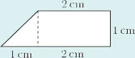

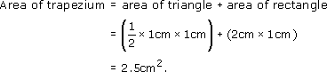

Back to - Question 1

Question 2

Answer

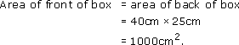

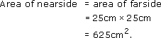

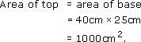

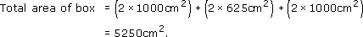

Therefore, the amount of material needed is 5250 cm².
Back to - Question 2

Question 3

Answer

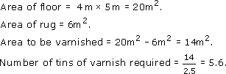

So six tins will have to be purchased.
Back to - Question 3

Question 4

Answer
The end wall of the bungalow, minus the windows, can be divided into simple shapes as shown.

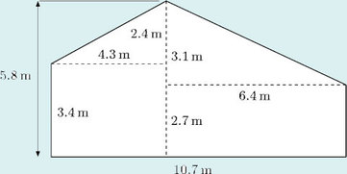

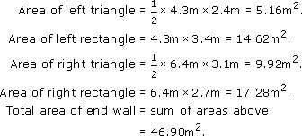

The dimensions of the windows, in metres, are 2.2 m by 1.45 m and 1.25 m by 0.88 m, respectively.

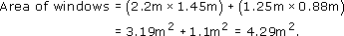

Back to - Question 4

Question 5

Answer

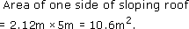

Area of one side of tent = 2 m × 5 m = 10 m².

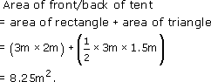

Area of door = 0.8 m × 1.75 m = 1.4 m².
Total area of canvas
- = ( 2 × area of one side of sloping roof )
  - + ( 2 × area of side of tent )
  - + ( 2 × area of front/back of tent )
  - − ( area of door )
- = ( 2 × 10.6 m² ) + ( 2 × 10 m² )
  - + ( 2 × 8.25 m² ) − 1.4 m²
- = 56.3 m².
So 56.3 m² of canvas are needed.
(In practice, the amount needed will depend upon the width of the canvas and on how many joins there are. It is likely that at least 60 m² will be needed.)
Back to - Question 5

Example 13

Answer
Circumference = 2 × radius = 2 × 10 m = 20 m ≈ 62.8 m

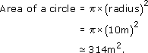

Back to - Example 13

Example 14

Answer
The diagram shows the area of the path.

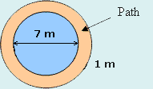

This area can be found by calculating the area of the path and pond together, and then subtracting the area of the pond.
So, Area of path = Area of path and pond – Area of pond.
The pond and the path form a circle of diameter 1m + 1m + 7m = 9m. A circle of diameter 9m has a radius of 4.5 m.
So, the area of the path and pond = × 4.5² m².
The pond has diameter 7 m, so its radius is 7 m ÷ 2 = 3.5 m.
Hence, the area of the pond = × 3.5² m².
So, the area of the path = × 4.5² m² − × 3.5² m²
25 m².
Back to - Example 14

Question 1

Answer
- (a)

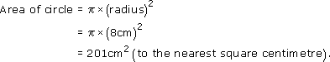

- (b)

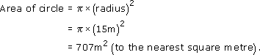

Back to - Question 1

Question 2

Answer
- (a) Area = 10 m × 6 m = 60 m².
- (b) Area = (1.1 m)² ≈ 3.80 m².
- (c) Area = × 10m × 5m = 25m².
Back to - Question 2

Question 3

Answer
Add together the areas of the rectangle and the triangle from Question 2, and subtract the area of the circle to find

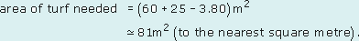

Back to - Question 3

Question 4

Answer
In the following calculation, full calculator accuracy numbers are indicated by three dots. For example the full calculator accuracy value for is written as 3.141 ... .

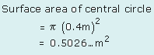

There are four slabs in this circle, so each slab will have a

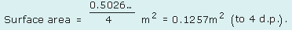

The surface area of the eight slabs in the inner ring is calculated by subtracting the central circle from the circle with radius 0.8 m:

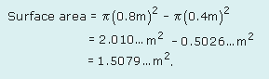

There are eight slabs in the inner ring, so each slab will have a

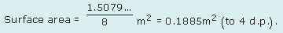

Use a similar method to find the surface area of the outer ring of slabs:

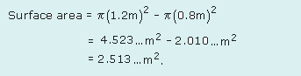

There are sixteen slabs in the inner ring, so each slab will have a

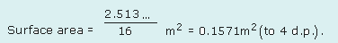

Type of slab | Surface area/m²
Central slab | 0.1257 | Lightest
Inner ring slab | 0.1885 | Heaviest
Outer ring slab | 0.1571

Assuming that the slabs are of equal thickness, and are made of the same material, the weights of the slabs will be proportional to the surface areas. So the results show that the lightest slabs are in the central circle and the heaviest in the inner ring.
Back to - Question 4

Example 15

Answer
- (a) For this object,
cross-sectional area = 8 cm × 8 cm = 64 cm²,
- therefore
volume = 16 cm × 64 cm² = 1024 cm³.
- (b) For this object,

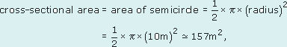

therefore
volume ≅ 157 m² × 100 m = 15 700 m³.
Back to - Example 15

Question 1

Answer
(a)

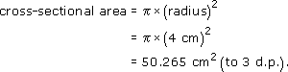

So
volume = 50.265 cm² × 10 cm = 502.65 cm³.
Thus the volume is 503 cm³ (to the nearest cubic centimetre).
(If you used the approximate value of 3.14 for , you will have got a cross-sectional area of 50.24 cm² and a volume of 502.4 cm³.)
- (b)

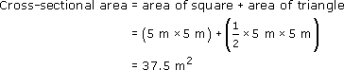

So
volume = 37.5 m² × 10 m = 375 m³.
Back to - Question 1

Question 2

Answer
Car A has four cylinders, each with a radius of 4.3 cm and a height of 8.6 cm. The volume of one cylinder is calculated by using the formula

So, the four cylinders will have

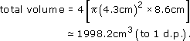

Car B has four cylinders, each with a radius of 4.6 cm and a height of 7.5 cm. From the same formula, the four cylinders will have

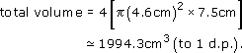

Therefore, both engines have a cubic capacity very close to 2000 cm³. They are both said to have two-litre engines. Hence the claims of both manufacturers are true.
Back to - Question 2

Question 3

Answer
The cross-section of the guttering is a semicircle of radius 0.05 m. So

Then, since the length of the guttering is 12m,

Therefore the guttering will hold about 0.047 m³ of water.
Back to - Question 3

Example 16

Answer
The real window has an area of 240 cm × 120 cm = 28 800 cm². It might be easier to think of this in square metres, that is

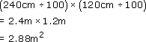

To find the dimensions of the window in the model, divide the real lengths by 20 as the scale is 1 cm to 20 cm:

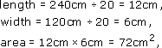

or in square metres,

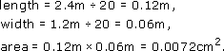

Now find the number of times that the area of the real window exceeds the area of the window in the model:
working in square centimetres 28 800 ÷ 72 = 400,
or
working in square metres 2.88 ÷ 0.0072 = 400.
As the real lengths are 20 times greater than those on the model, the areas are 20² (= 400) times greater.
Back to - Example 16

Example 17

Answer
Just as areas must be multiplied or divided by the scale squared, so volumes (and capacities) must be multiplied or divided by the cube of the scale. Here the capacity of the real tank must be divided by 20³ (= 8000). Therefore
capacity of model tank = 250 litres ÷ 8000 = 0.03125 litres.
As there are 1000 cm³ in one litre,
capacity = 0.03125 × 1000 cm³ = 31.25 cm³.
A check on this value can be made by considering the volume of the real water tank. If it is assumed that the full tank holds exactly 250 litres, the volume of the tank would be at least 250 × 1000 cm³ = 250 000 cm³.
The question does not give the dimensions of the real tank, but to produce this volume, the dimensions might perhaps be 50 cm by 50 cm by 100 cm. (Note that 50 × 50 × 100 = 250 000.) The dimensions of the model of such a tank would be

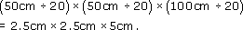

So
volume of model tank = 31.25 cm³.
Back to - Example 17

Question 1

Answer
(a) Since 1 cm in the model represents 25 cm in real life, areas must be scaled by 25 × 25 (the area scale is 25² because the length scale is 25). So

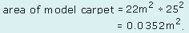

This can be converted to square centimetres by multiplying by 100 × 100:

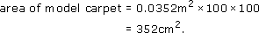

Alternatively, you could convert to cm² first:

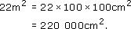

So

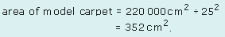

Back to - Question 1

Question 2

Answer
Since 1 cm in the model represents 20 cm in real life, volumes must be scaled by 20 × 20 × 20.
So the volume of the tender in real life must be

Thus the volume of coal that could be carried in the real engine's tender is 40 m³.
Back to - Question 2

Figure ang1

Description
Figure ang1
Back to - Figure ang1

Figure ang2

Description
Figure ang2
Back to - Figure ang2

Figure ang3

Description
Figure ang3
Back to - Figure ang3

Uncaptioned Figure

Description
Figure ang4
Back to - Uncaptioned Figure

Figure ang5

Description
Figure ang5
Back to - Figure ang5

Figure ang6

Description
Figure ang6
Back to - Figure ang6

Figure ang1

Description
Acute angle
Back to - Figure ang1

Figure ang2

Description
Right angle
Back to - Figure ang2

Figure ang3

Description
Obtuse angle
Back to - Figure ang3

Uncaptioned Figure

Description
Half turn (Straight angle)
Back to - Uncaptioned Figure

Figure ang5

Description
Reflex angle
Back to - Figure ang5

Figure ang6

Description
Complete turn
Back to - Figure ang6

Uncaptioned Figure

Description
Figure 100
Back to - Uncaptioned Figure

Pie chart showing results of 60 mathematics students over a five-year period (Source: Tutor's own records)

Description
Pie chart showing results of 60 mathematics students over a five-year period
Back to - Pie chart showing results of 60 mathematics students over a five-year period (Source: Tutor's own records)

Uncaptioned Figure

Description
Vertically opposite angles
Back to - Uncaptioned Figure

Uncaptioned Figure

Description
Parallel lines
Back to - Uncaptioned Figure

Uncaptioned Figure

Description
Corresponding angles
Back to - Uncaptioned Figure

Uncaptioned Figure

Description
Alternate angles
Back to - Uncaptioned Figure

A quadrilateral is a shape with four straight sides.

Description
Quadrilateral
Back to - A quadrilateral is a shape with four straight sides.

A square has four equal sides and four right angles. Opposite sides are parallel.

Description
Square
Back to - A square has four equal sides and four right angles. Opposite sides are parallel.

A rectangle has four right angles and opposite sides are equal and parallel.

Description
Rectangle
Back to - A rectangle has four right angles and opposite sides are equal and parallel.

A parallelogram has opposite sides equal and parallel. Opposite angles are equal.

Description
Parallelogram
Back to - A parallelogram has opposite sides equal and parallel. Opposite angles are equal.

A rhombus has four equal sides. Opposite sides are parallel and opposite angles are equal.

Description
Rhombus
Back to - A rhombus has four equal sides. Opposite sides are parallel and opposite angles are equal.

Uncaptioned Figure

Description
A circle with the centre is often labelled with the letter O.
Back to - Uncaptioned Figure

Uncaptioned Figure

Description
Semicircle
Back to - Uncaptioned Figure

Uncaptioned Figure

Description
Line symmetry
Back to - Uncaptioned Figure

Uncaptioned Figure

Description
Scalene triangle
Back to - Uncaptioned Figure

Uncaptioned Figure

Description
Car wheel trim
Back to - Uncaptioned Figure

Uncaptioned Figure

Description
Rotational symmetry of order 1
Back to - Uncaptioned Figure

Uncaptioned Figure

Description
Base angles
Back to - Uncaptioned Figure

Uncaptioned Figure

Description
Diagram of a wooden buttress supporting the wall of a medieval church.
Back to - Uncaptioned Figure

Uncaptioned Figure

Description
Diagram of the arrangement of the struts in a wall of a shed.
Back to - Uncaptioned Figure

Uncaptioned Figure

Description
Trapezium-shaped lawn
Back to - Uncaptioned Figure

Uncaptioned Figure

Description
The dimensions of a frame tent
Back to - Uncaptioned Figure

