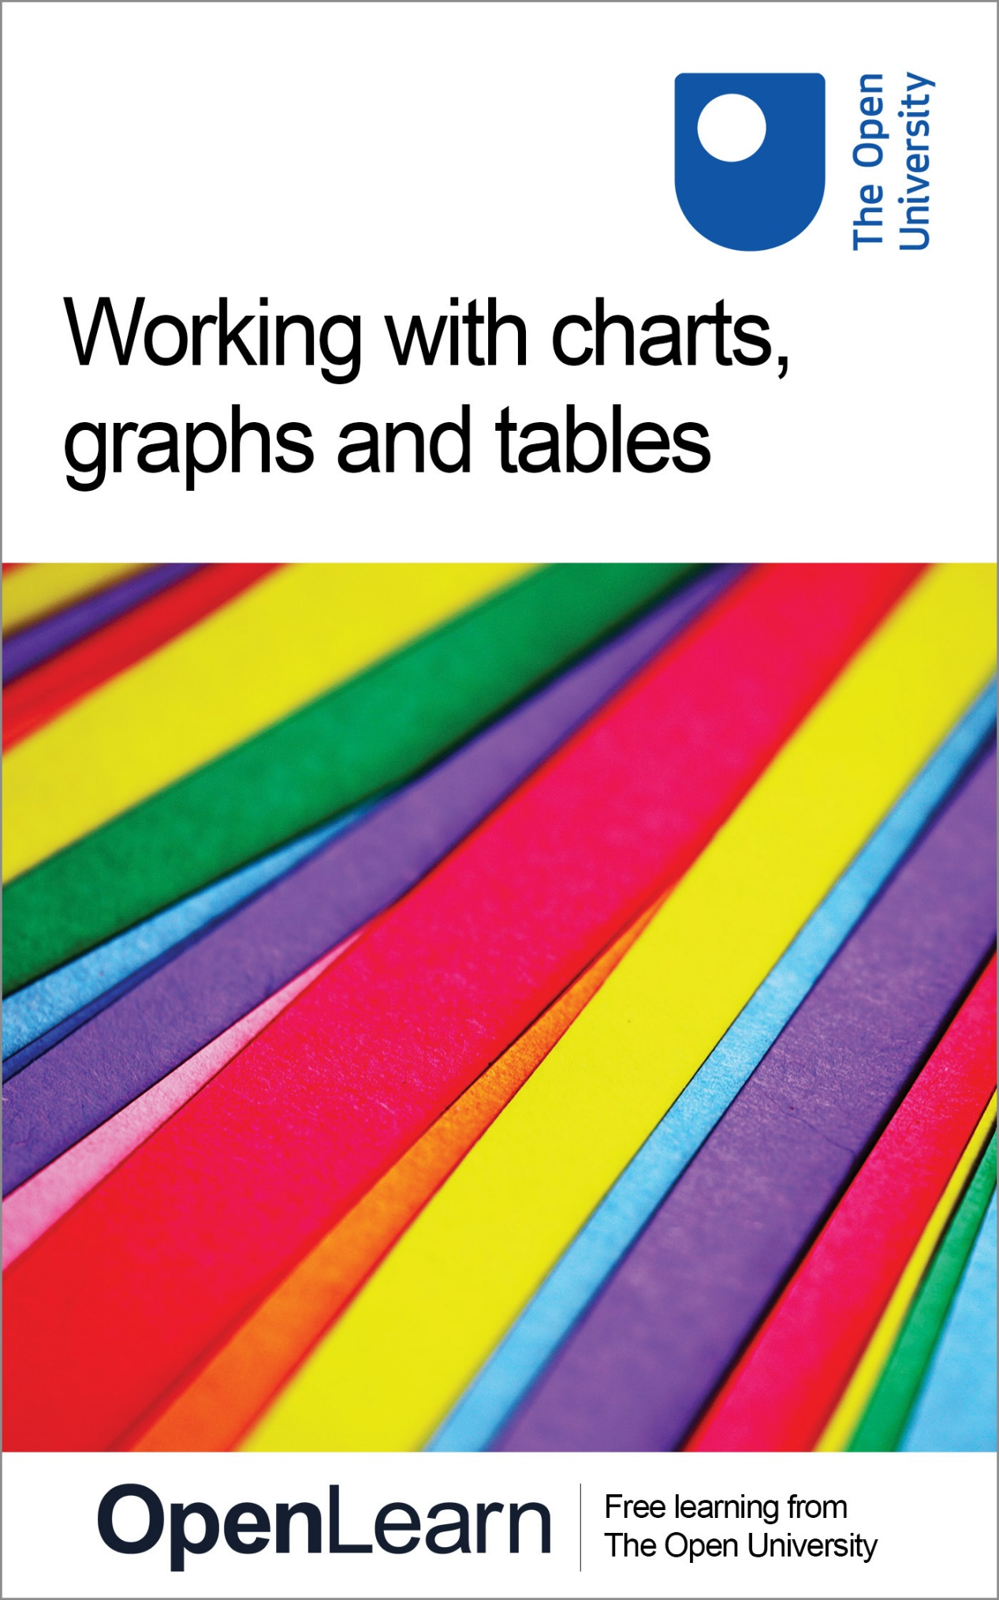

**LDT\_3**

**Working with charts, graphs and tables**

**About this free course**

Find out more about studying with The Open University by [visiting our online prospectus](http://www.open.ac.uk/courses?utm_source=openlearn&utm_campaign=ol&utm_medium=ebook).

This version of the content may include video, images and interactive content that may not be optimised for your device.

You can experience this free course as it was originally designed on OpenLearn, the home of free learning from The Open University - [http://www.open.edu/openlearn/science-maths-technology/mathematics-and-statistics/mathematics-education/working-charts-graphs-and-tables/content-section-0](http://www.open.edu/openlearn/science-maths-technology/mathematics-and-statistics/mathematics-education/working-charts-graphs-and-tables/content-section-0?utm_source=openlearn&utm_campaign=ol&utm_medium=ebook).

There you’ll also be able to track your progress via your activity record, which you can use to demonstrate your learning.

The Open University, Walton Hall, Milton Keynes MK7 6AA

Copyright © 2016 The Open University

**Intellectual property**

Unless otherwise stated, this resource is released under the terms of the Creative Commons Licence v4.0 <http://creativecommons.org/licenses/by-nc-sa/4.0/deed.en_GB>. Within that The Open University interprets this licence in the following way: [www.open.edu/openlearn/about-openlearn/frequently-asked-questions-on-openlearn](http://www.open.edu/openlearn/about-openlearn/frequently-asked-questions-on-openlearn). Copyright and rights falling outside the terms of the Creative Commons Licence are retained or controlled by The Open University. Please read the full text before using any of the content.

We believe the primary barrier to accessing high-quality educational experiences is cost, which is why we aim to publish as much free content as possible under an open licence. If it proves difficult to release content under our preferred Creative Commons licence (e.g. because we can’t afford or gain the clearances or find suitable alternatives), we will still release the materials for free under a personal end-user licence.

This is because the learning experience will always be the same high quality offering and that should always be seen as positive – even if at times the licensing is different to Creative Commons.

When using the content you must attribute us (The Open University) (the OU) and any identified author in accordance with the terms of the Creative Commons Licence.

The Acknowledgements section is used to list, amongst other things, third party (Proprietary), licensed content which is not subject to Creative Commons licensing. Proprietary content must be used (retained) intact and in context to the content at all times.

The Acknowledgements section is also used to bring to your attention any other Special Restrictions which may apply to the content. For example there may be times when the Creative Commons Non-Commercial Sharealike licence does not apply to any of the content even if owned by us (The Open University). In these instances, unless stated otherwise, the content may be used for personal and non-commercial use.

We have also identified as Proprietary other material included in the content which is not subject to Creative Commons Licence. These are OU logos, trading names and may extend to certain photographic and video images and sound recordings and any other material as may be brought to your attention.

Unauthorised use of any of the content may constitute a breach of the terms and conditions and/or intellectual property laws.

We reserve the right to alter, amend or bring to an end any terms and conditions provided here without notice.

All rights falling outside the terms of the Creative Commons licence are retained or controlled by The Open University.

Head of Intellectual Property, The Open University

The Open University

United Kingdom by Thanet Press Limited, Margate, Kent

978-1-4730-1375-9 (.kdl)  
978-1-4730-0607-2 (.epub)

# Contents

* [Introduction](#Introduction1)
* [Learning outcomes](#LearningOutcomes1)
* [1 Your worries and concerns with charts, graphs and tables](#Session1)
* [2 Reflection on mathematics](#Session2)
  + [2.1 Reflecting on your mathematical history](#Session2_Section1)
* [3 Reading articles for mathematical information](#Session3)
* [4 Making sense of data](#Session4)
  + [4.1 Reading data from tables](#Session4_Section1)
  + [4.2 Interpreting percentages](#Session4_Section2)
  + [4.3 Pie charts, bar charts, histograms and line graphs](#Session4_Section3)
  + [4.4 Bar charts](#Session4_Section4)
  + [4.5 Histograms](#Session4_Section5)
  + [4.6 Line graphs](#Session4_Section6)
  + [4.7 Proportion](#Session4_Section7)
  + [4.8 Mean, median and mode](#Session4_Section8)
* [5 Interpreting graphs and charts](#Session5)
  + [5.1 Difficulties in interpretation](#Session5_Section1)
  + [Conclusion](#Session5_Section2)
* [6 Technical glossary](#Session6)
* [7 Further reading and sources of help](#Session7)
  + [Further reading](#Session7_Section1)
  + [Sources of help](#Session7_Section2)
* [Keep on learning](#Session8)
* [Acknowledgements](#Acknowledgements1)
* [Solutions](#Solutions1)

## Introduction

Your course might not include any maths or technical content but, at some point during your course, it's likely that you'll come across information represented in charts, graphs and tables. You'll be expected to know how to interpret this information. This course will help you to develop the skills you need to do this. This course can be used in conjunction with **openlearn** course LDT\_4 More working with charts, graphs and tables, which looks into more ways to present statistical information and shows you how to use charts, graphs and tables to present your own information.

Find out more about studying with The Open University by [visiting our online prospectus](http://www.open.ac.uk/courses?utm_source=openlearn&utm_campaign=ol&utm_medium=ebook).

## Learning outcomes

After studying this course, you should be able to:

* reflect on existing skills and mathematical history, set up strategies to cope with mathematics and assess which areas need improving
* understand the following mathematical concepts, through instruction, worked examples and practice activities: reflecting on mathematics; reading articles for mathematical information; making sense of data; interpreting graphs and charts
* draw on a technical glossary, plus a list of references to further reading and sources of help, which can help to improve maths skills.

## 1 Your worries and concerns with charts, graphs and tables

Do you sometimes feel that you do not fully understand the way that numbers are presented in course materials, newspaper articles and other published material?

What do you consider are your main worries and concerns about your ability to understand and interpret graphs, charts and tables?

Spend a few minutes writing these down before you read on.

One student has said:

Start of Quote

I am never quite sure that I have understood what the figures mean. I tend to skip over the graphs or charts that I come across, hoping that I can get the information I need from the text.

End of Quote

This is one course in a series of Student Toolkits; there are (or will be) others to help you with such things as effective use of English, essay writing, revision and exams, and other areas of study skills.

As a student, the amount of numerical information that you will have to deal with varies greatly from course to course. Many courses with no mathematical, scientific or technical content still require you to be able to interpret and draw conclusions from tables and graphs, and understand basic statistics. This course is primarily aimed at those who are not confident about their ability to do these things.

You may well feel that difficulties you have with the numerical information are holding you back from making progress in your studies. We hope that when you have worked through this course, you will have gained the confidence to understand and interpret the graphs, charts and tables you meet in your course work. That is, that you will be able to draw conclusions from tables and graphs, understand basic statistics, and answer the questions associated with them more effectively. Having a greater understanding of these areas will also allow you to read newspaper and magazine articles containing graphs, charts or tables with a more critical eye. This is a practical course and if you look at the course home page www.open.ac.uk/skillsforstudy/ you will see that it begins by asking you to reflect on your own ideas about mathematics. Many people try to avoid this area altogether, although they are actually using many more mathematical concepts in their everyday life than they realise. We strongly recommend that you spend some time on this section. The rest of the course works through the skills that you are likely to find useful, and which will allow you to get the most out of your studies. There is a technical glossary, which provides a basic explanation of the common mathematical terms we have used, and at the end we give you some suggestions for further sources of help.

We expect you to be an active learner and, as with your course material, we shall ask you to work through this course with a pen and paper handy so that you can do the activities as you go.

We anticipate that after you have worked through this course you will feel more confident about your ability to interpret and work with graphs, charts and tables. Hopefully, your understanding of course materials will be more complete and you will find it easier to tackle any assignments you may have to undertake. Remember though that these things do not happen instantly and that, as with any skill, it often takes a long time to master it completely. If this course helps to put you on the road to a better understanding of the numerical information that you meet everyday, then it will have achieved its aim.

Good luck!

## 2 Reflection on mathematics

Mathematics is a subject about which people have strong views, and these can be negative, positive, or a combination of the two. Our own experience, as tutors and students of mathematics, is that mathematics is often seen by others as something that ‘isn't for me’, and one where beliefs and feelings, especially worry and even fear, can be strong, as a result of previous unhappy experiences. We have written this section to help you to look at your mathematical background, so that you can understand some of the reasons you feel as you do.

## 2.1 Reflecting on your mathematical history

One of the obstacles that we see to understanding and working with mathematics is that people feel the need to avoid it entirely, because they feel nervous about it. Others don't feel as nervous, but may still avoid mathematical work. In practice, you may well be using more mathematical concepts than you think, as numbers are all around us; for example, when shopping, going out for a drink with friends, paying bills, or planning a budget so that you can take a holiday.

Start of Activity

**Activity 1**

Start of Question

This activity is designed to get you to look at the previous experience you have of mathematics. It will take you between 15 and 20 minutes, and to put your concerns into context, we suggest that you carry it out before you begin work on the rest of the course.

**All through school**

Think about your schooldays: nursery or kindergarten, first or primary school, middle or secondary school. Now consider the following questions.

1. What were your experiences of mathematics?
2. How do you feel about these experiences?

**Work and study since school**

1. How have the jobs you have done since school affected your mathematical thinking? Think about reading newspapers, preparing reports, watching television. For example, when was the last time you noticed that you were thinking about mathematics?
2. In your experience of study since school, what more have you learnt about your own use of mathematics? What do you expect of yourself when you approach a mathematical problem: are you confident, worried, or concerned?

End of Question

[View discussion - Activity 1](" \l "Session2_Discussion1)

End of Activity

## 3 Reading articles for mathematical information

We gain much of our mathematical information from our surroundings, including reading newspaper and magazine articles. A skill that will be useful to all of us in our studies is the ability to do this in a structured way, as it is very easy to be uncritical of the information that we see. Newspapers and magazines frequently place mathematical information in the form of graphs and diagrams. All too often, we tend to assume that the information is correct, without questioning possible bias or inaccuracy by the author or authors.

When you next look through a newspaper or magazine, try to get an idea of which ones use some form of mathematical representation. We noticed that some magazines rarely use this form of information, and that broadsheet newspapers were more likely to use mathematical information than the tabloid newspapers.

Start of Activity

**Activity 2**

Start of Question

To show you what we mean we have included a newspaper article, ‘On your marks’ taken from The Guardian. Read it now and then answer the questions below before moving on to the discussion. You can download a more easily readable Word version here: [On your marks](https://www.open.edu/openlearn/ocw/mod/resource/view.php?id=105651).

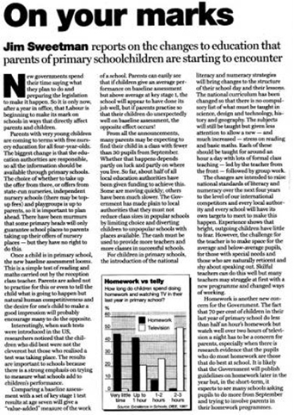

1. What influences might the identity of the newspaper have had on how you react to the diagram or article and, in particular, to the conclusions drawn?
2. Where was the data in the graphs derived from?
3. How does it relate to the article?
4. What conclusions can you draw from the use of the graphs related text?

End of Question

[View discussion - Activity 2](" \l "Session3_Discussion1)

End of Activity

## 4 Making sense of data

## 4.1 Reading data from tables

Tables are used as a way of describing what you are talking about in a structured format. They tend to be used to present figures, either as a summary or as a starting point for discussion. Tables are also probably the most common way of presenting data in educational courses.

Tables have always been compiled by someone. In doing so, the compiler may have selected data and they will have chosen a particular format, either of which may influence the reader. You need to be aware of the compiler of any table you are looking at. Could it be someone who is trying to tell you something in particular? For example, if a table were showing the costs of running a hospital, would you expect figures from the government or the local administrators to be more accurate? The government may be trying to make a comparison across the whole NHS, whereas local administrators may be trying to explain why they are a special case. If you consider one source to be more accurate than another, try to think of reasons why you do so. It may be due to where your sympathies lie.

Tables are a very common way of putting information across to people; so common that we probably don't notice that they are there most of the time. On the other hand, they can look quite formidable when there is a lot of information presented at once, and finding your way around them can be hard. To be easy to read, tables should have a title and sub headings. Often, there will be details of where the information in the table has come from, but this is not always the case.

Start of Activity

**Activity 3**

Start of Question

Look at the table entitled ‘The changing face of UK business schools’ and note down your answers to the following questions.

Start of Figure

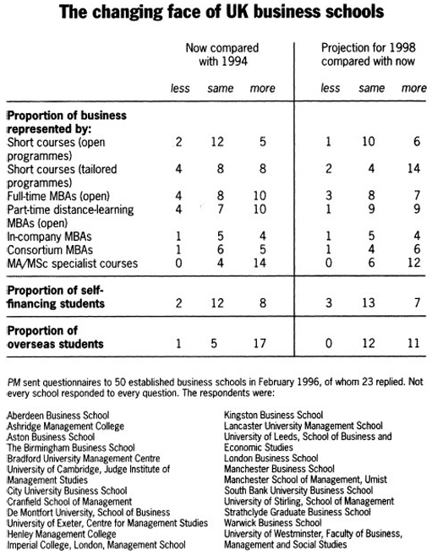

Source: People Management 21 March 1996

End of Figure

1. Where does the table come from? When was it prepared?
2. Where does the data come from? Does its source tell us anything?
3. On the left-hand side of the table is a list of headings referring to proportions. What could make this easier to follow?

End of Question

[View discussion - Activity 3](" \l "Session4_Discussion1)

End of Activity

**Short courses (open programmes).** Most of the respondents here, 12 out of 19 (about 63 per cent), feel their business has remained stable, 2 feel that it has decreased and 5 that it has increased since 1994. In other words, two and a half times more business schools feel that business has increased rather than decreased in this area. These courses seem to be increasing overall as a proportion of income, but not in a significant way. However, the business schools appear to be expecting more change in future, note the 6 in the last column. Looking forward, the same numbers of business schools think that the proportion will change. It depends on how you interpret these figures, though. We could say that:

* 6 times as many business schools are expecting to run more short courses than are expecting to run less such courses

or

* one more school (6 looking forward rather than 5 looking back) has decided that they are likely to increase the proportion of students who will be represented in this category

or

* only 6 out of 17 (about 35 per cent) could see an increase in students by 1998.

Any of these is a truthful statement, but they give very different pictures, don't they?

**Short courses (tailored programmes).** These are programmes made for a particular audience, mainly for a single organisation. Looking back, these seem to show a similar pattern, where twice as many business schools are looking at an increase than a decrease. This is a more changeable pattern, with only 8 out of 20 (40 per cent) of the group showing no change. Looking forward though, only 4 out of 20 (20 per cent) imagine there will be no change in tailored programmes, whereas 14 out of 20 (70 per cent) imagine that this will increase by 1998.

**Note:** To convert 8 out of 20 to a percentage, we carry out the division 8 ÷ 20. This equals 0.4; this is then multiplied by 100 to express it as a percentage. Expressing all the values in the table as percentages enables easier comparison. Try it yourself for the full-time MBAs in 1994. (The answers are 18 per cent, 36 per cent, and 45 per cent. This doesn't add up to 100 per cent, but to 99 per cent, so we would normally round one of the numbers up. The one that is nearest to the next whole number, is 45 per cent, so it becomes 46 per cent.) Percentages are discussed more fully in [Section 4.2](#sec004_002).

Start of Activity

**Activity 4**

Start of Question

Now, think about the patterns shown by the proportion of overseas students. What are the perceived changes and expectations here?

End of Question

[View discussion - Activity 4](" \l "Session4_Discussion2)

End of Activity

Start of Activity

**Activity 5**

Start of Question

Overall, what does the table show us about the changing face of UK business schools?

End of Question

[View discussion - Activity 5](" \l "Session4_Discussion3)

End of Activity

## 4.2 Interpreting percentages

Many articles give information in the form of percentages. In such articles, tables and other numerical information are also often presented in terms of percentages. Percentages are used so often because they enable comparisons to be made more easily. Every percentage is expressing a value as a fraction (that is, as a proportion) of a hundred. ‘Percent’ is denoted by % and means ‘out of a hundred’, so 75% means 75 out of 100.

Look at the table in the article in Activity 6. It considers the provision of company cars in the private and voluntary sector. What is the percentage of Chief Executive Officers (CEOs) in the private sector with company cars?

It is 75 per cent. If we say that 75 per cent of CEOs in the private sector have company cars, we mean that 75 out of every 100 CEOs have a company car.

As a fraction, this is written as D:\AaaF\OUT\httpswwwopeneduopenlearnocw_cmid4388_2020-09-24_08-58-27_js34827\word\assets\_d8c4cc81dc7f968a859eff6d2517350da42d1ef9_ldt_3_ie002i.gif, and this is said as ‘75 over 100’ (D:\AaaF\OUT\httpswwwopeneduopenlearnocw_cmid4388_2020-09-24_08-58-27_js34827\word\assets\_d8c4cc81dc7f968a859eff6d2517350da42d1ef9_ldt_3_ie002i.gif is the same as D:\AaaF\OUT\httpswwwopeneduopenlearnocw_cmid4388_2020-09-24_08-58-27_js34827\word\assets\_ac422cfa44c77f5c79e9faf8a1ed703e827c1f4e_ldt_3_ie003i.gif),

As a decimal 75 per cent is 0.75. This is said as ‘nought point seven five’ – note that each number after a decimal point is said separately, and that the leading zero (nought) is always included.

Start of Activity

**Activity 6**

Start of Question

What can we tell about the table entitled ‘Provision of company cars’, using the questions we asked earlier and which are reproduced below the article?

Start of Figure

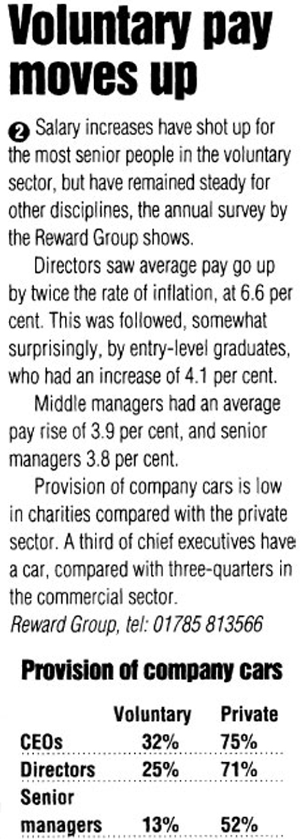

Source: Personnel Today 17 December 1998

End of Figure

1. Who wrote the article and table, and for which publication?
2. What influences has this had on the article and its conclusions?
3. Where was the data in the table derived from?
4. How does the table relate to the article?
5. What conclusions can you draw from the table and related text?

End of Question

[View discussion - Activity 6](" \l "Session4_Discussion4)

End of Activity

Note: A word of warning about comparing two percentages. In the private sector, 75 per cent of the CEOs have company cars, while only 32 per cent of CEOs in the voluntary sector have them. It would be very tempting to say that the difference between the two percentages is 43 per cent (i.e. 75 per cent minus 32 per cent) and that the figure for the private sector is therefore 43 per cent bigger than that for the voluntary sector. However, because of the way percentages work, we should say that the difference between the two percentages is 43 percentage points and that the percentage for the private sector is 43 percentage points more than that for the voluntary sector. We could only say that 43 per cent more CEOs in the private than voluntary sector have company cars if we are talking about the same number of people in each group. This is a very subtle point, which is often missed by journalists in newspapers and on television and radio. See if you can spot the error next time that percentages are being discussed in the media.

## 4.3 Pie charts, bar charts, histograms and line graphs

These are all different ways of representing data and you are likely to be familiar with some, if not all of them. They usually provide a quick summary that gives you a visual image of the data being presented. Below, we have given a brief definition and some ideas of how each can be used, along with a corresponding activity. We suggest that you look out for similar examples in everyday life, and question the information that you see.

### 4.3.1 Pie charts

A pie chart is a diagram in the form of a circle, with proportions of the circle clearly marked. A pie chart is a good method of representation if we wish to compare a part of a group with the whole group. It gives an immediate idea of the relative sizes of the shares. So, for example, it can be used to consider advertising income. It can also be used to look at, say, shares of market for different brands, or different types of sandwiches sold by a store.

Start of Activity

**Activity 7**

Start of Question

The two short articles opposite use pie charts to compare recruitment advertising volumes in February 1996 and in September 1996 in the UK. Look at them carefully and answer the questions that follow. (The original pie charts are in colour and some of the information is unclear or invisible in black and white. We have therefore added some labels to the pie charts.)

Start of Figure

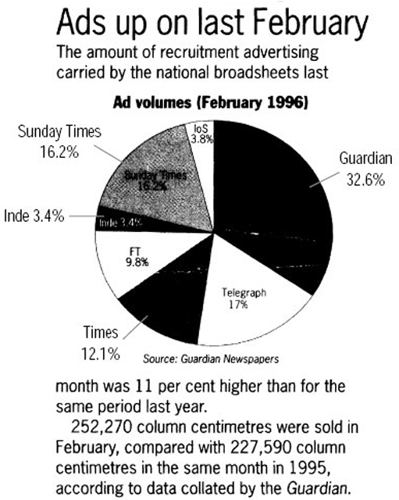

Source: People Management 21 March 1996

End of Figure

Start of Figure

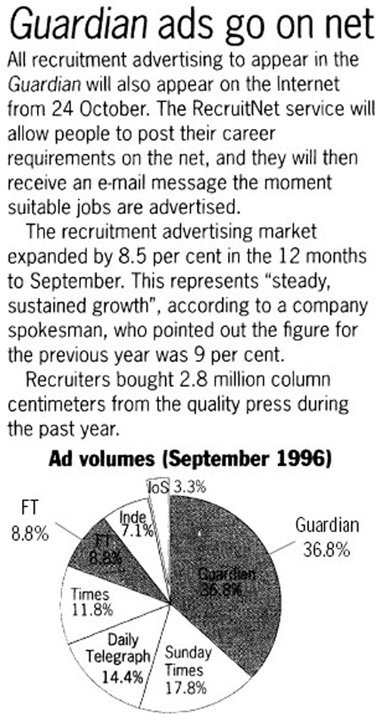

Source: People Management 24 October 1996

End of Figure

1. Which newspaper ran about a third of all advertisements?
2. Which two newspapers together ran about a third of all advertisements?
3. Where was the data in the pie charts derived from?
4. How does it relate to the article?
5. What conclusions can you draw from the pie charts and related text?

End of Question

[View discussion - Activity 7](" \l "Session4_Discussion5)

End of Activity

## 4.4 Bar charts

Bar charts show data in the form of bars that illustrate the relationship between the items of information in terms of size: the bars get larger (generally taller) as the amounts being shown increase.

When the bars touch, they show continuous data. In other words, data that changes gradually along some sort of a scale, for example weight, height, temperature, or length (these charts are called histograms, see [Section 4.5](#sec004_005)). When the bars are separate, they show discrete data. This is data that changes in whole units, such as the number of eggs, children, cars being produced, or TMAs in a course.

In particular, bar charts are useful to show comparisons. For example, male and female earnings over time, or the company car comparisons that we talked about earlier in this section.

Start of Activity

**Activity 8**

Start of Question

Look at the short article entitled ‘Cost of living is high in the UK’ and the accompanying bar chart, which shows discrete data at particular points in time. Then answer the questions that follow.

Start of Figure

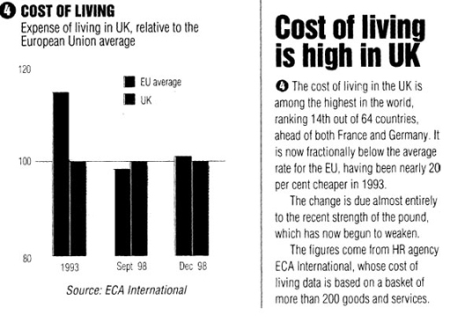

Source: Personnel Today 21 January 1999

End of Figure

1. What is the chart about?
2. How has the cost of living in the UK changed in the period since 1993?
3. Where was the data in the bar chart derived from?
4. How does it relate to the article?
5. What conclusions can you draw from the bar charts and related text?

End of Question

[View discussion - Activity 8](" \l "Session4_Discussion6)

End of Activity

## 4.5 Histograms

Histograms are a special form of bar chart in which the bars usually touch each other because histograms always show data collected into ‘groups’ along a continuous scale. They tend to be used when it's hard to see patterns in data, for example when there are only a few variables, or the actual amounts are spread over a wide range. For example, suppose you manufactured biscuits; it is important to manufacture closely to a given size, as there are regulations governing the sales of biscuits that are not the advertised size. By grouping your data along a continuous scale measuring size, you can see quickly whether the size is near to the ideal, or whether your machinery needs to be adjusted.

Start of Activity

**Activity 9**

Start of Question

We would now like you to look at an example based on engineering pay settlements and answer the questions that follow. You will notice that the bars don't actually touch, which they should do.

Start of Figure

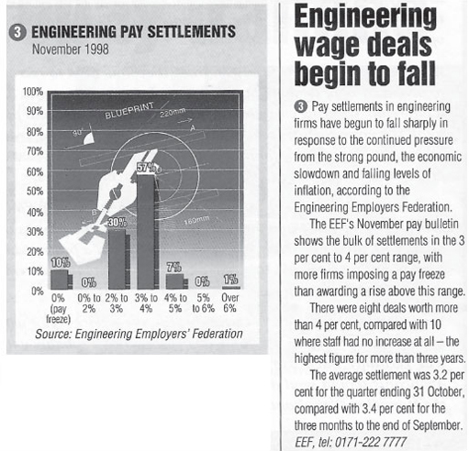

Source: Personnel Today 17 December 1998

End of Figure

1. What is shown on the vertical axis?
2. What was the most common pay settlement?
3. How many settlements were for a pay freeze?
4. Where was the data in the histograms derived from?
5. What specific influences has the data source had on the graphs, diagrams or articles and its conclusions in particular?
6. How does it relate to the article?
7. What conclusions can you draw about the use of the histograms and related text?

End of Question

[View discussion - Activity 9](" \l "Session4_Discussion7)

End of Activity

In addition, again as a small point, we found the format of the graph to be distracting. It's very interesting and it's obviously a relevant drawing in the background, but it perhaps makes it hard to look at the actual figures.

## 4.6 Line graphs

These are probably the graphs that you will be most used to seeing on an everyday basis. Line graphs are most suitable when you are just comparing one value as it changes with another value. They are less suitable when you want to look at several things at once; for example to study changes in oil prices and supermarket profits on petrol sales, the scales on the left-hand and right-hand sides of a graph would have to be different, and this can be very misleading (there is an example of this in [Activity 16](#act001_016)). However, you can see this quite often in line graphs in newspapers and magazines.

Start of Activity

**Activity 10**

Start of Question

Look at the line graph entitled ‘Employment prospects’ and the accompanying article, then answer the questions that follow.

Start of Figure

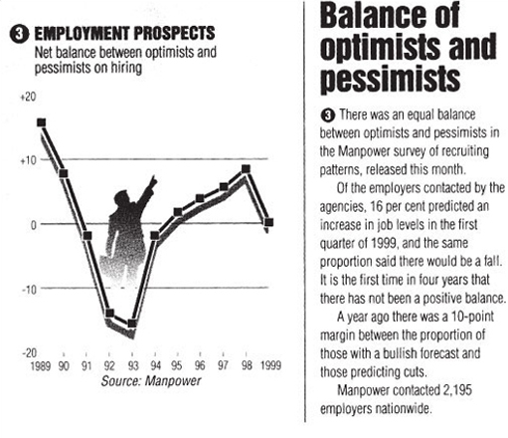

Source: Personnel Today 21 January 1999

End of Figure

1. Overall, what is the graph trying to say?
2. The graph joins up the lines between the years. How reasonable do you think this is?
3. Where was the data in the graph derived from?
4. How does it relate to the article?
5. What conclusions can you draw about the use of the graph and related text?

End of Question

[View discussion - Activity 10](" \l "Session4_Discussion8)

End of Activity

## 4.7 Proportion

We can use a number of different ways to indicate change – fractions, decimals, and percentages tend to be the ones with which many of us are familiar.

Start of Activity

**Activity 11**

Start of Question

Which of these represents the greater proportion:

10 per cent of 1260 or 140 out of 1260?

139 out of 1500 or 75 out of 250?

End of Question

[View discussion - Activity 11](" \l "Session4_Discussion9)

End of Activity

The phrase ‘proportional representation’ (PR) is used when we talk about systems of electing MPs or local councillors. This means that election results are according to the number of votes that people place for a party, rather than an individual. Once the votes have been counted for the party, then the MPs or councillors are elected according to their agreed position on a party list. In the UK, at the time of writing, we have a ‘first past the post’ system for local and national elections, but PR for the elections to the European Parliament, Scottish Parliament, Welsh Assembly and for elections in Northern Ireland. This brings the UK more into line with many other European countries.

## 4.8 Mean, median and mode

Most of us are familiar with the word ‘average’. We regularly encounter statements like ‘the average temperature in May was 4 °C below normal’ or ‘underground water reserves are currently above average’. The term average is used to convey the idea of an amount, which is standard; typical of the values involved. When we are faced with a set of values, the average should help us to get a quick understanding of the general size of the values in the set. The mean, median and mode are all types of average, which are typical of the data they represent. Each of them has advantages and disadvantages, and can be used in different situations. Here we provide brief definitions and some idea of how each can be used.

### 4.8.1 Mean

The mean is found by adding up all the values in a set of numbers and dividing by the total number of values in the set. This is what is usually meant by the word ‘average’.

For example, if a company tests a sample of the batteries it manufactures to determine the lifetime of each battery, the mean result would be appropriate as a measure of the possible lifetime any of the batteries and could be used to promote the product.

Start of Activity

**Activity 12**

Start of Question

A sample of 15 batteries was tested. The batteries lasted, in hours:

Start of Quote

**23, 28, 25, 30, 18, 29, 23, 19, 30, 24, 25, 21, 26, 25, 23**

End of Quote

1. Calculate the mean life of a battery, correct to one decimal place (i.e. with one figure after the decimal point).
2. How many hours of life will the company claim?

End of Question

[View discussion - Activity 12](" \l "Session4_Discussion10)

End of Activity

However, the mean is not always a good representation of the data. To illustrate this, consider the annual salaries of the people employed by a small company. The salaries, in euros, are:

Start of Quote

**22 000, 22 000, 25 000, 28 000, 35 000, 65 000, 92 000**

End of Quote

The mean salary = 289 000 ÷ 7 = 41 286 euros (approximately). Here, however, the mean is very misleading because the two highest salaries raise the mean considerably. You might like to confirm this by calculating the mean of just the five lowest salaries.

### 4.8.2 Median

The median is the middle value of a set of numbers arranged in ascending (or descending) order. If the set has an even number of values then the median is the mean of the two middle numbers. For example:

Start of Table

|  |  |
| --- | --- |
| 1, 1, 2, 5, **8**, 10, 12, 15, 24 | This set of nine values is arranged in ascending order and the median is 8. |
| 32, 25, 20, 16, **14, 11**, 9, 9, 4, 0 | This set of 10 values is arranged in descending order and here the median is (14 + 11) + 2, which is 12.5. |

End of Table

The salaries considered in the discussion above are in ascending order and the median is 28 000 euros. This value is more representative of the state of affairs in the company than the mean (41 286 euros) as half the employees earn less than the median and half earn more.

Start of Activity

**Activity 13**

Start of Question

Consider the scores of one batsman during the cricket season:

Start of Quote

**0, 0, 0, 4, 7, 10, 12, 15, 24, 30, 42, 48**

End of Quote

Calculate the median and the mean of this set of scores.

End of Question

[View discussion - Activity 13](" \l "Session4_Discussion11)

End of Activity

### 4.8.3 Mode

The mode, or modal value, is the most popular value in a set of numbers, the one that occurs most often. However, it is not always possible to give the mode as some sets of values do not have a single value that occurs more than each of the others. Like the median, the mode can help us to get a better feel for the set of values. Retailers find the mode useful when they want to know which item to restock first.

Start of Activity

**Activity 14**

Start of Question

The following list is the number of goals scored by a football team in a series of 18 games:

Start of Quote

**0, 0, 0, 3, 0, 1, 1, 2, 0, 2, 0, 0, 4, 0, 1, 2, 0, 2**

End of Quote

Calculate the mode, median and mean for this list.

End of Question

[View discussion - Activity 14](" \l "Session4_Discussion12)

End of Activity

## 5 Interpreting graphs and charts

## 5.1 Difficulties in interpretation

Graphs and charts are often used to illustrate information that is discussed in course materials or a newspaper article, so it is important to be able to interpret them correctly. Often, the authors of an article will attempt to emphasise the point they are trying to make by presenting the facts and figures in such a way as to confirm their argument. This is a commonly used journalistic approach, which means that it is essential to examine graphs and charts used to support arguments very carefully.

In this section we are going to look at the aspects of a graph or a chart that need to be considered in order to interpret the information correctly. We are not going to consider in detail how to draw graphs or create charts, as this is not something that most people find that they need to do.

The examples that follow have all been taken from journals and newspapers, but we have not included the articles from which they are taken from. Our main purpose is to explore some of the difficulties that people face in interpreting information presented in charts and graphs.

Start of Activity

**Activity 15**

Start of Question

This set of line graphs appeared in an article about the transformation of the workforce over the past two decades. Look at the graphs and try to answer the questions.

Start of Figure

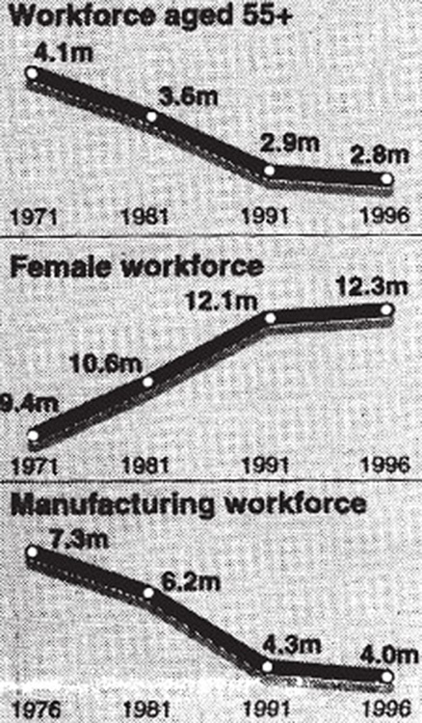

Source: The Guardian 4 January 1999

End of Figure

1. What do you think 4.1m means?
2. What do you think 55+ means?
3. What impression do you get about the workforce aged 55+ and the manufacturing workforce?
4. Describe what appears to have happened to the female workforce in comparison to the workforce aged 55+.
5. What can you say about the time scales of these graphs?

End of Question

[View discussion - Activity 15](" \l "Session5_Discussion1)

End of Activity

Every graph should have a vertical and a horizontal scale. The main purpose of each scale is to allow us to read the values from the graph at any point that we want. None of these graphs have a vertical scale, instead figures are given at intervals corresponding to the vertical scale. If you look carefully at these figures you will see that each graph has a different vertical scale. The top graph goes from 4.1m to 2.8m, a difference of 1.3m, the middle graph goes from 9.4m to 12.3m, a difference of 2.9m and the bottom graph goes from 7.3m to 4.0m, a difference of 3.3m. The height of each of the graphs is roughly the same but as we can now see, the scale is different in each case. This gives a misleading impression of the numbers involved and means that only the general trend of each graph can be compared. For a fairer comparison the vertical scale should be the same for all three graphs.

Start of Activity

**Activity 16**

Start of Question

This line graph appeared in an article about the number of non-UK registered nurses with the NHS (National Health Service). After you have looked at the graph, try to answer the questions below.

Start of Figure

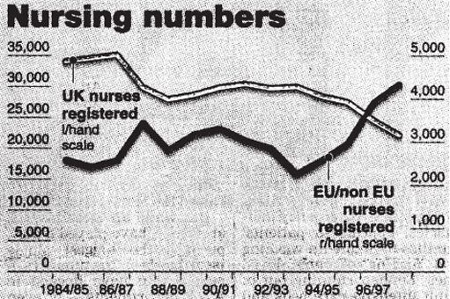

Source: The Guardian 9 January 1999

End of Figure

1. What impression do you think the author is trying to give?
2. There appears to be a crossover point, when did it take place?
3. How many UK nurses were registered with the NHS at this time?
4. How many EU/non-EU nurses were registered with the NHS at this time?
5. Describe what the actual situation as regards UK and EU/non-EU nurses was at this time.

End of Question

[View discussion - Activity 16](" \l "Session5_Discussion2)

End of Activity

First impressions can be very misleading. ‘Nursing numbers’ shows two graphs with two different vertical scales superimposed on one another. As the scales are different, it is incorrect to draw any conclusions from the visual impression of how the two graphs compare to each other. A fairer picture would have been given if the same scale had been used for both. However, given that the number of EU/non-EU nurses registered with the NHS has never exceeded 5000, the resulting graph would not be very meaningful. You might like to have a go at sketching it.

Start of Activity

**Activity 17**

Start of Question

This horizontal bar chart appeared in an article about the pros and cons of modern life for children. After studying it, try to answer the questions that follow.

Start of Figure

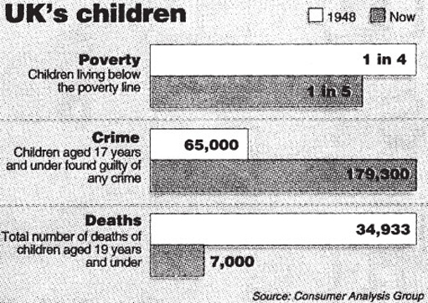

Source: The Guardian 14 January 1999

End of Figure

1. What impression do you get about the number of deaths in 1948 compared with the number of children aged 17 years and under found guilty of any crime now?
2. Do we have any idea of the number of children living in poverty in 1948?
3. Can we tell from the bar chart if the number of children living in poverty has increased or decreased since 1948?

End of Question

[View discussion - Activity 17](" \l "Session5_Discussion3)

End of Activity

The three charts do not have a common scale and therefore should not be compared directly. Here it is very important to consider each chart separately, particularly as the information in the first one is given as a ratio and the other two quote actual numbers. The bar for 65 000 is less than half the length of the bar for 34 933 so unless you look at the figures carefully, your brain can be deceived.

Start of Activity

**Activity 18**

Start of Question

This bar chart shows the number of mentions that each age group got in job advertisements appearing in the Sunday Times, The Guardian and The Telegraph during November 1995.

Start of Figure

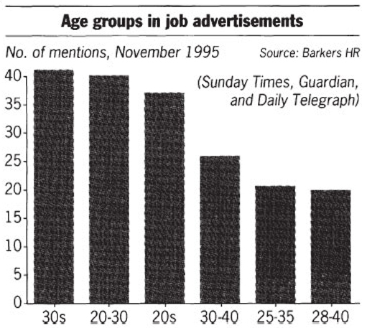

Source: People Management 11 January 1996

End of Figure

1. Which age group got the largest number of mentions?
2. Which age group got the fewest mentions?
3. What does this chart tell us?
4. Look at the horizontal scale and comment on it.

End of Question

[View discussion - Activity 18](" \l "Session5_Discussion4)

End of Activity

Start of Activity

**Activity 19**

Start of Question

This bar chart gives the percentage of women giving birth by caesarean section since 1970. Have a look at the chart, bearing in mind the points that have been made so far.

Start of Figure

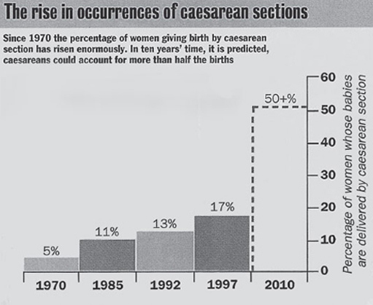

Source: Radio Times 23–29 January 1999

End of Figure

The author of the article in which this bar chart appeared makes the following final comment in the accompanying text:

Start of Quote

One specialist I spoke to reckons that the rate could rise to over 50% within the next 20 years. A quick look at the graph suggests he could be right.

End of Quote

What do you think about this statement?

End of Question

[View discussion - Activity 19](" \l "Session5_Discussion5)

End of Activity

Start of Activity

**Activity 20**

Start of Question

This line graph gives the age distribution of the working population in Great Britain (GB). After you have considered it, try to answer the questions alongside.

Start of Figure

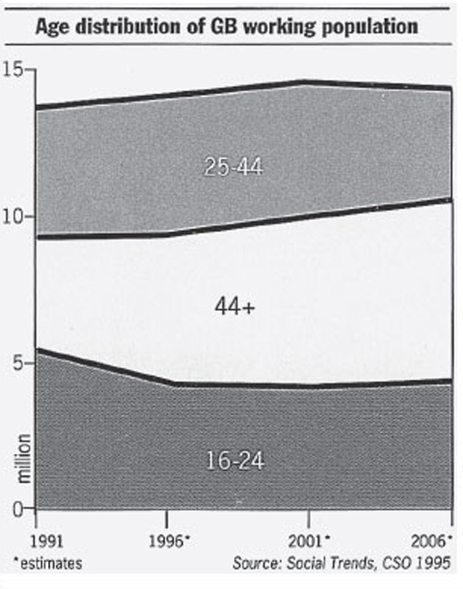

Source: People Management 11 January 1996

End of Figure

1. What trend do you think that this graph is trying convey?
2. Do you find it easy to interpret this graph?

End of Question

[View discussion - Activity 20](" \l "Session5_Discussion6)

End of Activity

This is an example of how an author can try to emphasise the point they want to make by the way that they draw the graph. We need to take great care when we look at a graph or chart in case we are misled by it. The original graph also used colour to emphasise the spaces: the 16–24 space was blue; the 44+ space bright yellow; and the 25–44 space, orange. It would make more sense for the graph to have the 44+ band on top, but the author has chosen to sandwich it in the middle. The accompanying article was about age discrimination and it maybe that the author felt that by structuring the graph in this way, it highlighted the situation for the over 44s.

## Conclusion

We have now looked at a number of different graphs and charts, all of which were potentially misleading. We hope that from now on if you have to work with a graph or a chart, you will always consider the following points:

* look carefully at any horizontal or vertical scale that is given;
* consider each graph or chart separately, don't compare them unless you are sure that they have the same scales;
* if it is not easy to interpret the graph or chart, trying reading off some values.

## 6 Technical glossary

This glossary is intended to provide a basic explanation of how a number of common mathematical terms are used. Definitions can be very slippery and confusing, and at worst can replace one difficult term with a large number of other difficult terms. Therefore, where an easy definition is available it is provided here, where this has not been possible an example is used. If you require more detailed or complete definitions, you should refer to one of the very good mathematical dictionaries that are available, or to one or more books listed in Section 7.

**Approximation:** A numerical result given to a required level of accuracy, for example, to the nearest metre.

**Average:** The word ‘average’ is often used instead of the word ‘mean’ but it can have other interpretations so it is best to use the appropriate correct term; this is usually ‘mean’, but may be ‘median’ or ‘mode’ (see below).

**Chart:** Pictorial representation of data, e.g. piechart, bar chart.

**Data:** Items of numerical information, raw facts or statistics collected together for analysis.

**Decimals:** A way of expressing numbers using place value,

e.g. D:\AaaF\OUT\httpswwwopeneduopenlearnocw_cmid4388_2020-09-24_08-58-27_js34827\word\assets\_ecef0652f7786314e6b74e07d2b59b96ca8bb117_ldt_3_ie011i.gif

**Fractions:** Parts of a whole number, e.g. D:\AaaF\OUT\httpswwwopeneduopenlearnocw_cmid4388_2020-09-24_08-58-27_js34827\word\assets\_9a3e0e26d964c64eb60bc73b4d20bf638b1fffe0_ldt_3_ie012i.gif, D:\AaaF\OUT\httpswwwopeneduopenlearnocw_cmid4388_2020-09-24_08-58-27_js34827\word\assets\_82ca8d4116401c0cc744176320feccdff2d25cba_ldt_3_ie012.2i.gif, D:\AaaF\OUT\httpswwwopeneduopenlearnocw_cmid4388_2020-09-24_08-58-27_js34827\word\assets\_4fc42869d6defcbe9505810140e28fc6505c70cb_ldt_3_ie012.3i.gif etc.

**Graph:** A drawing which depicts the relationship between data or values.

**Mean:** A typical value of a set of data; which is equal to the sum of the values in the set divided by the number of values in the set.

**Median:** The middle point of a set of values arranged in ascending or descending order.

**Mode:** The most common value in a set of data.

**Percentage:** A proportion of a hundred parts, e.g. 75 per cent =D:\AaaF\OUT\httpswwwopeneduopenlearnocw_cmid4388_2020-09-24_08-58-27_js34827\word\assets\_a6835d1572865c5f8ea7515c48514e2c48f69f6f_ldt_3_ie001i.gif

**Ratio:** A comparison of one quantity with another.

**Scale:** A series of marks at regular intervals on a line used for measuring, e.g. the divisions on the axis of a graph or the degree markings on a thermometer.

**Value:** A numerical amount.

## 7 Further reading and sources of help

Where to get more help with using and interpreting tables, graphs, percentages, and with other aspects of numerical work.

## Further reading

* \*The Good Study Guide, by Andrew Northedge published by The Open University, 1990, ISBN 0 7492 00448.

Chapter 4 is entitled – ‘Working with numbers’.

Other chapters are ‘Reading and note taking’, ‘Other ways of studying’, ‘What is good writing?’, ‘How to write essays’, ‘Preparing for examinations’

* The Sciences Good Study Guide, by Andrew Northedge, Jeff Thomas, Andrew Lane, Alice Peasgood, published by The Open University, 1997, ISBN 0 7492 341 1 3. More mathematical and science-based than The Good Study Guide.

Chapter titles are: ‘Getting started’, ‘Reading and making notes’, ‘Working with diagrams’, ‘Learning and using mathematics’, ‘Working with numbers and symbols’, ‘Different ways of studying’, ‘Studying with a computer’, ‘Observing and experimenting’, ‘Writing and tackling examinations’, followed by 100 pages of ‘Maths help’ on: calculations, negative numbers, fractions, decimals, percentages, approximations and uncertainties, powers and roots, scientific notation, formulas and algebra, interpreting and drawing graphs, and perimeters, areas and volumes.

* \*Breakthrough to Mathematics, Science and Technology (K507) – only available from the Open University. Module 1, entitled ‘Thinking about measurement’, looks at mathematics in a variety of contexts, e.g. in the kitchen, on the road, in the factory, in the natural world. Module 4, entitled ‘Exploring pattern’, looks at geometrical and numerical patterns using everyday examples. The other four modules in the series have a greater emphasis on science or technology than on mathematics. Each module refers to The Sciences Good Study Guide.
* \*Teach yourself basic mathematics, by Alan Graham, Hodder and Stoughton, London, 1995, ISBN 0 340 64418 4. A book aimed at a more general (i.e. non-OU) audience is in two parts entitled ‘Understanding the basics’ and ‘Maths in action’.
* Countdown to mathematics Volume 1, by Lynne Graham and David Sargent, Addison-Wesley, Slough, 1981, ISBN 0 201 13730 5. This is a useful next stage after any of the above and includes an introduction to algebra.
* Investigating Statistics: a beginner's guide by Alan Graham, Hodder and Stoughton, London, 1990, ISBN 0 340 4931 1 9. This is a more thorough introduction to dealing with data and statistics.
* Statistics without tears, by Derek Rowntree, Penguin, Harmondsworth, 1981, ISBN 0 14 013632 0 is intended to support those people without a previous background in statistics, who may need it as part of a course that they are studying.
* The MBA Handbook, Study Skills for Managers by Sheila Cameron, 3rd edition, Pitman Publishing, 1997, ISBN 0 273 62812 7. Chapter 13, ‘Using numbers’ introduces the use of number in a management context.

Finally, all the topics are comprehensively covered in the Open University course MU 120 Open Mathematics. This course assumes you are already reasonably confident with the material covered by any of the books marked (\*) or by Module 1 of Countdown to mathematics Volume 1. The course has been studied successfully by many students whose primary interest lies in the humanities or social sciences.

## Sources of help

### Local colleges and schools

The local newspaper is a source of reference here, or your local library. Alternatively, most schools and colleges nowadays have evening or daytime courses that are open to adult learners. Many of them will have an advice point, so that you can telephone or drop in to discuss what you are looking for. Many will have an open-learning centre where self-assessment tests and open-learning materials are available.

### Learning direct

This is a telephone line that was set up in the middle of 1998, to help adults to find out about local provision. The number is 0800 100 900. Lines are open 08.00. to 22.00 everyday. Calls are free and you can ring as many times as you like. There is also a comprehensive website at www.learndirect.co.uk.

### Internet access

The Scottish Learning Network at www.globalweb.co.uk/sln.html is a gateway to information, guidance, assessment and on-line education and training opportunities in Scotland. At the time of writing, there is nothing similar for England, Wales, or Northern Ireland.

## Keep on learning

Start of Figure

D:\AaaF\OUT\httpswwwopeneduopenlearnocw_cmid4388_2020-09-24_08-58-27_js34827\word\assets\_d3c986e615af52d98ee2159f5114e2c4bec9ff99_ol_skeleton_keeponlearning_image.jpg

End of Figure

## Study another free course

There are more than **800 courses on OpenLearn** for you to choose from on a range of subjects.

Find out more about all our [free courses](http://www.open.edu/openlearn/free-courses?utm_source=openlearn&utm_campaign=ol&utm_medium=ebook).

## Take your studies further

Find out more about studying with The Open University by [visiting our online prospectus](http://www.open.ac.uk/courses?utm_source=openlearn&utm_campaign=ol&utm_medium=ebook).

If you are new to university study, you may be interested in our [Access Courses](%20http://www.open.ac.uk/courses/do-it/access?utm_source=openlearn&utm_campaign=ol&utm_medium=ebook) or [Certificates](%20http://www.open.ac.uk/courses/certificates-he?utm_source=openlearn&utm_campaign=ol&utm_medium=ebook).

## What’s new from OpenLearn?

[Sign up to our newsletter](http://www.open.edu/openlearn/about-openlearn/subscribe-the-openlearn-newsletter?utm_source=openlearn&utm_campaign=ol&utm_medium=ebook) or view a sample.

Start of Box

For reference, full URLs to pages listed above:

OpenLearn – [www.open.edu/openlearn/free-courses](http://www.open.edu/openlearn/free-courses?utm_source=openlearn&utm_campaign=ol&utm_medium=ebook)

Visiting our online prospectus – [www.open.ac.uk/courses](http://www.open.ac.uk/courses?utm_source=openlearn&utm_campaign=ol&utm_medium=ebook)

Access Courses – [www.open.ac.uk/courses/do-it/access](%20http://www.open.ac.uk/courses/do-it/access?utm_source=openlearn&utm_campaign=ol&utm_medium=ebook)

Certificates – [www.open.ac.uk/courses/certificates-he](%20http://www.open.ac.uk/courses/certificates-he?utm_source=openlearn&utm_campaign=ol&utm_medium=ebook)

Newsletter ­– [www.open.edu/openlearn/about-openlearn/subscribe-the-openlearn-newsletter](%20http://www.open.edu/openlearn/about-openlearn/subscribe-the-openlearn-newsletter?utm_source=openlearn&utm_campaign=ol&utm_medium=ebook)

End of Box

## Acknowledgements

Course image: [Pink Sherbet Photography](https://www.flickr.com/photos/pinksherbet/) in Flickr made available under [Creative Commons Attribution-NonCommercial-ShareAlike 2.0 Licence](https://creativecommons.org/licenses/by-nc-sa/2.0/legalcode).

The content acknowledged below is Proprietary (see terms and conditions) and is used under licence.

Grateful acknowledgement is made to the following sources for permission to reproduce material in this course:

Activity 2: Sweetman, J. 'On Your Marks', The Guardian (19 May 1998)

Activity 3: People Management (21 March 1996)

Activity 6: Personnel Today (17 December 1998)

Activity 7: People Management (21 March 1996, 24 October 1996)

Activity 8: Personnel Today (21 January 1999)

Activity 9: Personnel Today (17 December 1998)

Activity 10: Personnel Today (21 January 1999)

Activity 15: The Guardian (4 Janaury 1999)

Activity 16: The Guardian (9 Janaury 1999)

Activity 17: The Guardian (14 Janaury 1999)

Activity 18: People Management (11 January 1996)

Activity 19: Radio Times (23–29 January 1999)

Activity 20: People Management (11 January 1996)

All other materials included in this course are derived from content originated at the Open University.

**Don't miss out:**

If reading this text has inspired you to learn more, you may be interested in joining the millions of people who discover our free learning resources and qualifications by visiting The Open University - [www.open.edu/openlearn/free-courses](http://www.open.edu/openlearn/free-courses?utm_source=openlearn&utm_campaign=ol&utm_medium=ebook)

## Solutions

## Activity 1

#### Discussion

Now that you have completed this for yourself, perhaps you could check out the following questions, either on your own or with a fellow student or friend.

1. How could past experiences have influenced the way that you feel?
2. Can you see why some people don't feel this way? Why could this be?

To help you, we have asked several people to complete this activity and have collected some of their views and feelings under three headings: ‘Feelings about mathematics’, ‘Coping strategies for mathematics’, and ‘Need to learn mathematics’.

## Feelings about mathematics

Many people have strong feelings about mathematics, often linked with worry or fear, from a difficult previous experience.

Start of Quote

I wouldn't say I have learnt a great deal more since school and regret not having a better grounding in it. When faced with a problem I feel confident if the problem is within the realms of my capability. However, I do know that I end up going the long way round. Or as we say in Guernsey, I go round Sark to get to Herm (two islands off Guernsey).

I am constantly worried about the use of maths – I always presume that I will get simple problems wrong if numbers are involved.

We were mixed-ability taught in all subjects in the first year, but after that we were rigidly grouped according to ability and, as expected, I ended up in one of the lower maths groups, where I remained for the rest of my time at secondary school. Any chance of improving my mathematical skills were also limited by the school deciding we were a lost cause, and being taught by a procession of some of the most eccentric and disinterested teachers I have ever met.

End of Quote

It is possible that you came up with comments that are similar to these. We are not trying to suggest that everyone feels this way about mathematics; some people really enjoy it and others can get by, but feelings of apprehension can often get in the way of learning.

## Coping strategies for mathematics

To get round feelings of worry, people have often developed very good coping strategies, and you might recognise some of these. There is nothing wrong with this at all; it's a sensible thing to do.

Start of Quote

On reflection I suspect that I have spent most of my working life sidestepping anything vaguely connected with maths and have consequently developed a number of avoidance techniques. These range from ‘I am busy at the moment, I am not sure what you want to know, try to work it out yourself’, through to ‘I haven't got my glasses’ – all very similar to the techniques employed by those who have difficulty in reading.

If I see a pure mathematics problem then I don't attempt it. I tend not to be drawn to articles in newspapers/TV that have a mathematical focus.

I was good at hiding within the class… I usually stay quiet and I would never contemplate a job where I would have to add up in front of others.

I am not terribly confident when presented with certain sets of figures, but, if I work through it carefully, I can usually cope with it.

End of Quote

## Need to learn mathematics

How much mathematics do you need to learn to study successfully? Well, that is likely to vary depending on the courses that you take.

Start of Quote

I have just started a science course, so I know I will need to improve my skills.

I am aware that presumed difficulties with maths prevent me from attempting certain aspects of the course. Basic skills could help my confidence, though I feel it may be too late to start. (Arts student.)

In my previous course, I was studying German. My ideas about what mathematics meant to me were not even considered and did not develop throughout. My next course (Third World Development) will be different, but I haven't started it yet.

End of Quote

What we have asked you to do here is to look at your experience of mathematics in the context of your experience as a student, as well as in the past. As you can see, other people feel unconfident about their use of mathematics. Now you can move on to considering what to do about it. The final question in the activity asks you to think about what you need to concentrate on now, and we hope that you are now ready to look at the rest of the course.

[Back to - Activity 1](" \l "Session2_Activity1)

## Activity 2

#### Discussion

1. This is difficult to answer. The Guardian is a broadsheet, and has a reputation for reasonably accurate reporting. This material is from The Guardian Education (published weekly on a Tuesday) – you might feel this tends to give an air of authority.
2. The data was taken from a Department for Education and Employment (DfEE) publication, called Excellence in Schools, and published in 1997. Therefore, the UK Government published the data. The data relates to the amount of homework and television that children in their last year of primary school were doing – in other words, while they were aged about 11 or 12.
3. If you look at this article carefully, you will see that the last paragraph of the article is the only one that discusses the data.
4. The author has linked the data to the discussions about changes in schools. He talks about the reduction in class sizes that was a pledge made by Labour at the 1997 election, and the baseline assessment tests. He suggests that the children who do least homework also watch the most television, but you can't see that from the figures given in the diagram. While the two activities do seem to be related, it is possible, for example, that some children don't watch any television and don't do any homework.

To find examples for the rest of this course, we looked through a variety of sources to see how mathematical information is presented in newspapers and magazines. We are not suggesting that the ones we selected are entirely representative, as we have deliberately chosen examples that will help you to question what you see. This means that some of the graphs and diagrams that we have used are accurate representations and others are less so. However, although we have chosen these representations carefully, we had no difficulty in selecting across the spectrum from completely accurate to misleading. We suggest that you bear this in mind as you look at the information you see around you.

[Back to - Activity 2](" \l "Session3_Activity1)

## Activity 3

#### Discussion

1. The table has been taken from a publication called People Management. This is the house journal for the Institute of Personnel and Development, a professional organisation that has a membership of human resources and training staff, especially in industry. It was prepared for an article in March 1996, but we can't tell from the table itself, or the explanatory notes, exactly when the data was collected.
2. The information comes from a group of 23 out of a possible 50 business schools that People Management contacted. This is only a sample of the possible business schools in the UK. People Management tells us that questionnaires were sent to established business schools, but we don't know what criteria were used to decide what is meant by ‘established’.

We have no information about how People Management chose the original sample or why only business schools in England and Scotland replied. It may be that business schools in Wales and Northern Ireland were not asked or were not interested. The Open University Business School is not mentioned here, and again we don't know why this is.

1. The headings could be expressed more clearly. Overall, the table is trying to convey two types of information. The first is about the number of business schools who run certain types of course and changes in these course-types over a four-year period. The second is about how business schools perceive changes in proportions of their business income.

The table includes the heading ‘Proportion of business represented by:’ followed by various row-heads such as ‘Consortium MBAs’. Proportion usually means a percentage (see page 13), but the figures seem to relate to the number of business schools in each category: none of the values for 1994 or 1998 add up to more than the 23 organisations that responded. Therefore, the heading should perhaps read ‘Number of business schools who think that their business incomes will increase/will not change/will decrease’.

[Back to - Activity 3](" \l "Session4_Activity1)

## Activity 4

#### Discussion

Only 5 out of the 23 business schools feel that they have the same number of overseas students as in 1994, i.e. about 22 per cent of the sample. Change has been very strongly biased towards an increase in overseas students, with 17 out of 23 (about 74 per cent) of the business schools seeing an increase over the two years. Looking forward, no business school thinks their proportion of overseas students will reduce: 12 out of the 23 (about 49 per cent) business schools don't see a change in the proportion of students in this category, and 11 out of the 23 (about 48 per cent) see a likely increase here.

[Back to - Activity 4](" \l "Session4_Activity2)

## Activity 5

#### Discussion

First, it tells us absolutely nothing about the number of students involved. You will have noticed that we have been referring to proportions of students in the business schools, rather than actual numbers. That is because there is no information here. Any business school could have had a huge increase or decrease in numbers. Those who are predicting an increase could have 20 or 2000 students. We simply don't know from this table. Secondly, looking at the short courses, and our discussion above, there seems to be an increase in a perception that tailored short courses are growing as a form of business.

[Back to - Activity 5](" \l "Session4_Activity3)

## Activity 6

#### Discussion

1. The information is from Reward Group, which carriesout an annual survey in this area, but we don't know anything about the organisation; for example whether they are a government or private organisation. The article was published in Personnel Today, (a rival publication to People Management).
2. It's hard to say. However, the name Reward Group suggests a company that is interested in pay and conditions, such as employee perks. You may know of Reward Group yourself and be able to draw some extra conclusions.
3. An annual survey carried out by Reward Group. We don't know how big the sample size was; in other words, we don't know how many people were questioned.
4. It doesn't until the end; the article starts out by talking about other factors that were presumably also listed by Reward Group. The article starts by discussing salary increases, rather than company cars. This isn't unusual; articles quite often don't begin by discussing the figures in graphs and diagrams.
5. Their discussion of the data is fairly accurate, although one part could be misinterpreted. It is true to say, as they do, that (about) a third of chief executives in the voluntary sector have a car, compared with three-quarters in the private sector. However, there could be a much larger number of CEOs who have cars in the voluntary sector than in the private sector. For example, if there were 3000 CEOs in the voluntary sector who had been surveyed, then about 1000 could have a company car. If there were only 1000 surveyed in the private sector, then only 750 of them would have a company car. We don't know the size of the sample involved. It is true that this is unlikely, but it is possible.

[Back to - Activity 6](" \l "Session4_Activity4)

## Activity 7

#### Discussion

1. The Guardian. Note that one-third is about 33 per cent. In February 1996, it ran 32.6 per cent of the advertisements, and in September 1996, it ran 36.8 per cent of the advertisements. However, see our comments in (5) below.
2. The Telegraph and the Sunday Times together. In February 1996, they accounted for 33.2 per cent of the advertisements (17 per cent + 16.2 per cent), and in September 1996, for 32.2 per cent (14.4per cent + 17.8 per cent)
3. The data was derived from The Guardian and shows a breakdown of recruitment advertising by column centimetres (an area that is one standard column wide and one centimetre deep). This is the standard format for selling newspaper space. The pie charts show the percentage split and the text in the articles shows what this means in overall volume of advertising.
4. Not directly, in either case. The February article simply relates volume of advertising and the fact that, in February 1996; advertising was up by 11 per cent on February 1995. In September 1996, the article relates the increase to the previous 12 months, so it's not possible to compare increases month by month here. It's possible that there was in fact a decrease in advertising space in the year to September 1996. The other interesting feature in the September 1996 article is that it includes a plug for the new internet recruitment advertising programme of The Guardian.
5. We think that the source of the graphs and diagrams is relevant. The Guardian, which seems to be leading in terms of advertising space, has provided the details, and has been mentioned in both of the articles. The choice of newspapers shown in the pie charts is interesting, in that most of the broadsheets are mentioned separately for the weekday and Sunday editions (the FT doesn't have a Sunday edition). However, neither the Sunday Telegraph nor The Guardian's Sunday partner, the Observer, are mentioned. This seems a slightly odd way to present the data. There is a possibility that The Guardian has combined the two, so that it shows a higher percentage share being taken by The Guardian than other papers. If you combine the share for The Times and Sunday Times for February 1996, you can see that the total share is 28.7 per cent, and for September, 29.6 per cent; much closer to The Guardian's 32.6 per cent and 36.8 per cent respectively. This may be coincidence, and the Observer may have sales that are not recorded here.

The other small point that interested us is that the two pie charts don't follow the same format. If you look at them closely, you can see there are two differences. First, the newspapers aren't in the same order in both the pie charts and second, in the September chart, a small ‘slice’ of the pie chart is projecting out of it. We think this is probably so that the magazine can fit in the label for the slice, but it has the effect of emphasising the small share of the market of the Independent on Sunday.

[Back to - Activity 7](" \l "Session4_Activity5)

## Activity 8

#### Discussion

1. It shows the UK cost of living in comparison to an EU average.
2. This is quite confusing. The graph is hard to read, and it doesn't use a consistent scale on the horizontal axis. As you can see, it starts at 1993 and then gives two dates in 1998. In the article, it says that the UK cost of living has now risen in comparison to the rest of Europe, by nearly 20 per cent since 1993. The cost of living index is based on a ‘basket of goods’, much like the Retail Price Index in the UK. This means that specific goods, such as food, housing costs, transport, etc., are monitored and changes in price are recorded.
3. The bar chart has data provided by ECA International. This is a human resources agency. (It seems likely that it is an organisation that relocates staff within Europe, which would mean that it needs this data to supply to clients.)
4. The bar chart relates to the article to only a small extent, most of the article talks about other data that can't be seen from the diagram. It also seems that the data that has been chosen in the article is slanted, as it only talks about France and Germany, while referring to the fact that the UK is 14th in a table of 64 countries. Unless we know all the data, we can't tell if these are the best comparisons to make, although most readers will certainly understand them. In addition, as the EU doesn't have 64 member states, the article is clearly including data that is outside of the scope of the information on the bar chart.
5. We found the chart very confusing to read. The authors, whether Personnel Today or ECA International, have taken the UK index as the standard, and used this as 100 on the vertical axis, hence the horizontal line. They haven't said anywhere that this is what they have done, and it alters how we read the picture. Also, the chart starts the vertical axis at 80, and the normal convention would be to start it at zero. The chart would be clearer in terms of proportion if this were the case, because the differences would not be as marked. You might like to sketch this graph, starting the vertical axis at zero, and see if you can see what difference it makes.

[Back to - Activity 8](" \l "Session4_Activity6)

## Activity 9

#### Discussion

Technically, the group sizes in a histogram should all be the same. However, the authors have chosen to group some of the pay rises together, probably to keep the graph small.

1. The percentage of engineering firms in the sample.
2. The most common settlement was between 3 per cent; and 4 per cent; 57 per cent of the sample gave rises in that range.
3. The graph shows that 10 per cent of settlements were for a pay freeze. The article says that 10 firms gave this.
4. The Engineering Employers Federation, an employers organisation representing some of the country's engineering firms, is the source of the data. (The Federation has a series of regional offices, with a Head Office in London, which is presumably where the data came from. Member firms pay a levy to join the EEF. It isn't clear from the histogram or the accompanying article whether the EEF have surveyed only their own members or engineering firms in general.)
5. As with the articles on the pie charts, the magazine seems to have been influenced by the people who have provided the data, to the extent of mentioning their name frequently. In this case, the EEF have had a telephone number printed as well.
6. It relates well to the article, which talks about the spread of pay. The authors have also added two other pieces of information though. First, they talk about the pressure downwards on pay settlements, which is not in the diagram. In addition, they talk about the number of deals involved.
7. If you add up all the percentages, you will see that they come to 105 per cent. This isn't unusual, as charts often show rounded figures, for ease of understanding, although it does seem a lot. However, look at the article. You will see that they say that 8 deals were for over 4 per cent (which includes 7 per cent of deals in the 4 per cent to 5 per cent range, and 1 per cent of deals in the over 6 per cent range) and they say that 10 deals were for a pay freeze. There are 10 pre cent of deals in the pay freeze range. Therefore, it seems odd that the other numbers don't relate quite as neatly to the formula: one deal =1 per cent.

[Back to - Activity 9](" \l "Session4_Activity7)

## Activity 10

#### Discussion

1. This graph is quite difficult to interpret. It is a plot of the differences in opinion between employers who feel that the number of jobs they have will increase, minus those who feel that the number of jobs they have will decrease. In other words, it shows the differences between people who feel that their business is doing well enough for them to take on extra staff, and those who don't feel this confident.
2. The data here should be presented as a series of points. There is no good reason for joining up the points, as has been done here. We can't tell anything from the data about the pattern of employers concerns in between the dates that are mentioned. In other words, there may have been a period of optimism about growth in jobs between 1992 and 1993, or pessimism between 1997 and 1998.
3. An organisation called Manpower, which specialises in the provision of temporary staff to organisations. The article refers to agencies, and it is possible that Manpower used data from elsewhere as well as their own, but it's hard to tell. The article also mentions the number of people contacted. This seems like a high enough number for us to be able to rely on the conclusions. Organisations such as MORI that conduct opinion polls tend to use a sample of about 1000 people.
4. It relates well, providing a summary of the information in the graph. The only query we would have is that the article says that a year ago there was a 10-point margin between the two groups, whereas the graph seems to show somewhere between an 8- and 9-point margin. This may be because the graph isn't very accurate, or it may be dramatic license on behalf of the authors.
5. The 1999 data relies on the first quarter (and only the first part of that, as the article is from the 21 January), while the other years presumably are based on data from all four quarters. The article doesn't mention this at all. The other unknown here is the number of people that Manpower usually contact. It may be that 2195 is unusually high or low number and has distorted the eventual figures. The article also doesn't say how many of these 2195 replied. It could be all, 1000 or just 100. The actual number would probably affect our views of the reliability of the data.

[Back to - Activity 10](" \l "Session4_Activity8)

## Activity 11

#### Discussion

D:\AaaF\OUT\httpswwwopeneduopenlearnocw_cmid4388_2020-09-24_08-58-27_js34827\word\assets\_ac8c4803e0a1f59ea537d754e553f0b7b2c42276_ldt_3_ie004i.gif or about 11 per cent, so this is the greater proportion. Alternatively, 10 per cent of 1260 is 126, which is less than 140.

139 is clearly the greater actual value. However, 139 out of 1500 is equivalent to D:\AaaF\OUT\httpswwwopeneduopenlearnocw_cmid4388_2020-09-24_08-58-27_js34827\word\assets\_12011ecb62800dcbe7b603bcf5f6cd1563c8b618_ldt_3_ie005i.gif × 100 = 9.27% of 1500.75 out of 250 is equivalent to D:\AaaF\OUT\httpswwwopeneduopenlearnocw_cmid4388_2020-09-24_08-58-27_js34827\word\assets\_3132e9bf161fc0c3b3fe8e2d47799a66fc67e220_ldt_3_ie006i.gif × 100 = 30% of 250. Therefore, 75 out of 250 is a greater proportion than 130 out of 1500.

[Back to - Activity 11](" \l "Session4_Activity9)

## Activity 12

#### Discussion

1. Adding up all the values gives 369. Dividing 369 by 15 gives 24.6.
2. The company is likely to claim an average battery life of 25 hours (24.6 rounded up to the nearest hour).

[Back to - Activity 12](" \l "Session4_Activity10)

## Activity 13

#### Discussion

Start of Table

|  |  |
| --- | --- |
| The median = (10 + 12) + 2 = 11 | The mean = 192 ÷ 12 = 16 |

End of Table

The median is not appropriate here as the number of runs may vary greatly during the season and will probably include a number of zeros. The average actually used to rank players is the mean.

[Back to - Activity 13](" \l "Session4_Activity11)

## Activity 14

#### Discussion

Arranging the values in ascending order gives:

Start of Quote

**0, 0, 0, 0, 0, 0, 0, 0, 0, 1, 1, 1, 2, 2, 2, 2, 3, 4**

End of Quote

The mode (the value that appears most frequently in the list) = 0

The median (here the mean of the two middle numbers) = (0 + 1) ÷ 2 = 0.5

The mean (total of all the goals scored divided by the number of games) = 18 ÷ 18 = 1

This football team would probably prefer us not to quote the mode as their average score during a season as it is zero!

[Back to - Activity 14](" \l "Session4_Activity12)

## Activity 15

#### Discussion

1. ‘m’ is an abbreviation for million, so 4.1m is 4.1 million or 4 100 000 people.
2. 55+ is a short hand way of indicating all those older than 55.
3. If you compare the top and bottom graphs, your first impression is likely to be that the workforce aged 55+ has declined by much the same amount as the manufacturing workforce. However, the workforce aged 55+ has declined by 1.3m (4.1m − 2.8m), which as a percentage is a decrease of D:\AaaF\OUT\httpswwwopeneduopenlearnocw_cmid4388_2020-09-24_08-58-27_js34827\word\assets\_d20dd8b0aa0ca212c873b1384cff7f28bc58388f_ldt_3_ie007i.gif × 100, approximately 32 per cent. The manufacturing workforce has declined by 3.3m and this is a percentage decrease of D:\AaaF\OUT\httpswwwopeneduopenlearnocw_cmid4388_2020-09-24_08-58-27_js34827\word\assets\_7cef360e8818ccbc0a6357e3709ec7c037cb159e_ldt_3_ie008i.gif × 100, approximately 45 per cent. This means that the manufacturing workforce has actually declined more significantly than the workforce aged 55+ in the last 20 years or so.
4. The impression given by the graph of the female workforce is that the number of women in work has risen steadily over the last 20 years, in direct contrast to the workforce aged 55+. The actual increase in the female workforce is 2.9m. As a percentage, this is D:\AaaF\OUT\httpswwwopeneduopenlearnocw_cmid4388_2020-09-24_08-58-27_js34827\word\assets\_27ee5a21a3c508fae8ec1798eb1fb715d8599a14_ldt_3_ie009i.gif × 100 which is approximately 31 per cent. Here our initial impression is the correct one.
5. The first two graphs give figures from 1971 and the third one starts in 1976. All three graphs have the same distance between each year given on the graph. However, this distance should be less when there is a gap of 5 years than when there is a gap of 10 years.

The horizontal scales are not the same for each graph. It is possible that the 1976 in the third graph is a misprint but even if it is not, the horizontal scales are still misleading. Each of the graphs has the years 1981, 1991 and 1996 evenly spaced along the horizontal axis but the intervals are not the same. 1996 should be closer to 1991 and this would mean that each of the graphs would flatten off less.

[Back to - Activity 15](" \l "Session5_Activity1)

## Activity 16

#### Discussion

1. The author would like us to believe that the number of EU/non-EU nurses registered with the NHS is now greater than the number of UK nurses registered with the NHS.
2. The crossover point appears to have occurred some time between 1996 and 1997. However, the horizontal scale is very difficult to read and it isn't clear where each year starts and finishes.
3. At the point where the lines cross, there were approximately 25 000 UK nurses registered with the NHS.
4. At the same time, there were approximately 2500 EU/non EU nurses registered with the NHS.
5. Contrary to the impression given by the graphs, the number of UK nurses registered with the NHS far exceeded the number of EU/non-EU nurses also registered with the NHS. The total number of nurses registered at that time was 27 500. If we calculate the number of EU/non-EU nurses as a percentage of the total number of nurses (D:\AaaF\OUT\httpswwwopeneduopenlearnocw_cmid4388_2020-09-24_08-58-27_js34827\word\assets\_22fe20f7865459aa5db21afbb5072ee8542de993_ldt_3_ie010i.gif × 100) we find that they accounted for 9 per cent of the total. It is fair to say that the number of UK nurses registered is declining but the number of EU/non-EU nurses registered has a long way to go before it over takes the UK number.

[Back to - Activity 16](" \l "Session5_Activity2)

## Activity 17

#### Discussion

1. The bar representing the number of deaths in 1948 appears to be exactly the same in length as the bar representing the number of children found guilty of any crime now. If you looked at this chart quickly, you could easily come away with the impression that the numbers were the same in both cases. However, the numbers given tell a completely different story: the number of deaths in 1948 was 34 933, and the number of children found guilty of any crime now is 179 300.
2. The chart gives the number of children living in poverty in 1948 as 1 in 4, but the number of children living in Britain in 1948 is not given on the chart. The ratio 1 in 4 tells us that D:\AaaF\OUT\httpswwwopeneduopenlearnocw_cmid4388_2020-09-24_08-58-27_js34827\word\assets\_916652bfeaf642e7f2b11e336b39a8cdb7002858_quarter.gif (which is the same as 0.25 or 25 per cent) of the number of children living in Britain in 1948 were living in poverty.
3. No, because we don't know the number of children. The chart gives the impression that the number has reduced as the ratio today is 1 in 5, which tells us that D:\AaaF\OUT\httpswwwopeneduopenlearnocw_cmid4388_2020-09-24_08-58-27_js34827\word\assets\_31e464111405f78c00b99b501cd952a2219dabd4_one-fifth.gif (which is the same as 0.2 or 20 per cent) of children are living below the poverty line. Since the chart does not give the number of children living in the UK in 1948 or now, we can't be sure whether or not there has been a drop in the actual number of children living below the poverty line.

In order to get a feel for the actual number of children living below the poverty line, you need the figures given in the article, namely that there were 14.5 million children living in the UK in 1948 and there are 14.8 million now. This makes the number of children living below the poverty line in 1948, 3.625 million (D:\AaaF\OUT\httpswwwopeneduopenlearnocw_cmid4388_2020-09-24_08-58-27_js34827\word\assets\_916652bfeaf642e7f2b11e336b39a8cdb7002858_quarter.gif × 14 500 000) and now there 2.96 million (D:\AaaF\OUT\httpswwwopeneduopenlearnocw_cmid4388_2020-09-24_08-58-27_js34827\word\assets\_31e464111405f78c00b99b501cd952a2219dabd4_one-fifth.gif × 14 800 000). These values are very much larger that those relating to crime and death but this is not evident when you first look at the charts.

[Back to - Activity 17](" \l "Session5_Activity3)

## Activity 18

#### Discussion

1. The age group which got the largest number of mentions is 30s.
2. The age group which got the least number of mentions is 28–40.
3. The answers to the first two questions are somewhat contradictory since the age group 28–40 covers the 30s. The introduction to this example says that this chart gives the number of mentions of different age groups in job advertisements in November 1995. It appears that the age group given in each of the advertisements was recorded with the number of each being recorded by this chart. In other words, the chart is simply recording how often each age group description was used.
4. The horizontal scale is simply being used to record the different age groups. Normally you would expect the values to increase from left to right but in this case it is difficult to order the different age groups. The author has chosen to given the age groups in descending order of the number of mentions, which gives the visual impression that the younger age groups got more mentions.

This chart actually tells us very little. The overall impression is that 20s, 20–30 and 30s get mentioned most and no mention is made of 40+ age groups orthose under 20. Given the confused nature of the horizontal scale, it is pointless to look for any meaningful trend in the graph. However, it is interesting to note that this graph appeared in an article claiming that age discrimination still exists.

[Back to - Activity 18](" \l "Session5_Activity4)

## Activity 19

#### Discussion

You might agree, as the numbers are increasing and the projection has been drawn on the chart. But if you look more closely at the figures given, you will probably feel that the projection is somewhat exaggerated. You might feel that we should be able to make a stab at what the figure will be and this is exactly what we will now do.

In order to decide if the statement is correct we must first look at the horizontal scale. The interval between 1970 and 1985 is 15 years, there are 7 years between 1985 and 1992, and 5 years between 1992 and 1997. However, there is not a regular interval between each of the years given on the chart which means that it is not possible to extrapolate the diagram to predict the value in 2010. The easiest way to decide what the figure might be, is to redraw the chart as a line graph with an evenly spaced scale on the horizontal axis. When we do so, we get this line graph.

Start of Figure

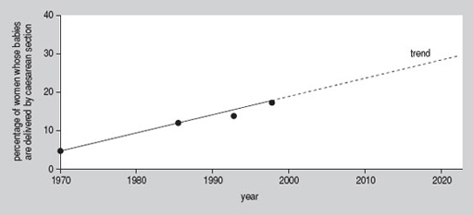

Source: Radio Times 23–29 January 1999

End of Figure

By extending the line drawn through the data values we were given, we can now see that the possible value in 2010 might be 22%. When we consider the 20-year interval that the author refers to, in 2019 the value only increases to about 28%. This is somewhat less than the 50% suggested by the article.

The article discusses whether or not women should be allowed to have a caesarean section on demand and cites evidence to show that more and more women are opting for this. Even if we allow forthe fact that the number of caesarean sections is growing more quickly now than in the 1970s or 1980s, it is not obvious from the figures that the rate could rise to over 50 per cent within the next 20 years.

[Back to - Activity 19](" \l "Session5_Activity5)

## Activity 20

#### Discussion

1. You may well feel that there is no obvious trend. However, you might have said that the graph shows that the number of people aged 44+ is going to increase. You may also have said that the other two age groups will see a slight drop in numbers.
2. The graph is not very easy to read. It is not immediately clear whether one is looking at the space between the lines or the three lines themselves. If we consider the spaces, in 2006 the working population is predicted to be made up of about 5 million people aged 16–24, about 3.5 million people aged 25–44, and about 5.5 million people aged 44+. This suggests that the total working population will be 14 million. However, if we consider the lines, in 2006 the working population is predicted to be made up of about 5 million people aged 16–24, about 14 million people aged 25–44 and 10.5 million people aged 44+. This suggests that the working population will be 29.5 million. This figure is more believable since the actual working population is currently about 27.5 million.

[Back to - Activity 20](" \l "Session5_Activity6)