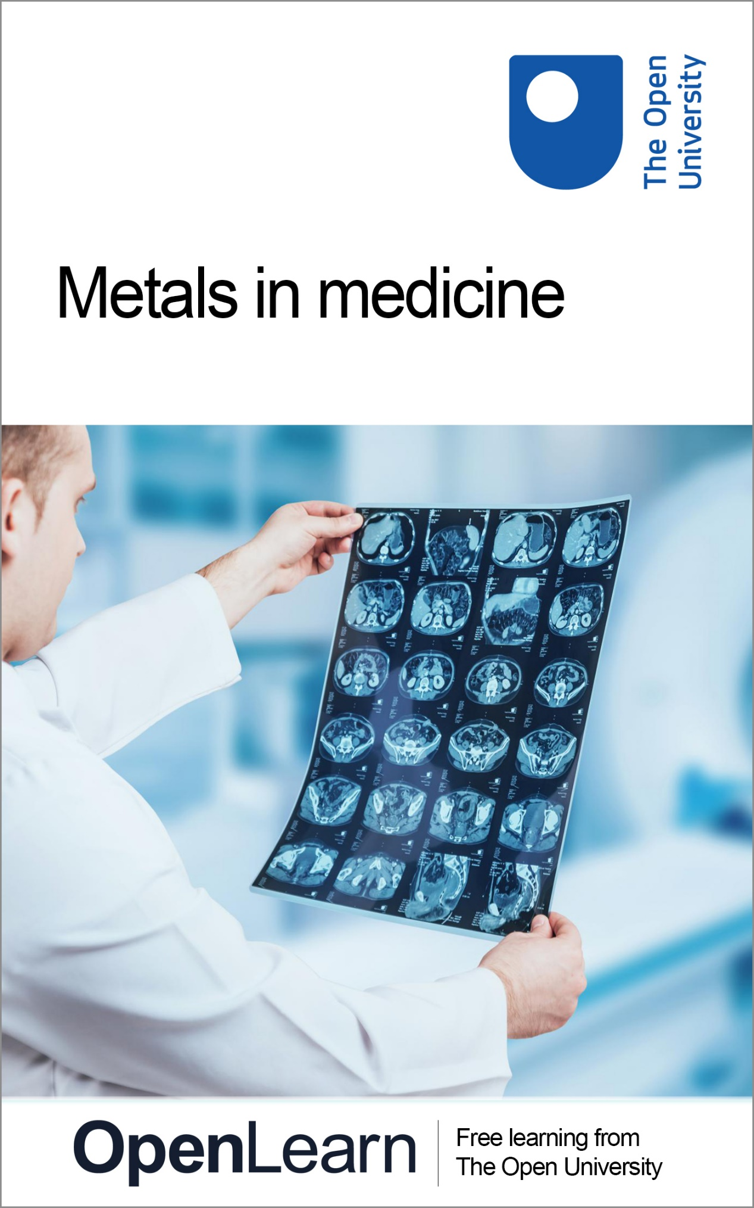

s315_1

Metals in medicine

About this free course
This free course is an adapted extract from the Open University course S315 Chemistry: further concepts and applications http://www.open.ac.uk/courses/modules/s315.
This version of the content may include video, images and interactive content that may not be optimised for your device.
You can experience this free course as it was originally designed on OpenLearn, the home of free learning from The Open University – Metals in medicine https://www.open.edu/openlearn/science-maths-technology/metals-medicine/content-section-0
There you’ll also be able to track your progress via your activity record, which you can use to demonstrate your learning.
Copyright © 2019 The Open University
Intellectual property
Unless otherwise stated, this resource is released under the terms of the Creative Commons Licence v4.0 http://creativecommons.org/licenses/by-nc-sa/4.0/deed.en_GB. Within that The Open University interprets this licence in the following way: www.open.edu/openlearn/about-openlearn/frequently-asked-questions-on-openlearn. Copyright and rights falling outside the terms of the Creative Commons Licence are retained or controlled by The Open University. Please read the full text before using any of the content.
We believe the primary barrier to accessing high-quality educational experiences is cost, which is why we aim to publish as much free content as possible under an open licence. If it proves difficult to release content under our preferred Creative Commons licence (e.g. because we can’t afford or gain the clearances or find suitable alternatives), we will still release the materials for free under a personal end-user licence.
This is because the learning experience will always be the same high quality offering and that should always be seen as positive – even if at times the licensing is different to Creative Commons.
When using the content you must attribute us (The Open University) (the OU) and any identified author in accordance with the terms of the Creative Commons Licence.
The Acknowledgements section is used to list, amongst other things, third party (Proprietary), licensed content which is not subject to Creative Commons licensing. Proprietary content must be used (retained) intact and in context to the content at all times.
The Acknowledgements section is also used to bring to your attention any other Special Restrictions which may apply to the content. For example there may be times when the Creative Commons Non-Commercial Sharealike licence does not apply to any of the content even if owned by us (The Open University). In these instances, unless stated otherwise, the content may be used for personal and non-commercial use.
We have also identified as Proprietary other material included in the content which is not subject to Creative Commons Licence. These are OU logos, trading names and may extend to certain photographic and video images and sound recordings and any other material as may be brought to your attention.
Unauthorised use of any of the content may constitute a breach of the terms and conditions and/or intellectual property laws.
We reserve the right to alter, amend or bring to an end any terms and conditions provided here without notice.
All rights falling outside the terms of the Creative Commons licence are retained or controlled by The Open University.
Head of Intellectual Property, The Open University

Contents
- Introduction
- Learning outcomes
- 1 Imaging in medicine
- 2 Anatomical imaging using X-rays
  - 2.1 Computed tomography (CT) scans
  - 2.2 X-ray contrast agents
- 3 Anatomical imaging using MRI
  - 3.1 MRI in practice
  - 3.2 MRI: theoretical background
  - 3.3 MRI: Producing an image
  - 3.4 Contrast in MRI
  - 3.5 Chemistry of the lanthanides
  - 3.6 MRI contrast agents
- 4 Metals for therapeutic applications
  - 4.1 Brief historical background
  - 4.2 Current use of metals in medicine: an overview
- 5 Cancer therapy: the cisplatin story
  - 5.1 Aquation of cisplatin
  - 5.2 Biological targets of cisplatin
  - 5.3 Platinum binding to DNA
  - 5.4 Anticancer effect
  - 5.5 Why is transplatin inactive?
  - 5.6 Cisplatin in the body
  - 5.7 Side effects of cisplatin
  - 5.8 Resistance to cisplatin
  - 5.9 Limitations of cisplatin
- Conclusion
- Acknowledgements
- Solutions

Introduction
This free course, Metals in medicine, is comprised of two parts, which illustrate the key role metals play in medicine. The main focus of sections 1 – 3 is the role metals play in medical imaging, whereas sections 4 and 5 show how metal containing compounds play a crucial role in the treatment of many diseases including cancer.
After studying this course you will be able to answer the following questions:
- How can the measurement of signals from living tissue be converted into images useful for diagnostic medicine?
- What is an MRI contrast agent and how can the properties of metal complexes be applied to this role?
- What aspects of the coordination chemistry of cisplatin underpin its effectiveness as an anticancer treatment, and what are the shortcomings of this drug which have necessitated the search for alternatives?
This OpenLearn course is an adapted extract from the Open University course S315 Chemistry: further concepts and applications.

Learning outcomes
After studying this course, you should be able to:
- state the different types of imaging used in medicine, and describe how X-rays are exploited in anatomical imaging
- explain how signals from living tissue can be converted into images useful for diagnostic medicine
- explain what a MRI contrast agent is and describe how the properties of metal complexes be applied to this role
- describe the role of metals in pharmaceutical science
- explain how aspects of the coordination chemistry of cisplatin underpin its effectiveness as an anticancer treatment, and describe the shortcomings of this drug which have necessitated the search for alternatives.

1 Imaging in medicine
Many of the important advances in medicine in recent decades have arisen from our progress in understanding the structure and workings of the human body.
Diagnosis of illness is aided by the ability to obtain detailed information about the structure of a particular organ or part of the skeleton to see if it is abnormal, damaged or malfunctioning in some way. For example, a growth may prevent the passage of food and waste through the gut, or fatty deposits may cause problems with blood circulation.
To obtain this information, the abnormal or diseased tissue has to stand out from those around it – its properties have to be sufficiently different from the properties of normal tissue or surrounding matter, to be distinguished by the techniques chosen for investigation.

- Can you list a few medical imaging techniques you are familiar with?
- X-ray, magnetic resonance imaging (MRI) and ultrasound.

There are two main types of imaging.
- Anatomical imaging, in which structures are examined by exploiting differences in the physical or chemical properties of the materials in the body – for example, between bones and soft tissue, or between normal breast tissue and breast tumour.
- Functional imaging, in which, for example, a substance can be injected into the body and its distribution tracked and monitored, to assess the functioning of a particular organ or system.
You will focus on the first of these – anatomical imaging – in the next two sections where you will look at X-ray and MRI.

2 Anatomical imaging using X-rays
X-rays are routinely used in diagnosis – for example, in examining broken bones. They are part of the electromagnetic spectrum and have the potential to interact with matter, either atoms or molecules. The nature of the interaction depends on the energy of the radiation concerned.

- In which part of the electromagnetic spectrum are X-rays found?
- X-rays, with wavelengths in the range 0.01–10 nm, are higher energy than ultraviolet, but lower energy than gamma radiation.

As X-rays pass through matter they may:
- go straight through unimpeded
- be absorbed
- be scattered and carry on in a slightly different direction.
Absorption of X-rays can excite the core electrons in an atom, giving them sufficient energy to be ejected from the atom; as such, X-rays are examples of ionising radiation.

- What are core electrons in an atom?
- These are the electrons that are not involved in bonding. For example, in nitrogen, which has the electronic configuration , the electrons are core electrons. The remaining five electrons, which are involved in bonding, are the valence electrons.

The greater the atomic number of an element, the more strongly it absorbs X-rays.
Similarly, the scattering of X-rays also increases with increasing atomic number; which of these processes is the dominant one will depend on the energy range used for imaging.
In addition, the denser the matter, the more opportunities there are for interactions leading to absorption or scattering. In this context, you’ll often come across the term attenuation: the gradual loss of intensity of radiation as it passes through a particular medium.

- At this point, pause and list the factors that contribute to the overall attenuation as radiation travels through a sample.
- Atomic number, density and, of course, the thickness of the sample.

To achieve a good image where there is a clear contrast between the components, there must be a difference in the attenuation between the different tissues.
Most body tissue is made from water and carbon-based polymers containing low atomic-number atoms – mainly carbon, nitrogen, oxygen and hydrogen.

- Bone absorbs X-rays more strongly than the surrounding soft tissue (Figure 1). Why is this?

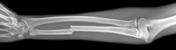
Figure 1 X-ray of a broken bone.

- Bone not only contains elements with higher atomic number than the surrounding soft tissue, such as calcium and phosphorus, but also is denser – a solid with closely bonded atoms.

Some types of tissue – for example breast tumours, which are denser than the surrounding tissue – can also be differentiated by X-rays (Figure 2).

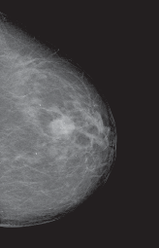
Figure 2 X-ray of a breast tumour.

2.1 Computed tomography (CT) scans
A conventional X-ray of a bone fracture is a two-dimensional (2D) image, taken from the front of the patient by a single camera, and is sometimes known as a planar X-ray.
However, a computed tomography (CT) scan produces many 2D images of sections throughout the body using detectors arranged in a circular field, which can then be computer processed to give a three-dimensional (3D) reconstruction of the body.
With carefully controlled conditions, even changes in soft tissues indicating tumours can be picked up and located by this method. The resolution can be as good as 1 mm or less.
The following video shows a CT scan being done in a hospital for a patient with a suspected injury to his spine.

Video content is not available in this format.
Video 1 X-ray imaging in a CT scan. (2:32 min)
View transcript - Video 1 X-ray imaging in a CT scan. (2:32 min)

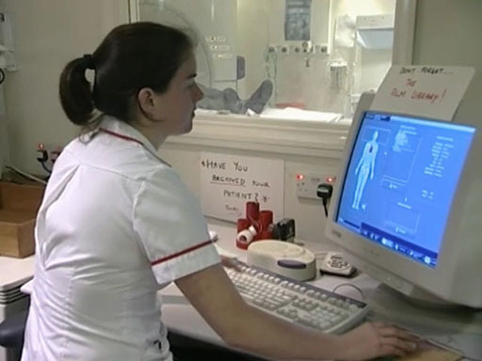

So, how is a CT image produced?
The X-ray source is rotated around the patient and the intensity recorded on the opposite side of the patient. Using data from a large number of angles, a computer generates a two-dimensional map of the tissues in a slice of the body.
Note that there are three directions in which slices through the brain (or the body in general) are typically reported in imaging, as illustrated in Figure 3: axial, sagittal and coronal. You’ll meet these terms again when looking at MRI.

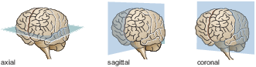
Figure 3 The three section planes through the brain: axial, sagittal and coronal.

2.2 X-ray contrast agents
One way of improving the differentiation between tissues when using X-rays is to use a contrast agent.
This is a substance which, in this instance, preferentially absorbs X-rays and hence shows up more clearly the organs into which it is injected or introduced. (Another type of contrast agent is used in MRI, as you will see later on in the course.)

- Can you suggest one property of an X-ray contrast agent that would influence its absorbance?
- The contrast agent should have a high atomic number, since this will lead to greater absorbance.

There are a variety of these agents available, the oldest of which is barium sulfate.

Barium sulfate
Barium has a high atomic number and absorbs X-rays extremely well. A ‘barium meal’ consisting of an insoluble barium salt such as barium sulfate, BaSO₄, is given to patients to swallow in the form of a milky-looking drink, and its progress through the digestive system is followed with X-rays. This is typically used to visualise the structures of the upper gastro-intestinal tract. For the lower parts of the intestines, including the bowel, a barium enema is given instead.

- Why is it desirable for this contrast agent to be insoluble? (The solubility product of BaSO₄ is )
- The very low solubility product of BaSO₄ means that this is not absorbed in the body but is simply excreted with no danger. (In fact, soluble salts of barium are highly poisonous.)

- You may recall that the units of solubility product will differ depending on the expression for the sparingly soluble salt concerned. Account for the units shown above for barium sulfate.
- The equilibrium for barium sulfate is:

So the solubility product is given by

and in this case the units will be:

Abnormalities such as ulcers in the stomach wall and abnormal growths can be picked up using a barium meal.
Figure 4 shows an X-ray of the large intestine of a patient using this method. In this example, the contrast of the image has been reversed to see the intestines better and hence allow the medical practitioner to make a diagnosis.

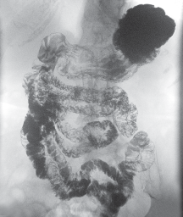
Figure 4 X-ray image of a barium meal passing through the bowel.

Contrast agents are also used to enhance the image in organs such as the kidneys, liver and bladder, as well as in bronchography (imaging of the lower respiratory tract).

Other X-ray contrast agents
An alternative to barium sulfate for imaging of the gastro-intestinal tract is a tri-iodinated benzenoid compound which goes under the trade name Gastrografin® (Structure 1). Iodine is also used in intravenous contrast agents for imaging blood vessels and organs such as the heart (angiogram).

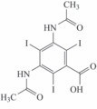
Structure 1

Polymetallic tungsten complexes such as K₃[PW₁₂O₄₀] have also been investigated for some applications.

- Why do you suppose that such compounds are being studied as contrast agents?
- Iodine and tungsten are heavy elements, so compounds containing a number of these atoms will absorb X-rays well.

- When having an X-ray taken, you are asked not to use talcum powder (a magnesium silicate) or antiperspirant (typically containing aluminium and often zirconium) on the day of the appointment. Why might this be so?
- Magnesium, silicon, aluminium and zirconium are heavier elements than those contained in body tissue, and so show up as spots on the image where they absorb the X-rays.

Now watch the following short video which shows a CT scan of the head using a tri-iodated contrast agent. In this example, the contrast agent has been preferentially taken up in the blood.

Video content is not available in this format.
Video 2 CT scan of the head. (Note that there is no soundtrack on this sequence.) (0:33 min)

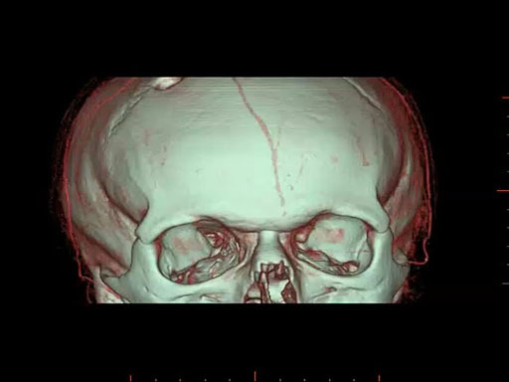

3 Anatomical imaging using MRI
The potential of nuclear magnetic resonance (NMR) spectroscopy to be applied to investigations of the human body was recognised soon after the technique was developed in the 1940s. But its use as an imaging technique to visualise anatomy was first shown to be practicable in the 1970s.
Since then, magnetic resonance imaging (MRI) has become an astonishingly common procedure.
For example, figures released by the National Health Service in England reveal there were 2.4 million MRI examinations carried out during the financial year 2012/13.
The following quotation from MRI from Picture to Proton (Cambridge University Press) illustrates both the complexity and the utility of the technique:

MRI involves an amazing combination of advanced science and engineering, including the use of superconductivity, cryogenics, quantum physics, digital and computer technology – and all within the radiology department of your local hospital (Robbie et al., 2007).

- Can you suggest why MRI is potentially less harmful to patients than CT?
- Unlike X-ray-based diagnostics such as CT, MRI does not expose patients to potentially harmful ionising radiation.

A typical MRI scanner is shown in Figure 5.

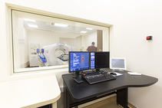
Figure 5 A clinical MRI instrument.

3.1 MRI in practice
It’s important to appreciate from the start that MRI involves the measurement of signals from tissues in the body.
MRI produces a 3D image of the body from a series of 2D images by measuring the signals from mobile protons – mostly in the water present in the body, but also in the protons present in fats and proteins.
These signals are presented in such a way that they may show where they originate in the body. In other words, the image that is seen represents a map of signals in real spatial dimensions.
Watch the following video which demonstrates MRI being used for diagnosis in a hospital –in fact, it’s the patient with the suspected brain injury you saw having the CT scan. It also gives an introductory account of how MRI works.
Don’t worry about terms like , and proton density; these will be explained later.

Video content is not available in this format.
Video 3 Obtaining an MR image of a patient. (3:03 min)
View transcript - Video 3 Obtaining an MR image of a patient. (3:03 min)

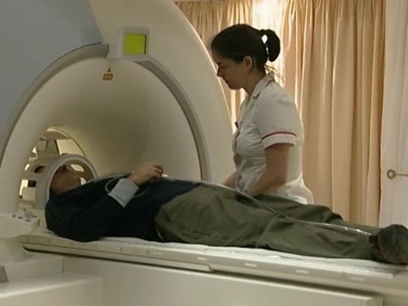

Activity 1
Allow approximately 10 minutes.

Now that you have watched the video, briefly summarise the main stages in the MRI process.

View answer - Activity 1

As has already been mentioned, at the very basic level an MR image is formed from signals from tissue in the body. And as you’ve seen, in order to obtain these signals the body must be
- immersed in a strong magnetic field
- irradiated at the appropriate radio frequency.
However, by itself this process will not lead to an image.
Although MRI involves the measurement of signals from tissues within the body, these signals are presented in such a way that they show where they originate from within the body.
There is thus a major difference between the spectroscopic studies used to determine the structure of organic molecules for example, which provided information about chemical environments on the molecular scale, and imaging investigations that provide information about spatial location on a macroscopic scale.
So, how is it possible to be able to identify from whereabouts in the body the excited hydrogen nuclei emit their NMR signals?
In addition, a considerable strength of MRI is its exceptionally high sensitivity to changes in soft tissue. From what you’ve seen so far, a striking feature of an MR image is the level of detail that is available. Areas of high signal intensity appear white, while those of low signal intensity appear dark, and those in between are shades of grey.
How is this excellent contrast achieved? You will address these questions in the sections that follow but first you will briefly revise the relevant theoretical aspects of MRI.

3.2 MRI: theoretical background
Consider the hydrogen nuclei in a sample in a strong magnetic field.

- What happens to the protons in the presence of an applied magnetic field?
- The protons align with or against an applied magnetic field (spin-up or spin-down, respectively).

This can be represented by an energy level diagram of the form shown schematically in Figure 6. Here the lower (ground) state represents the protons aligned parallel to the field and the higher (excited) energy state represents those against the field.

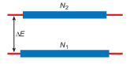
Figure 6 Schematic energy level diagram for a collection of nuclear spins in a strong magnetic field. The rectangular boxes represent the energy level populations.

- At thermal equilibrium what is the distribution of these spins?
- At thermal equilibrium there is an excess of spins in the lower energy level and, overall, the populations of the two energy levels are characterised by a Boltzmann distribution.

Because there are slightly more protons aligned parallel to the field (i.e. in the ground state), the tissue has an overall net magnetic moment, usually known as the net magnetisation vector in the same direction as the applied magnetic field. It is conventionally given the symbol M_{z}, where the subscript denotes the direction of magnetisation – in this case, parallel to the external magnetic field in the z-direction.
When a radio frequency pulse is applied, it excites some of the protons into the higher (excited) energy state. The net effect of this interaction is that the net magnetisation vector rotates away from its original direction. The angle through which it rotates is determined by the duration of the radio frequency pulse: a 90° pulse rotates the magnetisation into the xy-plane, and a 180° pulse rotates the magnetisation into the z-direction. In MRI experiments, a 90° pulse is used.
The probability of a transition from the higher energy state back to the lower level by a spontaneous process is virtually negligible (about 1 in 10¹⁸ years). It might therefore seem that net absorption due to irradiation at the resonance frequency will eventually lead to a situation in which the populations of the two energy levels become equal. Under these circumstances the NMR signal would fall to zero and the spin system would then be referred to as a saturated nuclear spin system.

- From a practical point of view, what are the implications of the above discussion for measuring a spectrum?
- Since the intensity of the signal is related to the population, it would suggest that if several experiments were carried out – one after another – on the NMR sample then the signal would become progressively smaller. This is because the population difference between the energy levels would decrease in each case.

However, NMR spectra can be repeatedly measured on the same sample with no obvious saturation effects. The reason for this is that there is a mechanism available for restoring thermal equilibrium in a nuclear spin system. This mechanism is called spin–lattice relaxation.
But what do we mean by the term ‘lattice’?
Lattice refers to the surroundings of a nuclear spin – both within a molecule and in the further molecular environment. In liquid samples there is fast, random motion on the molecular scale and it is possible to view this motion as constituting a reservoir of energy – furthermore, this reservoir is a very good acceptor of energy. In these terms, spin–lattice relaxation is a process that allows nuclei to transfer magnetic energy to their surroundings. In this way, the populations of the magnetic energy levels are restored to their thermal equilibrium values. Admittedly, this picture is simplified but it does provide some insight into a complex process.
Considering again the net magnetisation vector, this will return to the z-direction through spin–lattice relaxation as shown in Video 4. This sequence starts at the point where the net magnetisation vector has been flipped into the xy-plane by an RF pulse. The component in the xy-plane reduces while the component in the z-direction recovers. The line on the graph to the right indicates the size of the z-component, M_{z}.

Video content is not available in this format.
Video 4 Spin–lattice relaxation. (Note that there is no soundtrack on this sequence.) (0:31 min)

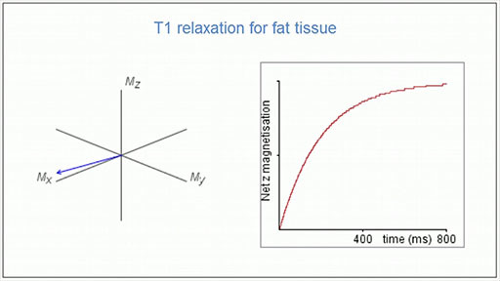

- How does M_{z} change with time? What does this reflect?
- An exponential increase in M_{z} is observed with time. The time taken reflects the efficiency with which the spin system can lose magnetic energy to its surroundings.

In general, spin–lattice relaxation can be viewed as the return to thermal equilibrium from saturation. The time taken reflects the efficiency with which the spin system can lose magnetic energy to its surroundings and is different for different tissues. This contributes to different contrast as you will see in Section 3.4, but first you will consider how an image is produced.

3.3 MRI: Producing an image
Although the basis of the MRI technique is , it is important to realise that it does not involve recording an NMR spectrum in order to analyse which molecules are present.
A complete spectrum of the human body would show a large number of signals from protons in different proteins (DNA, etc.) and from different parts of the body, and would be impossible to interpret.
So how is an image produced?
We start by looking at a real example.
Figure 7 shows a typical slice through the sagittal plane which clearly shows the skin, grey and white matter, cerebrospinal fluid and other components of the brain. The smallest detail in this image is a millimetre or smaller, and images such as this are used to provide vital information as a means of diagnosis or to identify the need for any surgical intervention.

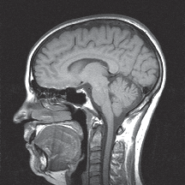
Figure 7 A typical slice through the brain in the sagittal plane.

How are different components, such as the grey and white matter and cerebrospinal fluid in the brain, identified using MRI? And how is the spatial localisation achieved, providing information about where in the brain the different components are located?
In the next section you will consider spatial localisation. A key component is the use of magnetic field gradients.

Spatial localisation
A magnetic field gradient is applied across the body in three directions. This means that the external magnetic field experienced by a proton depends on where in the body it is situated. And when a proton returns to the ground state, the energy emitted will depend on the position of that proton in the magnetic field gradient and hence on its location in the body.
Figure 8 gives you a simplified view of how spatial localisation works.

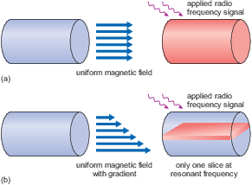
Figure 8 Cylindrical object in (a) a uniform magnetic field and (b) after applying a magnetic field with gradient. The blue arrows represent the magnetic field, length being proportional to intensity.

Consider a cylindrical object placed in a completely uniform magnetic field (Figure 8a). If an RF signal is now applied at a frequency which matches the resonant frequency, then all the protons in the cylinder will resonate (indicated by the red shading) and a signal will be obtained from all of them.
In Figure 8b, a small additional magnetic field has been applied in such a way that the overall magnetic field is larger at the bottom of the cylinder than it is at the top. (The length of the blue arrows represents the magnetic field strength, and it is proportional to the magnetic field intensity.) If the RF signal now matches the resonant frequency in the middle of the object, it will not match above and below; so only one slice will resonate (shown in red).
Note that in Figure 8b the magnitude of the change in overall magnetic field is exaggerated to illustrate the concept; in MRI scans, magnetic field gradients typically contribute no more than a small percentage to the main magnetic field. Also note that the magnetic field is always in the same direction – the magnitude is just altered slightly by the gradient fields.
So, by changing the direction of the gradient of the field (not the direction of the field), slices can be chosen in any direction, as required.
But choosing the slice has only specified the position in one direction – there is still no information about different areas of the slice. So the next step is to detect the signal from different pixels within the slice. This is done by the application of two more gradients, applied at exactly the right moment in the sequence of pulses.
A complicated sequence of pulses and gradient fields enables the signal to be localised, which in turn enables a 3D image of the distribution of protons to be created.
Both fat and water signals are detected at each position, but the magnetic field gradient is such that the range of frequencies required to excite protons is distinct for each volume element or voxel (the 3D equivalent of the 2D pixels of computer screens or digital cameras).
To obtain an MR image, the intensity of the NMR emission signal is recorded for each voxel; that is, as a function of position. Different signals can be obtained from different tissue types, depending on the distribution of water.

3.4 Contrast in MRI
Factors that influence contrast in an MR image are often referred to as intrinsic and extrinsic. Intrinsic contrast will depend on the proton density.
This is directly related to the number of hydrogen atoms in the different voxels that make up the imaging slice. For this reason, it is also referred to as proton density contrast (or PD contrast). A key factor for this type of contrast is the water content of different tissues – although the variations in soft tissue are not major.
For example, the water contents of brain grey matter, brain white matter, heart tissue and blood are approximately 71%, 84%, 80% and 93% by mass, respectively. Conversely, bone is only 12% water by mass and will always appear dark in MR images.
If intrinsic contrast was the only factor that determined ‘dark to light’ in an MR image, the clinical versatility of the technique, such as the ability to distinguish cancerous tissues, would be very limited.
However, there are additional factors which can influence NMR signal intensity, and these can be exploited in the design of an imaging sequence. To fully understand these extrinsic factors requires a further appreciation of relaxation processes – the mechanisms by which nuclear spins return to the ground state following excitation.
As you’ll see, relaxation characteristics vary for the different tissues in the body.

Relaxation time
It is the relaxation characteristics that are particularly important in determining the contrast of an MR image.
There are two relaxation mechanisms for NMR transitions:
- spin–lattice relaxation time or longitudinal relaxation time (you met this briefly in Section 3)
- spin–spin relaxation time or transverse relaxation time.
You’ll now look at each one in turn.

- What is spin–lattice relaxation?
- Spin–lattice relaxation is a process that allows nuclei to transfer magnetic energy to their surroundings, both within a molecule and in the further molecular environment.

As you saw previously, this process is characterised by an exponential increase in the population difference between magnetic energy levels with time, as shown by the schematic diagram in Figure 9.

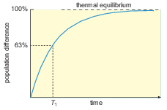
Figure 9 Schematic plot of the return to thermal equilibrium. The population difference between two magnetic energy levels, from an initially saturated state, is plotted as a function of time. The manner in which the spin-lattice relaxation time, T₁, is defined is shown on the plot.

The spin-lattice relaxation time, , corresponds to the time it takes for the population difference of the magnetic energy levels to rise to a value equal to 63% of the thermal equilibrium value. The value of reflects the efficiency with which the spin system can lose magnetic energy to its surroundings. The larger the value of , the less efficient is the process, the slower the return to equilibrium and the more prone is the NMR sample to saturation.
Different tissue types have different values of . For example, cerebrospinal fluid (CSF), which is found in the brain and spinal cord has in the region of 2000 ms, whereas fat-based tissues have in the region of 200 ms. Other tissues, depending on their water content, range between these values. It follows that individual voxels in an imaging slice can have different values of depending on their content. Hence, they will be prone to saturation in different ways.
The second type of relaxation behaviour associated with an assembly of nuclear spins is transverse or spin–spin relaxation and the associated time constant is the spin–spin relaxation time, . This relates to the transfer of energy between protons in the ground state and those in the excited state.
For small molecules in solution, in a conventional NMR experiment, and are roughly equal, but protons in different tissues have different relaxation times. (Approximate values are given in Table 1.)

Table 1 Approximate relaxation times of water protons in brain tissues in a magnetic field of 1 Tesla compared with fat and water.
Tissue | (mean)/ms | (mean)/ms
Fat | 250 | 80
white matter | 650 | 90
grey matter | 800 | 100
cerebrospinal fluid (CSF) | 2000 | 150
Water | 3000 | 2500

The reasons for the range of values shown in the table is because the protons in different types of tissue will have different degrees of freedom or mobility. This will directly affect how readily they can interact with other species in their surroundings.

- By referring to Table 1, what can you say about the relative magnitude of and ?
- in general tends to be much shorter than .

T₁- and T₂-weighted images
You’ve seen that the intensities of the tissues in an image will depend on their relaxation characteristics, but it’s also important to consider the way in which the MRI sequence is set up.
Contrast can be enhanced by designing the pulse sequence so that either or effects dominate the relative intensities measured for different tissues.
Images are said to be either -weighted – that is, the image contrast depends largely on the differing values of the tissues – or -weighted. In fact, you saw this being put into practice with a real patient in Video 3.
For example, in -weighted images, the MRI sequence is set up so that it is repeated at set time intervals. This is referred to as the repetition time (TR). This means that signals from voxels which contain tissue with large values, compared with TR, will be saturated to some extent. Essentially, there will have been insufficient time for the thermal equilibrium population of the magnetic energy levels to be re-established before the imaging sequence is applied again. Such tissues will appear very dark and those with small values very bright.
It is important to recognise that the value of TR is set by the operator of the MRI instrument and so it can be set to ensure optimum contrast between specific tissues with different values of .

- Predict the appearance of a -weighted image of the spine containing CSF and fat-based tissue. (Hint: look back at the values in Table 1.)
- A characteristic of a spine (or indeed brain) -weighted image is that CSF (‘large ’) appears very dark and fat-based tissue (‘small ’) appears very bright.

Figure 10 shows a - and a -weighted image of a spine.

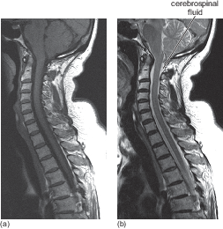
Figure 10 (a) -weighted image and (b) -weighted image of the spine of an elderly patient.

- What differences do you notice in these images?
- In -weighted images, tissues that have lower values (in particular, fat) appear bright.
In -weighted images, tissues that have greater values such as CSF (and water) appear brighter.

- -weighting is particularly used to image anatomy, for example the boundary between different types of tissue, such as the brain, because white and grey matter have different values of (see Table 1).
- -weighting is more sensitive to water, which appears as bright in Figure 10b. Unfortunately, -weighted images have a poorer signal-to-noise ratio and so are not such clear images. -weighting is used in particular to show disease, as water tends to accumulate in diseased tissue and appears bright against normal tissue.
It can be useful in diagnosis to be able to enhance the contrast even more. This can be done by injecting patients with artificial contrast agents. As you’ll see later, this involves the use of complexes of the element gadolinium.

- Where is gadolinium located in the Periodic Table?
- Gadolinium is an element from the f-block – more specifically, it is a lanthanide.

3.5 Chemistry of the lanthanides
It was mentioned in the previous section that complexes of gadolinium, a lanthanide, are used as MRI contrast agents. So, before continuing your study of MRI and contrast agents in particular, you’ll take a short diversion and look at some relevant background chemistry of the lanthanides.
But before getting started, here is a word about nomenclature.
Although we’re calling this series of elements the lanthanides, you’ll often come across the alternative – lanthanoid. In fact, it should be acknowledged that the International Union of Pure and Applied Chemistry (IUPAC) recommends using the latter as the ending ‘ide’ implies a negative ion – but lanthanide is still (arguably) the more commonly used name.
Start by working through the following exercise.

Activity 2 Exploring the lanthanides
Allow approximately 1 hour

To introduce you to the lanthanides and their chemistry, let’s start with the Periodic Table and think a little about where these elements fit – as you’ll see, it’s not entirely straightforward.
Work through the activity Exploring the lanthanides, but please note that the first 48 seconds of the activity are not relevant for your study of this course. The final sentence also talks about actinides but, again, this is not relevant for your study.
When you have completed this activity, return here to continue your study.

- What is the prominent oxidation state of the lanthanides?
- It is +3. Other states do exist: and , for example, and in aqueous solution can be formed.

Now take a look at the electronic configurations of the free lanthanide atoms and ions shown in Table 2.

Table 2 Electronic configurations of the free lanthanide atoms and ions.
Element | Symbol | Ln(g) | Ln²⁺(g) | Ln³⁺(g)
lanthanum | La | [Xe]5d¹6s² | 5d¹ | 4f⁰
cerium | Ce | [Xe]4f¹5d¹6s² | 4f² | 4f¹
praseodymium | Pr | [Xe]4f³6s² | 4f³ | 4f²
neodymium | Nd | [Xe]4f⁴6s² | 4f⁴ | 4f³
promethium | Pm | [Xe]4f⁵6s² | 4f⁵ | 4f⁴
samarium | Sm | [Xe]4f⁶6s² | 4f⁶ | 4f⁵
europium | Eu | [Xe]4f⁷6s² | 4f⁷ | 4f⁶
gadolinium | Gd | [Xe]4f⁷5d¹6s² | 4f⁷5d¹ | 4f⁷
terbium | Tb | [Xe]4f⁹6s² | 4f⁹ | 4f⁸
dysprosium | Dy | [Xe]4f¹⁰6s² | 4f¹⁰ | 4f⁹
holmium | Ho | [Xe]4f¹¹6s² | 4f¹¹ | 4f¹⁰
erbium | Er | [Xe]4f¹²6s² | 4f¹² | 4f¹¹
thulium | Tm | [Xe]4f¹³6s² | 4f¹³ | 4f¹²
ytterbium | Yb | [Xe]4f¹⁴6s² | 4f¹⁴ | 4f¹³
lutecium | Lu | [Xe] 4f¹⁴5d¹6s² | 4f¹⁴5d¹ | 4f¹⁴

- What does the notation [Xe] represent?
- This is a shorthand notation to represent the filled shell of the preceding noble gas – in this case, xenon.

Note how the 4f shell progressively fills on moving across the series.
For free lanthanide atoms, the 4f electrons may be viewed as valence electrons. But in compounds, where two or more electrons are involved in bond formation, the residual 4f electrons experience increased nuclear charges and contract into the core.
In fact, in compounds in which the lanthanide has oxidation state +3, the lowering of energy is so marked that the 4f electrons may be classified as core electrons, so oxidation states higher than +3 are (almost) unknown.

Ionic radii of the lanthanides
If you now consider the ionic radii of the lanthanide ions (Figure 11), they show a smooth decrease across the series.
This is often referred to as the lanthanide contraction.
In essence, this reduction in size of the lanthanide ions results from poor shielding of the positive nuclear charge by the 4f electrons which pulls the 6s electrons towards the nucleus. This has important consequences for the Periodic Table, as the size of the last four ions – and – falls below that of in the preceding transition series. This means that the elements that follow yttrium in the third transition series are much smaller than expected.
But if you make a comparison with the ionic radii of dipositive ions of the first transition series (Figure 11) where a double-bowl variation is seen. This reveals an important feature of the coordination chemistry of the lanthanides.

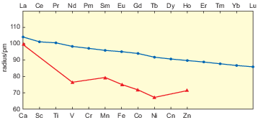
Figure 11 The ionic radii of ions (blue circles) and dipositive ions of calcium and the first transition series (red triangles).

- How is the double-bowl shape of the first transition series explained?
- This arises from the influence of crystal-field effects superimposed on the effect of increasing nuclear charge.

- What does the smooth lanthanide contraction tell you about crystal-field effects in lanthanide compounds?
- They are much smaller than in first-row transition metal compounds, which supports the notion that, in lanthanide compounds, the 4f orbitals are almost part of the core.

Paramagnetism of lanthanide complexes
When considering the lanthanides in the context of MRI contrast agents, the magnetic properties of their complex ions are important.
There are two possible contributions to the paramagnetism of a transition-metal complex. One arises from the spin of the unpaired electrons.

- From what does the other contribution arise?
- The orbital angular momentum of the unpaired electrons.

You know that for transition metal complexes, the d orbitals are strongly split by the crystal field.
This splitting can quench the orbital angular momentum meaning that for first-row transition metal complexes, the paramagnetism arises almost entirely from the spin of the unpaired electrons.
The magnetic moment is close to the ‘spin-only’ value and Equation 1 can be used to determine its magnitude.

(Equation 1)

Recall that μ_{S} is the spin-only magnetic moment, n is the number of unpaired electrons, and μ_{B} is the Bohr magneton.
But for lanthanide complexes this isn’t the case – take a look at Table 3.

Table 3 Magnetic moments of the tripositive aqueous ions of the lanthanides and lutetium.
Ion | Electronic configuration | μ/μ_{B}
La³⁺ | 4f⁰ | diamagnetic
Ce³⁺ | 4f¹ | 2.51
Pr³⁺ | 4f² | 3.53
Nd³⁺ | 4f³ | 3.55
Pm³⁺ | 4f⁴ | 2.68
Sm³⁺ | 4f⁵ | 1.46
Eu³⁺ | 4f⁶ | 3.37
Gd³⁺ | 4f⁷ | 8.00
Tb³⁺ | 4f⁸ | 9.33
Dy³⁺ | 4f⁹ | 10.55
Ho³⁺ | 4f¹⁰ | 10.40
Er³⁺ | 4f¹¹ | 9.50
Tm³⁺ | 4f¹² | 7.35
Yb³⁺ | 4f¹³ | 4.30
Lu³⁺ | 4f¹⁴ | diamagnetic

The magnetic moments are plotted in Figure 12, along with the spin-only values calculated from Equation 1.

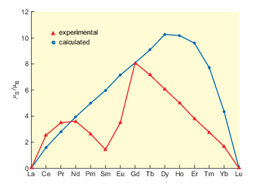
Figure 12 Experimental and calculated magnetic moments for ions.

The clear failure of the spin-only formula shows that the orbital angular momentum is not quenched in the way that it is in first-row transition-metal complexes.

- What does this suggest about the splitting of the 4f orbitals in lanthanide compounds?
- It must be small (backing up what you saw in the previous section), and not sufficient to quench the orbital angular momentum

This, in turn, suggests that the exposure of the 4f orbitals to the ligands is small, and is further evidence that the 4f electrons are close to being part of the noble-gas core.
The magnetic moments in Table 3 are very similar to those in other lanthanide compounds, and are characteristic of the configurations set alongside them. They can therefore be used to identify the configuration concerned.
Note that any 4f configuration is associated with just one high-spin magnetic moment.

- How does this differ from complexes of the d-block metals?
- Certain d-electron configurations occur in both high- and low-spin states.

- Why is this further evidence that crystal-field effects are small in lanthanide compounds?
- Low-spin complexes would require a large crystal-field splitting in the 4f orbital energy levels.

You will now be looking in detail at MRI contrast agents and, as you’ll see, the magnetic properties of the lanthanide ion play a key role.

3.6 MRI contrast agents
MRI contrast agents enter some types of tissue in preference to others, interacting with the water, reducing the relaxation times (increasing 1/ and 1/) of protons in these tissues to differing extents and thus increasing the signal intensity.

- Based on your experience of coordination chemistry, describe how water can interact with a metal ion.
- Water molecules can act as ligands and bind directly to a metal in an inner-sphere coordination. Other water molecules are bound further away from the metal ion, often hydrogen-bonded to one of the ligands; this is outer-sphere coordination (Figure 13). Although not interacting directly with the metal, bulk water is also included here.

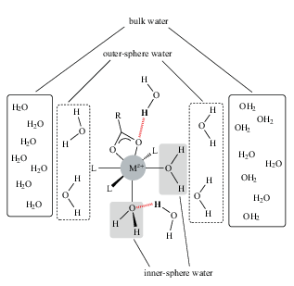
Figure 13 Different types of water molecule around a metal complex (also showing a bidentate ligand and three monodentate ligands, L). Note how hydrogen-bonding of an outer sphere water molecule to either a ligand or an inner sphere water molecule renders the proton shown in bold as belonging to the inner sphere.

Looking again at Figure 13, you can see that protons on the outer-sphere water may also effectively become inner sphere by hydrogen-bonding to an inner-sphere ligand.
In the inner sphere, water molecules will be influenced more by the magnetic field of the metal ion than water molecules in the outer sphere. But the latter are in a good position to interact with protons in the bulk of the surrounding tissues.
As mentioned earlier, practical contrast agents tend to be based on the lanthanide metal gadolinium.

- What oxidation state will gadolinium cations exhibit?
- As is the case for the lanthanides in general, +3 is the most common oxidation state.

As you saw previously, gadolinium(III) has a high magnetic moment (μ = 8.0 μ_{B} due to seven unpaired electrons), and it’s this high moment which makes it especially effective at modifying the relaxation processes of nearby protons.
But that’s not the whole story.
For a contrast agent to affect the relaxation rates of protons in tissues, there must be a dynamic exchange of water molecules between the inner sphere, the outer sphere and uncomplexed bulk water molecules. This exchange must be fast relative to the proton relaxation rate.
During MRI, a patient is injected with about a gram of gadolinium, but in aqueous solution the metal exists as , which, as you’d expect for a heavy metal, is highly toxic.

- What challenge does this present to a chemist working in this field?
- This means researchers have had to find suitable ligands that form complexes that remain bonded while in the body and are excreted intact. This will be considered in more detail in the next section.

Gadolinium complexes
Figure 14 shows an example of the marked improvement in the quality of the MRI data when a gadolinium contrast agent is used.
The complex is delivered to the patient intravenously and is carried round in the blood plasma but does not enter the cells. Considering the example of the brain, gadolinium complexes cannot cross the blood–brain barrier in a normal brain. However, in Figure 14 a tumour is present; this causes the blood–brain barrier to become ‘leaky’ and thus allows the contrast agent to cross into the brain.

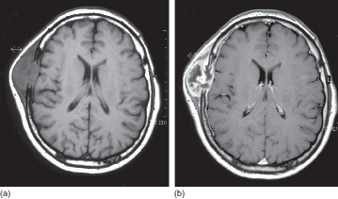
Figure 14 MR images of a brain containing a tumour of the frontal bone: (a) without and (b) with gadolinium contrast enhancement.

Now, before moving on to look at some specific gadolinium complexes, consider what you should be looking for in a ligand by having a go at the following questions.
To get round the toxicity issue mentioned in the previous section, is in the form of a complex – one that will not dissociate. You saw earlier that chelating ligands form particularly stable complexes, and indeed these are used here.

- What factor will influence the choice of ligand for a contrast agent?
- The ligand should form a complex with a high stability constant. This can be influenced by the choice of polydentate ligands, ligand preorganisation and/or the choice of correct ligating atoms.

- Why do chelating ligands lead to greater stability compared with a simple monodentate ligand – say, NH₃?
- Complexes containing polydentate (chelating ligands) are particularly stable. Several factors contribute, but it is thought that the most influential is the entropy change in the formation reaction. The entropy change for the chelated complex is positive, whereas that for the complex with no chelate rings is negative.

- Which coordinating atoms would be preferred for binding?
- is a hard acid, so is likely to coordinate to hard bases such as O or N atoms.

The first gadolinium complex to be used clinically, in 1988, was Magnevist®, a nine-coordinate complex of gadolinium(III), .
The DTPA ligand is diethylenetriaminepentaacetate (ethanoate), shown as the protonated form in Structure 2.

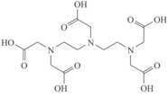
Structure 2

DTPA is an octadentate ligand, with coordination by all five carboxylate groups and the three nitrogen atoms. A ninth coordination site on gadolinium is occupied by a water ligand (remember – high coordination numbers are common for lanthanide ions).

- What type of ligand is H₂O in this structure?
- It is an inner-sphere ligand as it is attached directly to the metal.

This is the water molecule that undergoes ligand exchange with bulk water.
This Gd(III) complex has since been followed by others, shown in Figure 15.

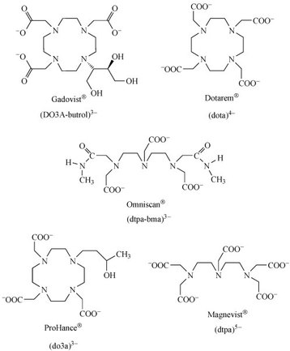
Figure 15 Ligands of Gd(III) complexes approved for clinical use as MRI contrast agents.

- What do you notice about the charges on these ligands?
- These ligands are anionic.

The negative charge will promote binding to the metal cation. In addition, an anionic complex will have greater interactions with outer-sphere water.
And, as is characteristic of the lanthanides, gadolinium being a very large atom can accommodate a large number of ligands. A single octadentate ligand such as DTPA ensures that there is not room for many water ligands to coordinate, as too many water ligands may make the complex too reactive.
A further consideration is the rate at which the contrast agent rotates or tumbles in solution.
A slow rotation rate can reduce relaxation times, although the relationship between rotation rate and relaxation rates is complex. One line of research is to use large molecules such as proteins as ligands, which tumble slowly in solution. Another possibility is to use antibodies as ligands to improve tissue targeting.

- Why is not a suitable ligand for gadolinium coordination in a 1 : 1 metal–ligand complex?
- As a hexadentate ligand, alone will not saturate all the coordination shell in a 1 : 1 complex. This will leave room for other ligands, such as water, to coordinate.

In this first part of the course you have seen the role that metals play in medical imaging. In the next two sections you will look at metal containing compounds as drugs.

4 Metals for therapeutic applications
When considering drugs used for the treatment of disease, your first thoughts might lean towards treatments involving organic compounds. But metals and their compounds have been used for medical applications since ancient times. The use of metals in drugs is the focus of the next two sections, and as you will see it is a wide-ranging, exciting and ever-expanding topic.
Metals and their compounds have had a variety of medical applications throughout history – some more successful than others. Some of the earliest examples date back to 3000 BC, when the ancient Egyptians were using copper sulfate to sterilise the water used in their tonics. Zinc was also reportedly used by the Romans to promote the healing of wounds.
You will consider some examples of the historical uses of metals in medicine next – starting with gold.

4.1 Brief historical background
Gold has been valued for centuries, as far back as the time of the ancient Egyptians – not only as a precious metal, but also for its healing powers. In more recent times, gold complexes have been used to treat patients with rheumatoid arthritis, a debilitating and painful inflammatory condition where the cartilage between bone joints is lost over time.
Mercury, in the form of its salt mercury(I) chloride, was traditionally used in the 16th century throughout Europe as a diuretic and laxative, and was also used to treat syphilis, often effectively poisoning the patient. And, by the 19th century, HgCl was incorporated in a tonic known as ‘blue mass’ and prescribed for many ailments including such diverse conditions as constipation, toothache and depression. The use of mercury compounds is now largely avoided because of their poisonous properties, but they are still to be found in traditional therapies such as Chinese medicines.
The semimetal (or metalloid) arsenic, perhaps most well known as a poison, has also been used in medicine. It was prescribed for a range of ailments, such as rheumatism, malaria, tuberculosis and diabetes. In the 18th century, ‘Dr Fowler’s solution’ – a mixture of potassium arsenite and lavender water – was prescribed as a general tonic and an aphrodisiac.
It was not until the 20th century, however, that metal complexes began to be screened more systematically for their medicinal properties. In 1909, the organoarsenic compound Salvarsan became the first modern chemotherapeutic agent for the treatment of syphilis, although it was later superseded by antibiotics.
The discovery of Salvarsan is described in the following video – watch this now.

Video content is not available in this format.
Video 5 The discovery of Salvarsan. (5:40 min)
View transcript - Video 5 The discovery of Salvarsan. (5:40 min)

- What experimental strategy was adopted by Paul Ehrlich (1854–1915) in his search for a cure for syphilis?
- Ehrlich, or more precisely his assistant, Sahachiro Hata (1873–1938), painstakingly tested hundreds of organic arsenic compounds on rabbits which had been purposely infected with syphilis. Compound 606 was the one that worked – curing the disease, but not poisoning the animal – this was Salvarsan.

Salvarsan and indeed salts of another toxic heavy metal antimony have been used in the treatment of tropical diseases. However, probably the most famous metal-containing complex found in the 20th century was the platinum-containing anticancer drug cisplatin.
Its anticancer activity was discovered serendipitously by Barnett Rosenberg (1926–2009) in the 1960s and it went on to revolutionise the treatment of some cancers, notably testicular cancer. Intensive research in this area has since spawned the development of other metal complexes for cancer therapy. In addition, the 20th century also saw a growth in the use of radioactive metals to treat certain types of cancers, such as bone cancer.
Although some of the examples above are rather extreme, this snapshot does serve to make the point that metal-based drugs are generally speaking toxic, and a medical strategy must be in place to carefully control their dose to bring out their health benefits and/or therapeutic activity.
You will learn about the hits, misses and current developments of metal-based drugs throughout the next sections. But first, the next section provides an overview of the current use of metals not just in medicine but also in health care in general.

4.2 Current use of metals in medicine: an overview
Take a look at Table 4, in which you’ll see examples of where metals may be found in therapeutic and other health care applications. This is certainly not a comprehensive list; it has just been included to give you a feel for the topic. A quick look at of the table reveals applications ranging from cancer treatment to over-the-counter medication and personal care.

Table 4 Examples of metals used in therapeutic and other health care applications.
Metal | Form (common/trade name) | Use/treatment
Li | carbonate (Camcolit®) | bipolar disorders
Na | bicarbonate (Alka-Seltzer®) | heartburn
Mg | sulfate (Epsom salts) | constipation
 | hydroxide (milk of magnesia) | heartburn
Al | hydroxide (Gaviscon®) | heartburn
 | silicate (kaolin) | diarrhoea
Ca | carbonate | heartburn, peptic ulcer, diarrhoea
Ga | Ga(III) complex | cancer
As | organic arsenic compound (Melarsoprol®) | sleeping sickness
Sr | ⁸⁹Sr complex | bone cancer
Sb | sodium stibogluconate | leishmaniasis
Bi | bismuth subsalicylate, C₇H₅BiO₄ (Pepto-Bismol®) | heartburn, diarrhoea
 | tripotassium dicitratobismuthate (De-nol®) | peptic ulcer
Ti | oxide | sunblock
V | complex | diabetes
Fe | Na₂[Fe(CN)₅(NO)].2H₂O | hypertension
Cu | histidine complex | Menkes disease
Zn | oxide | sunblock
 | oxide with 0.5% Fe₂O₃ (calamine lotion) | antimicrobial agent
Y | ⁹⁰Y complex | bone and liver cancer
Zr | Zr(IV) glycinate | antiperspirant
Ru | Ru(III) complex | cancer  parasitic disease
Ag | silver sulfadiazine | burns
 | Ag/Hg amalgam | dental amalgams
Pt | Pt(II) complex | cancer
 | Pt(IV) complex | cancer
Au | Au(III) complex | cancer
 | Au(I) complex | arthritis
Re | ¹⁸⁶Re, ¹⁸⁸Re complex | bone cancer
Ti | Ti alloy | hip and knee replacement
Sm | ¹⁵³Sm complex | bone cancer

You should note from Table 4 that many of the metal complexes listed are used in the treatment of cancer and this will be the main focus of the next sections. However, before you look at metal complexes used in cancer therapy, you will briefly consider a few examples where metals are used in medical treatments for more common ailments, including those available ‘over the counter’.
- Gold complexes have been used in the treatment of rheumatoid arthritis; the most recent drug to be used is aurofin which is taken orally. The active component is Au(I), the ligands in the complex conferring the necessary absorption and transport properties to the pharmaceutical agent.
- NO plays a number of important roles in the body, in particular in the dilation of blood vessels in the cardiovascular system. Complexes, such as Nitropress® (Na₂[Fe(CN)₅(NO)].2H₂O, which release NO can be used to alleviate acute hypertension; a series of Ru complexes have been investigated in this regard.
- Lithium, taken orally as Li₂CO₃ tablets, is used for the treatment of bipolar affective disorders. The mode of action is unclear; however, the active ingredient is believed to be .
- Two vanadium complexes have completed clinical trials for the treatment of Type II (insulin-resistant) diabetes. The complexes are prodrugs (see below), dissociating to release vanadyl ions which are believed to enhance the effect of insulin in controlling glucose levels. The key role for the ligands in the complexes appears to be to aid absorption and to provide sufficient stability to the complex so that it only dissociates when required.
- Metal alloys have long been used as bone replacements in both hip and knee replacement surgery; such alloys need to be biocompatible, must be able to withstand the corrosive environment in the body and have a high strength and resistance to fatigue. Biomaterials such as hydroxyapatite, Ca₁₀(PO₄)₆(OH)₂, the mineral component of bones and teeth, are also undergoing study for this application. Metal alloys are also used in dentistry as implants and in amalgams.
- Peptic ulcers, of which the most common are gastric (stomach) and duodenal, are associated with the bacterium Helicobacter pylori, which thrives in the acidic environment of the stomach. The bacterium causes inflammation by preventing the regulation of acid in the gastrointestinal tract. These ulcers can be very painful, especially when stimulated by gastric and duodenal acids.
The active ingredient in one treatment for peptic ulcers is tripotassium dicitratobismuthate.
The acidic environment present in the stomach results in the precipitation of bismuth oxychloride and/or bismuth citrate polymers. These precipitates coat the ulcer site, isolating it from the gastric and duodenal acids and allowing it to heal. Bismuth may also have an antibacterial action, and given in combination with antibiotics is particularly successful at treating stomach ulcers.
- Magnesium and aluminium hydroxides are examples of antacids sold commercially to treat heartburn, an unpleasant sensation which arises from the regurgitation of gastric acid up the oesophagus.

- Suggest why these compounds might be used as antacids.
- These compounds are bases. The hydroxide ions neutralise the stomach acid. For the same reason, sodium bicarbonate and calcium carbonate are also antacids.

- Magnesium hydroxide can also be used as a laxative (as can a range of other magnesium compounds). is not readily absorbed by the body and remains in the intestines in faeces, where it will absorb water from the surrounding tissue. This results in softening of the faeces as well as encouraging excretion as the increase in volume stimulates the intestines.
The laxative effect of when given as an antacid can be neutralised by the addition of aluminium hydroxide, which is also an antacid but also can cause constipation. In this case, the aluminium absorbs water from the faeces.
- Zinc oxide is commonly used to treat a variety of skin conditions and is a key ingredient in calamine lotion, barrier and nappy creams to sooth itching and irritation. It is also occasionally used as a sunblock, although TiO₂ is more common; particles of the oxide act as a physical block, reflecting and/or scattering harmful UV radiation.
In the next section, you will start to look at the use of metal complexes in cancer treatment, beginning with the molecule that started it all – cisplatin.

5 Cancer therapy: the cisplatin story
The most effective drugs for treating certain forms of cancer are a series of platinum-containing complexes.
For example, they have transformed the statistics of testicular cancer survival from a rare chance up to the 1970s to around a 90% survival rate today. But the discovery of their efficacy is one of serendipity.
The videos that follow throughout this course summarise the history and development of these drugs, with interviews with key players in the field. In the first video, you will meet Barnett Rosenberg (1926–2009), a physicist who had noted similarities between the appearance of magnetic lines of force and a cell when it is dividing. You will see how this led to the experiment that established the anticancer properties of platinum.

Video content is not available in this format.
Video 6 The cisplatin story: Part 1. (6:32 min)
View transcript - Video 6 The cisplatin story: Part 1. (6:32 min)

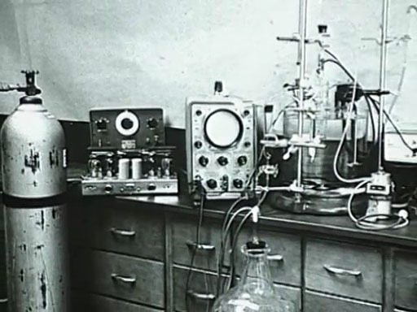

As you saw in Video 6, Rosenberg wondered if an electric field would affect cell division.
He conducted an experiment on the bacterium Escherichia coli, subjecting it to a field in an electric cell containing platinum electrodes, with a growth medium of ammonium chloride.

- What did Rosenberg and his group observe?
- They found that cell growth was not affected, but that cell division was curtailed, with the result that he observed the growth of long filaments (Figure 16). He realised that the inhibition of cell division could be a very important discovery for cancer.

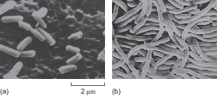
Figure 16 Scanning electron micrographs of E. coli grown in medium containing a few parts per million of cis-diamminedichloroplatinum(II). (The same magnification is used in each image.) The platinum drug has inhibited cell division (a), but not growth (b), leading to long filaments.

The initial assumption was that the platinum electrodes were inert but further studies showed they react with NH₄Cl to give cisplatin, [Pt(NH₃)₂Cl₂].

Interactive content is not available in this format.

- Sketch the structure of cisplatin. What is its geometry?
- Cisplatin (Structure 3) is a square-planar complex.

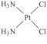
Structure 3

Early laboratory experiments showed cisplatin to be active against tumours in mice, and in 1971 it entered clinical trials. It was finally approved for clinical use in the USA in 1978. Now it and its derivative drugs are used very successfully not only against testicular and ovarian cancer, but also for head and neck, bladder, lung and cervical cancers, and lymphoma, melanoma and osteosarcoma.
You will now consider the mechanism of the anticancer activity of cisplatin.

5.1 Aquation of cisplatin
After intravenous administration, the cisplatin complex dissolves in the water of the bloodstream, in which it is carried and passes into cells, crossing their membrane by passive diffusion.

- What is passive diffusion?
- The movement of molecules from a region of high concentration to lower concentration with no energy expenditure.

As the complex is neutral, it can easily pass through the lipophilic cell membrane.
Recent research has also suggested that the copper transporters CRT1 and CRT2 may also play a role in the uptake of cisplatin.

- Is a hard or soft acid? What types of molecule or ion in the bloodstream might react with cisplatin before it gets a chance to cross the cell membrane?
- There are many species present in blood, including sugars, salt, proteins, oxygen and, of course, water. is a soft acid, so soft bases pose the greatest threat, also those species that are in the greatest concentration. Thus sulfur-containing compounds, such as cysteine, might react with cisplatin, as might water.

Fortunately, in practice, the high concentration of chloride ions in the blood suppresses the hydration of cisplatin, and it passes into the cells mostly unchanged.
However, once in the cells, it is a different story.
The concentration of chloride is now much lower (4 mmol inside, compared with 100 mmol outside). Cisplatin slowly reacts stepwise with the water in the cells to form first the monosubstituted aqua complex and then the disubstituted ion.
Equation 2 shows the hydration equilibria involved.

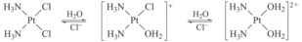
Equation 2

and studies have shown that the mono-aqua square-planar complex is the active species.
This is illustrated in the next video, in which Professor Stephen Lippard (MIT) describes some of the work completed to help understand the chemistry involved.

Video content is not available in this format.
Video 7 The cisplatin story: Part 2. (3:11 min)
View transcript - Video 7 The cisplatin story: Part 2. (3:11 min)

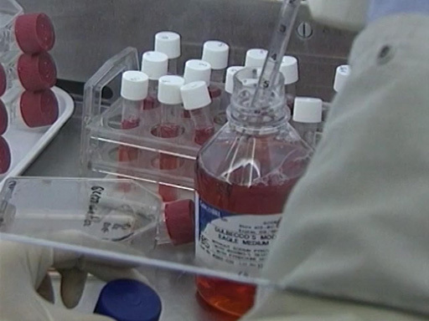

- How does the charge on the platinum complex change on aquation?
- The complex is now positively charged.

There is a 2–3 h delay in sensitisation after the administration of cisplatin due to the slow formation of this substituted complex.
The positive charge on the substituted complex means that it is attracted to the negatively charged surface of the DNA in the cell. This was confirmed by treatment of cancer cell cultures with a high dose of -radiolabelled cisplatin, which shows where cisplatin binds in the cells.
Analyses indicated there were about 9 Pt per 1 DNA molecule, compared with ~1 Pt in protein molecules and ~1 Pt per 10–1000 RNA molecules.
In addition, it was found that there is a correlation between Pt–DNA adducts in circulating (peripheral) blood cells and disease response in patients given cisplatin.
So Pt–DNA binding has been the main focus of further studies.

5.2 Biological targets of cisplatin
As it is clear that the DNA in the cell is being targeted by the cisplatin, it is useful to consider which parts of the DNA might be preferentially bound by the metal ion.
You can refresh your memory about the molecular structure and function of DNA in Box 1.

Box 1 DNA
DNA, or deoxyribonucleic acid, is a biopolymer composed of repeat monomers known as nucleotides. Each nucleotide consists of:
- a phosphate group
- a sugar molecule
- a nitrogen-containing base.
The sugar is deoxyribose (Figure 17a).
There are four different bases in DNA: adenine, guanine, cytosine and thymine, usually abbreviated to A, G, C and T, respectively. Their structures are shown in Figure 17b. A fifth base, called uracil, U (Figure 17c), usually takes the place of thymine in RNA and differs from thymine by lacking the methyl group on its ring.

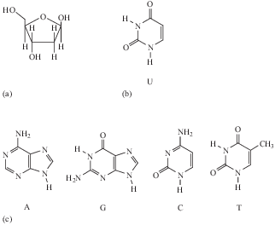
Figure 17 Structures of: (a) the sugar deoxyribose; (b) uracil; and (c) the four DNA bases.

DNA has a double-helix structure, which gives it stability.
The strand of alternating phosphate groups and sugars with ester linkages forms the sugar–phosphate backbone of each strand, and the bases protrude out from this towards the other strand of the helix. Along the length of the polynucleotide chain, each base makes a specific pairing (Watson–Crick pairing) with a corresponding base in the other polynucleotide chain with hydrogen-bonding: T (thymine) pairs only with A (adenine), and C (cytosine) pairs only with G (guanine).
The pairs of complementary bases are thus T and A, and C and G, as Figure 18 shows for a portion of a DNA molecule. These are by far the largest known molecules in living organisms, some containing millions of nucleotides.

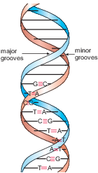
Figure 18 A portion of the DNA double helix showing 10 labelled complementary base pairs.

Inspection of the double-helix structure reveals two grooves (see Figure 18): the major groove and the minor groove, with approximate widths of 220 and 120 pm, respectively.
It is important to note that the bases are more exposed in the major groove and are therefore more accessible to other molecules, and this is where most reactions take place.
DNA can take a number of different conformations, of which three are found in nature, labelled as A-, B- and Z-DNA. Of these, B-DNA is the form most commonly found in cells.

The likely targets for the platinum ion would appear to be the nucleotide bases, and you will consider the chelating abilities of each base in turn.
But first, return to the work of Professor Lippard by watching the following video.

Video content is not available in this format.
Video 8 The cisplatin story: Part 3. (1:38 min)
View transcript - Video 8 The cisplatin story: Part 3. (1:38 min)

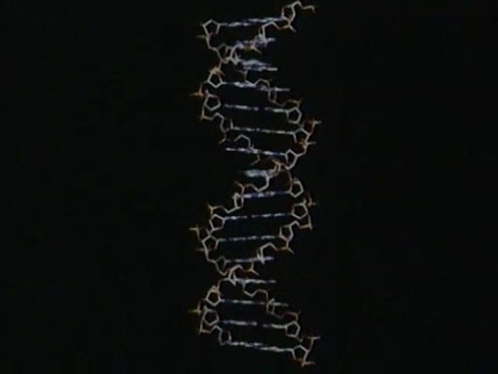

- From the NMR studies, to which base does the cisplatin appear to bind preferentially?
- The cisplatin binds to the guanine base, coordinated with the nitrogen labelled as N7.

Theoretical and experimental studies have shown that the N7 atom on guanine (imidazole) is the most electron-rich centre. (Remember that atom numbering starts at the functional group, as shown in Structure 4.)

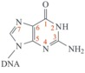
Structure 4

The monohydrated cisplatin reacts with DNA to form adducts, mostly forming Pt–N bonds to guanine N7, as shown in Structure 5.

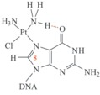
Structure 5

The Pt–G(N7) bond is very stable and can only be broken by a strong nucleophile (e.g. ). Hydrogen-bonding may also stabilise the adduct (as shown in Structure 4).
This adduct can be readily detected using spectroscopy: the resonance of the C8–H (shown in Structure 5) in guanine is a singlet at δ = 7.8 ppm. However, when guanine is complexed to cisplatin at N7, this singlet shifts to δ = 8.8 ppm and satellites are also observed.
This large shift means that becomes a very useful tool in elucidating the structures of these more complex systems – along with the crucial technique of X-ray crystallography, as you will see in the next section.

5.3 Platinum binding to DNA
Oligonucleotides are short sections of DNA (2 to 15 nucleotides long) used for model studies. They are often referred to as a ‘duplex’ in recognition of the two-stranded helical structure of DNA.
The early structural characterisation of oligonucleotide-bound cisplatin was done using X-ray crystallography, and molecular modelling. Cisplatin was found to form a cis complex with two adjacent guanines on the same strand (known as a G(N7)–p–G(N7) linkage, often shortened to G–p–G or G–G). This is shown in Figure 19.

Interactive content is not available in this format.
Figure 19 NMR structure of the DNA duplex dodecamer d(CCTCTG*G*TCTCC). d(GGAGACCAGAGG), containing the cisplatin (GpG–N7(1), N7(2)) 1,2-intrastrand cross-link at the position of the asterisks (pdb 1A84; Gelasco and Lippard, 1998).

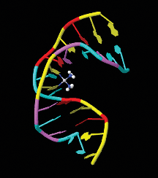
(Static version of Figure 19. Link to the online interactive version.)

Experiments found that cisplatin formed several different types of adduct with the DNA oligomers.
The major product (60–65%) is the G–G 1,2-intrastrand link between guanine residues which reside in the major groove in the B-form DNA (also shown in Figure 20): cis-[Pt(NH₃)₂(G–p–G)] (Structure 6).
Smaller quantities of other adducts include:
- 20–25% of a G–A 1,2-intrastrand: cis-[Pt(NH₃)₂(A–p–G)], (Structure 7).

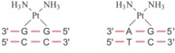
Structure 6 (left) and 7 (right)

- 5–10% of more widely spaced guanine adducts: the 1,3-intrastrand and G–p–G interstrand complexes (Structure 8, 9 and Figure 20). (Note: N in Structure 8 represents another base.) In the latter, cisplatin forms a cross-link between the two strands.

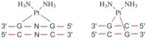
Structure 8 (left) and 9 (right)

Interactive content is not available in this format.
Figure 20 NMR solution structure of the short duplex [d(CAT–AG*CTATG)]₂ cross-linked at the position of the asterisk which here is doubled to represent guanine bases on two strands (pdb 1DDP; Huang et al., 1995).

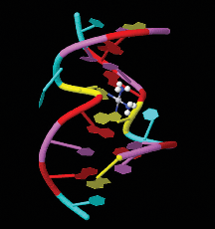
(Static version of Figure 20. Link to the online interactive version.)

- 2–5% of a monoadduct (Structure 10), and < 1% of DNA–protein binding (Structure 11).

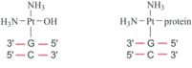
Structure 10 (left) and 11 (right)

The 1,2-intrastrand cross-links
It is thought that the 1,2-intrastrand cross-links are important to anticancer activity because they are the major adducts formed, and because clinically inactive compounds, such as the trans-dichlorodiammineplatinum(II) (transplatin), fail to form these cross-links.
The mechanism of the reaction of cisplatin with DNA is shown in Figure 21.

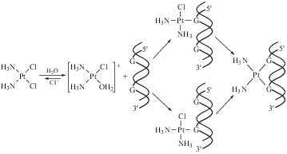
Figure 21 Scheme showing the reaction of cisplatin with DNA.

Kinetics is very important in this sequence of steps. The aquation of cisplatin is the slow, rate-limiting step, and the reaction of the cationic platinum complex with the DNA strand is fast.
Hydrogen-bonding from NH₃ and OH₂ ligands to the phosphate backbone of DNA is possibly important in orientating the platinum complex.
The structural studies of cisplatin binding to oligonucleotides (see the previous section) show that different adducts distort the DNA in different ways, as discussed in the next video.

Video content is not available in this format.
Video 9 The cisplatin story: Part 4. (3:47 min)
View transcript - Video 9 The cisplatin story: Part 4. (3:47 min)

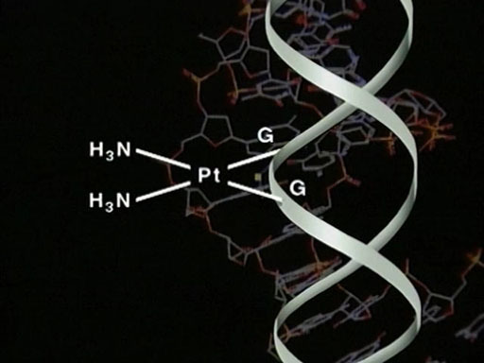

- Which technique was used to determine the nature of the binding in DNA, and what practical issues did it present?
- X-ray crystallography – you may recall this is a technique for determining the internal structure of solids. A specific arrangement of atoms will produce a unique diffraction pattern, which acts as a ‘fingerprint’ for a particular compound.
The necessity to produce single crystals of the cisplatin–DNA adduct proved a challenge, solved by the practical ingenuity of one of Professor Lippard’s students.

The main observed effects of 1,2-intrastrand cross-links are:
- a bend towards the major groove of about 35–40°, shown in Structure 12

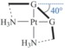
Structure 12

- unwinding of the duplex by about 20°
- widening of the shallow minor groove
- distortion of the Watson–Crick base pairing.
This all leads to destabilisation of the duplex, which in turn blocks replication and inhibits transcription. Replication stops at sites corresponding to one nucleotide preceding the first Pt–G residue and at positions opposite the two Pt–G residues.
You will now look at some experimental evidence for this.
A method for separating macromolecules and their fragments is gel electrophoresis. This is based on the principle that molecules having different sizes or charges will move through a gel under the influence of an electric field to different extents – small molecules move more easily than large ones. In fact, you will see the technique being used in the laboratory in the next section.
Figure 22 shows gel electrophoresis data obtained during a kinetic study of the effect of a cis-GG adduct on DNA polymerisation by HIV-1 reverse transcriptase.

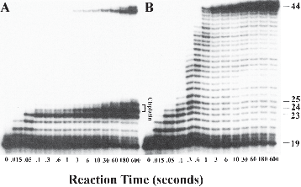
Figure 22 Gel electrophoresis data obtained during a kinetic study of the effect of a cis-GG adduct on DNA polymerisation by HIV-1 reverse transcriptase.

In Figure 22, panel A shows the fragments generated by enzymatic replication of a DNA duplex containing a site-specific cross-link at G(24)/G(25). Polymerisation is blocked by platination of the substrate. Panel B depicts results for an unmodified DNA probe.

5.4 Anticancer effect
There is evidence that cisplatin induces cells to undergo apoptosis (programmed cell death).
This occurs because the cell recognises the damaged DNA and triggers the mechanisms that signal the cell to die.
This self-destruct mechanism is present in all cells and is part of the organism’s way of destroying cells that might be harmful to itself.
See Box 2 for information on cell death and DNA repair systems.

Box 2 DNA repair systems and cytotoxicity: why do cells die?
Damage is constantly caused to cells and DNA by normal metabolism and by external factors such as UV radiation, smoking, chemicals, and so on. Sometimes this leads to the damaged cell swelling and then bursting – a form of cell death known as necrosis. DNA is continually checked for ‘errors’ in its sequence by various proteins.
If there is a large amount of damage, enzymes come into play that trigger the death of a cell by apoptosis or programmed death. If the damage is not too great, the checking proteins activate enzymes to eradicate the errors and perform a ‘repair’ by excising the damaged part and reconstituting the sequence. Indeed, it is the existence of these DNA repair systems that is believed to lead to resistance to cisplatin in certain cancers. On the other hand, studies have shown that repair-deficient mutant cells are much more sensitive to cisplatin.

Professor Lippard talks you through the effect of cisplatin on the autorepair mechanisms in the following video. You’ll also see the gel electrophoresis technique being used to separate DNA fragments.

Video content is not available in this format.
Video 10 The cisplatin story: Part 5. (3:42 min)
View transcript - Video 10 The cisplatin story: Part 5. (3:42 min)

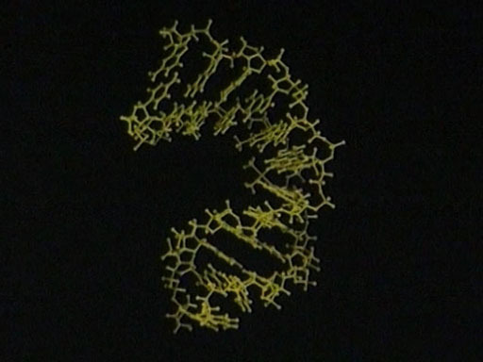

- What type of protein is thought to bind to cisplatin-modified DNA, preventing access by repair proteins?
- High-mobility-group (HMG) proteins.

So in general, cisplatin appears to inhibit repair in mutant cells, leading to cell death. The difficult question to be answered is how do Pt 1,2-intrastrand cross-links inhibit repair?
One hypothesis is that the binding of HMG protein HMGB1 with the 1,2-intrastrand cisplatin–DNA complex shields the DNA from intracellular repair, leading to apoptosis. This binding occurs by means of HMG inserting a phenyl group protruding from its backbone into the notch created when cisplatin forms a complex with DNA.
This also increases the bend in the DNA even more to about 60–90°, facilitating the binding of a signalling protein called P53 which triggers a cascade of events leading to cell death. However, there is equally compelling evidence suggesting that HMGB1 can cause these changes even in the absence of cisplatin-induced lesions. So it is clear that these complex mechanisms still remain an area where much research is required.
Figure 23 shows schematically how these mechanisms are thought to operate.

Interactive content is not available in this format.
Figure 23 An HMG-domain protein (HMGB1; domain A shown as grey ribbon) inserts a phenyl group (yellow) into the groove created when cisplatin forms a complex with DNA, causing it to bend. A mutant protein lacking this phenyl group does not form a complex with cisplatin and DNA, suggesting that the phenyl group is crucial for complex formation (pdb 1CKT; Ohndorf et al., 1999).

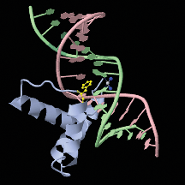
(Static version of Figure 23. Link to the online interactive version.)

5.5 Why is transplatin inactive?
As you saw previously, transplatin is not active. The distance between the two chlorine leaving groups is longer than in cisplatin (Figure 24), resulting in transplatin being unable to form 1,2-intrastrand DNA adducts similar to cisplatin.

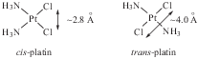
Figure 24 Distance between chlorine atoms in cisplatin and transplatin.

It can, however, form 1,3-intrastrand (G–p–N–p–G), 1,4-intrastrand and 1,4-interstrand links as well as monoadducts.
The lack of anticancer activity with transplatin is believed to be because transplatin lesions are more easily repaired than those of cisplatin, as they lead to more radical distortion of DNA. They don’t bind HMG proteins as strongly as cisplatin lesions, possibly because of the lack of an appropriate space for insertion of the HMG protein phenyl group in the manner described above.
In addition, transplatin is more readily intercepted by sulfur-containing species (e.g. glutathione, GSH, Structure 13), leading to the removal of platinum from the cancer cells (Equation 3).

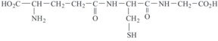
Structure 13

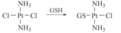
Equation 3

In addition, monoadducts of transplatin are displaced by the action of trans-labilising nucleophiles such as glutathione or thiourea (Equation 4).

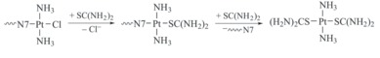
Equation 4

5.6 Cisplatin in the body
Once cisplatin has been introduced into the body, it will circulate in the bloodstream and so potentially can come into contact with all of the organs in the body.
The aim of cancer chemotherapy is to maximise damage to cancer cells while minimising damage to normal cells.
As you will see, this is not totally achieved in practice, but essentially it is hoped that any excess cisplatin can be excreted from the body without too much harm to other cells.
As a transition metal, platinum, by its nature, is able to bind to ligands available in the surrounding environment. As a soft metal, you know that it will favour soft ligands; foremost among these in natural systems are sulfur atoms. Many biomolecules contain sulfur centres, so these are clearly favourable potential coordination sites for platinum.

- Why is this likely to have a detrimental effect on the effectiveness of cisplatin?
- Some of these binding interactions will reduce the efficiency of the drug and some of them will lead to undesirable side effects.

Intracellular thiols include GSH, which is present in all cells – typically in concentrations of 3–10 mmol . It binds to platinum through sulfur to give a high-molecular-mass polymer with a Pt : GSH ratio of 1 : 2. GSH–Pt binding results in depletion of platinum from circulation and the Pt–GSH complex is pumped out from tumour cells.
Clearly, this affects the cytotoxic effect of the drug as it removes the cisplatin before it can damage the cancer cell.
In the kidney, the storage protein metallothionein reacts with cisplatin to give Pt₇₋₁₀MT containing PtS₄ units, which are also inactive.

5.7 Side effects of cisplatin
Cisplatin is a potent cytotoxic drug, which has limited targeting within the organism.
By its nature, it will bind to DNA within cells regardless of whether those cells are cancerous or not.
Fortunately, there are aspects of the biochemistry of cancer cells which render them more susceptible to damage from cisplatin, but there are still serious side effects associated with both DNA- and protein-bound platinum.
This limits the maximum dose of cisplatin to about 100 mg per day for up to five consecutive days.
The toxic side effects can be partially controlled by inhibiting the formation of Pt–protein complexes or by ‘rescuing’ platinum from these Pt–protein complexes.
A high concentration in the solution containing the drug helps to inhibit the formation of and RSH complexes, hence cisplatin is administered in a saline drip. This reduces kidney damage dramatically.
Rescue agents such as Structure 14 and 15 can be administered 3–4 h after cisplatin treatment.

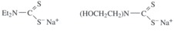
Structure 14 (left) and 15 (right)

These agents displace platinum from sulfur-containing biomolecules but crucially do not affect Pt–DNA complexes.
A typical treatment regime will involve infusions of cisplatin followed by infusions of rescue agents, followed by a period of rest to allow normal cells which have been damaged by the cytotoxic drug to recover.
This cycle will typically be repeated several times to maximise the benefit of the treatment.

5.8 Resistance to cisplatin
Some tumours have natural resistance to cisplatin, while others develop resistance after initial treatment.
Resistance arises through various mechanisms.
First among these is the ability of the cancer to ‘learn’ to recognise the lesions caused by cisplatin in DNA and to develop repair mechanisms to deal with them.
However, other processes also occur.
Cancer cell membranes are generally ‘leaky’, which is a favourable adaptation to maximise the sequestration of nutrients. They are therefore generally unselective in what they let into the cell. However, over time they can develop protective mechanisms to pump the cisplatin back out of the cell actively, and it will then be increasingly intercepted by sulfur-containing compounds.
Finally, cancer cells are constantly mutating. Therefore, there is a high probability that, by chance, a mutation will arise that is resistant to cisplatin.
There are various approaches to these problems, including developing new platinum drugs (see the next section), using a higher dosage, using combination chemotherapy with other active anticancer drugs (e.g. Taxol®), or using cisplatin in combination with other pharmacological agents. Much current cancer research is focused on looking at the biochemical mechanisms that make cancer cells successful, and it is likely that metallopharmaceuticals will find applications in these areas in future.

5.9 Limitations of cisplatin
Now watch the following video which summarises the limitations of cisplatin from a chemical viewpoint and looks at strategies for the development of new drugs. It starts by mentioning the drug carboplatin.

Video content is not available in this format.
Video 11 The cisplatin story: Part 6. (2:26 min)
View transcript - Video 11 The cisplatin story: Part 6. (2:26 min)

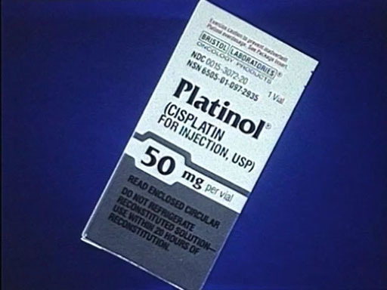

- What aspect of the chemistry of the cisplatin molecule motivated the search for alternative platinum-based drugs?
- The reactivity of the molecule – in particular, the rate at which chloride ligands leave the complex.

- What are combinatorial methods?
- A synthetic approach designed to produce a large number of related compounds in a single process – in this case, different combinations or permutations of ligands. The video referred to the technique as ‘one-pot cooking’.

Conclusion
You are now at the end of this free course, Metals in medicine. You should now be able to answer the following questions posed in the introduction – a note box is provided below for you to complete. You may find the questions in the exercise below useful in building your answers.
- How can the measurement of signals from living tissue be converted into images useful for diagnostic medicine?
- What is an MRI contrast agent and how can the properties of metal complexes be applied to this role?
- What aspects of the coordination chemistry of cisplatin underpin its effectiveness as an anticancer treatment, and what are the shortcomings of this drug which have necessitated the search for alternatives?

Interactive content is not available in this format.

Activity 3
Allow approximately 20 minutes.

(a)

Interactive content is not available in this format.

(b)

Interactive content is not available in this format.

(c)

Interactive content is not available in this format.

In this course you have seen the key role that metals play in medicine, both in medical imaging and in therapeutic applications. Research continues in both these areas with new metal containing compounds being synthesised, with optimised properties, leading to new generations of imaging agents and metallodrugs.
This OpenLearn course is an adapted extract from the Open University course S315 Chemistry: further concepts and applications.

IGCSE Chemistry with the NEC

Ignite your passion for this complex and interesting subject, study IGCSE Chemistry online with the National Extension College (NEC).
Everything you see, hear, smell, taste and touch involves chemistry and chemicals (matter). This broad and complex subject helps us to understand the world in which we live and opens up a range of science-based degree courses and careers. Chemistry is fun – no other subject offers bubbles, bangs and changes of colour or state! NEC's stimulating IGCSE Chemistry online course brings learning to life through a series of practical experiments suitable for completion at home.
You’ll develop your knowledge of core concepts across physical, organic and inorganic chemistry, plus key employability skills – such as problem-solving, analytical thinking and reasoning. This IGCSE Chemistry course offers flexible learning with course materials developed by subject experts and tutor-marked assignments.
Find out more about IGCSE Chemistry here.

Acknowledgements
This free course was written by Elaine Moore and Eleanor Crabb.
This free course is based on the Open University module S315 Chemistry: further concepts and applications and was adapted by Nicholas Chatterton.
Except for third party materials and otherwise stated (see terms and conditions), this content is made available under a Creative Commons Attribution-NonCommercial-ShareAlike 4.0 Licence.
The material acknowledged below is Proprietary and used under licence (not subject to Creative Commons Licence). Grateful acknowledgement is made to the following sources for permission to reproduce material in this free course:
Course image: Roman Zaiets / Shutterstock
227674: Figure 1: Du Cane Medical Imagine Ltd / Science Photo Library
227677: Figure 2: Copyright Holder Unknown
227680: Figure 4: Copyright Holder Unknown
227683: Figure 5: cylonphoto / 123RF
227690: Figure 7: Copyright Holder Unknown
227707: Figure 10: Copyright Holder Unknown
227713: Figure 13: Royal Society of Chemistry
227715: Figure 14: El Saghir, N. S. et al. (2005) ‘Trauma-associated growth of suspected dormant micrometastasis’, BMC Cancer, vol. 5, no. 94, BioMed Central. This file is licensed under a Creative Commons CC 2.0 license https://creativecommons.org/licenses/by/2.0/
227754: Figure 16: Professor Barnett Rosenberg
228311: Figure 19: Jmol: an open-source Java viewer for chemical structures in 3D. http://www.jmol.org/
228316: Figure 20: Jmol: an open-source Java viewer for chemical structures in 3D. http://www.jmol.org/
227772: Figure 22: Sou, Z., Lippard, S.J. and Johnson, K.A. (1999) ‘Single d(GpG)/cis-diammineplatinum(II) adduct-induced inhibition of DNA polymerization’, Biochemistry, vol. 38, 2, pp. 715–26.
228319: Figure 23: Jmol: an open-source Java viewer for chemical structures in 3D. http://www.jmol.org/
Every effort has been made to contact copyright owners. If any have been inadvertently overlooked, the publishers will be pleased to make the necessary arrangements at the first opportunity.
Don't miss out
If reading this text has inspired you to learn more, you may be interested in joining the millions of people who discover our free learning resources and qualifications by visiting The Open University – www.open.edu/openlearn/free-courses.

Solutions

Activity 1

Answer
The patient is placed in a strong magnetic field. This causes the protons present in molecules in the body to align with or against the magnetic field. The patient is then irradiated with pulses of radiofrequency (RF) radiation which flip these nuclei into another direction. Finally, the radio waves emitted by the subject as the protons relax back to the ground state are collected and converted, via computer processing, into an image.
Back to - Activity 1

Video 1 X-ray imaging in a CT scan. (2:32 min)

Transcript
RADIOGRAPHER: Okay, I’m going to take some pictures of your head now, okay? So what I’m going to do is just going to raise the bed up and get you into position ...
NARRATOR: Alan is now being placed in the CT scanner, and the radiographer uses a laser beam to place his head in precisely the right location. CT scanning is essentially an X-ray procedure, but the X-ray source is rotated around the patient and the intensity recorded on the opposite side of the patient.
Using data from a large number of angles, a computer reconstruction can produce a two-dimensional map of the tissues in a slice of the body.
RADIOGRAPHER: So what we’re going to do now is choose the protocols that we’re going to use to do the head. So we’re going to click on the appropriate part of the body here. So we click on ‘head’. And we’re going to do an adult brain.
Okay, the scan’s just about to start, so just keep nice and still there, okay?
NARRATOR: Planning is done by taking a pilot scan. The patient is moved through the gantry. The source remains stationary on one side. This produces an image similar to a planar X-ray. This pilot scan is taken in what is called the sagittal plane.
RADIOGRAPHER: We’re going to do thinner sections through the base of the skull, and then we’re going to do wider ones as we go through towards the head at the top of the skull there. So now we can do our actual scan, okay? And then we can produce the actual images that the radiologist will look at.
So we can just scroll through the images that we’ve just got, okay? And we can alter the grey levels of the images so we can see different bits of anatomy.
What we’ll do is we’ll look at the actual brain windows first. So we’re going to go through, okay? We’re looking basically for any asymmetry or any abnormalities.
When we get further up, we can change the window levels, so we can see the ventricles better. Just going through there. Now we’re at the top.
And as this patient has got suspected basal skull fracture, what we’d now do is go back and we’re going to change it to bony windows. We’ve highlighted – the bone is white and everything else is now dark – so it’s not seen so clearly.
So again, we’re just looking through to see if there’s any dark lines in the skull which could represent fractures.
NARRATOR: The concern over the potential for injury to the top of the spine has been dismissed. But there is a concern that there may be some damage to the brain. So it’s decided to do an MRI scan.
Back to - Video 1 X-ray imaging in a CT scan. (2:32 min)

Video 3 Obtaining an MR image of a patient. (3:03 min)

Transcript
RADIOGRAPHER: It does make a very loud drilling noise, okay? So what we’re going to do is pop these earphones ...
NARRATOR: To obtain images, the patient is placed in a large, static magnetic field produced by a superconducting magnet. This powerful field, typically one and a half teslas in strength, causes the nuclei of the hydrogen atoms in the body to line up. But they can also be flipped into another direction by a radio frequency pulse.
The way these nuclei then relax back to their original position depends on the environment of the hydrogen atoms. In other words, on tissue type. When imaging small parts of the body, specialised coils are used to detect the radio frequency signal given off by the relaxing nuclei. Here a head coil is being used for this purpose.
Laser alignment is used so that the patient can be moved to the correct position in the scanner.
RADIOGRAPHER: Okay?
NARRATOR: Because the powerful magnetic fields can disrupt pacemakers, and cause heating of metal implants, every patient must be carefully checked before entering the scanner room.
RADIOGRAPHER: Okay, so we’re just going to start the scan now. Okay, so what we do first is an initial pilot scan. So that’s so we can exactly locate the patient within the scanner.
NARRATOR: With MRI, it’s possible to choose any direction for the image slices. In this case, the radiographer is taking an axial pilot scan, to give a series of coronal images.
RADIOGRAPHER: What we’ve done now is we’ve planned to scan through that area of this person’s head and we’re going to scan from front to back there. And so, okay, your first scan’s just about to start. Each scan will take about five minutes, okay? And then, after that, we can have a look through the images and we can see what we’ve got.
NARRATOR: There are many different imaging sequences that can be used. But most of them produce an image where the intensity depends mainly on one of three characteristics – T₁, T₂ or proton density. The intensity in these images depends largely on T₂, the spin-spin relaxation time.
Substances with a long T₂, such as water, appear bright. This is very obvious if you look at the eyes in this image.
RADIOGRAPHER: We’ve now gone on to sagittal images. This is a T₁. So we’ve got bright fat and the fluid’s dark on these images. This is a way that we can differentiate contrast to see different pathologies or anatomy. We also scanned in the axial plane, so that’s head to toe. And again, this is T₂ with bright fluid. You can see the eyes. And finally, these ones are proton density. So this is weighting – where each tissue is the protons that are actually there, rather than any specific weighting.
NARRATOR: Thankfully for this patient, the images show no abnormality.
Back to - Video 3 Obtaining an MR image of a patient. (3:03 min)

Video 5 The discovery of Salvarsan. (5:40 min)

Transcript
[MUSIC PLAYING]
MICHAEL MOSLEY: At the start of the 20th century, diseases you might have associated with medieval times were still rampant syphilis, for example. Now, for centuries, doctors had used mercury to treat it but, being extremely toxic, it tended to kill the patients.
So when, in this Frankfurt mansion, a scientist called Paul Ehrlich set out to find a safe and effective drug against syphilis, it was a major challenge. Fortunately, he was a real obsessive.
DR WALTER SNEADER: Paul Ehrlich studied medicine in the early 1870s. But he spent an awful lot of time in the laboratory rather than in a clinic where he should have been.
MICHAEL (VOICEOVER): One of the things Ehrlich was doing was playing around with artificial dyes. The first had been discovered in 1856, and soon, people went dye crazy.
MICHAEL: His favourite colour was methylene blue. And with this, he made a remarkable discovery, one which would set him on the path to medical greatness.
DR DRUIN BURCH: Ehrlich was wonderful in showing how you could use dyes to illuminate the hidden world, the world which, even down a microscope, you wouldn’t be able to see unless you coloured it with these dyes that showed physical processes.
DR SNEADER: He spent wasted, whichever way you want to look at it a lot of time playing around dyeing regions of biological tissue.
MICHAEL (VOICEOVER): When Ehrlich added a drop of methylene blue to tissue infected with bacteria, he noticed something astonishing. Only the bacteria were stained by the dye, not the tissue around them.
DR BURCH: Often, what was needed to discover these bugs was the right stain. Get the right stain, and in amazing colours these bugs would appear before your very eyes.
MICHAEL: Now, the fact that an artificial dye will selectively stain bacteria was remarkable. But it’s what Ehrlich thought next that was truly revolutionary.
DR BURCH: What he did was he noted that some compounds were toxic. And he said, what if you create selective toxicity so that you can give somebody a compound that will kill off what’s making them unwell and leave them unharmed? And he famously coined a phrase from a German folk story, you could create these ‘magic bullets’, and which is what we’ve been trying to do ever since.
MICHAEL (VOICEOVER): Now many people thought Ehrlich was wasting his time. But he was convinced that magic bullets existed, and he would discover them. Initially, he tried finding a cure for sleeping sickness. But with the help of his Japanese assistant, Sahachiro Hata, he switched his attention to a pathogen that was rather more common in Germany. Common but horribly disfiguring syphilis.
MICHAEL: The end stage of syphilis was pitiable paralysis, insanity, and then death. There were no cures, and the only treatment mercury made your hair and teeth fall out before eventually destroying your entire nervous system.
(VOICEOVER): Ehrlich hoped to find a magic bullet that would be more selective, poisoning the bacteria but not the rest of the body.
MICHAEL: Ehrlich thought that arsenic might be effective against syphilis. Arsenic is notoriously poisonous. But by this point, German chemists had made hundreds of different compounds of arsenic. So Ehrlich asked his assistant Hata to work his way systematically through them, hoping that amongst them would be one that was safe and effective.
MICHAEL (VOICEOVER): Hata had found a way to infect rabbits with syphilis. He now set about the unenviable task of testing arsenic compounds on them one after the other. Some compounds killed both bacteria and rabbit. Some killed neither. Hata went through hundreds and hundreds of compounds until finally he found one that was rather special.
MICHAEL: Compound 606. It killed the bacteria but, best of all, it left the dear old rabbit intact. This was the magic bullet they had been hoping for.
DR BURCH: Salvarsan 606 showed that Ehrlich was right, that these things were out there. All you had to do was methodically screen for them, and you would find them. It showed the power of methodically screening lots of compounds 606 606 compounds to see what worked.
MICHAEL: I do think it’s wonderful that it was in this building, a hundred years ago, through a combination of luck, logic, and sheer hard work, that they eventually found a cure for syphilis, a disease that had destroyed the lives of countless millions.
DR SNEADER: The newspapers at the time carried it on the front pages. The medical profession were stunned.
DR BURCH: To be able to treat syphilis was miraculous, absolutely miraculous.
[MUSIC PLAYING]
Back to - Video 5 The discovery of Salvarsan. (5:40 min)

Video 6 The cisplatin story: Part 1. (6:32 min)

Transcript
NARRATOR: Fundamental research has led to a most amazing anticancer drug discovery here at Michigan State University. Professor Barnett Rosenberg is a physicist interested in electric and magnetic fields. But his curiosity was aroused by a picture in a biology textbook.
BARNETT ROSENBERG: Physicists rarely have any training or background in biology. But this picture was a very fascinating one because it looked very much like, to a physicist, what you’d see if you put a bar magnet on the table and put a piece of paper on it and covered it with iron filings, and you get that lovely pattern that we call a dipole field.
A dipole magnetic field, or a dipole electric field, they both share the same patterns. Now the curious thing is, is that this was a picture of a cell in the process of dividing. And it showed these lovely structures of the dipole field. And I wondered whether there might not be a connection between the dipole field and the division process.
To test this – and it had been suggested by other people but it had never been tested. So we decided to run a test on it.
NARRATOR: The test equipment he assembled was a combination of electronics and a biological apparatus to grow cells in. Cells of this bacterium E. coli were being cultivated within an electric field. But instead of increased numbers of bacteria, what they found surprised them. The bacteria had instead formed into long strands. What was causing this?
BARNETT ROSENBERG: We concluded finally that it had nothing to do with the bacteria, but it was something that the electric field, which was brought in with platinum electrodes into the chamber where the bacteria were growing, was somehow reacting to produce a chemical that went into the solution. And it was this chemical that was causing these enormously long filaments, which is what we saw under the microscope when we looked at the bacteria coming out of the growth chamber. And it stopped cell division.
Well, stopping cell division is precisely what you want to do if you can control the type of cell if you want to fight cancer. Because cancer is runaway cell division. And so we had initially the idea that this might give us some ability to handle cells, or control the growth of cells, by the electric field effect. But now what we found was, instead of a physical effect, a chemical effect.
NARRATOR: If it was a chemical effect, the culprit had to be within the growth chamber. It was narrowed down to a molecule made by the chemical reaction between the nutrient ammonium chloride and the electrodes, which were made of platinum.
BARNETT ROSENBERG: Platinum could be one of the possibilities, although we all believed that platinum was inert in the biologic environment. Then, when we had the chemicals isolated, we then tried to find out which particular one of the platinum/ammonium chloride chemicals it was. And we tried finally to isolate it. It turned out to be a neutral molecule. And it turned out to have a very specific structure.
NARRATOR: This is the formula of the chemical they had produced. The platinum had reacted with the ammonium chloride, and bonded to two chlorides and two ammonia groups. This molecule could have one of two flat structures where the platinum is surrounded by four ligands.
This shape is known as square planar. One form has cis chloride ligands, which means that they are on the same side of the molecule, at right angles to each other. This is commonly known as cisplatin. The other form has the same chemical formula but now the chloride ligands are trans or opposite one another. It’s known as transplatin. Only the cis form of this chemical was active against cell growth.
BARNETT ROSENBERG: We knew we had a method, then, of controlling cell division. It was not a physical method. We were disappointed in that. But we had a chemical method. And, therefore, we went back to our original concept. Could we then control the growth of cancer cells by using this?
NARRATOR: Next experiment was to inject doses of cisplatin into tumours in mice and compare results against a control group. The tumour decreased dramatically in size. The drug worked.
BARNETT ROSENBERG: So this became, then, the focus of our interest because now we could treat a cancer in a mouse. The question was, would it work in humans?
NARRATOR: Professor Rosenberg and his colleagues wrote up the reports in the science journals. And the medical research community went into action on both sides of the Atlantic.
LLOYD KELLAND: The drug then very rapidly, particularly for these days, went into clinical trial in patients, both in the United States and in Europe. And the first hospital to look at cisplatin in Europe was in fact the Marsden Hospital, next door to here, where Dr Eve Wiltshaw very rapidly showed that the drug had activity in ovarian cancer in particular. And, alongside that, other trials showed that the drug was active in men with testicular cancer.
Before the advent of cisplatin, especially in the case of men with testicular cancer, the cure rate was something like one in ten. When cisplatin-containing regimes came into clinical practice, the cure rate went up to something like nine in ten. So it had a dramatic effect and it was a very exciting time. It was probably the most active new cancer drug found in that period.
Back to - Video 6 The cisplatin story: Part 1. (6:32 min)

Video 7 The cisplatin story: Part 2. (3:11 min)

Transcript
NARRATOR: No drug is perfect. Cisplatin had side effects. Apart from nausea, it could also cause kidney damage. It didn’t work against all cancers. And, most of all, there was a huge gap in understanding. How did it work? And why didn’t the trans form of the same chemical have the same effect? Better understanding could possibly lead to better drugs, and this interested top chemical research teams across the world, including a group at the Massachusetts Institute of Technology (MIT) led by Professor Stephen Lippard.
STEPHEN LIPPARD: We were primarily a chemistry group, beginning to learn something about macromolecules – proteins and nucleic acids. And we were particularly intrigued, in the case of cisplatin, with the fact that the cis isomer, with the chlorides on the same side of the square plane, was active. And the trans isomer was inactive. And I’ve always been fascinated by problems in inorganic stereochemistry. And so it seemed that there would be a structure or function relationship that we ought to be able to sort out as chemists.
NARRATOR: This is one of the tools the research chemists can use to discover details of the structure of molecules. It’s known as nuclear magnetic resonance spectroscopy, or NMR. The large shiny vessels are cryostats. They store the liquid helium which cools superconducting magnets. These magnets generate huge magnetic fields and are so heavy that NMR facilities, such as this one at MIT, are usually housed in the basement.
Test samples are lowered into the magnetic field, and radio frequency energy is fired into them. Some atomic nuclei, such as the 195 isotope of platinum, possess a property known as ‘spin’. And the combination of the two fields can make such nuclei jump from one energy state to another. This in turn produces electronic signals unique to those particular atoms, giving information on their immediate environment in the molecule.
NMR proved to be an immensely useful tool in helping to determine how cisplatin gets into the cells and what happened to it once it was inside. These chemical formulae show what the NMR results meant. Cisplatin hydrolyses stepwise to produce positively charged ions. First, one chloride ion is replaced by water to form a species with a single positive charge. And then, the second chloride ion is replaced by another water molecule to form an ion with two positive charges.
STEPHEN LIPPARD: And when that happens, the platinum becomes positively charged. The platinum complex becomes positively charged. And there would be a natural attraction then for it to bind, migrate to and bind to DNA, which is a polyanion.
Back to - Video 7 The cisplatin story: Part 2. (3:11 min)

Video 8 The cisplatin story: Part 3. (1:38 min)

Transcript
NARRATOR: DNA is the complex molecule inside all living cells, shown here in a very simplified form. Like all cells, cancer cells grow by reproducing the DNA. And the assumption had to be that, somehow, cisplatin’s anticancer properties had to do with its interference in this process.
STEPHEN LIPPARD: Every time the cell divides it has to reproduce its DNA, completely and accurately. And, in order for it to function, it has to take the message that is encoded in the DNA, transcribe it into RNA and ultimately translate that into proteins. We know that platinum blocks both of these processes – replication and transcription.
NARRATOR: The vital portions of DNA are the centre groups. These are known as bases and they hold together the two strands of the double helix. The bases are adenine, thymine, cytosine and guanine. This is the chemical formula for guanine. What is important here is the nitrogen labelled as N7. It’s important because NMR was able to show that cisplatin could bond to the nitrogen at this site on the guanine base. This early work showed that most of the cisplatin formed what is called an adduct by linking to two neighbouring guanine bases on the same strand of the DNA through the N7 atom. We call this an intrastrand adduct because the bonding is all on the same strand.
Back to - Video 8 The cisplatin story: Part 3. (1:38 min)

Video 9 The cisplatin story: Part 4. (3:47 min)

Transcript
NARRATOR: More unusually, a very small amount of the cisplatin – less than five per cent – bonded to the DNA by straddling the two strands, making what is known as an interstrand adduct. The transplatin simply has the wrong geometry to form the linkages. Was this the beginning of the explanation? A more precise technology, such as X-ray crystallography, was needed to sort things out. But the great problem here is in growing good quality, single crystals.
STEPHEN LIPPARD: A major breakthrough in the laboratory, with respect to getting X-ray crystallographic information, came in the mid 1980s when a graduate student in my group – former grad student in my group, Suzanne Sherman – was successful in crystallising the smallest building block on DNA bound to cisplatin.
NARRATOR: The crystalline DNA–platinum adduct was needed for this machine – the X-ray diffractometer. The wavelength of X-rays is comparable in size to the distance between planes of atoms in a crystal, and the regular spacing inside the crystal diffracts the X-rays. Each plane of atoms in the crystal reflects the X-ray, producing a spot on a photographic plate.
This, at first sight rather unpromising, pattern of spots is the end result. Analysing both the position of the thousands of spots and their intensity produces these dramatic 3D pictures of the molecule itself, where the position of each atom is known precisely. The first structure determined was of cisplatin bound to a single-stranded DNA. And it wasn’t until 1995 that Lippard’s group determined the crystal structure for the double-stranded DNA complex that we see here.
Notice that cisplatin binds in the larger major groove. The platinum is still essentially square-planar, although the guanines are no longer parallel. What was this doing to the structure of the DNA molecule itself?
STEPHEN LIPPARD: The DNA molecule underwent some rather interesting and profound structural changes. For one thing, it underwent a rather significant bend, ranging from 50 to 80 degrees off of the linear direction that it ordinarily takes. For another – and probably this is the most significant – is that the minor groove of the DNA was substantially widened from the normal value in so-called B or classical B form DNA of about 5 to 6 angstroms up to 10 or 11 angstroms.
So, opposite the platinum lesion was a widened, flattened, minor groove, producing a very different type of external structure than the one that one would find in DNA containing no chemical modification. And we believe that it is this altered structure of DNA that leads to the recognition of other factors in the cell, which ultimately produce the anticancer activity.
LLOYD KELLAND: It’s a very complicated area. The cisplatin binds to DNA and forms a variety of adducts on DNA. About 90 per cent of them – much the majority – are the intrastrand adducts on the same strand of DNA, primarily against adjacent guanines on the DNA. But there are also interstrand cross-links that cross the two strands of DNA, of which maybe only two or so per cent, but there are a group of people who believe that they are the more important, in terms of biological significance, whereas there are another group of people who believe that it’s the intrastrand adduct, because of the higher numbers, that think they’re the more important.
Back to - Video 9 The cisplatin story: Part 4. (3:47 min)

Video 10 The cisplatin story: Part 5. (3:42 min)

Transcript
NARRATOR: Formation of the cisplatin DNA adduct has damaged the DNA. If the DNA is not repaired then the cell cannot reproduce itself or replicate. Research has moved on to examine the cell mechanisms that deal with this damage. Proteins are the key to processes such as the repair mechanism. Normally, damaged DNA is recognised and marked for repair, which is done by cutting out the damage, so-called excision repair.
The bent, platinated DNA seems to be recognised by other proteins which bind at the damaged site and prevent access by the repair proteins.
STEPHEN LIPPARD: The class of proteins that bind to the cisplatin-modified DNA, it turns out from gene sequencing and other experiments that we’ve done, generally contain what are called high-mobility group, or HMG, domains.
NARRATOR: The term ‘high-mobility group’ comes from this procedure known as electrophoresis. It’s used to identify and separate individual strands of DNA from a mix of all sorts. Cancer cells are cultured in the Petri dishes at body temperature, 37 degrees Celsius. The cells are harvested and the protein extracted.
They are then mixed with platinated DNA, which has also been made radioactive by including a radioactive isotope of phosphorus – 32 phosphorus – in the phosphate groups. The cultures are incubated for varying amounts of time and dyed a bright colour to make them visible.
The culture is dropped onto a gel and an electric field then applied. The DNA is negatively charged because of the phosphate groups. And so it begins to travel down the gel towards the positively charged cathode. To make a permanent record of the experiment, a photographic film is put next to the gel. The radioactive phosphorus isotope blackens the film, thus indicating the positions of the pieces of DNA.
As the repair mechanism operated during the incubation, bits of the DNA that are damaged by the cisplatin were excised. Because these pieces are smaller and lighter, they travel faster and further down the gel. The longer the incubation ran, the more small excised bits of platinum-containing DNA can be seen as the DNA tries to repair itself.
The technique can be used to study the effect of the HMG proteins on the repair mechanism.
STEPHEN LIPPARD: They could bind to the cisplatin-modified DNA and shield or protect the adduct from excision repair. If this happened more efficiently in a tumour cell than in a normal cell of the same tissue, that would be a wonderful mechanism for anticancer activity. And we’re working hard to evaluate that hypothesis.
NARRATOR: This structure shows an HMG protein – the red tube – attached to a natural binding site for transcription. It binds to the minor groove. But the similarity of the effect on the minor groove to the effect of cisplatin is striking. In both cases, the minor groove becomes wider and shallower. Perhaps it is possible that the cisplatin DNA confuses the repair mechanism by this similarity and so escapes excision.
Back to - Video 10 The cisplatin story: Part 5. (3:42 min)

Video 11 The cisplatin story: Part 6. (2:26 min)

Transcript
NARRATOR: As well as understanding the mechanism, the drive is also on to improve existing drugs.
LLOYD KELLAND: It was realised very early on that the problem with cisplatin was one of chemical reactivity – the rate at which those chloride ligands leave the molecule. And the whole idea behind carboplatin was to tone down that reactivity. And, in fact, what is present in carboplatin, instead of the chlorides, is a cyclobutane dicarboxylato group, which laboratory experiments have shown slows down the rate of aquation – the rate at which those ligands leave – by about tenfold in carboplatin.
And that has had a dramatic clinical effect in patients in that the kidney toxicity seen with cisplatin is almost totally absent with carboplatin. And indeed, the nausea and vomiting seen with cisplatin, which is also a severe problem, is much less with carboplatin as well.
NARRATOR: Research now continues to make new platinum-containing drugs. One method is to employ so-called combinatorial methods. This is like one-pot cooking, where all the ingredients are put into the pot together and then heated. In the set-up here, it is possible to synthesise 96 new compounds at a time by simply adding different combinations of ligands to a platinum-containing starting material.
The reactions can take place under inert atmospheres, such as argon or nitrogen, or in the air. They can also take place at different temperatures, in a range from minus 80 to 150 degrees Celsius. The reactants are mixed. And after a suitable reaction time, the products in each part are filtered off, dried and then tested for anticancer activity.
STEPHEN LIPPARD: We’ve been developing new methodologies that would allow us to test large families, or libraries, of platinum compounds prepared in a combinatorial way, meaning that we would take mixtures of ligands, including amines, but extending it way beyond amines, to examine thousands, or maybe even millions, of molecules, for their ability to damage DNA and to produce altered structures which would lead to the binding of these HMG domain proteins and/or the specific blocking of gene function.
Back to - Video 11 The cisplatin story: Part 6. (2:26 min)

