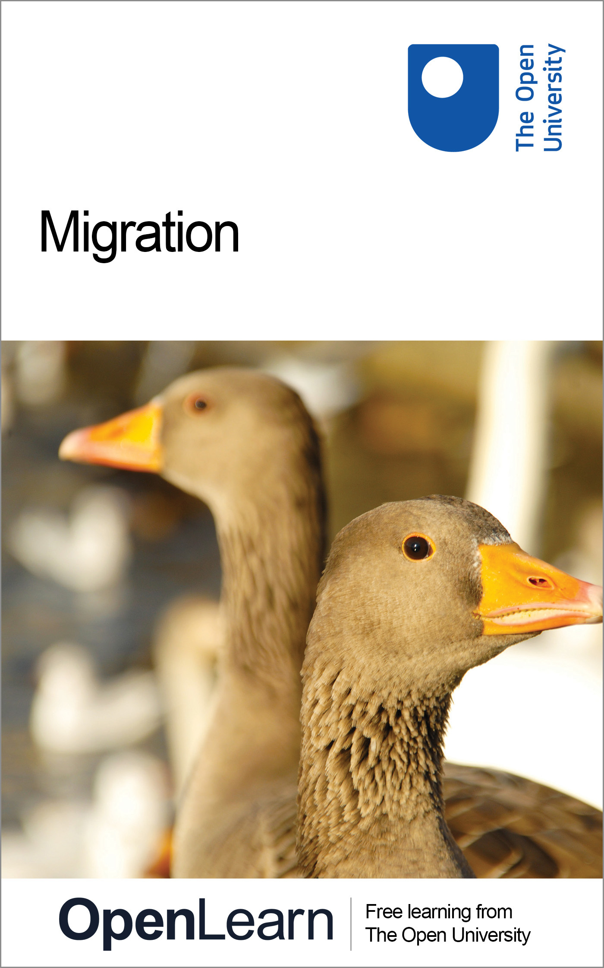

S295_1 The biology of survival

Migration
About this free course
This free course is an adapted extract from the Open University course S295 The biology of survival http://www.open.ac.uk/courses/modules/s295.
This version of the content may include video, images and interactive content that may not be optimised for your device.
You can experience this free course as it was originally designed on OpenLearn, the home of free learning from The Open University: http://www.open.edu/openlearn/science-maths-technology/science/migration/content-section-0.
There you'll also be able to track your progress via your activity record, which you can use to demonstrate your learning.
Copyright © 2016 The Open University
Intellectual property
Unless otherwise stated, this resource is released under the terms of the Creative Commons Licence v4.0 http://creativecommons.org/licenses/by-nc-sa/4.0/deed.en_GB. Within that The Open University interprets this licence in the following way: www.open.edu/openlearn/about-openlearn/frequently-asked-questions-on-openlearn. Copyright and rights falling outside the terms of the Creative Commons Licence are retained or controlled by The Open University. Please read the full text before using any of the content.
We believe the primary barrier to accessing high-quality educational experiences is cost, which is why we aim to publish as much free content as possible under an open licence. If it proves difficult to release content under our preferred Creative Commons licence (e.g. because we can't afford or gain the clearances or find suitable alternatives), we will still release the materials for free under a personal end-user licence.
This is because the learning experience will always be the same high quality offering and that should always be seen as positive - even if at times the licensing is different to Creative Commons.
When using the content you must attribute us (The Open University) (the OU) and any identified author in accordance with the terms of the Creative Commons Licence.
The Acknowledgements section is used to list, amongst other things, third party (Proprietary), licensed content which is not subject to Creative Commons licensing. Proprietary content must be used (retained) intact and in context to the content at all times.
The Acknowledgements section is also used to bring to your attention any other Special Restrictions which may apply to the content. For example there may be times when the Creative Commons Non-Commercial Sharealike licence does not apply to any of the content even if owned by us (The Open University). In these instances, unless stated otherwise, the content may be used for personal and non-commercial use.
We have also identified as Proprietary other material included in the content which is not subject to Creative Commons Licence. These are OU logos, trading names and may extend to certain photographic and video images and sound recordings and any other material as may be brought to your attention.
Unauthorised use of any of the content may constitute a breach of the terms and conditions and/or intellectual property laws.
We reserve the right to alter, amend or bring to an end any terms and conditions provided here without notice.
All rights falling outside the terms of the Creative Commons licence are retained or controlled by The Open University.
Head of Intellectual Property, The Open University
978-1-4730-1833-4 (.kdl)
978-1-4730-1065-9 (.epub)

Contents
- Introduction
- Learning outcomes
- 1 Introduction to movement and migration
  - 1.1 Examples of animal migration
- 2 Bird migration
  - 2.1 Migration paths and flyways
- 3 Introduction to natural selection
  - 3.1 Directional selection
  - 3.2 Stabilising selection
  - 3.3 Disruptive selection
  - 3.4 Natural selection in Darwin's finches
- 4 Introduction to homeostasis
  - 4.1 Thermoregulation in migratory birds
- 5 Navigation
  - 5.1 The star compass
  - 5.2 The Sun compass
- 6 The challenges of migration
- Conclusion
- Glossary
- References
- Further reading
- Acknowledgements

Introduction
This course introduces migration in animals, with special reference to birds and also introduces the integrated biological themes of movement, selection and homeostasis.
Movement is a facet of the life of animals and many migrate as part of their life cycle. The familiar movements of migratory birds follow a seasonal pattern and individuals complete round trips between different geographical locations. Figure 1 is a word cloud that represents concepts associated with migration.
This OpenLearn course is an adapted extract from the Open University course S295 The biology of survival.

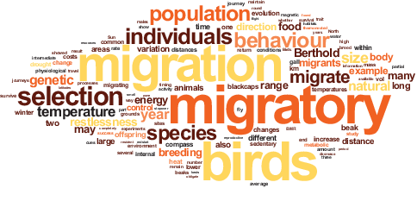
Figure 1 Migration word cloud.

Learning outcomes
After studying this course, you should be able to:
- describe some of the migratory journeys made by birds and other animals
- explain the process of adaptation by natural selection and how this results in evolution
- describe what is meant by homeostasis, with particular reference to how migratory birds regulate body temperature in order to conserve energy
- provide examples of the use of celestial and magnetic cues for navigation by migratory birds

1 Introduction to movement and migration
Not all animals migrate in the same way as birds. The mass migrations of locusts do not involve a round trip for any individual, for their life cycle is shorter than the seasonal cycle. The round trip of the monarch butterflies (Danaus plexippus, Video 1) that migrate between North America and Mexico takes more than one generation to complete.

Video content is not available in this format.
Video 1 Monarch butterfly migration.
View transcript - Video 1 Monarch butterfly migration.

The distances travelled during migration can be immense. Table 1 lists a few of the more spectacular journeys, and the animals that undertake them are shown in Figure 2.

Table 1 Migration records.
Record | Species | Distance
Longest recorded journey in water | leatherback turtle (Dermochelys coriacea) | 20 558 km in 647 days (Indonesia to Oregon, USA)
Longest mammal migration | humpback whale (Megaptera novaeangliae) | up to 8500 km each way
Longest insect migration | monarch butterfly (Danaus plexippus) | up to 4750 km in the autumn (North America to Mexico)
Longest recorded round-trip | arctic tern (Sterna paradisaea) | 70 900 km (North to South Pole)
Highest altitude migration | bar-headed goose (Anser indicus) | 9000 m above sea level

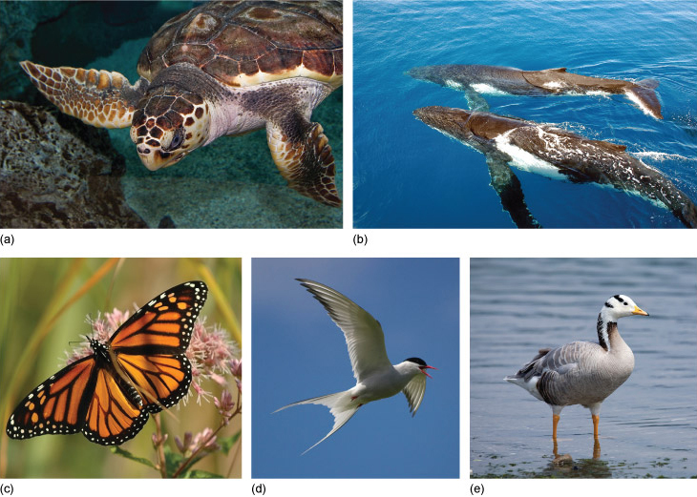
Figure 2 Some animals that undertake long migrations.
View description - Figure 2 Some animals that undertake long migrations.

1.1 Examples of animal migration
The humpback whale travels further than any other mammal (Video 2).

Video content is not available in this format.
Video 2 The humpback whale (Megaptera novaeangliae).
View transcript - Video 2 The humpback whale (Megaptera novaeangliae).

Travelling long distances over land may mean coping with a changing terrain. The migratory route of the bar-headed goose (Anser indicus) takes it over the peaks of the Himalayas at an altitude of around 9000 m (Video 3). The altitude record for a bird is 11 227 m, held by a griffon vulture.

Video content is not available in this format.
Video 3 The bar-headed goose.
View transcript - Video 3 The bar-headed goose.

Even with a long distance to cover, the arctic tern does not take a direct route and also makes a stop in the North Atlantic to feed on plankton (Figure 3).

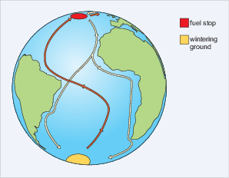
Figure 3 Migration route of the arctic tern. After setting out from their breeding sites in Greenland and Iceland (yellow line) the birds feed in the North Atlantic (red circle) and then follow one of two southward migration routes to reach their overwintering sites in the Antarctic; they then return (orange line) to their breeding sites, a round trip of 70 900 km.
View description - Figure 3 Migration route of the arctic tern. After setting out from their breeding ...

One of the most amazing of all bird migrations is undertaken by the bar-tailed godwit (Limosa lapponica), a wading bird, frequently found in marshes or mudflats where it forages for food (Figure 4).

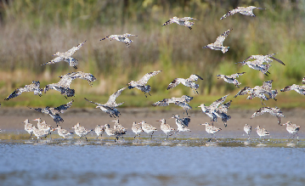
Figure 4 Bar-tailed godwits feeding and taking off.
View description - Figure 4 Bar-tailed godwits feeding and taking off.

It has been possible to tag individuals with satellite transmitters that encode position data on a radio signal, a process called telemetry. The data obtained from one bird showed that it had travelled 11 680 km (7258 miles), non-stop, over nine days to reach New Zealand from the Alaskan breeding grounds (Figure 6). This bird (E7) flew at an average speed of 56 km per hour (34.8 miles per hour) at an altitude of 3000-4000 m. Along the way, she lost more than half her body mass. The reasons for this extraordinary journey are the same for the majority of bird and other animal migrations - to increase both survival and reproductive success.

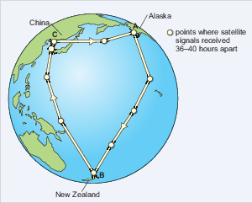
Figure 5 Flight paths and timings of the bar-tailed godwit E7. The journey from Alaska to New Zealand is non-stop. The return journey is achieved in two stages. A, Yukon Delta, Alaska, 5 May to 30 August; B, Miranda, New Zealand, 7 September to 17 March; C, Yalu Jiang, China, 24 March to 1 May.
View description - Figure 5 Flight paths and timings of the bar-tailed godwit E7. The journey from Alaska ...

For some species, there may be no opportunity to learn a route prior to setting off. Young ospreys born on Martha's Vineyard, an island off the east coast of Massachusetts, do not migrate with their parents but set off alone to spend the winter in Central or South America (Video 4). They are thought to find their way by flying southwards, keeping over land. It may be 18 months before they make the return trip.

Video content is not available in this format.
Video 4 The ospreys of Martha's Vineyard.
View transcript - Video 4 The ospreys of Martha's Vineyard.

2 Bird migration
The remarkable migratory behaviours of some bird species provide excellent experimental systems for studying the underlying processes, and the results have a much wider application to the study of migration than just bird behaviour. Studies on genetics, the influence of magnetic fields and physiological processes behind homeostasis illustrate general principles, but as birds have attracted so much scientific attention, they provide some of the best examples of migration studies.
Although migration is widespread amongst bird species, not all species are migratory and in some species, not all populations of the same species migrate and sometimes not all members of a population migrate. For example, in many regions, including the British Isles, some populations of birds are residents all year round and do not migrate. Other populations exhibit partial migration, where some individuals of the population in the same breeding areas remain all year round while others migrate to overwinter elsewhere..
Migration occurs to some degree in most bird species that live in seasonal environments. It is prevalent because in such environments (e.g. the Arctic tundra) food supplies vary markedly throughout the year, changing from abundance during the summer to scarcity during the winter (Figure 6).

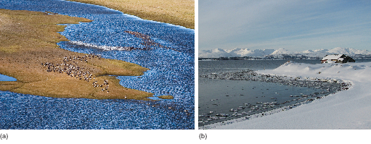
Figure 6 (a) Summer in the Arctic. Snow geese (Chen caerulescens) nest in tundra pools in the summer and migrate south to Mexico in the winter. (b) Winter in the Arctic.
View description - Figure 6 (a) Summer in the Arctic. Snow geese (Chen caerulescens) nest in tundra ...

Generally speaking, birds time their migrations so that they are present in breeding areas during periods of food abundance and are absent during periods of scarcity.
In lowland tropical forests, where food supplies remain stable throughout the year, many birds that breed there remain all year. However, these forests also receive a seasonal influx of other bird species from higher latitudes which migrate from colder regions for the winter.
This means that worldwide, up to half of the 10 000 or so species of birds, totalling about five billion individuals, are thought to migrate every year on return journeys between breeding and non-breeding areas.
Because migration is between warm and cool habitats, birds move mainly on a north-south axis. Some, however, have an easterly or westerly component to their movements, especially those that breed in the central areas of the northern landmasses and move to the warmer edges for winter. Figure 7 shows some examples of different migration routes used by birds.

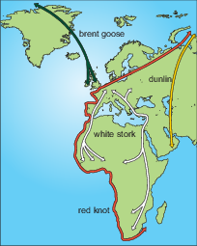
Figure 7 Examples of different migration routes.
View description - Figure 7 Examples of different migration routes.

The patterns of bird migration are very diverse. Passerines are perching birds (Figure 8). They make up almost half of all bird species and some of the small passerines travel at night.

Interactive content is not available in this format.
Figure 8 Passerine species.
(This slideshow will play in the latest versions of most browsers including Chrome, Firefox, Safari and Internet Explorer. It will not play in Internet Explorer 8.)

The mass migration of large storks is a spectacular sight during daylight (Figure 9).

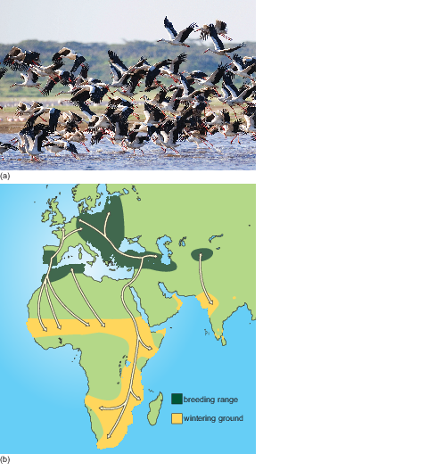
Figure 9 (a) Migrating white storks (Ciconia ciconia). (b) Migratory paths (lines with arrows at each end) of white storks that breed in Europe and migrate to the South, principally Africa, for the winter.
View description - Figure 9 (a) Migrating white storks (Ciconia ciconia). (b) Migratory paths (lines ...

In contrast, individuals of some species travel alone.
When the routes taken by migrating birds are plotted on a map, many long-distance migration routes are found to be clustered together, as the next section describes.

2.1 Migration paths and flyways
Birds that migrate are generally categorised as short-distance migrants or long-distance migrants. Short-distance migrants (e.g. waxwings) usually fly overland, within continents: for example, across several states in the USA and Canada or within Europe (Figure 10).

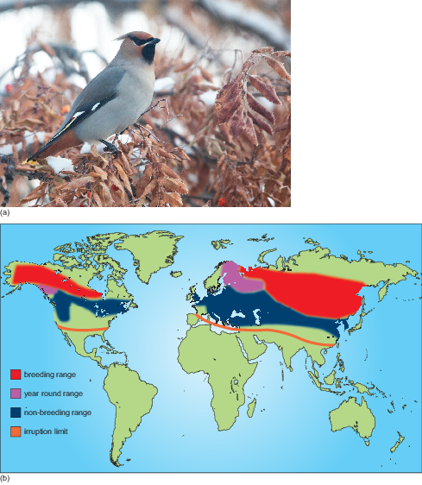
Figure 10 (a) Bohemian waxwing (Bombycilla garrulous). (b) The geographical range of the Bohemian waxwing including the areas which may experience irruptions of the species. An irruption is incursion of individuals or flocks into areas where they do not routinely overwinter.
View description - Figure 10 (a) Bohemian waxwing (Bombycilla garrulous). (b) The geographical range ...

Long-distance migrants, on the other hand, cross continents and their journeys often involve substantial sea crossings (Figure 11).

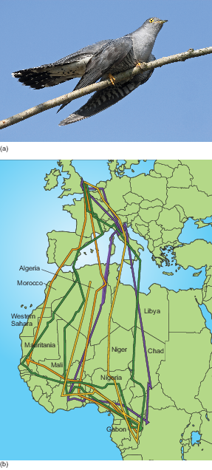
Figure 11 (a) Common cuckoo (Cuculus canorus), a long-distance migrant that travels between the UK and Africa. (b) Migration paths of several cuckoos tracked from the UK to Africa and back. Different-coloured lines indicate migration paths of different individuals.
View description - Figure 11 (a) Common cuckoo (Cuculus canorus), a long-distance migrant that travels ...

The division into two categories is really a matter of convenience, since these two categories merge into each other and there is continuum of variation in the distance travelled.

- Would you classify white storks (Figure 9) as long- or short-distance migrants?
- White storks are long-distance migrants, as they fly mainly from Europe to Africa and hence cross continents.

Long-distance migrants commonly use a migration corridor which is known as a flyway. Flyways are invisible highways or corridors which cross several continents. There are three main global flyways for migrating birds (Figure 12).

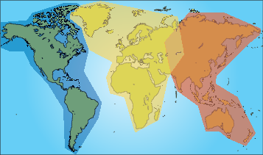
Figure 12 Three main global flyways of migratory birds. Americas flyway - blue; African-Eurasian flyway - yellow; East Asian-Australasian flyway - brown.
View description - Figure 12 Three main global flyways of migratory birds. Americas flyway - blue; African-Eurasian ...

Although the small number of flyways suggests strong similarities between the behaviour of migrating bird species, there are actually lots of differences in, for example:
- timing of migration
- stops along the way
- triggers for migration.
This variation has been the subject of many studies on the evolution of migratory behaviour. Before examining some of these studies, it is useful to look at the two main processes that underlie all aspects of evolutionary biology: adaptation and natural selection.
Studies have shown that variation in many aspects of migratory behaviour has a genetic basis and are subject to natural selection, including the urge to migrate, the timing and direction of migration and migratory distance. Changes in migratory behaviour are adaptive. The next section looks at the different ways in which natural selection can result in adaptive evolution of behavioural and/or morphological traits.

3 Introduction to natural selection
Evolution is central to biology and natural selection is the mechanism that produces adaptation.

- In a single sentence, write down what you understand by the term 'adaptation'.
- An adaptation is a morphological, physiological, biochemical, developmental or behavioural trait that gives an organism a greater ability to survive and reproduce in a particular environment.

For selection to occur there must be variation within a population, because if every individual is identical, there is nothing for selection to act upon. So, for example, there is variation in beak size in finches and those individuals with beaks well-suited to a particular size of seed do better than others in the population and therefore are selected for.

- Write down a few sentences that illustrate your understanding of natural selection.
- Natural selection refers to the differential survival and/or reproduction of organisms due to their physical attributes or phenotype. The concept of selection is central to the theory of evolution by means of natural selection, formulated by Charles Darwin, which forms the cornerstone of many explanations of animal behaviour.

- What three criteria must be met within a population of interacting individuals in order for natural selection to occur?
- The three criteria are:
  - there must be phenotypic variation
  - phenotypic variation must be genetically determined (so that it can be inherited)
  - phenotypic variation produces variation in some component of fitness, such as survival or mating success, and is ultimately expressed as differential reproductive success.

There are three kinds of natural selection that will be considered in this course. How the frequencies of phenotypes within a population change in response to these forms of natural selection is shown in the accompanying figures.

3.1 Directional selection
Directional selection occurs when conditions favour individuals expressing one extreme of a phenotypic range, thereby shifting a population's frequency distribution for the phenotypic character in one direction or the other. For example, in long tailed widowbirds (Euplectes progne, Figure 13a) males with long tails have a reproductive advantage over males with shorter tails because females prefer to mate with males with long tails. Directional selection therefore favours long tails and may shift the distribution of the population so that tail length increases over time (Figure 13b).

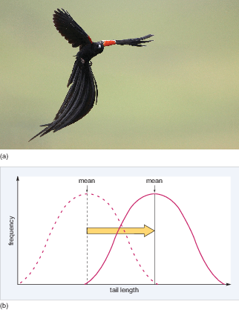
Figure 13 (a) The long tailed widowbird (Euplectes progne). (b) Because directional selection favours long tails, over time the distribution may shift to the right (shown by the arrow) so that mean tail size increases.
View description - Figure 13 (a) The long tailed widowbird (Euplectes progne). (b) Because directional ...

- If shorter tailed males were more successful in attracting and mating with females than long tailed males, in which direction would the mean tail length shift?
- Tail length would shift to the left, that is, towards shorter tail length.

With respect to migration, studies have shown that under strong directional selection, populations can switch from sedentary to migratory or vice versa relatively quickly and that factors such as climate change could lead to the evolution of sedentariness in many bird populations that are currently migratory.

3.2 Stabilising selection
Stabilising selection occurs where there is an optimal value for the trait of interest. This means that selection acts against both extreme phenotypes and favours intermediate variants which have the highest fitness (survive to reproduce). For example, goldenrod gall flies (Eurosta solidaginis, Figure 14a) lay their eggs individually in developing shoots of the tall goldenrod plant (Solidago sp.). The fly larva that hatches from the egg makes a chemical that causes the plant tissue to swell around it, and the result is a mass of plant tissue called a gall (Figure 14b), which serves as a home for the larva. Downy woodpeckers attack large galls and eat the gall fly larva. Parasitic wasps lay eggs inside small galls and the wasp larvae that hatch from the eggs eat the gall fly larva when it hatches. Only galls of intermediate size remain intact because the wall of the gall is too thick for the ovipositor of a parasitic wasp to penetrate, and the size of the gall and hence the larva within makes it less attractive to woodpeckers than a larger gall containing a larger larva and hence a larger meal. So, selection pressures act on gall size and only larvae in galls of intermediate size survive (Figure 14c).

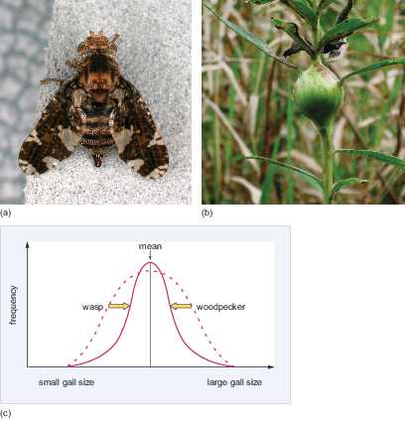
Figure 14 (a) Goldenrod gall fly. (b) Gall on the goldenrod plant in which gall fly larvae hatch. (c) Stabilising selection favours intermediate-sized galls, since these are not attacked by wasps or birds. The distribution of gall sizes therefore 'stabilises' around an optimal trait - in this case, intermediate gall size.
View description - Figure 14 (a) Goldenrod gall fly. (b) Gall on the goldenrod plant in which gall fly ...

- Under stabilising selection, what happens to the amount of variation in the size of galls in the population?
- The amount of variation decreases; that is, there is a decrease in the range of gall sizes.

3.3 Disruptive selection
Disruptive selection in which selection favours individuals with the smallest and largest values of the trait. These individuals have the highest fitness and individuals with intermediate values are at a fitness disadvantage. One example of this type of selection involves feather colour in male lazuli buntings (Passerina amoena), a bird species native to North America (Figure 15a). The feather brightness of males varies, ranging from brown to bright blue. In a habitat with limited nesting sites, both the dullest and the brightest yearling males are more successful in obtaining high quality territories and therefore attract females. This is because adult males tolerate non-threatening dull yearlings and also leave brightly coloured yearlings alone. Because of their dominance, both these groups are able to establish territories and attract females but yearling males with intermediate plumage are attacked by adults and therefore fail to obtain territories and mate (Figure 15b).

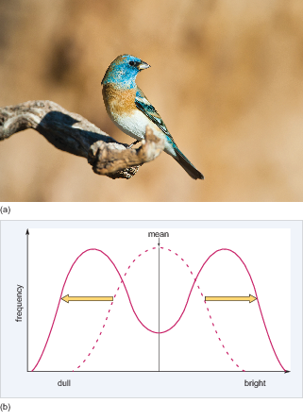
Figure 15 (a) Male bright lazuli bunting. (b) Disruptive selection in lazuli buntings. Only yearling males that are brightly coloured or dull are able to establish territories and breed. Males with intermediate plumage do not mate.
View description - Figure 15 (a) Male bright lazuli bunting. (b) Disruptive selection in lazuli buntings. ...

- What effect does disruptive selection have on variation in plumage brightness?
- It increases variation (increases the range of plumage colour).

Each kind of selection alters the mean of and/or variance in (amount of variation) of the phenotypic trait in a population or species. In the long term, directional selection and disruptive selection can have the most dramatic evolutionary impact and can lead to the formation of a new type from an existing type, the process of speciation.
This contrasts with the action of stabilising selection, which maintains the existing type without change in mean phenotype over long periods of time. Stabilising selection eliminates the extremes in a distribution of phenotypes, and as such it leads to a refinement of the existing type.
Because the trait under selection has a genetic basis, the differential reproduction of individuals carrying the genetic variants - the alleles - that underlie the trait (e.g. body size) results in a change in the frequencies of genetic variants by selection processes. Genetic variants that underlie phenotypes that are reproductively successful will increase in frequency, while those that underlie phenotypes that are not successful in reproducing will decrease. Thus, genetic changes across generations result from differences in reproductive success of genetically determined phenotypes.

3.4 Natural selection in Darwin's finches
An influential study of natural selection in birds illustrates how effective, and rapid, natural selection can be. Scientists Peter and Rosemary Grant studied the medium ground finch (Geospiza fortis, Figure 16) over a long period of time, on the Galápagos island of Daphne Major. See also Video 5.

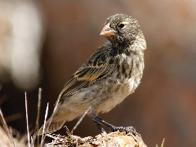
Figure 16 Medium ground finch.
View description - Figure 16 Medium ground finch.

Video content is not available in this format.
Video 5 An introduction to Darwin's finches.
View transcript - Video 5 An introduction to Darwin's finches.

In these finches, beak size is heritable, meaning that adults with large beaks pass large beak size onto their offspring. Figure 17 illustrates this relationship.

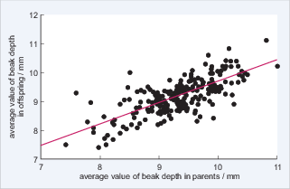
Figure 17 The beak size (measured as beak depth - the distance between the top and bottom of the beak) of offspring plotted against their parents' beak size. Based on Grant and Grant (2000).
View description - Figure 17 The beak size (measured as beak depth - the distance between the top and ...

During 1977 there was a major drought on Daphne Major and many of the plants on the island produced few or no seeds. The medium ground finch population, which depends on seeds for food, declined drastically from about 1400 individuals to a few hundred in just over two years.
What the Grants' research group observed was that following the drought the population of finches had recovered; but now, the average size of the beaks was larger. The underlying reason for this was that during the drought, small seeds were exceedingly rare but large seeds with thick husks were still available. Only the large birds with large beaks were able to crack open the husks and eat the contents of the seeds. Smaller birds with smaller beaks were unable to do so and therefore starved. From this differential pattern of death, there was a rapid change in the finch population. Figure 18 illustrates how natural selection caused a rapid change in the size of the beaks in the finch population following the drought.

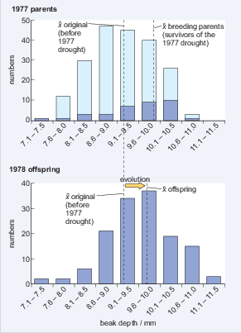
Figure 18 (a) The pale blue bars show the total number of birds on the island with beaks in each size class, before the drought. The blue bars show the number of birds with beaks in each size class that survived the drought and subsequently reproduced. (b) The average beak size of offspring produced by adults that survived the drought. The dashed vertical lines show the average beak size from one year to the next. Based on Grant et al. (2003).
View description - Figure 18 (a) The pale blue bars show the total number of birds on the island with ...

- What was the difference in average beak size of all adults before the drought in 1977 and the average beak size of adults that survived the drought?
- Before the drought, the average size of adult beaks was 9.2 mm. The average beak size of adults that survived was 9.9 mm.

- Explain how the average beak size of birds changed from before the drought in 1977 to after the drought in 1978, once the population had recovered and started to breed again.
- Before the drought, the average size was around 9.2 mm. After the drought, it shifted to around 9.7 mm.

- Taking the information from Figures 17 and 18 into account, explain how natural selection could have caused an increase in beak size in this population of ground finches.
- The adult survivors of the drought were the ones with the largest beaks because they could still crack large seeds. These birds then mated and because beak size is heritable and is passed on to offspring, the chicks from these birds inherited large beak size. Birds with large beaks therefore produced a large fraction of the next generation and because of this, the average size of beaks of medium ground finches increased quickly within the population.

- What type of selection is operating in this example?
- Directional selection.

What is important to note here is that the genetic variation that underlies differences in beak size was already present in the population. As a consequence of natural selection, the frequency of genetic variants that expressed the larger beak size increased in the population and those variants that expressed smaller beak size declined in frequency and may even be lost from the population.
From this example, you can see how dramatic changes can occur in a population as a result of natural selection. You can also see how careful observation by the Grants over consecutive years allowed them to capture empirical evidence of natural selection.

Activity 1 Finch beak size and population distribution

Use the resources to answer the interactive questions on finch population distributions.

Interactive content is not available in this format.

During their migratory journeys, birds encounter extremes of temperature, storms, changes in altitude and shortage of food and water. Birds have evolved a suite of remarkable physiological adaptations to deal with these changes in the external environment. Before discussing some of these adaptations, how organisms in general maintain a constant internal environment is explored, a process known as homeostasis.

4 Introduction to homeostasis
Organisms have the remarkable ability to regulate their internal environment, and maintain a favourable state even if the external environment changes. Normal functioning involves a self-regulating mechanism whereby any deviations from optimum conditions tend to cause responses that return the system to this state. The ability of an organism to regulate its internal environment is the result of a suite of physiological processes, called homeostasis. Homeostatic mechanisms regulate many different aspects of physiology, including temperature, concentrations of dissolved oxygen, carbon dioxide and sugar, osmotic pressure, redox potentials and pH.
The methods used to maintain body temperature can be divided broadly into two types. Animals that rely predominantly on internal metabolic processes as a source of heat energy generally maintain a stable body temperature that is precisely regulated. They are known as endotherms or homeotherms. Those animals that rely on external sources of heat energy may maintain a relatively stable and precisely regulated body temperature, as long as external heat energy is available, but will be unable to do so when it is absent. These ectotherms or poikilotherms are able to tolerate a substantial lowering of body temperature, which endotherms generally cannot. Birds and mammals are endotherms; all other animals are ectotherms, with a few species specific exceptions.
When ambient temperatures fall so low that heat loss to the environment threatens to lower body temperature, endotherms use several strategies to supplement and conserve body heat. Specialised nerve cells detect a drop in temperature and relay this information to the brain. Shivering is initiated in muscles, warming them and the blood flowing through them. This response is an example of negative feedback (Figure 19), where a control mechanism reacts to a change in the output of the system by initiating a restoring action. If the brain detects that body temperature is not optimal, then actions are triggered that will restore homeostasis.
Negative feedback systems maintain a preset state and so are stabilising - an important feature of homeostasis.

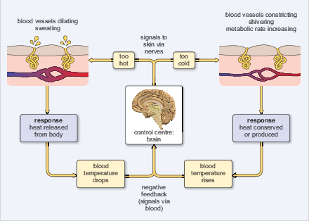
Figure 19 Temperature regulation using negative feedback - a control mechanism that reduces or 'damps' fluctuations in temperature.
View description - Figure 19 Temperature regulation using negative feedback - a control mechanism that ...

The amount of energy an organism uses in a unit of time is called its metabolic rate. Metabolic rate can be determined by the amount of oxygen consumed or carbon dioxide produced by cellular respiration. Organisms must maintain a minimum metabolic rate for basic functions such as cell maintenance, repair and internal transport. The minimum metabolic rate of a homeotherm is known as the basal metabolic rate (BMR).
Basal metabolic rate is measured under a temperature range that does not require the generation or shedding of heat above the minimum. In other words, it does not involve thermoregulation because external temperatures do not diverge from comfortable limits. The range of temperatures over which BMR is maintained comprise the thermoneutral zone (Figure 20). When external temperatures exceed or drop below those within the thermoneutral zone, physiological changes such as those initiated by shivering or sweating are deployed to maintain body temperature within the thermoneutral zone.
However, thermoregulation causes an increase in BMR and this increase in BMR sets the limit of what temperatures can be tolerated beyond the thermoneutral zone. When ambient temperatures fall below the thermoneutral zone (lower critical temperature), heat production must increase and/or heat loss must decrease. Above the thermoneutral zone (upper critical temperature), heat loss must increase and must also cope with the rise in BMR that is a consequence of rising body temperature. Maintaining a constant temperature therefore makes a constant demand on either the biochemical processes of heat production and/or the physical mechanisms for heat loss. Figure 20 illustrates the effect of rising ambient temperature on BMR, shown as oxygen consumption, and heat loss which is a combination of evaporative water loss and peripheral blood flow changes, i.e. dilation.

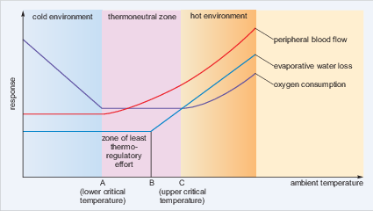
Figure 20 Relationship between heat production and heat loss as a function of ambient temperature for a homeotherm.
View description - Figure 20 Relationship between heat production and heat loss as a function of ambient ...

- In the thermoneutral zone, what happens to BMR?
- It stays constant at a low level. Therefore thermoregulation is achieved at minimal metabolic cost in the thermoneutral zone.

Thermoregulation is critical for survival because most biochemical and physiological processes are sensitive to changes in temperature. For every 10 °C decrease in temperature the rates of most enzyme-mediated reactions decrease two- to threefold. A substantial decrease in temperature (hypothermia) can result in such a decrease in overall metabolic rate that it causes a breakdown in normal cellular function and eventually death. Increase in temperature (hyperthermia) conversely speeds up reactions and causes an increase in metabolic rate. It may also cause proteins (including, of course, enzymes) to become less active through denaturation of their structure.

- Rüppell's fox is nocturnal. During the day when the ambient temperature is around 40 °C the fox rests inside the underground den. At night the fox emerges and forages for reptiles and insects. What advantage does the nocturnal life style offer the fox?
- Resting in the den during the day avoids the need for physiological thermoregulation such as panting. At night the ambient temperature is much lower. By emerging to hunt at night the fox reduces the need for evaporative water loss and minimises energy consumption for thermoregulation.

4.1 Thermoregulation in migratory birds
Compared with mammals, birds have high basal metabolic rates, using energy at higher rates (Figure 21), and also higher body temperatures. Metabolic rates lie within a range of values between a minimum value, the basal metabolic rate (BMR), and the summit metabolic rate, when the bird is under the greatest physiological stress. Passerines tend to have higher BMR values than non-passerines. The smallest birds, hummingbirds, have the highest BMRs of all birds. In general, BMR is related to mass per unit surface area, with larger organisms, which have larger mass per unit area, expending less energy per unit mass than smaller ones.
In general, body temperatures of birds range from about 38 °C to 44 °C. Body temperatures of large flightless birds (e.g. emu and ostrich, Figure 22a) and some aquatic birds (e.g. penguins) are at the lower end of this range and within the range of mammals. The house sparrow (Figure 22b) has a body temperature of 43.5 °C.

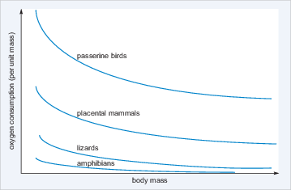
Figure 21 Basal metabolic rate (as measured by oxygen consumption) in different groups of vertebrates.
View description - Figure 21 Basal metabolic rate (as measured by oxygen consumption) in different groups ...

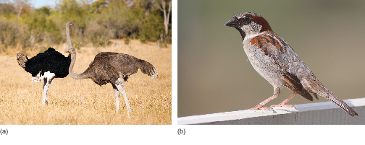
Figure 22 (a) Ostrich (Struthio camelus). (b) House sparrow (Passer domesticus).
View description - Figure 22 (a) Ostrich (Struthio camelus). (b) House sparrow (Passer domesticus).

To maintain temperature within the thermoneutral zone requires energy which for most organisms is a precious resource. Migratory birds in particular have tight energy budgets; to cover long distances without food means that migrating birds need to assimilate and conserve energy as much as possible before and/or during migration. The birds should avoid both heat and cold stress, as these use energy needed for flight, and they do so in a number of different ways.
In cases where individuals travel for long distances without drinking - for example, when crossing oceans or deserts - both thermoregulatory and osmoregulatory (water regulation) adjustments are required in order to conserve energy and water. Before migration, birds increase food intake, sometimes doubling their mass (pre-migratory fattening). Much of this food is stored as lipid, which, when metabolised, produces carbon dioxide and also water (which can contribute to water balance).
Some migrants enter regions where temperatures can become extreme. When crossing deserts, heat stress can become a problem due to the increased heat produced from persistent muscle contraction. To avoid overheating, many birds pant and some species may increase flight altitude to reach cooler conditions. However, some birds, especially small passerines, are unable to cross the Sahara Desert fast enough for a non-stop flight and must land during the heat of the day and rest to avoid overheating and dehydration.
At high latitudes and altitudes, ambient temperatures can be very low and so before migration, changes in feather covering and fat layers may be needed, reducing the energy used for thermoregulation and thus making more available for migration itself.
Some small passerines reach stopover sites that are very cold so that individuals are at risk of hypothermia. Some species have been observed to huddle at stopover sites and it has been suggested that this behaviour reduces energy expenditure and contributes to thermoregulation.
There is now increasing evidence that during and before migration, birds are able to lower their body temperature below ambient in order to conserve energy for the flight. Migrating passerines at stopover sites are thought to lower body temperatures by 8-10 °C during the night, conserving energy. Measurements of daily changes in body temperatures in migrating blackcaps appear to support this. Using radio telemetry at a stopover site at Midreshet Ben-Gurion, Israel, Wojciechowski and Pinshow (2009) showed that while at rest during a stopover, blackcaps can lower their body temperature by up to 10 °C below normal resting temperature at night and become hypothermic (Figure 23).

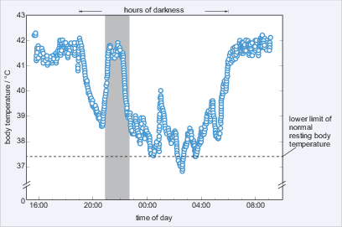
Figure 23 Body temperature of a blackcap on the night of 9-10 April 2007. The vertical grey bar indicates a period with relatively high nocturnal body temperature, possibly associated with a period of nocturnal migratory restlessness.
View description - Figure 23 Body temperature of a blackcap on the night of 9-10 April 2007. The vertical ...

The effect of this is to reduce energy expenditure by as much as 30%. Blackcaps use protein as a fuel source during flight which is derived from the liver, gut, breast and leg muscles. Because of this, they arrive at stopover sites with atrophied liver and gut and during the initial stage of the stopover, their digestive efficiency is significantly lower than in the later part of the stopover. When they arrive therefore, birds may save energy by entering controlled hypothermia during cold nights until they are able to rebuild tissues and energy stores by foraging during the day.
It is now known that many bird species allow body temperature to drop below normal resting levels at night. For example, it has recently been suggested that lowered body temperature might be an important mechanism of energy conservation in migrating brent geese (Branta leucopsis, Figure 24).

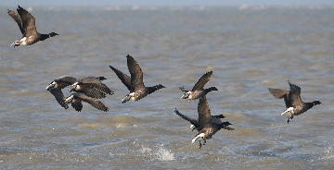
Figure 24 Migrating brent geese.
View description - Figure 24 Migrating brent geese.

However, none have been observed to lower it to the same extent as hummingbirds, which undergo deep, mammal-like torpor with body temperature decreasing by as much as 30 °C and BMR by a substantial amount, as shown in Figure 25a. Studies on rufous hummingbirds (Selasphorus rufus, Figure 25b) show that they use torpor to conserve energy that can be used later for migration. So, unusually, they go into torpor even when fat reserves are high and they also may go into torpor for periods during migration.

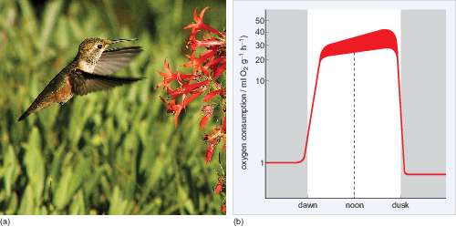
Figure 25 (a) Rufous hummingbird. (b) Torpor in hummingbirds: oxygen consumption (red line) is high when hummingbirds are active during the day but may drop to one-twentieth of these levels at night.
View description - Figure 25 (a) Rufous hummingbird. (b) Torpor in hummingbirds: oxygen consumption ...

Activity 2 Studying the physiology of migration
Allow 1 hour

Homeostasis introduced the processes concerned with the regulation of body temperature, using migratory birds as an example. How can physiological information be obtained from birds that migrate long distances? Lucy Hawkes discusses her research on bar-headed geese with Brett Westwood, in an interview recorded for the BBC. Listen to the interview and makes notes about the environmental limitations that the bird faces and the adaptations in both behaviour and physiology that enable it to migrate.

Audio content is not available in this format.
Audio 1 Heart rate monitoring of migrating geese.
View transcript - Audio 1 Heart rate monitoring of migrating geese.

The bar-tailed godwit undertakes a very long migration. How does the bird prepare for the journey? Phil Batley studies migration and has been tagging the birds to follow their progress. He discusses his research in an interview with Philippa Forrester, which you should listen to now. What particular physiological strategy do the birds adopt to prepare for the flight?

Audio content is not available in this format.
Audio 2 Satellite tagging of migrating bar-tailed godwits.
View transcript - Audio 2 Satellite tagging of migrating bar-tailed godwits.

One way of countering problems associated with energy expenditure and thermoregulation in migrating birds is to have good orientation and navigational skills. This does not necessarily involve finding the shortest way to a destination; and in fact sometimes physiological difficulties may be avoided by taking a roundabout route. For example, favourable winds and meteorological conditions can conserve energy by reducing the costs of thermoregulation and birds require exceptional navigational skills to take advantage of this. The next section will explore these skills.

5 Navigation
For most migrating birds, their journey is two-way and the need for navigational information is obvious. Sedentary birds that do not migrate do of course make short, localised trips - for example, to and from their nests. Nonetheless, these short trips form the basis from which the longer return movements that characterise migration can develop.
Although short trips may be facilitated by learning landscape features in the local area, travelling over long distances requires something more. Recall from Section 1 the young ospreys leaving Martha's Vineyard with no experience and no help from adult birds. Detailed landscape features would be of no help.

- From what you have read, what gross landscape features probably guide the young ospreys?
- If they distinguish between land and sea and only fly south over land, they will reach suitable feeding areas.

- What other cues might be available to birds to help them navigate?
- Possible navigation cues might be:
  - celestial cues derived from the Sun, Moon and stars
  - magnetic cues from the Earth's magnetic field
  - the plane of polarisation of light
  - chemical signals detectable as smells.

To navigate effectively, birds need an internal map and a compass. The internal map provides a bird with the general location of where it is relative to its homing or migration goal and the internal compass is required to guide its flight and keep it on course.
Birds are believed to use two kinds of maps for goal-directed orientation. The first of these is an olfactory map, suggested to be used by homing pigeons. This theory is still controversial.
The second hypothesis is that birds use a magnetic map to locate themselves in space. In fact, it is now believed that birds can use the Earth's magnetic field as a map and as a compass based on variation in the strength of the field and its inclination relative to the Earth's surface, respectively.
There are three types of compass that birds can use. The magnetic one has already been mentioned.

- What two other compass cues might be available to birds?
- The stars and the Sun both provide compass information that birds could use.

5.1 The star compass
The stars are principally of value to nocturnal migrants and, of course, the sky has to be fairly clear. Experiments using caged birds show that their direction of take-off is correct on starry nights, but not on overcast nights when they become disorientated. In a series of classic experiments on North American indigo buntings (Passerina cyanea, Figure 26) where the location and movements of stars and constellations were manipulated in a planetarium, researchers showed that the buntings derive directional information from the pattern of constellations relative to each other and to the celestial pole. In other words, birds do not learn the star patterns themselves but learn to respond to a star pattern that rotates about a single conspicuous star.

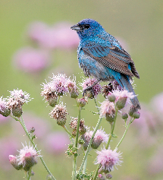
Figure 26 Indigo bunting.
View description - Figure 26 Indigo bunting.

The experiments also showed that birds needed experience of the night sky in order to orientate correctly in the planetarium.

5.2 The Sun compass
The use of the Sun for orientation by birds was first demonstrated in the 1950s with European starlings (Sternus vulgaris). Mirrors were used to alter the apparent position of the Sun and the birds then orientated to the apparent position rather than orienting in the correct compass direction.

- Can birds use the Sun alone as a compass guide?
- The Sun on its own is not sufficient, because it moves across the sky during the day; so to maintain a constant direction using the Sun as a guide, a bird needs an internal clock.

The internal clock maintains a cycle of about 24 hours and is reset by the light-to-dark cycle of the environment. So, the Sun is playing two roles:
- it acts as a marker from which direction can be deduced
- its regular cycle keeps the internal clock accurate.
The importance of an internal biological clock for use of the Sun compass has been demonstrated by 'shifting' the clock.
For example, the bearings of the flight direction of rock pigeons (Columba livia, Figure 27) kept for several days in a room where the 'artificial' photoperiod was shifted by six hours either forward or backward, differed from those of non-shifted pigeons by about 90 degrees.

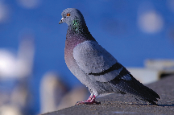
Figure 27 Rock pigeon.
View description - Figure 27 Rock pigeon.

6 The challenges of migration
In studying this course it will have become apparent that migration involves a diversity of behaviours and physiological adaptations, many of which are far from being fully understood. Birds such as arctic terns, which have a mass of around 100 g and yet can travel an average of 70 900 km in a year, challenge current understanding. New technology is adding more and more information about these long-distance migrations and arctic terns have been fitted with lightweight geolocators that record data that enables their position to be calculated twice each day. The devices have a mass of just 1.9 g.
Information about rate of travel contributes to an understanding of the energetic costs of migration, but these are still difficult to calculate. However, a full cost-benefit analysis of migration as a strategy for a species could provide a lot of information about the selection pressures that drive the evolution of the behaviour.
The methods used by birds for navigation are becoming clearer, but the physiology of the senses and sensory processing needed to take advantage of natural cues is not well understood. Birds are a good study model, but migration and navigation are part of the life of many animals, and research on bird navigation will have a much wider impact and command a wider interest in biological science.

Conclusion
- Migration is defined as the regular movement of animals each year between separate breeding and wintering grounds.
- There are many different types of migratory behaviour, ranging from completely sedentary populations to populations that are completely migratory (obligate migrants).
- There are three kinds of natural selection that can cause evolutionary change: directional selection, disruptive selection and stabilizing selection.
- The study of Darwin's finches illustrates how rapidly natural selection can result in a change in phenotype.
- Homeostasis is an important mechanism for maintaining internal balance. In achieving homeostasis, animals maintain a relatively constant internal environment even when the external environment changes significantly.
- Birds use both internal maps and compasses to find their way during migration.
- Olfactory maps and magnetic maps are believed to help birds locate themselves in space.
- Three internal compasses allow birds to sense the direction in which they are flying. These are the Sun compass, the star compass and the magnetic compass.
- The mechanisms used by birds to orientate during migration are still largely unknown and are currently the subject of ongoing research.

Glossary
basal metabolic rate (BMR)
The minimum metabolic rate of an endotherm.
directional selection
Occurs when conditions favour individuals expressing one extreme of a phenotype range, thereby shifting a population's frequency curve for the phenotypic character in one direction.
disruptive selection
Selection that favours individuals with the smallest and largest values of a trait. These individuals have the highest fitness and individuals with intermediate values are at a fitness disadvantage.
ectotherms
An organism that relies on external heat sources to maintain a body temperature within limits.
endotherms
Animals that have a nearly uniform body temperature, maintained independently of ambient temperature, largely by heat derived from metabolism.
flyway
A long-distance migration corridor. There are three main global ones for migrating birds.
homeostasis
Maintenance of a stable internal state by regulation.
homeotherms
Animals that have a nearly uniform body temperature, maintained independently of ambient temperature, largely by heat derived from metabolism. Older term for endotherms.
metabolic rate
The amount of energy used by an organism in unit time.
negative feedback
A control mechanism that reacts to a change in the output of the system by initiating a restoring action.
partial migration
Describes the behaviour of a population on the same breeding grounds where some individuals remain throughout the year and others migrate to avoid adverse condition.
phenotype
The characteristics and physical attributes of an organism controlled by the genotype.
poikilotherms
An organism that relies on external heat sources to maintain a body temperature within limits Older term for ectotherms.
stabilising selection
Occurs where there is an optimal value for the trait of interest. This means that selection acts against both extreme phenotypes and favours intermediate variants which have the highest fitness.
telemetry
An automated process for collecting data remotely, for example encoding position data on a radio signal.
thermoneutral zone
The range of temperatures over which the metabolic rate is equal to the basal value.
variation
Differences between individuals of a species, excluding those associated with sex, age or stage of life cycle.

References
Grant, P.R. and Grant, B.R. (2000) 'Quantitative genetic variation in populations of Darwin's finches', in Mousseau, T.A., Sinervo, B. and Endler, J. (eds), Adaptive Variation in the Wild, New York, Academic Press, pp. 3-40.
Grant, P.R., Grant, B.R., Keller, L.F., Markert, J.A. and Peren, K. (2003) 'Inbreeding and interbreeding in Darwin's finches', Evolution, vol. 57, no. 12, pp. 2911-16.

Further reading
Berthold, P. (1999) 'A comprehensive theory for the evolution, control and adaptability of avian migration', Ostrich: Journal of African Ornithology, vol. 70, no. 1, pp. 1-11.
Castelvecchi, D. (2012) 'The compass within', Scientific American, vol. 306, pp. 48-53.
Lohmann, K.J. (2010) 'Magnetic field perception', Nature, vol. 464, pp. 1140-42.
Mouritsen, H. (2012) 'Search for the compass needles', Nature, vol. 484, pp. 320-1.
Mueller, J.C., Pulido, F. and Kempenaers, B. (2011) 'Identification of a gene associated with avian migratory behaviour', Proceedings of the Royal Society of London B, vol. 278, pp. 2848-56 [Online]. Available at http://rspb.royalsocietypublishing.org/content/early/2011/02/11/rspb.2010.2567.full (Accessed 24 July 2014).
Pulido, F. (2007) 'The genetics and evolution of avian migration', Bioscience, vol. 57, no. 2, pp. 165-74.
Pulido, F. and Berthold, P. (2010) 'Current selection for lower migratory activity will drive the evolution of residency in a migratory bird population', Proceedings of the National Academy of Sciences USA, vol. 107, no. 16, pp. 7341-46.

Acknowledgements
This course was written by Mandy Dyson and David Robinson.
Except for third party materials and otherwise stated in the acknowledgements section, this content is made available under a Creative Commons Attribution-NonCommercial-ShareAlike 4.0 Licence.
Course image: notspavin in Flickr made available under Creative Commons Attribution-NonCommercial-ShareAlike 2.0 Licence.
The material acknowledged below is Proprietary and used under licence (not subject to Creative Commons Licence). Grateful acknowledgement is made to the following sources for permission to reproduce material in this course:
Figures
Grateful acknowledgement is made to the following sources:
Figure 2a: © iStockphoto.com/red_moon_rise.
Figure 2b: © iStockphoto.com/Jan Kratochvilla.
Figure 2c: © iStockphoto.com/Eric Lawton.
Figure 2d: © iStockphoto.com/Ai-Lan Lee.
Figure 2e: © iStockphoto.com/Frank Leung.
Figure 4: © J.J. Harrison. This file is licensed under the Creative Commons Attribution-Share Alike Licence http://creativecommons.org/licenses/by-sa/3.0/.
Figure 5: © Adrian Riegen.
Figure 6a: © Jeff Schultz/AlaskaStock/Corbis.
Figure 6b: © Mettesd/Dreamstime.com.
Figure 8 Chiffchaff: ©iStockphoto.com/TobyPhotos.
Figure 8 Whinchat: ©iStockphoto.com/geoleo.
Figure 8 Nightingale: ©iStockphoto.com/BorislavFilev.
Figure 8 Blackcap: ©iStockphoto.com/Andrew_Howe.
Figure 8 Ring ouzel: Andreas Trepte. This file is licensed under the Creative Commons Attribution-Share Alike Licence http://creativecommons.org/licenses/by-sa/3.0/.
Figure 8 Wood warbler: Steve Garvie. This file is licensed under the Creative Commons Attribution-Share Alike Licence http://creativecommons.org/licenses/by-sa/3.0/.
Figure 9a: © Arco Images GmbH/Alamy.
Figure 10a:: © iStockphoto.com/The Power of Forever Photography.
Figure 10b: Adapted from a figure created by Melissa Mayntz, www.birding.about.com.
Figures 11a: © iStockphoto.com/Andy Gehrig.
Figure 11b: British Trust for Ornithology, www.bto.org/.
Figure 12: BirdLife International/www.birdlige.org.
Figure 13a: Pyshnyy Maxim Vjacheslavovich/Shutterstock.
Figures 13b, 14c and 15b: Taken from: All About Evolution by alexjiwon. www.allaboutevolution.wordpress.com/.
Figure 14a: Patrick Coin.
Figure 14b: John B. This file is licensed under the Creative Commons Attribution Licence http://creativecommons.org/licenses/by/3.0/.
Figure 15a: © Rinus Baak/Dreamstime.com.
Figure 16: David Cook. This file is licensed under the Creative Commons Attribution-Share Alike Licence http://creativecommons.org/licenses/by-sa/3.0/.
Figures 17 and 18: Zimmer, C. and Emlen, D. J. (2012) Evolution: Making Sense of Life. Roberts and Company Publishers.
Figure 21: Adapted from a figure created by the University of Miami, Department of Biology.
Figure 22a: ©iStockphoto.com/pjmalsbury.
Figure 22b: Fir0002/Flagstaffotos. This file is licensed under the Creative Commons Attribution-Noncommercial Licence http://creativecommons.org/licenses/by-nc/3.0/.
Figure 23: Wojciechowski, M. S. and Pinshow, B. (2009) 'Heterothermy in small, migrating passerine birds during stopover: use of hypothermia at rest accelerates fuel accumulation', Journal of Experimental Biology, vol. 212, The Company of Biologists Ltd.
Figure 24: © iStockphoto.com/dmaroscar.
Figure 25a: Oregon Department of Transportation. This file is licensed under the Creative Commons Attribution Licence http://creativecommons.org/licenses/by/3.0/.
Figure 25b: Adapted from a figure from www.biocyclopedia.com.
Figure 26: © All Canada Photos/Alamy.
Figure 27: © iStockphoto.com/martinspurny.
Tables
Table 1: Adapted from Nebel, S. (2012) 'Animal migration', Nature Education Knowledge, vol. 3, no.10, p. 77, Nature Publishing Group.
Videos and audios
Video 1: Monarch Butterfly migration: from BBC Life, Ep 6 © BBC.
Video 2: The Humpback Whale: from BBC Life, Ep 3 © BBC.
Video 3: Bar-headed geese: from BBC Realm of the Russian Bear, Ep 2 22.11.1992 © BBC.
Video 4: Ospreys of Martha's Vineyard: from BBC Osprey Odyssey, 22.10.06 © BBC.
Video 5: Introduction to Darwin's Finches © The Open University.
Audio 1: Heart rate monitoring of migrating geese © The Open University.
Audio 2: Satellite tagging of migrating bar-tailed godwits - from World on the Move Ep24 29.07.08 © BBC.
Every effort has been made to contact copyright holders. If any have been inadvertently overlooked, the publishers will be pleased to make the necessary arrangements at the first opportunity.
Don't miss out:
If reading this text has inspired you to learn more, you may be interested in joining the millions of people who discover our free learning resources and qualifications by visiting The Open University - www.open.edu/openlearn/free-courses

Figure 2 Some animals that undertake long migrations.

Description
This figure consists of photos of the five animals listed in Table 1. Part (a) shows a leatherback turtle, so named because it has a thick, leathery skin rather than a bony carapace. The dorsal surface is dark grey to brown, while the underside is light coloured. Part (b) shows two humpback whales. These mammals get their name from the 'hump' in front of the small dorsal fin. They are mainly black and grey with white undersides and have long flippers. Part (c) shows a monarch butterfly. The wings are reddish-orange with black vein-like markings and have a black border studded with white spots. Part (d) shows an arctic tern. The bird is mainly grey and white, with a black neck and crown. It has a long red beak and a deeply forked tail. Part (e) shows a bar-headed goose. This large bird is mostly pale grey with two black bars on its white head, and an orange beak and legs.
Back to - Figure 2 Some animals that undertake long migrations.

Figure 3 Migration route of the arctic tern. After setting out from their breeding sites in Greenland and Iceland (yellow line) the birds feed in the North Atlantic (red circle) and then follow one of two southward migration routes to reach their overwintering sites in the Antarctic; they then return (orange line) to their breeding sites, a round trip of 70 900 km.

Description
This figure is a simplified world map on which the migration routes of the artic tern are shown as arrowed lines. The birds travel a relatively short distance from their breeding sites in Greenland and Iceland to an area in the North Atlantic, where they make a fuel stop. Then they head south over the Atlantic, passing close to the northwest coast of Africa, after which the route branches. One branch heads southwest, towards the northeast coast of South America; it follows the coastline, then turns southeastwards to terminate in the wintering grounds of the Antarctic. The other southward migration route follows the west coast of Africa down to the tip of the continent and then turns southwest and on to the Antarctic wintering grounds. There is a single return route, which snakes over the Pacific and Atlantic oceans, heading first north, then northwest up to the northeast of South America, then north again up to the fuel stop in Greenland and Iceland, and finally back to the North Atlantic breeding areas.
Back to - Figure 3 Migration route of the arctic tern. After setting out from their breeding sites in Greenland and Iceland (yellow line) the birds feed in the North Atlantic (red circle) and then follow one of two southward migration routes to reach their overwintering sites in the Antarctic; they then return (orange line) to their breeding sites, a round trip of 70 900 km.

Figure 4 Bar-tailed godwits feeding and taking off.

Description
This figure shows a flock of bar-tailed godwits feeding and taking off from a strip of land near water. They are medium-sized birds with a winter plumage that is mainly grey-brown. There are black markings on the wings and barring on the tail.
Back to - Figure 4 Bar-tailed godwits feeding and taking off.

Figure 5 Flight paths and timings of the bar-tailed godwit E7. The journey from Alaska to New Zealand is non-stop. The return journey is achieved in two stages. A, Yukon Delta, Alaska, 5 May to 30 August; B, Miranda, New Zealand, 7 September to 17 March; C, Yalu Jiang, China, 24 March to 1 May.

Description
This figure is a simplified world map on which the flight paths of a single female bar-tailed godwit between sites in Alaska (marked A), New Zealand (B) and China (C) are shown as white arrowed lines. White circles at points along these lines indicate the locations at which satellite signals, 36-40 hours apart, were received. From start to finish of the direct outward journey from Alaska to New Zealand, there are five signal reception sites, which are fairly uniformly spaced, indicating a fairly constant flight speed. The five signal reception sites for the first stage of the return journey, from New Zealand to China, get progressively closer together, indicating a reduction in flight speed as the journey progressed; the last two are very close together, indicating that the final miles of the approach to Yalu Jiang were very slow. For the second stage of this journey, from China to Alaska, the one satellite signal between the start and finish sites was received after about 60 per cent of the journey was completed, indicating some slowing down.
Back to - Figure 5 Flight paths and timings of the bar-tailed godwit E7. The journey from Alaska to New Zealand is non-stop. The return journey is achieved in two stages. A, Yukon Delta, Alaska, 5 May to 30 August; B, Miranda, New Zealand, 7 September to 17 March; C, Yalu Jiang, China, 24 March to 1 May.

Figure 6 (a) Summer in the Arctic. Snow geese (Chen caerulescens) nest in tundra pools in the summer and migrate south to Mexico in the winter. (b) Winter in the Arctic.

Description
Part (a) of the figure shows the brown landscape of the Arctic tundra flanked by ocean. In part (b) the Arctic land is covered by snow and ice.
Back to - Figure 6 (a) Summer in the Arctic. Snow geese (Chen caerulescens) nest in tundra pools in the summer and migrate south to Mexico in the winter. (b) Winter in the Arctic.

Figure 7 Examples of different migration routes.

Description
This figure is a simplified map on which the migration routes of four birds are shown as arrowed lines of different colours. A green line shows the route taken by the brent goose, between northeast Greenland and sites in Southern Ireland and England. The route of the red knot is the long red line extending from beyond the northeast coast of Russia overland and in a southwesterly direction into northern France and then south along the west coast of France, Spain and Africa down to and around the Horn, terminating southwest of Madagascar. The migration route of the dunlin (yellow line) runs from beyond the northeast coast of Russia southwards as far as the southeastern corner of the Arabian Peninsula. White lines show the two migration routes for the white stork, both of which span parts of Europe and Africa. One route extends from northeast France down through eastern Spain to terminate in three short branches all within northwest Africa. The other, longer, route runs from two regions within central Europe, southwestwards through Greece and Turkey, then directly south into east Africa. The route then splits, with one branch terminating in central Africa and the other continuing down towards the south where it splits once more, the two forks terminating in Botswana and South Africa, respectively.
Back to - Figure 7 Examples of different migration routes.

Figure 9 (a) Migrating white storks (Ciconia ciconia). (b) Migratory paths (lines with arrows at each end) of white storks that breed in Europe and migrate to the South, principally Africa, for the winter.

Description
Part (a) is a photo showing a flock of white storks taking off from the water. These are large birds with plumage that is mainly white on the body, but mostly black on the wings. They have long red legs and long pointed red beaks. Part (b) of this figure is a simplified map showing a number of migration routes of white storks, with the breeding ranges and wintering grounds shown in green and orange respectively. There is a large breeding range extending over eastern and southern Europe from which there is mostly migration to areas in eastern and southern Africa. Migrations to wintering grounds in central and western Africa are mainly from breeding ranges in Spain and the far northwestern strip of Africa. A further migration route runs from a breeding range in Central Asia to wintering grounds in northwest India.
Back to - Figure 9 (a) Migrating white storks (Ciconia ciconia). (b) Migratory paths (lines with arrows at each end) of white storks that breed in Europe and migrate to the South, principally Africa, for the winter.

Figure 10 (a) Bohemian waxwing (Bombycilla garrulous). (b) The geographical range of the Bohemian waxwing including the areas which may experience irruptions of the species. An irruption is incursion of individuals or flocks into areas where they do not routinely overwinter.

Description
Part (a) is a photo of a Bohemian waxwing. This small bird has mainly grey-brown plumage; it has black face with a brown area along its head, just in front of its pointed crest. The area under the tail is also brown in colour and there is white and yellow edging on the wing feathers. Waxwings were given their name due to the bright red waxy tips on some of their wing feathers (visible in the enlarged photo). Part (b) is a simplified world map showing the Bohemian waxwing's main geographical ranges, with breeding range, year-round range, non-breeding range and irruption limit shown in contrasting colours. In North America, the breeding range is a band extending and progressively narrowing from Alaska across Canada to the southwest shore of Hudson Bay to the east; the year-round range is an adjacent small area of Canada, southeast of Alaska; and the non-breeding range is a band immediately south of these two regions, which extends across southern Canada and the northern states of the USA. This band is deepest towards the west, where it extends as far south as Nevada. The irruption limit is a narrow band running from southern California across to North Carolina. The Bohemian waxwing has an even larger geographical range over Russia, Europe and Asia. The breeding range extends across the southern half of Russia, down to Mongolia; the year-round range is to the west of this region and includes Finland; and the more southerly non-breeding extends as far west as England and northern France, down to the Mediterranean in the south and across to northern China and Korea to the east. Just below this region is the irruption limit, which runs from northeast Spain across Central Asia to just north of Hong Kong.
Back to - Figure 10 (a) Bohemian waxwing (Bombycilla garrulous). (b) The geographical range of the Bohemian waxwing including the areas which may experience irruptions of the species. An irruption is incursion of individuals or flocks into areas where they do not routinely overwinter.

Figure 11 (a) Common cuckoo (Cuculus canorus), a long-distance migrant that travels between the UK and Africa. (b) Migration paths of several cuckoos tracked from the UK to Africa and back. Different-coloured lines indicate migration paths of different individuals.

Description
Part (a) is a photo of an adult male cuckoo. It is grey in colour with a barred patterning on its underparts. The base of the beak and the feet are yellow and the eyes are also surrounded by a yellow ring. Part (b) of this figure is a simplified map of Europe and northwest Africa which shows the migration routes of four individual cuckoos. All the routes originate in eastern England, pass through Europe and then across the Mediterranean into northwest Africa and back again.
Back to - Figure 11 (a) Common cuckoo (Cuculus canorus), a long-distance migrant that travels between the UK and Africa. (b) Migration paths of several cuckoos tracked from the UK to Africa and back. Different-coloured lines indicate migration paths of different individuals.

Figure 12 Three main global flyways of migratory birds. Americas flyway - blue; African-Eurasian flyway - yellow; East Asian-Australasian flyway - brown.

Description
This figure is a world map showing the three main global flyways of migratory birds. The Americas flyway comprises North and South Americas and the Caribbean. The African-Eurasian flyway comprises Greenland, Europe, western Russia, central and southern Asia down to and including the Arabian Peninsula, and all of Africa. The East Asian-Australasian flyway overlaps with the African-Eurasian flyway in central Asia and extends over the whole of Russia and Asia to the east, and down as far as and including Australasia to the south.
Back to - Figure 12 Three main global flyways of migratory birds. Americas flyway - blue; African-Eurasian flyway - yellow; East Asian-Australasian flyway - brown.

Figure 13 (a) The long tailed widowbird (Euplectes progne). (b) Because directional selection favours long tails, over time the distribution may shift to the right (shown by the arrow) so that mean tail size increases.

Description
Part (a) is a photo of a long-tailed widowbird in flight. It is almost entirely black with orange and white markings on the upper part of the wings. It has a bluish-white bill and a long tail with numerous tail feathers. Part (b) shows two partially overlapping bell-shaped frequency versus tail length plots (distribution curves). For each plot, the mean length, corresponding to the frequency peak, is marked as a vertical line. A left-to-right arrow spanning these two lines indicates a shift of the mean tail length to a larger value.
Back to - Figure 13 (a) The long tailed widowbird (Euplectes progne). (b) Because directional selection favours long tails, over time the distribution may shift to the right (shown by the arrow) so that mean tail size increases.

Figure 14 (a) Goldenrod gall fly. (b) Gall on the goldenrod plant in which gall fly larvae hatch. (c) Stabilising selection favours intermediate-sized galls, since these are not attacked by wasps or birds. The distribution of gall sizes therefore 'stabilises' around an optimal trait - in this case, intermediate gall size.

Description
Part (a) is a photo of a goldenrod gall fly, a small brown fly about five millimetres long. Part (b) is a photo of a gall on the goldenrod plant; this is visible as a hard ball-shaped swelling of the stem. In part (c), a dashed line shows the frequency versus gall size plot (distribution curve) that would be expected in the absence of stabilising selection. Selection by parasitic wasps for small galls leads to a lower frequency of small gall sizes, steepening the left arm of the distribution curve (as indicated by the rightward arrow). Balancing this effect is selection by woodpeckers for large gall sizes, which leads to a lower frequency of large gall sizes, steepening the right arm of the distribution curve (as indicated by the leftward arrow). The distribution curve with this stabilising selection (shown as a continuous line) is thus narrower and taller (greater frequency of the mean size) but the mean value is unchanged.
Back to - Figure 14 (a) Goldenrod gall fly. (b) Gall on the goldenrod plant in which gall fly larvae hatch. (c) Stabilising selection favours intermediate-sized galls, since these are not attacked by wasps or birds. The distribution of gall sizes therefore 'stabilises' around an optimal trait - in this case, intermediate gall size.

Figure 15 (a) Male bright lazuli bunting. (b) Disruptive selection in lazuli buntings. Only yearling males that are brightly coloured or dull are able to establish territories and breed. Males with intermediate plumage do not mate.

Description
Part (a) is a photo of a male lazuli bunting. This bird has a bright blue head and back, white bars across its wings, a pale rust-coloured breast and a white underside. In part (b) a dashed line shows the frequency versus plumage brightness plot (a bell-shaped distribution curve) that would be expected in the absence of disruptive selection. Selection for dull-coloured plumage pulls the curve to the left, while selection for bright plumage pulls the curve to the right. The combined result of these two selection pressures is a curve with two frequency peaks separated by a frequency trough centred on the mean plumage brightness value.
Back to - Figure 15 (a) Male bright lazuli bunting. (b) Disruptive selection in lazuli buntings. Only yearling males that are brightly coloured or dull are able to establish territories and breed. Males with intermediate plumage do not mate.

Figure 16 Medium ground finch.

Description
This is a photo of a female medium ground finch; its plumage is brown with lighter streaks. (The male, in contrast, has black plumage.) This finch species has a short, stout beak adapted for eating seeds found on the ground.
Back to - Figure 16 Medium ground finch.

Figure 17 The beak size (measured as beak depth - the distance between the top and bottom of the beak) of offspring plotted against their parents' beak size. Based on Grant and Grant (2000).

Description
This figure is a plot of average value of beak depth in offspring against average value of beak depth in parents, measured in millimetres. The axes are labelled from 7 to 12 millimetres, with beak depth values ranging from 7.5 to 11 mm in both groups. A line of best fit is drawn through the numerous data points. The figure shows a strong positive correlation between beak depth in offspring and parents.
Back to - Figure 17 The beak size (measured as beak depth - the distance between the top and bottom of the beak) of offspring plotted against their parents' beak size. Based on Grant and Grant (2000).

Figure 18 (a) The pale blue bars show the total number of birds on the island with beaks in each size class, before the drought. The blue bars show the number of birds with beaks in each size class that survived the drought and subsequently reproduced. (b) The average beak size of offspring produced by adults that survived the drought. The dashed vertical lines show the average beak size from one year to the next. Based on Grant et al. (2003).

Description
This figure comprises two bar diagrams plotting frequency (numbers) of birds against beak depth. The vertical axis is marked from zero to 50 in (a) and from zero to 40 in (b). Beak depth intervals, marked along each horizontal axis, are from 7.1-7.5 mm up to 11.1-11.5 mm. Part (a) shows the data for the 1977 parents: both those that were present before the drought that occurred that year, and those that survived the drought and went on to breed. Numbers were greatly reduced following the drought; for example, the frequency for the 9.1-9.5 mm beak size interval fell from 45 down to 8. Part (b) shows the data for the 1978 offspring. Vertical dashed lines mark the average beak depth values, x̄, for each of the three groups: from part (a), x̄ of birds before the drought = 9.2 mm and x̄ of the breeding survivors = 9.9.mm; from part (b), x̄ of the offspring =9.7 mm.
Back to - Figure 18 (a) The pale blue bars show the total number of birds on the island with beaks in each size class, before the drought. The blue bars show the number of birds with beaks in each size class that survived the drought and subsequently reproduced. (b) The average beak size of offspring produced by adults that survived the drought. The dashed vertical lines show the average beak size from one year to the next. Based on Grant et al. (2003).

Figure 19 Temperature regulation using negative feedback - a control mechanism that reduces or 'damps' fluctuations in temperature.

Description
This figure is a flow diagram summarising the regulation of body temperature in endotherms, using negative feedback. A change in blood temperature (too hot or too cold) is detected by specialised nerve cells, which relay a signal to the brain (the control centre). The brain responds to a 'too hot' message by sending neural signals to the skin which initiate dilation of blood vessels and sweating, which causes heat to be lost from the body. This results in a lowering of blood temperature which shuts off the 'too hot' signals to the brain. The brain responds to a 'too cold' message by sending out neural signals that cause constriction of blood vessels near the skin, initiate shivering in the muscles and increase metabolic rate. Together these responses cause release of heat within the body. This results in a rise of blood temperature which shuts off of the 'too cold' signals to the brain.
Back to - Figure 19 Temperature regulation using negative feedback - a control mechanism that reduces or 'damps' fluctuations in temperature.

Figure 20 Relationship between heat production and heat loss as a function of ambient temperature for a homeotherm.

Description
This figure shows graphically the pattern of change in peripheral blood flow, evaporative water loss and oxygen consumption (a measure of BMR) with change in ambient temperature. The area of the graph is divided into three regions: cold environment, thermoneutral zone and hot environment. Point A, the lower limit of the thermoneutral zone, is labelled 'lower critical temperature'; and point C, the upper limit of the thermoneutral zone, is labelled 'upper critical temperature'. In a cold environment, peripheral blood flow and evaporative water loss (both of which result in heat loss) are low and constant; while BMR is initially high but decreases with increase in temperature. Within the thermoneutral zone, BMR stays at a constant low level while peripheral blood flow climbs steadily. Evaporative water loss is low and constant until the temperature marked B, which is between A and C near the upper limit of the thermoneutral zone. The region from A to B is identified as the zone of least thermoregulatory effort, for beyond B, evaporative water loss begins to increase. In the hot environment, all three parameters increase with increase in temperature.
Back to - Figure 20 Relationship between heat production and heat loss as a function of ambient temperature for a homeotherm.

Figure 21 Basal metabolic rate (as measured by oxygen consumption) in different groups of vertebrates.

Description
This figure shows generalised plots of oxygen consumption (per unit mass) against body mass for four vertebrate groups: the highest values are for passerine birds, followed by placental mammals, then lizards and just behind these are the amphibians. All four groups show a fall in oxygen consumption per unit mass with increasing body mass.
Back to - Figure 21 Basal metabolic rate (as measured by oxygen consumption) in different groups of vertebrates.

Figure 22 (a) Ostrich (Struthio camelus). (b) House sparrow (Passer domesticus).

Description
This pair of photos contrasts the ostrich, the largest and heaviest of all living birds, with the house sparrow, a small bird weighing less than 40 grams. Part (a) shows two adult ostriches, a male and a female. They have a relatively small head, a long, bare neck, large body and long, sturdy legs. The male has black plumage with a white tail, while the female is grey-brown in colour. Part (b) shows an adult male house sparrow in breeding plumage. It is dark grey-black on the crown, around the beak and on the throat, and is chestnut brown at the back of its head. Its cheeks and underparts are pale grey and white. Its upper back and mantle are a warm brown colour with broad black streaks, while the rump is greyish brown.
Back to - Figure 22 (a) Ostrich (Struthio camelus). (b) House sparrow (Passer domesticus).

Figure 23 Body temperature of a blackcap on the night of 9-10 April 2007. The vertical grey bar indicates a period with relatively high nocturnal body temperature, possibly associated with a period of nocturnal migratory restlessness.

Description
This figure is a plot of blackcap body temperature against time of day between 16.00 (4 p.m.) and 08.00 (8 a.m.) the next day. The hours of darkness are from about 7 p.m. until 6 a.m. The vertical (body temperature) axis is marked from 37 to 43 °C. From 4 p.m. until about 7 p.m. body temperature fluctuated between 41 and 42 °C, after which it fell steeply to 38.5 °C just before 9 p.m. Temperature then rose steeply back up to 41-42 °C, but fell sharply again about an hour later. The brief period (about 90 minutes) of relatively high nocturnal body temperature is shown as a grey bar. By shortly after midnight, body temperature had fallen to 37.4 °C, which is the lower limit of normal resting body temperature (shown as a horizontal dashed line). There were some fluctuations in body temperature over the next 5 hours, with values never exceeding 40 °C and at 2.30 a.m. a temperature as low 36.5 °C was recorded. At about 5.30 a.m. there began a sustained rise in body temperature, bringing it back up into the 41-42 °C range by 7 a.m.
Back to - Figure 23 Body temperature of a blackcap on the night of 9-10 April 2007. The vertical grey bar indicates a period with relatively high nocturnal body temperature, possibly associated with a period of nocturnal migratory restlessness.

Figure 24 Migrating brent geese.

Description
This is a photo of a flock of brent geese flying above the ocean. These birds have a white face and belly and black head, neck, and upper breast. The wings and back are silver grey with black-and-white bars.
Back to - Figure 24 Migrating brent geese.

Figure 25 (a) Rufous hummingbird. (b) Torpor in hummingbirds: oxygen consumption (red line) is high when hummingbirds are active during the day but may drop to one-twentieth of these levels at night.

Description
Part (a) is a photo of rufous hummingbird in flight. It has long, straight and very narrow beak, a white breast, reddish-brown face, upper parts, flanks and tail. Part (b) is a plot of oxygen consumption over the course of a day, from pre-dawn to post-dusk. Dawn, noon and dusk are marked on the horizontal axis and grey shading marks the two periods of darkness. The oxygen consumption scale along the vertical axis is non-linear and is marked from one to 50, in units of nanolitres of oxygen per gram per hour. In the hours before dawn, oxygen consumption is at a constant low level of one nl per gram per hour; it then rises rapidly, reaching 20 nl a couple of hours into the day. By noon it reaches 30 nl, and peaks at around 40 nl in the late afternoon. Then, just before dusk, consumption falls very rapidly and is back to the baseline level of around one unit as soon as darkness descends.
Back to - Figure 25 (a) Rufous hummingbird. (b) Torpor in hummingbirds: oxygen consumption (red line) is high when hummingbirds are active during the day but may drop to one-twentieth of these levels at night.

Figure 26 Indigo bunting.

Description
This is a photo of an adult male indigo bunting during the breeding season. It is mostly a vivid blue, with an indigo head and grey-to-brown wings and tail.
Back to - Figure 26 Indigo bunting.

Figure 27 Rock pigeon.

Description
The rock pigeon in this photo is pale bluish-grey with two black bars on each wing and an iridescent throat.
Back to - Figure 27 Rock pigeon.

Video 1 Monarch butterfly migration.

Transcript
DAVID ATTENBOROUGH:
September on the shores of Lake Erie in southern Canada. A monarch butterfly is fuelling up on nectar. A chill gust of northerly air. It's time to leave. The coming winter will be so cold, it would kill her.
She has never flown more than a few hundred metres in her life. But now she is heading out over Lake Erie, which is a hundred miles across. This is just the first leg of one of the world's greatest animal migrations.
She will continue south, using the Sun as a compass to cross America, a journey of 2000 miles. Her destination is Mexico, and one small and special group of trees. No one knows how she finds them in these great mountain forests.
She joins other monarch butterflies that have travelled here from all over North America. Countless butterflies crowd these particular trees, hanging from every branch. They come here because, although winter brings a chill to the air, there will not be a lethal freeze as there will in Canada. The conditions are perfect for hibernation.
Hibernating butterflies are vulnerable to predators, but monarchs are poisonous. However, a few birds have learnt to rip out the toxic parts and eat the rest. They kill hundreds of thousands of butterflies and dislodge many more.
Those that fall must get back into the trees before nightfall brings another killer. They vibrate their wings to warm their flight muscles, but it's a race against time. Night brings a lethal ground frost. Those that do survive sleep safely huddled together in the trees for four months. The warmth of spring wakes them from their hibernation.
The majority of the butterflies that flew here from Canada have survived. They take their first drink since their arrival last autumn. With increasing warmth, more and more butterflies awake. Soon they will all disperse northwards and tranquillity will return to this forest until the great grandchildren of these butterflies return to escape the freezing northern winter.
Back to - Video 1 Monarch butterfly migration.

Video 2 The humpback whale (Megaptera novaeangliae).

Transcript
NARRATOR:
A female humpback whale and her calf. Every few years, she will travel 3000 miles from the rich waters of the Antarctic to these warm, but comparatively sterile, waters of the Pacific, to give birth to a single calf.
Back to - Video 2 The humpback whale (Megaptera novaeangliae).

Video 3 The bar-headed goose.

Transcript
NARRATOR:
The bar-headed goose - it winters on the plains of Northern India. And each spring it cuts through the Himalayan barrier, threading its way through high glaciated valleys to reach its nesting grounds.
[MUSIC PLAYING]
These geese hold what is surely the altitude record for migrating birds. Many years ago, an astronomer in Northern India was photographing the Moon. When he developed the prints, one showed a skein of geese silhouetted against the Moon's disc. From their size, he calculated that they must have been flying at 29,000 feet. That's almost the height of Everest.
Bar-heads breed in what must be some of the most remote and desolate places on Earth. Most nest on soda lakes on the Tibetan Plateau. But a few travel on north and west to the Tian Shan and Pamir. Some 200 pairs nest on Karakum. Another 50 or so come here, to Lake Rankoo, a shallow salt lake hard by the border with Xianjiang.
[GEESE HONKING]
Almost no rain falls here. And even in winter, there's little snow. The lake's surroundings are a high, dry desert.
The geese arrive in late May, when the lake is still frozen. They settle on barren salty islands. The female digs a hole in the caustic soil, and lines it with down from her breast.
In this simple nest, she lays between two and five eggs. It will take them nearly a month to hatch. She shoulders the burden of all the incubating. But while she sits, her mate stands guard.
Though nesting on islands keeps wolves and foxes at bay, there are other dangers - ravens. When the first clutches hatch, a few addled eggs are left in the abandoned nests. These attract scavengers from the surrounding mountains. But given the chance, ravens take eggs from any unguarded nest.
Most eggs do hatch safely. The chicks remain in the nest for a day. Then their mother calls them down to the water.
[HONKING AND CHEEPING]
Rankoo is very shallow. Much of the lake is only three to six feet deep. In summer, its corrosive waters warm rapidly. And there are prolific hatches of midges, full of protein for the growing goslings.
Back to - Video 3 The bar-headed goose.

Video 4 The ospreys of Martha's Vineyard.

Transcript
[MUSIC PLAYING]
NARRATOR:
Ospreys are not only masters of the air ... but of the sea as well.
[MUSIC PLAYING]
Every year, they take part in an extraordinary migration of around 6000 miles between the perfect nesting sites in the north and the best fishing - way, way south. Our journey begins north of New York, in Martha's Vineyard. Sixty-five pairs of ospreys breed on this little island - and they're all about to leave.
Osprey biologist Rob Bierregaard has been studying their migration for the last five years. He attaches little solar-powered transmitters to wild ospreys. Via satellites, they beam the birds' location back to him, so he can see where they are, anywhere on the planet.
Back to - Video 4 The ospreys of Martha's Vineyard.

Video 5 An introduction to Darwin's finches.

Transcript
DAVID ROBINSON:
Although he didn't realise it at the time, the most important specimens that Charles Darwin brought back from the Galapagos were finches. Initially, he wasn't sure how they were related, but when, back in England, they were examined by the ornithologist John Gould, he reported that, in fact, Darwin had brought back 13 different species of finch, all of which were unique to the Galapagos. This realisation played a significant role in Darwin's formulation of his theory of evolution.
The most important differences between the finches came in their beaks. Some were large. Some were small. Each one was suited to the availability of particular foodstuffs. Eventually, Darwin theorised that different species of finch had evolved on different islands, their distinctive beaks being an adaptation to distinct natural habitats or environmental niches.
In the years since Darwin's visit, many other scientists and ornithologists have come to the Galapagos to study its finches. In this experiment, researchers are observing the woodpecker finch, using this wooden box to stand in for a tree. The woodpecker finch is one of the only birds to use tools to help it find food. A stick or small twig enables it to dig deeper into tree bark for insect larvae.
This skill enables it to survive in conditions which other birds would find difficult. In the dry season, it can gather up to 50 per cent of its food in this way. Woodpecker finches are hungry birds, which in the wild need to eat every three hours. So they never turn down the chance of a free meal.
Back to - Video 5 An introduction to Darwin's finches.

Audio 1 Heart rate monitoring of migrating geese.

Transcript
Interviewer
Now back in June on Saving Species we heard from Bangor University scientist Lucy Hawkes, who's studying the migration physiology of bar-headed geese, which summer in Mongolia and winter in India, crossing the Himalayas twice on their journey, which is no mean feat. The geese have proved to be superbly adapted to this extraordinary journey, with organs and tissues working at extremes they can endure altitudes and very low oxygen levels. Well, Lucy returned to Mongolia in July to retrieve heart rate monitors which had been fitted to 30 of the geese last year, and she's with me now.
So before we talk about the geese themselves and the heart rate monitor work, let's talk about Mongolia, what sort of landscape were you working in, Lucy?
Lucy Hawkes
Mongolia's an incredible country of just vast never ending rolling landscapes of tundra. It's probably one of the most overgrazed countries in the world, having said which there are huge numbers of flocks of sheep and horses and yaks, so the terrain is basically just comprised of very short grass, which also happens to be ideal forage for bar-headed geese.
Interviewer
How did you make your way through Mongolia, do you have fixers out there to tell you where the geese are?
Lucy Hawkes
We worked with a group called the Mongolian Academy of Sciences, and they set us up with drivers and technicians, and we've been working with them for four years now. It takes us two and half days to drive out from the capital and it's a very bumpy ride. It also is a very difficult terrain for surveying for animals as well, so we have to undergo enormous amounts of time in vehicles to actually manage to get anywhere near bar-headed geese.
Interviewer
Well the journey itself must be fascinating, but when you get to the places, are they vast lakes or small lakes in the tundra?
Lucy Hawkes
We specifically target one big lake called Terkhiin Tsagaan Lake in Western Mongolia, because it's huge. It's one of the biggest lakes in Mongolia. And bar-headed geese go to these lakes for one major reason. They're in Mongolia because they are breeding but they're also taking this as an opportunity to drop and regrow their flight feathers. Flight feathers get easily worn down over the course of a year, and so at some point they need to be replaced for nice new shiny firm ones. And during this time these birds can't fly, so they're very vulnerable to terrestrial predators. If you start hanging out next to a lake though, you can jump onto a lake whenever a terrestrial predator comes along and hopefully remain safe.
Interviewer
Give me a good description of a bar-headed goose, because not many of us have been lucky enough to go out to Mongolia and see them in their native habitat.
Lucy Hawkes
You may be lucky enough to see them in the UK. They're very pretty birds, so they tend to be kept in ornamental collections, and I know that there are some in Slimbridge as well. It's about two kilos in weight, so it's a good armful I suppose in size. It's got a lovely white head with two distinct black bars behind its eyes, bright yellow beak and bright orange legs.
Interviewer
And where does it live, what's its range in the world?
Lucy Hawkes
Its natural range extends from the southernmost tip of India all the way up to in the furthest north Russia. You might find it as far west as Kyrgyzstan and you might find it as far east as China.
Interviewer
So these populations you're studying, they're migrating from breeding grounds in Mongolia south to India, and that means they've got to cross the Himalaya Mountains.
Lucy Hawkes
Indeed, which is an unbelievably challenging feat. One thing that our tracking has revealed is that the birds actually cross the mountains at the same time of year when humans try to make their ascents of Everest. Both humans and geese seem to be waiting for this ideal weather window when conditions become the most benign as the time that they choose to cross.
Interviewer
We've heard stories of terrific feats of bar-headed geese supposedly being the most, the highest altitude migrants out, but do these birds, as far as you know, do they go over the top or do they go through the Himalayas?
Lucy Hawkes
It didn't seem to make an awful lot of sense to us that these birds would be flying over the peaks of say Mount Everest, when you could perhaps just go through the valleys next to them. And we've satellite tracked 62 of them so far, and all of them have been following the valleys rather than the peaks of the mountains. The maximum altitude we've recorded from any of these birds was 6,540 metres. Which is still incredible, that would be plenty enough to make us feel really quite dizzy and a little bit sick. Without sufficient acclimatisation we'd actually have trouble surviving at that altitude.
Interviewer
Well, talking of dizziness, that brings us to your work really. You're studying bar-headed geese to find out how they make these journeys and how they use oxygen, how they conserve resources on those journeys, so can you sum up what your work has been about?
Lucy Hawkes
So our work is trying to find out what strategies maybe the birds might use to kind of play the conditions to their advantage. The big finding that we've had so far is that the birds actually wait for a specific weather window to cross the Himalayas. So during the day, as the sun heats the ground, the air starts to rise, because obviously heat rises, and that means that you eventually have a very strong uphill wind blowing. And this is true if you go to the Andes or the Alps or the Himalayas or any mountain region on earth.In the Himalayas this means an uphill wind blows really reliability every single day. You might think bar-headed geese would use that as an opportunity to go, we actually found the opposite.
Those winds are quite strong and they're also quite turbulent, so a little bit dangerous flying in those winds, so the bar-heads actually wait for those winds to stop.It might sound a little bit crazy, but at night it's also an awful lot colder. Colder air is denser, it's got more molecules of all the various component gasses within a particular volume, that also means there's going to be a little bit more oxygen there, and we think they go at night perhaps because they're both risk averse and also because they're trying to use conditions where more oxygen is present.
Interviewer
Yeah, so this oxygen use is absolutely critical to the way that they migrate. What have you discovered about that? Have you discovered that they're physiologically adapted in any particular way to undergo these strenuous journeys?
Lucy Hawkes
We've been very fortunate to work with a big team of colleagues who've made some of those findings for us. For instance, we know that bar-headed geese have a mutation in their haemoglobin that makes it a little bit more hungry for oxygen, it will take it up a little bit more readily. They've also got a lot more blood circulating to their flight muscles than other birds perhaps do, and also they've got slightly larger wings compared with other geese as well, so these are some sort of what might appear very minor adaptations but taken together they actually make these geese into really amazing athletes.
Interviewer
So when you went back in July, you were trying to retrieve heart rate monitors that you'd put on 30 of the geese, how did you get on?
Lucy Hawkes
We managed to retrieve nine of them, and we think that's a pretty good return. This is the Tibetan Plateau after all, this is one of the largest land masses on earth, we're literally looking for a needle in a haystack, so we couldn't believe that we were able to get almost a third of those loggers back. Catching the geese, however, is quite something else!
Interviewer
So how do you go about it? I mean if they're moulting, they're flightless, are they?
Lucy Hawkes
They are, which is obviously a massive advantage for us. In brief, we set the nets into basically sort of a funnel on the bank of a lake. We get onto the lake in kayaks. And the thing to do really is just be where you don't want the geese to be. So we basically herd them into the nets but we do it ever so gently and ever so carefully, and eventually the geese will decide they've had enough of being on the same lake as us and they decide to get out. Our job is to try and make them get out into our nets, and at that point we can close a little gate, surround them on all four sides and capture them.
Interviewer
So this is gradually corralling them in kayaks and then paddling furiously to try and persuade them to go onto land and catch them in the nets. How did you get on?
Lucy Hawkes
We managed to catch 100% of the birds. We did five catches altogether, and every single one we caught all of the birds that we aimed to catch, which was fantastic. We've come a long way in that regard. We caught just over 400 birds altogether over the three week trip to Mongolia, and those included those nine birds carrying heart rate loggers.
Interviewer
Do you have any results at all from those heart rate loggers? Can you draw any conclusions from it, or is it too early at this stage?
Lucy Hawkes
So the heart rate loggers altogether contained over 14 Gigabytes of data, so an enormous amount of analysis needs to be done. We've made a start. Those have shown some really interesting things. For instance some of the geese's heart rate actually dropped to about 40 beats per minute overnight. That's really, really low; you wouldn't even expect to see that in a human. But the really astounding thing we saw was a 25 hour long flight where the bird's heart rate was sustained, and in addition to having heart rate we also had something called an accelerometer, and an accelerometer not surprisingly measures acceleration. Well it measures it forwards, backwards, left, right, up and down, and that tells us a little bit about how the animal's moving, and by looking at that data we could see that the animal was actually consistently flapping for that whole 25 hour period, so we know that bird made an entire 25 hour migration, which is just astounding.
Interviewer
Well it's an astonishing feat, even in normal conditions, but at high altitude it must demand enormous energy resources.
Lucy Hawkes
Absolutely, and we think that at the beginning of the flight it would have started on the Tibetan Plateau, and its heart rate was quite a lot higher, probably because the oxygen is so much more scarce there, because you're at high altitude. As the flight went along, the heart rate dropped and dropped and dropped, and towards the end we think the bird probably was just basically gliding down and was having quite an easy time of it, and its heart rate dropped down to about 240 beats per minute, which is high for us but not very high for a flying bird at all.
Interviewer
Well no. As you followed these remarkable birds, you must have learnt a lot about their migration strategy and you must have learnt an awful lot about the habitats that they're using en route as well. What's the bigger picture for conserving bar-headed geese? I mean do they need conserving, are they in danger at all or are they doing quite well?
Lucy Hawkes
For wide ranging species like the bar-headed goose, a real conservation conundrum is being able to actually measure if the population is increasing or decreasing. That's easy if they only occur over a small area and you can count them all, you can figure it out one year, count them again the next year and you know if they're going up or down. Bar heads occur over such a massive area it's really difficult to make those counts. So our tracking is enabling us to direct our efforts to count birds in specific places and in specific times of the year when we believe that we may have captured large portions of the population. As yet, those counts have not been made and they need to be made over several years in order to be robust, so we don't know if bar-heads are threatened or not.
One very important thing regards bar-headed geese is that they are thought to be vectors of avian influenza. They occur in several places where bird flu is known to be present, in for instance poultry farms, so they've been suggested to be suitable vectors. We've been swabbing bar-headed geese for avian influenza as part of our work as well, and we've never yet detected one positive result.
Interviewer
If you stand in a certain place in the Himalayas and look at a particular valley, will you see large numbers of bar-headed geese travelling down there, or are they diffuse. Do they travel down lots of different areas; do they have their favourite fly ways?
Lucy Hawkes
I think one of the problems is that they'd be flying at night, so you probably wouldn't see them, but you probably would hear them. Apparently bar-heads call while they're flying, and I don't think that's so much to do with communication as the fact that they're flapping their wings so hard it's expanding and contracting their lungs, and it's probably a bit like Monica Seles playing tennis, you know, just 'huh!' just comes out. But I believe that there must be tens of thousands of bar-heads crossing particular valleys in the Himalayas, and that that would be most likely in March and also in October. So anybody who's just been to the Himalayas this month or is just about to go may well see some.
The other thing that's really interesting about bar-heads migrating at high altitude is that they are performing a type of locomotion that requires huge amounts of oxygen but huge amounts of oxygen aren't available, so how do these tissues manage to cope in very low oxygen conditions? Well some of the ramifications of that have importance when we think about conditions when we as humans suffer very low oxygen conditions, such as when we're having a stroke or perhaps a heart attack, so some of the biomedical implications of how the system manages to cope may in fact one day lead to some discoveries that may help us to recover from those kinds of events.
Interviewer
And, as far as other geese are concerned, do bar-headed geese show adaptations beyond, over and above what most other geese show, that they are definitely adapted to this particular high altitude migration?
Lucy Hawkes
We believe that to be the case, although I think there are a large number of different species that can cope very well, probably at high altitude and also in low oxygen conditions. One of the world records for birds being found at extremely high altitude is held by the lowly mallard, a mallard duck was sucked into an aeroplane engine at about, I think it was about 1200 metres. They I guess scraped the bits off later and confirmed that it was a mallard. So there are probably other species of birds up there. I'm also aware that a pilot at cruising altitude spotted a flock of swans flying in formation as well.
Interviewer
So bar-headed geese don't necessarily hold the crown when it comes to high altitude flying?
Lucy Hawkes
I think they hold the crown for the most regular high altitude migrants, but I'm not sure that they hold the absolute Guinness world records.
Interviewer
Thank you very much Lucy.
Thank you Lucy Hawkes from the University of Bangor for sharing the information of bar-headed geese, and may your work continue.
Back to - Audio 1 Heart rate monitoring of migrating geese.

Audio 2 Satellite tagging of migrating bar-tailed godwits.

Transcript
Phil Battley
So this is D-zero, the first of the satellite-tagged birds tonight. So he's ready for release, he's strolling off down the beach towards the tide edge, then he'll take stock of his surroundings, and he'll be heading off.
David Steemson
And next stop Alaska?
Phil Battley
Yeah, in a manner of speaking.
David Steemson
Well, next stop the Yellow Sea.
Phil Battley
Yeah, next stop the bit of shelving just over the creek.
Reporter
Well, that was back in February. Our reporter David Steemson joined scientist Phil Battley and his team at Miranda in New Zealand where a group of Alaskan bar-tailed godwits were fitted with electronic tags so we could follow their migration north. At the end of March the godwits left New Zealand and flew a mere 6,000 miles to Asia. After stopping off to feed for several weeks, they left for their breeding grounds in Alaska, then at the beginning of July they moved to the Yukon Delta in South West Alaska to fuel up. Critical, because sometimes towards the end of August or early September these birds will set out on their journey south back to New Zealand and will attempt to do that with no stopover. However, after all that travelling, only one godwit is left with a transmitter which is still working, so all eyes are fixed on a bird named D8. So to find out how D8 and the other godwits are preparing for this epic journey I rang Phil Battley who began by explaining how feeding up results in both internal and external changes.
Phil Battley
Well, for a start, when they're feeding they're putting on a lot of fat so that's going to go in a thick layer under their skin, right around their body, and also inside their abdomen, so it'll pack around their internal organs, and it's going to cause the bird to get a lot heavier and, because they're heavier, then they're going to need to have bigger flight muscles and leg muscles to carry that. And they're also going to need bigger hearts to pump their blood around faster, their blood's probably going to get thicker as well, their lungs will probably get bigger, so sort of everything that's associated with exercise will get bigger in that bird, probably dramatically bigger. But the flip side of that, as we know from other birds, smaller ones called knots that have a very big stomach, a big gizzard, once they take off on a long flight things like the digestive system is just waste sort of ballast, so they may have the option of shrinking their guts down just before they leave, and saving themselves a few grams in weight along the way. We haven't had a conclusive demonstration of that in godwits but it's quite likely for a bird that flies this far that they may do something like that.
Reporter
Extraordinary changes, and physically would you be able to see that? Is there appearance change?
Phil Battley
Oh, it certainly does. Now when you see a bird that's not migrating, it's skinny, you can see lots of legs. By the time they're ready to leave, it's like a brick with wings, is one way I've had it described, so they're, you know, their backside is hanging out, their breast is bulging down towards the ground, so they are quite a different bird really.
Reporter
It doesn't really conjure up an image of a sleek, lean flying machine preparing for this journey of brick with legs.
Phil Battley
No, it doesn't really, but it's a very streamlined brick. It is a finely honed flying machine, it just happens to be a rather fat one at the time, but if you ever see a photograph of a bird flying in a wind tunnel it's a revelation. It looks like this animal is swimming underwater, its feathers are just so sleek on its body so you can take that image and put it on to this godwit, and imagine it, and you can see once they're up in the air they cut through it, you know like it's nothing, really.
Reporter
So what cues trigger that migration south? What makes them think right, now's the time to go, do we know?
Phil Battley
There is one quite strong correlate with wind as they leave Alaska and that's the presence of a large low pressure system in the sort of Northern Pacific and when they've done the modelling of the wind systems around it, it looks like they can probably get tail winds of the best part of 30 km an hour off those. Now these birds will be flying at something like 60-70 km an hour under their own steam, so a 30k tail wind is, you know, as much as half of your own airspeed so it's a real good boost. But the really amazing thing is that the juveniles, the young birds, which have never done this flight before, some of them will be ready to fly with the adults, but a whole lot of them will get left behind at the end, after the adults have gone. They will have to advance on a trans-Pacific flight of some kind, you know, without ever having done it before.
Reporter
Well, last year one bird, E7, stayed airborne for 7,150 miles, the longest non-stop flight of any bird. Energetically this is a massive challenge for a bird, so I asked Phil about the benefits of flying non-stop back to New Zealand.
Phil Battley
The benefit of it is that it gets them to New Zealand directly, it gets them here very quickly, and they don't have to go through Asia, so some of the benefits that may be there is that because they aren't stopping they're not exposing themselves to predation risk. Every time a bird goes somewhere new there could be new risks to it, or it could be that the islands that they have an option of landing on, and it's all really good for refuelling. The other thing for them is that they're likely to fly at quite high altitudes so if they come right down low, then they have to get up to altitude again and that's quite expensive for them. And also if they travel direct here then there's no risk of encountering any new parasites or pathogens, or something like that, so it seems extraordinary, but if they can do it, it seems very sensible.
Reporter
Well our own strategy seems to be quite high risk now, not because we've chosen it, but because we only have one godwit left to track. So I mean how high is the likelihood that we'll be able to follow them home, do you think?
Phil Battley
Well, it's 50/50 I'd say. If he's transmitting we will know when he arrives absolutely.
Reporter
So that is D8, you're our only hope!
Phil Battley
Exactly! Not quite... but, you know, one step better.
Reporter
Phil, thank you very much.
Phil Battley
My pleasure.
Back to - Audio 2 Satellite tagging of migrating bar-tailed godwits.

