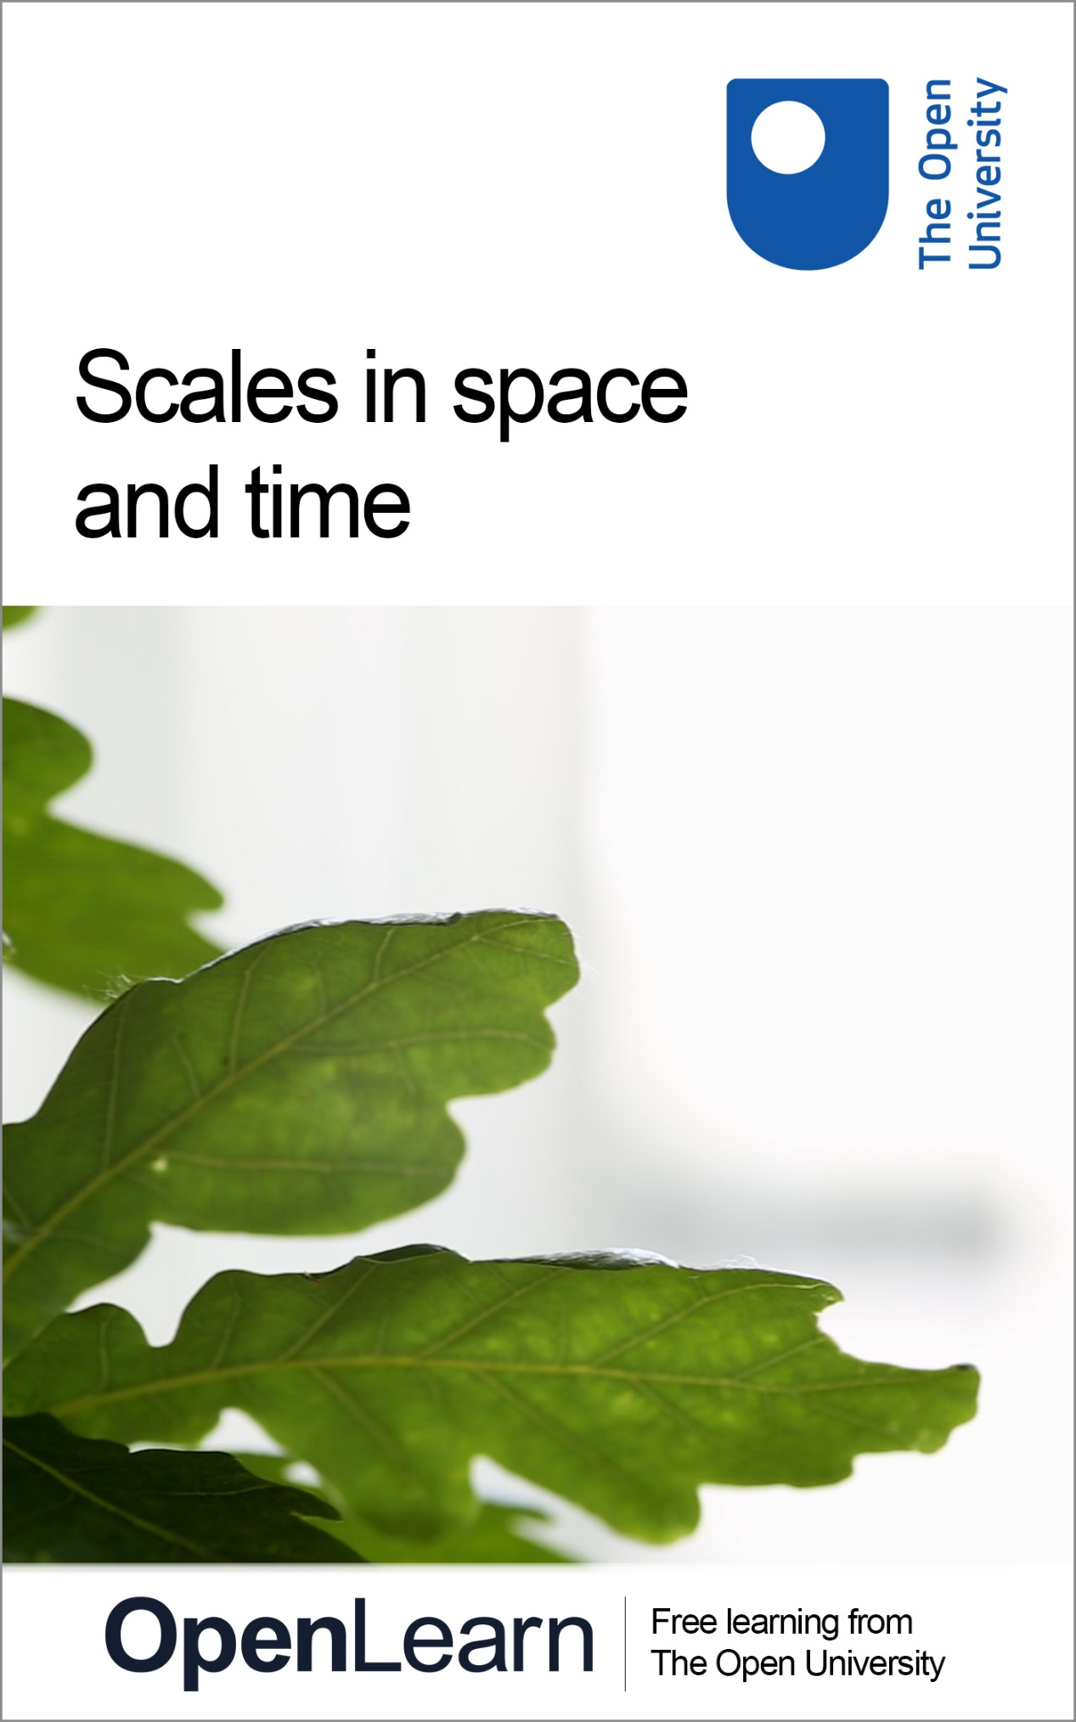

S112_1

Scales in space and time

About this free course
This free course is an adapted extract from the Open University course S112 Science: concepts and practice www.open.ac.uk/courses/modules/s112 .
This version of the content may include video, images and interactive content that may not be optimised for your device.
You can experience this free course as it was originally designed on OpenLearn, the home of free learning from The Open University –
www.open.edu/openlearn/science-maths-technology/scales-space-and-time/content-section-0
There you’ll also be able to track your progress via your activity record, which you can use to demonstrate your learning.
Copyright © 2019 The Open University
Intellectual property
Unless otherwise stated, this resource is released under the terms of the Creative Commons Licence v4.0 http://creativecommons.org/licenses/by-nc-sa/4.0/deed.en_GB. Within that The Open University interprets this licence in the following way: www.open.edu/openlearn/about-openlearn/frequently-asked-questions-on-openlearn. Copyright and rights falling outside the terms of the Creative Commons Licence are retained or controlled by The Open University. Please read the full text before using any of the content.
We believe the primary barrier to accessing high-quality educational experiences is cost, which is why we aim to publish as much free content as possible under an open licence. If it proves difficult to release content under our preferred Creative Commons licence (e.g. because we can’t afford or gain the clearances or find suitable alternatives), we will still release the materials for free under a personal end-user licence.
This is because the learning experience will always be the same high quality offering and that should always be seen as positive – even if at times the licensing is different to Creative Commons.
When using the content you must attribute us (The Open University) (the OU) and any identified author in accordance with the terms of the Creative Commons Licence.
The Acknowledgements section is used to list, amongst other things, third party (Proprietary), licensed content which is not subject to Creative Commons licensing. Proprietary content must be used (retained) intact and in context to the content at all times.
The Acknowledgements section is also used to bring to your attention any other Special Restrictions which may apply to the content. For example there may be times when the Creative Commons Non-Commercial Sharealike licence does not apply to any of the content even if owned by us (The Open University). In these instances, unless stated otherwise, the content may be used for personal and non-commercial use.
We have also identified as Proprietary other material included in the content which is not subject to Creative Commons Licence. These are OU logos, trading names and may extend to certain photographic and video images and sound recordings and any other material as may be brought to your attention.
Unauthorised use of any of the content may constitute a breach of the terms and conditions and/or intellectual property laws.
We reserve the right to alter, amend or bring to an end any terms and conditions provided here without notice.
All rights falling outside the terms of the Creative Commons licence are retained or controlled by The Open University.
Head of Intellectual Property, The Open University

Contents
- Introduction
- Learning outcomes
- 1 Working with large and small numbers
  - 1.1 Scientific notation
  - 1.2 Units
  - 1.3 Precision and magnitude
- 2 Exploring scales in space and time
  - 2.1 The Universe
  - 2.2 The Milky Way
  - 2.3 The Earth
  - 2.4 The British Isles
  - 2.5 An oak woodland
  - 2.6 An oak tree
  - 2.7 An oak leaf
  - 2.8 Stomata
  - 2.9 Chloroplasts
  - 2.10 Glucose
  - 2.11 Carbon
  - 2.12 Protons and neutrons
  - 2.13 Quarks and photons
- 3 Comparing and connecting scales
- Conclusion
- Acknowledgements
- Solutions

Introduction
In science, people encounter a huge range of scales both in space and time. These scales can be difficult to appreciate because they are beyond the range that the human body can perceive. For example, it is possible to measure timescales that are much longer than a person will ever live, and items that are far too small to see. In this short course, to deepen your appreciation of scales, you will explore both familiar scales and the extremes of what humans can measure.
Across multiple scientific disciplines, from biology and chemistry to physics and geology, time scales are explored that include ages, durations and rates, and size scales including distances in three dimensions, which underpin areas and volumes. In this short course, you will use an interactive ‘size–time explorer’ tool to help you get to grips with these ideas, and at the same time you will learn about the interconnections between multiple science disciplines.
An oak tree is a central feature in the size–time explorer. In the video below, different scientists introduce themselves and discuss how their subject area relates to an oak tree, at the same time talking about some of the different scales at which they work.

Video content is not available in this format.
View transcript - Uncaptioned interactive content

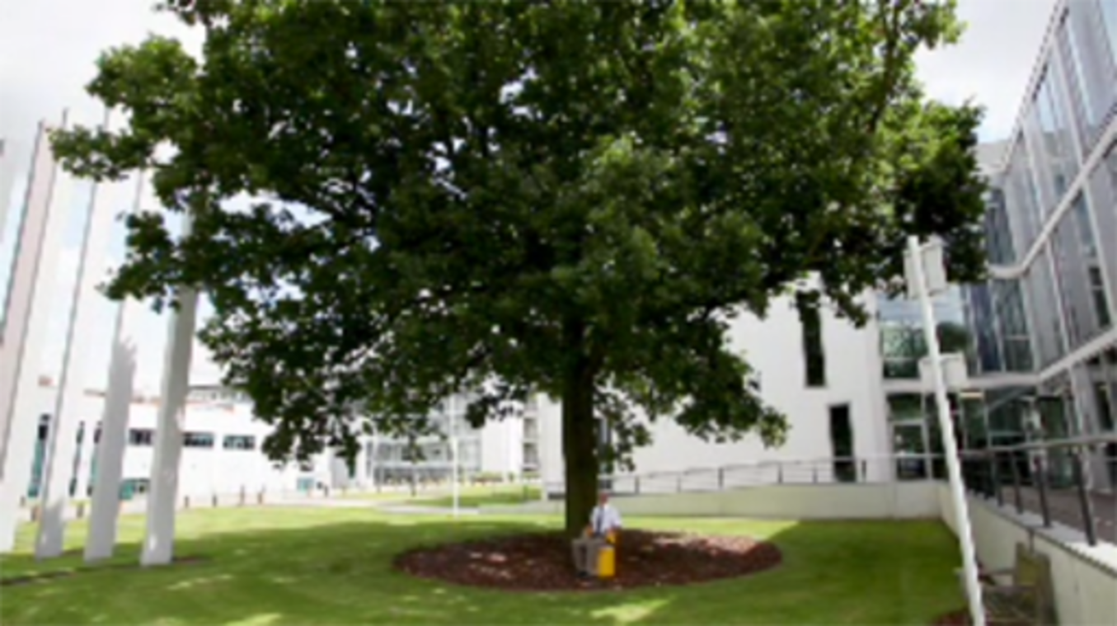

This OpenLearn course is an adapted extract from the Open University course S112 Science: concepts and practice.

Learning outcomes
After studying this course, you should be able to:
- demonstrate an understanding of the range of size and time scales encountered in science
- collect information from multiple sources
- use maths skills to convert between units and scales
- describe how processes on one scale can impact processes at another scale.

1 Working with large and small numbers
When exploring different scales, you will inevitably encounter very big and very small numbers, and need to be able to express these and use them in calculations. Values will also be measured to varying degrees of precision and sometimes presented in different units from those you are familiar with.
The size–time explorer and associated questions rely on some knowledge of some fundamental mathematical concepts that underpin scientific study and practice. Before you explore the tool it is worth spending some time (re-)visiting these mathematical ideas. This is a brief look at some principles before you have the opportunity to apply your skills to exploring scales, but links are provided to more in-depth maths support, if you need it.

1.1 Scientific notation
Large and small numbers are best expressed by using scientific notation. The convention of scientific notation is that a quantity is presented as a number, equal to or greater than 1 but less than 10, multiplied by a power of ten.
For example, 3500 000, or 3.5 million, is written as 3.5 × 10⁶. Here, the number part is 3.5, which is clearly greater than 1 but less than 10, and the power of ten is 6. Similarly, 0.0095 is written as 9.5 × 10⁻³ in scientific notation. Table 1 shows some examples of powers of ten and their meanings.

Table 1 Translating values into powers of ten
 | Thousands | Hundreds | Tens | Units | Tenths | Hundredths | Thousandths
Value | 1000 | 100 | 10 | 1 | 0.1 | 0.01 | 0.001
Power of 10 | 10³ | 10² | 10¹ | 10⁰ | 10⁻¹ | 10⁻² | 10⁻³

You might already be familiar with these concepts. Have a go at the following questions to test your knowledge.

- Write 365 000 000 in scientific notation.
- 365 000 000 is written in scientific notation as 3.65 × 10⁸.

- Write 0.0465 in scientific notation.
- 0.0465 in scientific notation is written as 4.65 ×10⁻².

How confident did you feel completing those questions?
- If you were able to answer the questions correctly then move straight to the next section.
- If you found some of the questions challenging then look at the additional maths resources that are available from the link below.

If you need any guidance on the maths content, take a look at the badged open course, Mathematics for science and technology.

1.2 Units
When exploring different scales, you will inevitably encounter a number of different units.
There is an International System of Units that gives a preferred unit (known as an SI unit) for each type of measurement. For time, this is seconds (abbreviated to s) and for distance this is metres (m). These are both known as base units.
There are seven base units in the SI system and every other SI unit can be expressed as a combination of these. As you will see, the main axes of the size–time explorer uses SI units, but you will come across other units that are also used for time and length. Note that when the symbols for units are used, do not make them plural. For example, write ‘4 cm’, not ‘4 cms’.

Units with prefixes
The SI system also includes standard prefixes that provide another way to write large and small values more efficiently. You will be familiar with a kilo, meaning a thousand, from a kilometre (1000 m), and also centi, meaning a hundredth, from centimetres (0.01 m, or one-hundredth of a metre). So, instead of writing 3000 metres, write 3 kilometres, or 3000 m = 3 km. Similarly, 0.04 m = 4 cm.
Table 2 contains a selection of prefixes, from the large to the small. Note that the case, or capitalisation, of the symbol is important; for example, a mm is a thousand million (i.e. a billion) times smaller than a Mm. Also, there is not a prefix for every power of ten. Some prefixes, such as deca (da), are rarely used.

Table 2 Examples of prefixes
Name | Symbol | 10^{n} | Meaning
giga | G | 10⁹ | 1000 000 000
mega | M | 10⁶ | 1000 000
kilo | k | 10³ | 1000
hecto | h | 10² | 100
deca | da | 10¹ | 10
 |  | 10⁰ | 1
deci | d | 10⁻¹ | 0.1
centi | c | 10⁻² | 0.01
milli | m | 10⁻³ | 0.001
micro | µ | 10⁻⁶ | 0.000 001
nano | n | 10⁻⁹ | 0.000 000 001

Apart from centi, which is commonly used in centimetres, and deci, which is sometimes used to measure volume in decilitres, the major prefixes increase or decrease by three powers of 10: kilo (10³), mega (10⁶), giga (10⁹), for example.

- How would you describe 0.000 003 seconds using a SI prefix?
- 0.000 003 seconds can be written as 3 microseconds, or 3 µs.

- How would you describe 0.045 metres using a SI prefix?
- This can be written as 45 millimetres or 45 mm, or alternatively as 4.5 centimetres or 4.5 cm. Both are correct, but one may be more appropriate than the other in a given context.

Although metres and seconds are the standard SI units for length and time, other units are sometimes used that are appropriate to scales frequently encountered in a particular field. For example, the age of a person might be given in years (y) rather than in seconds as it is more meaningful in that context. However, it can be easily converted from one unit to another, and during this course you will become familiar with that process.
Note that you will encounter both SI units and other commonly used units in the size–time explorer.

Don’t forget, if you need any guidance on the maths content, take a look at the badged open course, Mathematics for science and technology.

Compound units and rates
Some quantities need multiple units (known as compound units) to describe them. One such quantity is speed, which is a measure of distance travelled over time taken.
For example, at the time of writing (2017), the women’s world record for the 100.0 m sprint is 10.49 s, as set by Florence Griffith-Joyner in 1988. To calculate the (average) speed at which she ran, you need to divide the distance over the time:

Her average speed was therefore 9.532 metres per second (m s⁻¹). This value describes the average rate at which she covered distance over the course of the race, namely 9.532 metres every second.
Note the way the units are written in the example above. The result of the calculation could be reported as ‘metres per second’, ‘m per s’ or ‘m/s’, but ‘m s⁻¹’ is most appropriate for scientific reporting as it is the most concise.
The notation of ‘negative exponents’ is commonly used for units. So, for example, just as , can be expressed as s⁻¹ and as m⁻³. Writing compound units using negative exponents is generally good scientific practice.
You should also note that care is needed when writing and interpreting compound units. A space is required between the ‘m’ and the ‘s’ in m s⁻¹. The unit ms⁻¹ has a completely different meaning, namely ‘per millisecond’.
Any quantity that changes with time can be expressed as a rate. For example, it takes 5 minutes for an oven to heat up from room temperature, 20 °C, to 200 °C. The change in temperature is 180 °C, so the (average) rate at which the temperature changes is:

Usually SI units should be used for calculations, which is why minutes were converted to seconds in the example above. However, at times, other non-SI units might be more meaningful. For example, reporting the oven temperature in degrees Celsius (°C) is far more familiar than using the SI unit of temperature – kelvin, K.
It is important to include units throughout a calculation, as well as in a final answer. It makes it clear to the reader (and yourself!) what units are used, and where units have been converted.

Don’t forget, if you need any guidance on the maths content, take a look at the badged open course, Mathematics for science and technology.

1.3 Precision and magnitude
When working with quantities at any scale, and when combining numbers through addition, multiplication, etc., it is important to report the answers with an appropriate level of precision. To do this you need to consider the number of significant figures, which is the number of digits that carry a ‘meaning’ for the measurement.
The cardinal rule here is shown below:

Key point
An answer in a calculation cannot be more precise than the least precise number used in that calculation.

For example, 361 has three significant figures and 31.01 has four significant figures. When reporting an answer to a calculation, you should use the number of significant figures from the least precise value (or value with the smallest number of significant figures) in the calculation.
If you multiply 361 by 31.01, the answer provided by a calculator is 11 194.61. This value has seven significant figures, but the least precise value in the calculation (361) has just three significant figures. The answer should therefore be quoted to the same level of precision, which is 11 200. In this example, the part of the number that affects the third significant figure, namely 194.61, is rounded to 200 rather than 100. (More information on rounding is provided in Box 1.)

Box 1 A reminder about rounding
When rounding values, look only at the digit immediately to the right of where you want to stop the number of significant figures. If it is less than 5, round it down, if it is equal to or greater than 5, round it up.
For example, if rounding 11 194.61 to three significant figures, stop after the third significant figure. Therefore, look at the digit to the right of this third significant figure, and see it is a 9. As 9 is greater than or equal to 5, round up by increasing the third significant figure by 1. In effect, 11 194.61 is nearer to 11 200 than it is to 11 100.

When giving an answer to a calculation you should also quote the number of significant figures used. Note that you can do this by stating ‘to x significant figures’ in your final answer, or abbreviate it as ‘to x sig figs’ or even ‘to x s.f. (where x is the number of digits in question).

Precision and exact integers
There are some special cases where numbers do not affect the number of significant figures, such as exact integers. Sometimes this is encountered this when applying a formula.
For example, the perimeter of a square = 4 × edge length, because, by definition, a square has four sides of equal length. Here the integer 4 is exactly four, and not more or less. A square has exactly four sides so this number is a multiplier and not an amount measured.
The edge length, in contrast, is a measure, and therefore determines how precisely the perimeter can be reported. If the side of a square was measured be 2.62 cm, which has three significant figures, then:

Note, again, that the answer given by the calculator has been provided as well as the answer rounded to the appropriate number of significant figures to make work flow clear. This approach is good practice when it is appropriate to show working in calculations.

Significant figures and decimal places
When using numbers with decimal places, zeros that are after the decimal point but precede non-zero numbers are not included in the count of significant figures. Such digits are just place-holders indicating number size, and they are not giving you information about how precisely you know the value. For example, 0.0034 has two significant figures, meaning you are confident it is closer to 0.0034 than it is to 0.0033 or 0.0035.
In contrast, when dealing with zeros that fall after the decimal point and follow non-zero numbers these digits are significant, because they are giving you information about the precision. So 0.00340 has three significant figures, meaning you are confident it is closer to 0.00340 than it is to 0.00339 or 0.00341.
This is a special case that only affects decimal numbers. So, 3000 has one significant figure, but 3000.0 has five significant figures because it indicates that it has been measured to one decimal place. Another benefit of using scientific notation is that it is an efficient way to show the number of significant figures. For example, 3000 would be written in scientific notation as 3 × 10³ but 3000.0 would be written as 3.0000 × 10³, where it is clear that the second number has more (five) significant figures.
You might already be familiar with the concepts of precision and significant figures. A selection of questions is provided below for you to test your knowledge.

- If you multiply 3.01 by 2.1 (3.01 × 2.1) to how many significant figures should you report the answer?
- The answer should be reported to two significant figures because 2.1 is the least precise number and is quoted to two significant figures.

- What is the result of multiplying 3.01 by 2.1, to the correct level of precision?
- 3.01 × 2.1 = 6.321, which to two significant figures is 6.3 (because 6.321 is nearer to 6.300 than it is to 6.400).

- Express 2052 × 0.033 with the appropriate precision.
- The exact answer is 67.716, which has five significant figures. However, 2052 is significant to four figures and 0.033 is significant to two figures. The answer should therefore not be quoted to more than two significant figures either, so 67.716 = 68 to 2 sig fig.

- Express the number 9.2499 × 10³ to two significant figures.
- 9.2499 × 10³ is expressed as 9.2 × 10³ to two significant figures. (The first digit after the final significant figure in question is 4, which is less than 5 so the number is rounded down to 9.2 rather than up to 9.3.)

Magnitude
It can be just as important to appreciate that an answer is in the tens versus in the millions, as it is to know the exact amount. Alongside precision you need to develop an appreciation of the magnitude of numbers. You do this by considering the nearest power of ten. For example, 340 m is closer to 100 m (10² m) than it is to 1000 m (10³ m). Hence its nearest order of magnitude is 10².
An example of when the magnitude of a number is useful is if someone has over 10 million followers on Twitter. Knowing there are roughly 10⁷ people potentially reading their tweets may be more important than knowing exactly how many there are at a given minute. Using another Twitter example, someone with 83 839 followers has closer to 100 000 followers than 10 000 followers, hence the magnitude or power of ten that best describes their following is 10⁵.
Using the magnitude, you can then easily compare between these two examples:

Note that ~ means ‘approximately equal to’, and applies only to the first step in the expression above because the exact numbers of followers has been rounded to provide these values. The three parts thereafter are exactly equal to one another, which is why the equals symbol (=) has been used.
Ten million (10⁷) is one hundred (10²) times larger than one hundred thousand (10⁵), or two orders of magnitude greater. It is therefore easy to see that Person 1 has 100 times more followers than Person 2.
Note also that the order of magnitude quoted is the power of ten difference between the two numbers, in this example, 2. It is important to appreciate that if A is two orders of magnitude larger than B, then A is 100 times larger, not twice as large.
You might already be familiar with the concepts of magnitude. A question is provided below for you to test your knowledge.

- Express the number 9.2499 × 10³ to the nearest order of magnitude.
- 9.2499 × 10³ is approximately 10⁴ to the nearest order of magnitude, because 9.2499 × 10³ is closer to 10⁴ than 10³. That is, 9249.9 is closer to 10 000 than 1000.

Don’t forget, if you need any guidance on the maths content, take a look at the badged open course, Mathematics for science and technology.

2 Exploring scales in space and time
An interactive ‘space-time explorer’ has been built for you to investigate, to help you develop an appreciation for different scales in space and time that are encountered in science. It houses much of the learning content for this course.
The size–time explorer provides videos and slide shows that describe processes at very different scales. In addition to observing these processes, the visual resources are accompanied by a series of self-assessment questions in which you will make calculations relating to the processes selected to appreciate the significance of the scales. As an example, in one question you will use data from a video to work out how many leaves an 800 year old oak might produce in its lifetime (hint: it’s a lot!).
The explorer is an interactive graph, with time in seconds on the x-axis, and size in metres on the y-axis. The numbers on each axis are presented as powers of ten on a logarithmic scale (usually referred to as a log scale), which allows a large range in scales to fit in a small space.
On the graph, there are the 13 levels, shown as cream-coloured bars, which each represent a process. You will be making measurements and carrying out calculations using data from the resources provided in these levels, so it might be helpful to have a pen and paper ready for making notes, as well as a calculator. Some levels also include links to an activity within the explorer where you will add entries to the existing scales.
Here is the size–time explorer. Open the explorer in a new browser tab or window and leave it open there, to help you to navigate between it and the associated questions. There are instructions for what you will need to do in the next section, but for now, familiarise yourself with the interface:
- use the ‘?’ (‘Help’) button for instructions on how to navigate around the explorer
- scroll along both axes to see what scale levels are available
- play a video/or a slide show (the ‘Oak tree’ level is a good one to start with)
- identify the chain-link symbol that opens the associated questions.

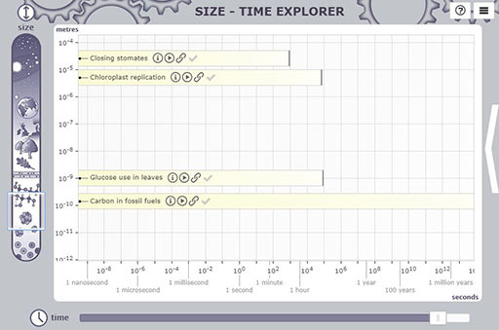

Interactive content is not available in this format.

Activity 1 Explore scales in space and time
Allow approximately 10 hours in total

To begin, access the size–time explorer and pick one of the 13 levels of scale. It is recommended that you start at the oak tree, as this should be a fairly familiar level of scale.
In the explorer, for each level you will find a brief description and also a resource in the form of a short video or slide show with accompanying audio. Familiarise yourself with the resource and then click on the ‘Link to materials’ icon for that level to access some associated questions.
You will then be asked to watch the video or slide show again, this time making notes about specific things. Armed with this information, you should then work through the questions presented.
You should aim to spend 30–40 minutes studying each level and answering the associated questions, although you may find that some sections can be completed in a shorter time period. Note that you can also use the checkboxes within the explorer to mark levels complete once you have finished studying them.
You can either study the levels of scale by investigating the size–time explorer or you can work through the levels given in the following sections on this course. The choice is yours; the content is the same, but it may help you to appreciate the relationship between levels if you return to the tool between activities.

Study note
The questions within the sections that follow are entirely formative, and answers/feedback will be given as you go along. This means that answers you put in will not be saved if you break from the quiz, so close down your browser and return to it later on.

2.1 The Universe
This video provides a brief history of the Universe and gives details of its age and size today. The questions that follow will help you discover the time and space scales that correspond to the biggest and oldest objects in the size–time explorer. First you will look at describing the age and size of the Universe in SI units, and then consider how quickly some of the early occurrences in the Universe took place.
While watching the video, record the following information to use in the questions that follow:
- the age of the Universe today
- the diameter of the Universe today (in metres)
- the times that events occurred since the big bang.

Video content is not available in this format.
Origins of the Universe
View transcript - Origins of the Universe

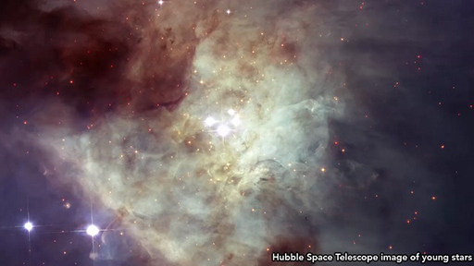

Question 1

Interactive content is not available in this format.

Question 2

Interactive content is not available in this format.

Question 3

Use your notes from the video to identify which of the following two tables correctly describes the events and temperatures that occurred after the big bang:

Table 3A
Event | Temperature/K | Time since big bang/s
big bang | unknown | 0
neutrons and protons formed | ~100 000 | 10⁻⁶
quarks exist in a plasma | 100 000 000 000 | 10⁻¹²
quarks and other fundamental particles form stable particles | 10 000 000 000 000 | 10–1000
today | 2.7 | × 10¹⁷

Table 3B
Event | Temperature/K | Time since big bang/s
big bang | unknown | 0
quarks exist in a plasma | 10 000 000 000 000 | 10⁻¹²
quarks and other fundamental particles form stable particles | 100 000 000 000 | 10⁻⁶
neutrons and protons formed | ~100 000 | 10–1000
today | 2.7 | × 10¹⁷

View answer - Question 3

Question 4

Use the information from Question 3 to consolidate your learning and fill in the missing gaps in the paragraph below.

Interactive content is not available in this format.

Summary
Here, you learned about the current size of the Universe and its age, as well as it origin by working backward through time. The Universe is the biggest thing known, but considering how it began requires you to think about some of the very smallest things known, including subatomic particles such as protons and neutrons.

Next: That’s as big as possible! Now return to the size–time explorer to choose your next level of scale, or use the ‘Next >’ button to go to the next level down on the size scale.

2.2 The Milky Way
This video describes our Galaxy (the Milky Way) and another nearby galaxy, Andromeda. The distances describing their size are measured in light-years (abbreviated to ly), and the timescales describing their movement in millions and billions of years. Here, to appreciate the size of a light-year, you will convert some of these distances and durations into standard SI units and generate some very big numbers in the process!
While watching the video, record the following information to use in the questions that follow:
- the definition of a light-year
- the diameter of the Milky Way and the time it takes to rotate once
- the examples of elements produced in smaller stars
- the distance from the Milky Way to Andromeda, and the time it is expected for the two galaxies to collide.

Video content is not available in this format.
The Milky Way
View transcript - The Milky Way

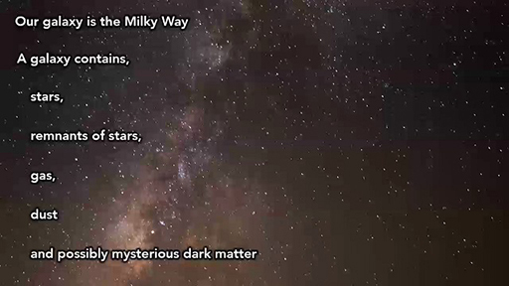

To convert from millions and billions of years to seconds, which are the SI units of time, you first need to calculate how many seconds there are in a year.

Question 1

If you consider a year to have 365.25 days (to account for leap years), how many seconds are there in a year? Give your answer to three significant figures.

Interactive content is not available in this format.

Question 2

The smallest size scale of the scale comparator tool states that the speed of light in a vacuum is approximately 3.0 × 10⁸ m s⁻¹. Use the definition of a light-year from your notes, together with your answer from Question 1, to fill in the gaps and so calculate how far a light-year is in metres.

Interactive content is not available in this format.

Question 3

How wide is the Milky Way? Use your calculation of the length of a single light-year, together with your notes from the video, to convert the diameter of the Milky Way from light-years (ly) to metres.

Interactive content is not available in this format.

View discussion - Question 3

Question 4

Interactive content is not available in this format.

Question 5

In other sections of the size–time explorer you learn about photosynthesis, which is the fixing of carbon dioxide (CO₂) into carbohydrates using light as energy. Complete the following paragraph, which describes how stars are the source of the components of this reaction described above.

Interactive content is not available in this format.

Question 6

The video introduced another galaxy, Andromeda, which is 2.5 million light-years away. Researchers predict that the Milky Way and Andromeda galaxies will collide in about 4.5 billion years.
Use the calculations above as a model to convert this distance and time to SI units then add the bar ‘Milky Way collision with Andromeda’ to the size–time explorer. (You may want to open the explorer in a new tab in your browser, for ease of reference back to these questions.)

Summary
In this section you learned about our Galaxy, the Milky Way. By converting light-years (a measure of distance based on the speed of light) into metres you made calculations with very large numbers. Using these big numbers allowed you to gain an appreciation of the size of galaxies and why scientists use alternative units when scales are very large. (The same occurs at very small size scales.)
Stars are the most visible component of a galaxy in comparison to star remnants, gas and dust. They release light and form elements, which are fundamental to life on Earth.

Next: Take a look at the Universe now, but you can also return to the size–time explorer and select a level for yourself, or use the ‘Next >’ button to go to the next level down on the size scale.

2.3 The Earth
In the slide show below, the dimensions of the Earth and its trajectory around the Sun are given, together with the time it takes the Earth to spin on its axis and complete an orbit of the Sun. Using these data, you can consider the speed at which the Earth is moving. The way to describe a unique location on Earth is covered, along with the implications for life of the Earth’s motion over different timescales.
While working through the slides, record the following information to use in the questions that follow:
- the average radius of the Earth
- the average distance and duration of the Earth’s orbit around the Sun
- the time it takes for the Earth to spin once on its axis.

Interactive content is not available in this format.
Implications of the spin and orbit of Earth

Question 1

What is the average circumference of the Earth? Use the value of the radius you recorded from the video and the following equation:
- circumference = 2 × π × r
where r is the radius and π has a value of 3.14.
Write your answer without spaces between consecutive digits, and don’t forget to consider significant figures.

Interactive content is not available in this format.

View discussion - Question 1

Question 2

The circumference at the Equator is 40 030 km. (Remember the Earth is widest at the Equator so this value is slightly different from that given in Question 1.) Ignoring the fact that the Earth is travelling around the Sun, how fast would you be moving if you were standing at the Equator? (Note that speed is calculated as distance travelled over (divided by) time taken, and you’ll need to use the time it takes for the Earth to rotate once in your calculation.)
Give your answer to the nearest km h⁻¹, remembering to quote your answer to the correct number of significant figures.

Interactive content is not available in this format.

Question 3

When standing in the Equator, or indeed anywhere on Earth, you don’t feel as though you are moving at such high speeds as you have just calculated (or indeed any speed). The following is an explanation given by one of the physicists at The Open University. Use your developing knowledge of units, and rates, to complete the paragraph by selecting the correct options from the drop-down lists.

Interactive content is not available in this format.

View discussion - Question 3

As described in the slides, locations at the same latitude experience the same lengths of day. Locations at the same longitude are (generally) in the same time zone, but experience differences in day length across the year due to the tilt of the axis on which the Earth spins. you can compare two locations: High Park in England (51.84 °N, 1.4 °W), which is marked on Figure 1, and the city of Accra (5.6 °N, 0.2 °W).

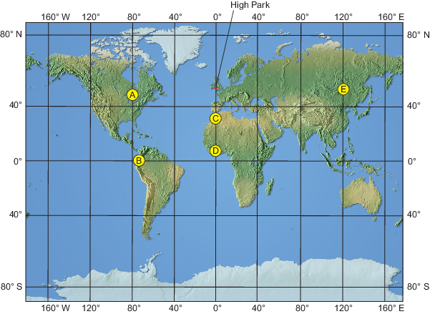
Figure 1 Flat projection of the world with High Park shown, and five other locations (see circles A–E)
View description - Figure 1 Flat projection of the world with High Park shown, and five other locations ...

Question 4

Interactive content is not available in this format.

Question 5

To explore the variation in the time that locations have daylight, Table 4 below gives the sunrise and sunset times for two locations at the same longitude but different latitudes. Some of the values are missing (see X–Z). Select the correct daylight length times for these values from the options below.

Table 4 Sunrise and sunset times (nearest 15 minutes), daylight length and long-term minimum and maximum daily temperatures for two locations on the same longitude: High Park, England (Europe) and Accra, Ghana (Africa).
 | High Park, United Kingdom  Latitude: 51.84 °N |  |  |  | Accra, Ghana  Latitude: 5.6 °N
 | Sunrise | Sunset | Daylight length/hours:min | Min–max temp/°C | Sunrise | Sunset | Daylight length/ hours: min | Min–max temp/°C
Mar 20 | 6:00 | 18:15 | W | 3.7–10.0 | 6:00 | 18:15 | 12:15 | 24.5–32.5
Jun 20 | 4:45 | 21:30 | X | 10.9–20.3 | 5:45 | 18:15 | 12:30 | 22.8–29.6
Sep 20 | 6:45 | 19:00 | Y | 10.7–19.1 | 5:45 | 18:00 | 12:15 | 22.5–29.1
Dec 20 | 8:15 | 15:45 | Z | 2.3–7.7 | 6:00 | 18:00 | 12:00 | 22.5–31.6

Interactive content is not available in this format.

Question 6

Using Table 4, describe the changes in day length over a year in both locations including how much that time changes over the year. How do these changes relate to variation in temperature? (You answer should be 100–150 words.)
Compare your answer to ours once you have completed it.

Provide your answer...
View answer - Question 6

Question 7

Consolidate your knowledge by considering how the environmental conditions resulting from the Earth’s properties relate to the biology of an oak. Complete the following paragraphs by selecting the correct options from the drop-down lists.

Interactive content is not available in this format.

How the distance the Earth travels around the Sun compares to the other distance scales encountered has not yet been considered. The final question in this section will allow you to do that, and combine it with how long that orbit takes.

Question 8

Calculate the average trajectory distance of the Earth around the Sun in metres, and also the time this takes in seconds, then use these to add the bar ‘Earth’s orbit around the Sun’ bar to the size–time explorer. (Remember that you can use the ‘Link to material’ icon to return to these questions once you’ve added your new bar to the explorer.)

Summary
In this section you considered how the rotation of the Earth and its orbit around the Sun affects the planet. Specific locations can be described with values of latitude and longitude. Using information from multiple scales in time and space you were able to consider how planetary motion relates to chemical reactions in leaves. Through calculations you considered how fast a point at the Equator moves as the Earth spins.

Next: Learn about galaxies or you can return to the size–time explorer and choose a level for yourself, or use the ‘Next >’ button to go to the next level down on the size scale.

2.4 The British Isles
The following video presents information about how oaks colonised the British Isles after the last ice age using data from scientific papers (Birks, 1989; Clark et al., 2012; Lowe et al., 2005). You will use the information in the video to calculate how quickly they spread. You will also look at how references to sources of information are presented and what each part of one means, so that you can see when it was published and be able to find the source again easily.
While watching the video, record the following information to use in the questions that follow:
- the year of the first record of oaks in the British Isles
- the year the most northerly record was reached
- the details of the publication that the map with the coloured arrows came from.

Video content is not available in this format.
Oak colonisation of the British Isles
View transcript - Oak colonisation of the British Isles

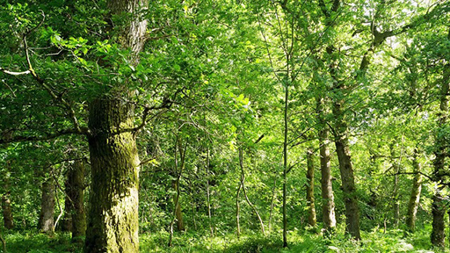
View description - Uncaptioned Figure

Question 1

How long ago did oaks first arrive in the British Isles? Give you answer to the nearest 500 years.

Interactive content is not available in this format.

Figure 2 is a repeat of one of the figures in the video but here one route of oak dispersal in the British Isles is picked out in red.

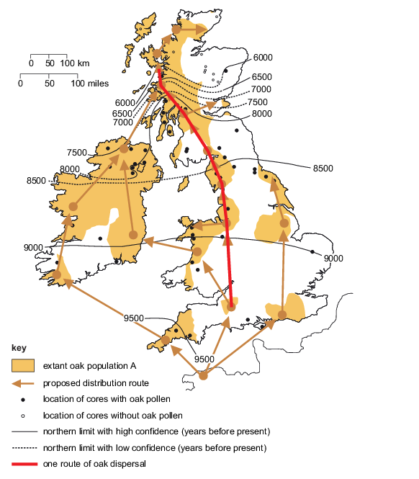
Figure 2 One route of oak dispersal in the British Isles indicated by the dark red line.
View description - Figure 2 One route of oak dispersal in the British Isles indicated by the dark red ...

Question 2

Using Figure 2, estimate the distance that the dark red line represents.

Interactive content is not available in this format.

Question 3

Approximately how many years are represented by the line in Figure 2 that traces this particular oak dispersal route?

Interactive content is not available in this format.

Now you know the distance and the timescale involved, you can calculate the rate at which oaks spread through the British Isles.

Question 4

How fast did the oak spread along the dark red line in Figure 2? Don’t forget to give your answer to the correct number of significant figures.

Interactive content is not available in this format.

Question 5

Does this rate seem reasonable? If you think about an oak dispersing acorns, what does this number mean? Write some notes on the interpretation of what the rate means and how realistic the rate might be. (Your answer should be between 100 and 200 words.)

Provide your answer...
View answer - Question 5
View discussion - Question 5

The data in Figure 2 stem from a combination of diagrams from published scientific papers. The details of the papers were provided in the video, where this figure also appeared.
The map with the dated pollen cores came from the reference below and, in order, this reference shows: the author, year of publication, article title, journal, journal volume and the starting and finishing page numbers of the original article.

Birks, H.J. (1989), ‘Holocene isochrone maps and patterns of tree-spreading in the British Isles’, Journal of Biogeography, vol. 16, pp. 503–40.

Question 6

Another paper reported the DNA of extant oaks. It is important that you can identify the source of information and know how to interpret a reference. When viewing the video you were asked to jot down the details of the paper that identified the various routes of oak distribution. Use your notes to complete the following statements by selecting the correct options from the drop-down lists.

Interactive content is not available in this format.

View discussion - Question 6

Summary
The video collated information from published research papers, and with some additional measurements and calculations you worked out how far and how fast oaks spread. You were also able to interpret the references to identify the first author, the year it was published and in which journal – information that could help you search for the original papers in the library, or prepare your own reference list.

Next: By looking at a planet level, learn more about the Earth or you can return to the size–time explorer and choose a level for yourself, or use the ‘Next >’ button to go to the next level down on the size scale.

2.5 An oak woodland
The following video describes oak woodlands and their history in the United Kingdom. High Park, at Blenheim Palace in central England, is used as an example of a woodland that has been better preserved than in many other areas. Using information from the video you can consider the size of the woodland remnant, how long it has been protected and the implications of these values for conservation.
While watching the video, record the following information to use in the questions that follow:
- the area of High Park at Blenheim Palace in km²
- the span of years since the ecosystem was provided with a first level of protection.

Video content is not available in this format.
An oak woodland ecosystem
View transcript - An oak woodland ecosystem

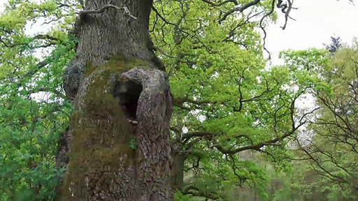

Question 1

How big is the area of the oak woodland ecosystem in High Park?

Interactive content is not available in this format.

The area of the ecosystem is a two-dimensional measure of space, as outlined by the solid line in Figure 3.

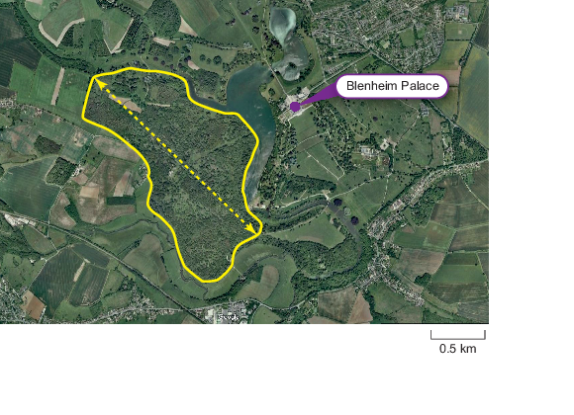
Figure 3 Map of High Park showing the outline of the main area of the woodland ecosystem. The location of Blenheim Palace is provided to assist with orientation.
View description - Figure 3 Map of High Park showing the outline of the main area of the woodland ecosystem. ...

Question 2

From the map in Figure 3, what is the longest length of the main area in metres, as illustrated by the dotted line? Note that you will need to estimate the length and then convert it to the appropriate units.

Interactive content is not available in this format.

Question 3

If you assume that the woodland was protected in the middle of King Henry I’s life, by 2017 CE how long had the ecosystem been protected? (Use your notes from the video about the dates of his life to work out the midpoint.)

Interactive content is not available in this format.

Question 4

A Forestry Commission report says:

In prehistoric times England was largely covered with woodland. By the end of the first millennium much had already been cleared to satisfy the needs of an increasing population, with the Domesday records showing approximately 15% woodland cover across England. This trend continued, and by the end of the nineteenth century woodland had dropped to below 5%. Since then England’s forest and woodland area has been expanding, and by the beginning of the twenty-first century there were over 1.1 million hectares, equivalent to 8.4% woodland cover.
(Smith and Gilbert, 2001)

Using the dates above, comment on why protected ancient woodlands such as High Park are so valuable. (Your answer should be between 50 and 100 words.)

Provide your answer...
View answer - Question 4

In the video an example of a food-web was shown, with arrows showing energy flow between organisms (Figure 4). For example, an arrow points from the grass and another goes from the rabbit to the fox, indicating the rabbit gets its energy by eating grass, and the fox obtains energy from eating the rabbit.

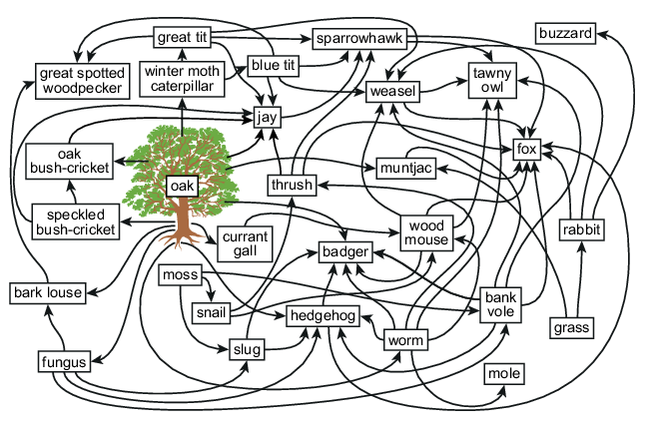
Figure 4 A food-web for selected species in an oak woodland ecosystem.
View description - Figure 4 A food-web for selected species in an oak woodland ecosystem.

Question 5

In Figure 4, the fox has eight arrows pointing to it, indicating that at least eight different organisms form its food supply. If one of those animals were not present in the ecosystem, the fox would have other food choices.
The winter moth caterpillar, currant gall and speckled-bush cricket only have one arrow leading to them, indicating that their food/energy supply entirely comes from the oak. What does this tell us about the value of oaks in the ecosystem? (Your answer should be about 50 words.)

Provide your answer...
View answer - Question 5

Question 6

Tables are a useful way to summarise data and can be used to organise calculations. Table 3 shows the areas of broadleaf woodland in England determined by the Forestry Commission in 2001, divided into woodlands with different dominant trees. They have distinguished between areas of woodland that are greater than 0.02 km² and those that are smaller. Larger areas are considered more resilient because they are more likely to contain closer to the full suite of ecosystem species, including large herbivores that need space, and have an area large enough to resist invasive plants from the edges. The total area of each forest type (the sum of the two area categories) is also given.
Calculate the missing values for areas of woodland in Table 5 (i.e. X and Y) and then select the sentence that correctly interprets the table from the four options below.

Table 5 Broadleaf woodland in England (Smith and Gilbert, 2001)
Main species/forest type | Woodland area/km² |  | Total area km²
 | Areas 0.02 km² and greater | Areas 0.001–0.02 km²
Oak | 1478 | X | 1586
Beech | 606 | 35 | 641
Sycamore | 450 | 38 | 488
Ash | 963 | 86 | Y
Birch | 685 | 11 | 696
Other broadleaves | 896 | 210 | 1106
Mixed broadleaves | 775 | 134 | 909
Total | 5853 | 622 | 6475

Interactive content is not available in this format.

Question 7

Choose the correct words from the drop-down lists to complete the paragraph below to consider the significance of the preservation of the oak ecosystem in the video, using information from Table 5.

Interactive content is not available in this format.

Summary
In this section, you learned about a remnant of oak woodland in the grounds of Blenheim Palace that contains ancient oaks. It is a valuable site because oaks have long lifespans and so the ecosystems in which they occur need long-term protection to persist and allow oaks to reach the large size that supports many other species.

Next: Now look at how oaks colonised the British Isles, or you can return to the size–time explorer and choose for yourself, or use the ‘Next >’ button to go to the next level down on the size scale.

2.6 An oak tree
The following slide show describes the life of an oak, using an ancient oak from High Park at Blenheim Palace as a particular example. To better appreciate the age and size of the oak, and the link between them, some calculations are needed.
While working through the slides, record the following information to use in the questions that follow:
- the age and girth of the oldest High Park oak
- the period over which an oak grows fastest
- the approximate age at which an oak becomes mature and produces acorns.

Interactive content is not available in this format.
The life of an ancient oak

Question 1

Use the conservative age of the ancient oak, estimated in 2017, to calculate the year in which it would it have germinated if it was exactly this age.

Interactive content is not available in this format.

Question 2

Using some of the other information that you recorded, in which year did the High Park oak’s ‘growth spurt’ end if it was exactly it’s conservatively estimated age?

Interactive content is not available in this format.

Question 3

The time axis in the size–time explorer is in seconds, and the size axis is in metres. Nevertheless, you can use many other units for time (minutes, days, weeks, millennia) depending on the context, so you need to be able to convert between them.
In this question, you will calculate, step by step, the age in seconds of the ancient High Park oak – assuming it is exactly 800 years old. Use the interactive Figure 5 to help you work through the calculations from converting years to days (assuming 1 year = 365.25 days to include leap years), then to hours, to minutes and finally to seconds. At this stage don’t worry about significant figures or scientific notation.

Interactive content is not available in this format.
Figure 5 Convert the age of the ancient oak into SI units of seconds.

Question 4

Give the age of the oak in standard scientific notation to three significant figures.

Interactive content is not available in this format.

View discussion - Question 4

Now let’s look now at how the oak changed in size over that time. The tree heights over time from the slides are plotted in Figure 6. The first seven data points from the left were calculated from an approximately 220 year-old tree felled at Blenheim Palace, and the data point on the extreme right is from a 800 year old oak that is still standing there.

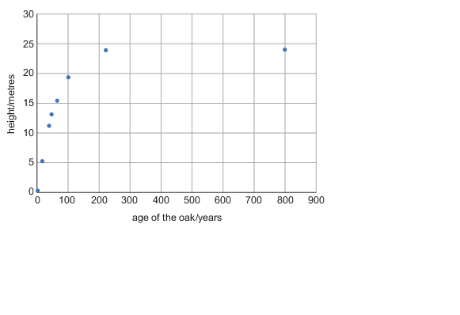
Figure 6 Change in height of an oak tree with age (Sylva Foundation, 2017).
View description - Figure 6 Change in height of an oak tree with age (Sylva Foundation, 2017).

Question 5

Select the terms from the drop-down options below that best describe the graph in Figure 6

Interactive content is not available in this format.

Question 6

What is the girth, or distance around the trunk, of the ancient High Park oak?

Interactive content is not available in this format.

Summary
Oaks can live for over one thousand years, but ancient oaks are rare. Survival to this age requires successful germination, growth through seedling and sapling stages, withstanding damage from herbivores and weather and, across the British Isles, being protected from being cut down for timber. Oaks grow very quickly for about 120 years, rapidly increasing in height in this time, in comparison to later years. Many other species depend on oaks, making them a critical part of oak woodland ecosystems.

Next: It is recommended that you keep zooming in, and looking at parts of an organism or living thing – in this case a leaf on the oak, which you can do with the ‘Next >’ button. Alternatively, you can return to the size–time explorer and choose a level yourself.

2.7 An oak leaf
In the following video you will learn that leaves are organs to collect light and carbon dioxide. There is a substantial diversity of leaf sizes among plant species. You will also learn about the size and longevity of oak leaves. When you have watched the video, you will carry out some calculations to determine how much leaf size varies across plant species, how many leaves an oak might produce in its lifetime. You will also consider the benefits and limitations of making estimates.
While watching the video, record the following information to use in the questions that follow:
- the leaf length of the Amazonian water lily and tiny Wolffia leaves
- the size of an oak leaf (length)
- the approximate lifespan of a leaf (in months or weeks)
- the number of leaves on trees of different ages
- the thickness of an oak leaf, and the amount of time that leaves take to expand.

Video content is not available in this format.
The lifetime of oak leaf
View transcript - The lifetime of oak leaf

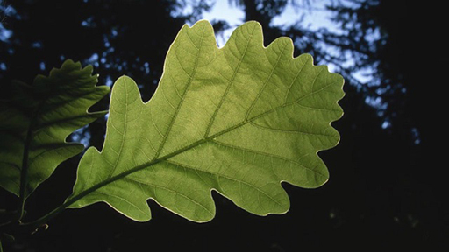
View description - Uncaptioned Figure

To begin with, get a feel for the range of leaf sizes across species.

Question 1

The video describes one of the largest simple leaves as the Amazonian waterlily (genus Victoria) and one of the smallest from the genus Wolffia. How many orders of magnitude are there between the leaf lengths of these two organisms?

Interactive content is not available in this format.

Question 2

Oak leaves can vary in size depending on the environmental conditions in which the tree is growing. These include whether the leaves grow in the sun or shade. To simplify the calculations, the video reports a leaf length measured from a local tree, rather than providing a range of lengths. What is that length?

Interactive content is not available in this format.

Question 3

Interactive content is not available in this format.

Question 4

Oak leaves are one type of plant organ, and the woody trunk is another. The leaves are discarded each year, but the trunk continues growing bigger and bigger. Given this information, what might you predict about how long the cells in each organ type might last? (You answer should be 1–2 sentences.)

Provide your answer...
View answer - Question 4

Question 5

Using the average number of leaves per tree in given age brackets that you recorded from the video, calculate how many leaves an 800 year old tree could have produced in its life. You may like to use a table, such as Table 6 below, to help you make the calculations (the first row here has already been completed).
Report the answer without rounding for significant figures.

Table 6
Age bracket/years | Number of years spent in  this age bracket |  | Number of leaves produced each year |  | Total number of leaves produced during age bracket
1–20 | 20 | × | 10 000 | = | 200 000
21–100 |  | × |  | =
101–500 |  | × |  | =
501+ |  | × |  | =
 |  |  |  |  | Total:

View answer - Question 5
View discussion - Question 5

Question 6

In Question 5, you estimated the number of leaves an 800 year old oak could produce in its lifetime. Give a reason why it is useful to estimate a number like this instead of determining the number exactly.

Provide your answer...
View answer - Question 6

Question 7

Based on the information in Question 5 suggest two limitations, or sources of error, with approximating the number of leaves in this way.

Provide your answer...
View answer - Question 7

Question 8

Using the details you recorded regarding how thick oak leaves are, and how long it takes them to grow, add the bar ‘Oak leaf expansion’ to the size–time explorer.

Summary
Here you determined the order of magnitude that leaf sizes can vary across plant species and considered the dimensions of an oak leaf. In addition, you used a table to help organise numbers in a multi-part calculation when you estimated the number of leaves an ancient oak produces in its lifetime. By making calculations such as these, you can better appreciate the implications of the deciduous nature of oak leaves.

Next: Now look at the components of a leaf at even smaller scale by examining a stomata (the pores on a leaf), which you can do with the ‘Next >’ button, or you can return to the size–time explorer and pick a new level yourself.

2.8 Stomata
The following video explains what stomata are and their function in gas exchange between the inside of a leaf and the air. To appreciate the size, abundance and rate of movement of the guard cells that form stomata, some measurements and calculations are needed. Using information from the video and some additional details you can calculate the number of stomata on a leaf and a whole tree! You should also consider why they might not move more quickly. There are quite a few calculations in this section, but you will be stepped through them.
While watching the video, record the following information to use in the questions that follow:
- the length of a guard cell to the nearest micrometre (μm)
- the density of stomata (per square millimetre) on the upper surface of an oak leaf
- how long it takes stomata to open or close, to the nearest 5 minutes. (You will need to use the clock in the top left-hand corner of the video to estimate this.)

Video content is not available in this format.
Stomata: specialised leaf cells
View transcript - Stomata: specialised leaf cells

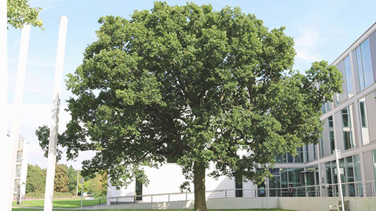
View description - Uncaptioned Figure

Question 1

What is the length of a guard cell, to the nearest micrometre?

Interactive content is not available in this format.

Question 2

Interactive content is not available in this format.

The density of stomata is the number of stomata in a given area. In the video, stomatal density is stated as the number of stomata per square millimetre (stomata per mm², or stomata mm⁻²). If the average size of an oak leaf is 15 cm², you can use the density of stomata to work out roughly how many stomata are on the top side of a leaf. Let’s go through the calculations step by step. You may find Figure 7 will help you to visualise the scales.

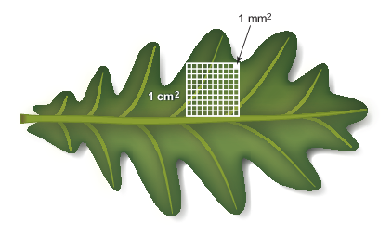
Figure 7 An oak leaf with a large square showing 1 cm² and smaller squares which are 1 mm² each. (The figure is not a 15 cm² leaf.)
View description - Figure 7 An oak leaf with a large square showing 1 cm2 and smaller squares which ...

Question 3

First, how many square millimetres are there in a square cm?

Interactive content is not available in this format.

Question 4

Interactive content is not available in this format.

View discussion - Question 4

Question 5

Finally, use your answer to Question 4 to work out how many stomata there are on the upper surface of a leaf which has an area of 15 cm². Provide your answer using standard scientific notation.

Interactive content is not available in this format.

Question 6

The video indicated that there is a higher density of stomata on the lower surface of the leaf (500 stomata mm⁻²). Using this value and the answer to Question 5, work out the total number of stomata on both sides of the leaf.

Interactive content is not available in this format.

View discussion - Question 6

Question 7

A large oak might have 400 000 leaves in a single year. How many stomata would there be on a tree with this many leaves?

Interactive content is not available in this format.

View discussion - Question 7

Researchers use high precision equipment, such as leaf chambers and infrared gas analysers to measure the amount of CO₂ taken up by a leaf over time (Figure 8). You can use the information from such measurements together with your earlier calculations to estimate the number of CO₂ molecules taken up by stomata.

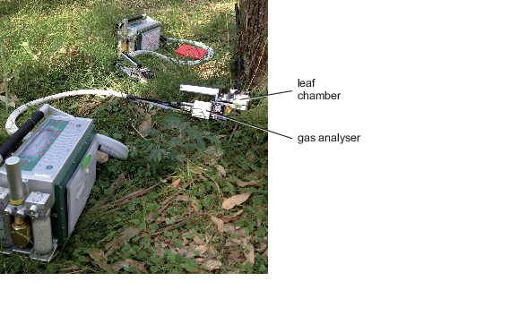
Figure 8 Portable equipment for measuring photosynthesis, through rates of CO₂ uptake, in the field. Two machines are shown with chemicals and electronics in the main console boxes, connected by cables to the chambers in which leaves are clamped and the infrared gas analysers measure CO₂.
View description - Figure 8 Portable equipment for measuring photosynthesis, through rates of CO2 uptake, ...

Question 8

Experiments have shown that an oak leaf in sunlight can take up CO₂ at a net rate of 4.4 × 10⁻⁹ grams per cm² of leaf per second (or 4.4 × 10⁻⁹ g CO₂ cm⁻² s⁻¹). Calculate the mass of carbon dioxide taken up by one stomata in one second by dividing this value by the number of stomates in a cm² of leaf.

Interactive content is not available in this format.

View discussion - Question 8

Each of the stomata will open and close during the day to regulate CO₂ uptake and water loss. Now it is time to consider the time it takes stomata to open and close.

Question 9

How long does it take a stomata in the animation to open and close (to the nearest 5 minutes)?

Interactive content is not available in this format.

Question 10

In oaks, light stimulates stomata to open and lack of light stimulates closure. Why might stomatal closure take some minutes rather than being instantaneous? Suggest possible reasons. Note: this question is to encourage you to consider possibilities rather than necessarily knowing the ‘right’ answer. (Your answer should be between 50 and 100 words.)

Provide your answer...
View answer - Question 10

Summary
In this section you learned that microscopic guard cells form stomata or pores, which allow billions of molecules of CO₂ to be exchanged between the leaf and the atmosphere every second. The stomata open and close to regulate the movement of gases. Through a series of calculations, you were able to consider just how many stomata there are on a leaf and a whole tree. There were some really massive numbers there!
Although this section focuses on the scale of cells (micrometres) your calculations showed how process at this scale affect bigger (leaves and trees) and smaller (molecules) size scales.

Next: Now look at the components of a leaf at even smaller scales by examining a chloroplast within a stomatal cell, which you can do with the ‘Next >’ button, or you can return to the size–time explorer to choose a level for yourself.

2.9 Chloroplasts
The following slide show describes chloroplasts as organelles, or specialised components of cells. It explores the role of chloroplasts in photosynthesis, particularly the infrastructure they have to facilitate chemical reactions.
While working through the slides, record the following information to use in the questions that follow:
- the length of an oak chloroplast
- the amount of time it takes for a chloroplast to divide into two
- the thickness of a thylakoid membrane
- the rate at which ATP synthase makes ATP molecules.

Interactive content is not available in this format.
Chloroplasts: a source of green
View description - Chloroplasts: a source of green

Question 1

Interactive content is not available in this format.

Length measures one dimension of an object. Chloroplasts and the cells that contain them are three dimensional, and therefore have a volume. Calculating volumes of irregularly shaped objects is difficult, so for simplicity you will consider a chloroplast to be a rectangular prism as shown in Figure 9.

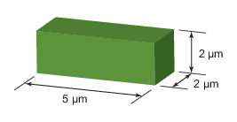
Figure 9 Dimensions of a stylised (rectangular prism) chloroplast showing the length, width and height in µm.
View description - Figure 9 Dimensions of a stylised (rectangular prism) chloroplast showing the length, ...

Question 2

The volume of a rectangular prism is determined by length × width × height, and the volume of the block in Figure 9 is consistent with chloroplast volumes in the scientific literature. What is the volume of the stylised chloroplast shown here?

Interactive content is not available in this format.

Question 3

What is the minimum volume that a cell would need to be to contain 100 chloroplasts within it?

View answer - Question 3

Question 4

Which of the following cell dimensions describe a cell of 2000 µm³?

Interactive content is not available in this format.

Question 5

Use your notes from the slide show to calculate how long in seconds it takes a chloroplast to divide. Select the correct option from the list below to complete your answer.

Interactive content is not available in this format.

Question 6

The chlorophyll molecules in the folded membranes inside chloroplasts absorb some wavelengths of light to power photosynthesis. However, they reflect light in the green part of the visible spectrum, which is why they appear green. You can therefore discern where there are chloroplasts in a plant, even though they are microscopic. There are so many that most people can see their colour pretty easily! Examine Figure 10 and consider which organs are green.

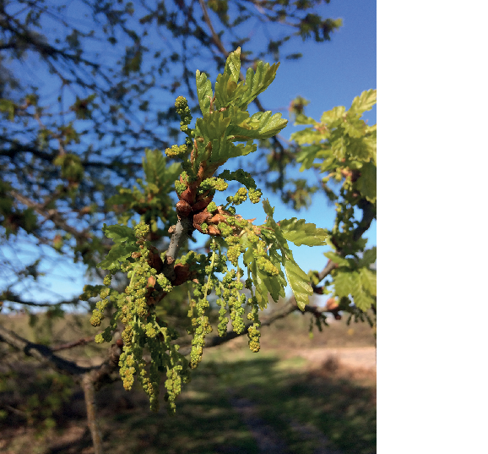
Figure 10 Young shoots of an English oak as well as flowers or catkins.
View description - Figure 10 Young shoots of an English oak as well as flowers or catkins.

If you have the inclination you could investigate some real plants, either house plants or outside (on thin branches or smooth tree trunks, try scratching a small area of the surface gently with the edge of a ruler). Make some notes in the box below, particularly commenting on in which organs you observe chloroplasts to occur.

Provide your answer...
View answer - Question 6

Question 7

ATP, short for adenosine triphosphate, is a key molecule used by living organisms to drive the processes of life. From your notes, use the rate at which the protein ATP synthase makes ATP molecules to calculate the time it takes for one ATP molecule to be synthesised. Use the drop-down boxes below to give your answer in seconds, using an appropriate unit prefix.

Interactive content is not available in this format.

Question 8

In light of the thickness of a thylakoid membrane (which you noted from the slide show) and your answer from the calculation above, add the bar ‘ATP synthase reaction across a membrane’ to the size–time explorer.

Summary
Chloroplasts – organelles within a plant cell – are where photosynthesis occurs. They provide conditions that facilitate the reactions involved. In this level, you learned that microscopic proteins in the membranes inside chloroplasts are so abundant that you can discern their presence by the green colour you see when you look at most vegetation!

Next: Now look at the components of a leaf at even smaller scales by examining a glucose molecule, which you can do with the ‘Next >’ button, or you can return to the size–time explorer to choose a level for yourself.

2.10 Glucose
The following video introduces glucose molecules and their size. It describes how glucose stores energy, in some cases by forming more complex molecules that can be stored for longer. Plants and animals obtain glucose in different ways, but use it in the same way. Here you will consider the size of a glucose molecule and the timescales over which plants and animals use it.
While watching the video, record the following information to use in the questions that follow:
- the length of the linear form of the glucose molecule
- the amounts of glucose used by an oak leaf for growth and maintenance per day
- definition of autotroph and heterotroph
- a description of the solubility of glucose and starch
- the uses of energy listed (e.g. growth).

Video content is not available in this format.
Glucose: a molecule that stores energy
View transcript - Glucose: a molecule that stores energy

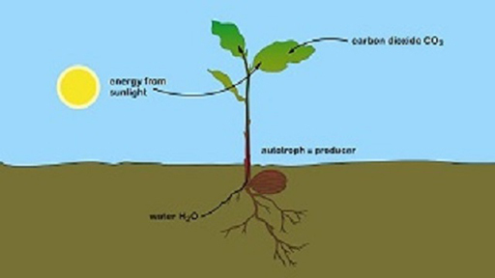
View description - Uncaptioned Figure

Question 1

How big is a glucose molecule? Give your answer in scientific notation.

Interactive content is not available in this format.

Question 2

How much glucose is needed to maintain a gram of oak leaf each day? Give your answer in scientific notation.

Interactive content is not available in this format.

The English oak, Quercus robur, is a deciduous species that loses its leaves over winter. The following graph (Figure 11) shows the amount of sugars (including glucose) and starch – both of which are carbohydrates – in English oak twigs during the year. Three specific time periods are shown: just before leaves are lost, when the tree has no leaves, and just before bud break (which is when the leaf buds begin expanding into leaves). The columns are the mean values of 10 twigs, each from a different plant.

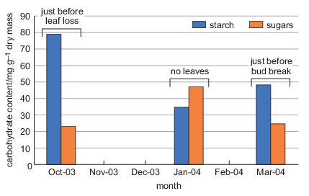
Figure 11 Sugar (including glucose) and starch content in twigs of Quercus robur at three time periods (adapted from Morin et al., 2007).
View description - Figure 11 Sugar (including glucose) and starch content in twigs of Quercus robur ...

Question 3

Use your notes from the video together with Figure 11 to describe the graph and interpret its significance in terms of how a plant uses glucose and starch to store energy. Select the most appropriate terms from the drop-down lists to complete the following paragraph.

Interactive content is not available in this format.

A very simple food chain was shown in the video. It involved a bird (great tit) obtaining its energy (and protein) by eating the caterpillar (hairstreak butterfly larvae), which in turn obtained glucose by eating the oak leaf. You can measure the blood glucose concentrations in birds in order to compare them with other species.
Table 7 shows the average blood sugar levels of 14-day-old blue tit and great tit chicks (both of which can feed on caterpillars on oak leaves). For comparison, it also contains the levels of a healthy adult human both before and after eating.

Table 7 Average blood glucose concentrations in blue tit and great tit chicks in an oak woodland in Poland (Kaliński et al., 2015) and for an adult human after fasting and two hours after eating (Diabetes UK, n.d.).
Animal | Average blood glucose concentration/mg ml⁻¹
Blue tit chick | 2.503
Great tit chick | 2.684
Fasting adult human | 0.900
Adult human 2 h after eating | 1.400

Question 4

Use your list of the functions of glucose in an animal from the video to comment on the relative amounts of glucose in the bloodstream of tits and humans. Specifically, consider the age of the animals and what types of activity (work) the adult animals listed in the table do that might account for the differences. (Your answer should be between 50 and 100 words.)

Provide your answer...
View answer - Question 4

Summary
Here you learned about a molecule, glucose, which stores energy in both plants and animals. It takes energy to synthesise glucose and when glucose is broken down into CO₂ and water again, that energy is released (through cellular respiration). Your calculations and interpretation of graphs and tables of data allowed you to consider how plants and animals use glucose over time and at different stages in their development.

Next: Now look at even smaller scales by examining a carbon atom, which you can do with the ‘Next >’ button, or you can return to the size–time explorer to choose a level for yourself.

2.11 Carbon
The following video looks at a carbon atom, exploring its size and inclusion in diverse organic molecules. Carbon is ‘fixed’ by plants through photosynthesis – by which you mean incorporated into molecules used by living organisms. Here you can explore the length of time the carbon is stored in various forms after a plant dies before being released into the atmosphere again as CO₂.
Humans use fossil fuels to power many of the things used in your daily lives. These fossils fuels are energy stored in carbon molecules fixed through photosynthesis that occurred hundreds of millions of years ago, during the Carboniferous and Jurassic periods.
While watching the video, record the following information to use in the questions that follow:
- the diameter of a carbon atom
- how long it takes an oak leaf and an acorn to grow
- the dates of the Carboniferous and Jurassic periods, when much of the carbon forming today’s coal, oil and gas reserves was fixed though photosynthesis.

Video content is not available in this format.
Carbon in energy sources
View transcript - Carbon in energy sources

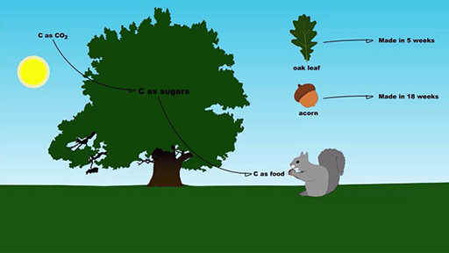
View description - Uncaptioned Figure

Question 1

What is the diameter of a carbon atom?

Interactive content is not available in this format.

Question 2

The video explained that you cannot see an individual carbon atom because they are shorter than the wavelengths of visible light. The shortest wavelength of light that you can see is about 390 nm (which is violet light). How many orders of magnitude longer is this than a carbon atom?

Interactive content is not available in this format.

Question 3

Carbon is part of glucose molecules. Choose the appropriate words below to compare the sizes of a single carbon atom to a glucose molecule.

Interactive content is not available in this format.

Many of our fuel sources use carbon-based compounds as sources of energy, from foods that you metabolise to wood, coal, crude oil and natural gas that you burn. Different sources vary in the amounts of energy released per unit mass.
Table 8 lists different fuel sources, the amount of energy released per kg, and the amount of CO₂ emissions for the energy produced. Joules (J) is an SI unit that describes energy; you will have seen it listed on food wrappers.

Table 8 The age, amount of energy per kg, and CO₂ emissions and % of carbon in different carbon sources exploited for energy
Energy source | Net calorific value/MJ kg⁻¹ | CO₂ emissions/g MJ⁻¹ | % Carbon
Wood and leaves | 16 | 4 | 42
Coal | 29 | 115 | 67
Natural gas | 38 | 50 | 76
Crude oil | 42 | 72 | 89

Question 4

Use information from the video to determine the age of the different energy sources in Table 8. (Note that for coal, natural gas and crude oil you should express your answer using scientific notation.)

Interactive content is not available in this format.

Question 5

Tabulated information, such as Table 8, facilitates comparisons between values. Select the correct words in the sentences below to describe the patterns in energy and carbon content and emissions of the different energy sources.

Interactive content is not available in this format.

View discussion - Question 5

Question 6

Returning to the oak tree, how long does it take for an oak to produce an oak leaf? Use the equation below to aid your conversion from weeks to seconds. You can identify pairs of units that occur both in the numerator and denominator, which will cancel each other and give the final units for the answer. (The cancelling of weeks are shown as an example.) Leave no spaces between digits in your answer.

Interactive content is not available in this format.

View discussion - Question 6

Question 7

Organisms including oaks use carbon to make many different types of molecules. Acorns are full of carbon-based sugars and starches to fuel the embryo when an acorn germinates; hence acorns are an attractive energy source for animals.
Oaks also use carbon to make defensive compounds to deter animals. The English oak makes compounds called sesquiterpenes which have been shown to deter insects. One of these compounds, farnesene, contains 15 carbon atoms of which 13 form a long carbon chain. Hence the molecule has a length of roughly 1.8 × 10⁻⁹ m (calculated as 13 × 1.4 × 10⁻¹⁰ m).
Use this size and the time it takes an acorn to grow to add the bar ‘Acorn and sesquiterpenes production’ to the size–time explorer. You can use the same calculation as you used in Question 6 to calculate the length of time it takes for the oak to produce an acorn.

Summary
After learning about carbon atoms and how small they are, you learned that carbon is a component of many of our fuel sources. The food you eat is produced relatively quickly – as is the wood you burn – but fossil fuels are ancient sources of carbon that were fixed by plants many millions of years ago. They cannot be replaced quickly as it takes time to build up large reserves of these compounds, of which tiny carbon atoms are a significant component.

Next: Now look at even smaller scales by examining the components of an atom, which you can do with the ‘Next >’ button, or you can return to the size–time explorer to choose a level for yourself.

2.12 Protons and neutrons
The following slide show considers the size of subatomic particles, protons and neutrons, and their role in determining the identity of an element. You will consider the size of protons and neutrons relative to an atom, and how to use isotopes of carbon to date samples for a specific period.
While working through the slides, record the following information to use in the questions that follow:
- the diameter of a neutron
- the half-life of carbon-14 (¹⁴C).

Interactive content is not available in this format.
Subatomic particles: protons and neutrons

Question 1

Interactive content is not available in this format.

Question 2

In another part of this topic you learn that the diameter of a carbon atom is about 1.4 × 10⁻¹⁰ m. How many times larger is a carbon atom than a neutron? Report your answer in full, not using scientific notation, and leaving no spaces between digits.

Interactive content is not available in this format.

Question 3

Radioactive ¹⁴C (read aloud as ‘14-C’) decays to ¹⁴N in a predictable way. The half-life of ¹⁴C is the number of years it takes half the amount of ¹⁴C remaining in a sample to decay.
Table 9 shows the percentage of ¹⁴C remaining against years since plant death for a sample. Using the value of the half-life you noted from the slide show, select the correct values for the list below to replace W, X, Y and Z.

Table 9 Decay of ¹⁴C in dead plant tissue.
Years since plant death | % ¹⁴C remaining
0 | 100
5730 | 50
11 460 | 25
W | 12.5
X | 6.3
28 650 | Y
34 380 | Z
40 110 | 0.8
45 840 | 0.4

Interactive content is not available in this format.

Question 4

There are equations describing the curve of the decay graph that was shown in the slide show, and these allow an organic sample to be dated accurately. However, you can use Table 9 to estimate the age of sample.

Interactive content is not available in this format.

Question 5

Different radioactive isotopes have different half-lives. The time frame varies substantially across the elements. For uranium-232, the half-life is just 68.9 years. Use the diameter of a uranium atom (312 pm or picometres), together with the half-life of ²³²U to add the ‘Half-life of a uranium-232’ bar to the size–time explorer. (Note that 1 pm = 1 × 10^{–12} m).

Summary
In this section you have learned that atoms consist of subatomic particles including protons and neutrons. The number of protons determines the element. The number of neutrons in atoms can vary, which results in different isotopes of the same element (e.g. ¹²C, ¹³C and ¹⁴C). Neutrons are lost from atoms at predictable rates. This phenomenon has various practical scientific applications, including radiocarbon dating.

Next: Look at the smallest scale now: quarks, which you can do with the ‘Next >’ button. Alternatively, you can return to the size–time explorer and choose a level for yourself.

2.13 Quarks and photons
The following slide show describes elementary particles including quarks and photons. While quarks are tiny – smaller than neutrons – they do not have a defined size. However, they are placed representing the smallest size in the size–time explorer. Photons are packets of energy, which have properties of both waves and particles. They have wavelengths and frequencies, some of which you can see as different coloured light. The activities for this section focus on photons.
While working through the slides, record the following information to in the questions that follow:
- the size, or description of the size, of an elementary particle
- the speed of light in a vacuum
- the wavelength of red photons absorbed by plants (you may need information from multiple slides to work this out).

Interactive content is not available in this format.
Elementary particles: quarks and photons
View description - Elementary particles: quarks and photons

Erratum
Please note that there is a small error in the voice over for Slide 3 of this slide show. The final sentence states that ‘Photons with a frequency of around 400–700 nm are visible to humans...’, but this should be ‘Photons with a wavelength of around 400–700 nm are visible to humans...’.

The value of the speed of light quoted in the slides gives a value in m s⁻¹. In this question you will calculate how many seconds it takes a photon to travel a metre, which can be expressed in units of s m⁻¹.
To do this you need to invert the relationship, so n m s⁻¹ (where n could be any number) becomes:

As an example, if a ball travels 5 m s⁻¹, you can write this as:

The inverse of this is therefore:

Which means the ball takes 0.2 seconds to travel 1 m.

Question 1

Interactive content is not available in this format.

Question 2

The Earth is about 1.5 × 10¹¹ metres from the Sun, our main source of light. Using the answer from Question 1, which of the following correctly calculates how long it takes light from the Sun to reach the Earth.

Interactive content is not available in this format.

Question 3

Using the answer to Question 2, how many minutes does it take photons from the Sun to reach Earth? Round your answer to one significant figure.

Interactive content is not available in this format.

Figures in the slides showed the visible light spectrum of photons with different wavelengths, and the proportion of these absorbed by chlorophyll and proteins in photosynthetic plants. There were two main peaks in the absorption graph.
In addition, the equation describing the relationship between photon wavelength and frequency was given as:

where λ represents the wavelength of light, f is the frequency (in cycles per second) and c is the speed of light in a vacuum. This equation can be rearranged to calculate the frequency of waves, such that:

Question 4

Use values for the speed of light and the wavelength of red light corresponding to a peak in absorption to determine the frequency of the photons absorbed by plants.

Interactive content is not available in this format.

Question 5

Use the time it takes photons to travel from the Sun to the Earth, and the size of the wavelength of red light to add the bar ‘Red light travelling from the Sun to the Earth’ to the size–time explorer.

Summary
From your calculations, you now know how long it takes photon from the Sun to reach the Earth, and which photons are absorbed in photosynthesis. The slide show finished with the comment that the efficiency of photosynthesis is related to the way elementary particles move through leaves, which forms a nice link to other levels in the size–time explorer.

Study note
Don’t forget to answer the questions and fill in the entries associated with this level in the scales data table that you downloaded or printed in Activity 1.

Next: That’s as small as you can go. It is recommended that you now go to ‘The oak woodland’ section and start working towards the bigger size scales, or you can return to the size–time explorer and choose your own level.

3 Comparing and connecting scales
Now that you have worked through the resources and questions for each scale level, you should have an appreciation to of the huge range of scales encountered across the sciences. To consolidate your learning the next task is to compare the time and size scales across two levels.
Write a paragraph describing the relationship between any two levels that you found interesting, and what gave you an appreciation of both the time and size scales between those levels. For example, you might choose to compare the oak tree and oak ecosystem levels, and describe the implications of the duration of the lifecycle of an oak on the history of oak ecosystem conservation. You can revisit the size–time explorer if you want to.
Your paragraph should be no more than 250 words in length. Be sure to clearly identify the two levels and then explain how the connection between them contributed to your understanding of both size and time scales in science, specifically referring to the numbers and scales involved. Indeed, you could use some of the maths skills you have been practising to compare the scales between levels. Note that the two levels do not have to be adjacent in the size–time explorer, but they can be if you choose.

Provide your answer...

Conclusion
Well done! Using the size–time explorer, you have explored many different scales in space and time, centred around an oak tree. Through this you have strengthened your ability to manipulate small and large numbers as well as developed or deepened an appreciation of the huge range of scales encountered in science, across multiple disciplines.
The activities encouraged you to make connections between the various scale levels, and therefore appreciate the implication of fast and slow processes as well as the influence of big and small objects on each other. Hopefully you also have appreciation for how knowledge from different scientific disciplines contribute to each other.
At the beginning of the course you watched a video of physicists, chemists, biologists and geologists talking about how they saw the oak tree, where they spoke about massive forces and miniscule molecules, and processes that occur over milliseconds and millennia. Having completed this course, you should now have a new appreciation of scales at which processes are happening all around you too.
This OpenLearn course is an adapted extract from the Open University course S112 Science: concepts and practice.

Acknowledgements
This free course was written by Dr Julia Cooke, with contributions from Dan Berwick, Anthony Stanton, Brian Richardson, Sara Hack, Frazer Payne, Bryan Waddington and Jonathan Martyn.
Except for third party materials and otherwise stated (see terms and conditions), this content is made available under a Creative Commons Attribution-NonCommercial-ShareAlike 4.0 Licence.
The material acknowledged below is Proprietary and used under licence (not subject to Creative Commons Licence). Grateful acknowledgement is made to the following sources for permission to reproduce material in this free course:
Shadow of the Dark Rift, Milky Way: NASA/A. Fujii
Supernova Remnant Menagerie: NASA/ESA/HEIC and The Hubble Heritage Team (STScI/AURA)
Artist’s concept of the Milky Way Galaxy (GLAST): NASA JPL
Knopper Gall on Oak Acorns: MichaelGrantPlants/Alamy
Quercus robur, English oak, Scanning electron microscope (SEM) image of a pollen grain from an English or pedunculate oak tree: Natural History Museum/Alamy
Hubble Views a Colorful Demise of a Sun-like Star: NASA, ESA, and K. Noll (STScI): The Hubble Heritage Team (STScI/AURA)
English Oak Leaves (Quercus robur): Klaus Reitmeier/123RF.com
Bluebells in beech woodland: David Tipling: Photo Library/Alamy
X-ray image of the hot gas in the Perseus galaxy cluster: NASA’s Goddard Space Flight Center/Stephen Walker et al.
Google Earth image - Blenheim Palace and park: Google Earth Image 2016. Infoterra Ltd & Bluesky
Quercus pollen in the British isles: Birks, H. J. B. (1989) ‘Holocene Isochrone Maps and Patterns of Tree-Spreading in the British Isles’, Journal of Biogeography, vol. 16. no. 6, pp.503-540, Wiley
Soil profile of Clarion soil from Iowa, United States: Photo by Erwin Cole, USDA Natural Resources Conservation Service
Sessile Oak (Quercus petraea) in small woodland clearing: Annie Poole / Science Photo Library
Fungi growing: Juhani Viitanen/123RF.com
Purple Hairstreak Butterfly: Avalon/Photoshot License/Alamy
Band of the Milky Way seen in dark skies with the ALMA antenna: ESO/B. Tafreshi
Oak (Quercus robur) buds in January: Colin Varndell / Science Photo Library
Eastern white oak (Quercus alba) leaf: Change Accordingly/Science Photo Library
A grouping of young stars called the Trapezium Cluster: NASA, ESA, K. Luhman (Penn State University), and M. Robberto (STScI)
Ultraviolet Coverage of the Hubble Ultra Deep Field, provides the missing link in star formation: NASA/ESA
Jay bird bathing in forest pool: AGAMI Photo Agency/Alamy
Oak tree in Surrey Woodland (oak_separated_3.png): M. Disney, P. Wilkes, M. Boni Vicari, UCL Geography
English oak leaf pores, SEM: Power and Syred / Science Photo Library
Male catkins of English oak (Quercus robur), Fagaceae: De Agostini Picture Library / Universal Images Group/Alamy
Hubble Spotlight on Irregular Galaxy IC 3583: ESA/Hubble & NASA
Death of Giant Galaxies Spreads from the Core - Elliptical galaxy IC 2006: NASA/ESA/Judy Schmidt and J. Blakeslee (Dominion Astrophysical Observatory)
The Pelican Nebula in Gas, Dust, and Stars: NASA/Roberto Colombari
The Grand Bridge, Blenheim Palace: Robertharding / Alamy Stock Photo
New View of the Crab Nebula: NASA, ESA, NRAO/AUI/NSF and G. Dubner (University of Buenos Aires)
Wild victoria waterlily (Victoria amazonica): Andre Seale/Alamy
Blenheim Palace, Park and Gardens - Autumn aerial view of the bridge and lake: © Blenheim Palace 2019
Giant elliptical galaxy NGC 1316: NASA, ESA, and The Hubble Heritage Team (STScI/AURA)
Oak leaves (Quercus robur): The Natural History Museum/Alamy
Soil samples collected using the truck mounted core punch tool: Tom Ballard/Flickr. Covered under creative commons BY 2.0. http://creativecommons.org/licenses/by/2.0/
Hubble Spots Two Interacting Galaxies Defying Cosmic Convention - NGC 3447B: ESA/Hubble & NASA
Map of the universe - cosmic microwave background: ESA and the Planck Collaboration
Oakbug Milkcap (Lactarius quietus) mushroom, Russulaceae. De Agostini / E. Ferrari Alamy
A Nearby Stellar Cradle - star cluster Cygnus OB2: NASA
Ice caps over the British Isles at the end of the last ice age (2): Clark, C.D. et al. (2010) ‘Pattern and timing of retreat of the last British-Irish Ice Sheet’, Quaternary science reviews 44: 112–146.
Blenheim Palace bridge, lake and house: Nigel Francis / Robert Harding/Alamy
Wolffia: G Newport / Science Photo Library
For the new Description of Blenheim, William Fordyce Mavor, 1806: © Blenheim Palace 2019
Tree - Oak Common (Quercus robur) Close-up of leaves: Eric and David Hosking/Getty Images
Badger in Oak woodland: DamianKuzdak/iStock/Getty Images Plus
Andromeda galaxy M31: NASA/JPL-Caltech
English Oak Acorns: Fir Mamat/Alamy
Oak leaves fallen in Autumn: Tim Graham/Getty Images
Ice caps over the British Isles at the end of the last ice age (1): Clark, C.D. et al. (2010) ‘Pattern and timing of retreat of the last British-Irish Ice Sheet’, Quaternary science reviews 44: 112–146.
Sunlight shining through young beech leaves (Fagus sylvatica) in spring: Nigel Cattlin/Alamy
An artist’s impression of a Carboniferous forest: Ludek Pesek / Science Photo Library
Wood mouse (Apodemus sylvaticus) in hollow cork trunk: Alternative Image: Sergei Markov/123RF.com
Solitary English oak tree (Quercus robur) in spring: Drian Bicker / Science Photo Library
Sessile oak Leaf (Quercus petraea): blickwinkel / Alamy Stock Photo
Stout Tooth Agave (Agave parrasana or Agave wislizeni): DEA/C.DANI/Getty
Every effort has been made to contact copyright owners. If any have been inadvertently overlooked, the publishers will be pleased to make the necessary arrangements at the first opportunity.
Don’t miss out
If reading this text has inspired you to learn more, you may be interested in joining the millions of people who discover our free learning resources and qualifications by visiting The Open University – www.open.edu/openlearn/free-courses.

Solutions

Question 3

Answer
Table 3B is correct. It shows the correct combination of events, temperatures and times, with the universe cooling over time, and the times listed in a logical order.
Back to - Question 3

Question 3

Discussion
These numbers are huge, and it is not surprising that scientists prefer to use light-years rather than metres to describe distances in space.
Back to - Question 3

Question 1

Discussion
You may have wondered about what number of significant figures was appropriate for your answer. Let’s look at the data provided.
The radius was given to 4 significant figures and the value for π was given to three significant figures. However, the 2 might appear to have only 1 significant figure, but in fact it is a special case. It is an integer, and so is viewed as being infinitely precise – it isn’t something measured, it is an absolute value.
So, the least precise value here is π, so the answer should be quoted to the same precision, and so the answer is given as 40 000 km (to three significant figures). It is very important to quote the level of precision here as, without it, 40 000 km has an ambiguous number of significant figures. It could be understood to be an answer given to the precision of 1 significant figure or 5 significant figures, when actually the value is calculated to 3 significant figures.
Back to - Question 1

Question 3

Discussion
There was a tricky conversion in this question, where 450 km h⁻² was converted to 0.035 m s⁻². Here’s some additional information about how this was done.
The value 450 km h⁻² is a measure of acceleration (not speed), which indicates that the Earth has an acceleration of 450 km per hour, each hour. To convert km h⁻² to m s⁻² you first convert km to m (by multiplying by 1000), which gives
450 km h⁻² × 1000 m km⁻¹ = 450 000 m h⁻²
Then you need to convert hours into seconds, twice, because the acceleration is ‘m per hour per hour’. As there are 3600 seconds in an hour, you should divide by 3600, but because you are working with h⁻², you need to do apply to conversion twice. Hence:

Notice how dividing by 3600 s h⁻¹ × 3600 s h⁻¹ results in the h⁻² on the top cancelling with the h⁻¹ × h⁻¹ on the bottom.
Back to - Question 3

Question 6

Answer
Day length at High Park varies from less than 8 hours in winter to more than 16 in summer. The number of daylight hours in summer is double that in winter (see June and December respectively). This is mirrored in big changes in temperature with nearly 10 °C differences between summer and winter.
In contrast in Accra, day length is between 12.25 and 12.5 hours all year around, varying by less than 15 minutes. Similarly, the maximum and minimum temperatures vary by less than 4 °C throughout the year.
There must be factors other than day length that determine temperature, because when day length is over 16 hours in the UK the temperature is still lower than for shorter days in Ghana.
Back to - Question 6

Question 5

Answer
To achieve a rate of 220 m year, an acorn could be dispersed 220 metres from the parent plant and then grow and produce another acorn that is spread 220 metres in the following year. However across 3300 years, some acorns are likely to be dispersed long distances and others short distances, so the rate calculated represents an average across the years, so there may have been periods of faster and slower spread.
In addition, oaks do not produce acorns until they are mature trees, so the scenario described at the beginning of this paragraph would be impossible as oaks can’t produce acorns within a year. This means that the distance they are dispersed must be much further than 220 metres to account for the time lag in producing new acorns. That is, if an acorn germinated and it took some years to produce acorns, then you would need to multiply that number of years by the 220 m to determine a more realistic dispersal distance.
Back to - Question 5

Discussion
If you have watched the oak tree level video, you will know oaks begin producing acorns at about 40 years. Instead of thinking of how far oaks spread acorns in one year, you could think about how far an oak must disperse its acorn in 40 years in order to account for the time lag in production and distribution. So, 220 m y⁻¹ × 40 y = 8800 m or 8.8 km.
This seems a long way for acorns to be dispersed. From these calculations, you might speculate that animals, perhaps squirrels and jays, play an important role in the colonisation of oaks across the British Isles.
Back to - Question 5

Question 6

Discussion
Various organisations and publications use different ways to cite and give references, and it is useful for you to be able to understand and interpret these different styles.
Back to - Question 6

Question 4

Answer
The oak woodland ecosystem at High Park was protected around the year 1100 CE. At this time, much woodland in England had already been cleared and about 15% woodland cover existed across England. In the next 1000 years, oak ecosystems were further reduced to 5% cover. High Park was part of this 5% because it was protected from complete clearing. Ecosystem remnants have protected diverse species and provide a model to help the recovery and restoration of oak woodland ecosystems seen in this century.
Back to - Question 4

Question 5

Answer
The single arrow pointing to these species suggests that they only eat oak tissue, so the loss of this plant from the ecosystem would likely mean the loss of the insects that feed on them, as they would not have alternative food sources. This could have further consequences on species that eat the caterpillar, currant gall or cricket.
Back to - Question 5

Question 4

Discussion
That is a lot of seconds! You can check that the number you calculated fits with where the oak tree is placed on the size–time explorer.
Back to - Question 4

Question 4

Answer
Almost certainly, the cells in the woody trunk survive for much longer than those in the leaves. In an oak, nutrients from the leaves are stored in the oak wood over the winter so these cells last much longer than the leaves.
Back to - Question 4

Question 5

Answer
The completed Table 6 is shown below:

Table 6 (Completed)
Age bracket/years | Number of years spent in  this age bracket |  | Number of leaves produced each year |  | Total number of leaves produced during age bracket
1–20 | 20 | × | 10 000 | = | 200 000
21–100 | 80 | × | 200 000 | = | 16 000 000
101–500 | 400 | × | 400 000 | = | 160 000 000
501+ | 300 | × | 300 000 | = | 90 000 000
 |  |  |  |  | Total: 266 200 000

Using the data in the video, you can calculate that an 800 year old oak could have produced 266 200 000 leaves in its lifetime. That’s nearly 300 million leaves!
Back to - Question 5

Discussion
Are you surprised at this number? Did you ever consider that a tree might produce this many leaves over its lifetime? Scientists estimate the number of leaves on a tree for multiple reasons, but some examples are to:
- estimate the amount of whole-tree photosynthesis or carbon fixation
- determine how much of a tree’s resources are allocated to leaves compared to other parts of the plant
- consider how much light is intercepted or if self-shading occurs, and
- estimate nitrogen use.
Back to - Question 5

Question 6

Answer
One reason is that you can get a good estimate using techniques including digital imaging without damaging the tree. Cutting down a tree and counting the leaves is one way to determine leaf number, but clearly that’s not possible to do multiple times in its lifetime.
Another reason is it is clearly extremely difficult, if not impractical, to count all of the leaves on a tree every year for 800 years, and it is very unlikely that you could provide an accurate number. (It would take generations of people collecting every single fallen leaf and counting them!)
Back to - Question 6

Question 7

Answer
There are several possible limitations; here are two.
- The age brackets (time spans) for each of the growth periods, particularly the latter two, are very large (100 years and 500 years, respectively) so any error in the average annual number of leaves will be magnified when multiplied by such large numbers and will render the estimate inaccurate.
- The leaf numbers for each age range are averages determined from other plants of the same species, but likely to be growing in a different area. The actual oak tree under scrutiny will almost certainly have produced a different numbers of leaves.
Back to - Question 7

Question 4

Discussion
Note the way that the units were derived for the final answer. In multiplying ‘stomata mm⁻²’ by ‘mm² cm⁻²’ the ‘mm’ terms cancelled each other out, leaving just ‘stomata cm⁻²’.
Back to - Question 4

Question 6

Discussion
Another way to work out the answer to this question is to consider the ratio of stomatal density between the upper and lower side of the leaf. Using the stomata densities on either side of the leaf – 500 mm⁻² on the lower side and 100 mm⁻² on the upper side – it is possible to calculate that there are

times as many stomata on the lower side.
Using this ratio, if there are 1.5 × 10⁵ stomata on the upper surface there must be 7.5 × 10⁵ on the lower side. Adding the two numbers together gives the total number of stomata on the leaf as 9.0 × 10⁵.
Back to - Question 6

Question 7

Discussion
Clearly these are estimates, as the actual number of stomata on every leaf, or even exactly how many leaves are on the tree haven’t been counted. However, these values are based on numbers published in scientific reports for Quercus robur and should provide a reasonable estimate. Next time you walk past a large tree, take a minute to think about how many stomata their might be on the whole tree… and then think about how many stomata there might be in a forest!
Back to - Question 7

Question 8

Discussion
You can turn this mass of CO₂ into a number of molecules of CO₂.
It turns out that 44 g of CO₂ contain 6.023 × 10²³ molecules (this is called Avogadro’s number).
So if there are 6.023 × 10²³ molecules in 44 g of CO₂ there must be

To calculate the number of molecules of CO₂ taken in by each stomata per second you now need to multiply the mass of CO₂ per stomata per second by the number of molecules of CO₂ per gram of CO₂.

This gives a value of 1.0 × 10⁹ molecules CO₂ stomata⁻¹ s⁻¹. That is 1 billion molecules of CO₂ per stomata per second!
Back to - Question 8

Question 10

Answer
Light levels can change very quickly, as a leaf can be shaded by others intermittently in windy conditions or as clouds roll by. The plant uses energy to open and close stomata, which could be wasted if the stomata were to respond too quickly to environmental conditions. However, if the weather clouds over for a long time, or the leaf moves into long-term shade and low light levels prohibit photosynthesis, stomata need to close to reduce water loss.
Back to - Question 10

Question 3

Answer
The minimum volume the cell would need to be is 100 × 20 µm³ = 2000 µm³.
Back to - Question 3

Question 6

Answer
Chloroplasts are not just restricted to leaves. They are also found in the thin stems of woody species and in some plants, such as the oak pictured, the flowers and their stems contain chloroplasts.
If you were able to look further afield, you may have found that there are chloroplasts in the stems of herbaceous species and in some trees and shrubs, there are chloroplasts in the cells just under the bark which are visible when you scratch the surface.
Back to - Question 6

Question 4

Answer
The tit chicks have two to three times the concentration of glucose in their blood compared to adult humans. Glucose is used to power growth, reproduction, work, generate heat, maintain cells and some is lost in waste. As the tits are just 14 days old they are likely to be growing quickly. Growth requires lots of energy in comparison to maintaining cells, so this could be one reason for the high blood glucose levels in the chicks, compared to the human.
Alternatively, flying uses a lot of energy, so perhaps birds have higher blood glucose levels in general than animals that do not fly.
Back to - Question 4

Question 5

Discussion
The amount of CO₂ emissions depends on the carbon content and the ratio of carbon: hydrogen in fuel. Although all energy sources are formed from the fixation of carbon dioxide through photosynthesis, wood, coal and gas are made of different compounds. Gas, often methane (CH₄), has a higher ratio of hydrogen to carbon in comparison to coal and wood, and therefore lower CO₂ emissions than coal for a given energy release.
Back to - Question 5

Question 6

Discussion
Note that this is a special case where each number is an exact integer. Each day has exactly 24 hours, each minute has exactly 60 seconds, etc, so you can report the answer as 3024 000 seconds.
Back to - Question 6

Figure 1 Flat projection of the world with High Park shown, and five other locations (see circles A–E)

Description
A map of the world. Vertical lines of longitude and horizontal lines of latitude are drawn across the map every 40 degrees. Five locations are marked with yellow circles: A – in North America, close to 50 degrees north, 80 degrees west; B – in South America, close to 0 degrees north, 80 degrees west; C – in Africa, close to 30 degrees north, 0 degrees north; D – in Africa, close to 10 degrees north, 0 degrees west; E – in Asia, close to 50 degrees north, 120 degrees east. One location, within the United Kingdom, is marked with a red dot, labelled ‘High Park’
Back to - Figure 1 Flat projection of the world with High Park shown, and five other locations (see circles A–E)

Uncaptioned Figure

Description
The video contains these scenes: 1. Photograph of oaks in a woodland setting; 2. Photograph of some research tools used to investigate oak colonization in the UK; a. Soil cores – metal tubes containing soil; b. Soil profile – photograph of soil with lines marked every 10 cm representing ages about every 500 years; c. Pollen grain; d. DNA strand; 3. Maps of the UK showing the extent of ice age glaciation; a. 23000 years before present - ice covering most of the UK and North Sea; b. 15 000 years before present – largely ice free except patches in Scotland and Ireland; 4. Photograph of catkins – green oak flowers; 5. Oak pollen grain; 6. Soil profile – photograph of soil with lines marked every 10 cm representing ages about every 500 years; 7. Map of the British Isles showing locations of soil cores, expanded to show lines when oaks arrived (see Figure 2). Source: Birks H.J. (1989) ‘Holocene Isochrone maps and patterns of tree-spreading in the British Isles’, Journal of Biogeography, vol. 16 no. 6 pp 503-540 8. Map of the British Isles showing coloured regions of 3 populations of oak. Added to it are lines showing when oak arrived and arrows showing the colonisation routes. (see Figure 2). Source: Lowe, A., Unsworth, C., Gerber, S., Davies, S., Munro, R., Kelleher, C., King, A., Brewer, S., White, A. and Cottrell, J. (2005) ‘Route, speed and mode of Oak Postglacial colonisation across the British Isles: Integrating molecular ecology, palaeoecology and modelling approaches’ Botanical Journey of Scotland, Vol. 57, no. 1–2, pp. 59–81.
Back to - Uncaptioned Figure

Figure 2 One route of oak dispersal in the British Isles indicated by the dark red line.

Description
A map of the British Isles. Parts are shaded in light brown to show the location of oak population A. This includes regions of Ireland; the west coast of Scotland; north-west England; Wales; Cornwall; north-east England. Dots mark locations of soil cores with and without pollen. Lines drawn largely from east to west show northern extent of the population at different times. These are spaced by 500 years, showing that oaks arrived in the south around 9500 years before the present, and to north Scotland by 6000 years before the present. These lines are solid lines where the data is known with high confidence, dotted with low confidence. These lines are widely spaced in England and southern Scotland, showing extents up to 8000 years before the present. North of this point, they are much more closely spaced. Arrows on the map show routes of dispersal, roughly drawn from south to north. A continuous set of these arrows is labelled in red, from the south of England to north-west Scotland. It starts about halfway between the 9000 and 9500 lines, and finishes on the 6000 line. This line is 7.4 cm long on screen; the scales shown are 1 cm to 100 km (1.6 cm to 100 miles).
Back to - Figure 2 One route of oak dispersal in the British Isles indicated by the dark red line.

Figure 3 Map of High Park showing the outline of the main area of the woodland ecosystem. The location of Blenheim Palace is provided to assist with orientation.

Description
A satellite image of High Park. Blenheim Palace is marked by a purple dot near the centre of the image. A region within the map is contained by a yellow line. The longest dimension is shown by a dotted line, 4.2 cm long. The scale is 1 cm to 0.5 km.
Back to - Figure 3 Map of High Park showing the outline of the main area of the woodland ecosystem. The location of Blenheim Palace is provided to assist with orientation.

Figure 4 A food-web for selected species in an oak woodland ecosystem.

Description
This is a diagram showing a food-web, starting off with an oak tree. It includes species such as speckled bush-cricket, snail, hedgehod, tawny owl and badger.
Back to - Figure 4 A food-web for selected species in an oak woodland ecosystem.

Figure 6 Change in height of an oak tree with age (Sylva Foundation, 2017).

Description
A graph of the change in height of an oak tree, from 0 to 30 metres on the verticle axis, against age of the oak tree, for 0 to 900 years on the horizontal axis. The points follow a steep curve (with decreasing gradient) from close to 0 m at 0 years up to a height of about 19 m after 100 years. Subsequent points are at a height of about 24 m after 200 years and 24 m after 800 years.
Back to - Figure 6 Change in height of an oak tree with age (Sylva Foundation, 2017).

Uncaptioned Figure

Description
This video contains these scenes: 1. Oak leaves on a branch against the background of a tree trunk; 2. Tree leaves at increasing magnification; 3. Dark leaves that are small and thick, with pointed edges; 4. Waterlily leaves – large, flat and circular, floating on water; 5. Duckweed leaves – very small and roughly circular, floating on water; 6. English oak leaves; 7. An animation showing oak activities over an annual cycle (18 weeks– bud burst, 24 weeks – leaves fully expanded, 39 weeks – leaf senescence begins, 50 weeks – leaf fall complete); 8. Table showing average numbers of leaves produced at different ages

Tree age/years | Average number of leaves
1–20 | 10 000
20–100 | 200 000
100–500 | 400 000
500–1000 | 300 000

; 9. Image of tree created by 3D laser scan; 10. Images of senescent leaves.
Back to - Uncaptioned Figure

Uncaptioned Figure

Description
This video contains these scenes: 1. A tree; 2. Oak leaf; 3. Scanning electron microscope image of oak stomata – oval shaped openings formed between two guard cells. The scale bar represents 15 µm (15 micrometres) and the stomates are about 1.45 times the length of the scale bar; 4. Animation of the underside of a leaf, showing two stomata and cells at the surface. The intake of carbon dioxide molecules and release of water and oxygen molecules is shown as dots passing through the stomata. A clock indicates that the stomata remain open for about 15 minutes.
Back to - Uncaptioned Figure

Figure 7 An oak leaf with a large square showing 1 cm2 and smaller squares which are 1 mm2 each. (The figure is not a 15 cm2 leaf.)

Description
A single oak leaf. A white square, divided into 100 smaller squares (10 by 10) is drawn on the leaf. The outer square is labelled 1 cm² (1 cm squared) and a smaller square is labelled 1 mm² (1 mm squared).
Back to - Figure 7 An oak leaf with a large square showing 1 cm2 and smaller squares which are 1 mm2 each. (The figure is not a 15 cm2 leaf.)

Figure 8 Portable equipment for measuring photosynthesis, through rates of CO2 uptake, in the field. Two machines are shown with chemicals and electronics in the main console boxes, connected by cables to the chambers in which leaves are clamped and the infrared gas analysers measure CO2.

Description
Portable equipment for measuring photosynthesis. A large device is identified as the main console box, connected by tubes to components labelled as the ‘leaf chamber’ and the ‘gas analyser’.
Back to - Figure 8 Portable equipment for measuring photosynthesis, through rates of CO2 uptake, in the field. Two machines are shown with chemicals and electronics in the main console boxes, connected by cables to the chambers in which leaves are clamped and the infrared gas analysers measure CO2.

Chloroplasts: a source of green

Description
The video contains these scenes: 1. Images of a tree, an oak leaf, leaf features (stomata and stomate guard cells) and plant cells containing chloroplasts; 2. Cross section of a plant cell, with one chloroplast labelled with its length – 5 µm (5 micrometres); 3. Image of the chloroplast cycle, with arrows between these stages, returning to the first – a. Chloroplast (shown as a green oval), b. Protein complex forms around the middle of the chloroplast like a belt, c. Protein complex constricts, squeezing the chloroplast into two connected ovals, d. Chloroplast splits in two; 4. Drawing of chloroplast with magnified microscope image. A scale bar labelled 1 µm (1 micrometre) is shown below this image. The chloroplast is about 5 times as long as this bar; 5. Detail of a chloroplast, with the interior fluid labelled stroma, containing stacks of coin-shaped items. One of these stacks has been magnified and the edges are labelled thylakoid membrane around the interior thylakoid lumen; 6. Detail of the thylakoid membrane containing chlorophyll pigment molecules, and a molecule of ATP synthase; 7. As 6.
Back to - Chloroplasts: a source of green

Figure 9 Dimensions of a stylised (rectangular prism) chloroplast showing the length, width and height in µm.

Description
A chloroplast stylised as a green rectangular prism. Length = 5 µm (5 micrometre), width = 2 µm (2 micrometres) and height = 2 µm (2 micrometres).
Back to - Figure 9 Dimensions of a stylised (rectangular prism) chloroplast showing the length, width and height in µm.

Figure 10 Young shoots of an English oak as well as flowers or catkins.

Description
A photograph of young shoots of an English Oak. The image includes green leaves and green flowers (catkins) on green stems.
Back to - Figure 10 Young shoots of an English oak as well as flowers or catkins.

Uncaptioned Figure

Description
The video contains these scenes: 1. Images of the molecular formula of glucose C₆H₁₂O₆ and its structural formulae (linear and cyclical chains). The length of the linear molecule chain is shown as 1 nanometre; 2. Animation of the production of glucose, showing the sun and a plant; 3. Animation showing a plant, a caterpillar feeding on the plant, and a bird feeding on the caterpillar; 4. Drawing showing the cyclical structural formula of glycogen; 5. Animation of a caterpillar on a leaf with the equation for cellular respiration (oxygen + water + energy); 6. Animation of a butterfly with a list of activities that living things need energy for – growth, reproduction, waste, work, heat, maintenance; 7. Animation detailing the mass of glucose needed per day for growth and maintenance; 8. Animation showing the sun, a plant and a butterfly.
Back to - Uncaptioned Figure

Figure 11 Sugar (including glucose) and starch content in twigs of Quercus robur at three time periods (adapted from Morin et al., 2007).

Description
A bar chart with carbohydrate content in mg g-1 (milligrams per gram) dry mass), from 0 to 90 mg g-1 (milligrams per gram) on the vertical axis and month (from October 03 to March 04) on the horizontal axis. The bars are in pairs for each period, blue for starch and orange for sugars. The bar for starch is taller than for sugars in the October and March measurements; the bar for starch is shorter than for sugars in the January measurement. Approximate values of the data are tabulated as: Month – October 03, Label – Just before leaf loss, Starch/mg g⁻¹ – 79, Sugars/mg g¹ – 22; Month – January 04, Label – No leaves, Starch/mg g¹ – 34, Sugars/mg g¹ – 47; Month – March 04, Label – Just before bud break, Starch/mg g¹ – 34, Sugars/mg g¹ – 24.
Back to - Figure 11 Sugar (including glucose) and starch content in twigs of Quercus robur at three time periods (adapted from Morin et al., 2007).

Uncaptioned Figure

Description
The video contains these scenes: 1. Drawing of a carbon atom as a black sphere, labelled with its diameter 1.4 × 10–10 metres (1.4 times 10 to the power of –10 metres); 2. Models of glucose and carbon dioxide molecules with atoms represented as spheres and rods between the atoms; 3. Drawings of molecules contain carbon – DNA, protein, fibres and cellulose; 4. Drawing showing part of the carbon cycle – It contains the sun, a tree and a squirrel. Carbon flows are shown as: a. C as CO2 carbon dioxide in the air, with an arrow to... b. C as carbon in the tree, with an arrow to... c. C as food being eaten by a squirrel. Also shown are an oak leaf, labelled ‘made in 5 weeks’ and an acorn, labelled ‘made in 18 weeks’; 5. Drawing showing a tree and logs; the logs are labelled ‘carbon accumulated over decades’; 6. Animation of leaves falling from a tree, releasing carbon dioxide to the atmosphere; 7. Drawing of a forest in a swamp, with some fallen trees, labelled ‘Carboniferous period, 360 – 280 million years ago’; 8. Drawing illustrating the formation of crude oil: a. Marine organisms in the sea 140 to 180 million years ago b. Organisms turn into oil and gas over time (50 to 100 million years ago) c. Trapped oil and gas, within porous sedimentary rock, under layers labelled ‘sediment and rock’ and ‘hard rock’ – this is extracted (present time); 9. A drawing of an oak tree and a car.
Back to - Uncaptioned Figure

Elementary particles: quarks and photons

Description
This video contains these scenes: 1. Image of a carbon atom, with a bundle of red and green spheres in the centre, surrounded by blue spheres. Each red sphere represents a proton, containing 2 purple spheres and 1 yellow sphere (3 quarks). Each green sphere represents a neutron, containing 1 purple sphere and two yellow spheres (3 quarks). Each blue sphere represents and electron; 2. Image showing quark flavours – up and down, charm and strange, top and bottom. They are shown as spheres labelled with the first letter of the flavour, with u, c and t coloured purple, and d, s and b coloured orange; 3. Drawing of the electromagnetic spectrum, in order of increasing wavelength, decreasing frequency: a. Gamma rays (lowest wavelength) b. X-Rays c. Ultraviolet d. Visible (expanded into colours violet, blue, green, yellow, orange, red) e. Infrared f. Microwaves g. Radio waves The final sentence should read ‘Photons with a wavelength of around 400–700 nm are visible to humans, as shown here.’; 4. Line graph of photons absorbed / % (percent) against wavelength / nm, over the range 400 – 700 nm). The percentage absorbed is close to 100 percent for around 400 – 500 nm, falls to around 20 % between 500 and 570 nm (the range of wavelengths of light absorbed by chlorophyll), then rises to over 90% at around 660 nm, then falls to almost zero by 700 nm. The line is labelled ‘pigment extract’; 5. Drawing of a green leaf. Photons of different wavelengths are shown as coloured arrows pointing downwards towards the leaf. A green arrow shown pointing upwards from the top of the leaf, is labelled ‘some green light is not absorbed but reflected.’ A green arrow shown pointing downwards from under the leaf is labelled ‘green light can also be transmitted through the leaf’. The leaf is also labelled – ‘photons of many wavelengths are absorbed by leaves and power photosynthesis’.
Back to - Elementary particles: quarks and photons

Uncaptioned interactive content

Transcript
[MUSIC PLAYING]
JULIA COOKE
In science, we encounter things that are massive and minuscule, that take a millisecond or millennia. And it can be hard to get your head around these different scales. This is not least because we can measure things that are well beyond what the human body can perceive. This activity is designed to develop a deeper appreciation of time and space scales, and through that, a deeper understanding of science.
An oak tree, like the one behind me, is the focus, is the story that runs through all the different levels and helps us relate from one to the next. But don’t mistake this for a biology activity; let’s hear what all of the scientists think when they look at an oak tree.
JIM ILEY
When I look at this oak tree, I think about all of the unseen chemical activity that’s going on to make it grow. The structural material that holds this tree up is largely cellulose. And that’s made up of lots of little glucose molecules. Those units are tiny, about half a nanometer from end to end. So it takes about 12 billion of them to go from the bottom of the tree up into the crown.
JIM HAGUE
You may think this tree is old, but in fact it’s incredibly young compared with the age of the Universe. Although the tree is biological, there’s a lot of incredibly interesting physics within it. For instance, huge forces hold up the trunk and the branches of the tree. The laws of physics govern the flow of fluid from the roots all the way up to the leaves to sustain life. And the chemistry of the cells in those leaves is governed by quantum physics.
DANIEL BERWICK
I’m Dan Berwick, a molecular neuroscientist interested in the earliest events in Parkinson’s disease. Looking at this tree, I can see it’s affected by disease too. There are galls, strange structures caused by a type of wasp larvae. They’re not unlike cancer. But when I look at the tree, I also think of all the compounds used in medicine. We call this tree the mighty oak because it’s big and strong. But maybe the true power of this tree comes from the small molecules within.
JULIA COOKE
I’m a plant ecologist. And I’m interested in how this tree acquires resources and then what it does with those resources. So how it spreads out its leaves to get sunlight and carbon, how it spreads out its roots to get water and nutrients. How does this change across its lifetime of hundreds of years? And how did this evolve over millions of years? And how this species differs from other species to make it the enduring species it is today.
CALUM MACCORMICK
I study highly excited atoms using lasers and magnetic fields. When I look at this tree, I see that it’s also made of atoms. It’s made of hydrogen, which is created in the big bang, but the heavier elements, such as oxygen and silicon were made in the star which previously occupied this part of the Universe. That star’s long since gone. It’s been replaced by our star, the Sun, which gives energy to the tree in the form of light.
STEPHEN BLAKE
The oak tree has seen the building of the Open University campus about 50 years ago. But way before then, about 10 000 years ago, its predecessors started to colonise the UK following a long period of glaciation. The rocks beneath the soil are even older than that, about 165 million years, and were formed by the accumulation of mud on the sea floor. So to me, the oak tree and its environment is part of a big movie picture extending over many scales of time.
SARAH ALLMAN
Hi. I’m a biological chemist and I’m interested in sugars and their function and disease. To me, this tree is a big pile of bioreactors, making sugars, building proteins, making molecules. In the winter months, low temperatures change the properties of these molecules and the speed of these reactions. Whilst in the summer months, the leaves harvest energy and use this to build molecules. And every year, energy is captured by the leaves and stored as sugars and starches for the following year.
CHRISTOPHER HEATH
I’m a neuroscientist that means I’m very interested in understanding how the millions of cells of the nervous system work together to allow us to do the things we need to do to live. When I look at this oak tree, I think about how similar and how different it is to us. Just like us, this oak tree needs nutrition, it needs water, and it needs to exchange gases with the environment, such as carbon dioxide and oxygen.
It has parents. It has children. And, unfortunately, it too will die. However, unlike us, the oak tree isn’t exactly renowned for its ability to move. Unlike us, the oak tree can pull off one of the greatest tricks of biology: photosynthesis.
JULIA COOKE
Every scientist sees this tree very differently. And that’s because the tree is a product of the evolution of life, of the history of the Universe, the history of the Earth, it’s a potential source of medicines, it’s a pile of bioreactors, it’s an organism that interacts with its environment. And this amazing tree is perfect for exploring scales in space and time.
[MUSIC PLAYING
Back to - Uncaptioned interactive content

Origins of the Universe

Transcript
JULIA COOKE
The universe is the biggest and oldest thing we know. It contains all existing matter and space. And its origin marks the beginning of time as far as we understand it. We don’t know what made the formation of the universe possible, nor why it occurred. The visible universe is currently about 93 billion light years wide. A light year is the distance that light travels in a year, which makes the universe about 880 trillion trillion metres wide.
The visible universe is, however, still expanding, and we can measure that rate of expansion. Then, working backwards, we can figure out when the universe would have begun. To the best of our knowledge, the universe formed about 13.8 billion years ago in what is commonly referred to as the Big Bang. This image shows the universe about 370 000 years after the Big Bang, which is the oldest light that we’ve been able to record with the greatest precision.
The image records ancient light, or cosmic microwave background. The colours show tiny temperature fluctuations from an average temperature. These indicate areas of different densities, which became the stars and galaxies of today. Red spots are a bit hotter and blue spots a bit cooler. The image was recorded between 2009 and 2013, during the Planck mission, when the space observatory was operated by the European Space Agency, in conjunction with NASA, the National Aeronautics and Space Administration.
Today, the universe is very cold. On average, it is 2.7 Kelvin. Kelvin is a measure of temperature with the same magnitude as degrees Celsius. But 0 Kelvin equals minus 273.15 degrees Celsius. In the universe the hot parts, such as stars, make up only a tiny fraction. If we wind the clock backwards, the universe gets smaller. And this means the universe was hotter in the past. When matter gets hot, solids melt and liquids boil. The hot matter glows – red at first, but it becomes bluer as the temperature goes up. Eventually, all matter is gas. So we have a bright, glowing blob of gas.
Going further back in time, as the gas gets hotter, the electrons are separated from the nuclei and a plasma is made. The temperature at this point is about 3000 to 6000 Kelvin and the glowing blob is white hot. As we go back further in time, the universe gets even smaller and hotter. The nuclei themselves, containing protons and neutrons, are broken up. The reason for the breakup of nuclei is that the individual particles and the energy of the radiation is so great that the collisions of all this hot stuff are incredibly violent. The light is no longer in the visible spectrum. It is energetic enough to be x-rays and even gamma rays.
Between just 10 seconds and 1000 seconds after the Big Bang, subatomic particles, including neutrons and protons, were formed. Neutrons live for just 9 minutes when they are free. Hence only those that stuck to protons during this period survived. All of the ordinary matter present today formed in this short window of time. At about 1 microsecond after the Big Bang, the universe was very hot, at 10 to the 10 Kelvin, and quarks formed stable particles called hadrons.
Before 1 picosecond, or 10 to the minus 12 seconds, the universe was an exotic place. The gas was hotter still and the laws of physics appeared different to how we see them today. The distinction between matter and radiation, such as light, cannot be detected. The forces of electromagnetism and the weak nuclear force also become indistinguishable. At the very earliest times, the universe was so hot and dense that we cannot yet describe them accurately.
Back to - Origins of the Universe

The Milky Way

Transcript
JULIA COOKE
The Sun, Earth, and other planets in our solar system are part of a galaxy called the Milky Way. A galaxy is a system of stars, remnants of stars, gas, dust, and possibly mysterious dark matter, held together by gravity. The word galaxy comes from the Greek word galaxis, which means milky. This description refers to the opaque appearance, punctuated by brighter stars and dark patches, which is how we see our galaxy.
We can see parts of our milky galaxy with the unaided eye, though telescopes provide more detailed images. Because we are inside the galaxy, views such as this are only part of the Milky Way. It is estimated that there are between 200 billion and 2 trillion galaxies in the universe. In the spaces between them is very low density gas.
Galaxies occur in three main types – elliptical, spiral, and irregular. These terms describe the shape of galaxies, which are a product of the way they were formed and their age. The Milky Way is a spiral galaxy. On average, it is about 100 000 light years across. A light year is the distance that light travels in one year and a useful way to describe the vast distances in space. The Earth is about 27 000 light years away from the galaxy’s centre. The Milky Way rotates once every 200 million years. The heavier the galaxy, the faster they rotate.
One of the nearest galaxies to the Milky Way is called Andromeda. It is another spiral galaxy, much bigger than our own. It is 2.5 million light years away. Researchers predict that the Milky Way and Andromeda galaxies will collide in about 4.5 billion years and will eventually form an even bigger galaxy.
As well as dust, galaxies contain trillions of stars. Star formation can be considered as the beginning of structure in the universe. Small variations in the density of matter mean gravity can pull together protons or hydrogen, fusing them in huge numbers, and forming massive outputs of energy. The energy released in this process, called nuclear fusion, is what makes stars shine.
Old and dying stars, such as the one shown here, run out of fuel or hydrogen. They are so large that the heat and pressure they produce allows the formation of new elements by fusing protons. Smaller stars make carbon, silicon, oxygen, and iron, while larger stars, or supernovas, make other elements. These explosions send clouds of matter out into the universe. Everything we know is made of this stardust – planets, our atmosphere, and all of life on Earth, including ourselves.
Back to - The Milky Way

Oak colonisation of the British Isles

Transcript
JULIA COOKE
How long have oak trees been in the British Isles, and how did they get there? In order to understand ancient plant ecology on large scales, a way to track the presence of plants over time is needed. We can do this by studying pollen, which can be well-preserved and unique to the plant species.
There is a relationship between soil depth and the age of the soil, and we can find out if pollen is buried at various depths. Preserved pollen is used to establish the presence of the species. Radiocarbon dating is used to date the soil core depth.
Finally, we can study the DNA of existing plants to discover how closely oak trees in different parts of the country are related to each other. This is because DNA is passed on from generation to generation. Ancient pollen and extant DNA are powerful tools for looking at ancient ecology.
Between 23 000 and 15 000 years ago, ice sheets and glaciers covered much of the British Isles and sea level was much lower than today. What are islands today were joined to each other and to mainland Europe. Oaks, including Quercus robur, the English oak, did not occur in the UK before about 10 000 years ago. It was too cold. However, land bridges between continental Europe and what is now the British Isles provided a source of plants and animals which could colonise the area as the climate warmed.
Palynologists, researchers who study pollen, have tracked the colonisation of the British Isles by oaks using pollen preserved in peat and soil. Pollen is released from male catkins, or flowers. Oak pollen has a distinctive shape, so it can be identified as coming from this type of tree.
Soil cores, such as the ones shown here, are extracted from locations where peat or sediment have been laid down over long periods. Here is an example of a core. The depths are marked. The age of the soil at several depths is determined using a technique called radiocarbon dating.
Slices of the core are examined for oak pollen. Where the pollen was found in this example is shown by a plus sign, and a minus sign shows where none was found. From this core, it appears that oaks were present at this site from 1000 years ago until today.
The dots on this map show where cores have been collected and analysed. The age at which oak pollen first appeared in each core has been worked out, and a research paper from 1989 collects the results. We can see that oaks spread from south to north. Each line represents the northern limit at a particular time. The dotted lines are where the pollen evidence was limited, and so there is less certainty.
The rate of dispersal was probably limited by how quickly oaks could grow and produce acorns, and how far these acorns were spread by animals. Oak distribution may also have been limited by environmental factors, such as temperature.
In 2005, other researchers published an analysis of DNA from extant oaks across the British Isles. The three colours indicate three genetically distinct populations of oaks. Using the information from the pollen analysis, the researchers suggested how these oaks could have spread, as shown by the arrows, to explain the patterns we see today. Together, the two studies suggest the likely colonisation routes and timing of oaks in the British Isles.
Back to - Oak colonisation of the British Isles

An oak woodland ecosystem

Transcript
JULIA COOKE
An oak woodland is an ecosystem. That is a biological community of organisms that interact with each other and their physical environment. Quercus robur woodland occurs in the United Kingdom on predominantly clay soils where there is a temperate climate.
Oak woodlands host a unique diversity of plants and animals. And because of their size, the oaks themselves play an important role. Oak leaves, trunks, acorns and roots provide food and shelter for many other organisms, including animals and fungi. There are many species that coexist with the pedunculate oak. For example, purple hairstreak butterflies and various species of fungi.
Some organisms have a mutualistic relationship with the oak, meaning both species benefit. Jays eat many acorns, but they help disperse the seeds too.
Other species are parasitic, such as the knopper gall wasps that form acorn galls, gaining nutrients from the oak, but reducing the number of acorns produced. Oaks can support hundreds of species of invertebrates.
Oak woodlands consist of a suite of plant species that can include bluebells, hyacinthoides non-scripta, and bracken, Pteridium aquilinum. The plant species are often the easiest way to designate an ecosystem. But animals and fungi are key components too.
The plants, animals and other life forms such as fungi, interact in an ecosystem. Here is an example of a food web in an oak woodland. The arrows indicate the flow of energy between different components. Looking at one pathway, the winter moth caterpillars eat oak leaves and so an arrow points from the leaf to the caterpillar, because energy is transferred from the oak to the caterpillar. This energy is then transferred to the blue tit and the sparrowhawk, as one eats the other.
Common types of ecosystem damage are land clearing and heavy grazing, which can destroy an ecosystem, reduce its size, or compromise its resilience by reducing the number of species in the food web.
In the past, forests would have covered much more of the United Kingdom. But today, only pockets remain. Most of these have experienced some form of forestry or other disturbance, such as grazing.
One area of ancient oak woodland is High Park at Blenheim Palace. It's 0.5 kilometres squared. Blenheim Palace was the ancestral home of the Duke of Marlborough. The Palace Gardens, adjacent to the woods, were designed by Capability Brown.
In High Park, there are many very old trees. King Henry protected the forest by establishing it as a rural hunting park sometime during his life from 1068 to 1135. Presumably, some of the forest was cleared when Blenheim was built by the first Duke of Marlborough in 1705. And the oak woodland was also changed through deer grazing.
Here you can see an estate map in 1789, which shows High Wood. Today, the ancient woodland is not pristine or unaltered by humans. But as a deer park, it was afforded an unusual level of protection. Therefore, in part because of the ancient trees, it's a very valuable site.
Woodlands, particularly those with ancient oaks, are highly valued for their biodiversity today. The forest at Blenheim is a site of special scientific interest. The large number of species of animal and fungi that depend on oaks in these ecosystems is extraordinary. There are now few ancient patches remaining. We need to conserve not just individual species, but ecosystems as whole entities.
Back to - An oak woodland ecosystem

The lifetime of oak leaf

Transcript
JULIA COOKE
Multicellular plants and animals can be complex, with many parts having different functions. An organ is a self-contained part of an organism with specific functions. And these organs usually consist of different materials or tissues. Your organs include your liver, kidneys, and skin. Leaves are an example of organs in plants. In oaks, leaves provide the energy or food for the rest of the plant. They collect light and carbon dioxide and synthesise glucose and more complex carbohydrates that can be used for growth.
In plants, leaves are often flat for maximum light interception and thin so that the light can penetrate the leaf to power the chemical reactions inside. Because leaves also lose water, some leaves growing in dry, bright conditions are small, thick, and tough to conserve water and protect against herbivores. Where water is more abundant, leaves can be thinner and softer. Across the plant kingdom, there is much variation in leaves, including in leaf size.
Amazonian waterlily leaves, from the genus Victoria, are amongst the largest simple leaves. They can have a diameter of 2.4 metres and an area of 4.5 metres squared. Some of the smallest leaves, from plants in the Wolffia genus, which are also aquatic plants, can fit through the eye of a needle. They have a length of 0.6 millimetres and an area of 0.81 millimetres squared. The leaves of an English oak are about 8 centimetres long and 15 centimetres square in area. The leaves are about 140 micrometres, or 0.14 millimetres, thick.
Organs are not static, but can change in response to environmental conditions. In oaks leaves bud, expand, photosynthesize, senesce – or die – fall, and decompose. This is a seasonal cycle within the life cycle. Each year the oak tree absorbs some nutrients from the leaves and stores them, ready to deploy these nutrients in the leaves the following year. Quercus robur loses its leaves to avoid exposing them to cold temperatures in winter when cold limits the chemical reactions and water expansion during freezing can damage cells in thin leaves. Some species make tougher leaves that can persist throughout the winter.
Every year the oak produces entirely new leaves. Over the lifetime of an oak that adds up to a lot of leaves. The number of leaves depends on the size of the tree. In this visual, we’ve given examples of how many leaves an oak produces annually at different stages of its life. It is possible to accurately determine how many leaves are on a tree by cutting it down, pulling the leaves off, and counting them. A less destructive method involves creating a 3D visualisation after many measurements with a special laser. This can also allow for a fairly accurate estimation of the number of leaves.
But regardless of life stage, every year the leaves are lost and new ones are produced in an English oak. Seasonal leaf budding and senescence in Quercus robur is triggered by changes in temperature together with light cues. The production of an entirely new canopy of leaves each year seems extraordinary, but it is these leaves that power the whole tree and provide the energy it needs for growth and reproduction.
Back to - The lifetime of oak leaf

Stomata: specialised leaf cells

Transcript
JULIA COOKE
Plants make food through photosynthesis, by converting carbon dioxide and water into sugars and other carbohydrates, using sunlight as energy. The first part of the process is to allow carbon dioxide into the leaves through little pores on the leaf surfaces. On this oak leaf, there are roughly 500 pores in each one millimetre by one millimetre square of leaf on the lower side, and 100 pores in each square millimetre of leaf on the upper side.
The pores are called stomata, or stomates. As well as the entry of carbon dioxide into the leaf, water also evaporates from the plant through these pores, known as transpiration, and oxygen is released, which is critical to our own survival. Plants take up carbon dioxide and release oxygen and water vapour. We call this gas exchange. Plants carefully balance gas exchange to maximise photosynthesis but avoid too much water loss by opening and closing the stomata.
To open the pores, water is pumped into the two guard cells that border each stomate, and water is pumped out of the cells to close them. Opening and closing pores isn’t instantaneous. It takes time and occurs in response to environmental cues. In oak leaves, stomata respond to light levels, because light is needed as the energy source for photosynthesis. They can also respond to water availability in the air and soil.
Back to - Stomata: specialised leaf cells

Glucose: a molecule that stores energy

Transcript
JULIA COOKE
Glucose, C₆H₁₂O₆, is a sugar ubiquitous in nature as a way of storing energy. It takes energy to assemble the molecule, and this stored energy is what is useful to living things. Glucose is a carbohydrate because it contains only carbon, hydrogen and oxygen. And the hydrogen and oxygen are in a ratio of two to one. Glucose can occur in a linear or cyclic form.
Autotrophs, including plants, make their own food using energy from sunlight to assemble glucose. They make glucose from non-living ingredients, water, and carbon dioxide. Autotrophs are also called ‘producers’.
Heterotrophs consume other living things as food sources. A caterpillar, for example, eats a leaf to get energy, including glucose, and a bird will eat a caterpillar is its energy source. Heterotrophs are also called ‘consumers’.
Plants store glucose as starch, and animals store it as glycogen, both by chemically linking glucose molecules together. Starch and glycogen are similar but have different branching patterns. They are useful ways to store glucose because, unlike glucose, they’re not soluble. When needed, both are broken down by breaking the chemical bonds to form glucose.
Regardless of where the glucose came from, all living things obtain energy by breaking glucose back into carbon dioxide and water again in a process called ‘cellular respiration’. This releases the energy used to assemble glucose initially, and the energy is used to sustain life. Respiration occurs in heterotrophs such as the caterpillar and us. We take in oxygen and breathe out carbon dioxide. Autotrophic plants both respire and photosynthesise.
Living things use energy to grow and reproduce and some is lost in waste, not able to be used by the organism. Living things use energy to do work, such as moving and lifting, and use energy to produce heat, and in maintenance. It takes energy to assemble the molecules of life.
We can look at how much glucose an oak leaf uses for growth and maintenance. Research has determined that, in a single day, a young leaf of an oak tree used 1.3 grams of glucose for each gram of growth. It used 27 milligrams of glucose to maintain each gram of leaf. That’s nearly 50 times as much glucose to use for growth compared to maintaining the tissue.
Getting enough energy or glucose contributes to some of the patterns we see in nature. Plants can only grow where they can get enough sunlight to power photosynthesis. Animals can only survive where there is enough of the right kind of food to sustain them. A butterfly, for example, will lay its eggs away from other eggs to increase chances that there is enough food for the larvae and food which locations are sought after. Many distribution patterns and behaviours are driven by the need for glucose, the molecule that stores energy.
Back to - Glucose: a molecule that stores energy

Carbon in energy sources

Transcript
JULIA COOKE
Carbon is a chemical element, often abbreviated to the letter C. Individual carbon atoms are too small to be seen by eye or even through a light microscope because they’re smaller than the wavelengths of visible light. Carbon is frequently depicted as a black sphere, but is represented in other ways depending on the type of information we want to show, such as chemical bonds or molecule structure.
Carbon is a component of an impressive diversity of molecules, including carbon dioxide and glucose and many biological molecules, including DNA, proteins, fibres, and cellulose, as well as synthetic products such as plastics. We obtain carbon compounds from our food to fuel our bodies and as building blocks to make our cells. Energy from the sun as light and carbon as carbon dioxide from the air can be captured by plants and turned into something ready to eat within a few weeks.
The term ‘organic’ is used in science to describe compounds containing carbon. Some organic energy sources take a long time to form but can store large amounts of energy. We burn wood for heating, but that wood may have taken decades for the tree to accumulate.
When plants and animals die, much of their organic matter decomposes and is broken down into simpler molecules, and eventually, the carbon is released back into the atmosphere as carbon dioxide. But in some conditions, decomposition doesn’t occur, and the carbon is trapped and stored.
Coal, a fossil fuel, began forming between 360 and 280 million years ago when huge areas of peat bogs and swamps grew and then were buried. Over time, they were subjected to very high pressures and heat, which transformed the plant material into coal. Crude oil is formed when large quantities of tiny plants and animals, zooplankton and algae, are buried under sedimentary rock and subjected to high pressures and heat.
Between 180 and 140 million years ago, during the Jurassic period, the carbon for much of today’s crude oil was deposited. When we burn fossil fuels in power plants and cars, we’e using energy from the sun and carbon fixed through photosynthesis hundreds of millions of years ago. They can’t be replaced quickly, as hundreds of thousands to millions of years are needed to accumulate the solar energy and carbon to form coal and oil.
Back to - Carbon in energy sources

