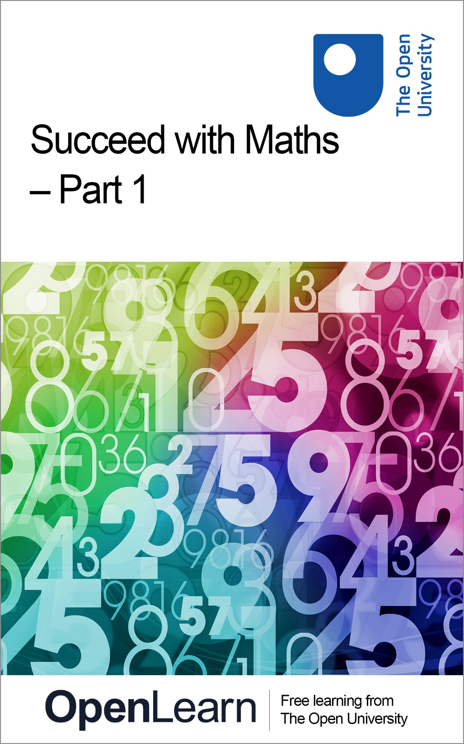

ALT_1

Succeed with Maths – Part 1

About this free course
This free course is an adapted extract from the Open University course .
This version of the content may include video, images and interactive content that may not be optimised for your device.
You can experience this free course as it was originally designed on OpenLearn, the home of free learning from The Open University –
There you’ll also be able to track your progress via your activity record, which you can use to demonstrate your learning.
Copyright © 2022 The Open University
Intellectual property
Unless otherwise stated, this resource is released under the terms of the Creative Commons Licence v4.0 http://creativecommons.org/licenses/by-nc-sa/4.0/deed.en_GB. Within that The Open University interprets this licence in the following way: www.open.edu/openlearn/about-openlearn/frequently-asked-questions-on-openlearn. Copyright and rights falling outside the terms of the Creative Commons Licence are retained or controlled by The Open University. Please read the full text before using any of the content.
We believe the primary barrier to accessing high-quality educational experiences is cost, which is why we aim to publish as much free content as possible under an open licence. If it proves difficult to release content under our preferred Creative Commons licence (e.g. because we can’t afford or gain the clearances or find suitable alternatives), we will still release the materials for free under a personal end-user licence.
This is because the learning experience will always be the same high quality offering and that should always be seen as positive – even if at times the licensing is different to Creative Commons.
When using the content you must attribute us (The Open University) (the OU) and any identified author in accordance with the terms of the Creative Commons Licence.
The Acknowledgements section is used to list, amongst other things, third party (Proprietary), licensed content which is not subject to Creative Commons licensing. Proprietary content must be used (retained) intact and in context to the content at all times.
The Acknowledgements section is also used to bring to your attention any other Special Restrictions which may apply to the content. For example there may be times when the Creative Commons Non-Commercial Sharealike licence does not apply to any of the content even if owned by us (The Open University). In these instances, unless stated otherwise, the content may be used for personal and non-commercial use.
We have also identified as Proprietary other material included in the content which is not subject to Creative Commons Licence. These are OU logos, trading names and may extend to certain photographic and video images and sound recordings and any other material as may be brought to your attention.
Unauthorised use of any of the content may constitute a breach of the terms and conditions and/or intellectual property laws.
We reserve the right to alter, amend or bring to an end any terms and conditions provided here without notice.
All rights falling outside the terms of the Creative Commons licence are retained or controlled by The Open University.
Head of Intellectual Property, The Open University
978-1-4730-3564-5 (.kdl)
978-1-4730-3565-2 (.epub)

Contents
- Introduction and guidance
  - Introduction and guidance
    - What is a badged course?
    - How to get a badge
- Week 1 Getting started
  - Introduction
  - 1 Puzzles and real-world maths
  - 2 Problem solving
  - 3 Understanding numbers
    - 3.1 Parts of the whole – decimal numbers
  - 4 Addition
  - 5 Subtraction
    - 5.1 Subtracting one number from another
  - 6 Multiplication
    - 6.1 Everyday multiplication
  - 7 Division
  - 8 Does order matter for multiplication and division?
  - 9 This week's quiz
  - 10 Summary of Week 1
- Week 2: Working with numbers
  - Introduction
  - 1 Fractions and decimals
  - 2 Rounding
  - 3 Getting to know your calculator
    - 3.1 Another calculator activity
  - 4 Exponents or powers
    - 4.1 Calculator exploration: exponents
  - 5 Order of operations
  - 6 Using maths in the real world
    - 6.1 Maths cycle in practice: insulating the attic
  - 7 Problem-solving strategies
  - 8 This week's quiz
  - 9 Summary of Week 2
- Week 3: Parts of the whole
  - Introduction
  - 1 Fractions
    - 1.1 Folding paper
  - 2 Equivalent fractions
    - 2.1 Working with equivalent fractions
  - 3 Fractions of a group
    - 3.1 Thinking more about fractions
  - 4 Mixed numbers
    - 4.1 Improper fractions
  - 5 Fractions – bringing it all together
  - 6 This week's quiz
  - 7 Summary of Week 3
- Week 4: More parts of the whole
  - Introduction
  - 1 Adding and subtracting fractions
    - 1.1 The process of adding and subtracting
    - 1.2 Adding and subtracting mixed numbers
    - 1.3 Reporting results using fractions
  - 2 Multiplying fractions
    - 2.1 Multiplying mixed numbers and fractions
    - 2.2 Practical multiplication
  - 3 Dividing fractions
    - 3.1 Practising dividing fractions
    - 3.2 Dividing mixed numbers and fractions
    - 3.3 Dividing mixed numbers and fractions – more examples
  - 4 Fractions on your calculator
  - 5 This week's quiz
  - 6 Summary of Week 4
- Week 5: Relationships among numbers
  - Introduction
  - 1 Percentages
  - 2 Writing a percentage as a fraction or decimal
  - 3 Writing a decimal as a percentage
  - 4 Writing a fraction as a percentage
  - 5 Converting between percentages, decimals and fractions
  - 6 Finding a percentage of a number
  - 7 What percentage is it?
  - 8 Facts and figures
  - 9 This week's quiz
  - 10 Summary of Week 5
- Week 6: Percentage calculations and ratios
  - Introduction
  - 1 Using percentages
    - 1.1 Finding a percentage of a value
    - 1.2 Money
  - 2 Percentage increase or decrease
    - 2.1 Calculating a result following a percentage increase or decrease
    - 2.2 Does the order of percentage change calculations matter?
    - 2.3 Calculating original amounts
  - 3 Percentage points
  - 4 Ratios
    - 4.1 Ratios in recipes
  - 5 This week's quiz
  - 6 Summary of Week 6
- Week 7: Negative numbers
  - Introduction
  - 1 Understanding negative numbers
  - 2 More practical uses of negative numbers
    - 2.1 Determining if a value is positive or negative
  - 3 Addition and subtraction on the number line
  - 4 Adding and subtracting negative numbers
  - 5 Rules for negatives
  - 6 Calculator exploration: negative numbers
  - 7 This week's quiz
  - 8 Summary of Week 7
- Week 8: Sharing maths with others
  - Introduction
  - 1 Multiplication and division with negative numbers
    - 1.1 Investigating multiplication by a negative number
    - 1.2 Rules for multiplication and division of signed numbers
    - 1.3 Using negative numbers in golf
  - 2 Calculator exploration: exponents with negative numbers
  - 3 Wrapping up negative numbers
  - 4 Reading and writing mathematics
    - 4.1 Writing mathematics
    - 4.2 Understanding a solution
  - 5 This week's quiz
  - 6 Summary of Week 8
  - Where next?
- References
- Acknowledgements
- Solutions

Introduction and guidance

Introduction and guidance
Succeed with maths – Part 1 is a free badged course which lasts 8 weeks, with approximately 3 hours' study time each week. You can work through the course at your own pace, so if you have more time one week there is no problem with pushing on to complete another week’s study.
You'll start with the most familiar territory of how numbers are put together and look at addition, subtraction, division and multiplication. In the following weeks you'll move on to look at fractions, percentages and negative numbers. You’ll use plenty of real-life examples to help with this and have plenty of opportunities to practise your new understanding and skills.
Part of this practice will be the weekly interactive quizzes, of which Weeks 4 and 8 will provide you an opportunity to earn a badge to demonstrate your new skills. You can read more on how to study the course and about badges in the next sections.
After completing this course you will be able to:
- use maths in a variety of everyday situations
- understand how to use percentages, fractions and negative numbers in some everyday situations
- begin to develop different problem-solving skills
- use a calculator effectively.

Moving around the course
In the ‘Summary’ at the end of each week, you will find a link to the next week. If at any time you want to return to the start of the course, click on ‘Full course description’. From here you can navigate to any part of the course.
It's also good practice, if you access a link from within a course page, including links to the quizzes, to open it in new window or tab. That way you can easily return to where you've come from without having to use the back button on your browser.

Viewing maths and equations
As you view the different text styles and symbols used to display maths throughout the course, you may notice that some of the text appears clickable or linked to something else. This is part of the equation processing software used by The Open University. You can ignore these clicks or links as they won't provide you with any useful information, but if you do click by accident you can just come back to where you were by using the back button.

If you enjoy this course and want to practise more of your skills for maths, or if you find that you are already familiar with most of the material in the course, you might like to take a look at Succeed with maths – Part 2.

The Open University would really appreciate a few minutes of your time to tell us about yourself and your expectations for the course before you begin, in our optional start-of-course survey . Participation will be completely confidential and we will not pass on your details to others.

What is a badged course?
While studying Succeed with maths – Part 1 you have the option to work towards gaining a digital badge.
Badged courses are a key part of The Open University’s mission to promote the educational well-being of the community. The courses also provide another way of helping you to progress from informal to formal learning.
To complete a course you need to be able to find about 24 hours of study time, over a period of about 8 weeks. However, it is possible to study the course at any time, and at a pace to suit you.
Badged courses are all available on The Open University's OpenLearn website and do not cost anything to study. They differ from Open University courses because you do not receive support from a tutor. But you do get useful feedback from the interactive quizzes.

What is a badge?
Digital badges are a new way of demonstrating online that you have gained a skill. Schools, colleges and universities are working with employers and other organisations to develop open badges that help learners gain recognition for their skills, and support employers to identify the right candidate for a job.
Badges demonstrate your work and achievement on the course. You can share your achievement with friends, family and employers, and on social media. Badges are a great motivation, helping you to reach the end of the course. Gaining a badge often boosts confidence in the skills and abilities that underpin successful study. So, completing this course should encourage you to think about taking other courses.

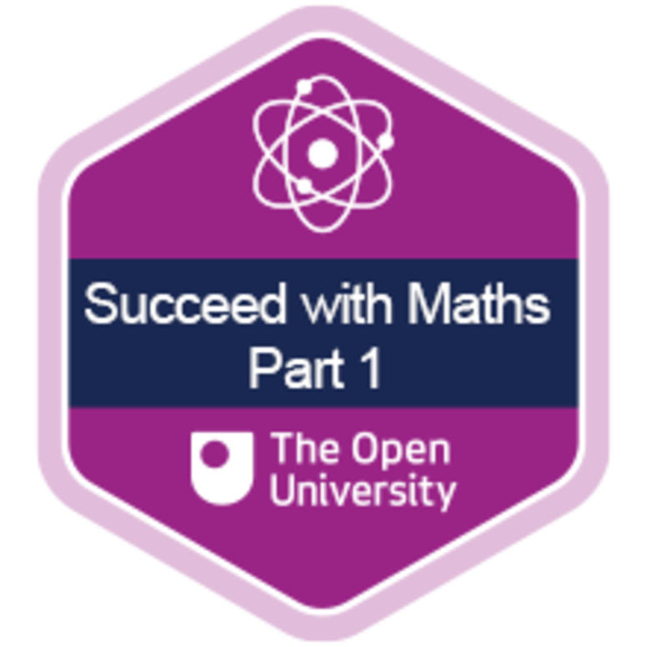
View description - Uncaptioned Figure

How to get a badge
Getting a badge is straightforward! Here's what you have to do:
- read each week of the course
- score 50% or more in the two badge quizzes in Week 4 and Week 8.
For all the quizzes, you can have three attempts at most of the questions (for true or false type questions you usually only get one attempt). If you get the answer right first time you will get more marks than for a correct answer the second or third time. Therefore, please be aware that for the two badge quizzes it is possible to get all the questions right but not score 50% and be eligible for the badge on that attempt. If one of your answers is incorrect you will often receive helpful feedback and suggestions about how to work out the correct answer.
For the badge quizzes, if you're not successful in getting 50% the first time, after 24 hours you can attempt the whole quiz, and come back as many times as you like.
We hope that as many people as possible will gain an Open University badge – so you should see getting a badge as an opportunity to reflect on what you have learned rather than as a test.
If you need more guidance on getting a badge and what you can do with it, take a look at the OpenLearn FAQs. When you gain your badge you will receive an email to notify you and you will be able to view and manage all your badges in My OpenLearn within 24 hours of completing the criteria to gain a badge..
Get started with Error! Hyperlink reference not valid..

Week 1 Getting started

Introduction
In this first week you will be focusing on some introductory maths activities. Some of these problems may seem more like puzzles than mathematics, and others will clearly fall into the category of maths problems. To help you there will be hints for you to use, if you need them. All of these puzzles bring up points about how to engage in maths and what is useful to know.
In the following video, the course author Maria Townsend introduces you to Week 1:

Video content is not available in this format.
View transcript - Uncaptioned interactive content

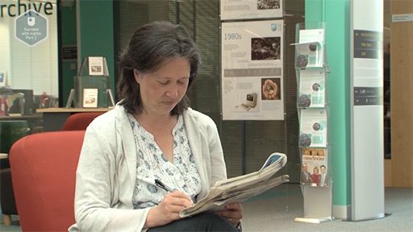
View description - Uncaptioned Figure

After this week, you should be able to:
- tackle maths activities with more confidence
- use addition, subtraction, multiplication and division in different situations
- understand decimal numbers and place value.
The Open University would really appreciate a few minutes of your time to tell us about yourself and your expectations for the course before you begin, in our optional start-of-course survey . Participation will be completely confidential and we will not pass on your details to others.

1 Puzzles and real-world maths
You probably use maths every day without realising, from working out how much change you might receive, to how long a journey might take, to solving puzzles. You’re going to start by looking at some puzzles.
You may be wondering what puzzles have to do with solving real problems. First of all, they introduce you to working logically and systematically, which is an important general technique that is used often in mathematics. Second, they introduce the idea that sometimes you have to find a ‘way in’ to a puzzle by trying different things. By doing this, it doesn’t mean that you can’t do the puzzle or that you’re getting it wrong!

- Can you draw the shape given in Figure 1 without taking your pen off the page or going over any lines more than once? Have a go on a piece of paper now.

Figure 1 Line drawing puzzle
View description - Figure 1 Line drawing puzzle
View description - Figure 1 Line drawing puzzle

- Figure 2 shows a sequence of images which gives one solution to solving the puzzle.

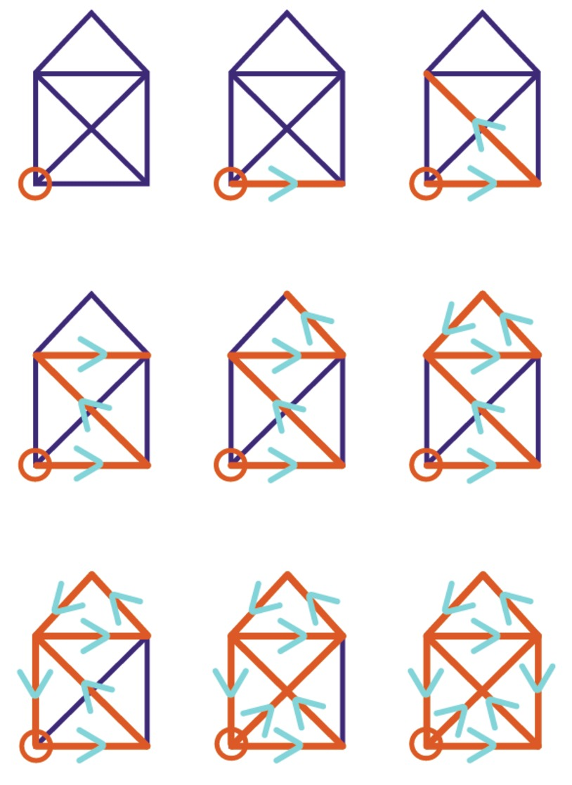
Figure 2 The solution to the line drawing puzzle
View description - Figure 2 The solution to the line drawing puzzle
View description - Figure 2 The solution to the line drawing puzzle

But you don’t have to do it exactly like this! Provided you start with one of the bottom corners and end with the other, you can’t really go wrong.
This type of puzzle relates to a part of maths that involves studying networks. A real-life example of this type of puzzle could be: if a salesperson had to visit five towns, what order should they do it to travel the least total distance overall?

It quite often happens in mathematics that what started out as very abstract topics with no practical use, later turn out to be extremely important in science or technology. Just because it is difficult to see a use at the time does not mean that there will not be some important practical development later!

Activity 1 Organising a dinner party
Allow approximately 15 minutes

Sandy and Les are having some friends round for dinner. There will be six of them sitting round their circular table, but unfortunately not all their friends get on well and so they want to arrange a seating plan that will keep everyone happy.
Read the conversation between Sandy and Les and then work out how they can seat their guests.

Sandy
Faisal doesn’t get on with Gareth, so we can’t put them next to each other. And Jordan used to go out with Aria, but they split up, so they can’t be next to each other.
Les
Don’t put Jordan directly opposite Aria either – they’ll just glare at each other! Just sit them with one person between them. And as the hosts, we can’t sit together. But I’d better be nearest the kitchen so I can go to get more drinks for people.
Sandy
Oh, and we can’t put Gareth next to you then – it’s too near the radiator and he’ll moan it’s hot all the time. And we can’t put Jordan and Gareth with their backs to the window as they’ll want to keep an eye on those fancy cars they have.
But I’d really like to sit next to Aria – I’ve not had a good chat to her for so long.

Try it! See if you can seat everybody and stick to the rules Les and Sandy have. You might find it helpful to draw out the plan of the table so you can try different ideas. Hints are given below if you get stuck.

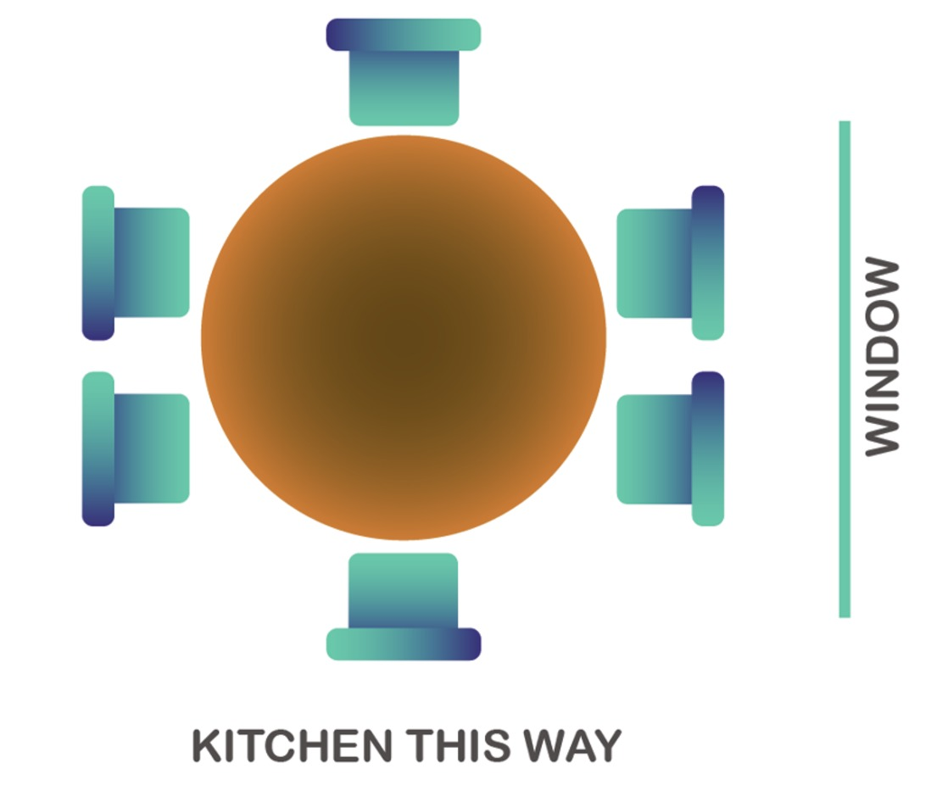
Figure 3 Dinner party table layout
View description - Figure 3 Dinner party table layout
View description - Figure 3 Dinner party table layout

Hint 1
There’s one person who can only be in one place – put them in first. Then think about which places Gareth can be in.

View discussion - Part

Hint 2
For each of the instances given in Figure 4 (Hint 1), where can Faisal be? Remember you need to leave two seats together for Aria and Sandy to sit together.

View discussion - Part

Hint 3
Now think about where Jordan can sit. Remember, he doesn’t want his back to the window and he can’t be seated next to Aria.

View discussion - Part

Hint 4
Now you need to place Sandy and Aria. Remember, Aria can’t be opposite Jordan, and Sandy can’t be next to Les.

View answer - Part

The hints to solve Activity 1, and the order of doing things, may have been quite different to how you approached it. Maybe you figured out where you could put Sandy first, or Aria and Jordan? Maybe you did some trial and error? That’s quite normal! There’s often not just one best approach, but there are some good strategies to use – and that’s what you’ll look at next.

2 Problem solving
When two people tackle a problem there is a good chance they will solve it in a different way to each other – that is absolutely fine! Some approaches may just be more efficient and get you to an answer more quickly than others. The more experience you have with problem solving the better you will become at it.
Depending on your previous experiences and how you initially take in a particular problem, the way you decide to begin to solve the problem will vary. Solutions to everyday problems may just need the use of common sense and organisation to work your way through them.
As you work through any problem, remember that there are usually alternative methods for reaching the solution. If you get stuck using your initial approach, try a different one. Keep in mind that using pictures and staying level-headed will carry you far, and most likely help you finish solving an exercise. So try not to panic!
With these thoughts in mind, try the next activity. Just as with the dinner party puzzle in Activity 1, you will need to use logic and reasoning to recover missing pieces of information.

Activity 2 New vehicle
Allow approximately 10 minutes

Imagine you’ve recently been looking for a new vehicle. You don’t know at the moment if you would like a motorbike or a car because you would like to get the best price possible and have the most options available.
When you call the dealership to enquire about its stock, the assistant manager, Paul, jokingly tells you that they have 21 vehicles available, with a total of 54 wheels. Just as you ask him how many of each type of vehicle he has, the phone call is inadvertently disconnected.
Can you work out how many motorcycles and how many cars the dealership currently has?
As with any problem there are different ways of approaching this problem, so when you’ve got your answer take a look at some other possible methods.
Remember, if you need a hint to help you get started click on ‘Reveal comment’ below.

View comment - Part

Method 1: Diagrams

View answer - Part

Method 2: Comparing to ‘all cars’

View answer - Part

Method 3: Educated guess

View answer - Part

You are going to leave problem solving behind for a moment and move onto subjects that you might think feel like proper maths! It is important to have a good understanding of how numbers are put together so that they make sense to us and what they represent. You will turn your attention to this in the next section.

3 Understanding numbers
As part of learning about maths, you need to understand how numbers work – both whole numbers and decimals.
Every number that we see around us is made up of a series of digits, such as 1302 (one thousand, three hundred and two). The value that each digit has depends not only on what that digit is, but also on its place, or position, in a number. This allows you to represent any number that you want by using only 10 digits (0, 1, 2, 3 etc.).
Each place in a number has a value of ten times the place to its right, starting with ones – or called more properly units – then tens, hundreds, thousands and so on. So in 1302, the 2 is in the units place, the 0 is in the tens place, the 3 is in the hundreds place and the 1 is in the thousands place. This means that the 3 has a value of 300 and the 1 has a value of 1000.
If you now rearrange the digits in your first number they will have different values and you’ll have a new number. So, 3120 has all the same digits but now the 3 is 3000, rather than 300 as it has moved one place to the left.
Now have a look at another example in Figure 8.

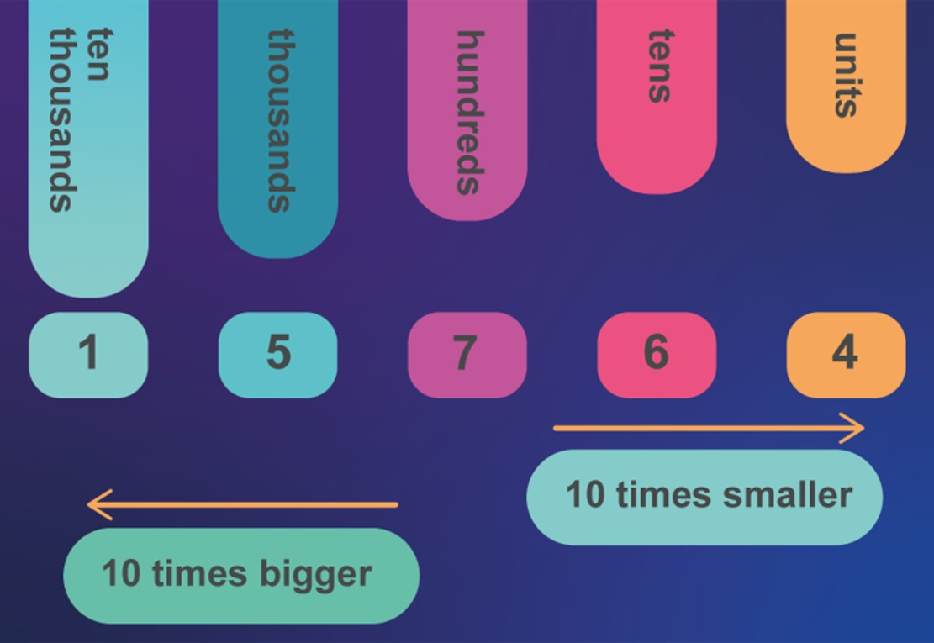
Figure 8 Place value
View description - Figure 8 Place value
View description - Figure 8 Place value

You can see in Figure 8 that the following is true:
- 1 is in the ten thousands place
- 5 is in the thousands place
- 7 is in the hundreds place
- 6 is in the tens place
- 4 is in the units place.
… and the number is 15 764, which is spoken as ‘fifteen thousand, seven hundred and sixty-four’.
Using this system, you can write and understand any whole number, but as you are probably aware numbers are not limited to only whole numbers. You also need ways to represent parts of whole numbers. The two ways that you do this are by using either decimal numbers, like 3.25, or fractions, such as .
You’ll start with a look at decimal numbers, and then in the coming weeks you will learn about fractions.

3.1 Parts of the whole – decimal numbers
An example of a decimal number is 1.5, said as one point five. The point in the middle is called the decimal point and is used to separate the whole numbers from decimal parts of the number. The 5 in 1.5 represents the part of a whole number.
To understand how the decimal part of a number works, you can start by extending the place values you have already to the right, making each one 10 times smaller. This allows you to represent numbers that are parts, or have parts of whole numbers. These are known as decimals numbers. This gives a place value table that looks like that shown in Table 2.

Table 2 Extended place value table
Tens | Units | Tenths | Hundredths | Thousandths
10 | 1

The next place value table shown in Figure 9 shows a decimal point added in. This is where the whole numbers are separated from the parts of whole numbers.

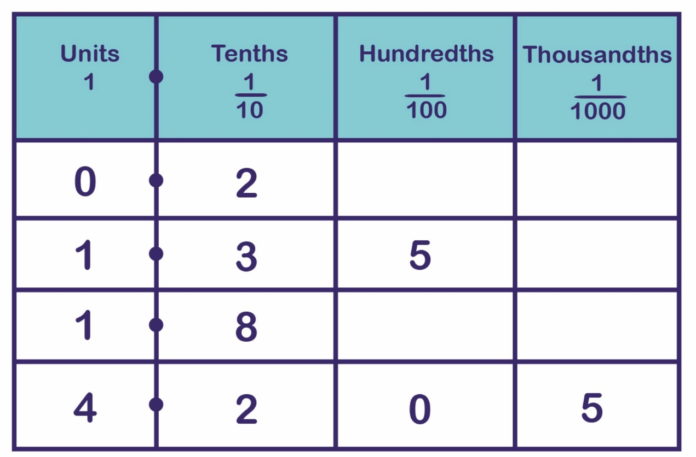
Figure 9 A place value table showing decimal numbers
View description - Figure 9 A place value table showing decimal numbers
View description - Figure 9 A place value table showing decimal numbers

The numbers shown in the table (Figure 9) are:
- no units and two-tenths, written as 0.2
- one unit, three-tenths and five hundredths, written as 1.35
- one unit and eight-tenths, written as 1.8
- four units, two tenths, zero hundredths and five thousandths, written as 4.205.
As well as using a place value table you can also show decimal numbers on a number line. This may help you to visualise decimal numbers. Take a look at the number line in Figure 10. The intervals between the whole numbers (or units) have each been split into ten equal intervals, each one is therefore 10 times smaller than a unit, so each of these is a tenth. If each tenth had then been split into ten equal intervals, these new intervals will be hundredths, since there will be 100 of these intervals in a whole unit.

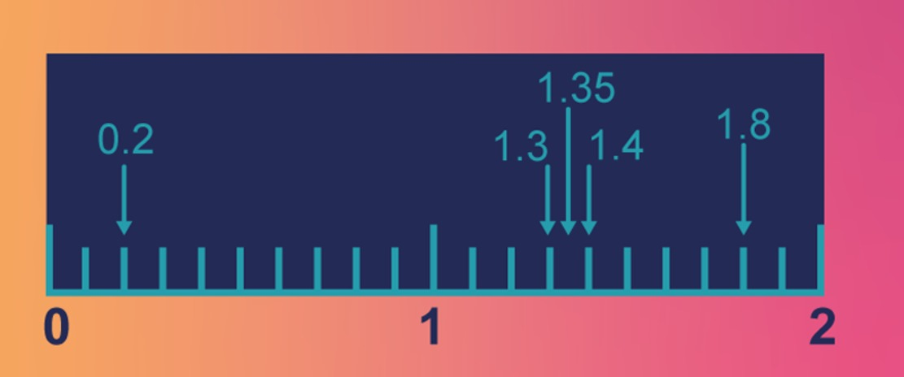
Figure 10 A number line
View description - Figure 10 A number line
View description - Figure 10 A number line

The number line shows the following numbers expressed in decimal form:
- two-tenths, written as 0.2
- one unit and three-tenths, written as 1.3
- one unit, three-tenths and five-hundredths, written as 1.35
- one unit and four-tenths, written as 1.4
- one unit and eight-tenths, written as 1.8.
Now have a go at these questions, which give you practice at identifying the different place values.

- What digit is in the hundredths position in this number?
5.603
- 0 is in the hundredths position.

- What digit is in the thousands position?
32 657
- 2 is in the thousands position.

- What digit is in the thousandths position?
5.8943
- 4 is in the thousandths position.

You’ve already used some of the four basic operators, such as multiplication and addition in the new vehicle problem in Section 2, but now you’re going to look at all these basic operators in turn, as they are all fundamental to maths and everyday calculations.

4 Addition
If you are working out a budget, checking a bill, claiming a benefit, assessing work expenses, determining the distance between two places by car or any other everyday calculations, you will probably need to add some numbers together. Consider the following questions.
- How much is the bill altogether?
- How much will your holiday cost now that the total price of your airfare has increased by £50 due to fuel surcharges?
- Five more people want to come on the trip: What is the total number of people booked on the bus now?
- What is the cost plus VAT?
All the questions above involve addition to work out the answer. The key or ‘trigger’ words that indicate addition are in bold. The process of adding numbers together may also be referred to more formally as finding the sum of a set of numbers.
Something that you probably take for granted is that when you add two numbers together, it does not matter which order do this in, for example 2 + 3 gives the same answer as 3 + 2. In mathematical terms, we say that addition is commutative. Not every operation will possess this property, for example 5 − 3 does not equal 3 − 5.
There are a few ways that you can carry out addition on paper, in your head or using a calculator for more complicated sums. You may already feel comfortable with adding on paper, which is great, but here’s a quick overview just to make sure.

To add numbers in the decimal system, you write the numbers underneath each other so that the decimal points and the corresponding columns (or place holders) line up. Then you add the numbers in each column, starting from the right. Remember that when you are adding, if the sum from one column is larger than 10, you will need to carry into the next place holder.
For example, to add 26.20, 408.75 and 0.07 together, first check you’ve got the calculation lined up correctly, with the decimal points below each other. It is also a good idea to put the decimal point in the answer line too, so you don’t forget at a later stage.

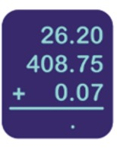
Figure 11 The calculation 26.20 + 408.75 + 0.007
View description - Figure 11 The calculation 26.20 + 408.75 + 0.007
View description - Figure 11 The calculation 26.20 + 408.75 + 0.007

Now, look at the numbers starting with the far right column: 0 + 5 + 7 = 12. So you write down a 2 underneath these figures and carry the 1 from the 12 to the next column.
Then move one column to the left: 2 + 7 = 9 – but don’t forget that 1 you carried over. So that makes 10 and should be written as a 0 in the tenths column with 1 carried over. The next column has 6 + 8 + 0 – and the one you’ve carried again. This equals 15, so put five down in the units column and carry the 1.
For the next column the sum is 2 + 0 plus the carried 1 to make 3. Nothing to carry this time! Just write down the 3. The final column just has a four, so all you need to do here is write down that four in the answer line and now you have your answer: 435.02.

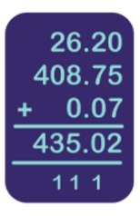
Figure 12 Adding decimals
View description - Figure 12 Adding decimals

Now try this activity on adding up items for a bill.

Activity 3 Checking a bill
Allow approximately 10 minutes

Imagine you have bought three items costing £24.99, £16.99 and £37.25 from a mail order catalogue and the postage is £3.50. Start by rounding these prices to the nearest pound and working out an estimate for the total bill in your head, or on paper.

View answer - Activity 3 Checking a bill

The next section will look at subtraction.

5 Subtraction
Subtraction follows naturally on from addition, because one way of viewing it is as the opposite of addition. For example, if you add 1 to 3, the answer is 4. If you subtract 1 from 4, the answer is 3, giving the original value.
Just as with addition there are trigger words in problems that tell you that you will need to subtract.
Consider the following questions:
- What’s the difference in distance between Milton Keynes and Edinburgh via the M6 or M1/A1?
- How much more money do you need to save?
- If you take away 45 of the plants for the front garden, how many will be left for the back garden?
- If all holiday prices have been decreased (or reduced) by £20, how much is this one?
All these questions involve the process of subtraction to find the answer – a process that you often meet when dealing with money. You can see that the ‘trigger’ words for subtraction are again in bold.
Remembering that subtraction is the opposite of addition gives one way of tackling problems involving subtraction using addition. A lot of people find addition lot easier than subtraction, so it’s a useful tip to remember.

For example, instead of saying, ‘£10 minus £7.85 leaves what?’ you could say, ‘What would I have to add to £7.85 to get to £10?’.
Adding on 5 pence gives £7.90, another 10 pence gives £8 and another £2 will give you a total of £10. So, the total amount to add on is £0.05 + £0.10 + £2.00 = £2.15. This is the same answer as the one obtained by subtraction: £10 − £7.85 = £2.15

This means that you can also check an answer to a subtraction problem by using addition.
However, as you saw in the example above, subtraction is not commutative, so, for example, subtracting 3 from 4 does not give the same answer as subtracting 4 from 3; 4 – 3 does not equal 3 – 4.
You may need to carry out subtraction on paper, so in the next section there is a quick reminder of how to do this.

5.1 Subtracting one number from another
As with addition, you may feel comfortable already with how to perform subtraction on paper. You may have also learned a different method to the one shown here and if this works for you it’s fine to continue with your method. Here’s a quick overview in case you feel that you need a reminder.
Write out the calculation so that the decimal points and the corresponding columns line up, making sure the number you are subtracting is on the bottom. Then, subtract the bottom number from the top number in each column, starting from the right. Remember, if you need to borrow from the next column, you need to change the value in that column. Figure 15 below describes how you can do this. You will only need to do this if you don’t have enough in one column to perform the subtraction.

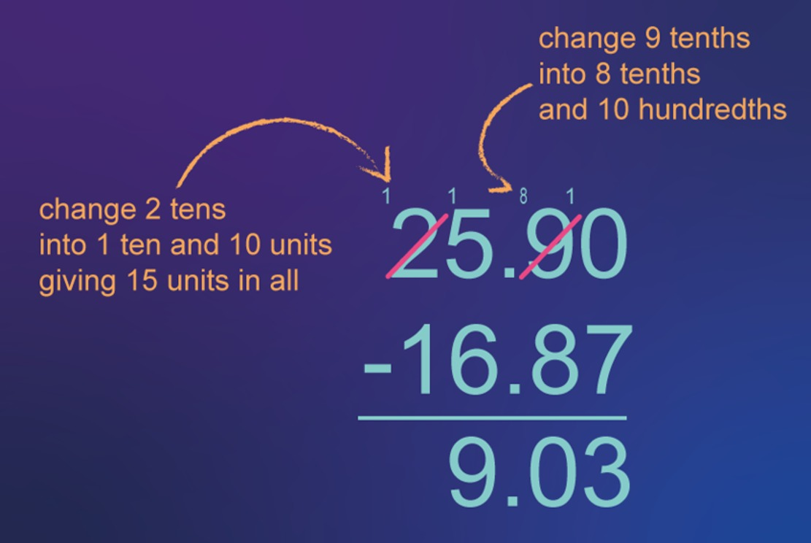
Figure 15 Subtracting one number from another
View description - Figure 15 Subtracting one number from another
View description - Figure 15 Subtracting one number from another

Now it’s time to put your knowledge to use in an activity using addition and subtraction when dealing with the slightly trickier situation of time.

Activity 4 Time, addition and subtraction
Allow approximately 10 minutes

Imagine you are travelling by train to attend a very important meeting. The train is leaving at 9:35 a.m. and arriving at 11:10 a.m. The ticket costs £48.30 but you have a refund voucher for £15.75, following the cancellation of a train on an earlier journey. How long will the journey take, and how much money will you have to pay for the ticket if you use the entire refund voucher?
Remember, if you need a hint, click on ‘Reveal comment’.

View comment - Part

Solution

View answer - Part

Now it’s time to investigate the two other operations: multiplication and division, starting with multiplication.

6 Multiplication
Multiplication is an extension of addition, and provides a quick way of carrying out repeated addition. For example, you know that 3 × 2 = 6. But why is this true? Well, another way to think of 3 × 2 is as 3 lots of 2; which is the same as 2 and 2 and 2. So, 3 × 2 is telling us to add 2 to itself 3 times: 2 + 2 + 2 = 6. We’ve already used one word that tells you to use multiplication, which is lots. But there are some others, as with addition, which mean the same thing. These are shown in bold below:
- 5 times 6
- On a cashpoint you might see the phrase ‘Please enter a multiple of £10’.
All the words in bold are again ‘trigger’ words telling you to multiply.
Now you’ve looked at some of the language of multiplication you’ll take a quick look at carrying it out on paper.

6.1 Everyday multiplication
Just as with addition and subtraction, there are a number of ways that you can carry out multiplication, in your head, on paper or using a calculator. You’ll probably find for more complicated examples you will need a calculator, but if you don’t have one handy remembering how to multiply on paper will be a great help. Of course, a good knowledge of the multiplication (times) tables will also be a bonus!
To make sure that you are happy with multiplying on paper have a look at a couple of examples.

Suppose that you need to work out 9 lots of £32.50 when you are out shopping.
You need to set up the calculation so that the smaller number is on the bottom, as shown below (you have to do less work then!). Working from right to left multiply each number in turn, writing the result in line with the appropriate column. If the result is greater than 9, remember you will need to carry to the next column.

If you need to multiply by a number that is 10 or more, then follow the same procedure as described in the example above to set up the calculation. Then multiply each number in the top row by each digit in the lower number in turn, finally adding up the two results.
For example, when multiplying 3965 by 25, start with the 5 and then move onto the 2. But you are not really multiplying by 2 but by 20 (2 is in the 10s place). To take this into account, add a zero to the beginning of the 2nd line of working, as shown below.

The next activity will give you a chance to practise this. Here’s a reminder of your times tables.

Table 3 Times table
× | 1 | 2 | 3 | 4 | 5 | 6 | 7 | 8 | 9 | 10 | 11 | 12
1 | 1 | 2 | 3 | 4 | 5 | 6 | 7 | 8 | 9 | 10 | 11 | 12
2 | 2 | 4 | 6 | 8 | 10 | 12 | 14 | 16 | 18 | 20 | 22 | 24
3 | 3 | 6 | 9 | 12 | 15 | 18 | 21 | 24 | 27 | 30 | 33 | 36
4 | 4 | 8 | 12 | 16 | 20 | 24 | 28 | 32 | 36 | 40 | 44 | 48
5 | 5 | 10 | 15 | 20 | 25 | 30 | 35 | 40 | 45 | 50 | 55 | 60
6 | 6 | 12 | 18 | 24 | 30 | 36 | 42 | 48 | 54 | 60 | 66 | 72
7 | 7 | 14 | 21 | 28 | 35 | 42 | 49 | 56 | 63 | 70 | 77 | 84
8 | 8 | 16 | 24 | 32 | 40 | 48 | 56 | 64 | 72 | 80 | 88 | 96
9 | 9 | 18 | 27 | 36 | 45 | 54 | 63 | 72 | 81 | 90 | 99 | 108
10 | 10 | 20 | 30 | 40 | 50 | 60 | 70 | 80 | 90 | 100 | 110 | 120
11 | 11 | 22 | 33 | 44 | 55 | 66 | 77 | 88 | 99 | 110 | 121 | 132
12 | 12 | 24 | 36 | 48 | 60 | 72 | 84 | 96 | 108 | 120 | 132 | 144

If you like you can download and print a version of this table.

Activity 5 Multiplication
Allow approximately 10 minutes

On a piece of paper, perform the following operations by hand.
(a) 348 × 37

View answer - Part

(b) 560 × 23

View answer - Part

You might now be wondering about multiplying by a decimal. How do you calculate something like 30 × 0.6, for example, or even 1.2 × 0.7? One way to do it is to do the calculation first without the decimal points in, and then put the decimal point back afterwards. To work out where to put the decimal point afterwards, count how many digits after the decimal point there are altogether in the numbers you started with. Then put the decimal point in the answer to give the same number of digits after the point.

For example, to calculate 30 × 0.6, you would first do the calculation without the decimal points, so 30 × 6 = 180. You now need to put the decimal point back! In the numbers you started with, there was just one digit after the decimal point (the 6 in 0.6). So you need one digit after the decimal point in the answer. Therefore the answer is 18.0
To calculate 1.2 × 0.7, you would do the calculation without the decimal points: 12 × 7 = 84. As there are a total of two digits after the point in the numbers you started with (the ‘2’ in 1.2 and the ‘7’ in 0.7) you now need to move two digits after the point in the answer. Therefore the answer is 0.84.

Now you’ve looked at multiplication, it’s time for division, a close relation of multiplication.

7 Division
You know from the last section that multiplication is repeated addition, similarly division can be thought of as repeated subtraction. For example, 20 divided by 4 is 5 (20 ÷ 4 = 5). The answer is 5 because 5 is the number of times you subtract 4 from 20 to arrive at zero:

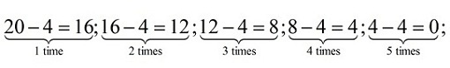
Figure 16 Demonstrating division
View description - Figure 16 Demonstrating division
View description - Figure 16 Demonstrating division

This also leads to the realisation that division is the opposite or undoes multiplication. If you add 4, five times to zero (repeated addition or multiplication) then you will arrive back at 20.
And just as with the other operators, there are words that tell us you need to divide.
Here are some examples that you may recognise:
- How many times does 8 go into 72?
- How can you share 72 items equally among eight people?
- How many lots of five are there in 20?
Unlike multiplication when there is only one symbol that says multiply, division has a whole family of notation! If you want to divide 72 by 8 this can be written in the following ways:
72 ÷ 8, or , or 72/8 or
Not all division problems will result in a nice whole number answer and you may have a number left over. This number is known as the remainder. The common notation is to show this using the letter R.
Now, you’re going to look at division on paper, just as you did with multiplication. You set up division on paper using the final notation from the list above. Starting from the left divide into each number in turn, writing the result above the number you have divided into. Watch the video below to see how this works.

Video content is not available in this format.
View transcript - Uncaptioned interactive content

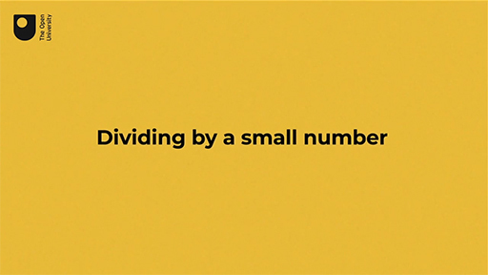
View description - Uncaptioned Figure

Division also works in a similar way when you are dividing a number involving decimals by a whole number. In cases like this, you just have to be careful to put the decimal point in the right place.
Wacth the video below to see an example.

Video content is not available in this format.
View transcript - Uncaptioned interactive content

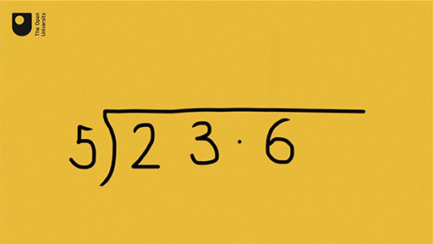
View description - Uncaptioned Figure

What happens if you have to divide by a larger number – something like 16, say? It’s easiest to do it using your calculator, but if you don’t have your calculator, you can still do it using this method. The next video shows how.

Video content is not available in this format.
View transcript - Uncaptioned interactive content

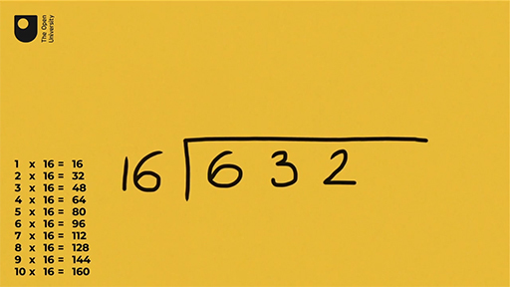
View description - Uncaptioned Figure

Now have a go at the next activity. If you wish you can view the times table again.

Activity 6 Division
Allow approximately 10 minutes

On a piece of paper, perform the following operations by hand.
(a) 4968 ÷ 24

View answer - Part

(b) 4035 ÷ 15

View answer - Part

When looking at subtraction and addition, you thought about whether it mattered in what order these were carried out. You found that for addition the answer is the same whatever the order, but that this is not the case for subtraction. What about multiplication and division? You’ll find out in the next section.

8 Does order matter for multiplication and division?
When you add two numbers together, the order does not matter – addition is said to be ‘commutative’ as 2 + 4 is the same as 4 + 2. However, subtraction isn’t commutative as 6 − 2 isn’t the same as 2 − 6. So what about multiplication and division? Is 3 × 2 the same as 2 × 3? Is 4 ÷ 2 the same as 2 ÷ 4? To help with this, we’ll use a diagram in Figure 17.

Figure 17 Order of multiplication
View description - Figure 17 Order of multiplication
View description - Figure 17 Order of multiplication

Figure 17 shows on the left three rows of two dots (3 × 2), and on the right two rows of three dots (2 × 3).
The number of dots in both arrangements is the same, 6, and hence you can see that 3 × 2 = 2 × 3.
However, you can’t say the same for division, where order does matter. For example, if you divide £4.00 between two people, each person gets £2.00. If instead you need to divide £2.00 among four people, each person only gets £0.50. Division is not commutative.
Now you’ve looked at the fundamentals of multiplication and division, you are going to get a chance to apply these to a more everyday problem.
The next activity uses both multiplication and division to solve a problem.

Activity 7 How many teabags?
Allow approximately 10 minutes

Try doing these on paper and then check your answers using a calculator.
A café buys boxes of teabags in bulk to cater for their customers. Each box contains 20 packs of teabags. Each pack contains 100 teabags.
a) How many teabags are there in one box?

View answer - Part

b) The café estimates they use 500 teabags a day. How many days will a box last them?

View answer - Part

c) If the café is open 300 days a year, how many boxes of teabags do they need for the year?

View answer - Part

d) Each box normally costs £80 but if the shop orders more than 50, they get a discount of £10 on each box. How much will their teabags for the year cost them?

View answer - Part

The next activity is a slightly more complex problem, or puzzle, than you’ve encountered so far in this week. You can use your calculator to help solve it and remember to use the hints, if you need to, by clicking on reveal.

Activity 8 Running a hospital
Allow approximately 10 minutes

The local hospital is keen to encourage people not to miss appointments. It has a sign up saying ‘This hospital costs £4000 every three minutes to run.’
a) Use a calculator to find out how much it costs to run the hospital in a 365-day year.

View answer - Part

b) An American visitor who comes to the hospital seeking treatment is charged £400 for this. For how long (in seconds) does his payment fund the running of the hospital?

View answer - Part

c) A pound is currently worth $1.39. How much does the American pay in dollars for their treatment?

View comment - Part

In Week 1, you have learnt how to carry out the four arithmetic operations – adding, subtracting, multiplying and dividing – on paper. You’ve also learnt that maths has a lot in common with doing puzzles – both need a logical systematic approach, and persistence.

9 This week's quiz
Well done – you have reached the end of Week 1. You can now check what you’ve learned this week by taking the end-of-week quiz.
Open the quiz in a new tab or window by holding down Ctrl (or Cmd on a Mac) when you click on the link. Return here when you have finished.
Week 1 practice quiz.

10 Summary of Week 1
Congratulations on making it to the end of this week. You started by warming up your mathematical skills with some puzzles. By working your way logically through these puzzles to the answer, you have made a great start in honing problem-solving skills that you may not even have been aware that you had. As well as this, you’ve begun your study of the foundations of maths. This new knowledge will provide a solid base from which to move on to Week 2. In Week 2, you’ll return to problem solving and learn about a new operation – finding the power of a number. You’ll also look at how to round numbers and how to use a calculator.
You should now feel that you can:
- tackle maths activities with more confidence
- use addition, subtraction, multiplication and division in different situations
- understand decimal numbers and place value.
You can now go to Week 2.

Week 2: Working with numbers

Introduction
In this week you will extend your work from Week 1 by looking at decimals again. You will also learn about powers (or exponentiation). When using all the mathematical operations you’ve studied so far, it is important to know what order to carry these out in, just like you would when making a piece of flat pack furniture. If you start in the wrong place, you may not end up with a correctly finished wardrobe, or correct answer. You will look at the correct order to carry out calculations, before turning again to problem-solving strategies.
After this study week, you should be able to:
- be able to round numbers
- be able to relate simple fractions to decimals
- use your calculator for the four operations of +, –, × and ÷
- use and understand powers
- carry out mathematical operations in the correct order
- appreciate the steps in solving a problem mathematically.

1 Fractions and decimals
You use fractions every day even if you're not really thinking about it. For example, if somebody asks you the time it could be half past 2 or a quarter to 6. The half and the quarter are parts of an hour; in other words they are fractions of a whole.
The number at the bottom of the fraction tells you how many parts the whole one has. So, has two parts in the whole one and has 4. The number at the top tells you how many of these parts there are. Hence, is 1 lot of 2 parts. You’ll be looking at this again in more detail in Week 3.
Since fractions are parts of a whole, just as decimals are, this means that you can relate fractions and decimals. Here you will only be dealing with fractions that are easily shown in a place value table.

So, say you needed to write out 2 and (three-tenths) as a decimal. The whole part is 2 and the fractional part is . Remember in order to separate the whole number from the fraction you use a decimal point, with the part of the whole number to the right. So, you would write the 2 to the left of the decimal point and the fractional part to the right of the decimal point. Thus, it would be written as 2.3. If you were dealing with on its own, you would need to show that there were no whole parts by showing a zero to the left of the decimal point. is therefore written as 0.3.

Now you’ve seen a few examples, it’s your turn to have a try yourself in the next activity. You can use a place value table if it helps you.

Activity 1 Fractions to decimals
Allow approximately 10 minutes

a) Rewrite each of the following fractions as a decimal number.
- Remember: if the number does not have a whole number part, a zero is written in the units place. This makes the number easier to read (it’s easy to overlook the decimal point).

View answer - Part

View answer - Part

View answer - Part

View answer - Part

b) Match the numbers below to the letter shown on the number line in Figure 1.

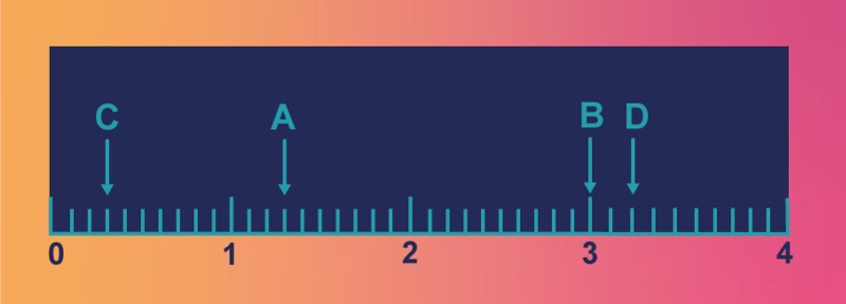
Figure 1 Number line exercise
View description - Figure 1 Number line exercise
View description - Figure 1 Number line exercise

B
C
A
D
View answer - Part

Now, you’re going to turn your attention to rounding numbers, and making estimates. Understanding place value will help with this, but you’ll also investigate the idea of decimal places when rounding.

2 Rounding
The world population in April 2021 was estimated to be 7.86 billion. That is not an exact value but it does give you an indication of the world’s population at the time. This is an example of a rounded or estimated number.
In newspapers and elsewhere, numbers are often rounded so that people can get a rough idea of the size, without getting lost in details. You may use rounding yourself, such as prices in a supermarket (£2.99 is about £3) or distances (18.2 miles is about 20 miles).
Using approximate values is also useful if you want to get a rough idea of an answer before you get out scrap paper or a calculator. This estimation acts as a check on your calculation and may help you to catch any errors you may have.
The general rules for rounding are:
- Locate the place value to be rounded.
- Look at the next digit to the right.
- If that digit is a 5 or greater, ‘round up’ the previous place value digit – which means increase it by one.
- If that digit is a 4 or less, leave the previous place value digit unchanged.
- Replace all digits after the place value digit with 0, but only if these are to the left of the decimal point.
This last rule may be a little harder to understand, so here’s an example.

If you are rounding 5423 to the nearest one hundred this would be 5400 – the tens and units places being replaced by zeros.

With decimals we often refer to the number of decimal places to round to rather than a digit’s place value. So, instead of asking you to round to the nearest tenth, you might see instructions to ‘round to 1 decimal place’ (1 d.p.). The decimal places are numbered consecutively from the right of the decimal point. So, 1.54 has 2 decimal places, and 34.8942 has 4 decimal places.
Whether you are rounding using place value or decimal places, the general rules remain the same.
Before you have a look at some examples, you might like to view this video on rounding.

Watch the video at YouTube.com.
View transcript - Uncaptioned interactive content

Here are a few more examples to have a look at before you have a go yourself.

Imagine you want to round the world population figure of 7.86 billion to the nearest billion. The place value that you want to round in this case is the units as these represent the billions, which is a 7. The next number to the right of this is a 8, which is 5 or more, so you need to round up and the 7 becomes an 8.
So 7.86 billion rounded to the nearest billion is 8 billion.

Now suppose you want to round 1.72 to 1 decimal place. The 7 is in the first decimal place and to the right of this is a 2. This is 4 or less, so the 7 stays as it is.
So 1.72 rounded to 1 decimal place is 1.7. Now it’s your turn.

Activity 2 Rounding
Allow approximately 5 minutes

Round each of the following numbers as stated.
(a) Round 126.43 to the nearest tenth.

View answer - Part

(b) Round 0.015474 to the nearest thousandth.

View answer - Part

(c) Round 1.5673 to 2 decimal places (2 d.p.).

View answer - Part

Now complete Activity 3.

Activity 3 How much is it?
Allow approximately 10 minutes

Suppose you want to buy a new pick-up truck. When you visit the dealership’s website, it says the cost of the vehicle you are looking at is £19 748. When you call the dealership on Thursday, the sales representative, Joe, tells you the cost is £19 750. However, the next day another sales representative, Tina, informs you that the vehicle costs £19 700. Why did the quote you were given on the cost of the pick-up truck change?
Hint: Round the website cost to the nearest £10. Then round the website cost to the nearest £100.

View answer - Part

You’re now going to take some time to get to know your calculator. Calculators can save you a lot of time, but it’s important to know how to get the most from them.

3 Getting to know your calculator
In the following activities you’ll start to learn how to use your calculator. You have plenty of options when it comes to what calculator to use. You may find it easier to use the one that you are most familiar with, maybe a calculator on your mobile phone, your computer or tablet, an online calculator, or a handheld calculator.
Start with a calculation that you can check in your head to make sure your calculator is working properly. Click on or press the following keys:

View description - Uncaptioned Figure

You should get the answer 7! If you didn’t, have another go now, being careful with the numbers that you enter.
Once the calculation is complete, it needs to be cleared before the next calculation can be performed. You clear a calculation by clicking on the button labelled AC. Do this now; your last calculation should disappear.
Now you’re ready to do arithmetic on your calculator. You may find Table 1 helpful in finding the correct button or key if you are using a computer keyboard. Remember, if you are using the calculator on your phone, you may need to switch it to landscape mode to be able to access the full range of functions.

Table 1 Arithmetic on your calculator
Mathematical operation | Calculator button | Computer keyboard key
+ |  | Shift and ‘=’ on the main keyboard or ‘+’ on the number pad
− |  | ‘−’ (the key to the left of ‘=’) on the main keyboard or on the number pad
× |  | Shift and ‘8’ on the main keyboard or ‘*’ on the number pad
÷ | 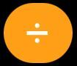 | ‘/’ on the main keyboard or on the number pad
= |  | Enter
Clear | 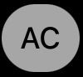 | Backspace (as often as needed to clear all entries)

Now have a go at these straightforward calculations to make sure that you can get your calculator to work properly.Check the answer in your head so that you know what your calculator should show. Remember to clear the calculation before you enter each new calculation.

  - 5 + 20
  - 100 – 99
  - 2 × 4
  - 10 ÷ 2
- Your calculator should have given the following answers:
  - 25
  - 1
  - 8
  - 5

How did that go? Hopefully you found it fairly straightforward. There will be plenty of chances throughout the eight weeks of the course to become more confident using a calculator. If you want to learn more about how to use a scientific calculator, the OpenLearn course Using a scientific calculator may be of interest. (Open the course in a new tab or window by holding down Ctrl (or Cmd on a Mac) when you click on the link to avoid losing your place in this course!)

3.1 Another calculator activity
This next number puzzle involves doing calculations.

Activity 4 Cross-number puzzle
Allow approximately 10 minutes

Here’s a cross-number puzzle to give you some more practice using your calculator. It’s like a crossword puzzle, only with numbers instead of words. You may want to download and print the puzzle, and then use your calculator to solve it.

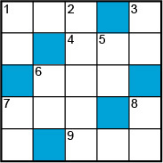
Figure 2 Blank cross-number puzzle
View description - Figure 2 Blank cross-number puzzle
View description - Figure 2 Blank cross-number puzzle

Table 2 Questions for cross-number puzzle
Across | Down
1. 21 × 47 | 1. 19 × 5
4. 1788 ÷ 6 | 2. 8003 × 9
6. 497 – 105 + 12 | 3. 1234 – 1216
7. 1458 ÷ 3 × 2 | 5. 1 + 11 + 111 – 29
9. 32 + 681 – 13 | 6. 517 ÷ 11
 | 7. 21 × 33 ÷ 7
 | 8. 49 + 49 – 48

View answer - Activity 4 Cross-number puzzle

You’ll now turn your attention to repeated multiplication of the same number, which is exponents or powers.

4 Exponents or powers
As you saw in Week 1, multiplication is a way to represent and quickly calculate repeated addition. What if you have repeated multiplication? For example, say you have 2 × 2 × 2 × 2. In this case, 2 is being multiplied by itself four times.
In mathematics this is written as 2⁴ and read as ‘2 raised to the power 4’ or ‘2 to the power 4’. The 4 is superscripted (raised) and referred to as the exponent, power or index. This notation tells you to take the base, 2, and multiply it by itself four times. When the exponent is 2, you usually say ‘squared’ and, when the exponent is 3, you say ‘cubed’.
Usually you will use a calculator to work these out and in the next section you’ll look at how to do this.

4.1 Calculator exploration: exponents
Suppose you want to calculate 7 × 7 × 7 × 7. Do this on your calculator now; you should get 2401. This is fine, but as you have just seen, this calculation can be written more concisely as 7⁴ and there is a quicker way of calculating it, too.
To work out an exponent on a calculator, you use the buttons (x raised to the power y) or . Find the correct button on your calculator now.
If you are using a calculator on your phone you may need to change it to landscape mode in order for the button to be displayed.
On most calculators you will need to enter 7, then press the exponent key followed by the 4.
Try this now for 7⁴ and make sure you get 2401.
Most calculators will also have separate buttons for finding the square of a number and in some cases the cube. To find the square of a number, the button will look like and is just a short cut to finding this power; you need to press one less button!
So far you’ve been dealing with each operator separately in a calculation but there will be occasions where you will use them in combination. In these cases you will have to know the rule that is used to ensure that everybody gets the same answer to the same calculation. This will be the subject of the next section.

5 Order of operations
Since many everyday problems that you encounter require the use of more than one operation, you need to make sure you know how to correctly proceed, write and carry out the calculation.
The five operations you have looked at so far are joined by brackets when considering order of operation.
Brackets indicate the highest priority, followed by any exponents (powers). Then carry out the multiplication and division, and finally any addition and subtraction. If part of the calculation involves only multiplication and division or only addition and subtraction, work through from left to right.
The correct order to carry out the operations can be summarised by using the mnemonic BEDMAS, where the letters stand for Brackets, Exponents, Division, Multiplication, Addition and Subtraction.
The following everyday problem involving more than one operation demonstrates the importance of BEDMAS.

Let’s suppose you purchased four very large pepperoni pizzas that cost £15.99 each and you want to split the total cost among six people. One way to do this is by using addition and division.
You might think that you can enter this into your calculator as:
15.99 + 15.99 + 15.99 + 15.99 ÷ 6.
However, this will give you £50.635 as the answer! That is clearly not correct as each pizza only costs £15.99.
The calculator has actually worked out:
15.99 + 15.99 + 15.99 + (15.99 ÷ 6) = 47.97 + 2.665 = 50.635. This is because it follows BEDMAS, dividing only the last £15.99, not the total, by six. To obtain the correct answer you must use brackets:
(15.99 + 15.99 + 15.99 + 15.99) ÷ 6 = 10.66
Now the total cost of the pizzas is divided by 6 (remember, B comes before D in BEDMAS), to give a much more sensible answer of £10.66.

You can now see how important it is to get the correct order for calculations.
Now, it is your turn to have a go. Try applying this rule in the next activity.
Before you start this activity you need to ensure that your calculator does know the BEDMAS rules. So, check this by working out 3 + 5 × 2 , without pressing the equals sign until after the final 2. If your calculator knows the rules the answer will be 13, if it doesn’t it will give you 16.
But don’t worry! Just be aware of the rules and work through the calculations carefully yourself.

Activity 5 BEDMAS on paper versus the calculator
Allow approximately 10 minutes

First of all, try these examples on paper without using a calculator. Then, check your answer using a calculator.
(a) (3 + 4) × 2
Hint: Remember BEDMAS. Are there brackets? If so, then do the calculation inside those first. Next, look for exponents, then multiplication, division, addition, and subtraction.

View answer - Part

(b) 2 + 3²

View answer - Part

(c) (2 + 3)²

View answer - Part

(d) 3² + 4²

View answer - Part

(e) 2 + 3 × 4 + 5. Take care with this one!

View answer - Part

The last few sections have been activities that were not related to any real-world problems so could seem a little abstract in nature. Next, you will apply this maths to more real-world problems and also continue your work on problem-solving skills from Week 1.

6 Using maths in the real world
Quite often, you will need to decide how to tackle a problem, as well as consider what information you need. That can be a lot more challenging than working through some examples in a textbook.
However, it can be very useful to visualise problem solving as loop, in which you follow a series of steps to solve a problem. You can then repeat these if your answer needs further investigation or refining. We’re going to call this the maths cycle.
The steps in the cycle are summarised in Figure 4.

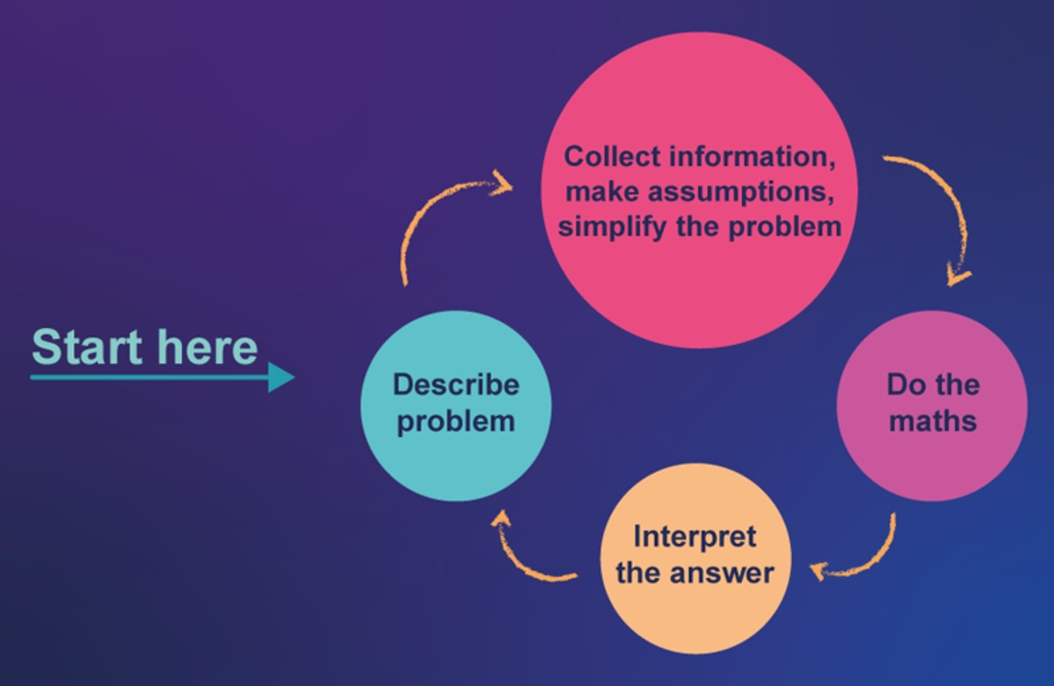
Figure 4 Mathematical modelling cycle
View description - Figure 4 Mathematical modelling cycle
View description - Figure 4 Mathematical modelling cycle

So you can see that the four main steps in this cycle are:
- Describe the problem – do this as clearly as you can, remembering to discuss with others if you need to.
- Collect information and make any assumptions – make sure you have everything you need to solve the problem.
- Do the maths – decide what mathematical techniques to use.
- Interpret the answer – so you know what this means practically and check that it is reasonable.
If the answer doesn’t look plausible, or isn’t sufficiently accurate, you may need to refine the assumptions and go through the cycle again.
Now you’ll see how the maths cycle works in practice.

6.1 Maths cycle in practice: insulating the attic
Work through this real-life problem using the maths cycle.

Step 1: Describe the problem
My father has recently moved into an old terraced house that needs insulation in the attic. I have volunteered to take care of this task. Although I think it’s going to cost less to put in the insulation myself, my dad can get a grant from local government if the insulation is installed by an approved contractor. But which is the cheaper option?

View description - Uncaptioned Figure

Step 2: Collect information, make assumptions and simplify the problem
Now I need to write down what I know and what I still need to find out. After measuring the attic space and joists, visiting a DIY shop, contacting the local government department about the grant and local contractors for quotes, I wrote down the list given in Table 4.

Table 4 Collecting information
I know: | I want:
The attic is approximately 825 cm by 900 cm. | To find the cheaper option
Each joist is 5 cm wide.
There are 17 joists.
The insulation fits perfectly between the joists.
A £200 grant is available.
The cheapest quote from a contractor is £650.
The insulation comes in rolls that are 40 cm wide and 800 cm long.
Each roll costs £15 but there is a special 3 for 2 offer at the moment.
I need safety glasses, a face mask and gloves costing £40 to install the insulation.

Step 3: Do the maths! (Part 1)
This is a complicated problem, so a useful strategy would be to break it down into more manageable chunks. There are two separate problems:
- How much would my father have to pay if he got the £200 grant and used the contractor?
- How much would the ‘do-it-yourself’ option cost? Broken down into:
  - How much insulation will I need?
  - How much will the materials cost?
In Activity 6, you will focus on the first question: how much would my father have to pay if he got the £200 grant and used the contractor?.

Activity 6 The contractor’s costs
Allow approximately 3 minutes

How much will it cost if the contractor installs the insulation and the grant is used?

View answer - Activity 6 The contractor’s costs

Now you know how much it would cost if a contractor installed the insulation, you want to know how much the ‘do-it-yourself’ option will cost to allow you to make a comparison. You should start by working out how much insulation is required.

Step 4: Do the maths! (Part 2)
This means working out how many rolls are needed. In this case a diagram will probably help.
Figure 5 shows a rough plan of the attic.

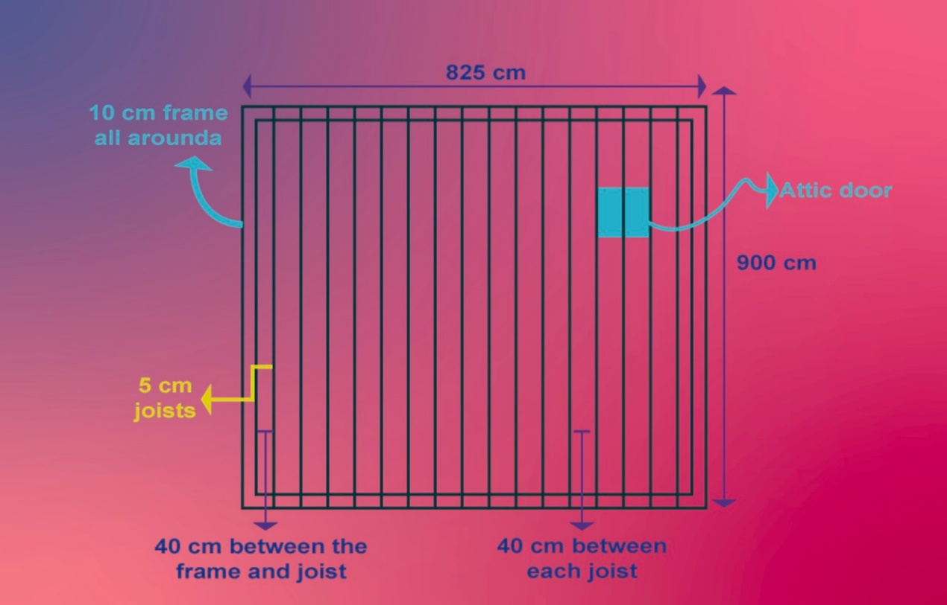
Figure 5 Plan of joists in an attic
View description - Figure 5 Plan of joists in an attic
View description - Figure 5 Plan of joists in an attic

Note: the attic door is in the floor and will be covered by insulation. The insulation will later be cut to allow the door to open.
As the insulation fits perfectly between the joists, as well as the frame and outer joists, the amount of insulation needed will be easy to calculate.
- One roll of insulation is 800 cm long.
- The length of the attic minus the frame at each end is 900 cm − 10 cm − 10 cm = 880 cm.
- So one roll between the joists is not quite enough to do the job because there is an extra 880 cm − 800 cm = 80 cm that need to be covered between any two joists.

Activity 7 How many rolls do I need to buy?
Allow approximately 10 minutes

Use the information given above to work out how many rolls of insulation are needed.

View answer - Activity 7 How many rolls do I need to buy?

You’re nearly there now – just one more step to finally work out the DIY cost.

Step 5: Do the maths! (Part 3)

Activity 8 The price of doing it yourself
Allow approximately 10 minutes

Now work out the DIY cost using all the information you’ve gathered and worked out.
Remember:
- Each roll costs £15.
- There is a ‘three-for-two’ special offer.
- I will also need to buy some safety equipment costing £40.
- I need to buy 20 rolls of insulation.

View answer - Activity 8 The price of doing it yourself

You can now move onto the final step in the problem solving cycle – interpreting the answer

Step 4: Interpret the answer
Now you can make an informed decision.
Should I hire the contractor and use the grant for placing the insulation in the attic, or should I do it myself?
The cost of using an approved contractor is £450. The price of installing the insulation myself is £250. Based on these values, I should choose the DIY option. However, I may also take other factors into consideration when coming to a decision, such as the convenience of undertaking the work myself. So, the mathematical solution may be just one of several issues to consider.
Well done for working your way through this more complex problem. If there were points when you got stuck, don’t worry this happens to us all. The final section will summarise the techniques you used to help solve this last problem.

7 Problem-solving strategies
There are many different ways that you can help yourself solve a problem, and get around an aspect that you find particularly tricky.

View description - Uncaptioned Figure

In the last problem you used the following techniques, try to keep these in mind when faced with any new problem.
- Write down what you know – the information you have, any techniques that might be helpful, and your ideas for tackling the problem.
- Write down what you want to do or find.
- Break the problem down into smaller steps that you can tackle one at a time.
- Draw a diagram or use a physical model.

8 This week's quiz
Well done – you have reached the end of Week 2. You can now check what you’ve learned this week by taking the end-of-week quiz.
Open the quiz in a new tab or window by holding down Ctrl (or Cmd on a Mac) when you click on the link. Return here when you have finished.
Week 2 practice quiz.

9 Summary of Week 2
Congratulations for making it to the end of this week. You’ve covered quite a lot of ground in this week, some of which you may well have been more familiar with than other parts. This is perfectly normal. The important thing is that you are continuing to build your knowledge from Week 1 and hopefully already seeing your own progress. All this will help you in later weeks. Next week you will move on again and start your journey through fractions. This can be quite a daunting subject for many people. We will make sure though that you cover the basics before looking at calculations with fractions. See you next week!
You should now feel confident to:
- round numbers to the nearest hundred, ten, etc., as well as to a given number of decimal places
- understand how some simple fractions relate to decimals
- use your calculator for the four operations of +, –, × and ÷
- use and understand exponents (powers)
- carry out operations in the correct order (following the BEDMAS code)
- appreciate the steps in solving a problem mathematically.
You can now go to Week 3.

Week 3: Parts of the whole

Introduction
You encountered fractions briefly in Week 2, when you looked at how to show them on a number line and related them to decimal numbers. This week you will continue your exploration of fractions and look at them in more detail.
First, you’ll look at what a fraction is and then look at different types of fraction. Some of this may seem a little like maths for the sake of maths but much of this week’s study is to provide a solid foundation for carrying out calculations using fractions. So stick with it and their importance will become clear!
By the end of the week, and after you have completed all the activities, you should feel more confident in dealing with different types of fraction as well as the language to use when describing them.
Doing the activities as you come across them is a very important part of cementing your understanding of the maths that you will be studying. Just as someone learning a sport needs to practise their skills to get better at it, so doing the activities helps develop your mathematical skills.
Now watch Maria introduce Week 3.

Video content is not available in this format.
View transcript - Uncaptioned interactive content

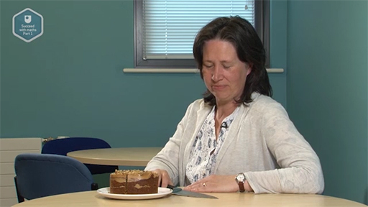
View description - Uncaptioned Figure

After this study week, you should be able to:
- understand the language of fractions
- write and understand fractions
- find the simplest form of a fraction
- convert between improper fractions and mixed numbers, and vice versa.

1 Fractions
Most people use fractions in their everyday life when they talk about time (a quarter past ten), parts of pizzas and cakes (halves and quarters), or when shopping (two-thirds off marked prices). You may also see fractions in news reports or on the internet. How often do you think about what these fractions really mean? If you can explain to somebody else what a fraction means then you are already on your way to having a good understanding of fractions.
To get going this week, look at this example and ask yourself some questions about the meaning of the fraction. This headline appeared appeared in the Yorkshire Post in April 2021.

Three quarters of Yorkshire’s residents plan to holiday in the region this year.
(Snowdon, 2021)

What did you think when you read the headline? Do a majority of Yorkshire people want to holiday in their home county? Do you know how many people actually think in this way?
No, you don’t actually know the number of people who want to do this – the headline just tells you the proportion who do. In other words, the headline tells you how many people plan to holiday in Yorkshire compared with the whole group. If you gathered together all the people who were polled, you could arrange them into four equal groups, so that the people in three of the groups would have planned to holiday in Yorkshire and those in the fourth would not.
If only four people had been interviewed, three would have said they intended to holiday in Yorkshire. If 4000 people were interviewed, then 3000 would have said that, and so on. How much notice you should take of the headline would probably depend on both the number of people who were surveyed and how they were selected.
Interviewing a lot of people who had been selected at random may give a better indication of the intentions of the general population than would polling just a few people.

This starts to show you just what a fraction is – it tells you a proportion rather than what the actual numbers were that enabled this fraction to be written.

- Suppose that for this article 500 Yorkshire residents were surveyed.
By dividing this group into quarters, work out how many of the people had the intention to holiday in Yorkshire. How many did not agree?
- Remember three-quarters of the 500 people were going to holiday in Yorkshire.
First, split the group into quarters by dividing 500 by 4: 125 people is equivalent to one-quarter of the people surveyed.
To find three-quarters of the group means you need three sets of 125 people. So, 375 people intended to holiday in Yorkshire and 125 did not. (You can check your arithmetic by noting that 375 + 125 = 500.)

In a similar way to the method used here, you can often make sense of most everyday fractions by:
- dividing the amount or number into the desired number of equal parts
- considering how many of these parts you need.
One way to help with understanding fractions is to use diagrams or physical objects. A large cake would be nice, but in the next section you’re going to use a piece of paper instead. So, before you start find a piece of paper – some scrap will do.

1.1 Folding paper
It is possible to use a simple piece of paper to help understand fractions. Here you’ll see how.
Take a piece of paper and fold it in half, creasing along the fold. Open it up and shade the left-hand side. You don’t have to fill this completely, just make sure that one half is clearly different from the other.

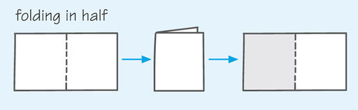
Figure 1 Folding a piece of paper in half
View description - Figure 1 Folding a piece of paper in half
View description - Figure 1 Folding a piece of paper in half

Since your paper has been divided into two equal parts, each piece is half of the original. This fraction is written as and read as ‘one-half’.
The ‘bottom number’ is called the denominator. It tells you how many parts of the whole one has been divided into. For example, if it’s a four, then the whole thing (piece of paper, cake, etc.) has been divided into four parts.
The ‘top number’ or numerator tells you how many of those parts you have. So for , it means the whole thing is divided into four parts, and you have three of them.
The numerator and denominator are separated by a line known as the fraction bar.

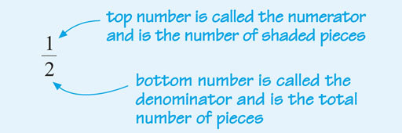
Figure 2 Defining a fraction
View description - Figure 2 Defining a fraction
View description - Figure 2 Defining a fraction

Now fold your piece of paper back along the original crease and then in half again along the long side. If you open up the paper, you should see four pieces of the same size, with two of them shaded.
The paper is now divided into quarters, and the fraction of the paper shaded is .

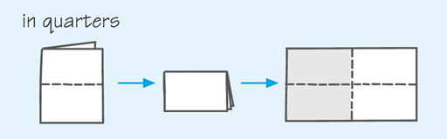
Figure 3 Folding a piece of paper into quarters
View description - Figure 3 Folding a piece of paper into quarters
View description - Figure 3 Folding a piece of paper into quarters

Since you haven’t altered the shading in any way, this demonstration shows that one half is equal to two quarters:
Now fold the paper back into quarters along the crease lines, and then fold into three equal pieces or thirds along the long side. If you now open up the paper you can see that there are 12 equal pieces. These pieces are ‘twelfths’, of which six are shaded, so of the paper is shaded. This fraction also represents the same amount as .

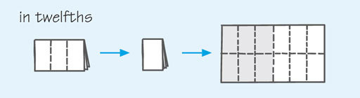
Figure 4 Folding a piece of paper into twelfths
View description - Figure 4 Folding a piece of paper into twelfths
View description - Figure 4 Folding a piece of paper into twelfths

You can continue to fold the paper into smaller and smaller pieces. Each time you open up the paper it will be divided into smaller fractions but half of it will still be shaded. The fractions that represent the shaded part are all equivalent to each other.
So .
Now it’s time to look at equivalent fractions in more detail.

2 Equivalent fractions
If you multiply the numerator (the number on top) and the denominator (the number underneath) of any fraction by the same number (except zero), you will get a fraction that is equivalent to the original one, as Figure 5 shows.

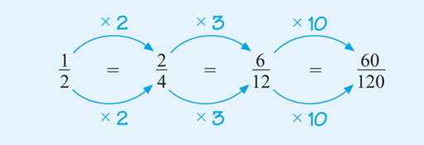
Figure 5 Equivalent fractions by multiplying the numerator and denominator
View description - Figure 5 Equivalent fractions by multiplying the numerator and denominator
View description - Figure 5 Equivalent fractions by multiplying the numerator and denominator

Note that you must multiply the numerator and denominator by the same number. This is actually the same as multiplying by one, so it doesn’t change the value of the fraction. You can also generate equivalent fractions by dividing the numerator (top number) and the denominator (bottom number) of the fraction by the same number (again, not zero). This is the method that you will be employing frequently since fractions should usually be shown in their simplest form.
A fraction in its simplest form is one where you can no longer find a number (except one) to divide into both the numerator and the denominator to give you whole number answers.
This process of dividing the numerator (the number above the line) and the denominator (the number below the line) by the same number is known as cancelling or simplifying the fraction – hence ultimately a fraction in its simplest form.
Figure 6 shows an example of simplifying a fraction, using division. Before you look at the method used, think about how you would go about simplifying . Look for numbers that you can divide exactly into the top and bottom of the fraction.

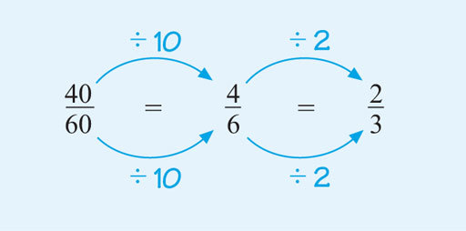
Figure 6 Equivalent fractions by dividing the numerator and the denominator
View description - Figure 6 Equivalent fractions by dividing the numerator and the denominator
View description - Figure 6 Equivalent fractions by dividing the numerator and the denominator

It is important to realise that there is often more than one way to simplify a fraction, so it is fine if you did use different steps here. For example, you could have started by dividing by 20, 5 or 2. The most efficient way in terms of the number of steps would be to start with 20 because you would need to use only one step.
Try these different starting steps for yourself now to see how else this could have been approached; just remember to divide the top and the bottom of the fraction by the same number. If there is no whole number apart from 1 that can be divided into both the numerator and the denominator, the fraction is said to be in its simplest form.
The next section shows a way of visualing this process.

2.1 Working with equivalent fractions
This section shows you a slightly different way to help you visualise the process of finding equivalent fractions and simplifying fractions.
Figure 7 shows three pizzas. You can see that of a pizza is the same as of a pizza, and also the same as of a pizza. So all these fractions are equivalent and can be simplified to . This is similar to the example of folding a piece of paper.

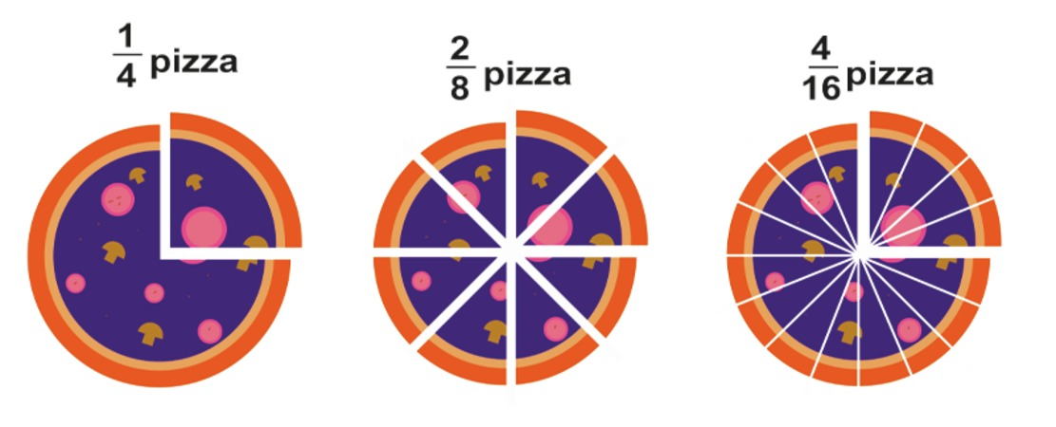
Figure 7 Pizza maths
View description - Figure 7 Pizza maths
View description - Figure 7 Pizza maths

Below are some examples for you to try but before you do that you might like to view this video on equivalent fractions.

Video content is not available in this format.
View transcript - Uncaptioned interactive content

View description - Uncaptioned Figure

Remember, when carrying out the activity there may be more than one way to arrive at the answer, and you must divide or multiply both the numerator and the denominator by the same number at each step. Note it has to be multiplying or dividing – they are the only operations that make this work.

Activity 1 Equivalent fractions
Allow approximately 10 minutes

(a) Use your knowledge of equivalent fractions to determine the missing numbers. Remember that both the numerator and the denominator must be multiplied or divided by the same number.
(i)
Hint: the denominator of the fraction on the left is 3. What do you have to multiply it by to get 18? Remember that if you multiply the denominator by a particular number, you must do the same to the numerator to keep the fractions equivalent.

View answer - Part

(ii)

View answer - Part

(b) Which of the following three fractions are equivalent to each other?
(i)
(ii)
(iii)

View answer - Part

(c) Simplify the following fractions:
(i)
(ii)
(iii)
(iv)
Hint: what number can divide exactly into both the numerator and the denominator of each fraction? Remember, there could be more than one option or step to fully simplify these.

View answer - Part

In the next section, you can try an activity where you need to write your own fractions from information you are given. Remember to show these in their simplest form – this is the way that fractions should be shown.

3 Fractions of a group
When completing the following activity think back to the very first example given this week about the number of people in a group of 500 who planned to go on holiday in Yorkshire. You worked out that 375 of these did intend to holiday in their own county. These two numbers give the numerator (375) and the denominator (500) for the fraction, which when simplified results in the reported in the article.

Activity 2 Group fractions
Allow approximately 10 minutes

From a survey of a group of 560 people, 245 say that they have taken a college course during the last year, and 140 say that they have taken a maths course.
(a) What fraction of the total group has taken a college course during the last year?
Hint: what number will give you the denominator and which the numerator? The denominator tells you the total number of parts, and the numerator the number of parts for a particular fraction. Remember to simplify your fraction!

View answer - Part

(b) What fraction of the total group has taken a maths course?

View answer - Part

3.1 Thinking more about fractions
The next activity is different from the numerical activities you’ve seen so far: it asks you to consider some general statements about fractions and decide whether they are true or false. This will give you the chance to think more about what a fraction is.

Activity 3 True or false?
Allow approximately 10 minutes

Read the following statements carefully and decide whether they are true or false.
(a) ‘Only a fraction of the group were on time’ always means that less than half the people were on time.
Hint: can you think of a fraction that is larger than one half?

True
False
View answer - Part
View comment - Part

(b) You can write any fraction in a decimal form.
Hint: what operation does a fraction bar represent?

True
False
View answer - Part
View comment - Part

(c) Fractions always have a value of less than one.
Hint: could the numerator (top number) of a fraction be larger than its denominator?

True
False
View answer - Part
View comment - Part

Now, back to working with specific numbers, rather than general rules! In the next section you are going to look at mixed numbers – these consist of both a fraction and a whole number.

4 Mixed numbers
In most of the examples considered so far in this week, you have been using fractions to describe part of a whole. The result is a positive number whose value is less than 1. Fractions in which the numerator (top number) is less than the denominator (bottom number), such as and , are known as proper fractions.
A mixed number consists of a whole number and a proper fraction, for example , which means two and one third.
Mixed numbers can be represented on a number line, as shown in Figure 11, by dividing each unit interval into parts. For example, to mark on the number line, the interval from 2 to 3 can be divided into thirds.
Then, can be marked at the point one-third of the way along the interval from 2 to 3.

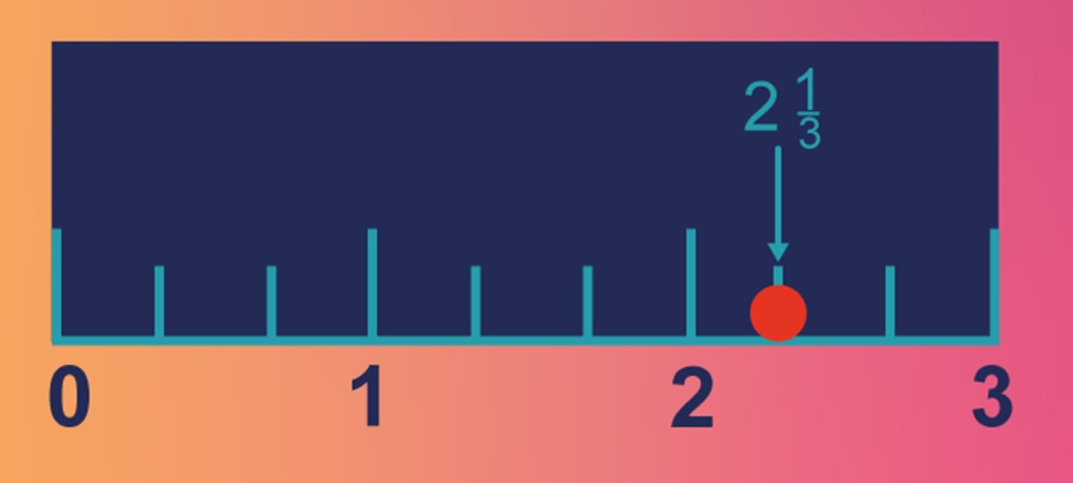
Figure 11 Number line showing 2 and one-third
View description - Figure 11 Number line showing 2 and one-third

You can get a better feel for this in the next activity.

Activity 4 Fractions on the number line
Allow approximately 10 minutes

Draw a number line from 0 to 5. Leave enough space between the numbers to be able to divide an interval into 8 parts. Now, plot the following fractions on the number line:
Which two whole numbers does lie between? Into how many parts do you want to divide the distance between these whole numbers if you have quarters?

View answer - Part

What if the numerator (the number on the top of the fraction) is more than the denominator? What kind of fraction is that? You’ll find the answer to this question in the next section.

4.1 Improper fractions
Improper fractions are fractions in which the numerator is greater than or equal to the denominator. You can think of these as ‘top-heavy’ fractions, such as and . These mean 5 halves, and 8 fifths respectively.
Improper fractions are another way of showing mixed numbers. So, can be rewritten as an improper fraction to give . You can again imagine this in terms of pizzas. If you have two and one third pizzas, and cut each of the whole pizzas into thirds, then how many thirds of a pizza will you have?

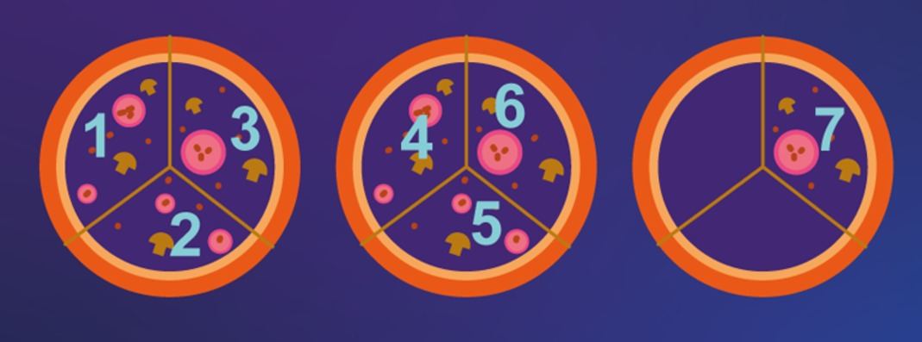
Figure 13 Seven thirds
View description - Figure 13 Seven thirds

In this case, the total number of thirds will be , showing that can indeed be written as .
Now think about how seven thirds was found. Because there were two whole parts broken into thirds, plus one extra third, 2 was multiplied by 3 to calculate how many thirds there were in two whole pizzas, then 1 was added. Since these are all thirds, the 7 was placed over the 3 in fractional notation. This can be worked out as follows:
This works for any mixed number that you need to convert into an improper fraction. So, the rule is:
You can also change improper fractions back into mixed numbers. For example, for imagine some pizzas have been cut into eight equal slices (eighths), and that you have 17 slices, but you don’t know how many whole pizzas this makes. You know that eight slices make one whole pizza, and that two pizzas would be 16 slices (2 x 8). There would be one-eighth (one slice) left over. So, . You can also carry out the division implied by the fraction:
Since eight goes into 17 at most two whole times, and there is one out of eight parts left over, this again gives .
One of the best ways for you to cement new ideas in your mind is to practise them. Try the next activity for mixed numbers and improper fractions.

Activity 5 Mixed numbers and improper fractions
Allow approximately 10 minutes

(a) Change the following mixed numbers into improper fractions.

Hint: if you are having trouble with this, did you try using a picture?

View answer - Part

(b) Change the following improper fractions into mixed numbers.

View answer - Part

Well done for completing this activity with mixed numbers and improper fractions. You will need the skills that you have been practising here next week when you learn how to carry out calculations with fractions. You’ve got one last activity in the next section before finishing this week.

5 Fractions – bringing it all together
This is the final activity for this week, it brings everything you’ve learned about fractions together, and gives you a bit more practice.

Activity 6 Reasons for enrolment
Allow approximately 10 minutes

A group of 240 new students were asked about the main reasons they had decided to enrol on courses at The Open University.
Of the 240 students, 80 wished to improve their career prospects, 60 had enrolled for interest and 72 had signed up for a course in order to help their children.
(a) Write a fraction for each of these groups, remembering to show them in the simplest form.

View answer - Part

(b) How many students expressed some other reason for enrolling?

View answer - Part

(c) What fraction of the students surveyed expressed some other reason for registering for courses?

View answer - Part

6 This week's quiz
Well done – you have reached the end of Week 3. You can now check what you’ve learned this week by taking the end-of-week quiz.
Open the quiz in a new tab or window by holding down Ctrl (or Cmd on a Mac) when you click on the link. Return here when you have finished.
Week 3 practice quiz.

7 Summary of Week 3
This week you furthered your study of fractions and the aim was to put in place the foundations that you will need to be able to carry out calculations using fractions. Week 4 will remind you of these ideas, so you’ll be getting more and more practice to help to you remember these new found skills. You will have also come across quite a bit of new language relating to fractions this week. It may be useful to make a list of these words, with a brief definition of your own before you start on Week 4.
For now, though, congratulations on making it this far through your study of fractions. You should now feel more confident in:
- understanding the language of fractions
- writing and understanding fractions
- understanding and finding the simplest form of a fraction
- converting between improper fractions and mixed numbers, and vice versa.
You can now go to Week 4.

Week 4: More parts of the whole

Introduction
This week you will continue to study fractions and will perform calculations with them using addition, subtraction, multiplication and division. To do this, you’ll use what you learned in Week 3 about equivalent fractions, mixed numbers and improper fractions.
Fractions can often cause anxiety. Our aim is that, by working through this week, you will understand how calculations with fractions work rather than try to remember a set of rules. Understanding will make you feel much more confident in approaching problems that involve fractions that you may not have come across before. Doing the activities as you study is a vital part of gaining this understanding.
In this video, Maria will introduce you to the first quiz that counts towards your badge, at the end of Week 4.

Video content is not available in this format.
View transcript - Uncaptioned interactive content

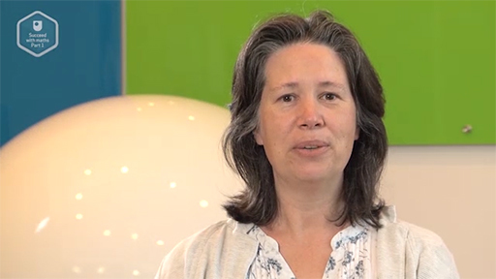
View description - Uncaptioned Figure

After this study week, you should be able to:
- perform addition and subtraction with fractions
- perform multiplication and division with fractions
- understand how fractions can be used in everyday life.

1 Adding and subtracting fractions
In this section, you will look at how to add and subtract numbers that include fractions. To get started you’ll look at visual representation to help you understand the process used.

Video content is not available in this format.
View transcript - Uncaptioned interactive content

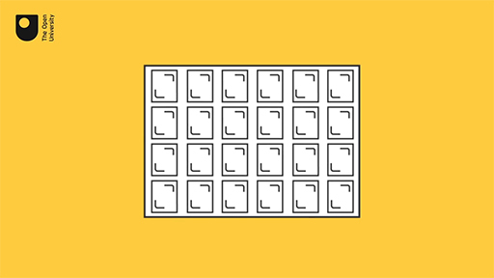
View description - Uncaptioned Figure

This method of changing the fractions into the same kind (using equivalent fractions) can be used for adding and subtracting fractions in general. If you want a reminder of equivalent fractions, return to Week 3.
If you need to add or subtract fractions, the first question you need to ask yourself is, ‘Are these the same kind of fractions?’ That is, are they divided into the same number of parts? Or in maths language, are the denominators the same? If the answer is no, then you need to convert the fractions into equivalent fractions with the same denominator in order to add or subtract them.

1.1 The process of adding and subtracting
You might like to watch this next video before attempting Activity 1, which will guide you through the process of adding and subtracting fractions.

Video content is not available in this format.
View transcript - Uncaptioned interactive content

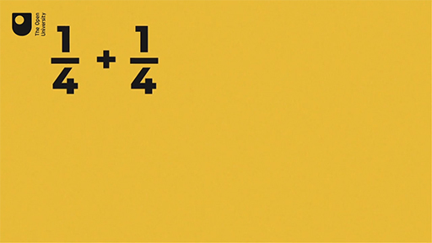
View description - Uncaptioned Figure

Activity 1 Adding and subtracting fractions
Allow approximately 10 minutes

Have a go at these questions, showing your answers in the simplest form or mixed number where relevant. Remember to make sure before you add or subtract to make the denominators the same.
Hint: Are both fractions out of the same number of parts? Remember as always to show your answer in the simplest form.

View answer - Part

Hint: both fractions are eighths, so again you can add them directly.

View answer - Part

Hint: can you find equivalent fractions for each given fraction that all share the same denominator? What number can be divided by both 6 and 7?

View answer - Part

Hint: try adding the whole numbers first, and then add the fractional parts together.

View answer - Part

View answer - Part

Hint: first ensure both fractions have the same denominator.

View answer - Part

- Two children were squabbling about chocolate. Josie had been given of a bar by her aunt and of a bar by her dad. Tim had been given a bar by his mum and by his friend. All the original bars were the same size. Was Josie or Tim given more chocolate, or were they given equal amounts?
Hint: add up what fraction of a bar each child had. To compare your two fractions, cancel each to its lowest terms.

View answer - Part

Well done – you’ve completed your first activity involving carrying out calculations with fractions! In the next activity you will look at a more practical application of fractions.

1.2 Adding and subtracting mixed numbers
To add or subtract mixed numbers, there are multiple methods you can use. The way you’re going to learn here will involve using improper fractions which you learnt about in Week 3.
To add or subtract mixed numbers, first change them all to improper fractions and then find the common denominator. Once you have found a common denominator you can do the addition or subtraction, before changing the improper fraction back to a mixed number.

For example, when presented as an improper fraction is .
The common denominator for these is 6 (as that’s the smallest number that both 2 and 3 go into). So you need to convert both to have a denominator of 6, then do the calculation:
Here the answer is a top-heavy fraction. By changing it back to a mixed number it gives: .

Now take a look at this second example, which looks at subtracting mixed numbers.

when presented using improper fractions is .
The common denominator for these is 21 (as that’s the smallest number that both 3 and 7 go into). So you need to convert both to have a denominator of 21, then do the subtraction:
As the answer is already a “normal” (not top-heavy) fraction, there is no need to change anything here.

1.3 Reporting results using fractions
Activity 2 illustrates how fractions can be used to report results from a survey. As you work through the activity, think about why fractions are useful in a report, rather than actual numbers.

Activity 2 Summarising survey results
Allow approximately 10 minutes

In 2020, the website ‘Save the Student’, which focuses on financial issues for students, published a survey about the impact of the Covid-19 pandemic on students (Save the student, 2020).
The report summarised the results of a survey of 2200 students. Of those students, were feeling anxious due to isolation.
They found of these students had needed to ask for help about issues related to Covid-19. Out of this group, nearly half found it hard to ask for help.
- How many of the students surveyed were feeling anxious due to isolation?
Hint: how many people are there in one tenth of the students?

View answer - Part

- How many students needed to ask for help?
Hint: think about how many parts the total is divided into.

View answer - Part

- Roughly how many students found it hard to ask for help?
Hint: we are told ‘nearly half’ of students found it hard to ask for help, so the best we can do is to find half of the students.

View answer - Part

- What fraction of the total number of students surveyed found it hard to ask for help?
Hint: we know from part (c) 792 found it hard to ask for help.

View answer - Part

You may not realise it, but by completing this activity you have already multiplied using fractions – well done! In the next section you’ll find out more.

2 Multiplying fractions
To help visualise multiplying fractions, take a piece of paper again. To find out what one-third of one-half is, fold your piece of paper in half along the long side and shade one half of the paper. Then, fold it into thirds along the short side. The paper is now split into six equal pieces, or sixths. If you look at the shaded half, you can see that one out of three parts of this portion represents one out of six parts of the entire piece of paper, as shown in Figure 1. This is the same as saying that it is one-third of a half.

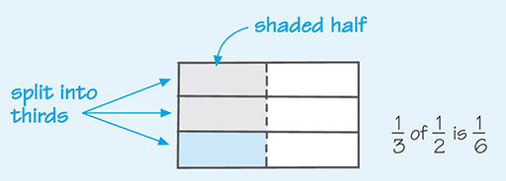
Figure 1 Folding a piece of paper into sixths
View description - Figure 1 Folding a piece of paper into sixths
View description - Figure 1 Folding a piece of paper into sixths

Mathematically, this is written as .
If you look at this carefully, you should be able to see that to multiply these two fractions, the numerators were multiplied together, and the denominators were multiplied together. This is the way that all fractions are multiplied. You must just remember to show any answer in its simplest form.
It is often easier to cancel or simplify before multiplying, as this can give you easier numbers to deal with. For example, looking at , multiplying the numerators and then the denominators together gives , but you can cancel the 2s using division:

This calculation is equivalent to cancelling at the start of the calculation:
Try this for yourself in the next activity.

Activity 3 Multiplying fractions
Allow approximately 10 minutes

Carry out the following examples, showing your final answers in the simplest form.
Hint: remember to multiple the numerators and then the denominators together.

View answer - Part

View answer - Part

View answer - Part

You will remember from Week 3 that you will also come across mixed numbers, which are a combination of whole numbers and proper fractions. In the next section you will look at calculations involving mixed numbers.

2.1 Multiplying mixed numbers and fractions
Say you want to calculate . The way to handle this is first by changing the mixed numbers to improper fractions, as you learned in Week 3, then you can once again multiply the numerators together followed by the denominators:
, so .
, so .
Now you can perform the calculation just as before, looking for ways to cancel first, as you did when multiplying fractions in the previous section.

Note that you should write the answer as a mixed number, if appropriate. You usually do this if the original numbers were given as mixed numbers.
Now try multiplying with fractions in Activity 4. If you would like to watch somebody working through multiplying mixed numbers, have a look at this video. Note again that the presenter refers to ‘fourths’ instead of quarters, and uses a dot at some points to represent multiplication rather than the more usual cross symbol (×).

Watch the video at YouTube.com.
View transcript - Uncaptioned interactive content

Activity 4 Multiplying mixed numbers and fractions
Allow approximately 10 minutes

Remember to cancel before multiplying, and convert mixed numbers to improper fractions if necessary.
Hint: you need to change the mixed number into an improper fraction first.

View answer - Part

View answer - Part

View answer - Part

2.2 Practical multiplication
The examples in Activity 4 helped you develop your understanding of multiplying fractions. You will now apply these new skills in a more practical situation in Activity 5.

Activity 5 Banking with fractions
Allow approximately 10 minutes

In the New Policy Institute survey, it was found that of the 210 young people had bank accounts. Of these, had overdraft protection and approximately had debit cards.
- How many of the people surveyed had overdraft protection?
Hint: how many people from the group had a bank account? The word ‘of’ often translates into multiplication and a whole number can be written as a fraction by placing it over 1. What fraction of those with bank accounts have overdraft protection?

View answer - Part

- How many survey participants had debit cards?
Hint: what fraction of the group with bank accounts also have debit cards?

View answer - Part

You might have approached the problem in Activity 5 differently to what was shown. Perhaps you found what one-fifth of the group was first by using division, and then used this portion to find three of those sets. Once you had this value, which indeed is 126 people, you could have then found the number of people with overdraft protection and debit cards as shown above. Both approaches are valid and will give you the correct answers. Choose whichever method is easier for you.
Now you’ve dealt with multiplication of fractions, you’ll move onto the last of the four basic operations of maths: division.

3 Dividing fractions
Dividing fractions is a little more difficult, so you’ll start by considering simple examples. You’ll then attempt to translate that to a more complex question by applying a similar strategy.
Suppose that you have three circles, and you divide each of them in half (see Figure 2).

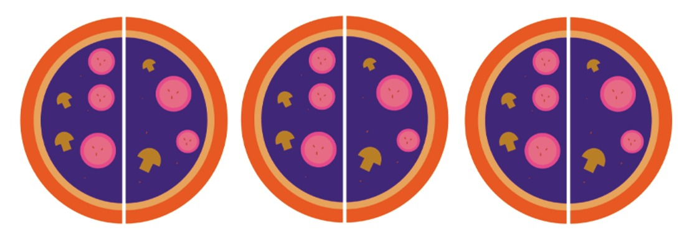
Figure 2 Three circles, each divided into half
View description - Figure 2 Three circles, each divided into half

How many halves do you have? You can see that there are six halves in three circles. Thus this shows how many halves there are in three. This is the same as dividing 3 by a . When you calculate , you can think of this as ‘How many halves are there in three?’
Here are few similar examples to work out how to divide by fractions.

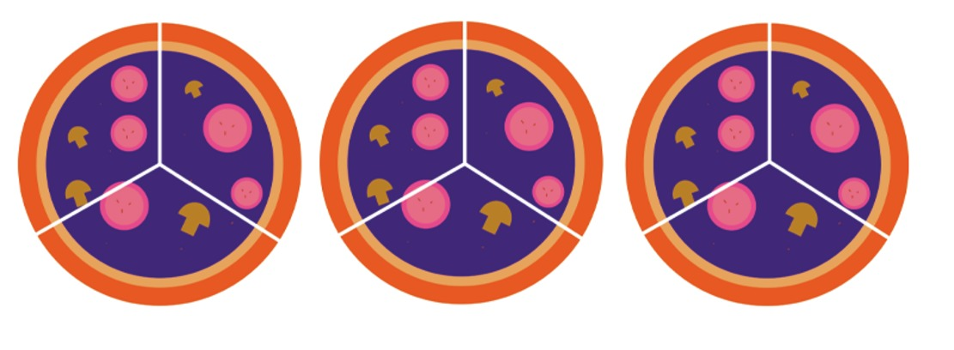
Figure 3 Three circles, divided into thirds
View description - Figure 3 Three circles, divided into thirds

There are three circles again, but this time the question is 'How many thirds can they be cut up into?' (Figure 3). This is the same as asking what is .
From this, you can see that there are 9 thirds in 3. So .
Now divide these three circles into quarters, which gives the answer to . Each circle will be cut into four parts to give quarters and there are three pizzas, so the total number of slices will be .
You also know that .

Looking at these three calculations, can you see a way of arriving at the answers without drawing out a picture to help? Look at the whole numbers and the denominators.
You may have noticed that if you multiply these together, then you arrive at the answer.
So it seems that ; ; and .
So put into words, you can say that to divide by a fraction, you have to swap the numerator and the denominator, and then multiply.
Or, in mathematical language (so that you can communicate this clearly and concisely to others): when the numerator and denominator change places, the result is called the reciprocal of the original fraction. Thus, dividing by a fraction is the same as multiplying by its reciprocal.
In the next section you’ll look at this in practice.

3.1 Practising dividing fractions
You now know that to divide by a fraction, you convert the second fraction (the one you are dividing by) into its reciprocal, then multiply by that fraction instead.

Just once more, consider .
If you swap the numerator and the denominator of , you will have : this is the reciprocal of .
Thus,
So, dividing a number by is the same as multiplying the number by .

This process of finding the reciprocal of the fraction that appears after the division sign, and then multiplying by that value, can be used in any division problem.
Take the example below.

Aman wants to know how fast she was driving. She drove of a mile in half a minute. To work out speed, you need to divide distance by time. Therefore you can work out how fast she was driving by doing divided by . Using the rule for dividing fractions, that means . So, Aman was driving at or per minute.

Now you are going to look at dividing mixed numbers and fractions.

3.2 Dividing mixed numbers and fractions
The same principles apply to dividing mixed numbers as dividing proper fractions.

Let's try to calculate
First, just as with multiplication, you rewrite the mixed numbers as improper fractions:

Then, you find the reciprocal of the fraction after the ÷ sign, and change the division symbol to the multiplication symbol, so your new calculation is:
Then, you cancel and multiply:
Because your original numbers were mixed numbers, it is appropriate to rewrite your answer as a mixed number as well. In this case, your answer is equivalent to .

Here’s another example:
Convert into an improper fraction:
Now you need to work out the reciprocal of 7. Remember, any whole number can be expressed as an improper fraction by using 1 as the denominator, thus , and its reciprocal is . Now, multiply by .

Now you’ve had a chance to work through a few examples, try the next activity yourself to see how you get on.

Activity 6 Dividing fractions
Allow approximately 10 minutes

Work through the following examples, using what you have just learned. Remember to convert any mixed numbers to improper fractions.

Hint: how do you convert division by a fraction into a multiplication problem?

View answer - Part

- If it takes of an hour to clean one car, how many cars can be cleaned in hours?
Hint: you are trying to determine how many hours are in hours.

View answer - Part

- Imagine that you are trying to put a fence along the side of a garden. The side of the garden measures metres. The fencing available is made of panels that measure of a metre each. How many panels will be needed?

View answer - Part

The more practice you get with anything the easier it becomes. So, as well as having a go at the activities in the next section, see if you can spot fractions in your everyday life and use them to solve problems.

3.3 Dividing mixed numbers and fractions – more examples
This section includes some more activities to test yourself with. It will be useful to take the time to do these, as it will help you to absorb the techniques for when you need to recall them at a later time.

Activity 7 Timing is everything
Allow approximately 10 minutes

A recipe specifies a cooking time of hours and suggests checking and basting your joint two-thirds of the way through the cooking time.
After how long should you check and baste your dinner?

View answer - Part

The next activity is another practical application of fractions, once again involving time.

Activity 8 Mowing lawns
Allow approximately 10 minutes

During the summer, a friend decides to mow lawns. It takes her an average of three-quarters of an hour to cut one person’s garden.
If she decides to work a total of hours per day, how many lawns can she mow in that time?

View answer - Part

In Week 1, you spent some time on puzzles, and so to finish this week you will have a go at another puzzle this time with fractions!

Activity 9 Puzzling!

I have just baked some cakes. I have given half of them to my friend Anj. I then gave a third of what I had left to my friend Bilal. My dog then ate four fifths of what was left, leaving me with just two cakes. How many did I have to start with?
Hint: Try working in reverse. For example, at the end, I am left with two cakes. My dog had eaten four fifths of what I’d had before. If he’d eaten four fifths, what fraction was left? So how many cakes did I have before the dog ate them?

View answer - Part

4 Fractions on your calculator
Many calculators allow you to enter values as fractions. The button for it looks something like this: .
If you wanted to enter on your calculator, for example, you could enter 2, then the button, then 3.
You can then use the normal buttons for the number operations. Your calculator will give the answer as a fraction, too. It may be a top heavy fraction.
Some calculators have a special button which lets you convert between mixed numbers and top heavy fractions, and even between them and decimals. Don’t worry if the calculator you are using doesn’t have it though – you don’t have to have it. If your calculator does have it, then it probably looks like this:

Try using your calculator to work out these then check your answers.

View answer - SAQ

Well done! You have completed your study of fractions. Hopefully you now feel more confident with this area of maths, which is often seen as quite challenging.
You may not use fractions in everyday life as much as previous generations who worked with imperial measurements and currency in pounds, shillings and pence, but fractions are an important part of maths. If you go on to further maths study, you will find out how understanding fractions will be a big help with algebra when solving and manipulating equations.

5 This week's quiz
It’s now time to take the Week 4 badge quiz. It’s similar to previous quizzes but this time, instead of answering five questions, there will be 15.
Open the quiz in a new tab or window by holding down Ctrl (or Cmd on a Mac) when you click on the link. Return here when you have finished.
Week 4 compulsory badge quiz
Remember, this quiz counts towards your badge. If you’re not successful the first time, you can attempt the quiz again in 24 hours.

6 Summary of Week 4
Congratulations for making it to the end of this week and completing the first quiz that will count towards your badge. You should have a great sense of achievement already, with all the new skills and knowledge that you worked on over the first four weeks of the course. You’ve come from understanding how numbers are put together to carrying out calculations with fractions in a very short time. In the next four weeks, you’ll move your attention to percentages and negative numbers. See you there!
After studying Week 4, you should now feel confident to:
- perform addition and subtraction with fractions
- perform multiplication and division with fractions
- understand how fractions can be used in everyday life.
You are now half way through the course. The Open University would really appreciate your feedback and suggestions for future improvement in our optional end-of-course survey, which you will also have an opportunity to complete at the end of Week 8. Participation will be completely confidential and we will not pass on your details to others.
You can now go to Week 5.

Week 5: Relationships among numbers

Introduction
News reports often mention the results of surveys and studies in ‘per cent’. Literally, ‘per cent’ means ‘per one hundred’, so ‘25 per cent’ means ‘25 out of one hundred’. A per cent is just a specific kind of fraction – one that always has 100 as its denominator.
This week, you will start your study of percentages. This will continue in Week 6, when you will use percentages in a variety of different everyday situations. Whether you are shopping around for the best deal, or reading an article online, understanding percentages can be useful in your everyday life. Don’t forget, you can also use all your knowledge about fractions, because that’s what percentages really are. Keep this in mind as you work your way through the activities here. The activities will give you the chance to build your confidence with a concept that can at first seem quite challenging.
First watch Maria introduce Week 5.

Video content is not available in this format.
View transcript - Uncaptioned interactive content

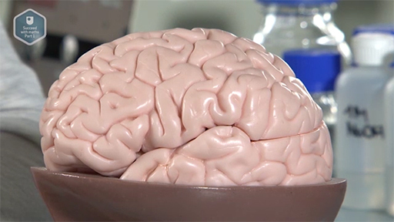
View description - Uncaptioned Figure

After this study week, you should be able to:
- convert between fractions, decimals and percentages
- work out a percentage of a number
- write one number as a percentage of another
- understand how percentages are used in everyday life.

1 Percentages
It is important to remember what the per cent symbol, ‘%’, means. It stands for ‘divided by 100’. So, for example, 28% means , or 0.28
If you would like to see this explained visually, have a look at this short video.

Watch the video at YouTube.com.
View transcript - Uncaptioned interactive content

One of the reasons why percentages are useful is that you can make comparisons between different sets of data more easily than with the actual numbers.
Suppose that you are told that, over the course of one week, 345 people opted for a meat dish in one restaurant, but only 217 did in another. Does this mean that the meat dish was less popular in the second restaurant? You couldn’t conclude that unless you knew how many people in total had actually eaten in the two restaurants. In fact, in the first restaurant, 35 per cent of the total numbers of diners ordered a meat dish; in the second, 39 per cent. It is now immediately clear that the meat option was more popular in the second restaurant.
Hopefully, you can see from this example how useful showing data as a percentage can be for the understanding of that data. This use of percentages will occur many times, not only in your everyday life but also in other areas of study.
For example, if you ran a small bed and breakfast business and read that tourist numbers were expected to increase by 34 per cent across the UK by 2027, you might like to be able to work out what that could mean for your business. Or, you may be faced with a set of numbers breaking down the UK population into different age categories and for the purpose of your studies need to work these out as percentages. So knowing what a percentage can and can’t tell you, and how to present the raw data (the actual numbers) as a percentage, can relieve a lot of headaches!
As it was said earlier, since a percentage is just a specific kind of fraction and you know from your previous study that fractions and decimals are related to each other, you can also write percentages as fractions and decimals. You’ll look at how to do this in the next section.

2 Writing a percentage as a fraction or decimal
Fractions, decimals and percentages are all interchangeable, so you can choose to use whichever is most appropriate for your situation. From the definition of a percentage, ‘75 per cent’ means 75 out of 100. This can therefore be written as , which can be simplified to . Alternatively, means , or 0.75. Therefore, .
So to write a percentage as a fraction, the numerator for the fraction is the percentage value and the denominator is always 100. Because a fraction can also be viewed as an instruction to divide by the denominator, which is 100, in order to write a percentage as a decimal you should divide it by 100.
Understanding how to represent percentages as a fraction or a decimal will help a great deal when you carry out calculations involving percentages – so getting to grips with this now is time well spent. As well as carrying out the activities this week, you can give yourself extra practice by converting percentages that you see in your everyday life.
You can show this visually by comparing three pizzas divided using percentages, fractions and finally decimals. From this it is clear that and , or 25% and 75%, or 0.25 and 0.75, always amounts to the same thing.

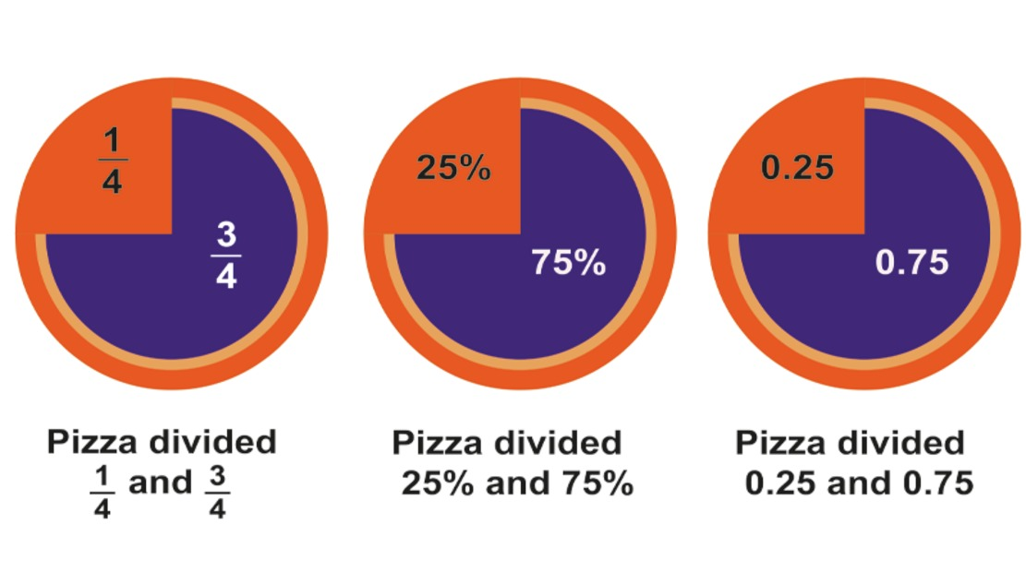
Figure 1 Pizza maths
View description - Figure 1 Pizza maths
View description - Figure 1 Pizza maths

When writing a percentage as a decimal, you have a shortcut to the answer. Dividing a number by 100 has the same effect as moving its decimal point two places to the left.

To check that this works, enter 6.0 (the equivalent of 6 per cent) into your calculator and divide by 100.
6.0 ÷ 100 = 0.06, and the decimal point has indeed moved two places to the left.
Remember, the decimal point can be inserted at the end of your number behind the units place when dealing with a whole number.
So, .

What about writing decimals as percentages? You’ll look at how to do this in the next section.

3 Writing a decimal as a percentage
Because you divide a percentage by 100 to convert it into a decimal, you may assume that in order to change a decimal to a percentage, you must multiply by 100 (because multiplication undoes division). And you would be correct to assume this! A quick way to do this is to move the decimal point two places to the right.
For example, to change 0.31 into a percentage you would multiply by 100 to get 31%. Equally, 0.012 would become 1.2% after moving the decimal point two places to the right.
To try it for yourself, use a calculator to work out 0.005 x 100. The answer should be 0.5 (that is, 0.5 per cent), the same as moving the decimal point two places to the right, as expected.
Let’s take a closer look at this to make sure that this makes mathematical sense. ‘Per cent’ means ‘over 100’, so an equivalent way of expressing ‘100 per cent’ is , which is the number 1. Multiplying by 100 per cent does not change the value of a number; it just makes it look different.
If you like, you can show the conversion with one or both of the following steps: .
Now you need to look at writing fractions as a percentage. This can be useful, because many people will have a much better understanding of what a percentage means rather than a fraction. For example, you could say that , or 37.5 per cent, of the population prefers vanilla ice cream. For most people, the percentage would mean more.

4 Writing a fraction as a percentage
To convert a fraction into a percentage, you should multiply it by 100%. It’s easiest to do that if you multiply by as shown here.

Convert to a percentage:

(since ).

You may be wondering why this is allowed. It is because 100% just means one whole one. By multiplying by 100% you are multiplying the fraction by 1, which doesn’t change it to another value. 60% and mean the same as each other, they just look different.

As another example, if you want to convert to a percentage, it can be shown as follows:

As an alternative, you can turn the fraction into a decimal (by dividing the numerator by the denominator) and then move the decimal point two places to the right (because you are multiplying by 100). This is shown in the example below, where is converted to a percentage.

As with a lot of maths, there are other alternative ways to convert a fraction into a percentage. You can also multiply the fraction by , as shown in this example:

For this last example, note that you can use the ideas from equivalent fractions so that the denominator is turned into 100. For some fractions, this gives you another alternative for the conversion. For this last example, it looks like this:

You’ve covered a few ideas here, so here’s a quick summary as a reminder before you have a go yourself.

- Percentage to fraction – write the percentage value as a fraction out of 100, and simplify.
- Percentage to a decimal – divide the percentage value by 100.
- Decimal to percentage – multiply the decimal by 100 per cent.
- Fraction to percentage – multiply the fraction by 100 per cent, and simplify as necessary.

You may be wondering why any of this matters! It is not just some interesting maths; being able to carry out these conversions can help you when it comes to working with percentages in problems.
Bear all these ‘rules’ in mind as you work through this week.

5 Converting between percentages, decimals and fractions
In the next activity you’ll get some practice in converting between percentages, decimals and fractions. You may wish to do your working out on paper then put your answers in the boxes provided. Show fractions on one line using the ‘/’ symbol, so one half would be entered as ‘1/2’.

Activity 1 Converting between percentages, decimals and fractions
Allow approximately 10 minutes

- Turn each of these percentages into a decimal and a fraction in its simplest form.
  - 10%
  - 25%
  - 50%
  - 125%
  - 0.5%

Provide your answer...
View answer - Part

- Write each of the following fractions and decimals as percentages.

  - 0.4
  - 0.0075

View answer - Part

Percentages above 100
As you know, 100% means ‘the whole thing’, so what, therefore, do percentages over 100 mean?
Percentages over 100 can be related to top heavy fractions and to decimal numbers bigger than 1. For example, if you wanted to find as a percentage, you would do:

If you wanted to find 1.04 as a percentage, you would shift the decimal point two spaces to the right to get 104%.
But what about in real life? Well, suppose you were earning £20,000 a year and were told you were to get a 5% rise.What you started off with (the £20,000) is your full salary – so 100%. By adding 5% to it your new salary is 105% of the old one.
Now it is time to turn your attention to using percentages and find out how useful these techniques you’ve just covered are.

6 Finding a percentage of a number
There may be times when you are given a number and you need to find out a percentage of that number. One possible situation would be finding out how many marks are needed in a test to achieve the required percentage pass mark.

For example, suppose a maths test is out of 75 marks, and students need to achieve at least 60 per cent to pass. How many points guarantee a passing grade?
To pass, the student has to earn at least 60 per cent of 75. Here, you can change the percentage into a fraction, then calculate the marks required. You can work this out by simplifying the fraction and then multiplying.
Here is one way of reaching the answer:

Or, you can convert the percentage to a decimal and multiply by this, as follows:
60% = 60 ÷ 100 = 0.6
So the number of marks required to pass the maths test = 0.6 × 75 = 45.
And it is no surprise that both methods gave the same answer!

This means that you can choose whichever method you prefer – either converting the percentage to a fraction or a decimal – and then multiplying by the number.
The method you choose can depend on what tools you have to hand. If you have a calculator, converting to a decimal can be the easiest option; if not, you may find it easier to convert to a fraction and cancel to give yourself easier numbers to work with. Have a go at this in the next activity.

Activity 2 Going solo
Allow approximately 10 minutes

- A radio programme reported the following:
  - Our ‘Going Solo’ survey of 4000 single people found that only one in five people are happy on their own.
Write ‘one in five’ as a fraction, a decimal and a percentage. Which form do you think is easiest to understand? Show fractions on one line using the ‘/’ symbol, e.g. one half would be entered as ‘1/2’.
Hint: what does one in five mean? For every five people interviewed, one of these said they were happy on their own. Write this as fraction first.

Provide your answer...
View answer - Part

- How many of the 4000 ‘Going Solo’ survey participants seem to be content with being single?
Hint: you know that it’s one-fifth of the group, and remember: ‘of’ means ‘multiply.’

View answer - Part

Now you know how to work out the percentage of a number, what about working in the other direction? Using the last example in Activity 2, if you know that 800 people out of a group of 4000 said that they were not happy living on their own, how do you turn these two numbers into a percentage to represent the proportion? The next section will look at this.

7 What percentage is it?
You probably agree that comparing percentages can be easier than comparing fractions. So it is useful to know when you have a certain quantity, how to write it as a percentage of another, usually larger, number.

For example, in a test if you got 42 out of 70 , what percentage did you get?

View description - Uncaptioned Figure

Whenever you have numbers for a part of a total and the total, you can calculate the percentage by first expressing the numbers as a fraction. So the number for the total marks is the fraction’s denominator and the number for marks received is the numerator. You can then turn this fraction successfully into a percentage.
So in this example, the fraction is . Remember that to turn a fraction into a percentage you first multiply by 100 per cent and then simplify, as shown below:

(Note: you also could have simplified to first and then turned it into a percentage.)
These calculations show us that in the test you scored 60 per cent.
The calculation 42 ÷ 70 × 100 can be performed even more quickly with a calculator, as can the other percentage calculations, but it is good to get practice on paper to cement your understanding of percentages.

Have a go yourself in the next activity.

Activity 3 What percentage?
Allow approximately 10 minutes

As before, you may wish to do your working out on paper then put your answers in the boxes provided.
- In a group of 250 children, 75 said that they would prefer to visit the zoo and 25 the cinema. What percentage of children preferred to visit the zoo?

Provide your answer...
View answer - Part

- There are 159 important habitats for conservation recognised by the European Habitats Directive. Scotland reportedly has 65 of these habitats (Scottish Executive, 2004). What percentage of the total recognised habitats does Scotland have? Give your answer to one decimal place.

Provide your answer...
View answer - Part

You’ve covered a lot of the important foundations of percentages this week – understanding these will be a great help when you are faced with new situations that involve them.

8 Facts and figures
When trying to cement these ideas, there is no substitute for practice. So before you finish for this week and move onto the weekly quiz, have a go at this final activity, which brings some of these ideas together. You can also try out your new skills when you see percentages and data that can be turned into percentages in your everyday life!

Activity 4 Commonwealth facts and figures
Allow approximately 10 minutes

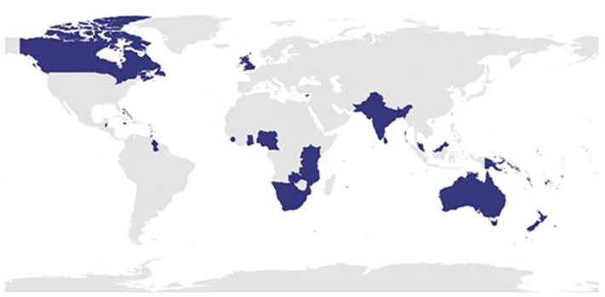
View description - Uncaptioned Figure

The Commonwealth in 2020 represented about 30% of the total global population. The global population is constantly growing, but an estimate of this in 2020 was around 7.23 billion (7 760 000 000) people. Bangladesh, a Commonwealth country, has an estimated population of 165 000 000.
Work out what percentage (to one decimal place) of the Commonwealth population lives in Bangladesh. Show this as a decimal and a fraction as well.
Hint: there is quite a bit of information contained in the question. You may find it helps to start by writing this all down in a list, as well as making a note of what you need to work out. Then you can think about where you need to start.

Provide your answer...
View answer - Part

9 This week's quiz
Well done – you have reached the end of Week 5. You can now check what you’ve learned this week by taking the end-of-week quiz.
Open the quiz in a new tab or window by holding down Ctrl (or Cmd on a Mac) when you click on the link. Return here when you have finished.
Week 5 practice quiz.

10 Summary of Week 5
Congratulations for making it to the end of another study week of Succeed with maths – Part 1. You are more than halfway (over 50%!) through the course and now would be a good time to think back to how you felt about maths before you started and what you are feeling now. We hope that you can see the difference in your own confidence in tackling maths problems as well as an increasing understanding. All these skills that you are developing will contribute to successful study of many other subject areas – but even if you don’t go on to more study, they will certainly assist you in your everyday life.
At the end of this week you should feel more confident to:
- convert between fractions, decimals and percentages
- work out a percentage of a number
- write one number as a percentage of another
- understand how percentages are used in everyday life.
You can now go to Week 6.

Week 6: Percentage calculations and ratios

Introduction
This week, you will continue your study of percentages. After a refresh of some of last week’s ideas, you will turn your attention to carrying out calculations with percentages. A lot of the time you see percentages in everyday life, they are about something changing – money off in a sale, or how much house prices have risen. These are the sorts of calculations you’ll be doing this week. This will help you to feel confident in using these calculations in everyday situations. Finally, you’ll spend a little time learning about ratios. Again, the activities this week will provide opportunities to practise your skills and grow in confidence.
So far in this course, you’ve learnt how to calculate a percentage, and how to find a percentage of a number. In everyday life you’ll hear a lot about percentage change, such as 20% off in a sale, or house prices going up by 5%. But percentage changes may give unexpected results – start by watching this video, which shows why you need to be careful with these sorts of calculations.

Video content is not available in this format.
View transcript - Uncaptioned interactive content

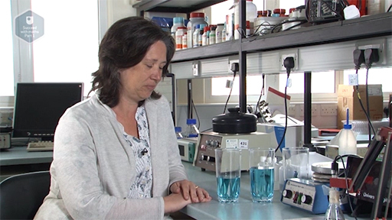
View description - Uncaptioned Figure

After this study week, you should be able to:
- work out a percentage increase or decrease
- work backwards to remove a percentage increase or decrease
- understand how percentages and ratios are used in everyday life
- use ratios in calculations.

1 Using percentages
Take a look at the two t-shirts in Figure 1 which are on sale. Which shop is offering the better deal? You’ll find out how to work this out and questions like it this week.

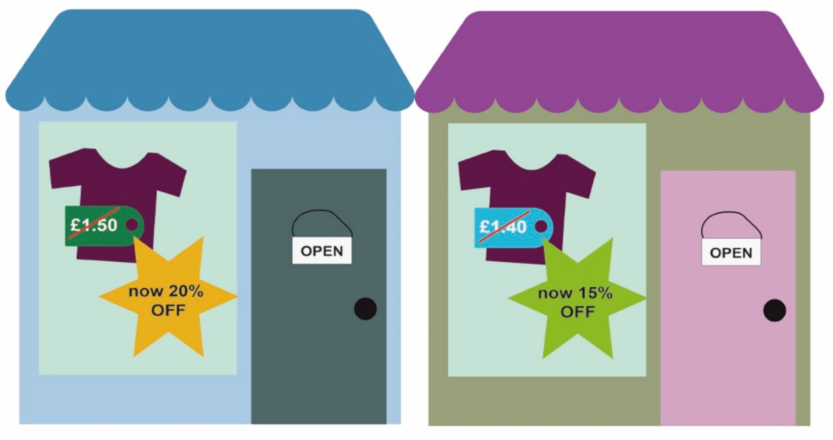
Figure 1 Finding the best deal
View description - Figure 1 Finding the best deal
View description - Figure 1 Finding the best deal

First, start by trying a refresher activity before moving onto some new ideas.
You will definitely find a calculator useful for Activity 1, which involves population figures.

Activity 1 Writing one number as a percentage of another
Allow approximately 10 minutes

- In 2020, the population of the European Union was about 447 700 000, and the total population of the Republic of Ireland was about 4 940 000. What was the population of the Republic of Ireland as a percentage of the total population of the European Union?
Hint: to find the percentage, you write the numbers as a fraction and multiply by 100.

View answer - Part

- Now looking at one of the larger member states – Germany, which had a population of around 83 800 000 in 2020. Find the population of Germany as a percentage of the total population of the European Union, rounding your answer to 1 decimal place again.

View answer - Part

Hopefully, you felt confident from your practice last week in completing this refresher activity. If it proved slightly more challenging, you may find it useful to look back at Section 3 'What percentage is it?' in Week 5.
Another way that you will often see a percentage used is when saying what a certain percentage of a number is: for example, being advised when going on holiday that 10 per cent of the cost of a flight is a fuel surcharge, or that 15 per cent of a group of people have a preference for a certain food type. In the next section, you’ll look at how to use this information to find the actual numbers involved. Again, you should recognise some of these techniques from Week 5.

1.1 Finding a percentage of a value
Suppose that residents in a town are asked for their views on the proposed development of a nearby wind farm. The local paper says that 450 people voted, with 54 per cent in favour of the proposal, 36 per cent against and 10 per cent undecided. How can you find out how many people were in favour of the proposal?

View description - Uncaptioned Figure

To find the number of people who were in favour, you need to find 54 per cent of 450. There are two ways to work this out. You can either start by converting the percentage to a fraction, or alternatively to a decimal number.
- As a fraction: .
- As a decimal: 54 % = 54 ÷ 100 = 0.54.
Now remember that when ‘of’ is used in maths, it is usually an instruction to multiply.
Using the fraction conversion, write the calculation as:

So 243 people were in favour of the proposal.
So to calculate a percentage of a number, first convert the percentage to either a fraction or a decimal, and then multiply it by the given number. Have a go at this in the next activity.

Activity 2 Number of voters
Allow approximately 10 minutes

Find the number of people who were against the proposed wind farm, and then find the number of people who were undecided about the proposal. (Try this second calculation without using the calculator.)

View answer - Part

You will do some work with money and percentages in the next section.

1.2 Money
You will probably see percentages used most often in your everyday life when money is involved: for example, discounts in shops, or how much tax you have to pay on your income. All the same principles apply when dealing with percentages associated with money, so use what you have learned so far in the following activities.

Activity 3 Where does the money go?
Allow approximately 10 minutes

Suppose somebody’s gross monthly income (that is, the income before taxes) is £1250. From this money, £315 a month goes on paying housing costs and £135 is saved. Work out the percentage (to 1 decimal place) of the gross monthly income that goes towards:
- housing costs
- savings.
Hint: think of these as fractions first before trying to find the percentage.

View answer - Part

Now let’s look at a different type of saving: putting something aside for retirement.

Activity 4 Saving for retirement
Allow approximately 10 minutes

Many people think that saving for retirement is important. How much somebody needs to save or can afford to save will depend upon many factors, including when they want to retire and when they start saving for retirement.
One way to get an estimate of what percentage of gross salary (before tax) individuals should be putting towards a pension is to base it upon their age when they start saving. Fortunately, there is a quick way to do this. The percentage to save is found by halving the age of the individual at the time they plan to start saving. So if somebody planned to starting saving at 50, they would need to save 25 per cent of their gross salary. (Obviously these are just estimates – you would need to take advice from a financial expert for your own situation!)
Use this information to calculate the amounts that the following people should be putting into a pension fund:
- A 20-year-old with a gross salary of £15 000.
- A 35-year-old with a gross salary of £25 000.
- A 45-year-old with a gross salary of £43 000.

View answer - Part

Hopefully you are now feeling even more confident about working with percentages. Now that you’ve looked at the basics, you are going to build on this confidence in the next section and move on to another stage. Keep in mind that percentages are a specific kind of fraction, where the denominator is always 100. First you’re going to look at whether the order that you use a percentage increase or decrease matters.

2 Percentage increase or decrease
In this section, you will look at how to find the result of percentage increases and decreases. You'll also cover repeated changes (for example, what happens if you increase a price by 20%, and then decrease by 20%? It probably isn’t what you expect!). Finally, you'll look at how to undo the effect of a percentage change – for example, finding out what something cost before a sale discount was applied.

2.1 Calculating a result following a percentage increase or decrease
In this section you will concentrate on how to find out the result of a percentage increase and decrease. Like lots of things in maths, there’s more than one way of working this out. The way shown here is designed to make some of the later sections this week easier.
Let’s see how it works with a couple of examples.

Figure 2 Shop sale
View description - Figure 2 Shop sale

A coat originally priced at £80 is now in the sale with 30% off. What is the new sale price?
The original price was £80. That corresponds to 100%. It now has 30% off, so that means you are left with 100% − 30% = 70%. Therefore, to find out how much the coat costs now, you need to find 70% of £80.
To do that, you need to multiply £80 by , so

which can be cancelled down to leave .

Now take a look at an example of a percentage increase.

In 2012, a house was sold for £180 000. Its value has now increased by 35%. What is it now worth?
The house started at £180 000 which corresponds to 100%. It’s worth 35% more so the price now corresponds to 135%.
To find its current price you need to find 135% of £180 000. To do that, you need to multiply £180 000 by so

which can be cancelled down to leave .

Now have a go yourself.

Activity 5 Percentage increases and decreases

- A type of chocolate used to come in 200g bars. The new bars are 15% smaller than the old ones. How big are the new bars?

View answer - Part

- In an old job I earnt £25 000 a year. In my new job I earn 10% more. What do I earn now?

View answer - Part

2.2 Does the order of percentage change calculations matter?
In the next activity you will explore whether the order in which you carry out percentage increases and decreases matters, or whether you can apply them either way round. One practical situation in which you might come across this is when shopping.

Activity 6 Discount or VAT first? Does it matter?
Allow approximately 10 minutes

You have set your eyes on a new dresser for your room, which is on sale with a 30 per cent discount. But does it matter if the discount is applied first, and then VAT, or if the VAT is applied before the discount? If the cost of the dresser is £100 before the discount and VAT are applied, work out the cost of dresser including both, first starting with the discount and then with the VAT. Take the current value of VAT as 20 per cent.

View answer - Activity 6 Discount or VAT first? Does it matter?

In Week 1 you learned that multiplication is commutative, which means it doesn’t matter what order you carry out multiplication operations: the answer will be the same. Hence by looking in more detail at the maths, you’ve seen that this idea will work for any type of combined percentage increase and decrease.

2.3 Calculating original amounts
A situation that can be a little tricky to understand is how to undo a percentage change that has been added to or subtracted from a number. The video below will show how to work this out, again using an example with discounts and VAT.

Video content is not available in this format.
View transcript - Uncaptioned interactive content

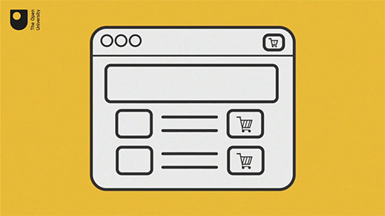
View description - Uncaptioned Figure

From the video, you can check your answer by working out the 5 per cent postage charge on £28.57 to see that the grand total will be £30.
Many people in this situation may think that they can work out 5 per cent of £30 and subtract this from the £30 to find out how much they can spend. Try this now.
5% of £30 = 0.05 × £30 = £1.50
£30 – £1.50 = £28.50
This answer is 7p less than using our other method! So something must be wrong.
The reason for this is because this is all to do with what it’s 5% of! 5% of different numbers gives a different answer. The 5% added here is 5% of £28.57. 5% of £30 isn’t the same as 5% of £28.57 – it’s a bigger number.
This is an important idea to remember. Have a go at this in the next two activities.

Activity 7 What was the price before VAT?
Allow approximately 10 minutes

The price of a tennis racquet, including 20 per cent VAT, is £45.24. What was the price before VAT?
Hint: the £45.24 includes VAT. What percentage does this total represent? Find the monetary amount that represents 1 per cent, and use that figure to arrive at 100 per cent.

View answer - Part

Activity 8 What was the original price before a sale?
Allow approximately 10 minutes

I saw a coat in a sale. Its sale price was advertised as £64, which was after a 20% discount.
Unfortunately, I wasn’t able to buy it in the sale – the sale was ending soon and I’d not yet been paid that month.
However, as I really liked the coat, I thought I might buy it anyway at full price once I’d been paid. How much would it cost me when not in the sale?

View answer - Part

You have very nearly finished your work on percentages for this week, but before you move onto ratios you’re going to take a quick look at the idea of percentage points. You may have heard or read about these in news reports, but not really thought about what these mean. Now it’s your chance to find out about the important difference between percentages and percentage points.

3 Percentage points
When comparing percentages, the difference between the percentages is described in terms of ‘percentage points’. Subtracting percentages gives percentage points. Note that this is not the same as the percentage increase or decrease – this distinction is something to be aware of in media reports.
For example, if 72 per cent of students starting at a college were studying maths one year, but only 63 per cent the next, the college had a decrease of nine percentage points in students studying maths. The following example illustrates the difference between percentage points and percentage change using mortgage interest rates.

You see a headline reading ‘Mortgage interest rates jump 2 per cent’. How should you interpret this? Most people read this headline to mean that the interest rate on the loan increases by two percentage points. But is there another way to think about the headline that isn’t as sensational?

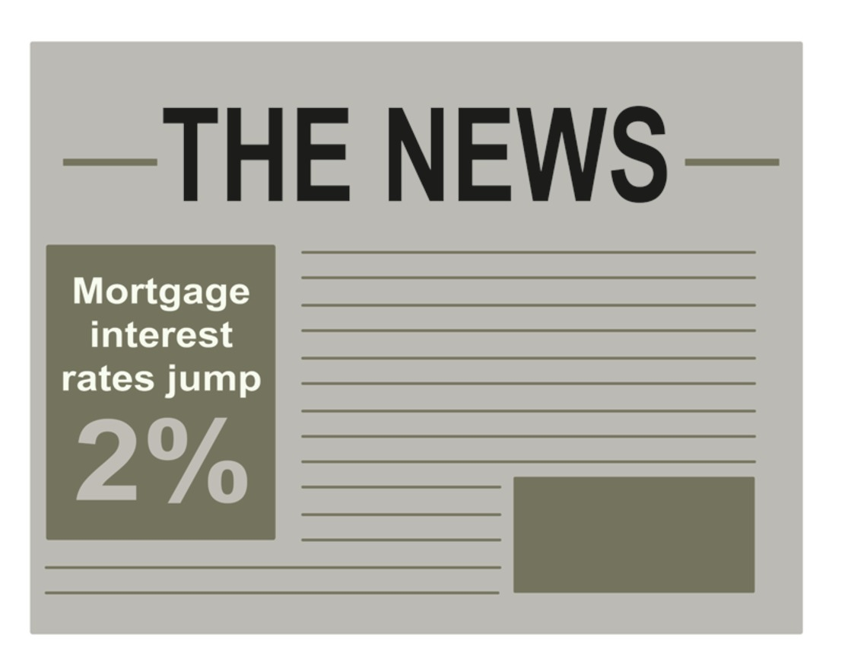
View description - Uncaptioned Figure

The headline is ambiguous. It could mean ‘Interest rates increase by 2 percentage points’ – for example, from 10 per cent to 12 per cent. This is a big deal – your interest rate just went up 20 per cent, as the 2 per cent extra is 20 per cent of 10.
On the other hand, the headline could mean ‘Interest rates increase by 2 per cent based on your previous interest rate’. In our example, that would mean rates go up from 10 per cent to 10 per cent + 2 per cent of 10 per cent, which is only 10.2 per cent (0.10 + 0.02 × 0.10 = 0.10 + 0.002 = 0.102 = 10.2%). Not great news, but hopefully manageable and much better than the first interpretation.

So you should be able to see how important it is to use the correct language. When people mean percentage points, they should say so! Unfortunately, many news articles do not. It’s up to you to find out from the article itself what it is about. You will often see articles that contain percentages online, in newspapers and magazines, or in study material in many different subjects, and it is important to consider carefully what these represent. Now you have the skills to enable you to do that successfully. This section finishes your exploration of percentages, but before you get onto this week’s quiz you’ll look at one final way to compare numbers that you may come across: ratios.

4 Ratios
We often think that there will be roughly the same number of men and women in a population. But is that really true? A report in 2019 (Human Rights Watch, 2019) said we should be ‘worrying about the women shortage’. The World Health Organisation says that 105 boys are born for every 100 girls, and in some countries the ratios are more extreme, for example up to 120 boys born for every 100 girls. You can visualise this by dividing the group into men and women. If the ratio is 105 to 100, then if there were 105 in the males group, there’d be 100 in the females group. Mathematically, you would write this as a ratio 105:100 (or for the more extreme one, 120:100). The colon in between tells you it’s a ratio.
This ratio of men to women could be written as or in colon notation as 105:100. The colon simply replaces the line separating the top and bottom of the fraction. Ratios provide us with yet another way to convey information.
Note, it’s important to say which way round the ratio is! In this instance 105:100 means 105 men to 100 women, so we needed to know it was men: women not women: men.
Now consider the following example.

After 22 rounds of the Rugby Union Premiership in the 2012/2013 season, Northampton Saints had won 14 matches and lost eight. What is the ratio of wins to losses for the team?
The ratio of wins to losses can be set up as a fraction, placing the wins in the numerator (the top of fraction) and the losses in the denominator (the bottom of fraction). Northampton Saints have 14 wins over 8 losses, or . If you were a sports reporter you may well leave this as it is, but in maths you would want to show these in the simplest form, to reduce any numbers to those that are easiest to handle. You’ll probably agree that the smaller a whole number is, the easier it is to carry out calculations with! So you would simplify this as follows by dividing the numerator and denominator by 2:

Thus, the ratio of wins to losses is or 7:4 (7 to 4).

One place that you may encounter ratios is in scale models of the real world – one very common model of the real world is a map. Maps use ratios to tell you how the distances on the map relate to the actual distances in the real world and are usually called scales. If you have a scale of 1:25 000 (said as 1 to 25 000), this means that for every 1 unit measured on the map, the unit in real life is 25 000. So to convert from map distances to real distances, you need to multiply by 25 000.
For now though you'll look at an example of ratios using recipes.

4.1 Ratios in recipes
So far, you have worked mainly with ratios as fractions, but you know that ratios are also given in colon notation. For example, a recipe may call for two cups of raisins for every three cups of oatmeal. This can be written as the ratio 2:3. If you decided to make more or less of recipe, you need to preserve the ratio. In other words, there would need to be two parts raisins for every three parts of oatmeal, however much of each ingredient you were using. The video below shows an example.

Video content is not available in this format.
View transcript - Uncaptioned interactive content

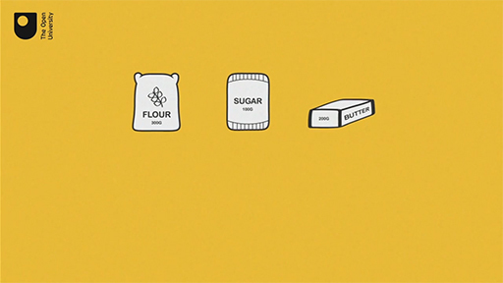
View description - Uncaptioned Figure

Now have a go yourself at something similar in the final activity of the week.

Activity 9 Chocolate chip cookies
Allow approximately 10 minutes

A recipe for chocolate chip cookies requires 48 tablespoons of flour, 16 tablespoons of sugar, and 32 tablespoons of chocolate chips.
- What is the ratio of flour to sugar to chocolate chips?

View answer - Part

- If you only have 36 tablespoons of flour, how many tablespoons of sugar and chocolate chips do you need to maintain the recipe’s taste and consistency?

View answer - Part

- Suppose you have 40 tablespoons of chocolate chips, and plenty of everything else. Determine the amount of flour and sugar you will need if you want the maximum number of cookies you can make with your 40 tablespoons of chocolate chips.

View answer - Part

5 This week's quiz
Well done – you have reached the end of Week 6. You can now check what you’ve learned this week by taking the end-of-week quiz.
Open the quiz in a new tab or window by holding down Ctrl (or Cmd on a Mac) when you click on the link. Return here when you have finished.
Week 6 practice quiz.

6 Summary of Week 6
Congratulations for getting to the end of another week. This finishes your study of percentages and in the last two weeks you have covered a lot of ground. Remember to try and keep your new-found skills fresh by having a go at working out percentages for yourself. If you see a sale in a shop, for example, can you work out how much the original price was from the discounted price and the percentage discount? Keep a look out for percentages in the news or on websites as well. Being able to use and work out percentages is a great skill to have and this will be very useful in ways that you might not have even considered yet. So, well done again and keep practising!
The week should have helped to make you feel more confident to:
- work out a percentage increase or decrease
- work backwards to remove a percentage increase
- understand how percentages and ratios are used in everyday life
- use ratios in calculations.
You can now go to Week 7.

Week 7: Negative numbers

Introduction
For the final two weeks of this course you are going to look at numbers that are less than zero; that is, negative numbers. You will probably be familiar with these in relation to temperatures below zero, and in banking, when any debits are made. Here you will explore the use of negative numbers and how to work with them. As well as these everyday uses of negative numbers, they are also very important in some academic study, such as science and technology. If you go on to further study, having a firm understanding of negative numbers will prove very useful.
First, watch Maria introducing the penultimate week of the course, Week 7.

Video content is not available in this format.
View transcript - Uncaptioned interactive content

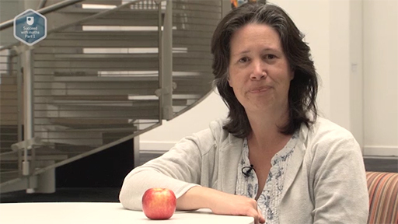
View description - Uncaptioned Figure

After this study week, you should be able to:
- understand negative numbers using a number line
- use negative numbers in different contexts
- work out everyday problems that involve negative numbers using addition and subtraction.

1 Understanding negative numbers
The common unit that is used to measure temperature is degrees Celsius (°C). You can check the temperature of a fridge or freezer using a special thermometer that shows the temperature between about –30 ºC and +40 ºC. Normally you don’t include the plus sign though, as it is assumed that any number without a negative sign is positive. On the thermometer in Figure 1, the marks above each of the small divisions represent one degree C. This means that the temperature recorded in Figure 1 is –4 ºC. You can see on the thermometer that the temperature increases to the right and decreases to the left.

Figure 1 A fridge thermometer
View description - Figure 1 A fridge thermometer
View description - Figure 1 A fridge thermometer

You are now going to extend the work you did on number lines in Week 1 to help with understanding negative numbers.
You already know that positive whole numbers – known as natural numbers – are not sufficient to describe the world around us. Think about going to the supermarket and the various prices you see, most of these will have a decimal component showing the number of pence you have to pay. You also know that there are fraction and decimal numbers. You can show all these numbers on a number line as illustrated in Figure 2.

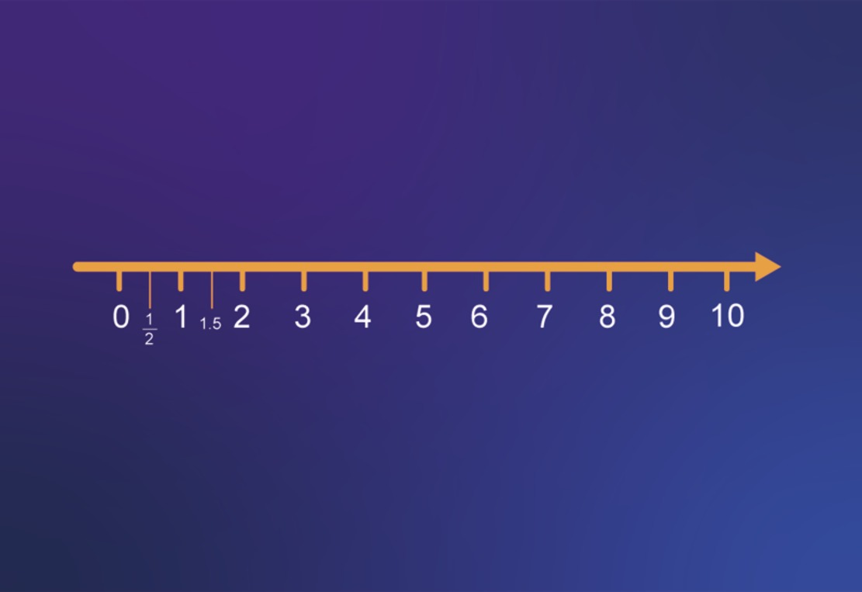
Figure 2 Positive numbers on a number line
View description - Figure 2 Positive numbers on a number line
View description - Figure 2 Positive numbers on a number line

What happens if you extend this number line to the left? What numbers are represented in this new section? These are the negative numbers, which are all less than zero. The number line now looks like that shown in Figure 3.

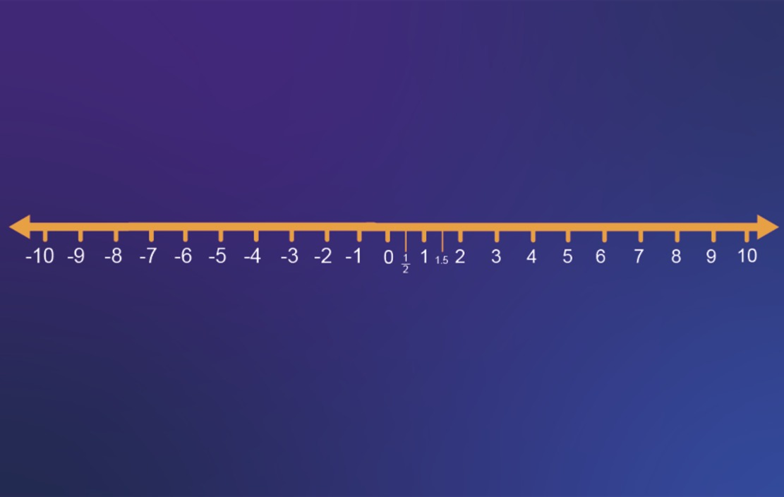
Figure 3 Negative numbers on a number line
View description - Figure 3 Negative numbers on a number line
View description - Figure 3 Negative numbers on a number line

Notice the order that the negative numbers are in. For example, -3 is to the left of -1. That means -3 is smaller than -1, just as in a lift, floor -3 would be lower than floor -1, and a temperature of -3 is colder than a temperature of -1.
Using the number line example gives you a useful way to start exploring these new numbers, as you’ll see in the next section.
Before you do that though, you’ll look at the convention used to show negative numbers in the rest of this course.
Throughout your work, negative numbers will be denoted by using a small subtraction sign, i.e. ‘-3’. However, when negative numbers are used in calculations they will also be enclosed in brackets, to make it clear that they are negative numbers. This is a convention that you will see in some other maths text books and material, but not all.
You may be wondering what roles negative numbers play in everyday life, and why they might be useful to get to grips with. There are a few examples to look at in the next section.

2 More practical uses of negative numbers
Banks and other companies use negative numbers to represent overdrawn accounts or a debt: if you had £50 in your account but then withdrew £60, your account would be overdrawn by £10. This might be recorded as ‘–£10’ or ‘(£10)’. (Brackets are sometimes used to show a negative balance.)
You may also have seen negative numbers on maps, where they are used to record the depth below sea level. If you’re an avid golfer, or enjoy following it on television, you’ve probably noticed that the scores are often negative (which is a good thing), representing the number of strokes below the average.
As you’ve seen, negative numbers can be identified on the number line in a similar way to the temperatures on a thermometer. For example, the number line in Figure 4 shows the numbers –0.5, –1.8 and –2.4. These numbers are read as ‘minus zero point five’, ‘minus one point eight’ and ‘minus two point four’.

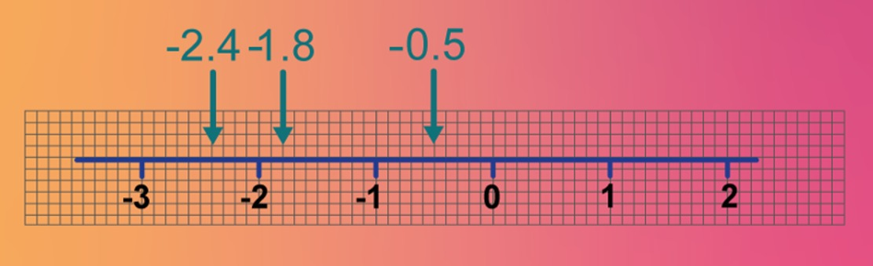
Figure 4 A number line with –2.4, –1.8 and –0.5 marked on it
View description - Figure 4 A number line with –2.4, –1.8 and –0.5 marked on it
View description - Figure 4 A number line with –2.4, –1.8 and –0.5 marked on it

Remember from earlier that the numbers increase to the right on the number line, so –1 is greater than –3 because it is to the right of –3, and 2 is greater that –1 because it’s to the right of –1. You might like to try this quick activity yourself by drawing your own number line. Before you start, think about how these numbers would be shown in ascending order in a list.

Activity 1 Negative numbers on the number line
Allow approximately 5 minutes

Draw the number line below and mark the numbers –6, –2.5, and –12 on it.

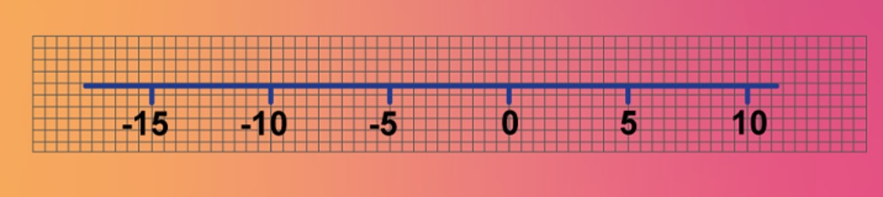
Figure 5 A number line from –15 to 10
View description - Figure 5 A number line from –15 to 10
View description - Figure 5 A number line from –15 to 10

View answer - Part

Now you’ve looked at some visual representations of negative numbers you need to think about whether a value you are being given is positive or negative from a written description. Thinking in this way will help you develop a better understanding of negative numbers in context.

2.1 Determining if a value is positive or negative
It may not be immediately obvious whether a number you are dealing with is positive or negative from the description given. You may need to use clues in the descriptions or even try visualising the value to help. Use these techniques in the next activity and see how you get on with this.

Activity 2 Positive or negative?
Allow approximately 10 minutes

Tick the values described below that are negative.

3 degrees below zero
52 m below sea level
£1000 net gain
£500 withdrawal from a cashpoint
£1000 deposit in savings account
3 kg weight loss
2 kg weight gain
80 m above sea level
37 degrees above zero
£2000 net loss
View answer - Activity 2 Positive or negative?

Now that you have looked at some examples of negative numbers and learned how to represent them on a number line, you’ll move on to using negative numbers in calculations. Again, you’ll make use of your old friend, the number line, to help.

3 Addition and subtraction on the number line
Watch the video below to see how you can use a number line to help you with addition and subtraction involving negative numbers.

Video content is not available in this format.
View transcript - Uncaptioned interactive content

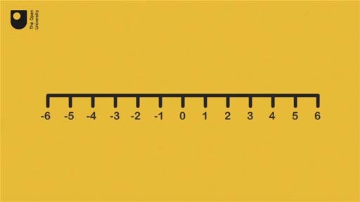
View description - Uncaptioned Figure

See how you get on in this next activity.

Activity 3 Working with negative numbers
Allow approximately 10 minutes

Try the following examples. Start by drawing your own number line from –10 to + 10.
- 3 − 7

View answer - Part

- (–2) + 5

View answer - Part

- (–3) − 6

View answer - Part

- (–4) + 2

View answer - Part

Well done for completing your first calculations using negative numbers. These examples all involved subtracting or adding positive numbers to a negative number. Things become slightly more challenging when looking at adding and subtracting negative numbers, but again you’re going to call in your trusty number line to help.

4 Adding and subtracting negative numbers
You use a similar process to that shown in the previous section, when adding and subtracting negative numbers. Watch the example given in the video below.

Video content is not available in this format.
View transcript - Uncaptioned interactive content

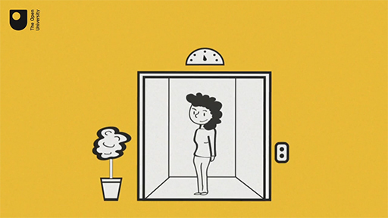
View description - Uncaptioned Figure

Now, consider a simple case first of 0 + (–2). If you add a number to zero, you end up with the same number, so 0 + 6 = 6. It then follows that the same must be true for our example: 0 + (–2) = –2.
This can be shown on the number line (Figure 11) as follows. Starting at 0 and moving 2 units to the left, the answer is –2. This is the same operation as subtracting 2 from zero as subtraction requires moving to the left in the same way.

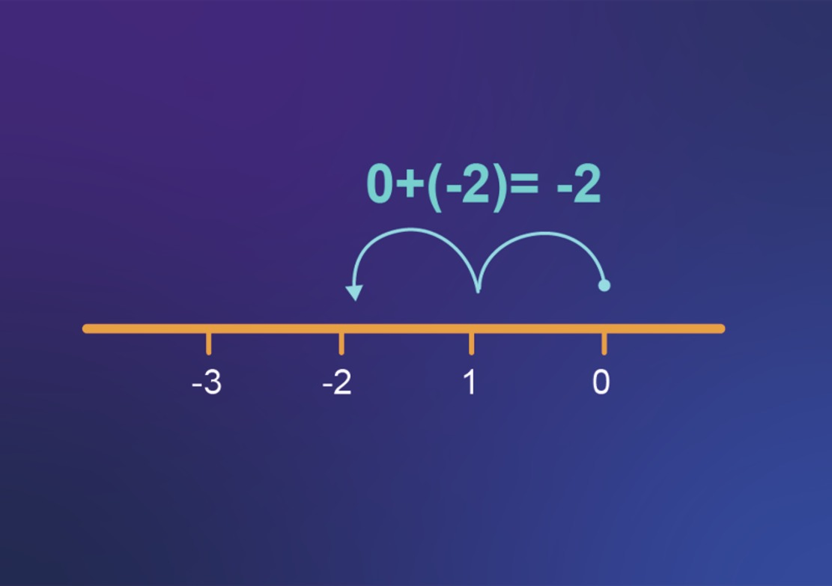
Figure 11 The sum 0 + (–2) = –2
View description - Figure 11 The sum 0 + (–2) = –2
View description - Figure 11 The sum 0 + (–2) = –2

You now have your first rule to remember when working with negative numbers. Rules in maths are crucial as they give you a way of working with any number – it is always important to use the right rule, at the right time though! Always think carefully if the rule you are using works in the context you are trying to apply it in. The rule here is:
- Adding a negative number is the same as subtracting the corresponding positive number.
For example:
30 + (–20) = 30 − 20 = 10 and
(–5) + (–10) = (–5) − 10 = –15
How about what happens when you subtract a negative number? This isn’t easy to visualise, so you can try thinking of subtraction in a different way. For example, for the calculation 30 − 20, instead of saying ‘30 take away 20 is …’ you can say, ‘What do I have to add on to 20 to get 30?’. This is finding exactly the same difference but looking at it in a different way.
In the same way, 0 − (–2) can be interpreted as ‘What do I have to add on to (–2) to get 0?’. From the number line in Figure 12, you can see you have to move 2 units to the right to arrive at zero, which is the same as adding on 2. Thus, 0 − (–2) = 2, is in fact the same as 0 + 2.

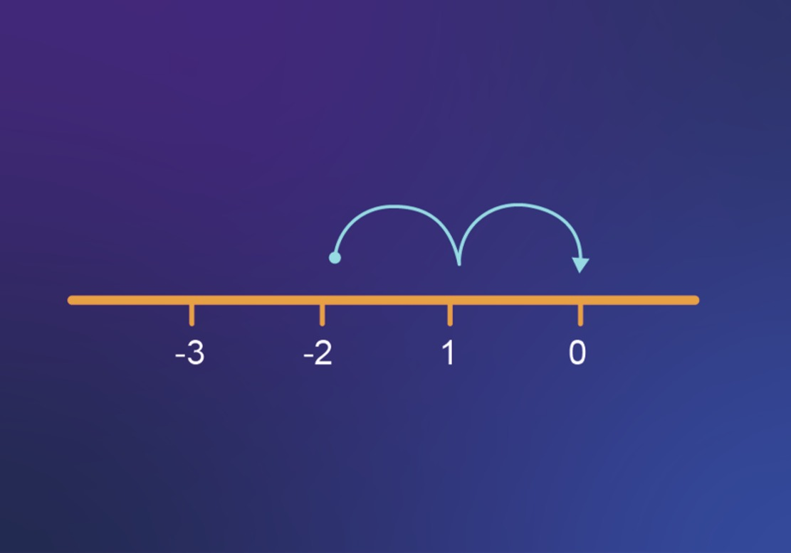
Figure 12 What do I have to add on to –2 to get 0?
View description - Figure 12 What do I have to add on to –2 to get 0?
View description - Figure 12 What do I have to add on to –2 to get 0?

So, now you have your second rule to help you with working with negative numbers:
- Subtracting a negative number is the same as adding the corresponding positive number.
For example, 30 − (–20) = 30 + 20 = 50 and –30 − (–20) = –30 + 20 = –10.
It’s not easy to see why subtracting a negative number is equivalent to adding a positive number in real life, so think of driving a car along a road, going in a forward direction that you can consider as ‘positive’. If you wanted to go back in the opposite direction, considered as backwards, or ‘negatively’, you have two choices. You could either reverse or turn round. Either is a sort of equivalent to a negative number. But, if the car did both at the same time (that is, turned itself around, and then reversed), then it would continue in the original direction – that is, positively. So, subtraction of a negative number is addition of the positive number.
Now it’s time to practise adding and subtracting negative numbers.

Activity 4 Adding and subtracting negative numbers
Allow approximately 10 minutes

Work through these examples without using a calculator.
Hint: remember that adding a negative number is the same as subtracting the corresponding positive number.
- 20 + (–5)

View answer - Part

- (–20) + (–5)

View answer - Part

- 20 – (–5)
Hint: remember that subtracting a negative number is the same as adding the corresponding positive number.

View answer - Part

- (–20) − (–5)

View answer - Part

The next section looks at some other methods or rules for addition and subtraction involving negative numbers before moving onto exploring how to use a calculator to help.

5 Rules for negatives
As you first learn how to work with negative numbers and develop your skills, a number line is very helpful – but it can sometimes be very tedious and not very convenient!
Remembering a few basic rules can be a great help and so can a ‘common sense’ check using some of the practical examples.

Rule 1
If you are adding two numbers that have the same sign, like (–4) + (–3) , momentarily ignore the signs, and add the numbers together. Then place the sign in front of the sum.
You can think of (–4) + (–3) as 4 + 3, which equals 7. Since both numbers were negative, you place a negative sign in front of the answer: (–4) + (–3) = –7. You can verify this using a number line.

Common sense check
If you are £4 in debt, (so ‘-4’) and then you owe another £3 (so ‘-3’) you will still end up in debt, and more in debt than you started! Your answer must be compatible.

Rule 2
If you are adding two numbers that have different signs, such as (–8) + 2, you momentarily ignore the signs. Then subtract the numbers and place the sign of the ‘larger’ number in front of the difference.
You ignore the signs in (–8) + 2 and subtract 8 − 2, which equals 6. Since the ‘larger number’ is 8, and it has a negative sign in front of it, the overall answer is also negative: (–8) + 2 = –6.

Common sense check
If you are £8 in debt (‘-8’) and someone gives you £2 (‘+2’) then you can see that you will still be in debt, but less in debt than you started out. So the answer is still negative, but the size of the debt is less.

Rule 3
If you are subtracting a positive number, like (–5) − 3, then rewrite it as addition of the negative number and then use the rules for addition: (–5) − 3 = (–5) + (–3) = –8.

Common sense check
Debt works here too! If you are £5 in debt (-5) and then you have to pay out £3 (so you subtract 3) – you end up more in debt.
To help you visualise this example, look at the number line in Figure 13.

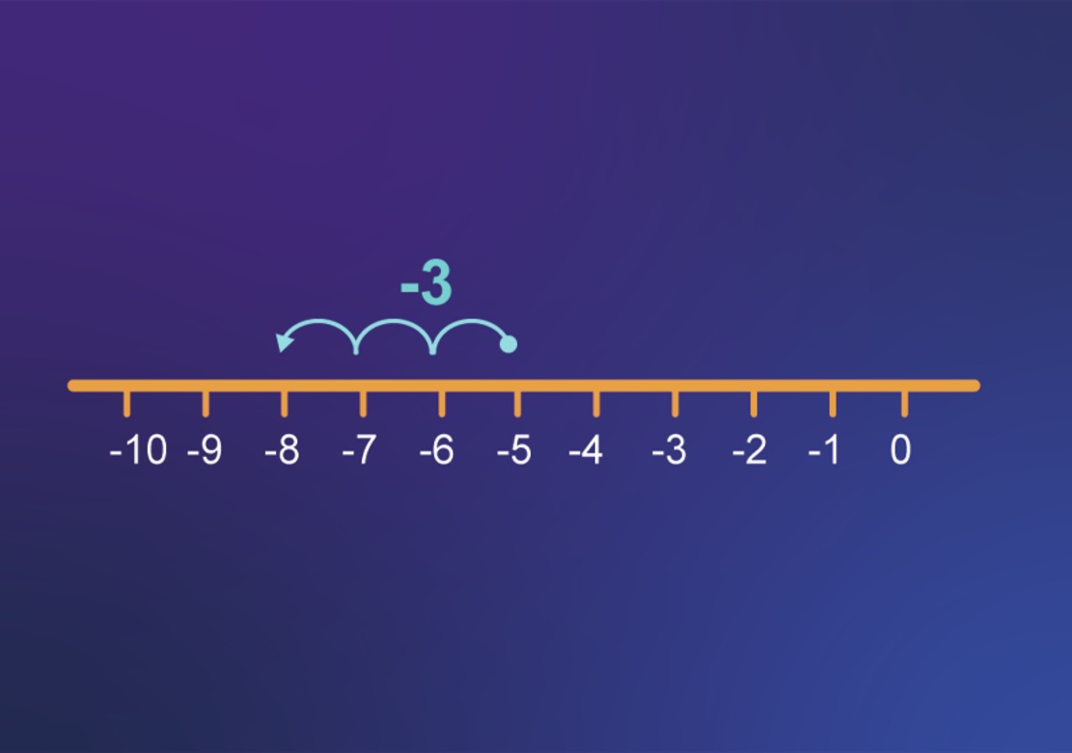
Figure 13 The sum (–5) – 3 = –8
View description - Figure 13 The sum (–5) – 3 = –8
View description - Figure 13 The sum (–5) – 3 = –8

Rule 4
If you are subtracting a negative number, such as (–6) − (–3), then rewrite it as addition of the positive number and then use the rules for addition: (–6) − (–3) = (–6) + 3 = –3.

Common sense check
Using debt as an example again – if you are £6 in debt, and someone cancels (= takes away) £3 of the debt (so – (-3)), then you are left with £3 debt.
Check out the number line in Figure 14 to see the addition.

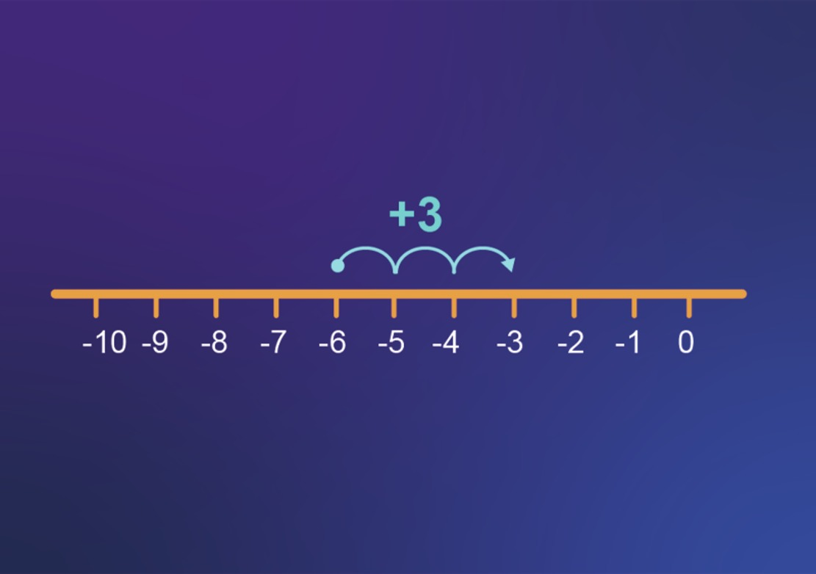
Figure 14 The sum (–6) − (–3) = –3
View description - Figure 14 The sum (–6) − (–3) = –3
View description - Figure 14 The sum (–6) − (–3) = –3

Of course, if you feel comfortable adding and subtracting negative numbers without these rules, there is no need to use them.
Use the rules in this next activity to help you to decide if you find them useful.

Activity 5 Adding and subtracting negative numbers using the four strategies
Allow approximately 10 minutes

Try these questions using the four strategies above.
- 18 + (–3)
Hint: look at Rule 2 above.

View answer - Part

- (–21) + (–6)
Hint: look at Rule 1 above.

View answer - Part

- 32 − (–8)
Hint: look at Rule 4.

View answer - Part

- (–25) − (–4)

View answer - Part

It’s important to get to grips with carrying out addition and subtraction involving negative numbers on paper or in your head to get a real understanding of how to do this. It will also help if you keep the rules to hand and practise your new skills. Fortunately, you can also turn to a calculator. You can try this in the next section.

6 Calculator exploration: negative numbers
Using a calculator for negative numbers can make life a lot easier!
You have plenty of options when it comes to what calculator to use and you may find it easier to use the one that you are most familiar with. This could be a calculator on your mobile phone, computer or tablet, an online calculator, or a handheld calculator.
To enter a negative number on a calculator you will usually use the 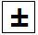(plus/minus) key or the (-) key.
Find either of these keys now.
How you enter a negative number will depend upon the calculator you are using. For most newer calculators you will need to press the or the (-) key and then enter the number.
You may be wondering which key to use on your keyboard for negative numbers. There is no direct equivalent of the button, but the minus key performs the same task.

Table 1 Minus operator buttons
Mathematical operation | Calculator button | Keyboard key
Negative number | or (-) | The − (minus) key

Now you can have a go at some examples using a calculator.

Activity 6 Adding and subtracting negative numbers using the calculator
Allow approximately 10 minutes

Work out the answers to the following questions in your head first to get some more practice. Then check that they are correct on the calculator.
- 2 + (–5)

View answer - Part

- (–4) − 3

View answer - Part

- 8 − (–5)

View answer - Part

- (–10) + (–2)

View answer - Part

- (–3) + 3

View answer - Part

7 This week's quiz
Well done – you have reached the end of Week 7. You can now check what you’ve learned this week by taking the end-of-week quiz.
Open the quiz in a new tab or window by holding down Ctrl (or Cmd on a Mac) when you click on the link. Return here when you have finished.
Week 7 practice quiz.

8 Summary of Week 7
Congratulations for making it to the end of another week. There has been a lot to take in this week and you can really help yourself with all these new rules by keeping them to hand and referring back to them. Eventually, without too much effort, you’ll just be able to apply them without looking them up. Next week, the final week of this course, you will expand on your new skills with negative numbers to look at multiplication, division and negative powers. See you there!
This week should have helped to make feel more confident to:
- understand negative numbers using a number line
- use negative numbers in different contexts
- work out everyday problems that involve negative numbers using addition and subtraction.
You can now go to Week 8.

Week 8: Sharing maths with others

Introduction
Last week you learnt about adding and subtracting negative numbers. But what about the other two operations – multiplying and dividing?
It is possible to imagine what might happen when multiplying a negative number by a positive number by thinking about owing money. For example, if you currently owe £100 but your debt triples, that means you owe £300. So that suggests –100 × 3 = –300.
But what does –4 × –2 mean? Or –15 ÷ –5? You’ll find out more this week.
You’ll then finish off this course by thinking about how to communicate maths. Maths isn’t just about getting the right answer – you also often need someone else to be able to understand how you came to that answer, so they know it’s correct. So you’ll be looking at how to write maths clearly and correctly.
In the following video Maria introduces Week 8, the final week of the course, and the final badge quiz.

Video content is not available in this format.
View transcript - Uncaptioned interactive content

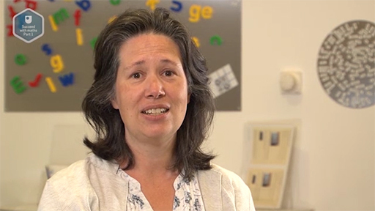
View description - Uncaptioned Figure

After this study week, you should be able to:
- understand more about negative numbers
- work out everyday problems that involve negative numbers using multiplication and division
- understand exponents or powers of negative numbers
- understand the importance of clear mathematical communication and how to achieve this.

1 Multiplication and division with negative numbers
To get a feel for negative numbers, last week you used a number line and also learned how to carry out addition and subtraction involving negative numbers. Now you’re going to turn your attention to multiplication and division. First, you’ll work through a calculator exploration to investigate what happens when you multiply by negative numbers.

Activity 1 Multiplying negative numbers
Allow approximately 10 minutes

Use a calculator to find the answers and see if you can spot any patterns that emerge.

Table 1 Multiplying negative numbers (to complete)
Calculation | Answer | Calculation | Answer
2 × 4 | Provide your answer... | 2 × (–4) | Provide your answer...
1 × 4 | Provide your answer... | 1 × (–4) | Provide your answer...
0 × 4 | Provide your answer... | 0 × (–4) | Provide your answer...
(–1) × 4 | Provide your answer... | (–1) × (–4) | Provide your answer...
(–2) × 4 | Provide your answer... | (–2) × (–4) | Provide your answer...
(–3) × 4 | Provide your answer... | (–3) × (–4) | Provide your answer...

View answer - Activity 1 Multiplying negative numbers

See if you can use this observation with the next activity. You can often look for patterns in maths to help you solve problems and help with your understanding of any underlying rules that there may be. Seeing a pattern to help you with the next activity should also help you with your understanding of any rules that are developed.

Activity 2 What happens next?
Allow approximately 5 minutes

Use the patterns in Table 2 to predict the answer to the next calculation in each sequence. Then check your predictions using a calculator.
- The next calculation in the first column will be (–4) × 4.

View answer - Part

- The next calculation in the third column will be (–4) × (–4).

View answer - Part

Now you’ll look at some rules to help you remember this pattern.

1.1 Investigating multiplication by a negative number
It’s time to turn your observations from the previous activities into some useful mathematical rules to go with the ones that you already have for negative numbers from Week 7. This is an important part of problem solving in many different situations, not just in maths.

Activity 3 Being a mathematical detective
Allow approximately 5 minutes

Use the results from the Table 2 (repeated below) to complete the following statements.

Table 2 Multiplying negative numbers (complete) (repeated)
Calculation | Answer | Calculation | Answer
2 × 4 | 8 | 2× (–4) | –8
1 × 4 | 4 | 1 × (–4) | –4
0 × 4 | 0 | 0 × (–4) | 0
(–1) × 4 | –4 | (–1) × (–4) | 4
(–2) × 4 | –8 | (–2) × (–4) | 8
(–3) × 4 | –12 | (–3) × (–4) | 12

- If you multiply a negative number by a positive number, the answer is …

View answer - Part

- If you multiply a negative number by a negative number, the answer is …

View answer - Part

Now you have these rules, it is helpful for your understanding to look a bit closer at what is actually happening.

1.2 Rules for multiplication and division of signed numbers
You’ve just established the following rules that you can use when faced with multiplication or division involving negative numbers:
- negative × positive or positive × negative = negative
- negative ÷ positive or positive ÷ negative = negative
- negative × negative = positive
- negative ÷ negative = positive.
When you used your calculator, you found that 4 × (–2) = –8. This is the same as asking what four lots of (–2) are, or answering the calculation (–2) + (–2) + (–2) + (–2), both of which give an answer of –8. So you can see that it makes sense that positive × negative = negative.
You also found that the product of any two negative numbers is positive; for example, (–2) × (–4) = 8.
Why is this? Consider (–6) ÷ 2 = (–3). An alternative way of considering this problem is to say: ‘What do I have to multiply 2 by to get (–6)?’ Since 2 is positive and –6 is negative, the answer must be negative. Because 2 × (–3) = (–6), then (–6) ÷ 2 = (–3).
Similarly, to answer the calculation (–6) ÷ (–2) you would need to multiply (–2) by 3 to get (–6). Therefore, you can deduce that (–6) ÷ (–2) = 3.
Now you’ll get some practice without your calculator. Look back at the rules if you need to.

Activity 4 Multiplying and dividing negative numbers
Allow approximately 5 minutes

Work out the answers to the following questions.
- (–3) × 5
Hint: remember: negative × positive = negative.

View answer - Part

- (–3) × (–5)
Hint: remember: negative × negative = positive.

View answer - Part

- (–10) ÷ 5
Hint: remember: negative ÷ positive = negative.

View answer - Part

- (–10) ÷ (–2)
Hint: remember: negative ÷ negative = positive.

View answer - Part

Now that you’re familiar with these rules, see if you can use negative numbers to help solve Activity 5 in the next section. Hopefully, you’ll be able to see how useful it is to have clear rules in place – we’ve summarised them for you below.

When multiplying or dividing:
- Combining two numbers of the same sign gives a positive.
- Combining two numbers of the opposite sign gives a negative.
NB: these rules are for multiplying and dividing – you need to use the different ones, covered last week, for adding and subtracting.

1.3 Using negative numbers in golf
Negative numbers can be used in golf to show how well a player is doing on a particular course, compared to the average number of shots needed to complete each hole. If a player has a score of +2, it means that it took them two more shots than expected. But if they have a score of –2, this is better news! Then they have finished the hole in two shots fewer than expected.

View description - Uncaptioned Figure

Use this knowledge in the next activity.

Activity 5 Are you ready for some golf?
Allow approximately 10 minutes

On a lazy Sunday afternoon, you are watching golf on TV. There are two players that you are particularly interested in and their scores for the first nine holes of the round are shown below. The score for each hole is the number of shots below or over the average for that hole – so the lower (which means more negative) the score, the better!
What is the total score for each player and who, at this point in the game, is ahead? Use multiplication and addition to find your answer, not addition alone.
Player 1 scored as follows:
- 0 on hole 7
- –1 on holes 1,3, 4
- –2 on holes 2,5,8,9
- –3 on hole 6.
Player 2 scored as follows:
- 0 on holes 4 and 7
- –1 on holes 5, 8 and 9
- –2 on holes 1, 2 and 6
- –3 on hole 3.
Hint: count how many of each score the player has and then use multiplication and addition to find the total.

View answer - Part

One final operation to look at with regards to negative numbers is what happens when you raise a negative number to an exponent or power. You’re going to make good use of a calculator again now to explore this.

2 Calculator exploration: exponents with negative numbers
From your previous study you know that when a number is raised to a certain whole number, exponent or power, that is an instruction to multiply the number by itself as many times as the value of the power. So, 3³ = 3 × 3 × 3. In Activity 6 you’re going to explore what happens when the number to be raised to a certain power is negative.

Activity 6 Taking exponents of negative numbers
Allow approximately 10 minutes

Use the exponent button on your calculator to find the value of each of the calculations in Table 3. Before you start, think about what pattern you might see and make a note of it.

Table 3 Exponents (to complete)
(–1)² | Provide your answer...
(–1)³ | Provide your answer...
(–1)⁴ | Provide your answer...
(–1)⁵ | Provide your answer...
(–1)⁶ | Provide your answer...
(–2)² | Provide your answer...
(–2)³ | Provide your answer...
(–2)⁴ | Provide your answer...
(–2)⁵ | Provide your answer...
(–2)⁶ | Provide your answer...

View answer - Part

There are lots of patterns like these in mathematics. It’s worth watching out for them, as they often give shortcuts to an answer.
You can also see another important feature of maths here – that things link together. The rules for exponents come from the rules about multiplying together negative and/or positive numbers.
The next section is one final recap of all the rules that you have learned involving negative numbers.

3 Wrapping up negative numbers
You now know how to perform the basic operations with negative numbers by hand and using a calculator. Hopefully, your confidence has grown and you will continue to utilise all of your resources as you extend your knowledge and develop new skills.
Here are the important rules to remember again:

Adding and subtracting
- adding a negative number is the same as subtracting the corresponding positive number.
- subtracting a negative number is the same as adding the corresponding positive number.

Multiplying and dividing
- combining two numbers of the same sign gives a positive answer.
- combining two numbers of different signs gives a negative answer.

Well done for reaching the end of another challenging section.
Now you are going to turn your attention to how you read and write using the language of mathematics correctly. This will mean that you can communicate with other people clearly and that your meaning will be understood. So if you were doing some calculations at work or at home that you needed to share with other people, or if you decided to continue with more formally assessed work, others would be able to understand clearly the steps you have taken to arrive at your answer, so that they can trust your answer and know it makes sense.

4 Reading and writing mathematics
Reading a piece of mathematics requires a more detailed and active approach than some other types of reading, so it is worth taking a few moments to think about strategies to use when doing this. Some useful tactics are summarised below, but of course you might have your own ideas as well. Writing these down is a great way to acknowledge the skills and understanding that you already have.
- Read carefully and check that you understand any special terminology, symbols or abbreviations.
- Make sure you understand what you have to do.
- Highlight or underline key pieces of information.
- Check that you have all the information you need at hand, including skills and techniques learned earlier.
- Add extra lines of working if that helps your understanding.
- Draw a diagram to help you visualise the problem and put the information you have on it.
- Mark the parts of the problems that you find difficult. You may want to come back to these, talk through the ideas with a friend or look on the internet for some guidance. Don’t worry if there are tough parts – you are learning more and developing your skills as you attempt them!
The key is to take your time and be methodical; that way you are less likely to miss any important details or instructions.

4.1 Writing mathematics
There is more than one purpose to writing your maths clearly and concisely. One is to make your meaning and logic clear to others; in some ways, though, this is not the most important reason. Rather, it is to help you to follow your own logic when problem solving and, hopefully, to help you find the way to the solution. Also, if you review some work in a few weeks’ time, it may not mean anything to you if you haven’t written it down clearly! This idea applies to study in any subject area that you may undertake and especially to university-level study. Often, the new ideas that you study will build on each other and you will need to look back over previous work as a reminder – so it is important that you can understand what you have written.
A couple of ways of helping with this is to ask someone else to read your work, or imagine that you are writing for someone who has little knowledge of the topic and requires a full explanation. This can help you to make sure that you include sufficient detail. At the moment, tell yourself that all your working, however obvious it may seem, should be written down.
Mathematical writing requires skills in using notation and specialist vocabulary. Remember, maths is a language! This skill takes time to develop, so whenever you encounter any maths problems, try to communicate them properly – even if they are just for you. The more you do this, the more like second nature writing your maths correctly will become – and the easier it will be.
The three most important things to remember are as follows:
- Explain each step in your working clearly.
- Lay out your explanation clearly.
- Use correct maths – make sure that what you write is mathematically correct.
See how you get on with spotting what is wrong with the way that the maths has been presented in Activity 7.

Activity 7 What’s wrong with the maths?
Allow approximately 10 minutes

Consider the following scenario.
You want to pave a patio that’s 4 m long by 3 m wide with paving slabs that are 0.5 m square. The paving slabs cost £6 each. How many will you need, and what will they cost in total?
You go to your local contractor, who says ‘Let me see …’ and scribbles down the following calculation:

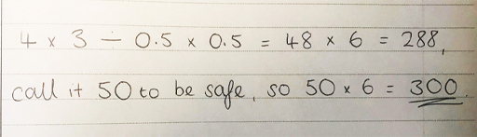
Figure 1 Writing mathematics 1
View description - Figure 1 Writing mathematics 1
View description - Figure 1 Writing mathematics 1

Can you see the difficulty with the maths and suggest any improvements?
Remember that well-written mathematics is easy to follow and uses correct notation. List any problems or issues you see. Think about how you have seen maths presented in the course so far.

View answer - Part

4.2 Understanding a solution
You’ll now take a closer look at some of the problems with the solution provided by the contractor in Activity 7.

Figure 1 (repeated) Writing mathematics 1
View description - Figure 1 (repeated) Writing mathematics 1
View description - Figure 1 (repeated) Writing mathematics 1

If you calculate 4 × 3 ÷ 0.5 × 0.5 following BEDMAS, the answer is 12. However, the contractor seems to have worked this out as 48. What they needed to do to make this calculation clear was to include brackets: (4 × 3) ÷ (0.5 × 0.5) = 48.
There is another problem with the contractor’s calculation. Does (4 × 3) ÷ (0.5 × 0.5) = 288? No, it doesn’t – so the contractor has misused the equals sign here and needed another line of working.
What about ‘288, call it 50 to be safe’? Why is the contractor calling 288, 50? This doesn't make sense. Finally, what about ‘so = 50 × 6 = 300’? Do you really know if the 300 means slabs or pounds?
Figure 2 shows another way that the contractor could have written out your quote to be clear:

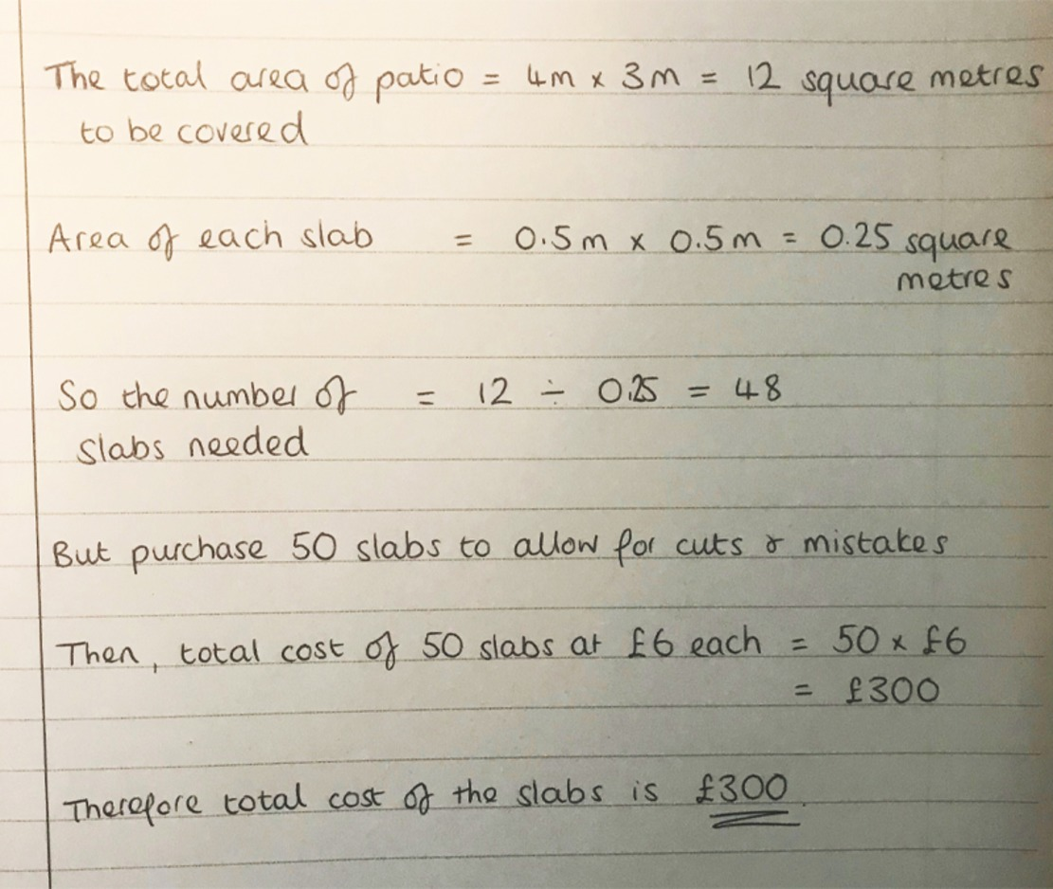
Figure 2 Writing mathematics 2
View description - Figure 2 Writing mathematics 2
View description - Figure 2 Writing mathematics 2

This solution now:
- explains using words in each step of the working
- uses a new line for each part of the working
- makes use of linking words such as ‘so’, ‘then’, ‘but’ and ‘therefore’
- uses equals signs correctly
- includes units to make the final answer and workings clear.
If you follow these basic ideas, your maths will be clear to others and – most importantly – clear to you.
So, that was the final message of this course! And if you follow it, this really will make a big difference to your maths.

5 This week's quiz
Now that you’ve come to the end of the course, it’s time to take the Week 8 badge quiz. It’s similar to previous quizzes but this time, instead of answering five questions, there will be 15.
Open the quiz in a new tab or window by holding down Ctrl (or Cmd on a Mac) when you click on the link. Return here when you have finished.
Week 8 compulsory badge quiz.
Remember, this quiz counts towards your badge. If you’re not successful the first time, you can attempt the quiz again in 24 hours.

6 Summary of Week 8
Congratulations on making it to the end of this week and Succeed with maths – Part 1. You’ve come a long way in just eight weeks, starting from the very foundations of maths with how numbers are put together, through to tackling fractions and decimals, and finally building your confidence with negative numbers. What an achievement!
The skills that you have been building up over these eight weeks are not just about how to mechanically follow the rules that are written to help with maths, but are also all about understanding what lies behind these rules. It is this basic understanding that will enable you to apply your new-found skills in different situations, and help you to solve problems that you have not seen before.
Studying university-level maths is about both of these aspects, as is the study of any other subject at university. This may sound more challenging than just following some rules, and it can be, but it is a satisfying and rewarding process that can change the way that you think and interact with the world around you. We hope that you enjoyed your journey over the last eight weeks and, whatever your next steps, wish you every success.
You should now be able to:
- understand more about negative numbers
- work out everyday problems that involve negative numbers using multiplication and division
- understand exponents or powers of negative numbers
- understand the importance of clear mathematical communication and how to achieve this.
If you've gained your badge you'll receive an email to notify you. You can view and manage your badges in My OpenLearn within 24 hours of completing all the criteria to gain a badge.

A level Maths with the NEC

View description - Uncaptioned Figure

Through pure maths topics including algebra and trigonometry, to statistical topics such as probability and hypothesis testing, NEC's A level Maths course provides challenges that will extend your current understanding of maths. The course offers flexible online learning with materials developed by subject experts and tutor-marked assignments.
Deepen your knowledge, enhance your analytical thinking skills and move to the top of the candidate pool with A level Maths from the National Extension College (NEC).
Enrol from £750.
Find out more about A level Maths here.

Where next?
If you’ve enjoyed this course you can find more free resources and courses on OpenLearn. In particular, you may be interested in the following resources:
- Succeed with Maths – Part 2
- Everyday Maths 1
- Everyday Maths 2
- Maths skills for Science
New to University study? You may be interested in our courses on Maths. You might be particularly interested in our BSc (hons) Mathematics.
Making the decision to study can be a big step and The Open University has over 50 years of experience supporting its students through their chosen learning paths. You can find out more about studying with us by visiting our online prospectus.

References
Snowdon, R. (2021) ‘Three quarters of Yorkshire's residents plan to holiday in the region this year’, Yorkshire Post, 5 April. Available at: https://www.yorkshirepost.co.uk/business/three-quarters-of-yorkshires-residents-plan-to-holiday-in-the-region-this-year-3189517 (Accessed 21 April 2021). (
Save the student (2020) COVID-19 UK student survey – Results. Available at: https://www.savethestudent.org/money/covid-19-student-survey.html (Accessed: 22 April 2021).
Scottish Executive (2004) Scotland’s Biodiversity: It’s in Your Hands – A Strategy for the Conservation and Enhancement of Biodiversity in Scotland, Scottish Executive. Available at http://www.scotland.gov.uk/Resource/Doc/25954/0014583.pdf (Accessed 17 June 2014).
Human Rights Watch (2019) You should be worrying about the women shortage. Available at: https://www.hrw.org/world-report/2019/country-chapters/global-0# (Accessed: 23 April 2021).

Acknowledgements
This course was written by Hilary Holmes and Maria Townsend. It was updated by Cath Brown in 2022.
Except for third party materials and otherwise stated (see FAQs), this content is made available under a Creative Commons Attribution-NonCommercial-ShareAlike 4.0 Licence.
The material acknowledged below and within the course is Proprietary and used under licence (not subject to Creative Commons Licence). Grateful acknowledgement is made to the following sources for permission to reproduce material in this free course:

Images
Introduction and guidance
Course image: pixel_dreams; Getty Images
Week 2: Working with numbers
Course image: pixel_dreams; Getty Images
Section 7: Image by StockSnap from Pixabay
Week 3: Parts of the whole
Course image: pixel_dreams; Getty Images
Week 4: More parts of the whole
Course image: pixel_dreams; Getty Images
Week 5: Relationships among numbers
Course image: pixel_dreams; Getty Images
Section 7: Samorn Tarapan; 123rf
Section 8: © Commonwealth Secretariat 2021
Week 6: Percentage calculations and ratios
Course image: pixel_dreams; Getty Images
Week 7: Negative numbers
Course image: pixel_dreams; Getty Images
Week 8: Sharing maths with others
Course image: pixel_dreams; Getty Images
Section 1.3: Image by Colleen Inniss-Gittens from Pixabay

Videos
Week 3: Parts of the whole
Section 2.1: Produced by The Open University based on the following video produced by Khan Academy: https://www.youtube.com/watch?v=-YpEkExjq2E
Week 4: More parts of the whole
Section 1.1: Produced by The Open University based on the following video produced by Khan Academy: https://www.youtube.com/watch?v=52ZlXsFJULI
Every effort has been made to contact copyright owners. If any have been inadvertently overlooked, the publishers will be pleased to make the necessary arrangements at the first opportunity.

Don't miss out:
If reading this text has inspired you to learn more, you may be interested in joining the millions of people who discover our free learning resources and qualifications by visiting The Open University – www.open.edu/ openlearn/ free-courses.

Solutions

Activity 1 Organising a dinner party

Part

Discussion
You should have put Les at the foot of the table as he wants to be closest to the kitchen.
Figure 4 then shows the two places that Gareth could sit.

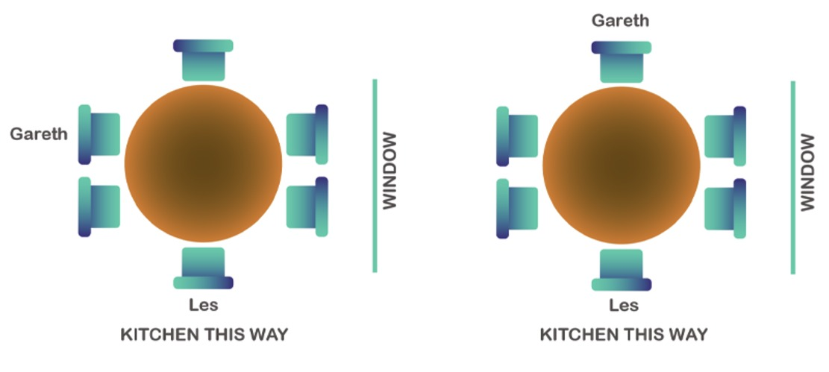
Figure 4 Possible places Gareth can sit
View description - Figure 4 Possible places Gareth can sit
View description - Figure 4 Possible places Gareth can sit

Back to - Part

Part

Discussion
Faisal can’t sit next to Gareth. So Figure 5 shows where Faisal could sit (remembering to leave two seats next to each other for Sandy and Aria).

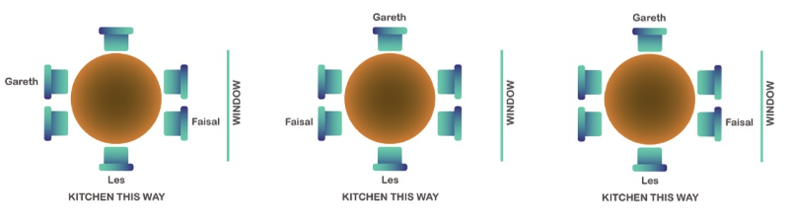
Figure 5 Possible places Faisal can sit
View description - Figure 5 Possible places Faisal can sit
View description - Figure 5 Possible places Faisal can sit

Back to - Part

Part

Discussion
In Figure 5, Jordan has to be in the seat on its own as two seats need to be left spare together for Aria and Sandy to sit next to each other. Because Jordan also can’t have his back to the window it means the seating arrangement can’t be the third sketch in Figure 5.
So the options then become:

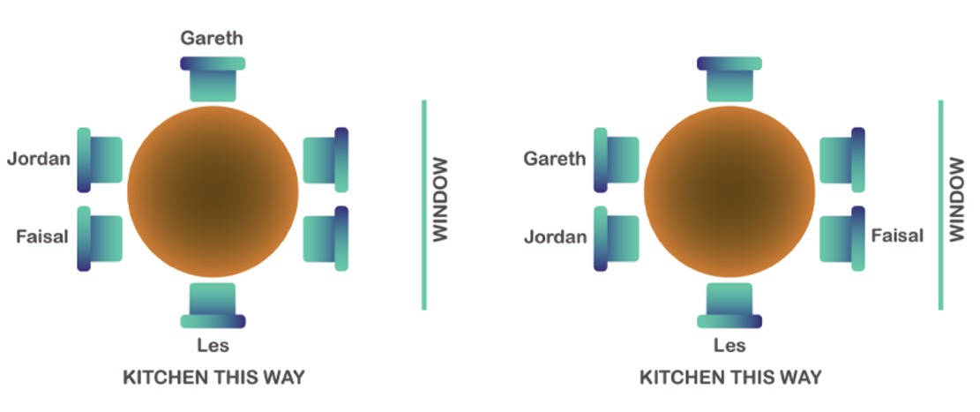
Figure 6 Possible places Jordan can sit
View description - Figure 6 Possible places Jordan can sit
View description - Figure 6 Possible places Jordan can sit

Back to - Part

Part

Answer
The final seating plan must be:

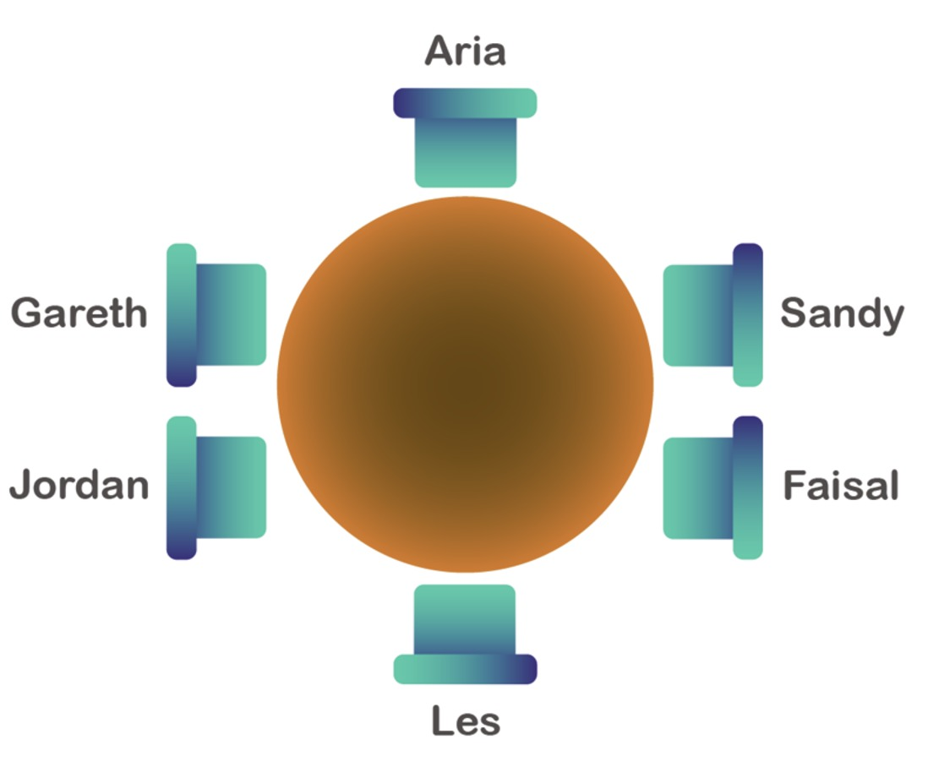
Figure 7 The final seating plan
View description - Figure 7 The final seating plan
View description - Figure 7 The final seating plan

Back to - Part

Activity 2 New vehicle

Part

Comment
There are many ways to solve this problem. You might consider trying to use pictures (visualisation can be very helpful) or select a starting point, such as assuming half are motorbikes and half are cars, and then revising your first guess.
Back to - Part

Part

Answer

Video content is not available in this format.
View transcript - Uncaptioned interactive content

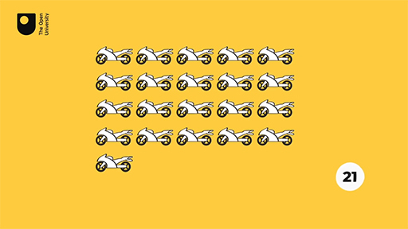
View description - Uncaptioned Figure

Back to - Part

Part

Answer

Video content is not available in this format.
View transcript - Uncaptioned interactive content

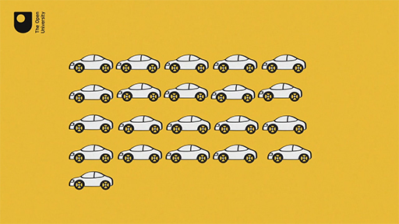
View description - Uncaptioned Figure

Back to - Part

Part

Answer
You can make any guess you think is reasonable. For example, you might assume that about half of the vehicles were motorbikes – say, ten of the vehicles. To keep track of your guesses, a table is quite useful. As you make adjustments to your guesses, remember that the number of motorbikes plus the number of cars must equal 21.

Table 1 Calculating the number of motorbikes and cars using an educated guess
Motorbikes | Cars | Total number of wheels
10 | 11 | 10 × 2 + 11 × 4 = 64 | (too many wheels → need fewer cars)
12 | 9 | 12 × 2 + 9 × 4 = 60 | (too many wheels → need fewer cars)
14 | 7 | 14 × 2 + 7 × 4 = 56 | (too many wheels → need fewer cars)
15 | 6 | 15 × 2 + 6 × 4 = 54 | This matches with what Paul told you.

Once again, the conclusion is that there are 15 motorbikes and 6 cars at the dealership.
So, remember that when you come across a problem there will usually be more than one way to approach it. If you don’t get anywhere with your first method, see if you can come at the problem a slightly different way.
Back to - Part

Activity 3 Checking a bill

Answer
You may have your own method of working things out in your head that works fine for you. If so, there is no need to change how you do this, but you might find the following method useful to work through. The four rounded prices are £25, £17, £37 and £4. To find an estimate for the total cost, add the four rounded prices together.
This is easier to do if you split each number apart from the first one, into tens and units, so 17 can be split into 10 + 7 and 37 into 30 + 7. This makes the sum much easier to work out in your head and the sum then becomes 25 + 10 + 7 + 30 + 7 + 4.
Then, working from the left and adding each number in turn, you can say, ‘25 and another 10 makes 35; another 7 gives 42; another 30 gives 72; 7 more makes 79, and another 4 gives 83’. The answer is 83, so the total bill will be approximately £83.

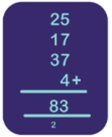
Figure 13 Adding up a bill
View description - Figure 13 Adding up a bill
View description - Figure 13 Adding up a bill

You can then check your estimate by writing out the problem without rounding and performing the calculation again to give the accurate bill.

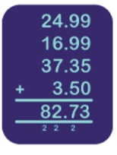
Figure 14 Checking your estimate
View description - Figure 14 Checking your estimate

You can see that the estimate of £83 was very close to the exact amount £82.73. Now you can be confident in your answer.
Back to - Activity 3 Checking a bill

Activity 4 Time, addition and subtraction

Part

Comment
Start by taking out and listing all the information from the question – this should help to make the problem clearer.
Back to - Part

Part

Answer
Working with times can be tricky because you have to remember that there are 60 minutes in an hour, so you are not working with the simple decimal system based on the number 10. One way to do this is by imagining a clock and saying, ‘From 9:35 a.m. to 10:00 a.m. is 25 minutes; 10:00 a.m. to 11:00 a.m. is an hour and 11:00 a.m. to 11:10 a.m. is an extra ten minutes. So the journey time is 1 hour and 35 minutes, assuming the train runs on time.’
Now you have one more step. To find out how much you will have to pay for the ticket, you need to subtract £15.75 from £48.30. There are different ways of doing this; one way is to work up from £15.75, adding on 25 pence to give you £16.00, then £32.00 to get to £48.00 and finally another 30 pence to reach £48.30. The total to pay is £32.00 plus 25 pence plus 30 pence or £32.55.
Back to - Part

Activity 5 Multiplication

Part

Answer

Thus, the answer is 12876. (This seems reasonable since 300 × 40 = 12000.)
Back to - Part

Part

Answer

Thus, the answer is 12880. (This seems reasonable since 600 × 20 = 12000.)
Back to - Part

Activity 6 Division

Part

Answer

The solution is 207.
Back to - Part

Part

Answer

The solution is 269.
Back to - Part

Activity 7 How many teabags?

Part

Answer
Since each box contains 20 packs, and each pack contains 100 teabags, there are 20 × 100 = 2000 teabags in each box.
Back to - Part

Part

Answer
2000 ÷ 500 = 4 days.
This looks like a difficult division, but it is possible to work it out like this:
You know that 2 × 500 gives 1000, so each lot of 1000 contains two 500s. Therefore, in 2000 there are 2 × 2 = 4 lots of 500.
You can also think about it as 500 + 500 + 500 + 500 = 2000, so they last 4 days.
Back to - Part

Part

Answer
300 ÷ 4 = 75 boxes.
From Part b of this activity, you know that a box lasts 4 days. So to work out how many boxes are needed for 300 days, you need to find out many lots of 4 days there are in 300 days.
To do that, you find 300 ÷ 4 = 75.
Back to - Part

Part

Answer
Cost is £70 per box. £70 × 75 = £5250.
You know the shop is going to order 75 boxes from what you have worked out already in this activity, which means they will get the discount.
Therefore they pay £70 per box. You need to work out 75 boxes at £70 per box, so you need to do £70 × 75.
One way to do that is to work out £7 × 75, and then multiply the result by 10 to find the answer to £70 × 75. Using the multiplication strategies from earlier £7 × 75 = £525 and then multiplied by 10 is £5250.
Back to - Part

Activity 8 Running a hospital

Part

Answer
An hour is 60 minutes which is 20 lots of 3 minutes.
So it costs £4000 × 20 = £80000 per hour.
There are 24 hours in a day so 24 × £80 000 = £1 920 000 per day.
There are 365 days in a year, so £1920000 × 365 = £700 800 000 per year.
Back to - Part

Part

Answer
There are 180 seconds in 3 minutes. 180 seconds costs £4000.
£400 is a tenth of £4000. So it pays for 18 seconds.
Back to - Part

Part

Comment
400 × 1.39 = $556.
Back to - Part

Activity 1 Fractions to decimals

Part

Answer
Back to - Part

Part

Answer
Back to - Part

Part

Answer
Back to - Part

Part

Answer
Back to - Part

Part

Answer
The correct matches are:
B
C
A
D
Back to - Part

Activity 2 Rounding

Part

Answer
- Locate the place value to be rounded – in this case, the number 4.
- Look at the next digit to the right – in this case, it’s 3.
- 3 is less than 5, so you round down, and the answer is 126.4.
Back to - Part

Part

Answer
- Locate the place value to be rounded – in this case, the number 5.
- Look at the next digit to the right – in this case, it’s 4.
- Because 4 is less than 5, you round down, and the answer is 0.015.
Back to - Part

Part

Answer
- Locate the decimal place to be rounded – in this case the number is 6.
- Look at the next digit to the right – in this case, it’s 7.
- Because 7 is greater than 5, you round up, and the answer is 1.57.
Back to - Part

Activity 3 How much is it?

Part

Answer
Here’s how the variation in the quotes happened:
Rounding to the nearest £10 (this is the same as rounding to the tens place): the digit 4 is in the tens place. Looking to the place value to the right of the 4, the digit is an 8. Since 8 is larger than 5, you round up the 4 to 5 in the tens place. Finally, you replace the units digit with 0 (because this place is to the left of the decimal point). The rounded number is £19 750. This explains Joe’s quote.
Rounding to the nearest £100 (this is the same as rounding to the hundreds): the digit 7 is in the hundreds place. Looking to the tens place (to the right of the 7), the digit is a 4. Since 4 is less than 5, you leave the digit 7 unchanged and replace the digits after the 7 with zeros. The rounded number is £19 700. This explains Tina’s quote.
Back to - Part

Activity 4 Cross-number puzzle

Answer

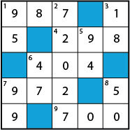
Figure 3 Completed cross-number puzzle
View description - Figure 3 Completed cross-number puzzle
View description - Figure 3 Completed cross-number puzzle

Table 3 Answers for cross-number puzzle
Across | Down
1. 21 × 47 = 987 | 1. 19 × 5 = 95
4. 1788 ÷ 6 = 298 | 2. 8003 × 9 = 72027
6. 497 – 105 + 12 = 404 | 3. 1234 – 1216 = 18
7. 1458 ÷ 3 × 2 = 972 | 5. 1 + 11 + 111 – 29 = 94
9. 32 + 681 – 13 = 700 | 6. 517 ÷ 11 = 47
 | 7. 21 × 33 ÷ 7 = 99
 | 8. 49 + 49 – 48 = 50

Back to - Activity 4 Cross-number puzzle

Activity 5 BEDMAS on paper versus the calculator

Part

Answer
Carry out the calculation in brackets first: 3 + 4 = 7. Now multiply by two and the answer is 14.
Back to - Part

Part

Answer
No brackets this time, so start with the exponent: 3² = 9. Add the two and you get 11.
Back to - Part

Part

Answer
This looks like part (b), but this time there are brackets, so you must do the calculation inside the brackets first: 2 + 3 = 5. Now square the result, and the answer is 25.
Back to - Part

Part

Answer
Work out the exponents first: 3² = 9 and 4² = 16. Finally add 9 + 16 = 25.
Back to - Part

Part

Answer
It can help to make calculations like this easier to read if you put brackets around the part that you need to do first.
This time, you have addition and multiplication, so you must do the multiplication first: 3 × 4 = 12.
So now, the calculation is 2 + 12 + 5 = 19.
Using brackets you would write 2 + (3 × 4) + 5.
This will give you the same answer, but just might make your job easier!
Hopefully you got the same answers using your calculator.
Back to - Part

Activity 6 The contractor’s costs

Answer
The contractor charges £650 and the grant is £200
So, overall cost = £650 − £200 = £450.
So the total cost using an approved contractor is £450.
Back to - Activity 6 The contractor’s costs

Activity 7 How many rolls do I need to buy?

Answer
First, you can see I will need 18 rolls to lie between the joists and between the frame and outer joists.
However, you know that each roll leaves an extra 80 cm not covered. This happens 18 times, so I am short 18 × 80 cm = 1440 cm. Since one roll is 800 cm, I will need to buy two more rolls of insulation (1440 cm ÷ 800 cm = 1.8). Therefore, I need a total of 20 rolls of insulation.
Back to - Activity 7 How many rolls do I need to buy?

Activity 8 The price of doing it yourself

Answer
Since I need to buy 20 rolls of insulation, I will be able to take advantage of the ‘three-for-two’ offer. So for every three rolls I purchase, I only pay for two rolls.
So cost of three rolls = £15 × 2 = £30
To determine how many times I will get to take advantage of the offer, a picture can be used.

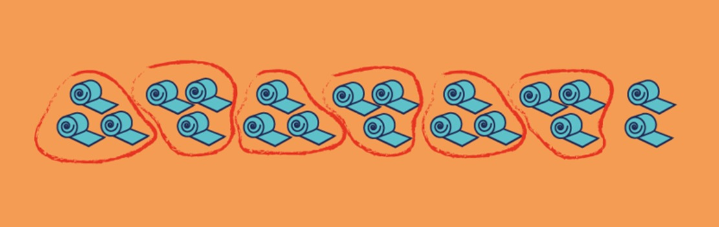
Figure 6 20 rolls of insulation
View description - Figure 6 20 rolls of insulation
View description - Figure 6 20 rolls of insulation

Since there are six sets of three rolls, it will cost £30 × 6 = £180. Unfortunately, the two additional rolls won’t be on offer, so the insulation will cost £180 + £15 + £15 = £210.
Finally, the safety equipment is £40. This puts the total cost at £210 + £40 = £250
Back to - Activity 8 The price of doing it yourself

Activity 1 Equivalent fractions

Part

Answer
The 3 is multiplied by 6 to reach 18, so this is the number that is used to multiply both the numerator and the denominator. The missing number is 12.

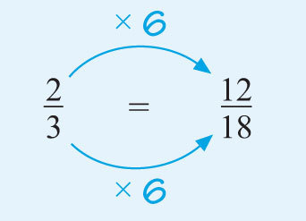
Figure 8 is equivalent to
View description - Figure 8 ...

Back to - Part

Part

Answer
Similarly, since 5 × 4 = 20, multiply the numerator and the denominator by four. The missing number is 16.

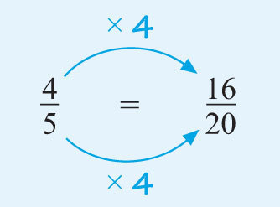
Figure 9 is equivalent to
View description - Figure 9 ...

Back to - Part

Part

Answer
Multiplying the numerator and the denominator of the first fraction by five gives:

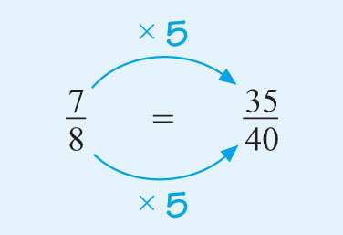
Figure 10 is equivalent to
View description - Figure 10 ...

Only the two fractions labelled (i) and (ii) are equivalent.
You cannot create from by multiplying the numerator and the denominator by the same number.
If you multiply by 7 you get , which isn’t . If you multiply by 8 you get , which isn’t , either.
Back to - Part

Part

Answer
(i) Dividing the top and the bottom by 2 gives .
(ii) Dividing the top and the bottom by 10 (or by 5 and then by 2) gives .
(iii) Dividing the top and the bottom by 9 and then by 3 gives .
(iv) Dividing the top and the bottom by 4 and then 3 gives .
(Of course it does not matter which number you divide by first, and there are even more choices than the ones shown.)
If you find it difficult to spot the numbers to divide by, try to work systematically by trying 2, 3, 5 … in turn.
Back to - Part

Activity 2 Group fractions

Part

Answer
The total number in the group is 560, so this gives the denominator for the fraction. Of these, 245 took a college course. This is the numerator (the number of parts of the whole).
Therefore, the fraction who have taken a college course during the last year is .
Both 245 and 560 look as though they can be divided by 5, as they end with a 5 and a 0 respectively. Let’s try it. Yes! That gives . Seven is one of the few numbers that can divide evenly into 49. Does it also divide into 112? It does, so this fraction can be simplified by dividing the top and bottom by 5 and then by 7:

So of the group took a college course in the last year.
Back to - Part

Part

Answer
The fraction who have taken a maths course is .
Simplify the fraction by dividing the top and bottom by 10, then by 7, and finally by 2. (A different order, or even a different choice of numbers to cancel with can be used, but many people find it easy to divide by 10 first.)

As the numerator is now 1, you know that we have reached the simplest form of this fraction. No number, other than one, will now divide evenly into both the numerator and the denominator, so you know you have your answer.
The fraction of the group who have taken a maths course is .
Back to - Part

Activity 3 True or false?

Part

Answer
Right:
False
Wrong:
True
Back to - Part

Comment
False. The fraction could be or , which are both bigger than one half. Be careful! The use of the word ‘only’ may suggest to you that it is a small fraction, perhaps less than one half, but this could be a wrong interpretation.
Back to - Part

Part

Answer
Right:
True
Wrong:
False
Back to - Part

Comment
True. A fraction can be thought of as a division problem. For example, is the same as . However, some decimal fractions do not stop; instead they have a repeating set of digits, such as These are known as recurring decimals. They are accurately represented by placing a dot over the first and last numbers of the repeating set, like this: .
Often, these decimal numbers are rounded, so you might see rounded to 0.29 or 0.286. Keep in mind that rounded values, while useful for some purposes, are not the same accurate representations as fractions.
Back to - Part

Part

Answer
Right:
False
Wrong:
True
Back to - Part

Comment
False. But don’t worry if you said true! This is something new, and is a bit tricky. We can have fractions that are equal to one (e.g. is equal to 1) or even bigger than one (e.g. (seven-thirds) has a value greater than 1 because it means , which is greater than 2. You will look more at fractions like this later this week.
Back to - Part

Activity 4 Fractions on the number line

Part

Answer
You can determine the position of a number by dividing the length between the two appropriate whole numbers on the scale into 2, 4 or 8 equal parts (or pieces) as appropriate, and then plotting the fractions on it as shown in Figure 12.

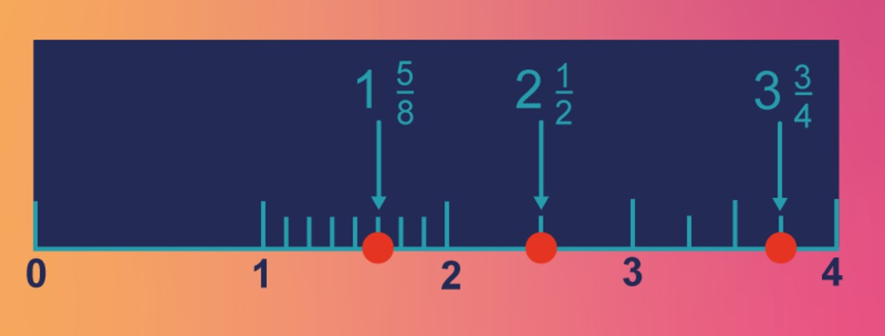
Figure 12 A number line with answers
View description - Figure 12 A number line with answers
View description - Figure 12 A number line with answers

You can visualise these fractions again by using pizzas. For example, would be two whole pizzas plus one half pizza.
Back to - Part

Activity 5 Mixed numbers and improper fractions

Part

Answer
(i) You are working in quarters, so using ‘pizza maths’ you need to divide each pizza into four to give you Figure 14.

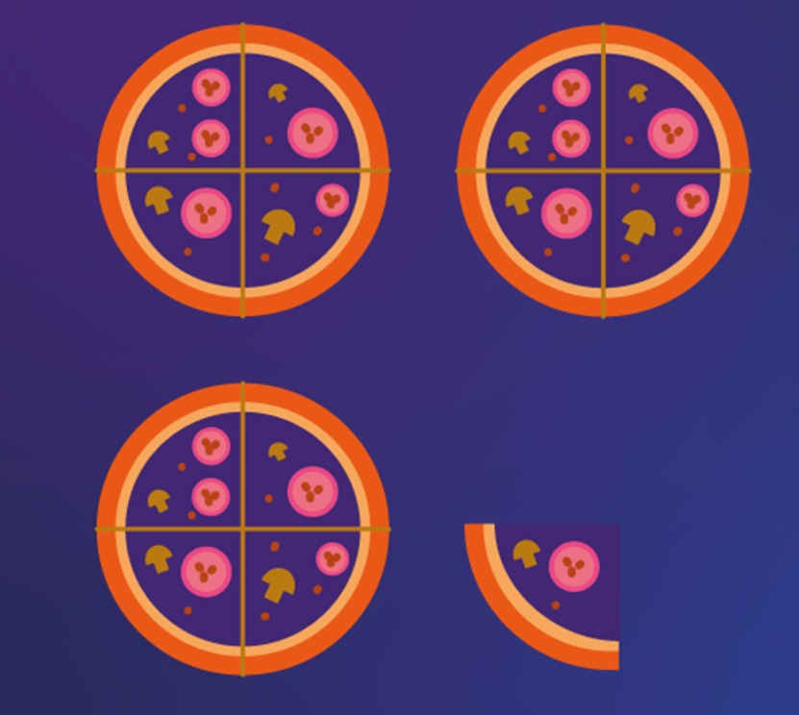
Figure 14
View description - Figure 14 ...

As there are four quarters in each whole, three wholes will give 3 × 4 = 12 quarters. The one extra quarter makes 13 quarters overall.
Thus, .
(ii) You could use the following shortcut to solve this one:

(iii) There are eight eighths in each whole, so seven wholes will give 56 eighths (7 x 8). The extra three eighths makes 59 overall, so the fraction is . Hence, .
Back to - Part

Part

Answer
- Since 4 × 5 = 20, 20 fifths will make up 4 wholes. This leaves an extra 3 fifths, so the fraction is . Thus, .
- Let’s try using long division:
Since 2 × 7 = 14, 14 sevenths will make up two wholes. This leaves one seventh over, so the fraction is . Hence, .
- Since 4 × 4 = 16, 16 quarters will make up four wholes. This leaves one quarter over, so the fraction is . Consequently, .
Back to - Part

Activity 6 Reasons for enrolment

Part

Answer
There are 240 in the whole group, giving the denominator needed for all the fractions before simplification.
- Career prospects: 80 of 240 students is .
Divide the top and bottom by 10, and then by 8, to give .
- Interest: 60 of 240 students is .
Divide the top and bottom by 10, and then by 6, to give .
- To help their children: 72 of 240 students is .
Divide the top and bottom by 12, and then by 2, to give .
Back to - Part

Part

Answer
The total number of people who chose one of the three reasons is 80 + 60 + 72 = 212.
So, the number of people who expressed some other reason for enrolling is 240 − 212 = 28.
Back to - Part

Part

Answer
Take your solution from part (b) and express it as a fraction. You should now have .
This fraction can then be simplified by dividing by 4 (Figure 15).

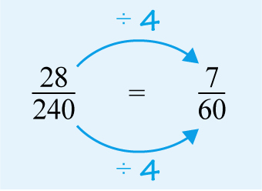
Figure 15 is equivalent to
View description - Figure 15 ...

So, of the group gave some other reason for enrolling on Open University courses. (You could also have used your calculator to work out these fractions.)
Back to - Part

Activity 1 Adding and subtracting fractions

Part

Answer
Both the given fractions are eighteenths, so they can be added together directly:
To simplify to , divide the numerator (top) and the denominator (bottom) by 6.
Back to - Part

Part

Answer
The answer is:

If this is converted to a mixed number, the answer is:

Back to - Part

Part

Answer
This sum involves sixths and sevenths, which are different types of fraction. However, you can change both into forty-seconds, since both 6 and 7 evenly divide into 42. So, by multiplying by 7 and by multiplying by 6.
Thus, the sum is .
Back to - Part

Part

Answer
In this calculation you can add the whole numbers first (2 + 3 = 5) and then add the fractions. First, you must convert each fraction into twenty-fourths, as both 3 and 8 divide exactly into 24. So, the sum is:
Back to - Part

Part

Answer
Both the fractions are sixteenths so you subtract straightaway:
Back to - Part

Part

Answer
You need both fractions to be out of the same number of parts (the denominators).
Since , you can multiply the top and bottom of by 3 to make the equivalent fraction of and then carry out the subtraction.
Therefore:
Back to - Part

Part

Answer
Josie had of a bar. To add these, we need to put them over a common denominator. The common denominator is 12. So becomes . cancels down to of a bar.
Tim has of a bar. The common denominator is 6. So becomes . cancels down to of a bar.
Therefore, Josie and Tim had the same amount of chocolate.
Back to - Part

Activity 2 Summarising survey results

Part

Answer
One tenth of the students is 220 people. So three tenths are people.
Back to - Part

Part

Answer
One twenty-fifth of the students is 88 students. We need 18 twenty-fifths: students.
Back to - Part

Part

Answer
1584 students needed to ask for help. Half of them found this hard to do. Half of 1584 is 792. So 792 students found it hard to ask for help.
Back to - Part

Part

Answer
We know 792 students found it hard to ask for help. There were 2200 students survey altogether. Therefore, the fraction that found it hard to ask for help is .
Back to - Part

Activity 3 Multiplying fractions

Part

Answer
- Cancel by dividing by 3.

Back to - Part

Part

Answer
- Cancel by dividing by 2.
Back to - Part

Part

Answer
- Cancel by dividing by 5 and 12.

Back to - Part

Activity 4 Multiplying mixed numbers and fractions

Part

Answer
- , so
Back to - Part

Part

Answer

Back to - Part

Part

Answer

Back to - Part

Activity 5 Banking with fractions

Part

Answer
- of 210 translates to
So, you know that 126 people have bank accounts. One third of this group have overdraft protection:
Therefore, 42 of the people surveyed have overdraft protection.
Back to - Part

Part

Answer
- You already know how many people have bank accounts: 126. You then need to find of this group.
You can calculate that people.
This fraction, it turns out, is an approximation. You need to interpret the results of your calculation carefully – particularly if it involves fractions of a person!
So, about 50 people have debit cards.
Back to - Part

Activity 6 Dividing fractions

Part

Answer
- Change the first fraction into an improper fraction before dividing:
Back to - Part

Part

Answer
Here, you need to find how many times ‘three-quarters’ goes into ‘seven and a half’. So you need to divide by .

Thus, 10 cars can be cleaned in the given time.
Back to - Part

Part

Answer
You need to find how many metre sections there are in metres. The calculation is:

So, 17 panels are needed.
Back to - Part

Activity 7 Timing is everything

Part

Answer
There are several ways you can do this calculation. For example, you could calculate two-thirds of as follows:

So, the time is hours, or 1 hour and 40 minutes (two-thirds of 60 minutes).
Alternatively, you might have converted the hours to minutes. Since there are 60 minutes in an hour and 30 minutes in half an hour, hours is the same as minutes, or 150 minutes.
minutes is 100 minutes, or 1 hour and 40 minutes. The same as the other answer, fortunately!
Back to - Part

Activity 8 Mowing lawns

Part

Answer
You must determine how many times goes into . The calculation is:

Therefore, she could mow 11 lawns, if she works a full day and all the houses are next to each other!
Back to - Part

Activity 9 Puzzling!

Part

Answer
Like so many puzzles, there are different ways of working this out. Here is one way:
After I gave cakes to Anj, I had of the total left.
After I gave cakes to Bilal, I had of my previous total left. So of the original total.
After my dog ate cakes, I had of the previous total left. So of the original total = 2 cakes

2 cakes = of the original. Therefore there were 30 cakes originally.
And here is a different way, working in reverse:
I ended up with 2 cakes after my dog had eaten of what I had. This means the 2 remaining cakes must be of what I had. Therefore, before the dog ate them, I had 10 cakes.
Ten cakes were what I had after giving a third of what I had before to Bilal. So if I gave her a third, ten cakes must be of what I had before. If ten cakes were , then was five cakes. This means that before I gave cakes to Bilal, I had 15 cakes.
15 cakes was what was left after I gave half to Anj. Therefore I started with 30 cakes.
Back to - Part

SAQ

Answer
- or
- or
- or
Back to - SAQ

Activity 1 Converting between percentages, decimals and fractions

Part

Answer
  - Decimal: 10% = 0.1 Fraction:
  - Decimal: 25% = 0.25 Fraction:
  - Decimal: 50% = 0.5 Fraction:
  - Decimal: 125% = 1.25 Fraction:
  - Decimal: 0.5% = 0.005 Fraction:
Back to - Part

Part

Answer
- Multiplying each fraction or decimal by 100% gives the following answers:

By no means did you have to do it this way, but don’t forget that your answer must include a per cent symbol.
Back to - Part

Activity 2 Going solo

Part

Answer
- ‘One in five’ can be written as or , as well as
The report could have said ‘one-fifth’ or ‘20 per cent’ of people in the survey, but ‘one in five’ makes the proportion easy to visualise for people not comfortable with fractions and percentages. Which form is easiest to understand depends on your way of thinking. You may have noticed already that you are feeling more confident with different ways of representing proportions. Remember, all of these express the same number, although ‘0.2 of the people’ would probably not be used, because it’s much harder to visualise and put in context.
Back to - Part

Part

Answer
- . So 800 out of the 4000 surveyed single people feel happy on their own.
You can show this visually using a pie chart, which divides a circle into the different proportions to represent them. If you continue on to Succeed with maths - Part 2, you will learn more about pie charts and other visual ways to represent data.

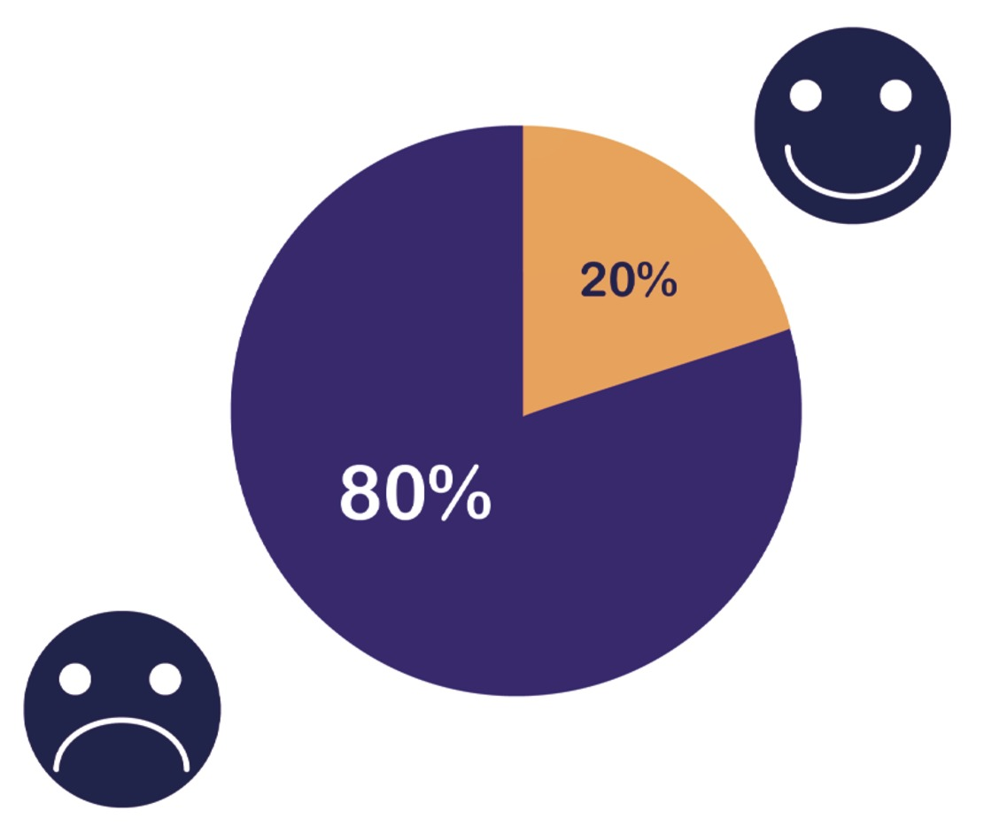
Figure 2 A pie chart
View description - Figure 2 A pie chart
View description - Figure 2 A pie chart

Back to - Part

Activity 3 What percentage?

Part

Answer
Start by writing the numbers as a fraction.

Now simplify the fraction by dividing the top and bottom by 25, to give:

Now multiply by 100% to convert to a percentage

So, 30% of the children preferred to go to the zoo.
Back to - Part

Part

Answer
The two numbers shown as a fraction are:
You may remember from your study of fractions that a good way to start looking at ways to simplify is to start by seeing if 2, 5 or 10 will divide into both the numerator and the denominator. Looking at the numerator here, you can divide it by 5 to give 13. So you could use either of these numbers to try and simplify the fraction. Unfortunately, if you try and divide 159 by 5 or 13, you don’t get a whole number – this means that you can’t simplify it, so you’ll have to move straight on to multiplying by 100 per cent to work out the percentage.
The percentage is (to 1 decimal place). So, Scotland has around 41 per cent of the recognised important habitats.
Back to - Part

Activity 4 Commonwealth facts and figures

Part

Answer
The information that you have is as follows:
- Commonwealth = 30% of world population.
- World population = 7 760 000 000.
- Population Bangladesh = 165 000 000.
You want to find the following:
- The percentage of the Commonwealth that lives in Bangladesh.
- Show this as a decimal and a fraction.
The first thing you need to do is work out the population of the Commonwealth – without that you can’t answer the question asked.
Population of Commonwealth = 30% of the population of the world

Now you have the information, you need to answer the question.
Percentage of Commonwealth living in Bangladesh = (to 1 decimal place)
To convert this to a decimal, you just need to divide by 100.
7.1 % ÷ 100 = 0.071
To convert to a fraction, write as a fraction with 100 as the denominator.
This gives . You wouldn’t usually show a fraction with a decimal number, but by multiplying the top and bottom by 10 you can resolve this issue, to give:

So the final answer is that 7.1% of the population of the Commonwealth live in Bangladesh. This can be represented as 0.071 as a decimal and as a fraction.
Back to - Part

Activity 1 Writing one number as a percentage of another

Part

Answer
First write the two numbers as a fraction:

Then multiply by 100, to give:

The answer is rounded to 1 decimal place. By necessity, population figures are estimates – so showing the answer any more accurately would not make sense in this case.
Rounded to 1 decimal place, the population of the Republic of Ireland was 1.1 per cent of the total population of the European Union in 2020.
Back to - Part

Part

Answer
Write the two numbers as a fraction gives:

Then multiply by 100, to give:

The population of Germany, rounded to 1 decimal place, was about 18.7 per cent of the total population of the European Union in 2020.
Back to - Part

Activity 2 Number of voters

Part

Answer
Since 36 per cent of the 450 people were against the proposal, you want to calculate 36 per cent of 450 to find the actual number. Here’s two methods you could have used.
- Percentage against: .
- Using a decimal instead of a fraction: .
So 162 people were against the proposal.
You know that 10 per cent of the 450 people were undecided, so you need to find 10 per cent of 450. You should be able to do this calculation without the calculator: 10 per cent is one-tenth, and one-tenth of 450 is 45. So, 45 people were undecided. The calculator should give you the same answer, but do watch for easy calculations that you can do in your head – it’s good practice!
As a final check, the three numbers you have calculated should add up to 450. The number in favour was 243, the number against was 162 and the number undecided was 45, and these do add up to 450. So, you can feel confident with the answers!
Back to - Part

Activity 3 Where does the money go?

Part

Answer
- Write the numbers as a fraction first: .
Now convert to a percentage by multiplying by 100 %.
(to 1 decimal place)
So 25.2% of the gross income is spent on housing costs.
- Using the same method as in part (a), the percentage towards savings = (to 1 decimal place).
Of course, if you had started with the net pay (after tax has been deducted), these percentages would have been larger because you would be comparing the savings and housing costs to a lower figure.
Back to - Part

Activity 4 Saving for retirement

Part

Answer
- Percentage to save = half the age = 10%
Converting the percentage to a decimal for the calculation:
10% = 10 ÷ 100 = 0.1
- Percentage to save = half the age = 35 ÷ 2 = 17.5%
Converting the percentage to a decimal for the calculation:
17.5% = 17.5 ÷ 100 = 0.175
- Percentage to save = half the age = 45 ÷2 = 22.5%
Converting the percentage to a decimal for the calculation:
22.5% = 22.5 ÷ 100 = 0.225
You could have also calculated all these answers by converting the percentages to fractions.
Back to - Part

Activity 5 Percentage increases and decreases

Part

Answer
The new chocolate bar is 100% – 15% = 85% the size of the old one. To work out the size of the new bar, you therefore need to find 85% of 200g.

Back to - Part

Part

Answer
The new pay is 100% + 10% = 110% of the old pay. So to work out the new pay, you need to find 110% of £25000.

Back to - Part

Activity 6 Discount or VAT first? Does it matter?

Answer

Discount first, then VAT
Discount on dresser = 30% of £100 = 0.3 × £100 = £30
So price including discount = £100 – £30 = £70
Now add the VAT onto this discounted price.
VAT = 20% of £70 = 0.2 × £70 = £14.00
So the final price to pay = £70 + £14 = £84

VAT first, then discount
VAT on original price = 20% of £100 = 0.2 × £100 = £20
So price including VAT = £100 + £20 = £120
Discount on price = 30% of £120 = 0.3 × £120 = £36
So final price = £120 – £36 = £84
Both prices are the same!
It does not seem to matter whether the discount or the VAT is applied first. But can you be sure that this is always true from exploring one example? Doing more numerical examples would confirm it. However, these could just be lucky choices of numbers. What you need to do is analyse what you can tell about the maths being used by looking at these particular discount and VAT rates.
The original cost of the dresser is 100 per cent of the price – that is, the whole price. You know that the discount is 30 per cent, so the price after the discount will be 100% – 30% = 70% of the original cost. You can find the discounted price by multiplying the cost by 0.7, since 0.7 is 70% as a decimal.
To calculate the price including VAT, you need to find 20 per cent of the price and add this onto the price (100 per cent). To do this in one step, you can work out 100% + 20% of the price, which is the same as 120 per cent of the price (or 1.2 as a decimal).
So if the discount is applied first and then the VAT, it’s 120 per cent of 70 per cent of the original price and can be expressed as 1.2 × 0.7 × original price.
If the VAT is applied first and then the discount, it’s 70 per cent of 120 per cent of the original price, and can be expressed as 0.7 × 1.2 × original price.
Back to - Activity 6 Discount or VAT first? Does it matter?

Activity 7 What was the price before VAT?

Part

Answer
The price before VAT was added is the original 100 per cent.
So £45.22, which includes VAT, is equivalent to 120 per cent of the cost (100% + 20%).
1 per cent of £45.24 = £45.24 ÷ 120

Thus, the price of the tennis racquet before VAT was applied was £37.70.
Back to - Part

Activity 8 What was the original price before a sale?

Part

Answer
The price before the sale is the original 100 per cent.
In the sale, 20% was taken off. That means 80% was left. So £64 is 80%.
You can work out what 1% is by doing £64 ÷ 80 = £0.80
Based on this, 100% is 100 × £0.80 = £80. So, the price of the coat when it’s not in the sale is £80.
Back to - Part

Activity 9 Chocolate chip cookies

Part

Answer
48:16:32, which simplifies to 3:1:2 (through division by 16).
Back to - Part

Part

Answer
Three parts of flour is equivalent to 36 tablespoons. So, one part is equivalent to 12 tablespoons. Thus, you will need 12 tablespoons of sugar and 24 tablespoons of chocolate chips.
Back to - Part

Part

Answer
In this case, two parts of chocolate chips will be equivalent to 40 tablespoons. So, one part is equivalent to 20 tablespoons (40 ÷ 2). Thus, you will need 3 × 20 = 60 tablespoons of flour and 1 × 20 = 20 tablespoons of sugar.
Back to - Part

Activity 1 Negative numbers on the number line

Part

Answer

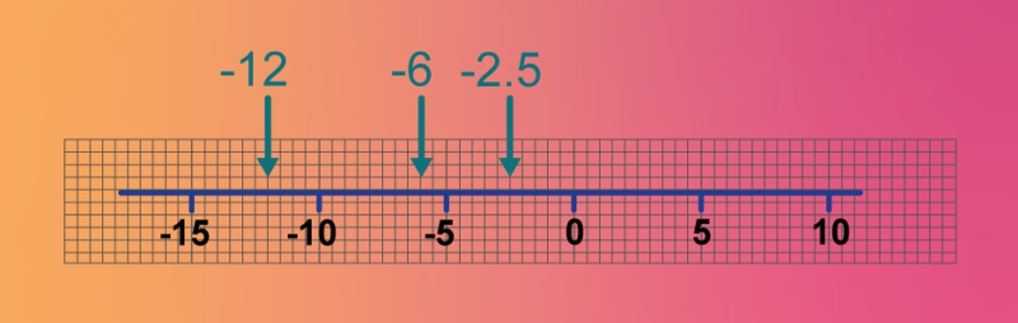
Figure 6 A number line from –15 to 10 showing Activity 1 answers
View description - Figure 6 A number line from –15 to 10 showing Activity 1 answers
View description - Figure 6 A number line from –15 to 10 showing Activity 1 answers

Back to - Part

Activity 2 Positive or negative?

Answer
Right:
3 degrees below zero
52 m below sea level
£500 withdrawal from a cashpoint
3 kg weight loss
£2000 net loss
Wrong:
£1000 net gain
Feedback
This is a 'gain'; meaning £1000 is added. Therefore it is positive.
£1000 deposit in savings account
Feedback
This is a 'deposit'; meaning £1000 is added to the savings account. Therefore it is positive
2 kg weight gain
Feedback
This is a 'gain'; meaning the weight is 2kg more. Therefore it is possitive.
80 m above sea level
Feedback
It is 80 m higher than sea level or 80 m has been added. Therefore it is positive.
37 degrees above zero
Feedback
'above' means 37 is added. Therefore it is positive.
Back to - Activity 2 Positive or negative?

Activity 3 Working with negative numbers

Part

Answer
- Start at 3, move 7 units to the left.

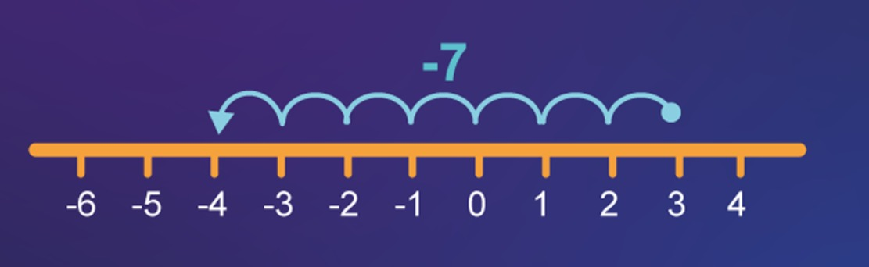
Figure 7 Number line for Activity 3, part (a)
View description - Figure 7 Number line for Activity 3, part (a)
View description - Figure 7 Number line for Activity 3, part (a)

Thus, 3 − 7 = –4.
Back to - Part

Part

Answer
- Start at –2, move 5 units to the right.

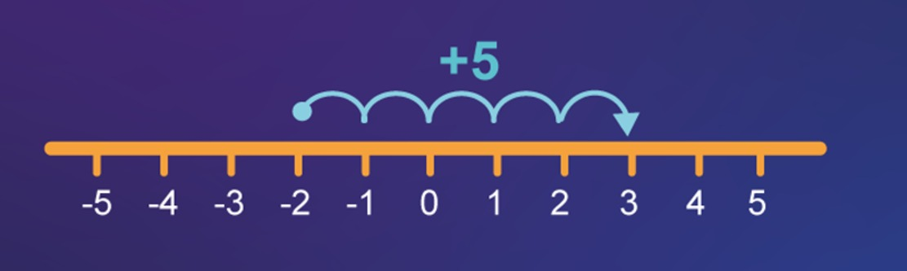
Figure 8 Number line for Activity 3, part (b)
View description - Figure 8 Number line for Activity 3, part (b)
View description - Figure 8 Number line for Activity 3, part (b)

Thus, (–2) + 5 = 3.
Back to - Part

Part

Answer
- Start at –3, move 6 units to the left.

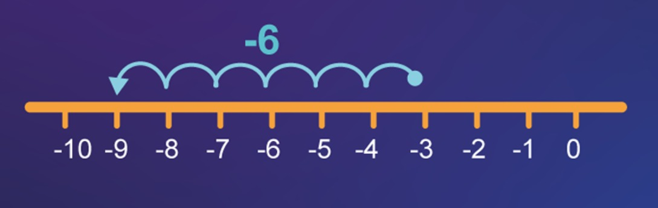
Figure 9 Number line for Activity 3, part (c)
View description - Figure 9 Number line for Activity 3, part (c)
View description - Figure 9 Number line for Activity 3, part (c)

Thus, (–3) − 6 = –9.
Back to - Part

Part

Answer
- Start at –4, move 2 units to the right.

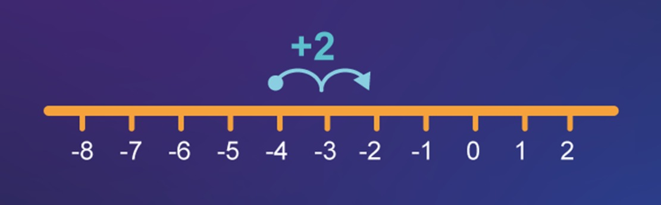
Figure 10 Number line for Activity 3, part (d)
View description - Figure 10 Number line for Activity 3, part (d)
View description - Figure 10 Number line for Activity 3, part (d)

Thus, (–4) + 2 = –2.
Back to - Part

Activity 4 Adding and subtracting negative numbers

Part

Answer
- You are adding a negative number, which is the same as subtracting the corresponding positive number.
20 + (–5) = 20 − 5 = 15
Back to - Part

Part

Answer
- Again, you are adding a negative number, which is the same as subtracting the corresponding positive number.
(–20) + (–5) = (–20) − 5 = –25
Back to - Part

Part

Answer
- You are subtracting a negative number which is the same as adding the corresponding positive number.
20 − (–5) = 20 + 5 = 25
Back to - Part

Part

Answer
- Again, you are subtracting a negative number which is the same as adding the corresponding positive number.
(–20) − (–5) = (–20) + 5 = –15
Back to - Part

Activity 5 Adding and subtracting negative numbers using the four strategies

Part

Answer
- You are adding two numbers with different signs. Ignore the signs and subtract the numbers 18 − 3 and use the sign from the larger number in the answer. So, 18 − 3 = 15.
Back to - Part

Part

Answer
- You are adding two numbers with the same sign. Ignore the signs and add the numbers, 21 + 6, and put back the signs from the numbers. So, (–21) + (–6) = –27.
Back to - Part

Part

Answer
- Rewrite as addition of a positive number, 32 + 8. So, 32 − (–8) = 40.
Back to - Part

Part

Answer
- Rewrite as addition of a positive number, –25 + 4. Then follow rule 2. Ignore the signs and subtract the numbers 25 − 4, and use the sign from the larger number in the answer.
(–25) − (–4) = –21
Back to - Part

Activity 6 Adding and subtracting negative numbers using the calculator

Part

Answer
- Remember the rule that adding a negative number is the same as subtracting the corresponding positive number.
2 + (–5) = 2 − 5 = –3
Back to - Part

Part

Answer
- (–4) − 3 = –7
Back to - Part

Part

Answer
Remember the rule that subtracting a negative number is the same as adding the corresponding positive number.
- 8 − (–5) = 8 + 5 = 13
Back to - Part

Part

Answer
- (–10) + (–2) = (–10) − 2 = –12
Back to - Part

Part

Answer
- (–3) + 3 = 0
Back to - Part

Activity 1 Multiplying negative numbers

Answer

Table 2 Multiplying negative numbers (complete)
Calculation | Answer | Calculation | Answer
2 × 4 | 8 | 2× (–4) | –8
1 × 4 | 4 | 1 × (–4) | –4
0 × 4 | 0 | 0 × (–4) | 0
(–1) × 4 | –4 | (–1) × (–4) | 4
(–2) × 4 | –8 | (–2) × (–4) | 8
(–3) × 4 | –12 | (–3) × (–4) | 12

You can probably see that in the first answer column, the numbers are going down by 4 each time. In the second answer column, the numbers are increasing by 4 each time.
Back to - Activity 1 Multiplying negative numbers

Activity 2 What happens next?

Part

Answer
The next number in the sequence –4, –8 and –12 is –16.
On the calculator, as expected, (–4) × 4 = –16.
Back to - Part

Part

Answer
The next number in the sequence 4, 8 and 12 is 16.
On the calculator, again as expected, (–4) × (–4) = 16.
Back to - Part

Activity 3 Being a mathematical detective

Part

Answer
If you multiply a negative number by a positive number, the answer is negative: (–) × (+) = (–).
You can extend this rule a little. The order of the numbers doesn’t matter, so multiplying a positive number by a negative number also gives a negative answer.
Back to - Part

Part

Answer
If you multiply a negative number by a negative number, the answer is positive: (–) × (–) = (+).
Both of the rules in this activity also work for division! Try dividing 20 by (–5), and (–20) by (–5) to confirm that this is the case.
Back to - Part

Activity 4 Multiplying and dividing negative numbers

Part

Answer
Since negative × positive = negative, (–3) × 5 = –15.
Back to - Part

Part

Answer
Since negative × negative = positive, (–3) × (–5) = 15.
Back to - Part

Part

Answer
Since negative ÷ positive = negative, (–10) ÷ 5 = –2.
Back to - Part

Part

Answer
Since negative ÷ negative = positive, (–10) ÷ (–2) = 5.
Back to - Part

Activity 5 Are you ready for some golf?

Part

Answer

Player 1
3 × (–1) + 4 × (–2) + 1 × (–3) + 0 = (–3) + (–8) + (–3) = –14.

Player 2
3 × (–1) + 3 × (–2) + (–3) + 0 + 0 = (–3) + (–6) + (–3) = –12
Player one is therefore ahead at this stage.
Back to - Part

Activity 6 Taking exponents of negative numbers

Part

Answer

Table 4 Exponents (complete)
(–1)² | 1
(–1)³ | –1
(–1)⁴ | 1
(–1)⁵ | –1
(–1)⁶ | 1
(–2)² | 4
(–2)³ | –8
(–2)⁴ | 16
(–2)⁵ | –32
(–2)⁶ | 64

The following patterns should be quite clear in the table:
- raising a negative number to an even exponent gives a positive number
- raising a negative number to an odd exponent gives a negative number.
Looking at what is happening, it should be clear that this was the answer to expect:
- (–2)⁴ = (–2) × (–2) × (–2) × (–2) = 4 × 4 = 16 (since negative × negative = positive)
- (–2)³ = (–2) × (–2) × (–2) = 4 × (–2) = –8 (since negative × negative = positive, and positive × negative = negative).
Back to - Part

Activity 7 What’s wrong with the maths?

Part

Answer
- You’re going to have great difficulty in checking their work. This could be a problem – you really don’t want to buy more slabs than you need! Nor do you want to purchase too few to finish the job.
- It’s not clear what the answer is. What does that final figure of 300 represent – 300 slabs or £300?
- It’s mathematically incorrect at a number of points. That could lead to some serious miscalculations, such as more or fewer slabs, and overcharging or undercharging. In particular, the contractor misuses the equal sign a few times. You can only use an equal sign if the expression on the left is equivalent – that is, if it gives the same answer – to the expression on the right. If it’s not, this means you need another, separate step.
The next section will help you to see how to make this solution clearer.
Back to - Part

Figure 1 Line drawing puzzle

Description
A line drawing showing a square with a cross through it with the two lines going to the diagonally opposite corner. A triangle then sits on top of the square from the corners.
Back to - Figure 1 Line drawing puzzle

Figure 2 The solution to the line drawing puzzle

Description
Step-by-step drawing to show one possible solution to the puzzle in a series of nine images.
The first image shows the complete shape outlined in blue with a circle in the bottom left hand corner of the square to mark the starting point.
The second image shows an arrow pointing from the circle to the bottom right hand corner of the square and the line connecting these two corners has now turned orange.
The third image has replicated the second image but also has an arrow pointing from the bottom right hand corner of the square to the top left hand corner of the square. This line has now also turned orange.
The fourth image has replicated the third image but also has an arrow pointing from the top left hand corner of the square to the top right hand corner of the square. This line has now also turned orange.
The fifth image has replicated the fourth image but also has an arrow pointing from the top right hand corner of the square to the top of the triangle. This line has now also turned orange.
The sixth image has replicated the fifth image but also has an arrow pointing from the top of the triangle to the bottom left corner of the triangle/top left corner of the square. This line has now also turned orange.
The seventh image has replicated the sixth image but also has an arrow pointing from the bottom left corner of the triangle/top left corner of the square to the bottom left corner of the square (starting point). This line has now also turned orange.
The eighth image has replicated the seventh image but also has an arrow pointing from the bottom left corner of the square (starting point) to top right corner of the square. This line has now also turned orange.
The ninth and final image has replicated the eighth image but also has an arrow pointing from the top right corner of the square to the bottom right corner of the square. This line has now also turned orange meaning the whole line drawing is orange.
Back to - Figure 2 The solution to the line drawing puzzle

Figure 3 Dinner party table layout

Description
Sketch of a table with six chairs round it – two chairs on the left, two chairs on the right, one at the top of the table and one at bottom. The kitchen is indicated to be at the bottom of the image and there is a window on the right.
Back to - Figure 3 Dinner party table layout

Figure 4 Possible places Gareth can sit

Description
Two sketches of the table and chairs arrangement side by side.
The first sketch shows Gareth positioned on the left side in the seat furthest away from the kitchen. It also shows Les seated in the chair at the foot of the table closest to the kitchen.
The second sketch shows Les again at the foot of the table closest to the kitchen, but this time Gareth has been positioned directly opposite him at the top/head of the table.
Back to - Figure 4 Possible places Gareth can sit

Figure 5 Possible places Faisal can sit

Description
Three sketches of the table and chairs arrangement side by side.
The first sketch shows Gareth positioned on the left side in the seat furthest away from the kitchen, Les seated in the chair at the foot of the table closest to the kitchen and Faisal next to Les on the right hand side with their back to the window.
The second sketch shows Les again at the foot of the table closest to the kitchen, but this time Gareth has been positioned directly opposite him at the top/head of the table and Faisal next to Les on the left hand side.
The third sketch shows Les again at the foot of the table closest to the kitchen, Gareth directly opposite him at the top/head of the table and Faisal next to Les on the right hand side.
Back to - Figure 5 Possible places Faisal can sit

Figure 6 Possible places Jordan can sit

Description
Two sketches of the table and chairs arrangement side by side.
The first sketch shows Les at the foot of the table closest to the kitchen, Gareth positioned directly opposite him at the top/head of the table, Faisal next to Les on the left hand side and Jordan in between Faisal and Gareth.
The second sketch shows Les seated in the chair at the foot of the table closest to the kitchen, with Faisal next to him on his right hand and Jordan next to him on his left. Gareth is then next to Jordan on Jordan’s left.
Back to - Figure 6 Possible places Jordan can sit

Figure 7 The final seating plan

Description
Sketch of a table with six chairs round it – two chairs on the left, two chairs on the right, one at the top of the table and one at bottom.
Les is seated at the foot of the table and Aria is directly opposite. Faisal is sat on Les’s right and has Sandy next to him. Sandy is then also sitting next to Aria.
On Les’s left is Jordan, who is also sitting next to Gareth.
Back to - Figure 7 The final seating plan

Figure 8 Place value

Description
From left to right: ten thousands with a 1 underneath, thousands with a 5 underneath, hundreds with a 7 underneath, ten with a six underneath and units with a 4 underneath to show the place values of the number 15764.
Beneath the number are two boxes. One box says ‘10 times bigger’ with an arrow pointing to the left, the other box say ‘10 times smaller’ with an arrow pointing to the right.
Back to - Figure 8 Place value

Figure 9 A place value table showing decimal numbers

Description
This is a table with four columns and five rows. The first column is headed Units, the second Tenths, the third Hundredths, and the fourth Thousandths. In the second to fifth rows there is a decimal point between the Units column and the Tenths column.
In the first row the first column contains 0, the second 2, the third and fourth columns are blank. This is a representation of 0.2.
In the second row the first column contains 1 and the second 3 and the third contains 5, the fourth column is blank. This is a representation of 1.35.
In the third row the first column contains 1 and the second contains 8. The third and fourth columns are blank. This is a representation of 1.8.
In the fourth row the first column contains 4, the second 2, the third 0 and the fourth 5. This is a representation of 4.205.
Back to - Figure 9 A place value table showing decimal numbers

Figure 10 A number line

Description
A number line from 0 to 2 marked out in intervals of 0.1. Arrows point to the places where 0.2, 1.3, 1.35. 1.4 and 1.8 sit on the number line.
Back to - Figure 10 A number line

Figure 11 The calculation 26.20 + 408.75 + 0.007

Description
The calculation 26.20 + 408.75 + 0.007. The numbers are stacked on top of each other, with the units, decimal points etc. all lined up.
Back to - Figure 11 The calculation 26.20 + 408.75 + 0.007

Figure 13 Adding up a bill

Description
This diagram shows the numbers 25, 17, 37 and 4 arranged underneath each other so that the place-value columns line up. The answer is shown as 83.
Back to - Figure 13 Adding up a bill

Figure 15 Subtracting one number from another

Description
This shows the subtraction 25.90 − 16.87. It highlights the 9 tenths being changed into 8 tenths and 10 hundredths and the 2 tens being changed into 1 ten and 10 units, so that the subtraction can be carried out. The answer is 9.03
Back to - Figure 15 Subtracting one number from another

Figure 16 Demonstrating division

Description
This shows 5 being subtracted from 20 five times. Giving, 20 − 4 = 16, 16 − 4 = 12, 12 − 4 = 8, 8 − 4 = 4 and 4 − 4 = 0.
Back to - Figure 16 Demonstrating division

Figure 17 Order of multiplication

Description
Two images of dots side by side. The first image shows 3 rows of 2 dots (a total of 6 dots). The second image show 2 rows of 3 dots (also a total of 6 dots).
Back to - Figure 17 Order of multiplication

Figure 1 Number line exercise

Description
A number line to be used as part of Activity 1, part b. The number shows the letters A to D at different points of a number line ranging from 0 to 4, marked out in intervals of 0.1.
A is marked 3 intervals to the right of 1. C is marked three intervals from the right of 0. D is marked 2 intervals to the right of 3.
Back to - Figure 1 Number line exercise

Figure 2 Blank cross-number puzzle

Description
Blank cross-number puzzle with numbers 1, 4, 6, 7 and 9 across and 1, 2, 3, 5, 6, 7 and 8 down.
Back to - Figure 2 Blank cross-number puzzle

Figure 3 Completed cross-number puzzle

Description
Answers to clues: Across 1. 987, 4. 298, 6. 404, 7. 972, 9. 700. Down 1. 95, 2. 72027, 3. 18, 5. 94, 6. 47, 7. 99, 8. 50.
Back to - Figure 3 Completed cross-number puzzle

Figure 4 Mathematical modelling cycle

Description
This diagram of the modelling cycle contains four ovals arranged in a circle and connected by arrows, pointing in a clockwise direction. An arrow saying ‘Start here’ point to the first oval which says ‘Describe problem’. The second oval says ‘Collect information, make assumptions, simplify the problem’. The third oval says ‘Do the maths’ and the fourth oval says ‘Interpret the answer
Back to - Figure 4 Mathematical modelling cycle

Figure 5 Plan of joists in an attic

Description
Diagram of the attic with 17 joists each separated by 40 cm. The outer joists are also 40 cm from the attic frame around the edge of the whole area. The frame is 10 cm wide and the joists are 5 cm wide. The attic is 825 cm wide by 900 cm long and the diagram indicates the position of the attic door in the top right of the space.
Back to - Figure 5 Plan of joists in an attic

Figure 6 20 rolls of insulation

Description
20 rolls of installation arranged in six groups of 3 and one group of 2. The groups of 3 rolls are circled, giving 6 groups of 3, with 2 rolls not circled.
Back to - Figure 6 20 rolls of insulation

Figure 1 Folding a piece of paper in half

Description
A piece of paper shown at three different stages. At the first stage the paper is blank with a dotted line splitting the piece of paper in two. At the second stage, the piece of paper is folded along the dotted line, so the piece of paper is folded in half. In the third stage the piece of paper looks the same as it did in the first stage, but this time the left-hand side of the piece of paper is greyed out.
Back to - Figure 1 Folding a piece of paper in half

Figure 2 Defining a fraction

Description
The fraction ‘one-half’ is shown as a one over a two, with a horizontal line between the two numbers. An arrow points to the one with the comment ‘top number is called the numerator and is the number of shaded pieces’. An arrow points to the two with the comment ‘bottom number is called the denominator and is the total number of pieces’.
Back to - Figure 2 Defining a fraction

Figure 3 Folding a piece of paper into quarters

Description
A piece of paper folded in half, then in quarters and opened up with the two left-hand quarters (i.e. one half) shaded.
Back to - Figure 3 Folding a piece of paper into quarters

Figure 4 Folding a piece of paper into twelfths

Description
A piece of paper folded in quarters, then in twelfths, with each twelfth marked by a dotted line. Opened up to a full piece of paper, it shows six twelfths shaded on the left-hand side shaded.
Back to - Figure 4 Folding a piece of paper into twelfths

Figure 5 Equivalent fractions by multiplying the numerator and denominator

Description
This diagram shows that one-half is equivalent to two-quarters by multiplying the top and bottom of one-half by two. It also shows that two-quarters are equivalent to six-twelfths by multiplying the top and bottom of two-quarters by three, and that six-twelfths are equivalent to sixty one-hundred and twentieths by multiplying the top and bottom of six-twelfths by ten.
Back to - Figure 5 Equivalent fractions by multiplying the numerator and denominator

Figure 6 Equivalent fractions by dividing the numerator and the denominator

Description
This diagram shows that forty-sixtieths is equivalent to four-sixths (by dividing the top and bottom by ten) and that four-sixths is equivalent to two-thirds (by dividing the top and bottom by two).
Back to - Figure 6 Equivalent fractions by dividing the numerator and the denominator

Figure 7 Pizza maths

Description
Three pizzas: the first pizza has a quarter section cut out of it and is labelled ‘one quarter pizza’; the second pizza has two one-eighths sections cut out of it and is labelled ‘two-eighths pizza’; and the third pizza has four one-sixteenths sections cut out of it and labelled ‘four-sixteenths pizza’. The amounts cut out are equivalent to each other so the figure shows that one quarter is the same as two eighths, which is the same as four sixteenths.
Back to - Figure 7 Pizza maths

Figure 12 A number line with answers

Description
A number line from 0 to 4. Between 1 and 2, the number line is divided into eight parts. On the fifth interval from 1, a red dot is labelled as one and five eighths.
Between 2 and 3, the number line is divided into two parts. At the interval half way between 2 and 3, a red dot is labelled as two and one half.
Between 3 and 4, the number line is divided into four parts. At the third interval from 3, a red dot is labelled as three and three quarters.
Back to - Figure 12 A number line with answers

Figure 1 Folding a piece of paper into sixths

Description
This is a rectangle divided into three rows and two columns so that there are six identical pieces. The first column is shaded and an arrow points to the column with the comment ‘shaded half.’ Arrows point to the three rows with the comment ‘split into thirds.’ The piece in the first column third row is shaded to emphasise that one third of one half is a sixth.
Back to - Figure 1 Folding a piece of paper into sixths

Figure 1 Pizza maths

Description
Three circles each with a quarter cut out. Each quarter is labelled ‘one quarter,’ ‘twenty five per cent,’ and ‘0.25’ respectively. The remaining parts of the circles are labelled ‘three quarters’, ‘ seventy five per cent’ and ‘0.75’.
Back to - Figure 1 Pizza maths

Figure 2 A pie chart

Description
A pie chart. 80% is shaded in blue with an unhappy face next to it. The remaining 20% is shaded in red and has a smiley face next to it.
Back to - Figure 2 A pie chart

Figure 1 Finding the best deal

Description
Two shop fronts. One has a t-shirt displayed with a label that says £1.50 crossed out. There is a sign which says ‘now 20% off’.
The second shop front has a t-shirt with a label that says £1.40 crossed out. There is a sign which says ‘now 15% off’.
Back to - Figure 1 Finding the best deal

Figure 1 A fridge thermometer

Description
This shows a fridge thermometer with a scale marked in one degree C intervals from –30 °C to 40 °C. The bar of mercury stops at –4 °C.
Back to - Figure 1 A fridge thermometer

Figure 2 Positive numbers on a number line

Description
A number line from 0 to 10. One half is shown between 0 and 1, one and a half between 1 and 2.
Back to - Figure 2 Positive numbers on a number line

Figure 3 Negative numbers on a number line

Description
A number line from -9 to +10. One half is shown between 0 and 1, one and a half between 1 and 2.
Back to - Figure 3 Negative numbers on a number line

Figure 4 A number line with –2.4, –1.8 and –0.5 marked on it

Description
A number line from –3 to 2 with the numbers –2.4, –1.8 and –0.5 marked on it.
Back to - Figure 4 A number line with –2.4, –1.8 and –0.5 marked on it

Figure 5 A number line from –15 to 10

Description
A number line from –15 to 10, with the scale marked every 5 units.
Back to - Figure 5 A number line from –15 to 10

Figure 6 A number line from –15 to 10 showing Activity 1 answers

Description
A number line from –15 to 10 on grid paper. Each individual grid square represents 0.5.
–12 is positioned four grid squares to the left of –10. –6 is positioned two grid squares to the left of –5. –2.5 is positioned five grid squares to the left of 0.
Back to - Figure 6 A number line from –15 to 10 showing Activity 1 answers

Figure 7 Number line for Activity 3, part (a)

Description
A number line from –6 to 4. The scale is marked on in units and the numbers –4 and 3 marked on it. A stepped line starts at 3 and works back to –4. Above the line is –7 showing moving 7 units to the left.
Back to - Figure 7 Number line for Activity 3, part (a)

Figure 8 Number line for Activity 3, part (b)

Description
A number line from –5 to 5. The scale is marked on in units and the numbers –2 and 3 are marked on it. A stepped line starts at –2 and works to 3. Above the line is +5 showing moving 5 units to the right.
Back to - Figure 8 Number line for Activity 3, part (b)

Figure 9 Number line for Activity 3, part (c)

Description
A number line from –10 to 0. The scale is marked on in units and the numbers –9 and –3 are marked on it. A stepped line starts at –3 and works back to –9. Above the line is –6 showing moving 6 units to the left.
Back to - Figure 9 Number line for Activity 3, part (c)

Figure 10 Number line for Activity 3, part (d)

Description
A number line from –8 to 2. The scale is marked on in units and the numbers –4 and –2 are marked on it. A stepped line starts at –4 and works to –2. Above the line is +2 showing moving 2 units to the right.
Back to - Figure 10 Number line for Activity 3, part (d)

Figure 11 The sum 0 + (–2) = –2

Description
This is a number line from –3 to 0 with the scale marked on in units. An arrow starts at 0 on the scale and moves 2 units down to end at –2. It shows the calculation: 0 + (–2) = –2.
Back to - Figure 11 The sum 0 + (–2) = –2

Figure 12 What do I have to add on to –2 to get 0?

Description
This is a number line from –3 to 0 with the scale marked on in units. An arrow starts at –2 on the scale and moves 2 units to end at 0.
Back to - Figure 12 What do I have to add on to –2 to get 0?

Figure 13 The sum (–5) – 3 = –8

Description
This is a number line from –10 to 0 with the scale marked on in units. An arrow starts at –5 on the scale and moves 3 units down to end at –8.
Back to - Figure 13 The sum (–5) – 3 = –8

Figure 14 The sum (–6) − (–3) = –3

Description
This is a number line from –10 to 0 with the scale marked on in units. An arrow starts at –6 on the scale and moves 3 units to end at –3.
Back to - Figure 14 The sum (–6) − (–3) = –3

Figure 1 Writing mathematics 1

Description
4 × 3 ÷ 0.5 × 0.5 = 48 × 6 = 288, call it 50 to be safe, so = 50 × 6 = 300
Back to - Figure 1 Writing mathematics 1

Figure 1 (repeated) Writing mathematics 1

Description
4 × 3 ÷ 0.5 × 0.5 = 48 × 6 = 288, call it 50 to be safe, so = 50 × 6 = 300
Back to - Figure 1 (repeated) Writing mathematics 1

Figure 2 Writing mathematics 2

Description
The total area of the patio to be covered = 4 m × 3 m = 12 square metres
Area of each slab = 0.5 m × 0.5 m = 0.25 square metres
So the number of slabs needed = 12 ÷ 0.25 = 48
But purchase 50 slabs to allow for cuts and mistakes
Then the total cost of 50 slabs at £6 each = 50 × £6 = £300
Therefore, the total cost of the slabs is £300.
Back to - Figure 2 Writing mathematics 2

Uncaptioned interactive content

Transcript
Maria Townsend
Like me, many people enjoy completing puzzles without even realising they’re doing some maths at the same time. This Sudoku certainly contains numbers, but does it relate to maths in any other way. I think it does. You see to complete it I have to take a logical step-by-step approach. If I just filled in numbers randomly it would be impossible to complete. And it’s just the same with maths puzzles as you’ll see this week. So next time you see a Sudoku in a paper why not have a go? You can always tell everybody around you that you’re studying.
Back to - Uncaptioned interactive content

Uncaptioned interactive content

Transcript
NARRATOR:
Suppose that all the vehicles are motorbikes. Draw a diagram-- you don't have to be an artist-- that shows these 21 motorbikes. Be sure to use a representation that will allow you to clearly distinguish between 2 and 4 wheels. How many wheels do you have? There were 21 motorbikes, each with 2 wheels. So in total, there are 42 wheels.
However, Paul said that there were 54 wheels in total. So you need to add an additional 12 wheels because 54 take away 42 is 12. To work out how many motorbikes and cars the dealership has from here, you could just start adding two wheels to each motorbike until you've counted up to the 12, or you could change a motorbike into a car to gain two additional wheels.
Since you know you need 12 more wheels to reach the required total, you need to change 6 motorbikes to cars because 12 divided by 2 is 6. You can now see, there are six cars and 15 motorbikes, giving a total of 21 vehicles. You can check that the total number of wheels adds up to 54.
Each car has four wheels, which makes 6 times 4 equals 24 wheels. Each motorbike has 2 wheels, which makes 15 times 2 equals 30 wheels. Together, that is 24 plus 30 equals 54 wheels. So the dealership has 15 motorbikes and 6 cars in stock.
Back to - Uncaptioned interactive content

Uncaptioned interactive content

Transcript
NARRATOR:
Suppose the dealership had all cars. That would mean there were 84 wheels, because 21 times 4 is 84. But you've been told by Paul there are only 54 wheels. That means there are 30 wheels too many, as 84 take away 54 is 30.
To solve this, you need to change some cars into motorbikes. When a car changes into a motorbike, it loses 2 wheels. Therefore, you need to divide the number of wheels you have too many, that's 30, by 2. 30 divided by 2 is 15. So, 15 cars to change into motorbikes.
Back to - Uncaptioned interactive content

Uncaptioned interactive content

Transcript
SPEAKER 1:
First, let's look at doing division by dividing by quite a small number. Let's do 2,568 divided by 3. This is how it is written. The number you are dividing by goes at the start. That's the 3. And the number you are dividing by 3 goes next that's the 2,568. The first step is to look at the first digit of 2,568, the two, and say how many 3's go into two.
Well, 3's don't go into two. So you should carry the 2 over and say how many 3's go into 25. The answer to that is 8, as 3 times 8 is 24. You show that by writing an eight above the top line above the five. But you've also got one left over as eight times 3 is 24 not 25. So you need to carry over that one. Now you need to ask yourself, how many 3's are there in 16? The answer is 5, as three times 5 is 15.
But again, there is one left over. So you put a 5 above the top line, above the 6 and carry the 1. Next, you need to ask yourself how many 3's are there in 18. The answer is 6 and nothing left over. So put a 6 above the 8 to give 856.
You can also check your answer by working out three times 856. If you get the answer, 2,568, that shows the calculation is correct.
Back to - Uncaptioned interactive content

Uncaptioned interactive content

Transcript
SPEAKER 1:
To divide 23.6 by 5, you would first ask yourself, how many 5s in two? As 5 doesn't go into two, you would carry the two, and ask yourself, how many 5s in 23? Since 4 times 5 is 20 the answer is 4 with 3 left over that need to be carried. So now you need to add the 4 above the top line above the 3. Here you can also see the 3 has carried over to be with the 6 after the decimal point. Even though this is after the decimal point, the carrying just works like before.
At this point, before you do anything else you need to put a decimal point on the top line exactly above the one under the line. Now, you should ask yourself, how many 5s in 36? The answer is 7 as 7 times 5 is 35, with 1 left over that you'll need to carry. So put the 7 on the top line after the decimal point.
You may now be thinking, how am I going to carry the 1 as there aren't any more digits left? The way to do this is to put an extra 0 after the 6. This is OK to do is 23.6 is the same number as 23.60. The 0 just means there is zero hundredths. Now, ask yourself, how many fives in 10? The answer to that is 2, and nothing left over. So you'd put the 2 above the 0, and you have finished. The answer to 23.6 divided by 5 is 4.72.
Back to - Uncaptioned interactive content

Uncaptioned interactive content

Transcript
SPEAKER 1:
Suppose you wanted to do 632 divided by 16? Before you start, unless you know your 16 times table, which most people don't, it can help to jot down the multiples of 16. You can work these out by adding 16 to the previous one. You'll see how to use them as we go through.
As normal, start by asking yourself, how many 16s go into 6? As 16 doesn't go into 6, you need to carry the 6 over. Now ask yourself, how many 16s are there in 63? This is where the list of multiples of 16 comes in handy.
You can see that 3 times 16 is 48, and 4 times 16 is 64. So only 3 16s go into 63, with 15 left over as 63 minus 48 is 15. So as normal, you should put the 3 above the line and carry over 15.
The next step is to ask, how many 16s in 152? The list tells you that 9 times 16 is 144, so the answer is 9, with 8 left over. So you put a 9 above the line, but you also need to carry that 8 to somewhere. Here, what you need to do is put a decimal point after the 2 in 632, and a 0 after it. This is fine to do, as 632.0 is the same number as 632. It just means 632 and 0 tenths.
That now gives you somewhere to carry the 8. Before doing any more division, you need to remember to put a decimal point above the line, then ask yourself, how many 16s in 80? And the answer from the list is 5, as 5 times 16 is 80. So 632 divided by 16 is 39.5.
Back to - Uncaptioned interactive content

Uncaptioned interactive content

Transcript
Narrator
Round 24 259 to the nearest hundred. You're going to find that doing these problems are pretty straightforward, but what I want to do is just think about what it means to round to the nearest hundred. So what I'm going to do is I'm going to draw a number line. Let me draw a number line here, and I'm just going to mark off the hundreds on the number line. So maybe we have 24 100, and then we go to 24 200, then we go to 24 300, and then we go to 24 400. I think you see what I mean when I'm only marking off the hundreds. I'm going up by increments of 100. Now, on this number line, where is 24 259? So if we look at the number line, it's more than 24 200 and it's less than 24,300. And it's 259, so if this distance right here is 10, 059 is right about there, so that is where our number is. That is 24 259. So when someone asks you to round to the nearest hundred, they're literally saying round to one of these increments of 100 or round to whichever increment of 100 that it is closest to. And if you look at it right like this, if you just eyeball it, you'll actually see that it is closer to 24 300 than it is to 24 200. So when you round it, you round to 24 300. So if you round to the nearest hundred, the answer literally is 24 300. Now that's kind of the conceptual understanding of why it's even called the nearest hundred.
The nearest hundred is 24 300. But every time you do a problem like this, you don't have to draw a number line and go through this whole process, although you might want to think about it. An easier process, or maybe a more mechanical process, is you literally look at the number 24 259. We want to round to the nearest hundred, so you look at the hundreds place. This is the hundreds place right here, and when we round, that means we don't want any digits. We only want zeros after the hundreds place. So what you do is you look at the place one less than the place you're rounding to. This is the hundreds place so you look at the 5 right there, and if this number is 5 or greater, if it's 5, 6, 7, 8, or 9, you round up. So 5 or greater, you round up.
And so rounding up in this situation, it is 5. It is 5 or greater, so rounding up means that we go to 24,000, and since we're rounding up, we make the 2 into a 3. We increment it by one, so rounding up, so 24,300. That's what we mean by rounding up. And just as kind of a counterexample, if I had 24 249 and I wanted to round to the nearest hundred, I would say, OK, I want to round to the nearest hundred. Let me look at the tens place, this place one level to the right. It is not 5 or greater, so I will round down.
And when you round down, be careful. It doesn't mean you decreases this 2. It literally means you just only have the 2. Just get rid of everything after it. So it becomes 24 200. That's the process where you round down. If you round up, it becomes 24 300. And it makes sense. 24 249 is going to be sitting right over here someplace, so it's going to be closer to 24 200. 24 200 would be the nearest hundred when we round down in this case. For the case of the problem, 24 259, the nearest hundred is 24 300. We round up.
Back to - Uncaptioned interactive content

Uncaptioned interactive content

Transcript
Maria Townsend
This week is all about fractions; a way of showing equal parts of something. I’ve cut this cake into quarters. If I was feeling generous and wanted to share a slice I could cut this into quarters as well. Both the cake and the slice are now cut into quarters but are very different sizes. So for fractions to mean anything you need to know what they’re fractions of.
Back to - Uncaptioned interactive content

Uncaptioned interactive content

Transcript
NARRATOR:
Take 2/3. Can you think of any other fractions which are equivalent to this? Well, to do this, it's first helpful to visualise what 2/3 is. So let's draw a box, which we would divide into three equal sections. And so, 2/3 would equal two of those three equal sections.
So now, there are a couple of things you can do to find equivalent fractions of 2/3. You can take the box and draw a horizontal line across the whole box to divide each of the three sections into two parts. So now, how many equal sections do we have? We have six equal sections. And how many of those equal sections are shaded in now? We can see four of those sections are shaded in.
So here, we can see that 4/6 is the exact same fraction of the whole as 2/3. These are equivalent fractions. We can say that 2/3 is equal to 4/6.
And now, let's find another equivalent fraction of 2/3. Instead of dividing each of the three pieces into two parts, we can divide these into three parts.
So, I can draw two more horizontal lines here. So now, I have divided what was in three equal parts into three times as many parts. I now have nine equal parts. And how many of those are shaded in? We have six shaded in. So 2/3 is equal to 4/6, which is also equal to 6/9. All three of those are equivalent fractions.
Now, take this second example. Say you have 6/10. This can be shown as a block of 10 equal sections with six shaded in. If you were to pair each square up so that there were only five pieces all together, you can see that there are now only three blocks painted. But it still covers the same area. We then know that 6/10 is equal to 3/5.
Back to - Uncaptioned interactive content

Uncaptioned interactive content

Transcript
Maria Townsend
Once you’ve completed this week, it’ll be time to do your first badged quiz. This is very similar to the quizzes for weeks 1 to 3 so if you’ve already completed these you’ll have no trouble with this one. Take your time to read the questions very carefully as this will give you the best chance to show your skills. Good luck and I’ll see you next week.
Back to - Uncaptioned interactive content

Uncaptioned interactive content

Transcript
NARRATOR:
Take this chocolate bar. It has 24 pieces. Each piece is 1 out of 24 of the bar, or 1/24 of the bar. So the whole bar is 24/24, or 1.
There are 4 identical rows. So each row is 1/4 of the bar. There are also 6 identical columns. So each column is 1/6 of the bar.
Now imagine that you eat 8 of the 24 pieces. This is equivalent to 1/3 of the chocolate bar because 1/3 is equal to 8/24. You can visualise this by covering up 2 of the columns.
You are still feeling hungry five minutes later, so you decide to eat another 5 pieces. What fraction of the bar will you have eaten in total? And what fraction of the bar is left?
The fraction eaten would be 1/3 plus 5/24. But it's not easy to quickly determine what fraction this is because the two fractions are out of different numbers of parts. However, if you recall that eating a 1/3 of the bar is the same as eating 8/24, the fraction eaten is 8/24 plus 5/24, which is equal to 13/24. You can check this answer on the bar of chocolate. Just count the number of squares that have been eaten.
Back to - Uncaptioned interactive content

Uncaptioned interactive content

Transcript
NARRATOR:
Let's start with a 1/4 plus a 1/4. To work this out, let's say we have a pie which we divide into four pieces. If our first 1/4 in our calculation was this quarter of the pie, and we were going to add it to another quarter of the pie, if I was to eat both of those quarters, so a quarter and then another quarter, how much would I have eaten? You could work this out by looking at the pie, and seeing that I've eaten two of the four pieces.
So 2/4 of the pie, which is the same as half of the pie. If we look at it mathematically, you can see that the denominators or the bottom numbers in the fractions stayed the same. This is because they represent the total number of pieces we had in this example. For the numerators, the top numbers in the fraction, we added them together. I had one of the four pieces of pie, and then I had another one of the four pieces of pie. So I ate two of the four pieces of pie, which is one half of the whole pie. It works the same way for subtraction.
If we had 3/7 take away 2/7, that would equal 1/7. As we just subtract the two from the 3 to get one, and we keep the denominator the same. Thinking again about this as pieces of pie, if you had three of the seven pieces of pie and you were to give away two of those seven pieces, you would be left with just one of the seven pieces of pie.
You can see that it is fairly straightforward to add and subtract fractions, when the denominator is the same. But what happens when we have different denominators? Let's say we have 1/4 plus 1/2. If you take the example of the pie again, for the first quarter of the calculation, let's colour this quarter of the pie in. And then if I was to eat another half of the pie, I would eat this much. So what does that equal in total?
Well, there's a couple of ways we can think about this. First of all, we could rewrite one half. One half of the pie is the same as 2 quarters. There's one quarter here, and another quarter here. So one half is the same as 2 quarters, 2 over 4. That means 1/4 plus 1/2 is the same as 1/4 plus 2 quarters. All we did here was change a half to two quarters, by multiplying the numerator and the denominator, the top and the bottom of the fraction by 2.
And you can do that to any fraction, as long as you multiply the numerator and the denominator by the same number. The reason I picked two here, is because I wanted to get the same denominator as a quarter. To finish off this calculation, we just add the numerators to give 3 and keep the denominator the same of course. So the answer is 1/4 plus 2/4 equals 3/4. If you look at the image of the pie, you can see 3/4 of it has been shaded in.
Now let's try 1/2 plus a 1/3. With this, it isn't possible to multiply the denominator 2 by anything to get 3, or to multiply the denominator 3 by anything to get 2. So instead, in order to find the common denominator, we need to find the least common multiple of 2 and 3. So what's the least common multiple of 2 and 3?
Well, that's the smallest number that's a multiple of 2 and a multiple of 3, or the smallest number that both 2 and 3 divide into exactly. The smallest number that's a multiple of both 2 and 3 is 6, so let's convert both these factions to something over 6. So 1/2 is equal to what over 6? Well, if I ate a half of a pizza which had been divided into six slices, I would have eaten three slices. And that makes sense, because one is a half of 2 and 3 is a half of 6.
Similarly, if I ate a third of that pizza with six slices, it would be the same as 2/6. So 1/2 plus a 1/3 is the same thing as 3/6 plus 2/6. All we've done is write the original calculation with different denominators. We've essentially just changed the number of pieces in the pie. And now at this point, the problem becomes easy. We add the numerators to give 5, 3/6 plus 2/6 gives us 5/6. And we've kept the denominator the same as always.
And it works the same for subtraction. 1/2 take away 1/3, is the same as 3/6 take away 2/6. And that is equal to 1/6.
Back to - Uncaptioned interactive content

Uncaptioned interactive content

Transcript
Narrator
Multiply 1 and 3/4 times 7 and 1/5. Simplify your answer and write it as a mixed fraction. So the first thing we want to do is rewrite each of these mixed numbers as improper fractions. It's very difficult, or at least it's not easy for me, to directly multiply mixed numbers. One can do it, but it's much easier if you just make them improper fractions. So let's convert each of them. So 1 and 3/4 is equal to- it's still going to be over 4, so you're still going to have the same denominator, but your numerator as an improper fraction is going to be 4 times 1 plus 3.
And the reason why this makes sense is 1 is 4/4, or 1 is 4 times 1 fourths, right? 1 is the same thing as 4/4, and then you have three more fourths, so 4/4 plus 3/4 will give you 7/4.
So that's the same thing as 1 and 3/4. Now, let's do 7 and 1/5. Same exact process. We're going to still be talking in terms of fifths. That's going to be the denominator. You take 5 times 7, because think about it.
7 is the same thing as 35/5. So you take 5 times 7 plus this numerator right here. So 7 is 35/5, then you have one more fifth, so you're going to have 35 plus 1, which is equal to 36/5. So this product is the exact same thing as taking the product of 7/4 times 36/5. And we could multiply it out right now. Take the 7 times 36 as our new numerator, 4 times 5 as our new denominator, but that'll give us large numbers. I can't multiply 7 and 36 in my head, or I can't do it too easily. So let's see if we can simplify this first. Both our numerator and our denominator have numbers that are divisible by 4, so let's divide both the numerator and the denominator by 4. So in the numerator, we can divide the 36 by 4 and get 9. If you divide something in the numerator by 4, you need to divide something in the denominator by 4, and the 4 is the obvious guy, so 4 divided by 4 is 1. So now this becomes 7 times 9, and what's the 7 times 9? It's 63, over 1 times 5. So now we have our answer as an improper fraction, but they want it as a mixed number or as a mixed fraction. So what are 63/5? So to figure that out- let me pick a nice colour here—we take 5 into 63. 5 goes into 6 one time. 1 times 5 is 5. You subtract. 6 minus 5 is 1. Bring down the 3. 5 goes into 13 two times. And you could have immediately said 5 goes into 63 twelve times, but this way, at least to me, it's a little bit more obvious. And then 2 times 5 is 12, and then we have sorry! 2 times 5 is 10.
That tells you not to switch gears in the middle of a math problem. 2 times 5 is 10, and then you subtract, and you have a remainder of 3.
So 63/5 is the same thing as 12 wholes and 3 left over, or 3/5 left over. And if you wanted to go back from this to that, just think: 12 is the same thing as 60 fifths, or 60/5. 60/5 plus 3/5 is 63/5, so these two things are the same thing. These two things are equivalent. This is as an improper fraction. This is as a mixed number or a mixed fraction. But this is our answer right there: 12 and 3/5.
Back to - Uncaptioned interactive content

Uncaptioned interactive content

Transcript
Maria Townsend
You may have heard the claim that we only ever use 10% of our brains. That means that if I could divide this model brain into a 100 equal parts I’d only ever be using 10 of them at any one time. That’s because each part represents 1%. This means 90% would be going to waste! Fortunately that’s just not true. I’ll show you other examples of percentages this week and how to use them.
Back to - Uncaptioned interactive content

Uncaptioned interactive content

Transcript
Narrator
We're asked to shade 20% of the square below. Before doing that, let's just even think about what percent means. Let me just rewrite it. 20% is equal to-- I'm just writing it out as a word—20 percent, which literally means 20 per cent. And if you're familiar with the word century, you might already know that cent comes from the Latin for the word hundred. This literally means you can take cent, and that literally means 100. So this is the same thing as 20 per 100. If you want to shade 20%, that means, if you break up the square into 100 pieces, we want to shade 20 of them. 20 per 100. So how many squares have they drawn here? So if we go horizontally right here, we have one, two, three, four, five, six, seven, eight, nine, ten squares. If we go vertically, we have one, two, three, four, five, six, seven, eight, nine, ten. So this is a 10 by 10 square. So it has 100 squares here. Another way to say it is that this larger square-- I guess that's the square that they're talking about. This larger square is a broken up into 100 smaller squares, so it's already broken up into the 100. So if we want to shade 20% of that, we need to shade 20 of every 100 squares that it is broken into. So with this, we'll just literally shade in 20 squares. So let me just do one. So if I just do one square, just like that, I have just shaded 1 per 100 of the squares. 100 out of 100 would be the whole. I've shaded one of them. That one square by itself would be 1% of the entire square. If I were to shade another one, if I were to shade that and that, then those two combined, that's 2% of the entire square. It's literally 2 per 100, where 100 would be the entire square. If we wanted to do 20, we do one, two, three, four-- if we shade this entire row, that will be 10%, right? One, two, three, four, five, six, seven, eight, nine, ten. And we want to do 20, so that'll be one more row. So I can shade in this whole other row right here. And then I would have shaded in 20 of the 100 squares. Or another way of thinking about it, if you take this larger square, divide it into 100 equal pieces, I've shaded in 20 per 100, or 20%, of the entire larger square. Hopefully, that makes sense.
Back to - Uncaptioned interactive content

Uncaptioned interactive content

Transcript
Maria Townsend
This glass contains 200mls of water. If I add 50% to it and then reduce it by 50% will I end up back where I started? If I increase the volume by 50% I have to add 100mls, giving me 300, as in this glass here. If I reduce the volume now by 50%, that only leaves me with 150mls. As we have here. So you can see we haven’t ended up back with 200mls. This week, we’ll look at this kind of thing in more detail.
Back to - Uncaptioned interactive content

Uncaptioned interactive content

Transcript
NARRATOR:
In some situations, you may be given the total after the discount or VAT has been applied and asked to find the original amount. For example, suppose an online shop charges an extra 5% of the cost of purchases for postage and packing. You have a gift voucher for 30 pounds. What is the maximum you can spend at the shop so that the total, including the postage, is less than 30 pounds? The cost of your purchases is 100%, as it is the whole value being dealt with. And the postage is an additional 5%. Therefore, 105% is equal to 30 pounds. We know the most you can spend is 30 pounds. So that would mean the 105% is equal to the 30 pounds.
Let's start by working out what 1% would be. Since 105% is 30 pounds, 1% is 30 pounds divided by 105. That's about equal to 0.2857 pounds to 4 decimal places. We now want to know what amount in money 100% corresponds to because that will tell us what we can buy.
Since 1% is 0.2857 pounds, 100% is 0.2857 pounds times by 100. That's equal to 28.57 pounds. The maximum amount that can be spent then is, 28.57 pounds.
Back to - Uncaptioned interactive content

Uncaptioned interactive content

Transcript
NARRATOR:
A recipe for shortbread requires 300 grams of plain flour, 100 grams of sugar, and 200 grams of butter. This means that the ratio of flour to sugar to butter is 300 to 100 to 200.
Now, ratios can be cancelled down, like fractions. Dividing all parts of this ratio by 100, it can be expressed more simply as 3 to 1 to 2, or 3 parts flour to 1 part sugar to 2 parts butter.
Now, suppose you wish to make some shortbread following this recipe using 300 grams of butter. How much flour and sugar would you need?
Well, starting with the butter, 300 grams is equal to 2 parts. So 1 part is 300 grams divided by 2. That's 150 grams. So 3 parts will be the same as 150 grams times 3. That makes 450 grams. So we need 450 grams of flour and 150 grams of sugar.
Now, say you wanted to batch-cook the shortbread using 6 kilograms of flour. How much sugar and butter will you need this time?
Using the same ratio as before, 6 kilograms is equivalent to 3 parts. So 1 part equals 2 kilograms, and 2 parts equal 4 kilograms. So to make the shortbread with 6 kilograms of flour, you would need 2 kilograms of sugar and 4 kilograms of butter.
Back to - Uncaptioned interactive content

Uncaptioned interactive content

Transcript
Maria Townsend
Negative numbers might first seem like a strange concept. After all I can have one apple in my hand but I can’t have minus one apple - that just doesn’t make any sense. There are everyday situations where it does though, such as with temperature. Clearly, negative numbers have a purpose, and we’ll look at how to use them this week.
Back to - Uncaptioned interactive content

Uncaptioned interactive content

Transcript
NARRATOR:
The number line can be used to show how calculations can be carried out with negative numbers. First, you'll have a reminder of how this works with positive numbers, by looking at the sum 2 plus 4. To add 4 onto 2, you need to move four places to the right of 2, giving 6.
The same method of moving to the right works even if the starting number is negative. For example, suppose an account is overdrawn by 5 pounds. The account balance will be recorded as minus 5. If the account holder then paid 8 pounds into the account, 5 pounds of this would pay off the debt and 3 pounds will be recorded as the new balance. That's like saying minus 5 plus 8 equals 3. This is verified on the number line.
Now let's consider subtraction-- again, first with positive numbers-- for example, 6 minus 4. The starting number is 6, but this time, you move 4 units to the left to get the answer, which is 2. To subtract, you move to the left on the number line.
Similarly, if an account is overdrawn by 2 pounds-- so that's a balance of minus 2-- and then the account holder withdrew another 3 pounds, the account will be overdrawn by 5 pounds after that. This is represented on the number line, by starting at minus 2 and then moving 3 units to the left to get the answer minus 5. This is written as, minus 2 take away 3 equals minus 5.
Back to - Uncaptioned interactive content

Uncaptioned interactive content

Transcript
NARRATOR:
Let's see how traveling in a lift ties in with adding and subtracting negative numbers. Suppose I come in at floor 2 and want to go up to floor 5. How many floors do I go up? Pretty clearly, that's 3. And that can be worked out by doing the calculation 5 subtract 2 equals 3.
Now, suppose I come in at floor minus 3, and I want to go up to floor 4. How many floors do I have to go up? You can work it out looking at the lift buttons. Going up 3 floors, gets us to floor 0 and another 4 floors get us to floor 4.
So that's 7 floors we've gone up all together. So that suggests using the same calculation as before that we would say 4 subtract minus 3 equals 7. You'll explore the mathematical rules we can use to work this out next.
Back to - Uncaptioned interactive content

Uncaptioned interactive content

Transcript
Maria Townsend
Well done. You’ve reached the end of Succeed with Maths Part 1. At the end of this week, you’ll be able to do the final badged quiz. I hope you’ve enjoyed gaining some new maths skills and will feel like coming back for more. Goodbye for now and thanks for all your hard work.
Back to - Uncaptioned interactive content

Uncaptioned Figure

Description
'Succeed with maths – Part 1' digital badge
Back to - Uncaptioned Figure

Uncaptioned Figure

Description
Back to - Uncaptioned Figure

Figure 1 Line drawing puzzle

Description
A square with two lines going to the diagonally opposite corner. A triangle sits on top of the square from the corners.
Back to - Figure 1 Line drawing puzzle

Figure 2 The solution to the line drawing puzzle

Description
The solution to the puzzle. Detailed description in Long description link below image.
Back to - Figure 2 The solution to the line drawing puzzle

Figure 3 Dinner party table layout

Description
Table with 6 chairs. A window and kitchen are also labelled. Full description in Long description link.
Back to - Figure 3 Dinner party table layout

Figure 4 Possible places Gareth can sit

Description
Table plan options with Les and Gareth seated. Full description in Long description link below image.
Back to - Figure 4 Possible places Gareth can sit

Figure 5 Possible places Faisal can sit

Description
Table plan options with Les, Gareth and Faisal seated. Full description in Long description link.
Back to - Figure 5 Possible places Faisal can sit

Figure 6 Possible places Jordan can sit

Description
Table plan options with Les, Gareth, Faisal and Jordan seated. Full description in Long description link
Back to - Figure 6 Possible places Jordan can sit

Figure 7 The final seating plan

Description
Table plan options with all guests seated. Full description in Long description link below image.
Back to - Figure 7 The final seating plan

Uncaptioned Figure

Description
Back to - Uncaptioned Figure

Uncaptioned Figure

Description
Back to - Uncaptioned Figure

Figure 8 Place value

Description
A place value diagram for 15764. Full description in Long description link below image.
Back to - Figure 8 Place value

Figure 9 A place value table showing decimal numbers

Description
A place value diagram for 0.2, 1.35, 1.8 and 4.205. Full description in Long description link below image.
Back to - Figure 9 A place value table showing decimal numbers

Figure 10 A number line

Description
A number line from 0 to 2 marked out in intervals of 0.1 and showing the place of different numbers.
Back to - Figure 10 A number line

Figure 11 The calculation 26.20 + 408.75 + 0.007

Description
26.20 + 408.75 + 0.007
Back to - Figure 11 The calculation 26.20 + 408.75 + 0.007

Figure 12 Adding decimals

Description
26.20 + 408.75 + 0.07 = 435.02
Back to - Figure 12 Adding decimals

Figure 13 Adding up a bill

Description
25 + 17 + 37 + 4 = 83
Back to - Figure 13 Adding up a bill

Figure 14 Checking your estimate

Description
24.99 + 16.99 + 37.25 + 3.50 = 82.73
Back to - Figure 14 Checking your estimate

Figure 15 Subtracting one number from another

Description
Method for calculating 25.90 − 16.87 = 9.03. Full description in Long description link below image.
Back to - Figure 15 Subtracting one number from another

Figure 16 Demonstrating division

Description
20 − 4 − 4 − 4 − 4 − 4 = 0. Full description in Long description link below.
Back to - Figure 16 Demonstrating division

Uncaptioned Figure

Description
Back to - Uncaptioned Figure

Uncaptioned Figure

Description
Back to - Uncaptioned Figure

Uncaptioned Figure

Description
Back to - Uncaptioned Figure

Figure 17 Order of multiplication

Description
Three rows of two dots and two rows of three dots.
Back to - Figure 17 Order of multiplication

Figure 1 Number line exercise

Description
A number line from 0 to 4 marked out in intervals of 0.1. A to D point at different places along the line.
Back to - Figure 1 Number line exercise

Uncaptioned Figure

Description
Calculator symbols showing the sum 2 + 5 =
Back to - Uncaptioned Figure

Uncaptioned InlineFigure

Description
Plus symbol
Error! Hyperlink reference not valid.

Uncaptioned InlineFigure

Description
Minus symbol
Error! Hyperlink reference not valid.

Uncaptioned InlineFigure

Description
Multiplication symbol
Error! Hyperlink reference not valid.

Uncaptioned InlineFigure

Description
Division symbol
Error! Hyperlink reference not valid.

Uncaptioned InlineFigure

Description
Equals symbol
Error! Hyperlink reference not valid.

Uncaptioned InlineFigure

Description
Calculator clear button: AC.
Error! Hyperlink reference not valid.

Figure 2 Blank cross-number puzzle

Description
An empty 5 × 5 crossword grid.
Back to - Figure 2 Blank cross-number puzzle

Figure 3 Completed cross-number puzzle

Description
Answers to the calculations input into crossword grid.
Back to - Figure 3 Completed cross-number puzzle

Uncaptioned InlineFigure

Description
‘x to the y’ calculator button
Error! Hyperlink reference not valid.

Uncaptioned InlineFigure

Description
‘x to the blank’ calculator button
Error! Hyperlink reference not valid.

Uncaptioned InlineFigure

Description
‘x squared’ calculator button
Error! Hyperlink reference not valid.

Figure 4 Mathematical modelling cycle

Description
Cycle: describe problem; collect information, make assumptions, simplify problem; do the maths; interpret answer.
Back to - Figure 4 Mathematical modelling cycle

Uncaptioned Figure

Description
Sketch to represent insulation in a house attic.
Back to - Uncaptioned Figure

Figure 5 Plan of joists in an attic

Description
Diagram of attic joists plan. Full description in long description link below image.
Back to - Figure 5 Plan of joists in an attic

Figure 6 20 rolls of insulation

Description
6 lots of 3 rolls of insulation circled, with 2 rolls remaining.
Back to - Figure 6 20 rolls of insulation

Uncaptioned Figure

Description
Man sitting at a desk in front of a laptop. He is writing in a notebook.
Back to - Uncaptioned Figure

Uncaptioned Figure

Description
Back to - Uncaptioned Figure

Figure 1 Folding a piece of paper in half

Description
A piece of paper is shown being folded in half, and then opened up with the left-hand half shaded.
Back to - Figure 1 Folding a piece of paper in half

Figure 2 Defining a fraction

Description
Example fraction showing the numerator and denominator. Full description in Long description link.
Back to - Figure 2 Defining a fraction

Figure 3 Folding a piece of paper into quarters

Description
Piece of paper folded in half, then in quarters and opened up with the two left-hand quarters shaded.
Back to - Figure 3 Folding a piece of paper into quarters

Figure 4 Folding a piece of paper into twelfths

Description
Piece of paper folded in quarters, then in twelfths and opened up with the six left-hand twelfths shaded.
Back to - Figure 4 Folding a piece of paper into twelfths

Figure 5 Equivalent fractions by multiplying the numerator and denominator

Description
Relationship between 4 equivalent fractions. Full description in Long description link below image.
Back to - Figure 5 Equivalent fractions by multiplying the numerator and denominator

Figure 6 Equivalent fractions by dividing the numerator and the denominator

Description
How to get from 40 over 60 to two thirds. Full description in Long description link below image.
Back to - Figure 6 Equivalent fractions by dividing the numerator and the denominator

Figure 7 Pizza maths

Description
Three pizzas showing one quarter, two eighths and four sixteenths.
Back to - Figure 7 Pizza maths

Uncaptioned Figure

Description
Back to - Uncaptioned Figure

Figure 8 2 3 is equivalent to 12 18

Description
Two-thirds is equivalent to twelve-eighteenths by multiplying the top and bottom by six.
Back to - Figure 8 2 3 is equivalent to 12 18

Figure 9 4 5 is equivalent to 16 20

Description
Four-fifths is equivalent to sixteen-twentieths by multiplying the top and bottom by four.
Back to - Figure 9 4 5 is equivalent to 16 20

Figure 10 7 8 is equivalent to 35 40

Description
Seven-eighths is equivalent to thirty-five fortieths by multiplying the top and bottom by five.
Back to - Figure 10 7 8 is equivalent to 35 40

Figure 11 Number line showing 2 and one-third

Description
A number line from 0 to 3 marked out in thirds and showing the place of 2 and one-third.
Back to - Figure 11 Number line showing 2 and one-third

Figure 12 A number line with answers

Description
A number line from 0 to 4 showing the place of 1 and 5 eighths, 2 and a half and 3 and three quarters
Back to - Figure 12 A number line with answers

Figure 13 Seven thirds

Description
Three pizzas each divided into thirds. Seven of the thirds are labelled from 1 to 7.
Back to - Figure 13 Seven thirds

Figure 14 13 4

Description
Three whole pizzas each divided into quarters, plus one extra quarter of a pizza totalling 13 quarters.
Back to - Figure 14 13 4

Figure 15 28 240 is equivalent to 7 60

Description
28 over 240 simplified by dividing the numerator (28) and denominator (240) by 4, giving simplified fraction 7 over 60.
Back to - Figure 15 28 240 is equivalent to 7 60

Uncaptioned Figure

Description
Back to - Uncaptioned Figure

Uncaptioned Figure

Description
Back to - Uncaptioned Figure

Uncaptioned Figure

Description
Back to - Uncaptioned Figure

Figure 1 Folding a piece of paper into sixths

Description
How to find one third of one half. Full description in Long description link below image.
Back to - Figure 1 Folding a piece of paper into sixths

Figure 2 Three circles, each divided into half

Description
Three circles, each divided into half
Back to - Figure 2 Three circles, each divided into half

Figure 3 Three circles, divided into thirds

Description
Three circles, each divided into thirds
Back to - Figure 3 Three circles, divided into thirds

Uncaptioned InlineFigure

Description
Fractions calculator button
Error! Hyperlink reference not valid.

Uncaptioned InlineFigure

Description
Calculator SD button
Error! Hyperlink reference not valid.

Uncaptioned Figure

Description
Back to - Uncaptioned Figure

Figure 1 Pizza maths

Description
Three circles showing 0.25 and 0.75 using fractions, decimals and percentages.
Back to - Figure 1 Pizza maths

Figure 2 A pie chart

Description
A pie chart split into 80 per cent and 20 per cent
Back to - Figure 2 A pie chart

Uncaptioned Figure

Description
Person taking an exam on a table.
Back to - Uncaptioned Figure

Uncaptioned Figure

Description
Map of world with Commonwealth countries shaded in.
Back to - Uncaptioned Figure

Uncaptioned Figure

Description
Back to - Uncaptioned Figure

Figure 1 Finding the best deal

Description
Two t-shirts. One originally £1.50, now 20% off. The other originally £1.40 now 15% off.
Back to - Figure 1 Finding the best deal

Uncaptioned Figure

Description
Six wind turbines
Back to - Uncaptioned Figure

Figure 2 Shop sale

Description
A shop front with a coat on display. There is a sign which says 30% off.
Back to - Figure 2 Shop sale

Uncaptioned Figure

Description
Back to - Uncaptioned Figure

Uncaptioned Figure

Description
Front page of a newspaper with a headline that reads: ‘Mortgage interest rates jump 2 per cent’.
Back to - Uncaptioned Figure

Uncaptioned Figure

Description
Back to - Uncaptioned Figure

Uncaptioned Figure

Description
Back to - Uncaptioned Figure

Figure 1 A fridge thermometer

Description
A fridge thermometer showing the temperature –4 °C.
Back to - Figure 1 A fridge thermometer

Figure 2 Positive numbers on a number line

Description
A number line from 0 to 10. One half is shown between 0 and 1, one and a half between 1 and 2.
Back to - Figure 2 Positive numbers on a number line

Figure 3 Negative numbers on a number line

Description
A number line from -9 to +10. One half is shown between 0 and 1, one and a half between 1 and 2.
Back to - Figure 3 Negative numbers on a number line

Figure 4 A number line with –2.4, –1.8 and –0.5 marked on it

Description
A number line from –3 to 2 with the numbers –2.4, –1.8 and –0.5 marked on it.
Back to - Figure 4 A number line with –2.4, –1.8 and –0.5 marked on it

Figure 5 A number line from –15 to 10

Description
A number line from –15 to 10, with the scale marked every 5 units.
Back to - Figure 5 A number line from –15 to 10

Figure 6 A number line from –15 to 10 showing Activity 1 answers

Description
A number line from –15 to 10 with the numbers –12, –6 and –2.5 marked on.
Back to - Figure 6 A number line from –15 to 10 showing Activity 1 answers

Uncaptioned Figure

Description
Back to - Uncaptioned Figure

Figure 7 Number line for Activity 3, part (a)

Description
Moving 7 units to the left from 3 to –4.
Back to - Figure 7 Number line for Activity 3, part (a)

Figure 8 Number line for Activity 3, part (b)

Description
Moving 5 units to the right from –2 to 3
Back to - Figure 8 Number line for Activity 3, part (b)

Figure 9 Number line for Activity 3, part (c)

Description
Moving 6 units to the left from –3 to –9.
Back to - Figure 9 Number line for Activity 3, part (c)

Figure 10 Number line for Activity 3, part (d)

Description
Moving 2 units to the right from –4 to –2.
Back to - Figure 10 Number line for Activity 3, part (d)

Uncaptioned Figure

Description
Back to - Uncaptioned Figure

Figure 11 The sum 0 + (–2) = –2

Description
Moving 2 units to the left from 0 to –2.
Back to - Figure 11 The sum 0 + (–2) = –2

Figure 12 What do I have to add on to –2 to get 0?

Description
Moving 2 units to the right from –2 to 0.
Back to - Figure 12 What do I have to add on to –2 to get 0?

Figure 13 The sum (–5) – 3 = –8

Description
Moving 3 units to the left from –5 to –8.
Back to - Figure 13 The sum (–5) – 3 = –8

Figure 14 The sum (–6) − (–3) = –3

Description
Moving 3 units to the right from –6 to –3.
Back to - Figure 14 The sum (–6) − (–3) = –3

Uncaptioned InlineFigure

Description
Calculator plus/minus key
Error! Hyperlink reference not valid.

Uncaptioned InlineFigure

Description
Calculator plus/minus key
Error! Hyperlink reference not valid.

Uncaptioned InlineFigure

Description
Calculator plus/minus key
Error! Hyperlink reference not valid.

Uncaptioned InlineFigure

Description
Calculator plus/minus key
Error! Hyperlink reference not valid.

Uncaptioned Figure

Description
Back to - Uncaptioned Figure

Uncaptioned Figure

Description
A golfer on playing on a golf course.
Back to - Uncaptioned Figure

Figure 1 Writing mathematics 1

Description
4 × 3 ÷ 0.5 × 0.5 = 48 × 6 = 288, call it 50 to be safe, so = 50 × 6 = 300
Back to - Figure 1 Writing mathematics 1

Figure 1 (repeated) Writing mathematics 1

Description
4 × 3 ÷ 0.5 × 0.5 = 48 × 6 = 288, call it 50 to be safe, so = 50 × 6 = 300
Back to - Figure 1 (repeated) Writing mathematics 1

Figure 2 Writing mathematics 2

Description
Example of how to work out and display calculation from Activity 7 so it is clear. Full description in Long description link.
Back to - Figure 2 Writing mathematics 2

Uncaptioned Figure

Description
National College Extension logo
Back to - Uncaptioned Figure

