

S218_1

Sustainable chemistry

About this free course
This OpenLearn course is an adapted extract from the Open University course S218 Concepts in chemistry https://www.open.ac.uk/courses/modules/s218/. You can find out more about The Open University courses and qualifications, tuition fees and funding options by visiting our online prospectus.
.
This version of the content may include video, images and interactive content that may not be optimised for your device.
You can experience this free course as it was originally designed on OpenLearn, the home of free learning from The Open University – https://www.open.edu/openlearn/science-maths-technology/sustainable-chemistry/content-section-0
There you’ll also be able to track your progress via your activity record, which you can use to demonstrate your learning.
First published 2026.
Unless otherwise stated, copyright © 2026 The Open University, all rights reserved.
Intellectual property
Unless otherwise stated, this resource is released under the terms of the Creative Commons Licence v4.0 http://creativecommons.org/licenses/by-nc-sa/4.0/deed.en. Within that The Open University interprets this licence in the following way: www.open.edu/openlearn/about-openlearn/frequently-asked-questions-on-openlearn. Copyright and rights falling outside the terms of the Creative Commons Licence are retained or controlled by The Open University. Please read the full text before using any of the content.
We believe the primary barrier to accessing high-quality educational experiences is cost, which is why we aim to publish as much free content as possible under an open licence. If it proves difficult to release content under our preferred Creative Commons licence (e.g. because we can’t afford or gain the clearances or find suitable alternatives), we will still release the materials for free under a personal end-user licence.
This is because the learning experience will always be the same high quality offering and that should always be seen as positive – even if at times the licensing is different to Creative Commons.
When using the content you must attribute us (The Open University) (the OU) and any identified author in accordance with the terms of the Creative Commons Licence.
The Acknowledgements section is used to list, amongst other things, third party (Proprietary), licensed content which is not subject to Creative Commons licensing. Proprietary content must be used (retained) intact and in context to the content at all times.
The Acknowledgements section is also used to bring to your attention any other Special Restrictions which may apply to the content. For example there may be times when the Creative Commons Non-Commercial Sharealike licence does not apply to any of the content even if owned by us (The Open University). In these instances, unless stated otherwise, the content may be used for personal and non-commercial use.
We have also identified as Proprietary other material included in the content which is not subject to Creative Commons Licence. These are OU logos, trading names and may extend to certain photographic and video images and sound recordings and any other material as may be brought to your attention.
Unauthorised use of any of the content may constitute a breach of the terms and conditions and/or intellectual property laws.
We reserve the right to alter, amend or bring to an end any terms and conditions provided here without notice.
All rights falling outside the terms of the Creative Commons licence are retained or controlled by The Open University.
Head of Intellectual Property, The Open University

Contents
- Introduction
- Learning outcomes
- 1 Chemistry and chemical manufacture – negative perceptions
- 2 Circular economies
  - 2.1 Plastic and the circular economy
- 3 UN Sustainable Development Goals
  - 3.1 UN Sustainable Development Goals in practice: zero hunger
  - 3.2 Affordable and clean energy
- 4 Introducing green chemistry
  - 4.1 Atom Economy – quantifying waste in chemical reactions
  - 4.1.1 Calculating atom economy – an example
  - 4.2 The Principles of green chemistry
  - 4.2.1 A greener way of making 2-phenyl propane
- 5 Elements at Risk
  - 5.1 Supply
  - 5.2 Cost
- 6 Summary
- Acknowledgements
- Glossary
- Solutions
- Descriptions

Introduction
This free course will look at how chemists play an increasingly crucial role in ensuring a sustainable future for the planet.
By focussing on the large scale production ammonia, one of the most important industrial chemicals, you will look at how chemists are leading the development of new manufacturing processes that use chemicals more efficiently, and in a less polluting way, together with greater use of recycling. You will look at how the principles of ‘green chemistry’ may be adopted to make chemicals and chemical-based products whilst minimising any detrimental impact on the environment.
In addition, sustainable use of resources and raw materials must be considered too. As such you will look at the chemical elements, in particular those that are likely to be in short supply in the future and what steps must be taken to ensure they are not lost forever.

Glossary
Chemical terms are highlighted in bold when they appear within the text, and a brief definition is provided when clicking on the word, as well as within a glossary at the end of the course.

This OpenLearn course is an adapted extract from the Open University course S218 Concepts in chemistry.

Learning outcomes
After studying this course you should be able to:
- recognise how chemists can play a role in achieving the United Nations Sustainable Development Goals and helping to ensure a sustainable future for the planet
- understand the difference between linear and circular economies
- appreciate the challenges facing chemists when manufacturing chemicals on a large scale
- understand what is meant by ‘green chemistry’ and ‘atom economy’
- identify endangered elements in the Periodic Table.

1 Chemistry and chemical manufacture – negative perceptions
There is no doubt chemistry, and its vast associated manufacturing industry is crucial for our existence – from food production to pharmaceuticals; and from modern materials to the cleaning products we find in our homes.
Chemistry and the chemical industry is often viewed in a poor light. But why?
Chemical manufacture is often perceived as being polluting and a major cause of damage to our environment. And indeed for many years that was the definitely the case (Figure 1)

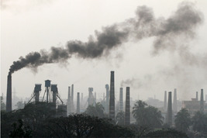
Figure 1 The chemical industry is often viewed as a major source of pollution and environmental damage.
View description - Figure 1 The chemical industry is often viewed as a major source of pollution and ...

2 Circular economies
There is currently a drive to transition from a traditional linear economy to a circular model in which the latter maximises the use of renewable resources (more on this in Video 1 in the next section.).
These models are summarised in Figure 2.

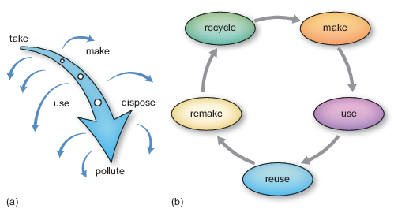
Figure 2 (a) Linear and (b) circular economies
View description - Figure 2 (a) Linear and (b) circular economies

- What are the main differences between a linear and circular economy?
- In the linear approach, goods are produced and then thrown away – often in landfill. The circular economy involves treating waste as a raw material for the production of new goods. This extends to recycling and reusing products where possible.

One material that exemplifies the need to move to a circular economy is plastic – this is the focus of the next section.

2.1 Plastic and the circular economy
There’s no doubt plastic is vital to our everyday lives. But if thrown away, many plastics take hundreds of years to break down.. One positive aspect of moving towards a circular approach would means less waste plastic would end up in landfill or our environment.
In fact it is the unique properties of plastic itself that helps us keep it in use as long as possible. This is discussed in the following video.

Video content is not available in this format.
Video 1 How to solve the plastic problem (video: ©The Open University and BBC)
View transcript - Video 1 How to solve the plastic problem (video: ©The Open University and BBC)

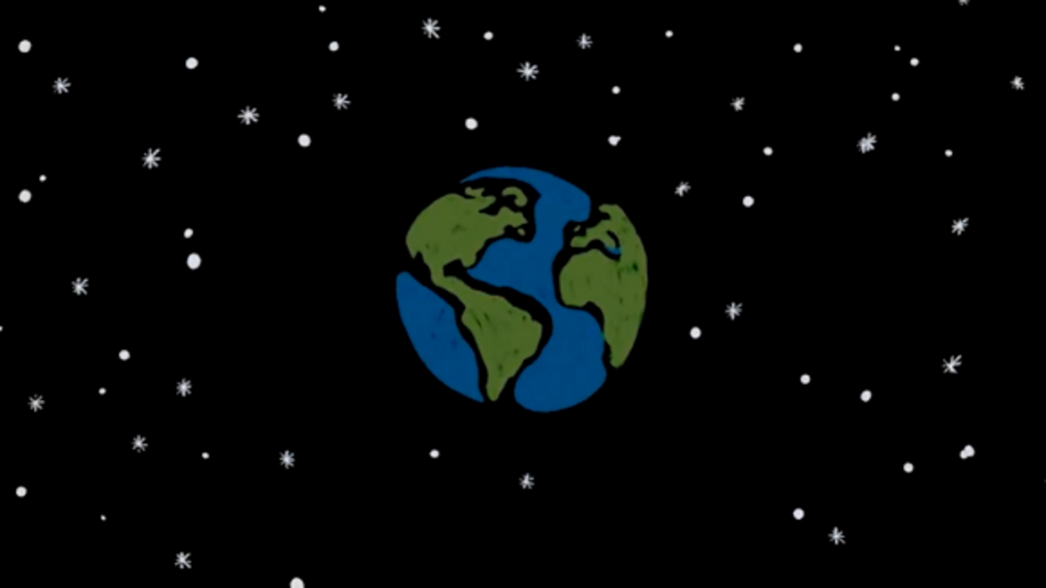

3 UN Sustainable Development Goals
In 2015 the United Nations (UN) introduced 17 wide ranging globally agreed objectives – Sustainable Development Goals (SDGs), aimed at ending poverty, protecting the planet and ensuring prosperity for all. The aim is to achieve these targets by 2030. See Video 2 below.

Video content is not available in this format.
Video 2 UN SDGs. (This video has no narration.)
View transcript - Video 2 UN SDGs. (This video has no narration.)

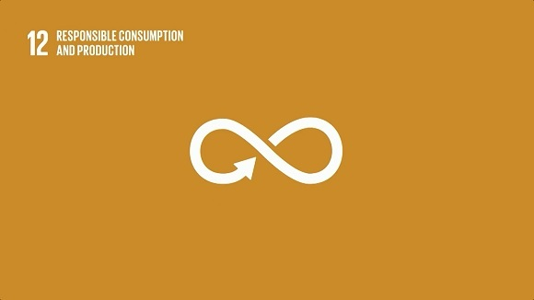

The circular economy approach you saw in Section 2 is in line with the United Nations (UN) Sustainable Development Goal (SDG) 12, ‘Responsible consumption and production’.
And in the next two sections you’ll be looking at two further UN goals that are of particular relevance to chemists:
- SDG 2, ‘Zero hunger’, and
- SDG 7, ‘Affordable and clean energy’.

3.1 UN Sustainable Development Goals in practice: zero hunger
One of the most important industrial chemicals is ammonia (represented by the chemical formula, NH₃).
Ammonia is prepared, on a massive scale using the Haber–Bosch process.
The chemistry at the heart of the Haber-Bosch process is the reaction of two gases, nitrogen and hydrogen, which may be represented by the following chemical equation.

(1)
View alternative description - Uncaptioned Equation

But why is this reaction so important in the context of the SDG 2? Video 3 in the activity below provides some answers.

Activity 1 The Haber–Bosch process
Allow about 10 minutes

Watch the video and then answer the question that follows.

Video content is not available in this format.
Video 3 The Haber–Bosch process (video: ©The Open University)
View transcript - Video 3 The Haber–Bosch process (video: ©The Open University)

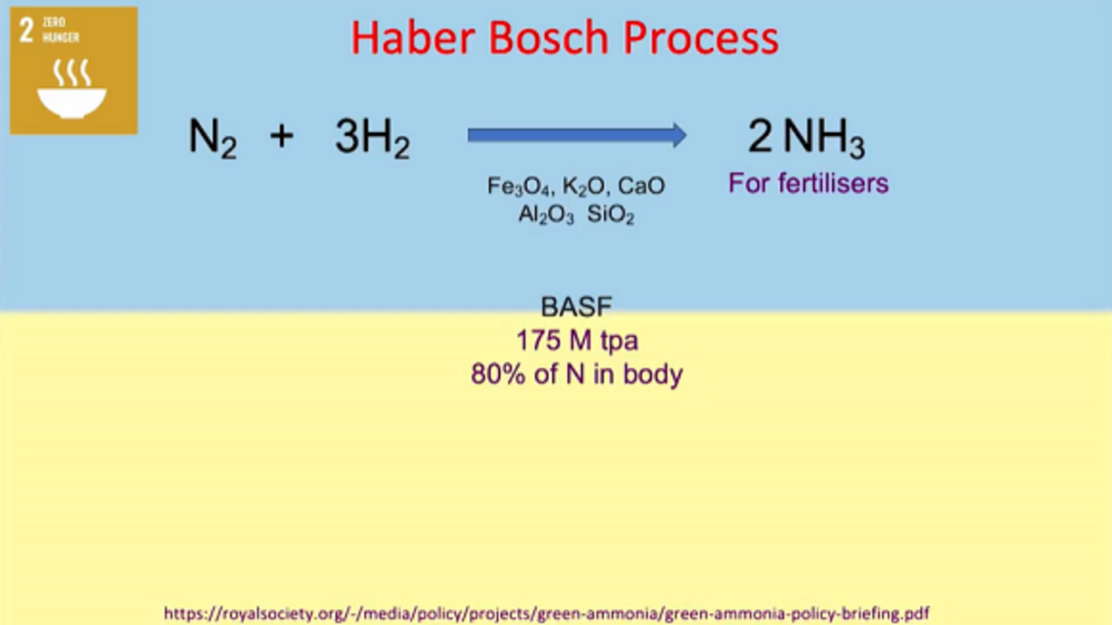

Professor Cole-Hamilton refers to the Haber-Bosch process as the ‘most important chemical reaction in the world’. How does he justify this statement?

View answer - Activity 1 The Haber–Bosch process

As discussed in Video 3, a chemical balancing act is required when selecting the ideal conditions for this reaction. So, let’s summarise the challenges faced by chemists.
Challenges faced by chemists
As a general rule chemical reactions go faster as the temperature is raised. High temperatures do indeed increase reaction rate, but they also favour the reverse reaction which sees ammonia being converted back into nitrogen and hydrogen.
So, as discussed in Video 3, on balance, a moderate temperature with the addition of a catalyst and operating at high pressures is the preferred option.
But that’s not all.
You also learned the production of ammonia is incredibly energy intensive, the main reason for this lies with one of the raw materials – hydrogen,
The other feedstock, nitrogen, isn’t a problem, there’s plenty of it available in the air, but as described in Video 2 hydrogen has to be prepared by a chemical reaction on a vast scale which is hugely costly in terms of its energy requirement.

- The synthesis of hydrogen also has another drawback, detrimental to the environment. What is this?
- Methane, the source of hydrogen has the chemical formula CH₄, comprising one atom of carbon and four atoms of hydrogen. The problem is that in industrial scale chemical reactions used to produce hydrogen, all the carbon in methane is converted to huge amounts of carbon dioxide.

- How can chemists contribute to reducing the environmental impact of the Haber–Bosch process?
- By developing different approaches to hydrogen production and new catalysts for the reaction.

3.2 Affordable and clean energy
You’ll now look at another UN SDG; this time number 7, ‘Affordable and clean energy’.

Activity 2 Generating clean energy
Allow about 15 minutes

In the clip below you will look at the vital role of the Sun in generating clean energy, and how hydrogen is, and will be an important fuel moving forward. Then answer the two questions that follow.

Video content is not available in this format.
Video 4 Affordable and clean energy (video: ©The Open University)
View transcript - Video 4 Affordable and clean energy (video: ©The Open University)

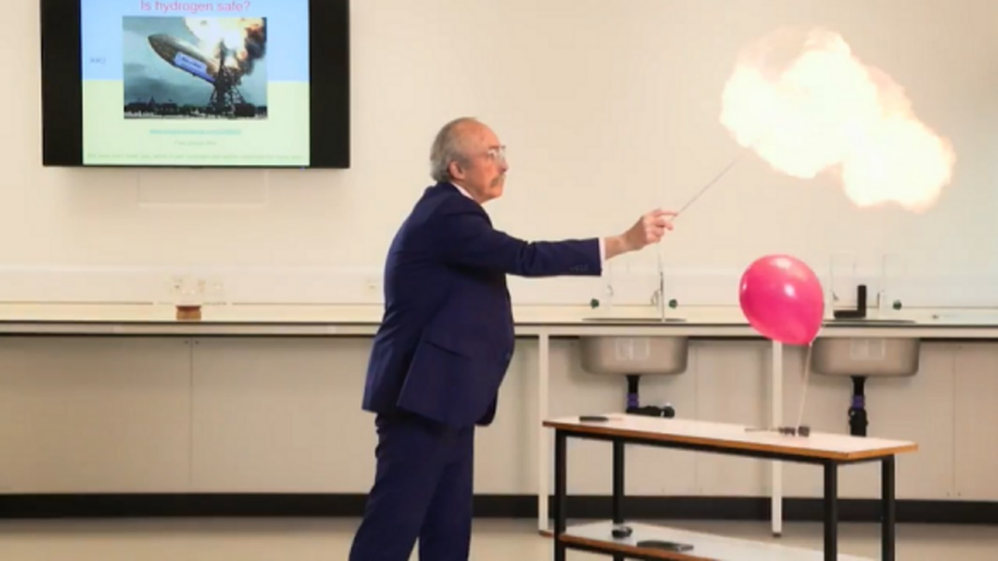

Select the types of hydrogen from the given definitions.

Interactive content is not available in this format.

Why are new electrode materials required for electrolysis of water?

View answer - Part

4 Introducing green chemistry
In the 1990s, American chemists Paul Anastas and John Warner introduced the concept of green chemistry. Green chemistry is a set of twelve principles that view industrial scale chemical production in an environmentally sustainable, and economically viable way. In fact the principles are equally applicable to the chemist working in the laboratory.
Section 4.2 will look at the application of these principles but first you’ll consider an important indicator of the efficiency of a chemical reaction, in other words how successful a reaction is at converting reactants to products, with as little waste as possible.

4.1 Atom Economy – quantifying waste in chemical reactions
One way of gauging the efficiency of a chemical manufacturing process and hence its environmental impact is to determine the atom economy for the reaction.
Atom economy – expressed as a percentage – is a sustainability metric that considers every chemical used in a chemical reaction, and the extent to which each is incorporated into the product.
To calculate atom economy, you start from a balanced chemical equation and determine how many atoms of reactant are incorporated into the product, and how many end up as by-products or waste.
The atom economy of a process is quantified by the following formula:

(2)
View alternative description - Uncaptioned Equation

Where the formula mass of a substance is the sum of the average relative atomic masses of each atom in the chemical formula.
The higher the atom economy, the more efficient is the chemical manufacturing process, and the less waste is produced.

4.1.1 Calculating atom economy – an example
Let’s consider 2-phenyl propane, an organic compound used in the synthesis of polymers and resins.
2-phenylpropane may be prepared by the reaction between benzene and 2-chloropropane (Figure 3).

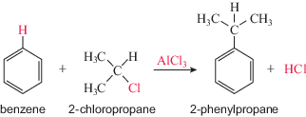
Figure 3 Synthesis of 2-phenylpropane. Atoms not used in product are shown in red.
View description - Figure 3 Synthesis of 2-phenylpropane. Atoms not used in product are shown in re ...

Aluminium chloride (AlCl₃) is the catalyst for this reaction.
As a general rule catalysts are unchanged in a chemical reaction.
This is indeed the case for AlCl₃ but it remains in solution after the reaction and is difficult to recover. So in this particular case the catalyst has to be considered alongside the other reactants when calculating atom economy.

Activity 3 Calculating atom economy for the synthesis of 2 phenylpropane
Allow about 10 minutes

Let’s work though the calculation of the atom economy of the reaction shown in Figure 3.To do this you will need to know the relative atomic masses of carbon (12.0 ), hydrogen (1.0), chlorine (35.5) and aluminium (27.0).
- Looking back at equation (2) what will be your first step in the calculation?

View answer - Part

- Now, determine the percentage atom economy for the synthesis of 2-phenylpropane. Give your answer to the nearest whole number.

View answer - Part

Clearly this reaction is not particularly efficient. And if you look back at Figure 3, the atoms that get ‘wasted’ are in colour.
Note that when calculating atom economy you need to consider the number of atoms or molecules of reactants and products in the equation.
In Figure 3 – this isn’t an issue, the equation indicates you have one molecule of each of the reactants and products.
But think back to the synthesis of ammonia:

(1)
View alternative description - Uncaptioned Equation

Here you have 3 molecules of hydrogen reacting with one molecule of nitrogen so in this case you would need to multiply the formula mass of hydrogen (H₂) by 3, and NH₃ by 2 in your calculation.

- Calculate the atom economy for the synthesis of ammonia according to reaction 2.1 (the relative atomic mass of nitrogen = 14.0)
- Atom economy = 34/(28 + 6) = 100%

In addition, practical considerations may also impact the efficiency of a chemical process.
In chemical reactions there are other components; the reaction may take place in a solvent, or there may be additional substances added during the reaction (auxiliary chemicals). These are not accounted for in Atom Economy calculations but will contribute to the environmental impact of the process concerned.

4.2 The Principles of green chemistry
The 12 principles of green chemistry provide a basis with which to assess the sustainability of a chemical manufacturing process or procedure. These are illustrated in Figure 4.

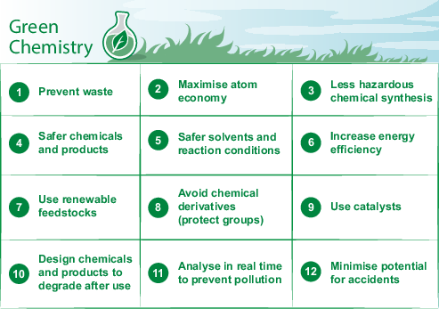
Figure 4 The 12 principles of Green Chemistry
View description - Figure 4 The 12 principles of Green Chemistry

You can find out a little more about each of the principles below.

The 12 principles of green chemistry
- Prevent waste
It is better to prevent waste than to treat or clean up waste after it is formed.
- Maximise atom economy
Synthetic methods should be designed to maximise the incorporation of all process materials into the final product.
- Less hazardous chemical synthesis
Wherever practicable, synthetic methodologies should be designed to use and generate substances that possess little or no toxicity to human health and the environment.
- Safer chemicals and products
Chemical products should be designed to do what they are intended to do (their required function) while reducing toxicity.
- Safer solvents and reaction conditions
The use of auxiliary substances (e.g. solvents or extraction agents) should be made unnecessary wherever possible, and harmless when used.
- Increase energy efficiency
Energy requirements should be recognised for their environmental and economic impacts and should be minimised. Synthetic methods should ideally be conducted at ambient temperature and pressure.
- Use renewable feedstocks
A raw material should be renewable rather than depletable, wherever technically and economically practicable.
- Avoid chemical derivatives (protect groups)
Unnecessary derivatisation – chemical modifications to a molecule during a synthesis, often used to protect a functional group – should be avoided whenever possible.
- Use catalysts
The use of selective catalytic reagents is superior to stoichiometric reagents (i.e. those that are used up in a reaction). You'll recall catalysts do not undergo a permanent change during a reaction ( ).
- Design chemicals and products to degrade after use
Chemical products should be designed so that at the end of their function they do not persist in the environment but break down into innocuous degradation products.
- Analyse in real time to prevent pollution
Develop analytical techniques for real-time in-process monitoring and control prior to the formation of hazardous substances.
- Minimise potential for accidents
Substances and the form of a substance used in a chemical process should be chosen to minimise the potential for chemical accidents, including releases, explosions and fires.

Let’s return to the 2-chloropropane synthesis and put its “green credentials” to the test.
First a reminder of the reaction.

Figure 5 Synthesis of 2-phenylpropane

  - Which of the principles of green chemistry are not followed?
  - Based on what you know about this reaction, Principles 1 and 2 are violated as waste is produced because not all of the chemicals from the reactants are incorporated into the desired product. Principle 7 is not followed because the chemicals are non-renewable.

Less obvious, but to this you could add:
Principle 6 is violated, since a large amount of energy is required especially during removal of the excess benzene.
Principle 12 is not obeyed as benzene is highly flammable.
This is by no means a complete list, but it does give you a flavour of the types of consideration involved.
In fact there is a greener way of producing 2-phenylpropane which you’ll look at next.

4.2.1 A greener way of making 2-phenyl propane
Industrially, 2-phenylpropane is now synthesised by the reaction of benzene with propene using a catalyst (Figure 4).

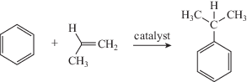
Figure 6 Alternative synthetic route to 2-phenylpropane
View description - Figure 6 Alternative synthetic route to 2-phenylpropane

The catalyst is an aluminosilicate (an oxide based on aluminium and silicon), which does not dissolve in the reaction mixture and so can be recovered and recycled.
Also, no by-products are formed in the reaction.

- What is the atom economy of this reaction?
- 100%; all atoms of the two reactants are incorporated into in the product. As the catalyst is recycled it is not considered.

At this point you will move away from chemical manufacture to take a look at the very building blocks of chemical compounds themselves, the elements, in particular problems around their availability and how can we use them in a more sustainable way.

5 Elements at Risk
There are two key factors that determine the availability of an element to chemists: supply and cost.

5.1 Supply
The Periodic Table is the iconic depiction of all the known chemical elements, organised by atomic number. It is one of the iconic images most of us remember from our school days, perhaps even being taught weird mnemonics to help us remember at least a fair chunk of it.
But Figure 7 shows a somewhat different version of the Periodic Table. In this case the area occupied by each element represents its abundance: the greater the area, the more common the element is. Importantly it also highlights those natural elements that are being overused and are running out.

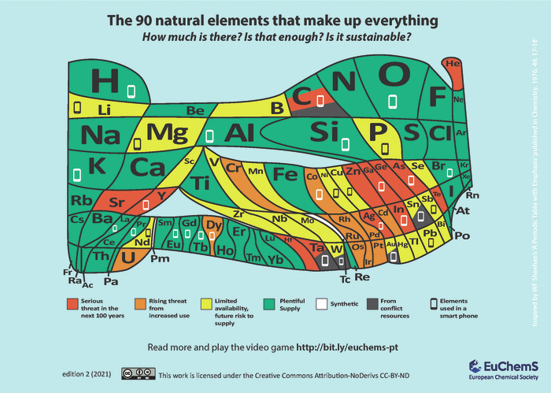
Figure 7 A form of the Periodic Table showing those elements in plentiful supply and those under serious threat of running out
View description - Figure 7 A form of the Periodic Table showing those elements in plentiful supply ...

Activity 4 Sustainability and The Periodic Table
Allow about 20 minutes

You can find out more about the way the elements are represented in Figure 7 and in the two videos below, including the drive to recycle elements in low abundance.

Video content is not available in this format.
Video 5 The Periodic Table and sustainability (part 1) (video: ©The Open University)
View transcript - Video 5 The Periodic Table and sustainability (part 1) (video: ©The Open Univers ...

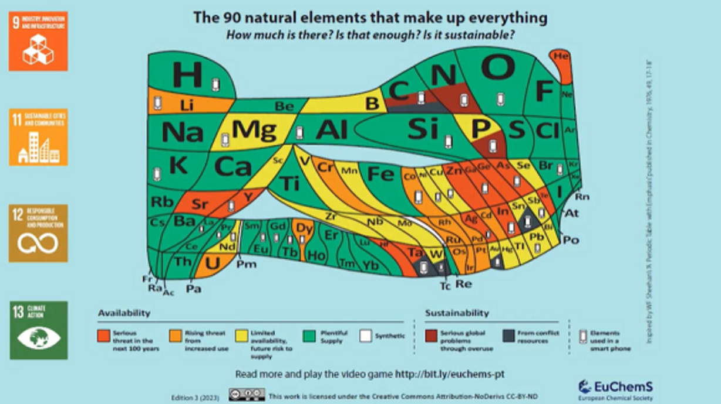

Video content is not available in this format.
Video 6 The Periodic Table and sustainability (part 2) (video: ©The Open University)
View transcript - Video 6 The Periodic Table and sustainability (part 2) (video: ©The Open Univers ...

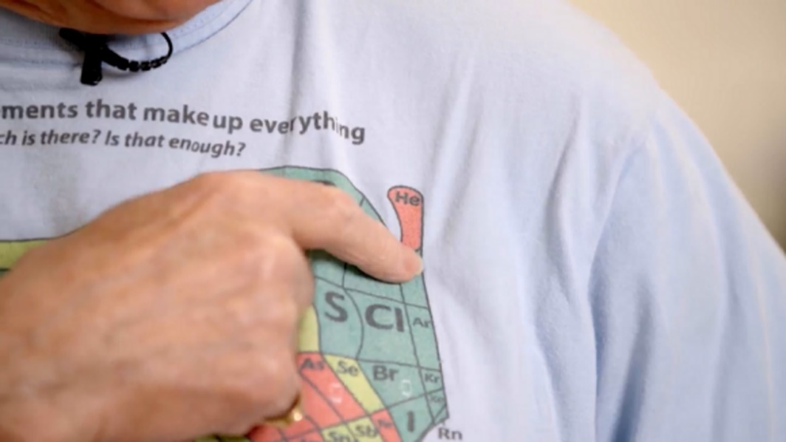

- What role does the element indium play in mobile phones?
- The compound of indium, indium tin oxide (ITO) enables touchscreens to work – it is electrically conducting, sticks to glass and is transparent.

- What is the important clinical application of helium, which means it is essential we have a continued supply of the gas?
- Liquid helium is the coolant used in MRI scanners. As you saw in Video 6, hospitals tend to recycle helium.

- Why is the use of helium filled party balloons justifiably frowned upon, and why are they banned in Gibraltar?
- Helium is a finite resource; there are only a few places on earth where it is found. The gas readily escapes into outer space if released and lost for ever, its use in balloons would there seem incredibly wasteful. In addition, given the likelihood plastic balloons may end up in the sea, thus harming marine life, the Gibraltar government has banned their use.

So you have seen that many ‘at-risk’ elements are found in consumer electronics, such as mobile phones and computers.
Technologies are being developed that can be utilised for the recovery of metals from electronic devices and electronic waste (e-waste) – this is part of so-called urban mining, where valuable materials are recovered from urban waste of various types .
Best known for the manufacture of UK coins, the Royal Mint based in Llantrisant, South Wales is carrying out ‘urban mining’, using innovative chemical processes to recover precious metals. Working in partnership with an international clean technology partner, it is using room-temperature chemistry to leach gold from printed electronic circuit boards. This gold is precipitated out and formed into ingots that can be used in a range of products – another example of a circular economy.
This work is described in the following video.

Video content is not available in this format.
Video 7 Extracting gold from e-waste
View transcript - Video 7 Extracting gold from e-waste

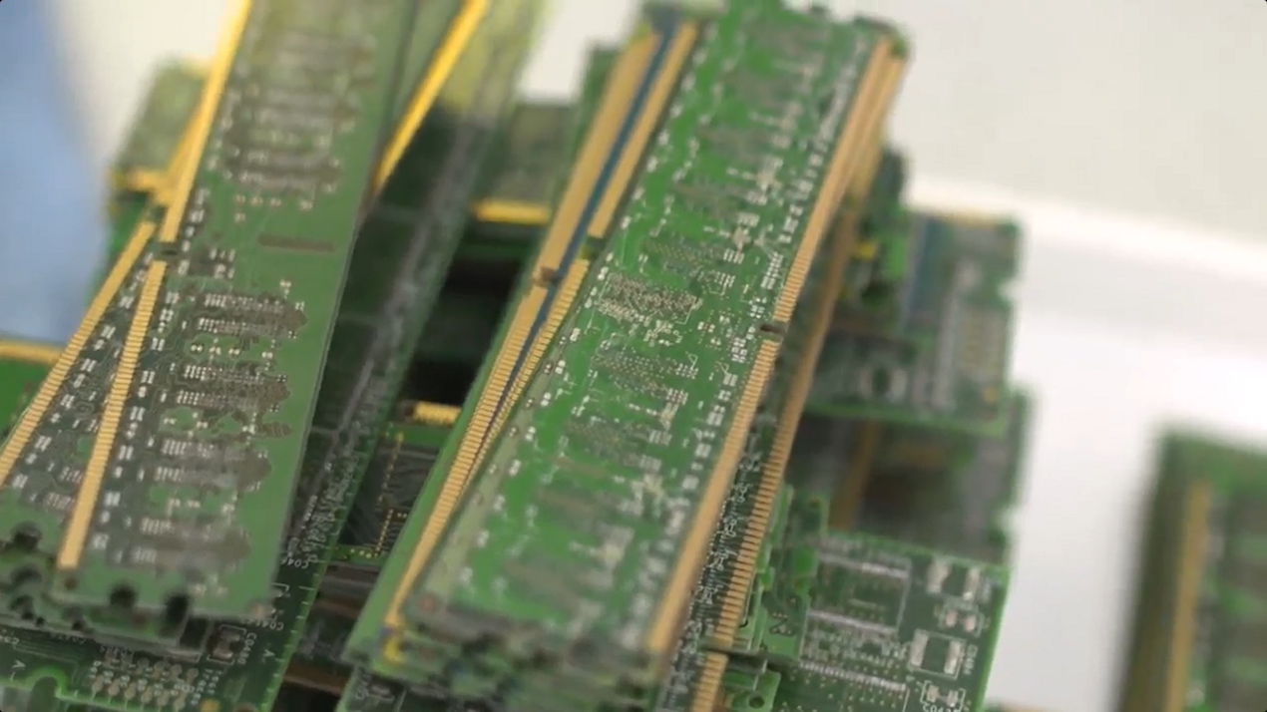

5.2 Cost
Concern over supply is not the only reason for recycling elements. Recycling can be cost effective too. For example, consider aluminium – the most abundant metal on Earth.
Aluminium is extracted using electrolysis from aluminium oxide found in the mineral bauxite. In this process you require a metal ore which has been heated to a temperature high enough to convert it into a liquid. But this is particularly problematic in the case of aluminium extraction, as aluminium oxide requires a temperature of 2000ºc in order to melt it. This would be incredibly energy consuming and too expensive to be economically viable.
Instead, aluminium oxide is dissolved in molten cryolite, Na₃AlF₆ , which has a much lower melting point then aluminium oxide, meaning the electrolysis reaction can be carried out at about 950ºC.
However, even so, aluminium extraction is still a highly energy-intensive process.

Aluminium production on Anglesey
For many years, aluminium production was carried out on the island of Anglesey in North Wales and used over 12% of the total electricity consumption of Wales. Electricity was supplied by the nearby Wylfa nuclear power station (below), the closure of which in 2010 led to production of aluminium on the island also coming to an end, as an economically viable source of electricity was not available.

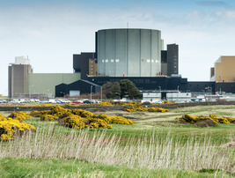
Figure 8 Wylfa nuclear power station
View description - Figure 8 Wylfa nuclear power station

So, even though there is plenty of aluminium ore around (look back at Figure 7), recycling aluminium (Figure 9) which involves re-melting the metal, saves almost 95% of the energy required to recover aluminium from its ore, making it a more economical source of the metal.


Figure 9 On-product recycling label, indicating it is made from aluminium and can be recycled
View description - Figure 9 On-product recycling label, indicating it is made from aluminium and can ...

In fact the physical and chemical properties of aluminium must be thanked for this saving:
- Aluminium melts at 660ºC, which means the aluminium-recycling process operates at a much lower temperature than extraction by electrolysis.
- Aluminium is resistant to corrosion owing to the formation of a thin oxide layer on its surface, which protects the underlying metal and is another plus point in favour of recycling.

6 Summary
In this course, you looked at how the chemical industry is shedding its dirty and polluting image, as it moves towards a more sustainable approach to chemical manufacture with a reduced environmental impact.
You looked at:
- The UN Sustainable Development Goals which aim (by 2030) to end poverty, protect the planet and ensure prosperity for all.
- The circular economy which is based on reuse and recycling of materials or products in a sustainable and environmentally friendly manner.
- The Haber–Bosch process for the production of ammonia for fertilisers, and the challenges to chemists to produce the gas in a way that reduces the huge energy requirements that currently exist.
- The 12 principles of green chemistry that encourage the design of sustainable chemical processes.
- Atom economy as a metric for the efficiency of a chemical manufacturing process.
- The imperative for the recycling and reuse of many elements as demand increases, and their availability diminishes.
More from OpenLearn
OpenLearn Sustainability Hub

Acknowledgements
This free course was written by Rob Janes and was first published in August 2026.
OpenLearn editor: Dale Harry
Except for third party materials and otherwise stated (see terms and conditions), this content is made available under a Creative Commons Attribution-NonCommercial-ShareAlike 4.0 Licence.
The material acknowledged below is Proprietary and used under licence (not subject to Creative Commons Licence). Grateful acknowledgement is made to the following sources for permission to reproduce material in this free course:
Course Image: ARTFULLY PHOTOGRAPHER/Shutterstock
Images
Figure 1: Photograph of Widnes in the late 19th century showing the effects of industrial pollution https://commons.wikimedia.org/wiki/File:Widnes_Smoke.jpg
Figure 2: (adapted from: Catherine Weetman, https://commons.wikimedia.org/wiki/File:Linear_versus_circular.jpg https://creativecommons.org/licenses/by-sa/4.0/deed.en
Figure 4: The 12 principles of Green Chemistry: adapted from https://www.labroots.com/tag/green-chemistry/webinars https://www.labroots.com
Figure 7: A form of the Periodic Table showing those elements in plentiful supply and those under serious threat of running out https://www.euchems.eu/wp-content/uploads/2019/10/Highlights-template-4.jpgDeed - Attribution-NoDerivatives 4.0 International - Creative Commons
Figure 8: Charles Hawes/Getty Images
Figure 9: aluminium recycling label symbol
Videos
Video 1: How to solve the plastic problem: made by Gemma Green for The BBC and The Open University © BBC and The Open University
Video 2: UN SDGs: courtesy: Department of Global Communications United Nations, New York https://www.unmultimedia.org/avlibrary
Video 3: extract: The Haber–Bosch process: photographic images (drone) Suwin Puengsamrong /Alamy Stock Photo ; (Eutrophication in a river in Suffolk) geogphotos/Alamy. ©The Open University
Video 4: Affordable and clean energy: (identified Illustrations: adapted from: C. Niether, S. Faure, A. Bordet, J. Deseure, M. Chatenet, J. Carrey, B. Chaudret and A. Rouet, Nature Energy, 2018, 3, 476; Alamy). ©The Open University
Video 5: The Periodic Table and sustainability (part 1) (identified images; photo of recyclable label: Martin Lízal/Shutterstock; The 90 natural elements that make up everything https://www.euchems.eu/wp-content/uploads/2019/10/Highlights-template-4 Deed - Attribution-NonCommercial-NoDerivatives 4.0 International - Creative Commons). ©The Open University
Video 6: The Periodic Table and sustainability (part 2): (identified images: Alamy; MRI scanner: in Chialvo, C & Sayles, T & Diederichs, Jost & Spagna, Stefano & Gabal, Miguel & Sesé, J. & Rillo, Conrado. (2014). Smart Energy Compressors for Helium Liquefiers ) ©The Open University
Video 7: Recycling Gold from Electronic Waste Recycling Gold from Electronic Waste courtesy of The Royal Mint
Every effort has been made to contact copyright owners. If any have been inadvertently overlooked, the publishers will be pleased to make the necessary arrangements at the first opportunity.
Don't miss out
If reading this text has inspired you to learn more, you may be interested in joining the millions of people who discover our free learning resources and qualifications by visiting The Open University – www.open.edu/openlearn/free-courses.

Glossary
Atomic number
The number of protons in the nucleus of an atom.
Catalyst
A substance that increases the rate of a chemical reaction. The catalyst itself does not undergo a permanent change.
Chemical formula
A representation of the relative proportions of elements in a compound using chemical symbols. For example, the chemical formula of the nitrogen molecule is N₂, where N is the chemical symbol for nitrogen and the subscript 2 tells you how many nitrogen atoms are in the molecule.
Chemical equation
Representations of chemical reactions. A chemical equation must be balanced, so the number of atoms on the left-hand side of the equation is equal to the number of atoms on the right-hand side.
Electrolysis
A chemical reaction driven by electricity.
Electrode
The conducting points through which an electric current enters or leaves something, for example, a battery or electrolysis reaction
Element
A single substance that cannot be split into a simpler substance
Functional Group
An atom, or a group of atoms, that has similar chemical properties whenever it occurs in different compounds. Functional groups define the characteristic physical and chemical properties of families of organic compounds
Natural elements
Elements up to 94 which are found in nature (e.g. obtained from minerals). Elements with higher atomic number are synthesised in the laboratory
Organic compound
Compounds based on carbon.
Product
The compound(s) formed as a result of a chemical reaction.
Reactant
The starting materials in a chemical reaction.
Relative atomic mass
A set of numbers, one for each chemical element. The ratio between the numbers for any two elements being equal to the ratio between the average masses of their atoms. The scale of numbers is fixed by assigning a value to one particular type of atom carbon-12, 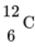, where the relative atomic mass of carbon is taken as exactly 12 and values for other atoms are defined relative to this.
Solution
A liquid mixture made up of a solute dissolved in a solvent. The solvent is present in the largest amount in the mixture .

Solutions

Activity 1 The Haber–Bosch process

Answer
Ammonia is essential for production of agricultural fertilisers essential for feeding the world’s population. Fertilisers are used to make plant protein, which we either eat directly, or via animals – in fact 80% of the nitrogen in our bodies originates from industrially produced ammonia.
Back to - Activity 1 The Haber–Bosch process

Activity 2 Generating clean energy

Part

Answer
Currently electrodes are based on metals that are relatively scarce on Earth (e.g. platinum and iridium), so large scale application of this technology will require electrodes based on more abundant (and cheaper) materials.
Back to - Part

Activity 3 Calculating atom economy for the synthesis of 2 phenylpropane

Part

Answer
Looking back at the equation for atom economy given in Section 4.1, you need to start by working out the formula masses of your reactants and products.
Remember you are including AlCl₃ in this case.
These are as follows:
2 chloropropane: (3 x 12 g) + 35.5 g + 7.0 g = 78.5 g
Benzene: (6 x 12g) + (6 x 1) = 78 g
AlCl₃: 27.0 g + (3 x 35.5) = 133.5 g
2-phenylpropane: (9 x 12.0 g) + (12.0 x 1 g) = 120.0 g
Back to - Part

Part

Answer
Atom Economy = 120/(78⋅0+78.5+133⋅5)×100 = 41%
Back to - Part

Descriptions

Figure 1 The chemical industry is often viewed as a major source of pollution and environmental damage.
This is a photograph showing an industrial skyline of large factory chimneys emitting clouds of smoke
Back to - Figure 1 The chemical industry is often viewed as a major source of pollution and environmental damage.

Figure 2 (a) Linear and (b) circular economies
The figure consists of two parts labelled (a) and (b) that illustrate linear and circular economies.
Part (a): linear economy. An illustration depicts a large (blue) curved arrow pointing downward. The arrow contains three dots of increasing size. The tail end of the arrow is labelled ‘take’. The arrowhead is labelled ‘pollute’. Eight small, curved arrows point away from the large arrow. The three dots are labelled ‘make’, ‘use’ and ‘dispose’.
Part (b): circular economy. A circular flowchart depicts five coloured oval shapes cyclically connected by curved arrows which are labelled: ‘make’, ‘use’, ‘reuse’, ‘remake’ and ‘recycle’.
Back to - Figure 2 (a) Linear and (b) circular economies

Uncaptioned Equation
cap n sub two postfix times plus three times cap h sub two right arrow two times cap n times cap h sub three
Back to - Uncaptioned Equation

Uncaptioned Equation
per cent atom economy equals formula mass of product divided by sum of reactant formula masses times 100 per cent
Back to - Uncaptioned Equation

Figure 3 Synthesis of 2-phenylpropane. Atoms not used in product are shown in red.
The figure illustrates a reaction depicting the synthesis of 2-phenylpropane. The reaction has two reactants and two products. The atoms of reactant not used in the product are shown in red. The first reactant is benzene. The second reactant is 2-chloropropane. A reaction arrow labelled ‘A l C l 3’, where the 3 is a subscript leads to two products. The first product is 2-phenylpropane and the second product is H C l (highlighted in red).
The molecular structures of reactants and products are as follows, where single bonds are represented as a single line and double bonds as two lines one above the other.
Benzene: the atoms are arranged in a ring containing six carbon atoms, which will be referred to as C1 to C6.
The ring is shown in a vertical orientation with C1 occupying the topmost vertex. The ring contains alternating double bonds between C2 and C3, C4 and C5, and C6 and C1. The H atom bonded to C1 by a single bond is highlighted in red.
2-chloropropane: a central C atom is single bonded to H on the upper right, Cl (highlighted in red) on the lower right, CH3 (where 3 is a subscript) on the lower left, and CH3 (where 3 is a subscript) on the upper left.
2-phenylpropane: a benzene ring is in a vertical orientation with C1 occupying the topmost vertex. The ring contains alternating double bonds between C2 and C3, C4 and C5, and C6 and C1. C1 is single bonded to C. C is single bonded to CH3 (where the 3 is a subscript) on the upper left, H above and CH3 (where the 3 is a subscript) on the upper right.
Back to - Figure 3 Synthesis of 2-phenylpropane. Atoms not used in product are shown in red.

Uncaptioned Equation
cap n sub two postfix times plus three times cap h sub two right arrow two times cap n times cap h sub three
Back to - Uncaptioned Equation

Figure 4 The 12 principles of Green Chemistry
The figure illustrates the 12 principles of green chemistry. A table is titled ‘Green Chemistry’, next to an image of a round bottom flask containing a green liquid and a green leaf. The table has three columns and four rows depicting the following twelve principles:
- Prevent waste.
- Maximise atom economy.
- Less hazardous chemical synthesis.
- Safer chemicals and products.
- Safer solvents and reaction conditions.
- Increase energy efficiency.
- Use renewable feedstocks.
- Avoid chemical derivatives (protect groups).
- Use catalysts.
- Design chemicals and products to degrade after use.
- Analyse in real time to prevent pollution.
- Minimise potential for accidents.
Back to - Figure 4 The 12 principles of Green Chemistry

Figure 6 Alternative synthetic route to 2-phenylpropane
The figure illustrates a reaction depicting an alternative synthetic route to 2-phenylpropane. The reaction has two reactants and one product. The first reactant is benzene. The second reactant is 2-chloropropane. A reaction arrow labelled ‘catalyst’ leads to the product. The product is 2-phenylpropane.
The molecular structures of reactants and products are as follows:
Benzene: a benzene ring is in a vertical orientation with the carbon atoms labelled 1 to 6 for the purposes of this description and with C1 occupying the topmost vertex. The ring contains alternating double bonds between C2 and C3, C4 and C5, and C6 and C1. C1 is single bonded to H.
2-chloropropane has the following line structure: a central C atom is single bonded to H on the upper left, CH3 (where 3 is a subscript) on the lower left, and double bonded to CH2 (where 2 is a subscript) on the right.
2-phenylpropane: a benzene ring is in a vertical orientation with C1 occupying the topmost vertex. The ring contains alternating double bonds between C2 and C3, C4 and C5, and C6 and C1. C1 is single bonded to C. C is single bonded to CH3 on the upper left, H above and CH3 on the upper right. In both cases in CH3, the 3 is a subscript.
Back to - Figure 6 Alternative synthetic route to 2-phenylpropane

Figure 7 A form of the Periodic Table showing those elements in plentiful supply and those under serious threat of running out
The figure illustrates a form of the Periodic Table showing elements in plentiful supply and those under serious threat of running out, depicting 90 natural elements. The top of the figure has the following text: ‘The 90 natural elements that make up everything. How much is there? Is that enough? Is it sustainable?’
The elements are arranged in a table and are grouped under the following categories:
Elements in plentiful supply: H, Be, C, N, O, F, Ne, Na, Al, Si, S, Cl, Ar, K, Ca, Ti, Fe, Br, Kr, Rb, I, Xe, Cs, Ba, La, Pr, Sm, Gd, Eu, Tb, Ho, Er, Tm, Yb, Yb, Lu, Po, At, Rn, Fr, Ra, Ac, Pa, and Th.
Elements with a limited availability, future risk to supply: Li, Mg, B, P, Sc, V, Mn, Ni, Cu, Se, Zr, Nb, Mo, Sn, Sb, Nd, W, Au, Hg, Tl, Pb, and Bi.
Elements with serious threat in the next 100 years: C, He, Sr, Y, Zn, ga, Ge, As, Ag, In, Te, Hf, and Ta.
Elements with rising threat from increased use: Cr, Co, Dy, Ru, Rh, Pd, Cd, Os, Ir, Pt, and U.
Synthetic: none.
Elements from conflict resources: C, Sn, Ta, W, and Au.
Elements used in a smartphone: H, C, O, Li, Mg, Al, Si, P, K, Co, Ni, Cu, Ga, As, Br, Y, La, Pr, Nd, Eu, Gd, Tb, Dy, Ag, In, Sn, Sb, Ta, W, and Au.
Back to - Figure 7 A form of the Periodic Table showing those elements in plentiful supply and those under serious threat of running out

Figure 8 Wylfa nuclear power station
A photo showing the Wylfa nuclear power station, which sits in the distance. There is one large, tube-like structure that is prominent and centrally placed within the frame. To the far left and right are two brick buildings and the factory complex appears to be surrounded by a perimeter fencing.
Back to - Figure 8 Wylfa nuclear power station

Figure 9 On-product recycling label, indicating it is made from aluminium and can be recycled
An illustration depicts an on-product recycling label, indicating that it is made from aluminium and can be recycled. Two bold cyclic arrows surround the term ‘alu’.
Back to - Figure 9 On-product recycling label, indicating it is made from aluminium and can be recycled

Video 1 How to solve the plastic problem (video: ©The Open University and BBC)

Transcript
[MUSIC PLAYING]
NARRATOR
Plastic is incredible. It helps send fresh food around the world, keeps us warm or cool and dry, and enables medicines like vaccines to be delivered safely at scale to billions of people. But it’s also increasingly in our soil, our oceans, and the stomachs of birds, mammals and fish. In fact, the amount of plastic on our planet now outweighs all the land and sea creatures currently alive. So how can we sort out our problem with plastic?
[ON SCREEN: The problem with plastic and how to solve it; made in partnership with The Open University]
These are sights we’re all too familiar with, plastic floating in the oceans, or piled up in bursting landfills. And whilst our instinct might be to demonise the material itself, arguably the main problem is how we use it. But first, it’s worth remembering what a versatile and useful material plastic is, making everything from car parts to bulletproof vests and wind turbines.
It was first created in the 1860s, with the noble intention to replace elephant ivory used in billiard balls. Plastic became popular with the military during the Second World War. But it only grew at scale commercially in the 1960s. Since then, it’s been produced in many different forms, including polystyrene, acrylic, nylon, polyester and vinyl, and has been incorporated into almost every aspect of our lives.
Plastic is so cheap and easy to make our use of it has grown at a phenomenal rate. And this has unintended consequences. It’s been found in the guts of creatures living deep in the ocean, and even in human placentas. And because most plastic is based on oil, its use contributes to climate change, accounting for around 3.5% of the world’s greenhouse gas emissions.
Some plastic can be recycled. But globally, only about 9% is. While decent recycling exists in some countries, in others, there’s just no real recycling infrastructure. And when most plastic is recycled, its quality deteriorates.
And no matter how many ocean or river clean ups we arrange, our environment simply cannot cope with our love of single use plastic. In the UK alone, we throw away over 2.5 billion disposable coffee cups a year. Conventional plastic can take anywhere from 20 to 500 years to decompose, with the average supermarket bag needing around 20 years and a plastic bottle around 450 years.
Biodegradable plastic, made from plants rather than petrochemicals or fossil fuels, isn’t the simple answer either. Bacteria degrades bioplastic much more rapidly than conventional plastic, but that releases both methane and carbon dioxide, greenhouse gases that contribute to global warming. It also breaks down into microplastics, meaning it gets into our food systems via the soil and fish.
One way to address these problems is to take a circular approach to plastic, designing it to stay in use for as long as possible. In the current model, we take raw materials, make them into plastic products, likely only use them once, and then throw them away.
In the circular model, plastic would never become waste or pollution. We could eliminate its unnecessary use, such as excessive food packaging, and ensure that all plastic products can be upcycled. A coffee cup could be turned into a coat. A toothbrush could help make a suitcase.
Improving the quality and design of plastic so that we pull its polymers, the long chains of molecules that make it up, apart and put them back together in an endless loop, would mean that plastic would be made once, and then reused multiple times. It could then be cleaned, processed and remoulded to make different types of plastic or a new product of the same quality. This approach, which would help reduce both pollution and greenhouse gas emissions, requires commitment and innovation.
But it is achievable. A temple in Thailand turns plastic bottles into new robes for monks, helping to process 10 tonnes of plastic waste every month. Returnable packaging schemes where consumers return reusable packaging in a shop or a drop off point help to eliminate waste from deliveries. A fleece jacket typically contains 95% recycled polyester fibre.
Let’s face it. We’re not going to completely get rid of plastic from our lives, nor would we want to. But with the equivalent of 2000 rubbish trucks full of plastic dumped into the world’s oceans and rivers every single day, we also can’t leave future generations to clean up our mess.
Our attitude to plastics has to change. We need to make better plastic, treat plastic items as indispensable, and stop thinking that it can be used once and then thrown away. Because let’s be honest. The ‘away’ in this scenario doesn’t really exist.
Back to - Video 1 How to solve the plastic problem (video: ©The Open University and BBC)

Video 2 UN SDGs. (This video has no narration.)

Transcript
The video details the United Nations Sustainable Development Goals. It begins with the following words appearing on the screen: ‘The world’s best plan’. This sentence is then completed with the words ‘to end poverty’. Those words then disappear and are replaced by ‘to reduce inequalities’. These words then also disappear and are replaced by ‘to tackle climate change’. This sentence is then replaced by the heading ‘The sustainable development goals’ and a collection of tiles listing each of these goals.
Each goal is then introduced individually on the screen, accompanied with an image illustrating the theme of the goal, in the following order:
17 – Partnerships for the goals (depicted by five interlocking circles)
12 – Responsible consumption and production (depicted by an arrow looped into a figure of eight)
8 – Decent work and economic growth (depicted by a bar chart with an arrow trending upwards)
3 – Good health and wellbeing (depicted by a pulse line and heart)
14 – Life below water (depicted by a fish swimming in water)
6 – Clean water and sanitation (depicted by water in a glass)
13 – Climate action (depicted by an eye with the iris and pupil coloured like the surface of the Earth)
15 – Life on land (depicted by a tree and three birds flying above it)
16 – Peace, justice and strong institutions (depicted by a dove with an olive branch and gavel)
7 – Affordable and clean energy (depicted by a power button styled to look like the Sun)
5 – Gender equality (depicted by the male and female gender symbols combined into a single shape)
4 – Quality education (depicted by a book and pencil)
2 – Zero hunger (depicted by a bowl with steam rising from it)
9 – Industry, innovation and infrastructure (depicted by four boxes stacked upon each other)
10 – Reduced inequalities (depicted by an equals sign with arrows pointing in every compass direction)
11 – Sustainable cities and communities (depicted by four buildings of varying heights)
1 – No poverty (depicted by people of different ages holding hands)
The video then ends with an image of a smartphone and the following text appearing on screen: ‘Learn more about the Sustainable Development Goals: un.org/sustainabledevelopment. Download the app: sdgsinaction.com. Follow us: @GlobalGoalsUN on Facebook and Twitter. #GlobalGoals’.
Back to - Video 2 UN SDGs. (This video has no narration.)

Video 3 The Haber–Bosch process (video: ©The Open University)

Transcript
DAVID COLE-HAMILTON
And here I have on the slide the Haber–Bosch process. Now, the Haber–Bosch process takes nitrogen from the air, reacts it with hydrogen and converts it into ammonia, and ammonia is used as a fertiliser.
Now, this is the most important chemical reaction in the world. It’s done on an enormous scale, 175 million tonnes a year. But a really interesting and remarkable thing is that 80% of the nitrogen in our bodies, in our proteins, in our amino acids, comes through this process. It’s not natural nitrogen coming from outside. It’s nitrogen coming from the Haber–Bosch process through plants when it’s put on as a fertiliser, and then, eventually, we eat the plants, or we eat animals that have eaten the plants.
With this process and other agricultural chemicals, which have to be extremely selective so they only do the job you want them to do, they have to be extremely active so we only use a small amount of them, they have to be non-toxic so they don’t poison anybody, half the world is kept alive.
If we didn’t have agricultural chemicals, we would not be able to support the 8 billion people in the world. We would only be able to support about 4 billion. So it’s an amazingly important reaction, really important.
But there are some disadvantages. It uses 1.8% of all the energy used in the world. That’s huge. It’s equivalent to the energy used by 144 million people in a year.
And the reason for this is partly because of the way the hydrogen is made. At the moment, you take methane, natural gas, it goes through a process called steam reforming, which produces hydrogen and carbon monoxide. The carbon monoxide is then treated in something called the water–gas shift process, and that produces more hydrogen and carbon dioxide.
So all of that carbon in the methane is converted to carbon dioxide, which is thrown away. And that is 5% of all the methane used in the world is used in this one process. It’s amazing. And all of the carbon from that methane is thrown away. And 1.8% of all the carbon dioxide that we generate is produced in this process.
Now, this is terrible. If we could stop that carbon dioxide being emitted into the atmosphere, we would really be able to tackle some parts of global warming. So one challenge is, can we change the process by which we make the hydrogen? And in principle, it’s very easy.
If we can do water electrolysis so you take water, you pass electricity through it, and I’m going to talk about this in a bit more detail later on, you produce hydrogen and oxygen, no carbon involved. And that would completely get rid of this problem of using the methane, the large amounts of methane, and producing the large amounts of carbon dioxide.
Another aspect is the chemistry. Because this is entropically unfavoured, it means that you have to run it at low temperature. You put a catalyst in, and the catalyst system is shown there. That catalyst was developed by Alwin Mittasch.
And he worked extremely hard for the Bosch company. And I think he looked at 20,000 different combinations to produce this catalyst. And that’s the catalyst that’s still used.
But it’s not fast enough. So they have to run at high temperature. And when they run at high temperature, they have a low equilibrium position. So they have to recycle everything all the time. So it’s an enormously inefficient reaction.
So another area where people could perhaps improve this is by changing the catalyst or even by doing some special heating of the catalyst, which only heats the catalyst and doesn’t heat the flowing stream. And then you can hope to get a higher position for the equilibrium at lower temperature.
Now, this is being tried in some places, and it could make an enormous difference. And so there’s an enormous amount of work to do in this process. What I’m going to do in this lecture is I’m going to give you opportunities, which I think chemists have, to help in these kinds of reactions. So my first opportunity is to develop and commercialise low-temperature, low-energy routes, low-carbon routes to fertilisers.
There is another problem with ammonia, and that is the way it’s supplied. It’s supplied in large quantities to fields, and it flows off into streams and rivers and causes eutrophication. Eutrophication is the development of green algae, which you can see in this river here. And eutrophication stops the oxygen going into the water. And so plant life and fish in the water cannot survive. So it’s really very, very bad.
Ammonia also causes air pollution. It creates nitric oxide, which causes smog. And it also can cause ozone depletion.
So there are very important things to do here. Can you apply the ammonia only to the plants that need it, not in a blanket way all over the field? I show you here a drone which is spraying individual plants. And you can actually have a drone which will look at the plants and say, those all look healthy, that one doesn’t look very well, we’ll put some ammonia onto that.
Now, that probably isn’t the way it’s going to be done. But that’s the kind of thing we need to think about. And here we need to collaborate with other people. We need to collaborate with agriculturalists to make this work. And that’s why I’ve put here a sustainable development goal, 17 partnerships for the goals. And here’s another opportunity to work with these people to get ammonia application specific to individual plants.
Back to - Video 3 The Haber–Bosch process (video: ©The Open University)

Video 4 Affordable and clean energy (video: ©The Open University)

Transcript
DAVID COLE-HAMILTON
Number seven is affordable and clean energy. Now, this is a really important aspect because it relates to climate change as well.
In this picture, you will see a number of different ways of generating energy. So the first one, if you look at the green parts of this, they are biomass. If you burn wood, for example, that’s burning biomass, and the wood is formed by photosynthesis. Photosynthesis is driven by the sun.
And, in fact, all of these methods, with the exception of one, are driven by the sun. The sun is the only source of energy that we have coming into the planet, and we have to be able to use that if we want to have renewable energy.
So if the sun shines on the ground, it warms the ground. The air becomes hot. The hot air rises. That causes winds. If winds blow across water, that causes waves. If the sun shines on water and it evaporates it, it forms clouds and then rain, and we can have that as hydroelectric power. All of these are driven by the sun.
Photovoltaics, where you have solar panels, they’re solar driven. The only one in here that isn’t is the one in the front, which is geothermal energy, where you take heat from the Earth to heat other things. And, of course, nuclear energy is not run by the sun but is also not renewable.
Now, all of these methods have a contribution to be made from chemistry, and we need to develop them all so that we can have clean energy, affordable clean energy in the future, without using fossil fuels.
Now, you may say to me, well, wind energy has got nothing to do with chemistry, but it’s got a huge amount to do with chemistry. If you go to see these new wind turbines that they’re building in the North Sea, the blades are 200 metres long – 200 metres. It would take Usain Bolt 20 seconds to run along them. It’s fantastic.
But think of the chemistry, the material science, the engineering that goes into making a blade like that, which will stand out in the North Sea rotating in 100 mile an hour winds and produce energy. It’s a fantastic challenge. So all of these have a lot of chemistry in them. So there’s an opportunity to develop new ways of converting solar energy.
Now, when we think about how much energy we require, we need to think, do we have enough energy from the sun? Well, if we convert solar energy with 10% efficiency, we would indeed have enough energy to supply the whole world if we covered an area the size of Libya. Now, I’m not suggesting we cover Libya in solar panels. I don’t think they’d like it very much. But, of course, when you think about it, we have all these deserts in the world. We have the Great Australian Desert, the Gobi Desert, the Sahara Desert, the Kalahari Desert, the Mojave Desert, the Atacama Desert. All of these are places where there’s just sand and nothing else and sun. Could we harness that sun to produce energy that we could then use around the world? And there’s a lot of work going on in this, but the conversion of the sunlight and the storage of the energy are the really interesting problems.
Now, one fascinating idea is, of course, that you could convert water to hydrogen, and hydrogen is an excellent fuel, and you could burn it. And sunlight has enough energy in it to do this. Now, you will realise that doesn’t happen because – and it’s a good thing it doesn’t happen because if it did happen, you’d be sitting down on the beach. You’d be having your barbecue. Sun come out. Hydrogen would bubble off the sea, and you’d be blown to smithereens, and it wouldn’t be a good idea.
So people are working on trying to find catalysts that you can put into the water which will allow it to happen, and they’ve made a lot of progress, and that could be one way of doing it. But there are other ways which are probably more likely to work, and the most important one is electrolysis, and I mentioned electrolysis before. Passing a current through water converts it into hydrogen and oxygen. We can burn the hydrogen. And, of course, when we burn the hydrogen, we get water back again. So it’s a totally circular system, cyclical, renewable, no carbon, perfect system.
And we could do this from overproduced electricity from wind, solar. So, for example, in the North Sea when the wind is blowing at night and people aren’t using their electricity very much, we’ve got a lot of excess electricity. Now, what they do at the moment is they pay people to turn the wind turbines off, but what we should do is we should use that electricity to electrolyse water and produce hydrogen, and this can be done.
But let me talk about now the production of hydrogen because the production of hydrogen is very important. We do it at the moment, and I mentioned before that we do it particularly for the Haber-Bosch process. There, as I said, we take natural gas. We put it into a factory. We go through these processes that I described, and all the carbon dioxide is released into the atmosphere, and it produces huge amounts of carbon dioxide, and you see there I’ve put the number.
One possibility is just continue to use that process but to trap the carbon dioxide by pumping it underground. This is called carbon capture and storage, and the idea is it will go into old oil mines and old coal mines. It’s not being developed yet in the UK. Some is done in Norway. Some is done in the United States. But it’s not a particularly good process. As I say, the best way to do this would be by electrolysis, and we’ve got to see that the demand could be something like seven times what we’ve got at the moment. So we’ve got to have a huge amount of this hydrogen if we want to use it as a fuel. But this is what we’re aiming for, and this is a very, very important thing.
The main problem with electrolysis is that it’s quite efficient, 70% to 80% efficient, but it uses electrodes which are based on rare elements, not readily available elements such as platinum and iridium. So what we need to do here is we need to develop ways of electrolysing water, which will produce the hydrogen using non-rare and endangered elements.
And my friend Bruno Chaudret, who works in Toulouse, has done this wonderful piece of work on electrolysis. What he does is he takes iron carbide nanoparticles and supports nickel on the outside of them. He sticks these onto a graphite electrode, and he then passes a magnetic current over them. And the point about the magnetic current is the iron carbide particle is magnetic, so it flips the domains of the magnet, and that heats the particle without heating the water very much. And it allows you then to have a different kinetics, which allows the reaction to go at low temperature.
Using this type of electrode, they’ve been able to reduce the overpotential for oxygen production by 200 millivolts and for hydrogen production by 100 millivolts. To do that, normally without this kind of electrode, you would have to heat the system to 200 degrees centigrade. In this case, the temperature of the water rose only five degrees, and that’s because, of course, the particles are warming, and so they warm the water a little bit.
This is the kind of thing we need to develop. We need to develop new electrodes and new processes for doing the electrolysis of water.
Now, you may say to me, is hydrogen safe? And obviously there have been some really serious disasters where there have been hydrogen explosions. In this picture, you can see theRR2, which was an airship which blew up. But what’s important about this picture is to look at the flame. The flame is above the airship, and that’s because hydrogen is extremely light, and when it burns, it burns upwards.
So, in fact, in this accident, not many people in the airship died because the hydrogen and the heat went upwards. Some died because the infrastructure burnt. Now, if that had been petrol, it would have gone down onto the ground. It would have run along the ground. It would have incinerated all the people on the ground. So, in fact, hydrogen is safer than petrol, although it can explode, but petrol explodes in engines anyway.
And I’m old enough to remember when we had town gas. Town gas was half carbon monoxide, half hydrogen. We used to burn it in our cookers. We used to put it in pipes all around the country, and we used to store it in gasometers. So we know how to handle hydrogen, and it is intrinsically safe because it’s so light.
I thought I’d show that to you with these two hydrogen balloons that I have here. So these two balloons are filled with hydrogen. And if I’m telling the truth, if I burn this top balloon, it will not burn this bottom one here.
So let’s try it and see. I’ll just move some of these things out of the way so that we don’t get into trouble. Put my safety glasses. Right, so what I’m going to do is I’m going to light the top balloon, and the idea is that it should not light the bottom one because the flame will go upwards.
So I’m going to burst the top one and see what happens.
[David sets top balloon alight with a small flame. The top balloon explodes upwards leaving the lower balloon intact]
And the bottom one survived. So clearly the heat didn’t go down or it would have burnt it. And just to show that I’m not cheating, I’m now going to burn this one as well. If you don’t like loud bangs, please put your fingers in your ears, but watch this because what I want you to see is the fireball that comes from it going upwards.
Here we go. Do you see how it went upward?
Back to - Video 4 Affordable and clean energy (video: ©The Open University)

Video 5 The Periodic Table and sustainability (part 1) (video: ©The Open University)

Transcript
DAVID COLE-HAMILTON
Everything in this whole world is made from just 90 building blocks, the 90 natural elements. That’s an amazing thought. Put together in different ways, they give all the different beauty and diversity of the world. If we didn’t have them, or if we lost some of them, we couldn’t have the same diversity and beauty that we have at the moment.
The area occupied by each element represents its abundance in the Earth’s crust and in the atmosphere. Some are large. Some are small.
It’s on a logarithmic scale, because otherwise you wouldn’t see the ones at the bottom. And even then, we’ve had to expand some of them. You see lots of oxygen, rather little of some of the others.
The colours represent what we’re doing to the element. So if we have a phone and we put it away somewhere, the elements in that phone are lost. And if we go on doing that, then we disperse the element, and it’s not available.
So what we’re saying is that the ones that are red will not be available in less than 100 years, and sometimes much less, as we’ll see in a minute. The ones that are orange, there’s an increasing use of them. And so we’re having to produce more, and there may become a danger that we run out of them. And yellow, there is some worry that in the longer term we will have a problem of supply of them.
Now you’ll also see that there are five elements which have a black symbol on them, or grey symbol. And these are elements that can come from areas where wars are fought over the mines that they come from, or the proceeds of the mining are used to fund wars, mainly in the Democratic Republic of the Congo. Now they don’t only come from there, but it means that if you have something that’s come from there in your pocket, in your phone, for example, then somebody died to give it to you. So we have to try to make sure we don’t use those elements from those things.
There are three elements, carbon, nitrogen, and phosphorus, which have a deep red colour to them. This is that we’re worried about the fact that we’re overusing them. I mentioned nitrogen already in eutrophication. Carbon, we overuse, causing global warming. And phosphorus is very similar to nitrogen.
And then you’ll see there are 31 elements on which there’s a mobile phone signal. Now that represents the 31 elements in most mobile phones. Some have more. Some have less. But they’re the normal ones.
And you’ll see that all four of the elements that can come from conflict minerals, which are tantalum, tungsten, tin, and gold, are in mobile phones. And six of the other elements, which are red, are also in mobile phones. So we have to think about that. And mobile phones are very, very important.
Now I want to refer to this periodic table in the rest of the lecture, but I don’t want to do it by flicking it back up and down. So I thought I would show it to you in a slightly different way. And I have a copy of it, which I’ll show you here. I hope you’ll be able to see it and then I won’t have to flick up and down to the pictures. Here we are.
I want to talk about mobile phones because everybody has one, and they are potentially a really difficult problem. They are the ultimate in use and discard technology in the linear economy. 1.5 million phones every month are exchanged in the UK. Every month, think about that, 18 million a year, 150 million in Europe and in the United States, extraordinarily large numbers of phones.
So I want to talk about two elements, specifically. Indium, which is here, red, and tantalum, which is here, black and red. And the reason I want to talk about them is because they cause a serious problem. Indium is a byproduct of zinc mining. And there is only enough if we continue to do what we’re doing for 20 years.
Now indium is used in every touchscreen. Indium tin oxide is the conductive material that allows the touchscreen to work. Without it, we cannot have a mobile phone in the way we have it at the moment. The second one is tantalum, which is both red and black. That means it’s not going to last very long, and it also can come from conflict minerals.
What mobile phone companies do is they use a thing called traceability, where they look at the tantalum they’re getting to put into the phone, they trace it back through all the processing steps it’s gone through to the mine it came from and make sure it didn’t come from the Democratic Republic of the Congo. Usually it comes from Canada.
Tantalum is used as a micro capacitor, stopping surges of current in your phone and protecting your main processor. So it stops you frying your chips, if you like. But it’s really very, very important. And we have to have that.
And think about what you do with your mobile phone when you get that phone call saying you’re due an upgrade, come and get a new phone. Well, most people would stick the phone in the drawer. And I would imagine if I asked any one of you who’s watching this, whether you’ve got a phone in the drawer, at least half of you would have, or that’s what the Royal Society of Chemistry found in a survey that they did.
If you don’t put it in your drawer, and you hand it in back to the phone company, very often it goes to the developing world where it can be reused, which is good. But then after it’s been reused, the absolutely appalling situation happens where children in the street sit with pools of acid trying to extract the gold while the carcasses of the phones build up by the side of the road. It’s absolutely shocking.
And this is a major environmental problem. It’s a major social problem. And it’s a major problem for supply of these elements.
And the other thing about them, of course, is phones are not readily mended if something goes wrong. The mobile phones build in redundancy. And so this is a problem. If you have a phone, usually you have to have a special screwdriver to undo it. You have special glues.
Now I have a Fairphone here. And Fairphones are actually modular. So you can take bits out and put them in very easily. And you can do it yourself. And this is very important, very good.
So I recommend the Fairphone. And I don’t get any money from them for saying that, by the way. So modular phones are good.
But when you know all this about phones, can you really justify having a new phone every two years? Do you need it? You don’t really need it. You’ve got a perfectly good phone that’s working fine. And if the battery goes down, you can hope to replace it. And indeed, we’ll talk about that again in a minute.
So what we really need is a circular economy for phones. We need to reduce the amount of phones we use. And we can do this by extending the lifetime of them that we keep them. So keep it for five years instead of two years. That really cuts the problem by more than half.
If it goes wrong, have it repaired. If you don’t want it anymore, then give it to somebody else. Don’t just chuck it away or put it in a drawer. Give it to, I don’t know, a grandparent or a child who wants it.
And I’ve put here at the bottom replace. But I don’t mean replace the phone. I mean we as chemists have to replace the materials in the phone so that we use earth abundant elements.
And there’s a lot of work going on this to find equivalent materials which will do what indium tin oxide does, for example, but using earth abundant elements. And a few examples are antimony, stannate, and calcium molybdate. None of them are as good as indium tin oxide.
And indium tin oxide has to have certain very important properties. It has to stick to glass, it has to be conducting, and it has to be transparent. So there’s an enormous challenge there to develop new materials for making phones.
There is good news because the European Commission and the UK have brought in a right to repair. This means mobile phone companies now are not allowed to do what they were doing before. They have to make phones which can be repaired, either by you or at a corner shop. So very good news that, and this will make things much easier, and make it much easier for you to keep your phone by putting in a new battery.
Back to - Video 5 The Periodic Table and sustainability (part 1) (video: ©The Open University)

Video 6 The Periodic Table and sustainability (part 2) (video: ©The Open University)

Transcript
DAVID COLE-HAMILTON
I now want to talk about helium, which is up here. Now, helium is a really interesting element. Its main use is in cooling the magnets for MRI imaging. Some of you will have had an MRI scan, and there’s a picture of somebody going into an MRI scanner.
The magnets have to be at very low temperature, 4 degrees Kelvin. And the only thing that will take them down to that temperature is liquid helium, which boils at 4 degrees Kelvin. So it’s very important to have it.
It’s also used in other uses. One of them is in deep-sea diving to prevent people getting the bends. If you dive with air, deep sea, nitrogen dissolves in your blood. When you come up, it comes out as bubbles. It can give you gas embolism, which can affect your brain, your heart, and you can die from it. It’s very unpleasant.
But helium doesn’t dissolve in the body. It’s inert. It doesn’t do any harm. So you place some of the nitrogen with helium, and you can then dive deep down.
Now, the important thing about helium is it’s very, very light. It’s the second-lightest element we have. And it’s also very, very stable. If it gets into the atmosphere, it goes up and up and up and up because it’s light till it gets to the edge of the atmosphere, and then it’s knocked into outer space and lost forever.
So if you release helium into the air, that’s it, gone. You see, it’s red here. There’s a shortage of supply of helium. Now, in these cases, the helium is, in fact, recycled. So here’s somebody wearing a helium recycling apparatus for diving, and here’s a recycler for MRI scanners.
Now, what about the supply of helium?
The main suppliers are Qatar, which did shut for a long time but is reopening it is supplying a bit now; the USA, which is running down its reserves; Russia and they’ve had enormous problems because of explosions in the plants they have there; and then Tanzania, where there’s a fairly new find, a large field, that will not open until 2025.
And even then, if you use all the helium in the Tanzanian field and use it once and let it go, then it would only be enough to last for about 8 to 12 years so really quite a small amount.
The one thing that we do where we don’t recycle helium is party balloons. Now, party balloons go down. They either pop or they go down because the helium diffuses out. And that helium always then goes into the atmosphere, goes through this process of going up to the top, and being kicked out into outer space. When you know this, can you really justify having helium celebration balloons when this precious resource will be lost forever?
Now, I got in contact with the European Balloon Council, and they sent me their fact sheet. This is it, Balloon Gas. And they told me, there’s not a problem with helium. We know exactly what’s happening, and it’s fine.
And in this report, they say that only a tiny amount of helium is used in party balloons. And then they tell you how much it is. It’s 10% in the UK.
Now, I did do a programme for a Russian television channel which is not controlled by Vladimir Putin. And in Russia, apparently, 47% of helium is used in party balloons. That’s not a tiny amount.
They then say it’s dirty helium, it can’t be recycled, and it’s not useful. Reliquefying it is not economical.
But then, when you look at exactly what that means, in order for the helium balloon to float, it has to be 95% helium. The Tanzanian field only has less than 10% helium, and they say they can’t refine 95% when people are going to refine 10%. So this is nonsense. And I’ve upset them a great deal, these balloon people, by telling them this.
So if you think of the Tanzanian field, I said, there’s enough here if we just use it once for everything. But only 10% is used in balloons. So in 8 years, that will all be gone. And then you won’t be able to have an MRI scan.
So would you prefer to have helium party balloons, or would you like your child or grandchild to be able to have an MRI scan? It’s a no-brainer. We really shouldn’t use helium party balloons.
Now, again, there is some good news. Gibraltar used to have a national day every year where they release red and white balloons. They’re the colour of Gibraltar. And they were helium balloons, and they’re now banned. And they were banned partly because of the loss of helium, and partly because of what happens to them is they go into the sea, the sea mammals eat them, and the sea mammals die. And it’s very tragic.
And the balloon people will say, no, no, no, it’s fine. The plastic we use for the balloons is biodegradable. Well, the plastic takes a year to biodegrade. It takes about 10 seconds for a sea mammal or a calf or something to eat a helium balloon. So, really, it’s a very serious problem.
And then, in London, in Hyde Park, they had a winter festival. And you’ll notice that they said, we have banned helium balloons. And we’re making progress.
So what about recycling? We’ve been talking about recycling, and here we are. This is the same periodic table, the original one, now coloured in a different way. And pink means that less than 5% is recycled up to blue, which means that more than 50% is recycled.
And you’ll see the elements that I’ve been talking about. Indium is not recycled at all. Tantalum is not recycled at all. And helium, of course, is recycled. But we have this problem of it actually leaving the atmosphere, the only element we lose from the atmosphere.
Back to - Video 6 The Periodic Table and sustainability (part 2) (video: ©The Open University)

Video 7 Extracting gold from e-waste

Transcript
[ON SCREEN: Anne Jessopp, Chief Executive, The Royal Mint]
ANNE JESSOPP
So the Royal Mint is the original maker, one of the oldest manufacturing organisations in the world, with 1,100 years of history. People will know us for making coins, but we do a lot more than that. So today, I’m really delighted to announce a partnership with a Canadian company, Excir, and we’re actually working in partnership with them on some really exciting, sustainable technology, which takes waste electronics and takes out the precious metals and actually recycles that.
[ON SCREEN: Sean Millard, Chief Growth Officer, The Royal Mint]
SEAN MILLARD
Electronic waste, at the moment, is one of the world’s global problems. If we’re going to put this in context, there’s 50 million tonnes of this stuff that is created every year, and it’s growing very quickly. At the moment, what happens to those printed circuit boards is they all get collected and then shipped to other countries. So 99% of the printed circuit boards go outside this country and go to places to either be burnt or, unfortunately, in some cases, into landfill. So this technology provides a significant solution to the problem of e-waste.
We’re also being able to transform those printed circuit boards not only by extracting the precious metals from them, but also converting the byproducts of that into something useful. So a complete circular economy.
[MUSIC PLAYING]
Back to - Video 7 Extracting gold from e-waste

