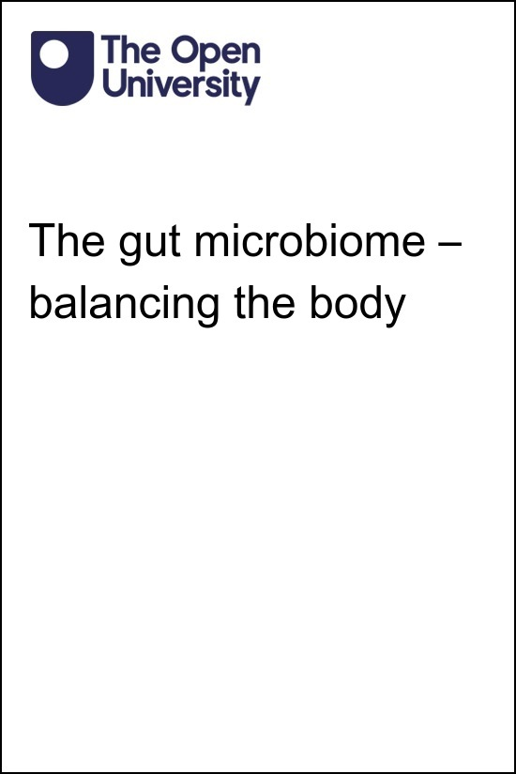

SK190_1 The gut microbiome – balancing the body

The gut microbiome – balancing the body

About this free course
This free course is an adapted extract from the Open University course .
This version of the content may include video, images and interactive content that may not be optimised for your device.
You can experience this free course as it was originally designed on OpenLearn, the home of free learning from The Open University –
There you’ll also be able to track your progress via your activity record, which you can use to demonstrate your learning.
First published 2025.
Unless otherwise stated, copyright © 2025 The Open University, all rights reserved.
Intellectual property
Unless otherwise stated, this resource is released under the terms of the Creative Commons Licence v4.0 http://creativecommons.org/licenses/by-nc-sa/4.0/deed.en. Within that The Open University interprets this licence in the following way: www.open.edu/openlearn/about-openlearn/frequently-asked-questions-on-openlearn. Copyright and rights falling outside the terms of the Creative Commons Licence are retained or controlled by The Open University. Please read the full text before using any of the content.
We believe the primary barrier to accessing high-quality educational experiences is cost, which is why we aim to publish as much free content as possible under an open licence. If it proves difficult to release content under our preferred Creative Commons licence (e.g. because we can’t afford or gain the clearances or find suitable alternatives), we will still release the materials for free under a personal end-user licence.
This is because the learning experience will always be the same high quality offering and that should always be seen as positive – even if at times the licensing is different to Creative Commons.
When using the content you must attribute us (The Open University) (the OU) and any identified author in accordance with the terms of the Creative Commons Licence.
The Acknowledgements section is used to list, amongst other things, third party (Proprietary), licensed content which is not subject to Creative Commons licensing. Proprietary content must be used (retained) intact and in context to the content at all times.
The Acknowledgements section is also used to bring to your attention any other Special Restrictions which may apply to the content. For example there may be times when the Creative Commons Non-Commercial Sharealike licence does not apply to any of the content even if owned by us (The Open University). In these instances, unless stated otherwise, the content may be used for personal and non-commercial use.
We have also identified as Proprietary other material included in the content which is not subject to Creative Commons Licence. These are OU logos, trading names and may extend to certain photographic and video images and sound recordings and any other material as may be brought to your attention.
Unauthorised use of any of the content may constitute a breach of the terms and conditions and/or intellectual property laws.
We reserve the right to alter, amend or bring to an end any terms and conditions provided here without notice.
All rights falling outside the terms of the Creative Commons licence are retained or controlled by The Open University.
Head of Intellectual Property, The Open University

Contents
- Introduction
- 1 What are microbiomes?
  - 1.1 Overview of the gut microbiome
  - 1.2 Balancing the gut microbiome
  - 1.3 Loss of balance – dysbiosis
- 2 Functions of the gut microbiome
  - 2.1 Metabolic – digestion of food
  - 2.2 Metabolic – production of nutrients
  - 2.3 Metabolism of drugs and xenobiotic chemicals
  - 2.4 Structural integrity of the gut wall
  - 2.5 Protection against pathogens
  - 2.6 Communication within the body
  - 2.7 Gut microbiome and the immune response
  - 2.8 Gut microbiome and stress
- 3 Factors affecting the gut microbiome
  - 3.1 Genetics of the human host
  - 3.2 Early exposure to microorganisms
  - 3.3 Geographical location and microbiome diversity
  - 3.4 The impact of diet
  - 3.5 Exercise
  - 3.6 Medications
  - 3.7 Infection and disease
  - 3.8 Age and the menopause
- 4 Impact of dysbiosis on health
  - 4.1 Inflammatory bowel disease – Crohn’s disease and ulcerative colitis
  - 4.2 Irritable bowel syndrome and small intestinal bacterial overgrowth
  - 4.3 Obesity and Type 2 diabetes
  - 4.4 Colorectal cancer
  - 4.5 Kidney disease
  - 4.6 Mental health
- 5 Restoring/maintaining the balance of the gut microbiome
  - 5.1 Prebiotics and probiotics
  - 5.2 Faecal transplant
- 6 Quiz
- 7 Summary
- References
- Acknowledgements
- Glossary
- Solutions
- Descriptions

Introduction
Did you know that there are an estimated 37 trillion human cells in the adult body? In fact, there are only an estimated 100-400 billion stars in the Milky Way, so there are more cells in the human body than there are stars in the Galaxy!
In addition to human cells, there are also another 30-100 trillion non-human cells, such as bacteria, archaea and fungi, and non-living organisms such as viruses, that live on or in the human body. These microscopic organisms (microorganisms) and their interactions with a specific environment, such as the gut or skin, are known as the microbiota. You may be more familiar with the terms ‘friendly bacteria, commensal bacteria, or flora’. The organisms of the microbiota, their genetics and the substances they release interact with each other and their environment to form the microbiome. Humans have several microbiomes, including in the gastrointestinal tract (gut), urogenital tract (urinary and genital systems) and on the skin.

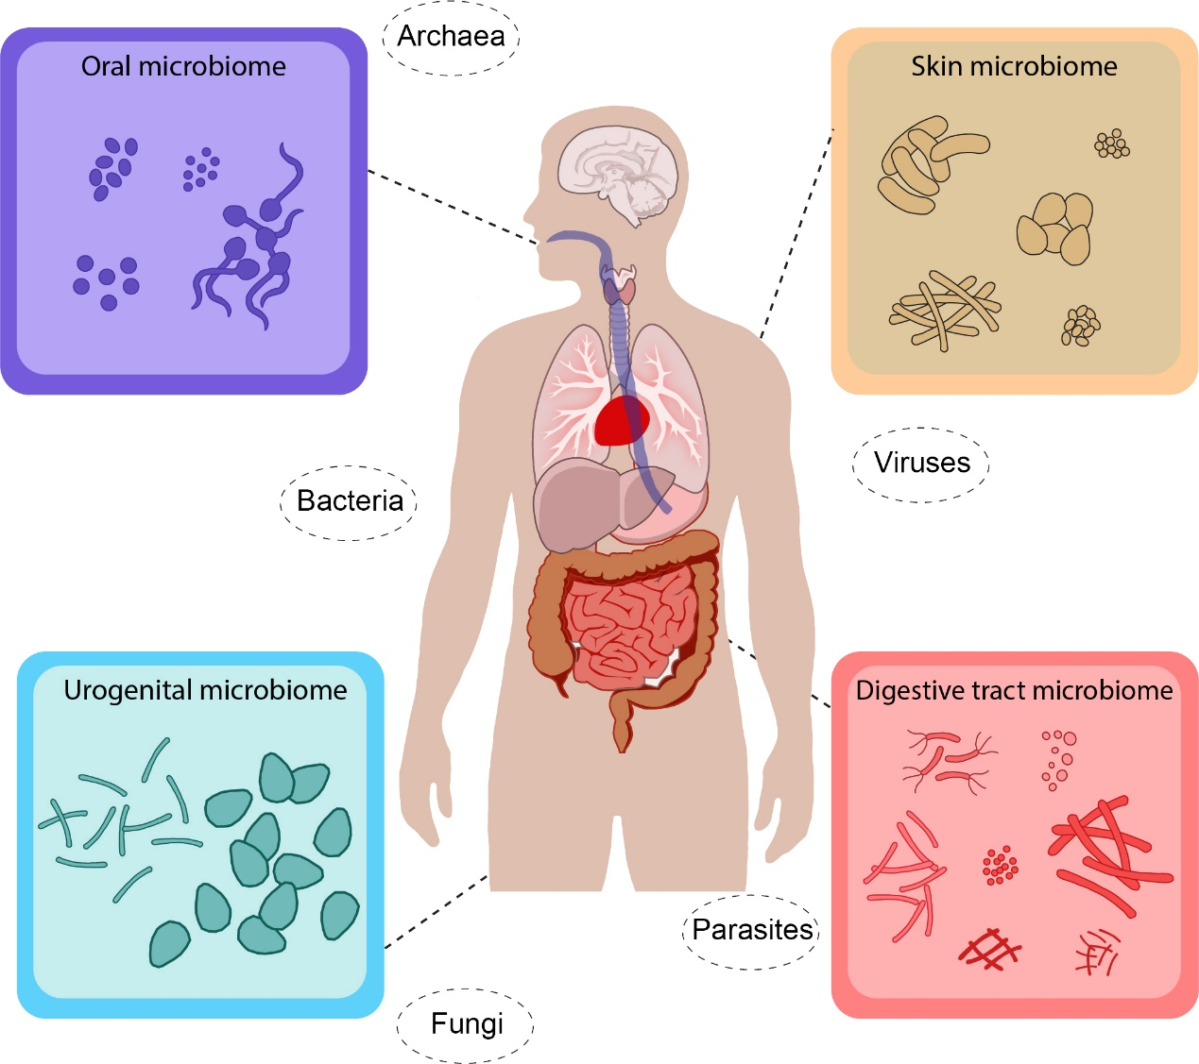
Figure 1 Microbiomes around the body
View description - Figure 1 Microbiomes around the body

Scientific research is increasingly showing the importance of these microbiomes for the correct functioning of the human body and for maintaining health. In fact, disruption to these microbiomes can lead to a number of long-term health conditions, such as cardiovascular and respiratory diseases, some cancers and some mental health disorders.
The gut microbiome is the largest and most diverse of the microbiomes and is particularly important in maintaining optimal health. However, there are numerous factors which can affect the balance of the microorganisms in the gut microbiome, such as genetics, age, menopause, pollutants, and diet. The microorganisms of the gut microbiome are located throughout almost the entire length of the gastrointestinal tract (gut). The main anatomical components of the GI tract can be seen in Figure 2.

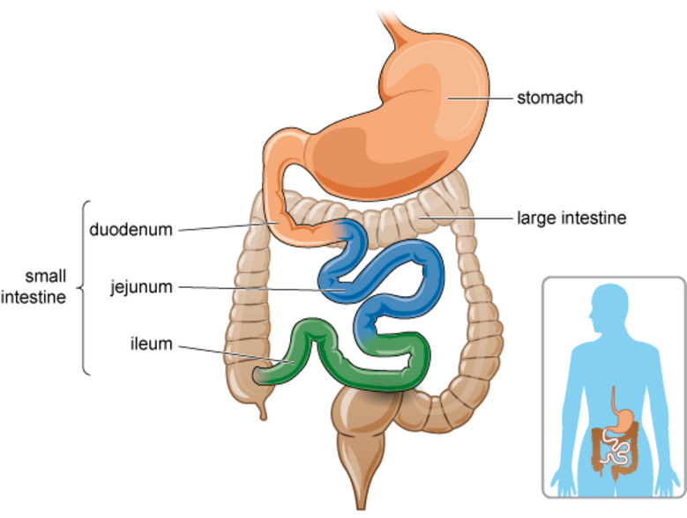
Figure 2 Simplified representation of some components of the gastrointestinal tract (gut)
View description - Figure 2 Simplified representation of some components of the gastrointestinal tract ...

During this free course, The gut microbiome – balancing the body, you will initially explore the gut microbiome in more detail. You will learn about the typical components of the gut microbiome, and how every human’s microbiome is unique, before moving on to consider the various functions of the gut microbiome. You will then look at factors that can affect the microorganisms of the gut microbiome, and how this can contribute to the development of a number of common health conditions. The course will conclude by briefly looking at some of the ways in which we can improve the health of our gut microbiomes.
After studying this course, you should be able to:
- demonstrate and understand what the gut microbiome is and outline how it functions within the human body
- describe some of the ways the gut microbiome can be altered by factors including genetics and age, as well as lifestyle factors, such as diet and exercise
- explain the importance of the gut microbiome for human health
- recognise the impact of dysbiosis on the development of various health conditions
- outline strategies to improve the health of the gut microbiome.
This OpenLearn course is an adapted extract from the Open University course SK190 Human biology: a body in balance.

1 What are microbiomes?
Humans live in a variety of environments, such as cities, deserts, river deltas and mountain tops. Humans also live alongside a wide variety of animals and plants, eat a large variety of foods, and travel to diverse environments. Microorganisms, also known as microbes, can be found in all these environments alongside humans. Microorganisms are usually single-celled (for example, bacteria) or multi-celled (such as some fungi) that can only be seen through a microscope.
The warm core temperature of the human body and resource-rich internal environment makes the human body optimal for the growth and maintenance of the body’s own cells. However, it also means that this is an ideal environment for the growth and survival of some microorganisms.
The vast majority of microorganisms that humans encounter on a daily basis are harmless. However, some microorganisms can invade the body and use resources at a cost to the human host, or excrete damaging waste products and toxins, all of which can cause disease or even death. These microorganisms are called pathogens and are potentially disease-causing microorganisms. Pathogen is a broad term that encompasses different types of microorganisms, including bacteria, viruses, fungi, protozoa and parasites. Some molecules are disease-causing too, such as toxins and prions. However, some microorganisms can actually be beneficial to humans, and these are known as symbionts, and this includes the microorganisms of the microbiome.
Often, the terms microorganisms, microbiota and microbiome are used interchangeably, which can be confusing. However, they have all have slightly different meanings and this is shown in Figure 3.

Figure 3 The difference between microorganisms, microbiota and microbiome

The key difference is that the microbiota refers purely to the collective group of organisms living within a specific environment, such as the gut. So, the gut microbiota is all of the bacteria, fungi, viruses, etc, that are found within the gut.

Fun fact: tricky terminology
Scientific terminology can sometimes be challenging! The words often seem very long and complicated. To help understand them, it can be useful to break the words down into smaller parts. For example, microbiome can be broken down as follows:
- micro- derived from the Greek words for ‘small’ or ‘tiny’
- -biota also has Greek origins, relating to ‘life’
- -biome translates as ‘the root of life’ and also meaning ‘community, area or environment’.
So, microbiota refers to the small living microorganisms in their specific environment. The microbiome refers to the environment and the microbiota and their genetic make-up and all the substances they produce to interact to form a community.

- Question 1
Thinking about a specific type of microorganism mentioned earlier, can you use the information above to deduce what the word ‘viriome’ means?
- This word can be broken down into ‘viri’ which relates to viruses, and ‘ome’ which, as you learnt above, means ‘community or environment’. So a viriome of an environment is the total virus content within it.

The microbiome includes the microbiota but also includes other elements, such as structural components, the metabolites (substances produced by the microbiota) and the environmental conditions themselves, such as the wall of the gut and substances it produces.
The gut microbiome is highly dynamic, with constant interaction between the human cells, the microorganisms of the gut microbiota, and the substances they produce. The microorganisms of the gut microbiota even interact and influence the behaviour of each other! You’ll learn more about this shortly.

1.1 Overview of the gut microbiome
The gut microbiome is composed of trillions of bacteria, viruses, archaea and fungi. In fact, it is estimated that there are 10¹⁴ bacteria in the gut – that’s 100,000,000,000,000 individual bacteria living in our guts! However, the microbiome is dynamic and many of these bacteria will be dying or lost on a daily basis, while it is thought that 10¹¹ new bacteria enter the gut every day, travelling from the pharynx (back of the throat) to the rest of the gastrointestinal (GI) tract.

Fun fact: Dealing with very large or very small numbers
You may have noticed that the paragraph above used two ways of writing the same number. One approach involved writing out lots of zeros, while the other approach used the number 10, raised to the power of 14 – an approach known as scientific notation.
Using scientific notation removes the difficulty of having to keep an eye on all those zeros and reduces the potential to accidentally miss one out or include an extra one! Scientific notation can be used to write very large numbers and also for writing very small numbers.
For example:
- (a) A population of 100,000,000 microorganisms could be written as 1 x 10⁸
- (b) The diameter of a particular bacterium might be written as 0.000006 m, or 6 x 10⁻⁶ m

- Question 2
In example (a) above, how many zeros are there in the number written in full, and what is the power of 10 used when the number is written in scientific notation?
- There are 8 zeros in the number written in full, and the power of 10 used in the scientific notation is 8. Essentially, you have moved the decimal point 8 spaces.

- Question 3
In example (b) above, how many zeros are there in the number written in full, and what is the power of 10 used when the number is written in scientific notation?
- There are 6 zeros in the number written in full, and the power of 10 used in the scientific notation is -6. Essentially, you have moved the decimal point 6 spaces.

This may help you to convert from a number in full, to a number of scientific notation. When converting a very large number into scientific notation, the power of 10 will be a positive value (as in example a), and when converting a very small number into scientific notation, the power of 10 will be a negative value (as in example b). To work out what the power should be, you simply count how many times you moved the decimal point.

The composition of the gut microbiome changes throughout our lives. During the first 3 years of life our gut microbiome is formed and affected by various factors, such as breastfeeding, weaning and bacteria found in the local environment. As we age, two groups of bacterial species become predominant, called Firmicutes and Bacteroidetes, which form about 90% of the gut microbiota (Arumugam, 2011).
Figure 4 shows the distribution of the most common bacterial groups found in microbiomes around the body. You may notice that the different parts of the GI tract contain different proportions of the bacteria.

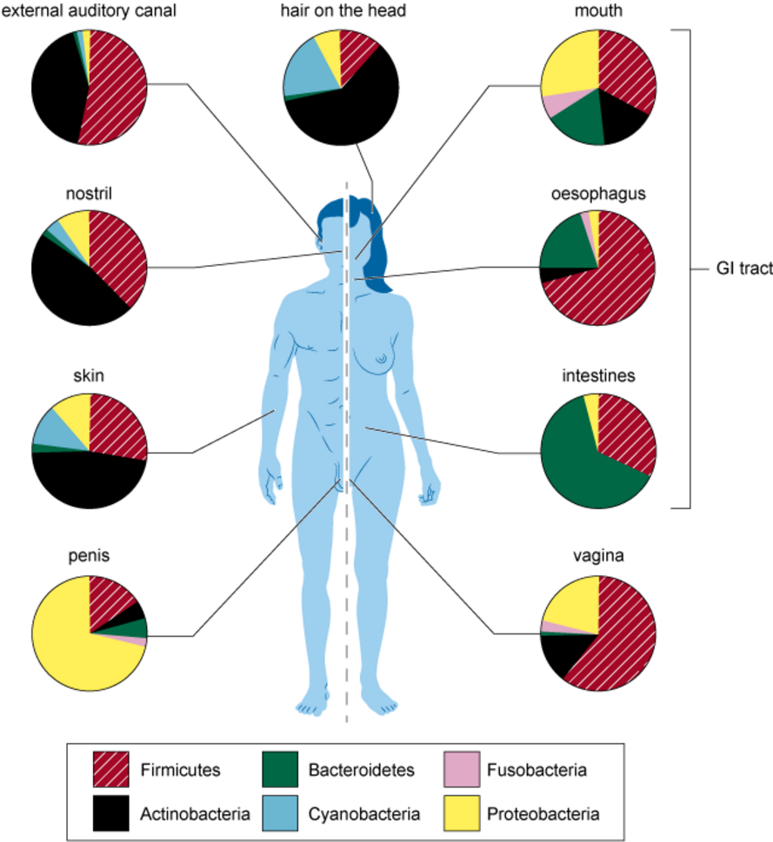
Figure 4 Distribution of bacteria found on or in different parts of an average healthy body
View description - Figure 4 Distribution of bacteria found on or in different parts of an average healthy ...

- Question 4
What is the most common bacterial group in the oesophagus and in the intestines?
- Firmicutes is the most common group of bacteria in the oesophagus, while Bacteriodetes is the most common bacterial group in the small and large intestines.

The six most common bacterial groups found in the microbiota are Firmicutes, Bacteroidetes, Fusobacteria, Actinobacteria, Cyanobacteria and Proteobacteria. The distribution of bacterial groups or species in an individual forms their enterotype, and this is named after the predominant bacterial type present in that individual. For example, an individual with the highest proportion of Bacteroidetes in their gut microbiome would be referred to as having a Bacteroidetes enterotype. The identification of these enterotypes may have important consequences for health (you’ll learn more about the importance of bacterial diversity and balance later).
The bacteria of the gut microbiome interact with the local gut environment and with each other to play several important roles in the human body. These fall into five main functional categories:
- metabolic
- structural
- protective
- communication
- immune.
You will explore the many functions of the gut microbiome in detail later in the course.

1.2 Balancing the gut microbiome
The balance between the different bacterial groups within an individual’s enterotype is important in maintaining health, as is the balance between pathogenic and symbiotic bacteria of the microbiome. In fact, some microorganisms within the microbiota actually help to maintain this balance between pathogens and beneficial/harmless microbiota (working alongside the immune system) to avoid the development of disease.
In Figure 4, you saw that there is a different distribution of bacteria contained within the different microbiomes around the body. While this figure shows the typical distribution of bacteria, every human actually has a unique combination of microorganisms that form their microbiota. This can be seen in Figure 5, which shows the bacterial groups of the gut microbiota from five individuals.

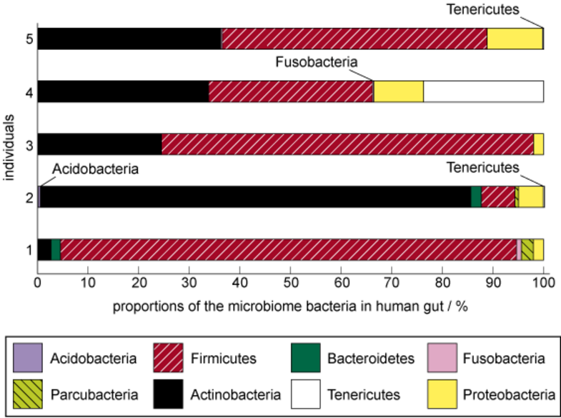
Figure 5 Bar chart (presented horizontally) showing the proportions of the different bacterial groups making up the microbiota within the gut of five individuals
View description - Figure 5 Bar chart (presented horizontally) showing the proportions of the different ...

- Question 5
Based on the information in Figure 5, which individual has greater diversity in their gut microbiota, individual 1 or individual 3?
- Individual 1 has 6 bacterial groups present in their gut microbiota. In contrast, individual 3 has three bacterial groups present in their gut microbiota. Based on the information in the figure, individual 1 has a more diverse gut microbiota.

Fun fact: gaseous by-products!
The unique microbiota profiles of each individual produce a unique combination of gases that are made as a by-product from the food that is consumed. As a result, each individual has a unique gas profile that can be measured. It is even thought that these gases may have important functions within the body, contribute to the development of diseases and might even be useful for the treatment of some conditions in the future! (Kalantar-Zadeh, 2019)

There are many factors which contribute to the microbiota profile of an individual. These include:
- genetic make-up
- exposure to microorganisms during pregnancy and early postnatal development
- geographical exposure to different environments
- diet
- exercise
- antibiotics, antimicrobials and other medications
- infection and disease
- age, including menopause.
Some factors, such as medications, menopause and disease, reduce the diversity of the organisms in the gut microbiota. Certain foods can also disrupt the normal balance of the bacterial species within the microbiota, while some other foods, pre/probiotics and exercise can improve the health of the microbiota, by promoting the growth of beneficial bacteria. All of these factors can have an impact on the health of the individual, and in the next section you are going to start to learn more about an unbalanced microbiome.

1.3 Loss of balance – dysbiosis
The importance of a healthy microbiome for human health is becoming increasingly clear. A healthy microbiome needs a good diversity of microorganisms within the microbiota and a balanced ratio of the two main bacterial groups: Firmicutes and Bacteroidetes. This is shown in Figure 6, where the Firmicutes and Bacteroidetes are shown to be in balance (the actual amounts and ratio will vary between individuals).

Fun fact: What are ratios?
Ratios are a simple way of comparing two or more quantities. In the example discussed here, the ratio would be the number of Firmicutes compared to the number of Bacteroidetes. Ratios are typically expressed as numbers separated by a colon. As a simple example, if you had 3 apples and 6 pears in a fruit bowl, the ratio of apples to pears would be 3 to 6 (3:6) or simplified to 1:2.

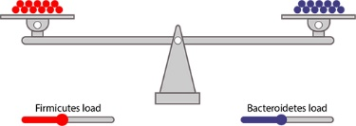
Figure 6 There is a healthy (but not necessarily equal) ratio of Firmicutes and Bacteroidetes in healthy individuals
View description - Figure 6 There is a healthy (but not necessarily equal) ratio of Firmicutes and Bacteroidetes ...

Loss of diversity of the microorganisms within the microbiota is known as dysbiosis, and can contribute to a number of conditions affecting the gut, including irritable bowel syndrome (IBS), inflammatory bowel disease (IBD), as well as affecting other parts of the body.

- Question 6
There are three mechanisms through which dysbiosis might occur. For example, there is a loss of overall bacterial diversity. Thinking back to what you have read earlier, select the correct word from the drop-down menu to complete the other two mechanisms.

Interactive content is not available in this format.

If there is a loss of bacterial diversity, the ratio between the bacterial groups Firmicutes and Bacteroidetes can change. But why is this important? As mentioned earlier, the microorganisms that compose the microbiome not only affect the cells of the human host, but also influence each other. That is, they have a symbiotic relationship with each other. Some of the microorganisms are known to secrete molecules that are beneficial for other microorganisms, and with dysbiosis these symbiotic relationships are disrupted.
Diet and pathogenic bacteria are both important causes of dysbiosis. Ultra-processed foods (UPFs), alcohol and foods rich in sugar or food additives can lead to dysbiosis. Bolte et al. (2022) found that processed or animal-based foods were associated with increased numbers of opportunistic pathogenic bacteria which reduced microbiota diversity. Conversely, plant-based foods, fish and fermented foods increased the number of healthy bacteria which helped to reduce the number of pathogenic bacteria.
Some of the common signs and symptoms of dysbiosis include:
- bad breath (halitosis)
- nausea
- bloating
- constipation and/or diarrhoea
- abdominal pain
- rash or redness
- fatigue and brain fog.
You will learn more about the role of dysbiosis in various health conditions in Section 4. First, you are going to learn more about some of the functions of the gut microbiome.

2 Functions of the gut microbiome
As you have learnt previously, the gut microbiome has important roles in the normal functioning of the human body.

- Question 7
Can you remember the five main functions of the gut microbiome?
- The five main functions are:
  - metabolic
  - structural
  - protective
  - communication
  - immune.

You will learn about each of these functions in more detail in the following sections.

2.1 Metabolic – digestion of food
The microorganisms of the gut microbiome play an important role in several metabolic processes – that is, the chemical processes that take place in an organism to produce energy or resources necessary for life.
The breaking down, or digestion, of the food we eat is an important metabolic process, as it enables us to gain energy and nutrients from food. The energy obtained from food is used as fuel by the cells throughout the body, while the nutrients are used as building blocks to manufacture important molecules.
Food is digested within the human gut via several mechanical and chemical processes, and involves many specialised molecules, called enzymes. Once broken down into smaller components, the nutrient molecules cross the gut wall and enter the bloodstream to travel around the body to where they are needed. However, certain substances cannot be digested by the human host.
While most of the digestion by the human host takes place in the stomach and small intestines, a small proportion of the food will not have been fully digested by the time it reaches the large intestine. Here, the microbiota of the microbiome produce their own enzymes which digest some of the remaining food products, particularly complex carbohydrates and dietary fibre, but also some protein and fats. The nutrients from these substances are then absorbed across the gut wall of the human host or used by the bacteria of the microbiome as a food source.
The digestion of dietary fibre by the microbiome is particularly important, as a group of important molecules are produced as a by-product. These molecules are known as short-chain fatty acids (SCFAs) and are absorbed into the human body (Figure 7) where they have several important functions.

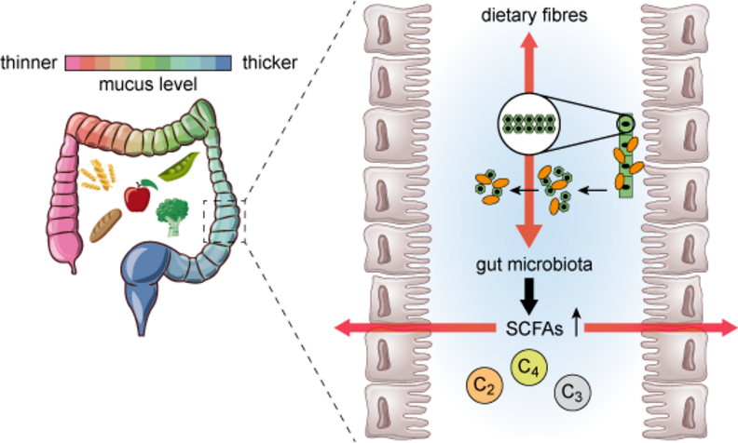
Figure 7 Role of the colon (part of the large intestine) in the digestion of dietary fibre with the production and absorption of SCFAs into the body. The long dietary fibre molecules (shown in green) are broken down into smaller molecules by the orange microorganisms of the microbiota. Some of these smaller molecules are absorbed across the gut wall, while others are used as fuel stores by the microbiota. The microbiota then produce SCFAs (shown by the circles C2, C3 and C4), which are also absorbed across the gut wall.
View description - Figure 7 Role of the colon (part of the large intestine) in the digestion of dietary ...

Fun fact: amazing molecules!
You will learn more later in this course, but in brief, SCFAs can provide energy for the body, regulate appetite, reduce obesity and insulin resistance in diabetes, destroy colorectal cancer cells, provide energy for other microbiota, and prevent gut dysbiosis. SCFAs are also involved in several communication pathways within the body, and recent evidence suggests that they can interact directly with the brain (Silva, Bernardi and Frozza, 2020) and may have a long-lasting impact on neurological and behavioural processes.

As well as producing molecules of use to the human host, some of the bacteria in the microbiome will use the fibre from the diet as their own food source. A lack of fibre can result in some bacterial groups dying out due to a lack of nutrients, leading to an imbalance in the diversity of the microbiota. This is one of the reasons having a diet high in fibre is important for maintaining good health. One type of Firmicutes bacteria, called Lactobacillus, is particularly important for digesting dietary fibre to produce SCFAs (and vitamins). Lactobacillus bacteria are found in high proportions in fermented food, such as kimchi, sauerkraut, yoghurt, and kefir, and in many probiotics (you will learn about probiotics at the end of this course).

2.2 Metabolic – production of nutrients
In addition to digesting the food we eat to provide the human host with nutrients, the gut microbiome also manufactures important micronutrients, such as vitamins and minerals, which are essential to the survival of the human host and other microbiota. For example, the B vitamins are all synthesised by the microbiome. In addition, the microbiota increases absorption of other dietary vitamins and minerals in different parts of the GI tract.
Figure 8 shows some of the dietary micronutrients and SCFAs produced by the microbiome and absorbed across the host gut wall.

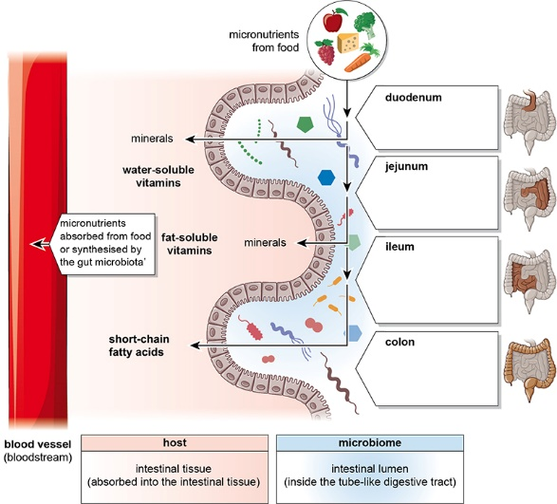
Figure 8 Micronutrients present within the intestinal gut microbiome from the dietary sources and synthesis by the gut microbiome are transported into the intestinal tissue and then into the bloodstream for the host to use
View description - Figure 8 Micronutrients present within the intestinal gut microbiome from the dietary ...

Fun fact: why is it called the ‘small’ intestine?
The length of the tube that forms the small intestine is around 6 metres in an adult, compared to the length of the tube forming the large intestine, which is only around 1.5 m in length. So, you might wonder why the small intestine is called ‘small’. The name refers to the diameter of tube, rather than length. The diameter of the small intestine is much smaller than that of the large intestine.

The B vitamins synthesised by the gut microbiome are important in the generation of energy in the cells. Some bacterial groups in the gut microbiome, such as Firmicutes and Bacteroides, synthesise:
- fat-soluble vitamins such as vitamin A, D, E, and K (around half the daily requirement of vitamin K is provided by gut bacteria)
- water-soluble vitamins – B vitamins such as folate, thiamine, biotin, riboflavin and pantothenic acid, and vitamin C.
The gut microbiome is an important additional source of the water-soluble vitamins, as levels of these vitamins in food are often inadequate and they cannot be stored in the body.

2.3 Metabolism of drugs and xenobiotic chemicals
Another important function of the gut microbiome is the metabolism of some chemicals which are foreign to the human body. Such substances are known as xenobiotics.

- Question 8
Every human is exposed to some xenobiotic chemicals during their lifetime. From your general knowledge, think of some categories of xenobiotics you may have come across before.
- Some of the categories of xenobiotic chemicals you may have thought of include food additives, such as flavourings and colourings, pesticides, cosmetics, and fragrances. You might also have considered drugs (both medicinal and recreational), industrial chemicals and environmental pollutants.

As well as producing enzymes that are important for digesting components of the food eaten by the human host, the gut microbiome also manufactures enzymes which can break down some xenobiotic chemicals (Zhoa, 2023).


Figure 9 Medications and chemicals ingested from the environment can be modified by the gut microbiome
View description - Figure 9 Medications and chemicals ingested from the environment can be modified ...

It has long been known that the human host genetics, age, sex assigned at birth, lifestyle, metabolism, disease status, other medications and environmental factors can all affect how different individuals respond to medications. This is termed individual variability in drug response (IVDR). However, recent research has shown that the gut microbiome of the individual also plays an important role in the IVDR. This new area of research has been called pharmacomicrobiomics.
As you will learn shortly, the gut microbiome can be modified (both beneficially and detrimentally) in many ways. This can potentially alter the way an individual will respond to a medication, for example, changing drug efficacy and therapeutic effects. So, this modification of the microbiome is potentially an important new way that drugs can be made more effective in an individual, or have fewer side effects and interactions with other medications.
The Human Microbiome Project (HMP) in collaboration with the National Institutes of Health (NIH) are investigating the diversity and function of the human gut microbiome (much like the Human Genome Project), to identify its impact on health human and IVDR (HMPDACC, n.d.).

2.4 Structural integrity of the gut wall
The human gut wall is made up of several layers of different tissue types, including muscle, nerves and blood vessels and an innermost mucosal layer. The cells of the mucosal layer of the small intestine secrete important enzymes for digestion of food and allow nutrients to pass through them into the bloodstream. They also secrete mucus to lubricate the contents in the gut tube. The inner layers of the gut wall are highly folded into finger-like projections known as villi, which increase the surface area of the gut (Figure 10).

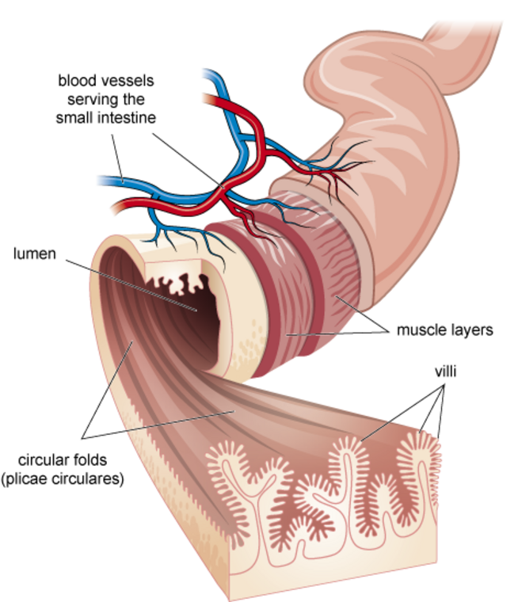
Figure 10 Schematic of the small intestine, showing the individual layers and highly folded surface of the internal layers of the gut. Blood vessels supply oxygen to the gut wall and transports nutrients to the rest of the body.
View description - Figure 10 Schematic of the small intestine, showing the individual layers and highly ...

- Question 9
Why do you think a large surface area would be useful in the gut?
- The large surface area created by the presence of villi and folds in the gut wall of the small intestine maximises the absorptive capacity of the gut (i.e. more of the nutrients obtained from the digestion of food substances, can be absorbed from the gut lumen).

The mucosal cells of the innermost layer are tightly bound to one another, to prevent pathogens in the food from crossing over into the tissue of the gut or into the bloodstream. These cells are held together by protein complexes known as tight junctions (Figure 11).

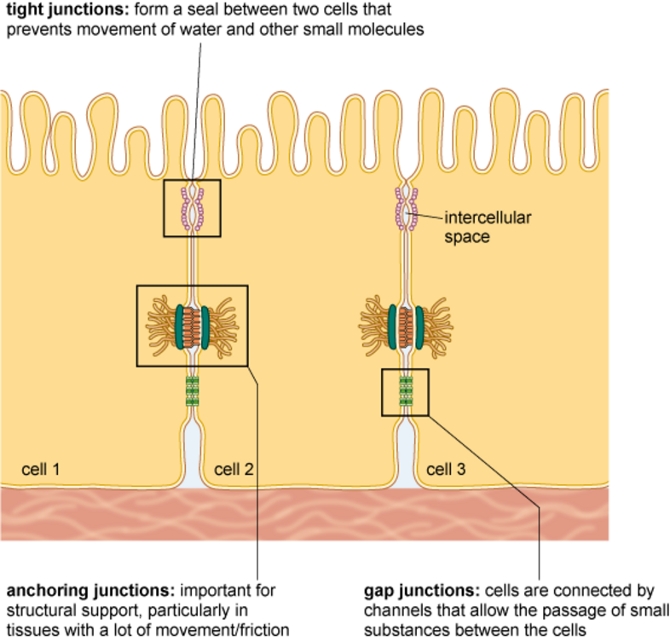
Figure 11 Cells are connected to each other by three main types of junctions: tight junctions, anchoring junctions, and gap junctions
View description - Figure 11 Cells are connected to each other by three main types of junctions: tight ...

A healthy gut microbiome helps to maintain the structural integrity of the gut wall in several ways. Firstly, it helps to regulate the proteins that are made by the human gut cells which are needed to secure the cells to each other via tight junctions. This helps to maintain the structural integrity of the gut wall and prevent it from becoming permeable to damaging substances. Additionally, the SCFAs produced by the microbiome modify the production of mucus by the gut wall, and affect how the immune cells located in the gut respond to pathogenic invaders (Sanders, 2021). These all have an important role in the health of the gut wall, and consequently the human host.
Dysbiosis is associated with increased permeability of the gut. That is, the tight junctions between the cells of the gut wall become weakened and substances that normally would not be able to cross the gut wall can enter the local tissue or bloodstream. The presence of such substances triggers an immune response, leading to significant inflammation of the gut. Several health conditions are associated with this increased permeability and inflammation, as you’ll learn later in this course.

2.5 Protection against pathogens
Another important function of the gut microbiome for human health is protection against invading pathogens (Figure 12). Pathogens can be harmful to the human host in two ways. Firstly, by penetrating through the gut wall and causing an infection and/or inflammation, and secondly by replacing some of the resident symbiotic microorganisms within the microbiome through colonisation, which then causes dysbiosis and alters the normal functioning of the microbiome.

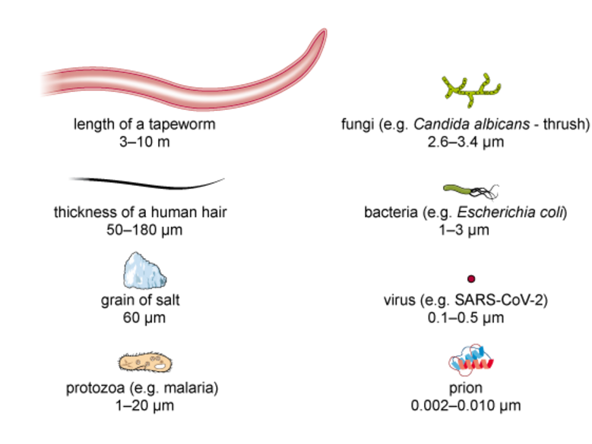
Figure 12 The six groups of pathogens illustrated with their size compared to other cells and objects
View description - Figure 12 The six groups of pathogens illustrated with their size compared to other ...

Until recently, it was unclear how the microbiome prevented colonisation by pathogens. However, recent research from the University of Oxford has identified that the beneficial bacteria of the microbiome consume the nutrients that pathogenic bacteria need to grow and replicate, so the pathogenic bacteria cannot thrive and instead die out (Spragge et al., 2023).
The researchers tried to identify if there were particular species or groups of microbiota bacteria that are important for protection against the pathogenic bacteria. While they identified that certain bacterial species were better for consuming the nutrients that the pathogens needed to survive, individual bacterial species were very poor at preventing pathogenic colonisation. Instead, the bacterial species needed to be in communities of at least 50 different types of bacterial species to fully prevent the pathogens from multiplying. This again highlights the ways in which the different bacterial species within the microbiome interact and function collectively, and the importance of a balanced microbiome.

2.6 Communication within the body
In the previous sections, you have learnt that the gut microbiome affects digestion of nutrients, structural integrity of the gut wall, prevents pathogens from entering the body and can contribute additional micronutrients to the body. However, the effects of the gut microbiome extend beyond the GI tract, and it can affect many processes throughout the body. For example, the gut microbiome can affect appetite, energy levels, metabolism, and body temperature. The gut microbiome also communicates with the brain to affect cognition (the way we think), behaviour, mood, and mental health (Bastiaanssen et al., 2020).
The gut microbiome communicates with the rest of the body and brain via:
- the nervous system (neural pathway)
- circulating hormones (endocrine pathway)
- immune cells and molecules (immune pathway).

2.6.1 Neural pathway – the microbiota-gut-brain axis
The nerve cells located in the wall of the GI tract form the enteric nervous system (ENS), which supplies the entire length of the gut. The long projections of these nerve cells extend out of the gut wall and merge to form the vagus nerve, which travels all the way up to the brain (Figure 13).

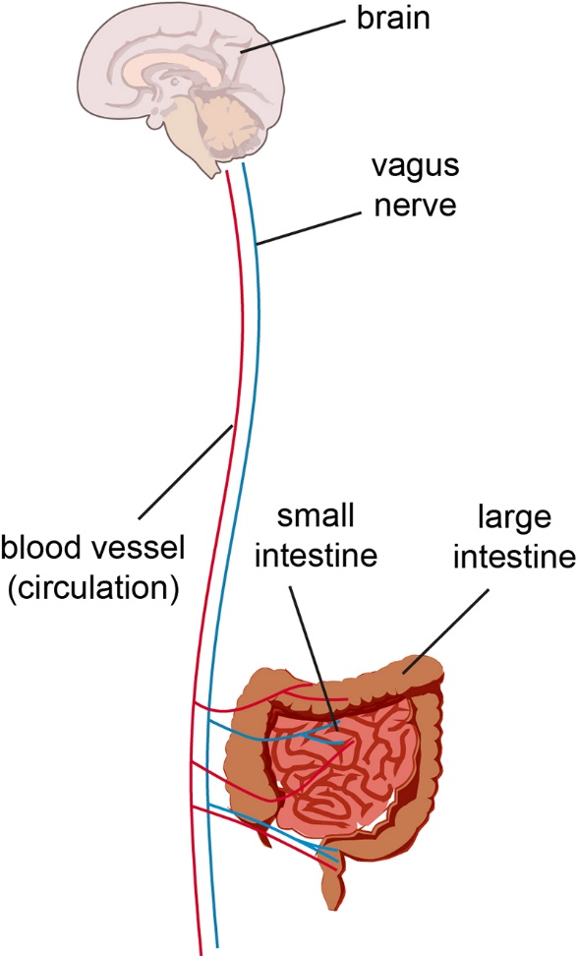
Figure 13 Simplified representation of the vagus nerve communicating between the GI tract and brain
View description - Figure 13 Simplified representation of the vagus nerve communicating between the ...

Fun fact: another brain?
The ENS is often referred to as ‘the second brain’ or ‘the brain in your gut’ because of the extensive number of nerve cells located in the gut wall. The ENS contains more than 100 million nerve cells!
The ENS can function independently, but it can also function in coordination with the brain, and this is often referred to as the gut-brain axis. The gut-brain axis is vital for regulating appetite, metabolism, and gastrointestinal function (e.g. gut motility).

As you learnt earlier, the gut microbiome produces metabolites, such as SCFAs, which pass into the cells of the gut wall. These metabolites then stimulate the vagus nerve, to send signals to the brain, such as hunger signals. However, this communication with the vagus nerve is bidirectional, and the brain can send signals back to gut to modify gut motility and other functions. This is termed the microbiota-gut-brain axis, and is shown in Figure 14.

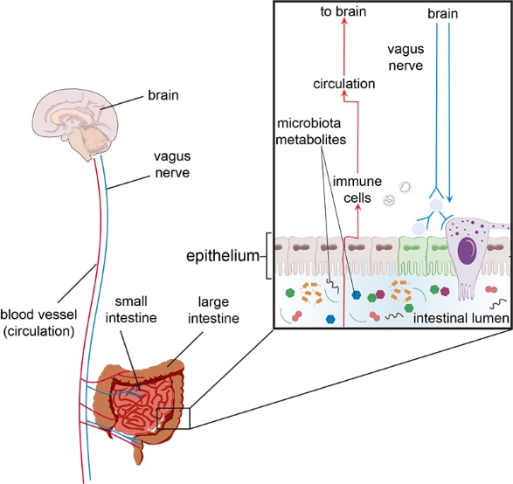
Figure 14 Microbiota gut-brain axis. Communication between the gut and brain is bidirectional. Metabolites produced by the microbiome are sensed by the intestinal cells, and this relays a signal via the vagus nerve to the brain. The metabolites can also be detected by immune cells which can directly stimulate the brain or stimulate the vagus nerve.
View description - Figure 14 Microbiota gut-brain axis. Communication between the gut and brain is bidirectional. ...

- Question 10
Earlier you learnt a way that the microbiome can directly relay information to the brain. What were the metabolites involved in this direct mechanism called?
- Short chain fatty acids (SCFA)s. The SCFAs produced by the microbiome can cross the gut wall to enter the bloodstream and travel to the brain. These SCFAs can modulate brain and behaviour to alter brain function, such as cognition (Chen, Xu and Chen, 2021).

In the next section, you’ll learn about other ways the gut microbiome can influence the brain.

2.6.2 Gut microbiome and hormone signalling
In addition to the mucosal cells lining the inner surface of the gut wall, there are specialised hormone-producing cells interspersed between them. These are known as enteroendocrine cells (EECs) where entero = gut and endocrine = hormone.
EECs are scattered all along the length of the GI tract and produce a wide range of hormones. Some of the hormones produced by the EECs act locally to affect the functioning of the gut, such as modifying gut motility. Other hormones enter the bloodstream and travel to the brain. The metabolites made by the microbiome can stimulate the enteroendocrine cells (Figure 15), to trigger the same signalling pathways resulting in messages in the brain modifying satiety, hunger, and mood.

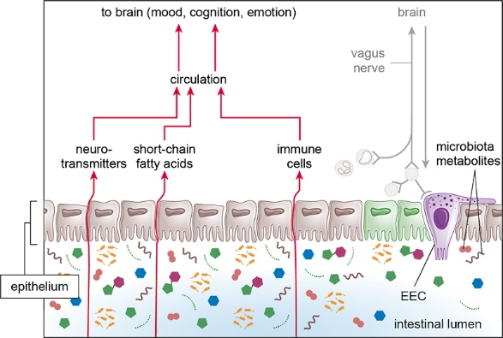
Figure 15 The location of enteroendocrine cells in the gut wall and signalling to the brain
View description - Figure 15 The location of enteroendocrine cells in the gut wall and signalling to ...

The EECs in the gut are also the largest producer of serotonin – a hormone which is important in the regulation of mood in the brain. However, some species of microbiota bacteria also directly produce and secrete serotonin and together they make approximately 95% of the body’s serotonin. Serotonin is associated with feelings of happiness, calmness, and focus, as well as the initiation of sleep. Reduced concentrations of serotonin have been linked to depression, anxiety, mood disorders and not being able to enjoy things. Recent evidence has indicated that changes in the gut microbiome can alter the amount of serotonin produced, which may provide a previously unknown mechanism for how diet and the gut microbiome can affect mood and mental health (Stasi, Sadalla and Milani, 2019).
As you can see, there are several mechanisms by which the gut microbiome could potentially help to regulate mood, cognition, emotion, and even pain.

2.7 Gut microbiome and the immune response

- Question 11
From your everyday knowledge, what, in simple terms, is the function of the immune system?
- The immune system protects the body from invading pathogens or toxins – microorganisms or substances which can cause disease or even death.

The immune system consists of several different types of immune cells, tissues and organs located throughout the body. This includes the lymphatic system, composed of lymphatic vessels that travel throughout the body and lymphatic tissue, such as lymph nodes. Lymph nodes can become enlarged during infection, when they are often referred to as swollen glands.
There are large numbers of lymph nodes in the abdomen surrounding the GI tract. In addition, the majority of immune cells in the body are located in specialised areas of gut-associated lymphatic tissue (GALT) mainly located in the wall of the small intestine (Figure 16). The tonsils, adenoids and appendix are all GALT.

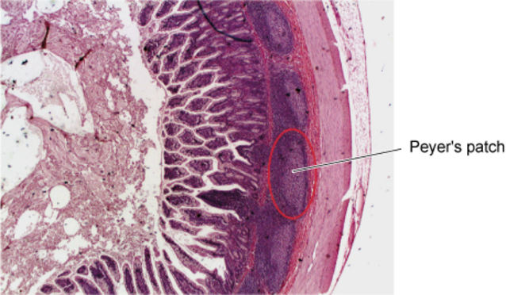
Figure 16 A cross-section of the small intestine with GALT circled in red known as a Peyer’s patch
View description - Figure 16 A cross-section of the small intestine with GALT circled in red known as ...

There is a close interaction between the gut microbiota and the GALT cells, and imbalance of the gut microbiota can alter the way in which the immune system is regulated. As you learnt earlier, the gut microbiome is important for maintaining the structural integrity of the gut wall. If this is compromised during dysbiosis, the gut wall can become more permeable to pathogens and toxins consumed in the food. This can trigger an inflammatory immune response by the GALT tissue and other immune cells located throughout the GI tract and has been linked to the development of some autoimmune conditions.
The metabolites from the microbiome can also communicate with the immune cells directly, to trigger a widespread immune response or send signals to the brain via the vagus nerve. Conversely, the immune system and stress can affect the health and diversity of the gut microbiome.

2.8 Gut microbiome and stress
Stress is the body’s physiological response to a potential internal or external threat that can involve and/or impact several of the body systems and functions. Intense, short-term threats lasting for minutes to hours are categorised as acute stress, while longer periods of stress lasting for weeks to months are categorised as chronic stress. The acute stress response results in immediate changes in the functioning of the body that are beneficial to the survival of the organism, such as increased heart and respiratory rate.
During stress, cortisol is secreted from the adrenal glands. For response to an immediate stressful event, such as threat to life or other danger, raised cortisol is important for preparing the body to respond to the threat, such as increasing energy levels and awareness. Part of the response to cortisol is to redirect blood away from the gut to organs vital for survival, such as muscles for running and heart for delivering oxygen to the muscles. Video 1 contains a brief summary of some of the effects of the acute stress response on the body.

Video content is not available in this format.
Video 1 Overview of body systems affected by the acute stress response
View transcript - Video 1 Overview of body systems affected by the acute stress response

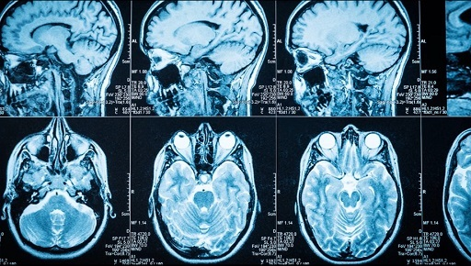

With prolonged or chronic stress, cortisol levels stay high for prolonged periods of time. As a result, the reduced blood flow to the GI tract can have an impact on the health and diversity of the microorganisms in the microbiome. Typically, there is a reduction in the bacteria of the microbiota and an increase in pathogenic bacteria, leading to a decrease in gut microbiota diversity and dysbiosis. The pathogenic bacteria can contribute to the intestinal lining becoming more permeable, which can trigger inflammation in the gut wall. Figure 17 shows a colonoscopy of healthy, pale pink colon on the left with clear folds in the gut wall, and a swollen, red inflamed colon on the right.

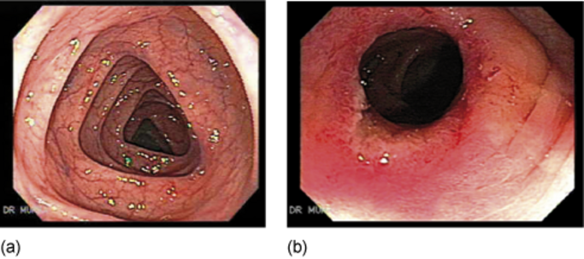
Figure 17 (a) Healthy colon; (b) Inflamed colon
View description - Figure 17 (a) Healthy colon; (b) Inflamed colon

The altered blood flow in chronic stress also affects gut motility and is linked to irritable bowel syndrome (IBS). Recent research has shown that there is altered gut diversity in patients with IBS, but whether this is a cause or effect is not yet known (Kim, 2023).
As you may be starting to see, the optimal functioning and health of the human host and gut microbiome are intertwined. In the next few sections you are going to learn about some of the factors affecting the health of the gut microbiome. You will then explore more about how imbalances in the gut microbiome can lead to several common health conditions.

3 Factors affecting the gut microbiome
There are many factors which can affect the diversity and health of the gut microbiome. Some of these factors are non-modifiable, such as our genetics and age. However, other factors affecting the health of our gut microbiomes are modifiable, that is, it is possible to alter the health of our gut microbiomes through lifestyle changes. These include diet, exercise and stress. In the next few sections, you will explore some of the modifiable and non-modifiable factors which affect the diversity and health of the gut microbiome.

3.1 Genetics of the human host
Recent research has identified that the genetic make-up of the human host can directly influence the microbiome, and vice versa.
As you will see in Video 2 below, human genetic material is composed of extremely long molecules of deoxyribonucleic acid (DNA), located in the nucleus of the cell. Within the DNA molecules are shorter sequences, called genes, which form the ‘recipe’ for the manufacture of proteins, which control many of the essential processes within the human host. However, the proteins that the human host produces can also affect the functioning of the gut microbiome. What’s particularly interesting is that recent evidence has shown that the gut microbiome can actually change which proteins are made by the human host cells. For example, the gut microbiome can affect which proteins are made by the cells of the gut wall, and this has an impact on digestion of food and the immune response to pathogens that enter the gut. Exactly how the microbiome is controlling which proteins are made by the human host cells is still not very well understood, but evidence suggests that this is through epigenetics (Alenghat, 2013). As Video 2 explains, epigenetics is the addition or removal of chemical groups from the DNA molecule, which helps to control which proteins are made in a cell at any given time.

Watch the video at YouTube.com.
Video 2 Summary of epigenetics (TED Ed talk)

The finding that the microbiome can affect epigenetic regulation of the human DNA is important for health. Epigenetic changes are highly dynamic and known to be important in regulating numerous important processes within the cells. Altered epigenetic regulation of genes is also linked to a number of health conditions, such as cancers, autoimmune disorders, neurodegenerative disorders, stress and mental health disorders. It is also well known that changes in epigenetic control of the DNA can pass down through successive generations within a family, so this may be an important target for improving health of not only the individual but their subsequent offspring.

3.2 Early exposure to microorganisms
The gut microbiome starts to develop in a fetus during pregnancy and continues to change rapidly during the first 2-3 years of life (Roswall et al., 2021).
There are several factors which affect the microbiome of the developing fetus during pregnancy, including:
- maternal microbiota
- diet
- maternal genetics and epigenetics
- medications
- infections.
The mode of delivery can affect the microbiome of the newborn. Vaginal delivery can result in transference of the microorganisms from the mother’s vagina to the newborn, while caesarean section leads to exposure to microorganisms on the mother’s skin. A shorter or longer exposure time to the maternal microbiome during gestation can also influence the newborn’s gut microbiome, so gestational age can be important.
Finally, during childhood both maternal and environmental factors play an important role in the development of the gut microbiome. These include:
- breastfeeding versus formula feeding
- maternal diet if breastfed
- child’s genetics
- child’s environment (e.g., microorganisms on toys, family)
- family lifestyle (including stress)
- geographical location.
Figure 18 highlights some of the main factors during the three stages thought to influence a child’s microbiome.

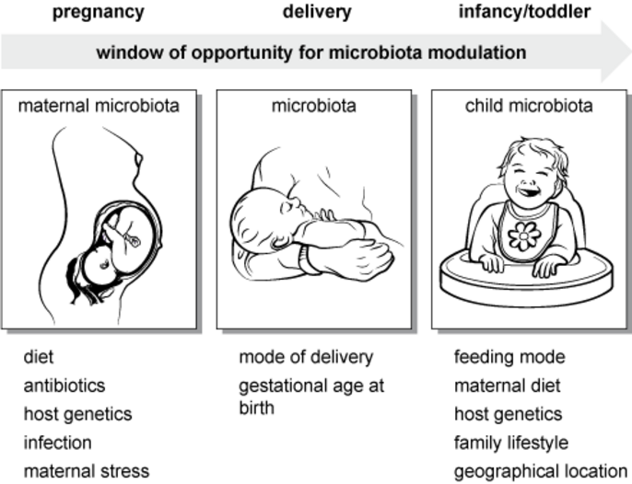
Figure 18 Microbiota development in early life
View description - Figure 18 Microbiota development in early life

3.3 Geographical location and microbiome diversity

- Question 12
Thinking back to an earlier section of this course, which are the two most common bacterial groups of the gut microbiome?
- Firmicutes and Bacteroidetes.

Interestingly, the ratio of these two groups has been found to consistently change depending on the geographical latitude of the human hosts.
The further North humans live, the more Firmicutes they have in their microbiome, whereas humans living nearer to the Equator have more Bacteroidetes (Suzuki and Worobey, 2014). As you will learn in Section 4, the ratio of Firmicutes to Bacteroidetes is important in several health conditions, such as Crohn’s disease and obesity. So, this difference in the diversity of microbiota within the microbiome may in part explain the geographical difference in some health conditions. However, it is still unclear why there is this difference, but possible contributing factors include:
- ethnicity
- diet
- Bergmann’s rule (populations at higher latitudes have on average a higher body mass to withstand colder conditions)
- climate
- other microorganism distribution, especially pathogens/parasites.
While the reasons for the geographical variations in the diversity of the gut microbiome are still not clear, and much research is underway, geographical effects do appear to play an important role in the diversity of the microbiome. However, an important consideration is that human geography is complex, and may be linked to factors such as socioeconomic status. Additionally, differing diet in different geographical regions may have a significant impact and you are going to learn more about this next.

3.4 The impact of diet
As you learnt previously, the gut microbiota digest nutrients from the diet of the human host for their own growth and survival, as well as providing the human host with important nutrients. Undigested fibre and protein results in the preferential growth of bacteria that can use these substances, and this in turn increases the production of SCFAs by these bacterial groups. SCFAs are not only important in the health of the gut itself but also throughout the body of the human host (Zhang, 2022).
As humans typically eat a diverse diet, having good bacterial diversity is also important to be able to digest and metabolise the wide range of nutrients required for good health. Dietary fibre in particular is known to be essential for maintaining a good diversity of bacteria in the gut. However, Westernised diets often contain low amounts of fibre and protein, with high levels of fat, sugar and ultra processed foods (UPFs). In contrast, diets such as the Mediterranean diet and Japanese diets, which are higher in fresh ingredients, particularly fruit and vegetables, are known to be beneficial to the health of the gut microbiome and promoting good bacterial diversity.

Interactive content is not available in this format.
Figure 19 (interactive) The effect of the Mediterranean diet compared with the Western diet on gut microbiota
View description - Figure 19 (interactive) The effect of the Mediterranean diet compared with the Western ...

Not only does high fibre maintain the diversity of the bacteria within the gut microbiome, but it also helps to reduce colonisation by pathogenic bacteria and improve the mucus barrier of the gut wall. Diets which are low in fibre increase the risk of a number of health conditions, including obesity, heart disease, some cancers, and diabetes.
Another important aspect of diets high in fresh food, particularly fruit and vegetables, are higher levels of micronutrients (vitamins and minerals). This helps to increase the proportion of Firmicutes (and so SCFA-producing bacteria). For example:
- Vitamins A, B6, B12, D and E – increases Firmicutes compared to Bacteroidetes, which helps SCFA-producing bacteria thrive.
- Calcium with phosphorous increases SCFA-producing bacteria.
- Vitamin C has antioxidant properties to protect against damage to cells by some metabolites.
Both high sugar levels and UPFs found in Westernised diets can change the gut microbiome diversity and are associated with inflammation of the gut wall (Shi, 2019).

- Question 13
What is the name of an imbalanced gut microbiome, or one lacking diversity?
- Dysbiosis.

Microbes and additives in the UPFs have been found to lead to dysbiosis of the microbiome. This results in an increase in pathogenic bacteria, reduced structural integrity of the gut wall with increased permeability, inflammation of the gut wall and altered signalling via the microbiota-gut-brain axis. This has been linked to several immune conditions, such as Crohn’s disease, ulcerative colitis and rheumatoid arthritis.
Introduction of beneficial bacteria or their products, such as SCFAs, can help to reverse these effects. However, prolonged consumption of a Westernised-type diet or UPFs can lead to permanent changes in the microbiome, gut wall and wider responses to the microbiome throughout the body. This is at least partly due to epigenetic changes of the human host which, as you learnt earlier, can also be passed down through the generations (Zinocker, 2018).

3.5 Exercise
Exercise is well known for having multiple health benefits, for both physical and mental health. Despite this, finding time and motivation to exercise can sometimes be challenging. While finding time for exercise may remain elusive, recent research has shown that the gut microbiome may actually play a role in increasing motivation. Certain metabolites made by the gut microbiome can relay signals to the pleasure/reward centre of the brain via the microbiota-gut-brain axis. This improves motivation to exercise, as well as exercise performance, and may help to explain why there is variability between individuals around motivation and pleasure from exercise (Dohnalová, 2022).
Conversely, exercise can help to improve the health of the gut microbiome. Higher intensity or prolonged exercise improves cardiorespiratory fitness. This leads to improved oxygen intake and transport around the body in the bloodstream, including to the gut wall, which is beneficial to the health of the gut bacteria (Mailing, 2019). In fact, the distance runners regular undertake can correlate to the ratio between Bacteroidetes and Firmicutes!

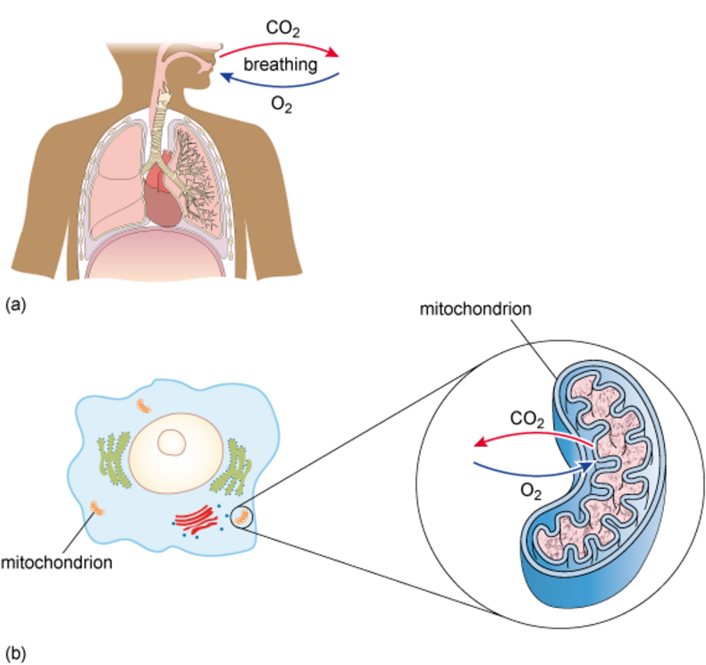
Figure 20 (a) Breathing in (inspiration) and breathing out (expiration) allows the exchange of oxygen and carbon dioxide; (b) The cells use the oxygen to generate energy in the mitochondria. Carbon dioxide is produced as a waste product.
View description - Figure 20 (a) Breathing in (inspiration) and breathing out (expiration) allows the ...

Recent research has shown that some elite endurance runners have an increase in a bacterial species called Veillonella. This species is thought to increase the amount of lactate that the athlete can tolerate, which in turn is linked to the function of mitochondria in the cells. Mitochondria are often called the ‘powerhouses of the cell’ as they produce the majority of the body’s energy (Figure 20). The metabolites produced by the microbiome, such as SCFAs, can improve the health and number of the mitochondria (Damman, 2024).
Lower intensity exercise helps to reduce transit time of the stool, that is, the stool passes through the GI tract faster. This reduces the amount of time pathogenic bacteria can come into contact with the gut wall and potentially displace the microorganisms of the microbiome. There is also an increase in SCFAs produced during low intensity exercise, which reduce the risk of colorectal cancer and Crohn’s disease. Exercise is also known to reduce the risk of both of these conditions (Monda, 2017).
However, exercise should not be considered in isolation. High intensity exercise combined with a diet high in UPFs has been linked to increased gut permeability and an increase in musculoskeletal injuries (Álvarez-Herms, 2023). This indicates that there is an important balance needed between a healthy diet and exercise, in order to maintain the optimal health of the gut microbiome.
Interestingly, the benefits of exercise on microbiome health are more pronounced during childhood, so it has been proposed that children who exercise more frequently will have a better microbiome diversity. This results in better brain development, more lean mass, and better energy regulation.

3.6 Medications
As you learnt earlier, the gut microbiome is now known to affect how different medications, recreational drugs and other chemicals are processed in the body and this can contribute to IVDR.

- Question 14
From earlier in this course, can you remember what IVDR stands for?
- Individual variability of drug response.

Recreational drugs, medications and other chemicals can also directly affect the gut microbiome.

- Question 15
From your general knowledge, which type of pathogenic organisms are treated by using antibiotics?
- Antibiotics are given for the treatment of bacterial infections (they are sometimes prescribed as a preventative manner too, if an individual has particular health conditions or illness).

- Question 16
How might antibiotics affect the gut microbiome?
- Antibiotics might change the number and diversity of the bacterial groups within the gut microbiome.

Indeed, antibiotics and non-antibiotic drugs, such as proton-pump inhibitors (PPIs) (which are often used to treat acid reflux), statins (which can lower cholesterol in the blood), laxatives, and chemotherapies can change the composition of the gut microbiome. These are typically associated with a reduction in the biodiversity of the bacteria within the gut microbiome (Weersma, 2020). However, often individuals who are taking these medications need to do so for significant health reasons, so an important balance needs to be achieved to maintain good overall health.


Figure 21 Medication packages
View description - Figure 21 Medication packages

It can therefore be helpful for individuals who regularly take antibiotics or certain groups of non-antibiotic medications to use pre- or probiotics (as you’ll explore later in this course).

3.7 Infection and disease
One of the important functions of the gut microbiome is to reduce the risk of harmful pathogenic bacteria from colonising the gut. A reduction in healthy bacteria can lead to infection caused by the pathogenic bacteria, such as Clostridium difficile (C. difficile) and Helicobacter pylori (H. pylori). Both of these infections can have significant impact on health, and H. pylori is an important cause of stomach ulcers.
Changes in the gut microbiome has also been shown to be associated with the severity of the response to infection with the SARS-CoV-2 virus – the virus which causes COVID-19 (Figure 22).

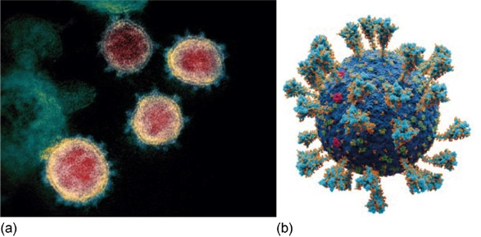
Figure 22 (a) A transmission electron micrograph shows four red-orange coloured SARS-CoV-2 coronaviruses, with the typical ‘corona’ appearance around the virus; (b) A 3D representation of the SARS-CoV-2 virus with the spike proteins, which have a key role in enabling the virus to enter host cells and cause infection.
View description - Figure 22 (a) A transmission electron micrograph shows four red-orange coloured SARS-CoV-2 ...

Yeoh et al. (2021) found that in patients with COVID-19, there was a reduction in the gut bacterial groups which would usually promote a good immune response. The more severe the disease, the more significant the changes in the gut microbiome. The researchers also found that these changes persisted for more than 30 days after the symptoms had resolved and proposed that dysbiosis may play a role in the development of post-COVID syndrome (more commonly known as long COVID). In some individuals, symptoms such as breathlessness, fatigue and pain persist for a prolonged period – in some instances even years – following initial infection.

3.8 Age and the menopause
The composition of the gut microbiome changes with age, and this is particularly noticeable after the age of 65 years. The changes that occur can reflect the physical fitness, frailty, and longevity of the individual. In healthy ageing, there is consistently a depletion of some of the core bacterial groups, particularly Bacteroidetes. In contrast, individuals assessed as having a higher degree of frailty have an increase in the levels of Bacteroidetes (Wilmanski, 2021). The decrease in Bacteroidetes seen in healthy ageing also appears to be associated with longevity, and individuals over 100 years of age typically have fewer Bacteroidetes and an increase in rare bacterial groups.
Often these changes in gut microbiome diversity reflect the environmental and personal factors that an individual has been exposed to during their lifetime. As we age, there is age-related decline in the structural integrity of the gut wall, to our internal physiology, and there are many molecular and cellular changes, such as epigenetic changes, all of which can have an impact on the gut microbiome. As a result, an important area of scientific research is exploring the impact of environment, diet, exercise, disease, medication and societal factors and their impact on the ageing gut microbiome (Ghosh, 2022). A better understanding of these factors will hopefully help to promote better health and longevity in ageing (Figure 23).


Figure 23 (a) Ernestine Shepherd and (b) Toshisuke Kanazawa, body builders aged 80 and 81 years, respectively, at the time of these photos, demonstrate that it is possible to maintain good physical health and fitness in the later decades of life
View description - Figure 23 (a) Ernestine Shepherd and (b) Toshisuke Kanazawa, body builders aged 80 ...

One particular period of life that affects females is the menopausal period.

Fun fact: are perimenopause and menopause the same thing?
In everyday language, the two terms are often used interchangeably, however, the scientific terminology is more precise. From the age of approximately 40–44 years onwards, most females will enter the perimenopause, which is a transitional period which can last several years. During perimenopause, hormone levels fluctuate and there are often changes in the pattern of menstruation. The menopause is a specific moment in time, defined by the NHS as being when there has been no menstruation for a year in females over 50 years, or for two years, if under 50 years of age. The average age of the menopause in the UK is 51 years of age.

There is a sex-related difference in the microbiomes of males and females, however, during the perimenopause and post-menopausal period there is a reduction in diversity and the gut microbiome in females becomes more similar to males (Peters, 2022). At present, there is very little research into the changes in the gut microbiome during the menopausal period, and how hormonal changes contribute to this alteration in bacterial diversity. There are many health-related risks associated with the menopause, and it is unclear whether modification of the gut microbiome after the menopause may help to reduce the risk of developing some of these conditions. Therefore, more research into this area will be essential to try to improve the health and wellbeing of post-menopausal females.

4 Impact of dysbiosis on health
As you have seen from the previous sections, the relationship between the gut microbiome and human host is truly symbiotic. The anatomy, physiology and health of the human host affects the composition and functioning of the microbiome, which in turn has an impact on many different structures and processes within the human body.
It is becoming increasingly clear that an alteration or reduction in the diversity of microbiota, or dysbiosis, is linked to several very common health conditions. These health conditions can often be debilitating or life-threatening, so understanding the role of the microbiome in their development will not only improve the design of better treatment plans but may also help to reduce the risk of developing these conditions in the first place.
In the next few sections, you will explore some of the conditions known to be linked to dysbiosis in more detail. You will then finish this course by looking at some of the current ways that the microbiome can be modified to improve patient outcomes and some potential future treatment options.
Two common conditions affecting the GI tract are inflammatory bowel disease (IBD) and irritable bowel syndrome (IBS). Sometimes, these two terms are used interchangeably among the general public, and although some symptoms may overlap, they are very different disorders, with very different treatments and prognosis, as you will learn next.

4.1 Inflammatory bowel disease – Crohn’s disease and ulcerative colitis
IBD is a group of two chronic inflammatory diseases which includes Crohn’s disease and ulcerative colitis (UC). These two immune conditions can be identified using diagnostic testing and imaging techniques. Genetics, environmental factors, and dysfunction of the individual’s immune system are important in the development of both Crohn’s disease and ulcerative colitis.
In addition, recent research has shown that many individuals with IBD have dysbiosis, which may be a key step in the early development of the disease. Dysbiosis in the gut microbiome leads to the colonisation of opportunistic harmful pathogens and increased permeability of the gut wall. This in turn triggers an immune response by the host, which can lead to extensive and damaging inflammation in the gut.
Inflammation in the gut wall in Crohn’s disease and ulcerative colitis can be seen using an endoscope. An endoscope is a long thin tube with a camera on the end, that is passed through the mouth or via the anus, to view the gut wall. Viewing of the upper GI tract is by gastroscopy, which enables observation of the stomach and first part of the duodenum. Viewing of the large intestine (colon), rectum and anus is via colonoscopy. In a healthy individual, the surface of the gut is smooth, and you can see the blood vessels. In IBD the gut wall becomes red, swollen, and raised in patches due to inflammation and ulceration.

Interactive content is not available in this format.
Figure 24 (interactive) Endoscopic images of a healthy gut wall and inflamed gut walls in ulcerative colitis in the large intestine (colon)
View description - Figure 24 (interactive) Endoscopic images of a healthy gut wall and inflamed gut ...

While Crohn’s disease and ulcerative colitis are both considered IBD, they differ in the severity, location and extent of the damage to the GI tract by the inflammation (Table 1)

Table 1 Comparison of Crohn’s disease and ulcerative colitis
Crohn’s disease | Ulcerative colitis
Inflammation and ulceration in any part of the GI tract, from the mouth to the anus. | Inflammation and ulceration only found in the large intestine, rectum and anus (colitis = inflammation of the colon).
Ulceration occurs in patches. | Ulceration tends to be continuous.
Inflammation penetrates and leads to destruction of the entire thickness of the gut wall. | Inflammation only affects the inner layer of cells lining of the gut wall.
Widespread damage to other abdominal organs and cavity can occur. | Damage localised to the GI tract.
Multiple other parts of the body outside of the GI tract can be affected, both within the abdominal cavity and other tissues/organs throughout the body. | Inflammation also affects other body parts, such as eyes, skin, liver and joints.

Common signs and symptoms of both diseases are persistent diarrhoea, blood and mucus in faeces, abdominal pain and cramps, bloating and swelling, weight loss and extreme tiredness. Both conditions are often associated with poor digestion and absorption of nutrients, causing deficiencies that can affect other parts of the body. These deficiencies are normally dependent on the location and extent of the damage to the gut wall and tend to be worse in Crohn’s disease due to small intestine involvement, which is the main site of nutrient absorption.
Both Crohn’s disease and UC have been linked with dysbiosis. You may recall from earlier that in a healthy gut microbiome, there is a balanced ratio of Firmicutes and Bacteroidetes with typically slightly more Bacteroidetes than Firmicutes (although this varies by individual, age, and geographical region). However, in IBD there is often an increase in Bacteroidetes, which results in significantly more Bacteroidetes than Firmicutes. The Firmicutes/Bacteroidetes (F/B) ratio influences other microorganisms within the microbiome and is important for maintaining normal intestinal function and protecting against inflammation.

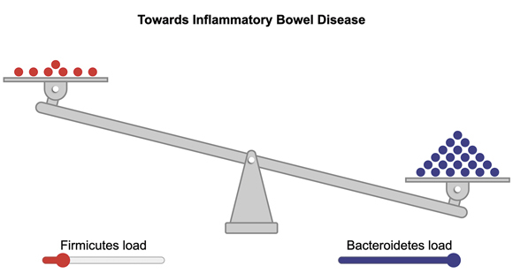
Figure 25 The Firmicutes to Bacteroidetes ratio in inflammatory bowel disease is altered
View description - Figure 25 The Firmicutes to Bacteroidetes ratio in inflammatory bowel disease is ...

- Question 17
What important molecule do Firmicutes produce in the gut microbiome? (Look back over Section 3 for a reminder.)
- SCFAs, which protect against inflammation and help maintain the gut integrity.

There is currently no cure for either disease. However, treatments which modify the immune system to reduce inflammation and to alleviate the symptoms can be effective. Research into the benefits of taking probiotics in IBD are still very limited. A study by Stojanov, Berlec and Štrukelj (2020) suggests that orally administered, pharmaceutical-grade probiotics could help restore the F/B ratio in IBD by increasing the amount of Firmicutes and achieving a more balanced F/B ratio. While there is some early evidence to suggest that it may reduce inflammation and trigger remission (a reduction in disease pathology) in ulcerative colitis, to date there has been no evidence of a benefit in Crohn’s disease (Limketkai et al., 2022).

4.2 Irritable bowel syndrome and small intestinal bacterial overgrowth
In contrast to IBD, the causes of irritable bowel syndrome (IBS) are currently poorly understood, but it is thought to be a collection of disorders rather than one single disease, all of which affect the functioning and motility of the GI tract. IBS is characterised by abdominal pain, change in stool consistency and stool frequency (diarrhoea or constipation). The different subtypes of IBS are based on stool consistency.
Historically, IBS was thought to be primarily due to altered gut motility and gut-brain interactions, which was triggered by psychological stressors. However, recent research has indicated that there are other factors involved in the development of the condition, including alterations in gut permeability, immune response and gut microbiome.
It is thought that dysbiosis leads to inflammation and increased permeability of the gut wall. Often this is triggered by an infectious episode of gastroenteritis, irrespective of the cause of the infection (e.g. bacterial, viral, or fungal). This infection then affects the stability and diversity of the microorganisms of the microbiome (Menees, 2018). However, the infection alone is unlikely to be enough of a triggering factor, and the individual may need to have other susceptibilities in order for IBS to develop.
Another potential risk factor that links dysbiosis of the gut microbiome and IBS is small intestinal bacterial overgrowth (SIBO).

- Question 18
In which part of the GI tract are the majority of gut microbiome found?
- The majority of the gut microbiome reside within the large intestine.

However, it is possible to get an overgrowth of the healthy bacterial groups from the microbiome or pathogenic bacteria (or a combination of both) in the small intestine. This leads to excessive usage of nutrients by the bacteria so fewer nutrients are absorbed into the human host. This is termed SIBO. SIBO can trigger an immune response, increase intestinal permeability, and alter carbohydrate digestion and absorption. All of these are similar to the effects of dysbiosis in IBS. In SIBO, the bacterial overgrowth often produces higher quantities of gas, causing bloating and flatulence, symptoms often described in IBS patients. This overlap of signs and symptoms suggests that SIBO may play an important role in IBS. However, it is currently unknown whether SIBO could be a cause of IBS or a consequence of the condition (Figure 26).

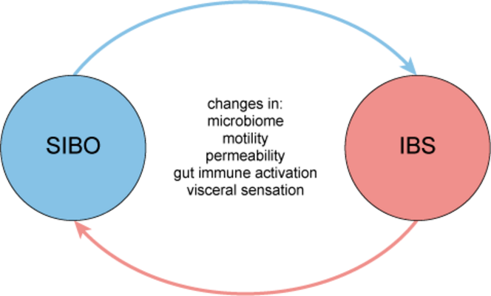
Figure 26 Small intestinal bacterial overgrowth: the chicken or the egg?
View description - Figure 26 Small intestinal bacterial overgrowth: the chicken or the egg?

Several studies have reported promising results on the benefits of pre- and probiotics in improving the quality of life and reducing symptoms in IBS, but more work needs to be done to identify which substances and strains are most beneficial for which subtypes. You will learn more about pre- and probiotics in the final section.

4.3 Obesity and Type 2 diabetes
The World Health Organisation (2022) defines obesity as abnormal or excessive fat accumulation that presents a risk to health. Obesity is a complex, multifactorial condition linked to a wide range of genetic and non-genetic factors, including environmental, lifestyle, socioeconomic and psychological factors. The primary cause of obesity is an imbalance between the energy consumed by an individual and the energy they expend.
The gut microbiome is involved in energy usage and digestion of carbohydrates for the human host, so the gut microbiome is thought to play a key role in energy balance. Dysbiosis is a frequent finding in obesity, which may affect how those individuals extract and use energy from food (Boccuto, 2023).
You may recall that the ratio of Firmicutes to Bacteroidetes (F/B ratio) is important for a healthy microbiome and human host.

- Question 19
In inflammatory bowel disease (IBS – Crohn’s and UC) there is an imbalance in the F/B ratio. Is there a shift towards more Bacteroidetes or more Firmicutes?
Bacteroidetes
Firmicutes

In contrast, in obesity there is again a loss of the healthy F/B ratio, but this time with a shift towards more Firmicutes and less Bacteroidetes (Figure 27).

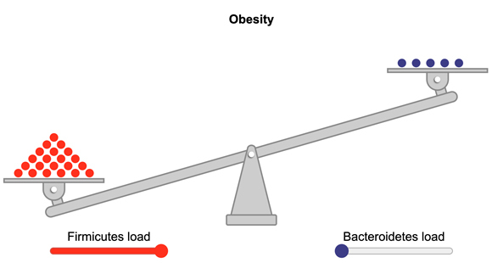
Figure 27 The F/B ratio in obese individuals typically shows an increase in Firmicutes and reduction in Bacteroidetes
View description - Figure 27 The F/B ratio in obese individuals typically shows an increase in Firmicutes ...

Fun fact: complex interactions
Research has shown that specific types of bacteria are linked to obesity. However, perhaps unsurprisingly, research suggests this is highly complex! For example:
- Christensenellaceae – associated with weight loss
- Akkermansia muciniphila – associated with weight loss
- Lactobacillus paracasei – associated with a reduction in obesity
- Lactobacillus reuteri and Lactobacillus gasseri – increase in obesity
- Bifidobacterium – increase in obesity

As you can probably tell, unpicking the role of the different bacterial species in obesity is challenging as there are an estimated 500-1000 different types of bacteria in the gut microbiome! As the bacterial species also influence each other, trying to identify the role of a single bacterial species in obesity may not give true understanding of what happens when you combine all the influences of the entire gut microbiota, microbiome and human host. However, this is still a promising area of research into obesity and understanding some of challenges that individuals may face in losing weight. Finding a way to improve the gut microbiome may also help some individuals with their weight loss goals.
One of the conditions commonly linked with obesity is Type 2 diabetes (T2D). In T2D, the body has poor sensitivity to insulin, the hormone which helps to reduce blood glucose (sugar) levels.

- Question 20
In T2D, are blood glucose levels likely to be higher than normal or lower than normal?
Higher than normal
Lower than normal
- Higher than normal.
In T2D the prolonged unregulated blood glucose sugar levels can result in damage to multiple parts of the body.

Dysbiosis is a common finding in diabetics and is related to poor sensitivity to insulin and poor control of blood glucose levels (Sadagopan, 2023).
Obesity and Type 2 diabetes are rising at a rapid rate, with both being among the ten most common health conditions globally. So, addressing gut dysbiosis to improve the health of the gut microbiome raises the possibility of providing a fairly cheap and easy mechanism to reduce the impact of these conditions, both for the individual and globally.

4.4 Colorectal cancer
Colorectal cancer (CRC – cancer of the colon and/or rectum) is the third most common cancer worldwide and is often associated with dysbiosis of not just the gut bacteria, but also other microorganisms found in the gut microbiome, such as viruses, fungi, and Archaea (World Health Organization, 2023).

- Question 21
What role does the gut microbiome have in the fibre consumed in the diet?
- Fibre cannot be digested by the human host but is digested by some of the bacterial species of the gut microbiome (particularly Firmicutes). These bacteria then produce SCFAs as a by-product, which are beneficial for the other bacteria of the gut microbiome and human host.

SCFAs produced by the gut microbiome are also protective against colorectal cancer cells, helping to destroy them.
A study found that in colorectal cancer, the more fibre (particularly from cereal fibre and whole grains) consumed, the lower the estimated risk of developing colorectal cancer (Aune et al., 2011). This can be seen in Figure 28. As fibre consumption increases, the risk of developing colorectal cancer decreases.

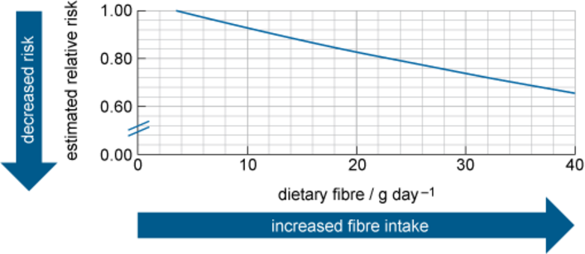
Figure 28 Colorectal cancer risk decreases as the consumption of dietary fibre in grams per day (g day⁻¹) increases
View description - Figure 28 Colorectal cancer risk decreases as the consumption of dietary fibre in ...

- Question 22
From Figure 28, what is the estimated risk of developing colorectal cancer if you consume around 20 g of fibre a day?
- The relative risk is just above 0.80. This equates to an approximate 20% reduction in the likelihood of developing colorectal cancer.

A diet high in fibre helps to ensure that the Firmicutes bacteria survive and thrive to produce lots of beneficial SCFAs, but is also thought to be beneficial in reducing CRC risk in other ways:
- Fibre increases the bulk of the stool, so it travels through the gut more rapidly, reducing contact of the gut wall with cancer-causing substances (carcinogens).
- Fibre increases the feelings of fullness which helps to prevent overeating. Obesity is also linked to colorectal cancer, as well as 12 other types of cancer (Cancer Research UK, 2022).
As you may recall from earlier, the gut microbiome also affects how individuals respond to medications and recreational drugs. This includes chemotherapeutic agents and immunotherapy often used in the treatment of colorectal and other cancers. Therefore, the gut microbiome may have an impact on both the risk of developing CRC and how well an individual responds to the treatment (Wong, 2023).

4.5 Kidney disease
The kidneys are two bean-shaped organs, found on either side of the spine, below the ribcage. Each kidney contains approximately 1 million specialised tubes, known as nephrons (Figure 29).

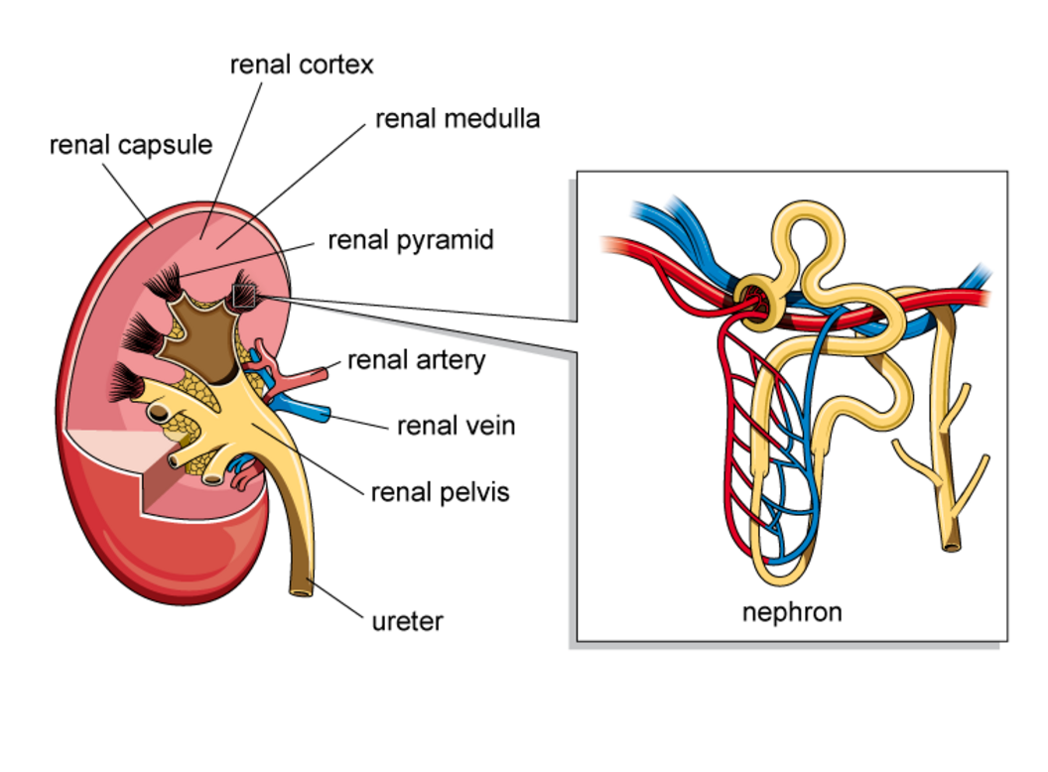
Figure 29 Schematic of a single kidney; here an enlarged nephron is shown, in reality, individual nephrons can only be seen with the aid of a microscope
View description - Figure 29 Schematic of a single kidney; here an enlarged nephron is shown, in reality, ...

The kidneys contribute to the balance of several aspects of body function. As part of the urinary system, the nephrons within the kidneys filter the blood plasma. Blood plasma is the yellowish liquid component of blood. A variety of substances are suspended within plasma, including red blood cells, several types of white blood cell and platelets (involved in blood clotting). The plasma also contains some waste materials or toxins that need to be filtered out from the plasma and removed from the body. The nephrons filter the blood plasma, and regulate the excretion of the filtered substances. The urine produced as a result of this process reflects the role of the kidneys in balancing the composition of the blood plasma and clearing substances such as metabolites and drugs from the body. The kidneys are also involved in the production of various hormones and play an important role in regulating blood pressure.
Chronic kidney disease is a long-term condition, where the nephrons become damaged, leading to a gradual loss of function. If kidney function falls to 10-15% of normal function, dialysis or transplantation are the only treatments available for the patient. It is estimated that currently 7.2 million people in the UK (Kidney Research UK, 2023) and 1 in 10 adults worldwide are believed to suffer from chronic kidney disease (Li et al., 2021).
Dysbiosis has been observed in patients with chronic kidney disease. The relationship between the gut microbiome and kidney disease is complex and is an active area of research. In kidney disease, the damaged nephrons fail to filter plasma appropriately, which changes plasma composition. Research suggests that this may alter the number and diversity of gut microbiota.

- Question 23
You learnt earlier that dysbiosis changes the structure of the gut wall. What is the name of the junction between the gut wall cells that are affected and what are the implications of this in terms of permeability?
- In dysbiosis, the tight junctions between cells of the gut wall become weakened and substances that normally would not be able to cross the gut wall can enter the local tissue or bloodstream. Dysbiosis is associated with increased permeability of the gut wall.

Due to the ‘leaky’ gut wall, some products of metabolism and toxins from food pass into the bloodstream and this has been linked to the onset and progression of kidney disease, and increased mortality risk. Conversely, other metabolites from the gut microbiome, such as SCFAs, appear to protect the kidneys and may increase survival rates of chronic kidney disease patients.
Although more research is needed, current understanding of the complex interactions between the gut microbiome and kidney function suggests that there may be the potential for improvements in patient outcomes, based on microbiome-based treatments.

4.6 Mental health
As well as having physical consequences to the health of the body, dysbiosis has been linked to a number of mental health conditions.

- Question 24
What is the name given to the interaction between the gut microbiome and brain?
- Microbiota-gut-brain axis.

Recent studies suggest that the microbiota-gut-brain axis plays a key role in depression and anxiety (Zhu, Tu and Chen, 2022). You may recall that the gut microbiome communicates with the brain via a number of routes, but particularly via:
- Nerves – nerve endings in the gut wall are triggered by substances produced by the gut microbiome and signals are relayed to the brain via the vagus nerve.
- Hormones, neurotransmitters, and other molecules (such as serotonin, SCFAs, and other important neurotransmitters involved in signalling in the brain and nervous system) – which are made by the gut microbiome and enter the bloodstream to travel to the brain (and other organs).
An altered F/B ratio, with a reduction in Firmicutes and increase in Bacteroidetes, is frequently seen in individuals with anxiety, while the reverse is more common in individuals experiencing depression. Other mental health disorders such as bipolar disorder, schizophrenia and post-traumatic stress disorder are associated in changes in the amount of other bacterial species (Xiong et al., 2023).
Some studies have suggested that dietary modifications are particularly beneficial in improving the symptoms of anxiety, even more so than pharmaceutical-grade probiotics (Yang et al., 2019). Prebiotics, dietary fibre and particularly probiotics (which you will learn about in the next section) are considered a potential therapeutic strategy for reducing anxiety, depression or improving dysbiosis (Bibbò et al., 2022; Cooke, Catchlove and Tooley, 2022).

5 Restoring/maintaining the balance of the gut microbiome
As you learnt earlier in this course, there are many genetic, environmental and lifestyle factors which can have an impact on the health of the gut microbiome and consequently the health of the human host. Dietary factors, such as reducing consumption of UPFs and increasing fresh foods and dietary fibre can reduce the risk of developing some diseases and/or improve the severity of the condition.
However, two additional means of improving the health of the gut microbiome are medical interventions: consumption of pre- and probiotics and faecal transplant.

5.1 Prebiotics and probiotics
One way in which the health of the gut microbiome can be improved is through the use of prebiotics and probiotics. Although these have similar names, they contain quite different substances designed to improve the health of the gut microbiome.
Prebiotics act as a food source for the beneficial bacteria in the gut microbiome and help those bacteria to thrive in order to improve the balance of bacteria within the microbiome. Prebiotics are typically substances that cannot be broken down by human enzymes, that can withstand the acidic environment of the stomach, and which are not absorbed in the upper GI tract.

- Question 25
Why might a prebiotic need these characteristics?
- A substance that is broken down in the acidic environment of the stomach, by human enzymes, or be absorbed in the upper GI tract, might not reach or be available to the majority of the gut microbiome, located in the large intestine.

Prebiotics are typically complex carbohydrates, and can be found naturally in high quantities in lots of different food sources, but especially:
- legumes, beans, and peas
- oats
- bananas
- berries
- Jerusalem artichokes (not the same as regular artichokes)
- asparagus
- dandelion greens
- garlic
- leeks
- onions.
In contrast, probiotics are a collection of live, beneficial microorganisms, often bacteria or yeasts, that are ingested with the aim of colonising the gut to improve the quality and diversity of the gut microbiota. Probiotic bacteria are found in fermented foods, such as live yoghurt, kimchi, sauerkraut, and pickled vegetables, but there are many other commercial mixtures and dietary supplements available too, such as probiotic yoghurt drinks and kefir.

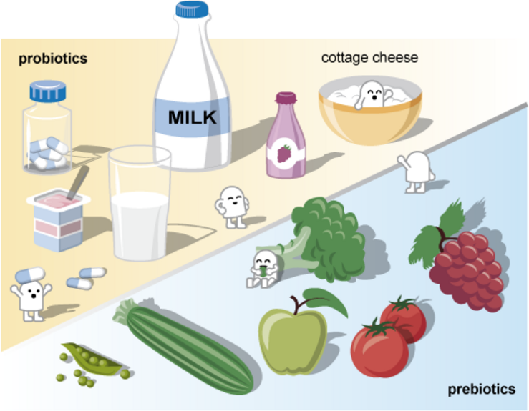
Figure 30 Prebiotic and probiotic foods. The cartoon figures represent the microorganisms in the microbiota that use the pre- and probiotics to thrive and replicate. The tablets represent probiotic supplements (dried or desiccated bacteria products)
View description - Figure 30 Prebiotic and probiotic foods. The cartoon figures represent the microorganisms ...

Pharmaceutical-grade probiotics, which contain very high amounts of microorganisms, have been shown to have some benefit in clinical trials (NHS, 2022). The high number of microorganisms in pharmaceutical-grade probiotics is thought to result in some of the bacteria being able to survive the highly acidic stomach and beyond. The benefits of commercially-bought probiotic supplements are still controversial, as they contain low concentrations of the microorganisms, the majority of which will most likely be destroyed by the highly acidic environment of the stomach. However, there is still some anecdotal evidence (i.e. not scientific, based on personal accounts) that these may provide some benefit in specific intestinal disorders. To date, there has been no scientific evidence to indicate that there is any benefit to healthy individuals taking probiotics (Jabr, 2017).
You are going to finish off this OpenLearn course by learning about a slightly less palatable way to improve the health of the gut microbiome – faecal transplant!

5.2 Faecal transplant
You learnt earlier that IBS can be triggered by an episode of gastroenteritis by pathogenic bacteria, such as Clostridium difficile (C. difficile). Unfortunately, C. difficile is highly resistant to treatment, and can extensively colonise the gut which damages the health of the gut microbiome. A chronic C. difficile infection can have a devastating impact on the health of the individual.
One of the functions of the gut microbiome is prevention of colonisation of the gut by pathogenic bacteria, however in a C. difficile infection the individual’s own gut microbiota get overwhelmed. So, they may need help from another individual via a faecal microbiota transplant (FMT) to reestablish a healthy balance of bacteria in the gut.
Volunteers are rigorously screened for infections, gastrointestinal diseases, antibiotic use in the past 6 months and not being immunocompromised before donation of the faecal matter (Johns Hopkins, n.d.).

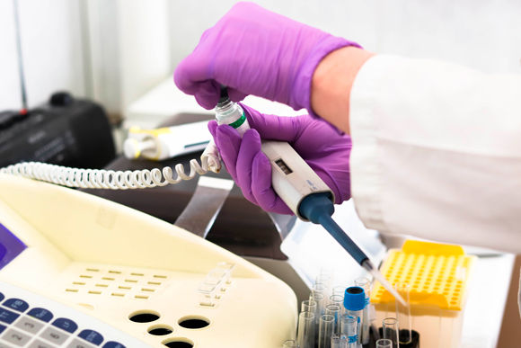
Figure 31 Scientist at work in the laboratory
View description - Figure 31 Scientist at work in the laboratory

The screened and processed FMT is then delivered by one of four main routes:
- Colonoscopy – the most common method, where the donor faecal matter is distributed along the length of the large intestine.
- Upper endoscopy – typically only used if an individual cannot have a colonoscopy, but is less effective.
- Enema – donor faecal matter is placed in the rectum.
- Tablet – freeze-dried but live microbiota organisms.
While the idea of FMT may be challenging, the impact of recurrent C. difficile that is not responding to treatment can be debilitating. However, FMT results in an estimated 87-90% cure rate of recurrent C. difficile, so for most individuals it provides significant relief and improvement in their health (Gupta, 2016).

Fun fact: the importance of FMT
At the time of writing, FMT is only approved for treatment of recurrent C. difficile infection, but there is a lot of active research into the potential benefits of FMT in other chronic health conditions, such as IBD, IBS, obesity, high blood pressure and depression.

6 Quiz
We hope that you have enjoyed studying about the fascinating subject of the gut microbiome! Below are a series of questions for you to assess your understanding and knowledge gained while studying this OpenLearn course.

Question 1 Microbiomes

Select from the drop-down lists to complete the following paragraph.

Interactive content is not available in this format.

Question 2 Bacterial profiles

Select the two correct statements from the following:

Firmicutes and Bacteroidetes are the most abundant bacteria in the gut microbiome
Bacteroidetes and Actinobacteria are the most abundant bacteria in the gut microbiome
An individual’s unique community of bacterial groups is known as their enterotype
Most individuals have a similar profile of bacteria in their gut microbiomes
View answer - Question 2 Bacterial profiles

Question 3 Functions of the gut microbiome

One of the important functions of the gut microbiome is digestion of foods, in particular certain fibres. This results in the production of metabolites, which are then used by the human host. An important group of metabolites are short chain fatty acids. Select which of the following are functions of SCFAs.

Protect against dysbiosis
Destroy colorectal cancer cells
Regulate appetite
Reduce obesity
Provide energy for the body and other microbiota
Communicate with the brain
View answer - Question 3 Functions of the gut microbiome

Question 4 Dysbiosis

There are three main mechanisms which cause dysbiosis. Select from the drop-down lists to describe each mechanism.

Interactive content is not available in this format.

Question 5 Health

Several health conditions have been linked to dysbiosis, and a change in diversity of the microorganisms of the gut microbiome. The ratio of Firmicutes to Bacteroidetes is thought to be particularly important in health. Drag the correct statement to the matching description.

Healthy individual
Obese individual
Individual with Crohn’s disease
Balanced ratio of Firmicutes to Bacteroidetes
Increase in Firmicutes compared to Bacteroidetes
Increase in Bacteroidetes relative to Firmicutes
View answer - Question 5 Health

Question 6 Exercise

Exercise is well known for having both physical and mental health benefits. Identify the true statements from the following:

Certain metabolites made by the gut microbiome have been linked to increased motivation to exercise
Certain metabolites made by the gut microbiome have been linked to improved exercise performance
The bacterial species Veillonella has been shown to increase the amount of lactate athletes can tolerate
The benefits of exercise on microbiome health are pronounced in childhood
Exercise is known to reduce the risk of colorectal cancer and Crohn’s disease
View answer - Question 6 Exercise

Question 7 Obesity

Obesity is a complex, multifactorial condition linked to a wide range of genetic and non-genetic factors, including environmental, lifestyle, socioeconomic and psychological factors. Select from the drop-down lists to complete the following paragraph.

Interactive content is not available in this format.

Question 8 Medications

Antibiotics are given for the treatment of bacterial infections and have undoubtably saved millions of lives worldwide. The graph below shows research investigating gut bacterial diversity before and after taking a course of antibiotics. The key in the graph indicates the type of antibiotic used.

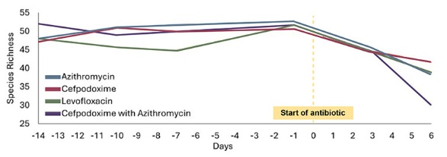
Figure 32 Antibiotic perturbation of gut microbiomes in healthy volunteers
View description - Figure 32 Antibiotic perturbation of gut microbiomes in healthy volunteers

Looking at the graph, which of the following statements is correct?

The lines on the graph suggest that antibiotic use does not seem to impact bacterial diversity
Prior to antibiotic use, species richness fluctuates but remains below 45
Three days after antibiotic use, species richness has decreased
Six days after antibiotic use, species richness has returned to normal levels
View answer - Question 8 Medications

Question 9 Age
The graph below illustrates gut microdiversity over a typical human lifespan. The graph explores stability (i.e. whether the gut microbiome experiences lots of changes) and also gut diversity (i.e. the proportions of different types of bacteria in the gut microbiome). Look carefully at the graph and then answer the following questions.

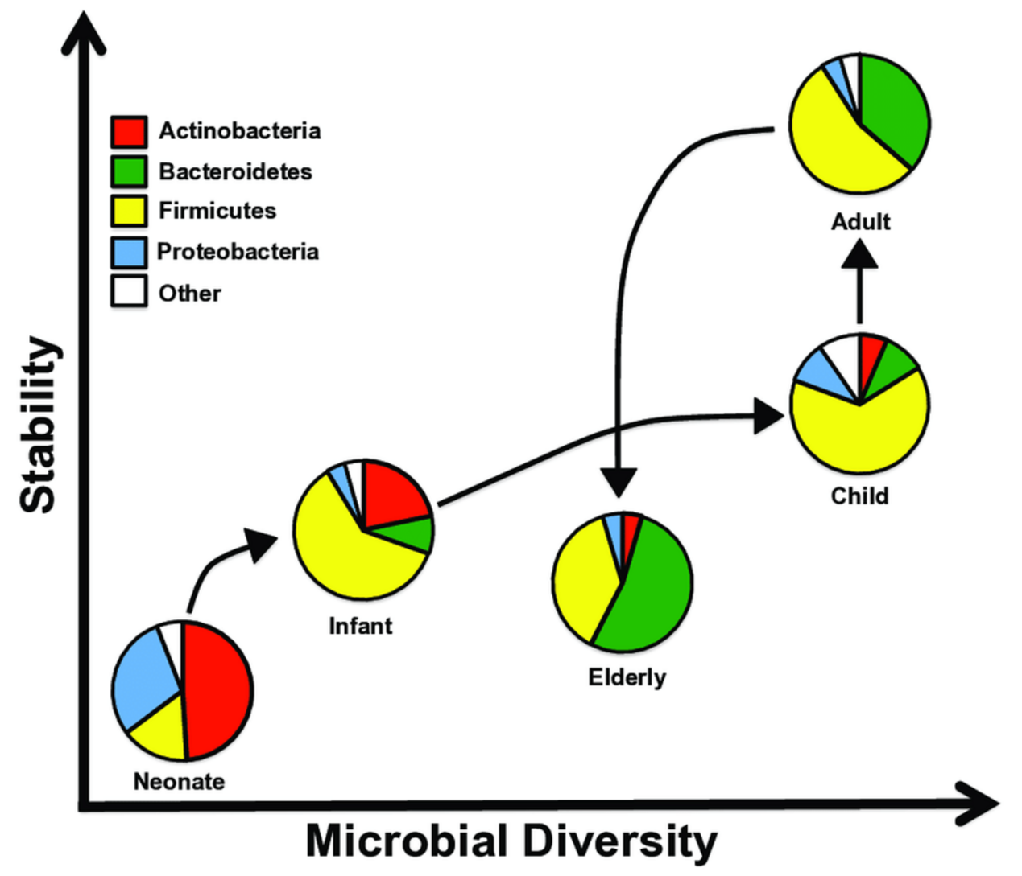
Figure 33 Human gut microbiome composition across the life cycle
View description - Figure 33 Human gut microbiome composition across the life cycle

From examining the graph, determine whether the following statements are true or false.

The pie charts show there are no changes in gut diversity over the lifespan

True
False
View answer - Part

The gut microbiome is least stable in neonates

True
False
View answer - Part

The stability of the gut microbiome decreases in the transition from adult to elderly life

True
False
View answer - Part

Question 10 Diet

A balanced diet helps provide nutrients for the gut microbiome and the host. Select from the drop-down lists to describe the following food items.

Interactive content is not available in this format.

Now consider the diets which typically incorporate these food items, and complete the sentences below.

Interactive content is not available in this format.

7 Summary
In this course you have learnt about the composition and functions of the human gut microbiome. In particular, you have looked at the role of the gut microbiome in metabolism of nutrients, gut structure and function, in protection against pathogens, in communication with the body (including the microbiota-gut-brain axis, and hormonal signalling) and its role during stress.
You have explored how the gut microbiome interacts with different parts of the body and considered how the gut microbiome can be altered by factors related to the human host (such as genetics, age, and the menopause) and through lifestyle factors (such as diet, exercise, and medications).
You have also explored how altered composition of the gut microbiome, called dysbiosis, is associated with various health conditions, including inflammatory bowel disease (Crohn’s disease and ulcerative colitis) and irritable bowel syndrome (and small intestinal bowel overgrowth), as well as obesity and Type 2 diabetes, colorectal cancer, kidney disease and mental health.
Finally, you learnt about strategies for improving the health of the gut microbiome to restore balance, such as prebiotics and probiotics, and faecal transplants.
Hopefully, you now feel that you have enough knowledge to be able to confidently hold a conversation with other people about the importance of the gut microbiome in health and some disease conditions.
This OpenLearn course is an adapted extract from the Open University course SK190 Human biology: a body in balance.

References
Alenghat, T., Osborne, L.C., Saenz, S.A., Kobuley, D., Ziegler, C.G.K., Mullican, S.E., Choi, I., Grunberg, S., et al. (2013) ‘Histone deacetylase 3 coordinates commensal-bacteria-dependent intestinal homeostasis’, Nature, 504, pp. 153–157. Available at: https://doi.org/10.1038/nature12687
Álvarez-Herms, J., González, A., Corbi, F., Odriozola, I. and Odriozola, A. (2023) ‘Possible relationship between the gut leaky syndrome and musculoskeletal injuries: the important role of gut microbiota as indirect modulator’, AIMS Public Health, 10(3), pp. 710–738. Available at: https://doi.org/10.3934/publichealth.2023049
Arumugam, M., Raes, J., Pelletier, E., le Paslier, D., Yamada, T., Mende, D.R., Fernandes, G.R., Tap, J., et al. (2011) ‘Enterotypes of the human gut microbiome’, Nature, 473, pp. 174–180. Available at: https://doi.org/10.1038/nature09944
Aune, D., Chan, D.S.M., Lau, R., Vieira, R., Greenwood, D.C., Kampman, E. and Norat, T. (2011) ‘Dietary fibre, whole grains, and risk of colorectal cancer: systematic review and dose-response meta-analysis of prospective studies’, British Medical Journal, 343, d6617. Available at: https://doi.org/10.1136/bmj.d6617
Bastiaanssen, T.F.S., Cussotto, S., Claesson, M.J., Clarke, G., Dinan, T.G. and Cryan, J.F. (2020) ‘Gutted! Unraveling the role of the microbiome in major depressive disorder’, Harvard Review of Psychiatry, 28(1), pp. 26–39. Available at: https://doi.org/10.1097/hrp.0000000000000243
Bibbò, S., Fusco, S., Ianiro, G., Settanni, C.R., Ferrarese, D., Grassi, C., Cammarota, G. and Gasbarrini, A. (2022) ‘Gut microbiota in anxiety and depression: Pathogenesis and therapeutics’, Frontiers in Gastroenterology, 1. Available at: https://doi.org/10.3389/fgstr.2022.1019578
Boccuto, L., Tack, J., Ianiro, G., Abenavoli, L. and Scarpellini, E. (2023) ‘Human Genes Involved in the Interaction between Host and Gut Microbiome: Regulation and Pathogenic Mechanisms’, Genes (Basel), 14(4), p. 857. Available at: https://doi.org/10.3390/genes14040857
Bolte, L.A., Vila, A.V., Imhann, F., Collij, V., Gacesa, R., Peters, V., Wijmenga, C. and Kurilshikov, A. (2021) ‘Long-term dietary patterns are associated with pro-inflammatory and anti-inflammatory features of the gut microbiome’, Gut, 70(7), pp. 1287–1298. Available at: https://doi.org/10.1136/gutjnl-2020-322670
Cancer Research UK (2022) Wholegrains, fibre and cancer risk. Available at: https://www.cancerresearchuk.org/about-cancer/causes-of-cancer/diet-and-cancer/wholegrains-fibre-and-cancer-risk (Accessed: 7 March 2025).
Chen, Y., Xu, J. and Chen, Y. (2021) ‘Regulation of neurotransmitters by the gut microbiota and effects on cognition in neurological disorders’, Nutrients, 13(6), p. 2099. Available at: https://doi.org/10.3390/nu13062099
Cooke, M.B., Catchlove, S. and Tooley, K.L. (2022) ‘Examining the influence of the human gut microbiota on cognition and stress: a systematic review of the literature’, Nutrients, 14(21), p. 4623. Available at: https://doi.org/10.3390/nu14214623
Damman, C. (2024) ‘Athletes looking for a competitive edge may find it within their gut microbiome’, The Conversation, 23 July. Available at: https://theconversation.com/athletes-looking-for-a-competitive-edge-may-find-it-within-their-gut-microbiome-234979 (Accessed: 10 June 2025).
Dohnalová, L., Lundgren, P., Carty, J.R.E., Goldstein, N., Wenski, S.L., Nanudorn, P., Thiengmag, S., Huang, K-P., et al. (2022) ‘A microbiome-dependent gut–brain pathway regulates motivation for exercise’, Nature, 612, pp. 739–747. Available at: https://doi.org/10.1038/s41586-022-05525-z
Ghosh, T.S., Shanahan, F. and O’Toole, P.W. (2022) ‘The gut microbiome as a modulator of healthy ageing’, Nature Reviews Gastroenterology & Hepatology, 19, pp. 565–584. Available at: https://doi.org/10.1038/s41575-022-00605-x
Gupta, S., Allen-Vercoe, E. and Petrof, E.O. (2016) ‘Fecal microbiota transplantation: in perspective’, Therapeutic Advances in Gastroenterology, 9(2), pp. 229–39. Available at: https://doi.org/10.1177/1756283X15607414
HMPDACC (n.d.) NIH Human Microbiome Project. Available at: https://www.hmpdacc.org (Accessed 7 March 2025).
Jabr, F. (2017) ‘Do probiotics really work?’, Scientific American, 1 July. Available at: https://www.scientificamerican.com/article/do-probiotics-really-work (Accessed: 7 March 2025).
Johns Hopkins (n.d.) Fecal Transplant. Available at: https://www.hopkinsmedicine.org/health/treatment-tests-and-therapies/fecal-transplant (Accessed: 10 June 2025).
Kalantar-Zadeh, K., Berean, K.J., Burgell, R.E., Muir, J.G. and Gibson, P.R. (2019) ‘Intestinal gases: influence on gut disorders and the role of dietary manipulations’, Nature Reviews Gastroenterology & Hepatology, 16, pp. 733–747. Available at: https://doi.org/10.1038/s41575-019-0193-z
Kidney Research UK (2023) Kidney disease: A UK public health emergency. Available at: https://www.kidneyresearchuk.org/about-us/policy/health-economics-report/ (Accessed: 10 June 2025).
Kim, G., Lee, K. and Shim, J.O. (2023) ‘Gut Bacterial Dysbiosis in Irritable Bowel Syndrome: a Case-Control Study and a Cross-Cohort Analysis Using Publicly Available Data Sets’, Microbiology Spectrum, 11, e02125-22. Available at: https://doi.org/10.1128/spectrum.02125-22
Li, P.K-T., Chan, G.C-K., Chen, J., Chen, H-C., Cheng, Y-L., Fan, S.L-S, He, J.C., Hu, W., et al. (2021) ‘Tackling dialysis burden around the world: A global challenge’, Kidney Diseases, 7(3), pp. 167–175. Available at: https://doi.org/10.1159/000515541
Limketkai, B.N., Akobeng, A.K., Gordon, M. and Adepoju, A.A. (2020) ‘Probiotics for induction of remission in Crohn’s disease’, The Cochrane Database of Systematic Reviews, 7(7), CD006634. Available at: https://doi.org/10.1002/14651858.CD006634.pub3
Limketkai, B.N., Hamideh, M., Shah, R., Sauk, J.S. and Jaffe, N. (2022) ‘Dietary Patterns and Their Association With Symptoms Activity in Inflammatory Bowel Diseases’, Inflammatory Bowel Diseases, 28(11), pp. 1627–1636. Available at: https://doi.org/10.1093/ibd/izab335
Mailing, L.J., Allen, J.M., Buford, T.W., Fields, C.J. and Woods, J.A. (2019) ‘Exercise and the Gut Microbiome: A Review of the Evidence, Potential Mechanisms, and Implications for Human Health’, Exercise and Sport Sciences Reviews, 47(2), pp. 75–85. Available at: https://doi.org/10.1249/JES.0000000000000183
Menees, S. and Chey, W. (2018) ‘The gut microbiome and irritable bowel syndrome’, F1000Research, 7(F1000 Faculty Rev), 1029. Available at: https://doi.org/10.12688/f1000research.14592.1
Mohajeri, M.H., Brummer, R.J.M., Rastall, R.A., Weersma, R.K., Harmsen, H.J.M., Faas, M. and Eggersdorfer, M. (2018) ‘The role of the microbiome for human health: from basic science to clinical applications’, European Journal of Nutrition, 57, pp. 1–14. Available at: https://pmc.ncbi.nlm.nih.gov/articles/PMC5962619/
Monda, V., Villano, I., Messina, A., Valenzano, A., Esposito, T., Moscatelli, F., Viggiano, A., Cibelli, G., et al. (2017) ‘Exercise Modifies the Gut Microbiota with Positive Health Effects’, Oxidative Medicine and Cellular Longevity, 2017, 3831972. Available at: https://doi.org/10.1155/2017/3831972
NHS (2022) Probiotics. Available at: https://www.nhs.uk/conditions/probiotics (Accessed: 7 March 2025).
Peters, B.A., Santoro, N., Kaplan, R.C. and Qibin, Q. (2022) ‘Spotlight on the gut microbiome in menopause: Current insights’, International Journal of Women’s Health, 14, pp. 1059–1072. Available at: https://doi.org/10.2147/IJWH.S340491
Roswall, J., Olsson, L.M., Kovatcheva-Datchary, P., Nilsson, S., Tremaroli, V., Simon, M.-C., Kiilerich, P., Akrami, R., et al. (2021) ‘Developmental trajectory of the healthy human gut microbiota during the first 5 years of life’, Cell Host & Microbe, 9(5), pp. 765–776. Available at: https://doi.org/10.1016/j.chom.2021.02.021
Sadagopan, A., Mahmoud, A., Begg, M., Tarhuni, M., Fotso, M., Gonzalez, N.A., Sanivarapu, R.R., Osman, U., et al. (2023) ‘Understanding the Role of the Gut Microbiome in Diabetes and Therapeutics Targeting Leaky Gut: A Systematic Review’, Cureus, 15(7), e41559. Available at: https://doi.org/10.7759/cureus.41559
Salvadori, M. and Rosso, G. (2024) ‘Update on the gut microbiome in health and diseases’, World Journal of Methodology, 14(1), 89196. Available at: https://doi.org/10.5662/wjm.v14.i1.89196
Sanders, D.J., Inniss, S., Sebepos-Rogers, G., Rahman, F.Z. and Smith, A.M. (2021) ‘The role of the microbiome in gastrointestinal inflammation’, Bioscience Reports, 41(6), BSR20203850. Available at: https://doi.org/10.1042/BSR20203850
Shi, Z. (2019) ‘Gut microbiota: An important link between Western diet and chronic diseases’, Nutrients, 11(10), pp. 2287.
Silva, Y.P., Bernardi, A. and Frozza, R.L. (2020) ‘The role of short-chain fatty acids from gut microbiota in gut-brain communication’, Frontiers in Endocrinology, 11. Available at: https://doi.org/10.3389/fendo.2020.00025
Spragge, F., Bakkeren, E., Jahn, M.T., Araujo, E.B.N., Pearson, C.F., Wang, X., Pankhurst, L., Cunrath, O. and Foster, K.R. (2023) ‘Microbiome diversity protects against pathogens by nutrient blocking’, Science, 382, eadj3502(2023). Available at: https://doi.org/10.1126/science.adj3502
Stasi, C., Sadalla, S. and Milani, S. (2019) ‘The relationship between the serotonin metabolism, gut-microbiota and the gut-brain axis’, Current Drug Metabolism, 20(8), pp. 646–655. Available at: https://doi.org/10.2174/1389200220666190725115503
Stojanov, S., Berlec, A. and Štrukelj, B. (2020) ‘The influence of probiotics on the Firmicutes/Bacteroidetes ratio in the treatment of obesity and inflammatory bowel disease’, Microorganisms, 8(11), p. 1715. Available at: https://doi.org/10.3390/microorganisms8111715
Suzuki, T.A. and Worobey, M. (2014) ‘Geographical variation of human gut microbial composition’, Biology Letters, 10, 20131037. Available at: https://doi.org/10.1098/rsbl.2013.1037
Weersma, R.K., Zhernakova, A. and Fu, J. (2020) ‘Interaction between drugs and the gut microbiome’, Gut, 69, pp. 1510–1519.
Wilmanski, T., Diener, C., Rappaport, N., Patwardhan, S., Wiedrick, J., Lapidus, J., Earls, J.C., Zimmer, A., et al. (2021) ‘Gut microbiome pattern reflects healthy ageing and predicts survival in humans’, Nature Metabolism, 3(2), pp. 274–286. Available at: https://doi.org/10.1038/s42255-021-00348-0
Wong, C.C. and Yu, J. (2023) ‘Gut microbiota in colorectal cancer development and therapy’, Nature Reviews Clinical Oncology, 20, pp. 429–452. Available at: https://doi.org/10.1038/s41571-023-00766-x
World Health Organization (2023) Colorectal cancer. Available at: https://www.who.int/news-room/fact-sheets/detail/colorectal-cancer (Accessed: 10 June 2025).
Xiong, R.G., Li, J., Cheng, J., Zhou, D.D., Wu, S.X., Huang, S.Y., Saimaiti, A., Yang, Z.J., et al. (2023) ‘The Role of Gut Microbiota in Anxiety, Depression, and Other Mental Disorders as Well as the Protective Effects of Dietary Components’, Nutrients, 15(14), p. 3258. Available at: https://doi.org/10.3390/nu15143258
Yang, B., Wei, J., Ju, P. and Chen, J. (2019) ‘Effects of regulating intestinal microbiota on anxiety symptoms: a systematic review’, General Psychiatry, 32(2), e100056. Available at: https://doi.org/10.1136/gpsych-2019-100056
Yeoh, Y.K., Zuo, T., Lui, G.C., Zhang, F., Liu, Q., Li, A.Y.L., Chung, A.C.K., Cheung, C.P., et al. (2021) ‘Gut microbiota composition reflects disease severity and dysfunctional immune responses in patients with COVID-19’, Gut, 70, pp. 698–706.
Zhang, P. (2022) ‘Influence of Foods and Nutrition on the Gut Microbiome and Implications for Intestinal Health’, International Journal of Molecular Sciences, 23(17), p. 9588. Available at: https://doi.org/10.3390/ijms23179588
Zhao, Q., Chen, Y., Huang, W., Zhou, H. and Zhang, W. (2023) ‘Drug-microbiota interactions: an emerging priority for precision medicine’, Signal Transduction and Targeted Therapy, 8, p. 386. Available at: https://doi.org/10.1038/s41392-023-01619-w
Zhu, F., Tu, H. and Chen, T. (2022) ‘The microbiota-gut-brain axis in depression: the potential pathophysiological mechanisms and microbiota combined antidepression effect’, Nutrients, 14(10), p. 2081. Available at: https://doi.org/10.3390/nu14102081
Zinöcker, M.K. and Lindseth, I.A. (2018) ‘The Western Diet-Microbiome-Host Interaction and Its Role in Metabolic Disease’, Nutrients, 10(3), p. 365. Available at: https://doi.org/10.3390/nu10030365

Acknowledgements
This free course was written by Vikki Haley and Karen New. It was first published in September 2025.
This OpenLearn course is an adapted extract from the Open University course SK190 Human biology: a body in balance.
Except for third party materials and otherwise stated (see terms and conditions), this content is made available under a Creative Commons Attribution-NonCommercial-ShareAlike 4.0 Licence.
The material acknowledged below is Proprietary and used under licence (not subject to Creative Commons Licence). Grateful acknowledgement is made to the following sources for permission to reproduce material in this free course:
Images
Course image: JAYK-ART / Shutterstock
Figure 7: ScienceDirect
Figure 9: Nick Youngson, https://pix4free.org/photo/31273/prescription-drugs.html, Image is under a Creative Commons Share Alike (CC BY-SA 3.0) Licence, https://creativecommons.org/licenses/by-sa/3.0/
Figure 31: Belova59 / Pixabay
Figure 32: adapted from Figure 1(c) of Anthony et al. (2022), Cell Reports, 39(2): 110649. DOI: 10.1016/j.celrep.2022.110649
Figure 33: Ozdemir, T. (2018) ‘Design and construction of therapeutic bacterial sensors in Escherichia coli Nissle 1917’, Doctoral thesis (Ph.D), UCL (University College London)
Video
Video 1: Overview of body systems affected by the acute stress response. sk299_T12_Video1.1_Slidecast_1_Mixed race teenage couple watching a movie at home, LaraBelova / Getty Images; sk299_T12_Video1.1_Slidecast_4_The brain, Trifonov_Evgeniy / Getty Images; sk299_T12_Video1.1_Slidecast_6_Immune System Concept, wildpixel / Getty Images; sk299_T12_Video1.1_Slidecast_3_Cuisine Culinary Buffet Dinner Catering Dining Food Celebration, _jure / Getty Images; sk299_T12_Video1.1_Slidecast_2_Beating heart, 3DME PTY LTD / Science Photo Library; sk299_T12_Video1.1_Slidecast_5_There are decreases in reproductive hormone production, Claus Lunau/Science Photo Library; sk299_T12_Video1.1_Slidecast_5_Female fighter with injured knee in gym, Dean Mitchell / Getty Images.
Video 2: TED-Ed, Summary of epigenetics, Licensed under the Creative Commons Attribution-Noncommercial-NoDerivatives Licence http://creativecommons.org/licenses/by-nc-nd/4.0/
Every effort has been made to contact copyright owners. If any have been inadvertently overlooked, the publishers will be pleased to make the necessary arrangements at the first opportunity.
Don’t miss out
If reading this text has inspired you to learn more, you may be interested in joining the millions of people who discover our free learning resources and qualifications by visiting The Open University – www.open.edu/openlearn/free-courses.

Glossary
colonoscopy
A procedure using a colonoscope or scope (a long thin flexible tube with a camera) inserted into the rectum and colon to view the colon wall tissue.
deoxyribonucleic acid (DNA)
Large molecules present in almost all cells. In humans, DNA is packed into structures called chromosomes. DNA carries genetic information.
dysbiosis
Disruption of the microbiome resulting in an imbalance of microbiota and diversity, which changes the function and metabolic activities of the microbiome.
endoscope
A long thin flexible tube with a camera that is passed through the mouth or into the anus, to view the gut wall.
enteric nervous system (ENS)
Responsible for communicating information about and within the digestive system.
enteroendocrine cells (EECs)
Specialised epithelial cells found scattered along the epithelium of the gastrointestinal tract. Secretes a wide range of hormones into the blood in response to the presence (or absence) of dietary nutrients and mechanical stimuli.
enterotype
The community of bacterial groups or species in an individual, that is often classified based on their predominant bacterial species.
enzyme
A biological molecule that speeds up the rate of chemical reactions (i.e. a catalyst), but is not itself destroyed in the process. Most (but not all) enzymes are proteins.
epigenetics
Modifications of DNA that do not change the DNA code but alter the pattern of gene expression.
gastroscopy
A long thin flexible tube with a camera that is passed through the mouth to view the throat, oesophagus, stomach and first part of the duodenum i.e. the upper part of the digestive system.
genes
A gene is a sequence of nucleotides in DNA, that is transcribed to produce RNA; it can be considered as the basic unit of heredity.
gut-associated lymphatic tissue (GALT)
Collections of lymphatic cells and tissue in or around the digestive system, that support the immune response of the gut.
gut-brain axis
The cross talk between the digestive system and the brain.
individual variability in drug response (IVDR)
The difference in how one individual compared to another may respond to a drug, including serious adverse reactions.
inflammatory bowel disease (IBD)
A collection of two conditions, Crohn's disease and ulcerative colitis, associated with a chronic immune response resulting in severe inflammation, ulceration and damage to the GI tract, abdominal cavity and other body systems.
irritable bowel syndrome (IBS)
A collection of disorders associated with altered gut motility, inflammation and permeability for which the cause and pathology is not fully understood.
lymphatic system
The lymphatic organs (lymph nodes, spleen, tonsils, thymus and bone marrow) and the network of fine tubules that connect them and extend throughout the body. Leukocytes, antibodies and other specialised chemicals involved in the immune response to infection circulate between the lymphatic system, the tissues and the blood, and the lymphatic capillaries collect fluid draining from the tissues and return it to the blood stream.
microbiome
A population of viruses, bacteria and eukaryotic microbes, e.g. in the digestive tract, where it is termed the ‘gut microbiome’.
microbiota
A community of microorganisms on or in the body.
microbiota-gut-brain axis
A communication network between the microorganisms of the gut microbiome, vagus nerve, bloodstream, and brain.
nephron
The functional unit of the kidney, composed of tubules and blood vessels which produce the urine.
pathogens
Infectious agents (e.g. parasites, protists, bacteria, fungi, viruses, prions) that cause infectious diseases.
prebiotics
Substances that are eaten or drunk to promote the growth of beneficial gut microbes.
probiotics
One or more live microbial species eaten or drunk to promote gut health.
short-chain fatty acids (SCFAs)
Fatty acid molecules each consisting of 6 or less carbon atoms. It is produced by bacteria within a microbiome by digesting fibre and releasing the fat as SCFAs. Examples are butyrate, propionate and acetate. SCFAs can be used by the host’s body or by other bacteria as an important energy source.
small intestinal bacterial overgrowth (SIBO)
Excessive and abnormal growth of either healthy bacteria from the gut microbiome or pathogenic bacteria in the small intestine.
symbionts
An organism that lives with another for mutual benefit.
vagus nerve
The tenth cranial nerve that is a key mediator of the parasympathetic nervous system that extends from the brain down to the majority of organs within the thorax, abdomen and pelvis.
villi
Small, finger-like projections of tissue. Typically these are thin, consisting of only a few layers of cells. Villi are important for increasing the surface area of the tissue which is in contact with surrounding material, such as in the placenta or in the gut. This serves to increase the area of surface over which transport of substances can take place.

Solutions

Question 2 Bacterial profiles

Answer
Right:
Firmicutes and Bacteroidetes are the most abundant bacteria in the gut microbiome
An individual’s unique community of bacterial groups is known as their enterotype
Wrong:
Bacteroidetes and Actinobacteria are the most abundant bacteria in the gut microbiome
Most individuals have a similar profile of bacteria in their gut microbiomes
Back to - Question 2 Bacterial profiles

Question 3 Functions of the gut microbiome

Answer
Right:
Protect against dysbiosis
Destroy colorectal cancer cells
Regulate appetite
Reduce obesity
Provide energy for the body and other microbiota
Communicate with the brain
Wrong:
Back to - Question 3 Functions of the gut microbiome

Question 5 Health

Answer
The correct matches are:
Healthy individual
Balanced ratio of Firmicutes to Bacteroidetes
Obese individual
Increase in Firmicutes compared to Bacteroidetes
Individual with Crohn’s disease
Increase in Bacteroidetes relative to Firmicutes
Back to - Question 5 Health

Question 6 Exercise

Answer
Right:
Certain metabolites made by the gut microbiome have been linked to increased motivation to exercise
Certain metabolites made by the gut microbiome have been linked to improved exercise performance
The bacterial species Veillonella has been shown to increase the amount of lactate athletes can tolerate
The benefits of exercise on microbiome health are pronounced in childhood
Exercise is known to reduce the risk of colorectal cancer and Crohn’s disease
Wrong:
Back to - Question 6 Exercise

Question 8 Medications

Answer
Right:
Three days after antibiotic use, species richness has decreased
Wrong:
The lines on the graph suggest that antibiotic use does not seem to impact bacterial diversity
Prior to antibiotic use, species richness fluctuates but remains below 45
Six days after antibiotic use, species richness has returned to normal levels
Back to - Question 8 Medications

Question 9 Age

Part

Answer
Right:
False
Wrong:
True
Back to - Part

Part

Answer
Right:
True
Wrong:
False
Back to - Part

Part

Answer
Right:
True
Wrong:
False
Back to - Part

Descriptions

Figure 1 Microbiomes around the body
A schematic illustration in the centre of the image shows the head, neck, torso and upper arms and upper legs, with the components of the digestive tract in the middle. There are four boxes projecting out from the schematic of the digestive tract. The box in the top right corner is labelled ‘skin microbiome’. The label from this box connects to the skin of the upper arm. The box in the bottom right corner is labelled ‘digestive tract microbiome’, and there’s a line connecting this box to the guts in the central schematic. The box in the bottom left corner is labelled ‘urogenital microbiome’ with a line connecting to the space between the thighs in the pubic region. The box in the upper left corner is labelled ‘oral microbiome’ and the line connects to the mouth. Each of the four boxes contains schematics of different microorganisms. Interspersed between the full boxes are dotted ovals containing the words ‘virus’, ‘parasite’, ‘fungi’, ‘bacteria’ and ‘Archaea’.
Back to - Figure 1 Microbiomes around the body

Figure 2 Simplified representation of some components of the gastrointestinal tract (gut)
A schematic illustration shows the components of the digestive tract. An inset shows the location of the components of the digestive tract in the abdominal and pelvic regions of the human body. The following components of the continuous digestive tract are shown: stomach (orange J-shaped pouch), small intestine with the duodenum (orange tube), jejunum (blue tube), ileum (green tube), and large intestine (brown wide bent tube with segmented folds).
Back to - Figure 2 Simplified representation of some components of the gastrointestinal tract (gut)

Figure 4 Distribution of bacteria found on or in different parts of an average healthy body
A schematic illustration depicts the distribution of bacteria found on or in different parts of an average healthy body. For each distinct distribution, a pie chart is illustrated. An illustration of a half-male (on the left) and a half-female body (on the right) is depicted at the centre. External auditory canal in males. A pie chart illustrates the highest number of Firmicutes, a very higher number of Actinobacteria, a very lower number of Cyanobacteria and Proteobacteria, and a minute amount of Bacteroidetes present in the external auditory canal. Nostril in males: A pie chart illustrates the highest number of Actinobacteria, a moderately higher number of Firmicutes, a lower number of Proteobacteria, a very lower number of Cyanobacteria, and a minute amount of Bacteroidetes present in the nostril. Skin in males: A pie chart illustrates the highest number of Actinobacteria, a moderate number of Firmicutes, a moderately lower number of Proteobacteria and Cyanobacteria, and a minute amount of Bacteroidetes present on the skin. Penis in males: A pie chart illustrates the highest number of Proteobacteria, a moderate number of Firmicutes, a moderately lower number of Cyanobacteria and Bacteroidetes, and a minute amount of Fusobacteria present in the penis. Hair on the head in females: A pie chart illustrates the highest number of Actinobacteria, a moderate number of Cyanobacteria, a moderately lower number of Firmicutes, a very lower number of Proteobacteria, and a minute amount of Bacteroidetes present in the hair on the head. Mouth (part of G I tract) in females: A pie chart illustrates the moderately higher number of Firmicutes, a moderate number of Proteobacteria, Actinobacteria, and Bacteroidetes, and a low number of Fusobacteria present in the mouth in females. Oesophagus (part of G I tract) in females: A pie chart illustrates the highest number of Firmicutes, a moderate number of Bacteroidetes, and a very low number of Fusobacteria, Proteobacteria, and Actinobacteria present in the oesophagus in females. Intestines (part of G I tract) in females: A pie chart illustrates the highest number of Bacteroidetes, a moderately high number of Firmicutes, and a very low number of Proteobacteria present in the intestines. Vagina in females: A pie chart illustrates the highest number of Firmicutes, a moderate number of Proteobacteria and Actinobacteria, a very low number of Fusobacteria, and a minute amount of Bacteroidetes present in the oesophagus in females.
Back to - Figure 4 Distribution of bacteria found on or in different parts of an average healthy body

Figure 5 Bar chart (presented horizontally) showing the proportions of the different bacterial groups making up the microbiota within the gut of five individuals
A horizontal stacked bar graph depicts the proportions of different bacteria making up the microbiota within the gut of 5 individuals. The horizontal axis is labelled proportions of the microbiome bacteria in human gut in per cent and ranges from 0 to 100 in increments of 10 units. The vertical axis is labelled individuals and ranges from 1 to 5 in increments of 1 unit. The data for 5 individuals is represented as follows: Individual 1 has approximately 2.7 per cent of Actinobacteria, 2.3 per cent of Bacteroidetes, 90 per cent of Firmicutes, 0.2 per cent of Fusobacteria, 2.6 per cent of Parcubacteria, and 2.2 per cent of Proteobacteria. Individual 2 has approximately 0.2 per cent of Acidobacteria, 84.3 per cent of Actinobacteria, 2.4 per cent of Bacteroidetes, 7.4 per cent of Firmicutes, 0.2 per cent of Parcubacteria, 5.4 per cent of Proteobacteria, and 0.1 per cent of Tenericutes. Individual 3 has approximately 25 per cent of Actinobacteria, 73 per cent of Firmicutes, and 2 per cent of proteobacteria. Individual 4 has approximately 35 per cent of Actinobacteria, 31 per cent of Firmicutes, 0.1 per cent of Fusobacteria, 10 per cent of Proteobacteria, and 23 per cent of Tenericutes. Individual 5 has approximately 37.8 per cent of Actinobacteria, 0.1 per cent of Fusobacteria, 50.5 per cent of Firmicutes, 11.5 per cent of Proteobacteria, and 0.1 per cent of Tenericutes.
Back to - Figure 5 Bar chart (presented horizontally) showing the proportions of the different bacterial groups making up the microbiota within the gut of five individuals

Figure 6 There is a healthy (but not necessarily equal) ratio of Firmicutes and Bacteroidetes in healthy individuals
The illustration shows a schematic of a set of scales equally balanced. On the left side of the scale are 11 red circles. On the right side of the scale are 11 blue circles. Underneath this set of scales on the left is a red, sliding bar with the wording ‘Firmicutes load’. Underneath the scales on the right is another sliding bar, this time in blue, labelled ‘Bacteroidetes load’.
Back to - Figure 6 There is a healthy (but not necessarily equal) ratio of Firmicutes and Bacteroidetes in healthy individuals

Figure 7 Role of the colon (part of the large intestine) in the digestion of dietary fibre with the production and absorption of SCFAs into the body. The long dietary fibre molecules (shown in green) are broken down into smaller molecules by the orange microorganisms of the microbiota. Some of these smaller molecules are absorbed across the gut wall, while others are used as fuel stores by the microbiota. The microbiota then produce SCFAs (shown by the circles C2, C3 and C4), which are also absorbed across the gut wall.
The schematic is shown in two parts. On the left is the large intestine around the outside with various foods in the middle. The colour of the large intestine changes from a pale purple on the bottom left to a blue-green on the bottom right, which represents an increase in the thickness and amount of mucus produced at various points. On the right is a section of the large intestine expanded out to show the gut wall as two columns of cells on the left and right. In the middle there are long, green, fibre molecules, and then shorter fibre molecules which have been broken down into smaller molecules by the orange ovals representing the microorganisms of the microbiota. The microbiota are then shown to produce SCFAs (shown by the circles C2, C3 and C4), which are also absorbed across the gut wall.
Back to - Figure 7 Role of the colon (part of the large intestine) in the digestion of dietary fibre with the production and absorption of SCFAs into the body. The long dietary fibre molecules (shown in green) are broken down into smaller molecules by the orange microorganisms of the microbiota. Some of these smaller molecules are absorbed across the gut wall, while others are used as fuel stores by the microbiota. The microbiota then produce SCFAs (shown by the circles C2, C3 and C4), which are also absorbed across the gut wall.

Figure 8 Micronutrients present within the intestinal gut microbiome from the dietary sources and synthesis by the gut microbiome are transported into the intestinal tissue and then into the bloodstream for the host to use
A schematic illustration depicts micronutrients present within the intestinal gut microbiome and host bloodstream, which support the survival and function of the gut microbiome. The illustration shows a blood vessel (bloodstream), host intestinal tissue lined by intestinal epithelial cells with microvilli, and a microbiome present in the intestinal lumen (inside the tube-like digestive tract. The dietary-derived micronutrients are provided by different regions of the intestine as follows: the duodenum provides vitamins B1, B2, B3, B7, B9, vitamins A, D, E, K, and minerals; the jejunum provides minerals, vitamins A, D, E, K, B vitamins, and vitamin C; the ileum provides selenium, magnesium, vitamins C, D, K, and vitamins B1, B7, B9, and B12; the colon provides vitamins B7, K, potassium, sodium, chloride, and short-chain fatty acids. Micronutrients (inset: fruits, cheese, and vegetables) are also synthesised by the microbiota present in the intestinal lumen. The dietary-derived micronutrients from different regions of the intestines are ultimately absorbed into the intestinal tissue as follows: minerals from duodenum, jejunum, ileum and colon; water-soluble vitamins (vitamins B1 through B12, and C) from duodenum; fat-soluble vitamins (vitamins A, D, E, K) from jejunum; short-chain fatty acids (butyrate, propionate, and acetate) from colon. Micronutrients synthesised from gut microbiota are then transported into the bloodstream.
Back to - Figure 8 Micronutrients present within the intestinal gut microbiome from the dietary sources and synthesis by the gut microbiome are transported into the intestinal tissue and then into the bloodstream for the host to use

Figure 9 Medications and chemicals ingested from the environment can be modified by the gut microbiome
This photo shows a prescription pad on the bottom left with various tablets, stethoscope and syringe in the remainder of the photo representing medications.
Back to - Figure 9 Medications and chemicals ingested from the environment can be modified by the gut microbiome

Figure 10 Schematic of the small intestine, showing the individual layers and highly folded surface of the internal layers of the gut. Blood vessels supply oxygen to the gut wall and transports nutrients to the rest of the body.
A schematic illustration demonstrates the general structure of the small intestine composed of 4 histological layers. The cylindrical concentric layers are extended out to reveal the histological layers of the small intestine. The small intestine has longitudinal and circular muscle layers, present beneath the outermost serosa layer. The lumen of the small intestine is enclosed by submucosa and innermost mucosa. The blood vessels serving the small intestine supply blood to all the histological layers. The internal surface of the mucosa has circular folds (plicae circulares). There are numerous finger-like projections in the circular folds labelled ‘villi’.
Back to - Figure 10 Schematic of the small intestine, showing the individual layers and highly folded surface of the internal layers of the gut. Blood vessels supply oxygen to the gut wall and transports nutrients to the rest of the body.

Figure 11 Cells are connected to each other by three main types of junctions: tight junctions, anchoring junctions, and gap junctions
This figure shows a schematic diagram which illustrates the three main types of cell junctions. The schematic shows three rectangular cells, with finger-like projections on the upper edge, lying in close proximity and above the basal membrane. From left to right, the cells are labelled cell 1, cell 2 and cell 3, and there are three types of junctions joining the cells together. Cell 1 is attached to cell 2 by an anchoring junction placed in the middle between both cells, holding the two cell membranes close together. This junction is labelled ‘anchoring junctions: important for structural support, particularly in tissues with a lot of movement/friction’. The cells are anchored to one another by a bundle of tubular cytoskeletal structures and extracellular matrix components. Cell 1 is also attached to cell 2 by a tight junction labelled ‘tight junctions: form a seal between two cells that prevents movement of water and other small molecules’. An intercellular barrier between two neighbouring adjacent cells has intercellular spaces between protein complexes and connects two cells tightly forming a fluid-tight seal. Cells 2 and 3 are attached by a gap junction placed near the basal membrane. This junction is labelled ‘gap junctions: cells are connected by channels that allow the passage of small substances between the cells’. The cell junction is formed by an intercellular bridge (fluid-filled protein channels) formed between adjacent cell membranes of neighbouring cells.
Back to - Figure 11 Cells are connected to each other by three main types of junctions: tight junctions, anchoring junctions, and gap junctions

Figure 12 The six groups of pathogens illustrated with their size compared to other cells and objects
A schematic illustration shows examples of six pathogens with their size compared to other cells or substances. The size of the following is depicted in the illustration: Tapeworm (red tubular structure): 3 to 10 metres long. Human hair (a hair strand): 50 to 180 micrometres thick. Grain of salt (powder salt): 60 micrometres. Protozoa (oval-shaped) (for example, malaria): 1 to 20 micrometres. Fungi (green branched filaments with multiple nuclei) (for example, Candida albicans - thrush): 2.6 to 3.4 micrometres. Bacteria (for example, Escherichia coli): 1 to 3 micrometres. Virus (a red sphere) (for example, SARS-CoV-2): 0.1 to 0.5 micrometres. Prion (protein molecule): 0.002 to 0.010 micrometres.
Back to - Figure 12 The six groups of pathogens illustrated with their size compared to other cells and objects

Figure 13 Simplified representation of the vagus nerve communicating between the GI tract and brain
A schematic illustration shows the gut-brain axis. The illustration shows the lower back region of the brain is connected via the vagus nerve and blood vessels (circulation) to different regions of the small intestine and large intestine. The vagus nerve, shown in blue, travels to and from the brain to the GI tract, where various branches connect to the small and large intestines. This relays a signal via the vagus nerve to the brain. The immune cells also pass from the intestinal lumen through the epithelial cells into the blood circulation. The metabolites of the microbiota can also be detected by the immune cells, which can directly stimulate the brain, or indirectly stimulate the brain via the vagus nerve.
Back to - Figure 13 Simplified representation of the vagus nerve communicating between the GI tract and brain

Figure 14 Microbiota gut-brain axis. Communication between the gut and brain is bidirectional. Metabolites produced by the microbiome are sensed by the intestinal cells, and this relays a signal via the vagus nerve to the brain. The metabolites can also be detected by immune cells which can directly stimulate the brain or stimulate the vagus nerve.
A schematic illustration shows the gut-brain axis. The illustration shows the lower back region of the brain is connected via the vagus nerve and blood vessels (circulation) to different regions of the small intestine and large intestine. A magnified view of the large intestine shows a layer of intestinal epithelial cells with microvilli surrounding the intestinal lumen. The intestinal lumen contains numerous types of intestinal microbiota which produce metabolites that are then sensed by the intestinal cells. This relays a signal via the vagus nerve to the brain. The immune cells also pass from the intestinal lumen through the epithelial cells into the blood circulation. The metabolites of the microbiota can also be detected by the immune cells, which can directly stimulate the brain, or indirectly stimulate the brain via the vagus nerve.
Back to - Figure 14 Microbiota gut-brain axis. Communication between the gut and brain is bidirectional. Metabolites produced by the microbiome are sensed by the intestinal cells, and this relays a signal via the vagus nerve to the brain. The metabolites can also be detected by immune cells which can directly stimulate the brain or stimulate the vagus nerve.

Figure 15 The location of enteroendocrine cells in the gut wall and signalling to the brain
A schematic illustration shows the communication between the gut microbiota and the brain. The illustration shows a layer of intestinal epithelial cells with microvilli surrounding the intestinal lumen. An EEC is embedded in the epithelium. The intestinal lumen contains numerous types of intestinal microbiota. The neurotransmitters, short-chain fatty acids, and immune cells also pass from the intestinal lumen through the epithelial cells into the blood circulation to travel to the brain. The immune cells and metabolites also relay signals to the brain via the vagus nerve. The vagus nerve creates a synaptic contact with the EEC and relays stimulating signals to the brain. The brain then regulates mood, cognition, and emotion.
Back to - Figure 15 The location of enteroendocrine cells in the gut wall and signalling to the brain

Figure 16 A cross-section of the small intestine with GALT circled in red known as a Peyer’s patch
A micrograph shows a cross-section of the ileum with a Peyer’s patch (encircled by a red oval) present in the third layer (from the exterior) of the ileum.
Back to - Figure 16 A cross-section of the small intestine with GALT circled in red known as a Peyer’s patch

Figure 17 (a) Healthy colon; (b) Inflamed colon
The figure consists of two parts labelled (a) and (b) that illustrate the healthy colon and inflamed colon. Part (a): an endoscopic image of a healthy colon shows the triangular lumen with characteristic colonic haustrations (segmented appearance), clearly visible vascular pattern (blood vessels), and smooth pale pink mucosa. Part (b): an endoscopic image of an inflamed colon shows the round lumen with no colonic haustrations (segmented appearance), loss of vascular markings (blood vessels), oedematous mucosa, and erythema.
Back to - Figure 17 (a) Healthy colon; (b) Inflamed colon

Figure 18 Microbiota development in early life
A schematic illustration depicts microbiota development in early life. The window of opportunity for microbiota modulation either during pregnancy, delivery, or during infancy or toddler is outlined as follows. During pregnancy, maternal microbiota (inset image: a fetus in the mother’s womb) is affected by factors such as diet, antibiotics, host genetics, infection, and maternal stress. During delivery, microbiota (inset image: a mother breastfeeding her infant) is affected by factors such as mode of delivery and gestational age at birth. During infancy or toddler stages, child microbiota (inset image: a toddler) is affected by factors such as feeding mode, maternal diet, host genetics, family lifestyle, and geographical location.
Back to - Figure 18 Microbiota development in early life

Figure 19 (interactive) The effect of the Mediterranean diet compared with the Western diet on gut microbiota
A schematic illustration shows the effect of the Mediterranean diet compared with the Western diet on gut microbiota. The first pyramid diagram is labelled ‘mediterranean diet’, and comprises (from top to bottom) a chocolate bar, muffins with cream, meat, cheese, fish, egg, milk, peas, pasta, kidney beans, bread loaf, apple, carrot, broccoli, orange, zucchini, and a bunch of red grapes. Underneath the diagram, text reads: fresh foods, high-fibre whole natural foods, balance of health-promoting microbiota. The second pyramid diagram is labelled ‘western diet’, and comprises (from top to bottom) a chocolate bar, doughnuts, muffins with cream, meat, cheese, fish, egg, milk, kidney beans, pasta, peas, bread loaf, apple, orange, and broccoli. Underneath the diagram, text reads: processed foods, low fibre, balance of health-promoting microbiota disrupted.
Back to - Figure 19 (interactive) The effect of the Mediterranean diet compared with the Western diet on gut microbiota

Figure 20 (a) Breathing in (inspiration) and breathing out (expiration) allows the exchange of oxygen and carbon dioxide; (b) The cells use the oxygen to generate energy in the mitochondria. Carbon dioxide is produced as a waste product.
The figure consists of two parts labelled (a) and (b) that illustrate external respiration and cellular respiration. Part (a): a schematic illustration of the respiratory system depicts external respiration, which includes cycles of inspiration and expiration. The respiratory system includes the nasal passage, pharynx, larynx, trachea, bronchi, bronchioles, and lungs. Inspiration involves breathing in oxygen (O₂) and expiration involves breathing out carbon dioxide (CO₂). Part (b): a schematic illustration of cellular respiration shows a typical eukaryotic cell with cell membrane (outer blue layer), nucleus (brown circle), nucleolus (brown core), endoplasmic reticulum (green tubular network), cytosol (blue environment inside the cell), mitochondrion (orange double-membrane organelle), and Golgi apparatus (stack of red saccules). A magnified view of mitochondrion from the cell shows the exchange of O₂ and CO₂. O₂ moves into the mitochondrion during cellular respiration and CO₂ is released out of the mitochondrion.
Back to - Figure 20 (a) Breathing in (inspiration) and breathing out (expiration) allows the exchange of oxygen and carbon dioxide; (b) The cells use the oxygen to generate energy in the mitochondria. Carbon dioxide is produced as a waste product.

Figure 21 Medication packages
This is a photo of medication packages, showing different sizes and types of tablets.
Back to - Figure 21 Medication packages

Figure 22 (a) A transmission electron micrograph shows four red-orange coloured SARS-CoV-2 coronaviruses, with the typical ‘corona’ appearance around the virus; (b) A 3D representation of the SARS-CoV-2 virus with the spike proteins, which have a key role in enabling the virus to enter host cells and cause infection.
The figure consists of two parts labelled (a) and (b) that illustrate the structure of coronavirus. Image (a) is a transmission electron micrograph showing four red-orange coloured SARS-CoV-2 coronaviruses. Image (b) is a 3D illustration showing spike proteins projecting from the surface of the spherical coronavirus.
Back to - Figure 22 (a) A transmission electron micrograph shows four red-orange coloured SARS-CoV-2 coronaviruses, with the typical ‘corona’ appearance around the virus; (b) A 3D representation of the SARS-CoV-2 virus with the spike proteins, which have a key role in enabling the virus to enter host cells and cause infection.

Figure 23 (a) Ernestine Shepherd and (b) Toshisuke Kanazawa, body builders aged 80 and 81 years, respectively, at the time of these photos, demonstrate that it is possible to maintain good physical health and fitness in the later decades of life
This figure consists of two photographs labelled (a) and (b). Photograph (a) shows the female body builder, Ernestine Shepherd (aged 80 years), flexing and posing for the camera. Photograph (b) shows the male body builder, Toshisuke Kanazawa (aged 81 years), also flexing and posing for the camera.
Back to - Figure 23 (a) Ernestine Shepherd and (b) Toshisuke Kanazawa, body builders aged 80 and 81 years, respectively, at the time of these photos, demonstrate that it is possible to maintain good physical health and fitness in the later decades of life

Figure 24 (interactive) Endoscopic images of a healthy gut wall and inflamed gut walls in ulcerative colitis in the large intestine (colon)
An interactive illustration shows four empty slots for the endoscopic images of the gut wall in the large intestine (colon). They are labelled as follows: Empty slot 1: healthy; no inflammation; blood vessels visible; smooth tissue. Empty slot 2: mild inflammation; red and swollen. Empty slot 3: moderate inflammation; red and swollen. Empty slot 4: severe inflammation; red and raised patches almost everywhere. Endoscopic image 1 shows the gut wall of the colon with smooth tissue and blood vessels visible. Endoscopic image 2 shows a slightly red and swollen gut wall of the colon. Endoscopic image 3 shows a red and swollen gut wall of the colon. Endoscopic image 4 shows raised red patches distributed in the gut wall of the colon.
Back to - Figure 24 (interactive) Endoscopic images of a healthy gut wall and inflamed gut walls in ulcerative colitis in the large intestine (colon)

Figure 25 The Firmicutes to Bacteroidetes ratio in inflammatory bowel disease is altered
A schematic illustration shows Firmicutes to Bacteroidetes (F/B) ratios in inflammatory bowel disease (IBD). The illustration shows a set of scales with two pans. An increase in the Bacteroidetes (represented by the blue circles) has resulted in the right side of the balance tipping downwards, while the lighter Firmicutes load (represented by fewer red circles) has lifted up.
Back to - Figure 25 The Firmicutes to Bacteroidetes ratio in inflammatory bowel disease is altered

Figure 26 Small intestinal bacterial overgrowth: the chicken or the egg?
The schematic shows a blue circle on the left labelled ‘SIBO’, with a blue arrow leading across to a red circle on the right labelled ‘IBS’. There is a red arrow leading from the bottom of the red circle back across to the blue SIBO circle. Text in the middle of this cycle diagram reads: ‘changes in: microbiome, motility, permeability, gut immune activation, visceral sensation’.
Back to - Figure 26 Small intestinal bacterial overgrowth: the chicken or the egg?

Figure 27 The F/B ratio in obese individuals typically shows an increase in Firmicutes and reduction in Bacteroidetes
The schematic illustration of the set of scales with Firmicutes to Bacteroidetes (F/B) ratio is shown for a third time, this time in individuals who are obese. There is an increase in the Firmicutes load on the left and a decrease in the blue Bacteroidetes, with the extra red circles of the Firmicutes causing the balance down to tip down on the left.
Back to - Figure 27 The F/B ratio in obese individuals typically shows an increase in Firmicutes and reduction in Bacteroidetes

Figure 28 Colorectal cancer risk decreases as the consumption of dietary fibre in grams per day (g day−1) increases
A line graph illustrates a relationship between the decreased risk of colorectal cancer and increased consumption of dietary fibre. The horizontal axis is labelled ‘dietary fibre’ (in grams per day) and ranges from 0 to 40 in increments of 10 units. A rightward arrow labelled ‘increased fibre intake’ is drawn along the horizontal axis. The vertical axis is labelled ‘estimated relative risk’ and ranges from 0.00 to 1.00 in increments of 0.20 units. A kink is present between 0.00 and 0.60. A downward arrow labelled ‘decreased risk’ is drawn along the vertical axis. The line graph shows a line with a negative slope trending downward from upper left to lower right. A line starts from 3.85 grams per day of dietary fibre with an estimated relative risk of 1.00. The line drops gradually and passes through the following points: fibre intake of 10 grams per day decreases risk to 0.92; fibre intake of 20 grams per day decreases risk to 0.83; fibre intake of 30 grams per day decreases risk to 0.78; fibre intake of 40 grams per day decreases risk to 0.66. All values are approximated.
Back to - Figure 28 Colorectal cancer risk decreases as the consumption of dietary fibre in grams per day (g day−1) increases

Figure 29 Schematic of a single kidney; here an enlarged nephron is shown, in reality, individual nephrons can only be seen with the aid of a microscope
On the left is a schematic of the whole kidney showing the different anatomical components, including: the renal capsule (a thin outer membrane), renal cortex, renal medulla, renal pelvis merging to form the ureter. The renal artery and vein are showing entering the kidney just behind the ureter. On the right is a schematic of one of the nephrons, the functional unit of the kidneys.
Back to - Figure 29 Schematic of a single kidney; here an enlarged nephron is shown, in reality, individual nephrons can only be seen with the aid of a microscope

Figure 30 Prebiotic and probiotic foods. The cartoon figures represent the microorganisms in the microbiota that use the pre- and probiotics to thrive and replicate. The tablets represent probiotic supplements (dried or desiccated bacteria products)
A cartoon-style illustration depicts prebiotic and probiotic foods. Probiotics include supplements in capsule form, milk, flavoured yoghurt, and cottage cheese containing microbiota. Prebiotics include a bunch of red grapes, tomatoes, green apple, zucchini, peas, and broccoli containing microbiota.
Back to - Figure 30 Prebiotic and probiotic foods. The cartoon figures represent the microorganisms in the microbiota that use the pre- and probiotics to thrive and replicate. The tablets represent probiotic supplements (dried or desiccated bacteria products)

Figure 31 Scientist at work in the laboratory
This photo shows the gloved hands of a scientist, with a pipette in their hand and various other standard items of laboratory equipment.
Back to - Figure 31 Scientist at work in the laboratory

Figure 32 Antibiotic perturbation of gut microbiomes in healthy volunteers
This figure shows a graph. On the X axis are days running from -14 days to +6 days. The Y axis shows species richness, starting at 25 and going up to 55. There are four different coloured lines showing the effects on species richness when taking four different antibiotics. The antibiotic Azithromycin is shown as a blue line, with the species richness remaining stable at approximately 53 until day zero when the antibiotics are started. The line then declines to a species richness of approximately 40 by day 6. The antibiotic Cefpodoxime is shown by a red line, with the species richness remaining stable at just under 50 until day zero when the antibiotics are started. The line then declines to a species richness of approximately 45 by day 6. The antibiotic Levofloxacin is shown by a green line, with the species richness dipping down to about 45 at day -7, increasing slightly to approximately 50 at day zero, and then declining to a species richness of approximately 40 by day 6. Finally, Azithromycin and Cefpodoxime combined treatment is represented by a purple line. This species richness before antibiotic treatment remained around the 50 mark, but following initiation of treatment at day 0 there is a rapid decline to a species richness of approximately 30.
Back to - Figure 32 Antibiotic perturbation of gut microbiomes in healthy volunteers

Figure 33 Human gut microbiome composition across the life cycle
This figure shows a graph with ‘microbial diversity’ shown on the X axis, but no numerical values. The Y axis has the word ‘stability’, again with no numerical values. A figure legend in the top left of the graph shows red for actinobacteria, green for bacteroidetes, yellow for firmicutes, blue for proteobacteria and white for other. The graph itself shows 5 pie charts with various proportions of the bacterial groups shown in the legend. The bottom left pie chart labelled ‘neonate’ shows 50% actinobacteria, with the remainder split between proteobacteria, firmicutes and other. An arrow then leads to the next pie chart labelled ‘infant’, which is further along both the microbial diversity and stability axes. Approximately 60% of the pie chart is firmicutes in yellow, with the remainder a mix of the other bacterial groups. Next along the microbial diversity but with reduced stability is a pie chart for ‘elderly’. Just over 50% is bacteroidetes, 40% approximately firmicutes and the remainder is a mix. On the far right of the microbial diversity X axis is a pie chart for ‘child’, with the majority of the pie chart shown as firmicutes. Just above the child pie chart with the same microbial diversity, but this time with increased stability is the ‘adult’ pie chart which again shows the highest proportion of firmicutes.
Back to - Figure 33 Human gut microbiome composition across the life cycle

Video 1 Overview of body systems affected by the acute stress response

Transcript
NARRATOR
The fight-or-flight response is a body’s adaptive response to acutely stressful situations, both real and imagined. Acute stress causes rapid changes to occur in most body systems. There are changes to the cardiovascular systems, including increases in heart rate and contractility in heart muscle, as well as changes in the perfusion of blood through the organs of the body. There are changes in metabolism to increase the blood levels of glucose, fatty acids and amino acids. There are cognitive changes, including alterations in perception and memory. There are changes in pain perception, including stress-induced analgesia; or in other words, pain relief. There are changes to the immune system, including a short-term enhancement in its activity. Finally, there are decreases in reproductive hormone production. Overall, the response to acute stress is to prepare the body for action. This is achieved by ensuring resources are preferentially delivered to those systems needed for rapid action.
Back to - Video 1 Overview of body systems affected by the acute stress response

