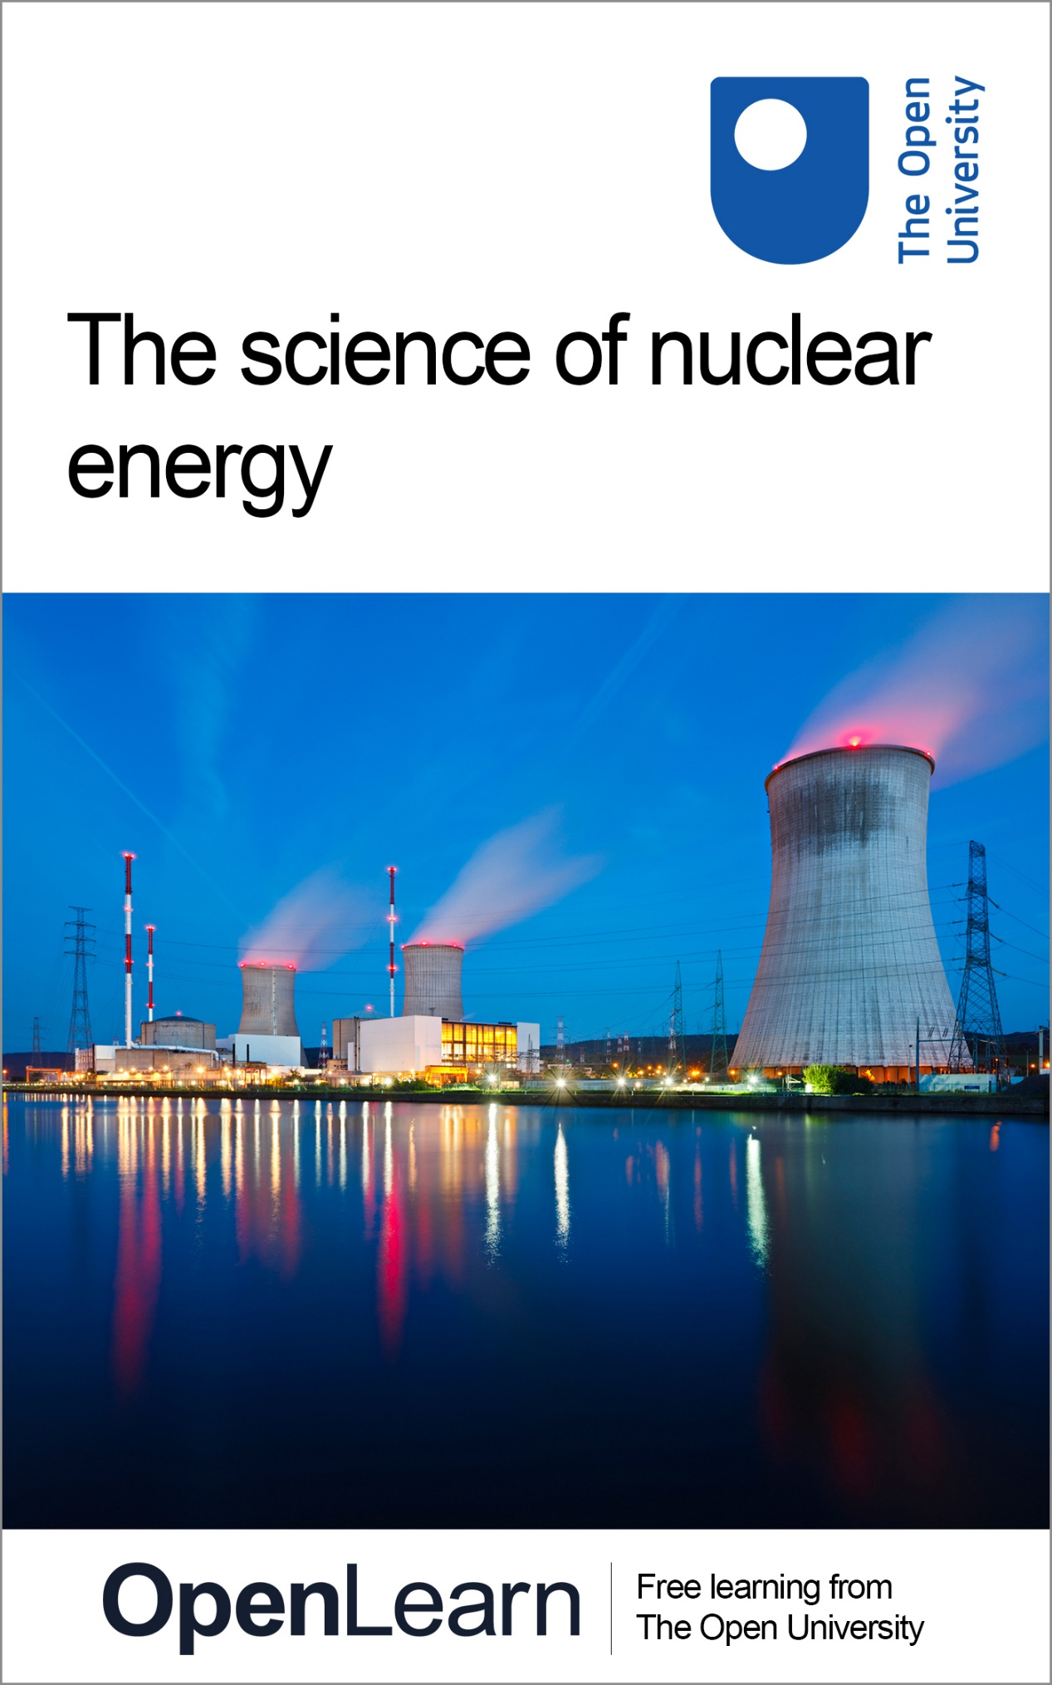

OUFL_18

The science of nuclear energy

This content was created and adapted within The Open University and originally published as an open educational resource on the OpenLearn website – http://www.open.edu/openlearn/. This content may include video, images and interactive content that may not be optimised for your device. To view the original version of this content please go to OpenLearn – http://www.open.edu/openlearn/.
If reading this text has inspired you to learn more, you may be interested in joining the millions of people who discover our free learning resources and qualifications by visiting The Open University – http://www.open.ac.uk/choose/ou/open-content.
Copyright © 2016, The Open University.
Except for third party materials and/or otherwise stated (see terms and conditions http://www.open.ac.uk/conditions) the content in OpenLearn and OpenLearn Works is released for use under the terms of the Creative Commons Attribution-NonCommercial-ShareAlike 4.0 Licence – http://creativecommons.org/licenses/by-nc-sa/4.0/deed.en_GB.
In short this allows you to use the content throughout the world without payment for non-commercial purposes in accordance with the Creative Commons non commercial sharealike licence. Please read this licence in full along with OpenLearn terms and conditions before making use of the content.
When using the content you must attribute us (The Open University) (the OU) and any identified author in accordance with the terms of the Creative Commons Licence.
The Acknowledgements section is used to list, amongst other things, third party (Proprietary), licensed content which is not subject to Creative Commons licensing. Proprietary content must be used (retained) intact and in context to the content at all times. The Acknowledgements section is also used to bring to your attention any other Special Restrictions which may apply to the content. For example there may be times when the Creative Commons Non-Commercial Sharealike licence does not apply to any of the content even if owned by us (the OU). In these stances, unless stated otherwise, the content may be used for personal and non-commercial use. We have also identified as Proprietary other material included in the content which is not subject to Creative Commons Licence. These are: OU logos, trading names and may extend to certain photographic and video images and sound recordings and any other material as may be brought to your attention.
Unauthorised use of any of the content may constitute a breach of the terms and conditions and/or intellectual property laws.
We reserve the right to alter, amend or bring to an end any terms and conditions provided here without notice.
All rights falling outside the terms of the Creative Commons licence are retained or controlled by The Open University.
Head of Intellectual Property, The Open University

Contents
- Week 1: Into the atom
  - Introduction
  - 1.1 The structure of atoms
    - 1.1.1 Isotopes
    - 1.1.2 Common isotopes
    - 1.1.3 Structure of atoms
    - 1.1.4 The nature of the nucleus
  - 1.2 Radioactive atoms
    - 1.2.1 Radioactivity
    - 1.2.2 Alpha, beta and gamma radiation
    - 1.2.3 Doses of radiation
    - 1.2.4 Precise doses of radiation
    - 1.2.5 Some uses of radioactivity
    - 1.2.6 Myths of radiation
    - 1.2.7 Ideas about radioactivity
  - 1.3 Nuclear processes
    - 1.3.1 Uranium
    - 1.3.2 Isotope trumps!
    - 1.3.3 What is fission?
    - 1.3.4 The chain reaction
    - 1.3.5 Energy from fission
    - 1.3.6 The early days of fission
  - 1.4 Quiz for Week 1
  - 1.5 Summary of Week 1
- Week 2: Using nuclear energy
  - Introduction
  - 2.1 Energy and power
    - 2.1.1 What uses most energy in the home?
    - 2.1.2 Human power station
    - 2.1.3 Generating electricity
    - 2.1.4 Energy sources
    - 2.1.5 Running the National Grid
    - 2.1.6 The National Grid
    - 2.1.7 Peak output
  - 2.2 Components of a nuclear power station
    - 2.2.1 Looking inside a nuclear reactor
    - 2.2.2 Inside a nuclear reactor
    - 2.2.3 Types of nuclear reactor
    - 2.2.4 The world’s nuclear power stations
  - 2.3 Waste produced by nuclear power
    - 2.3.1 Half-life
    - 2.3.2 Types of radioactive waste
    - 2.3.3 Decommissioning at Dounreay
    - 2.3.4 What can be done with nuclear waste?
    - 2.3.5 Solution: reuse
    - 2.3.6 Solution: transmutation
    - 2.3.7 Solution: deep geological repository
    - 2.3.8 Case study: Yucca mountain
  - 2.4 Quiz for Week 2
  - 2.5 Summary of Week 2
- Week 3: Is nuclear power safe?
  - Introduction
  - 3.1 Atomic men!
    - 3.1.1 What can go wrong in a nuclear power station?
    - 3.1.2 Accidents at Three Mile Island and Chernobyl
    - 3.1.3 Errors
    - 3.1.4 Clean-up at Three Mile Island and Chernobyl
  - 3.2 The Fukushima Daiichi reactor
    - 3.2.1 What caused the meltdown at Fukushima?
    - 3.2.2 Hydrogen explosions demonstration
    - 3.2.3 Inside the Daiichi power plant
    - 3.2.4 Exclusion zone
    - 3.2.5 Clean-up of Iitate
    - 3.2.6 Fukushima level 7
    - 3.2.7 Fukushima – six months later
  - 3.3 Fukushima – water issues
    - 3.3.1 Fukushima – ongoing challenges
    - 3.3.2 Fukushima – health effects three years later
    - 3.3.3 Chernobyl today – the reactor
    - 3.3.4 Chernobyl today – exclusion zone
    - 3.3.5 Chernobyl today – health effects
    - 3.3.6 What have we learned?
  - 3.4 Quiz for Week 3
  - 3.5 Summary of Week 3
- Week 4: A future for nuclear power?
  - Introduction
  - 4.1 Energy for the future or relic of the past?
    - 4.1.1 Carbon emissions and global warming
    - 4.1.2 Find your carbon footprint
    - 4.1.3 The energy gap
    - 4.1.4 The role of nuclear energy
    - 4.1.5 New reactor at Hinkley C
    - 4.1.6 Nuclear waste
    - 4.1.7 Happy with Hinkley?
  - 4.2 Thorium – nuclear fuel of the future?
    - 4.2.1 The Sun’s energy source
    - 4.2.2 What is nuclear fusion?
    - 4.2.3 Making use of fusion
    - 4.2.4 Challenges of fusing nuclei
    - 4.2.5 Fusion
    - 4.2.6 Fusion at JET and ITER
    - 4.2.7 The National Ignition Facility
  - 4.3 Nuclear energy debate
    - 4.3.1 What are your views on nuclear power?
  - 4.4 End-of-course quiz
  - 4.5 Summary of Week 4
- References
- Further reading
- Acknowledgements
- Solutions

Week 1: Into the atom

Introduction
Welcome to this free course, The science of nuclear energy.
In the following video, course authors Sam Smidt and Gemma Warriner introduce themselves and do some experiments with a Geiger counter to show radioactivity.

Video content is not available in this format.
View transcript - Uncaptioned interactive content

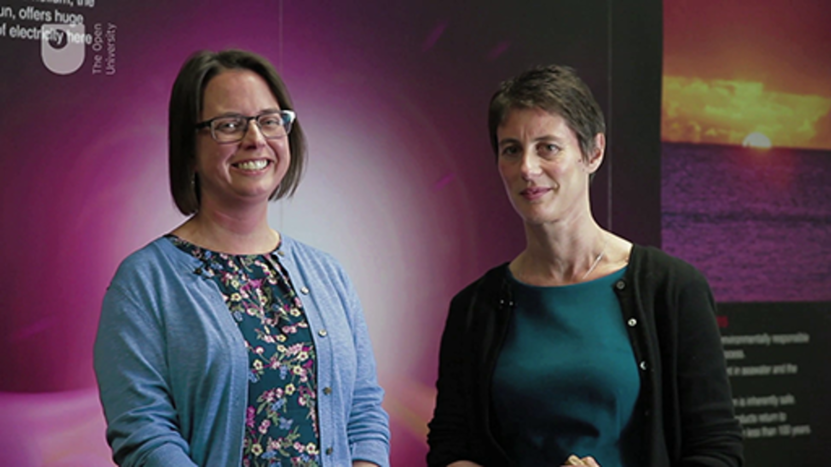

In Week 1 you’ll learn about the science behind nuclear energy. This learning will set you up for the rest of the course as you consider nuclear energy in context.
Before you start, The Open University would really appreciate a few minutes of your time to tell us about yourself and your expectations of the course. Your input will help to further improve the online learning experience. If you’d like to help, and if you haven’t done so already, please fill in this optional survey.

1.1 The structure of atoms

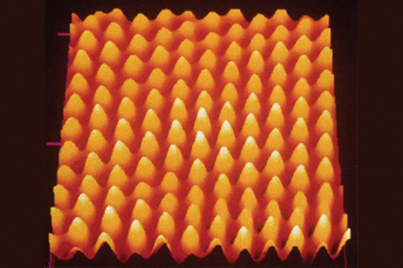
Figure 1 A layer of gold atoms on the surface of a crystal obtained by scanning tunnelling microscopy.
View description - Figure 1 A layer of gold atoms on the surface of a crystal obtained by scanning tunnelling ...
View alternative description - Figure 1 A layer of gold atoms on the surface of a crystal obtained by scanning tunnelling ...

To gain a good understanding of the processes behind nuclear energy and radioactivity, you’ll need first to consider the atom.

What are atoms?
If you look around you all the matter in the world is made up of very tiny building blocks called atoms.
Atoms are very small. The diameter of an average atom is a ten-billionth of a metre (or 10⁻¹⁰m if you are familiar with scientific notation). This means that 10 million atoms would fit between a millimetre division on a ruler. It is only recently that technology has progressed enough to enable us to see atoms. Figure 1 was produced with a type of microscope that enables us to distinguish individual gold atoms.
Different types of atoms combine in a number of ways to form the varying substances of matter. You might think there would need to be a huge number of different sorts of atoms to account for all the substances that exist and that can be made, but in fact there are just 118 different types of atom that have been observed. These are known as the chemical elements and of those 118, only about 90 occur naturally. Each element is represented by a chemical symbol, consisting of one or two letters, for example, H is for hydrogen and He is helium. An element important in Week 2 is uranium (U).

What is inside an atom?

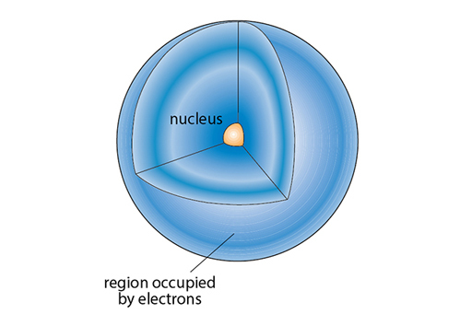
Figure 2 The inside of an atom.
View description - Figure 2 The inside of an atom.
View alternative description - Figure 2 The inside of an atom.

At the centre of an atom is a nucleus. If the atom was the size of a football stadium the nucleus would be the size of an orange at the centre! The diameter of a nucleus is about one ten-thousandth of that of an atom (or 10⁻¹⁴m). Pretty much all the matter in each atom is concentrated in this tiny volume and so nuclei are super dense and packed with energy. In this course we will be concerned with nuclei (NB nuclei is the plural of nucleus) and the release of this energy.
The nucleus itself is made up of smaller particles called protons and neutrons. These have similar (and very tiny) masses. The proton is positively charged and the neutron is neutral giving an overall positive charge to the nucleus. Protons and neutrons can be referred to collectively as nucleons.
The rest of the atom is taken up with the orbital electrons. These are much lighter than the proton or the neutron and are negatively charged, balancing out the positive charge of the nucleus.

What is an element?
Much of the matter around you is made up of compounds. Compounds are made up of molecules where there are two or more different atoms bonded together. Elements are made up of just one type of atom. You may be familiar with the periodic table which gives the full list of elements.
The number of protons in the nucleus of an atom is known as its atomic number and given the symbol Z. It is this number that determines the chemical element. Elements are defined by their chemistry, and chemistry is all about the interactions of the electrons of the atom, not the nuclei. The number of electrons in a neutral atom is always the same as the number of protons in its nucleus.
You may be wondering what role neutrons play and you’ll find that out in the next section.

1.1.1 Isotopes
So, the properties of a given element are determined by the number of electrons and protons within its atoms.
The number of protons determines what the element is. For example, all atoms of carbon have six protons, and any atom containing six protons must be carbon.

What role do the neutrons play?
An element can have different forms wherein the atoms have the same number of protons but a different number of neutrons. These different forms are called isotopes. The number of neutrons in an atom can be worked out from the mass number given the symbol A. The mass number is equal to the number of protons in a nucleus plus the number of neutrons.
So:

- Mass number = number of neutrons + number of protons
- A = number of neutrons + Z
- Number of neutrons = A−Z

The number of neutrons in an isotope can be found from the difference between the mass number and the atomic number.
As a shorthand, isotopes of each element may be represented by using the following notation . X is the symbol for the element itself and two numbers are used to indicate the atomic number (lower number, Z) and mass number (upper number, A).
So, a normal hydrogen atom is represented as and an atom of a heavier isotope, deuterium, as . Isotopes of some other light atoms are shown in Figure 3.

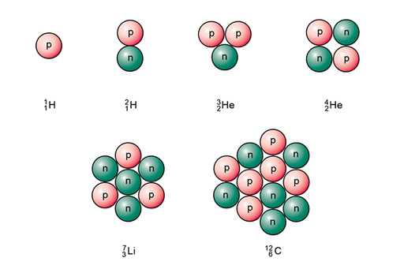
Figure 3 A schematic diagram of the nuclei of some isotopes.
View description - Figure 3 A schematic diagram of the nuclei of some isotopes.
View alternative description - Figure 3 A schematic diagram of the nuclei of some isotopes.

An alternative notation is to use the name of the element followed by a hyphen and then the mass number. For example, helium would usually be denoted by helium-4, but the lighter isotope referred to above would be given as helium-3. These can also be abbreviated to just the chemical symbol and mass number, for example, He-4 and He-3.
In the next section, you will discover more about isotopes.

1.1.2 Common isotopes
Table 1 shows some of the isotopes of the eight lightest elements. Isotopes of the same element have the same atomic number but a different mass number.

Table 1 Common isotopes
Atomic number Z | Mass number A | Isotope name | Isotope symbol
1 | 1 | hydrogen
1 | 2 | deuterium
2 | 3 | helium-3
2 | 4 | helium-4
3 | 7 | lithium-7
4 | 7 | beryllium-7 (unstable)
4 | 8 | beryllium-8 (unstable)
4 | 9 | beryllium-9
5 | 11 | boron-11
6 | 12 | carbon-12
6 | 13 | carbon-13
6 | 14 | carbon-14 (unstable)
7 | 14 | nitrogen-14
8 | 16 | oxygen-16

Only the isotopes of hydrogen have their own names. All the H isotopes have one proton but hydrogen has no neutrons, deuterium has one neutron and tritium has two neutrons.
It is worth mentioning that protons and neutrons do themselves have an internal structure and are comprised of even smaller particles, known as quarks.
You will have noticed that some isotopes in the table are labelled unstable. You’ll find out the reason for this later this week. Next, take a short quiz about what you’ve learned so far.

1.1.3 Structure of atoms
Test what you’ve learned about atoms so far in this short quiz.

Activity 1

Which of the following sentences describes a proton?

This particle has no charge and exists in the nucleus
This particle has a positive charge and exists in the nucleus
This particle is in orbit around the nucleus
This particle has a negative charge
View answer - Part

Use Table 2 to work out which of the following particles make up an atom of carbon-13.

Table 2
Atomic number Z | Mass number A | Isotope name | Isotope symbol
1 | 1 | hydrogen | H
1 | 2 | deuterium | H
2 | 3 | helium-3 | He
2 | 4 | helium-4 | He
3 | 7 | lithium-7 | Li
4 | 7 | beryllium-7 (unstable) | Be
4 | 8 | beryllium-8 (unstable) | Be
4 | 9 | beryllium-9 | Be
5 | 11 | boron-11 | B
6 | 12 | carbon-12 | C
6 | 13 | carbon-13 | C
6 | 14 | carbon-14 (unstable) | C
7 | 14 | nitrogen-14 | N
8 | 16 | oxygen-16 | O

6 electrons, 6 protons, 6 neutrons
6 electrons, 7 protons, 6 neutrons
6 electrons, 6 protons, 7 neutrons
7 electrons, 7 protons, 6 neutrons
View answer - Part

Using Table 3, what is the difference between an atom of beryllium-8 and beryllium-9?

Table 3
Atomic number Z | Mass number A | Isotope name | Isotope symbol
1 | 1 | hydrogen | H
1 | 2 | deuterium | H
2 | 3 | helium-3 | He
2 | 4 | helium-4 | He
3 | 7 | lithium-7 | Li
4 | 7 | beryllium-7 (unstable) | Be
4 | 8 | beryllium-8 (unstable) | Be
4 | 9 | beryllium-9 | Be
5 | 11 | boron-11 | B
6 | 12 | carbon-12 | C
6 | 13 | carbon-13 | C
6 | 14 | carbon-14 (unstable) | C
7 | 14 | nitrogen-14 | N
8 | 16 | oxygen-16 | O

They are different isotopes of beryllium
They have different numbers of protons
They have the same number of neutrons
They have different atomic numbers
View answer - Part

1.1.4 The nature of the nucleus
You have now learned about the particles that make up atoms, protons, neutrons and electrons.
These are collectively termed subatomic particles and are summarised in Table 4.

Table 4 The constituents of atoms: subatomic particles
 | Electric charge | Notes
Electron | −1 unit | In a neutral atom, number of electrons = number of protons
Nucleons |  | Mass number = number of nucleons
Proton | +1 unit | Atomic number = total number of protons
Neutron | 0 | Isotopes of the same elements have different numbers of neutrons

In the next sections you will find out how the nature of the nucleus and the nucleons within lead to radioactivity and the fission reactions that power nuclear reactors.

1.2 Radioactive atoms

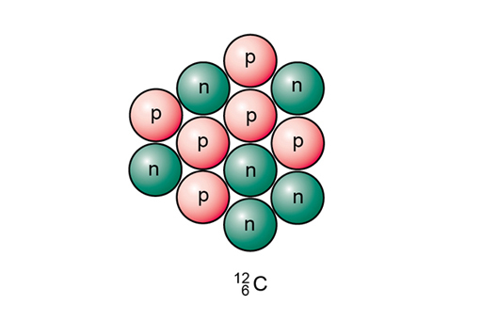
Figure 4 A schematic diagram of the nucleus of the carbon-12 isotope.
View description - Figure 4 A schematic diagram of the nucleus of the carbon-12 isotope.
View alternative description - Figure 4 A schematic diagram of the nucleus of the carbon-12 isotope.

What does it mean for an atom to be radioactive? What forces are at play within the nucleus?

Forces within the nucleus
Consider a nucleus of carbon-12 shown in Figure 4. It contains six positive protons and six neutral neutrons, crammed into an extremely small volume.
You may already know that like charges repel, this is an aspect of the electromagnetic force. Therefore, you would imagine that the positively charged protons would mutually repel each other and the nucleus would fly apart! The fact that nuclei hold together suggests the presence of another force within the nucleus that pulls the nucleons together. The force in question is the strong force. It is beyond the scope of this course to give a full explanation of the strong force, but the key idea for us is that it pulls nucleons together within the nucleus.
So, to summarise:
- There is a repulsive electromagnetic force within the nucleus that acts between protons.
- There is an attractive strong force within the nucleus that acts between both protons and neutrons.
Neutrons are necessary to hold the nucleus together. In Table 5, notice that as nuclei get bigger the ratio of neutrons to protons increases – the uranium nucleus needs significantly more neutrons than protons to hold together.

Table 5 The number of protons and neutrons within isotopes
Element | Isotope | Number of protons | Number of neutrons
carbon |  | 6 | 6
calcium |  | 20 | 20
zinc |  | 30 | 35
iodine |  | 53 | 74
uranium |  | 92 | 146

Stability and instability
We can now visualise the nucleus as an energetic and dynamic environment; densely packed with two opposing forces acting on the particles within it.
Within many nuclei, the two forces reach an equilibrium. Such nuclei are able to hold together and are said to be stable. In other nuclei the interaction between the forces can make the nuclei unstable. To gain stability, the unstable nucleus will emit particles and energy, and such nuclei are called radioactive. When it emits a particle, the nucleus is said to decay.
Most elements within the periodic table have both stable and radioactive isotopes. For example, carbon-12 is stable while carbon-14 is radioactive. The stable form of each element tends to be the form that is most abundant. It is possible to quantify how radioactive an isotope is by how many particles are emitted in a given time – you will examine this later in the course when you’ll consider half-life.
The emitted particles have enough energy to detach electrons from atoms or molecules that they interact with. This turns the neutral atoms or molecules into charged ions and hence the emitted particles are sometimes called ionising radiation.
Radioactivity and nuclear energy are not the same thing but they are linked – if it were possible to somehow get the energy without having to worry about the radioactivity, nuclear energy would be a lot less problematic! But the radioactive particles that are emitted mean that there are all sorts of problems associated with generating nuclear energy.
Radioactivity isn’t new – it has been around longer than humans and has always been part of the environment. In fact, it is radioactive decay that provides the majority of the Earth’s internal heat that causes volcanoes to erupt and drives plate tectonics. Radioactive materials are all around you!
Watch the video in the next section for some background to the discovery of radioactivity.

1.2.1 Radioactivity
Now watch the following video.

Video content is not available in this format.
View transcript - Uncaptioned interactive content

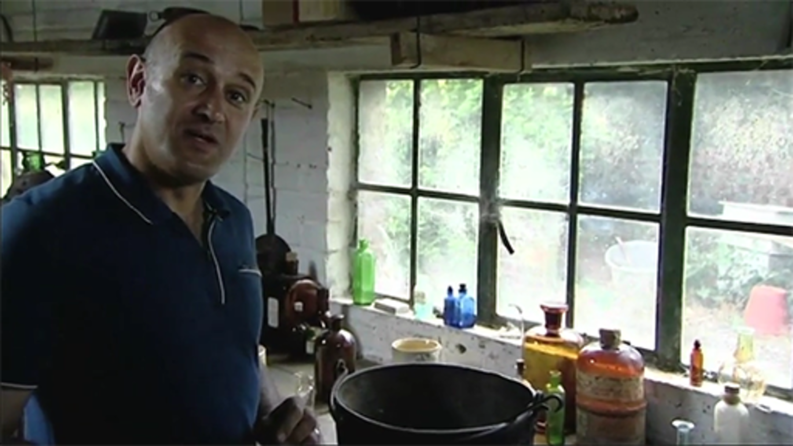

Radioactivity was discovered in 1896 by Henri Becquerel who noticed that the radiation from uranium salts had similar characteristics to X-rays that had been discovered the previous year by Wilhelm Röntgen. The uranium salts emitted particles that reacted with photographic plates.
Over the following 20 years, Marie and Pierre Curie, Ernest Rutherford, and many others worked on identifying the different emissions called initially ‘uranic rays’. Marie Curie was working with a uranium ore called pitchblende, and managed to isolate two new elements within the pitchblende – polonium and radium. This was no mean feat as within a tonne of pitchblende there was less than a gramme of these new, highly radioactive elements.
It was discovered that radioactive materials emit particles of three distinct types and that these had differing masses and charges. These three types of emission were called alpha, beta and gamma particles.
You’ll look at these particles in the next section.

1.2.2 Alpha, beta and gamma radiation
The imbalance of forces within unstable nuclei leads to the emission of particles.
Here you’ll find out about three types of particle that can be emitted; α, β and γ or alpha, beta and gamma particles. Collectively they are often referred to as radiation from a radioactive substance.

Alpha particles
Alpha particles are the largest of the emitted particles and are positively charged. They are composed of two protons and two neutrons that are bonded together, which is the same as a helium-4 nucleus. This makes them the most massive of the types of radioactive emission.
The nucleus therefore loses two protons and becomes a different element!
For example, if emits an α particle it will become ; uranium has transformed into thorium.
Alpha particles are easier to stop than other forms of radiation because they are bigger than the other forms and because they have a double positive charge (remember that a proton has a single positive charge). They can be stopped by a sheet of paper or by clothing. This is important because they cause a lot of damage if they interact with biological tissue. Even when they are travelling in air, their positive charge means that they attract electrons and quickly become nothing more than harmless helium.

Beta particles
Beta particles are negatively charged and turned out to be an electron ejected from a nucleus. They have a much lower mass than alpha particles. In neutral atoms, electrons exist outside the nucleus, and have a negative charge equal and opposite in magnitude to the positive charge on a proton.
In β-decay, a neutron inside a nucleus changes into a proton and emits an electron, that is the β-particle (another particle called an antineutrino is also emitted but it has no charge and almost no mass, and can be ignored in the present context).
In this case the initial nucleus has gained a proton and so again a new element may be formed. Note that the mass number doesn’t change as the number of nucleons is the same. The number of neutrons has reduced by one, and the number of protons has increased by one.
For example, if emits a β particle it will become ; caesium has transformed into barium.
A β-particle has more kinetic energy than a normal electron and carries a single negative charge. It’s harder to stop than an α-particle and can get through paper or clothing but is stopped by denser materials such as water or aluminium. Once they are stopped, the β-particles simply become part of the material they are in, like any other electron.

Gamma particles
Gamma rays are high-energy electromagnetic radiation emitted by radioactive elements. They possess energy but no mass. The electromagnetic spectrum, shown in Figure 5, is the range of all possible energies of electromagnetic radiation. A photon can be defined as the basic unit, or elementary particle, of electromagnetic radiation. Like visible light, a γ-ray is just energy but a γ-photon has more energy than a photon of visible light or even of X-rays.

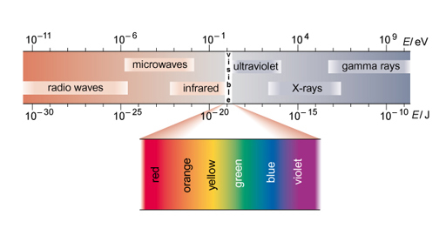
Figure 5 The electromagnetic spectrum (the energy scale is given in two units; both the electronvolt (eV) and the joule (J) are explained later).
View description - Figure 5 The electromagnetic spectrum (the energy scale is given in two units; both ...
View alternative description - Figure 5 The electromagnetic spectrum (the energy scale is given in two units; both ...

Unlike α or β radiation, loss of a γ particle does not change the composition of the nucleus, although it does lose energy. Gamma emission usually occurs together with α- or β-emission and it is rare to get gamma rays emitted on their own.
Because they have no mass or charge and high energy, γ-rays are more difficult to stop than β- or α-particles and it takes dense materials such as lead, or concrete, to absorb their energy and stop them. This is an issue you’ll consider in Week 2 when you’ll hear about the storage of radioactive waste.
All three types of radiation can damage human cells and this damage can lead to cancers developing in the area affected. All three types of radiation can be detected by a Geiger counter.
Next, you will find out where radiation is found.

1.2.3 Doses of radiation
Radioactive materials are all around you. They are in the air that you breathe and the food that you eat. They are in the materials with which we build our houses and the rocks in the ground.
You are radioactive yourself! Radioactive carbon-14 is decaying within you, as is potassium-40.
This means that we are subject to a constant bombardment of alpha, beta and gamma particles. This is called background radiation. There is no avoiding background radiation and we have evolved within it. The amount of background radiation that we experience is generally so low that it is highly unlikely to do us any harm.
The amount of background radiation at a given place is called the background count. This is due, mainly, to the radioactive elements in the sources. The amount of radiation you experience is called the dose of radiation and is based on both the radiation present and on you and the tissue (bones, organs) involved; the unit is the mSv (milliSievert). The average annual dose from background radiation in the UK is 2.7mSv.
If the radiation locally is raised above the background count then you may receive a bigger dose. For instance, some medical procedures involve the use of radiation and flying increases your exposure to cosmic rays. Cosmic rays are composed of radiation from the Sun and other stars.
In the activity below, you’ll find eight activities that would expose you to radiation. Decide which you think would give you the highest annual dose of radiation and sort the items from highest to lowest by dragging the names up and down the list. The computer will tell you when you’ve got it right, and will offer you help after you’ve made a certain number of moves.

Interactive content is not available in this format.

1.2.4 Precise doses of radiation

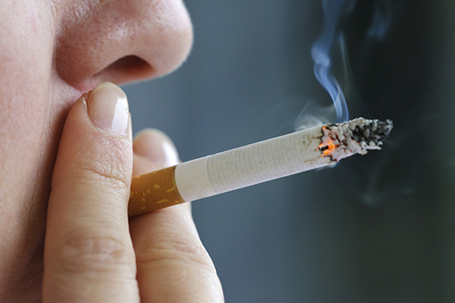
Figure 6
View description - Figure 6
View alternative description - Figure 6

How did you get on with the ordering activity in the previous section? Were you surprised with the results?
The measures were:
- smoking every day (13mSv)
- one chest CT scan (12mSv)
- cooking with natural gas (10mSv)
- living in Cornwall (7.8mSv)
- working for an airline (3 to 9mSv)
- working in nuclear power (0.18mSv)
- eating a banana a day (0.036mSv)
- one dental X-ray (0.014mSv).
In the next section, discover uses for radioactivity.

1.2.5 Some uses of radioactivity
The radioactive nature of some isotopes and the emission of particles can be put to good use.
Four examples are given below but there are many more applications. You will be shown more in the activity at the end of the week – Isotope trumps!

Figure 7
View description - Figure 7
View alternative description - Figure 7

Americium-241
Americium-241 is used in smoke detectors. It is an alpha emitter and the alpha particles ionise the air molecules in a chamber open to the air, so that the air molecules now carry a charge. The charged ions allow a tiny current to flow. If smoke particles enter the chamber this current is disrupted and an alarm sounds.

Carbon-14

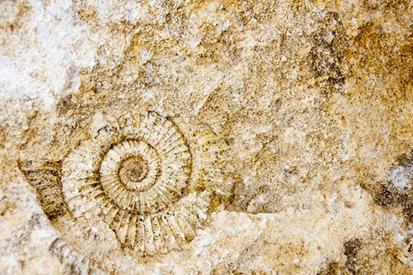
Figure 8
View description - Figure 8
View alternative description - Figure 8

Carbon exists in the organic molecules that make up the cells of living organisms and some of this carbon will be radioactive carbon-14, a beta emitter.
Plants can fix carbon from the air so that the amount of carbon-14 in living organisms is roughly constant throughout their lifetime and reflects the amount of C-14 in the atmosphere at the time. Once an organism dies, the C-14 will start to decay – the rate of this decay is known.
If you measure the amount of C-14 in a sample today it is possible to trace back and work out how old the sample is. This has been very useful in archaeology and palaeontology.

Iodine-131

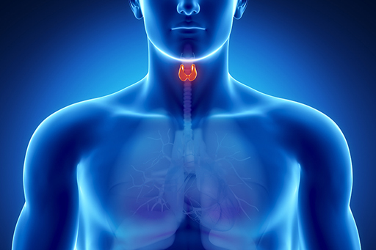
Figure 9
View description - Figure 9
View alternative description - Figure 9

Iodine-131 emits beta and gamma radiation and can be used to treat thyroid problems, such as thyroid cancer or an overactive thyroid, where treatment requires destruction of some of the cells within the thyroid.
When a capsule of I-131 is swallowed, it is absorbed into the bloodstream before concentrating in the thyroid gland. The radiation from the I-131 will destroy the cells locally – which, in this case, is the desired effect.

Technetium-99

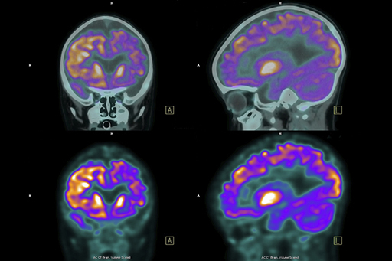
Figure 10
View description - Figure 10
View alternative description - Figure 10

If technetium-99 is introduced into the body it can be used as a tracer. For example, it can show the blood flow through the heart or the brain. The Tc-99 will flow with the blood and emit gamma radiation that can be detected and imaged. This can build up a picture of how the blood is flowing and into what areas. The Tc-99 decays at a good rate for this use and only lasts in the body for a day, with a very low risk of damage.
Tc-99 is produced from the decay of molybdenum-99. In turn, this Mo-99 is usually created commercially by fission of uranium in nuclear reactors. It is a fission product, and these are discussed in the next section.

1.2.6 Myths of radiation
Watch the following video.

Video content is not available in this format.
View transcript - Uncaptioned interactive content

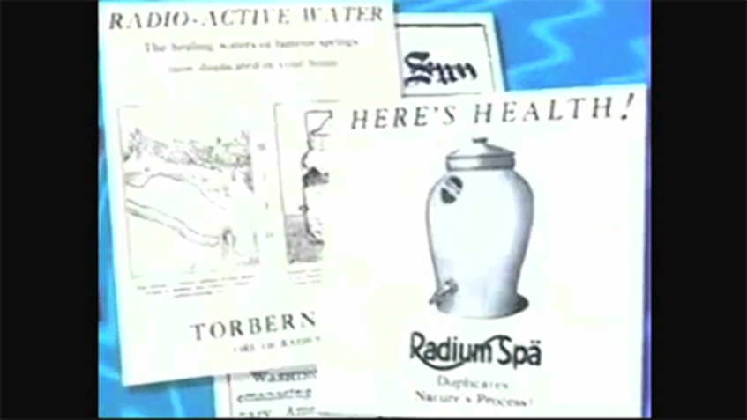

Radium was discovered by Marie and Pierre Curie at the end of the nineteenth century and was one of the first radioactive elements to be identified.
While scientists endeavoured to understand the nature of radioactivity, some were quick to capitalise on its perceived properties. Radium was a brand new element unlike any that had been seen before and seemed to have near magical properties.
Many of these inventions seem bizarre to us today! We have come a long way in our understanding but misconceptions still swirl around radioactivity nowadays.
You’ll have a chance to consider the public perception of radioactivity in the next section.

1.2.7 Ideas about radioactivity

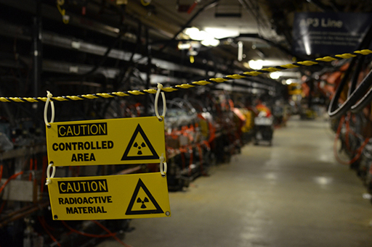
Figure 11
View description - Figure 11
View alternative description - Figure 11

Many bold claims were made in the video about the health benefits of contact with radioactive materials.
In the intervening years the scientific community has learned much about radioactivity, but not all of these ideas are well understood by the wider community.

Activity 2

Consider the following questions:
- Can you contrast the attitude to radioactivity a hundred years ago to our attitude today?
- Do you think that people are better informed today?

Provide your answer...

1.3 Nuclear processes

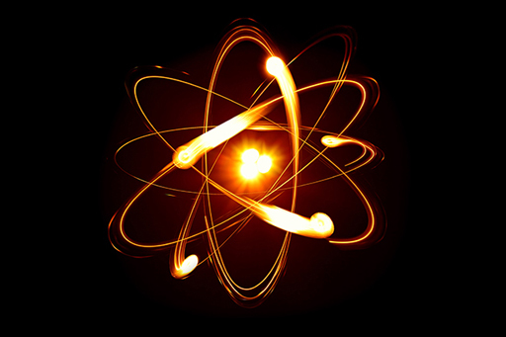
Figure 12
View description - Figure 12
View alternative description - Figure 12

So far, you have looked inside the nucleus and determined its composition. You have learned that the composition of the nucleus and the forces at play can lead to instability and emission of particles.
In fact, something even more dramatic can happen to the largest nuclei such as uranium and plutonium. They can split apart into smaller fragments and release energy as they do so. This process is called fission and is the basis of the current nuclear industry.
In the next sections, you will learn about the process of fission and how it may be induced. There is another process where smaller nuclei can bind together called fusion. You will come back to fusion during Week 4.

1.3.1 Uranium

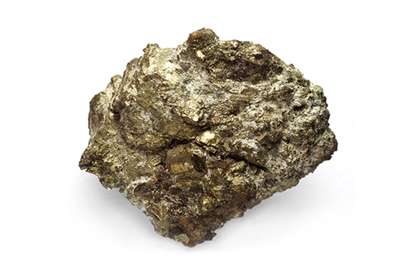
Figure 13
View description - Figure 13
View alternative description - Figure 13

Since uranium is an element that you are going to learn more about, it is worth spending a little time now outlining its properties.
Uranium is a naturally occurring element found mainly in small quantities everywhere on Earth. Uranium has played a vital role in the evolution of the Earth. Its natural radioactivity is believed to have provided the heat source powering such processes as plate tectonics and the maintenance of the Earth’s molten core. It is likely that without the energy released by radioactive decay, the Earth would have cooled long ago causing it to have a Mars-like environment. Indeed, without uranium it is probable that there would be no life on Earth as the core would have cooled to a point where the Earth’s magnetic field would have collapsed, allowing the solar wind to strip away the atmosphere and the oceans.
Uranium is the main fuel used in nuclear reactors. Natural uranium has three isotopes: uranium-238, uranium-235 and uranium-234. All of the isotopes are radioactive and so are sometimes called radioisotopes or radionuclides. Uranium-238 forms about 99.3% of all natural uranium, with uranium-235 forming around 0.7% and uranium-234 just 0.0055%, so U-238 is by far the most common uranium isotope.
The properties of the U-235 were crucial to the development of nuclear energy and we are concerned with this particular isotope in this course.

1.3.2 Isotope trumps!
Fancy a hand of cards? Have a go at our Isotope trumps game!
We’ve placed the same five attributes (proton number, neutron number, half-life, the speed of the emitted particle and the energy of the emitted particle) for a number of isotopes for you to compare.
Half-life will be explained more fully next week but consider it as a measure of how rapidly an atom decays. A short half-life means that it decays very quickly and a long half-life indicates a slower decay.
You win a turn by choosing an attribute that has a higher value than on the card held by your opponent, the computer. You can choose how smart the computer is. Normally, whoever wins a turn plays first in the next turn, but you can give yourself an extra advantage by forcing the computer to always play second.
You will need to take an ‘educated guess’ in many cases. We hope this will improve your feel for the nature and uses of many different isotopes. When you’ve had enough, move on to the next section. You can come back any time you like and try to beat the computer as your knowledge grows.

Interactive content is not available in this format.

1.3.3 What is fission?
Fission is the splitting of large nuclei into smaller nuclei with the release of energy. Spontaneous fission is rare and generally fission is induced by bombarding the heavy nucleus with neutrons.
In the late 1930s it became evident that bombardment of uranium-235 by neutrons could lead to fission. The U-235 nucleus is able to absorb the neutron to become (very briefly) U-236. The U-236 then undergoes fission to form two new nuclei called fission products.
Fission also produces neutrons and energy. Neutron induced fission is illustrated in Figure 14. Bombarding the uranium-235 nucleus with a neutron leads to the formation of a uranium-236 nucleus, which very quickly undergoes fission. Fission products are formed, and neutrons are emitted. Note that gamma radiation is also emitted.

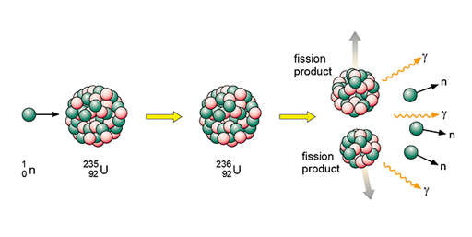
Figure 14 The particles and types of radiation involved in fission
View description - Figure 14 The particles and types of radiation involved in fission
View alternative description - Figure 14 The particles and types of radiation involved in fission

Neutrons are shown as using the same notation as for isotopes. The fission products themselves can vary but examples would be xenon-140 and strontium-93. An equation representing this particular fission would be:
In words this would be: ‘A uranium-235 atom absorbs a neutron to become uranium-236 which then undergoes fission to form the products xenon-140 and strontium-93 with three neutrons.’
Some important points to note:
- Fission products tend to be radioactive. These by-products of nuclear power form the majority of the radioactive waste that we will consider next week.
- The fact that neutrons are also produced means that these neutrons can go on to induce further fissions. Once started, fission can become self-sustaining – this is called a chain reaction.
- For fission to occur the neutrons must be going at the right speed – too fast and they will bounce off rather than be absorbed. The neutrons may need to be slowed down and are then referred to as thermal neutrons. Both the number and speed of the neutrons is crucial within a working reactor.
- The energy released per fission is relatively large. It is 50 million times more energy than burning the equivalent amount of carbon. We will consider where the energy comes from in the next section.
While uranium-235 is the isotope that undergoes fission it is worth noting that uranium-238 atoms can absorb neutrons to become plutonium-239 which is another atom that can undergo fission.

1.3.4 The chain reaction
A fission chain reaction can proceed without intervention, as the free neutrons created by one fission event go on to trigger the next fission event.
As two or three neutrons are produced by each fission event, it is easy to see that a chain reaction could get out of hand and ‘runaway’, producing too much energy too quickly.

Terminology
- Criticality: the number of fission events is steady and the chain reaction releases a steady amount of energy.
- Sub-critical: the number of fission events decreases and the chain reaction releases progressively less energy.
- Super-critical: the number of fission events increases and the chain reaction releases progressively more energy.
In Figure 15, the left image shows a mass that is too small to sustain a chain reaction, as too high a proportion of neutrons escape by passing out of the mass. The right image shows that increasing the mass to the ‘critical mass’ causes a higher proportion of neutrons to stay within the volume long enough to induce further fissions.

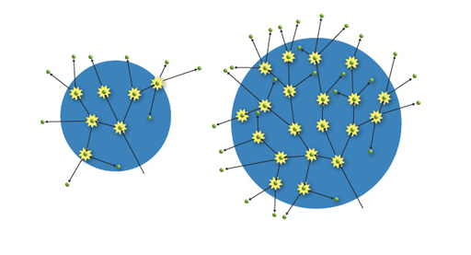
Figure 15 On the left, a mass too small to sustain a chain reaction; on the right, increasing the mass to ‘critical mass’ has enabled further fissions
View description - Figure 15 On the left, a mass too small to sustain a chain reaction; on the right, ...
View alternative description - Figure 15 On the left, a mass too small to sustain a chain reaction; on the right, ...

As you will discover, the requirement in a nuclear power station is to maintain the reaction at, or close to, criticality. If it is sub-critical, the fission reaction will gradually reduce; if super-critical the reaction could run out of control.
In order for a fission reaction to go ‘critical’ it needs a critical mass of uranium. Effectively, the important property is size rather than mass and the fact that small objects have a greater surface area to volume ratio. If the amount of uranium-235 is too small the neutrons will escape from the surface and the chain reaction will peter out.

1.3.5 Energy from fission
Nuclear power is based on the energy that is released each time a uranium nucleus undergoes fission.

Energy and mass
In nuclear reactions, the energy released can be understood from Einstein’s most famous equation:
E = mc²
Here E is energy; m is mass and c the speed of light.
This shows that there is a clear equivalent relationship between mass (m) and energy (E). The speed of light is shown as c and it is has a large value. Light travels at 300 million ms⁻¹. In fact, the speed of light is squared in the equation giving an even bigger number, 90 million billion! (The units of this would be (ms⁻¹)² but we don’t need to worry about this.) Suffice to say, to work out the amount of energy bound up in a mass we multiply the mass by a huge number – a small mass converts into a very large energy.
This equation holds true if you can convert mass into pure energy – although this is easier said than done! One place that this conversion takes place is within the nucleus, so if we can master nuclear reactions we can tap into this energy.

Binding energy
Imagine you had a marble and knew its mass was 5g. If you then received a bag of 20 identical marbles and were asked the total mass of these marbles you may reason that it is 20 × 5g = 100g. And you would be correct!

Mass of 20 marbles = 20 × mass of one marble

Now imagine you had a nucleon and knew it was a certain mass m (protons and neutrons have pretty much the same mass) and you were then asked the mass of a nucleus containing 20 nucleons. You may reason, as before, that its mass would be 20m. But in fact the mass of the nucleus would be less than this – the mass of the nucleus is less than the mass of the constituent parts! This is represented in Figure 16.

Mass of a nucleus containing 20 nucleons < 20 × mass of one nucleon

The difference in mass is called the mass defect.

Mass defect = Mass of separate nucleons − Mass of nucleus

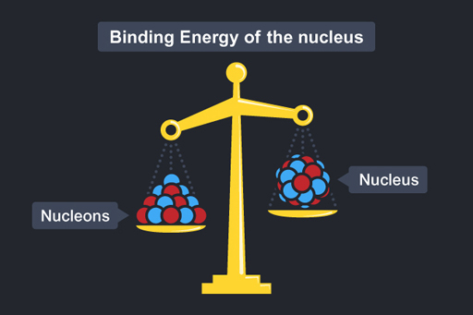
Figure 16
View description - Figure 16
View alternative description - Figure 16

Where has the missing mass gone? It has been converted into energy – this is called the binding energy of the nucleus. The binding energy is associated with the forces that bind the nucleus together.
From E = mc²

Binding energy = mass defect × c²

Different nuclei have differing amounts of binding energy. In fission, a large nuclei is split into smaller parts. The total mass of these parts may be lower than the initial large nucleus. This difference in mass is due to the difference in binding energy between the nuclei and is released as energy.

Energy from fission
The mass of the fission products and the three neutrons is less than of the U-236, although the number of nucleons is the same. This missing mass is released as energy – generally taken away by the fission products, the neutron and the gamma radiation.
The energy released from one fission is small but with many nuclei, the energy adds up to far exceed the amount from the equivalent chemical reactions. The fission of 1kg uranium provides a million times more energy than the burning of 1kg of coal. Fission can provide a great deal of heat energy.
It was this knowledge, before the ability to harness this energy had been developed, that led nuclear physicist Leo Szilard, in 1934, to speculate about planned experiments that, if successful, would lead to:

Power production … on such a large scale and probably with so little cost that a sort of industrial revolution could be expected; it appears doubtful for instance whether coal mining or oil production could survive after a couple of years.
(Quoted in Weart and Szilard, 1978, p. 39)

Next week, you will be learning more about the use of fission as an energy source to generate electricity.
In the next section is a video outlining the development of working nuclear reactors.

1.3.6 The early days of fission
The following video outlines the early days of induced fission and the development of nuclear reactors based on induced fission.
The timeline of development is:
- In 1948 and 1951, electricity was first generated by a nuclear reactor in the US in two experiments.
- In June 1954, the Soviet of City of Obninsk opened the world’s first nuclear power plant to generate electricity for a power grid.
- In October 1956, the first full scale nuclear power station opened at Calder Hall in Cumbria, England.

Video content is not available in this format.
View transcript - Uncaptioned interactive content

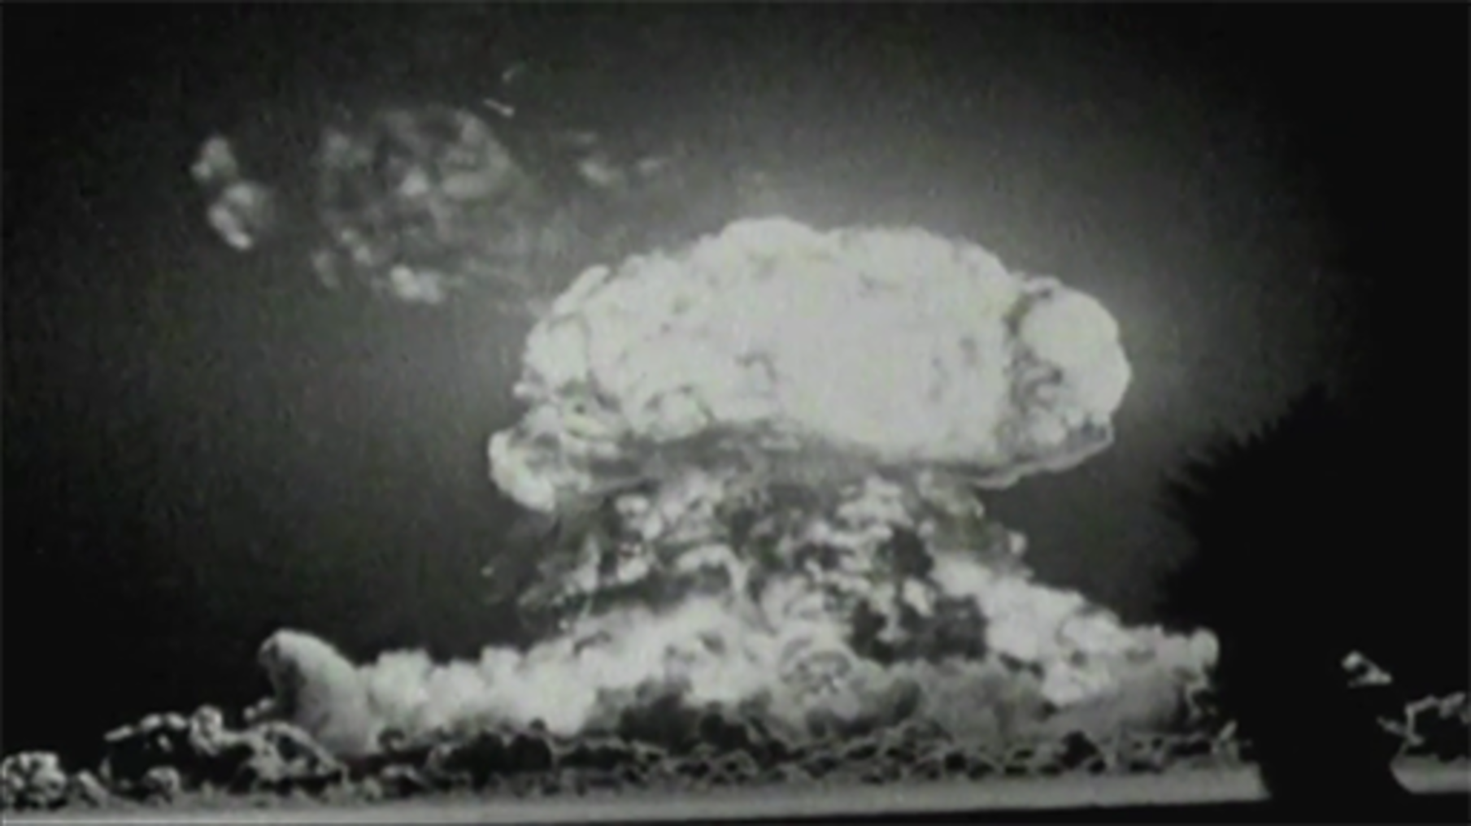

Next week, you will be examining nuclear power stations, how they function and some of the problems associated with them.

1.4 Quiz for Week 1
Now take the quiz for this week, which allows you to test and apply your knowledge of the material in Week 1.
Week 1 quiz
Open the quiz in a new window or tab and return here when you have finished.

1.5 Summary of Week 1
In this week, you have examined the science behind nuclear energy. You’ve learned that atoms are made up of a much smaller nucleus with electrons in orbit around it. The nucleus contains positively charged protons and neutral neutrons, collectively known as nucleons.
The same elements contain atoms that always have the same number of protons within them but can have differing numbers of neutrons. These different forms are called isotopes.
The interplay of forces within a nucleus leads to some isotopes being stable while others are unstable. Unstable nuclei emit particles to gain stability and are called radioactive. Alpha, beta and gamma radiation can be emitted from radioactive substances.
Radiation is all around us and is measured by the background count. The radioactive nature of some elements is put to good use.
Some heavy isotopes (such as uranium-235) can undergo fission. Fission involves the nucleus splitting into smaller nuclei and releasing energy. The products from fission are very radioactive and must therefore be disposed of with care.
In Week 2, you will examine how the energy from fission can be harnessed into a workable energy resource that can be used to generate electricity. You will look at the National Grid and the components of a nuclear power station.
One of the most contentious issues surrounding nuclear power is that of nuclear waste. You will look at the different types of nuclear waste and current ideas on how to deal with it.
You can now go to Week 2.

Week 2: Using nuclear energy

Introduction
In the following video, Sam and Gemma discuss our energy needs, where our power comes from and how it is delivered.

Video content is not available in this format.
View transcript - Uncaptioned interactive content

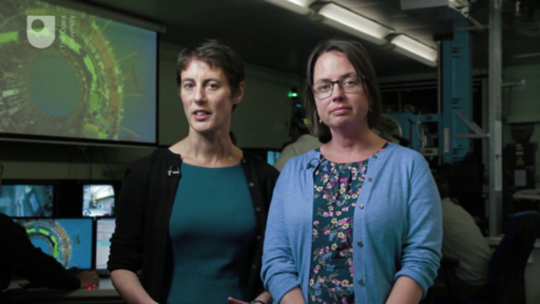

In the next section, you will find out about the principle of the conservation of energy.

2.1 Energy and power

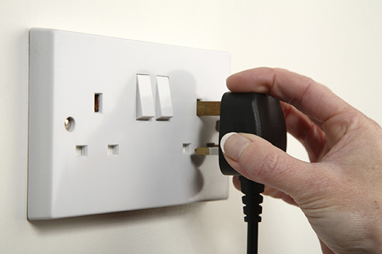
Figure 1
View description - Figure 1

One of the most fundamental principles in physics is that of the conservation of energy.
This means that in any process energy cannot be created or destroyed; it can only be transformed from one form into another. The total amount of energy is therefore said to be conserved.
This might or might not be a familiar concept to you, but here are a couple of examples to help explain it.
- Chemical energy stored in food is transformed when you digest what you eat into a form of energy that your body can use as ‘fuel’.
- Solar energy, from the Sun, is used in photosynthesis by plants to create chemical energy that enables the plants to grow and to perhaps produce food for the previous process!
The standard unit that energy is measured in is the joule (J). To get an idea of the size of the joule, look at these examples:
- energy content of a cereal bar: 800,000J
- energy stored in an AA battery: 9000J
- energy required to climb a flight of stairs: 3000J.
These are rough values and may vary a bit in reality, but they can give a general idea. In this course, you’ll be concerned with the transfer of nuclear energy into heat energy and then to electrical energy.
Power is the rate at which energy is transferred. For example, an electric fire transfers energy in the form of heat to its surroundings.
Energy can be related to power and time by the equation:

energy = power × time
power = energy/time

A watt (W) is the unit of power and it corresponds to an energy transfer of 1 joule per second. Many domestic appliances have their power given in thousands of watts, or kilowatts (kW), and electricity power stations normally have their outputs rated in millions of watts, that is, in megawatts (MW). The energy requirement for the UK as a whole is often given in gigawatt (GW). Each gigawatt is 1 billion (1 000 000 000) watts.
Appliances around your home will have power ratings on them which indicate how many joules of energy they transform every second.
For example, an average kettle is rated at 3kW. That means that it uses 3000J every second it takes to heat up and boil water. To make one cup of tea, the amount of water needed takes one minute to boil.
So using:

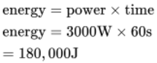
View alternative description - Uncaptioned Equation

It takes 180,000J of energy to make a cup of tea. This is equivalent to the energy required to climb 60 flights of stairs!
When you plug in a kettle, this 180,000J is provided by the electrical energy supplied from the National Grid. Modern life requires a great deal of electrical energy to be produced and it is sometimes difficult to get a tangible idea of how much energy this is.
In the next section, you will be asked to estimate the energy requirements of appliances found around the home.

2.1.1 What uses most energy in the home?
Most of us are aware of the need to be careful of how much energy we use in our homes.
Do you know which electric appliance would use the most energy if it was switched on for an hour?
Have a look at the power rating on some of your own appliances then see if you can put the list of domestic appliances in order. Put those using the most energy at the top by dragging the names up and down the list. The computer will tell you when you’ve got it right, and will offer you help after you’ve made a certain number of moves.

Interactive content is not available in this format.

In the next section, you will watch an experiment where human cyclists were used to provide the electrical energy to run a house.

2.1.2 Human power station
In the following clip, Bang goes the Theory demonstrates how much electricity we use without even thinking about it.

Video content is not available in this format.
View transcript - Uncaptioned interactive content

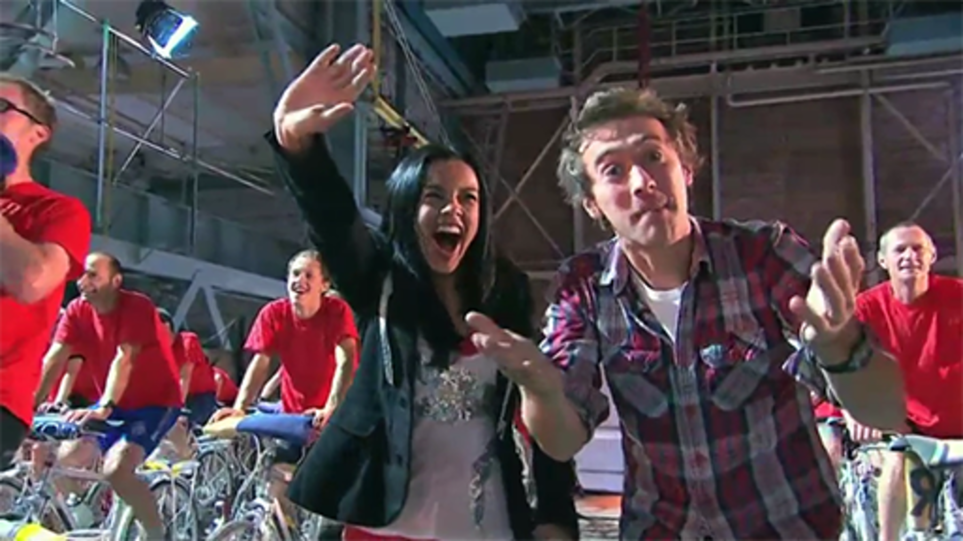

In the experiment, cyclists were used to provide the electrical energy to run a house. When Bradley Wiggins broke the hour record recently, his average power over the hour was 400W.
In the next section, you’ll think about where the energy in the video came from.

2.1.3 Generating electricity

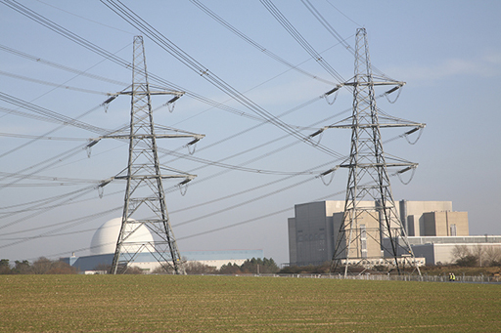
Figure 2 Pylons taking electricity away from the Sizewell A and B nuclear power stations
View description - Figure 2 Pylons taking electricity away from the Sizewell A and B nuclear power ...

From the human power station video, it is apparent how much energy is required for one short power shower!
The shower is 8kW which means that 8000J of energy is required every second.
Chemical energy within the cyclists themselves is being converted into the kinetic (or moving) energy of the pedals. It is then converted to electrical energy via dynamos in the bicycles. In a dynamo, a magnet is rotated within some coils of wire and the changing magnetic field induces a current within the wire and electricity is produced.
Electricity production within power stations is on a much larger scale, but is based on the same essential principle as the dynamo. Rather than pedals, a turbine is spun and this in turn spins a magnet. Again, the changing magnetic field induces a current within the wire – this is the origin of the electricity you use within your home.
All the electrical appliances in your home need an input of electrical energy to work. For the most part we get this electrical energy from the National Grid and its network of pylons and generators maintaining the flow of electricity around the country.

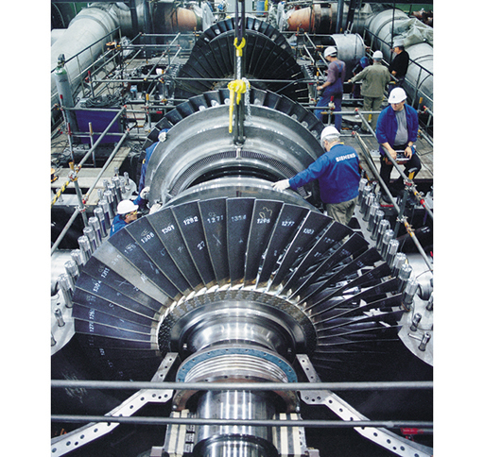
Figure 3 A steam turbine with the case opened revealing the turbine blades
View description - Figure 3 A steam turbine with the case opened revealing the turbine blades

The electricity is produced in power stations. Most power stations (but not all) employ similar processes. They use fuel to heat water to produce steam under pressure. The steam is then used to turn the blades of a turbine (in Figure 3), causing the central shaft to rotate. This in turn rotates a generator, which produces electrical power.
Next, find out about the different fuels used.

2.1.4 Energy sources
Power stations use different resources to produce energy. Each method has environmental and technical issues associated with its use.
Some sources of energy, such as nuclear and fossil fuels, are finite and will run out at some point in the future. The finite nature of fossil fuels in particular will be examined further in Week 4. Other sources are renewable and are naturally replenished on a small enough timescale to be useful to us. These sources include solar, wind, hydroelectric and geothermal. You’ll consider both types of energy source below.

Fossil fuels
The majority of the power stations in the UK use fossil fuels. They create steam from the heat produced from burning coal or gas.
The remains of living organisms, plants and animals, buried and compressed over millions of years, have formed the fossil fuels, coal, oil and natural gas. Plants absorb solar radiation and use it in a process called photosynthesis to produce new plant material.
The issues associated with the burning of fossil fuels will be discussed further in Week 4.

Nuclear

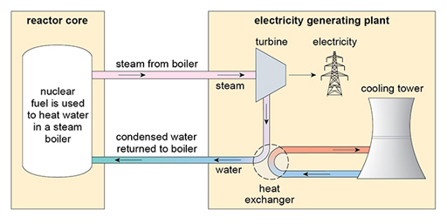
Figure 4 The basic design of a nuclear power station
View description - Figure 4 The basic design of a nuclear power station

The fission of uranium or other heavy elements produces a great deal more energy than fossil fuels but needs additional safeguards. However, the basic structure of the power stations is very similar. The use of fission will be discussed more fully later this week. A schematic diagram of a nuclear power station is shown in Figure 4.

Biofuel
Organic materials, collectively called biofuel, can be used to generate electricity. Biofuel can be obtained directly from plant material, such as peat and wood, or indirectly from agricultural, commercial, domestic and industrial waste.
It can be burned directly, in the same way as fossil fuels in a power station, or used to produce gas (biogas) that can then be burned. It is generally used in vehicles and not in power stations.
There are problems surrounding the technology, economics and the environmental impact of biofuel. Nonetheless, the constructive use made of waste material makes this a worthwhile field to develop.

Wind power

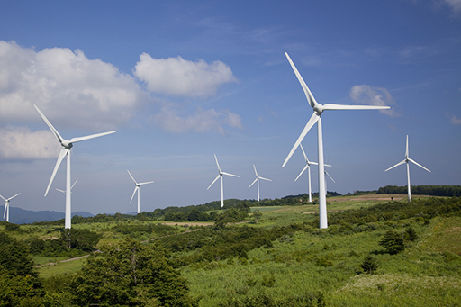
Figure 5 Wind turbines
View description - Figure 5 Wind turbines

The rotation of the blades in windmills harness kinetic energy from the wind and so wind farms are able to produce electrical energy. Clearly, the position of the windmills is an important consideration. They can be installed both onshore and offshore.
Single wind turbines generate in the order of 2.5 MW of electricity – enough to power the needs of over a thousand households. In 2015, it was the most productive of the UK’s renewable energy resources.

Hydroelectric and wave power

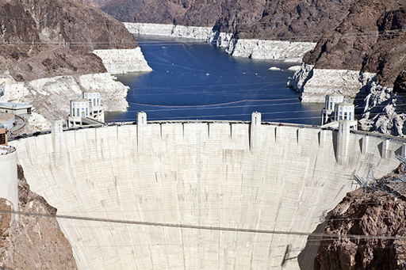
Figure 6 The Hoover Dam in Nevada
View description - Figure 6 The Hoover Dam in Nevada

Most hydroelectric power comes from dammed water being allowed to fall and then turn a turbine. The falling water loses gravitational energy and this is converted to kinetic energy of the turbine. It is the most widely used form of renewable energy but the damming of rivers can have huge impact to those communities situated downstream.
There are plans to harness ocean wave power to generate electricity, but this is proving difficult to do on a commercial basis. Waves, of course, are also produced largely by wind. Tidal power can be obtained from barrages built across estuaries.

Solar energy
Solar energy is the ultimate source of nearly all the energy sources! Solar energy can be harnessed directly via the use of photovoltaic cells which produce electricity. There have been great advances in the efficiency of photovoltaic cells in recent years.
Solar energy can also be used to heat water directly, replacing the need for heating by gas or electricity derived from other sources.

Geothermal power
Another source of electricity is hydrothermal power, which usually depends on water being pumped down into the ground, heated by hot rocks deep below the surface and the steam produced is then used to run turbines.
In Iceland, the Svartsengi geothermal power station uses naturally occurring hot water (at about 90 °C), which gushes to the surface of the volcanically active island at a rate of over 400 litres per second. The steam from this hot water is used to run turbines. Access to geothermal energy is only possible in a tectonically favourable setting so not all countries can use this source of energy.
The job of those running the National Grid in the UK is to utilise these different energy sources to provide electrical power to all our homes and businesses.
In the next section you will find out about how the National Grid runs.

2.1.5 Running the National Grid
Maggie Philbin spends the morning in one of Britain’s most secret locations, the control room of the National Grid where she monitors our demand for electricity with supply.

Video content is not available in this format.
View transcript - Uncaptioned interactive content

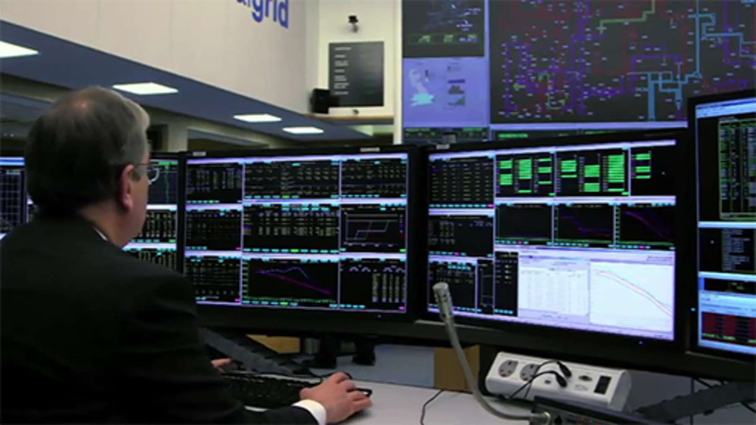

In the next section, you will look in more detail at where the UK’s power stations are sited.

2.1.6 The National Grid

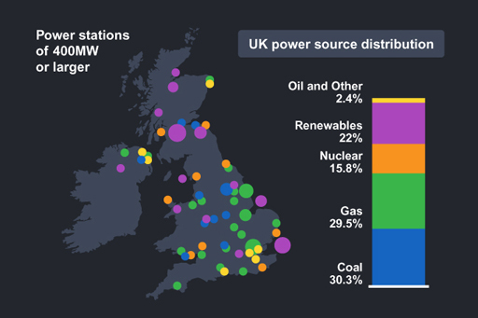
Figure 7 The UK’s power stations
View description - Figure 7 The UK’s power stations

As you saw in the video in the previous section, the majority of power stations in the UK use fossil fuels – oil and gas – as their energy source. In Week 4 you will consider the implications of these fossil fuels running out.
The video mentioned Ironbridge and West Burton power stations, which are coal fired and gas fired respectively. Figure 7 shows the distribution of the different power sources across the UK.
After fossil fuels, nuclear and renewable sources contribute roughly equal amounts to the National Grid.
In the next section, check out what the National Grid is doing right now.

2.1.7 Peak output

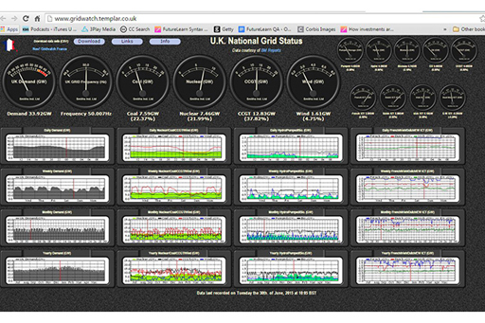
Figure 8 The National Grid
View description - Figure 8 The National Grid

The UK’s National Grid provides information about its status right now on their website. There is a great deal of information on this page and it is updated every ten minutes!
In Activity 1, you are asked to visit the page and gather information.

Activity 1

You will see the total demand in GW or gigawatt. One gigawatt is 1 billion watts. The dials along the top show the proportion from the different energy sources. You should see four:
- coal
- nuclear
- CCGT – the energy source here is natural gas
- wind.
For each, the number of GW used can be seen on the dial and also underneath. On the left you can see graphs of the demand in GW. The daily, weekly, monthly and yearly demands are shown. The other graphs show more detailed information on how the different sources meet demand over these timescales.
Visit Gridwatch.
At the time that you looked:
- What was the total UK demand? How much was supplied by nuclear power stations?
- When was peak demand that day? Why do you think that was the case?
- When was peak demand in the previous year? Why do you think that was the case?
Look at the French National Grid. What differences do you notice?

In the next section, you’ll move on to learn more about nuclear power stations.

2.2 Components of a nuclear power station

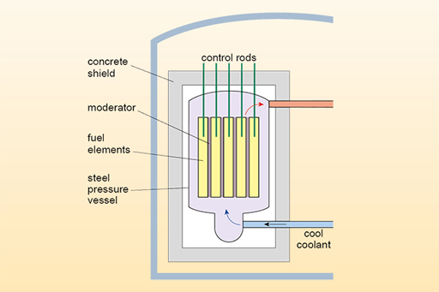
Figure 9
View description - Figure 9

In essence, a nuclear power station is a system for maintaining a fission chain reaction and extracting the resulting heat.
The key to creating so many fission events is the two or three free neutrons that are typically released by each fission event. The chain reaction takes place in the core of the reactor, and the resulting heat passes into a fluid, or coolant, which is pumped through the core. The different components of a nuclear reactor are described below.

The fuel
The elements that undergo the fission are generally uranium (U) or plutonium (Pu). The fuel itself is normally in the form of uranium or plutonium dioxide (UO₂ or PuO₂). In UO₂ the uranium is bonded to two oxygen atoms via its electrons but the nucleus of the uranium is still free to undergo fission, and the same is true of the plutonium in PuO₂. The fuel is referred to as the fissile material as it undergoes fission.
The fuel is arranged in the form of a cylindrical rod (or a stack of cylindrical pellets) in a thin-walled metal container; often the metal is zirconium. The containing material is known as cladding and works as a physical barrier, preventing the fission products and fuel from entering or reacting chemically with the coolant. In practice, a nuclear fuel element will produce energy for three to six years before it needs to be replaced.
You will recall from last week that the majority of the products of fission are radioactive, and it is obviously important to prevent them from escaping from the reactor. The simplest way to do this is to keep them in the fuel and this is the purpose of the cladding.

The control rods
A nuclear fission reaction at criticality can be maintained by controlling the critical mass (as you heard about in Week 1). However, the critical mass will change as fuel is used up or even as the temperature fluctuates so a dynamic method is needed that can adapt to changing circumstances and control the neutron population.
The standard method for controlling a chain reaction in a nuclear power station is by control rods. Control rods are made from a material that absorbs neutrons. As the rods are inserted further into the fissile material, more neutrons are absorbed and so fewer fission events are triggered.
Other control methods may be used in addition to inserting rods. For example, some reactors have the option of introducing neutron absorbing material into the coolant in order to reduce the rate of fission.

The moderator
As you learned last week, induced fission is often more likely with neutrons of lower energy (slower) rather than higher energy (faster). If this seems counter-intuitive, imagine a golfer trying to putt a ball. The ball is more likely to be ‘captured’ by the hole if it is not going too fast.
If the free neutrons created by fission are not slowed down, they are described as fast neutrons. If they are slowed down to lower energies (the process of moderation), they are called thermal neutrons.
In the moderation process, fast neutrons are slowed down by interaction with a moderator. The moderator is a volume of a material such as hydrogen. The neutrons collide with the nuclei of the moderator and, in the process, are slowed down to the same average speed as those of the moderator. If the moderator is at room temperature, the neutrons emerge with a range of velocities typical of a material at this temperature.
The three most important isotopes used as moderators are:
- hydrogen in the form of light water H2O
- deuterium in the form heavy water D2O
- carbon in the form of graphite.

The coolant
The coolant is a gas or liquid that passes through the hot reactor core and carries away the heat produced. It flows around the fuel rods and is in contact with the cladding, rather than with the fuel itself. Apart from being able to remove heat from the fuel rods efficiently, coolants should not react chemically with the cladding, or with any other part of the cooling circuit, and they should not absorb too many neutrons. The coolant should also not be too expensive because a lot of it is used.
Taking all these factors into consideration, the coolants used in the majority of reactors are the gases carbon dioxide and helium, and liquid water.
If water is used as the coolant, it may be allowed to boil, and hence to produce steam directly for use in the turbine: this is called a direct steam cycle. Alternatively, the light water may be prevented from boiling by keeping it under very high pressure, and the hot water pumped to a steam generator, where steam is produced by heating a separate water supply: this is called an indirect steam cycle.
If a gas coolant is used, the gas that has been heated by the core is pumped to the steam generator, where steam is produced – this is also anindirect steam cycle.
Note that water can be used as both a coolant and a moderator – some nuclear reactors use water for both purposes.
In the next section you will see a diagram of a nuclear power station.

2.2.1 Looking inside a nuclear reactor

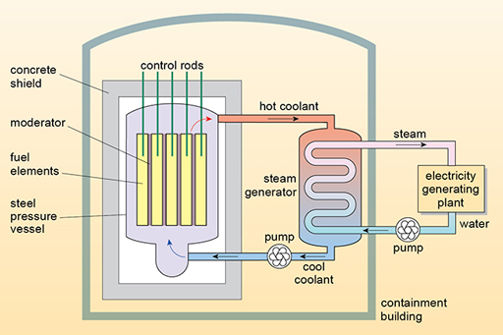
Figure 10 A nuclear reactor
View description - Figure 10 A nuclear reactor

Figure 10 shows the basic components of a nuclear power station.
The control rods that determine the number of neutrons are shown within the fuel elements. Note the moderator that controls the speed of the neutrons is close to the fuel rods too. This reactor works on an indirect steam cycle and so heat energy from the coolant is used to heat water to produce steam that turns the turbine.
In the next section, you will watch a video which shows inside a real nuclear reactor.

2.2.2 Inside a nuclear reactor
The video shows Jem Stansfield looking around the Zwentendorf nuclear power plant in Austria.
This reactor was designed as a boiling water reactor (BWR). In this type of reactor, the reactor heats the water which produces steam that then turns the turbine. The steam is then cooled back to water and returned back to cool the core. The water is also used as a moderator.
The Zwentendorf reactor was built but never used; it was prevented by a vote within a referendum on the issue. Since 1978 Austria has banned using fission as an energy source in power stations.

Video content is not available in this format.
View transcript - Uncaptioned interactive content

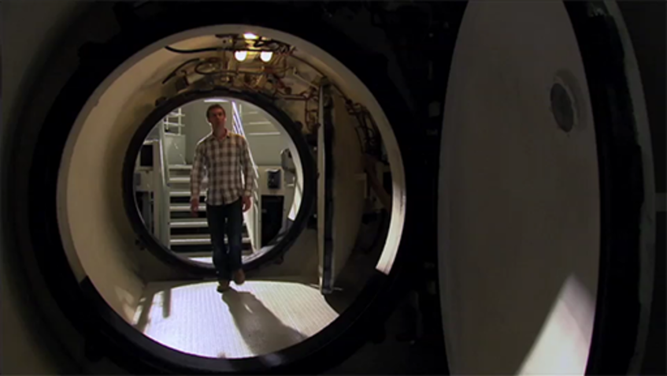

In the next section you’ll consider the distribution of nuclear power stations around the world.

2.2.3 Types of nuclear reactor

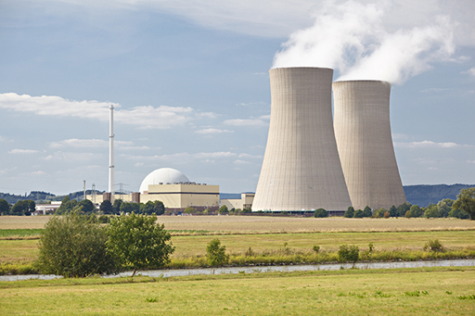
Figure 11
View description - Figure 11

There are many different types of nuclear reactor and the list below is not exhaustive! By far the most common type of nuclear reactor is the pressurised water reactor or PWR.
The main types of reactor currently in use (or used in the past) to generate electricity are:
- Pressurised water reactor (PWR): pressurised water reactors are the most common – about two-thirds of all reactors in the world are of this type. These work on an indirect steam cycle.
- Boiling water reactor (BWR): boiling water reactors are a popular alternative to pressurised water reactors – both are used in the USA and in Japan. These work on a direct steam cycle.
- Advanced boiling water reactor (ABWR): advanced boiling water reactors incorporate improvements on earlier boiling water reactors and are used in Japan, with new reactors planned in Japan and Taiwan.
- Pressurised heavy water reactor (PHWR): pressurised heavy water reactors use heavy water as the coolant and the moderator, and natural uranium as the fuel. They were developed in Canada and are sometimes called CANDU reactors.
- Gas-cooled reactor (GCR): a gas-cooled reactor has a graphite moderator and a carbon dioxide gas coolant. It is only found in the UK. Early models were known as Magnox reactors and later versions as the advanced gas-cooled reactor (AGCR or more commonly AGR).
- Light water-cooled graphite-moderated reactor (LGR): these water-cooled, graphite moderated reactors were used mainly in the former Soviet Union. They are sometimes known as RBMK (reaktor bolshoy moshchnosty kanalny) reactors and there were four such units at the Chernobyl plant at the time of the accident there (in 1986), about which you will read more later.
The various reactor types are mainly defined by the materials used as moderator and coolant and, although these factors affect the design of the reactor, the basic principles are common to all nuclear power stations.
Another type of reactor worth noting is the EPR – the European pressurised reactor. The EPR is a pressurised water reactor designed to improve on safety and security, and enhance economic competitiveness. It is not fundamentally different from the pressurised water reactors described earlier but it is the most widely discussed reactor under consideration for new nuclear power stations. The design was developed by a consortium of French and German companies. An EPR is under construction in the UK at Hinkley Point C in Somerset.
Next, find out more about where new power stations are planned.

2.2.4 The world’s nuclear power stations

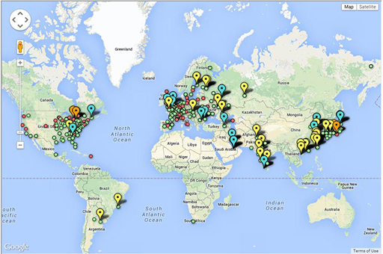
Figure 12
View description - Figure 12

In January 2015, 30 countries worldwide were operating 437 nuclear reactors for electricity generation and 71 new nuclear plants are under construction in 15 countries. Nuclear power plants provided 12.3% of the world’s electricity production in 2012 according to the Nuclear Energy Institute.

Activity 2

Find out for yourself the distribution of nuclear power stations across the world and what type of reactors they are using via the Guardian nuclear power station interactive map (Clark, 2012).
Note the colour coding at the top which distinguishes between active and non-active power stations and those that are being built. As with street view you can drag the orange figure to the vicinity of the power stations and have a look around!
- Find a power station that is planned or under construction. What type of reactor will be used?
- At a glance, estimate which countries have the most nuclear reactors under construction.
- Contrast the situation between France and Italy. Why do you think that the situation differs between these two countries?

Next, you’ll move on to think about nuclear waste.

2.3 Waste produced by nuclear power

Video content is not available in this format.
View transcript - Uncaptioned interactive content

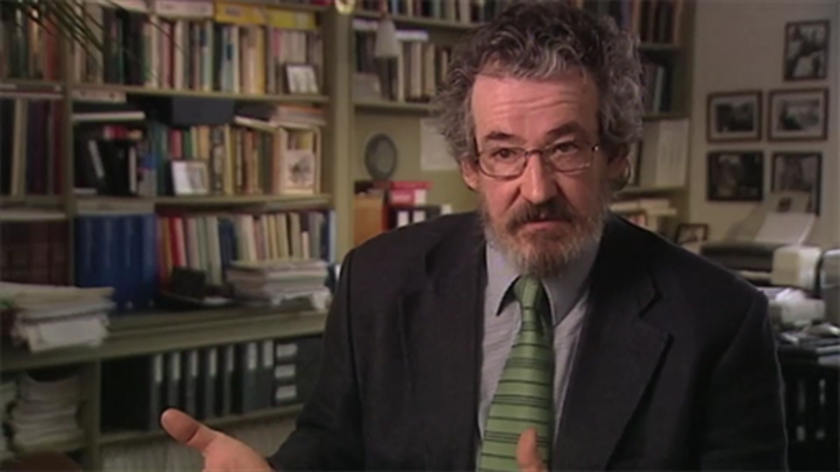

The reactor at Calder Hall, which was on what is now the Sellafield site in Cumbria, was the first operating nuclear power station in the world.
It connected to the grid in 1956 and was a Magnox type reactor. Initially its main purpose was the production of plutonium from uranium-238, but the secondary process of electricity production soon took over and became the primary function of the site. Calder Hall was closed in March 2003 and decommissioning began.
Older reactors produced a great deal of radioactive waste, 20 000 tonnes were produced from Calder Hall.
The video states that ‘Some of that radioactive waste has to be stored for tens of years, some for hundreds of years and some for thousands of years.’ These timescales are obviously problematic! To understand why such forward thinking is involved we need to look again at the nature of radioactivity and the concept of half-life. You’ll do this in the next section.

2.3.1 Half-life

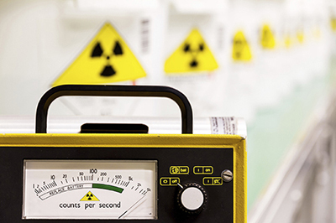
Figure 13
View description - Figure 13

When quantifying the risk posed by a particular isotope, it’s important to consider the amount of time that it will remain radioactive and its activity during this time. Both of these quantities relate to the half-life of the isotope.
Last week, we defined activity as a measure of the number of particles (alpha, beta or gamma) that are emitted in a given time. As the particles are emitted, the isotope is said to decay and changes into an isotope of another element.
Let’s consider the alpha emission that you looked at last week:
emits an α particle and decays to .
If there are a certain number of uranium-238 atoms in a particular sample, the half-life is the time taken for half of these radioactive atoms to decay. After another half-life, half of the remaining atoms will decay and so on.
Imagine you were given 1200 atoms of uranium (in reality it would be a much larger number). After one half-life, half the uranium atoms will have decayed into thorium, so you will only have 600 uranium atoms left. After another half-life, another half will have decayed so you will have 300 uranium atoms, after another half-life you will have 150 uranium atoms. After four half-lives you would be left with 75 atoms of uranium and 1125 atoms of thorium.
Now, in fact, the half-life of uranium is 4.5 billion years so you would have to watch your atoms for a long time to see them decay! Half-lives can vary from billions of years to nanoseconds. Some half-lives are shown in Figure 14.

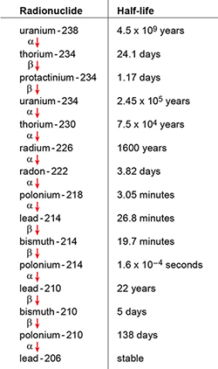
Figure 14 The main decay chain for uranium-238; other radioisotopes similarly have their own characteristic decay chains
View description - Figure 14 The main decay chain for uranium-238; other radioisotopes similarly have ...

If an isotope has a short half-life, it will decay quickly, and emit more particles in a given time than an isotope with a longer half-life. So isotopes with shorter half-lives have higher activity than those with longer half-lives. The activity of all isotopes will diminish over time as the number of atoms that are present decay away. It is worth noting that, unlike chemical reactions, the rate at which radioactive isotopes decay at any particular moment cannot be changed; heating them, subjecting them to high or low pressures, or to any other physical process, does not alter the half-life.
Both the high rates of decay, or activities, of radioisotopes with short half-lives and the longer life span of those with long half-lives have an impact on the disposal of radioactive waste. Some products of fission have half-lives of the order of hours or days, while others have half-lives of thousands of years or more. This requires both short- and very long-term planning when considering what to do with the waste.
Next, you’ll look in more detail at the different sorts of radioactive waste produced.

2.3.2 Types of radioactive waste

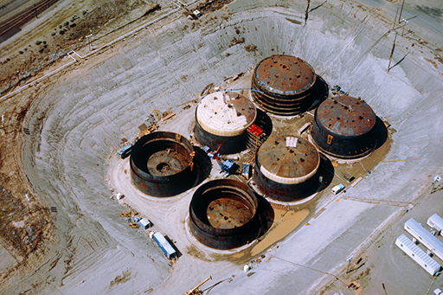
Figure 15
View description - Figure 15

One of the major issues with nuclear power is what to do with the radioactive waste intrinsic to the process of fission.

Classifying the waste
Radioactive waste comes in a wide variety of forms, from the clothing worn by workers at a power plant to the fuel rods themselves. The range of activity levels of the materials in the waste is also wide ranging, for example, from minute traces of radioactivity on a pair of worker’s gloves to the contents of spent fuel rods which have levels of activity more than 100 million times that of natural uranium.
Classifying the items is helpful to ensure that each item is dealt with in an appropriate manner, for safety and economic reasons. Different schemes have been proposed and used in different countries at different times. These schemes can become quite complex but all classify waste into three broad categories: low-, intermediate- and high-level waste.

Low-level waste
Laboratory clothing that has become contaminated, used paper towels, as well as liquid, gaseous and solid wastes from different parts of the fuel cycle can be classed as low-level waste. These items share low activity and low heat production: in fact, the heat produced in them is negligible.
Although low-level wastes require isolation and containment for a few hundred years, they can be stored at facilities near the surface with limited regulation. Most of the material is barely radioactive but is nonetheless sealed in steel drums and checked before storage.

Intermediate-level waste
Intermediate-level waste has higher activity (per unit mass or volume) than low-level waste, and so poses a greater radiation hazard. It includes fuel cladding and wastes from different stages of fuel reprocessing. The storage needs to be more elaborate than that for low-level waste, but no cooling is necessary, or only very limited cooling, during storage and disposal.
Waste in this category requires disposal at greater depths than low-level waste, of the order of tens of metres to a few hundred metres.

High-level waste
The fission products found within the used fuel or waste materials remaining after spent fuel is reprocessed are high-level waste. These items produce so much heat from the decay of radioisotopes that continuous cooling is required, and safe storage requires elaborate precautions to be taken. Such waste requires specially constructed disposal facilities.

Disposal
Whatever the form of the waste, some initial processing usually takes place to reduce the volume of the waste, or to make it safer and more convenient to handle. For example, low-level waste may be incinerated or compressed and possibly encapsulated in concrete; intermediate-level waste may be evaporated if it is in liquid form or cut up or crushed if it is in solid form, prior to encapsulation in concrete-filled drums as shown in Figure 16.

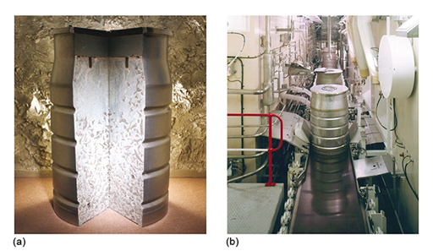
Figure 16 (a) A drum used to store intermediate-level waste encased in concrete, cut away to show its contents, (b) waste packaging and encapsulation plant (Sellafield, UK)
View description - Figure 16 (a) A drum used to store intermediate-level waste encased in concrete, ...

High-level waste is generally placed in containers and stored, often under water, for some years in order for its activity level to reduce. A proportion of spent fuel is also reprocessed.
Only the low-level waste currently has established and accepted mechanisms for final storage or disposal. It is typically either sent to regulated landfill sites or buried in special low-level waste repositories. Currently, intermediate- and high-level wastes are held in storage on the surface, often at the nuclear power stations from which they originated, while a longer-term solution is sought.
Initially this high-level waste is so active that it will be extremely hot. The emission of the radioactive particles transfers energy and raises the temperature in the vicinity. The fuel rods, therefore, need to be actively cooled for years before they can be dealt with.
In the next section, you will look at the decommissioning of Dounreay power station.

2.3.3 Decommissioning at Dounreay

Video content is not available in this format.
View transcript - Uncaptioned interactive content

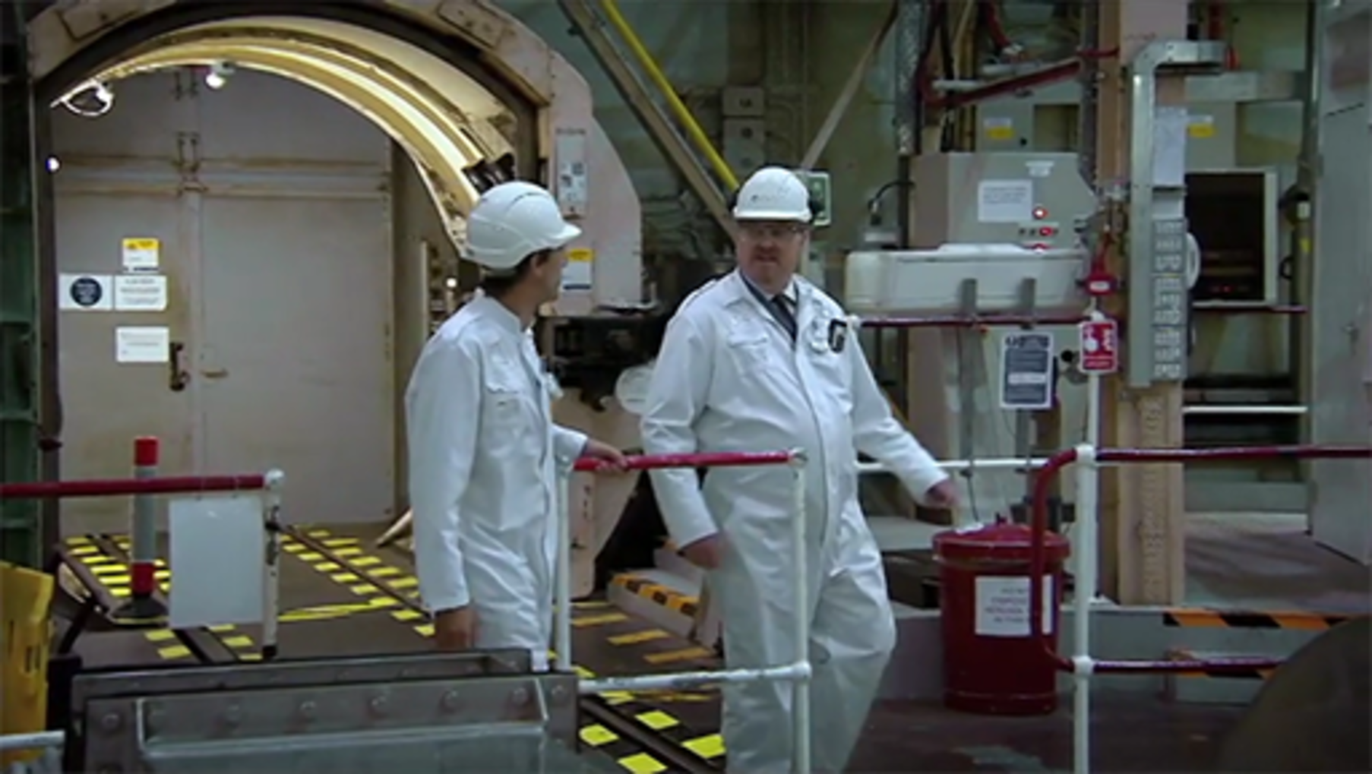

The video shows the progress made, by 2011, of the decommissioning of the Dounreay power station in the north of Scotland, UK.
The task of dealing with the waste continues. The end date for the entire process is given as 2022–25, that is about 30 years after the last reactor closed in 1994.
You can learn more at the Dounreay decommissioning website (Dounreay Site Restoration Ltd, n.d.).
Next week you’ll consider the decommissioning of reactors that have malfunctioned.

2.3.4 What can be done with nuclear waste?

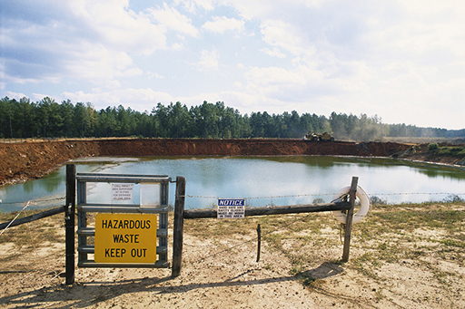
Figure 17
View description - Figure 17

The Dounreay video mentioned that the radioactive waste would need to be stored ‘forever’. Forever is a long time!
Let’s recap what is known about nuclear waste:
- The production of radioactive materials is intrinsic to the process of fission so all nuclear reactors produce radioactive waste. The reactors you’ve heard about so far produced thousands of tonnes of waste.
- The waste can be classified into different levels.
- Some of the waste is very active now. Some of the waste has a long half-life indicating it will be active for many thousands of years.

Activity 3

You may have your own thoughts on the issue of nuclear waste and about what happens in your own country.
Think about these questions:
- What would you do with nuclear waste?
- Do you know the nuclear waste disposal policy in your country? For example, read about the UK Government’s policy on radioactive waste.
- What do you think of your country’s policies?

In the next section, you’ll find out about some possible solutions.

2.3.5 Solution: reuse

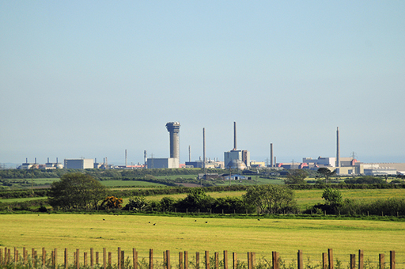
Figure 18
View description - Figure 18

Three ways that nuclear waste can be dealt with are reuse, transmutation and burial. The most common method is burial – you will look at this later. Some radioactive waste can be reduced by reprocessing, or reusing, some of the spent fuel.
Fuel reprocessing is a complex technological process which is only performed at a relatively small number of sites worldwide, for example, the COGEMA plant at La Hague in France and the Sellafield plant in Cumbria in the UK. If the fuel is to be reprocessed, it first needs to be transported to one of these sites.
On arrival at the site, the fuel is stored under water until it can be handled for reprocessing. The main reprocessing stages are summarised in Figure 19.

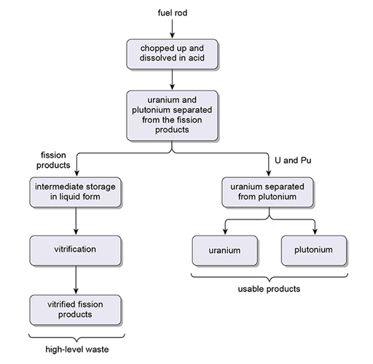
Figure 19 The main stages in reprocessing nuclear waste
View description - Figure 19 The main stages in reprocessing nuclear waste

After being separated from the fission products, the uranium and plutonium are separated from each other. The plutonium may be combined with depleted uranium from an enrichment plant to form what is known as MOX (mixed oxide) fuel. MOX has similar characteristics to normal uranium dioxide fuel and it may be used in place of a proportion of this fuel in the same reactors. There are issues with the relative proportion of isotopes within MOX and such issues affect the economic viability of reprocessing fuel. The various stages of reprocessing spent fuel create a considerable quantity of high-, intermediate- and low-level waste themselves.
Aside from reprocessing, increased thought is given to other uses of waste. For example, the fission product molybdenum-99 decays to technetium which is used in medical tracers. Caesium 137 and strontium-90 can both be used in radiotherapy. Extraction of these useful isotopes is not always straightforward but will reduce the quantity of waste that needs storage.
In the next section, you will look at another solution – transmutation.

2.3.6 Solution: transmutation

Video content is not available in this format.
View transcript - Uncaptioned interactive content

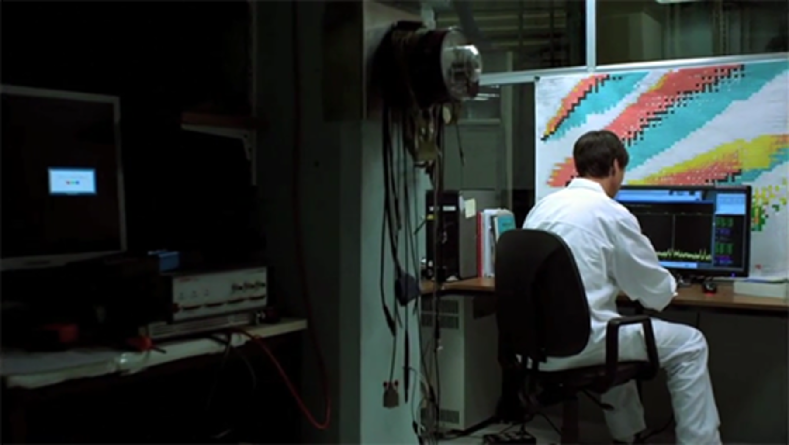

The video shows the process of transmutation. Heavy fission products with long half-lives are bombarded with neutrons and split into smaller fragments with shorter half-lives.
Opinion on transmutation is mixed. It does provide a solution to the problem of storing the long-lived isotopes in radioactive waste. It is also possible that the process of transmutation could itself be used to generate electricity and future power stations could incorporate transmutation into their running. This would reduce the volume of long-lived isotopes that are produced by fission of uranium.
However, the technology is not able yet to deal with large amounts of waste in an economically viable way and the research in this field would be expensive. Also transmutation would itself generate low-level radioactive waste!
In any event, while transmutation may significantly reduce the long-term risk of the radioactive waste, it wouldn’t replace the need for storage. The next section considers the siting of this storage.

2.3.7 Solution: deep geological repository
The favoured option for nuclear waste management around the world at the time of writing, 2015, is to bury the waste in purpose-built underground repositories.
The siting of such a repository requires much thought as many of the fission products will remain active for thousands of years. Thus, a repository needs to be secure, both now and into the far flung future!
There are two main issues that need to be considered:
- The possibility of seismic activity. Earthquakes could bring the material to the surface.
- The problem of water. It is vital that water is not able to come in contact with the radioactive material now or in the future.
In order to reduce the possibility of either of these problems arising, the design of repositories includes containers with multiple layers enclosing the waste and other engineered barriers or seals around the containers. Great attention is also paid to the suitability of the surrounding environment, particularly the geology in terms of stability and rock composition, and the way water can move through it. Several processes combine to cycle water globally, and these in Figure 20.

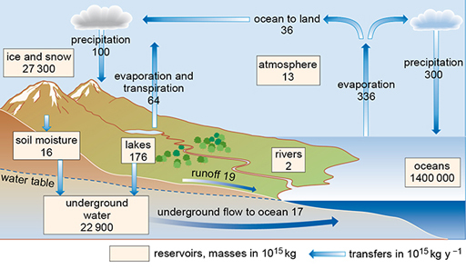
Figure 20 The global water cycle: showing the distribution of the world’s water. ‘Lakes’ includes freshwater and saline lakes. The values shown as transfers represent the amounts of water cycled annually (in units of 10¹⁵kg y⁻¹), as opposed to that stored in reservoirs (in units of 10¹⁵ kg)
View description - Figure 20 The global water cycle: showing the distribution of the world’s water. ...

At any stage in the water cycle where evaporation occurs, anything dissolved in the water is left behind. In particular, radioisotopes transported into the oceans would accumulate there; they would not evaporate and re-enter the water cycle.
How water flows through the ground is largely determined by the geology. Many of the rocks that make up the Earth’s crust contain voids, which can hold water. These voids can take various forms. In sandstones, for example, they consist of small interconnected pores between the grains of sand. In granites, which are made up of interlocking crystals, there may be fissures or fractures, which can be interconnected so allowing water to travel through the rock. Below a certain level, the rock voids are all filled with water. This level is called the water table, and the rocks below it are said to be saturated. By using the voids as a pathway, water can flow through the saturated rocks.

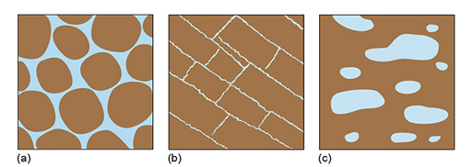
Figure 21 Void structures in different rock types.
View description - Figure 21 Void structures in different rock types.

The ease with which water flows through rocks varies with the rock types. For example, if the rock contains large well-connected pores or voids, like the sandstone in (a), or extensive linked fractures, like the granite in (b), the water will flow easily through the rock. In (c) there are large pores in the rock, but the pores are not interconnected, so the water cannot flow easily through the rock. Any repository would ideally need to sit above the water table and within a rock that resisted the flow of water.
In the next section you’ll see a video of the planning for a depositary in Yucca Mountain, a mountain in Nevada, US. This site was deemed to be near perfect as regards its geology.

2.3.8 Case study: Yucca mountain

Video content is not available in this format.
View transcript - Uncaptioned interactive content

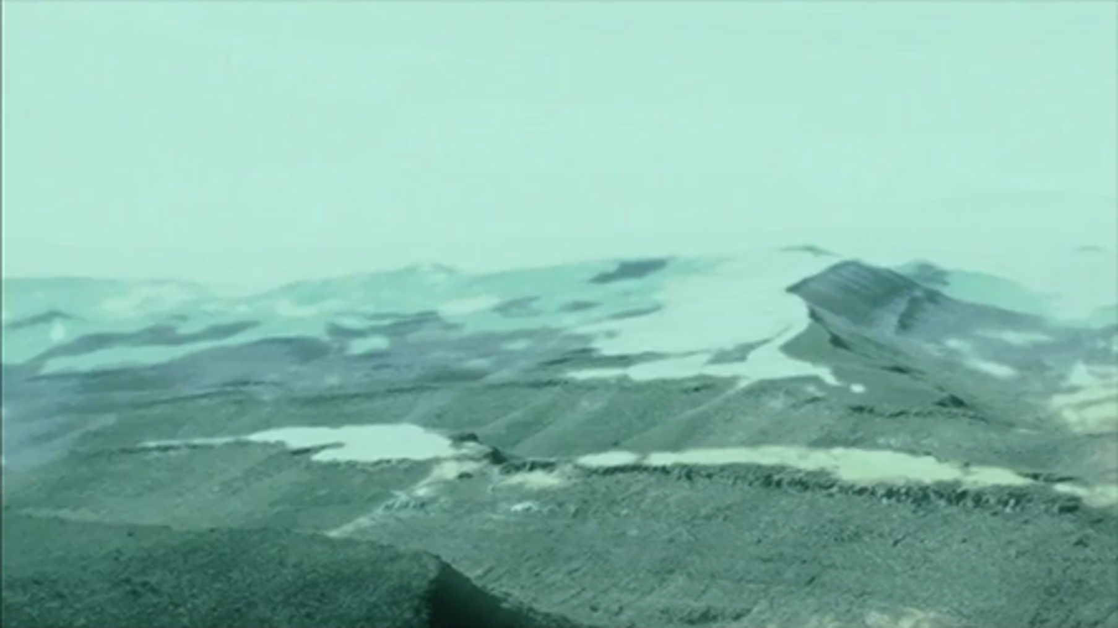

Funding to the Yucca Mountain repository project was removed in 2009 due to protests from the people of Nevada.
Strong views exist on both sides. The situation is complicated as the closure is in conflict with a federal law designating Yucca Mountain as the nation’s nuclear waste repository for the US.
For more on renewable energy in the UK, look at information from the Renewable Energy Trade Association RenewableUK (2016).
There is lots of information on nuclear power in the UK on the World Nuclear Association website (2016).
Next week, you will look at another contentious issue – the possibility of meltdown in nuclear power stations.

2.4 Quiz for Week 2
Take the quiz to test and apply your knowledge of the material in Week 2.
Week 2 quiz
Then come back here.

2.5 Summary of Week 2

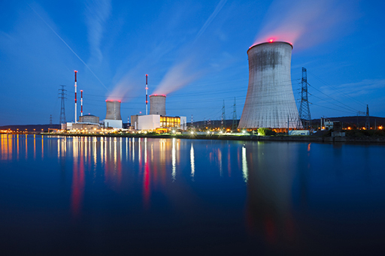
Figure 22
View description - Figure 22

This week you looked initially at how to quantify the energy we use and how this links to nuclear power.
The electrical energy we use within the home is provided by the National Grid, which utilises various energy sources including coal, gas, nuclear, wind and solar. Nuclear power stations exploit the energy produced from induced fission released in the form of heat energy. The elements within the power station are there to safely sustain the chain reaction and to extract the heat produced. A major issue surrounding nuclear power is the production of nuclear waste which may remain active for many years. A proportion of radioactive waste can be reused or transformed via transmutation but the favoured option for nuclear waste management at the moment is to bury the waste in purpose-built underground repositories.
Next week, you’ll examine another controversial aspect of nuclear power – the fear of a nuclear accident. Historically, there have been very few accidents at power stations but you’ll examine the causes in each case and look at the recent events at Fukushima in some depth. You will look at the long range effects on the surrounding environment and the local population.
You can now go to Week 3.

Week 3: Is nuclear power safe?

Introduction
In the following video, Sam and Gemma discuss the safety of nuclear power.

Video content is not available in this format.
View transcript - Uncaptioned interactive content

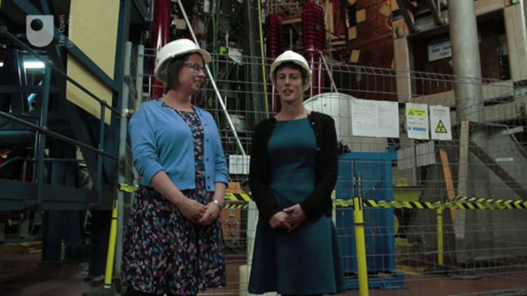

Next, you will find out about the excitement at the start of the nuclear industry.

3.1 Atomic men!

Video content is not available in this format.
View transcript - Uncaptioned interactive content

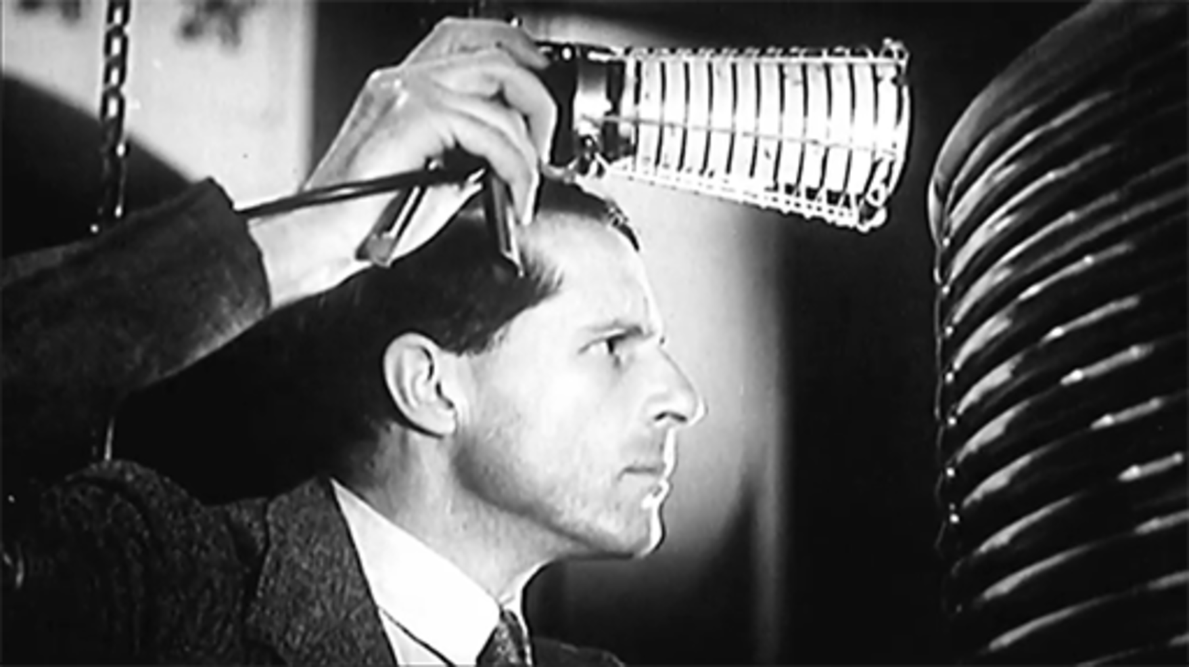

In the early 1950s, the nuclear industry was very young – the video shows the initial excitement surrounding it; ‘we were in the vanguard of something really new’. People began to talk of an ‘atomic age’.
Windscale was perceived as an exciting and dynamic place. It was located on the Sellafield site in Cumbria (right next to Calder Hall that you looked at last week) and was home to the Windscale Piles which were part of the weapons industry, producing plutonium for nuclear bombs.
In 1957, Windscale experienced a reactor accident that profoundly affected public confidence in the nuclear industry. Other accidents you might have heard of, that involved nuclear power plants (i.e. those designed to generate electricity), include the accident at Three Mile Island, in Pennsylvania USA, in 1979 and the accident at Chernobyl in the former Soviet Union in 1986. The most recent accident occurred in Fukushima, Japan in 2011.
In the next sections, you will examine these accidents and what can go wrong in a nuclear power station.

3.1.1 What can go wrong in a nuclear power station?

Figure 1
View description - Figure 1

The design of every nuclear power station includes many safeguards that are put in place to ensure that the core is protected from the environment.
Every serious nuclear accident has arisen because a sequence of events has led to the core going into meltdown. You have probably heard of the term meltdown before. It is an informal term for the more technical descriptions core melt accident and partial core melt.
A meltdown occurs when the heat in the core of the reactor rises high enough that the fuel rods begin to melt. This can have disastrous consequences as, under these circumstances, the fuel cladding can be breached and highly radioactive materials leak into the environment beyond.
Have a look at Figure 1 to remind yourself of the layout of a nuclear reactor.
There are three different situations that can lead to a meltdown:

Control of the fission reaction is lost and the reactor goes supercritical
You will recall that for a critical reaction the population of neutrons is such that the number of fission events is steady and that the chain reaction continues in a controlled manner and releases a manageable amount of energy. The reactor will be designed to have some tolerance, but there will be a limit to the amount of heat energy that the coolant can safely transport away.
If the number of neutrons is allowed to increase, the number of fission events increases and the chain reaction releases progressively more and more energy. This uncontrolled chain reaction is what is allowed to happen in a nuclear bomb but needs to be avoided in a power station!
The control rods control the number of neutrons. A supercritical reaction can occur if the control rods are not adequately inserted within the fuel.
In April 1986, the Chernobyl nuclear power plant was running tests on one of the four reactors based there. The nature of the test led to the control rods being fully pulled out from the fuel before the test began, as the fission product xenon (Xe) had begun to build up which is itself a neutron absorber.
Once the test started the fission began to go supercritical and the control rods could not be inserted again quickly enough. The reactor was no longer under control and rapidly jumped to ten times its usual energy output (some reports have the final measured output as 100 times higher). This led to two explosions in the core.
The fuel elements became exposed and extremely radioactive materials were released into the environment. Chernobyl is considered the worst nuclear power disaster in history.

Coolant failure
All may be well with the fuel rods and the criticality of the fission reaction but if the coolant fails and the heat is allowed to build up then the temperature can become dangerous in the reactor core. Heat will build up even if the fission reaction itself has been stopped. This is due to the radioactivity of the fission products within the fuel rods. These will be highly active and able to heat the surroundings sufficiently to melt the fuel rods.
At Three Mile Island a partial meltdown occurred in one of the two reactors on the site. A small valve was accidentally stuck open and allowed coolant to escape. It took a while for operators to understand the situation and in the interim some steps were taken that made matters worse, in particular the decision to release more of the coolant.
The temperature rise was slower than at Chernobyl but the delays allowed the diminishing coolant to expose fuel elements within about two hours of the initial malfunction. The cladding around the fuel elements was damaged and radioactive isotopes leaked into the remaining coolant and into the surrounding environment.
A coolant failure also occurred at Fukushima which you will look at in more depth later in the week.

Fire within a reactor
The reactor that was built in Windscale used carbon graphite as the moderator. The graphite was therefore bombarded with neutrons which led it to a change of structure, allowing energy to build up with each new neutron interaction.
This process was known about (it is called Wigner energy) and efforts were made to release it. However, in October 1957, the release of the Wigner energy was not successful and the moderator caught fire, which soon spread to the fuel elements.
Windscale was an air-cooled power station and this air was vented up and out of a chimney. The fire in the core caused radioactive materials to escape out through the chimney with the air and into the surrounding environment. Lessons were learned from the events at Windscale and the Magnox design of reactor was phased out.
Next, you will find out more about the accidents at Three Mile Island and Chernobyl.

3.1.2 Accidents at Three Mile Island and Chernobyl

Video content is not available in this format.
View transcript - Uncaptioned interactive content

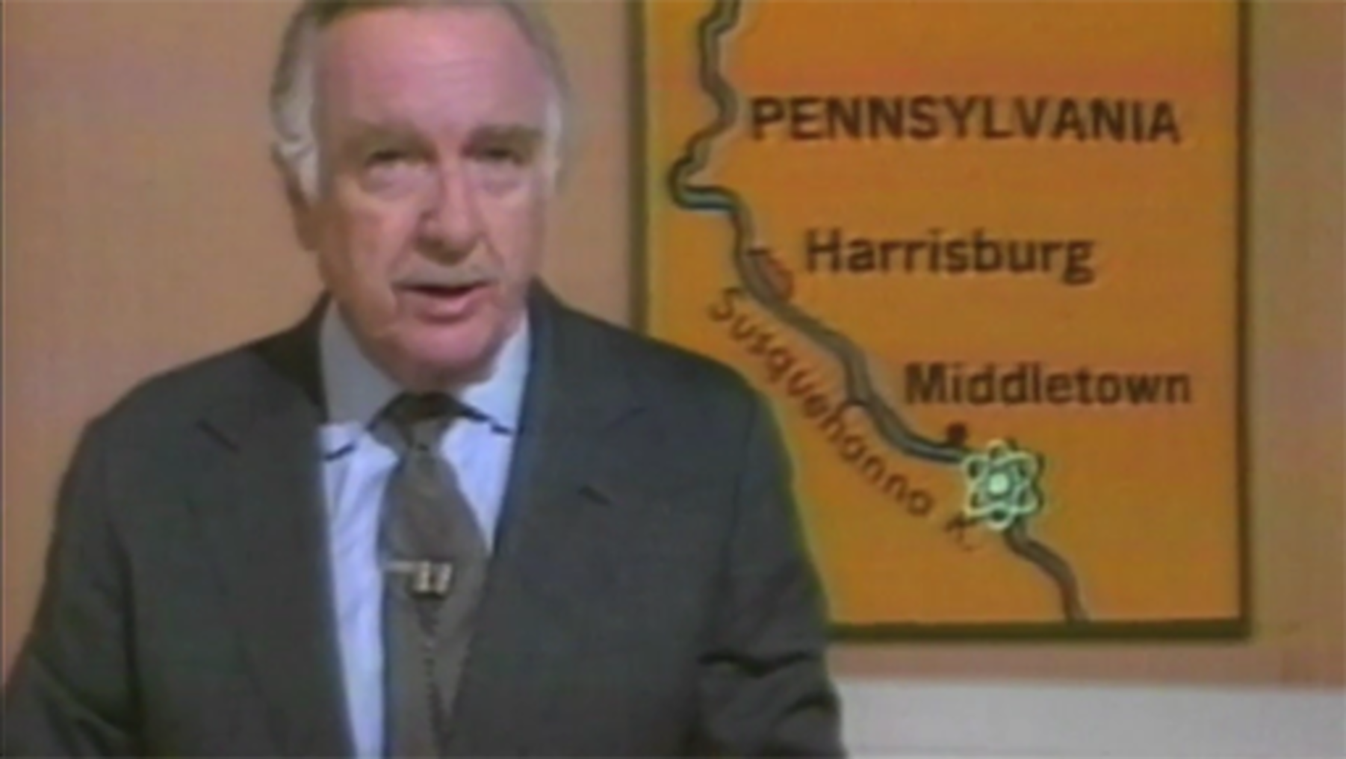

Accidents occurred at the Three Mile Island nuclear facility in Pennsylvania and the Chernobyl nuclear power station.
(Remember that PWR stands for pressurised water reactors.)
In the next section, you will consider what could be learned from these incidents.

3.1.3 Errors

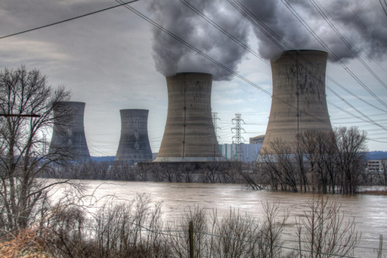
Figure 2
View description - Figure 2

The video in the previous section identified errors that contributed to the severity of both the accidents at Three Mile Island and Chernobyl.

Activity 1

Think about these questions and write a paragraph explaining your thoughts.
- Is there any link between the disasters at Three Mile Island and Chernobyl?
- How could they have been avoided?

Next, find out the fate of the Three Mile Island nuclear facility and the Chernobyl nuclear power station.

3.1.4 Clean-up at Three Mile Island and Chernobyl

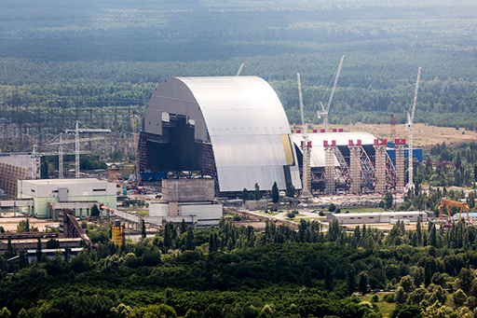
Figure 3
View description - Figure 3

It is 36 years since the events at Three Mile Island. The reactor that underwent meltdown was permanently shut down.
Over the years much of the radioactive waste has been removed although the site remains monitored. The other reactor was also closed temporarily but began to operate again in 1985. It has a licence to operate until 2034 when it is planned that the entire site will be decommissioned.
After the disaster at Chernobyl the remains of the reactor will remain radioactive for hundreds of years. Shortly after the meltdown, it was entombed in a concrete and steel structure called a sarcophagus. This was an attempt to shield the surrounding environment from the worst of the radiation.
The other reactors at Chernobyl functioned for some years after but are now all shut down. At the end of the week, you’ll come back to Chernobyl and examine what conditions are like there today.
In the next sections, you will find out the sequence of events that led to the crisis in the Fukushima nuclear power plant.

3.2 The Fukushima Daiichi reactor

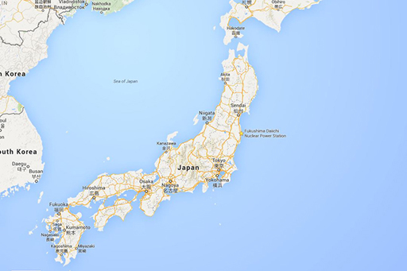
Figure 4
View description - Figure 4

The Fukushima Daiichi nuclear power plant lies on the east coast of Japan in the Futaba District.
It is one of two nuclear power stations in the vicinity – the other is Fukushima Daini, sited a little further south. Both are owned and run by the Tokyo Electricity Production Company (TEPCO).

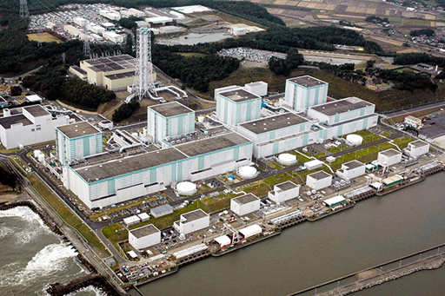
Figure 5
View description - Figure 5

Fukushima Daiichi is a large plant containing six boiling water reactors (BWRs) with water used as both the moderator and coolant. The reactors are referred to by numbers 1–6. You can see the reactor buildings in Figure 5.
The BWR reactors were old and of a design popular in the 1960s. The first reactor connected to the Japanese grid in 1971.
Japan is situated near the boundary of several tectonic plates so it is a region where earthquakes are relatively frequent and can occur at all magnitudes.
In the next section, find out what happened when the reactor was affected by an earthquake.

3.2.1 What caused the meltdown at Fukushima?

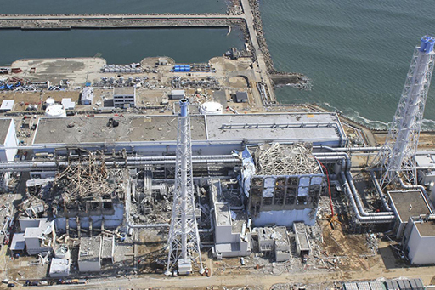
Figure 6
View description - Figure 6

At 14:46 Japanese time on Friday 11 March 2011, a magnitude nine earthquake struck Japan with its epicentre 30km east of the Oshika peninsula and 150 km north-east of the Fukushima Daiichi site.

The earthquake
On the day, only reactors 1, 2 and 3 were running with the other three reactors shutdown for routine inspection. The earthquake produced significant tremors within the site and although some tolerance was built into the design of these reactors, the shocks were large enough to exceed this tolerance in reactors 2, 3 and 5.
The reactors had built-in safety systems that responded to the earthquake by implementing an immediate and automatic shutdown. This was achieved by lowering control rods into the fuel to absorb enough neutrons for fission to cease.
The connections to external power failed but the emergency diesel generators on site successfully kicked in, these were crucial to power the pumps that kept the coolant circulating through the core. Remember that, although the fission had been successfully stopped, the fission products within the fuel elements would be extremely active, creating a great deal of heat from radioactivity.
In addition to the fuel rods situated within, there were spent fuel rods within the building of reactor 4. These also needed cooling due to the concentration of fission products within them.
After the earthquake the safety mechanisms performed well and the power station was in a stable condition, with cores shutdown and able to cool.

The tsunami
The stability within the power station was not to last. The earthquake triggered a huge tsunami and 50 minutes after the earthquake it hit the Daiichi site. A tsunami had been anticipated within the power plant’s design, with a 10m wall built for protection from the sea. Unfortunately, this tsunami was 14m and able to surge over the barrier. Seawater flooded into the plant and its buildings.
Disastrously, the buildings housing the back-up generators were also flooded despite being situated on higher ground. The generators were now unable to power the coolant pumps. Power was now being supplied from batteries that had a lifespan of eight hours maximum.
This left the site both flooded with seawater and with an extremely worrisome situation regarding power for the cooling system. An emergency was declared surrounding the status of generators 1, 2 and 3.
The earthquake and tsunami had also left the local infrastructure badly damaged and it took many hours for additional batteries to arrive on the scene. Portable generators were also acquired but there was little success in connecting these up.

The next few days
In the days after the incident, the workers at the Daiichi site desperately battled to manage the hot cores while the rest of the world looked on from a distance. There were explosions at the plant itself and the issue of containment became a serious concern.
The reactors suffered a series of explosions. These were not nuclear explosions due to fission but chemical explosions caused by the action of heat at the centre of the core on the coolant. The next section describes how the hydrogen explosions occurred and later sections discuss the issue of containment.

3.2.2 Hydrogen explosions demonstration

Video content is not available in this format.
View transcript - Uncaptioned interactive content

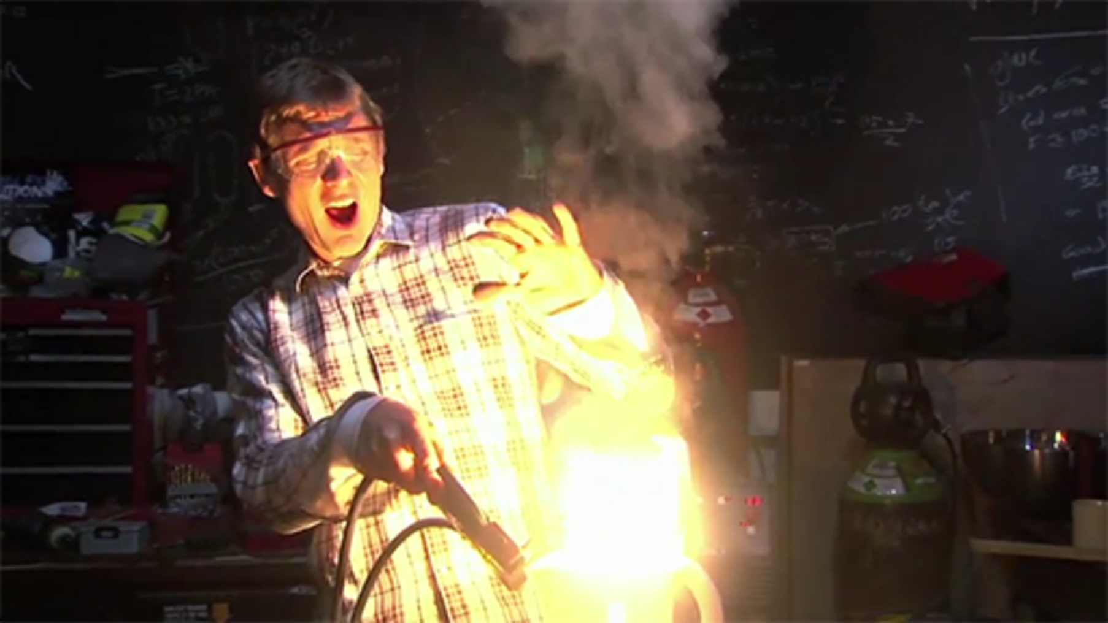

The three explosions at Fukushima caused a great deal of damage. The video illustrates how dramatic a hydrogen explosion can be!
In 2011, TEPCO who owned the Daiichi plant would declare that cooling systems for reactors 1–4 were beyond repair and would have to be replaced.
The video in the next section shows the damage within the Daiichi plant.

3.2.3 Inside the Daiichi power plant

Video content is not available in this format.
View transcript - Uncaptioned interactive content

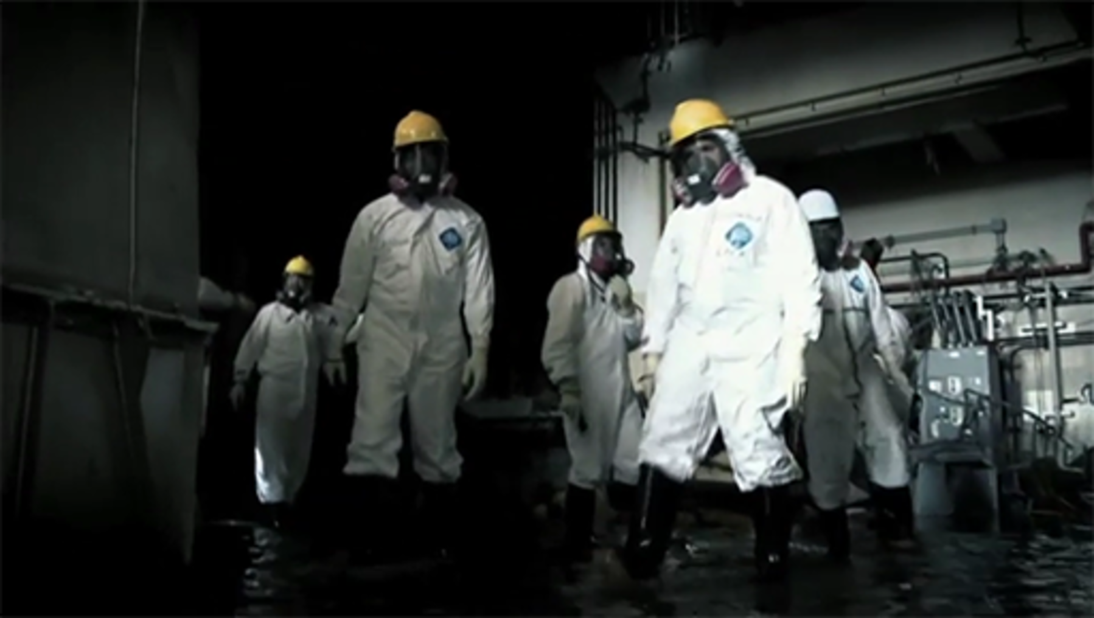

This video shows the inspection of the Daiichi plant in May 2011, two months after the initial crisis.
The damage done to the plant by the explosions is apparent as is the continuing presence of seawater.
The inspectors are an international group of scientists. They are there to work out what happened and why; to fully understand the physics so that appropriate precautions can be taken within the nuclear industry.
During the first few weeks, many were frustrated at the piecemeal nature of the information coming out of Daiichi so this visit was also an opportunity to increase transparency of information.
Initially, the main battle was with the reactors themselves. As time went on the overriding issue became the continuing effort to limit the radioactive contamination of the area and to try to contain the Daiichi site.
In the next section, find out about the exclusion zone set up around Fukushima.

3.2.4 Exclusion zone

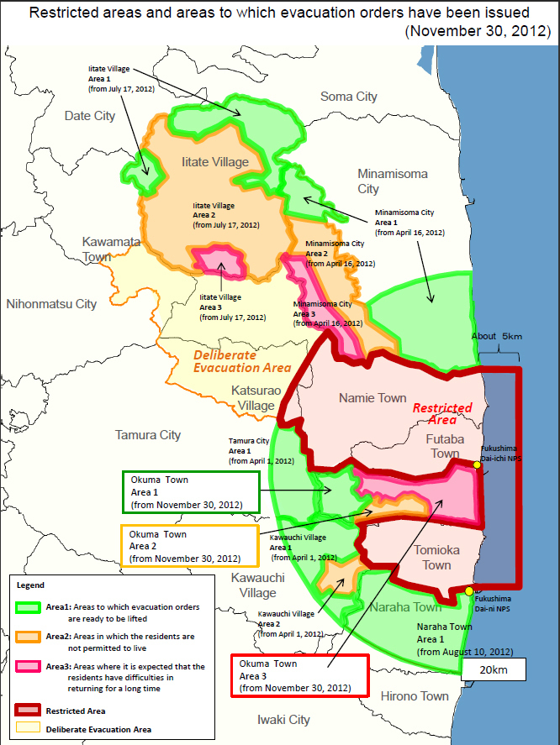
Figure 7
View description - Figure 7

The meltdowns within the reactors led to some of the radioactive fission products leaking into the environment.
This was exacerbated by release of gases and material by the explosions and the venting of gases that occurred to try to reduce pressure within the reactors and limit further explosions. In addition, the entire plant was flooded with seawater that provided a medium to transport the radioactive isotopes into the surrounding area and into the sea!
From 17 March, the decision was made to drop seawater from helicopters on the reactors targeting reactors 3 and 4 in particular. This would create radioactive steam that also contaminated the environment, but it was getting desperately necessary to cool the reactors down.
In response to the radiation leaks the Japanese government ordered an evacuation around the Daiichi plant initially of 2km but as the crisis developed it extended up to 20km by the evening of 12 March. The exclusion zone around the site is shown in Figure 7. In total about 160,000 people were evacuated as a result of the meltdowns.
Clean-up of the exclusion zone could not begin in earnest until December 2011 when the nuclear plant was cool enough to be deemed in ‘cold shutdown’.
Two particular isotopes were of concern, both fission products spread extensively within the exclusion zone:
- Iodine-131. This is commonly ingested by humans as an element within many foodstuffs. Iodine-131 is a beta emitter with a half-life of eight days and can pose a serious health risk. This means that is active initially, but will decay rapidly enough to cease to be a threat in the long term. Iodine tablets were distributed to workers and those near the plant. The tablets are taken so that this non-radioactive iodine will be taken by the body to the thyroid gland. The aim is to ‘fill up’ the thyroid gland so that any radioactive iodine ingested will pass through the body and not linger in the thyroid gland to cause damage.
- Caesium-137. This is also readily incorporated into the human body and its salts are water soluble. It is also a beta emitter and has a much longer half-life of 30 years. This means that caesium-137 continues to be a threat for many years.
The clean-up involved removal of the contaminated topsoil within the exclusion zone. This is fraught with many difficulties including that there is a variable radiation within the zone, that each worker is only allowed a limited time within the zone and the issue of where to store the radioactive soil once collected. Another problem is the huge area that needs to be covered. It is estimated that the clean-up will cost tens of billions of pounds.
In the next section, you will look at the measurement of radioactivity within the soil four months after the crisis.

3.2.5 Clean-up of Iitate

Video content is not available in this format.
View transcript - Uncaptioned interactive content

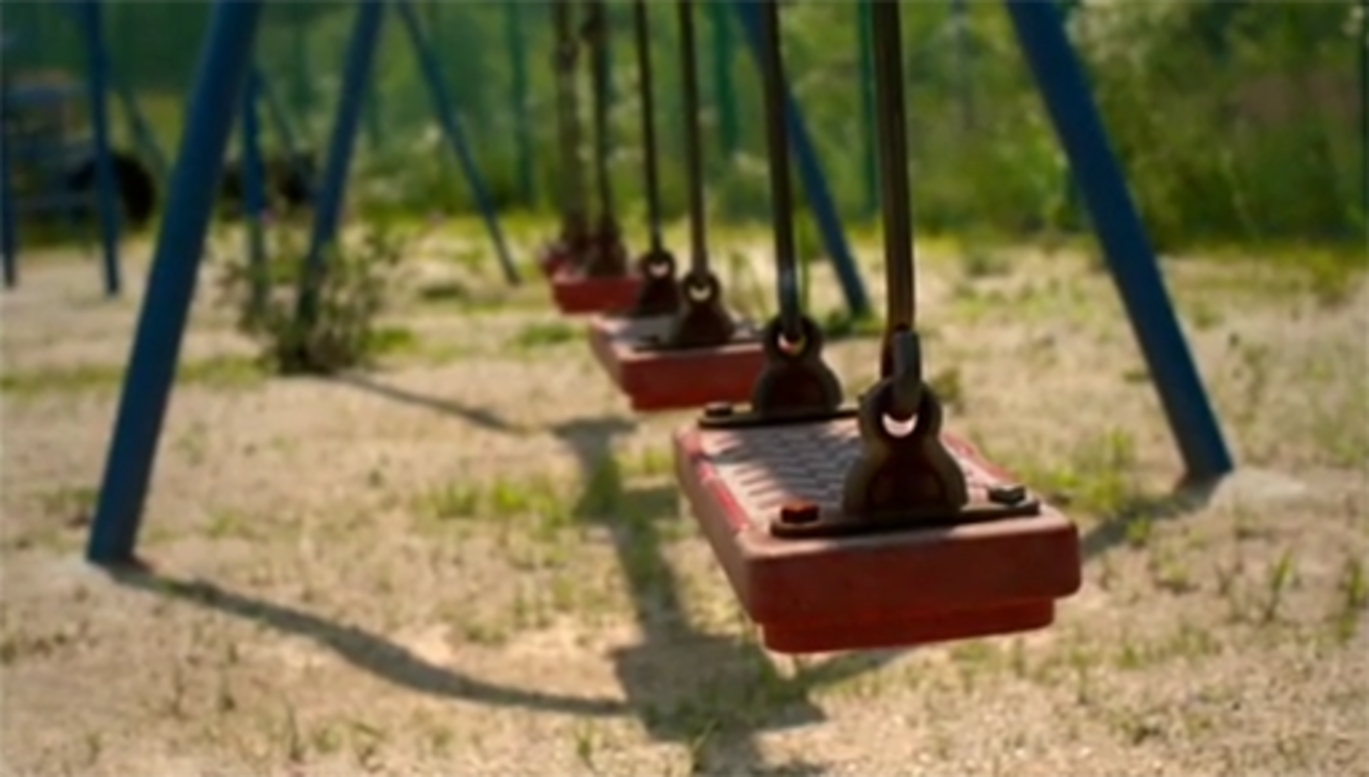

Iitate is a village outside the exclusion zone, 39km northwest of the Daiichi Nuclear plant. It is outside the exclusion zone but the prevailing winds were able to bring radioactive material with them and in April 2011 the village was evacuated.
The scientists are particularly interested in iodine-131 and caesium-137. The iodine is found to be decayed but the presence of caesium is still a worry. The top two and a half cm of soil are found to have high activity. This would need to be removed to make Iitate safe.
The evacuation order was listed on 1 April 2017. Residents were keen to go back to their homes and were proactive in measuring radiation levels themselves, so that they could make an informed decision about their return.
In the next section, you’ll find out how the accident was graded.

3.2.6 Fukushima level 7

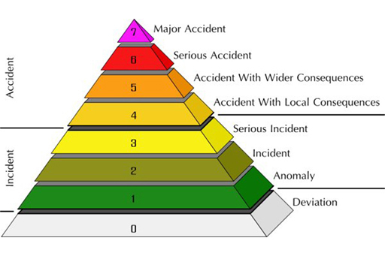
Figure 8
View description - Figure 8

One month after the tsunami the Fukushima nuclear crisis was upgraded from a level 5 nuclear incident – an accident with wider consequences – to a level 7 incident – a major accident.
This is the maximum level and puts it in the same category as Chernobyl. At the time, many found the classification to be misleading as the severity of the disaster was determined by measuring the total amount of radiation emitted over the month. Ten times the amount of radiation had been emitted at Chernobyl over a much shorter time span.
In addition, the authorities in Japan evacuated the area far more quickly and, to date, no one has suffered ill effects from the radiation from Fukushima.
The next section looks at the levels of radiation in the population six months after the meltdown.

3.2.7 Fukushima – six months later

Figure 9
View description - Figure 9

The text below is from the New Scientist and describes the situation in Fukushima six months after the incident.

The fallout from the radiation leak at the Fukushima Daiichi nuclear reactor in Japan may be less severe than predicted.
Radiology researcher Ikuo Kashiwakura of Hirosaki University, Japan, and colleagues responded immediately to the disaster, travelling south to Fukushima prefecture to measure radiation levels in more than 5000 people there between 15 March and 20 June.
They found just 10 people with unusually high levels of radiation, but those levels were still below the threshold at which acute radiation syndrome sets in and destroys the gastrointestinal tract. Geiger-counter readings categorised all others in the area at a ‘no contamination level’.
How did the population of Fukushima prefecture dodge the radioactivity? Gerry Thomas at Imperial College London, director of the Chernobyl Tissue Bank, says the answer is simple. ‘Not an awful lot [of radioactive material] got out of the plant – it was not Chernobyl.’ The Chernobyl nuclear disaster released 10 times as much radiation as Fukushima Daiichi.

Rapid response
Thomas says the quick and thorough response by the Japanese government limited radioactive exposure among the population. On 12 March, the same day as the first explosion at Fukushima Daiichi, the government ordered the evacuation of residents within 20 kilometres, and asked various institutions to begin monitoring contamination levels.
‘They had no faxes, no emails, nothing was working,’ says Thomas, adding that other countries might not have coped as well with a combined earthquake, tsunami and nuclear plant malfunction. ‘Given the circumstances, they did phenomenally.’
The Japanese authorities also removed contaminated food and gave iodine to those who were very young, she says. Radioactive iodine can contaminate the thyroid gland in the body, leading to radiation-induced cancer, but can be counteracted by introducing non-radioactive iodine into the body.
Health researchers will have to keep an eye on radiation levels, however. ‘There are many “hotspot” areas where radioactivity has accumulated locally,’ says Kashiwakura. This is because rainfall deposited radioactivity unevenly. ‘The Japanese people have a responsibility to continue research on the effect of radioactivity in humans.’
(Whyte, 2011)

Next, you’ll move on to finding out how the situation developed in Fukushima and how it compares to Chernobyl.

3.3 Fukushima – water issues
Listen to the news report from the BBC’s Tokyo correspondent, Rupert Wingfield-Hayes talking to Adam Rutherford, dated August 2013, about two and a half years after the incident at Fukushima.
It discusses plans for an ice wall that was being designed to help stem the flow of water at the Fukushima. Rupert Wingfield-Hayes explains why the geographical position of the site and the flow of groundwater are making the task extremely difficult.

Audio content is not available in this format.
View transcript - Uncaptioned interactive content

The two main issues identified are:
- Containment of the contaminated water. There is an increasing amount of this in storage!
- Isolating the groundwater from the contaminated water.
In fact the ice wall method of containment failed and was abandoned in 2014. Various attempts were made to cool the water sufficiently for it to freeze but were unsuccessful, leaving the issue of water flow ongoing.
In the next section, find out about the other ongoing challenges at Fukushima.

3.3.1 Fukushima – ongoing challenges

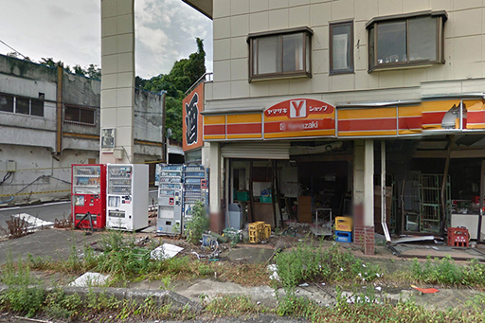
Figure 10
View description - Figure 10

Like any nuclear incident site, the problems at Fukushima will take many many years to solve.
Some of the challenges the Japanese government face are:

Daiichi site
The ice wall failed and radioactive material at the site is still being released through contaminated water, four years after the crisis.
From 2014 onward, efforts were made to treat the water and remove some of the radioactive isotopes within it using the filtering system mentioned in the news report you heard in the previous section. This has had some success. The long-term aim is to be able to safely release the water to the sea with a legal discharge concentration of activity. The presence of radioactive isotope of hydrogen-3 (tritium) is limiting how much water can be returned.
The problem is likely to continue as long as the source of the radioactivity is still present. There are however severe problems connected with the removal and containment of melted fuel and debris. The radiation is still so high that workers cannot safely be within reactors 1 to 3 for even short amounts of time so technological advances would be required to begin dismantling in the near future.
In all likelihood, it will take 30–40 years for all the cores to be dismantled and removed off-site and the flow of water may well remain a difficult issue until then.

Exclusion zone
In April 2014, the first group of the people that had been evacuated in 2011 were allowed to return home. This first group were 350 residents of the Miyakoji district in Tamura city, which lies inside the 20km-radius exclusion zone. In October 2014, residents of Kawachi village were also allowed home.
While this appears positive, many of those evacuated are too fearful to return and wary of the information they have been given by the government and by TEPCO.
Also those allowed to return are very much in the minority. In the Fukushima prefecture overall, 130,000 people are still displaced. It is very unclear when the remaining evacuees will be able to return home. The large scale decontamination continues but some areas are likely to have very high levels of radiation for many years to come.
In the next section, you will consider the health effects on the misplaced population of Fukushima.

3.3.2 Fukushima – health effects three years later

Video content is not available in this format.
View transcript - Uncaptioned interactive content

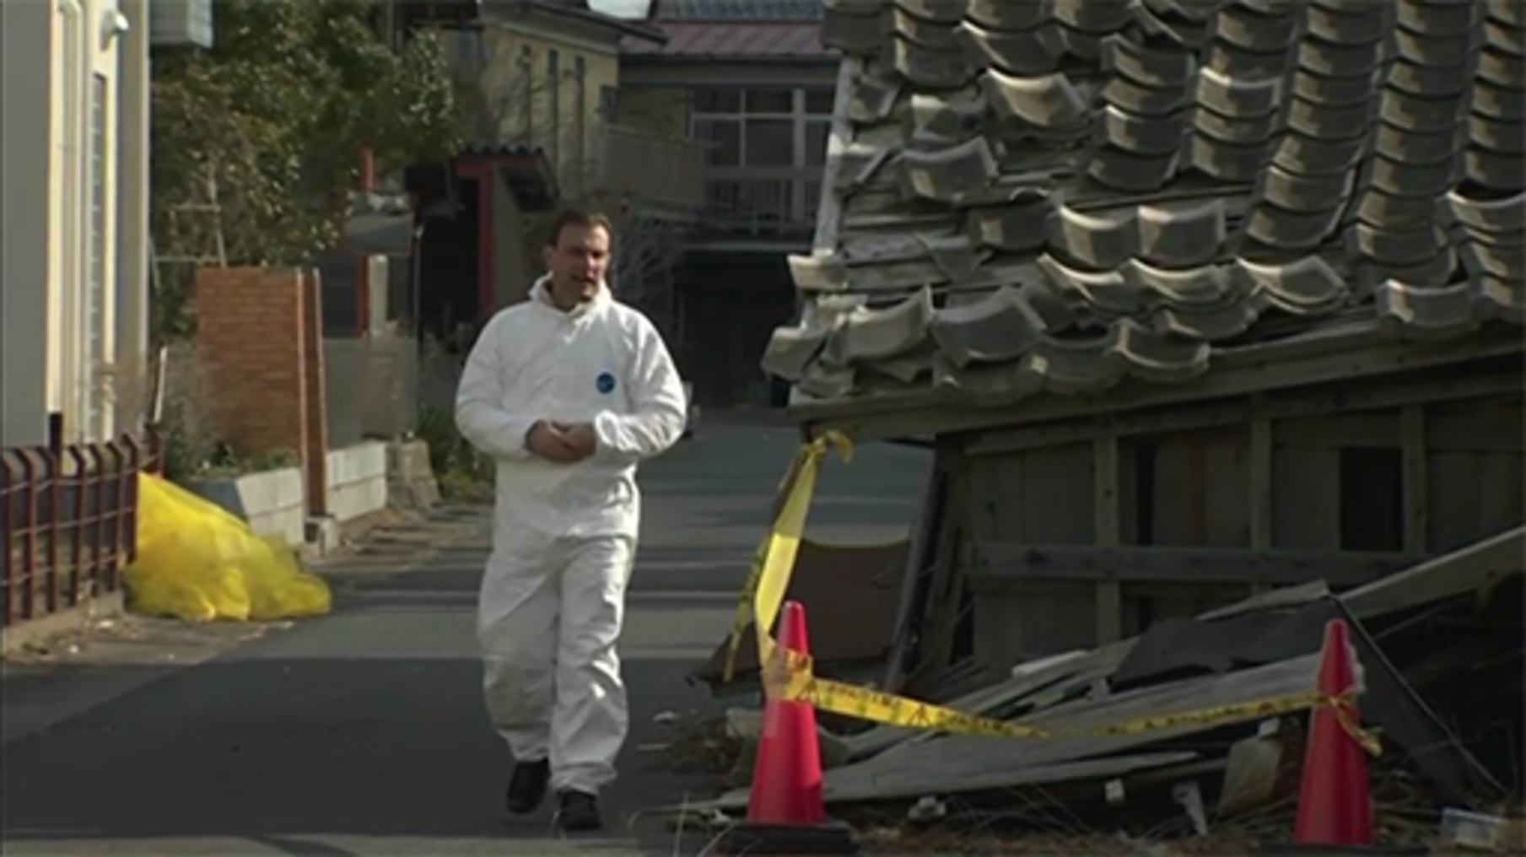

Three years after the tsunami in Fukushima, the majority of those evacuated are still living in temporary accommodation and unable to return home.
The video states that the ongoing fear of the radiation is leading to more health effects than the radiation. To date, no one has died from the radiation from the nuclear fallout. Only a few of the workers at the Daiichi plant have the possibility of suffering any health effects. In contrast, the earthquake and tsunami took thousands of lives.
Nonetheless, those unable to return home lost everything, their homes, woodlands, fields and farmlands. Many have suffered with their health and are traumatised.
Things will not be able to go back to how they were in Fukushima for many decades. If we want to imagine what Fukushima’s exclusion zone will be like in future it is helpful to look at Chernobyl today, which you’ll do in the next section.

3.3.3 Chernobyl today – the reactor

Figure 11
View description - Figure 11

It is nearly 30 years since the nuclear disaster at Chernobyl’s power plant. The Chernobyl nuclear plant remains entombed in its concrete and steel sarcophagus which is due to end its 30 year lifespan in 2016.
The sarcophagus will be replaced by a ‘New Safe Confinement’ which is under construction. This is designed to contain the radioactive material within the plant and act as a shield from the weather for the next 100 years. It is a huge engineering challenge.
In the future, it is hoped that one day all this radioactive material will be disposed of safely – that will be an even more challenging task! The New Safe Confinement will provide a protected space where the dismantling can begin, but this is likely to be performed by machines as the radiation levels are still too much of a risk for humans. Figure 11 shows the stages of assembly – the building is being built in two domed halves.
The radiation in the exclusion zone is variable and dependent on the weather, still needs constant monitoring for those that are working on the abandoned plant. Levels of radiation are still high but have dropped sufficiently for workers to be able to spend a week or two working on the plant. Care stills needs to be taken not to ingest radioactive material in the air and to wear suitable protective clothing.
In the next section, see images from the exclusion zone around Chernobyl.

3.3.4 Chernobyl today – exclusion zone

Video content is not available in this format.
View transcript - Uncaptioned interactive content

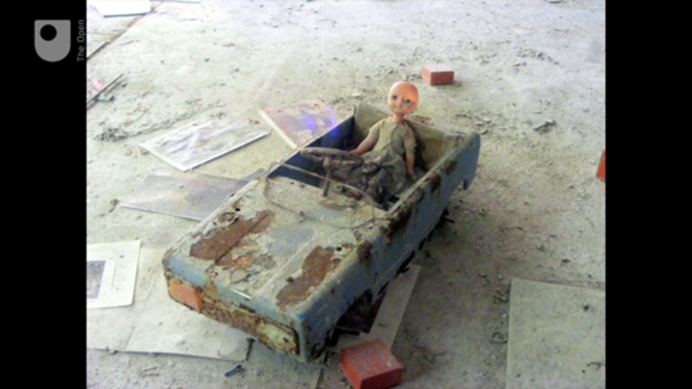

The 30 km exclusion zone around Chernobyl remains predominantly abandoned and much is a wilderness. The nearby Red Forest has encroached on the plant and the nearby town of Pripyat.
The exclusion zone may look lush but the vegetation itself contains high levels of radioactive material. The forest is monitored for wildfires as a large fire in forest would lead to dangerous levels of smoke particles entering the atmosphere.
Further out than Pripyat, there have been some attempts at resettlement into areas evacuated in 1986 due to the fallout from Chernobyl. In 2010, the Belarus government adjusted their policy on Chernobyl, with some regions reclassified with a view to begin the process of returning the region to normal use. They state that for many areas and with minimal restrictions, the annual dose will be between 0.1 and 1 mSv – significantly less than the annual dose from granite to those living in Cornwall.
The task is large as the infrastructure, utilities and new buildings (to replace those that will be demolished) all need to be provided. Much caution is required in the use of local resources such as wood due to lingering high-level of caesium in some places, although in others the level is low and agriculture may be attempted. Cultivated food will be safe to eat although wild fruit will still be restricted.
The images in the video were taken on a tour around the Chernobyl reactor and the town of Pripyat.

3.3.5 Chernobyl today – health effects

Video content is not available in this format.
View transcript - Uncaptioned interactive content

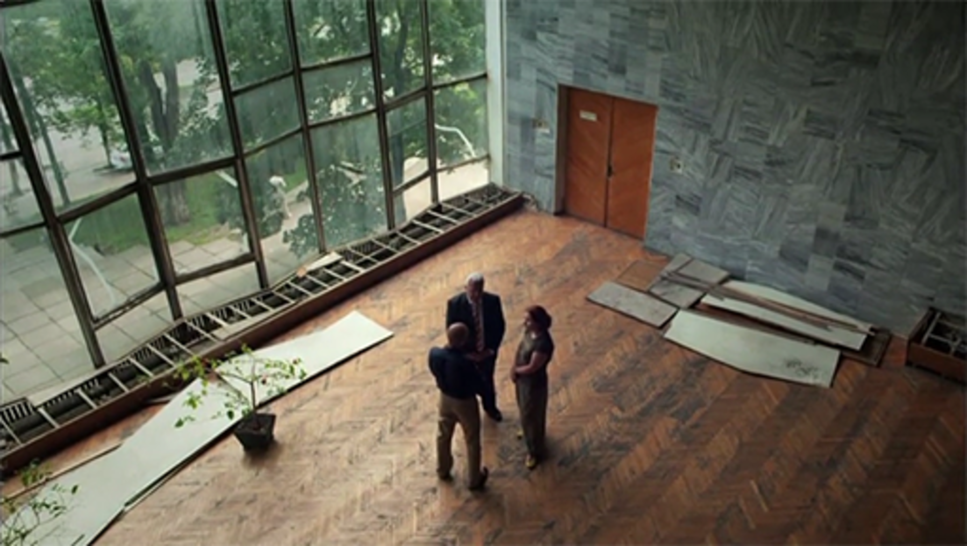

In the video, Jim al-Khalili talks to Professor Mykola Tronko at the Institute of Endocrinology and Metabolism in Ukraine.
Initially, there were great fears about the health risks of the radiation on the nearby community. Pripyat was not evacuated until two days after the explosions, so the residents would certainly have been exposed.
From 1990, there were higher incidences of thyroid cancer in children and this was a cause of great concern. This particular cancer was screened for as it was known that any ingested iodine-131 would collect in the thyroid. As we learned in Week 1, the emitted particles from radioactive substances can damage human tissue and lead to cancers forming.
However, there was no rise in other cancers. From the vantage point of today we can see that the effects from the fallout were substantially less than were feared at the time.
In the next section, you will think about the lessons that can be learned from these disasters.

3.3.6 What have we learned?

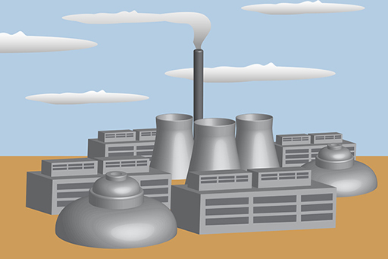
Figure 12
View description - Figure 12

In this final section of this week, you will use what you have learned so far to think about what you would do if you were involved with a nuclear power station.

Activity 2

Imagine that there is a nuclear power station being built ten miles from where you live. You have an advisory role in its construction!
Based on what you have learned this week about previous nuclear incidents, think about the advice you would give and write a paragraph explaining your answers to these questions:
- What would you require from the reactor to minimise the risk of meltdown?
- If there was an incident, what guidelines would you recommend for action afterwards?
- If these measures were put in place, would you be happy to live in the vicinity?

3.4 Quiz for Week 3
Take the quiz which will test and apply your knowledge of the material in Week 3.
Week 3 quiz
Come back here when you are done.

3.5 Summary of Week 3

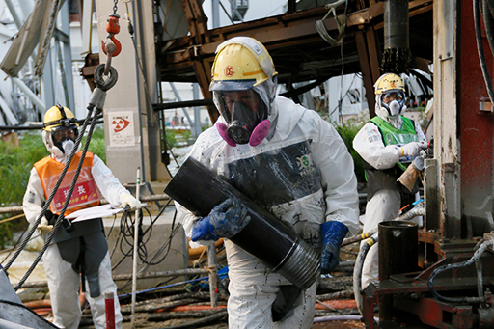
Figure 13
View description - Figure 13

The nuclear incidents that you examined this week were the result of reactors going into meltdown.
In the case of Chernobyl, an error with the control rods led to the fuel rods going supercritical. The accidents at Three Mile Island and Fukushima were both due to failures in the coolant circulating.
At Fukushima, the reactors were shut down satisfactorily after an earthquake but a tsunami then flooded the building and this was the primary reason for the coolant failure. Meltdown and hydrogen explosions followed which led to radioactive fission products contaminating the surrounding area.
The containment of the reactors at both the Fukushima plant and Chernobyl is an ongoing problem and the decommissioning of the reactors themselves cannot happen for decades.
Next week, you will consider the environmental issues that surround the need to limit our use of fossil fuels. You will look at the design of the new nuclear reactor, being built at Hinkley Point, which has taken the events at Fukushima into account. You will also look at new developments including the use of thorium as a fuel and the pursuit of nuclear fusion.
You can now go to Week 4.

Week 4: A future for nuclear power?

Introduction
In the following video, Sam and Gemma discuss developments in energy sources in a replica of the JET facility at Cullham.

Video content is not available in this format.
View transcript - Uncaptioned interactive content

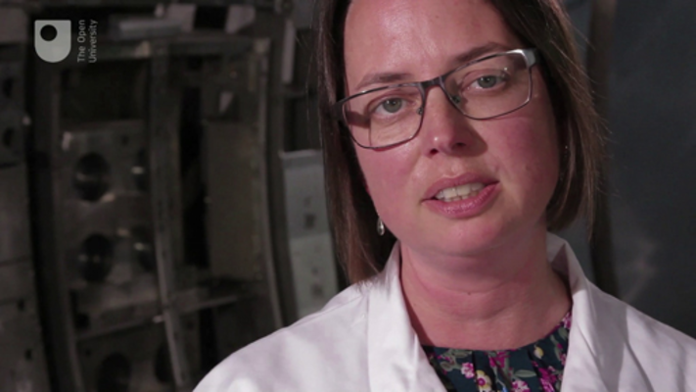

4.1 Energy for the future or relic of the past?

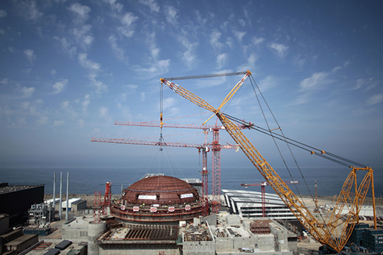
Figure 1
View description - Figure 1

The Flamanville plant is the first new nuclear plant to be built in France for 15 years.

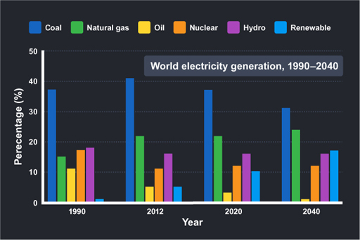
Figure 2
View description - Figure 2

Nuclear power – an energy source for the future?
The events at Fukushima had repercussions around the world. It led many to question whether nuclear power is an energy for the future or a relic of the past.
It was well publicised that in the wake of the accident at Fukushima, Italy and Germany announced plans to phase out their nuclear industry, with the latter intending to phaseout all reactors by 2022. Both Spain and France aim to reduce their dependency on nuclear power.
Less publicised is, what you learned in Week 2, that there are many nuclear reactors under construction and a further 500 proposed plants! Table 1 shows in which countries these are to be situated.

Table 1 Nuclear reactors around the world
Country | Reactors operable | Reactors under construction | Reactors planned | Reactors proposed
US | 99 | 5 | 5 | 17
France | 58 | 1 | 1 | 1
Japan* | 48 | 3 | 9 | 3
Russia | 34 | 9 | 31 | 18
South Korea | 23 | 5 | 8 | 0
China | 22 | 27 | 64 | 123
India | 21 | 6 | 22 | 35
Canada | 19 | 0 | 2 | 3
UK | 16 | 0 | 4 | 7
Ukraine | 15 | 0 | 2 | 11
World Total | 437 | 70 | 183 | 311
This table shows the top ten countries with the most nuclear reactors and the world total. *Japan shut down all of its nuclear reactors following the Fukushima disaster in 2011.
(Source: World Nuclear Association)

Many countries intend to increase the amount of nuclear energy that they use; these include Hungary, Romania and Ukraine. Poland and Turkey plan to build their first nuclear reactors and as you can see from the table, China has many reactors planned.

Why are so many countries forging ahead with nuclear power?
You will examine the answers to this question in the following sections along with some of the issues that surround the use of fossil fuels. In particular, you will look at the need to find cleaner energy sources that reduce the emission of carbon dioxide.

4.1.1 Carbon emissions and global warming
There is much research going into energy resources that have low carbon emissions because it’s recognised that carbon dioxide damages the Earth’s atmosphere.
Most of the Earth’s atmosphere is composed of nitrogen and oxygen but there are other gases in the atmosphere that concern us here: water and carbon dioxide.

Figure 3 The electromagnetic spectrum (the energy scale is given in two units; both the electronvolt (eV) and the joule (J) are explained later)
View description - Figure 3 The electromagnetic spectrum (the energy scale is given in two units; both ...

These gases consist of molecules which are made up of more than one type of atom and as a consequence of this the bonds between the atoms vibrate. These vibrations enable the gases to absorb infrared (IR) radiation which comes from the Earth’s surface. If you look at Figure 3 you can see that IR is next to visible light, and this part of the electromagnetic spectrum has slightly lower energy.
It means that IR cannot pass through the gases, it is absorbed and re-emitted by the gases in the atmosphere, warming up the Earth’s surface. This warming is called the greenhouse effect and gases such as water and carbon dioxide that are able to absorb IR are called greenhouse gases. If the amount of greenhouse gas in the atmosphere increases, then more energy is absorbed by the atmosphere and re-emitted towards Earth.

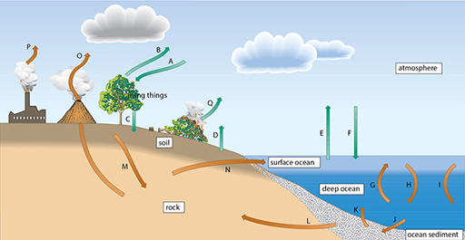
Figure 4 Today’s carbon cycle; the transfers P and Q represent human-accelerated release of carbon from the rock reservoir to the atmosphere (P) and from living things reservoir to the atmosphere (Q)
View description - Figure 4 Today’s carbon cycle; the transfers P and Q represent human-accelerated ...

Carbon exists in many different forms on the Earth and the carbon cycle consists of the flow of carbon between different reservoirs – these are shown schematically in Figure 4. There are many natural processes that exchange carbon between the different reservoirs.
One of these reservoirs is the atmosphere. If more carbon dioxide enters the atmosphere, it is possible that more will be retained within it and there will be an increased greenhouse effect and temperature rise leading to global warming.
There are processes that remove carbon from the atmosphere – for example, photosynthesis into the reservoir of ‘living things’ – and throughout Earth’s history the flow between reservoirs has been able to adjust in times of increased temperature or cooling. However, burning fossil fuels over the past 100 years has led to a new and additional process by which carbon can be transferred to the atmosphere.
When fossil fuels burn in air, oxygen reacts with organic carbon to form carbon dioxide and water vapour, usually released into the atmosphere. These are both greenhouse gases. The fear is that our prolonged burning of fossil fuels in power stations and vehicles may lead to a situation where the carbon cycle is unable to adjust and carbon (as carbon dioxide) will build up in the atmosphere and lead to irreversible climate change.
Consequently, there have been moves recently to reduce the release of carbon dioxide to a sustainable level – one that would allow the carbon cycle to cope with its absorption from the atmosphere.
In both the UN Kyoto protocol and at a G8 summit, steps have been taken to legally require nations to limit their carbon dioxide emissions. The UK is committed to reducing its carbon emissions to 80% of its 1990 value by 2050. You can have a look at the UK regulations on the Committee on Climate Change website (n.d.). You may want to find the requirements of your own country.
As a result of these issues everyone is encouraged to reduce their carbon footprint as individuals. You can calculate your carbon footprint in the next section.

4.1.2 Find your carbon footprint

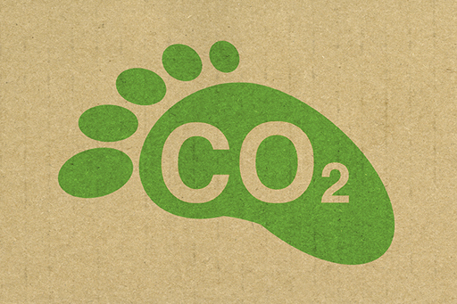
Figure 5
View description - Figure 5

You may have heard the term ‘carbon footprint’; this is a measure of how much carbon dioxide is released into the atmosphere as a result of activities carried out.

Activity 1

Calculate your own carbon footprint by answering questions about your home, car, travel and eating habits. The calculator will give you a figure for your approximate carbon footprint – this is the number of tonnes of greenhouse gas that is released due to your actions.
The first section is about your house. If you have your utility bills to hand you can add in figures for your consumption. At the end you’ll see your footprint in comparison with the average in the UK and the target for the world.
Calculate your carbon footprint using Carbon Footprint’s carbon calculator (2016).
- What was your carbon footprint?
- What made the largest contribution to it?
- In what ways could you reduce it?

In the next section, you can find out how the government plans to meet the carbon reduction targets.

4.1.3 The energy gap

Video content is not available in this format.
View transcript - Uncaptioned interactive content

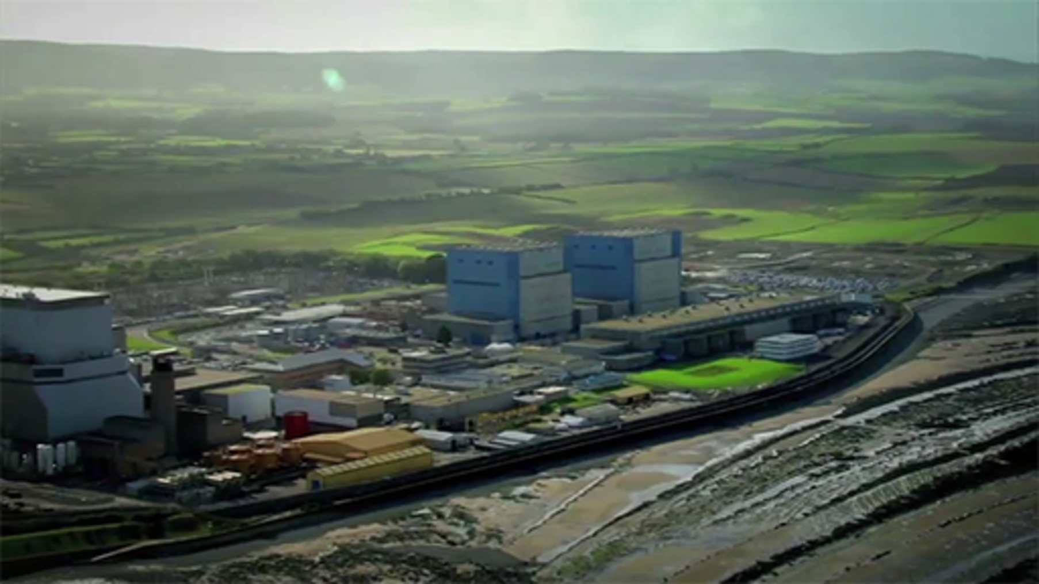

The UK National Grid faces supply problems due to the closure of gas and coal powered power stations.
These are being closed, primarily, to reduce carbon emissions and meet targets. But even if there weren’t environmental reasons, the amount of fossil fuel of any type is finite and the reserves within the Earth will run out in the future.
The video mentions the use of nuclear energy as an energy source that will fill part of the gap in energy resources that is left from the diminishing use of fossil fuels.
In the next section, you will look at nuclear energy in the context of carbon emission and cost.

4.1.4 The role of nuclear energy
In the current era, there are three main factors driving energy policy.
They are:
- climate change and the need to look for energy sources that reduce emissions of carbon dioxide into the atmosphere
- the finite supply of fossil fuels
- energy security and the need for countries to be able to supply their own energy with reduced dependency on other nations.
Given all of these factors, nuclear energy is given serious consideration.

How does nuclear energy fit the bill?
The graph in Figure 6 shows the cost of nuclear energy in comparison to other emissions and also an indication of the carbon emission status. Note that the costs are in US dollars per megawatt.

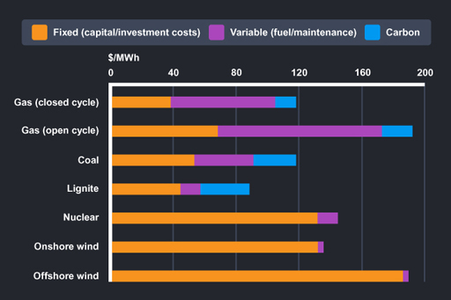
Figure 6
View description - Figure 6

You can see that the running costs of nuclear power (shown in purple) compare favourably to those of other alternatives and once up and running nuclear power is very efficient. However, the cost of building nuclear power stations (in orange) is large. This means that if a government wishes to use nuclear power as a resource they need to commit to a large initial investment.
The initial outlay is comparable to renewable energy resources such as wind but still much more expensive than solar energy, for example. Some people feel that the money spent on nuclear energy is better spent elsewhere.
Carbon emissions are shown on the graph and while there may be some carbon emission involved in the construction of nuclear power stations, the process of fission itself has no carbon emissions.
Next, you will find out how plans have started to be implemented in the UK.

4.1.5 New reactor at Hinkley C

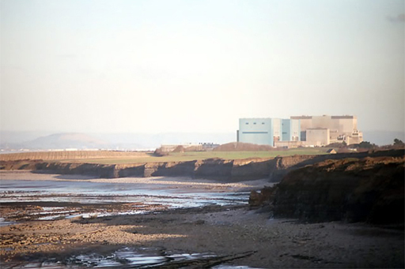
Figure 7
View description - Figure 7

In Week 2, you heard that, at the moment, nuclear power provides up to 20% of the electricity requirements of the UK. This is a large proportion, but many of the UK’s power stations are old and will need replacing soon.
To address the energy shortfall that will occur from limitations on the use of fossil fuels, a new nuclear power station in the UK was given the go ahead in 2013. The power station, called Hinkley C, is being built at Hinkley Point, Somerset. On the same site is Hinkley A, a decommissioned Magnox reactor and Hinkley B an AGR reactor that has been running since the early 1970s. Once built, it is hoped that the two new reactors will provide about 7% of the UK’s electricity. They are being built by a consortium led by EDF Energy and will be half owned by Chinese investors.
Hinkley C will be a modern power station with significant differences to the older reactors on the site, in both the design of the power station and the issue of radioactive waste. Hinkley C’s reactors are the first to be built post-Fukushima and their design takes into account lessons learned there and in other nuclear incidents.
Some of the improvements are listed below.
- The European pressurised reactors (EPRs) are an improvement on the pressurised water reactor and a huge improvement on the old Magnox and AGR systems. THE EPRs will be more efficient in producing energy and so need smaller amounts of fuel which will reduce the risk of a major accident.
- The floor of the reactors is on a base of 6m concrete with channels carved into it. In the event of a meltdown, this should stop the molten core burning through the floor and guard against leakage into the environment.
- Hinkley will have two concrete walls each over 1m thick. These are designed to protect the reactors and even to withstand aircraft strikes!
- In a direct response to the events at Fukushima and the importance of the cooling systems to safety, there will be two extra back-up generators in widely spaced, waterproof buildings.
In the next section, you will hear about how the developments will also improve the management of nuclear waste.

4.1.6 Nuclear waste
In the following audio, Adam Rutherford talks to Professor Sue Ion, former Director of Technology at British Nuclear Fuels.
She discusses how the modern design of Hinkley means a much smaller volume of nuclear waste of all categories.

Audio content is not available in this format.
View transcript - Uncaptioned interactive content

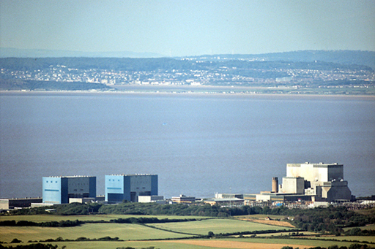
Figure 8
View description - Figure 8

In the next section, you will consider how important you think this development is.

4.1.7 Happy with Hinkley?

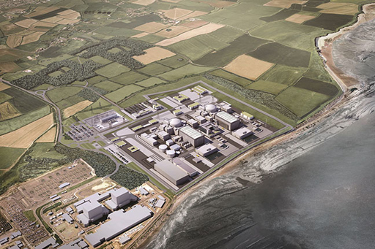
Figure 9
View description - Figure 9

At the end of last week, you considered what you would want to be present in the design of a nuclear power station. How does what you said match to Hinkley C?

Activity 2

Think through these questions:
- Do you agree with the building of Hinkley C? Why or why not?
- Do you think the new safety measures are enough? Why or why not?
- Do you think that the lower volume of radioactive waste is significant? Why or why not?

In the next section you will look at one of the alternatives to fission of uranium or plutonium.

4.2 Thorium – nuclear fuel of the future?

Video content is not available in this format.
View transcript - Uncaptioned interactive content

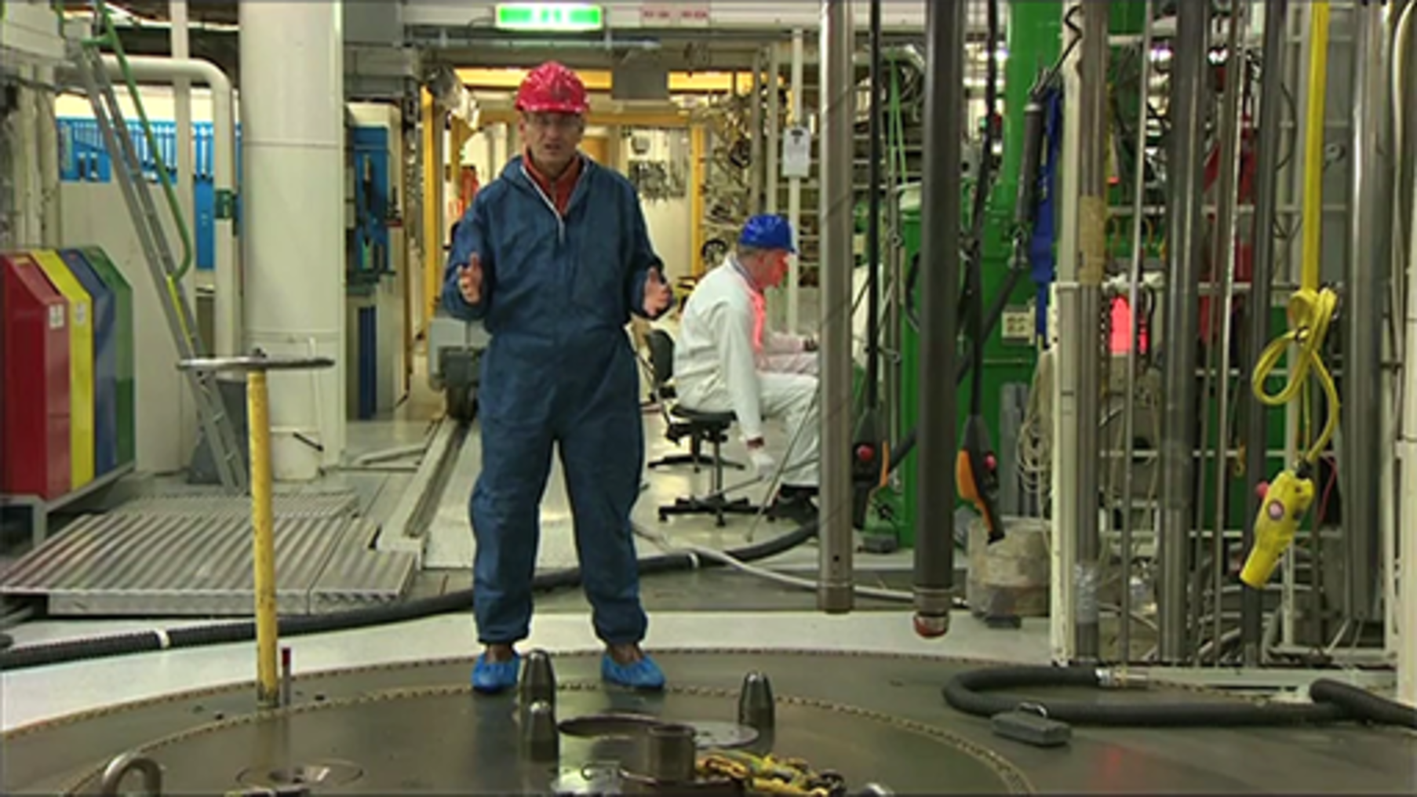

So far, the course has considered only uranium and plutonium as nuclear fuels.
However, thorium has been suggested as an alternative fuel because it is more abundant than uranium and has some advantages regarding safety.
The transformation of thorium-232 into a fissile isotope follows two β-decays:

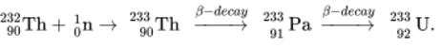
View alternative description - Uncaptioned Equation

Many research groups are actively pursuing thorium as a fuel. It is of particular interest to countries such as Norway and India which have large natural reserves of thorium.
The next sections consider a more radical change in nuclear fuel!

4.2.1 The Sun’s energy source

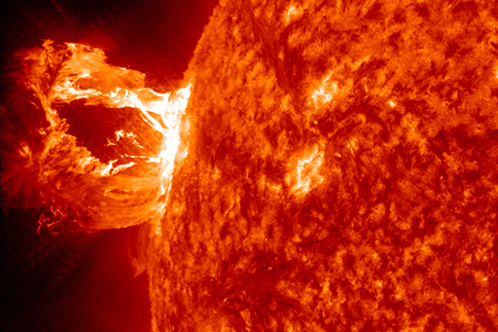
Figure 10
View description - Figure 10

The origin of most of the energy sources on the Earth is the energy we receive from the Sun in the form of electromagnetic radiation.
The Sun produces the whole of the electromagnetic spectrum (look back at Carbon emissions and global warming). The Sun’s power output is 3.846×10²⁶ W – this means it produces about 400 million billion billion joules of energy every second! It is clearly of interest to determine the Sun’s own energy source.
The Sun is (as all stars are) composed mainly of hydrogen. The Sun is by far the largest object in the Solar System – it contains 99% of the mass of the entire Solar System. The large mass means that there are very large gravitational forces that pull the Sun together and create extremely high temperatures and pressures at the centre. These conditions allow nuclear fusion to occur.
Fusion involves combining, or ‘fusing’, two small nuclei into one larger one. It is the opposite of fission which, as you learned in Week 1, involves splitting large nuclei into two smaller ones. Like nuclear fission, fusion is a nuclear process because fusion reactions involve changes in the number of protons and neutrons within nuclei. These changes within the nucleus itself define nuclear reactions as opposed to chemical reactions. In both cases energy is released, considerably more in the case of fusion.
You will examine a bit more of the physics behind fusion in the next section, however all that you need to know is that the process of fusion produces a huge amount of energy.

4.2.2 What is nuclear fusion?

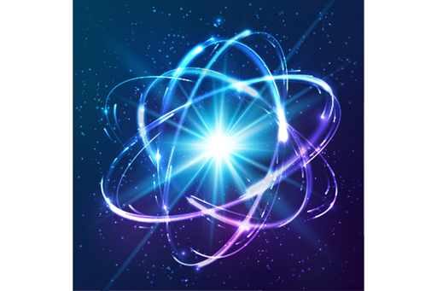
Figure 11
View description - Figure 11

You will recall from Week 1 that the origin of the energy that is released is the change in mass and binding energy when a large nucleus splits into two lighter ones.
This works for massive atoms such as uranium, plutonium or thorium. You looked at the fission reaction:

View alternative description - Uncaptioned Equation

The mass of the fission products and the three neutrons is less than of the U-236, although the number of nucleons is the same and this missing mass is released as energy due to equivalence of mass expressed by the equation E = mc².
We can also consider this in terms of binding energy – the energy released is due to the difference in binding energy of the nuclei involved.

Nuclear fusion
Let us look at a fusion reaction:

View alternative description - Uncaptioned Equation

Here hydrogen is fused with deuterium – the heavier isotope of hydrogen that contains one neutron to produce helium-3.
As with the fission reaction above, the number of nucleons is the same on each side but the mass of the helium nucleus is less than that of the hydrogen plus deuterium. This missing mass is converted to energy and released. In fact, the mass difference tends to be larger than with fission so that more energy is released in fusion reactions.
You may well be puzzling over how both splitting nuclei apart and fusing them together can produce energy. The full answer to this is beyond the scope of this course, but suffice to say that the physics within nuclei mean that the following is true.
- heavy nuclei with more than 56 nucleons release energy by undergoing fission
- light nuclei with fewer than 56 nucleons release energy by undergoing fusion.
This is shown in Figure 12.

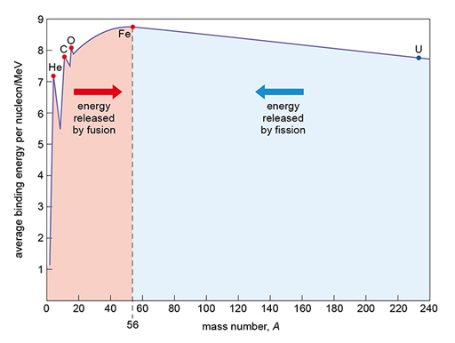
Figure 12 Energy released by fission and fusion
View description - Figure 12 Energy released by fission and fusion

The advantages of fusion over fission
Nuclear fusion is often heralded as the ultimate future technology although this has been the case for some time! It is nonetheless pursued as it has significant advantages over fission.
- The fuel for fusion is hydrogen. Hydrogen is by far the most common element in the Universe and is plentiful on Earth. Water contains hydrogen, for example. The fuels used are often the isotopes of hydrogen called deuterium (hydrogen-2) and tritium (hydrogen-3). Deuterium can be extracted from water and tritium can be produced from lithium in the Earth’s core. Both of these resources are plentiful and will last for millions of years.
- Unlike the radioactive products of fission, fusion produces no long-lived isotopes. Only plant components become radioactive and these will be safe to recycle or dispose of conventionally within 100 years.
- The process of fusion produces a huge amount of energy and only very tiny amounts of fuel need to be used. This means that nuclear incidents, such as those you heard about last week, are not possible with fusion.
- As with fission, there are no carbon emissions. The only by-products of fusion reactions are small amounts of helium, which is an inert gas that will not add to atmospheric pollution.
In the next section, you will consider the difficulties of achieving fusion.

4.2.3 Making use of fusion
In the following video, Professor Steve Cowley of JET explains the process of fusion and discusses the challenges of creating it on Earth.
You will learn more about the JET project at Culham later.

Video content is not available in this format.
View transcript - Uncaptioned interactive content

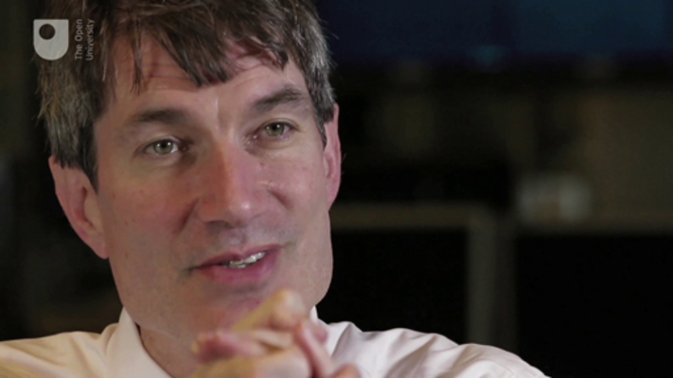

In the next section, you will review the science behind it.

4.2.4 Challenges of fusing nuclei
The main challenge of achieving fusion on Earth, as described by Steve Cowley in the video, can be examined by looking at the fusion equation again.

View alternative description - Uncaptioned Equation

The hydrogen nucleus contains one proton and the deuterium nucleus one proton plus one neutron. Both of these nuclei are positively charged and will therefore repel each other. As we discovered in Week 1, it is the strong force that holds nuclei together and it is certainly capable of overcoming the electrostatic repulsion but only acts at extremely short range. To get the strong force to pull the nuclei together you need to get the nuclei very close. This is no mean feat as the nuclei are trying to push themselves apart!
If the nuclei are going fast enough they will be able to overcome the repulsion to get close enough for the strong force to allow fusion. The intense temperatures and pressures at the centre of stars make these speeds achievable but suitable conditions cannot be easily recreated on Earth.
The fuels used are generally deuterium (hydrogen-2) and tritium (hydrogen-3) – these each have neutrons in their nuclei that contribute to the attraction of strong force but not to the repulsion. Tritium and deuterium fuse to give helium-4 and one neutron. In order to enable nuclei to fuse, a plasma is used. A plasma is a gas that has had a significant proportion of its atoms ionised so that the positively charged nuclei and negatively charged electrons are dissociated from one another. In order to produce a plasma the gas needs to be extremely hot – over 100 million degrees Celsius!
The Joint European Torus (JET) uses magnetic fields to confine the enormously hot fuel, called a plasma. The fields are within a large donut-shaped device called a tokamak or torus.
Another approach is to use lasers to produce pulses of X-rays, fired at a small fuel pellet of tritium or deuterium. The pulses squeeze the pellet causing it to implode and briefly undergo fusion. The National Ignition Facility (NIF) project uses this approach and you will learn more about this later.
In the next section, you will test yourself on what you’ve learned about fusion.

4.2.5 Fusion
Test yourself on what you’ve learned about fusion in the following activity.

Activity 3

What do the processes of fission and fusion have in common?

They both produce a great deal of long lived radioactive waste
Both processes produce a great deal of carbon dioxide
They both occur within the Sun
Fusion and fission release a proportionally large amount of energy
View answer - Part

Why is nuclear fusion difficult to achieve?

The fuel used is very rare on Earth
The nuclei are negatively charged and repel each other
Very high temperatures are required
The reactor is likely to go into meltdown
View answer - Part

4.2.6 Fusion at JET and ITER

Video content is not available in this format.
View transcript - Uncaptioned interactive content

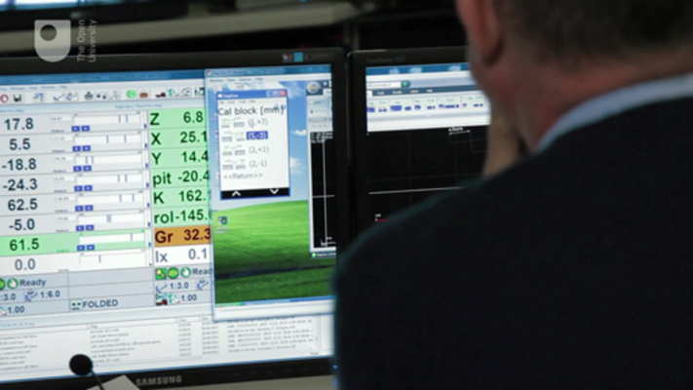

In the video Steve Cowley explains the experiments conducted at JET (Joint European Torus) in inducing nuclear fusion and looking to the future at the tokamak being built at ITER, (International Thermonuclear Experimental Reactor).
One of the main challenges in the development of fusion is creating a reactor that is commercially viable. At the moment, the fusion at JET can only occur for a matter of seconds. The energy achieved is about the same as that put in, to achieve the contained plasma or a little more. This means that the tokamak at JET is not commercially viable.
The successor to JET is ITER, a new tokamak that is being built in France. This should be able to produce 500 MW of fusion power.
Next, read about the National Ignition Facility (NIF).

4.2.7 The National Ignition Facility
In the following video, Brian Cox looks round the National Ignition Facility (NIF) and observes laser-induced fusion.
NIF has been running since 2009 and is still a way from producing fusion that maintains an overall gain in energy on a large scale.
However, since 2014 they have been able to produce more energy than that required to start the reaction. If you want to read more about this development, read this article from New Scientist (Aron, 2014).

Video content is not available in this format.
View transcript - Uncaptioned interactive content

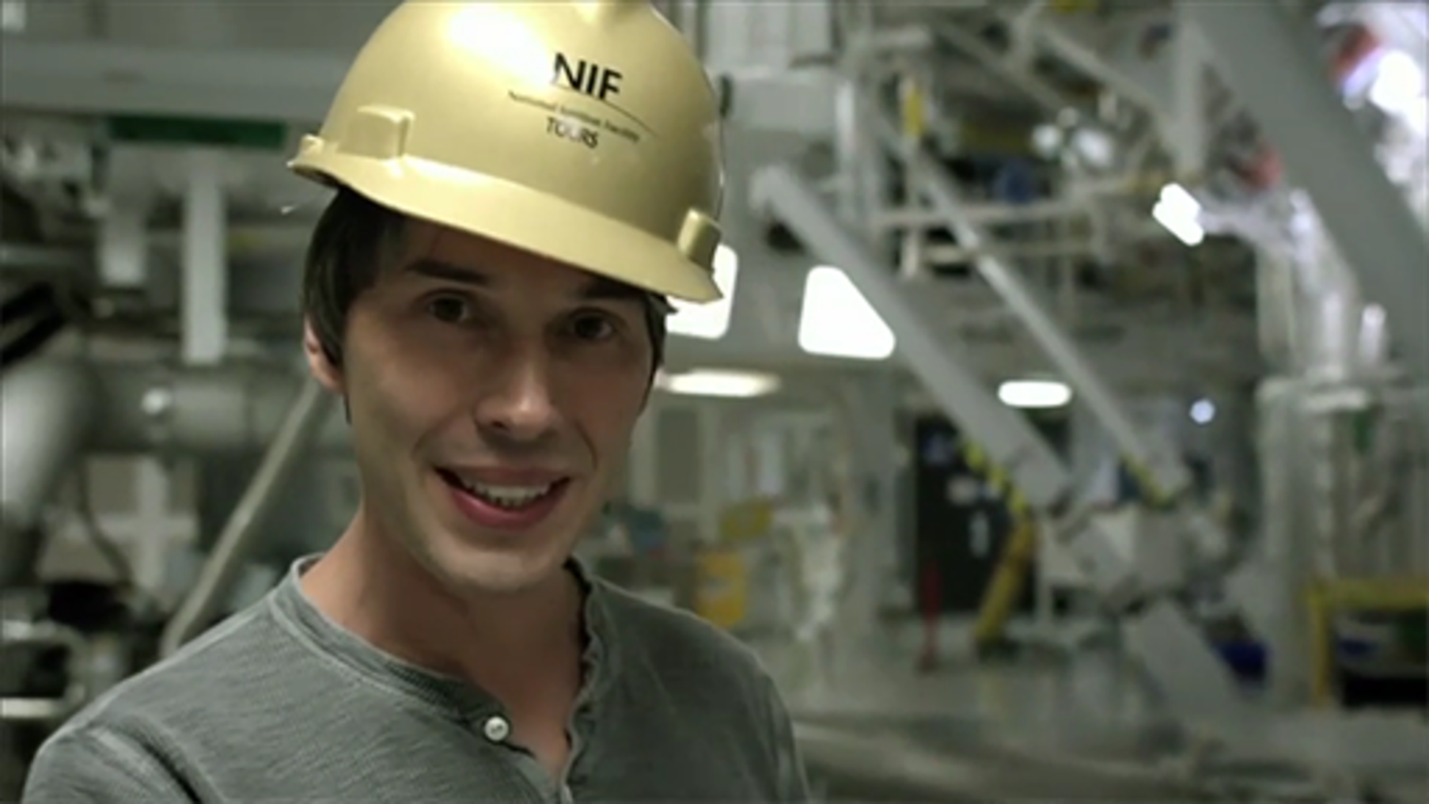

4.3 Nuclear energy debate
Now that you have explored the science behind nuclear power and all the key issues surrounding its use, take time to reflect on the arguments for and against nuclear power.
Listen to the debate. You may feel that you agree with some of the points that they raise, perhaps even points from both sides.

Video content is not available in this format.
View transcript - Uncaptioned interactive content

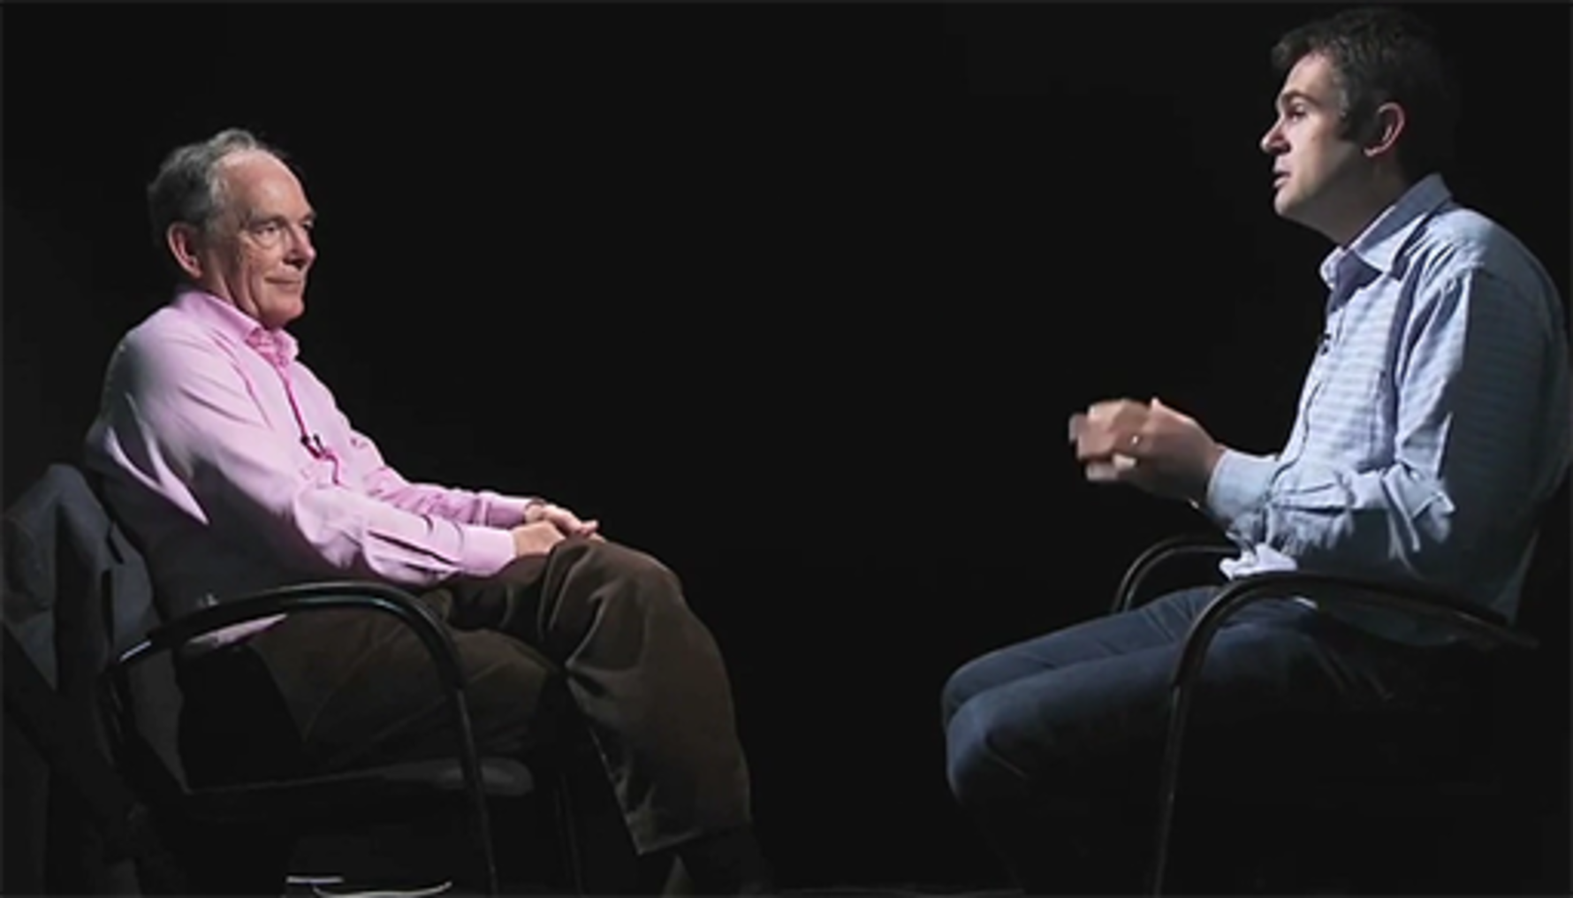

In the next section, you will be invited to consider your views on nuclear power.

4.3.1 What are your views on nuclear power?

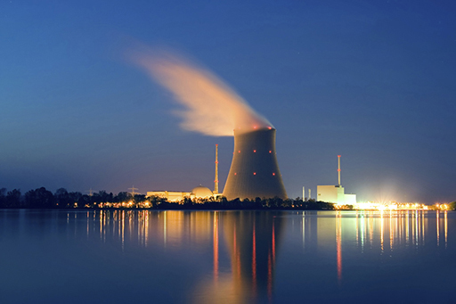
Figure 13
View description - Figure 13

Now you have a chance to bring together the ideas that you have examined throughout this course.

Activity 4

Consider the following questions:
- What are the main arguments for investing in nuclear energy at the present time?
- How convinced are you that nuclear energy should form part of the energy mix for the future?
- Have your views changed through your study? If not, how have they been reinforced?

4.4 End-of-course quiz
Review your learning throughout the course in the end-of-course quiz.
End-of-course quiz.
Open the quiz in a new tab or window and come back here when you are done.

4.5 Summary of Week 4

Figure 14
View description - Figure 14

At the moment, most of our power comes from the burning of fossil fuels, which release carbon dioxide and water when burnt.
These are greenhouse gases and contribute to the greenhouse effect and global warming. Because of these environmental concerns and the finite nature of fossil fuels, alternative resources are being pursued, one of which is nuclear energy.
In order to meet the UK’s energy requirements, a new nuclear power station is being constructed at Hinkley Point in Somerset. It has enhanced safety features in order to protect the core and to contain it in the event of a meltdown. It is also expected to produce significantly less nuclear waste compared to older type reactors. Research is being done elsewhere on using thorium as a nuclear fuel rather than uranium or plutonium. This would particularly advantage countries that have reserves of thorium.
Another technology that is being pursued is nuclear fusion. Like nuclear fission, this also involves changes within the nucleus itself but involves bonding light nuclei together rather than splitting heavy nuclei apart.
Fusion reactions power the stars but it is very difficult to achieve on Earth as the two nuclei are both positively charged and require very high energies to overcome the repulsion. To date, nuclear fusion has not attained the status of a workable energy resource but research is progressing at NIF in the US and ITER in France.

Complete our survey
We would love to know what you thought of the course and what you plan to do next. Whether you studied each section or dipped in and out, please take our Open University end-of-course survey. Your feedback is anonymous but will have massive value to us in improving what we deliver.

References
Clark, D. (2012) ‘Nuclear power plants around the world – map’, Guardian, 8 March [Online]. Available at www.theguardian.com/environment/interactive/2012/mar/08/nuclear-power-plants-world-map (Accessed 24 February 2016).
Dounreay Site Restoration Ltd (n.d.) Dounreay Site [Online]. Available at www.dounreay.com/decommissioning (Accessed 24 February 2016).
RenewableUK (2016) RenewableUK: The Voice of Wind & Marine Energy [Online]. Available at www.renewableuk.com/en/renewable-energy/wind-energy/index.cfm (Accessed 24 February 2016).
World Nuclear Association (2016) World Nuclear Association [Online]. Available at www.world-nuclear.org/information-library/country-profiles/countries-t-z/united-kingdom.aspx (Accessed 24 February 2016).
Whyte, C. (2011) ‘Radiation levels in Fukushima are lower than predicted’, New Scientist, 16 Nov [Online]. Available at www.newscientist.com/article/dn21181-radiation-levels-in-fukushima-are-lower-than-predicted.html (Accessed 15 April 2015).
Anderson, R. (2015) ‘Nuclear power: energy for the future or relic of the past?’ BBC News [Online]. Available at www.bbc.co.uk/news/business-30919045 (Accessed 24 January 2018).
Aron, J. (2014) ‘Laser-sparked fusion power passes key milestone’, New Scientist, 12 February [Online]. Available at www.newscientist.com/article/mg22129562-400-laser-sparked-fusion-power-passes-key-milestone/ (Accessed 24 January 2018).
Carbon Footprint Ltd (2016) Carbon Footprint Calculator [Online]. Available at www.carbonfootprint.com/calculator.aspx (Accessed 24 January 2018).
Committee on Climate Change (n.d.) The Climate Change Act and UK Regulations [Online]. Available at www.theccc.org.uk/tackling-climate-change/the-legal-landscape/global-action-on-climate-change/ (Accessed 24 January 2018).

Further reading
Look up the periodic table.
Find out more about Marie Curie by listening to the BBC programme In Our Time: The Curies.
Compare different sources of radiation at the UK Government site.
Review a list of the uses of radioactive isotopes.
There is more information from the World Nuclear Association about Fukushima.
There is much more information from the World Nuclear Association about Chernobyl.
Read more about Hinkley C from EDF Energy.
Look again at The National Grid status from Week 2.

Acknowledgements
This free course was written by Sam Smidt and Gemma Warriner.
Except for third party materials and otherwise stated (see terms and conditions), this content is made available under a Creative Commons Attribution-NonCommercial-ShareAlike 4.0 Licence.
The material acknowledged below is Proprietary and used under licence (not subject to Creative Commons Licence). Grateful acknowledgement is made to the following sources for permission to reproduce material in this free course:

Images
Course image © MichaelUtech/iStockPhoto.com

Week 1
Figure 1 courtesy of TopoMetrix Corporation
Figure 6 © Mac99/iStockPhoto.com
Figure 7 © KeremYucel/iStockPhoto.com
Figure 8 © dedek/Shutterstock.com
Figure 9 © janulla/iStockPhoto.com
Figure 10 © wenht/iStockPhoto.com
Figure 11 © Michael Kappel, in Flickr: https://creativecommons.org/licenses/by-nc/2.0/
Figure 12 © Roman Sigaev/Shutterstock.com
Figure 13 © abadonian/iStockPhoto.com

Week 2
Figure 1 © Innershadows/iStockPhoto.com
Figure 2 © Geography photos/Getty Images
Figure 3 Siemens Pressebild http://creativecommons.org/licenses/by-sa/3.0/
Figure 5 © studiocasper/iStockPhoto.com
Figure 6 © trekandshoot/iStockPhoto.com
Figure 8 Reproduced with kind permission, Gridwatch, Templar http://www.gridwatch.templar.co.uk/
Figure 11 © MichaelUtech/iStockPhoto.com
Figure 12 © Google Maps
Figure 13 © dennisvdw/iStockPhoto.com
Figure 15 © Courtesy of US Department of Energy/Science Photo Library
Figure 16 (a): The Nuclear Decommissioning Authority (NDA), (b): courtesy of Sellafield Ltd
Figure 17 © courtesy of Will & Deni Mcintyre/Science Photo Library
Figure 18 © Maxian/iStockPhoto.com
Figure 22 © MichaelUtech/iStockPhoto.com

Week 3
Figure 1 © The Open University
Figure 2 © joelsp, in Flickr.com http://creativecommons.org/licenses/by-nc-sa/2.0
Figure 3 © Dmitry Birin/shutterstock.com
Figure 4 © Google Maps
Figure 5 © The Asahi Shimbun/Getty Images
Figure 6 © Gamma-Rapho/Getty Images
Figure 7 © courtesy of the website of the Ministry of Economy, Trade and Industry of Japan (http://www.meti.go.jp/english/earthquake/nuclear/roadmap/pdf/20121130_01.pdf)
Figure 8 © Silver Spoon, via Wikimedia (https://commons.wikimedia.org/wiki/File:INES_en.svg), Creative Commons Attribution-Share Alike 3.0 Unported Licence (http://creativecommons.org/licenses/by-sa/3.0)
Figure 9 © wellphoto/Shutterstock.com
Figure 10 © Eric Parker, in Flickr http://creativecommons.org/licenses/by-nc/2.0
Figure 11 © Dmitry Birin/Shutterstock.com
Figure 12 © Oxlock/Shutterstock.com
Figure 13 © Bloomberg/Getty Images

Week 4
Figure 1 © Charly Triballeau/Stringer/Getty Images
Figure 2 courtesy BBC News, Source: IEA (http://www.bbc.co.uk/news/business-30919045)
Figure 5 © ChrisSteer/iStockPhoto.com
Figure 7 © Richard Baker in Wikimedia Commons https://commons.wikimedia.org/wiki/File:HinkleyPointCoast.jpg, http://creativecommons.org/licenses/by-sa/2.0
Figure 8 Richard Baker in Wikimedia Commons https://commons.wikimedia.org/wiki/File:Hinkley_Point_Nuclear_Power_Station.jpg?uselang=en-gb, http://creativecommons.org/licenses/by-sa/2.0
Figure 9 © courtesy of EDF Energy
Figure 10 © courtesy of NASA/SDO/GSFC
Figure 11 © art_of_sun/Shutterstock.com
Figure 13 © BERGMANNSTUDIO/iStockPhoto.com
Figure 14 © art_of_sun/Shutterstock.com

Audio-visual

Week 1
1.2.1 Radioactivity video Chemistry - a volatile history, S01 E03 9pm, 4 February 2010 © BBC
1.2.6 Myths of radiation video © courtesy Museum of Quackery, May 2007
1.3.6 The early days of fission © The Open University and its licensors

Week 2
2.1.2 Human power station video Bang Goes the Theory Christmas Special 3 December 2009 © BBC
2.1.5 Running the National Grid Bang Goes the Theory, Series 8 Energy (2014) © BBC
2.2.2 Inside a nuclear reactor video Bang Goes the Theory Series 5.10.11© BBC
2.3 Waste produced by nuclear power © The Open University and its licensors
2.3.3 Decommissioning at Dounreay Bang Goes the Theory Series 5 Episode 8 (2011) © BBC
2.3.6 Solution: transmutation video Horizon - Is Nuclear Power Safe (2011) © BBC
2.3.8 Case study: Yucca Mountain © The Open University

Week 3
3.1 Atomic Men various clips Windscale: Britain's Biggest Nuclear Disaster 08 October 2007 © BBC
3.1.2 Accidents at Three Mile Island and Chernobyl © The Open University and its licensors
3.2.2 Hydrogen explosions demonstrations various clips © BBC
3.2.3 Inside the Daiichi power plant video Horizon: Is Nuclear Power Safe, 14 September 2011 © BBC
3.2.5 Clean-up if Iitae video Horizon: Fukushima Is Nuclear Power Safe 2011 © BBC
3.3 Fukushima - water issues audio BBC Radio 4 news, 5 September 2013 © BBC
3.3.2 Fukashima - health effects three years later video Horizon: Fucuskina Is Nuclear Power Safe, episode 6, 2011 © BBC
3.3.4 Chernobyl today: exclusion zone © The Open University
3.3.5 Chernobyl today - health effects video Horizon: Fukushima Is Nuclear Power Safe, episode 6, 2011 © BBC

Week 4
4.1.3 Energy gap video Bang Goes the Theory, series 8, 2011 © BBC
4.1.6 Nuclear waste audio BBC Inside Science Radio 4 programme 8, 2013 © BBC
4.2 Thorium - nuclear fuel of the future? video Thorium backed as a 'future fuel', BBC News 2013 http://www.bbc.co.uk/news/science-environment-24638816 © BBC
4.2.7 The National Ignition Facility video Human Universe: A Place in Space and Time, 28 October 2014 © BBC
4.3 Nuclear energy debate video © Copyright Guardian News & Media Ltd 2015
Every effort has been made to contact copyright owners. If any have been inadvertently overlooked, the publishers will be pleased to make the necessary arrangements at the first opportunity.
Don’t miss out
If reading this text has inspired you to learn more, you may be interested in joining the millions of people who discover our free learning resources and qualifications by visiting The Open University – www.open.edu/openlearn/free-courses.

Solutions

Activity 1

Part

Answer
Right:
This particle has a positive charge and exists in the nucleus
Feedback
Yes! The proton is positively charged. The nucleus is made up of positively charged protons and neutral neutrons.
Wrong:
This particle has no charge and exists in the nucleus
Feedback
This describes a neutron not a proton. Consider the nature of the other particles in the nucleus.
This particle is in orbit around the nucleus
Feedback
Electrons are in orbit around the nucleus, not protons. Consider the nature of the other particles in the nucleus.
This particle has a negative charge
Feedback
Protons are not negatively charged. Consider the nature of the other particles in the nucleus.
Back to - Part

Part

Answer
Right:
6 electrons, 6 protons, 7 neutrons
Feedback
Well done! The number of protons and neutrons add up to 13 to make carbon-13.
Take a look at Isotopes.
Wrong:
6 electrons, 6 protons, 6 neutrons
Feedback
The number of protons and neutrons has to add up to 13 in carbon-13.
Take a look at Isotopes.
6 electrons, 7 protons, 6 neutrons
Feedback
The number of protons has to equal the number of electrons.
Take a look at Isotopes.
7 electrons, 7 protons, 6 neutrons
Feedback
Carbon has atomic number = 6. This is equal to the number of protons.
Take a look at Isotopes.
Back to - Part

Part

Answer
Right:
They are different isotopes of beryllium
Feedback
Yes, the different numbers indicate they are different isotopes of beryllium.
Take a look at Isotopes.
Wrong:
They have different numbers of protons
Feedback
All atoms of beryllium have the same number of protons in their nuclei. Think about what it is that the different numbers tell us.
Take a look at Isotopes.
They have the same number of neutrons
Feedback
The different numbers (8 and 9) indicate differing numbers of neutrons. Think about what it is that the different numbers tell us.
Take a look at Isotopes.
They have different atomic numbers
Feedback
All atoms of beryllium have the same atomic number in their nuclei. Think about what it is that the different numbers represent.
Take a look at Isotopes.
Back to - Part

Activity 3

Part

Answer
Right:
Fusion and fission release a proportionally large amount of energy
Feedback
This is true for both processes. Fission is the process used in nuclear power stations to create energy and fusion will hopefully be able to be used for this process in the future.
Wrong:
They both produce a great deal of long lived radioactive waste
Feedback
The process of fission produces radioactive waste but the process of fusion does not. Think again about what fission and (hopefully one day) fusion are used for.
Both processes produce a great deal of carbon dioxide
Feedback
In fact, neither process produces a great deal of carbon dioxide. Think again about what fission and (hopefully one day) fusion are used for.
They both occur within the Sun
Feedback
Nuclear fusion occurs in the Sun but fission does not. Think again about what fission and (hopefully one day) fusion are used for.
Back to - Part

Part

Answer
Right:
Very high temperatures are required
Feedback
Nuclear fusion is difficult to achieve because very high temperatures are required – of the order 200 million ºC.
Wrong:
The fuel used is very rare on Earth
Feedback
The fuel, deuterium, is found in water which is readily available on Earth! Think of the process involved in achieving fusion.
The nuclei are negatively charged and repel each other
Feedback
This is not true. The nuclei are both positively charged and repel each other. Think of the process involved in achieving fusion.
The reactor is likely to go into meltdown
Feedback
The reactor is not likely to go into meltdown with a fusion reactor as the mass of the fuel is so small and fusion is difficult to achieve.
Back to - Part

Figure 1 A layer of gold atoms on the surface of a crystal obtained by scanning tunnelling microscopy.

Description
The image shows a layer of gold atoms on the surface of a crystal obtained by scanning tunnelling microscopy.
Back to - Figure 1 A layer of gold atoms on the surface of a crystal obtained by scanning tunnelling microscopy.

Figure 2 The inside of an atom.

Description
The image is of an atom with a section removed so you can see inside. At the centre of the atom is a label ‘nucleus’. There is a label indicating that on the outside of the atom is a ‘region occupied by electrons’.
Back to - Figure 2 The inside of an atom.

Figure 3 A schematic diagram of the nuclei of some isotopes.

Description
A schematic diagram of the nuclei of some isotopes: protons are coloured red and labelled with p, and neutrons green and labelled with n
Back to - Figure 3 A schematic diagram of the nuclei of some isotopes.

Figure 4 A schematic diagram of the nucleus of the carbon-12 isotope.

Description
A schematic diagram of the nucleus of the carbon-12 isotope
Back to - Figure 4 A schematic diagram of the nucleus of the carbon-12 isotope.

Figure 5 The electromagnetic spectrum (the energy scale is given in two units; both the electronvolt (eV) and the joule (J) are explained later).

Description
This is an image of the electromagnetic spectrum.
Back to - Figure 5 The electromagnetic spectrum (the energy scale is given in two units; both the electronvolt (eV) and the joule (J) are explained later).

Figure 6

Description
This is a close-up image of a person smoking.
Back to - Figure 6

Figure 7

Description
This is an image of a smoke detector.
Back to - Figure 7

Figure 8

Description
This is an image of the imprint of a shell in the sand.
Back to - Figure 8

Figure 9

Description
This image illustrates that the thyroid gland is in the throat.
Back to - Figure 9

Figure 10

Description
This shows four scans of a brain.
Back to - Figure 10

Figure 11

Description
This is a photograph with a factory setting in the background and a sign saying ‘CAUTION CONTROLLED AREA. CAUTION: RADIOACTIVE MATERIAL’ in the foreground.
Back to - Figure 11

Figure 12

Description
This is an image depicting nuclear fusion.
Back to - Figure 12

Figure 13

Description
This is an image of a block of Uranium.
Back to - Figure 13

Figure 14 The particles and types of radiation involved in fission

Description
This image shoes the particles and types of radiation involved in fission
Back to - Figure 14 The particles and types of radiation involved in fission

Figure 15 On the left, a mass too small to sustain a chain reaction; on the right, increasing the mass to ‘critical mass’ has enabled further fissions

Description
On the left, a mass too small to sustain a chain reaction; on the right, increasing the mass to ‘critical mass’ has enabled further fissions
Back to - Figure 15 On the left, a mass too small to sustain a chain reaction; on the right, increasing the mass to ‘critical mass’ has enabled further fissions

Figure 16

Description
At the top of this image is the heading ‘Binding energy of the nucleus’. The image shows a set of scales: on the left-hand side are the nucleons and on the right-hand side is the nucleus.
Back to - Figure 16

Figure 1

Description
This is an image of someone putting a plug into a plug socket on the wall.
Back to - Figure 1

Figure 2 Pylons taking electricity away from the Sizewell A and B nuclear power stations

Description
This is a photograph of pylons in a field.
Back to - Figure 2 Pylons taking electricity away from the Sizewell A and B nuclear power stations

Figure 3 A steam turbine with the case opened revealing the turbine blades

Description
This is a photograph of a steam turbine.
Back to - Figure 3 A steam turbine with the case opened revealing the turbine blades

Figure 4 The basic design of a nuclear power station

Description
This illustration shows the basic design of a nuclear power station. On the left is the reactor core and on the right is the electricity generating plant.
Back to - Figure 4 The basic design of a nuclear power station

Figure 5 Wind turbines

Description
This is a photograph of a set of wind turbines in a field.
Back to - Figure 5 Wind turbines

Figure 6 The Hoover Dam in Nevada

Description
This is a photograph of the Hoover Dam in Nevada.
Back to - Figure 6 The Hoover Dam in Nevada

Figure 7 The UK’s power stations

Description
This image shows a map of the UK and shows power stations of 400MW or larger. There are dots on the grid showing where these power stations are located.
Back to - Figure 7 The UK’s power stations

Figure 8 The National Grid

Description
This image shows a snapshot of data from the National Grid.
Back to - Figure 8 The National Grid

Figure 9

Description
The illustration shows the various components of a nuclear power station.
Back to - Figure 9

Figure 10 A nuclear reactor

Description
This illustration shows the components making up a nucelar power station.
Back to - Figure 10 A nuclear reactor

Figure 11

Description
This is an image of a power plant.
Back to - Figure 11

Figure 12

Description
This is a map of the world with pins showing the location of nuclear power stations.
Back to - Figure 12

Figure 13

Description
This is an image of a device which reads counts per second.
Back to - Figure 13

Figure 14 The main decay chain for uranium-238; other radioisotopes similarly have their own characteristic decay chains

Description
This image shows the main decay chain for uranium-238.
Back to - Figure 14 The main decay chain for uranium-238; other radioisotopes similarly have their own characteristic decay chains

Figure 15

Description
This is a birds-eye view of a nuclear power plant.
Back to - Figure 15

Figure 16 (a) A drum used to store intermediate-level waste encased in concrete, cut away to show its contents, (b) waste packaging and encapsulation plant (Sellafield, UK)

Description
Part (a) of the image shows the drum used to store intermediate-level waste. Part (b) is a photograph of the encapsulation play at Sellafield in the UK.
Back to - Figure 16 (a) A drum used to store intermediate-level waste encased in concrete, cut away to show its contents, (b) waste packaging and encapsulation plant (Sellafield, UK)

Figure 17

Description
This image shows a pool of water which is fenced off. There is a warning sign on the fence saying ‘HAZARDOUS WASTE. KEEP OUT’.
Back to - Figure 17

Figure 18

Description
This is a photograph with a nuclear power plant in the background.
Back to - Figure 18

Figure 19 The main stages in reprocessing nuclear waste

Description
This illustration is a flow diagram showing the main stages in reprocessing nuclear waste.
Back to - Figure 19 The main stages in reprocessing nuclear waste

Figure 20 The global water cycle: showing the distribution of the world’s water. ‘Lakes’ includes freshwater and saline lakes. The values shown as transfers represent the amounts of water cycled annually (in units of 1015kg y-1), as opposed to that stored in reservoirs (in units of 1015 kg)

Description
This illustration shows the global water cycle.
Back to - Figure 20 The global water cycle: showing the distribution of the world’s water. ‘Lakes’ includes freshwater and saline lakes. The values shown as transfers represent the amounts of water cycled annually (in units of 1015kg y-1), as opposed to that stored in reservoirs (in units of 1015 kg)

Figure 21 Void structures in different rock types.

Description
This is three separate images showing the void structures in different rock types.
Back to - Figure 21 Void structures in different rock types.

Figure 22

Description
This shows a nuclear power station.
Back to - Figure 22

Figure 1

Description
This illustration shows the components which make up a nuclear power station.
Back to - Figure 1

Figure 2

Description
This is a photograph of a nuclear power station.
Back to - Figure 2

Figure 3

Description
This is a photograph of a reactor.
Back to - Figure 3

Figure 4

Description
Ths is a map of Japan.
Back to - Figure 4

Figure 5

Description
This shows the Fukushima Daiichi plant from the air.
Back to - Figure 5

Figure 6

Description
This shows the Fukushima Daiichi plant from the air.
Back to - Figure 6

Figure 7

Description
This is a map of the inclusion zone.
Back to - Figure 7

Figure 8

Description
This is a pyramid illustrating seven levels of incident/accident. from Deviation at the bottom to Major accident at the top.
Back to - Figure 8

Figure 9

Description
This is the photograph of a person holding a machine close to the ground to check for radiation levels.
Back to - Figure 9

Figure 10

Description
This is a photograph of an empty shop in a derelict area.
Back to - Figure 10

Figure 11

Description
This is an image of the Chernobyl nuclear plant.
Back to - Figure 11

Figure 12

Description
This is an illustration of a nuclear power plant.
Back to - Figure 12

Figure 13

Description
This is a photograph of three people wearing protective clothing .
Back to - Figure 13

Figure 1

Description
This is a photograph of the Flamanville plant.
Back to - Figure 1

Figure 2

Description
This is a graph showing world electricity generatiion, 1990–2040.
Back to - Figure 2

Figure 3 The electromagnetic spectrum (the energy scale is given in two units; both the electronvolt (eV) and the joule (J) are explained later)

Description
This is an image of the electromagnetic spectrum.
Back to - Figure 3 The electromagnetic spectrum (the energy scale is given in two units; both the electronvolt (eV) and the joule (J) are explained later)

Figure 4 Today’s carbon cycle; the transfers P and Q represent human-accelerated release of carbon from the rock reservoir to the atmosphere (P) and from living things reservoir to the atmosphere (Q)

Description
This is an illustration of today’s carbon cycle.
Back to - Figure 4 Today’s carbon cycle; the transfers P and Q represent human-accelerated release of carbon from the rock reservoir to the atmosphere (P) and from living things reservoir to the atmosphere (Q)

Figure 5

Description
This is an image of a green footprint with CO2 within it.
Back to - Figure 5

Figure 6

Description
This is a graph showing the cost of nuclear energy in comparison to other emissions.
Back to - Figure 6

Figure 7

Description
This is a photograph of the reactor at Hinkley C.
Back to - Figure 7

Figure 8

Description
This is a photograph of the reactor at Hinkley C.
Back to - Figure 8

Figure 9

Description
This is a photograph of the reactor at Hinkley C.
Back to - Figure 9

Figure 10

Description
This is an image of the Sun.
Back to - Figure 10

Figure 11

Description
This is an image depicting nuclear fusion.
Back to - Figure 11

Figure 12 Energy released by fission and fusion

Description
This is a chart showing energy released by fisison and fusion.
Back to - Figure 12 Energy released by fission and fusion

Figure 13

Description
This is a photograph of a nuclear power plant.
Back to - Figure 13

Figure 14

Description
This is an image depicting nuclear fusion.
Back to - Figure 14

Uncaptioned interactive content

Transcript
SAM SMIDT
Hello, and welcome to the course. I’m Sam Smidt.
GEMMA WARRINER
And I’m Gemma Warriner. Over the next four weeks, you’ll be taking a good look at the issues that surround nuclear energy and energy supply in general.
SAM SMIDT
You’ll also be looking at some of the issues that make nuclear energy more of a difficult choice and the reasons why governments are sometimes more cautious about adopting it. But this first week’s all about the science.
GEMMA WARRINER
We’re going to be looking at fission and radioactivity. Now, I have a Geiger counter here. You might have seen one of these before. Radioactive materials emit particles, and we’ll be looking at these particles later this week.
When one of these particles enters the tube, it’s registered as a click. So the more clicks you hear, the more radioactive it is nearby. Now, you may hear there’s some clicks going on while I’m talking to you now. Now, that’s to be expected. That’s background radiation, and it’s due to the low level radioactivity that surrounds us all the time.
Now, I have a couple of sources of that radioactivity here. Well, Sam does. We have some bananas. So if I put the Geiger counter next to them, they’re getting a few clicks. So they are contributing to the background.
We’re going to get more clicks if I put the Geiger counter next to Sam’s watch. You can hopefully hear there. We’re getting quite a few more clicks. That’s because Sam’s watch is quite an old watch, and the fluorescent paint actually contains radium, and radium is radioactive.
SAM SMIDT
The other thing we’re going to focus on this week is fission, which is how we get most energy that is produced in nuclear reactors. Fission is when you split nuclei of large unstable elements, usually uranium, into two smaller, more stable nuclei and energy is released in the process. That’s pretty much all there is to it, but you’ll learn about how we measure that energy, and that’s all related to Einstein’s famous equation e equals mc squared. Stay with us and it’ll all become clear.
Back to - Uncaptioned interactive content

Uncaptioned interactive content

Transcript
JIM AL-KHALILI
In 1896, French scientist Henri Becquerel was working with uranium crystals and found ultraviolet light made them glow. It looks eerie. He left uranium salts overnight on a photographic plate that had never been exposed to light. In the morning, he found a dark shadow on it, and realised that the uranium salts must have been the source of energy. Becquerel had discovered radioactivity.
Scientists began to investigate. One was young Polish chemist Marie Curie.
Marie began collecting uranium ore, called pitchblende. Testing it with an electrometer, she found that it was four times more radioactive than pure uranium. She checked it 20 times. What could be going on?
Then she had a brainwave. She decided there was something else in the pitchblende that was boosting its radioactivity, something more radioactive than uranium. But what? Could it be a new element?
Marie Curie didn’t have a well equipped lab. It was far more basic - a bit like this. One chemist called it a cross between a horse stable and a potato cellar. She had a tonne of pitchblende - some say 10 tonnes-- delivered by horse and cart. And then with just basic equipment like this, she attempted to isolate her mystery elements.
Her experiments had a myriad of complex stages, including potentially lethal processes using highly flammable hydrogen gas.
But all her hard work was worth it. With just her primitive kit, Marie Curie discovered two radioactive elements - polonium, named after her native Poland, and another that would launch an entire industry - radium.
Radium was once the key component in luminous paint. It’s intensely radioactive. The world fell in love with radium, assuming its invisible energy must be good for you.
The French slapped on radium face powder. The Germans ate radium chocolate. The Americans wore radium-branded condoms. But the magic faded when doctors realised that far from boosting health, it triggered cancers.
Marie Curie didn’t live to see the amazing journey the radioactive elements would take us on. Because whilst these are naturally occurring elements, they would take man one step closer to a seemingly impossible dream - to create entirely new elements.
Back to - Uncaptioned interactive content

Uncaptioned interactive content

Transcript
INSTRUCTOR
With the discovery of radium in the early part of this century, it was thought that it had great curative powers. Many spas were set up, like at Battle Creek, Michigan where Dr Kellogg had a radium room where people were treated with radioactive salts and blankets. Other spas were set up at Saratoga Springs, where they had radium mud baths, radium regular baths in California, in Arkansas. Radium was thought to have great beneficial effects.
So some clever entrepreneurs thought that if it’s possible to sell something that you could use in your home, maybe they could capture some of the profit that was made from people who were spending it in radium spas. And they advertised, why spend money for an expensive train trip to some health spa when you can buy one of our water jugs? And it will make your water just as radioactive as you’ll find at Saratoga Springs.
One of the more popular so-called radium spas for the home was this Revigator, made in 1912. Hundreds of thousands of these were sold, and it was made in a variety of shapes and sizes. It has radium ore on the inside of this crock. Now, we’ll put this Geiger counter sensor down inside. You’ll hear quite a loud response determining how much radium is in this crock.
They tried to sell their customers on the idea that more illness was caused by improper water than any other reason, largely because the radioactivity was lost in the water that we were drinking.
Back to - Uncaptioned interactive content

Uncaptioned interactive content

Transcript
NARRATOR
The birth of nuclear power is often linked to the development of the nuclear bomb, used with such effect at the end of the Second World War. But nuclear fission has been a topic for discussion since Einstein had postulated that mass and energy were interchangeable. Then in 1942, Enrico Fermi, an Italian physicist, achieved the first nuclear reaction on a significant scale.
In a disused squash court in the University of Chicago, he built a pile of graphite blocks with uranium and control rods interspersed. Pulling out the control rods began the reaction, but it was low level and generated a small amount of heat. The uranium atoms were being made to split or fission. This was initiated by bombarding uranium atoms with neutrons. The atoms break up into two large fragments, releasing heat and radiation.
Several neutrons are also emitted, but they’re fast moving and have to be slowed if they’re to successfully break up other uranium atoms. Graphite, a moderator material, is used to do this. These neutrons then cause other atoms to fission, producing even more neutrons and heat and setting off a chain reaction. In reality, all this happens rapidly in fractions of a second.
Fermi’s reactor was developed into larger, more powerful reactors. These needed to be cooled, and it was decided to use water to do the job. A small water cooled reactor powered the world’s first nuclear submarine, the Nautilus.
REPORTER
Then Mrs Eisenhower christened the Nautilus, and it was committed to its rightful element.
NARRATOR
Apart from their use as propulsion systems, nuclear reactors were built primarily to produce plutonium, a key bomb making material. It’s a byproduct of the fission process. But there was growing political pressure to reduce nonmilitary uses of the technology.
PRESIDENT EISENHOWER
Today, at Shippingport, Pennsylvania, we begin building our first atomic power plant of commercial size. Mankind comes closer to fulfilment of the ancient dream of a new and a better Earth.
Back to - Uncaptioned interactive content

Uncaptioned interactive content

Transcript
SAM SMIDT
Hi. This week, you'll be looking at electricity and the various ways in which electricity is generated and how it's distributed by the national grid.
GEMMA WARRINER
This kettle, for example, has a power rating of 3,000 watts. That means every second, it uses 3,000 joules of energy. It gets this energy when I plug it in and it connects to the national grid. The national grid has to cope with all our energy needs throughout the day and how they change, and it does this by managing how it utilises all its different power stations.
SAM SMIDT
Here at JET, for example, when they're running an experiment at full power, they can use 2 per cent of the national grid for 30 seconds, and that's so much that they have to phone up and get permission before they switch on. We'll be looking at power stations, the way in which electricity's generated, and how it is delivered to the national grid for distribution. We'll also take a look at nuclear power stations and the ways in which they differ and are similar to gas fired or coal fired power stations.
GEMMA WARRINER
One important way that nuclear power stations differ from other power stations is in the production of radioactive waste. Now, we saw last week that you can't avoid this nuclear waste, that it's part of the fission process. This means that any commitment to nuclear energy also involves a commitment to dealing with this radioactive waste. At the end of the week, you'll look at some solutions.
Back to - Uncaptioned interactive content

Uncaptioned interactive content

Transcript
DALLAS CAMPBELL
Okay. I'm watching Dan. I don't know what he's doing. He's mooching about a bit. Where has he gone? He's vanished.
LIZ BONNIN
I can't see where he is now.
DALLAS CAMPBELL
Okay.... He's - - OH! The shirt's coming off! The shirt's coming off!
LIZ BONNIN
Dan is taking off his clothes!
[Yelling]
DALLAS CAMPBELL
Oh! Whoa! I mean, he's a good looking man. He's a good looking guy. Don't get me wrong.
Avert your eyes. Avert your eyes.
Okay. So basically, I think by that, we can ascertain that Dan is about to have a shower. What does that mean?
LIZ BONNIN
We need all cyclists on board now, because it's not any ordinary shower. It is an electric shower.
DALLAS CAMPBELL
It's been switched on, the most feared appliance in the house. It's the moment we've all been dreading.
[Yelling]
Here we go. Okay. Tim and Colin are really whipping the cyclists up now.
LIZ BONNIN
They really are.
TIM
Don't kill yourself!
LIZ BONNIN
An electric shower, of course, means 8.5 kilowatts. That equates to about 70 of our cyclists sprinting like the clappers to get that power shower going.
We need some power -
DALLAS CAMPBELL
Come on, guys!
LIZ BONNIN
--ASAP. Let's go! We're in the white, boys, we're in the white. And the needle is dropping. It's gone up again. Come on!
DALLAS CAMPBELL
Keep going!
LIZ BONNIN
Give it welly, boys.
DALLAS CAMPBELL
Keep going!
LIZ BONNIN
And of course, Mrs C's sister did say that Mr Collins likes to have a grand, long shower in there.
[SHOUTING]
MR. COLLINS
Ooh.
DALLAS CAMPBELL
Come on!
MR. COLLINS
[HUMMING]
DALLAS CAMPBELL
Let's hope he doesn't stay in that shower too long.
SPEAKER 2
Come on!
LIZ BONNIN
There is no free bike at all. This is really the test of the day so far.
Colin, the needle really dropped there. Didn't it?
COLIN
Yeah, it really did.
LIZ BONNIN
We're in the middle of the white.
COLIN
It was great, because some fresh legs just arrived and jumped on the bikes. That's seven people just arrived from Herne Hill Velodrome. So that's really good news.
LIZ BONNIN
Okay. Talk me through how many cyclists we have now on the floor.
COLIN
I believe we've got 78 cyclists currently pedalling.
LIZ BONNIN
We've put on as many people as we've got. And everyone is pedalling as hard as they can.
COLIN
All right, guys. Can we get a bit more pace. That's dropping, 26. We need to get back in the green.
SPEAKER 2
Come on!
COLIN
Come on, guys. Let's go! Dig deep! Come on in the front! Let's go! Come on!
Keep going! It is not off. Keep going! Guys, come on! Let's go! We need a bit more pace!
LIZ BONNIN
Dallas, are you all right, my love?
DALLAS CAMPBELL
Yeah, well, here's the thing. You've actually got to pedal like you're pedalling up hill to engage and to generate the power.
LIZ BONNIN
Can you really feel it?
DALLAS CAMPBELL
It's no good just to kind of free wheel. You actually need to have a bit of resistance.
LIZ BONNIN
Can you feel it?
DALLAS CAMPBELL
Yeah, like massively.
LIZ BONNIN
Our cyclists are going like the clappers. It's literally like pedalling very fast up hill. They've gained some power. We're back in the green. Well done, guys!
He's out of the shower. Oh my god. The relief is mighty.
DALLAS CAMPBELL
Woo! Well done, everybody! Well done!
Back to - Uncaptioned interactive content

Uncaptioned interactive content

Transcript
MAGGIE PHILBIN
Dawn breaks, and Britain gets going. Breakfast time means the toaster's on, the kettle's boiling, and showers are pumping out hot water, all using electricity. And all the electricity in the country is controlled here, by this team of 25 people. This is the National Grid. This is one of the most secret locations in the UK - National Grid's control centre.
Up there on that board you've got every single power station in the country, and the demand at this precise moment. Over 300 power stations across the country turn coal, gas, nuclear, and wind into precious electricity. And it's the job of these guys to send that electricity from where it's made to where we need it, down thousands of miles of high voltage cable across the country, directly to our homes.
MAN
Hello?
MAGGIE PHILBIN
And on this particular cold winter morning, the demand for electricity is skyrocketing, nearly doubling in just 90 minutes. In charge of the grid this morning is Rachel Morfill.
So it's now 20 past 6 in the morning, and we're coming into this big power increase. What are you calling on? Which stations are you bringing online?
RACHEL MORFILL
What we have is we've got a whole variety of power stations. Today here, we've got Ironbridge power station will be coming on fairly soon. West Burton there. But we will just look at how much we need, and make sure that's planned in.
MAGGIE PHILBIN
In winter, Britain uses on average 50 gigawatts of electricity. That's 50 billion watts. The grid meets that demand using 7 gigawatts from 9 nuclear power stations. Coal power stations generate around 25 gigawatts, gas power stations make a little more, and renewables, including wind, provides around 10 gigawatts. Another 6 gigawatts comes from abroad, or other sources.
Back to - Uncaptioned interactive content

Uncaptioned interactive content

Transcript
JEM STANSFIELD
I'm about to do something almost no one ever gets to do - go right inside a nuclear reactor. Built in 1978, this one is almost identical to the Fukushima reactor, except it was never switched on. When you walk into a nuclear power plant, you can't help being slightly awestruck by the size and apparent complexity of the place.
But the truth is when you get to the heart of the operation, it's all surprisingly simple. All of this complex machinery is here just to monitor and control the nuclear reaction that then heats water and turns it into steam. Once the steam leaves the reactor, you're pretty much in the realms of conventional power. Hot, high pressure steam comes down pipes like this, and gets fed into a turbine like this.
There the technology is not so much nuclear as positively Victorian. The pressure of the steam pushes on the blades of the turbine, causing this to rotate. That then turns a generator, which produces the electricity that this whole plant was built for in the first place. A big problem I find with nuclear power stations is the sheer scale of them makes them a little confusing.
But honestly, it all just boils down to this. You've got yourself a nuclear reactor here. It's kind of like a kettle, except the water's not heated by electricity, it's heated by nuclear fuel rods. Boiling water produces steam. The steam comes down a pipe, and there it impacts on a turbine, which is essentially a bunch of spoons on a spindle. That produces electricity, and, hey presto, you've got yourself a happy town.
The thing that makes a nuclear power station different from a conventional one is how the water is heated to form steam. And to see that, I need to go into the reactor core itself. This is the heart of a nuclear reactor, and not many people get to stand here, because when active, all of this would be at around 300 degrees Celsius, and under a similar pressure to you'd find half a mile below the ocean, pushing these walls apart with a force of around 40,000 tonnes.
But where is all the energy coming from to do that? It's coming from down here. These are nuclear fuel assemblies. Now, if operational, this small space would be packed with over 100 of these, each giving out vast amounts of energy in the form of heat. And that's because every one of these square metal tubes would be packed with thousands of little pellets, like this.
The pellets are made of uranium oxide, and uranium is very special to us because it's an atom we can split. When things break apart, they tend to release the energy stored in whatever was holding them together. Now, it doesn't matter whether that's an atom or a stretched elastic band, like this one. So I'm going to come in, split it, and what I end up with is two smaller, high energy elements flying off in opposite directions.
Now, when that's an atom, those two smash into their surroundings, warming things up. Big difference is no matter how small your scissors, they're not the tool for splitting an atom. To do that you need a small particle called a neutron. Now, when this hits the very centre of a uranium atom, it can get absorbed, causing the atom to become unstable and split.
But as well as releasing all that energy, you also release two or three more neutrons that can then fly off into the surroundings, causing more trouble. Thing is, that's still not really enough to sustain a nuclear reaction, because uranium atoms don't absorb neutrons that easily. The neutrons need to be going at just the right speed, and for that, this whole reactor needs one more thing. Just add water.
The water plays a pivotal role, because it slows down those little neutrons to a speed where they're much more likely to be absorbed by nearby uranium atoms, causing them to become unstable and release more energy, and more neutrons in a continuous cascade. Now, if you can keep this sustainable, you've gone critical, which is a good thing, because then you're generating heat sufficiently quickly to run a power station.
Back to - Uncaptioned interactive content

Uncaptioned interactive content

Transcript
NARRATOR
Calder Hall was what's called a Magnox reactor. They used natural uranium metal fuel clad in a magnesium alloy canister. When the magnesium alloy is stripped from the fuel rods, it's highly radioactive. In the UK, the spent rods are reprocessed to salvage plutonium, but this still produces waste. And further waste is produced when the reactors are eventually dismantled.
SPEAKER 2
A single Magnox reactor in decommissioning will produce about 20,000 tonnes of radioactive waste. That has to be consigned, segregated, packaged, and stored. Some of that radioactive waste has to be stored for tens of years, some for hundreds of years, and some for thousands of years.
NARRATOR
So the birth of nuclear power saw the beginnings of the problem of nuclear waste. At the time, low level waste, such as clothing, was put in shallow pits and covered, but high level, highly radioactive waste was stored on site, awaiting a long term solution.
Back to - Uncaptioned interactive content

Uncaptioned interactive content

Transcript
JEM STANSFIELD
After 35 years of service, Dounreay power station was finally decommissioned in 1994. But nearly 20 years later, it's still full of radioactive waste.
Nuclear reactors always produce radioactive waste, and this can range from the contents of the actual core, where the reaction happens, to really anything in the entire plant that becomes contaminated with radiation. Now, current figures show that right now in the UK, we've got well over 160,000 tonnes of the stuff, and something needs to be done with it.
Here at Dounreay, a 2.9 billion pound cleanup is well underway. But after six years, they're still dealing with the lowest level waste. Contaminated paper, rags, tools, which all must be sealed into steel drums and painstakingly analysed.
There's far more low-level waste here than anything else, and some of it's barely radioactive. But inside the reactor itself lies a far more serious challenge.
Literally where I'm walking now below my feet is the Dounreay reactor. Now, it's not in use anymore, but inside the core just down there is some very hazardous radioactive material that still remains - uranium, and plutonium. And the big challenge is to get all that stuff out and make it safe.
This final stage of the cleanup is due to start next year. Handling this waste will be so hazardous, they're now installing robots ready to do the entire job remotely.
MIKE BROWN
The core on this reactor is going to be radioactive for hundreds and hundreds of years. First thing you would do is remove the fuel from the reactor. This is a very sophisticated mast, and it has 14 different tools on it. Tools can go into the reactor and cut free the elements.
JEM STANSFIELD
So it's like a big Swiss army knife of multi-tools that can rotate on a mast.
MIKE BROWN
It's a huge Swiss army knife that is designed to work remotely and reliably. That gets rid of all the fuel that's in the system.
JEM STANSFIELD
Once extracted, the fuel rods will be transferred into a cell containing an automated dismantling robot. For now the robot's practising with dummy fuel rods, but once active, it'll be handling the plant's most radioactive waste.
So once it's on, once it starts, you're in production as it were, that's it. Nobody will be in here again.
MIKE BROWN
Unlikely we'll ever put anybody in here again.
JEM STANSFIELD
From here, another robot will transfer the individual fuel pellets into stainless steel drums, before sealing them in turn inside heavily shielded containers.
MIKE BROWN
These drums of waste would go into an underground repository under very controlled conditions, and they would be stored there forever.
Back to - Uncaptioned interactive content

Uncaptioned interactive content

Transcript
JIM AL-KHALILI
I think one of the most exciting prospects to come out of recent research is how to deal with nuclear waste. You see, long term waste remains radioactive for tens of thousands of years, so how to deal with it is obviously a very thorny issue. At the moment, the only accepted thing to do is to bury it deep underground in geologically sealed sites. But there's an obvious problem with this. It simply sits there as a legacy for future generations.
Here in Grenoble in the southeast of France, they're working on how to transform long term waste into something which can be disposed of more effectively. Dr Ulli Koester is in charge of researching this process here. It's called transmutation.
ULLI KOESTER
So we can turn one element to another, so we can destroy long-lived radioactive waste by turning it with this transmutation into short-lived isotopes, which go away quickly.
JIM AL-KHALILI
Ultimately, what happens in any nuclear reactor is that by splitting atomic nuclei, an element is transformed into other, different elements. And what they do here is rather similar-- just accelerated. They take heavy elements that are radioactive for tens of thousands of years and split them into lighter ones that are radioactive for just tens, or hundreds of years.
ULLI KOESTER
Transmutation's an alchemist's dream. It's where people try to convert lead into gold, which is actually possible with a strong accelerator, but the gold price has to go a long way before it becomes interesting economically.
JIM AL-KHALILI
To perform this work, they need a specialised nuclear reactor. They then take a small piece of radioactive material - in this case amaricium 241 - and load it remotely into the reactor's core. Once deep inside, it's bombarded with a high flux of neutrons, triggering fission of as many nuclei in the waste as possible. So burning it up more completely.
ULLI KOESTER
So here we have 50 times higher neutron flux compared to a power reactor, which means we can accelerate the process by a factor of 50. Instead of waiting for 50 years for something to happen, we can shorten it down to one year.
JIM AL-KHALILI
And this blue light in the shielding water is a sign that transmutation is happening. It's called Cherenkov radiation, and it's created by the products released as one element is changed into another. After 50 days or so in the reactor, the americium, which had a half-life of 430 years, has been transformed into completely different elements.
ULLI KOESTER
Each peak represents a fingerprint for an individual isotope. If you find this peak, we can look it up, and we will find it is a decay of krypton 87, which has a much shorter half-life of a couple of hours, so it will decay away very quickly.
JIM AL-KHALILI
It's a process that can be applied to other, more toxic waste products, which can be radioactive for thousands of years. It's not yet a working solution for our nuclear waste problems, but it shows what might be possible if scientists are able to pursue wider options.
Back to - Uncaptioned interactive content

Uncaptioned interactive content

Transcript
NARRATOR
But what makes Yucca Mountain such a suitable candidate for this sort of facility?
EXPERT
t has various attributes. It's isolated. It's in a desert region with very low rainfall. There's a very deep water table, so the repository is above the water table, relatively dry, and even would be above the water table if the climate changed dramatically in the future and that region became wetter.
They can go into the side of the mountain and still be well beneath the surface and well above the water table. Compacted volcanic ash produced by these large explosive eruptions is relatively easy to drill. It's also got some chemical attributes whereby there's a lot of a certain type of mineral called a zeolite, which is a very absorptive mineral often used in philtres. But if there were any leaks in the future, it's hoped that this rock would actually absorb many of the radionuclides that might be travelling through the rock.
It's also located on a US government military range next door to the place where all of the atomic bomb tests were done in the 1950s and '60s. So there've been above ground and below ground explosions conducted there over a long period of time until the ban to have such experiments came into effect. It's very isolated in terms of access. You have to have special permission to go within this very large area in the Nevada desert.
NARRATOR
So how will the US transport 11,000 canisters of nuclear waste across its state lines? But how will it be treated when it arrives?
EXPERT
The spent nuclear fuel from a power station would be - the rods would be pulled out of the reactor, stored locally in some ponds or pools adjacent to where they've been used. The waste would then be put into some sort of a temporary transport container, moved to the repository site where it would be put into the permanent containers, and then sent on its way into the mountain, into the repository where it would sit for a very long period of time. So the transport is planned to be by rail, mainly, from the various places where the waste is stored to the Yucca mountainside.
In the future, although the US doesn't reprocess the waste right now, it may start, as other countries do, reprocessing the waste into other forms. Some of the reprocessed material might be used for other purposes. Then eventually, the waste would be sent to a geologic repository. Then they would be put into a sort of truck and remotely loaded into the tunnels that they're going to be drilled in the side of the mountain to store the waste.
NARRATOR
Radionuclides take thousands of years to release their energy and become less harmful, so for how long might the mountain repository function?
EXPERT
A repository like Yucca Mountain is being evaluated on how it would perform over 10,000 years, and even out to a million years. It's quite unusual for anybody, even geologists, to think ahead 10,000 years. I mean, we're very good at looking back 10,000 years or 100,000 years or a million years into earth history. But I think very few engineering or planning exercises look forward that long, way beyond the sort of normal future that we look at.
Back to - Uncaptioned interactive content

Uncaptioned interactive content

Transcript
SAM SMIDT
Did you know that every year, 100 people on average die in Russia from icicles falling on them, and 450 people on average die every year in the United States from falling out of bed?
GEMMA WARRINER
That sounds pretty random, but we are looking at risk in the context of nuclear energy this week, because nuclear energy's considered pretty dangerous, right?
SAM SMIDT
Well, actually the answer to that's quite complicated. Of course, any accident in a nuclear reactor is very serious, but they're also very rare, and impossible in a nuclear fusion reactor like JET. This week we'll look at four examples where accidents have happened, and look at two of them in more detail. The first of these is Chernobyl, in what was then the Soviet Union in 1986, and the second is the incident at Fukushima in Japan in 2011.
For each example we'll look in more detail at what happened, to what extent the accident might have been avoided, and what happened in the aftermath.
GEMMA WARRINER
Now, we want you to go on a trip to Chernobyl, but the budget wouldn't allow for it. It's a really interesting place, and the absence of humans in the exclusion zone has allowed wildlife to flourish there. In November 2014, brown bears were seen there for the first time in 100 years.
Back to - Uncaptioned interactive content

Uncaptioned interactive content

Transcript
[MUSIC PLAYING]
NARRATOR
Suddenly, science was sexy.
MAN
Morning.
WOMAN
Morning.
MAN
More VIPs?
WOMAN
No. Boffins.
[MUSIC PLAYING]
DR BRYON TAYLOR
It was just part of this feeling that science has done great things, can do great things, and will do great things, and we were just part of it.
SCIENTIST
If one of us went to a conference, there might be newspaper headlines - atom man will be there. It was very, very heady.
NARRATOR
More than 5,000 atom men and women landed in a small part of the northwest of England. The locals came up with their own names for the invaders.
NEVILLE RAMSDEN
Probably the favourite was the atomics, to describe to new people in the village.
JOHN HARRIS
I can remember all laughing one morning because of the headline. Britain's Atom Age Heroes. And then you did feel that we were in the vanguard of being something really new.
REPORTER
Men dressed like visitors from Mars add a slightly sinister touch to the hospital atmosphere of the laboratory.
NARRATOR
The local town of Seascale, just a few hundred yards from the site, was becoming Britain's first atomic town.
ROBERTA COOPER
Seascale was an absolutely marvellous place to grow up. It really was. There were golf classes, a riding school, ballroom dancing classes, ballet classes, tea dances, even, in the Windscale Club.
MARGARET DAVIS
All the people were young and ambitious, and there was chemists, there was teachers, there was physicists. There was all kinds of people. People from all over the world. We all got on wonderfully well, and it really was-- it was quite exciting.
NARRATOR
Seascale was called the brainiest town in Britain.
Back to - Uncaptioned interactive content

Uncaptioned interactive content

Transcript
WALTER CRONKITE
Good evening. The world has never known a day quite like today. It faced the considerable uncertainties and dangers of the worst nuclear power plant accident of the atomic age.
NARRATOR
At the Three Mile Island nuclear facility in Pennsylvania, a distress call had been sounded after a partial meltdown of the core. Somehow there had been a loss of cooling water from the reactor, and no one was sure what was happening.
MAN
The operators were so complacent and so sure that their machine was guaranteed that they took it for granted that a particular valve, a pilot operated valve wasn't malfunctioning. Everything told them it was, but they didn't believe what they saw. Nor did they believe the way in which the reactor was performing.
NARRATOR
As the coolant spilled out of the reactor, it began to overheat, and the core began to burn. The situation was serious, but no public warning was given for several hours.
MAN
The reactor boiled and melted down. The secondary containment contained the radioactive products, although some iodine was released. And although supposedly only 12,000 people were recommended to evacuate, at the end of the day, over 480,000 people self-evacuated.
NARRATOR
It was claimed that no one was directly contaminated by the fallout, but the incident at Three Mile Island did damage the nuclear programme in the US.
MAN
Here you had a multi-billion dollar plant, where one single two dime component failed, and that completely wrote down that capital investment. No repair. The whole thing - shot. Lost.
NARRATOR
The Three Mile Island incident fueled a further growth in the anti civil nuclear power movement worldwide. But back in the UK, a new conservative government decided that expansion of nuclear power was needed to help stave off a future energy crisis. They turned to the US designed PWR for their next nuclear power station, and the first was built at Sizewell.
This was meant to be one of several new PRWs to be built in the UK, but in the late 1980s, nuclear power suddenly seemed less attractive again.
NEWSCASTER
Good evening. A much clearer picture has emerged tonight of what may have happened at the nuclear power station in Chernobyl. The Russians had already admitted that it is a disaster.
MAN
What happened at Chernobyl was effectively the operators, rather like Three Mile Island, disregarded the obvious signs.
NARRATOR
Scientists at the facility were trying to test whether the reactor could keep itself stable should there be a loss of power from the grid.
MAN
They arranged with the grid, the national grid controller, to run this experiment where they would deliberately isolate themselves from the power grid, and run their turbines on to self generate.
NARRATOR
Unfortunately, there was a long delay before they could start the test. During this period, the reactor was kept on standby at low power. But the delay caused a disastrous side effect.
MAN
That introduced what's called xenon, which is a neutron absorbing fission product, in the fuel. That meant the control rods had to be pulled out of the reactor as the xenon level was built up at low power.
When they started the experiment, that meant they had a spike of fast neutrons, which got to the xenon and killed the xenon off, flashed the xenon off, and it meant the controllers had to go in very fast. Couldn't get them in fast enough. The whole thing just went into a super critical condition, and then blew up.
NARRATOR
31 staff and firefighters died, either immediately or soon after. Many thousands of others were exposed to potentially dangerous levels of radiation. The cloud of radioactive material thrown up from the reactor spread across Europe and beyond.
Back to - Uncaptioned interactive content

Uncaptioned interactive content

Transcript
[AUDIO FUZZ]
EMILY MAITLISS
Concerns are now being raised over three separate nuclear reactors at Fukushima, following an explosion at one yesterday. There are worries that the reactors could overheat, leading to meltdown.
[AUDIO FUZZ]
BBC CORRESPONDENT
So serious are the shortages of power, from tomorrow, the government will start rationing it here. In Tokyo and around the country, there'll be planned power cuts lasting for three hours in each place. They're warning the restrictions on energy usage could last for weeks.
[AUDIO FUZZ]
DAVID SHUKMAN
The building housing Number 1 exploded yesterday, and officials say a partial meltdown of the nuclear fuel may have happened. Number 2 reactor has a water level that's too low, so more is being pumped inside it.
[AUDIO FUZZ]
DAVID SHUKMAN
The authorities tackling the crisis at Fukushima have increased the size of the zone which may be at risk from 10 kilometres to 20. Hundreds of thousands of people are being moved out.
[AUDIO FUZZ]
DAVID SHUKMAN
The third reactor, that's causing greatest anxiety right now. It's impossible to know exactly what's going on inside it. But the flow of cooling water clearly stopped, the fuel rods will have heated up, and officials say it's possible they started to melt.
[AUDIO FUZZ]
HUW EDWARDS
The Japanese authorities underestimated the risk that a nuclear plant could be hit by a tsunami, and that sea defences were inadequate. That's the view of the UN Nuclear Energy Agency in its official report, but the investigators go on to say that the response to the crisis, which struck on the 11th of March, was exemplary.
JEM STANSFIELD
So, what was it that went wrong at Japan's Fukushima reactor? To find out, I headed back to the workshop for a bit of experimentation.
[EXPLOSION]
This is pretty much what created those very dramatic-looking explosions - an unfortunate mixture of hydrogen and oxygen coming into contact with something hot. The big difference is theirs involved about a million times more hydrogen and risked splitting far more than my eardrums. But what possible course of events could have resulted in a nuclear power station releasing a tonne of hydrogen?
[EXPLOSION]
In the case of Fukushima, a massive earthquake struck, and all the main power went out. You can imagine the scenario. Now, the good news is that these reactors are fitted with a kind of automatic break. And in the case of an emergency, neutron-absorbing rods are immediately inserted between the fuel rods, shutting down the main reaction.
But the bad news is you cannot just totally switch off a nuclear reactor. Because all the time it had been working, the uranium in there would have been producing a whole host of radioactive byproducts. And these continue splitting and giving off heat long after the main reaction has been shot off.
Now, this is known as decay heat. And even though it's only about one and a half per cent of the normal running power of the reactor, it still equates to about 20 megawatts. That's the equivalent of having about 10,000 kettles still boiling away in there.
But even 10,000 kettles worth of heat is not a problem, provided you've got plenty of water circulating through the reactor, taking that heat away. And even after the earthquake, those pumps pumping water were still working fine, running off backup generators. But 40 minutes later, the tsunami hits, wiping out the backup generators and the electrical switch gear. This meant, now, there was no water circulating through the reactor. And just like this kettle, it was beginning to boil dry.
That exposed electrical element is a bit like the nuclear fuel rods in the reactor. And as you can see, it's just getting hotter and hotter. In the reactor, the temperature soon reached 1,200 degrees Celsius, at which point fuel assemblies start to crack.
At 1,300 degrees Celsius, something even more serious started to happen. Surrounding the uranium fuel pellets is a metal called zirconium. And at those extreme temperatures, the zirconium gets so hot that it begins to chemically react with the steam inside the reactor, producing the extremely flammable gas hydrogen. Now you've got both steam and hydrogen being produced in the reactor vessel, and the pressure is going up dramatically, leaving the engineers with an extremely difficult dilemma.
Here's a model we've made to demonstrate the problem. Now, this is my reactor core. I'm going to pop that inside my nuclear plant.
[MUSIC PLAYING]
Inside the model, I've put some reactive metal to simulate the zirconium. And if I add some acid, it will start producing hydrogen gas in much the same way. And I've recreated their problem.
Now, already, that's getting dangerously high, which leaves me in a very similar position to the Japanese were. I've got to release the pressure in there, because the worst case scenario is that--
[HISSING]
[SIGHS]
That reactor vessel bursts due to the pressure built up inside it.
The workers at Fukushima had avoided the worst-case scenario.
Bursting under pressure and spraying superheated nuclear material out. But some of the gases they released into the chimney flowed back into the building and created a new danger.
That gas I've vented off is hydrogen. And when that mixes with air and comes into contact with any kind of spark, you have a potentially explosive situation.
[MUSIC INTENSIFIES]
[EXPLOSION]
Oh! Dramatic and powerful as a hydrogen explosion is, it really is just rapidly burning gas. And it's reassuring to know that, even with a horrendous natural disaster, there are enough control measures built into the plant that engineers could prevent excess pressure from bursting the actual reactor itself. And more importantly, the materials used in nuclear power mean that these places can never become nuclear bombs.
Back to - Uncaptioned interactive content

Uncaptioned interactive content

Transcript
JIM AL-KHALILI
We can't get inside the Fukushima Daiichi plant, but in May this year, an international group of scientists went inside to investigate what went wrong. There's now a well-established story of what happened at the Fukushima Daiichi nuclear plant on March 11. First the earthquake hit, followed by the tsunami, wiping out the vital power supply needed to cool the reactors once they shut down. And they did shut down.
This is the moment the tsunami struck the power station. As the 14 metre wave hit, it overwhelmed the sea wall and swamped the diesel pumps. The resulting loss of power shut off cooling to the reactors. This was crucial, because even though the reactors were shut down, they were still generating heat.
Heat remained within the reactors, and they slowly started to cook. And this led ultimately to the buildup of pressure and explosions. Not nuclear explosions, but gas explosions. Accompanied by them was the release of radioactive particles out into the atmosphere. There was a release of steam and radioactive material, including isotopes of cesium and iodine.
Back to - Uncaptioned interactive content

Uncaptioned interactive content

Transcript
JIM AL-KHALILI
I'm in Japan four months after the tsunami struck the plant. What remains of the radiation now, and does it justify the exclusion zone?
This is the village of Iitate, population usually 6,165. But it's been completely evacuated, even though it's outside the exclusion zone. That's because radioactive particles from the Fukushima reactor have been carried here by the weather. Now it's entirely abandoned-- every house, every street, even this school.
I've come here today to witness something I've never seen before. In fact, it's an event that's only happened a few times during my lifetime. And that's part of a radioactive cleanup operation. And so as a precautionary measure, I'm wearing these Wellington boots just to make sure that I don't get any contamination from any dust on the ground as I walk around.
JIM AL-KHALILI (VOICEOVER)
Today, scientists from Fukushima University will take measurements of the soil, which is where most or all of the radioactive particles will be now, because they've fallen from the air to the ground. They're looking for two toxic elements which escaped from Fukushima - in particular, radioactive iodine and radioactive cesium.
But one of these elements - radioactive iodine - is only present for a short time.
HITOSHI KANAZAWA (VIA TRANSLATOR)
Right now, because about four months has passed, I predict the iodine has disappeared.
JIM AL-KHALILI
And that's because radioactive elements decay over time, eventually changing into stable, non-radioactive forms. It's the half life of an element that's a good measure of how quickly this happens.
HITOSHI KANAZAWA (VIA TRANSLATOR)
So only traces of caesium 137 and 134 are being detected.
JIM AL-KHALILI
So there will only be caesium in the soil. How dangerous is this? How long will it remain in the ground?
HITOSHI KANAZAWA
The half life of caesium is said to be close to 30 years. So for a long time, caesium will be the biggest problem.
JIM AL-KHALILI
Back in the lab, they found high levels of radiation in the top 2 and 1/2 centimetres of the soil. Other studies from nearby found levels more than 500 times higher than normal.
Removing this topsoil here will be an expensive option. And Iitate isn't even in the exclusion zone. Recently, the Japanese government has been monitoring the radiation level across 50 sites inside the zone. They've set their safety limit at 20 millisieverts per year, which is the same limit as for people working in the nuclear industry in the UK. And what they've found is that 35 of the sites exceeded this level, and the highest reading was 500 millisieverts.
The tests will help decide whether these people can go home. The government has decided to keep the exclusion zone in place. But that's a more complex decision than it looks.
For perspective, you'd get around that level - 20 millisieverts a year - from two CT scans per year. On one hand, setting such a limit protects people's health effectively. But on the other, that comes at a cost - the upheaval of 78,000 lives.
Back to - Uncaptioned interactive content

Uncaptioned interactive content

Transcript
ADAM RUTHERFORD:
BBC Tokyo correspondent Rupert Wingfield-Hayes is on the line from Japan. Rupert, tell us more about the recent problems.
RUPERT WINGFIELD-HAYES:
Well there really are two fundamental problems and they both relate to water. So essentially they are using water to inject into the reactors to cool the melted reactor cores, then that is contaminated by contact with the radioactive material. It then has to be stored, it’s being stored in more and more and more large storage tanks than they’ve been building at the site and now those storage tanks are starting to leak. And we’ve had a number of leaks, one major one about two weeks ago where 300 tonnes of radioactive water escaped from a water tank, and then they’ve had a second water problem which is groundwater. In the initial earthquake and disaster two and a half years ago, the basements of the reactor buildings were badly damaged, because of that groundwater is managing to seep into those basements, mix with the cooling water, get contaminated and then leak out into the ocean.
ADAM RUTHERFORD:
And this current problem – the leaking tanks – this is the result of previous fixes right? Is it the case that the temporary fixes are just not working properly?
RUPERT WINGFIELD-HAYES:
It’s essentially to do with the approach that they’ve taken. They’ve decided that unlike Chernobyl, which was basically they decided to seal up Chernobyl, create an entombment and then leave it for 50 to 100 years. The Japanese have decided – mainly for political reasons – that they are going to clean up the site, and decontaminate it and dismantle it. Because of that they have opted to continue cooling these reactors and to then dealing with the cooling water and eventually dismantling the reactors. But this is creating huge engineering challenges for them and they’re basically making it up as they go along, and so we’re starting to see the results of these temporary fixes, as they come apart at the seams.
ADAM RUTHERFORD:
Now you’ve visited the site, what is the layout like, what is the geography of where they are storing the contaminated water?
RUPERT WINGFIELD-HAYES:
Well the geography is one of the things that makes it very complicated. Firstly the site is very close to the Pacific ocean, the reactors are less than 100 metres from the shoreline and so any contaminated water doesn’t have far to go to get into the sea. And the second thing is it’s a very mountainous part of Japan, so if you go inland from the site, it immediately climbs away from the power station site steeply, and within a few kilometres you are at the foot of the mountains. So there is a natural underground movement of water from the mountains to the sea, and it passes right under the site and that’s why they’re having so many problems with contaminated groundwater, and of course it means the leaks from the storage tanks are likley to end up in the sea.
ADAM RUTHERFORD:
So the government have just come to the rescue with this huge 300 million pound plan, and you mentioned that there are sort of political motivations behind it, what is the plan?
RUPERT WINGFIELD-HAYES:
Well the plan is two-fold. One is to build what they’re calling an underground barrier, right around the damaged reactor buildings to ring them underground with an ice wall, so they’ll freeze the ground, and that’s going to cost a lot of money. And then the second thing they’re doing is they’re trying to get what they call a mutlinuclied decontamination plant, it’s basically a very complicated filtering system to take radiation out of the water, so that they can then dispose of the water into the sea. They’ve been trying to build that for two years and it’s still not working properly and so they need more money to try and get that working properly.
Back to - Uncaptioned interactive content

Uncaptioned interactive content

Transcript
SOPHIE RAWORTH
It's three years since Japan was hit by a massive earthquake and tsunami which triggered a nuclear leak. Now doctors are warning that a second, silent disaster is unfolding. In the area around Fukushima, the number of evacuees who have died since the disaster has exceeded the number killed in the initial earthquake and tsunami. Many of the deaths have been linked to suicide, depression, and illness, as Rupert Wingfield-Hayes reports.
RUPERT WINGFIELD-HAYES
This is the dead zone. In the little towns around the Fukushima nuclear plant, time stands still. The destruction wrought by the earthquake lies unrepaired, but what has happened to the people who once lived here? Forced to flee the radiation, forced to abandon all they owned. Three years after the disaster, there are now some very serious questions about its aftermath that need to be answered.
Firstly, has the threat of radiation to people's health here actually been greatly overstated by, for example, the media, and by anti-nuclear campaigners? And secondly, is the fear of radiation now actually turning out to be much more lethal than the radiation itself? At a private clinic 60 kilometres from the plant, a little boy is having his thyroid gland examined. His mother is scared.
WOMAN (VIA A TRANSLATOR)
At Chernobyl, children were diagnosed many years after the disaster. Children here may be fine now, but if there's any risk, I want to find out as soon as possible.
RUPERT WINGFIELD-HAYES
But child cancer experts say Fukushima cannot be compared with Chernobyl. The 33 cases discovered so far are not connected to the nuclear disaster.
[SCIENTIST SPEAKING JAPANESE]
The radiation released from Fukushima was much less than at Chernobyl, he says. Children here got a much smaller dose. But once you start using sensitive equipment to check for thyroid cancer, you will find more cases. That is why we're seeing an increase - not because of the disaster.
But the Fukushima disaster is taking lives. Hideko Takeda has come to pray at her father's grave. She says his health collapsed after he was forced to abandon his farm and his animals. Within two years, he was dead.
HIDEKO TAKEDA (VIA TRANSLATOR)
I blame the power company for his death. They took his dreams, his hope. They took his land and scattered his family far from home. Nothing will ever bring those back.
RUPERT WINGFIELD-HAYES
No one has died from radiation in Fukushima. But unable to return home and rebuild their lives, a growing number of evacuees are dying - from anxiety, from suicide, and from losing the will to live. Rupert Wingfield-Hayes, BBC News, in Fukushima.
Back to - Uncaptioned interactive content

Uncaptioned interactive content

Transcript
NARRATOR
Nearly 30 years after the Chernobyl disaster there is still a heavily guarded 30 kilometre exclusion zone around the plant. To get through, it requires a special pass from the Ukrainian government and involves a long journey down deserted road that have been taken over by the wilderness. You catch your first glimpse of the site of the disaster as the top of the reactor peaks above the tree line.
Over the years the red forest has encroached on the plant and on the nearby town of Pripyat gradually taking over. All around you are the signs of an all conquering nature. Gradually reclaiming what was once one of the most technologically advanced parts of the Soviet empire. Now, the place is a cross between a ghost town and a museum. All about you are the signs of a typical Soviet town going about its business.
You can see the ephemera of a normal everyday life. The toys, books, musical instruments, and other amusements. Until one day in 1986 life there came to a stop. However, while the exclusion zone may look lush, vegetation contains high levels of radioactive material. You certainly wouldn't like those apples. The surrounding forest is regularly checked for wildfires.
A large forest fire here could lead to dangerous levels of radioactive smoke particles entering the atmosphere. Further out than Pripyat there have been some attempts at resettlement into areas evacuated in 1986. In 2010, the government in nearby Belarus adjusted their policy on Chernobyl. Now, some regions have been reclassified with a view to returning the region to normal use.
They claim that for many areas the annual dose will be less than the annual dose received by people living in Cornwall. Much caution is required in the use of local resources, such as wood, due to lingering high levels of cesium in some places. Although, in others the level is low and agriculture may be attempted. Cultivated food will be safe to eat. Although, wild fruit will still be restricted. However, it remains to be seen how successful they will be in attracting a young, vibrant, and sustainable community back to the area.
Back to - Uncaptioned interactive content

Uncaptioned interactive content

Transcript
JIM AL-KHALILI
But 20 years after the accident, a large-scale international project, the Chernobyl Forum, set out to understand the impacts of the release of this radiation. I've come to meet Professor Mykola Tronko, who's in charge of the Institute of Endocrinology here in the Ukraine. Initially, many doctors expected Chernobyl to cause different types of cancer in hundreds of thousands of people. But what actually happened was very different.
PROFESSOR MYKOLA TRONKO (via INTERPRETER)
Starting from 1990, we saw the increase of thyroid cancer incidents among children. I must say that it certainly caused a big discussion in the scientific world.
JIM AL-KHALILI
Despite this wave of cases of thyroid cancer, there were no confirmed increases in any other type of cancer in the general population.
PROFESSOR MYKOLA TRONKO (via INTERPRETER)
We can say that problem number one, as far as the medical effects of the Chernobyl accident are concerned, is the problem of pathologies of the thyroid gland, particularly thyroid cancer.
JIM AL-KHALILI
How many thousands of people have been diagnosed as having thyroid cancer as a result - as far as you understand - as a result of the accident itself?
PROFESSOR MYKOLA TRONKO (via INTERPRETER)
For all cases of thyroid cancer, the Institute has a register of patients who were operated on for thyroid cancer. In this register, 2,000 to 2,500 refer to radio-induced thyroid cancer.
[MACHINE PUMPING]
JIM AL-KHALILI
The thyroids were removed, studied, and stored here. They found that radioactive iodine from the fallout had been taken up into the thyroid gland. And there, it had caused tumours. It affected children more, because the rate of cell division is faster in the thyroid when you're young.
This might have been prevented. Iodine tablets contain the stable form of iodine, which your body takes up in preference to the radioactive form so cancers don't start. But unlike Fukushima, in Chernobyl, these tablets weren't immediately made available.
How many deaths has this resulted in so far?
PROFESSOR MYKOLA TRONKO (via INTERPRETER)
There were a few cases of deaths. The number of deaths for these patients - to be more exact, aged zero to 18 at the time of the accident - was seven.
JIM AL-KHALILI
That's an incredible survival rate for this type of thyroid cancer.
PROFESSOR MYKOLA TRONKO (via INTERPRETER)
Yes, high survival rate. After five years, we had a survival rate of 99.5%.
[MUSIC PLAYING]
JIM AL-KHALILI
Once the findings of scientists from across other contaminated areas of Belarus and Russia were added in, they found a total of 15 deaths amongst 6,000 cases of thyroid cancer, within a population some 6 million.
People will listen to you, and they will say, yes, of course. He's in the Ukraine, he has the old, the Soviet mentality of sticking to a particular line. Why should we believe him?
PROFESSOR MYKOLA TRONKO (via INTERPRETER)
It has already been recognised by the world's scientific medical community. WHO [The World Health Organisation] recognised it, the United Nations recognised it. These results have been published in the most respected scientific journals - in particular, in Nature, in Science, and many, many others.
Back to - Uncaptioned interactive content

Uncaptioned interactive content

Transcript
GEMMA WARRINER
In this last week we're going to look to the future. Can we afford nuclear energy? Can we afford to do without it? We're going to be looking at all of this in the context of climate change, and the need to find cleaner and more renewable energy sources.
SAM SMIDT
You'll also be looking at some of the developments in nuclear energy, and the way in which current reactors differ from previous reactors.
GEMMA WARRINER
Not least, we'll be looking at the research that's going into fusion here at JET. Now so far in the course, we've just looked at fission, which is splitting large nuclei apart. Fusion involves smaller nuclei coming together, and that's much more difficult and requires a lot of energy, and very high temperatures.
We're standing in a replica of the Torus. Now, if this was real and switched on, right here it would be 200 million degrees C. That's 10 times hotter than the centre of the sun.
Back to - Uncaptioned interactive content

Uncaptioned interactive content

Transcript
MAGGIE PHILBIN
In winter, Britain uses on average 50 gigawatts of electricity. That's 50 billion watts. The grid meets that demand using seven gigawatts from nine nuclear power stations. Coal power stations generate around 25 gigawatts, gas power stations make a little more, and renewables, including wind, provide around 10 gigawatts. Another six gigawatts comes from abroad or other sources.
At the moment, the grid has more than enough power to supply all our needs. But over the next 10 or 20 years, that will change. Government have set ambitious carbon reduction targets, at least 34 per cent less carbon emissions by 2020. To hit that target, we have to close almost all our coal power stations.
And as our nuclear stations reach the end of their lives, almost all will need to be switched off, too. So within 10 years, Rachel and the team at the grid might not have enough electricity to meet all our needs, and that could be catastrophic. Day to day, to make sure there's no disruption, Rachel and her team make a detailed energy plan, estimating the amount of power they think the nation will need minute by minute.
RACHEL
We've got years worth of demand data, and we use that then to build up what we think we're going to get today looking at things like the weather, time of day, what day of the year it is, and make our forecast.
MAGGIE PHILBIN
And as the morning progresses and we as a nation settle down to work, the grid's predictions help her manage any change in demand.
MAGGIE PHILBIN
So it's 20 past 11. And if you take a look over here, the graph has really levelled off.
RACHEL
Yes, Yeah. During the morning into the early evening, it does have quite a flat shape there because people are now kind of doing things consistently. So people are sat at their offices working. They're not changing their uses of electricity, so we tend to get a flatter profile.
MAGGIE PHILBIN
This morning, the plateau is about 45 gigawatts, and this is mainly supplied by three key types of power station.
So in terms of managing that power demand, what do you use?
RACHEL
Well, we've got a lot of our steady, reliable generators on. So we've got a lot of gas and coal on and the nuclear with six there as a base load.
MAGGIE PHILBIN
And this is the heart of our looming energy problem. Our base load is currently supplied by power stations that are closing. So why are we turning off our precious stations?
Coal currently forms the backbone of our supply, providing the largest single power contribution. But coal is very dirty, with one of the largest carbon footprints of any fuel. So to meet our 2020 carbon reduction targets, six major coal power stations are closing.
Back to - Uncaptioned interactive content

Uncaptioned interactive content

Transcript
ADAM RUTHERFORD:
One of the big issues with nuclear power is what do we do with the waste? There’s low, intermediate and high level waste. The waste created by Hinckley C, how will we dispose of that?
PROFESSOR SUE ION:
For starts, one thing to try and get across is the fact that there’s much less waste created by modern-like water reactors than there was with our historic gas-cooled reactor types. For instance the pressure vessel at Hinckley, it’s only 5 metres, just under 5 metres in diameter, so that’s tiny and we get 1600 megawatts of power out of something that’s only 15 feet in diameter.
ADAM RUTHERFORD:
It’s smaller than this studio we’re sitting in.
PROFESSOR SUE ION:
Yeah it’s smaller than this studio we’re in, so it’s an incredibly dense source of electricity for us, so the waste volumes are much, much smaller in this type of reactor than they are in more traditional gas-cooled reactors.
ADAM RUTHERFORD:
Where’s it going to go though?
PROFESSOR SUE ION:
Well the vessel itself will be decontaminated and then cut up and packaged into concrete for disposal in the ILW repository and that will eventually be built here in the UK. And most of the rest of the IWL that is created in the course of reactor operations will be packaged in concrete, in concrete containers, or concrete in steel containers, again for destination to the repository.
ADAM RUTHERFORD:
We do have quite a big legacy of nuclear waste though in this country, how large is the stockpile, how much is Hinckley C going to contribute to that?
PROFESSOR SUE ION:
Hinckley C will only contribute a tiny amount of that. If we replace the whole of the nuclear fleet in the UK, it was only going to add 10 per cent to the overall waste inventory that we already have, so Hinckley’s only going to contribute 1 to 3 per cent of that total. Most of the legacy we’ve got to remember was generated partly as a result of the military programme back in the early days of nuclear energy and in development of the early prototype reprocessing plants and the reactors themselves. And the choice of Magnox – which needs reprocessing – as a fuel for our early type of reactors. So nearly all the legacy is contributable to those early years.
ADAM RUTHERFORD:
So you mentioned the geological repository, but we don’t really have concrete plans for that yet, we don’t know where it’s going to be built?
PROFESSOR SUE ION:
That’s true. So during the course of the reactor operations, which will last up to 60 years, all the wastes generated – intermediate level waste – will be stored on site in an engineered store and LLW – that’s low-level waste – that’s created will go as it always has done from UK nuclear power stations to the national low-level site up at Drigg in Cumbria.
ADAM RUTHERFORD:
And what about the high-level waste, so that’s things like the spent fuel rods, they are highly radioactive, what are the plans for storing them?
PROFESSOR SUE ION:
Well spent fuel rods will be stored on site for the duration of the reactor operations, so they’ll be on site for 60 years in the spent fuel storage pool.
Back to - Uncaptioned interactive content

Uncaptioned interactive content

Transcript
FIONA BRUCE
Do we need a new kind of nuclear fuel? Some of the world's top physicists are gathered in Geneva to discuss the merits of the radioactive element thorium. Although it's lagging way behind the standard fuel uranium in its development, potentially it has some major advantages. Thorium is three times more plentiful than uranium. It's estimated to produce 10 times less waste than uranium.
And unlike uranium, its byproducts can't be made into a nuclear bomb. Our environment analyst Roger Harrabin reports from a thorium test site in southern Norway, partially funded by the UK government.
ROGER HARRABIN
The gentle hills of southern Norway, forged 600 million years ago from the fire and ash of a supervolcano. It left a hidden bounty for mankind.
GUIDE
Here's the opening to the mine.
ROGER HARRABIN
Centuries of iron have been hewn from this rock, but a guide with a Geiger counter shows that the walls inside are also peppered with a radioactive element.
GUIDE
Thorium. High levels of thorium in this rock, as you can see here.
ROGER HARRABIN
So if it's radioactive, could thorium be used as a nuclear fuel, instead of its volatile cousin uranium? Scientists are trying to find out. Tests are going on under this hill. There's a nuclear reactor in the belly of the mountain. It's like a Bond movie. A private firm's being helped by the British government to trial thorium here.
I'm standing now right on top of the reactor itself. If I look down the hole, I can see the top of the reactor down there below me. It's turned off now for maintenance, so I'm safe. Down there is where the thorium has been tested, and the firms say so far the experiments are going well. Similar tests are being carried out in India, China, and Japan, as several nations assess the potential of thorium.
OYSTEIN APSHJELL
There's lots of thorium in the world. Very well distributed all over the globe. In operations, in a reactor, it has some chemical and physical properties that make it really superior over uranium as well. On the waste side, we don't generate new long-lived waste.
ROGER HARRABIN
There's a potential safety benefit, too. When the tsunami hit the uranium-fueled Fukushima nuclear plant two years ago, the reaction spun out of control. Scientists in Norway say that wouldn't have happened with thorium. But critics say developing thorium will be expensive, and won't produce clean energy for decades.
DR. NILS BOHMER
The advantage of thorium is purely theoretical. The technology's development is decades in the future. Instead, I think we should focus on developing renewable technology - for example, offshore wind technology, which I think there's a huge potential to develop.
Back to - Uncaptioned interactive content

Uncaptioned interactive content

Transcript
PROFESSOR STEVE COWLEY
Stars are mostly made - at least our sun is mostly made - of hydrogen and helium. And what's happening inside the sun is that hydrogen is being converted into helium by sticking together the hydrogens, the nuclei of hydrogens, in order to build up the nucleus of helium. And this process is called fusion, and it is because the binding, the strong force wants to pull together a bigger nucleus.
Now, the tough thing for all stars is that if you've got hydrogen this far apart, they repel each other because they're charged. It's only when you get them almost as close as they're absolutely touching that they pull themselves together, and they will fuse, and they will make helium. And out of helium they can make carbon, and out of carbon they can make oxygen and nitrogen, all the things that you're made of.
In fact, we are just stardust, right? We are made of stars, and all the elements in our body are made by sticking together smaller elements to make heavier elements by this process of fusion. And you release energy from that because you've released the binding energy - the energy that pulls them together has to be released somehow. And that makes stars hot.
So this process of doing fusion, of sticking together small atoms to make bigger ones, would be a marvellous way to make energy. Just a fantastic way to make energy, because it's so powerful that it can power the stars. But the difficulty is in order to get them close enough that they will fuse, they have to rammed together, at great energy.
And stars do that because they're hot, and the hydrogen inside the sun is running around, and every now and again it smashes into each other, and they get close enough, and they bind. So you've got to have temperature to make fusion happen, because you've got to ram together your nuclei at great speed. Sometimes they glance off each other, but often they'll hit them smack on and fuse.
So, here at Cullen, we're trying to do this process to eventually make electricity to power the planet. And we're trying to create the conditions like the middle of a star, so we need tens, or even hundreds of millions of degrees in temperature in order to have our fuel, which is two kinds of hydrogen, run around fast enough that it will stick and fuse.
Back to - Uncaptioned interactive content

Uncaptioned interactive content

Transcript
PROFESSOR STEVE COWLEY
What we see right now is the beginning of a shot on JET. Now, it's got up to full temperature. You don't see the hottest bit. The hottest bit of the fuel, what we call the plasma, is probably about there.
You see actually the cold bits where it's touching the wall here and here. And you saw that shaking. There was a little bit of instability there. But you also saw speckles of white. Those were neutrons hitting the wall during the shot.
That was a typical shot on JET, probably going up to a temperature of about, well, probably about 100 million degrees. Here at Culham we've done fusion. We've managed to heat up the fuels for fusion, which are called deuterium and tritium, two kinds of hydrogen, up to a temperature of 230 million degrees. And at that temperature, we got 16 megawatts of fusion power out of our reacting deuterium and tritium. We were holding it in a cage of magnetic field, so we created the conditions like the middle of a star.
This experiment that we're going to be doing in southern France, ITER, in ITER, what will happen is not only will we get fusion to happen, but the fusion will be sufficiently virulent that it'll make enough heat to keep the fuel at the temperature to react and make a self-sustained fusion burn. So what will happen in ITER is that we will get to a temperature like 250 million degrees.
It will start producing fusion. The fusion will hold it as a temperature of 250 million degrees, and we can just put in more fuel. It will burn more fuel, and you will keep going. It will sustain itself, and we call that a fusion burn.
And if we can do that, we've proved that scientifically, fusion energy is possible. And we're going to be doing that sometime in the late 2020s. It'll be a fantastic experiment.
We are in this business to make fusion the power source of the future. One day, a great deal of the planet will be powered by fusion power because it's the perfect way to make energy. We have 30 million years worth of fuel supply.
It doesn't produce long lived radioisotopes, so we don't have a nuclear waste problem. It doesn't produce carbon dioxide, so we have no global warming, and it's safe. The only problem with fusion is we have yet to really master it.
When we do master it, it will power the planet and may provide 50, 80, 90 per cent of our energy needs from fusion. So it is coming. The question is, how quickly? I'm hoping by the second half of this century, we are doing some fusion power in a commercial way.
Back to - Uncaptioned interactive content

Uncaptioned interactive content

Transcript
ENGINEER
So this is the sharp end of the whole system, if you like. This is where the lasers come down and start to get focused into the chamber. And each one of them has to be synchronised to a few trillionths of a second to arrive at exactly the same time and of course in exactly the right spot.
BRIAN COX
It's worth stepping back and realising what's happening here, isn't it, because you said there's 192 of these laser beams, which are not small in the middle of that, which is definitely not small.
ENGINEER
Absolutely.
BRIAN COX
There was a target. It was about that big.
ENGINEER
It's like about a millimetre wide.
BRIAN COX
It's a level of precision -
ENGINEER
Absolutely.
BRIAN COX
- and power that you're able to achieve.
ENGINEER
If you can do it uniformly. Then you can create a little star.
[MUSIC PLAYING]
BRIAN COX
It reminds me a little bit of Apollo in a sense. You just think, look what we can do if we try. So you see there, there's a gold cylinder, and in the middle, a little red ball. That's the fusion fuel.
One of those pellets, when all the fusion happens just right, could power my house for a day. So you imagine having a little bag of those pellets. And say you had 300 or 400 of them. You could fit them in your pocket. Then that would power your life for a year.
Thousands of these little pellets could power a spacecraft to the moon. Hundreds of thousands could power a spacecraft out to the edge of the solar system, or perhaps outwards to the stars. One of the interesting things about fusion technology is that there's no waste.
What happens when you released all the energy in that pellet of fuel is you produce helium. So you get your electricity and you get your party balloons, and that's pretty much it. So it's an inherently clean, safe, and extremely efficient technology.
OPERATIONS WORKER (OVER LOUDSPEAKER)
May I have your attention? Preparations for shot operations in laser bay two are underway. Leave laser bay two now. I repeat, leave laser bay two now.
BRIAN COX
This is the NIF control room. This is the heart of all operations. The reason I have to be quiet is because we're getting ready to do a shot.
OPERATIONS WORKER (OVER LOUDSPEAKER)
Main laser operation will begin in approximately one minute.
BRIAN COX
It's a bit like charging a flash gun. The banks of the capacitors all storing up the electric charge, getting ready to discharge all this energy into the lasers and output and output and output.
LEAD OPERATOR
Jacob, looks like it just turned green. Are you comfortable with us moving forward?
JACOB
Yeah. I don't see a problem.
LEAD OPERATOR
OK. So we're ready to proceed if you're OK with it.
JACOB
Yeah.
WOMEN OPERATOR (OVER LOUDSPEAKER)
All right. Proceeding to system shot countdown state.
BRIAN COX
It's the countdown.
LEAD OPERATOR
Start sequence on my mark. Three, two, one, mark. Count down started at T minus 255 seconds.
BRIAN COX
255 seconds. So in 255 seconds time, about 1,000 times the power generating capacity of the United States of America is going to be fired down into something a few millimetres across. That's cool. Brilliant that we can do this, isn't it? By we, I mean them. We, as in our civilisation.
[SIRENS SOUNDING AND MUSIC]
LEAD OPERATOR (OVER LOUDSPEAKER)
Five, four, three, two, one. Shot. [EXPLOSION]
BRIAN COX
That's it. Bang. And that's the future.
Back to - Uncaptioned interactive content

Uncaptioned interactive content

Transcript
CRAIG BENNETT
With the most recent warnings around climate change, and obviously also increasing gas bills, it's absolutely right that we're looking at all the different types of low carbon power that should be out there. But a cold hard look at that, I think, leads us to the conclusion that nuclear will take too long and be too expensive to make any difference. It crowds out all the investment, all the political attention for other much quicker, more effective, low carbon technologies. It's a bit like the big kind of burly bruiser at your cousin's wedding that drinks too much, knocks everyone else off the dance floor, crashes into the black forest gateau before you've had a chance to have any of it. It pushes everything else out, and it's an old technology from last century. We need to move on.
SIMON JENKINS
Well, on the technology, I'm inclined to agree with you. It's always puzzled me that we can have a nuclear reaction in a submarine yet not in a village. My view is that nuclear is vastly over costed. It's too protected. It's too guarded. We're so terrified of it. There's a taboo surrounding it, so we make these buildings much, much too safe [INAUDIBLE]. We can get far, far cheaper nuclear energy.
I don't think nuclear energy's the answer to the world's energy problems, although we have to remember that 50 years ago, everybody did. We're wiser now, but I think to rule it out is frankly ridiculous. It is clearly low carbon. I tend to divide - since I'm something of an agnostic on aspects of climate change - my view is if there's a genuine crisis with global warming, we've got to switch everything out of coal into gas because gas is the quickest way of getting lower carbon emissions.
And my solution to those - that terms is the dash for gas. I'm quite unashamed about that. The dash for gas is carbon. It's all your eggs in one basket. We need to have eggs in many baskets.
One of those baskets for me is nuclear, and nuclear at least is cheaper than wind. It's cheaper than a number of renewables. It should be cheaper than it is, but it's not something I'd ever rule out.
CRAIG BENNETT
It's crazy to think that just by repeating the same old energy policies of the past, we're going to end up with a different outcome. And we have new options now. We have very fantastic energy efficiency technologies that don't get nearly enough the political attention or will they deserve to really bring about a reduction in energy consumption.
That's perfectly possible now because of those technologies, and yet, we're not looking at it. Nuclear saps all the attention from that debate and instead, we don't get the attention that's needed with energy efficiency. The same with renewables. Actually, after 60 years of nuclear sector being pampered like no other sector out there - subsidised, pampered, protected, lied about, and so on, and actually, we've not seen the cost of nuclear come down. We're seeing the cost of nuclear going up.
And yet, with renewables, we're seeing the cost of them plummeting year after year, 30 per cent year on year in the case of solar, for example. The opportunities there for us are tremendous if we can just really get behind them. And of course, renewables isn't one technology. It's a whole family of technologies.
So even if you don't like wind, there's a whole range of other ones - tidal, wave, solar as well, and we've got to unlock that potential. And the reason we don't at the moment is because we're obsessed with trying to repeat the same old energy policy of the past.
SIMON JENKINS
Well, I don't disagree with anything about renewables except that I think we're slaves to fashion in renewables. May well be one day, the whole of the Sahara can power Europe, as somebody once said. It may well be that we can get nuclear very cheaply. And the nuclear is itself inherently a very efficient, carbon free energy source.
The fact is, France, most of French energy was produced by nuclear. It is a proven source of energy. It's a proven source of expensive energy, but it's carbon free. I come from a position where I'm not that worried about carbon as some people are. I would rather we got away from it, and I think over time, as they have in America, we will be moving away from it.
CRAIG BENNETT
We absolutely have to get out of carbon, but nuclear can't do it quickly, and your point was suggesting that somehow nuclear is over regulated. Sometimes it's sort of suggested that what green organisations have is an ideological opposition to nuclear. And I'll be clear. I think there's been a lot of nonsense written on both sides of the debate about nuclear power down the years.
But actually, the point is it's not a fear of nuclear science that I think holds modern environmentalists that have an opposition to nuclear. It's actually, it's not a scientific question. It's a question about human behaviour. It's a question about project management systems, about the economics, around the politics of nuclear.
And the moment we look into all of that, you do need good regulations to make sure you try and make sure these reactors are operating safely. If you're going to do nuclear even half decently - and that's me being very generous - it's going to take a very long time and it's going to be very expensive. And that's why it saps up all the political will and it saps up all the money. That's why I don't think it's a good solution.
SIMON JENKINS
I totally agree it depends on what you put your emphasis on. But ultimately, this is going to be a mix of political will and money. It's gone hopelessly wrong. One of the reasons has been the agony over nuclear. I don't disagree with that, but I just cannot believe that nuclear is not a part of the answer.
Back to - Uncaptioned interactive content

Figure 1 A layer of gold atoms on the surface of a crystal obtained by scanning tunnelling microscopy.

Alternative description
The image shows a layer of gold atoms on the surface of a crystal obtained by scanning tunnelling microscopy.
Back to - Figure 1 A layer of gold atoms on the surface of a crystal obtained by scanning tunnelling microscopy.

Figure 2 The inside of an atom.

Alternative description
The image is of an atom with a section removed so you can see inside. At the centre of the atom is a label ‘nucleus’. There is a label indicating that on the outside of the atom is a ‘region occupied by electrons’.
Back to - Figure 2 The inside of an atom.

Figure 3 A schematic diagram of the nuclei of some isotopes.

Alternative description
A schematic diagram of the nuclei of some isotopes: protons are coloured red and labelled with p, and neutrons green and labelled with n
Back to - Figure 3 A schematic diagram of the nuclei of some isotopes.

Figure 4 A schematic diagram of the nucleus of the carbon-12 isotope.

Alternative description
A schematic diagram of the nucleus of the carbon-12 isotope
Back to - Figure 4 A schematic diagram of the nucleus of the carbon-12 isotope.

Figure 5 The electromagnetic spectrum (the energy scale is given in two units; both the electronvolt (eV) and the joule (J) are explained later).

Alternative description
This is an image of the electromagnetic spectrum.
Back to - Figure 5 The electromagnetic spectrum (the energy scale is given in two units; both the electronvolt (eV) and the joule (J) are explained later).

Figure 6

Alternative description
This is a close-up image of a person smoking.
Back to - Figure 6

Figure 7

Alternative description
This is an image of a smoke detector.
Back to - Figure 7

Figure 8

Alternative description
This is an image of the imprint of a shell in the sand.
Back to - Figure 8

Figure 9

Alternative description
This image illustrates that the thyroid gland is in the throat.
Back to - Figure 9

Figure 10

Alternative description
This shows four scans of a brain.
Back to - Figure 10

Figure 11

Alternative description
This is a photograph with a factory setting in the background and a sign saying ‘CAUTION CONTROLLED AREA. CAUTION: RADIOACTIVE MATERIAL’ in the foreground.
Back to - Figure 11

Figure 12

Alternative description
This is an image depicting nuclear fusion.
Back to - Figure 12

Figure 13

Alternative description
This is an image of a block of Uranium.
Back to - Figure 13

Figure 14 The particles and types of radiation involved in fission

Alternative description
This image shows the particles and types of radiation involved in fission
Back to - Figure 14 The particles and types of radiation involved in fission

Figure 15 On the left, a mass too small to sustain a chain reaction; on the right, increasing the mass to ‘critical mass’ has enabled further fissions

Alternative description
On the left, a mass too small to sustain a chain reaction; on the right, increasing the mass to ‘critical mass’ has enabled further fissions
Back to - Figure 15 On the left, a mass too small to sustain a chain reaction; on the right, increasing the mass to ‘critical mass’ has enabled further fissions

Figure 16

Alternative description
At the top of this image is the heading ‘Binding energy of the nucleus’. The image shows a set of scales: on the left-hand side are the nucleons and on the right-hand side is the nucleus.
Back to - Figure 16

Uncaptioned Equation

Alternative description
multiline equation line 1 energy equals power multiplication time line 2 energy equals 3000 cap w prefix multiplication of 60 s line 3 equals 180 comma 000 cap j
Back to - Uncaptioned Equation

Uncaptioned Equation

Alternative description
Th 90232 postfix plus n 01 right arrow Th 90233 right arrow minus minus beta times times times times times decay Pa 91233 right arrow minus minus beta times times times times times decay cap u .92233
Back to - Uncaptioned Equation

Uncaptioned Equation

Alternative description
cap u 92235 postfix times plus n 01 right arrow cap u 92236 right arrow Xe 54140 postfix times plus Sr 3893 postfix times plus three n 01 postfix times
Back to - Uncaptioned Equation

Uncaptioned Equation

Alternative description
cap h 11 postfix times plus cap h 12 postfix times right arrow He 23
Back to - Uncaptioned Equation

Uncaptioned Equation

Alternative description
cap h 11 postfix times plus cap h 12 postfix times right arrow He 23
Back to - Uncaptioned Equation

