WOM_1

The search for water on Mars

About this free course
This version of the content may include video, images and interactive content that may not be optimised for your device.
You can experience this free course as it was originally designed on OpenLearn, the home of free learning from The Open University – https://www.open.edu/openlearn/science-maths-technology/the-search-water-on-mars/content-section-0
There you’ll also be able to track your progress via your activity record, which you can use to demonstrate your learning.
Copyright © 2021 The Open University
Intellectual property
Unless otherwise stated, this resource is released under the terms of the Creative Commons Licence v4.0 http://creativecommons.org/licenses/by-nc-sa/4.0/deed.en_GB. Within that The Open University interprets this licence in the following way: www.open.edu/openlearn/about-openlearn/frequently-asked-questions-on-openlearn. Copyright and rights falling outside the terms of the Creative Commons Licence are retained or controlled by The Open University. Please read the full text before using any of the content.
We believe the primary barrier to accessing high-quality educational experiences is cost, which is why we aim to publish as much free content as possible under an open licence. If it proves difficult to release content under our preferred Creative Commons licence (e.g. because we can’t afford or gain the clearances or find suitable alternatives), we will still release the materials for free under a personal end-user licence.
This is because the learning experience will always be the same high quality offering and that should always be seen as positive – even if at times the licensing is different to Creative Commons.
When using the content you must attribute us (The Open University) (the OU) and any identified author in accordance with the terms of the Creative Commons Licence.
The Acknowledgements section is used to list, amongst other things, third party (Proprietary), licensed content which is not subject to Creative Commons licensing. Proprietary content must be used (retained) intact and in context to the content at all times.
The Acknowledgements section is also used to bring to your attention any other Special Restrictions which may apply to the content. For example there may be times when the Creative Commons Non-Commercial Sharealike licence does not apply to any of the content even if owned by us (The Open University). In these instances, unless stated otherwise, the content may be used for personal and non-commercial use.
We have also identified as Proprietary other material included in the content which is not subject to Creative Commons Licence. These are OU logos, trading names and may extend to certain photographic and video images and sound recordings and any other material as may be brought to your attention.
Unauthorised use of any of the content may constitute a breach of the terms and conditions and/or intellectual property laws.
We reserve the right to alter, amend or bring to an end any terms and conditions provided here without notice.
All rights falling outside the terms of the Creative Commons licence are retained or controlled by The Open University.
Head of Intellectual Property, The Open University

Contents
- Introduction
- 1 Observing Mars from Earth
- 2 Why search for water?
  - 2.1 Why is water so important?
- 3 How do we find water on Mars?
  - 3.1 The shape of the martian surface
  - 3.2 A record in the rocks
- 4 The search is on!
  - 4.1 How it all began: a tale of why resolution matters
  - 4.2 Viking 1 and 2: looking for life but finding water!
  - 4.3 Meteorites – rock samples from Mars!
  - 4.4 The 1990s revival
  - 4.5 Next generation – detecting water from space
  - 4.6 Landing robotic geologists on Mars
  - 4.7 Mars Reconnaissance Orbiter
  - 4.8 Phoenix Lander – a better look at the polar region
  - 4.9 Rolling on the ground again: MSL
  - 4.10 Observations from space continue
- 5 Pulling the evidence together
- Conclusion
- Glossary
- References
- Acknowledgements
- Solutions

Introduction
In 1972, the crew of the Apollo 17 spacecraft took an iconic photograph of the Earth as they travelled towards the Moon. The photograph (Figure 1a), known as ‘The Blue Marble’, shows the extent of the Earth’s water held within oceans, polar ice and clouds. You may be familiar with Earth being known as the ‘blue planet’. Indeed, the Earth’s surface is approximately 70% water, with most of this within the oceans. On continents, water is found in rivers, streams, lakes and underground.

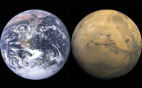
Figure 1a (left-hand side) ‘The Blue Marble’, taken by the crew of the Apollo 17 mission. Figure 1b (right-hand side) A composite image of Mars created using images taken by the Viking orbiters. The planets are not the same size in reality: the Earth is 12742 km diameter, whereas Mars is only 6779 km in diameter. Image credit for both: NASA
View description - Figure 1a (left-hand side) ‘The Blue Marble’, taken by the crew of the Apollo 17 ...
View description - Figure 1a (left-hand side) ‘The Blue Marble’, taken by the crew of the Apollo 17 ...

Water is also the majority component of all living organisms. The human body itself is approximately 60% water, present within blood, muscle, fat and bone. As a solvent, water can dissolve substances (such as salt and sugars) in order for them to be transported around both an organism’s body and within the natural environment. This important role means water is considered to be the principle requirement for life, not only on Earth, but also on other planetary bodies both within and outside our Solar System. For this reason, the discovery of water is the primary goal of many space missions.
Despite being 55 million kilometres from Earth, Mars (Figure 1b) can often be spotted with the naked eye in the night sky as a reddish-orange object (Figure 2). It has been observed throughout human history, with the earliest record dating back to ancient Egypt, and for this reason it has captured human imagination for millennia.

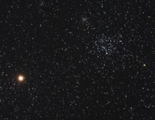
Figure 2 An orange-hued Mars in the western sky taken in April 2006. Image credit: Chris Schur
View description - Figure 2 An orange-hued Mars in the western sky taken in April 2006. Image credit: ...
View description - Figure 2 An orange-hued Mars in the western sky taken in April 2006. Image credit: ...

Activity 1: Mars in the night sky
10 minutes

If you want to find Mars in the night sky, an ideal viewing position would be a location away from artificial light sources and relatively flat. Remember that Mars’ location in the night sky is dependent on where you are on Earth, the time of year and the time of night. All planets are near the ecliptic, which is the imaginary line marking the Sun’s path across the sky, so keep an eye on where the Sun rises and sets and its path during the day and try to project this onto the night sky.
The Moon can also be used to help you. It never strays more than 5° to either side of the ecliptic during the course of each month. Remember that the ecliptic will change throughout the year and that the night sky looks different in the Northern and Southern hemispheres.
Planets usually look bigger than stars, and don’t appear to twinkle like stars might. Mars usually has a characteristic red-orange colour and can be found anywhere close to the ecliptic depending on the time of the year.
Astronomy catalogues are also available (for example NASA’s Night Sky Planner or In-The-Sky.org) to find out when and where Mars (or any other astronomical object) is visible.

As humanity pushes its boundaries to beyond our own planet, Mars has become a primary target for exploration. In this course, you will learn more about some of these exploration efforts, specifically those that have hunted for water on Mars. You will learn about how evidence for water in Mars’ past and present has been identified, and what this might mean for Mars’ history and the possibilities of finding life there.
After studying this course, you should be able to:
- understand the history of Mars and the role of its environment on the presence of water over time
- describe the methods used to find water on Mars, including the techniques employed by robotic and orbiting spacecraft
- evaluate the evidence for water on Mars
- describe the different settings in which water has been in Mars’ past and today
- understand the implications of finding water on the possibility of finding life.

1 Observing Mars from Earth
Mars appears like a star when observed with the naked eye, but it is impossible to discern any details. The first person to take a closer look at Mars with a telescope was Galileo Galilei, in 1609. As astronomers developed better telescopes, they were able to see distinct features on Mars and used these to calculate key information such as its rotation period and axial tilt. Table 1 shows some of the key data we now have about Mars, updated from the 1600s as technology and our understanding of the Solar System has improved.

Table 1 Comparison between Earth and Mars based on current data
 | Earth | Mars
Average distance from Sun (km) | 1.50 × 10⁸ | 2.27 × 10⁸
Orbital period (length of year, Earth days) | 365 | 687
Rotation period (length of day, hours:min) | 23:56 | 24:37
Axial tilt | 23.44° | 25.19°
Equatorial radius (km) | 6378 | 3397
Average surface temperature (°C) | 14 | −63
Atmospheric pressure* | 1013 mbar/1 atm | 7.5 mbar/0.006 atm
Atmospheric composition | carbon dioxide 0.04%  nitrogen 78%  argon 0.9%  oxygen 21% | carbon dioxide 95%  nitrogen 2.6%  argon 1.9%  oxygen 0.16%  carbon monoxide 0.06%
Satellites | The Moon | Phobos and Deimos
*The SI unit of pressure is actually the Pascal (Pa) and 1 atmosphere is 101 325 Pa.

On 13 August 1672, Dutch astronomer Christiaan Huygens observed a white spot at Mars’ south pole (Figure 3). This was the first sign that ice might be present on the planet, and was a finding corroborated by Giacomo Miraldi in the early 18th century. It is now known that there is also an ice cap at Mars’ north pole, and that the ice caps are made of a mixture of water ice and dry ice (frozen carbon dioxide). You will hear more about this later.

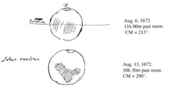
Figure 3 Christiaan Huygens’ sketch of Mars made 13 August 1672. He observed dark patches on the planet’s surface and a white patch at the south pole. The south pole on his sketch appears to be the north pole because the lenses in some telescopes produce images that are upside down.
View description - Figure 3 Christiaan Huygens’ sketch of Mars made 13 August 1672. He observed dark ...
View description - Figure 3 Christiaan Huygens’ sketch of Mars made 13 August 1672. He observed dark ...

Improvements in the size and quality of telescopes throughout the 19th century allowed more detailed studies of the red planet. Among the most famous, and significant in the search for water – and life – on Mars, is that of Giovanni Schiaparelli. His global map of the planet’s surface (Figure 4) displayed a number of straight lines, which he called ‘canali’ (Italian for channels).

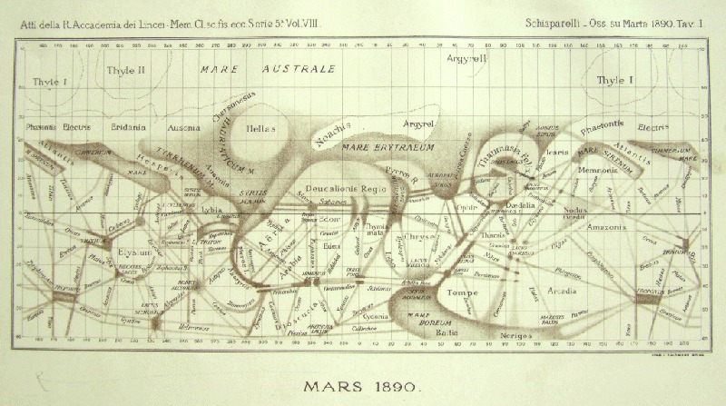
Figure 4 Global Mars map by Giovanni Schiaparelli in 1890 after a period of Mars observations starting in 1877. The most striking feature of the map are the straight lines, which Schiaparelli called ‘canali’ meaning channels but were mistranslated to canals implying their creation by a martian civilisation.
View description - Figure 4 Global Mars map by Giovanni Schiaparelli in 1890 after a period of Mars ...
View description - Figure 4 Global Mars map by Giovanni Schiaparelli in 1890 after a period of Mars ...

- Can you think of reasons why astronomers of Schiaparelli’s time thought they saw lines on Mars?
- The telescopes available in the 19th century were unable to distinguish small features on Mars and they therefore appeared to be thin lines. These were then interpreted as straight lines. Figure 5, taken with a telescope comparable to the one Schiaparelli used (although much more recently) gives you an idea what Mars may have looked like for observers during the late 19th century.

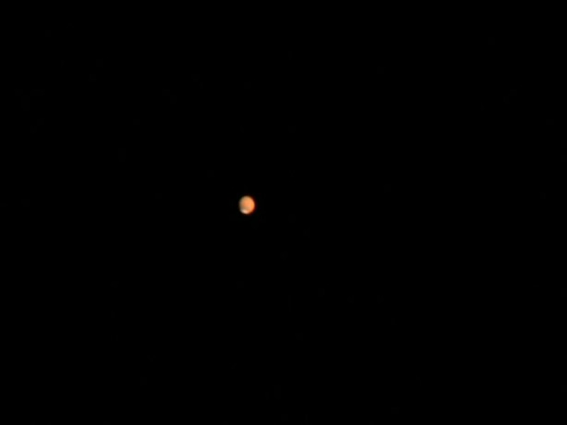
Figure 5 Mars, taken using a telescope comparable to that used by astronomers in the 1800s. Image credit: NASA/Ron Wayman
View description - Figure 5 Mars, taken using a telescope comparable to that used by astronomers in ...
View description - Figure 5 Mars, taken using a telescope comparable to that used by astronomers in ...

The word ‘canali’ used by Schiaparelli was mistakenly translated to ‘canals’, which implied the presence of significant amounts of water and a civilisation capable of shaping the planet. Naturally, excitement grew around the theory of a martian civilisation. American astronomer Percival Lowell was its most fervent advocate and believed that the canals were swaths of vegetation and that the intelligent beings inhabiting the planet would resort to irrigation to survive the otherwise harsh conditions on Mars. However, the ‘canali’ proved to be elusive to other skilled observers, who argued that the straight lines were an optical illusion. In the early 20th century, Eugène Antoniadi was able to show that the features on Mars were of irregular shapes rather than straight lines and that there were no canals, or civilisations. Despite this, the search for water has continued and the next section of this course will help you understand why it remains central to many missions to the red planet.

2 Why search for water?
As you have seen in Figure 1, two-thirds of the Earth’s surface is covered in water; however, it is not evenly distributed across the globe. For those living in humid climates (such as at The Open University’s campus in Milton Keynes, UK), water can be easily taken for granted until there is a spell of hot weather! When this happens, plants dry up and some may die, but others are remarkably resilient and will spring back to health as soon as rain arrives.
On Earth, there are also regions that are much drier than the UK. Look at photographs in Figure 6 and Figure 7. Both were taken in January and show differences in the availability of water depending on geography and climate.

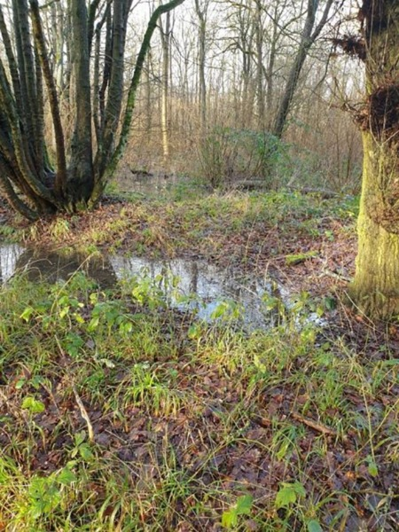
Figure 6 A photograph taken in a small wood near the OU campus in Milton Keynes, UK, after some rain. Image: Susanne Schwenzer.
View description - Figure 6 A photograph taken in a small wood near the OU campus in Milton Keynes, ...
View description - Figure 6 A photograph taken in a small wood near the OU campus in Milton Keynes, ...

Life is obvious in Figure 6, with green leaves and even a small insect causing the ripples on the puddle. Figure 7, a photograph taken at the same time of year as Figure 6 but in the Atacama desert, shows no obvious signs of life in this picture, but studies have shown that microbial life is possible even with the extreme lack of water here. Occasionally you can find a tiny burrow or footprints of animals that have adapted to the harsh conditions.

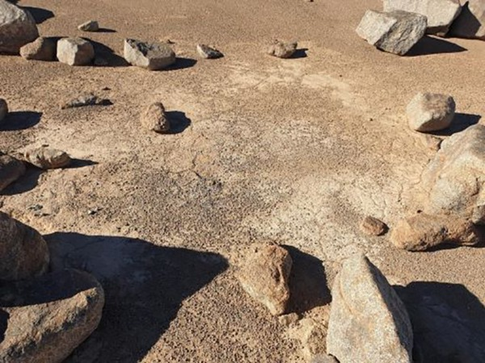
Figure 7 The Atacama desert. Image: Susanne Schwenzer.
View description - Figure 7 The Atacama desert. Image: Susanne Schwenzer.
View description - Figure 7 The Atacama desert. Image: Susanne Schwenzer.

What is clear, therefore, is that even where water is scarce, life can be found. For this reason, the search for life beyond Earth has been intimately linked with the search for water. Indeed, ‘follow the water’ has been NASA’s guiding motto for many years.
But if we’re looking for evidence of water on another planet, what might we be looking for?

- List as many places as you can think of where water can be found outdoors on Earth?
- Although most of the Earth’s water is in oceans, you might have also thought of rivers and lakes, puddles, rain, snow, ice, frost, fog, and steam.

- In your answer, you may have listed forms of water that are liquid, some that are solid, and others are gaseous. Can you organise your list into these three states of matter?
- Liquid: rivers and lakes, puddles, rain
Solid: ice, snow, frost
Gaseous: steam
Fog cannot easily be organised because it consists of tiny droplets of water or ice that float in the air. For this reason, it may be best described as a ‘suspension’.

There are many forms of water on Earth but, so far, you’ve only heard about ice on Mars. In the next section you will learn more about the properties of water and why it is specifically liquid water that is important for life.

2.1 Why is water so important?
To understand why water is important for life, we need to know about the structure and the chemistry of water.
The two hydrogen atoms are not exactly opposite each other, but are instead at an angle. Video 1 shows a three-dimensional representation of water molecules, with the atoms in a water molecule (two hydrogen atoms and one oxygen atom) represented by spheres. Watch this video now.

Video content is not available in this format.
Video 1 three-dimensional representation of water molecules.
View transcript - Video 1 three-dimensional representation of water molecules.

The bonds that join the oxygen and hydrogen atoms in a water molecule are made up of electrons shared between the atoms. However, the electrons are more strongly attracted to the oxygen atom than to the hydrogen atoms. This means that, near to the oxygen atom the molecule has a slight negative charge, but near the hydrogen atom the molecule has a slight positive charge. We call molecules with this feature polar and it is this polarity that makes water special. For example, it can form large networks of water molecules where the positive charge of a hydrogen atom attracts the negative charge of an oxygen atom - this forms a hydrogen bond between water molecules. This is shown on Figure 8, which is a different method of visually representing molecules – a ball and stick model – in which the atoms are shown as spheres and the bonds between them as sticks.

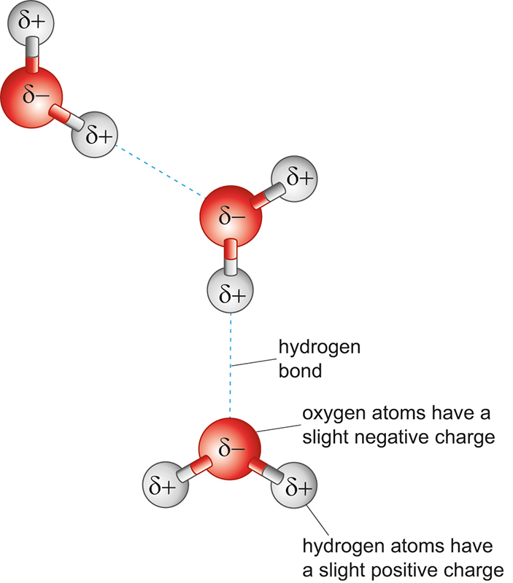
Figure 8 Hydrogen bonding between water molecules, shown by the dashed line.
View description - Figure 8 Hydrogen bonding between water molecules, shown by the dashed line.
View description - Figure 8 Hydrogen bonding between water molecules, shown by the dashed line.

The three-dimensional shape of hydrogen bonds, and the polarity of water molecules is the main reason for some of the unusual properties of liquid water, such as its high surface tension and the fact that ice floats on water. It is also why water is an extremely good solvent for solids, liquids and gases. These properties have critical roles to play in why water is a key target in the exploration of Mars.

Surface tension
Hydrogen bonds between molecules of water are quite strong so when water molecules come into contact with each other, they will be held together tightly. This tight packing creates a surface tension in the water that forces it to adopt the smallest shape possible. To understand this more, try this simple experiment.

Activity 2: Surface tension experiment
20 minutes

You will need:
- A clean (and detergent free) glass
- A sewing needle
- A fork
- Water
If you don’t have these items, you can still learn without carrying out the experiment.
Fill your glass with water. Notice the water surface appears ‘thicker’ against the glass. This is because it is slightly pulled upwards due to surface tension. Using the fork, gently place the sewing needle onto the water surface. Notice the ‘dents’ in the water around the needle. Again, this is because of the surface tension of the water; the strength of the hydrogen bonds is such that water can form a surface even against air. Surface tension against air is also the reason why raindrops are spherical.

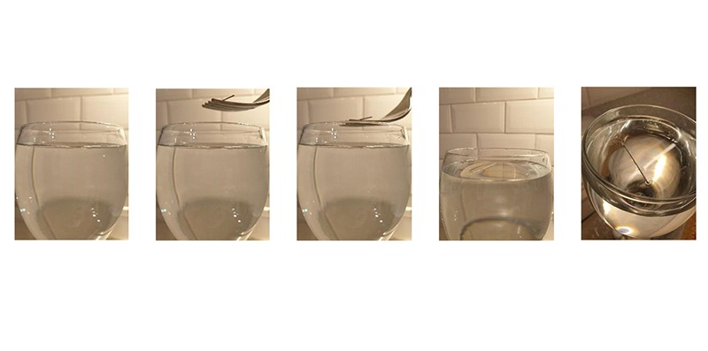
Figure 9 From left to right: A clean (and detergent free!) glass is filled with tap water. A fork is used to gently place a sewing needle onto the water surface creating ‘dents’ in the water adjacent to the needle. Image credit: Susanne Schwenzer.
View description - Figure 9 From left to right: A clean (and detergent free!) glass is filled with tap ...
View description - Figure 9 From left to right: A clean (and detergent free!) glass is filled with tap ...

Specific heat capacity
Another effect of hydrogen bonding between water molecules is that it takes a lot of energy (supplied as heat) to boil or evaporate water, i.e., to break the bonds between the water molecules. Water is therefore described as having a high specific heat capacity, where the specific heat capacity is a measure of how much energy it takes to raise the temperature of 1 kg of a particular substance by 1 °C. This makes water fairly stable over a wide temperature range and it helps to protect cells, which contain water, even if external temperatures are high.
Water’s specific heat capacity also allows large bodies of water, such as oceans, to absorb a lot of heat. Conversely, landmasses have low specific heat capacity and heat up more than oceans. Oceans can absorb the heat of nearby landmasses, moderating the temperature and - on a planetary scale - the climate. This allows ecosystems to thrive that would otherwise suffer from large temperature fluctuations. Although it takes longer for water to heat up than other substances, when water evaporates, the cooling effect is efficient. This is why forests are cooler in the summer (from the evaporation of water from the leaves) and why we sweat when our bodies need to cool down.
The transition of water between liquid, gas and solid (ice) is not only dependent on temperature, but also pressure – in particular the pressure of the atmosphere. Figure 10 shows which phase of water might exist at any given temperature and pressure.

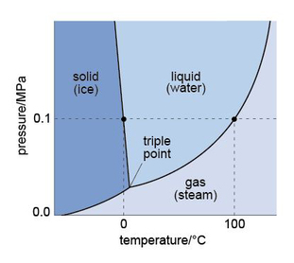
Figure 10 Diagram showing the temperatures and pressures at which different phases of water can exist.
View description - Figure 10 Diagram showing the temperatures and pressures at which different phases ...
View description - Figure 10 Diagram showing the temperatures and pressures at which different phases ...

- Look at Figure 10 and refer back to Table 1 in Section 1. Considering the average temperature and pressure on Mars, do you expect water to be solid, liquid or gas?
- The average temperature on Mars is -63 °C and the average pressure is 75 mbar. Reading from Figure 10, this would suggest that any water on Mars would be ice (a solid).

The likely presence of ice on Mars is still significant. When water freezes, its molecular structure becomes ‘frozen’ into a uniform, three-dimensional arrangement. Figure 11 shows that this structure has a repeating pattern, characterised by large hexagonal open channels. This structure means the molecules are more spread out than in liquid water, so ice is less dense than liquid water and can float. This is very important for life on Earth because it protects the water below the ice from cold air temperatures. Water under the ice stays liquid, providing life a more clement range of temperatures in which life can survive. As you will see later, ice on Mars may also protect bodies of liquid water that could be significant in the search for life.

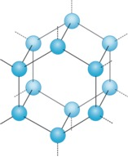
Figure 11 Schematic diagram showing the molecular structure of frozen water. When the water is frozen solid, the molecules fit together in a rigid structure.
View description - Figure 11 Schematic diagram showing the molecular structure of frozen water. When ...
View description - Figure 11 Schematic diagram showing the molecular structure of frozen water. When ...

The ‘openness’ of the ice structure also has another important function - it can allow other molecules, such as methane, to become trapped. On Earth such systems - called clathrates - have been found underneath ocean floors. Methane is a molecule that can be generated by life (and also by natural processes), so finding these on Mars has been a focus of some exploration missions looking for evidence that life was once present.

Water as a solvent
As mentioned earlier, water is a solvent. A solvent is a liquid that is able to dissolve substances, and water is often described as ‘the universal solvent’ because of its ability to dissolve so many substances - solids, liquids and gases.
When solids dissolve in water, they dissociate (separate) into their constituent elements or ions. Take sodium chloride (you will know this as table salt) as an example. With the molecular formula NaCl, it contains ions of sodium that have a positive charge (Na⁺) and chloride ions that have a negative charge (Cl⁻). Solid NaCl occurs as regularly shaped crystals, in which the sodium and chloride ions are held together by the electrical attraction between these positive and negative charges. With this in mind, watch Video 2 to see what happens when sodium chloride is dissolved in water.

Video content is not available in this format.
Video 2 when sodium chloride is dissolved in water.
View transcript - Video 2 when sodium chloride is dissolved in water.

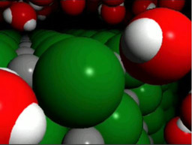

You have seen from Video 2 that the slightly positive part of the polar water molecule is attracted to the negative chloride ion, and the slightly negative end is attracted to the positive sodium ion. You will also remember that water molecules are attracted to one another by hydrogen bonds. Multiple hydrogen bonds together exert a considerable force that can exceed the strength of the bonds between sodium and chlorine in sodium chloride. This separates them, dissolving the crystal into the water.
This dissociation is also the reason why even tap water contains numerous dissolved ions, such as magnesium, potassium, sodium, calcium, chloride and fluoride. These ions come from either the natural environment, particularly from interactions (for example, chemical weathering) between water and the rocks over or through which it flows, or they have been added to the water to ensure it is safe to drink. This means that water can contain ions that can be transported and made available for life to utilise.
Importantly, this also means that water can carry dissolved substances around our bodies (and all living organisms). For instance, they can provide nourishment or remove unwanted waste, within and outside cells, performing essential functions to maintain life.
There are many reactions that involve water and its solvent properties – too numerous to mention. However, it is important to note that some may result in conditions that may not be hospitable to life. For example, when carbon dioxide (CO₂) dissolves in water, it forms carbonic acid (H₂CO₃). This carbonic acid dissociates to release one of its hydrogens (H⁺), which attaches itself to a water molecule to form a ‘hydronium ion’ (H₃O⁺).

- What property of a water molecule might attract a hydrogen ion (H⁺)?
- A water molecule is polar and has a slightly negative charge near its oxygen atom, which will attract the positive hydrogen ion.

The more hydronium ions present, the more acidic the water. This is measured using the pH scale. If the pH of a solution is less than 7, it is classed as acidic. If the pH is greater than 7, it is classed as alkaline. Pure water has a pH of 7 and is neutral. Biological processes tend to occur towards the middle range of the pH scale, although there are organisms that can survive extremes of acidity or alkalinity.

Water’s key properties
You have now learned about a number of properties of water that make it important, both for the environment and for life.
- A water molecule contains one oxygen and two hydrogen atoms.
- Water is a polar molecule.
- Water molecules are attracted to one another by hydrogen bonds.
- Water has a high specific heat capacity, so it can balance temperature differences.
- Water is an efficient coolant when evaporating.
- Water is the universal solvent for life.
- Water is a transport medium for ions, nutrients and waste.
- Water takes part in reactions, some of which can change the acidity of a solution.
As such an important molecule for life and the environment, finding water beyond Earth would have huge significance. In the next section you will learn how to find it.

3 How do we find water on Mars?
Now you know why water is so important for life and the natural environment, it should not surprise you to hear that the search for water has been central to many Mars exploration endeavours. We know that ‘follow the water’ is a motto that NASA adopted, particularly in relation to narrowing down the search for life on Mars. But how do we recognise the presence of water?

3.1 The shape of the martian surface
You learned in the introduction about the early efforts to map the surface of Mars and the tantalising suggestions of the presence of water based on the features seen on the planet’s surface. This approach, of studying the planet’s geomorphology (surface features), is still key to finding water on Mars. On Earth, rivers, lakes and ice carve out characteristic shapes in the landscape by erosion. These shapes can be used to identify where water might have once been.
Key indicators that water has been present include:
- vast river networks of deep valleys and channels
- large lake basins and channels caused by floods
- rounded pebbles found in dry riverbeds, indicating the flow of water was strong enough to tumble and round the pebbles over time.
Mars’ surface also shows evidence of circular features called craters, formed when an object from space has impacted on the martian surface, ejecting material. Although they don’t indicate the presence of water, they do help to determine the relative timing of events in Mars’ history. On Earth, some ancient craters show evidence that the energy generated on impact resulted in the heating of groundwater, generating hydrothermal systems that could have been habitable places where life may flourish.
These features can all be identified from images taken of the martian surface by orbiting spacecraft, which you will hear about shortly. However, what if those features are no longer visible on the surface because they occurred much further back in Mars’ history?
For this, it’s important to look in the martian geological record. Evidence for water in the past (on Earth or Mars) is recorded in rocks in several different ways.
Water can carry rocks of many different sizes and shapes, and then deposit these in beds, one on top of another. Sometimes these beds show a repeating pattern, suggesting seasonal fluctuations. Sometimes the beds are inclined against one another, known as cross bedding. Water can also erode existing beds so they might appear to be truncated – this break is known as a discontinuity. Rocks that show these features include some sandstones and mudstones, most of which form in flowing water or large bodies of water. However, water also evaporates, and when it does it can deposit minerals such as clay minerals or salts.
To find details such as these on the martian surface requires much higher resolution images than those available on orbiting spacecraft, which typically cannot resolve anything below 20 cm in size. For this, cameras on landers and rovers are important, for example the Mars Hand Lens Imager (MAHLI) on NASA’s Curiosity rover is able to resolve features less than a millimetre in size. However, identifying the presence of minerals requires more sophisticated techniques, as you will learn now.

3.2 A record in the rocks
When we want to look for minerals, cameras can be a great help but not necessarily just for taking photographs.
Consider that ‘sunlight’ is composed of light of different wavelengths; you may be familiar with how light is ‘split’ into a rainbow of colours by a prism or even a raindrop. However, sunlight also consists of infrared and ultraviolet light that you cannot see. The Sun and other objects also emit other types of electromagnetic radiation, shown in Figure 12. Although the human eye can only see visible light, scientific instruments can be built that extend our ability to ‘see’ the full range of the electromagnetic spectrum and these are used extensively in the exploration of our Solar System.

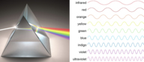
Figure 12 Visible light split into constituent wavelengths by a prism. Within this spectrum, red has the longest wavelength and violet the shortest.
View description - Figure 12 Visible light split into constituent wavelengths by a prism. Within this ...
View description - Figure 12 Visible light split into constituent wavelengths by a prism. Within this ...

Objects do not only emit radiation, they also absorb it and interact with it in different ways. For example, different wavelengths of light interact with the minerals within rocks in ways that are specific to those minerals. This is, in fact, why we see colours. It also means that minerals can be identified using the wavelengths of light that they emit after interacting with sunlight, using cameras on rovers and landers that are fitted with filters to enable them to ‘see’ these wavelengths.
Using light in this way is not new, however. In 1867, astronomers Pierre Janssen and Willian Huggins examined the atmosphere of Mars using a spectroscope, an instrument used to measure the properties of light emitted or absorbed by different materials. Their measurements, later corroborated by others, suggested water vapour was present in the martian atmosphere and so Mars could be water-rich, like Earth. Later astronomers, however, were able to measure how much water vapour was present and concluded that Mars was likely to be desert-like.
In 1947, Gerard Kuiper used infrared spectroscopy to detect twice as much carbon dioxide (CO₂) in the martian atmosphere as found on Earth. This atmospheric composition would be inhospitable to life as we know it from Earth.
Now you understand some of the main ways in which the search for martian water is conducted, it’s time to hear something about the search itself.

4 The search is on!
In the following section, you will learn more about how the spacecraft exploration of Mars has assisted in the search for water on Mars. Before you begin, you might like to take a look at the ’15 minutes on Mars’ interactive feature that has a timeline of spacecraft exploration of the red planet.

Activity 3: 15 minutes on Mars
15 minutes

Take a look at the 15 minutes on Mars Interactive feature.

As you move through the following sections, you might find it useful to make notes about what evidence has been found that suggests water exists on Mars today, or in Mars’ past. You will return to the evidence in Section 5.

4.1 How it all began: a tale of why resolution matters
In the 1960’s, the space race between the United States of America (USA) and the Soviet Union helped fuel Solar System exploration, including of Mars. In 1964, NASA’s Mariner 4 was the first spacecraft to perform a fly-by mission of Mars and its cameras took 21 images from a distance of over 9800 km above the planet. From this distance, the images (e.g., Figure 13) could only resolve kilometre-sized objects, which were mainly impact craters. Disappointingly, there were no features that might suggest water. However, when Mariner 9 became the first spacecraft to orbit Mars in 1971, the photos it took from about 1500 km above ground revealed something different: river channels (Figure 14).

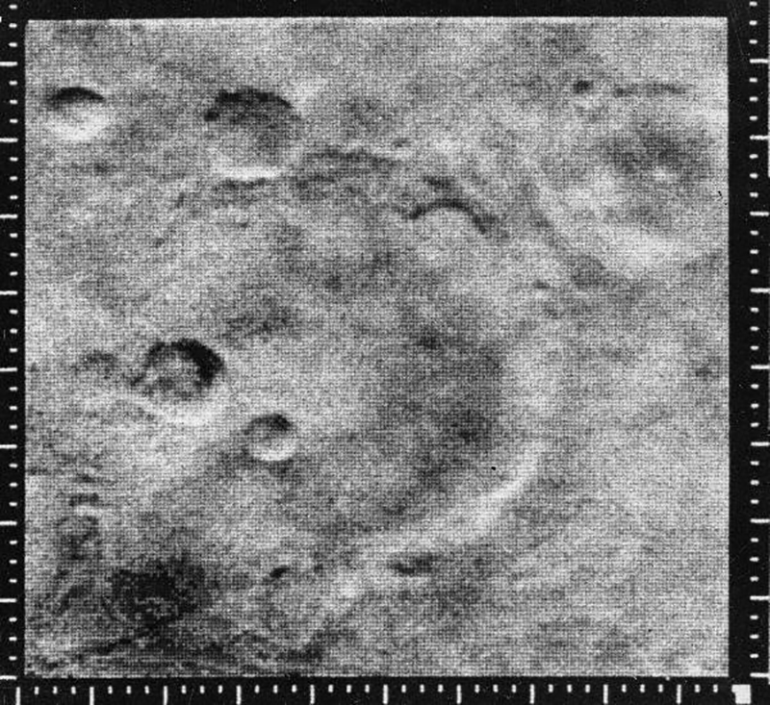
Figure 13 Mariner 4 image of the martian surface. The image is about 460 km wide, and shows some large impact craters (circular features), but no signs of any water-formed features. Image credit: NASA.
View description - Figure 13 Mariner 4 image of the martian surface. The image is about 460 km wide, ...
View description - Figure 13 Mariner 4 image of the martian surface. The image is about 460 km wide, ...

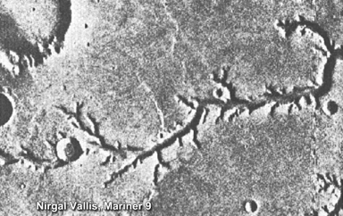
Figure 14 Nirgal Vallis as seen by Mariner 9. The image (94 km across) shows a valley network, interpreted to be river channels with tributaries. The circular features are impact craters. Image credit: NASA.
View description - Figure 14 Nirgal Vallis as seen by Mariner 9. The image (94 km across) shows a valley ...
View description - Figure 14 Nirgal Vallis as seen by Mariner 9. The image (94 km across) shows a valley ...

Five years later, in 1976, two Viking orbiters took images with unprecedented resolution. They mapped the entire surface of Mars at a resolution of 200 m per pixel, with some at 8 metres per pixel, and, for the first time, Mars was imaged in colour. These improvements allowed for much more detailed interpretation of images, confirming the presence of features formed by water on Mars.

Activity 4: How old is the surface of Mars?

Take a look again at Figure 14. If you look at the mid-sized crater towards the left of the image, about a third of the image up from the ‘l’ in Nirgal, you will notice that this crater appears to overlap and truncate the river channel. This means the impact must have happened after the channel was formed, and the impact is therefore younger than the channel.
Using this same principle, look at Figure 15.

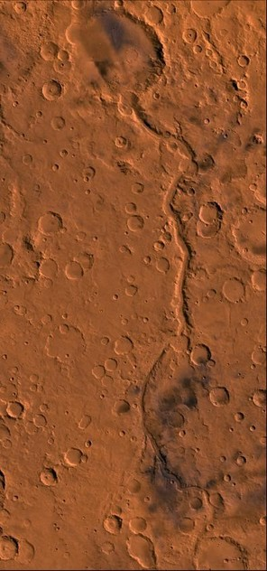
Figure 15 Ma’adim Vallis region. Note the channel, which is breached by some impact craters, and itself breaches a very large impact crater. The largest crater visible at the top of the image is Gusev Crater, a 166 km diameter crater which was the landing site of the Mars Exploration Rover, Spirit. Image credit: NASA.
View description - Figure 15 Ma’adim Vallis region. Note the channel, which is breached by some impact ...
View description - Figure 15 Ma’adim Vallis region. Note the channel, which is breached by some impact ...

Can you find:
- A crater that is younger than the stream?
- Pairs of craters where one is younger than the other?
- A crater that is younger than Gusev Crater?

View answer - Activity 4: How old is the surface of Mars?

The two Viking orbiters also delivered two landers to the surface of Mars: Viking 1 and Viking 2. Although they were not designed to search for water, the data they returned is key to our story, as you will learn next.

4.2 Viking 1 and 2: looking for life but finding water!
The two Viking landers carried numerous instruments with which to measure pressure, temperature and wind on the martian surface. However, they also carried three biology experiments, designed to look for signs of life, and an instrument – a gas chromatography-mass spectrometer (GC-MS) - that could measure the composition and abundance of organic compounds in the martian soil. Although the biology experiments did not provide evidence of the presence of living organisms, the GC-MS revealed that the soil contained up to 0.8% water!
Using other instruments on board the landers, the minerals in the soil were revealed to be iron-rich clay and water-bearing iron oxides. This was the first proof, measured directly on the surface of Mars, of minerals that can only form when liquid water is present. Once, in Mars’ history, there had been liquid water present.
The Viking 2 lander also observed a thin layer of frost on the martian surface that could only form if water vapour was present in the atmosphere (Figure 17). On measuring the atmosphere, 0.03 % water vapour was indeed identified. You will learn more about these measurements of the atmosphere in the next section.
Alas, despite these results, there was a decline in scientific interest in the planet with no missions for nearly two decades. During that time, attention turned to samples of the martian surface available here on Earth – martian meteorites.

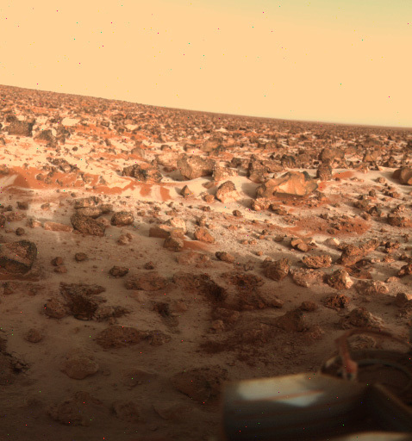
Figure 17 Viking 2 image showing a thin layer of water ice frost on the martian surface at Utopia Planitia. Image credit: NASA.
View description - Figure 17 Viking 2 image showing a thin layer of water ice frost on the martian surface ...
View description - Figure 17 Viking 2 image showing a thin layer of water ice frost on the martian surface ...

4.3 Meteorites – rock samples from Mars!
In 1983, data from the Viking missions was compared with that obtained from the analysis of a group of meteorites (known as SNCs - shergottites, nakhlites, and chassignites named after Shergotty, Nakhla, and Chassigny). These meteorites (such as Figure 18) differed from most other meteorite types known, and their minerals, and chemical composition, suggested they formed from the crystallisation of molten rock, i.e., they are igneous rocks. Therefore, it was assumed they must have originated from a planetary body in the Solar System that was similar to Earth and large enough for volcanic activity to occur.
Gases were found to be trapped within glass produced when the meteorites were ejected from Mars. When this gas was compared with the modern martian atmosphere, as measured by the Viking landers, there was a match – the SNC meteorites were from Mars. To date, martian meteorites remain the only samples of Mars available for study on Earth, until planned sample return missions are launched.

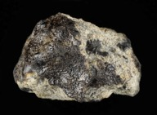
Figure 18 The Nakhla martian meteorite (on loan to The Open University from the Natural History Museum). Sample is approximately 2.5 cm long. Image credit: Andy Tindle ‬‬
View description - Figure 18 The Nakhla martian meteorite (on loan to The Open University from the ...‬
View description - Figure 18 The Nakhla martian meteorite (on loan to The Open University from the ...‬

Water in meteorites
When the mineralogy and chemical composition of martian meteorites were analysed, there was evidence of traces of water. To understand the importance of this, we need to consider how these rocks formed.
Firstly, when these rocks crystallised from molten rock, they may have trapped water within their crystal structure. Since this was in very low amounts, they probably formed in water-poor conditions. Secondly, these rocks and their constituent minerals might have been exposed to liquid water (or gases) that may have weathered, or altered, them into new minerals. When certain minerals in martian meteorites were studied closely, some were found to be hydrous, i.e., they contained water or hydroxyl ions (OH⁻) in their molecular structure.
Examples of hydrated minerals include: the iron hydroxide goethite; evaporite minerals (precipitated when water evaporates) such as gypsum; opaline silica, and phyllosilicates (which are also known as clay minerals, such as those found by the Viking landers). Collectively these are known as alteration (or secondary) minerals. In martian meteorites, most of these alteration minerals are so small that they can only be seen using high magnification microscopes, such as a scanning electron microscope (SEM). An example of a high resolution image of a martian meteorite, taken using an SEM, is shown in Figure 19.

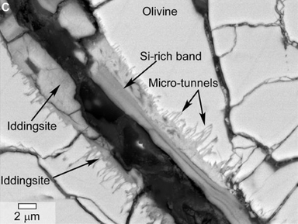
Figure 19 Scanning electron microscope image of a polished thin section of martian meteorite Y000593 (a nakhlite) showing iddingsite, a mineral formed by the alteration by water of olivine. Image credit: NASA/JPL
View description - Figure 19 Scanning electron microscope image of a polished thin section of martian ...
View description - Figure 19 Scanning electron microscope image of a polished thin section of martian ...

Not all minerals incorporate water in their structure, but some of them require water to be formed. You will be familiar with rust that appears on metal surfaces when they are exposed to water. Rust is iron oxide (haematite) or iron hydroxide (goethite), and both are found in martian meteorites, often associated with other hydrous minerals.
You may also be familiar with limescale, which is the deposit left behind when water dries up in bathtubs and sinks. This is made predominantly of calcium carbonate (CaCO₃), and carbonates have also been found in martian meteorites (Figure 20). Indeed, the carbonates present in one particular martian meteorite – ALH 84001 – became the focus of huge scientific attention when it was argued that they contained organic, fossilised remnants of ancient martian bacteria.

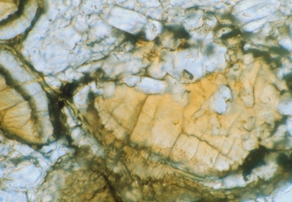
Figure 20 Carbonate mineral globules with orange-brown cores and colorless rims in microscope view (~0.2 mm across) in martian meteorite ALH 84001. Image credit: Allan Trieman, LPI
View description - Figure 20 Carbonate mineral globules with orange-brown cores and colorless rims in ...
View description - Figure 20 Carbonate mineral globules with orange-brown cores and colorless rims in ...

To date, numerous studies have shown that the organic material was likely to be contamination from Earth and that the carbonates can be formed by processes that do not require life to be present. Despite this, the controversy around ALH 84001 came at a time when interest in Mars was experiencing a renaissance, with the 1990s seeing the launch of several missions to the red planet. The search for water on the planet was back on!

4.4 The 1990s revival
1997 was a big year for Mars exploration. NASA’s orbiter, Mars Global Surveyor, reached the planet and the Pathfinder lander, with its shoebox-sized Sojourner rover, arrived on the martian surface.
Mars Global Surveyor was equipped with instruments including a high-resolution camera (that captured images of what appeared to be gullies formed by flowing water) and a laser altimeter (to measure the shape and elevation of the surface in detail) (Figure 21). This topographical information has revolutionised our understanding of Mars’ geomorphology, and provided essential information for engineers designing spacecraft for missions to Mars.

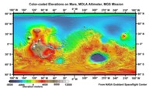
Figure 21 Colourised Mars Orbiter Laser Altimeter (MOLA) topographic map of Mars.
View description - Figure 21 Colourised Mars Orbiter Laser Altimeter (MOLA) topographic map of Mars ...
View description - Figure 21 Colourised Mars Orbiter Laser Altimeter (MOLA) topographic map of Mars ...

Despite the successes of Mars Global Surveyor, in the search for water at that time, the Pathfinder mission took centre stage. This was mainly because it carried the first martian rover – the Sojourner rover (Figure 22). Sojourner did not directly contribute to the investigation of water on Mars but was an important demonstrator of instruments that would be used on Mars in the future. The Pathfinder lander, however, made a number of important discoveries.

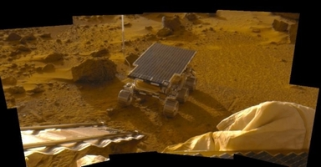
Figure 22 Mosaic image of the Sojourner rover after leaving the landing platform. The ramp is visible on the bottom left of the image, a part of the deflated airbag on the bottom right. Image credit: NASA.
View description - Figure 22 Mosaic image of the Sojourner rover after leaving the landing platform. ...
View description - Figure 22 Mosaic image of the Sojourner rover after leaving the landing platform. ...

Pathfinder was fitted with an instrument with which to measure temperature variations at its landing site, Ares Vallis. Although it observed early morning water ice clouds in the lower atmosphere, even the warmest temperature it recorded was −8 °C, seemingly too cold for pure liquid water to exist on the surface. Two other clues, however, suggested this had not always been the case. Firstly, it detected that airborne dust was magnetic. This was speculated as being because it contained the mineral maghemite, a magnetic iron oxide. Importantly, maghemite forms from the weathering of iron in rocks.
Secondly, you will see when looking at Figure 23, taken at the landing site that Pathfinder also found evidence of flowing water in Mars’ past. This evidence included rounded rocks (labelled with red arrows) that were likely to have been shaped by the forces of water, possibly during a flood. The pale areas on Figure 23, indicated by the white arrows, are also believed to be deposits left behind by evaporating water, or aggregates of material fused together by the action of water. In contrast, the blue arrows indicate rocks with sharp edges that were probably ejected by nearby impact craters and/or ancient volcanoes.

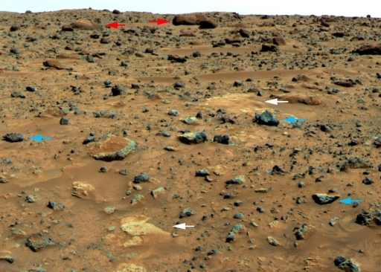
Figure 23 View to the northeast of the Pathfinder lander showing a variety of rocks recording past geological processes on Mars including water activity. Image credit: NASA.
View description - Figure 23 View to the northeast of the Pathfinder lander showing a variety of rocks ...
View description - Figure 23 View to the northeast of the Pathfinder lander showing a variety of rocks ...

Although the presence of rounded pebbles (which you can see more closely in Figure 24) is good evidence that there was once water, the pebbles were found buried in loose sand, making it hard to clearly discern their relationships to each other. It was therefore not possible to absolutely confirm a watery origin and the search for compelling evidence of liquid water continued!

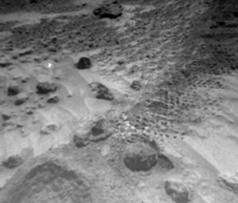
Figure 24 The area called ‘Cabbage Patch’ by the Pathfinder mission science team, which shows rounded pebbles that could be formed by the action of flowing water. Image credit: NASA.
View description - Figure 24 The area called ‘Cabbage Patch’ by the Pathfinder mission science team, ...
View description - Figure 24 The area called ‘Cabbage Patch’ by the Pathfinder mission science team, ...

4.5 Next generation – detecting water from space
The next generation of spacecraft sent to Mars were NASA’s Mars Odyssey and ESA’s (European Space Agency) Mars Express. They arrived at Mars in 2001 and 2003, respectively, and are still both operational to date (2021). In the search for water, these spacecraft were key.

Mars Odyssey
Mars Odyssey’s Thermal Emission Imaging System (THEMIS) mapped the distribution of minerals on Mars at a resolution of 100 m per pixel. This included clay minerals, which you will recall can only form if water is present. You can see a map of clay mineral distribution in Figure 25. This map is very exciting, because it can be combined with topographic maps showing stream beds and other landforms (Figure 26), to understand the types of environments in which the minerals might have formed.

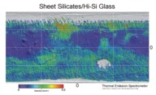
Figure 25 This map, based on data of the Thermal Emission Spectrometer aboard of the Odyssey orbiter, shows the location of sheet silicates - a synonym for clay minerals and silica rich glasses. Both types of minerals can only form in the presence of water. Image credit: NASA/ASU
View description - Figure 25 This map, based on data of the Thermal Emission Spectrometer aboard of ...
View description - Figure 25 This map, based on data of the Thermal Emission Spectrometer aboard of ...

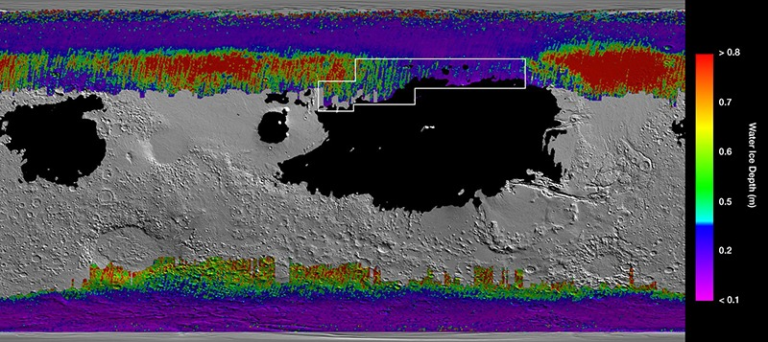
Figure 26 The map from Figure 25 is combined with data from the Mars Reconnaissance and Mars Global Surveyor orbiters. This shows the location of water ice beneath the surface of Mars. Image credit: NASA/JPL-Caltech/ASU.
View description - Figure 26 The map from Figure 25 is combined with data from the Mars Reconnaissance ...
View description - Figure 26 The map from Figure 25 is combined with data from the Mars Reconnaissance ...

In addition to THEMIS, Mars Odyssey also carries a Gamma Ray Spectroscope (GRS). This can detect gamma radiation produced when cosmic rays from space interact with elements in the rocks and soils on Mars. In particular, it can detect hydrogen, which in significant quantities could indicate the presence of water ice. Figure 27 shows that the GRS found high amounts of hydrogen at polar latitudes (dark blues and purples), but lower amounts distributed across the planet.

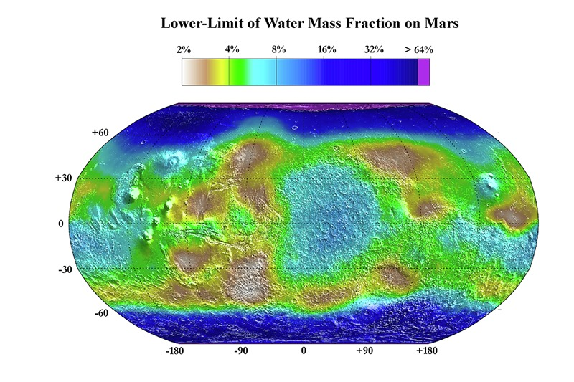
Figure 27 This map is the result of the GRS investigations of the martian surface and is based on the observation of hydrogen in the upper metre of the surface. Image credit: NASA/JPL/Los Alamos National Laboratory.
View description - Figure 27 This map is the result of the GRS investigations of the martian surface ...
View description - Figure 27 This map is the result of the GRS investigations of the martian surface ...

Mars Express
The Mars Express orbiter carries the High Resolution Stereo Camera (HRSC) that can take full colour images of the planet’s surface at a resolution of 2 m per pixel, or at 10 m per pixel in 3D. Remember Nirgal Vallis from the Mariner images? Figure 28 shows a HRSC image of that region in much higher resolution, and Figure 29 shows what can be achieved when images are combined with a digital elevation map. You can see in stunning detail the channels and perhaps even beds that may have been formed in the presence of water.

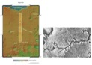
Figure 28 On the left-hand side, a context map for the HRSC observation of the stream bed at Nirgal Vallis. The boxes indicate the HRSC observations made in November 2018. Image Credit: ESA. On the right-hand side, a repeat of Figure 14, the greyscale image of Nirgir Vallis taken by Mariner 9. Image credit: NASA.
View description - Figure 28 On the left-hand side, a context map for the HRSC observation of the stream ...
View description - Figure 28 On the left-hand side, a context map for the HRSC observation of the stream ...

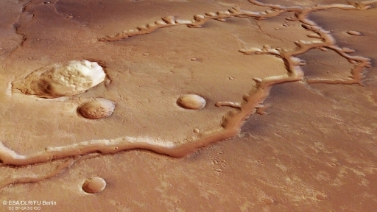
Figure 29 A composite of a digital elevation map and Mars Express images. Image credit: ESA.
View description - Figure 29 A composite of a digital elevation map and Mars Express images. Image credit: ...
View description - Figure 29 A composite of a digital elevation map and Mars Express images. Image credit: ...

Mars Express also carries the OMEGA (Observatoire pour la Minéralogie, l’Eau, les Glaces et l’Activité) instrument, which can detect minerals on the martian surface. Clay minerals and hydrated sulfates, which can only form in the presence of water, were found at Terra Meridiani, Mawrth Vallis, Nili Fossae, Aram Chaos, and Valles Marineris - as well as in isolated locations in the martian Highlands.
Combining relative age information obtained from craters with the locations of these minerals showed that most of the clay minerals are found on the oldest, Noachian, areas, the sulfates on Hesperian areas and the iron oxides on Amazonian surfaces. (You met these martian geological periods in Activity 4).
This observation tells an important story: Mars’ climate changed from a wet, and likely warm, planet in the Noachian, to dryer and colder period in the early Hesperian. Then the cold and dry conditions that prevail today emerged in the Amazonian. The transition from warm and wet to cold and dry is now believed to have occurred around 4.2 billion years ago and is a critical part of the story of water on the red planet, and its possibility of ever having hosted life.
But Mars Express has given us one other, crucial, piece of information. Using its radar system (MARSIS - Mars Advanced Radar for Subsurface and Ionospheric Sounding), it may have detected a 20 km diameter subglacial lake, approximately 1.5 km beneath the martian south pole. We will return to this later.

Mars Express and Beagle 2
The Mars Express orbiter was also significant because it delivered the Beagle 2 lander to the martian surface. Beagle 2 was the first UK-led mission to the red planet and was led by, and built at, The Open University campus in Milton Keynes, UK, with the University of Leicester and EADS Astrium UK (now Airbus Defence and Space) as key partners. Although its objective was not to search for water, the primary aim was to find evidence of life itself – particularly the gases, such as methane, that life might generate.

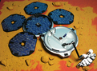
Figure 30 The Beagle 2 lander. Credit: Beagle 2/ESA
View description - Figure 30 The Beagle 2 lander. Credit: Beagle 2/ESA
View description - Figure 30 The Beagle 2 lander. Credit: Beagle 2/ESA

Beagle 2 was due to land on the martian surface on 25 December 2003, but no signal was detected from Earth and it was considered lost. However, in 2015 it was observed in images taken by NASA’s Mars Reconnaissance Orbiter. It had landed as planned, but not all of its solar panels, which should have provided power for its instruments, had successfully opened. This meant that the radio antenna to be used for communications with Earth was uncovered and could not transmit or receive data.

4.6 Landing robotic geologists on Mars
In 2003, two robotic geologists were launched towards Mars. Their names: Spirit and Opportunity. The Spirit rover landed on 4 January 2004 in Gusev crater, a site chosen because it may have been a drainage basin or ‘catchment area’. The Opportunity rover landed two weeks later in Meridiani Planum, a large area where clay minerals had been detected from orbit. Carrying the same instruments, the two rovers were tasked with finding out if Mars had ever been habitable, i.e., hunting for evidence of water within the rocks.

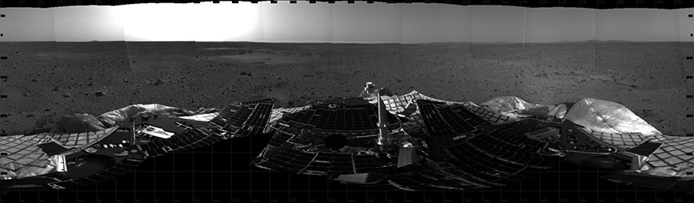
Figure 31 This was the first 360° panorama from the Spirit landing site in Gusev crater, with the rover still on the landing platform. Note how flat and featureless the landscape appears. Image credit: NASA/JPL.
View description - Figure 31 This was the first 360° panorama from the Spirit landing site in Gusev ...
View description - Figure 31 This was the first 360° panorama from the Spirit landing site in Gusev ...

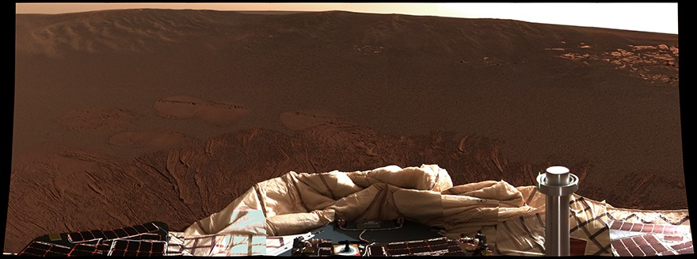
Figure 32 Opportunity at its landing site in a small, ~20 m diameter crater in Meridiani Planum. While it was not planned for Opportunity to land in a crater, the walls around it were the first rocks that the mission encountered. Image credit: NASA/JPL.
View description - Figure 32 Opportunity at its landing site in a small, ~20 m diameter crater in Meridiani ...
View description - Figure 32 Opportunity at its landing site in a small, ~20 m diameter crater in Meridiani ...

The evidence of water that the rovers returned was plentiful but it is impossible to cover everything here. Instead, we can look at the important highlights, starting with…blueberries!
Features called ‘blueberries’ were found by the Opportunity rover. Figure 33 shows that these are not fruit but are, in fact, small, cm-sized, almost perfectly spherical features made mostly of the iron oxide mineral haematite. As you learned earlier, iron oxides are an excellent indicator that water has once been present.

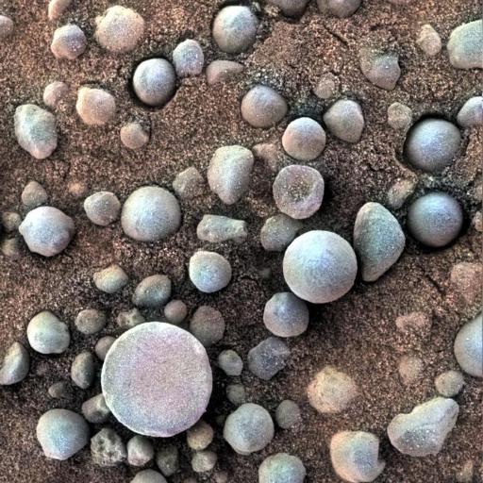
Figure 33 Haematite rich concretions named ‘blueberries’ because of their almost perfectly spherical shapes. Image credit: NASA/JPL.
View description - Figure 33 Haematite rich concretions named ‘blueberries’ because of their almost ...
View description - Figure 33 Haematite rich concretions named ‘blueberries’ because of their almost ...

A second highlight came from the discovery of bright white material (Figure 34) at a site named ‘Gertrude Weise’. This material was only uncovered because Spirit’s wheel malfunctioned and the rover dragged it along, creating a trench in the soil. This gave an opportunity for the rover’s instruments to analyse this uncovered material, and it was identified as almost pure silica (SiO₂), another product of the interaction of water with rocks.

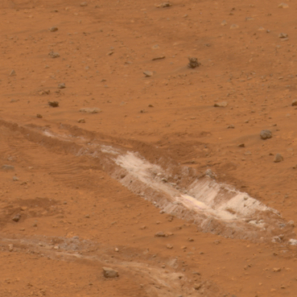
Figure 34 ‘Gertrude Weise’ is a trench made by the malfunctioning wheel on Spirit. It is almost pure SiO₂, a mineral phase likely formed by water. Image credit: NASA/JPL.
View description - Figure 34 ‘Gertrude Weise’ is a trench made by the malfunctioning wheel on Spirit. ...
View description - Figure 34 ‘Gertrude Weise’ is a trench made by the malfunctioning wheel on Spirit. ...

A third highlight was the discovery of calcium sulfate dispersed in the soils and in thin veins in rocks (Figure 35). Calcium sulfate can form three different minerals: anhydrite, bassanite and gypsum. These differ from one another depending on the amount of water they contain: anhydrite has no water (as represented by its formula CaSO₄), bassanite (CaSO₄.0.5H₂O), and gypsum (CaSO₄.2H₂O) have some water, in differing proportions.

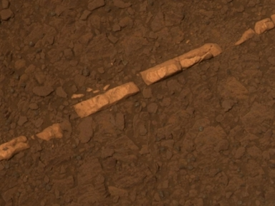
Figure 35 Vein, called ‘Homestake’, filled with gypsum, which was investigated by Opportunity. Image credit: NASA/JPL.
View description - Figure 35 Vein, called ‘Homestake’, filled with gypsum, which was investigated by ...
View description - Figure 35 Vein, called ‘Homestake’, filled with gypsum, which was investigated by ...

The Opportunity rover still holds the record for the longest distance travelled on Mars, taking over 11 years to reach Endeavour crater (Figure 35) where clay minerals had been found by orbiting spacecraft. Its reward for driving over 45 km (more than marathon distance) was more exciting findings.
It found clay minerals in a small incision (called ‘Marathon Valley’) in the crater rim, the chemistry of which suggested they had to have formed in the presence of hot water. As mentioned earlier, impact events might heat groundwater, producing hydrothermal systems. The hot water would alter the minerals to secondary minerals, which are then detected by spacecraft. The chemistry of the clay minerals detected (specifically the presence of nickel) suggested that the temperatures had once been very hot, probably several hundred degrees Celsius.

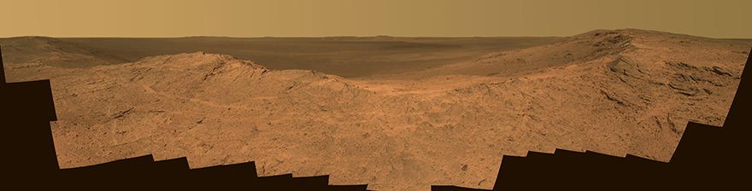
Figure 36 ‘Pillinger Point’, named in honour of the Open University’s late Professor Colin Pillinger who led the Beagle 2 mission, is at the rim of Endeavour crater allowing a beautiful view over the crater.
View description - Figure 36 ‘Pillinger Point’, named in honour of the Open University’s late Professor ...
View description - Figure 36 ‘Pillinger Point’, named in honour of the Open University’s late Professor ...

It is important to remember that, although the evidence from Spirit and Opportunity, coupled with the evidence from earlier missions, was categorical about water once being present. However, in the time these spacecraft were operating at Mars, others were being launched with the same broad goals: to find evidence of water. And so the story continues…

4.7 Mars Reconnaissance Orbiter
In 2005, NASA sent its most powerful orbiter (even to date, 2021) to Mars. The Mars Reconnaissance Orbiter (MRO) is equipped with a number of instruments with which to image the surface, determine its mineralogy and even investigate the subsurface.
Figure 37 shows a stunning example of an image taken by MRO’s High Resolution Imaging Science Experiment (HiRISE), capable of imaging the surface of Mars at 30 cm per pixel. It shows horizontal layers or beds that are probably sedimentary rocks deposited in a standing body of water. These beds also appear to be disrupted, possibly by episodic flooding. Sedimentary beds can also be seen on Figure 38, which shows the floor of the Ebersawalde impact crater, further evidence of significant bodies of liquid water in Mars’ past.

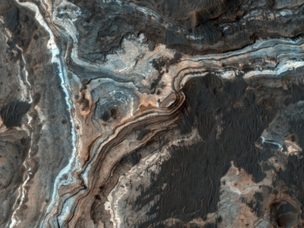
Figure 37 HiRISE image taken of Ladon Vallis, a 600 km-long outflow channel extending from a basin in the south to the north of Mars. The light-toned layers contrast with the darker-toned deposit on the floor of the channel, with dark toned dunes partly filling fractures and impact craters. Credit: NASA/JPL-Caltech/University of Arizona.
View description - Figure 37 HiRISE image taken of Ladon Vallis, a 600 km-long outflow channel extending ...
View description - Figure 37 HiRISE image taken of Ladon Vallis, a 600 km-long outflow channel extending ...

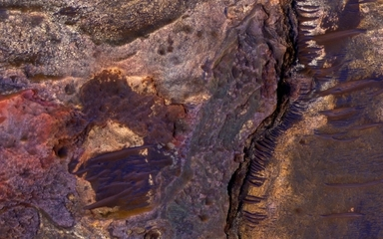
Figure 38 HiRISE image of the floor of an impact crater north of Ebersawalde crater. Credit: NASA/JPL-Caltech/University of Arizona.
View description - Figure 38 HiRISE image of the floor of an impact crater north of Ebersawalde crater. ...
View description - Figure 38 HiRISE image of the floor of an impact crater north of Ebersawalde crater. ...

HiRISE has also identified processes that are happening now on Mars. Figure 39 shows two images taken three years apart. Comparing these, you can see a new channel (labelled with an arrow) on the more recent, right-hand image that is absent in the older image. This means a process is operating now on the martian surface that can produce features such as this. Although at first this was thought to be a process involving water, it is now believed to be formed by the sublimation of carbon dioxide frost over the martian winter. Similar processes are thought to be responsible for other surface features (e.g., Figure 40), but this shows that geomorphology is not always a reliable tool with which to look for water.

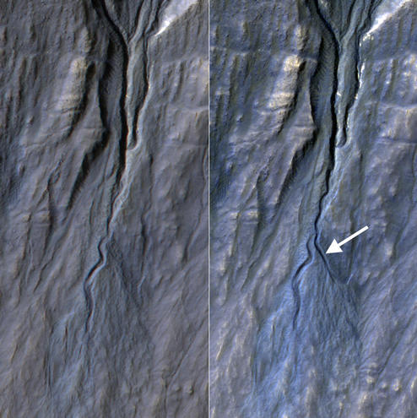
Figure 39 Pair of HiRISE images taken in 2010 (left) and 2013 (right), showing a new channel, as indicated by the white arrow, formed by seasonal variation in carbon dioxide frost. Other HiRISE observations have indicated that these processes typically occur gradually in winter. Credit: NASA/JPL-Caltech/Univ. of Arizona.
View description - Figure 39 Pair of HiRISE images taken in 2010 (left) and 2013 (right), showing a ...
View description - Figure 39 Pair of HiRISE images taken in 2010 (left) and 2013 (right), showing a ...

Video content is not available in this format.
Figure 40 Animation of a series of images acquired by HiRISE between 2007 and 2013. The animation shows the transition of carbon dioxide from ice to gas (sublimation) at the south pole of Mars. As the ice sublimates from the walls of the pit it reforms on nearby flat surfaces. Credit: NASA/JPL-Caltech/University of Arizona.

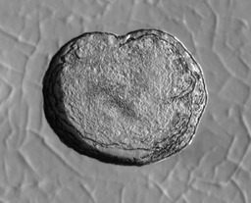
View description - Uncaptioned Figure
View description - Uncaptioned Figure

MRO has two other instruments important to the search for water. The CRISM (Compact Reconnaissance Imaging Spectrometer for Mars) instrument can detect minerals on the martian surface at a resolution of 18 m per pixel. Consistent with previous spacecraft, it has found widespread clay minerals, but has also identified sulfates and carbonates. These were previously unseen by lower resolution orbiting instruments but had been identified by spacecraft on the martian surface. Figure 41 shows a false-colour image created using CRISM data to highlight the distribution of certain minerals in Jezero crater. These data were key in selecting this crater as the landing site for the NASA Perseverance rover, which you will hear more about later.

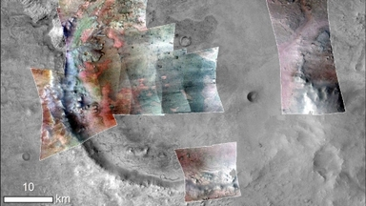
Figure 41 Topographic image with CRISM false-colour imagery overlain. Green suggests carbonate minerals (formed by water) and red indicates olivine sand. Credit: NASA/JPL-Caltech/MSSS/JHU-APl/Purdue/USGS.
View description - Figure 41 Topographic image with CRISM false-colour imagery overlain. Green suggests ...
View description - Figure 41 Topographic image with CRISM false-colour imagery overlain. Green suggests ...

MRO also carries SHARAD (SHAllow RADar sounder), a radar instrument, like MARSIS on Mars Express. This has found that the ice at the north pole is around 2 km thick and has internal layers (Figure 42), but it has also found ice at other areas of Mars, located approximately 90 m below the surface (Figure 43).

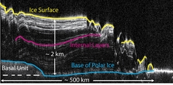
Figure 42 SHARAD radar cross section of the north polar cap of Mars You can see an internal ice structure with the white lines representing radar reflections due to layers/boundaries. Credit: NASA/JPL-Caltech/ASI/UT.
View description - Figure 42 SHARAD radar cross section of the north polar cap of Mars You can see an ...
View description - Figure 42 SHARAD radar cross section of the north polar cap of Mars You can see an ...

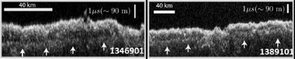
Figure 43 SHARAD radargram showing subsurface water ice in Utopia Planitia region of Mars. The white arrows indicate subsurface reflections caused by the subsurface water ice. Credit: NASA/JPL-Caltech/Univ. of Rome/ASI/PSI.
View description - Figure 43 SHARAD radargram showing subsurface water ice in Utopia Planitia region ...
View description - Figure 43 SHARAD radargram showing subsurface water ice in Utopia Planitia region ...

4.8 Phoenix Lander – a better look at the polar region
You will recall that the poles were one of the first places suggested to have evidence of water, and several orbiter missions have confirmed this. Yet, until the Phoenix mission landed in the martian north polar region in 2008, these areas had not been investigated by ground-based spacecraft.
Phoenix was specifically designed to look for water and determine whether habitable areas might exist. When its robotic arm dug a trench into the soil, it found dice-sized clumps of bright material that vaporised over four days (Figure 44). Using its on-board instruments, this was confirmed as being water ice. Phoenix also observed water frost early on a morning, which disappeared as the Sun rose.
Phoenix also made two particularly important discoveries. Firstly, it confirmed the presence of perchlorate (ClO₄₋), which can act as an antifreeze (i.e., it can lower the freezing point of water), potentially allowing liquid water to exist. Secondly, it observed snow falling – the first time this was seen on Mars.

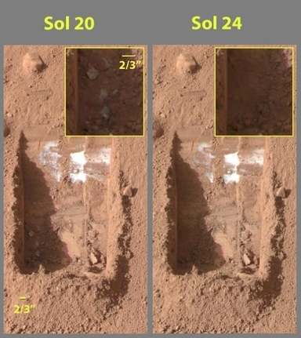
Figure 44 Colour images taken by the Phoenix lander on the 21st and 25th days of the mission. A group of dice-sized pieces is visible in the lower left corner of the trench (left image), which disappeared after 4 days (right image). Image credit: NASA/JPL
View description - Figure 44 Colour images taken by the Phoenix lander on the 21st and 25th days of ...
View description - Figure 44 Colour images taken by the Phoenix lander on the 21st and 25th days of ...

4.9 Rolling on the ground again: MSL
On 6 August 2012, NASA’s Mars Science Laboratory (MSL) rover Curiosity landed in Gale crater at a location called ‘Bradbury Landing’. Gale crater was chosen as Curiosity’s landing site because orbital data, e.g., from the CRISM instrument, had suggested water might once have been present there. Curiosity was fitted with an array of instruments with which to investigate the martian surface and atmosphere, and these have made a number of discoveries relating to water on Mars.
Firstly, Curiosity confirmed the presence of water frost also seen by Viking and Phoenix, and clouds observed by Pathfinder (Figure 45).

Video content is not available in this format.
Figure 45 Clouds moving across the horizon just at sunset in Gale crater observed by Curiosity. Those are either made of carbon dioxide or water, depending on the height they occur. The clouds in this GIF are about 19 km above the surface and likely to be water clouds. Image credit: NASA/JPL.

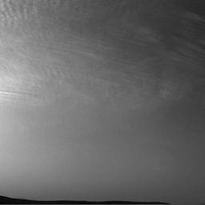
View description - Uncaptioned Figure
View description - Uncaptioned Figure

Secondly, Curiosity found evidence that water had once existed in Gale crater itself. Very early in its mission, it found conglomerates – rocks made up of rounded pebbles that were transported by water (Figure 46). Careful investigation of the size, rounding and distribution of the pebbles led the mission team to conclude that they were deposited by a stream that was knee to hip deep and probably flowed at an average velocity of 0.20 to 0.75 m s⁻¹. In addition to these conglomerates, sandstones and mudstones were found. The fine-grained nature of the mudstones showed that they settled out from a body of water after coarser grained material had settled out (Figure 47).

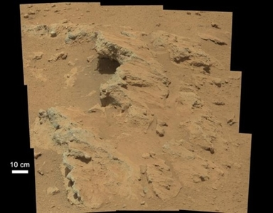
Figure 46 Conglomerate at the site called ‘Hottah’ encountered on sol 39 (a sol is a martian day, 24 hours 39 minutes) of the Curiosity mission at Gale crater, Mars. This and two similar sites allowed calculation of the water depth and flow-speed of the stream that transported those 2-40 mm sized pebbles to this site. Image credit: NASA/JPL.
View description - Figure 46 Conglomerate at the site called ‘Hottah’ encountered on sol 39 (a sol is ...
View description - Figure 46 Conglomerate at the site called ‘Hottah’ encountered on sol 39 (a sol is ...

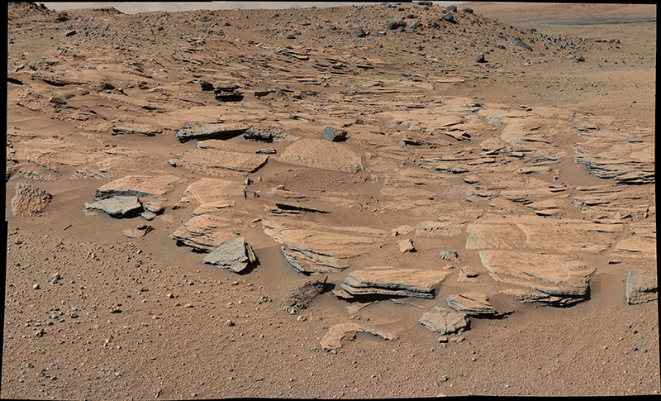
Figure 47 Sandstones at the location ‘The Kimberly’ at Gale crater, Mars. Those sandstones occur together with conglomerates in the sequence of deposits in the crater. The third water-laid type of rock are mudstones. The black, triangular rock in the middle of the image is about 80 cm wide. Image credit: NASA/JPL.
View description - Figure 47 Sandstones at the location ‘The Kimberly’ at Gale crater, Mars. Those sandstones ...
View description - Figure 47 Sandstones at the location ‘The Kimberly’ at Gale crater, Mars. Those sandstones ...

Take a look at Figure 48. This shows the minerals found within rocks at Gale crater expressed as pie charts, where the larger the wedge of the pie, the more of that mineral present. The first two pies (lower left of the image, labelled JK and CB) and the last three (upper right of the image, labelled MB, QL and SB) are mudstones.

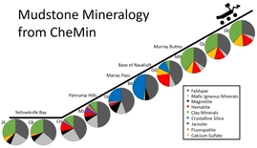
Figure 48 Mineralogical composition of rocks at Gale crater, Mars drilled between 2012 and 2016. Image credit: NASA/JPL.
View description - Figure 48 Mineralogical composition of rocks at Gale crater, Mars drilled between ...
View description - Figure 48 Mineralogical composition of rocks at Gale crater, Mars drilled between ...

- Excluding mafic minerals and feldspar, which are common minerals, what is the most common type of mineral shown on the mudstone pie charts?
- In almost all of the mudstone pie charts, clay minerals (green wedge) are the most dominant type of mineral. Haematite (red wedge) is also prominent in some of the charts, as is calcium sulfate (yellow wedge).

- From what you have learned so far, what has led to the presence of clay minerals, haematite and sulfates?
- Clay minerals, haematite and sulfates form in the presence of water by the alteration of existing minerals. Therefore, these suggest there has been water in the Gale crater area.

You will recall that the Spirit rover observed sulfates that were finely dispersed in soils and present as veins within rocks. Curiosity also found these forms of sulfate (e.g., Figure 49), but also observed rocks that contained sulfate as cement holding the grains together. In addition, the ChemCam instrument also found trace elements such as boron and chlorine in some of the sulfate veins, giving further information about the chemistry of the water that formed them (Figure 50).

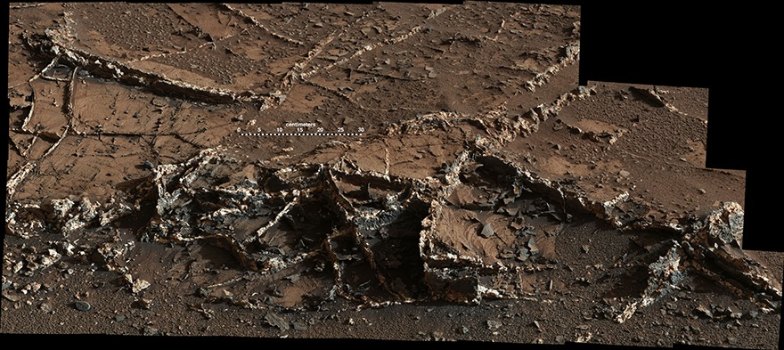
Figure 49 Calcium sulfate veins (white) at a location called ‘Garden City’. Note the scale bar in the centre of the image. Image credit: NASA/JPL.
View description - Figure 49 Calcium sulfate veins (white) at a location called ‘Garden City’. Note ...
View description - Figure 49 Calcium sulfate veins (white) at a location called ‘Garden City’. Note ...

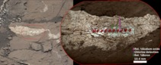
Figure 50 Sodium, chlorine and boron analysis as seen by ChemCam. There are ten investigation points in this image, and for each of them the bar height indicates the amount of the three elements found. Image credit: NASA/JPL-Caltech/MSSS/LANL/CNES/IRAP/LPGNantes/CNRS/IAS.
View description - Figure 50 Sodium, chlorine and boron analysis as seen by ChemCam. There are ten investigation ...
View description - Figure 50 Sodium, chlorine and boron analysis as seen by ChemCam. There are ten investigation ...

The results obtained by Curiosity have allowed the science team to reconstruct some of the history of Gale crater. It is probable that the crater was once filled by a lake for an extended period of time. Fresh water flowed into the lake, occasionally from fast flowing streams, which deposited the conglomerates and sandstones. Mudstones were deposited in quieter periods. The lake level fluctuated, and in places there is evidence (e.g., desiccation or mud cracks) that it dried out (Figure 51). This reconstruction allows scientists to understand the changes in climate that might have taken place in Mars’ history and has enabled them to create an animation (Video 3) of the transition between the warmer and wetter Mars evidenced at Gale crater, to the cold and dry Mars that we observe today.

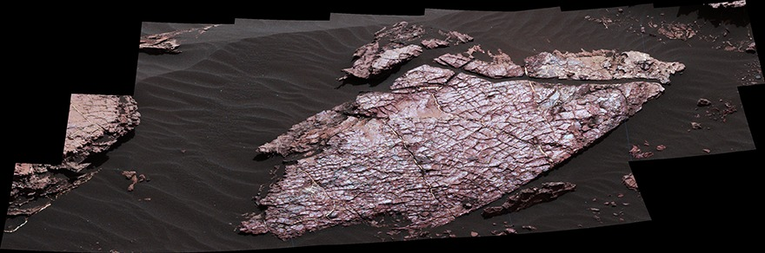
Figure 51 Possible mud (dessiccation) cracks at a location ‘Old Soaker’ at Gale crater. Mud cracks form when fine grained mud is repeatedly dried out and becomes wet again. This is evidence for fluctuating levels of the lake. Image credit: NASA/JPL.
View description - Figure 51 Possible mud (dessiccation) cracks at a location ‘Old Soaker’ at Gale crater. ...
View description - Figure 51 Possible mud (dessiccation) cracks at a location ‘Old Soaker’ at Gale crater. ...

Video content is not available in this format.
Video 3 Animation of the drying out lake at Gale crater, Mars. Image credit: ASU Knowledge Enterprise Development (KED), Michael Northrop. (Please note, this video has no sound.)

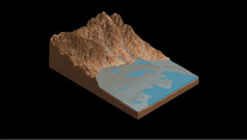

Activity 5: Curiosity on Mars
10 minutes

To date, the Curiosity rover mission has exceeded 3000 sols on Mars, and collected a cornucopia of evidence for past and present water at Gale crater.
Since landing at Bradbury Landing in Gale crater, it has travelled over 20 km across the crater floor, passing by several landmark features such as the Bagnold Dunes and Vera Rubin Ridge. If you would like to find out more about the rover’s traverse and track its current location, you can access this via NASA’s interactive map (Figure 52).

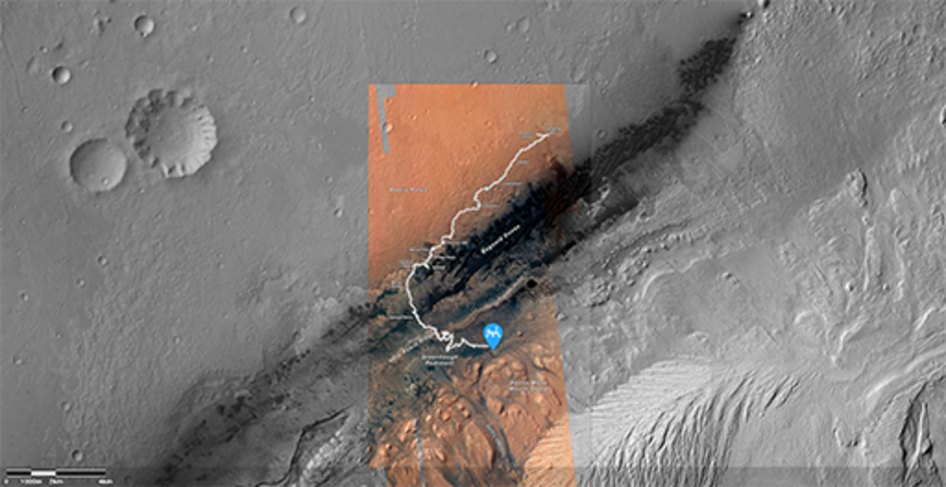
Figure 52 Screenshot of NASA’s rover location tool
View description - Figure 52 Screenshot of NASA’s rover location tool
View description - Figure 52 Screenshot of NASA’s rover location tool

New rovers arrive!
The tantalising glimpse into Mars’ watery past that has been provided by Curiosity is just the start of what researchers hope will be a fuller reconstruction of the history of water on Mars. While Curiosity continues to traverse the martian surface, new rover missions to Mars are already underway.
NASA’s Perseverance rover landed in Jezero crater February 2021. This landing site was selected by the mission team because HiRISE images indicated it may once have had a deltaic environment (Figure 53). The rover carries an array of instruments that can investigate the chemistry and mineralogy of the martian surface to construct the geological history of Jezero crater.

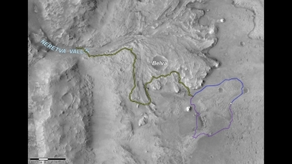
Figure 53 HiRISE image of Jezero crater, which was used to select this site as the Perseverance landing site. Two possible routes (purple and green lines) that the Perseverance rover might travel are shown. Image credit: NASA/JPL-Caltech/University of Arizona.
View description - Figure 53 HiRISE image of Jezero crater, which was used to select this site as the ...
View description - Figure 53 HiRISE image of Jezero crater, which was used to select this site as the ...

Perseverance also carries an instrument, called MOXIE, that can produce oxygen from the carbon dioxide of the martian atmosphere. This will test the technologies needed to create life support system and generate rocket fuel, in preparation for sending astronauts to Mars.
Importantly for our story of water on Mars, Perseverance will fill several tubes with rock samples as it traverses the Jezero crater area, and deposit these so that a future sample fetch rover will collect them and bring them back to Earth. The samples it collects will be carefully chosen to represent those that are most likely to have harboured life, if it ever had been there.

- Based on what you have learned so far, what types of rock samples do you think Perseverance might select for future sample return?
- Perseverance is likely to select rocks that had been in contact with water, including rocks that contain clay minerals and/or sulfates. It may target sedimentary rocks that have been deposited in water-rich environments.

The samples, once returned to Earth, will be analysed using more sophisticated instrumentation than can be sent to Mars and provide us with an unprecedented level of detail about the martian surface, the presence of water and the possibility of life.
A second rover landed on Mars in 2021: the Chinese National Space Administration’s Zhurong rover. China’s first mission to the red planet was delivered by their Tianewen-1 orbiter, and is intending to study the martian topography, subsurface and atmosphere, and look for signs of life and possible resources for future human missions.

4.10 Observations from space continue
While Curiosity began exploring the martian surface, the ExoMars 2016 orbiter was launched. This is the first mission in the joint ESA-Roscosmos ExoMars programme, with an objective to determine whether life ever existed on Mars. It carries the Trace Gas Orbiter (TGO), which is a suite of instruments designed to detect gases that may indicate the presence of life or geological processes operating on Mars.
One of those instruments, NOMAD (Nadir and Occultation for MArs Discovery) can map the distribution of gases in the martian atmosphere. It has observed seasonal variations in the transport of water vapour high into the martian atmosphere and confirmed that water can escape to space. This finding is important for understanding where and how Mars might have lost its water in the past and how this might have affected the habitability of the planet.

Activity 6: Lost water
5 minutes

Watch the following video that explains how ExoMars is investigating how water might have been lost from Mars’ surface.

Video content is not available in this format.
Video 4 Tracking the history of water on Mars.
View transcript - Video 4 Tracking the history of water on Mars.

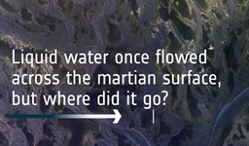

The TGO has also detected hydrogen chloride (HCl) in the atmosphere that probably resulted from the interaction between dust from the surface and water vapour in the atmosphere. This might be a mechanism for producing the perchlorates detected by the Phoenix mission.
The next mission in the ExoMars programme will carry the Rosalind Franklin rover that will land in a region called Oxia Planum. Oxia Planum was chosen – once again – for the signs of water that shaped the features in the landscape, and for the clay minerals found by orbital investigations. The Rosalind Franklin rover will carry a drill that can reach 2 metres below the subsurface. It will take samples, hopefully containing organic matter, that have been shielded from the harsh environment of space radiation. It will also carry a radar instrument to investigate the subsurface, to identify where water may be present – possibly as ice – but not detectable above ground.

What’s in a name?
You may be wondering where the ExoMars rover got its name. Rosalind Franklin was a British chemist and pioneer of a technique known as X-ray diffraction, which can be used to understand the internal structure of crystals. She began using this to understand the structure of coal but then applied this to understand the structure of DNA. Indeed, she was the first person to photograph DNA, determine its dimensions and unravel it’s double helix structure.
Since the rover’s main objective is to look for signs of life, it is named in honour of the scientist who first determined life’s fundamental building blocks.

Figure 54 Chemist Rosalind Franklin
View description - Figure 54 Chemist Rosalind Franklin
View description - Figure 54 Chemist Rosalind Franklin

You can read more about Rosalind Franklin here.

ESA is not the only space agency embarking on their own Mars exploration programme. The United Emirates’s launched their first Mars orbiter - the Hope probe, which entered Mars orbit in 2021. This will investigate the martian atmosphere from a different orbit to the existing orbiters, to assess weather and climate systems and understand the evolution of the martian atmosphere.

5 Pulling the evidence together
We now know that there are no civilisations on Mars. But we have found evidence for past water. Throughout this course, you have learned about the many different lines of evidence that have been identified to show that Mars was once present on the martian surface in significant quantities: rivers, lake beds, and maybe even an ocean may have been present 4 billion years ago.

- What evidence can you list that indicates that water was once present in Mars’ ancient past?
- The evidence for a wet ancient Mars is extensive and has come from orbital and rover/lander investigations and the study of martian meteorites. Some things you might have noted are:
  - Geomorphological evidence – gullies, river channels, streams
  - Geological evidence – sedimentary rocks such as conglomerates and mudstones, ‘blueberries’, cross bedding, horizontal bedding,
  - Mineralogical evidence – clay minerals, sulfates, carbonates, iron oxides, silica
There has also been direct measurement of water in martian meteorites.

On the basis of this evidence, researchers have been able to recreate the watery environments of some parts of Mars, and their relevance to the potential for life to have once existed.
Mars today, though, is dry and hostile, with a very, very thin atmosphere and ExoMars has shown us that water vapour can be lost to space. However, some water does still exist on the planet.

- List the evidence to support the suggestion that water is present today on Mars.
- Again, evidence has come from orbit and from rovers/landers on the surface. You might have listed:
  - The detection of water in the soil
  - Water frost seen on the martian surface
  - Water-ice clouds
  - Water vapour detected in the atmosphere
  - Hydrogen (indicating water) and water itself detected at the poles and across the planet’s surface.
  - A subglacial lake in the South Polar Region
  - Subsurface ice

Future missions may be able to utilise this water – for life support, fuels or other purposes – to enable humans to walk on the planet’s surface. But it’s imperative that those environments are understood first, to prevent any unintended harm from coming to life that may inhabit those places.

Conclusion
Now that you have completed the course, you should be able to:
- understand the history of Mars and the role of its environment on the presence of water over time
- describe the methods used to find water on Mars, including the techniques employed by robotic and orbiting spacecraft
- evaluate the evidence for water on Mars
- describe the different settings in which water has been in Mars’ past and today
- understand the implications of finding water on the possibility of finding life.
There is much more to learn about Mars and its potential for life, and the story of the search for water is only one part of that. If you’d like to learn more, you could take a look at the following resources:
- Astrobiology hub on OpenLearn
- The Mars collection on OpenLearn
- The latest from NASA’s Perserverance rover
- ESA’s ExoMars programme updates
- Results from UAE’s Hope probe

Glossary
Amazonian
A geological period in Mars’ history, from 2.9 billion years to the present day.
Axial tilt
The angle between a planet’s rotational axis and its orbital plane (north pole).
Clathrates
A chemical substance into which molecules of a different substance can become trapped. They usually have a cage or lattice structure.
Cross bedding
Layering seen in beds of sedimentary rocks that are at an angle to the horizontal. They can represent ripples or dunes.
Crystallisation
The ordering of atoms or molecules into a defined crystal structure. In geology, represent the formation of crystals on cooling from an igneous melt.
Deltaic
An area with a delta, usually at the mouth of a river.
Dessication
The process of drying, i.e., the loss of water from a substance.
Discontinuity
In geology, a disruption to sedimentary beds caused by a change in physical or chemical conditions.
Dissociate
Dissociation is the process in which molecules of a substance separate or split, usually when a solvent.
Ecliptic
The plane of the Earth's orbit about the Sun. Also the path of the Sun in the sky (on the celestial sphere) during the course of a year.
Electromagnetic radiation
Energy in the form of waves that have both electrical and magnetic properties.
Erosion
The process by which soil and rock particles are broken down and moved elsewhere by wind, water or ice.
Gas chromatography-mass spectrometer
A scientific instrument that can separate and identify molecules within a substance.
Geological record
Rock strata laid down over geological time.
Geomorphology
The study of the physical features on a planet’s surface and their relation to its geological history.
Hesperian
A geological period in Mars’ history spanning from 3.7 to 2.9 billion years ago.
Hydrogen bond
A weak bond between two molecules that results from the attraction of a hydrogen within a module to an atom in a neighbouring molecule because of their electron charge.
Hydrothermal
The presence and action of hot water. Could refer to hot water systems on Earth or Mars.
Igneous
Rocks formed by the cooling and crystallisation of molten magma or lava.
Ions
Positive or negative forms of atoms in which electrons have been gained or lost from the atomic structure.
Laser altimeter
An instrument on board an orbiting spacecraft that is used to investigate the topography of a planet’s surface, using laser pulses.
Meteorites
Rocks ejected from a Solar System object (e.g. Mars or asteroids) because of an impact event, that are delivered to the Earth’s surface.
Noachian
A geological period in Mars’ history spanning from 4.1 to 3.7 billion years ago.
Organic compounds
Molecules composed predominantly of carbon and hydrogen.
Pixel
A small dot or square that makes up an image. The more pixels there are, the better the resolution of the image.
Polar
A term applied to molecules where there is a charge difference between its constituent atoms.
Polarity
The relative degree to which molecules are polar.
Rotation period
The time it takes for a planet or other object to take a single revolution around its axis of rotation. For Earth, this is 23.93 hours.
Scanning electron microscope
A powerful microscope that uses electrons to image objects at high resolution. Can also be used to determine chemical composition of objects.
Sedimentary
Rocks formed by the transport and deposition of sediments produced by erosion and weathering of pre-existing rocks, or the precipitation and accumulation of substances from solution.
Sol
A sol is a martian day, 24 hours 39 minutes in length.
Solvent
A liquid that is able to dissolve substances.
Spectroscope
An instrument for measuring the spectrum of electromagnetic radiation.
Sublimation
The phase change of a substance directly from solid to gas, for example from water ice to water vapour.
Suspension
A fluid mixture containing fine solid particles.
Wavelength
The distance between one part of a wave profile and the next identical part of a wave profile.
Weathered
To have been subjected to weathering, the process of breaking down rocks through the action of rainwater, extremes of temperature, and biological activity. It does not involve the removal of rock material.

References
Adams, W. S. and Dunham, T. Jr. (1934) ‘The B band of oxygen in the spectrum of Mars’, Astrophysical Journal, 79, pp. 308–316.
Adams, W. S. and St. John, C. E. (1926) ‘An attempt to detect water-vapor and oxygen line in the spectrum of Mars with the registering microphotometer’, Astrophysical Journal, 63, pp. 133–137.
Agee, C. B., Wilson, N. V., McCubbin, F. M., Ziegler, K. et al. (2013) ‘Unique Meteorite from Early Amazonian Mars: Water-Rich Basaltic Breccia Northwest Africa 7034’, Science, 339, pp. 780–785.
Biemann, K. et al. (1977) ‘The search for organic substances and inorganic volatile compounds in the surface of Mars’, Journal of Geophysical Research, 82, pp. 4641–4658.
Bogard D. D. and Johnson P. (1983) ‘Martian gases in an Antarctic meteorite?’, Science, 221(4611), pp. 651–654.
Filiberto, J. and Treiman, A. H. (2009) ‘Martian magmas contained abundant chlorine, but little water’, Geology, 37, pp. 1087–1090.
Malin, M. C. and Edgett, K. S. (2000) ‘Sedimentary Rocks of Early Mars’, Science, 290(5498), pp. 1927–1937. doi:10.1126/science.290.5498.1927
Menzel, D. H., Coblentz, W. W. and Lampland, C. O. (1926) ‘Planetary temperatures derived from water-cell transmissions’, Astrophysical Journal, 63, pp. 177–187.
Schiaparelli, G. (n.d.) Collection of Giovanni Schiaparelli’s documents (in Italian). Available at: http://www.brera.inaf.it/MARTE/marte.html (Accessed: 17 August 2021).
Smith, P. H. et al. (1997) ‘Results from the Mars Pathfinder Camera’, Science, 278(5344), pp. 1758–1765.
Soffen, G. A. (1977) ‘The Viking project’, Journal of Geophysical Research, 82(28), pp. 3959–3970.
Orosei, R., Lauro, S. E., Pettinelli, E. A., Cicchetti, A., Coradini, M., Cosciotti, B., Di Paolo, F., Flamini, E., Mattei, E., Pajola, M., Soldovieri, F., Cartacci, M., Cassenti, F., Frigeri, A., Giuppi, S., Martufi, R., Masdea, A., Mitri, G., Nenna, C., Noschese, R., Restano, M. and Seu, R. (2018) ‘Radar evidence of subglacial liquid water on Mars’, Science, 361(6401), pp. 490–493. doi: 10.1126/science.aar7268
Owen, T. et al. (1977) ‘The Composition of the Atmosphere at the Surface of Mars’, Journal of Geophysical Research, 82(28), pp. 4635–4639.
Petit, E. and Nicholson, S. B. (1924) ‘Radiation measures on the planet Mars’, Publications of the Astronomical Society of the Pacific 36, pp. 269–272.

Acknowledgements
This free course was written by members of AstrobiologyOU (Vic Pearson, Julia Semprich, Susanne Schwenzer and Stuart Turner) in collaboration with the OpenLearn team (Sofia Maruzza and Sudesh Loi). With thanks to Claire Batty for critical reading.
Except for third party materials and otherwise stated (see terms and conditions), this content is made available under a Creative Commons Attribution-NonCommercial-ShareAlike 4.0 Licence.
The material acknowledged below is Proprietary and used under licence (not subject to Creative Commons Licence). Grateful acknowledgement is made to the following sources for permission to reproduce material in this free course:

Figures
Course image: ©ESA/DLR/FU Berlin https://creativecommons.org/licenses/by-sa/3.0/igo/
Figure 1a: NASA https://www.nasa.gov/content/blue-marble-image-of-the-earth-from-apollo-17
Figure 1b: Viking Project, USGS, NASA https://apod.nasa.gov/apod/ap140511.html
Figure 2: Chris Schur https://apod.nasa.gov/apod/ap060419.html
Figure 3: © European Space Agency Provided by the NASA Astrophysics Data SystemDollfus, Audouin http://articles.adsabs.harvard.edu//full/2004ESASP1278..115D/0000124.000.html
Figure 4: NASA publication http://www.brera.inaf.it/MARTE/opposizione7/opposizione7_big5.html
Figure 5: Ron Wayman of Tampa https://www.nasa.gov/vision/universe/watchtheskies/18jun_approachingmars.html
Figures 6, 7 and 9: courtesy © Susanne Schwenzer
Figure 13: NASA/JPL https://photojournal.jpl.nasa.gov/catalog/PIA02979
Figure 14: NASA https://photojournal.jpl.nasa.gov/jpeg/PIA15090.jpg
Figure 15/16: NASA https://commons.wikimedia.org/wiki/File:Gusev_-_Ma%27adim_Vallis.jpg
Figure 17: NASA https://nssdc.gsfc.nasa.gov/imgcat/hires/vl2_p21873.jpg
Figure 18: image courtesy: Andy Tindle
Figure 19: NASA/JPL PIA17953.jpg (607×456) (nasa.gov)
Figure 20: Photo © Allan Treiman, Lunar and Planetary Institute https://www.lpi.usra.edu/lpi/meteorites/ahtts36.html
Figure 21: NASA Goddard Spaceflight Center https://www.lpi.usra.edu/science/treiman/greatdesert/workshop/marsmaps1/marsmaps1_imgs/mola_color_2.jpg
Figure 22 NASA https://www.nasa.gov/image-feature/nasas-first-rover-on-the-red-planet
Figure 23: NASA https://mars.nasa.gov/MPF/ops/NEcolor_annot.jpg
Figure 24: NASA https://photojournal.jpl.nasa.gov/catalog/PIA01133
Figure 25: from: Mars Global Data Sets: TES Silicates and high-Silicon Glass (asu.edu) TES Silicate/High-Silicon Glass Abundance Bandfield, J. L., Global mineral distributions on Mars, J. Geophys Res., 107, 2002. Image: NASA/ASU
Figure 26: NASA/JPL-Caltech/ASU https://www.jpl.nasa.gov/images/a-water-ice-map-for-mars
Figure 27: NASA/JPL/Los Alamos National Laboratory https://mars.nasa.gov/odyssey/gallery/science/PIA04907.html
Figure 28: NASA MGS MOLA Science Team http://www.esa.int/ESA_Multimedia/Images/2019/10/Nirgal_Vallis_in_context
Figure 29: ESA/DLR/FU Berlin https://www.esa.int/ESA_Multimedia/Images/2019/10/Perspective_view_of_Nirgal_Vallis#.YFsc2RT-yzM.link
Figure 30: ESA ESA - Beagle 2 lander
Figure 31: NASA/JPL https://photojournal.jpl.nasa.gov/catalog/PIA04980NASA/JPL/Cornell
Figure 32: NASA/JPL/Cornell Catalog Page for PIA05152 (nasa.gov)
Figure 33: NASA/JPL-Caltech/Cornell/USGS https://mars.nasa.gov/resources/6944/martian-blueberries/
Figure 34: NASA/JPL https://www.nasa.gov/images/content/176933main_pia09403.jpg
Figure 35: NASA/JPL https://www.nasa.gov/mission_pages/mer/multimedia/pia15033.html
Figure 36: NASA https://mars.nasa.gov/resources/6355/pillinger-point-overlooking-endeavour-crater-on-mars/
Figure 37: NASA/JPL-Caltech/University of Arizona https://mars.nasa.gov/resources/7744/light-toned-layered-rock-outcrop-in-ladon-valles/
Figure 38: NASA/JPL-Caltech/University of Arizona https://mars.nasa.gov/resources/7729/sedimentary-rock-layers-on-a-crater-floor/?site=msl
Figure 39: NASA/JPL-Caltech/Univ. of Arizona https://mars.nasa.gov/resources/6087/a-new-gully-channel-in-terra-sirenum-mars/
Figure 40: NASA https://photojournal.jpl.nasa.gov/archive/PIA23238.gif
Figure 41: NASA/JPL-Caltech/MSSS/JHU-APL/Purdue/USGS https://mars.nasa.gov/resources/24680/jezero-crater-minerals/
Figure 42: NASA/JPL-Caltech/ASI/UT https://mars.nasa.gov/resources/3244/north-polar-cap-cross-section-annotated/
Figure 43: NASA/JPL-Caltech/Univ. of Rome/ASI/PSI https://mars.nasa.gov/resources/radargrams-indicating-ice-rich-subsurface-deposit/
Figure 44: NASA/JPL-Caltech/University of Arizona/Texas A&M University https://www.nasa.gov/mission_pages/phoenix/images/press/sol_020_024_change_dodo_v2.html
Figure 45: NASA/JPL-Caltech https://mars.nasa.gov/resources/22498/curiosity-sees-more-clouds-over-gale-crater/
Figure 46: NASA/JPL-Caltech/MSSS https://photojournal.jpl.nasa.gov/catalog/PIA16156
Figure 47: NASA/JPL-Caltech/MSSS https://mars.nasa.gov/resources/6856/inclined-martian-sandstone-beds-near-kimberley/?site=msl
Figure 48: NASA/JPL-Caltech https://mars.nasa.gov/resources/8194/mudstone-mineralogy-from-curiositys-chemin-2013-to-2016/?site=msl
Figure 49: NASA/JPL-Caltech/MSSS https://mars.nasa.gov/resources/7057/prominent-veins-at-garden-city-on-mount-sharp-mars/?site=msl
Figure 50: NASA/JPL-Caltech/MSSS/LANL/CNES/IRAP/LPGNantes/CNRS/IAS https://mars.nasa.gov/resources/8200/boron-sodium-and-chlorine-in-mineral-vein-diyogha/?site=msl
Figure 51: NASA/JPL-Caltech/MSSS https://mars.nasa.gov/resources/8231/mars-rovers-mastcam-view-of-possible-mud-cracks/?site=msl
Figure 52: NASA https://mars.nasa.gov/maps/location/?mission=Curiosity
Figure 53: NASA/JPL-Caltech/University of Arizona https://mars.nasa.gov/resources/25705/the-road-ahead-for-perseverance/
Figure 54: European Space Agency (ESA) https://www.esa.int/Science_Exploration/Human_and_Robotic_Exploration/Exploration/ExoMars/ESA_s_Mars_rover_has_a_name_Rosalind_Franklin

Video
Videos 1 and 2: courtesy of Professor Roy Tasker, University of Western Sydney
Video 3: ASU Knowledge Enterprise Development (KED), Michael Northrop https://mars.nasa.gov/resources/24655/sutton-island-model-of-drying-lakes/?site=msl
Video 4: Tracking the History of Water on Mars. Courtesy of ESA - European Space Agency
Every effort has been made to contact copyright owners. If any have been inadvertently overlooked, the publishers will be pleased to make the necessary arrangements at the first opportunity.
Don't miss out
If reading this text has inspired you to learn more, you may be interested in joining the millions of people who discover our free learning resources and qualifications by visiting The Open University – www.open.edu/openlearn/free-courses.

Solutions

Activity 4: How old is the surface of Mars?

Answer
Figure 16, below, shows:
- four craters younger than the stream, labelled with a white circle.
- a blue triangle around three pairs of craters where one superimposes the other.
- a grey square around the largest of the craters that is younger than Gusev Crater.
You may have found different examples of each of these – there are many to find and each gives a relative age to the surface of Mars.
Regions that have accumulated many craters are relatively older than surfaces that have accumulated fewer craters. This has led to Mars being divided into three eons: the Noachian (4.1–3.7 billion years ago) as the oldest era, followed by the Hesperian (3.7–2.9 billion years ago) and the Amazonian (2.9 billion years ago to now).

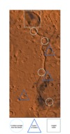
Figure 16 A labelled version of Figure 15: Ma’adim Vallis region. Note the channel, which is breached by some impact craters, and itself breaches a very large impact crater. The largest crater visible at the top of the image is Gusev Crater, a 166 km diameter crater which was the landing site of the Mars Exploration Rover, Spirit.
View description - Figure 16 A labelled version of Figure 15: Ma’adim Vallis region. Note the channel, ...
View description - Figure 16 A labelled version of Figure 15: Ma’adim Vallis region. Note the channel, ...

Back to - Activity 4: How old is the surface of Mars?

Figure 1a (left-hand side) ‘The Blue Marble’, taken by the crew of the Apollo 17 mission. Figure 1b (right-hand side) A composite image of Mars created using images taken by the Viking orbiters. The planets are not the same size in reality: the Earth is 12742 km diameter, whereas Mars is only 6779 km in diameter. Image credit for both: NASA

Description
This figure has two parts. On the left hand side is a photograph of the Earth surrounded by the black background of space. The whole globe is shown, which has a pattern of blue water, and green and brown continents. Clouds form white streaks and swirls obscuring details of the continent and water bodies in view. On the right hand side is a photograph of Mars. It also shows the full globe of the planet, coloured bright orange and brown, surrounded by the black background of space. Across the middle of the globe runs a dark brown feature, which looks like a scar but is a deep valley.
Back to - Figure 1a (left-hand side) ‘The Blue Marble’, taken by the crew of the Apollo 17 mission. Figure 1b (right-hand side) A composite image of Mars created using images taken by the Viking orbiters. The planets are not the same size in reality: the Earth is 12742 km diameter, whereas Mars is only 6779 km in diameter. Image credit for both: NASA

Figure 2 An orange-hued Mars in the western sky taken in April 2006. Image credit: Chris Schur

Description
This is a photograph taken using a telescope of the nights sky. It shows Mars as a bright orange star, much larger than other smaller, white stars in the sky.
Back to - Figure 2 An orange-hued Mars in the western sky taken in April 2006. Image credit: Chris Schur

Figure 3 Christiaan Huygens’ sketch of Mars made 13 August 1672. He observed dark patches on the planet’s surface and a white patch at the south pole. The south pole on his sketch appears to be the north pole because the lenses in some telescopes produce images that are upside down.

Description
This figure has two parts. The upper part is a sketch of Mars shown as a circle. It is divided in two by a horizontal line through its middle, marking the equator. Some light grey shading indicates two areas across and south of the equator. This sketch is labelled: Aug. 6, 1672, 11h 00m past moon, CM = 213 degrees. The lower part is another sketch of Mars shown as a circle. Darker grey shading is shown across the equator and southern hemisphere, with a more distinct shape than in the top sketch. The sketch is labelled: Aug. 13, 1672, 10h 30m past moon, CM=290 degrees. Both circles also have a small mark at their top point, which signifies the south pole.
Back to - Figure 3 Christiaan Huygens’ sketch of Mars made 13 August 1672. He observed dark patches on the planet’s surface and a white patch at the south pole. The south pole on his sketch appears to be the north pole because the lenses in some telescopes produce images that are upside down.

Figure 4 Global Mars map by Giovanni Schiaparelli in 1890 after a period of Mars observations starting in 1877. The most striking feature of the map are the straight lines, which Schiaparelli called ‘canali’ meaning channels but were mistranslated to canals implying their creation by a martian civilisation.

Description
This figure shows a hand-drawn map, about double the width compared to its height. Its title reads ‘Mars 1890’. The map area is divided into a grid pattern by horizontal and vertical lines, with a thicker horizontal line in the middle marking the equator. The top quarter of the map is mostly featureless and is labelled “Mare Austraale”. There are three circles in that area, named Thyle I and Thyle II, and Argyre II. Towards the bottom of the map, the drawing becomes more complex. In the second quarter from the top, dark shading surrounds two larger circles, one labelled Hellas and one labelled Thaumasia. The bottom half of the map is very different. There many random criss-crossing lines, no large circles, and only one small, shaded area in the bottom quarter. There are many labels on the map, including Hesperia and Arabia.
Back to - Figure 4 Global Mars map by Giovanni Schiaparelli in 1890 after a period of Mars observations starting in 1877. The most striking feature of the map are the straight lines, which Schiaparelli called ‘canali’ meaning channels but were mistranslated to canals implying their creation by a martian civilisation.

Figure 5 Mars, taken using a telescope comparable to that used by astronomers in the 1800s. Image credit: NASA/Ron Wayman

Description
This figure is a photograph taken through a telescope. It shows a large black square, with a tiny orange feature that covers less than 1 % of the area of the image. The feature is oval with a tiny white mark at its southern pole.
Back to - Figure 5 Mars, taken using a telescope comparable to that used by astronomers in the 1800s. Image credit: NASA/Ron Wayman

Figure 6 A photograph taken in a small wood near the OU campus in Milton Keynes, UK, after some rain. Image: Susanne Schwenzer.

Description
This is a photograph of a wood. In the foreground, the ground is covered in brown leaves with a few small green plants growing in it. In the middle ground a small body of standing water can be seen, with rings forming on the surface of the water from drops that fall into the pond. Behind and to the right of the pond are large trees, extending out to a wood.
Back to - Figure 6 A photograph taken in a small wood near the OU campus in Milton Keynes, UK, after some rain. Image: Susanne Schwenzer.

Figure 7 The Atacama desert. Image: Susanne Schwenzer.

Description
This is a photograph of the Atacama desert. The image is filled with a barren, brown ground surface that has very little structure apart from some polygonal patterns made from cracks in the middle ground. Around the cracked area there are large rocks, casting their shadows in the bright sunlight. The rocks are of various sizes and most have sharp edges and are of angular forms. One area in the foreground is covered in very small, dark brown nodules.
Back to - Figure 7 The Atacama desert. Image: Susanne Schwenzer.

Figure 8 Hydrogen bonding between water molecules, shown by the dashed line.

Description
The figure shows three water molecules represented by ball-and-stick models. Each water molecule consists of one red ball with delta minus (δ–) in the middle of it and two smaller white balls, each containing delta plus (δ+). Each white ball (or hydrogen atom) is attached to the red ball (or oxygen atom) by a short straight ‘stick’. The angle between the two sticks is more than a right angle. One of the water molecules is on the left of the figure and the other two on the right, one above the other. The molecule on the left has been rotated so that one of its white balls is above the red ball, and the other is below and to the right of the red ball. The first molecule on the right has been rotated so that its red ball is diagonally aligned with the lower white ball of the molecule above and to its left. There is a dashed blue line between this lower white ball at , and the red ball of the first molecule on the right. One of the white balls attached to this red ball is directly below it, and the other above and to its right. The second molecule on the right has been rotated so that its red ball is below and aligned with the lower white ball of the molecule directly above it. There is a dashed blue line between this white ball and the red ball of the second molecule. The white balls attached to this red ball are below and either side of it. The second dashed blue line is labelled as a hydrogen bond. The red ball of the third molecule is labelled 'oxygen atoms have a slight negative charge' (i.e. δ–). Its right white ball is labelled 'hydrogen atoms have a slight positive charge' (i.e. δ+).
Back to - Figure 8 Hydrogen bonding between water molecules, shown by the dashed line.

Figure 9 From left to right: A clean (and detergent free!) glass is filled with tap water. A fork is used to gently place a sewing needle onto the water surface creating ‘dents’ in the water adjacent to the needle. Image credit: Susanne Schwenzer.

Description
This image shows five photographs that illustrate the steps in Activity 2. From left to right, the first photograph shows a clean glass filled with water. The next two photographs show a fork with a needle balanced on it being lowered onto the water in the glass. The fourth photograph shows the needle floating on the water surface – the fork has been removed from the image. The final image shows an aerial view of the surface of the water, with the needle floating. ‘Dents’ in the water are visible around the needle.
Back to - Figure 9 From left to right: A clean (and detergent free!) glass is filled with tap water. A fork is used to gently place a sewing needle onto the water surface creating ‘dents’ in the water adjacent to the needle. Image credit: Susanne Schwenzer.

Figure 10 Diagram showing the temperatures and pressures at which different phases of water can exist.

Description
This is a diagram illustrating the different phases that water can take. It is an x-y graph, with temperature (in degrees Celsius) on the horizontal (x) axis and pressure (in mega pascals) on the vertical (y) axis. The x and y axes cross at approximately -75 degrees Celsius 0 mega pascals. The x axis reads from -75 to 150 degrees Celsius and 0 °C and 100 degrees Celsius are labelled. The y axis has a logarithmic scale and reads from 0 to 1 mega pascal, but only 0.1 mega pascals is labelled, about half way up the axis. The diagram is divided into three areas by three lines. Central to this is a point at about one quarter above the x-axis at 0.06 mega pascals and about one third to the right of the Y-axis at 0 °C. This is labelled the triple point of water. From the origin of the graph to the triple point a concavely curved line divides two areas – one to the right of the line labelled gas (steam) and one above the line labelled solid (ice). The line ends at the triple point. From there, another line extends, also concavely curved through a point marked at 0.1 mega pascal and 100 °C up towards the top of the diagram. This line divides the area labelled gas (steam) from an area labelled liquid (water). A third line extends from the triple point to the top of the diagram, running slightly back towards the y axis. This line divides the areas labelled solid (ice) on the left of the line from the area labelled liquid (water) to the right of the line.
Back to - Figure 10 Diagram showing the temperatures and pressures at which different phases of water can exist.

Figure 11 Schematic diagram showing the molecular structure of frozen water. When the water is frozen solid, the molecules fit together in a rigid structure.

Description
Whole molecules are represented as blue spheres (i.e. H and O are not shown separately).
Back to - Figure 11 Schematic diagram showing the molecular structure of frozen water. When the water is frozen solid, the molecules fit together in a rigid structure.

Figure 12 Visible light split into constituent wavelengths by a prism. Within this spectrum, red has the longest wavelength and violet the shortest.

Description
Figure 12 consists of two parts. On the left hand side is a photograph of a glass prism. The triangular structure is facing the observer with a beam of white light hitting its left surface and passing trough the glass structure. The beam exits the glass structure on the right hand side, with the light split into its constituent colours. This appears as a rainbow, from red on top over yellow to green blue and finally purple. On the right hand side is an illustration of the different wavelengths of light of different colours. From top to bottom these are: infrared, red, orange, yellow, green blue, indigo, violet, ultraviolet. Wavelengths decrease down the image, with infrared having the longest and ultraviolet having the shortest.
Back to - Figure 12 Visible light split into constituent wavelengths by a prism. Within this spectrum, red has the longest wavelength and violet the shortest.

Figure 13 Mariner 4 image of the martian surface. The image is about 460 km wide, and shows some large impact craters (circular features), but no signs of any water-formed features. Image credit: NASA.

Description
This figure shows a photograph taken from orbit of the martian surface. It is in greyscale and is heavily pixelated. Several circular features are evident, which are craters.
Back to - Figure 13 Mariner 4 image of the martian surface. The image is about 460 km wide, and shows some large impact craters (circular features), but no signs of any water-formed features. Image credit: NASA.

Figure 14 Nirgal Vallis as seen by Mariner 9. The image (94 km across) shows a valley network, interpreted to be river channels with tributaries. The circular features are impact craters. Image credit: NASA.

Description
This figure shows a photograph of the martian surface taken from orbit by the spacecraft Mariner 9. It is in greyscale. A prominent feature is shown across the centre of the image from right to left, which looks like a branch. This is the valley network called Nirgal Vallis. Circular features are evident in several places on the image, which are impact craters.
Back to - Figure 14 Nirgal Vallis as seen by Mariner 9. The image (94 km across) shows a valley network, interpreted to be river channels with tributaries. The circular features are impact craters. Image credit: NASA.

Figure 15 Ma’adim Vallis region. Note the channel, which is breached by some impact craters, and itself breaches a very large impact crater. The largest crater visible at the top of the image is Gusev Crater, a 166 km diameter crater which was the landing site of the Mars Exploration Rover, Spirit. Image credit: NASA.

Description
This figure is a photograph taken from Mars orbit of the martian surface. The area is brown-red colour. There are many circular features, of varying sizes, across the area. There is a large circular feature at the top of the image. From this, a channel extends directly south. The channel cuts through and is overlain y several circular features.
Back to - Figure 15 Ma’adim Vallis region. Note the channel, which is breached by some impact craters, and itself breaches a very large impact crater. The largest crater visible at the top of the image is Gusev Crater, a 166 km diameter crater which was the landing site of the Mars Exploration Rover, Spirit. Image credit: NASA.

Figure 16 A labelled version of Figure 15: Ma’adim Vallis region. Note the channel, which is breached by some impact craters, and itself breaches a very large impact crater. The largest crater visible at the top of the image is Gusev Crater, a 166 km diameter crater which was the landing site of the Mars Exploration Rover, Spirit.

Description
This figure is a repeat of Figure 15 with additional annotations. A grey square is drawn around the large circular feature at the top. A pale blue circle is drawn around four circular features. A dark blue triangle is drawn around three areas where there are two overlapping craters.
Back to - Figure 16 A labelled version of Figure 15: Ma’adim Vallis region. Note the channel, which is breached by some impact craters, and itself breaches a very large impact crater. The largest crater visible at the top of the image is Gusev Crater, a 166 km diameter crater which was the landing site of the Mars Exploration Rover, Spirit.

Figure 17 Viking 2 image showing a thin layer of water ice frost on the martian surface at Utopia Planitia. Image credit: NASA.

Description
This is a photograph of the martian surface taken by the Viking 2 lander. The horizon is sloping from left to right. The sky is a pale orange colour. The surface is covered in red-brown dust with red-brown boulders of various sizes. The surface between the boulders has a dusting of white, which is water ice.
Back to - Figure 17 Viking 2 image showing a thin layer of water ice frost on the martian surface at Utopia Planitia. Image credit: NASA.

Figure 18 The Nakhla martian meteorite (on loan to The Open University from the Natural History Museum). Sample is approximately 2.5 cm long. Image credit: Andy Tindle ‬‬

Description
This is a photograph of a rock. Its surface is black and shiny in some places. This is a fusion crust. In other places it is grey-green.
Back to - Figure 18 The Nakhla martian meteorite (on loan to The Open University from the Natural History Museum). Sample is approximately 2.5 cm long. Image credit: Andy Tindle‬‬

Figure 19 Scanning electron microscope image of a polished thin section of martian meteorite Y000593 (a nakhlite) showing iddingsite, a mineral formed by the alteration by water of olivine. Image credit: NASA/JPL

Description
This figure is a photograph taken with a scanning electron microscope. It is approximately 35 micrometers in diameter. It is in greyscale and shows a highly magnified rock sample. From the top left hand side to the bottom right hand side is a black band. To the left hand side of the black band is a band of mottled grey material labelled iddingsite. To the left of that is a smooth grey material with dark cracks running through it. To the right hand side of the black band is a partially striped dark grey band labelled Si-rich band. To the right of that is the smooth grey material, labelled olivine.
Back to - Figure 19 Scanning electron microscope image of a polished thin section of martian meteorite Y000593 (a nakhlite) showing iddingsite, a mineral formed by the alteration by water of olivine. Image credit: NASA/JPL

Figure 20 Carbonate mineral globules with orange-brown cores and colorless rims in microscope view (~0.2 mm across) in martian meteorite ALH 84001. Image credit: Allan Trieman, LPI

Description
This figure is a photograph taken using an optical microscope. It shows a large globular shaped orange mineral in the centre. This is carbonate. This is surrounded by irregular rims of green and white material. White material and partial globules of orange ill the rest of the image.
Back to - Figure 20 Carbonate mineral globules with orange-brown cores and colorless rims in microscope view (~0.2 mm across) in martian meteorite ALH 84001. Image credit: Allan Trieman, LPI

Figure 21 Colourised Mars Orbiter Laser Altimeter (MOLA) topographic map of Mars.

Description
This figure is a map of Mars showing surface topography. Latitude and longitude are labelled, with the equator running across the centre of the image, horizontally. The map is colour coded. Blue and green areas are low elevation, red and brown areas are high elevation. The image can be divided into three areas. Across the top quarter (north) there is an area of low elevation, represented by blues and greens. Across the bottom quarter (south) there is an area of high elevation represented by reds and oranges. Between these areas there are regions of varying topography. Towards the left hand side of the image is a distinct red-brown region, which has some white patches. This represents very high elevations, in this case Olympus Mons volcanic region. To the right of the image is a distinct blue circular region, which represents a low lying impact crater.
Back to - Figure 21 Colourised Mars Orbiter Laser Altimeter (MOLA) topographic map of Mars.

Figure 22 Mosaic image of the Sojourner rover after leaving the landing platform. The ramp is visible on the bottom left of the image, a part of the deflated airbag on the bottom right. Image credit: NASA.

Description
This figure is a photograph taken by the Pathfinder langer of the Sojourner rover on the martian surface. The rover has four wheels with a flat platform on top. At the bottom of the image, a ramp and a deflated airbag are visible. The surface is mars is orange in colour, with fine soil and boulders and pebbles of various sizes.
Back to - Figure 22 Mosaic image of the Sojourner rover after leaving the landing platform. The ramp is visible on the bottom left of the image, a part of the deflated airbag on the bottom right. Image credit: NASA.

Figure 23 View to the northeast of the Pathfinder lander showing a variety of rocks recording past geological processes on Mars including water activity. Image credit: NASA.

Description
This figure is a photograph taken by the Pathfinder mission showing the martian landscape. The surface is a red-brown colour and is strewn with boulders of varying shapes and sizes. Red arrows point to rounded rocks which were likely shaped by the forces of water. White arrows point to lighter colour areas where the surface dust is thinner. Blue arrows indicate rocks with sharp edges that were likely ejected by nearby impact craters and/or ancient volcanoes.
Back to - Figure 23 View to the northeast of the Pathfinder lander showing a variety of rocks recording past geological processes on Mars including water activity. Image credit: NASA.

Figure 24 The area called ‘Cabbage Patch’ by the Pathfinder mission science team, which shows rounded pebbles that could be formed by the action of flowing water. Image credit: NASA.

Description
This figure is a photograph taken by the Pathfinder lander of the martian surface. It is a greyscale image. It shows fine grained dust that contains small rounded pebbles and larger rounded boulders.
Back to - Figure 24 The area called ‘Cabbage Patch’ by the Pathfinder mission science team, which shows rounded pebbles that could be formed by the action of flowing water. Image credit: NASA.

Figure 25 This map, based on data of the Thermal Emission Spectrometer aboard of the Odyssey orbiter, shows the location of sheet silicates - a synonym for clay minerals and silica rich glasses. Both types of minerals can only form in the presence of water. Image credit: NASA/ASU

Description
This figure is a map of Mars. The map is rainbow colour coded from red to violet. Violet and blue colours represent low detection of silicates. Orange and red colours show high detection of silicates. The map is roughly divided into thirds from top to bottom (north to south). The top third is mainly grey, indicating no data was collected there. The next third (to the south) is mainly blue, showing low levels of silicates, with some green areas to the south. The next third south blue and green, indicating higher levels of silicates. The south polar region is coloured grey, indicating no data was collected there.
Back to - Figure 25 This map, based on data of the Thermal Emission Spectrometer aboard of the Odyssey orbiter, shows the location of sheet silicates - a synonym for clay minerals and silica rich glasses. Both types of minerals can only form in the presence of water. Image credit: NASA/ASU

Figure 26 The map from Figure 25 is combined with data from the Mars Reconnaissance and Mars Global Surveyor orbiters. This shows the location of water ice beneath the surface of Mars. Image credit: NASA/JPL-Caltech/ASU.

Description
This figure is a map of Mars. It is rainbow colour coded according from red to violet. Violet and blue areas represent low levels of subsurface water. Red areas represent high levels of subsurface water. The north and south pole, and a band across the middle of the map are grey, representing no data collected there. The sub-polar areas are violet and blue colours. Mid-latitude areas, particularly in the northern hemisphere are green to red colours.
Back to - Figure 26 The map from Figure 25 is combined with data from the Mars Reconnaissance and Mars Global Surveyor orbiters. This shows the location of water ice beneath the surface of Mars. Image credit: NASA/JPL-Caltech/ASU.

Figure 27 This map is the result of the GRS investigations of the martian surface and is based on the observation of hydrogen in the upper metre of the surface. Image credit: NASA/JPL/Los Alamos National Laboratory.

Description
This figure is a map of Mars. It is colour coded from white, through browns, green, blue and violet. The colours are overlain onto a topographic map of Mars. Violet represents the highest amounts of water in the upper metre of the martian surface. White represents the lowest amounts of water in the upper metre of the martian surface. The martian poles are coloured dark blue. The remainder of the map is coloured light blue to brown. There is no obvious correlation with topography.
Back to - Figure 27 This map is the result of the GRS investigations of the martian surface and is based on the observation of hydrogen in the upper metre of the surface. Image credit: NASA/JPL/Los Alamos National Laboratory.

Figure 28 On the left-hand side, a context map for the HRSC observation of the stream bed at Nirgal Vallis. The boxes indicate the HRSC observations made in November 2018. Image Credit: ESA. On the right-hand side, a repeat of Figure 14, the greyscale image of Nirgir Vallis taken by Mariner 9. Image credit: NASA.

Description
This figure consists of two parts. The left hand side is a false-coloured topographic map of the martian surface at Nirgal Valles. It is mostly orange coloured, but circular features (imact craters) are green, indicating low elevation. In the centre of the image a long box is overlain, containing a smaller box, highlighting where HRSC observations were made. The right hand side is a repeat of Figure 14 – the greyscale photograph of the martian surface taken from orbit by the spacecraft Mariner 9. This is part of the same area as that shown in the left had photograph of this figure.
Back to - Figure 28 On the left-hand side, a context map for the HRSC observation of the stream bed at Nirgal Vallis. The boxes indicate the HRSC observations made in November 2018. Image Credit: ESA. On the right-hand side, a repeat of Figure 14, the greyscale image of Nirgir Vallis taken by Mariner 9. Image credit: NASA.

Figure 29 A composite of a digital elevation map and Mars Express images. Image credit: ESA.

Description
This figure shows the surface of Mars viewed at an angle from above. The surface is coloured shades of red-brown. A winding branching pattern goes across the image from bottom left to top right. Four circular features are visible, of different sizes.
Back to - Figure 29 A composite of a digital elevation map and Mars Express images. Image credit: ESA.

Figure 30 The Beagle 2 lander. Credit: Beagle 2/ESA

Description
This figure is a photograph of the beagle 2 lander. It shows a circular silver disk with an arm protruding outwards to the right. On the end of the arm is a metallic, semi-circular shaped box housing scientific instruments. On the opposite side of the silver disk to the arm a blue circular disk is attached. Four roughly circular, blue disks are attached to its circumference. These five circular disks are solar panels.
Back to - Figure 30 The Beagle 2 lander. Credit: Beagle 2/ESA

Figure 31 This was the first 360° panorama from the Spirit landing site in Gusev crater, with the rover still on the landing platform. Note how flat and featureless the landscape appears. Image credit: NASA/JPL.

Description
This figure is a panoramic photograph taken by the Spirit rover of the martian surface. It is in greyscale. In the foreground is part of the rover’s landing platform. In the background is a dark grey surface with fine grained material and some boulders evident. The horizon is flat and sky is a pale grey colour.
Back to - Figure 31 This was the first 360° panorama from the Spirit landing site in Gusev crater, with the rover still on the landing platform. Note how flat and featureless the landscape appears. Image credit: NASA/JPL.

Figure 32 Opportunity at its landing site in a small, ~20 m diameter crater in Meridiani Planum. While it was not planned for Opportunity to land in a crater, the walls around it were the first rocks that the mission encountered. Image credit: NASA/JPL.

Description
This figure is a photograph taken by the Opportunity rover of the martian surface. It is in shades of orange-brown. In the foreground is part of the rover’s deflated airbags. In the background is a dark brown surface with fine grained material and some boulders evident. In the distance, rock outcrops can be seen. The horizon slopes slightly to the right hand side and the sky is pale orange.
Back to - Figure 32 Opportunity at its landing site in a small, ~20 m diameter crater in Meridiani Planum. While it was not planned for Opportunity to land in a crater, the walls around it were the first rocks that the mission encountered. Image credit: NASA/JPL.

Figure 33 Haematite rich concretions named ‘blueberries’ because of their almost perfectly spherical shapes. Image credit: NASA/JPL.

Description
This figure is a photograph taken by the Opportunity rover. It shows small spherical pebbles sitting on a fine grained surface. The pebbles are coloured light blues and greys, and the surface underneath is an orange hue.
Back to - Figure 33 Haematite rich concretions named ‘blueberries’ because of their almost perfectly spherical shapes. Image credit: NASA/JPL.

Figure 34 ‘Gertrude Weise’ is a trench made by the malfunctioning wheel on Spirit. It is almost pure SiO2, a mineral phase likely formed by water. Image credit: NASA/JPL.

Description
This figure is a photograph taken by the Spirit rover of the martian surface. The surface is coloured orange, and is fine grained with some larger pebbles. Across the centre of the image are two small valleys in the soil, the interior of which are coloured white.
Back to - Figure 34 ‘Gertrude Weise’ is a trench made by the malfunctioning wheel on Spirit. It is almost pure SiO2, a mineral phase likely formed by water. Image credit: NASA/JPL.

Figure 35 Vein, called ‘Homestake’, filled with gypsum, which was investigated by Opportunity. Image credit: NASA/JPL.

Description
This figure is a photograph taken by the Opportunity rover of a rock outcrop. The rock is brown in colour, but a band of white goes across the image from bottom left to top right. The band is broken in places, interrupted by brown.
Back to - Figure 35 Vein, called ‘Homestake’, filled with gypsum, which was investigated by Opportunity. Image credit: NASA/JPL.

Figure 36 ‘Pillinger Point’, named in honour of the Open University’s late Professor Colin Pillinger who led the Beagle 2 mission, is at the rim of Endeavour crater allowing a beautiful view over the crater.

Description
This figure is a panoramic photograph taken by the Opportunity rover of the martian surface. A ridge is evident, lying left to right across the image. This is coloured light orange. Behind this is a darker orange region that appears flat. The horizon in the distance is horizontal and the sky is pale yellow.
Back to - Figure 36 ‘Pillinger Point’, named in honour of the Open University’s late Professor Colin Pillinger who led the Beagle 2 mission, is at the rim of Endeavour crater allowing a beautiful view over the crater.

Figure 37 HiRISE image taken of Ladon Vallis, a 600 km-long outflow channel extending from a basin in the south to the north of Mars. The light-toned layers contrast with the darker-toned deposit on the floor of the channel, with dark toned dunes partly filling fractures and impact craters. Credit: NASA/JPL-Caltech/University of Arizona.

Description
This figure is a photograph taken from Mars orbit. The main feature is a series of parallel, wavy lines representing a channel, that that track upwards from the bottom of the image to roughly the middle of the image. In the middle there is a roughly circular feature. Further channels extend from that feature upwards and to the right. The centre of the channels are coloured blue, and the outer edges are greys and browns. All other areas are darker grey colours and varying shades.
Back to - Figure 37 HiRISE image taken of Ladon Vallis, a 600 km-long outflow channel extending from a basin in the south to the north of Mars. The light-toned layers contrast with the darker-toned deposit on the floor of the channel, with dark toned dunes partly filling fractures and impact craters. Credit: NASA/JPL-Caltech/University of Arizona.

Figure 38 HiRISE image of the floor of an impact crater north of Ebersawalde crater. Credit: NASA/JPL-Caltech/University of Arizona.

Description
This figure is a photograph taken from Mars orbit. The main feature is a ridge extending north to south on the right hand side of the image. To the right of this ridge, dark brown horizontal lines are shown, surrounded by purple and brown material. To the left of this ridge are complex shapes with different textures and colours.
Back to - Figure 38 HiRISE image of the floor of an impact crater north of Ebersawalde crater. Credit: NASA/JPL-Caltech/University of Arizona.

Figure 39 Pair of HiRISE images taken in 2010 (left) and 2013 (right), showing a new channel, as indicated by the white arrow, formed by seasonal variation in carbon dioxide frost. Other HiRISE observations have indicated that these processes typically occur gradually in winter. Credit: NASA/JPL-Caltech/Univ. of Arizona.

Description
This figure consists of two photographs of the same area of Mars side by side. Both show a v-shaped channel at the top with a single channel extending from the point of the v, downwards towards the bottom of the image. On the right hand image, a second channel is evident, branching off in a different direction from the original channel.
Back to - Figure 39 Pair of HiRISE images taken in 2010 (left) and 2013 (right), showing a new channel, as indicated by the white arrow, formed by seasonal variation in carbon dioxide frost. Other HiRISE observations have indicated that these processes typically occur gradually in winter. Credit: NASA/JPL-Caltech/Univ. of Arizona.

Uncaptioned Figure

Description
This figure is an animation using photographs taken of the south pole of Mars from Mars orbit over several years. The images are grey scale. The image shows a roughly circular ice cap. The animation shows this growing in size over time.
Back to - Uncaptioned Figure

Figure 41 Topographic image with CRISM false-colour imagery overlain. Green suggests carbonate minerals (formed by water) and red indicates olivine sand. Credit: NASA/JPL-Caltech/MSSS/JHU-APl/Purdue/USGS.

Description
This figure is a greyscale image of the surface of Mars showing a circular impact crater. This is overlain with coloured panels in some areas. The colours range from red to blue, with reds and pinks mainly around the outside of the impact crater, and greens and blues inside the crater.
Back to - Figure 41 Topographic image with CRISM false-colour imagery overlain. Green suggests carbonate minerals (formed by water) and red indicates olivine sand. Credit: NASA/JPL-Caltech/MSSS/JHU-APl/Purdue/USGS.

Figure 42 SHARAD radar cross section of the north polar cap of Mars You can see an internal ice structure with the white lines representing radar reflections due to layers/boundaries. Credit: NASA/JPL-Caltech/ASI/UT.

Description
This figure is a radar profile. It shows wavy white lines on a black background. The white lines represent layers of ice underneath the surface. The lines are roughly parallel and run horizontal in the left hand side of the image. Here, there are many tightly packed white lines at the top of the image, which is labelled ice surface. A third down the image the lines are less frequent, labelled internal layers, and at the bottom they are not well defined but are labelled base of polar ice and basal unit. To the right hand side of the image the lines are uneven, broken and slope downwards, representing the edge of the icecap. They still follow the same pattern as the left hand side of the image.
Back to - Figure 42 SHARAD radar cross section of the north polar cap of Mars You can see an internal ice structure with the white lines representing radar reflections due to layers/boundaries. Credit: NASA/JPL-Caltech/ASI/UT.

Figure 43 SHARAD radargram showing subsurface water ice in Utopia Planitia region of Mars. The white arrows indicate subsurface reflections caused by the subsurface water ice. Credit: NASA/JPL-Caltech/Univ. of Rome/ASI/PSI.

Description
This figure shows two radar profiles, side by side. Each image is represents an area approximately 100km across, from left to right. The bottom of each image has white, mottled shading on a black background. The top of the mottled area, on both images, is a wavy line that extends across the centre of the image from left to right. Each image shows white arrows pointing upwards towards areas where the white shading is more concentrated.
Back to - Figure 43 SHARAD radargram showing subsurface water ice in Utopia Planitia region of Mars. The white arrows indicate subsurface reflections caused by the subsurface water ice. Credit: NASA/JPL-Caltech/Univ. of Rome/ASI/PSI.

Figure 44 Colour images taken by the Phoenix lander on the 21st and 25th days of the mission. A group of dice-sized pieces is visible in the lower left corner of the trench (left image), which disappeared after 4 days (right image). Image credit: NASA/JPL

Description
This figure consists of two photographs of the martian surface taken by the Phoenix lander, side by side. The left hand image is labelled Sol 20 and the right hand image is labelled Sol 24. Both images show a rectangular-shaped trench in the brown-coloured martian soil. The trench in the left hand image has small, dice-sized cubes towards one corner. These are absent in the right hand image. An inlay magnifying this area of the trench is shown.
Back to - Figure 44 Colour images taken by the Phoenix lander on the 21st and 25th days of the mission. A group of dice-sized pieces is visible in the lower left corner of the trench (left image), which disappeared after 4 days (right image). Image credit: NASA/JPL

Uncaptioned Figure

Description
This figure is an animation composed of photographs taken of thin, streaky clouds in the martian atmosphere. The photographs are grey scale. The clouds move from right to left across the images.
Back to - Uncaptioned Figure

Figure 46 Conglomerate at the site called ‘Hottah’ encountered on sol 39 (a sol is a martian day, 24 hours 39 minutes) of the Curiosity mission at Gale crater, Mars. This and two similar sites allowed calculation of the water depth and flow-speed of the stream that transported those 2-40 mm sized pebbles to this site. Image credit: NASA/JPL.

Description
This figure is a photograph of the martian surface taken by the Curiosity rover. It shows a rock outcrop covered by a thin layer of dust. The dust is a red-brown colour, and the rock outcrop is green-orange.
Back to - Figure 46 Conglomerate at the site called ‘Hottah’ encountered on sol 39 (a sol is a martian day, 24 hours 39 minutes) of the Curiosity mission at Gale crater, Mars. This and two similar sites allowed calculation of the water depth and flow-speed of the stream that transported those 2-40 mm sized pebbles to this site. Image credit: NASA/JPL.

Figure 47 Sandstones at the location ‘The Kimberly’ at Gale crater, Mars. Those sandstones occur together with conglomerates in the sequence of deposits in the crater. The third water-laid type of rock are mudstones. The black, triangular rock in the middle of the image is about 80 cm wide. Image credit: NASA/JPL.

Description
This figure is a photograph of the martian surface taken by the Curiosity rover. In the foreground is an area of fine grained martian dust with some larger pebbles. Behind this is a rock outcrop covered by a thin layer of dust. The dust is a red-brown colour, and the rock outcrop is green-orange. The rock has horizontal, parallel beds.
Back to - Figure 47 Sandstones at the location ‘The Kimberly’ at Gale crater, Mars. Those sandstones occur together with conglomerates in the sequence of deposits in the crater. The third water-laid type of rock are mudstones. The black, triangular rock in the middle of the image is about 80 cm wide. Image credit: NASA/JPL.

Figure 48 Mineralogical composition of rocks at Gale crater, Mars drilled between 2012 and 2016. Image credit: NASA/JPL.

Description
This figure is an illustration showing ten pie charts. Each pie chart represents the composition of the mudstone analysed along the Curiosity rover’s traverse along the martian surface and they are arranged along a line representing that traverse. The locations marked on the line, from left to right, are Yellowknife Bay, Pahrump Hills, Marias Pass, Base of Naukluft, and Murray Buttes. The minerals present are represented by colours: Feldspar is dark grey, mafic minerals are light grey, magnetite is black, haematite is red, clay minerals are green, crystalline silica is blue, jarosite is purple, fluorapatite is orange and calcium sulfate is yellow. All pie charts have a large wedges of dark grey and light grey. All bar two have a wedge of green, and all bar four have wedges of red and yellow. Blue, purple and orange wedges are much less common.
Back to - Figure 48 Mineralogical composition of rocks at Gale crater, Mars drilled between 2012 and 2016. Image credit: NASA/JPL.

Figure 49 Calcium sulfate veins (white) at a location called ‘Garden City’. Note the scale bar in the centre of the image. Image credit: NASA/JPL.

Description
This figure is a photograph taken of a martian rock by the Curiosity rover. It covers approximately 180 cm from left to right. The rock is shades of dark brown, but there are criss-crossing white lines across its surface.
Back to - Figure 49 Calcium sulfate veins (white) at a location called ‘Garden City’. Note the scale bar in the centre of the image. Image credit: NASA/JPL.

Figure 50 Sodium, chlorine and boron analysis as seen by ChemCam. There are ten investigation points in this image, and for each of them the bar height indicates the amount of the three elements found. Image credit: NASA/JPL-Caltech/MSSS/LANL/CNES/IRAP/LPGNantes/CNRS/IAS.

Description
Figure 50 is divided into two parts. On the left hand side is a photograph of the surface of a martian rock outcrop. The rock is mainly brown, but there is a white area in the centre. This has a red oval drawn around it. On the right hand side of the image is a close-up photograph of the area within the red oval, approximately 7cm in length (left to right). This is a light brown rock, with a white area in the centre. Overlain on this are ten bar charts showing the relative amounts of sodium, chlorine and boron. The bar charts are overlain where the rock was analysed to show the distribution of elements across the white area. The details of the bar charts is not relevant.
Back to - Figure 50 Sodium, chlorine and boron analysis as seen by ChemCam. There are ten investigation points in this image, and for each of them the bar height indicates the amount of the three elements found. Image credit: NASA/JPL-Caltech/MSSS/LANL/CNES/IRAP/LPGNantes/CNRS/IAS.

Figure 51 Possible mud (dessiccation) cracks at a location ‘Old Soaker’ at Gale crater. Mud cracks form when fine grained mud is repeatedly dried out and becomes wet again. This is evidence for fluctuating levels of the lake. Image credit: NASA/JPL.

Description
This figure is a photograph taken by the Curiosity rover looking down on the top of a rock outcrop on the martian surface. The rock outcrop is surrounded by fine grained, dark grey soil. The surface of the rock appears to be cracked.
Back to - Figure 51 Possible mud (dessiccation) cracks at a location ‘Old Soaker’ at Gale crater. Mud cracks form when fine grained mud is repeatedly dried out and becomes wet again. This is evidence for fluctuating levels of the lake. Image credit: NASA/JPL.

Figure 52 Screenshot of NASA’s rover location tool

Description
This figure is a screenshot of the NASA interactive map, showing a satellite, greyscale image of the martian surface near a crater edge. The traverse of the Curiosity rover is overlaid as a white line, moving from inside the crater to the rim.
Back to - Figure 52 Screenshot of NASA’s rover location tool

Figure 53 HiRISE image of Jezero crater, which was used to select this site as the Perseverance landing site. Two possible routes (purple and green lines) that the Perseverance rover might travel are shown. Image credit: NASA/JPL-Caltech/University of Arizona.

Description
This figure is a greyscale satellite image of the martian surface. A delta area is evident, from left to right across the image, fanning out towards the right. Two lines are overlain. A green line meanders from left (from a region labelled Nereta Valles) to right to the centre of the image, and then winds around the central area, to the south of a region labelled Belva. A purple line meanders in a roughly circular pattern to the right of the green line, in the right hand side of the image.
Back to - Figure 53 HiRISE image of Jezero crater, which was used to select this site as the Perseverance landing site. Two possible routes (purple and green lines) that the Perseverance rover might travel are shown. Image credit: NASA/JPL-Caltech/University of Arizona.

Figure 54 Chemist Rosalind Franklin

Description
This figure is a black and white photograph of Rosalind Franklin looking down a microscope.
Back to - Figure 54 Chemist Rosalind Franklin

Video 1 three-dimensional representation of water molecules.

Transcript
Narrator
This animation illustrates how water molecules behave under normal conditions, for example, in a glass of pure drinking water. The water molecules are in constant random motion, bumping into each other and bouncing apart.
This way of representing water molecules is called a space-filling model because filled spheres are used to represent the atoms. Each water molecule is represented by three overlapping spheres, a single large red sphere, representing an oxygen atom, which is joined to two small white spheres, the two hydrogen atoms in a water molecule. Oxygen and hydrogen are two of the more than 100 unique chemical elements known to science.
Of course, water molecules are not really made of overlapping red and white spheres. The colours chosen for the atoms are simply a convention in chemistry. Oxygen atoms in molecular models like this one are always coloured red, and hydrogen atoms are white.
A static image makes it easier to describe the structure of an individual water molecule. In the space-filling model of a water molecule, the single oxygen atom is red and is joined to two hydrogen atoms coloured white. Here the hydrogen and oxygen atoms have been labeled with their chemical symbols, capital H for hydrogen and capital O for oxygen. Combining these symbols gives the familiar chemical formula for water, H2O. Water is described as a chemical compound, because the water molecule contains more than one type of atom.
Back to - Video 1 three-dimensional representation of water molecules.

Video 2 when sodium chloride is dissolved in water.

Transcript
Narrator
When salt dissolves, the positive parts of the water molecules align themselves with the negatively charged chloride ion, eventually surrounding it. The chloride ion is then shepherded into the surrounding water. Similarly, the negative parts of the water molecules, align themselves with the positively charged sodium ion, eventually surrounding it. The sodium ion is then shepherded into the surrounding water. Here you can see the whole process again.
Back to - Video 2 when sodium chloride is dissolved in water.

Video 4 Tracking the history of water on Mars.

Transcript
[Music playing]
[Text on screen:]
Tracking water loss on Mars
Liquid water once flowed across the martian surface, but where did it go?
Some water is in ice caps and underground, but water loss still occurs today
The ESA-Roscosmos ExoMars Trace Gas Orbiter is providing data on Mars’ climate evolution and its habitability potential
ExoMars is following the vertical path of water through the atmosphere and its changing isotopic composition
As water moves to colder regions it condenses and its isotopic composition changes
Independent of reservoir, and over time, the ratio of D to H atoms increases
Today, the D/H ratio is about six times higher on Mars than Earth indicating great water loss
Water loss is accelerated during dust storms when the atmosphere is warmer
Southern summer drives water loss as the pole is heated up
ExoMars will continue to provide new insights into the history of water on Mars
Back to - Video 4 Tracking the history of water on Mars.

Figure 1a (left-hand side) ‘The Blue Marble’, taken by the crew of the Apollo 17 mission. Figure 1b (right-hand side) A composite image of Mars created using images taken by the Viking orbiters. The planets are not the same size in reality: the Earth is 12742 km diameter, whereas Mars is only 6779 km in diameter. Image credit for both: NASA

Description
This figure has two parts. On the left hand side is a photograph of the Earth surrounded by the black background of space. The whole globe is shown, which has a pattern of blue water, and green and brown continents. Clouds form white streaks and swirls obscuring details of the continent and water bodies in view. On the right hand side is a photograph of Mars. It also shows the full globe of the planet, coloured bright orange and brown, surrounded by the black background of space. Across the middle of the globe runs a dark brown feature, which looks like a scar but is a deep valley.
Back to - Figure 1a (left-hand side) ‘The Blue Marble’, taken by the crew of the Apollo 17 mission. Figure 1b (right-hand side) A composite image of Mars created using images taken by the Viking orbiters. The planets are not the same size in reality: the Earth is 12742 km diameter, whereas Mars is only 6779 km in diameter. Image credit for both: NASA

Figure 2 An orange-hued Mars in the western sky taken in April 2006. Image credit: Chris Schur

Description
This is a photograph taken using a telescope of the nights sky. It shows Mars as a bright orange star, much larger than other smaller, white stars in the sky.
Back to - Figure 2 An orange-hued Mars in the western sky taken in April 2006. Image credit: Chris Schur

Figure 3 Christiaan Huygens’ sketch of Mars made 13 August 1672. He observed dark patches on the planet’s surface and a white patch at the south pole. The south pole on his sketch appears to be the north pole because the lenses in some telescopes produce images that are upside down.

Description
This figure has two parts. The upper part is a sketch of Mars shown as a circle. It is divided in two by a horizontal line through its middle, marking the equator. Some light grey shading indicates two areas across and south of the equator. This sketch is labelled: Aug. 6, 1672, 11h 00m past moon, CM = 213 degrees. The lower part is another sketch of Mars shown as a circle. Darker grey shading is shown across the equator and southern hemisphere, with a more distinct shape than in the top sketch. The sketch is labelled: Aug. 13, 1672, 10h 30m past moon, CM=290 degrees. Both circles also have a small mark at their top point, which signifies the south pole.
Back to - Figure 3 Christiaan Huygens’ sketch of Mars made 13 August 1672. He observed dark patches on the planet’s surface and a white patch at the south pole. The south pole on his sketch appears to be the north pole because the lenses in some telescopes produce images that are upside down.

Figure 4 Global Mars map by Giovanni Schiaparelli in 1890 after a period of Mars observations starting in 1877. The most striking feature of the map are the straight lines, which Schiaparelli called ‘canali’ meaning channels but were mistranslated to canals implying their creation by a martian civilisation.

Description
This figure shows a hand-drawn map, about double the width compared to its height. Its title reads ‘Mars 1890’. The map area is divided into a grid pattern by horizontal and vertical lines, with a thicker horizontal line in the middle marking the equator. The top quarter of the map is mostly featureless and is labelled “Mare Austraale”. There are three circles in that area, named Thyle I and Thyle II, and Argyre II. Towards the bottom of the map, the drawing becomes more complex. In the second quarter from the top, dark shading surrounds two larger circles, one labelled Hellas and one labelled Thaumasia. The bottom half of the map is very different. There many random criss-crossing lines, no large circles, and only one small, shaded area in the bottom quarter. There are many labels on the map, including Hesperia and Arabia.
Back to - Figure 4 Global Mars map by Giovanni Schiaparelli in 1890 after a period of Mars observations starting in 1877. The most striking feature of the map are the straight lines, which Schiaparelli called ‘canali’ meaning channels but were mistranslated to canals implying their creation by a martian civilisation.

Figure 5 Mars, taken using a telescope comparable to that used by astronomers in the 1800s. Image credit: NASA/Ron Wayman

Description
This figure is a photograph taken through a telescope. It shows a large black square, with a tiny orange feature that covers less than 1 % of the area of the image. The feature is oval with a tiny white mark at its southern pole.
Back to - Figure 5 Mars, taken using a telescope comparable to that used by astronomers in the 1800s. Image credit: NASA/Ron Wayman

Figure 6 A photograph taken in a small wood near the OU campus in Milton Keynes, UK, after some rain. Image: Susanne Schwenzer.

Description
This is a photograph of a wood. In the foreground, the ground is covered in brown leaves with a few small green plants growing in it. In the middle ground a small body of standing water can be seen, with rings forming on the surface of the water from drops that fall into the pond. Behind and to the right of the pond are large trees, extending out to a wood.
Back to - Figure 6 A photograph taken in a small wood near the OU campus in Milton Keynes, UK, after some rain. Image: Susanne Schwenzer.

Figure 7 The Atacama desert. Image: Susanne Schwenzer.

Description
This is a photograph of the Atacama desert. The image is filled with a barren, brown ground surface that has very little structure apart from some polygonal patterns made from cracks in the middle ground. Around the cracked area there are large rocks, casting their shadows in the bright sunlight. The rocks are of various sizes and most have sharp edges and are of angular forms. One area in the foreground is covered in very small, dark brown nodules.
Back to - Figure 7 The Atacama desert. Image: Susanne Schwenzer.

Figure 8 Hydrogen bonding between water molecules, shown by the dashed line.

Description
The figure shows three water molecules represented by ball-and-stick models. Each water molecule consists of one red ball with delta minus (δ–) in the middle of it and two smaller white balls, each containing delta plus (δ+). Each white ball (or hydrogen atom) is attached to the red ball (or oxygen atom) by a short straight ‘stick’. The angle between the two sticks is more than a right angle. One of the water molecules is on the left of the figure and the other two on the right, one above the other. The molecule on the left has been rotated so that one of its white balls is above the red ball, and the other is below and to the right of the red ball. The first molecule on the right has been rotated so that its red ball is diagonally aligned with the lower white ball of the molecule above and to its left. There is a dashed blue line between this lower white ball at , and the red ball of the first molecule on the right. One of the white balls attached to this red ball is directly below it, and the other above and to its right. The second molecule on the right has been rotated so that its red ball is below and aligned with the lower white ball of the molecule directly above it. There is a dashed blue line between this white ball and the red ball of the second molecule. The white balls attached to this red ball are below and either side of it. The second dashed blue line is labelled as a hydrogen bond. The red ball of the third molecule is labelled 'oxygen atoms have a slight negative charge' (i.e. δ–). Its right white ball is labelled 'hydrogen atoms have a slight positive charge' (i.e. δ+).
Back to - Figure 8 Hydrogen bonding between water molecules, shown by the dashed line.

Figure 9 From left to right: A clean (and detergent free!) glass is filled with tap water. A fork is used to gently place a sewing needle onto the water surface creating ‘dents’ in the water adjacent to the needle. Image credit: Susanne Schwenzer.

Description
This image shows five photographs that illustrate the steps in Activity 2. From left to right, the first photograph shows a clean glass filled with water. The next two photographs show a fork with a needle balanced on it being lowered onto the water in the glass. The fourth photograph shows the needle floating on the water surface – the fork has been removed from the image. The final image shows an aerial view of the surface of the water, with the needle floating. ‘Dents’ in the water are visible around the needle.
Back to - Figure 9 From left to right: A clean (and detergent free!) glass is filled with tap water. A fork is used to gently place a sewing needle onto the water surface creating ‘dents’ in the water adjacent to the needle. Image credit: Susanne Schwenzer.

Figure 10 Diagram showing the temperatures and pressures at which different phases of water can exist.

Description
This is a diagram illustrating the different phases that water can take. It is an x-y graph, with temperature (in degrees Celsius) on the horizontal (x) axis and pressure (in mega pascals) on the vertical (y) axis. The x and y axes cross at approximately -75 degrees Celsius 0 mega pascals. The x axis reads from -75 to 150 degrees Celsius and 0 °C and 100 degrees Celsius are labelled. The y axis has a logarithmic scale and reads from 0 to 1 mega pascal, but only 0.1 mega pascals is labelled, about half way up the axis. The diagram is divided into three areas by three lines. Central to this is a point at about one quarter above the x-axis at 0.06 mega pascals and about one third to the right of the Y-axis at 0 °C. This is labelled the triple point of water. From the origin of the graph to the triple point a concavely curved line divides two areas – one to the right of the line labelled gas (steam) and one above the line labelled solid (ice). The line ends at the triple point. From there, another line extends, also concavely curved through a point marked at 0.1 mega pascal and 100 °C up towards the top of the diagram. This line divides the area labelled gas (steam) from an area labelled liquid (water). A third line extends from the triple point to the top of the diagram, running slightly back towards the y axis. This line divides the areas labelled solid (ice) on the left of the line from the area labelled liquid (water) to the right of the line.
Back to - Figure 10 Diagram showing the temperatures and pressures at which different phases of water can exist.

Figure 11 Schematic diagram showing the molecular structure of frozen water. When the water is frozen solid, the molecules fit together in a rigid structure.

Description
Whole molecules are represented as blue spheres (i.e. H and O are not shown separately).
Back to - Figure 11 Schematic diagram showing the molecular structure of frozen water. When the water is frozen solid, the molecules fit together in a rigid structure.

Figure 12 Visible light split into constituent wavelengths by a prism. Within this spectrum, red has the longest wavelength and violet the shortest.

Description
Figure 12 consists of two parts. On the left hand side is a photograph of a glass prism. The triangular structure is facing the observer with a beam of white light hitting its left surface and passing trough the glass structure. The beam exits the glass structure on the right hand side, with the light split into its constituent colours. This appears as a rainbow, from red on top over yellow to green blue and finally purple. On the right hand side is an illustration of the different wavelengths of light of different colours. From top to bottom these are: infrared, red, orange, yellow, green blue, indigo, violet, ultraviolet. Wavelengths decrease down the image, with infrared having the longest and ultraviolet having the shortest.
Back to - Figure 12 Visible light split into constituent wavelengths by a prism. Within this spectrum, red has the longest wavelength and violet the shortest.

Figure 13 Mariner 4 image of the martian surface. The image is about 460 km wide, and shows some large impact craters (circular features), but no signs of any water-formed features. Image credit: NASA.

Description
This figure shows a photograph taken from orbit of the martian surface. It is in greyscale and is heavily pixelated. Several circular features are evident, which are craters.
Back to - Figure 13 Mariner 4 image of the martian surface. The image is about 460 km wide, and shows some large impact craters (circular features), but no signs of any water-formed features. Image credit: NASA.

Figure 14 Nirgal Vallis as seen by Mariner 9. The image (94 km across) shows a valley network, interpreted to be river channels with tributaries. The circular features are impact craters. Image credit: NASA.

Description
This figure shows a photograph of the martian surface taken from orbit by the spacecraft Mariner 9. It is in greyscale. A prominent feature is shown across the centre of the image from right to left, which looks like a branch. This is the valley network called Nirgal Vallis. Circular features are evident in several places on the image, which are impact craters.
Back to - Figure 14 Nirgal Vallis as seen by Mariner 9. The image (94 km across) shows a valley network, interpreted to be river channels with tributaries. The circular features are impact craters. Image credit: NASA.

Figure 15 Ma’adim Vallis region. Note the channel, which is breached by some impact craters, and itself breaches a very large impact crater. The largest crater visible at the top of the image is Gusev Crater, a 166 km diameter crater which was the landing site of the Mars Exploration Rover, Spirit. Image credit: NASA.

Description
This figure is a photograph taken from Mars orbit of the martian surface. The area is brown-red colour. There are many circular features, of varying sizes, across the area. There is a large circular feature at the top of the image. From this, a channel extends directly south. The channel cuts through and is overlain y several circular features.
Back to - Figure 15 Ma’adim Vallis region. Note the channel, which is breached by some impact craters, and itself breaches a very large impact crater. The largest crater visible at the top of the image is Gusev Crater, a 166 km diameter crater which was the landing site of the Mars Exploration Rover, Spirit. Image credit: NASA.

Figure 16 A labelled version of Figure 15: Ma’adim Vallis region. Note the channel, which is breached by some impact craters, and itself breaches a very large impact crater. The largest crater visible at the top of the image is Gusev Crater, a 166 km diameter crater which was the landing site of the Mars Exploration Rover, Spirit.

Description
This figure is a repeat of Figure 15 with additional annotations. A grey square is drawn around the large circular feature at the top. A pale blue circle is drawn around four circular features. A dark blue triangle is drawn around three areas where there are two overlapping craters.
Back to - Figure 16 A labelled version of Figure 15: Ma’adim Vallis region. Note the channel, which is breached by some impact craters, and itself breaches a very large impact crater. The largest crater visible at the top of the image is Gusev Crater, a 166 km diameter crater which was the landing site of the Mars Exploration Rover, Spirit.

Figure 17 Viking 2 image showing a thin layer of water ice frost on the martian surface at Utopia Planitia. Image credit: NASA.

Description
This is a photograph of the martian surface taken by the Viking 2 lander. The horizon is sloping from left to right. The sky is a pale orange colour. The surface is covered in red-brown dust with red-brown boulders of various sizes. The surface between the boulders has a dusting of white, which is water ice.
Back to - Figure 17 Viking 2 image showing a thin layer of water ice frost on the martian surface at Utopia Planitia. Image credit: NASA.

Figure 18 The Nakhla martian meteorite (on loan to The Open University from the Natural History Museum). Sample is approximately 2.5 cm long. Image credit: Andy Tindle ‬‬

Description
This is a photograph of a rock. Its surface is black and shiny in some places. This is a fusion crust. In other places it is grey-green.
Back to - Figure 18 The Nakhla martian meteorite (on loan to The Open University from the Natural History Museum). Sample is approximately 2.5 cm long. Image credit: Andy Tindle‬‬

Figure 19 Scanning electron microscope image of a polished thin section of martian meteorite Y000593 (a nakhlite) showing iddingsite, a mineral formed by the alteration by water of olivine. Image credit: NASA/JPL

Description
This figure is a photograph taken with a scanning electron microscope. It is approximately 35 micrometers in diameter. It is in greyscale and shows a highly magnified rock sample. From the top left hand side to the bottom right hand side is a black band. To the left hand side of the black band is a band of mottled grey material labelled iddingsite. To the left of that is a smooth grey material with dark cracks running through it. To the right hand side of the black band is a partially striped dark grey band labelled Si-rich band. To the right of that is the smooth grey material, labelled olivine.
Back to - Figure 19 Scanning electron microscope image of a polished thin section of martian meteorite Y000593 (a nakhlite) showing iddingsite, a mineral formed by the alteration by water of olivine. Image credit: NASA/JPL

Figure 20 Carbonate mineral globules with orange-brown cores and colorless rims in microscope view (~0.2 mm across) in martian meteorite ALH 84001. Image credit: Allan Trieman, LPI

Description
This figure is a photograph taken using an optical microscope. It shows a large globular shaped orange mineral in the centre. This is carbonate. This is surrounded by irregular rims of green and white material. White material and partial globules of orange ill the rest of the image.
Back to - Figure 20 Carbonate mineral globules with orange-brown cores and colorless rims in microscope view (~0.2 mm across) in martian meteorite ALH 84001. Image credit: Allan Trieman, LPI

Figure 21 Colourised Mars Orbiter Laser Altimeter (MOLA) topographic map of Mars.

Description
This figure is a map of Mars showing surface topography. Latitude and longitude are labelled, with the equator running across the centre of the image, horizontally. The map is colour coded. Blue and green areas are low elevation, red and brown areas are high elevation. The image can be divided into three areas. Across the top quarter (north) there is an area of low elevation, represented by blues and greens. Across the bottom quarter (south) there is an area of high elevation represented by reds and oranges. Between these areas there are regions of varying topography. Towards the left hand side of the image is a distinct red-brown region, which has some white patches. This represents very high elevations, in this case Olympus Mons volcanic region. To the right of the image is a distinct blue circular region, which represents a low lying impact crater.
Back to - Figure 21 Colourised Mars Orbiter Laser Altimeter (MOLA) topographic map of Mars.

Figure 22 Mosaic image of the Sojourner rover after leaving the landing platform. The ramp is visible on the bottom left of the image, a part of the deflated airbag on the bottom right. Image credit: NASA.

Description
This figure is a photograph taken by the Pathfinder langer of the Sojourner rover on the martian surface. The rover has four wheels with a flat platform on top. At the bottom of the image, a ramp and a deflated airbag are visible. The surface is mars is orange in colour, with fine soil and boulders and pebbles of various sizes.
Back to - Figure 22 Mosaic image of the Sojourner rover after leaving the landing platform. The ramp is visible on the bottom left of the image, a part of the deflated airbag on the bottom right. Image credit: NASA.

Figure 23 View to the northeast of the Pathfinder lander showing a variety of rocks recording past geological processes on Mars including water activity. Image credit: NASA.

Description
This figure is a photograph taken by the Pathfinder mission showing the martian landscape. The surface is a red-brown colour and is strewn with boulders of varying shapes and sizes. Red arrows point to rounded rocks which were likely shaped by the forces of water. White arrows point to lighter colour areas where the surface dust is thinner. Blue arrows indicate rocks with sharp edges that were likely ejected by nearby impact craters and/or ancient volcanoes.
Back to - Figure 23 View to the northeast of the Pathfinder lander showing a variety of rocks recording past geological processes on Mars including water activity. Image credit: NASA.

Figure 24 The area called ‘Cabbage Patch’ by the Pathfinder mission science team, which shows rounded pebbles that could be formed by the action of flowing water. Image credit: NASA.

Description
This figure is a photograph taken by the Pathfinder lander of the martian surface. It is a greyscale image. It shows fine grained dust that contains small rounded pebbles and larger rounded boulders.
Back to - Figure 24 The area called ‘Cabbage Patch’ by the Pathfinder mission science team, which shows rounded pebbles that could be formed by the action of flowing water. Image credit: NASA.

Figure 25 This map, based on data of the Thermal Emission Spectrometer aboard of the Odyssey orbiter, shows the location of sheet silicates - a synonym for clay minerals and silica rich glasses. Both types of minerals can only form in the presence of water. Image credit: NASA/ASU

Description
This figure is a map of Mars. The map is rainbow colour coded from red to violet. Violet and blue colours represent low detection of silicates. Orange and red colours show high detection of silicates. The map is roughly divided into thirds from top to bottom (north to south). The top third is mainly grey, indicating no data was collected there. The next third (to the south) is mainly blue, showing low levels of silicates, with some green areas to the south. The next third south blue and green, indicating higher levels of silicates. The south polar region is coloured grey, indicating no data was collected there.
Back to - Figure 25 This map, based on data of the Thermal Emission Spectrometer aboard of the Odyssey orbiter, shows the location of sheet silicates - a synonym for clay minerals and silica rich glasses. Both types of minerals can only form in the presence of water. Image credit: NASA/ASU

Figure 26 The map from Figure 25 is combined with data from the Mars Reconnaissance and Mars Global Surveyor orbiters. This shows the location of water ice beneath the surface of Mars. Image credit: NASA/JPL-Caltech/ASU.

Description
This figure is a map of Mars. It is rainbow colour coded according from red to violet. Violet and blue areas represent low levels of subsurface water. Red areas represent high levels of subsurface water. The north and south pole, and a band across the middle of the map are grey, representing no data collected there. The sub-polar areas are violet and blue colours. Mid-latitude areas, particularly in the northern hemisphere are green to red colours.
Back to - Figure 26 The map from Figure 25 is combined with data from the Mars Reconnaissance and Mars Global Surveyor orbiters. This shows the location of water ice beneath the surface of Mars. Image credit: NASA/JPL-Caltech/ASU.

Figure 27 This map is the result of the GRS investigations of the martian surface and is based on the observation of hydrogen in the upper metre of the surface. Image credit: NASA/JPL/Los Alamos National Laboratory.

Description
This figure is a map of Mars. It is colour coded from white, through browns, green, blue and violet. The colours are overlain onto a topographic map of Mars. Violet represents the highest amounts of water in the upper metre of the martian surface. White represents the lowest amounts of water in the upper metre of the martian surface. The martian poles are coloured dark blue. The remainder of the map is coloured light blue to brown. There is no obvious correlation with topography.
Back to - Figure 27 This map is the result of the GRS investigations of the martian surface and is based on the observation of hydrogen in the upper metre of the surface. Image credit: NASA/JPL/Los Alamos National Laboratory.

Figure 28 On the left-hand side, a context map for the HRSC observation of the stream bed at Nirgal Vallis. The boxes indicate the HRSC observations made in November 2018. Image Credit: ESA. On the right-hand side, a repeat of Figure 14, the greyscale image of Nirgir Vallis taken by Mariner 9. Image credit: NASA.

Description
This figure consists of two parts. The left hand side is a false-coloured topographic map of the martian surface at Nirgal Valles. It is mostly orange coloured, but circular features (imact craters) are green, indicating low elevation. In the centre of the image a long box is overlain, containing a smaller box, highlighting where HRSC observations were made. The right hand side is a repeat of Figure 14 – the greyscale photograph of the martian surface taken from orbit by the spacecraft Mariner 9. This is part of the same area as that shown in the left had photograph of this figure.
Back to - Figure 28 On the left-hand side, a context map for the HRSC observation of the stream bed at Nirgal Vallis. The boxes indicate the HRSC observations made in November 2018. Image Credit: ESA. On the right-hand side, a repeat of Figure 14, the greyscale image of Nirgir Vallis taken by Mariner 9. Image credit: NASA.

Figure 29 A composite of a digital elevation map and Mars Express images. Image credit: ESA.

Description
This figure shows the surface of Mars viewed at an angle from above. The surface is coloured shades of red-brown. A winding branching pattern goes across the image from bottom left to top right. Four circular features are visible, of different sizes.
Back to - Figure 29 A composite of a digital elevation map and Mars Express images. Image credit: ESA.

Figure 30 The Beagle 2 lander. Credit: Beagle 2/ESA

Description
This figure is a photograph of the beagle 2 lander. It shows a circular silver disk with an arm protruding outwards to the right. On the end of the arm is a metallic, semi-circular shaped box housing scientific instruments. On the opposite side of the silver disk to the arm a blue circular disk is attached. Four roughly circular, blue disks are attached to its circumference. These five circular disks are solar panels.
Back to - Figure 30 The Beagle 2 lander. Credit: Beagle 2/ESA

Figure 31 This was the first 360° panorama from the Spirit landing site in Gusev crater, with the rover still on the landing platform. Note how flat and featureless the landscape appears. Image credit: NASA/JPL.

Description
This figure is a panoramic photograph taken by the Spirit rover of the martian surface. It is in greyscale. In the foreground is part of the rover’s landing platform. In the background is a dark grey surface with fine grained material and some boulders evident. The horizon is flat and sky is a pale grey colour.
Back to - Figure 31 This was the first 360° panorama from the Spirit landing site in Gusev crater, with the rover still on the landing platform. Note how flat and featureless the landscape appears. Image credit: NASA/JPL.

Figure 32 Opportunity at its landing site in a small, ~20 m diameter crater in Meridiani Planum. While it was not planned for Opportunity to land in a crater, the walls around it were the first rocks that the mission encountered. Image credit: NASA/JPL.

Description
This figure is a photograph taken by the Opportunity rover of the martian surface. It is in shades of orange-brown. In the foreground is part of the rover’s deflated airbags. In the background is a dark brown surface with fine grained material and some boulders evident. In the distance, rock outcrops can be seen. The horizon slopes slightly to the right hand side and the sky is pale orange.
Back to - Figure 32 Opportunity at its landing site in a small, ~20 m diameter crater in Meridiani Planum. While it was not planned for Opportunity to land in a crater, the walls around it were the first rocks that the mission encountered. Image credit: NASA/JPL.

Figure 33 Haematite rich concretions named ‘blueberries’ because of their almost perfectly spherical shapes. Image credit: NASA/JPL.

Description
This figure is a photograph taken by the Opportunity rover. It shows small spherical pebbles sitting on a fine grained surface. The pebbles are coloured light blues and greys, and the surface underneath is an orange hue.
Back to - Figure 33 Haematite rich concretions named ‘blueberries’ because of their almost perfectly spherical shapes. Image credit: NASA/JPL.

Figure 34 ‘Gertrude Weise’ is a trench made by the malfunctioning wheel on Spirit. It is almost pure SiO2, a mineral phase likely formed by water. Image credit: NASA/JPL.

Description
This figure is a photograph taken by the Spirit rover of the martian surface. The surface is coloured orange, and is fine grained with some larger pebbles. Across the centre of the image are two small valleys in the soil, the interior of which are coloured white.
Back to - Figure 34 ‘Gertrude Weise’ is a trench made by the malfunctioning wheel on Spirit. It is almost pure SiO2, a mineral phase likely formed by water. Image credit: NASA/JPL.

Figure 35 Vein, called ‘Homestake’, filled with gypsum, which was investigated by Opportunity. Image credit: NASA/JPL.

Description
This figure is a photograph taken by the Opportunity rover of a rock outcrop. The rock is brown in colour, but a band of white goes across the image from bottom left to top right. The band is broken in places, interrupted by brown.
Back to - Figure 35 Vein, called ‘Homestake’, filled with gypsum, which was investigated by Opportunity. Image credit: NASA/JPL.

Figure 36 ‘Pillinger Point’, named in honour of the Open University’s late Professor Colin Pillinger who led the Beagle 2 mission, is at the rim of Endeavour crater allowing a beautiful view over the crater.

Description
This figure is a panoramic photograph taken by the Opportunity rover of the martian surface. A ridge is evident, lying left to right across the image. This is coloured light orange. Behind this is a darker orange region that appears flat. The horizon in the distance is horizontal and the sky is pale yellow.
Back to - Figure 36 ‘Pillinger Point’, named in honour of the Open University’s late Professor Colin Pillinger who led the Beagle 2 mission, is at the rim of Endeavour crater allowing a beautiful view over the crater.

Figure 37 HiRISE image taken of Ladon Vallis, a 600 km-long outflow channel extending from a basin in the south to the north of Mars. The light-toned layers contrast with the darker-toned deposit on the floor of the channel, with dark toned dunes partly filling fractures and impact craters. Credit: NASA/JPL-Caltech/University of Arizona.

Description
This figure is a photograph taken from Mars orbit. The main feature is a series of parallel, wavy lines representing a channel, that that track upwards from the bottom of the image to roughly the middle of the image. In the middle there is a roughly circular feature. Further channels extend from that feature upwards and to the right. The centre of the channels are coloured blue, and the outer edges are greys and browns. All other areas are darker grey colours and varying shades.
Back to - Figure 37 HiRISE image taken of Ladon Vallis, a 600 km-long outflow channel extending from a basin in the south to the north of Mars. The light-toned layers contrast with the darker-toned deposit on the floor of the channel, with dark toned dunes partly filling fractures and impact craters. Credit: NASA/JPL-Caltech/University of Arizona.

Figure 38 HiRISE image of the floor of an impact crater north of Ebersawalde crater. Credit: NASA/JPL-Caltech/University of Arizona.

Description
This figure is a photograph taken from Mars orbit. The main feature is a ridge extending north to south on the right hand side of the image. To the right of this ridge, dark brown horizontal lines are shown, surrounded by purple and brown material. To the left of this ridge are complex shapes with different textures and colours.
Back to - Figure 38 HiRISE image of the floor of an impact crater north of Ebersawalde crater. Credit: NASA/JPL-Caltech/University of Arizona.

Figure 39 Pair of HiRISE images taken in 2010 (left) and 2013 (right), showing a new channel, as indicated by the white arrow, formed by seasonal variation in carbon dioxide frost. Other HiRISE observations have indicated that these processes typically occur gradually in winter. Credit: NASA/JPL-Caltech/Univ. of Arizona.

Description
This figure consists of two photographs of the same area of Mars side by side. Both show a v-shaped channel at the top with a single channel extending from the point of the v, downwards towards the bottom of the image. On the right hand image, a second channel is evident, branching off in a different direction from the original channel.
Back to - Figure 39 Pair of HiRISE images taken in 2010 (left) and 2013 (right), showing a new channel, as indicated by the white arrow, formed by seasonal variation in carbon dioxide frost. Other HiRISE observations have indicated that these processes typically occur gradually in winter. Credit: NASA/JPL-Caltech/Univ. of Arizona.

Uncaptioned Figure

Description
This figure is an animation using photographs taken of the south pole of Mars from Mars orbit over several years. The images are grey scale. The image shows a roughly circular ice cap. The animation shows this growing in size over time.
Back to - Uncaptioned Figure

Figure 41 Topographic image with CRISM false-colour imagery overlain. Green suggests carbonate minerals (formed by water) and red indicates olivine sand. Credit: NASA/JPL-Caltech/MSSS/JHU-APl/Purdue/USGS.

Description
This figure is a greyscale image of the surface of Mars showing a circular impact crater. This is overlain with coloured panels in some areas. The colours range from red to blue, with reds and pinks mainly around the outside of the impact crater, and greens and blues inside the crater.
Back to - Figure 41 Topographic image with CRISM false-colour imagery overlain. Green suggests carbonate minerals (formed by water) and red indicates olivine sand. Credit: NASA/JPL-Caltech/MSSS/JHU-APl/Purdue/USGS.

Figure 42 SHARAD radar cross section of the north polar cap of Mars You can see an internal ice structure with the white lines representing radar reflections due to layers/boundaries. Credit: NASA/JPL-Caltech/ASI/UT.

Description
This figure is a radar profile. It shows wavy white lines on a black background. The white lines represent layers of ice underneath the surface. The lines are roughly parallel and run horizontal in the left hand side of the image. Here, there are many tightly packed white lines at the top of the image, which is labelled ice surface. A third down the image the lines are less frequent, labelled internal layers, and at the bottom they are not well defined but are labelled base of polar ice and basal unit. To the right hand side of the image the lines are uneven, broken and slope downwards, representing the edge of the icecap. They still follow the same pattern as the left hand side of the image.
Back to - Figure 42 SHARAD radar cross section of the north polar cap of Mars You can see an internal ice structure with the white lines representing radar reflections due to layers/boundaries. Credit: NASA/JPL-Caltech/ASI/UT.

Figure 43 SHARAD radargram showing subsurface water ice in Utopia Planitia region of Mars. The white arrows indicate subsurface reflections caused by the subsurface water ice. Credit: NASA/JPL-Caltech/Univ. of Rome/ASI/PSI.

Description
This figure shows two radar profiles, side by side. Each image is represents an area approximately 100km across, from left to right. The bottom of each image has white, mottled shading on a black background. The top of the mottled area, on both images, is a wavy line that extends across the centre of the image from left to right. Each image shows white arrows pointing upwards towards areas where the white shading is more concentrated.
Back to - Figure 43 SHARAD radargram showing subsurface water ice in Utopia Planitia region of Mars. The white arrows indicate subsurface reflections caused by the subsurface water ice. Credit: NASA/JPL-Caltech/Univ. of Rome/ASI/PSI.

Figure 44 Colour images taken by the Phoenix lander on the 21st and 25th days of the mission. A group of dice-sized pieces is visible in the lower left corner of the trench (left image), which disappeared after 4 days (right image). Image credit: NASA/JPL

Description
This figure consists of two photographs of the martian surface taken by the Phoenix lander, side by side. The left hand image is labelled Sol 20 and the right hand image is labelled Sol 24. Both images show a rectangular-shaped trench in the brown-coloured martian soil. The trench in the left hand image has small, dice-sized cubes towards one corner. These are absent in the right hand image. An inlay magnifying this area of the trench is shown.
Back to - Figure 44 Colour images taken by the Phoenix lander on the 21st and 25th days of the mission. A group of dice-sized pieces is visible in the lower left corner of the trench (left image), which disappeared after 4 days (right image). Image credit: NASA/JPL

Uncaptioned Figure

Description
This figure is an animation composed of photographs taken of thin, streaky clouds in the martian atmosphere. The photographs are grey scale. The clouds move from right to left across the images.
Back to - Uncaptioned Figure

Figure 46 Conglomerate at the site called ‘Hottah’ encountered on sol 39 (a sol is a martian day, 24 hours 39 minutes) of the Curiosity mission at Gale crater, Mars. This and two similar sites allowed calculation of the water depth and flow-speed of the stream that transported those 2-40 mm sized pebbles to this site. Image credit: NASA/JPL.

Description
This figure is a photograph of the martian surface taken by the Curiosity rover. It shows a rock outcrop covered by a thin layer of dust. The dust is a red-brown colour, and the rock outcrop is green-orange.
Back to - Figure 46 Conglomerate at the site called ‘Hottah’ encountered on sol 39 (a sol is a martian day, 24 hours 39 minutes) of the Curiosity mission at Gale crater, Mars. This and two similar sites allowed calculation of the water depth and flow-speed of the stream that transported those 2-40 mm sized pebbles to this site. Image credit: NASA/JPL.

Figure 47 Sandstones at the location ‘The Kimberly’ at Gale crater, Mars. Those sandstones occur together with conglomerates in the sequence of deposits in the crater. The third water-laid type of rock are mudstones. The black, triangular rock in the middle of the image is about 80 cm wide. Image credit: NASA/JPL.

Description
This figure is a photograph of the martian surface taken by the Curiosity rover. In the foreground is an area of fine grained martian dust with some larger pebbles. Behind this is a rock outcrop covered by a thin layer of dust. The dust is a red-brown colour, and the rock outcrop is green-orange. The rock has horizontal, parallel beds.
Back to - Figure 47 Sandstones at the location ‘The Kimberly’ at Gale crater, Mars. Those sandstones occur together with conglomerates in the sequence of deposits in the crater. The third water-laid type of rock are mudstones. The black, triangular rock in the middle of the image is about 80 cm wide. Image credit: NASA/JPL.

Figure 48 Mineralogical composition of rocks at Gale crater, Mars drilled between 2012 and 2016. Image credit: NASA/JPL.

Description
This figure is an illustration showing ten pie charts. Each pie chart represents the composition of the mudstone analysed along the Curiosity rover’s traverse along the martian surface and they are arranged along a line representing that traverse. The locations marked on the line, from left to right, are Yellowknife Bay, Pahrump Hills, Marias Pass, Base of Naukluft, and Murray Buttes. The minerals present are represented by colours: Feldspar is dark grey, mafic minerals are light grey, magnetite is black, haematite is red, clay minerals are green, crystalline silica is blue, jarosite is purple, fluorapatite is orange and calcium sulfate is yellow. All pie charts have a large wedges of dark grey and light grey. All bar two have a wedge of green, and all bar four have wedges of red and yellow. Blue, purple and orange wedges are much less common.
Back to - Figure 48 Mineralogical composition of rocks at Gale crater, Mars drilled between 2012 and 2016. Image credit: NASA/JPL.

Figure 49 Calcium sulfate veins (white) at a location called ‘Garden City’. Note the scale bar in the centre of the image. Image credit: NASA/JPL.

Description
This figure is a photograph taken of a martian rock by the Curiosity rover. It covers approximately 180 cm from left to right. The rock is shades of dark brown, but there are criss-crossing white lines across its surface.
Back to - Figure 49 Calcium sulfate veins (white) at a location called ‘Garden City’. Note the scale bar in the centre of the image. Image credit: NASA/JPL.

Figure 50 Sodium, chlorine and boron analysis as seen by ChemCam. There are ten investigation points in this image, and for each of them the bar height indicates the amount of the three elements found. Image credit: NASA/JPL-Caltech/MSSS/LANL/CNES/IRAP/LPGNantes/CNRS/IAS.

Description
Figure 50 is divided into two parts. On the left hand side is a photograph of the surface of a martian rock outcrop. The rock is mainly brown, but there is a white area in the centre. This has a red oval drawn around it. On the right hand side of the image is a close-up photograph of the area within the red oval, approximately 7cm in length (left to right). This is a light brown rock, with a white area in the centre. Overlain on this are ten bar charts showing the relative amounts of sodium, chlorine and boron. The bar charts are overlain where the rock was analysed to show the distribution of elements across the white area. The details of the bar charts is not relevant.
Back to - Figure 50 Sodium, chlorine and boron analysis as seen by ChemCam. There are ten investigation points in this image, and for each of them the bar height indicates the amount of the three elements found. Image credit: NASA/JPL-Caltech/MSSS/LANL/CNES/IRAP/LPGNantes/CNRS/IAS.

Figure 51 Possible mud (dessiccation) cracks at a location ‘Old Soaker’ at Gale crater. Mud cracks form when fine grained mud is repeatedly dried out and becomes wet again. This is evidence for fluctuating levels of the lake. Image credit: NASA/JPL.

Description
This figure is a photograph taken by the Curiosity rover looking down on the top of a rock outcrop on the martian surface. The rock outcrop is surrounded by fine grained, dark grey soil. The surface of the rock appears to be cracked.
Back to - Figure 51 Possible mud (dessiccation) cracks at a location ‘Old Soaker’ at Gale crater. Mud cracks form when fine grained mud is repeatedly dried out and becomes wet again. This is evidence for fluctuating levels of the lake. Image credit: NASA/JPL.

Figure 52 Screenshot of NASA’s rover location tool

Description
This figure is a screenshot of the NASA interactive map, showing a satellite, greyscale image of the martian surface near a crater edge. The traverse of the Curiosity rover is overlaid as a white line, moving from inside the crater to the rim.
Back to - Figure 52 Screenshot of NASA’s rover location tool

Figure 53 HiRISE image of Jezero crater, which was used to select this site as the Perseverance landing site. Two possible routes (purple and green lines) that the Perseverance rover might travel are shown. Image credit: NASA/JPL-Caltech/University of Arizona.

Description
This figure is a greyscale satellite image of the martian surface. A delta area is evident, from left to right across the image, fanning out towards the right. Two lines are overlain. A green line meanders from left (from a region labelled Nereta Valles) to right to the centre of the image, and then winds around the central area, to the south of a region labelled Belva. A purple line meanders in a roughly circular pattern to the right of the green line, in the right hand side of the image.
Back to - Figure 53 HiRISE image of Jezero crater, which was used to select this site as the Perseverance landing site. Two possible routes (purple and green lines) that the Perseverance rover might travel are shown. Image credit: NASA/JPL-Caltech/University of Arizona.

Figure 54 Chemist Rosalind Franklin

Description
This figure is a black and white photograph of Rosalind Franklin looking down a microscope.
Back to - Figure 54 Chemist Rosalind Franklin

