

T213_2

Transport and Sustainability

About this free course
This free course is an adapted extract from the Open University courses T213 Energy and Sustainability..
This version of the content may include video, images and interactive content that may not be optimised for your device.
You can experience this free course as it was originally designed on OpenLearn, the home of free learning from The Open University – Transport and Sustainability https://www.open.edu/openlearn/science-maths-technology/transport-and-sustainability/content-section-0
There you’ll also be able to track your progress via your activity record, which you can use to demonstrate your learning.
First published 2024.
Unless otherwise stated, copyright © 2024 The Open University, all rights reserved.
Intellectual property
Unless otherwise stated, this resource is released under the terms of the Creative Commons Licence v4.0 http://creativecommons.org/licenses/by-nc-sa/4.0/deed.en. Within that The Open University interprets this licence in the following way: www.open.edu/openlearn/about-openlearn/frequently-asked-questions-on-openlearn. Copyright and rights falling outside the terms of the Creative Commons Licence are retained or controlled by The Open University. Please read the full text before using any of the content.
We believe the primary barrier to accessing high-quality educational experiences is cost, which is why we aim to publish as much free content as possible under an open licence. If it proves difficult to release content under our preferred Creative Commons licence (e.g. because we can’t afford or gain the clearances or find suitable alternatives), we will still release the materials for free under a personal end-user licence.
This is because the learning experience will always be the same high quality offering and that should always be seen as positive – even if at times the licensing is different to Creative Commons.
When using the content you must attribute us (The Open University) (the OU) and any identified author in accordance with the terms of the Creative Commons Licence.
The Acknowledgements section is used to list, amongst other things, third party (Proprietary), licensed content which is not subject to Creative Commons licensing. Proprietary content must be used (retained) intact and in context to the content at all times.
The Acknowledgements section is also used to bring to your attention any other Special Restrictions which may apply to the content. For example there may be times when the Creative Commons Non-Commercial Sharealike licence does not apply to any of the content even if owned by us (The Open University). In these instances, unless stated otherwise, the content may be used for personal and non-commercial use.
We have also identified as Proprietary other material included in the content which is not subject to Creative Commons Licence. These are OU logos, trading names and may extend to certain photographic and video images and sound recordings and any other material as may be brought to your attention.
Unauthorised use of any of the content may constitute a breach of the terms and conditions and/or intellectual property laws.
We reserve the right to alter, amend or bring to an end any terms and conditions provided here without notice.
All rights falling outside the terms of the Creative Commons licence are retained or controlled by The Open University.
Head of Intellectual Property, The Open University

Contents
- Introduction
- Learning outcomes
- 1 The transport energy challenge
- 2 Transport’s environmental impacts
  - 2.1 Local air pollution
  - 2.2 Transport’s carbon dioxide emissions
- 3 Is your journey really necessary?
- 4 Petrol and diesel engines
- 5 Petrol and diesel emissions
  - 5.1 Petrol and diesel emission performance
  - 5.2 Technologies and standards
  - 5.3 Reducing CO₂ emissions
  - 5.4 Cheating on emission standards
- 6 Lower-carbon fuels
  - 6.1 CNG and LPG vehicles
  - 6.2 Biofuels
- 7 Hybrid and electric vehicles
  - 7.1 Battery and motor developments
  - 7.2 Hybrid and plug-in hybrid vehicles
  - 7.3 Full battery electric vehicles (BEVs)
  - 7.4 Charging infrastructure
  - 7.5 Fuel cell vehicles
- 8 The path to fully decarbonised transport
  - 8.1 International shipping
  - 8.2 International aviation
- Conclusion
- References
- Acknowledgements
- Glossary
- Solutions
- Descriptions

Introduction
Transport has considerable environmental impacts. It creates problems of urban air pollution and greenhouse gas emissions. There is also the problem of determining who is the most important urban road user; the private car, public road transport, or cyclists and pedestrians.
The ultimate energy service provided by transport energy is mobility. However, there is a fundamental issue of whether or not all of the physical movement of people (expressed in passenger-kilometres) is actually necessary. Could those journeys that are necessary be made in less energy and pollution intensive modes?
This course includes a detailed consideration of current transport technologies, starting with petrol and diesel engines, looking at the efforts to reduce their environmental impact since the 1990s. The urgent need to cut global CO₂ emissions and to reduce the UK’s reliance on imported oil means that the days of fossil-fuelled vehicles are numbered. One option has been the use of lower-carbon fuels, particularly biofuels, but the future of transport is likely to be electric.
This course explains the technologies of battery-electric hybrid vehicles, full battery electric vehicles and fuel cell vehicles, where the electricity is produced from hydrogen fuel. The final section of this course also looks at those transport modes that may be the most difficult to decarbonise – shipping and aviation.
Table 1 provides an overview of the content of this free course.

Table 1 course overview
Section | Content | What to look out for
Introduction | Introduction to the free course
1 The transport energy challenge | The wide range of issues that influence transport policy. | Local air pollution, climate change and energy security are all major factors.
2 Transport’s environmental impacts | NO_{x}, particulate and CO₂ emissions from transport in the UK. | The large energy consumption and pollution emissions from the transport sector.
3 Is your journey really necessary? | Moving to the most energy efficient and least polluting modes of transport. | The hierarchy of modes of transport.
4 Petrol and diesel engines | How petrol and diesel engines work. Why diesel engines have slightly higher energy efficiency than petrol engines. | The reasons for the shift from petrol to diesel engines.
5 Petrol and diesel emissions | Typical emissions of vehicles under ‘driving cycle’ and real-world conditions; ways to reduce NO_{x} and particulate emissions. | The importance of ‘real world’ emissions testing. The Volkswagen scandal.
6 Lower-carbon fuels | An overview of CNG, LPG and biofuel vehicles. | The differences between types of biofuel.
7 Hybrid and electric vehicles | Information on hybrid and pure electric vehicles, and fuel-cell powered vehicles. | Any type of new technology (fuel or battery driven) requires a properly established supply infrastructure.
8 The path to fully decarbonised transport | Exploring the possibilities for future low carbon transport. | The problem areas of shipping and aviation.
Conclusion | A brief summary of the course

This OpenLearn course is an adapted extract from the Open University course T213 Energy and Sustainability.

Learning outcomes
After studying the material in this course, you should be able to:
- outline the energy and environmental impacts of transport activities and their importance, and understand that behavioural changes have an important role in achieving transport sustainability
- carry out simple calculations on fuel consumption, CO₂ emissions and running costs and understand the possible limitations to their deployment
- describe the key differences between petrol and diesel engines
- describe the low-carbon fuels and vehicle technologies available to reduce emissions.

1 The transport energy challenge

Activity 1
10 minutes

Before reading the rest of this section, make a list of what you consider to be the main issues and challenges concerning energy use in transport.

Provide your answer...
View discussion - Activity 1

Appreciating the importance of energy use in transport requires a look at UK national energy statistics. These use two categories of energy:
- Primary energy − this is essentially energy in its ‘raw’ form. Examples include crude oil before it is refined and the fuels used to generate electricity, such as natural gas and nuclear heat.
- Delivered (or final) energy − this is the energy that the consumer actually receives (and pays for): refined petrol and diesel, mains electricity, piped natural gas.
The statistics also split energy use into different sectors: the domestic sector − people’s homes; the services sector – shops, offices, schools, etc.; transport and, finally, industry.

Box 1 Energy units
Perhaps the most familiar energy unit is the kilowatt-hour (kWh). Household gas and electricity bills are normally expressed in these. In electrical terms this is the amount of energy used by a 1 kilowatt (kW) appliance, such as a small electric fire, in one hour.
The prefix ‘kilo’ means 1000 and is shortened to ‘k’. 1 kW = 1000 watts.
Most of the energy calculations in this course are in watts, kilowatts and kilowatt-hours.
Energy statistics may use a ‘scientific’ unit of the ‘joule (J)’. This is the (tiny) amount of energy used by a 1 watt device in 1 second. 1 kilowatt-hour = 3.6 million joules.
Larger energy units use other prefixes. Those used in this course are:
- mega – shortened to ‘M’. 1 MJ = 1 million joules and 1 kWh = 3.6 MJ
- giga – shortened to ‘G’. 1 GJ = 1000 MJ
- tera – shortened to ‘T’. 1 TJ = 1000 GJ
- peta – shortened to ‘P’. 1 PJ = 1000 TJ

Figure 1 shows the breakdown of UK primary and delivered energy for 2018 in different ways. The top bar shows the actual primary fuels used. The three bars below show the delivered (or final) energy use expressed in three ways: by fuel, by energy sector and by end use.
In 2018 transport accounted for over 80% of the UK’s oil consumption and 40% of the UK’s final energy use. Liquid fuels produced from oil made up 97% of the final transport energy demand. Electricity made up less than 1%.

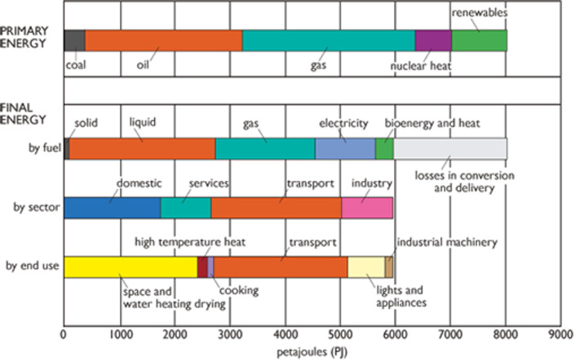
Figure 1: UK primary and final energy use, 2018
View description - Figure 1: UK primary and final energy use, 2018

The UK produces oil but its oil reserves have been falling. Peak UK oil production was in 1999 and it has fallen since then. The UK both imports and exports oil and its products. It became a net oil importer in 2006 and in 2023 net imports were almost a half of the total UK consumption (DESNZ, 2024).
The cost of oil imports is a serious national concern. The world price of oil has varied enormously from year to year since the 1970s. The COVID-19 pandemic resulted in curbs on transport use across the globe and a fall in oil demand. The world oil price fell from US$70 a barrel in 2018 to only US$30 in spring 2019. However, the war in Ukraine and restrictions on the purchase of Russian oil forced the price back up to over US$100 a barrel.
As will be described in Section 7 of this course, there is an ongoing rapid switch from oil to electricity as the UK’s main transport fuel. This raises the question of how much extra (low carbon) electricity will be required. At present, the transport oil fuel is burned with a relatively low efficiency in internal combustion engines (see Section 4 of this course). As shown in Figure 1, the UK’s final electricity consumption in 2018 was nearly 1100 PJ or about 300 TWh. Of this only about 5 TWh (about 1.7%) was used for transport. Electrifying the UK’s car and van fleet could produce an extra electricity demand of 65 – 100 TWh by 2050 (DfT, 2021a). You might like to reflect on exactly how all this is going to be generated.

2 Transport’s environmental impacts
Transport can produce both direct and indirect environmental impacts:
- Direct impacts: the results of transport operation, such as pollutants emitted by vehicles, noise intrusion, traffic accident casualties, and the land take of roads, railways and airports (i.e. the amount of land they use).
- Indirect impacts: how changes in travel behaviour lead to urban sprawl, changes in activity patterns and unhealthy lifestyles resulting from a lack of physical exercise.
This course focuses on energy issues, and for transport these tend to be the direct impacts concerning the source and amount of energy used in vehicles. However, the energy used in the manufacture and disposal of the vehicles and such items as batteries is a significant factor. This is likely to be entered into national statistics under the category of ‘industry’.

2.1 Local air pollution
The main local air pollutants from burning transport fuels in the UK are:
- Carbon monoxide (CO) – this is a highly toxic gas that can impair brain function and, in sufficient concentrations, kill. Transport was a significant source of CO in the 1970s but tightened emission standards have dramatically reduced emissions and it now only contributes about one sixth of the UK total.
- Nitrogen oxides (NO_{x}) – mainly the acidic gases NO, nitric oxide and NO2, nitrogen dioxide. These cause respiratory problems and contribute to low-level ozone formation and acid rain. In 2019 transport produced about 40% of all UK NO_{x} emissions.
- Particulate matter (PM) – this is responsible for respiratory problems and is thought to be a carcinogen. Small particulate matter, known as PM10 and PM2.5 (particles smaller than 10 μm and 2.5 μm in diameter respectively), is particularly dangerous as it can penetrate deep into the lungs.
- Volatile organic compounds (VOCs) – benzene (which can be a component of petrol) and 1,3-butadiene (a product of incomplete combustion of fuels) are both carcinogens. They are easily inhaled owing to their volatile nature. VOCs are also ‘ozone precursors’. In the presence of bright sunlight their presence can assist the oxidation of oxygen in the air to ground-level ozone, which is toxic, even in low concentrations.
Other pollutants are:
- Sulfur dioxide (SO₂) – this is an acidic gas that can affect health and damage vegetation. It is produced by the combustion of sulfur compounds in the fuel. Emissions of this have been dramatically reduced in the UK by refining the sulfur content out of road vehicle fuel. However, sulfur is still permitted in shipping diesel fuel.
- Lead dioxide dust – lead is a heavy metal that can cause brain damage. In the past, tetraethyl lead was a common additive to improve the octane rating of petrol. Its use was banned in the UK in 2000 and this ban is now almost worldwide.
The level of air pollution in a particular location or city can be reported as a combined Air Quality Index (AQI) figure, the higher the number, the worse the air quality. Different countries have slightly different AQI definitions, but generally, they attempt to reflect the overall likely negative effect on health.
This is a global problem. In the USA, California has long had serious vehicle air pollution problems. These have led to progressively tightening emission standards since the 1970s, which have necessitated the development of new ‘clean-up’ technologies.
In other countries such as India and China where emission standards are less developed, air pollution is particularly severe.
Total emissions of SO₂, NO_{x} and particulates in the UK have fallen significantly since 1990. However, in 2019 it was estimated that there were still 28,000 – 36,000 deaths each year attributable to human-made air pollution in England alone (PHE, 2019).
NO_{x} and particulate pollution are intensely localised around main roads. This can clearly be seen when monitored and then plotted or mapped on to the traffic grids of major cities.
Figure 2 shows estimated concentrations of a single pollutant, NO₂, in London in 2019, extrapolated from measurements at a number of sites.

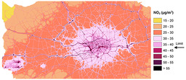
Figure 2: A map of estimated annual average NO₂ levels in London in 2019
View description - Figure 2: A map of estimated annual average NO2 levels in London in 2019

A gram of NO₂ emitted in London’s Oxford Street can do far more health damage than one emitted on a rural road because there is a higher density of people there to breathe it in. The financial damage cost of a gram of NO₂ thus depends on where and when it is emitted. This is unlike the damage cost for CO₂ which has a global effect and largely independent of where it is emitted.
Note that Figure 2 is a snapshot of NO₂ levels in 2019. London has had a series of progressively tightening ‘Low emission zone (LEZ)’ and ‘Ultra low emission zone (ULEZ)’ policies since 2008. These aim to make sure that only vehicles meeting the latest low emission standards enter the city and have resulted in significant reductions in pollution levels. Many other cities worldwide have introduced similar policies.

2.2 Transport’s carbon dioxide emissions
There is a second major issue: the emission of ‘greenhouse’ gases which contribute to climate change. These are mainly carbon dioxide (CO₂) from the combustion of fossil fuels, although with small contributions from nitrous oxide, a minor component of NO_{x} and methane, a product of incomplete fuel combustion.
Globally, in 2022, transport contributed over 20% of CO₂ emissions from the burning of fossil fuels (IEA, 2024).
In the UK, national domestic CO₂ emissions (i.e. those emitted within the UK) have fallen, but as shown in Figure 3, most of the reduction between 1990 and 2018 was in electricity generation. Despite tightening vehicle fuel efficiency standards over this time period, there was almost no change in overall transport emissions. In 1990, transport CO₂ emissions only made up about a fifth of total UK emissions. This proportion had risen to a third in 2018.

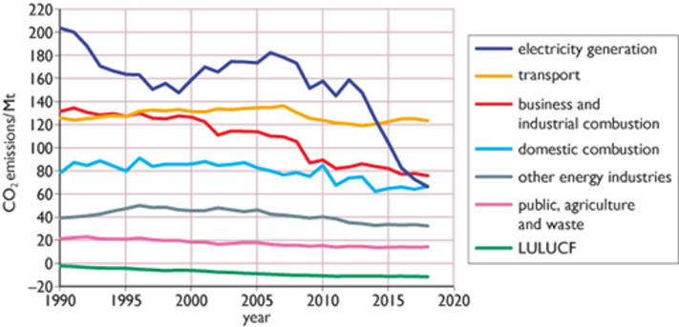
Figure 3: UK domestic CO₂ emissions by sector, 1990–2018
View description - Figure 3: UK domestic CO2 emissions by sector, 1990–2018

In 2018, greenhouse gas emissions from cars and taxis made up over a half of the UK domestic total (see Figure 4). Although domestic aviation and shipping only made up 6% of the total, there were a further 42 million tonnes of international emissions (shown in black) produced by aircraft and ships which refuel in the UK.

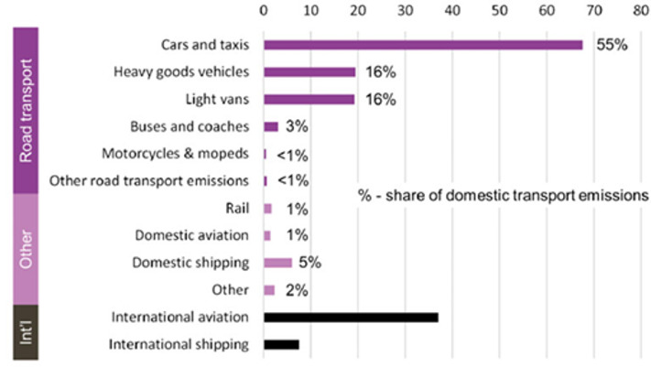
Figure 4: Greenhouse gas emissions by mode of transport (millions of tonnes), UK - 2019
View description - Figure 4: Greenhouse gas emissions by mode of transport (millions of tonnes), UK ...

The UK Committee on Climate Change, which advises the government, has been most insistent that UK policies should address both domestic and international transport emissions.

3 Is your journey really necessary?
The UK population has grown by about 30% since the early 1950s but transport energy demand has increased nearly fourfold. This growth is particularly a product of increased car travel, as shown in Figure 5.

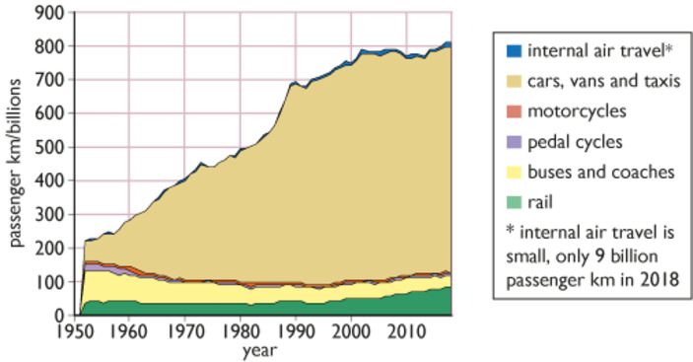
Figure 5: UK passenger transport by mode, 1952–2018
View description - Figure 5: UK passenger transport by mode, 1952–2018

Reducing transport energy use raises a number of questions. The first is: ‘Is your journey really necessary?’ The ultimate energy service of transport is mobility; however, this is not quite the same as physical transportation.
Modern telecommunications offer a form of mobility. The Covid-19 pandemic severely limited the movement of people throughout 2020 and 2021. Lock-downs in many countries have changed patterns of energy use, with large numbers of people working from home. This resulted in large reductions in transport energy use, particularly aviation, and global oil consumption in 2020 was down 8% from its 2019 level. It has been replaced, in part, by extensive use of home working, reducing the amount of physical commuting, and by tele-conferencing over the Internet. It is difficult to say how much of the ‘physical transport habit’ has been permanently broken. In the UK, final transport energy use in 2023 was 7% down on its pre-COVID level in 2019. It is still possible that the world could return to its previous ‘business as usual’ state.
The next question is ‘Can your journey be done in a less energy (and CO₂) intensive manner?’ Figure 6 compares the CO₂ emissions of different modes of transport, both within the UK and for short international journeys to and from it. They vary enormously in their emissions per passenger-kilometre travelled. Air travel, for example, is both energy and CO₂ intensive. International rail travel, between the UK and France through the Channel Tunnel, has the advantage of being both energy efficient and able to use low-carbon electricity.

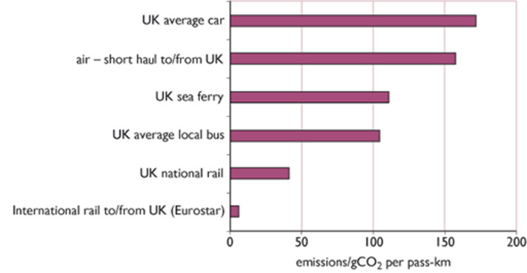
Figure 6: CO₂ emissions of different modes of UK transport
View description - Figure 6: CO2 emissions of different modes of UK transport

One social method to reduce the energy and CO₂ intensity of travel is modal shift, i.e. moving journeys away from the energy-intensive modes and towards the more energy-frugal ones.
For policy purposes, modes of transport can be ranked in a hierarchy, with walking and cycling at the top and air travel at the bottom (see Figure 7).

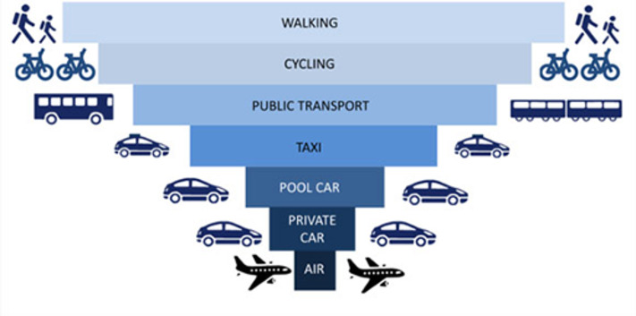
Figure 7: The low carbon hierarchy of transport modes
View description - Figure 7: The low carbon hierarchy of transport modes

For example, if a greater proportion of long-distance journeys within Europe were made by inter-city train rather than by air, the overall energy demand involved could be reduced substantially. In Sweden, an ‘anti-flying’ movement has arisen that has coined the word ‘flygskam’ (flying shame). Those who successfully shift to carrying out their journeys by train can indulge in a certain amount of ‘tågskryt’ (train bragging).
One particular target for improvement is the urban commuter who drives to work. The energy intensity could be significantly improved by making sure that cars contain more than just one person. Even better, the journey could be made by rail, bus or cycling.
The final question is, perhaps: ‘Does suburbia have a future?’ It may be necessary to create (and recreate) cities where it is not necessary to use a car to reach shops or schools, and they can be reached by walking or cycling.

4 Petrol and diesel engines
The vast majority of the world’s road vehicles are powered by petrol and diesel internal combustion engine (ICE), so we will start by looking at this technology, the emissions involved and ways that these emissions could be reduced.

Petrol engines
The most common form of petrol engine is the four-stroke Otto cycle engine. This uses a piston which is driven up and down inside a cylinder and connected to the drive section by a rotating crankshaft. At the top of a four-stroke engine there is a cylinder head containing a number of valves controlling the flow of gas in and out. The four ‘strokes’ are: induction, compression, power and exhaust, illustrated in Figure 8.

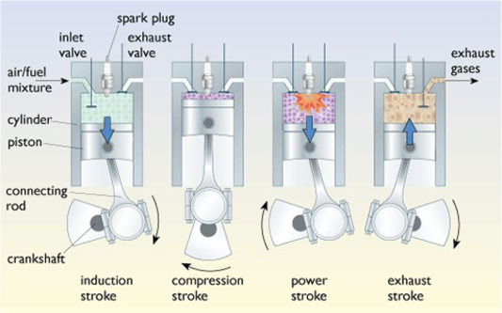
Figure 8: The four strokes of an Otto cycle engine
View description - Figure 8: The four strokes of an Otto cycle engine

On the induction stroke a small amount of fuel and air is drawn into the cylinder through the open inlet valve. The fuel/air ratio has to be controlled very tightly (typically to 1 gram of fuel to 14.7 grams of air) for clean combustion. In older cars the fuel and air was mixed in a carburettor, but in modern ones a specified quantity of fuel is injected by a computerised engine management system. When the piston reaches the bottom of the stroke the inlet valve closes. On the next stroke this air/fuel mixture is then compressed into typically one-tenth of its original volume, creating a highly inflammable mixture which is then ignited using an electric spark on a sparking plug. The gases then burn very rapidly reaching a high temperature (750 °C or more) and expand, pushing down the piston on the power stroke. Finally, on the exhaust stroke, the burned gases are pushed out into the exhaust system through the open exhaust valve. The whole cycle then repeats.
The power of the engine is controlled by varying the total amount of fuel and air admitted to the cylinder.
The reduction in volume during the second stroke is a rather critical factor called the compression ratio. If the volume of the cylinder is 300 cc when the piston is at the bottom of its stroke and the mixture is compressed down to only 30 cc when the piston is right at the top, then the compression ratio is 300:30 or 10:1. Typical figures for modern car engines are between 9:1 and 13:1.
An animated version of this four-stroke engine figure can be found on the Animated Engines website.

Diesel engines
The diesel engine works using the same four-stroke cycle as the petrol engine, but with two major differences involving the air–fuel mixture and injection systems. In the diesel engine, only the air is compressed in the cylinder instead of an air–fuel mixture, and at the end of the compression stroke, the fuel is directly injected into the combustion chamber by a fuel injection pump. In modern engines this pump is likely to be controlled by a computerised engine management system.
A typical compression ratio of 20:1 is used, which is sufficient to raise the air temperature to over 400 °C. Once the diesel fuel is injected into the cylinder, it immediately vaporises and spontaneously ignites without needing a sparking plug.
The power of the engine is controlled by varying the quantity of fuel injected. This means that the fuel/air ratio can vary over a wide range.
This diesel engine cycle can also be seen on the Animated Engines website
In general, the fuel efficiency of a diesel engine is higher than that of a petrol engine. This is primarily due to the fact that the combustion temperature within a diesel engine is higher (higher temperatures give a higher Carnot efficiency).
The higher combustion temperature also leads to higher emissions of nitrogen oxides (discussed later).
Petrol fuel and diesel for road vehicles (DERV) are internationally traded standard commodities (even though they are sold by different companies at the pump). The low heating value (LHV) properties of these fuelsare shown here in Table 2. (These values assume that the water vapour produced in combustion is released into the exhaust as steam).

Table 2 Properties of DERV and petrol
 | Low heating value /MJ kg⁻¹ | Low heating value /kWh litre⁻¹ | LHV CO₂ emissions /g CO₂ MJ⁻¹ | LHV CO₂ emissions /kg litre⁻¹
DERV (no blended biofuel) | 42.8 | 10 | 74 | 2.7
Petrol (no blended biofuel) | 44.8 | 9.1 | 70 | 2.3
Note that although diesel fuel has a slightly lower energy content per kilogram than petrol, it is denser and so contains more energy per litre. Diesel fuel contains a higher proportion of carbon and thus has a higher (i.e. worse) CO₂ emission factor than petrol.
BEIS, 2020

Petrol and diesel vehicle energy efficiency
In a diesel car engine about 32% of the heat energy is delivered to the crankshaft, compared to only about 24% in a petrol engine. As this energy is delivered to the wheels via the mechanical drive-train, more energy is ‘lost’ owing to friction. As a result, in theory about 24% of diesel fuel’s energy ends up being used for moving the car; in the case of petrol this figure is only 18%. In practice, the actual values found vary enormously with the vehicle type and with the driving conditions. ICEs are particularly inefficient in slow stop/start urban motoring and in situations of high acceleration; they work most efficiently running at a constant speed (for example on motorways).
If we consider how much of the fuel’s energy is actually used to move the payload (as opposed to the whole vehicle), the situation is even worse. Only around 1–2% of the fuel’s energy is used to move the vehicle’s occupants.

Box 2 Miles per gallon and litres per 100 km
The traditional UK unit of vehicle fuel efficiency is ‘miles per gallon’. This course uses the metric unit of ‘litres per 100 km’.
An old petrol car might achieve a consumption of 10 litres per 100 km. What is that in miles per gallon?
There are 4.546 litres in a (UK) gallon and 1.609 kilometres in a mile.
10 litres per 100 km = 10 / 4.546 gallons per 100 km
= 10 / (4.546 × 100) gallons per km
= 10 × 1.609 / (4.546 × 100) gallons per mile
= (4.546 × 100) / (1.609 × 10) miles per gallon = 28.3 miles per gallon
More simply:
Miles per gallon = 283 / litres per 100 km
Litres per 100 km = 283 / miles per gallon

Activity 2
10 minutes

List the key differences between petrol and diesel engines.

Provide your answer...
View answer - Activity 2

5 Petrol and diesel emissions
Petrol (known as gasoline or ‘gas’ in the USA) and diesel are refined from crude petroleum. Most of the world’s crude oil supplies are of ‘heavy oil’ which needs to be ‘cracked’ (heated and broken down) to produce shorter chains of hydrocarbons suitable for petrol and DERV fuel. Diesel fuel consists of longer hydrocarbon chains than petrol and needs only about half as much energy to refine. Note, however, that oil produced from ‘fracking’ is relatively light and more suitable for petrol than diesel.
Internationally, there has been a trend towards introducing cleaner conventional fuels through the removal of lead, sulfur and other additives and impurities. Lead was originally added to petrol early in the 20th century as an octane rating improver, but owing to proven health risks (particularly its effect on the mental development of young children), leaded fuels have been phased out in most developed countries and have been banned in the EU since 2000. The ban is now almost worldwide.
European fuel specifications have a low sulfur content. This has been necessary not just to reduce acid pollution emissions, but also to prevent poisoning of vehicle catalytic converters designed to reduce NO_{x} emissions. ‘Sulfur-free’ petrol and diesel (which in practice means a maximum of 10 parts per million by volume (ppmv)) has been required in the EU since 2009.
It is also worth pointing out here that sulfur dioxide emissions from the diesel engines of shipping are a matter of concern globally and particularly in port cities. Starting in 2020, the sulfur limit for shipping diesel has been reduced from 3.5% (35 000 ppmv) down to 0.5% (5000 ppmv). Note: ppmv = parts per million by volume.

Emissions in use, manufacture and disposal
Conventional road transport also leads to environmental pollution as a result of vehicle and fuel manufacture, the vehicles in use and the disposal of scrap vehicles. These impacts can be assessed using life cycle analysis, which traces all the environmental impacts of a product – from the extraction and processing of raw materials through to manufacture and delivery of the product, its use and what happens at the end of its life. For petrol- and diesel-engine cars, the energy consumed in use can be less than 20% of the total life cycle energy use (Rosendfeld et al., 2019). However, for electric vehicles operating on renewable energy, the proportion is likely to be higher. The actual CO₂ emissions involved in manufacture will depend on the fuels used. They are likely to be higher for vehicles manufactured in a coal-based country such as China than in the UK.
There are also environmental impacts associated with road construction, road maintenance and the development of the transport and fuel-supply infrastructure. All these other impacts are important, but course concentrates on the energy used for the vehicle operations themselves.

5.1 Petrol and diesel emission performance
Within an internal combustion engine (ICE), chemical reactions take place between the hydrocarbons (HCs) of the fossil fuel, any fuel additives and the oxygen and nitrogen gases in the atmosphere. These processes include complete and partial oxidation of the fuel, producing carbon dioxide (CO₂), water (H₂O) and carbon monoxide (CO). Nitrogen from the air is also oxidised to nitrogen oxides (NO_{x}). This reaction only takes place if the combustion temperature exceeds 1500 °C.
Partially burned and unburned fuel in the exhaust gases can form methane and a complex cocktail of volatile organic compounds (VOCs) together with small particles of sooty matter (‘particulates’ or PMs).
In bright sunshine tropospheric (low-level) ozone (O₃) is produced by the chemical action of sunlight on NO_{x} and VOCs. This has been a particular problem in sunny cities such as Los Angeles in the USA and Athens in Greece.
Petrol and diesel engines differ in their relative emissions performances. Petrol engines run with an almost constant fuel/air mixture. This makes designing for complete combustion relatively simple. In diesel engines the fuel/air mixture varies with the power output. At low power there is plenty of air to ensure complete combustion. However, at high power, there may be a high fuel/air ratio and (without proper clean-up technology) incomplete combustion can result in a pall of NO_{x}, black smoke and particulates from the exhaust pipe.
Overall petrol vehicles produce lower NO_{x} and particulate emissions. Despite the fact that DERV fuel, when burned, emits more CO₂ per MJ than petrol fuel, diesel vehicles produce less CO₂ per kilometre. This is because of the increased engine efficiency. The relatively high combustion temperatures attained in a diesel engine explain both diesel’s higher NO_{x} emissions (i.e. a combustion temperature greater than 1500 °C) and its lower CO₂ emissions (due to the engine’s higher efficiency). Levels of particulates up to 10 micrometres in size (termed PM₁₀) are also generally higher for diesel.
The CO₂ advantages of diesel engines, coupled with available technologies to reduce NO_{x} and particulate emissions, have led to diesel vehicles being promoted over petrol ones since 1990.

5.2 Technologies and standards
Over the last 50 years, several technological advances have significantly reduced the emissions from internal combustion engined vehicles.

Reducing pollution from petrol engines
One of the most important developments in emission-control technology for petrol (and other spark ignition) engines has been the introduction of the three-way catalytic converter (see Box 3). This technology was first used in the USA in the 1970s so that vehicles would conform to the US Clean Air Act, one of the first regulations that limited pollution from mobile (and stationary) sources. Since then, these catalyst systems have done much to improve air quality in the USA, Japan and Europe.

Box 3 Catalytic converters
Catalytic converters are an important type of ‘tailpipe’ or exhaust technology. Inside the catalytic converter, three catalysts are used, each to convert a different pollutant, hence the term ‘3-way’ catalytic converter. Platinum and palladium are used to help oxidise the unburned hydrocarbons and carbon monoxide to carbon dioxide, and rhodium is used to help convert the nitric oxides back to nitrogen and oxygen. The catalysts are applied to a support structure within the exhaust pipe with a high surface area through which the exhaust gases are made to flow.
A catalytic converter unit is usually protected in a steel canister located within the vehicle’s exhaust pipe. Most systems have to meet stringent durability requirements, including working for 100 000 km or 5 years – whichever occurs first.
Catalytic converters do have some inherent drawbacks. They are relatively ineffective before they have reached an initial ‘light-off’ temperature (between 150 °C and 300 °C), which means that they are inactive during short trips. Also, they tend to slightly increase fuel consumption (and hence CO₂ emissions). The precious metals in the converters can also be poisoned by certain fuel components such as lead and sulfur, which is why the use of catalysts has been dependent on the availability of lead-free and ultra-low sulfur fuels.

Reducing pollution from diesel engines
There are a range of possible technologies:
- Diesel particulate filters (DPFs) and oxidation catalytic converters – also known as Continuously Regenerating Traps (CRTs). These use a filter to trap sooty particulates, a control system to monitor the soot level and to make sure that these particulates are ‘burned off’ from the filter later on, thus ‘regenerating’ the filter.
- Exhaust gas recirculation – NO_{x} is only produced when the combustion temperature exceeds 1500 °C. A computerised engine management system can rapidly control the peak combustion temperature by recirculating some of the exhaust gas back into the engine air intake.
- Selective catalytic reduction (SCR) – this involves injecting ammonia (NH₃) into the exhaust where it reacts with NO_{x} emissions in the presence of a catalyst reducing the gases back to nitrogen. Vehicles using this technology have to top up with ‘diesel exhaust fluid’ (often known as ‘Adblue’), a mixture of urea (a compound of ammonia and oxygen) and water.
Particulate filters and oxidation catalysts are now fitted as standard to heavy-duty engines and are proven to reduce particulates by up to 90%.
As in the USA and Japan, legislation in Europe has been successful in reducing some of the pollutants associated with road transport. Key European legislation for passenger cars has been the ‘Euro’ standards, introduced periodically from 1992; similar limits have been introduced for light commercial vehicles (vans) and heavy-duty vehicles (the latter specified in terms of grams per kWh of engine output).
Note that these are measured in laboratory conditions, over a defined driving cycle. The tests represent a mix of urban and longer-distance inter-urban car journeys and can include long periods of running at a constant speed with little acceleration or deceleration.
Table 3 illustrates how the Euro standards have tightened since 1992.

Table 3 European emissions limits for passenger cars (grams per km)
Standard | Year | Petrol |  |  |  |  | Diesel
Standard | Year | CO | HC | NO_{x} | HC+NO_{x} | PM | CO | HC | NO_{x} | HC+NO_{x} | PM
Euro 1 | 1992 | 2.72 | – | – | 0.97 | – | 2.72 | – | – | 0.97 | 0.14
Euro 4 | 2005 | 1.0 | 0.10 | 0.08 | – | – | 0.50 | – | 0.25 | 0.30 | 0.025
Euro 6 | 2014 | 1.0 | 0.10 | 0.06 | – | 0.005 | 0.50 | – | 0.08 | 0.17 | 0.005
Source: data taken from DieselNet

5.3 Reducing CO₂ emissions
For petrol and diesel cars, CO₂ emissions are directly related to the fuel economy of the vehicle.
Key technologies for improving fuel economy include:
- optimisation of the internal combustion engine (ICE) for enhanced fuel efficiency using computer engine management
- auto start/stop – the automatic switching-off of the car’s engine when it idles (e.g. waiting in queues or at traffic lights). This can improve fuel consumption by up to 10% in urban driving.
- tyres with a low rolling resistance
- driver information technologies – for example, continuous displays of fuel consumption and indicator lights advising drivers when to shift to a high or lower gear to get the best fuel efficiency
- improved aerodynamics. This can include body streamlining, radiator grilles, underbody panels and spoilers designed to reduce drag.
Cars featuring these technologies may be sold as ‘eco’ models.
The most significant new technology has been the move to hybrid petrol-electric and diesel-electric drive trains, incorporating an electric storage battery. This allows:
- the use of regenerative braking to recharge the battery when braking or decending hills. This cuts the need for the internal combustion engine to generate electric power.
- tightly controlling the ICE engine to only run at its peak efficiency and minimum pollution levels.
This can be considered as part of the switch towards full battery-electric vehicles and will be described further in Section 7.
The tightening standards meant that the average CO₂ emissions of newly registered cars in Great Britain fell from about 170 grams per km in 2005 to only 122 grams per km in 2015, (DfT, 2015).
Although this was a significant improvement, it had become obvious that mere incremental changes to the existing fossil fuel-based technology would not produce the large reductions in national CO₂ emissions required to meet a policy of Net Zero emissions by 2050. In 2020, the UK government announced that the sale of new cars and vans powered solely by petrol or diesel fuel would be phased out by 2030.

5.4 Cheating on emission standards
So far, all of the emissions performance data given has been under ‘standard driving cycle’ conditions. This raises the interesting possibility that a car’s computerised engine management system might be able to recognise when the car was being ‘tested’. It could then comply with the NO_{x} emission regulations by limiting the peak power but ignore them otherwise.
In late 2015 the head of Volkswagen’s US business admitted to a US court that some of their cars had such a system. In 2017 the company agreed to pay US$4.3 billion in civil and criminal damages in the US. The company admitted that its specialists were not able to reconcile the conflicting goals of fuel economy and emissions, given the competition from hybrid petrol-electric cars (described later). Worldwide Volkswagen were forced to buy back hundreds of thousands of vehicles. By the end of 2018, the cost to the company was US$21 billion.
In 2016 the humorous scientific magazine Annals of Improbable Research awarded the ‘Ig Nobel Prize’ in chemistry to Volkswagen for this elegant method of ‘solving the problem of excessive automobile pollution emissions’.
The effect on the ‘green credentials’ of diesel cars has been considerable with calls for them to be banned from many European cities. The scandal has seriously assisted the move from fossil fuelled to electric cars.

Activity 3
15 minutes

A petrol car built in 2014 has a fuel consumption of 55 miles per gallon and meets the Euro 6 standards for NO_{x} emissions. It is running on petrol with no added biofuel which has an emission factor of 2.3 kg CO₂ per litre.
- Express the fuel consumption in litres per 100 km.
- The car is being used on a trip of 300 km. Calculate the quantity of CO₂ emitted in kilograms.
- What is the maximum amount of NO_{x} that it is permitted to emit over 300 km?

Provide your answer...
View answer - Activity 3

6 Lower-carbon fuels
An alternative approach to cutting CO₂ emissions is the use of transport fuels with a lower CO₂ emission factor. Two fossil fuel options for internal combustion engines are compressed natural gas (CNG) and liquefied petroleum gas (LPG). Other options are renewable liquid biofuels derived from plant or animal sources.

6.1 CNG and LPG vehicles
Compressed natural gas is basically methane (CH₄). Liquefied petroleum gas consists of a mixture of propane (C₃H₈) and butane (C₄H₁₀). Both or these have a higher ratio of hydrogen to carbon than petrol or diesel fuel. As shown in Table 4, these fuels have a slightly lower CO₂ emission factor than conventional DERV or petrol.

Table 4 CO₂ emission factors of fuels
Fuel | LHV CO₂ emission factor /g CO₂ MJ⁻¹
DERV (no blended biofuel) | 74
Petrol (no blended biofuel) | 70
LPG | 64
CNG | 57

CNG and LPG are cleaner burning than petrol or diesel and produce lower emissions of particulates. As such, these fuels have been promoted in cities with serious air-pollution problems, such as Buenos Aires in Argentina and New Delhi in India.
Overall, although CNG and LPG can improve urban air quality, they cannot drastically reduce transport’s carbon intensity simply because they are derived from fossil fuels.

6.2 Biofuels
Liquid biofuels, derived from plant or animal sources, have the potential to be carbon neutral. In theory, the CO₂ emitted during the processing and use of the fuel could be balanced by CO₂ absorption from the atmosphere during the fuel crop’s growth. However, in practice this is rarely the case as growing the biomass currently requires the input of fossil fuels for fertilisers, harvesting, crop processing and fuel distribution.
Such biofuels can be produced by the fermentation of energy crops or from vegetable oils or animal fats.
Biofuels can come from a wide number of sources, and include:
- bioethanol , an alcohol that can be produced from virtually any fermentable source of sugar.
- methanol, an alcohol that is normally produced from natural gas, but can also be produced from biomass. It has the disadvantage of being poisonous and requires careful handling.
- biodiesel, which is most commonly produced from energy crops such as oilseed rape or recycled vegetable oils. Although many vegetable oils can be burned directly in road diesel engines, most are chemically modified to produce biodiesel by a process called transesterification. This turns the oils into chemicals called fatty acid methyl esters (FAME).
- biogas, which is a mixture of methane and carbon dioxide gases. This can be produced from farm or food waste or sewage sludge by anaerobic digestion in the absence of oxygen.

Practical use
Transport biofuels have been widely used in many countries, primarily to reduce dependence on imported oil. They have been promoted in the USA ever since the oil crises of the 1970s and the USA is now the world’s largest consumer of them.
Although ethanol may be used in conventional petrol engines, it is not a complete ‘drop-in’ replacement. It is normally sold blended with petrol. In the UK, since 2021, petrol may contain up to 10% ethanol (this blend is called E10).
The effect of this is to reduce the CO₂ emission factor of pump petrol. In 2022, the average UK emission factor for petrol was 2.18 kg CO₂ per litre compared to 2.3 kg CO₂ for petrol with no added biofuel (BEIS, 2022).
Much higher proportions of ethanol are used in other countries. For example, 85% ethanol (E85) is used in Brazil.
Since the ethanol molecule contains some oxygen, blends of petrol and ethanol require a different fuel/air mixture and the ignition timing may need modifying. ‘Flexible fuel vehicles’ can change their engine settings automatically according to the fuel used.
Biodiesel may be used blended with conventional DERV or in a pure form (B100 = 100% biodiesel). It has a naturally low sulfur content which allows its use with catalytic clean-up systems to cut NO_{x} and particulate emissions.
The actual extent of greenhouse gas emissions is strongly dependent on the type of energy crop grown and the amount of fossil fuel used for processing.

Indirect environmental impacts of biofuels
Although using the right sort of biofuel could yield a significant reduction in transport CO₂ emissions, there have been serious criticisms in particular over the diversion of productive land from growing food and the destruction of rainforest for biofuel production.

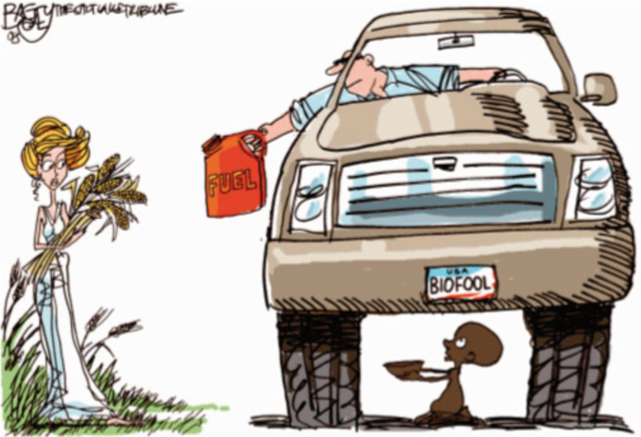
Figure 9: The biofuel dilemma
View description - Figure 9: The biofuel dilemma

As a result, transport biofuels from energy crops have fallen from favour in the EU and the UK. Given the alternatives of battery electric or hydrogen powered transport, the UK Committee on Climate Change has recommended that the use of biofuels in UK surface transport should be phased out in the 2030s (CCC, 2019). They suggest that its use in the UK should be restricted to the area most difficult to decarbonise, air transport.
However, the International Energy Agency sees a continuing expanding role for biofuels in transport. In its ‘Net Zero Emissions by 2050’ scenario, it projects world consumption of transport biofuels to more than double from 5 million tonnes in 2023 to 12 million tonnes by 2040 (IEA, 2024).
If you wish to explore this issue further, a useful online review of biofuel issues is provided on the explainthatstuff website.

7 Hybrid and electric vehicles
Electricity has been used to propel road vehicles since the 19th century, initially using batteries. Petrol-electric hybrid drive systems (without batteries) were developed in the early 20th century to avoid the difficulties of having to use a gearbox. This section looks at modern hybrid electric vehicles, using batteries, plug-in hybrid electric vehicles (PHEVs) where the battery can be recharged from the mains, and full battery electric vehicles (BEVs).

7.1 Battery and motor developments

Batteries
Lead-acid batteries have been used in battery electric vehicles since the 1890s. They have been the standard technology for vehicle starting and lighting ever since.
Battery electric vehicles using lead-acid batteries have been produced right through the 20th century. They have had the advantages of silence, relative reliability and being easy to drive. However, the critical disadvantages compared to fossil-fuelled vehicles have been the limited speed and range.

The importance of energy density
Petrol and diesel fuel have a very high energy density, both in terms of energy per unit weight and energy per unit volume, as shown in Table 5.

Table 5 Lower calorific value energy densities of transport fuels
Fuel | kWh per litre | kWh per kg
Petrol (no blended biofuel) | 9.1 | 12.4
DERV (no blended biofuel) | 10.0 | 11.9

The stored energy density of electricity in batteries is far lower. Even for the best lithium ion batteries, the energy density per kilogram is a factor of 60 lower than that for petrol.
Many types of rechargeable battery have been developed. Nickel cadmium (Ni-Cd) batteries were popular in the 1980s and nickel metal-hydride (NiMh) batteries were widely used in the 1990s. Figure 10 shows their energy densities, both in terms of stored energy per unit weight and energy per unit volume. Note the large increase in energy density as the technologies have progressed from lead-acid through to nickel metal hydride and lithium-ion batteries.

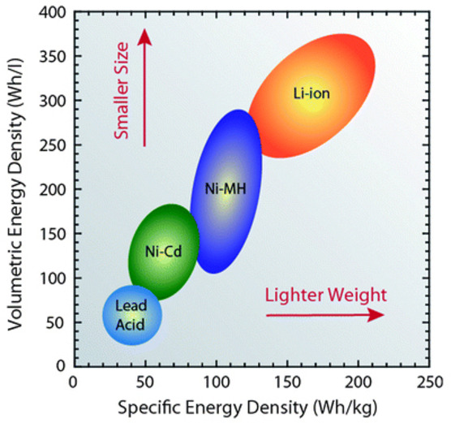
Figure 10: The energy density of different types of rechargeable batteries
View description - Figure 10: The energy density of different types of rechargeable batteries

The expansion in the use of plug-in hybrid electric vehicles (PHEVs) and full battery-electric vehicles (BEVs) since 2010 has been made possible by the high energy density of lithium-ion technology, coupled with extraordinary feats of mass production. Each cell of a lithium battery has a voltage of about 3.7 volts, so a typical 400 volt vehicle battery module will require over 100 cells. A whole battery may have 1000 or more. The large-scale production plants for these cells need to produce them in quantities of billions and the total energy storage produced per year can be measured in gigawatt-hours. The US Tesla company has thus called them gigafactories.
The cost of lithium-ion batteries has fallen from over US$1200 per kWh of electricity stored in 2010 to about US$130 in 2021 (Henze, 2021). Since the battery can make up a half of the total cost of a battery electric vehicle, its life expectancy is an important consideration. A typical warranty on BEV batteries is for a life of 8 years.

Electric motors
The first-generation electric vehicles used direct current (DC) motors, but more recent cars convert the direct current to alternating current (AC) using an electronic inverter, which then drives a variable speed induction motor. These motors are lighter and have a higher efficiency.

Environmental problems of materials
The rapid development of a new technology has raised questions about the toxicity and sustainability of the materials used.
Lithium-ion batteries do not contain highly toxic elements such as lead or cadmium. In 2023, world lithium reserves were estimated to be about 26 million tonnes (about a third in Chile). The reserve/production (R/P) ratio (i.e. the number of years the reserves will last if extracted at the current rate) was over 100 years.
However, the most common type of lithium-ion battery also contains the element cobalt, which is a by-product of copper mining. World cobalt reserves in 2023 were only about 10 million tonnes, with an R/P ratio of only 54 years. A half of the reserves were in the Democratic Republic of the Congo, which has had a long history of politic unrest. Newer low cobalt batteries contain 75–90% less cobalt than earlier generations of batteries, although they use twice as much nickel (which is also in short supply). This perhaps stresses the need for cobalt and nickel recycling from used battery packs.
The high efficiency electric motors used in electric vehicles have also created an increased demand for a range of ‘key elements’ such as copper and nickel required for basic wiring. Other ‘critical rare elements’ include cobalt, neodymium and samarium used in the manufacture of powerful magnets.
The need for such elements in batteries and motors could give rise to future ‘resource wars’ similar to those over oil and gas supplies in the past (and present). More optimistically, new battery technologies could be developed, such as lithium-sulfur or lithium-air, which are not so dependent on critical rare elements.

7.2 Hybrid and plug-in hybrid vehicles
As mentioned earlier in Section 5.3, combining an internal combustion engine (ICE) with a small storage battery and an electric drive motor is one way to improve the overall engine fuel efficiency. Petrol–electric hybrids were initially introduced in the late 1990s by Toyota and Honda, and are now offered by a large number of car manufacturers.
Overall, hybrids reduce fuel consumption through a combination of the following:
- reducing wasted energy during idling and low output, generally by turning off the ICE off and using the electric drive motor
- recapturing waste energy through regenerative braking
- using the internal combustion engine only when it can be run close to its maximum efficiency, substituting an electric motor at lower power and using it to boost the ICE for acceleration.
The battery is charged by the ICE when the engine loading is low.
The first generation of family hatchback hybrids, such as the Prius, introduced in 1997 (Figure 11), incorporated a 30 kW (40 hp) electric motor and a 1.7 kWh nickel metal hydride (NiMH) battery (i.e. only a slightly larger storage capacity than a normal car lead-acid starting battery).
They had CO₂ emissions of about 90 grams per km compared to 130 grams per km for a comparable standard petrol car.

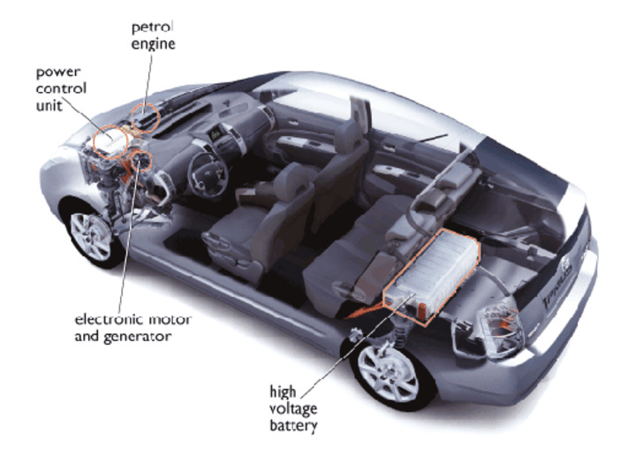
Figure 11: Cutaway section of a Toyota Prius Hybrid
View description - Figure 11: Cutaway section of a Toyota Prius Hybrid

Plug-in hybrid electric vehicles (PHEVs)
In the earliest hybrid designs, the vehicle would only be driven in full battery mode when starting, or at low speed, such as in slow traffic or when parking. However, increasing the storage capacity of the battery, to 4.4 kWh in the later 2017 Prius design, together with a larger, 60 kW (80 hp) electric motor, has allowed more flexible operation. The battery technology also moved from Ni-MH to lithium-ion technology. This, as shown in Figure 10, has a higher energy density per kilogram, so the larger storage capacity did not incur a serious weight penalty.
A PHEV can be operated in a full battery electric mode for short journeys, as well as in a hybrid mode with the ICE. The battery can either be recharged from the ICE or from the mains, thus saving on fossil fuel. Depending on the vehicle model, the battery capacity and the care taken in driving gently the electric range can be 20–60 kilometres.
Although the PHEV can be seen as a modification of a basic hybrid design, it may also be described as an extended range electric vehicle. It is essentially a battery electric vehicle whose internal combustion engine is only used on long journeys.
Key advantages of this configuration are that:
- most car trips are short and so for these the car will be running in pure electric mode
- the larger battery allows even higher efficiency improvements to the ICE performance, improving its energy efficiency and reducing its emissions
- it overcomes the range limitation of a pure battery electric vehicle.

7.3 Full battery electric vehicles (BEVs)
Full battery electric cars require a larger battery storage capacity than hybrids or PHEVs.
In the 1990s, they were only available in small numbers as variants of ICE cars. (For example, the Peugeot 106 electric car, using nickel-cadmium batteries, was manufactured from 1995 to 2003). The Indian REVA G-Wiz micro car, using lead-acid batteries, was launched in 2001 and secured a small niche market becoming the world’s best selling electric vehicle in 2006.
The real change has taken place more recently. In the nine years between 2012 and 2021 global sales, PHEV and BEV vehicles increased by a factor of 50, with BEVs making up about 70% of the market.
A number of high-performance BEVs have been launched commercially, including the Nissan Leaf. This was initially produced with an 80 kW (107 hp) electric motor and a 24 kWh lithium ion battery, giving a range of 175 km. The battery size was increased in later models to 30 kWh.
As shown in Figure 12, the battery is fitted at the bottom of the car under the seats. The electric motor, control and charging electronics are all at the front of the car in the ‘engine bay’.

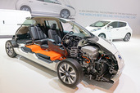
Figure 12: A cutaway of a Nissan Leaf BEV at a 2014 international trade fair
View description - Figure 12: A cutaway of a Nissan Leaf BEV at a 2014 international trade fair

The US company Tesla has developed the high end of the BEV market. Their battery electric roadster, introduced in 2008, was fitted with a 56 kWh lithium ion battery. It had a top speed of 200 kph and an advertised range of nearly 400 kilometres.
Since then, Tesla has produced a range of different BEVs. In June 2021, their Model 3 saloon became the first electric car to sell more than 1 million cars worldwide. Tesla has managed to make the electric car an aspirational item of social status. The first electric Rolls Royce production model, the Spectre, was launched in late 2023.
Electric car sales in the UK have also been increasing rapidly. In early 2025 there were 1.4 million BEVs and 780 000 PHEVs. However this only represents less than 7% of the total number of cars in the UK.

Activity 4
15 minutes

The 2010 Nissan Leaf was fitted with a 24 kWh battery and had a range of 175 km.
- How many kilowatt hours of electricity would be needed for a journey of 50 km?
- If the efficiency of the electric motor is 80%, calculate the energy used to actually move the car over this distance.
- The energy density of petrol is 9.1 kWh per litre. An equivalent petrol-engined car has a fuel consumption of 5 litres per 100 km. Calculate the energy content of the petrol consumed in covering 50 km.
- Assuming that the energy used to move the petrol car is the same as for the electric one, show that the thermal efficiency of the engine is 24%.
- If the electric car is recharged with domestic on-peak electricity at 25 p per kWh and the petrol car is refuelled with petrol at £1.50 per litre, calculate the fuel costs for each car over 50 km.

Provide your answer...
View answer - Activity 4

7.4 Charging infrastructure
In 2022, there were about 8500 conventional filling stations in the UK. The number and siting of them has been limited by the need for large underground fuel storage tanks and the logistics of tanker deliveries.
Setting up the necessary equivalent BEV charging infrastructure has a number of problems.
A fundamental difficulty is the speed of charging. Refilling the tank of a petrol or diesel car (and paying) can be achieved in a little over five minutes. Recharging a BEV car battery may take an hour or more, depending on the charging power and the ability of the battery to accept ‘rapid charging’.
A normal domestic 13 amp electric power socket can supply about 3 kW. At this rate, the 24 kWh battery of the early Nissan Leaf shown earlier would require 8 hours to fully recharge. Domestic BEV chargers normally operate at either 3 kW or 7 kW.
Figure 13 shows a typical public roadside charging point

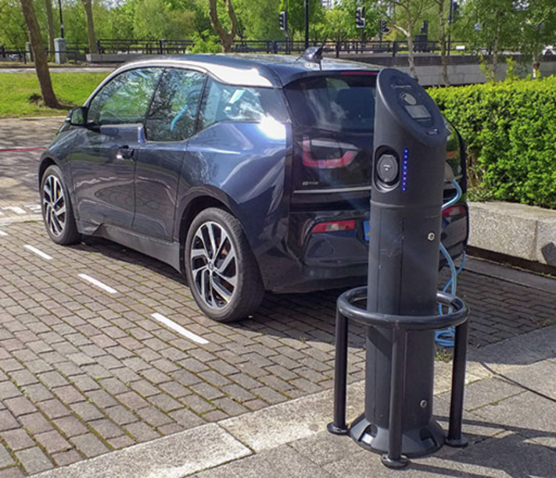
Figure 13: A roadside BEV charging point in Milton Keynes in 2021
View description - Figure 13: A roadside BEV charging point in Milton Keynes in 2021

Figure 14 shows three 50 kW ‘rapid’ chargers. At this rate, a 24 kWh battery would take about 30 minutes to recharge.

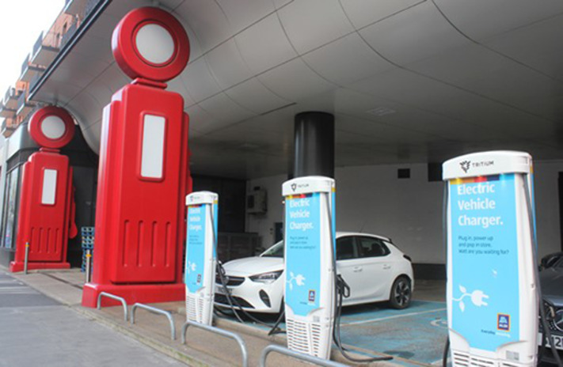
Figure 14: Three 50 kW rapid BEV chargers in a repurposed petrol station forecourt in London.
View description - Figure 14: Three 50 kW rapid BEV chargers in a repurposed petrol station forecourt ...

The need for cars to occupy parking space for some time may create issues for the design of future BEV ‘filling stations’. Additional charging points (and, most importantly, parking space) will be needed to cope with the relatively longer times to ‘fill up the car’ and facilities such as coffee shops will be needed to give the drivers and passengers something to do while they wait.
A full transition to BEV vehicles will also increase the UK’s total electricity demand (by up to 30% of its current level). Generating the extra ‘low carbon’ electricity is a national strategic issue, but there is also the question of the need to reinforce the local electricity distribution grid.
There is much concern that the provision of public electric vehicle charging points is not keeping up with the sales of BEV vehicles. In January 2025 there were about 73 000 public charging points available in the UK, but only 20% were ‘rapid chargers’.

7.5 Fuel cell vehicles
A fuel cell vehicle (FCV) is a hybrid electric car, but instead of using an internal combustion engine, energy is stored as hydrogen and a fuel cell converts that hydrogen into electricity to run the electric motor. A small rechargeable battery is also used as an energy store for regenerative braking.
Hydrogen fuel cells can be thought of as a form of battery, but where hydrogen and oxygen (from the air) are used instead of the lead and lead dioxide in the plates of a lead-acid car battery. Hydrogen can be manufactured in a wide variety of ways, but the fuel cells used in road vehicles require high purity hydrogen that is best produced by the electrolysis of water.
Hydrogen produced from electricity from renewable energy sources will have low associated CO₂ emissions and may be described as ‘green’ hydrogen. That from nuclear electricity has been called ‘pink’ hydrogen.
You may also like to look at Howstuffworks basics on fuel cells.

Hydrogen as a fuel
Hydrogen can be conveniently distributed and stored as a high pressure gas, typically at 700 bar (atmospheres) pressure.
The energy densities of petrol, DERV and batteries have been discussed in Section 7.1. Table 6 compares the densities of petrol and hydrogen.

Table 6 LCV energy densities of petrol and hydrogen
Fuel | kWh per litre | kWh per kg
Petrol (no blended biofuel) | 9.1 | 12.4
Hydrogen at 700 bar | 1.4 | 33.3

Hydrogen would appear to have a considerable advantage over petrol in that its energy density per kilogram is three times higher. However, its volumetric energy density is considerably worse. In practice, these figures are masked by the need to contain the hydrogen in suitably strong (and heavy) storage tanks. A practical vehicle hydrogen tank is likely to be far heavier than the hydrogen it contains.
High pressure hydrogen can be rapidly dispensed from filling pumps in a similar manner to petrol or DERV. However, the infrastructure problems of setting up a new network of hydrogen filling stations are even larger than those for battery electric vehicles.
Hydrogen remains an attractive option for forms of transport that undertake long journeys but require a short refuelling time and for which a limited number of refuelling points would be acceptable. Examples are long distance heavy goods vehicles, coaches, trains and even aircraft.

FCVs in practice
Interest in fuel cells for road transport developed with the rise in environmental concerns around transport in the 1980s and 1990s.
Fuel cell cars have been produced but sales worldwide have only been a tiny fraction of those of BEVs. The life expectancy of fuel cells has improved and is now considered sufficient to last the whole life of a car.
Fuel cell buses have been in use for over fifteen years in various European cities (see Figure 15) and much operational experience has been gathered for comparison with the rival low-carbon technology of battery-electric buses.

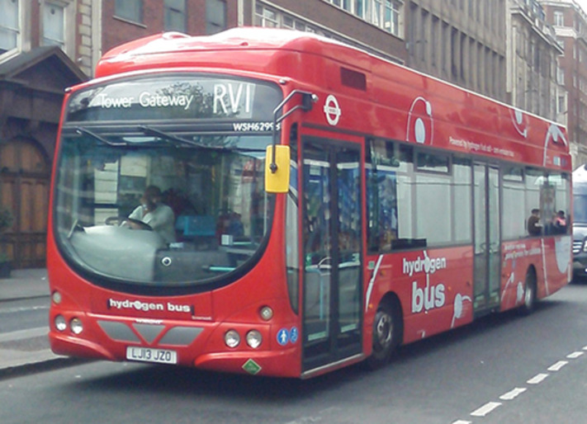
Figure 15: A hydrogen fuel cell bus in London
View description - Figure 15: A hydrogen fuel cell bus in London

8 The path to fully decarbonised transport
As pointed out in Section 2.2, apart from a large dip due to COVID lockdowns in 2020 and 2021, there has been little change in UK transport CO₂ emissions since 1990. This is in contrast to those from electricity generation which have fallen dramatically. Also, transport fuels are still almost totally based on oil.
The COP26 climate change meeting in Glasgow in 2021 stressed the urgent need to cut UK (and world) transport CO₂ emissions and the need to cut UK oil imports has been reinforced by the war in Ukraine.
In 2021, the UK government set out a number of policy objectives for decarbonising transport (DfT, 2021a, DfT, 2021b). Ranked in terms of the ‘hierarchy of transport modes’ of Figure 7, they are:

Improved provision for cycling and walking
There is a target that 50% of all journeys in UK towns and cities will be cycled or walked by 2030. This would include schemes to encourage schoolchildren to walk or cycle to school rather than being driven by their parents.

A zero carbon bus fleet
This would encourage the use of battery-electric and fuel cell buses, which are already being deployed in major cities. Hydrogen fuel cells are probably the most appropriate technology for long-distance coaches.

A decarbonised UK rail network
As shown in Figure 4, UK rail transport only makes up 1% of the UK’s domestic CO₂ emissions but is the one transport mode where electricity is already a major fuel source.
In 2019, 38% of the network was electrified and this covered two thirds of passenger rail use (Lyons et al., 2021). The other third still relied on diesel haulage and rail freight was mainly diesel hauled.
The carbon intensity of UK electricity has been falling and in 2018 was only 0.21 kg CO₂ per kWh. This is one reason why, as shown in Figure 6, the CO₂ emissions for UK national rail were only about 40 grams per passenger-km. This was less than a quarter of that for travel in a ‘UK average car’.
Reducing emissions will require further electrification of the system. However, this may not be economic for rural lines and for freight. There are two possibilities for replacing diesel traction:
- Battery-electric trains could be used on short routes. There is nothing new about this. Between 1932 and 1949, the 20 km route from Dublin to Bray in Ireland was operated by battery-electric trains equipped with nickel-zinc batteries.
- Hydrogen fuel cell trains entered service in Germany on rural routes in 2018. Their practical range could be over 600 km. In the UK, a prototype ‘Hydroflex’ train was tested in 2020, essentially a normal suburban electric train incorporating a 100 kW fuel cell and hydrogen storage tanks. Hydrogen freight locomotives are under development, but these will each require several megawatts of fuel cell power.

A transition to zero carbon cars and vans
According to the UK government reports, this is to be ‘market-led’. The sale of new petrol and diesel cars will only be allowed up to 2030 and that of plug-in hybrids (PHEVs) up to 2035.
There are a whole range of problems that will need to be tackled:
- Generating enough low carbon electricity to cope with the increased demand.
- Setting up a battery-charging infrastructure including provision for home charging. The UK government has a target of 300,000 public charging points by 2030 (an enormous increase on the 2021 figure of 23,000).
- Manufacturing sufficient batteries. This also includes ensuring stable supplies of key elements for both batteries and electric motors and for recycling them at the end of a car’s life.
- Producing cars with a sufficient range (and convincing sceptical customers).
- Training a workforce for the manufacture and maintenance of new technology.

Zero carbon road freight transport
Heavy goods vehicles may travel hundreds of kilometres. They are an area where the use of hydrogen fuel cells is attractive. Battery-electric operation poses problems for recharging. One intriguing possibility is the use of catenary technology, equipping motorways with overhead wires, allowing heavy goods vehicles to recharge their batteries while still moving. Tests are underway in the USA, Germany and Sweden.

Development of sources and distribution infrastructure for ‘green hydrogen’
This will be required for a whole range of ‘zero-carbon’ technologies.

8.1 International shipping
Shipping and aviation are ‘international’ topics and often get omitted from national transport policy considerations.
In 2023, globally CO₂ emissions from shipping made up about 2.3% of the total (IEA, 2024). The bulk of the world’s shipping currently uses large highly efficient diesel engines. These usually run on heavy fuel oil which has the advantage of being cheap, but it can be highly polluting (an international limit of 0.5% sulfur content was introduced in 2020).
A range of options for decarbonisation have been suggested.

Hybrid diesel-electric and full battery electric ships
For ships making short journeys, such as ferries, the weight of batteries may not be a serious problem. However, ports would need to introduce high capacity charging facilities.
A full battery electric ferry, the Aurora has been operating the 4 km crossing between Denmark and Sweden since 2018. The power ratings and battery capacity are about 100 times larger than those for a car. The Aurora has a 4.1 MWh lithium ion battery driving 6 MW of electric motors turning the propellers.

Watch the video at YouTube.com.
Video 1 Battery and charging system for an electric ferry

Alternative fuels
Biofuels – the fuel flexibility of large diesel engines potentially means that ship biodiesel would not have to reach the same tightly specified standard as road vehicle or aircraft biofuel. But could large quantities be produced sustainably and at an acceptable cost?
Hydrogen produced from low carbon sources – this could be used directly with fuel cells. As described earlier, the volume of the hydrogen required could pose problems. A better solution might be to convert it to liquid ammonia, which could be burned in large internal combustion engines.
Wind power – various schemes for ‘wind assistive technologies’ have been proposed to add automatically deployed and controlled sails to large cargo ships.
And, of course, there is always the option of reduced international shipping movement by using more home-produced goods.

8.2 International aviation
In 2019, globally CO₂ emissions from aviation made up about 2.9% of the total. Most of the fuel was consumed in the form of jet kerosene, which is a tightly specified, internationally traded, commodity.
Decarbonising aviation poses an even greater challenge than for shipping. What are the options?

Battery electric aircraft
A small electric aircraft, the Solar Impulse 2, powered directly by PV panels (plus a small lithium ion battery) has managed a 40,000 km trip in 17 stages right round the world in 2015 and 2016.
However, full size battery electric aircraft remain limited by the energy density of batteries. As described in Section 7.1, the stored energy per unit weight for the best current (2025) lithium ion batteries is only a small fraction of that of petroleum fuel. New battery technologies with higher energy densities are likely to be required before short haul battery electric passenger aircraft become commercially available.

Hydrogen
Industrial gas turbines as used for power stations are being manufactured that can run on hydrogen, so why not jet engines in aircraft? Or electric aircraft using fuel cells?
The Zeroavia company has been testing a small hydrogen powered aircraft using a 600 kW fuel cell. It aims to develop a short-haul 20-seat plane.
Again, although hydrogen has a weight advantage over kerosene in terms of energy density, the difficulty is the volume of the hydrogen fuel. Currently, long distance aircraft store their kerosene fuel in flexible tanks in the wings. Hydrogen would need to be stored at a very high pressure and the storage tanks will need to be within the body of the aircraft, reducing the number of passengers that can be carried.

Sustainable aircraft fuel (SAF)
Small quantities of ‘bio-kerosene’ produced from biomass sources have been produced and tested in commercial jet engines. However, the cost is high and the future demand for such a fuel would probably outstrip the available supply. This is thus a ‘technical possibility’ but with severe limits on its future deployment.

Conclusion
This course has looked at some of the environmental problems produced by UK transport. Local air pollution, particularly from NO_{x} and particulates, has required tightening emission standards since the 1990s. Many cities worldwide have now introduced “low emission” policies restricting access to only those vehicles meeting the latest standards.
The UK is now (early 2025) seeking to drastically reduce its total CO₂ emissions to ‘net zero’ by 2050. Past policies since the 1990s of incrementally improving the fuel economy of petrol- and diesel-engined cars will not produce a sufficiently radical improvement.
A step change is required:
- to ensure that overall transport demand is reduced and that it uses the least polluting modes of transport
- for a complete switch away from the use of fossil fuelled internal combustion engines to battery electric vehicles or those fuelled by hydrogen. In both cases, the electricity and the hydrogen needs to be provided from low-carbon sources such as renewable energy or nuclear power.
Although biofuels are currently blended with petrol and diesel fuel to reduce their carbon intensity, there are concerns about the sustainability of biofuel supplies. International shipping and aviation may prove to be sectors that will be difficult to decarbonise and biofuels could be a ‘choice of last resort’ for them.
This OpenLearn course is an adapted extract from the Open University course T213 Energy and Sustainability.

References
BEIS (2019a) Digest of United Kingdom energy statistics: Main chapters and Annex A dataset (DUKES), Department for Business, Energy and Industrial Strategy [Online]. Available at https://www.gov.uk/government/statistics/digest-of-uk-energy-statistics-dukes-2019 (Accessed 28 January 2025).
BEIS (2019b) UK Energy in Brief 2019, Department for Business, Energy and Industrial Strategy [Online]. Available at https://www.gov.uk/government/statistics/uk-energy-in-brief-2019 (Accessed 28 January 2025).
BEIS (2019c) Energy Consumption in the United Kingdom, Department for Business, Energy and Industrial Strategy [Online]. Available at https://www.gov.uk/government/publications/energy-consumption-in-the-uk-archive (Accessed 28 January 2025).
BEIS (2020) Final UK greenhouse gas emissions national statistics: 1990 to 2018: data tables, London, Department for Business, Energy and Industrial Strategy [Online]. Available at https://www.gov.uk/government/statistics/final-uk-greenhouse-gas-emissions-national-statistics-1990-to-2018 (Accessed 11 February 2025).
BEIS (2022) Greenhouse gas reporting: Conversion factors 2021, updated January 2022: data tables, Department for Business, Energy and Industrial Strategy [Online]. Available at https://www.gov.uk/government/publications/greenhouse-gas-reporting-conversion-factors-2021 (Accessed 12 February 2025).
CCC (2019), Net Zero – Technical report, Committee on Climate Change, London [Online]. Available at https://www.theccc.org.uk/wp-content/uploads/2019/05/Net-Zero-Technical-report-CCC.pdf (Accessed 11 February 2025).
DEFRA (2019) Greenhouse gas reporting factors: conversion factors 2019, London, Department of Environment, Food and Rural Affairs [Online]. Available at https://www.gov.uk/government/publications/greenhouse-gas-reporting-conversion-factors-2019 (Accessed 11 February 2025).
DESNZ (2024) UK Energy in Brief, 2024, Department for Energy Security and Net Zero [Online]. Available at https://www.gov.uk/government/statistics/uk-energy-in-brief-2024 (Accessed 28 January 2025).
DfT (2015) Average CO₂ emissions of newly registered cars, Great Britain, Department for Transport [Online]. Available at https://www.gov.uk/government/publications/new-car-carbon-dioxide-emissions (Accessed 11 February 2025)
DfT (2021a) Transitioning to zero emission cars and vans: 2035 delivery plan, Department for Transport [Online]. Available at https://www.gov.uk/government/publications/transitioning-to-zero-emission-cars-and-vans-2035-delivery-plan (Accessed 28 January 2025)
DfT (2021b) Decarbonising transport - A better, greener Britain, Department for Transport [Online]. Available at https://www.gov.uk/government/publications/transport-decarbonisation-plan (Accessed 3 February 2025)
Energy Institute (2024) Statistical review of world energy [Online]. Available at https://www.energyinst.org/statistical-review (Accessed 12 February 2025)
Everett, B., Peake, S. and Warren, J. (eds) (2021) Energy Systems and Sustainability: Power for a Sustainable Future, (3rd edn), Milton Keynes, The Open University/Oxford, Oxford University Press.
Henze, V. (2021) Battery Pack Prices Fall to an Average of $132/kWh, But Rising Commodity Prices Start to Bite, BloombergNEF [Online]. Available at https://about.bnef.com/blog/battery-pack-prices-fall-to-an-average-of-132-kwh-but-rising-commodity-prices-start-to-bite/ (Accessed 11 February 2025).
IEA (2024) World Energy Outlook 2024, International Energy Agency, Paris [Online]. Available at https://www.iea.org/reports/world-energy-outlook-2024 (Accessed 28 January 2025).
GLA (2016) London Atmospheric Emissions Inventory (LAEI) 2013: dataset, Greater London Authority [Online]. Available at https://data.london.gov.uk/dataset/london-atmospheric-emissions-inventory-2013 (Accessed 28 January 2025)
Lyons, G. et al. (2021) Decarbonising UK Transport - Final report and technology roadmaps: Report to the UK Department for Transport, Mott MacDonald and partners, March. [Online] Available at https://uwe-repository.worktribe.com/output/7584286/decarbonising-uk-transport-final-report-and-technology-roadmaps (Accessed 11 February 2025).
PHE (2019) Review of interventions to improve outdoor air quality and public health (March 2019), Public Health England [Online] Available at https://www.gov.uk/government/publications/improving-outdoor-air-quality-and-health-review-of-interventions (Accessed 28 January 2025).
Rosenfeld, D. et al. (2019) ‘Comparison of advanced fuels: Which technology can win from the life cycle perspective?’ Journal of Cleaner Production, Elsevier [Online]. Available at https://doi.org/10.1016/j.jclepro.2019.117879 (Accessed 11 February 2025).

Acknowledgements
This free course was written by Bob Everett, James Warren and Stephen Potter.
Except for third party materials and otherwise stated (see terms and conditions), this content is made available under a Creative Commons Attribution-NonCommercial-ShareAlike 4.0 Licence.
The material acknowledged below is Proprietary and used under licence (not subject to Creative Commons Licence). Grateful acknowledgement is made to the following sources for permission to reproduce material in this free course:
Course image: Filipe.Samora / Shutterstock
Figure 2: © Copyright 2025 Greater London Authority
Figure 4: Licensed under under the Open Government Licence v3.0. https://www.gov.uk/government/publications/decarbonising-uk-transport-technology-roadmaps
Figure 7: © Copyright Transport Scotland. Licensed under under the Open Government Licence v3.0. https://www.transport.gov.scot/media/43461/sustainable-travel.png
Figure 9: © Pat Bagley, Cagle Cartoons via CartoonStock.com
Figure 10: Redrawn slightly from Epec engineered technologies https://www.epectec.com/batteries/cell-comparison.html
Figure 11: Courtesy of Toyota (GB) plc.
Figure 12: © Sjo / Getty
Figure 13: Courtesy of Stephen Potter
Figure 14: Courtesy of Bob Everett
Figure 15: Courtesy of Bob Everett
Every effort has been made to contact copyright owners. If any have been inadvertently overlooked, the publishers will be pleased to make the necessary arrangements at the first opportunity.
Don’t miss out
If reading this text has inspired you to learn more, you may be interested in joining the millions of people who discover our free learning resources and qualifications by visiting The Open University – www.open.edu/openlearn/free-courses.

Glossary
anaerobic digestion
The decomposition of biomass in the absence of oxygen, producing a mixture of methane and carbon dioxide.
battery electric vehicle (BEV)
A vehicle that runs on electricity drawn from a battery (as opposed to a fuel cell).
BEV
See battery electric vehicle.
biodiesel
A biomass-derived alternative to DERV. The term can refer to a pure biofuel, or to a blend of DERV and biofuel.
bioethanol
An alcohol that can be produced from virtually any fermentable source of sugar.
biofuels
Types of fuel derived from biomass.
biogas
The mixture of methane and CO₂ produced by the anaerobic digestion of animal waste and wet food waste in a closed container.
carbon dioxide (CO₂)
A gas produced from the combustion of hydrocarbons and by respiration in plants and animals. Strictly speaking it is not toxic in the same sense as carbon monoxide, but it does not support respiration or burning and is a greenhouse gas.
carbon monoxide (CO)
A highly toxic gas that is produced by the combustion of any carbon-based fuel that takes place with insufficient oxygen. A powerful reducing agent used in the smelting of metals such as iron.
Carnot efficiency
The theoretical maximum efficiency of a heat engine or heat pump, which depends upon the difference between the starting and final temperatures of the process.
catalyst
A substance that increases the rate of a chemical reaction without itself undergoing any permanent chemical change.
catalytic converter
See three-way catalytic converter.
compressed natural gas
A gaseous fuel that can be used as an alternative to petrol or diesel for transportation, typically stored in high pressure tanks.
compression ratio
The reduction in volume during the compression phase of a four-stroke engine cycle. It is expressed as a ratio of the original volume to the reduced volume.
Delivered (or final) energy
Another term for final energy. The energy actually received by a consumer, for example that measured by a consumer’s electricity meter after the losses in generation and distribution. Contrast with primary energy.
DERV
Diesel fuel. The acronym stands for Diesel Engines for Road Vehicles.
diesel engine
A type of internal combustion engine. It has a higher compression ratio than a petrol engine. The diesel fuel ignites under pressure, rather than being ignited by an electric spark in a petrol engine.
Diesel particulate filters (DPFs)
A device for reducing the particulate matter emissions of diesel road vehicles.
E10
A blend of 10% ethanol and 90% petrol.
energy service
The ultimate aims for which energy systems are built: warm homes, cooked food, illumination, mobility and manufactured articles.
final energy
see delivered energy
fuel cell
A device for producing an electric current by means of what is essentially the reverse process to electrolysis – combining two gases (typically hydrogen and oxygen) to produce electricity.
fuel cell vehicle (FCV)
An electric car or bus that uses a fuel cell (and hence may need to carry hydrogen as a fuel) rather than a battery.
internal combustion engine (ICE)
A type of engine in which the fuel is burned inside the engine, such as the petrol and diesel engine.
‘joule (J)’
SI unit of energy
kilowatt-hour (kWh)
A unit of energy. If a device operates with a power of one kilowatt for one hour, the total cumulative energy that has flowed in that hour is one kilowatt-hour. The standard ‘unit’ of electricity bills.
lead-acid battery
A rechargeable battery based on plates of lead and lead dioxide with a sulfuric acid electrolyte, commonly used for car starting and lighting batteries.
‘light-off’ temperature
The engine temperature at which a three-way catalytic converter starts to work.
Liquefied petroleum gas
Butane and propane, alkanes which are gases at room temperature and can be liquefied under mild pressure. Sold for use in road vehicles, domestic heating and camping stoves and lanterns. Not to be confused with liquefied natural gas (LNG) which is mainly methane.
lithium ion batteries
A rechargeable battery based on lithium. It has a high energy density and is being widely used for computer batteries and electric cars.
low heating value (LHV)
The energy content of a hydrocarbon that is burned in a system where the water given off by the combustion is not condensed. Also known as the lower calorific value (LCV) or the net calorific value (NCV).
methane (CH₄)
The lightest of the alkanes, with the chemical formula CH₄. The major component of natural gas.
methanol
An alcohol, often used as a vehicle fuel. Largely produced from natural gas, but can also be produced from biomass.
modal shift
Moving journeys away from energy-intensive modes of travel and on to more energy-frugal modes. For example moving from car use to walking and cycling.
nickel metal-hydride (NiMh)
A rechargeable battery based on nickel and hydrogen. It may include a ‘rare earth’ such as lanthanum.
Nitrogen oxides (NO_{x})
NO_{x} consists of two oxides of nitrogen: the acidic gases NO, nitric oxide, and NO₂, nitrogen dioxide, both produced in high-temperature combustion. NO₂ is the more powerful acid gas. N₂O, nitrous oxide, is not normally classified as part of NO_{x} although it is an oxide of nitrogen. It is a powerful greenhouse gas.
octane rating
A rating of the capacity of petrol to resist spontaneous ignition (‘knocking’) prior to the ignition phase of the four-stroke engine cycle.
Otto cycle
Another term for the four-stroke petrol engine cycle.
oxidation catalytic converters
A device for reducing the particulate matter emissions of heavy-duty road vehicles. Also known as a one-way catalyst.
particulate matter (PM)
Solid particles that are small enough to float in air (a few microns in size). Also known as particulates.
particulates
Another term for particulate matter.
petrol
Confusingly, not the same as petroleum, but one of its products – a blend of light distillate hydrocarbons. Alternative names for petrol are motor spirit and gasoline.
petrol–electric hybrid
General term for a car that has both a petrol engine and a rechargeable battery used to drive an electric motor.
petrol engine
A type of internal combustion engine. Also known as the spark ignition engine because it uses a spark plug to ignite a petrol–air mixture in the cylinders. Most petrol engines use the four-stroke engine cycle.
petroleum
Alternative term for crude oil. (Not the same as petrol.)
plug-in hybrid
A car with a petrol engine and a battery that can be recharged by the engine but can also be charged by mains electricity.
PM
See particulate matter.
PM10
Particulate matter less than 10 microns in size.
PM2.5
Particulate matter less than 2.5 microns in size.
primary energy
The total energy content of an energy resource before that energy is extracted/transformed/processed. Primary energy is the starting point for an energy transformation system: the incoming ‘amount we have to work with’ before it is acted upon by power stations. See also notional primary energy input and final and delivered energy.
regenerative braking
The use of an electric motor during the braking of a vehicle to convert some of the kinetic energy of the vehicle into electrical energy to recharge the battery.
reserve/production (R/P) ratio
The number of years a given reserve will last if it continues to be produced/extracted at the current rate.
selective catalytic reduction (SCR)
A technique for reducing NO_{x} emissions using injected ammonia to reduce it to nitrogen. Variants of this method can be used in both coal-fired power stations and diesel engines.
sulfur dioxide (SO₂)
A gaseous by-product of the combustion of any fuel that contains sulfur. It contributes to acid rain and is a respiratory irritant.
three-way catalytic converter
A device for reducing the emissions of CO, NO_{x} and unburned hydrocarbons from the exhausts of petrol engines.
tetraethyl lead
A poisonous compound that used to be added to petrol in order to improve its octane rating.
volatile organic compounds (VOCs)
A range of hydrocarbons, many carcinogenic. They may be produced by combustion or are evaporated chemical solvents.

Solutions

Activity 1

Discussion
Energy use in transport reflects a mix of concerns that varies over time and between countries. The list that you have just made will contain a number of issues and may well be influenced by what is happening at the time you are studying.
Important topics include:
- the health implications of local air pollution, particularly NO_{x} from diesel vehicles
- the urgent need to reduce global carbon dioxide emissions
- continuously changing world oil prices affecting domestic fuel prices
- the possibility of armed conflicts (such as the war in Ukraine) interrupting oil supplies
- the honesty (or otherwise) of vehicle manufacturers about the emission standards of their products.
Energy issues are rarely about energy alone. They may also be about:
- financial costs (varying from the personal cost of travel, through to that of energy costs affecting industrial competitiveness)
- the impacts of traffic congestion (from its effects on people to its economic cost)
- energy security (i.e. not being dependant on energy supplies from politically unstable or unfriendly nations)
- health (for example, the effects of local air pollution or obesity brought about by lack of physical exercise)
- a whole range of environmental issues (such as the land take for new transport infrastructure, global warming etc.).
Back to - Activity 1

Activity 2

Answer
Petrol engines:
- compression ratio around 9:1 (up to 13:1 max.)
- relatively low temperature and pressure
- tightly controlled fuel/air ratio
- overall efficiency in moving the car about 18%
Diesel engines:
- compression ratio around 20:1
- direct injection of fuel
- variable fuel/air ratio
- relatively high temperature and pressure
- overall efficiency in moving the car about 24%
Back to - Activity 2

Activity 3

Answer
- If the fuel consumption is 55 miles per gallon:
Litres per 100 km = 283 / 55 miles per gallon
= 5.145 litres per 100 km
- Fuel consumption over 300 km = 3 × 5.145 = 15.44 litres
CO₂ emitted = 15.44 litres × 2.3 kg per litre = 35.5 kg
- From Table 3 in Section 5.2, the maximum NO_{x} emissions under the Euro 6 standard are 0.06 grams per km.
So maximum permitted emissions over 300 km
= 300 km × 0.06 g per km = 18 g
Back to - Activity 3

Activity 4

Answer
- If the car uses 24 kWh for 175 km:
energy used for 50 km = 24 kWh × 50 km / 175 km = 6.86 kWh
- If the efficiency of the electric motor is 80%, the energy produced to physically move the car = 80% × 6.86 = 5.49 kWh
- At 5 litres per 100 km:
petrol consumed for 50 km = 50 / 100 × 5 = 2.5 litres
Energy content = 2.5 l × 9.1 kWh l⁻¹ = 22.75 kWh
- If the physical energy used to move the vehicle is 5.49 kWh, thermal efficiency of engine
= 5.49 kWh / 22.75 kWh = 24%
- At 25 p per kWh, the cost for electric car
= 6.86 kWh × 25 p per kWh = £1.72
At £1.50 per litre, the fuel cost for the petrol car
= 2.5 litres × £1.50 = £3.75
Back to - Activity 4

Descriptions

Figure 1: UK primary and final energy use, 2018
This figure shows UK primary and final energy use in a stacked bar form. There are four horizontal bars, one above the other. The top bar is labelled at the left ‘Primary energy’. The lower three bars are labelled together as ‘Final energy’ and individually as being broken down ‘by fuel’, ‘by sector’ and ‘by end use’. There is an x-axis at the bottom which is marked in Petajoules with a scale running from zero to 9000.
The top bar, primary energy, contains the following items: coal, shown in black, about 360 petajoules; oil, shown in orange, about 2870 petajoules; gas, shown in blue-green, about 3140 petajoules; nuclear heat, shown in purple, about 660 petajoules; and renewables, shown in green, about 1000 petajoules. The total is just over 8010 petajoules.
The second bar, final energy broken down by fuel, contains the following items: solid fuel, shown in black, about 80 petajoules; liquid fuels, shown in orange, about 2660 petajoules; gas, shown in blue-green, about 1830 petajoules; electricity, shown in blue, about 1080 petajoules; bioenergy and heat, about 320 petajoules. This gives a total of nearly 6000 petajoules. There is a further section of the bar marked losses in conversion and delivery, shown in light grey of about 2040 petajoules which makes up a total of just over 8010 petajoules, equal to that in the top primary energy bar.
The third bar, final energy broken down by sector, contains the following items: domestic, shown in blue, 1730 petajoules; services, shown in blue-green, about 910 petajoules; transport, shown in orange, about 2390 petajoules; and industry, shown in pink, about 950 petajoules. The total is nearly 6000 petajoules, identical to that for the second bar.
The fourth bar, final energy broken down by end use, contains the following items: space and water heating drying, shown in yellow, about 2420 petajoules; high temperature heat, shown in dark red, about 150 petajoules; cooking, shown in light purple, about 140 petajoules; transport, shown in orange, about 2440 petajoules; lights and appliances, shown in light yellow, about 690 petajoules; and industrial machinery, shown in dark brown, about 150 petajoules. The total is nearly 6000 petajoules, identical to that for the second and third bars.
Back to - Figure 1: UK primary and final energy use, 2018

Figure 2: A map of estimated annual average NO2 levels in London in 2019
This is a map showing nitrogen dioxide concentrations in London. It covers an area approximately 50 kilometres from east to west and 30 kilometres from north to south. Central London is shown in the middle with Heathrow Airport visible at the lower left. The annual mean nitrogen dioxide concentration is shown by colour. A legend at the right shows yellow as indicating a level of between 15 and 20 microgrammes per cubic metre, light orange 20 to 25 microgrammes, orange 25 to 30 microgrammes, light pink 30 to 35 microgrammes, pink 35 to 40 microgrammes, light purple 40 to 45 microgrammes, mid-purple 45 to 50 microgrammes, dark purple 50 to 55 microgrammes, dark purple brown 50 to 55 microgrammes and dark brown over 55 microgrammes. There is an arrow to the right of the legend indicating a limit of 40 microgrammes. The map shows that the annual mean is only below 25 microgrammes in the outer suburbs and increases towards the centre of London. Most of central London has a level of 30 microgrammes or higher. The main roads are visible on the map as purple lines, indicating high levels of nitrogen dioxide, above the limit of 40 microgrammes. There are also high levels around Heathrow airport.
Back to - Figure 2: A map of estimated annual average NO2 levels in London in 2019

Figure 3: UK domestic CO2 emissions by sector, 1990–2018
This is a line chart of UK CO₂ emissions from different sectors of the economy from 1990 to 2018. It has a y- axis labelled CO₂ emissions in millions of tonnes with a scale which runs from minus 20 to plus 220. The x- axis is marked in years. It shows emissions from seven sectors: electricity, shown in dark blue; transport, shown in orange, business and industrial combustion, shown in red; domestic combustion, shown in light blue, other energy industries, shown in grey; public, agriculture and waste, shown in pale purple and land use, land use change and forestry, LULUCF*, shown in green. Emissions from the electricity sector started at about 200 million tonnes in 1990 and fell unevenly to 150 million tonnes in 1999 before rising to a peak of 182 million tonnes in 2006. They then fell unevenly to about 150 million tonnes in 2013 before falling more steeply to only 66 million tonnes in 2018. Emissions from transport are almost constant across the chart. They started at 125 million tonnes in 1990, rose to 135 million tonnes in 2007 and fell to just over 120 million tonnes in 2010, remaining at about that level until 2018. Emissions from business and industrial combustion have a slow declining trend across the chart. They started at 130 million tonnes in 1990, falling to 114 million tonnes in 2005 and to 75 million tonnes in 2018. Emissions from domestic combustion are almost constant across the chart. They started at about 80 million tonnes in 1990, and remained at about that level until 2013, after which they fell to 66 million tonnes in 2018. Emissions from other energy industries change little across the chart. They started at 40 million tonnes in 1990, rose slightly to 50 million tonnes in 1996 and then declined back to 40 million tonnes in 2010 and to just over 30 million tonnes in 2018. Emissions from public, agriculture and waste again change little across the chart. They started at about 20 million tonnes in 1990 and fell to 15 million tonnes in 2018. Emissions from land use, land use change and forestry are shown as negative, meaning a net uptake of CO₂. They started at about minus 2 in 1990, becoming minus 10 in 2005 and remaining at that level up to 2018.
Back to - Figure 3: UK domestic CO2 emissions by sector, 1990–2018

Figure 4: Greenhouse gas emissions by mode of transport (millions of tonnes), UK - 2019
This is a horizontal bar chart. It has a scale at the top in millions of tonnes. It shows UK domestic emissions broken down by mode. The percentage contribution of each mode is marked as a percentage. Contributions from road transport are shown in dark purple. Those for other categories are shown in light purple. The contributions for domestic transport are as follows: cars and taxis: 68 million tonnes or 55%; heavy goods vehicles: 19 million tonnes or 16%; light vans: 19 million tonnes or 16%; buses and coaches: 3.1 million tonnes or 3%; motorcycles and mopeds: 0.5 million tonnes, less than 1%; other road transport emissions: 0.5 million tonnes, less than 1%; rail transport: 1.7 million tonnes or 1%; domestic aviation: 1.4 million tonnes or 1%; domestic shipping: 6.1 million tonnes or 5%; other non road transport: 2.3 million tonnes or 2%. In addition, at the bottom there are two bars, shown in black for international transport that this not part of UK domestic transport statistics. International aviation contributes 37 million tonnes and international shipping 7.5 million tonnes.
Back to - Figure 4: Greenhouse gas emissions by mode of transport (millions of tonnes), UK - 2019

Figure 5: UK passenger transport by mode, 1952–2018
This is an area chart showing the changes in UK passenger transport by different modes between 1952 and 2018. It is broken down into: rail, shown in green; a group consisting of buses and coaches, shown in yellow; pedal cycles, shown in grey; motorcycles, shown in red; a group consisting of cars, vans, and taxis, shown in light brown and then internal air travel, shown in blue. At the left it has a y-axis labelled ‘passenger kilometres in billions’, with a scale running from zero to 900. At the bottom is an x-axis, which runs from 1952 to 2018 and labelled ‘year’. Overall, there has been an enormous growth in passenger transport, the total number of passenger kilometres rising strongly from 220 billion in 1952 to about 400 billion in 1970 and on to 750 billion in 2000. After that, growth has slowed, only reaching 800 billion in 2018. The rail contribution is relatively small starting at 38 billion in 1952 and remaining at about that level until 1995 after which it has grown steadily to about 80 billion in 2018. The contribution from buses and coaches has a slow falling trend. It starts at 92 billion in 1952, falling to 60 billion in 1970 and to only 35 billion in 2018. The contribution from pedal cycles is small, starting at 23 billion in 1952, falling to only 4 billion in 1970 and only rising slightly to 5 billion in 2018. The contribution from motorcycles is also small, starting at 7 billion in 1952, falling to about 4 billion in 1970 and rising slightly to 5 billion in 2018. The contribution from cars, vans and taxis shows spectacular growth across the chart. It starts at 58 billion in 1952, rising to nearly 300 billion in 1970, nearly 590 billion in 1990 and 640 billion in 2000. The growth then slows to reach 670 billion in 2018. The contribution from internal air travel is small. It is virtually zero in 1952, growing to only 2 billion in 1970 and then to a peak of about 10 billion in 2005 before falling slightly to only 9 billion in 2018.
Back to - Figure 5: UK passenger transport by mode, 1952–2018

Figure 6: CO2 emissions of different modes of UK transport
This is a chart of the carbon dioxide emissions per passenger kilometre for different modes of UK travel. It is a horizontal bar chart showing six modes of transport. The x-axis is labelled emissions in grams of carbon dioxide per passenger kilometre. The scale runs from zero to 200 grams. Reading downwards, the emissions for the six options are: UK average car, 172 grams of carbon dioxide per passenger kilometre; Air, short haul to and from the UK, 158 grams; UK sea ferry, 111 grams, UK average local bus, 104 grams; UK national rail, 41 grams and International rail to and from the UK by Eurostar, 6 grams.
Back to - Figure 6: CO2 emissions of different modes of UK transport

Figure 7: The low carbon hierarchy of transport modes
This chart shows a set of seven horizontal bars stacked one above the other. The bars decrease in width from top to bottom and give the overall shape of an inverted pyramid. The topmost and widest bar is labelled ‘walking’ and has drawings of walking schoolchildren at left and right. The next, narrower, bar is labelled ‘cycling’ and has images of bicycles at the left and right. The next, narrower, bar is labelled ‘public transport’ and has an image of a bus at the left and a train at the right. The next, narrower, bar is labelled ‘taxi’ and has an image of a taxi at the left and right. The next, narrower, bar is labelled ‘pool car’ and has an image of a car at left and right. The next, narrower, bar is labelled ‘private car’ and has an image of a car at left and right. The lowest and narrowest bar is labelled ‘air’ and has an image of an aeroplane at the left and right.
Back to - Figure 7: The low carbon hierarchy of transport modes

Figure 8: The four strokes of an Otto cycle engine
There are four sectional drawings of the engine arranged from left to right. Each view shows a piston moving inside a vertical cylinder. It is attached by a connecting rod to a rotating crankshaft at the bottom of the picture. The crankshaft is shown rotating in a clockwise direction. At the top of the cylinder there is a spark plug. At the top left of the cylinder is an inlet port opened and closed by an inlet valve. There is also an exhaust port opened and closed by an exhaust valve.
Back to - Figure 8: The four strokes of an Otto cycle engine

Figure 9: The biofuel dilemma
This is a cartoon. In the centre is an enormous car with a number plate reading ‘Biofool’. The driver is leaning out of the window waving a fuel tank towards and stylised fertility goddess at the left holding stems of wheat. A small child is shown kneeling under the car holding a food bowl and looking upwards to the car driver.
Back to - Figure 9: The biofuel dilemma

Figure 10: The energy density of different types of rechargeable batteries
This chart shows the energy density of four different types of rechargeable battery. It has a y- axis labelled ‘volumetric energy density’ in watt-hours per litre, with a scale running from zero to 400. A red upward-pointing arrow next to the axis is labelled smaller size. The x- axis is labelled ‘specific energy density’ in watt-hours per kilogram, with a scale running from zero to 250. A red arrow pointing to the right is labelled ‘lighter weight’. There are four coloured shapes indicating the properties of the batteries. A blue circle is labelled ‘Lead acid’. The range of volumetric energy densities is between 30 and 90 watt hours per litre and that for the specific energy density between 20 and 60 watt hours per kilogram. A green ellipse is labelled ‘nickel cadmium’. The range of volumetric energy densities is between 70 and 180 watt hours per litre and that for the specific energy density between 40 and 90 watt hours per kilogram. A blue ellipse is labelled ‘nickel metal hydride’. The range of volumetric energy densities is between 110 and 290 watt hours per litre and that for the specific energy density between 85 and 130 watt hours per kilogram. An orange ellipse is labelled ‘lithium ion’. The range of volumetric energy densities is between 240 and 380 watt hours per litre and that for the specific energy density between 125 and 215 watt hours per kilogram.
Back to - Figure 10: The energy density of different types of rechargeable batteries

Figure 11: Cutaway section of a Toyota Prius Hybrid
This is a cutaway drawing of a Toyota Prius petrol-electric car. It is shown viewed from high above the rear left-hand side of the car. The front of the car is to the left of the diagram. At the front of the car, labels show the locations of the ‘power control unit’, the ‘petrol engine’ and the ‘electronic motor and generator. At the rear of the car under the rear seats is shown the ‘high voltage battery’.
Back to - Figure 11: Cutaway section of a Toyota Prius Hybrid

Figure 12: A cutaway of a Nissan Leaf BEV at a 2014 international trade fair
This is a photograph of a Nissan Leaf battery electric car which has been cut away lengthwise to show the interior components. The front of the car is shown pointing to the right. The engine bay in front of the driver’s seat contains the electric motor driving the front wheels and a lot of control equipment. The storage battery is shown in orange positioned in the floor under the seats.
Back to - Figure 12: A cutaway of a Nissan Leaf BEV at a 2014 international trade fair

Figure 13: A roadside BEV charging point in Milton Keynes in 2021
This is a photograph of an electric car plugged into a charging point on a small black pillar on the pavement.
Back to - Figure 13: A roadside BEV charging point in Milton Keynes in 2021

Figure 14: Three 50 kW rapid BEV chargers in a repurposed petrol station forecourt in London.
This is a photograph of a repurposed petrol station forecourt. At the left there are two enormous bright red advertising models of petrol pumps each about six metres high. To the right are three light blue and white boxes about two metres high each labelled ‘electric vehicle charger’.
Back to - Figure 14: Three 50 kW rapid BEV chargers in a repurposed petrol station forecourt in London.

Figure 15: A hydrogen fuel cell bus in London
This shows a single decker red London bus in a city street. It has a small sign saying ‘hydrogen bus’ on the front.
Back to - Figure 15: A hydrogen fuel cell bus in London

