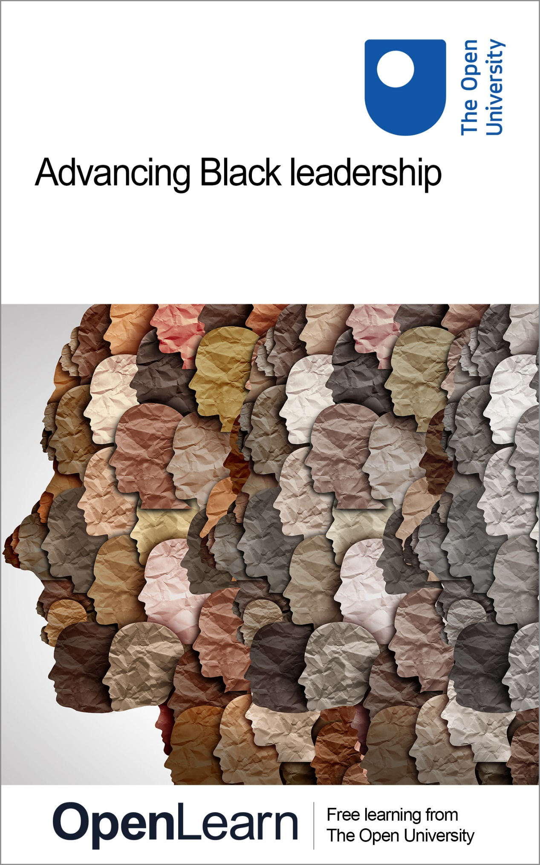

BLL_2

Advancing Black leadership

About this free course
This version of the content may include video, images and interactive content that may not be optimised for your device.
You can experience this free course as it was originally designed on OpenLearn, the home of free learning from The Open University:
https://www.open.edu/openlearn/society-politics-law/introducing-black-leadership/content-section-overview
There you’ll also be able to track your progress via your activity record, which you can use to demonstrate your learning.
Unless otherwise stated, copyright © 2024 The Open University, all rights reserved.
Intellectual property
Unless otherwise stated, this resource is released under the terms of the Creative Commons Licence v4.0 http://creativecommons.org/licenses/by-nc-sa/4.0/deed.en_GB. Within that The Open University interprets this licence in the following way: www.open.edu/openlearn/about-openlearn/frequently-asked-questions-on-openlearn. Copyright and rights falling outside the terms of the Creative Commons Licence are retained or controlled by The Open University. Please read the full text before using any of the content.
We believe the primary barrier to accessing high-quality educational experiences is cost, which is why we aim to publish as much free content as possible under an open licence. If it proves difficult to release content under our preferred Creative Commons licence (e.g. because we can’t afford or gain the clearances or find suitable alternatives), we will still release the materials for free under a personal end-user licence.
This is because the learning experience will always be the same high quality offering and that should always be seen as positive – even if at times the licensing is different to Creative Commons.
When using the content you must attribute us (The Open University) (the OU) and any identified author in accordance with the terms of the Creative Commons Licence.
The Acknowledgements section is used to list, amongst other things, third party (Proprietary), licensed content which is not subject to Creative Commons licensing. Proprietary content must be used (retained) intact and in context to the content at all times.
The Acknowledgements section is also used to bring to your attention any other Special Restrictions which may apply to the content. For example there may be times when the Creative Commons Non-Commercial Sharealike licence does not apply to any of the content even if owned by us (The Open University). In these instances, unless stated otherwise, the content may be used for personal and non-commercial use.
We have also identified as Proprietary other material included in the content which is not subject to Creative Commons Licence. These are OU logos, trading names and may extend to certain photographic and video images and sound recordings and any other material as may be brought to your attention.
Unauthorised use of any of the content may constitute a breach of the terms and conditions and/or intellectual property laws.
We reserve the right to alter, amend or bring to an end any terms and conditions provided here without notice.
All rights falling outside the terms of the Creative Commons licence are retained or controlled by The Open University.
Head of Intellectual Property, The Open University

Contents
- Introduction and guidance
  - Introduction and guidance
  - What is a badged course?
  - How to get a badge
- Week 1: Understanding power and its effects
  - Introduction
  - 1 Defining power
  - 2 Power over bodies
    - 2.1 Power over movement
    - 2.2 Power over space
    - 2.3 Power over life
  - 3 Power over minds
    - 3.1 Colonialism, racism and the mind
    - 3.2 Gaslighting
  - 4 This week’s quiz
  - 5 Summary of Week 1
- Week 2: Frameworks of power
  - Introduction
  - 1 Faces of power
    - 1.1 Decision-making power
    - 1.2 Non-decision-making power
    - 1.3 Ideological power
  - 2 Bases of Power
  - 3 Powerful solidarity
  - 4 This week’s quiz
  - 5 Summary of Week 2
- Week 3: From power to resistance
  - Introduction
  - 1 Power-resistance
    - 1.1 Defining resistance leadership
    - 1.2 Constructive dissent and destructive consent
    - 1.3 Radical resistance leadership
  - 2 From resistance to power
    - 2.1 Mimicking the oppressor
    - 2.2 Resisting resistance
    - 2.3 Stuck in opposing
  - 3 This week’s quiz
  - 4 Summary of Week 3
- Week 4: Forms of resistance
  - Introduction
  - 1 Mapping forms of resistance
    - 1.1 Continuums of resistance
    - 1.2 Four Is of resistance
  - 2 Resistance as distance, persistence and difference
    - 2.1 Resistance through distance
    - 2.2 Resistance through persistence
    - 2.3 Resistance through difference
  - 3 Resistance under corrupt conditions
  - 4 This week’s quiz
  - 5 Summary of Week 4
- Week 5: Influencing professional power of local public services
  - Introduction
  - 1 Local public services and their bureaucratic apparatus
    - 1.1 The power of professionals
  - 2 Local professional power
    - 2.1 Engaging with Local professional power
    - 2.2 Minorities’ engagement with local professional power
  - 3 Holding local public service professionals accountable
  - 4 Challenging professional power through internal complaint procedures
  - 5 Holding professionals accountable through professional and oversight bodies
  - 6 Professional power and Public Sector Equality Duty
    - 6.1 Equality Act 2010
    - 6.2 Northern Ireland Act 1998
  - 7 This week’s quiz
  - 8 Summary of Week 5
- Week 6: Influencing the power of corporations on the ground
  - Introduction
  - 1 Understanding the power of businesses and corporations
    - 1.1 Power – businesses and corporations
  - 2 Historical legacy of corporate power on Black people
    - 2.1 Choosing between racial equality and racial equity
  - 3 Mediating corporate power through civil society institutions
    - 3.1 Civil society organisations
  - 4 Mediating corporate power through public institutions
    - 4.1 Redress for victims and witnesses of discrimination
  - 5 Mediating corporate power through individual action
    - 5.1 Boycott brands
    - 5.2 Resignation
  - 6 This week’s quiz
  - 7 Summary of Week 6
- Week 7: Campaigning
  - Introduction
  - 1 What is campaigning?
    - 1.1 Mobilising human resources
    - 1.2 What is a constituency?
  - 2 Electing leaders
  - 3 Applying pressure to leaders
    - 3.1 Internal vs external campaigning
    - 3.2 Strategy and tactics
  - 4 This week’s quiz
  - 5 Summary of Week 7
- Week 8: Organising – building collectives for change
  - Introduction
  - 1 Organising as building power
    - 1.1 The membership organisation
    - 1.2 Campaigning to build the organisation
    - 1.3 Leadership and organising
  - 2 Workplace organising
    - 2.1 Mapping your workplace
    - 2.2 Moving to a campaign
  - 3 Community organising
    - 3.1 Mapping your community
    - 3.2 The organising drive
    - 3.3 Moving to a campaign or just getting to work?
  - 4 This week’s quiz
  - 5 Summary of Week 8
  - Tell us what you think
  - References
  - Acknowledgements
- Solutions
- Descriptions

Introduction and guidance

Introduction and guidance
Welcome to this free badged course, Advancing Black leadership.
The course lasts eight weeks, with approximately three hours of study per week. You can work through the course at your own pace, so if you have more time one week there is no problem with pushing on to complete another week’s study. You can also take as long as you want to complete it.
There are lots of opportunities to check your learning, including short quizzes at the end of each week. The quizzes at the end of Week 4 and Week 8 are a bit longer and will contribute towards earning a digital badge to recognise your achievement.
Badges are not accredited by The Open University but they’re a great way to demonstrate your interest in the subject and commitment to your employer/potential employer, and to provide evidence of continuing professional development. You can find out more about the badges in the next section.
Learning outcomes
After studying this course, you should be able to:
- understand the meaning of power and how it is exercised to maintain racial inequality
- identify and engage with various forms of power that can be exercised through Black leadership to enact radical and systemic change
- identify key issues in organisations and society that can be worked upon through powerful Black leadership
- use organising tools and techniques to maximise the power exerted through Black leadership.
Moving around the course
In the ‘Summary’ at the end of each week, you can find a link to the next week. If at any time you want to return to the start of the course, click on ‘Full course description’. From here you can navigate to any part of the course. Alternatively, use the week links at the top of every page of the course.
The Open University would really appreciate a few minutes of your time to tell us about yourself and your expectations for the course before you begin, in our optional start-of-course survey. Once you complete the course we would also value your feedback and suggestions for future improvement, in our optional end-of-course survey. Participation will be completely confidential and we will not pass on your details to others.

What is a badged course?
While studying Advancing Black leadership, you have the option to work towards gaining a digital badge.
Badged courses are a key part of The Open University’s mission to promote the educational well-being of the community. The courses also provide another way of helping you to progress from informal to formal learning.
To complete a course you need to be able to find about 24 hours of study time, over a period of about 8 weeks. However, it is possible to study them at any time, and at a pace to suit you.
Badged courses are all available on The Open University’s OpenLearn website and do not cost anything to study. They differ from Open University courses because you do not receive support from a tutor. But you do get useful feedback from the interactive quizzes.
What is a badge?
Digital badges are a new way of demonstrating online that you have gained a skill. Schools, colleges and universities are working with employers and other organisations to develop open badges that help learners gain recognition for their skills, and support employers to identify the right candidate for a job.
Badges demonstrate your work and achievement on the course. You can share your achievement with friends, family and employers, and on social media. Badges are a great motivation, helping you to reach the end of the course. Gaining a badge often boosts confidence in the skills and abilities that underpin successful study. So, completing this course should encourage you to think about taking other courses.

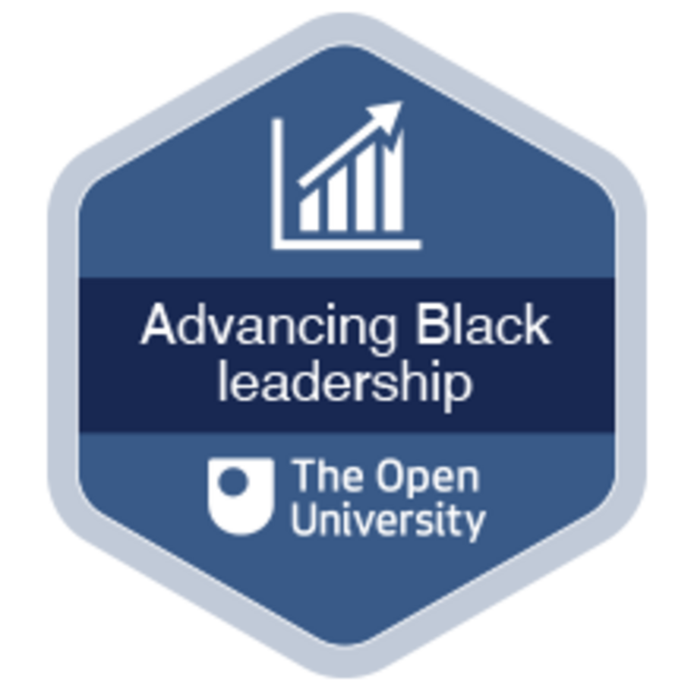

How to get a badge
Getting a badge is straightforward! Here’s what you have to do:
- read each week of the course
- score 50% or more in the two badge quizzes in Week 4 and Week 8.
For all the quizzes, you can have three attempts at most of the questions (for true or false type questions you usually only get one attempt). If you get the answer right first time you will get more marks than for a correct answer the second or third time. Therefore, please be aware that for the two badge quizzes it is possible to get all the questions right but not score 50% and be eligible for the badge on that attempt. If one of your answers is incorrect you will often receive helpful feedback and suggestions about how to work out the correct answer.
For the badge quizzes, if you’re not successful in getting 50% the first time, after 24 hours you can attempt the whole quiz again, and come back as many times as you like.
We hope that as many people as possible will gain an Open University badge – so you should see getting a badge as an opportunity to reflect on what you have learned rather than as a test.
If you need more guidance on getting a badge and what you can do with it, take a look at the OpenLearn FAQs. When you gain your badge you will receive an email to notify you and you will be able to view and manage all your badges in My OpenLearn within 24 hours of completing the criteria to gain a badge.
You can now go to Week 1.

Week 1: Understanding power and its effects

Introduction
This week was written by Owain Smolović Jones and Fidèle Mutwarasibo.


Figure 1 Harnessing power to achieve equity lies at the heart of Black leadership
View description - Figure 1 Harnessing power to achieve equity lies at the heart of Black leadershi ...

Power is the key ingredient for leadership in general and Black leadership in particular. Power is the capacity to affect the world around you, for better or worse. Historically, colonial Britain – and colonial powers more generally – systematically disempowered Black people, diminishing or removing their capacity to affect the world. Such disempowerment took the form of overt racism – racial slurs, segregation, slavery, physical attack and murder – but also subtler forms of disempowerment, such as microaggressions, derogatory cultural portrayals of Black people in culture and the deployment of racial stereotypes. Even as overt structures of disempowerment are challenged and defeated through law, we know that covert and subtler forms of racism persist.
It is important to understand how power works so that you can be better positioned to offer alternative forms of power. You will therefore begin this week of study by defining power, learning that it is not something inherently bad or good, but a collective capacity that can be put to various uses. From the basis of this definition, you will think about the largely negative effects of power – on the body and on the mind. You will explore how the body is restricted and potentially liberated as power affects movement, space and life. In terms of the mind, you will consider how the legacy of colonialism continues to affect mental health and the capacity of people to lead in ways that enhance equity. You will also learn how to identify practices of gaslighting, which are deployed to disguise oppressive forms of power, such as racism.
By the end of this week, you should be able to:
- understand a definition of power as the ability to affect the world around you, which can be used for oppressive or equity-enhancing ends
- identify and critically analyse ways in which power affects movement, space and life
- identify and critically analyse ways in which power affects the mind in relation to leadership practice.
The Open University would really appreciate a few minutes of your time to tell us about yourself and your expectations for the course before you begin, in our optional start-of-course survey. Participation will be completely confidential and we will not pass on your details to others.

Before you start
Make sure you’ve read the Introduction and guidance section which gives advice on navigating through and completing the course.

1 Defining power
Power is a word that can provoke worry. This is because people think of power as something that oppresses and abuses – often using the authority of official institutions and the law to do so. Such views of power are of course legitimate and important to understand, as they speak to the everyday experiences of many Black people in the UK. However, it is also important to understand that power can be deployed more positively to enact change that enhances equity.

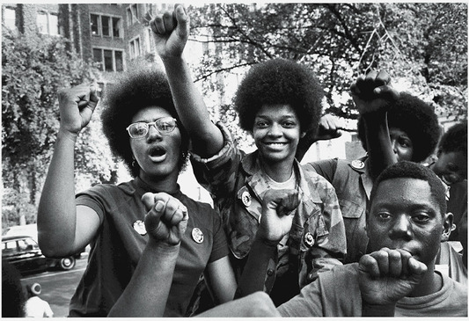
Figure 2 Black Power movement activists in Philadelphia, 1970
View description - Figure 2 Black Power movement activists in Philadelphia, 1970

Because power is such an important resource for influencing and shaping the world, it is no surprise that it has played a major role in Black activism over the years. Most obviously, the Black Power movement, originating in the US in the 1960s, was itself a reaction to a previous era of civil rights activism that valued peaceful non-violence, advocated love and made great efforts to build a broad-based movement that appealed to white people as well as Black people. Black Power emphasised the need to defend oneself when attacked violently. But it also supported notions of self-sufficiency and autonomy, through building independent networks, services and institutions. Love and power can be closely related – you can spread love through power and change the nature of power through practising love. Love can indeed be powerful (hooks, 2016).
Power is not an abstract or distant phenomenon for people who practise leadership, but a force you can apply through doing real work. It is a collective resource that you can discover and create by working together to develop one another’s capacity for leadership. Sometimes this power is built and deployed on, against or through established institutions – such as branches of government, public services, major charities or businesses. Power can challenge these institutions from outside with a view to disrupting and changing them. At other times power can be exerted from within, working inside structures and systems of existing power to change them. However, power can also be built independently of existing formal institutions, with groups deciding to create their own institutions, resources and networks of support.
Bearing the above discussion in mind:

Power can be defined as the capacity to shape or influence the world around you.

As you will notice from this definition, power is closely related to leadership, which is a practice of making meaning and establishing direction through affecting people’s heads and hearts. Power and relations of power therefore run right the way through leadership.
However, you need to bear in mind that power to do things is always limited by structures – the web of institutions we navigate on a daily basis, as well as the informal traditions and ways of life that shape everyday behaviours and values. When you exercise power, there is always a pushing back from these institutions. This pushing back can be more or less obvious: from racist laws and people in positions of authority abusing their power, to more casualised social assumptions that are nevertheless racist.
Contemporary life
In contemporary life it is often hard to pinpoint exactly where dominant power sits. Notionally, political leaders are ‘powerful’, but we know that they are also reliant on support from a wider base of political supporters – in private business or society. In a world with more globalised trade and production chains, power is ever more distributed, with the super-rich and powerful having more freedom than the rest when it comes to influence over government and indeed other social responsibilities, such as paying tax. Nevertheless, it is also true that, more often than not, people are unaware of how much power they could wield were they to engage in effective forms of leadership – they tend not to push as hard against structures as they could. As you proceed through this course you will explore a number of frameworks and approaches that will help you in placing power at the heart of leadership practice. Before you get there, you will spend the remainder of this week exploring how and why power is so important – through considering its effects on bodies and minds.

2 Power over bodies
Black people know well how power can bear upon the body – in negative and positive ways. Power, when experienced positively – such as through demonstrations of solidarity at work or in activism – can feel joyous on the body as you make authentic human connections with others. You will return to such positive forms of power in Week 2. Negatively, power can work on the body in many ways, some of which you will explore as power over movement, space and life. By identifying ways in which the body negatively experiences power, it becomes possible to identify a focus for positive forms of Black leadership in the future.

2.1 Power over movement
Crucial to a person’s freedom is how easy or otherwise it is to move around space. Being able to move easily and affordably creates options for work and leisure. It is perhaps no surprise, then, that transport is an ongoing topic that is connected to racial (in)justice. In the UK, the freedom of movement gained by owning a car is disproportionately enjoyed by white over Black people. Black people are more reliant on public transport for commuting to work, leisure activities and to uphold family and social obligations.
Black people are proportionately more likely to travel by bus or rail than white people (UK Government, 2020). Therefore, expensive and/or unreliable public transport will affect Black people proportionately more than it will white people. Both the cost of rail and bus journeys continue to grow year on year, a trend that has been steady since these services were privatised in the 1980s. Although in 2023 rail prices grew less than the previous year and more closely matched the rate of pay rises for public sector workers (ONS, 2023), according to research by the Trades Union Congress (TUC) the pattern between 2009-2019 was of the cost of rail growing roughly twice as much as people’s earnings (TUC, 2019a).
The TUC also showed in 2019 that the shareholders of rail companies in the UK were paid dividends of more than £1bn between 2013-2019, while passengers in the UK paid a far greater percentage of their monthly earnings on rail travel than their European counterparts (TUC, 2019b). Buses are the most common form of public transport in the UK and although the bigger picture is that of steady price rises, the situation is uneven, with commuters outside London often paying far more than in the capital (Pidd, 2019).
Stop-and-search
Power over movement is experienced by Black people in relation to the police using its powers to stop and search. Such powers are used disproportionately against Black people. For example, between April 2020 and March 2021 there were 7.5 stop and searches per 1,000 white people but 52.6 for every 1,000 Black people (UK Government, 2022). At the very least your journey on foot is far more likely to be inconvenienced if you are Black. However, the effects on Black people stopped and searched stretch far beyond inconvenience, with more than half of Black people in a recent poll stating that they felt humiliated or embarrassed by the incident (Dodd, 2022).
Power in movement can also mean freedoms to cross national borders with ease – something that enhances a person’s opportunities for work and leisure. Conversely, restricting a person’s international movements is a negative use of power. While most people accept that some restrictions on international movement are necessary to maintain national security, economic health and sustainable public services, it is also the case that Black people have experienced significant discrimination in relation to international movement. The Windrush scandal is a prime example. In 2018 it became clear that Black British people were being denied entry into the UK and deported because they were unable to prove their legal status as citizens. When the UK needed workers to help rebuild the country’s economy and infrastructure after the Second World War, people from colonised countries in the Caribbean were encouraged by the British government to settle and work in the UK. However, at the time, the administrative procedures and provision of written proof of citizenship were inadequate.
Many years later, in the 2010s, the then-government introduced a series of harsh policies aimed at illegal immigrants (known as the ‘hostile environment policy’). Such policies created a problem for many in the Windrush generation, who were unable to provide paperwork to satisfy the government that they were indeed citizens. One effect of this situation was that people who had been invited to the UK decades earlier, who had settled in Britain, starting families, were either being denied re-entry to the country or were threatened with deportation to countries they had little to no connection with. Controversies regarding compensation payments and continued discrimination against Windrush victims trying to access public services and welfare are ongoing.
While restrictions over movement certainly represent a negative exercise of power over bodies, it is also worth thinking about how power of movement can be used in positive ways through Black leadership, something you will now explore in an activity.

Activity 1 Powerful movement
Allow around 15 minutes for this activity

Watch the following video, about the Bristol Bus Boycott of 1963. The boycott is a good example of how power is used to restrict and enable movement. Movement here can be literal movement, through the spaces of a city, or social mobility, which is the ability to build a better life for yourself.
As you watch, identify one example of how power is used to restrict movement and one example of how power is used to enhance movement.
Bristol Bus Boycott video (open the video in a new tab or window by holding down Ctrl [or Cmd on a Mac] when you click on the link)

View discussion - Activity 1 Powerful movement

2.2 Power over space
Space has always been used to enact power. Historically, corporate power worked on the bodies of Black people through capturing and enslaving them – forcing them out of their home spaces to toil and die in foreign spaces. Segregation works by applying restrictions on who can and can’t enter certain spaces. However, power can also work on space to open up possibilities for equity – for example, by building residential accommodation and social infrastructure in ways that enhance sociality and participation.
It is possible to think about how power works on and through space at a number of different scales.

Global power
Globally, the ‘dispossession’ of land and resources from people in colonised spaces has been, and continues to be, significant for how economies function globally (Harvey, 2019). Capitalism, to a degree, is premised on uneven spaces, with certain spaces exploited so that others can flourish (Smith, 2010). Even though such power dynamics stretch across global spaces, their effects are felt on bodies in specific spaces. For example, cobalt mining, which is essential for rechargeable batteries in products such as smartphones, laptops and cars, is an industry built upon the ‘modern-day slavery’ of miners in the Congo who ‘do extremely dangerous labour for the equivalent of just a few dollars a day’ (Gross, 2023).
The bodies of one group of people (miners in this case) are placed in precarious positions so that bodies in other spaces can experience more freedom – to communicate, to move around. The counter to this position is that enthusiastic supporters of global trade maintain that it ultimately improves the standard of living for everyone and that more time and regulation are needed to allow international market forces to run their course, delivering prosperity for more people.
Another key global spatial dynamic is what the geographer David Harvey (2018) refers to as the ‘spatial fix’. This means the tendency of corporations to keep moving through space to maximise profits. The most obvious example of a spatial fix at work can be seen in the relocation of factory production to maximise cheap labour. Such movements can leave communities in the UK and other post-industrial contexts gutted of meaningful economic activity. Meanwhile, workers in newly ‘fixed’ spaces abroad save corporations money by working for worse terms and conditions.
As Harvey (2019) states, this movement is continuous. As workers in new spaces (e.g. China) develop more power through organising and succeed in improving their pay and conditions, so corporations continue to move in search of cheaper options (e.g. from China to Vietnam) (Braw, 2022). You can also think of the spatial fix as working in relation to technology. As digital technology improves, it becomes possible for corporations to employ more people remotely, in locations where it can pay lower salaries. Artificial intelligence is an extreme version of the spatial fix, because it involves replacing people with software programmes that can learn and adapt.

National power
Governments use their spending power to stimulate economic activity in sectors deemed of strategic importance. Hence in 2023 the UK government’s Levelling Up Fund distributed £2.1bn of funding to projects it believed held the possibility of boosting economic activity – funding a range of projects in the areas of tourism, artificial intelligence and transport, amongst others (UK Government, 2023). Governments can also use their national power to invest in public services. National investment from government shapes local spaces – providing jobs and infrastructure that support some activities over others. National housing policy and legislation leverages power over how people live. For example, legislation introduced in the UK in 1980 by UK Prime Minister Margaret Thatcher gave tenants of council homes the right to buy their properties – which allowed a growth in the number of home owners, but also a national shortage of affordable housing for people who either could not or did not want to own their own homes.

Local power
Power works on space through shaping cities and neighbourhoods in its image. Hence in addition to cities growing, their spaces can also be repurposed over time, depending on economic forces and the commitments of local political leaders. One of the effects of urban spaces changing as a result of economic forces is referred to as ‘gentrification’.

Gentrification
The phenomenon whereby former working-class areas of cities are changed and adapted to the lives and lifestyles of the better off is commonly known as gentrification. The dynamics of gentrification are extensively discussed and debated by academics and policymakers, although broad agreement exists that gentrification has both significant economic and cultural aspects. Economically, residents are forced out of certain areas of cities as rents rise and the cost of home ownership becomes unattainable. In the UK, gentrification tends to work from the centre of cities outwards, meaning that people are pushed ever further to the peripheries of cities, forced to travel greater distances to work. However, an irony is at play in the fact that the process of gentrification tends to feed off an existing culture that long predates it (Harvey, 2019). The food, craft, music, art and broader social practices established by Black people in certain parts of a city are marketed as part of that area’s core appeal, which is leveraged to push up rental and purchase prices. The outcome is that the very people whose identities and practices were drawn on to increase profit are also the same people who are forced to move away.

Local councils have power to determine how space is used in a particular area – to develop spaces for people to socialise, receive information, learn, live, and so on. However, councils are also restricted by national legislation and available budgets, meaning that their discretion is often curtailed – for example, councils might want to build more council housing but legislation prevents them from borrowing enough money to build to the scale they would like. Reductions in the budgets of local councils mean that local spaces can become more shaped by private, corporate entities than the public sector. One example of this tendency to privatise public space is the selling off and closing down of public toilets in city centres, meaning that to go to the toilet, people increasingly need to purchase something in a café, restaurant or bar (Smolović Jones, 2022).
It can often feel that changes to local spaces are driven by economic powers so large that it is impossible for local people to do much about them. But that is not always the case, and there are many examples of successful leadership of local spaces that you can learn from.

Activity 2 Community leadership
Allow around 20 minutes for this activity

Watch the following interview with Kemar Knight, who talks about his work as a Unite trade union representative at the Park Royal Bus Garage. In the interview, he explains Unite’s approach to building collective forms of power to represent the members. As you watch the video take notes of the practices highlighted by Kemar in building collective forms of power.

Video content is not available in this format.
Video 1 Kemar Knight – Building collective forms of power
View transcript - Video 1 Kemar Knight – Building collective forms of power

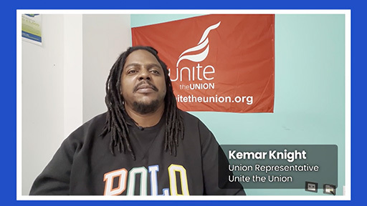

View discussion - Activity 2 Community leadership

2.3 Power over life
One way of making sense of power that affects the body is the concept of ‘necropolitics’. The term was devised by Achille Mbembe (2019) as a way of describing power that determines how certain groups of people are made more deserving of being alive than others. Mbembe’s case is that certain people are identified by those in power as scapegoats for a society’s problems, and are dehumanised, marked as less deserving of life. Hence people in many societies are given the status of the ‘living dead’ (Mbembe, 2019, p. 92), their lives considered more disposable and of less value than others. Historically in the UK and other contexts, Black people have been victimised by such necropolitics, subjected to abuse by dominant powers.

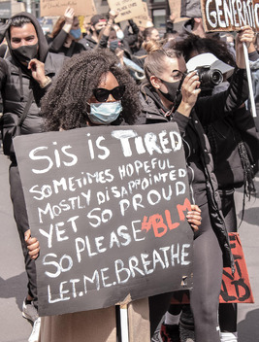
Figure 3 Necropolitics is marked by an oppressive power which targets certain groups of people
View description - Figure 3 Necropolitics is marked by an oppressive power which targets certain groups ...

Necropolitics can also be understood on a global scale as tied to colonialism. A sense of misplaced superiority seems bound up with this legacy, with those who have benefited from the exploitations of colonialism feeling entitled to the resources and lives of people in colonised contexts. In the UK and other contexts the most obvious examples of necropolitics are found in the policing and criminal justice systems, with Black lives being made to count for less than white lives. Indeed, Black Lives Matter is a movement whose main focus is on a person’s right to life – power at its most fundamental.
However, necropolitics is not restricted to a UK or US context – its dynamics can be identified globally. One example of such necropolitics can be found in the way that migrant workers are treated in Russia. In their study, Round and Kuznetsova (2016) highlight Russia’s dependency on foreign labour, largely from Central Asia, for performing essential, precarious and dangerous work. Yet foreign workers are also made a scapegoat by the government, demonised as responsible for the country’s problems. The authors therefore identify a contradiction experienced by people who are made victim of necropolitics. On the one hand they are made hyper visible – demonised as causing a country to lose its values, resources and identity. On the other hand, foreign workers are made invisible when it comes to accessing welfare, employment rights and public services, with government and employers using their positions of power to deprive workers of essential protections and services. The dynamics of necropolitics identified by the authors in Russia will be recognisable in many other national contexts.

3 Power over minds
Power does not only affect the freedoms and comforts of the body, but also affects the mind. How people think and process feelings can be shaped by power, as you will now explore.

3.1 Colonialism, racism and the mind
It is well known that colonialism works in ways that exploit a country’s natural resources and people for profits to be made elsewhere. Experiencing such relations of exploitation and oppression has significant repercussions for the mind (Fanon, 2021; wa Thiong’o, 1981) – for general mental health, as well as how leadership is thought about. The same can be said for any context where racism and prejudice are significant problems, whether the dynamics are explicitly those of colonialism or not. However, it is worth bearing in mind what the great OU academic and cultural theorist Stuart Hall (2018) said about the ‘post-colonial’. Hall argued that although British colonial rule had largely ended, its legacy in the form of traces of beliefs and attitudes lived on: ‘We continue to stand in its shadow’ (p. 23). The legacy of colonialism, for Hall, is corrosive, with its effects ‘unravelling’ in and on the present – creating a ‘disaster-littered, protracted, bloody and unfinished terrain’ (p. 24), within which we must build a more equitable and liveable future. You will now move on to consider how the legacy of colonialism on the mind may affect leadership practice in the present, and how some specific practices of decolonising the mind can be important for practising positive forms of leadership.

Activity 3 Decolonising the mind
Allow around 15 minutes for this activity

Watch the following video of OU PhD graduate Lace Jackson, an expert in race, colonialism and leadership. In the video, Dr Jackson talks about how the legacy of colonialism affects Black leadership. As you watch, try to identify two practices of decolonising the mind that Dr Jackson recommends for positive leadership practice.

Video content is not available in this format.
Video 2 Lace Jackson – The legacy of colonialism and slavery on Black leadership
View transcript - Video 2 Lace Jackson – The legacy of colonialism and slavery on Black leadership

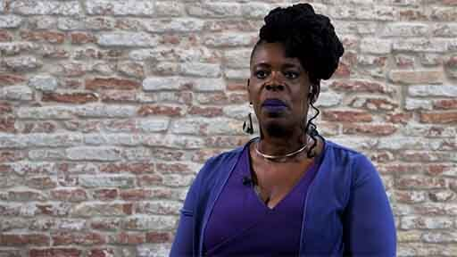

View discussion - Activity 3 Decolonising the mind

3.2 Gaslighting
It is common to hear Black people saying that they have experienced gaslighting – at work and in society. What is meant by this is that Black people can be made to feel that they are imagining experiences of racism, even though they are the victims of very real prejudice.
Gaslighting is a form of power typically associated with abusive personal relationships, where an abuser seeks to create an alternate reality through distortions, untruths and manipulations (Smolović Jones, 2023). The effect is to make the victim feel as if they are losing their ability to correctly perceive reality, eroding their mental health. Recently, gaslighting has been explored as a significant weapon of institutional and organisational power, particularly in seeking to make Black people feel as though they are imagining racism where it does not exist. Former US President Donald Trump and his followers are masters at such gaslighting (Honig, 2021). They take advantage of the increasingly short attention spans of the media and people at large to continuously hop from one outrageously untrue statement to another, never allowing attention to settle, offering increasingly bizarre interpretations of reality to unsettle those they target.
As gaslighting is increasingly used by people in power to divert attention away from racism, you will now proceed to explore the practice in more depth by engaging with an academic expert in this area.

Activity 4 Gaslighting
Allow around 15 minutes for this activity

Nela Smolović Jones has studied gaslighting in organisational and institutional settings (Smolović-Jones, 2023). She states that gaslighting is a form of corruption, wielded by organisations and individuals to defend their positions of power and privilege over those they oppress. In her study, she highlights four dimensions of gaslighting practice from corrupt organisational actors.
Watch the video, where Dr Smolović Jones talks about her framework of gaslighting practices. After you watch, complete the table below with an example from your own experience, or an experience you know about.

Video content is not available in this format.
Video 3 Nela Smolović Jones – Gaslighting in organisational settings
View transcript - Video 3 Nela Smolović Jones – Gaslighting in organisational settings

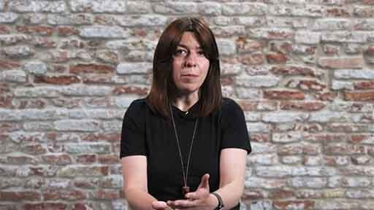

Type of gaslighting | Definition | Example
Weaponising victimhood | Oppressors claim the status of victimhood, inverting the claims of the truly oppressed to strengthen dominant power. | Provide your answer...
Ruling | Those in power introduce previously unspoken rules as it suits their purposes. They use such ruling to restrict meaningful access to spaces and participation. | Provide your answer...
Exposing | Corrupt organisations can make their critics look and feel incompetent in front of other people, when in fact they are making valid points or asking important questions. | Provide your answer...
Collective affirmation | People in power gain approval from other corrupt actors, particularly those seeking more access to power and wealth. Although they are still misrepresenting reality, such tactics can make it harder for those seeking to resist because they can feel outnumbered. | Provide your answer...

View discussion - Activity 4 Gaslighting

Although gaslighting is increasingly common and can feel difficult to combat, you can effectively resist it. Sometimes it is possible to do this in a direct and confrontational way. However, because gaslighting often emerges as a series of practices in corrupt contexts, it can be difficult to find enough support for direct forms of resistance, meaning that people are often forced into adopting subtle and indirect resistance. You will explore these issues in Week 3.

4 This week’s quiz
Now that you’ve completed Week 1, you can take a short quiz to help you to reflect on what you’ve learned.
Week 1 practice quiz
Open the quiz in a new window or tab, then come back here when you’ve finished.

5 Summary of Week 1
Power is a crucial force underpinning leadership practice. It can be used to control and oppress but also more positively to enhance racial equity. Hence power is defined as the capacity to shape or influence the world around you. Power is often exercised on bodies – with some people made more disposable and valuable than others. Power also works on the body by placing restrictions and freedoms on movement and space. Working on the mind, the legacy of colonialism can affect Black leadership in important ways.
Another way in which power plays out on the mind is through the corrupt practice of gaslighting, which often manifests as weaponising victimhood, ruling, exposing and collective affirmation (Smolović Jones, 2022). Next week you will continue to explore the topic of power by engaging with some important frameworks that will help you interpret your own leadership contexts.
You can now go to Week 2.

Week 2: Frameworks of power

Introduction
This week was written by Owain Smolović Jones and Fidèle Mutwarasibo.
In this week of study you will be digging deeper into power and the role it can play in leadership. To do this you will focus on some key frameworks that are effective in analysing the basis of power and how it is used in practice. These frameworks should be useful for you in making sense of the kind of power that you are subjected to as you pursue leadership and the kind of power you can draw on.


Figure 1 Leadership and power are intertwined
View description - Figure 1 Leadership and power are intertwined

You will begin the week by studying a framework that offers three faces of power (Lukes, 2005). By engaging with this framework, you will better understand how power is exercised in overt and covert ways. From there you will explore where power derives from and the various bases people draw on to exercise power. Finally, you will consider a more positive form of power, that of collective solidarity, and how you can harness it to generate impactful Black leadership.
By the end of this week, you should be able to:
- analyse your own experiences of leadership using the three faces of power framework
- evaluate the operation of various bases of power within everyday work contexts
- identify everyday practices that are useful for building forms of relational power and solidarity in organisations and communities.

1 Faces of power


Figure 2 A useful way to think about power is through the metaphor of ‘faces’
View description - Figure 2 A useful way to think about power is through the metaphor of ‘faces’

The metaphor of a ‘face’ of power is a potent way of understanding power in relation to race. Colour is visible on the faces of all people and as such all people are visibly marked in different ways. The colour of someone’s face is highly visible and therefore an outward sign that seems to licence racism and privilege. Steven Lukes (2005), although he did not directly write about race, developed a theory of three faces of power that can provide a basic navigation system for understanding how some of these power dynamics work.

1.1 Decision-making power
The first face of power is decision-making. For this kind of power to exist, a person or organisation needs to make a decision that affects others. Such power is visible. A police officer visibly decides to harass a Black person on the street. A hiring committee decides to appoint a white person over an equally qualified Black person. Decision-making power is most visible in the arena of elected politics, where decisions on policy and legislation bear direct consequences for how people experience their lives.
The advantage of conceptualising power in this way lies in its visibility – because we can see it, it is also easier in many ways to scrutinise, challenge and resist. However, it is often difficult to directly attribute decisions to prejudice, because it is rare that people express prejudices out loud when justifying their decisions: indeed, with regards race in the UK, doing so would make organisations guilty of discrimination under law.

1.2 Non-decision-making power
It is therefore important to consider Lukes’ second face of power – that of non-decision-making. This relates to how individuals or groups organise and set the agenda for action through inaction. Being able to keep certain discussions and debates away from consideration is a clear exercise of power. Hence police forces and governments can choose not to take action – or at least to take virtually no action – on corruption, criminality and regressive practices amongst police officers. Political parties can choose not to take seriously complaints of racism within their ranks. Organisations can choose not to address issues of discrimination in recruitment and promotion decisions. Globally, businesses can choose not to address issues of exploitation and slavery in their supply chains.
Very often such non-decision-making is facilitated by a wider array of actors and forces. For example, the media decides what merits attention and wider circulation, and can decide not to cover certain issues. Other stakeholders – such as charities and trade unions – can decide to support certain groups of people but not others.
A significant aspect of non-decision-making power is the tendency of organisations and politicians to focus on symptoms rather than root causes of problems. One example of such a tendency can be found in the issue of knife crime in the UK. While issues such as the supposed effects of hip-hop music, video games and a vague notion of ‘gang culture’ are widely discussed, underlying issues of deprivation, lack of access to voice, autonomy and democracy are ignored. To truly understand why some issues are discussed and others subdued, it is necessary to engage with Lukes’ third face of power.

1.3 Ideological power
The final face is ideological power: in this dynamic, power means being able to shape meaning, and influence how people interpret the world. Ngugi wa Thiong’o’s 1981 book Decolonising the Mind: The Politics of Language in African Literature highlights the purpose of controlling the thoughts and feelings of the individuals at the receiving end of power. In summary, doing so prevents people in power from needing to explicitly and openly exercise power; it also encourages populations of people to self-manage, meaning that they control themselves. This view of power sees it as widely distributed in any society. It is not just senior people or those with lots of money who maintain power, but most people, through their everyday activities and attitudes. This is how the ‘common sense’ of a society is created – by informal networks of people, institutions and organisations going about their everyday business in ways that re-enforce certain power dynamics.
Political theorist Antonio Gramsci (2005), writing before the Second World War, described this view of power as ‘hegemony’, which is a word indicating a collection of people dispersed across various organisations and tiers of life who exert power over a society. From this perspective power is inescapable, as its ideologies are renewed daily by ordinary and powerful people alike. For example, the power of a hereditary monarchy is maintained not only by the king or queen but by the network of politicians, media, charities, businesses and ordinary people who promote, take an interest in and celebrate royalty. Resisting hegemony can therefore be very difficult because its resources are spread out across a society. However, another implication of interpreting power as hegemony is that it can be more accessible precisely because it is widely distributed. For instance, you could contribute to or resist monarchical power in a range of ways and through a range of organisations – you could join a celebratory street party or a street protest, for example.
Marginalisation
However, certain groups of people do have less access and power, or are even marginalised entirely, as you explored in relation to necropolitics in Week 1. People who are marginalised by dominant power, however, may also have different identities, priorities and values to one another – for example, a climate action pressure group may want economies to shrink while trade unions may want them to grow. Yet if these different groups manage to find some commonalities, they can form a chain of association, building what is known as a ‘counter-hegemony’, which can offer meaningful challenge to power. However, counter-hegemonies can still be absorbed by ruling power – e.g. a government can adopt most of a trade union’s demands but do little to address climate change – thus breaking the internal unity of a counter-hegemony. Or the counter-hegemony can grow in size over time, absorbing greater numbers of people until it is in a position to offer a serious challenge to ruling power – sometimes even taking power for itself.

Housing hegemony
A strong example of hegemony at work exists in relation to housing in the UK. Although a significant proportion of people in the UK pay a disproportionate amount of their monthly income to private landlords, the issue is rarely discussed in any depth by any of the three major UK political parties or by the national media. There is a powerful hegemony at work to maintain this status quo, involving big-money housing developers, politicians, private landlords, media and even many people who own their homes outright. In the UK, owning a property and keeping it as a financial asset is viewed as aspirational, even as ever greater numbers of young people find this goal an impossible one to achieve.
Such an ideological view of housing is re-enforced daily through reality television programmes and the finance columns of newspapers and websites. It is even visible in the dominance of the word ‘property’ as shorthand for a flat or house; property can be anything that someone owns, yet its common use has become synonymous with housing. Alternative models – such as the widespread provision of social housing in Vienna (Austria) and models of regulated renting in Germany – are left undiscussed.

Although Gramsci was a white Italian from Sardinia, race scholar Stuart Hall (2021) believed that his ideas held great value for understanding how race and racism work in society. The power of Gramsci’s ideas is perhaps best illustrated by the oppression he was personally subjected to. Sardinians in Gramsci’s time suffered racism within Italy, with reactionary people, particularly in the north, treating them as inferior. Gramsci, a communist, was considered so dangerous by the ruling fascist party that he was imprisoned for 11 years under grim conditions during the 1920s and 1930s, suffering terrible health and eventually dying as a result.
Hall took Gramsci’s idea of hegemony as a way of exploring how racism works in societies. He stated that racism needed to be understood as something that is widely distributed and systemic, which was kept alive through everyday practices and cultures. Such racism always suit a particular purpose – for example, powerful people creating a panic about refugees entering the UK can distract from other issues affecting the country, related to the economy or public services. The flip side of this argument is that an anti-racist power can be built by engaging and connecting across multiple, dispersed organisations – e.g. charities working with businesses, trade unions and community groups. A counter-hegemony can work from the bottom-up, influencing how people in formal positions of power approach race.

Activity 1 Identifying faces of power
Allow around 20 minutes for this activity


Figure 3 Adopting a faces of power view can help you identify the many ways in which power works in societies and organisations
View description - Figure 3 Adopting a faces of power view can help you identify the many ways in which ...

Identify one issue that matters to you at work, in your community or in society at large. Is it extensively addressed by people in power, not addressed at all or somewhere in between? Working through each face of power in turn, make some notes or have a conversation with someone about what is done (or not done) about your issue by people in power.

View discussion - Activity 1 Identifying faces of power

2 Bases of Power
John French Jr and Bertram Raven’s 1959 book chapter ‘The Bases of Social Power’ and Raven’s 1965 book chapter ‘Social influence and power’ identified six bases of power. You can discover more about these bases of power below. You will note that all of these bases have been used in various ways to convey and re-enforce racist and colonial systems, but can also be deployed to offer more positive forms of power.

Legitimate power | Power comes from a formal social status bestowed onto a person: e.g. a monarch, chief executive, prime minister, chief planning officer, shift manager at a supermarket.
Reward power | Power comes from a person’s ability to reward those who follow and/or comply. Rewards may include donating, hiring, promotion, training, or increasing salaries.
Coercive power | Power comes from a person’s capacity to punish others. Most obviously judges, magistrates and the police possess coercive power; but it is also possessed by politicians and regular organisational managers, who can sanction employees.
Informational power | Possessing information can mean power. Information can range from large-scale suppression of the horrors of colonial rule to everyday cultural information about how institutions and organisations work.
Expert power | Power comes from a person’s ability to define what is correct and incorrect from a basis of expertise. Scientists, engineers, lawyers, academics and policymakers are examples of people who may possess expert power, as are people with deep lived experience of certain social, community and work contexts.
Referent power | Power comes from social standing. Community leaders can have power because people relate to them as reliable and/or inspirational. Trade union leaders can inspire workers to collectivise and take action. Other examples include celebrities and social media influencers.

People can exert power from more than one base at a time. For example, racial equity campaigners can work from bases of referent, expert and informational power. The bases can also be challenged – e.g. information and expertise can be questioned; someone’s referent power can be undermined through questioning their integrity; reward power can be exposed as corruption. You will now practise identifying these bases of power through an activity.

Activity 2 Identifying bases of power
Allow around 20 minutes for this activity

Watch the following video, where Kemar Knight talks about the power held by employers, trade unions and workers. As you watch, identify as many bases of power as you can through the lens of what Kemar says about himself, the employer, the trade unions and the media.

Video content is not available in this format.
Video 1 Kemar Knight – Building collective forms of power
View transcript - Video 1 Kemar Knight – Building collective forms of power

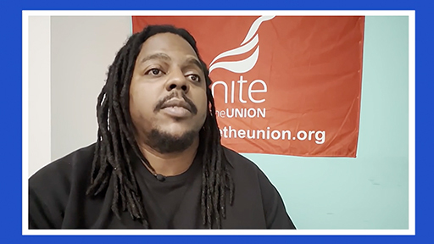

View discussion - Activity 2 Identifying bases of power

Although bases of power can help you think about how power can be used to enact positive change, it does tend to focus more on the detail of how people are subjected to power. So you will now move on to consider a perspective that emphasises more of the positive aspects of power.

3 Powerful solidarity


Figure 4 Some of the most significant achievements in the world have been accomplished through the power of solidarity
View description - Figure 4 Some of the most significant achievements in the world have been accomplished ...

Giving and receiving solidarity can be a joyous experience. Part of the reason why it is so powerful is that it can be experienced in and against other forms of power that are less positive. The feminist philosopher Amy Allen (2017) has developed a framework that situates solidarity amongst two other kinds of power – the three playing off one another in work and social life. Explore these below to find out more.

Power-over | Refers to the ability of the powerful to affect the actions and thoughts of others, including through racist ideology.
Power-to | Is the capacity to act and exercise agency. This is a positive enactment of power that aims to enhance equity for diverse groups of people.
Power-with (solidarity) | Is about how groups of people build alliances that enable and strengthen power-to. Key to developing ‘power with’ is solidarity.

Solidarity means not only providing others with your support but the feeling of security, comfort and strength that person gains from knowing that you will always be there to support them. Offering solidarity works both ways – it is relational – meaning that those you support will offer support in return. There is always an element of risk involved – you are showing those in power that you are prepared to make yourself potentially vulnerable to support other people – but in stepping up, you are displaying collective strength. This collective strength can be hard to resist. Solidarity can be crucial in ‘opening up closed spaces’ (Garlington et al., 2019, p. 30). This means that one way in which you can show solidarity is helping others gain opportunities and access. However, solidarity comes with significant challenges. It is a process rather than a settled state. This means that you have to keep working at solidarity for it to remain valuable and valid – if you stop, confidence that someone will offer you support can wane.
Sticking with the process of solidarity can be even more challenging when those you are trying to build solidarity with have different identities and priorities. Under such circumstances you need to work hard to understand where others are coming from, allowing yourself to be open to feeling empathy. Smolović Jones et al.’s (2021) study of building feminist solidarity makes the case that people need to expose themselves to the experiences of others, inhabiting the pressures and challenges of their lives. This process, the authors say, can be difficult and sometimes fraught with conflict, as both parties try to understand and adapt. However, when seemingly different people come together in solidarity, the effects can be powerful, demonstrating diversity as well as collective strength (Collins, 2008). In the case of the Smolović Jones et al. (2021) study, based in Montenegro, common ground was found between largely rural mothers with socially conservative views and professional metropolitan feminists with socially progressive views. They both opposed unconstitutional changes made to the benefits system by the government, recognising in one another a common desire for freedom and dignity (Ng, 1980).
Building power-with, and therefore also power-to, can seem somewhat vague but there are practical ways in which you can build and exercise power-with, as you will explore in the following activity.

Activity 3 Power-with in practice

Watch the following video, where social entrepreneur Yaina Samuels talks about the importance of practices of solidarity in enhancing support and action on mental health. As you watch, note some of the practical ways in which we can offer solidarity to people suffering from mental health problems.

Video content is not available in this format.
Video 2 Yaina Samuels – Solidarity in supporting action on mental health
View transcript - Video 2 Yaina Samuels – Solidarity in supporting action on mental health

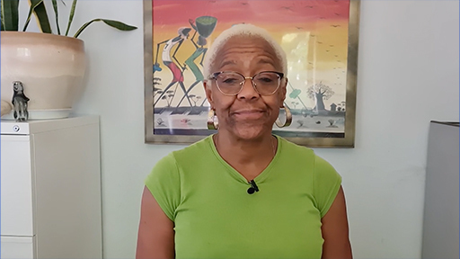

View discussion - Activity 3 Power-with in practice

4 This week’s quiz
Now that you’ve completed Week 2, you can take a short quiz to help you to reflect on what you’ve learned.
Week 2 practice quiz
Open the quiz in a new window or tab, then come back here when you’ve finished.

5 Summary of Week 2
Frameworks of power can help you identify the kind of power you are being subjected to and the kind of power you can draw on in your leadership. Lukes’ (2005) three faces of power offers a useful way of differentiating between broad types of power – decision-making, non-decision-making and ideological. Taking a more granular approach, it is worth bearing in mind that people gain power from various sources – such as their access to information and ability to reward compliance. Amy Allen’s (2017) framework of power-over, power-to and power-with helps to identify how different kinds of power work in and against each other. It also helps appreciation of the power of solidarity (power-with), which can be built through everyday acts. Power is of course a huge topic and there are many more aspects to it that you will uncover as you progress through the course. One important area to explore is the role of resistance in opposing power but also in driving leadership. You will now move on to study resistance over Weeks 3 and 4.
You can now go to Week 3.

Week 3: From power to resistance

Introduction
This week was written by Owain Smolović Jones and Fidèle Mutwarasibo.
Welcome to the resistance. Over the next two weeks you will learn about a crucial aspect of Black leadership, working with and through resistance, which can provide energy and a critical edge to leadership practice. History is usually told through the eyes of the powerful, those who amass the greatest economic and cultural power, and there is no greater example of this than the ways in which official history has been warped to normalise – or forget – the horrors and legacies of colonial rule globally.


Figure 1 Resistance leadership can change the world
View description - Figure 1 Resistance leadership can change the world

However, there is a powerful case to be made that reality, rather than what is officially recorded in ‘history’, is largely a series of responses to resistance: that it is the less powerful standing up to the powerful who force change, innovation, progress and equity in the world. Often made to feel weak by dominant power, resisters are nevertheless the force that must always be responded to. After all, every step towards more equal and empowering societies has always been fought for.
This week you will study the myriad of people and relations that create resistance leadership, the force that drives equity and progress. You will begin through considering how resistance can be defined in relation to power, and by extension how resistance leadership always involves a claiming of power by the previously powerless. You will consider the constructive role of resistance, as something that helps organisations, communities and societies develop through offering constructive forms of dissent (Grint and Smolović Jones, 2022). The week concludes by considering some of the challenges you can face when you move from positions of resistance to positions of power.
By the end of this week, you should be able to:
- understand resistance as always being a response to power, and vice versa, creating a process of struggle
- distinguish between constructive dissent and destructive consent as enabling organisations to develop and adapt to contemporary demands
- identify and analyse some of the key challenges groups face when transitioning from positions of resistance to positions of power.

1 Power-resistance
In the summer of 2020, waves of protesters took to the streets globally after George Floyd was murdered by a police officer in Minneapolis. Having tried for decades to eliminate systemic and violent racisms by working through formal political systems, the murder symbolised the feeling (and fact) that such work had only been, at best, partially successful. Marching and protesting in the street was therefore a logical and authentic means of giving voice to deeply held frustration and distress. Bold acts of resistance demand a response, which can create progress or signal more struggle to come.


Figure 2 Resistance leadership can shift power dynamics
View description - Figure 2 Resistance leadership can shift power dynamics

In retrospect, what was fascinating about the Black Lives Matter (BLM) protests of 2020 were the ways in which people in positions of power responded. Major corporations started to voice their support. Premier League and international footballers started taking the knee before matches – likewise some political leaders and even a right-wing television presenter (the latter soon quit his role after a backlash from viewers) (BBC, 2021a). More meaningfully, organisations across the UK started to have difficult conversations about the effectiveness or otherwise of work to date on addressing racial inequalities, with multiple new initiatives and policies launched. In the case of the Open University, the outpouring of resistance from the BLM movement coincided with new organisational leaders who prioritised racial equity, leading to a new Black scholarship fund, Black leadership courses and a programme of decolonising curriculum. Who was ‘in power’ and who ‘in resistance’ became blurred as a result of these ripples of activity. You will now move on to make sense of how power and resistance feed off one another.

1.1 Defining resistance leadership
The nature of power and resistance and the boundaries between them can become ambiguous when resistance is so pronounced that power needs to respond, as in the case of the after-effects of the BLM protests. One important implication of this statement is that resistance can itself provide leadership because it pushes a response from power. When resistance generates a response and change, it is doing the work of leadership.
At the heart of such leadership is a reliance on those with less power generating the courage, determination and collective ability (a bundle of qualities known together as ‘agency’) to make resistance happen. For resistance leadership to occur, those with less power need to step up and take action. This suggests the following definition of resistance leadership:

Resistance leadership can be defined as the process whereby the less powerful gain more power in relation to the status quo while providing direction for meaningful change.

Resistance and power are closely related: they unfold against one another in a continuous process of struggle (Fleming and Spicer, 2007 and 2008). Power responds to resistance in many different ways. It can concede entirely or partially; but it can also try to resist the resistance, through language and/or action. Hence as the BLM protests and national dialogue continued, the far right themselves took to the streets, ostensibly to ‘defend’ public monuments – although in reality we all knew the intention was to intimidate and assert power. Some people in positions of power – in the media and politics – started to publicly criticise the act of taking the knee and even to deny the extent of racism in the UK. The struggle continued.
Yet one important lesson of this discussion is to note that those in power can never truly predict or control resistance, as it has the capacity to surprise and challenge in unexpected ways. For example, during a far-right street action in London in 2020, a white man, Bryn Male, was left stranded amongst BLM activists when his colleagues ran away. A few BLM protesters tried to protect Male, and one of them, Patrick Hutchinson, aged 50, carried Male to the police in a fireman’s lift (Iqbal, 2020). The image, reproduced extensively in the media, was iconic, a symbol of the dignity and courage of Patrick Hutchinson and the Black struggle for equity in the face of hatred and violence. Patrick Hutchinson himself, who was motivated by experiences of witnessing the division created in communities by white supremacists when he was growing up, has since become a powerful advocate for racial equity, writing a book in the form of a letter to his children and grandchildren (Hutchinson, 2021).
Resistance and power are implicated within one another and the relationship between them can be ambiguous. In some instances, resistance can even help status quo power within organisations adapt, as the next section explores.

1.2 Constructive dissent and destructive consent
Resistance is not always about causing trouble for organisations – it can serve a more ‘constructive’ purpose, helping adaptation and growth. This kind of leadership is known as ‘constructive dissent’ (Grint and Smolović Jones, 2022). The argument is that people in senior positions need active and motivated followers who are prepared to step in at key moments, providing disagreement and opposition to those with more power than them when they think that a decision or direction of travel is wrong. Providing a necessary corrective to poor leadership and decision-making, it has been argued that such forms of resistance are far more common than we imagine – and indeed their importance in maintaining the health of organisations greatly under-appreciated (McCabe et al., 2020).
Constructive dissent can be more or less public. When it happens privately, it is usually within small groups of people who are committed to improving the organisation through dialogue. However, such attempts to provide constructive dissent are sometimes not acknowledged or listened to. Under such circumstances, dissenters need to decide how far they are willing to go to influence an organisation. Ultimately, dissenters can opt for whistleblowing as a solution, when they feel that the organisation they find fault with has failed to listen. There are many examples of whistleblowing over racism.
One is the case of the professional cricket player Azeem Rafiq, who was subjected to racism at Yorkshire County Cricket Club. Having failed to gain a satisfactory outcome to his complaints internally, he publicly revealed his claims to the media and in Parliament. Following an investigation by the national governing body for cricket, the England and Wales Cricket Board, most of Rafiq’s complaints were upheld. Like many whistleblowers, Rafiq faced significant personal attacks in the media and threats from members of the public, which forced him to move abroad for a period of time (Liew, 2023). He also admitted to, and apologised for, using anti-Semitic language in messages he sent in 2011 (BBC, 2021b).


Figure 3 Dissent can empower leadership rather than diminish it
View description - Figure 3 Dissent can empower leadership rather than diminish it

Motivating Rafiq’s whistleblowing was a desire to fix behaviour at the club and to ensure that future players did not experience racist bullying. It was important for him that there was ‘acceptance by the new leadership [of Yorkshire] of what happened to me, which was the most important part for me, and a real willingness to do the right thing and take proper steps to address racism at the club’ (Protect, 2022). Although the process has been difficult for Rafiq and his family, his leadership has resulted in significant personnel change at Yorkshire and a general reckoning with racism in cricket. Dissent, therefore, can be constructive, aimed at repairing a broken system.
The flip side of constructive dissent is the notion of ‘destructive consent’ (Grint and Smolović Jones, 2022). This is the phenomenon of followers staying silent when they know that a leader’s decision-making or behaviour is flawed, even catastrophically so. For leaders to fail, followers need only stay silent. The case at Yorkshire is an example of destructive leadership, an unwillingness of staff at the club to properly address racism when it was first highlighted by Azeem Rafiq. This highlights poor leadership that was compounded when the club chose to release the player in 2018, a year after he raised his complaints.
The causes of destructive consent and constructive dissent are numerous, as you will now explore.

Activity 1 Exploring consent and dissent
Allow around 20 minutes for this activity

The degree to which constructive dissent and destructive consent happen can depend a lot on the organisational conditions. At work, it is possible for people to make it easier or harder to speak up. You will now engage with what some of these conditions are.

Part 1

Watch the following video of OU PhD graduate Lace Jackson as she talks about the times in which she has witnessed both destructive consent and constructive dissent, and the conditions that seemed to enable them to happen. As you watch, make some notes about the main conditions highlighted.

Video content is not available in this format.
Video 1 Lace Jackson – Constructive dissent and destructive consent
View transcript - Video 1 Lace Jackson – Constructive dissent and destructive consent

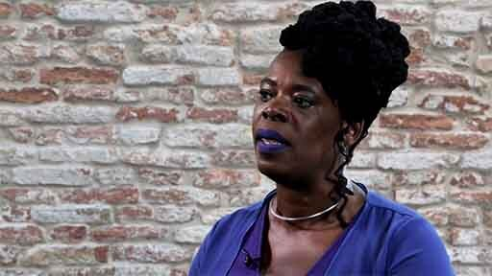

Part 2

Can you think of some examples of constructive dissent and destructive consent in your own experience? Were the conditions similar to those highlighted by Dr Jackson or did you identify any in addition?

View discussion - Part 2

1.3 Radical resistance leadership
Sometimes it is not the case that resisters want to fix an organisation or system, but rather to abolish them entirely. Under such circumstances, the aim is not to reform but to dismantle. Such resistance emerges when organisations betray the trust of those they are supposed to serve, often repeatedly.
Historically, abolition has been a word associated primarily with the slave trade, but in more recent times with aspects of the criminal justice system. For example, the official review by Baroness Casey of the Metropolitan Police in 2023 found ‘institutional racism, sexism and homophobia’ in the force (Casey, 2023, p. 7). The peer’s report stated that if ‘sufficient progress’ was not made on key points that ‘more radical, structural options, such as dividing up the Met into national, specialist and London responsibilities, should be considered to ensure the service to Londoners is prioritised’ (ibid, p. 25). In other words, the Baroness was recommending dissolving, dividing and re-forming the entire organisation. Such sentiments echoed points made by numerous experts and campaigners (Barradale, 2023).


Figure 4 When a system cannot be fixed, more radical forms of resistance leadership can create the conditions for better alternatives to emerge
View description - Figure 4 When a system cannot be fixed, more radical forms of resistance leadership ...

Resistance that seeks radical forms of change, even to the point of abolition, is referred to as ‘dissensual leadership’ (Barthold et al., 2022). This kind of leadership is confrontational and driven by direct forms of action and conflict. People may use their bodies to occupy space or use force to obtain their goals. Campaigners do not often move directly to dissensual leadership but arrive there after having exhausted other options. One example of such dissensual leadership is the toppling and disposal of the statue of slave trader Edward Colson by protesters in Bristol in 2020. Campaigners had spent decades trying to have the statue removed through official channels, without success. Physically removing it and dumping it in the river proved successful, if confrontational, controversial and risky for those who took the direct action – they were criminally prosecuted. Dissensual leadership has proven to be a hot topic in the UK, particularly in relation to forms of direct action taken by environmental protesters, such as stopping traffic or attaching themselves to buildings.
Ultimately, dissensual leadership, while being a form of radical resistance, is also an exercise of power. Collectives of people seek to assert an alternative form of power, often bypassing and choosing to ignore the legitimacy of existing organisations and institutions. Having considered the role of resistance in driving leadership, you will now move on to consider some of the challenges that arise when resistance is so successful that resisters gain real power.

2 From resistance to power
While many resisters aim to gain concessions from those in power, others go a step further by trying to take power for themselves. There are specific dynamics that you need to bear in mind when considering the transition from resistance to power, which you will now explore.

2.1 Mimicking the oppressor
There is a danger that when resisting groups grow and experience success, they can begin to adopt some of the harmful practices of those they initially resisted (Collinson et al., 2018). There are many ways in which this can happen but some of the most common are shown below.

New inequalities | Resistance groups substitute new inequalities for old ones. For example, they introduce sexist or racist attitudes and practices while campaigning against economic inequalities. This has been a criticism of some trade unions in the past.
Authoritarian practices | Many resistance groups are formed in opposition to authoritarian practices – yet it is possible that individual leaders within resistance groups come to centralise more power than is healthy. To some degree a concentration of power is inevitable for getting things done, so finding the balance between centralising and delegating is important.
Corruption | Resisting groups can oppose cronyism and special favours from those in power. Yet when resistance groups gain power, they can simply replicate such corruption, only this time favouring their own people.
Illusory inclusion | Resisting groups can promise new forms of inclusive leadership, but this can be a front for delegating unwanted tasks away from senior and privileged people within an organisation.

2.2 Resisting resistance


Figure 5 Power can be abused through ‘oblique’ resistance
View description - Figure 5 Power can be abused through ‘oblique’ resistance

Resisting groups need to be aware that the people they depose will not go away quietly and will probably fight back. This phenomenon is that of resisting resistance.
In a contemporary UK context, it is becoming increasingly unacceptable for those in power to straightforwardly deny the need for equality, diversity and inclusion (EDI). Indeed, voicing opposition to EDI on its own terms – e.g. ‘White people are inherently superior’; ‘Men are superior to women’, etc. – is usually, and rightly, career limiting. Opponents of EDI have therefore been forced to adapt to new social standards and attitudes towards equality. In practice this has resulted in a sneakier form of resistance, one that disguises itself because resisters know it is socially unacceptable to openly voice sexist, racist and homophobic views.
This kind of resistance is called ‘oblique resistance’ (Smolović Jones et al., 2021). Oblique resistance never openly opposes EDI, but instead tries to move the target and distract from the goal of enhancing equality. At its root, oblique resistance is a way for powerful people to defend their privileges by resisting the resistance offered by those pursuing EDI. Smolović Jones et al. (2021) elaborate on this practice in their study of how people in sections of the Labour Party resisted gender equality initiatives. They practised oblique resistance in three ways, which you can explore below. Do any of these practices seem familiar within your own contexts?

Ethics | Claiming that gender equality initiatives were unethical because they did not reward merit and because they overlooked other forms of inequality, such as deprivation. However, in practice it was evident that many resisters did not take action on any other forms of inequality either.
Territory | Claiming that bringing more women into senior elected positions would erode the autonomy of local communities to decide for themselves. The assumption was that women were somehow ‘foreign’, ‘other’.
Convention | Superficially voicing support for equality but always preferring white men from middle class professional backgrounds.

2.3 Stuck in opposing
Resisting groups can become stuck in opposing, overlooking the need for a positive programme of change. Yet simultaneously they cannot abandon the resistance focus because it is unlikely that the threat from the power they have unseated will disappear entirely – powerful people will keep resisting the resistance. Sinha et al. (2021) therefore propose a ‘trifold focus’ for resisting groups transitioning to power. This means simultaneously:
- Resisting a hostile status quo: Successfully resisting opponents who still hold significant forms of power.
- Subduing resistance from the newly deposed leaders: Being able to predict the resistance that is coming and successfully overcoming it can be a difficult identity shift for resisting groups taking power, but is an essential one if they are to maintain power.
- Building alternatives: Focusing on a positive programme of change can build a more sustainable platform from which to lead into the future.
This trifold focus is a tricky balance to get right in practice, because attention is always split between competing priorities. The key to making it work appears to be keeping the three demands explicit, encouraging colleagues to draw attention to a slippage when priorities are weighted too far in one direction. Here it is possible to loop back to the discussion on constructive dissent. When trying to balance resisting, subduing counter-resistance and building alternatives, it is wise to allow your group plenty of space and freedom to voice disagreement, so that the various tensions at play can be made explicit. On the other hand, too much open dissent means that the group will become incoherent and disorganised – hence the need to make the ethos of open dialogue explicit from the beginning

Activity 2 Transition challenges in practice
Allow around 15 minutes for this activity

Can you think of any examples in your life and work where resistance has faced challenges when assuming power, or at least assuming more responsibility? The example could be from your own direct experience or from your knowledge of the world at large. Make a note of two or three key pieces of advice you would pass on to others based on your experience and/or interpretation of events.

View discussion - Activity 2 Transition challenges in practice

3 This week’s quiz
Now that you’ve completed Week 3, you can take a short quiz to help you to reflect on what you’ve learned.
Week 3 practice quiz
Open the quiz in a new window or tab, then come back here when you’ve finished.

4 Summary of Week 3
Power and resistance are closely related, feeding from one another to generate ongoing struggle. Resistance leadership provides a necessary spark of energy that enables organisations, communities and societies to adapt and become more equitable. It is possible to define resistance leadership as the process whereby the less powerful gain more power in relation to the status quo while providing direction for meaningful change; and this process always requires the less powerful to accept more responsibility for their own emancipation.
One way in which resistance can help strengthen the leadership of organisations is through constructive dissent, which offers essential challenge to enable organisations to grow and adapt with the times. More radical forms of resistance leadership – such as dissensual leadership – have very different aims, usually to abolish and rebuild organisations that are deemed too ethically compromised to continue in their present form. When transitioning from resistance to power, there are some key challenges to bear in mind. These include: the tendency of groups to mimic the power they resist; the counter-resistance offered by those people in power who are being challenged; and the tendency of some resistance groups to become stuck in practices of opposing. Next week you will build on this knowledge by exploring the variety and effectiveness of various forms of resistance leadership.
You can now go to Week 4.

Week 4: Forms of resistance

Introduction
This week was written by Owain Smolović Jones and Fidèle Mutwarasibo.
Resistance is a rich phenomenon that can be practised in a range of different ways. Although there are many views on which forms of resistance are more effective than others, the effectiveness of one type of resistance over another depends on the context and the goals of the resisters. In this week of study you will therefore learn how to distinguish between different types of resistance, and the strengths and weaknesses of these.


Figure 1 Resistance can take many forms and shapes.
View description - Figure 1 Resistance can take many forms and shapes.

You will be introduced to a framework that can help with distinguishing between variations of public, private, individual and collective resistances. Another useful way of differentiating between various forms of resistance is to consider how they relate to the power they claim to oppose – doing so offers three forms of resistance worth considering: resistance through distance, difference and persistence. Finally, you will consider forms of resistance relevant in highly oppressive or corrupt settings. In particular, you will engage with resistance that offers a way of overcoming the gaslighting practices you learnt about in Week 1 – these are known as dispelling practices.
By the end of this week, you should be able to:
- identify and analyse various forms of resistance in relation to the conditions of power under which they are practised
- articulate the strengths and weaknesses of a range of resistances
- evaluate what forms of resistance may be possible in a range of contexts, including your own.

1 Mapping forms of resistance
You will now be introduced to a framework for mapping and analysing resistance in practice. It is useful because it helps you see how different forms of resistance appear, and how resistance can adapt its form over time as circumstances change. You will learn about mapping resistance through continuums.

1.1 Continuums of resistance
Continuums are useful for interpreting organisational practices because they allow for nuanced thinking and analysis. A continuum is a range of potential practices between two extreme poles.
Resistance is a big concept, so it is helpful to have a framework that can organise your thinking and practice. Mumby et al. (2017) provide such a framework through offering two continuums of resistance. These are:


Figure 2 First continuum of resistance
View description - Figure 2 First continuum of resistance

At one pole, resistance is conducted by a single person, and at the other pole it is something that is only ever conducted by many people simultaneously. Sometimes it is important for resistance to be practised by a single individual, because that individual may have unique insight or opportunity. Sometimes it will be necessary to conduct resistance collectively, because only a group of people will have the abilities, power and expertise to successfully resist. Between these lie various mixes – sometimes resistance is more or less individual or collective, depending on the circumstances.


Figure 3 Second continuum of resistance
View description - Figure 3 Second continuum of resistance

At one pole, resistance is always hidden from view, and at the other pole it is always conducted in full public view. Sometimes it is necessary to conduct resistance in secrecy, because being open would mean that it would be easy for power to crush it. At other times, it is necessary to conduct resistance openly so that others can gain courage from seeing it, or to intimidate those in power into agreeing to the demands of those resisting. Between extremes lie a range of mixes where sometimes resistance is more or less hidden or public, depending on the circumstances.
None of these options are inherently better than the others, but their dynamics are distinctive. Mumby et al. place these two continuums of resistance together, offering a map, which you can use to plot various forms of resistance that you notice around you. This allows you to note whether the resistance you see demonstrates more or less individual–collective and public–hidden qualities.

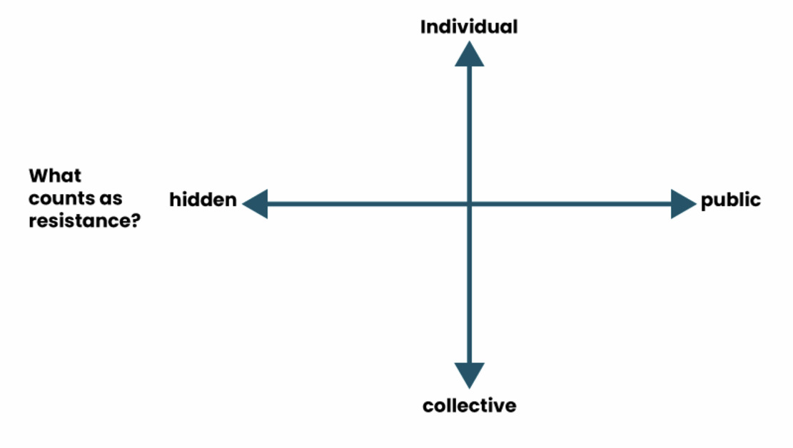
Figure 4 The Four Is of resistance (Mumby et al., 2017)
View description - Figure 4 The Four Is of resistance (Mumby et al., 2017)

Resistance can vary greatly depending on context, the aims of the resisters and the power dynamics in play. Depending on the situation, certain kinds of resistance can be more effective than others. The most ineffective forms are those that are easily deflected or even absorbed into the dominant power, whereas more effective forms of resistance prompt an alteration of power dynamics.

Activity 1 Resistance continuums in your experience?
Allow around 20 minutes for this activity

Can you think of any examples, either from your own experience or in the world at large, of these continuums of resistance in action? How effective do you think the resistance was in each case? Make some notes about your thoughts.

View discussion - Activity 1 Resistance continuums in your experience?

1.2 Four Is of resistance
The map of resistance generates four forms of resistance, with each sitting in a particular quadrant of the map, as shown in Figure 5.

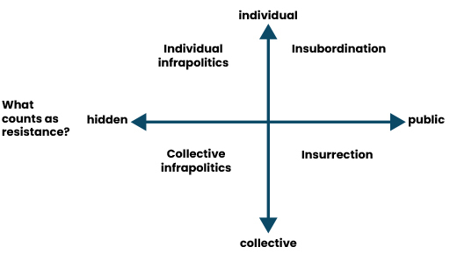
Figure 5 The Four forms of resistance (Mumby et al., 2017)
View description - Figure 5 The Four forms of resistance (Mumby et al., 2017)

These different types of resistance are referred to as the ‘Four Is’:
Individual infrapolitics
Resistance that is hidden and individual. Infrapolitics is a word meaning political activity that is concealed from open view. The identity of the resister in this type of resistance would be secret, and the effects of the act of resistance more or less effective depending on how many people engage with it and take resistant action themselves as a result. An advantage of this kind of resistance is that it can be difficult for the dominant power to stop, but can nevertheless galvanise wider agency for resistance. A disadvantage could be lack of reach and impact, as there are limits on what an individual working alone can achieve. A good example of individual infrapolitics could be a whistleblower publishing an anonymous blog article exposing wrongdoing in an organisation.
Collective infrapolitics
Resistance that is hidden but collective. Such resistance is common where you have a network of people organising behind the scenes, usually under the radar of the powers they resist. Technological developments in messaging and web software have made such resistant organising easier over time. Indeed, trade unions rely on collective infrapolitics to connect workers and share experiences. An advantage is that the hidden nature of collective infrapolitics can provide a safe space where people can explore sensitive topics and gain reassurance from others – as has been the case with the Everyday Sexism Project, which enables women to share experiences and plan action without experiencing sabotage from the powerful men they are resisting (Vachhani and Pullen, 2019). A disadvantage of collective infrapolitics could be that the actions of the group remain limited by their secrecy if they are unable to openly challenge power.
Insubordination
This is an individual and public form of resistance. Others can see the identity of the resister, who is openly oppositional. Most obviously in recent memory is the example set by climate campaigner Greta Thunberg. Her global Fridays for Future movement of young people taking strike action from school started as a solitary but public protest from Thunberg, as she sat outside the Parliament building in Sweden protesting the lack of action from political parties on the climate crisis. A whistleblower could also be a good example, if that person exposed wrongdoing publicly, such as through the media. As an advantage, such public but individual demonstrations of resistance can be powerful in providing a symbol of hope to others – the David vs Goliath underdog figure. Such resistance is more or less effective depending on how many people relate to it and join the cause. Insubordination, however, can also be isolating and expose the resister to hostility, even danger.
Insurrection
This is resistance at its most public and collective. Strike action or street protest are excellent examples. The effectiveness of insurrection is measured by the degree to which it manages to force concessions from those in power or whether it enables resisters to take power themselves. There are of course risks. Sometimes it is unclear where the leadership comes from and what the strategy is, because power is shared by so many people. However, a large body of people, if properly organised and led, can provide a powerful mass that can be hard to ignore. In the case of strike action, it is the number of people refusing to work and the disruption caused, combined with how long they are prepared to go on strike that can determine success – it is then a matter of which side concedes first. Insurrection is not necessarily aimed at demanding concessions from an organisation, but can instead try to harm or destroy it if the organisation’s ethics are considered to be beyond repair – the practice known as dissensual leadership, which you explored in Week 3 (Barthold et al., 2022). Climate activists using their bodies to prevent fossil fuels being extracted is one example of such leadership, likewise direct and peaceful action from race equality campaigners.
Groups rarely stick to only one form of resistance. They can move between the four quadrants over time. This is usually from individual and hidden to more public and collective – as was the case with Greta Thunberg and her movement. However, the direction of travel can migrate the other way – an example may be collective action on racial equality inspiring individuals to take action (private or public) in their workplaces and/or communities.
You will now practise identifying types of resistance by engaging with a real example.

Activity 2 Identifying resistance types
Allow around 30 minutes for this activity

In this video Kemar Knight discusses limitations of individual complaints (individual infrapolitics practices). As you watch the video, try to identify one or more of the Four Is.
Do the experiences in the video speak to your own? If you wanted to start some resistance leadership in your own context, which of the Four Is would you choose? Make some notes about your thoughts.

Video content is not available in this format.
Video 1 Kemar Knight – Limitations of complaints
View transcript - Video 1 Kemar Knight – Limitations of complaints

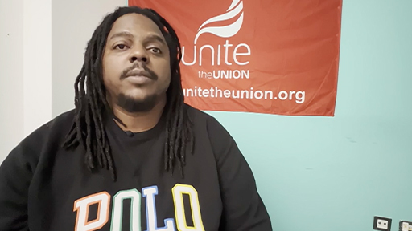

View discussion - Activity 2 Identifying resistance types

The framework offered by Mumby et al. (2017) is a useful one, but it does not cover all types of resistance. You will now move on to consider a framework that defines types of resistance according to how they respond to power.

2 Resistance as distance, persistence and difference
Leadership scholar David Collinson conducted seminal research into resistance in the 1990s. Collinson (1992 and 1994) identified two forms of resistance that are distinctive responses to different kinds of power – resistance through persistence and distance. Working with Suzanne Gagnon, Collinson identified a third practice of resistance – resistance through difference (Gagnon and Collinson, 2017). All three forms spill over the boundaries of the Four Is (Mumby et al., 2017). They are worth learning about because they draw attention to the fact that resistance can be more or less troubling to status quo power. They also show that resistance can serve purposes other than challenging power – it can be practised as a way of helping resisters cope and feel better about themselves under difficult circumstances.


Figure 6 Resistance through distance can involve disengaging from an organisation
View description - Figure 6 Resistance through distance can involve disengaging from an organisatio ...

2.1 Resistance through distance


Figure 7 Resisting sometimes involves creating a boundary between oneself and the dominant power
View description - Figure 7 Resisting sometimes involves creating a boundary between oneself and the ...

First, David Collinson identified ‘resistance through distance’. In this kind of resistance ‘employees are primarily concerned to differentiate themselves psychologically, culturally and spatially from the organisation and from those in power’ (Gagnon and Collinson, 2017, p. 1271). Note here how the resistance defines itself according to the power it opposes. It acts as a way for people to give themselves space to recover and recuperate from what they feel are the injustices or indignities of work. This resistance can appear anywhere in the Four Is identified by Mumby et al. (2017) – it can be individual, collective, hidden or public. Resisters create boundaries between themselves and dominant power. The boundaries can be collective and cultural, with resisters crafting their own social circles and activities that exclude anyone perceived as with ‘them’. Collectively, groups can also develop a distinctive sense of humour, which targets figures in positions of power, making them seem smaller and less powerful.
An advantage of this kind of necessarily exclusionary resistance is that it enables resisting groups to develop a strong identity and perhaps also loyalty. It can also help in developing solidarity that can transition to forms of resistance capable of damaging the dominant power. However, the conclusion of Collinson’s study is that resistance through difference can be both counter-productive and alienating. It can be counter-productive because those in power are not affected too much by it. In some cases resistance through difference can even strengthen the status quo. First, because those in power have more freedom to make decisions without the input of those who oppose them. Second, because people in power can show that they are tolerant and human – people who can take a joke and who are relaxed about distinct cultures emerging within an organisation. This kind of resistance can be alienating because many people can feel that they are not represented by the cultural norms exemplified by groups founded on ‘distance’. In Collinson’s study, the resisting group was archetypally male (and white), meaning that those who did not fit such an identity would have struggled to identify with the resisters.

2.2 Resistance through persistence
Second, Collinson posited ‘resistance through persistence’. This kind of resistance can be individual or collective but is always public. Resisters ‘seek to render managerial decisions more visible, transparent and accountable’ through persistence (Gagnon and Collinson, 2017, p. 1271). Such resistance can also consistently prioritise certain demands, such as better pay and conditions in workplaces, or policies and legislation in the political realm. In stark contrast to resistance through distance, resistance through persistence gets close to those in power, taking a keen interest in detail as well as broader principles.


Figure 8 Resistance through persistence is always public and seeks accountability
View description - Figure 8 Resistance through persistence is always public and seeks accountabilit ...

Whether formal or otherwise, special interest groups within workplaces – such as groups of employees established to further equality, diversity and inclusion – may persistently scrutinise and request changes to organisational practices. Trade unions may consistently campaign for and take action over pay, working conditions and pensions. Social campaign groups can form to find flaws with proposals they oppose – such as airport expansions, plans for housing or other developments. Persistence usually requires some expertise to be effective – people able to interpret the technical details of what people in power are suggesting and capable of offering alternative proposals. But resistance through persistence can also rely on experience or willingness to learn.
Persistent resistance, of course, can backfire if it is persistent over issues that do not interest a wide enough group of people. In such instances resisters can appear irrelevant, exclusionary and even obsessive, and the effect can be to repel potential allies. A good example of this phenomenon of over-persistence were people at either extreme of the Brexit debate who doggedly pestered politicians outside Parliament for several months, even years.

2.3 Resistance through difference


Figure 9 Resistance through difference involves challenging the dominant culture through diversity
View description - Figure 9 Resistance through difference involves challenging the dominant culture ...

Resistance through difference, the third practice added in a later study by Suzanne Gagnon and David Collinson, harnesses diversity as a ‘productive resource’ for resisters (Gagnon and Collinson, 2017, p. 1270). It is usually a response to an employing organisation or culture that is overly controlling and monolithic in what it sees as legitimate cultural and social expression and identity. Difference can only be valued relationally and collectively – with someone’s difference valued in relation to our own qualities. However, resistance through difference can be more or less publicly affirmed. Asserting the value of difference can generate learning amongst resisting groups and help ensure that they adapt to the world around them.
As people interested in enhancing racial equity, you obviously already know the value of diversity for groups. It brings energy and learning. Seeing solidarity between diverse people can feel especially moving because it demonstrates the human capacity for empathy and growth. Too much difference can of course be problematic when groups are so eclectic that they become incoherent, incapable of agreeing on basic principles, let alone strategy and tactics. That is why the practices of leadership communication that you learnt about in Week 4 and Week 5 of Introducing Black leadership are important, because they help you find a way through difference, making diversity a strength for leadership.
To conclude the discussion on resistance through distance, persistence and difference, it is worth noting that one is not necessarily more effective than another. Their effectiveness depends on the context. Resistance through distance is the type that is most criticised, because it offers the least challenge to power. However, this kind of resistance can offer people a sense of comfort and support under difficult circumstances, the importance of which should not be underestimated. Finally, it is worth noting that resistance through distance, persistence and difference rarely exist in isolation. Resisting groups are capable of demonstrating more than one at any one time and frequently transition between them. You will now explore some of the contextual dependencies of these forms of resistance through an activity.

Activity 3 Distance, persistence and difference in practice
Allow around 20 minutes for this activity

Watch the following video where Christy Adeola Braham, Workers Health Coordinator, Women in Informal Employment: Globalizing and Organizing, talks about her resistance in relation to power. As you watch, try to find examples of resistance through distance, persistence and difference.
If you wanted to start resistance leadership in your own context, would you choose distance, persistence, difference or more than one of these approaches? Make some notes or have a conversation with a colleague about your thoughts.

Video content is not available in this format.

Video content is not available in this format.
Video 2 Christy Adeola Braham – Resistance to power
View transcript - Video 2 Christy Adeola Braham – Resistance to power



View discussion - Activity 3 Distance, persistence and difference in practice

3 Resistance under corrupt conditions
When considering resistance, it is important not to lose sight of the specific circumstances under which it takes place. Too often studies of resistance are dismissive of hidden, constructive or subtle forms because they do not offer substantial challenge to the dominant power. However, there are many circumstances under which resisting can hold such serious consequences that doing so in open ways can be severely limiting to career, wellbeing or even physical safety. Hence some important research has been conducted into how people manage to gain concessions under circumstances when the organisations and institutions they are working with, through and against are corrupt – i.e. they cannot be trusted to uphold the basic standards expected within a liberal democracy, such as a commitment to equality, freedom of expression and adherence to the rule of law.


Figure 10 Resisting corrupt power requires persistence and skill
View description - Figure 10 Resisting corrupt power requires persistence and skill

When such standards are compromised – i.e. when organisations and institutions show favour to some groups of people, while acting in prejudiced ways towards others – then this can usually be characterised as corruption. The charity Transparency International, which researches and campaigns on corruption, defines it as ‘the abuse of entrusted power for private gain’ (Transparency International, 2023). In other words, corruption always involves two factors: first, an abuse of power; second, someone gaining from this abuse. You can note from the definition that it can cover basic corruption that enriches a person or small group of people financially – such as taking bribes in exchange for preferential treatment. Corruption can also work to enhance the private gain of some people in insidious ways, through protecting the dominance of some groups over others – such as men who abuse their partners, or racists who expose Black people to violence and hate.
Such corruption can of course overlap – corruption that enriches can also dominate – e.g. white traders who became rich through enslaving Black people. Corruption in general has broader political and social implications because it ‘erodes trust’ in public institutions and society in general, which also means that it ‘weakens democracy, hampers economic development and further exacerbates inequality, poverty, social division and the environmental crisis’ (Transparency International, 2023).
When corruption takes hold deeply in a society, resistance becomes challenging. If corruption is limited to just a few organisations, it is possible to expose them and gain justice through the usual channels of media, police or other organisations responsible for upholding public standards. When corruption is more deeply entrenched, it is still possible to resist, but doing so involves uncomfortable compromises and working through institutions you know are, at best, deeply flawed.
Smolović Jones (2023) studied a non-corrupt women’s rights organisation operating in a corrupt context. The organisation’s workers usually had to work through public organisations and institutions that were corrupt. Such corrupt organisations were occupied by people who tended to assume that the dominance of men over women was natural and who used their power to protect male abusers. Such a system, where it is assumed that men are superior to women, is known as a patriarchy. To protect the patriarchy, Smolović Jones found that corrupt organisations and individuals would adopt gaslighting, seeking to confuse and throw off kilter those practitioners trying to secure justice for victims of abuse. The practitioners were unable to rely on official channels and processes because corruption was too endemic for this to work. Instead, they had to adopt a subtler and undercover form of resistance. Smolović Jones calls this dispelling practice, meaning to clear away the fog created by corrupt gaslighting, reorienting efforts towards gaining justice. She identified four ways in which dispelling was achieved, as you will explore in the next activity.

Activity 4 Dispelling practice
Allow around 30 minutes for this activity

Watch the following video, where OU academic Nela Smolović Jones talks about dispelling practices of resistance under conditions of corruption. As you watch, try to identify the four practices highlighted. In your own context, what would be the advantages and disadvantages of adopting such an approach? Make some notes of your thoughts.

Video content is not available in this format.
Video 3 Nela Smolović Jones – Resistance under conditions of corruption (dispelling gaslighting)
View transcript - Video 3 Nela Smolović Jones – Resistance under conditions of corruption (dispelling ...

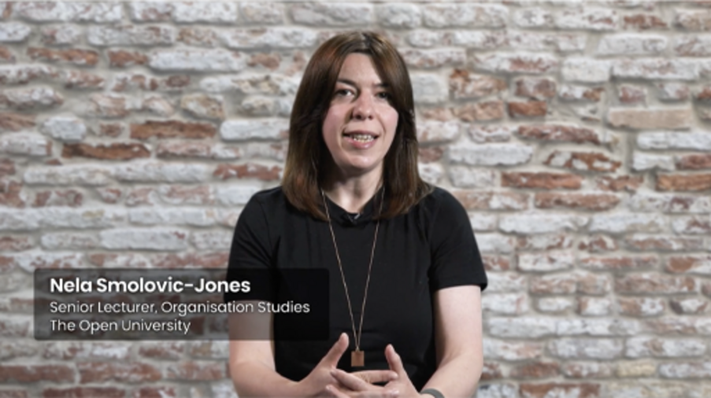

View discussion - Activity 4 Dispelling practice

4 This week’s quiz
It’s now time to take the Week 4 compulsory badge quiz. It’s similar to previous quizzes, but this time instead of answering five questions there will be 15.
Open the quiz in a new tab or window, then come back here when you’ve finished.
Week 4 compulsory badge quiz
Remember, this quiz counts towards your badge. If you’re not successful the first time, you can attempt the quiz again in 24 hours.

5 Summary of Week 4
Resistance is a rich topic and practice that can take many forms, depending on the circumstances and the people involved. It is possible to map various forms of resistance along two continuums – that of hidden–public and individual–collective. These continuums suggest Four Is of resistance. Individual infrapolitics is resistance that is individual and hidden. Collective infrapolitics is hidden but conducted by many people. Insubordination is individual but public. Insurrection is both collective and public. The map does not cover all forms of resistance, however. It is also possible to surface forms of resistance by considering how they respond to power. Taking this approach allows you to see resistance that is practised through distance, persistence and difference.
No single form of resistance is necessarily more effective than the others. What is (in)effective will depend on the circumstances – the type of power that is being resisted and the resources/opportunities that resisters have available. Resistance can also adapt in form over time, depending on the shifting nature of the power being resisted and the resources/opportunities available to those who resist. Finally, it is worth considering resistance that occurs under very challenging circumstances, such as those of heightened corruption. Under such circumstances, some practices of dispelling may be useful for gaining equitable outcomes in the short term, while recognising that the goal remains more systemic change.
You are now halfway through the course. The Open University would really appreciate your feedback and suggestions for future improvement in our optional end-of-course survey, which you will also have an opportunity to complete at the end of Session 8. Participation will be completely confidential and we will not pass on your details to others.
You can now go to Week 5.

Week 5: Influencing professional power of local public services

Introduction
This week was written by Fidèle Mutwarasibo.
Over the previous four weeks, you have been looking at power and exploring how as a leader, you can influence people and institutions with power. You have by now noted that a broad range of people holds power at a local level. This week you will look back at how the COVID-19 pandemic and the Black Lives Matter (BLM) protests brought the issues associated with racial inequalities to the fore.
You will explore how local public services have proactively sought to engage with Black people and other racialised minorities in the aftermath of COVID-19 and the BLM protests. You will examine how the issues around trust may impact how Black people respond to the emerging calls for participation and engagement, and you will look at the powers held by professionals involved in delivering local public services and how you can influence them.
You will be encouraged to consider the disconnect between legal provisions such as Public Sector Equality Duty and the lived experiences of Black people and other racialised minorities. Finally, you will look at the avenues you can use to keep professionals involved in local public service delivery accountable. Accountability through your elected officials aside, there are other pathways to accountability, including internal organisational complaint mechanisms and complaints through professional and oversight bodies.
By the end of this week, you should be able to:
- understand the role and power of professionals involved in delivering local public services
- speak with confidence about the experiences of Black people in accessing and using their local public services
- gather evidence, prepare and make a formal complaint if you feel mistreated or discriminated against
- understand the responsibilities of local public institutions in promoting equality to comply with the Public Sector Equality Duty provisions
- approach with confidence your engagement and interactions with local public services as a leader or a member of a community or network.

1 Local public services and their bureaucratic apparatus
The year 2020 will be remembered by many for two transformational phenomena that raised concern about racial inequalities in the United Kingdom and beyond. The COVID-19 pandemic exposed racial inequalities, and the Black Lives Matter protests challenged racial discrimination and made loud and explicit calls for racial equity.
To highlight what is at stake, you will now explore some statistics. According to the Office of National Statistics, ‘deaths involving the coronavirus … by ethnicity for England and Wales … among some ethnic groups [are] significantly higher than that of those of White ethnicity … Black males are 4.2 times more likely to die from a COVID-19-related death, and Black females are 4.3 times more likely than White … People of Bangladeshi and Pakistani, Indian, and mixed ethnicities … had a statistically significant raised risk of death involving COVID-19’ (ONS, 2020).


Figure 1 Public services
View description - Figure 1 Public services

Many explanations of the disproportionate impact of COVID-19 emerged, including ‘social and economic inequalities, racism, discrimination and stigma, occupational risk, inequalities in the prevalence of … obesity, diabetes, hypertension and asthma’ (Tapper, 2020). Three years after the initial response to COVID-19 and the associated lockdowns, there is an emerging consensus that the ‘COVID-19 pandemic has revealed the depth of social and racial inequalities in the United Kingdom’ (Balakumar et al., 2020).
The death of George Floyd in Minneapolis on 25th May 2020 led to global Black Lives Matter protests that ‘brought inequalities and institutional bias to the forefront of public consciousness’ in the United Kingdom (Balakumar et al., 2020). Across the United Kingdom, in ‘260 towns and cities, thousands defied lockdown to join largest anti-racism rallies since slavery era’ (Mohdin et al., 2020). In terms of numbers, ‘more than 210,000 people … attended demonstrations around the country, including 10,000 protesters in Brighton, 4,000 in Birmingham and 3,000 in Newcastle’ (Mohdin et al., 2020).
One of the issues relating to policing that has been high on the agenda among young Black people and other racialised minorities is stop-and-search. Stop-and-search occurs when police officers have reasonable suspicion that a member of the public they stop and search is, for example, carrying a knife or drugs. In the year ending in March 2021, there was an increase of 24 per cent in stop-and-search across England and Wales. On the face of it, stop-and-search is neutral and arises when there is reasonable suspicion. AndHome Office figures suggest that ‘Black, Asian and minority ethnic … males aged 15-19 were searched 208 times for every 1,000 people’ (Dodd, 2021). In 2021, Black people were seven times more likely to be stopped and searched than white people compared to nine times the previous year; a rational explanation for ‘impact of the tactic on Black people compared with people of other races’ is yet to emerge (Dodd, 2021).
Addressing racial inequalities requires joining the dots and getting all the stakeholders on board. It requires individual, group and societal actions. It is, in other words, everyone’s business, including you. Local actions are vital in addressing racial inequalities. Recently, racialised minority activists have noted an increased demand by individuals wanting to be involved in consultations with local authorities, local National Health Services (NHS) trusts and the local Police (Mutwarasibo, 2021). Public service consultations with racialised minorities are not new and have mixed reviews; moreover, as a Black leader, consultations with local public services offer an opportunity to influence and shape how the local public services address racial inequalities. One vital point is that many people managing these consultation processes are not necessarily elected representatives. Although councillors, the police and crime commissioners might feature in some of these consultations, they are, by and large, managed by professionals working for local public services. This week, you will explore how to engage and work with professionals delivering local public services.

1.1 The power of professionals
Influencing professionals is different from influencing elected officials, who are subject to scrutiny and regular elections to renew their mandate. In addition, elected officials can be petitioned; they often run clinics for the constituents and can be accessed in other ways, including when dropping off leaflets and flyers in neighbourhoods during electoral campaigns. Professionals involved in local bureaucracies are accountable in different ways. They occupy a vital position in local public institutions, and any work you do or are involved in addressing racial inequalities will only succeed if you have them on board. You will explore their power and put some thought into how you can influence local public services.

Activity 1 Fidèle Mutwarasibo: Leadership practices
Allow 20 minutes for this activity

Now watch this video with Fidèle Mutwarasibo, lecturer at the Open University Business School. As you watch, draw up a list of the leadership practices deployed in the activities discussed.

Video content is not available in this format.
Video 1 Fidèle Mutwarasibo – Engaging and collaborating with local public service providers
View transcript - Video 1 Fidèle Mutwarasibo – Engaging and collaborating with local public service ...

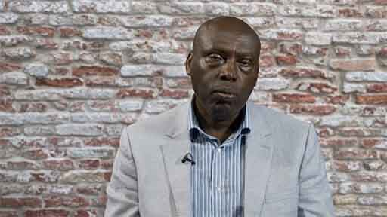

Provide your answer...
View discussion - Activity 1 Fidèle Mutwarasibo: Leadership practices

2 Local professional power


Figure 2 Professional power
View description - Figure 2 Professional power

Now that you are familiar with the role of professionals in delivering local public services, it is time to explore local professional power. As you work through the course content this week, consider entry points and techniques you could deploy to influence local public services’ inclusion policies and procedures.
As you might recall from previous weeks, power is ‘the network of social boundaries that delimit fields of possible action’ (Hayward 1998, p. 2). Power can be used positively or negatively, and power can be used to dominate, resist, or express solidarity with the less powerful (Allen, 1999). As a leader, you must think about power and how you can use your leadership to engage, work with, or resist the power you face or encounter. In other words, you must consider your freedom and how you use it. In this context, freedom is ‘the capacity to participate effectively in shaping the social limits that define what is possible’ (Hayward, 1998, p. 2). You will recall that power is often used with other descriptive words – power over, power to, power within and power with (Allen, 1999; Gaventa, 2006). As you go through this week’s material on local public services, think about the two keywords – power and freedom.

2.1 Engaging with Local professional power
Over a lifetime, you have to deal with many local public institutions. Knowing which public institution to contact in your time of need can be challenging, especially if you are unfamiliar with their functions. Institutions like Citizens Advice can help you to navigate this situation and help with developing the best way to approach the relevant local public service. With the experience shared in Activity 1 in mind, you will explore the power of professionals involved in delivering local public services, for example, councils, local NHS Trusts, and the local police.
Professionals play a vital part in the delivery of local public services. Some professionals have specialisms – for example, medical professionals, police officers, and specialist council officials. These professionals may not have political power but wield professional power. Professional power is embedded in professionals’ ability to provide or withhold resources or administer punishments (Goltz, 2003; Keltner et al., 2003; Zhang, 2020). As a leader, you ought to be aware that professionals in your local public institutions can be the most influential people in the delivery of the local public services (Scott, 2008, p. 223). Local public services professionals are well positioned to adjust local public services, especially in economic crises and when the resources become scarce to deliver services (Currie et al., 2012). As a leader, you should know that professionals have influence and access to resources through their roles (Reader, 1966). They may deflect and defer to elected officials. However, they have the technical knowledge the elected officials rely on in their assessments and decision-making processes. The key point here is that as a leader, you should be aware of professional power and, vitally, how to influence professional power.
In addition to influencing professional power through your elected representatives, it is critical to put some thought into other avenues to use when seeking to influence professionals (Sercombe, 1998; Lohmeyer, 2017); you should appreciate the potential power imbalances between you as a service user and people and institutions with professional power. The local public services are mandated to deliver services, meaning that elected representatives have ceded some powers to professionals (Sercombe, 1998).
The mandate may be generational or socially constructed. As a leader and a service user, you may need to be aware of the professionals’ mandate to you and how you can withdraw it if you are unhappy with the services they deliver to you or your community (Sercombe, 2010; Lohmeyer, 2017). As a leader, you and your community may need to engage in empowerment processes to become ‘knowable and governable’ citizens/service users (Dean, 2010; Lohmeyer, 2017). Furthermore, as a leader, you would know that the premise of empowerment is that knowledge is power (Batsleer, 2008; Lohmeyer, 2017).

2.2 Minorities’ engagement with local professional power


Figure 3 Leaders should encourage people to be aware of their rights
View description - Figure 3 Leaders should encourage people to be aware of their rights

If you are a member of a less-represented community, you should be aware and conscious that some of the holders of professional power may perceive or treat you like someone deficient (Honkasalo, 2013; Lohmeyer, 2017). You should support other leaders and ensure that members of your community and networks know that knowledge is power if used correctly.
As a leader, you should encourage people to be aware of their rights, entitlements and obligations and reassure themselves that they are treated fairly and respectfully. Awareness of the power–knowledge relationships is critical to ensuring that people with professional power do not mistreat you or those you represent (Bacchi, 2009; Lohmeyer, 2017).

3 Holding local public service professionals accountable
Earlier in this week, you were reminded that professionals are mandated to deliver public services to you and other community members. You and the community regularly renew and sustain the mandate through the officials you are called upon to vote in and out of office. Consequently, you can ensure that the local NHS, the local councils, and the local police are held accountable through the councillors and the Police and Crime Commissioners, for example.
You have also been reminded how you can access the elected officials. Contact points include clinics, public meetings, voting and other interactions throughout the electoral campaigns.
In addition to holding local public services accountable through the elected officials, there are other formal and semi-formal mechanisms to engage with local authorities, the NHS, and the police. Now and then, the local public services will ask members of the public to join consultation panels. As a member of the public, you can apply where appropriate and get on such platforms. During the early months of the pandemic, some local councils and local NHS asked members of the public to apply to become COVID-19 ambassadors. Becoming an ambassador allowed volunteers to access first-hand information on the pandemic, vaccinations, and other COVID-19 related information.
The ambassadors were expected to share the information with community members, especially those least connected to mainstream information flows. Some local police forces have established independent advisory groups to improve their engagement with communities that are less connected with the police. In some areas, the membership is open and advertised widely. Some local police forces also have scrutiny panels where members of the public are invited to review police practices, such as stop-and-search, and then give feedback to help the police in improving their practices.
There are other accountability routes, and you will focus on three for the rest of this week:
- internal complaints procedures
- accountability to professional bodies
- public sector duty.

4 Challenging professional power through internal complaint procedures
Local public services have internal complaint mechanisms to enable you and community members to complain when you are unsatisfied with how you or your community are treated. Complaints can be submitted on complaint forms, by phone, by letter and in some circumstances, through online forms. The complaint should spell out details, including the complainant’s name, contact details, name (if known) or function of the person the complaint is about, the date the complaint is lodged, the date of the incident, and a description of the incident. You will learn more about this in Activity 2.

Activity 2 Stop-and-search and following up the complaint procedure
Allow 20 minutes for this activity

As you watch the video, take note of the stop-and-search process, and think about communities and groups that are affected most. Consider the complaint procedures you or a community member could use if you feel that the experience of stop-and-search described in the clip was justified or not justified.

Watch the video at YouTube.com.
Video 2 Stop-and-search

Provide your answer...
View discussion - Activity 2 Stop-and-search and following up the complaint procedure

5 Holding professionals accountable through professional and oversight bodies
Professionals involved in delivering local public services may need membership in professional bodies to secure and maintain their posts. Professional bodies are there to promote the interests of their membership, ensure that the members are involved in continuous professional development and that their membership adheres to the ethical standards of their profession. Some professionals involved in local public delivery are expected to renew their membership in their professional organisations at regular intervals.
Not all professionals involved in local public service delivery must be members of professional bodies or subject to oversight bodies. Moreover, depending on their expertise and qualification disciplines, they may be members of professional bodies. For example, accountants, lawyers, and engineers must maintain membership in relevant professional bodies. Members of such bodies would be expected to adhere to the standards set by their professional bodies. Some of those bodies may consider and process complaints from the public about their members.
There are many professional bodies for medical professionals, including the British Psychological Society, the General Medical Council, and The Nursing and Midwifery Council.
The Independent Office for Police Conduct (IOPC) oversees police complaints in England and Wales. In Scotland, the Police Investigations & Review Commissioner (PIRC) independently investigates incidents involving the police. In Northern Ireland, The Police Ombudsman handles complaints about the police’s conduct.
Complaints through professional and oversight bodies will involve a process like the one in Activity 2 earlier. As a leader, you can lodge a formal complaint through professional or oversight bodies; as a citizen or service user, you can lodge a complaint for a colleague or a team or community member, if appropriate. In that case, it is vital to familiarise yourself with the process, gather the evidence needed and then complete and submit the relevant form. You may seek support from voluntary sector organisations, your trade union (if applicable), faith organisations, and other relevant actors.

6 Professional power and Public Sector Equality Duty
Earlier you looked at the accountability of local public service professionals to you as a citizen and a leader through your elected officials, and the consultative mechanism open to members of the public. Additionally, you explored how you can hold professionals accountable through the organisational complaints mechanism and how you can complain through professional and oversight bodies.
There is another route to accountability via the equality and human rights legislation provisions under the Public Sector Equality Duty. As a leader, you are encouraged to learn more about the provisions, check out what works and what doesn’t in terms of implementation, and explore how you can hold local public services to deliver their service equitably to all the communities.
As you acquaint yourself with the legal provisions, you are encouraged to question them, think about how the local public services assess their performance, and consider whether the community and you, as a leader, can hold them to account through such mechanisms. Ask yourself questions like: are you doing enough to influence local public services’ practices, ensuring that they deliver on their Public Sector Equality Duty and are transparent in gathering evidence to demonstrate compliance?
You will note that there are variations across the four UK nations. If required, you can find out more information through the statutory bodies responsible for implementing the legislation.

6.1 Equality Act 2010
The Public Sector Equality Duty is set out in section 149 of the Equality Act 2010. The legislation makes provisions for the following:
- eliminate unlawful discrimination, harassment, victimisation, and other conduct prohibited by the Act
- advance equality of opportunity between people who share a protected characteristic and those who do not
- foster good relations between people who share a protected characteristic and those who do not.
The Equality Act 2010 covers the following characteristics:
- age
- disability
- sex
- gender reassignment
- marriage, or civil partnership (in employment only)
- pregnancy and maternity
- race
- religion or belief
- sexual orientation.
It applies in England, Scotland and Wales. Under the legislation, all the public bodies were expected to publish their equality information by 30 March 2022. In Wales, annual reports for 2021 to 2022 were expected by 31 March 2023. In Scotland, most listed authorities started their reporting in 2013 and are expected to publish their reports every two or four years, depending on the duty.

6.2 Northern Ireland Act 1998
In Northern Ireland, Section 75 of the Northern Ireland Act 1998 requires government and public authorities’ practices to be underpinned by equality and to ensure that good relations with the communities are at the centre of policy-making and delivery of services. Section 75, in effect, encourages public institutions to address inequalities and demonstrate that they are making measurable impacts along the way on those affected by inequalities. Designated agencies under Section 75 include government departments and agencies, local councils, health trusts, housing associations, colleges and universities, and education and library bodies. Under Section 75, public authorities are required to have due regard for the need to promote equality of opportunity between:
- persons of different religious beliefs, political opinions, racial groups, ages, marital status or sexual orientation
- men and women generally
- persons with a disability and persons without
- persons with dependants and persons without.
In Northern Ireland, in complying with the provisions of Section 75, public institutions are expected to undertake inequalities audits, produce annual progress reports, assess the equality implications of their work, monitor their work, establish complaints mechanisms, and produce five-year reviews of their equality schemes.
If, as a leader, you feel and believe that a decision or a policy that affects you has not considered the equality duty, you can use the Public Sector Equality Duty to articulate your feelings and views to the authority concerned. You can also use the public duty to strengthen your discrimination case when discrimination arises.
You will explore the practicalities of how to hold professionals involved in local service delivery accountable in Activity 3.

Activity 3 Dealing with public services
Allow 20 minutes for the activity

As you watch the video, consider Yaina’s experiences dealing with local services as an ordinary citizen before she acquired the leader status. Reflect on how the lived experience helped develop her leadership skills and profile. Contrast her experience accessing public services as a private citizen and after emerging as a leader. Take notes of what she is doing to support emerging leaders and how she encourages using the equality legislation to improve and enhance service delivery to Black and other ethnic minority communities.

Video content is not available in this format.
Video 3 Yaina Samuels – accessing public services
View transcript - Video 3 Yaina Samuels – accessing public services

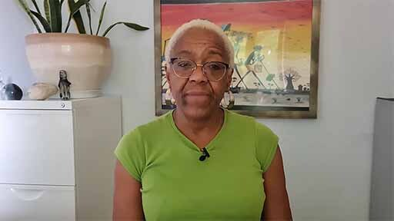

Provide your answer...
View discussion - Activity 3 Dealing with public services

7 This week’s quiz
Now that you’ve completed Week 5, you can take a short quiz to help you to reflect on what you’ve learned.
Week 5 practice quiz
Open the quiz in a new window or tab, then come back here when you’ve finished.

8 Summary of Week 5
This week you looked at professional power in the local public service. You examined how racial inequalities still exist despite the Public Service Equality Duty provisions’ urge to deliver inclusive service, and you got to hear from Black leaders about how they have contributed to change through their leadership. Towards the end of the week you explored avenues to seek redress if you feel that you, a colleague, a friend, or a member of your group or community has been mistreated or discriminated against. Next week, you will examine the power of businesses and corporations and how you can influence them.
You can now go to Week 6.

Week 6: Influencing the power of corporations on the ground

Introduction
This week was written by Fidèle Mutwarasibo.
This week you will be building on last week’s discussion on professional power and exploring the power of businesses and corporations. Corporations influence public opinion, provide employment, support the community through their corporate social responsibility activities, and provide financial resources to the community through their philanthropic contributions. In a nutshell, businesses and corporations significantly affect your life and the lives of members of your community and broader society.
This week, you will explore how you can influence businesses and corporations as an individual or as part of a group or organised community from the bottom up. You can work with civil society and its diverse membership (voluntary sector organisations, faith-based organisations, trade unions) to influence businesses and corporations. The law, especially equality and human rights legislation, has provisions to help you as an individual with protected characteristics to assert your rights if you are discriminated against, victimised, or harassed.
By the end of this week, you should be able to:
- understand the difference between equality and equity
- understand ways to influence businesses and corporations – civil society, public institutions, and personal actions
- analyse the influence of businesses and corporations in politics and the media
- challenge harassment, discrimination, and victimisation if and when they happen to you or a colleague at work or when accessing services.

1 Understanding the power of businesses and corporations
You have looked at power and how you can influence people and institutions in power, as an individual or as part of a group. This week, you will learn about ‘corporate power’ (this was introduced by Johal et al., 2014). Corporate power is the power to shape and influence the public narrative and, public policy by extension (Johal et al., 2014, p. 403).

1.1 Power – businesses and corporations
Businesses can influence societies through discursive legitimacy (Hardy and Phillips, 1998; Purdy, 2012; Ba, 2022), for example, by changing and manipulating perceptions and expectations. Discursive-based power means businesses can access, influence, dominate and manipulate what is publicly discussed and communicated (Fairclough, 2002; Van Dijk, 1996; Ba, 2022).
In liberal democracies such as the United Kingdom, the economy plays a big part in politics. As you would recall, the economy played a crucial role in the Brexit referendum and is a common theme during electoral campaigns. Businesses can use the healthy economy argument to influence elected officials. In addition, businesses can get involved formally in politics through lobbying, campaign contributions and getting their representatives in politics either as elected officials, advisors or people moving across to work in the public sector (Hathaway, 2018, pp. 1–2). As a leader, you should understand corporate power and its manifestations to develop practical approaches to influence local, regional, and national businesses. It is vital to be aware of all potential entry routes for your leadership practices, whether these are exercised at a personal or group level.

2 Historical legacy of corporate power on Black people


Figure 1 Businesses and corporations pledge support opportunities for Black people
View description - Figure 1 Businesses and corporations pledge support opportunities for Black peop ...

The murder of George Floyd in 2020 and Black Lives Matter protests across the world not only focused minds on policing in multi-ethnic societies, but posed profound questions concerning the legacy of slavery and colonialism. While the colonial empires were responsible for the political dispensation of slavery and colonialism, business played its part and had questions to answer. Unsurprisingly, some big businesses undertook an audit to examine how their wealth was accumulated during the slavery and colonial eras.
Lloyds Bank apologised for its ‘shameful’ role and pledged to fund opportunities for young Black and ethnic minority people; the Bank of England apologised for its ‘inexcusable connections’ with slavery; and Greene King, one of the leading UK pub chains and brewers apologised for one of its founders’ profits from slavery (Faulconbridge and Holton, 2020).
The business and corporations’ pledge to support opportunities for Black people and other racialised communities is a welcome development in addressing racial inequalities. As a matter of justice, racial equality means at a minimum parity of participation; it ‘requires social arrangements that permit all to participate as peers in social life’ (Fraser, 2005). You will now explore the difference between racial equality and racial equity.

2.1 Choosing between racial equality and racial equity
There are many discussions on the meaning of equality, and you will be introduced to the Equality and Human Rights Commission’s (EHRC) definition to simplify the situation. According to EHRC:

Equality is about ensuring everyone has an equal opportunity to make the most of their lives and talents. It is also the belief that no one should have poorer life chances because of how they were born, where they come from, what they believe, or whether they have a disability. Equality recognises that historically certain groups of people with protected characteristics such as race, disability, sex, and sexual orientation have experienced discrimination
(EHRC)

Equality, at face value, is about ensuring that people get the same treatment, whereas equity focuses on fairness (Espinoza, 2007; Lanfranconi et al., 2020). In other words, equity refers to ‘distributions based on deservingness … equality, … favours identical allocations’ (Huppert et al., 2019, p. 2). Equity means ‘each of us getting what we need to survive or succeed—access to opportunity, networks, resources, and supports—based on where we are and where we want to go’ (Lee and Navarro, 2018, p. 25). Equity has many dimensions: economic, political, health, and legislative (Junfeng, 2012, p. 30).
As this week focuses on the power of businesses and corporations, it makes sense to spend some time exploring equity in the labour market. Racially equitable labour market means a labour market where the labour market processes operate similarly for Black people and other racialised minorities and the majority white population (Daymont, 1980, p. 379). In effect, racial equity in the workplace means a labour market where the legacy of race is no longer relevant (Duncan, 1969) and race no longer plays a part in labour market outcomes (Wilson, 1978).

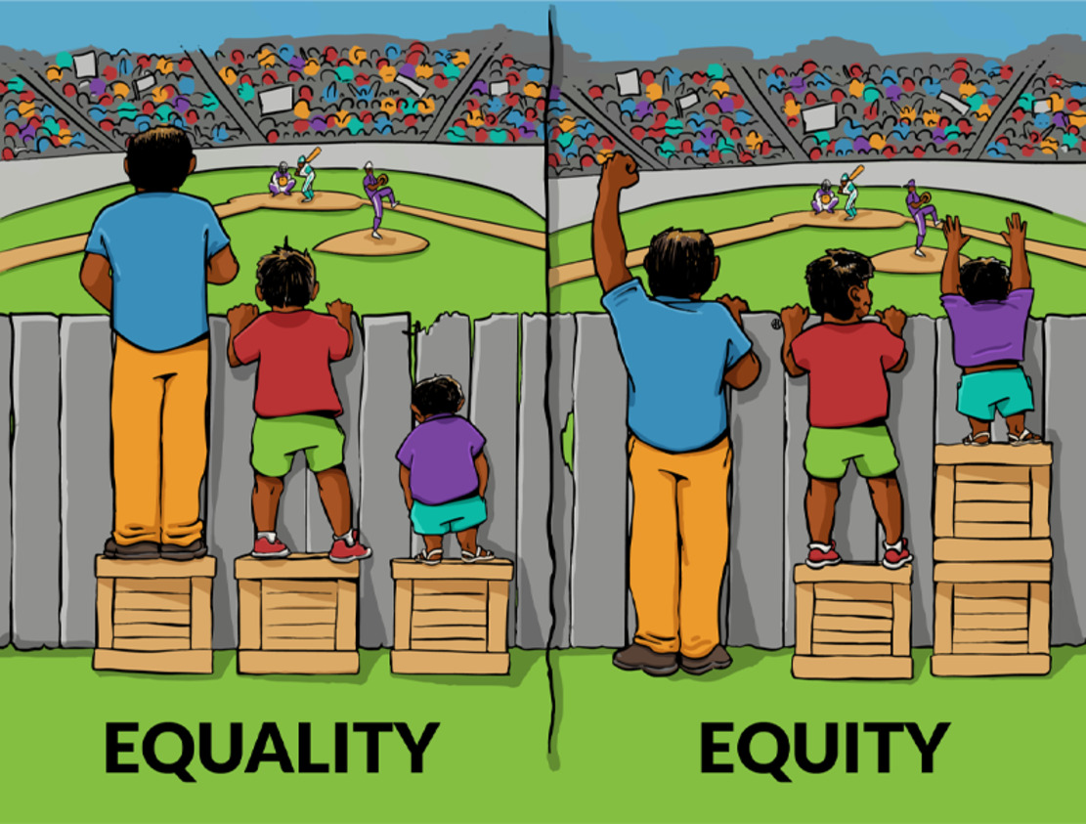
Figure 2 Visual representation of the difference between equality and equity
View description - Figure 2 Visual representation of the difference between equality and equity

Dealing with racial inequalities in the labour market through a racial equity approach would, over time, ‘result in smaller racial differences in backgrounds in the next generation’ (Daymont, 1980). Figure 2 highlights the difference between equality and equity. As the image on the left (equality) shows, the short person in the picture must look through the gaps in the fence to see what is happening on the pitch, whereas the taller ones can see clearly. The image on the right (equity) highlights how adjustments and levelling up help all the three people featured to watch and enjoy the match.

Activity 1 Interventions to improve labour market outcomes for Black people
Allow around 25 minutes for this activity

Based on your understanding of the UK labour market, identify and evaluate two potential racial equity interventions that you would suggest to an official of a corporation of similar size and power to Lloyds Bank (if you met with them), based on their commitment to fund opportunities for Black people and other racialised minorities. These interventions should positively impact the labour market outcomes for Black people and other racialised minorities.

View discussion - Activity 1 Interventions to improve labour market outcomes for Black people

3 Mediating corporate power through civil society institutions
Civil society is a collection of diverse organisations ranging from informal to formal that are connected to some degree to the community, public institutions, and businesses. In liberal democracies like the United Kingdom, civil society plays a vital role in ensuring that the diverse voices in society, including those on the margins, are heard and not suppressed.
Voluntary associations, faith communities and other local networks that form civil society help ensure that decisions that affect the community are made where they are likely to have a positive impact, as opposed to having everything controlled by those with political and professional power (Bell, 1989).
Some historic gains in equality, including the advancement of gender equality, the abolition of slavery, health and safety in the workplace, the electoral rights of minorities, and change in equality legislation, happened because people organised under the banner of human rights and called for change (Sikkink, 2011, 2017; Smith, 2021). Those processes have ‘nurtured networks of activists, professionals, and public officials working across local and global scales which are well-versed in international human rights laws and their articulation in a variety of global treaties and institutions’ (Smith, 2021). Social movements in those campaigns have connected the local, regional, national, and international dimensions of the causes they have been championing.

3.1 Civil society organisations
Civil society organisations have various sources of income. Sources of income include individual contributions (regular or one-off). Civil society institutions also get funding through philanthropic sources. The word philanthropy has its origin in Greek. It is made of two words, philos – meaning ‘loving’ and anthropos – meaning ‘humankind’. In other words, philanthropy means love for humanity. Those who practise philanthropy are called philanthropists. Most of those involved in philanthropy are current or former business leaders, owners, or family members. Philanthropy is another way of getting businesses’ investment in the community, but such interventions do not necessarily lead to equality or equity (Valley, 2020).
Another emerging form of civil society funding is getting paid a commission to deliver public services commissioned by the government or local authorities. Being closer to communities can enable civil society to provide public services to those in need. The other aspect of funding that cannot be overstated is volunteering. Businesses and corporations can contribute to volunteering through their corporate social responsibility interventions. Volunteers play a vital role in civil society, across the organisation, from service delivery to governance.
Knowing how civil society is funded is critical in understanding the services you would expect when seeking to influence businesses through civil society. Civil society organisations’ services range from information provision, service delivery, representation, research, organising community and cultural events, education, training and development, employment services, and advocacy, among other services.
These services are essential for you and other members of the community. Volunteering and other services can benefit you in developing skills that can be applied in a work setting. Civil society can also help you build your networks and make connections that can be leveraged in other contexts, including employment. Through a variety of interventions, civil society plays a vital role in leveraging or, indeed, resisting corporate power. The key is identifying which actor in civil society can help engage with a specific corporate actor and on what terms.

Activity 2 Working with businesses and corporations to promote racial equity
Allow around 10 minutes for this activity

As you watch the video, jot down a list of steps to encourage businesses and corporations to support the community in fighting against hate and discrimination. When you finish watching the clip, reflect on a local issue that concerns you – for example, employment, training, inclusion, or exclusion – and think about what you can do to get a particular business or businesses interested and engaged in addressing the issue.

Video content is not available in this format.
Video 1 Fidèle Mutwarasibo – Arriva, Network Rail, and chartered accountants
View transcript - Video 1 Fidèle Mutwarasibo – Arriva, Network Rail, and chartered accountants

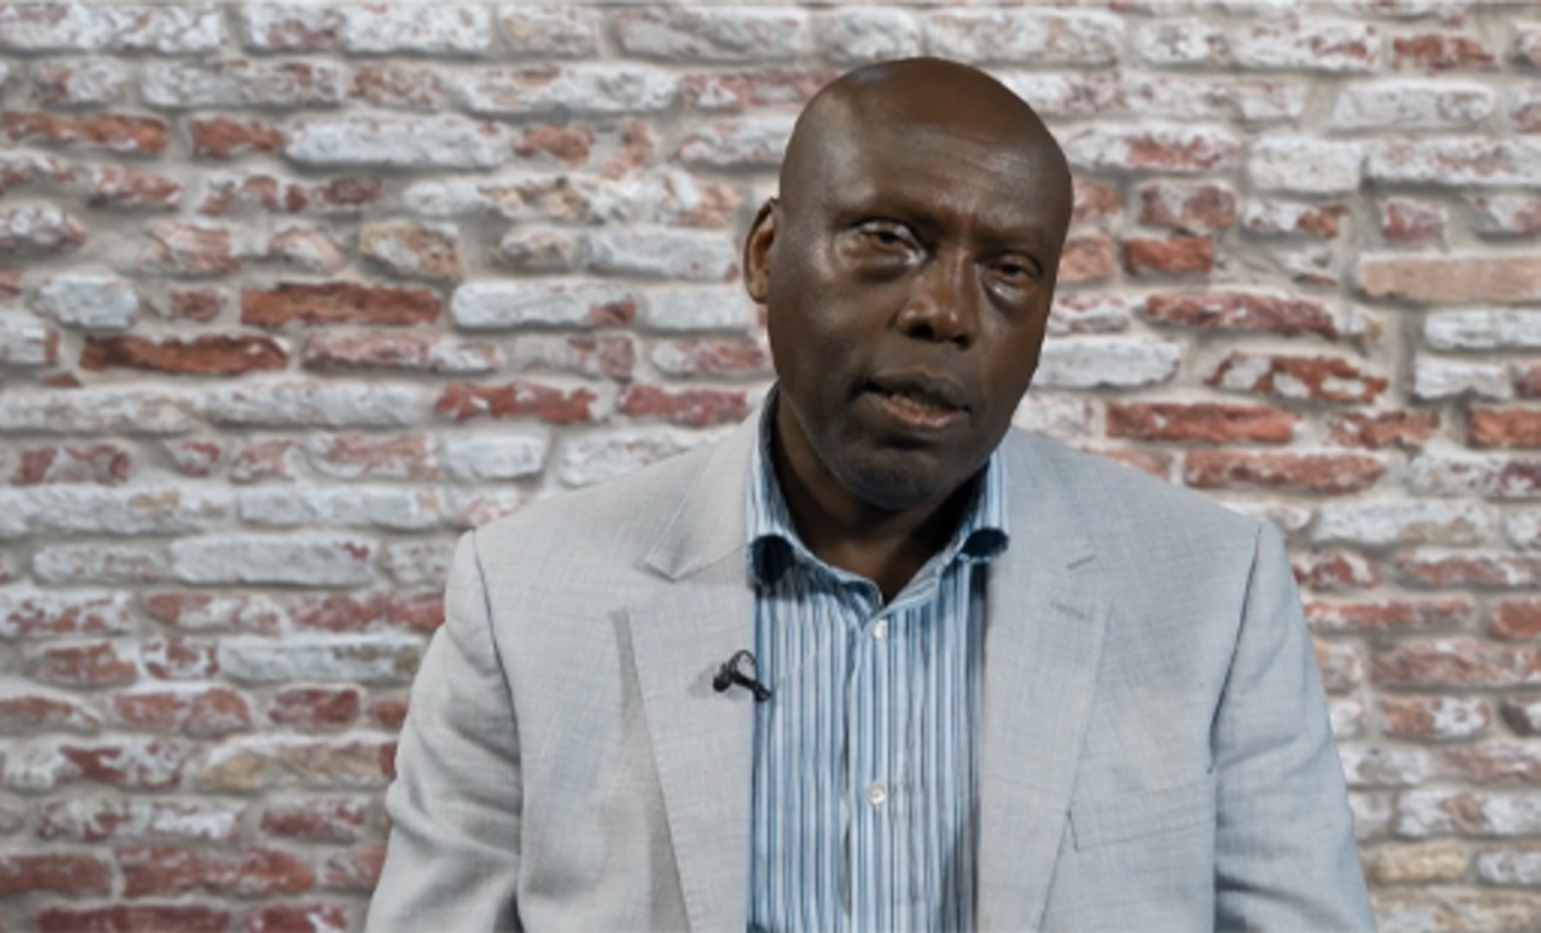

Provide your answer...
View discussion - Activity 2 Working with businesses and corporations to promote racial equity

4 Mediating corporate power through public institutions
As discussed previously, The Equality Act 2010 prohibits discrimination under the protected characteristics:
- age
- disability
- sex
- gender reassignment
- marriage, or civil partnership (in employment only)
- pregnancy and maternity
- race
- religion or belief
- sexual orientation.
Protected characteristics are aspects of personal identity that make the person who they are. The legislation means that employers should not unfairly treat people due to protected characteristics. It covers:
- businesses and organisations which provide goods or services like banks, shops and utility companies
- health and care providers like hospitals and care homes
- someone you rent or buy a property from like housing associations and estate agents
- schools, colleges and other education providers
- transport services like buses, trains and taxis
- public bodies like government departments and local authorities.
Unfair treatment or discrimination can be direct, indirect or by association or perception. Direct discrimination occurs when you are treated worse than another person or other people because: you have a protected characteristic; someone thinks you have that protected characteristic (known as discrimination by perception), and you are connected to someone with that protected characteristic (known as discrimination by association). Indirect discrimination happens when a policy applies the same way for everybody but disadvantages a group with protected characteristics. If this happens, the person or organisation using the policy must show a good reason. For example, on rare occasions, an employer can demonstrate that an employee needs to have a particular characteristic to do a specific job.
The legislation also covers victimisation and harassment. Harassment is unwanted behaviour that the person at the receiving end finds offensive. In the context of the legislation, harassment arises when the perpetrator targets a victim because they have a protected characteristic or are perceived to have a protected characteristic. Unwanted behaviour could include: spoken or written abuse, offensive emails, comments on websites and social media, images and graffiti, physical gestures, facial expressions, and humour that is offensive to you. Victimisation in this context refers to a situation where you are mistreated because you (a person with a protected characteristic) complained about discrimination, or because you helped and supported a person with a protected characteristic being discriminated against.

4.1 Redress for victims and witnesses of discrimination
If you are a victim or a witness of discrimination, victimisation and harassment, there are opportunities for redress. Under the Equality Act, the Equality and Human Rights Commission offer various services, including a helpline and advice service, a legal support scheme, enforcement powers, and pre-enforcement interventions. The Equality and Human Rights Commission and court services are potentially available to you if you are a victim of discrimination, harassment, and victimisation under any protected characteristics. Working through your trade union is possible if you think your rights have been compromised.
The equality legislation provides opportunities to challenge corporate power if you feel that you are being discriminated against, harassed, or victimised at work because you have one or many protected characteristics. The same applies if you experience discrimination, harassment or victimisation when accessing business services.

Activity 3 Supporting victims of discrimination, harassment and victimisation in the workplace or community
Allow around 20 minutes for this activity

As you watch the video, draw up a list of what you as a leader can do to support colleagues in the community and/or workplace if they are victims of discrimination (direct, indirect, by association, by perception), harassment or intimidation. After, write a note to a hypothetical line manager at work or a leader in the community who fails to notice and/or deal with a situation where a person with protected characteristics is discriminated against.

Video content is not available in this format.
Video 2 The State’s obligations relating to discrimination
View transcript - Video 2 The State’s obligations relating to discrimination


Video 2 What is discrimination?

View discussion - Activity 3 Supporting victims of discrimination, harassment and victimisation in ...

The biggest challenge with discrimination is that victims sometimes internalise discrimination and live with it, which significantly negatively impacts victims and witnesses. As civil rights, leader Martin Luther King Jr. said, ‘The ultimate tragedy is not the oppression and cruelty by the bad people but the silence over that by the good people’.
As a leader, you are expected to pick sides. Witnessing discrimination, harassment, victimisation, and doing nothing speaks volumes about the silent witness. There are intervention mechanisms and support tools available if only you look out for them. What will the future you say about what you did when you witnessed discrimination?

5 Mediating corporate power through individual action
Outside organisations in civil society and trade unionism, there are many other options you can take as an individual to assert your rights. You will cover two potential actions you can take as an individual, but they may trigger thinking about other options.

5.1 Boycott brands
You are living in an era that is dominated by consumerism. Day and night, you are bombarded with television, radio, print or social media adverts. There are reports of abuse of corporate power through child labour, prisoners’ exploitation, wars and conflicts instigated by those interested in exploiting rare minerals, using dirty money in politics and other forms of exploitation and discrimination. There are, as articulated earlier, ways through which you can be involved in seeking redress. You can also use your consumption to make your point. Boycotting brands is one of the methods deployed to influence corporate power. Building a critical mass of people boycotting a brand would undoubtedly be noted by businesses and influence their decision-making processes.

5.2 Resignation
A resignation is a tool in your armoury as an individual. Whether you are an employee or a volunteer, there will be provisions for terminating the contract in your contract. Resignation can be used to make a statement and to resist corporate power. Ensuring to mention the rationale in the exit interview is vital in stating why resignation is a proportionate action concerning a disagreement with a business or a corporate entity.

6 This week’s quiz
Now that you’ve completed Week 6, you can take a short quiz to help you to reflect on what you’ve learned.
Week 6 practice quiz
Open the quiz in a new window or tab, then come back here when you’ve finished.

7 Summary of Week 6
Having spent Week 5 looking at professional power, you explored corporate power this week. You looked again at the sources of power and how through a variety of other actors, you can influence businesses and corporations’ power. In addition, you looked at how you can influence businesses and corporations’ power through your actions, or as part of a broader network involving others like you who want to do something about the issue they are concerned with.
You can now go to Week 7.

Week 7: Campaigning

Introduction
This week was written by Tom Morton, Fidèle Mutwarasibo and Owain Smolović Jones.
The history of Black leaders campaigning for change is well known and includes civil rights and anti-apartheid movements, as well as the Black Lives Matter movement of today. This week you will consider the role campaigning plays in leadership practice, including how campaigns use and interact with power, how they can play an important part in developing leadership skills, and are in themselves significant practices in leadership.

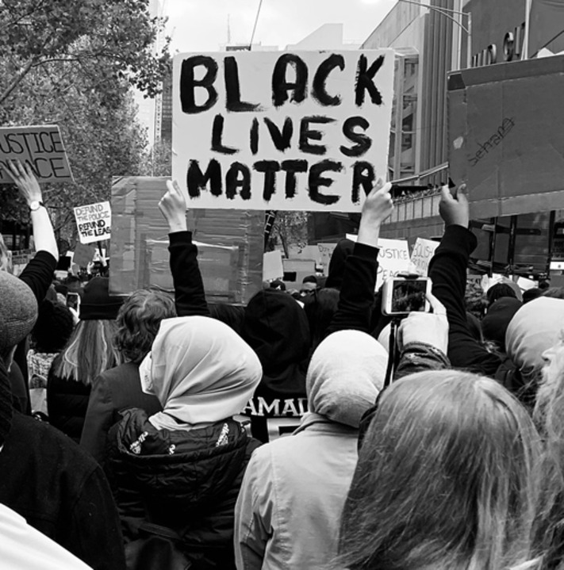
Figure 1 Campaigning means mobilising for change
View description - Figure 1 Campaigning means mobilising for change

There are many approaches to campaigning, but this week you will consider them in two contexts:
- Campaigning for a candidate. This means getting individuals into positions of leadership and is focused on elections in government, workplaces, and civil society organisations. Election campaigns have been a key area of struggle for Black leaders, from the first Black councillors to the first Black presidents.
- Campaigning on an issue. This looks at leading a campaign for change on a particular issue and applying pressure on people in leadership positions to enact change. It includes internal campaigning e.g. on workplace issues, and external campaigning e.g. in social movements.
By the end of this week, you should be able to:
- understand what campaigning means in practice, as well as its strengths and limitations as a model of organising
- understand and evaluate various frameworks for running campaigns
- apply one or more of these frameworks to your leadership practice.

1 What is campaigning?
In its most fundamental sense, campaigning is a process of mobilising resources towards a specific goal. Campaigns can aim for almost any goal (think of promotional campaigns in advertising for instance) but often campaigning is associated with a social or political issue – and the term issue should be examined here.
Think of ‘issues’ as different to ‘problems’. For instance, the Midwest Academy was founded in the 1970s and has trained organisers and campaigners across multiple causes, such as Black Lives Matter, Planned Parenthood, and education unions. In their approach to campaigning (Bobo, 2010; Whelan, 2002), they think of problems as broad areas of concern, something really complicated that it is hard to imagine a single solution to. Things like climate change, poverty, or racial discrimination. Issues, on the other hand, can be thought of as partial parts of problems. So, a decarbonisation plan, living wage, or specific equality legislation, would all be examples of solutions to specific issues. Campaigning, then, is about coordinating activity in order to achieve a desired outcome on a particular issue.
You will now explore how campaigning can be applied to different contexts, before considering how you might apply it in your own context.

1.1 Mobilising human resources
People sometimes think of ‘mobilising resources’ as meaning financial resources. Indeed, an organisation or group will likely need some money to undertake a campaign. But here, this narrow understanding can obscure the real reason for undertaking a campaign. After all, what is the real aim of, say, a public relations or advertising campaign? It is to mobilise human resources, what can be referred to as a constituency, to take some form of action. For advertising it might be buying a product or service; for a political party it might be voting for a particular candidate; for a social movement it could be taking part in a demonstration.

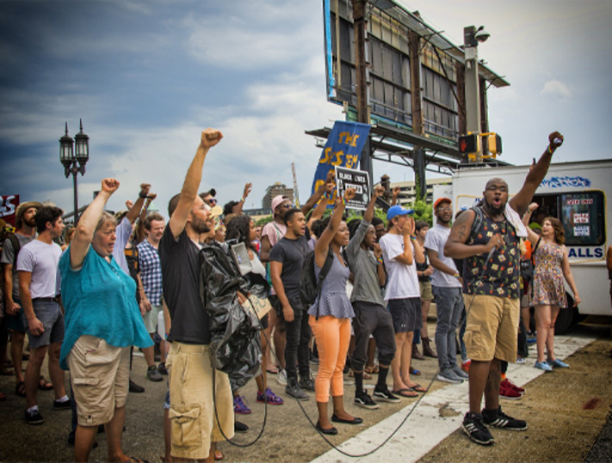
Figure 2 Mobilising people for change
View description - Figure 2 Mobilising people for change

Understanding people as resources can be instructive for how you view campaigns, particularly in the case of social movement campaigning where, quite often, money is not the primary resource available.
Building on an understanding of campaigning as mobilising resources, you will now learn what is meant by mobilising a constituency.

1.2 What is a constituency?
A constituency might be a concept you are familiar with. In the UK it is common to think of constituencies as electoral boundaries, a group of voters arranged in a geographical area. In campaigning terms, however, you should think of a constituency in its broader sense, as a group of people with shared material interests or shared political/social outlooks. Material interests, here, might include things like being employed by the same organisation, living in the same neighbourhood, or facing the same kinds of discrimination in these spaces.
Material concerns may intersect with a particular social or political outlook. A group of individuals may prescribe to a particular political belief or value ideals like ‘community’ or ‘equality’. These different and complex aspects group individuals into constituencies.
In a campaign, you should think about who comprises the constituency you want to target. Who are the people who care enough about the issue to do something about it? Other approaches to campaigning might refer to a core demographic, a target audience, a voter base. But in all cases, you are being directed to think about how people’s material interests or shared outlooks can draw them into action. This drawing into action is what is meant by ‘mobilising’.

Activity 1 Mobilising a constituency
Allow around 15 minutes for this activity

Christy Adeola Braham led a campaign to reform police and council services regarding tenants’ rights and eviction. Following what she believes was racial profiling by the police, Christy was illegally evicted from her home. In response, Christy built a coalition of organisations that successfully won increased training for police officers in eviction law.
In this scenario, the coalition of organisations are the resource Christy used to undertake the campaign. But how Christy came to decide that they were the most appropriate resource to use was a process of targeting a constituency to mobilise.
- Think of an issue relevant to your own context. Perhaps an issue in your community or workplace. Who would your constituency be and how would you mobilise them?
- Watch the video about how Christy approached this. After you have watched it, use the table below to list examples of good practice that could be relevant to your issue. Consider the following:
  - What questions did Christy ask when identifying a constituency?
  - How did she approach and communicate with them?

Video content is not available in this format.
Video 1 Christy Adeola Braham – Mobilising constituency
View transcript - Video 1 Christy Adeola Braham – Mobilising constituency



Christy’s practice | Application to my context
Provide your answer... | Provide your answer...
Provide your answer... | Provide your answer...
Provide your answer... | Provide your answer...

View discussion - Activity 1 Mobilising a constituency

You will now consider the different contexts in which campaigns take place and how, in each, a target constituency is identified and mobilised around a particular issue.

2 Electing leaders

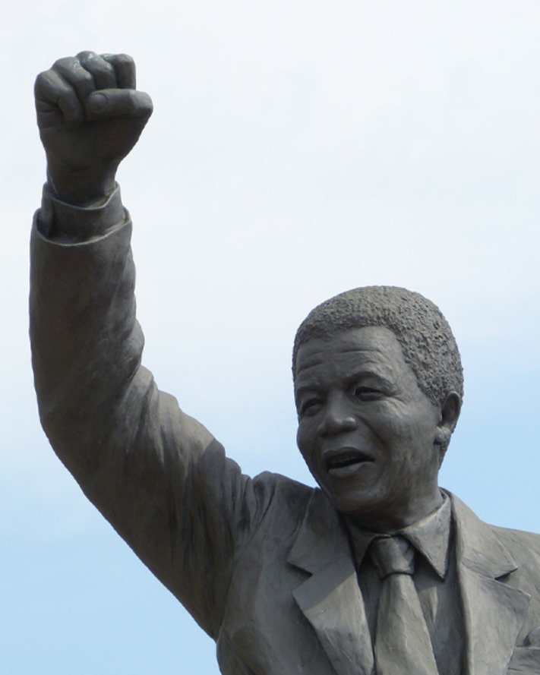
Figure 3 Campaigners fought to elect the first Black leaders
View description - Figure 3 Campaigners fought to elect the first Black leaders

Perhaps the place you will be most accustomed to seeing campaigns on social issues is in electoral politics. Despite so much of electoral politics being centred on political parties, they often involve campaigning for individual candidates. Electoral politics, however, is not the only space where democratic processes create opportunities for individualised campaigns in support of candidates or leaders. These kinds of campaigns emerge wherever democratic processes are in place for leadership selection, such as within trade unions and civil society organisations.
These campaigns involve a fixed electorate, but nonetheless require identifying a constituency within this electorate to mobilise in support of your desired candidate. The basis of having a particular candidate elected, then, is to ask, ‘who is the constituency that is most likely to vote for them’ and targeting your campaign at mobilising those people.
Here are some examples of individualised campaigns and how mobilising constituencies plays a central role.

1. Political parties and local, regional, and national government: electing leaders in the public sector
Party politics in the UK takes place at multiple levels. Individual leaders can run as candidates to be councillors, mayors, MPs, as well as for leadership positions within their parties. In these campaigns, you will hear the word ‘constituency’ used both to mean an electoral boundary and in the sense of less clearly defined groups with shared interests or politics.
Often candidates run for election as a candidate for a political party, meaning that, even within a geographic boundary, candidacy is dependent upon winning the approval of the party itself. Here, social and political outlooks will influence decision-making more explicitly.
In this context there are two factors to consider when identifying a constituency:
- Your constituency is likely to be geographically bound (i.e., you will have to find them within a pre-defined area).
- Candidates running for a political party must also identify a constituency – or more than one constituency – within their party membership.

2. Trade unions: electing leaders in the workplace
Campaigns also serve an important function in electing leaders in workplace unions. Again, this takes place at multiple levels. Trade union leaders are elected within individual workplaces, in regional branches and at the national level. In some respects, identifying a constituency in this context is more straightforward, as instead of having to worry about a wider electorate, trade union leaders are only elected by their members.
In this context, constituencies will exist around structures (workplaces and the trade union organisation) and the material interests/social and political outlooks of the individuals organised around these structures will still be the basis on which constituencies are formed.
Here, identifying a constituency may involve asking:
- What are the most pressing issues for the membership and how can I speak to them?
- Are there any political/ideological interests I need to be aware of and/or who might be on my side?

3. Civil society: electing leaders in the community
Less commonly, you may find democratic organisations that exist in civil society. These can include residents’ associations and community land trusts (organised around neighbourhoods, buildings, and space), social movement organisations (climate activist groups, racial equality organisations, charities and pressure groups), as well as multi-issue organisations (community unions, religious organisations).
Where democratic processes exist in civil society organisations, they tend to, again, be membership organisations, with membership being arranged solely around the organisational structure. As above, the material interests/social and political outlooks of the membership will still be the basis on which constituencies are formed.
Again, you should consider:
- What are the most pressing issues for the membership and how can I speak to them?
- Are there any political interests I need to be aware of and/or who might be on my side?

Activity 2 Approaching an election campaign
Allow around 30 minutes for this activity

Sharon Thompson is a Birmingham City Councillor and trade union activist. Her journey to being an elected leader has taken her through community organisations, workplace trade unions, and party politics.
Watch the video below where Sharon talks about her approach to planning an election campaign. After you have watched it, think of one of the scenarios outlined above (1-3) where you could imagine yourself undertaking an electoral campaign or that relates to the campaign issue you identified in Activity 1 (could your issue involve campaigning to elect a different councillor who supports your campaign for instance?). Use your local community, workplace, or an organisation you are a member of as your example and plot your campaign across a four-week timeline using the table provided. This could also include informal organisations and groups.

Video content is not available in this format.
Video 2 Sharon Thompson – Resistance to power
View transcript - Video 2 Sharon Thompson – Resistance to power

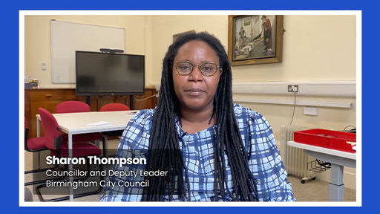

Consider the following and then fill out the table below with your ideas.
- Research:
What different neighbourhoods are there in your area, or departments/social groups in your workplace/organisation? What are they like? Are there any ‘network hubs’ or community infrastructure where lots of people meet? Who do you think would support you and where would your support be weaker? What are the issues affecting your target constituency that will be important to take a stance on?
- Press and communications:
What do you want people to know about your campaign and how will you communicate it? (Local newspapers, social media, leaflets/posters etc.)
- One-to-one conversations:
Could you speak to people in person? Find out if they would vote for you or your candidate. If not, why? Will this involve knocking on doors, speaking to colleagues in break-out rooms etc.
- Events:
Speak with lots of people at once and get press and social media attention on your campaign. Relevant events could be pre-existing community events that you can use to your advantage or ones you plan yourself.

 | Week 1 | Week 2 | Week 3 | Week 4
Research | Provide your answer... | Provide your answer... | Provide your answer... | Provide your answer...
Comms | Provide your answer... | Provide your answer... | Provide your answer... | Provide your answer...
One-to-one conversations | Provide your answer... | Provide your answer... | Provide your answer... | Provide your answer...
Events | Provide your answer... | Provide your answer... | Provide your answer... | Provide your answer...

View discussion - Activity 2 Approaching an election campaign

3 Applying pressure to leaders
You have covered how a constituency can be mobilised in support of an individual leader. But at other times, getting the right person into the right position may not be the best approach to achieving change on your issue. Another approach to campaigning is to mobilise a constituency to leverage change from those already in formal positions of power. We sometimes hear this discussed as ‘public pressure’ or ‘popular opinion’. Signing petitions, attending demonstrations, lobbying parliament. This is the kind of campaigning most associated with social movements and pressure groups, but it is also true of trade unions and political parties.

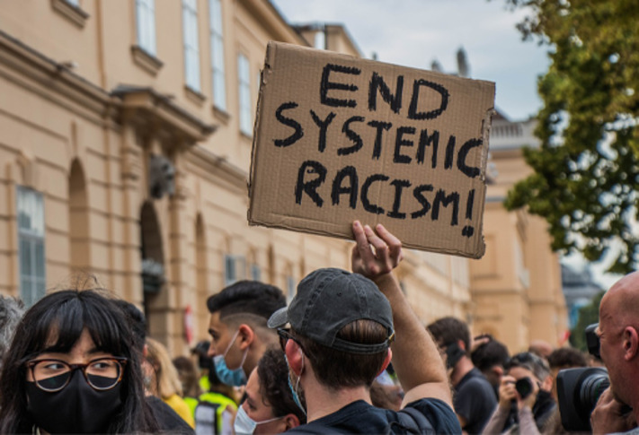
Figure 4 Collectives can demand change from individual leaders
View description - Figure 4 Collectives can demand change from individual leaders

You will now consider the role of the collective in campaigning and how acting collectively can win specific changes from leaders in positions of formal authority. Remember, while people often think of leaders as individuals, leadership can also be approached as a collective practice. These campaigns can be undertaken internally within organisations or externally when an organisation campaigns to win something from someone else. In this section, you will see how collectives can lead campaigns and consider strategies and tactics to approach this kind of campaigning.

3.1 Internal vs external campaigning
It can be helpful to think of collective campaigning as at times taking place internally within an organisation, as well as externally to achieve change in another organisation. As an example of internal campaigns, you can look to trade unions and political parties.

Internal campaigning

Trade unions: collective campaigning at work
Trade unions campaign in the workplace. These are internal campaigns aimed at winning changes from an employer. They might be around gender pay gaps, working conditions, or workplace policy and use various tactics including petitions, demonstrations, and strikes.
However, it is important to note that trade unions at times also undertake external campaigning, pushing for policy changes from local or national government, for instance where an issue affects members across multiple workplaces.

Factionalism: collective campaigning in a political organisation
In previous sections it was noted that even in membership organisations it is necessary to know your target constituency when you are undertaking a campaign. While it might generally seem reasonable to suggest that all members of, say, a political party should share social and political outlooks or material aims, the reality is much more complicated. Quite often within membership organisations like political parties, so-called factions exist – political/ideological groupings within the organisation. These factions often undertake campaigns internally to attempt to force or influence the party leadership to adopt a certain position on an issue.
For instance, an issue like Brexit saw the two major parties in the UK divided, with both sides of the dispute undertaking campaigns for their party to adopt their favoured position. These included digital campaigns, press and social media campaigning as well as protests and demonstrations.

External campaigning

Pressure groups and social movements
It is most common to think of campaigns as being targeted externally. A pressure group campaigning for public ownership of railways for instance would aim to mobilise a constituency to apply pressure to national government. The pressure group itself might be an organisation or a coalition of organisations aiming to apply pressure to a decision-maker external to them. And it is not always the case that these kinds of externalised campaigns are targeted at public authorities. Sometimes groups target private organisations, as has been the case when climate campaigners target banks with demands to divest from oil production.
In all cases, whether internal or external, collectivised campaigning, rather than being focused on mobilising a constituency behind an individual leader, places the onus on using a constituency’s collective power to achieve change.
Next you will consider more closely how collective campaigning is approached, reflecting on strategy and tactics and how this style of campaigning could offer an approach to your own leadership context.

3.2 Strategy and tactics

Strategy without tactics is the longest route to victory. Tactics without strategy is the noise before defeat.
Sun Tzu (Griffith, 1963)

The above quote considers strategy and tactics as two sides of the same coin. There are many interpretations of what strategy means. But here, a strategy is the overall plan. The route you have laid out to achieving your goal. A tactic on the other hand is an individual step, one of many single actions that will get you there.
The distinction is important in campaigning. You might see an individual tactic, like launching a petition for instance, referred to as a campaign. But it is not really a campaign in itself. Rather, it is a tactic that might be one of many tactics in a broader campaign strategy.
This might seem pedantic, but it can be important for the success of your campaign. People often move straight to a tactic, like holding a protest, without a broader strategy in place and, likewise, there is no point having a strategy if you are not actually going to take any action.
With this understanding, it is time to study some tools for planning strategy and tactics. Click through the slideshow below.
Midwest Strategy Chart
This slideshow is unavailable in this format, please see the OpenLearn course online to view it.

Activity 3 Building campaign strategy
Allow 30 minutes for this activity.

Using the issue you identified at the start of this week, try using the Midwest Strategy Chart to begin planning a collective campaign (feel free to imagine/make up any specific information you might be missing). There is no need to complete an entire strategy, but rather to get a feel for using the chart and begin thinking about how you might fill out some of the columns.

Goals | Organisational considerations | Constituents  (allies and opponents) | Decision maker(s) | Tactics
Long term | List the resources you have available | Who is directly affected by the issue? | Primary decision maker (who is the individual person that can give you what you want?) | Using your resources, how can each of your constituents put pressure on your decision makers?
 | Provide your answer... | Provide your answer... | Provide your answer... | Provide your answer...
Intermediate |  | Who is indirectly affected? | Secondary decision maker (who has influence over your primary decision maker?)
 | Provide your answer... | Provide your answer... | Provide your answer... | Provide your answer...
Short term |  | Allies? (Not affected but might be on your side)
 | Provide your answer... | Provide your answer... | Provide your answer... | Provide your answer...
 |  | Opponents? (Not a decision maker who can give you what you want, but someone who might not want you to win and could campaign against you)
 | Provide your answer... | Provide your answer... | Provide your answer... | Provide your answer...

View discussion - Activity 3 Building campaign strategy

Now that you have a strategy, the next step is to move to action. Think about your list of tactics. Where would you start?
It is important to remember that your strategy chart is a live document. Refer back to it. Maybe you will need to change your approach, maybe a tactic you hadn’t thought of will reveal itself, and hopefully… you will achieve your goals!

4 This week’s quiz
Now that you’ve completed Week 7, you can take a short quiz to help you to reflect on what you’ve learned.
Week 7 practice quiz
Open the quiz in a new window or tab, then come back here when you’ve finished.

5 Summary of Week 7
Campaigning is a process of mobilising resources towards a specific goal. Often campaigning is associated with social or political movements and tends to involve mobilising a particular constituency to act on an issue. ‘Issues’ in this context are thought of as partial parts of broader problems, and ‘constituencies’ as broad social groupings based in material interests or political/ideological outlooks. Campaigning is applied in a broad range of contexts, including electing political leaders, or indeed pressuring these leaders to enact change. The latter of these contexts is usually associated with collective campaigning in some form, at times occurring internally within an organisation (trade unionism/factionalism) or to apply pressure to an external organisation (social movements/pressure groups). Collective campaigning uses a range of tactics, with the common strategies using collective strength to apply public pressure to a decision-maker. Campaigns can be useful vehicles for developing leadership – something you will explore in greater detail in the next (and final) week of the course, which is about organising.
You can now go to Week 8.

Week 8: Organising – building collectives for change

Introduction
This week was written by Tom Morton, Fidèle Mutwarasibo and Owain Smolović Jones.
This week the focus will be on organising. In its most fundamental sense, you can think of organising as developing the capacity of a formal or informal group to achieve goals. This can include building relationships with investors who can finance a start-up, constituting a charity to provide aid to refugees, becoming a recognised trade union at work, building a community organisation that can campaign for civil rights… the list really is endless. Whether you are building a new collective from scratch or building the capacity of an organisation that already exists, you are organising.

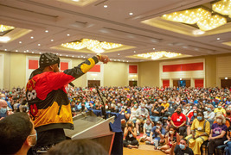
Figure 1 Organising means building a collective for change
View description - Figure 1 Organising means building a collective for change

You will focus on organising in two contexts: workplace organising and community organising. Both have been crucial areas of struggle for Black leaders. In the workplace, you may be aware of the work of Chris Smalls and the Amazon Labour Union, building an entirely new organisation with which to represent the interests of workers in the retail giant. Organising in the community also has a longstanding and prestigious history of Black leadership. In the UK today, these community movements are made up of diverse organisations that include the Black Equity Organisation and the Forever Family.
Last week the focus was campaigning and more specifically how, beginning with issues, campaigns can mobilise a given constituency to win a specific social change. You can think of organising as this process in reverse. Rather than beginning from the perspective of issues before identifying a constituency to mobilise around them, organising begins from the perspective of a constituency before asking what issues will mobilise people within it. Organising is about people and how people can be arranged in a way that develops their capacity to act.
This week you will frame an understanding of organising as a process of building power, before thinking about how campaigning fits into this context and the spaces for leadership that this creates.
By the end of this week, you should be able to:
- understand approaches to organising in the workplace and in the community
- evaluate theories of power in several organising contexts
- apply campaigning theory to your organising contexts
- situate leadership practices in workplace and community organising.

1 Organising as building power


Figure 2 Organising can be used to build power
View description - Figure 2 Organising can be used to build power

Organising is defined as developing the capacity of a group to achieve goals. Think back to your considerations of power in Week 1. There, power was defined as the capacity to shape or influence the world around you. In this sense, you can think of organising as a process of building power. In the context of Black leadership, the most common kinds of organising practices are in building social movements. For this reason, the aspect of power you are dealing with is Amy Allen’s ‘power with’ or powerful solidarity. This is why organising begins with a constituency of people rather than a particular issue. Remember back to last week on campaigning – constituencies are groups of people with shared material interests or political/social outlooks. Organising, then, is a process of bringing these people together under one roof and, by doing so, building their power to shape and influence the world around them.
For some organising practices, this bringing together of people under one roof can focus on individuals who might have access to particular resources like money or assets, or authorities such as the power to enact legislation, public policy, or enforce laws. In the context of social movement or workplace organising, however, access to resources or authority might not be so readily available to your constituency. Here, the focus is on power in numbers. Put plainly: the more people organised, the greater the power.
Relationships with others in your workplace or community, then, are a source of power, and organising is a method of building power through developing relationships and channelling them into a common direction.

Activity 1 What is your organising context and constituency?
Allow around 15 minutes for this activity

Watch the video below in which Sharon Thompson, Councillor and Deputy Leader, Birmingham City Council, discusses organising context and developing relationships, and then answer the questions that follow.

Video content is not available in this format.
Video 1 Sharon Thompson – Organising context and constituency
View transcript - Video 1 Sharon Thompson – Organising context and constituency

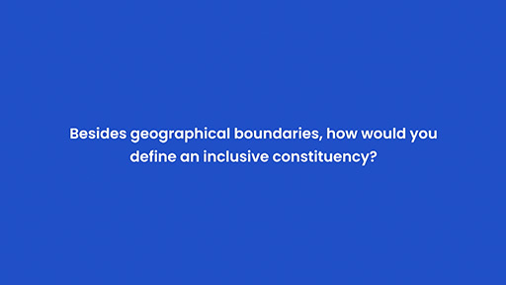

Who is a constituency that you think lacks power and struggles to represent their interests in society? Consider the following:
- What are the signs that they lack power or are underrepresented?
- Does this constituency exist in the workplace or the community?

View discussion - Activity 1 What is your organising context and constituency?

1.1 The membership organisation
Whether we’re organising in the workplace or the community, the principles underlying organising practices are the same. The point of divergence is the constituency your organisation seeks to represent. For a tech start-up, a relatively small constituency of investors might grant you enough resources to run with. But social movement organisations are often seeking to represent constituencies who are relatively low on material resources. So, whereas the tech start-up might have a traditional organisational structure, with managers and a CEO allocating resources, social movement organisations are quite often membership organisations.
Membership organisations tend to be ‘dues paying’ organisations with democratic processes. This means that individuals join the organisation by paying a regular contribution, which grants them a vote in the democratic processes that elect leaders and enact decisions. Of course, these processes and the organisational structures associated with them are varied. But the advantage of the membership organisation to social movement organising is that the pooling of resources, even where your constituency may have very few of them, allows the organisation to function (e.g., if a thousand people can pay £5 a month, that gives your organisation £5000 per month in income to spend on its project).
So, in a workplace your constituency might be Deliveroo couriers, refuse workers, bus drivers. In a community it could be low-income people, people receiving social benefit, refugees, etc. Establishing an organisation with a membership creates a vehicle for your constituency to pool resources with which to represent their interests as a collective.

1.2 Campaigning to build the organisation
By beginning with the constituency in organising, campaigning, while integral, becomes secondary. Rather than mobilising a constituency around achieving change on a particular issue, the aim is to mobilise a constituency around the principle of being organised so that the views of that constituency can be represented, whatever the issue might be.
Campaigning, then, is the way that the organisation might represent its views on a particular issue, but the role of organising is to build the necessary power with which a constituency can represent itself. This is true whether you are building the Organisation of Petroleum Exporting Countries or building the Amazon Labour Union.
You will now look at examples of organising practices in the workplace as well as in the community, discussing how organising can create spaces for leadership to emerge, as well as some useful tools for organising in practice.

1.3 Leadership and organising
Leaders are integral to organising processes because they are people who can inspire others to join an organisation and act. But it is important to distinguish between the role of ‘the organiser’ per se and a leader. The organiser is concerned with building an organisation, not necessarily leading it. While of course an organiser plays a kind of leadership role, directing others to act collectively, the organising process itself is about creating space for individuals to acquire and learn leadership skills, and for leaders to emerge from within a target constituency.

1.3.1 Organic leadership by individuals

In most, though by no means all, organisations there are of course formal positions of seniority and responsibility. But outside these roles, leadership can still emerge informally in communities and workplaces. If an individual is influential, well liked (even perhaps feared!) they can bring others with them and impact organisational behaviour whether they are in a formal position or not. In organising theory these individuals are often referred to as being ‘organic’ leaders.
(McAlevey, 2015)

Whether in a workplace or a community, nurturing leadership potential is central to building effective organisations. This may involve identifying someone practising leadership in this organic sense and encouraging them to put themselves forward for a formal role. But it may simply involve using their leadership to your advantage. Bringing others in a workplace with them, influencing opinion, or supporting others in their work.
But organising in the context of workplaces and communities is less concerned with enabling individuals to lead and more concerned with asking:

how power can be… exercised by as many people as possible starting from conditions of widespread inequality and popular disempowerment.
(Phulwani, 2016, p. 864)

That is why good organising will aim to build distributed leadership amongst several or many people.

1.3.2 Distributed leadership by a collective
In the context of social movement organising, the tendency is to talk about collectives and the ability of collectives to represent their own interests. So, while individual leaders do of course play a key role, creating the opportunities for leadership to be shared is a central principle of social movement organising.
This can sometimes be as straightforward as using democratic processes of governance and decision-making. If members are given the opportunity to deliberate and vote on a decision, then space has been created for them to represent themselves collectively. However, this principle can be extended to create an organisational culture in which as many members as possible can practise leadership.
This could take the form of rotating roles in informal leadership positions. Different members could lead a particular action or activity at different times, or be given different responsibilities – whether that’s behind the scenes with administrative activity or public speaking. Sharing and rotating roles can allow for new leaders to emerge and nascent leaders to practise their skills and develop confidence. Then perhaps, when a longstanding leader steps down from a formal position, there will be plenty of people in your organisation ready to step up.

Activity 2 Identifying leaders
Allow around 15 minutes for this activity

Below are three fictional characters who work in a school. You and a group of colleagues have decided to organise staff in your workplace into a trade union. As part of the organising drive, you map your workplace to identify potential leaders.
From the description of these individuals, identify how they might fulfil the role of an organic leader. Remember, an organic leader is someone influential who could bring other people along with them, convince them to join a particular activity, or someone people don’t want to disappoint.

Shanice
Shanice is one of the year 5 teachers.
She is well liked by staff, pupils, and parents in year 5 and her work is generally thought to be exceptional.
Shanice works best with peace and quiet so often uses lunch breaks to grab some time to herself and get some work done.
Although she is relatively new to the school, Shanice is very popular with the people who have got to know her.

Michael
Michael is the head of year 5.
He has worked at the school for a while and is an outspoken member of the workplace union.
Michael has a reputation for knowing a lot about politics and often engages in debates in the staffroom during lunch.
He has very clear opinions about the national government’s education policies.
People generally respect his opinion and, indeed, expect him to have an opinion on everything.
He is generally thought of as being a good teacher and is well liked by the team of three teachers he manages.

Kam
Kam is part of the admin team, so knows pretty much everyone who works in the school.
As they work in the school reception, they meet a mixture of staff, pupils, and parents at drop off and pick up times.
Lots of staff rely on Kam in their administrative capacity for their work, and they have a good reputation for delivering work on time and to a high standard.
Kam will go out of their way to help other staff last minute with admin work, but most staff try to avoid this situation as it’s clear that they disapprove of it.

View discussion - Activity 2 Identifying leaders

You have covered the basic principles underlying organising:
- Building power by drawing your target constituency into a membership organisation through which they can campaign to represent their interests.
- Using the organisation as a vehicle to develop effective leadership.
Next you will look at some practical tools with which to organise for change in workplaces and communities. Some parts of the following two sections may not, at first, feel relevant to your organising or leadership context. However, no matter the context you are working in, there are good lessons for all kinds of organising to learn. Remember, the basic principles underlying all kinds of organising are largely the same.

2 Workplace organising


Figure 3 Organising around workplace issues can be a key area of struggle for Black leaders
View description - Figure 3 Organising around workplace issues can be a key area of struggle for Black ...

In general, when you hear about workplace organising, it is concerned with trade union organising. This can be done by affiliating with a pre-existing trade union or by building an independent trade union from scratch. But the basic principles in both cases are largely the same. In your workplace, you may already have a recognised trade union you can become a member of. But in lots of workplaces there is no formally recognised union. In either case, ensuring that employees in the workplace are well placed to represent their interests is of the utmost importance, and this is largely a numbers game.

2.1 Mapping your workplace
The first questions to ask are simple ones:
- Is anyone in my workplace a member of a trade union? How many of them are there? What percentage of the overall workforce does this represent?
Winning formal recognition for a trade union at work requires that more than 50% of the employees vote in favour of recognition. So you can ask yourselves the following questions: How many people does your workplace employ? How many of them are in a union already? How far away does this put you from recruiting more than 50%?
This is a process called mapping, and it straightforwardly involves making a list of everyone you work with and figuring out whether they are a member of the union or not, or, if you think they would be interested in joining a union (or not). This is a good opportunity to start thinking about who the organic leaders might be. Who is influential and well liked and do they support your cause? Who do you know or think will be on your side? Who do you know or think will oppose you? Who do you think you could convince?
- Who do you know that supports your cause and would be willing to help you organise?
At this stage you can form an organising group comprised of people who support your cause and are willing to help. These are people who will plan activity, have one-to-one recruitment conversations with co-workers, and set aims and agendas at union meetings.
An organising group can literally be two people to begin with and will build membership over time. Here, workplace organising theorist Jane McAlevey cautions that as an organising group grows, it must be representative of the diversity in a workplace. This can include diversity across gender, ethnicity, race, workplace roles and positions, etc.
- Have one-to-one conversations with your co-workers. Learn what issues matter to them and if they are interested in joining a union at work.
Think of this activity as having three purposes. First, you are trying to recruit people to join the union. Second, if they’re not immediately willing to join, you are attempting to understand why. Third, you are beginning to identify the kinds of issues at work that matter to people. What do people want to see change, and how might getting organised at work achieve it?
This step is about building trust and emphasises why good leadership is so important. Your organic leaders are important people to win over. If they aren’t on board, it is likely that you will struggle to get everyone else on board as well.
Once you are confident you have more than 50% of your workplace onside, you can move to a vote on union recognition. If more than 50% of the employees vote in favour of union recognition, you have become the recognised union at work.

Activity 3 workplace mapping
Allow around 30 minutes for this activity

Think about your workplace and make a list of the people you work with directly (feel free to use a previous workplace or professional networks if you don’t work within an organisation). If you were starting a union recognition drive, who do you think would support you and who would be against you?
Type your answers into the table below, putting a star next to people who you think would make good organic leaders. Are they on your side? How far off 50% would you be?

For | Neutral | Against
Provide your answer... | Provide your answer... | Provide your answer...

View discussion - Activity 3 workplace mapping

2.2 Moving to a campaign
Once you have union recognition at work, it is time to start the work of achieving change. Think back to your one-to-one conversations with your colleagues. What were the issues that came up again and again? What were the issues that people felt strongly about? Now is the time to consider how the union can take action on those issues.
Here is where the work you did last week on campaigning comes in. Identify your issue, develop a strategy, and act. This is how a collective achieves change, develops leadership, and builds the organisation in the longer term.

3 Community organising
Organising in the community uses the same principles as organising in the workplace. However, organising in the context of a community can be more complicated. Unlike a workplace, there are no predefined mechanisms for an organisation to be ‘recognised’ – no single authority to recognise your organisation and no predefined constituency to win 50% support from. Instead, community organising relies much more on reputation and effective organising/campaigning practices.

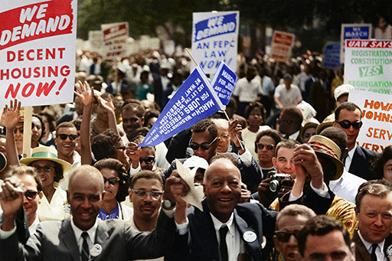
Figure 4 A large group of protestors
View description - Figure 4 A large group of protestors

3.1 Mapping your community
Where it lacks a predefined constituency to organise, community organising can focus on demographics, social groups, or geographies to organise around. Nonetheless, mapping processes are still central to beginning your organising. Think back to the work you did on identifying a constituency last week. Who is it that you are seeking to organise and how can you reach them? This may involve identifying neighbourhoods if you are organising low-to-middle income people, or particular network hubs in your community if you are aiming to organise demographics such as older people, refugees and migrants, etc. Once you have identified where your constituency is, it is time to speak to them.

3.2 The organising drive
As in a trade union at work, the basis of community power is the collective. This means that you are going to have to recruit people to your organisation, whatever it is. How are you going to do it?
The Association of Community Organisations for Reform Now (ACORN) provides a good example. It was once one of the biggest civil society organisations in the United States, comprising more than 500,000 members spread across the country and achieving change on a wide range of issues, from welfare rights to housing reform. ACORN built its membership through having one-to-one recruitment conversations on doorsteps in communities and through holding public events. As in workplace organising, the one-to-one conversation is the favoured method of not only recruiting members but also identifying the issues that matter to your constituency. This can be done by knocking on doors or making phone calls, and should always involve going to where your constituency already is.

3.3 Moving to a campaign or just getting to work?
The main point of divergence between workplace and community organising is whether the organisation you are building is a campaigning organisation. While some trade unions do use their resources to provide services to members, their primary role is in campaigning for workplace change. Community organisations, on the other hand, are much more varied. Predicated on collectivising resources and managing them democratically, community organisations do not always use these resources for campaigning. The following section outlines some examples of common practices in community organising.


Figure 5 A community organisation
View description - Figure 5 A community organisation

3.3.1 Self-help and mutual aid
There are lots of examples of communities organising to share resources.
Buyers’ clubs – by acting collectively, organised groups can access resources more cheaply by buying in bulk. Notable examples include purchasing expensive medicines in the US or buying family essentials like nappies and food.
Community land trusts – at other times communities can access extremely expensive assets like land by pooling their resources. More recent examples have included community energy and community solar groups.
Credit unions – as covered above, mass membership organisations can allow for large sums of money to be organised under one roof. Credit unions are one example of using these cash resources to provide low/no interest loans to people in the community.
The above examples can be classified as self-help and mutual aid – organising people, so that resources can be pooled and used to provide services to the constituency they seek to represent.

3.3.2 Advocacy
One slight variation on the previous examples of sharing resources would be advocacy practices. In these cases, resources in the community are used to pay for professionals to represent the constituency in place of the constituency representing itself. Many workplace unions use advocacy practices to support individual members, but examples in the community include crowd justice groups that organise resources to cover legal expenses, or advocacy planning groups that pool resources to pay for professional city planners to advocate on a particular community’s behalf.

3.3.3 Direct action
Some community organisations use direct action to achieve a desired change. These are the community organisations that would move to campaign on issues rather than seeking to solely provide services. Direct action describes using strikes, demonstrations, and protests to make demands of decision-makers. Some of the strategy and tactics of direct action were covered last week on campaigns.
Perhaps the most famous direct-action organisations are known from the twentieth century civil rights movements in the United States. Rosa Parks and the freedom riders, ‘eat-ins’ against racial segregation, the million-man march, were all examples of direct action. What is perhaps less well known is the community organising processes that were necessary to make these actions possible.
The most recognised community organiser from this time was Ella Baker, who worked in the NAACP, the Southern Christian Leadership, and the Student Non-Violent Coordinating Committee (to name but a few). Baker describes the role of community organising as she saw it below.

The major job was getting people to understand that they had something within their power that they could use, and it could only be used if they understood what was happening and how group action could counter violence even when it was perpetrated by the police or, in some instances, the state. My basic sense of it has always been to get people to understand that in the long run they themselves are the only protection they have against violence or injustice… People have to be made to understand that they cannot look for salvation anywhere but to themselves.
(Baker, 1972, p. 3)

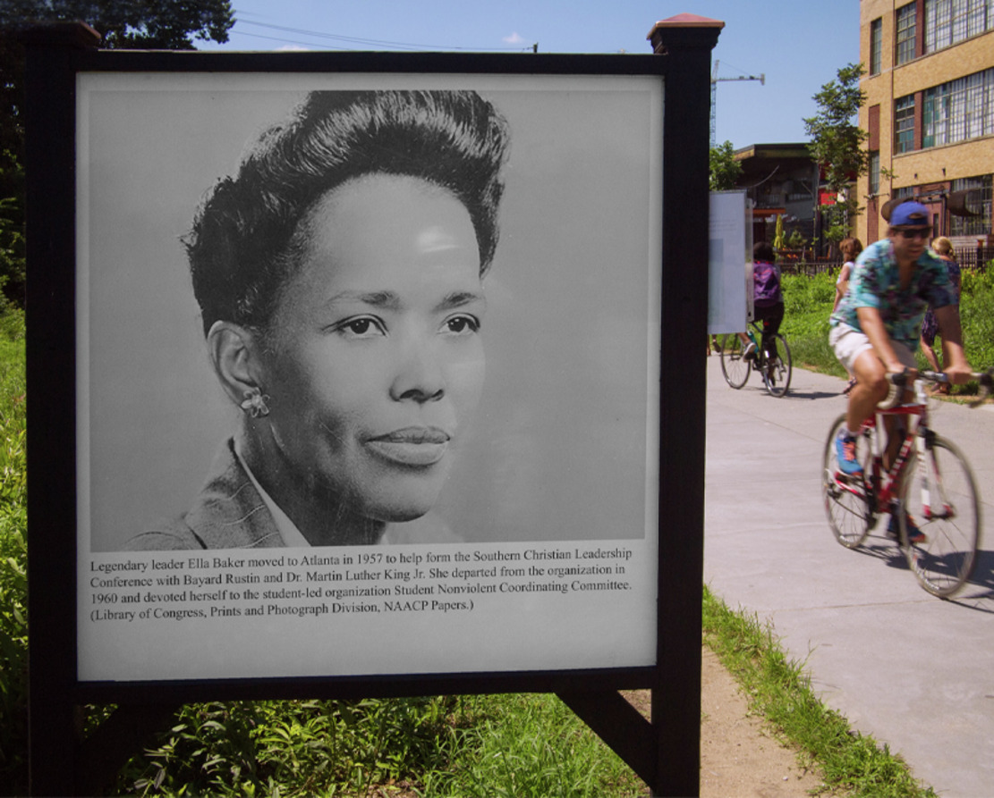
Figure 6 Ella Baker
View description - Figure 6 Ella Baker

Baker’s view of community organising was precisely based in a theory of building collective power and how Black communities in the United States could use this power to counter racial disparities and discrimination. The above quotation demonstrates the interrelation between organising and leadership. Baker’s emphasis on communities ‘themselves’ holding the capacity for change directs us to an understanding of community organising as a practice in building collective leadership.

Activity 4 Moving to action
Allow around 15 minutes for this activity

Think about a constituency in your community that you think lacks power and who could benefit from a community organisation to advance their interests. Thinking about the kinds of community organisation outlined, consider the issues affecting this constituency and what kind of action is the most appropriate way of addressing them. How would it do this?
Fill out the table below with your answers.

Who is the constituency you aim to organise?
Provide your answer...
What are the issues that are affecting them?
Provide your answer...
What kind of organisation would be best to solve the issue?
Provide your answer...

View discussion - Activity 4 Moving to action

4 This week’s quiz
It’s now time to take the Week 8 compulsory badge quiz. It’s similar to previous quizzes, but this time instead of answering five questions there will be 15.
Open the quiz in a new tab or window, then come back here when you’ve finished.
Week 8 compulsory badge quiz
Remember, this quiz counts towards your badge. If you’re not successful the first time, you can attempt the quiz again in 24 hours.

5 Summary of Week 8
Organising is a process of arranging resources to develop the capacities of a group to achieve goals. In the context of organising for change, you can think of this as a process of building relational power by collectivising your target constituency. Organising creates spaces for leadership to emerge and power with which to exercise leadership. In workplaces, organising tends to refer to winning trade union recognition to campaign for change on workplace issues, whereas community organising can refer to a broad range of practices including self-help, mutual aid, advocacy, and direct action.

Tell us what you think
Now you’ve come to the end of the course, we would appreciate a few minutes of your time to complete this short end-of-course survey (you may have already completed this survey at the end of Week 4). We’d like to find out a bit about your experience of studying the course and what you plan to do next. We will use this information to provide better online experiences for all our learners and to share our findings with others. Participation will be completely confidential and we will not pass on your details to others.

References
Braw, E. (2022) ‘Companies are fleeing China for friendlier shores’, Foreign Policy, 2 August. Available at: https://foreignpolicy.com/2022/08/02/companies-fleeing-china-friendshoring-supply-chains (Accessed: 28 February 2024).
Dodd, V. (2022) ‘More than half of black people searched by UK police felt humiliated, survey finds’, The Guardian, 8 November. Available at: https://www.theguardian.com/uk-news/2022/nov/08/more-black-people-than-white-find-stop-and-search-humiliating-uk-survey-finds (Accessed: 28 February 2024).
Fanon, F. (2021) Black skin, white masks. London: Penguin.
Gross, T. (2023) ‘How ‘modern-day slavery’ in the Congo powers the rechargeable battery economy’, NPR, 1 February. Available at: https://www.npr.org/sections/goatsandsoda/2023/02/01/1152893248/red-cobalt-congo-drc-mining-siddharth-kara (Accessed: 28 February 2024).
Hall, S. (2018) Familial stranger: A life between two islands. London: Penguin.
Harvey, D. (2018) The limits to capital. London: Verso.
Harvey, D. (2019) Spaces of global capitalism: A theory of uneven geographical development. London: Verso.
Honig, B. (2021) Shell-shocked: Feminist criticism after Trump. New York: Fordham University Press.
hooks, b. (2016) All about love: New visions. New York: William Morrow.
Mbembe, A. (2019) Necropolitics. Durham, North Carolina: Duke University Press.
Ng, S. H. (1980) The social psychology of power. London/New York: Academic Press.
Office for National Statistics (2023) ‘Cost of living insights: Transport’. Available at: https://www.ons.gov.uk/economy/inflationandpriceindices/articles/costoflivinginsights/transport#:~:text=Overall%20transport%20price%20rises%20are,lowest%20rate%20since%20November%202020 (Accessed: 28 February 2024).
Pidd, H. (2019) ‘‘Massively unfair’ gulf in bus fares between London and rest of England’, The Guardian, 5 May. Available at: https://www.theguardian.com/uk-news/2019/may/05/bus-fares-reveal-massively-unfair-gulf-between-london-and-rest-of-england (Accessed: 28 February 2024).
Round, J. and Kuznetsova, I. (2016) ‘Necropolitics and the migrant as a political subject of disgust: The precarious everyday of Russia’s labour migrants’, Critical Sociology, 42(7-8), pp. 1017–1034.
Smith, N. (2010) Uneven development: Nature, capital and the production of space. London: Verso.
Smolović Jones, O. (2022) ‘Creating and contesting space through leadership’ in B. Carroll, J. Ford, and S. Taylor (eds) Leadership: Contemporary critical perspectives. London: Sage, pp. 270–289.
Smolović Jones, S. (2023) ‘Gaslighting and dispelling: Experiences of non-governmental organization workers in navigating gendered corruption’, Human Relations, 76(6), pp. 901–925.
TUC (2019a) ‘Rail fares have risen twice as fast as wages in the past 10 years, finds TUC’. Available at: https://www.tuc.org.uk/news/rail-fares-have-risen-twice-fast-wages-past-10-years-finds-tuc (Accessed: 28 February 2024).
TUC (2019b) ‘Rail firms have paid over £1bn to shareholders in last 6 years, finds TUC’. Available at: https://www.tuc.org.uk/news/rail-firms-have-paid-over-ps1-billion-shareholders-last-6-years-finds-tuc (Accessed: 28 February 2024).
UK Government (2020) Travel by distance, trips, type of transport and purpose. Available at https://www.ethnicity-facts-figures.service.gov.uk/culture-and-community/transport/travel-by-distance-trips-type-of-transport-and-purpose/latest (Accessed: 28 February 2024).
UK Government (2022) Stop and search. Available at: https://www.ethnicity-facts-figures.service.gov.uk/crime-justice-and-the-law/policing/stop-and-search/latest#title (Accessed: 28 February 2024).
UK Government (2023) Landmark levelling up fund to spark transformational change across the UK. Available at: https://www.gov.uk/government/news/landmark-levelling-up-fund-to-spark-transformational-change-across-the-uk (Accessed: 28 February 2024).
wa Thiong’o, N. (1981) Decolonising the Mind: The Politics of Language in African Literature. Harare: Zimbabwe Publishing House (Pvt.) Ltd.
Allen, A. (2017) The end of progress: Decolonizing the normative foundations of critical theory. New York: Columbia University Press.
Collins, P. H. (2008) Black feminist thought: Knowledge, consciousness, and the politics of empowerment. New York: Routledge.
French, J. R. P., Jr., and Raven, B. H. (1959) ‘The Bases of Social Power’, in D. Cartwright (ed.) Studies in Social Power. Ann Arbor, Michigan: Institute for Social Research, pp. 150–167.
Garlington, S., Bossaller, M., Shadik, J. and Shaw, K. (2019) ‘Making Structural Change with Relational Power: A Gender Analysis of Faith-Based Community Organising’, Social Inclusion, 7(2), pp. 24–32.
Gramsci, A. (2005) Selections from the prison notebooks. London: Lawrence and Wishart.
Hall, S. (2021) Selected writings on race and difference. Durham, North Carolina: Duke University Press.
Lukes, S. (2005) Power: A Radical View. London: Palgrave Macmillan.
Ng, S. H. (1980) The social psychology of power. London/New York: Academic Press.
Raven, B. H. (1965) ‘Social influence and power’, in ID. Steiner and M. Fishbein (eds.) Current studies in social psychology. New York: Holt, Rinehart, Winston, pp. 371–382.
Smolović Jones, S., Winchester, N., and Clarke, C. (2021) ‘Feminist solidarity building as embodied agonism: An ethnographic account of a protest movement’, Gender, Work & Organization, 28(3), pp. 917–934.
wa Thiong’o, N. (1981) Decolonising the Mind: The Politics of Language in African Literature. Harare: Zimbabwe Publishing House (Pvt.) Ltd.
Barradale, G. (2023) ‘Should we break up the Met? We asked experts what comes next after the Casey Review’, Big Issue, 24 March. Available at: https://www.bigissue.com/news/activism/break-up-the-met-defund-the-police-uk/ (Accessed: 28 February 2024).
Barthold, C., Checchi, M., Imas, M. and Smolović Jones, O. (2022) ‘Dissensual leadership: Rethinking democratic leadership with Jacques Rancière’, Organization, 29(4), pp. 673–691.
BBC (2021a) ‘Guto Harri quits GB News over taking the knee row’. Available at https://www.bbc.co.uk/news/entertainment-arts-57885955 (Accessed: 28 February 2024).
BBC (2021b) ‘Azeem Rafiq not expecting ‘quick’ forgiveness from Jewish people over anti-Semitic messages’. Available at: https://www.bbc.co.uk/sport/cricket/59347334 (Accessed: 28 February 2024).
Casey, L. (2023) ‘The Baroness Casey Review’, UK Government. Available at: https://www.gov.uk/government/publications/the-casey-review-a-review-into-opportunity-and-integration (Accessed: 28 February 2024).
Collinson, D., Smolović Jones, O. and Grint, K. (2018) ‘‘No more heroes’: Critical perspectives on leadership romanticism’, Organization Studies, 39(11), pp. 1625–1647.
Fleming, P. and Spicer, A. (2007) Contesting the corporation: Struggle, power and resistance in organizations. Cambridge: Cambridge University Press.
Fleming, P. and Spicer, A. (2008) ‘Beyond power and resistance: New approaches to organizational politics’, Management Communication Quarterly, 21(3), pp. 301–309.
Grint, K. and Smolović Jones, O. (2022) Leadership: Limits and possibilities (2nd ed). London: Bloomsbury.
Hutchinson, P. (2021) Everyone versus racism: A letter to change the world. London: HarperCollins.
Iqbal, N. (2020) ‘Patrick Hutchinson: ‘My natural instinct is to protect the vulnerable’’, The Observer, 6 December. Available at: https://www.theguardian.com/world/2020/dec/06/patrick-hutchinson-black-lives-matter-protest-london-faces-2020 (Accessed: 28 February 2024).
Liew, J. (2023) ‘A rancid melody has been directed at Azeem Rafiq but he’s not the only target’, The Guardian, 30 January. Available at: https://www.theguardian.com/sport/2023/jan/30/rancid-melody-azeem-rafiq-not-the-only-target-cricket (Accessed: 28 February 2024).
McCabe, D., Ciuk, S. and Gilbert, M. (2020) ‘‘There is a crack in everything’: An ethnographic study of pragmatic resistance in a manufacturing organization’, Human Relations, 73(7), pp. 953–980.
Protect (2022) ‘Interview: Blowing the whistle on racism, with Azeem Rafiq’, Protect, 27 June. Available at: https://protect-advice.org.uk/an-interview-with-azeem-rafiq/ (Accessed: 28 February 2024).
Sinha, P., Smolović Jones, O. and Carroll, B. (2021) ‘Theorizing dramaturgical resistance leadership from the leadership campaigns of Jeremy Corbyn’. Human Relations, 74(3), pp. 354–382.
Smolović Jones, O., Smolović Jones, S., Taylor, S. and Yarrow, E. (2021) ‘‘I wanted more women in, but…’: Oblique resistance to gender equality initiatives’, Work, Employment and Society, 35(4), pp. 640–656.
Barthold, C., Checchi, M., Imas, M. and Smolović Jones, O. (2022) ‘Dissensual leadership: Rethinking democratic leadership with Jacques Rancière’, Organization, 29(4), pp. 673–691.
Collinson, D. (1992) Managing the shop floor: Subjectivity, masculinity and workplace culture. Berlin: Walter de Gruyter.
Collinson, D. (1994) ‘Strategies of resistance: Power, knowledge and subjectivity in the workplace’, in J. Jernier, D. Knights and W. Nord. (eds) Resistance and power in organizations. London: Routledge, pp. 25–68.
Gagnon, S. and Collinson, D. (2017) ‘Resistance through difference: The co-constitution of dissent and inclusion’, Organization Studies, 38(9), pp. 1253–1276.
Mumby, D., Thomas, R., Martí, I. and Seidl, D. (2017) ‘Resistance redux’, Organization Studies, 38(9), pp. 1157–1183.
Smolović Jones, S. (2023) ‘Gaslighting and dispelling: Experiences of non-governmental organization workers in navigating gendered corruption’, Human Relations, 76(6), pp. 901–925.
Transparency International (2023) ‘What is corruption?’ Available at: https://www.transparency.org/en/what-is-corruption (Accessed: 28 February 2024).
Vachhani, S. and Pullen, A. (2019) ‘Ethics, politics and feminist organizing: Writing feminist infrapolitics and affective solidarity into everyday sexism’, Human Relations, 72(1), pp. 23–47.
Allen, A. (1999) ‘Solidarity after identity politics: Hannah Arendt and the power of feminist theory’, Philosophy & Social Criticism, 25(1), pp. 97–118.
Bacchi, C. L. (2009) Analysing Policy: What’s the Problem Represented to Be?. Frenchs Forest, NSW: Pearson.
Balakumar, V., Kirubakaran, A. and Tariq, S. (2020) ‘Covid-19 and Ethnic Minorities – Are we responsible for the racial inequalities of covid-19?’, BMJ. Available at: https://www-bmj-com.libezproxy.open.ac.uk/content/bmj/370/bmj.m2873.full.pdf (Accessed: 28 February 2024).
Batsleer, J. R. (2008) Informal Learning in Youth Work. London: SAGE Publications.
Currie, G., Lockett, A., Finn, R., Martin, G. and Waring, J. (2012) ‘Institutional Work to Maintain Professional Power: Recreating the Model of Medical Professionalism’, Organization Studies, 33(7), pp. 937–962.
Dean, M. (2010) Governmentality: Power and Rule in Modern Society. London: SAGE Publications.
Dodd, V. (2021) ‘Use of stop and search rises 24% in England and Wales in a year: Equivalent of one in five male minority ethnic teenagers stopped in year ending March 2021’, The Guardian, 18 November. Available at: https://www.theguardian.com/law/2021/nov/18/stop-and-search-rose-by-24-in-england-and-wales-during-lockdowns (Accessed: 28 February 2024).
ECNI (n.d.) Section 75 duties for Public Authorities. Available at: https://www.equalityni.org/S75duties (Accessed: 28 February 2024).
Equality and Human Rights Commission (2022) The Public Sector Equality Duty. Available at: https://www.equalityhumanrights.com/guidance/public-sector-equality-duty-psed (Accessed: 28 February 2024).
Gaventa, J. (2006) ‘Finding the Spaces for Change: A Power Analysis’, IDS Bulletin, 37(6), pp. 23–33.
Goltz, S. M. (2003) ‘Toward an operant model of power in organisations’, The Behavior Analyst, 26, 131–150. DOI: https://doi.org/10.1007/BF03392071
Hayward, C. R. (1998) ‘De-Facing Power’, Polity, 31(1), pp. 1–22.
Honkasalo, V. (2013) ‘“Save the Girls!” Gender Equality and Multiculturalism in Finnish Youth Work Contexts’, Girlhood Studies, 6(2), pp. 47–64.
Keltner, D., Gruenfeld, D. H. and Anderson, C. (2003) ‘Power, approach, and inhibition’, Psychological Review, 110, pp. 265–284. DOI: https://doi.org/10.1037/0033-295X.110.2.265
Lohmeyer, B. A. (2017) ‘Restorative Practices and Youth Work: Theorizing Professional Power Relationships with Young People’, Young, 25(4), pp. 375–390.
Mohdin, A., Swann, G. and Bannock, C. (2020) ‘How George Floyd’s death sparked a wave of UK anti-racism protests’, The Guardian, 29 July. Available at: https://www.theguardian.com/uk-news/2020/jul/29/george-floyd-death-fuelled-anti-racism-protests-britain (Accessed: 28 February 2024).
Mutwarasibo, F. (2021) ‘CVSL research to explore how to increase the pool of leaders from BME communities that collaborate with local service providers’. Available at: https://www.open.ac.uk/centres/voluntary-sector-leadership/news/increasing-bme-leaders (Accessed: 28 February 2024).
Office for National Statistics (2020) ‘Coronavirus (COVID-19) related deaths by ethnic group, England and Wales: March 2nd 2020, to April 10th 2020’. Available at: https://www.ons.gov.uk/peoplepopulationandcommunity/birthsdeathsandmarriages/deaths/articles/coronavirusrelateddeathsbyethnicgroupenglandandwales/2march2020to10april2020?hootPostID=b229db5cd884a4f73d5bd4fadcd8959b (Accessed: 28 February 2024).
Reader, W. J. (1966) Professional Men. London: Weidenfeld & Nicolson.
Scott, W. R. (2008) ‘Lords of the dance: Professionals as institutional agents’, Organization Studies, 29, pp. 219–238.
Sercombe, H. (1998) ‘Power, Ethics and Youth Work’, Youth Studies Australia, 17(1), pp. 18–24.
Sercombe, H. (2010) Youth Work Ethics. London: SAGE Publications.
Tapper, J. (2020) ‘Minorities more at risk from COVID-19 because of racism, says the report’, The Guardian, 13 June. Available at: https://www.theguardian.com/inequality/2020/jun/13/leaked-report-says-racism-and-inequality-increase-covid-19-risk-for-minorities (Accessed: 28 February 2024).
Zhang, C., Li, Y., Liu, D. and Hu, X. (2020) ‘Professional power, job security, and decision making in project funding: The assessors’ perspective’, Social Behaviour and Personality: An international journal, 48(2), e8567.
Ba, Y. (2022) ‘Power Dynamics and Corporate Power in Governance Processes: Evidence From U.S. Environmental Governance Systems’, American Review of Public Administration 2022, 52(3), pp. 206-220. DOI: https://orcid.org/0000-0002-4148-2494
Bell, D. (1989) ‘American Exceptionalism Revisited: The Role of Civil Society’, The Public Interest, 95, pp. 38–56.
Daymont, T. N. (1980) ‘Racial Equity or Racial Equality’, Demography, 17(4), pp. 379–393.
Duncan, O. D. (1969) ‘Inheritance of Poverty or Inheritance of Race’, in D. P. Moynihan (ed.), On Understanding Poverty. New York: Basic Books, pp. 85–110.
Equality Act 2010. Available at https://www.legislation.gov.uk/ukpga/2010/15/contents (Accessed: 15 March 2024).
Espinoza, O. (2007) ‘Solving the equity-equality conceptual dilemma: A new model for analysis of the educational process’, Educational Research, 49(4), pp. 343–363. DOI: https://doi.org/10.1080/00131880701717198
Fairclough, N. (2002) ‘Language in New Capitalism’, Discourse & Society, 13(2), pp. 163–166. https://doi.org/10.1177/0957926502013002404
Faulconbridge, G. and Holton, K (2020) ‘Lloyd’s of London to pay for ‘shameful’ Atlantic slave trade role’, Reuters, 18 June. Available at: https://www.reuters.com/article/us-minneapolis-police-protests-lloydsofl-idUSKBN23P0SM (Accessed: 28 February 2024).
Fraser, N. (2005) ‘Reframing justice in a globalising world’, New Left Review, 36 (November-December).
Hardy, C. and Phillips, N. (1998) ‘Strategies of engagement: Lessons from the critical examination of collaboration and conflict in an interorganizational domain’, Organization Science, 9(2), pp. 217–230. DOI: https://doi.org/10.1287/orsc.9.2.217
Hathaway, T. (2018) ‘Corporate Power Beyond the Political Arena: The Case of the ‘Big Three’ and CAFE Standards’, Business and Politics 2018, 20(1), pp. 1–37.
Huppert, E. et al. (2019) ‘The development of children’s preferences for equality and equity across 13 individualistic and collectivist cultures’, Dev Sci, 22(2). DOI: https://doi.org/10.1111/desc.12729
Johal, S., Moran, M. and Williams, K. (2014) ‘Power, Politics and the City of London after the Great Financial Crisis’, Government and Opposition, 49(3), pp. 400–25.
Junfeng, M. (2012) ‘The Marxist View of Equity: Basic Dimensions and Methodological Principles, Social Sciences in China’, 33(1), pp. 23–37. DOI: https://doi.org/10.1080/02529203.2012.650403
Lanfranconi, L. M., Chang, Y-L., Das, A. and Simpson, P. J. (2020) ‘Equity versus equality: Discourses and practices within decentralised welfare-to-work programs in California’, Soc Policy Adm, 54, pp. 883–899. DOI: https://doi.org/10.1111/spol.12599
Lee, M. M. and Navarro, A. (2018) ‘Prioritising Racial Equity: How Efforts to Advance Racial Equity Helped Shape the W. K. Kellogg Food & Fitness Initiative’, Health Promotion Practice September 2018, 19, pp. 24s–33s. DOI: 10.1177/1524839918783970
Northern Ireland Act 1998. Available at https://www.legislation.gov.uk/ukpga/1998/47/contents (Accessed: 15 March 2024).
Purdy, J. M. (2012) ‘A framework for assessing power in collaborative governance processes’, Public Administration Review, 72(3), pp. 409–417.
Sikkink, K. (2011) The Justice Cascade: How Human Rights Prosecutions Are Changing World Politics. New York: W.W. Norton & Company.
Sikkink, K. (2017) Evidence for Hope: Making Human Rights Work in the 21st Century. New Jersey: Princeton University Press.
Smith, J. (2021) ‘Challenging Corporate Power: Human Rights Globalization from Above and Below’, Development, 64, pp. 63–73. DOI: https://doi.org/10.1057/s41301-021-00292-2
Valley, P. (2020) ‘How philanthropy benefits the super-rich’, The Guardian, 8 September. Available at: https://www.theguardian.com/society/2020/sep/08/how-philanthropy-benefits-the-super-rich (Accessed 328 February 2024).
Van Dijk, T. (1996) ‘Discourse, power and access’, in C. R. Caldas and M. Coulthard (eds.) Texts and practices: Readings in critical discourse analysis. London/New York: Routledge, pp. 84–106.
Wilson, J. W. (1978) The Declining Significance of Race: Blacks and Changing American Institutions. Chicago: University of Chicago Press.
Bobo, K. (2010) Organizing for social change: Midwest Academy manual for activists. Santa Ana, California: The Forum Press
Whelan, J. (2002) ‘Community Organizing by the Book: A Critical Appraisal of Midwest Academy Training As a Possible Model for the Australian Environment Movement’, Applied environmental education and communication, 1(2), pp. 115–122. DOI: https://doi.org/10.1080/15330150213997
Allen, A. (2018) The power of feminist theory: Domination, resistance, solidarity. London/New York: Routledge.
Baker, E. (1972) Developing community leadership. Black women in white America: A documentary history, pp. 345-352.
McAlevey, J. F. (2015) No Shortcuts: The Case for Organizing DPhil dissertation. City University of New York. Available at: https://academicworks.cuny.edu/cgi/viewcontent.cgi?article=2057&context=gc_etds (Accessed: 14 March 2024).
Office for National Statistics (2023) Ethnicity pay gaps, UK: 2012 to 2022. Available at https://www.ons.gov.uk/employmentandlabourmarket/peopleinwork/earningsandworkinghours/articles/ethnicitypaygapsingreatbritain/2012to2022
Phulwani, V. (2016) ‘The Poor Man’s Machiavelli: Saul Alinsky and the Morality of Power’, American Political Science Review, 110(4), pp. 863–875.
Rathke, W. (1973) ACORN Community Organising Model. Available at: https://chieforganizer.org/wp-conten t/uploads/2011/06/ACORN-Organizing-Model.pdf (Accessed: 28 February 2024).
Schutz, A. and Miller, M. (2015) People power: The community organizing tradition of Saul Alinsky. Nashville, Tennessee: Vanderbilt University Press.
Simms, M. and Holgate, J. (2010) ‘Organising for what? Where is the debate on the politics of organising?’, Work, employment and society, 24(1), pp. 157–168. DOI: https://doi.org/10.1177/0950017010361413

Acknowledgements
This free course was written by Owain Smolović Jones, Fidele Mutwarasibo and Tom Morton.
Except for third party materials and otherwise stated (see terms and conditions), this content is made available under a Creative Commons Attribution-NonCommercial-ShareAlike 4.0 Licence.
The material acknowledged below is Proprietary and used under licence (not subject to Creative Commons Licence). Grateful acknowledgement is made to the following sources for permission to reproduce material in this free course:
Introduction and guidance
Images
Course image: wildpixel/iStock/ Getty Images Plus
Course Badge: ©The Open University
Week 1
Images
Figure 1: JohnnyGreig/Getty Images
Figure 2: David Fenton/Getty Images
Figure 3: Anacarooo/Pixabay
Audio-visual
Video 1: Kemar Knight – Building collective forms of power © The Open University
Week 2
Images
Figure 1: metamorworks/Getty Images Plus
Figure 2: Jeaneves/Pixabay
Figure 3: geralt/Pixabay
Figure 4: geralt/Pixabay
Audio-visual
Video 1: Kemar Knight – Building collective forms of power ©The Open University
Video 2: Yaina Samuels – Solidarity in supporting action on mental health ©The Open University
Week 3
Images
Figure 1: alphaspirit/ Getty Images Plus
Figure 2: ArtisticOperations/Pixabay
Figure 3: AaronAmat/Getty Images Plus
Figure 4: GDJ/Pixabay
Figure 5: ljubaphoto/Getty Images
Week 4
Images
Figure 1: StockSnap/Pixabay
Figure 6: congerdesign/Pixabay
Figure 7: kichipitan7220/Pixabay
Figure 8: mevans/Getty Images
Figure 9: peepo/Getty Images
Figure 10: tatianazaets/Getty Images Plus
Audio-visual
Video 1: Kemar Knight ©The Open University
Video 2: Christy Adeola Braham Resistance to Power ©The Open University
Week 5
Images
Figure 1: Fly View Productions/Getty Images
Figure 2: Professional power by Nick Youngson CC BY-SA 3.0 Deed Alpha Stock Images
Figure 3: An art image showing the outline of a group of people with some designed in colourful mosaic styling. Some have one arm raised in what looks like the black power salute. https://creativecommons.org/2017/01/24/platform-cooperatives-movement-helps-light-commons/people-power-mosaic/
Audio-visual
Video 2: Yaina Samuels accessing public services ©The Open University
Week 6
Images
Figure 1: Angelina Bambina/iStock/ Getty Images Plus
Figure 2 Visual representation of the difference between equality and equity “Interaction Institute for Social Change | Artist: Angus Maguire https://interactioninstitute.org/illustrating-equality-vs-equity/
Audio-visual
Activity 3: Video/Podcast: courtesy: Foreign, Commonwealth and Development Office https://www.gov.uk/government/organisations/foreign-commonwealth-development-office
Week 7
Images
Figure 1: 8268513/Pixabay
Figure 2: BruceEmmerling/Pixabay
Figure 3: falco/Pixabay
Figure 4: UnratedStudio/Pixabay
Section 3.2.1: Midwest strategy chart: Extract from Midwest strategy chart in : Bobo, Kimberley. A. (2010). Organizing for social change: Midwest Academy manual for activists
Slideshow Midwest Strategy Chart: Image 1, https://creativecommons.org/2017/01/24/platform-cooperatives-movement-helps-light-commons/people-power-mosaic/; Image 2, Extract from Midwest strategy chart in: Bobo, Kimberley. A. (2010) Organizing for social change: Midwest Academy manual for activists; Image 3, eralt/Pixabay
Audio-visual
Video 1: Christy Adeola Braham – Mobilising constituency ©The Open University
Video 2: Sharon Thompson – Resistance to power ©The Open University
Week 8
Images
Figure 1: Jim West/Alamy Stock Photo
Figure 2: LanaStock/Getty Images Plus
Figure 3: NanoStockk/Getty Images Plus
Figure 4: Photo by Unseen Histories on Unsplash
Figure 5: Photo by Joel Muniz on Unsplash
Figure 6: Thomas Cizauskas https://www.flickr.com/photos/75714412@N00/29549987188 https://creativecommons.org/licenses/by-nc-nd/2.0/
Audio-visual
Video 1: Sharon Thompson – Organising context and constituency ©The Open University
Every effort has been made to contact copyright owners. If any have been inadvertently overlooked, the publishers will be pleased to make the necessary arrangements at the first opportunity.
Don’t miss out
If reading this text has inspired you to learn more, you may be interested in joining the millions of people who discover our free learning resources and qualifications by visiting The Open University – www.open.edu/openlearn/free-courses.

Solutions

Activity 1 Powerful movement

Discussion
There are many examples you could have identified here. In terms of negative uses of power, it was clear that the informal power of a trade union at the time was used to prevent Black people gaining social mobility through employment. More positively, Black people used their power of movement to restrict the income of the bus company, forcing change. Positive forms of social mobility were enhanced through the boycott. The boycott built up confidence and self-belief, a power that echoed down the generations, from Bristol’s first Black bus driver Norman Samuels, to his son Vernon, and onwards to Amelia, the young interviewer in the film. Finally, the boycott resulted in more material security for Black British people, whose employment options were expanded.
Back to - Activity 1 Powerful movement

Activity 2 Community leadership

Discussion
At the heart of Unite’s approach is building collective forms of power amongst people who learn to fight for themselves. They work towards a position where people are less reliant on representation from others – such as MPs, councillors or professional organisers – and instead can work together to make change happen.
Back to - Activity 2 Community leadership

Activity 3 Decolonising the mind

Discussion
Lace share insights into how colonialism and post-colonialism has influenced human resources management historically. As a consequence, people from global majority backgrounds, according to Lace, may experience unbelonging in the workplace. Unbelonging may result in global majority workers being self-critical in the workplace instead of understanding the real causes of their experience. Lace concludes by suggesting that global majority workers should emancipate and frame understanding of their experience through the lens of racialisation.
Back to - Activity 3 Decolonising the mind

Activity 4 Gaslighting

Discussion
Below is an example of how the table could have been completed.

Type of gaslighting | Definition | Example
Weaponising victimhood | Oppressors claim the status of victimhood, inverting the claims of the truly oppressed to strengthen dominant power. | White supremacists claiming that a fictional ‘woke’ elite is marginalising them from power.
Ruling | Those in power introduce previously unspoken rules as it suits their purposes. They use such ruling to restrict meaningful access to spaces and participation. | Can range in application, from governments introducing draconian laws to tackle virtually non-existent problems, to white-dominated organisations eroding self-confidence through micro-aggressions against apparent minor infringements of unspoken rules.
Exposing | Corrupt organisations can make their critics look and feel incompetent in front of other people, when in fact they are making valid points or asking important questions. | A corrupt person telling someone in a meeting that they are imagining things, even though they are making valid and substantiated points.
Collective affirmation | People in power gain approval from other corrupt actors, particularly those seeking more access to power and wealth. Although they are still misrepresenting reality, such tactics can make it harder for those seeking to resist because they can feel outnumbered. | Supporters of a corrupt person in a meeting agreeing – despite knowing that they are wrong – that the person being gaslit is imagining things.

Back to - Activity 4 Gaslighting

Activity 1 Identifying faces of power

Discussion
For the purposes of the activity, let’s suppose that you are concerned about the rising cost of your gas and electricity bills. You want to better understand how power might create higher energy prices but also how it can be used to lower them.
Decision-making power: Recognising that companies made inflated profits from energy from 2022 the UK Government decided to implement a range of measures to lower people’s bills. It imposed a windfall tax on profits. It announced an Energy Price Guarantee, limiting how much customers could be charged for their energy; an Energy Bills Support Scheme providing a £400 discount for households during the winter; further provisions were put in place for businesses, as many small businesses were facing insolvency, and for people living in poverty.
Non-decision-making power: Neither the government or the main UK-wide opposition parties suggested that parts or all of UK energy be brought under public ownership, as happened in other countries.
Ideological power: Politicians tend to focus on tighter control and management of private energy companies, signalling a broad shared ideology amongst the main UK-wide political parties. Such an ideology may be a commitment to privatised utilities in principle – a belief in the ability of markets to provide efficient and empowering outcomes – or one that does not regard public ownership as a priority.
Back to - Activity 1 Identifying faces of power

Activity 2 Identifying bases of power

Discussion
Kemar discusses the various forms of power he encounters in his role as a trade union representative in the workplace. Kemar shares insights into the powers of the employer (reward and coercive powers) and the media (informational power) and how these influence how he goes about helping those he represents in seeking change. Kemar also shares the changes he has made in his leadership practices since taking the role of leader.
Back to - Activity 2 Identifying bases of power

Activity 3 Power-with in practice

Discussion
Yaina Samuels uses her experience in working in mental health to articulate why power-with in practice requires earning trust of the people leaders work with. Yaina suggests techniques that can be used, including: outreach in the communities, building up rapport overtime, responding to invitations to attend community events and maintain the trust once the trusting relationships develop.
Back to - Activity 3 Power-with in practice

Activity 1 Exploring consent and dissent

Part 2

Discussion
Below are some examples of answers you could have provided.
Destructive consent:
- Organisations headed by people with oversized egos can generate a lot of destructive consent. Senior executives and managers can over-personalise the organisation as revolving around their feelings and self-image rather than focusing on the purpose of the organisation. They can reward people for agreeing with them and punish those who disagree.
- Destructive consent can be heightened when an organisation’s conditions of employment are poor and precarious. If people do not feel secure in their jobs, or if they are made to feel disposable, then they will be more likely to perceive speaking out as risky or even pointless.
- Concentrating power and decision-making in very few hands can disempower everyone else, making them less likely to want to speak out at important times.
Constructive dissent:
- Organisations headed by people committed to the mission of the organisation and pursuing its purpose over their own interests are more likely to attract constructive dissent from colleagues, who will be similarly committed.
- If conditions of employment are good and secure, people will feel more empowered to prevent an organisation from making poor decisions.
- If power is widely shared, it is likely that workers will feel more responsibility to speak up at important times.
- People holding senior roles in organisations can model constructive dissent by showing that they are open to disagreement and ready to listen to the views of others.
Back to - Part 2

Activity 2 Transition challenges in practice

Discussion
Resistance groups do sometimes take power, or at least take on more responsibility. The most obvious examples lie in countries under oppressive rule, such as apartheid South Africa, where the resisters, the African National Congress, led by Nelson Mandela, took charge of the country after a concerted campaign of resistance. Examples can be less dramatic, of course, such as employees unseating a bullying boss, and one of their own taking on more responsibility.
Some examples of advice could include:
- Do your homework – make sure you have researched the power that you are resisting so that you are well informed about the counter-resistance you may face.
- Draw up some accountability procedures – make sure that when leaders emerge within your group, you remain agile but also not too dependent on any one person.
- Provide forums for dialogue – foster a culture of difference, where people are free to bring in new perspectives.
Back to - Activity 2 Transition challenges in practice

Activity 1 Resistance continuums in your experience?

Discussion
There are no right or wrong answers to the question of which end of a continuum is more effective. Much depends on the context in which the resistance takes place. For example, under conditions of surveillance and even danger, it makes sense to resist in hidden ways. Resistance can also be fluid, migrating from one end of a continuum to the other as circumstances change.
Back to - Activity 1 Resistance continuums in your experience?

Activity 2 Identifying resistance types

Discussion
There is no right and wrong answer to which type of resistance you should apply to your own context. What is worth noting in conclusion, however, is the fact that individual resistance rarely gets substantial results in and of itself. At some point in time, if resistance is to win, it nearly always needs to become more collectivised so that it can build more power.
Back to - Activity 2 Identifying resistance types

Activity 3 Distance, persistence and difference in practice

Discussion
In the video, Christy shared her insights into resistance through persistence. She articulates the five steps she used in her housing campaign, that involved: raising awareness through social media, joining local housing unions, engaging with other social movements, engaging in promoting racial equity, reaching out to the media and speaking to power holders. Christy highlights the impact of activism on the leaders and shares tips that might be useful to other leaders, including maintaining a balance by pursuing hobbies, being physically active, etc.
Back to - Activity 3 Distance, persistence and difference in practice

Activity 4 Dispelling practice

Discussion
The four dispelling practices identified are as follows (Smolović Jones, 2023):
- Reiteration: practitioners seeking justice continuously repeat the same messages when the organisations they are dealing with try to change the subject and re-direct focus to peripheral issues.
- Presenting evidence: practitioners go into meetings prepared, with evidence systematically collected and organised.
- Tactical withdrawal: sometimes practitioners need to concede some issues to gain justice overall for the people they are representing.
- Instigating compassion: corruption is a complex and contradictory phenomenon, and many people working within such organisations can be ethically upstanding in some ways but not in others. Finding points of empathy and understanding appears important in dispelling practice.
The obvious advantage of working in this way is that practitioners are able to resist patriarchy and discrimination, gaining some degree of justice for the people they represent. This was important for the people Dr Smolović Jones researched because they had no choice but to continuously work through people in corrupt organisations. However, this is clearly a restrictive approach as the bigger system is still one of corruption and discrimination. In your own contexts, it may well be that on occasion you will need to adopt some of these tactics of dispelling, but you should never lose sight of opportunities for resistance that promises more systemic change. Ultimately dispelling is about professional, capable and ethical people resisting as much as they can under the circumstances.
Back to - Activity 4 Dispelling practice

Activity 1 Fidèle Mutwarasibo: Leadership practices

Discussion
The clip highlighted several leadership practices that made a difference in the campaigns and research practices covered. Some of these practices are shared below, but the list is not exhaustive, and there may be others you have thought of:
- Storytelling: telling authentic stories helps in getting other people on your side. Storytelling also humanises people and helps people look at human experiences rather than dwelling on the statistics that dominate discourses on equality and diversity issues.
- Teamwork: collective leadership requires working with others. Successful campaigns involve many leaders, and a successful community campaign requires many skills that are not likely to be possessed by one individual leader.
- Communication: a leader has to communicate with team members and other stakeholders. Communicating in this instance may involve intercultural communication skills; as a leader, you have to engage with leaders from other communities.
- Research: in leadership, it is essential to do homework, for example, involving evaluating alternative solutions. Research is, therefore, an essential leadership practice, and many leaders use action research practices.
- Negotiation: success implies seeking solutions that benefit most if not all stakeholders. The winner-takes-all approach is likely to fail as a negotiation strategy. An approach which focuses on benefitting all parties, on the other hand, allows all stakeholders to claim success and suggests a process of give and take.
- Networking: networking skills are vital in leadership. As articulated in the video, successful community-led campaigns require expanding your networks.
- Stakeholder engagement: leading change requires you to undertake a stakeholder analysis. Stakeholders range from those affected by the issue, those with influence over the change you are pursuing and others in between. As a leader, you must engage with stakeholders from various backgrounds.
Back to - Activity 1 Fidèle Mutwarasibo: Leadership practices

Activity 2 Stop-and-search and following up the complaint procedure

Discussion
The police’s stop-and-search practices have been subject to public debate, and the disproportionate impact of the measure on Black and other ethnic minorities was one of the issues raised during the Black Lives Matter protests.
Before thinking about complaining about your stop-and-search experience or the experience of a friend or community member, you must reflect on the legal powers under which stop-and-search is practised. There are two reasons for the policy: reasonable grounds for suspicion, or a Section 60 Order. You also have to reflect on the stop-and-search experience and whether or not the established steps were followed, and the required information was provided. These include:
- the name of the searching officer and their station’s name
- the search power
- whether they spelt out what they were expecting to find and state what they were searching for
- whether or not they provided a copy of the record of the stop-and-search exercise.
When considering the complaint, consider whether personal factors, for example, race, were at play. You also have to consider the scene where the stop-and-search took place, the clothes removed, and the gender of the person searching you, if relevant.
Local police may have feedback forms and follow-up survey forms. These could be used to share your experience, the experience of your colleague or community members.
If you feel that a formal complaint is necessary, especially if you feel that the search officers were rude or discriminated against you, a friend or colleague or a member of the community, you should complete and submit a formal complaint. Some police forces have online complaint forms; if they are unavailable, you might consider getting a physical complaint form from the local station where the search officers stated they came from.
Back to - Activity 2 Stop-and-search and following up the complaint procedure

Activity 3 Dealing with public services

Discussion
Several takeaways from the interview are listed below. You may have considered others.
Experience as a private citizen:
- Not getting the support and assistance needed to overcome challenges.
- Being sent from one service to another without anyone taking responsibility.
- Feeling discriminated against because of her background as a Black and female person.
Experience as a leader:
- Being taken more seriously.
- Being encouraged to speak up about any injustices.
- Experiencing tokenism and doing everything to resist it.
- More access to information, including Public Sector Equality Duty reports.
- Appreciating and valuing collective leadership.
- Making better use of lived experience to articulate what does not work.
Back to - Activity 3 Dealing with public services

Activity 1 Interventions to improve labour market outcomes for Black people

Discussion
Here are some potential interventions, and you may have had others.
- Scholarships: encourage Lloyds Bank or relevant business officials to fund scholarships for Black people and other racialised minorities. The scheme would help those who missed out on educational opportunities due to dropping out early, being expelled, lacking role models at home, school and the community and not being able to identify with the school curriculum and hence losing motivation. The scholarships would help develop the skills to enable recipients to get into better jobs and help break the circle of poverty, exclusion, and marginalisation.
- Mentoring: Lloyds Bank or relevant businesses could offer a mentoring scheme for Black people and racialised minorities. Getting a mentor would help build confidence, broaden networks, and help with career aspirations and mobility in the labour market.
- Apprenticeships: Lloyds Bank or relevant businesses could sponsor apprenticeships, helping Black people to acquire qualifications and work experience while earning.
- After-school programmes: suggest to Lloyds Bank or relevant businesses’ officials to invest in after-school activities for people living in disadvantaged neighbourhoods where Black and racialised minority people tend to live, thereby helping young people stay in school, improving their education outcomes and, by extension, their future labour market outcomes.
- Banning all-white shortlisting and interview panels: suggest to Lloyds Bank or relevant business officials to ban all ‘White’ panels and tell them how you have felt in the past or would feel if you do not see yourself represented on an interview panel when you show up for the interview.
Back to - Activity 1 Interventions to improve labour market outcomes for Black people

Activity 2 Working with businesses and corporations to promote racial equity

Discussion
There are many potential steps to consider based on the situation and the resources, including the following:
- Identifying the issue: it is essential not to rush but spend time identifying the problem that is of interest and how it impacts on others.
- Identifying who is affected by the issue: testimonies are crucial in securing the buy-in of other stakeholders. Focusing on issues affecting many people in the community is essential, it helps in identifying and building a team of advocates for change.
- Drawing up a list of potential solutions: identifying an issue and who is affected is essential; however, this is only the beginning. Getting other stakeholders’ attention requires you to develop a list of solutions.
- Finding out how the issue and the proposed solutions resonate with the interest of the business or corporation you want to approach: before approaching a company or corporation, you must ask yourself what is in it for them. There is no point in reaching out to a business or corporation if there is no benefit for them. The benefit may not necessarily be financial; it can be symbolic or reputational.
- Finding out if the business or corporation has a budget or other non-financial provisions to tap into: you need to do your homework before approaching the business or corporation. There is no worse thing than asking for money or service if there is no provision or commitment.
- Finding an entry point: approaching a business or a corporation can be daunting; you may need to do your homework and identify the pathway to the decision-makers.
Back to - Activity 2 Working with businesses and corporations to promote racial equity

Activity 3 Supporting victims of discrimination, harassment and victimisation in the workplace or community

Discussion
There are many actions that you can consider as a leader in the community or at work if you see a colleague experiencing discrimination, harassment, or intimidation. Here are some actions, but the list is not exhaustive. Your actions may include the following:
- Taking notes of what you witnessed (including time, those present, how the incident started, and how it ended).
- Reassuring the victim that they are not alone.
- Reminding the perpetrators of the company or community’s equality, diversity, inclusion, and access policies and procedures.
- Reporting what you witnessed to the relevant authority.
- Whistleblowing or speaking to the confidential recipient of anonymous complaints.
Back to - Activity 3 Supporting victims of discrimination, harassment and victimisation in the workplace or community

Activity 1 Mobilising a constituency

Discussion

Practice | Application to my context
Asked who is directly affected by the issue. | ‘My chosen issue is the ending of no-fault evictions for the tenants of private landlords. The people who are directly affected would be private tenants.’
Asked how these people are organised. Christy approached a range of Black community organisations to access lots of her target constituency at once. | ‘I would look at tenants’ groups such as pressure groups, residents’ associations, and tenants’ unions.’
Asked who is indirectly affected to build a broader coalition. | ‘This might include families of young renters, homeless charities and services, local politicians who deal with lots of eviction work, etc.’

Back to - Activity 1 Mobilising a constituency

Activity 2 Approaching an election campaign

Discussion
The chair of a union branch is an elected leader who oversees local union activity. I have decided to run to be the chair of my workplace trade union branch. Below is a campaign timeline of activities I will undertake.

 | Week 1 | Week 2 | Week 3 | Week 4
Research | Find out what issues matter most to staff and colleagues.
Comms |  | Announce my candidacy via email, social media, and poster around work. | Announce the central issue I will seek to work on if elected. | Remind all my supporters to vote via email and phone call.
One-to-one conversations | Have one-to-one conversations with as many staff as possible and sign them up to my campaign if they seem interested. | Campaign volunteers to keep up with one-to-one conversations to find out most important issues. | Find out who is planning to vote for or against me in the election. | Speak with colleagues who expressed support for me and remind them to vote.
Events |  | Hold a launch event after work where I can speak to people about my campaign as they leave for home.

Back to - Activity 2 Approaching an election campaign

Activity 3 Building campaign strategy

Discussion
Below is an example of a fictitious campaign so that you can see how a scenario can be distilled into a completed chart.
A local refugee charity has been renting a premises by a landlord which has turned out to not pass the required gas and electric safety requirements. The charity needs to begin work immediately and have decided the premises is not suitable. They had paid £6000 in rent up front as well as a £500 deposit, and want the money returned so that they can find a suitable premises. But the landlord has refused, insisting that the charity is bound by a contract. In partnership with a local community union, they decide they want to campaign for their money to be returned. Below is the campaign strategy:

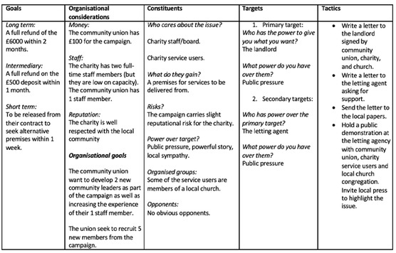
Figure 5 Midwest Strategy Chart
View description - Figure 5 Midwest Strategy Chart

Back to - Activity 3 Building campaign strategy

Activity 1 What is your organising context and constituency?

Discussion
Black British workers are a constituency that struggles to represent their interests in the workplace. This is evidenced by the ethnicity pay gap and the fact that Black employees have consistently earned less than white employees since 2012 (ONS, 2023).
Back to - Activity 1 What is your organising context and constituency?

Activity 2 Identifying leaders

Discussion
There are not necessarily any wrong answers here. It is more about looking for people’s leadership potential and giving them the opportunity to develop it. But here are some useful ways of thinking about it:

Shanice
Shanice is a less senior member of staff, which by no means counts her out of leadership potential, but as she is quite new it seems less likely that she has had the opportunity to build rapport with other colleagues. This is also made harder by the fact that she often uses lunch breaks to get work done on her own, which is one of the key opportunities for organising work to take place.
However, people respect her work and get along well with her. This goes for parents as well as teachers, making it more likely for people to take her seriously if she were to raise an issue in the workplace.

Michael
Michael has a formal leadership role as head of year 5 and he has worked at the school for a long time, likely making him generally more trusted, plus he’s already in the union which might give you a head start going forward.
Michael is also thought of as being well versed in politics. However, while this could seem like a plus for leadership potential, it also carries the possibility that people could find him confrontational, strongly disagree with him (quietly or vocally), or think that any issues he might raise at work are just ‘Michael making everything political’. So, perhaps he is one to think twice about.

Kam
Kam is very well networked in the school, not only with staff but with parents as well. Though they don’t have a formal leadership position, the nature of their work means that lots of people rely on them being good at their job, and they are, which means people generally respect them. All big ticks as far as leadership is concerned.
It sounds like Kam has helped people out of a few last-minute scrapes, which again makes it more likely that people will appreciate them in the workplace. However, they clearly don’t appreciate having to drop everything to handle late work. This could go one of two ways: either they have enough respect that other staff will understand and try to avoid disappointing them, or they will find it unreasonable and be less likely to want to follow them. Still, definitely one to think about.

Back to - Activity 2 Identifying leaders

Activity 3 workplace mapping

Discussion
The example below is a long way off 50% with only three people in the ‘For’ column. Don’t let this dishearten you. It just means there is a lot of work to do and actually most people are neutral. Luckily one of the organic leaders is in favour of the union, but there is also one against. This makes convincing the organic leaders who are neutral of the utmost importance.

For | Neutral | Against
Chris  Toni*  Emma | Denise  Martin  Hayley  Terry*  Letitia*  Kerri | Mark*  Robert  Hannah  Teresa

Back to - Activity 3 workplace mapping

Activity 4 Moving to action

Discussion
Below is a short sample answer:

Who is the constituency you aim to organise?
Low to middle income people in my community.
What are the issues that are affecting them?
Many families in my area find the additional cost of paying for food outside of school term a struggle.
What kind of organisation would be best to solve the issue?
A mutual aid organisation could allow us to raise the funds to start a ‘school holiday lunch club’ that could spread the cost of feeding school age children in the area outside of term time.

Back to - Activity 4 Moving to action

Descriptions

Figure 1 Harnessing power to achieve equity lies at the heart of Black leadership
The image depicts a Black female teacher standing in front of a school building holding some books.
Back to - Figure 1 Harnessing power to achieve equity lies at the heart of Black leadership

Figure 2 Black Power movement activists in Philadelphia, 1970
A group of activists are holding their fists in the air at the Revolutionary People’s Party Constitutional Convention, Philadelphia, September 1970
Back to - Figure 2 Black Power movement activists in Philadelphia, 1970

Figure 3 Necropolitics is marked by an oppressive power which targets certain groups of people
The image depicts a woman holding a sign saying ‘Sis is tired, sometimes hopeful, mostly disappointed, yet so proud. So please Let. Me. Breathe. #BLM’
Back to - Figure 3 Necropolitics is marked by an oppressive power which targets certain groups of people

Figure 1 Leadership and power are intertwined
The image depicts a number of image in bubbles, connected together in a circular web over a city landscape. The central bubble shows Planet Earth and the smaller bubbles around it contain images showing: a close up of a laptop being used; brain activity; a woman standing holding a laptop; two people in shadow shaking hands; a person manipulating a digital image; a shot of a man from behind with his hand on his chin; a cityscape; a cloud symbol.
Back to - Figure 1 Leadership and power are intertwined

Figure 2 A useful way to think about power is through the metaphor of ‘faces’
The image features a number of carnival masks haphazardly scattered.
Back to - Figure 2 A useful way to think about power is through the metaphor of ‘faces’

Figure 3 Adopting a faces of power view can help you identify the many ways in which power works in societies and organisations
The image features two silhouettes, one entirely black and one multi-coloured.
Back to - Figure 3 Adopting a faces of power view can help you identify the many ways in which power works in societies and organisations

Figure 4 Some of the most significant achievements in the world have been accomplished through the power of solidarity
The image depicts a grid of intertwined arms belonging to people stemming from multi-racial contexts.
Back to - Figure 4 Some of the most significant achievements in the world have been accomplished through the power of solidarity

Figure 1 Resistance leadership can change the world
The picture features a child in a cape and mask. She extends her arm through the air, shattering a large ball.
Back to - Figure 1 Resistance leadership can change the world

Figure 2 Resistance leadership can shift power dynamics
The image features a mural of George Floyd, depicted as an angel, in Houston, Texas. Flowers and cards are placed beneath it on the ground.
Back to - Figure 2 Resistance leadership can shift power dynamics

Figure 3 Dissent can empower leadership rather than diminish it
The image depicts a woman looking directly to the camera lens, holding one thumb up and one thumb down.
Back to - Figure 3 Dissent can empower leadership rather than diminish it

Figure 4 When a system cannot be fixed, more radical forms of resistance leadership can create the conditions for better alternatives to emerge
The image depicts a black silhouette of a person talking into a megaphone with one arm outstretched.
Back to - Figure 4 When a system cannot be fixed, more radical forms of resistance leadership can create the conditions for better alternatives to emerge

Figure 5 Power can be abused through ‘oblique’ resistance
The image depicts a woman holding her head in despair. Two blurred silhouettes of co-workers in conversation are situated in the background.
Back to - Figure 5 Power can be abused through ‘oblique’ resistance

Figure 1 Resistance can take many forms and shapes.
This is an aerial image of a coastal city with the tide coming in. A group of people organised into the shape of the word ‘resist’ are on the beach.
Back to - Figure 1 Resistance can take many forms and shapes.

Figure 2 First continuum of resistance
A horizontal line with an arrow at each end. The arrow to the left is labelled ‘individual’, and the arrow to the right is labelled ‘collective’.
Back to - Figure 2 First continuum of resistance

Figure 3 Second continuum of resistance
A horizontal line with an arrow at each end. The arrow to the left is labelled ‘hidden’, and the arrow to the right is labelled ‘public’.
Back to - Figure 3 Second continuum of resistance

Figure 4 The Four Is of resistance (Mumby et al., 2017)
A diagram showing four arrows positioned at north (labelled ‘individual’), south (‘collective’), east (‘public’) and west (‘hidden’) points. To the left of the diagram it reads ‘What counts as resistance?’
Back to - Figure 4 The Four Is of resistance (Mumby et al., 2017)

Figure 5 The Four forms of resistance (Mumby et al., 2017)
A diagram showing four arrows postioned at north (labelled ‘individual’), south (‘collective’), east (‘public’) and west (‘hidden’) points. There is a label in each quadrant: in clockwise direction they are ‘individual infrapolitics’, ‘insubordination’, ‘insurrection’ and ‘collective infrapolitics’. To the left of the diagram it reads ‘What counts as resistance?’
Back to - Figure 5 The Four forms of resistance (Mumby et al., 2017)

Figure 6 Resistance through distance can involve disengaging from an organisation
The image depicts stick-people, some of whom are grouped together and some of whom who are disengaged from others. All but one person stands on arrows pointing in different directions.
Back to - Figure 6 Resistance through distance can involve disengaging from an organisation

Figure 7 Resisting sometimes involves creating a boundary between oneself and the dominant power
The image depicts a person in dark clothing surrounded by white boxes that are stacked up around them.
Back to - Figure 7 Resisting sometimes involves creating a boundary between oneself and the dominant power

Figure 8 Resistance through persistence is always public and seeks accountability
The image depicts two ants pushing a boulder up a hill.
Back to - Figure 8 Resistance through persistence is always public and seeks accountability

Figure 9 Resistance through difference involves challenging the dominant culture through diversity
The image depicts a jigsaw of a woman’s face in many colours.
Back to - Figure 9 Resistance through difference involves challenging the dominant culture through diversity

Figure 10 Resisting corrupt power requires persistence and skill
The image depicts two enlarged hands weaving a web around the torso and head of a person.
Back to - Figure 10 Resisting corrupt power requires persistence and skill

Figure 1 Public services
A picture which appears to be in a hospital or medical centre. A health worker is attending to a patient.
Back to - Figure 1 Public services

Figure 2 Professional power
A road sign with the word ‘Professional’.
Back to - Figure 2 Professional power

Figure 3 Leaders should encourage people to be aware of their rights
An art image showing the outline of a group of people with some designed in colourful mosaic styling. Some have one arm raised in what looks like the black power salute.
Back to - Figure 3 Leaders should encourage people to be aware of their rights

Figure 1 Businesses and corporations pledge support opportunities for Black people
An art image of a number of people of different races and ages.
Back to - Figure 1 Businesses and corporations pledge support opportunities for Black people

Figure 2 Visual representation of the difference between equality and equity
Visual representation of the difference between equality and equity. The image is split into two parts. The left side shows three people of varying height standing on a single box behind a fence, with a baseball game being played in the background. The tallest and second tallest person can comfortably view the game by peering over the fence, but the shortest person has their view completely obscured. At the bottom is the word ‘EQUALITY’. The right side of the image shows the same three individuals but this time the tallest person does not stand on a box, the second tallest person stands on one box, and the shortest person stands on two boxes. They are now all viewing the game at the same height. All three can view the baseball game. At the bottom is the word ‘EQUITY’.
Back to - Figure 2 Visual representation of the difference between equality and equity

Figure 1 Campaigning means mobilising for change
The image shows a crowd of protesters holding placards. One placard reads ‘Black Lives Matter’.
Back to - Figure 1 Campaigning means mobilising for change

Figure 2 Mobilising people for change
A group of protesters stand in the street with their fists raised.
Back to - Figure 2 Mobilising people for change

Figure 3 Campaigners fought to elect the first Black leaders
The image shows a statue of Nelson Mandela with his fist raised.
Back to - Figure 3 Campaigners fought to elect the first Black leaders

Figure 4 Collectives can demand change from individual leaders
The image shows a group of protestors. One holds a placard that reads ‘End Systemic Racism’.
Back to - Figure 4 Collectives can demand change from individual leaders

Figure 5 Midwest Strategy Chart
This is a table with five columns. The headers for the columns (from left to right) are ‘Goals’, ‘Organisational considerations’, ‘Constituents’, ‘Targets’, ‘Tactics’. Each column provides examples, sub-categories, and strategies for each category.
Back to - Figure 5 Midwest Strategy Chart

Figure 1 Organising means building a collective for change
Amazon Labour Union organiser Chris Smalls addresses a crowded meeting.
Back to - Figure 1 Organising means building a collective for change

Figure 2 Organising can be used to build power
The picture shows a group of raised fists.
Back to - Figure 2 Organising can be used to build power

Figure 3 Organising around workplace issues can be a key area of struggle for Black leaders
A group of workers in overalls and hard hats are gathered listening to a speaker off camera.
Back to - Figure 3 Organising around workplace issues can be a key area of struggle for Black leaders

Figure 4 A large group of protestors
A large group of protestors with some holding banners. Many are smiling and appear to be in a joyous mood.
Back to - Figure 4 A large group of protestors

Figure 5 A community organisation
An image which shows fruit, tinned food and general food being sorted by helpers on large tables.
Back to - Figure 5 A community organisation

Figure 6 Ella Baker
A picture of Ella Baker in a tall wooden plaque, positioned alongside a pedestrianised pathway.
Back to - Figure 6 Ella Baker

Video 1 Kemar Knight – Building collective forms of power

Transcript
[RHYTHMIC ELECTRONIC MUSIC]
KEMAR KNIGHT
My name is Kemar Knight. I’m the Union rep at Park Royal Bus Garage and I represent the drivers day in and day out. Power is in numbers, and by having a Union in place at any workplace-- or per se in this workplace-- it will help drivers to be treated fairly and for no one to feel as if they’re being discriminated or harassed. So basically, it’s to also ensure that the employer is adhering to regulation and legislations under the Employment Act.
The Union will have meetings with directors to basically iron out stuff, identify issues that are happening within the workplace-- not just this depot, but within the whole company itself-- in order to make both the company and the employees that are members to have a reasonable standard of work. And I do understand that the public may not like strike actions or whatever. Sometimes, it’s essential because we as a Union, we are fighting for not what we want, but what our members are asking for us to fight for.
And sometimes, the company is not adhering to our requests. As a collective, we will come together and strike in order to achieve what we want. Like last two pay talks, we had to go on strike, and we achieved 10% pay rise.
Collective lobbying is rather more impressive than individual lobbying. So for an example I could give, there was a driver who was transferred to this depot, and he noticed that the Boxing Day bonus was significantly lower than what he was receiving at the depot that he transferred from. So he notified the Union, and then the Union went about it by thoroughly investigating it.
And when the Union found out that it was factual, then because we were also in pay talks at that moment, we as a Union incorporated within the pay talks. The company agreed that they did fail this depot in that aspect, so they decided to not only harmonise this depot with the other depot, but also to backdate each and every driver who were affected by this. And that’s the example that I can give.
Back to - Video 1 Kemar Knight – Building collective forms of power

Video 2 Lace Jackson – The legacy of colonialism and slavery on Black leadership

Transcript
[MUSIC PLAYING]
LACE JACKSON
The legacy of colonialism, neocolonialism, and slavery on Black leadership in the UK has a long and lasting legacy. It has a lasting legacy in the sense that a lot of our human resource practices actually derived from slavery. There’s a recent book by Peter Bloom that talks about the practices of colonialism or slavery in the sense of reward and sanctions are what is used in human resource management.
And it derives from how they dealt with the slaves, and that has carried through and still abides in most organisations’ human resource practice. In respect of the legacy of neocolonialism and colonialism, what we find for global majority people is a legacy of what they call unbelonging. An inability to at first in terms of the Windrush era parents being able to get loans, and having to support themselves through what they call pardners. So that’s the kind of loan in each of the money in order to make ends meet so that they could buy houses because there was no mortgages that were given.
And what you then have is a kind of generational deficit in respect of children having generational wealth within families because their first generation parents who were Windrush here like 70 years ago aren’t able to leave kind of inheritances that their then children can draw on. So there is that legacy of unbelonging.
Sometimes some poverty we also have I guess the pioneering roles of leadership where we still see people are only just getting two positions and they’ve been the first one. And so that’s the kind of lasting legacy that slavery, colonialism, and neocolonialism still have and is still affecting generations to come.
[MUSIC PLAYING]

My tips would be on decolonising the mind of Black leaders is really to understand what I call a term in my research as the invisible force fields. So understanding what are the challenges and what are the obstacles, and understanding what is the organisational-induced trauma and stress because without knowing that you’re coming up against this force field, and you’re thinking it’s yourself. So you’re being self-critical. You’re losing self esteem because you don’t understand what’s happening to you.
So I think that decolonising their own mind, understanding some of the legacies of colonialism and slavery, i.e. the human resource practice that continue to in a sense try to enslaved people in that way if you understand that those are the practices that underpin these organisations you’re more likely to be able to operate in a more emancipatory way and navigate around them.
[MUSIC PLAYING]

Back to - Video 2 Lace Jackson – The legacy of colonialism and slavery on Black leadership

Video 3 Nela Smolović Jones – Gaslighting in organisational settings

Transcript
NELA SMOLOVIĆ JONES
My name is Nela Smolović Jones. I am a gender academic who explores how equality is achieved in organisations and societies. I am also director of the Open University’s Gendered Organisational Practice Research Cluster.
[MUSIC PLAYING]
Gaslighting is a form of organisational corruption where powerful individuals and groups can gain even more power by confusing and undermining those who could potentially challenge them. And this is achieved via complex web of actions through which targets are made to question their own sanity and their own competence and thus prevented from equalising the playing field in organisations where power and wealth can be distributed more fairly
[MUSIC PLAYING]

Gaslighting is a useful concept to know, especially in contexts where power is overwhelmingly skewed towards one group at the expense of another, such as patriarchal and racist contexts or contexts where these two forces of inequality overlap. For example, institutions such as the media, judiciary, or police may be less responsive to and protective of interests of Black communities and individuals. And moreover, such institutions or let’s say, certain groups within them may proactively aim to gaslight those who openly challenge acts of racism be it within these or in broader society.
[MUSIC PLAYING]

Ruling refers to the introduction of arbitrary and unspoken rules into procedures and spaces employed to confuse and inhibit meaningful participation in those conversations that matter. For example, talks about decolonising the curriculum in schools or introducing positive action or positive discrimination practices in workplaces may be obstructed by deliberately complicated bureaucratic procedures.
[MUSIC PLAYING]
Exposing describes those situations in which people are made to appear inept in front of an audience when they raise queries and questions regarding corrupt practices. For example, attempts to talk about discriminatory portrayals of Black people on television may be countered not with facts, but by concerted unfair character assassinations of the people speaking out.
[MUSIC PLAYING]
Weaponising victimhood is probably the most devious aspect of gaslighting. This is when gaslighters is assumed the status of victim portraying their targets as bullies, realigning the boundaries of engagement in the process. So, for example, you may wish to challenge racially-motivated police malpractice but end up being accused of bullying or slandering the very police officers who are at fault.
[MUSIC PLAYING]
Collective affirmation describes those situations where the practice of gaslighting is shifted to a collective level through the power of a crowd, which is called into action to affirm the logic and sense of otherwise, senseless and corrupt practice. For example, you may publicly voice your experience of racially-motivated crime to raise awareness about it. However, media outlets may collectively overwhelm public consciousness by deliberately constructing a misleading narrative about the event.
[MUSIC PLAYING]

Back to - Video 3 Nela Smolović Jones – Gaslighting in organisational settings

Video 1 Kemar Knight – Building collective forms of power

Transcript
KEMAR KNIGHT
So prior to becoming a Union rep, I could say things more out loud. But after consider people’s feelings a bit more because I’m within a position where in which I can’t let someone feel less favored or as if I’m talking down at them. So I have to be very mindful with my words, number one.
Working with my employers as a Union rep can be challenging at times because Union rep are the union. And the company don’t really see eye to eye at all times, which is understandable. So that can be difficult.
But as a Black leader, it can also be difficult at times because sometimes when I’m in a room, people may say stuff that they themselves don’t perceive as a bit prejudice. But for me, I may find it to be that or wherever with the position that I am in and because I’m in a position where in which I have to be very careful what I say so I won’t say it within the room. I’ll wait at the side and explain to them, earlier, you said something, and it didn’t sound too right. And this is my take on it. Or you may not see it like this, but be very mindful because others may take it differently.
It’s a bit one sided. It can be manipulative. For example, when we go on strike, if the buses or the train go on strike, they make it seems as if we’re all in the country to ransom. They’re not explaining or stipulating on the good deeds that we do for our members.
They don’t explain, like, for example, working standards improve because of the Union. Females got better rights. People from the BAME community have better rights. There’s better regulations and legislations out there now due to the lobbying of the Union.
I believe the media have a responsibility also to share both narrative, to share the narrative of the good of the Union and also the bad of the Union. However, it seems to me, personally, as if they only share the negative side of the Union.
With the Union leader that inspired me, Mr Anafi. When he is fighting for his members, he is fighting as if he is fighting for himself. He is my inspiration because I remember when I told him that the drivers asked him to put my name up. I was doubting myself. And he said I should go on, I can do it, along with my family telling me to do it as well. So it was a concrete decision for me to say, yes, I can do it. And I have some believe in myself. So it’s highly inspirational.
Back to - Video 1 Kemar Knight – Building collective forms of power

Video 2 Yaina Samuels – Solidarity in supporting action on mental health

Transcript
YAINA SAMUELS
My name is Yaina Samuels. I work in mental health within the ethnic minority community.
I think the understanding of mental health in minoritised communities is important because of the services that we need to provide. Very often, people can get misdiagnosed and when we look in Wales at the organisations that are working within mental health, many of them are white-led. So we don’t have an ethnic minority leadership there.
Already, people have preconceived ideas of people with mental health. They also have preconceived ideas of Black people with mental health. So you put those two together and there’s a double whammy. And then when you have no leadership at the top, then the cultural awareness and understanding of how to effectively engage with an ethnic minority person who has a mental health problem, that is going to be very difficult.
When we look at the representation or the lack of representation of Black people within Welsh organisations, it’s important for the treatment. It’s important so that people aren’t misdiagnosed. It’s important. So that people aren’t labeled criminals. It could be a mental health problem that somebody is presenting with. From my previous work with working with the community, ethnic minority community in mental health, so many of my clients have been misdiagnosed and labeled criminal and treated as a criminal. And then it’s later found out that the client has mental health problems. So it’s very important that cultural awareness is embedded in organisations’ policies and practices.
So in order to support my work in mental health and build up solidarity, I went into the communities and had conversations for change with them on the topic of mental health. It’s a huge stigma within the ethnic minority community so it was important that I was able to build up relationships of trust. Once those were built up, over a period of a year because you can’t rush these things, then I started to get invited to meetings, forums, meeting with community elders, women’s groups. And the conversations started to open up about the stigma attached to mental health and the barriers which prevent communities from seeking help.
Back to - Video 2 Yaina Samuels – Solidarity in supporting action on mental health

Video 1 Lace Jackson – Constructive dissent and destructive consent

Transcript
[MUSIC PLAYING]

LACE JACKSON
Constructive dissent for me in Black leadership in relation to what came out of the research was that it was a way of global majority leaders finding emancipatory ways to exercise and practise leadership. So for me, it’s how do they find ways to be the first in role. How do they find ways to collaborate? How do they find ways to support each other to be able to exercise their leadership even though there are so many obstacles in the way?
So for me, that’s a form of constructive dissent. What was really interesting from my research was how faith played a big part in a number of global majority leadership practice. So even if it wasn’t as explicit and they didn’t necessarily make it known, it was a counter-narrative that ran throughout the leadership practices of the majority of the participants. And, therefore, I would say that is a constructive dissent from the leadership on offer.
So destructive consent in Black leadership can take a number of forms. Mainly, what I’ve found throughout my research was about intercultural and intercultural betrayals. And that led to disconnection from communities. It would mean that other in-groups within the global majority leadership could judge each other more harshly.
We hear the term coconut that you’re Black on the outside but white on the inside. Those are the types of things that come through in destructive consent. So you’re consenting to the patriarchal norms of the organisations in which they operate, which then excludes other groups.
The example of constructive dissent that I could give you was shared with me by a research participant who was a senior police officer. They had witnessed, which was known in terms of public media or social media that there was a death in police custody of somebody who’d been assaulted whilst receiving treatment in the hospital became aggressive and was then arrested. But they ended up dying in police custody. They made representations of that, asking questions as to why did this happen.
But being a senior police officer, they knew that would limit their career. If I gave an example in light of destructive consent, it would be that they would be in that similar role and not say anything about how that situation should not have occurred. I guess what I wanted to really illustrate was the cost of that to Black leaders in that it did limit that person’s career by having that constructive dissent.
Back to - Video 1 Lace Jackson – Constructive dissent and destructive consent

Video 1 Kemar Knight – Limitations of complaints

Transcript
KEMAR KNIGHT
I have a branch meeting because there was problems with scheduling prior to me becoming a Union rep. So I have a branch meeting to hear what the members are saying so they can explain what is affecting them within the schedule, what ideas they have that they would like myself and the Union to do in order to make changes to facilitate a better working environment for them. So I’ve taken on board everything that what they have said. I have brought the ideas to the employer in order to make the changes. The employers are looking into the matter. And they will be getting back to me in due time to make the changes or to stick to what it was. And then we’ll take it from there. I’ll start off with, don’t work. So for example, you would have members having issues. And they’re making complaints. But they’re only making the complaint so little management and not notifying myself or other Union representatives of the complaint. So I find it difficult for me to sort out the issue. So my advice to my members are to make the complaint to the managers as your willing right to, and that’s the right process. But also provide myself or other Union representative within my branch with a copy of that complaint in order for me to follow it up. And where it can become collective is if myself or other representative notice that the complaint or complaints are the same, then we will go down the collective grievance route.
Back to - Video 1 Kemar Knight – Limitations of complaints

Video 2 Christy Adeola Braham – Resistance to power

Transcript
CHRISTY ADEOLA BRAHAM
So several years ago, I found myself in a situation where I was going to be evicted. The police were involved as well. And I had no choice but to challenge some very racist practices, which I was subject to from both the landlord, from the local council, and also from the police officers involved.
For us, we really took like a multi-pronged approach. Step 1, of course, was raising awareness. So social media was a really important tool for that. And that was a way for me to engage friends, family, acquaintances, people I knew, people who knew people that I knew, and to really shed some light on what had happened. Step 2 was then me joining a local union. And that was great because it was like-minded people-- like-minded engaged people who were already doing so much work on housing but had really cared about what had happened and really took an interest. Step 3 was then moving beyond working with people in the housing union to really engaging people from other social movements. We needed to engage people who worked on race and inclusion and diversity. And so through that, we really engaged people beyond the initial network and really generated a lot more interest. Stage 4 was then reaching out to media. So by now, we had a petition with thousands and thousands of signatures from people all across the UK and beyond and different countries in the world. And then the next stage, stage 5, was really taking everything that had happened, using all the interest that we generated to speak to power, to engage local politicians, to get councillors, MPs from the Green Party and Labour Party on our side. And we managed to pique the interest of the mayor of Bristol, managed to get some agreements with him and the council as to their various housing and policing policies.
So I think as a leader involved in these various resistance struggles, I think, it’s really important to be determined. There’s no short-term gain here. We’re talking about months and years. I also think it’s important to be thick skinned. Unfortunately, there are going to be many detractors, lots of people who don’t believe in your campaign or just don’t understand the issues that you’re trying to shed light on or don’t believe in the existence of these issues. And you’re going to have to learn to navigate that.
Back to - Video 2 Christy Adeola Braham – Resistance to power

Video 3 Nela Smolović Jones – Resistance under conditions of corruption (dispelling gaslighting)

Transcript
[MUSIC PLAYING]
NELA SMOLOVIĆ JONES
Dispelling is a practice of resisting gaslighting. And it is called dispelling to evoke the image of breaking a spell or dispersing a smokescreen of gaslighting practice so that it’s possible to see corruption for what it is.
[MUSIC PLAYING]

Practising dispelling as a whole is useful for contexts of pervasive systemic corruption and accompanying injustices. Hopefully, these are situations none of you are experiencing, but you may find individual dispelling practices useful. These are tactics that can help deflect and break through gaslighting.
However, the underlying value lies in being able to stay in the game. It decreases our chances of being excluded from spaces where we can make a difference. This is often an arduous process and far from ideal. Practising dispelling absolutely does not mean giving up on fighting the presence of injustice head on. We need to do both.
[MUSIC PLAYING]

Re-iteration is repeating the same message almost verbatim to refocus discussion on the needs of marginalised people. Such a tactic is usually employed when gaslighters trying to change the subject by attacking you personally or when they try to weaponise victimhood to distract from the main topic. The key here is not to get distracted by gaslighter’s attempt to change the direction of conversation but to stay focused on the issue of racial justice.
[MUSIC PLAYING]
Evidencing refers to the introduction of reports, analysis, witness statements, and so on to dispel the effects of gaslighting and refocus discussion. Our best tool here is well researched and effectively presented information. This is particularly important when there is a possibility to mobilise additional support for our cause. For example, if our goal is to stop the underfunding of schools in Black communities, it might be useful to share facts with friendly media, which can then amplify our voice and contribute more useful evidence into the public domain.
[MUSIC PLAYING]
Tactical withdrawal refers to consciously conceding to an unfair or inaccurate criticism in order to redirect the conversation back to the main area of concern. This one is particularly difficult to sustain, but it is sometimes necessary in those situations where gaslighters seem to be gaining significant ground. People sometimes withdraw in order to give gaslighters a false sense of winning and so buy themselves time to reorganise their efforts, yet sometimes they do it because pushing further may trigger retaliation, damaging the cause. But it’s crucial to remember that we should never give up on fighting injustice. It’s just that sometimes we need to temporarily pick our battles.
[MUSIC PLAYING]
Instigating compassion is when people seek to dispel corrupt practice by provoking empathetic feelings from corrupt actors in an attempt to trigger ethical action. For example, you might build a case in a way that can appeal to gaslighters personal circumstances where they might be able to imagine themselves or someone dear to them in a marginalised position suffering injustice, which might in turn prompt them to act relationally.
[MUSIC PLAYING]

Back to - Video 3 Nela Smolović Jones – Resistance under conditions of corruption (dispelling gaslighting)

Video 1 Fidèle Mutwarasibo – Engaging and collaborating with local public service providers

Transcript

FIDLE MUTWARASIBO
Hello, my name is Fidèle Mutwarasibo. I am a lecturer at the Open University Business School, and I’m the director of the Centre for Voluntary Sector Leadership.
My research interests relate to the leadership of racialised minority networks. Before my Open University role, I worked in various positions in the voluntary sector. And I’m still active in the voluntary sector.
[MUSIC PLAYING]

Between 2017 and 2019, I call it the Fight Against Hate campaign under the banner of Citizens:mk, a chapter of Citizens UK, which involves local community groups, schools, and the Open University, among other partners to promote social justice. Through my involvement in the campaign and the broader research activities I engage in, I have engaged with Milton Keynes Council, the police, and the NHS. In my community leadership roles, I prioritise teamwork and collaboration and negotiations with the institutions I engage with.
I always want to allow people to tell their stories instead of speaking on their behalf. I engage effectively with stakeholders on any issues I’m working on. I always try to ensure that there are ongoing communications with all the stakeholders while investing time and energy into networking and building up my social capital.
[MUSIC PLAYING]

I have learned many lessons from engaging with local public services. These include making sure that I have done my homework in order to identify the right person to speak to. Using authentic testimonies rather than relying on statistics.
Engaging as part of a team rather than doing solo runs. Helping local public services to expand their reach in the communities. Proposing solutions that are realistic and actionable. Adding value to the work of local public services but also holding them accountable.
Back to - Video 1 Fidèle Mutwarasibo – Engaging and collaborating with local public service providers

Video 3 Yaina Samuels – accessing public services

Transcript
YAINA SAMUELS
As a user accessing public services and being a Black woman, it was difficult. And the reason why say it was difficult is because there was a lack of understanding of cultural awareness and the barriers that prevented me from accessing services and also, on my part, a lack of trust.
I didn’t see anybody in the services at the time that looked like me. On the other side of it as a professional, my difficulties arise when I’m accessing public services on behalf of a client. I often find myself in discussion, in debate about the level of service, about the needs of the clients. I often find myself in difficult situations because of the complexities of ethnic minority mental health issues.
Firstly, we have the stigma and the shame attached to mental health. That prevents people accessing the services. Then we have the possibility of an inaccurate diagnosis that often happens, especially when many cultures are deemed as aggressive as in my culture, African.
I myself have been deemed aggressive as a diagnosis in the past. And then we have care. If you have an incorrect diagnosis, then that can lead to the incorrect care. And I think there can be a huge barrier and language issue when it comes down to care.
And the danger of not having the correct care for somebody having a mental health episode can be a huge risk to the client’s life. Based on my own leadership journey, my advice would be to get out there and meet the people, mix with the community, attend meetings and forums, so you get your face seen, let people know what you do, and also engage with the community at a level that you understand them, and they understand you, and the trust gets built up.
Once trust is built up, you can then start having those conversations for change around mental health and the stigma attached to mental health. So first and foremost, go into the community, get to know who you’re working with, and build up those relationships.

Back to - Video 3 Yaina Samuels – accessing public services

Video 1 Fidèle Mutwarasibo – Arriva, Network Rail, and chartered accountants

Transcript
[MUSIC PLAYING]

FIDELE MUTWARASIBO
Through my role as co-lead of the Citizens:MK Fight Against Hate campaign, I promoted the campaign on posters displayed inside Arriva buses and got posters displayed at the three Milton Keynes railway stations, thanks to Network Rail.
In my role as vice president at MK Community Foundation, I supported the successful application for a grant from the Institute of Chartered Accountants in England and Wales for a project aimed at promoting Black people’s social mobility.
I have learned a lot of lessons from my engagement with the business and the corporate sector. One of the lessons I learnt is that although businesses drive for the bottom line-- i.e., profit-- it doesn’t mean they don’t care or have time for social justice. Public image is vital for businesses.
We don’t have to look too far away because in 2020, following the Black Lives Matter protest, many businesses and corporations reviewed their history and committed to being more inclusive, lifting up those left behind because of history or any other reason, and ensuring their mobile within the workplace can increase people’s disposable income and ability to spend.
And we know businesses are keen to get us to go to buy services and goods. And finally, diversity advantage has been gaining prominence in the corporate world. In addition to helping businesses improve their retention, diversity in the workplace helps them make better decisions, if and when all the perspective within the organisations are given a fair hearing.
Back to - Video 1 Fidèle Mutwarasibo – Arriva, Network Rail, and chartered accountants

Video 2 The State’s obligations relating to discrimination

Transcript
NARRATOR
What are State’s obligations relating to discrimination? The state’s first duty is that it should not itself when providing for human rights, discriminate against persons on the grounds listed, namely race, color, sex, language, religion, political or other opinion, national or social origin, property, birth, or other status.
Under the Apartheid system in South Africa, there was a system of institutionalised racial segregation and discrimination. There were separate public services, such as toilets, parks, and beaches. The second obligation of a state is that it must protect individuals against discrimination in the private sphere on the grounds listed. For example, in Northern Ireland, the owners of a private bakery refused because of their religious beliefs to provide a cake with images supporting gay marriage. The court held that this was prohibited discrimination on grounds of sexual orientation.
Thirdly, when certain groups have traditionally or historically been subjected to discrimination, states can undertake special measures or affirmative action in favor of the discriminated group. Some human rights treaties have made express provision for this so that it is not considered to be discriminatory.
Examples of such special measures or affirmative action might be quotas for underrepresented groups, job advertisements that state that applications from underrepresented groups are particularly welcome, lower admission standards from underrepresented groups, or rules that if two candidates are equally meritorious, then preference can be given to a candidate from an underrepresented group. We now need to consider the concept of equal treatment and within that the, ideas of direct and indirect discrimination.
In terms of equal treatment, individuals have a right to be treated equally. However, this is not an obligation to treat everyone in exactly the same way, regardless of differences in situation, needs, or capacities. So for example, a football club can choose the best football players, but it should not choose the best football players from only one race or from one religion.
Secondly, equal treatment involves a prohibition on treating people in an unfavorable manner on the basis of characteristics of theirs that leave them exposed to prejudice or abuse. In simple terms, individuals should be judged on their merits and capacities, not on the basis of prejudices against them. The list of non-discrimination characteristics is not a fixed one, it inevitably changes over time, taking account of social developments. It includes race, sex, nationality, color, ethnicity, property, birth, and social status. More recently, it has come to embrace age and disability.
In some states, it has been extended to cover sexual orientation discrimination. However, this is not acceptable to all states. Discrimination can be considered to have occurred when it was either specifically intended, namely direct discrimination or when it is the outcome of an action that had another purpose but which has the effect of discriminating, namely indirect discrimination. Both forms are prohibited in international law.
An example of direct discrimination would be where the director of a company states that it will only employ men because women take too much time off to have babies. That is direct discrimination against women. The concept of indirect discrimination is more complicated because on the face of it, the rules are the same for everyone. So a requirement that all police personnel be 1.68 meters tall is a general rule that can be applied equally. However, because the average man is taller than 1.68 meters while the average woman is smaller, the rule is in its effects, discriminatory against women.
Finally, what makes the issue of discrimination complicated and controversial is that not all differentiation of treatment are prohibited. As the Human Rights Committee observed in one of its general comments, not every differentiation of treatment will constitute discrimination if the criteria for such differentiation are reasonable and objective and if the aim is to achieve a purpose, which is legitimate under the covenant.
Social evolution and standards will obviously affect what is considered as reasonable and objective. In addition, reasonable people may also disagree on what they consider to be reasonable and objective.
Back to - Video 2 The State’s obligations relating to discrimination

Video 1 Christy Adeola Braham – Mobilising constituency

Transcript
CHRISTY ADEOLA BRAHAM
In terms of mobilising people. I think it’s really important to firstly explain the issue. You also want to explain the impact of the incident on the person at the centre of it. But more importantly, you want people to understand the implications of this incident on wider society, that race has a place in housing, that Black and minority ethnic people statistically often have very negative experiences in the housing market. It’s also helping people to understand also that policing and criminalisation is also part of housing and helps to propagate mass inequity.
When you’re connecting the dots between these seemingly disparate issues, I feel that you’re inviting people to think deeper about these issues. You’re inviting people to widen their perspectives. You’re creating an opportunity to engage in a new way.
And when people engage in a new way, they also speak about these issues in a different way to their own networks. So at each level, you’re generating new interest and new ways of thinking about these really important issues. I feel that that’s a really important thing that I’ve experienced in my mobilisation work from various different issues previously as well.
[MUSIC PLAYING]

The advice I would give to any emerging leaders about how to engage in collective action would be just to get stuck in. Just jump right in, join a union, get active in a local campaigning group, get active in an online group. And if they don’t exist yet, start at yourself, and just come with an open mind. Be ready to learn and be challenged. The longer you go along on your journey, the more inspired that you’ll be to really get stuck into the action.
Back to - Video 1 Christy Adeola Braham – Mobilising constituency

Video 2 Sharon Thompson – Resistance to power

Transcript

SHARON THOMPSON
My name is Sharon Thompson. And I am a councillor in Birmingham, and I am the Deputy Leader for Birmingham City Council, and also Birmingham Labour group.
When planning and executing an election campaign, it’s really important that you connect with the local people that you want to represent. There’s different phases of this. And the first one is ultimately getting yourself selected, if you come from a party. So you need to make sure that you’re winning the votes of the people that are going to be in the room, but essentially, also making sure that they turn up to vote for you as well. So that’s really key in the first stages of any form of election.
If you are successful, and once you become selected as the candidate, those principles carry you throughout the whole of the campaign. It’s about bringing out the vote. It’s about speaking to people, connecting winning hearts and minds. And there’s a number of methods that you can utilise in order to do that.
We break our campaigns up into different types of area. And the first one is essentially, what we would call the long campaign. This is where you get more time to connect with people, for them to understand who you are as a candidate, and you can understand the local community, meet people, build your networks, and really help them to influence some of the things that are going into your material, sharing your key messages across the whole of that geographical area.
The next part of the campaign is the short campaign. And that’s the really intense bit. This is where you’re really focused on the numbers and getting out the vote. And some of that means that you have to focus on specific areas based on some of the data and information that you’ve collected over those few months or so leading into the short campaign.
The advice that I would give to an aspiring Black leader considering coming into politics starts with being your authentic self. So please make sure you stick to who you are, and be really clear on your brand, and who you want to be remembered as, because reputation is key, and it really does matter. I would also say that it’s really important that you understand the drivers in the places that make you passionate.
I was passionate about housing, and I made sure that I turned my passion into something practical. I went and understood what the legislation meant, I understood that who the key people were in the housing market, where the places were to get information, and who it was I wanted to network with.
In addition to that, one of the key things is to build up your network. I made sure that I went on a number of courses across the country. Some of those with Operation Black Vote, some of them were cross-party, some of them were the LGA, and a number of other places. Because it’s really important that you build your networks across the country, not just in your geographical area. So I would say, ultimately, build your brand, get your good reputation, and also build that network to help you to thrive within the political space. Because if you do get elected, we need Black leaders who are going to be competent, strong, and be able to influence people when it comes to the political system.
Back to - Video 2 Sharon Thompson – Resistance to power

Video 1 Sharon Thompson – Organising context and constituency

Transcript
SHARON THOMPSON
Besides geographical boundaries, what makes a constituency inclusive is the people, and you have to understand your role within that. It’s about understanding the differences between communities, the cultural differences, the things that make people tick. Whether that’s based on an estate, whether it’s based on a faith, it’s how people come together.
Within my ward, I made sure that last year, we had our first Iftar that brought together the community to break bread in the middle of Ramadan, which was really important for us as political leadership to work with the community and bring people together. So it’s about celebrating the differences between cultures. But also within that, it’s also about recognising the differences and the challenges that individual communities have. So it’s really, really important that you are the advocate, and you are the voice, but you also share power across the community.
To recognise the differences some of the things that we’ve done is there was an attack in our local area, and I made sure that we pulled together the different types of agencies, whether that was the police, the police and crime commissioner, community services, so that we could bring rest into the community, so that people didn’t feel nervous, anxious, or scared within the community in which they lived. It’s really is about sometimes being the peacemaker, being the advocate, being the person that actually, really helps them to find their space in community power, and making sure that we all come together in a really equitable way. There’s lots of issues in local communities, but there’s lots of value. And inclusive communities will always start by putting the people at the heart and centre of that.
In my opinion, we’ve come a long way when it comes to representation of the Black community in politics, but it hasn’t gone far enough. When you think back to when Diane Abbott, Bernie Grant, and Paul Boateng were first actually elected, and now we have 65 Black MPs across the chamber. But I think one of the key things is that we always need more, because we need local communities to be represented well within parliament and within politics.
Now there’s a whole broad spectrum of that. It’s not just about your identity as a Black or ethnic minority in politics, it’s also taking those other nuances into account. So I’m also conscious of the fact that I’m also a woman, so I represent in terms of the gender equality. It’s also looking at those from the LGBT community, disability, also those that come from the working class. There’s a whole range of things, because our identities are very fluid. So it’s really key that we have more people coming through. We have come a long way, but are you going to be the person that puts yourself forward to step into politics and join people like me, who are sitting in chambers across the country.
The advice that I would give to Black leaders coming into politics, when it comes to championing around diversity, equality, and inclusion, my starting point would be to pick what your niche is. There are so many different areas where policy needs to be influenced and looked at through that inclusive space. So it might be housing, it might be policing, it might be education. There’s a whole raft of areas. So pick the area that you’re most familiar and passionate about. And be really clear with yourself, what is the type of change that you want to make.
I think the other thing that I would say is definitely is about allyship. It’s about making sure that you build allies around the political space. Because sometimes, there are rooms where we are not represented, as in the Black community. And we need people inside those rooms speaking up and making those changes and recommendations around those tables. So allyship is really, really important.
And finally, being unapologetic about standing up when it comes to inclusion, equality, and diversity. There’s going to be people that you come across across the way that won’t always understand our perspective, your perspective, and some of the things that we’re trying to champion for. Make sure that you deliver your message in a way that when you’re in certain rooms and in different spaces that your message may remain the same, but your delivery and the language that you use is in a way that’s palatable, that brings people together, and actually influences them to make the changes that we need to see.
And there’s not one size that fits all. There are many aspects and many different ways that we can utilise our voice to get to the change that we need to see. And it’s about understanding where you fit into that, and how you can work with others to deliver different parts of that message. Whether you’re the campaigner, the lobbier, or the one that goes into the room, or the person that holds the pen on the policy changes of recommendations.

Back to - Video 1 Sharon Thompson – Organising context and constituency

