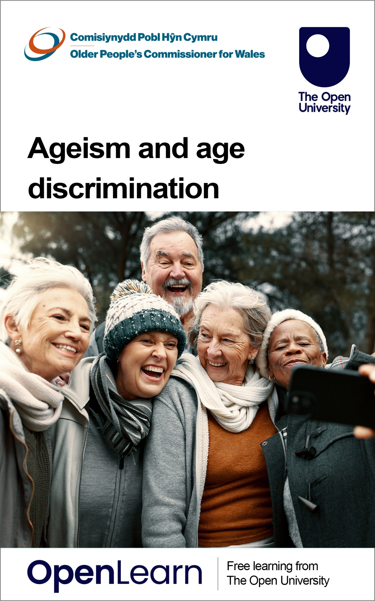

AGE_1 Ageism and age discrimination

Ageism and age discrimination

About this free course
This free course is an adapted extract from the Open University course .
This version of the content may include video, images and interactive content that may not be optimised for your device.
You can experience this free course as it was originally designed on OpenLearn, the home of free learning from The Open University –
There you’ll also be able to track your progress via your activity record, which you can use to demonstrate your learning.
First published 2025.
Unless otherwise stated, copyright © 2025 The Open University, all rights reserved.
Intellectual property
Unless otherwise stated, this resource is released under the terms of the Creative Commons Licence v4.0 http://creativecommons.org/licenses/by-nc-sa/4.0/deed.en. Within that The Open University interprets this licence in the following way: www.open.edu/openlearn/about-openlearn/frequently-asked-questions-on-openlearn. Copyright and rights falling outside the terms of the Creative Commons Licence are retained or controlled by The Open University. Please read the full text before using any of the content.
We believe the primary barrier to accessing high-quality educational experiences is cost, which is why we aim to publish as much free content as possible under an open licence. If it proves difficult to release content under our preferred Creative Commons licence (e.g. because we can’t afford or gain the clearances or find suitable alternatives), we will still release the materials for free under a personal end-user licence.
This is because the learning experience will always be the same high quality offering and that should always be seen as positive – even if at times the licensing is different to Creative Commons.
When using the content you must attribute us (The Open University) (the OU) and any identified author in accordance with the terms of the Creative Commons Licence.
The Acknowledgements section is used to list, amongst other things, third party (Proprietary), licensed content which is not subject to Creative Commons licensing. Proprietary content must be used (retained) intact and in context to the content at all times.
The Acknowledgements section is also used to bring to your attention any other Special Restrictions which may apply to the content. For example there may be times when the Creative Commons Non-Commercial Sharealike licence does not apply to any of the content even if owned by us (The Open University). In these instances, unless stated otherwise, the content may be used for personal and non-commercial use.
We have also identified as Proprietary other material included in the content which is not subject to Creative Commons Licence. These are OU logos, trading names and may extend to certain photographic and video images and sound recordings and any other material as may be brought to your attention.
Unauthorised use of any of the content may constitute a breach of the terms and conditions and/or intellectual property laws.
We reserve the right to alter, amend or bring to an end any terms and conditions provided here without notice.
All rights falling outside the terms of the Creative Commons licence are retained or controlled by The Open University.
Head of Intellectual Property, The Open University

Contents
- Introduction
- Learning outcomes
- 1 What is ageism and why does it matter?
  - 1.1 Stereotyping and prejudice
  - 1.2 Unconscious bias
  - 1.3 Age discrimination
  - 1.4 Impacts of ageism
- 2 Age discrimination and UK law
  - 2.1 The Equality Act 2010
  - 2.2 Protection from age discrimination
  - 2.3 Exceptions
  - 2.4 Objective justification
  - 2.5 The Public Sector Equality Duty
  - 2.6 Older People’s Commissioner for Wales
- 3 Taking action against ageism
  - 3.1 Challenging ageism
  - 3.2 Case studies and helpful resources
- Conclusion
- References
- Acknowledgements
- Solutions
- Descriptions

Introduction
Ageism can change how we view others and ourselves, perpetuate intolerance between generations, devaluing what younger and older people can contribute. It can also negatively impact our health, longevity and well-being while also having far-reaching economic consequences.
In this course you’ll be learning what ageism is and why it matters, as well as what the law says on ageism and what you can do to identify and challenge ageism you may encounter across different parts of society.
While ageism affects everyone, this course will focus on ageism experienced by older people. The World Health Organization (WHO) has reported that half the world’s population is ageist against older people (2021).
This course was co-developed with the Older People’s Commissioner for Wales; you’ll find useful links to the Commissioner’s resources throughout the course. In the video below, Rhian Bowen-Davies, the current Older People's Commissioner for Wales, outlines what you can expect from this course.

Video content is not available in this format.
Video 1 Introduction from Rhian Bowen-Davies, Older People’s Commissioner for Wales
View transcript - Video 1 Introduction from Rhian Bowen-Davies, Older People’s Commissioner for Wa ...

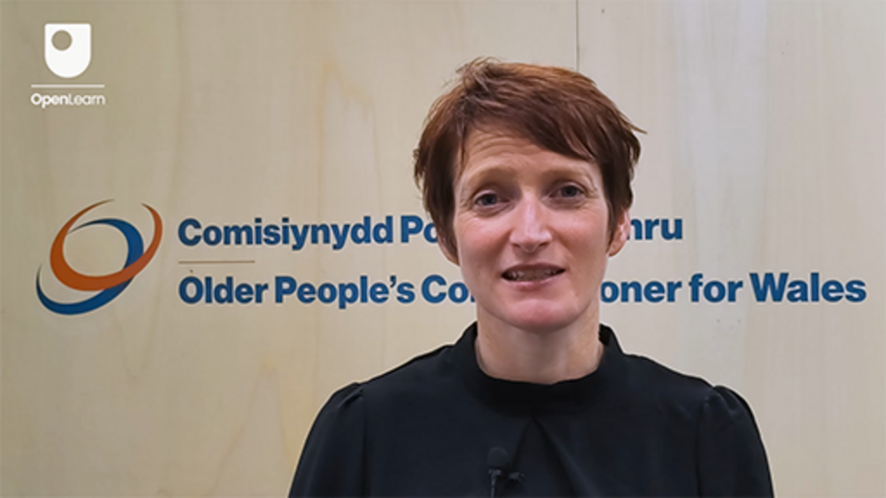
Video 1 Introduction from Rhian Bowen-Davies, Older People’s Commissioner for Wales

Enrolling on the course and successfully completing it means you will earn an Open University digital badge. Badges are not accredited by The Open University but they're a great way to demonstrate your interest in the subject and/or commitment to continuing professional development. In addition, you can also download your own OpenLearn statement of participation when you complete the course.

Learning outcomes
After studying this course, you should be able to:
- understand what ageism is, the impact it has on older people and why it matters
- have an awareness of the law in the UK regarding age discrimination (Equality Act 2010) with an appreciation of specific requirements and regulations in Wales
- confidently identify, challenge and act against ageism.

1 What is ageism and why does it matter?
Ageism refers to the stereotypes (how we think), prejudice (how we feel) and discrimination (how we act) directed towards people based on their age. (WHO, 2021).

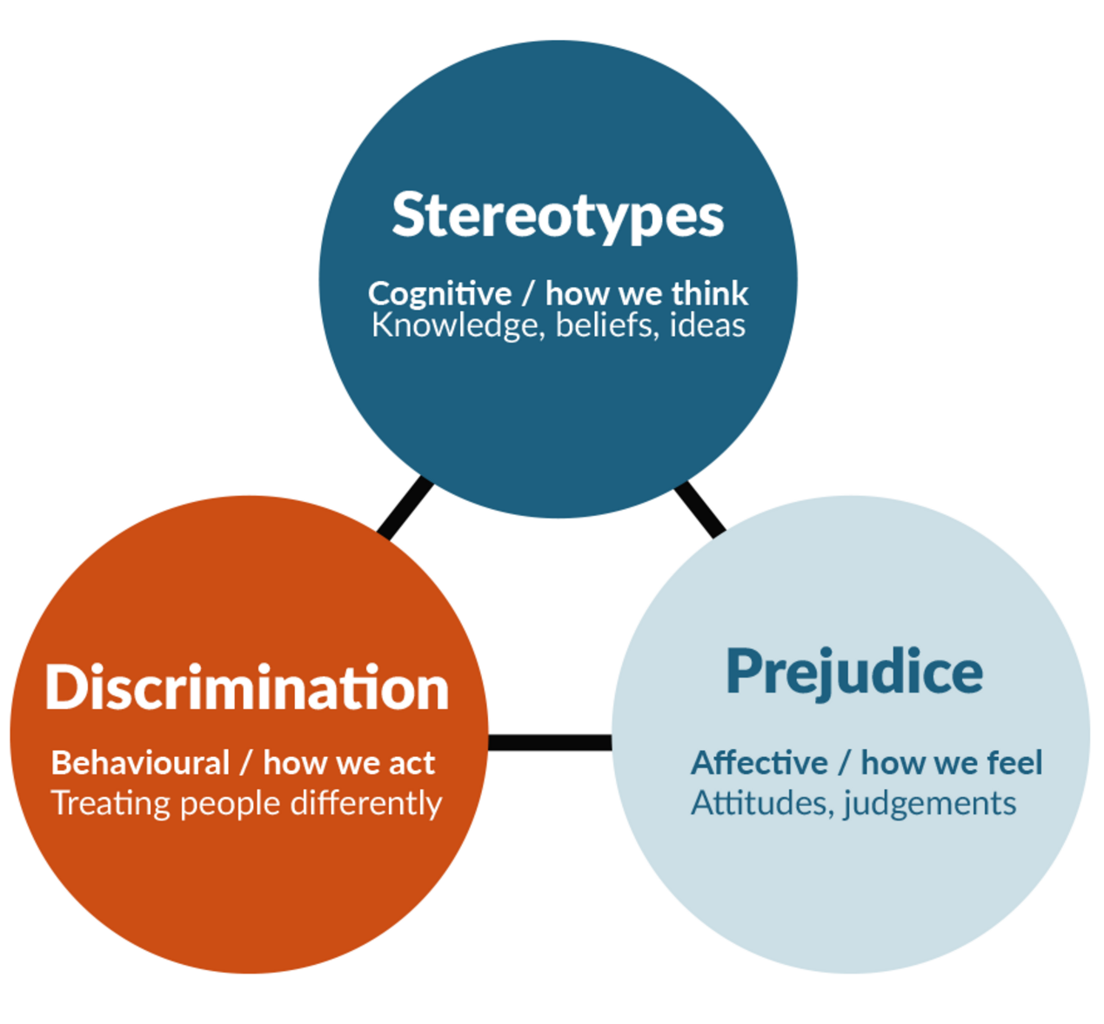
Figure 1: How stereotypes, discrimination and prejudice are defined and can inform each other.
View description - Figure 1: How stereotypes, discrimination and prejudice are defined and can inform ...
View alternative description - Figure 1: How stereotypes, discrimination and prejudice are defined and can inform ...

Ageism can be institutional, interpersonal or self-directed.

Institutional ageism
Ageism within organisations and the structures and systems that exist within them, such as workplaces or the media.

Example: Health systems that routinely deprioritise older people for certain treatments or assume symptoms are 'just ageing'.

Interpersonal ageism
Ageism within our relationships, how we connect or relate to others.

Example: A social care worker speaking to an older person’s family member instead of the older person themselves.

Self-directed ageism
Ageism within how we direct things at ourselves, an inward reflection, sometimes referred to as internalised ageism.

Example: An older person downplaying symptoms or delaying seeking care because they believe 'it’s just old age'.

1.1 Stereotyping and prejudice

Activity 1
2 minutes

Watch the following short video about ageism and older people.

Watch the video at YouTube.com.
Video 2 'Break free from ageism', HelpAge International (See transcript [PDF, 18 KB])

What are your initial thoughts having watched this video?

View discussion - Activity 1

Let’s look at stereotypes and prejudice – how we think and how we feel.

Stereotypes (how we think)
Stereotypes are generalised, oversimplified ideas or beliefs about a group of people.
They dehumanise individuals by grouping people together under a label: a label that is often unrelated/unrecognisable to the individuals being labelled.
They do not consider individual differences, perspectives, preferences, aspirations and needs.
They can influence how we communicate (the language, terminology and images we use). One common example is that all older people are frail and vulnerable. This is a common depiction seen in the media, an image or video of an older person with wrinkled hands on a walking stick, for example.
Stereotypes can become harmful when:
- the stereotype is so strongly held that it overrides evidence that an individual who belongs to the group does not conform to
- they start informing how we feel and influencing how we act.

Prejudice (how we feel)
Prejudice can be defined as attitudes, feelings or judgements about members of other groups. They may be positive or negative, though are frequently negative.
Examples of negative prejudice include:
- all older people are ‘stuck in their ways’
- all older people enjoy financial security at the expense of younger people
- older people can’t use IT
- older people are a ‘drain’ on public services
- older people shouldn’t be working.

Hostile or benevolent
Stereotyping and prejudice against different groups in society does not take the same form. It can be hostile or benevolent.
A hostile example would be ‘older people are a drain on public services’.
Examples of benevolence include ‘all older women are like a kindly grandmother’. This is still ageist and has consequences in how we think, feel or act towards older people and ageing, it does not take account of the individual.

1.1.1 Language
A good example of how common or prevalent ageism against older people can be is to examine language we may have encountered in our day to day lives.

Activity 2
5 minutes

What do you think about the statements in the word balloons below?
Do you think these statements are benevolent or hostile?
Do you ever question them when you hear them? Have you used them yourself, even about yourself?

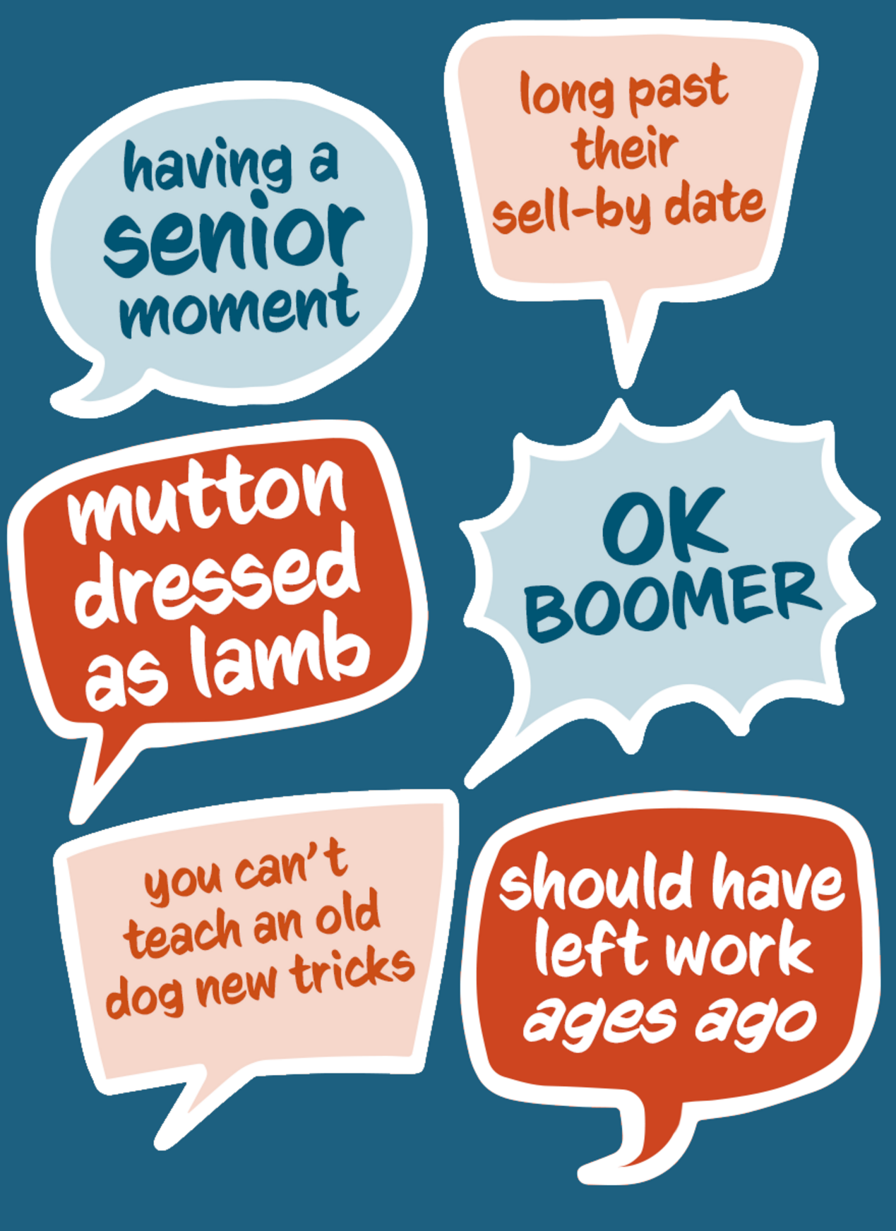
Figure 2: Examples of statements based on age
View description - Figure 2: Examples of statements based on age
View alternative description - Figure 2: Examples of statements based on age

View discussion - Activity 2

1.1.2 Imagery
Like language, images influence how we think, feel and react to what we see. Images that portray older people as frail, vulnerable, in ill health or as victims can also lead to stereotyping behaviour and ignore the diversity of older people.
An everyday example of this is the UK traffic sign warning that older pedestrians may be crossing the road. It was originally designed in 1981 as the result of a children's competition. The same sign is also used for disabled pedestrians. Many older people find this sign to be ageist.
In 2020, the Centre for Ageing Better held a competition inviting designers to ‘rethink the symbols and icons commonly used in public to represent older age groups.’ The winning ‘dancing couple’ design was based on the UK traffic sign.

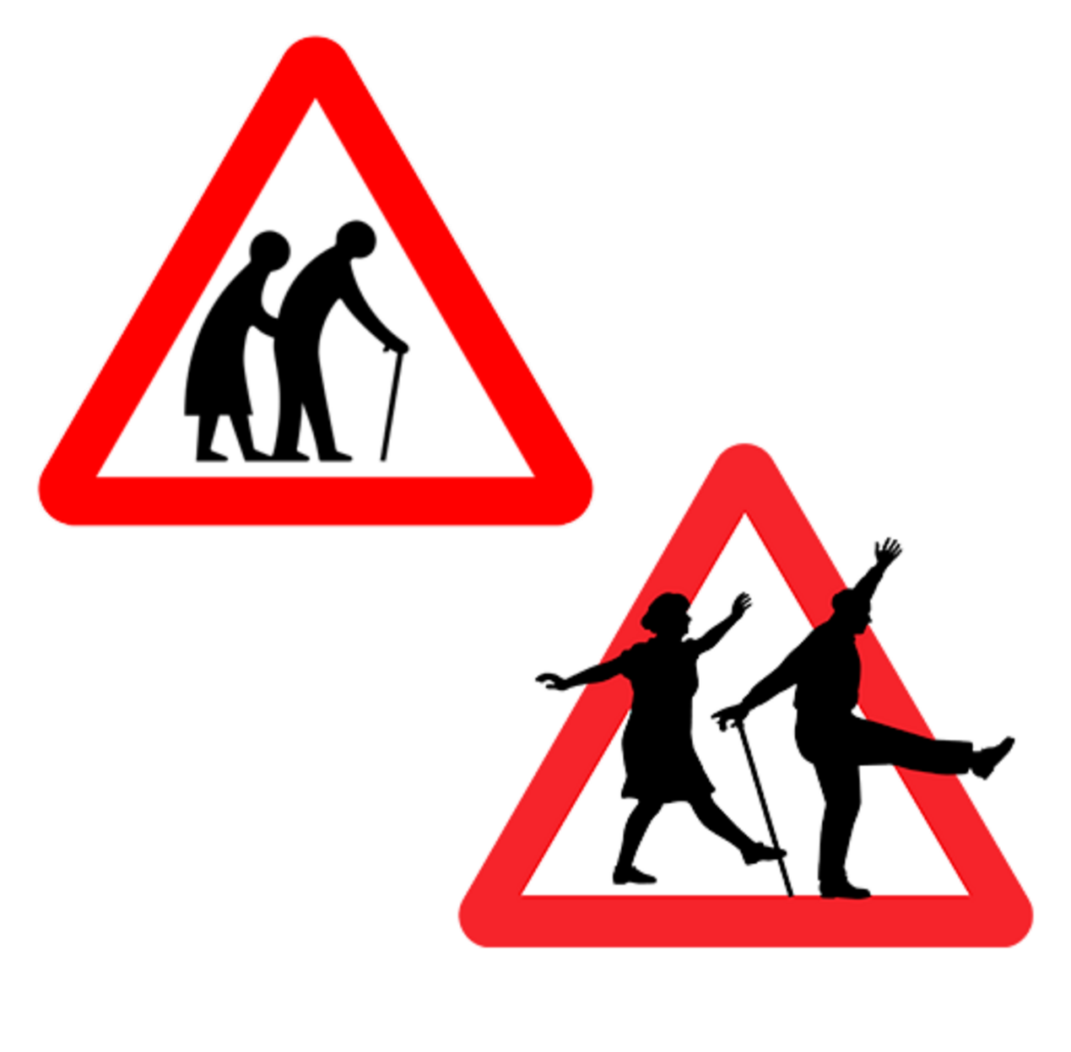
Figure 3: The UK traffic sign for older and disabled pedestrians (top left) and the 'dancing couple' winning competition design (bottom right).
View description - Figure 3: The UK traffic sign for older and disabled pedestrians (top left) and the ...
View alternative description - Figure 3: The UK traffic sign for older and disabled pedestrians (top left) and the ...

The judges noted that the winning design was able to capture the diversity of older people, portraying an active and social pair while breaking out of the triangular road sign shape (Centre for Ageing Better, 2020).

Activity 3
5 minutes

Look at the four images below. Which images do you think have a negative influence on how we think and feel about older people? Which ones may have a more positive influence? Why?
Hint: Think about the images you would like to see of yourself or of family and friends.

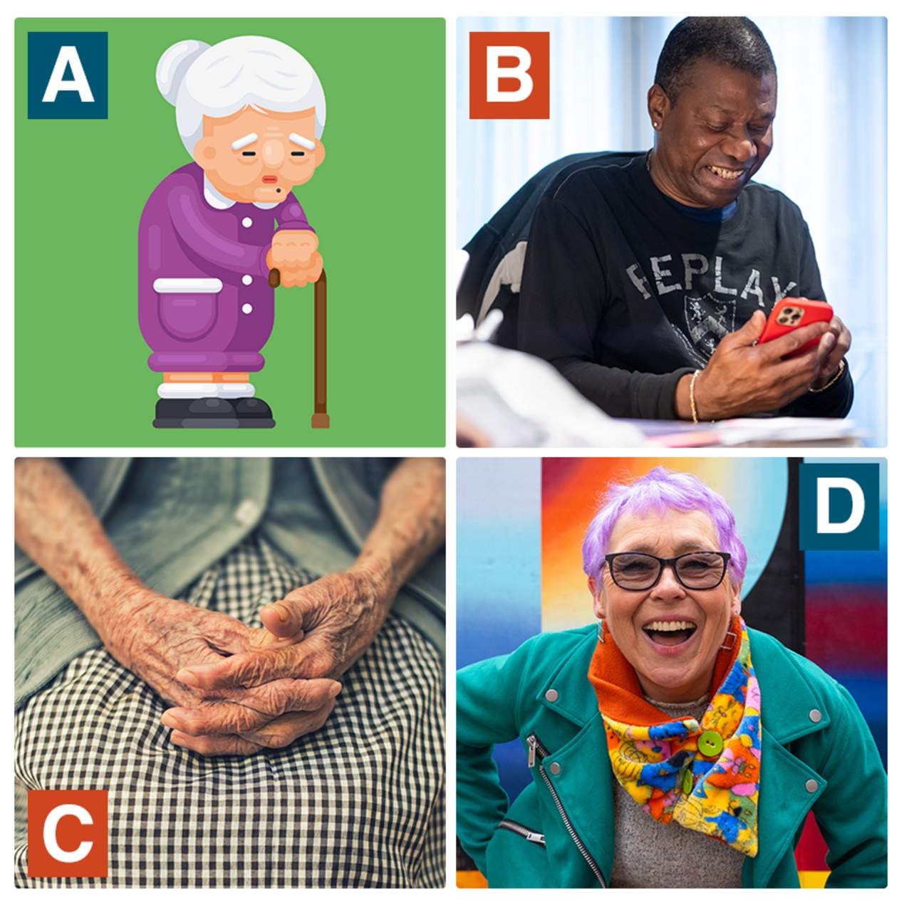
Figure 4: Images of older people
View description - Figure 4: Images of older people
View alternative description - Figure 4: Images of older people

View discussion - Activity 3

1.1.3 Implications
Watch this short video produced by the World Health Organization’s campaign to combat ageism.

Watch the video at YouTube.com.
Video 3 'Global Campaign to Combat Ageism - #AWorld4AllAges', UN Decade of Healthy Ageing (See transcript [PDF, 21 KB])

The video focuses on the personal impact of stereotyping and prejudice based on age. You may have similar experiences in terms of how you have felt or how you have thought about another person.
Having considered stereotypes and prejudice and looked at some examples we can conclude that the society and culture we live in sometimes makes it easy to stereotype others without much thought on the consequences it can have.

1.1.4 Hostile vs benevolent ageism
Hostile and benevolent ageism are two types of prejudice that often co-exist. Hostile ageism involves open depreciation, negative stereotyping, and seeing older people as a burden. In contrast, benevolent ageism manifests as well-meaning but patronising, protective, or 'kind' behaviours that can diminish the autonomy of older people.

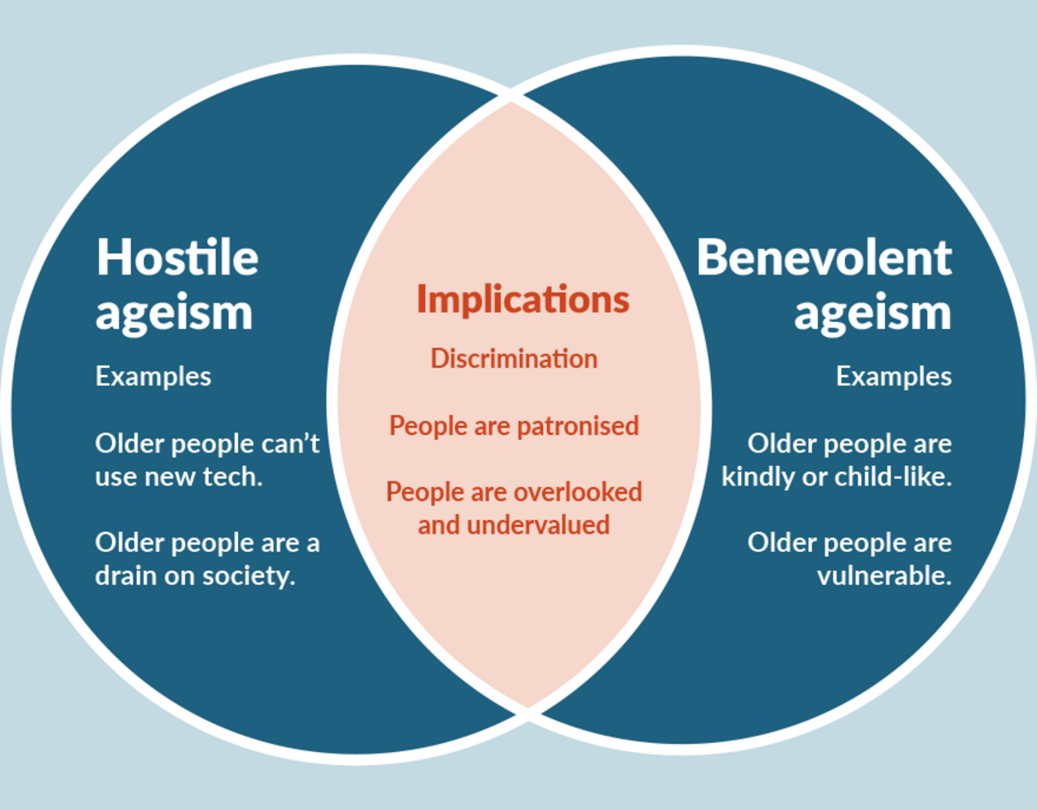
Figure 5: Shared implications of both hostile and benevolent ageism
View description - Figure 5: Shared implications of both hostile and benevolent ageism
View alternative description - Figure 5: Shared implications of both hostile and benevolent ageism

The negative impact of hostile ageism is generally more obvious, but benevolent ageism is also damaging, perhaps more subtly so. Benevolent stereotypes and prejudices may seem harmless, perhaps even kind, but can mean older people can be seen as 'not up to the job' or 'incompetent'. They can also lead to assumptions that it is 'natural' for older people to have lower expectations, reduced choice and control with less account taken of their views.

1.2 Unconscious bias
How do stereotypes and prejudice have such a hold on how we think and feel about other people?
Unconscious bias is a learned stereotype or prejudice that is deeply ingrained, unintentional, automatic and able to influence behaviour. It is result of the natural tendency of the human brain to sift, sort, and categorise information about the world.
There are three main drivers that make humans susceptible to unconscious bias:
- We tend to seek out patterns. Unconscious bias occurs because of the brain's natural tendency to look for patterns and associations in the world. Social cognition, or our ability to store, process, and apply information about people in social situations, is dependent on this ability to form associations about the world.
- We like to take shortcuts. Like other cognitive biases, the unconscious bias is a result of the brain's tendency to try to simplify the world. Because the brain is constantly inundated with more information than it could conceivably process, mental shortcuts make it faster and easier for the brain to sort through all of this data.
- Experiences and social conditioning. Unconscious biases are influenced by experiences, although these attitudes may not be the result of direct personal experience. Cultural conditioning, media portrayals, and upbringing can all contribute to the implicit associations that people form about the members of other social groups.
Unconscious bias can be addressed through training and awareness. One of the benefits of being aware of the potential impact of unconscious bias is that you can take a more active role in overcoming social stereotypes, discrimination, and prejudice.

1.3 Age discrimination
Stereotypes and prejudice are how we think and feel. Discrimination is how we act.

Direct age discrimination is when someone is treated less favourably than others because of their age.
Indirect age discrimination occurs when a policy or practice that applies to everyone puts people of a particular age group at a disadvantage.

Both direct and indirect age discrimination occurs on both a personal and organisational / institutional level.

Activity 4
5 minutes
Think about whether the following are examples of direct or indirect age discrimination:

A gym refusing a 76-year man membership because of his age.

Direct age discrimination
Indirect age discrimination
View answer - Part

A Local Authority requires people to access important services — such as applying for Blue Badges, ordering recycling bins, or booking a computer at a library — exclusively through an online portal, with no alternative by phone or in-person.

Direct age discrimination
Indirect age discrimination
View answer - Part

A line manager refuses a request for training because the employee is close to retirement.

Direct age discrimination
Indirect age discrimination
View answer - Part

Stereotypes and assumptions
Age-based stereotypes may also result in someone drawing very different conclusions when seeing an older and a younger adult with back pain or a limp. They might well assume that the younger person's condition is temporary and treatable, perhaps the result of an accident, while the older person's condition might be assumed to be chronic and less responsive to treatment.
This assumption may have no consequence if someone makes it in the blink of an eye as someone is passing on the street, but if it is held by a health professional offering treatment or managers thinking about occupational health, it could inappropriately influence their actions and lead to age-related discrimination.
This treatment can occur as the result of ageist stereotypes and prejudice or because of a failure to see individual differences.

1.4 Impacts of ageism
A World Health Organization report on ageism published in 2021 found that 1 in 2 people worldwide hold ageist views against older people (2021).

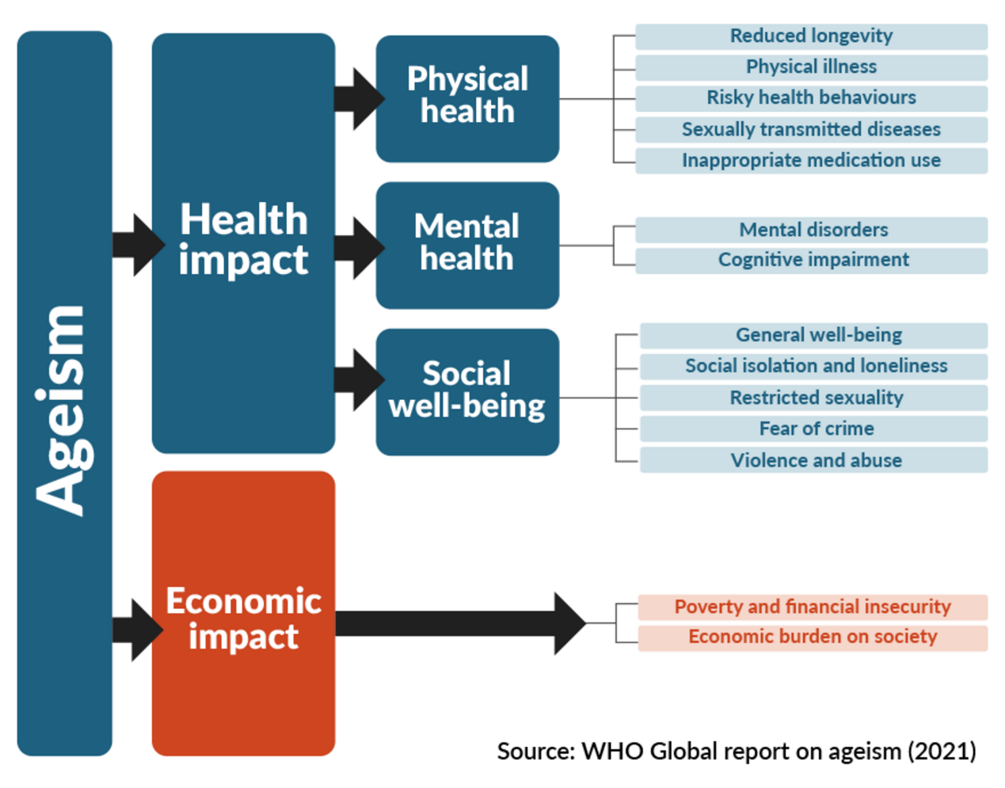
Figure 6: The impacts of ageism on older people (WHO, 2021)
View description - Figure 6: The impacts of ageism on older people (WHO, 2021)
View alternative description - Figure 6: The impacts of ageism on older people (WHO, 2021)

As shown in Figure 6, the report evidenced the impact of ageism on older people’s physical and mental health as well as their social well-being. The evidence reiterated the need for global action to combat ageism.
Ageism has serious and far-reaching consequences for people’s health, well-being and human rights:
- For older people, ageism is associated with a shorter lifespan, poorer physical and mental health, slower recovery from disability and cognitive decline.
- Ageism reduces older people’s quality of life, increases their social isolation and loneliness (both of which are associated with serious health problems), restricts their ability to express their sexuality and may increase the risk of violence and abuse against older people.
- For individuals, ageism contributes to poverty and financial insecurity in older age, and costs society billions of pounds.
Ageism can also lead to higher costs for public services and the economy. An example would be where older people experience barriers and challenges in accessing GP services, there is a risk that these barriers and challenges will push individuals towards accessing other, less appropriate unscheduled care services, adding unnecessary pressures and costs to other parts of public health services.
Older people make a significant contribution to society through working, volunteering, providing care and support and paying taxes. Ageism can lead to us all undervaluing the vital roles and contributions played by older people across society.

2 Age discrimination and UK law
This section will look at how age discrimination is treated under UK law. You will be introduced to relevant aspects of the Equality Act 2010 and the regulations for public bodies known as the Public Sector Equality Duty.
You will also learn about the specific duties that apply in Wales and the role of an Older People’s Commissioner, an office unique to Wales and Northern Ireland.
For context, it is worth noting some demographic data such as the median age of the UK’s population and how it has increased since 1975.

What is meant by 'median age'?
Imagine all the ages of all people in a country are arranged in numerical order, e.g. from 0 to 100. The age that falls in the exact middle of this sorted list is the median age. If the median age is getting higher, it means more people are living for longer.

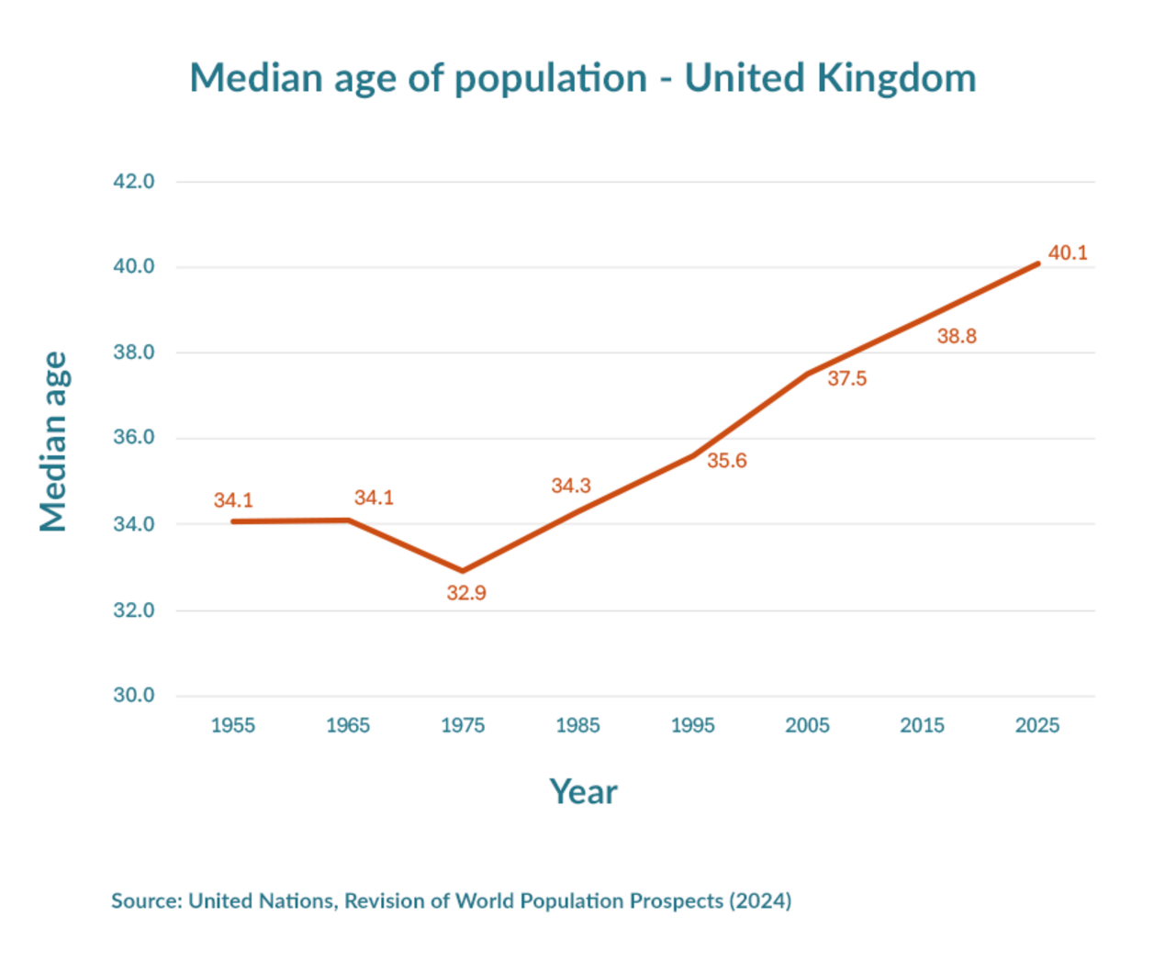
Figure 7: Median age since 1955 in the UK (UN, 2024)
View description - Figure 7: Median age since 1955 in the UK (UN, 2024)
View alternative description - Figure 7: Median age since 1955 in the UK (UN, 2024)

According to the Office for National Statistics, Scotland and Wales have the highest median ages in the UK. 898,383 people over 60 live in Wales, a number projected to rise to 993,000 by 2030 (ONS, 2024).
An ageing population enriches every level of society and brings opportunities to rethink how we design our communities, services and systems. It has important implications for policy decisions across health and social care, the economy, housing, infrastructure and more. The evidence is clear: older people must be recognised as full and equal participants in society, able to live healthy, connected and independent lives for as long as possible.
For a more detailed look at the overall picture for older people in Wales you can read Growing older in Wales: A snapshot of older people’s experiences (PDF, 5.1 MB) by the Older People’s Commissioner for Wales. This link will also be available in the resources section at the end of the course.

2.1 The Equality Act 2010
The Equality Act 2010 is a key piece of legislation in the UK designed to protect individuals from unfair treatment and promote a fair and more equal society. It consolidated numerous pieces of anti-discrimination legislation into a single Act, making the law easier to understand and apply. (GOV.UK, 2013)
The Act protects people based on nine protected characteristics, as seen in Figure 8 and listed below.

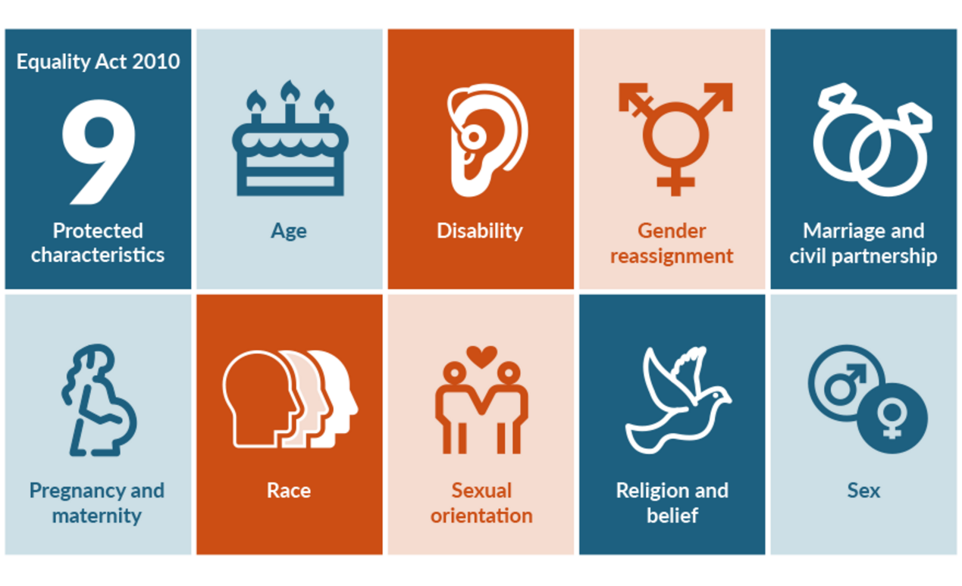
Figure 8: Equality Act 2010 nine protected characteristics
View description - Figure 8: Equality Act 2010 nine protected characteristics
View alternative description - Figure 8: Equality Act 2010 nine protected characteristics

- Age
- Disability
- Gender reassignment
- Marriage and civil partnership
- Pregnancy and maternity
- Race
- Sexual orientation
- Religion and belief
- Sex
The Equality Act 2010 states that providers of goods and services and employers should not discriminate - or offer inferior services or treatment - on the basis of a protected characteristic.
Age is one of these protected characteristics. This means that shops, GPs, hospitals, transport services, public toilets, colleges, universities and so on cannot discriminate against somebody based on their age.

2.2 Protection from age discrimination
Discrimination under the Equality Act 2010 can take several forms:

Direct age discrimination: Treating someone less favourably because of a protected characteristic. Example: A gym refusing a 76-year man membership because of his age.

Indirect age discrimination: Applying a rule or policy that disadvantages people with a protected characteristic. Example: An optician allows customers to pay for their glasses by instalments but restricts eligibility to those in work. This could put older people at a disadvantage as they are less likely to be working.

Harassment: Unwanted behaviour related to a protected characteristic that violates someone’s dignity or creates a hostile environment. Example: A person’s colleagues repeatedly making jokes about their age, which the individual finds offensive or upsetting.

Victimisation: Treating someone unfairly because they’ve made or supported a complaint under the Act. Example: A workplace excluding someone from social activities or a pay rise as they are taking, or believed to be taking, action under the Equality Act.

Discrimination by association: Being treated unfairly because of your connection to someone with a protected characteristic. Example: A workplace changing work arrangements (e.g. working from home) without notice when the person needs to be based at home for caring duties.

Discrimination by perception: Being treated unfairly because someone thinks you have a protected characteristic, even if you don’t. Example: A manager assuming an older colleague will not take part in certain away day activities as they believe them likely to be disabled in some way.

The Equality Act can be used to challenge all these forms of discrimination, as defined above.
It is important to note that individuals, i.e. people themselves, have these protections as rights holders, however, public bodies must ensure they are mindful of them as duty holders (meaning they are responsible for compliance with the law).

Activity 5
5 minutes

Reflect on a time when you or someone you know may have experienced unfair treatment.
- Was it related to any of the nine protected characteristics?
- Which type of discrimination (if any) might it have been?
- How did it make you feel?
- What could have been done differently?

2.3 Exceptions
A difference in services or treatment between people may be lawful if the circumstances fall under one of the exceptions that allow this:



Age-based concessions and age-related discounts. Businesses are allowed to offer concessions or discounts based on age – for example, cheaper access to leisure facilities for 18–25-year-olds, or lunch deals for older people. The Equality Act recognises that not all age-based differences in treatment are unlawful. In some cases, they are explicitly permitted as exceptions (such as concessions), or may be allowed where they are a proportionate means of achieving a legitimate aim.



Age-related holidays. It is not unlawful for a holiday company to offer holidays for particular age groups – for example, over-50s cruises or Club 18–30 holidays. The Equality Act allows this where the holiday is designed to bring together people of the same age group as a central feature of the experience. To qualify, the holiday must normally include a package of at least two elements, such as travel, accommodation, or significant activities, and usually involve an overnight stay. Holiday providers may choose to accept someone outside the stated age range, but they must not treat them less favourably – for example, by charging a higher price.



Financial services. Age can be used to assess risk, and this can be used to work out the price you pay for a financial product or service such as insurance, banking, credit, pensions etc or whether it's made available to you. They can also stage limits and offer products to people in certain age groups only. However, any use of age must be based on relevant and reliable evidence when assessing risk, rather than assumptions or stereotypes.



Other laws. If there is another relevant law which says people can be treated differently based on their age and therefore it’s not unlawful discrimination under the Equality Act. One example of this is free bus passes for people over 60 under the Transport Act 2000.



Age verification. Businesses selling goods like alcohol, fireworks and cigarettes can ask for proof of age if they think you’re under-age. They can refuse to serve you if you can’t prove how old you are. This is not unlawful age discrimination.

These specific exceptions are in addition to:
- general exceptions already allowed by the Equality Act (e.g. ability to contravene the Act in the interests of national security, for charitable or sporting purposes)
- positive action measures
- objective justification.

2.4 Objective justification
Even if something doesn’t fall under one of the exceptions in the Equality Act, it can still be lawful for a trader or service provider to treat you differently – or even discriminate against you – because of your age.
Objective justification can be used for both direct and indirect age discrimination. The trader or service provider would have to show they have a good enough reason for discriminating against you. For example, a gym refusing membership to someone over 80 could be justified if the owner cannot obtain affordable insurance for users over that age.
However, a reason may not be good enough if the provider could have acted in a less discriminatory way. In the gym example, this might mean charging all members a small extra fee to cover higher insurance costs for older users. The Equality Act requires providers to show they considered the discriminatory impact of their decision and that the action was necessary. They must demonstrate that it is a proportionate means of achieving a legitimate aim.
Here are examples of legitimate aims supported by evidence:
- Ensuring health and safety. For example, limiting the number of pushchairs or wheelchairs on public transport to allow quick boarding and exit.
- Protecting welfare. The fire service requires applicants to pass physical tests for firefighting roles. This could seem like indirect age discrimination, as older people are less likely to pass. However, the fire service can justify this because firefighting demands physical capability. The aim is to ensure firefighter safety and maintain an effective service. Physical tests are a proportionate way to achieve this.
- Enabling people of particular groups to enjoy activities together. For example, offering age-specific swimming sessions or women-only sessions.
- Targeting services to those who need them most. For example, promoting breast screening and mammograms to people over 50.

2.5 The Public Sector Equality Duty
The Public Sector Equality Duty (PSED) is a legal obligation under the Equality Act 2010 that requires public bodies in England, Scotland, and Wales to consider how their decisions and actions affect people with protected characteristics.
It applies to:
- Public bodies (e.g. schools, hospitals, police)
- Private or voluntary organisations carrying out public functions (e.g. a private company running a prison or a train service franchise).
Watch this video from the Equality and Human Rights Commission for an overview of the Public Sector Equality Duty.

Watch the video at YouTube.com.
Video 4 'What is the Public Sector Equality Duty? | Equality law: discrimination explained', Equality and Human Rights Commission (See transcript [PDF, 20 KB])

Public bodies must have ‘due regard’ to the need to achieve three main aims, as can be seen in Figure 9.

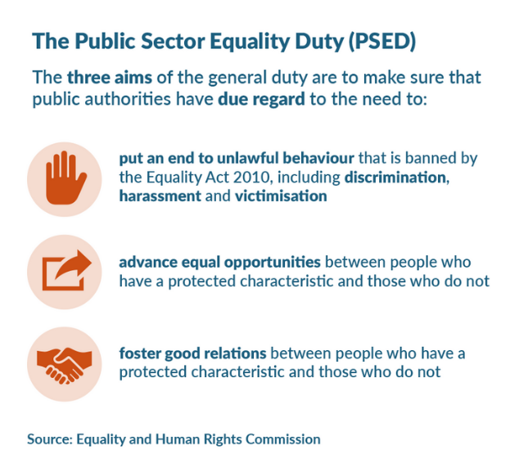
Figure 9: The three aims of the Public Sector Equality Duty (The Equality and Human Rights Commission, 2022)
View description - Figure 9: The three aims of the Public Sector Equality Duty (The Equality and Human ...
View alternative description - Figure 9: The three aims of the Public Sector Equality Duty (The Equality and Human ...

2.5.1 The PSED in practice
Here are some illustrative examples of how public bodies might show due regard to the Public Sector Equality Duty:

A local authority reviews data on access to adult education and finds that older Black, Asian and Minority Ethnic women are less likely to attend digital skills courses. In response, it funds community-based sessions with translation support and flexible timings to meet both cultural and caregiving needs.

A city council is redesigning a public park and consults with older disabled residents and LGBTQ+ older people. Based on their feedback, it improves pathways for mobility aids, installs accessible toilets, and creates inclusive community spaces where everyone feels welcome.

Before launching a new healthcare initiative, a local health board conducts an Equality Impact Assessment (EIA) and identifies that older men from low-income and rural backgrounds have poorer access to mental health services. They adapt the policy by introducing local outreach clinics and transport assistance to reduce these inequalities.

Key points to remember:
- The PSED is a legal duty on public bodies in Wales and not meeting it can create risks for public body, including the possibility of legal challenge.
- The PSED places a positive duty on public bodies in Wales to actively consider the needs and experiences of people with protected characteristics, including older people, when designing policies, delivering services, and making decisions, and to build equality considerations into their work from the outset rather than treating them as an afterthought.
- The PSED encourages public bodies to make better informed, fairer decisions by understanding how their actions may affect different groups and taking steps to eliminate and/ or reduce avoidable disadvantage.
- The PSED is about process, not outcomes. Public bodies must show they considered equality, even if the final decision isn’t perfect for all groups

2.5.2 Specific duties in Wales
The Equality Act 2010 (Statutory Duties) (Wales) Regulations 2011 are a set of specific duties that apply to public bodies in Wales. They build upon the general Public Sector Equality Duty (PSED) in the Equality Act 2010, outline specific actions public bodies in Wales must take to enhance the performance of the general duty.
It seeks to do this by adding a focus on outcomes. Complying with the specific duties in Wales is not therefore just about processes and procedures as per the general PSED – the Wales regulations add requirements for generating positive equality outcomes.
The specific duties are interlinked and complement each other continuously to inform the listed authority as to how to better achieve better equality outcomes:



Equality Objectives
Public bodies must set and publish equality objectives, which are specific, measurable goals aimed at improving equality. These must be revised and published at least once every four years.



Strategic Equality Plans
Public bodies must publish a Strategic Equality Plan (SEP). These plans draw together various elements of the specific duties to detail how public bodies intend to achieve their equality objectives, including how they will measure and report progress. They can be used as a timetabled action plan for meeting the duties.



Transparency and accountability
The regulations promote transparency by requiring public bodies to publish their objectives and plans, and to report on their progress. This means publishing annual reports setting out compliance with specific duties. The annual report can include specified employment information; if this is not included, it must be published separately on an annual basis. The regulations also promote transparency by requiring public bodies to publish impact assessments where they show a substantial impact (or likely impact) on their ability to meet the general duty.



Impact Assessments
Public bodies are expected to assess the impact of their policies and practices on different groups with protected characteristics. The public body will have to consider how policies and practices affect groups with different protected characteristics. There is a requirement for assessments to engage with appropriate persons and have due regard to information that the authority holds. Such assessments are sometimes referred to as Equality Impact Assessments. As above, there is a requirement that public bodies publish impact assessments where they show a substantial impact (or likely impact) on their ability to meet the general duty.



Engagement with appropriate persons
For all of the aspects above, the regulations emphasise the importance of engaging with diverse communities to understand their needs and inform the development of policies and services. The Act describes what effective engagement looks like, with people who share protected characteristics and others with interest.
Effective engagement should be:
- Well-structured and focused
- Adequately resourced and accessible
- Influential and transparent
- Respectful of confidentiality
- Proportionate

The Equality and Human Rights Commission (EHRC) acts as the regulator for the PSED in Wales, monitoring compliance and ensuring actions are taken to support equality. There is more guidance available on the EHRC website, including Technical guidance on the PSED in Wales (Word Document, 300 KB). These links will also be available in the resources section at the end of the course.

2.6 Older People’s Commissioner for Wales
The Older People's Commissioner for Wales protects and promotes the rights of people aged 60 and over.



Role and legal Powers
The Commissioner’s role and statutory powers are defined by the Commissioner for Older People (Wales) Act 2006 and accompanying Regulations.

Video content is not available in this format.
Video 5 Rhian Bowen-Davies on the role of the Older People’s Commissioner for Wales
View transcript - Video 5 Rhian Bowen-Davies on the role of the Older People’s Commissioner for Wa ...

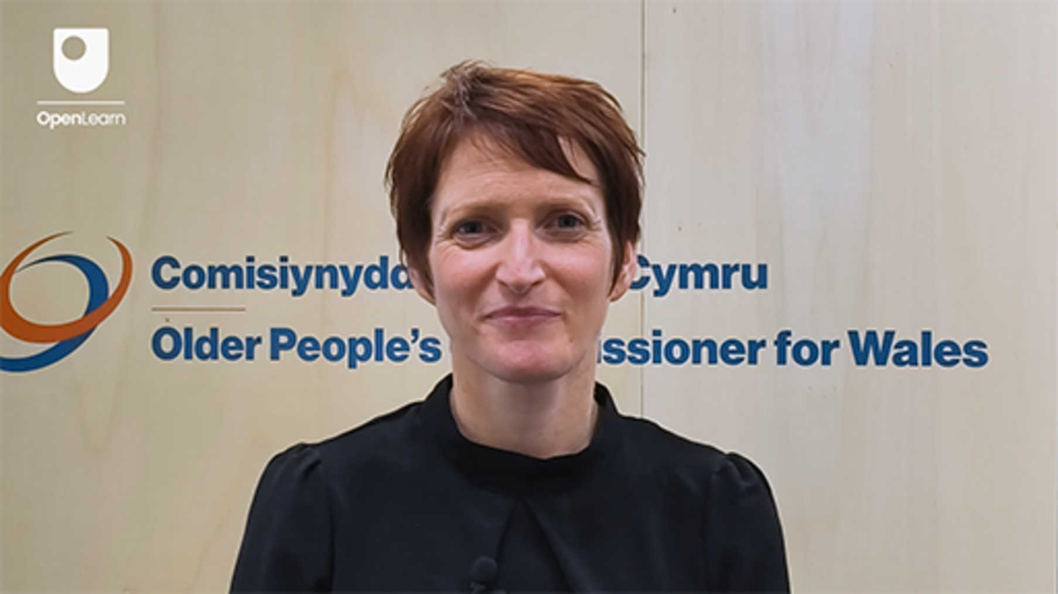
Video 5 Rhian Bowen-Davies on the role of the Older People’s Commissioner for Wales

The Act outlines the action that the Commissioner is able to take to ensure that the interests of older people are safeguarded and promoted when public bodies discharge their functions and the assistance the Commissioner may provide directly to older people in certain situations.
Commissioner’s Functions
- Promote awareness of the rights and interests of older people in Wales
- Challenge discrimination against older people in Wales
- Encourage best practice in the treatment of older people in Wales
- Review the law affecting the interests of older people in Wales

3 Taking action against ageism
To combat ageism, we must be aware of it. Watch the video below from the Centre for Ageing Better for an overview of how ageism factors into many different aspects of our lives and society.

Watch the video at YouTube.com.
Video 6 'Ageism: Explained', Centre for Ageing Better (See transcript [PDF, 16 KB])

As a minimum you should try to:
- Be alert to ageism, in all its forms: stereotyping, prejudice and discrimination.
- Play your part in ensuring your organisation is following the requirements of the Equality Act 2010.
- Always be conscious of the language, terminology and any images you use.
- Reflect on your behaviour and actions – could they be ageist?
- Challenge ageism - informally or formally.
In their global report on ageism, the World Health Organization outlined three effective strategies for combatting ageism, which you should take into account when planning your actions:
- Policy and law – (such as the Equality Act 2010) what changes do we need to see in policy – locally, regionally or nationally. Do we need changes to strengthen the law on equalities?
- Educational activities (formal and informal) – training courses, ongoing educational activities, taking a lifelong learning approach.
- Intergenerational activities – bringing different generations together to share ideas, work on projects and break down barriers, proven to be effective at reducing ageism directed towards older people.

Activity 6
10 minutes

Consider how you might help combat ageism in your day-to-day life and work to help address ageism.
Can you think of three tangible actions you can take based on what you have learnt so far?

View discussion - Activity 6

3.1 Challenging ageism
You can challenge ageism you encounter informally or formally.
Informally - drawing attention to ageism, exposing any incorrect assumptions being made and highlighting the damaging impacts of ageism, highlight where inappropriate or stereotyping language has been used.
Formally - drawing attention to the ageism and using legislation designed to address discrimination and advance equality: the Equality Act 2010 / seek opportunities to contribute to a fairer society through the PSED and specific equality duties in Wales.
The following sections will look at what you can do both formally and informally when you encounter ageism in the media, in the workplace, in health and social care services and as a general consumer. While these sections are focused on what we can do as individuals to challenge ageism, they are also helpful to understand where older people you work with or support can find help and information if they feel they are being discriminated against.
We also hope these sections will help you to reflect on how policies and practice within your own organisation or area of work could be improved to ensure that older people are not discriminated against, whether directly or indirectly.

3.1.1 In the media
The media has a lot of power in influencing how we think about age. It is therefore important that the way older people are represented is fair and accurate.
This includes using images and language that reflect the diverse range of experiences, interests and aspirations of older people.

Figure 10: Ageism in UK media
View description - Figure 10: Ageism in UK media

When seeing, listening to or reading media reports or advertisements (including print, television, radio, internet and social media), the following questions may be useful in determining whether ageism is present:
- Does reporting a person’s age add anything to the story?
- Does this image or story reinforce or challenge negative stereotypes?
- Does this publication or channel regularly report negative stories of older people or ageing?
- Has this publication or channel reported positive stories about older people or ageing?
- Where there are positive stories, are they patronising in nature?
If you feel ageism is present, you can make an informal challenge through contacting the editor (newspapers or magazines), broadcaster (radio or TV) or person sharing the story (social media) to highlight the ageism and request more balanced coverage that more accurately reflects the contribution and value that older people bring to society.
If this doesn’t produce a satisfactory response, then contact the relevant regulatory body to escalate the complaint (Ofcom for most media coverage or the Advertising Standards Authority for advertisements).

3.1.2 In the workplace
Meaningful work can help people stay active, feel valued and improves health and well-being. However, ageism and discrimination within the workplace – founded on debunked myths about a lack of productivity, poorer health and an unwillingness to adapt to change – is a barrier to older people remaining in, or re-entering, paid work.
Older workers in Wales seem to face greater barriers to employment than those in other parts of the UK. Figures show that during 2024-25 employment rates for people aged 50-64 were lower in Wales than in all other parts of the UK, and more than 10% lower than in some areas. (ONS, 2024)

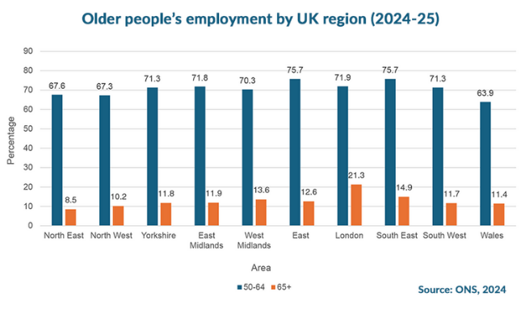
Figure 11: Older people’s employment by UK region (2024-25)
View description - Figure 11: Older people’s employment by UK region (2024-25)
View alternative description - Figure 11: Older people’s employment by UK region (2024-25)

When applying for jobs or whilst in work, the following questions may be helpful in determining whether ageism is present:
- Do job advertisements give you the impression that the employer might not be interested in you as an older person (e.g. the employer asking for qualifications such as GCSEs or recruitment being targeted at graduate fairs)?
- In the workplace, are opportunities for promotion and training open to people of all ages on an equal and fair basis?
- In the workplace, are work appraisals unclouded by preconceptions about age and based on actual performance?
- If redundancy situations arise, are they carried out without assumptions about age (e.g. free from assumptions that older people will soon retire)?
- It is important to note that there may be an ‘objective justification’ for treating someone differently based upon age in an employment context. This could include examples such as age limits to do certain jobs or payment of the National Minimum Wage.
If you feel you are experiencing age discrimination in looking for work or in the workplace, you can:
- Speak to your Trade Union or employee representative in the workplace.
- Talk with the employer to seek an informal and agreeable solution.
- Make a formal complaint to the employer using their grievance procedure.
- Take a claim to an employment tribunal (time limits apply for making a claim – 3 months minus 1 day from the date of the last incident of discrimination, you should contact the ACAS early conciliation service to try and resolve the matter first).
At any of the stages above, you can get free advice and support from a specialist agency that can give you advice based upon your individual experiences and circumstances (e.g. from the Advisory, Conciliation and Arbitration Service (ACAS)).

3.1.3 In health and social care
When we are unwell, we want to receive the best treatment available. However, sometimes problems are dismissed as ‘old age’, overlooked and not investigated or treated fully.
Anyone who works for the NHS or in the private healthcare sector (including professional medical staff such as consultants, doctors and nurses, receptionists, managers, security staff, cleaners, ambulance drivers) or anyone who works for a local authority (including social workers) has a duty not to discriminate against older people.
When using health or care services, the following questions may be helpful in determining whether ageism or discrimination is present:
- Are you being refused a service because of your age? (It is important to note there are some treatments for which the evidence base suggests they are not effective beyond a certain age.)
- Are you receiving a service of worse quality or on worse terms than would normally be offered because of your age?
- Is the provider behaving in a way related to your age which causes you distress, offends or intimidates you?
- Is the provider punishing you because you complain about discrimination or helping someone else complain because of an issue related to age?
If you experience age discrimination in health or care services, then you can make a complaint to the ward, hospital, care home or care provider.
If you are not satisfied with the outcome of your complaint, you can take it further by making a complaint to the relevant health board (for health services) or local authority (for care services). If this doesn’t produce a satisfactory response, then you can make a complaint to a regulatory body or watchdog.
You can also get free advice and support from a specialist who can give you advice based upon your individual experiences and circumstances (e.g. from the Equality Advisory & Support Service).

3.1.4 In consumer services
The Equality Act 2010 covers providers of goods and services, as well as services such as health and social care. This includes, for example, shops, hotels, and insurers. It means that, in most instances, you can’t be discriminated against because of your age.
There are, however, a number of specific exemptions relating to some consumer and financial services, including:
- Age-related holidays offered for people over 50.
- Social or leisure clubs which cater for people of specific ages only.
- Insurers being able to take age into account when calculating a premium and a bank being able to refuse a financial product to a customer based on their age (however, they must make sure that they base the decision on reliable and relevant information, as opposed to just making a general assumption based on age).
If you feel that you have been treated badly as a customer on the basis of your age‚ you can:
- Make a complaint using the company’s complaints procedure, stating that you believe you have been discriminated against on the grounds of age.
- Report a local business to trading standards (teams based in local authorities that enforce legislation to protect consumers).
Depending on who you are complaining about, you could take your complaint further to a regulatory body:
- The Advertising Standards Authority (ASA) about non-broadcast advertisements‚ sales promotions and direct marketing. You may want to complain if you’ve seen a press advertisement‚ promotion‚ leaflet or poster that you think is ageist and you want it changed or withdrawn. The ASA can stop misleading or offensive advertising and ensure sales promotions are run fairly. Complain about television or radio advertising through the regulator Ofcom.
- Complaints about financial organisations, insurers and banks can be taken to the Financial Ombudsman, which can investigate complaints that haven’t been resolved through the organisation’s complaints process first.
- At any of the stages above, you can also contact the Equality Advisory and Support Service for advice.
You may also wish to take your business elsewhere‚ and tell your friends and family to do the same. Write to the company telling them that ageism is the reason they’ve lost your business.
Online reviews can be a powerful way of making your views known and can sometimes get a more favourable response from the company if they fear losing more business

3.2 Case studies and helpful resources
Case studies and lived experiences
- The Centre for Ageing Better has a section on their website for stories and case studies and has a collection of stories as part of their Age Without Limits campaign.
- Age-Friendly Communities in Practice: Good Practice Examples, compiled by the Older People's Commissioner for Wales
- HelpAge International #OlderNotOver campaign stories
- BBC News allows you to filter by ageism as a topic and receive updates by following the topic (BBC account required).
Resources and guidance
- If your work involves communicating with the public, the Older People’s Commissioner for Wales has produced a guide on avoiding ageism in professional communications. Download: How to avoid ageism in communications (PDF, 631 KB)
- The Older People’s Commissioner for Wales website also has a library of resources including reports, key statistic and information guides. This includes the Taking Action Against Ageism resource used in this course and Growing older in Wales: A snapshot of older people’s experiences, the report mentioned in Section 2.
- If your work involves using imagery, the Centre for Ageing Better has created a library of free images to help show a more realistic and diverse depiction of ageing. Explore the Age-positive image library. Age Cymru has also developed a free stock image library, providing images that represent the diversity and experience of older people in Wales. Explore the This is Older stock image library.
- The Equality and Human Rights Commission (EHRC) has published useful guides to the Public Sector Equality Duty for Wales, Scotland and England. The EHRC webpages on the specific duties in Wales also has Technical guidance on the PSED in Wales (Word Document, 300 KB).
- Guidance for using the WHO Ageism Scale: an extensively tested tool designed to help you evaluate the impact of interventions aimed at reducing ageism.
Videos featured in this course
- 'Break free from ageism', HelpAge International
- 'Global Campaign to Combat Ageism - #AWorld4AllAges', UN Decade of Healthy Ageing
- 'What is the Public Sector Equality Duty? | Equality law: discrimination explained', Equality and Human Rights Commission
- 'Ageism: Explained', Centre for Ageing Better

Conclusion
Ageism is often hidden, but it can seriously affect our dignity, and wellbeing and opportunities to live and age well. By completing this course, you’ve taken an important step in understanding what ageism is, how it impacts older people, and the role we can all play in stopping it.
Now, let’s make a difference:
- Share this free course with friends, family, and colleagues.
- Talk about what you’ve learned - start conversations that challenge ageist attitudes.
- Take action to make sure older people are treated with respect and fairness.
The more people understand, recognise and challenge ageism, the closer we get to ending it. Together, we can make it happen.

References
World Health Organization (2021) Global report on ageism. Available at: https://www.who.int/publications/i/item/9789240016866 (Accessed 13 August 2025).
Centre for Ageing Better (2020) 'Dancing couple design wins age-positive icon competition'. Available at: https://ageing-better.org.uk/news/dancing-couple-design-wins-age-positive-icon-competition (Accessed 10 February 2026)
United Nations (2024) World Population Prospects 2024. Available at: https://population.un.org/wpp/ (Accessed 10 February 2026).
Office for National Statistics (2024) Population estimates for the UK, England, Wales, Scotland, and Northern Ireland: mid-2022. Available at: https://www.ons.gov.uk/peoplepopulationandcommunity/populationandmigration/populationestimates/bulletins/annualmidyearpopulationestimates/mid2022 (Accessed 11 July 2025).
GOV.UK (2015) 'Equality Act 2010: guidance'. Available at: https://www.gov.uk/guidance/equality-act-2010-guidance (Accessed 10 February 2026).
The Equality and Human Rights Commission (2022) 'The Public Sector Equality Duty (PSED)'. Available at: https://www.equalityhumanrights.com/guidance/public-sector/public-sector-equality-duty-psed (Accessed 10 February 2026).
Reuben Ng and Jeremy W Lim-Soh (2021), 'Ageism linked to culture, not demographics: Evidence from an 8-billion-word corpus across 20 countries', The Journals of Gerontology Series B, Vol 76 (9), pp 1791–1798 https://academic.oup.com/psychsocgerontology/article/76/9/1791/5938666 (Accessed 10 February 2026).
Centre for Ageing Better (2023) Cast aside? Exploring the presence of older characters in British films. Available at: https://ageing-better.org.uk/resources/cast-aside-exploring-presence-older-characters-british-films (Accessed 10 February 2026).
Advertising Standards Authority (2025) The Depiction of Older People in Advertising. Available at: https://www.asa.org.uk/news/the-depiction-of-older-people-in-advertising.html (Accessed 10 February 2026).
Office for National Statistics (2024) X01 Regional labour market: Estimates of employment by age. Available at: https://www.ons.gov.uk/employmentandlabourmarket/peopleinwork/employmentandemployeetypes/datasets/regionalemploymentbyagex01/current (Accessed 10 February 2026).

Acknowledgements
This free course was produced by the Older People's Commissioner for Wales in partnership with The Open University in Wales.
Except for third party materials and otherwise stated (see terms and conditions), this content is made available under a Creative Commons Attribution-NonCommercial-ShareAlike 4.0 Licence.
The material acknowledged below is Proprietary and used under licence (not subject to Creative Commons Licence). Grateful acknowledgement is made to the following sources for permission to reproduce material in this free course:
Images
Course image: Clement C /peopleimages.com via Adobe Stock
Figure 3 composite image:
UK traffic sign for older and disabled pedestrians, © Crown copyright, Open Government Licence
The 'dancing couple' winning competition design, courtesy of Centre for Ageing Better, Creative Commons - CC0 1.0 Universal (CC0 1.0)
Figure 4 composite image:
Older Woman with a Walking Stick in a Standing Pose, BeezeeStock via Envato Elements.
Man on his phone by In-Press Photography via Centre for Ageing Better, Creative Commons - CC0 1.0 Universal (CC0 1.0).
Person's hand in shallow focus, Danie Franco via Unsplash
Older woman smiling in front of art via Centre for Ageing Better, Creative Commons - CC0 1.0 Universal (CC0 1.0).
Figure 11: Courtesy of the Older People's Commissioner for Wales.
Video
Video 1 Courtesy of the Older People's Commissioner for Wales.
Video 2: Courtesy of HelpAge International.
Video 3: Courtesy of Global Campaign to Combat Ageism.
Video 4: Courtesy of Equality and Human Rights Commission.
Video 5: Courtesy of the Older People's Commissioner for Wales.
Video 6: Courtesy of Centre for Ageing Better.
Every effort has been made to contact copyright owners. If any have been inadvertently overlooked, the publishers will be pleased to make the necessary arrangements at the first opportunity.
Don't miss out
If reading this text has inspired you to learn more, you may be interested in joining the millions of people who discover our free learning resources and qualifications by visiting The Open University – www.open.edu/openlearn/free-courses.

Solutions

Activity 1

Discussion
We hope you found that short video thought provoking - and that it helped you to think about how prevalent ideas about older age are and how easily assumptions can be made.
Back to - Activity 1

Activity 2

Discussion
It’s important to think about these common statements as they have the power to influence our thinking and by extension, our behaviour.
They reinforce subtle and easy to miss messages: that in older age, we are passed our prime and that frailty, deteriorating mental or physical capabilities and dependence are the inevitable and defining characteristics of ageing.
There is no mention of experience, wisdom, or having more confidence.
Lots of these statements are about identity, older people should behave in an ‘age appropriate’ manner and succession, older people have ‘had their turn’ and should make way for younger people (‘boomers’ and the idea that older people should make way in workplaces to give jobs for younger people).
There is also a gender link. For example, we have found more negative ageism against older women than older men, enhanced by phrases like ‘mutton dressed as lamb’.

If your work involves communicating with the public, the Older People’s Commissioner for Wales has produced a guide on avoiding ageism in professional communications.
Download: How to avoid ageism in communications (PDF, 631 KB)
This guide will also be available in the resources section at the end of the course.

Back to - Activity 2

Activity 3

Discussion
Image A is a cartoon depicting an older woman with a walking stick (very commonly depicted) but also with a weak posture and old-fashioned clothes that make her appear child-like. This image focuses on making the older woman look frail and vulnerable with a sad or pained expression on her face.
Image B appears natural, with the older person smiling and looking engaged. The image also challenges stereotypical notions that older people do not engage with modern technology.
Image C shows a pair of older-looking hands close up. Images like this are commonly used in news articles about older people. This means we do not see the individual, something that dehumanises older people and can lead to older people being treated as a homogenous group.
Image D is a staged photo but challenges the typical depictions of what older people wear. The person photographed also looks to be happy, confident and energetic, again making you think beyond typical assumptions.

If your work involves using imagery, the Centre for Ageing Better has created a library of free images to help show a more realistic and diverse depiction of ageing.
Explore the Age-positive image library.
Age Cymru has also developed a free stock image library, providing images that represent the diversity and experience of older people in Wales.
Explore the This is Older stock image library.
Both links will also be available in the resources section at the end of the course.

Back to - Activity 3

Activity 4

Part

Answer
Right:
Direct age discrimination
Wrong:
Indirect age discrimination
Direct age discrimination, he has been treated differently.
Back to - Part

Part

Answer
Right:
Indirect age discrimination
Wrong:
Direct age discrimination
Indirect age discrimination, it puts older people at a disadvantage as they are less likely to be digitally included.
Back to - Part

Part

Answer
Right:
Direct age discrimination
Wrong:
Indirect age discrimination
Direct age discrimination, the employee has been treated differently due to their age.
Back to - Part

Activity 6

Discussion
In your day-to-day life, take time to reflect on your own thoughts, attitudes and opinions as well as those of others within your social circle. Three tangible actions might be:
- Seek out opportunities to interact more with people of different generations in your family, workplace and community.
- Engage with your local authority, elected representatives, petitions or other democratic activism to help make positive change.
- Comment on social media content from organisations or brands to share knowledge or resources – equally important to acknowledge or amplify content that is age positive.
At work, consider what your organisation or team can do to combat ageism through service design, recruitment and training, provision of information and in decision making. Three tangible actions might be:
- Promote or encourage training or knowledge sharing.
- Review language or images in use in documents, on websites or other materials for potentially harmful stereotypes.
- Challenge any conversational comments or jokes made by colleagues.
If you struggled to think of tangible actions, don’t worry! Even though you may understand what ageism and the laws that apply in challenging it, it can be difficult to know what you are empowered to do and how best to do it. This section will look closely at how you can challenge ageism in different areas of life and society, as well as organisations that can support you.
Back to - Activity 6

Descriptions

Figure 1: How stereotypes, discrimination and prejudice are defined and can inform each other.
A diagram featuring three circles in a pyramid formation connected to each other by a line. The top circle has the word ‘Stereotypes’ in bold text and provides the definition as ‘Cognitive / how we think – Knowledge, beliefs, ideas’. The bottom right circle has ‘Prejudice’ in bold text and provides the definition as ‘Affective / how we feel – Attitudes, judgements’. The bottom left circle has ‘Discrimination’ in bold text and provides the definition as ‘Behavioural / how we act – Treating people differently.’
Back to - Figure 1: How stereotypes, discrimination and prejudice are defined and can inform each other.

Figure 1: How stereotypes, discrimination and prejudice are defined and can inform each other.
A diagram featuring three circles in a pyramid formation connected to each other by a line. The top circle has the word ‘Stereotypes’ in bold text and provides the definition as ‘Cognitive / how we think – Knowledge, beliefs, ideas’. The bottom right circle has ‘Prejudice’ in bold text and provides the definition as ‘Affective / how we feel – Attitudes, judgements’. The bottom left circle has ‘Discrimination’ in bold text and provides the definition as ‘Behavioural / how we act – Treating people differently.’
Back to - Figure 1: How stereotypes, discrimination and prejudice are defined and can inform each other.

Figure 2: Examples of statements based on age
Six comic book style speech balloons in a vertical 2x3 layout. Each balloon is either red or blue in colour set against a darker blue background. The top two balloons have the statements ‘having a senior moment’ and ‘long past their sell-by date’. The middle balloons say ‘mutton dressed as lamb’ and ‘OK boomer’. The bottom two balloons say ‘you can’t teach an old dog new tricks’ and ‘should have left work ages ago’.
Back to - Figure 2: Examples of statements based on age

Figure 2: Examples of statements based on age
Six comic book style speech balloons in a vertical 2x3 layout. Each balloon is either red or blue in colour set against a darker blue background. The top two balloons have the statements ‘having a senior moment’ and ‘long past their sell-by date’. The middle balloons say ‘mutton dressed as lamb’ and ‘OK boomer’. The bottom two balloons say ‘you can’t teach an old dog new tricks’ and ‘should have left work ages ago’.
Back to - Figure 2: Examples of statements based on age

Figure 3: The UK traffic sign for older and disabled pedestrians (top left) and the 'dancing couple' winning competition design (bottom right).
Image showing the UK traffic sign for older and disabled pedestrians crossing alongside the Centre for Ageing Better design competition winner. The competition winning design is a parody image of UK traffic sign, depicting two people dancing and breaking out of the red triangle frame.
Back to - Figure 3: The UK traffic sign for older and disabled pedestrians (top left) and the 'dancing couple' winning competition design (bottom right).

Figure 3: The UK traffic sign for older and disabled pedestrians (top left) and the 'dancing couple' winning competition design (bottom right).
Image showing the UK traffic sign for older and disabled pedestrians crossing alongside the Centre for Ageing Better design competition winner. The competition winning design is a parody image of UK traffic sign, depicting two people dancing and breaking out of the red triangle frame.
Back to - Figure 3: The UK traffic sign for older and disabled pedestrians (top left) and the 'dancing couple' winning competition design (bottom right).

Figure 4: Images of older people
A 4x4 grid of four images that each depict an older person. The images are labelled A–D. Image A is a cartoon-style illustration of an older woman with white hair leaning on a walking stick. Her expression is pained, and she is wearing a vintage-style purple dress. Image B shows an older man smiling while looking at his smartphone in his hands. He is wearing a modern-looking long-sleeved sweatshirt with a logo on it. Image C is a close-up of an older woman’s hands and forearms crossed on her lap. She is wearing a plaid skirt and a vintage-style green cardigan. Image D is a more staged photo of an older woman in profile looking at the camera and laughing. She is wearing a colourful scarf, a modern-looking turquoise jacket and has dyed purple hair in a short modern style.
Back to - Figure 4: Images of older people

Figure 4: Images of older people
A 4x4 grid of four images that each depict an older person. The images are labelled A–D. Image A is a cartoon-style illustration of an older woman with white hair leaning on a walking stick. Her expression is pained, and she is wearing a vintage-style purple dress. Image B shows an older man smiling while looking at his smartphone in his hands. He is wearing a modern-looking long-sleeved sweatshirt with a logo on it. Image C is a close-up of an older woman’s hands and forearms crossed on her lap. She is wearing a plaid skirt and a vintage-style green cardigan. Image D is a more staged photo of an older woman in profile looking at the camera and laughing. She is wearing a colourful scarf, a modern-looking turquoise jacket and has dyed purple hair in a short modern style.
Back to - Figure 4: Images of older people

Figure 5: Shared implications of both hostile and benevolent ageism
A Venn diagram consisting of two blue circles intersecting to create a red area in the middle. The blue circle on the left has title ‘Hostile ageism’ and lists the following examples: ‘Older people can’t use new tech’ and ‘Older people are a drain on society’. The blue circle on the right has the title ‘Benevolent ageism’ and lists the following examples: ‘Older people are kindly or child-like’ and ‘Older people are vulnerable’. The red intersection area between the two blue circles has the heading ‘Implications’. Underneath this it says ‘Discrimination’, ‘People are patronised’ and ‘People are overlooked and undervalued’.
Back to - Figure 5: Shared implications of both hostile and benevolent ageism

Figure 5: Shared implications of both hostile and benevolent ageism
A Venn diagram consisting of two blue circles intersecting to create a red area in the middle. The blue circle on the left has title ‘Hostile ageism’ and lists the following examples: ‘Older people can’t use new tech’ and ‘Older people are a drain on society’. The blue circle on the right has the title ‘Benevolent ageism’ and lists the following examples: ‘Older people are kindly or child-like’ and ‘Older people are vulnerable’. The red intersection area between the two blue circles has the heading ‘Implications’. Underneath this it says ‘Discrimination’, ‘People are patronised’ and ‘People are overlooked and undervalued’.
Back to - Figure 5: Shared implications of both hostile and benevolent ageism

Figure 6: The impacts of ageism on older people (WHO, 2021)
Flow diagram showing the impacts of ageism. On the left, a vertical blue box labelled ‘Ageism’ points to two main categories in boxes: ‘Health impact’ and ‘Economic impact’. Under ‘Health impact’, three subcategories are listed in boxes: ‘Physical health’, ‘Mental health’, and ‘Social well-being’. Physical health links to boxes that say: ‘Reduced longevity’, ‘Physical illness’, ‘Risky health behaviours’, ‘Sexually transmitted diseases’, ‘Inappropriate medication use’. Mental health links to boxes that say: ‘Mental disorders’, ‘Cognitive impairment’. Social well-being links to boxes that say: ‘General well-being’, ‘Social isolation and loneliness’, ‘Restricted sexuality’, ‘Fear of crime’, ‘Violence and abuse’. Economic impact links to boxes that include: ‘Poverty and financial insecurity’, ‘Economic burden on society’. Source: WHO Global report on ageism (2021).
Back to - Figure 6: The impacts of ageism on older people (WHO, 2021)

Figure 6: The impacts of ageism on older people (WHO, 2021)
Flow diagram showing the impacts of ageism. On the left, a vertical blue box labelled ‘Ageism’ points to two main categories in boxes: ‘Health impact’ and ‘Economic impact’. Under ‘Health impact’, three subcategories are listed in boxes: ‘Physical health’, ‘Mental health’, and ‘Social well-being’. Physical health links to boxes that say: ‘Reduced longevity’, ‘Physical illness’, ‘Risky health behaviours’, ‘Sexually transmitted diseases’, ‘Inappropriate medication use’. Mental health links to boxes that say: ‘Mental disorders’, ‘Cognitive impairment’. Social well-being links to boxes that say: ‘General well-being’, ‘Social isolation and loneliness’, ‘Restricted sexuality’, ‘Fear of crime’, ‘Violence and abuse’. Economic impact links to boxes that include: ‘Poverty and financial insecurity’, ‘Economic burden on society’. Source: WHO Global report on ageism (2021).
Back to - Figure 6: The impacts of ageism on older people (WHO, 2021)

Figure 7: Median age since 1955 in the UK (UN, 2024)
A line graph titled ‘Median age of population – United Kingdom’. The x-axis shows years from 1955 to 2025 in 10-year intervals. The y-axis shows median age from 30.0 to 42.0. Data points: 1955 – 34.1, 1965 – 34.1, 1975 – 32.9, 1985 – 34.3, 1995 – 35.6, 2005 – 37.5, 2015 – 38.8, 2025 – 40.1. The trend shows a slight dip in 1975, then a steady increase to 40.1 by 2025. Source: United Nations, Revision of World Population Prospects (2024).
Back to - Figure 7: Median age since 1955 in the UK (UN, 2024)

Figure 7: Median age since 1955 in the UK (UN, 2024)
A line graph titled ‘Median age of population – United Kingdom’. The x-axis shows years from 1955 to 2025 in 10-year intervals. The y-axis shows median age from 30.0 to 42.0. Data points: 1955 – 34.1, 1965 – 34.1, 1975 – 32.9, 1985 – 34.3, 1995 – 35.6, 2005 – 37.5, 2015 – 38.8, 2025 – 40.1. The trend shows a slight dip in 1975, then a steady increase to 40.1 by 2025. Source: United Nations, Revision of World Population Prospects (2024).
Back to - Figure 7: Median age since 1955 in the UK (UN, 2024)

Figure 8: Equality Act 2010 nine protected characteristics
Graphic showing the nine protected characteristics under the Equality Act 2010. Text reads: ‘Equality Act 2010 – 9 Protected characteristics’. The nine characteristics are displayed with icons: Age, Disability, Gender reassignment, Marriage and civil partnership, Pregnancy and maternity, Race, Sexual orientation, Religion and belief, and Sex.
Back to - Figure 8: Equality Act 2010 nine protected characteristics

Figure 8: Equality Act 2010 nine protected characteristics
Graphic showing the nine protected characteristics under the Equality Act 2010. Text reads: ‘Equality Act 2010 – 9 Protected characteristics’. The nine characteristics are displayed with icons: Age, Disability, Gender reassignment, Marriage and civil partnership, Pregnancy and maternity, Race, Sexual orientation, Religion and belief, and Sex.
Back to - Figure 8: Equality Act 2010 nine protected characteristics

Figure 9: The three aims of the Public Sector Equality Duty (The Equality and Human Rights Commission, 2022)
Graphic with the title ‘The Public Sector Equality Duty (PSED)’. The text below the title reads ‘The three aims of the general duty are to make sure that public authorities have due regard to the need to:’ It then lists the three aims with an icon next to each one: ‘put an end to unlawful behaviour that is banned by the Equality Act 2010, including discrimination, harassment and victimisation’ (icon of a raised hand), ‘advance equal opportunities between people who have a protected characteristic and those who do not’ (icon of a box with an arrow pointing upwards and forwards), ‘foster good relations between people who have a protected characteristic and those who do not (icon of a handshake)’. Source: Equality and Human Rights Commission.
Back to - Figure 9: The three aims of the Public Sector Equality Duty (The Equality and Human Rights Commission, 2022)

Figure 9: The three aims of the Public Sector Equality Duty (The Equality and Human Rights Commission, 2022)
Graphic with the title ‘The Public Sector Equality Duty (PSED)’. The text below the title reads ‘The three aims of the general duty are to make sure that public authorities have due regard to the need to:’ It then lists the three aims with an icon next to each one: ‘put an end to unlawful behaviour that is banned by the Equality Act 2010, including discrimination, harassment and victimisation’ (icon of a raised hand), ‘advance equal opportunities between people who have a protected characteristic and those who do not’ (icon of a box with an arrow pointing upwards and forwards), ‘foster good relations between people who have a protected characteristic and those who do not (icon of a handshake)’. Source: Equality and Human Rights Commission.
Back to - Figure 9: The three aims of the Public Sector Equality Duty (The Equality and Human Rights Commission, 2022)

Figure 10: Ageism in UK media
Ageism in UK media
Click on the icons below for some facts and figures.
There are three icons, from left to right:
First icon: A smart phone: A 2021 study of language about older people in online publications concluded that the UK was the most ageist of 20 countries across the British Isles, North America, Oceania, Asia, Africa, and the Caribbean. (Reuben Ng, Jeremy W Lim-Soh, 2021)
Middle icon: A television screen with remote control: According to research by the Centre for Ageing Better, the number of older characters in British films does not reflect the population. Only 1 in 10 characters aged 50 or older who featured in a British film in 2023 had a major role. (Centre for Ageing Better, 2023)
Last icon: A printed magazine or newspaper: Research by the Advertising Standards Authority has found that over a third (35%) of the UK population agree that older people tend to be negatively stereotyped in ads, while 44% believe that older people are either underrepresented or not represented at all in ads, particularly in categories like fashion, beauty, technology and household goods. (ASA, 2025)
Back to - Figure 10: Ageism in UK media

Figure 11: Older people’s employment by UK region (2024-25)
A bar chart titled 'Older people’s employment by UK region (2024-25)' showing employment rates for two age groups: ages 50–64 and ages 65+. For ages 50–64, employment percentages range from about 64% to 76%, with the highest in the East (75.7%) and South East (75.7%), and the lowest in Wales (63.9%). For ages 65+, employment ranges from about 8% to 21%, with most regions between 10% and 14%, except London which is highest at 21.3%. The data is sourced from ONS, 2024.
Back to - Figure 11: Older people’s employment by UK region (2024-25)

Figure 11: Older people’s employment by UK region (2024-25)
A bar chart titled 'Older people’s employment by UK region (2024-25)' showing employment rates for two age groups: ages 50–64 and ages 65+. For ages 50–64, employment percentages range from about 64% to 76%, with the highest in the East (75.7%) and South East (75.7%), and the lowest in Wales (63.9%). For ages 65+, employment ranges from about 8% to 21%, with most regions between 10% and 14%, except London which is highest at 21.3%. The data is sourced from ONS, 2024.
Back to - Figure 11: Older people’s employment by UK region (2024-25)

Video 1 Introduction from Rhian Bowen-Davies, Older People’s Commissioner for Wales

Transcript
Rhian Bowen-Davies
Hello, I’m Rhian Bowen-Davies, and I’m the Older People’s Commissioner for Wales, I’d like to take a moment to thank you for your interest in learning more about ageism and age discrimination.
Ageism is often subtle, but its impacts are profound – within our communities, our workplaces, and also within our health and social care services.
The more that we understand the stereotypes and prejudice that underpin ageism and age discrimination, the more that we can ensure that everybody is treated with respect, dignity and empowered within our communities.
Your participation today is part of a much bigger movement, a movement to understand ageism and age discrimination and ensure that people of all ages have the same opportunities and are treated with dignity and respect within our communities, regardless of their age.
I want you also to know that your learning doesn't stop today. I'd like you to share your learning with your friends, your colleagues, your family. Every action you take matters. So challenge that ageism and age discrimination that you may see in any setting that it occurs.
Thank you for your dedication in learning more about ageism and age discrimination. Together, we can build a nation where everyone is respected and treated with dignity.
Keep up your great work and thank you very much.
Back to - Video 1 Introduction from Rhian Bowen-Davies, Older People’s Commissioner for Wales

Video 5 Rhian Bowen-Davies on the role of the Older People’s Commissioner for Wales

Transcript
Rhian Bowen-Davies
Hello again. At this point in the course, I'd like to spend some time talking a little bit more about the role of the Older People's Commissioner for Wales and why it is so important. As the Older People's Commissioner, I am the independent voice and champion for older people in Wales. This means listening to older people's voices and experiences, particularly in relation to ageism, age discrimination, accessing services such as health and social care and what enables them to live an age well within their communities.
As the Commissioner, I am supported by statutory functions and a unique set of legal powers that enable me to hold public bodies to account. This can be through reviewing decisions, issuing guidance and providing assistance for older people across Wales. Our older population in Wales is rapidly rising, and this presents both opportunities and challenges. We need to ensure that our services can meet the needs of our ageing population, whilst ensuring that people's rights, dignity are respected within our communities.
If we are to work towards a future where ageism and age discrimination no longer exist, we each have a part to play. And I'm hoping that this training programme will give you the confidence and the tools to be able to go away and play your part in building a nation where we can all live and age well without ageism and age discrimination.
Back to - Video 5 Rhian Bowen-Davies on the role of the Older People’s Commissioner for Wales

