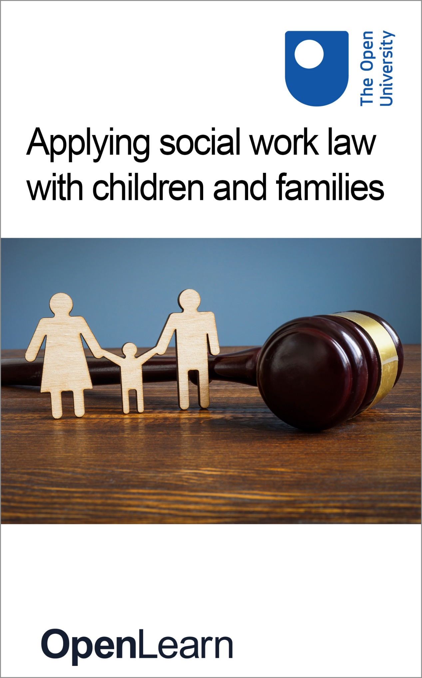

K271_3

Applying social work law with children and families

About this free course
This free course is an adapted extract from the Open University course K271 Social work law: www.open.ac.uk/courses/modules/k271 .
This version of the content may include video, images and interactive content that may not be optimised for your device.
You can experience this free course as it was originally designed on OpenLearn, the home of free learning from The Open University –
www.open.edu/openlearn/society-politics-law/applying-social-work-law-children-and-families/content-section-0
There you’ll also be able to track your progress via your activity record, which you can use to demonstrate your learning.
Copyright © 2022 The Open University
Intellectual property
Unless otherwise stated, this resource is released under the terms of the Creative Commons Licence v4.0 http://creativecommons.org/licenses/by-nc-sa/4.0/deed.en_GB. Within that The Open University interprets this licence in the following way: www.open.edu/openlearn/about-openlearn/frequently-asked-questions-on-openlearn. Copyright and rights falling outside the terms of the Creative Commons Licence are retained or controlled by The Open University. Please read the full text before using any of the content.
We believe the primary barrier to accessing high-quality educational experiences is cost, which is why we aim to publish as much free content as possible under an open licence. If it proves difficult to release content under our preferred Creative Commons licence (e.g. because we can’t afford or gain the clearances or find suitable alternatives), we will still release the materials for free under a personal end-user licence.
This is because the learning experience will always be the same high quality offering and that should always be seen as positive – even if at times the licensing is different to Creative Commons.
When using the content you must attribute us (The Open University) (the OU) and any identified author in accordance with the terms of the Creative Commons Licence.
The Acknowledgements section is used to list, amongst other things, third party (Proprietary), licensed content which is not subject to Creative Commons licensing. Proprietary content must be used (retained) intact and in context to the content at all times.
The Acknowledgements section is also used to bring to your attention any other Special Restrictions which may apply to the content. For example there may be times when the Creative Commons Non-Commercial Sharealike licence does not apply to any of the content even if owned by us (The Open University). In these instances, unless stated otherwise, the content may be used for personal and non-commercial use.
We have also identified as Proprietary other material included in the content which is not subject to Creative Commons Licence. These are OU logos, trading names and may extend to certain photographic and video images and sound recordings and any other material as may be brought to your attention.
Unauthorised use of any of the content may constitute a breach of the terms and conditions and/or intellectual property laws.
We reserve the right to alter, amend or bring to an end any terms and conditions provided here without notice.
All rights falling outside the terms of the Creative Commons licence are retained or controlled by The Open University.
Head of Intellectual Property, The Open University

Contents
- Introduction
- Learning outcomes
- 1 Defining childhood
- 2 Society’s influence
  - 2.1 Perceptions of children
  - 2.2 From parental authority to rights of the child
- 3 UNCRC and legal definitions of ‘a child’
  - 3.1 Working with children and families
  - 3.2 Consent
- 4 Key legislation in the UK
- 5 Family
  - 5.1 Why does understanding ‘family’ matter?
  - 5.2 Parental responsibility
- 6 Key principles and concepts
  - 6.1 The principle of non-intervention
  - 6.2 The welfare principle
  - 6.3 The views and wishes of the child
  - 6.4 Parenthood
- 7 Policy, implementation and practice
- Conclusion
- References
- Acknowledgements
- Solutions

Introduction
In this free course, Applying social work law with children and families, you will be introduced to the law as it applies to social work with children and families in the United Kingdom. You will learn about varying definitions of childhood and family and then explore underpinning principles for the law relating to child rights and parental responsibilities.

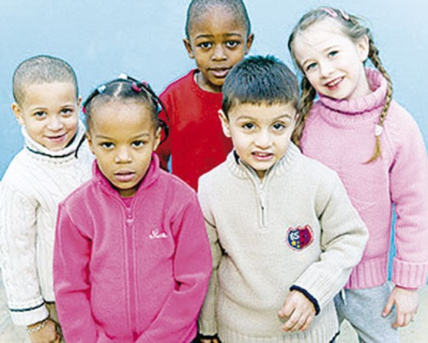
Figure 1 Children
View description - Figure 1 Children

This OpenLearn course is an adapted extract from the Open University course K271 Social work law.

Learning outcomes
After studying this course, you should be able to:
- define childhood and recognise how it is perceived
- recognise the underpinning principles for the law relating to social work with children and families
- identify the key policy guidance for social workers
- understand what is meant by ‘children’s’ rights’ and how are these promoted.

1 Defining childhood
Before you look at the law relating to children, you need to know how the law provides for what a child can do and can’t do. This often varies according to the particular decision or issue in question. This is referred to as ‘childhood’.
In Activity 1, you will start to think about what ‘childhood’ means to you.

Activity 1 Childhood
5 minutes

Interactive content is not available in this format.

Interactive content is not available in this format.

View discussion - Part

In this course, you will look at the ways in which different perspectives on childhood may influence how children’s views are heard, and how far they can participate in making decisions about matters that affect them. First, however, you will look at how trends in society have influenced the way the law and practice have developed and changed over time.

2 Society’s influence
Social work practice does not exist in a vacuum – it is influenced and informed by wider social, political, economic and intellectual trends. It is important to have an awareness of historical trends and how they inform current social work practice. Examining the ways in which attitudes toward children change and how these changes come to be reflected (or not) in legislation and public policy is a part of that understanding.
Legislation relating to children and families arose from a social and political climate that considered it appropriate for the state to intervene in family life and prevent the necessity for public care. This climate also envisaged a capacity for the state to provide alternative parenting, where necessary: for example, residential care was seen as a primary service for children in need.

2.1 Perceptions of children
Harding (1997) describes four ways to understand developments in the way children are perceived. These are outlined in more detail in Box 1 below.

Box 1 Understanding developments in perceptions of children

Laissez-faire and patriarchy
- A belief in the benefit to society of minimum state intervention.
- A belief in the value to all of undisturbed family life.
- A clear dichotomy between the private domain of the family and the public arena.

State paternalism and child protection
- A belief that the state should have a considerable role in intervening in families to protect children.
- Parental rights are not valued as highly as the parental duty of care.
- The state in the paternalistic perspective is construed as neutral and wise, taking the best course of action for children.

Defence of birth family and parents’ rights
- The importance of biological and psychological parenting.
- The role of the state in supporting and encouraging parents.
- An emphasis on the role of preventative work with families.
- Substitute care may be more damaging than poor parenting.

Children’s rights and child liberation
- The child is seen as a separate entity.
- An emphasis on the competence and strength of the child.
- The link between responsibilities and rights.
(Harding, 1997, in Featherstone et al., 2014)

These perspectives are interesting to consider when looking at the ways legislation develops and how the role of the state in family life changes over time. In turn, these changes impact the role of professionals working with families.

2.2 From parental authority to rights of the child
Previously, the parental ‘rights’ and ‘duties’ that formed the basis of family law in England, Wales, Scotland and Northern Ireland were adult-centred, rather than being focused on the child. In England and Wales, the Children Act 1989 (CA 1989) marked a profound change of approach from previous law. It moved from a frame of reference focused on parental authority and their rights to more of a system focused on the needs the child.
A similar shift towards more child-centred legislation and policy has also been seen in Scotland and Northern Ireland. For example, the Children and Young People (Scotland) Act 2014 put the Scottish child wellbeing framework Getting it Right for Every Child (Scottish Government, 2008) onto a statutory footing. The introduction of the Children (Northern Ireland) Order 1995 was a significant milestone in protecting children in Northern Ireland.
Globally, the United Nations Convention on the Rights of the Child 1989 (UNCRC) was created with the aim of encouraging governments worldwide to recognise the importance of children in society and to recognise that children have rights. You will look at the UNCRC in more detail next.

3 UNCRC and legal definitions of ‘a child’
The United Nations Convention on the Rights of the Child (UNCRC) is the world’s most ratified convention, with Somalia and the USA being the only UN members who have not ratified it.

Figure 2 UNICEF logo: Rights of the child
View description - Figure 2 UNICEF logo: Rights of the child

The United Nations Convention on the Rights of the Child (UNCRC) 1989 – which has been ratified by the UK – defines a child as any person under the age of 18. However, Article 1 UNCRC states that this definition only applies unless ‘under the law applicable to the child, majority is attained earlier’. Therefore, a child can be defined differently in different legal contexts. England, Wales, Northern Ireland and Scotland each have their own laws that specify age limits in different circumstances. For example, for the purposes of the Children's Hearings (Scotland) Act 2011, a child is defined as any person under the age of 16. The Children (Northern Ireland) Order 1995 defines a child as a person under the age of 18.

3.1 Working with children and families
For social workers working with children and families, a vital part of the mindset is having a focus on the child. Nearly all work with children rightly also means working with adults in their family; there is, however, a long history of concern that adult conversations can dominate, and adult views and opinions can silence those of children. You will revisit in more detail later why this might happen, but first you will spend some time focusing on children. An important underpinning principle of the need to listen to children, not just in the social work arena but generally in society, is the recognition that children have rights.
The UNCRC includes 54 articles that set out fundamental rights for children and how governments should ensure that these rights are available to all. These include a child’s right to protection from harm, access to education, right to a family life and the right to express an opinion and be listened to. At an individual level, taking on the messages of the UNCRC can have major implications for all practitioners in their work − such as the extent to which children are enabled to have a say in decisions that affect their lives (e.g. the design of services). This can be challenging – for example, how much say should children have in how a school is run or how a social work assessment and intervention should proceed?
While the UNCRC defines a child as any person under the age of 18, the overarching principle of the Convention deems that this is not the earliest a child's views should be heard. Consequently, the age at which children can make decisions for themselves may be significantly lower than 18. The boundary between child and adult in certain aspects of the law is not always distinct – is it age or understanding that is most significant? An example of this is shown in the next section.

3.2 Consent
The issue of consent was tested in court in England in a landmark case relating to the lawfulness of doctors giving contraceptive advice to those under 16 without parental knowledge or consent (Gillick v West Norfolk and Wisbech Area Health Authority [1986] AC 112). Gillick established the position that a parent’s ability to make decisions for their children is not absolute but reduces with the evolving maturity of the child to the point where they may be judged capable of making their own decisions even regarding serious (even life-threatening) matters.
The Age of Legal Capacity (Scotland) Act 1991 defines that people aged 16 and over have a capacity to make decisions about medical procedures on their own behalf. If under the age of 16 years, the question of whether the child is ‘capable of understanding the nature and possible consequences of the procedure or treatment’ (s.2(4)) will be determined by a qualified medical practitioner. The taking into account of the age and maturity of the child does not just apply in relation to ‘medical’ decisions but applies much more broadly, such as to the hearing of children’s views in legal proceedings.
This principle of age and understanding is very relevant to social work in terms of giving weight to children’s views, and assessing and making decisions about their capacity to understand. It is relevant, too, where there are issues of confidentiality.

4 Key legislation in the UK
The Children Act 1989 marked a radical legal change by ensuring that parents retain parental responsibility when their child enters public care and is looked after by the local authority. The Children Act 1989 recognises that the birth family has a symbolic and important place in the lives of individual children. Radical legal change has also been seen within Scotland, with the introduction of the Getting it Right for Every Child policy.
The mandate for practice for professionals working with children and families in England and Wales still comes largely from the Children Act 1989, additional legislation and the related guidance and regulations, for example: Working Together to Safeguard Children (Department for Education, 2018) which applies in England, and Safeguarding Children: Working Together under the Children Act 2004 (Welsh Assembly Government, 2007) which applies in Wales. The Social Services and Well-being (Wales) Act 2014 is also relevant; this took over Part 3 of the Children Act 1989, but all other parts of the Children Act 1989 continue to apply in Wales.
In Scotland, the mandate for practice comes from the Children (Scotland) Act 1995 (C(S)A 1995) and guidance, such as the National Guidance for Child Protection in Scotland (Scottish Government, 2014).
In Northern Ireland, practice is directed by The Children (Northern Ireland) Order 1995 (C(NI)O 1995) and Co-operating to Safeguard Children and Young People in Northern Ireland guidance (Department of Health, Social Services and Public Safety, 2017).

5 Family
It is difficult to define the notion of a ‘family’. Although some people may still have a stereotypical image of a family – a mother, father and two children – this is not the family form that many people will have experienced. Nearly half of all children in the UK are now born outside of marriage (more than half in Scotland; see National Records of Scotland). Over three million couples cohabit (Office for National Statistics, 2017) and there are nearly three million lone parents with dependent children in the UK (Office for National Statistics, 2017). Government data from 2019 suggests that there are now 212,000 same sex families across the UK, an increase of 40 per cent registering as such since 2015. The number of same sex couples raising children has remained the same as in 2013 at around 12,000 (FFLAG, 2021). Statistics easily demonstrate that family ‘norms’ change over time.

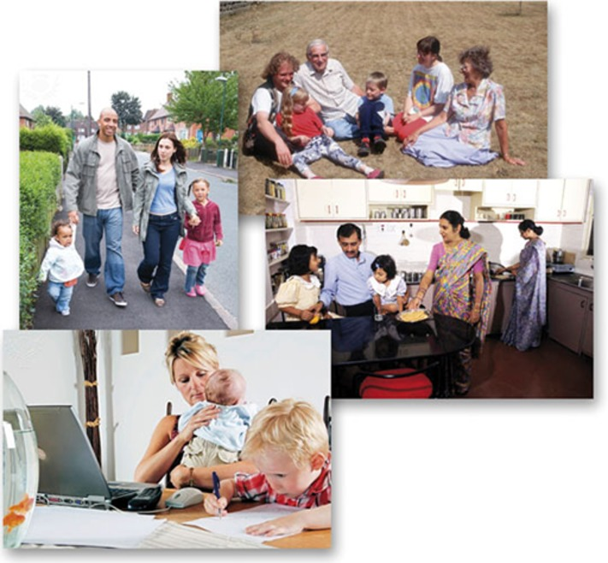
Figure 3 Different images of families
View description - Figure 3 Different images of families

In the following activity, you are going to consider what the term ‘family’ means to you and what the difficulties of defining ‘family’ are. You will then start to think about why and how the state regulates and intervenes in family life within the UK.

Activity 2 What is a ‘family’?
20 minutes

In this activity you will think about who you are closest to or who the most significant people in your life are. Using a piece of paper, create a ‘map’ of significant people in your life – you should copy the image below as a template.

Figure 4 Your family circle
View description - Figure 4 Your family circle

- Begin by writing ‘YOU’ in the centre circle on your piece of paper.
- Next, write the names (and their relationship to you) of those individuals who are most significant in your life in the first circle out from the centre.
- In the next circle out, add those people that you are ‘less close to’, but who are ‘still very important’.
- In the outer circle, add any people who you have not already mentioned but who are important enough in your life to be included.
- Finally, highlight the ones you would consider to be within your own definition of your family.

- In general terms, how would you define a ‘family’?
- Does it matter how we, collectively or personally, define a family?

Provide your answer...
View discussion - Part

5.1 Why does understanding ‘family’ matter?
While precision about family structures might be required for legal reasons (for example, who has ‘parental responsibility’), ‘what is a family’ is not just a legal issue. Children often live in diverse family forms with people they are not ‘technically’ related to, for example, new parental partners and their siblings, long-standing friends. However, some or all of these people may fall within their own definition of who is a member of their family.
This perspective of who is in a family and who is important to a child or young person can be vital for a social worker trying to understand their world view and working constructively with them through difficult family circumstances.
It is also important for social work practitioners to be aware of their own views about ‘family’, as what we believe to be a good or normal family composition can carry a particular value base that may influence our approaches to working with children in their own family context.
In the same way that ‘family’ is a dynamic and contested concept, the meaning of ‘family life’ is also problematic. Legislation does not define ‘family life’; whether or not there is family life depends on the circumstances and these have been interpreted by the European Court of Human Right (ECtHR) in a way that includes a wider range of relationships than covered by statute (see K v United Kingdom [1986] 50 DR 199; 207 E Comm HR).
Family life usually requires the existence of a close personal relationship, but it is not limited to relationships based only on blood, marital ties or recognised in law in some other way. The recognition by legislators and the courts that there are many different forms of family living, including step-families, gay and lesbian families and civil partnerships, is an important development in family law (Ruspini, 2015).
Clearly, the state can, and does, intervene in family life in various ways within the UK, but why, what for, and what should the limits of this be? In the next activity you will reflect on your own views regarding the regulation of family life by the state.

Activity 3 Why regulate?
15 minutes

In Table 1 below, note reasons for and against the need for the regulation of family life.

Table 1 Regulation of family life
Reasons for the regulation of family life | Reasons against the regulation of family life
Provide your answer... | Provide your answer...

View discussion - Activity 3 Why regulate?

5.2 Parental responsibility
Under both the Children’s Act (CA) 1989 and Children Northern Ireland Order (C(NI)O) 1995, parental responsibility refers to the legal rights, duties, powers and authority a parent has for a child and the child’s property. This same concept is referred to as ‘parental responsibilities and rights’ in Scotland, under the Children (Scotland) Act (C(S)A) 1995, where parental ‘rights’ enable parents to fulfil their parental responsibilities. Nonetheless, this concept is significant across the nations as it exists so that the child can be protected and nurtured until they reach independence or adulthood (Barton and Douglas, 1995).

Figure 5 Mother reading with child
View description - Figure 5 Mother reading with child

The next activity will help you to understand what ‘parental responsibility’ means and who has this under the law of England and Wales.

Activity 4 Understanding parental responsibility
20 minutes

Read the law resource ‘Parental responsibility in England and Wales’ and make notes in answer to the following questions:
- What does the term ‘parental responsibility’ mean?
- Who has automatic parental responsibility?
- Who may acquire parental responsibility and how?
- How and when may parental responsibility be exercised?

Provide your answer...
View discussion - Activity 4 Understanding parental responsibility

In the next activity you will explore the practice issues that may be raised by exercising parental responsibility.

Activity 5 Limits to parental rights
20 minutes

Read the following case study and then, based on your learning from this course so far, answer the questions that follow it.

Imagine you are a social worker in this case. You receive a request from the head teacher of a local primary school to investigate the circumstances of a ten-year-old girl who she is concerned about. This girl appears very withdrawn and is unable to make relationships with the other children in the school. In your discussion with the parents, you discover that the child is taken to and from school each day by her mother and is not allowed out of the home unless she is in the company of one or other of her parents. Her parents explain that, in their view, the attitudes, values and behaviour of the local community are unsuitable for their daughter and therefore they do not want her to mix socially. They consider that the behaviour described by the school is a price worth paying to ensure their daughter’s well-being.

- What arguments can you give for intervening in this situation?
- What arguments can you give for non-intervention?
- What assistance, if any, can you give?

Provide your answer...
View discussion - Activity 5 Limits to parental rights

6 Key principles and concepts

Figure 6 Two children and a woman
View description - Figure 6 Two children and a woman

The Children’s Act 1989, the Children (Scotland) Act 1995 and the Children (Northern Ireland) Order 1995 form the basis of public and private law relating to the care and welfare of children in the UK. This legislation aims to strike a balance between the rights of children, the responsibilities of both parents to the child and the duty of the state to intervene when the child’s welfare requires it (Department for Education, 2014). The overriding objective of all three pieces of legislation is to safeguard and promote the welfare of children – the child’s welfare is the court’s paramount consideration. When working with children and families, it is imperative to have consideration for the principles that underpin this legislation, as they represent best practice. These core underpinning principles will be discussed in more detail throughout this section.

6.1 The principle of non-intervention
The three principle pieces of legislation mentioned in Section 6 are based on the belief that children are generally best looked after within the family, with their parents playing a full part in their lives, and without recourse to legal proceedings unless absolutely necessary. Therefore, a key principle underpinning the legislation is that of minimum state intervention; the aim being to restrict intervention into family life by the courts and local authorities unless it is necessary to safeguard a child’s welfare.

The ‘no order’ principle
The Children’s Act 1989, the Children (Scotland) Act 1995 and the Children (Northern Ireland) Order 1995 prohibit the court from making an order (even when it has the power to do so), unless it would be better for the child than making no order at all. There are three aims underpinning this principle:
- To discourage unnecessary court orders from being made, in line with the principle of non-intervention. The restriction of orders to those cases where they are necessary to resolve a specific problem is also intended to reduce conflict and promote parental agreement and cooperation.
- To ensure that the order is granted only where it is likely to improve the child’s welfare and not simply because there are grounds for making the order. For example, in care proceedings, the court may decide that it would be better for a particular child not to be made the subject of a care order that would place that child in local authority care. The application by the court of this ‘no order’ principle should not deter local authorities from bringing proceedings in those cases where they believe that a care or supervision order is necessary in order to safeguard and promote a child’s welfare.
- To discourage the making of unnecessary applications.

6.2 The welfare principle
The Children’s Act 1989, the Children (Scotland) Act 1995 and the Children (Northern Ireland) Order 1995 all stipulate that in determining any issue with regard to the upbringing of a child, the child’s welfare should be the paramount consideration for courts and children’s hearings.

6.3 The views and wishes of the child
Enshrined within each piece of legislation is the right of children to have a voice in the decisions being made about them and their future. The legislation acknowledges that children have views, opinions and feelings about what happens to them, and stipulates that these should be taken into account by decision-makers. Even while they are still legally defined as ‘children’, individuals may reach a stage where they are capable of making informed choices.

6.4 Parenthood
Arguably, these three pieces of legislation mentioned in Section 6 promoted a new model of parenthood, as they introduced the concept of parental responsibility; which seeks to balance the rights and duties of parents with the welfare of the child. Before the Children’s Act 1989, the Law Commission (England and Wales) considered that the law had focused on parental rights, rather than recognising parenthood in terms of responsibility (Brammer, 2015). The introduction of the concept of parental responsibility clearly places the responsibility for children with their parents – the state only intervening in those cases where it is necessary to safeguard children.

7 Policy, implementation and practice
Policies are often derived from research, the findings of which can become enshrined in good practice guidance or legislation. It is important to recognise this when studying the law that frames social work practice.
In June 2010, Professor Eileen Munro conducted an independent review of the child protection system in England. In the final report of her review, A Child Centred System (Munro, 2011), she concluded that child protection had become too focused on compliance and procedures and had lost its focus on the needs and experiences of individual children. This particular finding is reflected within research, which has found that professionals within the child protection system seem to be overly reliant on bureaucratic requirements. Arguably, this may compromise the ability of practitioners to develop relationships with children and young people, and thus to establish their views and wishes.
Similar recommendations have also been made by reviews covering other areas of the UK, such as the review into the family justice system, by the Family Justice Review Panel (2011) – in Wales. The panel published its final report in November 2011, and made a number of recommendations aimed at ensuring that children’s wishes are truly central to the operation of the system.
The recommendations outlined in reviews are supported by research, such as the small-scale study conducted by Woolfson et al. (2010), in which eleven children and young people from one Scottish local authority were interviewed about their experiences of the child protection system in one Scottish local authority. Their recommendations for improving the child protection system included greater involvement of children and young people in the decision-making process.
In May 2012, Professor Munro published her progress update on the reforms set out in her review. The updating report (Munro, 2012) stated that a culture change in the child protection system was underway, with reforms moving the focus of support and protection onto children and young people, and away from excessive bureaucratic demands.

More information about Professor Munro’s work and the changes and pace of reform can be accessed at: Munro review reports.

Many of the reforms highlighted by research and national reviews have subsequently been reflected within national guidance across the UK. For example, the National Guidance for Child Protection in Scotland (Scottish Government, 2014, p. 92) is explicit about the involvement of children in child protection processes, stating that: ‘Children should be listened to at every stage of the child protection process and given appropriate information about the decisions being made’. Similarly, the statutory guidance – Working Together to Safeguard Children (Department for Education, 2018, p. 10), which relates to England – encourages professionals to take a child-centred approach: ‘see and speak to the child; listen to what they say; take their views seriously; and work with them collaboratively when deciding how to support their needs.’
Social work practice within Northern Ireland has also been significantly impacted by events, inquiries, reviews and research originating from elsewhere in the UK (Duffy et al., 2016), and a key principle of the Co-operating to Safeguard Children and Young People in Northern Ireland (Department of Health, Social Services and Public Safety, 2017) guidance is that ‘the voice of the child or young person should be heard’.

Conclusion
In this course you have:
- seen how the concepts of childhood, family and family life are not static, but shift over time
- explored how policy and legislation develop in response to social changes
- considered the concept of parental responsibility
- seen that it is not always straightforward to determine whether the exercise of parental responsibility benefits the child, and that there may be competing views, based on different values and beliefs, about how a child’s best interests should be met in relation to the decisions that are made about their lives and futures.

Key points
- Social work practice is influenced and informed by wider social, political, economic and intellectual trends.
- The definition of family and family life is broad and changes over time.
- The key legislation relating to children and families across the UK share a number of core principles, including the non-intervention, no order and welfare principles.
- Mothers and married fathers have automatic parental responsibility.
- Others may acquire parental responsibility, either through parental agreement orders or by an order of the court.
- The exercise of parental responsibility is likely to reflect differing values and moral positions about what is in a child’s or a young person’s best interests.
- Findings from research can become enshrined in both good practice guidance and legislation.
This course is part of a suite of courses on social work and the law. You may be interested in continuing your studies in this subject with the following courses:
- An introduction to social work law
- Social work law and UK regulation
- Applying social work law to asylum and immigration
This OpenLearn course is an adapted extract from the Open University course K271 Social work law.

References
Legislation
Age of Legal Capacity (Scotland) Act 1991
Children Act 1989
Children and Young People (Scotland) Act 2014
Children (Scotland) Act 1995
Children’s Hearings (Scotland) Act 2011
Human Rights Act 1998
Social Services and Well-Being (Wales) Act 2014
Secondary legislation
The Children (Northern Ireland) Order 1995 (SI 1995/755)
International instruments
European Convention on Human Rights 1950
United Nations Convention on the Rights of the Child 1989
Cases
Gillick v West Norfolk and Wisbech Area Health Authority [1986] AC 112
International cases
K v United Kingdom [1986] 50 DR 199; 207 E Comm HR
Books, articles, reports and other sources
Barton, C. and Douglas, G. (1995) Law and Parenthood, London, Butterworth.
Brammer, A. (2015) Social Work Law, 4th edn, Essex, Pearson Education Limited.
Department for Education (2014) Children Act 1989: Guidance and Regulations, Volume 1: Court Orders, London, The Stationery Office [Online]. Available at www.dcsf.gov.uk/everychildmatters/publications/documents/childrenactguidanceregulations (Accessed 28 January 2019).
Department for Education (2018) Working Together to Safeguard Children: A Guide to Inter-agency Working to Safeguard and Promote the Welfare of Children, August [Online]. Available at www.gov.uk/government/publications/working-together-to-safeguard-children--2 (Accessed 28 January 2019).
Department of Health, Social Services and Public Safety (2017) Co-operating to Safeguard Children and Young People, August [Online]. Available at www.health-ni.gov.uk/publications/co-operating-safeguard-children-and-young-people-northern-ireland (Accessed 21 June 2018).
Duffy, J., Caldwell, J., and Collins, M. (2016) ‘Reflections on the impact of the Children (NI) Order 1995‘, Child Care in Practice, vol. 22, no. 4, pp. 327–32.
Family Justice Review Panel (2011) Family Justice Review: Final Report, November [Online]. Available at www.gov.uk/government/publications/family-justice-review-final-report (Accessed 23 January 2019).
Featherstone, B. White, S. and Morris, K. (2014) Re-imagining Child Protection: Towards Humane Social Work with Families, Policy Press, Bristol.
FFLAG (2021) LGBT+ Parenting. Available at: https://www.fflag.org.uk/portfolio-item/lgbtplus-parenting/ (Accessed: 21 March 2021).
Harding, L. F. (1997) Perspectives in Child Care Policy, Abingdon, Taylor & Francis.
Munro, E. (2011) The Munro Review of Child Protection: Final Report - A Child-centred System, May, Cm 8062 [Online]. Available at https://assets.publishing.service.gov.uk/government/uploads/system/uploads/attachment_data/file/17 5391/Munro-Review.pdf (Accessed 23 January 2019).
Munro, E. (2012) The Munro Review of Child Protection: Progress Report: Moving Towards a Child Centred System, 1 May [Online]. Available at https://assets.publishing.service.gov.uk/government/uploads/system/uploads/attachment_data/file/18 0861/DFE-00063-2012.pdf (Accessed 23 January 2019).
Office for National Statistics (2017) Families and Households: 2017 [Online]. Available at https://www.ons.gov.uk/peoplepopulationandcommunity/birthsdeathsandmarriages/families/bulletins/familiesandhouseholds/2017 (Accessed 28 January 2019).
Ruspini, E. (2015) Diversity in Family Life: Gender, Relationships and Social Change, Policy Press, Bristol.
Scottish Government (2008) Getting it Right for Every Child [Online]. Available at www2.gov.scot/resource/doc/1141/0065063.pdf (Accessed 13 February 2019).
Scottish Government. (2014) National Guidance for Child Protection in Scotland, 19 May [Online]. Available at www.gov.scot/publications/national-guidance-child-protection-scotland/ (Accessed 23 January 2019).
Welsh Assembly Government (2007) Safeguarding Children: Working Together Under the Children Act 2004, September, G/232/06-07 [Online]. Available at http://gov.wales/pubs/circulars/2007/nafwc1207en.pdf?lang=en (Accessed 4 June 2015).
Woolfson, R., Hefferman, E., Paul, M. and Brown, M. (2010) ‘Young people’s views of child protection in Scotland’, The British Journal of Social Work, vol. 40, no. 7, pp. 2069–85.

Acknowledgements
This free course was written by Justin Rogers. It was first published in August 2022.
Except for third party materials and otherwise stated (see terms and conditions), this content is made available under a Creative Commons Attribution-NonCommercial-ShareAlike 4.0 Licence.
The material acknowledged below is Proprietary and used under licence (not subject to Creative Commons Licence). Grateful acknowledgement is made to the following sources for permission to reproduce material in this free course:

Images
Course image: designer491 / iStock / Getty Images Plus
Figure 1: John Birdsall Photography
Figure 2: dpa picture alliance / Alamy Stock Photo
Figure 3, Family walking down street: John Birdsall / John Birdsall Creative / John Birdsall Social Issues Photo Library / Press Association Images / Universal Images Group
Figure 3, Family sitting on beach: John Birdsall MR / John Birdsall Social Issues Photo Library / Press Association Images / Universal Images Group
Figure 3, Family in kitchen: David R. Frazier Photolibrary, Inc. / Alamy Stock Photo
Figure 3, Mother holding baby: CLAIRE DEPREZ/REPORTERS/SCIENCE PHOTO LIBRARY
Figure 5: John Birdsall / Alamy Stock Photo
Figure 6: Alena Ozerova/Shutterstock
Every effort has been made to contact copyright owners. If any have been inadvertently overlooked, the publishers will be pleased to make the necessary arrangements at the first opportunity.
Don't miss out
If reading this text has inspired you to learn more, you may be interested in joining the millions of people who discover our free learning resources and qualifications by visiting The Open University – www.open.edu/openlearn/free-courses.

Solutions

Activity 1 Childhood

Part

Discussion
This activity was designed to get you thinking about what the term ‘childhood’ means to you, and to look at some of the key legal milestones in a person’s life, such as when they can get a job or get married.
Although the law often uses age to determine when a child is capable of taking on certain responsibilities or making certain decisions, it sometimes adopts a more flexible approach. For example, case law has established in respect of certain decisions children are able to make the decision in question depending on their competence to do so (sometimes referred to as ‘Gillick competence’).
It is important to remember that from a young age and irrespective of their competence, children will have views about their own lives and what is important to them. Therefore, children should not simply be seen as vulnerable, and it should not be assumed that they are unable to recognise what is in their own best interests or when they are in need of protection. Professionals should also consider the children they work with as social actors who engage in the complexities of their world in specific ways, and who are entitled to respect and choice.
Back to - Part

Activity 2 What is a ‘family’?

Part

Discussion
You may have found the task of defining your family fairly easy – but it can be difficult to decide where the boundaries of your family lie. Some people may include lifelong friends, ‘distant’ relatives and biologically unrelated siblings.
Trying to arrive at a definition of ‘family’ that allows for all the ways in which different people see their own family is difficult. But is this a problem? While each of us having a different definition of the word ‘family’ does not create difficulties for us in everyday life, it can create difficulties for the people who make the law; it is difficult, if not impossible, to make laws that apply to every family when every family is different.
Back to - Part

Activity 3 Why regulate?

Discussion
Under ‘for’, you may have included the need to protect vulnerable people in society, which would include children, or the rights of all children to have equality of opportunity. Under ‘against’, you may have considered that family life should be private and parents should be able to bring up their children in a way that they choose. In considering these matters, you are reflecting on the different, and sometimes competing, rights of individuals in society. It is the role of government to recognise and acknowledge that in society there are competing rights that have to be managed at the same time as being respected. In turn, regulation necessarily leads to professionals being under a duty to take certain steps.
Where the line is drawn on the need for regulation also changes over time, or is renegotiated within societies. In legislative terms, in the UK, intervention into the way that parents care for their children is generally agreed to have effectively started only in the 1880s with the Prevention of Cruelty to, and Protection of, Children Act 1889. The expanding role of the state into the arena of family life since then has sometimes been controversial and continues to be so.
While the law provides an important framework for practice, government policy is equally, if not more, directly influential on what practitioners do on a day-to-day basis. We are all affected by social policy in different areas of our lives and what kind of policy we have depends upon a range of political, economic and social factors. For practitioners there can be little flexibility in terms of law and policy shaping the nature of their work. However, it is important to understand law and policy while also having a critical perspective on the reasons for their development.
Back to - Activity 3 Why regulate?

Activity 4 Understanding parental responsibility

Discussion
A range of decisions can be taken when exercising parental responsibility. However, determining whether the exercise of parental responsibility is to the benefit of the child may sometimes be difficult. One person’s interpretation of what is appropriate will vary from another’s and will reflect the different values and moral positions they hold. For example, some will see it as legitimate to seek to control a young person’s sexual activity; others will see this as an infringement of their privacy and their right to bodily integrity. Others will use parental responsibility to control a child’s religious upbringing, which school they attend or how they are disciplined. Strong feelings are aroused as the issues often form part of a person’s belief system about upbringing, and those views may be of a cultural or a religious nature, as well as being born out of an individual’s own life experiences. The idea of family privacy is very strong and society is often prepared to accept behaviour from parents that it would not accept from other people.
Who does or does not have parental responsibility is important for social workers when they become involved with a family – either as a result of a referral concerning the welfare of a child or a request for a court report or involvement in public law proceedings. Knowing who has parental responsibility will assist the social worker in knowing who they must liaise with and who is, or may be, involved in court proceedings. One way for social workers to ascertain who has parental responsibility, is to check the marital status of the parents. If they are unmarried, enquiries should be made as to whether the father is named on the birth certificate for children registered after 1 December 2003. If he is not, the next step is to find out whether an agreement or a court order has been made.
Back to - Activity 4 Understanding parental responsibility

Activity 5 Limits to parental rights

Discussion
The law will not provide a solution to issues arising in relation to the exercise of parental responsibility. When working with children and families, there is a need for the key social work skills of partnership and communication. You have to take into account the themes of empowerment and valuing diversity, while also maintaining a focus on the law regarding parental responsibility.
It is generally at the discretion of a parent (or the holder of parental responsibility) how parental responsibility should be exercised. However, this is subject to the following limitations:
- Minimum standards of care are imposed by criminal law, breach of which can result in a conviction – for example, for criminal neglect.
- Civil law provides for the protection of a child’s welfare. Where this is not being met, there are provisions for state intervention. However, any intervention by a public body is subject to the Human Rights Act 1998 (which incorporates the European Convention of Human Rights). The state may only intervene to the extent that the intervention is necessary to the aims set out in article 8 of the European Convention of Human Rights.
- As a child acquires sufficient understanding to make their own decisions, parental responsibility diminishes.
Back to - Activity 5 Limits to parental rights

Figure 1 Children

Description
Five pre-school aged children standing together facing up to the camera. Most are smiling.
Back to - Figure 1 Children

Figure 2 UNICEF logo: Rights of the child

Description
UNICEF logo: a silhouette of an adult’s head and an infant child being held up by the adult. Both are encased by a circle representing Earth and two strands of wheat.
Back to - Figure 2 UNICEF logo: Rights of the child

Figure 3 Different images of families

Description
Different family groupings. 1: mother, father, two young children. 2: three female adults, one male adult, two children, a dog. 3: an older woman, male and female adult, two children. 4: woman holding a baby in her arms sat next to a young boy.
Back to - Figure 3 Different images of families

Figure 4 Your family circle

Description
Four different sized circles, the smallest in the centre and each encased by a larger circle.
Back to - Figure 4 Your family circle

Figure 5 Mother reading with child

Description
A mother and her young female child seated at a desk and leaning in together to look at a children’s workbook.
Back to - Figure 5 Mother reading with child

Figure 6 Two children and a woman

Description
An adult standing behind a young child smiling while mixing ingredients in a bowl together. Another slightly older child watches solemnly.
Back to - Figure 6 Two children and a woman

