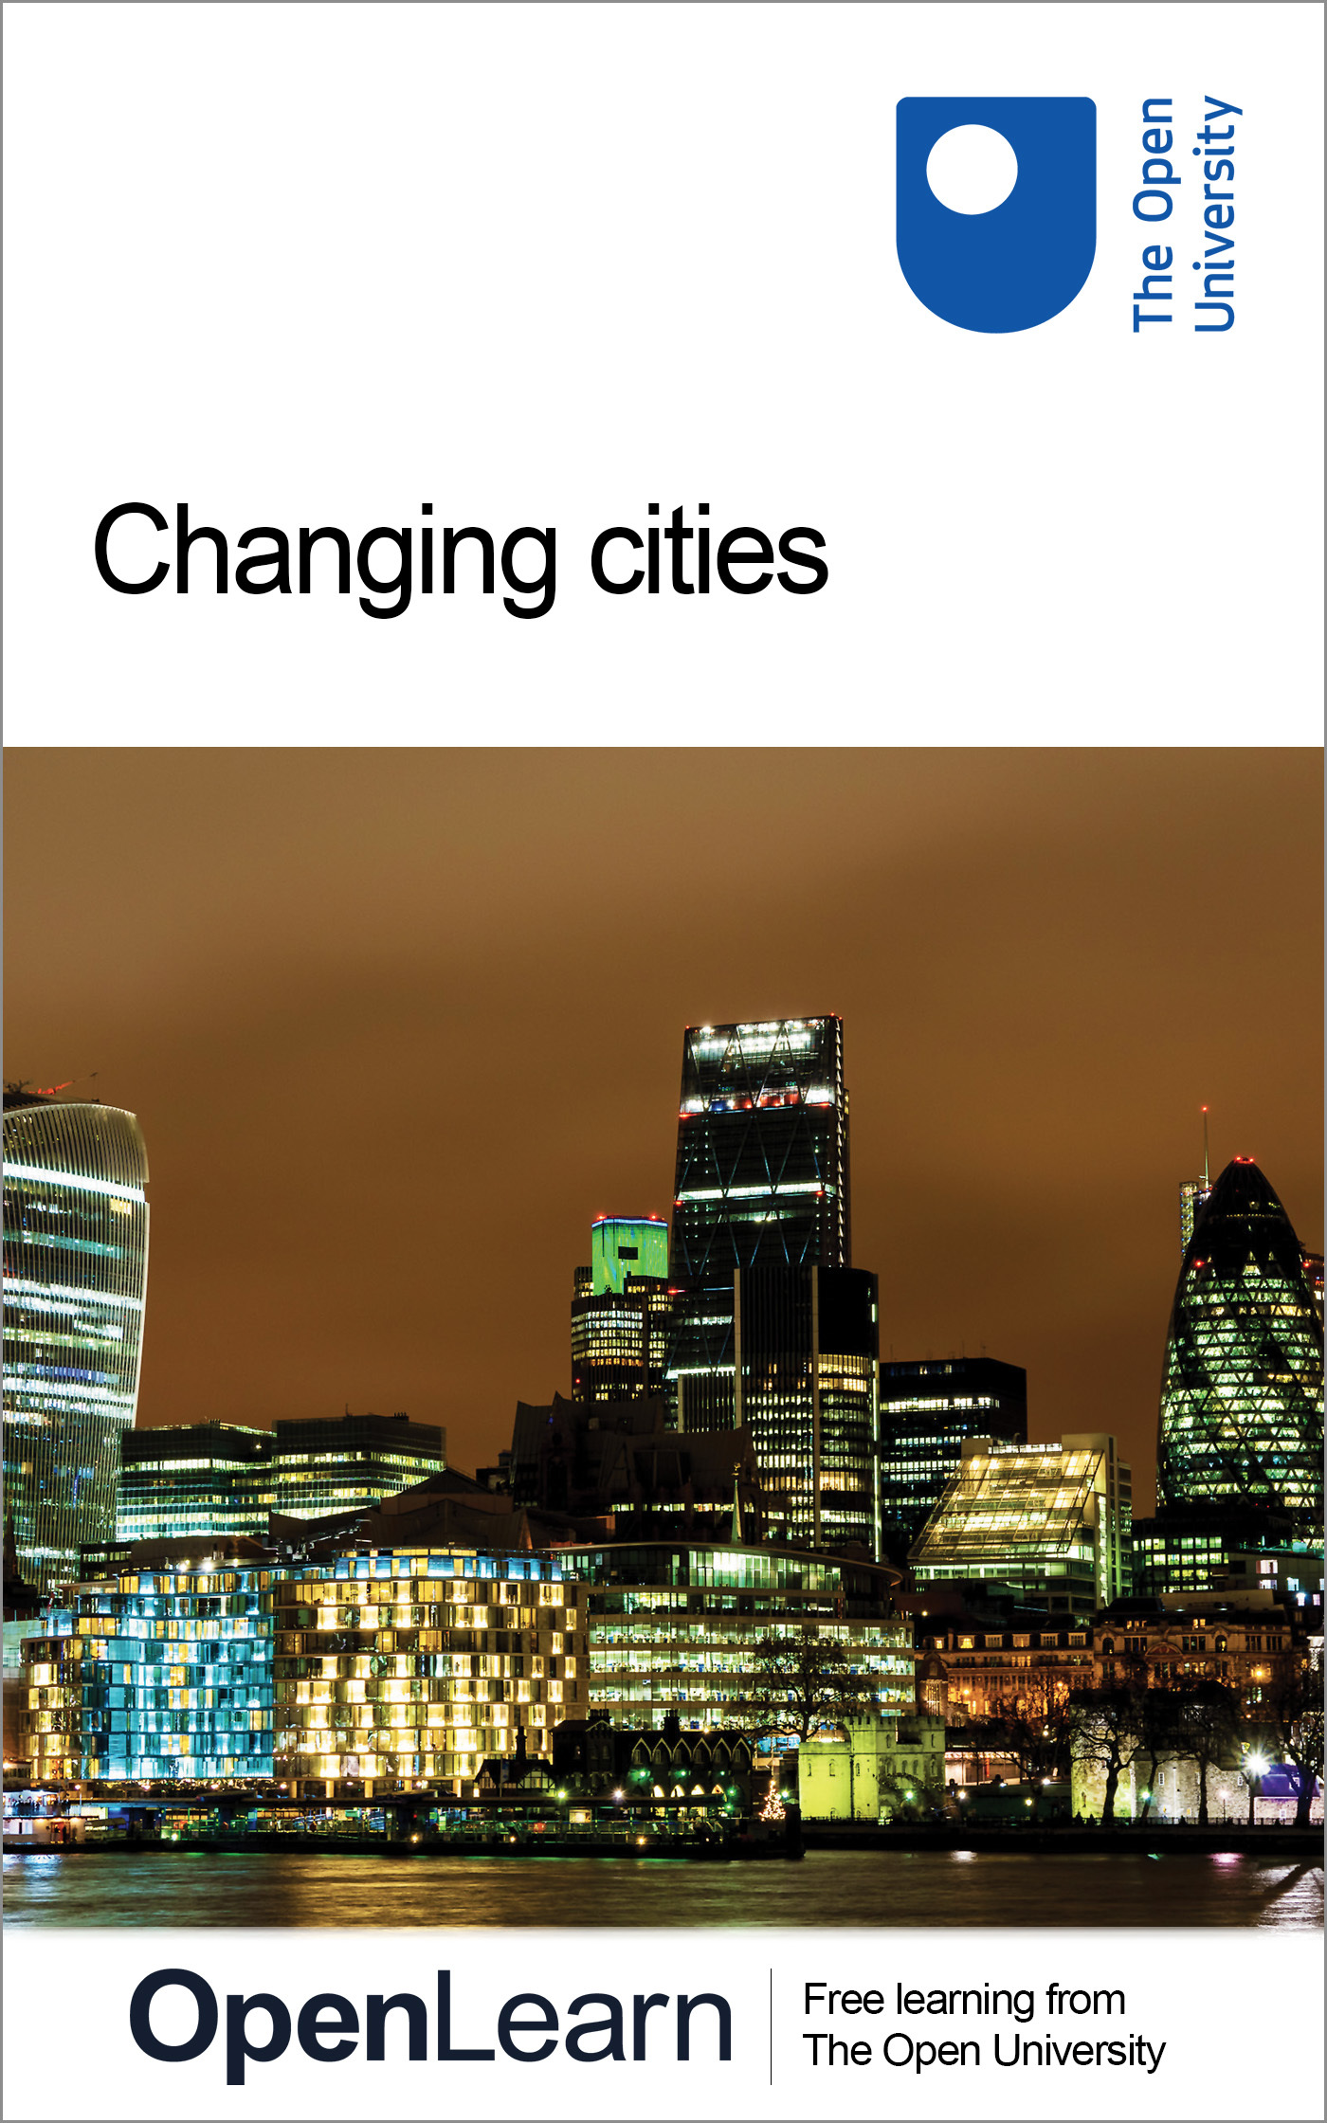

D837_1

Changing cities
About this free course
Find out more about studying with The Open University by visiting our online prospectus
This version of the content may include video, images and interactive content that may not be optimised for your device.
You can experience this free course as it was originally designed on OpenLearn, the home of free learning from The Open University – www.open.edu/openlearn/society/changing-cities/content-section-0
There you’ll also be able to track your progress via your activity record, which you can use to demonstrate your learning.
Copyright © 2016 The Open University
Intellectual property
Unless otherwise stated, this resource is released under the terms of the Creative Commons Licence v4.0 http://creativecommons.org/licenses/by-nc-sa/4.0/deed.en_GB. Within that The Open University interprets this licence in the following way: www.open.edu/openlearn/about-openlearn/frequently-asked-questions-on-openlearn. Copyright and rights falling outside the terms of the Creative Commons Licence are retained or controlled by The Open University. Please read the full text before using any of the content.
We believe the primary barrier to accessing high-quality educational experiences is cost, which is why we aim to publish as much free content as possible under an open licence. If it proves difficult to release content under our preferred Creative Commons licence (e.g. because we can’t afford or gain the clearances or find suitable alternatives), we will still release the materials for free under a personal end-user licence.
This is because the learning experience will always be the same high quality offering and that should always be seen as positive – even if at times the licensing is different to Creative Commons.
When using the content you must attribute us (The Open University) (the OU) and any identified author in accordance with the terms of the Creative Commons Licence.
The Acknowledgements section is used to list, amongst other things, third party (Proprietary), licensed content which is not subject to Creative Commons licensing. Proprietary content must be used (retained) intact and in context to the content at all times.
The Acknowledgements section is also used to bring to your attention any other Special Restrictions which may apply to the content. For example there may be times when the Creative Commons Non-Commercial Sharealike licence does not apply to any of the content even if owned by us (The Open University). In these instances, unless stated otherwise, the content may be used for personal and non-commercial use.
We have also identified as Proprietary other material included in the content which is not subject to Creative Commons Licence. These are OU logos, trading names and may extend to certain photographic and video images and sound recordings and any other material as may be brought to your attention.
Unauthorised use of any of the content may constitute a breach of the terms and conditions and/or intellectual property laws.
We reserve the right to alter, amend or bring to an end any terms and conditions provided here without notice.
All rights falling outside the terms of the Creative Commons licence are retained or controlled by The Open University.
Head of Intellectual Property, The Open University
978-1-4730-1267-7 (.kdl)
978-1-4730-0499-3 (.epub)

Contents
- Introduction
- Learning outcomes
- 1 Making use of critical spatial theory
  - 1.1 What do we mean by ‘theory’?
- 2 Acting locally in a world of connections
  - 2.1 Places shaping and responding to global change
- 3 Three ways of thinking about urban agency
  - 3.1 From urban theory to the problematisation of urban living
  - 3.2 Problematising urban processes
  - 3.3 Three types of questions about agency
- 4 Explaining urban issues
  - 4.1 Urban theory and case studies
  - 4.2 The globalisation of urbanisation
  - 4.3 Living on the knife-edge
  - 4.4 The right to the city
  - 4.5 Limits to explanation
- 5 Understanding urban issues
  - 5.1 Urbanism as a way of life
  - 5.2 Urban space and the public sphere
  - 5.3 Cities as communicative spaces
  - 5.4 Urban spaces of public address
- 6 Acting on urban issues
  - 6.1 The politics of urbanisation processes
  - 6.2 The limits of localism I: the limits of inclusion
  - 6.3 The limits of localism II: the limits of efficacy
  - 6.4 Making use of the critical spatial thinking framework
- Conclusion
- References
- Further reading
- Acknowledgements
- Solutions

Introduction
This free course explores the ways in which urbanisation processes help to generate issues of public concern. It elaborates a theoretical framework of critical spatial thinking that can be used to analyse the complex ‘agency’ of urban processes in generating, identifying and resolving the myriad issues associated with contemporary urbanisation. This framework draws on traditions of urban thought and spatial theory in disciplines such as geography and anthropology, development studies, planning, political science and sociology.
The framework developed in this course is meant to serve as an analytical heuristic, a device for framing the questions that should be asked when seeking to understand any particular urban issue or a place-based problem.
Find out more about studying with The Open University by visiting our online prospectus

Learning outcomes
After studying this course, you should be able to:
- demonstrate knowledge and understanding of key theories and styles of critical spatial thinking and decision making as they relate to the challenge of transforming urban areas
- apply a range of critical spatial and social theories to the analysis of specific issues
- track the way that issues and challenges facing specific places emerge and manifest themselves
- negotiate between a global level of analysis and the issues that are manifest in specific places.

1 Making use of critical spatial theory
This free course sets out to help you understand the challenges faced by the places in which people gather together, live and work. It’s about cities, but more broadly it’s about places, and it’s about the processes that go on, in and around places. It’s about neighbourhoods, suburbs, villages, towns and how the people in these places find themselves responding to a changing and uncertain world.
Places face many different kinds of challenges, from the very large-scale problems like climate change or global economic instability, right through to everyday issues like the quality of street lighting or even where your cup of coffee comes from. Increasingly, many of these challenges are identified as having their causes in the nature of urbanisation itself.
For most places, the challenges they face are mostly not entirely of their own making and are sometimes not of their making at all. Even when everyone pitches in, we can’t always solve these problems locally. But neither are individual places helpless in the face of changes, large or small. Even when we set out from the most ordinary and everyday places, there is a great deal that can be done when it comes to engaging effectively with a changing world.
This course shows how different traditions of spatial theory, or of what we call critical spatial thinking, can help us understand the challenges that urban processes present to us all. These ways of thinking are helpful, not so much because they will solve our problems, but because they can help us ask the right kinds of questions.

1.1 What do we mean by ‘theory’?


Figure 1 ‘Theory’ helps us to make sense of complex problems
View description - Figure 1 ‘Theory’ helps us to make sense of complex problems

Since this course is about different styles of spatial theory, it is worth considering for a moment what we mean by ‘theory’, and how it might help us get a handle on the messy, complex and often confusing predicaments that are constantly being engendered by urban environments and processes.
Put simply, theories are sets of ideas, concepts and procedures that have been developed to help make sense of certain aspects of existence. Ideally, a theory shows enough of its own working that others can follow its reasoning, can be convinced by its usefulness and can deploy it in new contexts. So, while all theories are put forward at particular times and in particular places, their purpose is to travel: to have at least some degree of relevance in situations beyond the setting in which they were first crafted.
Having a theory, or multiple theories, at hand offers an alternative to needing to begin our thinking from scratch each time we encounter something new or questionable in the world. Theories equip us to engage with events or processes as they take place and to speculate about what might happen in the future. They do this by providing ways to register what is significant: guidelines for identifying – amidst the clamour and bustle of our surroundings – the most important things going on. And they offer procedures by which these significant things should be observed, analysed and explained to others (see Pryke et al., 2003).
Of course, there are different ways of thinking about theory itself. For many researchers and thinkers, ‘theory’ is not simply a set of operations and assumptions that are brought to an exterior reality, as if from beyond. Working with theory, couching new theories or modifying received theory are all seen as practices: they are ‘doings’ that are part of the rest of a world of practices or doings. As such, theory makes a difference to the world or worlds it grapples with, however subtle this might be.
Another way of looking at this is to say that ‘practitioners’ – people who are going about their daily activities and working with the stuff of the world in all manner of ways – are also, in a sense, theorists. They too are following procedures and assumptions a lot of the time, and if pressed may be quite capable of offering explanations for what they are doing and why they are doing it.
So, whether we see ourselves as thinkers, researchers or practitioners, or as citizens or members of a community, most of us are working with theory in some sense: with germs of theory, fragments of theory, intermingling theories – and sometimes with fully articulated theoretical positions.

2 Acting locally in a world of connections
Places – the specific towns, cities, regions or neighbourhoods in which people find themselves living and working – are often presented as being increasingly at the mercy of ‘global’ forces, whether these are economic processes, social and cultural movements of people and ideas or natural processes of environmental change. Globalisation is presented as something to which places, localities or cities just have to respond and adjust. It is also often presented in disempowering terms, as if all places have to engage in a competitive race-to-the-bottom in search of foreign investment, slashing business taxes, relaxing planning regulations or lowering employment standards in the hope of attracting the attention of footloose capital. This kind of ‘globalisation’ narrative, in which places are at the mercy of the whims of fickle global investors, is just one example of how academic descriptions of cities or places are not simply neutral observations.
Fields such as geography, urban studies or planning theory are very active participants in the processes which shape decision making in cities and around urbanisation processes. In defining ‘the city’ as a distinct space, separate from ‘the rural’ or ‘the suburbs’, these academic fields help to make urban places knowable in particular ways. More specifically, they help to make them visible as objects of interventions of different kinds.
So, it matters how we imagine the spaces of urban life, because this helps to shape the sorts of agency that are ascribed to places. Places can be thought of:
- as causes of particular problems
- as potential spaces to convene public support for policy responses
- as political actors empowered to address public concerns.
The framework of critical spatial thinking developed in this course is designed to help you think through these issues of agency in context-sensitive ways.

2.1 Places shaping and responding to global change
Disciplines such as geography, anthropology and urban studies help us to see that, actually, cities, regions and other places actively help to shape global processes (see Barnett et al., 2008; Clark et al., 2008). Some places are sites from which globalising processes arise. All towns, cities and regions, to some extent, make their own contribution to global social, economic and environmental processes.

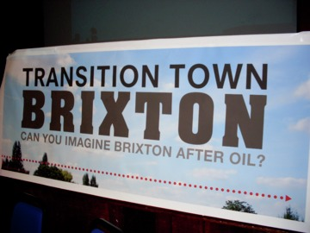
Figure 2 Transition Towns are one localised response to global issues
View description - Figure 2 Transition Towns are one localised response to global issues

The sense of a need to respond to global change is increasingly manifest in a range of strategies through which cities and other places aim explicitly and programmatically to transform not only themselves, but also other places with which they are connected. These initiatives include the rapidly internationalising Transition Town movement, Fairtrade Towns, city-twinning practices, ‘slow city’ movements and others. This response to global change is also expressed in various forms of collaboration through which different cities or towns officially or unofficially learn from the practices of other places, often including the circulation of different models for transforming cities or the sharing of templates for urban change. Alongside these more formal attempts to redirect urban processes there are also a great many less formal practices through which other agencies seek to bring about change or to resist the changes that are being imposed upon them. These include grass-roots associations and movements, day-to-day practices of maintaining and reconstructing the urban fabric and spontaneous forms of organisation that often spring up in the wake of sudden change or upheaval.
Any attempt to manage and transform specific places is going to be complex, subject to different or competing demands and constrained by limited resources and incomplete knowledge. The framework of critical spatial thinking outlined in this course is meant to help in the task of understanding the relationship between any single place and the wider world, giving ways of conceiving of linkages and interconnectivities that can help us make sense of the challenges of place making: how place-based issues arise, and how they take shape and gain intensity.

3 Three ways of thinking about urban agency
There are a number of different intellectual traditions that have defined the city or ‘the urban’, and which have tried to specify the distinctive types of agency that these places might have (see Bridge and Watson, 2011; Davies and Imbroscio, 2009; Fainstein and Campbell, 2002). Taken together, these strands of thought add up to a body of what in this course we call ‘critical spatial thinking’.
Broadly speaking, there are three ways in which the agency of urban places has been thought about in these traditions:
- The city is often imagined to have agency by virtue of the causal processes that characterise the very nature of urbanisation or urbanism.
So, for example, understanding urbanisation as a process of spatial agglomeration of functions, activities and practices leads to the sense that all sorts of contradictions and conflicts are clustered together in urban places. From this perspective, urbanisation is understood as a dynamic force in generating issues and contestation.
- The city is often presented as embodying a distinctive sort of community or culture: a community of strangers thrown together by circumstance and contingency, shaped by the rhythms and routines of urban life.
Here, the urban is often associated with the generation of distinctive styles of experience, consciousness and subjectivity that enable people to forge new identifications, new solidarities and new forms of belonging.
- The city is often talked about as a type of collective subject in its own right, with interests of its own and bestowed with capacities to act in the furtherance of those interests.
The idea of ‘the city’ as subject might be understood with reference to local government agencies, urban growth coalitions or the ‘community’.
Each of these three ways of thinking is most strongly developed in particular fields of academic work or in particular theoretical traditions. So, for example, thinking of the city as a cluster of contradictory processes is strongly indebted to Marxist urban and spatial theory; sociology has contributed to the idea of cities as distinctive cultural entities generating new forms of community; and political science and planning disciplines often think about the city as a locus of governance in its own right.

3.1 From urban theory to the problematisation of urban living


Figure 3 Urban theory is a response to specific problems of spatial development
View description - Figure 3 Urban theory is a response to specific problems of spatial development

Each of the three ways of thinking tells us something important, without necessarily telling the whole story of the agency of urban places and urban-based processes and practices.
The first way of thinking contains the germ of the idea that places are not contained or bounded, but that they overlap and are open to all sorts of influences from elsewhere: from other cities, but also from non-urban areas. And that it’s not only urban areas that are affected by urbanisation processes.
The second approach is open to the objection that there is no singular urban community, but multiple forms of urban experience and therefore a plurality of forms of collective associated with urbanisation processes.
The third idea of urban agency is open to the objection not only that all the members of a place do not have a single, collectively shared interest that ‘the city’ can pursue, but also that any agency that places do have might well be dependent on the relationships of dependence and autonomy they are tied into with other scales of authority, legitimacy and sovereignty.
So none of these three strands of urban thought and spatial theory provides a watertight, all-inclusive definition of the urban – the city – or of place.
But perhaps we shouldn’t think of disciplines or theoretical traditions as needing to provide such definitions or explanations in the first place. It might be better to think of different ideas of what defines a city, or what the urban is, as reflecting different ‘problematisations’ of spatial issues (see Cochrane, 2007). By this, all we really mean is that these different strands of urban theory might be better thought of as representing attempts to respond to recurring problems associated with some aspect of urbanisation processes. Some theoretical traditions are better than others at helping us grasp what is at stake in some aspects of urban processes, depending on just which aspect is the focus of concern.

3.2 Problematising urban processes

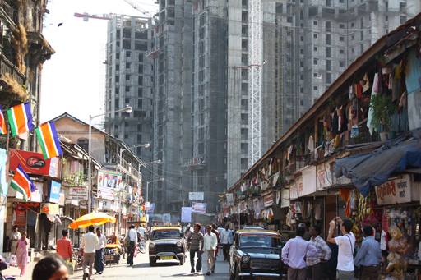
Figure 4 Girangaon, an area of central Mumbai
View description - Figure 4 Girangaon, an area of central Mumbai

We can revisit the three ways of thinking about urban agency in terms of ‘problematisations’, thinking of them as being guided by particular worries or concerns, or problems.
So, first, the strong emphasis on urbanisation as a causal process, generating conflicts and contradictions, is a response to the observable problems associated with the clustering and intensification of production, provisioning and consumption in larger and larger concentrations of built environment, with complex divisions of labour, and supported by complex technological infrastructures.
Second, the emphasis on the city as a distinctive form of social organism is likewise an index of the observable problems associated with the displacement and relocation of large numbers of people from different backgrounds into close proximity with one another and the ensuing challenge of forging new forms of sociability and belonging.
And third, the focus on the city as a scale of governance is a reflection on ongoing problems of defining just what powers local governments do and should have over what scope of activity and how those powers should best be exercised and regulated.
If we think of different strands of urban theory in this way – as distinctive problematisations of urban processes – then we arrive at a different approach to making use of these theories. Rather than thinking that our task is to arrive at the proper definition of what a city is, or how to characterise urbanisation, we might instead think of these strands as having degrees of ‘family resemblance’ to one another, overlapping in places, but as also drawing out and making visible distinctive ‘aspects’ of urban life.

3.3 Three types of questions about agency


Figure 5 Urban processes present multiple challenges for analysis
View description - Figure 5 Urban processes present multiple challenges for analysis

Thinking about ‘theory’ as comprising distinctive problematisations of urban processes helps us to regard these different strands of academic inquiry not so much as providing definitions, but as opening up questions, questions we can deploy analytically in our own investigations of particular urban issues and problems. So the three broad approaches to thinking about urban agency can be redescribed as drawing our attention to three types of questions about agency:
- The first type of question we can ask about urban issues concerns causal analysis. This type of question seeks to explain the processes, practices, interests and actors that generate the conditions through which issues emerge as potential objects of debate, contention, intervention, management and regulation.
- The second type of question focuses on how these potential objects of action are identified and recognised. This type of question seeks to understand the communicative processes which provide opportunities for people to recognise shared interests, identify a shared sense of grievance or develop collective strategies to express their concerns.
- The third type of question we can ask is concerned with understanding the powers that different actors or organisations have to act effectively on urban issues. Is the city, for example, necessarily the most effective jurisdictional scale for managing urban issues, whether it is thought of as a scale of legitimate government or as a scene for the exercise of citizenship?
It is important to reiterate that this three-way distinction between types of questions is an analytical device for thinking about spatial issues. Each of the three questions opens up to view one aspect of any particular issue – causal aspects, aspects related to how social relationships are formed and the aspect pertaining to the ‘who’ and ‘what’ of actually acting in response to issues and problems. A comprehensive approach to any specific issue will involve the integration of all three aspects.
In order to further develop the framework of critical spatial thinking that builds on these different traditions – in which cities and other places are thought of as agents in processes of issue formation, in the articulation of opinions and interests, and in the enactment of collective action and institutional authority – we will now move on to look at each of these three traditions in a little more detail in Sections 4, 5 and 6.

4 Explaining urban issues
The framework of critical spatial thinking outlined in Section 3 leads us to ask three types of question – about explanation, understanding and action. The first type of question focuses on identifying the causal processes at work in generating the stresses and strains, the opportunities and potentials provided by urbanisation processes.
To elaborate further on this first aspect of the analytical heuristic provided by critical spatial thinking, it is worth considering the work of the geographer and social theorist David Harvey.
Harvey’s work focuses on developing a comprehensive account of the causal dynamics of capitalist crisis. Harvey conceptualises neoliberal policy regimes as promoting the financialisation of everything, and in so doing makes visible the connections between the dynamics of global financial markets and the dynamics of urban restructuring around the world in the last 40 years. His strong claim is that his approach represents a more robust and more incisive causal explanation of the current financial crisis than those provided by others precisely because it does explain the internal relationship between, for example, the innovation of new financial instruments such as ‘derivatives’, which gamble on future commodity prices, and the explosion of sub-prime mortgage products in the USA from the 1990s onwards.

Activity 1

In order to get a sense of how Harvey’s approach to explanation differs from other approaches, watch this RSA Animate version of Harvey’s 2010 lecture on the crisis of capitalism. As you watch the animation, you might want to note down the different sorts of explanation Harvey identifies in his talk.

View discussion - Activity 1

4.1 Urban theory and case studies

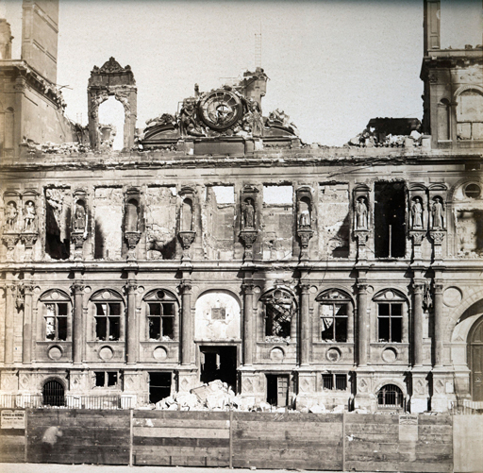
Figure 6 The exemplary city: damage to the Hôtel de Ville, Paris, in 1871, following the collapse of the Paris Commune. Nineteenth- and early twentieth-century Paris is a basic reference point for modern urban theory
View description - Figure 6 The exemplary city: damage to the Hôtel de Ville, Paris, in 1871, following ...

There is a clear relationship between causal generalisation and the use of empirical case studies underlying Harvey’s explanatory narrative. The explanatory analysis draws heavily on Harvey’s empirical and historical research on two very different cities:
- Harvey makes a great deal of the social, economic and physical transformation of Paris in the middle and late nineteenth century – one of the most researched cities in social theory, and one of the most researched periods of that city’s history.
- Harvey’s analysis of creative destruction also draws heavily on his experience of living and working in the much more ordinary city of Baltimore: a declining, chronically crisis-prone industrial port with little glamour about it, most famous perhaps for the dark images of urban living provided by TV series such as Homicide: Life on the Streets and The Wire, or the images of suburban pathology in the films of Barry Levinson or John Waters.

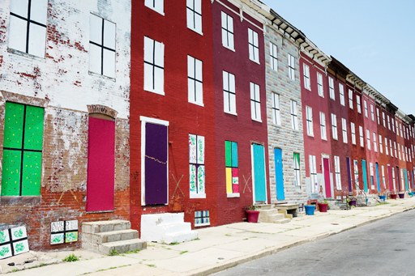
Figure 7 The ordinary city: boarded-up terraced houses in Baltimore
View description - Figure 7 The ordinary city: boarded-up terraced houses in Baltimore

Harvey’s explanatory conceptualisation of urbanisation therefore illustrates a more general point about the relationship between case studies and theory formation in spatial disciplines such as geography, anthropology, urban and regional studies and planning theory (see Campbell, 2003). These places are made exemplary of particular processes, but in different ways.
Paris, in Harvey’s analysis, is an example of an exceptional city, one which crystallises and makes visible dynamics that are not likely to be found in the same intense concentration in more ordinary places, but that, in their very concentration, serve as best-case models of a range of processes.
Baltimore serves as an exemplar of how these same processes do, indeed, play themselves out in all sorts of ‘ordinary’ places (see Robinson, 2006) – places where old neighbourhoods are replaced by shopping malls or office developments, where bus services are privatised, or where old industrial land uses are transformed into leisure spaces.
In both cases, Harvey uses these places as the cases through which to ask causal questions: about how things work; how processes hang together and interact with each other in particular places; how different interests shape spatial processes; and how practices and consequences travel between places as processes spread out and resonate across space.

4.2 The globalisation of urbanisation

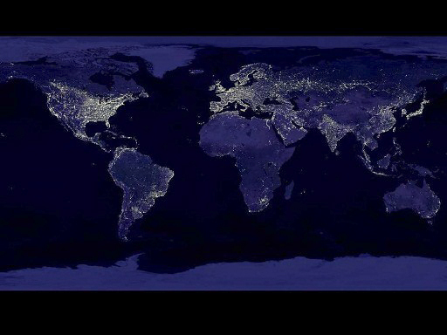
Figure 8 A NASA photo showing the lights from urban areas around the world
View description - Figure 8 A NASA photo showing the lights from urban areas around the world

Harvey’s analysis of what he calls ‘the urbanisation of capital’ (Harvey, 1985) identifies a constant tension in urban processes of economic growth. As the fixed patterns of built environments and material infrastructures are configured to enable the ongoing circulation of capital, there comes a point when these patterns come to act as a drag on further profitability, rather than greasing the path for ongoing accumulation. This is the dynamic that, according to Harvey, characterises urban development under capitalism, a tension arising from the internal connection between fixity and mobility in the urban landscape. In this view, capitalist urbanisation:

… must negotiate a knife-edge between preserving the values of past commitments made at a particular place and time, or devaluing them to open up fresh room for accumulation. Capitalism perpetually strives, therefore, to create a social and physical landscape in its own image and requisite to its own needs at a particular point in time, only just as certainly to undermine, disrupt and even destroy that landscape at a later point in time. The inner contradictions of capitalism are expressed through the restless formation and re-formation of geographical landscapes.
(Harvey, 1985, p. 150)

Harvey’s causal narrative of the knife-edge between the construction of material infrastructures of movement and circulation, and the destruction of stable built environments and ways of life through which modern urbanisation emerges as such a powerful historical force, informs his account of how the crisis-dependent dynamics of urbanisation have now become the driving force in the generation of a whole host of global challenges. It is also the basis for his account of how the crisis tendencies of capitalist urban development open up opportunities for all sorts of political action to challenge and transform established patterns of urban development.

Activity 2

In his essay on The right to the city, Harvey outlines how the dynamics of global financial crisis in the two decades from the mid-1990s onwards was intimately related to urbanisation processes. As you read, focus on the first three paragraphs after the subheading ‘Girding the globe’. You might want to keep in mind the ‘knife-edge’ metaphor that you have already seen is so important to Harvey’s analysis of ‘creative destruction’, and think about how the relationships captured by this image are worked through in this account.

4.3 Living on the knife-edge

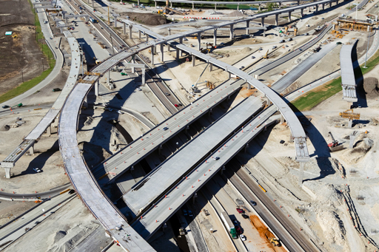
Figure 9 Urban development is a process of ongoing construction and reconstruction
View description - Figure 9 Urban development is a process of ongoing construction and reconstructi ...

In Harvey’s view of urbanisation, the ‘knife-edge’ negotiation between investment and devaluation leads to the generation of a whole host of crises:
- environmentally unsustainable patterns of transportation, provisioning and energy use
- financial collapse and insecurity
- underinvestment in public goods of affordable housing, clean water and sanitation or public health.
To underscore the key point, in Harvey’s causal narrative, cities are not just the locations in which these crises and challenges are felt; they are the incubators in which the conditions of these crises and challenges are bred and disseminated. In this view, global problems are not externally produced, and then ‘impact’ on places. They are internally generated by place-specific processes and the modes of relationship between places through which causes and consequences resonate across space and time.
Harvey’s causal narrative of urbanisation makes a particularly strong case for two related dimensions of the agency of urbanisation processes: as the generative force in the production of a range of pressing contemporary issues; and also for thinking of place-based, urbanised movements and organisations as having special responsibility and potential for creatively addressing these challenges.

4.4 The right to the city

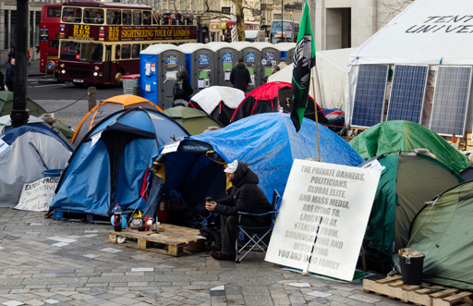
Figure 10 ‘Occupy London 2012’ camp outside St Paul’s Cathedral, 13 January 2012
View description - Figure 10 ‘Occupy London 2012’ camp outside St Paul’s Cathedral, 13 January 2012

In Harvey’s view, urban-based movements have special responsibility for addressing a range of contemporary issues because urbanisation processes are central to the increasingly unstable dynamic of accumulation that is resolved through and expressed through ever-accelerating rounds of creative destruction of the urban built environment (Harvey, 2012). The contradictions of neoliberalising capitalism as a regime of accumulation and mode of governance are, so the narrative goes, therefore increasingly concentrated in the rhythms and spaces of urban life itself. The inherent dynamic for the over-accumulation of capital finds its unstable resolution in the financialised recycling of capital surpluses into the creative destruction of urban environments. And this is why the global challenges generated by urbanisation are often experienced in a vocabulary of spatial or urban claims – claims to clean water, affordable food, safe neighbourhoods, local autonomy or clean environments – or, more broadly, of claims to the ‘right to the city’ or even ‘urban revolution’ (Harvey, 2012).
The idea of the ‘right to the city’ has become a rallying call for activists, non-governmental organisations (NGOs) and social justice campaigners around the world since the 1990s, and has even been integrated into policy thinking by international organisations such as UNESCO and UN-HABITAT. The idea was first developed by the French urban theorist Henri Lefebvre. As a normative ideal and a campaign objective, the ‘right to the city’ idea rests on the observation that the experience of injustice in the contemporary world is increasingly focused on some aspect of urban living or urbanised practice (see Merrifield and Swyngedouw, 1996). The implication is that more and more political contention is generated by the deepening dependence of social life on urban infrastructures, through which state capacity and the logics of accumulation reach into everyday life.
The notion of the ‘right to the city’ supposes that there is a cluster of activities that count as ‘urban politics’, not just because they take place in particular places but because they revolve around urbanised issues of contention (the concentrated, material conditions of social reproduction) and around distinctively urbanised value claims (the right to certain minimal standards of habitability, or ‘inhabitance’) (see Purcell, 2008). The ‘right to the city’ has also been made central to an assertive claim about urban politics now having a global importance in driving radical democratic possibilities.
In David Harvey’s view, challenges to the contemporary hegemony of finance capital should be centred on claims such as the ‘right to the city’ idea, since the inherent dynamic for the over-accumulation of capital finds its unstable resolution in the financialised recycling of capital surpluses into the creative destruction of urban environments. In Harvey’s analysis, the ‘right to the city’ illustrates a view of urban politics that is not restricted to the politics that goes on in cities and is directed solely at urban-scaled institutions, but that is global and cosmopolitan in its scope and ambition.
The ‘right to the city’ idea is therefore another example of the ‘urbanisation of responsibility’ already mentioned in this course. The idea is grounded in a narrative in which urbanisation processes are identified as being causally responsible for the generation of fundamental challenges to whole societies. At the same time, cities are also identified as being crucial agents responsible for solving these challenges.

4.5 Limits to explanation
We have emphasised Harvey’s explanatory narrative because of the clarity with which it picks out the causal forces of urbanisation processes. In his account of the ‘right to the city’ and ‘urban revolution’, he also makes claims about the other two dimensions of our three-way heuristic, the aspects of understanding and action.
It should be said, of course, that Harvey’s account is not without its critics. In particular, it is so all-encompassing in its view of capitalist dynamics that it ends up presenting the ordinary practices of urban politics, administration and management – the activities of planners, environmental managers, councillors, NGOs and the like – as, at best, ameliorating the worst effects of these processes or, at worst, as being complicit with their reproduction. The coherence of the explanatory narrative ends up leaving an ‘all or nothing’ impression about what can be done to address the challenges of what has been called ‘planetary urbanisation’ (Brenner, 2013).
A particular feature of Harvey’s analysis is the sense it gives that all places are subject to the same disciplining effects of global financial capital: they are forced to engage in a competitive race-to-the-bottom in establishing urban development policies that will attract apparently footloose and mobile global investment.
This vision of the powerful causal forces buffeting places might underestimate the autonomous ‘causal powers’ which mean that particular places have to adopt urban policies that are potentially more sustainable, egalitarian and redistributive than is often acknowledged.
Harvey’s narrative might provide the resources for explaining how the contradictions between economic growth, investment in fixed infrastructures and settled urban living spaces generate the conditions in which new visions of the possibilities for urban living might emerge.
However, on its own, this causal narrative doesn’t provide the whole story. It doesn’t account for why these conditions generate public issues in some places but not others. To account for this we need to move on to consider in more detail the second aspect of critical spatial thinking: how people come to understand their interests in an issue through processes of identification, recognition and communication.

5 Understanding urban issues
The second type of question which the framework of critical spatial thinking leads us to ask focuses on understanding how potential objects of action are identified and recognised. This aspect of analysis draws into view the various communicative processes which provide opportunities for people to recognise shared interests, identify a shared sense of grievance or develop collective strategies to express their concerns. In calling this second aspect ‘understanding’ of urban issues, we mean to signal two related things:
- This aspect of analysis is concerned with how participants in urban issues or spatial practices themselves come to understand their own identities and how best to pursue their own interests. Academic analysis can, of course, still seek to explain the processes through which this understanding is developed; however, because properly appreciating these processes requires sensitivity to the perspectives of actors themselves, adopting an observer–participant approach has its limits.
- The second aspect of critical spatial thinking requires a movement between an observer perspective and a sensitivity to participant perspectives, so academic analysis is better characterised here as seeking a form of understanding that is not necessarily reducible to causal explanation.
The second aspect of the critical spatial thinking framework draws on two related traditions of urban and spatial thought, both of which alight on the distinctive characteristics of modern cities as social and cultural organisms. Both of these traditions focus on ‘who’ questions more than ‘why’ questions.
First, there is a strand of sociological thought that has emphasised the distinctive forms of social interaction and sociability that characterise the city – a strand best-known for the claim that the city gives rise to a distinctive culture, dubbed ‘urbanism as a way of life’.
Second, there is a strand of sociological thought and political theory that connects this sense of the distinctive social forms of city life to a stronger quasi-political claim about the city as the scene for the formation of a distinctive type of public life, through which urban residents recognise themselves and act as citizens of a shared collective course.

5.1 Urbanism as a way of life

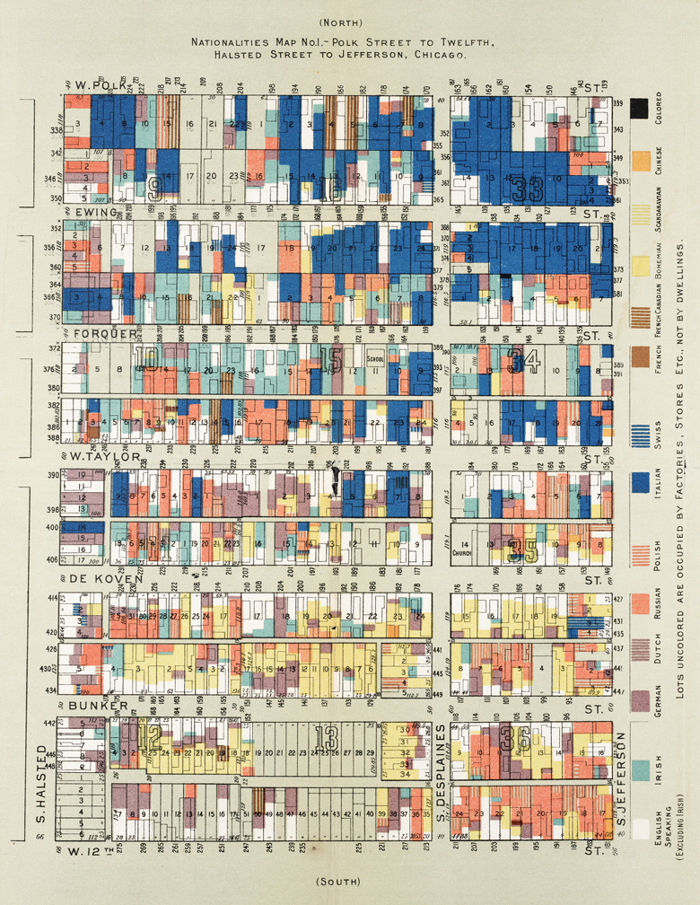
Figure 11 Mapping cultural difference in Chicago: social scientists associated with the Chicago School pioneered innovative styles of research into ethnic, race and class division in the city at the turn of the twentieth century. This map shows the distribution of people of different national origins in one small area of Chicago
View description - Figure 11 Mapping cultural difference in Chicago: social scientists associated with ...

There is a long-standing tradition of thought, most famously associated with the Chicago School of urban sociology that emerged in the late nineteenth and early twentieth century, in which urban spaces are presented as the locations for the emergence of novel forms of social interaction and personal identity. Succinctly captured in Louis Wirth’s formulation of ‘urbanism as a way of life’, the Chicago School provided a theoretical framework for a much broader cultural narrative in which the modern industrial city was understood as a place where old deferential, traditional forms of organic community life were broken down and replaced by much more individualised, anonymous, mechanical and impersonal forms of collective interaction (Abbott, 1999; Smith, 1995).
As with other traditions of urban theory, this definition of the city is a particular problematisation, emerging from the specific contexts of Chicago at that time. It is an understanding that is closely related to the experimental styles of academic engagement that members of the Chicago School were themselves involved in at the time amongst poor and marginalised immigrant communities in the city.
There is a strong emphasis in the Chicago School’s account of urban culture on the ways in which spatial patterns of interaction, heterogeneity, intensity and mobility shape identities, experience and expression. This is a long-standing feature of spatial theory, in which the problem of thinking about the relationship between spatial pattern and spatial form on the one hand, and social and cultural relations on the other, is a perpetual, unavoidable issue. It is a strand reflected in the work of some of the most famous proponents of normative urban thought, including the pioneer of urban sociology, Charles Booth, father figures of urban planning such as Ebenezer Howard and Raymond Unwin, and critics of planning such as Jane Jacobs and Richard Sennett.
One shared feature of this canon of urban cultural theory is a sense that life in the modern city is always on the cusp of anomie, breakdown, isolation, bewilderment or alienation.

Living with others
In contrast to this distinctively pessimistic view of life in the modern city, a counter-tradition of spatial thinking also emphasises the idea of the city as a distinctive social and cultural organism, but does not suppose that this needs to be understood in terms of decline or breakdown. For example, in a tradition of social network analysis developed in analyses both of London and in colonial and post-colonial contexts of southern Africa, the city is understood primarily as ‘a network of networks’. This is how the urban geographer Jenny Robinson summarises this idea:

Individuals in the city participate in varying types of networks of social relations, involving different qualities or intensities of interaction (from very intense and intimate in relation to kinsfolk, for example, to distant and fleeting in relation to people one passes on the street).
(Robinson, 2006, p. 51)

In this view, the city is not a scene for a singular experience of either pathological alienation or liberating anonymity, but rather is characterised by various experiences depending on the different social networks one is located in – of kin, family, profession or neighbourhood. Just as fundamentally, in this view, the networks of interaction within a place stretch beyond contexts of face-to-face interaction. The urbanity of modern experience is also in part defined by being entangled in mediated networks of print culture or electronic communication.
This relationship between the intense concentration of communicative resources and experiential stimuli has led some analysts to present the city as the incubator for distinctively cosmopolitan styles of identification. In this view, the city is understood as a space in which people are exposed to diverse cultures and different identities, both up close and through pervasive media representations. Urban spaces are, in this view, the places where resources for identifying with people one does not know well if at all – with strangers, near and far – are concentrated, and opportunities arise for learning to appreciate one’s implication in wider processes of causality and consequence. This aspect of urbanism as a way of life leads on to the second dimension of theories of urban sociality, one which emphasises urban life as the condition of a distinctive style of public life that informs concerted, collective public action.

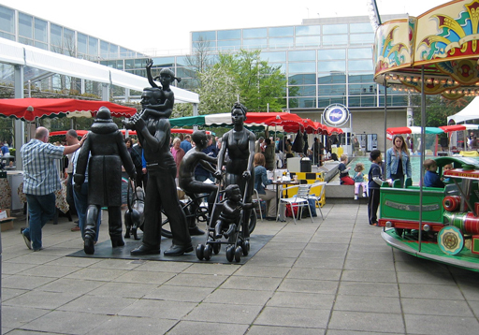
Figure 12 People use designed spaces like shopping malls for all sorts of purposes, some intended and some unanticipated
View description - Figure 12 People use designed spaces like shopping malls for all sorts of purposes, ...

5.2 Urban space and the public sphere
If sociologists and anthropologists have often used the city as a figure for a distinctive style of social life and personal identity, the same features that these accounts alight on are often presented by political philosophers as models for democratic politics and citizenship practice.
For example, the feminist philosopher Iris Marion Young has provided one of the most influential examples of this style of theorising, presenting city life as a ‘normative ideal’ of democratic participation which is preferable to models of community or liberal individuality that have trouble acknowledging the value of difference and diversity:

By ‘city life’ I mean a form of social relations which I define as the being together of strangers. In the city persons and groups interact within spaces and institutions they all experience themselves as belonging to, but without those interactions dissolving into unity or commonness. City life is composed of clusters of people with affinities – families, social group networks, voluntary associations, neighbourhood networks, a vast array of small ‘communities’. City dwellers frequently venture beyond such familiar enclaves, however, to the more open public of politics, commerce, and festival, where strangers meet and interact.
(Young, 1990, p. 237)

For Young, then, the diversity, complexity and vibrancy of the modern city is presented as a model of a certain form of sociality, characterised by contingency and difference. But her point is to translate this view, a feature of social science accounts of the city, into a model of democratic public life. In so doing, she spells out the links between the social and cultural characteristics of urban living and the expanded potential for identifying shared interests and chains of consequence:

City dwelling situates one’s own identity and activity in relation to a horizon of a vast variety of other activity, and the awareness that this unknown, unfamiliar activity affects the conditions of one’s own. City life is a vast, even infinite, economic network of production, distribution, transportation, exchange, communication, service provision, and amusement. City dwellers depend on the mediation of thousands of other people and vast organizational resources in order to accomplish their individual ends. City dwellers are thus together, bound to one another, in what should be and sometimes is a single polity.
(Young, 1990, pp. 237–8)

In this extract, Young spells out the conditions for the emergence of a shared sense of belonging as a citizen to a public. In so doing, she helps us to differentiate between two sorts of solidarity on which public life depends.

Two types of solidarity
The first type of solidarity is based on ‘functional interdependence’. This is a type of relationship based on structural connections that ‘join people in a mutuality that is not primarily manifest in their own common recognition of it but instead can operate, as it were, behind their backs’ (Calhoun, 2002, p. 161). This sort of relationship is not chosen, but is one we find ourselves already placed in by virtue of our jobs, our locations or our consumption practices.
Young’s exposition of city dwelling presents the city as a space in which people are simultaneously thrown into these sorts of functional relations of interdependence, but which also provides resources for translating this functional relationship into a chosen identification of solidarity or shared interest with others. She is, then, pointing towards a second form of solidarity, one which is actively shaped and cultivated by people themselves, in which they refashion the relationships they find themselves thrown into as ones of their own making, with their own significance and potential. For thinkers such as Young, and many others too, cities provide models for this type of public-making because of the experience of living among diverse and differentiated populations, and also because of the concentration in such places of mediated communications about distant peoples and places.
In developing her account of the city as a model of active public formation, therefore, Young alights on two dimensions of the relationship between urban living and solidarity – the experience of being thrown into new relationships of dependence and proximity with others, and also the practices of learning new ways of negotiating these relationships.
The image of the city as a social and communicative entity can, in fact, be traced back to older traditions of urban theory. For example, Robert Park, the leading figure of the Chicago School, is both a key figure in modern urban theory and a forebear of media and communication studies. Park’s academic writing spanned work on the urban immigrant press, on the connections of newspaper circulation and urbanising culture and, notably, on the ‘natural’ history of the newspaper. For Park, the newspaper was a countervailing force against the complexity of the modern city, instilling among its readers an awareness of, and interest in, an unprecedented common urban cultural world. As a ‘printed diary of the home community’ (Park, 1925, p. 85), the newspaper became a condition of possibility for mobilising the city as a social–political body: it provided the medium through which people could identify themselves as members of larger ‘imagined communities’ of class, city or nation.

5.3 Cities as communicative spaces


Figure 13 Cities have been associated with the formation of new forms of public life, often mediated by new forms of communication such as the radio, newspapers or social media
View description - Figure 13 Cities have been associated with the formation of new forms of public life, ...

Robert Park’s work is just one example of a broader emphasis on the role of media – news media and popular culture – in mediating the relationship between urban space and concerted public action. Mediated communications play different roles in the emergence of public life: they make available substantive topics as public issues; and they provide opportunities for the performance and representation of styles of identity and identification.
There is certainly a long-standing tradition of presenting urban space as the privileged stage for the formation of publics. In geography and urban studies, the emphasis tends to be on the spectacular dramaturgy of street protest and confrontational forms of mobilisation. Examples might include the pro-democracy campaigns staged in Tiananmen Square in Beijing in 1989, or the protests held in Tahrir Square in Cairo in 2011. This tradition succeeds in foregrounding the importance of claims-making as an important dimension of political contention. However, there is a recurrent tendency in such work to overestimate the degree to which city spaces are effective communicative spaces for political action (see Barnett, 2008).
Once we recognise that the city is a site where mediated communicative practices are particularly concentrated, then our sense of the role of urban spaces in the development of concerted public action should be freed from a focus on dramatic urban events like protests in the street or the occupation of public squares or public buildings.
Understandings of urban space as a communicative arena lead us to think of the city as serving multiple purposes in the recognition of consequences and interests through which issues emerge as matters of shared concern. Rather than focusing only on how people interact in face-to-face situations – in coffee shops, on the streets or as participants in protests – we can see urban life as a context in which all sorts of opportunities for communication present themselves to people. As the urban theorist Gary Bridge (2005, p. 95) remarks, our notions of the public ‘have been focused too much on the need for acknowledgement in public, in the open spaces of co-presence, rather than in the myriad ways that people are mediated by objects and systems of communication and the potential for publicity in them’.

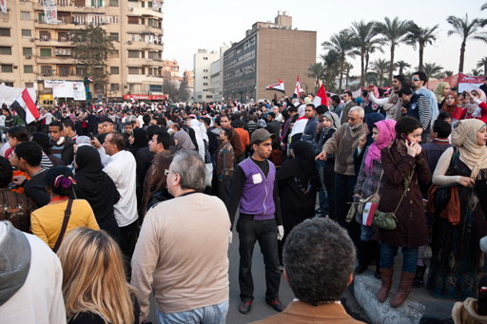
Figure 14 Egyptians celebrate the fall of the Mubarak regime in Tahrir Square, Cairo, 12 February 2011
View description - Figure 14 Egyptians celebrate the fall of the Mubarak regime in Tahrir Square, Cairo, ...

5.4 Urban spaces of public address
The work of the Australian geographer and planning theorist Kurt Iveson is helpful in order to better appreciate the importance of urban space as a medium for the communicative practices through which public action is formed around issues of shared concern. Iveson’s work is concerned with spelling out the relationship between urban space and public communication without putting a premium on the ideal of synchronous, face-to-face interaction.

Activity 3

Read Kurt Iveson’s paper, The city versus the media? Mapping the mobile geographies of public address. For this activity, focus on the first six paragraphs of the paper. As you read, pay particular attention to the distinction he draws between mediated and unmediated forms of interaction, and how this distinction leads to a focus on the relationships between different spaces.

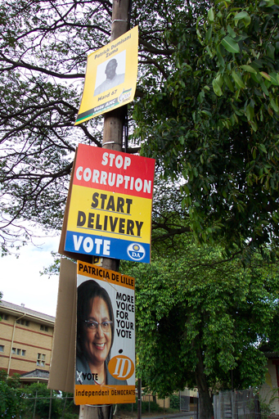
Figure 15 Urban space and political communication: election campaign posters in South Africa, a routine form of public communication in urban space
View description - Figure 15 Urban space and political communication: election campaign posters in South ...

In asking about the importance of urban spaces as communicative mediums of public address, Iveson identifies three interconnected dimensions to the public quality of urban space: urban space functions as a venue for public action, as an object of action and as the subject of action itself, as the public. In each case urban space is, as he puts it, ‘fundamentally related to (rather than opposed to) media practices’.

Activity 4

Return to Iveson’s essay The city versus the media?. This time, focus on the sections ‘Urban places as venues of public address’, ‘Urban places as objects of public address’ and ‘The city as “the public”’. As you do so, you might want to consider how his distinctions between the city as venue, object and public overlap with the distinctions in the framework of critical spatial thinking outlined in this course.

Iveson provides an analysis of urbanisation as a process which involves the generation of myriad spaces of public address, and of being addressed.
The dimension of urban space as an object of public concern corresponds to the first aspect we have identified – the ways in which urbanisation generates potential issues of public concern.
The dimension in which places serve as the venues of public address maps on to the aspect which is the main focus of this section: understanding the role of urban space in providing the communicative resources in which people come to see themselves as parts of larger collectives sharing identities and interests.
And the third of Iveson’s dimensions, where the city is itself understood to represent ‘the public’, speaks directly to the third aspect of the critical spatial thinking framework: the question of which actors are empowered to act effectively in response to urban issues.
With respect to both the third of Iveson’s dimensions and the third aspect of the analytical framework of critical spatial thinking outlined in Sections 2 and 3, the question of whether urban places should be thought of as an effective agent of concerted public action is far from clear-cut. It is to this issue – whether or not ‘the urban’ is an effective agent of concerted collective action – that we now turn.

6 Acting on urban issues
In Section 5 we looked at the spatial processes through which people come to see themselves as sharing an interest in particular issues with people they may never have known or met. We saw how Iris Marion Young suggested that urbanisation processes play two roles in this process: throwing people together so that they may come to see each other as sharing certain concerns, and also recognise their dependence and affinities with others; but also providing the mediums through which people can address and be addressed by others as potential members of a wider public.
The framework of critical spatial thinking leads us, however, to a third analytical question. Once people have identified themselves as members of wider collectives – perhaps as members of a public with shared interests, or perhaps as members of an interest group with specific grievances it wants to redress – what is to be done about their concerns? Who is responsible for taking action and who has the capacity to do so?
And, more to the point, at what spatial scale does effective power to do something about issues lie?
Does the answer to this question vary according to the issue involved, between, for example, toxic air pollution, inadequate housing, or the imminent threat of flooding?
In short, who can and should act in response to urban problems: to pre-empt them, reconfigure them or respond to their consequences?

6.1 The politics of urbanisation processes
A common assumption in urban studies and spatial theory is that the importance of urbanisation processes in generating issues, and in enabling them to be identified and recognised as potential political, public concerns, must also inform a distinctive style of urban politics, contained at the urban scale and consisting of actors with distinctively localised, place-based interests.
However, much of what we have already considered in this course should lead us to think that the politics of urbanisation processes does not necessarily lead to urban politics in this sense at all. We are returned to the challenge laid down by Harvey’s all-encompassing causal analysis of the dynamics of urbanisation – does this type of explanatory account of the factors shaping any and all localities necessarily imply that purely local action, contained within and enabled by place-specific factors, is doomed to failure or to be merely ameliorative?
The third aspect of the critical spatial thinking framework is meant to help us think more openly about the potentials of local action to make a difference in the context of this sort of causal, explanatory account of the degree to which particular places are shaped by, and in turn shape, processes that pass through and reach beyond them.
Recognising that ‘the local’ or ‘the city’ is not a privileged scale for concerted, effective political action should not lead us to dismiss the importance of activities at this scale. It is not necessary to assume that local institutions are somehow more democratic because in closer ‘proximity’ to people’s concerns in order to recognise, nevertheless, that those local institutions are empowered to act effectively in certain ways. This is particularly relevant for organisational fields such as town and country planning or environmental management, which are often by definition institutionally organised at local, territorially bounded scales and oriented towards the goal of bringing about locally specific objectives.
The challenge that the framework of critical spatial thinking seeks to answer is to provide insight into imagining alternative ways in which such localised action might be undertaken, including ways which are fully engaged with the extra-local dynamics that both constrain and enable such local interventions (see Barnett et al., 2011).
With this in mind, two issues are particularly important in understanding the forms of agency which can be exercised through locally embedded, locally oriented institutional fields such as urban planning or environmental management. The first concerns the forms of participation and influence that centralised, state authorities can and should be expected to be responsive to. The second relates to the way in which ‘local autonomy’ might be best conceptualised.

6.2 The limits of localism I: the limits of inclusion

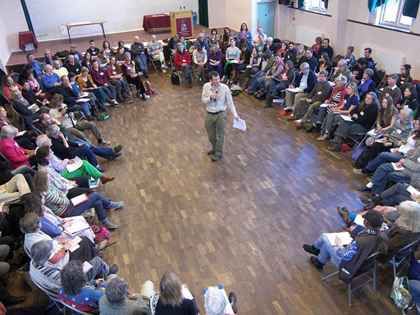
Figure 16 Second Transition Towns Conference, Cirencester, 2008. Initiatives like this make strong claims about the importance of including local people in decision-making processes
View description - Figure 16 Second Transition Towns Conference, Cirencester, 2008. Initiatives like ...

There is a long tradition of presenting ‘the city’ or local places as the best scale at which effective and democratic governance should be organised. This follows from rhetoric in which, since people live locally and experience the benefits and costs of government locally, it is assumed that local institutions should somehow be more responsive and accountable to these locally articulated concerns. The localism agenda of the UK Conservative/Liberal Democrat government elected in 2010, associated with the Big Society programme, is only the latest variant of this understanding; the same principle underwrote legislation introduced by the previous, Labour government to allow locally elected mayors (see Clarke and Cochrane, 2013).
In both cases, ‘local’ institutions of governance and participation are presented as being more democratic on both intrinsic and instrumental grounds – it is assumed that people can participate more effectively in local institutional settings; and that the different insights of local communities can provide more direct access to the needs and requirements of communities affected by institutional decision making.
These sorts of assumptions about local democracy and local governance have been important in shaping normative models of the role of expert decision makers such as planners and environmental managers.
In one model, professional actors are understood as experts, bestowed with technical knowledge which allows them to intervene and impose their expertise within local fields of concern to resolve potentially contentious issues. This sort of model of ‘planning’ as a general logic of bureaucratic governance has been sharply criticised by writers such as Jane Jacobs in her critique of modernist urban planning or James Scott in his critique of the failures of modern development programmes.
Partly in response to these sorts of criticisms of the omniscient expertise of planning professionals, alternative approaches have emerged. Informed by ideas of communicative or deliberative democracy, these tend to present professionals as facilitators who bring together all affected parties, ensure all viewpoints are expressed and move disagreement towards more or less rational consensus, or at least agreement (Fincher and Iveson, 2008; Flyvbjerg, 1998; Forrester, 2009).
In both cases, of course, the role of professional decision makers is still presented as one of neutrality. The problem with these assumptions is that they tend to overestimate the inclusiveness of local governance procedures, and thereby have difficulty acknowledging that there might be other ways in which affected parties to any decision might want to articulate their interests or concerns. This is particularly the case once it is also recognised that some affected parties will not presume that local institutions are the best placed actors to address their grievances or concerns.

Activity 5

Read this short comment paper by Catherine Sutherland, an academic researcher based in South Africa. She is reflecting on the general lessons to be drawn from the patterns of what she calls ‘insurgent urbanism’ that are a feature of the politics of planning in cities of the global South, and, it should be said, increasingly of the global North as well. As you read the piece, you might want to consider whether you can think of any local examples in your area of the dynamics of inclusion and exclusion that Sutherland identifies.

View discussion - Activity 5

6.3 The limits of localism II: the limits of efficacy

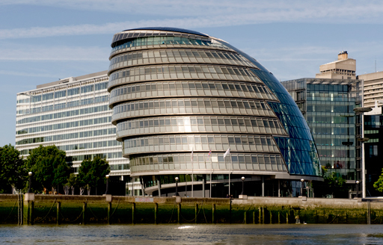
Figure 17 An effective site of power? City Hall in Southwark on the south bank of the River Thames, home of the Greater London Authority
View description - Figure 17 An effective site of power? City Hall in Southwark on the south bank of ...

If there are limits to the extent to which local-level institutions embedded in places or cities can claim to be democratically inclusive, then this is closely related to the fact that locally embedded institutional structures are not necessarily effectively empowered to address the fundamental causes of issues that are locally experienced. The frustrations that galvanise the insurgent urbanisms described by Sutherland in Section 6.2 are not only, or necessarily primarily, shaped by the internal logics of exclusion; they are just as much shaped by the acknowledgement by locally embedded actors that locally scaled governance structures do not necessarily command the efficacy required to be able to respond to their concerns and demands.
Geographers and planning theorists such as Mark Purcell (Purcell, 2006) and Murray Low (Low, 2004) have warned against falling into ‘the local trap’ – of assuming that local-scale initiatives are always a preferable option. Local problems might not necessarily have local causes, for one thing. And localities might face real constraints in being able t act effectively in relation to extra-local processes.
This should not, however, lead us to despair. It might actually encourage us to think of cities as experimental spaces, enabling us to recognise the ways in which particular places are empowered to act in relation to complex causal processes without necessarily overestimating the political efficacy of the urban as a scale of governance.
For example, the political scientist Archon Fung uses case studies of grass-roots mobilisation and participation in deprived neighbourhoods in the South Side of Chicago to develop a model of ‘empowered participatory governance’ relevant to other places (Fung, 2004). In one case, local residents turned around a poorly performing local school, Africanising the curriculum and instilling a greater degree of pride and self-confidence in the students. In another case, of resident participation in neighbourhood policing, neighbourhood liaison and representation on the local police board led to hitherto hostile styles of policing being transformed into more cooperative and effective forms. In both cases, Fung’s argument is that using locally embedded infrastructures enabled institutional experimentation that can be disseminated to other settings.
This sense of ‘experimental’ urbanism should, however, be linked to a stronger argument which challenges the ready-made understanding that local places have little influence over the processes that shape them from the outside. ‘Global’ processes are not external to places, but are located in and run through them (Allen, 2010; Massey, 2007). This implies that we should look carefully at how different places are empowered to configure their relationships with extra-local actors in different ways to the benefit of those localities. Examples of this sort of experimental urbanism, which seeks to engage creatively with the linkages that make up particular places, include practices such as Fairtrade urbanism, Transition Town movements and ‘slow city’ networks (see Tyszczuk et al., 2012).

6.4 Making use of the critical spatial thinking framework

Activity 6

Now listen to the audio for this course. In this audio, the geographer Clive Barnett, one of the authors of this course, talks to Margo Huxley about the relevance of the critical spatial thinking framework outlined in this course to her own work. Margo is an expert in urban planning and human geography, and also has extensive practical experience of working around issues of planning and urban change.
In their conversation, Clive and Margo reflect on the ways in which critical spatial thinking can throw light on examples close to their own concerns – Margo talks in particular about a place she is familiar with, personally and professionally, the city of Sheffield in the north of England. As you listen to the discussion, you might want to keep in mind that, like Margo, you are likely to be familiar with places or issues not covered in this course, and notice how she talks about how the critical spatial thinking framework might apply to her particular example.
Clive and Margo talk about three related topics. First, Margo reflects on the way in which issues arise in particular places, and she notes the idea of ‘ordinary cities’. Then, they move on to consider how the three dimensions of critical spatial thinking might be useful in understanding the specific example of urban change in Sheffield that Margo is involved in. Finally, they consider the practical relevance of this way of thinking, and touch on the notion of ‘spatial rationalities’ that underwrite practical interventions in spatial processes.
The discussion is intended to help by providing a guide to thinking about how you might apply the framework of critical spatial thinking to examples with which you might be familiar.

Audio content is not available in this format.
The framework of critical spatial thinking
View transcript - The framework of critical spatial thinking

Conclusion
This course has outlined a framework of critical spatial thinking, drawn from a variety of traditions of spatial and urban theory in the social sciences. The framework is intended to serve as an analytical device for investigating the key questions raised when presented with a pressing urban issue or a spatial problem. It is based on a threefold understanding of the problematisations to which definitions of the urban are a response:
- The urban represents a complex of issues, problems and objects which generate contention, gathering together myriad indirect consequences that are generated both locally and from afar.
- The urban is a field where the diversity and interconnectedness of effects operate as a seedbed for issue recognition. The recursiveness of urban life is also important in the formation of signs and symbols that can represent purposes and help anticipate consequences. These objects of recognition and intervention are also the medium out of which political subjectivities can be enhanced and people can learn to be affected.
- The urban remains the site of institutional architectures that might be useful in the development of further democratising impulses, either through challenge and alternative institutions or through further democratisation of institutions that already exist.
This framework is meant to help you structure the further investigation of an issue or a problem. It should provide avenues of enquiry more than answers, helping you to pinpoint the things to look for and the questions to pursue as you seek to understand the issues involved in making sense of contemporary challenges of ‘changing cities’ and the ‘urbanisation of responsibility’.

References
Abbott, A. (1999) Department and Discipline: Chicago Sociology at One Hundred, Chicago, IL, University of Chicago Press.
Allen, J. (2010) ‘Powerful city networks: more than connections, less than domination and control’,Urban Studies, vol. 47, pp. 2895–911.
Barnett, C. (2008) ‘Convening publics: the parasitical spaces of public action’ in Cox, K., Low, M. and Robinson, J. (eds), The Sage Handbook of Political Geography, London, Sage.
Barnett, C., Robinson, J. and Rose, G. (eds) (2008) Geographies of Globalisation: A Demanding World, London, Sage.
Barnett, C., Cloke, P., Clarke, N. and Malpass, A. (2011) Globalizing Responsibility, Chichester, Wiley Blackwell.
Brenner, N. (2013) ‘Theses on urbanization’,Public Culture,vol. 25, pp. 85–114.
Bridge, G. (2005) Reason in the City of Difference, London, Routledge.
Bridge, G. and Watson, S. (eds) (2011) The New Blackwell Companion to the City, Oxford, Wiley Blackwell.
Calhoun, C. (2002) ‘Imagining solidarity: cosmopolitanism, constitutional patriotism, and the public sphere’, Public Culture, vol. 14, pp. 147–71.
Campbell, S. (2003) ‘Case studies in planning: comparative advantages and the problem of generalization’, Urban and Regional Research Collaborative Working Paper Series, Ann Arbor, MI, University of Michigan.
Clark, N., Massey, D. and Sarre, P. (eds) (2008) Material Geographies: A World in the Making, London, Sage.
Clarke, N. and Cochrane, A. (2013) ‘Geographies and politics of localism: the localism of the United Kingdom’s coalition government’, Political Geography, vol. 34, pp. 10–23.
Cochrane, A. (2007) Understanding Urban Policy: A Critical Approach, London, Sage.
Davies, J. and Imbroscio, D. (eds) (2009) Theories of Urban Politics, London, Sage.
Fainstein, S. and Campbell, S. (eds) (2002) Readings in Urban Theory, Oxford, Wiley Blackwell.
Fincher, R. and Iveson, K. (2008) Planning and Diversity in the City: Redistribution, Recognition and Encounter, Basingstoke, Palgrave.
Flyvbjerg, B. (1998) Rationality and Power: Democracy in Practice, Chicago, IL, University of Chicago Press.
Forrester, J. (2009) Dealing with Differences: Dramas of Mediating Public Disputes, Oxford, Oxford University Press.
Fung, A. (2004) Empowered Participation: Reinventing Urban Democracy, Princeton, NJ, Princeton University Press.
Harvey, D. (1985) The Urbanization of Capital, Oxford, Blackwell.
Harvey, D. (2008) ‘The right to the city’, New Left Review, vol. 53, pp. 23–40.
Harvey, D. (2010) RSA Animate – Crisis of Capitalism [Online], Available at https://youtu.be/qOP2V_np2c0 London, RSA, (Accessed 3 January 2012).
Harvey, D. (2012) Rebel Cities: from the right to the city to urban revolution, London, Verso.
Iveson, K. (2009) ‘The city versus the media? Mapping the mobile geographies of public address’, International Journal of Urban and Regional Research, vol. 33, pp. 241–5.
Low, M. (2004) ‘Cities as spaces of democracy’ in Barnett, C. and Low, M. (eds), Spaces of Democracy: Geographical Perspectives on Citizenship, Participation and Representation, London, Sage.
Massey, D. (2007) World City, Cambridge, Polity Press.
Merrifield, A. and Swyngedouw, E. (eds) (1996) The Urbanization of Injustice, London, Lawrence and Wishart.
Park, R.E. (1925) ‘The natural history of the newspaper’ in Park, R. E., Burgess, E. W. and McKenzie, R. D. (eds), The City: Suggestions for the Investigation of Human Behavior in the Urban Environment, Chicago, IL, University of Chicago Press.
Pryke, M., Rose, G. and Whatmore, S. (eds) (2003)Using Social Theory, London, Sage.
Purcell, M. (2006) ‘Urban democracy and the local trap’, Urban Studies, vol. 43, pp. 1921–41.
Purcell, M. (2008) Recapturing Democracy: Neoliberalism and the Struggle for Alternative Urban Futures, London, Routledge.
Robinson, J.D. (2006) Ordinary Cities: Between Modernity and Development, London, Routledge.
Smith, D. (l995) ‘The new urban sociology meets the old: re-reading some classical human ecology’, Urban Affairs Review, vol. 30, pp. 432–57.
Sutherland, C. (2011) ‘Shifting away from binaries: the entanglement of insurgent urbanism, formal participation and state action’, Opinion Paper No. 1, May, Chance2Sustain [online], Available at www.chance2sustain.eu/29.0.html (Accessed 3 January 2012).
Tyszczuk, R., Smith, J., Clark, N. and Butcher, M. (eds) ATLAS: Geography, Architecture and Change in an Interdependent World, London, Black Dog Publishing.
Young, I.M. (1990) Justice and the Politics of Difference, Princeton, NJ, Princeton University Press.

Further reading
Bridge, G. and Watson, S. (eds) (2011) The New Blackwell Companion to the City, Oxford, Wiley Blackwell.

Acknowledgements
This free course was written by Clive Barnett (University of Exeter) and Nigel Clark (Lancaster University).
Except for third party materials and otherwise stated (see terms and conditions), this content is made available under a Creative Commons Attribution-NonCommercial-ShareAlike 4.0 Licence.
The material acknowledged below is Proprietary and used under licence (not subject to Creative Commons Licence). Grateful acknowledgement is made to the following sources for permission to reproduce material in this free course:
Every effort has been made to contact copyright owners. If any have been inadvertently overlooked, the publishers will be pleased to make the necessary arrangements at the first opportunity.
Course image Dustin Hackert in Flickr made available under Creative Commons Attribution-NonCommercial 2.0 Licence.

Images
Figure 1 © TommL/iStockphoto.com
Figure 2 From www.southendintransition.org.uk at flickr and used under Creative Commons BY-NC-SA 2.0
Figure 3 © Martina Barbist/iStockphoto.com
Figure 4 © GYI NSEA/Daniel Berehulak/iStockphoto.com
Figure 5 © aleksandar velasevic/iStockphoto.com
Figure 6 © Archive Farms. Inc/Alamy
Figure 7 © Bonnie Schupp/iStockphoto.com
Figure 8 © NASA
Figure 9 © JamesReillyWilson/iStockphoto.com
Figure 10 © Linda Steward/iStockphoto.com
Figure 11 Nationalities Map No 1. Seven Settlements: Database of Photos. University of Illinois at Chicago Library, Special Collections and University
Figure 12 Courtesy of Caitlin DeSilvey from www.envplan.com
Figure 13 © HultonArchive/iStockphoto.com
Figure 14 © Ahmed Refaat/iStockphoto.com
Figure 15 Courtesy of Clive Barnett
Figure 16 Courtesy of Mike Grenville at flickr.com
Figure 17 © Chris Mansfield/iStockphoto.com
Every effort has been made to contact copyright owners. If any have been inadvertently overlooked, the publishers will be pleased to make the necessary arrangements at the first opportunity.
Don't miss out
If reading this text has inspired you to learn more, you may be interested in joining the millions of people who discover our free learning resources and qualifications by visiting The Open University – www.open.edu/openlearn/free-courses.

Solutions

Activity 1

Discussion

The animated lecture helps us to see two things about Harvey’s view of capitalist crisis:
- There are always likely to be different explanatory narratives about a particular event: Harvey runs through a series of alternative explanations, and then develops his own preferred option.
- A distinctive feature of Harvey’s approach is the connection he makes between the dynamics of global financial markets and the situated, localised transformations of urban built environments.
In Harvey’s causal narrative, cities are not presented as self-contained, bounded entities, separate from the rest of society. Rather, they are understood as products of the concentration of more and more of a society’s surplus into tangible, material infrastructures. These built environments are constructed in order to facilitate the investment of profits in further productive activities and the circulation of capital through the integration of production, distribution, exchange and consumption. In the vocabulary of an alternative theoretical tradition, the ‘actor–network theory’ developed by the sociologist Bruno Latour, the built environments of contemporary urbanisation can be understood as immutable mobiles: they are the material mediums that facilitate the mobility of people, things and ideas by providing a stable background against which movement and circulation can take place.
Harvey’s work provides one version of what we can call the urbanisation of responsibility. It is an example of a causal narrative in which particular aspects of urbanisation processes are identified as being causally responsible for the generation of fundamental challenges to whole societies – in this case, the challenge of economic stability and social justice. In Harvey’s work, the flip side of this identification of urbanisation as responsible for causing various problems is the development of a normative argument about how cities are at the centre of efforts at solving these challenges. This second aspect focuses on the concept of the ‘right to the city’, which we will explore in Section 4.4.

Back to - Activity 1

Activity 5

Discussion

The key lesson to draw from Sutherland’s analysis is that, once one recognises that local actors such as the state or local planning authorities are not necessarily empowered to act on the full range of concerns which might mobilise local constituencies, then it is no longer necessarily appropriate to privilege models of inclusive, consensual participation as the only valid form of public action that those constituencies might legitimately adopt in order to articulate their concerns.
In the terms of Iveson’s analysis of spaces of public address in Section 5, insurgent urbanism of the sort Sutherland discusses might well seek to use local forums of deliberation as venues for the articulation of their concerns without necessarily presuming that these same organisational spaces are the most effective scales at which power to act on their concerns is contained. And in this case, these sorts of insurgent actors might have important lessons to teach us about the limits of local autonomy in addressing spatially complex processes and problems.

Back to - Activity 5

Figure 1 ‘Theory’ helps us to make sense of complex problems

Description
Photo of woman drawing on whiteboard to illustrate use of concepts and structuring information.
Back to - Figure 1 ‘Theory’ helps us to make sense of complex problems

Figure 2 Transition Towns are one localised response to global issues

Description
A hoarding with the slogan ‘Transition Town Brixton: can you imagine Brixton after oil?’
Back to - Figure 2 Transition Towns are one localised response to global issues

Figure 3 Urban theory is a response to specific problems of spatial development

Description
A rural tarmac road splitting and subsiding at the edge.
Back to - Figure 3 Urban theory is a response to specific problems of spatial development

Figure 4 Girangaon, an area of central Mumbai

Description
A photo of a street in Girangaon, with a low-rise residential busy street in the foreground, with cars and pedestrians, and new high-rise blocks of flats being constructed directly behind.
Back to - Figure 4 Girangaon, an area of central Mumbai

Figure 5 Urban processes present multiple challenges for analysis

Description
Abstract artwork of urban images and signs.
Back to - Figure 5 Urban processes present multiple challenges for analysis

Figure 6 The exemplary city: damage to the Hôtel de Ville, Paris, in 1871, following the collapse of the Paris Commune. Nineteenth- and early twentieth-century Paris is a basic reference point for modern urban theory

Description
A black and white photograph of the Hôtel de Ville in Paris, showing a damaged façade and no roof.
Back to - Figure 6 The exemplary city: damage to the Hôtel de Ville, Paris, in 1871, following the collapse of the Paris Commune. Nineteenth- and early twentieth-century Paris is a basic reference point for modern urban theory

Figure 7 The ordinary city: boarded-up terraced houses in Baltimore

Description
A row of narrow terraced houses in Baltimore, with front doors, opening onto the pavement. They are mostly painted red or dark pink with front doors in bright colours.
Back to - Figure 7 The ordinary city: boarded-up terraced houses in Baltimore

Figure 8 A NASA photo showing the lights from urban areas around the world

Description
A composite of photos taken from satellite by NASA and put into a flat world projection. It shows the lights that can be seen from above the world, with the bright areas across the USA, southern Canada and Europe, Japan, northern China, India, parts of central America, Russia and parts of the Middle East; there are also lights on the coastal areas of South America, some bright spots in South Africa and on the coast of Australia. The dark areas are most of Africa, northern Canada and Alaska, central and eastern China, and most of Australia.
Back to - Figure 8 A NASA photo showing the lights from urban areas around the world

Figure 9 Urban development is a process of ongoing construction and reconstruction

Description
Photograph of US highway construction. It is an aerial view of a complex interchange with flyovers under construction.
Back to - Figure 9 Urban development is a process of ongoing construction and reconstruction

Figure 10 ‘Occupy London 2012’ camp outside St Paul’s Cathedral, 13 January 2012

Description
This photo of the ‘Occupy London 2012’ shows a row of small, pop-up tents , with a row of Portaloos in the background, and one demonstrator sitting outside a tent.
Back to - Figure 10 ‘Occupy London 2012’ camp outside St Paul’s Cathedral, 13 January 2012

Figure 11 Mapping cultural difference in Chicago: social scientists associated with the Chicago School pioneered innovative styles of research into ethnic, race and class division in the city at the turn of the twentieth century. This map shows the distribution of people of different national origins in one small area of Chicago

Description
The caption describes the key features of the map. A heading at the top of the map indicates the area covered by the map. It reads as follows: ‘Nationalities Map No. 1 – Polk Street to Twelfth, Halsted Street to Jefferson, Chicago.
North is at the top, and is indicated by the word North in brackets. South is also marked at the bottom of the map.
The scale is not given.
A legend is provided at the right hand side of the map, running sideways from the bottom right to the top right of the map. It lists the colour coding used in the map. White represents English Speaking (excluding Irish), green represents Irish. German is depicted in red-ish brown, Dutch in a striped red-ish brown and Russian in pale rose. Polish is depicted in striped pink, Italian in dark blue and Swiss in striped blue. French is depicted in brown, French Canadian in striped brown and Bohemian in yellow. Scandinavian is depicted in pale green, Chinese in orange and ‘Colored’ in black. Underneath this is the following text: ‘Lots uncoloured are occupied by factories, stores etc. not by dwellings’.
The map shows the grid of streets with blocks running from left to right across the map. Each street is named, beginning with W. Polk St. to the north, followed from north to south by Ewing, Forquer, W.Taylor, De Koven and Bunker, ending with W. 12th at the southernmost point. Three streets running from north to south are indicated. These are S. Halsted, at the westernmost edge of the map, S.Despaines slightly east of the centre of the map, and S. Jefferson at the easternmost edge. Every individual plot is indicated and numbered on the map.
The overall impression of the map is to demonstrate the complex and diverse mixing of nationalities in this area of Chicago. Some patterns are discernible. To the North-East of the map there is a concentration of dark blue, representing Italian residents. To the south, particularly around De Koven and Bunker, the yellow colour representing Bohemians is strikingly common, while the block in the extreme South-East of the map has a high proportion of Russians.
Back to - Figure 11 Mapping cultural difference in Chicago: social scientists associated with the Chicago School pioneered innovative styles of research into ethnic, race and class division in the city at the turn of the twentieth century. This map shows the distribution of people of different national origins in one small area of Chicago

Figure 12 People use designed spaces like shopping malls for all sorts of purposes, some intended and some unanticipated

Description
This photograph is taken in an open-air part of the Central Milton Keynes shopping mall, with people walking round stalls, a child’s fairground roundabout and a sculpture.
Back to - Figure 12 People use designed spaces like shopping malls for all sorts of purposes, some intended and some unanticipated

Figure 13 Cities have been associated with the formation of new forms of public life, often mediated by new forms of communication such as the radio, newspapers or social media

Description
This is a black-and-white photo of a newspaper stall in a US street, probably from the 1940s.
Back to - Figure 13 Cities have been associated with the formation of new forms of public life, often mediated by new forms of communication such as the radio, newspapers or social media

Figure 14 Egyptians celebrate the fall of the Mubarak regime in Tahrir Square, Cairo, 12 February 2011

Description
Crowds fill the Tahir Square in Cairo.
Back to - Figure 14 Egyptians celebrate the fall of the Mubarak regime in Tahrir Square, Cairo, 12 February 2011

Figure 15 Urban space and political communication: election campaign posters in South Africa, a routine form of public communication in urban space

Description
This photo shows a telegraph polein Durban, South Africa, with three posters attached to it, calling for people to vote for different candidates.
Back to - Figure 15 Urban space and political communication: election campaign posters in South Africa, a routine form of public communication in urban space

Figure 16 Second Transition Towns Conference, Cirencester, 2008. Initiatives like this make strong claims about the importance of including local people in decision-making processes

Description
The Second Transition Towns Conference, Cirencester, 2008. From the middle of the floor of a large hall, the speaker addresses the assembled attendees, sitting round in a large circle listening.
Back to - Figure 16 Second Transition Towns Conference, Cirencester, 2008. Initiatives like this make strong claims about the importance of including local people in decision-making processes

Figure 17 An effective site of power? City Hall in Southwark on the south bank of the River Thames, home of the Greater London Authority

Description
A photo of City Hall, on the river front in London, a modern multi-storey office building housing the Greater London Authority.
Back to - Figure 17 An effective site of power? City Hall in Southwark on the south bank of the River Thames, home of the Greater London Authority

The framework of critical spatial thinking

Transcript
Clive Barnett
Hello, I’m Clive Barnett.
Margo Huxley
And I’m Margo Huxley.
Clive Barnett
Margo and I are going to talk about the relevance of the critical spatial thinking framework. The first topic we are going to talk about is the issue of place making. You’ve already learned that particular places generate their own distinctive issues, but also that those issues are in part shaped by the connections that places have with each other.
So Margo – I wonder if you could perhaps talk about some examples you’re aware of, of places which are associated with very distinctive issues which reveal some interesting spatial connections.
Margo Huxley
Well I think I’ll - that was an example of, as you can hear I’m Australian - when I first came to Sheffield, because that threw up lots of interesting examples of how it was different and yet similar to where I’d come from in Melbourne. Sheffield, of course had been a centre of steel making and had suffered great decline, but just walking around Sheffield and talking to people one of the issues that I noticed, was that everyone seemed to hate the shopping centre Meadow Hall which was out on the fringes of the town, and saw it as a cause of the decline of the shopping area in the centre of town. But to an Australian, Meadow Hall is amazing because it’s connected by train, by bus, by tram and by road to all the places around, and instead of having a sort of free standing shopping mall in the middle of nowhere accessible only by car, as you get in Australia, so we have there shopping malls, that are, sort of seem to be almost universal across, well at least advanced western society, but it takes on a particular cast in Sheffield and becomes a local issue. I think the city centre was probably declining anyway and it had a very difficult physical form, a long, spread out physical form that made it hard to, for the planners to deal with when shops were closing. But to me that showed the links between, sort of, large scale economic change, something that looks quite similar across different – different places, but raise a lot of local issues in a particular way.
Clive Barnett
Sheffield I guess, is a place which probably hasn’t been the source of a great deal of theorising about urban development or planning issues. From your experience, which as you’ve indicated comes from various contexts, I wonder if you have a sense of why certain places might become exemplary, might generate classic models of how to do things, or how things are done.
Margo Huxley
That’s an interesting question and I think Jenny Robinson’s idea of “Ordinary City” points us to the idea that, that in fact a lot of the things that theory might point out as being very important in making a place unique, such as the City of London being a centre of finance or New York being sort of everyone’s idea of the city of cities. Actually, when you get down into the nitty gritty and not so very different from ordinary cities that are also having investment and dis-investment and creative destruction. But one of the things that happens is that because these major cities play a role in major economies in the global economy, they become models to people who are planners, or politicians want to emulate and so they are seen to be, I think, more unique than they may actually be.
Clive Barnett
The second topic we want to talk about, is thinking a little bit more about the framework of critical spatial thinking. You will recall that that framework suggests that there’s three types of questions, or three types of problems that different traditions of urban thinking and spatial thinking direct you to. So the framework is really meant as a – as an orientation device for you rather than as a template to apply. Those three types of questions are first of all, causal ones: you can ask a series of questions about how and why particular events or particular issues have come to take place in particular contexts. Secondly this set of questions about the cultural, if you like, dynamics through which issues become recognised as important and as relevant to particular places and the people who live in them. And thirdly there is a series of issues about who and what scale action should be taken to address issues. So those three broad questions are the framework that you’ve been introduced to. What we want to do is to try and give you a sense of how you might make use of those different questions in the context in which you’re familiar with.
So I am going to ask Margo - first of all Margo, if you can talk a little bit about the ways in which those three aspects of the framework might apply to the place you’ve been talking about already - Sheffield.
Margo Huxley
Yes, we can apply this to everywhere in certain ways, and I’m picking Sheffield because I have been living there long enough to have noticed these things - could have done Melbourne. So, looking at the causal level of what’s going on in Sheffield and of course, immediately we have the loss of the steel industry and before that, the creative destruction of the Second World War which allowed a lot of redevelopment to take place. So there’s a history in the built environment there that you can see, and that can be read as part of Sheffield’s networking into a globalised economy and the changing nature of that economy. There’s also then, because of that and because of Sheffield being the place that it is, there’s a whole set of networks, both physical in terms of the type of place it is with hills and valleys and the kind of buildings that are able to be built there, networks of politics between the unions, the Labour Party, the Council and the various other bodies, which make Sheffield what it is. So we have those networks of, how decisions might be taken because of who is talking to who and who has power and who doesn’t and the changing nature of that. And thirdly then we have the kind of actions that we could take, and I would like to relate that to the idea that some of the policies that get put in place see action as having to be on a large scale; that we have to revive and regenerate Sheffield by lots of building, lots of funky new shops, lots of places for people to go and try to encourage large scale industrial investment to come back. And that tends to overlook small scale actions, and I’m associated with a group of people who are trying to buy collectively a small, late Nineteenth Century building called Portland Works, which was one of the few buildings still left that has traditional Sheffield cutlery and small metal fabrication in it. And so our actions are trying to, in effect, propose different futures to, say some of the more large-scale ideas that some of the planners have, so that they’re different levels of action there as well.
Clive Barnett
So it sounds like in that example, that rather than there being three distinct analytical strands of the causal, the cultural and communicative and agency, that all three are kind of wrapped up and, to really understand what’s going on around that particular campaign, in that particular place, we’d have to combine the three in different ways.
Margo Huxley
Yes, and certainly, and indeed the whole idea of the assemblage of a network of things and people, because of the actual nature of the building in Portland Works, is very much why it’s been able to have people carrying out the work that they do in it, and it is also part of the historical fabric of Sheffield, and so that becomes part of the things that are assembled in the attempt to preserve, not just the building but the kinds of things that go on in there. Whereas there tends to be a view among many planners that in order to regenerate you have to pull everything down and start with a blank slate, and so you start with a whole set of different networks and different ideas and different politics and different economics.
Clive Barnett
I’ll ask a further question about your example. I wonder whether or not the campaign you’ve been describing has drawn on experiences of other places, or indeed whether or not other places are now more and more interested in your campaign as something they can make use of.
Margo Huxley
That’s interesting. We did quite a bit of research on other collective and communal co-operative ways of buying buildings. There weren’t many that were about an industrial building. There were quite a few farms and housing associations and so on, so we set up something called an “Industrial Provident Society” which sounds beautifully Victorian. But there are examples. There are examples in Sydney. We looked at an example of a works that had existing industries in it. The thing about Portland Works is that it does have artists in it. Many of these old buildings get set up as artists’ studios. David Harvey and Neil Smith have said that then starts off gentrification but, we’re trying to keep - keep it with the traditional mixture of traditional and new things and there aren’t many initiatives like that, that we’ve come across. So we’re hoping - because we have a website and we do lots of publicity - we’re hoping perhaps, if we’re successful in our campaign, it might become something that other people could gather ideas for alternative ways of doing things from.
Clive Barnett
That kind of draws us on I think to the third topic we want to touch upon, which is the use the theoretical imagination can have in practice for professional decision makers or for campaigners and other people. I wonder if, you’ve been involved for some time in debates about the importance of normative thinking, as it were, in planning theory and in spatial thinking. And I wonder if from your experience you could say a little bit about what the practical relevance of a conceptual imagination is, and what we can learn theoretically from people’s practical experiences as well.
Margo Huxley
Yes, that’s a question that always used to come up when I was teaching in planning courses in Australia. Yes, but what’s it got to do with planning? And I think you could say almost everything has got something to do with planning. The theoretical framework that I looked at most in terms of planning theory is that of participatory planning, communicative and collaborative planning, which at the level of the academic work is very inspiring. It’s wanting to make sure that planners don’t go riding roughshod over people’s desires about how to make their own places, and that they do involve everybody and talk to them as much as possible and take on board their ideas. But I have found in practice, that in fact, it’s very difficult to do that if you’re working for a local government or even a private consultant. You have to meet the next deadline. You have to deal with what the politicians want or what your client wants. You can’t always carry out the kinds of processes that the theoretical framework suggests would be ideal. And so, on the ground you really have to think on your feet about how can we make this work without alienating people and particularly, I think, not allowing people to get the idea that, I think the idea is that, it is consultation and not participation, because planners by and large are bureaucrats working for the state. If it’s participation, they’re kind of bypassing the political as it were. So I think there are a lot of issues there where actually, working in practice should feed back more into making the theory slightly more in touch with reality.
Clive Barnett
Listening to you, it seems to me that what you’ve done is precisely that. You’ve actually made some interesting conceptual distinctions. For example, making it clear that planners or professionals or decision makers might be more appropriately thought of as consulting, rather than participating and that sort of distinction is what we think of as an important theoretical point, to make sure that we recognise what it is that’s going on under certain descriptions.
Margo Huxley
Yes and not call it by names that might set up false assumptions about what can or can’t be achieved through, through these kinds of processes. That’s not to deny that action through community activism and protest groups can’t change things. Of course they can but, and the planners can and should take on board people’s ideas, but I think planners also have to realise that they are not partisan members of those community groups, but neither should they be sort of party political. I mean this sounds very old fashioned, a lot of the communicative planning theory tries to get away from this, but I think there is something to be said as theoretically Weber did, that there is something to be said about, being a bit standing back a bit from the fray and trying to see where your position is in relation to the issue.
Clive Barnett
It’s interesting - this is perhaps a hard question to ask you but I’ll ask it anyway, because the example you’ve talked about in Sheffield, but also your general point about planning theory and consultation versus participation, those are all examples in which decision making about spatial practices are clearly about conflict and different interests. Yet on the other hand, planning theory and spatial theory in general has generated lots of interesting, kind of normative models of the just city and of spatial justice and of the right to the city. And it strikes me that there is an interesting tension between those discourses which seem to be telling professional thinkers of different ways of their normative roles, versus the sort of the sense of the slightly more conflictual and the difficult nature of doing things in practice. I wonder if you have a thought of why it is that those fields of professional practice and academic work, have been so concerned with thinking through their normative responsibilities.
Margo Huxley
I think there are two things there. One is that we can talk about processes of urbanisation and the powers that create the kinds of spaces, and the divisions and the inequalities in urban space and access to source – resources and services. So at one level a lot of those theories are thinking quite broadly about how space comes to be made, and so there are normative, broadly philosophical, normative issues raised there. Then there is the professional ethics that get taught to people who are going to be planners or architects, and there is a tension there between your ethical obligations to your boss or your organisation, against the theories about the state that may say that the state is the object of protest. So, inevitably I think professionals are walking a tightrope, particularly if they’re working for the state, about what are the ethics of what they can do. Should they leak secret deals and risk being sacked? I mean how do you deal with those kinds of ethical problems, which are at a much finer grain level than looking at the right to the city, in terms of social movements or homelessness in the philosophical sense.
Clive Barnett
Perhaps leading on from that, one final point first to think about, is on the one hand there is those very grand debates about justice and the just city and the right to the city, but it’s also clear that various fields of spatial practice, planning and environmental management and others, in the last decade or so have become focused on very particular sets of topics like sustainability and resilience, adaptation, transition – topics like that, which sort of seem to also have kind of a normative inflection to them but also interestingly, more modest. Just kind of being resilient or just adapting is a much less ambitious hope than substantiating social – social justice. I wonder if you have any thoughts about why those sorts of topics have become so important as grand discourses in particular fields.
Margo Huxley
I think that’s very interesting. I think there’s – I mean, again there’s several strands to that. As we are saying they’re all mixed together. On the one hand there’s an attempt to provide alternatives to what has been, for the last thirty or forty years, major thinking in terms of urban policy about regeneration, about – as I was saying before – bringing in mega investment in housing or offices or whatever, which has become, obviously, now, is beginning to be criticised and seen to be not necessarily the way to go. So it’s a posing of alternatives to some of the mainstream policy I see as being some of the advantages of this, and it’s also seeing that a lot of what we need to deal with in terms of the environment and future resilience, relies on people’s actions in their own places rather than necessarily major changes overall. Although of course we might like to see some change in, for instance investment banking, but - so there’s several reasons why that might be. And the thing that really interests me is that I think the people who are charged with policy and decision making, be it environmental or urban, need to take notice of those small changes; need to be aware of TransitionTowns and resilience and also, even, make it easier to recycle rubbish. Because those are the things that often slip underneath the radar, like Portland Works, that they’re doing things that can offer an alternative way of looking at the present and the future, and often need to be supported and often aren’t.
Clive Barnett
Actually I have one final question I’m going to ask you, Margo and it’s about a concept of yours. This was the idea that particular spatial practices, planning, permanent regional planning are often characterised by distinctive spatial rationales, causal rationales. They have particular understandings of how the design or form of space causes certain sorts of outcomes. So I wonder if, you think that that idea of a concept you developed in relation to the history of planning practice, is also something one might apply if one wanted to understand the emergence of debates and discourses about sustainability, or resilience and so on.
Margo Huxley
Yes, I think there are two aspects to that. There certainly have been in planning, thinking and in urban attempts at urban reform, this idea that if you make nice places you will get nice people. But of course as we say, you can’t - just because you design an environment to produce an outcome it doesn’t mean that it will. You can make a beautiful environment and people will not necessarily do as they are expected to in it, as we always had fights about antisocial behaviour. But nevertheless, it’s not the case as once perhaps more Marxist thinking in the Seventies implied, that space didn’t make any difference at all and it was just a blank sheet that capitalism formed and its only – spaces do make a difference and the smaller scale changes, such as sustainability and resilience, are very important but they are quite – they’re not necessarily quite so moralistic as saying we can make a good society by building good buildings. But it is saying that, that we can make a better form of city by smaller changes, which should be supported. I mean even down to the expensive problem of solar panels, they aren’t getting the support they might otherwise and of course there are debates about whether wind turbines are good or not. But the small scale I think is important, in terms of enabling people, enabling people to walk to the shops. You can’t guarantee they will but they certainly can’t if they’re not there. So yes, I think there is a midway between total environmental determinism and saying space doesn’t matter at all.
Clive Barnett
Thank you Margo, that’s a great point to end on. I think you’ve given us a sense of the opportunities and the limitations of acting locally, and how far that depends on the places you might be connected to.
Margo Huxley
Thank you.
Back to - The framework of critical spatial thinking

