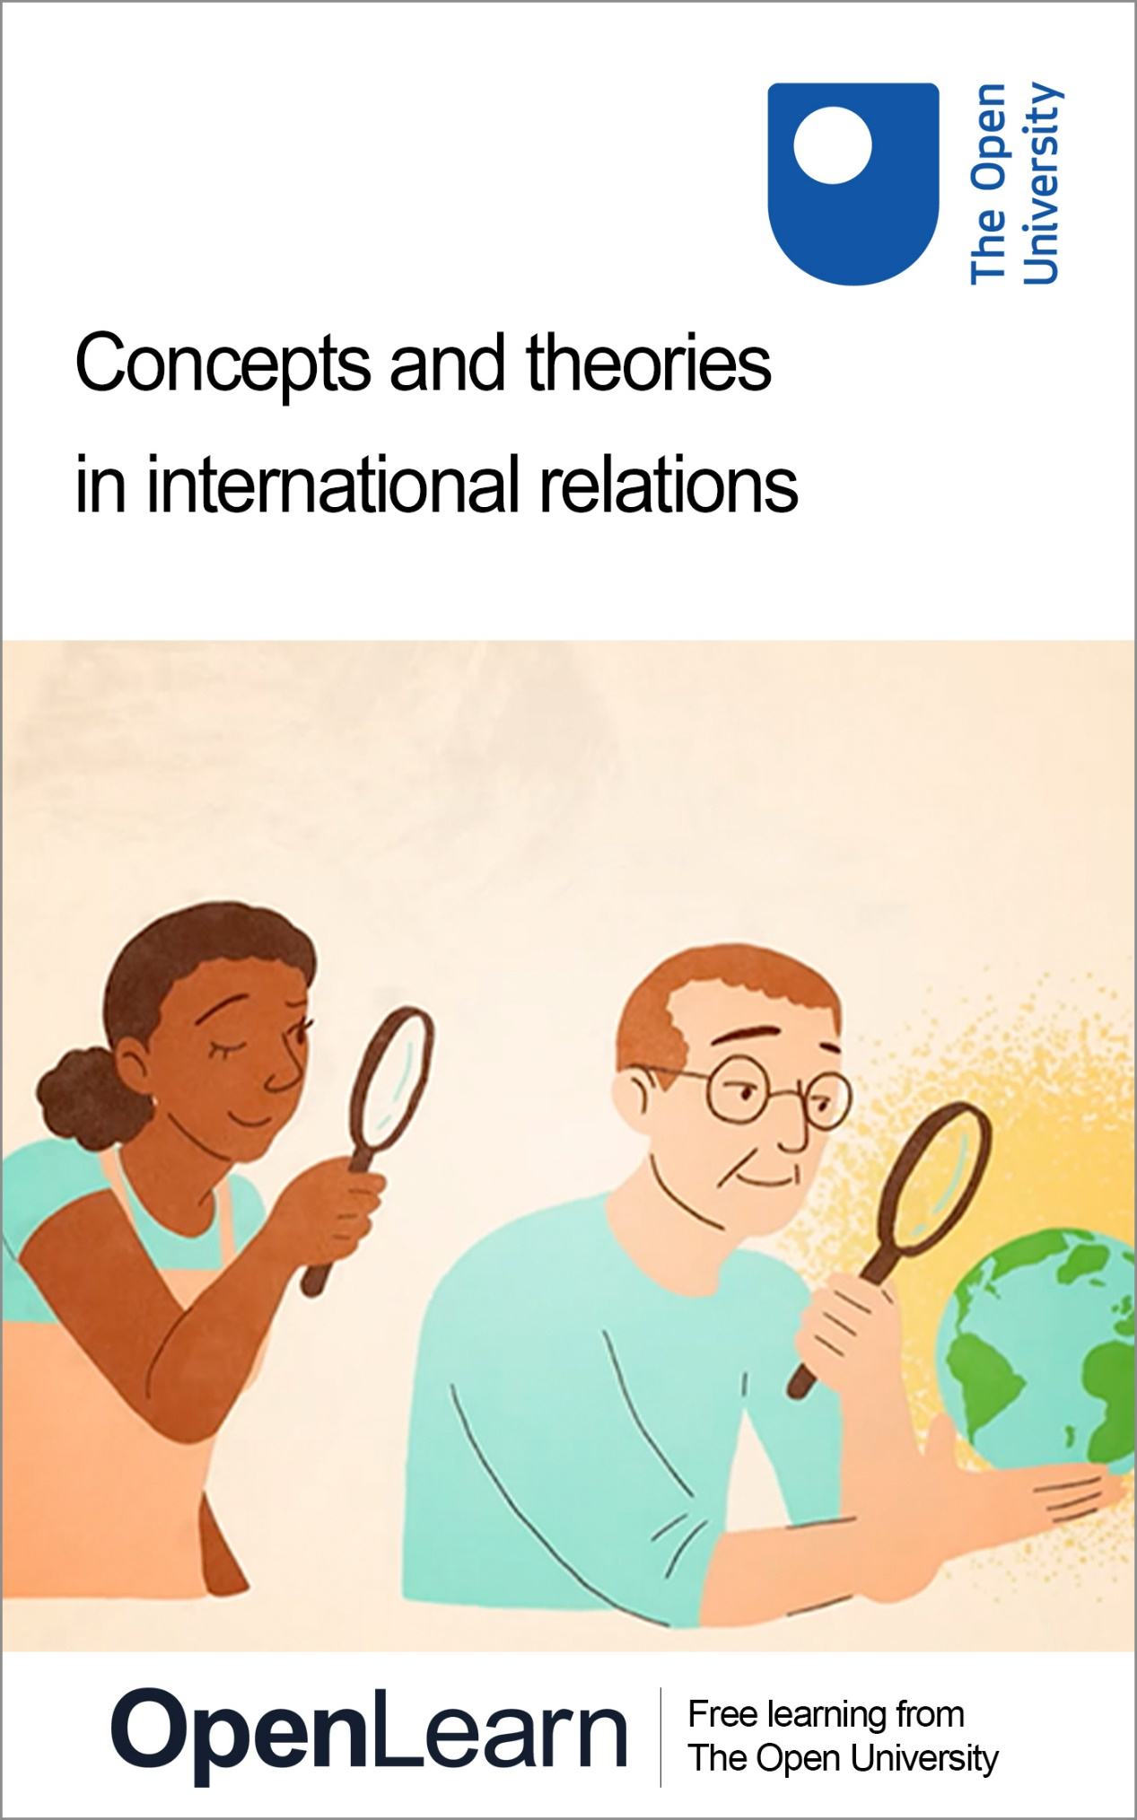

d322_1

Concepts and theories in international relations

About this free course
This free course is an adapted extract from the Open University course D322 International relations: people, power and change.
This version of the content may include video, images and interactive content that may not be optimised for your device.
You can experience this free course as it was originally designed on OpenLearn, the home of free learning from The Open University – https://www.open.edu/openlearn/society-politics-law/concepts-and-theories-international-relations/content-section-0
There you’ll also be able to track your progress via your activity record, which you can use to demonstrate your learning.
First published 2026.
Unless otherwise stated, copyright © 2026 The Open University, all rights reserved.
Intellectual property
Unless otherwise stated, this resource is released under the terms of the Creative Commons Licence v4.0 http://creativecommons.org/licenses/by-nc-sa/4.0/deed.en. Within that The Open University interprets this licence in the following way: www.open.edu/openlearn/about-openlearn/frequently-asked-questions-on-openlearn. Copyright and rights falling outside the terms of the Creative Commons Licence are retained or controlled by The Open University. Please read the full text before using any of the content.
We believe the primary barrier to accessing high-quality educational experiences is cost, which is why we aim to publish as much free content as possible under an open licence. If it proves difficult to release content under our preferred Creative Commons licence (e.g. because we can’t afford or gain the clearances or find suitable alternatives), we will still release the materials for free under a personal end-user licence.
This is because the learning experience will always be the same high quality offering and that should always be seen as positive – even if at times the licensing is different to Creative Commons.
When using the content you must attribute us (The Open University) (the OU) and any identified author in accordance with the terms of the Creative Commons Licence.
The Acknowledgements section is used to list, amongst other things, third party (Proprietary), licensed content which is not subject to Creative Commons licensing. Proprietary content must be used (retained) intact and in context to the content at all times.
The Acknowledgements section is also used to bring to your attention any other Special Restrictions which may apply to the content. For example there may be times when the Creative Commons Non-Commercial Sharealike licence does not apply to any of the content even if owned by us (The Open University). In these instances, unless stated otherwise, the content may be used for personal and non-commercial use.
We have also identified as Proprietary other material included in the content which is not subject to Creative Commons Licence. These are OU logos, trading names and may extend to certain photographic and video images and sound recordings and any other material as may be brought to your attention.
Unauthorised use of any of the content may constitute a breach of the terms and conditions and/or intellectual property laws.
We reserve the right to alter, amend or bring to an end any terms and conditions provided here without notice.
All rights falling outside the terms of the Creative Commons licence are retained or controlled by The Open University.
Head of Intellectual Property, The Open University

Contents
- Introduction
- Learning outcomes
- 1 Concepts and theories in focus
- 2 Realism and Marxism
- 3 Constructivism and postcolonialism
- 4 Liberalism and ecofeminism
- 5 Poststructuralism
- Conclusion
- Acknowledgements
- Solutions
- Descriptions

Introduction
‘Concepts’ and ‘theories’ are key tools in the study of International Relations (IR). They can help to impose a kind of analytical order on the real world in order to make it more understandable. However, concepts and theories fulfil different roles in IR, and there are also a variety of theories that approach the subject in different ways.


Figure 1 Mind mapping concepts and their relationships to one another
View description - Figure 1 Mind mapping concepts and their relationships to one another

In this course, you will start by covering the main differences between concepts and theories in the study of IR, and how they can help further our understanding. Afterwards, you will go on to learn about seven influential IR theories. You will find out about how these theories often take different approaches to IR, using different kinds of knowledge and addressing different questions.
This OpenLearn course is an adapted extract from the Open University course D322 International relations: people, power and change. You can find out more about Open University courses and qualifications, tuition fees and funding options by visiting our online prospectus.

Learning outcomes
After studying this course, you should be able to:
- understand the difference between concepts and theories of International Relations, and how they are used
- appreciate the difference between positivist and post-positivist approaches to International Relations
- have a good overview of a range of influential theories of International Relations
- recognise the key tenets, concepts, principles and theorists associated with the following International Relations theories: realism, Marxism, postcolonialism, constructivism, liberalism, ecofeminism, and poststructuralism
- critically analyse some of the relative strengths and weaknesses of different theories of International Relations.

1 Concepts and theories in focus
Terms like ‘concepts’ and ‘theories’ are used quite routinely when explaining why we think what we think about a particular topic, but they also have a more technical meaning when it comes to the study of IR. If we want to set aside partisan interpretations to build up a comprehensive picture of the complex web of reasons behind events and issues in international relations, then these more technical understandings of ‘concepts’ and theories’ can be very useful.
Put simply, concepts are the general ideas and terms that can be used to categorise observations about international relations, whereas theories are the simplifications of the world that can be used to interpret the relationship between key actors, issues and events.

Activity 1
Allow approximately 25 minutes

Watch the following two videos, which will give you an overview of what concepts and theories mean in the study of IR. Once you have watched the animations, complete the task that follows.

Video content is not available in this format.
Video 1 Concepts in International Relations
View transcript - Video 1 Concepts in International Relations

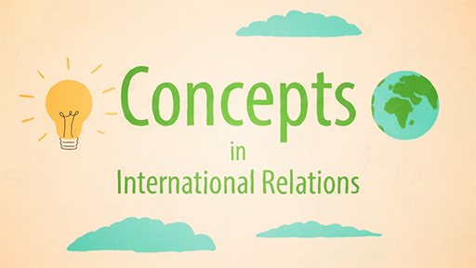

Video content is not available in this format.
Video 2 Theories in International Relations
View transcript - Video 2 Theories in International Relations



For each of the statements shown below, correctly determine whether it describes the notion of a concept or theory in IR by clicking the relevant pink ‘Concept’ or green ‘Theory’ button. For non-mouse users, use ‘Numpad 1’ to select ‘Concept’ and ‘Numpad 2’ to select ‘Theory’. The correct answers will be revealed when you have assigned all of the statements. If you select a category in error, you can use the ‘Reset’ button to clear your answers and begin again.

Interactive content is not available in this format.

View discussion - Activity 1

2 Realism and Marxism
In this section of the course, you will have the opportunity to engage in detail with two IR theories. As you will recall from Section 1, a theory is essentially a framework for understanding, which helps identify the relationships between different factors and seeks to explain phenomena in international relations.
Beyond this, though, scholars sometimes disagree on what their theory of IR should actually do. For some, the purpose of theory is to simplify the world in ways that can provide better explanations of what is happening and the relationships that underpin these happenings. For others, though, the mere fact of theorising about IR entails decisions about what to prioritise or overlook, and thus has an impact on what the world looks like.
In this section, you will be exploring two contrasting theories of IR: realism and Marxism. Both have established long traditions of thinking about power in international relations in different ways.

Activity 2
Allow approximately 40 minutes

Part 1: Realism theory quiz
10 minutes

Watch the animation about realism in International Relations, then work through the set of flashcards, in each case choosing the one that best reflects the realist perspective.

Video content is not available in this format.
Video 3 Realism in International Relations
View transcript - Video 3 Realism in International Relations

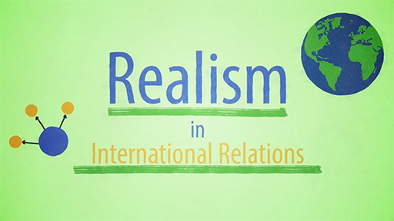

Interactive content is not available in this format.

View discussion - Part 1: Realism theory quiz

Part 2: Realism – key principles and features
10 minutes

Watch the Realism video again and make some notes relating to each of the bullet point prompts below, then click to reveal the course team’s answers.

The four key principles of realism are: Three traditions within realism mentioned are: Three key figures in realism are: Main criticisms of the realist tradition:
View discussion - Part 2: Realism – key principles and features

Part 3: Marxism theory quiz
10 minutes

Now watch the animation about Marxism in International Relations, then work through the set of flashcards, in each case choosing the one that best reflects the Marxist perspective.

Video content is not available in this format.
Video 4 Marxism in International Relations
View transcript - Video 4 Marxism in International Relations

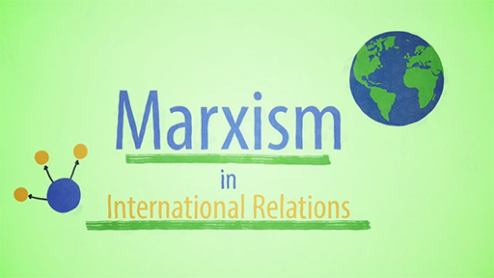

Interactive content is not available in this format.

View discussion - Part 3: Marxism theory quiz

Part 4: Marxism – key principles and features
10 minutes

Watch the Marxism video again and make some notes relating to each of the bullet point prompts below, then click to reveal the course team’s answers.

The key focus of Marxism in IR is: Four key ideas of Marxist IR: Two key contemporary IR scholars working in the Marxist tradition: Main criticisms of the Marxist tradition:
View discussion - Part 4: Marxism – key principles and features

This section has introduced you to realist and Marxist approaches to IR. You have learned that the core principles of realism are state-centrism, anarchy, survival and power. You were introduced to some of the different schools of realism, including classical realism, structural realism and neo-classical realism. You will have noted some differences or tensions within the realist tradition as to why states seek power, how power is defined and measured, and whether there is or should be any limits to the amount of power states seek.
In your introduction to Marxism, you have learned about its development as a general social theory, which has nevertheless developed unique analyses of international relations, particularly focusing on the relationship between the development of the state system and the capitalist world economy. You will have seen that power is also a key concept in Marxist approaches to IR, but in this case, the focus tends to be on the distribution of economic and social power. So, whilst different IR theories might rest upon similar concepts, they may interpret them in significantly different ways.

3 Constructivism and postcolonialism
In this section of the course, you will gain an understanding of two important perspectives within contemporary International Relations: constructivism and postcolonialism. Whilst both of these approaches touch upon the importance of ideas, identities and discourse in understanding International Relations, their different starting points mean that they approach these issues in contrasting ways.

Activity 3
Allow approximately 30 minutes

Part 1: Constructivism theory quiz
10 minutes

Watch the animation about Constructivism in International Relations, then work through the set of flashcards, in each case choosing the one that best reflects the constructivist perspective.

Video content is not available in this format.
Video 5 Constructivism in International Relations
View transcript - Video 5 Constructivism in International Relations

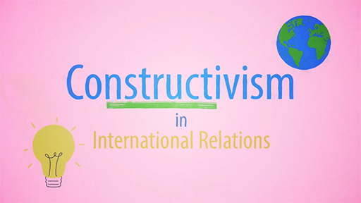

Interactive content is not available in this format.

Part 2: Postcolonialism theory quiz
10 minutes

Now watch the animation about Postcolonialism in International Relations, then work through the set of flashcards, in each case choosing the one that best reflects the postcolonial perspective.

Video content is not available in this format.
Video 6 Postcolonialism in International Relations
View transcript - Video 6 Postcolonialism in International Relations

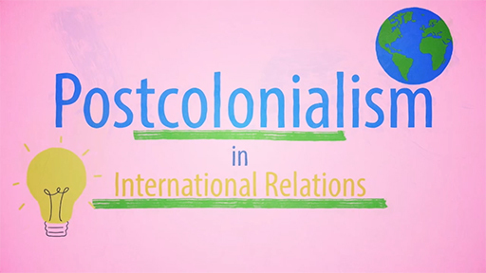

Interactive content is not available in this format.

Part 3: Comparing constructivism and postcolonialism
10 minutes

As you have learned over this short course so far, it can be difficult to define and apply a theoretical position based only on a true/false simplification. One way in which to achieve a more nuanced understanding of IR theories is to take an explicitly comparative approach to understand how they approach their topic of study.

Interactive content is not available in this format.

In this section, you have learned about constructivism and postcolonialism. First, you learned how constructivist approaches see the international system as socially constructed rather than determined solely by material forces. In this world view, identities are constructed through social interaction with others, and these identities go on to shape state behaviour, including what becomes generally accepted behaviour.
You also learned about postcolonial IR theory, which emerged as scholars from the Global South began to challenge western-centric theories about international relations. This worldview emphasises the ways in which today’s international order continues to be shaped by colonial history and residual imperial power structures. You will also note how postcolonial theorists have been influenced by other schools of thought, including Marxism (which you met in Section 2) and feminism (which you will meet in Section 4).

4 Liberalism and ecofeminism
In this section of the course, you will learn about liberal and ecofeminist approaches to International Relations. You will note that liberal approaches tend to emphasise the role that international institutions and shared values can play in helping address key global challenges. By contrast, ecofeminist approaches are more closely linked to social activism, with a subsequent focus more on grassroots movements than state-linked structures.

Activity 4
Allow approximately 30 minutes

Part 1: Liberalism theory quiz
10 minutes

Watch the animation about liberalism in International Relations, then work through the set of flashcards, in each case choosing the one that best reflects the liberal perspective.

Video content is not available in this format.
Video 7 Liberalism in International Relations
View transcript - Video 7 Liberalism in International Relations

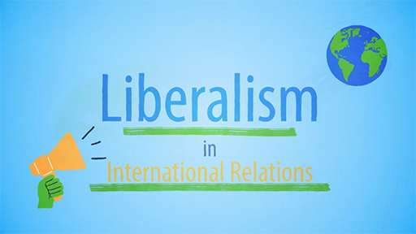

Interactive content is not available in this format.

Part 2: Ecofeminism theory quiz
10 minutes

Watch the animation about ecofeminism in International Relations, then work through the set of flashcards, in each case choosing the one that best reflects the ecofeminist perspective.

Video content is not available in this format.
Video 8 Ecofeminism in International Relations
View transcript - Video 8 Ecofeminism in International Relations

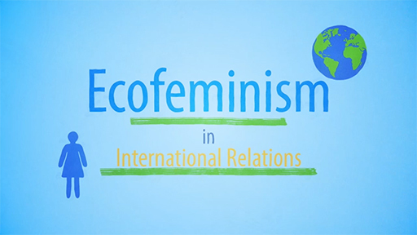

Interactive content is not available in this format.

Part 3: The language of liberalism and ecofeminism
10 minutes

You have learned throughout this short course how true/false simplifications do not always capture all the important features of IR theories. In the previous section, you built up your understanding by comparing the approaches taken by two theories. In this section, you will build your understanding of liberalism and ecofeminism by comparing some of the key concepts that they use, and what these mean.

Interactive content is not available in this format.

In this section, you have learned about liberalism and ecofeminism. Both theories have produced ideas and words that have become part of everyday speech, but for which everyday uses do not always capture the more specific meanings that words have in their original context. It is useful to reflect on how and why there can be a stretching or distortion of meanings, sometimes because most people are not closely invested in the ins and outs of the theory and sometimes because it is easy to caricature positions that you disagree with.
In many ways, liberalism and ecofeminism look at similar questions, most obviously about human nature and the impact of social structures. On the one hand, liberalism is often linked to Enlightenment ideals such as rational thought and individual freedom. Its focus tends to be on the institutions and mechanisms for cooperation that can exist within the current system of international relations to ensure equal access to resources and opportunities. By contrast, ecofeminism takes a more critical approach to the current system of international relations, informed by the contention that it is inherently structured around the domination of women and nature (as well as other hierarchies), and fails to take seriously alternative approaches to social organisation, including indigenous perspectives.

5 Poststructuralism
In this section of the course, you will learn about poststructuralist theories of international relations. Poststructuralist approaches take a critical stance, interrogating how particular understandings of the world gain acceptance as uncontested fact. They are concerned with how social meanings are made, enforced, contested and renegotiated in relation to other social factors.

Activity 5
Allow approximately 25 minutes

Part 1: Poststructuralism theory quiz
10 minutes

Watch the animation about poststructuralism in International Relations, then select which of the following statements about the poststructuralist approach to international relations are true and which are false.

Video content is not available in this format.
Video 9 Poststructuralism in International Relations
View transcript - Video 9 Poststructuralism in International Relations

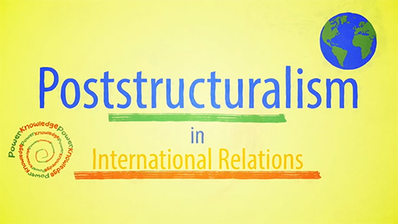

Interactive content is not available in this format.

Part 2: Poststructuralist approaches to IR
15 minutes

As you have learned throughout the prior sections of this short course, true/false simplifications are a helpful revision tactic but they do not always capture all the important features of IR theories. In the following activity, you will be expanding on your understanding of poststructuralist approaches to IR by considering what they are, and are not, most helpful for achieving.
What is a poststructuralist approach to international relations most useful for? Select all that apply.
You can attempt the question as many times as you’d like. To reveal the correct answer untick all the selections and click ‘Reveal answer’ at the bottom of the activity.

Establishing causality between different variables in international relations
Interrogating how dominant structures of knowledge and understanding came about
Challenging political assumptions that have been taken-for-granted
Examining the political effects of particular language choices
Predicting behaviours of state and non-state actors
Establishing parsimonious or universal accounts of international relations
Revealing objective facts about international relations using scientific methods
Helping uncover how dominant discourses and representations can shape international relations
Examining the contingency of many of the supposedly objective facts of international relations, as well as how they undergo constant reinforcement and reproduction
Explaining why political actors behave in the ways that they do, and what effects this has
View answer - Part 2: Poststructuralist approaches to IR

In this section of the course, you have been introduced to poststructuralist theories of International Relations. Where you have encountered various IR theories that seek to explain developments in international relations, poststructuralism is not an explanatory theory. Instead, it is a critical theory, in that it challenges some of the assumptions that other approaches might take for granted.
Poststructuralist approaches interrogate how social meanings are made, enforced, contested and renegotiated in relation to other social factors, and how certain understandings of the world come to gain acceptance as fact.

Conclusion
This course has introduced you to the meaning and function of concepts and theories in the study of International Relations. As you have learned, concepts are a tool that thinkers use to categorise the world around them, whilst theories offer a framework for understanding how the different elements of that world are connected to one another.
There is a great variety of theoretical approaches to international relations, and you have had the opportunity to engage with seven of these in detail. Resting on different philosophies, premises and assumptions, these theories tend to approach key issues in international relations in different ways. So, on the one hand, they might rely upon similar sets of concepts to categorise the world, but provide contrasting interpretations of these key concepts (recall the different ways in which realists and Marxists view power, as well as how poststructuralists link power to discourse). Alternatively, they might incorporate specific sets of concepts better suited to the issues that they aim to address (recall liberal ideas of norms and cooperation, constructivists’ focus on the process of social construction, as well as postcolonialist and ecofeminist attention to colonialism and gender).
Beyond their contrasting uses of key concepts, the seven theoretical traditions in IR that you have encountered in this course take fundamentally different approaches to their key topics of interest. This might be the state-focused elements of realist approaches, the economic aspects addressed by Marxist approaches, or the political and gender hierarchies considered by postcolonial and feminist approaches respectively. It might be the issues of discourse and values that, in one way or another, find themselves central to constructivist, poststructuralist and liberal approaches.
As you have learned throughout this course, each IR theory has different strengths and weaknesses. The key thing is to be able to relate the theoretical perspective to the problem under consideration, to ensure that its insights are of use in understanding the real-world problems and questions you are investigating. This short course has equipped you with the basics of each of these seven theoretical traditions, so that you can begin to make these connections yourself as you try to make sense of developments in international relations.
This OpenLearn course is an adapted extract from the Open University course D322 International relations: people, power and change. You can find out more about Open University courses and qualifications, tuition fees and funding options by visiting our online prospectus.

Acknowledgements
This free course was written by Precious Chatterje-Doody and Simon Usherwood and is an adapted extract of D322 course materials written by Precious Chatterje-Doody, Filippo Boni, Cengiz Gunes, William Brown, Georgina Holmes, Thomas Martin, Simon Usherwood, Charlotte Weatherill and Agnes Czajka.
Except for third party materials and otherwise stated (see terms and conditions), this content is made available under a Creative Commons Attribution-NonCommercial-ShareAlike 4.0 Licence.
The material acknowledged below is Proprietary and used under licence (not subject to Creative Commons Licence). Grateful acknowledgement is made to the following sources for permission to reproduce material in this free course:
Images
Figure 1: Image by Gerd Altmann from Pixabay.
Every effort has been made to contact copyright owners. If any have been inadvertently overlooked, the publishers will be pleased to make the necessary arrangements at the first opportunity.
Every effort has been made to contact copyright owners. If any have been inadvertently overlooked, the publishers will be pleased to make the necessary arrangements at the first opportunity.
Don’t miss out
If reading this text has inspired you to learn more, you may be interested in joining the millions of people who discover our free learning resources and qualifications by visiting The Open University – www.open.edu/openlearn/free-courses.

Solutions

Activity 1

Discussion
Concepts and theories are often spoken about in everyday life, as part of explanations for how the world works. Now, you have a clearer idea of the more technical ways in which these terms are used in the study of International Relations, it is worth thinking about how a more refined understanding of ‘concepts’ and ‘theories’ can help you think more about how they relate to one another. Indeed, various different concepts might be used within theories of International Relations to help produce more comprehensive explanations of real-world events and the myriad of factors that feed into them.
As you will find out as you progress through this course, different theories might treat the same key concepts in deeply divergent ways. On the other hand, theories might rest upon entirely different sets of concepts.
Back to - Activity 1

Activity 2

Part 1: Realism theory quiz

Discussion
Hopefully you will have been able to correctly identify some of the key features of realism, based on what you learned in the video. Remember, though, it is often difficult to define and apply a theoretical position based only on a true/false simplification. For this reason, it is important to start building a nuanced understanding of the key principles and features of realism.
Back to - Part 1: Realism theory quiz

Part 2: Realism – key principles and features

Discussion
The four key principles of realism in IR are:
- the centrality of states in international relations
- the lack of an overarching authority to control those states, producing an anarchy
- the consequential priority for states to ensure their own survival and security
- the pursuit of that security through power.
Three traditions within realism are:
- Classical realism, focused on competition for power as a function of human nature
- Structural realism, focused on the anarchy of the international system as the driver of competition
- Neoclassical realism, focused on how actions and perceptions of actions impact state competition
Three key figures in realism are:
- Hans Morgenthau
- Kenneth Waltz
- John Mearsheimer
Main criticisms of the realist tradition: the focus on states can lead to ignoring the role of other actors, while realism can also over-emphasise competition over cooperation. In addition critics say realism is too western-centric and too focused on great powers.
Back to - Part 2: Realism – key principles and features

Part 3: Marxism theory quiz

Discussion
Hopefully you will have been able to correctly identify some of the key features of Marxism, based on what you learned in the video. As you learned with respect to realism, though, it can be difficult to define and apply a theoretical position based only on a true/false simplification. For this reason, it is important to start building a nuanced understanding of the key principles and features of Marxism.
Back to - Part 3: Marxism theory quiz

Part 4: Marxism – key principles and features

Discussion
The key focus of Marxism in IR is: the interrelated development of the state system and global capitalism, and how it might be transformed
Four key ideas of Marxist IR:
- the international system is made up of a state system and a capitalist world economy
- the states that make up the system vary according to the class relationships within each society
- states’ actions in international relations are contingent on the interests of the ruling classes, and on the position of the state within the global economic hierarchy
- international relations are shaped and re-shaped by economic booms and busts.
Two key contemporary IR scholars working in the Marxist tradition: Robert Cox, Justin Rosenberg
Main criticisms of the Marxist tradition: Some argue it over-emphasises the negative aspects of capitalism compared with capitalism’s benefits; others believe it over-emphasises class hierarchies over, for example, racialised or gendered ones.
Back to - Part 4: Marxism – key principles and features

Activity 5

Part 2: Poststructuralist approaches to IR

Answer
Right:
Interrogating how dominant structures of knowledge and understanding came about
Challenging political assumptions that have been taken-for-granted
Examining the political effects of particular language choices
Helping uncover how dominant discourses and representations can shape international relations
Examining the contingency of many of the supposedly objective facts of international relations, as well as how they undergo constant reinforcement and reproduction
Wrong:
Establishing causality between different variables in international relations
Predicting behaviours of state and non-state actors
Establishing parsimonious or universal accounts of international relations
Revealing objective facts about international relations using scientific methods
Explaining why political actors behave in the ways that they do, and what effects this has
Back to - Part 2: Poststructuralist approaches to IR

Descriptions

Figure 1 Mind mapping concepts and their relationships to one another
This is an illustration of a seated figure contemplating a mind-map drawn on the surface in front of them. The figure is photographed from the rear, leaning back with hands clasped behind their head. Partly concealed on the screen beyond them is a diagram in which several groups of oval shapes branch out from the centre. Lines connect the ovals to show how the concepts which might occupy them are related to each other.
Back to - Figure 1 Mind mapping concepts and their relationships to one another

Video 1 Concepts in International Relations

Transcript
SPEAKER:
A concept is a general or abstract idea or term. International relations scholars use concepts to categorise what they observe in the international environment. There are many concepts in international relations-- justice, the state, accountability, power, security, identity, and gender, to name just a few. They use these concepts to connect the subjects of their research to more general political phenomena to draw conclusions.
The precise meanings of these concepts aren't fixed and are the subject of much debate. They gained layers of meaning over time and in different cultures and contexts. Even the concept of concepts is up for debate.
Scholars such as Andrew Heywood distinguish between descriptive concepts and normative concepts. Descriptive concepts are seen as value-free descriptions of observable phenomena, concepts like power or the state, for example. Normative concepts are seen as having value-free judgements within them, as they imply a commitment to certain values, concepts like justice and equality, for instance. In reality, all concepts tend to have both descriptive and normative aspects.
Some concepts can have very different meanings, making it almost impossible for scholars to agree on a single definition. We call these essentially contested concepts.
Security is a good example. Some scholars say security only concerns a military threat to a state. Others argue a military conception of security ignores common threats, like climate destruction and gender-based violence. This makes security an essentially contested concept. It's due to this ambiguity that academic articles have to define exactly how they are using key concepts.
Critical IR scholarship from people, including Edward Said, Cynthia Enloe, and Ayse Zarakol, have argued that many of IR's core concepts are shaped by Western-centric, capitalist, patriarchal, and colonial systems. They argue concepts need to be reinterpreted to understand the experiences of women, the working classes, and societies of the non-Western world. So concepts are used to categorise the international environment. But the precise meaning of these concepts is in a constant state of debate and development.
Back to - Video 1 Concepts in International Relations

Video 2 Theories in International Relations

Transcript
NARRATOR:
Broadly speaking, theories are simplifications of the real world. Scholars use theories to simplify the relationships between concepts, factors, and processes in international relations. There are a wide range of very different theories of IR. These theories are systems for understanding events and developments in the world, setting out the factors and processes that matter most and how they're connected.
Now, there's more than one way to simplify the world. There are therefore many theories of international relations, each based on a different set of assumptions and beliefs. One of the biggest distinctions is between positivist and post-positivist theories. For positivists, scholars can observe the world around them and use scientific methods to achieve objective knowledge. For post-positivist, all such knowledge is subjective as it's filtered through scholar's beliefs and interpretation. This has to be acknowledged and accounted for with qualitative and interpretive methods.
There is also a difference between what each theory sets out to do, whether the theory seeks to explain, understand, critique, or even transform the international environment. Explanatory theories aim to give generalisable accounts of why certain things happen. They may be the broad and simple explanations of the positivists, or the more complex interpretive explanations of post-positivist. Some theories focus on understanding the richer details of a given case.
Critical theories seek to interrogate the existing patterns of international relations to uncover the power structures that are maintaining unfair practices. Normative theories do this too, but with the explicit intention of transforming those power structures. So theories provide a framework for our research, setting out a notional relationship between different concepts, factors, and processes. Each of the many IR theories are based on different assumptions and beliefs about the purpose of theory, the nature of the world, and how to make sense of it.
Back to - Video 2 Theories in International Relations

Video 3 Realism in International Relations

Transcript
SPEAKER:
The realist tradition in international relations focuses on the pursuit of power by states. It is primarily seen as a positivist tradition, which aims to solve the problems states face in their pursuit of power and security. Some thinkers trace realist ideas back to ancient Greece and the work of Thucydides, who argued that the strong do what they will and the weak suffer what they must. Modern realism emerged in the 20th century, styling itself as a realistic view of international relations against what it saw as utopian theories about progress.
Realism is shaped by four key ideas-- state centrism, anarchy, survival through self-help, and power. State centrism-- realists see states as the most important actors in international relations. They assert that states always put their own interests first. Realists therefore focus on what states do, not other actors, like interest groups or individuals.
Anarchy-- realists see the international system as anarchic, with no overarching authority or government to control what states do. Survival through self-help-- with no government to protect them, states have to rely on their own resources to ensure they aren't invaded or attacked. Their own survival or security is the primary goal. Power-- states pursue survival by increasing their power. And for realists, the ultimate form of power is military might.
There are many strands of realism. Classical realists, like Hans Morgenthau, believed that states competition for power is driven by human nature. Structural realists argue that it's the anarchic character of the system that drives competition.
States behave differently depending on the power balance and whether there's one dominant state, known as unipolarity; two dominant states, bipolarity; or several dominant states, multipolarity. Key structural realists include Kenneth Waltz and John Mearsheimer. Neoclassical realists share elements of both approaches. They argue that though the system forces states to pursue power, the way states view each other and the actions of their leaders also have an impact.
Realism has been criticised for focusing too heavily on states and ignoring other actors. It's also been criticised for overemphasising conflict over cooperation, for being too Western centric, and for focusing on the great powers over the weaker ones. Realism gives us clear focus and tools to analyse power and states in international relations.
Back to - Video 3 Realism in International Relations

Video 4 Marxism in International Relations

Transcript
SPEAKER:
The Marxist tradition in international relations builds on Karl Marx's analysis of capitalist economies. It focuses on the interactions between the state system and the development of global capitalism. Marxism has both positivist and post-positivist tendencies, relying on objective observation, though arguing it has its limits.
Marxism is generally viewed as critical theory, exploring how the modern capitalist world developed and how it might be transformed. It also seeks to explore the problems faced by those seeking to either sustain or to challenge capitalism.
Many early Marxist thinkers were themselves involved in radical or revolutionary politics-- for instance, Lenin and Trotsky in Russia, Antonio Gramsci in Italy, and Rosa Luxemburg in Germany. Contemporary Marxist theory focuses on the US as the leading capitalist power and on the position of the Global South, including China, in the international system.
Marxist approaches to international relations share a number of core ideas. First, the international system is made up of a state system on the one hand and a capitalist world economy on the other. Second, the states that make up the system will vary according to the class relationships within each society.
Third, what states do in international relations depends on the interests and activities of the ruling class as well as the state's position in the system, whether it's a leading economy or a poorer one. Finally, international relations is a dynamic field shaped by the booms and busts of capitalist economies.
Some work in the Marxist tradition draws on earlier Marxists for inspiration. Robert Cox developed Gramsci's ideas to argue that US hegemony or leadership was sustained by both its material advantages and its social and cultural influence. Justin Rosenberg developed Trotsky's ideas to analyse how countries can catch up with leading states by developing new kinds of economy and state, such as China in relation to the US.
Marxism has been criticised for overemphasising the downsides of capitalism, such as inequality, and ignoring its benefits, such as wealth and technology. It's also been criticised for emphasising class over other forms of privilege, like race and gender. In international relations, Marxism highlights the role of modern capitalism in our understanding of the state system.
Back to - Video 4 Marxism in International Relations

Video 5 Constructivism in International Relations

Transcript
SPEAKER:
Constructivism argues that international relations is shaped by ideas. It is socially constructed rather than determined solely by material forces. Constructivism encompasses a broad range of perspectives. Some constructivists adopt positivist problem-solving methods and look for causal explanations, whereas others challenge the possibility of such explanations, drawing on post-positivist and interpretive methods.
Constructivism in international relations emerged in the late 1980s. This was a time when mainstream theories struggled to account for the end of the Cold War and the rise of globalism, neoliberalism, and new forms of international cooperation. Whilst neorealists and neoliberals attribute international change to material forces, like military might and economic independence, constructivists argue that changes are better explained by the role that ideas play.
Constructivists draw attention to the role of ideas in two key ways. First, they argue that identity shapes state behaviour. Identities are socially constructed through interaction with others. These identities inform an actor's interests and preferences.
In an influential article, "Anarchy is What States Make of It," Alexander Wendt argues that power alone can't explain who will be allies and adversaries and who will support or resist the system. We must examine how identities are constructed and how states perceive one another.
The second key way constructivists focus on the role of ideas in international relations is through norms. Norms are the shared rules or principles that shape some actions as sensible, appropriate, or morally right and others as irrational, inappropriate, or morally problematic. Scholars such as Peter Katzenstein, Martha Finnemore, Kathryn Sikkink, and Amitav Acharya have demonstrated how norms shape state behaviour and how norm entrepreneurs promote and institutionalise these norms.
Their studies have shown how collective understandings of sovereignty, international law, and humanitarian intervention all constitute norms that have developed over time. Some critics of constructivism argue that its focus on ideas comes at the expense of material factors, like military power or economics. Others argue its internal diversity and lack of consensus on epistemology and methodology make it difficult to define or apply consistently. Constructivism shifts our attention to the social dimensions of international relations-- how identities are formed, how norms evolve, and how both shape the behaviour of global actors.
Back to - Video 5 Constructivism in International Relations

Video 6 Postcolonialism in International Relations

Transcript
NARRATOR:
Postcolonial international relations theory is a critical approach that challenges the dominant Western-centric frame for understanding global politics. It draws on pan-Africanism, cultural theory, and the anti-colonial movement, and emphasises how colonial history and imperial power structures continue to shape the international order today.
For postcolonial theorists, the modern international order, including state sovereignty, borders, and global institutions, was constructed through colonialism and imperialism. These foundations continue to marginalise newly independent states and reinforce power balances between the Global North and the Global South.
Postcolonial IR challenges the assumption that Global politics are neutral or universal. It criticises realism and liberalism for their focus on Western experiences, such as the Treaty of Westphalia, the Enlightenment, and the Cold War. For postcolonial theorists, global politics remained deeply influenced by colonial legacies. They therefore call for a fundamental change in how we understand sovereignty, development, conflict, and cooperation on a global scale.
They criticise the depiction of the Global South as backward, uncivilised, and in need of Western intervention. They argue that these narratives justify continued control, which ultimately inflicts different forms of violence on oppressed and marginalised people.
Contemporary postcolonial IR scholars, such as Siba Grovogui, L. H. M. Ling, and Naeem Inayatullah highlight how cultural differences shape interactions. Their work critiques how Western politics and philosophies shape the international order and even IR scholarship itself. They seek to incorporate a wider range of groups' ideas and perspectives into IR theorising.
Postcolonial IR has been criticised for presenting a static concept of colonialism and the relationship between the West and the Global South, and for engaging less with traditional IR issues, such as diplomacy and state behavior. Postcolonial international relations theory challenges mainstream IR theories, like realism and liberalism, by examining how colonial histories, race, culture, and power dynamics shape global politics.
Back to - Video 6 Postcolonialism in International Relations

Video 7 Liberalism in International Relations

Transcript
SPEAKER:
Liberalism tries to find mutual gains between states with a focus on the role external actors play in shaping state choices. It's a positivist tradition which aims to solve the problems states face with each other. Liberals reject the realist theory that self-interested power politics is the only way to conduct international relations.
Liberalism emerged in the Enlightenment with Voltaire, John Locke, and Immanuel Kant considering how to avoid the disastrous effects of war. More recently neoliberals have investigated how international institutions changed the relationship between democracy and war.
For liberals, there are three key factors that encourage cooperation and reduce conflict between states. Democracy, war is destructive and costly. In democracies where leaders rely on popular support, there's an incentive to avoid conflict. International institutions, bodies like the UN and the EU help states resolve disputes without violence. Regular exchanges make it easier to understand each other's interests. International trade, as complex economic activity spills over borders, states and economic actors press for stable and peaceful relationships.
In the 17th century, John Locke proposed the classical liberal view that in a raw free state of nature, civil government is necessary for human rights to emerge and be maintained. His ideas were influential in the French and American revolutions. Since the 1970s, neoliberals such as Joseph Nye and Robert Keohane have built on these ideas, observing how democracies actually operate in the international system.
Democracies do fight, just not against other democracies. Liberalism's limitations come when democracies, international institutions and trade come up against a state that doesn't want to be bound into such systems. Is a damning resolution by the UN Security Council actually going to stop one state bent on invading another?
Also while many states call themselves democracies, it's not always meaningful in practice. Liberalism tries to find ways to avoid realist power politics. In doing so, it can't help but accept that power and might still matter.
Liberalism aims to create a more peaceful, stable, and inclusive world, focusing on the roles played by states, other institutions, and individuals, too.
Back to - Video 7 Liberalism in International Relations

Video 8 Ecofeminism in International Relations

Transcript
SPEAKER:
Ecofeminism is a feminist theory of international relations. It connects the destruction of the environment with the oppression of lives that are considered feminine and therefore weak. For ecofeminists, this includes not just women but also marginalised groups, such as Indigenous peoples and non-human lives too.
It's a critical theory. For ecofeminists, exploitation of the environment, women, and other marginalised peoples is caused by the supremacy of masculinity. In other words, ecofeminism connects the harms of colonialism, capitalism, and patriarchy.
Ecofeminism has close links with activism. It seeks to challenge power structures through theory and practice. It developed in the 1970s, as activists began to connect environmental crises and the feminist movement. Today, ecofeminists assert that climate change is developing due to the actions of a powerful few rather than humanity as a whole.
A key principle of ecofeminism is that patriarchal societies value masculine attributes over feminine ones. This starts with patriarchy, in which men dominate and women are subordinated. However, for ecofeminists, gender dualism stretch into all elements of society. This includes political dualisms, such as public and private, strong and weak, modern and traditional, culture and nature, and white and non-white.
Key ecofeminist thinkers, such as Vandana Shiva, Val Plumwood, and Sherilyn MacGregor, have highlighted the ways industrialisation, capitalism, and colonialism disproportionately impact both women and the environment. Ecofeminism critiques society, the economy, governance, language, and even epistemology. In fact, it could be criticised for being so wide ranging. It's difficult to operationalise.
Ecofeminism is a radical theory, not a pragmatic one. So for ecofeminists, the dominance of masculinity and gender dualisms in global power structures lead to a politics of exploitation and harm. It connects two struggles, struggles against environmental harms and violence against women and other feminised lives. In connecting these struggles, it argues that they must be resisted together.
Back to - Video 8 Ecofeminism in International Relations

Video 9 Poststructuralism in International Relations

Transcript
SPEAKER:
Poststructuralism focuses on how language and power shape what's seen as the reality of global politics. Rather than offering a grand theory of international politics, it instead questions the taken for granted assumptions. A critical post-positivist approach, post-structuralism emerged in the late 20th century, drawing on broader movements that challenged positivist ideas about objectivity and truth. Post-structuralism rests on three key assumptions. First, language isn't neutral. Words don't just describe the world-- they construct it. Calling someone an illegal immigrant frames them as a criminal, but calling them a refugee suggests they're fleeing from danger. Language choices shape public opinion and determine which policies are seen as legitimate. Post-structuralists ask whose framing dominates and whose is silenced and what are the consequences.
Second, power and knowledge are intertwined. What we know about IR is shaped by dominant discourses, which are sustained by the most powerful actors. Take the label failed state. It's used by powerful states to present other countries as chaotic or dangerous. This legitimises intervention and military action, typically in ways that serve powerful states' own interests. Post-structuralists ask, who gets to label a failed state and to what end?
Third, identities are not fixed or given. States construct narratives to define themselves in relation to others, and these narratives often shift. After 9/11, the US defined itself as the defender of freedom and civilisation against a threatening, radicalised Muslim other. These constructed identities shaped its foreign policy. US identity is continually redefined in relation to others, like a rising China or an aggressive Russia, again influencing and justifying foreign policy.
Michel Foucault's work on power is fundamental to the post-structuralist perspective. Writers like David Campbell and Jenny Edkins build on his work to discuss how states construct their identities. Post-structuralism has been criticised for its focus on critique and failure to provide clear alternatives. However, whilst post-structuralism may not offer many answers, its focus on language and power does help us ask more incisive questions.
Back to - Video 9 Poststructuralism in International Relations

