PWC_7

Capacity and demand management

About this free course
This content was originally published as an open educational resource on the OpenLearn website http://www.open.edu/openlearn/.
This version of the content may include video, images and interactive content that may not be optimised for your device.
You can experience this free course as it was originally designed on OpenLearn, the home of free learning from The Open University –https://www.open.edu/openlearn/education-development/capacity-and-demand-management/content-section-0?
There you’ll also be able to track your progress via your activity record, which you can use to demonstrate your learning.
Copyright © 2022 The Open University
Intellectual property
Unless otherwise stated, this resource is released under the terms of the Creative Commons Licence v4.0 http://creativecommons.org/licenses/by-nc-sa/4.0/deed.en_GB. Within that The Open University interprets this licence in the following way: www.open.edu/openlearn/about-openlearn/frequently-asked-questions-on-openlearn. Copyright and rights falling outside the terms of the Creative Commons Licence are retained or controlled by The Open University. Please read the full text before using any of the content.
We believe the primary barrier to accessing high-quality educational experiences is cost, which is why we aim to publish as much free content as possible under an open licence. If it proves difficult to release content under our preferred Creative Commons licence (e.g. because we can’t afford or gain the clearances or find suitable alternatives), we will still release the materials for free under a personal end-user licence.
This is because the learning experience will always be the same high quality offering and that should always be seen as positive – even if at times the licensing is different to Creative Commons.
When using the content you must attribute us (The Open University) (the OU) and any identified author in accordance with the terms of the Creative Commons Licence.
The Acknowledgements section is used to list, amongst other things, third party (Proprietary), licensed content which is not subject to Creative Commons licensing. Proprietary content must be used (retained) intact and in context to the content at all times.
The Acknowledgements section is also used to bring to your attention any other Special Restrictions which may apply to the content. For example there may be times when the Creative Commons Non-Commercial Sharealike licence does not apply to any of the content even if owned by us (The Open University). In these instances, unless stated otherwise, the content may be used for personal and non-commercial use.
We have also identified as Proprietary other material included in the content which is not subject to Creative Commons Licence. These are OU logos, trading names and may extend to certain photographic and video images and sound recordings and any other material as may be brought to your attention.
Unauthorised use of any of the content may constitute a breach of the terms and conditions and/or intellectual property laws.
We reserve the right to alter, amend or bring to an end any terms and conditions provided here without notice.
All rights falling outside the terms of the Creative Commons licence are retained or controlled by The Open University.
Head of Intellectual Property, The Open University

Contents
- Introduction
- 1 Criminological perspectives of demand
- 2 Crime pattern theory
- 3 Managerial perspectives of demand
- 4 Policing decision-making
- 5 Understanding time perspectives with capacity and demand decisions
- 6 Demand Analysis: four components of demand
- 7 Understanding seasonality
  - 7.1 Special events
- 8 Forecasting methods
- 9 Level and chase capacity strategies
- 10 Visualising your own demand
- 11 Why do we have queues?
- 12 Is some demand unnecessary?
- 13 Conclusion
- References
- Acknowledgements
- Solutions

Introduction
Good decision-making relies on having the right information presented in the right way. That information comes as data that we obtain either through extraction from existing records or newly collected information that we have gathered for the purpose of decision-making. This makes data analysis one important skill when decision-making. In this course you will take a look at capacity planning decisions as an example of effective data use.
It seems obvious that resource plans should not be created without an understanding of the demand for resource, but you will find that demand is not always measured, or collated in a way that is not helpful to decision-making. This course provides a range of perspectives of how data can be understood, in the context of managing capacity and demand.
After completing this course, you will be able to:
- understand how useful data can be to inform practical decision-making
- see how demand patterns are derived when looking at data
- understand how seasonal patterns in demand are caused and how this impacts on resource planning
- understand different perspectives of how demand for services can be assessed
- see how demand data can be used to plan capacity requirements.

1 Criminological perspectives of demand
One way of understanding demand for much policing activity comes through criminology – the scientific study of crime. At the simplest level, it is useful to know what types of crime occur and how frequently they are committed. For example, crime statistics in England and Wales show the following most commonly reported crimes:

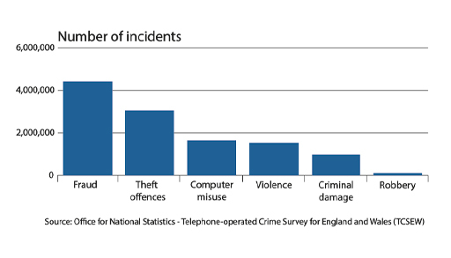
Figure 1 TCSEW estimated 3.1m theft offences in the last 12 months. (England and Wales, based on interviews conducted between May and December 2020.)
View description - Figure 1 TCSEW estimated 3.1m theft offences in the last 12 months. (England and ...

Activity 1 Crime statistics
Allow approximately 5 minutes

How do these crime statistics help plan policing capacity? What are their limits of how they help?

Provide your answer...
View discussion - Activity 1 Crime statistics

In the next section we look at an alternative way of understanding patterns in crime.

2 Crime pattern theory
Criminologists can look at why crimes occur and both where and when they happen. Crime pattern theory looks at the geometry of where crime occurs, based around the notion of where crime activity takes place and how offenders travel through likely places for crime and develop knowledge of those locations.

Activity 2 Locations of crime
Allow approximately 5 minutes

Reflect on your own known locations for crime or other police demand. Are there different locations dependent on the time of day?

Provide your answer...
View discussion - Activity 2 Locations of crime

This type of analysis helps us understand demand from a policing perspective. In the next section we see how we can take a management perspective to understanding demand.

3 Managerial perspectives of demand
In this section we take a look at some of the managerial perspectives of demand and capacity which focuses on understanding demand for decision-making.

Activity 3 Capacity management
Allow approximately 10 minutes

Pick any service that you are familiar with, such as a supermarket, airport or restaurant.

Figure 2 People queuing inside an airport
View description - Figure 2 People queuing inside an airport

Imagine that service in a situation where it does not have anywhere near enough capacity to meet demand. What sorts of things will go wrong? How will the capacity shortage affect the efficiency of the service?
Now imagine the same service but with far too much capacity. Is this a better position to be in? Will it be efficient?

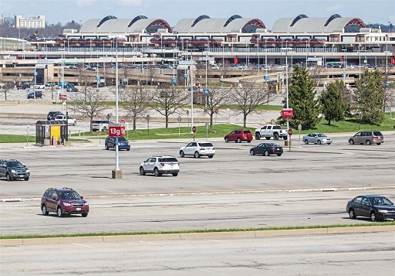
Figure 3 Airport car park
View description - Figure 3 Airport car park

Provide your answer...
View discussion - Activity 3 Capacity management

Given these two extremes, is there a balancing point where capacity is enough to do the job without there being excess wasted resource and maintaining good quality?

4 Policing decision-making
One technique that can be used to analyse local policing demand blends the SARA decision-making model of policing with demand analysis. The example below shows how a demand problem might be broken down into steps:
- Scanning
What are the recurring problems of concern to the public and police?
Can we confirm the problem exists?
Do we know how frequently the problem occurs?
- Analysis
What data do we need to analyse the problem and derive solutions?
What ideas do we test to see why the problem is occurring?
- Response
What interventions to reduce the problem can we test?
Do we have a plan to implement solutions and test their effectiveness?
- Assessment
Did our interventions work?
What evidence do we have to understand how well our interventions worked?
Do we need to do more work?
This approach can be used to identify many types of demand problems in policing, such as:
- Understanding the nature and scale of repeat offending
- Identifying where people are repeat victims and why this is the case
- Repeat locations
- Anti-social behaviour

Case study: Repeat attendances at A&E
In November 2021 the BBC reported new analysis by the British Red Cross of NHS data on regular Attendance at A&E departments. They discovered that less than 1% of the population account for 16% of all A&E attendances, with just 0.7% of the population accounting for 29% of ambulance journeys and 26% of unplanned hospital admissions. The data also showed that many of the regular attenders were dealing with ‘mental health problems, relationship breakdown, housing insecurity or loneliness.’
Some vulnerable people use A&E weekly or more BBC News
hiu-summary-report-final.pdf (redcross.org.uk)

Activity 4
Allow approximately 5 minutes

Think about your own work. Do you come into contact with people who regularly access services for similar reasons or problems such as drug addiction?

Provide your answer...

The next section looks at how we can apply the SARA decision-making model to help us understand demand management problems.

5 Understanding time perspectives with capacity and demand decisions
Capacity planning is a process of understanding demand and organising the right resources to meet the demand cost effectively. Conventional approaches divide the capacity management tasks into three time horizons:
- Long-term planning (18 month or more time horizon):
Long-term planning usually involves the planning of new facilities or locations and sometimes the recruitment and training of specialist staff. For example, the NHS has to plan the training of doctors many years in advance as it takes over 8 years to train and provide enough work experience to develop a new junior doctor.
- Medium-term planning (3-18 month time horizon):
When you look at demand patterns over a year or so you will usually see seasonal patterns to demand that require any operation to make adjustments to the availability of resources over that time, with peaks and troughs in demand. Organisations have to develop plans, such as shift patterns, hiring of seasonal or temporary staff etc. to be able to cope with these fluctuations.
- Short-term planning (less than 3-month planning):
Much of the planning work is to ensure that the right people are available at the right time and place. Often this is a scheduling role – which often also needs to include some reactive work to cope with unexpected events.

Activity 5 Capacity planning
Allow approximately 5 minutes

Think about how far in advance you may have to look if you are to plan for the following types of decisions:
- Building a new facility such as a police contact centre
- The full training and development of highly skilled and specialist staff

View discussion - Activity 5 Capacity planning

The next section looks at the influence of timescales on how we make demand and capacity decisions.

6 Demand Analysis: four components of demand
Simple models of demand break down the total demand into four components:
- Long-term growth or decline patterns
Demand is rarely completely stable. We often find that some types of demand are undergoing growth and others have significant declines over time. There can be “life-cycle” models of demand where demand for something grows, stabilises and later falls again.
- Cyclical or seasonal patterns
Most demand is cyclical in some way – going through peaks and troughs – with a variety of causes. We’ll explore this a bit more.
- Random variation
Sometimes things are busier or quieter than we have expected, with no known explanation. This is often seen as random, natural variation.
- Special cause or one-off events
One-off events, planned or unplanned, can cause demand to increase or decrease significantly, usually as a temporary effect.

Activity 6 Patterns of demand
Allow approximately 5 minutes

Which areas of your own demand would you see declining or increasing?

Provide your answer...
View discussion - Activity 6 Patterns of demand

7 Understanding seasonality
In this section we look at the idea of demand seasonality. This is where there are cyclical patterns in the demand data. Seasonality can occur over a range of timeframes. For example we will always expect some annual demand seasonality, but many services will see daily or hourly demand cycles they have to manage.

Activity 7 Causes of demand seasonality
Allow approximately 5 minutes

Take a look at the following products. What are the underlying causes of demand seasonality over a year? To what extent will demand change?

Figure 4 Examples of seasonal products
View description - Figure 4 Examples of seasonal products

View answer - Activity 7 Causes of demand seasonality

Other seasonal factors
What other seasonal factors exist? Beyond festive events and weather, are there any other causes of fluctuations in demand? Figure 5 below shows some of the underlying causes of demand seasonality.

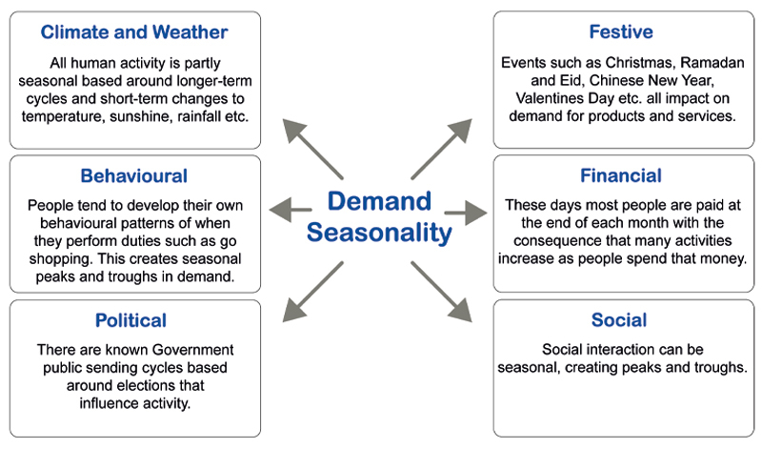
Figure 5 The underlying factors that influence demand seasonality
View description - Figure 5 The underlying factors that influence demand seasonality

The next section looks at situations where demand can spike during ‘one-off’ events.

7.1 Special events
Sometimes we get special ‘one-off’ events that increase or decrease demand hugely. Sometimes these are planned, such as a music festival. Sometimes these are unplanned or unexpected, such as an industrial fire. Example of special events: Notting Hill carnival

Figure 6 The Notting Hill Carnival
View description - Figure 6 The Notting Hill Carnival

The Notting Hill Carnival in London is regarded to be the second largest carnival in the world, behind the one in Rio de Janeiro, with 1 million people attending over the extended holiday weekend. The carnival has about 40,000 volunteers helping out and usually about 9,000 police.
The carnival creates a huge surge in demand for both private and public services. In a normal year about 270 licensed food, drink and merchandise stalls temporarily appear. The organisers also provide support services, such as an extra 329 sets of temporary toilets. Local transportation has to adapt to be able to accommodate the extra inflow and outflow of people in the Notting Hill area. Local healthcare systems also have to deal with an extra 1,000 casualties needing ambulance or paramedic care, with 20% going to hospital.

Activity 8 Seasonality in your own service
Allow approximately 10 minutes

Now apply these types of demand variation to your own work. Fill in the table below:

Question | Your response
Are there daily fluctuations in your demand? If so, why? | Provide your answer...
Does day-of-week affect your demand? | Provide your answer...
What annual cycles of demand do you have (if any)? | Provide your answer...
Are there special events that increase your demand? | Provide your answer...

To what extent does your organisation measure or record demand and especially these demand fluctuations?

Provide your answer...
View discussion - Activity 8 Seasonality in your own service

We next take a look at how this understanding of demand patterns can help build a forecast that is used to predict future demand.

8 Forecasting methods
Most situations use one of three types of forecasting model to help predict demand:
- Qualitative techniques can be used when there is no prior data. These would include expert panels or conventional market research, where this is appropriate.
- Time series analysis takes historical data and looks at the patterns in it with the intention of understanding future demand if the same patterns repeat. The analysis can range from the relatively simple approaches of understanding averages (‘moving averages’), to much more complex multi-variate techniques and probabilistic analysis.
- Causal analysis can be used to develop more sophisticated demand predictions. Data is used to help understand the factors that drive demand.
For a practical understanding of local demand, simple time series analysis is probably the most appropriate, but strategic planning activities will often use more sophisticated causal models.
We have spent quite a bit of time understanding demand. We will now focus on understanding how we manage capacity to meet demand.

9 Level and chase capacity strategies
When demand patterns are understood a service can decide when and how much capacity to provide to meet that demand. Where demand fluctuates there is the question ‘to what extent do we change capacity over time to match demand?’ This section looks at the reasoning that addresses this question.

Activity 9 Demand over time
Allow approximately 10 minutes

The figure below shows the expected demand over a period of time, e.g. one year. You can see there is quite a lot of seasonal variation in expected demand.

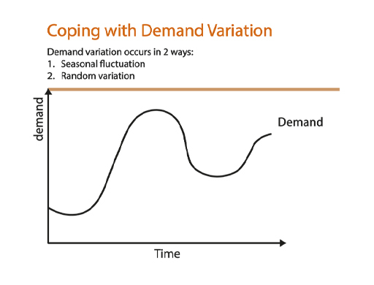
Figure 7 Meeting demand with a ‘level’ capacity strategy
View description - Figure 7 Meeting demand with a ‘level’ capacity strategy

The figure also shows a potential ‘capacity strategy’ that provides a constant amount of capacity throughout the year – known as a level capacity stategy. What do you think the likely advantages and disadvantages of this strategy are?

View answer - Activity 9 Demand over time

Now let’s look at a different capacity strategy. In this case the capacity is adjusted periodically so that it matches more closely the profile of forecast demand. This is known as a chase strategy. Is this always a better approach?

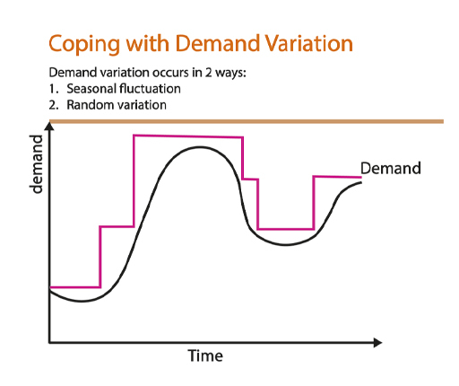
Figure 8 Meeting demand with a ‘chase’ capacity strategy
View description - Figure 8 Meeting demand with a ‘chase’ capacity strategy

The resources in this case have higher utilisation and you would expect this to be more efficient. However, this is not always the case. The key issue is that changing the capacity can be difficult to implement in some cases – think about how we might do this: Seasonal staff? Different shift patterns? Agency staff?
In some of these cases the extra resource might be more expensive and less productive than those on long-term contracts. Hence we sometimes have to balance between the stability of level strategies and the complexity of chase.
The following screencast explains the theory of level and chase capacity strategies in more detail.

Video content is not available in this format.
Screencast 1: Level and Chase

In the next section we take a look at how you might visualise data such as demand patterns.

10 Visualising your own demand
Sometimes you won’t have access to large data sets that will give you a definitive answer about what demand is coming in. However it is worth looking at the data just to gain an impression of what might be happening.

Activity 9 Arrival patterns in A&E
Allow approximately 15 minutes

The table below contains real data of patients arriving at a small emergency department of a hospital, recorded by day of week.

Patients arriving at an emergency department by day
Monday | Tuesday | Wednesday | Thursday | Friday | Saturday | Sunday
86 | 104 | 105 | 75 | 95 | 103 | 96
85 | 83 | 82 | 78 | 94 | 91 | 87
89 | 102 | 85 | 80 | 99 | 109 | 114
105 | 91 | 97 | 90 | 82 | 106 | 107
95 | 88 | 90 | 86 | 91 | 76 | 75

How might you first look at the data? What sort of analysis might you first undertake? Have a think and then click the discussion button below.

Provide your answer...
View discussion - Part

What day of week effects might be seen? How can you analyse this?

View discussion - Part

How might this outcome affect capacity planning?
We would need to look at the distribution of arrivals over the 24-hour period to fully understand what to do here. However, if we need to treat every patient how many should we be capable of seeing each day? If we plan for 92 patients per weekday would this be enough?

View discussion - Part

We next look at the causes of waits and delays in services, such as how queues form.

11 Why do we have queues?
Just about everyone has experience of being in some sort of queue. If you phone your bank, telecoms provider or similar service you will almost certainly be phoning a call centre where you can often expect to wait before someone picks up the phone. Similarly if you visit a supermarket you can expect to wait before you pay. In a barbers shop you wait your turn. If you go to a theme park many of the rides can have queues that are an hour long on busy days.
So why is it that all of these different types of service make you wait? Are they all just incompetent at managing capacity? Is it they are greedy and won’t pay enough staff on duty to meet demand?
Download the following excel files and open it so you can see the content (open the files in a new tab or window by holding down Ctrl [or Cmd on a Mac] when you click on the link).
Feedback
Instructions
Level and Chase
Queue
Now watch the following screencast that shows you how to use the spreadsheet in the following exercise.

Video content is not available in this format.
Screencast 2: Instructions

Using the average demand of 40 (ranging between 20 and 60) as has been set in the spreadsheet, compete the following tasks:
Task 1 Set your capacity much below average capacity. What happens to the size of the queue? Make a note of this. Repeat this a few times to see if the answer is always the same.
Task 2 Set your capacity at the average demand. Has the queue behaviour changed? Again make a note. Again, repeat this a few times to see if the answer is always the same.
Task 3 Now incrementally increase capacity until you think you have enough. How much capacity makes your queue disappear to almost zero?
Does the existence of a queue provide a clear indication there is not enough capacity to meet demand?
Once you have completed all the tasks watch the following screencast that provides feedback about the findings that you should have got from the exercise. Check that you did get the same kinds of results.

Video content is not available in this format.
Screencast 3: Feedback

The exercise shows that queues can form even when capacity is greater than demand. The following screencast explains the theory underpinning this idea.

Video content is not available in this format.
Screencast 4: What causes a queue?

Waits and delays example: Ambulance service responsiveness
Ambulance services are a good example of where demand must be understood so that planning can take place to ensure enough ambulances are available to meet all emergency demand. In the UK ambulance services are tasked with responding to life-threatening, urgent demand (“Category 1”) with an average response time of seven minutes and 90% within 15 minutes or less. The services have to plan the right number of ambulances and crew each day, anticipating any seasonal fluctuations in demand and taking into account random variation in demand that makes some days unexpectedly busy. As we can see from the previous section, there would need to be some spare capacity in the system if queues are not to develop.
When calls come in they are triaged so that urgent cases are put ahead of those less serious. When ambulances attend calls they will try to deal with the patient without a time-consuming journey to hospital either by treating and discharging those less seriously hurt in situ or by seeking alternative forms of transport to hospital for “walking wounded”. Some services even organise taxis for patients where an ambulance is not strictly necessary.
At busy times for emergency care one of the biggest problems is that ambulances often have to queue to drop patients off at A&E. This means the ambulances become unavailable for new patients and response times increase.

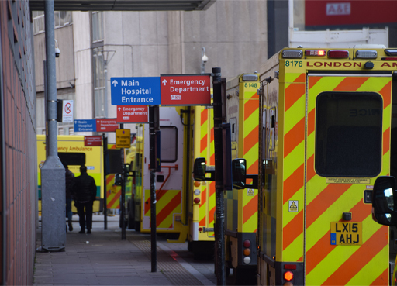
Figure 13 Ambulance queue outside an emergency department
View description - Figure 13 Ambulance queue outside an emergency department

We can see from queue theory that a small reduction in demand might make a big difference to waits and delays. The next section looks at an approach that tries to reduce demand entering a service by eliminating unnecessary demand.

12 Is some demand unnecessary?
Think about the last time you phoned a service provider. Was this for a good reason (e.g. you wanted to buy something) or was it because something had gone wrong? When we analyse calls going into service calls centres we often find that a very large proportion of the calls up to 80% are from unhappy or disgruntled customers reporting a problem rather than customers contacting the service to generate new business. Demand entering the system for avoidable reasons is often referred to as failure demand. One definition is shown below.
‘Failure demand is demand caused by a failure to do something or do something right for the customer.’
This idea that much demand is unnecessary or avoidable came from John Seddon when he had looked at calls coming into call centres. He divides demand into two categories ‘true demand’, i.e. new demand from a customer and ‘failure demand’.

Activity 10 Failure demand
Allow approximately 10 minutes

John Seddon and his consultancy team analysed 1200 calls coming into a council housing service call centre (Evaluating Systems Thinking in Housing, 2008). Most callers were council tenants who were dealing with necessary repairs to their properties. The team grouped these calls around main themes, listed below. Use the table to click whether you see the demand as ‘true’ demand or ‘failure demand’. Count up what percentage of the total you see as failure demand.
Then look at the two columns. What underlying problems are revealed by the nature and levels of failure demand?

Interactive content is not available in this format.

View discussion - Activity 10 Failure demand

This next exercise allows us to explore the notion of failure demand in a practical exercise. Use this as an opportunity to see whether or not you can spot unnecessary demand in a system.

Activity 11 Failure demand

Have a think about how much of the work coming in to your system might be classed as failure demand. What are the underlying causes of that demand? Also think about the impact on your work and whether or not the demand can be removed.

Provide your answer...
View discussion - Activity 11 Failure demand

This session concludes all the topics of Capacity and demand management. Now read the course conclusion on the next page.

13 Conclusion
Good decision-making requires effective data analysis when making challenging decisions such as the allocation and timing of capacity. When you look at your own data you will start to see some clear patterns in demand for the services you provide, but sometimes it can be difficult to find enough data. In these situations it is perfectly acceptable to use simple visual tools that give some insight into how demand behaves.
The course should have given you a better insight into some operational problems such as response delays or queues in services. When data is collected you can bust the myth that queues only form when systems are under-capacity. The data analysis provides a better insight into why these delays occur.
Our final concept we looked at was that of unnecessary or ‘failure’ demand. This can be a really useful idea to challenge what demand is coming into a service and what workload it should give you. You are encouraged to try to apply this idea further in your own work.

References
Boulton, L., McManus, M., Metcalfe, L., Brian, D. and Dawson, I. (2017), “Calls for police service: Understanding the demand profile and the UK police response”, Police Journal: Theory, Practice and Principles, 90 (1), pp 70–85.
Brantingham, P. L., & Brantingham, P. J. (1981). Notes on the geometry of crime. In P. J. Brantingham & P. L. Brantingham (Eds.), Environmental criminology, Beverly Hills: Sage, pp 27–54.
Christopher H. Lovelock (1984) Strategies for Managing Demand in Capacity-Constrained Service Organisations, The Service Industries Journal, 4 (3), pp 12–30. DOI: 10.1080/02642068400000059
Seddon, J. (2003), Freedom from Command and Control, Vanguard Press: Buckingham.
Jackson, M. C., N. Johnston, and J. Seddon. (2008), “Evaluating Systems Thinking in Housing”, Journal of the Operational Research Society, 59 (2), pp 186–197.
Recommended further reading:
Visualizations That Really Work

Acknowledgements
This free course was written by Paul Wally and was published in June 2022.[Editor: Dale to review page - send to Rights]
Except for third party materials and otherwise stated and referenced in the course (see terms and conditions), this content is made available under a Creative Commons Attribution-NonCommercial-ShareAlike 4.0 Licence.
The material acknowledged below is Proprietary and used under licence (not subject to Creative Commons Licence). Grateful acknowledgement is made to the following sources for permission to reproduce material in this free course:
Every effort has been made to contact copyright owners. If any have been inadvertently overlooked, the publishers will be pleased to make the necessary arrangements at the first opportunity.
Images
Course image:
Figure 1: © Office for National Statistics (ONS)
Figure 2:
Figure 3:
Figure 4:
Figure 5: The Open University
Figure 6:
Figure 7: The Open University
Figure 8: The Open University
Figure 9: The Open University
Figure 10: The Open University
Figure 11:
Figure 12:
Figure 13: © VVShots | Dreamstime.com
Audio-visual
Don't miss out
If reading this text has inspired you to learn more, you may be interested in joining the millions of people who discover our free learning resources and qualifications by visiting The Open University – www.open.edu/openlearn/free-courses.

Solutions

Activity 1 Crime statistics

Discussion
The crime statistics can act as a guide to what crimes police deal with and the skill sets needed within forces to deal with those crimes. The statistics are also useful when observed over time as trends in crime types can be observed. Planning can then address how to reduce or prevent these crimes or look at increasing particular skill sets.
There are a number of limitations. First the statistics themselves can only be a guide as much crime is unreported. Secondly, up to 80% of police work is not crime-related (Boulton, L. et al., 2017) so when we look at decisions such as numbers of police needed we are missing most of the workload. Thirdly, it does not usually tell us when or where officers are needed.
Back to - Activity 1 Crime statistics

Activity 2 Locations of crime

Discussion
Most of this would be personal to your situation but there are some obvious night-time economy sources of demand (public order and violence) which will occur in specific locations.
Back to - Activity 2 Locations of crime

Activity 3 Capacity management

Discussion
A service that is short of capacity will clearly have some very visible problems of queues and delays. We’ve often been in a position of queueing for hours to check in for a flight, been crammed into a train with no room, told that there is no table at the restaurant and so on. The performance of such services often rapidly declines once demand significantly exceeds (or even closely matches) the capacity to serve customers. In many cases the service quality suffers and staff become more stressed, often making the situation worse in the long run. In emergency services the response time to go to incidents rapidly declines when there is a shortage of capacity.
Services that have excess capacity sometimes also experience problems. For example, the atmosphere in an empty restaurant can be uncomfortable, especially if the staff are constantly hovering over you. Sometimes the service seems too rushed. Staff motivation can suffer if they don’t have enough to do. There is also the obvious problem that there is a lot of waste of resources, both in terms of under-utilised staff but possibly wasted food etc. For emergency services the responsiveness can be good, at a cost of sometimes unused staff.
Back to - Activity 3 Capacity management

Activity 5 Capacity planning

Discussion
Both of these decisions would come under long-term planning as the time horizon in each case is many years. In the case of the new facility it can take many years to obtain the right permissions and funding. To develop a highly skilled workforce again the lead time can be many years through degree education and then training. This can present problems as situations can change, leading to over- or under-supply of critical resources.
Back to - Activity 5 Capacity planning

Activity 6 Patterns of demand

Discussion
In policing there are several areas where more demand is expected in the future in general. These include cybercrime and online fraud, with some offences being under-reported, such as domestic violence. In the future it is likely that some of these types of offences will be reported more. There is a trend towards some additional non-crime demand for resources, especially that related to incidents involving mental health. Some crimes, such as burglary have fallen. You may have some very specific local trends in demand that others might not see so much.
Back to - Activity 6 Patterns of demand

Activity 7 Causes of demand seasonality

Answer
There are two categories shown in the photos:
Products with weather seasonality
Products such as sun cream, soft drinks and umbrellas have seasonality based around weather. Sales of drinks and sun cream can go up by 500% in a week during a hot spell – but this is not the time people will buy umbrellas! There are other underlying factors – for instance the sun cream sales will also increase at a time when more people start to take summer holidays.
Products with event seasonality
Products such as Easter eggs and Christmas cards clearly have a seasonality based around particular festive events. A problem for those making them is that the sales window for such products can be narrow.
Back to - Activity 7 Causes of demand seasonality

Activity 8 Seasonality in your own service

Discussion
We would expect most people to be able to identify examples of demand behaviour in all of the above categories. Anti-social behaviour, for example, tends to happen more when pubs and nightclubs are open but are starting to shut. They will also have an obvious day-of-week effect under most circumstances simply because Friday and Saturday are their busiest days of the week. However, these differences are becoming less noticeable in many cities. Most places will have annual cycles, but not necessarily the same ones. For example, university towns will have demand created by events such as ‘Freshers’ week’. Seaside towns will experience increases in many types of demand during the summer and other school holidays. You should be able to find special causes such as carnivals, concerts and festivals in many places.
Back to - Activity 8 Seasonality in your own service

Activity 9 Demand over time

Answer
The level strategy is not good at minimising wasted or idle resource as there are long periods where capacity significantly exceeds demand. A key advantage is that the plan should always meet demand – as long as the demand forecast used is reasonably accurate. Another simple feature is that the plan is quite easy to implement as the people involved in organising resources know that they need to keep the resource plan the same throughout the year.
Back to - Activity 9 Demand over time

Activity 9 Arrival patterns in A&E

Part

Discussion
The first action could be to plot the data on a simple chart just to see if there are any apparent trends or patterns that are obvious. We might be looking for any growth or decline trends, but these are unlikely to be seen in such a small data set. There could be cyclical patterns based around day of week but these are not immediately obvious from this graph, so more work can be done there. It is obvious that the data has some random variation.

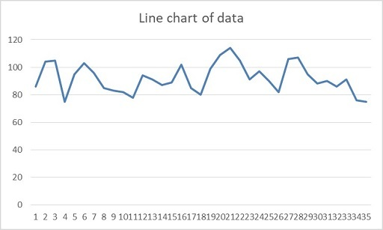
Figure 9 A line chart of the demand data
View description - Figure 9 A line chart of the demand data
View description - Figure 9 A line chart of the demand data

Back to - Part

Part

Discussion

 | Monday | Tuesday | Wednesday | Thursday | Friday | Saturday | Sunday
Max | 105 | 104 | 105 | 90 | 99 | 109 | 114
Mean | 92 | 93.6 | 91.8 | 81.8 | 92.2 | 97 | 95.8
Min | 85 | 83 | 82 | 75 | 82 | 76 | 75

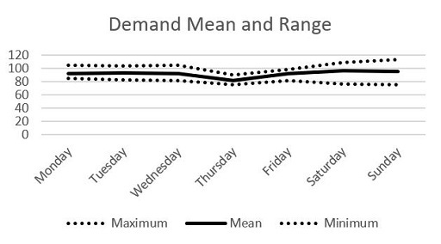
Figure 10 A graph of the demand mean and range by day of week
View description - Figure 10 A graph of the demand mean and range by day of week
View description - Figure 10 A graph of the demand mean and range by day of week

In this case the data tells us that most weekdays are very similar in terms of the number of people coming into the department for some kind of treatment. A typical day would have around 92 patients to treat over the 24-hour period. Thursday seems to be unusual – but there isn’t an obvious explanation. There does appear to be a slight difference at the weekends, which seem to be slightly busier but also the numbers seem to vary more as well. This might need to be explained. Obviously, only a much bigger data set would give us statistically significant results, but at least we now know something about the likely patterns in the data. We’d also need a much bigger data set to look at annual variation etc. (e.g. summer vs winter).
Back to - Part

Part

Discussion
If we only planned for 92 patients per day we would most likely not have enough capacity about half the time. To absolutely guarantee meeting demand we would have to take a look at our busiest ever day. As we have only a small amount of data demand can be even higher, as natural variation and special events would occasionally take it beyond our observed maximums. In practice we would have to also consider having some time of capacity on standby, maybe working other roles but brought in if demand goes higher than expected. In the next section we will also consider how this demand and capacity balance can affect how long people wait in a queue.
Back to - Part

Activity 10 Failure demand

Discussion
Those calls requesting a service for the first time, such as ‘I need a plumber’, are all true demand. The failure demand calls are made when something has either gone wrong, e.g. ‘the repair was not fixed properly’, or the work is being chased by the customer, e.g. ‘I’m still waiting for…’.
The chart below shows that 80% of the calls coming into the system were failure demand and the most common types of call were all failure demand.

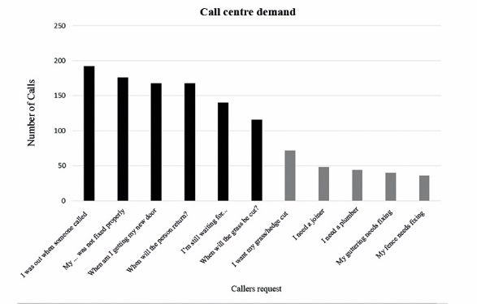
Figure 14 Call centre demand chart
View description - Figure 14 Call centre demand chart

There is clearly a problem within the housing service because too many work crews are attending properties when the customer is not present. They also seem to have difficulty finishing a job in one visit (shortage of spare parts?), or returning to finish a job in a timely manner (scheduling?). When the problem was studied in more depth it became clear that work crews were not empowered to deal flexibly with their customers’ problems because the cost control systems limited the availability of spares, required too many sign-offs before work was completed, and was too rigid in its scheduling of crews. Once crews were given more control over their work they were able to call customers in advance and ask about the need for spare parts etc., with deliveries to site quickly. This produced a huge improvement in the quality of the service to the customer and reduced demand.
Back to - Activity 10 Failure demand

Activity 11 Failure demand

Discussion
One of the biggest, somewhat hidden, sources of failure demand can be seen just by looking in your email inbox. Have a look to see how many emails are repeat requests, such as reminders for deadlines. How many of the emails are you copied in when it’s irrelevant to you?
For much of the demand coming in, have a look to see if there are more opportunities to do the work in the first contact, rather than prioritising or postponing work. One police force found that 100 non-urgent calls into the contact centre generated about 60 unnecessary additional contacts, with some calls needing 5 or more attempts to do simple things like answer a question.
Back to - Activity 11 Failure demand

Figure 1 TCSEW estimated 3.1m theft offences in the last 12 months. (England and Wales, based on interviews conducted between May and December 2020.)

Description
The diagram is a bar chart that shows the frequency of crimes reported in a survey. The crimes are listed from left to right in decreasing order of frequency starting with fraud as the most common offence, with over 4 million recorded. The other crimes in order are theft, computer misuse, violence, criminal damage and robbery.
Back to - Figure 1 TCSEW estimated 3.1m theft offences in the last 12 months. (England and Wales, based on interviews conducted between May and December 2020.)

Figure 2 People queuing inside an airport

Description
The figure is a photograph of a crowded area of an airport where hundreds of passengers are queuing to go through a gate.
Back to - Figure 2 People queuing inside an airport

Figure 3 Airport car park

Description
The figure is a photograph of a large airport car park where there are hundreds of empty parking spaces with a few parked cars spread across the parking area.
Back to - Figure 3 Airport car park

Figure 4 Examples of seasonal products

Description
The figure is a composite picture showing four types of product that might exhibit seasonal demand patterns. The products are fireworks, suncream, easter eggs and soft drinks.
Back to - Figure 4 Examples of seasonal products

Figure 5 The underlying factors that influence demand seasonality

Description
The figure is a diagram with the phrase ‘demand seasonality’ in the centre in bold writing. Around the outside are six boxes that identify separate drivers of seasonality. These drivers are climate and weather, festive, financial, social, political and behavioural.
Back to - Figure 5 The underlying factors that influence demand seasonality

Figure 6 The Notting Hill Carnival

Description
The figure is a photograph of people participating in the Notting Hill Carnival procession. They are wearing bright costumes. In the picture are two uniformed police officers joining in with the celebration.
Back to - Figure 6 The Notting Hill Carnival

Figure 7 Meeting demand with a ‘level’ capacity strategy

Description
The figure is a line chart with the x axis labelled as ‘time’ and the y axis labelled as ‘demand’. There is a line on the chart (coloured in black) labelled as ‘demand’ that starts low, dips, and then curves upwards towards a peak, falls to a new minimum point, and then rising again. A second line, labelled ‘capacity’, sits entirely above this fluctuating demand curve. This line is straight and horizontal across the entire graph.
Back to - Figure 7 Meeting demand with a ‘level’ capacity strategy

Figure 8 Meeting demand with a ‘chase’ capacity strategy

Description
This figure is a modified version of figure seven. The horizontal line is replaced by a stepped line, for capacity, that consistently sits above the demand curve but generally follows the shape of the demand curve, representing many changes in capacity to loosely match the changes in demand.
Back to - Figure 8 Meeting demand with a ‘chase’ capacity strategy

Figure 9 A line chart of the demand data

Description
The figure is a graph with demand on the y axis and time on the x axis. The line shows the data from the exercise plotted as a time series. The line shows a lot of random variation with some barely discernible cyclical patterns.
Back to - Figure 9 A line chart of the demand data

Figure 10 A graph of the demand mean and range by day of week

Description
The figure is a graph with demand on the y axis and day of week on the x axis. There are lines plotted within the chart. The main line is a graph of average demand. The maximum demand and minimum demand are also plotted by day of week as lines that sit either side of the mean line. The graph shows a lot of consistency in demand across the week but with slightly more demand and demand uncertainty at the weekend.
Back to - Figure 10 A graph of the demand mean and range by day of week

Figure 13 Ambulance queue outside an emergency department

Description
The figure is a photograph of ambulances queueing outside an accident and emergency department. It illustrates the waits and delays experienced by both paramedics and patients when trying to enter an emergency department that has a work backlog and arrivals queue.
Back to - Figure 13 Ambulance queue outside an emergency department

Figure 14 Call centre demand chart

Description
The figure is a bar chart with the labels of the types of demand on the x-axis, starting with ‘I was out when someone called’. The bars on the left hand side of the diagram are the tallest, going down left to right in descending order of frequency. The six bars on the left hand side are all highlighted in bold, showing they have been classed as failure demand. The five bars on the right hand side are identified as true demand.
Back to - Figure 14 Call centre demand chart

Figure 9 A line chart of the demand data

Description
Back to - Figure 9 A line chart of the demand data

Figure 10 A graph of the demand mean and range by day of week

Description
Back to - Figure 10 A graph of the demand mean and range by day of week

