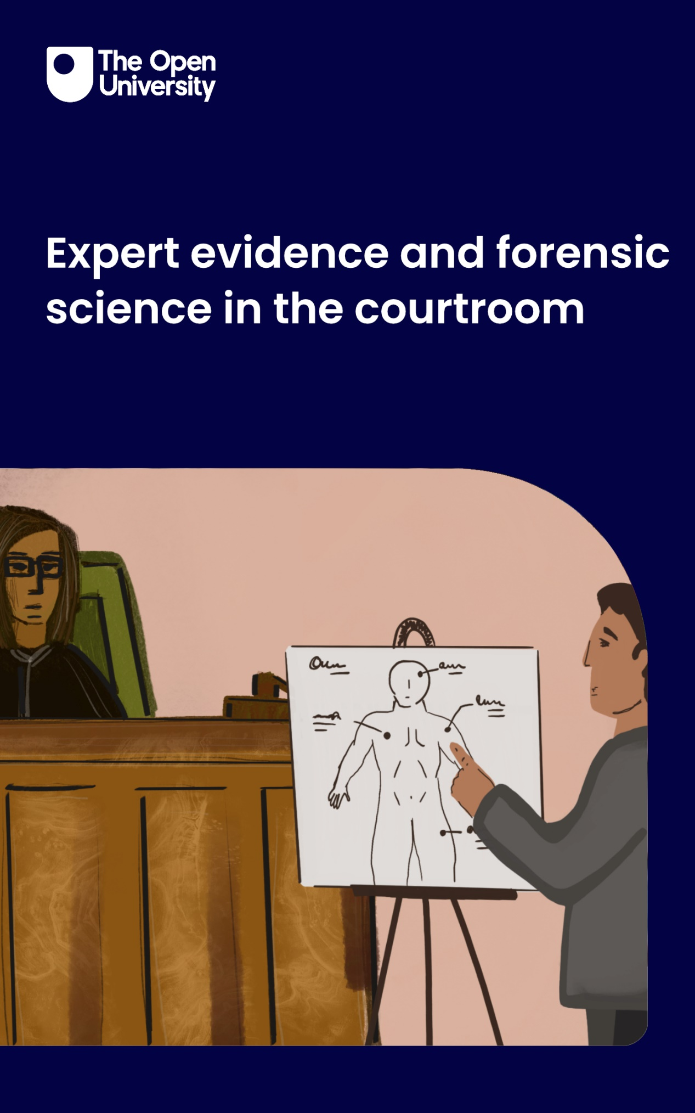

W250_1 Expert evidence and forensic science in the courtroom

Expert evidence and forensic science in the courtroom

About this free course
This free course is an adapted extract from the Open University course W250 Evidence law https://www.open.ac.uk/courses/modules/w250/ .
This version of the content may include video, images and interactive content that may not be optimised for your device.
You can experience this free course as it was originally designed on OpenLearn, the home of free learning from The Open University – https://www.open.edu/openlearn/society-politics-law/expert-evidence-and-forensic-science-the-courtroom/content-section-0
There you’ll also be able to track your progress via your activity record, which you can use to demonstrate your learning.
First published 2025.
Unless otherwise stated, copyright © 2025 The Open University, all rights reserved.
Intellectual property
Unless otherwise stated, this resource is released under the terms of the Creative Commons Licence v4.0 http://creativecommons.org/licenses/by-nc-sa/4.0/deed.en. Within that The Open University interprets this licence in the following way: www.open.edu/openlearn/about-openlearn/frequently-asked-questions-on-openlearn. Copyright and rights falling outside the terms of the Creative Commons Licence are retained or controlled by The Open University. Please read the full text before using any of the content.
We believe the primary barrier to accessing high-quality educational experiences is cost, which is why we aim to publish as much free content as possible under an open licence. If it proves difficult to release content under our preferred Creative Commons licence (e.g. because we can’t afford or gain the clearances or find suitable alternatives), we will still release the materials for free under a personal end-user licence.
This is because the learning experience will always be the same high quality offering and that should always be seen as positive – even if at times the licensing is different to Creative Commons.
When using the content you must attribute us (The Open University) (the OU) and any identified author in accordance with the terms of the Creative Commons Licence.
The Acknowledgements section is used to list, amongst other things, third party (Proprietary), licensed content which is not subject to Creative Commons licensing. Proprietary content must be used (retained) intact and in context to the content at all times.
The Acknowledgements section is also used to bring to your attention any other Special Restrictions which may apply to the content. For example there may be times when the Creative Commons Non-Commercial Sharealike licence does not apply to any of the content even if owned by us (The Open University). In these instances, unless stated otherwise, the content may be used for personal and non-commercial use.
We have also identified as Proprietary other material included in the content which is not subject to Creative Commons Licence. These are OU logos, trading names and may extend to certain photographic and video images and sound recordings and any other material as may be brought to your attention.
Unauthorised use of any of the content may constitute a breach of the terms and conditions and/or intellectual property laws.
We reserve the right to alter, amend or bring to an end any terms and conditions provided here without notice.
All rights falling outside the terms of the Creative Commons licence are retained or controlled by The Open University.
Head of Intellectual Property, The Open University

Contents
- Introduction
- Learning outcomes
- 1 Rationale for expert evidence
- 2 Admissibility of expert evidence
  - 2.1 Relevance
  - 2.2 Assistance
  - 2.3 Reliability
  - 2.4 Expertise
  - 2.5 Hearsay
- 3 Duties and responsibilities of an expert
  - 3.1 Hired guns and bias
  - 3.2 The Civil Procedure Rules
  - 3.3 Liability and immunity of experts
- 4 How non-experts can scrutinise experts
  - 4.1 Other means of scrutinising experts
- 5 Numbers
  - 5.1 The prosecutor’s fallacy
  - 5.2 Partial solutions
- 6 When science meets law
  - 6.1 An introduction to Bayesianism
  - 6.2 Bayes’ Rule in practice: the likelihood ratio
  - 6.3 The problem with Bayes’ Rule
- 7 Expert evidence case study
  - 7.1 The Sally Clark case
  - 7.2 The statistical evidence
  - 7.3 The medical evidence
  - 7.4 The aftermath
- Conclusion
- Exploring further
- References
- Acknowledgements
- Solutions
- Descriptions

Introduction
The law usually lets the judge or the jury decide what to make of the evidence. But there are some pieces of evidence that an ordinary fact-finder would not be expected to know anything about. For example:
- How is it relevant that the refractive index of a piece of glass found in a suspect’s shoe is a particular value?
- What is the significance of particular bands shown on a DNA gel?
- Is it usual or unusual to find a particular chemical in human blood?
To help a fact-finder make sense of such questions, the law sometimes permits a person who can offer an answer to give evidence. But because there are risks in allowing evidence from individuals who purport to know so much more about a topic than the actual fact-finders, the law strives to protect the fairness of the process with various legal safeguards.

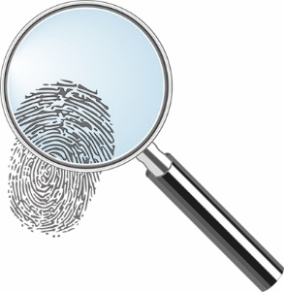
Figure 1 Fingerprint
View description - Figure 1 Fingerprint

This course gives an overview of the law of expert evidence, including discussion of key issues such as practice and procedure, the duties and liabilities of experts, the question of how non-experts can adjudicate over the views of experts, and the increasing mathematisation of scientific evidence. The various issues are finally brought together in a case study of one of the most notorious miscarriages of justice in recent years.
Some topics covered in this course are emotive (including reference to sexual violence and infant death). These are indicated by the words ‘sensitive topic’ in a ribbon that you can see below. For further guidance on how to deal with sensitive topics, please see Working with sensitive topics.

Sensitive topic

This OpenLearn course is an adapted extract from the Open University course W250 Evidence law.

Learning outcomes
After studying this course, you should be able to:
- explain the rules for admissibility and presentation of expert evidence
- describe the duties and responsibilities of forensic experts
- discuss the challenges posed by expert evidence and how these might be overcome
- discuss the issues raised by expert evidence in the context of a miscarriage of justice.
The table below outlines the activities you will undertake in this course.

What to expect
 | Activity 1 | Addressing ‘rape myths’ | 20 minutes
 | Activity 2 | What do courts consider reliable expert evidence? | 30 minutes
 | Online reading | Expert witnesses jailed in London after perjury on ‘industrial scale’ | 10 minutes
 | Activity 3 | Should experts be immune? | 30 minutes
 | Activity 4 | Which expert opinions are true and valid? | 30 minutes
 | Activity 5 | The prosecutor’s fallacy | 20 minutes
 | Activity 6 | Cadaver detector dogs | 30 minutes
 | Activity 7 | Try your hand at using likelihood ratios | 20 minutes
 | Activity 8 | Introduction to the Sally Clark case | 30 minutes
 | Activity 9 | Preventing future miscarriages of justice | 30 minutes

1 Rationale for expert evidence

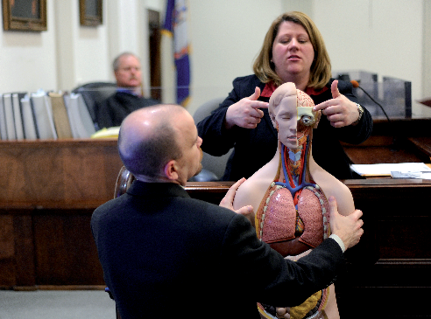
Figure 2 Pathologist giving evidence in a US court
View description - Figure 2 Pathologist giving evidence in a US court

There is an important principle in law that witnesses are not allowed to say what they thought about the evidence. What a witness thinks about the evidence is sometimes called ‘opinion’ evidence. Rather, witnesses limited to giving evidence of what they themselves directly perceived. However, expert evidence is an exception to this principle, and this section explains why.
To understand why expert evidence is an exception to the rule against opinion evidence, it helps to first understand what opinion evidence is and why it can be problematic. Another term for an opinion in this context is ‘an inference’. An inference is where a person makes a mental leap from the evidence to a further fact using tacit information that is personal to them. For example, if in a stabbing case a suspect is later found with the victim’s blood on his hands, one juror might infer that the suspect was responsible for the assault. But another juror might infer that the suspect only went to help the victim after somebody else stabbed the victim. A third juror might infer something else entirely. This explains why these inferences are called ‘opinions’: the facts that are inferred from the evidence are often uncertain and may vary from person to person, as illustrated by Figure 3.

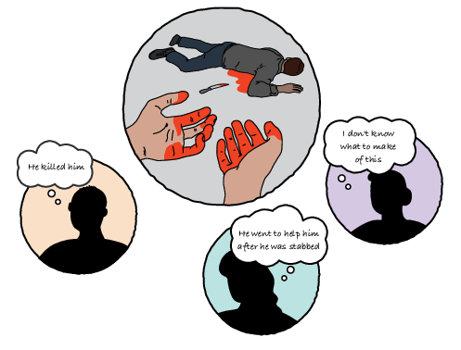
Figure 3 Different jurors’ opinions of the same evidence
View description - Figure 3 Different jurors’ opinions of the same evidence

The uncertain nature of inferences from evidence explains why so-called opinion evidence is generally not admissible. Court proceedings, whether criminal or civil, can have serious consequences for those involved. It is a great responsibility to be the decision maker as a judge or juror, and it is considered important that the decision is that of the individual or individuals assigned to decide the case, not that of a third party who is otherwise unaccountable. As a result, it is the opinion of the decision makers in the case (the judge or jurors) that matters, not the opinions of third parties.
However, there are circumstances where a lay decision maker will not have an opinion on particular evidence. For example, what would a lay decision maker who is unfamiliar with fingerprint evidence make of the evidence of a particular pattern of lines and ridges? Without relevant expertise, the decision maker might be unable to make any inference at all, or the inferences that they make might be very unreliable. Without assistance, a miscarriage of justice might occur. It is to overcome this problem that exceptions are made to allow suitably qualified experts to offer their opinions to the decision maker to help them make the right decision. That leaves an uneasy balance between the expert providing help to the decision maker without influencing them so much that the expert effectively becomes the decision maker. The law of expert evidence tries to navigate this delicate balance.

2 Admissibility of expert evidence
There are a number of rules, primarily common law, that prescribe when expert evidence will be admissible. Some of these rules apply to all evidence, but others are specific to expert evidence. For example, the concept of evidential 'weight' means how much influence the evidence will have on the fact-finder's decision. This applies both evidence from lay witnesses and expert witnesses, though often expert evidence will tend to carry more weight overall.
In the following sections, you will be introduced to some of the key admissibility rules concerning expert evidence, namely relevance, assistance, reliability, expertise and hearsay.

2.1 Relevance
As with all evidence, expert evidence needs to be relevant to be admissible. Relevance entails a link from the evidence to one of the facts in issue such that the expert evidence, if admitted, would bolster or undermine that fact. A fact in issue is one that is disputed between the sides. For example a fact in issue might be whether or not a partial fingerprint found at the scene matches the accused. Therefore, if there is no link between the evidence and a fact in issue, or if there is a link but the expert evidence does not illuminate that fact in issue, then it will not be relevant.
For example, fingerprint evidence placing a suspect at a crime scene will not be relevant if the suspect accepts that they were there. Similarly, if the suspect denies that they were at the crime scene, evidence that the suspect has particularly distinctive fingerprints would not be relevant if the prints taken from the crime scene are too poor in quality for identification purposes.

2.2 Assistance
In contrast to relevance, assistance is a concept that is specific to the law of expert evidence. Assistance is linked to the idea you examined in the introduction: expert evidence is only justifiable if it helps the decision maker make an inference that they would not be able to make without the assistance of expert evidence. If the decision maker would be able to make sense of the evidence using their ordinary common sense, then the expert evidence will not be of assistance. But, if the decision maker would not be able to do this, then the evidence may be of assistance. According to King CJ in the South Australian case of R v Bonython, ^{Footnote1} this means:

whether the subject matter of the opinion is such that a person without instruction or experience in the area of knowledge or human experience would be able to form a sound judgment on the matter without the assistance of witnesses possessing special knowledge or experience in the area.

For example, in the murder case of R v Turner, ^{Footnote2} the defendant admitted the killing but sought to argue that he was provoked. The defendant’s legal team tried to admit the expert evidence of a psychiatrist about the likelihood that he was telling the truth. However, the application was refused because the ability to assess whether an individual was telling the truth was considered to be a skill within the ordinary competence of a juror, and hence, expert evidence would not provide assistance. Similarly, in the case of Honeysett v The Queen, ^{Footnote3} the High Court of Australia refused an application to call an anatomist to compare CCTV footage of the offender at the crime scene with footage of the suspect in custody. This was held to be something that a layperson was capable of. Where the expert had used the phrase ‘ectomorphic’ to refer to the offender’s body type, a layperson could simply have said ‘skinny’.

Sensitive topic

Box 1 ‘Rape myths’ and alternatives to expert evidence
There are some areas where the opinions or inferences of the average juror are said to be prejudiced and unreliable and, therefore, in need of the assistance of expert evidence, or other alternatives, to combat this prejudice. Perhaps one of the most high-profile areas is that of ‘rape myths’ in prosecutions for rape and other sexual offences.
Historically, the conviction rate for such offences has been lower than other serious offences, and some have put this down to prejudiced views on the part of jurors. Examples might include views that:

- those who are voluntarily intoxicated are partially responsible
- those who did not scream or resist consented
- that the onus should be on the complainant to communicate lack of consent
- that false allegations due to revenge or regret are common
- that male sexuality is uncontrollable once aroused
- that women give mixed signals about their interest
- that rape only occurs between strangers; or
- that male rape only occurs between gay men.
(Leverick, 2020, p. 257)

To address such concerns, different strategies have been pursued. One option is to call expert evidence to support jurors in making more reliable inferences from the evidence. However, in R v Miller, ^{Footnote4} the Court of Appeal endorsed a second approach – that of providing tailored directions to jurors to address the risk of inappropriate stereotypes and mistaken beliefs. Directions can be given by the judge at the start of the case or at the summing-up stage (The Criminal Procedure Rules 2020, Rule 25.14).
In the civil courts, there is a third method of supporting decision makers on matters outside their expertise. This is through the use of appropriately qualified ‘assessors’. Assessors are experts in a particular area who can be called upon to sit with a judge and participate in the decision. For example, in County Court proceedings for disability, sex, race, religion and belief, and sexual orientation discrimination, judges can appoint an appropriately qualified assessor with expertise in the particular area. To some extent, this overcomes the risk of lack of accountability of experts in that the assessor is formally part of the decision-making process rather than simply a witness.

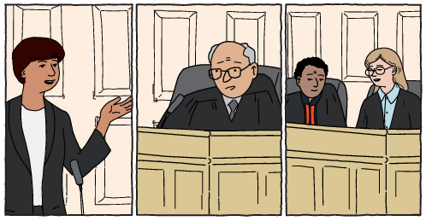
Figure 4 Assistance
View description - Figure 4 Assistance

In the following activity, you will have an opportunity to express your views on approaches to managing this issue.

Sensitive topic

Activity 1 Addressing ‘rape myths’
Allow about 20 minutes

A variety of approaches have been suggested to address ‘rape myths’ in jury trials. Which, if any, of the following do you think would be most appropriate? Once you have made your selection, remember to click ‘Save response’. The results of the poll will be displayed in the comment.

Interactive content is not available in this format.

View discussion - Part

2.3 Reliability
Reliability is the question of whether the particular topic is something upon which an expert is capable of having expertise. King CJ, again in Bonython, stated:

whether the subject matter of the opinion forms part of a body of knowledge or experience which is sufficiently organised or recognised to be accepted as a reliable body of knowledge or experience, a special acquaintance with which by the witness would render his opinion of assistance to the court.

On the one hand, there are topics such as fingerprint evidence and DNA evidence that (with some exceptions) are capable of supporting very robust inferences and are generally seen as reliable. On the other hand, there are topics that might include psychic communication or crystal healing that will probably never support robust inferences and are seen as unreliable (even if some people trust them). Between these two extremes are topics where a court may need to determine whether it is sufficiently well-established and scientific to be classed as reliable.

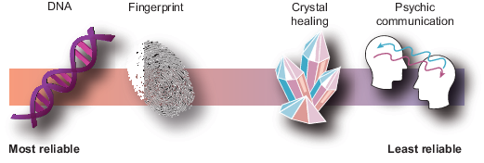
Figure 5 Scale of reliability
View description - Figure 5 Scale of reliability

Other jurisdictions, such as the USA, have taken a hard line on the question of reliability. For example, the US case of Daubert v Merrell Dow Pharmaceuticals, Inc. ^{Footnote5} established that the trial judge exercises a ‘gatekeeping’ function to ensure that the purported area of expertise rests on ‘a reliable foundation’. As such, these issues could not be left to the jury as a matter of weight. Characteristics that were relevant in determining the reliability of a particular area of expertise include:
- whether it has been subjected to peer review and publication
- whether it can be and has been tested
- whether it has a known error rate; and
- whether the research was conducted independent of the particular litigation or was dependent on an intention to provide the proposed testimony. ^{Footnote6}
By contrast, it is fair to say that in England and Wales, the common law courts have historically taken a fairly laid-back attitude to reliability compared to other jurisdictions. They have often considered such issues as a matter of weight, not admissibility (see Hodgkinson and James, 2020, 1-027). This has led to problems such as the admission of pseudoscientific evidence. In R v Dallagher, ^{Footnote7} the Court of Appeal quashed convictions based partially on ear prints and ordered a retrial. At the retrial, the prosecution offered ‘no evidence’ (meaning the defendant was immediately acquitted) after exonerating DNA evidence came to light. The Law Commission was highly critical of the English and Welsh approach (Law Commission, 2011), but the government at the time declined to legislate. However, a subsequent practice directions (Criminal Practice Directions (2023) ^{Footnote8} covers much of the same ground and effectively requires courts to now perform an assessment of the reliability of proposed expert evidence.
In the next activity, you will be asked to perform the ‘gatekeeping’ function normally undertaken by a trial judge to determine which of a list of topics might be treated as sufficiently reliable to be admitted as expert evidence.

Activity 2 What do courts consider reliable expert evidence?
Allow about 30 minutes

Access the Criminal Practice Directions 2023 and read Section 7 on Expert evidence. You can download the most recent version from the Courts and Tribunals Judiciary website (open the link in a new tab or window by holding down Ctrl [or Cmd on a Mac] when you click on the link).
Once you have read Section 7, consider which, if any, of the following areas might be considered sufficiently reliable to be admitted in evidence by a criminal court (subject to also meeting the other criteria). You may need to do a little research if you have not heard of any of these phrases.

Interactive content is not available in this format.

View discussion - Activity 2 What do courts consider reliable expert evidence?

2.4 Expertise
The next hurdle to admissibility is whether the individual witness is in fact an expert in the relevant area. If the witness possesses sufficient expertise, their evidence will be admissible even if the witness is not a terribly good expert. Once the hurdle of admissibility is overcome, it is for the court to attach such weight to the evidence as they see fit. In R (Doughty) v Ely Magistrates’ Court, ^{Footnote9} the justices had wrongly excluded the evidence of an expert in speed detection because of his relative lack of experience. The appeal court pointed out:

Whether the claimant is a good expert or not is neither here nor there. The quality of his report is neither here nor there. … These matters are not a sufficient basis for having ruled the claimant to be simply not competent to give expert evidence at all. ^{Footnote10}

In considering whether an individual is an expert, it is the fact of whether they have the expertise that is important, not their formal qualifications. The leading example of this is the case of R v Silverlock, ^{Footnote11} where a solicitor who had acquired expertise in handwriting recognition as an amateur for ten years was recognised as an expert, even in the absence of formal qualifications.

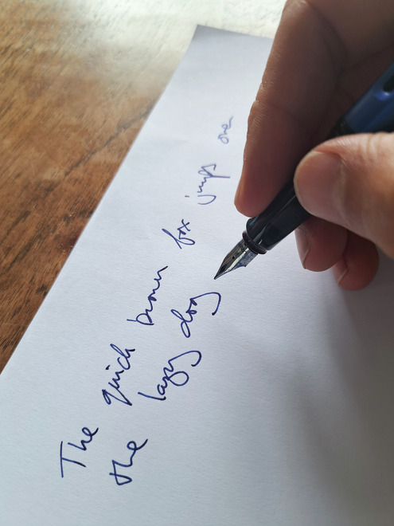
Figure 6 Handwriting
View description - Figure 6 Handwriting

2.5 Hearsay
Experts can use wider sources of information to draw their conclusions than standard evidence. This means that they can often draw on material that would normally be treated as inadmissible hearsay to support the inferences they draw. For example, in the case of R v Abadom, ^{Footnote12} the accused was charged with a robbery during which it was alleged he had broken a window. Fragments of glass were found on a pair of shoes taken from his home, and an expert was called to give evidence that the glass taken from the window and that from the defendant’s shoes had the same refractive index (a measure of how light rays are deflected by glass, and which provides a characteristic ‘fingerprint’ for different types of glass). The expert referred to Home Office Central Research Establishment statistics revealing that the particular refractive index occurred in only 4 per cent of glass specimens examined by them. He therefore concluded that there was a very strong likelihood the glass on the shoes had come from the broken window.

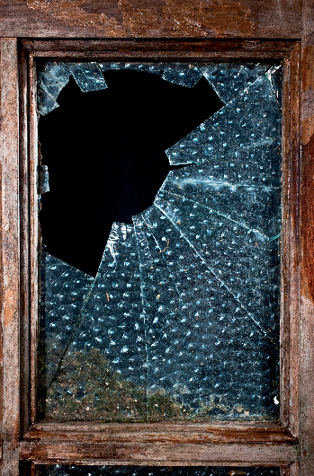
Figure 7 Broken glass
View description - Figure 7 Broken glass

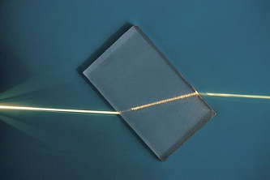
Figure 8 Refraction
View description - Figure 8 Refraction

The defendant appealed against his conviction on the basis that the refractive index evidence was inadmissible hearsay. The Court of Appeal held that the expert had been entitled to use such material in forming his opinion, just as he was entitled to use other work in the field, including unpublished work. It was to be used by the court to weigh the cogency and probative value of the opinion rather than as evidence in itself and, therefore, did not infringe the rule against hearsay.

3 Duties and responsibilities of an expert
Historically some experts appear, knowingly or unknowingly, to have been influenced by the party calling them, tending to give evidence that favours the party that is calling and (often) paying them. This seems very much in contradiction with the assumption that experts assist a court in finding a scientific or ‘correct’ answer. Steps have been taken to address the problem, but it has not been entirely solved.

3.1 Hired guns and bias

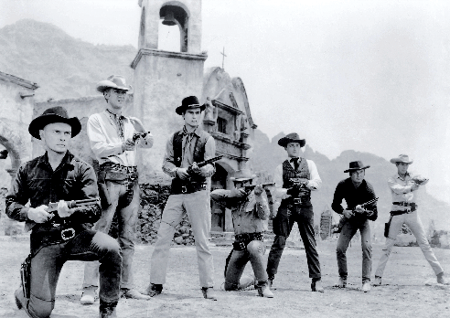
Figure 9 The Magnificent Seven
View description - Figure 9 The Magnificent Seven

One of the most notable cases to have identified the problem of experts acting as ‘hired guns’ (meaning giving the evidence that the party that was paying them wanted to hear) was the case of The ‘Ikarian Reefer’ ^{Footnote13} (shipping cases are often named after the ship in question). The trial judge Cresswell J became very concerned that experts were giving evidence that the party paying them wanted to hear, with negative effects on the length and cost of the trial and on perceptions of its fairness. He sought to set out guidelines for experts to follow to remind them of their duties and responsibilities.


Figure 10 The Ikarian Reefer
View description - Figure 10 The Ikarian Reefer

Similar problems were identified by Lord Woolf, who led the review into the cost and time involved in civil proceedings (Woolf and Lord Chancellor’s Department, 1996). Lord Woolf’s review led to a substantial reform of the Civil Procedure Rules, which included a particular focus on the responsibilities of experts. These rules remain largely the same in the present day.

3.2 The Civil Procedure Rules
Part 35 of the Civil Procedure Rules (CPR) and the accompanying practice direction enshrine the steps taken to guard experts against the influence of bias and other issues. The reforms introduced several novel measures.
Rule 35.3 puts a duty on experts to help the court on matters within their expertise and makes clear that this overrides any obligation to the party who has paid them or given them instructions. To ensure that the expert understands that duty, the expert must state in their report that they understand that duty. The practice direction echoes this, making clear that an expert ‘should not assume the role of an advocate’.
Reflecting the emphasis on independence and saving costs, courts now have a power under Rule 35.7 to order that expert evidence is given by a single joint expert. A single joint expert acts as the expert witness for both parties rather than just one. This makes it more difficult for them to act as a ‘hired gun’ for one party or the other. It also saves time and money.
Contents of an expert’s report are now quite tightly regulated (see Practice Direction (PD) 3.2), such that an expert must give details of:
- their qualifications
- the literature they have relied upon in forming their opinion
- what facts and instructions are material
- what facts are within their own knowledge
- who was involved in the preparation of the report
- a summary of the range of opinions
- reasons for their opinion (a key point we will return to when considering accountability); and
- a summary of their conclusions.
The rules also permit discussions between experts to narrow the issues, a process sometimes informally referred to as ‘hot-tubbing’ (Rule 35.12 and PD 9.1).

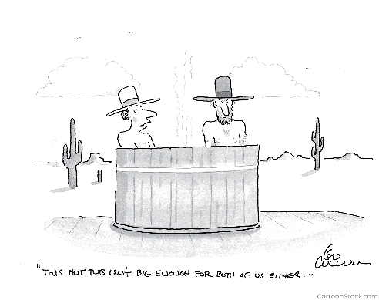
Figure 11 Hot-tubbing
View description - Figure 11 Hot-tubbing

Similar principles are now enshrined in the more recent Criminal Procedure Rules, Part 19 of which deals with expert evidence. These include the duty to the court (19.2), contents of an expert’s report (19.4), hot-tubbing (19.6), and joint experts (19.7).

3.3 Liability and immunity of experts
If an expert witness’s behaviour falls below the standards that are expected of them, there are some circumstances in which they can be held responsible for their failures. Simultaneously, the law also protects witnesses (including experts) from liability in some circumstances by extending immunity to them for things said and done in connection with litigation. The key types of liability that arise are:
- criminal
- civil (generally tortious)
- regulation by professional disciplinary bodies.

3.3.1 Criminal liability
As you will appreciate, giving evidence to a court is a solemn responsibility for any witness. Giving untrue or misleading evidence can lead to serious consequences, such as wrongful imprisonment and unmerited blame and compensation. As you will see later in the course, such unfairness destroys lives. To protect the integrity of the trial against intentional manipulation of evidence, unreliable witnesses can be prosecuted for perjury, and experts are no exception. Perjury is a criminal offence contrary to the Perjury Act 1911 and arises when a witness wilfully makes a false statement that they know to be false or do not believe to be true and which is material in the proceedings. It is punishable by up to seven years in prison.
An example of a prosecution for perjury was reported in The Guardian in 2017. Expert witnesses were jailed after committing perjury ‘on an industrial scale’.

Box 2 Expert witnesses imprisoned for perjury
The following article reports the consequences for a number of experts who fabricated evidence in civil trials. Accident Exchange Ltd was a company that provided replacement hire cars for cars damaged in accidents. The experts worked for Autofocus and gave misleading expert evidence about rates for hire cars, often far below the actual rate. This saved the insurers a lot of money, but eventually, the law caught up with the experts and they were jailed.
Press Association (2017) ‘Expert witnesses jailed in London after perjury on ‘industrial scale’’, The Guardian 16 Jun (open the link in a new tab or window by holding down Ctrl [or Cmd on a Mac] when you click on the link).

3.3.2 Civil liability and immunity
The law approaches civil liability somewhat differently from criminal liability. Historically, many things said or written by witnesses in court were treated as attracting immunity in civil proceedings. In other words, witnesses could not be held liable to pay compensation as a result of what they had said in court. Kelly CB, in Dawkins v Lord Rokeby, ^{Footnote14} stated:

The authorities are clear, uniform and conclusive, that no action of libel or slander lies, whether against judges, counsel, witnesses or parties, for words written or spoken in the ordinary course of any proceeding before any court or tribunal recognised by law.

This was justified by three reasons:
- Encouraging free speech by removing the fear of being sued (see Taylor v SFO ^{Footnote15}).
- Avoiding repeated litigation on the same issue (see Darker v CC W Midland Police ^{Footnote16}).
- Encouraging witnesses to give evidence (see Hall v Simons ^{Footnote17}).
But more recently, the courts have begun to chip away at the extent of civil immunity. The most drastic change came with the case of Jones v Kaney ^{Footnote18} where the Supreme Court swept away the immunity for expert witnesses in proceedings for breach of contract or negligence. Jones was a victim of a road traffic accident which he claimed had led to post-traumatic stress disorder (PTSD). Kaney was his expert clinical psychologist. However, during the ‘hot-tubbing’ discussions with the defendant’s expert, Kaney agreed that Jones did not have PTSD and that he was deceptive and deceitful. Predictably, this seriously damaged Jones’s case and he settled for a small amount. Jones then sued Kaney in a civil court.
By a majority, the Supreme Court ruled that experts could be sued for negligence and breach of contract. The majority considered:
- Lack of immunity was unlikely to discourage experts from appearing as witnesses.
- Lack of immunity was unlikely to discourage experts from giving evidence contrary to the interests of their clients. The court took the view that experts were under a duty to give honest evidence within their expertise, even if this was contrary to their client’s case, and that an expert’s terms of engagement ordinarily required this. As such, experts’ duties were similar to those of advocates who no longer enjoyed immunity either (after Hall v Simons ^{Footnote19}) and this had not proved problematic.
- While the possibility of multiple proceedings was a risk, it was not a large one.
- Abolition would provide a wronged client with a remedy.
- Abolition would ‘sharpen awareness of the risks of pitching their initial views of their client’s case too high or too inflexibly’. ^{Footnote20}
The minority, by contrast, felt that the court was not the right body to weigh up the policy arguments and reform the law in such a way and would have preferred to leave the issue to the Law Commission and Parliament.
In the next activity, you will be given an opportunity to reflect on this area of the law.

Activity 3 Should experts be immune?
Allow about 30 minutes

Do you think experts should be immune from negligence and breach of contract? Give two arguments in favour and two arguments against.

Arguments for | Arguments against
1. | 1.
2. | 2.

Which view do you prefer overall? Why?

Provide your answer...
View discussion - Part

3.3.3 Disciplinary proceedings
Many experts, particularly medical experts such as doctors and consultants, are members of a professional body that regulates their conduct. For example, most medical doctors in the UK are regulated by the General Medical Council (GMC). These bodies often bring proceedings where there is a complaint that the professional’s capability or conduct has fallen below the standards expected by that profession. In Meadow v General Medical Council ^{Footnote21} (concerning Roy Meadow – an expert in the ‘Sally Clark’ case, which involved a notorious miscarriage of justice based on expert evidence that you will examine at the end of this course), the Court of Appeal held that the expert was not immune in professional disciplinary proceedings.

4 How non-experts can scrutinise experts
A fundamental challenge with the use of expert evidence is an apparent conflict between the roles of the court and the expert. On the one hand, the court is supposed to be the decision maker but does not possess relevant expertise on crucial issues. On the other hand, the expert or experts possess the relevant expertise but are only supposed to assist the court – they are not permitted to engage in decision making. This seems to put the court in a difficult position where there is a single expert or disagreement between experts; how could a non-expert decision maker conclude that the opinion of an expert should not be followed?
This apparent contradiction was expressed by the US Judge Learned Hand as follows:

The whole object of the expert is to tell the jury, not facts … but general truths derived from his specialized experience. But how can the jury judge between two statements each founded upon an experience confessedly foreign in kind to their own? It is just because they are incompetent for such a task that the expert is necessary at all … When the conflict is direct and open, the absurdity of our present system is apparent.
(Hand, 1901, p. 54)

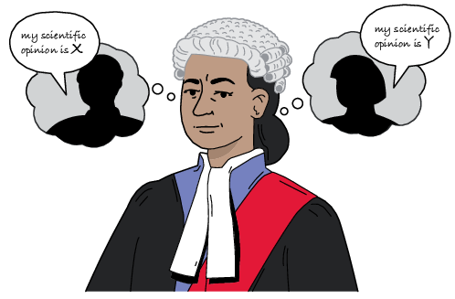
Figure 12 Weighing up evidence
View description - Figure 12 Weighing up evidence

Advocates appear similarly nervous about cross-examining experts, and the Law Commission (2011) has suggested that they tend to focus on undermining the credibility of the expert rather than challenging the substance of their opinions. Yet judges and juries routinely undertake this task, for better or worse, so it is worth examining how they might achieve this. To illustrate how this may be done, read the passage from a Sherlock Holmes story in Box 3.

Box 3 The adventure of the dancing men
Holmes had been seated for some hours in silence with his long, thin back curved over a chemical vessel in which he was brewing a particularly malodorous product. His head was sunk upon his breast, and he looked from my point of view like a strange, lank bird, with dull grey plumage and a black top-knot.
‘So, Watson,’ said he, suddenly, ‘you do not propose to invest in South African securities?’
I gave a start of astonishment. Accustomed as I was to Holmes’s curious faculties, this sudden intrusion into my most intimate thoughts was utterly inexplicable.
‘How on earth do you know that?’ I asked.
He wheeled round upon his stool, with a steaming test-tube in his hand and a gleam of amusement in his deep-set eyes.
‘Now, Watson, confess yourself utterly taken aback,’ said he.
‘I am.’
‘I ought to make you sign a paper to that effect.’
‘Why?’
‘Because in five minutes you will say that it is all so absurdly simple.’
‘I am sure that I shall say nothing of the kind.’
‘You see, my dear Watson’ – he propped his test-tube in the rack and began to lecture with the air of a professor addressing his class – ‘it is not really difficult to construct a series of inferences, each dependent upon its predecessor and each simple in itself. If, after doing so, one simply knocks out all the central inferences and presents one’s audience with the starting-point and the conclusion, one may produce a startling, though possibly a meretricious, effect. Now, it was not really difficult, by an inspection of the groove between your left forefinger and thumb, to feel sure that you did not propose to invest your small capital in the goldfields.’
‘I see no connection.’
‘Very likely not; but I can quickly show you a close connection. Here are the missing links of the very simple chain: 1. You had chalk between your left finger and thumb when you returned from the club last night. 2. You put chalk there when you play billiards to steady the cue. 3. You never play billiards except with Thurston. 4. You told me four weeks ago that Thurston had an option on some South African property which would expire in a month, and which he desired you to share with him. 5. Your cheque-book is locked in my drawer, and you have not asked for the key. 6. You do not propose to invest your money in this manner.’
‘How absurdly simple!’ I cried.
‘Quite so!’ said he, a little nettled. ‘Every problem becomes very childish when once it is explained to you.’
(Conan Doyle, 1903)

Sherlock Holmes is smart, but not necessarily an expert. Nonetheless, the story illustrates how another person (Watson), who is initially baffled by the inference drawn by Holmes, can be satisfied that his opinion is robust when Holmes spells out his thinking. Watson does not need to be able to make the inference himself; he only needs to be able to follow the individual links in the chain of reasoning one at a time to satisfy himself that each link is reasonable (or unreasonable). This is the type of task that a legal decision maker may be capable of.
Logicians divide this checking process into two different types:
- Checking for truth is where the decision maker checks whether the factual assumptions relied upon by the expert are true. For example, if the expert says that the brakes on the car were old and worn, the judge or juror can check the evidence to see if that is correct. As the court said in R v Turner, ^{Footnote22} ‘[b]efore a court can assess the value of an opinion it must know the facts upon which it is based. If the expert has been misinformed about the facts or has taken irrelevant facts into consideration or has omitted to consider relevant ones, the opinion is likely to be valueless.’
- Checking for validity is where the decision maker checks that the logical inferences made by the expert are correct. For example, if the expert multiplies two probabilities, the judge or juror can also do the multiplication themselves to check that the answer is right. In Bolitho v City and Hackney Health Authority, ^{Footnote23} the House of Lords said that if expert evidence is not capable of withstanding logical analysis, then the court is entitled to reject it. An illustration of a court using a validity error to overturn a conviction is that of R v T, ^{Footnote24} which we will look at in a bit more detail towards the end of the course. In that case, footprints from the crime scene showed that the culprit’s trainers had damage that did not match the trainers later recovered from the accused. However, the expert assigned this evidence a ‘likelihood ratio’ of 1 (meaning that the evidence was neither exculpatory nor inculpatory). Logically, the value should have been less than 1 (because it was exculpatory). The court was rightly sceptical of the expert’s opinion and upheld the appeal.
All things being equal, if the links in a chain of expert reasoning are true and valid, that is a reason to agree with the expert. But if a link is false or invalid, that is a reason to disagree with the expert. This explains the obligation on an expert to give reasons for their opinion that include the facts and assumptions on which it is based.

4.1 Other means of scrutinising experts
In addition to truth and validity, there are a number of other factors that fact-finders can use to assess an expert’s opinion. These include:
- Reasons – experts are required to provide reasons for their opinions, and without these, it is difficult for a fact-finder to have confidence in the expert. In Massey v Tameside and Glossop Acute Services NHS Trust, ^{Footnote25} the court said that a lack of written explanations of how conclusions were reached had added to difficulties in resolving differences of opinions between experts.
- Methodology – the methodology or investigation should be capable of identifying the relevant facts. For example, in Korpach v Klassen, ^{Footnote26} the court preferred a meticulous method of investigating crops compared to a ‘broad brush’ method.
- Respectable body of scientific opinion – a theory is preferable where it is widely respected by other scientists. For example, in Petursson v Hutchison 3G UK Ltd, ^{Footnote27} the court was sceptical of an expert’s theory about the risks of mobile telephone masts to human health given that the expert’s peers were strongly critical of the expert’s theory.
- Changes of opinion – while an expert may need to change their views if the underlying facts change, unilateral changes of opinion may be signs of unreliability. In BSkyB v HP Enterprise Services, ^{Footnote28} changes in an expert’s opinion were taken to undermine their evidence.
In this next activity, you can have a go at testing some expert opinions for truth and validity.

Activity 4 Which expert opinions are true and valid?
You should allow yourself 30 minutes for this activity

Compare the evidence with the expert opinion and give your view as to whether the expert opinion is true or false and whether the expert opinion is valid or invalid.

Case 1

Evidence:
Suspect was left-handed and had red hair. 10 per cent of people are left-handed and 4 per cent of people in England have red hair.
Expert opinion:
Given that 10 per cent of people are left-handed and 4 per cent of people have red hair in England, then the suspect would be one of 0.4 per cent of population.

Interactive content is not available in this format.

Case 2

Evidence:
Blood type found on broken window at scene of burglary was type AB. Suspect's blood type is A.
Expert opinion:
Blood type found on broken window at scene was type AB and the suspect's blood type was found to be type B.
This evidence does not inculpate or exculpate the suspect.

Interactive content is not available in this format.

Case 3

Evidence:
The speed limit was 50mph. The accused was travelling at 60mph.
Expert opinion:
Accused was travelling at 60mph in a 30mph zone. This indicates that they were driving completely inappropriately given the limits.

Interactive content is not available in this format.

5 Numbers
Both lawyers and laypeople often struggle with numbers. The Latin phrase ‘iudex non calculat’ (a judge does not calculate) means that it is the quality and not the quantity of arguments that counts – but some lawyers jokingly take it to mean that judges are not good at maths. While there is some truth that lawyers and laypeople can be uncomfortable with the numbers often used in expert evidence, there are ways of overcoming this problem.
In Box 4, you will be reminded about probabilities, a mathematical idea that underpins much of expert evidence.

Box 4 About probabilities
Much expert evidence is discussed in terms of numerical probabilities. These can be expressed as a percentage where 0 per cent is impossible and 100 per cent is a certainty (see Figure 13), or as a number where 0 is impossible and 1 is a certainty.

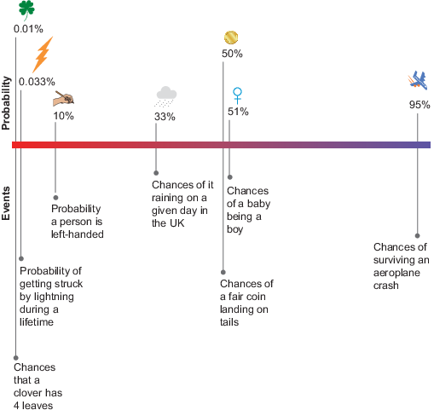
Figure 13 The scale of probability
View description - Figure 13 The scale of probability

5.1 The prosecutor’s fallacy
Judges and juries that are not comfortable with numbers may be at risk of misinterpreting them. A stark example of this is the so-called ‘prosecutor’s fallacy’. This is where the probability of a particular scientific test is mistakenly assumed to be the same as the probability of guilt.
Because the prosecutor’s fallacy is quite a tricky idea to understand, the following activity will guide you through the idea in a series of small steps.

Activity 5 The prosecutor’s fallacy
Allow about 30 minutes

Read through the following scenario and answer the questions as you progress.

Part 1

Imagine a scenario in which a burglary has been committed. Blood recovered from the scene of the burglary is type AB−, which is possessed by one person in a hundred or 1% of the population of the UK (see Figure 14 for the distribution of blood types in the UK).
Josip has been arrested. He was in the area where the burglary was committed at the time it was committed and has blood type AB−.

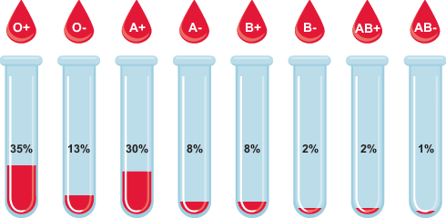
Figure 14 Proportion of blood types in the UK’s population
View description - Figure 14 Proportion of blood types in the UK’s population

- If this is the only evidence, what would you estimate the probability that Josip committed the burglary is? Once you have made your selection, remember to click ‘Save response’. Once you have saved your response, you can compare your view with that of other learners taking this course. The results of the poll are displayed by clicking the discussion tab below.

Interactive content is not available in this format.

View discussion - Part 1

Part 2

Next, imagine that Emma, a police detective constable, calculates that around 10,000 people were in the area during that time and had the opportunity to commit the burglary.
- Now what would you say the probability that Josip committed the burglary?

More than 99%
99%
Less than 99%
Difficult to say
View answer - Part 2
View discussion - Part 2

In summary, this activity should have demonstrated that the prosecutor’s fallacy (the idea that the probability of a positive test is the same as the probability of guilt) is often unsafe. There are a lot of other pieces of information, and assumptions, that you need to be aware of before you can make any assessment of guilt.
Do not feel bad if you did fall for the prosecutor’s fallacy. It even happens to experts who should know better. In R v Deen, ^{Footnote29} the Court of Appeal quashed a conviction in a rape case for precisely this reason. The DNA expert had said the probability of a positive test was 1 in 3 million and then made the mistake of concluding that the likelihood of the DNA coming from anybody other than Andrew Deen was also 1 in 3 million, a mistake that was adopted by the judge in the summing up to the jury. A retrial was ordered (at which he was convicted again, but this time not based upon a mathematical error).

5.2 Partial solutions
If you struggled a little with the figures in the previous section, you are not alone! Yet scientific tests can get even more complicated than that. For example, we assumed that the blood test referred to in the previous section was completely reliable. But in real life, scientific tests commonly suffer from two types of problem:
- false positives (also known as a ‘Type 1’ error): this is where the test reports something of interest when there is actually nothing.
- false negatives (also known as a ‘Type 2’ error): this is where the test reports nothing of interest when there is actually something.
In addition, the accuracy of a test depends on how common the thing you are interested in (for example, blood type, DNA genotype) is in the population – that is, the base rate.

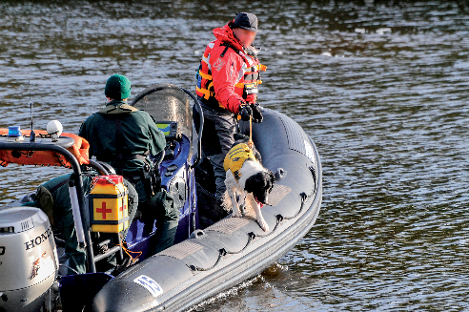
Figure 15 Cadaver dog
View description - Figure 15 Cadaver dog

An illustration of this is ‘cadaver dogs’ – dogs that use their sense of smell to indicate whether there has been a dead body at a location. This evidence might be used if there is no longer a body at a suspected crime scene, but the police believe there might have been. For example, in 2013, in the USA, a man was convicted of murdering his wife based in part on the evidence of a cadaver dog, even where there was no body (Ward, 2013).
Investigators are interested in responses from cadaver dogs when:
- a dog correctly indicates that there has been a body and there actually has been one; or
- a dog correctly indicates that there has been no body when there has not been one.
Problematic responses are where:
- a dog wrongly indicates that there has been a body but there has not been one (a false positive); and
- a dog wrongly indicates that there has not been a body but there has been one (a false negative).
Table 1 shows findings from a study on cadaver dog response rates by Jackson et al. (2015, p. 78). As you can see, cadaver dogs are generally quite accurate, but not all the time.

Table 1 Cadaver dog response rate
Dog’s response | Scent actually present | Scent actually absent
Woof! A body! | 224 | 4
No body | 11 | 115

Here, the number 4 represents a false positive, and 11 represents a false negative.
In this next activity, you will be given a chance to try to work out how often cadaver dogs accurately identify a body. A word of reassurance: very few people get this right!

Activity 6 Cadaver detector dogs
Allow about 30 minutes

Quite often, these sorts of figures will be presented by experts as percentages. This was what you encountered in the previous activity.
Here, the probability the dog signals if there is a body is 0.95 (224/235) or 95% (known as the sensitivity), and the probability the dog signals if there is not a body is 0.03 (4/119) or 3%. The calculation becomes even more complicated because the base rate in Jackson, Aitken and Roberts’, research was derived in a laboratory where they chose to provide scents from cadavers around two-thirds of the time (or roughly 66%). That seems quite high. In the real world, crime scenes with traces of bodies are likely to be rarer than that. Let us assume that in the real world the base rate is about 1 in 10 of suspected murder scenes (or 10%).
So, if a dog in the real world indicates a body, what is the probability there really has been a body?
This is really difficult to calculate, even for experts, so just do your best. Select your answer from the options below. Once you have made your selection, remember to click ‘Save response’. The results of the poll will be displayed in the discussion below.

Interactive content is not available in this format.

View discussion - Part

We know that even experts make mistakes with such calculations most of the time (see Gigerenzer, 1996, and Hoffrage and Gigerenzer, 1998). People seem to struggle with probabilities. However, Gigerenzer and others have suggested that presenting the numbers as ‘natural frequencies’ makes it a bit easier. That effectively means starting with an obvious number of cases.
This time, imagine 1,000 criminal cases where there might have been a body. Of these, based on the base rate assumption of 1 in 10, there will have been a body in 100 cases and no body in 900 cases. Where there has been a body, the dogs will detect it in 95 of those cases (as we worked out they would spot it in 95 per cent of cases and miss it in 5 per cent). If there is not a cadaver, the dogs will nonetheless wrongly indicate there has been a cadaver in 27 of those 900 cases (as we know they will wrongly indicate in 3 per cent or 3 out of every 100 cases). Figure 16 presents this same information visually.

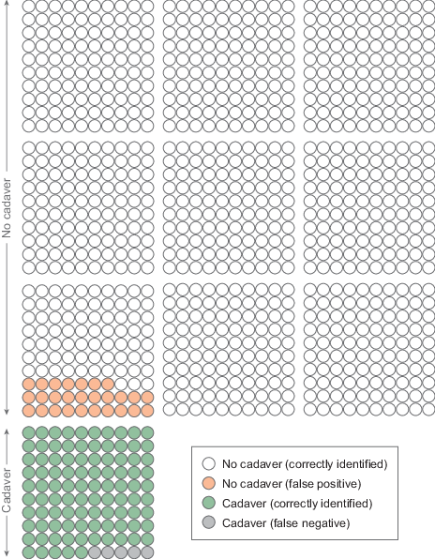
Figure 16 One thousand criminal cases
View description - Figure 16 One thousand criminal cases

Now try answering the question again:
If a dog indicates a body, what is the probability that there really has been a body? Hopefully this is a little easier. Again, remember to click ‘Save response’ after you make your selection.

Interactive content is not available in this format.

View discussion - Part

6 When science meets law
Increasingly, scientific evidence is being presented in a mathematical form based on a formula first articulated by the Reverend Thomas Bayes, an amateur mathematician, which was presented to the Royal Society in 1763, after his death. This approach is sometimes called ‘Bayesianism’, ‘the Bayesian approach’, or ‘Bayes’ Rule’. The Bayesian approach is that it is generally accepted to be the only logical method of combining different probabilities. Yet Bayesianism has created a significant problem for law courts because very few lawyers or laypeople think in such mathematical terms. This section will briefly introduce Bayesianism before discussing how the courts have tried to accommodate it.

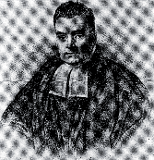
Figure 17 Thomas Bayes
View description - Figure 17 Thomas Bayes

6.1 An introduction to Bayesianism
You were introduced to probabilities in Section 5 of this course. As you saw, probabilities are expressed in figures between 0 and 1, where 0 is impossible, 1 is definite, and 0.5 is evenly balanced. These can also be expressed equivalently as a percentage of 0%, 100% and 50%. A legal case will often have a lot of different probabilities that need to be combined. For example, in a murder case:
- What is the probability that an eyewitness is reliable?
- What is the probability that the accused’s alibi is fake?
- What is the probability that the blood on the murder weapon is that of the victim?
- What is the probability that the accused hasn’t been framed by someone?
Bayes’ Rule provides a mathematical means of combining these probabilities to estimate the final probability of guilt. It is quite technical, so you will not go into much detail here, but if you are very interested, links are provided in the ‘Exploring further’ section at the end of the course. Instead, you will go through a short exercise in the next section that demonstrates how Bayes’ Rule works in practice.

6.2 Bayes’ Rule in practice: the likelihood ratio
In law, probabilities based on Bayes’ Rule are often presented in a particular form, known as the ‘likelihood ratio’. This is to avoid the legal requirement introduced earlier in the course that prevents experts from providing assistance on any non-expert issues. The likelihood ratio is a way of presenting probabilities in a way that does not depend on the probabilities of the rest of the evidence.
A likelihood ratio is calculated from a probability by dividing the probability by its opposite. For example, if the probability that it is going to rain on a certain day is 0.33, then the opposite is that there is a 0.66 probability that it is not going to rain. The likelihood ratio is, therefore, 0.33/0.66 = 0.5.
Whereas probabilities can take any value from 0 to 1, likelihood ratios can take any value from 0 to infinity. Likelihood ratios are not very intuitive, so you can refer to Table 2, which compares some probabilities with common likelihood ratios.

Table 2 Likelihood ratios
Probability | Equivalent likelihood ratio | Verbal description
0 | 0 | Impossible
0.25 | 0.33
0.5 | 1 | Evenly balanced
0.75 | 3
1 | Infinity | Certainty

Table 3 shows likelihood ratios with categories of verbal equivalents used by the Association of Forensic Science Providers (AFSP) and adopted by a large number of forensic practitioners.

Table 3 Likelihood ratio scale suggested by the AFSP
Value of likelihood ratio | Verbal equivalent
>1–10 | Weak support for proposition
10–100 | Moderate support for proposition
100–1000 | Moderately strong support for proposition
1000–10,000 | Strong support for proposition
10,000–1,000,000 | Very strong support for proposition
>1,000,000 | Extremely strong support for proposition

In the next activity, you will see how different probabilities can be converted to likelihood ratios so that standard evidence and expert evidence can be combined.

Activity 7 Try your hand at using likelihood ratios
Allow about 20 minutes

Interactive content is not available in this format.

6.3 The problem with Bayes’ Rule
The big problem with Bayes’ Rule is that though experts may be comfortable with expressing probabilities as numbers and working with likelihood ratios, judges and juries find it terribly difficult (as you may have found yourself!). The courts have struggled with the problem in different ways, but none are very satisfactory.

6.3.1 Bayesian fundamentalism

Sensitive topic

An approach that might be called Bayesian fundamentalism is illustrated by the case of R v Denis Adams. ^{Footnote30} This was a case of rape by an individual unknown to the victim. The victim described her attacker as ‘aged 20 to 25’. The accused, Denis Adams, had an alibi, was 37 and was not picked out by the victim in a line-up. The victim also estimated Adams’ age as ‘40 to 42’. The only evidence linking Adams to the offence was a DNA match, which a prosecution expert gave as 1 in 200 million. Crucially, the defence expert suggested that the jurors should analyse the whole case in mathematical terms (a bit like you did in the previous activity, but for every piece of evidence!), and the prosecution accepted this was valid. However, the Court of Appeal (obiter, because it was not raised in the appeal) expressed huge scepticism towards this approach.

6.3.2 Bayesian skepticism
A similarly sceptical approach towards Bayesian approaches was taken in R v T. ^{Footnote31} This was a murder case where key evidence was footwear marks from the scene. The prosecution expert assigned a ‘moderate’ degree of evidence to support the view that the trainers worn by T had made the marks. Upon further investigation, it turned out that he had used Bayes’ Rule to calculate a likelihood ratio from the sole pattern, size, wear and damage.

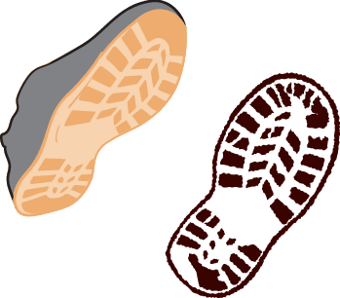
Figure 18 Footprints
View description - Figure 18 Footprints

Controversially, it seemed that the footprints from the scene showed evidence of damage that did not correspond to the trainers recovered from T. This should therefore have been exculpatory evidence and, as you will recall from Section 4, should have been given a likelihood ratio of less than 1. But the expert gave it a value of exactly 1, meaning it was neither exculpatory nor inculpatory.
The Court of Appeal spotted the error and overturned the conviction. However, they were very critical of the use of likelihood ratios in non-DNA cases.
Many outside the legal world have expressed dismay at the court’s scepticism towards Bayes’ Rule, particularly as scientists consider it the only rational way to combine probabilities. For example, Thompson (2012) writes:

I will say at the outset that I think R v T is an inept judicial opinion that creates bad law. The opinion went awry because the justices who wrote it misunderstood a key aspect of the evidence they were evaluating. The justices sought to achieve laudable goals, but their misunderstanding of basic principles of inductive logic, and particularly Bayes’ theorem, led them to exclude a type of expert evidence that, in general, is helpful and appropriate in favour of an alternative type of expert of evidence that is fundamentally inconsistent with the goals the court sought to achieve. The case has already received severe criticism and will inevitably come to be seen for what it is – a judicial blunder.

In addition, it was because the expert had explained his reasoning using Bayes’ Rule that it was possible to see that he had made a mistake. If he had simply maintained that his view was that there was a moderate amount of support for the evidence, this mistake might not have been spotted. Nonetheless, there does not seem to be a completely satisfactory way of using Bayes’ Rule in non-DNA cases.

7 Expert evidence case study

Sensitive topic

The Sally Clark case is a sobering illustration of when expert evidence goes badly wrong. Sally Clark was a solicitor who suffered the deaths of two of her children in unexplained circumstances but whose grief was then compounded by being accused of their murder and having her third son taken away from her. Numerous mistakes were made by the prosecution expert witnesses, but these errors were initially not picked up by the courts. After a second appeal and the dramatic discovery of exculpatory evidence, Sally Clark was released from custody. Nonetheless, some years after being released from prison, she was found dead at home, her death caused by acute alcohol intoxication, but few doubted her treatment at the hands of the justice system was to blame.

7.1 The Sally Clark case
In the next activity, you will learn more about Sally Clark, what happened to her family, and what happened to her in court.

Activity 8 Introduction to the Sally Clark case
Allow about 30 minutes

Read the following article, which reports in the case of Sally Clark. As you do so, try to identify some of the issues that you have explored earlier in this course.
- The Observer (2003) ‘The Clark case: the love that put doctors claims on trial’, 2 February. (open the link in a new tab or window by holding down Ctrl [or Cmd on a Mac] when you click on the link)

Provide your answer...
View discussion - Activity 8 Introduction to the Sally Clark case

7.2 The statistical evidence

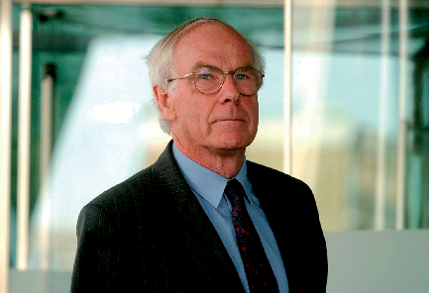
Figure 19 Professor Sir Roy Meadow
View description - Figure 19 Professor Sir Roy Meadow

A large number of mistakes were committed by the prosecution expert Sir Roy Meadow in the Sally Clark case, but we will focus only on the key issues here. One of the most damning pieces of evidence against Sally Clark was the frightening-sounding figure he gave that the probability of two unexpected infant deaths in the same family was one in 73 million, or equivalent to backing an 80 to 1 outsider in the Grand National horse race and winning 4 years in a row.


Figure 20 Grand National wins
View description - Figure 20 Grand National wins

One problem with this headline figure is that it assumes that the chance of each death is independent of the other. The figure was calculated from Meadow’s individual numbers on the chances of a single such death in a family of 1 in 8,543. To reach 1 in 73 million, he multiplied 1 in 8,543 by 1 in 8,543. Assuming the figure 1 in 8,543 is valid (which it probably is not), this calculation is only reliable if the two deaths are independent. However, if there is a common cause, such as an underlying genetic condition, then the deaths will not be independent. If there is a common underlying cause, then the probability of two such deaths becomes much higher. There was, in fact, evidence of a number of such deaths in Sally Clark’s family tree. Thus, the figure was fundamentally flawed.
Meadow also committed the prosecutor’s fallacy by equating the figure of 1 in 73 million as equivalent to the probability that Sally Clark was innocent. You know from Section 5.1 that much more information is needed before you can work out the probabilities of innocence or guilt. Here, you would also need the probability that a mother will murder two of her children, which is also likely to be very small.
A third major error committed by Meadow was that he overstepped his expertise. He was a paediatrician, not a statistician. Many of the errors in his evidence were statistical errors that would be unlikely to have been made by a statistician. Given that he was not an expert in these areas, his evidence ought to have been ruled inadmissible on the grounds of lack of expertise.
Many of these issues were recognised during the first appeal, but the Court of Appeal nonetheless dismissed Sally Clark’s appeal.

7.3 The medical evidence
Prosecution medical evidence against Sally Clark was given by Alan Williams, a home office pathologist. However, investigations by Sally Clark’s husband and Marilyn Stowe, a family lawyer working pro bono, discovered exculpatory evidence that had not been shared by Williams with other witnesses, the police or the lawyers. This suggested that Sally Clark’s second son had died naturally of a bacterial infection.

7.4 The aftermath

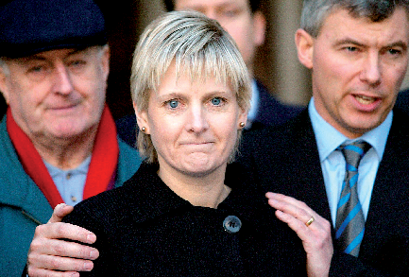
Figure 21 Sally Clark and husband at acquittal
View description - Figure 21 Sally Clark and husband at acquittal

Following a second appeal, Sally Clark’s conviction was overturned and she was released after serving several years in custody. Williams, the pathologist, was found guilty of serious professional misconduct by the General Medical Council (GMC). Meadow was also struck off the medical register by the GMC but then reinstated in 2006 after a successful appeal.
In light of the criticisms of Meadows, a number of other cases in which he had appeared as a prosecution expert witness were reviewed, and many convictions were overturned.
You may have strong feelings about what happened in the Sally Clark case. In the following activity, you will have an opportunity to discuss measures that could prevent such an egregious miscarriage of justice happening again.

Activity 9 Preventing future miscarriages of justice
Allow about 30 minutes

The Sally Clark case appears to cast a dim light on the legal system of England and Wales and the ability of lawyers and the court to scrutinise expert evidence. From what you have learnt in the course, and given what you know of the Sally Clark case, do you think there are any lessons that could be learnt regarding how lawyers and laypeople could scrutinise expert evidence?
Reflect on the Sally Clark case and type your thoughts in the text box. Aim to limit your response to 200 words.

Provide your answer...
View discussion - Activity 9 Preventing future miscarriages of justice

Conclusion
This course introduced the distinctive nature of expert evidence and some of the challenges it throws up. You explored some very tricky concepts that the courts have really struggled with in recent generations. While you will not be expected to know a great deal of detail of some of the more mathematical concepts we have looked at, these should have illustrated why the courts have struggled so much, and why some serious miscarriages of justice have occurred.
You should now be able to:
- explain the rules for admissibility and presentation of expert evidence
- describe the duties and responsibilities of forensic experts
- discuss the challenges posed by expert evidence and how these might be overcome
- discuss the issues raised by expert evidence in the context of a miscarriage of justice.
If you are unsure about any of these, go back and reread the relevant section(s) of the course.
Other courses on OpenLearn
Myths in law
Forensic science and fingerprints
Justice, fairness and mediation
Judicial decision making
Equity – law and idea

Exploring further
If you want to explore further and find out more about the issues discussed in this course, you may find the following of interest.
If you would like to find out more about the prosecutor’s fallacy, you can read this article: Mitchell, J. (2021) ‘The prosecutor’s fallacy: how flawed statistical evidence has been used to jail innocent people’, Cherwell, 2 May.
If you would like to read more about how a cadaver dog secured a conviction in the US, you can find more details in the following article: Ward, C. (2013) ‘Former aurora man found guilty of wife’s 1990 murder’, Chicago Tribune, 31 October.

References
Books
Conan Doyle, A. (1903) The adventure of the dancing men and other Sherlock Holmes stories. Illustrated edn. Mineola, NY: Dover Publications Inc.
Hodgkinson, T. and James, M. (2020) Expert evidence: law and practice. 5th edn. London: Sweet & Maxwell.
Articles
Bayes, T. and Price, R. (1763) ‘An essay towards solving a problem in the doctrine of chances’, Philosophical Transactions, 53, pp. 370–418. Available at: doi:10.1098/rstl.1763.0053.
Gigerenzer, G. (1996) ‘The psychology of good judgment: frequency formats and simple algorithms’, Medical Decision Making, 16(3), pp. 273–280.
Hand, L. (1901) ‘Historical and practical considerations regarding expert testimony’, Harvard Law Review, 15(1), pp. 40–58.
Hoffrage, U. and Gigerenzer, G. (1998) ‘Using natural frequencies to improve diagnostic inferences’, Academic Medicine, 73(5), pp. 538–540.
Jackson, G., Aitken, C. and Roberts, P. (2015) Case assessment and interpretation of expert evidence: guidance for judges, lawyers, forensic scientists and expert witnesses. Practitioner Guide No 4. Royal Statistical Society. Available at: https://rss.org.uk/RSS/media/File-library/Publications/rss-case-assessment-interpretation-expert-evidence.pdf (Accessed: 1 September 2022).
Leverick, F. (2020) ‘What do we know about rape myths and juror decision making?’, The International Journal of Evidence & Proof, 24(3), pp. 255–279. Available at: doi:10.1177/1365712720923157 (Accessed: 16 May 2022).
Mitchell, J. (2021) ‘The prosecutor’s fallacy: how flawed statistical evidence has been used to jail innocent people’, Cherwell, 2 May. Available at: https://www.cherwell.org/2021/05/02/the-prosecutors-fallacy-how-flawed-statistical-evidence-has-been-used-to-jail-innocent-people/ (Accessed: 16 May 2022).
Press Association (2017) ‘Expert witnesses jailed in London after perjury on “industrial scale”’, The Guardian, 16 June. Available at: https://www.theguardian.com/uk-news/2017/jun/16/expert-witnesses-jailed-perjury-cost-replacement-cars-insurance. (Accessed: 01 September 2022).
Thompson, W.C. (2012) ‘Discussion paper: hard cases make bad law – reactions to R v T’, Law, Probability & Risk, 11, pp. 347–360.
Ward, C. (2013) ‘Former aurora man found guilty of wife’s 1990 murder’, Chicago Tribune, 31 October. Available at: https://www.chicagotribune.com/suburbs/aurora-beacon-news/chi-former-aurora-man-found-guilty-of-wifes-1990-murder-20131030-story.html (Accessed: 01 September 2022).
Other sources
Law Commission (2011) Expert evidence in criminal proceedings in England and Wales (Law Com No 325, HC 829). London: The Stationery Office.
The Observer (2003) ‘The Clark case: the love that put doctors claims on trial’, 2 February. Available at: https://www.theguardian.com/observer/focus/story/0,6903,887163,00.html (Accessed: 11 January 2023).
Woolf, H. and Lord Chancellor’s Department (1996) Access to justice: final report to the Lord Chancellor on the civil justice system in England and Wales. London: HMSO.

Acknowledgements
This free course was written by Paul Troop and was first published in November 2025..
OpenLearn editor: Dale Harry
Except for third party materials and otherwise stated (see terms and conditions), this content is made available under a Creative Commons Attribution-NonCommercial-ShareAlike 4.0 Licence.
The material acknowledged below is Proprietary and used under licence (not subject to Creative Commons Licence). Grateful acknowledgement is made to the following sources for permission to reproduce material in this free course:
Images
Figure 1: The Open University
Figure 2: Kim Raff/The News & Advance via AP Archive
Figure 3: The Open University
Figure 4: The Open University
Figure 5: The Open University
Figure 6: Paul Troop
Figure 7: Barry Mason/Alamy Stock Photo
Figure 8: Ajizai. Used under CCO public Domain licence/Wikimedia. https://creativecommons.org/publicdomain/zero/1.0/
Figure 9: Steeve-x-foto/Alamy Stock Photo
Figure 10: (c) John Kent/www.shipspotting.com
Figure 11: Leo Cullum/Cartoonstock
Figure 12: The Open University
Figure 13: The Open University
Figure 14: The Open University
Figure 15: Stephen Barnes/Law and Order/ Alamy Stock Photo
Figure 16: The Open University
Figure 17: Picture of Thomas Bayes taken from https://mathshistory.st-andrews.ac.uk/Biographies/Bayes/poster/died/
Figure 18: The Open University
Figure 19: PA Images/Alamy Stock Photo
Figure 20: Image 1 2022: PA Images/Alamy Stock Photo; Image 2 2019: Dave Shopland/BPI/Shutterstock; Image 3 2018: News Images LTD / Alamy Stock Photo; Image 4 2021: PA Images / Alamy Stock Photo
Figure 21: REUTERS/Alamy Stock Photo
Text
The Adventure of the Dancing Men Arthur Conan Doyle: Smith, Elder & Co. of London
Every effort has been made to contact copyright owners. If any have been inadvertently overlooked, the publishers will be pleased to make the necessary arrangements at the first opportunity.
Don’t miss out
If reading this text has inspired you to learn more, you may be interested in joining the millions of people who discover our free learning resources and qualifications by visiting The Open University – www.open.edu/openlearn/free-courses.

Solutions

Activity 1 Addressing ‘rape myths’

Part

Discussion
The results of the poll are displayed below. You may need to refresh your browser to load the results.

Interactive content is not available in this format.

Obviously, there is no ‘right’ answer here, as different people will have different views. However, you might like to reflect on what other people thought, and whether your answer matches the majority view.
Back to - Part

Activity 2 What do courts consider reliable expert evidence?

Discussion

Evidence | Admissible?
Blood types | Yes – this is a very well scientifically evidenced area.
Astrology | No – astrology is a pseudoscience that is believed to give information about human behaviour and the future by analysing the positions and movements of celestial bodies. While many people strongly believed in astrology, there is no reliable scientific evidence to suggest that it makes reliable predictions.
Astronomy | Yes – not to be confused with astrology, this studies the movement of celestial objects. It is very well evidenced and reliable (i.e., it helped put a rocket on the moon).
Handwriting | Yes – this is probably less reliable than other areas, but it is generally treated as sufficiently reliable. You will read more about handwriting in the next section.
Homeopathy | No – homeopathy is a pseudoscience based on the assumption that giving a person a small amount of a substance that triggers similar symptoms to their illness will cure them. While many people believe in it, there is no reliable scientific evidence to suggest it makes reliable predictions.
Child psychology | Yes – although, it might depend on the particular area of child psychology.
Phrenology | No – this is a pseudoscience based on considering the size and shape of the head. It has a controversial history and has been almost entirely discredited.

Back to - Activity 2 What do courts consider reliable expert evidence?

Activity 3 Should experts be immune?

Part

Discussion
Although it is fair to say that there has been a distinct move away from blanket immunity in civil proceedings, there isn’t a ‘right’ answer as such. Even the judges in the Supreme Court were split on how to decide the case. What is more important is that you have plausible reasons for preferring one side or another.
Back to - Part

Activity 5 The prosecutor’s fallacy

Part 1

Discussion
The results of the poll are displayed below. You may need to refresh your browser to load the results.

Interactive content is not available in this format.

Back to - Part 1

Part 2

Answer
Right:
Less than 99%
Wrong:
More than 99%
99%
Difficult to say
Back to - Part 2

Discussion
You may have been tempted for the poll at the outset to choose 99%, but that would have been to ignore how many people could have committed the crime, a number sometimes called the ‘base rate’. The correct answer at that stage would have been ‘difficult to say’, as you were not given the base rate. Given the further information that 10,000 people had the opportunity and one person in a hundred has this blood type, then statistically, it is likely that there would be 100 from this group who test positive (this is calculated by dividing 10,000 by 100). The probability of Josip being involved is, therefore, only 1 in 100, 1%, or 0.01. Without the base rate information, it is difficult to say how likely it was that they committed the crime. Only with the base rate information can you give a figure.
Back to - Part 2

Activity 6 Cadaver detector dogs

Part

Discussion
The results of the poll are displayed below. You may need to refresh your browser to load the results.

Interactive content is not available in this format.

Back to - Part

Part

Discussion
The results of the poll are displayed below. You may need to refresh your browser to load the results.

Interactive content is not available in this format.

The correct answer is 78%. You can work it out because out of 1,000 cases, a dog will indicate 122 times: In 900 cases there will be no body, but the dog will nonetheless indicate that there is a body 3% of the time, making 27 false positives. And in 100 cases there will be a body, which the dog will spot 95% of the time, making 95 correct identifications. So the right answer is 0.78 (95/27+95) or 78%. Another way of seeing this is by looking at the ratio of the coloured dots in Figure 16. The pink and green dots represent the times that the dog indicates. Pink is a false positive and green is a correct identification. The ratio of the green dots out of all the coloured dots is 78%.
You may still have made a mistake the second time, but the research shows that far fewer mistakes are made when the statistics are presented as natural frequencies. The argument is that experts should present test results in natural frequencies to prevent the types of avoidable errors that happen with expert evidence.
Back to - Part

Activity 8 Introduction to the Sally Clark case

Discussion
Some of the issues you might have identified in the article include:
- the prosecutor’s fallacy
- wrongdoing by expert witnesses
- misunderstandings of statistics.
Back to - Activity 8 Introduction to the Sally Clark case

Activity 9 Preventing future miscarriages of justice

Discussion
You will have your own thoughts on the Sally Clark case, but it highlights a number of shortcomings in the way expert evidence was handled that, as we hope to have demonstrated in this course, we nonetheless have tools to address.
Back to - Activity 9 Preventing future miscarriages of justice

Descriptions

Figure 1 Fingerprint
Image of a magnifying glass hovering over a fingerprint with the portion of the fingerprint visible through the lens shown in more detail.
Back to - Figure 1 Fingerprint

Figure 2 Pathologist giving evidence in a US court
This is a photograph of a female pathologist standing in the witness box in a US court. She is standing behind a life-sized and partially cut-away anatomical model of a human body, which a male assistant is holding up for her, and she is indicating with the forefingers of both hands the entry point and exit point on either side of the head of a projectile.
Back to - Figure 2 Pathologist giving evidence in a US court

Figure 3 Different jurors’ opinions of the same evidence
This figure shows four circles, each containing an image. Top centre, the largest circle shows a body on the floor surrounded by blood and a knife. In the foreground, a pair of hands are shown covered in blood. Below the large circle are three smaller circles. The left smaller circle contains the silhouette of a person with a thought bubble reading ‘He killed him’. The centre smaller circle contains the silhouette of a person with a thought bubble reading ‘He went to help him after he was stabbed’. The right smaller circle contains the silhouette of another person with a thought bubble reading ‘I don’t know what to make of this’.
Back to - Figure 3 Different jurors’ opinions of the same evidence

Figure 4 Assistance
A three-panel cartoon illustration. Panel 1 (left) shows an expert warning the jury from the witness box. Panel 2 (centre) shows a judge warning the jury from the bench. Panel 3 (right) shows a civil judge sitting with an assessor at the bench.
Back to - Figure 4 Assistance

Figure 5 Scale of reliability
This figure shows different types of evidence along a scale of reliability, with the most reliable evidence towards the leftmost end of the scale and the least reliable towards the rightmost end of the scale. DNA evidence and fingerprint evidence are shown at the most reliable end of the scale. Crystal healing and psychic communication at the least reliable end of the scale.
Back to - Figure 5 Scale of reliability

Figure 6 Handwriting
A photograph showing a hand holding a blue fountain pen hovering over a piece of white paper resting on a wooden table. The white paper has the manuscript words ‘The quick brown fox jumps over the lazy dog’ written in blue ink.
Back to - Figure 6 Handwriting

Figure 7 Broken glass
A photograph of an old wooden door or window frame inlaid with textured glass panel. The glass panel has been broken by an impact, leaving cracks in the glass emanating from the impact point. Some of the glass around the impact point is also absent.
Back to - Figure 7 Broken glass

Figure 8 Refraction
A top-down photograph showing light refracting through a glass block. A beam of white light shines from left to right through a rectangular-shaped block of glass. Where the ray of light meets the glass, it is refracted upwards. Where the ray of light leaves the glass, it is refracted downwards. As a result, the ray of light exits the block of glass with a path parallel to that which it entered the block but refracted at a higher point.
Back to - Figure 8 Refraction

Figure 9 The Magnificent Seven
A black and white image from the film ‘The Magnificent Seven’ showing seven cowboys pointing rifles in the foreground. There is a building that resembles a church in the background.
Back to - Figure 9 The Magnificent Seven

Figure 10 The Ikarian Reefer
A photograph of the Ikarian Reefer, a large red and white ship.
Back to - Figure 10 The Ikarian Reefer

Figure 11 Hot-tubbing
A cartoon sketch of two cowboys looking awkward in a wooden hot tub in the desert. One of the cowboys is saying to the other, ‘This hot tub isn’t big enough for both of us either’.
Back to - Figure 11 Hot-tubbing

Figure 12 Weighing up evidence
An illustration showing a judge weighing up evidence from two experts in her head. On the left, there is a thought bubble containing a silhouette of an expert who is saying, ‘my scientific opinion is x’. On the right, there is a thought bubble containing a silhouette of an expert saying who is saying, ‘my scientific opinion is y’.
Back to - Figure 12 Weighing up evidence

Figure 13 The scale of probability
A diagram that shows the probability of different events. It shows a scale from impossible on the left to certain on the right. Events are labelled above the scale, and the corresponding percentage probability is shown below the scale. The probabilities and events shown are: the probability that a clover has four leaves is 0.01 per cent; the probability of getting struck by lightning is 0.0033 per cent; the probability a person is left-handed is 10 per cent; the probability that it will rain on a given day in the UK is 33 per cent; the probability of a fair coin toss landing on tails is 50 per cent; the probability that a baby will be a boy is 51 per cent; the probability of surviving an aeroplane crash is 95 per cent.
Back to - Figure 13 The scale of probability

Figure 14 Proportion of blood types in the UK’s population
An image of a series of eight test tubes of blood filled with the proportion of blood types in the UK population: O+ (35%), O− (13%), A+ (30%), A− (8%), B+ (8%), B− (2%), AB+ (2%), and AB− (1%).
Back to - Figure 14 Proportion of blood types in the UK’s population

Figure 15 Cadaver dog
A photograph of a large inflatable speedboat on the water with two men on board. One man is holding the lead of a working sniffer dog in a harness. The man and the dog are looking down at the water.
Back to - Figure 15 Cadaver dog

Figure 16 One thousand criminal cases
A diagram of 1,000 cases, each represented by a small circle. 900 circles represent cases where there is no body. 100 circles represent cases where there is a body. Of the 900, the dogs correctly indicate that there is no body 873 times and incorrectly indicate that there is a body 27 times. Of the 100, the dogs correctly indicate that there is a body 95 times and incorrectly indicate that there is no body 5 times.
Back to - Figure 16 One thousand criminal cases

Figure 17 Thomas Bayes
A black and white etching of the head and torso of a man in clerk’s clothes, said to be that of the Reverend Thomas Bayes.
Back to - Figure 17 Thomas Bayes

Figure 18 Footprints
An image of a trainer and a footprint with a similar pattern. However, the sole of the trainer shows damage, whereas the footprint shows no such damage.
Back to - Figure 18 Footprints

Figure 19 Professor Sir Roy Meadow
A colour photograph of Sir Roy Meadow
Back to - Figure 19 Professor Sir Roy Meadow

Figure 20 Grand National wins
This figure shows four photos of the winning horses crossing the finish line in four different Grand National horse races.
Back to - Figure 20 Grand National wins

Figure 21 Sally Clark and husband at acquittal
A photograph of Sally Clark at her acquittal Sally Clark is looking emotional. She has short blonde hair and is wearing a dark top. She is flanked by her husband, who wearing a dark suit and tie. He has both his hands on her shoulders. Other figures appear in the background.
Back to - Figure 21 Sally Clark and husband at acquittal

Footnotes
1: R v Bonython [1984] 38 SASR 45 (South Australia). Back to content
2: R v Turner [1975] QB 834. Back to content
3: Honeysett v The Queen [2014] 311 ALR 320. Back to content
4: R v Miller [2010] EWCA Crim 1578. Back to content
5: Daubert v Merrell Dow Pharmaceuticals, Inc. 43 F.3d 1311 (9th Cir 1995). Back to content
6: Daubert v Merrell Dow Pharmaceuticals, Inc. 43 F.3d 1311, 584–587 (9th Cir 1995). Back to content
7: R v Dallagher[2002] EWCA Crim 1903. Back to content
8: R v Dallagher[2002] EWCA Crim 1903. Back to content
9: R (Doughty) v Ely Magistrates’ Court [2008] EWHC 522 (Admin). Back to content
10: R (Doughty) v Ely Magistrates’ Court [2008] EWHC 522 (Admin) [24]. Back to content
11: R v Silverlock [1894] 2 QB 766. Back to content
12: R v Abadom [1983] 1 WLR 126. Back to content
13: The ‘Ikarian Reefer’ [1993] 2 Lloyd’s Rep 68. Back to content
14: Dawkins v Lord Rokeby [1873] LR 8 QB 255, 263. Back to content
15: Taylor v SFO [1999] 2 AC 177 at 208. Back to content
16: Darker v CC W Midland Police [2001] 1 AC 435 at 461. Back to content
17: Hall v Simons [2002] 1 AC 615 HL at 698. Back to content
18: Jones v Kaney [2011] UKSC 13. Back to content
19: Hall v Simons [2002] 1 AC 615. Back to content
20: Hall v Simons [2002] 1 AC 615 [67, 85]. Back to content
21: Meadow v General Medical Council [2006] EWCA Civ 1390, [2007] QB 462, CA. Back to content
22: R v Turner [1975] QB 834, 840. Back to content
23: Bolitho v City and Hackney Health Authority [1998] AC 232. Back to content
24: R v T [2010] EWCA Crim 2439. Back to content
25: Massey v Tameside and Glossop Acute Services NHS Trust [2007] EWHC 317. Back to content
26: Korpach v Klassen [2000] CanLII 19612 (SK PC). Back to content
27: Petursson v Hutchison 3G UK Ltd [2005] EWHC 920 (TCC). Back to content
28: BSkyB v HP Enterprise Services [2010] EWHC 86 (TCC). Back to content
29: Times, January 10, 1994. Back to content
30: R v Denis Adams (No 1) [1996] 2 Cr. App. R. 467. Back to content
31: R v T [2011] 1 Cr. App. R. 9 (CA). Back to content

