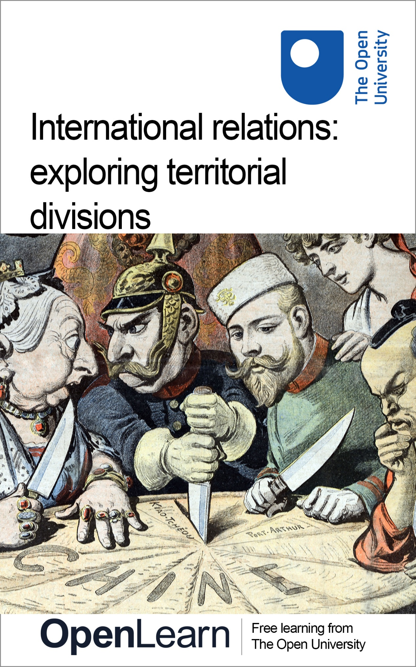

d818_1

International relations: exploring territorial divisions

About this free course
This free course is an adapted extract from the Open University course .
This version of the content may include video, images and interactive content that may not be optimised for your device.
You can experience this free course as it was originally designed on OpenLearn, the home of free learning from The Open University –
There you’ll also be able to track your progress via your activity record, which you can use to demonstrate your learning.
First published 2023.
Unless otherwise stated, copyright © 2023 The Open University, all rights reserved.
Intellectual property
Unless otherwise stated, this resource is released under the terms of the Creative Commons Licence v4.0 http://creativecommons.org/licenses/by-nc-sa/4.0/deed.en. Within that The Open University interprets this licence in the following way: www.open.edu/openlearn/about-openlearn/frequently-asked-questions-on-openlearn. Copyright and rights falling outside the terms of the Creative Commons Licence are retained or controlled by The Open University. Please read the full text before using any of the content.
We believe the primary barrier to accessing high-quality educational experiences is cost, which is why we aim to publish as much free content as possible under an open licence. If it proves difficult to release content under our preferred Creative Commons licence (e.g. because we can’t afford or gain the clearances or find suitable alternatives), we will still release the materials for free under a personal end-user licence.
This is because the learning experience will always be the same high quality offering and that should always be seen as positive – even if at times the licensing is different to Creative Commons.
When using the content you must attribute us (The Open University) (the OU) and any identified author in accordance with the terms of the Creative Commons Licence.
The Acknowledgements section is used to list, amongst other things, third party (Proprietary), licensed content which is not subject to Creative Commons licensing. Proprietary content must be used (retained) intact and in context to the content at all times.
The Acknowledgements section is also used to bring to your attention any other Special Restrictions which may apply to the content. For example there may be times when the Creative Commons Non-Commercial Sharealike licence does not apply to any of the content even if owned by us (The Open University). In these instances, unless stated otherwise, the content may be used for personal and non-commercial use.
We have also identified as Proprietary other material included in the content which is not subject to Creative Commons Licence. These are OU logos, trading names and may extend to certain photographic and video images and sound recordings and any other material as may be brought to your attention.
Unauthorised use of any of the content may constitute a breach of the terms and conditions and/or intellectual property laws.
We reserve the right to alter, amend or bring to an end any terms and conditions provided here without notice.
All rights falling outside the terms of the Creative Commons licence are retained or controlled by The Open University.
Head of Intellectual Property, The Open University

Contents
- Introduction
- Learning outcomes
- 1 How is the world divided territorially?
  - 1.1 The modern state system, geopolitics and imperial rivalry
  - 1.2 Geopolitics and imperial rivalry
  - 1.3 Great power competition in the age of empire
- 2 The making of the modern Middle East
  - 2.1 The interwar period and great power politics
- Conclusion
- References
- Acknowledgements
- Descriptions

Introduction
Different forms of international division remain at the heart of some of the most pressing issues of interest to International Relations (IR) today. Figure 1 below shows how two former empires (in this case the British and Russian Empires) expanded across Asia in the nineteenth and twentieth centuries, and demonstrate how the practices of former imperial powers have left a lasting imprint on global politics. A quick glance at a political map of the world shows us how the world is divided along territorial lines. Looking at the roots of such division helps us understand how they came about and how they can be understood in terms of their impact on contemporary international relations.
There are many factors that influence international division in its myriad forms, from basic geographic and climatic divides to the many varied pathways to development chosen by different states and leaders that have led to very different outcomes, and along with it, forms of inequality and division. The current international system, made up of a range of actors including states and international organisations, is only one form of how international relations are organised and understood. Throughout history, what we now see as the ‘international system’ has been organised, understood and experienced in other ways. Indeed, for much of history, different kinds of empire have predominated. The legacy of these historical antecedents continues to influence contemporary international relations between these different actors.

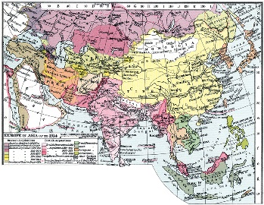
Figure 1 European empires in Asia, 1914
View description - Figure 1 European empires in Asia, 1914

This course will look at how the world is divided territorially and how certain parts of the modern state system came into being. It will then explore the impact of Great Power rivalries and imperialism on the development of the state system we see today, and finish with a case study exploring the development of modern Middle East.
Before you start, take a moment to note down a state with contested or interesting borders that you want to learn more about.

Activity 1
20 minutes

When thinking about this particular state, consider some of the ways in which its borders might have been formed.
- Are there some historical events, such as conflict, or external influences/powers that have shaped how this state evolved into its present day form?
- Perhaps it is or was a major power, or it may have once been a colony of an imperial power?
- Maybe it’s a recent addition to the political map of the world, or that has experienced a change in its borders?
- Perhaps the state in its present form doesn’t fully represent certain groups within it adequately, or maybe it has experienced challenges to its territorial integrity in the past.

Provide your answer...

You will return to this question at the end of the course to see if there are any aspects that you might want to explore further.

Learning outcomes
After studying this course, you should be able to:
- understand different forms of territorial division through selected examples in the Middle East and Eurasia
- enhance your knowledge of the historical roots of today’s nation states in relation to imperial rule and competition
- understand the making of the modern Middle East.
This OpenLearn course is an adapted extract from the Open University course D818 MA International relations part 1.

1 How is the world divided territorially?
If we consider the political map of the world at different points in history, we are presented with a fluctuating picture that shows a range of different territorial units forming, falling away and reforming again over time. For example, Figure 1 shows this in relation to the British and Russian Empires throughout the nineteenth and into the twentieth century. The fortunes of successive empires were one formative influence on how the world has been divided up territorially throughout history. The Achaemenians of ancient Persia, the Romans in Europe, the Mongols across Asia and the Songhai Empire in West Africa were all large, imperial administrations carving up vast swathes of territory that were often continental in scale. The colonial empires of European powers also had a major impact on the map of the world and their mark is still felt in contemporary international relations, with colonial-era administrative divisions forming the basis of many modern states.
Later, you will be introduced to a case study that illustrates the importance of territory in international relations, looking at the development of the modern Middle East state system. This is a part of the world where historic and contemporary conflicts over territory have, in part, resulted from still contested borders previously drawn up by external powers. In Europe too, we only need look at the 2022 Russian invasion of Ukraine, based in part on the pretext of Moscow seeking to redress perceived historical wrongs of a previous Soviet administration, to see how such borders remain contested. Before the Middle East case is examined further, there are some important, foundational ideas that you will be introduced to that provide the platform for understanding the ‘world of states’ that we are currently living in.

1.1 The modern state system, geopolitics and imperial rivalry
The conventional understanding in much International Relations (IR) scholarship is that the Peace of Westphalia of 1648 forms the basis for what many would recognise today as the modern nation state. The Peace of Westphalia brought an end to the Thirty Years War that involved various European powers. It consisted of the Treaty of Münster and the Treaty of Osnabrück, both signed in 1648. These treaties established the principle of autonomous and sovereign nation states in Europe that would not interfere with one another’s domestic affairs.
The Westphalian settlement, and its associated ideas of territoriality, sovereignty and autonomy, are seen by many IR scholars as the starting point for the modern state system, in the European context at least, and therefore the international relations that followed. However, this only tells part of the story of state formation and how the territorial units that we see on the political map today came about. Another story can be told through a different form of organising world politics – that of imperial administration and competition over territories far away from the European centres of imperial power. This allows us to explore how other forms of territorial divisions came about, in part through geopolitical competition and rivalry, but also in response to seismic events such as the First and Second World Wars, which have shaped understanding of international relations as both a phenomena and academic discipline.

1.2 Geopolitics and imperial rivalry
‘Geopolitics’ is a term that has entered the popular lexicon and is often quoted in academic works, newspapers and the media. However, there is often little attention given to what the term actually means. Kathleen Braden and Fred Shelley define geopolitics as ‘the study of International Relations from a geographical perspective’ (2000, p. 5). From this more disciplinary perspective, space and place remain of primary importance in international relations, and thus issues of place, location, scale, region and boundaries are emphasised – in other words, a spatial perspective on human behaviour. As such, the state remains an important tool for geopolitical analysis.
Historically, the term ‘geopolitics’ is often associated with the ideas of Halford Mackinder in the nineteenth and early twentieth centuries; in particular, his 1904 ‘heartland theory’, based on the particularities of British sea power during the age of empire and the historical dominance of land-based power evidenced by the Mongols in their conquest of much of Eurasia. For Mackinder (1904), whoever exercised control of the central Eurasian land mass – an area centred on the Eurasian steppe and Central Asia that he termed the ‘geographical pivot of history’ – would be the dominant global force. This region now comprises a number of independent states that have emerged from successive waves of conquest by and competition between imperial powers (namely British and Russian, then later Soviet). The area is rich in resources and forms an important focus of Russian and Chinese desire to counter United States (US) dominance in international relations. This reconstituted ‘heartland’ is also a site of competition between its constituent states, still grappling with the legacies of a complex and contested political geography originally decreed in a faraway capital, and where conflict over resources is an ever-present threat.
Geopolitical thought in the nineteenth and early twentieth centuries can be understood in terms of classical realism in so much as it involved balances of power and rivalries between the great powers of the day (such as the British, French, Russian, Austro- Hungarian and Ottoman Empires). David Atkinson and Klaus Dodds (2000) have highlighted how the discipline became tainted as the German school of geopolitics, with its ideas of living space or ‘lebensraum’ and came to be viewed by some as the field that allowed Adolf Hitler to articulate his expansionist ambitions. However, the place of geography remains of major importance to IR scholarship, forming a key determining factor in the neorealist theorising of scholars such as John Mearsheimer (2001) with its emphasis on the impact of land force in determining relations between great powers.

1.3 Great power competition in the age of empire
As an academic discipline, IR has had a preoccupation with the affairs of so-called ‘great powers’. Great powers have, since Westphalia, had an arguably unequal representation and attained special rights in terms of setting the shape of international order (Donelly, 2006, p. 152). As two rival powers dominating international affairs in the nineteenth century, British and Russian imperial competition played a role in shaping territorial configurations that are still experienced in today’s geopolitics. It is therefore no surprise that ideas such as Mackinder’s (1904), formed as they were in the milieu of such competition, found traction as they provided a form of explanation for the land grabs that were taking place across the Eurasian land mass during this period. Figure 1, repeated here, shows how British and Russian imperial competition played out across much of Asia at that time.

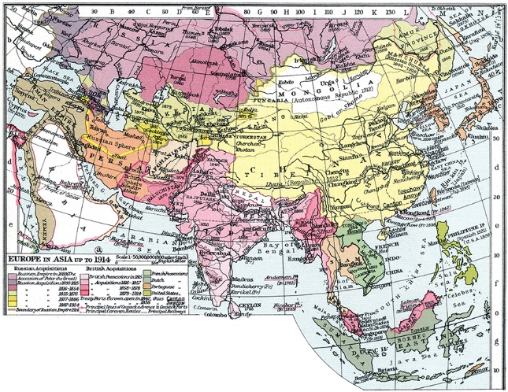
Figure 1 (repeated) European empires in Asia, 1914
View description - Figure 1 (repeated) European empires in Asia, 1914

By the mid nineteenth century Britain established control over much of what constitutes modern-day India, Pakistan, Bangladesh and Myanmar, with the so-called British Raj viewed as the jewel in the crown of the British Empire. Imperial Russia had also been expanding its control, subsuming a number of territories across Siberia and into the vast Eurasian steppe, culminating in the seizure of the nominally independent emirates of Khiva, Bukhara and Kokand in the heart of Central Asia by the late nineteenth century.
This period, often referred to as the ‘Great Game’ – a term popularised through its usage in Rudyard Kipling’s 1901 novel Kim – was characterised by mutual suspicion of the two imperial powers. This was largely based on British suspicion of Russian designs on India and Imperial Russia’s concern with British officials’ attempted inroads to Central Asia. This competition ultimately led to cooperation between Russia and Britain in demarcating (i.e. physically defining) the borders of Afghanistan to act as a ‘buffer state’ between their respective imperial possessions. Afghanistan’s Wakhan Corridor, separating the present-day states of Pakistan and Tajikistan, and which branches off from the main rump of the modern Afghan state, was designed to prevent the two empires’ borders coming together, and is a territorial reminder of the great power political intrigue played out during this period.

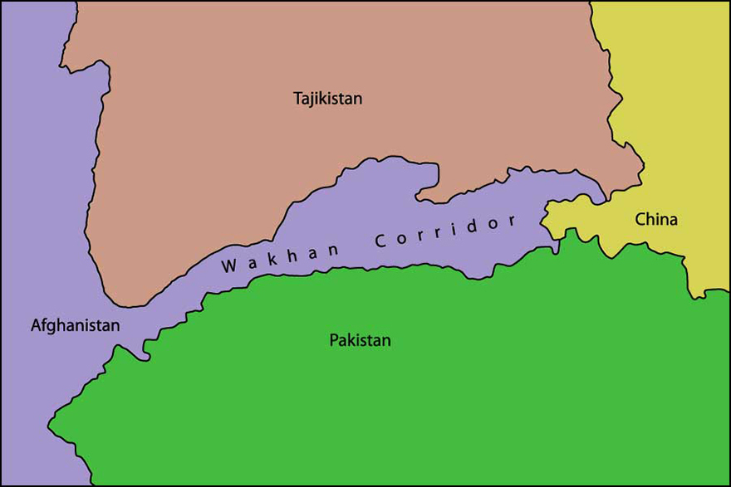
Figure 2 Wakhan corridor map
View description - Figure 2 Wakhan corridor map

The Bolshevik Revolution in 1917 saw Imperial Russia replaced by the Soviet Union. In Central Asia this led to an eventual dissolution of the previous administrative divisions and the redrawing of the map of the region on the basis of ‘one group, one territory’. Though not the first instance of a colonial power bringing previously non-existent ‘states’ into being, it was arguably the first time that one had forged new entities alongside new languages, national histories and folklores (Roy, 2007, p. 61). These went on to become constituent republics of the Soviet Union, with the territorial demarcation of that time forming the contours of the region’s geopolitical divisions today. In some cases, the hangover from this period has led to conflict with significant international repercussions, most notably in the Russia–Ukraine conflict, whereas others have been of less interest to Western observers, including the conflict between Armenia and Azerbaijan over the Nagorno-Karabakh region and conflict over water resources in Central Asia.
This briefest of whistle-stop tours of just one form of imperial rivalry demonstrates the cartographic impact of a form of great power competition. In the following case study, you will find out more about how the administration of imperial territories continues to have a resonance on today’s map of the world, and the relations between states in the modern international system.

2 The making of the modern Middle East
In 2014, fresh from their rapid gains across Syria and northern Iraq, members of the so-called Islamic State group (Daesh) triumphantly bulldozed a manufactured sand fortification that marked the border in a sparsely populated stretch of desert between Iraq and Syria. This was not just a symbolic gesture marking the unification of their territorial gains, but also a repudiation of nearly a century old ‘artificial’ boundary created by the then-imperial powers of France and the United Kingdom (UK).
Three years later, having played a major role in successfully pushing back Daesh, authorities in the Kurdish-controlled autonomous region of northern Iraq held a referendum in which more than 90 per cent of voters declared their wish to secede from Iraq. In both these cases, it looked for a moment that we might be getting our latest additions to the political map of the world in a region long mired in conflict, albeit in two very different guises. Though sworn enemies on the battlefield and ideologically, Daesh and the Kurdish authorities in northern Iraq did have one thing in common: a desire to put right the perceived injustice of borders drawn in faraway European capitals. The chief culprit was the colonial-era Sykes–Picot agreement, drawn up between France and the UK in 1916. Daesh’s leader, Abu Bakr al- Baghdadi, warned, ‘This blessed advance will not stop until we hit the last nail in the coffin of the Sykes-Picot conspiracy’ (Wright, 2016); while Kurdish leader, Massoud Barzani, claimed, ‘The fact is that Sykes-Picot has failed, it's over’ (Muir, 2016). However, the status quo of Iraqi sovereignty and its territorial integrity remained intact.

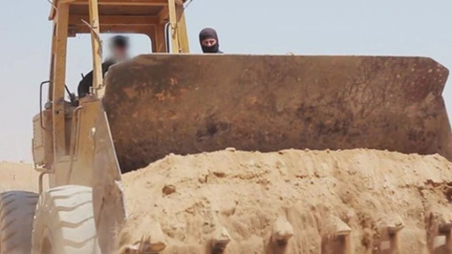
Figure 3
View description - Figure 3

2.1 The interwar period and great power politics
The political map of the modern Middle East is a product of the contrasting fortunes of the key belligerent powers that took part in the First World War, including victorious Britain and France and the vanquished Ottoman Empire. While the war was still raging across Europe and the Middle East, in 1916 British and French officials met in secret to sign the Sykes–Picot agreement, agreeing on a division of the Ottoman Empire following the end of the First World War. The British also supported a revolt in 1916 against the Ottomans in the Arabian Peninsula by the Sharif of Mecca, eventually leading to the establishment of what would become modern-day Saudi Arabia, still ruled by the House of Saud.
Following the end of the First World War, the defeated Ottoman Empire, which sided with Germany and the Austro-Hungarian Empire, was largely dismembered, leaving a rump state based around modern-day Turkey. A substantial portion of the territory previously controlled by the Ottoman Empire in the region was placed under de facto British and French rule, as ‘mandated territories’ under the auspices of the League of Nations (the forerunner to the United Nations (UN)). Following on from the stipulations of the Sykes–Picot agreement, the territories of modern-day Syria and Lebanon fell under French control, while present-day Palestine/Israel, Jordan and Iraq were administered by the British.
Figure 4 shows various territorial divisions, and with it, varying forms of imperial control. The British and French mandates over former Ottoman provinces, agreed by the victors following the San Remo Conference of 1920, gave the two then-imperial powers a role in providing the necessary administrative advice and assistance to prepare them for eventual independence. These joined the pre-existing ‘protectorates’ already administered by Britain and France in and around the region, whereby territories were subject to imperial control through military ‘protection’ for favoured local rulers, and more formal colonies, such as Algeria, which was subject to direct rule from Paris.

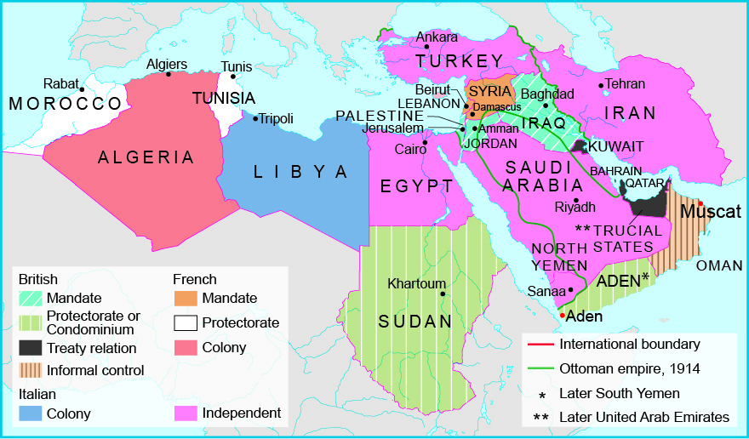
Figure 4 Interwar Middle East territorial divisions of the main European empires in the region
View description - Figure 4 Interwar Middle East territorial divisions of the main European empires ...

The establishment of the State of Israel in 1948 entailed further territorial division that continues to be a source of conflict today. The Holocaust led to increased support for a Jewish homeland in Palestine, which had been gaining momentum since the Balfour Declaration of 1917. This had seen the British government announcing its support for the World Zionist Organization’s goal of establishing a Jewish homeland in Palestine, subsequently paving the way for large-scale Jewish immigration there during the interwar period. Following a bitter conflict between the established Arab and more recently arrived Jewish populations in the then-Palestinian mandate territory, the British hastily withdrew, paving the way for the declaration of the State of Israel. The first, interstate Arab–Israeli war quickly followed as a coalition of Arab states sought to take control of Palestinian-inhabited areas.
Although only lasting a few decades, the colonial period in the region built on centuries of informal influence, and it went on to have a major impact on its politics and society, helping to establish the administrative, juridical and military structures that subsequently shaped its international relations (Halliday, 2006, p. 83). For example, sectarian divisions in Lebanon were utilised by France to favour a Christian elite at the expense of its Muslim majority population – itself also divided along Sunni and Shia lines – and that helped sow the seeds for a decades-long civil war in the 1970s and 1980s. Sectarian divisions in Lebanon are still notable in the present day, continuing to form the basis of external powers’ engagement with different groups there. Claims for self-determination around the interwar period were in some cases refused, as seen with the rejection of Kurdish aspirations for an independent homeland, or granted if they served great power interests, as seen with allied powers’ support for the Arab revolts noted earlier.

Revisiting Activity 1
15 minutes

At the start of this course you were asked to note down a state that was of interest to you, and to think about some of the ways its present borders might have been influenced by its historical experiences. You can see your answers below. When looking back on these, is there anything that you’ve learned from the course that might help you look at this example differently? Perhaps there are aspects of its history or political formation that are worth investigating further which can help you understand that state’s present form and the nature of its international relations today.
Not available in this format.

Conclusion
In this short taster course, you have been introduced to the idea of territorial division as an enduring feature of international relations. In the discipline of IR, the focus is often, though not exclusively, on relations between the states that make up the international system. This course has used examples from the geopolitical competition of 19th Century ‘Great Powers’, and from the making of the modern Middle East, to show how certain forms of territorial division came about and how they continue to shape and influence the often contested international relations of the present day.
This OpenLearn course is an adapted extract from the Open University course D818 MA International relations part 1.

References
Atkinson, D. and Dodds, K. (2000) ‘Introduction’, in D. Atkinson and K. Dodds (eds) Geopolitical traditions: a century of geopolitical thought. London: Routledge, pp. 1–24.
Braden, K.E. and Shelley, F.M. (2000) Engaging geopolitics. Harlow: Prentice Hall.
Donelly, J. (2006) ‘Sovereign inequalities and hierarchy in anarchy: American power and international society’, European Journal of International Relations, 12(2), pp. 139–170.
Halliday, F. (2006) The Middle East in international relations: power politics and ideology. Cambridge: Cambridge University Press.
Kipling, R. (1901) Kim. New York: Doubleday Page and Company.
Mackinder, H. (1904) ‘The geographical pivot of history’, Geographical Journal, 23(4), pp. 421–437.
Mearsheimer, J. (2001) The tragedy of great power politics. London: W.W. Norton and Co.
Muir, J. (2016) ‘Sykes-Picot: the map that spawned a century of resentment’, BBC News. Available at: https://www.bbc.co.uk/news/world-middle-east-36300224 (Accessed: 22 June 2022).
Roy, O. (2007) The new Central Asia: the creation of nations. London: I.B. Tauris.
Wright, R. (2016) ‘How the curse of Sykes-Picot still haunts the Middle East’, New Yorker, 30 April. Available at: https://www.newyorker.com/news/news-desk/how-the-curse-of-sykes-picot-still-haunts-the-middle-east (Accessed: 11 June 2022).

Acknowledgements
This free course was written by Edward Wastnidge.
Except for third party materials and otherwise stated (see terms and conditions), this content is made available under a Creative Commons Attribution-NonCommercial-ShareAlike 4.0 Licence.
The material acknowledged below is Proprietary and used under licence (not subject to Creative Commons Licence). Grateful acknowledgement is made to the following sources for permission to reproduce material in this free course:
Course image: Chris Hellier / Alamy Stock Photo
Figure 1: GRANGER - Historical Picture Archive / Alamy Stock Photo
Figure 2: Valerii_M / Shutterstock
Figure 3: Islamic State
Figure 4: The Open University
Every effort has been made to contact copyright owners. If any have been inadvertently overlooked, the publishers will be pleased to make the necessary arrangements at the first opportunity.
Don't miss out
If reading this text has inspired you to learn more, you may be interested in joining the millions of people who discover our free learning resources and qualifications by visiting The Open University – www.open.edu/openlearn/free-courses.

Descriptions

Figure 1 European empires in Asia, 1914
An early 20th Century map of Asia showing the extent of the British and Russian empires in the region as of 1914. The map has a key in the bottom left corner which indicates what the different colours of various territories refer to. Russian imperial possessions encompass a swathe of territories from Ukraine in the west, across the Caucasus and Central Asia in the middle of the map, and up into Siberia in the north.British imperial territories include India and modern day Pakistan, Bangladesh and Myanmar in the south.
Back to - Figure 1 European empires in Asia, 1914

Figure 1 (repeated) European empires in Asia, 1914
An early 20th Century map of Asia showing the extent of the British and Russian empires in the region as of 1914. The map has a key in the bottom left corner which indicates what the different colours of various territories refer to. Russian imperial possessions encompass a swathe of territories from Ukraine in the west, across the Caucasus and Central Asia in the middle of the map, and up into Siberia in the north.British imperial territories include India and modern day Pakistan, Bangladesh and Myanmar in the south.
Back to - Figure 1 (repeated) European empires in Asia, 1914

Figure 2 Wakhan corridor map
A map showing the Wakhan Corridor region of Afghanistan. The map shows where the borders of Afghanistan, Pakistan, Tajikistan and China all meet. The corridor can be seen as long, slim ‘finger’ of territory stretching from the main northeastern portion of Afghanistan, and separating the territories of southern Tajikistan and Northern Pakistan. The corridor of land ends at Afghanistan’s short border with China.
Back to - Figure 2 Wakhan corridor map

Figure 3
A large yellow bulldozer controlled by a driver whose face is blurred out. The bulldozer is shovelling a large quantity of dry, sandy earth typical of desert regions into its ‘ripper’ – the large claw-like instrument at the front of the machine used as a shovel. Above the ripper section, is a man’s balaclava head is poking over the top, supervising proceedings. A small amount of calligraphic Arabic script is in the top right hand corner of the image.
Back to - Figure 3

Figure 4 Interwar Middle East territorial divisions of the main European empires in the region
A map of the Middle East and North Africa that highlights the different territories administered by European empires after the First World War. The map extends from Morocco in the west to Iran in the east, and from Turkey in the north to Sudan in the south. The different imperial territories are identified by different colour shadings. The British mandate territories of Jordan, Iraq and Palestine are shaded light blue with white stripes. The British condominium/protectorate territories of Sudan and Aden (part of modern day Yemen) are shaded green with white stripes. The British treaty relation territories of Kuwait and the Trucial States (Bahrain, Qatar, modern day UAE) are shaded dark grey. The informally controlled British territory of Oman is shaded in beige stripes. The Italian controlled colony of Libya is shaded in blue. The French mandate territories of Syria and Lebanon are shaded in light orange. The French protectorates of Morocco and Tunisia are shaded in white. The French colony of Algeria is shaded in dark orange. The independent states of Egypt, Iran, Turkey and Saudi Arabia are shaded in pink.
Back to - Figure 4 Interwar Middle East territorial divisions of the main European empires in the region

