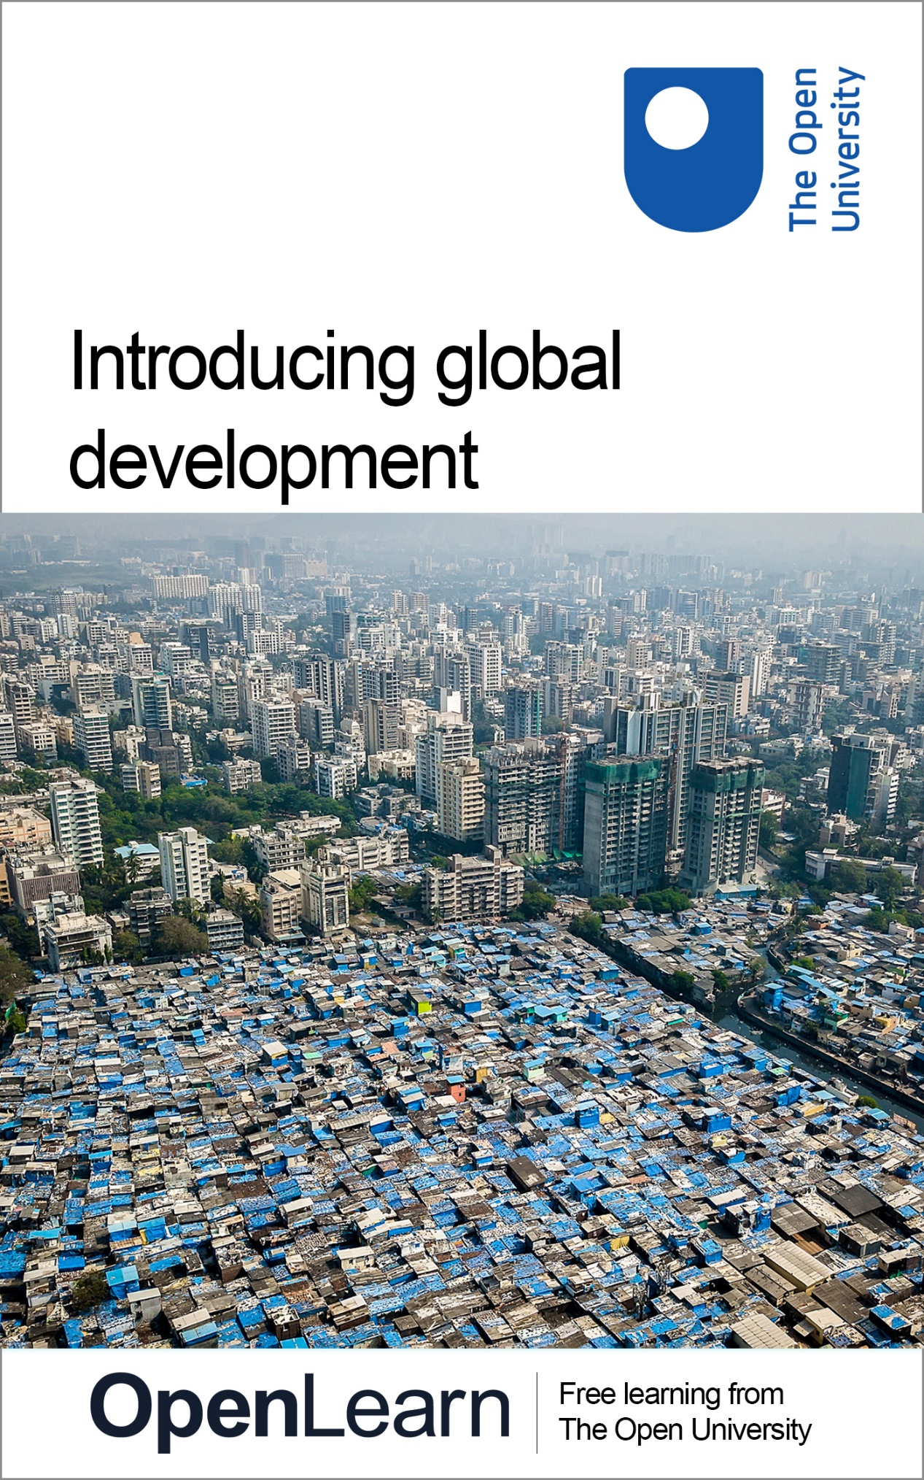

dd870_1

Introducing global development

About this free course
This free course is an adapted extract from the Open University course DD870 Understanding Global Development www.open.ac.uk/postgraduate/modules/dd870.
This version of the content may include video, images and interactive content that may not be optimised for your device.
You can experience this free course as it was originally designed on OpenLearn, the home of free learning from The Open University –
There you’ll also be able to track your progress via your activity record, which you can use to demonstrate your learning.
Copyright © 2022 The Open University
Intellectual property
Unless otherwise stated, this resource is released under the terms of the Creative Commons Licence v4.0 http://creativecommons.org/licenses/by-nc-sa/4.0/deed.en_GB. Within that The Open University interprets this licence in the following way: www.open.edu/openlearn/about-openlearn/frequently-asked-questions-on-openlearn. Copyright and rights falling outside the terms of the Creative Commons Licence are retained or controlled by The Open University. Please read the full text before using any of the content.
We believe the primary barrier to accessing high-quality educational experiences is cost, which is why we aim to publish as much free content as possible under an open licence. If it proves difficult to release content under our preferred Creative Commons licence (e.g. because we can’t afford or gain the clearances or find suitable alternatives), we will still release the materials for free under a personal end-user licence.
This is because the learning experience will always be the same high quality offering and that should always be seen as positive – even if at times the licensing is different to Creative Commons.
When using the content you must attribute us (The Open University) (the OU) and any identified author in accordance with the terms of the Creative Commons Licence.
The Acknowledgements section is used to list, amongst other things, third party (Proprietary), licensed content which is not subject to Creative Commons licensing. Proprietary content must be used (retained) intact and in context to the content at all times.
The Acknowledgements section is also used to bring to your attention any other Special Restrictions which may apply to the content. For example there may be times when the Creative Commons Non-Commercial Sharealike licence does not apply to any of the content even if owned by us (The Open University). In these instances, unless stated otherwise, the content may be used for personal and non-commercial use.
We have also identified as Proprietary other material included in the content which is not subject to Creative Commons Licence. These are OU logos, trading names and may extend to certain photographic and video images and sound recordings and any other material as may be brought to your attention.
Unauthorised use of any of the content may constitute a breach of the terms and conditions and/or intellectual property laws.
We reserve the right to alter, amend or bring to an end any terms and conditions provided here without notice.
All rights falling outside the terms of the Creative Commons licence are retained or controlled by The Open University.
Head of Intellectual Property, The Open University

Contents
- Introduction
- Learning outcomes
- 1 Global issues
- 2 Thinking about development
- 3 The concept of international development
- 4 Modernisation and development
- 5 Adopting a critical stance
- 6 The global nature of development
- 7 Complexity and development
- 8 Framework for a global development mindset
- 9 The four elements of PASH
- 10 The Sustainable Development Goals (SDGs)
- 11 Critiquing the SDGs
- 12 Final words and next steps
- References
- Further reading
- Acknowledgements
- Solutions

Introduction
Development is about change that is a result of human activity, and such change has happened throughout human existence. In this course, you will first examine a particular framing of change processes − that associated with industrialisation and the concept of a ‘modern’ society. The view of development as modernisation emerged clearly in the 1950s and 1960s, although its origins can be traced back much further. Between the seventeenth and twentieth centuries, the economic, social, cultural and political systems of countries in Western Europe and North America were transformed and, in the post Second World War period, the industrialised countries were the dominant actors in the international system. They promoted a message that all societies should aspire to follow in their path and become technologically advanced and modern. Such a view of development gives rise to an established perspective that sees a stark divide between the wealthy and powerful ‘developed’ countries of the global ‘North’ and the poorer, marginalised ‘developing’ countries of the global ‘South’.
You will explore the arguments for questioning and potentially moving away from such a binary view. There is increasing recognition of a need to think about development in global terms, a perspective that recognises that all countries are affected by, and need to participate and collaborate in, addressing the serious global issues of the twenty-first century. The Sustainable Development Goals (SDGs) are an important step in this direction. To support and provoke your thinking on global issues and on the SDGs, you will be introduced to PASH (Power, Agency, Scope, History), a conceptual and analytical framework created for the course.
This OpenLearn course is an adapted extract from the Open University course DD870 Understanding global development. You might also be interested in the related OpenLearn course, DD871 Introducing key global development challenges. To find out more, explore this OpenLearn article, which includes a video explaining what you can expect to learn.

Learning outcomes
After studying this course, you should be able to:
- use ideas of global development to better understand the interconnectedness of the world and how it shapes the major social, economic, political and environmental issues
- appreciate the global development agenda as represented by the Sustainable Development Goals and key development issues such as migration and environmental sustainability
- understand how to use a conceptual framework (PASH) to analyse global development.

1 Global issues
Before considering ideas of development, pause for a moment to think about the nature of issues. Issues are topics of importance within specific contexts and the subject of discussion and disagreement. In recent times, climate change, the coronavirus pandemic (COVID-19), the war in Ukraine (2022) are examples of global issues. They have directly and indirectly impacted people all over the world. They feature prominently in national and international media, and provoke strong reactions, arguments, and debate amongst people in many countries.
A common thread in such issues is that they are highly complex. They involve interconnected and interdependent social, economic, political, and cultural processes that operate at local, national, regional, and international levels. COVID-19 spread across the world due to the highly mobile nature of modern life and its impacts were felt on social, health and economic systems in practically every country and continent. Developing vaccines for the virus required timely and effective actions by governments and citizens, technological adaptation and innovation, and collaboration between scientific, technological and health professionals around the world. However, successful technological innovation is only one strand of the story. Questions of justice arise when developed countries and regional bodies such as the United States (US), the European Union (EU) and the United Kingdom (UK) have the capacity to reach advance agreements with pharmaceutical companies for supplies of vaccines (Papaioannou, 2022). The result is that economically less-powerful countries in Africa, Latin America and South Asia are disadvantaged. These latter countries have less capacity to absorb the health and economic shocks from the pandemic. Here you can see the connection to issues of poverty and exclusion. Overall, the prioritising of vaccine supplies to high-income countries seems to be self-defeating as COVID-19 does not respect national boundaries, and mutated variants emerge to replace the original ones.
Contemplating such issues raises questions regarding accountability and responsibility. Consider the oceans on planet Earth today, the oceans are filled with human-generated plastics, coral reefs are disappearing, fish stocks are being depleted and water temperatures are rising. The oceans are critical to the health of ecosystems globally and to climate stability. But who should take the lead in changing matters? Who should intervene? Who should pay the costs? Who should answer for any wrongs done? There are no easy, if any, answers to such questions. However, we can seek to better understand and to respond to such issues by using a range of key social science concepts and by looking at them from a global perspective. This course provides an introduction to doing this, starting with a consideration of the nature of development.

2 Thinking about development
What is development? Development involves changing a situation. This is not as straightforward as it sounds since change is perceived and experienced very differently by different people. A given change can be considered to be for better or for worse. Think of a housing development. Some will see this in a very positive light, providing homes and facilities for human occupation and bringing new life into a town or village. Others will be unhappy with the increased urbanisation of their locality and increases in human activity and traffic. The development may involve loss of natural habitat or of farming land, but local businesses and schools may benefit from the increased demand for their services. There are many dimensions to such change, no matter where it occurs.

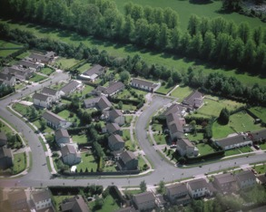
Figure 1: Aerial view of housing in Ireland: This is an example of a planned development although many of its side-effects may be unplanned. Such an interplay between planned and unplanned outcomes is a feature of many developmental processes.
View description - Figure 1: Aerial view of housing in Ireland: This is an example of a planned development ...

The housing development is an example of an intentional planned development intervention happening at a local or national level. Such interventions are also undertaken at the international level.
International development is a term that emerged in the twentieth century to describe interventions undertaken by ‘rich’, ‘developed’ countries, primarily in Europe and North America, in ‘poor’, ‘developing’ countries, predominantly in Africa, Asia, the Caribbean, and Central and Southern America. They aim to address big complex issues such as poverty, lack of access to health facilities and education, and food insecurity, all issues that are linked to global economies and political systems. An underlying assumption of such interventions, based on the experiences of ‘developed’ countries, is that progress and prosperity for all is linked to economic growth, technical innovation and industrialisation.

Activity 1: What does development mean to you?
Allow 10 minutes

When you hear the word ‘development’, what image or idea comes to mind? Think about your experiences of development or change at a personal or professional level. Was the development a planned intervention? Can you think of any unplanned outcomes?

As you will read in the following sections, there is an increasing consensus that the term international development is unhelpful and that thinking in terms of global development better captures the nature and needs of the twenty-first century.

3 The concept of international development
The use of the term International Development has its origins in the global political landscape of the twentieth century. As industrialisation spread across Europe, North America and Australia in the nineteenth and twentieth centuries, income inequalities with other parts of the world increased rapidly. The terms ‘developed’ and ‘developing’ countries emerged in fields of development study and practice and became a means of contrasting the different economic trajectories of the two groups of countries. The focus for international development policy and practice became one of addressing inequalities by enabling developing countries to emulate the economic pathways of developed countries and ‘to catch up’.
In this framing, development is associated with the purposeful and planned interventions undertaken by national governments of wealthier countries such as the United States Agency for International Development (USAID), and by international development agencies such as the United Nations Development Programme (UNDP).

Activity 2: Views on development
Allow 15 minutes

In 2019, The Open University hosted the Development Studies Association (DSA) conference attended by academics, researchers, policymakers and practitioners all interested and working in the development industry. In Video 1, conference participants talk about the contrast between development in the twentieth and the twenty-first century.

Video content is not available in this format.
Video 1: What does development mean in the twenty-first century?
View transcript - Video 1: What does development mean in the twenty-first century?

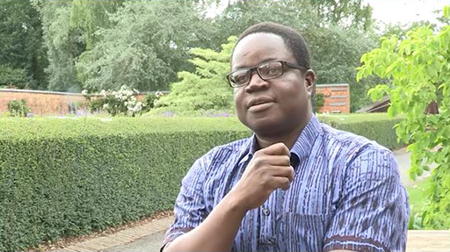

View discussion - Activity 2: Views on development

4 Modernisation and development
The previous section highlights the need to critically examine accepted ideas, such as the understanding of development that emerged primarily in the United States and Western Europe in the last century. Doing so leads to an examination of the international power dynamics at work and of underlying assumptions and worldviews.
After the Second World War (post-1945), the industrialised countries of Europe and North America, often collectively referred to as the global ‘North’, were the dominant powers in the international system. The divide between them and the ‘developing’ countries of the global ‘South’ was not solely economic in nature, but also significant in terms of decision-making power. The United States, in particular, held great influence over global agreements and over major global institutions such as the World Bank and the International Monetary Fund (IMF). Development projects and funding was greatly influenced by ideas of modernisation and modernisation theory. These ideas position technology as a key driver of social change and at the heart of economic growth and progress. In this way of thinking, all countries should aspire to follow the path of industrialised countries.
The economic historian Walt W. Rostow likened industrialisation to flight and that of a plane taking off, a technological metaphor which fitted well with popular culture at the time. He outlined the process as occurring in five stages, as shown in the accompanying diagram.

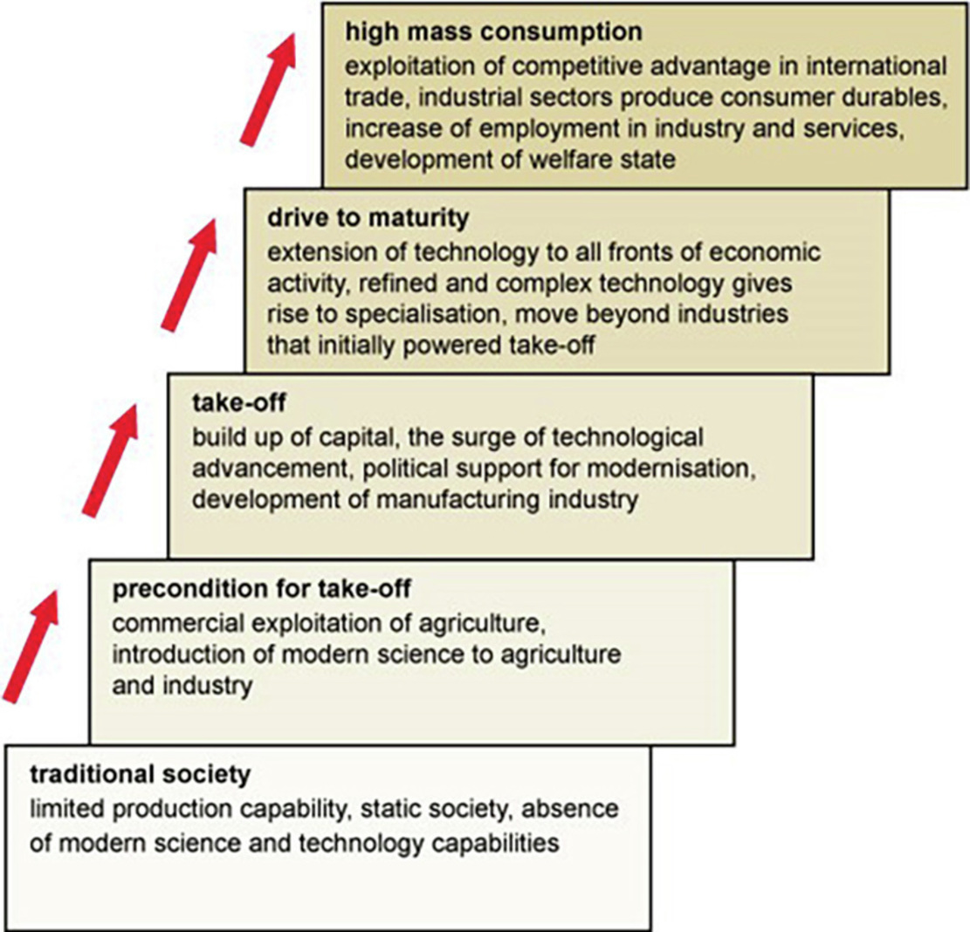
Figure 2: The five stages of economic growth (Rostow 1971)
View description - Figure 2: The five stages of economic growth (Rostow 1971)

In this process, ‘traditional’ societies are portrayed as unproductive, limited, and lacking the benefits of modern technology and science. With introduction and take-up of modern technologies, agricultural practices evolve and change, manufacturing industries develop and modernise. Technology spurs the evolution of service industries, employment rises, and consumer demand drives ongoing economic growth.
Taking a step further back in history, colonialism provided important influences in the evolution of modernisation theory and of international development. The process of decolonisation and granting of independence to former colonies brought with it a claimed sense of responsibility to promote social, economic and political reform in these countries following the model of developed countries (Hewitt, 2009). In this continuing dynamic, democracy is held up as the ideal governance system and individual choice is given precedence over social solidarity. It brings with it the idea of continuous improvement and progress, with science and technology being key to the process. Developed countries through institutions such as the World Bank used, and continue to use, their position of power and global influence to impose this way of thinking on developing countries in ways not always beneficial to these countries.

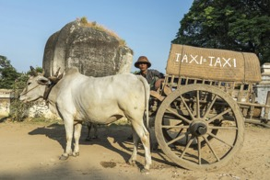
Figure 3: Oxcart taxi in Myanmar
View description - Figure 3: Oxcart taxi in Myanmar

Binary opposites? A traditional means of transport relying on animal power (Figure 3) contrasts with the technologically advanced high-speed train (Figure 4).

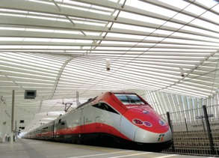
Figure 4: Italian high speed train
View description - Figure 4: Italian high speed train

5 Adopting a critical stance
In the previous section, you were encouraged to take a critical look at the concept of international development and to examine the ideas, assumptions and values that influence the actions and policies of those who undertake development.
Taking a critical stance is a requirement of academic study and research. It is an ability that is learnt and developed through practice. When thinking critically, you question, analyse, and challenge what you are reading and what you are being told. Does an argument have sufficient evidence? If so, of what kind? Is the conclusion consistent and reasoned?
A further key element of taking a critical stance is thinking reflexively. This involves being prepared to subject your own judgements to critical examination. It is important to recognise the role your own personal background and biases might play in your critical thinking. It is all too easy to interpret other people’s views in such a way that they reflect your own understanding and viewpoint. You seek confirmation of your thinking and may ignore contradictory interpretations. It is equally easy to prejudge what someone is saying and devalue or dismiss it because it does not make sense to you on your terms.
Now put on your critical hat and try out the below activity.

Activity 3: Being critical with data and statistics
Allow 25 minutes

Data takes many forms – numbers, words, measurements, observations. The collection, compilation, analysis, interpretation and presentation of data is crucial to social science research and to informing development practice. Data informs us of the number of people living in a city, the level of poverty in a country or the attitudes of a community towards a proposed new factory.
Statistics is that branch of mathematics that deals with numerical data. Raw numbers are converted into meaningful descriptions such as the percentage of children in a school who pass examinations, or the rate of increase of influenza infections in a city over the winter months. Statistics is also used to make inferences based on sampling a part of the population such as the overall literacy levels in a country.
The problem with statistics comes when they are accepted uncritically and seen as neutral and objective ‘facts’. Statistics are produced through processes of definition, evaluation and interpretation and so are never neutral. They are often interpreted inappropriately. For instance, a correlation between two sets of data identifies a possible relationship between them but does not prove causation (Sage Research Methods, 2017). Statistical analysis may show a correlation between a high cholesterol diet and heart disease but does not prove that one causes the other. Doing so needs further research.
The following activity asks you to select a statistic from a choice of three for each question. Note which figure you choose and whether the correct answer comes as a surprise or not. What do you think influenced your choice?
Gapminder created a quiz aimed at debunking our assumptions about the state of the world under the conditions of global development. Gapminder tested thousands of people to generate their own statistics on the extent to which people typically hold incorrect assumptions about this set of development issues. The statistics in the quiz below regarding how many people got each question wrong come from Gapminder’s findings (Gapminder, no date b).

1. How much of the world’s economy comes from agriculture, forestry and fishing?

Around 4%
Around 24%
Around 44%
View answer - Part

2. What share of countries in the world have laws against sexual harassment at work?

Around 35%
Around 55%
Around 75%
View answer - Part

3. What percentage of the world’s population lives in megacities (cities with at least ten-million people)?

Around 8%
Around 28%
Around 48%
View answer - Part

4. How much of the excess heat from global warming is captured in the oceans?

Around 10%
Around 50%
Around 90%
View answer - Part

5. What share of the world’s population don’t have enough food to meet their daily needs?

Around 11%
Around 23%
Around 37%
View answer - Part

6. How many people in the world have access to safe drinking water in their home or close by?

Around 30%
Around 50%
Around 70%
View answer - Part

7. Of all energy used in the world, how much comes from natural gas, coal and oil?

Around 42%
Around 62%
Around 82%
View answer - Part
View discussion - Part

6 The global nature of development
In the previous sections, you read of international development and how it frames development in terms of North-South, developed-developing countries. The problem with such a way of thinking about development is that it consistently leads to a view that developing countries need the intervention of developed countries in order to progress and to address the issues that they face. It not only perpetuates existing power imbalances in the way that global institutions have been set up and operate, but it also undermines the capacity of developing countries to determine their own development pathways.
Interventions often do not produce what is claimed to be the desired result. In the 1980s and 1990s, the structural adjustment programmes (SAPs) of the World Bank and the IMF provided loans to developing countries experiencing an economic crisis. The loan conditions required political and economic reforms supposedly aimed at addressing the root cause of the problem and providing for long-term development and growth. However, they had very mixed results and it was the poorest in society who suffered most from the austerity measures imposed (Stewart, 1995).
In going from the twentieth to the twenty-first century, there is increasing acknowledgement that the development agenda needs to recognise the universal nature of some of the important global development issues of our times, such as environmental sustainability, migration, poverty and economic security. By seeing development issues as primarily affecting ‘developing’, rather than all, countries, an international development framework is very limiting. Such a perspective overlooks many of the interdependencies between the social, economic, political, and environmental fortunes of all countries around the world. It is increasingly argued that a global development approach is better suited to the analysis of the universal and interdependent nature of complex development issues.

Activity 4: Why global development?
Allow 35 minutes

Listen to this audio or read the transcript in which Ben Lampert interviews Dr. Rory Horner from the University of Manchester about his work arguing for the need to think in terms of Global Development.

Video content is not available in this format.
Video 2: Rory Horner and Ben Lampert discuss the notion of global development
View transcript - Video 2: Rory Horner and Ben Lampert discuss the notion of global development

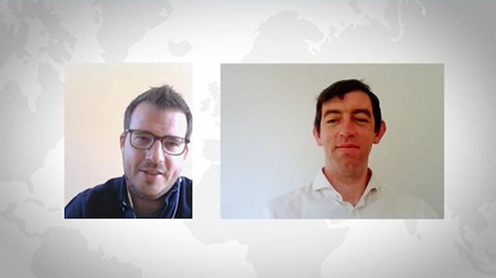

What arguments does Rory make for thinking in terms of global development?

View discussion - Activity 4: Why global development?

7 Complexity and development
Thinking in terms of global development requires dealing with the interconnections and interrelationships between a diverse range of individuals, groups and institutions at a world-wide scale. Poverty, hunger, inequality, injustice, and environmental degradation are all interlinked issues that impact on the health and well-being of many people, and transverse national boundaries. They entail processes that are global in nature, linking many if not all countries around the world, and it is not easy to untangle cause and effect. The reasons for the war in Ukraine in 2022 are linked to its present and past history, to that of neighbouring countries, as well as to that of global politics. The impacts are felt globally. Political alignments change as some countries feel threatened by Russia’s actions. Food supplies, especially that of wheat, are affected and prices rise globally due to the interdependence of food supply and economic systems, with the result that poorer countries will suffer most. The dynamic of the present struggles will merge into that history to create new narratives and provide potential drivers of future conflicts.
Even well-intentioned interventions in the lives of others can have unplanned and unintended consequences, even to the extent that the expected benefits of the intervention are not achieved, or worse, the intervention causes negative impacts. The provision of food aid may have mixed effects providing much-needed nourishment to people in times of crisis, yet also undermining local systems of food production and sale. This indicates that the situation is a somewhat more involved and complex one than anticipated.
What are some approaches to understanding the complexity of these global issues? Systems Thinking (ST) offers a critical framework through which to think about issues with many moving parts. The concept of a wicked problem is used to refer to complex situations that give rise to issues of concern. Global issues have all the characteristics of wicked problems.
Such characteristics are that the problems
- involve a wide and diverse range of actors who are interconnected in diverse ways
- involve multiple and partial perspectives
- generate disagreement as to what constitutes a solution because the root causes are unclear
- encompass a wide range of issues that are not easily contained within defined boundaries, and which can reveal a ‘chaotic’ mix of interrelations
- may be tackled using intervention strategies that have unintended harmful consequences.
ST refers to the traditions and disciplines in which theories, models and techniques relevant to working with complex interconnected situations have been debated and developed. However, it is essentially about a way of thinking and of seeing the world, and of developing skills to work with complexity.
ST skills include
- Exploring boundaries: Evaluate who and what has been included in and excluded from any analysis of a situation, and why.
- Appreciating multiple perspectives: Understand the different ways in which actors perceive issues and relate to them.
- Understanding relationships: Map and explore the multiple networks of interconnections that exist between actors and factors within and across systems.
- Thinking in terms of systems themselves: The whole cannot be fully appreciated from the sum of its parts.
(Midgley 2014)
The language of ST speaks of emergence, improvement, and possibilities. It recognises that the parts can never capture the properties, the magic of the whole. Take a computer apart. You can know the function of every part but unless combined in a certain way, no picture will emerge on your computer screen. You cannot have the picture without the complex interplay of the parts – it doesn’t exist outside of them. Movement is a property observed in living and non-living things. You can measure movement and try to define it, yet you cannot hold it in your hand and say exactly what it is made of. It has emerged from a source of energy interacting with a physical entity such as a machine or a body, itself made up of many parts.

Figure 5: Components
View description - Figure 5: Components

8 Framework for a global development mindset
Thinking systemically requires a both/and mindset. Working with a complex situation requires looking at individual parts of the whole – you cannot deal with everything, so you must draw a boundary somewhere. It is critical to keep a healthy ‘part-whole’ balance, and to work with the parts in such a way as to create an approximation of the whole.
The process of looking at the parts of a problem and breaking it down in order to gain understanding of a larger whole is one that researchers and practitioners continually grapple with. There is always a danger that the dots do not get joined up and valuable insights are not realised at opportune times.
The story of cholera is one where investigators, both past and present, work at different levels of complexity. It took careful detective work and study of the distribution of outbreaks of the disease for the British physician, John Snow, to identify the source of the problem in London in 1854. He did not know what caused the disease, but his findings provided the evidence that led to an effective intervention – removal of an offending water pump.

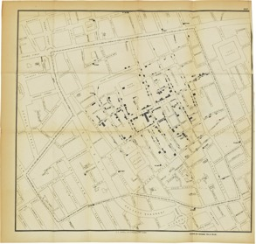
Figure 6: A map from ‘On the Mode of Communication of Cholera’, 1855 (litho), Snow, John (1813−58)
View description - Figure 6: A map from ‘On the Mode of Communication of Cholera’, 1855 (litho), Snow, ...

The causative organism, a bacterium, was identified in 1854 by the Italian physician, Filippo Pacini, although this work was unknown to John Snow (History.com 2020). It took some years before the work of different investigators was brought together and a more complete picture built up of the pathology of cholera and its spread. Taking a step back and looking at the disease organism in its natural setting provokes further questions and inquiry, such as why did a bacterium, which is present widely in coastal habitats and been around for thousands of years, evolve into a virulent strain and go on to cause devastating pandemics (Boucher et al., 2015). Similar questions can be asked regarding the emergence of a new type of coronavirus in 2019 and its spread to become a global pandemic. In gaining a more complete understanding of such situations, it is necessary to isolate the parts and study them in minute detail. It is also essential to look at the parts in context and consider the complex interactions between them and their environment.
In the fields of complexity and ST, a wide range of methodologies, techniques and tools have been developed to support thinking, and in seeking some understanding of complex situations. Such approaches are used by scholars and practitioners in order to reduce the complexity as it is impossible to deal with the whole in any meaningful detail but seek to maintain an awareness of the bigger picture. A framework is one such conceptual tool, one that gives insights and helps in exploring possibilities. PASH is a conceptual framework developed for the Global Development qualifications offered by The Open University. It brings into juxtaposition four key concepts, Power, Agency, Scale and History (PASH) that are important in making sense of global development and complex global development issues such as poverty, migration and environmental sustainability.

9 The four elements of PASH

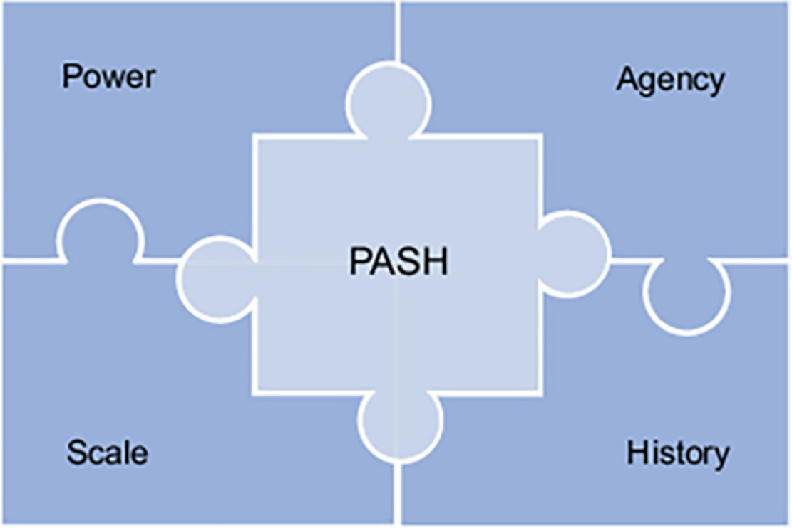
Figure 7: The four conceptual elements of PASH connect and work with one another, like the pieces of a jigsaw puzzle.
View description - Figure 7: The four conceptual elements of PASH connect and work with one another, ...

The four conceptual elements of PASH – Power, Agency, Scale and History – offer a useful means of making sense of global development. Together they provide a way to begin to get to grips with complexity, with each element of the framework helping us to develop critical insights into a particular dimension which can then be brought together to build a more comprehensive analysis of a development situation or issue.
Click through the tabs in Figure 8 and learn more about the four concepts: Power, Agency, Scale and History.

Interactive content is not available in this format.
Figure 8 (interactive): The four elements of PASH explained
View description - Figure 8 (interactive): The four elements of PASH explained

Activity 5: Using PASH in analysing a global issue
Allow 20 minutes

Working with all four elements of PASH simultaneously is a challenge. Consequently, it is advisable to start an analysis of a process or situation by working with each element in turn, identifying what each highlights about the context under examination. It is then important to build on this by explicitly working to identify what further insights can be generated by thinking about how the different elements of PASH can interact in the analysis of a situation.
Box 1 presents the initial thoughts of Richard Pinder, one of the authors on the Open University’s Global Development modules, as he attempts to think through the issue of climate change in terms of PASH. Note how Richard uses the ideas of power, agency, scale and history to get an initial grasp on this complex issue. Can you see points in which Richard is thinking with more than one of these ideas together? How does this aid his analysis of the issue?

Box 1: Climate change and PASH
Power is an obvious starting point. Industrialised countries are often seen as the wealthiest and most technologically advanced countries in the world, and it is widely recognised that this often derives from their history of being colonial powers which gave them privileged access to labour and natural resources and enabled them to establish a global ascendency. Therefore, these countries are historically situated in a position of power to shape and dominate the agenda of global negotiations and subsequent targets.
The new polluters, such as the ‘rising powers’ of China and India, whose economic and political resurgence on the global stage gives them the agency to challenge the established global powers, argue they should not have to compromise their new-found growth and therefore attempt to pass the responsibility back to past polluters.
But what about other actors such as the leaders and ordinary people from industrialised countries, rising powers and developing countries? It is clearly evident that these negotiations affect and reflect the decisions of ordinary people about their consumption and demands.
It will be evident from the actors I have mentioned that this is a story that is being worked out on a number of levels. So, scale is significant. There is certainly a strand of the story evident at the local level due to the individual household and business consumption of resources. Actions at the local level have implications for shaping national policy on climate change. This is reflected in negotiations between governments at the international level and the development of a global agenda for all individuals, communities and nations to pursue. It shows decisions are made, and the impact of these decisions, at different scales, from household and community to the international and global.

Inquiring into global issues such as migration or environmental sustainability requires that you engage with multiple perspectives and approaches. PASH provides a particular framework which acts as a prompt for critically thinking about such complex issues and about global development. You may start by examining power relations and ask how it relates to agency, to scale and to history. Questioning and reflecting in this way helps you in evolving new interpretations and alternative insights.

10 The Sustainable Development Goals (SDGs)
Taking action to address global development issues such as climate change, environmental degradation, social injustice or food insecurity, requires extensive and sustained levels of cooperation and commitment by actors at many levels of society. The Sustainable Development Goals (SDGs) – a framework of 17 goals adopted in 2015 by the 193 member states of the United Nations (UN, nd: a) − set out to do just this.

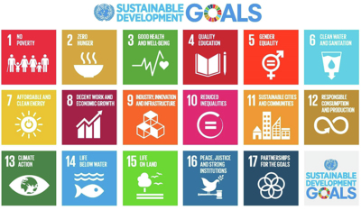
Figure 9: The 17 Sustainable Development Goals
View description - Figure 9: The 17 Sustainable Development Goals

The 2030 Agenda for Sustainable Development (UN 2015) set out to be far-reaching, people-centred, sustainable and transformative. The 17 Sustainable Development Goals (SDGs) that it established to achieve this provide a focus for collaboration between nations but also allow for diversity in approach. Each country decides what matters most to it and where it will target its energies and resources. Targets and indicators are associated with each goal.
The SDGs are global in the sense that they recognise that contemporary development issues are shaped by, and impact on, all countries, and that all need to be involved in addressing such issues as universal concerns. There is a focus on social transformation associated with achieving social justice through a radical transformation of economic, social, political and cultural systems so that resources are more equitably and sustainably shared. The SDGs cover structural issues such as the causes of poverty and economic inequality; social justice issues such as rights, inclusion and equity; policy issues such as peace, governance and human rights and environmental sustainability issues such as climate change and biodiversity loss.
The need for coordinated global action is reflected in SDG 17 which calls for a ‘global partnership for sustainable development’ involving not only cooperation between the governments of the world but also the involvement of private sector and civil society actors (https://sdgs.un.org/ goals/ goal17). Such a process is intrinsically political and requires building new relationships, new understandings and new institutions. It is a process of learning to do things differently.

Activity 6: Interconnected SDGs
Allow 25 minutes

Read the list of facts and figures below that is provided on the UN Sustainable Development Goals website (UN, nd; b).

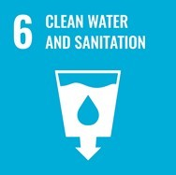 | Figure 10: SDG 6: Ensure access to water and sanitation for all. (Taken from Figure 9.)

Look at Figure 9 which shows all 17 SDG goals or visit the SDG website. What other goals do you see as connecting to goal 6?
- 1 in 4 health care facilities lacks basic water services.
- 3 in 10 people lack access to safely managed drinking water services and 6 in 10 people lack access to safely managed sanitation facilities.
- At least 892 million people continue to practice open defecation.
- Women and girls are responsible for water collection in 80 per cent of households without access to water on premises.
- Between 1990 and 2015, the proportion of the global population using an improved drinking water source has increased from 76 per cent to 90 per cent.
- Water scarcity affects more than 40 per cent of the global population and is projected to rise. Over 1.7 billion people are currently living in river basins where water use exceeds recharge.
- 2.4 billion people lack access to basic sanitation services, such as toilets or latrines.
- More than 80 per cent of wastewater resulting from human activities is discharged into rivers or sea without any pollution removal.
- Each day, nearly 1,000 children die due to preventable water and sanitation-related diarrheal diseases.
- Approximately 70 per cent of all water abstracted from rivers, lakes and aquifers is used for irrigation.
- Floods and other water-related disasters account for 70 per cent of all deaths related to natural disasters.
Bulleted list source: Sustainable Development Goals website: Goal 6: Ensure access to water and sanitation for all

View discussion - Activity 6: Interconnected SDGs

11 Critiquing the SDGs
It is perhaps not surprising that the SDGs, in attempting to address major global issues, will be imperfect and subject to critique. The effort and work involved in reaching this level of agreement between many very different countries and cultures deserves recognition. Inevitably, achieving consensus imposed limits on the scope of the agenda for sustainable development and involved many compromises.

Activity 7: Experts’ opinions
Allow 20 minutes

Watch Video 3, where experts attending the 2019 Development Studies Association (DSA) conference gave their opinions on the limitations of the SDGs. What themes can you identify?

Video content is not available in this format.
Video 3: Critiques of the SDGs: experts’ opinions
View transcript - Video 3: Critiques of the SDGs: experts’ opinions

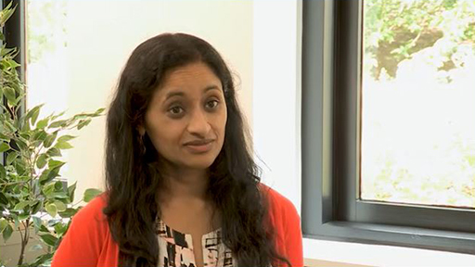

View discussion - Activity 7: Experts’ opinions

Critiquing the SDGs in this way is an important part of your learning. Whilst recognising the positive achievements, it is essential to question and delve deeper into the underlying processes.
Positive and distinctive features of the SDGs is that they forge a set of development priorities and indicators that apply to all regions, all nation states and all localities, not just those labelled as ‘poor’ or ‘developing’. Agreement has been reached on these 17 overarching goals but there is ongoing contention over the meaning of the agreed goals, over who should benefit from them, and who is responsible for attaining them (Scoones, 2016).
By adopting a Systems Thinking (ST) approach and examining the SDGs in terms of power, agency, scale and history (PASH), you begin to probe deeper into the complexities of the processes involved. In exploring key criticisms such as those listed below, it is possible to apply a PASH element to each as a starting point and then ask how they relate to the other elements of PASH.
- Power: The SDGs do not go far enough in challenging the status quo. They protect existing political and economic interests that contribute to the very global issues, such as environmental degradation, poverty and inequality, the goals are supposed to address.
- Agency: Many people are excluded by uneven processes of development that are directed by and benefit the most powerful.
- Scale: Even though the SDGs are global in scale, implementation is dependent on national governments and governments can select which SDGs they wish to pursue. There is a danger of losing the bigger picture perspective.
- History: The SDGs are premised on the continuing pursuit of economic growth, which has produced stark social inequalities and damaged the environment.
The power in this case lies with global institutions and corporations which have access to economic resources and political influence. Developed countries are prominent in this although the developed-developing distinction is increasingly blurred with the rising influence of countries such as Brazil, Russia, India, China and South Africa (BRICS). This power dynamic is continually evolving. Agency is an interesting aspect to consider. Technological innovation and the spread of the use of social media gives people from all walks of life a degree of agency. How this impacts at different scales − local, national and global − varies and is somewhat unpredictable. Taking a historical perspective, the link between the SDGs and the efforts of developed countries to set and to lead global development agenda can be recognised.

12 Final words and next steps
You are now reading the end of this Open Learn course in which you were introduced to the concept of global development as a framework for thinking and analysing global issues. The complexity underlying issues such as climate change, migration, social injustice and equality, food insecurity and poverty, require appreciating the interactions and interrelationships between many different actors and factors at multiple levels. Doing this is no easy task and use of conceptual frameworks such as PASH can both aid your analysis and provoke deeper questions.
This is the journey that awaits you should you decide to take your learning further and go on to study the Open University’s Global Development modules in full. In doing so, you will extend your knowledge and understanding of global development and the key development issues that face the world presently. You will also develop your critical thinking, analytical and reflective skills, and be well placed to contribute to the changes needed to make the world a better place for all.
This OpenLearn course is an adapted extract from the Open University course DD870 Understanding global development. You might also be interested in the related OpenLearn course, DD871 Introducing key global development challenges. To find out more, explore this OpenLearn article, which includes a video explaining what you can expect to learn.

References
Boucher, Y., Orata, F. D. and Alam, M. (2015) ‘The out-of-the-delta hypothesis: dense human populations in low-lying river deltas served as agents for the evolution of a deadly pathogen’, Frontiers in microbiology, 6, p. 1120. Available at: https://pubmed.ncbi.nlm.nih.gov/26539168/. (Accessed: 29 June 2022)
Hewitt, V. (2009) ‘Empire, International Development & the Concept of Good Government’, in M. Duffield and V. Hewitt (eds) Empire, Development and Colonialism: The Past in the Present. Suffolk, England: Boydell & Brewer, pp. 30–587.
History.com (2020) Cholera . Available at:https://www.history.com/topics/inventions/history-of-cholera#section_6 (Accessed: 30 June 2022).
Integration and Implementation Sciences (I2S) (2014) An Introduction to Systems Thinking by Gerald Midgley. 3 October 2014. Available at: https://www.youtube.com/watch?v=yYyTUs9ipmc (Accessed: 30 June 2022).
Papaioannou, T. (2022) The Demand of Justice in the Diffusion of the Vaccine for COVID-19. Available at: https://fass.open.ac.uk/school-social-sciences-global-studies-development/news/demand-justice-diffusion-vaccinTheo PapaioannouTe-covid-19 (Accessed: 30 June 2022).
Rostow, W. W. (1971) Politics and the stages of growth. Cambridge: Cambridge University Press.
Sage Research Methods (2017) Correlations. Available at: https://methods-sagepub-com.libezproxy.open.ac.uk/video/correlations?seq=1&fromsearch=true (Accessed: June 30 2022).
Scoones, I. (2016) ‘The politics of sustainability and development’, Annual Review of Environment and Resources, 41, pp. 293–319.
Stewart, F. (1995) Adjustment and poverty: options and choices. London: Routledge.
UN (2015) Transforming our World: the 2030 Agenda for Sustainable Development . Error! Hyperlink reference not valid.. Available at: https://www.un.org/ga/search/view_doc.asp?symbol=A/RES/70/1&Lang=E (Accessed: 25 May 2022)
UN (no date) Sustainable Development Goals . Available at:https://www.un.org/sustainabledevelopment/ (Accessed: June 30 2022).
UN (no date) Goal 6: Ensure access to water and sanitation for all. Available at: https://www.un.org/sustainabledevelopment/water-and-sanitation/ (Accessed: June 30 2022).

Further reading
Bateson, N. (2016) ‘Practicality in complexity’, norabateson, 2 January.
Ford, L. (2015) ‘Sustainable development goals: All you need to know’, The Guardian, 19 January.
Horner, R. (2020) ‘Towards a new paradigm of global development? Beyond the limits of international development’, Progress in Human Geography, 44(3), pp. 415-436.
Lewis, D. (2019) ‘“Big D” and “little d”: two types of twenty-first century development?’, Third World Quarterly, 40(11), pp. 1957–75.
Osterloff, E. (n.d.) ‘What is climate change and why does it matter?’ Natural History Museum.
SGDs Today’s storymaps on the Sustainable Development Goals
The World Bank The Atlas of Sustainable Development Goals 2020
Weber, H. (2017) ‘Politics of “leaving no one behind”: Contesting the 2030 sustainable development goals agenda’, Globalizations, 14(3), pp. 399–414.

Acknowledgements
This free course was written by Elizabeth Mc Donnell, in collaboration with the DD870 module team.
Except for third party materials and otherwise stated (see terms and conditions), this content is made available under a Creative Commons Attribution-NonCommercial-ShareAlike 4.0 Licence.
The material acknowledged below is Proprietary and used under licence (not subject to Creative Commons Licence). Grateful acknowledgement is made to the following sources for permission to reproduce material in this free course:
Course image: Media Drum World / Alamy Stock Photo
Figure 1: The Irish Image Collection / Design Pics / Bridgeman Images
Figure 2: adapted from: Rostow, W. (1959). The Stages of Economic Growth. The Economic History Review, 12(1), new series, 1-16. doi:10.2307/2591077
Figure 3: Photo © Dirk Bleyer/Imagebroker / Bridgeman Images
Figure 4: dpa picture alliance / Alamy Stock Photo
Figure 5: Photo by Robin Glauser on Unsplash
Figure 6: Photo © Christie's Images / Bridgeman Images
Figure 7: The Open University
Figure 8 (interactive): The Open University
Figure 9: The Global Goals Organisation
Figure 10: The Global Goals Organisation
Video 1: The Open University
Video 2: The Open University
Video 3: The Open University
Every effort has been made to contact copyright owners. If any have been inadvertently overlooked, the publishers will be pleased to make the necessary arrangements at the first opportunity.
Don’t miss out
If reading this text has inspired you to learn more, you may be interested in joining the millions of people who discover our free learning resources and qualifications by visiting The Open University – www.open.edu/openlearn/free-courses.

Solutions

Activity 2: Views on development

Discussion
Respondents in Video 1 see development as a process, a process that seeks to change problem situations for the better. A number commented that the conceptualisation of how such change should happen and who should be involved needs to be updated. In the twentieth century development was thought of in terms of ‘developed’ countries helping so-called ‘developing’ or ‘underdeveloped’ countries to progress according to a Western model of modernisation.
In the twenty-first century, thinking in terms of such opposing binaries – developed and underdeveloped countries, the ‘rich’ global ‘North’ and the ‘poor’ global ‘South’, and those who work in development and recipients of development – is no longer appropriate. Important issues such as climate change and inequality affect people across the globe and are not confined to particular countries or continents.
Back to - Activity 2: Views on development

Activity 3: Being critical with data and statistics

Part

Answer
Right:
Around 4%
Feedback
Yes, but 84% of people were wrong.
200 years ago, these economic activities made up much more than 5%, but that is not true today (World Bank, 2021). Poor countries won’t get rich from such exports. Makes you think, right?
Wrong:
Around 24%
Around 44%
Back to - Part

Part

Answer
Right:
Around 75%
Feedback
Yes, but 92% of people were wrong.
78% of countries have laws against sexual harassment at work (Tavares and Wodon, 2017). The problem is that these laws are not enforced.
Wrong:
Around 35%
Around 55%
Back to - Part

Part

Answer
Right:
Around 8%
Feedback
Yes, but 77% of people were wrong.
While the world is urbanising, most people still live in cities smaller than ten-million people (United Nations Department of Economic and Social Affairs, 2018). The media tends to focus more on megacities than on other urban areas. The abundance of images showing megacities also perpetuate this misconception.
Wrong:
Around 28%
Around 48%
Back to - Part

Part

Answer
Right:
Around 90%
Feedback
Yes, but 90% of people were wrong.
The global ocean is a heat trap, capturing most global warming (Rhein et al., 2013). You may find the sea’s temperature cold, but the world’s corals, fish, and polar bears would beg to differ. Imagine how much hotter it would be without healthy oceans.
Wrong:
Around 10%
Around 50%
Back to - Part

Part

Answer
Right:
Around 11%
Feedback
Yes, but 79% of people were wrong.
While it is impossible to calculate an exact figure, estimates for wasted children (6.9% in 2019; FAO et al., 2020) and extreme poverty (9.4% in 2020; FAO et al., 2020) are both lower than 11%.
Overestimating the size of a problem can be linked to feelings of sympathy around suffering, but it can often lead to bad policy. Fewer people go hungry than people think; there is hope that hunger can be ended.
Wrong:
Around 23%
Around 37%
Back to - Part

Part

Answer
Right:
Around 70%
Feedback
Yes, but 82% of people were wrong.
While preventable infectious diseases and parasites are still waterborne, the majority of people have access to safe drinking water (WHO, 2019). This could be increased further by managing local water resources.
Wrong:
Around 30%
Around 50%
Back to - Part

Part

Answer
Right:
Around 82%
Feedback
Yes, but 65% of people were wrong.
Fossil fuels are still the dominant source of energy; despite advances in the availability and use of renewable energy, fossil fuels constitute around 82% of global energy use (e.g. BP, 2020). There’s still a long way to go to cut harmful carbon emissions.
Wrong:
Around 42%
Around 62%
Back to - Part

Discussion
What this quiz shows is that, when asked about statistics, many people make underestimates or overestimates. Choices may be influenced by media stories, the focus of social media exchanges, personal bias and assumptions. In some cases, such inaccuracy doesn’t matter. In other situations, it may lead to negative attitudes, fearfulness, or poor decision-making. Critical appraisal of statistical data is essential.
Back to - Part

Activity 4: Why global development?

Discussion
In the twenty-first century, there is a much wider range and diversity of actors involved in development than in the previous century. The divide between the global North and global South is losing relevance. Underdevelopment and inequality exist in all countries. Important current issues such as migration, climate change and poverty are not contained, and cannot be addressed, within the borders of any particular country or continent. Economies are closely interconnected and addressing the challenge of sustainable development is one that all countries face. Global power dynamics are changing with the (re)emergence of rising powers such as China and India. These countries now play increasingly important roles in leading, influencing, and funding development.
Back to - Activity 4: Why global development?

Activity 6: Interconnected SDGs

Discussion
- Health (SDG 3: Ensure healthy lives and promote well-being for all ages) has obvious links to goal 3 as lack of access to clear water and sanitation impacts on health. The facts and figures show that nearly 1000 children die every day due to water and sanitation-related diseases.
- Poverty (SDG 1: End poverty in all its forms everywhere) is implied as well as lack of infrastructure (SDG 9: Build resilient infrastructure, promote sustainable industrialisation and foster innovation) such as water supply and sewage systems.
- Gender inequality (SDG 5: Achieve gender equality and empower women and girls) may be relevant as women and girls often bear responsibility for water collection and are vulnerable when having to practice open defecation.
- Discharge of untreated sewage and untreated wastewater into waterways and the oceans has adverse environmental consequences (SDG 14: Conserve and sustainably use the oceans, seas and marine resources).
- Justice is relevant (Goal 16: Promote just, peaceful and inclusive societies) as well as the need for collaboration and partnership (SDG 17: Revitalise the global partnership for sustainable development) in tackling lack of access to clean water and sanitation.
Back to - Activity 6: Interconnected SDGs

Activity 7: Experts’ opinions

Discussion
- The SDGs are broad and aspirational. Having a vision is not necessarily a limitation − the SDGs should cover everything and be ambitious. The SDG framework as a whole is good.
- It is unclear if there exists the political will for the degree of action required to achieve them. They are voluntary and lack bite. Implementation of long-term development goals is not compatible with the short-term nature of national political cycles.
- Issues relating to justice, equality and discrimination are not easily captured by such goals and can be easily lost.
- Many of the SDGs relate to economic growth and this is in tension with environmental sustainability.
- There are challenges in reporting and measuring mechanisms.
Back to - Activity 7: Experts’ opinions

Figure 1: Aerial view of housing in Ireland: This is an example of a planned development although many of its side-effects may be unplanned. Such an interplay between planned and unplanned outcomes is a feature of many developmental processes.

Description
A photograph of an aerial view of housing in Ireland.
Back to - Figure 1: Aerial view of housing in Ireland: This is an example of a planned development although many of its side-effects may be unplanned. Such an interplay between planned and unplanned outcomes is a feature of many developmental processes.

Figure 2: The five stages of economic growth (Rostow 1971)

Description
A flow diagram consisting of five rectangular boxes which appear in a stepped fashion with arrows pointing upward, indicating progression from bottom to top. The boxes contain the following text: First box (at the bottom) – Traditional society: Limited production capability, static society, absence of modern science and technology capabilities. Second box – Precondition for take-off: Commercial exploitation of agriculture, introduction of modern science to agriculture and industry. Third box – Take-off: Build up of capital, the surge of technological advancement, political support for modernisation, development of manufacturing industry. Fourth box – Drive to maturity: Extension of technology to all fronts of economic activity, refined and complex technology gives rise to specialisation, move beyond industries that initially powered take-off. Fifth box (at the top) – High mass consumption: Exploitation of competitive advantage in international trade, industrial sectors produce consumer durables, increase of employment in industry and services, development of welfare state.
Back to - Figure 2: The five stages of economic growth (Rostow 1971)

Figure 3: Oxcart taxi in Myanmar

Description
A photograph of an oxcart taxi in Myanmar.
Back to - Figure 3: Oxcart taxi in Myanmar

Figure 4: Italian high speed train

Description
A photograph of an Italian high speed train making a stop in the train station ‘Reggio Emilia AV Mediopadana’ near Reggio Emilia (Italy).
Back to - Figure 4: Italian high speed train

Figure 5: Components

Description
Components combined in a particular way create an emergent property such as a picture on a computer screen.
Back to - Figure 5: Components

Figure 6: A map from ‘On the Mode of Communication of Cholera’, 1855 (litho), Snow, John (1813−58)

Description
A photocopy/scanned image of a map from ‘On the Mode of Communication of Cholera’.
Back to - Figure 6: A map from ‘On the Mode of Communication of Cholera’, 1855 (litho), Snow, John (1813−58)

Figure 7: The four conceptual elements of PASH connect and work with one another, like the pieces of a jigsaw puzzle.

Description
A rectangular-shaped diagram. The word ‘PASH’ appears in the centre of the diagram in black text within a white box. Each of the four quarters of the diagram resemble jigsaw puzzle connecting with each other and each quarter overlaps in the centre of the diagram within the ‘PASH’ box just described. The top-left quarter is labelled ‘power’; the top-right quarter is labelled ‘agency’; the bottom-left quarter is labelled ‘scale’; and the bottom-right quarter is labelled ‘history’.
Back to - Figure 7: The four conceptual elements of PASH connect and work with one another, like the pieces of a jigsaw puzzle.

Figure 8 (interactive): The four elements of PASH explained

Description
Figure 8 is a rectangular box containing text within it. The text changes when each of four colour-coded tabs at the top of the rectangle are clicked. Thus the first tab heading is ‘Power’, below which is the following text:
A common understanding of the concept of power is that of having control or influence over others, of possessing power. Some forms of power, such as authoritarian rule, do appear dominant and can endure over long periods of time. However, this is but one manifestation of power. A relational approach sees power as negotiated and contested between individuals and groups. It emerges from the social relations between people, shaping such relations while also being shaped by them. Power is dynamic and intertwined with processes of change.
Such power relations are a key focus of analysis in seeking to understand any development process or situation. They play out in situations ranging from the gender relations between men and women in a household, interactions between different cultural groups in a residential area, through to the power plays between states in international trade and diplomacy.
The second tab heading is ‘Agency’, below which is the following text:
Agency is a concept that relates to the capacity of individuals to make choices, to act independently, to identify goals, and act to achieve them. In the social sciences, agency is often discussed in relation to the concept of structure. Structure refers to the underlying social framework within which events occur. It concerns the aspects of the context within which actors operate that affect their ability to exercise agency. It includes not only formal laws and regulations but also the more informal social norms and values that govern behaviour.
Agency and structure are inherently interlinked, with one influencing the other and vice versa. Social structures are created and reshaped by people’s agency, and, in turn, people’s agency is regulated and shaped by social structures. Structures can offer opportunities as well as constraints. For example, people coming together to take part in a sport such as football, will need to agree on rules and appoint an arbitrator, the referee. Doing so ensures some order and prevents the chaos that could result if each player operated according to his or her own understanding of how the game should be played. Recognising such interrelationships means that any attempt to explain a social process requires an understanding of both agency and structure, and how they interact in a given context.
The third heading is ‘Scale’, below which is the following text:
Scale is about the magnitude of processes and effects, operating and impacting at different levels such as the local, national, international and global. Getting a sense of the magnitude of processes and their impacts involves understanding the power of the forces driving them, the number of people involved in and affected by them, and the spatial extent of their operation and effects. This is an important first step in getting a sense of the boundaries of a process, deciding what responses can be devised, and how and where to focus them. It also helps to get a sense of the relative importance of different processes – in a world where it can seem like the number of development issues is increasing all the time, putting different issues into relative perspective with each other helps to work out which ones need the most urgent or largest response.
Disaggregating development processes across different scalar levels is a useful analytical strategy and a means of reducing the complexity of the situation. However, it is important to recognise that different levels are very much interconnected – what happens at one level both shapes and is in turn shaped by what happens at other levels. For example, globalisation involves global flows of money, ideas and goods but is shaped by actions and processes at local and national levels.
The fourth and final heading is ‘History’, below which is this text:
Looking at history is about recognising that what happened in the past has produced and shaped the social, economic, cultural and political structures and processes of today. It also helps us to recognise how important elements of development thinking, theory and practice emerged at particular historical moments and to reflect on the particular contexts and interests of those times, times that may now look quite different compared to our present circumstances.
The origins of development theory and practice can be traced to the ideas and practices of colonial administration – indeed, today’s development agencies of European former-colonial powers often grew directly from the agencies that had overseen colonial administration. Recognising such colonial continuities highlights some of the primary tensions and conflicts that still haunt global development, such as the power of former colonial nations in shaping today’s development agenda. History – as the exploration of the past-in-the-present – can help with the process of making sense of global development, not only in terms of the processes that drive it, but also in terms of the ideas that shape our understanding of it.
Back to - Figure 8 (interactive): The four elements of PASH explained

Figure 9: The 17 Sustainable Development Goals

Description
A brightly coloured poster. The top of the image contains the words ‘sustainable development goals’ in large, blue letters; the ‘o’ in ‘goals’ has been segmented into about 20 different colours. There is a blue symbol next to these words depicting the globe sitting on two olive branches. Below this there 18 squares, each of a different colour, each containing a number, text and a symbol. The first box is red, contains the number 1, the words ‘no poverty’ and a symbol of a stick family holding hands. The second box is gold, contains the number 2, the words ‘zero hunger’ and a symbol of a steaming bowl. The third box is green, contains the number 3, the words ‘good health and wellbeing’ and a symbol of some zigzag lines and a heart. The fourth box is dark red, contains the number 4, the words ‘quality education’ and a symbol of an open book and pencil. The fifth box is dark orange, contains the number 5, the words ‘gender equality’ and the male and female gender symbols (a circle with an arrow pointing in the north-east direction and a cross positioned at the bottom of the circle) combined as one with an equals sign within. The sixth box is light blue, contains the number 6, the words ‘clean water and sanitation’ and a symbol of a glass or cup which contains the symbol for a drop of water and an arrow pointing downwards. The seventh box is yellow, contains the number 7, the words ‘affordable and clean energy’ and a symbol of a power button. The eighth box is maroon, contains the number 8, the words ‘decent work and economic growth’ and the symbol of a partial bar chart with a zigzag arrow pointing upwards. The ninth box is orange, contains the number 9, the words ‘industry, information and infrastructure’ and a symbol of three cubes or boxes. The tenth box is dark pink, contains the number 10, the words ‘reduced inequalities’ and a square shape with an equals sign within. The eleventh box is mustard, contains the number 11, the words ‘sustainable cities and communities’ and a symbol of some tall buildings and houses. The twelfth box is gold, contains the number 12 and the words ‘responsible consumption and production’ and the infinity symbol containing an arrow within. The thirteenth box is dark green, contains the number 13, the words ‘climate action’ and a symbol of the Earth within the shape of an open eye. The fourteenth box is blue, contains the number 14, the words ‘life below water’ and the symbols of waves and a fish. The fifteenth box is green, contains the number 15, the words ‘life on land’ and the symbols of a tree, birds and the ground. The sixteenth box is dark blue, contains the number 16, the words ‘peace, justice and strong institutions’ and contains the symbols of a dove carrying an olive branch in its beak and perched on a gavel. The seventeenth box is navy blue, contains the number 17 and the words ‘partnerships for the goals’ and a symbol of five interlocking circles. The eighteenth and final box contains the words ‘sustainable development goals’ in the same style as the very top of the image, with the same blue symbol of the Earth on two olive branches.
Back to - Figure 9: The 17 Sustainable Development Goals

Video 1: What does development mean in the twenty-first century?

Transcript
INTERVIEWER
What does development mean to you in the twenty-first century?
JULIUS MUGWAGWA
Very interesting question. I think development to me means the same thing maybe that it has meant for so many other generations of people that do think about development, really about, how do you change societies? How do you improve societies? How do you deal with societal challenges? Or quoting the famous definition by Robert Chambers, "good change."
So development for me still means the same, whether it’s the twenty-first century or in another century. Of course, the dynamics and the challenges might be different. But at the end of the day, it’s all about, how do we restructure societies so that everyone can really have the good world being that they deserve?
KAMNA PATEL
So development to me in the twenty-first century means a really different way of thinking about development. And in the twenty-first century, what I hope is that we have learnt from the issues around how development has been conceptualised traditionally, the types of geographies that get mapped into development, the types of people that get mapped as development workers, and the types of people that get mapped as development educators.
MYLES WICKSTEAD
So I think development is different and viewed differently these days because I think the concept of development historically has been about the North helping the South to get on in its country, improve rights of people. What is increasingly evident, I think, is that development is something for everybody, for the North and the South, and that’s why I believe the sustainable development goals, which are universal goals, they apply as much to the UK as to Kenya, are really important to the very important sort of framework for all of us to think about development in the twenty-first century.
NEHA HUI:
So development in the twenty-first century basically means a rethinking of binaries that were extremely popular in the narrative in the last 50 years or so. And that is because – so the narratives like the binaries narrative, like global North and global South or developing and developed, those binaries are no longer relevant the way they were in the last century. This is as a consequence of the fact that, say, across the world, inequality has increased. So inequality has increased in the developed countries as well as in the developing countries. So the global South is no longer the geographical locus of development challenges.
REBECCA HANLIN:
So development to me in the twenty-first century means– well, that’s a difficult question because I think when you think of development, you think of progress. And increasingly, I think you also– people also talk about it in terms of good change. And increasingly, the narrative is definitely concentrating more on the good than the change. So there is a lot of work now looking at trying to make system-level changes, trying to make transformational changes, not just looking at economic progress but social and sustainable progress in terms of environment and climate change.
RORY HORNER:
I think development’s not an end point. It’s very much a process. And it’s a process towards a more prosperous, more inclusive, and more sustainable world. And it’s something that relates not just to the global South or so-called developing countries, but it relates to all countries in the world, particularly when we think about the causes of global development and think about global inequality and climate change as well as a classic focus on poverty in the global South.
HELEN YANACOPULOS:
So development in the twenty-first century is– we have to think of it very differently than we have in the past. I think the biggest problems right now that we have to address are those of climate change and inequality. And those are pivotal in the way that we do development, how we look at structures, how we look at individuals, mattering equally across the globe, how we deal with our– the way that we live in the world. That is the vital part of the way that we have to look at development in the future.
SMITA SRINIVAS:
I think the old way of thinking of development has been quite difficult and problematic, and it’s really a challenge now to rethink what we want. Development, I think, has to be both ambitious, and it has to incorporate people’s aspirations, going beyond minimum needs requirements and thinking more systematically about the way in which people feel more secure, more able. There’s a better sense of well-being.
PAUL MARSCHALL:
Development means process. It means there are many variables and influence that corresponding process. And because of that, many things can happen.
Back to - Video 1: What does development mean in the twenty-first century?

Video 2: Rory Horner and Ben Lampert discuss the notion of global development

Transcript
BEN LAMPERT
Rory, many thanks indeed for taking the time to speak to us about your understanding of global development. If I could start by asking you, what motivated you and your colleague David to advance your conception of global development?
RORY HORNER
I think our initial starting point was really a sense and a question of whether the existing international development paradigm is fit for purpose in terms of understanding the major actors, the major processes, and the major challenges that we face in the world in 2020, or well into the twenty-first century. The field of development studies essentially emerged in a very different time period, in the post-World War II period.
International development, when we take the literal meaning of the term ‘international,’ is the relations between states. Well, Jeremy Bentham was the one who originally coined the term. The term ‘international development’ is often associated with aid from countries in the north to countries in the south, and particularly with interstate relations.
Today, we have a much wider range of actors, with particularly businesses and civil societies playing a major role. We have states in the global south which are influential, not just in their own countries, but elsewhere. And in terms of the challenges facing the world, we have not just the kind of old problem, and which still does exist to a considerable degree, of poverty in what are seen as poorer countries, but we also have huge problems of global inequality which includes inequality within countries, as well as a major problem with climate change. And who needs to change, and who the major actors responsible for those problems, are really ones that, to me, we can only think of in terms of through a global development lens.
BEN LAMPERT
Thanks, Rory. That really gives me a clear sense of why you were motivated to write this piece. But what do you think is really most distinctive about the idea of global development compared to other understandings of development?
RORY HORNER
I think fundamentally we’re talking about a change in the geography of development. So we often think of development issues just in relation to – and we have different terms, we have third world, developing countries, industrialising countries, the global south. The problem of development is one, and underdevelopment is one, faced by that part of the world. And sometimes that’s also suggesting that the actual reasons for underdevelopment are also sometimes and responsibility for underdevelopment is sometimes also located within that part of the world, too.
Instead, when we think about global development, where we’re really recognising that there’s significant ways in which countries within the global north are significantly under development – underdeveloped. There’s no country in the world, when we think in terms of sustainable development, that meets basic societal needs while also existing within biophysical boundaries. There’re huge problems which are caused by inequality within countries, including in the global north. And those are not just problems for the global north.
But we see it, for example, with the United States, and arguably, moves in that country which are shaped by the huge polarisation within the country, which now are leading to the government deciding to withdraw from the World Health Organisation in the midst of a global pandemic, to potentially withdraw from the World Trade Organisation, to withdraw from the Paris Climate Agreement. So prospects for driving a better world can actually be significantly shaped by internal inequalities in the global north, too.
So a lot of classic theories of development are largely focused on what the problems are in the global south, rather than taking enough account of the problems in the global north, and also issues of global interconnectedness which are really fundamental today.
BEN LAMPERT
And you mentioned the issue of global connectedness. For me, when I was reading your paper, that’s something that came through really strongly. Could you just give some examples of where we see that global connectedness requiring us to think differently about development?
RORY HORNER
In a more relational sense, when we think of global interconnectedness, most places are shaped by the global social, economic, political relationships of which they’re a part. And there’s a number of those different types of relationships. Economic globalisation, of course, is a massive factor which drives and shapes interdependencies in terms of the world.
Just in the last few weeks we’ve seen, amidst the COVID-19 pandemic, how garment companies in Europe and North America cancelling their orders has led to massive unemployment in Bangladesh, for example, in the garment industry there. So you have transmitted through a global value chain. You have a decline in demand in a major consuming country leads to huge unemployment in a producing country.
But there’s other ways of global interconnectedness. Climate change is clearly an issue where one country just restricting its carbon emissions isn’t going to fundamentally change the global climate, unless you also have actions in many other countries. To public health, nobody needs any extra reinforcement at the moment that just one country, it’s very hard to take care of global public health individually. Migration is a massive process where we have the movement of people.
So we have a number of ways. We have the movement of goods, of people, across countries which really are fundamental to shaping both prosperity, but also inequality and poverty today.
BEN LAMPERT
OK, thanks, Rory. And the other thing I really picked up from the paper, that your ideas of global development really try to respond to some of the kind of shifting global power dynamics, if you like. Can you talk about the rising powers? I mean, can you just say a little bit more about what that development means for development? And why we need to think differently about development to account for that, or to understand that?
RORY HORNER
Sure. So I think, I mean, fundamentally we’re thinking of the whole landscape of development, we might call it, is really originating in a time period where, in a sense, the world was at its most polarised between what we usually call the global north and the global south in aggregate. We know when we go back in history for a few centuries that Asia was the most prosperous part of the world. And many people are suggesting now we’re moving again back towards a ‘ReORIENT,’ Andre Gunder Frank has talked about, towards Asia being again more the centre of the world in the twenty-first century.
But actually, the later 20th century was a time where, in aggregate, the divide between countries in the north and the south was the greatest. The United States had huge influence in shaping any kind of global agreements. The major global international institutions, the International Monetary Fund, the World Bank, and also what is now the WTO, but which was originally set up as the GATT, the General Agreement on Tariffs and Trade, they were all fundamentally shaped by a post-World War II world, where the United States was the clear hegemonic leader in the world. And for a number of decades, they were able to essentially shape the rules in terms of international collaboration.
What we’ve seen, instead, in the last two decades in particular is, by far and away, the rise of China. China wasn’t even original member of the World Trade Organisation when it was set up. It only joined in 2001. Ultimately, the WTO has struggled to secure any further agreement. China has set up its own development banks. And the China-led, essentially, development cooperation is a huge player in many parts of the world today.
So Emma Mawdsley has talked about how the sort of old north-south axis which was underlying, fundamentally, international development has now been ruptured by the rising powers. Where it’s not just China, India is a major actor in south’s cooperation. And also the trading engagement and the other types of influence these countries have, both directly, but also through global institutions, is incredibly important today in shaping our lives, and probably not just in the global south, but also actually in the global north, too.
Back to - Video 2: Rory Horner and Ben Lampert discuss the notion of global development

Video 3: Critiques of the SDGs: experts’ opinions

Transcript
JULIUS MUGWAGWA
The key limitations and criticisms of the SDGs, in my view, are maybe not an issue that’s embedded within the SDGs themselves, but the context within which the goals are supposed to be delivered and the targets are supposed to be delivered. [INAUDIBLE] we are still talking about the seminational systems or the semiglobal space where maybe they’re using that political will and the political action to actually see goals like this through.
KAMNA PATEL
The biggest limitation to the SDG framework is that perhaps it’s so aspirational that it can’t be implemented and it remains a vision. But I’m not convinced that that is entirely a limitation. It’s good to have vision. It’s good to have something to aim towards.
And I’m sceptical of the critics that say it covers everything, it covers too much. Well, it should. It should cover everything, and it should be ambitious in its scope. If it’s supposed to be a unifying framework to think and a unifying set of principles that we should all be committed to, then it’s fine as it is. It’s not implementable, and it shouldn’t be.
REBECCA HANLIN
The SDG’s framework as a whole I think is good. It’s definitely an improvement on the Millennium Development Goals. I think a key problem actually is in implementation and the issue of national-level governments and the politics. So you find that it’s very difficult to match up long-term development goals with shorter, national political cycles.
RORY HORNER:
The weakness − well, of course they are very broad in scope. They cover so many different issues. And there’s also issues of accountability in terms of whether they really put pressure and whether they’re actually going to be enforced by people.
And I mean, particularly, how much are people in the global North and countries in the global North, governments in the global North, going to take up SDGs? Because that’s where the action needs to take place, as well as the global South, if the SDGs are to be delivered on.
HELEN YANACOPULOS
There are a number of problems with them. I would say three issues that I would– that speak to me are– one is that it is– they’re very– they’re, by definition, goal driven, and that means that a lot of the nuances of development are not seen, such as issues of justice, issues of equality, discrimination. These things are not captured by them and can be easily lost.
The second is that they are pitting ecology with poverty. And it’s good that they’ve– the two have been brought together. However, if we look at growth– and a lot of the SDGs revolve around growth. If we look at growth, it will have impacts on ecology, and that contradiction and tension is very difficult to negotiate.
And the third is that they don’t have a bite. They’re voluntary. So it’s voluntary what SDGs countries take on. It’s also– they can also be used by different actors for different reasons.
KUNDAN MISHRA
Well, one of the key limitations of SDG framework is it’s very broad. And the measurement metrics are still emerging. How do reporting mechanisms comply with what SDGs have set up as benchmarks of development have still not taken shape completely. And I think that’ll harm the SDG in the longer run as well.
Back to - Video 3: Critiques of the SDGs: experts’ opinions

Uncaptioned InlineFigure

Alternative description
Figure 10: SDG 6: Ensure access to water and sanitation for all. (Taken from Figure 9.)
Back to - Uncaptioned InlineFigure

