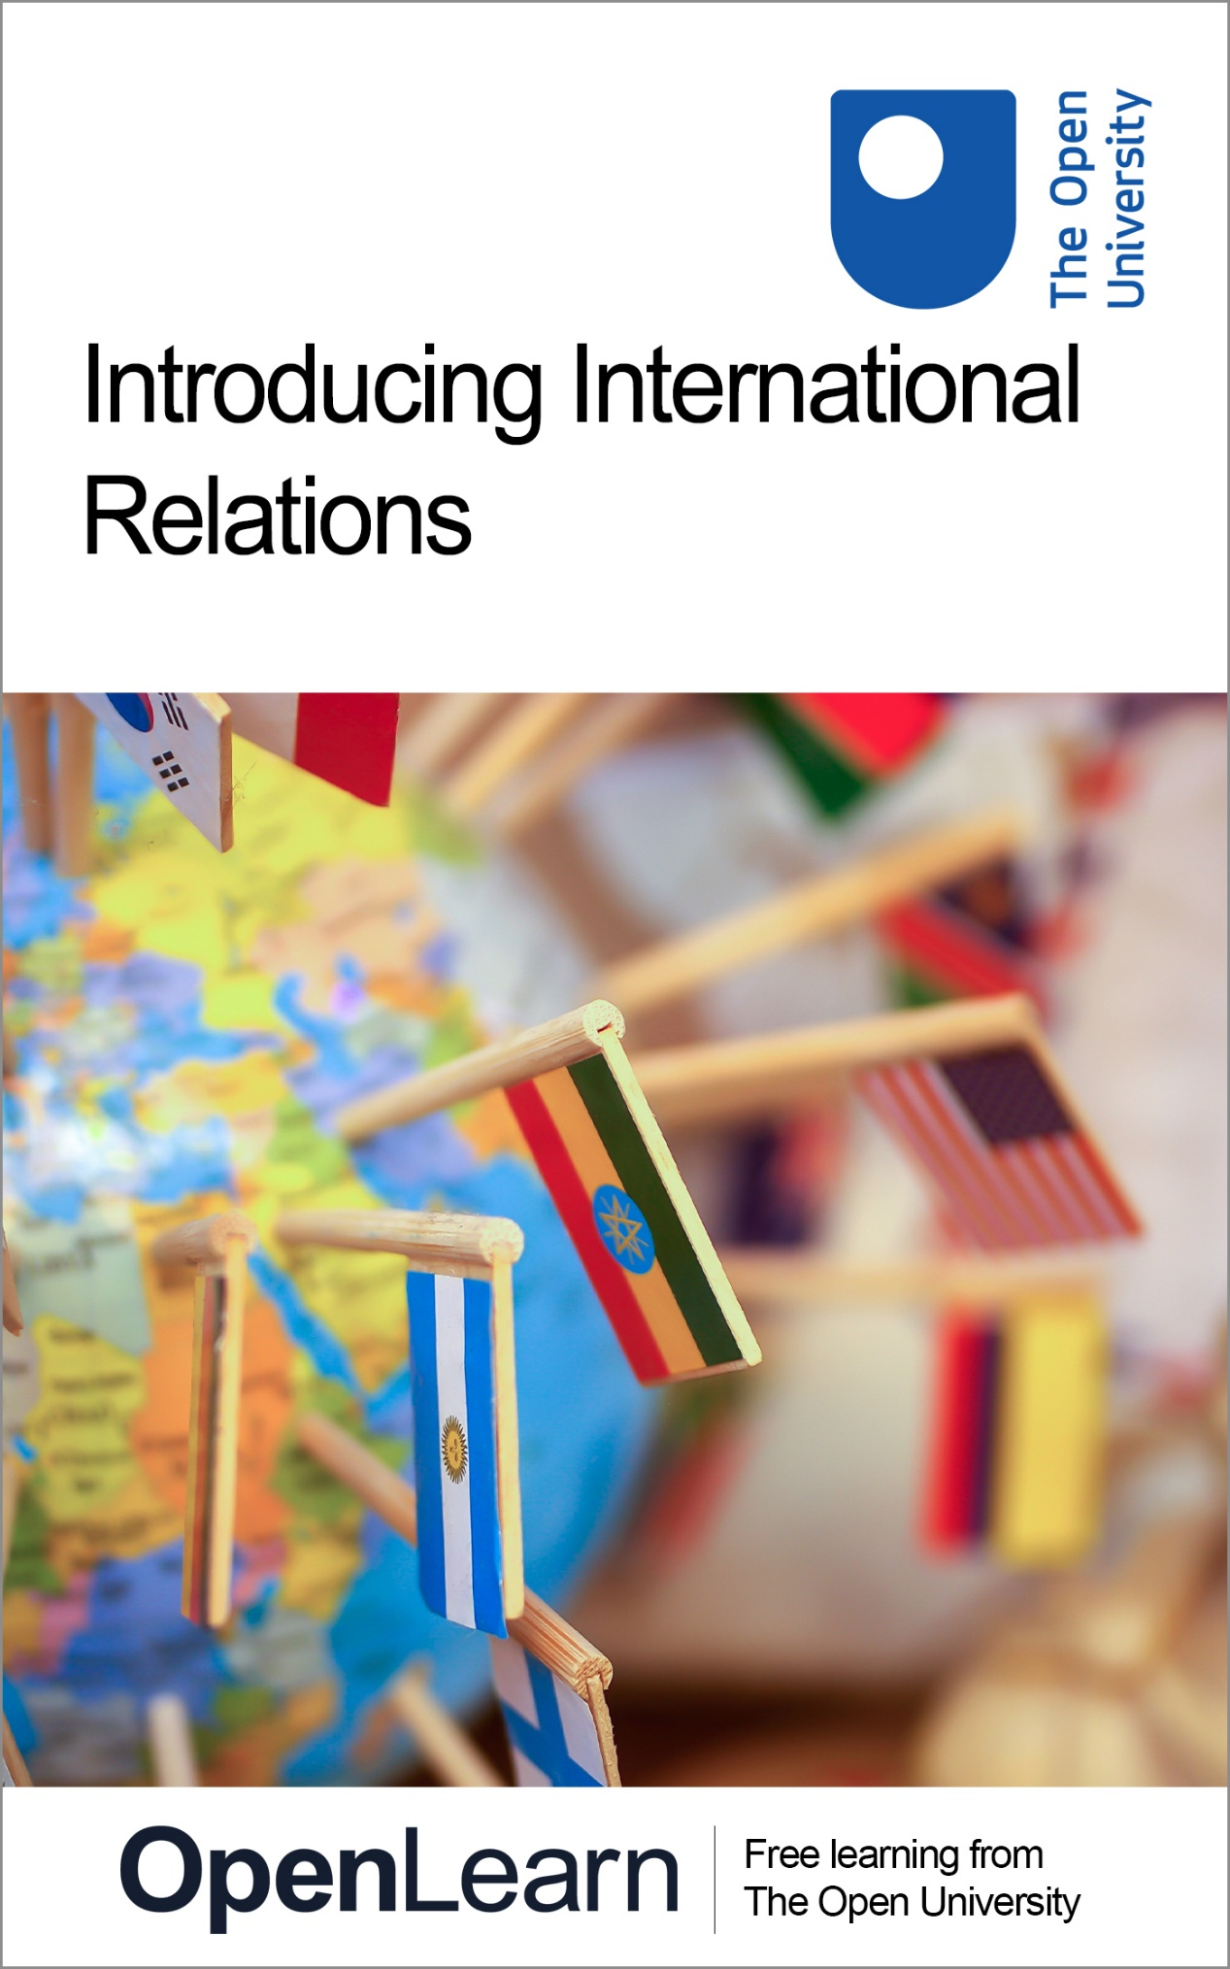

D228_1

Introducing International Relations

About this free course
This free course is an adapted extract from the Open University course .
This version of the content may include video, images and interactive content that may not be optimised for your device.
You can experience this free course as it was originally designed on OpenLearn, the home of free learning from The Open University –
There you’ll also be able to track your progress via your activity record, which you can use to demonstrate your learning.
First published 2025.
Unless otherwise stated, copyright © 2025 The Open University, all rights reserved.
Intellectual property
Unless otherwise stated, this resource is released under the terms of the Creative Commons Licence v4.0 http://creativecommons.org/licenses/by-nc-sa/4.0/deed.en. Within that The Open University interprets this licence in the following way: www.open.edu/openlearn/about-openlearn/frequently-asked-questions-on-openlearn. Copyright and rights falling outside the terms of the Creative Commons Licence are retained or controlled by The Open University. Please read the full text before using any of the content.
We believe the primary barrier to accessing high-quality educational experiences is cost, which is why we aim to publish as much free content as possible under an open licence. If it proves difficult to release content under our preferred Creative Commons licence (e.g. because we can’t afford or gain the clearances or find suitable alternatives), we will still release the materials for free under a personal end-user licence.
This is because the learning experience will always be the same high quality offering and that should always be seen as positive – even if at times the licensing is different to Creative Commons.
When using the content you must attribute us (The Open University) (the OU) and any identified author in accordance with the terms of the Creative Commons Licence.
The Acknowledgements section is used to list, amongst other things, third party (Proprietary), licensed content which is not subject to Creative Commons licensing. Proprietary content must be used (retained) intact and in context to the content at all times.
The Acknowledgements section is also used to bring to your attention any other Special Restrictions which may apply to the content. For example there may be times when the Creative Commons Non-Commercial Sharealike licence does not apply to any of the content even if owned by us (The Open University). In these instances, unless stated otherwise, the content may be used for personal and non-commercial use.
We have also identified as Proprietary other material included in the content which is not subject to Creative Commons Licence. These are OU logos, trading names and may extend to certain photographic and video images and sound recordings and any other material as may be brought to your attention.
Unauthorised use of any of the content may constitute a breach of the terms and conditions and/or intellectual property laws.
We reserve the right to alter, amend or bring to an end any terms and conditions provided here without notice.
All rights falling outside the terms of the Creative Commons licence are retained or controlled by The Open University.
Head of Intellectual Property, The Open University

Contents
- Introduction
- Learning outcomes
- 1 What is International Relations (IR)?
  - 1.1 The subject of international relations
  - 1.2 International relations and you
- 2 Analysing International Relations
  - 2.1 Actors in international relations
  - 2.2 Issues in international relations
  - 2.3 Debates in international relations
- 3 Case study: great powers in Africa
  - 3.1 Outline of the Africa case
  - 3.2 Key actors and issues in Africa
  - 3.3 Debates on great powers and Africa
- 4 Case study: international terrorism
  - 4.1 Outline of the terrorism case study
  - 4.2 Key actors and issues in terrorism
  - 4.3 Debates on terrorism and international relations
- 5 Theories on International Relations
  - 5.1 Theories as lenses
  - 5.2 Four theories
  - 5.3 Theories and the case studies
- Conclusion
- References
- Acknowledgements
- Solutions
- Descriptions

Introduction
This free course introduces you to the world of International Relations (IR). It introduces some of the tools scholars of IR use and insight into two important areas of contemporary international relations and the debates they raise. It is an excellent way to begin your exploration of what international relations is all about and to develop a feel for what studying international relations involves.
- In Section 1, you will learn about what International Relations (IR) is and how it seeks to analyse global challenges.
- Section 2 will focus on how IR analyses the interactions between various actors, while addressing key issues and debates to better understand global interactions and dynamics.
- Section 3 will introduce you to the first case study, which explores the competition among great powers for resources and influence in Africa, examining the interplay of actors, issues and debates within this context.
- Section 4 will explore the case of international terrorism and, in a similar way to Section 3, you will gain a basic understanding of the main actors involved and the key issues and debates addressed.
- In Section 5, you will be introduced to key theoretical approaches in IR – realism, liberalism, constructivism and postcolonialism – each offering different ways to analyse and interpret global interactions and their implications.
This OpenLearn course is an adapted extract from the Open University course D228 Exploring international relations: actors, issues, perspectives.

Learning outcomes
After studying this course, you should be able to:
- understand what International Relations is, and how International Relations is studied
- understand two contemporary examples of international relations: great powers in Africa and international terrorism
- demonstrate knowledge of the kinds of problems and questions International Relations as an academic subject tries to address
- identify some of the different actors and issues shaping international relations
- have an awareness of different perspectives and debates on international relations.

1 What is International Relations (IR)?

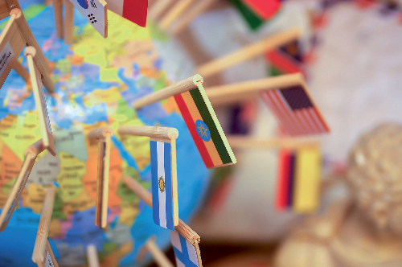
Figure 1 A world of sovereign states.
View description - Figure 1 A world of sovereign states.

International Relations (IR) is the study of global interactions between states, societies and people. While ‘international’ originally referred only to relations between countries, it now covers a wide range of interactions among different actors with global impact. The term ‘international relations’ (lowercase) generally describes real-world interactions, while ‘International Relations’ (uppercase) refers to the academic study of these interactions.
Since the world consists of many societies, each must consider others when making decisions. The way societies work together – or in opposition – shapes crucial global outcomes, such as peaceful coexistence, economic growth, and solutions for global challenges like climate change and human rights. IR explores topics like war, peace, trade, the environment and migration, making it a broad and dynamic field. Contemporary issues, like those seen in the daily news, frequently reshape the discipline of IR, demonstrating the importance of understanding these global interactions. IR also directly impacts everyday life. For example, international trade influences what we can buy, while international policies affect travel and job opportunities. These global decisions often begin with governments, but influence individuals and communities worldwide.

Activity 1
Allow about 10 minutes

Record some initial thoughts on what you think international relations means/covers. You can then reflect on you initial answer after reading the next section.

Provide your answer...

1.1 The subject of international relations
Every academic discipline has a main focus, or purpose. For instance:
- geography as an academic subject focuses on space: how the place where things happen (the natural or built environment) matters
- history as an academic subject focuses on time and how things change or don’t across time
- economics as an academic subject focuses on the distribution of resources.
Regarding IR, the core focus is ‘the international’, meaning the challenges and dynamics that arise from having multiple societies coexisting and interacting with each other. These interactions are often between states, but they also involve other actors such as organisations, corporations, and even individuals who impact global affairs.
Thus, IR is an academic discipline that aims to understand the interactions among societies, or what some scholars refer to as ‘societal multiplicity’. This simply means that the world consists of many separate societies or states. Though human societies have taken many forms – nation state, kingdom, empire – there has always been more than one of them and they have always had other societies to deal with. No other academic subject (which often look at issues within a single society or state) takes this as its core purpose – to analyse the consequences of the international.
In practical terms, the coexistence of multiple societies can lead to various challenges and consequences, including conflict, cooperation and competition. IR seeks to understand and explain these challenges by addressing different questions. For example, how do states protect their security? To answer this question, IR examines how states manage their sovereignty, form alliances and collaborations with other states or other actors such as international organisations and try to ensure the safety of their citizens against internal and external threats.
Overall, the field of IR is essential for understanding and interpreting our increasingly interconnected world. IR examines the causes and effects of global interactions, offering insights into how societies manage conflict, work together on global challenges, and shape one another’s internal and external realities. Whether dealing with peace, economic development or human rights, IR provides the framework to make sense of the world’s complexities. For anyone looking to understand the forces shaping our world, IR is an invaluable field of study that clarifies how and why global interactions matter at both the societal and individual levels. In the next activity you will be asked to reflect how international politics may affect you on an individual level, on your day-to-day life.

1.2 International relations and you
Our personal lives are affected by events in different parts of the world or by international politics. For instance, the invasion of Ukraine in 2022 contributed to an increase in fuel costs, which in turn caused the price of nearly everything to rise. Similarly, our lives might be influenced by events specific to where we live – some events have a greater impact on certain parts of the world than others.

Activity 2
Allow about 30 minutes

In the previous activity, you recorded some initial thoughts on what international relations mean to you. This follow-up activity invites you to think of an event in international politics and reflect on how it has affected your personal or everyday life. Note down your thoughts in the text box below.
Now reread your answer to Activity 1. Would you change what you initially wrote?

Provide your answer...

2 Analysing International Relations
To analyse IR effectively, it is important to understand and consider the various actors and issues involved and the debates they give rise to. They form the foundation for understanding how the global system works. In the next three sub-sections you can gain a basic understanding of these considerations. As you will see in sub-section 1, actors, ranging from states and international organisations to corporations and individuals, shape and drive interactions worldwide. Then, in sub-section 2, you can learn about ‘issues’, which are the main topics that actors engage with. For example, issues such as security, human rights, economics and the environment, are global challenges that impact societies, and different actors need to interact in order to deal with these. Finally, debates/perspectives offer different angles to understand motivations, conflicts, and potential cooperation among actors. These considerations – actors, issues and debates – can be a valuable tool to help in organising your knowledge about, and enquiries into, IR.

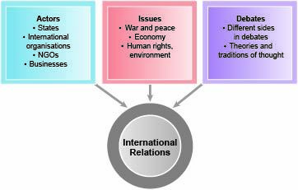
Figure 2 Actors, issues and debates.
View description - Figure 2 Actors, issues and debates.

2.1 Actors in international relations
‘Actors’ in international relations can be defined as the main organisations, groups or individuals who take part, or ‘make things happen’, in international relations. Actors can be divided into three broad groups, namely state, international organisations and non-state actors, with a number of sub-groups.
Traditionally, states have been viewed as the primary actors in IR, as they are the main entities with the power to make decisions on behalf of their citizens. A state in IR refers to the institutions that govern a specific territory and population, including entities like the military, civil service and public services. Unlike governments, which may change frequently, a state is a more enduring structure. States claim sovereignty, or ultimate authority, over their territories, and this sovereignty is normally recognised both internally by citizens and externally by other states and organisations. States form the foundation of the international system and have the authority to engage in diplomacy, establish treaties and international law. Of course, the power dynamics of states vary, with so-called ‘great powers’ like the US, China and Russia having significant global influence, while so-called ‘weaker’ states may exercise regional power. Nevertheless, over the years, globalisation has progressively introduced many other influential actors involved in IR:
- International organisations: Institutions like the United Nations (UN), World Health Organisation (WHO) and World Trade Organisation (WTO) work to address global issues by facilitating cooperation and setting standards.
Some of the main non-state actors include the following sub-groups:
- Non-governmental organisations (NGOs): NGOs such as Amnesty International or Doctors Without Borders advocate for issues like human rights, environmental protection, and health care, and have the potential to influence global policies.
- Networks: In its simplest form a network is any group of interconnected nodes – actors or groups – that doesn’t have a formal authority structure (like governments or governing bodies) and isn’t primarily commercial or market-based. While many NGOs might be thought of as individual entities, many are connected to each other via relations of collaboration, reciprocity or shared goals in a network. They are referred to as ‘networked actors’. As such there’s an overlap between NGOs and networks.
- Corporations and businesses: Large multinational corporations impact global economies, labour practices, and even political decisions through their global presence and financial power.
- Individuals: Prominent figures like diplomats, activists and everyday citizens can influence international relations through advocacy, cultural exchange or migration.
All the above actors work together or in competition, forming a dynamic web of interactions that drive international relations. For example, in the Democratic Republic of Congo, states, corporations, NGOs and local communities are all stakeholders in the global cobalt market – the cobalt mineral is a key ingredient in electric car and mobile phones batteries – which impacts policies on renewable energy and consumer goods. In a similar way global migration governance relies on the interactions of various actors, such as states, international organisations, NGOs, grassroots movements and migrants themselves.

2.2 Issues in international relations
‘Issues’ can be defined as the main topics or subjects that feature in international relations, and arise in the interactions between actors. The notion of issues is essential in defining the scope of international relations, or what they are ‘about’. Also issues often overlap, showing how interconnected global challenges are. To mention only some of the most important issues in IR these include:
- Political issues: These include diplomacy, state sovereignty and international law. For instance, as you will see in Section 3 of the course, the sovereignty of some African states is central to how they negotiate with foreign states, balancing their independence with the benefits of foreign investment or military support.
- Military and security issues: Security issues are foundational in IR and include war, peace and terrorism. Traditionally focused on state protection, security involves non-state threats like terrorism and cybersecurity. For example, the UK’s policies to combat international terrorism show how security concerns influence everything from foreign policy to local law enforcement, impacting the everyday lives of citizens.
- Economic issues: Economic issues in IR address wealth creation, trade, and inequality. They include trade agreements, investment flows, and labour standards. For example, global competition for resources like oil and minerals highlights economic competition, especially between powerful states like China and the US, who are competing for influence in African markets to secure access to raw materials.
- Environmental issues: Environmental issues have increasingly become prominent in IR due to climate change, biodiversity loss and pollution. These issues require international cooperation, as seen in global climate agreements. For example, competition over resources like cobalt has environmental implications, affecting mining practices in countries like Congo and influencing sustainable energy policies globally.
- Social and cultural issues: These issues involve cultural exchanges, identity conflicts, and social norms. IR examines how globalisation impacts local cultures, religious identities and migration patterns. Social issues often overlap with political issues, as seen, for example, in debates over human rights or refugee protection.
Consequently, each issue area can significantly affect others. For instance, military interventions may destabilise regions, impacting trade and human rights, while environmental crises like deforestation and pollution affect resource availability and can increase the risk of conflict.

2.3 Debates in international relations
Debates in IR help us interpret the motivations and outcomes of global interactions. For example, these debates might be competing views as to whether peace is possible, or how human rights can be respected, or how the environment might be protected. There are also different theories or traditions of thought in IR, that is, general academic approaches that seek to explain how international relations ‘work’ at a more general level. In particular:
- The first use of debates refers to the different views or positions there might be on a particular issue. In the main it refers to the different views that those analysing a problem or a challenge might take, but such things cross over into the ‘real world’ as well. Examples might include who was responsible for starting a conflict, or how it might be resolved; whether the action of a state is in its national interest; whether a country opening up to more international trade will improve livelihoods or whether changes to international law can help to improve the protection of human rights. So, in this substantive guise, debates tie in with both issues and actors discussed already.
- The second use of debates is somewhat more abstract – that is a further step removed from the ‘nitty gritty’ of everyday international relations and the problems it presents. This second use refers to the theories that scholars of IR use to research into and draw conclusions about international relations. Theories might be quite specific – a series of claims about a particular field of IR like security or peace. Or they might be general theories – broader, abstract ways of understanding IR. Debates in this theoretical sense also connects with the discussion of actors and issues you have already read about. In part, this is because different theoretical traditions have different takes on who the key actors are in international relations, and what the most important issues are. You can read more about these theories in Section 5 of this course.
Having explored the different debates in IR, you can now turn to the first case study, which examines the growing competition among powerful states for influence and resources in Africa. At this stage, the focus will shift away from theoretical traditions to the practical differences in debates on global challenges. This case study provides a lens for analysing competing interests and their broader implications for international relations.

3 Case study: great powers in Africa
The first case study in this course will explore the growing competition among powerful states for influence and resources in Africa. By reading this case study, you will gain a basic understanding into the main actors involved and the key issues – i.e. resources, diplomacy, and security – around which they compete. This will introduce you to the process of ‘doing’ International Relations analysis, by exploring who some of the most significant actors are, what are the main issues these actors have to deal with, and what debates arise from these issues and interactions among all these actors. As a result, you will be able to engage with ‘real world’ debates on a specific case.

3.1 Outline of the Africa case
In the twenty-first century, the African continent became a significant arena for global power competition. Leading powers like the US, France and Russia, as well as the so-called rising powers like China, India and Turkey started competing for influence in Africa. This increasing interest arose due to the fact that many African countries possess resources important to the economies of the world and are important markets. In addition, these countries possess considerable diplomatic influence in international organisations, like for instance the United Nations. At the same time, some African governments have been active in developing new relationships with various countries external to Africa and the financial, political and other advantages they might offer.
Consequently, despite sometimes being marginalised in the past, contemporary Africa has attracted global interest and started initiating collaborations with major powers seeking resources. Djibouti, the third smallest country in Africa with a population of under a million, exemplifies this shift. It is one of Africa’s key strategic locations, due to its position on the Bab al-Mandab Strait (see Figure 3), a critical point connecting the Red Sea to the Gulf of Aden, through which a significant portion of global trade passes. By the 2020s, its geographic importance had attracted military bases from no fewer than eight foreign countries, motivated by objectives such as combating piracy, securing trade routes and supporting energy supply lines.

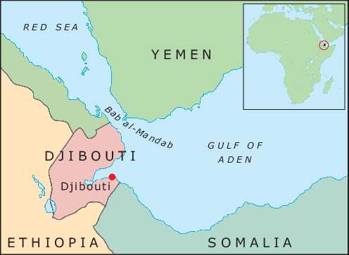
Figure 3 Map showing position of Djibouti in relation to the Horn of Africa and the Bab al-Mandab Strait.
View description - Figure 3 Map showing position of Djibouti in relation to the Horn of Africa and the ...

Djibouti and many other African states have progressively collaborated with external powers to secure economic benefits, infrastructure investment and trade relationships. The Economist magazine, which infamously declared Africa ‘the hopeless continent’ in 2000, changed its tune, investigating a ‘New Scramble for Africa’ in 2019 in which there were new diplomatic and economic opportunities opening up (The Economist, 2019).
The term ‘scramble for Africa’ referred to the colonisation of Africa roughly between 1880 and 1910, with only Liberia and Ethiopia remaining independent. This period’s legacy is evident in modern African borders, many of which align with those established during colonial rule (see Figures 4 and 5).

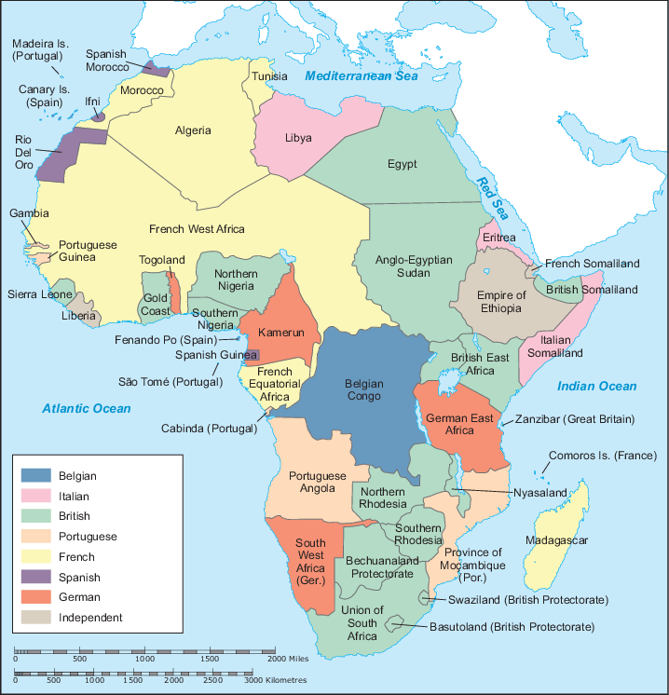
Figure 4 Africa in 1914.
View description - Figure 4 Africa in 1914.

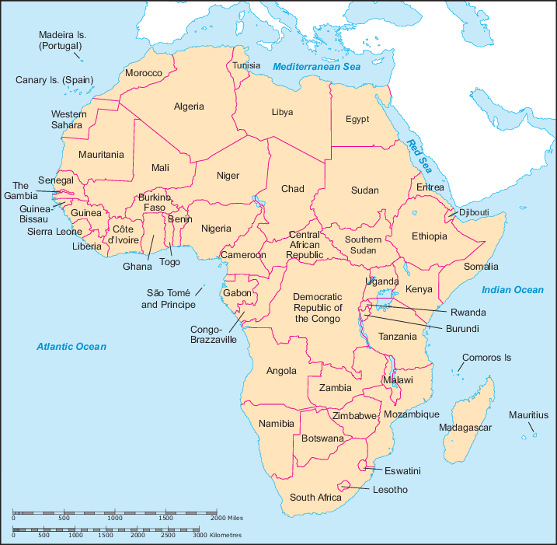
Figure 5 Africa in 2021.
View description - Figure 5 Africa in 2021.

It is important to note that this new reality has met with mixed responses within Africa. While some African counties welcome partnerships that provide economic or security advantages, concerns about labour, environmental impact, and local industry competition have given rise to protests and considerable criticism. For example, in 2013 protests erupted over labour conditions, environmental damage, and unfair business practices in Zambia, where workers clashed with Chinese managers at a coal mine, leading to government intervention. Similarly, in the 2020s, the East African Crude Oil Pipeline (EACOP) project, backed by European and Chinese investors, has faced environmental protests in Uganda and Tanzania due to ecological risks and displacement concerns. Thus, the African case shows the challenges of contemporary international relations, where global powers and African nations experience opportunities but also tensions arising from the growing competition on the African continent.
The following activity will review the categories of actors and how they have been featured in the Africa case study.

Activity 3
Allow about 20 minutes

As you have seen, actors have been defined in this course as ‘the main organisations, groups or individuals who take part, or “make things happen”, in international relations’. Actors can be divided into three broad groups (state, international organisations and non-state actors), with a number of subgroups.
Watch this short report from the BBC’s Africa Service which touches on many of the actors covered in section 2 of this course: Is this the ‘second scramble for Africa’?.
Identify which actors belong under each of the group headings.

Interactive content is not available in this format.

The slideshow below offers a specific example within the broader context of competition in Africa: the case of cobalt in the Democratic Republic of Congo (DRC). (Note that the DRC is often just referred to as ‘Congo’ but is distinct from the much smaller country of Congo (Brazzaville) which isn’t included here.) This example shows how international relations – particularly the competition over DRC’s mining sector – extend across continents, influencing national policies (such as the push for net-zero emissions) and impacting the lives of people far beyond the original site. It also brings together various international actors, interconnected within the global system on issues including commercial interests, national development, environmental policies and diplomatic relations.

Activity 4
Allow about 30 minutes

Watch the slideshow and then answer the following questions in the text boxes below.

Video content is not available in this format.
Slideshow 1 Cobalt: from the Congo to your car
View transcript - Slideshow 1 Cobalt: from the Congo to your car

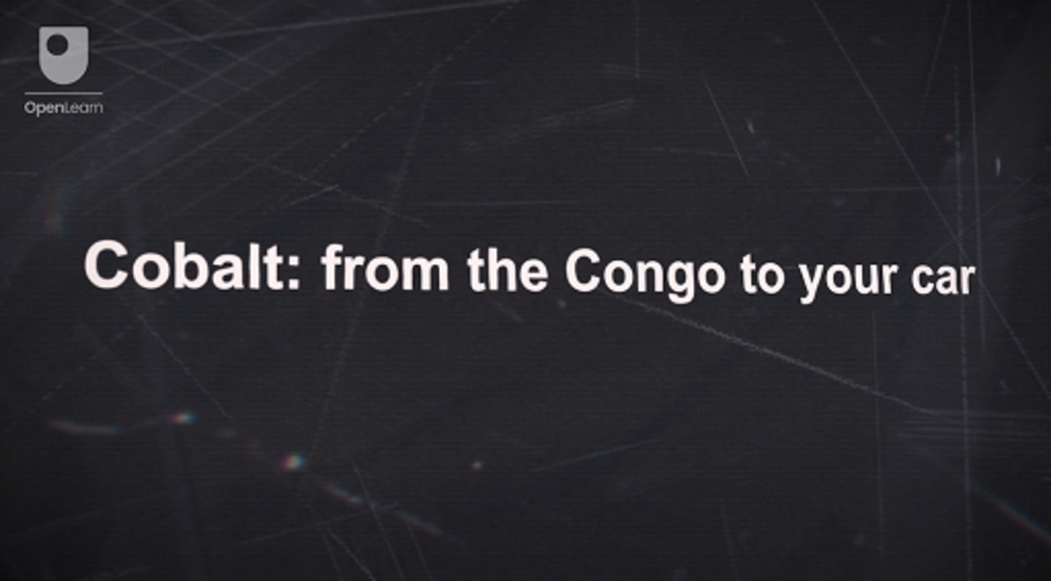

1. Write a couple of sentences as to why, in your view, the slideshow presents an example of international relations? There’s no single correct answer to this first question, so just write a couple of sentences to summarise your initial thoughts.

Provide your answer...
View discussion - Part

2. Try to identify some actors in this example

Provide your answer...
View discussion - Part

3. Try to identify some international relations issues this example.

Provide your answer...
View discussion - Part

You can now read the subsequent sub-section and compare your answers.

3.2 Key actors and issues in Africa
In this sub-section you can learn about the key actors in Africa and the emerging issues these actors need to deal with. In particular, the key actors involve both state and non-state actors.
Actors
- State actors include African states (e.g. DRC, Zambia, Djibouti and Zimbabwe), states outside the continent (e.g. China, Russia, US, UK and India), international organisations (e.g. the UN) and regional organisations (e.g. the African Union).
- Non-state actors include multinational corporations (e.g. Chinese mining corporations), NGOs (e.g. Greenpeace), interest groups (e.g. trade unions) and military groups.
Of course, African and external states are key protagonists, with countries like Djibouti forming strategic military (e.g. establishment of military bases) and economic partnerships with powerful countries such as the US, China, and France. It is also important to keep in mind that the actual influence different counties hold varies. The so-called great powers, like the US and China, have greater influence due to factors like economic strength and military force. In Africa, these powerful nations often make decisions based on their own strategic interests, such as accessing resources. For instance, China’s involvement in Africa is largely motivated by its need for raw materials, rather than the priorities of African nations, creating an imbalanced relationship where African states may feel dominated by these external powers. Despite power disparities, African states exert influence by managing relations with multiple powers, sometimes even leveraging these relationships to counteract sanctions or pursue specific interests.
Other significant actors include multinational corporations (MNCs) and state-owned enterprises (SOEs), especially those involved in natural resource extraction and infrastructure projects. Also, interest groups, NGOs and activist networks within Africa influence diplomatic and economic relations, often challenging foreign investments based on labour, environmental, or human rights concerns. Non-state military groups, such as terrorist organisations, are also influential in certain regions, further complicating international relations and security policies in Africa.
Issues
All the above-mentioned actors have to deal with various emerging issues, that can be grouped into three main areas: military and security, economic, and political issues.
- Military and security issues: Several countries, including the US, China and European states, have established military bases, especially in strategic locations like Djibouti. China’s military bases, for example, have been established to protect its interests in shipping routes and to protect Chinese citizens working in unstable regions. Respectively, the US focuses on counter-terrorism efforts, and European states aim to control piracy. Conflicts in various African regions also see intervention from external actors, the African Union and the UN aiming to stabilise the situation in such areas.
- Economic issues: Economic competition is intense as external powers compete for access to Africa’s valuable natural resources, particularly energy supplies (oil and gas) and strategic minerals (like cadmium and lithium). China’s focus on resource-rich countries like Angola and the Democratic Republic of Congo leads to increasing rivalry with the US and European countries seeking to counterbalance China’s influence. Control over these resources has impact on global supply chains and environmental goals.
- Political issues: Over the past twenty years diplomatic relations have become more complex as various powers with different agendas engage with Africa. On the one hand, western countries, including the US and the EU, promote democracy and human rights as central principles of their Africa policies. China and other emerging powers, on the other hand, generally emphasise economic partnerships without paying much attention on political reforms. This allows African countries to maintain relationships with multiple partners, enhancing their influence in international organisations like the UN General Assembly, where African states hold significant voting power.
The military, economic and political issues mentioned above are interconnected and, as you will notice in the next sub-section, they lead to various debates and competing views on how best to address them.

3.3 Debates on great powers and Africa
The case study on Africa involves numerous debates on great power competition with two of the most important focusing on what drives great power competition in Africa and who benefits from it.
External factors’ influence versus African agency is a main debate on what drives competition in Africa:
- External factors: Great power competition is driven by the rise of China as an economic and political power. Many see China’s rise as a global power, with its need for resources like oil, copper, and cobalt, as the main catalyst. This has led China to invest heavily in African countries, providing aid, loans, and trade in return for resources.
- African agency: The role of African states in pursuing new relations with rising powers such as China is a key area of debate. African states benefit from China’s ‘no strings attached’ stance and have found ways to leverage competition among great powers to expand partnerships and gain influence.
The answer to the first question, as who is driving change, leads on to a second debate about who benefits from this competition. To address this debate, you will explore some of the ‘issue’ categories discussed in the previous section:
- Economic impact: Chinese investment has contributed to economic growth in many African countries, but concerns arise over resource exploitation without local communities gaining substantial benefit. African resources often being processed abroad, may lead to limited local industry growth, and cheap imports that negatively influence African businesses.
- Political impact: Great power competition gives African states new diplomatic options, but it also has mixed results for local governance. For example, China’s ‘non-interference’ stance can support authoritarian regimes.
- Military impact: Military debates include whether the increase in great power competition fuels, or prevents, rising conflict. Some African coups (e.g. in Niger, Mali, Sudan, Guinea and Chad) in the 2020s have caused concern over external influences like Russia’s Wagner Group, which is thought to contribute to instability.
The interaction of these debates also shows how African countries have the potential to be not just passive players but actively shape global competition. Audio 1 in the next activity can help you better understand the various debates in international relations. It presents a discussion between two specialists in Africa’s international relations. Both experts, Dr Frangton Chiyemura and Dr Folashadé Soulé, explore the roles that African states have played in driving great power involvement in the continent, some of the benefits and pitfalls facing African states in their relations with great powers and why it is important to consider different points of view in international relations.

Activity 5
Allow about 1 hour

Listen to the audio.

Audio content is not available in this format.
Audio 1 Africa’s influence
View transcript - Audio 1 Africa’s influence

The audio discussion offered some additional insights into two of the questions posed: what is driving great power competition and who benefits from it?
Having listened to the audio can you:
- identify some key benefits African countries may gain from great power competition?
- identify some of the actions Folashadé and Frangton say that African states could take to increase benefits from great power competition?

Provide your answer...
View discussion - Activity 5

4 Case study: international terrorism
The second case study of this course is focused on international terrorism. In a similar way to the previous section, by reading about the case of international terrorism, you will gain a basic understanding of the main actors involved and the key issues addressed. This will introduce you to the process of ‘doing’ International Relations analysis by exploring who some of the most significant actors are, what the main issues these actors must address are, and what debates arise from their interactions.

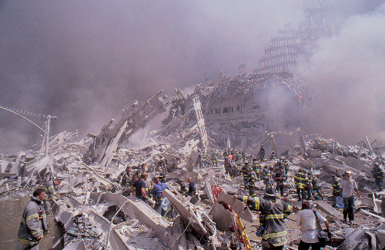
Figure 6 The remains of the World Trade Centre after the attacks of September 11 2001.
View description - Figure 6 The remains of the World Trade Centre after the attacks of September 11 ...

4.1 Outline of the terrorism case study
Terrorism has been a challenge for states and international organisations throughout the twentieth and twenty-first centuries. Academics have defined terrorism in various ways and the United Nations has struggled to reach a consensus on the definition of terrorism among its member states. As a result, there is no universal definition of terrorism, but it is broadly understood as the use of violence to achieve political, religious or ideological goals. For the purposes of this course, ‘terrorism’ will be understood in a colloquial sense, that is, where groups or incidents are widely referred to as ‘terrorists’ or ‘terrorism’, then that terminology will be followed.
The case of Nelson Mandela highlights some of the challenges in defining terrorism. Mandela was a leading member of the African National Congress (ANC), an organisation formed to fight for the rights of South Africa’s Black population, and a key figure in the movement against apartheid. He was labelled a terrorist by some because of his role in advocating violent resistance through uMkhonto weSizwe (‘Spear of the Nation’), the ANC’s armed wing. Mandela argued that violence was a necessary response to systemic oppression and white supremacy. This shift to violence shows how actions seen as justified and legitimate by some can be framed as terrorism by others. Mandela’s later recognition as a global statesman and champion of democracy shows how difficult it is to define terrorism.

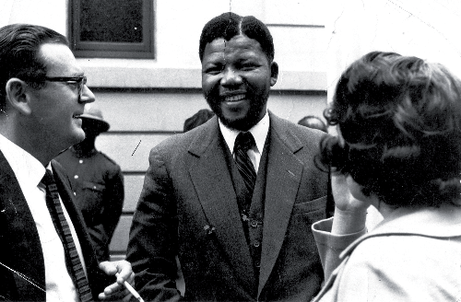
Figure 7 Alfred Kumalo and Nelson Mandela at the Rivonia trial in 1963.
View description - Figure 7 Alfred Kumalo and Nelson Mandela at the Rivonia trial in 1963.

Furthermore, one of the challenges with the term ‘terrorists’ is that it often implies a moral judgement – that terrorism is what the bad guys do. It is certainly the case that the liberation movement in South Africa, and uMkhonto weSizwe specifically, used violence to attain their political goals. This violence killed many, including civilians. Does their cause make them freedom fighters? Or do these acts of violence mean they are terrorists?

Activity 6
Allow about 15 minutes

Terrorist or freedom fighter? Reflect on this question and make a note of your thoughts in the text box below.

Provide your answer...

One of the most significant events related to terrorism was the September 11 2001 attacks, when al-Qaeda (AQ), a militant organisation committed to a global Islamist revolution, hijacked planes to target the United States, killing nearly 3,000 people. Following this act of terrorism, states, airports and the aviation industry responded by implementing a new security regime. These attacks initiated the so-called ‘war on terror,’ including military interventions in Afghanistan, where the Taliban were accused of protecting AQ, and later Iraq, over controversial claims related to terrorism and weapons of mass destruction. These conflicts would have significant implications, and AQ, and subsequently Islamic State, would mobilise into global insurgencies, prompting an equally global counterterrorism and counterinsurgency response. Furthermore, following the 9/11 attacks, other terrorist incidents followed, including major attacks in Madrid (2004), London (2005), Paris (2015), Brussels (2016) and Manchester (2017), causing significant loss of life and creating ongoing challenges to international security. Consequently, the ‘war on terror’ has transformed daily life, increasing surveillance, security measures, and debates about civil liberties worldwide.

Activity 7
Allow about 45 minutes

You’ll now watch a slideshow focused on terrorism, to gain a wider understanding of the different actors that have used ‘terrorism’ in the modern era and understand the effects that terrorism has had on international relations.

Video content is not available in this format.
Slideshow 2 Terrorism and international relations
View transcript - Slideshow 2 Terrorism and international relations

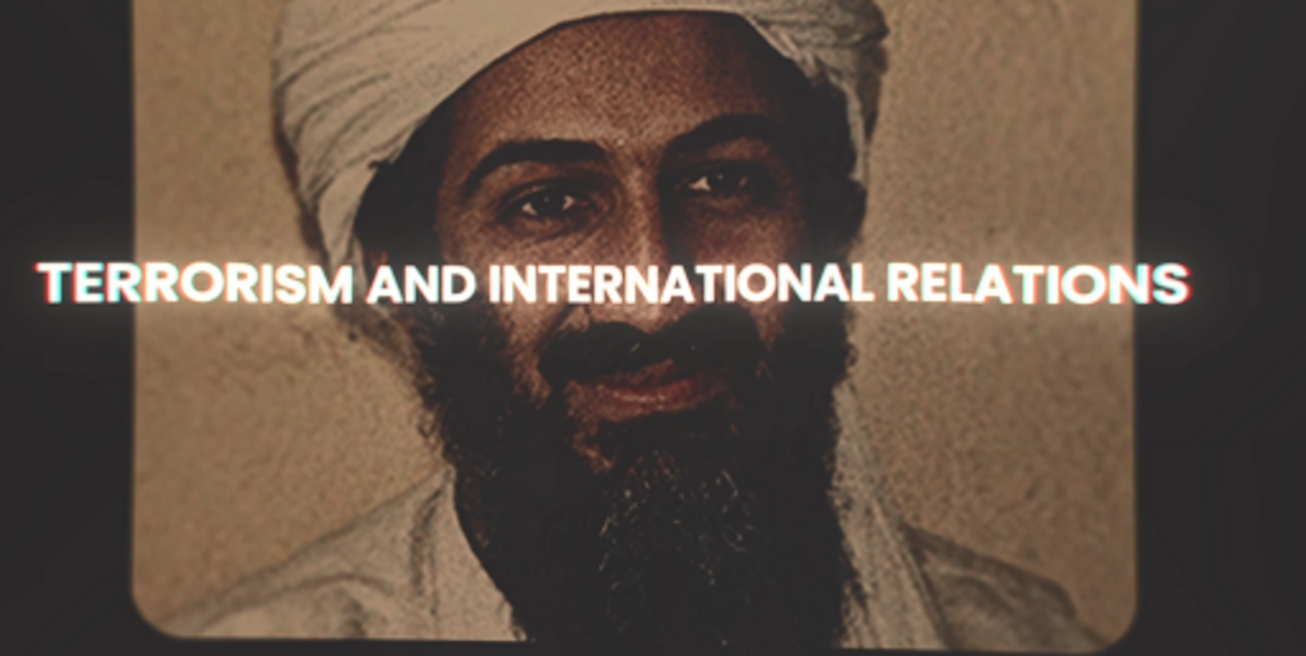

Then answer the following questions in the text boxes below
First, the slideshow introduced a variety of actors who have been described as ‘terrorists’ or as having used ‘terrorism’. Did any of these surprise you? Did any stand out to you? Why?
Reflect on these questions, writing down your thoughts in the text box below.

Provide your answer...

Second, the slideshow discussed some of the ways in which ‘terrorism’ has impacted on international relations. Which of these stood out to you? What do you think are the important effects that the issue of terrorism has had for international relations?
Reflect on these questions, writing down your thoughts in the text box below.

Provide your answer...
View discussion - Part

You can now read the next sub-section and compare your answers.

4.2 Key actors and issues in terrorism

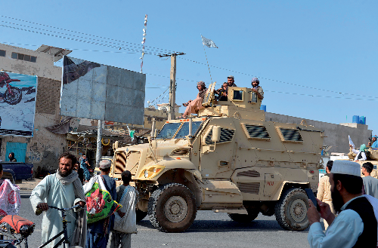
Figure 8 Taliban fighters in the Afghan city of Kandahar, August 2021, after the Taliban had retaken the country following US withdrawal.
View description - Figure 8 Taliban fighters in the Afghan city of Kandahar, August 2021, after the ...

When examining terrorism within international relations, several key actors play critical roles and various issues emerge. When considering which actors are important in the ‘war on terror’, terrorist groups, the networks they have developed, and the states and militaries opposing them are the most obvious.
Actors
- Militaries: States are key actors in international relations, with their militaries tasked to safeguard national security. States use their militaries to ensure national security, and respond to threats like terrorism. For example, US and UK militaries led operations in Afghanistan and Iraq during the ‘war on terror’.
- Violent non-state actors: These are individuals or groups that use violence but are not state actors. These may include terrorist organisations like Al-Qaeda, IS, the Ku Klux Klan, and the Provisional Irish Republican Army.
- Networks: Networks represent the tangible and intangible connections that bring individuals, groups, states and international organisations together to pursue shared objectives. Examples include transnational advocacy networks, which are nonviolent groups pushing for global change; dark networks, which are covert groups enabling illegal activities like terrorism and trafficking; coalitions, including state alliances formed to address security threats. An example of a coalition is the ‘coalition of the willing’, which referred to the US-led coalition that invaded Iraq in 2003.
- Security and intelligence agencies: Agencies like the CIA and Interpol enforce security policies and protect national and international security, especially during the war on terror.
- Insurgent groups: Unlike terrorists, insurgents aim to overthrow governments or disrupt political systems. For example, IS acted as both an insurgent group and de facto state, controlling territory in Iraq and Syria.
- Private Military Contractors (PMCs): Not all non-state violent actors act in opposition to the state. Mercenary organisations offer military capabilities for profit, and sometimes act in alignment with states. For example, Russia’s Wagner Group is seen to act as a proxy for the Russian state.
In summary, there are various important actors when examining the world of international relations through the lens of the ‘war on terror’. At the same time, terrorism raises a wide range of important issues in international relations, including military-security, political-legal as well as some broader concerns.
Issues
- Military-security issues: Terrorist attacks by groups like Al-Qaeda and IS and the military responses to them have had significant impacts on a global scale. Such responses have disrupted entire regions, strained diplomatic relationships, and resulted in thousands of civilian casualties, injuries, and forced displacement of people. Various questions emerge, such as, how should states take action against terrorism and who is responsible for assisting displaced populations?
- Political and legal issues: The invasions of Iraq and Afghanistan highlighted tensions between state sovereignty, international law, and human rights. For example, the Iraq invasion lacked UN approval, raising questions about the legitimacy of interventions. Questions arising include, when is it legitimate to intervene in another state’s affairs and how bound are powerful states by international legal frameworks?
- Broader implications: Terrorism and counter-terrorism measures often destabilise regions, by also affecting neighbouring counties and global politics. Also, attempts to create liberal democracies in conflict zones have often failed. For example, in the case of Afghanistan, following the withdrawal of US troops, the Taliban regained control of the country, leading to questions as to whether the project to develop a liberal democracy in Afghanistan was the most suitable course of action.
Overall, the military-security and political-legal dimensions are the most pressing issues related to terrorism, but they are not exhaustive. These challenges continue to raise debates about how best to address terrorism while respecting human rights, international law and global stability.

4.3 Debates on terrorism and international relations
As introduced in the previous case study on Africa, this section on terrorism will refer to the debates over substantive topics on which people will take different sides.
Assessing the ‘war on terror’, there are different debates on the effectiveness and appropriateness of its military interventions. One argument is that the ‘war on terror’, and the military interventions and engagements that characterise the conflict, have been broadly successful, effective in eliminating key terrorist leaders and organisational structures, and disrupting their operational capabilities. There are arguments, for instance, suggesting that, despite mistakes made during the ‘war on terror’, such as the invasion of Iraq, the war has largely been successful. However, an opposing point of view is that the ‘war on terror’ has increased the risk of terrorist attacks, given oxygen to the ideology of AQ and IS, and caused mass suffering and regional instability.
It has also been argued that the war on terror, and the legal questions surrounding the invasion of Iraq and the conduct of US and allied militaries, has led to a significant undermining of international law and respect for human rights. There is thus a question here as to whether the ‘war on terror’ has succeeded on its own terms.
You can now listen to an audio discussion with Professor Michael Clarke, the former Director-General of the UK’s Royal United Services Institute (RUSI). In this discussion, Professor Clarke explores the impact of terrorism and the war on terror on international relations.

Activity 8
Allow about 30 minutes

Listen to the audio discussion with Professor Michael Clarke and consider the question that follows. Make a note of your thoughts in the text box provided.
- What, as identified by Professor Clarke, are the significant impacts of the war on terror on international relations?

Audio content is not available in this format.
Audio 2 Terrorism and international relations
View transcript - Audio 2 Terrorism and international relations

Provide your answer...
View discussion - Activity 8

5 Theories on International Relations
In this final section, you will focus on the broader theoretical traditions that IR has developed. You will first explore the idea of theories as ‘lenses’, and then you will be introduced to four of these theoretical traditions:
- realism
- liberalism
- constructivism
- postcolonialism.
Finally, you can gain insights into how IR theories apply to the two case studies of great power competition and terrorism discussed in the previous sections.

5.1 Theories as lenses


Figure 9 Lenses to see the world.
View description - Figure 9 Lenses to see the world.

One way to think about theories is to think of them as lenses. Lenses can help you to:
- see more clearly – as spectacles do
- see things up close – as magnifying glasses do
- see the ‘bigger picture’ or what might otherwise be out of view – as a panoramic lens on your camera might
- focus on something and see it in minute detail – as microscopes do.
Lenses also filter what you see. They can reduce brightness (as sunglasses do) or remove reflection (as polarising lenses might). They can even make the world seem better than it is – as in, if you’re looking at it through rose tinted glasses. OK, maybe not that last one.
Using lenses
So, the first point to remember is that, just like lenses, theories can have different uses.
- Some are very general in their aims – focusing on the ‘bigger picture’ – and seek to say a few broad things about the world of international relations.
- Others are more specific, ‘magnifying’ a particular issue area such as security, peace or human rights, and seeking to set out key claims about that particular area.
The second point to keep in mind is that lenses help you see certain things, in certain ways. Different lenses have different foci, and different uses, so they allow you to see certain things better, or more clearly. But in doing so, lenses also distort. A microscopic lens, for instance, gives a very detailed picture of a very small piece of something, but at the cost of not seeing everything around it. A panoramic lens, on the other hand, can give a great view of a broad and expansive landscape, but you can lose the detail – such as, for instance, the people in the picture.
Lenses word cloud
You’ve been introduced to the idea that theories can function like ‘lenses’, sharpening, challenging or changing how you see the world, or approach a particular international relations issue. The next activity encourages you to reflect on what you have learned so far about how theories work and how they can be used.

Activity 9
Allow about 30 minutes

Based on what you have read in this course, think about how theories help us understand international relations. Write down up to five words or short phrases that describe how theories work. For example, you might think of words like lenses or perspectives to show how theories help us see the world in different ways. You can also use phrases like bigger-picture or minute-detail to describe how theories can focus on broad patterns or specific issues.
Type your words into the text box below. Using these words, think about how international relations theories work and can be used. Don’t worry if you’re struggling to think of some examples – just enter as many as you can.

Provide your answer...
View discussion - Activity 9

5.2 Four theories
International Relations theories are sets of ideas, assumptions or claims that can be grouped together into different traditions. Studying IR theories might be quite challenging at first due to their perceived complexity. However, theories are valuable tools that simplify and clarify different ideas and help us to understand and explain international relations. They can also help us to explain, predict, describe and critique relations among and between actors in international relations. Placing theories in dialogue with one another also brings to the surface their strengths and limitations. You will now be introduced to four theoretical traditions, namely, realism, liberalism, constructivism and postcolonialism.

Realism
Realism (Figure 10) has often been presented as a dominant theory in IR, emphasising power and competition. Realism has historically been, and to some extent still is, the dominant theoretical approach to IR. Its core claims and concepts are statism, self-help, and security.
According to
- statism, states are the central actors in IR, with non-state actors (e.g. non-governmental organisations, terrorist networks) exercising limited influence
- self-help, states must rely on their own resources for survival due to the anarchic nature (not to ‘chaos’ or ‘disorder’ as in common use of the term) of the international system, which lacks a global authority to enforce rules
- security, for realists, states’ over-riding concern is their security, meaning that states prioritise survival by maintaining or increasing power, often relying on military strength. Power, for realists, ultimately rests on the military capabilities of states. These pillars lead to a competitive international arena where meaningful or sustainable cooperation is unlikely, as states prioritise power and security.
Realism traces its own history back a long way and claim a number of political thinkers such as Thucydides (fifth century BC), Niccolò Machiavelli (fifteenth–sixteenth century), and Thomas Hobbes (seventeenth century), and modern thinkers such as Hans Morgenthau (1904–1980) and Kenneth Waltz (1924–2013).

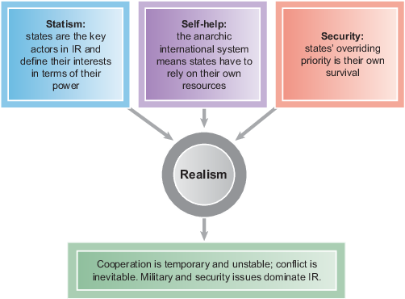
Figure 10 Realism, states, self-help and security.
View description - Figure 10 Realism, states, self-help and security.

Liberalism
Liberalism is often seen as a counterweight to realism, often emphasising the potential for cooperation, progress, and the role of non-state actors. While acknowledging the importance of states and the anarchic nature of the international system, the liberal tradition makes a number of distinct departures from realism.
First, unlike realism, liberalism rejects the inevitability of war, suggesting that change and cooperation can reduce conflict. Second, liberalism puts emphasis on the role of non-state actors. Thus international organisations, NGOs, and civil society can be influential in shaping state behaviour. Third, ‘low Politics’, such as trade opportunities, and human rights debates, can be as significant as military and security concerns. In that respect, ‘interdependence’ – the mutual reliance on each other to achieve shared interests – plays a crucial role in advancing cooperation among states. Fourth, liberalism promotes the ‘democratic peace theory’, which suggests that liberal democracies instead of going to war with each other, they aim to promote democracy worldwide. Fifth, liberalism advocates for protecting human rights globally, sometimes justifying humanitarian interventions or regime changes to address severe abuses.
Like realism, liberalism has a long historical ancestry and is closely associated with theorists including: John Locke (seventeenth century), Immanuel Kant (eighteenth century), and Eleanor Roosevelt (1884–1962), who put emphasis on human rights, democracy and international cooperation. Early twentieth-century liberalism, influenced by Woodrow Wilson, promoted peaceful relations through institutions like the League of Nations. Modern liberal theorists such as Robert Keohane and Helen Milner focus on institutional cooperation and interdependence, highlighting the well-being of human beings in international legal and political institutions.

Constructivism
Constructivism emerged in the late 1980s and 1990s, partly in response to what some saw as the limitations of realism and liberalism. It has its origins in ideas drawn from sociology and psychology, particularly those focused on human identity. Its key claims and concepts include the following.
The International environment is a social system, meaning that states and other actors interact like individuals in society, shaping their identities, interests, and perceptions of others through these interactions. Furthermore, there are shared understandings and norms, that govern international behaviour. These norms are not fixed, but rather evolve over time, challenging by this way static assumptions like state sovereignty. Also, in contrast to a realist (and some liberal) accounts that see a fairly simple relationship between a state’s interests and its actions in the international arena constructivists see a more complex process. Hence, unlike realists who view interests as fixed, constructivists suggest that interests emerge from identities, which are shaped by historical and social contexts. Finally, constructivists focus on how sustained interactions create new norms and expectations, which can influence even powerful states through a ‘compliance pull’. However, norm development is uneven, and violations by major powers can undermine their influence.
Key thinkers include Nicholas Onuf, Martha Finnemore and Kathryn Sikkink who focus on how norms and identities evolve through social processes. Alexander Wendt famously argued that ‘anarchy is what states make of it’ (1992) and suggested that state behaviour and relationships depend on constructed perceptions, ranging from enmity to friendship, rather than inherent competition.

Postcolonialism
Postcolonialism takes as its primary focus the lasting injustices and challenges created in the international system by colonial rule and its profound legacies in international relations. As with constructivism, its origins lie outside of IR – in this case in historical, cultural and literary studies.
There are two broad (linked) components to postcolonialism as a tradition in IR: an analysis of the ongoing inequalities in contemporary international relations; and a critique of the colonial inheritance within the discipline of IR itself, particularly the realist and liberal traditions. Unlike realism’s concept of anarchy, postcolonialism views global relations as structured by hierarchy and domination, especially in interactions involving international organisations like the International Monetary Fund (IMF) and World Bank.
Postcolonial theorists adopt a bottom-up perspective, focusing on marginalised actors resisting inequality and exploitation, rather than the actions of powerful states. Postcolonialism critiques not just the practices of international relations but also the theoretical foundations of IR as a discipline. These critiques argue that traditional IR theories (e.g., realism, liberalism) overlook marginalised voices and defend the interests of powerful Western states, reinforcing inequality.
Finally, postcolonialism challenges power imbalances and advocates for greater inclusion of diverse voices and alternative knowledge systems from the Global South to create a more equitable understanding of international relations.
Key postcolonial thinkers, such as Frantz Fanon (1925–1961), emphasised the pervasive violence of colonialism and the need for resistance; Edward Said (1935–2003) analysed the dehumanising narratives of ‘Orientalism’, and Gayatri Spivak explored marginalised voices through her concept of the ‘subaltern’. Scholars like Arlene Tickner advocate for ‘Worlding Beyond the West’, amplifying global perspectives in IR to challenge its Western-centric biases.

Summarising IR theories
Table 1 summarises the four IR theories.

Table 1 Summarising IR theories
Theoretical tradition | Which actors are key? | Which issues? | What kind of perspective? | Key thinkers
Realism | States | Conflict, security, power, national interest, polarity, continuity | ‘Outside-in’ or ‘top-down’:  The behaviour of state actors determined by the external character of the international system (anarchy is unchanging) | Waltz  Mearsheimer  Walt  Ayoob
Liberalism | States, international organisations, non-state actors, individuals | Cooperation, democratisation, peace, collective security, free trade, human rights | ‘Inside-out’:  Interdependent states cooperating with one another pursue shared interests (the impact of anarchy can be mitigated) | Nye  Milner  Moravscik  Slaughter
Constructivism | States, non-state actors | Norms, rules, values and expectations, social construction, ideational as well as material institutions, change | Interactive:  States and institutions/organisations impact one another’s identities and interests through social interaction (anarchy can be reimagined and reconstructed) | Wendt  Onuf  Sikkink  Keck
Postcolonialism | Formerly colonised states, marginalised/minoritised individuals | Colonialism, neocolonialism, resistance, inequality, epistemic violence, emancipation | ‘Bottom-up’:  Highlight the experiences, needs and voices of those exploited and marginalised in the international system  (Anarchy has been deployed as a justification for the colonial project) | Fanon  Said  Spivak  Jabri  Seth

5.3 Theories and the case studies
As an ending to the course, this sub-section will focus on bringing together the case studies and theory. You will listen to two audios.
In Audio 3, Claire Malcolm and William Brown discuss the different perspectives liberalism and postcolonialism might bring to scholars’ understanding of great power competition in Africa.

Activity 10
Allow about 30 minutes

Listen to Audio 3 and answer the questions that follow.

Audio content is not available in this format.
Audio 3 Theoretical approaches to great power competition in Africa
View transcript - Audio 3 Theoretical approaches to great power competition in Africa

- According to the speakers, what are some of the key aspects of great power competition in Africa that liberal IR theory might focus on?
- What are some of the aspects of great power competition in Africa that postcolonialism draws attention to?

Provide your answer...
View discussion - Activity 10

In Audio 4, Thomas Martin and Claire Malcolm discuss the different ways in which realist and constructivist IR theory might approach the issues of terrorism.

Activity 11
Allow about 30 minutes

Listen to Audio 4 and answer the questions that follow.

Audio content is not available in this format.
Audio 4 Theoretical approaches to terrorism
View transcript - Audio 4 Theoretical approaches to terrorism

- What are some of the key aspects of terrorism that realist IR theory might focus on?
- What are some of the aspects of terrorism that constructivist IR theory might highlight?

Provide your answer...
View discussion - Activity 11

Conclusion
This course was dedicated to introducing the field of International Relations (IR) and exploring its importance in understanding the modern world and important global problems.
In Section 1, you began by examining what IR is and how it seeks to analyse global challenges, from peace and security to trade and environmental issues. In Section 2, you explored how IR focuses on the interactions between various actors – e.g., states, organisations and individuals – while addressing key issues and debates to understand global interactions and dynamics. In Sections 3 and 4, you explored two case studies: the competition among great powers for resources and influence in Africa and the global challenges posed by international terrorism. These examples highlighted the complex interplay of actors, issues and debates that shape international relations. Finally, you were introduced to key theoretical approaches in IR – realism, liberalism, constructivism and postcolonialism – providing different ways to analyse and interpret global interactions and their implications.
If you enjoyed this course, why not explore the subject further with the Open University course D228 Exploring international relations: actors, issues, perspectives?

References
The Economist (2019) ‘The new scramble for Africa’, 7 March. Available at: https://www.economist.com/leaders/2019/03/07/the-new-scramble-for-africa? (Accessed: 19 June 2025).

Acknowledgements
This free course was written by William Brown and Dimos Sarantidis and is based on D228 course materials written by William Brown, Dimos Sarantidis, Tom Martin and Claire Malcolm.
Except for third party materials and otherwise stated (see terms and conditions), this content is made available under a Creative Commons Attribution-NonCommercial-ShareAlike 4.0 Licence.
The material acknowledged below is Proprietary and used under licence (not subject to Creative Commons Licence). Grateful acknowledgement is made to the following sources for permission to reproduce material in this free course:
Images
Course image/Figure 1: User5dc95804_908/iStock / Getty Images Plus 514414
Figure 6: Zuma Press / Alamy 520888
Figure 7: © Africa Media Online / Mary Evans 515073
Figure 8: Photo: Majority World CIC / Alamy 519472
Figure 9: Photo: RBFried/iStock / Getty Images Plus 517231
Audio/video
Slideshow 1: © The Open University and its licensors.
Slideshow 2: © The Open University and its licensors.
Every effort has been made to contact copyright owners. If any have been inadvertently overlooked, the publishers will be pleased to make the necessary arrangements at the first opportunity.
Don't miss out
If reading this text has inspired you to learn more, you may be interested in joining the millions of people who discover our free learning resources and qualifications by visiting The Open University – www.open.edu/openlearn/free-courses.

Solutions

Activity 4

Part

Discussion
You might have noted the involvement of multiple states (countries); the way issues like trade and investment reach across international boundaries or that events in the DRC have impacts across the globe.
Back to - Part

Part

Discussion
In terms of actors, there are several you might have noted: the governments of DRC and China; the US president; mining companies and car firms; labour activists. Those consuming renewable technologies in the UK – electric and hybrid car owners are also perhaps actors in this case, as consumers.
Back to - Part

Part

Discussion
Issues raised by the example that you might have noted include economic rivalries between China and western states; environmental issues related to the growth of renewable technology and the impact of mining in DRC; and political issues such as the cooperation agreement struck between the DRC and China. You may well have noted others.
Back to - Part

Activity 5

Discussion
Some of the key benefits mentioned are: benefits to economic development that African states might gain by ‘diversifying’ their development partners. A number of examples are mentioned: Rwanda negotiating with a variety of external aid donors over development projects; Kenya’s development of economic ties with China alongside its maintenance of long-standing security cooperation with the United States; and Zimbabwe’s diplomacy.
Some suggested possible actions include that African governments need to take notice of the views and wishes of their domestic populations and electorates. Frangton revisits the case of Zimbabwe and the opportunity African states have to play great powers off against each other.
Back to - Activity 5

Activity 7

Part

Discussion
There are lots of things that you could have identified or thought about when answering these prompts.
For many, it is interesting to learn about some of the groups that have been understood as ‘terrorists’ in the past, such as the anarchists of the late nineteenth century, or the liberation movements of the 1920s to 1960s.
Similarly, there are lots of ways you might have reflected on the international impacts of terrorism. You might have considered:
- the way in which terrorism has led to international cooperation between states in an effort to counter it
- the way in which some of the actors of national liberation movements have been considered terrorists, and the effects of decolonisation movements on the states that make up the international system
- the use of terrorism by state actors to suppress opposition.
Back to - Part

Activity 8

Discussion
In the discussion, Professor Clarke identifies a few ways in which the war on terror has had impacts on international relations.
First, he makes the claim that the attacks of September 11 had, for perhaps the first time when it came to terrorism, a significant strategic impact: in this case, a reshaping of international relations by the drawing of the United States and her allies, including the UK, into a series of wars that al-Qaeda wanted.
Second, he then goes on to make the argument that, within the war on terror, the term ‘terrorism’ itself has been used by states to legitimise the repression of internal opposition.
Back to - Activity 8

Activity 9

Discussion
In your text on how international relations theories work and can be used, you might have highlighted that international relations theories work like lenses: they highlight different aspects of a case or a problem, but in doing so, can distort, obscure or ignore others. You might have also said that, like lenses, different international relations theories have different uses – so, some are designed to focus on a specific issue area (such as security), whilst others offer broad-strokes or bigger-picture views of the international sphere as a whole. Finally, you might have said that given the different foci of different theories, and thus their ability to reveal some things but obscure others, it might be useful to analyse cases or issues in international politics using more than one lens or more than one theory – that is, to hold more than one theoretical lens over a case to get a better sense of its various aspects.
Back to - Activity 9

Activity 10

Discussion
You may have noted a number of points in response to the questions posed. Key aspects of the liberal approach that William Brown noted were that while states were key actors, NGOs, campaign groups and international organisations were as well; that human rights and economic issues were important alongside security; and that states could find ways to cooperate if conditions were right. Both speakers note aspects of great power competition in Africa that liberalism would highlight: the potential for cooperation, where there are shared interests (for example, between some African states and China), and the potential for conflict where you have clashing political agendas around human rights, for example. Key aspects of the postcolonial approach that Claire Malcolm mentioned were the importance of the legacies of colonialism, the inequalities between states and the importance of economic and racial inequalities and resistance to those. In terms of great power competition in Africa, postcolonialism might highlight the cooperation between states from the Global South or draw attention to the parallels between current intervention in Africa and that of the colonial era.
Back to - Activity 10

Activity 11

Discussion
As Claire Malcolm notes, realists focus on states as the most important actors and security as the most important issue. Through this lens, terrorism is seen as a high priority for states and the use of violence to counter terrorism as a priority.
Tom Martin points out how constructivism emphasises the fluid nature of state identities and interests; these are formed though ‘social’ interaction between states. States are important but non-state actors, including NGOs and international organisations, are also important – it is they that create the ideas that states and others hold about the international system. In analysing terrorism, constructivism would ask questions about why some acts are deemed ‘terrorist’ and some aren’t.
Back to - Activity 11

Descriptions

Figure 1 A world of sovereign states.
On the left of this colour photograph is a globe, framed against a blurred background. The nations of Africa, the Middle East and Europe are identified by different colours on its visible surface. Projecting from the globe are at least twenty small wooden flags, each of them marking the location of the corresponding nation.
Back to - Figure 1 A world of sovereign states.

Figure 2 Actors, issues and debates.
This diagram illustrates how international relations will be studied in the context of this course. It features a row of three boxes above a centred circle labelled ‘International Relations’. Each of the boxes is connected to the circle by a downward-pointing arrow. In the box on the left is the heading ‘Actors’ above the following bullet-point list: ‘States; International organisations; NGOs; Businesses’. In the middle box is the heading ‘Issues’ above the following list: ‘War and Peace; Economy; Human rights, environment’. In the box on the right is the heading ‘Debates’ above the following list: ‘Different sides in debates; Theories and traditions of thought’.
Back to - Figure 2 Actors, issues and debates.

Figure 3 Map showing position of Djibouti in relation to the Horn of Africa and the Bab al-Mandab Strait.
This outline colour map illustrates the location of Djibouti in relation to neighbouring states and sea channels. North is at the top of the map and Djibouti, coloured red, is in the centre. The nation is bordered by Ethiopia to the west and south, and has a short south-eastern border with Somalia. Djibouti’s eastern coastline adjoins the Gulf of Aden. The Gulf narrows at the top centre of the map into a strait of water that separates Djibouti from Yemen to its north east. The strait is labelled ‘Bab al-Mandab’, and where the strait widens at the top of the map, it is labelled ‘Red Sea’. A small square is superimposed in the top right-hand corner of the image. This shows a zoomed out outline of the African continent, with Djibouti’s location circled in red.
Back to - Figure 3 Map showing position of Djibouti in relation to the Horn of Africa and the Bab al-Mandab Strait.

Figure 4 Africa in 1914.
This is an outline map of Africa, colour-coded to show the territories controlled by seven European colonial powers in 1914. The map indicates that the British and French were the dominant colonial powers. British-controlled areas – coloured green – included much of southern Africa, including South Africa, Rhodesia and Nyasaland, as well as Egypt, Sudan and British East Africa in the north east and Sierra Leone, the Gold Coast and Nigeria in the west. France controlled much of inland and coastal north-west Africa – coloured yellow – as well as French Equatorial Africa and the island of Madagascar. Germany controlled Kamerun in the west, South West Africa and German East Africa. Portugal controlled Angola on the south-west coast, Mozambique in the south east and Portuguese Guinea on the far north-west coast. Italy controlled Libya on the north coast and Eritrea and part of Somaliland on the east. Spain controlled small territories on the north-west coast, including Rio del Oro. And finally, Belgium controlled the large area of the Congo in inland central Africa. The state of Liberia and the Empire of Ethiopia were independent.
Back to - Figure 4 Africa in 1914.

Figure 5 Africa in 2021.
This outline map identifies the modern-day sovereign states of Africa. The former British-controlled territories in the south are now occupied by the landlocked states of Zambia, Zimbabwe, Malawi and Botswana, along with South Africa at the continent’s southern tip. The former British East Africa is now made up of Kenya and Uganda. The former French-controlled territory in the north west is now occupied by the states of Morocco, Algeria, and Tunisia on the north coast, Mauritania and Senegal on the west coast, Côte d’Ivoire and Benin in the south, and the inland states of Mali, Burkina Faso, Niger and Chad. What was French Equatorial Africa is now occupied by Gabon and Congo-Brazzaville. What was German South West Africa is now Namibia, and most of the former German East Africa is now Tanzania – with the small countries of Rwanda and Burundi to its north west.. Angola on the south-west coast and Mozambique in the south east retain their former borders, but Libya now occupies a substantial area that was formerly part of British-controlled Egypt. The former Spanish territory of Rio del Oro is now Western Sahara, while the Democratic Republic of the Congo retains the borders of the former Belgian Congo. The states of Liberia and Ethiopia retain their former borders.
Back to - Figure 5 Africa in 2021.

Figure 6 The remains of the World Trade Centre after the attacks of September 11 2001.
This is a colour photograph of the ruins of the World Trade Center after the attacks of September 11, 2001. In the background, there are plumes of smoke and the remains of a building. In the midground and foreground is a large amount of debris. Emergency service workers and other people are standing within the rubble and seem to be surveying the damage.
Back to - Figure 6 The remains of the World Trade Centre after the attacks of September 11 2001.

Figure 7 Alfred Kumalo and Nelson Mandela at the Rivonia trial in 1963.
This black-and-white image depicts a tall, smiling man in suit and tie surrounded by a small group of people. To the man’s right, a second man stands and smokes a cigarette. In front of him and to his left, there is a woman. The group seems to be talking and the mood is happy. A few people are standing in the background.
Back to - Figure 7 Alfred Kumalo and Nelson Mandela at the Rivonia trial in 1963.

Figure 8 Taliban fighters in the Afghan city of Kandahar, August 2021, after the Taliban had retaken the country following US withdrawal.
This is a colour photograph of an armoured vehicle driving along an urban street. The vehicle is moving to the left as four robed men brandish a flag from its turret. Some of the pedestrians on the street pause to watch it pass, while others appear uninterested: a man in the left foreground pushes a bicycle away from the scene. An electronic screen is mounted beside the road on the left, with posters fixed to the building behind it.
Back to - Figure 8 Taliban fighters in the Afghan city of Kandahar, August 2021, after the Taliban had retaken the country following US withdrawal.

Figure 9 Lenses to see the world.
This is a colour photograph of a magnifying glass held over part of a world map. The Americas are on the left of the map, and Europe and Africa are on the right. The handle of the magnifying glass is in the bottom-right corner and is grasped between someone’s finger and thumb. The glass itself rests over Europe and North Africa, bringing those areas into clearer focus.
Back to - Figure 9 Lenses to see the world.

Figure 10 Realism, states, self-help and security.
This colour diagram illustrates the core concepts of the theoretical approach of realism. In the centre of the diagram is a grey circle labelled ‘Realism’. Above it are three boxes, each with an arrow pointing to the central circle. The left-hand box is blue and text in the box reads: ‘Statism: states are the key actors in IR and define their interests in terms of their power’. The middle box is purple and text in the box reads: ‘Self-help: the anarchic international system means states have to rely on their own resources’. The right-hand box is orange and text in the box reads: ‘Security: states’ overriding priority is their own survival’. A wide arrow points down from the central circle to a green box, in which the text reads: ‘Cooperation is temporary and unstable; conflict is inevitable. Military and security issues dominate IR
Back to - Figure 10 Realism, states, self-help and security.

Slideshow 1 Cobalt: from the Congo to your car

Transcript
The Congo has vast mineral wealth, its earth packed with ores like copper and cobalt. Cobalt was of limited value until it became a key ingredient in electric car batteries. Around Sixty per cent of the world’s supply is thought to be in the Congo.
Beneath the Democratic Republic of the Congo lie an estimated 3.4 million metric tonnes of cobalt.
In 2016, the Chinese mining corporation China Molybdenum took control of the huge Tenke Fungurume copper and cobalt mine situated in the south of the country. Four years later, the company expanded its operations, making a major investment in Kisanfu, one of the largest and highest grade undeveloped copper and cobalt deposits in the world.
Both mines had previously been run by an American company, so this was a major shift from dominance by US companies to those based in China.
By 2021, most of the DRC’s cobalt-producing mines were run by companies owned or financially backed by the Chinese state. So why does this matter, and what does it show us about the wider picture of contemporary international relations?
Cobalt plays a key role in the clean energy revolution. It’s a critical component of the batteries that power mobile phones and electric cars.
A typical electric car has of an array of batteries, and contains up to 15 kilograms of cobalt. The metal plays a vital role in shortening charging time and increasing how far vehicles can travel without recharging.
Promotion of electric vehicles is a core element of policies central to national and global efforts to tackle climate change. The batteries that power these vehicles are mostly made in China, or rely on Chinese supplies of cobalt. And China is increasingly important in the supply of electric vehicles themselves, a quarter of the EU market in 2024.
The Chinese came to Congo with an offer to rebuild the country’s infrastructure in return for a large slice of its natural resources.
The relationship with China dates back to 2005 when newly elected DRC President Joseph Kabila agreed a six billion dollar infrastructure deal with China. In return for access to Congo’s copper and cobalt reserves, China committed to building railways, roads and schools. The cooperation between the two has been sustained over many years.
However, there were also adverse impacts on individuals and communities arising from what the two countries had agreed.
Workers at the Tenke Fungurume mine claim the change of ownership was linked to a fall in safety standards. There were increasing conflicts between the Chinese owners and workers’ organisations. Those raising safety concerns were dealt with harshly, and reporting of incidents suppressed, something the company denied. Both the mining companies and the government used armed force to crack down on local people who tried to steal cobalt to sell on the black market.
Internationally, China’s involvement in the cobalt supply chain is causing increasing concern. And it’s not just cobalt. There are other minerals crucial to the transition to net zero. For example, nickel, copper and lithium.
Countries across Africa are key producers, with China playing an increasing role.
Western states eventually began to respond to China’s increasing dominance. Speaking to electric car manufacturers in Detroit in 2021, President Biden declared an intention to catch up lost ground. In 2022, he issued an executive order to boost domestic production of cobalt, lithium and other key minerals. He also launched a new Africa strategy to renew and develop closer relations with African states, including the DRC.
In his second term of office, President Trump also sought to cut new deals with the DRC.
Reports of human rights violations and the extensive use of child labour raised international concerns. In the US and Europe, environmental and labour rights campaigners sought to hold car and mobile phone manufacturers to account for their cobalt supply chains.
Ford announced plans to produce its own batteries in the USA, and Tesla committed to making its supply of cobalt more ethical, environmentally sound and safe.
In the DRC, elections in 2018 had also led to a change of government. New president Félix Tshisekedi maintained good relations with the Chinese government but took a harder line on some of the Chinese investment deals struck under his predecessor, Joseph Kabila.
Along with other African states, the DRC also started to explore ways of developing their own mineral processing and battery manufacturing facilities. Acting collectively, they began to use their diplomatic influence in the UN to call for more equitable development of the continent’s minerals.
In the words of one DRC delegate, ‘our experience of exporting them raw has shown us that there is no benefit for the continent. Africa’s minerals are enough to power the clean energy transition, but we don’t want to do things how we have done them in the past.’
Back to - Slideshow 1 Cobalt: from the Congo to your car

Audio 1 Africa’s influence

Transcript
WILLIAM BROWN
In this audio we are going to explore in a bit more detail how African states might respond to, and seek to benefit from, the increase in great power competition in the continent. And to do this, I am joined by two leading experts on Africa’s international relations. First, Dr Frangton Chiyemura, lecturer in International Development at The Open University.
FRANGTON CHIYEMURA
Hello.
WILLIAM BROWN
And second, Dr Folashadé Soulé from the Blavatnik School of Government at Oxford University.
FOLASHADÉ SOULÉ
Hello.
WILLIAM BROWN
So, let’s begin with the context that is important here – an increasing involvement and competition between great powers in African countries. This is often approached by thinking about what those external powers, the United States, China and others, are doing and their motives, but Frangton, why is it important to look at this case from the perspective of African countries? What does that add to the picture?
FRANGTON CHIYEMURA
Well, thanks, Will, for this. I think in contemporary international relations, the influence of African countries on great power rivalry is something of importance to us. The evolving dynamics of great power rivalry in Africa present an opportunity for African countries to potentially reshape their role in the international system, moving from the periphery to a more central position in global affairs. This introduces a new perspective, particularly one that considers African countries not merely as victims or passive actors within the international system, but instead positions them as shapers of international relations. If managed effectively, this rivalry presents several opportunities to African countries. Among these opportunities is the diversification of development partnerships. For instance, the growing economic presence of China in Africa has prompted Western powers to reassess their engagement with the continent. As a result, African countries are strategically playing these partners against each other to extract more benefits. Rwanda, for example, has adeptly managed relations with various partners – including China, the United States and the European Union – to support its ambitious development goals. Kenya, on the other hand, has successfully balanced its relationships with both China and the United States, attracting infrastructure investments from China while maintaining strong security ties with the United States. Zimbabwe, another interesting case study, has managed to play off Western powers against China and Russia, extracting economic benefits and political support. Beyond the diversification of development partners, this great power rivalry further offers an opportunity for African states to assert strategic influence on international issues, events and policies. South Africa, Egypt, and Ethiopia’s roles in the BRICS+ alliance and the African Union’s addition to the G20 attest to an increased leverage of African actors in pursuing strategic interests within the international system. For instance, the African Group has maintained a united stance on climate negotiations, demanding greater commitment from developed nations, exemplifying growing assertiveness in international relations. However, it is crucial to acknowledge the potential downsides of this great power competition in Africa. There are concerns that the second scramble for influence in Africa could mirror, albeit in a more nuanced form, the infamous Berlin Conference of 1884 1885, which led to the partition of Africa among European powers. The risk lies in African countries becoming pawns in a larger geopolitical competition, potentially compromising their sovereignty and long-term strategic interests.
WILLIAM BROWN
Thanks, Frangton, and it’s important to bring in those kind of historical perspectives as well. But you used the term ‘scramble for Africa’ and this is widely used in writing about this contemporary era of great power competition. But Folashadé, you’ve been critical of calling this a scramble for Africa, can you explain why?
FOLASHADÉ SOULÉ
Thank you. Well, the ‘scramble’, the initial ‘scramble’ for Africa, refers to the colonial competition for territorial establishment in Africa in the nineteenth century, epitomised by the Berlin Conference of 1884, as Frangton just mentioned, and that conference formalised and legitimised the idea of the continent as a playground and territory for external powers to pursue colonisation. But in a contemporary context where there is no longer an African country under colonial rule, it is questionable why the ‘scramble for Africa’ narrative is resurgent. Now, there are some common themes behind this narrative. The Berlin Conference brought together colonial powers with competing interests. The contemporary narrative around a ‘new scramble’ is constructed around similar lines of competition and geopolitical rivalry among great powers in Africa and largely focuses on the US–China–Russia rivalry on the continent. But I think that it is important and necessary to question this ‘new scramble’ narrative. As it too often descentres African actors from the narrative and lacks investigation on their motives and strategies for choosing their partners. So, instead of solely focusing on how external power rivalry is taking place on the continent, it is equally important to put African actors back at the centre and as key agents of the decision-making process in analysis, instead of stripping away their agency by focusing too much on how Africa is acted upon or as a commodity subject to competition. So our focus on agency is particularly relevant here as it allows us to understand how African agents are strategizing and using these various spaces and opportunities for their own interest.
WILLIAM BROWN
Thanks, Folashadé, those are really key points. But this competition has the potential to open opportunities for African states. Folashadé, if we think about the continent as a whole what are the diplomatic opportunities that might open up for African states?
FOLASHADÉ SOULÉ
Dealing with great power rivalry doesn’t necessitate to get involved into a zero-sum game by choosing one partner over the other for geopolitical reasons. So, for African states, the best way to get the most out of this competition is to determine how engagement with competing partners fits best African governments’ national development priorities.
WILLIAM BROWN
And for individual states, Frangton, there’s scope to play external powers off against each other, for example, in the UN, and seek gains from doing that kind of diplomatic activity.
FRANGTON CHIYEMURA
Absolutely, Will, and I think, because of Zimbabwe, it’s something with interest in looking at in this particular example. I think Zimbabwe is one of the few African countries that has been under US-led sanctions since 2001 and it has managed to navigate this challenge with some success by leveraging this geopolitical rivalry between China and Russia, on one side, and the USA and its allies, on the other side. So these sanctions have led to Zimbabwe’s international isolation. However, this isolation has also prompted Zimbabwe to seek alternative partnerships, initially with Russia and then later with China. Primarily for economic and political support reasons. So, Zimbabwe, by aligning diplomatically, politically and economically with China and Russia, it has been able to partially mitigate the impact of sanctions while securing economic benefits and political backing in international forums such as the United Nations.
WILLIAM BROWN
From the point of view of external powers, much of the competition centres on the pursuit of economic gains, access to supplies of commodities – oil, cobalt and other minerals – as well as seeing African states as potentially lucrative markets for exports. But are there opportunities for economic development also for African states?
FOLASHADÉ SOULÉ
African countries are in competition to attract foreign investment and the multiplication of ‘Africa+1’ platforms offers a venue to promote their countries as the best environment for these investments. But competition is not only economic, it’s also political. African politicians and political parties also need to demonstrate their capacity to deliver their electoral promises at home. So providing hard infrastructure to targeted communities and localities becomes a key determinant for these political actors to gain votes, especially in democratic settings, but also in autocratic settings where delivering infrastructure is often considered by the presidency as a means to legitimise the government’s action and to address growing dissatisfaction by civil society movements. But beyond government actors, it’s also important to look at non-state actors. African governments might benefit from taking into account their own citizens’ opinions on great power rivalry in Africa, especially on US–China competition. A survey conducted by Afrobarometer across 34 countries, between 2019 and mid-2021, showed that on average 62 per cent of those that were surveyed see China’s influence in Africa as positive and 60 per cent consider US influence to be equally positive. So this suggests that for many ordinary African citizens, US–China rivalry may not be an either/or proposition but rather a win-win opportunity.
WILLIAM BROWN
Okay, thank you, Folashadé, But Frangton, from a state’s point of view, what are the dangers in playing this kind of game and how might they be overcome?
FRANGTON CHIYEMURA
Thanks, Will, for this. I think African countries face potential challenges, particularly in navigating this great power competition. There is a risk of African countries becoming pawns in this great power competition, and there are also concerns about proxy conflicts, exploitation and exacerbation of existing divisions and tensions within African countries. These issues could compromise African sovereignty and hinder economic development goals.
WILLIAM BROWN
Thank you. And to round off this discussion, I think it has highlighted how African states and leaders are key actors in international relations alongside the great powers. And it’s shown how the importance of viewing IR from multiple perspectives, in this case, prioritising a view from African states to see how the issues and debates raised by great power competition can be viewed differently. I’d like to finish by inviting Frangton and Folashadé, just to offer some final thoughts.
FRANGTON CHIYEMURA
Well, thanks Will, and Fola, for this interesting conversation. I think it is important that international relations is relations really of different actors from different places in the world. And this great power competition is indeed a perfect opportunity through which African countries can recentre themselves within the international system.
WILLIAM BROWN
And Folashadé?
FOLASHADÉ SOULÉ
Thank you both. I also think that it’s important to analyse Africa’s international relations from different perspectives and different angles, and looking at the strategies carried out by various actors. This allows for a complete overview, and also strategies and tensions of, these actors while carrying out their international relations.
WILLIAM BROWN
Thank you both. All that remains is to thank you, Frangton and Folashadé, for your insights into this example of contemporary international relations.
Back to - Audio 1 Africa’s influence

Slideshow 2 Terrorism and international relations

Transcript
[Text on screen: The changing faces of terrorism]
The terms ‘terrorist’ and ‘terrorism’ first emerged in the late eighteenth century during the French Revolution. Fearful that enemies of the Revolution were gaining in strength, the new French government undertook a reign of terror, identifying and executing enemies of the people. These violent acts against sections of the population were effectively state terrorism. Terror was seen as virtuous and a necessary defence of the democratic principles of the Revolution.
[Text on screen: Using terror to bring about change]
What’s known as modern terrorism started with the anarchist movement of the late nineteenth century, emerging mainly in Russia. Anarchists used targeted violence to raise awareness about the poor conditions under which citizens lived. Their ultimate aim was revolution. So they tried to make clear that their actions were not those of criminals, but were politically motivated.
For example, in 1878, Russian revolutionary Vera Zasulich attempted to assassinate the governor of Saint Petersburg. She shot him once with a revolver before dropping the gun. When asked why she didn’t flee, she said, ‘I am a terrorist, not a murderer’. This was the propaganda of the deed, a term widely used by anarchist revolutionaries.
As Mikhail Bakunin, a key anarchist theorist, put it, ‘We must spread our principles, not with words, but with deeds, for this is the most popular, the most potent and the most irresistible form of propaganda.’
Using new international transport and communications technologies, the anarchist movement became global in scale. It claimed many successful political assassinations, including the Russian tsar, a French president, one Russian and two Spanish prime ministers, and the kings of Italy, Portugal and Greece.
In 1902, after the assassination of US President William McKinley, his successor, Theodore Roosevelt, declared a global war on terror. Denouncing anarchy as a crime against the whole human race. He fostered international cooperation between states to facilitate deportations, tight immigration controls and the sharing of information.
[Text on screen: Using terrorism to preserve the status quo]
The Ku Klux Klan emerged from the ashes of the American Civil War. It aimed to overturn new constitutional rights guaranteed to former slaves and restore white social and economic supremacy. Using terrorist tactics such as violent beatings and hangings, it was instrumental in white democrats regaining electoral control in many southern states. The group was banned by President Grant’s federal government in 1871, but this was too little, too late, as segregation was already being introduced across the former slave states. The Klan would re-emerge in the early twentieth century, again using a range of violent tactics to continue the fight against racial equality.
[Text on screen: Terrorism and national liberation]
The end of the First World War brought with it the first stirrings of what would become a wave of national liberation movements. In their challenge to the legitimacy of European colonial power, violence was a key element of their struggles for independence. One of the early conflicts was the Irish War of Independence between 1919 and 1921. The often violent activities of the Irish Republican Army were central to the creation of a new Irish free state.
In the 1930s and 40s, the Zionist paramilitary group Irgun used bombings and other terror tactics in their fight for the creation of a Jewish state in British-controlled Mandate Palestine. And in Algeria, between 1954 and 1962, the Front de libération nationale led the fight for independence. The colonising countries generally viewed such violence as terrorist activity. Citizens of the colonised countries inevitably perceive this as a delegitimization of their struggle for liberation. This difference in perspective is one reason it’s hard to get an international consensus on what terrorism is, particularly for previously colonised countries in the Global South.
[Text on screen: The return of state terror]
In the 1930s, fascist street movements emerged in Germany, Italy, Spain and other countries across Europe. Groups of uniformed men would take to the streets to intimidate and violently suppress those they saw as enemies of the state. One of the best-known groups are the Brownshirts of Nazi Germany.
Here, what started as street violence morphed into a regime of state terror, leading to Kristallnacht, a pogrom against Jews throughout Nazi Germany and Austria that took place on the 9th and 10th of November 1938, and to the horrors of the Holocaust during the Second World War.
State terror wasn’t confined to fascist regimes. In the USSR, Stalin used the ever-present threat of state violence as part of his paranoid attempts to enforce political orthodoxy and control of the country. Fabricated trials of enemies of the state led to death sentences or forced labour in remote gulags.
In later decades, the focus of state terrorism shifted further west, to Latin America. A series of fascist regimes took power by force, and with the assistance and training of the US, enacted violent campaigns in which enemies of the state were routinely killed and disappeared.
[Text on screen: The rise of non-state actors]
In the 1970s and 80s, small groups of left-wing revolutionaries emerged who saw themselves as the Vanguard of an oppressed third world. Organisations like the Red Army Faction, also known as the Baader–Meinhof Group, used kidnappings and assassinations against industrialists, politicians and other symbols of the system they despised. At the other end of the political spectrum, extreme right-wing groups harked back to the years of fascism. They used bombings and other terror tactics to create havoc and destruction to destabilise the democratic order.
Around the same time, a new wave of radical nationalist movements emerged to take up the struggles for liberation in countries in Europe and beyond. Founded in 1964, the Palestine Liberation Organization used hijackings and other terror tactics in its fight for self-determination for the Palestinian nation.
In the UK, the Provisional IRA staged a series of devastating attacks in its campaign to end British rule in Northern Ireland. In 1984, the IRA attempted to kill British prime minister Margaret Thatcher, blowing up the hotel in Brighton where she was staying. In Spain, the Basque separatist movement ETA targeted police officers and senior politicians, including Prime Minister Luis Carrero Blanco, with bombings and shootings used as favoured tactics.
Members of the wider population often ended up in the firing line. Although they were working towards national aims, liberation movements such as these built networks of solidarity and support that linked the Global North with the Global South.
[Text on screen: Religion as a motivation for terror]
In recent times, terrorist attacks are often associated with religious fundamentalism. The 1990s saw a series of events in which radical religious zealots used terrorism, often indiscriminately, against civilians, aiming to inflict as many casualties as possible. Examples of what’s been called ‘new terrorism’ include the bombing of the federal building in Oklahoma by white power activist and Christian nationalist Timothy McVeigh, the assassination of Israeli Prime Minister Yitzhak Rabin by Jewish ultranationalist Yigal Amir, and the sarin gas attack on the Tokyo subway by members of a doomsday cult, Aum Shinrikyo Supreme Truth.
But perhaps the most significant group to emerge was al-Qaeda, a militant Islamist group under the leadership of Osama bin Laden. Al-Qaeda’s deadly attack on the United States on September 11th 2001 shocked the world. US President George W Bush responded: ‘Our war on terror begins with al-Qaeda, but it does not end there. It will not end until every terrorist group of global reach has been found, stopped and defeated.’
Back to - Slideshow 2 Terrorism and international relations

Audio 2 Terrorism and international relations

Transcript
THOMAS MARTIN
Hello, my name is Thomas Martin. I’m a lecturer in International Studies at The Open University.
I’m very fortunate to be joined by Professor Michael Clarke. Michael is a visiting professor in the Department of War Studies at King’s College London and was previously Director-General of the Royal United Services Institute, or RUSI, the world’s oldest and one of the UK’s leading defence and security think tanks.
Thank you so much for joining us, Michael.
MICHAEL CLARKE
Yeah, nice to be here, Tom. Always happy to do something for The Open University.
THOMAS MARTIN
So, in this discussion, I wanted to ask Michael to share his thoughts on terrorism and how it has shaped international relations. Michael, first, how would you say international terrorism has affected and changed international relations?
MICHAEL CLARKE
Well, it’s changed it a lot, in recent years, but only in recent years. International terrorism, as most people understand it, only really goes back to the late nineteenth century, you know – the anarchists – and before that, governments and armies behaved in a terroristic way. Terror was used, I mean it goes back to the beginning of warfare. But the idea of a terrorist group, private group, or a state-sponsored group who were acting individually to try to create terror using this old idea of kill one, frighten a thousand, that actually is relatively modern, it’s really only a twentieth-century phenomenon. And I can say with some confidence, I think, it didn’t have any great strategic impact until 9/11, until 2001. And then the idea of jihadist terror set a trend in which international terrorism, and international terrorism is not now all jihadist terror, but that jihadist terrorism of that particular event had a significant strategic impact, mainly because of the way the United States and the Western world reacted to it. In other words, it was strategic because it was such a big attack. It was so shocking that we reacted to it as if it was a strategic threat. And so that’s what it became. It was strategic, but it’s quite a modern phenomenon. And we’re still really digesting the, the consequences of all of that.
THOMAS MARTIN
Thank you. That’s really interesting. Just to explore that a little bit further, what effects do you think the war on terror had for international relations?
MICHAEL CLARKE
In very specific terms, it drew the United States and some of its allies, including Great Britain, into the sort of wars that the jihadist groups that were behind 9/11, they particularly wanted – al-Qaeda, of course, was the group that promulgated 9/11, but lots of derivatives of that have arisen since. But they pulled the Western world into effectively unwinnable wars. In Afghanistan, then in Iraq, and then back in Afghanistan again. And that spread into North Africa and Sinai and the Sahel. And so, in a political sense, a direct political sense, a lot of jihadists would now say that we have pulled the West into the sort of conflicts in which they lose and we win just by continuing to exist. And I think that’s objectively been true over the last 25 or so years.
But there’s a deeper issue there, because since terrorism has been regarded as strategically important, it’s been used as a sort of hold-all phrase for anything that governments want to do. And so, when Putin’s Russia, President Putin’s Russia, suppresses all internal opposition, they call it counterterrorism. They say, no, it’s terrorists that we’re operating against, because somehow that’s okay in the modern world.
When the Chinese practise what most of us think is effectively genocidal policies in Xinjiang province, in northwest China, they call it anti-terrorism. In Argentina, both in the 1970s, but now in particular with radical government in Argentina, when that government, as it goes against its opponents, it says it’s acting against terrorists or potential terrorists. And some governments do have a point to make, and then they extend it. So, take Erdoğan’s Turkey. I mean, they do have a terrorist issue with the Kurdish terrorist PKK. There is also other Kurdish groups like the YPK, or youth group, who are not regarded as terrorists by the outside world, but as far as the Turkish government is concerned, they’re all terrorists.
So, they do have a genuine terrorist problem, certainly with the PKK, to worry about, but they use that as an excuse to suppress internal dissent as well. So, anything they don’t like, they call it operations against terrorists – it’s all counterterrorism. And that’s one of the problems, that since we’ve allowed terrorism over the last 25 years, since 2001, to become some sort of strategic challenge to governments, unscrupulous governments or governments behaving unscrupulously in this aspect of their behavior, this aspect of their policy, governments have used it as a way of justifying some of the less legal and less justifiable things that they really should be doing.
THOMAS MARTIN
Thank you, Michael. That’s fascinating. Just maybe if we could reflect on how terrorism is likely to emerge and evolve in the near future. How do you see the challenge of terrorism as shaping international relations in the near- and medium-term future?
MICHAEL CLARKE
Well, it both shapes the future and it’s shaped by it, I think, Tom. In a funny sort of way, it shades into international criminality because, of course, terrorism is extremely criminal and a lot of criminal gangs use terror themselves. The Mafia use terror all the time in order to create compliance and fear to give them the power.
When you look at the history of terrorist groups and criminal groups, certainly in the last half a century, but particularly since 2001, you see that they sort of perform figures of eight. They come together and cooperate, and then they depart from each other and then come together again and cooperate. Because both of them, they know, that they can’t stick together all the time, but they have a lot of things in common.
We are moving into a world in which the autocratic powers, the autocracies, the dictatorships, are on the rise. Liberal democracy is very much on the defensive now. And as those autocratic powers, as it were, become more influential in the world, so criminal groups, the gangsters, also find that they’ve got more space to operate because the autocratic powers are quite happy for gangsters to operate in Asia and Africa, in various parts of Europe. They undermine liberal democracies pretty efficiently and terrorist groups work with them. So, the growth of terrorism and gangsterism are part of a broader phenomenon whereby the world is moving towards the greater influence for autocratic powers. And I, to be honest, you know, maybe this is not really the moment for this discussion, but I worry. I really worry that whereas the twentieth century we defined as the century of decolonisation and the triumph of liberal democracy, I suspect, I worry, that the twenty-first century may come to be seen as the century of the decline or even the collapse of liberal democracy into a world of autocracy and gangsterism. And in that world, terrorist groups will be one of the factors which shape the environment. Not irrelevant in the way that they were in the twentieth century, but all too relevant in the tweny-first. I hope I’m wrong about that, but that is the path that we seem to be on at the moment.
THOMAS MARTIN
That’s really interesting, and maybe just to explore that a little bit further, in this context that you set out, what sort of terrorist groups or dynamics would you expect to see emerge or become more important?
MICHAEL CLARKE
Good point. What we’re seeing is the ubiquity of communication. I mean, we live in the era of the revolution in cyber power, in all the ways that we’re, you know, we’re well aware of. And that really is a mature revolution now, even after 10 or 15 years. I mean, quite honestly, 20 years ago, cyber didn’t make much difference to the terrorist challenge that governments face. So, they faced a jihadist challenge that we’ve spoken about, but terrorists are very imitative. So, the imitate each other as well as they imitate each other’s techniques and technologies. And so, as al-Qaeda made good use of the power of the internet, so they all started to do it. And so, we see other sort of groups, separatist terrorist groups, modern anarchist terrorist groups, there are many of them in the world, there are several hundred, if you try to list them all as, say, the American CIA do, they all use cyber power.
Now, at one time, this cyber power used to be their vulnerability because it meant that they could be chased around the internet, they could be identified, and they still are. I mean, Britain’s GCHQ down at Cheltenham does amazing work at triangulating information based on phone records, phone calls, internet access – and they can identify very often individual people exactly where they are and so on – that’s what they do.
So, it was a vulnerability, but increasingly it’s now become a real form of power accelerator for terrorist groups. Twenty years ago, when I was doing some work on counterterrorism and I was doing some work for the court and a little bit for government, we used to assume two things:
one is anyone who joins a terrorist group never does it only by the internet. There’s always somebody. There’s always a flesh-and-blood person that helps them, that works with them, even though they get a lot of stuff off the internet. We used to assume that.
And the second thing we used to assume is you can’t make a bomb only off the internet. You can’t learn how to do it. You have to know something about chemicals and explosives and the real world of steel and metals in order to make a bomb. Those truths were genuine. In the era from, say, 2001 to about 2010, but no longer. It is the case now that people are radicalised in their bedrooms, sitting, just drawing on cyber power, on the internet, communicating with people that they never actually meet. And it has become true that people have learned how to make bombs and explosives. And, you know, goodness help us, actual handguns and weapons through 3D printing. These things are now genuine, and so they’re part of the revolution of cyber power, and of course, the, the police and the counterterrorist authorities, they chase terrorists through the cyber domain all the time, but by and large, in the last few years, the terrorists are getting further away from the police, and that’s the reality that we live in at the moment.
THOMAS MARTIN
That’s fascinating. Michael, thank you so much for sharing your thoughts. This discussion has, I think, highlighted the important effects that terrorism has had upon international relations and the likely ways in which it will continue to do so.
Thank you again, Michael, for your time. I’m sure you’ve given our students a lot to think about.
MICHAEL CLARKE
My pleasure entirely, Tom.
Back to - Audio 2 Terrorism and international relations

Audio 3 Theoretical approaches to great power competition in Africa

Transcript
CLAIRE MALCOLM
In this conversation, we’re going to return to the issue of resource competition in Africa to get a feel for how using theoretical lenses might help to see different things in this case study. To do this, we’ll introduce two theoretical approaches: liberalism and postcolonialism. Without pre-empting the conversation too much, this is a key takeaway: looking at resource competition in Africa through the lens of liberalism and looking at it through the lens of postcolonialism means that we see resource competition in Africa very differently. That we have different perspectives on it and that we focus on different aspects and consequences of it. So let’s take liberalism first. Will, what are the key features or ideas that liberal theories bring to IR?
WILLIAM BROWN
Well, if we think of this in terms of actors and issues, liberal approaches, like many approaches in IR see states as very important actors. But rather than assuming states will always be in conflict with each other, liberal analyses highlight that relations between states can vary enormously. They can cooperate as well as pursue shared goals. But liberal approaches also highlight the role of non-state actors – businesses, international organisations, NGOs and others – in shaping international relations. They might directly influence what states do, by campaigning or lobbying for a particular policy, but they also shape the context in which states act by raising particular issues that shape agendas. In terms of issues, liberal approaches recognise the importance of security issues and military questions, but also highlight the importance of economic concerns – growth and trade – as well as political issues around democracy and human rights. An important claim liberals make is that where states have shared interests, such as in increasing trade, for instance, or where states are similar in terms of their political character, being democratic, say, then there is greater potential for cooperation between them. Where those things are missing, then relations may be more conflictual. But this gives us a particular perspective on the competition over Africa’s resources, Claire.
CLAIRE MALCOLM
So, if we look through a liberal theoretical lens at the case of resource competition in Africa, we’re looking at what states are doing and why, and what role non-state actors are playing. So, it might highlight some of the shared interests that exist – for example, between some African states and external powers – where access to resources is exchanged for, say, investment in infrastructure. Both parties here have a basis for cooperation in mutual benefits, and so they both get something from these arrangements.
But what would it show about the evident competition between, say, China and the US in Africa?
WILLIAM BROWN
Well, I think in that instance a liberal perspective here would look for reasons why that competition exists. It might highlight, for instance, the very different political character of those states – the authoritarian nature of states like China, and some African states, and the liberal democratic character of states like the United States or European Union. If you accept those characterisations, and you can challenge those, then you might argue from a liberal perspective that they have competing agendas on the world stage and they will each seek to gain allies in Africa and elsewhere. It would also have something to say I think about the promotion of democracy and human rights by the US, EU and others. There’s a strong liberal claim that if states are more democratic, then it increases the chance that relations between them will be peaceful and cooperative. And that’s a very different view to that taken by China and Russia in their dealings with African states.
That’s a view from a liberal perspective. If we use a different theoretical lens entirely, we’ll see a very different picture in this case study. The postcolonial perspective would give us a different and alternative interpretation of the issues.
CLAIRE MALCOLM
Absolutely, yeah, so if we turn to postcolonialism then, we’re talking about a different starting point from which to analyse international relations. Postcolonialism takes as its starting point the importance of colonialism and the profound legacies that it’s left in the international system. So, while states are still seen as key actors, as they would be with other theoretical approaches, the difference is that postcolonialism is focusing on the inequalities between states. And those inequalities have their roots in the colonial era. And that’s a fundamental basis of postcolonialism.
In terms of these issues then, postcolonialism also brings to the fore the importance of economic and racial inequalities.
And it draws our attention to the ways in which a range of actors – yes, states, but also marginalised and exploited groups, communities and individuals – seek to push back and resist inequality. And that prompts a different way of seeing resource competition in Africa. Will?
WILLIAM BROWN
Yes, instead of relations of cooperation, a postcolonial view would be looking at whether relations of inequality and exploitation are being perpetuated or resisted. And I think in this case you could go down a couple of routes from this starting point.
One would be to see the deals and cooperation between China and some African states as an attempt to overcome the dominance of the Global North that’s historically been there. On many issues Western states like the US, UK and France have exerted a lot of influence in Africa even after colonialism ended. Many African leaders therefore portray their cooperation with China – a fellow state from the Global South – as overcoming these postcolonial legacies.
But a different angle, also from a postcolonial starting point, might be to see the contemporary struggle over resources as replicating the colonial scramble for resources that happened at the end of the nineteenth century; again, we have external powers vying for their bit of Africa. And here China might be viewed much more negatively, but a postcolonial perspective would also want to show how non-state actors – community groups, trade unions, environmental activists and others – might be resisting this new form of external influence and control.
CLAIRE MALCOLM
Different theoretical approaches reveal different things, even when looking at the same case study. But both also leave out or obscure certain aspects as well.
By focusing on the potential benefits from trade cooperation, liberalism perhaps ignores the history of inequality that’s shaped what each side has to trade in the first place.
By emphasising historical legacies, perhaps postcolonialism underestimates the extent to which change could be a force for good for the African continent.
But this in itself can demonstrate some of the benefits that different theoretical approaches can bring to our understanding of IR. Will?
WILLIAM BROWN
Yes, viewing an issue through different lenses helps us to see more aspects of a particular case or issue, and that enriches our understanding.
But in doing so it also might invite us to start to evaluate those perspectives themselves – that is, to come to judgements about the strengths and weaknesses of different views.
Back to - Audio 3 Theoretical approaches to great power competition in Africa

Audio 4 Theoretical approaches to terrorism

Transcript
TOM MARTIN
So, in this conversation, we’re going to return to the issue of terrorism. We’ll look at it from the perspective of two theoretical approaches to international relations: realism and constructivism.
As we have this discussion, one of the key things we want you to take away from this conversation is that looking at the issue of terrorism through the lenses of realism and constructivism means that we see terrorism very differently. That we have different perspectives on it, so we focus on different aspects of it and potentially come up with different solutions to it.
That said, let’s start by thinking a little bit about realism. Claire, what are the key ideas that underpin realist thinking about International Relations?
CLAIRE MALCOLM
So, realism, as a theory of International Relations, focuses our attention on the questions of states and their security. For realists, states make up the fundamental unit of international relations, and they exist in competition with other states. Now, essentially, realists are pessimists when it comes to the possibilities of cooperation. And this doesn’t mean, crucially, that states are in constant conflict with one another. Cooperation is possible when pursuing shared goals. But, for realists, states can ultimately only rely upon themselves. Now, because of this, realists emphasise the need for states to protect themselves, primarily through developing their military power and their economic strength. So, if we think about the actors in international relations, for realists, this means that states are by far and away the most important, and militaries play a crucial role in ensuring the survival of states. Actors such as, say, international organisations are much less important. In terms of the issues that realism focuses on, I mean clearly security is important. Others, such as international trade and law are perhaps less important to realists and can be understood as further sites in which competition between states takes place.
TOM MARTIN
Thanks, Claire, that’s a really helpful introduction. I can see how the focus on security and military capabilities might mean that realist approaches would have a lot to say when it comes to the issue of terrorism. Building on that then, what would you say are the key ways in which realists approach the issue of international terrorism?
CLAIRE MALCOLM
A realist perspective would see terrorism as a threat to national security, and therefore a high priority for states. Moreover, realists would make a fundamental distinction, which would be between the legitimate violence of the state, on the one hand, and then, on the other hand, the illegitimate violence of non-state actors. Thus, regardless of the cause espoused by the terrorist group, the use of violence by non-state actors is fundamentally problematic. Military action against terrorism is therefore both important and justified. Lastly, realists would see the role of international law and norms around human rights as a secondary concern. If the first priority of the state is security, then this takes precedence over the need to follow international rules and norms. But if that’s how realists see it, constructivists would take quite a different approach to understanding terrorism. Tom, could you set out some of the core ideas that make up constructivist approaches to International Relations?
TOM MARTIN
Yeah, that’s a really helpful account of realism, Claire, and how it approaches this topic of terrorism. Now as we’ll see, constructivism does take quite a different view. Before we get on to terrorism though, it’s worth just saying a few words on the core ideas that underpin constructivist approaches to International Relations. In contrast to realism, the core idea of constructivism is that the identities of states, that is, how states understand their own interests and how states see other states, cannot be objectively determined. Instead, these are all socially constructed, hence, constructivism. Thus, while states may well see other states as competitors, or enemies, such as realists presuppose, they may also see other states as friends or allies. These relationships are formed by processes of interaction, through which states come to develop ideas about themselves and about others. So let’s take the issue of nuclear weapons, for instance. The United States sees North Korea or Iran holding nuclear weapons as a really significant threat, a problem to be addressed, but it sees the UK holding nuclear weapons as a source of deep security. So, in turn, these processes of interaction also lead to shared understandings about how the international system works, and the shared rules and norms states are expected to follow. So, for constructivists, states are still important actors to focus on, but they also tend to focus on other actors that can shape the norms of the international system, such as, for instance, international organisations and non-governmental organisations. In terms of issues, constructivists are interested in competition and cooperation, but their focus is more on the ideas, norms and understandings of the world that shape the identities of states and other actors, and which then inform and produce these relationships of competition and cooperation.
CLAIRE MALCOLM
Thanks, Tom, that’s really interesting. So, where realism sees the international system as one defined by the centrality of conflict and the need for security, constructivism by contrast sees the international system as one in which states interact to produce the shared understandings of conflict and cooperation that then inform international relations. But, Tom, how does this lead constructivists to approach the topic of terrorism specifically in a way which is different to the realist approach?
TOM MARTIN
Yeah, thanks. So, unlike for realists as you explored, where terrorism is treated as a self-evident form of political violence that we can objectively study, here the argument is made that terrorism is instead something which is, again, socially constructed. In other words, that something is termed ‘terrorism’ is the outcome of a social process in which, collectively, this terminology comes to be accepted by key actors. This approach does not deny that terrorism is real – these are acts that kill and injure. But, if terrorism is socially constructed, this opens up a number of other questions too. How do certain acts of violence come to be narrated as terrorism, while others do not? Have our understandings of ‘terrorism’ changed over time? Do particular groups or actors have more power than others when it comes to identifying and labelling certain groups or acts as terrorist? So, maybe to put that in context, let’s just revisit the example of Nelson Mandela. For some, the violence carried out by the movement headed by Nelson Mandela was terrorism. But, for others, this was part of a legitimate struggle for liberation. The violence was the same, but the social meaning and the implication of the violence was seen quite differently. So, unlike for realists, where violence by non-state actors is fundamentally illegitimate, as you discussed, a constructivist approach might instead seek to understand why certain acts of violence come to be understood as illegitimate, whereas others are seen as normal and acceptable, and how these shared norms are then produced and spread within the international community.
CLAIRE MALCOLM
Thanks, Tom, that’s really useful. What I find interesting in the constructivist approach is that it allows us to take a step back and to ask how concepts such as terrorism, and the shared international norm that terrorism is an illegitimate form of violence, come to be in the first place. I can see how this might enable one to critically interrogate other forms of violence within international relations and to ask why some are considered illegitimate, while others are legitimate, or even noble.
TOM MARTIN
Yeah, we can see that realists and constructivists both ask different questions about terrorism, and these questions are informed by their underlying views of the world.
Thank you so much, Claire, for joining me for this discussion.
CLAIRE MALCOLM
Thank you, Tom.
TOM MARTIN
So, it’s been a real pleasure. Hopefully, this has also been a useful introduction to these two theoretical traditions, illustrated by their different approaches to this topic of terrorism.
Back to - Audio 4 Theoretical approaches to terrorism

