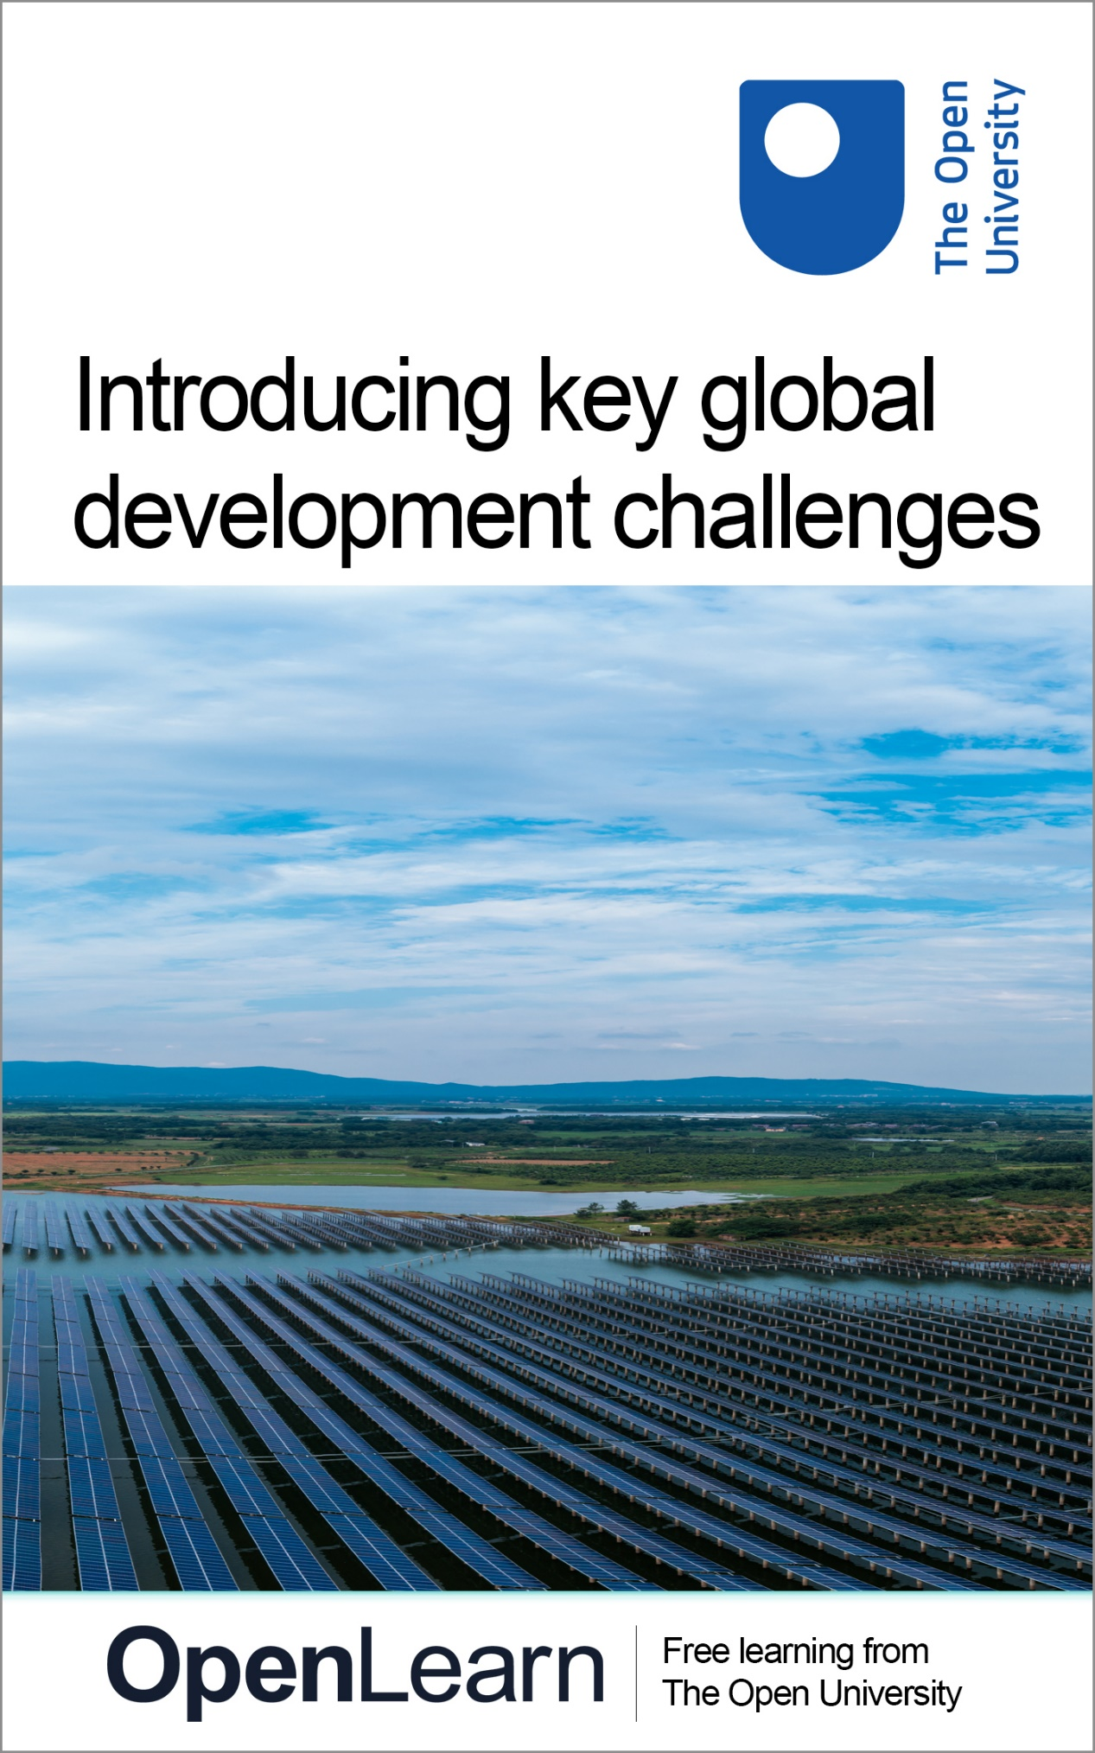

DD871_1

Introducing key global development challenges

About this free course
This free course is an adapted extract from the Open University course DD871 Key challenges in global development https://www.open.ac.uk/postgraduate/modules/dd871
This version of the content may include video, images and interactive content that may not be optimised for your device.
You can experience this free course as it was originally designed on OpenLearn, the home of free learning from The Open University –
There you’ll also be able to track your progress via your activity record, which you can use to demonstrate your learning.
Copyright © 2015 The Open University
Intellectual property
Unless otherwise stated, this resource is released under the terms of the Creative Commons Licence v4.0 http://creativecommons.org/licenses/by-nc-sa/4.0/deed.en_GB. Within that The Open University interprets this licence in the following way: www.open.edu/openlearn/about-openlearn/frequently-asked-questions-on-openlearn. Copyright and rights falling outside the terms of the Creative Commons Licence are retained or controlled by The Open University. Please read the full text before using any of the content.
We believe the primary barrier to accessing high-quality educational experiences is cost, which is why we aim to publish as much free content as possible under an open licence. If it proves difficult to release content under our preferred Creative Commons licence (e.g. because we can’t afford or gain the clearances or find suitable alternatives), we will still release the materials for free under a personal end-user licence.
This is because the learning experience will always be the same high quality offering and that should always be seen as positive – even if at times the licensing is different to Creative Commons.
When using the content you must attribute us (The Open University) (the OU) and any identified author in accordance with the terms of the Creative Commons Licence.
The Acknowledgements section is used to list, amongst other things, third party (Proprietary), licensed content which is not subject to Creative Commons licensing. Proprietary content must be used (retained) intact and in context to the content at all times.
The Acknowledgements section is also used to bring to your attention any other Special Restrictions which may apply to the content. For example there may be times when the Creative Commons Non-Commercial Sharealike licence does not apply to any of the content even if owned by us (The Open University). In these instances, unless stated otherwise, the content may be used for personal and non-commercial use.
We have also identified as Proprietary other material included in the content which is not subject to Creative Commons Licence. These are OU logos, trading names and may extend to certain photographic and video images and sound recordings and any other material as may be brought to your attention.
Unauthorised use of any of the content may constitute a breach of the terms and conditions and/or intellectual property laws.
We reserve the right to alter, amend or bring to an end any terms and conditions provided here without notice.
All rights falling outside the terms of the Creative Commons licence are retained or controlled by The Open University.
Head of Intellectual Property, The Open University

Contents
- Introduction
- Learning outcomes
- 1 Global interconnectedness
  - 1.1 Working with global interconnectedness
- 2 Why the four key development challenges?
- 3 Delving into the four challenges
  - 3.1 Conflict
  - 3.2 Governance
  - 3.3 Justice
  - 3.4 Transformation
- 4 Migration: a global development issue
  - 4.1 Migration and Lesvos
  - 4.2 Conflict and Lesvos
  - 4.3 Governance and Lesvos
  - 4.4 Justice and Lesvos
  - 4.5 Transformation and Lesvos
- 5 Final words and next steps
- References
- Further reading
- Acknowledgements
- Solutions

Introduction
Development is about change at local, national, international and global levels. Building a new shopping centre, changing national educational policy, creating international defence alliances, or developing a global transport system are forms of deliberate development. Such changes affect all of us, our livelihoods, and our wellbeing to a greater or lesser extent, depending on where we are located in the overall picture. The issues of deep concern associated with development, such as environmental degradation, poverty, disruptive new technologies, and shifting global power dynamics, connect every society around the world. Responding to such issues entails wide-reaching social, economic, political, cultural and environmental processes. There is a need for a renewed focus on cross-cutting principles of equality, justice and peace if development is to take the form of what Robert Chambers (1997) described as ‘good change’.
In this course, four key challenges - conflict, governance, justice and transformation- are introduced. They act as a means of framing key development principles and are central to seeking an understanding of any development issue. The four challenges force us to rethink the nature and meaning of development, and to critically evaluate attempts to address complex global issues. They call for recognition of obstacles that stand in the way of enabling the level of change that will benefit a wide range of people, and that is sufficient to resolve deep-seated social and economic problems. The challenges also provoke us to think through such difficulties and imagine a better future for all.
After exploring the meaning of the four challenges, you will read about one specific global development issue, that of migration. You will then focus on a particular case study, that of increased migration to the Greek island of Lesvos during the so-called ‘migration crisis’ in Europe in 2015, as a means of appreciating the complexity of the migration issue. You will use the four key challenges to provoke new questions and to evolve a deeper understanding on this and other global development issues.
This OpenLearn course is an adapted extract from the Open University course DD871 Key challenges in global development. You might also be interested in the related OpenLearn course, DD870 Introducing global development. To find out more, explore this OpenLearn article, which includes a video explaining what you can expect to learn.

Learning outcomes
After studying this course, you should be able to:
- appreciate how the four key challenges are used in this course to explore and identify fundamental development principles
- acquire a basic understanding of the nature of the four key challenges, namely conflict, governance, justice and transformation
- engage critically with a global development issue, that of migration, through the lens of the four key challenges.

1 Global interconnectedness
Issues such as environmental degradation, poverty, food insecurity, or the Covid-19 pandemic are transboundary in nature. They impact populations across the globe whether in the Global South or Global North, although in different ways and to varying degrees. This is not to say that national and international boundaries are unimportant. Such boundaries matter insofar as governments and institutions respond to the issues that impact upon their populations, and seek to control, modify, or ameliorate their negative impacts in some way. However, the complexity of global issues, and the interconnection between places means that such interventions do not always have the desired and intended effects and may also impact adversely on populations and ecologies elsewhere in the world.

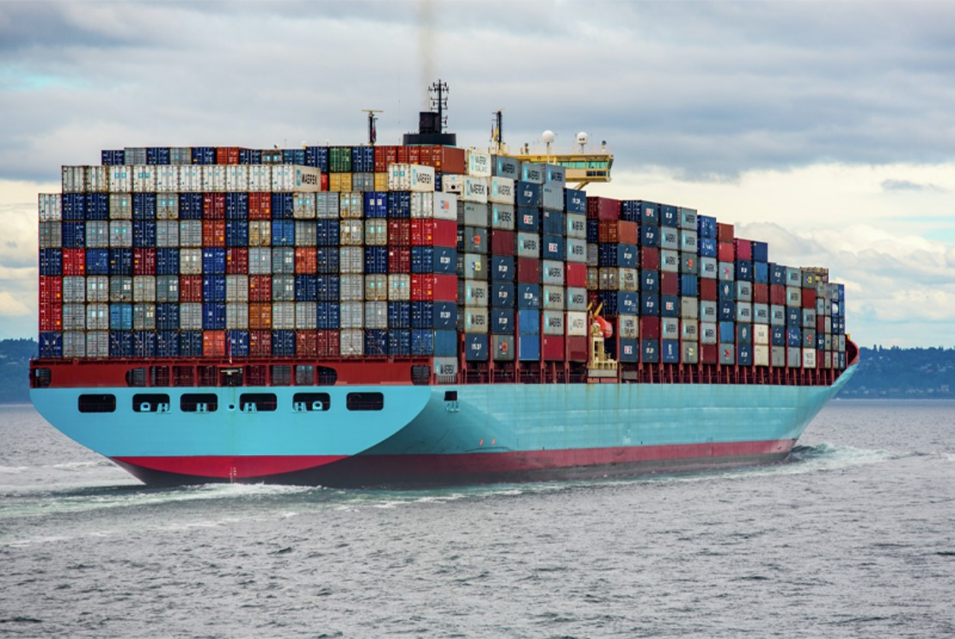
Figure 1: Container ships transport goods all over the world and are one component contributing to a highly interconnected and interdependent global economy.
View description - Figure 1: Container ships transport goods all over the world and are one component ...
View alternative description - Figure 1: Container ships transport goods all over the world and are one component ...

As an illustration, think about the global economy in the twenty-first century. It operates to connect the economic systems of countries across the world but accelerates processes such as migration and climate change. The flow of goods, labour and capital between countries has meant that industries benefit from cheap labour and supplies of raw materials. In turn, this can lead to increased revenue and employment in some countries, but losses in others. The availability of work, better pay and working conditions, contributes to migration from poorer to richer industrialised countries. The country from which people migrate loses precious human capital, but conversely, its resident population and economy may benefit from the financial contributions made by migrant communities, and the relationships cultivated between countries. Transport of goods by sea and air enables exchange of goods between countries. However, it involves the heavy consumption of fossil fuel and contributes to pollution and climate change, processes whose impacts are felt around the world. The more you probe into the situation, the more apparent the interconnection between countries becomes, and the less straightforward the balance between gains and losses.

1.1 Working with global interconnectedness
Addressing global development issues such as migration or environmental degradation creates difficulties and contradictions. The scope and impact of the problem is global in nature yet the impacts are felt at local community and household levels. In terms of response, it is predominantly at the level of nation states and international institutions that action is taken, such as in creating policies, rules and regulations. Conflicts and tensions can arise between the priorities and drivers at nation state level, and what is needed at a global level. For example, migrants meet the needs of nation-states by providing skilled and unskilled workers to address labour shortages. However, regulating the safe movement of people is extremely difficult and, additionally, public attitudes to the entry of migrants increasingly influence political agendas (OPAM 2018). As a result, migrants can experience harms and injustices. This is captured in this quote by Esteban Velázquez, a Jesuit priest and social activist, speaking of the need for an international tribunal on migration rights.

‘There’ll never be a thorough solution while sovereign states have the last word and there’s no international authority which decides on the violation of migrants’ rights……Sovereign states are a reality conceived in the last century and they’re insufficient for the global reality.’
(Velázquez, 2018)

The Sustainable Development Goals (SDGs) represent a significant step forward in this context in that the goals are meant to apply to all countries, developed and developing, and SDG17 recognises the need for collaborative partnerships at global, international, national and local levels (UN Assembly 2015). Breaking down the whole picture of sustainable development into the 17 SDGs and setting specific targets and indicators for each goal helps in building in-depth knowledge of each part, and in reaching a level of understanding of the processes at play. However, the danger is that nation states will pick and choose what to focus on and lose sight of the bigger picture.
The overall stated aims of the SDGs are to move towards a just, equitable and sustainable world. Critics of the SDGs argue that the goals do not go far enough in this direction as doing so will require transformation of existing social, economic and political systems, and create tensions between the multitude of people, ideas, values and beliefs involved (Esquivel, 2016; Langford 2016; Fukuda-Parr and McNeill 2019). In the next sections, you will read about the four key challenges - conflict, governance, justice and transformation - introduced in this course to provoke critical and creative thinking on the future of development on a global scale. The challenges draw attention to important cross-cutting principles and concerns in relation to development thinking and practice, including human rights, questions of peace and security, and how to achieve transformational change in conditions for the poorest and most vulnerable in societies around the world.

2 Why the four key development challenges?
In the previous sections you read about how global issues affect and connect people and places across the globe. Problems caused by hunger, poverty, and migration have led to planned and purposeful interventions seeking to address the issues and to improve the lives of those affected. Yet patterns of poverty persist throughout the world, with evidence that any decrease in inequalities between countries is being offset by the increases in inequalities within countries.

‘In 2021, after three decades of trade and financial globalisation, global inequalities remain extremely pronounced: they are about as great today as they were at the peak of Western imperialism in the early 20th century.’
Source: World Inequality Database (2021)

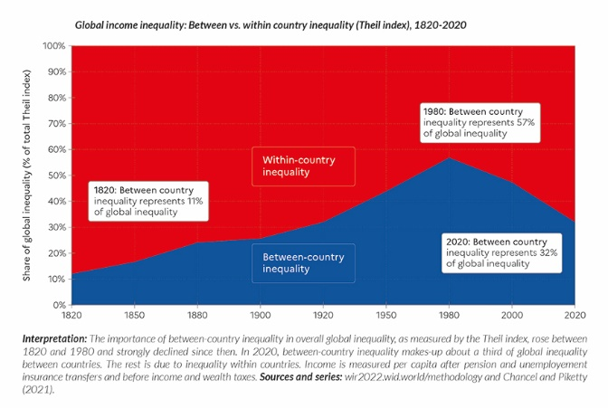
Figure 2: Between 1820 and 1980, the share of global income inequality due to inequalities between countries increased and then declined. However, this decline is offset by the rise of inequalities within countries. In 2020, between country income inequality contributes about a third to overall global income inequality (in blue), with two-thirds resulting from within country income inequality (in red). Source: Global Inequality Report 2022, Executive Summary
View description - Figure 2: Between 1820 and 1980, the share of global income inequality due to inequalities ...
View alternative description - Figure 2: Between 1820 and 1980, the share of global income inequality due to inequalities ...

Inequality is an example of an entrenched, enduring problem that seemingly defies all attempts to change it for the better. If anything, the data indicates a worsening of the situation. What is critical to realise is that inequality of income is but one fragment of the story. Inequality of income intersects with inequalities related to accessing education and healthcare. For instance, maternity mortality rates in low-income countries in 2017 was 462 per 100 000 live births compared to 11 per 100 000 live births in high-income countries, with most of these deaths being preventable if skilled healthcare is provided (WHO 2021).
Doing more of the same is unlikely to be the answer. The situation requires that we step back, reflect and ask ‘What is going on here? What is pushing against change? Who benefits from the status quo?’

Activity 1: World Inequality Report 2022
15 minutes

Read the following extract from the executive summary of the World Inequality Report 2022. If you would like to delve deeper into this issue, the full summary makes for fascinating and provocative reading. You can find the link in further reading.
The below extract concerns wealth rather than income. The net wealth of a country or an individual is the sum of their financial and non-financial assets, minus their debts.
Read the extract and reflect on its implications. What do you think governments can do in such a situation?

‘Nations have become richer, but governments have become poor’
‘One way to understand these inequalities is to focus on the gap between the net wealth of governments and net wealth of the private sector. Over the past 40 years, countries have become significantly richer, but their governments have become significantly poorer. The share of wealth held by public actors is close to zero or negative in rich countries, meaning that the totality of wealth is in private hands. This trend has been magnified by the Covid crisis, during which governments borrowed the equivalent of 10-20% of GDP, essentially from the private sector. The currently low wealth of governments has important implications for state capacities to tackle inequality in the future, as well as the key challenges of the 21st century such as climate change.’
Source: The World Inequality Report 2022, Executive Summary

View discussion - Activity 1: World Inequality Report 2022

The issue of persistent global income and wealth inequality, with that within countries increasing, even in developed countries, provokes questions on the very nature of development. It calls for recognition that the model of modernisation and industrialisation, promoted by Western democracies, does not equate with just and fair distribution of the benefits, nor does it support environmentally sustainable lifestyles.
Reflecting on this issue of income and wealth inequality, the four challenges identified in this course - conflict, governance, justice and transformation- encapsulate the thorny questions that need to be asked if development principles of justice, peace and equity are to prevail.
- The present global economic system benefits some greatly. Changing it to benefit others will have to push against a very entrenched way of working and the interests of those who currently benefit most from it. How do we negotiate the competing interests of the ‘haves’ and ‘have nots’? This raises the challenge of working with conflict.
- If, for example, wealth redistribution is seen as essential to addressing inequality, who will decide what is best and at what scale? How do we identify and enforce the ‘rules’ through which we manage socio-economic processes? These represent questions of governance.
- These in turn raise questions of justice. Who will evaluate the change that takes place and using which criteria? How do we work out what ‘good change’ looks like?
- The present global economic system has changed in various ways over the years yet still results in growing inequalities. How do we achieve meaningful change, especially in the face of long-standing, deeply entrenched socio-economic systems? This is the challenge of transformation.

3 Delving into the four challenges
In this section, you will read about the nature of the four challenges: conflict, governance, justice, and transformation in more detail.

3.1 Conflict
To begin this section, take a look at Activity 2.

Activity 2: Personal perceptions of conflict
10 minutes

What three words do you associate with conflict? Add these to the wordcloud below. Once you have added three words, click ‘Save Changes’ and then ‘Click here for the WORDCLOUD’ to see the results of everyone’s submissions.
(Note the following points: each word you add should be no more than 50 characters in length; the top 150 words only will appear in the generated wordcloud; if you are one of the first to add words, the cloud might still be quite empty – if so, you could return to this later to see the results after more words have been added.)
What terms dominate? Does anything surprise you?

Interactive content is not available in this format.

Conflict is intrinsic to social interactions and is part and parcel of change and development processes. Conflict emerges where there is difference, disagreement or dispute of interests and /or perspectives between two or more people. Its presence causes changes in the dynamics of their behaviour at emotional, psychological and intellectual levels. What starts as a tension or dispute between a few can quickly draw in others and extend the sphere and range of interactions taking place. The impacts of conflict can range from destructive violence to constructive change, and at times, deconstruction is a necessary prelude to creating something different.

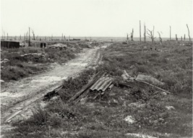
Figure 3: Longueval village, Somme battlefield, France, 1916-18
View description - Figure 3: Longueval village, Somme battlefield, France, 1916-18
View alternative description - Figure 3: Longueval village, Somme battlefield, France, 1916-18

Violence and war are undoubtedly forms of conflict that are extremely damaging to all involved. The World Bank (2021) gives a figure of 800 million people affected today by social fragility and violence. Forced migration is a direct outcome of destructive conflicts. The UN Refugee Agency reported that the number of people forced to flee violent conflict, persecution, human rights violations and persecution had crossed the 100 million mark by May 2022, driven upwards by the war in Ukraine (2022) and other deadly conflicts (UNHCR, 2022).
However, conflict does not inevitably become destructive - it is a process that evolves over time and has a dynamic of its own. Ignoring or avoiding conflict does not address the reasons for its existence whereas active engagement creates opportunities for determining the course of its evolution.
Table 1 shows three broad levels of conflict processes - disputes, goal-based problems and identity conflicts. Addressing them requires different skills and approaches. In any social context, as in disputes over land ownership, all three processes may be at work.

Table 1: Broad division of conflict process types.
Conflict process | Examples | Intervention process
Disputes over resources and wants | Land ownership  Investment choices  Sharing of facilities | Leadership  Negotiation
Goal-based problems - difference in objectives | Priorities - who should be first in line for housing, health services, and funding etc.  What counts as project success e.g. number of people in employment vs security of employment | Facilitation of open discussion  Mediation, Negotiation / compromise
Identity conflicts - deep-rooted | Cultural beliefs and traditions  Language  Historical and cultural links with place | Mediation and creative engagement  Finding ways of living with contradiction and disagreement

Social conflict brings added complexity to any situation. Not only are conflicts taking place simultaneously at individual, family, group, local and national level, but within these different dimensions the conflict may be at different stages and heading in a range of directions involving escalation on a destructive path, or de-escalation towards settlement of conflict (Kriesberg, 2011). In other words, there is more than one conflict at play.
Here you have read a brief overview of the nature of conflict. When seeking an understanding of development processes, recognising the inevitable presence of conflict brings added uncertainty, unpredictability and complexity to the situation. Keeping the challenge of conflict in mind requires you to probe into the social nature of development and to recognise it as a process involving interactions, allegiances and oppositions between many individuals, groups and communities. All are intertwined and can work against or with each other.
For instance, national representatives involved in negotiations on reducing greenhouse gas emissions, need to juggle the conflicting demands of industries dependent on fossil fuel use, communities dependent on employment in such industries, and the increasingly urgent need to address climate change by reducing fossil fuel consumption. The SDGs themselves reflect such conflicts - SDG 8 target 8.1 seeks to sustain per capita economic growth whilst SDG 15, target 15.1 seeks to ensure the conservation, restoration and sustainable use of terrestrial and inland freshwater ecosystems. These are the very systems threatened by continued resource consumption and fossil fuel use.
Civil disobedience and protest marches are manifestations of non-violent conflict between sectors of a population and those in authority. Such conflicts are often emotionally highly charged and may involve a mix of participants with differing agendas. Inappropriate security responses, frustration, and / or infiltration by groups that advocate violence can change the dynamic from one of peaceful protest to one of violence and rioting.

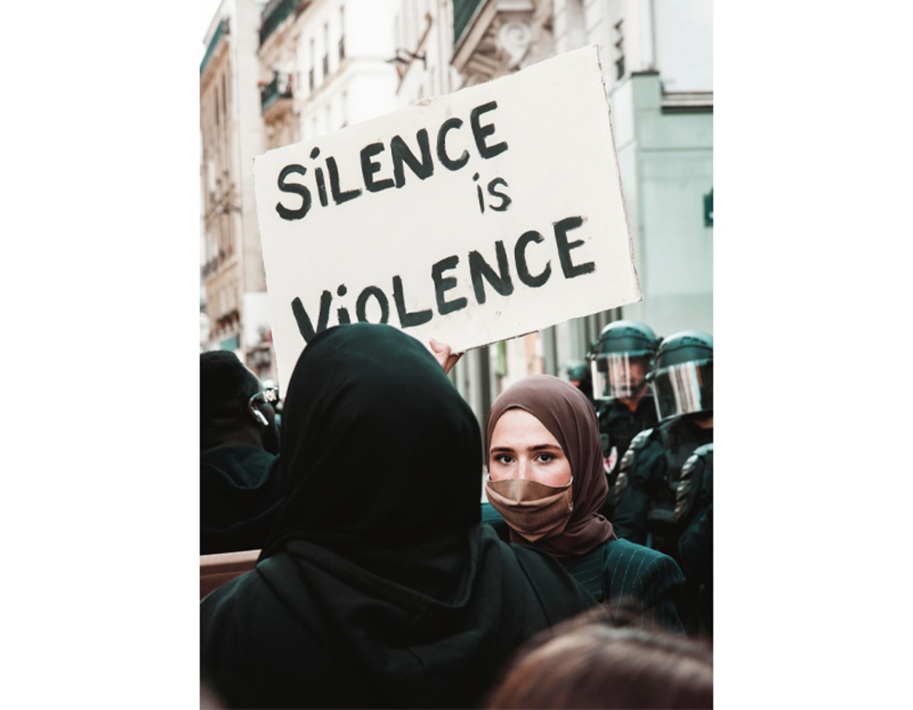
Figure 4: Public Protests in Paris, 2020.
View description - Figure 4: Public Protests in Paris, 2020.
View alternative description - Figure 4: Public Protests in Paris, 2020.

3.2 Governance
All societies create systems for managing social relationships, for allocating and exercising authority, and for distributing resources. Within some such systems are explicit, formal rules such as those codified in laws and regulations. Just as significant in social contexts are the informal, unwritten rules which make up norms, what is accepted and not accepted within any set of social relationships. These contribute to managing conflicts in social interactions. For instance, road safety is ensured by implementing a non-negotiable law regarding driving on the left or right-hand side of the road. Breaking the rule is met with punitive measures such as a jail sentence.
Take inter-generational relations as a further example. While it does happen that children often end up caring for and providing for their parents, this is usually an exceptional circumstance and there will be institutional responses, whether formal or informal, to support such juvenile carers. However, the norm of managing these generational relationships and allocating authority is that parental generations look after their children. When such rules are broken, and conflict develops, other rules come into effect, leading in some cases to the legal abrogation of parental authority and placing of children into foster care on the behalf of a governing authority.

Activity 3: The importance of good governance
20 minutes

Watch Video 1, or read the transcript, in which Dr Mo Ibrahim, a British-Sudanese businessman and founder of the Mo Ibrahim Foundation, speaks about governance in Africa. How does he see the relationship between governance, development and development aid?

Video content is not available in this format.
Video 1: Mo Ibrahim: Governance matters for Africa – and for everybody else!
View transcript - Video 1: Mo Ibrahim: Governance matters for Africa – and for everybody else!

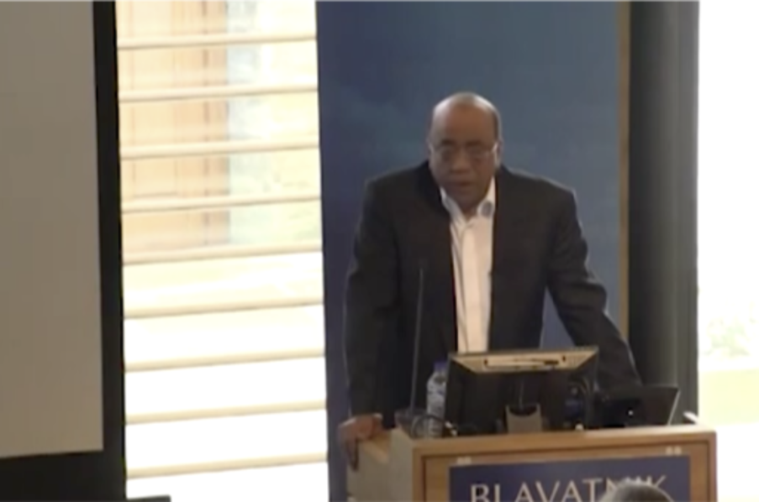

Provide your answer...
View discussion - Activity 3: The importance of good governance

When thinking in terms of governance in relation to development, questions you can ask include – who decides what to put in place, when and how? Such questions demand a recognition that governments, like all social institutions, are imperfect and do not always work in the best interests of all those governed. Governance is a much broader concept than government and necessitates the involvement of a wide spectrum of actors, social groups, civil society organisations, private companies and regional and international bodies. In turn, the involvement of such a diverse array of actors will inevitably engender conflict. The challenge of governance and its relationship to good development is an enduring and taxing one in global development and leads to a consideration of justice.

3.3 Justice
Figure 5 is a classic representation of justice: a blindfolded woman holding a set of scales and a sword. The feminine figure has its origins in the Greek and Roman goddesses of justice. The blindfold represents impartiality, the scales represent the weighing of evidence for and against an issue, and the sword represents authority and power.

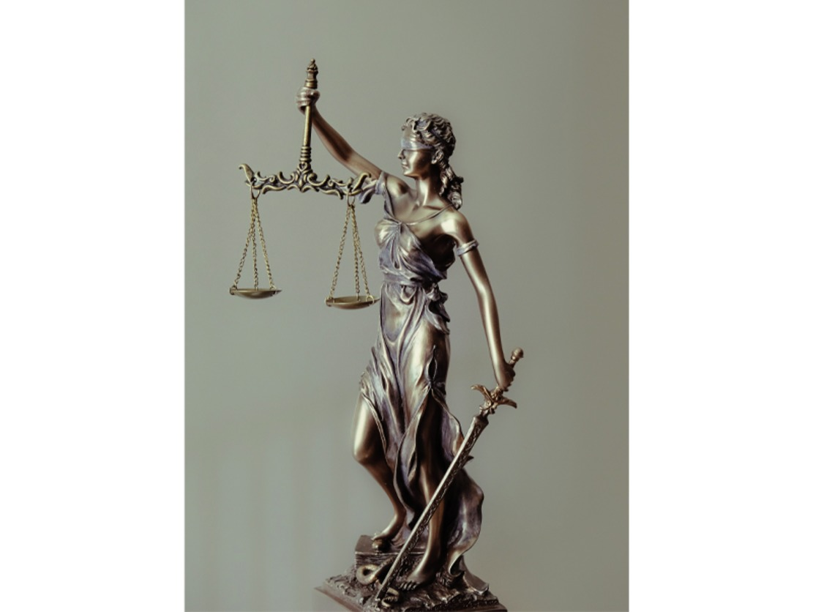
Figure 5: A classic representation of justice
View description - Figure 5: A classic representation of justice
View alternative description - Figure 5: A classic representation of justice

Justice is a term often associated with the criminal justice system, which exists to enforce laws of the state and normally comprises the police, courts and prison system. In principle the law is applied impartially and without prejudice so that all are treated fairly and equally in this system. In practice, however, the institutions can exhibit bias and discrimination as seen in the treatment of black people in the criminal justice system in the USA and in the UK (Belkin 2021).
This course encompasses the ideas of moral and political justice, as well as those of legal justice. The term that is often used in the context of global development is that of ‘social justice’. Social justice embraces two fundamental ideas which provide the foundations of global justice theories.
These ideas are those of:
- distributive justice which is concerned with the fair distribution of resources such as income and wealth.
- relational justice which is focused on the equalisation of social relations such as gender and employment relations.

Activity 4: Equality and fairness
15 minutes

Watch Video 2, or read the transcript, which outlines the difference between equal treatment for all and fair treatment for all. Can you think of an example of equal treatment which is unfair?

Video content is not available in this format.
Video 2: The difference between fairness and equality
View transcript - Video 2: The difference between fairness and equality

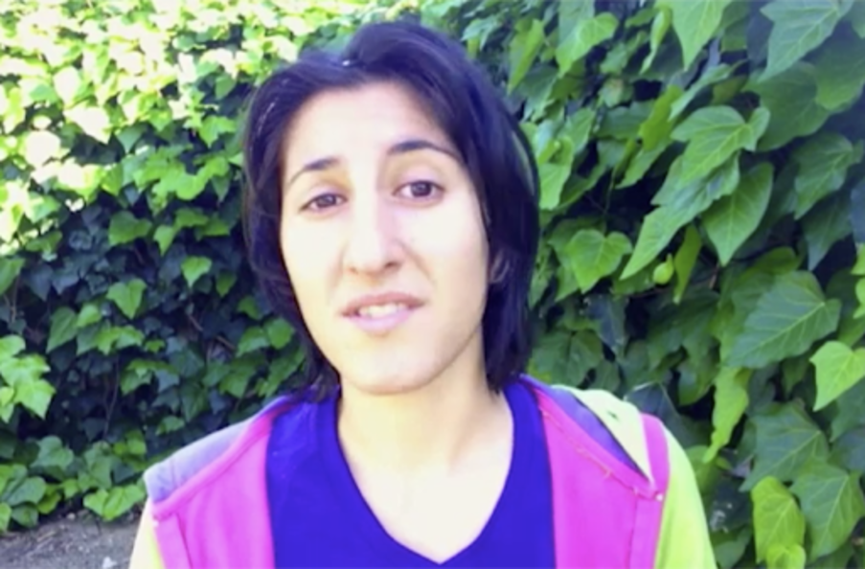

Provide your answer...
View discussion - Activity 4: Equality and fairness

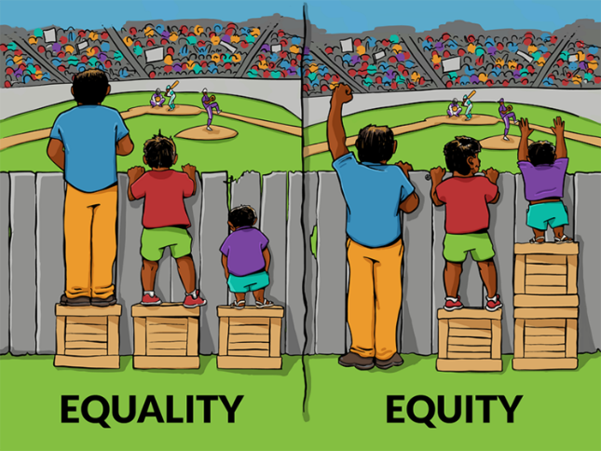
Figure 6: Interaction Institute for Social Change | Artist: Angus Maguire
View description - Figure 6: Interaction Institute for Social Change | Artist: Angus Maguire
View alternative description - Figure 6: Interaction Institute for Social Change | Artist: Angus Maguire

Video 2 brings attention to the fact that equality does not equate with fairness and provokes a more in-depth examination of the factors that enable some to benefit whilst others are disadvantaged. Take the example of international taxation practices that allow multinational companies and wealthy individuals to avoid paying tax through the use of tax havens. Non-wealthy citizens of such countries pay taxes with poor countries being hardest hit in this way. Is this fair?
The concept of social justice thus is critical when thinking in terms of global development and provides a means of evaluating its processes and outcomes. However, doing so creates a major challenge in that it brings in questions of governance - who defines what fairness and equity look like? How can fairness and equity be measured? Such questions will inevitably be sources of disagreement and conflict. Following on from this, what types of institutions and public actions are needed to address injustices in global development?

3.4 Transformation
The change in form and function from a caterpillar to a butterfly is one of nature’s truly wondrous examples of a transformation.

Figure 7: Queen swallowtail butterfly, Papilio androgeus, with caterpillar and pupa. Illustration drawn and engraved by Richard Polydore Nodder.
View description - Figure 7: Queen swallowtail butterfly, Papilio androgeus, with caterpillar and pupa. ...
View alternative description - Figure 7: Queen swallowtail butterfly, Papilio androgeus, with caterpillar and pupa. ...

As you have already read, development is about change. However, change takes place at many levels and the outcomes can range from minor adjustments to what previously existed to a wholesale upending and emergence of something entirely new. Change is a modification or adaptation of what went before, it involves looking back to what already exists and seeking to improve upon it. Transformation is future- focussed, seeking to imagine something that does not yet exist, and then explores and nurtures its emergence into a reality.

Activity 5: The nature of transformation
25 minutes

Listen to Audio 1, or read the transcript, in which the American anthropologist, Professor Joseph Tainter, discusses his interpretation of transformation with a focus on the level of transformation needed to make our economies and societies environmentally sustainable.

Audio content is not available in this format.
Audio 1: Joseph Tainter: What is transformation?
View transcript - Audio 1: Joseph Tainter: What is transformation?

What difficulties does Professor Tainter see in trying to fundamentally change our social and economic systems?

View discussion - Activity 5: The nature of transformation

Thinking of transformation as deep-seated and profound change immediately challenges the very nature of development theory and practice. The critique is that development effort is focussed on alleviating the negative effects of the prevailing global social, economic and political systems and processes. As an example, development approaches towards ‘making markets work for the poor’ sees the problem as being one where the poor are excluded from the market economy and the solution is to enable them to participate fully. The focus is on fixing or improving the current market system. The possibility that other factors – or even markets themselves – might operate to produce and sustain poverty and inequality is unquestioned. Transformation seeks to totally reconfigure these very things that go unquestioned, development theory and practice needs to shift from attempting to treat the symptoms of development ills to tackling their systemic causes (Ramalingam 2013).
The challenge of transformation calls for profound change of such a degree that is difficult to imagine clearly, and impossible to direct and control. Professor Tainter in Audio 1 argued that this is not an excuse for muddied and imprecise thinking but requires rigour and clarity as to what is to be transformed, for whom and at what cost. Even doing so will not guarantee outcomes. Transformation is a deeply disruptive process involving living with uncertainty and accepting losses as well as gains. There are powerful interests that benefit from existing social, economic and political systems - those benefiting are not only unlikely to seek change but actively resist it.

4 Migration: a global development issue
Migration - what does that word evoke for you? Why is migration a global development issue?
There is no internationally recognised definition of a migrant. The United Nations International Organization for Migration (IOM) defines a migrant as ”any person who is moving or has moved across an international border or within a State away from his/her habitual place of residence, regardless of (1) the person’s legal status; (2) whether the movement is voluntary or involuntary; (3) what the causes for the movement are; or (4) what the length of the stay is” (UN, nd). Thus, migrants can include those who move internally within a county as well as those who cross national borders, and those with and without a legally recognised status. Determining the scale of migration is not easy due to the fluid and varied nature of the movements of people across places.

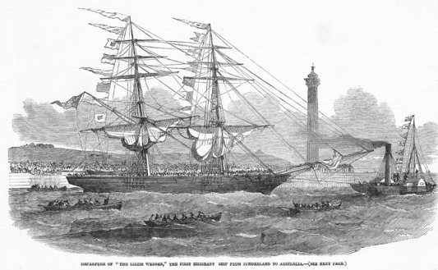
Figure 8: Departure of ‘The Lizzie Webber’, the first emigrant ship from Sunderland, UK to Australia in 1852
View description - Figure 8: Departure of ‘The Lizzie Webber’, the first emigrant ship from Sunderland, ...
View alternative description - Figure 8: Departure of ‘The Lizzie Webber’, the first emigrant ship from Sunderland, ...

In the 19th century, assisted passage was provided to encourage migration to Australia where labour was in short supply. Some sectors in the UK saw such migration as an opportunity to send the poor abroad and thus solve the problem of poverty in the country (Richards 1993).
Human beings have always migrated. Migration can be seen as a ‘normal’ and long-standing global process, and presents both challenges and opportunities for individuals, communities, and nations.
Yet migration, particularly across national borders, has become a prominent global issue. The right to migrate has been a cornerstone of the international order since the foundation of the UN, but the right to permanently settle in another country is not. Western media coverage in particular has increasingly highlighted what are framed as ‘migration crises’, such as those often identified in recent years along the US–Mexico border and across and around the Mediterranean Sea. Such coverage tends to emphasise the scale of the migration flows, drawing attention to what are generally seen as the large and unprecedented numbers of migrants, and articulating fears of being overwhelmed or ´flooded´ by unwanted foreigners.
The International Organisation for Migration (IOM) gives a figure of 281 million international migrants in the world in 2020, which is 3.6 percent of the global population. This is an increase from 178 million in 2000. Looking at the data from the other side, this means that over 96% of the global population stay in their home countries. However, migration is not evenly distributed across the world and shows specific geographical patterns. For instance, the 2020 data for international remittances - financial or in-kind transfers made by migrants directly to families or communities in their countries of origin - show that India and China are the top receiver countries with total inward remittances exceeding $83 billion and $59 billion, respectively. Mexico, the Philippines and Egypt are next in line. High-income countries such as the United States, the United Arab Emirates, Saudi Arabia, Switzerland and Germany are almost always the main source of remittances (IOM 2022).
Migration is interwoven with global social, economic and political processes, both influencing them and being influenced by them. Globalisation facilitates the movement of people, but this is not a level playing field for all. Nation states play an important role in determining who can move across their borders and the degree of ease of doing so. Increasingly, technology contributes to exerting such control. The ease of migration is determined by the passport you hold - nationals from developed countries can travel visa-free to about 85 percent of all other countries. Regular pathways of migration are much more restricted for those from poorer countries forcing them to resort to irregular pathways (IOM 2022). Thus, migration becomes a global development issue as it is intimately bound up with connections between people and places, with social, political and economic change, and highlights the inequalities and inequities of the global landscape in terms of privileges and opportunities to create a better life (Mavroudi and Nagel 2016).
In the next section, you will explore the situation in the Greek island of Lesvos in 2015. Examining a specific localised case of migration that created controversy and difficulties for both migrants and resident populations, will enable you to appreciate such situations at the micro, everyday level. Using the four challenges will provide you with a powerful way to analyse global development. You will connect this specific case to the bigger picture of global development, and recognise the messy complexity involved.

4.1 Migration and Lesvos
The Greek Island of Lesvos is a small island with a resident population of about 80,000. As shown in the map below, its location is the Aegean Sea close to the coast of Turkey. This makes it an ideal landing and stepping off point for migrants using the route known as the Western Balkans route. From Turkey, migrants land by boat on the north of the island, make their way to the south of the island, from there head for mainland Greece and onward through Macedonia, Serbia, Hungary, Croatia and Slovenia. Final destinations that they aspire to reach include Germany, Austria, Sweden and the United Kingdom.

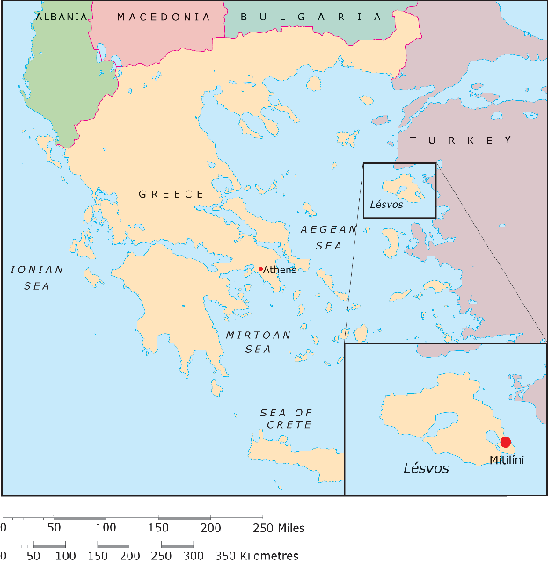
Figure 9: A map of Lesvos island
View description - Figure 9: A map of Lesvos island
View alternative description - Figure 9: A map of Lesvos island

Activity 6: Refugee, asylum-seeker or migrant?
15 minutes

Terminology refers to the set of specialised terms and their meanings relating to a particular practice or field of study. It matters because effective communication depends on a shared understanding of specialist terms along with their underlying assumptions. However, in everyday usage, terms are often used interchangeably such as that of migrant, refugee and asylum seeker. For the individuals involved, how they are defined is important because it affects their legal rights.
Take a moment to search for definitions of each term, migrant, refugee and asylum seeker. How do they differ?

View discussion - Activity 6: Refugee, asylum-seeker or migrant?

4.2 Conflict and Lesvos
The situation in Lesvos brought into play conflict involving different groups and at different levels. Examining this case study in terms of conflict provides useful insights and raises important questions as to how the competing interests can be met.
The initial humanitarian response depended on local residents as no humanitarian organisations were active in the north of the island during the first part of 2015. Initially ad-hoc, the volunteer response self-organised, created transit centres in the north of the island, provided food, clothing and transport. Subsequently, the Moira and Kara Tepe camps were constructed outside Mitilene to provide temporary accommodation to asylum seekers awaiting the registration process.
This goodwill of the resident population became extremely strained as the number of arrivals on the island increased. In 2015, Greece was struggling to recover from economic recession and the government had limited ability to react to the unfolding humanitarian emergency. The lack of capacity to manage the influx of refugees led to bottlenecks in the system such as delays in processing asylum applications, and then lack of capacity of ferries to take successful applicants to the mainland. This resulted in the refugees having to remain on Lesvos for prolonged periods of time. Policies introduced by the European Union (EU) and Turkey in 2016, such as closure of the Balkan route, led to a decrease in refugee arrivals but left those refugees already on the island with no way out.
The subsequent influx of other categories of foreigners – volunteers, journalists, celebrities and academic researchers – further compounded matters. Understanding and responding effectively to the migration issue on Lesvos requires appreciating the complexity of the different conflicts at play there, of their changing nature and of the range of actors involved.
The case of Lesvos shows conflict as a driver of migration in that, initially at least, those arriving were fleeing from violence and war. This situation was complicated later in the year by the arrival of migrants from other countries seeking better economic prospects. Conflict also becomes an outcome of the migration with several different conflicts at play.
These included:
- Conflict between refugees and locals
Many locals complained because they observed their island being turned into an ‘open prison’, where refugees lived in awful conditions. Lesvos’ tourist industry was negatively affected, while already struggling local services and infrastructures could not cope with the demand. Refugees became an ideal scapegoat and tensions between refugees and locals became the norm.
- Conflict among locals
An increasing divide became apparent amongst Lesvos locals – between those receptive to the refugees and those hostile towards them. Such conflict threatens social cohesion on Lesvos by fostering parallel local communities which live ‘alongside’ rather than ‘with’ one another.
- Conflict between locals and NGOs
Local people felt ignored and side-lined by the NGOs that arrived on the island, despite the fact that the islanders themselves had been dealing with the situation and supporting the refugees for some time before this, and many continued to do so. Some locals believed that the main aim of some NGOs is to make a profit by enabling a permanent emergency on Lesvos and by not criticising the EU’s exceptional border policies whereby temporary internal border controls were reintroduced and resulted in refugees being trapped on the island. As a result, many NGO workers were targeted by locals and spoke frequently of intimidation.
- Conflict between locals and the Greek State and the EU
Locals argue that both the central Greek state and the EU enforced border policies and overlooked locals’ interests and without consulting regional and municipal authorities. They complained of being abandoned by the Greek state. The EU is seen as an intervening actor aiming to transform islands such as Lesvos into warehouses for migrants and refugees. Demonstrations and general strikes opposing the Greek state and EU border practices are very frequent.
What emerges from a consideration of the challenge of conflict is a need to examine the competing interests and agendas of the different actors participating in the situation, as well as recognising that the dynamic of the ensuing conflicts changes and evolves over time as more actors get involved. The situation deteriorates or improves in different ways for different actors. The issue of migration on Lesvos links to wider issues of border security and control at European and global levels, as well as necessitating awareness of the economic, social and political drivers that make people undertake hazardous journeys in search of safety and a better life.

4.3 Governance and Lesvos
Governance as you read in section 3.2 is about the rules, policies and norms that set out how state and non-state actors manage their affairs and deal with competing interests and agendas. Asking ´Who gets to decide the rules and policies that are recognised and enforced?´ draws attention to the power dynamics at work in the Lesvos context.
Initially, the local population took responsibility for the refugees acting according to their own informal societal norms whilst at the same time having to pay attention to national laws and policies such as need for registration as a refugee, and the anti-trafficking laws of Greece which meant that the refugees could not be transported by taxi or public transport. However, as the numbers of migrants arriving increased, the Greek Prime Minister asked for external help in August 2015 and the UN recognised that the EU had a shared responsibility to address refugees’ needs. This brought into play international protocols such as the ‘responsibility to protect’, which states that sovereign states have a responsibility to protect their own citizens from avoidable catastrophes, but when they are unwilling or unable to do so, that responsibility must be borne by the broader community of states (International Commission on Intervention and State Sovereignty 2001). Additionally, the UN invoked the need to share responsibility for refugees needs (UNHCR, 2017).

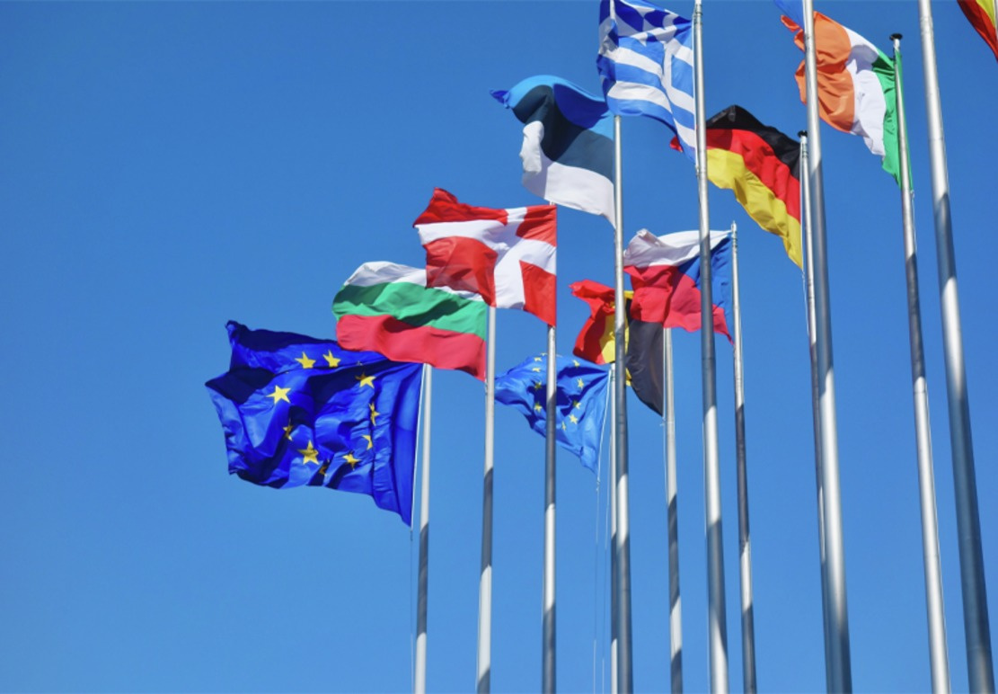
Figure 10
View description - Figure 10
View alternative description - Figure 10

Such actions changed dramatically the dynamics of the situation. It opened the doors to a huge humanitarian and security response by EU agencies, international NGOs (INGOs) and private actors who all started interacting with each other as well as with the Greek state, local authorities and civil society on Lesvos. Whilst seemingly for the good, the measures and actions imposed by those who had power to enforce policy and protocols, such as the EU and the Greek government, did not take into consideration the needs and interests of local communities on the island, nor were they required to. For example, various exceptional border policies were enforced by the Greek state and the European Commission, the executive branch of the EU. The geographical restriction of migrants’ movement on Lesvos was one policy that overlooked the interests and concerns of both refugees and locals who were affected directly by the enforcement of this policy.

Activity 7: Pause for reflection
15 minutes

Regulatory frameworks, laws and international protocols exist to protect citizens of a country, to guarantee human rights, to protect refugees.
In your opinion, what do you think can get lost when thinking in terms of rules, laws and regulations?

Provide your answer...
View discussion - Activity 7: Pause for reflection

Thinking in terms of governance, the Lesvos situation highlights the different levels at which governance operates - local, national, international and global, with multiple actors operating at every level. The interactions between the different actors brings to the fore unequal power dynamics and the interplay between governance and conflict. The exclusion of one group of important actors, the local people of Lesvos, from influencing a process that directly affected their lives, provoked a feeling of anger and helplessness. The confinement of migrants to Lesvos led to tensions and conflict between them and local people. Overcrowding and poor conditions created conflicts amongst the migrants themselves. Governance is a process that shapes development, what does and does not happen, who benefits and who does not.

4.4 Justice and Lesvos
The principles underpinning justice are those of fairness, equity and access to resources and opportunities. According to Article 13 of the Universal Declaration of Human Rights (United Nations, 1948), (a) ‘everyone has the right to freedom of movement and residence within the borders of each state’, and (b) ‘everyone has the right to leave any country, including his own, and to return to his country’.

‘This questions the legitimacy of European Union institutions in deciding who can move and settle freely in Europe. National interests and security concerns and their translation into border controls that restrict the movement of asylum-seekers are difficult to reconcile with ideas of justice and human rights for all.’
(Lendaro 2016)

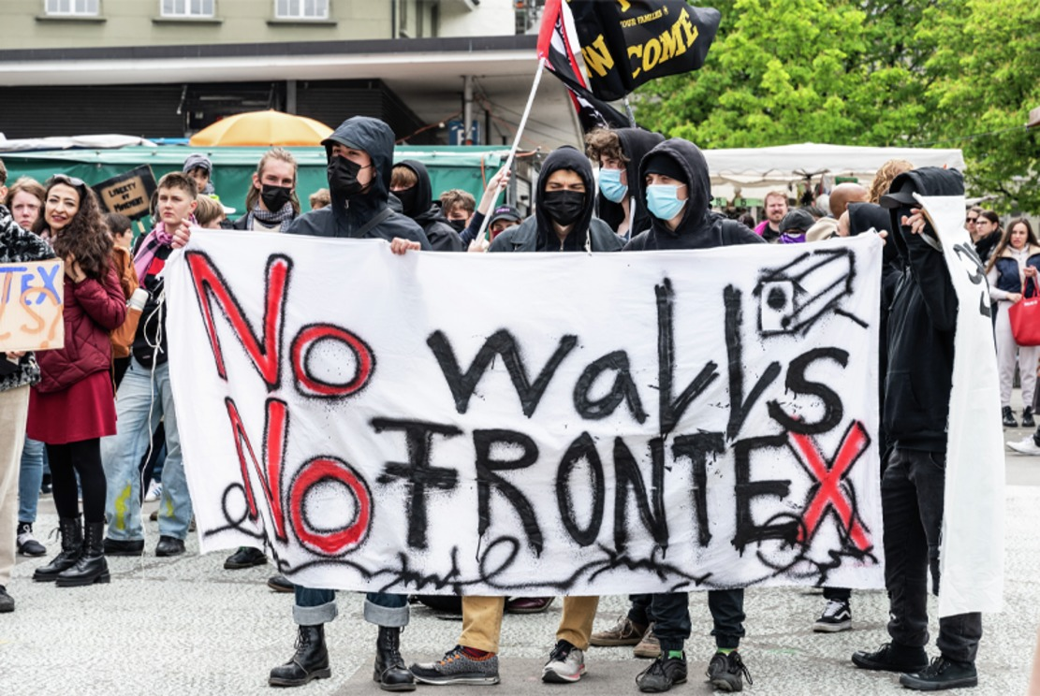
Figure 11: Protests organised as part of an international campaign for the defunding and dismantling of Frontex, the European Border and Coast Guard Agency. Activists accuse the EU of being responsible for the deaths of asylum seekers, and of being more interested in enforcing border control than safeguarding human rights.
View description - Figure 11: Protests organised as part of an international campaign for the defunding ...
View alternative description - Figure 11: Protests organised as part of an international campaign for the defunding ...

Activity 8: Human rights versus border control
15 minutes

Reflect on the 2016 closure of the Balkan route and the geographical restriction of movement placed on refugees on Lesvos. Does this adhere to equity of treatment for all?

Provide your answer...
View discussion - Activity 8: Human rights versus border control

The challenge of justice requires asking how we work out what is equitable treatment. Should migrants be allowed to leave Lesvos and go where they wish in Europe? How does this idea tally with national border policies? If they are allowed to leave, what about the impact on others where they settle? If they are not allowed to leave, then why? What counts as fair treatment for the people of Lesvos who must accommodate the refugees and what about the refugees themselves?

4.5 Transformation and Lesvos
Lesvos has been fundamentally changed, maybe even transformed. Since 2015, it is a very different place to what it was before. However, neither residents nor migrants see this as a case of ´good´ change. The island has been converted into a kind of ‘prison island’ and a ‘buffer zone’, changing the lives of both refugees and locals living on Lesvos.
Both populations exert what agency they can to change things for the better from their respective perspectives. For example, in February 2020 the Greek government announced that it would be going ahead forcibly with plans to build a new, huge, closed detention facility on Lesvos. These plans aligned with EU policies for transforming Lesvos into a securitised buffer zone. Following demonstrations and general strikes, local people managed to put an end to the plans. To local people, this represents a positive development but leaves the question of how to fundamentally transform the situation on Lesvos so that the needs of all are addressed.

Figure 12: Lesvos at sunset
View description - Figure 12: Lesvos at sunset
View alternative description - Figure 12: Lesvos at sunset

The EU-Turkey Statement is an example of influential actors coming together in order to significantly change a situation. Following the 2015 refugee crisis, this Statement was adopted by the European Council and Turkey with the stated aim of ending human suffering, dismantling the business model of smugglers, and offering migrants alternative options to putting their lives at risk (Council of the European Union, 2016). Nevertheless, the evidence suggests that despite these independent interventions from different actors, there has been no substantial positive change on Lesvos.
Thinking in terms of transformation, it can be argued that such attempts at change are fragmented and seem to be attempting to manage the symptoms of the problem rather than seek to transform the social and political situations that are leading to people having to flee their homes. Thinking back to Audio 1, Professor Tainter argued that we should have clear goals as to what is to be transformed, for whom and at what cost. Thus, we can also think in terms of other levels of transformation. Transformation of border policies and rethinking the support offered to refugees and resident communities could contribute to making the lives of all affected more tolerable than the present system allows. Goals would include ensuring the safety of refugees and being respectful of their human dignity.

Activity 9: Actors and Lesvos

Who do you think should be involved in transforming the immediate issue of increased migration to Lesvos?

Provide your answer...
View discussion - Activity 9: Actors and Lesvos

Transformation is a challenge that provokes thinking on what a desired future looks like and should look like. In the past it has been associated with significant disruption and intense social actions such as the campaigns for women’s voting rights and for the independence of colonised countries. Is it possible to nurture transformation in more incremental ways, with each small intervention adding up to more profound change?

5 Final words and next steps
In this course, you have been introduced to four key development challenges – conflict, governance, justice and transformation. These are challenges that need to be faced when seeking to understand and potentially intervene in any global development process or context. You have undertaken an initial exploration of migration as a global development issue. Then you engaged with the four key challenges in relation to one particular context, that of increased migration to the Greek island of Lesvos. This particular setting has served as an example of how thinking in terms of the four challenges can help you to better understand the complexity and implications of development issues such as migration, as well as enabling you to ask new questions of what global development means or should mean.
You have now reached the end of this OpenLearn course. It has given you a flavour of what to expect from the module on which this course is based, DD871 Key challenges in global development. An exciting and innovative feature of this module is that it encourages and supports you in becoming an independent researcher. You will have the opportunity to select development issues of most interest to you, pursue your own inquiry questions, and make use of a range of learning resources and support in researching further and formulating your own conclusions.
This OpenLearn course is an adapted extract from the Open University course DD871 Key challenges in global development. You might also be interested in the related OpenLearn course, DD870 Introducing global development. To find out more, explore this OpenLearn article, which includes a video explaining what you can expect to learn.

References
Amnesty International (2021) Refugees, asylum-seekers and migrants. Available at: https://www.amnesty.org/en/what-we-do/refugees-asylum-seekers-and-migrants/ (Accessed: 10 August 2022)
Belkin, L. (2021) How do we explain racial disproportionality in the criminal justice systems in the US and England and Wales? OpenLearn Available at: https://www.open.edu/openlearn/education-development/race-and-ethnicity-hub/how-do-we-explain-racial-disproportionality-the-criminal-justice-systems-the-us-and-england-and (Accessed: 01 July 2022)
Chambers, R. (1997) ‘Responsible Well-being: A Personal Agenda for Development’, World Development, Vol. 25(11) pp.1743-1754
Council of the European Union (2016) EU-Turkey statement, 18 March 2016. Available at: https://www.consilium.europa.eu/en/press/press-releases/2016/03/18/eu-turkey-statement/# (Accessed 02 July 2022)
Esquivel, V. (2016) ‘Power and the Sustainable Development Goals: a feminist analysis’, Gender & Development, 24(1), pp. 9–23.
Fukuda‐Parr, S. and McNeill, D. (2019) ‘Knowledge and politics in setting and measuring the SDGs: Introduction to Special Issue’, Global Policy, 10(S1), pp. 5–15. doi:10.1080/19452829.2014.910180.
Gillespie, M., Osseiran, S. and Cheesman, M. (2018) ‘Syrian Refugees and the Digital Passage to Europe: Smartphone Infrastructures and Affordances’, Social media + society, 4(1) Available at: https://journals-sagepub-com.libezproxy.open.ac.uk/doi/full/10.1177/2056305118764440 (Accessed: 02 July 2022)
Human Dignity Trust (2022) Map of Countries that Criminalise LGBT People. Available at:https://www.humandignitytrust.org/lgbt-the-law/map-of-criminalisation/ (Accessed: 30 June 2022)
International Commission on Intervention and State Sovereignty (2001) The responsibility to protect: report of the International Commission on Intervention and State Sovereignty. Ottawa: International Development Research Centre.
International Organization for Migration (2022) World Migration Report 2022 Available at: https://worldmigrationreport.iom.int/wmr-2022-interactive/ (Accessed: 02 July 2022)
Kriesberg, L. (2011) The state of the art in conflict transformation’, in Berghof Handbook of Conflict Transformation. Online Edition. Berlin: Berghof Foundation. Available at: https://berghof-foundation.org/files/publications/kriesberg_handbook.pdf (Accessed: 30 June 2022)
Langford, M. (2016) ‘Lost in transformation? The politics of the Sustainable Development Goals’, Ethics & International Affairs, 30(2), pp. 167–176.
Lendaro, A. (2016) A “European Migrant Crisis”? Some Thoughts on Mediterranean Borders Studies in ethnicity and nationalism 16: 148-157 https://onlinelibrary-wiley-com.libezproxy.open.ac.uk/doi/full/10.1111/sena.12169 (Accessed: 26 July 2022)
Mavroudi, E. and Nagel, C. (2016) Making sense of global migration In: Global Migration: Patterns, processes, and politics. 1st edn. London: Routledge, Chapter 1 pp. 1–27 Available at: https://www-taylorfrancis-com.libezproxy.open.ac.uk/chapters/mono/10.4324/9781315623399-1/making-sense-global-migration-elizabeth-mavroudi-caroline-nagel?context=ubx&refId=0d9aa82b-0b84-40a9-812d-606f46ef204b
Observatory of Public Attitudes on Migration (OPAM) 2018 Public Attitudes on Migration: rethinking how people perceive migration Available at: https://www.icmpd.org/file/download/48432/file/Public0attitudes0on0migration_0rethinking0how0people0perceive0migration0EN.pdf (Accessed: 25 July 2022)
Ramalingam, B. (2013) Thinking inside the box In: Aid on the Edge of Chaos: Rethinking International Cooperation in a Complex World, Chapter 2, Oxford University Press, pps 29-41 Available at: https://web-s-ebscohost-com.libezproxy.open.ac.uk/ehost/ebookviewer/ebook/bmxlYmtfXzYzNzAzNV9fQU41?sid=43369146-338f-42d8-a58e-b3e25d8e9d3d@redis&vid=0&format=EB&lpid=lp_3&rid=0 (Accessed: 01/07/2022)
Richards, E (1993) How did poor people emigrate from the British Isles to Australia in the 19th Century The Journal of British studies, 32(3), pp. 250–279 Available at: https://www-jstor-org.libezproxy.open.ac.uk/stable/176082?seq=17 (Accessed: 02 July 2022)
UNESCO (2020) Understanding access to Higher Education in the last two decades Available at: https://www.iesalc.unesco.org/en/2020/12/23/understanding-access-to-higher-education-in-the-last-two-decades/ (Accessed: 01 July 2022)
UN General Assembly (2015) Transforming our World: the 2030 Agenda for Sustainable Development https://sdgs.un.org/2030agenda Download available at: https://www.un.org/ga/search/view_doc.asp?symbol=A/RES/70/1&Lang=E (Accessed 25 May 2022)
UNHCR (2017) More action needed to share responsibility for refugees, 10 July. Available at: https://www.unhcr.org/uk/news/latest/2017/7/5964977c4/action-needed-share-responsibility-refugees.html (Accessed: 02 July 2022)
UNHCR (2022) UNHCR: Ukraine, other conflicts push forcibly displaced total over 100 million for first time. Available at: https://www.unhcr.org/news/press/2022/5/628a389e4/unhcr-ukraine-other-conflicts-push-forcibly-displaced-total-100-million.html (Accessed: 29 June 2022)
United Nations (1948) Universal Declaration of Human Rights. Available at: https://www.un.org/en/about-us/universal-declaration-of-human-rights (Accessed: 11 August 2022)
United Nations (nd) Migration Available at: https://www.un.org/en/global-issues/migration (Accessed: 01 July 2022/)
Velázquez, E (2018) “The truth along the southern border is a human tragedy which we only partly know about´” Available at: https://ajuntament.barcelona.cat/turisme/en/noticia/the-truth-along-the-southern-border-is-a-human-tragedy-which-we-only-partly-know-about-2_614207 (Accessed: 27 June 2022)
World Bank (2021) Development Impact Evaluation (DIME) Fragility, conflict and violence. Available at: https://www.worldbank.org/en/research/dime/brief/fragility-conflict-and-violence (Accessed: 28 June 2022)
World Health Organization (2021) Maternal Mortality Key facts. Available at: https://www.who.int/europe/news-room/fact-sheets/item/maternal-mortality (Accessed: 25 July 2022) World Inequality Database (2021) World Inequality Report 2022. Available at: https://wid.world/news-article/world-inequality-report-2022/ (Accessed: 28 June 2022)
The World Inequality Report (2022) Chapter 7: The Road to redistributing wealth. Available at: https://wir2022.wid.world/chapter-7/ (Accessed: 29 June 2022)

Further reading
Cove, V.L. (2021) In search of refuge, Mapping forced displacement from 1951 to 2020. Available at: https://storymaps.arcgis.com/stories/b1f500451eec439abcb15150feb19a5d
Hajer, M. et al. (2015) ‘Beyond cockpit-ism: four insights to enhance the transformative potential of the Sustainable Development Goals’, Sustainability, 7(2), pp. 1651–1660.
Mavroudi, E. and Nagel, C. (2016) Making sense of global migration In: Global Migration: Patterns, processes, and politics. 1st edn. London: Routledge, Chapter 1 pgs 1-27 Available at: https://www.taylorfrancis.com/chapters/mono/10.4324/9781315623399-1/making-sense-global-migration-elizabeth-mavroudi-caroline-nagel
Refugee Support Aegan (2018) The rise of xenophobic and racist incidents in the past 6 months: a timeline. Available at: https://rsaegean.org/en/rise-of-xenophobic-and-racist-incidents-in-the-past-6-months-a-timeline/
ReliefWeb (2019) As Lesvos battles migration crisis fatigue, the value of centalized migration decision-making is questioned https://reliefweb.int/report/greece/lesvos-battles-migration-crisis-fatigue-value-centralized-migration-decision-making
Scoones, I. et al. (2020) ‘Transformations to sustainability: combining structural, systemic and enabling approaches’, Current Opinion in Environmental Sustainability, 42, pp. 65–75.
The World Inequality Report 2022, Executive Summary https://wir2022.wid.world/executive-summary/

Acknowledgements
This free course was written by Elizabeth Mc Donnell, in collaboration with the DD871 module team.
Except for third party materials and otherwise stated (see terms and conditions), this content is made available under a Creative Commons Attribution-NonCommercial-ShareAlike 4.0 Licence.
The material acknowledged below is Proprietary and used under licence (not subject to Creative Commons Licence). Grateful acknowledgement is made to the following sources for permission to reproduce material in this free course:
Images
Course image: Photovoltaic power generation, China. Photo: yangna/iStock/Getty Images Plus
Figure 1: Photo by Ian Taylor on Unsplash
Figure 2: from World Inequality Report 2022 (c) World Inequality Lab
Figure 3: Photo © Bridgeman Images
Figure 4: Photo: Justin Essah on Unsplash
Figure 5: Photo: Tingey Injury Law Firm on Unsplash
Figure 6: Interaction Institute for Social Change | Artist: Angus Maguire; https://creativecommons.org/licenses/by-sa/4.0/
Figure 7: Illustration drawn and engraved by Richard Polydore Nodder. Handcoloured copperplate engraving from George Shaw and Frederick Nodder's The Naturalist's Miscellany, London, 1806. / © Florilegius / Bridgeman Images
Figure 8: Photo © Bridgeman Images
Figure 10: Photo: Antoine Schibler on Unsplash
Figure 11: Photo: Mortaza Shahed on Unsplash
Figure 12: Photo: Tânia Mousinho on Unsplash
Audio/Visual
Audio 1: Used with the permission of Joseph Tainter
Video 1: Used with the permission of Blavatnik School of Government, University of Oxford
Video 2: courtesy of Happy & Authentic™
Every effort has been made to contact copyright owners. If any have been inadvertently overlooked, the publishers will be pleased to make the necessary arrangements at the first opportunity.
Don’t miss out
If reading this text has inspired you to learn more, you may be interested in joining the millions of people who discover our free learning resources and qualifications by visiting The Open University – www.open.edu/openlearn/free-courses.

Solutions

Activity 1: World Inequality Report 2022

Discussion
The situation is one where the private sector has far more control over wealth and how it is used than governments have. This is of course an overall picture and varies in extent from country to country. It is critically important as this wealth enables governments to invest in infrastructure, education, health and environmental protection systems, and to address inequalities in access to public services. What governments can do is to impose taxes, regulate trade and enforce standards. Redistributing wealth is seen as a key strategy to addressing inequality and to investing in a better future for all (The World Inequality Report 2022, Chapter 7). However, doing so is highly political and contested. Altruistic wealthy individuals also voluntarily redistribute wealth, and it is worth exploring the impacts of such actions. Nothing is ever wholly one-sided.
Back to - Activity 1: World Inequality Report 2022

Activity 3: The importance of good governance

Discussion
Mo Ibrahim emphasises the importance of good governance in Africa. He speaks of the immense resources of Africa and contrasts this with the poverty of people there. He places the blame on poor governance. Development aid is not the answer. Governments have to take responsibility for the way in which the economy, social life, legal structures and institutions are managed and developed. What is not mentioned is the pathway by which the idea of good governance gained such prominence in Africa. This pathway is one whereby granting of aid and investment by EU institutions and the World Bank came with requirements for improved governance.
Video 1 advocates the setting up of good governance systems as the way forward for Africa. But who is to say what good governance is? It is highly contested. Laws and regulations, and social norms protect, but can also perpetuate social injustice and inequality. For instance, there are at least 71 jurisdictions across the globe that criminalise consensual, same-sex sexual activity for lesbian, gay, bisexual and transgender (LGBT) people (Human Dignity Trust 2022).
Back to - Activity 3: The importance of good governance

Activity 4: Equality and fairness

Discussion
Different people in society have different needs. Therefore, equal treatment of all might ignore the needs of some people, creating disadvantage and leading to unfair outcomes. In Video 2, the equal treatment of three people regardless of their height leads to an outcome that is unfair for the shortest person, who cannot see the action over the fence. If the three people could be treated according to their different needs, then the outcome would be fair.
An example of equal treatment which results in unfair outcomes is university education which is, in theory, available to all in many countries. However, figures show significant disparities in take-up between students from well-off backgrounds compared to those from poor backgrounds. Institutional barriers include tuition fees which require personal financial contributions, and entrance examinations which favour those who have attended high quality schools (UNESCO 2020). In other words, not everyone starts from a level playing field.
Back to - Activity 4: Equality and fairness

Activity 5: The nature of transformation

Discussion
Professor Tainter sees transformation as qualitative change, change that is so significant that we see that the system is different from what went before. The key difficulties in trying to bring about such a level of change is that we recognise transformation after it has happened, making it impossible to predict or direct the process. As humans, we have limited ability to think beyond our immediate needs and are ill-equipped to identify the transformations needed in the future with any clarity or precision.
Back to - Activity 5: The nature of transformation

Activity 6: Refugee, asylum-seeker or migrant?

Discussion
Legally, a migrant and a refugee are defined differently, and this has implications for their treatment and rights.
A refugee is someone who has fled their country of origin because their safety and life are at risk. They feel that their government cannot, or will not, protect them and that they have no option but to leave and seek safety outside their country. A refugee is entitled to international protection.
An asylum-seeker is someone who has left their country and is seeking protection from persecution and risk to life. They have not yet been legally recognised as a refugee and are awaiting a decision on their status. Seeking asylum is a human right.

‘A migrant is an umbrella term that is not defined under international law. The everyday understanding is that of someone who has left their country of origin, temporarily or permanently and for a variety of reasons. They are not necessarily refugees or asylum-seekers. Legally defined categories include migrant workers and smuggled migrants. All migrants are entitled to have their human rights protected.’
Source: Amnesty International (2021)

Back to - Activity 6: Refugee, asylum-seeker or migrant?

Activity 7: Pause for reflection

Discussion
This is a personal view, and you may have different ideas. What gets lost in my view is the very individual and human dimension of migration, both the good and not so good dimensions that exist in every social interaction. This is often difficult to manage and generalise as it is so individual and varied, but ultimately it is the human stories that engage and capture our attention. Witness how this works in social media and the media in general. The laws and protocols are necessary but, as the Lesvos case demonstrates, the question needs to be asked as to whose needs they serve, whose agendas?
Back to - Activity 7: Pause for reflection

Activity 8: Human rights versus border control

Discussion
Migrants were not allowed to travel to the Greek mainland or to other EU countries once the border control policies were implemented. This suggests that migrants are excluded from the right to move within a state and from the right to leave any country. Not only were they stranded on the island, but they endured overcrowding and poor conditions. There is a gap between the guarantees provided under European and international regulations on migration and human rights, and the application of such agreements to different populations.
Back to - Activity 8: Human rights versus border control

Activity 9: Actors and Lesvos

Discussion
Imposition by higher levels such as the EU and national governments of solutions to a problem which impacts on others is unlikely to engender support for the level of change needed. Neither do local people nor refugees have the power and authority to bring about sufficient levels of change. There is thus a need for a multi-level process or series of processes involving all concerned - the EU, international intervening actors, the Greek state, Turkey, refugees, and locals - in which they can explore the consequences of the border regime policies on their everyday lives and seek creative ways in which to improve matters. Although there is no guarantee of success as transformation is an uncertain process, involving all affected in the process gives agency and a sense of ownership of the process. Such approaches encourage toleration of the inevitable setbacks and collaborative and creative problem-solving in finding alternative approaches.
Back to - Activity 9: Actors and Lesvos

Figure 1: Container ships transport goods all over the world and are one component contributing to a highly interconnected and interdependent global economy.

Description
Photograph of a container ship on the water.
Back to - Figure 1: Container ships transport goods all over the world and are one component contributing to a highly interconnected and interdependent global economy.

Figure 2: Between 1820 and 1980, the share of global income inequality due to inequalities between countries increased and then declined. However, this decline is offset by the rise of inequalities within countries. In 2020, between country income inequality contributes about a third to overall global income inequality (in blue), with two-thirds resulting from within country income inequality (in red). Source: Global Inequality Report 2022, Executive Summary

Description
A line graph titled: Global income inequality: Between vs. within country inequality (Theil index), 1820-2020. The X-axis begins from 1820 and increases to 1850, 1880, 1900, 1920, 1950, 1980, 2000 and 2020. The Y-axis is labelled: Share of global inequality (% of total Theil index) and begins at 0% and increases in sums of 10% up to 100%. On the graph, there is the label: 1820: Between country inequality represents 11% of global inequality. Above the line of the graph is filled with the colour red, and labelled: Within-country inequality. Below the line of the graph is filled with the colour blue, and labelled: Between-country inequality. There is a peak at 1980, and the label: 1980: Between country inequality represents 57% of global inequality. There is another label towards the end of the graph: 2020: Between country inequality represents 32% of global inequality. Below the graph there is the following text: Interpretation: The importance of between-country inequality in overall global inequality, as measured by the Theil index, rose between 1820 and 1980 and strongly declined since then. In 2020, between-country inequality makes-up about a third of global inequality between countries. The rest is due to inequality within countries. Income is measured per capita after pension and unemployment insurance transfers and before income and wealth taxes. Sources and series: wir 2022.wid.world/methodology and Chancel and Piketty (2021).
Back to - Figure 2: Between 1820 and 1980, the share of global income inequality due to inequalities between countries increased and then declined. However, this decline is offset by the rise of inequalities within countries. In 2020, between country income inequality contributes about a third to overall global income inequality (in blue), with two-thirds resulting from within country income inequality (in red). Source: Global Inequality Report 2022, Executive Summary

Figure 3: Longueval village, Somme battlefield, France, 1916-18

Description
A black and white photograph of Longueval village, Somme battlefield, France, 1916-18.
Back to - Figure 3: Longueval village, Somme battlefield, France, 1916-18

Figure 4: Public Protests in Paris, 2020.

Description
A photograph of protesters holding up a sign: Silence is violence.
Back to - Figure 4: Public Protests in Paris, 2020.

Figure 5: A classic representation of justice

Description
A photograph of a small statue: a blindfolded woman holding a set of scales and a sword.
Back to - Figure 5: A classic representation of justice

Figure 6: Interaction Institute for Social Change | Artist: Angus Maguire

Description
An illustration of two halves. Both images show the same three people of different heights viewing a cricket match over a fence. On the left-hand side scene, the bottom of the image has the label: EQUALITY. The three people are all standing on the same size crate, allowing two of the three people (due to their heights) to see over the fence. The third person is not tall enough, even with the crate, to see over the fence. On the right-hand side, there is the label: EQUITY. The tallest person is not using a crate at all and is able to see over the fence. The middle-height person is using one crate, and able to see over the fence. The smallest person is using two crates and is now able to see over the fence to watch the cricket game.
Back to - Figure 6: Interaction Institute for Social Change | Artist: Angus Maguire

Figure 7: Queen swallowtail butterfly, Papilio androgeus, with caterpillar and pupa. Illustration drawn and engraved by Richard Polydore Nodder.

Description
Illustration of a queen swallowtail butterfly, Papilio androgeus, with caterpillar and pupa.
Back to - Figure 7: Queen swallowtail butterfly, Papilio androgeus, with caterpillar and pupa. Illustration drawn and engraved by Richard Polydore Nodder.

Figure 8: Departure of ‘The Lizzie Webber’, the first emigrant ship from Sunderland, UK to Australia in 1852

Description
A black and white illustration of the first emigrant ship from Sunderland, UK to Australia in 1852.
Back to - Figure 8: Departure of ‘The Lizzie Webber’, the first emigrant ship from Sunderland, UK to Australia in 1852

Figure 9: A map of Lesvos island

Description
A map of Lesvos island positioned in relation to mainland Greece and Greece’s neighbouring countries. Greece is light-yellow in colour and the names of Greece’s seas are included: ‘IONIAN SEA’ on the left, ‘SEA OF CRETE’ at the bottom-middle, ‘MIRTOAN SEA’ just below the centre and ‘AEGEAN SEA’ just above the centre. To the north-west of Greece, Albania is coloured green and Macedonia is pink. Next to Macedonia, to the north-east of Greece, Bulgaria is coloured light green. On the east, Turkey is coloured pale purple. On the bottom-right of the map, a close-up of Lesvos is shown, in which the areas ‘Kara tepe camp’, ‘Moria camp’ and ‘Mitilini’ are labelled. At the bottom of the map is a key, running from 0 to 250 miles along the top, in increments of 50, and running from 0 to 350 kilometres along the bottom, also in increments of 50. 50 miles appears to be about one tenth of the map area.
Back to - Figure 9: A map of Lesvos island

Figure 10

Description
A photograph of flags on poles in the air.
Back to - Figure 10

Figure 11: Protests organised as part of an international campaign for the defunding and dismantling of Frontex, the European Border and Coast Guard Agency. Activists accuse the EU of being responsible for the deaths of asylum seekers, and of being more interested in enforcing border control than safeguarding human rights.

Description
A photograph of protesters holding up different signs. The main one in view reads: No walls No frontex.
Back to - Figure 11: Protests organised as part of an international campaign for the defunding and dismantling of Frontex, the European Border and Coast Guard Agency. Activists accuse the EU of being responsible for the deaths of asylum seekers, and of being more interested in enforcing border control than safeguarding human rights.

Figure 12: Lesvos at sunset

Description
A photograph of a sunset.
Back to - Figure 12: Lesvos at sunset

Video 1: Mo Ibrahim: Governance matters for Africa – and for everybody else!

Transcript
MO IBRAHIM
Good governance is important. It’s important for all of us. Of course, it’s especially more important for us in Africa for various reasons, which I’ll try to go through them. Africa is a wonderful continent. It’s huge; second largest continent on Earth. There’s immense resources, and most of African territories actually have not really been explored for resources. But what we’ve discovered so far is really huge.
And there are not many African people around. We have just 1 billion people. That’s two thirds of India, two thirds of China. You can fit both China and India into Africa, and still, you have a lot of space to fit other people as well. It’s a very rich and huge continent, yet African people are poor, very poor.
And the question is, why are we poor? If we have all this land, wonderful land, seashores we have, why are we poor? And for me, the answer was obvious, was simple. We are poor because of misrule, because we are badly governed. What happened over the last 50 or 60 years, actually, is that we missed a lot of opportunities.
And it is sad to go back and see that at the moment of independence of most African countries – and actually, the African Union celebrated, this year, 50 years of its inception – that countries like Ghana, Egypt, and many other countries have higher income per capita than South Korea, or the two Koreas at the time, or China, or India, or Malaysia, or Singapore.
We had actually higher income per head at that time. Where are we now, and where are those guys? I think the blame should rest squarely, really, on the way we have governed ourselves. And it’s time to bring this issue to the forefront because there is no way, there’s no way, we’re going to move forward. Not any amount of aid is going to move Africa forward.
The only way for us to move forward is really to ensure the good governance, the way we manage our economy, our social life, our legal structures, institutions. That is the basis for development. Anything after that is not sustainable. We cannot rely on people to come and feed our poor. We cannot rely on people to come and treat our sick. This is the responsibility of our governments.
Now, we say it is so important to have governance, and it is a prerequisite for development. But governance in the public sector is not just enough. We cannot have good governance without also having good governance in the private sector. People need to understand that. This is very important.
You take any issue. Start with corruption. Public servants or political leaders don’t corrupt themselves. There’s partners for them in the private sector. And if we have a go at corruption, we really need to deal with corruption in the private sector. There’s no question about that.
The other thing is important for us is the issue of the illicit transfer of funds. Illicit transfer of funds out of Africa at least is double the amount of aid Africa receives every year. So it just speaks for itself.
We need companies, also multinational companies, to pay their taxes. Our problem is that these wonderful, great companies have the best lawyers in the world, have the best accountant in the world, because they can afford to pay whatever to have the best. And small African countries, we have very weak tax collection systems. We don’t have the smart or fantastic lawyers and forensic accountants who can really challenge.
If anybody is any good, they will get a job with the companies anyway. They wouldn’t work for the civil service. And so we have a big problem. And I was so delighted that Britain also discovered it has the same problem.
[LAUGHTER]
Actually, everybody have the same – even the United States have the same problem. So welcome to the club. And it’s interesting. One issue, which we have been screaming about for decades, suddenly came to be in the forefront of the political debate here in this country and many European countries. And we hope, at last, that people in this country, and in the developed countries, are going to move now to stop all this nonsense. It’s not acceptable anymore.
And the challenge we’ll have for the business leaders is the same we’ll have for the political leaders. Where is your leadership? Where is good governance in your institutions? Avoiding tax is not really a wonderful thing. Why didn’t you act in a decent way? That’s a challenge we need to throw at the business community.
And also, I believe that self-regulation is not enough. What we need, also, is some proper regulation at really the international level. And we hope Chinese and Russians will also join in that to enhance the transparency. I’m not against tax havens, or havens, or whatever it is. I realise the need for international trade for people from different countries and different parties to execute contracts in a neutral jurisdiction. Of course, I understand that.
But all we are asking for is transparency. We need to know who are the beneficial owners of all this huge number of companies which are syphoning profits under whatever fantastic rules of accountancy. That’s all what we want. And once you know that, I think the problem is solved. So we’re really seeking transparency, transparency everywhere.
And we need to insist on transparency in the private sector because, believe me, we cannot have good governance in the public sector unless also we have good governance in the private sector. Otherwise, we’ll still end with this massive corruption problem. So these two must really go hand in hand.
Back to - Video 1: Mo Ibrahim: Governance matters for Africa – and for everybody else!

Video 2: The difference between fairness and equality

Transcript
SPEAKER
This week’s happiness strategy is to understand the difference between fairness and equality. A lot of people use these words interchangeably. But acting as though they are the same thing will only bring you pain and discomfort.
Consider this picture. Equality results in the situation on the left side, where everyone gets the exact same treatment regardless of their actual needs. In this case, they get the same amount of boxes to stand on regardless of their height. But that just means that the little guy at the end can’t see the action, and so getting the box in the first place is pointless for him. He may as well have received nothing since it’s insufficient to meet his needs anyway.
On a similar note, the tall guy never needed a box to begin with. So again, the help he received was wasted on him. That’s what equal treatment means. It’s not always helpful or necessary.
Fair treatment, on the other hand, is what’s depicted on the right side of the picture. Each person receives a different amount of help because they each receive only what they need to see beyond the fence. That’s fairness.
Back to - Video 2: The difference between fairness and equality

Audio 1: Joseph Tainter: What is transformation?

Transcript
Joseph Tainter
The shorter Oxford English Dictionary also offers twelve definitions of transformation, one of which, number two, seems to match our purposes. It reads: ‘A complete change in character, nature, et cetera.’ Cultures change continuously but we do not consider such changes to be transformative. Instead we can conceive of transformation by the distinction made by Robert Carneiro between social changes that are quantitative and those that are qualitative.
Quantitative changes are small and incremental. Adding new roles to an institution is a quantitative change. Replacing the iPhone 5 with the iPhone 6 is a change that is quantitative. A qualitative change, on the other hand, is a change in the state of a system. The society or other system has been so altered that we recognise it as different. Transformation is qualitative change.
A classic example would be the emergence of industrialism and dependence on fossil fuels. These developments changed humanity’s dependence on immediate solar energy and caused new ways of life to emerge. We recognise this as a transformation – a qualitative change to something that didn’t exist before. Societies and cultures change continuously in small ways and we cannot speak of such quantitative changes as transformation. Transformation is, rather, a major qualitative change so that we recognise that a different way of life has emerged.
Considering transformation as qualitative change has implications for us to consider. One is that transformation is best recognised in hindsight. This is yet another reason why I argue that sustainability must be a historical science. This also suggests that we may not easily predict transformation, when it will occur or what it will consist of. And if we cannot readily predict transformation as qualitative change, we must be humble in thinking that we can direct it.
Qualitative change often brings something that we did not and could not envision. A historical perspective on sustainability and transformation brings up my second topic. Both are great in scale and large in concept. Sustainability and transformation require us to think broadly in terms of time and space. Think of the old admonition to think globally but act locally. Perhaps the greatest challenge we face is that evolution did not equip our species to think broadly in time and space.
Our ancestors never faced problems that were distant in time or space, so evolution never favoured individuals with the capacity to anticipate such problems. Thus most people live their lives locally, concerned with their immediate well-being, yet thinking broadly as precisely what sustainability and transformation require. Our most fundamental challenge is to recognise that we are limited in the very capabilities that are most essential to our future. The point of these observations is that sustainability and transformation require us to think rigorously about our future, discarding imprecise concepts and solutions that have only superficial appeal. In the present context, this leads to the question: transform what?
All of us came to this meeting believe that transformation to sustainability is a worthwhile goal. Yet if pressed on what to transform we would undoubtedly find many answers. This diversity is acceptable. The problem is in not stating one’s transformation goal at the outset. If we fail to state our transformation goal, we will all think that we share the same goal. Confusion and conflict will result when we find that we don’t. Explicitly stating a transformation goal is the first step toward averting this confusion. Similarly we must ask: transform for whom? Not everyone in a community or a society will have the same sustainability goal. Some will deny that there is any problem, now or in the future. People of a conservative disposition may oppose transformation as a matter of principle.
Many others will disagree about what needs to be transformed. Every situation of social change produces winners and losers. It is necessary to expect this at the outset. Transformation to sustainability is achievable only within a context – the context that makes the sustainability goal meaningful. A transformation that is a qualitative change depends on knowing that context. It is not enough to agree on a transformation goal, we must also understand under what conditions the goal is achievable, and recognise when it is no longer meaningful. Many people argue for transformation to a simpler, less costly kind of society. I have no quarrel with this ideal but will mention two points that give one pause. The first is that historically this would be quite rare. In my research, I have learned of only one large-scale complex society that achieved a measure of continuity by simplifying and reducing costs. It is disconcerting to realise that while many people advocate simplification, there is only one society that actually achieved it on a planned basis.
The others either grew in complexity and costliness or collapsed. The second point is that, as economists argue, people respond to incentives. People will not forgo affordable consumption today on the basis of abstractions about the future. We may wish that there were not costs associated with transformation to sustainability, but there will be and we cannot avoid confronting them. In conclusion we must acknowledge that transformation to sustainability presents a dilemma. Transformation is qualitative change, a change in the character of a system. In contrast, to sustain something is to support its continuation. Our predicament is, therefore, that we must reconcile the apparent contradiction between continuity and change. This is a matter of addressing the first question: what do we want to sustain and what do we want to transform?
Can we change in a way to sustain what people value, yet transform what we must?Transformation, as I have argued, is most evident in hindsight. It is also difficult or even impossible to anticipate or direct. In any instance of transformation to sustainability, there would be people who benefit but also many people who prefer the status quo. Transformation can be appropriated by people with selfish agendas, just as the term sustainability has been appropriated to apply to everything from ways of life to ceasefires to eyeshadow.
In the face of such dilemmas, we must be clear not only about what to transform but also for whom, for how long, and at what cost?I am calling for us to approach the goal of transformation rigorously, in contrast to the muddled and imprecise ways we have approached sustainability. We must be logical, explicit and consistent. The alternative is that transformation will come to reflect whatever shifting meanings and agendas people project onto it. Thank you.
Back to - Audio 1: Joseph Tainter: What is transformation?

Figure 1: Container ships transport goods all over the world and are one component contributing to a highly interconnected and interdependent global economy.

Alternative description
Photograph of a container ship on the water.
Back to - Figure 1: Container ships transport goods all over the world and are one component contributing to a highly interconnected and interdependent global economy.

Figure 2: Between 1820 and 1980, the share of global income inequality due to inequalities between countries increased and then declined. However, this decline is offset by the rise of inequalities within countries. In 2020, between country income inequality contributes about a third to overall global income inequality (in blue), with two-thirds resulting from within country income inequality (in red). Source: Global Inequality Report 2022, Executive Summary

Alternative description
A line graph titled: Global income inequality: Between vs. within country inequality (Theil index), 1820-2020.
Back to - Figure 2: Between 1820 and 1980, the share of global income inequality due to inequalities between countries increased and then declined. However, this decline is offset by the rise of inequalities within countries. In 2020, between country income inequality contributes about a third to overall global income inequality (in blue), with two-thirds resulting from within country income inequality (in red). Source: Global Inequality Report 2022, Executive Summary

Figure 3: Longueval village, Somme battlefield, France, 1916-18

Alternative description
A black and white photograph of Longueval village, Somme battlefield, France, 1916-18.
Back to - Figure 3: Longueval village, Somme battlefield, France, 1916-18

Figure 4: Public Protests in Paris, 2020.

Alternative description
A photograph of protesters holding up a sign: Silence is violence.
Back to - Figure 4: Public Protests in Paris, 2020.

Figure 5: A classic representation of justice

Alternative description
A photograph of a small statue: a blindfolded woman holding a set of scales and a sword.
Back to - Figure 5: A classic representation of justice

Figure 6: Interaction Institute for Social Change | Artist: Angus Maguire

Alternative description
An illustration of two halves – equality versus equity.
Back to - Figure 6: Interaction Institute for Social Change | Artist: Angus Maguire

Figure 7: Queen swallowtail butterfly, Papilio androgeus, with caterpillar and pupa. Illustration drawn and engraved by Richard Polydore Nodder.

Alternative description
Illustration of a queen swallowtail butterfly, Papilio androgeus, with caterpillar and pupa.
Back to - Figure 7: Queen swallowtail butterfly, Papilio androgeus, with caterpillar and pupa. Illustration drawn and engraved by Richard Polydore Nodder.

Figure 8: Departure of ‘The Lizzie Webber’, the first emigrant ship from Sunderland, UK to Australia in 1852

Alternative description
A black and white illustration of the first emigrant ship from Sunderland, UK to Australia in 1852.
Back to - Figure 8: Departure of ‘The Lizzie Webber’, the first emigrant ship from Sunderland, UK to Australia in 1852

Figure 9: A map of Lesvos island

Alternative description
A map of Lesvos island positioned in relation to mainland Greece and Greece’s neighbouring countries.
Back to - Figure 9: A map of Lesvos island

Figure 10

Alternative description
A photograph of flags.
Back to - Figure 10

Figure 11: Protests organised as part of an international campaign for the defunding and dismantling of Frontex, the European Border and Coast Guard Agency. Activists accuse the EU of being responsible for the deaths of asylum seekers, and of being more interested in enforcing border control than safeguarding human rights.

Alternative description
A photograph of protesters holding up different signs. The main one in view reads: No walls No frontex.
Back to - Figure 11: Protests organised as part of an international campaign for the defunding and dismantling of Frontex, the European Border and Coast Guard Agency. Activists accuse the EU of being responsible for the deaths of asylum seekers, and of being more interested in enforcing border control than safeguarding human rights.

Figure 12: Lesvos at sunset

Alternative description
A photograph of a sunset.
Back to - Figure 12: Lesvos at sunset

