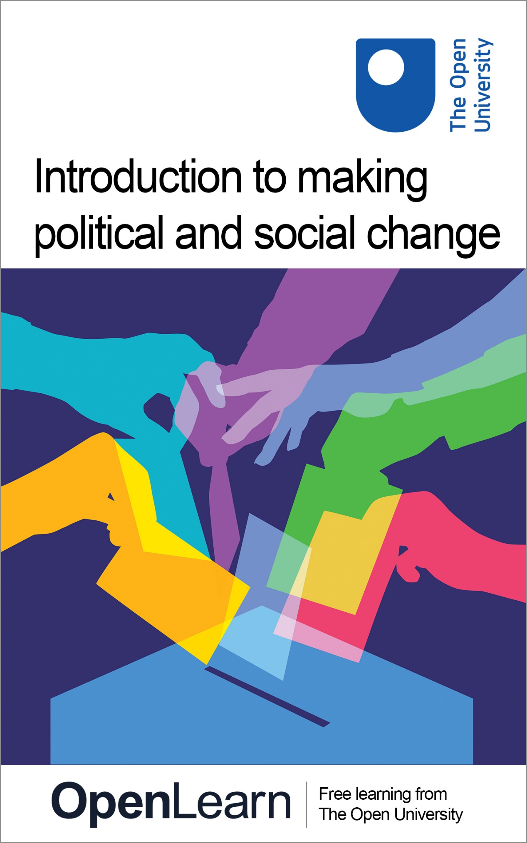

**d113\_1**

**Introduction to making political and social change**

**About this free course**

This free course is an adapted extract from the Open University course D113: [Global Challenges: Social Science in Action](https://www.open.ac.uk/courses/modules/d113?LKCAMPAIGN=ebook_&amp;MEDIA=ou)..

This version of the content may include video, images and interactive content that may not be optimised for your device.

You can experience this free course as it was originally designed on OpenLearn, the home of free learning from The Open University – [https://www.open.edu/openlearn/society-politics-law/introduction-making-political-and-social-change/content-section-0](https://www.open.edu/openlearn/society-politics-law/introduction-making-political-and-social-change/content-section-0?LKCAMPAIGN=ebook_&amp;MEDIA=ol)

There you’ll also be able to track your progress via your activity record, which you can use to demonstrate your learning.

Copyright © 2022 The Open University

**Intellectual property**

Unless otherwise stated, this resource is released under the terms of the Creative Commons Licence v4.0 <http://creativecommons.org/licenses/by-nc-sa/4.0/deed.en_GB>. Within that The Open University interprets this licence in the following way: [www.open.edu/openlearn/about-openlearn/frequently-asked-questions-on-openlearn](http://www.open.edu/openlearn/about-openlearn/frequently-asked-questions-on-openlearn). Copyright and rights falling outside the terms of the Creative Commons Licence are retained or controlled by The Open University. Please read the full text before using any of the content.

We believe the primary barrier to accessing high-quality educational experiences is cost, which is why we aim to publish as much free content as possible under an open licence. If it proves difficult to release content under our preferred Creative Commons licence (e.g. because we can’t afford or gain the clearances or find suitable alternatives), we will still release the materials for free under a personal end-user licence.

This is because the learning experience will always be the same high quality offering and that should always be seen as positive – even if at times the licensing is different to Creative Commons.

When using the content you must attribute us (The Open University) (the OU) and any identified author in accordance with the terms of the Creative Commons Licence.

The Acknowledgements section is used to list, amongst other things, third party (Proprietary), licensed content which is not subject to Creative Commons licensing. Proprietary content must be used (retained) intact and in context to the content at all times.

The Acknowledgements section is also used to bring to your attention any other Special Restrictions which may apply to the content. For example there may be times when the Creative Commons Non-Commercial Sharealike licence does not apply to any of the content even if owned by us (The Open University). In these instances, unless stated otherwise, the content may be used for personal and non-commercial use.

We have also identified as Proprietary other material included in the content which is not subject to Creative Commons Licence. These are OU logos, trading names and may extend to certain photographic and video images and sound recordings and any other material as may be brought to your attention.

Unauthorised use of any of the content may constitute a breach of the terms and conditions and/or intellectual property laws.

We reserve the right to alter, amend or bring to an end any terms and conditions provided here without notice.

All rights falling outside the terms of the Creative Commons licence are retained or controlled by The Open University.

Head of Intellectual Property, The Open University

# Contents

* [Introduction](#Introduction1)
* [Learning outcomes](#LearningOutcomes1)
* [1 Becoming a changemaker](#Session1)
  + [1.1 What is active citizenship?](#Session1_Section1)
  + [1.2 How to get started with making change](#Session1_Section2)
* [2 Making change via the UK Parliament](#Session2)
  + [2.1 Raise your issue in the UK Parliament](#Session2_Section1)
  + [2.2 Getting your MP on board](#Session2_Section2)
  + [2.3 Create a petition](#Session2_Section3)
* [3 Making change via the devolved administrations](#Session3)
  + [3.1 The Scottish parliament](#Session3_Section1)
  + [3.2 The Senedd (Welsh Parliament)](#Session3_Section2)
  + [3.3 The Northern Ireland Assembly](#Session3_Section3)
* [4 Making change globally](#Session4)
* [5 Making change outside of parliamentary politics](#Session5)
* [6 What makes a changemaker?](#Session6)
  + [6.1 Inspirations](#Session6_Section1)
* [7 Check your learning](#Session7)
* [Conclusion](#Session8)
  + [Further sources of information](#Session8_Section1)
  + [Recommendations for further study](#Session8_Section2)
* [References](#References1)
* [Acknowledgements](#Acknowledgements1)
* [Solutions](#Solutions1)

## Introduction

Written in a moment of multiple challenges – environmental, economic, political, social and health-related – ‘Introduction to making political and social change’ gives you a grounding in some of the key citizenship skills and political knowledge you need to intervene in the world as it changes around you. This free course explores how you can make change politically and socially as an active citizen, giving essential background information to get started, examples of inspiring changemakers, advice on how to have an impact both within and outside of traditional UK parliamentary politics, and the qualities needed to succeed. The course is primarily aimed at UK citizens, although much of the content will apply to people living outside of the UK.

Start of Figure

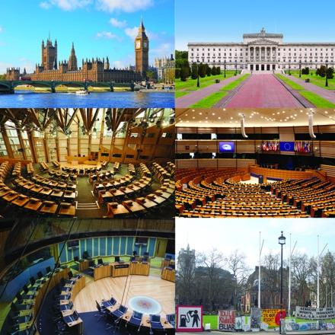

Figure 1: The UK Parliament (top left), Northern Ireland Assembly (top right), Scottish Parliament (middle left), European Parliament (middle right), Welsh Parliament (bottom left) and an example of political protest outside the UK Parliament (bottom right).

[View description - Figure 1: The UK Parliament (top left), Northern Ireland Assembly (top right), Scottish ...](" \l "Description1)

End of Figure

This OpenLearn course is adapted from [The Open University’s Changemakers guide](https://fass.open.ac.uk/sites/fass.open.ac.uk/files/files/politics/Changemakers%20Guide.pdf), but has been expanded to include content on the devolved nations and global change.

This OpenLearn course links to the Open University course D113: [Global Challenges: Social Science in Action](https://www.open.ac.uk/courses/modules/d113), now open for registration.

## Learning outcomes

After studying this course, you should be able to:

* Recognise some of the current UK and/or global challenges that interest you.
* Understand what is meant by ‘active citizenship’.
* Understand how to make political and social change as an active citizen: how to be a ‘changemaker’.
* Understand the workings of the UK political institutions and the role they have in making change, as well as other ways of making change.
* Identify and be able to apply in real-life settings some of the key skills and knowledge needed to make change.

## 1 Becoming a changemaker

We live at a time of multiple challenges – environmental, economic, political, social and health-related, amongst others. A time of UK and global challenges. Two big challenges the world is currently responding to are climate crisis and the legacies of colonialism.

How can ordinary people make a difference, politically and socially, to these challenges and others? How can they utilise the UK Parliament and the devolved parliaments/assemblies to make change? How can they be a ‘changemaker’?

This course will help you to make a difference through learning about political and social engagement, offering guidance and inspiration to all changemakers, no matter how small.

## 1.1 What is active citizenship?

A good place to start in making change is understanding what citizenship actually means.

**Political citizenship** can be thought of in a narrow and broad sense. Narrowly, it refers to someone’s ability to engage in electoral politics (so, voting in elections and the things that go with that, like supporting a political party and standing for political office), which is closely tied to a person’s citizenship status (the legal right to live in a state, e.g., someone is a citizen of the UK or of Australia or of India etc.).

Start of Figure



Figure 2: Voting in elections is an example of political citizenship.

[View description - Figure 2: Voting in elections is an example of political citizenship.](" \l "Session1_Description1)

End of Figure

More broadly, it refers to the ability a person has to engage politically in other ways. This could be closely tied to the narrow sense of political citizenship, for example, political protest, or signing a parliamentary petition. Or it could be less obvious. Indeed, there are things we do which can be considered political, even if we don’t see them as obviously political. For instance, it could be considered a political act to choose to read (or not to read) a certain newspaper, as that newspaper may have a political stance. Or to sign up to use, or delete, a social media account, as the company behind it may be run in a way that you agree or disagree with. In this sense you ‘do politics’, and are political citizens, in a multitude of ways every day, sometimes knowingly, sometimes unknowingly.

Recently, there has been a move towards an ‘active’ understanding of citizenship, focusing on the ‘acts’ and ability of individual people to influence the society they are part of. **Active citizenship** is the idea that someone can be an active political citizen; they can actively try and make change (or indeed prevent it). They can be a ‘changemaker’. To do so, they need to be motivated to participate as well as kept informed about politics, democracy and the workings of society. There is also an element of personal responsibility, i.e. they need to make the effort to engage.

Active citizenship is not a static term: it can be understood on a spectrum (Wood et al, 2018). It can be understood in a minimal sense (activities which relate to ‘personal responsibility’, such as obeying the law and paying taxes), all the way to a maximal sense, focusing on combatting injustice in society, defined by Westheimer and Kahne (2004) as ‘justice orientated’ citizenship. It is clear there are different ‘levels’ of active citizenship and, linked to this, questions about just how active an individual should be. Whatever approach a person takes, active citizenship is important for democracy, as is developing an understanding of what active citizenship means and involves; this is particularly the case in countries where democracy is at risk, but it applies everywhere.

This course is positioned more towards the ‘maximal’ end of the active citizenship spectrum, although it will be of use to anyone with an interest in political and social change. Indeed, research has shown that citizens need both deep knowledge about the social issue they are interested in, as well as the ability to think critically about it, i.e. how can their action lead to change? What are the different perspectives about the issue? Is the issue a contested one? (Wood et al, 2018; Westheimer and Kahne, 2002). They also need a range of practical skills and understandings to make real-life change within a democracy, including how to communicate effectively (Wood et al, 2018).

An Introduction to Political and Social Change is a great place for potential changemakers to start.

## 1.2 How to get started with making change

Change can be focused on:

* The political; for example, campaigning for a change of government or to change a policy.
* The social; changing how something works in society, such as the rights a group has.

Start of Figure



Figure 3: An example of political protest.

[View description - Figure 3: An example of political protest.](" \l "Session1_Description2)

End of Figure

Of course, these things overlap – campaigning for a social change may lead to political change. Change can be big or small. It could be a small individual action which leads to a much bigger change. There are lots of different ways you can make change, whether that’s by engaging with the UK Parliament to get your voice heard or by using other channels.

Read below for guidance on how to get started:

Start of Box

* **Do your research**: it’s important to gather all the facts, the names of key people and organisations, and information about the best approach to making change; read the news and keep on top of the issue and different opinions surrounding it – try and understand the ‘other side’ of the argument as this will help you make your argument
* **Work out your aims**: what are you trying to achieve? It is useful to have a limited number of clear objectives; focusing on informed solutions can be useful
* **Reach out to others**: you may be able to join in with a pre-existing campaign or make your own campaign stronger by working with others
* **Identify your target**: who is the best person or group to approach to make change? Who is the decision maker? Who is responsible? This could be an individual, multiple people, an organisation, council or parliament, or the general public – it depends on what your aims are
* **Think about timing**: too early and you may not have an impact, too late and you may not be able to influence. Recognise the topicality of an issue, and when decision makers might be receptive to certain arguments
* **Think about mode**: should your focus be social media, a formal report, or speaking at public meetings? What are your skills? You will probably need to campaign in more than one mode
* **Think about accessibility**: make sure as many people as possible are able to engage with your content (for instance, providing subtitles on videos, or the transcript of a speech)
* **Contact your representatives**: if you hope to change the law, you may need to contact or lobby your elected representative; this could be a councillor or a member of a parliament or assembly (such as the UK Parliament)
* **Publicise your campaign**: think about the best way to promote your cause. You could utilise social media, write letters to newspapers, and speak at meetings and events for instance
* **Finally**: start small: small actions can lead to big change!

End of Box

In relation to mode, and the skills and confidence needed to communicate change via public speaking, you may find it useful to read [‘Dare to speak up’, a guide to communicating change via persuasive speech](https://www.psa.ac.uk/sites/default/files/DARE%20TO%20SPEAK%20UP%20BOOKLET.pdf).

Start of Activity

**Activity 1: getting started with making change**

15 minutes

Start of Question

Think about whether there are any national or international issues that you are passionate about and how you could get involved. Think about whether there are already people or groups campaigning about this issue, and what level of involvement you can commit to (this could be as simple as signing a petition, or writing about it on social media, or it could involve a bigger time commitment).

End of Question

End of Activity

One of the ways you may want to make change if you are based in the UK is through the UK Parliament. Read on to see how you can do this.

## 2 Making change via the UK Parliament

Start of Figure



Figure 4: The UK Parliament logo.

[View description - Figure 4: The UK Parliament logo.](" \l "Session2_Description1)

End of Figure

Engaging in the democratic process is one of the most important ways you can make change: so, you need to vote! If you don’t vote you don’t get a say in who is elected and who makes the decisions that affect you. If you live in the UK, make sure your voice is heard in a UK general election by registering to vote at [www.gov.uk/register-to-vote](http://www.gov.uk/register-to-vote).

Registering using this link also gives you the right to vote in local, mayoral and police and crime commissioner elections, and Northern Ireland Assembly, Scottish Parliament, and Welsh Parliament elections if you live in one of those areas, as well as in referendums.

Start of Figure

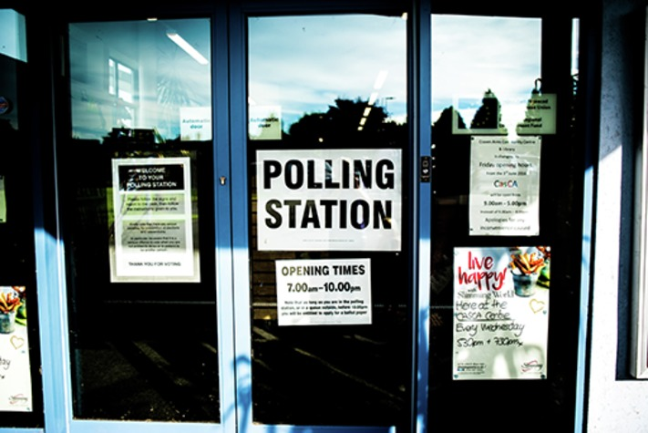

Figure 5: A typical UK polling station.

[View description - Figure 5: A typical UK polling station.](" \l "Session2_Description2)

End of Figure

The age at which you are eligible to vote depends on the type of election and where you live in the UK. You need to be 18 to vote in the UK Parliament General Election. You can vote in person, by post, or have a proxy (asking someone to vote for you).

## 2.1 Raise your issue in the UK Parliament

Whether the issue you’re passionate about is local, national, or international there are lots of ways to raise the profile of your campaign in the UK Parliament. Who should you be speaking to and what could you ask them to do?

Start of Figure

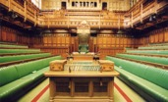

Figure 6: The UK Parliament House of Commons debating chamber.

[View description - Figure 6: The UK Parliament House of Commons debating chamber.](" \l "Session2_Description3)

End of Figure

**Did you know… you can speak to your Member of Parliament**

Most MPs hold regular sessions called surgeries where they meet constituents to talk about issues of concern – this can be face to face or online. Your MP’s website will have information about constituency surgeries. It will help your MP to help you if you bring along any documents or information about the issue or campaign you want to discuss. Find your MP’s contact details at: [www.parliament.uk/findyourmp](http://www.parliament.uk/findyourmp)

**Did you know… MPs can hold debates**

MPs can request time for debates on local, national, and international issues. They put their case to the Backbench Business Committee which allocates time on issues that have broad cross-party support among MPs, with many debates coming about through campaigns.

**Did you know... Members of the House of Lords can support your campaign**

Alongside your local MP, members of the Lords may also support your campaign. Members of the Lords are often appointed due to their knowledge and experience in areas such as business, health, education, the arts and sports. They play a key role in challenging the government and can help to champion your cause as they often have more freedom from party politics than MPs. Lords don’t represent a particular constituency but speak out on issues that interest them/they are expert in. You can search for members of the Lords online whose policy interests and expertise align with your campaign on [www.parliament.uk/lords](http://www.parliament.uk/lords)

**Did you know… Members of both Houses can put questions to the government**

You can ask members of both Houses to support your campaign by asking them to submit written questions to government departments and ask questions in the Chambers. Questions can be used to appeal for further information and press for action, so consider what sort of question would help your campaign most. For example, MPs or Lords can ask the government what it is doing about an issue or how many people have been affected by a problem or have been helped by a specific policy. They can also use questions as a direct way of urging the government to take action.

**Did you know… there are All-Party Parliamentary Groups**

All-Party Parliamentary Groups (APPGs) are informal, cross-party groups formed by MPs and members of the Lords who share a common interest in a particular policy area, region, or country. While they are not official Parliamentary committees, these groups can sometimes be influential because of their non-party political approach to an issue. If the focus of an APPG aligns with your campaign, you could approach members to ask if they’ll add their support. You can read more about APPGs including a list of the different groups on [www.parliament.uk/about/mps-and-lords/members/apg/](http://www.parliament.uk/about/mps-and-lords/members/apg/)

**Did you know… there are select committees**

Anyone can submit written evidence online to a select committee. Submitting evidence to one may not be the first thing that springs to mind when you want to raise the profile of an issue – but following committees online and submitting evidence can have a big impact and lead to positive changes.

At the beginning of an inquiry, select committees call for written evidence. Committees will also invite interested parties to give oral evidence to the committee where they may explore the focus of written evidence in more depth. Your experience or the focus of your campaign may provide valuable insights to a select committee inquiry. You can follow select committees online and find out when inquiries are taking place so you can submit evidence online: [www.parliament.uk/about/how/committees/select/](http://www.parliament.uk/about/how/committees/select/)

## 2.2 Getting your MP on board

Persuading your local MP to support your campaign can be a step towards getting the issues that matter to you raised in the UK Parliament.

Writing (by letter or email) is probably the best method for contacting your MP (or any other elected representative such as a devolved representative, or a member of the Lords) and it provides a written record that can be referred to at a later date.

When writing, keep in mind these tips:

Start of Box

**DO:**

Before writing:

* Finalise a clear description of what your campaign is trying to achieve.
* Gather evidence supporting your campaign.
* Consider how your issue fits with their policy interests.
* Have a clear idea of why you want them to be involved.
* Think about what action you would like them to take.

When writing:

* Explain who you are and clearly set out the issue you want to raise with them.
* Ask them to do something specific, e.g. ask a question during a debate or session, or attend a meeting with your campaign group to discuss the issue further.
* Remember to include your contact details.

After writing:

* Give them time to respond. They are busy juggling their time between their constituency work and their job as an elected representative, so it may take a little while for them to reply. But it’s ok to follow up if you don’t hear back.

**DON’T…**Rant! You may not agree with them on some issues, but they are your representative, so building a positive relationship is more likely to move your issue up the agenda.

End of Box

## 2.3 Create a petition

Raising awareness of an issue through petitions can connect people from across the UK on an issue that matters to them. It can demonstrate to MPs how an issue is affecting their constituents and how strongly people feel collectively.

The UK Parliament has an official petitions process. You can create your petition online at [petition.parliament.uk](https://petition.parliament.uk/). It must be about something the UK Parliament or government is responsible for. Only British citizens and UK residents can create or sign a petition.

If your petition achieves 10,000 signatures you will get a response from the government. A government response is a really important step for any campaign. It can help clarify the government’s position and provides the petitioner with further, more detailed information from which they may choose to take further action.

If your petition achieves 100,000 signatures then it will (almost always) be scheduled for a debate. MPs might consider a petition for a debate before it reaches 100,000 signatures. Sometimes people who create petitions are invited to take part in a discussion with MPs or government ministers, or to give evidence to a select committee. The Petitions Committee may also write to other people or organisations to ask them about the issue raised by your petition.

While you may set out with the ambition to change the law, there are many other significant outcomes that a UK Parliament petition can achieve. Gaining debating time in the UK Parliament’s agenda is a huge step as ministers must explain government policy and face challenging questions from MPs of all parties. And never underestimate the value of raising public awareness of an issue. It can connect people across the UK with similar experiences and be the start of a wider campaign to effect change.

Sites such as [Change.org](https://www.change.org/) and [38Degrees.org.uk](https://home.38degrees.org.uk/) can also be used to set up online petitions, or you can submit a petition (almost like a formal complaint) to an organisation directly. In choosing which petition site to use, you need to think about what you are trying to achieve. The UK Parliament petition site is useful if you want a government response and the subject matter discussed in UK Parliament. Other petition sites can help raise awareness, gather support, and gather media attention.

A good petition is clear and easy to understand, it has a realistic and specific aim (it’s often a good idea to start with a smaller change which can be built on), it outlines the issue and provides links to further information, it is directed to the right people, and launched at the right time.

Start of Activity

**Activity 2: find your UK Parliament representative**

15 minutes

Start of Question

If you live in the UK take some time to find who your local Member of Parliament is. You can also look up members of the Lords to see which ones are interested in the same issues that you are.

* [www.parliament.uk/findyourmp](http://www.parliament.uk/findyourmp)
* [www.parliament.uk/lords](http://www.parliament.uk/lords)

End of Question

End of Activity

If you live in Scotland, Wales or Northern Ireland you can also find your devolved representative. Read Section 3 to find out more.

If you live outside of the UK, you can also look up your own elected representative(s).

## 3 Making change via the devolved administrations

In the UK, as a result of devolution, there are separate legislatures in Scotland, Wales and Northern Ireland: the Scottish Parliament, the Welsh Parliament (or Senedd), and the Northern Ireland Assembly. These bodies have the power to make laws and deliver public services in certain policy areas devolved to them by the UK Parliament. The Scottish and Welsh legislatures were established in the late 1990s, after the public voted yes to devolution. The establishment of the Northern Ireland Assembly was a key part of the Good Friday Agreement and was then supported in a referendum in 1998.

## 3.1 The Scottish parliament

Start of Figure

D:\AaaF\OUT\httpswwwopeneduopenlearn_cmid135931_2023-02-27_09-53-01_10642f53111a44beb5abc6fecdafd50b\word\assets\d113_1_scot_parliament_logo426531.tif.jpg

Figure 7: Scottish Parliament logo.

[View description - Figure 7: Scottish Parliament logo.](" \l "Session3_Description1)

End of Figure

You can seek to make change through the Scottish Parliament in the following ways.

**Work with your elected representative**

Members of the Scottish Parliament (MSPs) represent constituents in the Scottish Parliament, as well as examining the work of the Scottish Government and holding it to account. MSPs can help constituents with issues devolved to the Scottish Parliament ([more information here](https://www.parliament.scot/msps/about-msps/what-issues-an-msp-can-help-you-with#topOfNav)) – other issues are dealt with by the UK Parliament or local councils. Unlike the UK Parliament, Scottish residents are represented by more than one MSP:

* One constituency MSP, who represents a local area.
* Seven regional MSPs, who represent a larger area which includes a person’s constituency.

[Look up your MSP by postcode here](https://www.parliament.scot/msps). MSP offices can be contacted by letter, email and phone, with Members holding regular surgeries. Check out the [dos and don’ts from Section 2.2](#d113_sec_2_2) for advice about contacting your elected representatives.

There are lots of ways MSPs can help a constituent with making change. In the debating chamber, MSPs can put forward a motion about a problem a constituent has brought to their attention and ask the Scottish Parliament to address it. MSPs can also raise local and national issues and question government policy during First Minister Question Time and other Question Times (topical, general and portfolio), as well as by sending in written questions. These are excellent opportunities for MSPs to raise awareness of issues that constituents have contacted them about.

MSPs can also propose up to two Member’s Bills during each four year parliamentary session; these can relate to issues that a constituent has raised. [You can see the proposals that have already been submitted here](https://www.parliament.scot/bills-and-laws/proposals-for-bills).

Start of Figure

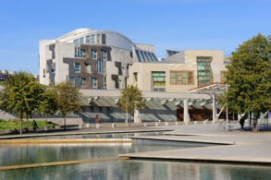

Figure 8: The Scottish Parliament debating chamber.

[View description - Figure 8: The Scottish Parliament debating chamber.](" \l "Session3_Description2)

End of Figure

**Working with Cross-party Groups (CPGs)**

Cross-party groups are made up of MSPs and other people who are interested in a specific issue. They must be made up of MSPs from more than one political party. While they do not have any powers to formally introduce issues into the parliamentary system, the groups are a useful place for external stakeholders, including organisations and members of the public, to discuss issues of relevance with MSPs, share information, and raise awareness of issues, which can in turn impact the wider political agenda. [There is more information on CPGs here](https://www.parliament.scot/get-involved/cross-party-groups).

**Giving your views to Committees**

Committees want to know the views of Scottish residents in order to help Members with their inquiries. You can submit your views on current committee inquiries and consultations by searching for the latest issues under discussion on the [Scottish Parliament website](https://www.parliament.scot/chamber-and-committees/committees/committee-call-for-views).

If the discussion relates to a bill, you can usually submit either a detailed online response on the specifics of the bill or answer a short survey on the general principles of the bill. There are also other topics under discussion where feedback is sought more generally via an online submission form or discussion forum.

You may also be called to be a witness at a committee session, if the committee feels you have important information to explore in more detail.

You can find out more about how Scottish Parliament Committees work by watching Video 1.

Start of Media Content

Video content is not available in this format.

Video 1: There shall be a Scottish Parliament – Committees (Please note this video has no spoken audio.)

Start of Figure

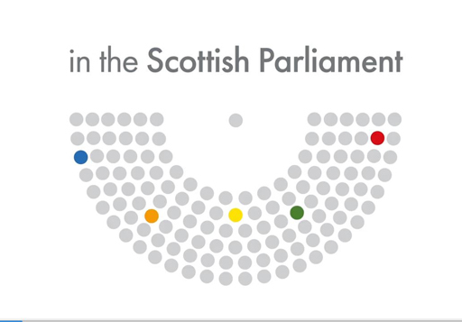

End of Figure

End of Media Content

**Submitting or signing a petition**

Any person or organisation can submit a petition – you don’t even need to live in Scotland, and it doesn’t matter how old you are. The Citizen Participation and Public Petitions Committee sets the rules about how petitions work.

One of the most important rules is the petition must be about a) something devolved to the Scottish Parliament, b) relevant to the whole of Scotland.

You should also have already contacted either an MSP or the Scottish government before starting the petition, and let the Committee know what happened as a result of that contact. If your petition meets the rules and is approved, it will then be added to the Petitions website for other people to sign.

Once your petition has been published it will be looked at by the Committee who will decide what action to take. This includes:

* Asking the Scottish government, organisations or individual people to respond.
* Asking the petitioner for more information or asking them to talk to the Committee about the petition.
* Recommending actions for the Scottish government.
* Asking for a debate in the Chamber.
* Referring it to another committee.
* Closing the petition down.

[You can find more information about Scottish Parliament petitions here](https://www.parliament.scot/get-involved/petitions).

You can also find out more about how Scottish Parliament petitions work by watching Video 2.

Start of Media Content

Video content is not available in this format.

Video 2: Petitioning the Scottish Parliament (Please note this video has no spoken audio.)

Start of Figure

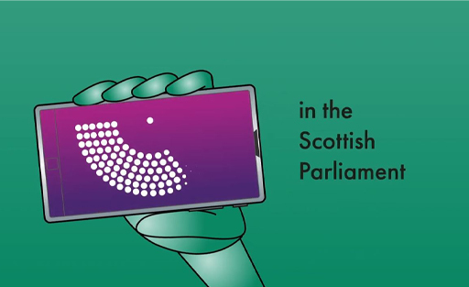

End of Figure

End of Media Content

**Taking part in peaceful protest or demonstration**

The Scottish Parliament has an official peaceful protest policy under the banner of being ‘open, accessible and participative’ with protests ‘a vital part of the expression of democracy in Scotland’. Anyone planning a protest at the Scottish Parliament should write to the Scottish Parliament’s police or security units to request permission to plan an official protest on Scottish Parliament land. To be approved, protests must address all the rules of the official policy, such as being non-party political. [More information about organising a protest on Scottish Parliament land can be found here](https://www.parliament.scot/get-involved/organising-a-protest).

Start of Figure

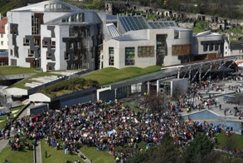

Figure 9: A student climate change strike outside the Scottish Parliament.

[View description - Figure 9: A student climate change strike outside the Scottish Parliament.](" \l "Session3_Description3)

End of Figure

**Holding an awareness raising event at Parliament**

MSP sponsored events normally take place on business days during lunchtimes and evenings. These events are an opportunity to raise awareness of an issue with MSPs in Parliament and they take place in different parts of the building, depending on how big an event it is.

MSPs can also sponsor exhibitions to inform Parliament’s work and raise awareness of issues, and photocalls (these are a chance to photograph MSPs in support of a cause).

Events must not be party-political but can reflect the interests and policy position of an MSP. Venues are available for free, although there is a cost to hire audio-visual equipment. [More information about organising an event is available here](https://www.parliament.scot/get-involved/events-and-exhibitions/organise-an-event-or-exhibition-for-msps).

## 3.2 The Senedd (Welsh Parliament)

Start of Figure

D:\AaaF\OUT\httpswwwopeneduopenlearn_cmid135931_2023-02-27_09-53-01_10642f53111a44beb5abc6fecdafd50b\word\assets\d113_1_welsh_parliament_logo426549.tif.jpg

Figure 10: Welsh Parliament logo.

[View description - Figure 10: Welsh Parliament logo.](" \l "Session3_Description4)

End of Figure

**Work with Members of the Senedd who represent you**

The Senedd (otherwise known as the Welsh Parliament, or Senedd Cymru in Welsh, and formerly the National Assembly for Wales or Welsh Assembly) is made up of 60 Members of the Senedd (MS or AS in Welsh).

Similarly to the Scottish Parliament, Welsh residents are represented by more than one MS: one representing the local area (the constituency), and four more representing the region of Wales the person lives in.

MSs work to hold the Welsh government to account, as well as to resolve issues raised by constituents which relate to matters devolved to the Welsh Parliament. [You can look up which areas the Senedd has power over here](https://senedd.wales/how-we-work/our-role/powers/), other areas are addressed by the UK Parliament or local councils.

[Look up your MS by postcode here](https://senedd.wales/find-a-member-of-the-senedd/). MS offices can be contacted by letter, email, phone, and social media, with Members holding regular surgeries. Check out the [dos and don’ts from Section 2.2](#d113_sec_2_2) for advice about contacting elected representatives.

MSs can raise issues that have been brought to their attention in a variety of ways. For example, they can ask a question to a Minister (including the First Minister) during full meetings of the Senedd. These meetings take place in the main debating chamber, the Siambr, on Tuesdays and Wednesdays. They can also ask written questions, make points during debate, raise issues in committee meetings, or write directly to decision makers.

Aside from assisting and supporting constituents, MSs also have an important role to play in scrutinising laws and taxes. MSs therefore work to represent Wales and the issues that matter to the people who live there, through their contributions.

**Signing or creating a petition**

Petitions to the Senedd can be used to bring attention to an issue of concern (if the Senedd has power over the issue in question). Petitions with enough signatures and which meet the required standards (including the person or organisation starting it has a Welsh address) are considered by the Petitions Committee:

* Petitions with over 250 signatures will be reviewed by the Petitions Committee, who will decide what they can do to take the petition forward, which includes asking the Welsh government to take action.
* Petitions with over 10,000 signatures will be considered by the Committee for a debate in the Senedd chamber. Factors that are taken into account include the topic, how urgent it is, and the number of signatures from Welsh residents.

[You can find more information about Senedd petitions here](https://senedd.wales/senedd-business/petitions/).

Start of Figure

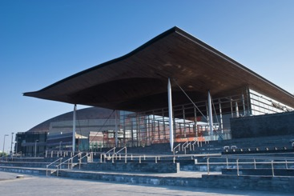

Figure 11: The Welsh Parliament.

[View description - Figure 11: The Welsh Parliament.](" \l "Session3_Description5)

End of Figure

**Working with Cross-party Groups (CPGs)**

Members of the Senedd can set up Cross-party Groups (CPGs) relating to issues covered by the Senedd. They must be made up of representatives from at least three different party political groups represented in the Senedd. While they don’t have a formal role in policy making, they are well placed to raise awareness about issues. CPGs are also a great way for interest groups and campaigning bodies to speak directly to MSs and to discuss policy issues in detail.

[You can see the current CPGs and contact details here](https://business.senedd.wales/mgListOutsideBodiesByCategory.aspx).

**Giving evidence to Committees**

Senedd Committees examine proposed legislation and scrutinise the expenditure and policies of the Welsh government. Committees are made up of Members from different political parties, appointed by the Senedd in Plenary, and focus on particular subjects. Welsh residents can contact committees to suggest issues they think should be looked at in detail.

Committees may collect evidence from the public and organisations and then write a report for the government. Calls for written evidence are published on a committee’s webpage. A committee may use this written evidence when deciding who to invite to an oral evidence session to discuss the issue further.

[You can find the current Senedd Committees here](https://senedd.wales/senedd-business/committees/).

These are excellent opportunities for MSs to hear about issues that Welsh residents are concerned about, and then to raise awareness of them within and outside of Senedd.

## 3.3 The Northern Ireland Assembly

Start of Figure

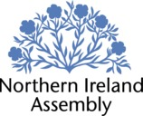

Figure 12: The Northern Ireland Assembly logo.

[View description - Figure 12: The Northern Ireland Assembly logo.](" \l "Session3_Description6)

End of Figure

**Work with your Northern Ireland Assembly representative**

The Northern Ireland Assembly elects Members of the Legislative Assembly (MLAs). MLAs pass laws and examine policy on issues which have been devolved to the Assembly ([see here for more information](http://www.niassembly.gov.uk/about-the-assembly/what-are-the-powers-of-the-northern-ireland-assembly/)) and listen to and act on behalf of their constituents. Like the Scottish and Welsh parliaments, Northern Ireland residents are represented by more than one MLA. There are five MLAs per each of the 18 constituencies across Northern Ireland and 90 MLAs overall.

[You can look up your MLAs by postcode here](http://www.niassembly.gov.uk/your-mlas/locate-your-mla2/). MLA offices can be contacted by letter, email and phone, with Members holding regular surgeries. Check out the [dos and don’ts in Section 2.2](#d113_sec_2_2) for advice about contacting elected representatives.

MLAs attend Plenary sessions in the Assembly Chamber (usually on a Monday or Tuesday). These meetings are excellent opportunities for MLAs to raise local issues during debates and question ministers on behalf of their constituents, including the First Minister and deputy First Minister. MLAs can also represent their constituents by sending in written questions (which normally receive more detailed responses from ministers than oral questions), table motions for debate (including adjournment debates, which usually relate to specific constituency issues), propose amendments to laws, and introduce private members bills. MLAs therefore have lots of different ways they can represent their constituents, and various opportunities to try and create change.

Assembly business is a matter of public record. You can research your MLAs’ positions on specific policy issues by searching the Assembly Hansard for debates they have participated in. You can also search for Bills they have supported and questions they have asked via the [Assembly website](http://aims.niassembly.gov.uk/officialreport/officialreport.aspx).

Start of Figure

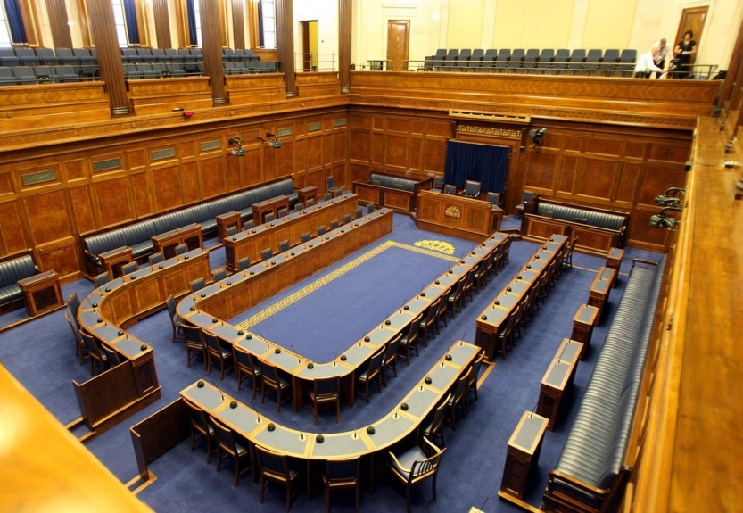

Figure 13: The Northern Ireland Assembly.

[View description - Figure 13: The Northern Ireland Assembly.](" \l "Session3_Description7)

End of Figure

**Submitting evidence to a Committee**

Committees are made up of MLAs and focus on a specific government department e.g. Finance, Health and Education. Committees are tasked with holding the Northern Ireland Executive to account, by examining and proposing amendments to legislation, as well as by raising issues by tabling motions for debate in the Chamber. Committees can also propose their own Bills.

They also hold inquiries, and as part of this individuals and organisations can submit written or oral evidence to inform their recommendations (which the Department or relevant minister must respond to). It’s possible to check online what issues committees are currently looking into and the deadline to respond. Committees can also ask someone to speak in person as a witness, if their expertise is deemed relevant to an inquiry.

Committees also call for evidence on Bills, so the public can influence legislation via committees too.

* [You can find the current Assembly committees here](http://www.niassembly.gov.uk/assembly-business/committees/about-committees/).
* [You can find out more about how NIA Committees work by watching this video](https://education.niassembly.gov.uk/video-gallery/committees_northern-ireland-assembly).

Start of Media Content

Video content is not available in this format.

Video 3: Committees of the Northern Ireland Assembly

[View transcript - Video 3: Committees of the Northern Ireland Assembly](" \l "Session3_Transcript1)

Start of Figure

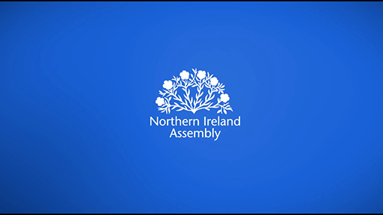

End of Figure

End of Media Content

**Working with All Party Groups (APGs)**

All Party Groups (APGs) are made up of MLAs from different parties with an interest in a particular issue. Formal membership is for MLAs only, but individuals and organisations can be invited to attend meetings and give briefings to inform and support the work of the group.

All three designations (Nationalist, Unionist, and Other) at the Assembly must be represented in the membership, which must be made up of at least ten MLAs.

[You can see the current APGs and contact details here](http://aims.niassembly.gov.uk/mlas/allpartygroups.aspx).

**Presenting a petition through an MLA**

MLAs can present a public petition, signed by members by the public and requesting government action on a particular issue, to the Assembly. Once approved by the Business Committee, the MLA presents the petition to the Speaker with some introductory words, and the Speaker then arranges for the petition to be sent to the relevant minster. At some point the minister will usually respond to other MLAs and/or the speaker outlining what action has been taken as a result of the public petition.

**Making change via North/South collaboration**

The North/South Ministerial Council, made up of ministers from the Northern Ireland Executive and Irish Government, co-operates on policy related to 12 areas of mutual interest. Six of these areas are agreed mutually but implemented separately in each jurisdiction. The other six are agreed together but implemented through shared implementation bodies covering both Northern Ireland and Republic of Ireland. Details on how to contact the Council, including areas of interest, are available on [this website](https://www.northsouthministerialcouncil.org/contact).

Start of Activity

**Activity 3: Who to contact?**

15 minutes

Start of Question

If you live in the UK you have multiple representatives: a UK Parliament MP, Members of Lords, and potentially devolved representative(s).

In Activity 1 we asked you to think about whether there are any national or international issues you are passionate about and how you could try and make change. Now, take it a step further and think about which representative is the best person to start with:

* Your MP?
* A Member of the Lords?
* A devolved representative?

You will need to research which issues are covered by which legislature (remember, the Scottish Parliament, Welsh Parliament and Northern Ireland Assembly have the power to make laws and deliver public services in certain policy areas devolved to them by the UK Parliament).

You may decide that someone different is better placed to help (this could be a local councillor, an international body, or a pressure group). The [Making change globally](#x_d113_sec4) and [Making change outside of parliamentary politics](#x_d113_sec5) sections will be of interest if so.

If you live outside of the UK, you can also think about which of your own elected representatives (or other organisation/person) is most appropriate for the issue you are interested in.

End of Question

End of Activity

## 4 Making change globally

There are so many international movements for change, campaigning individuals and organisations, and examples of relevant issues, that this section will take a slightly different tack and focus on one issue in particular: climate crisis.

Start of Figure



Figure 14: Wildfires in Los Angeles, made worse by lack of rain.

[View description - Figure 14: Wildfires in Los Angeles, made worse by lack of rain.](" \l "Session4_Description1)

End of Figure

**Thinking about climate crisis**

Climate crisis is an example of a social and political issue which crosses borders. It is a ‘global challenge’. Indeed, some people argue that we need to use the word ‘crisis’ to reflect the seriousness of the challenge, rather than climate ‘change’.

A global challenge is a very big problem that affects many people in a lot of different countries, the solution to which requires concerted action across national boundaries. This definition echoes the way in which the term ‘global challenge’ started to be used by policy makers in the first decades of the 21st century. A notable example can be found in the United Nations (UN) Sustainable Development Goals (SDGs). The UN describes those goals as seeking to address the ‘global challenges we face’ by offering a ‘blueprint to achieve a better and more sustainable future for all’ (United Nations n.d.). The challenges the SDGs highlight – things such as poverty and hunger – do not affect everyone everywhere but, in common with the definition of global challenge above, they do affect many people in a lot of different countries and their solution requires action across national boundaries.

What happens locally cannot be divorced from wider contexts, but there is not a simple, one-way relationship between the global and the local, with the global always dominating what happens locally. Instead, it is better to think of the local and the global as continually shaping each other. In particular, global forces are persistently resisted, refashioned and repurposed by people in their localities and these actions can ripple out and have global consequences.

Start of Figure

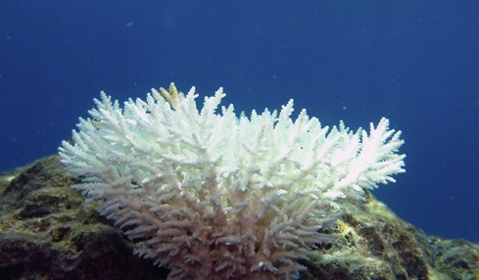

Figure 15: Bleaching of coral caused by ocean heating.

[View description - Figure 15: Bleaching of coral caused by ocean heating.](" \l "Session4_Description2)

End of Figure

Someone seeking to make political and social change needs to consider:

* Whether the issue is local and/or global and in what way.
* Which person/government/organisation is best placed to make change in that context.

Start of Activity

**Activity 4: Local/global relationships**

15 minutes

Start of Question

In Activity 1 you were asked to identify whether there are any national or international issues that you are passionate about. Take this even further by considering the local/global dimension. Is your issue an example in which what happens locally is shaped and influenced by something happening elsewhere in the world? Or is it an example in which a local outcome is shaped and influenced by a wider social, economic and political context or environment? You can write your answer in the text box provided.

End of Question

*Provide your answer...*

End of Activity

**Campaigning about climate crisis**

What can or should we do about climate crisis? Professor Mark Maslin writes in How to Save the Planet: The Facts, ‘We are not all equally liable for the mess we find ourselves in.’ He presents these figures to back up his point:

* The richest 10% of the world’s population emit 50% of carbon pollution into the atmosphere.
* The richest 50% of the world’s population emit 90% of carbon pollution into the atmosphere.
* The poorest 3.9 billion people have contributed just 10% of the carbon pollution in our atmosphere (Maslin, 2021).

Some people have felt it necessary to take action against climate crisis. One important figure is Greta Thunberg. In 2018 she began a solitary protest against climate change outside the Swedish Parliament. Her demands were simple: cut down CO2 emissions immediately in order to save the planet. Her protest inspired schoolchildren from across the world to act, like the ‘Fridays for Future’ movement.

For Greta Thunberg, acting against climate crisis was a matter of principle as much as doing everything to protect the future. She felt anger, shock and sadness at what was happening:

Start of Quote

‘We saw these horrifying pictures of plastic in the oceans and floodings and so on, and everyone was very moved by that. But then it just seemed like everyone went back to normal … And I couldn’t go back to normal because those pictures were stuck in my head. … When everyone else seems to just compromise … I want to walk the talk, and to practice as I preach.’

(in Chappell and Chang 2019)

End of Quote

That same year she also gave a speech to policymakers at the World Economic Forum in Davos that went viral:

Start of Quote

‘I don’t want you to be hopeful.

I want you to panic.

I want you to feel the fear I feel every day.

And then I want you to act.

I want you to act as you would in a crisis.

I want you to act as if our house is on fire.

Because it is.’

(Thunberg 2021: 15)

End of Quote

Greta Thunberg is far from the only climate striker out there. But she is one of the most well-known and recognisable. She has a powerful moral outlook that views the climate challenge in terms of simple right and wrong. She also shows that individuals can do something about global challenges like climate crisis. As she puts it, ‘no one is too small to make a difference’ (Thunberg 2021: 8).

Greta Thunberg has become a symbol of a much wider movement around the world, involving tens of thousands of young people going on strike and demonstrating in the streets against climate crisis. People are using the everyday technology that they have access to (such as phones) to communicate and organise those demonstrations, meet up with other people, and to take photos and videos of actions to spread the word on social media.

She is an example of how an individual can work with others to influence change on a global level. You can read more about how she created change in [Section 6.1 Inspirations.](#x_d113_sec6_1)

## 5 Making change outside of parliamentary politics

**Working with local councils**

In the UK, the issue you want to change may be best dealt with at a ‘local’ level, through working with your local elected representatives, known as councillors. Councillors represent their local community, develop and review council policy, and scrutinise decisions taken by the council. They can be a good place to start if it’s a ‘local’ issue, although you need to check who is responsible before you start. If you live outside the UK, you can work with your own local representatives.

**Working with the arts and music**

You can raise awareness through art (‘artivism’) and craft (‘craftivism’), using visual creations to promote a political or social cause. Similarly, social injustices and political causes can be highlighted through musical performance and lyrics. This can be a good way to raise the profile of a cause, although may need to be accompanied by more ‘formal’ campaigning and media activism.

Start of Figure



Figure 16: One way of making change is through music.

[View description - Figure 16: One way of making change is through music.](" \l "Session5_Description1)

End of Figure

**Taking part in media activism**

You may find this a quick and cheap way to raise the profile of an issue and gather support, including for groups who are underrepresented in ‘mainstream’ ‘traditional’ media. It includes social media campaigning, creating websites and making videos. Petitions are often advertised via social media. However, you may still need to get your campaign covered by the traditional media (newspapers, television news) to get traction.

**Getting involved in broadcasting**

Contributing to television and radio programmes, and even writing/presenting them, is a more traditional form of media activism. You will need to build up some traction to undertake the latter, with presenting often out of reach until you reach a certain level of reputation, or you already work in this field. For this reason, you may find social media campaigning a better initial approach. Making your own videos and broadcasting them via a website like YouTube is an accessible alternative to traditional broadcasting.

**Writing/publishing**

If you want to reach a broad audience you should make your writing easy to understand, accessible to people who are visually and hearing impaired, easy to find, free (or low cost if professionally published), and potentially interactive (give people the opportunity to respond).

It’s useful to write in more than one mode, to reach as many people as possible (if you write a report, you should also craft some social media messages which summarise it). Think about who you want to reach and what your aims are, and chose the mode(s) that fit. The written word can be very powerful, whether it takes the form of journalism, books, poetry, reports, or writing for social media (blogging, for instance). The work could be professionally published or more informal, depending on the audience and your aim.

**Lobbying those with influence**

You can attempt to influence your elected representative through lobbying. It is the lawful attempt to influence political decision makers, such as MPs and government ministers. Lobbying can be done by individuals, advocacy/special interest groups, or professional lobbyists (experts hired to lobby on behalf of an individual or group). Most lobbying is done by organisations via advocacy. You can also lobby businesses and organisations – basically, people and organisations who have power or make decisions.

**Taking part in economic activism**

You can utilise your economic power to make change. This can be done in two ways:

1. boycotting companies and organisations whose values/way of working you don’t agree with, therefore pressuring them to change their behaviour, or
2. rewarding ‘good’ companies and organisations through patronage and positive social media.

**Taking part in peaceful protest**

You can attempt to achieve change via raising the profile of an issue through non-violent and legal demonstrations. Peaceful demonstrations are legal under UK law, with restrictions. Wherever you live, it is a good idea to check current legal guidance before taking part in or organising a demonstration to make sure you are aware of current rules.

The attention gained from peaceful demonstrations can evolve into more formalised methods of campaigning like making documentaries, speaking at conferences, writing for newspapers etc.

**Focusing on your local community**

Community talks, presentations, and local lectures can be great ways for you to raise awareness of an issue. It can also be a good way to gather support and set up a campaign group.

Start of Activity

**Activity 5: making change using social media**

15 minutes

Start of Question

As discussed above, one of the ways you can try and create change is through social media.

Twitter, a microblogging site where you can publish messages (‘tweets’) of 280 characters or less, is a popular way to highlight an issue you are passionate about. The messages can be ‘retweeted’ by other people, ‘liked’ and responded to.

We have linked some examples of campaigning tweets below. Once you have read them, think about how you could utilise Twitter to support your cause. Try drafting some tweets using these examples as templates.

1. [Greta Thunberg](https://twitter.com/GretaThunberg/status/1502245630822998017?ref_src=twsrc%5Egoogle%7Ctwcamp%5Eserp%7Ctwgr%5Etweet)

Start of Figure

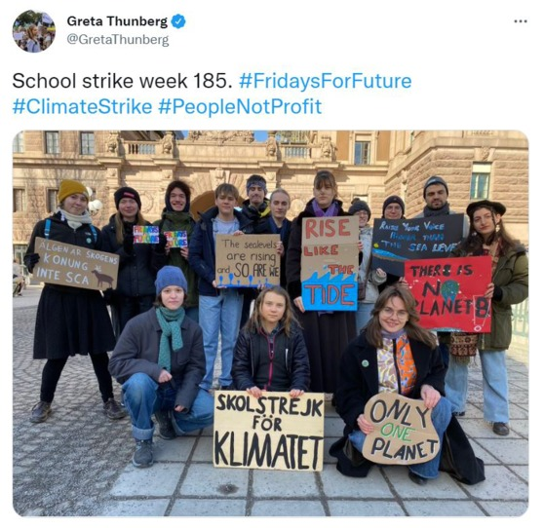

Figure 17: Greta Thunberg’s Tweet

[View description - Figure 17: Greta Thunberg’s Tweet](" \l "Session5_Description2)

End of Figure

1. [Marcus Rashford](https://twitter.com/MarcusRashford/status/1318676138332311553?s=20&t=FGUijFi0HSzg_1XHiYI0LA)

Start of Figure

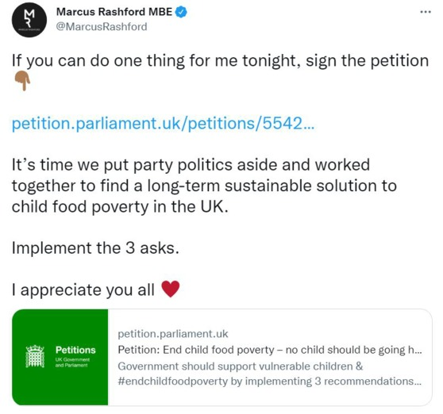

Figure 18: Marcus Rashford’s Tweet

[View description - Figure 18: Marcus Rashford’s Tweet](" \l "Session5_Description3)

End of Figure

End of Question

*Provide your answer...*

End of Activity

## 6 What makes a changemaker?

Making change can be tough. You may have immediate success or you may have to campaign and lobby for a long time. You may make some progress but then face a setback.

With this in mind, what qualities does a changemaker need?

Start of Box

* **Emotional awareness and empathy:** make an effort to understand how others feel – this will help when communicating with people in your own team and outside it. Placing yourself in the position of others can also help to strengthen your argument. Also, be aware of how you feel and how this impacts on your own performance.
* **Optimism:** stay positive, but…
* **Realism:** …be realistic. Understand what is achievable and set reachable goals.
* **Listening skills:** listen to other members of your team and other campaigning groups – including people who disagree with you. Listening to people with different views may help you to strengthen your argument, or to come up with solutions acceptable to both sides.
* **Communication skills:** you may need to communicate ‘formally’ (writing to a politician or submitting evidence to a committee) as well as ‘informally’ (campaigning on social media). You need to consider different ‘modes’ of communication (written, visual) and how to communicate with different groups of people (politicians, the public etc).
* **Assertiveness:** stand up for what you believe in, but in a calm and positive manner.
* **Strategic mind:** identify your long term goals and how you plan to achieve them.
* **Focus:** have a clear outcome in mind and try not to get distracted by side-issues.
* **Resilience:** if you face a setback, re-focus and re-strategise.
* **Self-motivation:** the ability to drive yourself to take action, even in the face of setbacks. Keep your end goal in mind.
* **Organisation**: be clear in what you want to achieve, with good planning and record keeping.
* **Flexibility:** have an openness to change and an ability to react to changed circumstances.
* **Ability to work with others:** it is possible to achieve change working on your own, although it’s often easier in a team. This will involve working with people who may have different views to you (even if they share your end goal and/or are part of your team).
* **Creativity:** be imaginative when campaigning. Think of the different ways you can engage with the public and how you can publicise your campaign as widely as possible using different methods.

End of Box

## 6.1 Inspirations

Which examples inspire you? Who can you learn from? While some (but not all) of the changemakers chosen have undoubtedly been able to harness their fame or position in making change, something not open to most of us, they all demonstrate how small actions can lead to big change, inspire others to act, raise the profile of important issues, and make change politically.

Start of Table

|  |  |
| --- | --- |
|  | |
| **Making change through peaceful protest** | |
| Start of Figure  D:\AaaF\OUT\httpswwwopeneduopenlearn_cmid135931_2023-02-27_09-53-01_10642f53111a44beb5abc6fecdafd50b\word\assets\d113_1_sec6_1_inspirations_greta.tif.jpg  Figure 19: Greta Thunberg  [View description - Figure 19: Greta Thunberg](" \l "Session6_Description1)  End of Figure | **Who:** Greta Thunberg, a Swedish environmental activist.  **Category:** Peaceful protest, media activism and petitioning.  **Action:** At the age of 15 she demonstrated outside the Swedish Parliament, calling for more action on climate change, holding up a sign which said: ‘school strike for climate’. Other students joined in across the world, creating a youth climate strike movement.  **Impact:** Her initial small step of individual peaceful protest inspired a youth movement across the world, got politicians to engage with climate change issues, and improved public awareness. Her impact has been called the ‘Greta effect’.  **Challenges:** Intense media/social media coverage and criticism from politicians and others. |
| **Making change through sport** | |
| Start of Figure  D:\AaaF\OUT\httpswwwopeneduopenlearn_cmid135931_2023-02-27_09-53-01_10642f53111a44beb5abc6fecdafd50b\word\assets\d113_1_sec6_1_inspirations_marcus.tif.jpg  Figure 20: Marcus Rashford  [View description - Figure 20: Marcus Rashford](" \l "Session6_Description2)  End of Figure | **Who:** Marcus Rashford, a British footballer and free school meals campaigner.  **Category:** Media activism, lobbying and economic activism.  **Action:** With food waste charity FareShare he raised over £20 million to provide free food for children who could no longer receive their free school meal due to the Covid-19 pandemic. He then lobbied the UK government about child poverty and free school meals. He has continued to campaign about this issue.  **Impact:** His highest profile impact was influencing the government to change its policy and extend free school meals for children. By doing this he also raised the profile of the issue in the media and with the general public, leading to a national conversation about food poverty.  **Challenges:** Bringing politicians on board with his ideas. His earlier campaigning (supplying food boxes for young homeless people in Manchester) also had a limited reach, demonstrating the challenge of making a campaign successful on a large scale. |
| **Making change through engaging with UK Parliament** | |
| Start of Figure  D:\AaaF\OUT\httpswwwopeneduopenlearn_cmid135931_2023-02-27_09-53-01_10642f53111a44beb5abc6fecdafd50b\word\assets\d113_1_sec6_1_inspirations_ian_mckellen.tif.jpg  Figure 21: Ian McKellen  [View description - Figure 21: Ian McKellen](" \l "Session6_Description3)  End of Figure | **Who:** Ian McKellen, actor and LGBT campaigner.  **Category:** Media activism and lobbying.  **Action:** One of the founders of the UK gay rights (now LBGT rights) charity Stonewall in the 1980s, he worked with the charity to lobby the UK Parliament to reform equality law (issues like the repeal of Section 28 and the introduction of an equal age of consent). The charity set out to professionally lobby and engage in the political process in order to initiate change, influence and work with politicians.  **Impact:** A slow and steady change in the law and public attitudes. As one of the most high-profile publicly gay actors, he has also inspired generations after him to be out and proud.  **Challenges:** The length of time it took to effect key political changes, and early hostile media attitudes. |
| **Making change through working with young people as stakeholders in Northern Ireland** | |
| **Who:** Pure Mental NI ([puremental.org](https://www.puremental.org/))  **Category:** Lobbying, media activism and social media.  **Action:** A youth led charity set up to put pressure on the Northern Ireland Executive about mental health issues (education and early intervention) in primary and secondary schools in Northern Ireland. They have designed mental health toolkits for teachers to use with students, they lobby politicians to try and improve mental health provision in schools, and they undertake research.  **Impact:** They have already had some key wins on improving mental health services in schools.  **Challenges:** Juggling working for change alongside other responsibilities, funding. | |
| **Making change through Scottish Parliament legislation** | |
| Start of Figure  D:\AaaF\OUT\httpswwwopeneduopenlearn_cmid135931_2023-02-27_09-53-01_10642f53111a44beb5abc6fecdafd50b\word\assets\d113_1_6_1_monica_lennon421462.tif.jpg  Figure 22: Monica Lennon  [View description - Figure 22: Monica Lennon](" \l "Session6_Description4)  End of Figure | **Who:** Monica Lennon MSP  **Category:** Scottish Parliament  **Action:** She campaigned to end period poverty (when women on low incomes cannot afford period products) from 2016 until 2020. She campaigned in the media and in the Scottish Parliament.  **Impact:** The ‘Period Products (Free Provision) (Scotland) Act’ became law in 2020, ensuring local authorities now have a legal duty to ensure that items like tampons and sanitary pads are free to those that need them. Women should now have better access to these items, across Scotland.  **Challenges:** Getting cross-party support to ensure the success of the proposal. Tackling the stigma around the issue of periods. |
| **Making change through young people making their voices heard in Wales** | |
| Start of Figure  D:\AaaF\OUT\httpswwwopeneduopenlearn_cmid135931_2023-02-27_09-53-01_10642f53111a44beb5abc6fecdafd50b\word\assets\d113_1_6_1angel_ezeadum421463.tif.jpg  Figure 23: Angel Ezeadum  [View description - Figure 23: Angel Ezeadum](" \l "Session6_Description5)  End of Figure | **Who:** Angel Ezeadum, former Member of the Welsh Youth Parliament  **Category:** Campaigning and petitioning.  **Action:** Angel was the Member of the UK Youth Parliament for Cardiff and was elected as the first Member of the Welsh Youth Parliament representing Race Council Cymru. She used her platform to make impactful contributions to the Welsh Youth Parliament’s proceedings and to call for Black and People of Colour’s histories to be made a mandatory part of Wales’s new school curriculum. Alongside campaigners who led a petition to the Education Minister, which received almost 35,000 signatures and was debated in the Senedd, she helped persuade the Welsh government to more explicitly require that diverse communities, in particular the stories of Black, Asian and Minority Ethnic people, are a mandatory part of the curriculum.  **Impact:** Diligent and politically astute campaigning by many people and organisations, with young people and people with lived experience having agency and the opportunity to make their voices heard, succeeded in contributing to a significant policy change from the Welsh Government.  **Challenges:** The Welsh government had been firm in its position until that point, and the Coronavirus pandemic was taking up most of the political and media agendas. |

End of Table

Start of Activity

**Activity 6: Finding inspiration**

15 minutes

Start of Question

Select one of the above changemakers or another example (they do not need to be in the public eye) and explore in more detail what actions they took to try and make change (for example, how they campaigned online, who they lobbied, how they tried to influence policy). Write down the four most important things you think they did:

End of Question

*1. 2. 3. 4.*

End of Activity

## 7 Check your learning

Have a go at the following quiz to check what you have learned.

Start of Activity

**Activity 7: Check your learning**

15 minutes

**Question 1**

Start of Question

Active citizenship involves being motivated to participate as well as keep informed about politics, democracy and the workings of society. There is also an element of personal responsibility, i.e. people need to make the effort to engage.

End of Question

true

false

[View answer - Question 1](" \l "Session7_Interaction1)

**Question 2**

Start of Question

Change can be focused on the political and the social.

End of Question

true

false

[View answer - Question 2](" \l "Session7_Answer1)

**Question 3**

Start of Question

You can vote in UK Parliamentary elections from the age of 16.

End of Question

true

false

[View answer - Question 3](" \l "Session7_Answer2)

**Question 4**

Start of Question

Only Members of Parliament (MPs) can put questions to the UK Government.

End of Question

true

false

[View answer - Question 4](" \l "Session7_Answer3)

**Question 5**

Start of Question

Only some UK Parliament petitions are discussed in Parliament.

End of Question

true

false

[View answer - Question 5](" \l "Session7_Answer4)

**Question 6**

Start of Question

Protest is discouraged by the Scottish Parliament.

End of Question

true

false

[View answer - Question 6](" \l "Session7_Answer5)

**Question 7**

Start of Question

Welsh citizens are represented by more than one Member of Senedd.

End of Question

true

false

[View answer - Question 7](" \l "Session7_Answer6)

**Question 8**

Start of Question

Anyone can be a member of a Northern Ireland Assembly All Party Group (APG).

End of Question

true

false

[View answer - Question 8](" \l "Session7_Answer7)

**Question 9**

Start of Question

A global challenge is a very big problem that affects many people in a lot of different countries, the solution to which requires concerted action across national boundaries.

End of Question

true

false

[View answer - Question 9](" \l "Session7_Interaction9)

**Question 10**

Start of Question

‘Artivism’ and ‘craftivism’ involve using visual creations to promote a political or social cause.

End of Question

true

false

[View answer - Question 10](" \l "Session7_Interaction10)

**Question 11**

Start of Question

Lobbying is illegal in the UK.

End of Question

true

false

[View answer - Question 11](" \l "Session7_Answer8)

End of Activity

## Conclusion

In this free course, Introduction to making political and social change, you have learned about:

1. Some of the current UK and global challenges that interest you.
2. What is meant by ‘active citizenship’.
3. How to make political and social change as an active citizen: how to be a ‘changemaker’.
4. The workings of the UK political institutions and the role they have in making change, as well as other ways of making change.
5. How to apply in real-life settings some of the key skills and knowledge needed to make change.

Written in a moment of multiple challenges, the course has given you a grounding in some of the key citizenship skills and knowledge that you need to intervene in the world as it changes around you.

In looking at these issues, you have explored how you can make change politically and socially, essential background information to get started, examples of inspiring changemakers, advice on how to have an impact both within and outside of traditional UK parliamentary politics, and the qualities needed to succeed.

## Further sources of information

Interested in finding out more about the political institutions discussed in this free course? The following free resources are a great place to start:

* The Open University’s [Changemakers: A Guide to Making Political and Social Change](https://fass.open.ac.uk/sites/fass.open.ac.uk/files/files/politics/Changemakers%20Guide.pdf) – a handy PDF guide to making change, focused on the UK Parliament.
* [The Open University Wales Active Citizenship Hub](https://www.open.edu/openlearn/ac-wales), a collection of free resources to help promote active citizenship in Wales.
* [UK Parliament Week](https://www.ukparliamentweek.org): sign up and join in, plus discover more about how the UK Parliament works via free resources.
* [UK Parliament educational resources](https://learning.parliament.uk/en/):
  + [How it Works: Parliament, Government, Democracy and You](https://assets-learning.parliament.uk/uploads/2019/12/How-it-Works-booklet.pdf)
  + [Get involved](https://www.parliament.uk/globalassets/documents/commons-information-office/leaflets/get_involved_leaflet_web.pdf)
  + [Teach Parliament YouTube resources](https://www.youtube.com/playlist?list=PLj3mInRJqIembDRZ2kdbf6oPbjkqNsPyb)
* [Scottish Parliament educational resources](https://www.parliament.scot/get-involved/education/education-resources)
* [Welsh Parliament educational resources](https://senedd.wales/visit/education-and-youth-engagement/):
  + [Senedd Research](https://research.senedd.wales/) – the latest topics under consideration by the Welsh Parliament.
  + [Senedd Now](https://senedd.wales/senedd-now/) – what’s happening in the Senedd and how citizens can get involved.
* [Northern Ireland Assembly educational resources](https://education.niassembly.gov.uk/):
  + [Making laws](https://education.niassembly.gov.uk/video-gallery/making-laws_northern-ireland-assembly)
  + [Scrutiny explained](https://education.niassembly.gov.uk/video-gallery/scrutiny-explained_northern-ireland-assembly)
* [European Parliament educational resources](https://www.europarl.europa.eu/unitedkingdom/en/education/teachingresources.html)

## Recommendations for further study

Interested in finding out more about studying at The Open University? If so, take a look at the following:

* D113: [Global Challenges: Social Science in Action](https://www.open.ac.uk/courses/modules/d113): find out more about the issues covered in ‘Introduction to making political and social change’ through interdisciplinary undergraduate study at The Open University. On D113 you will explore:
  + What are the major global challenges currently facing the world?
  + How do the social sciences help us understand those challenges?
  + How can we apply that social scientific understanding as active citizens?
* [ADXS001: Media, Politics, and Society](https://www.open.ac.uk/courses/short-courses/adxs001?cid=website-7822502337): a short course developed with the British Film Institute. By the end of the course, you’ll be able to better understand the key cultural and political dynamics that impact your everyday life.
* [Social Sciences at The Open University:](https://www.open.ac.uk/courses/social-sciences) find out more about studying a range of social science disciplines, from diploma, to degree, to postgraduate study.
* [Politics at The Open University](https://fass.open.ac.uk/politics): find out about studying politics and international studies at the OU, research and events.
* [OpenLearn at The Open University](https://www.open.edu/openlearn/):
  + [The law making process in England and Wales](https://www.open.edu/openlearn/society-politics-law/the-law-making-process-england-and-wales/content-section-0?active-tab=description-tab)
  + [The Scottish Parliament and law making](https://www.open.edu/openlearn/society-politics-law/politics/the-scottish-parliament-and-law-making/content-section-overview?active-tab=content-tab)
  + [Understanding devolution in Wales](https://www.open.edu/openlearn/mod/oucontent/view.php?id=108906&section=5)

## References

Chappell, B. and Chang, A. (2019). ‘Greta Thunberg To U.S.: “You Have A Moral Responsibility” On Climate Change’. NPR, 13 September. Social Entrepreneurs: Taking On World Problems section. Available at: <https://www.npr.org/2019/09/13/760538254/greta-thunberg-to-u-s-you-have-a-moral-responsibility-on-climate-change?t=1621025689843> (Accessed: 09 March 2022).

Maslin, M. (2021) How to Save Our Planet: The Facts. London: Penguin.

Thunberg, G. (2021) No One Is Too Small to Make a Difference. London: Penguin.

United Nations (n.d.) Sustainable development goals. Available at: <https://www.un.org/sustainabledevelopment/sustainable-development-goals/> (Accessed: 05 January 2022).

Westheimer, J., & Kahne, J. (2002) ‘Education for action: Preparing youth for participatory democracy’, in R. Hayduk, & K. Mattson (Eds.), Democracy’s moment: Reforming the American political system for the 21st Century. New York, NY: Rowman & Littlefield Publishers: pp. 91–107.

Westheimer, J., & Kahne, J. (2004) ‘What kind of citizen?: the politics of educating for democracy’, American Educational Research Journal, 41(2), pp. 237–269.

Wood, B. E., Taylor, R., Atkins, R., & Johnston, M. (2018) Pedagogies for active citizenship: Learning through affective and cognitive domains for deeper democratic engagement. Teaching and Teacher Education, 75, pp. 259–267.

## Acknowledgements

This free course was written by Dr Donna Smith (with additional content in Section 6 from D113 module team members Dr Peter Redman and Dr Dan Taylor).

Thank you to the OU students who helped to develop the Changemakers project upon which this course is partly based.

Thank you to the UK Parliament Week team for helping to develop the original Changemakers guide.

Thank you to the Political Studies Association for helping to fund the original Changemakers guide.

Thank you to OU Scotland, OU Wales and OU Ireland for commenting on/contributing to selected content.

Thank you to the UK Parliament, the Scottish Parliament, the Welsh Parliament, and the Northern Ireland Assembly for commenting on/contributing to selected content.

Thank you to the UK Parliament, Scottish Parliament, Welsh Parliament, and Northern Ireland Assembly for endorsing/branding this course.

Except for third party materials and otherwise stated (see [terms and conditions](http://www.open.ac.uk/conditions)), this content is made available under a [Creative Commons Attribution-NonCommercial-ShareAlike 4.0 Licence](http://creativecommons.org/licenses/by-nc-sa/4.0/deed.en_GB).

The material acknowledged below is Proprietary and used under licence (not subject to Creative Commons Licence). Grateful acknowledgement is made to the following sources for permission to reproduce material in this free course:

Course image: smartboy10 / Getty

Figure 1:

(top left) The UK Parliament. Photo: Pawel Libera / Getty <https://creativecommons.org/licenses/by-nc-nd/2.0/>

(top right) Northern Ireland Parliament. Photo: kilhan / Getty

(middle left) Scottish Parliament. Photo: ChrisHepburn / Getty

(middle right) European Parliament. Photo: Callan Quinn / Getty

(bottom left) Welsh Parliament. Photo: DaiPhoto / Getty

(bottom right) Political protest outside the UK Parliament. Photo: CGP Grey, http://www.cgpgrey.com via Flickr. This file is licensed under the Attribution 2.0 Generic licence <https://creativecommons.org/licenses/by/2.0/>

Figure 2 Photo: smartboy10 / Getty

Figure 3 Photo: Maskot / Getty

Figure 4 Photo: UK Parliament

Figure 5 Photo: Elliott Stallion via Unsplash

Figure 6 Photo: UK parliament via Flickr. This file is licensed under the Attribution-NonCommercial-NoDerivs 2.0 Generic licence <https://creativecommons.org/licenses/by-nc-nd/2.0/>

Figure 7 Photo: The Scottish Parliament

Figure 8 Photo: Christophe Boisvieux / Getty

Figure 9 Photo: Jeff J Mitchell / Staff / Getty

Figure 10 Photo: Senedd Cymru/Welsh Parliament

Figure 11 Photo: matthewleesdixon / Getty

Figure 12 Northern Ireland Assembly

Figure 13 Photo: PA Images / Alamy

Figure 14 Photo: Eddiem360. This file is licensed under the Attribution-ShareAlike 4.0 International licence <https://creativecommons.org/licenses/by-sa/4.0/deed.en>

Figure 15 Photo: Vardhanjp. This file is licensed under the Attribution-ShareAlike 4.0 International licence <https://creativecommons.org/licenses/by-sa/4.0/deed.en>

Figure 16 Photo: James Owen via Unsplash

Figure 17 Photo: Greta Thunberg / Twitter

Figure 18 Photo: Marcus Rashford MBE / Twitter

Figure 19 Photo: Anders Hellberg. This file is licensed under the Attribution-ShareAlike 4.0 International licence <https://creativecommons.org/licenses/by-sa/4.0/deed.en>

Figure 20 Photo: Oleg Bkhambri (Voltmetro). This file is licensed under the Attribution-ShareAlike 4.0 International licence <https://creativecommons.org/licenses/by-sa/4.0/deed.en>

Figure 21 Photo: Gage Skidmore via Flickr. This file is licensed under the Attribution-ShareAlike 2.0 Generic licence <https://creativecommons.org/licenses/by-sa/2.0/>

Figure 22 Photo: Colin Fisher / Alamy

Figure 23 Photo: Senedd Cymru/Welsh Parliament

Video 1: The Scottish Parliament

Video 2: The Scottish Parliament

Video 3: Northern Ireland Assembly

Every effort has been made to contact copyright owners. If any have been inadvertently overlooked, the publishers will be pleased to make the necessary arrangements at the first opportunity.

**Don’t miss out**

If reading this text has inspired you to learn more, you may be interested in joining the millions of people who discover our free learning resources and qualifications by visiting The Open University – [www.open.edu/openlearn/free-courses](http://www.open.edu/openlearn/free-courses?LKCAMPAIGN=ebook_&MEDIA=ol).

## Solutions

## Activity 7: Check your learning

### Question 1

#### Answer

**Right:**

true

**Wrong:**

false

[Back to - Question 1](" \l "Session7_Part1)

### Question 2

#### Answer

**Right:**

true

**Wrong:**

false

political = campaigning for a change of government or to change a policy; social = changing how something works in society, such as the rights a group has.

[Back to - Question 2](" \l "Session7_Part2)

### Question 3

#### Answer

**Right:**

false

**Wrong:**

true

You need to be 18 to vote in UK Parliamentary elections, as of 2022.

[Back to - Question 3](" \l "Session7_Part3)

### Question 4

#### Answer

**Right:**

false

**Wrong:**

true

Members of both the House of Commons and the House of Lords can submit written questions to Government departments and ask questions in the Chambers.

[Back to - Question 4](" \l "Session7_Part4)

### Question 5

#### Answer

**Right:**

true

**Wrong:**

false

If a petition achieves 10,000 signatures the Government will respond, if a petition achieves 100,000 signatures it will (almost always) be scheduled for a debate.

[Back to - Question 5](" \l "Session7_Part5)

### Question 6

#### Answer

**Right:**

false

**Wrong:**

true

The Scottish Parliament has an official peaceful protest policy under the banner of being ‘open, accessible and participative’ with protests ‘a vital part of the expression of democracy in Scotland’.

[Back to - Question 6](" \l "Session7_Part6)

### Question 7

#### Answer

**Right:**

true

**Wrong:**

false

They are represented by five MSs: one representing the local area, and four more representing the region of Wales the person lives in.

[Back to - Question 7](" \l "Session7_Part7)

### Question 8

#### Answer

**Right:**

false

**Wrong:**

true

Formal membership is for Members of the NI Assembly only, although individuals and organisations can be invited to attend meetings and give evidence to inform the work of the group.

[Back to - Question 8](" \l "Session7_Part8)

### Question 9

#### Answer

**Right:**

true

**Wrong:**

false

[Back to - Question 9](" \l "Session7_Part9)

### Question 10

#### Answer

**Right:**

true

**Wrong:**

false

[Back to - Question 10](" \l "Session7_Part10)

### Question 11

#### Answer

**Right:**

false

**Wrong:**

true

Lobbying is the lawful attempt to influence political decision makers, such as MPs and government ministers.

[Back to - Question 11](" \l "Session7_Part11)

# Figure 1: The UK Parliament (top left), Northern Ireland Assembly (top right), Scottish Parliament (middle left), European Parliament (middle right), Welsh Parliament (bottom left) and an example of political protest outside the UK Parliament (bottom right).

## Description

Photographs of: (top left) the UK Parliament, (top right) Northern Ireland Assembly, (middle left) Scottish Parliament, (middle right) European Parliament, (bottom left) Welsh Parliament, (bottom right) Political protest outside the UK Parliament.

[Back to - Figure 1: The UK Parliament (top left), Northern Ireland Assembly (top right), Scottish Parliament (middle left), European Parliament (middle right), Welsh Parliament (bottom left) and an example of political protest outside the UK Parliament (bottom right).](" \l "Figure1)

# Figure 2: Voting in elections is an example of political citizenship.

## Description

Colourful graphic of multiple hands putting a ballot in the box.

[Back to - Figure 2: Voting in elections is an example of political citizenship.](" \l "Session1_Figure1)

# Figure 3: An example of political protest.

## Description

A photograph of a political protest.

[Back to - Figure 3: An example of political protest.](" \l "Session1_Figure2)

# Figure 4: The UK Parliament logo.

## Description

Image of the UK Parliament logo.

[Back to - Figure 4: The UK Parliament logo.](" \l "Session2_Figure1)

# Figure 5: A typical UK polling station.

## Description

A photograph of a UK polling station.

[Back to - Figure 5: A typical UK polling station.](" \l "Session2_Figure2)

# Figure 6: The UK Parliament House of Commons debating chamber.

## Description

Photograph of the UK Parliament House of Commons debating chamber.

[Back to - Figure 6: The UK Parliament House of Commons debating chamber.](" \l "Session2_Figure3)

# Figure 7: Scottish Parliament logo.

## Description

Image of the Scottish Parliament logo.

[Back to - Figure 7: Scottish Parliament logo.](" \l "Session3_Figure1)

# Figure 8: The Scottish Parliament debating chamber.

## Description

Photograph of the Scottish Parliament debating chamber.

[Back to - Figure 8: The Scottish Parliament debating chamber.](" \l "Session3_Figure2)

# Figure 9: A student climate change strike outside the Scottish Parliament.

## Description

Photograph of a student climate change strike outside the Scottish Parliament.

[Back to - Figure 9: A student climate change strike outside the Scottish Parliament.](" \l "Session3_Figure5)

# Figure 10: Welsh Parliament logo.

## Description

Image of the Welsh Parliament logo.

[Back to - Figure 10: Welsh Parliament logo.](" \l "Session3_Figure6)

# Figure 11: The Welsh Parliament.

## Description

Photograph of the Welsh Parliament.

[Back to - Figure 11: The Welsh Parliament.](" \l "Session3_Figure7)

# Figure 12: The Northern Ireland Assembly logo.

## Description

Image of the Northern Ireland Assembly logo.

[Back to - Figure 12: The Northern Ireland Assembly logo.](" \l "Session3_Figure8)

# Figure 13: The Northern Ireland Assembly.

## Description

Photograph of the Northern Ireland Assembly.

[Back to - Figure 13: The Northern Ireland Assembly.](" \l "Session3_Figure9)

# Figure 14: Wildfires in Los Angeles, made worse by lack of rain.

## Description

This photo shows Wildfires in Los Angeles, made worse by lack of rain.

[Back to - Figure 14: Wildfires in Los Angeles, made worse by lack of rain.](" \l "Session4_Figure1)

# Figure 15: Bleaching of coral caused by ocean heating.

## Description

A photograph of bleached coral underwater.

[Back to - Figure 15: Bleaching of coral caused by ocean heating.](" \l "Session4_Figure2)

# Figure 16: One way of making change is through music.

## Description

A photograph of an electric keyboard.

[Back to - Figure 16: One way of making change is through music.](" \l "Session5_Figure1)

# Figure 17: Greta Thunberg’s Tweet

## Description

Image of a Tweet from Greta Thunberg, with the text: School strike week 185. #FridaysForFuture #ClimateStrike #PeopleNotProfit. There is also an image in the tweet with people in a group with different protest signs about climate change.

[Back to - Figure 17: Greta Thunberg’s Tweet](" \l "Session5_Figure2)

# Figure 18: Marcus Rashford’s Tweet

## Description

Image of a Tweet from Marcus Rashford, with the text:

If you can do one thing for me tonight, sign the petition 👇🏾

https://petition.parliament.uk/petitions/554276/

It’s time we put party politics aside and worked together to find a long-term sustainable solution to child food poverty in the UK.

Implement the 3 asks.

I appreciate you all ♥

https://petition.parliament.uk/petitions/554276/

[Back to - Figure 18: Marcus Rashford’s Tweet](" \l "Session5_Figure3)

# Figure 19: Greta Thunberg

## Description

Photograph of Greta Thunberg holding up a sign with the text: SKOLSTREJK FÖR KLIMATET.

[Back to - Figure 19: Greta Thunberg](" \l "Session6_Figure1)

# Figure 20: Marcus Rashford

## Description

Photograph of Marcus Rashford wearing the England football uniform.

[Back to - Figure 20: Marcus Rashford](" \l "Session6_Figure2)

# Figure 21: Ian McKellen

## Description

Photograph of Ian McKellen

[Back to - Figure 21: Ian McKellen](" \l "Session6_Figure3)

# Figure 22: Monica Lennon

## Description

Photograph of Monica Lennon.

[Back to - Figure 22: Monica Lennon](" \l "Session6_Figure4)

# Figure 23: Angel Ezeadum

## Description

Photograph of Angel Ezeadum.

[Back to - Figure 23: Angel Ezeadum](" \l "Session6_Figure5)

# Video 3: Committees of the Northern Ireland Assembly

## Transcript

[MUSIC PLAYING]

SPEAKER

Committees of the Northern Ireland Assembly shape legislation, influence government policy, and hold the executive departments to account. Committees are made up of between five and nine MLAs from different political parties. Like executive ministers, committee chairpersons, and deputy chairs are appointed using the d’Hondt mathematical formula. This means that the more seats parties win in the election, the more committees they’re entitled to chair.

Most committee meetings take place weekly on Wednesdays and Thursdays in parliament buildings. They tend to last about two to three hours, and members of the public may attend as observers or watch online.

There are three main types of assembly committee, standing, ad hoc, and statutory. Each committee specialises in an area of work. The six standing committees each have specific rules assigned to them. For example, the Business Committee agrees the agenda, called the order paper, for plenary meetings in the assembly chamber. The Committee for Procedures reviews the rules of the assembly, known as standing orders, and the Public Accounts Committee works with the Northern Ireland Audit Office to hold government departments to account for how they have spent public money.

Ad hoc committees are set up for a limited time to look at specific issues. These can be joint committees with MLAs from two or more committees working together. There are nine statutory committees, one for each Northern Ireland government department. Statutory committees play a big part in the lawmaking process. They scrutinise the work of ministers and departments, and allow the people of Northern Ireland to have their say on proposed new laws and government policy.

Most bills passed by the Northern Ireland Assembly are executive bills proposed by ministers. After a second stage debate, when the assembly votes to consider a bill further, it moves on to the committee stage. The relevant committee studies the bill line by line, consults researchers and experts, and asks groups of people affected by the law, called stakeholders, to comment. Members of the public may also write to the committee with their views.

The committee invites some people to attend a meeting to give oral evidence and answer questions. It then, produces a report on the bill, which often recommends changes, called amendments. The assembly debates the report, and usually votes in favor of committee amendments. Committees do have the power to introduce bills, although committee bills are rare.

Committees can also hold inquiries into issues raised by interest groups or members of the public, or to scrutinise an aspect of the department’s work. The commission research papers hear from experts, stakeholders, and the public, and produce a report with recommendations. The report is debated, and the relevant minister responds in the assembly chamber, as well as having to respond to the committee’s recommendations in writing within two months.

Committees have a legal right to send for persons and papers to help them do their job. They call on ministers and government officials to brief them on issues and answer questions. Refusing to provide documents or attend a meeting could result in a substantial fine or a prison sentence. So committees are pretty powerful. While meetings in the chamber may often highlight divisions between parties, working relationships and committees are usually harmonious. Members work constructively, while representing the interests of the people who voted for them.

[Back to - Video 3: Committees of the Northern Ireland Assembly](" \l "Session3_MediaContent3)