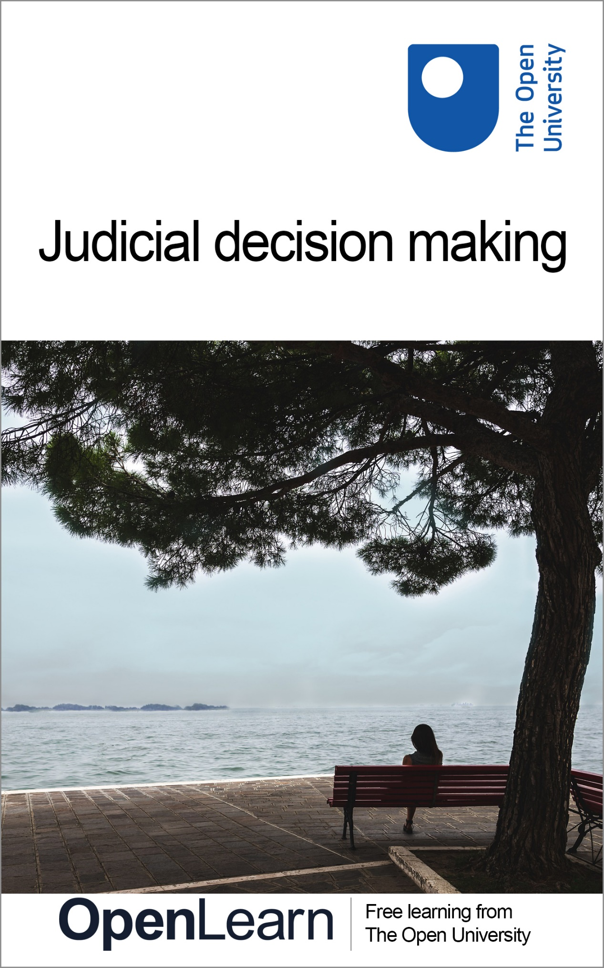

W112_1

Judicial decision making

About this free course
This free course is an adapted extract from the Open University course W112 Civil justice and tort law - www.open.ac.uk/courses/modules/w112.
This version of the content may include video, images and interactive content that may not be optimised for your device.
You can experience this free course as it was originally designed on OpenLearn, the home of free learning from The Open University –
Civil justice and tort law
There you’ll also be able to track your progress via your activity record, which you can use to demonstrate your learning.
Copyright © 2023 The Open University
Intellectual property
Unless otherwise stated, this resource is released under the terms of the Creative Commons Licence v4.0 http://creativecommons.org/licenses/by-nc-sa/4.0/deed.en_GB. Within that The Open University interprets this licence in the following way: www.open.edu/openlearn/about-openlearn/frequently-asked-questions-on-openlearn. Copyright and rights falling outside the terms of the Creative Commons Licence are retained or controlled by The Open University. Please read the full text before using any of the content.
We believe the primary barrier to accessing high-quality educational experiences is cost, which is why we aim to publish as much free content as possible under an open licence. If it proves difficult to release content under our preferred Creative Commons licence (e.g. because we can’t afford or gain the clearances or find suitable alternatives), we will still release the materials for free under a personal end-user licence.
This is because the learning experience will always be the same high quality offering and that should always be seen as positive – even if at times the licensing is different to Creative Commons.
When using the content you must attribute us (The Open University) (the OU) and any identified author in accordance with the terms of the Creative Commons Licence.
The Acknowledgements section is used to list, amongst other things, third party (Proprietary), licensed content which is not subject to Creative Commons licensing. Proprietary content must be used (retained) intact and in context to the content at all times.
The Acknowledgements section is also used to bring to your attention any other Special Restrictions which may apply to the content. For example there may be times when the Creative Commons Non-Commercial Sharealike licence does not apply to any of the content even if owned by us (The Open University). In these instances, unless stated otherwise, the content may be used for personal and non-commercial use.
We have also identified as Proprietary other material included in the content which is not subject to Creative Commons Licence. These are OU logos, trading names and may extend to certain photographic and video images and sound recordings and any other material as may be brought to your attention.
Unauthorised use of any of the content may constitute a breach of the terms and conditions and/or intellectual property laws.
We reserve the right to alter, amend or bring to an end any terms and conditions provided here without notice.
All rights falling outside the terms of the Creative Commons licence are retained or controlled by The Open University.
Head of Intellectual Property, The Open University

Contents
- Introduction
- Learning outcomes
- 1 Legal reasoning
- 2 Fact-finding
  - 2.1 Everyday fact-finding
  - 2.2 Legal fact-finding
  - 2.3 Material facts
- 3 Decision making
- 4 Reasons
- 5 Bias in judicial decision-making
  - 5.1 Empirical evidence
  - 5.2 Feminist Legal Judgments Project
- 6 Precedent and interpretation
- 7 Sliding Doors and stare decisis
  - 7.1 The Incorporated Council of Law Reporting
- 8 Precedent for prediction and persuasion
  - 8.1 Ratio decidendi and obiter dicta
  - 8.2 The judicial hierarchy
  - 8.3 Analogy in law
- 9 Certainty and uncertainty
- 10 Do judges make law?
  - 10.1 Judges as legislators
- 11 Consolidation quiz – Part 1
- 12 Consolidation quiz – Part 2
- Conclusion
- Acknowledgements
- References
- Solutions
- Descriptions

Introduction
Judges play a key role in a common law legal system such as that of England and Wales. But to outside observers, the way they arrive at their decisions may be something of a mystery. This course seeks to shed light on this process. The course starts by explaining how judges make factual findings from evidence, how they choose how a case should be decided, and how they explain their thinking. Key to all of these processes is the law, which influences judges at every stage.
To explain the role of the law, the course starts by focussing on the easier cases where the law is certain. As the course progresses, it introduces the harder cases where the law is uncertain and looks at how judges and lawyers navigate this uncertainty. As the challenges of uncertainty are introduced, the course also looks at fundamental debates concerning judicial decision making, in particular the issues of representativeness of the judiciary, bias, and whether judges make law.
This OpenLearn course is an adapted extract from the Open University course W112 Civil justice and tort law.

Learning outcomes
After studying this course, you should be able to:
- explain and distinguish fact-finding, decision-making and reason-giving
- discuss the issue of bias in the common law
- explain stare decisis and differentiate between ratio decidendi and obiter dicta
- recognise that some legal rules are uncertain
- discuss whether judges make law.

1 Legal reasoning
The start of this course (Sections 1-6) introduces you to what happens when a legal dispute goes through the courts, considering how the courts take the facts relating to legal disputes, analyse them, assessing what is relevant or not, and then uses them to make legal decisions. It also considers what happens when decisions are made and the process through which judges record their decisions so that future courts can follow them, if it is appropriate to do so.
Watch the video below for an introduction to what you will learn about in the start of this course.

Video content is not available in this format.
Video 1
View transcript - Video 1

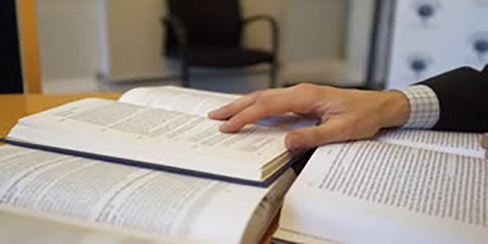

2 Fact-finding
The first step in resolving a legal dispute is finding the facts. Correct fact-finding is vital to a just outcome. For example, if a court wrongly found that parents had mistreated their child when they had not, that child could be taken away, with terrible consequences. The process of working out from the evidence where the truth lies is generally known as fact-finding.
There are some instances when the opposing parties are agreed on the facts, but these are quite rare. Generally, one side makes claims that the other side disagrees with, so the court has first to decide where it thinks the truth lies. A legal dispute often comes to court some time after the dispute arises, and the fact-finder (also known as a ‘tribunal of fact’) has no previous information about the dispute, so they have to try to work out what happened from the evidence that is presented. In civil cases, the tribunal of fact is normally a judge or a panel of judges, but sometimes it can be a jury. In more serious criminal cases the tribunal of fact is generally a jury, and in less serious cases it is lay (unqualified volunteers) or professional magistrates.
Figure 1 demonstrates some of the forms that evidence might take.

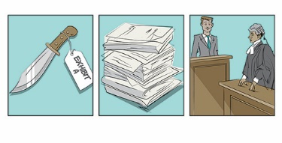
Figure 1 Examples of types of evidence
View description - Figure 1 Examples of types of evidence

The majority of fact-finding also takes place during the ‘first-instance’ stage, that is, when the case first comes to court and before any appeal. If a case is appealed, the appeal court rarely hears evidence, so the appeal court will tend to rely on the facts that were found by the first-instance fact-finder at the very start of the dispute.
As you shall also see further along in this course, fact-finding may be a point at which bias can creep into the legal process.

2.1 Everyday fact-finding
Fact-finding is something that people do day-in, day-out with such ease that they rarely think about it. Fact-finding is a type of inference. Inference is where we draw conclusions by combining evidence that we hear or see with existing knowledge. For example, when a person’s mobile phone alarm goes off (evidence) and even before they open their eyes, they infer that it is 7 a.m., (fact) on the basis that that is the time the alarm always goes off. And if there is a knock at the door (evidence) they infer before opening the door that it is a delivery (fact) because they are expecting a parcel and not a visitor.

Figure 2 In everyday life, people infer facts from evidence such as: (a) a mobile alarm or (b) the sound of a knock at the door
View description - Figure 2 In everyday life, people infer facts from evidence such as: (a) a mobile ...

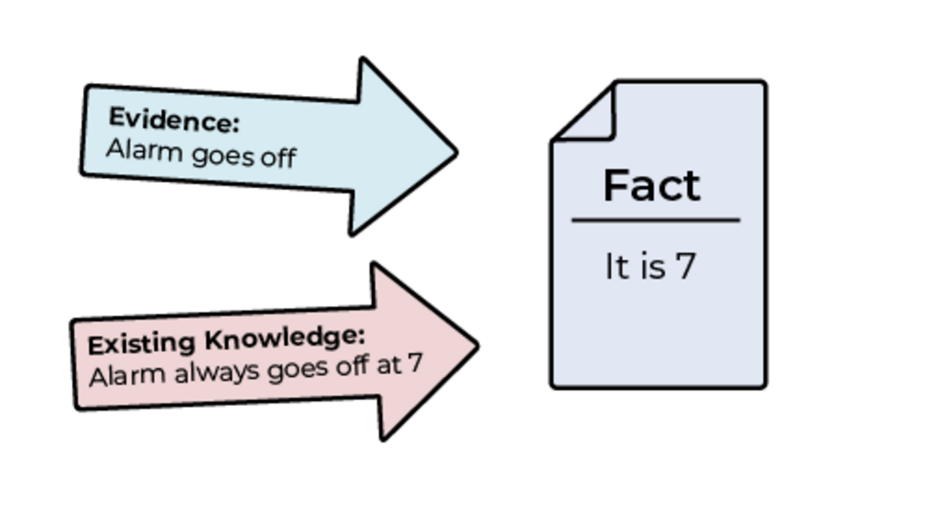

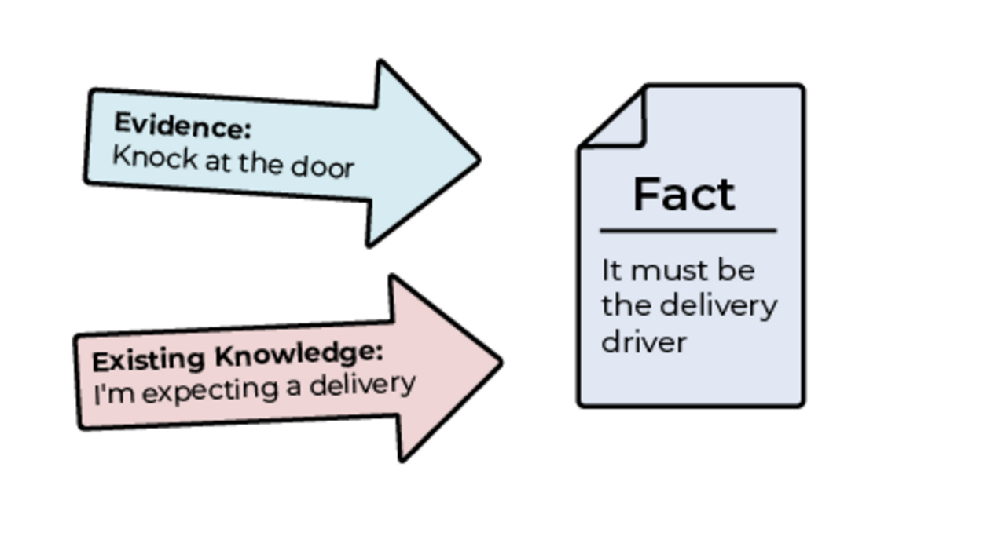
Figure 3 Using evidence and existing knowledge to infer facts
View description - Figure 3 Using evidence and existing knowledge to infer facts

Notice that the factual inferences are never certain. If you imagine a scale from 0 to 100% where 0% is impossible, 50% is evenly balanced, and 100% is absolute certainty, all factual inferences will fall somewhere along that scale (see Figure 4). When the alarm goes off, the person might think it 99% certain that it is 7a.m., but they could be wrong. Their dastardly housemate might have changed the time, they might have forgotten that the clocks went back, or they may have pressed the ‘snooze’ button earlier. They might infer that it is 80% likely that the knock on the door is the delivery driver, but perhaps it is instead a neighbour who has locked himself out of his flat, or a group of police officers coming to arrest him for that jewellery heist in the 1970s he thought he had got away with.

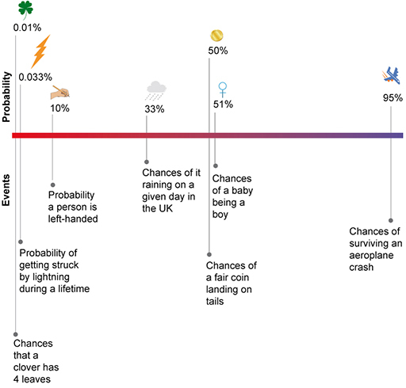
Figure 4 Scale of probabilities
View description - Figure 4 Scale of probabilities

In the next section, you will see how legal fact-finding is similar to everyday fact-finding.

2.2 Legal fact-finding
Fact-finding in a legal case is just like common-sense fact-finding in everyday life. The fact-finder has to use the evidence that is available at the trial to infer what they think happened in the past. For example, the court might use skid marks on the road to infer how fast a vehicle was travelling before it was involved in an accident, or medical evidence to infer how likely it was that the claimant’s disease was caused by exposure to toxic particles in the workplace, or chemical analysis to infer how likely it was that a particular company polluted a river.

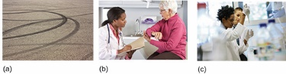
Figure 5 (a) skid marks; (b) medical evidence; (c) chemical analysis
View description - Figure 5 (a) skid marks; (b) medical evidence; (c) chemical analysis

However, when making findings of fact, the fact-finder also has to follow legal rules contained in common-law cases and parliamentary statutes. For example, in the previous section on everyday fact-finding, we noted how fact-finding is never certain, only probable, and a fact may be found with varying degrees of probability ranging from 0% (impossible) to 100% (dead certain). In everyday life, it is up to us what degree of likelihood we want to rely upon in making decisions, but in law there are legal rules that impose very strict requirements on what degree of probability is acceptable.

The standard of proof
The law generally treats fact-finding as a simple yes or no question, so we have to translate the grey scale of probabilities into a straight black-and-white answer. This is called the ‘standard of proof’ and in civil law context this standard is ‘on the balance of probabilities’. The balance of probabilities means more likely than not. Therefore anything with a probability of 50% or less is taken not to have happened, and anything with a probability of 51% or more is taken to have happened. In criminal cases the standard is much higher, ‘satisfied so that you feel sure’ or the famous ‘beyond reasonable doubt’. However, there is disagreement about what exact percentage this equates to.

The burden of proof
The standard of proof still does not tell us which way round to apply it (does the claimant need to show that something is 51% likely, or does the defendant need to show it is 51% likely?), so we also need the ‘burden of proof’. In civil law, the law is that the burden of proof is on the side alleging that a particular fact is true. So a claimant who says that a defendant polluted a river will need to show that it was at least 51% likely that the defendant did so. And if the defendant says that the pollution was instead caused by a factory further up the river, the defendant will need to show this with 51% probability. In criminal cases the burden is generally on the prosecution.
There are other legal rules that must be followed when fact-finding. Sometimes these rules have a drastic effect on the fact-finding process. For example, ‘public interest immunity’ is a process recognised by common law rules where the government can apply to a court to exclude evidence that would otherwise be used because the government believes it would harm the public interest. The evidence might put an informer’s life at risk if disclosed, or it might harm national security. Just before World War II, an experimental submarine sank while being tested, killing 99 sailors. When a claim was brought against the shipbuilders, the House of Lords upheld a certificate from the government that it would damage national security if the designs for the submarine were disclosed. This meant that the plans could not be used as evidence (Duncan v Cammell Laird and Co Ltd ^{Footnote1}). Public interest immunity is controversial because it can affect the fairness of the trial. Nonetheless, the tribunal of fact is obliged to follow these laws because if it does not, its decision will be overturned on appeal.

2.3 Material facts
Not all facts are important for legal reasoning. The facts that are important are called ‘material facts’ (material just means relevant) and are facts that make a difference to the decision or outcome. For example, in a negligence claim arising out of a road traffic accident, it would be a material fact whether or not one of the drivers was using their mobile telephone immediately prior to the accident. If he was using his telephone then the judge may decide that he was negligent, whereas if he was not using his telephone then the judge may not decide he was negligent.
Then there are other facts that are just background and would make no difference to the outcome. For example, the colour of the driver’s shirt would be unlikely to be a material fact.

Factual issues v legal issues
When a case comes to court, the parties may agree on some facts, but disagree on others. The disputed facts are called issues of fact whereas the undisputed facts are called agreed facts. The court has to determine the issues of fact. This course focuses mainly on issues of fact.
This course will start by assuming that the law is certain and agreed on by the parties. However, there are times when the parties disagree what the law is. A disagreement about the law is called an issue of law. You will look at issues of law in more detail later in the course.

Activity 1 Legal fact-finding
Allow about 20 minutes
Now it’s your turn. The following questions are designed to put you in the shoes of a tribunal of fact in the civil context. At this stage, do not worry about other rules of evidence, other than the legal rules that:
- the burden of proof lies on the side arguing that a particular fact is true
- the standard of proof is ‘on the balance of probabilities’, which is 51% or higher.
Once you have made your findings of fact and indicated your confidence, you will be able to see what other people’s views are.

1. Employment discrimination

You are sitting as a judge in the Cardiff Employment Tribunal. The claim is one for race discrimination, which is a statutory tort. The summary of the evidence that you have heard is that the claimant, Allegra Conti, says that her manager, Fiona Boyle, used racist language when raising a disciplinary issue. Fiona Boyle admits using a raised voice, but denies using discriminatory language. There is one other witness, Erika Edwards, another employee who was present at the time, who says that Fiona Boyle did use racial language. However, the words that Erika Edwards says Fiona Boyle used are different to the words the Allegra Conti says were used.

Interactive content is not available in this format.

2. False imprisonment

You are sitting as a member of a civil jury in a complaint for the tort of false imprisonment. The claimant, Tammy Smith, says she was falsely imprisoned for an hour by British Transport Police when she arrived at Newcastle railway station to attend a job interview. Tammy Smith says that she lost her ticket, and two police officers told her very clearly that she could not leave the station master’s office until they had investigated. One of the officers stood in front of the only door, preventing Tammy Smith from leaving. The experience was humiliating and led to Tammy Smith missing her interview. Both officers deny in evidence that Tammy Smith was detained because they say that Tammy Smith could have left the office at any point.

Interactive content is not available in this format.

3. Sale of goods

You are sitting as a judge in the County Court considering a case on the small claims track.
The claimant, Dev Patel, bought an expensive racing bicycle at a car-boot sale from Cameron Brown and is now bringing a claim for breach of contract. Dev Patel says in evidence that Cameron Brown assured him that the bicycle was ‘in perfect working order’, but after he took it home it transpired many of the components were in such a bad condition that replacing them all made the bicycle effectively worthless. Dev Patel says that when he returned to Cameron Brown to ask for a refund, Cameron Brown refused, saying ‘What do you think this is, John Lewis?’. In evidence Cameron Brown says that when Dev Patel asked about the condition, he had in fact said that the bike was ‘sold as seen’.
In relation to the assertion by Dev Patel that Cameron Brown said that the bicycle was in perfect working order, what is your finding of fact?

Interactive content is not available in this format.

In this section you learnt about the first stage of adjudication, fact-finding. In the next section, you will find out about the second stage, decision-making.

3 Decision making

Decision making
Watch the video below for an introduction to the role of decision making in law.

Video content is not available in this format.
Video 2 Decision making
View transcript - Video 2 Decision making

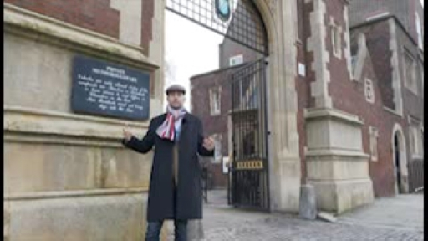

Now that you have been introduced to legal decision making, the next activity gives you an opportunity to try putting your understanding into practice.

Activity 2 Legal decision-making
Allow about 25 minutes
The following questions are designed to put you in the shoes of a legal decision maker. Again, you do not need to do any research, just try to make the decision you think is right on the basis of the facts that are given and the explanation of the law provided. The law may have been simplified for these exercises. This time, you do not have to make any factual findings, so assume that the facts have already been found or have been agreed by the parties.
Once you have made your decision, you will be able to see what other people’s views are.

1. Trespass to land

You are sitting as a judge in the Exeter County Court. Massbuild Housing Development Plc (‘Massbuild’) is suing Elaine Woodford for the tort of trespass to land. Massbuild bought a large area of land from the Ministry of Defence to build houses. For a number of years, the area was unfenced and Elaine Woodford accepts that for a couple of years she used to walk across the land as it was the shortest route for her to get to the shops and local facilities even though there were signs saying private. Nonetheless, she says that she did not cause any harm. The common law rule is that a claimant can win a claim for trespass to land even if the defendant caused no loss to the claimant.

Interactive content is not available in this format.

2. Treasure

You are sitting as a coroner in the Truro Coroner’s Court. Emmanuel James is a farmer whose family have rented land from the Duchy of Cornwall for generations. The James family have suffered a series of unexpected misfortunes and have very little money. While ploughing, Emmanuel James strikes a hard object, which turns out to be a valuable hoard of hundreds of silver Roman coins. The statute (the Treasure Act 1996 ^{Footnote2}) says that treasure includes coins which are at least 300 years old that are at least 10% precious metal and that treasure found within land that is part of the Duchy of Cornwall belongs to the Duke of Cornwall (who is currently Prince William).

Interactive content is not available in this format.

3. Artificial insemination

This question introduces an issue of law for the first time. Up until this point, the law you have applied has been certain. However, here the facts are certain, but the law that applies is uncertain. You therefore need to make a finding of law by deciding what the law is before you can apply it.
You are sitting as a civil judge in the Court of Session in Edinburgh. Andrew Wallace would like a divorce from his wife, Sandra Wallace. Mr and Mrs Wallace have been separated for 14 months and Mrs Wallace is pregnant. Assume that the law says that a person is only entitled to a divorce if they have committed adultery. Sandra Wallace admits that Andrew Wallace is not the father, but says that she became pregnant as a result of artificial insemination, not through intercourse. You need to decide the issue of law of whether artificial insemination amounts to adultery.

Interactive content is not available in this format.

Now you have studied both fact-finding and decision-making. In the next section, you will study the third important stage of adjudication, giving reasons.

4 Reasons

Box 4 Reasons
Watch the following video for a discussion of the role of reasoning in the law.

Video content is not available in this format.
Video 3 Reasons
View transcript - Video 3 Reasons

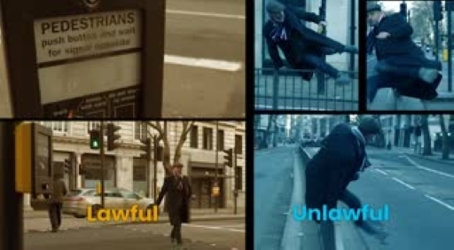

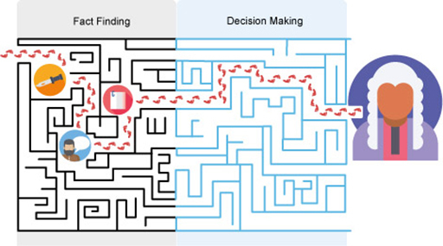
Figure 6 The route through evidence and facts to decisions
View description - Figure 6 The route through evidence and facts to decisions

In the following activity you will have an opportunity to try and give reasons for your finding of fact, your finding of law, and your decision-making. In the case you have to decide, both the facts and the law are uncertain. Do not worry if you find this challenging, it can be very difficult. Even experienced, professional judges sometimes struggle to explain the reasons for their thinking. It can happen that two judges reach the same conclusions, but for very different reasons.

Activity 3 Giving reasons
Allow about 15 minutes

1. Read the following scenario and complete the question that follows.
Sara Hopmeier has a number of disabilities and uses a motorised wheelchair. Where she lives is relatively isolated, and the shortest route to town is via a recognised public footpath. The landowner Tobia Broad previously installed a stepped stile that was impossible to navigate with a wheelchair. Sara Hopmeier complained and Tobia Broad replaced the stile with a gate. Nonetheless, Sara Hopmeier is still dissatisfied and is bringing a claim for disability discrimination under the Equality Act 2010 ^{Footnote3} before you in the Norwich County Court.
The law states that if a physical feature puts a disabled person under a ‘substantial disadvantage’, a landowner only has to make reasonable adjustments to it if they are a ‘service provider’.
There is one issue of fact and one issue of law. Everything else is agreed.
The factual issue is whether the gate amounts to a ‘substantial disadvantage’ to Sara Hopmeier. Sara Hopmeier says that she still finds the gate extremely difficult to operate without assistance, and it leaves her so exhausted that she has to call for help. Tobia Broad denies this and says that he has watched Sara Hopmeier navigate the gate without help on many occasions.
The legal issue is whether Tobia Broad is under a legal duty to make ‘reasonable adjustments’ to the gate. Even if a physical feature puts a disabled person under a substantial disadvantage, a landowner only has to make reasonable adjustments to it if they are a ‘service provider’. The legal issue is therefore whether the owner of land where a footpath runs is a service provider. Sara Hopmeier argues that Tobia Broad is a service provider, but Tobia Broad denies this.

Interactive content is not available in this format.

2. In the textbox below, write a post which explains the reasons for your findings and decisions.

Provide your answer...
View discussion - Part

In the next section, you will look a bit more closely at the reasons that a judge will give for their decision.

5 Bias in judicial decision-making
Up until this point, this course has been primarily practical, focusing on the nitty-gritty of doctrinal law, how judges make decisions, and how understanding these provides tools to answer practical problem questions that are commonly asked of law students to help them develop their legal skills and knowledge. But now you have a working understanding, we are now in a position to look at a deeper socio-legal issues of bias in legal reasoning.

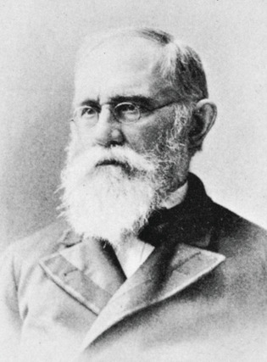
Figure 7 Christopher Columbus Langdell
View description - Figure 7 Christopher Columbus Langdell

At one extreme, some doctrinal lawyers (lawyers who study the rules and principles) believe that the cases and statutes that form part of the black-letter law always provide the answer, and that judges have very little discretion as to how they decide a case. This view is sometimes called ‘formalism’ and is associated with academic lawyers such as Christopher Columbus Langdell, dean of the Harvard Law School in the late 19th century. If the law does not leave a judge any discretion, then it seems there is no scope for bias to creep in. The law is the law and it does not matter who the judges are (Holland and Webb, 2019, p. 129). Formalism is sometimes called ‘the official theory of judicial behaviour’ because it gives the impression that adjudication is not political (Posner, 2008, p. 41). This can be attractive to a judge who wants to avoid controversy.
But in the 20th century, a group of American lawyers, many of whom were also practising lawyers began to question the neutrality of law. At the other extreme, Felix Cohen called doctrinal law ‘transcendental nonsense’ because he thought it was ‘entirely useless’ for predicting how a judge would behave (Cohen, 1935). They were called legal realists, because they sought a more realistic picture of law. If judges do have freedom to decide cases, it may be important who the judges are.

5.1 Empirical evidence
Arguments have raged between formalists and realists about how much freedom judges have, but empirical evidence suggests that the realists were at least partially right. Psychologists have recognised a phenomenon called ‘motivated reasoning’ which is where decision makers are influenced to choose the outcome they prefer (Kunda, 1990). For example, Balcetis and Dunning (2006) asked participants to decide whether an ambiguous character (I3) was a number 13 or a letter B. Depending on which they chose, their task was to drink some orange juice, or a ‘vile’ health drink. Perhaps unsurprisingly, participants preferred whichever interpretation let them avoid the vile drink. The table below shows the outcome of this study.

Balcetis and Dunning results
Condition | Number reporting they saw a B | Number reporting they saw a 13 | No answer
B = orange juice  13 = vile health drink | 18 | 0 | 7
B = vile health drink  13 = orange juice | 9 | 23 | 6

Experiments in a legal context have found that lawyers are also influenced by their outlook. For example, Redding and Reppucci (1999) found that US judges and law students’ decisions on whether to admit empirical research about the death penalty as evidence in a trial were influenced by whether or not they supported or objected to the death penalty. At the appellate level, there is also considerable evidence that appellate judges’ decisions are influenced by their attitudes.
While we know that motivated reasoning happens in a legal context, researchers do not have a clear picture of when it occurs. One aspect that seems to make a difference is whether the bias can be hidden (Kunda, 1990). Note that in the exercises earlier in this unit, some of the fact-finding and decision making were ‘easy’ where almost all judges would have come to the same conclusion. If a judge had come to a different conclusion, it might have looked a bit suspicious. Other cases were ‘hard’ where reasonable judges might have decided either way. These are the cases where the effect of bias is more difficult to spot. Overall, the potential for bias provides an argument in favour of a judiciary that reflects the community.

5.2 Feminist Legal Judgments Project
In England and Wales, in common with most other jurisdictions, the overwhelming majority of judges have historically been, and continue to be male (Ministry of Justice, 2020). To highlight the effect this has had on the law, scholars have rewritten many key common law judgments from a feminist perspective (e.g. Hunter, McGlynn and Rackley (2010)). These scholars seek to demonstrate that judges that believe in equality between women and men would have decided the cases differently, and would have given different reasons for their decisions.
In the following activity, you will have an opportunity to reflect on what you think about these issues.

Activity 4 Judicial bias
Allow about 30 minutes

1. Watch the following video of an interview with Professor Rosemary Hunter.

Video content is not available in this format.
Video 4 Interview with Professor Rosemary Hunter of the Feminist Legal Judgments Project
View transcript - Video 4 Interview with Professor Rosemary Hunter of the Feminist Legal Judgments ...

2. Read the following questions and summarise your response in the text box below. Explain your thinking as clearly as you can, and, if possible, draw on examples and experiences from your own knowledge.
- To what extent do you think bias is a problem in legal reasoning?
- What, if anything, do you think could be done about it?

Provide your answer...

6 Precedent and interpretation
From this point of the course, you are going to further explore what happens when the law is uncertain. Where the law is uncertain, it often will need to be researched, and correspondingly, people are more likely to need the help of a lawyer.

Introduction
Watch the following video, which is an introduction to the next part of this course.

Video content is not available in this format.
Video 5 Introduction
View transcript - Video 5 Introduction

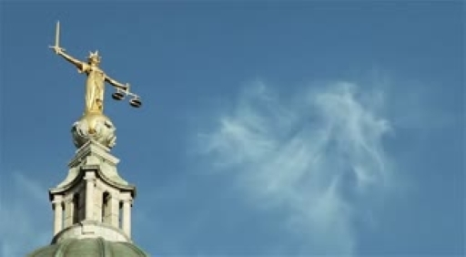

7 Sliding Doors and stare decisis
This section uses a famous movie to introduce the challenge posed to the law if different judges made different decisions about similar cases.

Figure 8 Sliding Doors
View description - Figure 8 Sliding Doors

Sliding Doors
Watch this short trailer for the film Sliding Doors (open the video in a new tab or window by holding down Ctrl [or Cmd on a Mac] when you click on the link).

The film Sliding Doors follows two histories of a character played by Gwyneth Paltrow. One follows what happens to her if she catches her train, and the other if she misses it. As you can imagine, this small twist of fate leads to two totally different outcomes. Earlier in the course, particularly in Sections 3 and 4, you saw that some cases are ‘difficult’ or ‘hard’ so that one judge might decide one way and other judge might decide the other way. Imagine if Gwyneth Paltrow was a judge and her missing the train meant the case was assigned to another judge who would have made a different decision to her. If cases were decided differently depending on which judge happened to be assigned to a case, this could seem unfair. The losing party might well ask why they could not have a judge that would have decided the case in their favour.
You have also seen that in hard cases it is difficult to know what the right decision is. The first judge to decide a legal problem might suggest a rule that afterwards turns out to cause more problems than it solves. A second judge faced with a similar case might be tempted to apply a different rule. But this would cause uncertainty because nobody would know whether a judge is going to follow a previous judge or decide a different way.
The common law legal system therefore needs a method of balancing flexibility and certainty, and this method is known by its Latin name of stare decisis. Stare decisis just means ‘letting the decision stand’. The earlier case becomes called a ‘precedent’ because later courts are expected to follow it. In general, decisions in cases are allowed to stand, even if they might not be perfect. This provides certainty for the public and the parties. At the same time, higher courts can overturn decisions by lower courts, which provides some flexibility.

7.1 The Incorporated Council of Law Reporting
Stare decisis became particularly important after 1865 when the Incorporated Council of Law Reporting (ICLR) was established. Law reporting is the publishing of judicial decisions so that the public can know the law and how cases have been decided. Before 1865, law reporting was a bit haphazard. Without a reliable law report, it was more difficult to be sure what previous courts had decided. A court that did not want to follow a particular precedent could cast doubt on whether the law report was accurate. For example, Lord Lyndhurst was reported to have said of the unfortunate law reporter Mr Barnardiston who wrote reports published between 1726 and 1735: ‘I fear that is a book of no great authority; I recollect, in my younger days, it was said of Barnardiston, that he was accustomed to slumber over his note-book, and the wags in the rear took the opportunity of scribbling nonsense in it’ (William, 1882, p. 424).
The establishment of the ICLR effectively put an end to judges querying law reports. After that time, the draft ICLR reports would be returned to the judges to check that the report was accurate. It would also include the arguments of the parties so that the context of the dispute was clear.

8 Precedent for prediction and persuasion
Practising lawyers use the rules in cases for persuading a court in addition to predicting how a court would decide. If the lawyer can find a previous case where the judge applied a rule similar to the case before the court and where the litigant in their position previously won, the requirement to follow stare decisis can force the judge to find in their favour, even if the judge would not want them to win otherwise. This makes finding supportive cases an important skill for a lawyer.
How influential a rule in a case is as a precedent depends on a number of factors. These include:
- whether the judge’s rule is central to the determination of the case, or more of a speculative comment
- whether the court is a senior or junior court
- how similar a precedent case is to later cases where the parties seek to apply it.
Some of these factors will be considered in the following sections.

8.1 Ratio decidendi and obiter dicta
The first factor that influences how persuasive a rule is whether the rule was key to the outcome, or whether it was just a speculative comment by the judge. If the rule was key, then it can be binding on later courts, whereas speculative comments are only persuasive and do not need to be followed. It is therefore necessary to distinguish between them. The two types of rules also tend to be called by their Latin names.

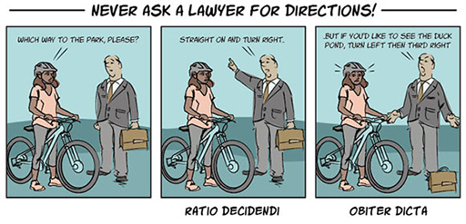
Figure 9 Ratio decidendi and obiter dicta
View description - Figure 9 Ratio decidendi and obiter dicta

The binding type of rule is one that actually decides the case. This is known in Latin as the ‘ratio decidendi’, or reason for the decision. Sometimes it is shortened just to ‘ratio’. All cases must have a ratio because it is the rule that the judge applies to decide the case and also the judge must explain this in their reasons. For example, in the circumstances of the case of MacLennan v MacLennan, ^{Footnote4} if the judge had decided that the partner who became pregnant by artificial insemination had not committed adultery, then the ratio might be something like: ‘a married woman who becomes pregnant through self-impregnation does not commit adultery’. The ratio is obviously the most important part of a case.
There is no easy way to identify what part of a case is the ratio (Holland and Webb, 2019). Court reporters such as those who work for the ICLR will try and identify the ratio in the summary of the case, but the reporters do not always get the ratio right. Judges themselves rarely try to highlight the ratio in their own decisions, but they may use the phrase when discussing what part of a previous case might be the ratio. As a result, spotting the ratio is a skill that comes with practice and familiarity with case reports.
The second type of rule is the one that is not binding. Judges sometimes like to offer comments about hypothetical and related circumstances that they do not have to decide. They do this to explain their thinking and check that the rules that they are applying make sense. This is also known by its Latin name of ‘obiter dictum’ meaning an incidental comment. Sometimes this is also shortened to just ‘obiter’. Rules that are obiter are not binding on later judges, but they may be persuasive. For example, in the case of MacLennan v MacLennan, when giving reasons, the judge might have said something like: ‘Of course, and hypothetically speaking, it might be the case that a married man might offer his sperm to somebody other than his wife for reproductive purposes and without having intercourse. While these are not the facts before the court today, my view is that those circumstances would not amount to adultery either’. If there was a later case that happened to fit those facts, then the earlier judge’s comments would not be binding, but they would be influential. Exactly how influential depends on how senior the court is. Obiter from a judge in the Supreme Court carries a lot more weight than obiter from an adjudicator in the Traffic Penalty Tribunal.

Activity 5 Ratio or obiter?
Allow about 30 minutes

Consider the following legal issue:

The issue in the case of Gillick v West Norfolk and Wisbech AHA ^{Footnote5} was set out by Lord Fraser as follows: ‘My Lords, the main question in this appeal is whether a doctor can lawfully prescribe contraception for a girl under 16 years of age, without the consent of her parents’ (p.162).

Below are some extracts from the speeches (speeches are what the judgments used to be called in the House of Lords) of the House of Lords. For each extract, try to distinguish between what is ratio decidendi and what is obiter dictum. To do this, you need to decide whether they are directly deciding the legal issue (in which case it is ratio), or whether they are speculating on a slightly different issue (in which case it is obiter). This is a difficult task, so do not worry if you do not get it right first time.

Interactive content is not available in this format.

Interactive content is not available in this format.

Interactive content is not available in this format.

The second factor that determines how influential a rule in a case is, is how senior the court is. Or to put it in comedy terms of the ‘Class sketch’ (see Figure 10 overpage), if a court looks down on other courts, it is more influential than a court that looks up to other courts.

8.2 The judicial hierarchy

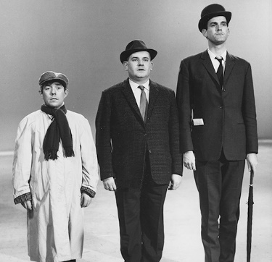
Figure 10 The ‘Class sketch’ featuring Ronnie Corbett as working class, Ronnie Barker as middle class, and John Cleese as upper class. In the sketch, Ronnie Barker looks up to John Cleese but looks down on Ronnie Corbett. If Ronnie Barker was the Court of Appeal, he would look up to the Supreme Court, but down to the High Court. (Image reversed for pedagogical reasons.)
View description - Figure 10 The ‘Class sketch’ featuring Ronnie Corbett as working class, Ronnie Barker ...

The second factor that influences whether ratio decidendi is binding on the court depends on where the earlier court is in the judicial hierarchy compared to the later court.
In general:
- Appeal courts are more senior than first-instance courts.
- Second level appeal courts (like the Supreme Court) are more senior than first level appeal courts (like the Court of Appeal).
- Higher level first-instance courts (like the High Court) are more senior than lower level first-instance courts (like the County Court).
This is illustrated in the civil context in Figure 11.

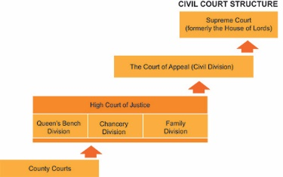
Figure 11 The court hierarchy showing which courts are more senior than other courts for deciding how influential a precedent is
View description - Figure 11 The court hierarchy showing which courts are more senior than other courts ...

Therefore, if the precedent is from a more senior court than the court hearing the new case, then the precedent tends to be binding. But if the precedent is from a more junior court than the court hearing the later case, then the earlier precedent tends not to be binding (but it may be persuasive). This allows the more senior court to make changes to the law.

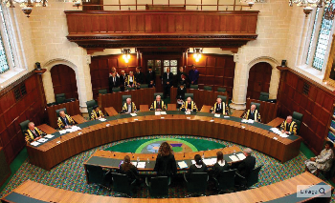
Figure 12 The Supreme Court
View description - Figure 12 The Supreme Court

Back in the day, the House of Lords (the predecessor to the Supreme Court) treated itself as bound by its previous decisions (see: London Tramways Co Ltd v London County Council ^{Footnote6}). This caused a problem because if the House of Lords made a mistake, the only way of overturning its mistake was to wait for Parliament to bring in a statute to overrule it. The House of Lords realised that there was a problem, and in 1966 issued a practice statement giving notice that in the future it would not bound by its previous decisions (see: Practice Statement (Judicial Precedent) [1966] ^{Footnote7}). After 1966, the House of Lords began to overturn some of their previous decisions. For example, recall the case of Duncan v Cammel Llaird, ^{Footnote8} discussed earlier in the course, where the House of Lords had ruled that a public interest immunity (‘PII’) certificate from the government that disclosing evidence would risk national security was the end of the matter. This principle was not followed in Conway v Rimmer ^{Footnote9} where the House of Lords ruled that it could scrutinise whether such a PII certificate was in fact justified. The Supreme Court now follows the same approach and can overrule its previous decisions.

Activity 6 Which precedent is binding?
Allow about 15 minutes

For this activity, assume that there are always two earlier precedents that apply to the issue before the court in the present case but that these conflict with each other. Each time you click the button, the activity will randomly choose different courts. Your task is to decide which of the two earlier precedents is binding on the present court.

Interactive content is not available in this format.

The third factor that determines whether a precedent is binding is whether the material facts are sufficiently similar (or analogous).

8.3 Analogy in law
Whether rules in cases are binding also depends on whether the facts of the cases are similar enough, or analogous, to each other. There are three different possibilities:
- On the one hand, if the material facts in the two cases are identical, then the earlier case is binding and the later court must follow it.
- On the other hand, if the material facts are completely different, then the earlier case is not binding. Here, the later court can ignore it and either follow another precedent, or establish a new principle.
- Between these two extremes there are many different gradations. Given the rich tapestry of life that comes before the law courts, many cases fall somewhere in the middle. This obliges the lawyers and the judges to grapple with the question of whether the cases are sufficiently similar. If a court decides that the facts in an earlier case are similar, but not similar enough, then this is called distinguishing.
Quite how people, or judges and lawyers, assess whether two things are similar or different is frankly something of a mystery. In general, we might assume that one type of apple is more similar to another type of apple than an orange. But as soon as we look at a specific case, this assumption becomes unreliable. For example, if somebody ordered sweet juicy Cox’s apples from an online supermarket, and the supermarket replaced the Cox apples with some very sour Bramley cooking apples, the customer might have preferred that they had been given oranges. The same happens in law. The aspects of cases that influence whether lawyers treat cases as the same are not well understood (Holland and Webb, 2019, pp.146–47). As a result, deciding whether a case is similar enough to be treated as a precedent is something that comes with practice and experience, and even then, trained lawyers may disagree.

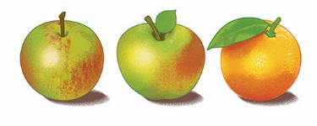
Figure 13 You might think an apple is more similar to another apple than an orange. But would you rather eat a sour apple or an orange?
View description - Figure 13 You might think an apple is more similar to another apple than an orange. ...

9 Certainty and uncertainty

The importance of certainty and uncertainty for lawyers
Watch the following video, which introduces some aspects of certainty and uncertainty, both important concepts for a lawyer.

Video content is not available in this format.
Video 6 Certainty and uncertainty
View transcript - Video 6 Certainty and uncertainty

After watching the video introducing the idea of uncertainty and how courts grapple with it, you will have a chance to grapple with a challenging case yourself in the next activity.

Activity 7 Is it a crisp?
Allow about 30 minutes

In this activity, you get to decide a similarly uncertain rule as in the Jaffa Cake case discussed in the previous video. This is whether Pringles should be treated like crisps or not. Generally VAT does not have to be paid on food, but crisps are an exception. When the issue first arose, schedule 8 of the the VAT Act 1994 ^{Footnote10} said that the following would incur VAT:

Any of the following when packaged for human consumption without further preparation, namely, potato crisps, potato sticks, potato puffs and similar products made from the potato, or from potato flour, or from potato starch, and savoury products obtained by the swelling of cereals or cereal products; and salted or roasted nuts other than nuts in shell.

The decision made a difference of around £20m in taxes per year!

Figure 14 A tube of Pringles, a savoury snack. But is it a crisp or not?
View description - Figure 14 A tube of Pringles, a savoury snack. But is it a crisp or not?

You may be relatively familiar with the snack known as Pringles, but if you are not, the facts as found by the VAT tribunal were that Pringles:
- Were made from potato flour, corn flour, wheat starch and rice flour together with fat and emulsifier, salt and seasoning.
- Were manufactured by mixing the dry ingredients into dough with water and emulsifier, cutting shapes out of a dough sheet, frying it for a few seconds, adding oil and salt, cooling and then adding flavours.
- The manufacturing process caused oil to go into the spaces throughout the texture of the product replacing the water content removed during the frying. This gave the ‘mouth-melt’ feel when eaten. For potato crisps most of the fat stays on the surface.
- Had a regular shape in the form of a saddle, which aids stacking them enabling high production speeds. They were a uniform pale-yellow colour, which is paler than a potato crisp. They had a crisp texture.
- Had an amount of potato flour of around 40%.
In the text box below, write a passage imagining you are a judge applying the provision of the VAT Act 1994 above to these facts. When you have done this, vote in the poll below. Once you make your choice you will be able to see what others thought.

Interactive content is not available in this format.

Provide your answer...
View comment - Part

10 Do judges make law?
Now that you are familiar with the mechanics and practical side of doctrinal law, we can turn to look at an old philosophical question about this law. We have seen in this course that some cases are ‘hard’, meaning that there is not always a clear rule for a judge to follow. When this happens, judges seem to have a choice about which rule to make, and they often could choose between making a number of different new rules. We have also seen that historically, much of the common law was created by judges. Whether judges make law is important because it raises fundamental questions about fairness.
An important common law and human rights standard is that of the so-called ‘rule of law’. The rule of law requires (amongst other things) that the rules that apply to people’s behaviour are clear in advance. If judges make up legal rules only after you have already done something, this seems unfair because you could not have complied with a rule before it existed. A losing party in a court case might justifiably be upset at losing if the rule they should have followed is set out only after the dispute arose.
There is also another concern about judges making law: judges, unlike elected politicians, are not democratically accountable. If they are not accountable to the community, it seems wrong for them to be making the law. This is aggravated if you also recall that the individuals who become judges in England and Wales are not yet representative of the wider community.
In the past, the answer to such worries was said to be the ‘declaratory theory of law’. It was argued that judges did not actually make the law, they only declared what everybody knew the law was. For example, Sir William Blackstone wrote in 1766:

it is not in the breast of any subsequent judge to alter or vary from according to his private sentiments: he being sworn to determine, not according to his own private judgement, but according to the known laws and customs of the land; not delegated to pronounce a new law, but to maintain and expound the old one.
(Blackstone, 1766, p. 69)

For a long time, the declaratory theory of law was widely accepted, but it was famously attacked by one of the most famous British legal philosophers, Jeremy Bentham. For example, in a colourful short pamphlet, he attacked the entire common law as ‘b*start law’ that was made ‘just as a man makes laws for his dog. When your dog does anything you want to break him of, you wait till he does it, and then beat him for it’ (Bentham, 1823, pp.11–12).

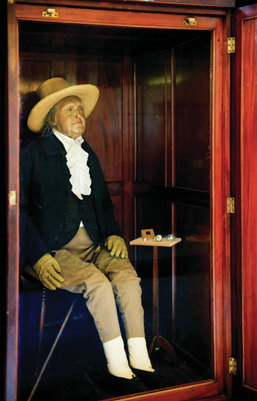
Figure 15 A photo of Jeremy Bentham’s autoicon in its cabinet at UCL. When Jeremy Bentham died, he asked that his body be preserved. This was done, and the body was subsequently presented to University College London. The body is now displayed and can be visited; the head has been replaced with a wax copy because the actual head is too disturbing for general viewing.
View description - Figure 15 A photo of Jeremy Bentham’s autoicon in its cabinet at UCL. When Jeremy ...

10.1 Judges as legislators
If you think back to some of the exercises and cases considered over this course and the previous one, some of the situations seemed quite tricky. It was not always obvious what the legal rule should have been. Some other recent cases also challenge the idea that judges are merely declaring what the law should be. For example, in R (Smeaton) v SS Health, ^{Footnote14} Munby J had to decide whether prescribing the ‘morning after’ pill amounted to the offence of supplying poison to procure a miscarriage, contrary to the Offences Against the Person Act 1861. ^{Footnote15} Obviously anxious to avoid being seen to be making law, he wrote [47]:

The issue which I have to decide is not whether the sale and use of the morning-after pill is morally or religiously right or wrong, nor whether it is socially desirable or undesirable. What I have to determine is whether it may constitute an offence under the 1861 Act.

The commentator David Kelly (2020, p. 515) is scathing about these words, writing: ‘With the greatest of respect to Munby J, what he seeks to avoid is exactly what he is forced to do in making his ‘legal’ decision.’ (Munby J eventually ruled it was not a crime.)
In the present day, the pendulum has swung back the other way, such that many now accept that judges make law. For example, Lord Reid writes:

There was a time when it was thought almost indecent to suggest that judges make law – they only declare it. Those with a taste for fairy tales seem to have thought that in some Aladdin’s cave there is hidden the Common Law in all its splendour and that on a judge’s appointment there descends on him knowledge of the magic words Open Sesame. Bad decisions are given when the judge has muddled the pass word and the wrong door opens. But we do not believe in fairy tales any more.
(Reid, 1972–73, p. 22)

If judges make law, then common law is at least partially retrospective, and therefore unfair. Bentham’s solution was to do away with the common law and attempt to codify the law in its entirety. It is fair to say that parliament legislates more than it did when most people believed in the declaratory theory of law. At the same time, present day judges are less interventionist. Where there seems to be a problem with the law, they are not always happy to set out a solution. Instead they sometimes refuse to act, saying it is a matter for parliament. For example, in R (Nicklinson) v Ministry of Justice ^{Footnote16} the appellants suffered from debilitating conditions and wanted to commit suicide, but were unable to do so without help. While it is not a crime to commit suicide, it is a crime to assist. The appellants sought declarations of incompatibility under the Human Rights Act 1998. The majority of the court thought that they had the power to give a declaration of incompatibility, but refused to do so, saying that the issue was one for parliament, not the courts.

Activity 8 Do judges make law?
Allow about 30 minutes

1. Submit your response to the following question:

Interactive content is not available in this format.

2. In the box below, type your response to the following question, explaining why you think the way that you do.

Provide your answer...

11 Consolidation quiz – Part 1
Now you’ve reached the end of this course, attempt the following questions in Part 1 of the quiz to help consolidate your knowledge. If you’re unsure of any of the answers, revisit the relevant sections .

Activity 9 Quiz questions
Allow about 10 minutes

1. What process would a judge do first, fact-finding or decision-making?

Fact-finding
Decision-making
View answer - Part

2. What is an inference?

A process of drawing conclusions from combining information we receive with information we already know
A type of evidence
A type of fact
View answer - Part

3. Who bears the burden of proof in civil proceedings?

The party who asserts a fact as being true
Always the defendant
View answer - Part

4. What is the standard of proof in civil proceedings?

On the balance of probabilities
More likely than not
51% or more
Beyond reasonable doubt
View answer - Part

5. How does the law influence legal decision-making?

Laws limit the decisions that a judge can make
Law does not influence decision-making
View answer - Part

6. Why are reasons important in legal judgments?

They allow a party to understand why they won or lost.
They provide guidance for how courts will decide similar cases in the future
Reasons are not important in legal reasoning
View answer - Part

7. What is an issue?

A disputed question of fact
A disputed question of law
A type of evidence
A type of fact
View answer - Part

8. What is evidence?

Information or clues that a court uses to infer the facts
Statements from witnesses, documents, or objects
A type of law
View answer - Part

9. What type of lawyer might believe that judges have no discretion in legal reasoning?

A formalist
A realist
A feminist
View answer - Part

12 Consolidation quiz – Part 2
Attempt Part 2 of the quiz to help consolidate your knowledge. If you’re unsure of any of the answers, revisit the relevant sections of the course.

Activity 10 Quiz questions
Allow about 10 minutes

1. What is stare decisis?

The practice of following previous decisions even if they are not perfect
The reason for the decision
The most important part of the decision
View answer - Part

2. Why was the creation of the Incorporated Council of Law Reporting Important?

It enabled lawyers and the public to be confident that the law report was an accurate report of what the judge had decided.
It stopped judges from questioning the quality of law reports
It made a single body responsible for all law reports
View answer - Part

3. Why is finding precedent an important skill for a lawyer?

A precedent that supports your case can force the judge to decide in your favour
Precedent can be used to help predict how a court will decide
Finding precedent is not an important skill for a lawyer
View answer - Part

4. Which is more influential on later courts, ratio decidendi or obiter dicta?

ratio decidendi
obiter dicta
View answer - Part

5. What is ratio decidendi?

The rule that determined the case
A principle that is binding on later courts
An offhand comment by the judge
A factual finding
View answer - Part

6. What is obiter dicta?

Speculation by the judge about how legal principles might apply in other circumstances
Persuasive comments that are not binding on later courts
The key rationale for the decision
View answer - Part

7. Where would you find Jeremy Bentham’s body?

University College London
The Open University
View answer - Part

8. What problems are there with the idea that judges make law?

It is unfair to the losing party because it is retrospective
Judges are not democratically accountable
Judges are not representative of wider society
There are no problems if judges make law
View answer - Part

9. What is the ‘declaratory’ theory of law

Judges do not make law
Judges simply declare the law as it already exists
Judges must give reasons for their decisions
Judges must follow previous precedent
View answer - Part

Conclusion
To an outsider, the process by which judges make decisions may seem mysterious. But by breaking down the process into smaller components, we can demystify the process.
You have seen how judges make sense of evidence to find the facts, by drawing inferences using tacit information that they already know. And then how judges decide cases once they have found the facts. At both stages, the law imposes restrictions on the types of inferences or decisions that judges can make. To help parties and members of the community understand and scrutinise judicial decision making, judges are generally required to give reasons for their decisions.
But there is also more to judicial decision making than this straightforward picture, particularly where the law is uncertain or contested. Here, we see how bias may creep into the law, where judges may use the latitude that legal uncertainty provides to make decisions that meet their own personal preferences. This suggests that it is important for judges to be representative of wider society, a situation that has not yet been achieved in England and Wales.
Law is also quite a technical subject and there are formal requirements to promote certainty and consistency in judicial decision making. Some of these requirements are known by their old Latin names: stare decisis, ratio decidendi, and obiter dicta. These are respectively the requirement to stick with previous decisions, the principle decided in the case, and non-binding but persuasive comments by a judge.
Finally, the course examined a longstanding and controversial question in judicial decision making which is whether judges make law. We saw how the convenient fiction that judges simply declare what the law has always been may not always be true, and that the reality is a little more complicated.
This OpenLearn course is an adapted extract from the Open University course W112 Civil justice and tort law.
Other OpenLearn resources:
Jury Hub

Acknowledgements
This free course was written by Paul Troop with contributions from Neil Graffin, Emma Jones, Suzanne Rab, and Max Weaver. It was first published in July 2023.
Except for third party materials and otherwise stated (see terms and conditions), this content is made available under a Creative Commons Attribution-NonCommercial-ShareAlike 4.0 Licence.
The material acknowledged below and within the course is Proprietary and used under licence (not subject to Creative Commons Licence). Grateful acknowledgement is made to the following sources for permission to reproduce material in this free course:
Images
Course image: Christian from Pixabay
Figure 2: Left: Photo by Ketut Subiyanto from Pexels; Right: LightFieldStudios/iStock / Getty Images Plus.
Figure 5: (a) Image by Jan Mallander from Pixabay; (b) MBI/Alamy (c) Hinterhaus Productions/Getty.
Figure 7: Granger Historical Picture Archive / Alamy.
Figure 8: Moviestore; Shutterstock.com.
Figure 10: Don Smith/Radio Times/Getty Images.
Figure 11: Adapted from www.slideshare.net/GymJamW/civil-courts-and-track-system.
Figure 12: REUTERS / Alamy Stock Photo.
Figure 13: left: Adapted from CKP1001 / shutterstock; centre: Adapted from jennyhorne / getty; right: Adapted from Kandhal Keshavala / EyeEm / Getty.
Figure 14: lleerogers / Getty images.
Figure 15: Luise Berg-Ehlers / Alamy.
Don't miss out
If reading this text has inspired you to learn more, you may be interested in joining the millions of people who discover our free learning resources and qualifications by visiting The Open University – www.open.edu/openlearn/free-courses.

References
Balcetis, E. and Dunning, D. (2006) ‘See what you want to see: motivational influences on visual perception’, Journal of Personality and Social Psychology, 91, p. 612.
Bentham, J. (1823) Truth versus Ashhurst, or, law as it is, contrasted with what is said to be: written in December, 1792 and now first published. London: T. Moses.
Blackstone, W. (1827 [1765]) Commentaries on the laws of England. New York: E Duyckinck.
Cohen, F.S. (1935) ‘Transcendental nonsense and the functional approach’, Columbia Law Review, 35, p. 809.
Hanson, S. (2016) Learning legal skills and reasoning. Abingdon: Routledge.
Hart, H.L.A. (1961) The Concept of Law . 2nd edn. Oxford: Clarendon Press.
Holland, J. and Webb, J. (2019) Learning legal rules: a students’ guide to legal method and reasoning. Oxford: OUP.
Horsey, K. and Rackley, E. (2019) Tort law. 6th edn. Oxford: OUP.
Hunter, R., McGlynn, C. and Rackley, E. (eds) (2010) Feminist judgments. 1st edn. Oxford: Hart Publishing.
Kelly, D. (2020) Slapper and Kelly’s the English legal system. London and New York: Routledge.
Kunda, Z. (1990) ‘The case for motivated reasoning’, Psychological Bulletin, 108, p. 480.
Posner, R.A. (2008) How judges think. Boston: Harvard University Press.
Redding, R.E. and Reppucci, N.D. (1999) ‘Effects of lawyers’ socio-political attitudes on their judgments of social science in legal decision making’, Law and Human Behavior, 23, p. 31.
Reid, Lord (1972) ‘The judge as law maker’, Journal of the Society of Public Teachers of Law (New Series), 12(1), pp. 22–29.
William, J.W. (1882) The Reporters: Arranged and Characterized with Incidental Remarks. 4th edn. Toronto: Carswell & Co.
Other sources
Ministry of Justice (2020) Diversity of the judiciary: 2020 statistics, annual official statistics on judicial diversity in England and Wales covering the current judiciary, judicial appointments and legal professions. London: Ministry of Justice.
Byrne v Deane [1937] 2 All ER 204
Cambridge Water v Eastern Counties Leather [1994] 2 WLKR 53
Collins v Wilcock [1984] 1 WLR 1177
Rylands v Fletcher (1865) 3 H&C 774
Sim v Stretch [1936] 52 TLR 669
Transco Plc v Stockport MBC [2003] 2 AC 1
Wainwright v Home Office [2003] UKLH 53.

Solutions

Activity 3 Giving reasons

Part

Discussion
As previously noted, there was no obvious right answer for the factual and legal issue. The focus was more on providing reasons that explain why you decided the issues the way that you did. You may also have struggled to articulate the reasons for your decisions. This is normal, particularly in an unfamiliar area. Judges sometimes struggle with this too! But through having a go at this process, you should have developed your understanding of the obligation to give reasons for decisions.
Back to - Part

Activity 7 Is it a crisp?

Part

Comment
This was the issue for the Court of Appeal in the case of Proctor & Gamble v HM Revenue & Customs. ^{Footnote11} The judges in the various courts struggled with the question! The VAT Tribunal judge (see Proctor & Gamble UK ^{Footnote12}) first ruled that they were crisps, but at the first appeal to the High Court, the judge thought that they were not crisps (see Proctor & Gamble UK ^{Footnote13}). Eventually the case was appealed further to the Court of Appeal which then decided that Pringles were crisps.
Back to - Part

Activity 9 Quiz questions

Part

Answer
Right:
Fact-finding
Wrong:
Decision-making
Back to - Part

Part

Answer
Right:
A process of drawing conclusions from combining information we receive with information we already know
Wrong:
A type of evidence
A type of fact
Back to - Part

Part

Answer
Right:
The party who asserts a fact as being true
Wrong:
Always the defendant
Back to - Part

Part

Answer
Right:
On the balance of probabilities
More likely than not
51% or more
Wrong:
Beyond reasonable doubt
Back to - Part

Part

Answer
Right:
Laws limit the decisions that a judge can make
Law does not influence decision-making
Wrong:
Back to - Part

Part

Answer
Right:
They allow a party to understand why they won or lost.
They provide guidance for how courts will decide similar cases in the future
Wrong:
Reasons are not important in legal reasoning
Back to - Part

Part

Answer
Right:
A disputed question of fact
A disputed question of law
Wrong:
A type of evidence
A type of fact
Back to - Part

Part

Answer
Right:
Information or clues that a court uses to infer the facts
Statements from witnesses, documents, or objects
Wrong:
A type of law
Back to - Part

Part

Answer
Right:
A formalist
Wrong:
A realist
A feminist
Back to - Part

Activity 10 Quiz questions

Part

Answer
Right:
The practice of following previous decisions even if they are not perfect
Wrong:
The reason for the decision
The most important part of the decision
Back to - Part

Part

Answer
Right:
It enabled lawyers and the public to be confident that the law report was an accurate report of what the judge had decided.
It stopped judges from questioning the quality of law reports
Wrong:
It made a single body responsible for all law reports
Back to - Part

Part

Answer
Right:
A precedent that supports your case can force the judge to decide in your favour
Precedent can be used to help predict how a court will decide
Wrong:
Finding precedent is not an important skill for a lawyer
Back to - Part

Part

Answer
Right:
ratio decidendi
Wrong:
obiter dicta
Back to - Part

Part

Answer
Right:
The rule that determined the case
A principle that is binding on later courts
Wrong:
An offhand comment by the judge
A factual finding
Back to - Part

Part

Answer
Right:
Speculation by the judge about how legal principles might apply in other circumstances
Persuasive comments that are not binding on later courts
Wrong:
The key rationale for the decision
Back to - Part

Part

Answer
Right:
University College London
Wrong:
The Open University
Back to - Part

Part

Answer
Right:
It is unfair to the losing party because it is retrospective
Judges are not democratically accountable
Judges are not representative of wider society
Wrong:
There are no problems if judges make law
Back to - Part

Part

Answer
Right:
Judges do not make law
Judges simply declare the law as it already exists
Wrong:
Judges must give reasons for their decisions
Judges must follow previous precedent
Back to - Part

Descriptions

Figure 1 Examples of types of evidence
There are three images displayed, the first image shows a knife with a label attached to it 'Exhibit A', indicating 'real evidence'. The second image shows a stack of paper indicating 'documentary evidence'. The third image shows two men in a court room, one is a barrister and one is a man standing in a witness box, indicating 'witness testimony'.
Back to - Figure 1 Examples of types of evidence

Figure 2 In everyday life, people infer facts from evidence such as: (a) a mobile alarm or (b) the sound of a knock at the door
(a) Person sleeping next to their phone; (b) Person knocking at the door.
Back to - Figure 2 In everyday life, people infer facts from evidence such as: (a) a mobile alarm or (b) the sound of a knock at the door

Figure 3 Using evidence and existing knowledge to infer facts
A diagram in two parts. The first shos two arrows pointing to a central tile. The arrows show people use evidence (their alarm going off, or the sound of a knock at the door). Arrow 2 shows existing knowledge (that their alarm always goes off at 7 a.m., or an expectation of a delivery). These arrows point to the central square, to indicate an inference of facts (that it is 7 a.m., or that the delivery driver must be at the door).
Back to - Figure 3 Using evidence and existing knowledge to infer facts

Figure 4 Scale of probabilities
A diagram that shows the probability of different events. It shows a scale from impossible on the left to certain on the right. Events are labelled above the scale, and the corresponding percentage probability is shown below the scale. The probabilities and events shown are: the probability that a clover has four leaves is 0.01 per cent; the probability of getting struck by lightning is 0.0033 per cent; the probability a person is left-handed is 10 per cent; the probability that it will rain on a given day in the UK is 33 per cent; the probability of a fair coin toss landing on tails is 50 per cent; the probability that a baby will be a boy is 51 per cent; the probability of surviving an aeroplane crash is 95 per cent.
Back to - Figure 4 Scale of probabilities

Figure 5 (a) skid marks; (b) medical evidence; (c) chemical analysis
The figure shows three photos. Photo (a) shows skid marks, suggesting how fast the car was going on a road. Photo (b) shows a medical expert examining a patient for the purpose of litigation. Photo (c) shows a scientific laboratory and two people who are working on test tubes.
Back to - Figure 5 (a) skid marks; (b) medical evidence; (c) chemical analysis

Figure 6 The route through evidence and facts to decisions
The image shows a maze. The reasons (in the form of footprints) show the route that a judge followed to get from the evidence, to the facts, and then from the facts to a decision, but within the constraints of the law (the walls of the maze).
Back to - Figure 6 The route through evidence and facts to decisions

Figure 7 Christopher Columbus Langdell
A black and white photograph of a man with a bushy white beard and small round glasses, wearing a suit in the style of the late 19th century.
Back to - Figure 7 Christopher Columbus Langdell

Figure 8 Sliding Doors
Poster for the film ‘Sliding Doors’ showing two different versions of the character played by Gwyneth Paltrow. The top half shows her character with long brown hair, the bottom half (upside down) shows her character with short blonde hair.
Back to - Figure 8 Sliding Doors

Figure 9 Ratio decidendi and obiter dicta
Three panel cartoon entitled ‘Never ask a lawyer for directions!’ with a woman on a bicycle asking for directions from a lawyer wearing a suit. First panel shows the cyclist asking the lawyer for directions to the park. The second panel, illustrating ratio decidendi, shows the lawyer giving her a straight answer to what she wants to know by saying: ‘Straight on and turn right.’ The third and final panel, illustrating obiter dicta, shows the lawyer speculating on a different question that the cyclist has not asked, saying: ‘… but if you’d like to see the duck pond, turn left then third right.’ The cyclist looks bemused.
Back to - Figure 9 Ratio decidendi and obiter dicta

Figure 10 The ‘Class sketch’ featuring Ronnie Corbett as working class, Ronnie Barker as middle class, and John Cleese as upper class. In the sketch, Ronnie Barker looks up to John Cleese but looks down on Ronnie Corbett. If Ronnie Barker was the Court of Appeal, he would look up to the Supreme Court, but down to the High Court. (Image reversed for pedagogical reasons.)
A black and white picture of three men showing, from left to right Ronnie Corbett, Ronnie Barker, and John Cleese, Ronnie Corbett on the left is the shortest and wears workers’ clothes, a scarf and cloth cap. Ronnie Barker in the middle is taller, wearing a suit and a trilby. John Cleese on the right is the tallest and wears a suit and a bowler hat, and carries an umbrella.
Back to - Figure 10 The ‘Class sketch’ featuring Ronnie Corbett as working class, Ronnie Barker as middle class, and John Cleese as upper class. In the sketch, Ronnie Barker looks up to John Cleese but looks down on Ronnie Corbett. If Ronnie Barker was the Court of Appeal, he would look up to the Supreme Court, but down to the High Court. (Image reversed for pedagogical reasons.)

Figure 11 The court hierarchy showing which courts are more senior than other courts for deciding how influential a precedent is
Diagram showing the relative seniority of the four main courts in England and Wales arranged in a trajectory from bottom left to top right. At the bottom left hand side is the junior first-instance court, the County Court. Slightly higher and to the right is the senior first-instance court, the High Court. Slightly higher and to the right and higher in the hierarchy is the first level appellate court, the Court of Appeal. Higher still and to the right is the Supreme Court, the second level appellate court, and highest court in England and Wales.
Back to - Figure 11 The court hierarchy showing which courts are more senior than other courts for deciding how influential a precedent is

Figure 12 The Supreme Court
An image taken from above of the Supreme Court. There are nine people in robes sitting at a curved bench, opposite another curved bench at which five other people are sitting.
Back to - Figure 12 The Supreme Court

Figure 13 You might think an apple is more similar to another apple than an orange. But would you rather eat a sour apple or an orange?
From left to right the image shows a Cox apple, a Bramley apple and an orange.
Back to - Figure 13 You might think an apple is more similar to another apple than an orange. But would you rather eat a sour apple or an orange?

Figure 14 A tube of Pringles, a savoury snack. But is it a crisp or not?
An image of a red Pringles tube with Pringles coming out of the open top.
Back to - Figure 14 A tube of Pringles, a savoury snack. But is it a crisp or not?

Figure 15 A photo of Jeremy Bentham’s autoicon in its cabinet at UCL. When Jeremy Bentham died, he asked that his body be preserved. This was done, and the body was subsequently presented to University College London. The body is now displayed and can be visited; the head has been replaced with a wax copy because the actual head is too disturbing for general viewing.
A man sitting in a wooden cabinet, dressed in 19th century clothes and a hat.
Back to - Figure 15 A photo of Jeremy Bentham’s autoicon in its cabinet at UCL. When Jeremy Bentham died, he asked that his body be preserved. This was done, and the body was subsequently presented to University College London. The body is now displayed and can be visited; the head has been replaced with a wax copy because the actual head is too disturbing for general viewing.

Video 1

Transcript
Welcome to this unit. I’m Paul Troop, a practising barrister and I’m the author.
In this unit we’re looking at the practical side of law. That’s the law that an individual would look at it if they wanted to know what their rights or their obligations were. It’s the law that a practising barrister or a solicitor would look at when they’re advising a client. And if a dispute came to court, it’s the law that a judge would rely upon when they’re deciding the case
Lawyers often describe this approach as ‘doctrinal’. Doctrine just means a set of rules or principles. So doctrinal law is all about what the rules are that people are supposed to follow, and how lawyers decide what they are. Sometimes doctrinal law is also called ‘black-letter’ law. This is because historically the two key sources of doctrinal law were statutes and common-law cases, both of which were printed in black letters in books.
This unit introduces problem questions. Problem questions are characteristic of legal study because they mimic this practical side. They give you a factual scenario to apply the law and answer the questions and from now on you’ll be seeing problem questions more and more often.
Answering a problem question requires you to apply the doctrinal or black-letter law to the problem to find an answer. This answer is generally what the legal rights or obligations are, or how a court would decide if the case came to court. This unit will show you how to answer problem questions using this approach.
Doctrinal law has been described as a neutral or objective approach to law, and some scholars have even described it as a science. But towards the end of the unit we’ll question how plausible that view really is.
Back to - Video 1

Video 2 Decision making

Transcript
The second important part of adjudication is decision making.
So in everyday life I can pretty much do what I want. I’m standing in this wide open space, so I could go this way, I could go this way, I could stay where I am, I could sit down on the ground, I could take my hat off and throw it at that annoying crow, or I could take my clothes off (probably not advisable in this cold) – I have total freedom to do whatever I want.
Legal decisions are similar to these day-to-day decisions, but with important differences. Often, they deal with fundamental issues that can be life altering, but they can also be quite trivial.
Legal decisions are like everyday decisions but rules prevent the types of choices which otherwise you might make. For example, not every member of the public can walk into Lincoln’s Inn, unless you’re a member of the Inn.
In law, whether a decision is sustainable, depends on whether it’s lawful or unlawful.
The most important difference is that black-letter law in common-law judgments and parliamentary statutes limits the decisions that an adjudicator can make. If an adjudicator doesn’t follow the legal rules, their decision is unsustainable, meaning that it can be overturned.
Back to - Video 2 Decision making

Video 3 Reasons

Transcript
The third important aspect of adjudication is giving reasons.
The first stage, fact-finding is travelling from evidence to facts. The second stage is travelling from facts to a conclusion. But if all you’re presented with is the conclusion, you have no idea how the judge got there. They could have got there by a lawful route or an unlawful route. Whereas if they give reasons you can tell if the route which they travelled was lawful or unlawful. And if it was unlawful, then you can appeal.
First instance courts responsible for both fact-finding and decision-making will generally explain both, but appeal courts will generally only give reasons for decision-making, as that is their primary focus.
Reasons are also important firstly because they’re a way by which the common law develops, step by step. And secondly they’re a fundamental part of the common law and human right to a fair trial
Back to - Video 3 Reasons

Video 4 Interview with Professor Rosemary Hunter of the Feminist Legal Judgments Project

Transcript
PAUL TROOP
Hello. My name is Paul Troop from the Open University Law School. I’m here with Rosemary Hunter, who is from the University of Kent Law School. She’s a professor of law and social legal studies and also one of the co-organisers of the Feminist legal Judgments Project. Rosemary, welcome.
ROSEMARY HUNTER
Thanks, Paul. Nice to be here.
PAUL TROOP
Can I ask you to explain what feminism is?
ROSEMARY HUNTER
OK, so feminism is an approach to thinking about the world, thinking about society, which pays attention to gender and gender difference. So it looks at the way in which social arrangements operate differently for men and women, treat men and women differently, and very often subordinate women to men.
PAUL TROOP
Can a male judge be a feminist?
ROSEMARY HUNTER
Absolutely, yes. So being a feminist means having a commitment to or having an interest in or concern about the groups who have been traditionally excluded from law and legal reasoning and the development of legal doctrine. And anybody can do that. Anybody can be concerned to produce equality and a more inclusive legal body, legal structure.
PAUL TROOP
What’s the Feminist Judgments Project? And how did it come about?
ROSEMARY HUNTER
So the project came about from a realisation that feminist theory and feminist legal theory has been very influential in academia in law schools and universities. And feminism more generally has been very influential in the development of scholarship and legal scholarship. But it hasn’t had very much impact in the outside world in the practise of law. And so we were interested in, I suppose, pushing it further and showing ways in which it could be relevant to and used in legal practise and legal judgments in particular.
The idea originally came from a group of legal scholars and legal activists, feminist legal scholars and activists, in Canada who had been involved in a project which – called the Women’s Legal Education and Action Fund. And that had been set up when the Canadian Charter of Rights and Freedoms was originally enacted.
And their particular interest was in persuading the Supreme Court or advising the Supreme Court in how the equality guarantees in the Canadian Charter – so the Canadian Charter guarantees rights to equality before and under the law. And LEAF was concerned with the interpretation of that section and Section 15 of the charter and particularly trying to advance a substantive conception of equality, a conception of equality which took into account differences and disadvantages and sought to overcome them. They used to write briefs to intervene in Supreme Court cases that involved the concept of equality.
And they had some initial successes where the court picked up on their arguments. But after a while, they felt that the court had stopped listening to them, perhaps had taken the view that equality or that gender issues were now done. And there wasn’t any relevance to what they were speaking about anymore although they obviously disagreed with that position. And so they hit on the idea of rather – in trying to get the court to pay attention to their arguments, rather than simply writing briefs to intervene in cases, they would show the court how they thought the court should have decided particular cases.
So that’s where the idea of rewriting judgments from a feminist perspective came from. And the Canadian project was focused solely on cases under Section 15 of the charter. But we in the project in England and Wales took the idea of rewriting judgments from a feminist perspective. Imagining that there was a feminist judge on the bench deciding the case, how would they have decided it?
And we applied that to the whole of English law. So we were interested in dealing with cases from any area of law rather than confining ourselves to a particular line of jurisprudence. But that’s where the idea originally came from.
PAUL TROOP
Some theorists, particularly formalists and formalist judges, might say, well, we’re not biased. There’s no scope for bias because the facts are the facts. The law is the law. And we simply apply the law to the facts to find out what the conclusion is. So there’s no scope for bias. And therefore, there’s no reason for having a Feminist Judgments Project to try and address or counter that bias. What might you say to that?
ROSEMARY HUNTER
What I would say to that is that I don’t accept the story of legal objectivity. So law presents itself as strictly objective, as strictly neutral, as unbiased. And it has a method. It has a procedure for doing that, which is to find the facts. Find the law. Apply the law to the facts.
But when you look at it more closely, what you can see is that all of those processes, the finding of the facts, the finding of the law, the application of the law to the facts, rest on a set of background assumptions, choices, distinctions, categorisations that proceed from the world view of a very narrow range of people, the people who have traditionally made the law and the people who have traditionally been the judges. And it appears to be objective because that’s all that they know.
But if you’re an outsider, if you’re someone who’s been traditionally excluded from legal knowledge or legal subjectivity, you can look at the way that the law has been developed and think that doesn’t seem right. That doesn’t include my experience. That’s not objective. That’s the subjective view of a particular group of society.
And so what Feminist Judgments is trying to do is to correct that bias, if you like. So it’s an argument that the way that the law currently operates is not objective but comes from a particular perspective and is trying to broaden out that perspective and include the perspectives of others who have traditionally been excluded from the processes of legal decision making and the processes of developing the law and to make it more inclusive and really applying to all of humanity rather than only a particular section of it.
PAUL TROOP
The American realists were quite notorious for being very sceptical of the things that the judges said and did as being the whole picture. Now, it strikes me that some of the motivations for the Feminist Judgments Project are sympathetic to those ideas to some extent. So would you say that the Feminist Judgment Project is in some ways a type of realism?
ROSEMARY HUNTER
Yes, definitely. Yeah, in fact, I’ve actually written about that in a book chapter on sociolegal methodology when I was asked to write about the Feminist Judgments Project as a form of sociolegal method. And one of the things that I did in that chapter was to show the ways in which the Feminist Judgments Project can be seen to draw on ideas that coming out of American legal realism.
And so certainly, some of the sort of legal scepticism of the realists is something that the Feminist Judgments Projects enact. And as I said earlier, if it’s possible for somebody to produce an equally plausible legal judgment that is written with the same law with the same facts as at the same time as the original judgment, then that demonstrates very powerfully that the original judgment, the original decision, was not inevitable. And so what we learned through the process was that there are a number of ways in which a judge can make their decision appear inevitable and appear to be dictated by the law.
But there are a number of, as I’ve said, a number of choices underlining that, including the way that the facts are described, the way that the level of abstraction or contextualisation that is used, the understanding of how the law should be applied to the particular facts. And they’re all products of choice, yes. So the realist argument that the judicial – the legal reasoning or the judgment that you read conceals as much as it reveals I think is something that Feminist Judgments Projects really demonstrate and follow through on.
PAUL TROOP
Can I ask what you think the key things that a new law student, or student very new to studying law, what’s the most important things they can take from the Feminist Judgments Project?
ROSEMARY HUNTER
Right. Well, I think that I suppose there’s two things. So one is about legal reasoning, about judicial reasoning so, as we’ve mentioned, understanding that the way that judgments are constructed is a construction. And so judges make choices about how they tell the story, how they present the facts, how they describe the law, and how they then apply the law to the facts.
And so what might seem unquestionable and inevitable is not in fact inevitable and often could be done differently. So it’s being aware that the authority and the authoritative voice that is found in judgments can be questioned and can be looked at critically and could possibly have been done differently by someone who was thinking about the issues differently. I suppose I’d want to empower students to be able to have that critical and questioning approach to judgments rather than feeling that they have to accept them as the inevitable conclusion in a particular case.
And then the other thing, I think, is to be aware because people, as, again, as I’ve said earlier, that people have an idea about feminist theory. We can understand feminism. But it’s often hard to see how that might apply to law. And so what the Feminist judgment Project does quite well is to illustrate exactly how feminist thinking can be applied to law and to legal reasoning.
PAUL TROOP
Professor Rosemary Hunter, thank you very much for your time.
ROSEMARY HUNTER
Thanks for the conversation, Paul. I really enjoyed it.
Back to - Video 4 Interview with Professor Rosemary Hunter of the Feminist Legal Judgments Project

Video 5 Introduction

Transcript
PAUL TROOP
This unit looks at which cases are the most powerful and persuasive.
It does this by looking at lots of old legal concepts, which unfortunately tend to be known by their Latin names.
Edward Marshall Hall, perhaps one of the most famous barristers ever, was once asked by a judge: ‘Surely Mr Marshall Hall, your client is familiar with the concept of res ipsa loquitur?’ ‘Of course’, said Mr Marshall Hall, ‘where my client comes from, they speak of little else’.
We’re going to explore what happens when the law is uncertain.
People are most likely to need the help of a lawyer when rules are uncertain and these are also the types of cases that are more likely to be appealed to the higher courts so that the law can be clarified.
Finally, once you have a good understanding of legal reasoning and precedent, the unit concludes by asking whether judges make law. Historically this has been a somewhat controversial question for the common law, due to the fact that judges are not democratically accountable, and in addition, as we’ve seen, judges tend not to be representative of wider society.
Back to - Video 5 Introduction

Video 6 Certainty and uncertainty

Transcript
Paul Troop
Legal rules can be certain most of the time, but there are circumstances where they will be uncertain. The legal philosopher H. L. A. Hart, who was based in Oxford, talked about the penumbra of uncertainty. Now, ‘penumbra’ is just a fancy word for half shade.
Where the light cast by the sun or a light shines on something, you’ll find that there’s an area which is definitely in the light, and there’s an area which is definitely in the shade. But between the two, there’s an area which isn’t quite in the light, and isn't quite in the shade, and that's the penumbra.
Now, legal rules are the same. There are circumstances where the rule definitely applies, and there’ll be circumstances where the rule definitely does not apply. But sometimes there's a small area-- the penumbra of uncertainty-- where it's not clear whether the rule applies or whether it doesn't.
So Hart suggested there are at least two reasons why legal rules were uncertain. The first is a problem with human language. It’s very difficult to explain everything perfectly clearly with human language, as opposed to computer language. And secondly, it’s sometimes very difficult for the rule-maker-- parliament or a judge-- to predict every possible circumstances where the rule might apply.
A famous legal example of uncertainty is whether or not a Jaffa cake is a cake or a biscuit. The issue matters very much to the producers of Jaffa cakes, because cakes are VAT-free-- VAT-exempt - so they don't need to pay tax, whereas there is tax on biscuits. Now, a Digestive is clearly a biscuit, whereas a Battenberg is clearly a cake. But Jaffa cakes fall somewhere in the penumbra of uncertainty.
They're small like a biscuit. They’re covered in chocolate like a biscuit. They're sold in packs like a biscuit. But they’re soft like a cake, and many of the ingredients are the same as cakes.
This issue was the issue in the real life case of United Biscuits in 1991. And in that case, the judge in the VAT Tribunal decided that a Jaffa cake was a cake, which was good news for the manufactures of Jaffa cakes.
Back to - Video 6 Certainty and uncertainty

Footnotes
1: Duncan v Cammell Laird and Co Ltd [1942] AC 624. Back to content
2: Treasure Act 1996 c.24. Back to content
3: Equality Act 2010 c.15. Back to content
4: MacLennan v MacLennan [1958] SC 105. Back to content
5: Gillick v West Norfolk and Wisbech AHA [1986] AC 112. Back to content
6: London Tramways Co Ltd v London County Council [1898] AC 375. Back to content
7: Practice Statement (Judicial Precedent) [1966] 1 WLR 1234. Back to content
8: Duncan v Cammel Llaird [1942] AC 624. Back to content
9: Conway v Rimmer [1968] AC 910. Back to content
10: VAT Act 1994 c.24. Back to content
11: Proctor & Gamble v HM Revenue & Customs [2009] EWCA Civ 407, [2009] BVC 461. Back to content
12: Proctor & Gamble UK [2004] BVC 4,038. Back to content
13: Proctor & Gamble UK [2007] BVC 4,107. Back to content
14: R (Smeaton) v SS Health [2002] EWHC 610. Back to content
15: Offences Against the Person Act 1861 c.100. Back to content
16: R (Nicklinson) v Ministry of Justice [2014] UKSC 38. Back to content

