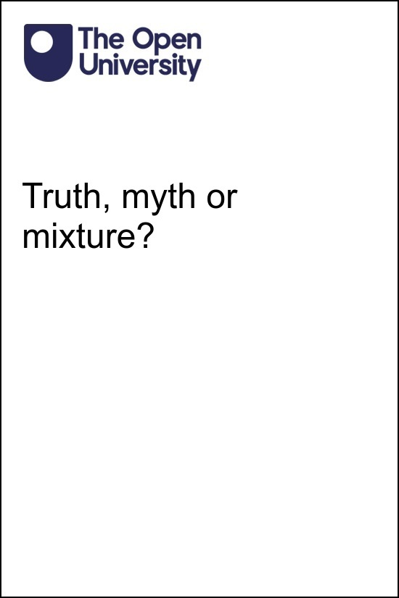

W111_1 Criminal law and the courts

Truth, myth or mixture?

This publication forms part of the Open University module [module code and title]. [The complete list of texts which make up this module can be found at the back (where applicable)]. Details of this and other Open University modules can be obtained from Student Recruitment, The Open University, PO Box 197, Milton Keynes MK7 6BJ, United Kingdom (tel. +44 (0)300 303 5303; email general-enquiries@open.ac.uk).
Alternatively, you may visit the Open University website at www.open.ac.uk where you can learn more about the wide range of modules and packs offered at all levels by The Open University.
The Open University,
Walton Hall, Milton Keynes
MK7 6AA
First published 200X. [Second edition 200Y. Third edition ....] [Reprinted 200Z]
Unless otherwise stated, copyright © 200X, 200Y The Open University, all rights reserved.
All rights reserved. No part of this publication may be reproduced, stored in a retrieval system, transmitted or utilised in any form or by any means, electronic, mechanical, photocopying, recording or otherwise, without written permission from the publisher or a licence from The Copyright Licensing Agency Ltd. Details of such licences (for reprographic reproduction) may be obtained from: Copyright Licensing Agency Ltd, 1 St. Katharine’s Way, London, E1W 1UN (website www.cla.co.uk).
Open University materials may also be made available in electronic formats for use by students of the University. All rights, including copyright and related rights and database rights, in electronic materials and their contents are owned by or licensed to The Open University, or otherwise used by The Open University as permitted by applicable law.
In using electronic materials and their contents you agree that your use will be solely for the purposes of following an Open University course of study or otherwise as licensed by The Open University or its assigns.
Except as permitted above you undertake not to copy, store in any medium (including electronic storage or use in a website), distribute, transmit or retransmit, broadcast, modify or show in public such electronic materials in whole or in part without the prior written consent of The Open University or in accordance with the Copyright, Designs and Patents Act 1988.
Edited and designed by The Open University.
Printed and bound in the United Kingdom by [name and address of printer].

ISBN XXX X XXXX XXXX X
X.X

Contents
- Introduction
- Learning outcomes
- 1 ‘Criminal cases are tried by jury’
  - 1.1 Truth?
  - 1.2 Myth?
  - 1.3 Mixture?
- 2 ‘Most judges are old, white men’
  - 2.1 Truth?
  - 2.2 Myth?
  - 2.3 Mixture?
- 3 ‘The police enforce the law’
  - 3.1 Truth?
  - 3.2 Myth?
  - 3.3 Mixture?
- 4 ‘Crimes are immoral’
  - 4.1 Truth?
  - 4.2 Myth?
  - 4.3 Mixture?
- 5 ‘All crimes have victims’
  - 5.1 Truth?
  - 5.2 Myth?
  - 5.3 Mixture?
- 6 ‘Convicted criminals are let off without prison sentences’
  - 6.1 Truth?
  - 6.2 Myth?
  - 6.3 Mixture?
- 7 ‘Criminal law and civil law are completely different’
  - 7.1 Truth?
  - 7.2 Myth?
  - 7.3 Mixture?
- Conclusion
- References
- Acknowledgements
- Solutions

Introduction
This free course explores the criminal law and courts of England and Wales and shows that some common ideas about them may not be entirely true! It examines those ideas and reveals the realities behind them.

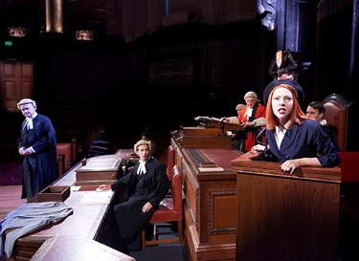
Figure 1 Courtroom drama
View description - Figure 1 Courtroom drama

The criminal justice system appears in news, documentaries, drama, and fiction. Many people also have direct contact with it, whether through their work or as victims, suspects or witnesses. How accurately do those experiences reflect the system as a whole? How realistic are the impressions given in the media or in fiction?
The different sections examine statements you may believe about the criminal law. They explore whether these common ideas about criminal justice are truths, myths or a mixture of both. They may change your mind about the criminal justice system – and should inspire you to learn more about the law. You will start by thinking about those involved in criminal court proceedings, and will look at juries in the first section.

Learning outcomes
After studying this course, you should be able to:
- explain some key features of the criminal justice system
- describe some key features of the criminal law
- understand the truth about the biggest myths around criminal law and the criminal courts.

1 ‘Criminal cases are tried by jury’
There are many images associated with the criminal justice system. Some are symbols: for example, the scales of justice represent law as a whole.

Figure 2 The scales of justice
View description - Figure 2 The scales of justice

Activity 1 Symbols of criminal law
Allow 10 minutes

What symbols come to mind when you think of the criminal courts?

Provide your answer...
View comment - Activity 1 Symbols of criminal law

Other images of the criminal justice system are more complex. For example, a criminal trial is often pictured as involving a red-robed judge, barristers in wigs and gowns, and a jury of 12 members of the public. This section will explore whether that picture of a criminal case being tried by a jury is the truth, a myth, or a mixture of myth and truth.

1.1 Truth?
It is true that some criminal cases are tried by jury. In the Crown Court, the judge is in charge of the trial. Their role is to ensure that it runs smoothly and fairly, and to decide any questions of law. However, the jury decides whether the defendant (the accused person) is guilty or not guilty. The jury is made up of members of the public chosen at random from the electoral register. Because they are not legal professionals, they are referred to as ‘lay people’. They represent the community and use their life experience to help them make decisions.

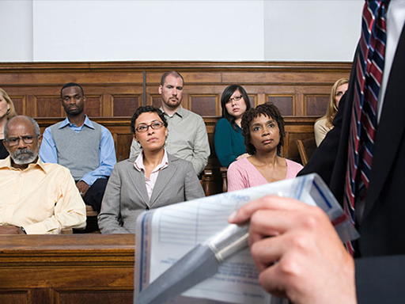
Figure 5 A jury
View description - Figure 5 A jury

1.2 Myth?
Most criminal cases are not tried by jury. This is because most are dealt with entirely by a magistrates’ court, or because the defendant pleads guilty.
There are two types of criminal courts which try and sentence defendants: the magistrates’ courts and the Crown Court. The magistrates’ courts deal with the early stages of criminal cases, and with the trial and sentencing of less serious offences. Unlike the Crown Court, a magistrates’ court does not have a jury.
Young people under 18 have their cases heard in a special part of the magistrates’ court: the youth court. This court can deal with most offences, even serious ones, and only the most serious cases involving young people (e.g. murder and manslaughter cases) will go to the Crown Court.

1.2.1 The magistrates’ court
All criminal cases start in a magistrates’ court, where decisions are made by a panel of magistrates or a district judge, with no jury. The magistrates’ court makes the first decisions about the defendant: for example, whether to release them on bail or keep them in prison to await trial.
Less serious cases (e.g. traffic offences, low-value shoplifting) are dealt with entirely by magistrates’ courts. Only some more serious cases (e.g. robbery, murder) are sent from a magistrates’ court to the Crown Court, where juries sit.
Like juries, magistrates are lay people (and are often referred to as ‘lay magistrates’). They receive training, but they are not legally qualified. District judges, however, are qualified lawyers.

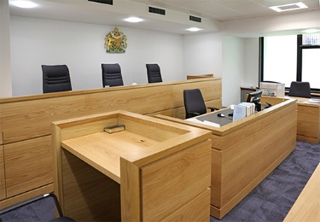
Figure 6 Interior of a magistrates’ court
View description - Figure 6 Interior of a magistrates’ court

Activity 2 Crown Court
Allow 10 minutes

What percentage of cases do you think go to the Crown Court?

More than 80 per cent
About 50 per cent
About 20 per cent
Fewer than 10 per cent
View answer - Activity 2 Crown Court
View comment - Activity 2 Crown Court

In summary, all cases begin in a magistrates’ court and most remain there. Figure 7 shows the criminal court process from the start of a case to the end of the trial and sentencing.

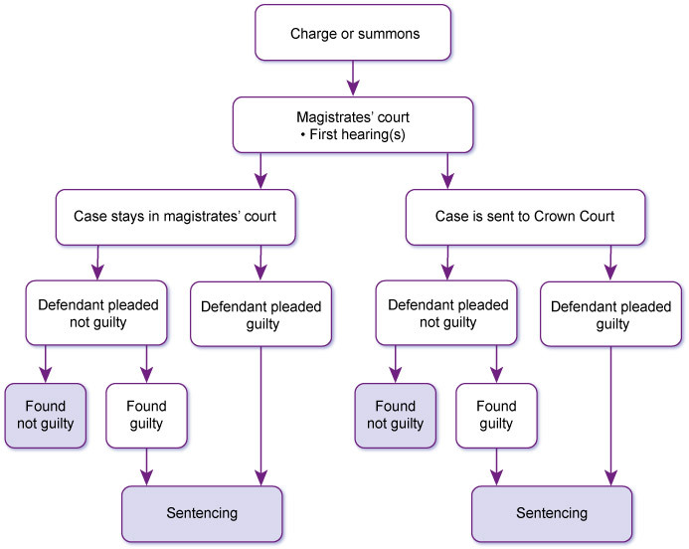
Figure 7 Criminal court process
View description - Figure 7 Criminal court process

1.2.2 Guilty pleas
The defendant will be asked at an early stage to plead guilty or not guilty to the offence. If the defendant pleads not guilty, there will be a trial. However, if the defendant pleads guilty, they admit that they committed the crime. There is no need to hear evidence in a trial to decide whether the defendant is guilty. The court only has to decide their sentence (punishment). This is decided by the magistrates or judge, so no jury is needed.

Activity 3 Guilty pleas
Allow 2 minutes

What proportion of defendants in the Crown Court do you think plead guilty?

More than two-thirds
About half
Fewer than one-third
Fewer than one-tenth
View answer - Activity 3 Guilty pleas
View comment - Activity 3 Guilty pleas

1.3 Mixture?
The claim that ‘criminal cases are tried by jury’ is a mixture of myth and truth. Almost all criminal cases are dealt with entirely in a magistrates’ court, which does not have a jury. Some more serious cases go to the Crown Court, where most defendants plead guilty. The tiny proportion of cases which go to the Crown Court and where the defendant pleads not guilty have a jury trial. However, as the courts deal with about 1.5 million cases every year (Ministry of Justice, 2020b), that still means tens of thousands of jury trials take place each year. Having considered the role of the jury in criminal cases, in the next section you will think about judges.

2 ‘Most judges are old, white men’
For many people, the stereotype of a judge is an older, white man with an upper middle-class accent. However, the judiciary has changed in recent years. How far have these changes gone?

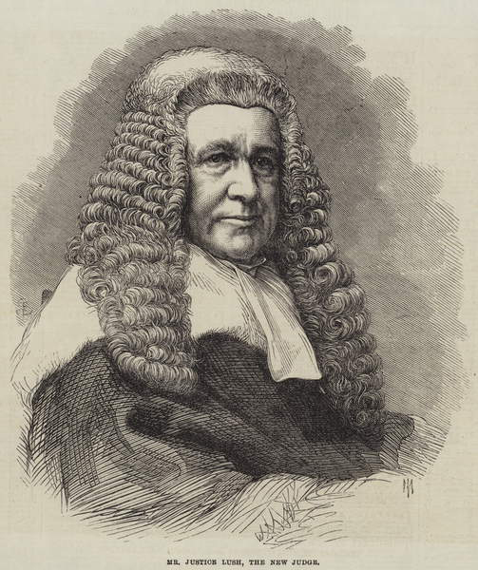
Figure 8 An older, white, male judge
View description - Figure 8 An older, white, male judge

Activity 4 Name three judges
Allow 2 minutes

What are the names of three judges, fictional or real, which first come into your mind when you think about judges? Write their names down below.

Provide your answer...
View comment - Activity 4 Name three judges

2.1 Truth?
There is some truth in the image of the white, male judge. That is unsurprising given the history of the legal profession. To become a court judge, a person must already be an experienced lawyer. Lawyers are people who provide legal services, including solicitors and barristers.

Box 1 Barristers and solicitors
Barristers typically specialise in courtroom advocacy or drafting specialist documents. Usually, they are introduced to their client by a solicitor.
Solicitors have direct contact with clients. They do most legal work, including preparing cases, speaking to witnesses, advising clients, and often speaking in court, but can also instruct a barrister for advocacy or specialist advice.

However, until 1919, only men could become barristers or solicitors. All barristers and pupils (trainee barristers) must belong to one of the four Inns of Court in London. Pupils must also complete qualifying sessions – traditionally, by eating dinners – at their Inn before they can be called to the Bar (i.e. formally qualify). While women had tried to join the Inns of Court before 1919, the Inns refused to admit them.
The Law Society, which was responsible for solicitors’ regulation and education, would not let women take the exams needed to qualify as a solicitor. In 1914, four women brought a case against the Law Society, ^{Footnote1} but they lost. The courts ruled that women should continue to be excluded from the profession because that had been accepted practice for centuries.
Ethnic minority men were not formally prohibited from becoming lawyers. However, the racism they faced made practising in England and Wales very difficult. Most black and Asian barristers who qualified before the twentieth century went on to practise in other countries of the British Empire.

2.1.1 Magistrates
Magistrates have been part of the legal system since the middle ages. They were traditionally men from the landed gentry: upper-class landowners. Inevitably, they were almost all white. One exception was Nathaniel Wells, a magistrate in Wales at the start of the nineteenth century. The son of a wealthy plantation owner and an enslaved black woman, he inherited his father’s wealth. He bought an estate in Chepstow and become part of Monmouthshire’s landed gentry (The National Archives, no date).

2.2 Myth?
There have been significant changes to the judiciary and legal profession in the last century – and particularly in recent decades.

Box 2 Gender diversity
Judges are no longer exclusively white men. The Sex Disqualification (Removal) Act 1919 (SDRA) allowed women to become solicitors and barristers. The first women solicitors and barristers qualified in 1922. By 2020, 49 per cent of solicitors in law firms and 38 per cent of practising barristers were women (Solicitors Regulation Authority, 2020; Bar Standards Board, 2020).

Video content is not available in this format.
Women lawyers and judges
View transcript - Women lawyers and judges

The first woman to be appointed as a judge was Rose Heilbron, who became a recorder (a part-time judge) in 1956.

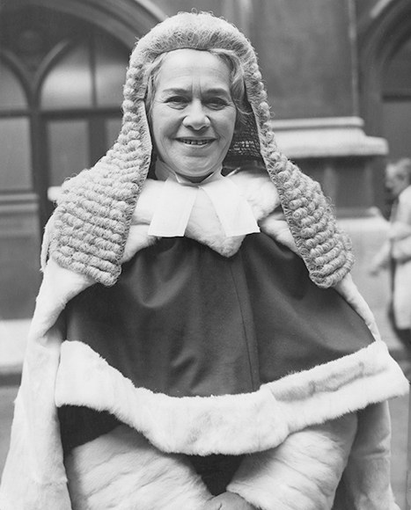
Figure 9 Rose Heilbron
View description - Figure 9 Rose Heilbron

Box 3 Ethnic diversity
There have also been significant increases in ethnic diversity among lawyers. In 2020, 21 per cent of solicitors and 13.6 per cent of barristers were from ethnic minority backgrounds (Solicitors Regulation Authority, 2020; Bar Standards Board, 2020).

Video content is not available in this format.
Ethnic minority lawyers and judges
View transcript - Ethnic minority lawyers and judges

The first black recorder was Tunji Sowande, appointed in 1978.

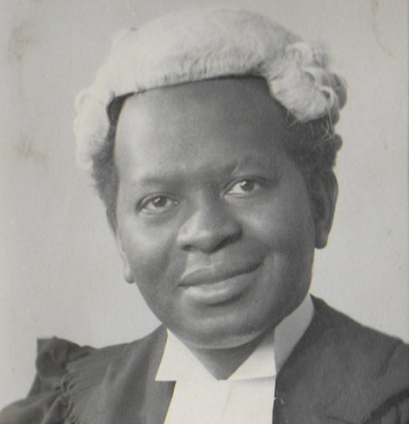
Figure 10 Tunji Sowande
View description - Figure 10 Tunji Sowande

The statistics for other forms of diversity are less clear. Many lawyers choose not to declare their disability, sexuality, gender identity, religion, or socio-economic background.

2.2.1 Magistrates
1919, the year the legal profession opened up to women, was also the year women could first become magistrates. Today, over half of magistrates are women (Magistrates Association, 2019).
Ethnic diversity has taken longer to achieve. It would be another four decades before a minority ethnic magistrate – black magistrate, Eric Irons – was appointed in 1962. By 2020, 16 per cent of magistrates were members of ethnic minorities (Ministry of Justice, 2020c).
Today’s magistrates are volunteers from a range of backgrounds. However, there are still concerns about their socio-economic diversity and age. In 2020, 82 per cent were aged over 50 (Ministry of Justice, 2020c).

Reflection point
Why do you think that such a high proportion of people who volunteer to become magistrates are aged over 50 years old?

2.3 Mixture?
The perception of judges as being older white men is not entirely false. Women and people from ethnic minorities remain under-represented among court judges, especially in the higher courts, such as the Court of Appeal.

Box 4 Court judges in England and Wales
On 1 April 2020, in the criminal and civil courts of England and Wales:

Interactive content is not available in this format.
(Ministry of Justice, 2020c)
View description - Uncaptioned interactive content

Not all judges are old, white men – but a disproportionate number are.

2.3.1 Increasing diversity
The judiciary is becoming more diverse in terms of age, sex and ethnicity. Activity 5 considers judicial diversity in more depth.

Activity 5 Judicial diversity
Allow 15 minutes

You have seen the statistics for the sex, age and ethnicity of judges. What other kinds of diversity do you think might be important?

Provide your answer...
View comment - Part

What do you think the most important benefits of greater diversity are?

Provide your answer...
View comment - Part

In the next section you will look at the police, who are part of the wider criminal justice system.

3 ‘The police enforce the law’
In dramas and documentaries, the police detect crime and chase criminals. On the news, police officers manage crowds, and hold press conferences when defendants are convicted and sentenced. It seems obvious that ‘the police enforce the law’, but is it true?

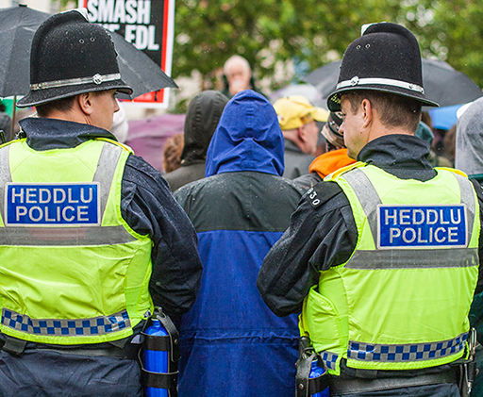
Figure 11 Police officers at a protest
View description - Figure 11 Police officers at a protest

Activity 6 Police enforce the law
Allow 2 minutes

How many territorial police forces are there in England and Wales?

a. 125
b. 31
c. 58
d. 43
View answer - Part

Which is the largest police force in England and Wales?

a. Metropolitan police
b. Greater Manchester police
c. South Wales police
d. North Yorkshire police
View answer - Part

How many full time employed police officers were there in England and Wales in September 2022?

a. 165,295
b. 151,875
c. 142,145
d. 130,825
View answer - Part

3.1 Truth?
The police have a duty to protect the public by preventing and detecting crime. The law also gives them special powers to help them carry out that duty.

Police powers and duties
Police powers are intended to allow officers to perform their duty to prevent and detect crime. For example, they can search people, vehicles and buildings, collect evidence, arrest and question suspects, and move people (e.g. protestors) from locations.

Box 5 Types of law
Police powers and duties are set out in two types of law:
- Common law is made through cases heard before the courts. The police’s duty to protect the public is a common law duty.
- Statute law is found in Acts: laws passed by Parliament. Police powers are defined in statutes such as the Police and Criminal Evidence Act 1984 (PACE).

Enforcing the law
The police investigate crime and gather evidence. They may identify and question suspects. They start the court process when they charge a suspect with an offence, either at the police station or by ‘postal charge’ (a written charge sent to the suspect along with a postal requisition requiring them to attend court).
For minor offences, the court process may start with a summons instead of a charge. The summons is a document requiring the accused person to attend court on a specific day.

Figure 12 A postal requisition
View description - Figure 12 A postal requisition

3.2 Myth?
The police are not the only body to enforce the law. First, some offences are enforced by other agencies. Second, the police work closely with the Crown Prosecution Service (CPS) to decide whether to charge a suspect and to prepare cases for court.

3.2.1 Other agencies
Parliament has given other bodies powers to investigate and prosecute certain crimes. These include:

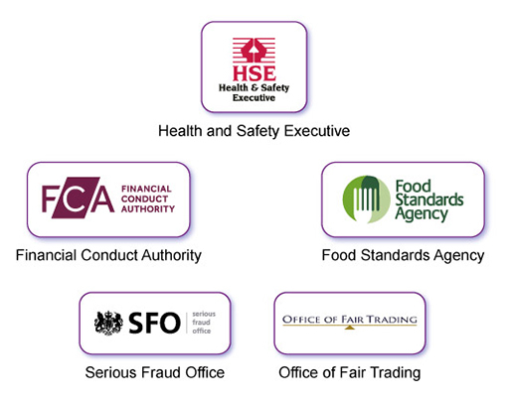
Figure 13 Government agencies
View description - Figure 13 Government agencies

An individual or organisation can bring a private prosecution. Some organisations, including the Royal Society for the Prevention of Cruelty to Animals (RSPCA), regularly investigate and bring private prosecutions. Private prosecutions by individuals are unusual: bringing a prosecution is costly and difficult.

Activity 7 Match the crime to the investigator/prosecutor
Allow 10 minutes

Match each crime to the agency who would investigate and prosecute it.

Health and Safety Executive
RSPCA
Financial Conduct Agency
Food Standards Agency
Serious Fraud Office
Breach of health and safety regulations
Causing unnecessary suffering to an animal
Insider-dealing in shares
Breach of food hygiene regulations
Conspiracy to commit a complex fraud
View answer - Activity 7 Match the crime to the investigator/prosecutor
View comment - Activity 7 Match the crime to the investigator/prosecutor

3.2.2 Crown Prosecution Service
The CPS brings most of the criminal prosecutions investigated by the police to court. Its head is the Director of Public Prosecutions. The CPS describes its role in Box 6.

Figure 14 Max Hill QC, Director of Public Prosecutions
View description - Figure 14 Max Hill QC, Director of Public Prosecutions

Box 6 The CPS

The Crown Prosecution Service (CPS) prosecutes criminal cases that have been investigated by the police and other investigative organisations in England and Wales. The CPS is independent, and we make our decisions independently of the police and government.
Our duty is to make sure that the right person is prosecuted for the right offence, and to bring offenders to justice wherever possible.
The CPS:
- decides which cases should be prosecuted;
- determines the appropriate charges in more serious or complex cases, and advises the police during the early stages of investigations;
- prepares cases and presents them at court; and
- provides information, assistance and support to victims and prosecution witnesses.
(Crown Prosecution Service, no date)

3.3 Mixture?
The police do enforce the law, using their powers and duties under statute and common law. They investigate offences and start the court process.
However, they alone do not enforce the law: they work closely with the CPS on their cases, and once a case goes to court the CPS is responsible for its prosecution. Some specialist offences are investigated and prosecuted by other bodies.
In the next few sections you will consider some of the common myths about crimes and criminals, starting with the relationship between crimes and morality.

4 ‘Crimes are immoral’
Are all crimes also moral wrongs? Before Section 4.1 looks at this question in more detail, Activity 8 encourages you to reflect on your own experiences and moral views.

Activity 8 Have you ever?
Allow 10 minutes

Have you ever done any of these things? (Don’t worry, nobody else will see your answers!)

Interactive content is not available in this format.

View comment - Activity 8 Have you ever?

4.1 Truth?
More serious criminal offences are also considered immoral. For example, murder, assault, and theft are generally considered morally, as well as legally, wrong.

Box 7 Morality and law
In 1962, one of the most senior judges of England and Wales, Viscount Simonds, said that the purpose of the criminal law is to enforce morality:

The supreme and fundamental purpose of the law [is] to conserve not only the safety and order but also the moral welfare of the State … The law must be related to the changing standards of life, not yielding to every shifting impulse of the popular will but having regard to fundamental assessments of human values and the purposes of society. ^{Footnote2}

4.2 Myth?
Some crimes are not generally considered immoral, while opinions will differ on others. Is it immoral to cycle along a wide pavement to avoid a dangerous road junction?
A distinction can be made between crimes which are serious and clearly immoral, and those which are minor and not considered ‘truly’ criminal – often called regulatory offences.

Figure 15 Cycling
View description - Figure 15 Cycling

Views about what is immoral can also change over time and vary widely between different people. For example, drink-driving (driving a vehicle after consuming more than a minimal amount of alcohol) was not considered ‘truly’ criminal a few decades ago. However, public opinion changed as people became more aware of the consequences of drink-driving. Now, many people would consider it a ‘true’ crime and an immoral act.

4.2.1 Regulatory offences
Many offences are not ‘truly’ criminal. They are regulatory offences, which are often punishable only by fines and may not have an obvious victim. Examples include:
- driving offences, e.g. driving with a broken brake light
- health and safety offences, e.g. minor breaches of regulations
- offences regulating the sale of certain items, e.g. selling lottery tickets to a child under 16.

4.2.2 Reasons for criminalising activity
Behaviour has sometimes been made illegal because it is immoral. However, there are other important reasons for making some actions a crime. One of the most influential factors in the current law of England and Wales is the harm principle.

Box 8 The harm principle
The harm principle was set out by philosopher and politician John Stuart Mill in 1859:

The only purpose for which power can rightfully be exercised over any member of a civilized community against his will, is to prevent harm to others.
(p.14)

In other words, the criminal law should only be used against someone when it is necessary to protect others from serious harm.

Critics of the criminal justice system emphasise that crimes often protect certain parts of society at the expense of others. For example, feminist critiques focus on the ways that the law takes the interests of men as the norm, thereby failing to protect women from sexual and domestic violence. Critical race theory points out the institutional racism of the criminal justice system and consequences including disproportionate prosecutions of colour. Other critiques emphasise that the law protects property-owners and the middle classes: benefit fraud is seen as more obviously criminal than, say, tax evasion.

4.2.3 Immoral but not illegal
A lot of immoral behaviour is not illegal. For example, cheating on a spouse or partner is not a crime.

Activity 9 Immoral or illegal?
Allow 5 minutes

Joshua is running along a canal path when he sees a small child struggling in the water. As he wants to finish his run and get to work on time, he does nothing to help the child.

Figure 16 Canal path
View description - Figure 16 Canal path

Interactive content is not available in this format.

View comment - Activity 9 Immoral or illegal?

4.3 Mixture?
Morality and the criminal law overlap: one reason for making behaviour a crime is that it is immoral. Most serious crimes are immoral, and most highly immoral acts are also criminal. For example, murder is one of the most serious crimes and is also generally considered immoral.
However, not all immoral acts are criminal, and not all crimes are immoral. In particular, regulatory offences are often minor and may not be moral wrongs. Morality is not the only basis for deciding what should be a crime: for example, the harm principle is also important.
In the next section you will continue to think about criminal offences by considering whether all crimes have a victim.

5 ‘All crimes have victims’
When crime is discussed, the victims of crime are often considered. Many crimes are discovered when a victim reports them to the police. It might therefore seem obvious that crimes have victims. But is that always true?

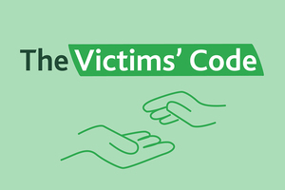
Figure 17 The Victims’ Code
View description - Figure 17 The Victims’ Code

[Editor: update numbering] [Editor: ]

5.1 Truth?
The Code of Practice for Victims of Crime (Ministry of Justice, 2015) defines a victim as:
- somebody who has suffered physical, mental or emotional harm or economic loss which was directly caused by a criminal offence
- a close relative of someone whose death was caused by a criminal offence.
Businesses and organisations may also be victims of crime.
Some crimes may not have actual victims, but pose a risk to potential victims. Consider the following extract from a newspaper report. Nobody had been injured by speeding motorists, but campaigners were concerned that they might be in future.

Box 9 Speeding on a Taunton road

Concerns about ‘reckless’ driving and ‘boy racers’ speeding on Taunton road with three schools
Concerns have been raised about ‘reckless’ driving and ‘boy racers’ speeding on a residential road in Taunton. […]
[An unnamed resident] said there have been incidents where people have been hit by vehicles while crossing the road. He believes it is ‘only a matter of time’ before a child is seriously injured or even killed.
‘My wife rushed to help a little boy who was knocked off his bike while crossing the road’, he said.
‘Nobody was at fault here, but that just goes to show how risky it is driving at excessive speeds here […]
‘Should we have speed bumps, speed cameras, or a 20mph speed limit? It’s only a matter of time before a child is killed, in my opinion.’

Figure 18 Speed limit sign
View description - Figure 18 Speed limit sign

Brenda Weston, a Labour councillor for the Priorswood area […] added:
‘I am a part of the 20’s Plenty For Us campaign and I think Cheddon Road is an area that needs it.’
‘There are a lot of older and young people who walk up and down the road. There are also a lot of cyclists, like myself, and they need to be protected. […]’
A spokeswoman for the 20’s Plenty For Us campaign, a movement aimed to lower speed limits to 20mph in residential areas, believes a lower speed limit will help protect children crossing the road and has more than just safety benefits.
She said: ‘[…] 20mph means actual, and perceived fear of, harm to kids reduces. Stopping distances halve from 30mph to 20mph and survival rates rise by 7–10 with 20+ per cent fewer casualties.’ […]
(Taylor, 2020)

For many crimes, the victim is not (or not only) an individual, but society as a whole. For example, if there is a series of violent robberies in a town, the people who were robbed are the immediate victims. However, many other people in the town will feel less safe and may change their behaviour as a result.

5.2 Myth?
Some crimes are victimless. For example, if a person drives along a quiet lane with a broken brake light, nobody else may be affected by their actions. Similarly, someone who grows cannabis for their own use in their own home is unlikely to harm anyone else. Nonetheless, both have committed crimes.

Figure 19 Police cannabis-disposal team
View description - Figure 19 Police cannabis-disposal team

5.3 Mixture?
Many crimes have victims, and the most serious crimes cause grave harms to their victims. However, that is not true of all crimes. And sometimes, it is unclear who is really the victim of a crime.

Activity 10 Who is the victim?
Allow 15 minutes

Alex and Sam get drunk, argue, and then exchange blows outside a nightclub. Which of them is the victim of a criminal assault, and why?

Provide your answer...

What if Alex struck the first blow: does that change your view? Why?

Provide your answer...

What if Alex struck first, but only after Sam made provocative remarks and gestures?

Provide your answer...

What if Sam started the fight, but Alex turned out to be a much better fighter? By the end of the fight, Alex had a few minor bruises but Sam was seriously injured.

Provide your answer...

View comment - Part

In the next section you will explore what happens when individuals are convicted of a criminal offence and whether they are ‘let off’ without prison sentences.

6 ‘Convicted criminals are let off without prison sentences’
You have probably seen headlines talking about criminals who ‘escaped prison’ or calling for ‘tougher sentences’. It might seem that a lot of criminals are being ‘let off’ rather than sent to prison. This section will look at how the courts punish people convicted of crimes, in order to explore whether that is true.

Figure 20 Behind Bars
View description - Figure 20 Behind Bars

Now click through to this ‘Prison’ activity.

Interactive content is not available in this format.

6.1 Truth?
Most people convicted of a crime do not go to prison. In the year to March 2020, over a million people were convicted of offences. Only 7 per cent were imprisoned; 78 per cent were fined (Ministry of Justice, 2020a).

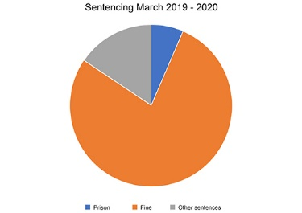
Figure 20 Pie Chart
View description - Figure 20 Pie Chart

6.2 Myth?
Most people who did not go to prison were not ‘let off’. Prison is only one punishment available to the criminal courts and is usually not the most appropriate one. The majority of offenders were convicted of motoring offences or other minor offences. Even for more serious crimes, a prison sentence may not be the best way of punishing the offender.

6.2.1 Sentences
The court has a range of sentences to choose from. Imprisonment is one of these, but other punishments include:
- a suspended sentence: the person does not actually go to prison if they commit no further offences over a set period of time
- a community sentence, e.g. unpaid work in the community or supervision by a probation officer, or participation in an alcohol- or drug-treatment programme
- a fine: a financial penalty paid to the court
- disqualification from an activity such as driving or being a company director
- an order relating to treatment for mental illness
- a conditional discharge: the person is not punished now, but if they commit a further offence within a certain period of time they will be punished for the current offence too.

6.2.2 Purposes of punishment
To decide whether a punishment is appropriate, it is important to consider its purpose. There are many reasons for punishing someone who has committed a crime, and this interactive considers the most important.
Now that you have read a little bit about the purposes of punishment, have a go at the activity below.

Activity 11 Sentencing Act 2020
Allow 10 minutes

Match each of the items at the top to an item below.
Section 57(2) Sentencing Act 2020 (SA) lists the purposes of sentencing as:

Retribution
Deterrence
Rehabilitation
Incapacitation
Reparation
The punishment of offenders
The reduction of crime (including its reduction by deterrence)
The reform and rehabilitation of offenders
The protection of the public
The making of reparation by offenders to persons affected by their offences
View answer - Activity 11 Sentencing Act 2020

6.3 Mixture?
While most people convicted of crimes are not imprisoned, they are punished in other ways. However, punishment is often controversial. Appropriate punishments can be difficult to decide.

Box 10 Sentencing decisions
Listen to this discussion of how sentencing decisions are made.

Audio content is not available in this format.
View transcript - Uncaptioned interactive content

6.3.1 You be the judge
Now that you have explored how and why people are sentenced, Activity 12 puts your knowledge into practice.

Activity 12 You decide the sentence
Allow 30 minutes

Mairead is 27 years old. She has many previous convictions for theft (shoplifting from supermarkets), including two in the past year. She has just pleaded guilty in the magistrates’ court to stealing food and toiletries valued at £45 from her local supermarket. Mairead has recently completed a community order which included supervision by a probation officer. A pre-sentence report prepared for the court by the National Probation Service suggests she is likely to commit further offences. It notes that she steals to supplement her income from benefits; she cannot work as she is a full-time carer for her disabled child.

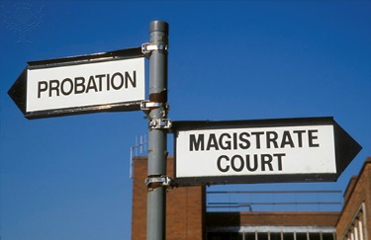
Figure 21 Court and probation
View description - Figure 21 Court and probation

What sentence do you think would be appropriate, and why?

Provide your answer...
View comment - Part

Courts decide sentences using sentencing guidelines produced by the Sentencing Council (2020). Since Mairead was acting alone with little planning, and the items were worth under £200, the guideline sentence is a conditional discharge or fine.
Do you think this is an appropriate sentence? Why (not)?

Provide your answer...
View comment - Part

The guidelines say that persistent offending might justify a community sentence or even imprisonment. However, being a sole carer for her child is a mitigating factor (i.e. one which might reduce Mairead’s sentence).
Does this change your view of the appropriate sentence?

Provide your answer...
View comment - Part

By pleading guilty early, Mairead saved public time and money and saved witnesses from coming to court. Now you have decided her sentence, the final step is to discount (i.e. reduce) it by one-third to recognise her guilty plea. For example, a £150 fine would be reduced to £100; a community sentence might be for one-third fewer hours or may be reduced to a fine.

Interactive content is not available in this format.

View comment - Part

In the last section, you will consider the differences between criminal and civil law: are they two different systems or is there some overlap between them?

7 ‘Criminal law and civil law are completely different’
One of the most important distinctions the legal system makes is between criminal and civil law. You will see that each has its own processes and purposes. However, is it true that they are completely different?

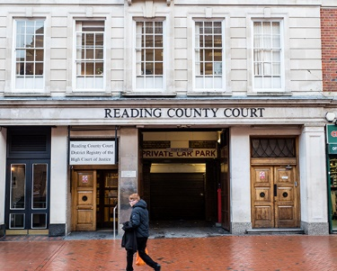
Figure 22 County Court
View description - Figure 22 County Court

Figure 23 Old Bailey criminal court
View description - Figure 23 Old Bailey criminal court

Activity 13 Criminal or civil case?
Allow 3 minutes
For each of the following, decide if they are potential criminal or civil cases.

1. Jennifer is accused of stealing a mobile phone.

View answer - Part

2. Pablo is dismissed from his job so that the manager’s daughter can be given the role.

View answer - Part

3. Brian buys a new washing machine which stops working after four days.

View answer - Part

4. Samara punches her friend, causing a black eye, after an argument about their favourite band.

View answer - Part

7.1 Truth?
The criminal justice system is separate from the civil justice system. The two systems have different courts, procedures and parties. These differences reflect the distinct purposes they serve.
The purpose of the criminal justice system is to punish those who commit crimes. As explored earlier, many crimes have individual victims. However, crimes are also considered to have been committed against society as a whole. The prosecution is therefore brought by the state.
By contrast, the civil courts’ purpose is to resolve disputes between individuals and put things right between the two sides, not to punish them. Typically, the person who is in the wrong is ordered to pay damages – a sum of money – to the other person. For example, if Zofia and Ahmad make a contract (a legally binding agreement) that Zofia will sell her car to Ahmad for £5000, but Ahmad only gives her £4000, the court may order him to pay the outstanding balance. Ahmad will then have the car and Zofia will have the full price, just as they had agreed. The court will not punish him with an additional fine.
The different purposes of the criminal and civil justice systems mean that there are important differences in the ways they operate. These include their courts, decision-makers, parties and levels of proof.

7.1.1 Different courts
All criminal cases begin in the magistrates’ courts, and some of the more serious ones are transferred to the Crown Court, as Figure 23 illustrates.

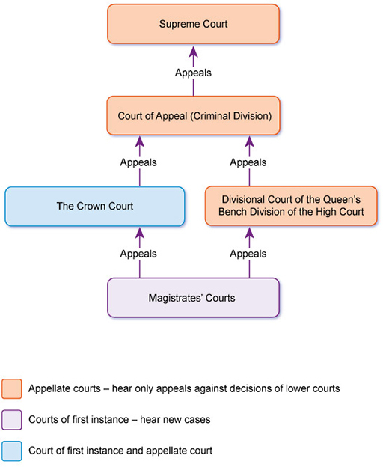
Figure 24 The criminal court system
View description - Figure 24 The criminal court system

Decisions in magistrates’ court cases can be appealed to the Divisional Court of the High Court, or to the Crown Court. Appeals from the Crown Court are heard by the Criminal Division of the Court of Appeal. Cases which raise points of particular importance may be appealed from the Court of Appeal to the Supreme Court, which hears appeals from both civil and criminal cases.
Before 2009, the highest court in the United Kingdom was known as the Appellate Committee of the House of Lords (usually referred to simply as ‘the House of Lords’). In October 2009, it was replaced as the highest court by the Supreme Court. Older cases therefore refer to the House of Lords rather than the Supreme Court.
Civil cases are heard by different courts, as Figure 24 illustrates.

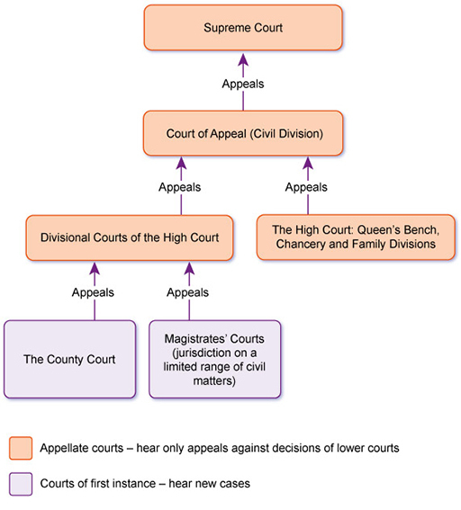
Figure 25 The civil court system
View description - Figure 25 The civil court system

Most civil cases are heard in the County Court, while very serious or complex cases are dealt with by the High Court. The types of civil cases heard in magistrates’ courts are very limited. They include alcohol-licensing appeals, enforcing council-tax demands, and certain family law proceedings.
Decisions in both County Court and magistrates’ court cases can be appealed to the Divisional Courts of the High Court. Appeals from the High Court are heard by the Civil Division of the Court of Appeal. Cases which raise points of particular importance may be appealed from the Court of Appeal to the Supreme Court (before October 2009, formerly to the House of Lords), which hears both civil and criminal cases.

7.1.2 Different decision-makers
The criminal courts are concerned with wrongs done to the community as a whole. They therefore involve lay people (non-lawyers) from the community, who sit as jurors and magistrates.
Because the civil courts are concerned with private disputes between individuals, they do not need to involve lay people. Decisions are almost always made by legally-qualified judges.

Court decision-makers
Criminal courts
Magistrates’ courts | A panel of lay magistrates or a legally trained district judge decide questions of law and fact
Crown Court | A legally trained judge decides questions of law  A lay jury decides questions of fact (i.e. whether the defendant is guilty or not guilty)
Civil courts
County Court | A legally trained judge decides questions of law and fact
High Court | A legally trained judge decides questions of law and fact

7.1.3 Different parties
In a criminal case, the people on each side – the parties – are the prosecution and defendant. When the CPS brings a prosecution, it does so on behalf of the state. The defendant is the accused individual.
Criminal case names usually have the format R v [Defendant]. ‘R’ is short for Regina or Rex (Latin for Queen or King, the head of state). In other words, the prosecutor represents the Crown or state.
In a civil case, the parties are the claimant and defendant. The claimant is the person (or organisation) asking the court to order the defendant to do something. The defendant is the person (or organisation) against whom the claim is made.
Civil case names usually have the format [Claimant Name] v [Defendant Name].

7.1.4 Different levels of proof

Burden of proof
The burden of proof is the obligation to prove the overall case or an element of it. The general rule in both criminal and civil cases is that whoever starts the case has the overall burden of proof. Therefore the prosecution has the burden of proof in a criminal case and the claimant has the burden of proof in a civil case.

Standard of proof
The standard of proof is the level to which the case has to be proved. The criminal standard is very different from the civil standard.
In a criminal case, the prosecution is brought by the state, which has huge powers and resources. By contrast, the defendant is usually an individual, whose liberty may be at stake. The standard of proof is therefore beyond reasonable doubt: the court must only convict the defendant if it is sure of their guilt.
In a civil case, the parties are (in theory, at least) more evenly matched. They are usually individuals or organisations, not representatives of the state. The standard of proof is therefore on the balance of probabilities: in order to win, the claimant must show their case is more likely than not to be true.

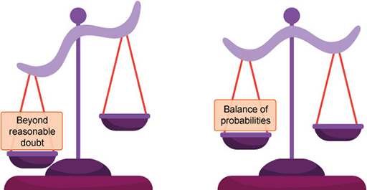
Figure 26 Standards of proof
View description - Figure 26 Standards of proof

7.2 Myth?
Civil and criminal law have different court systems and purposes, but they are not completely separate. In fact, they are often dealing with the same or overlapping situations.
In order to understand how criminal and civil justice overlap, this section will follow a case study from the original event to the end of legal proceedings.

7.2.1 A case for the courts
The case study begins with an incident described in Box 11.

Box 11 The facts
Shanice was driving to work at 8 a.m. on 5 March at the same time that Arjun was driving his young children to school. The children started arguing in the back seat. Distracted by their shouting, Arjun failed to notice Shanice’s car approaching as he made a right turn. His car hit hers, causing damage to both cars.

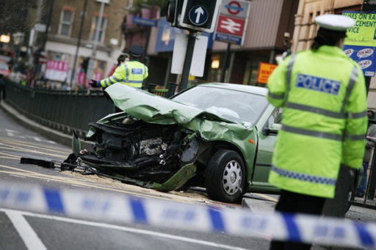
Figure 27 Police at an accident scene
View description - Figure 27 Police at an accident scene

The police and an ambulance attended the scene, where Arjun admitted what had happened. Shanice suffered a concussion and broken ribs. She had to take four weeks off work to recover.

7.2.2 In the criminal court
The car accident will lead to proceedings in both the criminal and civil courts. You will consider the criminal case first.

Activity 14 In the criminal court
Allow 5 minutes
A few weeks after the accident, Arjun receives a magistrates’ court summons for careless driving contrary to Section 3 of the Road Traffic Act 1988 (RTA).

The purpose of the criminal proceedings is to:

Punish Arjun for his conduct
Compensate Shanice for her injuries and financial losses
View answer - Part
View comment - Part

Arjun pleads guilty at the first hearing. This means that there will not be a trial but the court will sentence him. Who will decide his sentence?

A panel of magistrates
A district judge
Either a panel of magistrates or a district judge
A jury
View answer - Part
View comment - Part

Arjun is fined and receives six penalty points on his driving licence. He is not ordered to pay compensation: the criminal court does not usually make a compensation order in a road-traffic accident case.

7.2.3 In the civil court
While the criminal court has punished Arjun for his careless driving, it has not compensated Shanice for her injuries or financial losses. She will therefore need to start a civil case.

Activity 15 In the civil court
Allow 2 minutes

The purpose of the civil court proceedings is:

To punish Arjun for his careless driving
To compensate Shanice for her injuries and financial losses
Both to punish Arjun and to compensate Shanice
View answer - Activity 15 In the civil court
View comment - Activity 15 In the civil court

Shanice brings a claim for the civil wrong of negligence. A person is negligent if they fail to take reasonable care and, as a result, cause loss, harm, or injury to someone else. The central question will be similar to that in the criminal court: whether Arjun’s driving was of an adequate standard. Arjun’s guilty plea in the magistrates’ court can be used as evidence in the civil case.
The civil court will not punish Arjun. It will order him to pay compensation to Shanice. That compensation will include an amount for the pain and suffering her injuries caused her, as well as the cost of repairing the damage to her car, any wages she lost, and any expenses she incurred as a result of the accident.

7.3 Mixture?
The criminal and civil legal systems have different aims and purposes, different laws, and different courts. However, they also overlap: the same incident can give rise to both civil and criminal proceedings.
You have now considered a number of common myths about criminal cases and the criminal courts. You will have a final opportunity to reflect on your thoughts about the criminal justce system in the last section.

Conclusion
In this course you have considered how the criminal justice system differs from its popular image. By exploring a number of common myths and considering whether they are true, you have considered the court system and the people who work in it, as well as the purposes of criminal law and punishment.
Take a moment to reflect on how your impressions of the criminal law and courts have started to change. At the start of this course, you associated the following symbols with criminal justice:
Reflection point
Has the meaning of those symbols changed at all for you? Do you have a different image of Lady Justice now?

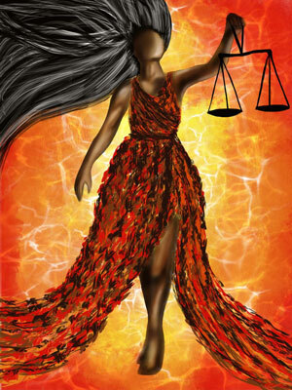
Figure 28 Equality and balance
View description - Figure 28 Equality and balance

You should now be able to:
- explain some key features of the criminal justice system
- describe some key features of the criminal law
- understand the truth about the biggest myths around criminal law and the criminal courts.
This OpenLearn course is an adapted extract from the Open University course W111 Criminal law and the courts.

References
Bar Standards Board (2020) Diversity at the Bar 2019. London: Bar Standards Board. Available at: https://www.barstandardsboard.org.uk/uploads/assets/912f7278-48fc-46df-893503eb729598b8/Diversity-at-the-Bar-2019.pdf (Accessed: 10 October 2020).
Crown Prosecution Service (no date) The Crown Prosecution Service. London: Crown Prosecution Service. Available at: https://www.cps.gov.uk/ (Accessed: 24 October 2020).
Hale, B. (2017) Judges, power and accountability [Speech]. Constitutional Law Summer School, Belfast, 11 August.
Magistrates Association (2019) History of the magistracy. London: Magistrates Association. Available at: https://www.magistrates-association.org.uk/About-Magistrates/History-of-the-magistracy (Accessed: 10 October 2020).
Mill, J. (1859) On Liberty. London: Parker & Son.
Ministry of Justice (2015) Code of Practice for Victims of Crime. London: Ministry of Justice. Available at: https://assets.publishing.service.gov.uk/government/uploads/system/uploads/attachment_data/file/476900/code-of-practice-for-victims-of-crime.PDF (Accessed: 25 October 2020).
Ministry of Justice (2020a) Criminal court statistics quarterly, England and Wales, January to March 2020. London: Ministry of Justice. Available at: https://assets.publishing.service.gov.uk/government/uploads/system/uploads/attachment_data/file/895063/ccsq_bulletin_jan_mar_2020.pdf (Accessed: 3 October 2020).
Ministry of Justice (2020b) Criminal Justice Statistics quarterly, England and Wales, April 2019 to March 2020. London: Ministry of Justice. Available at: https://assets.publishing.service.gov.uk/government/uploads/system/uploads/attachment_data/file/910530/criminal-justice-statistics-quarterly-march-2020.pdf (Accessed: 10 October 2020).
Ministry of Justice (2020c) Diversity of the judiciary: Legal professions, new appointments and current post-holders. London: Ministry of Justice. Available at: https://www.gov.uk/government/statistics/diversity-of-the-judiciary-2020-statistics (Accessed: 10 October 2020).
Sentencing Council (2020) Sentencing Guidelines for use in Magistrates’ Court. London: Sentencing Council. Available at: https://www.sentencingcouncil.org.uk/offences/magistrates-court/item/theft-from-a-shop-or-stall/ (Accessed: 25 October 2020).
Solicitors Regulation Authority (2020) How diverse is the legal profession? London: Solicitors Regulation Authority. Available at: https://www.sra.org.uk/sra/equality-diversity/key-findings/diverse-legal-profession/ (Accessed: 10 October 2020).
Taylor, M. (2020) ‘Concerns about ‘reckless’ driving and ‘boy racers’ speeding on Taunton road with three schools’. Somerset Live, 9 August. Available at: https://www.somersetlive.co.uk/news/somerset-news/cheddon-road-speeding-traffic-resident-4398394 (Accessed 11 March 2021).
The National Archives (no date) Black Presence: Asian and Black History in Britain, 1500–1850. London: The National Archives. Available at: https://www.nationalarchives.gov.uk/pathways/blackhistory/work_community/wealthy.htm (Accessed: 4 December 2020).

Acknowledgements
[Editor: Bernie to provide final acks. Acks below have been lifted from the module content s does not fully apply.]
This free course was initially written by Caroline Derry and amended by Liz Hardie. It was first published in September 2023.
Except for third party materials and otherwise stated (see terms and conditions), this content is made available under a Creative Commons Attribution-NonCommercial-ShareAlike 4.0 Licence.
The material acknowledged below and within the course is Proprietary and used under licence (not subject to Creative Commons Licence). Grateful acknowledgement is made to the following sources for permission to reproduce material in this free course:

Figures
Figure 1: Geraint Lewis/Alamy Stock Photo
Figure 3: junial/iStock /Getty Images Plus
Figure 4: Walter Rawlings/Robert Harding World Imagery/Universal Images Group
Figure 5: ©iStockphoto.com/IS_ImageSource
Figure 6: Simon Turner/Alamy Stock Photo
Figure 8: photogl/iStock/Getty Images Plus
Figure 9: Mr Justice Lush, the New Judge (engraving), English School, (19th century)/Private Collection/Look and Learn/Illustrated Papers Collection/Bridgeman Images
Figure 10: Gary Weaser/Stringer/Getty Images
Interactive in Activity 4: PA Images/Alamy Stock Photo
Figure 11: Taken from https://twitter.com/inner_temple/status/1048208636038840321
Figure 12: Police officers at a protest: Andrew Moreton/Flickr This file is licenced under Creative Commons Attribution-NonCommercial-ShareAlike 2.0 Generic (CC BY-NC-SA 2.0) (https://creativecommons.org/licenses/by-nc-sa/2.0/)
Figure 13: Postal Requisition: (2011)The Prosecution Team Manual of Guidance For the preparation, processing and submission of prosecution files,. www.patrolofficer.co.uk/
Figure 14: © Health and Safety Executive Logo, © Food Standards Agency, © Office of Fair Trading, © Serious Fraud Office and © Financial Conduct Authority
Figure 15: Max Hill QC/Open Government License., www.cps.gov.uk/about-cps (Accessed 8th June 2021)
Figure 16: tanakawho/Flickr This file is licences under Creative Commons Attribution-NonCommercial 2.0 Generic (CC BY-NC 2.0) (https://creativecommons.org/licenses/by-nc/2.0/)
Figure 17: Kit/Flickr This file is llicensed under Creative Commons Attribution-NonCommercial 2.0 Generic (CC BY-NC 2.0), (https://creativecommons.org/licenses/by-nc/2.0/)
Figure 18: © Chris Dorney | Dreamstime.com
Figure 19: West Midlands Police/Flickr This file is licensed under Creative Commons Attribution-ShareAlike 2.0 Generic (CC BY-SA 2.0), (https://creativecommons.org/licenses/by-sa/2.0/)
Figure 20: Diverse Images/Universal Images Group
Figure 24: MICHAEL DONNE/SCIENCE PHOTO LIBRARY/Universal Images Group
Figure 25: Latifat Obanigba

Text
Box 6: The Crown Prosecution Service., (2017), www.cps.gov.uk/ .,(Accessed: 24 October 2020) Contains public sector information licensed under the Open Government Licence v2., (www.nationalarchives.gov.uk/doc/open-government-licence/version/2/)
Box 9: Taylor, M.,( 2020).Concerns about ‘reckless’ driving and ‘boy racers’ speeding on Taunton road with three schools., Somerset Live ., 5th August., [online] https://www.somersetlive.co.uk/news/somerset-news/cheddon-road-speeding-traffic-resident-4398394 (Accessed 22nd April 2021)

Solutions

Activity 1 Symbols of criminal law

Comment
Some popular symbols include:
- A pair of handcuffs
- A gavel
- Lady Justice (often holding scales and a sword)
- A barrister’s wig.

Figure 3 A gavel
View description - Figure 3 A gavel

However, the gavel is never found in the courts of England and Wales.

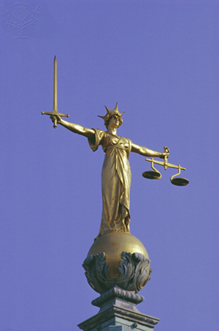
Figure 4 Lady Justice above the Old Bailey
View description - Figure 4 Lady Justice above the Old Bailey

Does Lady Justice wear a blindfold? The most famous British statue of her, on top of the Old Bailey, does not.
Back to - Activity 1 Symbols of criminal law

Activity 2 Crown Court

Answer
Right:
Fewer than 10 per cent
Wrong:
More than 80 per cent
About 50 per cent
About 20 per cent
Back to - Activity 2 Crown Court

Comment
Fewer than 10 per cent of criminal cases are sent to the Crown Court. Most cases are dealt with by magistrates’ courts alone.
Back to - Activity 2 Crown Court

Activity 3 Guilty pleas

Answer
Right:
More than two-thirds
Wrong:
About half
Fewer than one-third
Fewer than one-tenth
Back to - Activity 3 Guilty pleas

Comment
More than two-thirds of defendants in the Crown Court plead guilty (Ministry of Justice, 2020a). The proportion is even higher in magistrates’ courts.
Back to - Activity 3 Guilty pleas

Activity 4 Name three judges

Comment
You may have thought about some fictional judges such as Judge John Deed (TV series of the same name), Judge Roy Snyder (TV series The Simpsons), Judge Bullingham (Book and TV Series Rumpole of the Bailey) or Judge Judy (TV series of the same name). Alternatively you may have considered some real judges such as Baroness Lady Brenda Hale (former UK Supreme Court judge), Baron Tom Denning (former Master of the Rolls, UK Court of Appeal) or Clarence Thomas or Ruth Bader Ginsberg (Supreme Court Justices of the USA). Were the judges you considered male or female? What was their ethnicity and background? You will now consider whether the myth of the ‘old white male judge’ is accurate.
Back to - Activity 4 Name three judges

Activity 5 Judicial diversity

Part

Comment
You might have mentioned disability, gender identity, sexuality, religion, education, or social class. There are concerns about all these forms of diversity among the judiciary, but as you saw earlier, there is less information about these.
Back to - Part

Part

Comment
The first woman Supreme Court judge, Baroness Hale, gave the following reasons why judicial diversity matters (Hale, 2017):

Interactive content is not available in this format.

Did you think of any others?
Back to - Part

Activity 6 Police enforce the law

Part

Answer
Right:
c. 58
Wrong:
a. 125
b. 31
d. 43
Back to - Part

Part

Answer
Right:
a. Metropolitan police
Wrong:
b. Greater Manchester police
c. South Wales police
d. North Yorkshire police
Back to - Part

Part

Answer
Right:
c. 142,145
Wrong:
a. 165,295
b. 151,875
d. 130,825
Back to - Part

Activity 7 Match the crime to the investigator/prosecutor

Answer
The correct matches are:
Health and Safety Executive
Breach of health and safety regulations
RSPCA
Causing unnecessary suffering to an animal
Financial Conduct Agency
Insider-dealing in shares
Food Standards Agency
Breach of food hygiene regulations
Serious Fraud Office
Conspiracy to commit a complex fraud
Back to - Activity 7 Match the crime to the investigator/prosecutor

Comment
This activity illustrates how these agencies bring prosecutions only for specific offences related to their particular responsibilities.
Back to - Activity 7 Match the crime to the investigator/prosecutor

Activity 8 Have you ever?

Comment
Most people have done at least one of the things on this list. If you ticked ‘yes’ to any, take a moment to consider whether you felt at the time that you were acting immorally, and what you think now.
Back to - Activity 8 Have you ever?

Activity 9 Immoral or illegal?

Comment
You may well consider that Joshua’s failure to help the child is immoral. However, it is not illegal. The criminal law of England and Wales – unlike many other legal systems – does not generally criminalise omissions (i.e. failing to do something), although there are important exceptions.
Back to - Activity 9 Immoral or illegal?

Activity 10 Who is the victim?

Part

Comment
It is not easy to identify the victim in this scenario, and views may change in light of the extra information. It is arguable that neither party was a victim of crime, that both were, or that the victim changed according to the facts. There is no right answer here.
Back to - Part

Activity 11 Sentencing Act 2020

Answer
The correct matches are:
Retribution
The punishment of offenders
Deterrence
The reduction of crime (including its reduction by deterrence)
Rehabilitation
The reform and rehabilitation of offenders
Incapacitation
The protection of the public
Reparation
The making of reparation by offenders to persons affected by their offences
Back to - Activity 11 Sentencing Act 2020

Activity 12 You decide the sentence

Part

Comment
The sentence you choose (e.g. a prison sentence, community sentence or fine) will depend upon which factors you consider to be important. Should the court prioritise deterring Mairead from committing further offences? Should it focus on incapacitating her from committing more thefts? Might rehabilitation be the best way of preventing future offences? Do Mairead’s caring responsibilities affect your opinion?
Back to - Part

Part

Comment
You might think that this sentence is appropriate for shoplifting of this value, especially taking into account Mairead’s personal circumstances. However, is it appropriate for a frequently repeated offence?
Back to - Part

Part

Comment
If you considered a fine or conditional discharge to be appropriate, you may not have changed your view. However, if you thought it was too lenient then you might use the guidelines to suggest a more severe sentence.
Back to - Part

Part

Comment
This type of case frequently comes before the courts. It can be difficult to balance all the factors and decide on an appropriate sentence.
You might consider whether criminal prosecution is the best answer here. Is it helpful to consider Mairead’s thefts in isolation from their social context, including the level of financial and practical support she and her child receive?
Back to - Part

Activity 13 Criminal or civil case?

Part

Answer
Criminal case
Back to - Part

Part

Answer
Civil case
Back to - Part

Part

Answer
Civil case
Back to - Part

Part

Answer
Criminal case
Back to - Part

Activity 14 In the criminal court

Part

Answer
Right:
Punish Arjun for his conduct
Wrong:
Compensate Shanice for her injuries and financial losses
Back to - Part

Comment
The purpose of the criminal prosecution is to punish Arjun.
Back to - Part

Part

Answer
Right:
Either a panel of magistrates or a district judge
Wrong:
A panel of magistrates
A district judge
A jury
Back to - Part

Comment
In the magistrates’ court, either a panel of magistrates or a district judge decides the sentence. A jury only sits in the Crown Court, where it decides the verdict but not the sentence.
Back to - Part

Activity 15 In the civil court

Answer
Right:
To compensate Shanice for her injuries and financial losses
Wrong:
To punish Arjun for his careless driving
Both to punish Arjun and to compensate Shanice
Back to - Activity 15 In the civil court

Comment
The purpose of civil proceedings is compensation, not punishment.
Back to - Activity 15 In the civil court

Figure 1 Courtroom drama

Description
Illustrative image of a scene from a play: in the foreground, a young white woman with red hair and a dark hat and coat looks dramatically towards the camera; in the background, a judge and court clerk in robes and wigs look towards her.
Back to - Figure 1 Courtroom drama

Figure 2 The scales of justice

Description
Illustrative image of an old-fashioned set of balance scales with two pans hanging from either end of a horizontal beam.
Back to - Figure 2 The scales of justice

Figure 3 A gavel

Description
Illustrative image of a gavel – i.e. a small, wooden hammer – resting on a flat piece of wood. In the background, the scales of justice are visible.
Back to - Figure 3 A gavel

Figure 4 Lady Justice above the Old Bailey

Description
Illustrative image of a gilded statute of a woman wearing a long robe and crown. In her right hand she holds an upraised sword. In her left hand she holds a set of balance scales.
Back to - Figure 4 Lady Justice above the Old Bailey

Figure 5 A jury

Description
Illustrative image of men and women of various ethnicities sat in two rows, paying attention to a man whose hand and torso are visible in the foreground.
Back to - Figure 5 A jury

Figure 6 Interior of a magistrates’ court

Description
Illustrative image of a magistrates’ courtroom. There is a raised bench with three chairs at the back of the room, and a clerks’ bench with two chairs in front of it; both face towards the camera. In the centre are two long desks with seating for lawyers, facing towards the bench and away from the camera; to the left is the dock with a glass screen and to the right, a witness box.
Back to - Figure 6 Interior of a magistrates’ court

Figure 7 Criminal court process

Description
This figure consists of a series of boxes connected by arrows, showing the process of a criminal case through the courts. It begins with charge or summons, followed by the first hearings in the magistrates’ court. If the case remains in the magistrates’ court, and the defendant pleads guilty, the final stage is sentencing. If the defendant pleads not guilty, there will be a trial. If the defendant is found not guilty, the case ends. If the defendant is found guilty, the final stage is sentencing. If the case is sent to the Crown Court and the defendant pleads guilty, the final stage is sentencing. If the defendant pleads not guilty, there will be a trial. If the defendant is found not guilty, the case ends. If the defendant is found guilty, the final stage is sentencing.
Back to - Figure 7 Criminal court process

Figure 8 An older, white, male judge

Description
Illustrative image showing a nineteenth-century engraving of an older white man wearing a judge’s wig and robes.
Back to - Figure 8 An older, white, male judge

Figure 9 Rose Heilbron

Description
Illustrative head-and-shoulders photographic portrait of Rose Heilbron wearing a judge’s wig and robes.
Back to - Figure 9 Rose Heilbron

Figure 10 Tunji Sowande

Description
Illustrative head-and-shoulders photographic portrait of Tunji Sowande wearing a barrister’s wig and robe.
Back to - Figure 10 Tunji Sowande

Uncaptioned interactive content

Description
The pie charts in this interactive show: 32 per cent of judges were women. 8 per cent of judges identified as black, Asian or ethnic minority. 76 per cent of judges were aged 50 or over, and 40 per cent were 60 or over.
Back to - Uncaptioned interactive content

Figure 11 Police officers at a protest

Description
Illustrative photograph showing two police officers with their backs to the camera. They wear high-visibility vests saying ‘Heddlu – Police’. (‘Heddlu’ is the Welsh word for ‘police’.) They are looking at a group of people wearing raincoats and carrying umbrellas, and a placard.
Back to - Figure 11 Police officers at a protest

Figure 12 A postal requisition

Description
Illustrative image of a postal requisition document with blank spaces for details of the defendant, the charge, and the time and place they should attend court.
Back to - Figure 12 A postal requisition

Figure 13 Government agencies

Description
This figure shows the logos of four different government agencies. These include: Health and safety executive, Financial conduct authority, Food standards agency, Serious fraud office and Office of fair trading.
Back to - Figure 13 Government agencies

Figure 14 Max Hill QC, Director of Public Prosecutions

Description
Illustrative head-and-shoulders photographic portrait of Max Hill QC.
Back to - Figure 14 Max Hill QC, Director of Public Prosecutions

Figure 15 Cycling

Description
Illustrative photograph of the lower part of a bicycle being ridden through a puddle.
Back to - Figure 15 Cycling

Figure 16 Canal path

Description
Illustrative photograph of a short stretch of canal with an unpaved path running alongside it. In the background is a bridge crossing the canal, with steps leading up to it from the path.
Back to - Figure 16 Canal path

Figure 17 The Victims’ Code

Description
The Victims’ Code logo. It shows two hands apart, one with palm facing upwards and the other palm facing down.
Back to - Figure 17 The Victims’ Code

Figure 18 Speed limit sign

Description
Illustrative photograph of a quiet street. On the right-hand side are houses; on the left of the image is a pavement with a pedestrian walking away from the camera. Cars are parked on both sides of the road. A white van is being driven towards the camera and a small black car is being driven away from it.
Back to - Figure 18 Speed limit sign

Figure 19 Police cannabis-disposal team

Description
Illustrative photograph of three uniformed police officers standing behind a table covered with healthy cannabis plants. The room is painted white and has strong lighting with silver-covered shades.
Back to - Figure 19 Police cannabis-disposal team

Figure 20 Behind Bars

Description
A picture showing two hands clasping the bars of a prsion cell.
Back to - Figure 20 Behind Bars

Figure 20 Pie Chart

Description
A pie chart with three segments. The largest indicates ‘fine’ and the two smaller segments are for ‘other sentences’ and ‘prison’. The title for the pie chart is ‘Sentencing March 2019-2020’.
Back to - Figure 20 Pie Chart

Figure 21 Court and probation

Description
Illustrative photograph of a fingerpost sign. One finger points to ‘PROBATION’. The other finger points to ‘MAGISTRATE COURT’.
Back to - Figure 21 Court and probation

Figure 22 County Court

Description
A photograph of the outside of Reading County Court. The building appears to be located on a city centre street.
Back to - Figure 22 County Court

Figure 23 Old Bailey criminal court

Description
A photograph of the outside of the Old Bailey which sits on the corner of a junction of a central London street.
Back to - Figure 23 Old Bailey criminal court

Figure 24 The criminal court system

Description
This figure consists of a series of boxes, representing various courts. Upward-pointing arrows show the route of appeals from one court to another. Mauve boxes represent courts of first instance, which hear only new cases, light brown boxes represent appellate courts, which hear only appeals and a light green box represents a court that is both a court of first instance and an appellate court. At the bottom of the figure is a mauve box labelled ‘Magistrates’ Courts’, showing that these are courts of first instance. Two arrows go up from the box labelled ‘Magistrates’ Courts’. One arrow goes to a green box labelled ‘The Crown Court’, showing that the Crown Court is a court of first instance and an appellate court. The other goes to a light brown box labelled ‘Divisional Court of the Queen’s Bench Division of the High Court’, showing that this is an appellate court. One arrow from each of the ‘The Crown Court’ and ‘Divisional Court of the Queen’s Bench Division of the High Court’ boxes goes up to a light brown box labelled ‘Court of Appeal (Criminal Division), showing that this is an appellate court. An arrow from the ‘Court of Appeal (Criminal Division)’ box goes up to the light brown box at the figure, which is labelled ‘Supreme Court’, showing that this is the highest UK appellate court.
Back to - Figure 24 The criminal court system

Figure 25 The civil court system

Description
This figure consists of a series of boxes, representing various courts. Upward-pointing arrows show the route of appeals from one court to another. Mauve boxes represent courts of first instance, which hear only new cases, and light brown boxes represent appellate courts, which hear only appeals. At the bottom of the figure there are two mauve boxes side by side, representing two courts of first instance. These are labelled ‘The County Court’ and ‘Magistrates’ Courts (jurisdiction on a limited range of civil matters)’. One arrow from each of the ‘The County Court’ and ‘Magistrates’ Courts (jurisdiction on a limited range of civil matters)’ boxes goes up to a light brown box labelled ‘Divisional Courts of the High Court’, showing that these are appellate courts. Next to this light brown box is a mauve box labelled ‘The High Court: Queen’s Bench, Family and Chancery Divisions’, showing that these are courts of first instance. One arrow from each of the ‘Divisional Courts of the High Court’ and ‘The High Court: Queen’s Bench, Family and Chancery Divisions’ boxes goes up to a light brown box labelled ‘Court of Appeal (Civil Division), showing that this is an appellate court. An arrow from the ‘Court of Appeal (Civil Division)’ box goes up to the light brown box at the figure, which is labelled ‘Supreme Court’, showing that this is the highest UK appellate court.
Back to - Figure 25 The civil court system

Figure 26 Standards of proof

Description
This image shows two sets of balance scales. The left pan of the first set of scales is tipped as far down as it can go; this set of scales is labelled ‘beyond reasonable doubt’. The left pan on the second set of scales is tipped only slightly down; this set of scales is labelled ‘balance of probabilities’.
Back to - Figure 26 Standards of proof

Figure 27 Police at an accident scene

Description
Illustrative photograph showing a car in the middle of a road junction with a badly-damaged front. Several uniformed police officers are nearby. In the foreground, blue-and-white tape is visible.
Back to - Figure 27 Police at an accident scene

Figure 28 Equality and balance

Description
Illustrative painting of a Black woman with a long red dress and long, flowing hair. She holds up a set of balance scales. Behind her is a yellow background, darkening to orange near the edges of the image.
Back to - Figure 28 Equality and balance

Women lawyers and judges

Transcript
KAREN SHUMAN:
My name is Karen Schumann. I'm a chancery master. I was a barrister in independent practise. And unusually, because most people are a part-time judge before they take up a full-time appointment, I went straight from full-time barristering to full-time judging.
VICTORIA MCCLOUD:
My name's Victoria McLeod, and I'm currently a Queen's Bench master in the high court in London. I began life after school studying psychology, and I did research after university in how the human brain perceives things in three dimensions. So I did a doctorate in psychology.
But I always wanted to ultimately end up being a lawyer. So I qualified as a barrister, and I practised as a barrister in general common law for several years, from I think 1995 till 2010, when I was lucky enough to be appointed as a full-time judge in the Queen's Bench division in the high court.
REHANA POPAL:
My name is Rehana Popal. I'm a barrister. I practise at 33 Bedford Row Chambers. My practise is quite wide ranging, but it predominantly encompasses public law, and within that, immigration asylum, human rights.
It came as quite a surprise to me when I qualified, to find out that I was the first-ever Afghan female to qualify. It wasn't something that I set out to do. It just happened. That wasn't the goal or the objective.
Being in my position, I think, A: I realise how much more we have to do for inclusion and diversity, just generally along the bar. But also, I have faced other challenges in my day-to-day, whether or not that's discrimination from a client because they want, for example, a white male barrister.
KAREN SHUMAN:
In terms of my experiences as a woman barrister, I felt that entering the legal profession was very supportive, actually. Inevitably, many of the people, the experienced people I met were men. And they were incredibly supportive for me. So I had a really positive start to practise. So as a woman, I didn't see any of the problems that I am aware do happen in practise.
I say that because I chair the Equality, Diversity, and Inclusion Committee at Lincoln's Inn. So I do hear horror stories from other women. I would say that my experiences changed when I was pregnant with my first child. The experiences being pregnant as a woman barrister, I think, were regrettable with some of the support staff, because they made judgments about me. And they were matters for me or matters for my husband and I and not for clerks to make decisions on my behalf.
And so that was the first time that I really experienced or obviously experienced sexism in practise. I certainly have never experienced it from any judge or from any colleague.
VICTORIA MCCLOUD:
I'm kind of interesting in that I wasn't always a woman barrister, in the sense that I started my career, as far as everyone else was concerned, a male barrister and actually spent a couple of years before transitioning. So I spent most of my life, as far as the world was concerned, as a woman barrister. But actually very, very early on, I wasn't. So I've had the interesting experience of at least appearing to be both at various times.
Experience of, certainly as a woman barrister, certainly occasions-- this is way back when. I hope it's changed. I don't know if it has. I've haven't been a woman barrister for years. I've been a judge.
But certainly sometimes not really being heard. I mean, sometimes I would say something, and it was as if I haven't said it, which could be frustrating. But actually, mostly, I think because the bar is largely self-employed, and certainly in my day, it was virtually all self-employed, I think there is more opportunity to sort of make your own way.
REHANA POPAL:
Being dyslexic, it's been incredibly challenging at times. It was very challenging during universities. So throughout studying my undergrad, postgraduate, and particularly bar school, the BPTC, the Bar Professional Training Course, at that time what it was when I was studying, isn't set up for those who are dyslexic.
And there's a really big misconception about dyslexia. People forget that it's not the case of you're not clever enough, or you're not bright, or anything of that nature. It's rather the way you think is slightly different. Now, I believe, and in my practise, I believe that's given me a strategic advantage. I'm able to look at things from a wholly different angle that actually the vast majority of people who aren't dyslexic don't necessarily see.
VICTORIA MCCLOUD:
Anyone who's got the privilege of making decisions is bound to be disliked. Like all judges, one gets abuse. One gets emails. One gets social media stuff, even though I'm not active in social media. But there's stuff out there. All judges get that. Women judges get it, I think, more. And if you happen to be trans and a woman judge, you get the full set.
KAREN SHUMAN:
In terms of whether the profession is changing as a result of increasing attention to diversity, yes, because there is more equality in terms of, if one just looks at gender alone, there is more equality with people entering the profession. But I don't think that the profession is changing fast enough thereafter. There are still barriers, particularly for women and from anyone from a minority ethnic background, to not only getting a foot on the career ladder at the bar but having a free choice on the subject areas they practise in. And then a particular problem is retention. And all of that is an issue because in the main, but not wholly, the judiciary is drawn from the bar.
REHANA POPAL:
Though it takes years for a person to become a senior member of the bar, so going from a junior barrister to when you take silk, maybe 15, 20 years, to when you're called to the bench, maybe 10 years thereafter, that progress takes time. And it's important that we recruit and retain people that are reflective of the community and society that it represents. Because when they don't represent the community and society, there's a sense of disjointedness, particularly when it had comes to how people feel about the profession.
VICTORIA MCCLOUD:
Diversity's increasing gradually. I mean the profession is obviously a big word. Depends on which bit of profession you're talking about. So for example, the Institute of Paralegals is the most diverse branch of the legal profession. Solicitors, very diverse. The bar, I think, less, and the judiciary even less. And the senior judiciary, still less again.
So for example, and by Jove, don't they know it, many judges now know a trans judge, which they might not have known otherwise. So they hopefully will find it harder, and I'm sure they don't, to harbour certain sorts of prejudice that might have been there in ignorance of actually knowing someone. And that, I think, must go for all sorts of other groups, too. It can blow stereotypes.
KAREN SHUMAN:
Suppose I would make three points in relation to why it is important. One, I firmly believe that the legal profession should reflect society. Secondly, you should bring in people with different perspectives and backgrounds. And thirdly, you should open up the experiences that that cohort of people have. Because ultimately, it makes us a better decision maker.
And that doesn't just mean a judge. It means a lawyer acting on a case. And I think that if you have a more diverse and inclusive legal profession, then you have a greater legitimation for that legal profession. You have more public confidence. Because otherwise, you risk alienation.
So I think it is vital in any modern society that you have as diverse a legal profession as possible. And diversity does not mean that you water down the qualities and values of that legal profession. It only adds to them.
Back to - Women lawyers and judges

Ethnic minority lawyers and judges

Transcript
REHANA POPAL:
My name is Rehana Popal. I'm a barrister. And I practise at 33 Bedford Row Chambers. My practise is quite wide-ranging, but it predominately encompasses public law, and within that, immigration asylum, human rights.
LESLIE THOMAS:
My name is Leslie Thomas. I'm a Queen's Counsel. That means that I am a senior barrister.
I've been practicing for about 30 years. I practise in the field of human rights, actions against the state, actions against the police, some of the civil litigation. I'm a former Head of Chambers at one of the largest sets of chambers. Set of chambers is an office where barristers work. I'm now just practicing. I'm also a Professor of Law at Gresham College and a Visiting Professor of Law at University of London, Goldsmiths College.
REHANA POPAL:
The reason why I decided to enter the legal profession at that point as a child wasn't a sense of I need to justice or safeguard other people. It was from watching a TV show. That my brother walks into the living room. My brother was watching a show.
And I said, who are these people who wear wigs and standing in court and talk? And he said, barristers. I was like, OK, great. That's what I'm going to do when I grow up.
I think the attraction specifically to immigration comes from my own background, having that immigrant background. And it resonated with me. And just always having that kind of broader international human rights interest. And I think it was kind of the mixture of my background being here and that general interest in politics that kind of all folded into my immigration interest.
LESLIE THOMAS:
I decided to enter the legal profession for two main reasons. When I was at school, we had a really inspirational sociology teacher, who encouraged me to think outside the box. And I wanted to do something where I could use my mind.
The second reason why I decided to enter the profession was due to an unfortunate experience that I had when I was about 14, 15 years old. I was walking home from school one afternoon. I was in school uniform.
And I was stopped by a number of police officers, who decided to do a random search on me for no good reason. When I asked the officers why they wanted to search me, I was told simply to shut up, turn out my pockets, and put up with it. I'll never forget that day.
I thought to myself, this is unfair, unjust. I thought I was randomly picked up for no good reason. And I thought, perhaps I could do something to redress the balance and use the negative energy I had from that situation and turn it into something positive. So I decided that I wanted to become an advocate, a barrister, one of those lawyers who appears in court and argues for the rights of others.
REHANA POPAL:
So when I qualified, I didn't know at the time that I was going to be the first ever Afghan female to qualify in England and Wales. It wasn't an objective that I set out to do. It just happened by default.
LESLIE THOMAS:
I want to say a little bit about being in particular a black barrister at the bar in England and Wales. It's not easy. There have been times when I have experienced racism and discrimination.
Let me give you a couple of examples. I remember on one occasion I was entering the court building. And there was security there. And I stood in line and took my turn.
And I remember other barristers, white barristers, who were dressed just like me. The only difference between me and them was the colour of our skin. They were being waved through by the security guards, and I wasn't.
And I couldn't understand that. And when I got to the security guard, and I asked why they didn't wait their turn, I was effectively told that let them do their job. And I was searched even more thoroughly than they were. So that's one experience.
The second thing is, it's the assumptions people make about you. Oftentimes, these assumptions are unconscious assumptions. So I know many black lawyers who go into court. And they're assumed to be anyone other than the lawyer. So in my time, I've been assumed to be the defendant, the defendant's brother, the defendant's father, the clerk, or, perhaps, a friend.
REHANA POPAL:
My experiences whilst being at the bar so far is, it's all been on the whole very positive. But there have been times when I have felt discrimination. That predominantly comes from clients who, perhaps, pick. "Oh, I've wanted white male barristers," as opposed to young females or those who are ethnic minority. And that's been one of the challenges that I faced.
My client wanted a white male barrister because that client thought the judge is probably going to be a white male barrister, so they're probably more likely to understand one another. Now, that comes from an ignorant point of view I fully accept. But also, that's a failure of our judicial system or our legal system.
Because the reality is, our judiciary is not diversified. And that is the perception that she had of what a barrister needs to look like. And that is incorrect.
LESLIE THOMAS:
Diversity in a legal profession is important for a number of reasons. And I'm going to see if I can set those out. Firstly, I believe it's beneficial to have individuals of various talents, whether in the group, company, or social setting. It's what I describe as the variety argument why diversity matters. I think diversity makes us become more sensitive to traditions that we maybe aren't familiar with. And that, in turn, makes us better lawyers.
Different backgrounds and cultures approach conflict in different ways. And therefore, people with diverse backgrounds can provide different insights and new approaches to tackle legal problems and other moral dilemmas. And that makes us more creative. Productivity flourishes in culturally diverse settings. A mind expands when encountering different modes of thinking. Diversity provides innovation, which, in turn, makes us grow culturally and economically.
And finally, I believe diversity connects us. If we just look at the world's most cosmopolitan and integrated cities, these places have tangible benefits, from personal development to enriching communities and the economy as a whole. Diversity acts as a magnet, doesn't it? It attracts talent. And so in my mind, diversity can only be a good thing for the legal profession.
REHANA POPAL:
When you look at the kind of people coming through the court systems, and specifically for the area where I work in, which is asylum and immigration, these people are not going to be white or English. They don't need to claim asylum in England. They tend to or probably going to be from other third-world countries coming to the UK.
And so those experiences and being able to speak to them about their experiences or understanding their experiences are incredibly important in understanding their case and then being able to put it forward before the court or the tribunal in the best form that it can be. Diversity and inclusion is incredibly important because it affects every angle of the bar, whether or not it is people's perception of it, to the quality of advocates, to clients' confidence with the legal system. And so I believe, certainly, in my experience, that I think diversity and inclusion are incredibly important.
LESLIE THOMAS:
Despite the challenges, I think I would recommend a career at the bar for a number of reasons. I think there are very few professions where you get to be as creative, use your mind, help people, and challenge a system. You can do really good things.
And I'd had 30 years, with some negatives. But the vast majority of my time as a lawyer and, in particular, as a barrister has been positive. I just think it's an amazing career, and one that I would encourage people, particularly people of colour. Because I think it's important to have as much diversity as possible in this profession.
Back to - Ethnic minority lawyers and judges

Uncaptioned interactive content

Transcript
Caroline Derry:
I’m Caroline Derry. I’m here with a senior barrister and fellow member of the W111 module team, Mark Hill QC, to talk about sentencing.
Mark Hill:
We’ll take you through the sentencing process, which begins when the defendant either pleads guilty or is found guilty at trial.
CLD:
At that point, the court may sentence them immediately - but it will often adjourn the case to get reports. And by adjourn, I mean postpone it until another date.
MH:
You say the court – but who is actually doing the sentencing?
CLD:
In a magistrates’ court, it is a panel of lay magistrates or a district judge. In the Crown Court, it’s a judge – the jury does not get any say in the defendant’s sentence.
MH:
And what reports can the court get?
CLD:
The most common is a pre-sentence report prepared by a probation officer. That will give lots of information about the defendant’s background, their current circumstances, and the likelihood of them reoffending. It will also say whether they are suitable for a community sentence; and it may recommend the sort of sentence that is appropriate.
MH:
And the court can also get more specialist reports, such as a medical or psychiatric report?
CLD:
That’s right. The court will also have a copy of the defendant’s antecedents – their criminal record. But much of the information will come from the prosecution and defence lawyers. Mark, what will happen first at the sentencing hearing?
MH:
If the defendant pleaded guilty, or the case was adjourned for reports, the prosecution will begin by outlining the facts of the case. If the defendant pleaded not guilty and the trial has just happened, then obviously the court is familiar with the facts.
CLD:
So the prosecutor makes sure the court is aware of the relevant facts about the offence. What else will they tell the court?
MH:
If there is a Victim Personal Statement, the prosecutor can share that with the court.
CLD:
That’s a statement in which the victim explains the effect the crime had on them?
MH:
It is. The prosecution will also highlight significant features of the offence, particularly aggravating factors – which are things which make the offence more serious.
CLD:
Like the defendant having committed similar offences before?
MH:
Exactly – or it may be something about the offence itself, such as the victim being vulnerable, or the offence having been carefully planned.
The prosecution should also assist the court with any matters of law, for example by referring to relevant sentencing guidelines.
CLD:
Do the prosecution suggest what sentence the defendant should get?
MH:
No, that’s a matter for the magistrates or judge, not the prosecution. But they will ask for orders for the defendant to pay prosecution costs, compensation to the victim, and so on.
CLD:
So in summary, the prosecution tells the court the facts of the offence, its effect on the victim, the aggravating factors, and any matters of law.
MH:
Yes.
CLD:
And then the defence will make their plea in mitigation – in other words, they will present all the reasons why the court should give a lower sentence. They explain all the mitigating factors relevant to the offence, as well as any mitigating circumstances related to the defendant.
MH:
Mitigating factors are those which make the offence less serious. Can you give some examples?
CLD:
Well, a mitigating factor related to the offence might be that it was committed on the spur of the moment, or that the defendant only played a minor role in it. As for mitigating circumstances related to the offender, those might include that they haven’t been in trouble before, that they are the main carer for children, or that they are addressing the problems which led them to offend.
MH:
For example, they might be getting treatment for an addiction.
CLD:
Exactly. So the court is given a lot of information about the offence, the defendant, and the possible sentences. What does it do with that information?
MH:
It uses it to work through the sentencing guidelines, in order to decide the most appropriate sentence.
CLD:
Could you explain what the sentencing guidelines are?
MH:
They are guidance produced by the Sentencing Council, which takes the court step by step through the various considerations, in order to make a fair and consistent sentencing decision.
CLD:
So there are separate guidelines for different offences?
MH:
That’s right. But they all follow a similar format. The first step is to determine the sentencing range, which depends on two things – what is the level of culpability? And what is the degree of harm?
CLD:
Culpability, meaning blameworthiness. So having a leading role in a well-planned offence, or deliberately targeting vulnerable victims, is more culpable than taking part in the crime through coercion or on the spur of the moment.
MH:
Yes, and harm can be of various kinds – physical or financial, for example. The culpability and harm are considered together to decide whether the offence falls within a higher or lower category.
CLD:
And those factors together will give a starting point for the sentence, as well as a sentencing range. For example, a defendant with a medium level of culpability in a high-value theft – let’s call him Sam - faces a sentence of between 6 months and two years’ imprisonment, with a starting point of 1 year.
MH:
But Rita, a defendant with a low level of culpability in a low-value theft, can expect a fine roughly equivalent to her weekly income, with the sentencing range varying from a conditional discharge to a fine one and half times her weekly income.
CLD:
That’s right. The court takes the starting point, and then moves up and down within the sentencing range, depending on the aggravating and mitigating factors. So the starting point for Sam is a year in prison, but if there are significant aggravating features, such as previous convictions, that might increase to, say, 18 months.
MH:
While Rita can expect a fine, but if she has strong personal mitigation - like being very remorseful and having tried to make amends - that might be reduced to a conditional discharge.
CLD:
Yes – but there is a final step for the court to take. If the defendant pleaded guilty, their sentence will be reduced by up to one third.
MH:
So Sam’s 18 month sentence could be reduced to a year. Will the discount always be one-third?
CLD:
No, it depends on when they pleaded guilty. If they did so at the first opportunity, then they get the full discount. If they wait until the last minute – say, the first day of the trial - the reduction is only one-tenth.
MH:
And why do they get a reduced sentence for pleading guilty?
CLD:
Because it saves the victim and witnesses from having to give evidence in court, and it saves a lot of public time and money as well. It might also indicate that they are taking responsibility for their behaviour.
MH:
So: the court will use the sentencing guideline to decide the defendant’s level of culpability and the level of harm caused by the offence. Using those, it calculates the sentencing range and starting point. The sentence will move up the range from the starting point if there are aggravating factors, and down again if there are mitigating factors. The sentence may then be reduced by up to one third if the defendant pleaded guilty rather than having a trial.
CLD:
That’s right. Having decided the appropriate sentence, what will the magistrates or judge do now?
MH:
They will explain all of that reasoning to the defendant and then tell them what the sentence is. They will also make any other orders, such as for compensation to the victim. The reasoning matter because it helps an appeal court to understand the judges thought process if the sentence is appealed. And these sentencing remarks are also important so that the public and the press understand the basis for the court’s penalty, especially in high profile cases.
CLD:
Well, that sounds pretty straightforward – the guidelines must make sentencing a lot easier!
MH:
In many cases, they do. However, there are still lots of difficult decisions for the court to make. For example, how do you deal with somebody who commits minor offences, but does so repeatedly?
CLD:
That’s a good point. And sometimes, the best option might not be available. For example, the court can only order a defendant to join a programme to treat their addiction or anger management if a place is available. But lack of funding means that often, it may not be.
MH:
No – but sending them to prison instead won’t do much to help them deal with those issues. In particular, short sentences disrupt the defendant’s life and carry a lot of stigma, but they don’t allow the prison time to work with them on addressing their offending behaviour or providing them with the training and education to help change their life.
CLD:
In summary, then, sentencing guidelines help the courts to make sentencing decisions, and also help to ensure that different courts make those decisions consistently with each other. However, they only assist – there are still difficult decisions for the courts to make.
MH:
Could you summarise the whole process for us?
CLD:
Of course. Once a defendant has pleaded guilty or been found guilty, the court will sentence them. The prosecution will outline the facts of the offence and highlight any aggravating factors. Then, the defence will make a plea in mitigation, setting out mitigating factors relevant to the offence and the offender. The court may have other information to help it, such as any pre-sentence report and their criminal record. It will use all of that information to apply the relevant sentencing guideline.
MH:
So there is a lot of information considered and care taken in passing sentence.
CLD:
Exactly! So now it’s over to our listeners to try to make a sentencing decision in the next activity.
Back to - Uncaptioned interactive content

Footnotes
1: Bebb v Law Society [1914] 1 Ch 286. Back to content
2: Shaw v DPP [1962] AC 220, 267–8 (Viscount Simonds). Back to content

