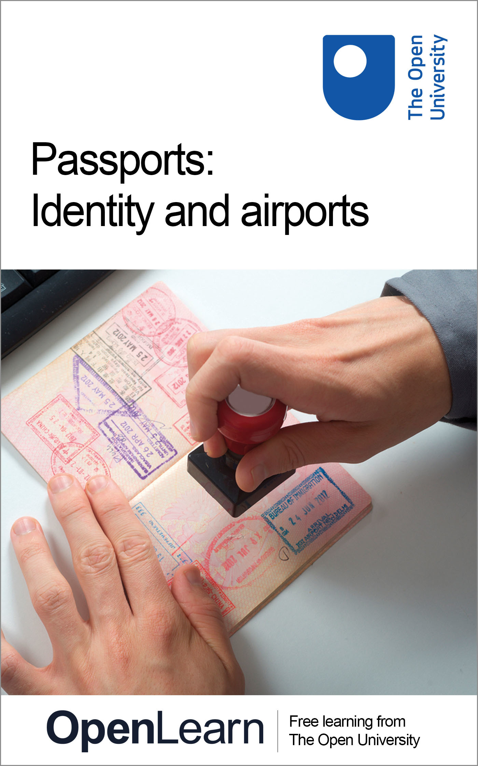

DD308_1

Passports: identity and airports
About this free course
This free course is an adapted extract from the Open University course DD308 Making social worlds www.open.ac.uk/courses/modules/dd308.
This version of the content may include video, images and interactive content that may not be optimised for your device.
You can experience this free course as it was originally designed on OpenLearn, the home of free learning from The Open University – www.open.edu/openlearn/society-politics-law/passports-identity-and-airports/content-section-0
There you’ll also be able to track your progress via your activity record, which you can use to demonstrate your learning.
Copyright © 2017 The Open University
Intellectual property
Unless otherwise stated, this resource is released under the terms of the Creative Commons Licence v4.0 http://creativecommons.org/licenses/by-nc-sa/4.0/deed.en_GB. Within that The Open University interprets this licence in the following way: www.open.edu/openlearn/about-openlearn/frequently-asked-questions-on-openlearn. Copyright and rights falling outside the terms of the Creative Commons Licence are retained or controlled by The Open University. Please read the full text before using any of the content.
We believe the primary barrier to accessing high-quality educational experiences is cost, which is why we aim to publish as much free content as possible under an open licence. If it proves difficult to release content under our preferred Creative Commons licence (e.g. because we can’t afford or gain the clearances or find suitable alternatives), we will still release the materials for free under a personal end-user licence.
This is because the learning experience will always be the same high quality offering and that should always be seen as positive – even if at times the licensing is different to Creative Commons.
When using the content you must attribute us (The Open University) (the OU) and any identified author in accordance with the terms of the Creative Commons Licence.
The Acknowledgements section is used to list, amongst other things, third party (Proprietary), licensed content which is not subject to Creative Commons licensing. Proprietary content must be used (retained) intact and in context to the content at all times.
The Acknowledgements section is also used to bring to your attention any other Special Restrictions which may apply to the content. For example there may be times when the Creative Commons Non-Commercial Sharealike licence does not apply to any of the content even if owned by us (The Open University). In these instances, unless stated otherwise, the content may be used for personal and non-commercial use.
We have also identified as Proprietary other material included in the content which is not subject to Creative Commons Licence. These are OU logos, trading names and may extend to certain photographic and video images and sound recordings and any other material as may be brought to your attention.
Unauthorised use of any of the content may constitute a breach of the terms and conditions and/or intellectual property laws.
We reserve the right to alter, amend or bring to an end any terms and conditions provided here without notice.
All rights falling outside the terms of the Creative Commons licence are retained or controlled by The Open University.
Head of Intellectual Property, The Open University

Contents
- Introduction
- Learning outcomes
- 1 The passport system
  - 1.1 Passport regimes – inclusion and exclusion
- 2 Passports and the airport
- 3 Aviopolis
- 4 Airports: the social, the material and the hybrid
  - 4.1 A material analysis of the airport
  - 4.2 Airports and hybrids
- Conclusion
- Acknowledgements

Introduction
We are all familiar with passports, but what can a sociological analysis tell us about these everyday objects? This free course, Passports: identity and airports, explores how the passport became a commonplace item and how material objects, such as the passport, have come to mediate modern air travel. Passports may seem like unremarkable everyday objects, but they’ve played a crucial, and often surprising, historical role in shaping the relationship between individuals and the social worlds in which they live. One place where we use a passport is at the airport, which we’ll explore as a case study later in this course.
This OpenLearn course is an adapted extract from the Open University course DD308 Making social worlds.

Learning outcomes
After studying this course, you should be able to:
- understand the historical and sociological context of how passports became commonplace
- identify ways in which passport regimes are used to sort, categorise, order and classify populations
- consider ways that the passport can produce racialised subjects
- understand how the passport has become a staple of security in the modern airport
- understand the role of matter and the material in making social worlds by using the airport as a case study.

1 The passport system

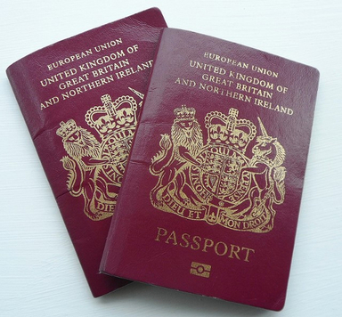
Figure 1 UK passports

Passport systems have a long and varied history. They’re probably the most widespread and enduring example of a ‘regime of identification’. The term ‘regime of identification’ refers to systematic efforts made by administrative bodies and governments to identify and register their populations. The regimes we’ll study in this section had some very different aims, but they share some common consequences. In particular, through identifying their populations, social worlds decide ‘who is who’, creating new categories which formalise who ‘belongs’ and who ‘does not’.
Now watch the video below which considers the history of various objects used to identify individuals. As you watch, consider the following questions:
- What different organisations have sought to identify people?
- What different devices have been used to aid identification?
- Who was identified and why?

Video content is not available in this format.
The passport – history
View transcript - The passport – history

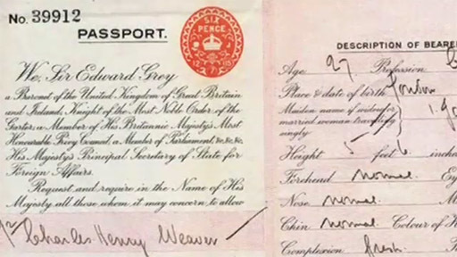

1.1 Passport regimes – inclusion and exclusion

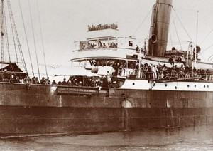
Figure 2 Komagatu Maru

We will now look more closely at the different ways in which passport regimes have functioned historically to meet social needs to regulate conduct. In the case study of early twentieth-century Canada to follow, you will see how a passport regime has been used to register individuals as part of a distinct social population. However, this process constantly leaches into efforts to categorise, sort, order and classify. At a minimum, identification and registration of individuals involve decisions about who is in and who is out. These decisions have been made on a variety of grounds including place of birth, ethnicity, race, class and – in some circumstances – gender. Categories such as race, class and gender often interact to produce sometimes subtle and sometimes overt processes of inclusion and exclusion.
Watch the video below, which is taken from an interview with sociologist Radhika Mongia, then complete Activity 1.

Video content is not available in this format.
Interview with Radhika Mongia
View transcript - Interview with Radhika Mongia

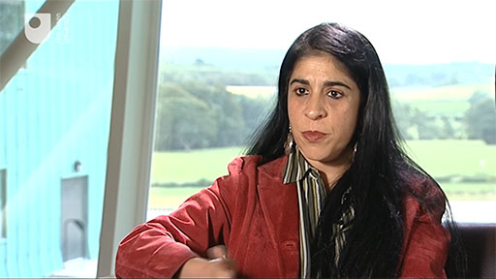

Activity 1

Answer the questions in the box below. When you have finished, read the following feedback.
- In what ways might passports produce racialised subjects?
- Is it more difficult for some people than for others to become attached to a new territory?
- Which groups of people were most subject to exclusion from Canada?

Provide your answer...
View discussion - Activity 1

2 Passports and the airport

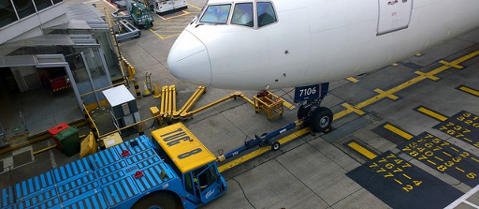
Figure 3 Airport

By now you should have an idea of how different objects have been used for identification purposes and how passport regimes are operated. You should also have had a chance to see how passport regimes have impacted on the lives of some individuals. In this section, we will be looking at the one place where we all use a passport – at the airport.
Now watch the video below which looks at the airport and the use of the passport within it, then attempt Activity 2.

Video content is not available in this format.
A sociological analysis of the airport
View transcript - A sociological analysis of the airport

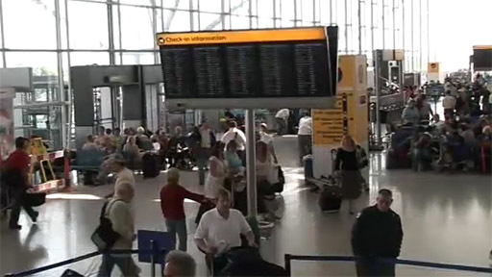

Activity 2

The video analyses the airport using the concepts of:
- Security
- Conduct
- Attachment.
In the boxes below, write some notes on how the video uses these concepts to analyse the airport. (You may wish to watch the video again.)

Security

Provide your answer...
View discussion - Untitled part

Conduct

Provide your answer...
View discussion - Untitled part

Attachment

Provide your answer...
View discussion - Untitled part

3 Aviopolis

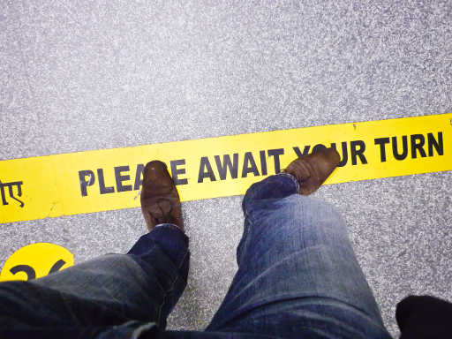
Figure 4 Mumbai airport

You’ll now look at an extract from the book Aviopolis: A Book about Airports by Gillian Fuller and Ross Harley (2004). Aviopolis is a critical study of airports and their place in social worlds. Using images and texts, it shows how information, architecture, people and machines are converging in the urban form of the airport. The extract combines cultural theory, schematic illustrations, technical photographs, and discourse to explore the airport as an ever-changing temporary city that could be anywhere.

Activity 3

You should read the extract now:
‘Anatomy of an airport’, from Fuller, G. and Harley, R. (2004) Aviopolis: A Book about Airports, London, Black Dog Publishing, pp. 16–49.

4 Airports: the social, the material and the hybrid

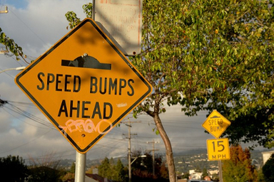
Figure 5 Speed bumps ahead

We have seen how the airport can be analysed using the concepts of security, conduct and attachment. But the airport can also be used to explore the sociology of matter.
The sociology of matter investigates the relationship between the social and the material, natural world. Are material objects primarily shaped by their social uses? Or does their material form in fact shape the social uses that spring up around them? The sociology of matter approaches these questions and the case study of the airport will explore them.
In a moment you will watch an extract from ‘Materiality and the airport’ that explores the sociology of matter by looking at the airport from two different perspectives:
- the social
- the material.
The meaning of these will be clarified in the video by looking at examples from the airport.
Also during the video, look out for the following two sociological concepts and how they are used in the analysis:
- delegation
- scripting.
Now watch the video below.

Video content is not available in this format.
Materiality and the airport
View transcript - Materiality and the airport

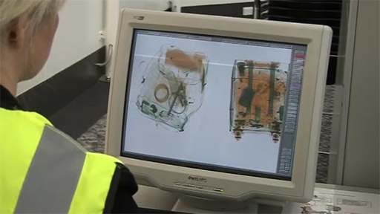

Within the context of the sociology of matter, delegation refers the idea of getting material artefacts to stand in for the work of humans – it means being able to find a material agent or device to ‘act at a distance’. Scripting or prescription refers to the use of material artefacts in order to configure users – to attempt to control humans via the use of material artefacts. Whether intentionally or not, the design of a material technology embeds particular expectations of purpose, context, practice and use.

4.1 A material analysis of the airport

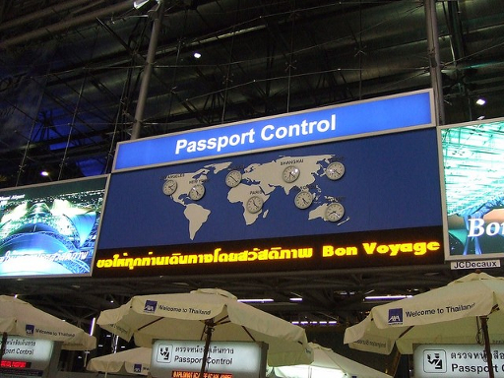
Figure 6 Towards passport control

You will now have the chance to apply some of the insights gained from the previous section to objects commonly found in the airport.

Activity 4

In this activity you’ll be examining two objects – the passport and the baggage scanner – in light of the analysis. To help you do this, consider the following questions for each item:
- What work has to be done if the object in question is present?
- What work would have to be done if the object in question were not present?
- What is being delegated?
- How (if at all) is this object configuring or scripting the person using it?
Then make some notes about them in the boxes below.

1. The passport

Provide your answer...
View discussion - Untitled part

2. The baggage scanner
Now watch the following video where these questions are posed for the baggage scanner.

Video content is not available in this format.
The baggage scanner – questions
View transcript - The baggage scanner – questions

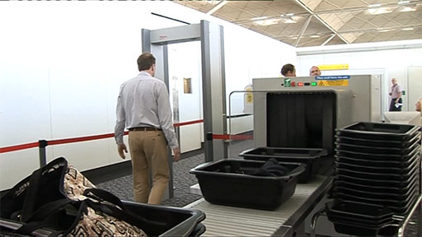

Provide your answer...
View discussion - Untitled part

4.2 Airports and hybrids
This analysis has constantly been hinting at the fact that it is impossible to separate humans from the material objects and artefacts that surround us all. This is why some sociologists think it makes more sense to talk about ‘hybrids’.
You should now watch a second extract from ‘Materiality and the airport’ that discusses hybrids in the context of the airport.

Video content is not available in this format.
Airports and hybrids
View transcript - Airports and hybrids

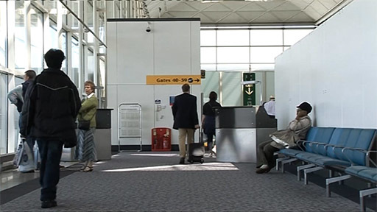

Much of the analysis of materiality or matter that you have just watched was based on the writings of social theorist Bruno Latour. Please take some time to read the Latour chapter extract below. Pay attention to the way that Latour is concerned with the distribution of competences (such as agency or morality) between humans and non-human material artefacts. He uses an example that you have already come across (of starting a car without a seat belt) but he also introduces another example from everyday life – the door.

Activity 5

You should read the extract now:
‘Where are the missing masses? The sociology of a few mundane artifacts’, from Bijker, W. E. and Law, J. (eds) (1992) Shaping Technology/Building Society: Studies in Sociotechnical Change, Cambridge, MA, MIT Press, pp. 225–58.

Conclusion
In this free course, Passports: identity and airports, we have been looking at passports and airports as a sort of token with the power to ‘open up’ the social world to closer inspection. In the first section, we looked at the history of passports as one of the most enduring examples of a regime of identification. Identifying the individuals that make up a given population is one of the fundamental tasks of any social order. This task involves passport systems directly in shaping the technologies and practices necessary to secure the social world. In identifying and registering populations, passport systems are entrenched in the business of defining who ‘belongs’ and consequently who ‘does not’.
In the section that followed, the emphasis was on the role of matter and the material in the social world of the airport. The social world of the airport demonstrates how closely interwoven the social and the material are – so close that separation can be difficult. For some sociologists, these tightly folded connections between the material and the social, between the human and the non-human, mean that it makes more sense to speak of hybrids rather than either humans or artefacts. How humans interact with material objects – and how material objects shape human behaviour – are therefore important questions for sociology.
This OpenLearn course is an adapted extract from the Open University course DD308 Making social worlds.

Acknowledgements
This free course was written by Simon Carter.
Except for third party materials and otherwise stated (see terms and conditions), this content is made available under a Creative Commons Attribution-NonCommercial-ShareAlike 4.0 Licence.
The material acknowledged below is Proprietary and used under licence (not subject to Creative Commons Licence). Grateful acknowledgement is made to the following sources for permission to reproduce material in this free course:
Course image
Image of a passport being stamped: © ArtWell/Shutterstock.com.
Images
Figure 1: © Karen Bryan/www.europealacarte.co.uk/blog. This file is licensed under the Creative Commons Attribution-No Derivatives Licence: http://creativecommons.org/licenses/by-nd/2.0/.
Figure 2: out of copyright.
Figure 3: © rbanks. This file is licensed under the Creative Commons Attribution-Non-commercial Licence: http://creativecommons.org/licenses/by-nc/2.0/.
Figure 4: © Nik Stanbridge. This file is licensed under the Creative Commons Attribution-Noncommercial-NoDerivatives Licence: http://creativecommons.org/licenses/by-nc-nd/2.0/.
Figure 5: © Rebecca Stanek. This file is licensed under the Creative Commons Attribution-Non-commercial Licence: http://creativecommons.org/licenses/by-nc/2.0/.
Figure 6: © shankar s. This file is licensed under the Creative Commons Attribution Licence: http://creativecommons.org/licenses/by/2.0/.
Extracts
Extract 1 ‘Anatomy of an Airport’: Harley, R. and Fuller, G. (2005), Aviopolis: A Book About Airports, Blackdog Publishing. Reproduced by permission of the authors.
Extract 2 ‘Where are the missing masses? The sociology of a few mundane artifacts’: Latour, B. (1992), ‘Where are the missing masses? The sociology of a few mundane artifacts’, in Bijker, W. E. and Law, J. (eds), Shaping Technology/Building Society: Studies in Sociotechnical Change, © 1992 Massachusetts Institute of Technology. Reproduced by permission of the author.
Every effort has been made to contact copyright owners. If any have been inadvertently overlooked, the publishers will be pleased to make the necessary arrangements at the first opportunity.
Don’t miss out
If reading this text has inspired you to learn more, you may be interested in joining the millions of people who discover our free learning resources and qualifications by visiting The Open University – www.open.edu/openlearn/free-courses.

Activity 1

Discussion
- Radikha Mongia suggests that passports not only mirror but produce race. This is quite a difficult argument but her analysis highlights the role of passport regimes in formalising and codifying national identities that were explicitly racialised. Thus passports create new forms of identity such that an individual is no longer simply from the Punjab but becomes the bearer of Indian national identity. In an international system which imposes different visa and admission requirements on different nationalities, passport regimes reinforce racialised national identities.
- Passport regimes make international migration,with attachment to new territories and national identities, more difficult for some than for others. The furore surrounding the Komagata Maru incident illustrates the influence of the media in drawing global attention to what the Canadian government saw as the problem of non-white immigration.
- Mongia states that Indians were excluded from Canada, and refers to the Komagatu Maru incident. More generally, she states ‘the Canadian government simply wanted a white Canada’.
Back to Session 1 Activity 1

Activity 2

Untitled part

Discussion
- Surveillance is essential for modern airports.
- Airports constantly rehearse for emergencies.
- Passengers are all treated as a potential threat.
- The passport is central to controlling security via use of ‘gateways’ and ‘choke points’ (points of congestion, like boarding gates).
Back to Session 2 Part 2

Activity 2

Untitled part

Discussion
- Conduct at airports is closely monitored.
- ‘Choke points’ and ‘sorting processes’ control the flow of planes, baggage, passengers and crew.
- Internationally recognisable signs comprise an interface that manages conduct and movement.
Back to Session 2 Part 3

Activity 2

Untitled part

Discussion
- There are simultaneous processes of attachment and ‘un-attachment’.
- There is sense of airports being ‘un-attached’ to geographic location.
- They are also however pre-attached to the generic place of ‘the airport’ terminal.
- Airports are built around different forms of attachment:
  - security technologies
  - pleasure
  - consumption.
Back to Session 2 Part 4

Activity 4

Untitled part

Discussion
Now watch the following video where these questions are posed and answered for the passport. (Don’t worry if your answers were different to ours.)

Video content is not available in this format.
The passport
View transcript - The passport

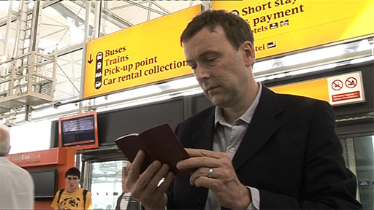

Back to Session 4 Part 2

Activity 4

Untitled part

Discussion
Now watch the following video where these questions are answered for the baggage scanner. (Don’t worry if your answers were different to ours.)

Video content is not available in this format.
The baggage scanner – answers
View transcript - The baggage scanner – answers

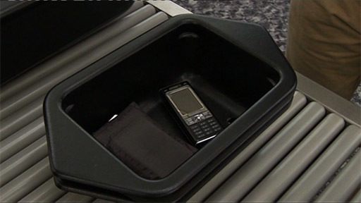

Back to Session 4 Part 3

The passport – history

Transcript
NARRATOR
In their contemporary form, as international travel documents attesting to both national and individual identity, passports are of surprisingly recent origin, dating back only to the early twentieth century. Yet alongside marks, badges and tattoos, passports have long been used by different governing organisations, from estates to parishes to nations, to determine who a person is and, more often than not, what sort of a person they are.
In the late Middle Ages, beggars were commonly required to wear metal badges, permitting them to beg, a practise enshrined across Europe in sixteenth century poor laws. In 1558, for instance, the town council of Dundee enacted that:
SCOTTISH NARRATOR
No beggars be tholet within this burgh, but quhilk are born within the same. And none of them be suffered to beg, except they, having the town's seal upon their hat or cloak, be auld, cruikit, lame, or debilifcatit be great seiknes.
NARRATOR
This method of identifying vagrants and beggars was extended in England in 1697 in an act which ordered that all poor persons receiving parish relief must wear a badge in red or blue cloth in an open and visible manner. Also in England, people taken and punished as idle, wandering beggars were issued with passports. These requested they be provided with food, drink and shelter en route home to their parish of settlement.
This seemingly bizarre means of identification fits into a long tradition of branding or tattooing individuals with the mark of an offence of which they have been found guilty. For example, V for vagabond, B for burglar, D for drunkard, and AD for adulterer. It also bears close relation to the much broader practises of using clothing to mark individuals as members of particular categories. Nathaniel Hawthorne's fictional heroine, Hester Prynne, was sentenced to wear a scarlet letter A for the rest of her life as punishment for her crime of adultery. The story offers an accurate, though rather lenient, portrayal of the consequences of adultery in the Puritan legal system of the seventeenth century Massachusetts colony in which the novel is set.
Clothing was also used for less spectacular purposes of identification. The recipients of charities founded in the early seventeenth century were often required to wear badged coats, while poor children lodged in workhouses wore badges and blue caps, whereby they might be known the children of the workhouse and distinguished from all other children. Badged coats and gowns were like liveries, representing the munificence of the benefactor. The Blue Coat School Movement, founded at the end of the seventeenth century to provide pious instruction and education to the children of the poor, systemised this practise.
By the nineteenth century, branding and marking were no longer widely acceptable as means of identification. While clothing persisted as a guide to social identity, more universal means of identification were sought. Passport systems were widely used throughout nineteenth century Europe and included security paper, seals, physical descriptions or signalment and signatures in an effort to make individual identification secure. Such means were far from foolproof and a range of schemes, including Bertillon's anthropometric descriptor of the ear, were developed in an attempt to secure more objective means of identification in advance of the widespread and effective use of photography.
While passport's became so widespread in the nineteenth century that they were found irksome by many travellers, the British passport remained an elite document until 1858. Until then, British passports were expensive and issued only to acquaintances of the foreign secretary. Most British travellers obtained cheaper passports from consulates of foreign states, especially France. Fuelled by a commitment to free trade, there was an unprecedented relaxation of passport controls across most West European states towards the end of the nineteenth century. This trend was brought to an abrupt halt by the outbreak of the Great War.
In 1914, the British Nationality and Status Aliens Act was passed and international moves towards using passports to distinguish between citizens and foreign nationals accelerated. The first folded, two page booklet style documents were issued in the UK in 1915. The document has space for photographs of the bearer and his wife. It also includes date of birth, residence, profession, height, colour of eyes, hair and distinguishing marks. In 1920, under the Aliens Order, wartime restrictions were permanently extended. From then on, anyone entering or leaving the UK was required to have either a valid passport furnished with a photograph of himself or some other documents satisfactorily establishing his national status and identity.
After an International League of Nations Conference in 1920, the 32 page old blue British passport was introduced. The old blue British passport changed little until the 1980s. In 1972, new watermarked, blue security paper and laminated photographs were introduced. Eye colour and wife's maiden name were dropped. In this 1982 passport, a space for spouse's photograph is included, a practise that was discontinued in 1988. By the end of 1988, the first burgundy, machine readable passports, featuring the words 'European community' were issued.
Back to Session 1 MediaContent 1

Interview with Radhika Mongia

Transcript
RADHIKA MONGIA
For something like the passport to function, more than one state has to be involved in the process, not only the place that's issuing the passport. But the place that you go to has to recognise this document as a travel document. So intuitively, one would imagine that it's something that different governments agreed to sort of sitting in a big room, and everyone agrees to this. And then you implement the instrument of technology for controlling movement and making it orderly.
It turns out, however, that the history of this document is much more piecemeal and a very counter-intuitive development. So a country might be issuing a passport and you arrive at another shore, and there you find that they don't recognise the document or vice versa.
I think in our world, the passport and what it means is predominantly around race and nationality of the bearer. The passport essentially dictates your access to mobility and does so along lines that are explicitly raised. So for instance, an Indian passport is more than merely Indian nationality as equivalent to any other nationality. You're already marked as a racialised subject.
And one of the arguments that I have made regarding the passport is that it's not merely a reflective technology. It's not merely a mirroring technology. It's in fact a productive technology, productive as in it secures racialised subjects.
The material, the archival sources on the Canadian case are really fascinating because what they alert us to is a very different world. So if in our world today it seems that any state can, in fact, limit the entry of certain people for whatever reasons they deem fit, in the early 20th century, this was not possible. The world was one dominated by empire.
And in the case under consideration of Indians moving to Canada, technically, both Indians and Canadians were British subjects. So they had the right to go and reside in any part of empire. Various Indians who found themselves in different parts of the globe were just sort of looking out for more opportunities, I guess.
They end up in Canada. And Canada is not at all happy with the influx of these racialised subjects. However, they're completely at a loss as to how to curtail this migration given that there's no legal precedent for doing so.
To put it bluntly, the Canadian government simply wanted a white Canada. And they began with rather sort of direct, simple claims, such as it was too cold in Canada for the Indians or that they were culturally unsuited to Canada, you know, these commonsensical kinds of objections and closed, of course, in this is, in fact, the best for the Indians themselves. So always looking out for our brothers and sisters across the way.
But of course, this has no legal basis. You know, if people want to go and shiver in Canada, then that really is their own business. So since these kinds of measures didn't work out, they then suggest more sort of systematic, legal measures.
In 1913, there were two dramatic incidents. The first of these incidents was the arrival of a ship called the Panama Maru in Vancouver with 56 Indians. Many of these Indians claimed that they had been in Canada before and were simply returning. So they already had Canadian domicile and, therefore, should be allowed entry. And they were.
This propelled Sardaar Gurdit Singh to hire a ship called the Komagata Maru to sail from Hong Kong to Vancouver. And they were hoping that their fate would be similar to that of the passengers on the Panama Maru. However, the Canadian government had meanwhile enacted some other small changes to their rules and regulations, such that they couldn't land.
And this, in fact, generated not only a furor in the Canadian House of Commons but, in fact, a massive global furor in terms of newspaper coverage and such. However, the sum total is that legally all these passengers were disallowed entry to Canada. The ship, which was anchored in harbour for a very long time, was eventually escorted out of the harbour by the entire Canadian Navy. But what this Komagata Maru incident, which is a really dramatic incident, revealed was that something sort of had to be done.
Frank Oliver in the Canadian House of Commons says, and I am quoting, that the Komagata Maru was an incident that revealed that Canada needed to manage her own immigration. And this was not, as he said, a labour question. This was not a racial question. It was a question of national dominance and the sort of national survival.
The advent of this word national into the discourse is a striking reformulation of the debate because up until then, the term had been empire, imperial. What you find now is the advent of national. And it's on the basis of this notion of national sovereignty, as opposed to imperial comity that Canada would prohibit the entry of Indians. And they would do so further on a principle of reciprocity between nations.
[MUSIC PLAYING]
Back to Session 1 MediaContent 2

A sociological analysis of the airport

Transcript
NARRATOR
The globalisation we've seen over the past five decades has led to a huge increase in mobility, rapid growth in the movement of both people and things. The airport is an icon of this global mobility, but it presents a problem. Mobility can be desirable. Airports are gateways for tourists, travellers, and imported goods. But mobility can also be undesirable, opening the door to criminals, terrorists, controlled substances, and diseases.
Security and surveillance are therefore essential to monitor movement at airports. Indeed, airports have become the modern frontier towns that control access to the very core of the nation state. Today's airport can be thought of as being in a ceaseless state of emergency, constantly organising for potential catastrophe. Emergency teams rehearse procedures for a range of disaster scenarios.
Passengers are subjected to ever more intimate searches, each one treated as a potential terrorist. Surveillance is therefore used to control not only mobility, but also threat. The airport is one of the most surveilled spaces in modern life with its security cameras, scanners, metal detectors, overt and covert security personnel, and checkpoints.
[MUSIC PLAYING]
The passport is central to controlling security and mobility within the airport. Without one it's impossible to pass key gateways and choke points, check in, going airside, boarding the plane, and so on. Within the airport, conduct is also closely monitored. The movement of people and things is controlled in flows, which are kept to designated spaces.
Different choke points and sorting processes govern the flow of planes, baggage, passengers, crew, and vehicles. This is made possible by artefacts, signs that are internationally recognisable. It's assumed that people are unfamiliar with the geography of a particular airport, but the signage is an interface that directs them to their temporary destinations. It manages what would otherwise be a cacophony of movement, sorting people, designating routes, creating decision points, and generally regulating the conduct of passengers.
[MUSIC PLAYING]
The airport is home to contrasting forms of attachment. Airports exist at specific locations, but are also unattached to these locations. Many people pass through airports like Amsterdam or Chicago without ever experiencing the place itself, yet the generic place called airport with its shopping malls, bars, cafes, and waiting areas is entirely familiar to most travellers. It's as if we have become pre-attached to the landscape of the airport. How does the simultaneous process of attachment and unattachment come about?
The airport is therefore structured and designed for different and disparate forms of attachment. It has built-in technologies of security and fear, at the same time is providing comforting spaces of pleasure and consumption. Within a few short steps, you can be subjected to a body search and then be given a free sample of perfume. Behaviour is monitored to an extreme, even specific words are prohibited like bomb or gun. But all this happens in the context of a familiar mall-like setting.
[MUSIC PLAYING]
Disparate systems can meet each other here and co-exist. High-speed jet routes intersect with slow urban motorways. To quote sociologists Fuller and Harley, airports mix multiple forms of life, matter, and information into a series of new and constantly changing relations between bodies and the sky, between local landscapes and global capital.
Back to Session 2 MediaContent 1

Materiality and the airport

Transcript
NARRATOR
The course themes of security, conduct, and attachment have emerged from this analysis of an airport. But it's also a fruitful area for exploring the sociological concern of matter. This involves looking at the airport from three different perspectives. The social, the material, and the hybrid.
The meaning of these terms will be clarified by looking at examples. First, the social.
A conventional sociological analysis might start by saying that society is made up of social relations. So it would consider the social groups that inhabit the airport. For example, passengers are often sorted into rudimentary classes such as first, business, or economy class.
There are other social groups in the airport who inhabit slightly different worlds. Commercial entities, like airlines or retailers, professional groups such as airline pilots, state agencies, like police, customs, and immigration. A sociological analysis of any of these groups could reveal different pictures of an airport.
But something is missing from this purely social view. There's a second perspective to consider. Many of these groups are only really effective because of the material artefacts or objects that surround them. For example, could a security guard really do his job without some kind of uniform? Could airport staff check your luggage quickly without a scanner? The ability to carry out a job is actually distributed between the person and the material artefact.
This ordinary traveller is leaving home to fly to Milan on business. His journey to and through the airport illustrates the role of objects in our lives. Almost immediately, our traveller Mr. T, is making a decision about whether to obey a socially-enacted law. Is he going to put on his seat belt?
But a material artefact is also involved in this decision. What Mr. T experiences was described by a sociologist, Bruno Latour. Here's what he said.
BRUNO LATOUR
Early this morning, I was in a bad mood and decided to break a law and start my car without buckling my seat belt. My car usually does not want to start before I buckle the belt.
It first flashes a red light. Fasten your seat belt. Then an alarm sounds. It is so high pitched, so relentless, so repetitive that I cannot stand it.
After 10 seconds, I swear and put on the belt. This time, I stood the alarm for 20 seconds and then gave in.
[BEEPING]
My mood had worsened quite a bit, but I was at peace with the law, at least with that law. I wished to break it, but I could not. Where is the morality? In me, a human driver dominated by the mindless power of an artefact or in the artefact forcing me, a mindless human, to obey the law that I freely accepted when I got my driver's licence?
Of course, I could have put on my seat belt before the light flashed and the alarm sounded, incorporating in my own self the good behaviour that everyone-- the car, the law, the police – expected of me. Or else some devious engineer could have linked the engine ignition to an electric sensor in the seat belt so that I could not even have started the car before having put it on.
Where would the morality be in those two extreme cases? In both cases, the result would be the same for an outside observer, say, a watchful policeman. This assembly of a driver and a car obeys the law in such a way that it is impossible for a car to be at the same time moving and to have the driver without the belt. A law of the excluded middle has been built, rendering logically inconceivable, as well as morally unbearable, a driver without a seat belt.
It has become logically – no, it has become sociologically impossible to drive without wearing the belt. I cannot be bad anymore. I, plus the car, plus the dozens of patented engineers, plus the police are making me be moral.
NARRATOR:
In this small example from everyday life, social links are not enough to make us follow our socially-enacted laws. Some would argue that social links are not even enough for us to behave morally. To give a full account of how social worlds are made we have to include material artefacts and their relationships with humans.
Some things we like to think of as human attributes, such as morality and agency, may actually reside in artefacts that surround us. We can also see how material objects are made to stand in for the work that humans would otherwise have to do. At some point in the past, human legislators decided that car passengers must wear seat belts, but that didn't in itself change behaviour.
Police officers could stand beside roads stopping people and fining those not wearing belts, but this is neither easy nor an efficient use of police time. It's far easier to get a small device to stand in for the work of police enforcement. Getting material artefacts to stand in for the work of humans is sometimes called delegation. It means being able to find an agent to act at a distance. If you look at the material artefacts all around you it becomes clear that many human competencies, actions, and agencies, are distributed, that they reside, at least partially, in things we use every day.
[MUSIC PLAYING]
Mr. T has parked his car and put his bags on a trolley. To get into the terminal, he has to go up a level. There are escalators for this, itself an example of delegation as is the trolley. The airport management, are keen to prevent luggage trolleys being taken on the escalator. They might obstruct travellers rushing for their flights or could topple over and fall on people.
So there are several possible choices to prevent this. The simplest would be to put a sign saying no trolleys on escalator or no trolleys beyond this point or even trolleys on escalators lead to injury. Each appeals to some aspect of the traveller's moral identity or self-interest to trust the good intentions of the airport management or to prevent others from being injured.
But such moral appeals alone prove to be relatively weak. Some travellers don't notice the signs. Others don't speak English. And some distrust the intentions of airport management.
Another option would be to employ a security guard to stand at the base of the escalator, warning people that taking trolleys beyond this point is forbidden. This might be effective, but it's hardly an efficient use of staff time as you'd have to stand there all day. And it could lead to confrontation with stressed travellers either not understanding him or refusing to accept his authority, the kind of thing airport managements want to avoid.
But there's another solution that doesn't depend on the use of signs or security guards. As Mr. T has discovered, there is a set of stainless steel posts by the base of the escalator. They're spaced evenly apart to prevent people taking trolleys up. Now, he has little choice but to obey. He can't do otherwise.
These attempts to control humans via the use of material artefacts are sometimes referred to as prescription or more simply scripting. Scripting refers to the use of material artefacts in order to configure users. Whether intentionally or not, the design of a material technology embeds particular expectations of purpose, context, practise, and use.
Scripts can be intentional on the part of the designer or not. They can be material or semiotic. And they can be relatively open and flexible or closed and prescriptive.
In the case of the escalator, the use of signs is a relatively open semiotic script. Nothing in particular happens if one ignores them. The security guard is a relatively closed semiotic script. Users either have to accept his authority and their new configuration as a traveller who does not take trolleys on escalators, or risk being ejected from the airport and maybe missing their flight.
On the other hand, the steel posts are a relatively closed material script. Take a few seconds to think of another common example of scripting from everyday life.
What about speed bumps? People can't drive over these too fast or they'll damage their cars. So this solution to speeding is a material one rather than one which relies on drivers' good moral sense to obey traffic regulations. In all these examples, there's an implied continuum from a person choosing freely to behave morally and obey laws to material objects unavoidably forcing people to behave this way.
For the sociologist analysing social worlds, the important point is to take account of the interaction between the human and the material, not just the two extremes. We rarely encounter one in isolation. It's rather that material artefacts and humans are interwoven in such a way that they both become an integral part of the relations that compose social worlds.
A second point to consider is that these material artefacts contain idealised versions of human identities. For example, the signs warning travellers not to put trolleys on the escalators contain an assumption, however unrealistic, that they can be addressed as rational individuals who will respond to reasonable information. A final point is that users can and do institute their own anti-programs to resist the attempts to discipline them into certain behaviours by a delegation or scripting. People can disconnect seat belt warnings, lift trolleys over the post, or drive fast over speed bumps.
Back to Session 4 MediaContent 1

The passport

Transcript
NARRATOR
Mr. T is double-checking his passport. It's the official document to establish one's identity, nationality, and the right to travel, and it controls his progress through the airport. Looking at the passport as a material artefact, here are the four questions again and an example of some possible answers.
A. What work has to be done if the passport is present? It only has to be handed over whenever it's needed to establish identity.
B. What work would have to be done to establish identity if people didn't carry passports? If there were no passports, other types of documentation would be needed to establish that people were who they said they were. It could be a birth certificate, a notarised photo, a mother's birth certificate or letter of naturalisation, or something to show a person's not on bail or wanted by the police.
C. What is being delegated by the use of a passport? In the front cover of a British passport, you'll find this text. "Her Britannic Majesty's Secretary of State requests and requires in the name of Her Majesty all those whom it may concern to allow the bearer to pass freely without let or hindrance, and to afford the bearer such assistance and protection as may be necessary." So the passport delegates the authority of the crown, the whole infrastructure and authority of the civil service into a single pocket-sized document.
D. How, if at all, is the passport configuring or scripting the person using it? The passport contains a number of literal scripts, which layout various expectations and obligations on its bearer, who tacitly accepts these every time he or she uses it. The very act of applying for a passport configures a person to adopt a number of subject positions regarding identity, national laws, and nationality. For example, one has to accept oneself as a citizen of Great Britain, rather than, say, Scotland or Wales, and accept a particular and specific relationship to the state and the head of state.
Back to Session 4 MediaContent 2

The baggage scanner – questions

Transcript
NARRATOR
Mr. T is ready to go through the security checks between the airport's landside and airside.
TICKET AGENT
May I see your boarding card?
NARRATOR
This involves showing his passport and boarding card, then queuing to go through security.
TICKET AGENT
Lovely. Thank you.
MAN
Thank you.
NARRATOR
First, he'll have to put all his things in trays, take off his shoes, and send it all through the X-ray machine.
He'll walk through the metal detector, and then be subjected to a body search.
SECURITY GUARD
OK. Arms out.
MAN
Thank you.
NARRATOR
While this is happening, airport staff are examining the contents of his bags in the luggage scanner.
How would you answer the same set of questions about the luggage scanner?
A) what work has to be done if the luggage scanner is present?
B) what work would have to be done if the luggage scanner was not present?
C) what does the luggage scanner delegate?
D) how, if at all, is the luggage scanner scripting or configuring the person using it?
Work out your answers now.
Back to Session 4 MediaContent 3

The baggage scanner – answers

Transcript
INSTRUCTOR
Here are some possible answers to questions about the luggage scanner.
A) The passenger has to put his belongings on the conveyor belt and collect them afterwards. The operator has to look at the scan of the luggage, pointing out anything suspicious so someone can inspect it more carefully.
B) Without this material artefact, every item of luggage would need to be searched by hand. That would mean more people working longer hours, passengers queuing much longer at security, and could even mean the airport would have to be bigger to accommodate the queues.
C) The scanner delegates the work of searching the bags to a machine. As well as saving staff time, the scanner can record and identify the contents of bags and separate different materials-- organic, non-organic, non-penetrable – using colour codes.
D) Scripting during the security check is relatively limited and overt. It configures the passenger in ways that make the process run efficiently, giving instructions on conduct like removing laptops and shoes, putting phones and change into trays, and so on.
Back to Session 4 MediaContent 4

Airports and hybrids

Transcript
NARRATOR
This interplay between people and objects is the third and final perspective to consider in looking at the airport. Social worlds, including the airport, are made up of complex mixtures of the social and the material that are so interwoven that they're difficult to separate. Therefore it's important to take account of the way that humans interact with material objects and not consider only the extremes of the purely human or the purely material.
Latour argues that culture or social worlds are actually made up of chains or assemblages of human and non-human that are so tightly folded that it makes more sense to speak of hybrids rather than either humans or artefacts. Indeed, the human and the material are often so fully interwoven that, in practice, it can be difficult to find where one ends and the other begins. The airport is a zoo of hybrids-- the passenger and the passport, the security guard and the scanner, the check-in staff and computer, even just the passenger and his wheeled suitcase finally heading for the plane.
[MUSIC PLAYING]
Back to Session 4 MediaContent 5

