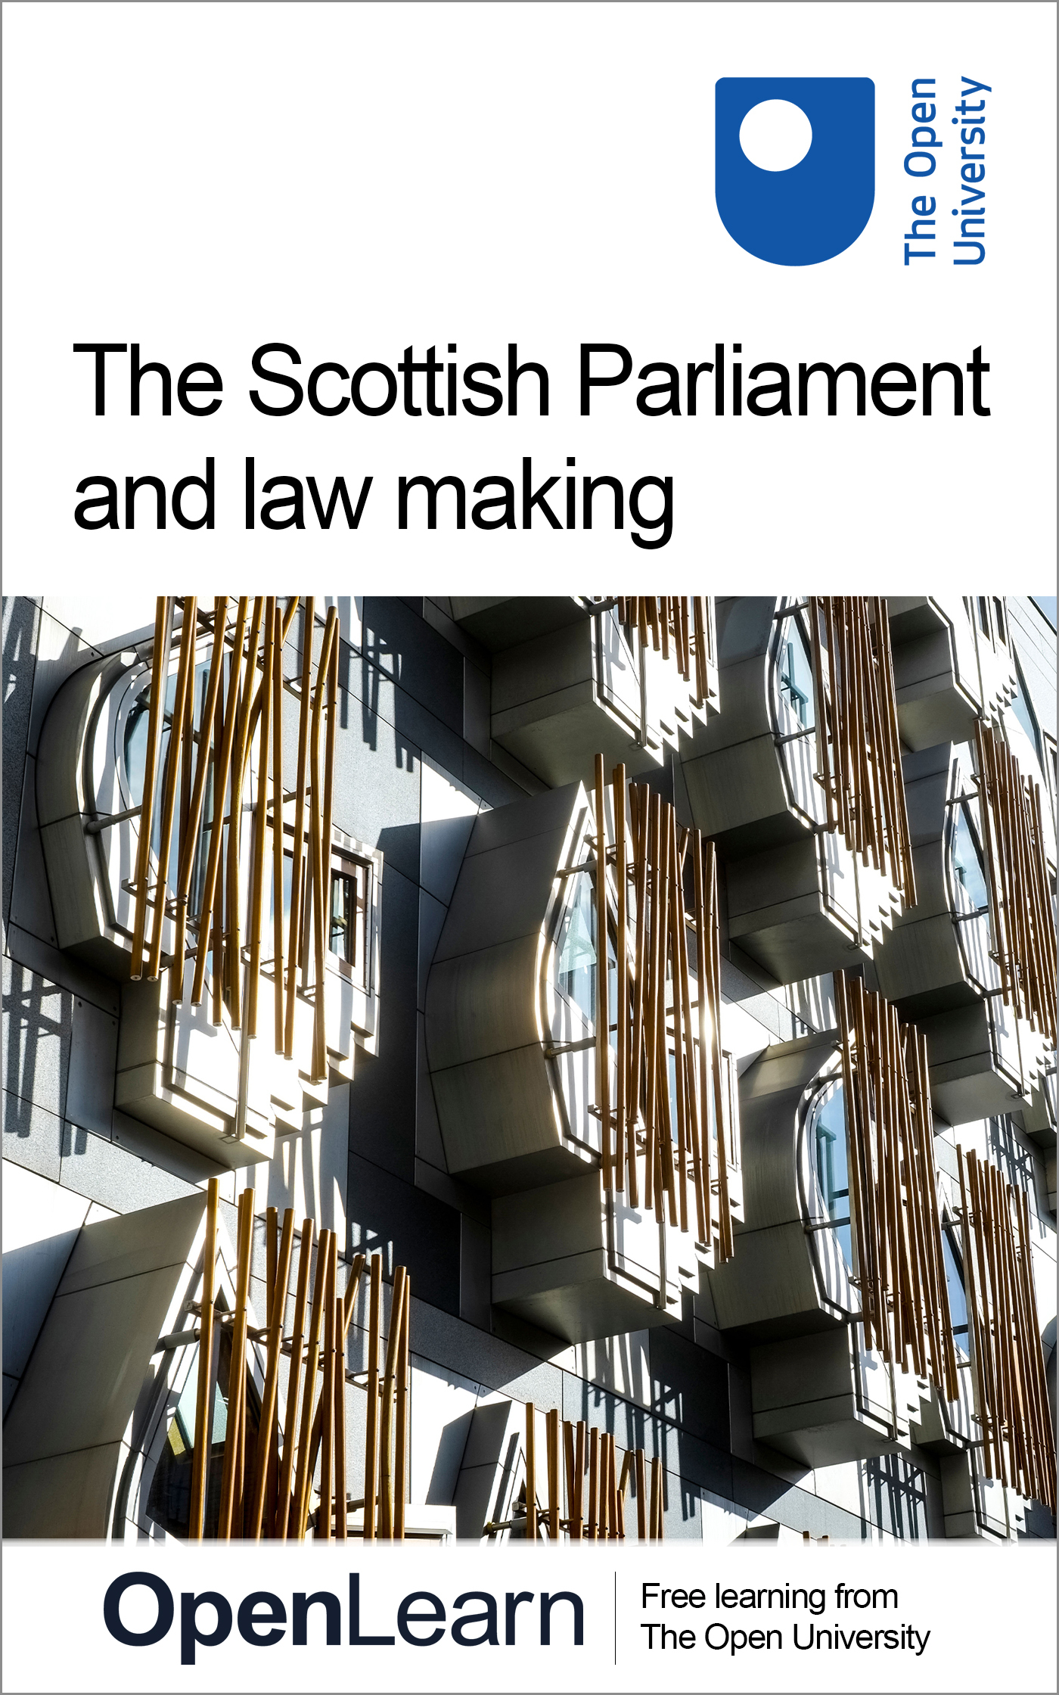

WXM151_1 The Scottish Parliament and law making

The Scottish Parliament and law making
About this free course
This version of the content may include video, images and interactive content that may not be optimised for your device.
You can experience this free course as it was originally designed on OpenLearn, the home of free learning from The Open University –
There you’ll also be able to track your progress via your activity record, which you can use to demonstrate your learning.
Copyright © 2017 The Open University
Intellectual property
Unless otherwise stated, this resource is released under the terms of the Creative Commons Licence v4.0 http://creativecommons.org/licenses/by-nc-sa/4.0/deed.en_GB. Within that The Open University interprets this licence in the following way: www.open.edu/openlearn/about-openlearn/frequently-asked-questions-on-openlearn. Copyright and rights falling outside the terms of the Creative Commons Licence are retained or controlled by The Open University. Please read the full text before using any of the content.
We believe the primary barrier to accessing high-quality educational experiences is cost, which is why we aim to publish as much free content as possible under an open licence. If it proves difficult to release content under our preferred Creative Commons licence (e.g. because we can’t afford or gain the clearances or find suitable alternatives), we will still release the materials for free under a personal end-user licence.
This is because the learning experience will always be the same high quality offering and that should always be seen as positive – even if at times the licensing is different to Creative Commons.
When using the content you must attribute us (The Open University) (the OU) and any identified author in accordance with the terms of the Creative Commons Licence.
The Acknowledgements section is used to list, amongst other things, third party (Proprietary), licensed content which is not subject to Creative Commons licensing. Proprietary content must be used (retained) intact and in context to the content at all times.
The Acknowledgements section is also used to bring to your attention any other Special Restrictions which may apply to the content. For example there may be times when the Creative Commons Non-Commercial Sharealike licence does not apply to any of the content even if owned by us (The Open University). In these instances, unless stated otherwise, the content may be used for personal and non-commercial use.
We have also identified as Proprietary other material included in the content which is not subject to Creative Commons Licence. These are OU logos, trading names and may extend to certain photographic and video images and sound recordings and any other material as may be brought to your attention.
Unauthorised use of any of the content may constitute a breach of the terms and conditions and/or intellectual property laws.
We reserve the right to alter, amend or bring to an end any terms and conditions provided here without notice.
All rights falling outside the terms of the Creative Commons licence are retained or controlled by The Open University.
Head of Intellectual Property, The Open University

Contents
- Introduction and guidance
  - Introduction and guidance
  - What is a badged course?
  - How to get a badge
- Week 1: Law making powers of the Scottish Parliament
  - Introduction
  - 1 The Scotland Act 1998
  - 2 The Scotland Act 2012
    - 2.1 New and amended powers
  - 3 The Scotland Act 2016
    - 3.1 Further additional powers
  - 4 Legislative consent – or ‘Sewel’ motions
  - 5 Working relationship between the Parliaments and Governments
    - 5.1 Devolution Guidance Note 10
    - 5.2 What next?
    - 5.3 Referencing
  - 6 This week’s quiz
  - Summary
  - References
- Week 2: Constitutional characteristics, the rule of law and Scotland
  - Introduction
  - 1 Constitutions
    - 1.1 What is a constitution?
    - 1.2 Features of a constitution
  - 2 Evolution of the United Kingdom
  - 3 Characteristics and functions of the UK’s constitution
  - 4 The UK’s constitutional arrangements
    - 4.1 The rule of law and UK's constitution
    - 4.2 Thinking about the UK’s constitution
  - 5 Constitutional characteristics and Scotland
  - 6 This week’s quiz
  - Summary
  - References
- Week 3: Law making processes in the Scottish Parliament
  - Introduction
  - 1 A new Scottish Parliament
  - 1.1 Law making processes in the Scottish Parliament
  - 2 Legislative competence
    - 2.1 The criteria to determine legislative competence
  - 3 How law is made in the Scottish Parliament
    - 3.1 Bills in the Scottish Parliament
    - 3.2 Types of Bills
    - 3.3 Finding Bills
    - 3.4 Stages of legislation
    - 3.5 A Government Bill
    - 3.6 Royal Assent
    - 3.7 Acts of Scottish Parliament
  - 4 This week’s quiz
  - Summary
  - References
- Week 4: Law making and the UK Parliament
  - Introduction
  - 1 Bills in the UK Parliament
    - 1.1 Preparation for Bills
  - 2 Stages of a Bill in the UK Parliament
    - 2.1 Debating Bills
    - 2.2 Royal Assent
    - 2.2 Commencement of Acts of the UK Parliament
    - 2.3 The UK Parliament and Scotland
    - 2.4 The work of the UK Parliament and getting involved
  - 3 This week’s quiz
  - Summary
  - References
- Week 5: Reading an Act of the Scottish Parliament
  - Introduction
  - 1 Acts: An overview
  - 2 Acts of the Scottish Parliament
    - 2.1 Accompanying documentation to Bills
    - 2.2 Structure of an Act of the Scottish Parliament
    - 2.3 Citing an Act
  - 3 Who drafts the Bills?
  - 4 Acts of the UK Parliament
  - 5 Bills and Acts and the UK Parliament
  - 6 Making law accessible
  - 7 This week's quiz
  - Summary
  - References
- Week 6: Exploring legislation
  - Introduction
  - 1 Secondary legislation
  - 2 The Scottish Parliament
    - 2.1 Subordinate legislation
    - 2.2 Affirmative or negative procedure
  - 3 The UK Parliament
    - 3.1 Scrutiny in the UK Parliament
    - 3.2 Reflection on subordinate legislation in the Scottish and UK Parliaments
    - 3.3 The expansion of regulation
    - 3.4 Advantages and disadvantages of using delegated legislation
    - 3.5 Delegated powers and the Scotland Act 1998
  - 4 This week’s quiz
  - Summary
  - References
- Week 7: MSPs, MPs and law making
  - Introduction
  - 1 Members of the Scottish Parliament (MSPs)
    - 1.1 Voting in Scottish parliamentary elections
  - 2 The work of MSPs
    - 2.1 The many roles of an MSP
  - 3 The Committee System
  - 4 The UK Parliamentary elections
    - 4.1 The UK Government
    - 4.2 The voting system for the UK Parliament
    - 4.3 Who can vote in a UK general election?
    - 4.4 The House of Lords
  - 5 Parliamentary election constituencies
  - 6 This week’s quiz
  - Summary
  - References
- Week 8: Getting involved in law making
  - Introduction
  - 1 Why law changes
  - 2 Where do ideas for change come from?
  - 3 How is law reformed?
    - 3.1 The Scottish and UK Parliaments
    - 3.2 The judiciary
    - 3.3 The European Court of Human Rights
  - 4 How can you become involved?
  - 5 This week’s quiz
  - Summary
  - End of course conclusion
  - Tell us what you think
- Acknowledgements

Introduction and guidance

Introduction and guidance
Welcome to this badged open course, The Scottish Parliament and law making.
The course lasts eight weeks, with approximately three hours of study each week. You can work through the course at your own pace, so if you have more time one week there is no problem with pushing on to complete another week’s study.
In this course you learn about the law making role of the Scottish Parliament and consider how, and why, laws are made by both the Scottish and United Kingdom (UK) Parliaments. You explore devolved matters, reserved matters, legislative competence, secondary legislation and consider changes in the legal culture of Scotland which took place at the end of the twentieth century. You are introduced to reading an Act of the Scottish Parliament, the workings of the Scottish and UK Parliaments and how citizens can become involved in the law making process.
Law is not made in isolation, it reflects the society and culture within which it is made, developed and applied. It is not static. Mechanisms (such as the Scottish and UK Parliaments) evolve to allow it to develop and change. Law making is heavily influenced by change, whether political, social, economic or technological. You consider aspects of this as you explore how the Scottish Parliament works.
No legal system is without its criticisms as there are both benefits and drawbacks to the way in which law is made and scrutinised. You will explore a number of these as you progress through the course.
After completing this course, you should be able to:
- understand the role of the Scottish Parliament in law making
- understand the relationship between the Scottish and UK Parliaments
- understand the role played by law and how you can influence the law making process.
After completing The Scottish Parliament and law making, you may like to enrol on these free OpenLearn courses:
Scottish courts and the law
Legal skills and debates in Scotland
Law and change: Scottish legal heroes
And if you would like to take your study in this subject area further, sign up to the Open University course Law making in Scotland.

Moving around the course
In the ‘Summary’ at the end of each week, you can find a link to the next week. If at any time you want to return to the start of the course, click on ‘Course content’. From here you can navigate to any part of the course. Alternatively, use the week links at the top of every page of the course.
It’s also good practice, if you access a link from within a course page (including links to the quizzes), to open it in a new window or tab. That way you can easily return to where you’ve come from without having to use the back button on your browser.

What is a badged course?
While studying The Scottish Parliament and law making you have the option to work towards gaining a digital badge.
Badged courses are a key part of The Open University’s mission to promote the educational well-being of the community. The courses also provide another way of helping you to progress from informal to formal learning.
To complete a course you need to be able to find about 24 hours of study time, over a period of about 8 weeks. However, it is possible to study them at any time, and at a pace to suit you.
Badged courses are all available on The Open University’s OpenLearn website and do not cost anything to study. They differ from Open University courses because you do not receive support from a tutor. But you do get useful feedback from the interactive quizzes.

What is a badge?
Digital badges are a new way of demonstrating online that you have gained a skill. Schools, colleges and universities are working with employers and other organisations to develop open badges that help learners gain recognition for their skills, and support employers to identify the right candidate for a job.
Badges demonstrate your work and achievement on the course. You can share your achievement with friends, family and employers, and on social media. Badges are a great motivation, helping you to reach the end of the course. Gaining a badge often boosts confidence in the skills and abilities that underpin successful study. So, completing this course should encourage you to think about taking other courses.



How to get a badge
Getting a badge is straightforward! Here’s what you have to do:
- read each week of the course
- score 50% or more in the two badge quizzes in Week 4 and Week 8.
For all the quizzes, you can have three attempts at most of the questions (for true or false type questions you usually only get one attempt). If you get the answer right first time you will get more marks than for a correct answer the second or third time. If one of your answers is incorrect you will often receive helpful feedback and suggestions about how to work out the correct answer.
For the badge quizzes, if you’re not successful in getting 50% the first time, after 24 hours you can attempt the whole quiz, and come back as many times as you like.
We hope that as many people as possible will gain an Open University badge – so you should see getting a badge as an opportunity to reflect on what you have learned rather than as a test.
If you need more guidance on getting a badge and what you can do with it, take a look at the OpenLearn FAQs. When you gain your badge you will receive an email to notify you and you will be able to view and manage all your badges in My OpenLearn within 24 hours of completing the criteria to gain a badge.
Get started with Week 1.

Week 1: Law making powers of the Scottish Parliament

Introduction
In this week you consider the law making powers of the Scottish Parliament. In subsequent weeks you consider the law making process in the Scottish Parliament.
When the process of devolution within the UK began in 1998, legislation from the UK Parliament created new devolved legislatures in Scotland, Wales and Northern Ireland with new law making powers. The Scotland Act 1998 outlined the initial powers of the new Scottish Parliament, the Government of Wales Act 1998 outlined those of the National Assembly of Wales and the Northern Ireland Act 1998 outlined those for the Northern Ireland Assembly. Those original devolution settlements have been built upon in subsequent decades. The powers of the Scottish Parliament and Welsh Assembly have been extended. The situation in Northern Ireland is more complex and differs. The Assembly there has been suspended on a number of occasions when agreement over power sharing arrangements has not been reached.
Devolution is therefore an ongoing process which reflects the changing nature of the UK. In Scotland it reflects the relationship between the Scottish and UK Governments and the people both parliaments represent. From its inception devolution has been seen as a ‘process and not an event’ and this week takes an historical approach to explore how the powers of the Scottish Parliament have evolved.
Understanding the law-making powers of the Scottish Parliament is important as it can only legislate (make laws) within certain defined areas. Its powers flow from the devolution legislation passed by the UK Parliament. In the first three sections you consider this transfer of powers and the subsequent expansion of those powers. There are three relevant Acts and each will be considered in turn:
- the Scotland Act 1998
- the Scotland Act 2012
- the Scotland Act 2016.

Learning outcomes
By the end of this week you will be able to:
- understand the law-making powers of the Scottish Parliament
- explain the difference between devolved and reserved matters
- explain what a legislative consent motion is and why they are used.
Before you start, The Open University would really appreciate a few minutes of your time to tell us about yourself and your expectations of the course. Your input will help to further improve the online learning experience. If you’d like to help, and if you haven't done so already, please fill in this optional survey.

1 The Scotland Act 1998
The Scotland Act 1998 (The 1998 Act) established the Scottish Parliament and outlined the law-making process, on what matters laws can be made (devolved matters) and the legislative competence of the Scottish Parliament. The law-making process is explored in week 3. Here you consider on what matters law can be made.

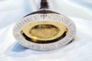
Figure 1 The Mace of Scotland

The 1998 Act contained a list of ‘reserved matters’ in Schedule 5. These were matters which were to be reserved for the UK Parliament and on which only the UK Parliament could make law. There was, however, no similar list of devolved matters on which the Scottish Parliament could legislate. It has therefore been established that the matters on which the Scottish Parliament can legislate are, in effect, all those matters that are not ‘reserved’. So, although power is devolved, there are some limitations as the UK Parliament continues to legislate for Scotland on reserved matters.

Box 1 Reserved and Devolved matters under the Scotland Act 1998 (unamended)

Reserved matters in Schedule 5 of the Scotland Act 1998 (original unamended) include: | Matters on which the Scottish Parliament can legislate under the original unamended Scotland Act 1998
constitutional matters | health
UK foreign policy (including relations with Europe) | education
UK defence and national security | local government
the fiscal, economic and monetary system | economic development
immigration and nationality | tourism
energy: electricity, coal, gas and nuclear energy | criminal law
common markets | civil law
trade and industry, including competition and customer protection | agriculture and food
railways, transport safety and regulation | sport and the arts
employment legislation | planning
social security and child support | social work
gambling and the National Lottery | national heritage
data protection | training
firearms | housing
consumer protection | some aspects of transport, including the road network, ports and harbours
ordnance survey | law and home affairs (the prosecution system and courts)
abortion, human fertilisation, embryology, genetics | the police and fire services
xenotransplantation and vivisection | the environment
equal opportunities | agriculture, forestry and fishing
regulation of activities in outer space | statistics, public registers and records

The Scottish Parliament has full legislative competence (it can pass both primary and subordinate legislation) in devolved areas (i.e. those matters that are not ‘reserved’).
Since its establishment in 1998 the Scottish Parliament in its law making and powers has influenced the character and style of Scots law in ways in which have resulted in differences from those applicable in England, Wales and Northern Ireland. The possibility of the UK Parliament legislating on devolved matters does, however, exist. This is explored in Weeks 2 and 4.

2 The Scotland Act 2012
In 2007 the Scottish Parliament voted to establish the Commission on Scottish Devolution (known as the Calman Commission after the Chair of the Commission, Professor Sir Kenneth Calman) to review how devolution was working and whether any amendments were needed to make it effective. The Commission was to provide an independent review. Its terms of reference are in Box 2.

Box 2 Terms of reference of the Calman Commission
To review the provisions of the Scotland Act 1998 in the light of experience and to recommend any changes to the present constitutional arrangements that would enable the Scottish Parliament to serve the people of Scotland better, that would improve the financial accountability of the Scottish Parliament and that would continue to secure the position of Scotland within the United Kingdom (Holden, 2010)

Following wide-ranging consultations the Commission made a number of recommendations in its final report Serving Scotland Better: Scotland and the United Kingdom in the 21st Century (Commission on Scottish Devolution, 2009).

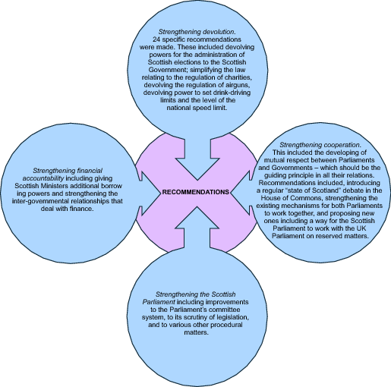
Figure 2 Recommendations from Serving Scotland Better: Scotland and the United Kingdom in the 21st Century
View description - Figure 2 Recommendations from Serving Scotland Better: Scotland and the United Kingdom ...

The Calman Commission provides an illustration of the difference between the roles of the Scottish Parliament and Scottish Government (Executive). The Calman Commission was established by the Scottish Parliament. The Scottish Government (Executive) had voted against the establishment of the Commission when the proposal was made in Parliament, although it later cooperated with the Commission.

2.1 New and amended powers
The UK Coalition Government (conservative and liberal democrats) had committed to implementing the recommendations of the Calman Commission. This commitment resulted in The Scotland Act 2012 (passed by the UK Parliament) which made a number of changes to the devolution settlement for Scotland. It gave effect to many of the recommendations as set out in the Calman Commission’s final report. The Scottish Executive was formally renamed as the Scottish Government, Revenue Scotland was established to replace HMRC for devolved taxes and further powers were transferred (see Box 3 for more detail).

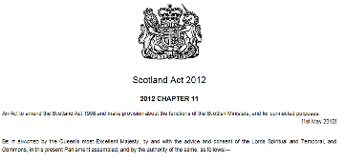
Figure 3 Scotland Act 2012 Chapter 11
View description - Figure 3 Scotland Act 2012 Chapter 11

Disagreement over the draft Bill which subsequently became the 2012 Scotland Act (the 2012 Act) had to be resolved before it was passed by the UK Parliament. The UK Government also required a legislative consent motion be passed by the Scottish Parliament before the 2012 Act was passed by the UK Parliament. Paragraph 8 of the explanatory notes to the 2012 Act state that the 2012 Act ‘contains provisions that trigger the Sewel Convention. As the Act changes the devolution settlement for Scotland, the Act contains provisions which alter the legislative competence of the Scottish Parliament (for example, relating to air weapons) and provisions which alter the executive competence of the Scottish Ministers (for example, relating to the power to prescribe drink-driving limits). The Scottish Parliament gave its consent to the provisions in the Act that trigger the Sewel Convention on 18 April 2012.’
You will learn more about the Sewel convention and legislative consent motions in Section 4.

Box 3 New and amended Devolved Powers following the 2012 Scotland Act

Power | Implementation
Air weapons | The Air Weapons and Licensing (Scotland) Act 2015 asp 10 received Royal Assent on 4 August 2015.
Borrowing powers | Power to borrow up to £2.2 billion (Capital) and £500m (Revenue) from 1 April 2016.
Drink-driving alcohol limits | Road Traffic Act 1988 (Prescribed Limit) (Scotland) Regulations 2014. New drink-driving alcohol limits applied in Scotland from 5 December 2014.
Land and Buildings Transaction Tax | Land and Buildings Transaction Tax replaced the Stamp Duty Land Tax from 1 April 2015.
Landfill Tax | Landfill Tax (Scotland) Act 2014 asp 2 applied in Scotland from 1 April 2015.
Scottish Rate of Income Tax (SRIT) | UK Government deducts 10p in the £ from basic, higher and additional rates of income tax and the Scottish Parliament has the power to levy a Scottish rate across the three bands from 1 April 2016.

Based on information from the Scottish Parliament website (n.d).

3 The Scotland Act 2016
In September 2014, following a Scottish referendum on independence, the people of Scotland voted to remain part of a United Kingdom. The Scottish Government had campaigned for independence. Following the referendum Lord Smith of Kelvin was tasked with overseeing and delivering a cross-party agreement on the shape of improved and enhanced devolution for Scotland.


Figure 4 The Smith Commission

On 27 November 2014 Lord Smith delivered an agreement. This had been agreed by all five of the main Scottish political parties and outlined further powers for the Scottish Parliament.

Box 4 Comment on the Scotland Bill leading to the 2016 Scotland Act.
The Bill will make the Scottish Parliament one of the world’s most powerful devolved parliaments and allow more decisions affecting Scotland to be taken in Scotland. It will increase the financial responsibility of the Scottish Parliament, and its accountability to the Scottish public.
The package contains significant financial powers, including over income tax and VAT, the devolution of substantial elements of the welfare system and a range of other powers, including constitutional powers and powers in areas such as oil and gas and transport.
Along with a more powerful and accountable Scottish Parliament, Scotland will also retain the huge benefits of being part of a strong United Kingdom with a large UK economy, a UK pound, UK pensions and UK armed forces – just as the Scottish people made clear they wanted in last year’s referendum.
Scotland Office and Mundell (2015a).

The explanatory note to the Bill indicates that it delivers the Smith Commission Agreement.

Box 5 Overview of the Bill
- The Scotland Bill will deliver the Smith Commission Agreement, which was published in November 2014 having gained all-party agreement in Scotland.
- The Bill is an enabling Bill and the majority of the provisions in the Bill set out the powers that are being transferred to the Scottish Parliament and or Scottish Ministers. In particular the Scotland Bill amends sections of the Scotland Act 1998 and rebalances the devolved and reserved responsibilities between the administrations. The Bill also includes provisions which set out the constitutional relationship of the Scottish Parliament and Scottish Government within the United Kingdom's constitutional arrangements. It does not amend this relationship.
Scotland Office and Mundell (2015b).

3.1 Further additional powers
The Scotland Act 2016 transferred the following additional powers to the Scottish Parliament:
- powers to set rates and thresholds of Income Tax, and devolution of Air Passenger Duty
- some social security powers including disability and carers’ benefits, Winter Fuel payments
- the power to create new benefits in devolved areas and to top up reserved benefits
- the power to adjust aspects of Universal Credit in Scotland including the housing element
- devolution of some employment services
- devolution of the Crown Estate in Scotland
- the arrangements for elections to the Scottish Parliament
- devolution of Tribunals in reserved areas – such as the Employment Tribunals – in Scotland
- devolution of additional powers over equal opportunities, including to legislate for gender balance on public boards
- devolution of British Transport Police.

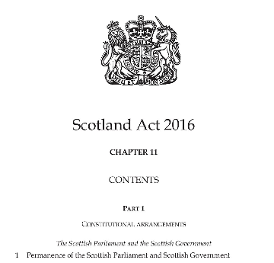
Figure 5 Scotland Act 2016 Chapter 11

The powers of the Scottish Parliament have grown since the original devolution settlement contained in the 1998 Scotland Act. The growth of those powers has been incremental (with subsequent Acts in 2012 and 2016) and piecemeal. There are now a number of Acts and other instruments to consider when looking at the powers of the Scottish Parliament.

Box 6 UK Government Policy paper 2010 to 2015 government policy: Scottish devolution
Scotland has two governments: the UK government is responsible for matters including defence, foreign affairs, the economy, social security and the constitution, while the Scottish government is responsible for matters including health, education, justice and policing, and local government.
Although responsibility is divided in this way, the two governments work together on many issues and cooperate to make sure that the devolution settlement is well managed.
The division of responsibilities is not fixed, and it has changed several times since devolution began in 1999.
Office for the Advocate General for Scotland (2015).

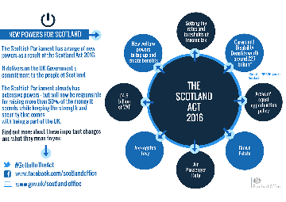
Figure 6 The Scotland Act 2016 - new powers for Scotland
View description - Figure 6 The Scotland Act 2016 - new powers for Scotland

Activity 1 Reserved or Devolved?
Allow about 20 minutes
This Activity is designed to provide you with an opportunity to pause and reflect on the information provided so far and to enable you to test your knowledge of reserved and devolved powers. You have engaged with a lot of important information about the powers of the Scottish Parliament.

- Take a few minutes to reflect on what you have read. How did you manage the information presented? Did you find it approachable or did you have to read it several times?

Provide your answer...

- The list below contains matters which are either devolved or reserved. Based on the knowledge you have gained from your studies indicate by clicking in the appropriate box whether a matter is devolved or reserved.

Devolved

Select the devolved matters.

social security
health
broadcasting
housing
education and training
equal opportunities
miscellaneous matters, such as compiling statistics and keeping public records
defence
planning and the environment
medicines
sport and the arts
aspects of transport (e.g. regulation of air services, rail and international shipping)
the prosecution system and the courts
the constitution
agriculture, forestry and fishing
tourism and economic development
aspects of energy regulation (e.g. electricity, coal, oil and gas and nuclear energy)
trade and industry
employment
financial and economic matters
social work
foreign affairs
Scottish road network, bus policy, and ports and harbours
misuse of drugs
immigration and nationality
local government
international development
the Civil Service

Reserved

Select the reserved matters.

equal opportunities
health
defence
employment
housing
aspects of energy regulation (e.g. electricity, coal, oil and gas and nuclear energy)
financial and economic matters
education and training
foreign affairs
immigration and nationality
planning and the environment
social security
international development
aspects of transport (e.g. regulation of air services, rail and international shipping)
the prosecution system and the courts
agriculture, forestry and fishing
misuse of drugs
medicines
broadcasting
sport and the arts
the constitution
tourism and economic development
the Civil Service
local government
miscellaneous matters, such as compiling statistics and keeping public records
trade and industry
Scottish road network, bus policy, and ports and harbours
social work
View comment - Reserved

4 Legislative consent – or ‘Sewel’ motions
During the debates of the Scotland Act 1998 in the House of Lords (UK Parliament), Lord Sewel, the then Parliamentary Under-Secretary of State for Scotland, stated that they ‘would expect a convention to be established that Westminster would not normally legislate with regard to devolved matters in Scotland without the consent of the Scottish Parliament’. It was important that this convention was established as there were no provisions in the Scotland Act 1998 (original unamended) which prevented the UK Parliament from legislating on devolved matters.
The Scottish Parliament is able to agree the incorporation of legislative provisions affecting Scotland in devolved areas. This enables the Scottish Parliament to consent to the UK Parliament legislating for Scotland on devolved matters in certain circumstances where, for example, it is considered sensible and appropriate to put in place a single, UK-wide regime, or where the Scottish Parliament supports the proposed legislation but there is no parliamentary time available because of separate Scottish priorities.
These agreements, initially known as Sewel motions, were renamed in 2005 as legislative consent motions. The procedures for legislative consent motions are stated in the Scottish Parliament’s Standing Orders. Such motions can save time and the need for separate and similar legislation in both the Scottish and UK Parliaments. They can also be used to confine legislative discussions to the UK Parliament only. Such a motion was used in respect of civil partnerships legislation which eventually became the Civil Partnerships Act 2004.

Box 7 Legislative consent motions
A legislative consent motion is the means by which a devolved body grants permission to the UK Parliament to pass a law on something that is a devolved matter. Sometimes referred to as Sewel motions, they arise out of the convention that the UK Parliament would not normally legislate on a devolved matter without the consent of the relevant devolved institution.
UK Parliament website (n.d.).

In practice five uses have emerged:
- Where it would be more effective to legislate on a UK basis in order to put in place a single UK-wide regime (for example, powers for the courts to confiscate the assets of serious offenders).
- Where there is a complex inter-relationship between reserved and devolved matters that can most effectively and efficiently be dealt with in a single Westminster Bill (for example, the introduction of civil partnerships).
- Where the UK Parliament is considering legislation for England and Wales which the Scottish Government believes should also be brought into effect in Scotland, but no Parliamentary time is available at Holyrood (for example, to strengthen protection against sex offenders).
- Where the provisions in question, although they relate to devolved matters, are minor or technical and uncontroversial (for example, powers for Scottish Ministers to vary the functions of the Central Council for Education and Training in Social Work).
- Where the breadth of the powers of the Scottish Parliament and/or Scottish Ministers would be enhanced in a manner that could not be achieved unilaterally through an Act of the Scottish Parliament (for example, conferral of functions in relation to railways).

Box 8 Legislative and Public Bodies Act consent memorandums and motions statistics

Current session statistics
Parliamentary Session | Sewel/ Legislative consent memorandums lodged | Supplementary memorandums published or lodged | Legislative consent motions lodged/Sewel Motions lodged | Legislative consent/Sewel Motions passed
Current 12 May 2016 to ……….. | 9 | 2 | 10 | 10
Session 4 1 May 2011 to 23 March 2016 | 40 | 12 | 46 | 11
Session 3: 9 May 2007 – 22 March 2011 | 34 | 6 | 30 | 30
Session 2 7 May 2003 to 2 April 2007 | 41 | 3 | 38 | 38
Session 1 12 Mat 1999 to 31 March 2003 | 38 | 1 | 39 | 39

Since 2011 consent motions to Public Bodies Acts are also recorded. In Session 4 these totalled 11, at the time of writing there had been none in Session 5.
(The Scottish Parliament, n.d.)

Activity 2 Reserved matters
Allow about 15 minutes

Take a moment to think about what you have read so far. The Scottish Parliament has devolved powers and there are reserved matters on which only the UK Parliament can legislate. It has been established that the UK Parliament would not normally legislate in a devolved matter in Scotland without the agreement of the Scottish Parliament. What might be the benefit to the Scottish Parliament in having some matters reserved to the UK Parliament?

Provide your answer...
View comment - Activity 2 Reserved matters

5 Working relationship between the Parliaments and Governments
In practice the principle that the UK Parliament would not normally legislate on a devolved matter in Scotland without the agreement of the Scottish Parliament operates through a system of consultation. The UK Cabinet Office publishes Devolution Guidance Notes which provide advice on the working relationships between the UK and Devolved Governments. Box 9 outlines the areas on which such notes have been published.

Box 9 Devolution Guidance Notes
- Common working arrangements: advice on common working arrangements between the UK government and the devolved administrations. It sets out an introduction to the main principles involved in the managing of the devolution settlements and looks in more depth at bilateral relations, correspondence, parliamentary business, legislation and concordats.
- Handling correspondence under devolution: the general principles for the handling by UK government departments of correspondence from members of the devolved legislatures. Guidance on the handling of inter-ministerial and inter-departmental correspondence is available in devolution guidance note 6.
- Role of the Secretary of State for Scotland: the functions and the role played by the Secretary of State for Scotland following devolution.
- […]
- […]
- Circulation of inter-ministerial and inter-departmental correspondence: the conventions to be followed by UK government departments when they are involving devolved administrations in matters which are the subject of correspondence between UK ministers, or otherwise writing to ministers of devolved administrations.
- Court proceedings regarding devolution issues: not yet published.
- […].
- […].
- Post-devolution primary legislation affecting Scotland: guidance for UK government departments on handling legislation affecting Scotland. Sets out how the LP Committee expects departments to handle primary legislation affecting Scotland, while ensuring the smooth management of the government’s legislative programme.
- Ministerial accountability after devolution: general advice on matters which remain the responsibility of UK ministers, and for which they are accountable to the UK Parliament.
- Attendance of UK ministers and officials at committees of the devolved legislatures: advice for UK ministers and civil servants on how to deal with invitations to attend committees of devolved legislatures. It does not provide guidance on the giving of evidence to these committees.
- Handling of parliamentary business in the House of Lords: general principles to be put in practice in business before the House of Lords. Comprises 2 separate weeks on Bills, and on parliamentary questions and debates.
- Use of Scotland Act 1998 Week 30(2) Orders: the use of Week 30(2) Orders to amend the list of reservations in the Scotland Act - either increasing or reducing the scope of reserved matters.
- Scottish legislative proposals giving devolved powers and functions to UK bodies: Acts of the Scottish Parliament can, in certain circumstances, include provisions giving powers or functions to UK government ministers, UK departments or other UK bodies. The Scottish Executive and the UK government have agreed a protocol setting out the procedures which will apply if considering the possibility of legislating in this way.
- […]
Cabinet Office (2011).

5.1 Devolution Guidance Note 10
Devolution Guidance Note 10 is relevant here as this sets out guidance for UK wide government departments on the ways in which legislation affecting Scotland is managed, including how and when consultations between relevant Ministers and departments should take place. The guidance restates the principle of legislative consent and notes that the Commons Procedures Committee (UK Parliament, House of Commons) also supports the convention.
A framework for consistent working with each of the devolved administrations has also been published as a Memorandum of Understanding (MOU). This represents an agreement reached between the UK Government and the Governments of the three devolved administrations (the most recent version at the time of writing was the 2012 version) and sets out principles which underlie relations between them. The MOU is not, however, intended to be legally binding.
This principle, that the UK Parliament would not normally legislate in a devolved matter in Scotland without the agreement of the Scottish Parliament, has now been enshrined into the Scotland Act 1998 with an amendment to Section 28. The amendment was made by the Scotland Act 2016 Sections 2 and 72(7). Figure 7 shows the relevant amendment. . The amendment added a new subsection, subsection 8, to Section 29. You will explore how legislation is set out and amended in more detail in Weeks 3 and 4.


Figure 7 Section 29(8) Scotland Act 1998

You may have noticed that the word ‘normally’ has been included in the wording of this new subsection. The meaning of ‘normally’ in this context has yet to be tested.
A complex system has emerged as two Parliaments can now make laws which affect Scotland. You will explore this in Week 7.

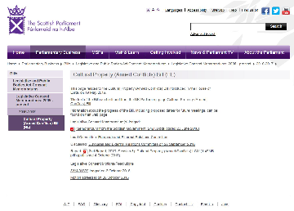
Figure 8 Example of an legislative consent motion

5.2 What next?
The results of the EU Referendum on 23 June 2016 have caused debate both within Scotland and within the UK. In Scotland the vote was 62% in favour of remain but within the UK overall the vote was 51.9% to leave the European Union. Article 50 of the Lisbon Treaty was triggered by the UK’s Prime Minister, Teresa May, on 23 March 2017. Following this the Scottish First Minister, Nicola Sturgeon, responded by writing to the UK Prime Minister, Teresa May. The letter expressed frustration over the way in which the devolved administrations have been consulted over Article 50. The EU set out its position in the European Council (Art. 50) guidelines for Brexit negotiations issued on 29 April 2017.

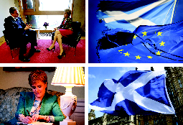
Figure 9 David Cameron and Nicola Surgeon, Figure 10 EU and Scottish flags, Figure 11 Nicola Sturgeon, Figure 12 UK Parliament and Scottish flag

These events were followed by a UK general election on 8 June 2017. This election changed the political landscape of both Scotland and the UK resulting in a minority government for the UK. This had a number of consequences including:
- for the moment, until the terms of the negotiations over the UK’s exit from the EU are clear, a second independence referendum in Scotland is unlikely to be held.
- the UK government was not returned with the anticipated majority. This resulted in a confidence and supply agreement with the Democratic Unionist Party (DUP) which has an impact on the approach taken to negotiations.
Debate over the terms of the UK’s exit from the EU will continue well into 2018. The outcome of negotiations and any roles of the administrations in Scotland, Wales and Northern Ireland in that process remain unclear. The negotiations are unlikely to be reported on in an unbiased manner with information coming from a number of sources. This makes it difficult to gain a clear overall picture. The UK is one of 28 member states and all member states will be consulted.
The UK remains a member of the European Court of Human Rights and a signatory to the European Convention on Human Rights. Although often confused with the EU and the Court of Justice of the European Union they are in fact separate institutions.
The EU currently exercises powers which come within the remit of the devolved administrations, for example, agriculture, as those EU powers cover devolved matters. The position in relation to the return of powers directly from the EU to the devolved administrations is a complex matter over which the devolved administrations and UK Government disagree.
The Scottish Parliament (and the devolved assemblies in Wales and Northern Ireland) as part of its legislative competence has to ensure that all laws comply with EU law. An amendment of some form will be needed to the 1998 Scotland Act in relation to legislative competence. This will be dependent on the outcome of negotiations.

5.3 Referencing
Referencing is an important skill. By referencing you are providing a clear note of where you found information that you are using and sharing this information with those reading your work. Referencing is important in academic work for a number of reasons.
- the points you make are clearly supported by evidence – for example, what the Section of an Act states
- you can use the sources for further research in the future – for example, you will know which Section of the Act you were discussing
- your work will be more persuasive – for example, you reference the Section of an Act around which you based your explanation or discussion – but the reader of your work can see your starting point and evidence
- your reader can find your sources – for example, you have referenced the Section of the Act around which you based your explanation or discussion and they can go and read the original if they wish to
- you can demonstrate how widely you have read and show that you understand the area
- your work will reflect expected academic values and good academic practice.
Referencing, whether to an Act you have discussed, a text book you have read, a piece you have found on the internet, a journal article or this course, demonstrates good academic practice.
You can reference this course as The Open University (2017) The Scottish Parliament and law making, [Online]. Available at www.open.edu/openlearn/society-politics-law/the-scottish-parliament-and-law-making/content-section-overview (Accessed 13 October 2017).
In this course you will learn how Acts of Parliament are structured and how to reference them (this is referred to by lawyers as a citation). This is covered in the weeks that follow.

6 This week’s quiz
Well done – you have reached the end of Week 1 and can now take the weekly quiz to test your understanding.
Week 1 practice quiz
Open the quiz in a new tab or window (by holding ctrl [or cmd on a Mac] when you click the link).

Summary
During this week you have learnt about the powers of the Scottish Parliament and the inter-relationship between the Scottish and UK Parliaments which continues to evolve.
Having studied this week you should now:
- understand the role of the Scottish Parliament in law making
- understand the relationship between the Scottish and UK Parliaments
In the following week you explore the importance of the principles that underpin law making.
You can now go to Week 2.
During this course, at the end of each Week you will be provided with a summary overview detailing what that Week covered. We hope you find these useful.

References
Cabinet Office. (2011). Devolution guidance notes [Online] Available at https://www.gov.uk/government/publications/devolution-guidance-notes (Accessed 5 May 2017).
Holden, H. (2010). The Commission on Scottish Devolution – the Calman Commission [Online]. Available at http://researchbriefings.files.parliament.uk/documents/SN04744/SN04744.pdf (Accessed 8th September 2017).
Office of the Advocate General for Scotland. (2015). 2010 to 2015 government policy: Scottish devolution [Online]. Available at https://www.gov.uk/government/publications/2010-to-2015-government-policy-scottish-devolution/2010-to-2015-government-policy-scottish-devolution (Accessed 8 September 2017).
Scotland Office and Mundell, D. (2015a). Scotland Bill 2015 - legislation and explanatory notes (summary) [Online]. Available at https://www.gov.uk/government/publications/scotland-bill-2015-legislation-and-explanatory-notes (Accessed 5 May 2017).
Scotland Office and Mundell, D. (2015b). Scotland Bill 2015 - legislation and explanatory notes[Online]. Available at https://www.gov.uk/government/uploads/system/uploads/attachment_data/file/430324/Scotland_Bill_2015_-_Explanatory_Notes.pdf (Accessed 5 May 2017).
Scottish Parliament website. (n.d.). List of devolved powers 1999-2016 [Online]. Available at http://www.parliament.scot/images/Parliament%20Publications/ListDevolvedPowers_1999-2016.pdf (Accessed 5 May 2017).
Scottish Parliament website. (n.d.). Legislative and Public Bodies Act Consent Memorandums and Motions statistics [Online]. Available at http://www.parliament.scot/parliamentarybusiness/Bills/19023.aspx (Accessed 5 May 2017).
UK Parliament Website. (n.d.).Glossary – legislative content [Online]. Available at http://www.parliament.uk/site-information/glossary/legislative-consent/ (Accessed April 2017).
Serving Scotland Better: Scotland and the United Kingdom in the 21st Century (June 2009)
European Council (Article 50) guidelines for Brexit negotiations

Legislation
Scotland Act 1998 c 46
Scotland Act 2012 c 11
Scotland Act 2016 c 11

Week 2: Constitutional characteristics, the rule of law and Scotland

Introduction
The UK’s constitution has undergone significant change in recent decades. In this week you will explore the role and function of a constitution, the constitutional arrangements of the UK and the rule of law. You then consider the implications of these for both the Scottish Parliament and Scotland.
By the end of this week you should be able to:
- explain the UK’s constitutional arrangements
- define the UK’s constitution
- explain the principle of the rule of law.

1 Constitutions
Here you consider constitutions as they apply to states. Other organisations such as sports clubs, companies, local authorities, Police Scotland, charities, volunteering organisations, the United Nations and Council of Europe also have constitutions which share some of the features of state constitutions. These are often contained in the form of rules, memorandum or articles of association.

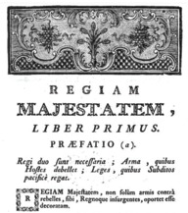
Figure 1 Regiam Majestatem

Most state constitutions develop over time and evolve as the structures of society in which they exist develop. Some constitutions are created as a result of conflict or rebellion (which generally results in a single constitutional document). For example, the French constitution was redrafted in the period leading to the declaration of a republic in 1792, and has been redrafted or refined on a number of occasions since. The Constitution of the United States of America developed after war with England. It first came into effect in 1789 and has been amended 27 times since.

1.1 What is a constitution?
The UK’s constitution is not contained in a written document but has developed and evolved in a piecemeal way over time.
In the media you may have come across or heard about the importance of ‘checks and balances’ on presidential or prime ministerial power. That phrase relates to constitutional arrangements within a state which you explore later.
The past 50 years has seen great constitutional change within the UK; the joining of the EU, the creation of the UK Supreme Court and devolution of the Nations. These changes have had a significant impact on the nature of the UK’s constitution and on the role of Scotland.

Activity 1 How would you define a constitution?
Allow about 10 minutes

Consider the following quotations and using these as your source of information identify what features you think a constitution should have.

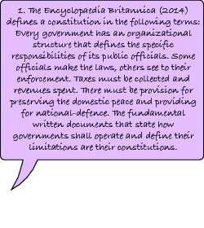
Figure 2a Definitions of a constitution

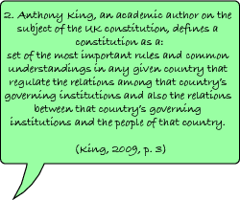
Figure 2b Definitions of a constitution 2

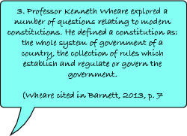
Figure 2c Definitions of a constitution 3

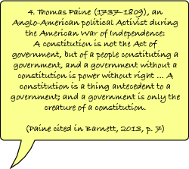
Figure 2d Definitions of a constitution 4

Provide your answer...
View comment - Activity 1 How would you define a constitution?

1.2 Features of a constitution
Before moving on take a few moments to reflect on what you have learnt as you will build on this as you consider the UK’s constitution. A constitution will do one or more of the following:

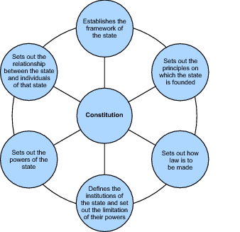
Figure 3 Features of a constitution
View description - Figure 3 Features of a constitution

2 Evolution of the United Kingdom
The constitutional arrangements in the United Kingdom (UK) are a reflection of the relationship between the four nations that make up the UK. This relationship is one based on a history of conflict, trade and war. Box 1 contains a very concise overview of how four nations came to be the UK.

Box 1 A concise historical overview
By 1283 much of Wales had been conquered by Edward I of England. Wales retained a separate legal system but was governed by the English Monarch. The Acts of Union with Wales 1535 to 1542 effectively ended the separate legal system. Wales continued to be governed by the English Monarch.
The kingdom of Scotland evolved around the early 800s. Scotland and England were often at war with each other and border raids were commonplace. Scotland during this time had a closer relationship with France than with England.

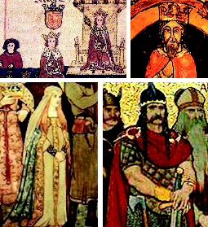
Figure 4 Alexander III , Figure 5 David of Scotland, Figure 6 Margaret Maid of Norway, Figure 7 Kenneth

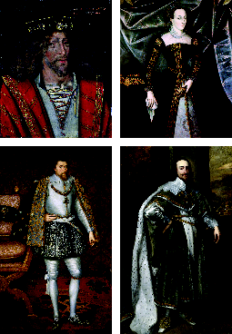
Figure 8 James I, Figure 9 Mary Queen of Scots, Figure 10 James VI, Figure 11 Charles I

In 1603 Elizabeth I of England died childless and her cousin James VI of Scotland was invited to become King of England. (Henry VII of England was Elizabeth’s grandfather and James VI’s great great grandfather). This united the two countries under one monarch for the first time. James VI of Scotland became James I of England. Although there was one monarch two separate parliaments and legal systems continued. It was not until the Union of Scotland Act 1706 and the Union with England Act 1707 that one Parliament at Westminster (the Parliament of Great Britain) was created with the power to make laws relating to Scotland.
The history of political relations between Ireland and England is complex. Ireland came under English control in the twelfth century but since this time there has been almost constant strife between the two countries. In 1800 the Act of Union with Ireland was passed. A civil war in the early twentieth century led to the Government of Ireland Act 1920, which split Ireland in 1920. This removed 26 counties of the Irish Free State from the UK. Ongoing political issues led to the Northern Ireland Act 1974. This established that the UK Parliament in London would rule over Northern Ireland directly. This lasted until the Good Friday Agreement in 1998.

3 Characteristics and functions of the UK’s constitution
Having learnt a little about the background of the evolution of the UK you now consider the specific characteristics and functions of the UK’s constitution. You may already be aware (from reports you may have seen in the media or TV and film dramas) of some underlying conventions of the UK’s constitution, for example that:
- free and fair elections are held on a regular basis (whether for the Scottish Parliament or the UK Parliament)
- in the Scottish Parliament, the leader of the political party with the largest majority normally becomes First Minister. The First Minister is nominated by the Scottish Parliament and is officially appointed by the monarch
- in the UK Parliament, the leader of the political party with the largest majority in the House of Commons normally becomes Prime Minister. The Prime Minister is officially appointed by the monarch
- in the UK Parliament, the custom that the Gentleman Usher of the Black Rod knocks at the door of the House of Commons chamber to summons the members of the House of Commons to hear the Queen’s Speech in the House of Lords.
The UK’s constitution has been described as monarchical, supreme, largely unwritten (uncodified), and flexible. On the diagram below click on each of the four boxes to learn more about these aspects of the UK’s constitution.

Interactive content is not available in this format.

4 The UK’s constitutional arrangements
Having considered the characteristics of the UK’s constitution you now consider some of the underpinning principles of the UK’s constitution.
The UK’s constitution can be thought of as a building with a number of columns.
As illustrated by Figure 12 the UK’s constitution can be thought of as a building with a number of columns. Listen to the following audio which explores the UK’s constitutional arrangements as illustrated by Figure 12.

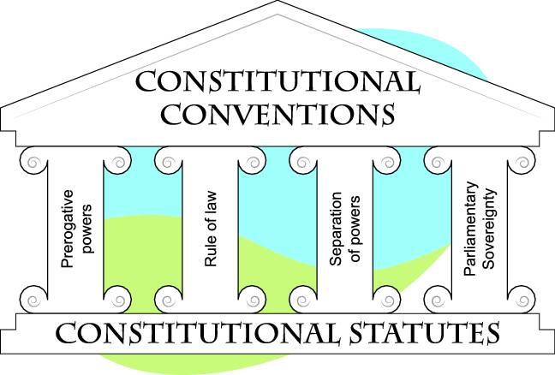
Figure 12 The UK's constitution can be thought of as a building with a number of columns

Audio content is not available in this format.
View transcript - Uncaptioned interactive content

4.1 The rule of law and UK's constitution
You should now be familiar with the rule of law and the constitutional arrangements of the UK. Activity 2 has been designed to test your knowledge of the rule of law and UK’s constitutional arrangements.

Activity 2 The rule of law
Allow about 10 minutes

You have learnt that the rule of law is a fundamental principle underpinning the constitution of the UK. This Activity is designed to test your knowledge of the rule of law as you will return to the rule of law when exploring the powers of the Scottish Parliament, delegated legislation, Members of Scottish Parliament (MSPs) and Members of Parliament (MPs).
Consider each of the statements below and select the statements which reflect the rule of law.

- Protects rights and liberties

True
False
View comment - Untitled part

- States everything must be done in accordance with the law (legality).

True
False
View comment - Untitled part

- Requires that government is carried out within a framework of rules and principles.

True
False
View comment - Untitled part

- States no one should be judge in his or her own cause.

True
False
View comment - Untitled part

- States there will be fairness between the government and its citizens.

True
False
View comment - Untitled part

- Requires that procedures for determining legal disputes must be fair, and must not involve inordinate delay or prohibitive cost. This is a principle about providing access to justice.

True
False
View comment - Untitled part

- Upholds fundamental human rights and the UK’s compliance with its obligations under international law.

True
False
View comment - Untitled part

- Requires that the law is written in language that is, so far as possible, clear and free from ambiguity.

True
False
View comment - Untitled part

- Must be observed at all stages of the law making process.

True
False
View comment - Untitled part

- Laws must also be freely available.

True
False
View comment - Untitled part

Figures 13, 14 and 15 take the form of cartoons which represent aspects of the rule of law and provide an example of an alternative way in which the rule of law can be illustrated.

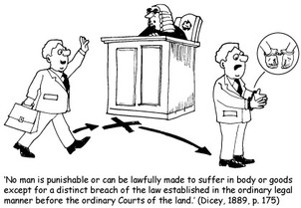
Figure 13 Dicey’s rule of law part 1

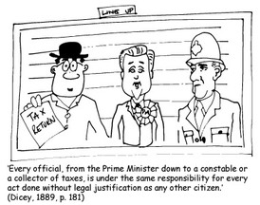
Figure 14 Dicey’s rule of law part 2

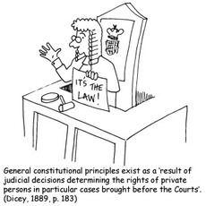
Figure 15 Dicey’s rule of law part 3

4.2 Thinking about the UK’s constitution
In this section you explore further the UK's constitutional arrangements and identify the key features of that constitution.

Activity 3 Defining the UK’s constitution
Allow about 10 minutes

Take a few moments to reflect on what you have learnt. How would you describe the UK’s constitution? Select the terms and phrases you think are applicable to the UK’s constitution and add them into the blank box provided. You are not being asked to create an order or hierarchy within the box. This Activity is designed to encourage you to identify the terms and phrases that you think provide an accurate description of the UK’s constitution.

Interactive content is not available in this format.

View comment - Activity 3 Defining the UK’s constitution

5 Constitutional characteristics and Scotland
The process of devolution has impacted the UK’s constitutional framework as new constitutional statutes exist. You have learnt about the theory that the UK Parliament is sovereign – it can make and unmake any law, it cannot be bound by decisions of past parliaments and it cannot bind future parliaments.
Questions about the sovereignty of the UK Parliament are not uncommon. In recent times, as you may have heard or seen in the media, these were often in relation to membership of the EU and the European Communities Act 1972. The nationwide referendum on EU membership in 2016 proved a turning point in relation to those questions as the UK Parliament prepared legislation to leave the EU.
In R (on the application of Miller and another) (Respondents) v Secretary of State for Exiting the European Union (Appellant) [2017] UKSC 5 the concept of Parliamentary Sovereignty was considered and upheld.

Since […] will be a fundamental alteration in the UK’s constitution, it can only be effected by Parliamentary legislation.

The process and consequences of devolution differ. New relationships between the nations which make up the UK have been created. These relationships differ significantly from EU membership and the aspirations which lead to the creation of Europe-wide institutions such as the EU or European Court on Human Rights.
The EU, as it is known today, emerged from institutions created at the end of WWII. In the aftermath of that war European politicians (including those based in the UK) and governments sought to create a climate of stability, harmony, prosperity and cooperation to ensure that the horrors which occurred during the war would never be seen again in Europe. The way forward was seen to be through agreed common values, such as the protection of the rights of citizens, security, democracy and the rule of law.
The relationship between the nations has a longer history encompassing conflict, revolution, conquest, integration and rule by one monarch. Scotland has always retained its own legal system and economic reasons lead to the Treaty of Union in 1707. That treaty was not necessarily popular with everyone, as shown by the popular uprisings and general unrest in Scotland at the time.
Scotland is also often referred to as the ‘most devolved nation’ as it was initially given the greater of the devolved powers. The Scotland Act 1998, established Scottish devolution. The Scotland Act 2016 inserted a new Section into the 1998 Act, providing for the permanence of the Scottish Parliament and Government. This acknowledges that both the Scottish Parliament and Government are a permanent part of the UK’s constitutional arrangements. The Section states that they should not be abolished without the consent of the Scottish people, which would be gained through a referendum (Section 63A(3)).

Box 2 Section 63(A) Scotland Act 1998


Figure 16 Section 63(A) Scotland Act 1998

In theory, despite devolution, the concept of parliamentary sovereignty remains. The UK Parliament granted the new law making powers as part of the devolution settlements, and so it could remove them. In theory the UK Parliament remains as the supreme law making power. You will explore this later when you consider the role and powers of both the Scottish and UK Parliaments.
Watch the following video of the opening of the fourth session of the Scottish Parliament. The video includes a speech made by the Presiding Officer of the Scottish Parliament and one made by Queen Elizabeth II. Listen to these speeches carefully. They explore the role and functions of the Scottish Parliament. In particular listen to how MSPs are reminded about the role of parliament to legislate, scrutinise and reflect the will of the people.

Watch the video at YouTube.com.
View transcript - Uncaptioned interactive content

The speeches in the audio have not been edited. They contain some important points which link to the following weeks of this course. Identifying key points in a text, speech, presentation or discussion is an important skill whether for study, for work or leisure time. If you choose further study (such as a degree or apprenticeship), you may attend events such as seminars in which you will expected to take notes of key points. In employment you may attend conferences or presentations of colleagues, where being able to concentrate and identify information relevant to your work could be important. In your leisure you may enjoy sports, travel or going to the cinema. In all these you will be presented with information to process and make sense of. Being able to concentrate and identify relevant information is something we hope the audios in this course will assist you in practising.

6 This week’s quiz
Well done – you have reached the end of Week 2 and can now take the weekly quiz to test your understanding.
Week 2 practice quiz
Open the quiz in a new tab or window (by holding ctrl [or cmd on a Mac] when you click the link.

Summary
In this week you explored the fundamentals of the UK’s constitution. An understanding of the overall picture of the UK provides a foundation on which to build your knowledge of the Scottish Parliament, its powers, role and relationship with the UK Parliament.
You should now be able to explain the different elements of the UK’s constitution. Before moving on take a few moments to reflect on what you have learnt about the sources and principles which underpin the UK’s constitution during this week of study.
You should now be able to:
- explain the UK’s constitutional arrangements
- define the UK’s constitution
- explain the principle of the rule of law.
In the next week you explore the law-making processes of the Scottish Parliament.
You can now go to Week 3.

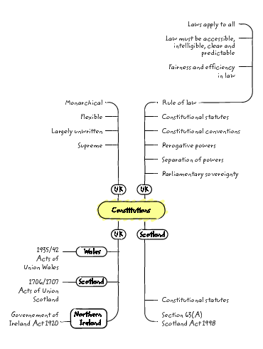
Figure 17 Summary overview of Week 2

References
R (on the application of Miller and another) (Respondents) v Secretary of State for Exiting the European Union (Appellant) [2017] UKSC 5

Legislation
Acts of Union with Wales 1535 - 1542
European Communities Act 1972 c 68
Government of Ireland Act 1920 c 67
Northern Ireland Act 1974 c 28
Scotland Act 1998 c 46
Scotland Act 2016 c 11
Union of Scotland Act 1706
Union with England Act 1707

Week 3: Law making processes in the Scottish Parliament

Introduction
In this week you consider the legislative powers (law making) of the Scottish Parliament and the procedures that Bills have to go through before they become law. A Bill is a draft Act. If the Bill is passed it is enacted and becomes an Act and part of legislation.
Before devolution, all Bills affecting Scotland were introduced in, and subject to the procedures of, the UK Parliament. Some of those Bills were limited in extent to Scotland, while others applied to the whole of the UK (although often with some distinct provisions applicable only to Scotland).
By the end of this week you should be able to:
- explain the different types of Bills
- describe the stages in the law making process of the Scottish Parliament
- explain the legislative competence of the Scottish Parliament.


Figure 1 Map of the four nations that make up the UK

1 A new Scottish Parliament
The Scotland Act 1998 established a new Scottish Parliament with 129 seats. The current Scottish Parliament has a unicameral parliament, meaning that, unlike the UK Parliament, there is only one parliamentary chamber.


Figure 2 Scottish Parliament at night

The Scotland Act 1998 gave the Scottish Parliament power to make laws (both primary and secondary legislation) in a number of areas. The Scotland Act 1998 also established a Scottish Government (at that time referred to as Executive). This consists of the First Minister and a number of ministers appointed by the First Minister. Members include the Lord Advocate and the Solicitor General for Scotland. The monarch appoints the First Minister. They are usually the leader of the party with the most seats in the Scottish Parliament. The roles of the Scottish Parliament and Scottish Government differ. In this course you consider the Scottish Parliament; if you wish to learn more about the role of the Scottish Government you can explore their website.

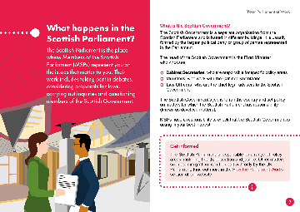
Figure 3 The Scottish Parliament and Scottish Government explained

1.1 Law making processes in the Scottish Parliament
Here you consider the processes used to make law in the Scottish Parliament. The Scottish Parliament can only make laws that are within its competence (i.e. that it has the power to make) so competence will be explored before the Parliamentary process.


Figure 4 The Scottish Parliament illuminated at night

The powers of the Scottish Parliament and processes of law making were established by the Scotland Act 1998, a constitutional statute which forms part of the UK’s constitution. Throughout this week extracts from that Act will be used to explain the powers of the Scottish Parliament. This approach has been chosen to enable you to become familiar with the layout of Acts (sometimes called statues, and often referred to as legislation), the technical language and terminology used. Do not be too concerned if the design, terminology and language of Acts looks and feels unfamiliar, possibly even alien. This is not an uncommon reaction but, as you become more familiar with them, you will begin to find Acts more approachable. The important point is that powers have been created in a particular way: a framework for law making has been created. As you will learn later, if that framework is not followed then there are consequences.

2 Legislative competence
The legislative competence of the Scottish Parliament is set out in the Scotland Act 1998 (as amended). In particular, Sections 28 and 29 of the Act are relevant. The concept of ‘legislative competence’ is an important factor in the law making process of the Scottish Parliament. The Scottish Parliament can only make laws that are within its legislative competence. Any law that is made without legislative competence is void (and therefore has no legal effect).
Section 28 (as amended) is set out in Figure 5. This Section gives the Scottish Parliament power to make laws and sets out the arrangements for Bills of the Scottish Parliament, once passed, to receive Royal Assent. You will learn more about the process of Royal Assent in the next week (it is signified by the monarch under the Scottish Seal).
Section 28(5) (this is a citation for an Act of Parliament: You look at these in more detail later in the course) notes that the validity of an Act of the Scottish Parliament will not be affected by any invalidity in the proceedings of the Scottish Parliament during the process of enactment. i.e. the debating and other stages of the parliamentary law making process.
Section 28(7) links to the parliamentary sovereignty discussion you explored in the previous week of study. This is the subsection that is said to maintain UK Parliamentary sovereignty.

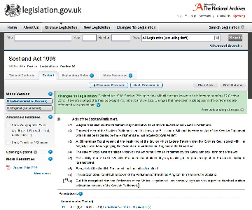
Figure 5 Section 28 Scotland Act 1998 (as amended)

As you looked at Section 28 you may have noticed the use of F1 and square brackets [..]. These brackets are used to show that the original Act has subsequently been amended. It is not uncommon for subsequent Acts to amend earlier Acts by making further additions. The copy of the Scotland Act 1998 in Figure 5 is a screen shot (of an Act currently in force) taken from legislation.gov.uk. On that website the original text of the Act (original pdf and sometimes called ‘as enacted’) can be found alongside the most up to date version of the Act and explanatory notes. Section 28(8) was added to the original Scotland Act 1998 by a later Act. Section 28(8) relates to legislative consent motions which you explored earlier in the course.
Section 29 of the Scotland Act 1998 sets out legislative competence and provides that ‘An Act of the Scottish Parliament is not law so far as any provision of the Act is outside the legislative competence of the Parliament’. This section sets out the powers of the Scottish Parliament to make laws in devolved areas. You now explore those powers in Section 2.1.

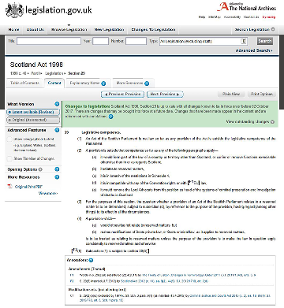
Figure 6 Section 29 Scotland Act 1998 (as amended)

2.1 The criteria to determine legislative competence
Legislative competence of the Scottish Parliament is defined according to five criteria:
- The UK Parliament can only legislate for or in relation to Scotland.
- The Scottish Parliament cannot legislate in relation to the ‘reserved matters’.
- The UK Parliament cannot modify certain enactments (these include the Human Rights Act 1998, certain provisions of the Acts of Union 1705-6 and the European Communities Act 1972).
- Any legislation must be compatible with the European Convention on Human Rights (ECHR) and with European Union law.
- The Scottish Parliament cannot remove the Lord Advocate from their position as head of the system for criminal prosecution.
The concept of legislative competence is important because the Scotland Act 1998 (as amended) requires the legislative competence of any Bill to be assessed before it is introduced, and also provides an opportunity for it to be challenged after a Bill is passed but before it can become law.
The Scottish Parliament does not have power to legislate for England, Wales or Northern Ireland; it cannot legislate on reserved matters and cannot create legislation which is incompatible with EU law or the ECHR. It must follow the provisions of the Scotland Act 1998 (as amended).

Box 1 Changing legal culture
Legislative competence is a way of determining whether an Act of the Scottish Parliament has been produced within the power of the Scottish Parliament.
This represents a change in the legal culture of Scotland. Practising and academic lawyers had, until this point, been taught that an Act of Parliament was law. With the introduction of the Scottish Parliament they must now question whether an Act of Parliament is law. If an Act of the Scottish Parliament has been passed in an area where there is no legislative competence, that Act can be challenged. Where such issues arise they will be determined by a court. The final court for the determination of these issues is the Supreme Court of the United Kingdom.

You may recall from your studies of the rule of law that one of the underlying principles was that laws should be freely available. The use of the internet has enabled greater access to legislation. Laws made by both the Scottish and UK Parliaments can be accessed quickly online. They are also available in hard copy. However, you also explored that the rule of law requires that the law is written in language that is, so far as possible, clear and free from ambiguity. Having considered Sections 28 and 29 Scotland Act 1998 (as amended) you may have developed a view as to whether laws of the UK Parliament (the Scotland Act 1998 was passed by the UK Parliament as it transferred its powers to a new Scottish Parliament) are written in a clear and unambiguous way.

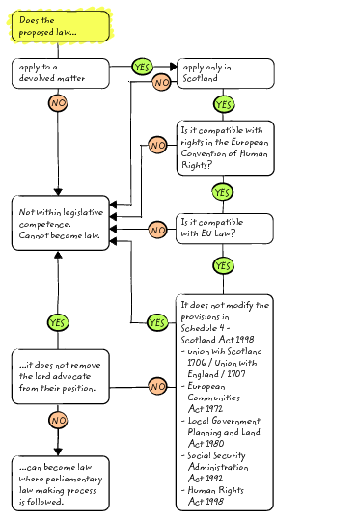
Figure 7 Competences

3 How law is made in the Scottish Parliament
The Scotland Act 1998 provided minimum requirements for the process which was to be followed by the Scottish Parliament in creating law by considering and passing Bills. Section 36(1) of the Scotland Act 1998 required there to be at least three distinct stages to which Bills are subject, including a stage when MSPs can debate and vote on the general principles of a Bill, a stage when they can consider and vote on its details and a final stage when the Bill can be passed or rejected.

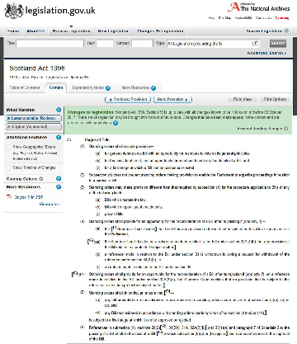
Figure 8 Section 36 Scotland Act 1998 (as amended)

3.1 Bills in the Scottish Parliament
Bills in the Scottish Parliament are very similar, in terms of layout, structure and the conventions of legislative drafting, to Bills of the UK Parliament. This is primarily because the Acts of the Scottish Parliament, to which they are intended to give rise, form part of the UK ‘statute book’ alongside existing statute law.
All current Bills can be accessed on the Scottish Parliament website. Alongside the original Bill other information such as the stages a Bill is going through, amendments, research briefings, lead committee (the committee designated to gather feedback and undertake scrutiny) and dates of consideration (both in public or private) can be found. Acts of the Scottish Parliament, as they form part of UK legislation, can be found at Legislation.gov.uk.

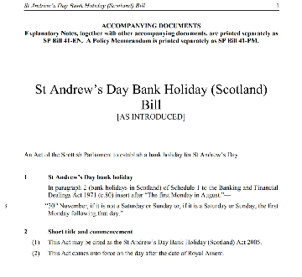
Figure 9 Example of the layout of a Bill

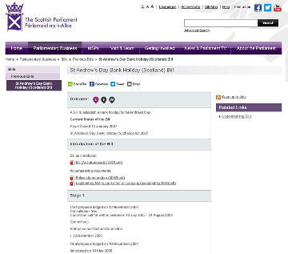
Figure 10 Example of overview information available on Scottish Parliament website in relation to a Bill

3.2 Types of Bills
The stages of a Bill through the Scottish Parliament will depend on a number of factors as not all Bills follow the same process.
- Public Bills seek to change the general law or deal with matters of public policy.
- Private Bills seek powers for a particular organisation or individual that are in excess of or in conflict with general law.
There are also a number of routes by which a Bill can be introduced.

Table 1 Routes by which a Bill can be introduced
Government Bill | introduced by Cabinet Secretaries and Ministers
Members’ Bill | introduced by an MSP
Committee Bill | introduced by the convenor of a parliamentary committee
Private Bill | introduced by an external person, company or group of people

All Bills submitted for introduction must be accompanied by various documents. These include:
- explanatory notes
- a financial memorandum
- a statement of legislative competence
- a policy memorandum.
Other requirements apply to Bills relating to the budget and to Bills which seek to repeal existing legislation. One of the purposes of this process is to provide as much information as possible to ensure informed decision making.
The Bills considered by the Scottish Parliament have been wide-ranging in their focus and topics, for example, from planning, historical monuments, succession, education, justice, carers, violence, alcohol, burial, bankruptcy, abusive behaviour, tenements, railways, dog fouling, climate change, criminal cases, agricultural holdings, elections, British sign language, welfare, the commonwealth games, fur farming, water industry, high hedges, charities and homelessness to emergency workers and wind farms.

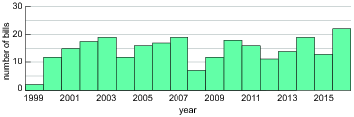
Figure 11 Bills of the Scottish Parliament 1999 to 2016

Details of Bills and the work of the Scottish Parliament can be found in their annual reports (accessible via the Scottish Parliament website).

Table 2 Breakdown of Bill types
Scottish Parliament Annual Report | Number of Bills | Government Bills | Members Bills | Committee Bills | Private Bills
2015-16 | 18 | 13 | 3 | 1 | -
2014-15 | 20 | 15 | 5 | - | -
2013-14 | 17 | 11 | 4 | - | 2
2012-13 | 18 | 16 | 1 | - | 1
2011-2012 | 13 | 13 | - | - | -
2000-2011 | 19 | 11 | 8 | - | -
1999-2000 | 18 | 12 | 2 | 1 | 2*

(* plus 1 hybrid Bill).

3.3 Finding Bills
Being able to access and find information is an important skill. As you have learnt, one aspect of the rule of law is that laws are accessible. The Scottish Parliament website is designed to encourage as much engagement with the public as possible and make the information about the work of the Scottish Parliament accessible. It covers information on the work of the Parliament, MSPs and Committees. You will also see that there is a parliamentary TV channel where you can watch live debates or access archive material form previous debates.

Activity 1 Finding Bills of the Scottish Parliament
Allow about 20 minutes

Find the Scottish Parliament website. Take a few moments to familiarise yourself with the website. What sort of information does it contain? Locate the information on current Bills under the Parliamentary business tab. Look at the number and range of those Bills and explore whether they are members’ Bills, government Bills or committee Bills.

Provide your answer...
View comment - Activity 1 Finding Bills of the Scottish Parliament

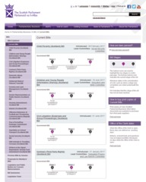
Figure 12 Examples of what can be found when looking for current Bills (6 May 2017).

3.4 Stages of legislation
When a Bill is introduced to the Parliament there are three stages that it must go through.
- Stage 1 involves consideration of the general principles of the Bill by the parliamentary committee designated to deal with it. Here there will be proactive engagement with the general public and relevant experts. The committee will report back to Parliament and, if Parliament agrees to the Bill’s general principles, it will be referred back to the committee.
- Stage 2 entails detailed consideration of the Bill, including any amendments proposed by the Scottish Government and MSPs.
- Stage 3 is where final consideration of the Bill takes place and the Parliament votes on whether or not the Bill should be passed.

Figure 14 shows an alternative and more visual way of illustrating the stages of a Bill. Pause for a few moments and reflect on how you process and remember information. Which of the two ways of presenting the information do you prefer? The linear list such as the one above, or the diagram in Figure 14? Being able to identify the way in which you respond to, and learn from information, is a skill. One of the keys to success is identifying which best suits your own needs.

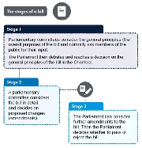
Figure 13 Stages of a Bill (from Scottish Parliament website)

One of the unique features of the Scottish Parliament is its openness, transparency of process and proactivity in engaging with the Scottish public. There are processes for wide consultation, an open evidence process at committees, and members of the public and interested parties are able to liaise directly with MSPs to lobby for amendments to a Bill. The Scottish Parliament website has a ‘Getting Involved’ week which encourages individuals to engage with and participate in the work of the parliament and explains how to do this. For all this work the Scottish Parliament has received international recognition and works more closely with the people MSPs represent.

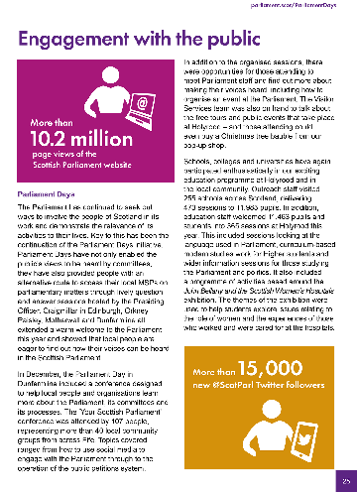
Figure 14 Extract from 2015-16 Scottish Parliament Annual Report

Watch the following videos which provides an overview of the law making process in the Scottish Parliament.

Watch the video at YouTube.com.
View transcript - Uncaptioned interactive content

Overview
http://www.parliament.scot/visitandlearn/100530.aspx
Stage 1
http://www.parliament.scot/visitandlearn/100531.aspx
Stage 2
http://www.parliament.scot/visitandlearn/100532.aspx
Stage 3
http://www.parliament.scot/visitandlearn/100533.aspx
How the Bill comes into force
http://www.parliament.scot/visitandlearn/100534.aspx

3.5 A Government Bill
To provide a flavour of the law making process you now consider the stages of a Government Bill.
A Government Bill begins life through the formulation of policy. If it is felt that legislation is required to achieve that policy, a team is put together to draft a Bill. While the draft Bill is being prepared there is usually a process of public consultation. ‘Pre-legislative’ scrutiny may also take place. This means that the proposals or draft Bill may be considered by a parliamentary committee. The committee chosen will be the one expected to consider the Bill when it is introduced to the Parliament. This procedure is useful as it allows members of the committee to familiarise themselves with the subject matter of the Bill at an early stage.
When the draft Bill is finalised, there is a three-week period during which matters such as legislative competence are checked. At this point the Bill is also checked to ensure that it is set out in the proper form.
Once the Bill has been introduced the Stage 1 processes of the consideration of the Bill take place. These are outlined in Table 3 below.

Table 3 The processes of the consideration of a Bill
Stage 1 Committee
The function of the committee is to produce a Stage 1 report on the general principles of the Bill. In preparing this they: look at the accompanying documents, may take evidence from witnesses, may ask for written evidence and consider, for an Executive Bill, whether sufficient consultation was undertaken before introduction.
Stage 1 Report
Committee report which will include a recommendation as to whether the general principles of the Bill should be agreed to.
Stage 1 Debate
Parliament decides whether to agree to the general principles of the Bill. Debates take place, amendments may be agreed or the Bill may be returned to the committee for a further report. Where there is agreement the Bill moves to Stage 2.
The Stage 2 processes involve a more detailed consideration of the Bill by a committee. The Stage 2 committee could be a committee of the whole Parliament of which all MSPs are members, the committee producing the Stage 1 report or another specialist committee. The Stage 2 process begins 11 whole sitting days after the completion of the Stage 1 process.
At Stage 2 the role of the committee is to consider and dispose of proposed amendments to the Bill. Once the Stage 1 decision is taken, any MSP could lodge an amendment to the Bill. If amendments are agreed, the Bill is reprinted.
Once Stage 2 has been completed, Stage 3 proceedings take place. Again amendments can be proposed. The Bill is now heard by Parliament. Proposed amendments are dealt with first. Once these have been voted on, Parliament must decide whether to pass the Bill. This is done by majority vote.

3.6 Royal Assent
Section 32 of the Scotland Act 1998 provides that a Bill, once passed, must be submitted by the Presiding Officer for Royal Assent. This is done after a period of four weeks. During that time, the Bill may be subject to legal challenge by the Advocate General for Scotland, the Lord Advocate or the Attorney General, and may also be subject to an order made by the Secretary of State. The Presiding Officer may, however, submit the Bill for Royal Assent after less than four weeks if notified by all three Law Officers and the Secretary of State that they do not intend to exercise their powers of legal challenge.
Royal Assent, when the Bill becomes an Act, is treated (under Section 28(3) of the Scotland Act 1998) as taking place at the beginning of the day on which Letters Patent signed by the Monarch are recorded in the Register of the Great Seal by the Keeper of the Registers of Scotland. When Royal Assent has been given, the Clerk of the Parliament writes the date of Royal Assent on the Official Print. The Clerk also assigns an ‘asp number’ in the form ‘2017 asp 1’ (for the first Act given Royal Assent in 2017. The letters asp stand for Act of the Scottish Parliament). The Clerk then sends a certified copy of the Official Print to the Queen’s Printer for Scotland, as authority to publish the Act. The Official Print itself is sent to the Keeper of the Records of Scotland for inclusion in the National Archives of Scotland (NAS). (NAS also hold the signed Letters Patent.)
The ‘Queen’s Printer’ version of the Act, which is identical to the Official Print except the date and asp number are added, is available to the public through Stationery Office bookshops and on the OPSI (Office of Public Sector Information) website. (It is not a publication of the Scottish Parliament and therefore does not appear on the Scottish Parliament website.) The text of the Act is also sent to the Statutory Publications Office for inclusion in the electronic Statute Law Database, legislation.gov.uk.
With a Scottish Bill, the interval between the passing of a Bill and Royal Assent is less predictable in advance than it would be in relation to a Bill of the UK Parliament because of the possibility of a Law Officer’s reference under Section 33 or 34 of the Scotland Act 1998 or a Secretary of State order under Section 35 of the Scotland Act 1998. Partly for that reason, most Bills provide for a commencement date by an order made under the resulting Act.
At the same time, the Official Print version of the Act is prepared. This is produced on special archive-quality paper bound with ribbon. The Official Print is identical, in terms of its legislative text, to the Bill that was passed by the Parliament. (This is made possible by the drafting convention that, within the text of a Bill, all references are, for example, to ‘this Act’ rather than ‘this Bill’.)
You should now watch this video which explores the Forth Road Bridge.

Video content is not available in this format.
View transcript - Uncaptioned interactive content

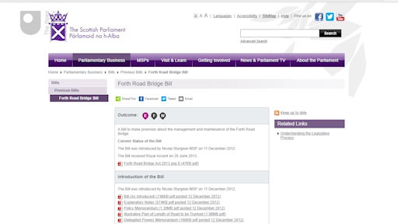

3.7 Acts of Scottish Parliament
Figure 15 shows the number of Acts passed by the Scottish Parliament from 1999 - 2017. Figure 16 shows the origin of Acts between 2009 and 2016, indicating whether they originated from Government, Members, Private or Committee Bills.

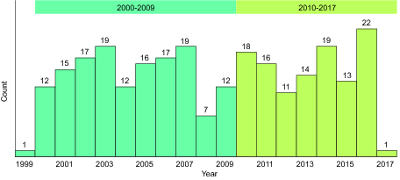
Figure 15 Acts of the Scottish Parliament 1999 to 2017

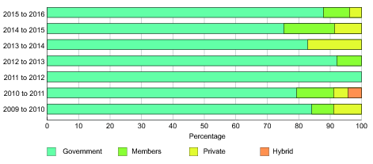
Figure 16 The origin of Acts of the Scottish Parliament 2009 - 2016

If you wish to find out more about the work of the Scottish Parliament then the annual reports provide a good starting point and can be found using the search function on their website.
You should now watch the following video in which Iain Gray, MSP, reflects on legislation of the Scottish Parliament and the important role that law plays in society.

Video content is not available in this format.
View transcript - Uncaptioned interactive content

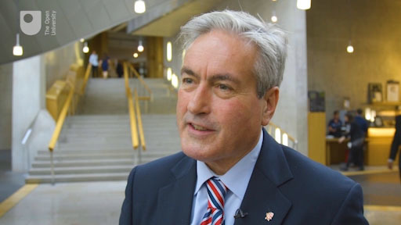

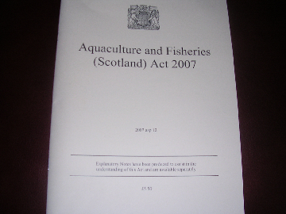
Figure 17 Aquaculture and Fisheries (Scotland) Act 2007

Before moving on to the next week watch this clip which explores the work of the Scottish Parliament in 2014.
You can out more about the work of the Scottish Parliament and how to follow their work on the Scottish Parliament website.

4 This week’s quiz
Well done – you have reached the end of Week 3 and can now take the weekly quiz to test your understanding.
Week 3 practice quiz
Open the quiz in a new tab or window (by holding ctrl [or cmd on a Mac] when you click the link).

Summary
In this week you learnt about the law making processes of the Scottish Parliament. You have explored how Bills become law, the different types of Bill and begun to understand the Scottish Parliament’s role in law making. You will learn to read an Act of the Scottish Parliament in later weeks.
You should now be able to:
- explain the different types of Bills
- describe the stages in the law making process of the Scottish Parliament
- explain the legislative competence of the Scottish Parliament.
In the next week you learn about the law making process in the UK Parliament. The UK Parliament legislates on reserved matters and matters where a legislative consent motion has been passed by the Scottish Parliament.
You can now go to Week 4.

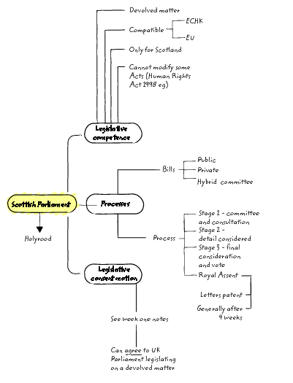
Figure 18 Summary overview of Week 3

References

Legislation
Aquaculture and fisheries (Scotland) Act 2007 asp 12
Human Rights Act 1998 c 42
Acts of Union 1705 and 1706 c 11
European Communities Act 1972 c 68
Scotland Act 1998 c 46

Week 4: Law making and the UK Parliament

Introduction
In this week you explore the role of the UK Parliament in law making. You have learnt that the UK Parliament legislates on reserved matters. It can also legislate on devolved matters with the agreement of the Scottish Parliament.

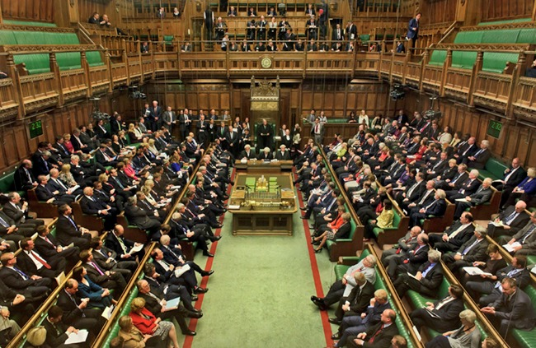
Figure 1 Inside the UK Parliament

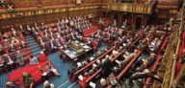
Figure 2 Inside the House of Lords

The law making process at Westminster is a very different process from that of the Scottish Parliament. It involves both the Houses of the UK Parliament. Unlike the Scottish Parliament, the UK Parliament is bicameral, it has two chambers, the House of Commons and the House of Lords.
By the end of this week you will be able to:
- understand the law-making process in the UK Parliament
- explain the difference between the House of Commons and House of Lords
- explain the types of Bills introduced in the UK Parliament.

1 Bills in the UK Parliament

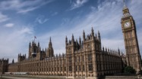
Figure 3 UK Parliament

An Act of the UK Parliament starts off as a Bill, which, if approved by a majority in the House of Commons and the House of Lords, becomes an Act of the UK Parliament. There are several types of Bill:
- A Public Bill –This is the most common type of Bill. Public Bills deal with matters affecting the public generally and are usually introduced by a government Minister. Most Bills are public and are introduced and supported by the government.
- A Private Members’ Bill – A Private Members’ Bill deals with matters affecting the public generally but is introduced by a Member of Parliament who is not a Minister. Private Members’ Bills are a type of Public Bill and should not be confused with Private Bills.
- A Private Bill – Deals with issues which affect only a very small number of people. For example a Private Bill could deal with a matter affecting a single local authority. Private Bills are promoted by the group concerned. A Private Bill does not affect the general public as a whole.
The rest of this section will deal mainly with Public Bills and the procedural stages through which they must pass to become Acts of the UK Parliament.

1.1 Preparation for Bills
A period of preparation of a Bill allows time to scrutinise evidence on the policies underlying Bills, and to consider whether Bills can be improved before they are introduced. Proper preparation of a Bill should lead to better-informed debates on Bills when they are introduced, and may save time by identifying problems at an early stage. This period of pre-legislative scrutiny allows valuable time for consideration and is intended to avoid introducing laws that are unworkable. Consultations are organised by the Government Department responsible for the Bill and may include the following:
- The Government Department will publish a Green Paper outlining the ideas for a Bill and seek comments and advice from affected organisations. These comments are summarised by civil servants and passed on to the relevant Minister.
- The Department may then publish a White Paper that outlines firm proposals which will be contained in the Bill. This White Paper will form the basis of the Bill to be introduced to Parliament.


Figure 4 Scotland's Parliament document

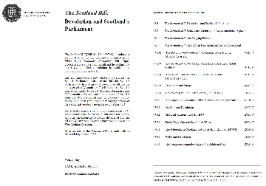
Figure 5 The Scotland Bill: Devolution and Scotland's Parliament

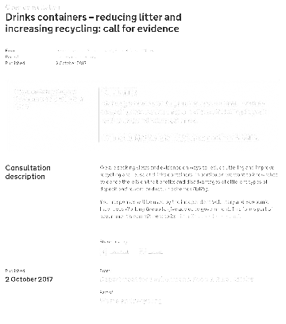
Figure 6 Public consultation on the United Kingdom’s future legal framework

Bills are drafted by Parliamentary Draftsmen (lawyers skilled in drafting Bills) who work to ensure that a Bill is clear and unambiguous.

Box 1 Bills and Parliamentary Counsel
Sir Geoffrey Bowman KCB, First Parliamentary Counsel […] in written evidence, [he] described the relationship between the Department from which a bill originated and the Parliamentary Counsel Office:

A Bill is a joint effort, and there are many participants – Ministers, administrative and legal civil servants, drafters, Members and officials of both Houses, and members of the public affected by the Bill. The drafter’s main contact will usually be with the departmental lawyers, who draw up written instructions to our office.
There is an inherent tension in the process of producing Bills. On the one hand there is the political need to get legislation prepared and enacted quickly. On the other hand there is the need to get legislation right. If it does not stand up to logical analysis or it is legally defective, it will be prone to attack as it passes through Parliament and (once enacted) it will be challenged in the courts. There is always a balance to be struck. If you go too quickly you risk producing a faulty product. If you go too slowly you risk getting nothing done. But any Bill needs a certain time to mature. Everything needs to be thought through and tested in order to make sure that it stands up. The iterative process in which successive drafts are tried out and discussed prior to introduction into Parliament is vital. And it takes time.
Kelly, R. and the Parliament and Constitution Centre. (2005).

2 Stages of a Bill in the UK Parliament
In order to become an Act of the UK Parliament a Bill has to be passed by both the House of Commons and the House of Lords. A Bill may start in either the House of Commons or the House of Lords, with the exception of Finance Bills which always start in the House of Commons. A Finance Bill is introduced by the UK Government shortly after the Budget to bring the government’s tax proposals into law.
Before the Bill can become an Act of the UK Parliament it must undergo a number of stages. Briefly these are as follows.

1 First reading
The title of a Bill is read out and copies of it are printed but no debate takes place. There will be a vote on whether the House wishes to consider the Bill further.

2 Second reading
The general principles contained in the Bill are debated. Frequently, the second reading stage is the point at which public attention becomes drawn to the proposal through press coverage and, on occasion, vociferous campaigns for and against the Bill by groups affected by the Bill. At the end of this debate a vote is taken: a majority must be in favour of the Bill in order for it to progress any further.

3 Committee stage
At this stage a detailed examination of each clause of the Bill is undertaken by a Committee of between 16 and 50 MPs. The Committee subjects the Bill to line-by-line examination and makes amendments. The Committee which carries out these discussions comprises representatives of the different political parties roughly in proportion to the overall composition of the House. Often there will be a government majority on the Committee; however, an attempt is made to ensure representation by minority parties. The membership of the Committee will usually be those with a special interest in, or knowledge of, the subject of the Bill under consideration. (For Finance Bills the whole House of Commons will sit in Committee.)

4 Report stage
A Bill that has been amended in Committee stage is reviewed by the House where it started. The amendments will be debated in the House and accepted or rejected. Further amendments may also be added.

5 Third reading
This is the final vote on the Bill. It is almost a formality since a Bill which has passed through all the stages above is unlikely to fail at this late stage. In fact in the House of Commons there will only be a further debate on the Bill if at least six MPs request it. In the House of Lords amendments are sometimes made at this stage.

6 The House of Lords
The House of Commons and the House of Lords must finally agree on the text of a Bill. If a Bill started life in the House of Commons it is now passed to the House of Lords where it goes through all of the stages outlined above. If the House of Lords makes amendments to the Bill it will go back to the House of Commons for that House to consider those amendments.

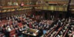
Figure 7 The House of Lords in session

If the House of Lords votes against a Bill it can go back to the House of Commons and will become law if the House of Commons passes it for the second time. The reason for this is that the House of Lords is not an elected body and its function is to refine and add to law rather than oppose the will of the democratically elected House of Commons. There are proposals to make the House of Lords more representative and some members of the House of Lords may be elected in the future. This could possibly lead to a change in the role and function of the House of Lords.

2.1 Debating Bills
There is opportunity for parliamentary debate and discussion at all stages except the initial stage. This process enables politicians from all parties to participate in parliamentary debates. The debate and discussion also allows the UK Government the opportunity to reflect on its proposed laws and modify them if necessary. An intricate web of politics therefore is woven into what otherwise might appear a rather mechanical procedure for making law.
Figure 7 provides an overview of the process a Bill goes through in the UK Parliament. You

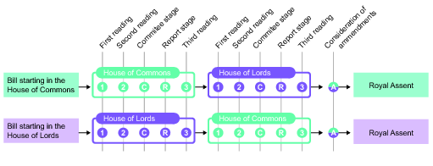
Figure 8 Stages of a Bill
View description - Figure 8 Stages of a Bill

Watch the following video which explores how the House of Lords works with the House of Commons to make a Bill law.

Watch the video at YouTube.com.
How the Lords works with the Commons to make a Bill law
View transcript - How the Lords works with the Commons to make a Bill law

2.2 Royal Assent
The monarch formally assents to a Bill in order for it to pass into law. Royal Assent has never been withheld in recent times. Queen Anne was the last monarch to withhold Royal Assent, when she blocked a Scottish Militia Bill in 1707. The Queen feared a Scottish militia might be turned against the monarchy.

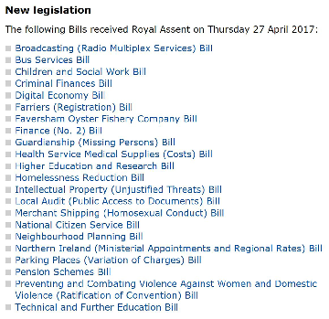
Figure 9 Bills of the UK Parliament receiving Royal Assent on 27 April 2017

Since the sixteenth century no monarch has actually signed a Bill themselves. Instead, the monarch signs what are known as Letters Patent which announce that the monarch has given their assent. Alternatively, the Queen signs a document known as a Commission which commands certain Lords, known as Royal Commissioners, to let both Houses of Parliament know that Royal Assent has been given.
Once Royal Assent has been given, the Bill is an Act of the UK Parliament.

2.2 Commencement of Acts of the UK Parliament
Following the Royal Assent the Act of the UK Parliament will usually come into force on midnight of that date. However there has been a growing trend for Acts of the UK Parliament not to come into force immediately. Instead, the Act itself either states the date when it will commence, or responsibility passes to the appropriate Minister to fix the date when the Act will come into force. In the latter case the Minister will bring the Act into force by issuing a commencement order.
To learn more watch the following video:
http://www.parliament.uk/about/how/laws/
To learn more about the role in the House of Commons in law making:
http://www.parliament.uk/about/podcasts/theworkofparliament/house-of-commons-chamber-film/making-laws/
To learn more about the work of the UK Parliament watch:

Watch the video at YouTube.com.

2.3 The UK Parliament and Scotland
The UK Parliament has the power to legislate on reserved matters and on devolved matters where a legislative consent motion has been passed by the Scottish Parliament. Activity 1 now asks you to explore Acts of the UK Parliament and their relevance to Scotland.

Activity 1 Exploring Acts of the UK Parliament
Allow about 10 minutes

Take a few moments to consider the Acts listed below. These Acts were some of the final Bills to receive Royal Assent before the dissolution of the UK Parliament on 3 May 2017 prior to the general election on 8 June 2017. Having read through the list, and based on the titles of the Act and your knowledge of matters which are devolved and reserved, indicate whether or not you think the Act covers Scotland.

The Broadcasting (Radio Multiplex Services) Act 2017 | Yes | No | Not sure
The Bus Services Act 2017 | Provide your answer... | Provide your answer... | Provide your answer...
Children and Social Work Act 2017 | Provide your answer... | Provide your answer... | Provide your answer...
Criminal Finances Act 2017 | Provide your answer... | Provide your answer... | Provide your answer...
Farriers (Registration) Act 2017 | Provide your answer... | Provide your answer... | Provide your answer...
Finance Act 2017 | Provide your answer... | Provide your answer... | Provide your answer...
Guardianship (Missing Persons) Act 2017 | Provide your answer... | Provide your answer... | Provide your answer...
Health Service Medical Supplies (Costs) Act 2017 | Provide your answer... | Provide your answer... | Provide your answer...
Homelessness Reduction Act 2017 | Provide your answer... | Provide your answer... | Provide your answer...
Intellectual Property (Unjustified Threats) Act 2017 | Provide your answer... | Provide your answer... | Provide your answer...
Local Audit (Public Access to documents) Act 2017 | Provide your answer... | Provide your answer... | Provide your answer...
Merchant Shipping (Homosexual Conduct) Act 2017 | Provide your answer... | Provide your answer... | Provide your answer...
National Citizen Service Act 2017 | Provide your answer... | Provide your answer... | Provide your answer...
Neighbourhood Planning Act 2017 | Provide your answer... | Provide your answer... | Provide your answer...
Northern Ireland (Ministerial Appointments and Regional Rates) Act 2017 | Provide your answer... | Provide your answer... | Provide your answer...
Parking Places (Variation of Charges) Act 2017 | Provide your answer... | Provide your answer... | Provide your answer...
Pension Schemes Act 2017 | Provide your answer... | Provide your answer... | Provide your answer...
Preventing and Combating Violence Against Women and Domestic Violence (Ratification of Convention) Act 2017 | Provide your answer... | Provide your answer... | Provide your answer...

View comment - Activity 1 Exploring Acts of the UK Parliament

2.4 The work of the UK Parliament and getting involved
You should now have an understanding of the UK Parliament’s role in relation to law making and Scotland. As you have seen from Activity 1 this can create complexity as parts of some Acts will apply to Scotland, all of some Acts will apply to Scotland and other Acts will not apply in Scotland at all. This is a piecemeal approach to law making which you consider further in later weeks.


Figure 13 Get involved

You can out more about the work of the UK Parliament and how to follow their work on the UK Parliament website.

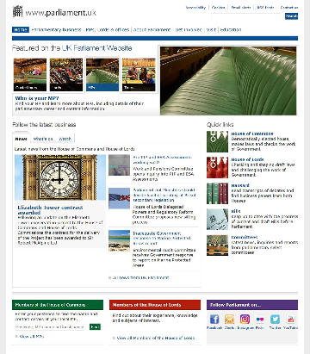
Figure 14 UK Parliament homepage

3 This week’s quiz
It’s time to complete the Week 4 badged quiz. It is similar to previous quizzes, but this time instead of answering five questions there will be fifteen.
Week 4 compulsory badge quiz
Remember, this quiz counts towards your badge. If you’re not successful the first time, you can attempt the quiz again in 24 hours.
Open the quiz in a new tab or window (by holding ctrl [or cmd on a Mac] when you click the link.

Summary
In this week you learnt about the law making processes of the UK Parliament. You have explored how Bills become law, the different types of Bill and begun to understand the UK Parliaments role in law making in relation to Scotland.
You should now be able to:
- understand the law-making process in the UK Parliament
- explain the difference between the House of Commons and House of Lords
- explain the types of Bills introduced in the UK Parliament.
Next week you explore how acts of the Scottish Parliament are structured and cited (referenced).
You can now go to Week 5.

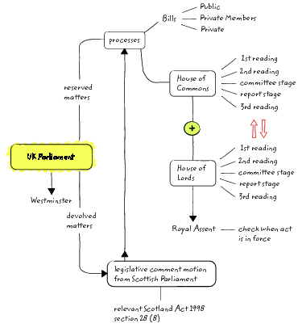
Figure 14 Summary overview of Week 4

References
Kelly, R. and the Parliament and Constitution Centre. (2005). Drafting Legislation and the Parliamentary Counsel Office [Online]. Available at http://researchbriefings.files.parliament.uk/documents/SN03756/SN03756.pdf (Accessed 12th September 2017)

Week 5: Reading an Act of the Scottish Parliament

Introduction
In this week you examine how legislation is structured and how you reference (cite) legislation. You were introduced to sections of an Act when you explored the powers of the Scottish Parliament and Sections 28 and 29 of The Scotland Act 1998 (as amended). Here you learn more about the structure of Acts and how to read them.
By the end of this week you should be able to:
- explain how an act is structured
- discuss the accessibility of language used in Acts
- understand the role of Parliamentary Counsel.

1 Acts: An overview
You have learnt that Acts of the Scottish Parliament and Acts of the UK Parliament (also referred to as statutes and often referred to as legislation) originate in the Scottish (Holyrood) or UK (Westminster) Parliaments as Bills. Once a Bill has passed through the various Parliamentary stages it may receive Royal Assent and become an Act. Some Acts of the UK Parliament still apply to Scotland, while all Acts of the Scottish Parliament apply to Scotland only.
Since 1999 Explanatory Notes have been produced for all Public Acts (and some Private Acts) published by the Scottish Parliament and UK Parliament. These Explanatory Notes are designed to make the Act of Parliament accessible by providing explanations in plain English outlining what the Act sets out to achieve, why it was passed and its content and extent. These are aimed at readers who have no specialised knowledge of the matters dealt with in the Act.
Recent Acts of Parliament have moved towards using ordinary language and being more clearly written so that they are accessible. This is regarded as important as individuals should easily be able to understand exactly what the Act was intended to cover and what ‘the law’ is on a particular subject. Some Acts of the Parliaments however, particularly older Acts, can be more difficult to understand. This may be due to the complexity of the subject matter, the more traditional language used, the length of the Act or the number of provisions within the Act.
Some Acts may codify (bring together) the law on a specific area. Some Acts codify common law, some Acts may amend the law while also creating new laws, others consolidate several Acts into one and other Acts create new laws. Acts of the Parliaments may also include a lot of exceptions to the Act, a lot of ‘whereases’ and cross-references to other Acts. This can make it difficult to understand what an Act means and covers.

Box 1 Citations
When an Act is referenced in writing it is given a citation. The citation allows the reader to locate the relevant Act and Section that the writer is referring to.
Every Act is given a running number for the year in which it is passed. These are known as the asp (lower case is used) number for Acts of the Scottish Parliament and Chapter Number for UK Acts.
Acts are referred to by their short title and year, for example, National Galleries of Scotland Act 2003 (whose running number is asp16) or the Scotland Act 2016 ( whose running number is Chapter 11).
Parts of statutes
Acts tend to be divided into sections which are often further divided into sub-sections. For example Section 28(6) refers to Section 28 subsection 6.
Schedules
Many Acts have schedules at the end. Don’t overlook these as they can contain important information. For example, in week 1 you learnt that Schedule 5 of the Scotland Act 1998 (as amended) sets out the reserved matters on which the Scottish Parliament cannot legislate. These may be further divided into paragraphs, for example: Sch.1 para 8 is a reference to schedule 1, paragraph 8.

2 Acts of the Scottish Parliament
In this section you look at an Act that started life as Private Members’ Bill. This Act has been chosen as it is short and has an accompanying explanatory note.
The starting point with any legislation from the Scottish Parliament is to consider whether it has been passed with the ‘legislative competence’ of the Scottish Parliament. The matter in this Private Members’ Bill is not a reserved one as it does not touch upon a reserved matter such as national security. The Bill relates to land and buildings in the centre of Edinburgh.

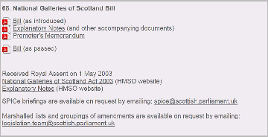
Figure 1 Screenshot of the summary of the National Galleries Bill from the Scottish Parliament website (accessed 5 October 2017)

2.1 Accompanying documentation to Bills
Through Activities 1 - 4 you will become familiar with the documents which accompany Bills.

Activity 1 fPromoters' memorandum to the National Galleries of Scotland Bill
Allow about 15 minutes

Read through the promoter’s memorandum (The Scottish Parliament, 2015b) then answer the following questions.
- Who were the promoters of the Bill?

Provide your answer...
View comment - Untitled part

- When was the Bill introduced?

Provide your answer...
View comment - Untitled part

- What were the objectives of the promoters?

Provide your answer...
View comment - Untitled part

- Who has been consulted?

Provide your answer...
View comment - Untitled part

Having read the promoters' memorandum Activity 2 asks you to think about legislative competence and how Bills are advertised as part of the open and transparent law making process.

Activity 2 Explanatory note
Allow about 10 minutes

Read through the explanatory note (The Scottish Parliament, 2015a) and answer the following questions.
- Who gave the statement on legislative competence?

Provide your answer...
View comment - Untitled part

- Where had advertisements giving notice of the Bill been placed?

Provide your answer...
View comment - Untitled part

2.2 Structure of an Act of the Scottish Parliament
Having considered the promoters' memorandum and explanatory note Activity 3 requires you to read the Act and answer a number of questions in relation to that Act.

Activity 3 Structure and commencement
Allow about 15 minutes

Read through the National Galleries of Scotland Act 2003 in Figure 5 below and answer the following questions.

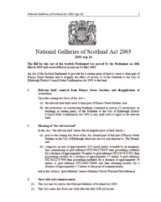
Figure 4 National Galleries of Scotland Act 2003 (asp 16)

- How is the Act to be cited and where is this information found?

Provide your answer...
View comment - Untitled part

- When did the Act come into force? I.e. when did it become law?

View comment - Untitled part

- How many sections does the Act have?

View comment - Untitled part

- What does the Act do?

View comment - Untitled part

An explanatory note accompanied the Act. You have not been asked to read this but you may wish to do so.
If you visit the National Gallery on the Mound in Edinburgh you will see the completed works which include a lecture theatre, café, improved access and a link between the buildings.


Figure 5 National Gallery of Scotland

Through Activities 1-3 you became familiar with the documents which may accompany a Bill and the structure of an Act of the Scottish Parliament. Although the Scottish Parliament works to be as transparent and open as possible in its law making process there are limitations as the structure of Acts is determined by long standing historical precedent. Activity 4 asks you to consider and reflect on the process.

Activity 4 Reflection on reading an Act
Allow about 10 minutes

Take a few moments to think about everything you have read. Reflect on the different types of document you have read, one of which contained a law. How approachable did you find the style of writing, layout and language used in the documents?

Provide your answer...
View comment - Untitled part

Understanding an Act is not always easy without some guidance. This activity was presented in a number of stages to introduce the specialist terminology used, including sections, schedules, commencement and asp numbers. This was designed to make the task more approachable and to introduce you to, and build your confidence in, reading unfamiliar and technical material.
Some familiarity with the terminology and conventions (such as citation) used makes understanding an Act much easier.

Some reading strategies
Figure 6 contains a number of suggestions that you may find useful when reading.

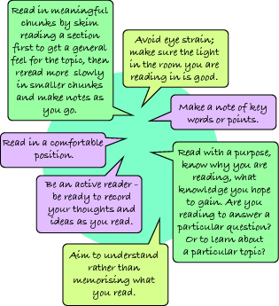
Figure 6 Some tips for reading
View description - Figure 6 Some tips for reading

2.3 Citing an Act
Acts can often seem confusing at first, particularly if they are long and use technical or complex language. The use of citation however can work as a sort of shorthand to make discussion of the Act more straightforward and ensure that people know exactly which Act, and which part of the Act or its supporting documents, are being discussed. Table 1 provides an overview guide to citing an Act in different ways and contexts.

Table 1 Citing an Act of the Scottish Parliament
Type of citation | Example
Short title including year | Harbours (Scotland) Act 2015
Number | 2015 asp 13
Citation in written material such as an academic essay | (Harbours (Scotland) Act 2015)
Citation where a Section of the Act has been referred to specifically or quoted | (Harbours (Scotland) Act 2015 Section 2) or (Harbours (Scotland) Act 2015 s.2.)
If you refer to the Act in a sentence | The Harbours (Scotland) Act 2015 was designed to …
If you want to refer to a specific Section to explain it | Section 2 of Harbours (Scotland) Act 2015 states that …
Reference included in a bibliography or reference list at the end of an article or academic essay | Harbours (Scotland) Act 2015 asp 13.

3 Who drafts the Bills?
You have seen that drafting (writing) a Bill in a way that is both legally certain and precise, and comprehensive and accessible, is no easy task. Drafting is a skill. At the Scottish Parliament there are a group of individuals whose task it is to draft Bills.

Box 2 Extract from drafting Legislation and the Parliamentary Counsel Office 2005
Since devolution, the Lord Advocate has become head of the Crown Office and Procurator Fiscal Service. He is assisted by the Solicitor General for Scotland. They are the Scottish Law Officers and members of the Scottish Executive.
The Office of the Scottish Parliamentary Counsel is located within the Scottish Executive. The Office is:

‘Responsible for drafting Bills to be put before Parliament by the Executive and handling associated work such as the preparation of Executive amendments to Bills.’

It is headed by to the First Scottish Parliamentary Counsel. In addition, the office has 12 Parliamentary Counsel.
However, the Scottish devolution settlement allowed for not only Members’ bills (similar to Westminster’s Private Members’ bills) but also for bills to be recommended by committees. Such bills are not prepared by the Office of the Scottish Parliamentary Counsel. The Scottish Parliament has a non-executive bill unit which provides support for both members’ bills and committee bills. It was described in evidence to the Richard Commission on the powers and electoral arrangements of the National Assembly for Wales:

‘It’s basically a drafting resource within the Parliament itself but the members of that Unit are all staff of the Parliament not staff of the Executive and they also incidentally draft Members’ Bills so it is quite distinct from the Office of the Scottish Parliamentary Counsel.’

Kelly, R. and the Parliament and Constitution Centre, (2005)

You will now consider Acts of the UK Parliament as these still have relevance in Scotland.

4 Acts of the UK Parliament
Copies of all Acts of the Parliament sitting at Westminster have been kept since 1497. Most of these are kept in the House of Lords Record Office in the Victoria Tower at Westminster and are available for public inspection on arrangement with the Clerk of the Records. The oldest Act held in the Victoria Tower dates from 1497 and is entitled ‘The Taking of Apprentices for Worsteads in the County of Norfolk Act’.

Box 3 The title of an Act of the UK Parliament
Acts before 1962 use the following reference:
Year of reign (known as Regnal Year)/Monarch/chapter number to define a chapter of the appropriate statute book. The terminology ‘chapter’ arises because the very earliest Acts were regarded as parts of a single statute passed at one meeting of Parliament. For example, ‘16 Charles II c.2’ was the second Act passed during the session of Parliament that fell during the 16th year of the reign of Charles II. Another example is the Bills of Sale Act of 1854 known as 17 & 18 Vict c.36.
Since 1962, the Regnal Year has been replaced by the calendar year.
Now all Acts of Parliament have a name and date, for example, the Road Traffic Act 1961. The name usually reflects the subject matter of the Act and the date indicates the year in which the Act passed through Parliament. Acts also have a number (for example, the Road Traffic Act was No. 50 of 1961 – that is, it was the 50th Act passed in 1961).

You should now watch the following video which considers the Farriers (Registration) Act 2017.

Video content is not available in this format.
View transcript - Uncaptioned interactive content

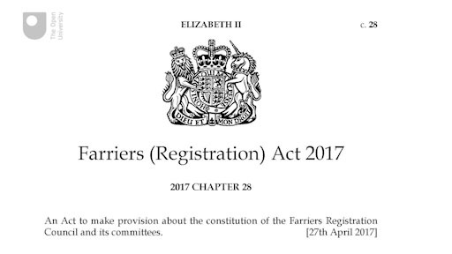

5 Bills and Acts and the UK Parliament
The Office of the Parliamentary Counsel is a group of government lawyers who specialise in drafting legislation. Their role begins when legislation is first being considered and they remain involved throughout the Parliamentary process and beyond.

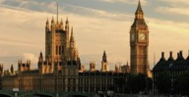
Figure 7 Houses of the UK Parliament at Westminster

Box 4 Information on Acts of the UK Parliament
Putting the Act into force
The Government is responsible for bringing new laws into force, once they have been passed by Parliament.
An Act may come into force immediately, on a specific future date, or in stages. You can find out when an Act is due to come into force by looking at a Section of the Act itself, headed ‘Commencement’ – this is among the very last sections of an Act.
Sometimes a specific date is not given and the timing is left to the discretion of the Secretary of State for the relevant government department.
Although Parliament is not responsible for implementing legislation, its committees can investigate how well an Act is being implemented by the Government and the effect that the new law is having. This is known as post-legislative scrutiny.
Changes to Acts
Future changes to the law happen through the passing of another Act or delegated legislation. An Act can also be repealed so that its provisions no longer apply. Parliamentary committees examine UK laws and recommend the removal of out-of-date legislation.
Finding the text of Acts
Almost all current Acts of Parliament are available to read on the Legislation.gov.uk website. Be aware that the text of the original Act passed by Parliament will differ from a revised version of the Act that incorporates changes made by subsequent legislation.
The UK Houses of Parliament changed from hand writing original Acts of Parliament to printing them in 1849. They are printed on vellum, and still are to this day.
The Acts were also the Bills, until the switch to printing. The Bills would pass through one House, be handwritten onto parchment after report stage, and all amendments made on third reading and during all stages in the second House were painstakingly made onto the parchment. This same document became the Act after Royal Assent. This was the case from 1497–1849, so anyone wanting to consult Bills in this period should actually consult the original Act.
There do additionally exist printed Bills for reference from the early 18th century but they were not made systematically. There is no single definitive set, sometimes they were printed by private promoters (rather than by Parliament), and where odd Bills do survive there is often no indication of what stage of debate they had reached. Their usefulness therefore varies.
Texts of most Acts of Parliament as originally passed by Parliament since 1800 are available on the Legislation.gov.uk website. The Parliamentary Archives has copies of original Acts from 1497.

6 Making law accessible
In Week 2 you explored the concept of the rule of law. Underpinning this were a number of criteria relating to the accessibility and openness of the law.
The Scottish Parliament does a great deal to ensure that its work is open and accessible to the public. The UK Parliament is also working to ensure the accessibility of its legislation. Making Acts easily available is an important part of this work. Here you explore whether what is being done is enough.

Box 5 Legislation and its impact
Legislation affects us all. And increasingly, legislation is being searched for, read and used by a broad range of people. It is no longer confined to professional libraries; websites like legislation.gov.uk have made it accessible to everyone. So the digital age has made it easier for people to find the law of the land; but once they have found it, they may be baffled. The law is regarded by its users as intricate and intimidating.
That experience echoes observations that have been made about statute law for many years. The volume of legislation, its piecemeal structure, its level of detail and frequent amendments, and the interaction with common law and European law, mean that even professional users can find law complex, hard to understand and difficult to comply with.
Should we be concerned about any of this? After all, modern life in a developed country like the UK is complicated, and we use the law to govern many aspects of it. So it is not surprising that statutes and their subordinate regulations are complex; and it is perhaps reasonable to assume that citizens will need help or guidance in understanding the raw material of law.
But in my view, we should regard the current degree of difficulty with law as neither inevitable nor acceptable. We should be concerned about it for several reasons. Excessive complexity hinders economic activity, creating burdens for individuals, businesses and communities. It obstructs good government. It undermines the rule of law.
Parliamentary Office and Office of the Parliamentary Counsel (2013)

Over the past decade there has been a growing movement to make the wording of law more accessible. The UK Cabinet Office and Parliamentary Counsel have launched an initiative called ‘good law’ which aims to make legislation more accessible and understandable for UK citizens. They have undertaken a number of reviews and set the challenge of making law clear, coherent, effective and accessible.

The good law initiative is an appeal to everyone interested in the making and publishing of law to come together with a shared objective of making legislation work well for the users of today and tomorrow.

Listen to the following clip in which the former First Parliamentary Counsel, Richard Heaton, explores law and the language used. The clip makes reference to delegated legislation which you will explore in more detail in week Six. The clip is longer than some of the others you have encountered in your studies. Being able to listen to presentations, concentrate and identify their key points is an important skill. This clip contains material relevant to this week of study and to the following week of study. As you listen reflect on what you have learnt so far in this course. Think about how the points made in the clip are relevant to your studies.

Watch the video at YouTube.com.
View transcript - Uncaptioned interactive content

https://www.gov.uk/guidance/good-law - TEDx Houses of Parliament speech by former First Parliamentary Counsel Richard Heaton
The material in the clip is relevant to current debates about the volume of legislation, complexity of drafting and new ideas for review and reform. Through activities you have been introduced to the law making processes in both the Scottish and UK Parliaments and have begun to see the complexity that this creates.
The interconnectedness between four areas (content, language and style, publication and the statute book) that have traditionally been treated separately is shown in Box 9. Parliamentary Counsel are challenging law makers to consider each of the four from the different perspectives of citizens, professional users and legislators. Reform has been called for and is ongoing.

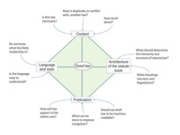
Figure 8 Good law
View description - Figure 8 Good law

Think back to Activity 4 where you were asked to reflect on your experience of reading the National Galleries of Scotland Act 2003 and explanatory notes. Do your reflections support the need for an initiative such as the ‘good law’ initiative to make law more accessible and clearer?

7 This week's quiz
Well done – you have reached the end of Week 5 and can now take the weekly quiz to test your understanding.
Week 5 practice quiz
Open the quiz in a new tab or window (by holding ctrl [or cmd on a Mac] when you click the link).

Summary
You have explored Acts from both the Scottish and UK Parliaments and considered how legislation is structured and cited (referenced). You have also been introduced to the growing complexity of law making, both in terms of sources of legislation (two Parliaments) and the language used.
You should now be able to:
- explain how an Act is structured
- discuss the accessibility of language used in Acts
- understand the role of Parliamentary Counsel.
In the next week you consider the use of delegated legislation. This links to the growing calls for reform on the grounds of accessibility to which you have been introduced during your studies of this week.
You can now go to Week 6.

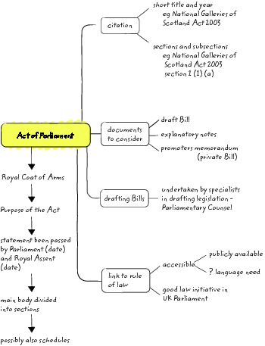
Figure 9 Summary overview of Week 5

References
Cabinet Office and Office of the Parliamentary Counsel. (2016). Working for the Parliamentary Counsel: Caroline MacBeath [Online]. Available at https://www.gov.uk/government/case-studies/working-for-the-parliamentary-counsel-caroline-macbeath (Accessed 7 May 2017).
Kelly, R. and the Parliament and Constitution Centre. (2005). Drafting Legislation and the Parliamentary Counsel Office [Online]. Available at http://researchbriefings.files.parliament.uk/documents/SN03756/SN03756.pdf.
National Galleries of Scotland Act 2003.
Parliamentary Office and Office of the Parliamentary Counsel. (2013). When laws become too complex [Online]. Available at https://www.gov.uk/government/publications/when-laws-become-too-complex/when-laws-become-too-complex (Accessed 13 September 2017).
The Scottish Parliament (2015a). National Galleries of Scotland Bill – Explanatory Notes [Online]. Available at http://www.parliament.scot/S4_Bills/National%20Galleries%20of%20Scotland%20Bill/b77s4-introd-en.pdf (Accessed 12 September 2017).
The Scottish Parliament (2015b). National Galleries of Scotland Bill – Promoter’s Memorandum [Online]. Available at http://www.parliament.scot/S4_Bills/National%20Galleries%20of%20Scotland%20Bill/b77s4-introd-pm.pdf (Accessed 12 September 2017).

Legislation
Farriers (Registration) Act 2017 c 28

Week 6: Exploring legislation

Introduction
In this week you explore and consider the growing use of secondary legislation for the purposes of law making. You also consider the processes for scrutiny in both the Scottish and UK Parliaments and explore some of the challenges presented by secondary legislation.
By the end of this week you will be able to:
- explain what secondary legislation is
- understand why secondary legislation is used
- Understand the difference between primary and secondary legislation.

1 Secondary legislation
An Act of Parliament (whether of the Scottish or UK Parliament) may give a Minister, or some other body, power to make detailed regulations in a specified area of their responsibility. In passing a Bill the Parliament accepts the principles and general objectives but subordinate (also referred to as secondary or delegated) legislation can then be used for the detail of the laws needed to achieve those objectives. It is becoming increasingly common for Acts of Parliament to provide a framework into which much of the real detail and impact of the law will subsequently be added through secondary legislation. Secondary legislation may also be used to state the date upon which an Act will come into force.
Subordinate (secondary or delegated) legislation is generally regarded as a tool for producing detailed legislation.

Box 1 Primary / Secondary / Subordinate / Delegated
An Act of Parliament is referred to as primary legislation. Secondary, Subordinate and Delegated legislation are the terms used to refer to legislation which is made under the authority of an Act of Parliament.

2 The Scottish Parliament
The time available for debate and scrutiny in the Scottish Parliament is limited. The Parliament sits on Tuesdays, Wednesdays and Thursdays. Parliamentary Committees will normally meet on a Tuesday or Wednesday (occasionally Monday). This means that it may not be possible to hear all the detailed aspects of a particular area of legislation quickly. A system, similar to the one used in the UK Parliament, has therefore been developed to allow for the creation of subordinate legislation in the Scottish Parliament.

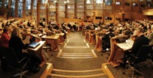
Figure 1 The debating chamber of the Scottish Parliament


Figure 2 Committee room inside the Scottish Parliament

2.1 Subordinate legislation
Primary legislation of the Scottish Parliament often grants powers to individual Ministers or executive bodies to create law. Their powers to make laws have limitations. They are only able to act within the powers and the framework set by the primary legislation. If they fail to do so then that law may be challenged by the Parliament or Committee.
As you have learnt it is quite common for the detail of an Act (for example concerning timing, implementation or the mechanism for updating) to be filled out by subordinate legislation.
The Scottish Parliament has a role in scrutinising subordinate legislation and has the power to approve or reject it. It is extremely rare, however, for the Scottish Parliament to have any scope to amend or change subordinate legislation.
Most subordinate legislation takes the form of statutory instruments. These are considered by the Delegated Powers and Law Reform Committee and at least one other Scottish Parliament committee. However, there are occasions when on a motion of the Parliamentary Bureau, the Parliament may decide that an instrument or draft instrument will go directly to the Parliamentary Chamber for consideration.
The parent Act will generally specify the type of parliamentary procedure that subordinate legislation must follow. They will follow either the negative procedure or the affirmative procedure.

Activity 1 Children and Young People (Scotland) Act 2014
Allow about 15 minutes

Read this section from the Children and Young People (Scotland) Act 2014. What powers does this Act give to Ministers?

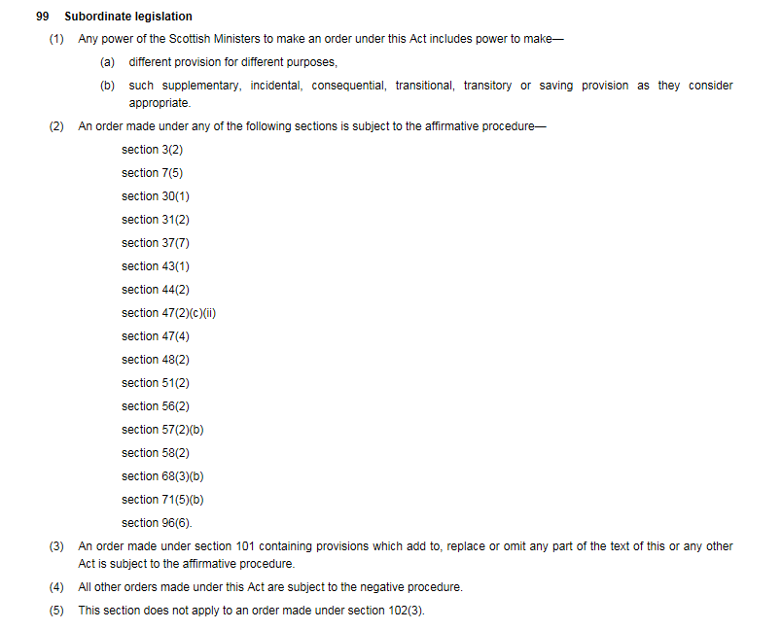
Figure 3 Section 99 Children and Young People (Scotland) Act 2014

Provide your answer...
View comment - Activity 1 Children and Young People (Scotland) Act 2014

2.2 Affirmative or negative procedure
Affirmative and negative procedures are important in scrutinising delegated legislation. Delegated legislation is a major source of law making. In the Scottish Parliament more than 300 pieces of delegated legislation are passed each year. Delegated legislation does not follow the same process as Bills so there is little public consultation although there may be consultation with experts in the particular area.
- The affirmative procedure means that delegated legislation is laid before Parliament in draft form. Approval of that draft by Parliament is needed before it comes into force (becomes law).
- The negative procedure means that the delegated legislation is signed by the Minister and then laid (go before) Parliament. Usually they come into force 28 days after they are laid.
The scope of delegated legislation varies considerably, from technical and procedural to much more wide-ranging powers.

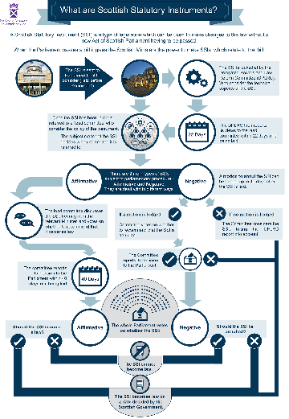
Figure 4 Infographic Scottish Parliament Delegated Powers and Law Reform Committee

Watch the following video which summarises the difference between primary and subordinate legislation and explores the work of the Delegated Powers and Law Reform Committee.

Watch the video at YouTube.com.
View transcript - Uncaptioned interactive content

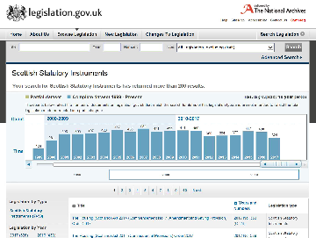
Figure 5 shows the volume of Scottish Statutory Instruments from 1999 to mid-2017. A significant number are passed each year with the highest number in 2007 (at 582).

Take a moment and reflect on how many Acts of the Scottish Parliament there have been (you considered these in Week 3). Statutory instruments far outnumber them.

3 The UK Parliament
Many UK-wide laws are also made by delegated legislation and do not go through the process set out in week 4. The term delegated legislation tends to be used more frequently when referring to the UK Parliament. As in the Scottish Parliament most delegated legislation is created as statutory instruments. Primary Acts set out the framework of powers delegated to Ministers or other bodies in the primary Act. Delegated legislation, mostly in the form of statutory instruments, is frequently used to supplement, provide detail, update and amend primary legislation. This can all be achieved without the UK Parliament having to pass a new Act.

Box 2 UK Parliament and delegated legislation
Delegated legislation is usually concerned with detailed changes to the law made under powers from an existing Act of Parliament. Statutory instruments form the majority of delegated legislation but rules or codes of practice can also be used.
What delegated legislation does
Delegated legislation allows the Government to make changes to a law without needing to push through a completely new Act of Parliament. The original Act (also known as primary legislation) would have provisions that allow for future delegated legislation to alter the law to differing degrees.
These changes range from the technical, like altering the level of a fine, to fleshing out Acts with greater detail; often an Act contains only a broad framework of its purpose and more complex content is added through delegated legislation.
Statutory instruments
Statutory instruments (SIs) are a type of delegated legislation. Approximately 3,000 SIs are issued each year, making up the bulk of delegated legislation. About two thirds of SIs are not actively considered before Parliament and simply become law on a specified date in the future.
SIs are normally drafted by the legal office of the relevant government department. Consultations often take place with interested bodies and parties.
The House of Lords Delegated Powers Scrutiny Committee
The Lords Delegated Powers Scrutiny Committee (established in 1992) keeps under constant review the extent to which legislative powers are delegated by Parliament to government ministers, and examines all Bills with delegating powers which allow SIs to be made before they begin their passage through the House. There is an informal understanding in the Lords that, when the Delegated Powers Committee has approved provisions in a Bill for delegated powers, the form of those powers should not normally be the subject of debate during the Bill's subsequent passage.
The House of Commons has no equivalent committee.
The House of Lords Secondary Legislation Scrutiny Committee (formerly the Merits Committee)
Established in 2003, the Lords Secondary Legislation Scrutiny Committee considers every negative and affirmative SI (or draft SI) laid before Parliament – about 1200 per year – with a view to determining whether the special attention of the House should be drawn to it on any of the following grounds:
- that it is politically or legally important or gives rise to issues of public policy likely to be of interest to the House
- that it may be inappropriate in view of the changed circumstances since the passage of the parent Act
- that it may inappropriately implement EU legislation
- that it may imperfectly achieve its policy objectives
- that the explanatory material laid in support provides insufficient information to gain a clear understanding about the instrument’s policy objective and intended implementation
- that there appear to be inadequacies in the consultation process which relates to the instrument.
The Lords Secondary Legislation Scrutiny Committee reports every week, normally considering SIs written 12–15 days of being laid before the House.
Like the Lords Delegated Powers and Regulatory Reform Committee, the Lords Secondary Legislation Scrutiny Committee's role is to advise the House of Lords, and it is for the House to decide whether or not to act on the Committee's conclusions.
The House of Commons has no equivalent committee.

From the information in Box 2 you can see that the procedures used in the UK Parliament differ from those in the Scottish Parliament and are more complex. The House of Lords has a wide-ranging membership with experts (including former members of the judiciary with their legal expertise) drawn from many areas and scrutinises delegated legislation. The Select Committee of the House of Lords on the constitution (9th Session 2015-16) raised concerns over the use of delegated legislation, in particular that the role of Parliament in scrutinising legislation and challenging the government was being undermined.

3.1 Scrutiny in the UK Parliament
The UK Parliament can delegate powers to UK Government ministers to make laws that extend to Scotland. Scrutiny of subordinate legislation by the UK Parliament is therefore important. You have explored the use of legislative consent motions and know that the UK Parliament is able to make laws for Scotland in reserved areas. To understand law making in Scotland it is therefore also necessary to be familiar with UK Parliamentary procedure for scrutiny and challenge. There are three procedures in the UK Parliament.

Box 3 Procedures for approving delegated legislation in the UK Parliament
(I) The Negative Procedure
- Delegated legislation going through this procedure becomes law on a stated date unless there is a motion passed in either House annulling the instrument. This motion is known as a ‘prayer’. If a member of either House wishes to reject a negative instrument they have to do so within 40 days of the instrument being laid before the UK Parliament.
- In the House of Commons, MPs table a prayer by putting it down as an Early Day Motion. If time is allocated, MPs have up to 90 minutes to debate the instrument.
- In the House of Lords, time is usually found for debate on a prayer motion. This debate is not subject to a time limit. Peers can either seek to reject the instrument or table a non-fatal motion, critical of the instrument without annulling it.
(II) The Affirmative Procedure
- The most substantial and important pieces of delegated legislation are subject to a more stringent form of control and require the active approval of both Houses of Parliament before they can come into effect.
- In the House of Commons, affirmative instruments are referred to a Delegated Legislation Committee for debate, unless a motion for the debate to be held in the Commons chamber is tabled. Debates last no longer than 90 minutes and are conducted on a ‘consideration’ motion. Following debate in committee, an approval motion is put formally to the House without debate on a separate day.
- In the House of Lords, a motion to approve an affirmative instrument can be taken in either Grand Committee or on the Floor of the House. Peers can express their opposition or concern by making an amendment to the approval motion or by tabling a separate motion, effectively withholding the agreement of the House – as was the case in October 2015 when Peers delayed approval of the Tax Credit regulations.
(III) The Strengthened Scrutiny Procedures
- There are currently 10 Acts of the UK Parliament that provide for certain of their powers contained to be subjected to a higher level of parliamentary scrutiny than the affirmative procedure. They confer upon a minister a significant power to amend primary legislation (often referred to as a Henry VIII power). The UK Parliament therefore has the opportunity to comment and recommend changes to proposals under these powers and in some cases to veto the proposed instrument.
Blackwell, J. (2015)

3.2 Reflection on subordinate legislation in the Scottish and UK Parliaments
The use of subordinate legislation is increasing. As you have learnt procedures for scrutiny differ between the UK and Scottish Parliaments. Activity 2 asks you to think about subordinate legislation and some of the concerns over its use.

Activity 2 Use or abuse? Thinking about delegated legislation
Allow about 20 minutes

Delegated legislation is a complex area. Take a few minutes to reflect on what you have learnt and then answer the following questions.

- Where do the powers to make delegated legislation come from?

Provide your answer...
View comment - Untitled part

- Are other terms used as an alternative to delegated legislation?

Provide your answer...
View comment - Untitled part

- What procedures exist to scrutinise delegated legislation?

Provide your answer...
View comment - Untitled part

- Legislation applicable to Scotland may be made by both the Scottish Parliament (on devolved matters) and the UK Parliament (on reserved matters). To find the applicable law on a topic you may need to research both primary and delegated legislation made by either Parliaments. The delegated legislation may not have received much scrutiny. Take a few moments and identify three issues you think this may raise and why.

Provide your answer...
View comment - Untitled part

3.3 The expansion of regulation
The increase in delegated legislation is an indicator of the growing complexity of society. The expansion of regulation, the wide range of social security provision and the wide range of tax provisions, the rapidly changing nature of technology, the growth in delegation of powers to local authorities and councils, use of the internet, the growth in technical detail required and the complexity of a 21st century society have all contributed to a significant increase in the volume, technicality and complexity of delegated legislation.

Activity 3 A need for reform?
Allow about 10 minutes

Look at the following list and indicate whether you class the statement as support for, or a criticism of, delegated legislation:

 | Support for delegated legislation | Criticism of delegated legislation
Supervising delegated legislation is very difficult. | Provide your answer... | Provide your answer...
Publication takes place but few people may be aware that the delegated legislation exists and where to find it. | Provide your answer... | Provide your answer...
Most individuals do not know on what ground you can challenge delegated legislation or how to go about it. | Provide your answer... | Provide your answer...
Some enabling Acts can be ambiguous and can therefore be open to wide interpretation. | Provide your answer... | Provide your answer...
Great power may be given to Ministers. The enabling Act might include a phrase like ‘the minister may make such regulations as he sees fit for the purpose of bringing the Act into operation’. | Provide your answer... | Provide your answer...
Relieves pressure on parliamentary time so that Parliament can concentrate on important laws, rather than technicalities. | Provide your answer... | Provide your answer...
Delegated legislation can be created more easily and quickly. | Provide your answer... | Provide your answer...
Delegated legislation can be drafted by experts in the field. | Provide your answer... | Provide your answer...
Delegated legislation can be made at any time, whereas Acts need to be timetabled. | Provide your answer... | Provide your answer...
Parliament has insufficient time to scrutinise it. | Provide your answer... | Provide your answer...
Delegation of powers causes complexity and confusion. | Provide your answer... | Provide your answer...
Sheer volume causes complexity – it is impossible keep abreast of all delegated legislation (an average of 4,000 and more a year between both Parliaments). | Provide your answer... | Provide your answer...
Lack of publicity for, and consultation on, delegated legislation. | Provide your answer... | Provide your answer...
Undemocratic: most delegated legislation is drafted by civil servants. | Provide your answer... | Provide your answer...
Henry VIII clauses can give power to amend or repeal Acts of the UK Parliament. | Provide your answer... | Provide your answer...
Saves limited time in Parliament allowing for more detailed debates on policy and other matters. | Provide your answer... | Provide your answer...
MPs and MSPs often lack detailed or technical knowledge. | Provide your answer... | Provide your answer...
Enables a quick response to new developments, crises or emergencies. | Provide your answer... | Provide your answer...
Enables minor changes to statutes, for example variations in sentences and approval of motor vehicle changes. | Provide your answer... | Provide your answer...
There is a fear that Ministers are increasingly seeking to use SIs rather than Bills to achieve their policy objectives as these receive much less scrutiny than primary legislation. | Provide your answer... | Provide your answer...
Delegated legislation takes up less parliamentary time. | Provide your answer... | Provide your answer...
Traditionally, the justifications for using delegated legislation have been the need to elaborate complex and technical detail that cannot be easily done on the face of a Bill. | Provide your answer... | Provide your answer...
Delegated legislation enables flexibility and adaptability. | Provide your answer... | Provide your answer...
The system of delegated legislation has been predicated on its reasonable use and application by Ministers coupled with trust in the Parliaments ’ systems of scrutiny. | Provide your answer... | Provide your answer...
Delegated legislation is now being used for administrative convenience and often in circumstances where governments have not fully pinned down the detail of policy proposals. | Provide your answer... | Provide your answer...
Delegated legislation can be found to justify almost any form of delegation a minister might now desire. | Provide your answer... | Provide your answer...

View comment - Activity 3 A need for reform?

3.4 Advantages and disadvantages of using delegated legislation
There are both advantages and disadvantages in using delegated legislation. For its critics, the growth in such legislation is however making law less accessible – something that goes against the rule of law. There are a growing number of calls for review, as some observers argue the current system is creaking. Box 4 outlines reasons put forward by the Hansard Society for change.

Box 4 The need for change
According to a blog written by the Hansard Society:

- The delegated legislation process is no longer fit for purpose. The way in which Parliament deals with delegated powers is neither systematic nor consistent. The Hansard Society’s research shows that too much of the process relies on ‘gut feeling’ and ‘judgement’ rather than objective criteria.
- An incremental approach to reform has created a patchwork of procedures, resulting in a system of scrutiny that is overly complex and confusing and often illogical.
- The language – ‘made’ and ‘laid’, ‘negative’, ‘affirmative’, and ‘super affirmative’, ‘prayers’ and ‘Henry VIII powers’ – is confusing and undermines parliamentary and public understanding of the legislation. Many parliamentarians openly admit they don’t understand them.
- Further patchwork reform risks making the situation worse. It is impossible to separate consideration of delegated legislation from that of primary legislation. The issues are now so serious that an independent expert inquiry is needed to review the entire legislative process looking at:
  - How both primary and delegated legislation is prepared in Whitehall and scrutinised at Westminster.
  - Issues of principle and practice, and where the balance should lie between administrative and political convenience and good legislative process.
  - Rationalisation of scrutiny procedures – exploring what criteria and principles define what members want to look at again in the area of delegated legislation and how this can best be achieved.
  - Whether the burden on Members to scrutinise delegated legislation should be reduced through the introduction of individuals or independent advisory bodies with genuine technical expertise in particular policy areas.
  - Whether the scrutiny system should be re-designed so that the greater burden of technical scrutiny work falls on the House of Lords in future.
Blackwell, J. (2015)

Unlike primary legislation, delegated legislation is not subject to judicial review.

3.5 Delegated powers and the Scotland Act 1998
You may be wondering what relevance this all has to law making in Scotland. Section 35 of The Scotland Act 1998 (as amended) helps illustrate some of the points made.

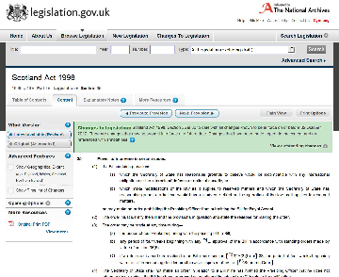
Figure 6 Section 35 Scotland Act 1998

This section gives the Secretary of State (a UK Government post) power to prevent the Presiding Officer of the Scottish Parliament from submitting a Bill of the Scottish Parliament for Royal Assent in certain circumstances. This applies to both devolved and reserved matters. Note the use of words such as ‘reasonable grounds’ and ‘interests of defence or national security’ which are not defined in the Act.

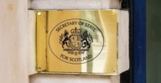
Figure 7 Secretary of State for Scotland logo

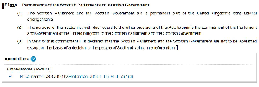
Figure 8 Section 63A Scotland Act 1998

Listen to the following audio discussion in which academics from the OU Law School, Simon Lavis and Edwin Parks, explore delegated legislation and reflect on its use and place in law making.

Audio content is not available in this format.
The use of delegated legislation
View transcript - The use of delegated legislation

4 This week’s quiz
Well done – you have reached the end of Week 6 and can now take the weekly quiz to test your understanding.
Week 6 practice quiz
Open the quiz in a new tab or window (by holding ctrl [or cmd on a Mac] when you click the link).

Summary
During this week you explored the reasons why secondary legislation is used and the procedures followed in the Scottish Parliament and the UK Parliament. You learnt that the procedures are different and that there is growing criticism of the use of such legislation. In particular, critics say that the growing use of secondary legislation is making the law less accessible and that this undermines one of the important principles underpinning the rule of law.
You should now be able to:
- explain what secondary legislation is
- understand why secondary legislation is used
- Understand the difference between primary and secondary legislation.
In the next week you learn about MSPs and MPs and their roles.
You can now go to Week 7.

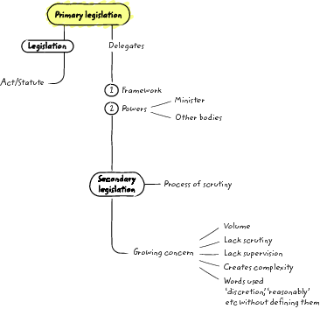

References
Blackwell, J. (2015, December 14). Delegated Legislation: Frequently Asked Questions [Blog post]. Retrieved from http://blog.hansardsociety.org.uk/delegated-legislation-frequently-asked-questions/

Legislation
Children and Young People (Scotland) Act 2014 asp 8
Scotland Act 1998 c 46

Week 7: MSPs, MPs and law making

Introduction
Both the Scottish and UK Parliaments make laws covering Scotland. This may be achieved through primary or subordinate / delegated legislation. In previous weeks you have considered how the Parliaments make laws. In this week you explore who the individuals who contribute to making those laws are – the MSPs (Members of the Scottish Parliament) and MPs (Members of Parliament, meaning the UK Parliament). You consider the election process and work of Committees in the Scottish Parliament.
By the end of this week you will be able to:
- explain who can vote in Scottish and UK Parliament elections
- explain the differences between Scottish and UK Parliament elections
- discuss the principles underpinning the Code of Conduct for MSPs.

1 Members of the Scottish Parliament (MSPs)
The Scotland Act 1998 established a Scottish Parliament with legislative powers. There were to be 129 seats in the Scottish Parliament. The Parliament was to be elected partly on the basis of proportional representation and assumed full powers on 1 July 1999. Terms of office of MSPs were to be for four years. The Scotland Act 1998 also established the Scottish Government (referred to as the executive until The Scotland Act 2012).
The Scottish Government consists of the First Minister (elected by the Scottish Parliament and appointed by the monarch), other ministers appointed by the First Minister, the Lord Advocate and the Solicitor General for Scotland. The law office for Scotland at the UK Parliament is now called the Advocate General for Scotland.


Figure 1 Members of the Scottish Government in March 2017

The Scottish Parliament is not responsible for organising or administering elections to the Scottish Parliament. You may recall from your studies of Week 2 that the separation of powers which underpins the rule of laws separates the function of the legislature (Scottish Parliament), executive (Scottish Government) and judiciary.


Figure 2 Aerial shot of Scottish Parliament

1.1 Voting in Scottish parliamentary elections
The Scottish Parliament Elections (Dates) Act 2016 sets out the rules on elections. The most recent elections were on 5 May 2016. The next Scottish Parliament elections are scheduled to take place on 6 May 2021. The Scottish Parliament is a fixed term parliament and power to set election dates is now devolved to the Scottish Parliament.
There are a number of differences between the systems for election to the Scottish and UK Parliaments. There are also differences in who is entitled to vote in elections.
For Scottish Parliament elections individuals can vote if they are:
- aged 16 or over on the day of the election, and
- a UK, Commonwealth or European Union citizen, and
- resident at an address in Scotland, and,
- on the electoral register.

Box 1 Registering to vote in the Scottish Parliament elections
You can register to vote:
- online at gov.uk/register-to-vote, or
- by contacting the Electoral Registration Officer (ERO) for your local area. You can find the ERO contact details using the postcode search on the About my vote website.

In elections for the Scottish Parliament individuals are voting for MSPs to represent them and make decisions on devolved matters in Scotland.
Every registered voter in Scotland has two votes:
- 1 vote for a constituency MSP
- 1 vote to elect regional MSPs.

Box 2 The power to set election dates
In June 2015 Scottish Secretary, David Mundell, announced:

The UK Government will devolve the power to Holyrood to set an alternative date for the Scottish Parliament election which had been due to take place in 2020
The UK and Scottish Governments agreed voters should be aware of the length of term they will be electing MSPs to in 2016.
Mr Mundell has written to the Presiding Officer and Scottish party leaders to inform them that Scotland Office is taking forward a Section 30 Order to devolve the power which will allow the Scottish Parliament to legislate on the timing of the first Scottish Parliament general election to be held after 2016.
The wider power to set election dates beyond the next Scottish Parliament election will be included in the Scotland Bill.
Elections to both the UK and Scottish Parliaments had been scheduled to take place on the same day in 2020, as a result of the Fixed-term Parliaments Act 2011.
The change will allow the Scottish Parliament to introduce and pass legislation to avoid this happening. Holyrood will be able to set a date which avoids holding the poll on the same day as UK Parliament, […] or local government elections.
The move is consistent with the Smith Commission’s recommendation that power over Scottish elections should be devolved to the Scottish Parliament.
The Order has the support of the UK and Scottish Governments, the Scottish Parliament’s Presiding Officer and the leaders of all parties represented at Holyrood.
Mr Mundell said:

‘This is a sensible move which ensures clarity for voters in Scotland by giving the Scottish Parliament the power to set its own parliamentary terms. It will ensure Holyrood elections take place separately from others in future.’

(Scotland Office and Mundell, D., 2015)

You should now watch the following explanation ‘How to vote in a Scottish Parliament election’.

Watch the video at YouTube.com.
How to vote in a Scottish Parliament election
View transcript - How to vote in a Scottish Parliament election

2 The work of MSPs
In Scotland every individual is represented by several MSPs, one for the constituency in which they live and others for the larger region in which they live.

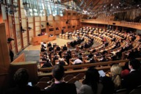
Figure 3 Inside the debating chamber

In Scotland MSPs have a number of roles and are expected to demonstrate certain characteristics such as honesty and integrity. Read the information in Box 3 taken from the Code of Conduct for Members of the Scottish Parliament 6th Edition (2016).

Box 3 Key principles underpinning the Code of Conduct for MSPs
3.1.2 These principles set the tone for the relationship between members and those they represent and between the Parliament and the people of Scotland.
Public duty
3.1.3 Members are expected to act in the interests of the Scottish people and the Scottish Parliament. Members should uphold the law and act in conformity with the rules of the Parliament.
3.1.4 In order to exercise their public duty, members must take the oath of allegiance or make a solemn affirmation as explained in Rule 1.2 of the Standing Orders.
Duty as a representative
3.1.5 Members should be accessible to the people of the areas for which they have been elected to serve and represent their interests conscientiously.
Selflessness
3.1.6 Members should take decisions solely in terms of the public interest. They should not act in order to gain financial or other material benefit for themselves, their family or friends.
Integrity
3.1.7 Members have a duty not to place themselves under any financial or other obligation to any individual or organisation that might reasonably be thought to influence them in the performance of their duties.
Honesty
3.1.8 Members should act honestly. They must declare any private interests (as required by the Interests of Members of the Scottish Parliament Act 2006) relating to their public duties and take steps to resolve any conflicts arising in a way that protects the public interest. The categories of registrable interest are outlined in the schedule to the Act. The schedule is contained in Volume 4 of the Code.
Accountability and openness
3.1.9 Members are accountable for their decisions and actions to the Scottish people. They should consider issues on their merits, taking account of the views of others.
3.1.10 Members should be as open as possible about their decisions and actions.
Leadership
3.1.11 Members should promote and support these principles by leadership and example, to maintain and strengthen the public’s trust and confidence in the integrity of the Parliament and its members in conducting public business.
Extract from Code of Conduct for Members of the Scottish Parliament (Scottish Parliament, 2016)

2.1 The many roles of an MSP
MSPs will become involved in law making and may propose new laws, take part in Chamber debates, participate on Parliamentary Committees, suggest amendments to laws, participate in campaigns to change the law, speak in debates, and ask questions of Government. Their work is varied. Each MSP has an office at the Scottish Parliament and their offices form part of the iconic images of the Scottish Parliament. Box 4 explains this in more detail.

Box 4 MSP accommodation at the Scottish Parliament
The unique façade of the Members’ office accommodation quickly became the first iconic image of Holyrood. The shape of the windows is said to have been inspired by an outline of the Reverend Robert Walker skating on Duddingston Loch taken from Raeburn’s famous painting.
The windows are made from stainless steel and framed in oak, with the oak lattices providing privacy and shade for MSPs. The cladding around the windows is a mosaic of materials, including Kemnay granite from Aberdeenshire and darker granite from South Africa. To break the uniformity of the façade the windows jut out at differing widths and face in both directions.
There are 114 projecting bay windows in total. MSPs occupy 108 of the offices and the others are used as party resource rooms.


Figure 4 Internal image of an MSP think window


Figure 5 External image of an MSP think window

Description of Members’ office accommodation taken from Scottish Parliament website (Scottish Parliament, 2015)

To learn more about the work of MSPs watch the following short videos.

Watch the video at YouTube.com.
In the Parliamentary Chamber
View transcript - In the Parliamentary Chamber

Watch the video at YouTube.com.
In Committees
View transcript - In Committees

Watch the video at YouTube.com.
Out and about
View transcript - Out and about

3 The Committee System
The way in which the Committee system operates and works is a unique feature of the Scottish Parliament. There are a number of Committees (shown in Box 5) with allocated areas of responsibility. They have between five and fifteen members and scrutinise the work of the Government. They work much more on cross-party lines than do Committees of the UK Parliament. There tends to be much more agreement among MSPs from different parties when they are scrutinising or challenging the Scottish Government’s legislation as it passes through Parliament. The Convenors of the Committees are responsible for organising the meetings. These Convenors are drawn from across the main political parties.

Box 5 Committees of the Scottish Parliament
- Culture, Tourism, Europe and External Relations Committee
- Delegated Powers and Law Reform Committee
- Economy, Jobs and Fair Work Committee
- Edinburgh Bakers’ Widows’ Fund Bill Committee
- Education and Skills Committee
- Environment, Climate Change and Land Reform Committee
- Equalities and Human Rights Committee
- Finance and Constitution Committee
- Health and Sport Committee
- Justice Committee
- Justice Sub-Committee on Policing
- Local Government and Communities Committee
- Pow of Inchaffray Drainage Commission (Scotland) Bill Committee
- Public Audit and Post-legislative Scrutiny Committee
- Public Petitions Committee
- Rural Economy and Connectivity Committee
- Social Security Committee
- Standards, Procedures and Public Appointments Committee

You should now watch this short video in which Iain Gray explores the work of the Scottish Parliament and its committees.

Video content is not available in this format.
Iain Gray on the work of the Scottish Parliament and its committees
View transcript - Iain Gray on the work of the Scottish Parliament and its committees



4 The UK Parliamentary elections
The UK Parliament can legislate for Scotland on reserved matters. In the UK Parliament there are 59 MPs who represent constituencies in Scotland. Both the workings of the UK Parliament and the election process differ from those of the Scottish Parliament.
The UK Parliament is divided into two chambers,the House of Commons and the House of Lords. The House of Commons is a directly elected Chamber. Members of the House of Commons are elected by the public, with the country being divided into constituencies. Each constituency returns one Member of Parliament (known as an MP).

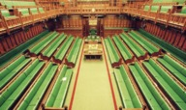
Figure 6 Inside the House of Commons

The Fixed-term Parliaments Act 2011 established a five-year fixed term for the UK Parliament. An election can, however, be announced before the end of the five-year period if:
- a motion of no confidence is passed and there is no alternative government, or
- if a motion for an early general election is agreed either by at least two thirds of the House or without division. This happened in April 2017 when agreement was given to hold an election on 8 June 2017, some two years before the end of the fixed five-year term of that Parliament.
Before the Fixed-term Parliaments Act 2011 Act a UK Prime Minister could call a general election at any time of their choosing within a five-year period of election to that parliament.

4.1 The UK Government
The UK Government of the day is generally formed by the political party which has the most MPs elected to the House of Commons. The Prime Minister will usually be the leader of the largest political party (i.e. the one with the most seats). The Prime Minister selects a large team of ministers to run each of the Government departments. The head of each department is usually a Secretary of State and sits in the Cabinet. The Cabinet is the group of approximately 20 senior Government ministers who are responsible for running the Government departments of state and deciding Government policy. For example, the Secretary of State for Scotland (Scottish Secretary), whose role is to promote and protect the devolution settlement and who has responsibilities which include promoting partnership between the UK government and the Scottish government, and relations between the two Parliaments.


Figure 7 Scotland Office


Figure 8 The Scottish Office Whitehall

4.2 The voting system for the UK Parliament
Each voter has only one vote and to vote they simply place a cross on the ballot paper to indicate their preference. The person who wins the highest number of votes within a constituency is the elected MP for that constituency. This electoral system is known as the ‘first-past-the-post’ system which is described in Box 6.

Box 6 The first-past-the-post system
The first-past-the-post system is the only system ever used in British general elections and it has many advantages over other systems. It usually produces strong, decisive Governments with an overall majority in Parliament; with every voter represented by one MP, it provides a clear democratic link between the people and Parliament and it is quick and simple for the voters. However, the system may also be unfair. As an example, an election for the constituency of Not-Real has taken place.
The three main candidates are from the three most prominent national parties. The result is as follows:
Candidate A: 25,000 votes
Candidate B: 20,000 votes
Candidate C: 10,000 votes
In this example, the clear winner is Candidate A with a majority over Candidate B of 5,000. However, 25,000 voted for the candidate who won that election but 30,000 voted against the winner. If more people vote against a candidate by choosing an alternative, is this democratic in terms of popular representation in Westminster?

In the 1997 UK General Election, the Labour Party gained 43.2% of the total votes cast and won 63.6% of seats at Westminster. The combined number of votes for the Conservatives and Liberal Democrats represented 47.5% of the total votes (over 4% more than Labour), yet between them they won 32.1% of the seats available at Westminster. In the 2001 election, Labour had 43% of the total vote whereas all the other parties had 57% – yet Labour maintained its very powerful position in Parliament with 413 MPs out of 659 (63% of the total number of seats in Parliament). In the 2005 General Election, Labour won 37% of the vote and 55% of the seats in the House of Commons. The combined number of votes for the Conservatives and Liberal Democrats represented 55% of the total votes (18% more than Labour), yet between them they got 40% of the seats available in the House of Commons.
The 2010 election resulted in the first coalition government in 70 years. The Conservatives and Liberal Democrats shared power. In the election the Conservatives won 36% of the votes, the Liberal Democrats 23% and Labour 29%. The combined votes of the Conservatives and Liberal Democrats represented 59% of the vote. The Conservatives had 306 seats, the Liberal Democrats 57 seats, the SNP 6 seats and Labour 258 seats.
The 2015 election resulted in an overall Conservative majority of 11 seats in the House of Commons (not including the Speaker). The Conservatives won 330 seats, Labour won 232, the Liberal Democrats 8 and the SNP 56. The Conservatives polled 11.3 million votes, 36.8% of the vote.
The 2017 election result resulted in a minority Conservative government with a confidence and supply agreement with the DUP. The Conservatives won 318 seats, Labour 262, the Liberal Democrats 12 and the SNP 35. The Conservatives polled 13.6 million votes, 42% of the vote.


Figure 9 UK Cabinet ministers

No UK Government since 1935 has had a majority of public support as expressed through votes cast at a national election. The effect of this on law making is that a powerful UK Government with overwhelming Parliamentary power can usually push through its required legislation – but with only a minority of the country supporting it.
In May 2011 a referendum was held on the voting system used to elect MPs to the House of Commons. The question asked on the ballot paper was:

At present, the UK uses the ‘first past the post’ system to elect MPs to the House of Commons. Should the ‘alternative vote’ system be used instead?
Electoral Commission (2011)

Of those who voted, 68% voted for no change and 32% voted for change.

4.3 Who can vote in a UK general election?
To vote in a UK general election you must be registered to vote and also
- be 18 or over, and
- be a British citizen, a qualifying Commonwealth citizen or a citizen of the Republic of Ireland, and
- not be subject to any legal incapacity to vote.
Voters cast their single vote for a constituency MP.
There are restrictions as to who can vote in a UK General election. The following individuals cannot vote (although they can vote at elections to local authorities):
- Members of the House of Lords.
- EU citizens resident in the UK.
- Anyone other than British, Irish and qualifying Commonwealth citizens.
- Convicted persons detained in pursuance of their sentences (though remand prisoners, un-convicted prisoners and civil prisoners can vote if they are on the electoral register).
- Anyone found guilty within the previous five years of corrupt or illegal practices in connection with an election.

4.4 The House of Lords
Originally the members of the House of Lords was comprised of those who had inherited a title (known as hereditary peers), senior judges who sat as Law Lords, and the most senior bishops in the country. During the twentieth century the awarding of a title for life (known as a life peerage) became more common. The Prime Minister nominated people who should receive a title for their lifetime only. In this way, people who had served the country and were thought to be suitable members of the House of Lords were able to bring their expertise to the House.

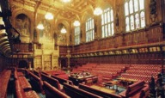
Figure 10 Inside the House of Lords

Most life peerages were given to former politicians who had retired from the House of Commons. For example, James Callaghan, who was Prime Minister from 1976 to 1979, was made a life peer in 1987, taking the title Lord Callaghan of Cardiff, while Margaret Thatcher, the first female Prime Minister, was made a life peer in 1992 and became known as Baroness Thatcher. When men are made life peers they are called lords; women life peers are called baronesses.
During the late 1990s the Labour Government decided that in a modern society an inherited title should not automatically allow someone to participate in making law. They felt that some of the members of the House of Lords should be elected and some should be nominated. The right of most of the hereditary peers to sit in the House of Lords was abolished in 1999. As a result of this change three types of peer now sit in the House of Lords: life Peers, Bishops and elected hereditary Peers.
The House of Lords is characterised by ‘independence of thought’. Some members (Peers) have a political background, most don’t. They represent a wide range of professions – including medicine, law, business, the arts, science, sports, education, the armed forces, diplomacy and public service.
Currently, there are about 825 members who are eligible to take part in the work of the House of Lords. The majority are life Peers. Others include 26 archbishops and bishops and 92 hereditary Peers. There is no upper limit on the total number of members.
- Life peers: the majority (about 700) of members are appointed for their lifetime by the Queen on the advice of the Prime Minister. Any British, Irish or Commonwealth citizen who is a UK resident and taxpayer over the age of 21 is eligible to be nominated or can apply to become a member, via the independent House of Lords Appointments Commission.
- Archbishops and bishops: 26 Church of England archbishops and bishops sit in the House. When they retire as bishops their membership of the House ceases and is passed on to the next most senior bishop.
- Elected hereditary members: the House of Lords Act 1999 ended the right of most hereditary peers to sit and vote in the House; 92 remain.
To learn more about the work of the House of Lords watch the following video.

Watch the video at YouTube.com.
How the Lords works with the Commons to make a Bill law
View transcript - How the Lords works with the Commons to make a Bill law

5 Parliamentary election constituencies
For elections to the Scottish Parliament, Scotland is divided into constituencies and regions. There are 59 constituencies and eight Regions. Information on constituencies, regions and MSP details can all be found on the Scottish Parliament website.
For UK Parliament elections the UK is divided into constituencies. Constituency boundaries are regularly reviewed. As of July 2017 there are 650 parliamentary constituencies: 533 constituencies are in England, 59 in Scotland, 40 in Wales, and 18 in Northern Ireland.
The size (both geographical and in terms of population) of UK Parliament constituencies differs between different parts of the UK. The geographically largest constituency of Ross, Skye and Lochaber is situated in Scotland. The smallest, Islington North, is in London. More details can be found on the UK Parliament website.

Activity 1 Elections to the Scottish and UK Parliaments
Allow about 15 minutes

Using your knowledge complete the following table.

Question | Scottish Parliament | UK Parliament
How many chambers? | Provide your answer... | Provide your answer...
How many elected members? | Provide your answer... | Provide your answer...
How many members represent Scotland? | Provide your answer... | Provide your answer...
Whose work does it scrutinise? | Provide your answer... | Provide your answer...
How are members selected? | Provide your answer... | Provide your answer...
What matters do they cover? | Provide your answer... | Provide your answer...
What age must you be to be eligible to vote? | Provide your answer... | Provide your answer...

View comment - Activity 1 Elections to the Scottish and UK Parliaments

6 This week’s quiz
Well done – you have reached the end of Week 7 and can now take the weekly quiz to test your understanding.
Week 7 practice quiz
Open the quiz in a new tab or window (by holding ctrl [or cmd on a Mac] when you click the link.

Summary
In this week you considered how MSPs and MPs are elected, who is eligible to vote and noted the differences in the systems between the Scottish and UK Parliaments. You learnt about the work of MSPs and the role of parliamentary committees. If you wish to learn more about your MSP or MP and the work they do, visit the relevant parliamentary website. If you wish to ask them a question you can do so by email or letter. Their contact details are available via the parliamentary website.
You should now be able to:
- explain who can vote in Scottish and UK Parliament elections
- explain the differences between Scottish and UK Parliament elections
- discuss the principles underpinning the Code of Conduct for MSP.
In the next week, the final week of the course, you explore how individuals are encouraged to become involved in law making and how they can do so.
You can now go to Week 8.

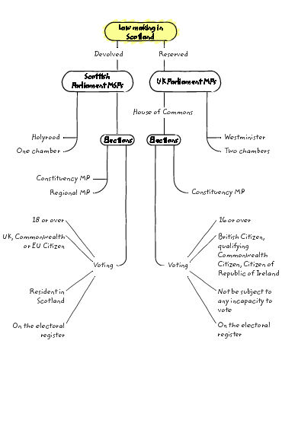
Figure 11 Summary overview of Week 2

References
Electoral Commission. (2011). Referendum on the voting system for UK parliamentary elections [Online]. Available at http://www.electoralcommission.org.uk/__data/assets/pdf_file/0019/141328/Final-PVS-report.pdf (Accessed 13th September 2017).
Scotland Act 1998 c 46
Scotland Office and Mundell, D. (2015, 10 June). Power to set 2016 Scottish Parliamentary term to be handed over [News article]. Retrieved from https://www.gov.uk/government/news/power-to-set-2016-scottish-parliamentary-term-to-be-handed-over
Scottish Parliament. (2015). About the building – MSP building [Web page]. Retrieved from http://www.parliament.scot/visitandlearn/15920.aspx
Scottish Parliament. (2016). Code of Conduct for Members of the Scottish Parliament (6th Edition) [Online]. Available at http://www.parliament.scot/Parliamentaryprocedureandguidance/CCEd06Rev01201605.pdf (Accessed 13th September 2017).

Week 8: Getting involved in law making

Introduction
In this week you consider where the ideas for the need for an Act of the Scottish Parliament come from. You explore the sources of those ideas before looking at how citizens can shape and become involved in the law making process of the Scottish Parliament. Earlier in the course you explored the different types of Bills that exist and how they go through a process before becoming law. You have also seen that in the Scottish Parliament the process for public engagement is transparent and that public engagement is encouraged. You start this week by considering why law changes.


Figure 1 Common questions

By the end of this week you will be able to:
- explain why law changes
- explain some of the ways in which law is changed
- understand how you can contribute to the work of the Scottish Parliament.

1 Why law changes
One of the most important functions of any legal system is to state the laws by which the society in which it exists is to operate. Society does not remain static so the legal system and the laws it produces need to be relevant in order to be effective. Laws need to respond to social, economic, technological, moral and political change by evolving as those changes emerge.

Activity 1 Why change?
Allow about 10 minutes

What new law would you introduce to improve life in the society in which you live? Write a short paragraph (no more than 150 words) outlining what law you would like to see introduced and arguing in favour of this law.

Provide your answer...

View comment - Activity 1 Why change?

You will now consider how laws can change and how you could become involved in the process. As you work through the next sections think about what would be the best way of achieving the law reform which you suggested in Activity 1 and what obstacles there may be to your proposal.

2 Where do ideas for change come from?
Society is constantly changing. The law and legal system need to reflect society’s views and keep pace with these changes and so, in turn, are constantly undergoing change. Inevitably, the more complex the society, the more complicated the legal issues and cases which arise. In the nineteenth century, the majority of cases coming before the courts concerned the sale of horses. Today’s courts often have to deal with large commercial transactions involving electronic communications.
The list of sources for ideas for change that follows is not exhaustive, but is intended to provide an illustration of the range of bodies interested in law and changes in the law.
- Political party manifestos
Party manifestos and pre-election promises are influenced by what politicians believe the public will vote for. A government is not, however, legally bound to introduce any pre-election promises.
- Public opinion
Members of the general public can influence members of parliament to introduce Bills.
- The media can harness public opinion in order to pressure Parliament to make new laws.


Figure 2 Publicity on the date of the first same-sex marriage in Scotland

- An emergency or crisis
Legislation may be passed because of some national emergency or crisis which emerged during the government’s period in office.
- Royal Commissions
Royal Commissions occasionally report to Parliament with recommendations for legislation which may be taken up as part of the government’s legislative programme. Royal Commissions are advisory committees established by the government, though formally appointed by the Crown – hence ‘royal’ – to investigate any subject the government of the day sees fit to refer to such a Commission. They are often used for non-party political issues, or for issues that a government wishes to be seen to be addressing in a non-party political way.
- The Scottish Law Commission
Another source of legislation is the recommendations of the Scottish Law Commission. The Commission was created in order to review and make recommendations about any areas of the law which it felt were in need of reform.


Figure 3 Logo of the Scottish Law Commission

- Private Members’ Bills
Individual Members of Parliament have the power to introduce their own legislation known as a ‘Private Members’ Bill’. Private Members’ Bills may be the result of an MSP being approached for support for a proposal put forward by particular interest groups operating outside Parliament. Alternatively, Private Members’ Bills may originate from a government suggestion to an MSP that he or she propose a particular measure.


Figure 4 National Gallery of Scotland, Edinburgh

- Pressure groups
A pressure group can be described as an organised group that exists for the purpose of permanently representing particular interests. Pressure groups do not generally put up candidates for election but seek to influence government policy or legislation. They can also be described as ‘interest groups’, ‘lobby groups’ or ‘protest groups’. In the UK, the number of political parties is very small, whereas the number of pressure groups runs into thousands. A pressure group can be a huge organisation like the CBI (Confederation of British Industry), which represents approximately 150,000 businesses, but it can also be a single-issue, locally-based organisation.
The aim of all pressure groups is to influence the people who actually have the power to make decisions. Pressure groups provide a means of popular participation in national politics between elections. They are sometimes able to gather sufficient support to force government to amend or even repeal legislation. There is considerable evidence of successful pressure group campaigns that have changed government policies.


Figure 5 Allan MacRae of the Assynt crofters trust

3 How is law reformed?
The one certainty in the study of any area of law is that it will be characterised by change. There is a continuous conflict between the need to acknowledge pre-established laws and the need to facilitate change in view of changing social and economic conditions. The law must be both static and dynamic: it must change, yet at the same time continue on its old path.
If the law was ever changing, it could not fulfil its basic function, namely to answer to the need for certainty, predictability, order and safety. An ever-changing law would increase practical uncertainty, social instability and economic insecurity.

Activity 2 Reflecting on why law changes?
Allow about 10 minutes

Do you think the law should always change as an immediate response to changes in society? Or do you think that changes to the law should be gradual, taking into account previous laws and with a process of full consultation?

Provide your answer...
View comment - Activity 2 Reflecting on why law changes?

Law in Scotland can be changed in a number of ways:
- through the Scottish Parliament on devolved matters
- through the UK Parliament on reserved matters (or on devolved matters if there is a legislative consent motion)
- through the judiciary in the Scottish legal system
- through treaty obligations as enforced by the European Court of Human Rights.

3.1 The Scottish and UK Parliaments
The Scottish and UK Parliaments are major sources of law in Scotland. They create new laws, reform and repeal existing laws and codify existing laws in their areas of legislative competence.


Figure 6 Scottish Parliament

One of the ways in which parliaments respond to changes in society or the demands of society is by creating new legislation. You explored the processes through which draft legislation goes and learnt about the process of scrutiny in earlier weeks on this course. On occasion, as a response to public pressures, scientific or other developments, legislation may be passed very quickly. Whilst this may seem to have benefits in that politicians can be seen to be doing something it can also have unintended consequences and the legislation may be prone to interpretation.

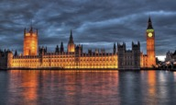
Figure7 UK Parliament

You have learnt that there are Parliamentary processes which have been designed to ensure the technical quality of legislation (you explored the ‘good’ law project in Week 5) and that effective parliamentary scrutiny is maintained. Legislation should also be proportionate, justified and transparent. It should uphold constitutional rights and abide by the rule of law.
However, there are occasions when emergencies arise and it may not be feasible for the full process to be used. In the Scottish Parliament there is an emergency bill procedure that enables the fast tracking of legislation. Procedural rules provide guidance on the scrutiny to be undertaken and the Bill (unless the parliament agrees otherwise) must be accompanied by the usual accompanying notes. In this way, if necessary, legislation can be passed in a day. In the UK Parliament there is also a fast track procedure where legislation can go through the House of Commons stages in one day. These fast track procedures have been used for a number of reasons, for example, economic reasons, terrorism, closing legal loop holes, responding to public concerns or court judgments.
Activity 3 now asks you to think about examples that you may have come across where the law has been changed as a result of public pressure.

Activity 3 Law reform and public pressure
Allow about 15 minutes

Can you think of any examples where Parliament changed the law in response to public or media pressure? Using your own experiences, can you identify any examples of a situation when Parliament reacted to public pressure to change what was considered unlawful conduct?

Provide your answer...
View comment - Activity 3 Law reform and public pressure

Some legal commentators see the growth and development of the law as reflecting particular phases and trends in social history as written by the mass media and politicians. Activity 3 helps illustrate this.


Figure 8 Big day out

3.2 The judiciary
Judges are not primarily concerned with law reform, but they frequently draw attention to anomalies in the law and call for change. Judges can, in fact, reform the law through the medium of interpreting Acts of Parliament and reinterpreting the common law.

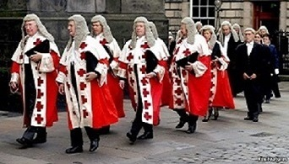
Figure 9 Members of the Scottish judiciary in the traditional procession which signifies the start of the new legal term

Much of the law in common law systems is judge-made. This means that there is an important body of law, doctrines and practices which developed over time, through case law, and which cannot be tied to any statutory text. Much of statute law is also subject to judicial interpretation. However, legislation is enacted by democratically elected representatives of the people; judges are not elected. Judges who make up new law could be thwarting the will of the people or usurping the role of Parliament.

3.3 The European Court of Human Rights
The European Convention on Human Rights (ECHR) was created in 1950 in the aftermath of the devastation of the Second World War. The UK was one of the first signatories and played a major role in drafting the Convention which protects a series of fundamental human rights, including:
- the right to life
- freedom from torture and inhuman and degrading treatment
- freedom from forced labour or slavery
- the right to liberty and to a fair trial
- the right to privacy.
The ECHR is important as it provides citizens with a tool for challenging excesses by public authorities. The European Court of Human Rights (the Court), which is based in Strasbourg, enables individuals to lodge complaints against those states who have signed up to the ECHR for alleged violations of rights contained in the Convention.
Any person claiming to be a victim of a violation of the ECHR may lodge a complaint directly with the Court provided that they have first tried to resolve their case in the domestic courts of the state concerned. All final judgments of the Court are binding on the state. The UK, as a signatory, is therefore expected to change the law to accommodate the Court’s ruling and judges of the Court may therefore make decisions which may lead to a change in what is considered unlawful in the UK.


Figure 10 Treaty obligations as enforced by the European Court of Human Rights

Although UK citizens already enjoyed many of the important rights contained in the ECHR judges in the Court have been called upon to decide socially and politically sensitive questions relevant to the UK. The Court has, on a number of occasions, held that the UK has violated the rights of individuals, for example, a judgment made by the European Court of Human Rights effectively abolished corporal punishment in schools in the UK.

4 How can you become involved?
As you have learnt the Scottish Parliamentary process has been designed to be as open as possible. This is reflected not only in the procedures that have been established but also in the design of the Parliament building itself. The debating chamber, which was central to the design for the Scottish Parliament, was designed to reflect the Parliament’s commitment to openness. The mace presented by the Queen at the opening of the Scottish Parliament on 1 July 1999 is engraved with the words: ‘wisdom’, ‘justice’, ‘compassion’ and ‘integrity’. These are designed to represent the aspirations of MSPs.
How can a citizen become involved in the law making process? As one of our constitutional duties citizens are expected to vote in parliamentary elections, where both MSPs and MPs are elected. In voting in those elections a citizen is becoming involved in law making (even though they may not realise this).

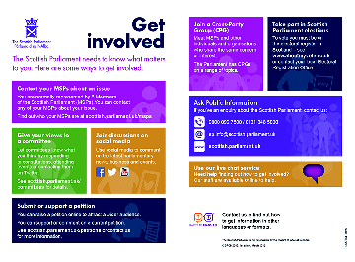
Figure 11 Get involved

Activity 4 How can I become involved in the law-making process of the Scottish Parliament?
Allow about 20 minutes

Reflect on what you have read in this course. Then make a list of all the ways in which you feel you could become involved in the law-making processes of the Scottish Parliament.

Provide your answer...
View comment - Activity 4 How can I become involved in the law-making process of the Scottish P ...

5 This week’s quiz
It’s time to complete the Week 8 badged quiz. It is similar to previous quizzes, but this time instead of answering five questions there will be fifteen.
Week 8 compulsory badge quiz
Remember, this quiz counts towards your badge. If you’re not successful the first time, you can attempt the quiz again in 24 hours.
Open the quiz in a new tab or window (by holding ctrl [or cmd on a Mac] when you click the link.

Summary
You have been introduced to where the ideas for the need for an Act of the Scottish Parliament may come from and considered why new laws may be needed. You have also seen that in the Scottish Parliament the process for public engagement is transparent and public engagement is encouraged. While the Scottish Parliament may seem remote, there are many opportunities for citizens in Scotland to participate and such participation is welcomed.
You should now be able to:
- explain why law changes
- explain some of the ways in which law is changed
- understand how you can contribute to the work of the Scottish Parliament.

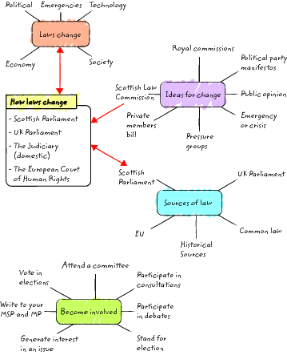
Figure 14 Summary overview of Week 8

End of course conclusion
We very much hope that you have enjoyed your studies on this course. As you may have gathered from your studies, the course authors think that law making is a fascinating and important subject which underpins all aspects of our daily lives. An understanding of law making can give us a fresh insight into the society in which we live. It also highlights the important role of MSPs and MPs. Law has an important function in assisting a society to grow and develop because the culture of any society is reflected in its legal system. We hope that through your studies on this course you have been able to recognise some of these aspects in the work of the Scottish Parliament. We also hope that your studies have given you a new viewpoint on, and a fresh insight into, the Scottish Parliament and the importance of its role in contemporary Scotland.
Now you’ve completed The Scottish Parliament and law making, you may like to enrol on these free OpenLearn courses:
Scottish courts and the law
Legal skills and debates in Scotland
Law and change: Scottish legal heroes
And if you would like to take your study in this subject area further, sign up to the Open University course Law making in Scotland.

Tell us what you think
Now you’ve completed the course we would again appreciate a few minutes of your time to tell us a bit about your experience of studying it and what you plan to do next. We will use this information to provide better online experiences for all our learners and to share our findings with others. If you’d like to help, please fill in this optional survey .

Acknowledgements

Acknowledgements
This free course was written by Carol Howells.
Except for third party materials and otherwise stated (see terms and conditions), this content is made available under a Creative Commons Attribution-NonCommercial-ShareAlike 4.0 Licence.
The material acknowledged below is Proprietary and used under licence (not subject to Creative Commons Licence). Grateful acknowledgement is made to the following sources for permission to reproduce material in this free course:
Course image: georgeclerk/iStockphoto.com

Week 1

Text
Box 1: Extracts from The Scotland Act (1998) © Crown http://www.nationalarchives.gov.uk/doc/open-government-licence/version/3/
Box 3: Extracts from The Scotland Act (2012) © Crown http://www.nationalarchives.gov.uk/doc/open-government-licence/version/3/
Box 4: From Scotland Office and Mundell, D. (2015a). Scotland Bill 2015 - legislation and explanatory notes https://www.gov.uk/government/publications/scotland-bill-2015-legislation-and-explanatory © Crown https://www.nationalarchives.gov.uk/doc/open-government-licence/version/3/
Box 5: From: Scotland Office and Mundell, D. (2015b). Scotland Bill 2015 - legislation and explanatory https://www.gov.uk/government publications/scotland-bill-2015-legislation-and-explanatory (c) Crown https://www.nationalarchives.gov.uk/doc/open-government-licence/version/3/
Box 6: Office of the Advocate General for Scotland. (2015). 2010 to 2015 government policy: Scottish devolutionhttp://www.nationalarchives.gov.uk/doc/open-government-licence/version/3/
Box 8: © Scottish Parliament Corporate Body http://www.parliament.scot/ Contains information licenced under the Scottish Parliament Copyright Licence
Box 9: Extracts from Cabinet Office. (2011). Devolution guidance notes [Online] Available at https://www.gov.uk/government/publications/devolution-guidance-notes , http://www.nationalarchives.gov.uk/doc/open-government-licence/version/3/

Figures
Figure 1: Mace was designed and crafted by Michael Lloyd Contains information licenced under the Scottish Parliament Copyright Licence
Figure 2: From: Serving Scotland Better: Scotland and the United Kingdom in the 21st Century © Produced by the Commission on Scottish Devolution.
Figure 3 :extracts from The Scotland Act (2012) © Crown (excluding logo): https://www.nationalarchives.gov.uk/doc/open-government-licence/version/3/
Figure 4: PA Images
Figure 5: from Scotland Act 2016 c11 © Crown: https://www.nationalarchives.gov.uk/doc/open-government-licence/version/3/
Figure 6: from Scotland Act 2016 c11 © Crown: https://www.nationalarchives.gov.uk/doc/open-government-licence/version/3/
Figure 7: extracts from The Scotland Act (1998) © Crown (excluding logo) https://www.nationalarchives.gov.uk/doc/open-government-licence/version/3/
Figure 8: from: Scottish Parliament (Parliamentary Business) content (excluding logo) http://www.parliament.scot/Fol/Scottish_Parliament_Licence_2017.pdf
Figure 9: BBC News Scotland
Figure 10 from: http://www.businessforscotland.com/fm-nicola-sturgeon-must-protect-scotland-brexit-fallout/ 68

Week 2

Figures
Figure 15: extract from Scotland Act (1998) © Crown http://www.nationalarchives.gov.uk/doc/open-government-licence/version/3/ (excluding logo)

Week 3
Figure 2: Andrew Cowan/Scottish Parliament Photograph (c) Scottish Parliamentary Corporate Body http://www.parliament.scot/Fol/Scottish_Parliament_Licence_2017.pdf
Figure 3: What Happens in the Scottish Parliament: http://www.parliament.scot/PublicInformationdocuments/SP_YPaW_A5_Leaflet_(alt).pdf https://www.nationalarchives.gov.uk/doc/open-government-licence/version/3/
Figure 4: Adam Elder/Scottish Parliament. Photograph (c) 2005 Scottish Parliamentary Corporate Body http://www.parliament.scot/Fol/Scottish_Parliament_Licence_2017.pdf
Figure 5: extract from Scotland Act (1998) as amended: © Crown http://www.nationalarchives.gov.uk/doc/open-government-licence/version/3/
Figure 6: extract from Scotland Act (1998) as amended: © Crown http://www.nationalarchives.gov.uk/doc/open-government-licence/version/3/
Figure 8: extract from Scotland Act (1998) as amended: © Crown http://www.nationalarchives.gov.uk/doc/open-government-licence/version/3/
Figure 9: Layout of Bill http://www.parliament.scot/parliamentarybusiness/Bills/576.aspx(c) Crown content available under http://www.parliament.scot/Fol/Scottish_Parliament_Licence_2017.pdf
Figure 10: screen shot of Scottish Parliament website © Crown content available under http://www.parliament.scot/Fol/Scottish_Parliament_Licence_2017.pdf
Figure 11: Bills of the Scottish Parliament 1999 to 2016 http://www.parliament.scot/parliamentarybusiness/Bills/576.aspx(c) Crown content available under
Figure 12: Examples of Scottish Bills 1999-2016 –http://www.parliament.scot/parliamentarybusiness/Bills/576.aspx(c) Crown content available under
Figure 13: Stages of a bill from Scottish Parliament website © Crown content available under http://www.parliament.scot/Fol/Scottish_Parliament_Licence_2017.pdf
Figure 14: Extract from 2015-16 Scottish Parliament Annual Report (c) Crown 2007 http://www.nationalarchives.gov.uk/doc/open-government-licence/version/3/
Figure 17: Front page of Aquaculture and Fisheries (Scotland) Act 2007 (c) Crown 2007 http://www.nationalarchives.gov.uk/doc/open-government-licence/version/3/

Week 4
Figure 1: Catherine Bebbington for © Scottish Parliament Corporate Body http://www.parliament.scot/Fol/Scottish_Parliament_Licence_2017.pdf
Figure 2: House of Lords © Parliamentary copyright
Figure 3: Houses of Parliament from the river Thames © BBC
Figure 4: © Scottish Parliament Corporate Body http://www.parliament.scot/Fol/Scottish_Parliament_Licence_2017.pdf
Figure 5: from: The Scotland Bill: Devolution of Scotland's Parliament Research Paper 98/7 1998 http://researchbriefings.files.parliament.uk/documents/RP98-1/RP98-1.pdf © Crown
Figure 6: © Crown (HM Government)
Box 1: extract from: Kelly, R. and the Parliament and Constitution Centre. (2005). Drafting Legislation and the Parliamentary Counsel Office Available at http://researchbriefings.files.parliament.uk/documents/SN03756/SN03756.pdf. ©Crown (HM Government)
Figures 7, 8, 9: (C) Parliamentary Copyright https://www.parliament.uk/site-information/copyright/open-parliament-licence/
Figures 10, 11, 12: screenshot content © Crown Copyright http://www.nationalarchives.gov.uk/doc/open-government-licence/version/2/
Figures 13, 14: screenshot content © Crown Copyright http://www.nationalarchives.gov.uk/doc/open-government-licence/version/3/

Audio Visual
2.1 Debating Bills: How the Lords works with the Commons to make a bill law | A day in the life | https://www.youtube.com/watch?v=-L5nSn_mbOs House of Lords Parliamentary copyright. WWW.parliament.uk I

Week 5

Figures
Figure 1: Screen shot from Scottish Parliament website: content © Scottish Parliament Corporate Body http://www.parliament.scot/Fol/Scottish_Parliament_Licence_2017.pdf
Figure 2: © Kim Traylor https://commons.wikimedia.org/wiki/File:National_Gallery_of_Scotland,_the_Mound_Edinburgh.jpg
Figure 3: © John Peter Photograph/Alamy
Figure 4: from: https://www.edinburghguide.com/
Figure 5: © Scottish Parliamentary Corporate Body Contains information licenced under the Scottish Parliament Copyright Licence: http://www.parliament.scot/Fol/ScottishParliamentLicence20160404.pdf
Figure 7: Houses of parliament (C) Crown Copyright https://www.nationalarchives.gov.uk/doc/open-government-licence/version/2/
Figure 8: From: www.gov.uk/guidance/good-law (c) Crown Copyright https://www.nationalarchives.gov.uk/doc/open-government-licence/version/3/
Box 2: Extract from: Kelly, R. and the Parliament and Constitution Centre. (2005). Drafting Legislation and the Parliamentary Counsel Office Available at http://researchbriefings.files.parliament.uk/documents/SN03756/SN03756.pdf. ©Crown (HM Government)
Box 5: Extract from: Parliamentary Office and Office of the Parliamentary Counsel. (2013). When laws become too complex [Online]. https://www.gov.uk/government/publications/when-laws-become-too-complex/when-laws-become-too-complex 70. © Crown https://www.nationalarchives.gov.uk/doc/open-government-licence/version/3/

Week 6
Figure 1: Andrew Cowan for Scottish Parliament (c) Scottish Parliamentary Corporate Body http://www.parliament.scot/Fol/Scottish_Parliament_Licence_2017.pdf
Figure 2: (c) Scottish Parliamentary Corporate Body http://www.parliament.scot/Fol/ScottishParliamentLicence20160404.pdf
Figure 3: From Children and Young People (Scotland) Act 2014 © Crown Copyright http://www.nationalarchives.gov.uk/doc/open-government-licence/version/3/
Figure 4: © Scottish Parliament Corporate Body. Contains information licenced under the Scottish Parliament Copyright Licence. http://www.parliament.scot/Fol/Scottish_Parliament_Licence_2017.pdf
Figure 5: Bar chart showing Scottish Statutory Instruments from 1999 - 2017. (c) Crown copyright http://www.nationalarchives.gov.uk/doc/open-government-licence/version/3
Figure 7: (c) Brian Anthony/Alamy Stock Photo not in place
Figure 8: Screen shot from Scotland Act (1998) © Crown Contains information licenced under the Scottish Parliament Copyright Licence. http://www.parliament.scot/Fol/ScottishParliamentLicence20160404.pdf
Figure 9: Screen shot from Scotland Act (1998) © Crown Contains information licenced under the Scottish Parliament Copyright Licence. http://www.parliament.scot/Fol/ScottishParliamentLicence20160404.pdf
Box 3: Extract from Blackwell, J. (2015, December 14). Delegated Legislation: Frequently Asked Questions from http://blog.hansardsociety.org.uk/delegated-legislation-frequently-asked-questions/
Box 4 Extract from Blackwell, J. (2015, December 14). Delegated Legislation: Frequently Asked Questions from http://blog.hansardsociety.org.uk/delegated-legislation-frequently-asked-questions/

Week 7
Figure 1: © Scottish Parliamentary Corporate Body http://www.parliament.scot/Fol/ScottishParliamentLicence20160404.pdf
Figure 2: © Scottish Parliamentary Corporate Body http://www.parliament.scot/Fol/ScottishParliamentLicence20160404.pdf
Figure 3: © Scottish Parliamentary Corporate Body http://www.parliament.scot/Fol/ScottishParliamentLicence20160404.pdf
Figure 4: © Scottish Parliamentary Corporate Body http://www.parliament.scot/Fol/ScottishParliamentLicence20160404.pdf
Figure 5: © Adam Elder for Scottish Parliamentary Corporate Body http://www.parliament.scot/Fol/ScottishParliamentLicence20160404.pdf
Figure 6: © Parliamentary Copyright https://www.parliament.uk/site-information/copyright-parliament/open-parliament-licence/
Figure 7: Scotland Office Logo © Crown
Figure 8: © James Paine Henry Holland (Wikimedia Commons) https://creativecommons.org/licenses/by-sa/2.0/
Figure 9: © Dan Kitwood/Getty Images
Figure 10: © Parliamentary Copyright https://www.parliament.uk/site-information/copyright-parliament/open-parliament-licence/
Text
Box 2: extract from: Scotland Office and Mundell, D. (2015, 10 June). Power to set 2016 Scottish Parliamentary term to be handed over .From https://www.gov.uk/government/news/power-to-set-2016-scottish-parliamentary-term-to-be-handed-over(c) Crown https://www.nationalarchives.gov.uk/doc/open-government-licence/version/3/
Box 3: extract from: Scottish Parliament. (2016).Code of Conduct for Members of the Scottish Parliament (6th Edition)http://www.parliament.scot/Parliamentaryprocedureandguidance/CCEd06Rev01201605.pdf(c) Scottish Parliamentary Corporate Body http://www.parliament.scot/Fol/ScottishParliamentLicence20160404.pdf

Week 8
Figure 1: (c) Scottish Parliamentary Corporate Body Copyright Contains information licenced under the Open Scottish Parliament Licence V.2 http://www.parliament.scot/Fol/Scottish_Parliament_Licence_2017.pdf
Figure 2: courtesy: Equality Network http://www.equality-network.org/
Figure 3 Logo: Scottish Law Commission https://www.scotlawcom.gov.uk/
Figure 4: © Kim Traynor https://creativecommons.org/licenses/by-sa/3.0/deed.en
Figure 5: courtesy: © John Paul http://www.photographerprofessional.com/
Figure 6: © Archphotography/Alamy
Figure 7: © Maurice from Zoetermeer, Netherlands in Wikimedia Commons https://creativecommons.org/licenses/by/2.5/
Figure 8: (c) Scottish Parliament Corporate Body Contains information licenced under the Open Scottish Parliament Licence V.2 http://www.parliament.scot/Fol/Scottish_Parliament_Licence_2017.pdf
Figure 9: Rex Features
Figure 10: © Council of Europe http://www.coe.int/documents/
Figure 11: (c) Scottish Parliamentary Corporate Body (2015) 1st edition, March 2015 Contains information licenced under the Open Scottish Parliament Licence V.2 http://www.parliament.scot/Fol/Scottish_Parliament_Licence_2017.pdf
Every effort has been made to contact copyright owners. If any have been inadvertently overlooked, the publishers will be pleased to make the necessary arrangements at the first opportunity.
Don't miss out:
1. Join over 200,000 students, currently studying with The Open University – http://www.open.ac.uk/ choose/ ou/ open-content
2. Enjoyed this? Find out more about this topic or browse all our free course materials on OpenLearn – http://www.open.edu/ openlearn/
3. Outside the UK? We have students in over a hundred countries studying online qualifications – http://www.openuniversity.edu/ – including an MBA at our triple accredited Business School.
Don't miss out
If reading this text has inspired you to learn more, you may be interested in joining the millions of people who discover our free learning resources and qualifications by visiting The Open University – www.open.edu/ openlearn/ free-courses.

Activity 1 Reserved or Devolved?

Reserved

Comment
- The powers of the Scottish Parliament are set out in Acts of the UK Parliament. Acts of Parliament create law. Those laws tend to be expressed in formal language that is quite different from the language you would find in a novel or newspaper article, and very different from the language in an online blog or tweet. Learning to order information to make sense of it is an important skill. Here the authors chose to take a step-by-step historical approach to build a picture of the powers of the Scottish Parliament. This enabled the incremental nature of those powers to be explained. The incremental nature reflects events such as the independence referendum. Devolution has not been a fixed and settled process and is on-going, reflecting changes within society.
- The Scotland Act 1998 (as amended) specifies those matters that are reserved to the UK Parliament. Matters not reserved by the Scotland Act 1998 (as amended) are devolved to the Scottish Parliament.
Back to Unit 2 Session 3 Part 4

Activity 2 Reserved matters

Comment
There are a number of reserved matters. These include constitutional issues, foreign policy, defence and national security, data protection, and ordnance survey. There are a number of benefits to having reserved matters, including:
- the Scottish Parliament has more time to devote to Scottish issues
- the Scottish Parliament is able to consult more widely on issues which affect Scotland
- it allows the UK Parliament to legislate in areas where there is likely to be common agreement (Scottish MPs still sit in the UK Parliament)
- it could be seen to prevent duplication of debate in both Parliaments.
This list is not exhaustive and you may have thought of other benefits. The relationship between the Scottish and UK Parliaments continues to develop. It can suit the Scottish Parliament to allow the UK Parliament to legislate in a devolved matter. Remember, however, that the Parliaments and Government are separate and serve different functions. Protocols have therefore emerged for the use of these powers and you will now explore these.
Back to Unit 2 Session 4 Activity 1

Activity 1 How would you define a constitution?

Comment
A range of state constitutions exists worldwide and each one is unique. A range of definitions also exist but at its most basic a state constitution is seen as having the following elements:
- rules about the structure and power of government of the state
- rules about the basic rights and freedoms of the citizens of that state
- rules on how law is created within that state.
States have their own legal systems and national laws which are created according to their constitution. Constitutions are fundamental to a society as they provide the structures which determine who has the right and the power to make and enforce the law. The constitution of each state also represents the history and culture of that state.
Looking at each of the definitions you were given as your source of information revealed different aspects of a state constitution and what features the authors thought ought to exist.
- The definition in The Encyclopaedia Britannica identifies the need for a structure, a definition of responsibilities, and different roles for different public officials is emphasised. The definition also links the notion of both peace and defence to a constitutional framework. You may have noticed that at the end of the definition it indicates that the constitution should be contained in a written form. This is an aspect that you will return to later.
- King’s definition focuses on the relations between governing institutions, but again mentions the relationship between the state (governing institutions) and individuals.
- Professor Wheare’s focuses on the regulation of the government by a system of rules. This definition has a narrower focus than the other definitions we have considered. There may at first glance appear to be a small difference; however, a constitution which is defined as regulating the state and state bodies has a wider scope than one which concentrates on regulation of the government.
The definitions discussed so far have considered the state, the government, and also the relationship between the state and individuals.
- Paine’s approach to defining a constitution provides a different perspective as it focuses on the source of a constitution. Paine’s view is that a constitution ultimately derives from the people acting through the government.
Another point to note is that definitions of a constitution tend to be neutral in their tone. They do not make a judgement as to whether the constitution is good or bad. Regimes such as Nazi Germany and the Soviet Union both had constitutions.
Back to Unit 3 Session 1 Activity 1

Activity 2 The rule of law

Untitled part

Comment
The rule of law protects rights and liberties. This requires that a person’s rights and obligations are determined by the law, that wrongs are punished according to law and that everyone is subject to the law.
Back to Unit 3 Session 4 Part 2

Activity 2 The rule of law

Untitled part

Comment
States everything must be done in accordance with the law (legality). For example, a public authority must not do something which affects a person’s rights or liberty (e.g. decide to refuse planning permission) unless Parliament has given it authority to do so, either in an Act of Parliament or indirectly by subordinate legislation..
Back to Unit 3 Session 4 Part 3

Activity 2 The rule of law

Untitled part

Comment
Requires that government is carried out within a stable framework of rules and principles which place appropriate restrictions on the exercise of power. This is why the judiciary has developed a series of administrative law rules) which public bodies are required to observe when exercising discretionary powers. This provides certainty and predictability and prevents the abuse of discretionary power.
Back to Unit 3 Session 4 Part 4

Activity 2 The rule of law

Untitled part

Comment
States no one should be judge in his or her own cause. Therefore, disputes about the legality of something done by the government are decided by a judiciary which is independent of the government. Judicial independence is seen as a cornerstone of the UK’s constitution.
Back to Unit 3 Session 4 Part 5

Activity 2 The rule of law

Untitled part

Comment
States there will be fairness as between the government and its citizens. In other words, public bodies should generally be subject to the same legal duties and liabilities as individuals, unless this is inconsistent with their government functions.
Back to Unit 3 Session 4 Part 6

Activity 2 The rule of law

Untitled part

Comment
Requires that procedures for determining legal disputes must be fair, and must not involve inordinate delay or prohibitive cost. This is a principle about providing access to justice.
Back to Unit 3 Session 4 Part 7

Activity 2 The rule of law

Untitled part

Comment
Upholds fundamental human rights and the UK’s compliance with its obligations under international law. As you will learn foreign affairs are reserved to the UK Parliament.
Back to Unit 3 Session 4 Part 8

Activity 2 The rule of law

Untitled part

Comment
Requires that the law is written in language that is, so far as possible, clear and free from ambiguity. Laws must avoid contradictions and must not command the impossible. Laws must be forward looking (prospective), in other words they must not be backdated (retrospective). This is a principle about how the law is written down and published.
Back to Unit 3 Session 4 Part 9

Activity 2 The rule of law

Untitled part

Comment
Must be observed at all stages of the law making process. It is relevant when deciding the content of laws, when drafting laws and when public bodies and the courts administer and enforce the law.
Back to Unit 3 Session 4 Part 10

Activity 2 The rule of law

Untitled part

Comment
Laws must also be freely available. Laws of both the Scottish and UK Parliaments are available electronically as the case reports of the UK Supreme Court, High Court of Justiciary and other appeal courts.
Back to Unit 3 Session 4 Part 11

Activity 3 Defining the UK’s constitution

Comment
There were a number of terms and phrases that you could have identified as relevant to the UK’s constitution. These included:
- Uncodified
- Parliamentary sovereignty
- Flexible
- Constitutional principles
- Conventions
- No one is above the law
- Separation of powers
- UK Parliament
- Monarch
- Statutes
- Rule of Law
- Scottish Parliament
- Welsh Assembly
- Northern Ireland Assembly
The other terms could apply to a written constitution (such as codified). The UK does not have a federal constitution (although some lawyers based outside the UK see the devolution settlements as moving towards a federal framework). Democracy does not form part of constitutional arrangements - it follows from them.
A federal constitution is one in which a national government and specificgovernments (for example, the devolved administrations) each has their own powers which are specified by the constitution.
Back to Unit 3 Session 4 Activity 2

Activity 1 Finding Bills of the Scottish Parliament

Comment
Figure 13 contains what we found when looking for current Bills.
Back to Unit 4 Session 4 Activity 1

Activity 1 Exploring Acts of the UK Parliament

Comment
The purpose of this activity was to get you to reflect on the which matters the UK Parliament may legislate for Scotland, whether these be as a result of reserved powers, such as international relations, or where there have been legislative consent motions.
Figures 10, 11 and 12 have been provided to show you where the information that appears in these comments for each Act was found. Legislation.gov.uk does, on occasion, change but the screen shots are of the following: Figure 9 is of the legislation.gov.uk home page. On this page Scotland was selected which lead to the screen shot in Figure 10. Then by clicking on UK Public Acts the screen shot in Figure 11 appeared. Each Act was selected and then the extent Section was read to locate the answers given below. Your studies in subsequent weeks will familiarise you with the look and layout of Acts.

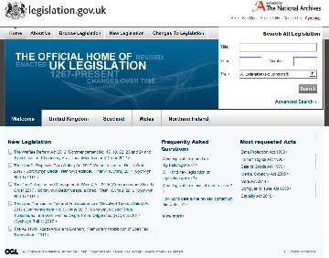
Figure 10 The official home of UK legislation

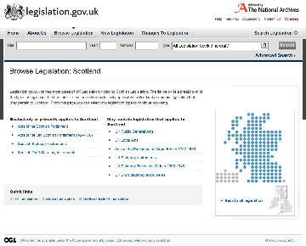
Figure 11 Selecting the Scotland tab on the home page leads to this and then selecting UK Public General Acts

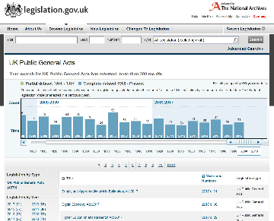
Figure 12 Selecting UK Public General Acts from the Scotland page

A number of the Acts had an impact on the law in Scotland.
Three of the Bills which you saw in Figure 8 earlier and which had received Royal Assent were not shown on legislation.gov.uk at the time of search 7 May 2017. These were the Digital Economy Bill, the Higher Education and Research Bill and the Haversham Oyster Fishery Company Bill.
- The Broadcasting (Radio Multiplex Services) Act 2017. Section 2 (1) states that it applies to (extends to) all of the UK.
- The Bus Services Act 2017 Section 25 states that only certain provisions apply in Scotland (sections 17 and 23 to 27).
- Children and Social Work Act 2017 states that section 10 and certain paragraphs in Schedule 1 apply to England, Wales and Scotland.
- Criminal Finances Act 2017 Section 57 states that certain provisions apply UK-wide and certain provisions only apply to Scotland or Northern Ireland or England and Wales.
- Farriers (Registration) Act 2017 Section 3(1) states that the Act applies in England, Wales and Scotland.
- Finance Act 2017 outlines fines to be applied on conviction in Scotland.
- Guardianship (Missing Persons) Act 2017 applies to England and Wales only.
- Health Service Medical Supplies (Costs) Act 2017 applies to England and Wales only.
- Homelessness Reduction Act 2017 Section 13 states it applies to England and Wales only.
- Intellectual Property (Unjustified Threats) Act 2017 Section 7 states that it applies to England, Wales, Scotland and Northern Ireland.
- Local Audit (Public Access to documents) Act 2017 Section 2 states that it applies to England and Wales only.
- Merchant Shipping (Homosexual Conduct) Act 2017 Section 2(3) states that the Act applies to England, Wales, Scotland and Northern Ireland subject to Section 3(2).
- National Citizen Service Act 2017 Section 13 states that the Act applies to England and Wales (subject to any subsequent amendments which may extend the Act).
- Neighbourhood Planning Act 2017 Section 45 states that the Act applies to England and Wales except Section 42 and Part 3 which apply to (extend to) England and Wales, Scotland and Northern Ireland.
- Northern Ireland (Ministerial Appointments and Regional Rates) Act 2017 Section 3(1) states that it applies to Northern Ireland only.
- Parking Places (Variation of Charges) Act 2017 Section 3(2) states that it applies to England and Wales only.
- Pension Schemes Act 2017 Section 43 states that the Act extends (applies to) to England, Wales and Scotland.
- Preventing and Combating Violence Against Women and Domestic Violence (Ratification of Convention) Act 2017 Section 3(3) states that the Act applies (extends to) England, Wales, Scotland and Northern Ireland.
- Technical and Further Education Act 2017 states in Section 46 that Part Four and Section 6 (as it relates to Section 426 of the Insolvency Act 1986) apply to England and Wales, Scotland, and Northern Ireland. Section 46(3) states that the remaining sections of the Act apply to England and Wales only.
Back to Unit 5 Session 2 Activity 1

Activity 1 fPromoters' memorandum to the National Galleries of Scotland Bill

Untitled part

Comment
The promoters of the Bill were the Board of Trustees of the National Gallery of Scotland. This information could be found in paragraph one.
Back to Unit 6 Session 2 Part 1

Activity 1 fPromoters' memorandum to the National Galleries of Scotland Bill

Untitled part

Comment
The Bill was introduced into the Scottish Parliament on 28 October 2002. This information was in paragraph one.
Back to Unit 6 Session 2 Part 2

Activity 1 fPromoters' memorandum to the National Galleries of Scotland Bill

Untitled part

Comment
The objectives of the promoters were in relation to a piece of land onto which new facilities for the National Gallery of Scotland would be built. These included new facilities and access. The proposed building works and improvements were prevented by a statutory restriction and the Trustees were seeking permission by legislation to carry out those works. They were seeking to have the land removed from the gardens over which there was a restriction and the restriction on that piece of land removed. This information could be found in paragraph three.
Back to Unit 6 Session 2 Part 3

Activity 1 fPromoters' memorandum to the National Galleries of Scotland Bill

Untitled part

Comment
Paragraph 34 contained a list of 19 organisations that had been consulted and explained why they had been chosen.


Figure 2 National Gallery of Scotland showing the extension


Figure 3 National Gallery of Scotland showing its location in the Mound, Princess Street gardens

Back to Unit 6 Session 2 Part 4

Activity 2 Explanatory note

Untitled part

Comment
The statement on legislative competence was given by the Presiding Officer (Sir David Steel) in paragraph 34.
Back to Unit 6 Session 2 Part 5

Activity 2 Explanatory note

Untitled part

Comment
Advertisements giving notice of the Bill had been placed both in newspapers (the Scotsman and Evening News on two separate occasions) and local libraries (based in six Edinburgh constituencies).
Back to Unit 6 Session 2 Part 6

Activity 3 Structure and commencement

Untitled part

Comment
Section 3(1) states that the Act to be cited as the National Galleries Scotland Act 2003.
Back to Unit 6 Session 2 Part 7

Activity 3 Structure and commencement

Untitled part

Comment
The Act came into force on 8 May 2003. This was one week after 1 May 2003, the date of Royal Assent. This information could be found in Section 3 (2).
Back to Unit 6 Session 2 Part 8

Activity 3 Structure and commencement

Untitled part

Comment
The Act has three Sections.
Back to Unit 6 Session 2 Part 9

Activity 3 Structure and commencement

Untitled part

Comment
The Act provides for a ‘certain piece of land to cease to form part of Princes Street Gardens and to disapply the effect of Section 22 of the Schedule to the City of Edinburgh District Council Order Confirmation Act 1991 to that land’. Section 1 is designed to remove the restrictions and Section 2 specifies the piece of land to which the Act applies.
Back to Unit 6 Session 2 Part 10

Activity 4 Reflection on reading an Act

Untitled part

Comment
Some of the information you may have found approachable and interesting, some you may have found difficult in its use of technical or specialised terminology and some you will have found straightforward. However you approached the information you have been asked to read in this activity, you will have started to develop strategies to help you make sense of it.
Back to Unit 6 Session 2 Part 11

Activity 1 Children and Young People (Scotland) Act 2014

Comment
Section 99(1) of the Children and Young People (Scotland) Act 2014 outlines the powers of Ministers. Where they have been given the authority to make orders under the Act then section 99(1) means Scottish Ministers are empowered ‘to make different provision for different purposes’ (Section 99(1)(a)). They also have further power to make ‘such supplementary, incidental, consequential, transitional, transitory or saving provision as they consider appropriate’ (Section 99(1)(b)). Note the wording: ‘as they consider appropriate’.
Section 99 delegates power to the Minister who is then able to use that power without further consulting the Parliament. You will return to consider this later.
You may have noted the mention of affirmative and negative procedures.
Back to Unit 7 Session 2 Activity 1

Activity 2 Use or abuse? Thinking about delegated legislation

Untitled part

Comment
The powers to make delegated legislation can be found in the primary Act. That Act will specify what powers have been delegated and to whom.
Back to Unit 7 Session 3 Part 2

Activity 2 Use or abuse? Thinking about delegated legislation

Untitled part

Comment
Delegated legislation is also referred to as secondary or subordinate legislation. Both the terms ‘secondary’ and ‘subordinate’ indicate that they are subject to something – in this case, the primary Act of Parliament.
Back to Unit 7 Session 3 Part 3

Activity 2 Use or abuse? Thinking about delegated legislation

Untitled part

Comment
There are procedures in both the Scottish and UK Parliaments. There are two procedures in the Scottish Parliament, the affirmative and negative procedures. The affirmative procedure requires parliamentary consideration. In the UK Parliament there are three procedures, affirmative, negative and strengthened scrutiny.
Back to Unit 7 Session 3 Part 4

Activity 2 Use or abuse? Thinking about delegated legislation

Untitled part

Comment
There is growing criticism of law making using delegated legislation. The issues you identified will reflect your viewpoint and views on law making in this way. There was no right or wrong answer to this question. It was designed to make you stop and think about what you had read, identify issues, reasons why you think they are issues and then note them. Accessibility may have struck you as one issue: if there was so much law how do you find it and navigate a way through it to find the answer to a question? And does this, in turn, mean that Ministers (whether of the Scottish or UK Government) are delegated a great deal of power with little scrutiny of how that power is used? Finally, there is no process for reviewing whether the delegation was effective and there is usually no stated point at which the power ends.
Back to Unit 7 Session 3 Part 5

Activity 3 A need for reform?

Comment

 | Support for delegated legislation | Criticism of delegated legislation
Supervising delegated legislation is very difficult. |  | Yes
Publication takes place but few people may be aware that the delegated legislation exists and where to find it. |  | Yes
Most individuals do not know on what ground you can challenge delegated legislation or how to go about it. |  | Yes
Some enabling Acts can be ambiguous and can therefore be open to wide interpretation. |  | Yes
Great power may be given to Ministers. The enabling Act might include a phrase like ‘the minister may make such regulations as he sees fit for the purpose of bringing the Act into operation’. |  | Yes
Relieves pressure on parliamentary time so that Parliament can concentrate on important laws, rather than technicalities. | Yes
Delegated legislation can be created more easily and quickly. | Yes | Yes
Delegated legislation can be drafted by experts in the field. | Yes
Delegated legislation can be made at any time, whereas Acts need to be timetabled. | Yes | Yes
Parliament has insufficient time to scrutinise it. |  | Yes
Delegation of powers causes complexity and confusion. |  | Yes
Sheer volume causes complexity – it is impossible keep abreast of all delegated legislation (an average of 4,000 and more a year between both Parliaments). |  | Yes
Lack of publicity for, and consultation on, delegated legislation. |  | Yes
Undemocratic: most delegated legislation is drafted by civil servants. |  | Yes
Henry VIII clauses can give power to amend or repeal Acts of the UK Parliament. |  | Yes
Saves limited time in Parliament allowing for more detailed debates on policy and other matters. | Yes
MPs and MSPs often lack detailed or technical knowledge. | Yes | Yes
Enables a quick response to new developments, crises or emergencies. | Yes
Enables minor changes to statutes, for example variations in sentences and approval of motor vehicle changes. | Yes
There is a fear that Ministers are increasingly seeking to use SIs rather than Bills to achieve their policy objectives as these receive much less scrutiny than primary legislation. |  | Yes
Delegated legislation takes up less parliamentary time. | Yes
Traditionally, the justifications for using delegated legislation have been the need to elaborate complex and technical detail that cannot be easily done on the face of a Bill. | Yes
Delegated legislation enables flexibility and adaptability. | Yes
The system of delegated legislation has been predicated on its reasonable use and application by Ministers coupled with trust in the Parliaments ’ systems of scrutiny. |  | Yes
Delegated legislation is now being used for administrative convenience and often in circumstances where governments have not fully pinned down the detail of policy proposals. |  | Yes
Delegated legislation can be found to justify almost any form of delegation a minister might now desire. |  | Yes

Back to Unit 7 Session 3 Activity 2

Activity 1 Elections to the Scottish and UK Parliaments

Comment

Question | Scottish Parliament | UK Parliament
How many chambers? | One | Two (House of Commons and House of Lords)
How many elected members? | 129 MSPs | 650 MPs  The House of Lords has approximately 825 members
How many members represent Scotland? | 129 MSPs | 59 MPs and all members of the House of Lords
Whose work does it scrutinise? | The Scottish Government | The UK Government
How are members selected? | 73 MSPs on the first-past-the-post system and 59 on proportional representation | MPs elected using the first-past-the-post system  Members of the House of Lords are not elected by the general public
What matters do they cover? | Devolved matters | Reserved matters
What age must you be to be eligible to vote? | 16 | 18

Back to Unit 8 Session 5 Activity 1

Activity 1 Why change?

Comment
What new law did you think of? Would your suggested law be responding to a technological development, change in the social or moral climate, or to economic conditions?
There are an endless number of suggestions that could be made and these will reflect your own circumstances and views. Here are some suggestions the course team came up with:
- New laws to make businesses responsible for protecting human rights and the environment wherever they operate would make a difference in Scotland and all over the world. This would mean that multinational companies would have to meet basic social and environmental standards no matter where they were operating.
- New laws in relation to bullying and abuse over the internet.
- New laws to make companies disclose and be transparent as to what data is collected, where it is stored and held and how it is used.
- New laws on organ donation.
These suggestions are responding to social, moral, economic and technological developments.
As technology develops it becomes easier and more profitable for multinational companies to set up in developing countries and take advantage of cheap labour and a lack of environmental legislation. Growing social awareness of the injustice this can cause and the damage to the environment that can result indicates the need for a new law.
Greater use of technology is changing behaviour. Abuse and bullying on social media websites is common but prosecution is rare. Many individuals don’t read the several pages of information which internet companies use to obtain consent before they allow them to proceed and use the application, and those pages are often written in technical legal language. There has been a long battle for greater consumer rights in areas such as loan agreements and faulty goods. But this is not yet being transferred to the online environment. While concerns over privacy and use of data are often expressed, and laws criminalising certain online behaviours exist, protections in this area could be broadened.
In relation to organ donation different systems and expectations now exist in the UK. Organ donation touches upon social, moral, economic and technological developments. Wales was the first nation to introduce an opt-out system – a system of deemed consent with the Human Transplantation (Wales) Act 2013 (anaw 5). Similar legislation is now being drafted in Scotland.
Back to Unit 9 Session 1 Activity 1

Activity 2 Reflecting on why law changes?

Comment
There is no one answer to this question. Your viewpoint will depend on your own views and experiences. Often, during debates about the law, there are few clear or obvious answers. One of the skills law students and lawyers develop is to create a persuasive argument using examples and information to lead their audience to the conclusion they wish to be drawn. This usually involves outlining the law, acknowledging strengths and weaknesses, considering other viewpoints, putting forward suggestions and creating a narrative. A narrative can be likened to a story with a beginning, middle and an end.
Back to Unit 9 Session 3 Activity 1

Activity 3 Law reform and public pressure

Comment
You may have thought of many laws introduced by Parliament in response to an emergency or crisis. Acts of Parliament which were introduced in response to national emergencies or crises include:
UK Parliament
- The Anti-Terrorism, Crime and Security Act 2001 – Introduced to respond to the new situation arising from the terrorist attacks on New York and Washington on 11 September 2001.
- The Human Reproductive Cloning Act 2001 – Introduced in response to a ‘breakthrough’ by US scientists in creating human embryo clones.
- The Animal Health Act 2002 – Introduced in response to the foot-and-mouth outbreak of 2001.
- The Counter-Terrorism and Security Act 2015 – Introduced to respond to ‘radicalised’ Britons travelling to Syria.
Scottish Parliament
- The Abusive Behaviour and Sexual Harm (Scotland) Act 2016 – introduced following campaigns against online ‘revenge porn’.
Back to Unit 9 Session 3 Activity 2

Activity 4 How can I become involved in the law-making process of the Scottish Parliament?

Comment
You could have identified a number of ways of becoming involved in the law-making process. These include:
- Taking part in the elections for MSPs – these are held every four years.
- Writing to a parliamentary committee to give your viewpoint.
- Using the media or social media to generate public interest in an issue and pressure Parliament to make changes to the law.
- Writing to an MSP on a particular issue.
- Lobbying an MSP to make an amendment to a Bill.
- Standing for election as an MSP (you need to be over 21 and could stand as an independent candidate or as a candidate for a political party).
- Participating in online debates using the discussion forums on the Scottish Parliament website.
- If you have specialist knowledge you can register as a potential adviser to a committee.
- You could submit a petition to the parliament asking for the introduction of a new law or change to an existing one (or that they look into a matter of public interest or concern).
- You could become involved in a Cross-Party Group. These provide an opportunity for MSPs, individuals and organisations to meet and discuss areas of interest.
- You could attend a committee event. These are held throughout Scotland to discuss issues with the public.
As you learnt earlier in the course the Scottish Parliament has achieved international recognition for its openness and the way in which it provides opportunities for its citizens to become involved.

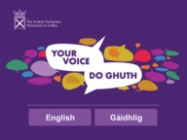
Figure 12 Making your voice heard at the Scottish Parliament

Back to Unit 9 Session 4 Activity 1

Figure 2 Recommendations from Serving Scotland Better: Scotland and the United Kingdom in the 21st Century

Description
Figure 2 consists of five circles. One circle in the middle and 4 circles going around it. Each of those 4 circles has an arrow pointing inwards towards the middle circle. The central circle has the words Recommendations in it. The other circles contain the following text.
- Strengthening devolution. 24 specific recommendations were made. These included devolving powers for the administration of Scottish elections to the Scottish Government; simplifying the law relating to the regulation of charities, devolving the regulation of airguns, devolving power to set drink-driving limits and the level of the national speed limit.
- Strengthening cooperation. This included the developing of mutual respect between Parliaments and Governments – which should be the guiding principle in all their relations. Recommendations included, introducing a regular “state of Scotland” debate in the House of Commons, strengthening the existing mechanisms for both Parliaments to work together, and proposing new ones including a way for the Scottish Parliament to work with the UK Parliament on reserved matters
- Strengthening the Scottish Parliament including improvements to the Parliament’s committee system, to its scrutiny of legislation, and to various other procedural matters.
Back to Unit 2 Session 2 Figure 1

Figure 3 Scotland Act 2012 Chapter 11

Description
Figure 3 contains a screen shot of part of the Scotland Act 2012. It shows the short title, the citation, the long title (which explains what the act is about), date of royal assent and the enacting formula ‘Be it enacted’ which introduce the provisions of the act having legal effect and declares that the law derives from proper authority. The short title is the Scotland Act 2012. The citation is 2012 CHAPTER 11. The long title is An Act to amend the Scotland Act 1998 and make provision about the functions of the Scottish Ministers; and for connected purposes. The date of royal assent was 1st May 2012. The enacting formula is ‘BE IT ENACTED by the Queen’s most Excellent Majesty, by and with the advice and consent of the Lords Spiritual and Temporal, and Commons, in this present Parliament assembled, and by the authority of the same, as follows’.
Back to Unit 2 Session 2 Figure 2

Figure 6 The Scotland Act 2016 - new powers for Scotland

Description
Figure 6 is a visual representation of the new powers for Scotland following the 2016 Scotland Act taken from the Scotland Office website.
Back to Unit 2 Session 3 Figure 3

Figure 3 Features of a constitution

Description
Figure 3 is set out in the form of a wheel. There is a central spoke with 6 lines going from it. At the end of each line is a further circle. Each circle contains a statement about the UK’s constitution. The central spoke contains the words constitution. In the circles contain the following words: Establishes the framework of the state. Sets out the powers of the state. Sets out how law is to be made. Defines the institutions of the state and set out the limitation of their powers. Sets out the relationship between the state and individuals of that state. Sets out the principles on which the state is founded
Back to Unit 3 Session 1 Figure 6

Figure 8 Stages of a Bill

Description
Figure 8 is a diagram which represents the stages a Bill of the UK Parliament goes through to reach Royal Assent. It provides a visual representation of what was discussed in Section 2.
Back to Unit 5 Session 2 Figure 2

Figure 6 Some tips for reading

Description
Figure six shows seven speech bubbles. Each speech bubble contains a tip to think about when reading.Aim to understand rather than memorising what you read. Be an active reader --be ready to record your thoughts and ideas as you read. Make a note of key words or points. Read with a purpose, know why you are reading, what knowledge you hope to gain. Are you reading to answer a particular question? Or to learn about a particular topic? Read in meaningful chunks by skim reading a section first to get a general feel for the topic, then reread more slowly in smaller chunks and make notes as you go. Avoid eye strain; make sure the light in the room you are reading in is good. Read in a comfortable position.
Back to Unit 6 Session 2 Figure 6

Figure 8 Good law

Description
Figure 8 is a visual representation of things to think about when making good law. These include:
- Content (is it necessary, does it duplicate an existing law, how much detail is needed)
- Language and style (who is the likely readership, is the language understandable)
- Architecture of the statue book (what determines the hierarchy and structure of the law, what should go into an act and what should go into regulations)
Publication (navigation, what will it look like to an online reader, should laws be drafted to
Back to Unit 6 Session 6 Figure 1

Uncaptioned interactive content

Transcript
INSTRUCTOR
The UK’s constitution is unwritten and uncodified. It can be likened to a building with the columns, roof and base representing different aspects of the constitution. There are six aspects, and we’ll look at the ones represented by the columns first.
Parliamentary sovereignty. The UK’s supreme lawmaking body is the UK Parliament. Parliamentary sovereignty forms one of the essential pillars of the UK’s constitutional framework. The UK Parliament and the legislature as a branch is the most powerful institution within the UK’s constitutional framework.
In theory, the UK Parliament can make and unmake any law. However, as both the UK Parliament and Scottish Parliaments are accountable to the electorate, ultimate sovereignty actually belongs to the citizens as the electorate.
Separation of powers. In the UK’s constitution, there is a separation of three powers: executive, legislative and judiciary. The executive relates to those state institutions that apply the law. It is formed of the government and its elements. The legislative, as the lawmaking branch, refers to Parliament as a sovereign lawmaking body. The judiciary includes the complex system of courts.
At first glance, this categorisation seems straightforward. The executive relates to the government, meaning the Prime Minister or First Minister, cabinet, and other ministers. However, the executive also includes the civil service, police forces and local authorities.
The executive is seen as democratically legitimised government, as it is formed in a democratic way, influenced by the voice of the citizens. Government is formed by the party which has won the most seats in Parliament or by a coalition of two or more political parties.
Although the executive, legislature and judiciary are viewed as being separate from each other, there are also links between them. For example, both the UK and Scottish governments set the policies. In order to give effect to those policies, they instigate legislation.
The UK government proposes legislation to the UK Parliament. The Scottish government proposes legislation to the Scottish Parliament. In this way, the executive influences the legislative branch.
Rule of law. The rule of law is regarded as a fundamental principle which underpins the UK’s constitution. There are a number of definitions. The World Justice Project has developed four universal principles of the rule of law. These have been tested and refined in consultation with a wide variety of experts worldwide.
Number one, the government and its officials and agents, as well as individuals and private entities, are accountable under the law. Number two, that laws are clear, publicised, stable, and just, are applied evenly, and protect fundamental rights, including the security of persons and property and certain core human rights.
Three, that the process by which the laws are enacted, administered and enforced is accessible, fair and efficient. Four, that justice is delivered timely by competent, ethical, and independent representatives and neutrals who are of sufficient number, have adequate resources, and reflect the makeup of the communities they serve.
Prerogative powers. Royal prerogative powers were powers traditionally exercised by the monarch alone. As the power of the monarch gradually diminished and the power of Parliament grew, governments representing the majority political party in Parliament began to exercise these powers.
Many prerogative powers are now exercised by the UK government in the name of the monarch. This means that although they are still royal powers and will always remain with the monarch, the exercise of the power is by a democratically-elected government. Examples of prerogative powers relating to foreign affairs are the power to declare war, to declare peace, and the power to become part of treaties.
Constitutional statutes. The written part of the UK’s constitution is formed by constitutional statutes. These are seen as the legal sources of the UK’s constitution. They are acts of the UK Parliament.
It is, however, very rare for an act to be recognised as a constitutional statute. There have been around 25 in the past 500 years. Constitutional statutes tend not to be repealed. They are much more difficult to amend, as they have a wider and significant impact on the UK’s constitution.
Referendums are often held to gauge support for constitutional change. Governments tend to want to involve the electorate directly in such changes, for example, the EU referendum, which was UK-wide, the referendum on Scottish independence, which was limited to Scotland, and greater powers for the Welsh Assembly, which was limited to Wales.
These examples also illustrate the caution with which any constitutional statute is treated. They are fundamental and help form the structure of the UK constitution. In the building metaphor, constitutional statutes are shown as foundational, as they form the written element of the constitution, which is produced by the supreme lawmaking body.
Constitutional conventions. Constitutional conventions represent traditional expectations created by informal rules of behaviour and rules of administration developed over the centuries. They are unwritten, as no one has felt the need to write them down. They are seen as nonlegal sources of the UK’s constitution.
Returning to the image of the UK’s constitution, constitutional conventions can be seen as the counterpart to constitutional statutes. Constitutional statutes and conventions form an essential part of the UK’s constitutional framework, so conventions have been added as the roof of the building.
Back to Unit 3 Session 4 MediaContent 1

Uncaptioned interactive content

Transcript
REPORTER:
--now is actually our first picture of the Queen, the Queen and the Duke of Edinburgh. That's them driving out of the gate of Holyrood Palace there. And behind them will actually be members of the royal household, who will also be going with them into Parliament. So just going past the guard of honour, who will give the royal salute.
And that's the bands and bugles of the rifles that she's about to go past now on this very short journey up to the Queensberry House entrance of the Parliament. And we will get actually a royal salute at some point before the Queen actually goes in to that side entrance there. There we have it.
Now, I want to, at this stage, actually mention the men who are going to play the fanfare. Ronald Creasy, Tony Laidlaw, and Stewart Malcolm. They will be waiting inside. They must be getting extremely nervous right around now, because theirs is the job of playing three fanfares today. And I don't think anybody would envy them that. The Queen now about to get out of the car at Queensberry House. Some members of the public there.
[APPLAUSE]
And the Queen there is being met by the Lord of Tennant and Lord Provost of Edinburgh. That's George Grubb, and the Lady Provost, Elizabeth. Again, Royal Company of Archers there. Lord Provost is interesting, actually. He's a church minister, and as well as his degrees in philosophy and theology, he has a gold medal in criminology, which seems a little incongruous with church minister, but perhaps that tells us a lot about modern ministry.
The Queen there with a presiding officer, Tricia Marwick. And she will have already been introduced to the deputies, John Scott and Elaine Smith. Queen now just walking into the Parliament building. And now as the Queen goes inside, we can cross to Brian Taylor, who's going to be there for the next half hour or so for all the key ceremonies. Brian.
BRIAN:
Yes, all, thank you very much indeed. You see four lonely souls lined up there waiting for Her Majesty. They are, of course, the political leaders of the main parties in Scotland, headed, as is right by the first minister, Alex Salmond. You can see him there. And next to him, two who are departing. Oh, they're just brushing off the dust a little bit there, getting themselves ready for the Queen. Two are departing, Iain Grey, the leader of the Labour Party, and Annabel Goldie, the leader of the Scottish Conservatives. And one who's newly arrived is fourth in line there, Willie Rennie of the Scottish Liberal Democrats.
As you said, as the Queen being escorted inside the building by Tricia Marwick, who's the new presiding officer wearing a smart new coat for the day, by the looks of it as well. She's an SNP, or was elected, rather, as an SNP MSP. She is, of course, now in the neutral position as presiding officer. And here she is escorting the Queen into the garden lobby, the rather magnificent and splendid area that has become the core of the whole of Parliament. Began as an add-on corridor, but now it's the very centre of Parliament.
Tricia Marwick from a Cowdenbeath mining family, worked for many years with a housing charity shelter, is now the presiding officer in the Scottish Parliament. A word for Alex Salmond, and now for Iain Grey. Curtsie from Annabel Goldie. Bow from Willie Rennie. Tricia Marwick, of course, follows Alex Ferguson as presiding officer. He's in the chamber, along with the other MSPs, waiting for Her Majesty. I actually saw earlier the two predecessors, George Reed and Sir David Steele. They're in the public gallery today looking on at the proceedings which they once chaired. And now Elaine Smith and [INAUDIBLE] deputies are sharing a joke with the Duke of Edinburgh.
This is the seventh time Her Majesty will have addressed MSPs. This is the fourth session she's opening, but there were other events, of course. The opening of the building itself in 2004. She was there for that session in Aberdeen to mark her own Golden Jubilee. And then there was the 10th anniversary of Parliament, there's the MSPs waiting, the 10th anniversary of Parliament in 2009 as well. The MSPs have been entertained by a school choir prior to this. But then they get down to the business.
I was intrigued by the remarks that Tom Divine was making there about the end, and about the invention of tradition. Certainly true, tradition has accrued upon the royal openings here. But they are grand affairs, but they are also democratic and down to earth. There will be a poem by Liz Lochhead, the Makar, Scotland's national poet, building upon the earlier endeavours by Edwin Morgan, Eddie Morgan, in 2004 when the building opened. And also a Burns song by Karine Polwart and one of Karine's own compositions.
Coming up the glass corridor, which runs up the side of the main chamber, is of course the presiding officer's entrance, which is just ahead of Her Majesty the Queen there. And as they go further up, they would reach the black and white corridor, which is where they're headed, which replicates the setting there was in the old building in the [INAUDIBLE] before this rather splendid and costly building in Holyrood was constructed. Pause to point out some of the sights you can see through the other side of that glass in the glass corridor.
And there's Lord Provost George Grubb and other members of the royal party. A sense of expectation there in the chamber. The hubbub has died down. They were chatting, and now we get the fanfare. Ministry Steps played by Ronald Creasy, Tony Laidlaw, [INAUDIBLE].
[MUSIC PLAYING]
As the fanfare played there, the, really, installation of the Parliament and of the monarch, the crown there remodelled in 1540, part of the Scottish regalia, the honours of Scotland. One of the oldest crowns in Europe, certainly the oldest of the British Isles, and the mace brought in by Philip Horwood, a parliamentary official. Phil served for 20 years with the Black Watch.
TRICIA MARWICK:
Your majesty, I am delighted to welcome you and the Duke of Edinburgh to Scottish Parliament today. As you join us to officially open a full session of Parliament, you return today, ma'am, to a chamber which is very familiar to you. You first joined us here in 2004 for the opening of this magnificent building. And you returned in 2007 to mark the opening of our third session.
More recently, you joined us just two years ago, when we marked the Parliament's 10th anniversary. Your continued support of the Scottish Parliament and its members is greatly appreciated, and this chamber is a place in which you will be always assured of a very warm welcome.
In each of our sessions to date, the voters of Scotland have presented this Parliament with fresh challenges. In this session, we have another first. The first single party majority government. And it will put our procedures to the test. But as before, I know that this Parliament will rise to that challenge.
Our track record is one of evolution and innovation. And I assure you, ma'am, that as presiding officer, I will do all I can to ensure that this Parliament lives up to the aspirations and expectations of the people of Scotland.
But no member of the Scottish Parliament should be under any illusion that the next five years will be easy or straightforward. The people of Scotland are experiencing a time where their incomes and lifestyles have felt the full effects of the difficult economic period through which we have all been living. And during the times ahead, people will, quite rightly, look to this Parliament for leadership.
This session, members will be asked to make some difficult decisions. But the words of our previous and now sadly departed Scotts Makar Edwin Morgan should provide us with some guidance. When this building opened for business in 2004, he reminded us of the hopes and the aspirations of the Scottish people for their Parliament.
And he warned us, "A nest of fearties is what they do not want. A symposium of procrastinators is what they do not want. A phalanx of forelock-tuggers is what they do not want. And perhaps, above all, the drippy mantra of, 'it wasnae me,' is what they do not want." They were strong words, but they're as relevant today as when they were penned.
The Scottish Parliament, now 12 years old, is an institution of growing maturity. Our greatest challenge over this extended five-year session is to continue to drive this Parliament forward. We have to challenge ourselves as elected members to be ambitious, to be bold, and to demonstrate the spirit of innovation for which Scots are renowned, and which will allow us to achieve more with fewer resources. Just as households and businesses across family are doing.
We have the knowledge. We have the experience. And now we have an opportunity to reflect as a mature Parliament on how we can find new ways of working in this chamber, in our committees, and in all of our other activities. Doing more with less, but still upholding our prime responsibilities as a Parliament, to legislate, to scrutinise, and hold to account the government of the day and to represent the will of the people.
Your Majesty, when you joined us in 2004 to mark the opening of this unique building, you said we must ensure that Holyrood came to be seen as a landmark of 21st century democracy. Your Majesty, like my predecessors, I will champion democracy in this full session of Parliament to ensure that our Parliament is open in all it does, represents the voices of our citizens, and is responsive and mature in its consideration of the issues that face us as a country.
But I am one of 129 MSPs. The onus is on each and every one of us to make sure that this Parliament works to meet the aspirations of the people of Scotland. We have five years to make it happen. And we owe it to the people of our great nation to do so. Your Majesty, it is a great privilege to invite you to address the Scottish Parliament.
[APPLAUSE]
BRIAN:
An excellent performance. It was confident, dignified, but also egalitarian, very much pragmatic. [INAUDIBLE] strains and tensions that will face this session. Now Her Majesty the Queen.
QUEEN ELIZABETH II:
Presiding officer, first minister, members of the Scottish Parliament, I am pleased to be with you once again on the occasion of the opening of the Scottish Parliament in this, its fourth term since the Scotland Act of 1998. Presiding officer, your appointment has been held by three distinguished predecessors, each of whom I'm very glad to see here today. They, as much as any others, have been responsible for the high reputation and good conduct of this parliament.
No one would ever argue that Scottish politics is the business of the meek, the passive, or the fainthearted. Accordingly, as the keeper and defender of the good name of this Parliament, the presiding officer requires not only an acute sense of fairness and impartiality, but also the capacity and inclination to exercise careful judgement. Presiding officer, as you embark upon this important task, I hope that you will draw inspiration from the example of those who came before you and the support of all those in Scotland and beyond who wish this institution well.
In earlier addresses to the Scottish Parliament, I have pointed to the particular difficulties, which confront a new and developing legislature. Now in its second decade, the Scottish Parliament is firmly established as an integral part of Scottish public life. The maturity of the legislation passed in this chamber, and the well-tested processes giving rise to it, are evidence of the Scottish Parliament having truly come of age. This is an achievement of which all members, past and present, should be proud.
To the new and returning members of the Scottish Parliament, I offer the observation that in return for the authority placed upon you, a very great deal is asked of Scotland's elected politicians, perhaps as much now as ever before. Among the Scottish people, the roles and responsibilities of this Parliament and all its members are probably better known and understood than at any stage in the past 12 years. As this consciousness of your work has grown, so inevitably have expectations.
This of course, is a ceremonial and celebratory occasion, an opportunity to reaffirm the importance we attach to the values and freedoms which underwrite and protect our democracy. Your work here is carried out in the presence of the mace, which was presented to this Parliament at its official opening on this day in 1999. As well as serving as a symbol of your authority to govern, the mace, with just a few words engraved upon it, is a reminder of your responsibilities to the people of Scotland. To govern with wisdom and compassion, to make fair and just laws, and to show integrity in all that you do.
You are charged to give these words meaning in the face of the constant and competing demands that will be placed upon you. As a close observer of every stage of this Parliament's life, I remain confident that you will manage to discharge your duty diligently and competently and serve the interests of the people in Scotland to the best of your ability. Presiding officer, first minister, members of the Scottish Parliament, the Duke of Edinburgh joins me in extending my very best wishes to you, and for this fourth session of Parliament.
[APPLAUSE]
BRIAN:
[INAUDIBLE] but the various relationships between them. Her Majesty the Queen and the Scottish Parliament, she's now talking about Parliament having come of age. [INAUDIBLE] business of the meek, the passive, or the fainthearted. Well, that's right. Now Westlin Winds, by Robert Burns sung by Karine Polwart with Kim Edgar and Kirsty Grace.
[MUSIC PLAYING]
SINGER:
(SINGING) Now westlin winds and slaughtering guns bring autumn's pleasant weather. The moorcock springs on whirring wings, among the blooming heather. Now waving grain, wild o'er the plain, delights the weary farmer. And the moon shines bright as I rove at night to muse upon my charmer. The partridge loves the fruitful fell, and the plower loves the mountain. The woodcock haunts the lonely dell, the soaring hern, the fountain. Through lofty groves the cushat roves, the path of man to shun it. The hazel bush o'erhangs the thrush, the spreading thorn the linnet.
Thus every kind their pleasure find, the savage and the tender. Some mortal join, some leagues combine, some solitary wander. Avaunt, away, the cruel sway, tyrannic man's dominion. The sportsman's joy, the murdering cry, and the fluttering, gory pinion. But Peggy dear, the evening's clear, thick flies the skimming swallow. And the sky is blue, the fields in view, all fading green and yellow.
And let us stray our gladsome way, and view the charms of Nature. The rustling corn, the fruited thorn, and every happy creature. We'll gently walk and sweetly talk till the silent moon shines clearly. I'll grasp thy waist and firmly prest, swear how I love thy dearly. Not vernal showers to budding flowers, not autumn to the farmer. So dear can be, as thou to me, my fair, my lovely charmer.
[APPLAUSE]
BRIAN:
One of Burns' most plaintive yet uplifting songs. And hear from [INAUDIBLE] with her own compositions.
Back to Unit 3 Session 5 MediaContent 1

Uncaptioned interactive content

Transcript
NARRATOR
How does the Parliament make laws? The Scottish Parliament makes laws by passing bills. Bills can be introduced by the Scottish government, MSPs who aren't members of the Scottish government, committees, and organisations or individuals who are not MSPs. They normally follow a three-stage process.
Stage 1, parliamentary committees consider the general principles, the overall purpose of the bill, and normally ask members of the public for their input. The Parliament then debates and reaches a decision on the general principles of the bill in the chamber.
Stage 2, a parliamentary committee considers the bill in detail and decides on proposed changes, amendments.
Stage 3, the Parliament can consider further amendments to the bill. Then the Parliament decides whether to pass or reject the bill.
What happens next? After a bill has been passed, there is normally a four-week period during which it can be challenged if it's believed to be outside the lawmaking powers of the Scottish Parliament. If it is not challenged, it will be submitted for royal assent from the monarch. Once a bill has received royal assent, it becomes an Act of the Scottish Parliament. However, it may not all come into force straightaway.
Back to Unit 4 Session 4 MediaContent 1

Uncaptioned interactive content

Transcript
INSTRUCTOR
The Forth Road Bridge Bill was introduced to the Scottish Parliament on the 11th of December, 2012. Take a few moments to look at the Bill. This is the version as introduced without any amendments.
You’ll see that the name of the Bill is followed by a contents section. A short note about the accompanying documents is then provided before the content of the Bill is introduced. The Bill is structured in the same way as an Act. Bills form that basis for Acts, and here you can see that the Bill has a short introductory statement and is then divided into sections with one schedule.
Glancing briefly through the Bill, you can see that it’s designed to form the basis of an Act which dissolves the Forth Estuary Transport Authority and makes provision in relation to this by defining the section of trunk road, indicating to whom the powers will be passed and making provision for the transfer of employees. The final section notes that the short title of the Act will be the Forth Road Bridge Act 2013.
This is a relatively short Bill and considers a very particular subject. The information from the parliamentary website details each stage. The bill may be short, but it still goes through the full process of debate, evidence, consideration and amendment. The information drawn from the Scottish Parliament website states who introduced the Bill and what the accompanying documents were.
Dates of the Stage 1, Stage 2 and Stage 3 hearings are all shown. The lead committee is indicated and the dates evidence was heard are included. The Bill as introduced was amended following consideration, and a list of these was provided at Stage 2. The Bill was finally passed by Parliament on the 23rd of May, 2013.
Back to Unit 4 Session 4 MediaContent 2

Uncaptioned interactive content

Transcript
IAIN GRAY
So I’ve had experience of new legislation from different angles. I mean, I’ve been a minister with legislation trying to get it through the Parliament, and I’ve been a member of a committee looking at legislation, a member of the bigger Parliament when in the final stages the whole Parliament looks at legislation.
And one of the things which I think strikes you about all of that is how varied the subjects are that you’ll be required to deal with legislation on. It may be anything from, well, we considered legislation the other day in docking puppy dogs tails and then in the same week we were looking at legislation to change the British transport police and make them part of Police Scotland.
I mean it can be incredibly varied, even day-to-day, and so over the years, I think I’ve probably had to deal with legislation about just about anything that you could think of. But you know, that’s one of the things that keeps the job interesting.
One of the pieces of legislation that I am most proud of was very early in my career as a parliamentarian, right back at the start of the Scottish Parliament. I was responsible for a piece of legislation called Adults with Incapacity. It set up the system whereby, if someone is disabled or perhaps has an illness like dementia, and they can’t take decisions for themselves anymore, how their family or someone else can be able to take decisions for them and to help them with their everyday life.
And one of the things which I think was unusual about that legislation was that, one of the reasons we needed it was that the laws which were being applied, some of them were 500 years old. And so it was a new bit of legislation to get rid of something that somebody had passed 500 years before.
When you are scrutinising legislation, you bring to that the values that you bring to being a parliamentarian, and those are fundamentally, I think, about fairness. I mean, the law as a system is designed to try and make sure that we’re all treated fairly. You know, we have that phrase, equal under the law. Nobody’s above the law.
And so I think a fundamental principle that parliamentarians have to be trying to apply is that principle of fairness. Does this make our country fairer or less fair? And fairer is where we should be aiming for.
Even over the 20 years that I’ve been involved in this process as a parliamentarian, I think that the language of our legislation probably has got a little more straightforward. But you know it would be kidding people really to suggest that laws are usually written in plain everyday English.
Somebody has to sit down and actually draft a law, write it out. And that’s quite a highly skilled job. And there’s not many of them in Scotland who can do it. And they do have their own rules about it.
So sometimes when you look at a piece of legislation, it does look as if the language is kind of deliberately complicated or convoluted or old and archaic. But actually, it will be like that for a good reason, because you know, a word out of place can change the meaning of the law. And if you only find that out later when somebody ends up in court, and it wasn’t what you meant, then it’s kind of too late to fix it then. So I think the language is getting a bit more accessible. But if I’m honest, laws are never going to be written in simple everyday English.
Back to Unit 4 Session 4 MediaContent 3

How the Lords works with the Commons to make a Bill law

Transcript
SIMON BLACKBURN:
So most bills start in the House of Commons and when they’ve finished with it and it’s been through all its stages there, literally a hard copy is still walked up to the House of Lords, wrapped up in ribbon. It gets brought into the chamber, and a government minister will stand up and read the long title and this is known as the first reading, and the long title is a paragraph on the bill which just sums up what that bill is doing. And then that hard copy of the bill gets taken out of the chamber and up to our office where we keep it safe.
So second reading is a debate and members take it in turns to stand up and talk about the subject, and it’s quite useful because they can also take the opportunity to tell the government, well, this is what I think of your bill, these are the bits I’m going to try and change later on.
Once we’ve received the bill and once it’s had its second reading, then a bill is open for amendmentsa and members come into the legislation office and discuss with us the changes they’d like to make to the bill and then we put everything in the right order and print it out all ready for everybody to look at when it’s in the chamber.
If, at a second reading, lots of people disagree with the subject, then at the end they can have a vote and they can decide to throw out the whole bill there and then, but that doesn’t tend to happen very often.
MP:
My Lords, I beg to move that the House do now resolve itself into a committee upon the bill.
SIMON BLACKBURN:
At committee stage, everybody turns up and they go through the bill, line by line, and most of the amendments are a chance to try and work out what the government is thinking, what its policy is in an area, so people suggest changes just to see what the government says about them and whether they’ll accept them or not.
MP:
Questions. One is what is the urgency to consider the report stage?
SIMON BLACKBURN:
So the next stage is called report stage, and this time they go through the bill line by line again, but the amendments are, they’re right down to the nitty gritty, these are changes that people really want to make and so, quite often we get more votes at report stage because people really want to push the government and find out how many people agree with them.
OFFICER:
Not contents, 218, therefore the not contents have it.
SIMON BLACKBURN:
The very last stage is called third reading, and this is pretty much just a tidying up, so if there’s been a big change earlier on, which has lots of consequential little changes. So after third reading, all of the changes that have been made will be stuck in, or crossed out, as the case may be, and then it’s wrapped up in red ribbon with a message saying, dear House of Commons, here’s a bill that the House of Lords passed, please, will you consider it.
OFFICER:
Message from the Lords.
SIMON BLACKBURN:
So Ping-Pong is the point where a bill is going backwards and forwards between the two houses, and all they’re looking at the areas where they can’t agree. So everything else that’s agreed is put to one side, and on the areas where they can’t agree they try and find a compromise. So the House of Lords might say, we don’t like this, what do you think of this instead? And the Commons will either say yes or they might say no, we don’t agree with that policy, but how about this compromise? And they’ll whittle it down until everybody is agreed on a way forwards.
So when both houses have finished the bill, then the last stage is that the Queen is asked to signify that she’s happy with it and when that happens, in both houses, the Speaker and the Lord Speaker stand up and announce that the bill has been given its royal assent.
OFFICER:
My Lords, I have to notify the house, in accordance with the royal ascent act 1967, that the Queen has signified her royal assent to the following acts.
SIMON BLACKBURN:
Then the bill goes off and the final copy is printed, and it’s that copy that is taken up to the parliamentary archives and is the official record.
Back to Unit 5 Session 2 MediaContent 1

Uncaptioned interactive content

Transcript
INSTRUCTOR
The Farriers (Registration) Act 2017 is an Act of the UK Parliament. You will see that the name of the Act is given immediately under the royal coat of arms. Underneath, the name ‘2017 Chapter 28’ means that this was the 28th Act to be passed in 2017.
Next follows a short statement about the purpose of the Act. There’s then a short statement confirming that the Act has been passed by both Houses of Parliament and received the royal assent. After this comes the main body of the Act. This is set out in sections. Each Act of Parliament will vary in the number of sections and parts it has.
The Farriers (Registration) Act 2017 is a short Act and has only three sections. Each section is equally important. Section one is not any more or less important than sections two and three or the schedules.
Section one states that changes are being made to the Farriers Registration Council and its committees, and that the Farriers (Registration) Act 1975, the 1975 Act, is being amended.
Section two makes a number of amendments to the Farriers Registration Act 1975.
Section three is concerned with the commencement, extent and citation of the Act. When looking at UK Parliament Acts, extent sections are important. This is where you find the information about the geographical extent of the Act, in particular, whether or not that Act applies in Scotland. Here you can see that the Act applies in England, Wales and Scotland.
Schedules allow for more detailed provisions to be included. You should not think of schedules as being an inferior source of law. Schedules form an important part of Acts of Parliament and are law in the same way that sections of the Act are law.
You may have noticed that throughout the Act there is a lot of punctuation and use of ‘and.’ You should assume all words and punctuation in the statute have meaning. It’s tempting to skip words you don’t understand and ignore awkward punctuation, but it’s all there for a reason.
You may find some of the terminology difficult to understand. There may be reference to other Acts of Parliament. Some Latin terms may be used, and there may be other terms you may not understand. It’s quite common for Acts of Parliament to contain language like this. You’ll be able to find the meaning of any words or terms about which you are unsure in a dictionary.
It’s important to interpret an Act so that it makes sense and it’s common for lawyers and law students when reading an Act to have to do so a number of times before they gain a full understanding. As you become more accustomed to reading Acts of Parliament, you’ll become more familiar with the language used, and you’ll begin to find it much easier to understand what the Acts are saying.
Back to Unit 6 Session 4 MediaContent 1

Uncaptioned interactive content

Transcript
[MUSIC PLAYING]
RICHARD HEATON
I want you to imagine a place on the Internet where everything is true and this is a pretty important place, this is a place which contains all the principles and ideas and concepts that we think between us are important. Not big kind of philosophical ideas but the stuff that we think help society make, help society work and function properly, things that stop us squabbling incessantly.
So you’ll go to this place to find out who gets to be a citizen, who gets to be a citizen of our country. Whether you’re allowed to carry a gun. Who’s allowed to get married to who. And this stuff is true because we ourselves between us, we’ve given it authority.
Now I’m talking about the law, no surprise. The law, I could equally be talking about our operating system. The law, our operating system, is amazing, an amazing idea to write down and agree the rules of our society, an amazing achievement. It’s also the story of our nation, the story of any country. A country’s history is told through the evolution of its operating system. So I brought you an example.
Go back to the early 19th century. Britain’s just finished a long ruinous war against Napoleon. Britain and the whole of Europe are plunged into a deep recession and the streets of London and our major cities are filled with thousands and thousands of discharged soldiers and sailors with no job, no work, no money, no food and the government and Parliament responds with a number of punitive statutes. This is one of them. This is the 1824 Vagrancy Act which punishes idle and disorderly persons and rogues and vagabonds with hard labour.
This is the 1824 Vagrancy Act still parts much amended but still in force. So look law is important and it’s really interesting. Those are the two qualities that got me into the law and got me into government law in particular. Law is important and it’s interesting, but there’s one aspect of law that’s a bit different. That’s what happens when you actually try and use it, when you actually try and look up the law.
You maybe want to check the law. You want to see if you’re complying. You want the law to guide your life and then it’s actually a bit of a misery because the user finds law complicated and difficult, difficult to navigate, confusing, hard to understand. And that’s always troubled me as a lawyer and it really should trouble all of us for whom this stuff is important.
So how did we let the law get into this state? What virus has infected our beautiful operating system? Well look, a number of reasons. I suppose you might start with volume. There are maybe 50 million words of law, of statute law, like this in force right now, 50 million. That’s a guess. We don’t know.
50 million words and every month the hundred thousand words are added or subtracted or taken away or amended,. That makes a hundred thousand new words of law every month. That’s roughly speaking the complete works of Shakespeare twice a year. That’s a lot of law.
What happens when you try and find something in this great mountain of words? Maybe you’re looking for the law on fingerprints. You find a statute and it’s called the Fingerprints Act of 1986. I made that up, it doesn’t exist, but you found the statute and you think, OK, I’ve got it.
But then you discover that maybe the statute’s been amended 30 times in 30 years so you’re looking for an amended version and then you discover that lots of the amendments aren’t yet in force so you’re kind of looking for a real-time version with the prospective amendments circling overhead. And then you discover there’s an Act over here which is supposed to help you by telling you that wherever you see finger on the statute it includes the word thumb.
And then you discover that actually fingerprints law is just contained in 20 different statutes, not one, and they’re all called different things and then you’ve got your head around that and you discover something called a fingerprint regulations. And you kind of give up and you go home.
Law can be really, really difficult. In fact, if there was a wall map of the statute book, and I would love someone to produce a wall map of the statute book, some bits are so confusing that the cartographer would kind of give up and write ‘here be sea monsters.’ This can be really, really difficult stuff.
And to add to that, the only tool that we use when we’re writing this stuff, the only tool we’ve got at our disposal is words and sentences and numbered paragraphs, same techniques we’ve been using for a thousand years, and we’re asked to achieve enormous detail in law. And to achieve detail, you have to add more and more words, and you do that at the expense of readability. So you have a paradox of precise language where you achieve certainty at the expense of clarity.
And you know there’s something about the language as well of law. It’s a kind of, it’s kind of deadening quality. It’s not quite jargon, but it’s the words we use. We have to choose precise words, you see, and we’re not allowed to use words that are colourful or or rhetorical, they have to be precise words. So the sorts of words that would engage you if you’re reading a book aren’t the words that we tend to use in the statute.
So if I could see you I would ask what are your favourite words? And I might get joyful, or quizzical, or purple or tulip. Those are not the language of law. Tulip does turn up once in the statute, but that is not the language of law. We don’t use words like that and I don’t suppose you’ll be coming up with words like necessary, or satisfactory, or schedule, or commence.
So anyway, all sorts of reasons, which make it a bit a challenge for us working on this side of the fence making laws, drafting laws, parliamentarians but also people lobbying for changes of the law. We are collaborators in an operating system, which by virtue of its complexity and its form and its architecture, are a million miles away from what is usable for the citizen. So that’s a challenge.
Now at this stage do I despair? I don’t actually. I’m really, really optimistic. I’m really optimistic that the law and your experience of the law could get and will get is about to get much, much better. And we’re kind of calling this good law.
First rule of good law: don’t make it worse. OK, you’ve got 50 million words of statute. Let’s see if we can try not to add to it unless we really have to. Let’s see if we can legislate maybe less or in less detail. What happens if we use fewer rules?
What happens if we leave more to trust or to common sense or to behaviour or to incentives? And while we’re about it, should we all agree not to make bad law? I’ll leave that thought with you.
Second rule of good law, first was don’t make it worst. Second rule of good law: make it better. Look, law is a complicated system. Yeah, OK? There are hundreds of complicated systems. We are no longer terrified by complexity.
We have the tools. We have the computing power. We have the ability to deal with complexity and to bring it to order. The same is true for law. How do we go about that?
Well first of all we think of law not just as language but as data. 50 million words of law, that’s not just a pile of words, there are patterns in there and we can treat this stuff as data. We can manage it. We can present it. We can manipulate it. We can make it available to an individual, to you, in a way that suits you just as we’re doing in healthcare data or weather data. Law is data.
We need to borrow. We need to borrow from information science. We need to borrow from software engineering. We need to use techniques like design patterns, easy to use, out-of-the-box frameworks, hypertext. That is not the language they use at the Palace of Westminster but it needs to become part of the language of lawmaking.
I think we probably also need to look at the form in which we pass laws and the architecture as well. Maybe it’s actually time to move away from this series of sequential time stamped documents, convenient to parliament and interesting to historians, but actually utterly baffling to users. Because we need, don’t we, to put law at the service of people rather than letting it be something that gets in the way, confuses, obfuscates, causes friction, causes disputes. That’s the key to it. We need to achieve clarity.
There’s a thought that’s lingering in my mind here about whether there are some areas of the law or some areas of existence, of life which are simply too complicated to be regulated by this technique of words and sentences and numbered paragraphs. Because it’s really striking to me that law is about the only modern discipline that actually only uses language. We don’t use symbols much. We don’t use pictures. We don’t use sounds. And that kind of, um, that places quite a big restriction on it.
So if I was to ask you to describe in great detail and accuracy and precision the Milky Way using only words and numbered paragraphs that would be quite difficult. Or supposing I was drafting a bit of road traffic law so it’s aimed to be read and understood by you, the driver. That bit make sense. But supposing the driver in 10 years time is a robot. What happens then?
Are my word supposed to be turned into computer code? Does the code become the law? Again I’ll leave that thought with you.
My real reason, however, my real reason for optimism that this will get better is that for the first time in history our operating system is in your hands. Two million of you, two million people in the United Kingdom every month are accessing legislation.gov.uk, brilliant website. Two million people are accessing it, which means that never again will law be imprisoned in law libraries and advocates chambers and the Palace of Westminster.
It’s out there. You are using it. You will demand improvements and better access to the law. You will innovate. You’ll put pressure on us and on business to innovate for you so that the law you use and have access to makes sense for you. And that for me would be fantastic news because look, this stuff, our law, our operating system, is something we should feel comfortable by and not alienated by.
Law belongs to us. This is our operating system. This is your law. So ladies and gentlemen, I would invite you to take part in good law and above all, reclaim the law. Thank you very much.
[APPLAUSE]
[MUSIC PLAYING]
Back to Unit 6 Session 6 MediaContent 1

Uncaptioned interactive content

Transcript
NARRATOR:
When a change to the law is proposed, it is normally known as a ‘Bill’. This is primary legislation. Primary legislation that has completed its journey of consultation, debate and scrutiny, and is passed by the Parliament becomes an Act.
Often, primary legislation grants power to the Scottish Ministers to introduce changes to the law without the need for new primary legislation or to fill in the detail of primary legislation. This is known as secondary legislation.
Secondary legislation generally sets out the technical details or administrative matters necessary for primary legislation to operate. It can include any subject matter, from establishing criminal penalties or licencing schemes to providing procedural rules.
It is the job of the Parliament, with advice from the delegated powers and Law Reform Committee, to decide whether or not to grant power to the Scottish Ministers to make secondary legislation. If that power is granted, it is then the job of the delegated powers and Law Reform Committee and the relevant subject committee to check and report on the secondary legislation when it comes forward.
[MUSIC PLAYING]
Back to Unit 7 Session 2 MediaContent 1

The use of delegated legislation

Transcript
INTERVIEWER
We’re going to talk about primary and secondary legislation in the Scottish Parliament and the UK Parliament, and some of the differences between them. So we know that primary legislation, that’s Acts of the Scottish Parliament, are invalid if they are in conflict with the Human Rights Act, or EU law, or outside of the powers of the Scottish Parliament. How does that differ from how UK Parliament primary legislation is treated?
SUBJECT
Well, the main difference to the UK Parliament legislation is that a court cannot strike down UK primary legislation as invalid, which they can with Scottish legislation. With the UK or Westminster legislation, it can only be declared incompatible by the court. It’s then up to the UK or Westminster Parliament to review it.
INTERVIEWER
So that’s if it’s in conflict with the Human Rights Act. In terms of EU law, how does it work?
SUBJECT
The same applies to EU law until Brexit. After Brexit, there’s a provision in the ‘Great Repeal Bill’, which is actually the European Union Withdrawal Bill, Section 11. Under that section, the Scottish Parliament cannot pass any legislation which is incompatible with retained EU legislation by the Westminster Parliament.
So there’s not only a problem with the status of primary legislation, it’s the volume of secondary legislation that I think we should examine.
The volume of secondary legislation, or what we call delegated legislation, has increased over the years. So what problems has this caused?
INTERVIEWER
Well, in the first instance, primarily in the UK Parliament, there’s an issue of scrutiny. A lot of delegated legislation, this is legislation under a parent Act, but that’s passed by ministers, is laid before Parliament. But there’s too much of it for Parliament to really scrutinise properly. So the increasing volume of dedicated legislation means that a lot of it is passed without proper parliamentary scrutiny.
SUBJECT
So for example, I think there was 11,000 pieces of secondary legislation passed two years ago. With the coming of the EU withdrawal, there’s going to have to be 14,000 pieces of secondary legislation that have to be scrutinised. So there’s a time problem, isn’t there?
INTERVIEWER
There’s a time problem, absolutely. And time in terms of the amount of time before withdrawal comes into play. And also, time just in terms of the parliamentary calendar, in terms of squeezing things into the day.
SUBJECT
It’s impossible for Parliament to scrutinise that legislation. But we’re told Parliament is supreme, or sovereign. So is there an inconsistency there, do you think?
INTERVIEWER
Part of parliamentary sovereignty has to be about the principle of transparency of good government, of people being able to see and understand Parliament acting out its supremacy, I suppose. And if it can’t properly scrutinise delegated legislation, that may be one thing if it’s something as simple as a commencement order, i.e., a minister stating when an Act comes into force.
But if it’s something much more significant or important, like a Henry VIII clause, which we might need more of, according to the so-called ‘Great Repeal Bill’, then it tends to start to sort of erode away at parliament’s sort of ability to exercise its sovereignty over all legislative matters. I mean, perhaps you can say a bit more about the scope of some of its delegated legislation that we might be talking about here.
SUBJECT
Well, we’ve mentioned that there’s going to be 14,000 pieces of EU legislation that’s going to become delegated legislation. But also, the problem on the scope is that with the Henry VIII power in the hands of a Minister, so by that, we mean the power of a Minister to change primary legislation without Parliament scrutinising what he’s doing, several questions arise, don’t they? Has he done it properly? Who draughts that secondary legislation? It’s not a parliamentary draughtsman, could be just a civil servant.
So I think as members of the public, we can’t always assume that their legislation is valid. And so going back to our first point, it means that the court in the UK, as in Scotland, has power to scrutinise secondary legislation. And in both cases, they can strike it down if it’s not valid.
INTERVIEWER
Yeah, absolutely. The difficulty there is that it takes time and happens, obviously, after the fact. Whereas it would be good to have a more effective scrutiny procedure, perhaps in advance. And I think we see that a bit more in the Scottish Parliament. Is there more scrutiny of delegated legislation through the Scottish Parliament?
SUBJECT
Scottish Parliament, I think there is more scrutiny. And the fact that every piece of legislation in the Scottish Parliament has to go back to be considered by a committee. Whereas in Westminster, that’s much more of an ad hoc basis. Some goes back to committee, some goes to the House of Lords, that’s the only scrutiny. But, of course, the reason in Scottish Parliament this happens, it’s a unicameral Parliament. There’s only one legislative body. So the committees have a very important role in scrutinising.
INTERVIEWER
And I think in the UK Parliament, it’s certainly true that there’s different types of delegated legislation. And quite a lot of it doesn’t even end up before Parliament to be scrutinised.
SUBJECT
Wwe still have the fundamental problem that more of our laws are secondary legislation than primary legislation. And it’s up to the citizen to ensure that they can track what laws apply in any situation, and not assume that the law is always correct if it’s secondary legislation.
INTERVIEWER
Yeah, and it’s much more difficult to do so with secondary legislation. It’s much more opaque, much more difficult to find, much more difficult to comprehend to some extent.
SUBJECT
And, of course, if you’re in Scotland, you have to look not only at the Scottish Acts, whether they’re secondary or primary, but you almost look at the Acts from Westminster, because they could also apply to Scotland. So you have different levels and hierarchies of law.
Back to Unit 7 Session 3 MediaContent 1

How to vote in a Scottish Parliament election

Transcript
[MUSIC PLAYING]
NARRATOR:
Voting in Scottish Parliament elections gives you the opportunity to make your voice heard in the Scottish Parliament. The Scottish Parliament passes laws on matters that affect your daily life, such as education, health, law and order, sport, training, transport, and housing. These are known as devolved matters. It will also be getting new powers over income tax and some aspects of welfare.
You’ll be voting to elect Members of the Scottish Parliament, MSPs, to represent you in the Scottish Parliament and work for you in your local area. Everyone in Scotland has one constituency MSP and seven regional MSPs. You can contact any of your eight MSPs or attend their surgeries to give them your views or seek their help with a devolved matter.
The party or coalition of parties with the most MSPs overall in the election will have the opportunity to form the next Scottish government. So make sure you vote in the next election, and have your say in who represents you.
Back to Unit 8 Session 1 MediaContent 1

In the Parliamentary Chamber

Transcript
[MUSIC PLAYING]
NARRATOR:
As part of their working week MSPs debate issues, take part in question and answer sessions and vote on business in a debating chamber. Debates can be on any topic and sessions are chaired by one of the presiding officers. A member’s business debate is an opportunity for a backbench MSP to highlight and discuss an issue. MSPs regularly cross-examine members of the Scottish government, cabinet secretaries and ministers during sessions like portfolio questions and general questions. First Minister’s Questions takes place on Thursdays at noon and is a chance for MSPs to question the head of the Scottish Government. Voting on the day’s business takes place during decision time, which usually begins at five p.m..
[MUSIC PLAYING]
Back to Unit 8 Session 2 MediaContent 1

In Committees

Transcript
[MUSIC PLAYING]
NARRATOR:
Many MSPs are members of committees. A committee is a small group of MSPs that meets on a regular basis and has a specific remit, such as justice or health and sport. The work of a committee is varied and includes taking evidence from experts often as part of an inquiry initiated by the committee itself, travelling around Scotland to find out about issues firsthand, scrutinising the work of the Scottish government and cross-examining cabinet secretaries and ministers, examining proposals for new laws, known as bills, in detail.
[MUSIC PLAYING]
Back to Unit 8 Session 2 MediaContent 2

Out and about

Transcript
NARRATOR:
MSPs’ work isn’t limited to the parliament building. Meeting people in the constituency or region they represent is an important part of every MSP’s working week. Constituency and region-based work will often involve a surgery, which is a meeting where members of the public can raise issues with an MSP in person. MSPs may also visit a variety of local businesses, to discuss issues with them. MSPs also meet regularly with organisations in their area, such as Police Scotland.
Back to Unit 8 Session 2 MediaContent 3

Iain Gray on the work of the Scottish Parliament and its committees

Transcript
IAIN GRAY
A big part of our job is to make the laws of Scotland in any area which is devolved to this Parliament. It's this Parliament that makes the laws. That's why we're a Parliament.
But how we go about actually doing that is quite complex. Somebody has to propose the idea behind the law. Somebody then has to draft it. And then in the Parliament, we spend a great deal of time working on it line by line, sometimes word by word, changing it, supporting it, opposing it until it comes out at the end as a new law for Scotland.
Committees in this Parliament have a really important role when it comes to laws. And that's partly because we don't have a House of Lords or anything here. So in the British Parliament, when they make a law, it then goes to the House of Lords and their job is to check and make sure that it's not bad law or it's got mistakes in it. We don't have that here, so a lot of that responsibility lies on our committees.
So when a law is going through the Parliament, and that can take a year for that process, on several different occasions at different stages, the committee, the relevant committee, so the Transport Committee, if it's a law about transport, about railways or buses, for example, they would look at that law. They would not just look at it themselves, but they would also invite in experts, users of the service if it was a transport law, and they would question them about what they thought about the law, whether it was right, whether it should be different. And then they would make recommendations to the whole Parliament. So any law, which comes out of this Parliament, will have the fingerprints of a committee all over it.
When a committee looks at a draft bill, the first question they're asking themselves is do we want this law at all? And there are occasions where the parliament will divide and some MSPs will vote for a law and against a law in a committee. Initially, we'll take that decision.
But if I'm honest though, most laws that come through this Parliament end up with fairly broad support because everybody has had an opportunity to amend it, to change it. And in the committee, that's a lot of what they will be doing. So, they will be deciding if the law is a good idea at all, asking people from outside for their views on that, and if they decide in general it's a good idea, they will then spend a lot of time changing words and sentences and paragraphs.
I mean, above all, to make sure it does the thing it is meant to do because if you get the drafting of a law wrong, you sometimes find it doesn't do the thing it was supposed to do, and then you're stuck with it.
Back to Unit 8 Session 3 MediaContent 1

How the Lords works with the Commons to make a Bill law

Transcript
BARONESS JENKIN OF KENNINGTON
So here we are in Central Lobby. This is the heart of Parliament. And we are equidistant between the Commons Chamber and the Lords Chamber. Usually this space is teeming with people. It's where any member of the public can come. But today we're here to talk about the House of Lords, so we're going through to the Peers' Lobby.
So here we are in the Peers' Lobby. Again, this is usually teeming with people. They might be members of the public who have come to watch our proceedings and they walk through here to go up to the gallery where they watch what's going on in the Chamber. But through those gates is the Chamber where, of course, most of our work is done, whether it's questions, debates, or part of the legislation, that is where it all happens.
- The press reports show how damaging that can be, but I shall indeed take all the Noble Lords' points on board.
LORD INGLEWOOD
We're right at the heart of the House of Lords, the Chamber. And it's in the Chamber that we debate government policy, pass laws, and generally scrutinise the activities of the whole of what's going on in Britain today. And despite the gold leaf, the carved wood, the heavily embossed leather, it's actually very much a working chamber. And I'm standing at the despatch box, which was where government ministers lead with government business.
- However, I can report to the House that a pilot to return these bookings--
LORD INGLEWOOD
Behind me on my right here is the government's side. And most of these benches are occupied by the Peers who are the government party, save that right at the far end over my shoulder is where the bishops always sit.
I'm now crossing the Chamber of the House of Lords on to the opposition side. And the opposition sit along the benches on my left. And it's not only the main opposition party, it's also the crossbenches who are the independents. And one of the unusual characteristics of the House of Lords is that there is a large independent presence, which means that no one party has an overall majority.
There are three other important parts of the Chamber that I think it's useful to know about. The first one is the Woolsack, which is where the Lord Speaker sits. Over to my right here is the Clerk's Table. And the Clerks are the administrators, the civil servants who keep us all right. And finally over my shoulder is the Royal Throne.
BARONESS JENKIN OF KENNINGTON
So here we are in the Grand Committee Room. But it's also known as the Moses room. And you will see from that picture of Moses coming down the mountain why it's known as that. It's used for debates and where we discuss some of the detail of the legislation. It enables the Chamber to be used for one bit of legislation and here for another. And the Minister sits here at the despatch box, his civil servants sit behind him, and members of the public can sit here and watch the proceedings in a very intimate experience for them.
LORD HASKEL
We're in one of the division lobbies. This is where we settle our arguments. There are two division lobbies- one for content, which means you are happy with the arguments, and the other is a not content, where you disagree. And we're in the not content.
If there is a dispute it is put to the vote. When the vote is called bells ring throughout the House of Parliament and you have eight minutes to walk through this lobby. After eight minutes they see how many people have walked through, they go into the Chamber, and they will read out who has won and who has lost. And that's the way we settle our arguments.
LORD FAULKES
This is the royal gallery. And the gallery is used for ceremonial occasions, which don't take place that often. But it's used every day for meetings. For example, here we have a table of six chairs. There are other tables like this. And there may be a meeting which has been set up involving people from outside the Houses of Parliament. Or it may be simply Peers hatching together some plan. Sometimes it is very crowded and very busy. There's a lot going on. And other times it's very quiet and slightly slightly spooky, particularly late at night.
That way is the Chamber but it's on the upper floor that a lot of the work is done in the committee rooms.
BARONESS PARMINTER
We're off on the Committee Corridor with the House of Lords Chamber over there and the river over there. And this space is really quiet now but normally it's abuzz with people. Peers will spend as much time up here on the Committee Corridor as they do down in the Chamber. You just get that sense that everything's alive here. All the issues that are worrying people out there in the street they're actually going to be talking about here in this corridor.
Well, we're up in one of the committee rooms. Some of the rooms are bigger than this, some are smaller, but they all pretty much look the same. And this is where we do the important work of scrutinising government policy and trying to influence future public policy debates. We will have people from all parties, and indeed no parties, coming together to really dig deeply into an issue that we feel strongly needs investigating, be it energy, or transport, or how we're going to feed the world in the future.
So these doors here mark the end of the House of Lords Committee Corridor. Down below us is the Central Lobby, which is the central point of the Houses of Parliament with two chambers flowing off from it. The House of Lords one side, House of Commons over there.
Back to Unit 8 Session 4 MediaContent 1

