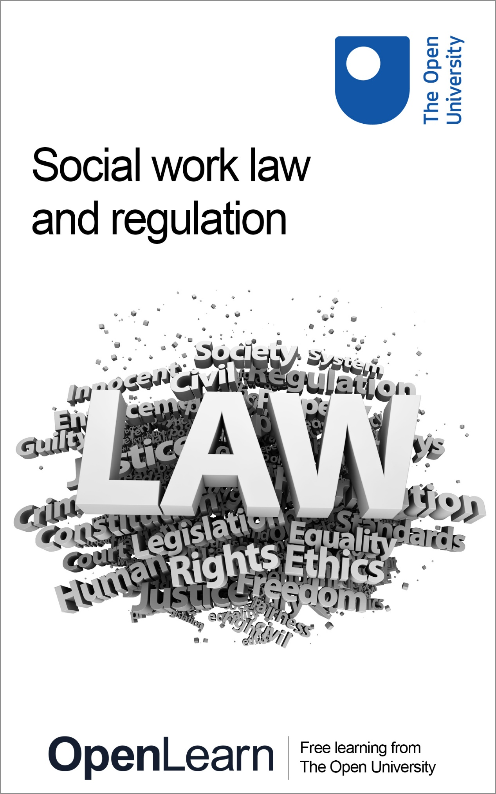

K271_2

Social work law and UK regulation

About this free course
This free course is an adapted extract from the Open University course K271 Social work law: www.open.ac.uk/courses/modules/k271 .
This version of the content may include video, images and interactive content that may not be optimised for your device.
You can experience this free course as it was originally designed on OpenLearn, the home of free learning from The Open University –
www.open.edu/openlearn/society-politics-law/social-work-law-and-uk-regulation/content-section-0
There you’ll also be able to track your progress via your activity record, which you can use to demonstrate your learning.
Copyright © 2022 The Open University
Intellectual property
Unless otherwise stated, this resource is released under the terms of the Creative Commons Licence v4.0 http://creativecommons.org/licenses/by-nc-sa/4.0/deed.en_GB. Within that The Open University interprets this licence in the following way: www.open.edu/openlearn/about-openlearn/frequently-asked-questions-on-openlearn. Copyright and rights falling outside the terms of the Creative Commons Licence are retained or controlled by The Open University. Please read the full text before using any of the content.
We believe the primary barrier to accessing high-quality educational experiences is cost, which is why we aim to publish as much free content as possible under an open licence. If it proves difficult to release content under our preferred Creative Commons licence (e.g. because we can’t afford or gain the clearances or find suitable alternatives), we will still release the materials for free under a personal end-user licence.
This is because the learning experience will always be the same high quality offering and that should always be seen as positive – even if at times the licensing is different to Creative Commons.
When using the content you must attribute us (The Open University) (the OU) and any identified author in accordance with the terms of the Creative Commons Licence.
The Acknowledgements section is used to list, amongst other things, third party (Proprietary), licensed content which is not subject to Creative Commons licensing. Proprietary content must be used (retained) intact and in context to the content at all times.
The Acknowledgements section is also used to bring to your attention any other Special Restrictions which may apply to the content. For example there may be times when the Creative Commons Non-Commercial Sharealike licence does not apply to any of the content even if owned by us (The Open University). In these instances, unless stated otherwise, the content may be used for personal and non-commercial use.
We have also identified as Proprietary other material included in the content which is not subject to Creative Commons Licence. These are OU logos, trading names and may extend to certain photographic and video images and sound recordings and any other material as may be brought to your attention.
Unauthorised use of any of the content may constitute a breach of the terms and conditions and/or intellectual property laws.
We reserve the right to alter, amend or bring to an end any terms and conditions provided here without notice.
All rights falling outside the terms of the Creative Commons licence are retained or controlled by The Open University.
Head of Intellectual Property, The Open University

Contents
- Introduction
- Learning outcomes
- 1 What is law?
  - 1.1 The law in books and the law in action: everyday meanings of law
- 2 Devolution and the United Kingdom’s constitution
  - 2.1 Scotland
  - 2.2 Northern Ireland
  - 2.3 Wales
  - 2.4 Professional regulation across the devolved nations
  - 2.5 Who regulates social workers?
- 3 Where does law come from?
  - 3.1 Classification of law
  - 3.2 Public and private law
  - 3.3 Duties, powers and responsibilities
- 4 Why do social workers need to know the law?
  - 4.1 A decision-making framework
  - 4.2 The importance of the practice context
  - 4.3 Studying law
  - 4.4 The role of professional judgement
- Conclusion
- References
- Acknowledgements
- Solutions

Introduction
In this free course, Social work law and UK regulation, you are going to learn about definitions of law and where legislation comes from. You will then apply this to social work and also learn how social work is regulated across the UK specifically. Finally, you will consider why it is important for social workers to understand the law.
This OpenLearn course is an adapted extract from the Open University course K271 Social work law.

Learning outcomes
After studying this course, you should be able to:
- understand what professional regulation is and how social work is regulated
- explain the differences in social work’s regulatory and legal frameworks across the four UK nations
- understand the interrelationship between duties, powers, rights and responsibilities, as these relate to social work practice.

1 What is law?
Your ideas about law are shaped through a series of images and encounters, and these affect your expectations of law as an area of study.

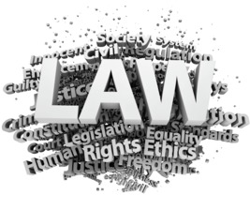
Figure 1 Understanding law
View description - Figure 1 Understanding law

Activity 1 asks you to think about the meaning of, and your own impressions about, law and lawyers.

Activity 1 Perceptions of law
15 minutes

Write down up to five words or phrases, or draw images, that you associate with ‘law’. Try to focus on what law means to you personally. (You may want to return to what you have written later on in the course and reflect on whether your thoughts have changed.)

Provide your answer...

Once you have compiled a list, see if you can separate your observations into positive and negative attributes. For example, if you associate law with ‘tradition’ do you see this as being a positive attribute or a negative one?

Table 1 Your positive and negative observations of law
Positive | Negative
Provide your answer... | Provide your answer...

View discussion - Part

Any attempt to provide a definitive answer to the question ‘What is law?’ has the potential to mislead, and legal theorists continue to debate its meaning. At first, this might seem unsatisfactory and difficult to comprehend, given people’s common understanding of law. The law may be defined as a set of rules and regulations, but this is a very basic definition that does not help when attempting to analyse the relationship between law and social work.
It is important to recognise that negative views of law are directly affected by how it is defined. For example, some social work students can view the law as technical and difficult to learn, which is usually based on the belief that studying law involves remembering an endless series of rules. However, the content of law changes over time and is not a fixed body of rules that they are expected to learn and recite. What is important for students of social work to learn is the underlying principles – how to find relevant law and apply it in practice, and keep abreast of legal developments – rather than committing whole areas to memory.

1.1 The law in books and the law in action: everyday meanings of law
Most people’s experience of law is with what might be called ‘the law in action’: you observe or encounter the application of law in practice through contact with, for example, solicitors, the courts or the police, and tend to associate their work with the law. However, social workers are also legal actors – professionals with legal power and authority. They are therefore very much part of the law in action, even if they do not fit your immediate associations with this role.

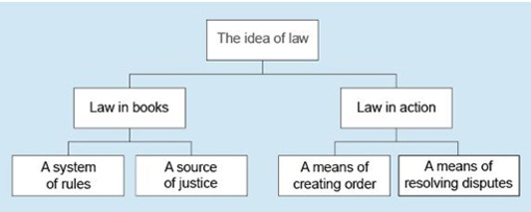
Figure 3 Everyday meanings of law
View description - Figure 3 Everyday meanings of law
View description - Figure 3 Everyday meanings of law

You may also be aware of the existence of ‘the law in books’ – the written rules and principles which are the sources on which these legal actors depend – but this idea of law tends to be regarded as the province of experts within the legal profession, beyond public concern. It is only when the law is put into action, or changes are proposed in the political sphere, that law in books can become the subject of intense public debate.

2 Devolution and the United Kingdom’s constitution
The UK is made up of four nations: England, Wales, Scotland and Northern Ireland.

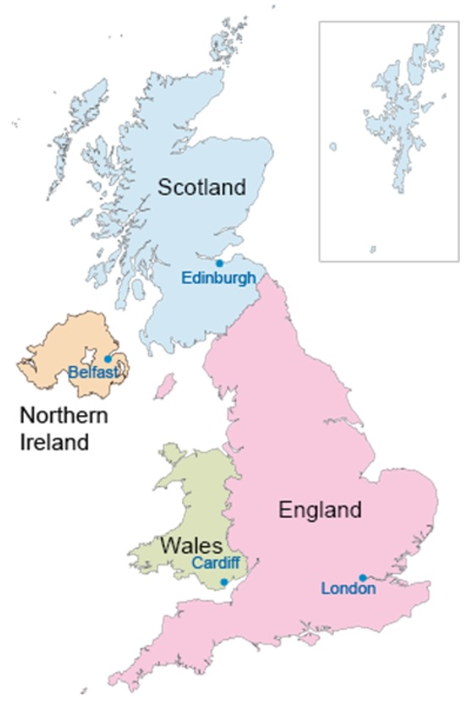
Figure 4 Map of the four countries that make up the UK
View description - Figure 4 Map of the four countries that make up the UK

In recent decades power has been devolved from Parliament to new law-making bodies in three of those nations: Wales, Scotland and Northern Ireland. Devolution transferred power from Parliament to the devolved law-making bodies. The process was the subject of much debate and the Acts that created the new law-making bodies are examples of recent constitutional statutes. In theory, Parliament remains the main source of power in the UK, because it granted limited powers to the new law-making bodies in defined areas. In theory, Parliament granted the new law-making powers and so it could remove them. Therefore, in theory, Parliament remains as the supreme law-making power.
Devolution impacts on the UK’s constitutional framework, as it questions the sovereignty of Parliament and creates a new relationship between the members of the UK. This section will give a basic overview of devolution and consider its impact.

2.1 Scotland
Scotland is often referred to as the most devolved nation, as it was initially given the greater of the devolved powers. The Scotland Act 1998 established Scottish devolution and established a new Scottish parliament with 129 seats, so there are 129 Members of the Scottish Parliament (MSPs).

Figure 5 Scottish Parliament
View description - Figure 5 Scottish Parliament

The Scottish Government consists of the first minister and a number of ministers appointed by the first minister. Members of the executive include the Lord Advocate and the Solicitor General for Scotland. The monarch appoints the first minister. This is usually the leader of the party with the most seats.
Under the Scotland Act 1998, the Scottish Parliament was given the power to make laws (both primary and secondary legislation) in a number of devolved areas. These include: agriculture, forestry and fisheries; education and training; environment; health and social services; housing; law and order; local government; sport and the arts; tourism; and economic development – indeed, all areas that were not expressly reserved to the UK Parliament at Westminster under the Act. Areas reserved to the UK Parliament in the 1998 Act include taxation, employment, broadcasting, trade and industry, consumer rights, data protection, the constitution, defence and foreign policy, and social security.
However, since the Scotland Act 1998, a number of additional powers have been devolved to the Scottish Parliament. These include the power to legislate for a Scottish rate of income tax (introduced under the Scotland Act 2012), while the Scotland Act 2016 provides that the Scottish Parliament may legislate for specified welfare benefits in Scotland, such as disability and carers benefit, as well as the power to ‘top up’ reserved benefits and to create other benefits.
Scotland’s devolution, and the powers given to the Scottish Parliament, have had an impact on Parliament. This is because Scotland has its own parliament and there are also Scottish members of Parliament (as is necessary, given that the Westminster Parliament passes law relevant to all of the UK). This means that England is the only nation without its own devolved legislature, determining law only relevant to that nation. This creates the imbalance that Scottish MPs are able to vote on legislation applying in England (and possibly Wales and Northern Ireland), whereas there are no English MSPs influencing purely Scottish matters in the Scottish Parliament.

2.2 Northern Ireland
The devolution of Northern Ireland is characterised by an intense ‘back and forth’ approach. Northern Ireland was split from the Republic of Ireland in 1920. Between 1921 and 1972, the devolved legislature for Northern Ireland was the Parliament of Northern Ireland, which was suspended in 1972 and abolished in 1973 by the Northern Ireland Constitution Act. The Northern Ireland Act 1974 made Parliament the only legislature for Northern Ireland. Political tensions and unrest eventually led to the Good Friday Agreement of 1998. A functioning Northern Ireland Assembly was created in 1999; however, the devolved powers have been suspended on a number of occasions since the Assembly was established.
The relationship between the UK and Northern Ireland, as well as between Ireland and Northern Ireland, is a sensitive one. Devolution in Northern Ireland was a mechanism to allow the political and legal circumstances to settle. It was designed to encourage compromise and power-sharing, and to end political unrest.
Northern Ireland has an assembly consisting of 90 members (known as Members of the Legislative Assembly – MLA). It is elected every five years. The Northern Ireland Executive is formed by the first minister and deputy minister accompanied by a maximum of ten ministerial offices. The Northern Ireland Assembly does not have powers comparable to those of the Scottish Parliament. However, it has the capacity to amend Acts of Parliament (UK) relating to the parts that concern Northern Ireland.

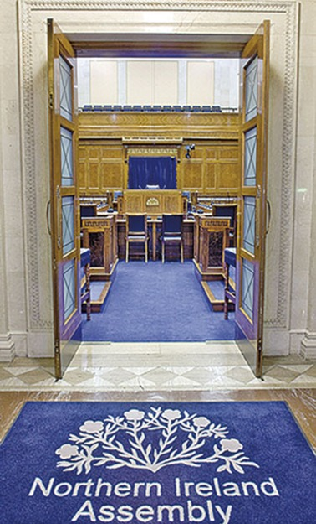
Figure 6 Northern Ireland Assembly
View description - Figure 6 Northern Ireland Assembly

2.3 Wales
Devolution in Wales was also a matter of much debate over the years. The Wales Act 1978 was meant to establish a Welsh Assembly, with secondary law-making powers in certain areas. The Act was passed in Parliament but subsequently repealed after an unsuccessful referendum result. The Government of Wales Act 1998 was passed at the same time as the Scotland Act 1998. However, as previously proposed by the provisions of the Wales Act 1978, more limited power was given to the newly formed National Assembly for Wales. In effect, it had power to make secondary (but not primary) legislation in similar areas to that of the Scottish Parliament. Following a referendum in Wales, the Government of Wales Act 2006 increased the law-making powers of the Welsh Assembly and established the Welsh Assembly Government as the executive. The Assembly, which changed its name to the Senedd in 2020, comprises 60 members, formerly known as Assembly Members (AMs), now known as Members of the Senedd (MS). Since 2011, Wales has had primary law-making powers.

Figure 7 The Senedd
View description - Figure 7 The Senedd

2.4 Professional regulation across the devolved nations
Along with differing laws and law-making bodies, the four nations each have their own regulators for the social work profession, which means although social work is now regulated throughout the UK, differing rules apply in each of the nations.

Figure 8 What are the priorities of regulation in your nation?
View description - Figure 8 What are the priorities of regulation in your nation?

However, along with the differences there are also similarities. For example, the term social worker is a protected job title throughout the UK. This means that only those who are suitably qualified can call themselves a social worker, though many others may be involved in social work. The need to protect the job title of ‘social worker’ is based upon the fact that social workers wield a great deal of power: they have the authority to intervene in people’s lives and make life-changing decisions. For example, a social worker could seek an order that a child be taken away from their birth family on a permanent basis.
The need for regulation is both to protect the public and service users and to maintain confidence in the profession. It is necessary for social workers to register with their regulatory body and if they fail to do so they will no longer be allowed to be employed as a social worker. All the areas that need to be regulated in order to achieve the aims of public protection and safety can be categorised into five key areas:
- Protection of titles and registration
In the UK, it is unlawful to call oneself a social worker or to practise as a social worker if you are not registered with the relevant national social work regulator.
- Education for initial registration
To be able to register with one of the four UK social work regulators you have to undertake an approved programme of education.
- Competence
To continue to practise as a social worker, practitioners have to ensure that you are competent to do so. This means you need to ensure that following your initial registration you continue to develop yourself professionally often through further training, which helps you develop your knowledge and skills.
- Standards for performance
To maintain registration with one of the four UK social work regulators, social workers have to ensure that they meet the standards (e.g. in a code of practice and ethics) that are laid down by them.
- Fitness to practise
If a social worker fails to meet any of these criteria, including the standards, they can face fitness-to-practise proceedings, which could censure them – including by the ultimate sanction of removing them from the professional register and thereby removing their ability to practise as a social worker.

2.5 Who regulates social workers?
There are four social work regulators in the UK: one for each of the four nations. Each nation can establish its own legislation for these areas, as social care and social work regulation is a devolved matter. Currently, the regulators are:
- England – Social Work England
- Northern Ireland – Northern Ireland Social Care Council
- Scotland – Scottish Social Services Council
- Wales – Social Care Wales.

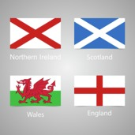
Figure 9 Social work regulators
View description - Figure 9 Social work regulators

Each of the regulators has a wealth of information about their role, how they undertake their function and the relevant legislation that established them.
If you are interested in pursuing a career in social work you should visit the regulator for your nation using the relevant link above. However, it would also be a good idea to look at the other regulators and see where there is any overlap in their functions.

3 Where does law come from?
In the UK, there is statute law, also called primary legislation. Statutes can be made by both the UK Parliament and the national parliaments/assemblies.
Statutes can begin life as part of the government of the day’s manifesto commitment in response to a public inquiry. For example, after the Hillsborough disaster (where 96 people were crushed to death as a result of overcrowding at a football stadium) the law was changed to introduce all-seater stadiums. In addition to statutes, there is ‘case law’, also referred to as ‘judge-made law’. This is in fact a misnomer: when it comes to case law, judges do not make the law but interpret and apply it to real-life situations.

3.1 Classification of law
There are two branches of the justice system: civil and criminal. Each branch has distinct procedures and terminology.
- Civil proceedings are generally concerned with disputes between what are termed ‘legal persons’ (which includes human and non-human entities, such as companies and agencies).
- Criminal law normally involves a proceeding brought by the state against one of its citizens.
Although there are two systems, there is not always a clear dividing line between civil and criminal matters, and the same facts can give rise to proceedings in either or both systems, as the case in the next activity illustrates.

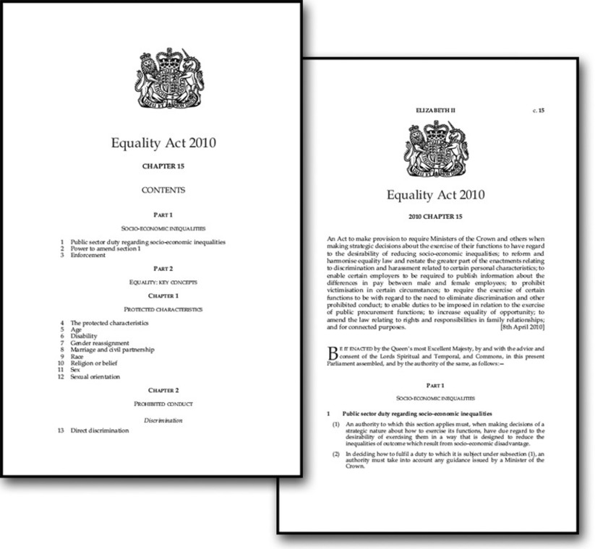
Figure 10 Equality Act 2010
View description - Figure 10 Equality Act 2010

Activity 2 Joanna's story
15 minutes

Read Joanna’s story and make notes below to see if you can identify the matters that fall under criminal law and those that fall under civil law.

Joanna’s story
Joanna is 92 and lives in social housing. She has been cared for by her children, Robert and Callum, who do not live with her. A neighbour contacts social services; he is concerned because he has not seen Joanna for a while.
On visiting the property, you find that Joanna has been living in very poor conditions. She has been hoarding and you feel that the conditions at the property are dangerous.
Joanna explains that she lent Robert a large sum of money to enable him to start a business, and that he has failed to pay it back. In addition, there is a significant amount of money missing from her bank account; she does not know what has happened to it but says that Callum has her bank card so that he can pay her bills.

Provide your answer...
View comment - Activity 2 Joanna's story

One important distinction to understand is that the rules and consequences of the two branches of justice systems are different. In civil proceedings the outcome would be in the form of an order that the court ultimately decided to make. If there was a criminal prosecution, the outcome on conviction would be punishment of some kind, such as a fine or imprisonment.
It is not only in terms of the possible outcomes that there are differences. One important distinction, for example, is that the standards of proof required for the two justice systems are not the same. In civil proceedings, the person who initiates the court action has to prove their case ‘on the balance of probabilities’ – that is, it is more likely than not that the events alleged to have occurred did in fact occur. The standard of proof in a criminal trial, however, is much stricter: the case against the accused must be proved ‘beyond reasonable doubt’. This means that if there remains any real doubt in the minds of the jury members, they must acquit the accused.
Therefore, in relation to Joanna’s case above, the standard of proof in respect of the housing matter and the loan would be on the balance of probabilities, while any allegations in criminal proceedings against Callum would have to be proved beyond reasonable doubt.
Law can also be further classified as being either public or private law. You will consider the difference between these in the next section.

3.2 Public and private law
Public law matters involve the state. It sometimes includes criminal law, as well as action taken against individuals by an organisation that represents the state, such as a local authority. Most proceedings involving social workers will be categorised as public law matters.

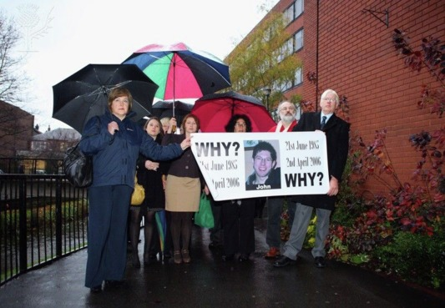
Figure 11 Public inquiry into Stafford Hospital scandal begins
View description - Figure 11 Public inquiry into Stafford Hospital scandal begins

Private law matters are proceedings between individuals, such as divorce or claims in respect of road traffic accidents. Social workers may become involved in private law matters, in particular private law family proceedings. For example, if family members cannot agree on where a child should live following divorce, they may ask the court to make the final decision. The court may need the help of a social worker in providing information that will inform that decision.

3.3 Duties, powers and responsibilities
There are key words in any statute that will help you to understand what social workers may do and what they must do. Two key words which will help you to interpret statutes are ‘duties’ and ‘powers’.
A duty is something that local authorities or, less commonly, social workers, are required by law to do. This means that they have to act in a particular way or that they must offer a certain service. There is no discretion. For example, every local authority must publish information about the services to children with disabilities in their area. (Children Act 1989, para 1(2) of sch 1 and Children (Scotland) Act 1995, s.20. The Children (Northern Ireland) Order 1995.)
Powers on the other hand give more discretion, so they may be exercised in one authority routinely, as a result of local policy and practice, but not in another. Therefore, if members of a family live in different areas, the assistance they receive may differ, and the social worker would need to be aware of this when working with or advising families.
Duties and powers relating to social care are generally placed on the local authority, but it is normally the social work department that implements them. The decisions and choices social workers make in their everyday practice will be regulated by whether they are acting under a duty or a power. A social worker is accountable to their profession, their employer and to service users. In order to ensure that your practice is accountable, it is imperative that you understand when there is a power or a duty to act.
The words ‘must’ or ‘shall’ indicate that there is a duty imposed on the local authority to carry out certain functions. However, if the paragraph, in addition to these words, includes the phrase ‘as they [the local authority] consider appropriate’, this means that there is discretion built into the Act and that the local authority has a duty only so far as it considers that it is appropriate to have one.
It could be argued that what might be appropriate in a large city housing estate might not be so in a rural area, and thus the wording allows local authorities to be responsive to local needs. The counterargument, however, is that such discretion can allow the local authority to avoid its responsibilities by wording obligations so loosely that citizens do not know exactly what their rights are. It is difficult to argue that the provision of services is not adequate if the local authority can claim that, according to its assessment, such provision is appropriate for the area.

4 Why do social workers need to know the law?
Understanding the law is crucial to the role of the social worker. There will be many situations where a social worker’s knowledge will be vital in making and explaining decisions and processes chosen with regards to service provision. Being able to interpret and explain what a social work department has a duty to provide and what it has the power to provide are key skills for a social worker.
Social workers need to know whether they have a duty (that is, they have to do something) or whether they have a power (that is, they have discretion). In a world where resources are finite, the emphasis may be on doing only what has to be done, and even this will vary according to the philosophy and approach of different social work departments. In the next section you will consider a framework to assist with such decisions.

4.1 A decision-making framework
The concept of a decision-making framework is that a number of interconnected areas of enquiry are prioritised in the course of making a decision. Braye and Preston-Shoot (2016) suggest that social workers can respond more appropriately within the legal context by using a decision-making framework.

Activity 3 A decision-making framework in practice
40 minutes

Read the following case study and then apply the decision-making framework given, making notes in answer to the questions. You may not yet be aware of all the relevant legislation, but working through the questions will help you to understand the importance of considering a situation from several different perspectives.

Decision-making framework
- What is the problem?
- Is there anything else I need to find out?
- What is the purpose of intervention?
- What do I hope to achieve in the short term?
- Are there particular outcomes that I must, or could, achieve in the long term?
- What are the risks, needs and rights involved?
- What is the legal context?
- What grounds do I have to intervene?
- What duties or powers exist?
- What discretion is available?
- What is the agency context?
- What does my employer expect of me?
- What resources are available?
- Are there other professionals I should speak to?
- When must I respond?
- Is this an emergency?
- Does the legal situation dictate timetables?
- Are there ‘good practice’ considerations?
- What are the consequences of action/inaction?
- Who should make the decisions?
- What about the service user’s voice?
- Are there potentially competing demands?
(adapted from Braye and Preston-Shoot, 2016)

Maisie’s story
Maisie is an 82-year-old widow who lives alone in a ground-floor flat. She is frail and isolated, but she does not want to move. She caused a minor fire in her kitchen when she forgot to take a saucepan off the stove. Her neighbours have presented a petition to the housing association asking that she be moved.

Provide your answer...
View discussion - Activity 3 A decision-making framework in practice

4.2 The importance of the practice context
Dilemmas for practice can also arise where there are perceived to be competing rights. Are some rights more important than others? In work with children and families, for instance, there can be a tension between the right to privacy and state powers in relation to child protection.
There are few ‘right’ answers in social work, and neither the law nor an understanding of social work values can give you the ‘right’ answer. Social workers must learn to exercise professional judgement, which is informed by knowledge of the law and the process of intervention, and underpinned by an understanding of, and a commitment to, social work values. Social workers must therefore continually reflect on their own values and beliefs and determine whether and how these values have had an impact on their professional judgement.

4.3 Studying law
Social workers are not lawyers; it is therefore important to know when to either call on professional legal advice or advise service users and others to seek such advice. Since the mid-1980s there has been much discussion and debate about the nature and level of legal knowledge needed by social workers. Historically, social work training programmes had tended to regard law as a discrete body of knowledge imported from another professional discipline without first being distilled through the value base of social work practice. Social workers were therefore encouraged to absorb legal facts in the abstract, which contributed to the view that the law was difficult to understand and not always relevant.
Learning the law in an abstract fashion, that is by just learning the text of legislation and the decisions on cases, is of little use to practitioners, because they must learn to apply the law to complex situations while ensuring that they do so in a way which is consistent with social work values. Often, the advice, support or intervention that is needed is clear – for example, in the case of a family with a disabled child whose mobility is being adversely affected by the width of the doorways in the family home. In such a case the social worker would provide advice on obtaining funding to make the alterations to the home, or advice and assistance in moving to a more suitable home. More often, the social worker will have a number of options or choices about the best way forward and must use professional discretion in order to decide on the appropriate path.
In summary, the law provides a framework for practice by granting the social worker the power to take action – such as applying to detain a person with mental health issues, or the discretion to provide support – but it does not prescribe what the correct course of action should be in each case. This is a matter for the social worker to decide, using the framework created by the law. Legal rules do not by themselves provide a clear, consistent and comprehensive guide to practice. The missing ingredient is a commitment to good or ethical practice.

4.4 The role of professional judgement
An ethical approach is one where the social work relationship with the legal framework takes account of social work skills and values. The existence of the legal framework does not mean that there is no need to exercise professional judgement and discretion. Such judgement is crucial and must be informed by the wider knowledge base, values and skills of social work practice (Stevenson, 1988). Sometimes practitioners may only have limited discretion in making decisions; at other times they may have considerable discretion. Social work practice is based on assessments of situations and decisions about strategies to be adopted. Tension may arise between the law and social work value; in such situations the law provides the framework or boundaries for practice.

Conclusion
Social workers have significant powers, rights and responsibilities in their professional role. As such, social work and social workers are regulated within the UK. This is part of their professional accountability and means that to be a social worker requires registration with a regulating body. In order to be registered, a period of education and training has to be undertaken. As part of that education the student social worker will learn about the law.
The law is not a simple entity that can just be read in a book. It has to be interpreted and applied to a given situation. Sometimes law, best social work practice and social work values may interact in a complex and challenging way. For this reason, it is important for social workers to continue to develop their understanding of the law in the context in which they practise. It is also an area where it is important for practitioners to take advice, particularly around complex and contested issues.
The law also has a vital role in the regulation of professional practice, and such regulation is important to social workers, as it provides clear boundaries for their practice. Boundaries also provide the public with confidence in the profession. It is important for service users to know that a legal framework exists and that remedies are available when professionals act outside the legal framework.
This course is part of a suite of courses on social work and the law. You may be interested in continuing your studies in this subject with the following courses:
- An introduction to social work law
- Applying social work law with children and families
- Applying social work law to asylum and immigration
This OpenLearn course is an adapted extract from the Open University course K271 Social work law.

References
Legislation
Children Act 1989
Children (Scotland) Act 1995
The Children (Northern Ireland) Order 1995
Government of Wales Act 1998
Government of Wales Act 2006
Northern Ireland Act 1974
Northern Ireland Constitution Act 1973
Scotland Act 1998
Scotland Act 2012
Scotland Act 2016
Wales Act 1978
Books, articles, reports and other sources
Braye, S. and Preston-Shoot, M. (2016) Practising social work law, Basingstoke, Macmillan.
Stevenson, O. (1988) ‘Law and Social work education: a commentary on the law report’, Issues in Social Work Education, vol. 8, no. 1, pp. 37–45.

Acknowledgements
This free course was written by Justin Rogers. It was first published in August 2022.
Except for third party materials and otherwise stated (see terms and conditions), this content is made available under a Creative Commons Attribution-NonCommercial-ShareAlike 4.0 Licence.
The material acknowledged below is Proprietary and used under licence (not subject to Creative Commons Licence). Grateful acknowledgement is made to the following sources for permission to reproduce material in this free course:

Images
Course image and Figure 1: (c) jpa1999 / istock / Getty
Figure 2: (c) Homer Sykes / Alamy Stock Photo
Figure 4: Volina / Shutterstock
Figure 5: John Peter Photography / Alamy Stock Photo
Figure 6: © Northern Ireland Assembly. This file is licensed under the Creative Commons Attribution-NoDerivatives Licence http://creativecommons.org/licenses/by-nd/3.0/
Figure 7: Matthew Dixon / Shutterstock
Figure 8: (c) iQoncept / www.shutterstock.com
Figure 9: (c) Sergey Mastepanov / www.shutterstock.com
Figure 10: Statute law: Image of Equality Act 2010: : Equality Act 2010. Crown Copyright 2010 Reproduced under the terms of the OGL, www.nationalarchives.gov.uk/ doc/ open-government-licence
Figure 11: Christopher Furlong / Staff / Getty
Figure 12: (c) Kristo-Gothard Hunor / www.shutterstock.com
Every effort has been made to contact copyright owners. If any have been inadvertently overlooked, the publishers will be pleased to make the necessary arrangements at the first opportunity.
Don't miss out
If reading this text has inspired you to learn more, you may be interested in joining the millions of people who discover our free learning resources and qualifications by visiting The Open University – www.open.edu/openlearn/free-courses.

Solutions

Activity 1 Perceptions of law

Part

Discussion

Figure 2 What does law make you think of?
View description - Figure 2 What does law make you think of?

There are no right answers to this activity, which probably provoked a range of responses and ideas about law. It is important to recognise that you have pre-existing knowledge and personal values that will affect your engagement with this course. Words you may have thought of might include ‘complicated’, ‘useful’, ‘rules’ and ‘boundaries’, or you may have come up with a completely different set of answers.
As you progress through the course, you can return to this activity and reflect on whether your views have changed. It is important to realise that your impressions of the law, gained from your own and others’ experiences, as well as media coverage, are likely to have an impact on your thoughts and feelings. It may also have an impact on how you feel about studying the law.
If you included the words ‘difficult’ or ‘boring’ in your list when answering, you will not have been alone. Law, like social work, has an image problem that, while not entirely undeserved, needs to be addressed, particularly in the context of concerns about inequality of access to law and the power that an understanding of law can bring. This has clear implications for promoting social justice, which is fundamental to social work. You will see that the law can assist in developing sound, evidence-based and anti-oppressive practice, so long as professionals are committed to practising in this manner.
Back to - Part

Activity 2 Joanna's story

Comment
Joanna could issue a civil claim against Robert to get him to repay the money she lent to him. There may be further civil proceedings issued by the housing authority to ensure that the property is made safe. In addition, criminal proceedings may be brought on behalf of the state against Callum if he has been using Joanna’s bank account fraudulently.
Back to - Activity 2 Joanna's story

Activity 3 A decision-making framework in practice

Discussion
By answering the questions in the framework, you will have a better understanding of Maisie’s situation and the options available for dealing with it. It is clear that there is no obviously ‘right’ decision, nor is there likely to be an outcome that will entirely satisfy everyone concerned. Social work is not just about identifying rights; it is also about assessing need. This could include gathering information from other professionals such as a GP (with the client’s permission). When need is assessed, decisions have to be made about whether there is a duty to act or whether there is a power to take action or provide support. In the latter case, decisions then have to be made about whether or not to offer a service.

Figure 12 Maisie
View description - Figure 12 Maisie

In Maisie’s case, you might conclude, after assessment, that she is able to stay in her own home, which is what she wants, but that she needs additional domiciliary support. You are assessing whether or not her needs could be met by a service, but this is not the same as her right to a service. You may think she has a moral right to a service because she is frail and isolated, but that is not the same as her having a legal right to a service: you would have to consider whether, according to your assessment, your agency is required to provide a service by law. If it does, then you have a duty that you cannot ignore. If it is not a matter of duty, and the law says you may provide a service, then your agency has discretion. It can judge the priority of that need against other demands on its financial resources. You should also remember that social workers often have a significant role as advocates for service users within their own agencies.
Maisie’s case is a good example of the interaction between rights and responsibilities.
For social workers acting as an advocate for service users and carers it can be a role that is fraught with potential conflict. It is difficult for a social worker to argue, for example, that a carer needs support in the form of respite care when their own policies prevent the allocation of resources to respite care because of cost.
Social work practice and decision-making are affected by a variety of factors. The law sets out the duties that social workers are legally bound to fulfil. However, the law can be open to interpretation. Legislation also provides social workers with certain powers, and thus frames the ‘choices’ that social workers have to make. Choices are made in the light of (among other factors) agency policies and personal judgement. Any decision you make, for example in cases such as Maisie’s, will be influenced not only by any legal duties or powers you may have, but also by a commitment to social work values and best practice within the profession.
It is clear when looking at the decision-making framework that you cannot make any decisions about Maisie’s care without having a thorough understanding of the relevant legislation.
Back to - Activity 3 A decision-making framework in practice

Figure 3 Everyday meanings of law

Description
A flow diagram. At the top is a single box with ‘The idea of law’ written in it. Below this are two feeder lines which feed into two boxes on the row below. One of these boxes has ‘Law in books’ written in it, the other reads ‘Law in Action’. Under the ‘Law in books’ box are two more more feeder lines which lead to two further boxes on the row below. These two boxes read ‘A system of rules’ and ‘A source of justice’. Under the ‘law in action’ box, there are two more boxes feeding from it. These read ‘A means of creating order’ and '‘A means of resolving disputes’.
Back to - Figure 3 Everyday meanings of law

Figure 1 Understanding law

Description
The word ‘LAW’ written in large text. Behind are other words relating to Law jumbled on top of each other, including rights, ethics, freedom, justice.
Back to - Figure 1 Understanding law

Figure 2 What does law make you think of?

Description
Photo of two judges. They are both wearing a judge wig and black robe.
Back to - Figure 2 What does law make you think of?

Figure 3 Everyday meanings of law

Description
Flow diagram showing the different types of law. Full description in long description link
Back to - Figure 3 Everyday meanings of law

Figure 4 Map of the four countries that make up the UK

Description
Map of England, Scotland, Wales, Northern Ireland – each nation in a different colour, with the capital of each nation noted.
Back to - Figure 4 Map of the four countries that make up the UK

Figure 5 Scottish Parliament

Description
A photograph of the Scottish Parliament building.
Back to - Figure 5 Scottish Parliament

Figure 6 Northern Ireland Assembly

Description
Photo of a council chamber, with a rug entitled ‘Northern Ireland Assembly’ at the entrance.
Back to - Figure 6 Northern Ireland Assembly

Figure 7 The Senedd

Description
A photograph of the building of the Senedd.
Back to - Figure 7 The Senedd

Figure 8 What are the priorities of regulation in your nation?

Description
A cartoon human torso and head in a thinking pose. Behind are thought bubbles with ‘Priority 1’up to ‘Priority 9’ written in them.
Back to - Figure 8 What are the priorities of regulation in your nation?

Figure 9 Social work regulators

Description
The flags of England, Scotland, Wales and Northern Ireland.
Back to - Figure 9 Social work regulators

Figure 10 Equality Act 2010

Description
Screenshots of the Equality Act. One shows the Equality Act contents page. The other shows the front text of Chapter 15.
Back to - Figure 10 Equality Act 2010

Figure 11 Public inquiry into Stafford Hospital scandal begins

Description
A group holding a banner with ‘Why?’, the dates 21 June 1986 and 4 April 2006, and a photo of a man with the name John written under it.
Back to - Figure 11 Public inquiry into Stafford Hospital scandal begins

Figure 12 Maisie

Description
An older lady smiling and holding a tea cup in her hand.
Back to - Figure 12 Maisie

