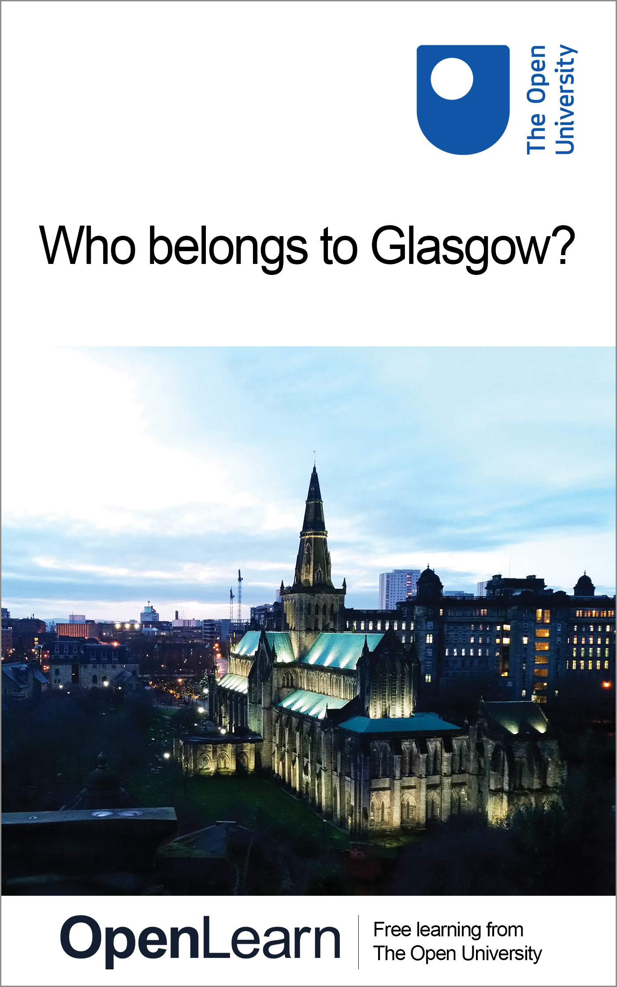

D215_6

Who belongs to Glasgow?
About this free course
This free course provides a sample of Level 1 study in Sociology www.open.ac.uk/courses/find/social-sciences.
This version of the content may include video, images and interactive content that may not be optimised for your device.
You can experience this free course as it was originally designed on OpenLearn, the home of free learning from The Open University – www.open.edu/openlearn/people-politics-law/politics-policy-people/sociology/who-belongs-glasgow/content-section-0
There you’ll also be able to track your progress via your activity record, which you can use to demonstrate your learning.
The Open University, Walton Hall, Milton Keynes, MK7 6AA
Copyright © 2016 The Open University
Intellectual property
Unless otherwise stated, this resource is released under the terms of the Creative Commons Licence v4.0 http://creativecommons.org/licenses/by-nc-sa/4.0/deed.en_GB. Within that The Open University interprets this licence in the following way: www.open.edu/openlearn/about-openlearn/frequently-asked-questions-on-openlearn. Copyright and rights falling outside the terms of the Creative Commons Licence are retained or controlled by The Open University. Please read the full text before using any of the content.
We believe the primary barrier to accessing high-quality educational experiences is cost, which is why we aim to publish as much free content as possible under an open licence. If it proves difficult to release content under our preferred Creative Commons licence (e.g. because we can’t afford or gain the clearances or find suitable alternatives), we will still release the materials for free under a personal end-user licence.
This is because the learning experience will always be the same high quality offering and that should always be seen as positive – even if at times the licensing is different to Creative Commons.
When using the content you must attribute us (The Open University) (the OU) and any identified author in accordance with the terms of the Creative Commons Licence.
The Acknowledgements section is used to list, amongst other things, third party (Proprietary), licensed content which is not subject to Creative Commons licensing. Proprietary content must be used (retained) intact and in context to the content at all times.
The Acknowledgements section is also used to bring to your attention any other Special Restrictions which may apply to the content. For example there may be times when the Creative Commons Non-Commercial Sharealike licence does not apply to any of the content even if owned by us (The Open University). In these instances, unless stated otherwise, the content may be used for personal and non-commercial use.
We have also identified as Proprietary other material included in the content which is not subject to Creative Commons Licence. These are OU logos, trading names and may extend to certain photographic and video images and sound recordings and any other material as may be brought to your attention.
Unauthorised use of any of the content may constitute a breach of the terms and conditions and/or intellectual property laws.
We reserve the right to alter, amend or bring to an end any terms and conditions provided here without notice.
All rights falling outside the terms of the Creative Commons licence are retained or controlled by The Open University.
Head of Intellectual Property, The Open University
Designed and edited by The Open University
978-1-4730-1488-6 (.kdl)
978-1-4730-0720-8 (.epub)

Contents
- Introduction
- Learning outcomes
- 1 Image of a city
  - 1.1 Why Glasgow?
  - 1.2 The hard side of Glasgow
  - 1.3 Constructing a new image
- 2 Who belongs to Glasgow? The TV programme
  - 2.1 How the programme progresses
  - 2.2 Postscript
  - 2.3 Watching the programme
- Conclusion
- References
- Acknowledgements

Introduction
This course focuses on the images of Glasgow and was first presented as a TV programme in 1993. It is not about Glasgow as such; it is about Glasgow's image. Images are representations of places: they are constructed and contested; images also represent multiple identities, uniqueness of place, interdependencies.
There are many different ways of interpreting and representing the character and identity of a place – many different geographical imaginations. Identities of places are a product of social action and of how people construct their own representations of particular places.
This OpenLearn course provides a sample of Level 1 study in Sociology.

Learning outcomes
After studying this course, you should be able to:
- demonstrate an awareness of ideas about place and identity using our concept of ‘geographical imagination’ by examining the images that represent a place to reveal how those images came about
- show an awareness of ideas about place and identity by examining the images that represent a place to reveal two sets of relationships that are important in understanding the character of a place: power relations and local-global relations.

1 Image of a city

1.1 Why Glasgow?
Glasgow fulfilled our aims and was also an interesting case study having, arguably, been the most successful among British cities in developing/manufacturing a new identity in the ‘post-industrial’ era. Glasgow illustrates:
- (a) power relations, reflected in:
  - constructed images – ‘Glasgow's miles better’ was a deliberate campaign to improve the image of Glasgow.
  - contested images – ‘City of Culture’ – but whose culture?
  - multiple identities – ‘Clydebuilt’, ‘Red Clydeside’, ‘Shock City’, ‘Glasgow's Alive’ are all images of Glasgow.
  - whose interests these dominant images represent and whose are ignored.
- (b) local-global relations – phrases like ‘second city of Empire’ and ‘a great European city’ reflect how Glasgow's (local) uniqueness has been constructed out of wider (global) interdependence.

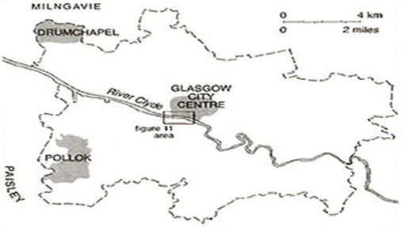
Figure 1 Glasgow

1.2 The hard side of Glasgow
Prior to its currently projected image of dynamism, Glasgow was regarded as the place which best illustrated all that was wrong with the modern industrial city: ‘Once called the “second city of the British Empire” because of its size and industrial might, Glasgow had sunk so low that even the locals disdained it’ (Bryson, 1989).

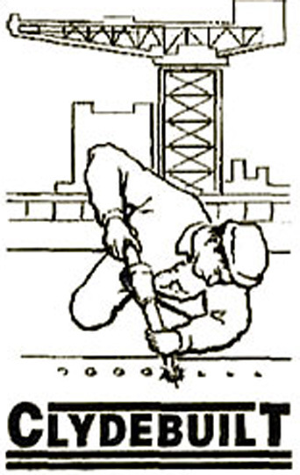
(Based on the cover of the exhibition catalogue for ‘Clydebuilt: The River, its Ships and its People’, organised by the Clyde Maritime Trust Ltd.) Riveter based on the cover of the exhibition catalogue for ‘Clydebuilt: The River, its Ships and its People’, organised by the Clyde Maritime Trust Ltd.
Figure 2

Glasgow's industrial base was laid during the latter half of the nineteenth century when the city became a prominent industrial centre. The idea of ‘Clydebuilt’ serves to illustrate the importance of the city in equipping not only Britain itself, but also the far-flung reaches of the Empire with the ships, locomotives and heavy engineering commodities necessary to fuel economic expansion. Crucially, then, Glasgow's (‘local’) economic fortunes, as with those of many of the other ‘older’ industrial centres of Britain such as Tyneside and Belfast, were integrally tied to the (‘global’) fortunes of the British Empire. The saying ‘Glasgow made the Clyde and the Clyde made Glasgow’ highlights the importance of shipbuilding and, behind that, of trade for Glasgow's industrial growth in the nineteenth and early twentieth centuries. It also illustrates the theme of interdependence. Industrial and economic decline in the period following the First World War, combined with growing problems of inadequate housing, rising unemployment and industrial agitation and militancy, gave rise to the image which arguably has dominated reportage of Glasgow for most of this century. For example:

There is something deeply wrong with the Clyde, … that sends in repeated menace, to every successive Parliament, the same bitter group of extreme left members, irrespective of the changing political mood of the rest of the country, to kill with their fierce interruptions any restful optimism of the remainder of the House.
(Bolitho, 1924)

This image, then, was a product of political agitation and conflict which had gripped much of Clydeside in the early part of this century. The period from around 1914 to the early 1920s, now known as ‘The Red Clyde’, was characterised by large-scale industrial conflict in the shipyards and factories. Community-based agitation over housing conditions gave rise to the 1915 rent strike which was organised mainly by women and received widespread support on Clydeside. Glasgow was regarded as a ‘melting-pot’ during the First World War when the government was increasingly concerned that a potentially revolutionary situation might develop. Glasgow during this period, then, was a very political place and this aspect of its history has also been reflected in many of the images and representations of the city over the decades.
Another image which developed during this period was that Glasgow was a very violent place. This is reflected in the novel No Mean City, written when the city was gripped by the inter-war slump and depression. This image and representation of Glasgow has dominated much of the discussion of the city ever since.

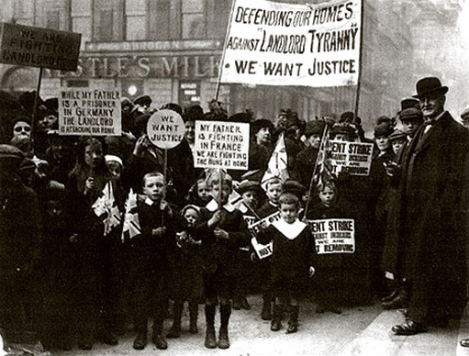
(Glasgow Herald/Caledonian Newspapers Limited) Glasgow Herald/Caledonian Newspapers Limited
Figure 3 Glasgow's image as ‘a very political place’ – the Rent Strike of 1915 brought women into the local political arena

It was reflected in the significant number of novels, dramas, documentaries and television plays which highlighted Glasgow's ‘hard side’. The work of Peter McDougall in the 1970s – an excerpt from which is included in the programme – serves to illustrate much of this negative image. But it is also claimed that this negative image of violence was constructed from outside the city by, among others, media based far away in London/England; it was essentially what others said about Glasgow. Glaswegians knew about these negative characteristics – and that they existed elsewhere as well – but they also knew other things about Glasgow which were never portrayed back to the outside world – that is, until the ‘Glasgow's miles better’ campaign was launched.

1.3 Constructing a new image
The image ‘Glasgow's miles better’ was deliberately constructed by the City Council, avowedly to make Glaswegians feel better about Glasgow but in fact largely on behalf of business. But it begged a question – ‘miles better for whom?’ Certainly, the city centre was better for shoppers and visitors and the new roads were literally ‘miles better’ for motorists, but the spiralling problems of the housing schemes provided stark counter-images. In other words, as with all images, the image of ‘miles better’ was partial and selective. It was a particular, preferred representation. It excluded other aspects of the city. It was not promoting housing estates like Drumchapel, and they benefited either little or not at all.

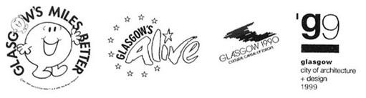
(Mr Happy adaptation: Mr Men and Little Miss™ and © 1995 Mrs Roger Hargreaves; All: Courtesy City of Glasgow) (top) Mr Happy adaptation: Mr Men and Little Miss™ and © 1995 Mrs Roger Hargreaves; (all) Courtesy: City of Glasgow
Figure 4 The work of image-builders in constructing a new sense of place

For many people, 1988 marked the arrival of Glasgow on the national scene in Britain, with the National Garden Festival (see Figure 8). For many Glaswegians it proved to be a missed opportunity to gain a lasting amenity, but for those promoting the city it was an important step. In 1990 Glasgow was European City of Culture. By the mid 1990s Glasgow was attracting international conferences (such as Rotary International in 1997 and City of Architecture and Design 1999). But the image of ‘City of Culture’ was particularly strongly contested. On the one hand Glasgow was looking outwards towards Europe in a new way – very different from the late nineteenth and the early part of the twentieth century. From another perspective it was failing to look inwards: the promotion of European and international culture was accompanied by a denial and marginalisation of Glasgow's own local culture. It was also argued that the city would be bankrupted in the process.

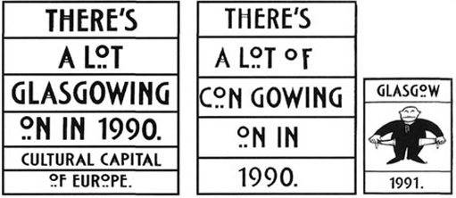
(Left: City of Glasgow; middle: Courtesy The Citizen; right: source unknown) (left) City of Glasgow; (middle) Courtesy: The Citizen; (right) source unknown
Figure 5 Contrasting images of Glasgow as European City of Culture in 1990: the official slogan, re-interpreted to highlight marginalised interests and concern over spending

The economy of Glasgow has undergone a major transformation since the inter-war period. In common with many other ‘old’ industrial centres, the majority of the city's workforce is now engaged in service sector employment, a far cry from its image as an industrial city par excellence. In part this transition reflects Glasgow's changing position in both the national and international economies. In the 1980s substantial inward investment in the form of business services and tourist-related activities has further altered its traditional economic base. Public and private sector agencies have been to the fore in promoting the city as a place in which to invest and the dominant image of Glasgow is a much more ‘positive’ one. From being a city characterised by violence and conflict, Glasgow is now marketed by the Glasgow Development Agency's Business Location Service as ‘no mean city’ in which to do business. This demonstrates that the same image can provide different interpretations, in this case one negative and one positive. It also serves to reinforce the point that images are built up over time, providing layers of representations. Contrasting images also illustrate the point that at any one time, more than one image or representation will be available. These alternative images frequently conflict with each other and, in different ways, refer to particular readings of previous histories to portray their messages, some of which may be hidden.
Today's competing images, then, not only compete in relation to contemporary developments and future plans, but also compete in the interpretations of the past of a city such as Glasgow. In Glasgow today, images of a vibrant, modern place, as reflected in the idea of Merchant City, clearly invoke a particular sense of the past. In this respect Merchant City is a particular representation of Glasgow today and one that serves to exclude other images and representations. These contrast strongly with the images of the city's large peripheral housing estates, typified by Drumchapel, which are clearly the product of a very different social and historical context. We can see in this, examples of different ‘envelopes of space-time’, different geographical imaginations. While people in Glasgow often identify with the city itself, different localities within, and competing images of, the city will give rise to different ideas or ‘senses’ of place. Identifying with Drumchapel as opposed to Merchant City or with the city as a whole reinforces the point that senses of place operate at a number of different levels and spatial scales, which may contradict or compete with each other. While spatial or geographical scale clearly refers to identification with particular geographical entities, by ‘different levels’ we refer to the very different class and power relations involved in identifying with a place. It is clear that ‘place’ means different things to different social groups. There are different representations of place at work at any given time, giving rise to competing or contradictory identities with the same place. These, in turn, give rise to counter-claims that the ‘real’ Glasgow is not reflected in Merchant City but in places like the peripheral estates. One of the dominant images to emerge from Glasgow in recent years, then, is the notion of a ‘dual city’: two cities experiencing very different social and economic fortunes in recent decades.

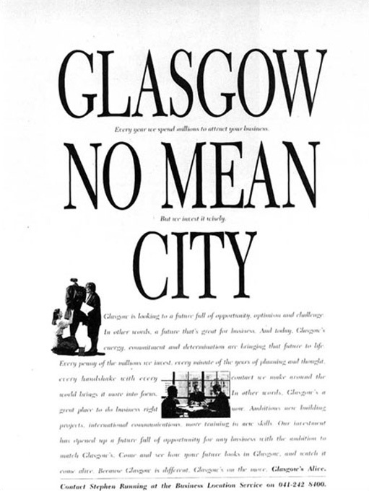
(Courtesy of Corporate Location Magazine) Courtesy of Corporate Location Magazine
Figure 6 Turning an image around – new use for an old slogan, confronting Glasgow's reputation as a violent place

Click here for a larger image.

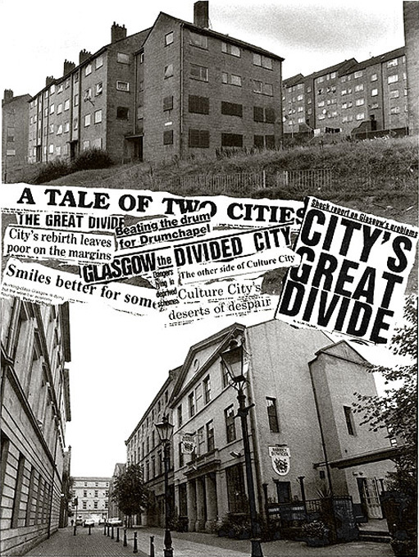
(© Alan Wylie Photographer) © Alan Wylie Photographer
Figure 7 ‘Dual City’ – different ways of imagining Glasgow (Drumchapel above, and Merchant City, below)

2 Who belongs to Glasgow? The TV programme

2.1 How the programme progresses
The programme takes the form of a visit to Glasgow. We talked to people and asked about their image(s) of Glasgow and whether these had changed – what was the ‘old’ image; what is the ‘new’; how has it changed; what will it be like in another ten years?
The five main participants have different experiences of Glasgow and these are represented in the images which they hold and aspects of the city's character which they highlight. The themes and ideas behind the programme are all to be found in what they say and what they see.
Gordon Borthwich talks about the long history of Glasgow and denies its violent image as being worse than elsewhere. His perspective highlights what he sees as the city's heritage, which links the past with the present and the future.
Linda Whiteford is part of the city's positive image-building. She sees a place that has always been better than it was painted and sees it now in a very positive, vibrant light.
Jean Forbes sees the urban regeneration process as positive and expects the benefits to ‘trickle down’ to other parts of the city – while acknowledging that this process has been slowed by recession in the economy.
Gerry Mooney points out many of the contrasts in Glasgow's image, or images, and adopts a more critical stance. He discusses the key concepts and themes which provide the framework for the programme.
Edward Stephenson looks, above all, to locality (Drumchapel) rather than to city or region. But he identifies with Glasgow against Belfast, London or Edinburgh.

2.2 Postscript
A headline-grabbing weekend of ‘midsummer madness’, when six murders occurred in (parts of) Glasgow over the weekend of 5–6 August 1995, reinforced the ongoing nature of contestation and debate about the issues discussed in the programme. As noted in The Scotsman (8 August 1995), the legacy of the imagery of No Mean City was quickly resurrected by the press – for example, ‘a darker side to that much-vaunted transformation of Glasgow from No Mean City to Culture City’ (Sunday Times Scotland, 13 August 1995). Others sought to prove empirically that Glasgow's murder rate was the highest in Britain; that the murders occurred in some parts but not in all parts of the city; that violence is closely linked to issues of poverty (Scotland on Sunday, 13 August 1995). A Labour MP declared the need to protect Glasgow's ‘new’ image; others claimed that the success of the image-makers had disguised the hardships still faced by many, pushing die problems of the city to the periphery – in every sense.
This episode futher illustrates the points made in the programme and the notes about the contested imagery and historical basis of competing representations of Glasgow.

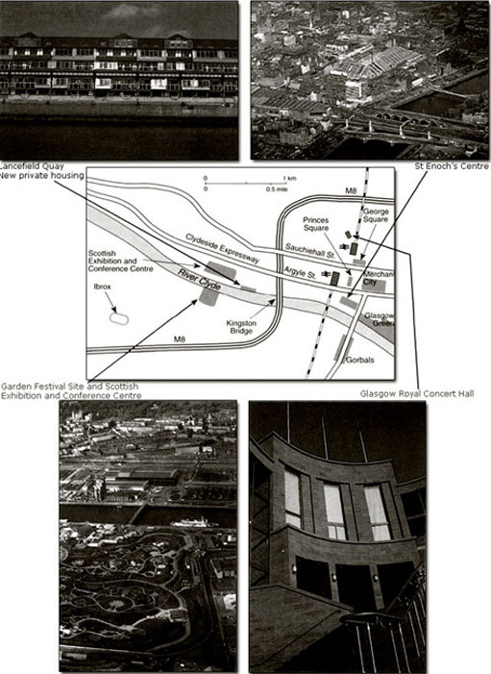
(Top left and right, and bottom left: Glasgow Development Agency; bottom right: © Alan Crumlish (top left and right, and bottom left) Glasgow Development Agency; (bottom right) © Alan Crumlish
Figure 8 Glasgow city centre

Click here for a larger image.

2.3 Watching the programme

Activity 1: Watching the programme

There are two main themes to consider as you watch the programme:
- (a) Image and identity
  - Note down examples of images of Glasgow. What/who is represented? What/who is not represented? Are there different interpretations of the images? Has this image been challenged – how and by whom?
  - You could use a rough matrix to help in this. For example:
Click here to open a printable matrix for your notes.
- (b) Uniqueness and interdependence
  - What wider (global) relationships have contributed to Glasgow's (local) character/distinctiveness?

Activity 2: After the programme

1. Briefly, try to develop the two themes in Activity 1 in relation to concepts of geographical imaginations, power relations, local-global relations.
- (a) Starting with your notes about images:
  - What do these images contribute to Glasgow's identity?
  - How have the images been ‘constructed’?
  - Whose interests have been represented and whose suppressed?
  - How is this conflict of interests represented?
  - What do we mean by ‘multiple identities’?
  - How can a place mean more than just one thing?
  - What does all this tell us about power relations in Glasgow?
- (b) Using your examples of local-global relationships:
  - How has Glasgow's uniqueness been constructed and reconstructed? What interrelationships have been involved?
  - In what ways does Glasgow's identity result from ‘what Glasgow is not’?
- (c) Note briefly how we have used our concept of geographical imaginations to explore Glasgow's uniqueness.
2. Think about these issues in relation to another place or other places.
- What is being represented/promoted?
- Who gains and who loses?
3. The main points to grasp from this programme are:
- that ‘image and identity’ are central to our geographical imagination;
- that images and identities are socially constructed and are not neutral or objective: how we define a place reflects and affects our attitudes towards it and our experience of it;
- that images are selective;
- that places have multiple identities;
- that images and identities are open to and reflect varied interpretations;
- that these interpretations may frequently be contested;
- that uniqueness of place is constructed out of local-global interdependencies.

Click to watch Part 1 of the TV programme. (5 minutes)

Video content is not available in this format.
Part 1
View transcript - Part 1

Click to watch Part 2 of the TV programme. (10 minutes)

Video content is not available in this format.
Part 2
View transcript - Part 2

Click to watch Part 3 of the TV programme. (8 minutes)

Video content is not available in this format.
Part 3
View transcript - Part 3

Conclusion
This free course provided an introduction to studying Sociology. It took you through a series of exercises designed to develop your approach to study and learning at a distance and helped to improve your confidence as an independent learner.

References
Ahmed, K. (1995) ‘Glasgow reputations: powerful case for the prosecution’, Scotland on Sunday, 13 August.
Au, O. (1995) ‘Midsummer madness makes one Mean City’, The Sunday Times Scotland, 13 August.
Allardyce, J. (1995) ‘Smiling through’, The Scotsman, 8 August.
Bolitho, W. (1924) Cancer of Empire, London, Putnam.
Bryson, B. (1989) ‘Glasgow isn't Paris, but …’, New York Times Magazine, 9 July.
Economist, The (1995) ‘Glasgow's miles tougher’, 12 August.

Acknowledgements
Grateful acknowledgement is made to the following sources for permission to use the following photographs in this course:
Figure 2 Riveter based on the cover of the exhibition catalogue for ‘Clydebuilt: The River, its Ships and its People’, organised by the Clyde Maritime Trust Ltd.;
Figure 3 Glasgow Herald/Caledonian Newspapers Limited;
Figure 4 Mr Happy adaptation: Mr Men and Little Miss™ and © 1995 Mrs Roger Hargreaves; (all) Courtesy: City of Glasgow;
Figure 5 (left) City of Glasgow; (middle) Courtesy: The Citizen; (right) source unknown;
Figure 6 Courtesy of Corporate Location Magazine;
Figure 7 © Alan Wylie Photographer;
Figure 8 (top left and right, and bottom left) Glasgow Development Agency; (bottom right) © Alan Crumlish.
This extract is taken from D215 © 1996 The Open University.
Course image: amateur photography by michel in Flickr made available under Creative Commons Attribution 2.0 Licence.
Every effort has been made to trace all copyright holders. If further information can be supplied to amend any acknowledgements, the publishers will be pleased to do so at the first opportunity.
Don't miss out:
If reading this text has inspired you to learn more, you may be interested in joining the millions of people who discover our free learning resources and qualifications by visiting The Open University - www.open.edu/openlearn/free-courses

Part 1

Transcript
Woman:
Nothing to beat Glasgow.
Woman:
Certainly very friendly, happy. Aye. Nice place to live really.
Man:
Great place, not as hard as everybody thinks it is.
Man:
Great place to live and work.
Woman:
Lot of violence in it. Lot of drugs in this area.
Man:
Glasgow? Ah, think it's alright, Glasgow.
Woman:
Great! Great place!!
COMMENTARY:
The identity of a city is complex.
To try to find the real identity of a city like Glasgow, we need to sift through the many images and historical layers that represent that place. So what do people mean when they say 'I belong to Glasgow'?
PAT JESS:
But in fact I don't belong to Glasgow. I'm from Belfast, a city which like Glasgow has part of its identity bound up with a river and with ship building.
COMMENTARY:
But there are other aspects to its image which Glasgow doesn't share. So to explore these ideas of image and identity, I'm going to talk to people around Glasgow and learn from their experience.
Pat Jess and Gordon Borthwick:
Morning Gordon. (Morning Pat, our only passenger today). Yes indeed. (Come aboard.)
COMMENTARY:
Maybe the Clyde is the best place to start. Many of the ships that sailed the international trade routes were built on this stretch of water. Gordon Borthwick has a keen interest in Glasgow's maritime history. His father worked on Clydeside.
Pat Jess:
Gordon, can you tell me what is the significance of the Clyde to Glasgow?
Gordon Borthwick:
Well there's an old saying that's been much quoted and even misquoted that Glasgow made the Clyde and the Clyde made Glasgow, and it's very true because here we have a river that was only fourteen inches deep and very sluggish and this was the river into which we were eventually to launch some of the largest liners and ships ever built. And over a period of about two or three hundred years, men dragging chains, barges; dredgers, they eventually deepened the river. So in a sense the city made the river and in return of course the river eventually made the city's fortunes.
The image of Glasgow is a strange thing, I mean only two or three centuries ago when Glasgow was a university city; small, quiet, described by Daniel Defoe who was well travelled, as "The beautifulest little city in all Europe", and suddenly all hell was let loose, the industrial revolution hit it and it became big, dirty brash Glasgow, the Chicago of Europe perhaps, and completely unfairly I think. I personally have been around in many cities throughout the world and I have never seen violence in Glasgow as I've seen it in other cities abroad, I've never seen a gang fight, I've never seen any razor attacks, but you give a dog a bad name and it sticks.
COMMENTARY:
Gerry Mooney grew up in Pollock, a working class estate on the south side of Glasgow.
Gerry Mooney:
Yes, I would say certainly over the last hundred years it was very much the shock city of Britain. Now nothing sort of illustrates that better than a book that was produced in the inter-war period called 'No Mean City'. Which tried to highlight the Glasgow wars, the sort of violent city portrayed by gangs, conflict, struggle, agitation etc. Another image is one coming out of the period of what's now known as the Red Clydeside, which is a period characterised by conflict, class struggle, the potential revolutionary situation that developed in 1919.
Now in the seventies there was a number of television programmes, dramas and documentaries, that were shown nationally which depicted Glasgow yet again as a city full of seething hoodlums and gangsters. If you take the films of the likes of Peter McDougall, for example 'Just Another Saturday', then that was film that actually portrayed Glasgow and Glaswegians in a very negative light.
MAN:
I'm no joking son. I'm gonna damage you.
MAN:
These people are animals.
MAN:
Oh is that right? Well you'd better save up your Embassy coupons for a Daktari gun, 'cos that's the only way you're gonna get near 'em!
Gerry Mooney:
Now I wouldn't say that was a wrong image, it was certainly only a partial image of what Glasgow represented at that time. But certainly that was the image that was, you know, exported outwith the city, and it was the image that many people would associate with the city at that time.
Back to - Part 1

Part 2

Transcript
COMMENTARY:
There's a different image of Glasgow today. The old image was constructed and represented through books and the media. Now there are shopping centres and wine bars in the city centre, and the Greater Glasgow Tourist Board actively promotes these and other images.
Linda Whiteford:
I have to say that I was surprised when I came here how friendly the place was, how welcoming it was. And it wasn't the dirty grimy place, it's er it has changed remarkably over the past ten to fifteen years anyway. Nowadays I would think of the beautiful architecture. It's a really wonderful city for Victorian architecture, and er over the past sort of twenty years the buildings have been cleaned up and you can see them as they were, as they were built and the Victorians really went to town in Glasgow.
My image of Glasgow has to incorporate the fact that in Gaelic, Glasgow means 'a dear green place', and we've got over seventy public parks and gardens, um that really are outstanding, and you would never think of that initially, you know, if you thought of Glasgow, ok, you've got the buildings, you've got the shops, it's a big city, it's sprawling, it's got a river, but you'd never think of it as being a green place.
COMMENTARY:
The change of image was quite deliberate. There were campaigns and events, some of which quite literally changed the face of the city. Jean Forbes lives in Milngavie, a middle-class suburb on the north side of Glasgow.
Jean Forbes:
It really all began in the middle 1980s. It was a very active Lord Provost, Mr Michael Kelly, in the 1980s, early 1980s, who decided as a, that he would take the definite step of trying to change this image.
Michael Kelly:
...so the Glasgow's Miles Better campaign is all about convincing people that Glasgow's improved, and we've really got to take it to London beacuse these are...
Jean Forbes:
And this was when our famous Mr Happy first appeared, the little, the little round sun-like figure with a big smile and it said 'Glasgow's Miles Better'.
Linda Whiteford:
I think the Miles Better campaign really got to the heart, it did the job it was supposed to do, in that it really got to the heart of the people. The people of Glasgow loved the character Mr Happy, they loved the fact that the people around the world were picking up on that logo, 'Glasgow's Miles Better', and they did begin to smile a bit better.
Gerry Mooney:
I don't think that you would have to say to Glaswegians that Glasgow was miles better, I mean they would all have known that anyway and certainly would have argued that. But really what they were trying to do was say to people outwith Glasgow that Glasgow was miles better than perhaps they had thought of, and perhaps was miles better than what the films of Peter McDougall had portrayed it as.
Nicholas Witche/1:
The Prince of Wales tried his hand at a Glasgow accent today and he and the Princess went for a ride in an open topped tram. They were in Glasgow for the city's biggest public event in fifty years, the opening of its Garden Festival.
Jean Forbes:
It was a great day out for the family. And er any time I was there it was always full of Glasgow people themselves sort of wandering about and enjoying themselves and it was a nice protected kind of place because it was, you know, it was free of traffic and there were many, many things to see and to do.
Gerry Mooney:
No, I think a large number of Glaswegians did attend the Garden Festival. Certainly I would say the bulk were probably tourists and people from outwith Glasgow, but it was somethin·g that Glaswegians actually liked and enjoyed. And it was something that they wanted to be kept within the city, you know, the sort of parkland area. But unfortunately as we'll see, it hasn't happened that way.
Unfortunately for most of the Glaswegians now, it's been left rather derelict, but there was a bit of a debate after the garden festival regarding the usefulness of the site, and certainly a number of people suggested that it should be kept as some sort of park or reminder of the garden festival itself. Which was a very popular event. As we see now, it's rather run down looking and doesn't appear to be serving much useful purpose.
Well what we have here is some of the housing that was put up on the Garden Festival site itself. And basically this is all that remains of the site. This was the main entrance to the Garden Festival, and along the riverbank here, you see some of the shrubbery and other grassland area that was created. And if we look across the other side of the river, you see again some very upmarket housing that was you know, created in the last few years, out of old dock warehouses.
COMMENTARY:
Symbolic of the old Glasgow is the area known as the Gorbals, remembered for the slums which were pulled down in the 1950s.
Gerry Mooney:
These are the multi-storey flats that are part of the Gorbals area of the city, most of them dating from the 1960s and 1970s. The Gorbals area was the first area in the city to be picked up for what was called 'comprehensive redevelopment', and this is the result of it.
Now the population of the area was reduced drastically in trying to lower the mass of housing densities that characterised the tenements, and many of the people were moved out to the outer housing estates of Castlemilk or Pollock or even to areas beyond the city.
MAN:
There's Glasgow. Forty thousand acres. And this small patch represents two thousand acres. And on that is crammed a hundred and fifty thousand of the city's dwellings. That is half the dwellings on a twentieth of the space.
MAN 2:
But that's ridiculous!
MAN:
Of course it is by any standards.
MAN 2:
What are you going to do about it?
MAN:
Knock them down!
COMMENTARY:
One of the outer estates of Glasgow is Drumchapel. Edward Stephenson lives in his father's flat on the estate, with his wife and their five children.
Edward Stephenson:
Our own house was gutted wi' a fire and we moved in with my dad. I'm not sure if it was an electrical fault, but obviously it went fire and we had to move in here. I don't know if it's been refurbished, but I mean they still got boards on the windows.
COMMENTARY:
Identity is not always linked to a country or a city. People often identify with an area or a street. The Stephensons identify strongly with the local area.
Edward Stephenson:
Definitely Drumchapel because I've more or less been brought up in Drumchapel.
Pat Jess:
Are you from Drumchapel or ... ?
Helen Stephenson:
Yes.
Pat Jess:
All your life?
Helen Stephenson:
Yes.
Pat Jess:
So you're a Drumchapel family?
Helen Stephenson:
Yes, thirty six year I'm up here.
Pat Jess:
Would you say more that you're from Drumchapel or more that you're from Glasgow?
Edward Stephenson:
Drum, Drumchapel.
Pat Jess:
Definitely?
Edward Stephenson:
Definitely.
Pat Jess:
What would you say is the image that Glasgow has now?
Edward Stephenson:
Oh, it has a better image. I mean the, the people are more friendly and everything. And we had that Garden Festival as well. We got tourists fe' all over the world that came and see that.
Pat Jess:
Did you experience the Garden Festival in any way? Did you go to it?
Edward Stephenson:
No. Well if me and my wife and children go, you're talking about what, ten pound there and back.
Pat Jess:
In bus fares?
Edward Stephenson:
Aye, in bus fares.
Martin Lewis:
The Queen has been to Glasgow to celebrate the city's new role as European City of Culture. Jacques Chirac, the Mayor of Paris, last year's Culture Capital, handed over the title. He spoke of the formidable renaissance of Scotland's largest city.
Jean Forbes:
It was a tremendous effort put into publicising the city as a place to come and visit during this particular year of 1990, and certain things the most particular being the construction of the new concert hall, they were tuned to arrive and be on the ground in 1990. Music programmes, drama, arts programmes, were all organised so that they would be there in that year, and it began on the first of January, and it just went like a fair until the 31st of December. It was a very busy year.
Gerry Mooney:
It certainly on an international level made Glasgow appear more attractive for inward investment, and I think that was the prime aim of the whole campaign anyway. But within the city itself it gave rise to a whole series of conflicts about where Glasgow was going, what was the new Glasgow about. Who was benefiting from this new Glasgow? But it was also a debate an argument about what was the old Glasgow like, because one of the attempts of the image makers in 1990 was in a sense sanitise the history of Glasgow, you know, undermine the old Red Clydeside image and create this new wonderful image in the 1990s and a number of people were very opposed to that.
Back to - Part 2

Part 3

Transcript
COMMENTARY:
So in selling the city, the image makers have bypassed the poorer aspects of Glasgow, highlighting instead those characteristics which attract inward investment, and with it, jobs.
Jean Forbes:
Well inevitably they haven't been as much in industry as you would like them to have been, because you can imagine the vast numbers who would be made unemployed by the closure of a shipyard or a major steelworks or even port facilities, and it's very difficult to replace those jobs for those particular people.
Gerry Mooney:
I would say that many of the jobs have been created in the retail and tourist sectors, a vast number of which I would say are low paid, primarily performed by women workers in the city centre. Now obviously there are a number of jobs that have been created by inward investment in the financial and banking sectors, but I would tend to say that that has been, you know, minimal. So you do have within the city centre, a large increase in the fast food outlets, the bistros, the wine bars, the conference centre type activities, all of which tends to be low paid temporary casualised type of employment.
Pat Jess:
So where is the real Glasgow? Is it here, in the city centre, or here by the Clyde and the old shipyards? Well it's a bit of both and many other aspects as well.
Gerry Mooney:
I think obviously there are people from Glasgow who would call themselves Glaswegians, but I don't think you can talk about one Glaswegian image at all. And there are within the city of Glasgow, very different ethnic backgrounds, gender divisions, class divisions, divisions of localities within the city. And people do have different images and representations of what Glasgow means.
COMMENTARY:
Walking around Glasgow, I've been wondering what images come to mind when Glaswegians think of their city.
Jean Forbes:
The city centre, the shopping centre which I think is now very attractive, it's a very pleasant place to shop. As a concert goer I'm very devoted to .the Concert Hall. Erm, I like the clean tenements, I think the tenements are splendid buildings, these great stone ranges of buildings, beautifully cleaned, either golden stone or pink sandstone.
COMMENTARY:
Edward Stephenson identifies with a rather different image.
Edward Stephenson:
lbrox. That's where Rangers play; It's the best in Britain. Parkhead is where Celtic play. If we can afford it, I try and get to as many as possible, but with five children it's not always possible. Now my youngest, his name's Graeme Souness; that's what I called him when he was born. At that time Graeme Souness was the manager of Rangers.
Gerry Mooney:
For argument's sake I would say that ordinary Glaswegians, if you can use that term, in the peripheral housing estates and elsewhere, probably identify more with each other and their experiences within the city in terms of a struggle to make ends meet, a struggle for survival, a struggle over bad housing, a struggle for employment, and maybe histories of previous employment passed down over the generations. I would say that probably middle class Glaswegians identify much more with sort of · physical things, with buildings. For example I think they would identify much more with Merchant City than many ordinary Glaswegians who had never heard of Merchant City until the image makers had created it.
Jean Forbes:
And then we're just passing on either side here ones which are nineteenth century buildings ... . . . I like what has been done to the Merchant City. This was an old really quite derelict part of the city centre, where it was the eighteenth century residential area for the merchants, the tobacco merchants. This is a very interesting building, this is the eighteenth century merchant's house which has now been ... The streets there are smaller scale than to the west which is a Georgian gridiron. The Merchant City gridiron is smaller and more intimate, and it really is a very attractive place to walk about and a very characterful place, very Glaswegian.
Edward Stephenson:
I was over in Belfast and I couldn't wait to get back to Glasgow, and I mean we've also been in England to visit my brother and my wife's sister, and we're always dying to get back to Glasgow.
COMMENTARY:
Glaswegians obviously have a great fondness for their city. But how do they see themselves?
Vox Pops:
Great people. Very friendly.
That's right, the people are friendly.
Well I'm a Glaswegian myself, so they're the tops.
Very friendly.
Very hospitable.
Jean Forbes:
If you're a stranger to the city and you open a map in the city centre and look vague, some Glaswegian will steam up beside you and offer to help you, and probably walk all the way with you, and I don't think that has changed at all.
COMMENTARY:
Like me, Jean Forbes is in fact from Northern Ireland. But she has adopted Glasgow as her home with considerable enthusiasm.
Jean Forbes:
I will hear no ill spoken of Glasgow, it is, I have been known to jump up in fury in distant cities when people speak poorly of this city. I think it's a splendid city, I've lived in it for many many years and enjoyed every minute of it.
Gerry Mooney:
Yes it is unique, but I think you can only grasp that uniqueness by looking at places or locales beyond Glasgow. So for example Glasgow isn't Birmingham, Glasgow isn't London. In a sense what I'm trying to get at is that Glasgow's uniqueness is not simply or only its geographical location, but it's the particular set of historical relationships that have been built up over time, relationships emerging out of the class base of the city, emerging out of the industrial and economic base of the city, and relationships emerging out of the stratified nature of the city today. So it is unique, but that uniqueness can only be understood by in a sense illustrating or discussing what Glasgow isn't as much as discussing what Glasgow is.
Pat Jess:
Well, I'm beginning to get a sense of what it means when people say 'I belong to Glasgow'. Though it's based on a very fleeting visit.
COMMENTARY:
The images that will remain in my mind include the Clyde, Merchant City, Drumchapel and the Garden Festival, and a sense that Glasgow is made up of much more than this.
Gerry Mooney:
I think again you have to talk about multiple identities and the fact that images and identities and representations are contested.
Gerry Mooney:
There's no agreement about the way Glasgow's been sold today or depicted today in the glossy magazines and in the media, just as there was no agreement about the way Glasgow was portrayed in the films of Peter McDougall in the 1970s. So there's a conflict there you know, about where Glasgow's going and what Glasgow's about.
Vox Pops:
We're born in Glasgow and we'll die in Glasgow.
Oh aye, very good in Glasgow, aye!
Back to - Part 3

