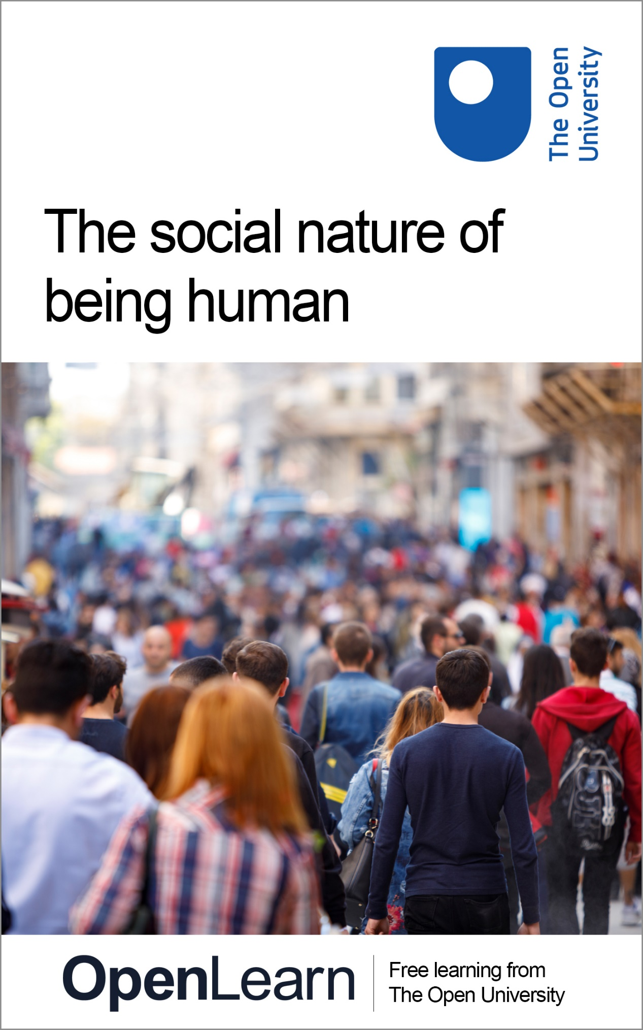

DD801_1

The social nature of being human

About this free course
This version of the content may include video, images and interactive content that may not be optimised for your device.
You can experience this free course as it was originally designed on OpenLearn, the home of free learning from The Open University – The social nature of being human
There you’ll also be able to track your progress via your activity record, which you can use to demonstrate your learning.
Copyright © 2018 The Open University
Intellectual property
Unless otherwise stated, this resource is released under the terms of the Creative Commons Licence v4.0 http://creativecommons.org/licenses/by-nc-sa/4.0/deed.en_GB. Within that The Open University interprets this licence in the following way: www.open.edu/openlearn/about-openlearn/frequently-asked-questions-on-openlearn. Copyright and rights falling outside the terms of the Creative Commons Licence are retained or controlled by The Open University. Please read the full text before using any of the content.
We believe the primary barrier to accessing high-quality educational experiences is cost, which is why we aim to publish as much free content as possible under an open licence. If it proves difficult to release content under our preferred Creative Commons licence (e.g. because we can’t afford or gain the clearances or find suitable alternatives), we will still release the materials for free under a personal end-user licence.
This is because the learning experience will always be the same high quality offering and that should always be seen as positive – even if at times the licensing is different to Creative Commons.
When using the content you must attribute us (The Open University) (the OU) and any identified author in accordance with the terms of the Creative Commons Licence.
The Acknowledgements section is used to list, amongst other things, third party (Proprietary), licensed content which is not subject to Creative Commons licensing. Proprietary content must be used (retained) intact and in context to the content at all times.
The Acknowledgements section is also used to bring to your attention any other Special Restrictions which may apply to the content. For example there may be times when the Creative Commons Non-Commercial Sharealike licence does not apply to any of the content even if owned by us (The Open University). In these instances, unless stated otherwise, the content may be used for personal and non-commercial use.
We have also identified as Proprietary other material included in the content which is not subject to Creative Commons Licence. These are OU logos, trading names and may extend to certain photographic and video images and sound recordings and any other material as may be brought to your attention.
Unauthorised use of any of the content may constitute a breach of the terms and conditions and/or intellectual property laws.
We reserve the right to alter, amend or bring to an end any terms and conditions provided here without notice.
All rights falling outside the terms of the Creative Commons licence are retained or controlled by The Open University.
Head of Intellectual Property, The Open University
978-1-4730-2717-6 (.kdl) 978-1-4730-2718-3 (.epub)

Contents
- Introduction
- Learning outcomes
- 1 Crowds and identity
  - 1.1 Crowd research: then and now
  - 1.2 Karma of the crowd: the Magh Mela pilgrimage
  - 1.3 Test yourself on what you’ve learned so far
  - 1.4 Magh Mela: some concluding thoughts
- 2 Groups and politics
  - 2.1 The Israeli–Palestinian conflict in Britain
  - 2.2 Engaged publics: the IPO at the BBC Proms
  - 2.3 Test yourself on what you’ve learned so far
  - 2.4 The IPO disruption: some concluding thoughts
- 3 Meaning as social
  - 3.1 Your experiences of charitable giving
  - 3.2 Partiality and public perceptions of deservingness
  - 3.3 Understanding campaigns about homelessness
  - 3.4 Charitable giving: some concluding thoughts
- Conclusion
- Take the next step
- References
- Acknowledgements
- Solutions

Introduction
‘Three is a crowd’, the saying goes. But what, exactly, is a crowd? And what, exactly, is the ‘three’ (i.e. the three individuals) that supposedly already constitutes ‘a crowd’? These are intricate questions for psychologists and other social scientists who have always been fascinated by these questions and come up with widely diverging answers to them. At one end, we have those arguing that crowds are best understood as undifferentiated and amorphous wholes. At another end, we have arguments about individuals themselves being akin to crowds: multi-faceted, fractious and emerging out of social practices.
What this free course, The social nature of being human, will argue is that the social aspect of human existence is inevitable and ever-present. Even when we are seemingly on our own, we are in the presence of imagined others; and even our most private thoughts or desires are formulated against the background of meanings that are necessarily socially constructed.
This course will give you some taste of the research into the social aspect of the human condition, by showing you three examples. First you will be introduced to research on crowds and look at a specific example: pilgrims gathering at the Magh Mela in India. Next, you will look at somewhat smaller social groups as you will be guided through an understanding of a politically inspired interruption of a BBC Proms concert. Lastly, you will turn to the topic of homelessness and charitable giving, and will see how our behaviour and attitudes are socially mediated even in the apparent absence of the group and the crowd.
This OpenLearn course is an adapted extract from the Open University course DD801 Principles of social and psychological inquiry. The topics and the general approach of this short course will give you a taster of this Open University course.

Learning outcomes
By the end of this course, you should be able to:
- understand popular representations of crowds
- understand the relationship between identity and crowds
- understand examples of the role of power and cultural values as applied to the Israel–Palestine conflict
- recognise the ways in which representations are used to attempt to influence public practices of charitable giving.

1 Crowds and identity

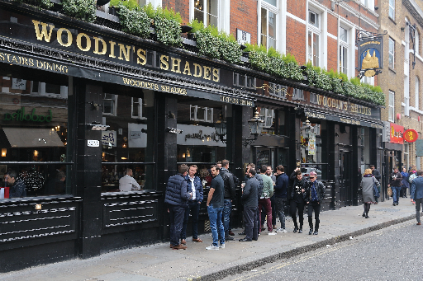
Figure 1 Looking suspicious or otherwise?
View description - Figure 1 Looking suspicious or otherwise?

Imagine that it is late in the evening in the city or town centre near where you live, you are with three friends and have decided on a final bar for a last drink before you head home. As you walk towards the bar, you spot a large group of men chanting the name of their football team as they enter the same bar. Would it affect your choice? Would you change venue?
Our lives require us to make quick decisions in uncertain scenarios, and we rapidly use our lay understandings of social behaviour to make those decisions. Perhaps the men are chanting the name of your team, you identify with them and enter the bar. Perhaps you sense that things could get out of hand and decide to go somewhere else. Perhaps you don’t drink alcohol and have been trying to think of an excuse to head home – you are not much of a fan of crowded bars anyway.
In this course you will first briefly look into the concepts, constructs and questions developed by crowd psychologists and how these have driven the terms of reference and subsequent lines of inquiry of contemporary crowd studies. One of the sustained lines of inquiry driving crowd studies is ‘Does the event of being in a crowd help to create a sense of identity or lead to a loss of identity?’ Though there are disagreements among crowd scientists, very few would argue against the idea that crowds are transformative.
Reading the example in the following section, you will appreciate how common-sense understandings of the crowd, whether ideological or practical, contain lay thinking that is often inaccurate or overly simplistic. For example, returning to the opening scenario, did you regard a large crowd entering a bar as problematic? When it comes to fighting in city centres late at night, Levine and Crowther (2008) and Levine, Taylor and Best (2011) have studied CCTV footage and shown that the likelihood of violence may increase with the size of the group. However, so does the likelihood of conciliatory behaviour – where a third party may step in to stop a potential incident. Perhaps the large group of football fans should have been wary of you and your friends!

1.1 Crowd research: then and now
Let’s start by the Ganges in Prayag, in Northern India, at the Magh Mela – precisely because it is likely that this is a place that you are not familiar with. The Magh Mela is one of the largest annual gatherings in the world. Why would researchers become interested in such a gathering? This is because the Magh Mela case study can be set within the context of contemporary crowd psychology, which has been working to understand the relationship between crowds and collective identity.
Modern crowd research is considered to have started with French polymath and political conservative Gustave Le Bon’s The Crowd: Study of the Popular Mind (1895). Le Bon problematised what we today would see as part of the popular democratic process; he views the crowd not so much as mindless but as of one collective mind acting towards theoretical inclinations. In his view, the psychological crowd is different from a physical crowd. He argues that the organised psychological crowd comes about through ‘a combination of elements, just as in chemistry’ (p.14). These elements are a collective mind, contagion and suggestibility. In short, Le Bon gave birth to what is today called ‘the classical view of the crowd’, stipulating that being in a crowd leads to a loss of identity with potentially irrational and irresponsible behaviour.
In contrast to this, crowd psychologists in the twenty-first century have become increasingly preoccupied with the notion of the crowd as a source of collective empowerment. Theirs is a view of the crowd as the development of a focused political rationality; a crowd whose members discover their identity through the dynamics experienced in the crowd. In short, the contemporary view of the crowd holds that crowd-led events are transformative and a source of identity, empowerment and collective self-realisation.

1.2 Karma of the crowd: the Magh Mela pilgrimage

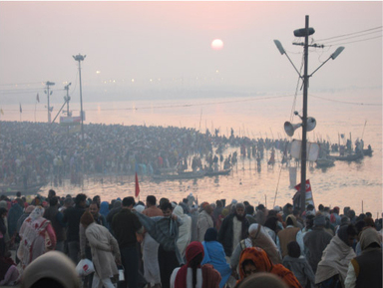
Figure 2 The Magh Mela
View description - Figure 2 The Magh Mela

In the Magh Mela case study, social psychologist Nick Hopkins and his team directly tackle the debate introduced in the previous section by reconsidering the concept of ‘effervescence’. Although ‘effervescence’ suggests a bubbly personality or something that is fizzing over, if you are in a position where you are concerned with control it could suggest unboundaried and unpredictable behaviour. So, although fizzy drinks should be effervescent, large groups that are effervescent could be a problem. This was precisely the perspective of Le Bon (1895) who regarded the effervescent nature of crowds as problematic and dangerous. However, Hopkins and colleagues show how a transformative effervescence can be the key ingredient to collective self-realisation, revivifying social bonds through processes of intimacy, intensity and immediacy that transcend the everyday (Hopkins et al., 2015).
Hopkins and colleagues theorise that these social psychological processes are not especially exceptional or exotic; rather, they can be understood as continuous with our everyday ways of living in the twenty-first century. They demonstrate that events such as the Magh Mela both enhance well-being and revivify social identities. Attending the event enhances a sense of ‘shared identity’ – pilgrims, known as kalpwasis, who attend the Magh Mela for the whole month see and embrace each other as members of the same group. This recognition and sharing of identity means fellow kalpwasis relate to each other with a higher level of intimacy and helpfulness. This change in boundaries leads to a construct that Hopkins and colleagues term ‘collective self-realisation’ (CSR). This self-realisation and shared identity serve to enhance well-being.
In a longitudinal component of the case study, the Magh Mela research team looked at people’s performance of their identity both before and after attending the Magh Mela, comparing this to people who were Hindus but did not attend the event (non-attendees). What they found was that kalpwasis who had been to the Magh Mela and had mixed with other kalpwasis saw themselves as a collective group, i.e. they had a shared identity. When the kalpwasis returned home, they practised more Hindu rituals and had a stronger self-identification as a Hindu. In this sense, the fact that they were able to enact the rituals and way of living associated with their identity (CSR) enabled them to maintain Hindu rituals some time after the event was finished.

1.3 Test yourself on what you’ve learned so far
In this activity, you have the opportunity to test yourself and your understanding of the material you have recently learned.

Activity 1 Quiz
Allow approximately 15 minutes

1. Which statement is untrue?

a) The classical view of the crowd is commonly considered to be first articulated by Gustave Le Bon.
b) The classical view of the crowd has had a considerable impact both on crowd research and popular perception of the crowd.
c) The classical view of the crowd originated the social scientific concept of individuation.
d) Contemporary crowd research is often conceived in dialogue with Le Bon’s original ideas and their thrust.
View answer - Part

2. Complete the sentence: The concept of ‘effervescence‘…

a) … was used by Le Bon and is ignored by contemporary crowd scientists.
b) … relates mainly to fizzy drink originating from the Italian region of Calabria.
c) … applies to a personal characteristic not seen in groups.
d) … was originally proposed by Le Bon and subsequently re-examined by contemporary crowd researchers.
View answer - Part

3. Which of the following statements is true?

a) The likelihood of violence increases with the size of the group.
b) The likelihood of conciliatory behaviour may increase with the size of the group.
c) When in crowds, individuals will lose their sense of self.
d) Crowd research has progressed little since the end of the nineteenth century.
View answer - Part

1.4 Magh Mela: some concluding thoughts
The Magh Mela case study stands in stark contrast to the conception of the anti-social crowd that dominated the early decades of crowd psychology. But the crowd that undergoes a cognitive and relational transformation, and whose members may be intimate and cooperative with each other towards their progressive goals, may also be in political opposition to other groups. It is worth considering both what is present within the Magh Mela crowd that promotes well-being, and also what is absent. There is an absence of tension within the Magh Mela crowd because other groups with different identities are not simultaneously present. This may be a key factor in the way that crowds enhance well-being.
Let us now see what the main author of the Magh Mela study, Nick Hopkins, finds important about the pilgrimage. He is in conversation with Open University academic Kesi Mahendran.

Video content is not available in this format.
View transcript - Uncaptioned interactive content

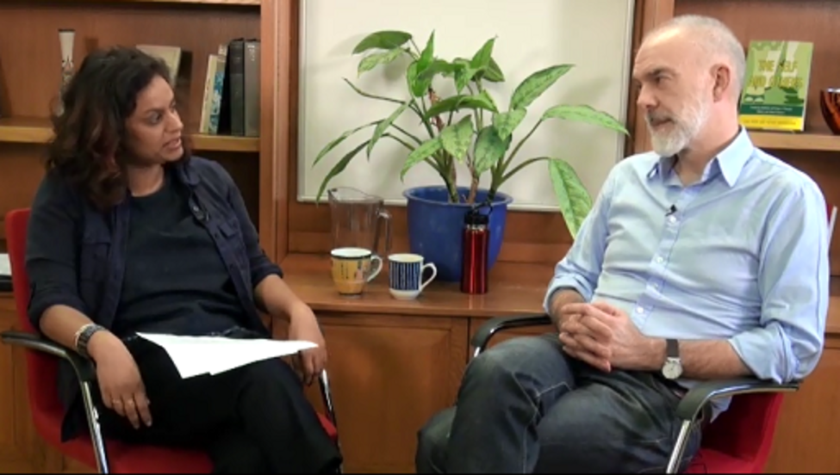

2 Groups and politics

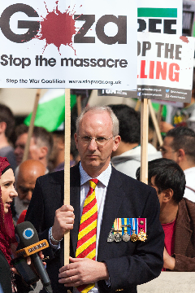
Figure 3 (Not) on his own
View description - Figure 3 (Not) on his own

In this course, you will examine different aspects of our ‘human-ness’ where we are, so to say, not alone and are joined by actual or imagined others. One such aspect of the social is politics. As was previously mentioned, behaviour of groups often go hand in hand with political concerns. In fact, the research on crowd behaviour had from its inception been suffused with political issues as Le Bon himself criticised riotous crowds from a particularly conservative and royalist political perspective. Likewise, celebrating the politically transformative potential of the crowd, contemporary researchers tend to focus on distinctly progressive, left-of-centre gatherings rather than, say, neo-Nazis.
While significantly absent in the Magh Mela case (yet, as mentioned, having a large impact on it, precisely due to its absence), you will now turn to an event where politics is conspicuously present: a manifestation of the Israel/Palestine conflict in British public life.
The broader issue at stake here is the very direction between politics and crowds, news reportage and publics. As you will see, while one may assume publics (note the use of the plural here to indicate the multi-dimensional nature of the phenomenon!) to act rather passively here, swayed by politics or merely consuming news item, you will consider another aspect of these relationships: that of engaged publics, forming and in no insignificant respects constructing both politics and supposedly neutral news of the world.

2.1 The Israeli–Palestinian conflict in Britain
While in a considerable geographical distance from the United Kingdom, the events in what used to be the Palestine of the British Mandate and what is now the Palestinian Authority and the State of Israel constantly make their presence felt in contemporary Britain. Events there lead to frequent and intense debates here: they have a remarkable impact on British public and political life, as evidenced by the row over Israel and antisemitism embroiling the Labour Party. (Just a quick aside here: this row, at the time of writing this course in 2018, pretty much appears to consume Britain’s Labour Party. But is that still the case at the time of your reading this material? You may find it worthwhile to reflect on this.)
For something that is of no apparent immediate concern for Britain, the Israeli–Palestinian conflict tends to generate unique intensity in debates. What we often have is a frantic ‘tennis match’ between charges of either anti-Israeli bias or even antisemitism, and accusations of the suffocation of free debate under the false pretences of fighting ‘antisemitism. The oft-quoted, if somewhat simplistic, adage of ‘someone’s freedom fighter is another one’s terrorist’ aptly captures when confrontation pertains not merely to facts or immediate events, but the very background or foundational narratives which confer meaning to those events.
In what follows, you will engage with a particular manifestation of the Israeli–Palestinian conflict in Britain: it will concern an event where the conflict literally disrupts British public life.

2.2 Engaged publics: the IPO at the BBC Proms
As mentioned, we tend to think of history or current affairs as happening ‘out there’, and then channelled by various media to be eventually received or ‘consumed’ by the public. Yet, things may not be this straightforward. Shortly, you will watch a short video clip reporting a very powerful incident at the BBC Proms in 2011 when publics engaged with politics in a very active and forceful way by disrupting the normal flow of a prestigious event.
As you may or may not know, the BBC Proms, founded in 1895, is an annual festival of (mainly classical) music. From mid-July up until early September, every single evening orchestras and individual performers from around the world appear at London’s Royal Albert Hall to perform in front of a large and often quite diverse audience. It is perhaps one of the most widely known (and arguably the biggest) classical and contemporary music festivals in the world today. The Israeli Philharmonic Orchestra (IPO) was founded as the Palestine Orchestra in 1936 and is Israel’s oldest and most prestigious orchestra. From 1979 onwards, the IPO were regularly invited to play at the Proms.
The short video clip, entitled Pro-Palestinian demonstrators inside the hall were greeted by boos when they tried to protest and embedded at a BBC website from 2011, shows the IPO’s Proms concert from 1 September 2011 being interrupted by protesters. At the time of writing this course (2018), the IPO have not returned to the UK. You should now watch the first clip on the website, the clip which ‘prefaces’ the reporting of the event.

Activity 2 The IPO at the Proms
Allow approximately 40 minutes for this activity

Part 1

As it was reported, the concert was repeatedly interrupted by Palestinian protesters, which led BBC Radio 3 to suspend its coverage. Bearing in mind social scientific concerns, think about the questions you would ask and would like to answer, especially from the perspective of publics and representations. For instance, you might want to think about the way activists manage to influence the representation of the event. Alternatively, you might want to focus on how the TV footage represents the activists – or the orchestra. Make some notes below.
When posing your questions, think also about which of your questions could be answered by analysing the video itself, and which would necessitate broadening the inquiry’s horizon, looking for and interrogating different pieces of data?

Provide your answer...
View discussion - Part 1

So, narrowing our analytical concern to the problem of the news item as a representation, try to think of two or three issues which may be of interest. Once you have made some notes about this, read the discussion.

Provide your answer...
View discussion - Part

Part 2

It is time now to do some independent work. The video, of course, is only an item with which the report starts. So read now through the whole material at the webpage and watch the remaining two videos. When doing so, think about whether the representation of the event you have just looked at changes throughout the report. Whose voices are represented? And what political-moral perspectives do those voices stand for? Below, make some notes.

Provide your answer...

2.3 Test yourself on what you’ve learned so far
Before you move on, test yourself on what you’ve learned so far.

Activity 3 Quiz
Allow approximately 15 minutes

1. What is the relationship between politics and crowds or groups?

a) There is no relationship to speak of.
b) Politics are often a concern for crowds or groups – any social scientific analysis should take this into account.
c) Politics always determines how crowds perceive themselves.
d) All social scientists are apolitical when it comes to studying crowds.
View answer - Part

2. Which statement is true? ‘The Israeli-Palestinian conflict…’

a) … plays no role in British public life as it is happening in a long geographical distance from it.
b) … exists only in the minds of anti-Semites.
c) … is predicated not simply on differences of opinions or factual knowledge but on differences in identities.
d) … basically holds British public life in its grips.
View answer - Part

3. Which statement is true? ‘The interruption of the BBC Proms concert by Palestinian protesters is…’

a) … a good example for how these passions have a capacity to destroy the British public sphere
b) … a good example of how biased the BBC is.
c) … a good example of how boring classical music is.
d) … a good example of active publics can be.
View answer - Part

2.4 The IPO disruption: some concluding thoughts
The first section of this short course focused on how individuals in a crowd can gain (as well as lose) an identity by virtue of being in a crowd. What did this section add to that?
We often think of an ‘audience’ as something passive. When you hear that the Israeli Philharmonics played at the Proms, you probably imagine some peaceful (or turbulent, for that matter) romantic music being played in front of a calmly receptive audience. Yet, as the actual example illustrated, such an image of audience may have to be revised. Audiences are engaged in a very active sense and have the potential to transform or even disrupt performances.
Thus, much like crowds are entities that actively create identities and relations, groups and even supposedly abstract categories as publics are best understood as active forces that create as much as receive contents.

3 Meaning as social

Figure 4 A social act
View description - Figure 4 A social act

In this section, you will be exploring the topic of charitable giving, in particular examining the factors that can influence it. In so doing, a further aspect of the ‘social nature of being human’ will be focused on.
While in the previous two sections the social aspect of human existence was quite conspicuous and we had groups containing a sizeable quantity of people, this section will start with the image of a seemingly very intimate encounter: giving money to someone who is homeless. What is more, it may be thought that our motivation to give (or not to) is simply a function of our individual psyche: our individual attitudes, as standard social psychology textbooks would phrase it. So where is the ‘social’ in all this? As you will see in this section, these seemingly individual actions, experiences and attitudes actually occur in a context of perceptions and meanings that are always and inevitably socially shared and constructed. That is to say, although the act of giving involves a supposedly private thought in an individual’s head and a supposedly intimate act between two individuals, it is also a very social act and a function of a web of the political, cultural or moral meanings that are always socially constructed.

3.1 Your experiences of charitable giving
Start by reflecting on your own experiences of giving to charity in the following activity.

Activity 4 Your experiences of charitable giving
Allow approximately 15 minutes

Think about your own experiences of making monetary donations to charity by answering the following questions:
- When did you last give to charity?
- What kind of charity was it?
- Would you give to someone begging on the street?
- What about a charity collector with a tin?
- What makes you more (or less) likely to give to charity?
Here you’re not being encouraged to give to charity (indeed, some people have argued against charitable giving from an ethical standpoint). No one else will see the answers to these questions, so if you answer that you never give, or if you’ve got particularly controversial or sensitive personal reasons for giving that you’d rather remain confidential, they won’t be shared with others. These answers are just to get you thinking about what matters to you in your own practices of charitable giving. Thinking about your own experiences of charitable giving is a useful starting point for thinking about the way in which you, as a member of the public, receive messages about charity.

Provide your answer...
View discussion - Activity 4 Your experiences of charitable giving

3.2 Partiality and public perceptions of deservingness
Research about real-world phenomena doesn’t just come from academia, but draws on concepts that are observable in the real world. One particularly important concept in thinking about altruism and charitable giving is the idea of ‘impartiality’, with questions raised about whether altruism has to be ‘impartial’.
The concept of partiality might be related to our own ideas of who is most in need, or who we think is most ‘deserving’ of our support, or even how they will make use of our donation. Homelessness researchers tend to be asked the same questions in conversations with friends and family: ‘Should we give money to people on the streets, or to a charitable organisation?’; ‘Should we offer food or drink, rather than money?’; ‘Which homelessness charity should we give to?’ These questions all relate to being ‘partial’ in choosing our actions, and there aren’t any easy answers to these questions. Indeed, many of the answers rely on each person’s own moral viewpoint. So, what other people would do might differ from you: we might feel differently about what is a suitable response to the plight of homelessness, and with good reason. Our lay opinions and moral frameworks can influence our own patterns of giving.
However, our opinions can be influenced by a range of factors, from numerous sources of information and opinion.
In the reading in Activity 5, anthropologist Stephen Gaetz explores where public perceptions of homeless youth come from, as well as the ways in which attitudes to youth homelessness matter.

Activity 5 Thinking about youth homelessness
Allow approximately 30 minutes

You should now read the following article, then try to answer the questions below.
Gaetz, S. (2009) ‘Attitudes about homelessness - how we THINK about homeless youth matters!’, Homeless Hub.
- Where does Gaetz suggest public ideas about homeless youth come from?
- According to Gaetz, what role does the media play in shaping attitudes about youth homelessness?
- How can media and political portrayals of youth homelessness affect public perceptions of it?

a)
b)
c)
View discussion - Activity 5 Thinking about youth homelessness

3.3 Understanding campaigns about homelessness
So far in Section 3, you have focused on your individual experiences, their intersection with some public meanings and the impact these may have on the act of giving. What you will look at now is yet another aspect of the interface between the individual act and public meanings: the involvement of charities.
Some charities suggest that instead of giving money to people who ‘beg’ on the streets, members of the public should instead donate money to them – allowing them to support people experiencing homelessness. The intricate issue these charities need to address (indeed, navigate around) is that they both need certain attitudes and need to change the same attitudes. That is, they need people who are favourable to homeless individuals and to the idea of donating money to them – yet who would not actually give money to the actual such individual they may encounter on the street.

Activity 6 Understanding charity campaigns
Allow about 30 minutes

Below, you will find an example of a charity campaign. It comes in the form of an extract from a charity’s website:
What is the argument of this extract? How does it try to persuade its audience? Try to think of three points and list them below.

Most people begging are not individuals in temporary difficulties, but people who are dependent on a begging income. This is almost certainly to fund a serious drug habit.
There is no need to beg on the streets in 2017. It is an urban myth that if you have no address, you cannot claim benefits. This simply isn’t true. Meanwhile, there are many day centres where homeless people can get food, clothing and support.
Assessment centres in London offer support to people who are new to the streets in London – 75 per cent of people no longer spend a second night out sleeping rough.
That is not to say that there are not many people on the streets needing help and support. Thames Reach’s outreach teams are out every night, in search of the isolated rough sleepers who are missed by other services, helping them into accommodation and to find a way out of homelessness.
Many people asking for your money are caught up in a desperate cycle of begging from the public, ‘scoring’ drugs from a dealer and then taking these drugs. There are many services seeking to help people sleeping rough. Please work with them, not against them.
(Thames Reach, n.d.)

Provide your answer...
View discussion - Activity 6 Understanding charity campaigns

You can now see how public meanings engage with (and thereby attempt to form or alter) individual attitudes and acts. The meaning of the act of giving, in this context, becomes socially constructed. What might have originally appeared as an act of kindness now looks as something harmful; and other possibilities of acting magnanimously are opened.

3.4 Charitable giving: some concluding thoughts
In this last section, the social social sciences or social psychology featured less obviously than in the previous two. Yet, as this course has tried to show, while on the surface involving private thoughts and an intimate act, charitable giving is in a sense a very public act whose (personal and public) meaning derives from the web of meaning surrounding it. This meaning is deliberated, contested, constructed, argued for an against by many agents in the social sphere. (One example for this in the section was the quote from the charity campaign.)
These acts of deliberations and arguments, of course, bring many different implications with them: the meaning of the act will be altered radically depending on which perspective lends meaning to it. In a way, they will therefore constitute your private experience in many different ways. What is important, however, is that regardless of which direction these webs of meanings take, regardless of what values they seek to generate, they exemplify the notion that the social is always and inevitably present: not just in the obvious cases of crowds, groups and publics as explored in the first two sections – but also in supposedly private thoughts and gestures.

Conclusion
This free course, The social nature of being human, looked at various instances of intersections between our individual human existence and ‘the social’ sphere surrounding it. What it demonstrates is that the social nature of human existence works on many levels and operates in more obvious as well as more mysterious ways. In line with this, you looked at a large scale and peaceful gathering of a crowd in a North Indian pilgrimage and thought about how the experience of being in a crowd can engender and enhance the creation of social identity or even social responsibility.
You then considered the case of pro-Palestinian protesters disrupting a BBC Prom concert and examined how a group used the social scene to disrupt its smooth flow and to communicate thereby a confrontative political message – as well as how the BBC then incorporated (and in a way de-politicised) this disruption into its reportage of the event.
Lastly, as a demonstration of how the social can feature in seemingly private thoughts and intimate events, you looked at the case of charitable giving and homelessness. What you discovered here was how the private and the intimate, in apparent distance from crowds and politicised groups, too exist in the social sphere and in ever-present dialogue with social meanings.
The social is therefore present when we are in smaller or bigger groups, when there are actual and tangible others around us, exerting a very concrete influence. Yet it is also part of us, our individuality, our thoughts, our innermost desires, when we are sitting on our own unaccompanied. For this individuality of ours, these thoughts and desires gain their particular individual shape against the background of many other thoughts and desires that we encountered, directly or indirectly, throughout our lives.
This OpenLearn course is an adapted extract from the Open University course DD801 Principles of social and psychological inquiry. The topics and the general approach of this short course will give you a taster of this Open University course.

Take the next step

If you enjoyed this course, why not explore the subject further with our paid-for short course, Media, politics and society?
Find out more about Media, politics and society.

References
Hopkins, N., Stevenson, C., Shanker, S., Pandey, K., Khan, S. and Tewari, S. (2015) ‘Being together at the Magh Mela: the social psychology of crowds and collectivity’ in Terry, A. and Gale, T. (eds) Sacred Mobilties: Journeys of Belief and Belonging, Surrey, Routledge. pp. 19–39.
Le Bon, G. (1895) The Crowd: A Study of the Popular Mind (trans: A. Gouveia), Charleston (SC), CreateSpace Independent Publishing Platform (this edition 2014).
Levine, M. and Crowther, C. (2008) ‘The responsive bystander: how social group membership and group size can encourage as well as inhibit bystander intervention’, Journal of Personality and Social Psychology, vol. 95, no. 6, pp. 1429–1439.
Levine, M., Taylor, P.J. and Best, R. (2011) ‘Third parties, violence, and conflict resolution: the role of group size and collective action in the microregulation of violence’, Psychological Science, vol. 22, no. 3, pp. 406–12.
Thames Reach (n.d.) ‘Giving money to people begging - frequently asked questions’, Thames Reach [Online]. Available at https://thamesreach.org.uk/what-we-do/campaigns/killing-with-kindness/giving-money-people-begging-frequently-asked-questions/ (Accessed 29 October 2018).

Acknowledgements
This free course was written by David Kaposi, Daniel McCulloch and Kesi Mahendran. It was first published in December 2018.
Except for third party materials and otherwise stated (see terms and conditions), this content is made available under a Creative Commons Attribution-NonCommercial-ShareAlike 4.0 Licence.
The material acknowledged below is Proprietary and used under licence (not subject to Creative Commons Licence). Grateful acknowledgement is made to the following sources for permission to reproduce material in this free course:

Images
Course image: © damircudic/iStock/Getty Images Plus.
Figure 1: © Tupungato/Shutterstock.
Figure 2: © Nicholas Hopkins.
Figure 3: © Paul Davey/Alamy.
Figure 4: © SolStock/iStock/Getty Images Plus.

Audio-visual
Interview with Nick Hopkins: stills © Nick Hopkins.
Every effort has been made to contact copyright owners. If any have been inadvertently overlooked, the publishers will be pleased to make the necessary arrangements at the first opportunity.
Don't miss out
If reading this text has inspired you to learn more, you may be interested in joining the millions of people who discover our free learning resources and qualifications by visiting The Open University – www.open.edu/openlearn/free-courses.

Solutions

Activity 1 Quiz

Part

Answer
Right:
c) The classical view of the crowd originated the social scientific concept of individuation.
Wrong:
a) The classical view of the crowd is commonly considered to be first articulated by Gustave Le Bon.
b) The classical view of the crowd has had a considerable impact both on crowd research and popular perception of the crowd.
d) Contemporary crowd research is often conceived in dialogue with Le Bon’s original ideas and their thrust.
c) The concept that the classical view promotes is deindividuation rather than individuation: it is thought that when being part of a crowd, we lose our individuality, especially as regards moral responsibility for our actions.
Back to - Part

Part

Answer
Right:
d) … was originally proposed by Le Bon and subsequently re-examined by contemporary crowd researchers.
Wrong:
a) … was used by Le Bon and is ignored by contemporary crowd scientists.
b) … relates mainly to fizzy drink originating from the Italian region of Calabria.
c) … applies to a personal characteristic not seen in groups.
d) Le Bon’s was an essentially pessimistic view of the crowd and he connected the phenomenon of effervescence to the crowd’s volatility; contemporary researchers like Nick Hopkins note the phenomenon of effervescence but relate it to the formation of new identities and enhanced relationships between members of the crowd.
Back to - Part

Part

Answer
Right:
b) The likelihood of conciliatory behaviour may increase with the size of the group.
Wrong:
a) The likelihood of violence increases with the size of the group.
c) When in crowds, individuals will lose their sense of self.
d) Crowd research has progressed little since the end of the nineteenth century.
b) An interesting finding by Levine and his colleagues. While findings are established that the likelihood of violence may increase with the size of the group, it is also true that so will conciliatory behaviour.
Back to - Part

Activity 2 The IPO at the Proms

Part 1

Discussion
There are many questions that you can ask and you can interrogate this event from many angles. One angle we will now focus on concerns not the event itself (i.e., the interruption of the concert) but the way it is represented by the BBC. After all, the video is quite obviously an edited material. And as such, it will not simply represent an event but will represent it from a particular perspective: showing certain images and people (but not others); including some of what they said (but leaving out something else); presenting them in a certain order; showing them from a certain perspectives etc.
Back to - Part 1

Part

Discussion
There is of course no shortage of interesting questions so if you chose something different to this, don’t worry. Nonetheless, here is what you may have found interesting about this video:
- The voices we hear – the perspectives that are represented: Interestingly, it is two perspectives that the BBC found worthy of directly quoting on the matter.
  - First, we hear a person who comes across as ‘an ordinary member of the public’ and as such with no obvious affiliation to those who were disrupting (let us call them something like ‘supporters of Palestine/Palestinians’) or those interrupted (i.e., the Israeli Philharmonics). An impartial or neutral observer, as it were, although someone who wished to enjoy a valuable cultural experience. What is important about this person who is presented as a neutral observer is that he actually offers a firm judgment. He flatly states that whatever the protesters are protesting against, the Israeli Philharmonics are not involved in that. That is to say, the protesters are not only implied to be culturally barbarous (i.e. they interrupted a cultural experience) but politically/morally wrong.
  - Second, most of the time is given to the IPO’s conductor of the night, Zubin Mehta. Mehta (himself not an Israeli and not Jewish either) represents the orchestra not simply as not involved or standing for in any problematic political projects but actually working for peace and for Palestinians (as well as, obviously, Israelis). It is therefore represented as an agent transcending any divisions and any binaries: something beyond politics and, arguably, violently dragged into the realm of politics by the protesters.
- The voices we do not hear – the perspectives that are not represented: what is intriguing in the report is that whist we are standing at the doorstep of the Royal Albert Hall, we do not know what actually had happened. That is, a voice that is conspicuously absent here is that of pro-Palestinians. Why did they do it? What were they thinking? What is the political-moral project they sought to advance with their disruptive action? And, most importantly, what can possibly be their problem with a cultural institution (i.e., the Israeli Philharmonics) which is either, as one voice flatly stated, not involved in politics or, as another voice elaborated on, aspires to heal political divisions?!
Back to - Part

Activity 3 Quiz

Part

Answer
Right:
b) Politics are often a concern for crowds or groups – any social scientific analysis should take this into account.
Wrong:
a) There is no relationship to speak of.
c) Politics always determines how crowds perceive themselves.
d) All social scientists are apolitical when it comes to studying crowds.
b) Politics are often, but not always, a direct concern of crowds or groups. What is more, social scientific analysis should also focus on how politics may be an implicit, not directly addressed but still relevant, concern for groups.
Back to - Part

Part

Answer
Right:
c) … is predicated not simply on differences of opinions or factual knowledge but on differences in identities.
Wrong:
a) … plays no role in British public life as it is happening in a long geographical distance from it.
b) … exists only in the minds of anti-Semites.
d) … basically holds British public life in its grips.
c) The conflict and its various manifestations are the result not simply of facts being disputed; various groups in the conflict seem to attributed different meanings to facts.
Back to - Part

Part

Answer
Right:
d) … a good example of active publics can be.
Wrong:
a) … a good example for how these passions have a capacity to destroy the British public sphere
b) … a good example of how biased the BBC is.
c) … a good example of how boring classical music is.
d) The activity of publics in the face of, say, academic research or politics or media protects can be manifested in many ways – rarely more conspicuously, than in the case of the disruption of the Proms concert.
Back to - Part

Activity 4 Your experiences of charitable giving

Discussion
By thinking about your own perspective on charitable giving, you can begin to see how your act of giving does not just all of a sudden ‘pop’ out of your head but exists in a web of experiences, thoughts and values.
Back to - Activity 4 Your experiences of charitable giving

Activity 5 Thinking about youth homelessness

Discussion
Public attitudes towards homelessness are shaped by various factors, including our own direct experiences – such as encounters with people experiencing homelessness – and indirect experiences, for example, portrayals in the media and claims made by people around us (such as politicians or friends).
The media can play an important role in influencing public perceptions about homeless youth, through their reporting of homelessness as a ‘problem’, and their subsequent framing of this ‘problem’. Accordingly, such portrayals can impact on public attitudes towards homeless youth.
Portrayals of homeless youth can impact on public perceptions of whether an individual or group is ‘deserving’ (or not) of charity, so it’s important to think about this critically.
Back to - Activity 5 Thinking about youth homelessness

Activity 6 Understanding charity campaigns

Discussion
There are a number of points that you might have considered. You could have mentioned:
- the notion that there is no need to beg in 2017
- the claim that, in the majority of cases, money provided is used to buy drugs
- the idea that it is irresponsible to give money to people who are ‘begging’.
Overall, the important message is that while a man or woman on the street may be a homeless person, it does not actually represent ‘homelessness’ as such, in the way to constitute a deserving subject for charitable giving. It is a mere appearance that giving money to the actual person on the street will help: it in fact exacerbates the problem that it tries to alleviate. This is how, to reiterate the title message of the poster ‘Your kindness could kill’: because this kindness is directed at the appearance of the solution.
Back to - Activity 6 Understanding charity campaigns

Figure 1 Looking suspicious or otherwise?

Description
This is a photograph of a group of people standing outside a pub.
Back to - Figure 1 Looking suspicious or otherwise?

Figure 2 The Magh Mela

Description
This is a photograph of a crowd of people at the Magh Mela.
Back to - Figure 2 The Magh Mela

Figure 3 (Not) on his own

Description
This is a photograph of a man taking part in a demonstration.
Back to - Figure 3 (Not) on his own

Figure 4 A social act

Description
This is a photograph of a person giving another person a hot drink.
Back to - Figure 4 A social act

Uncaptioned interactive content

Transcript
INTERVIEWER:
Well, we've become very interested in your Magh Mela case study and I was wondering, how did you end up getting involved in a case study like that?
NICK HOPKINS (SOCIAL PSYCHOLOGIST, UNIVERSITY OF DUNDEE):
The thing that we were trying to do, looking at the Magh Mela, was to apply some insights that people had developed through looking at violent crowds to a very different sort of crowd. So in a sense, what we were trying to do was to say, let's look at this crowd event in India.
Are some of the concepts that we've developed through looking at violent crowds going to help us understand what's going on here? And the thing with violent crowds very often is there's a sense of shared identity. There's a sense of us as a group being able to enact the values that we believe and we've invested in. It's an opportunity for us to assert and to have a voice.
So very often, violence can be seen naturally as a form of the expression of a particular political viewpoint or a standpoint. Through coming together, you are able to realise those values. Well, in a similar way, looking at this pilgrimage site, we were trying to say, let's look here at how people come together and they're able to organise amongst themselves to be able to express these values.
So we just created a proposal based upon some of the work that we've done in these previous attempts with PhD students. We had an idea of what was feasible, what was practical, what was difficult. We had a sense of the sorts of questions that we could ask that would be meaningful in that context.
So we put together a proposal from scratch. And we were very lucky in that we were successful.
INTERVIEWER:
And did you have any concepts that drove that proposal?
NICK HOPKINS:
Yeah, I think as social psychologists, there were a number of us involved at the very outset. And we were interested very much in group processes, of how being part of a group, typically, historically, has always been seen as rather problematic, as something that takes away from your sense of who you are.
But there's a lot of research that suggests actually it's the opposite. Your sense of who you are is bound up with group memberships. So we were interested in this particular event, where people gather on the banks of the Ganges for a month. They stay there. They live there in pretty difficult circumstances.
And there is a very strong sense of this being a collective event, that you've got large numbers of people, but also there is a sense that people have a feeling of connection with others who are there. So although it's large numbers of people, it's not like being in a railway station that's equally crowded. There's something else there. It's that sense of being together, having some sense of a shared identity.
So those were the sorts of ideas that we were interested in. How do people have a sense of connection with other people that they don't necessarily know in this event? How does that shape your relationship with others? How does that impact, then, upon your experience of the whole event?
INTERVIEWER:
What would you say was unique about the context?
NICK HOPKINS:
I guess the scale of it. We're talking about five or six million people gathering on the banks of the Ganges annually for a month. So just the scale of it is massive. The circumstances in which people are living are very, very basic. The early part of January in North India is very, very cold.
People are bathing in the Ganges before dawn and then again in the evening. So visually, when you go there, it is just a stunning environment, crowded, with this cacophony of noise, yet also this tremendous sense of tranquillity and calm. And it's a curious mixture to have all of that in one place at one time.
INTERVIEWER:
And did you want to try and explain that calm, do you think?
NICK HOPKINS:
Yeah. When we did interviews with people, very much from the outside, our sense was, wow, this is amazingly stressful. If you look at a lot of the literature in psychology, being in a noisy environment, a crowded environment, a physically demanding environment, that's going to be a very stressful environment.
That's going to take its toll. It's going to - you're going to be exhausted. And to some degree, I must say that when I was there, I felt exhausted. But of course, if you're there as a believer and if you are there with this sense of connection with other people, that transforms your experience of the whole event.
INTERVIEWER:
So can I ask, do you think that when they arrive, their identity changes? Or do they bring the same Hindu identity with them?
NICK HOPKINS:
Well, certainly, they conceptualise themselves as Hindus. It's a big part of why they're there. It is a Hindu religious festival. But I think the thing that does change is you're then in a context where you're surrounded by other people. You're living cheek by jowl with other people. You're sleeping in large tents, perhaps.
You will be going through rituals with people, some of whom you will know, but some of whom you won't know. Whenever you go to bathe, you're surrounded by people all of the time. Wherever you go, there are other people. And I think there, there is some sense of connection that people establish.
Now, it's not with everybody, for sure. So the kalpwasi, these are the people who stay there for a month, they think of themselves as, I'm a kalpwasi, and this person is also a kalpwasi, and that person's a kalpwasi. And there you have that sense of a shared identity, some sense of connection.
And sometimes that's expressed. As people are going to bathe, they will greet each other. They don't know each other as individuals, but there's a particular greeting that will be given. So there's some sense there, I think, of a recognition that these are people like ourselves who've made a commitment to be here for a month.
They're also struggling with the same sorts of things that we're struggling with - the cold, the pressures of living in this difficult environment. So then, you have a sense of an esprit de corps or some sense of relational intimacy. You don't know them as individuals, but there, there is definitely a sense of a shared identity. So in that sense, I think you can talk about a change in how you conceptualise yourself.
Back to - Uncaptioned interactive content

