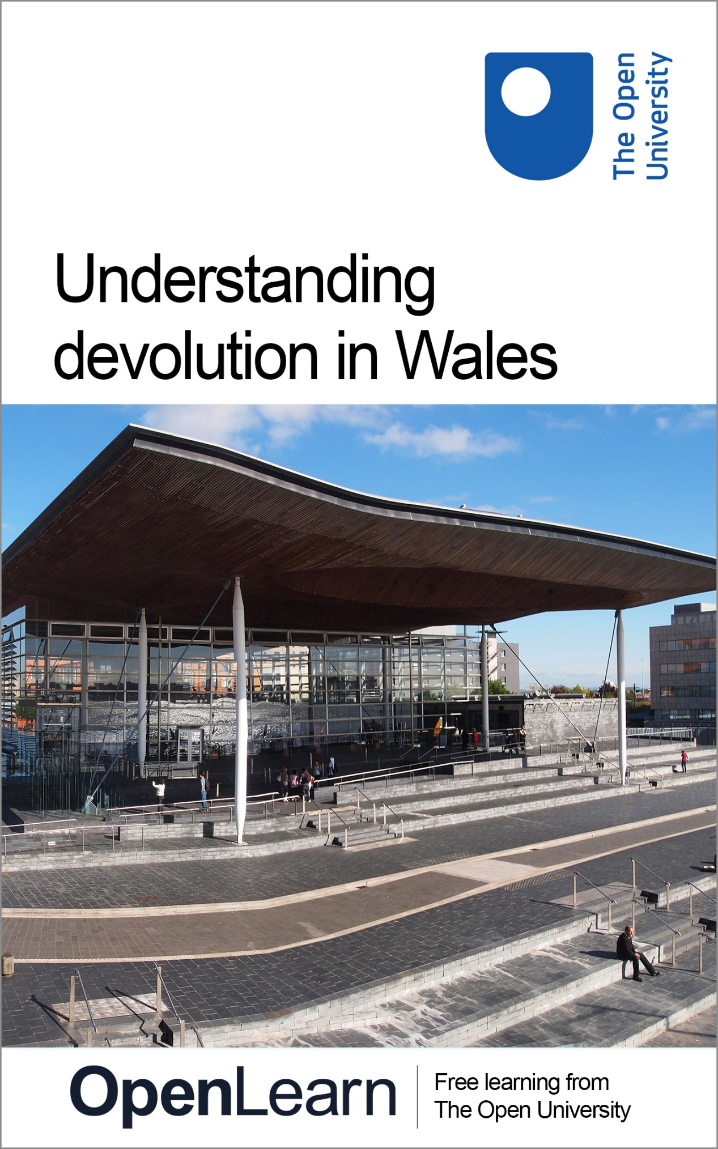

DEV_1

Understanding devolution in Wales

About this free course
This free course is an adapted extract from the Open University course .
This version of the content may include video, images and interactive content that may not be optimised for your device.
You can experience this free course as it was originally designed on OpenLearn, the home of free learning from The Open University –
There you’ll also be able to track your progress via your activity record, which you can use to demonstrate your learning.
Copyright © 2020 The Open University
Intellectual property
Unless otherwise stated, this resource is released under the terms of the Creative Commons Licence v4.0 http://creativecommons.org/licenses/by-nc-sa/4.0/deed.en_GB. Within that The Open University interprets this licence in the following way: www.open.edu/openlearn/about-openlearn/frequently-asked-questions-on-openlearn. Copyright and rights falling outside the terms of the Creative Commons Licence are retained or controlled by The Open University. Please read the full text before using any of the content.
We believe the primary barrier to accessing high-quality educational experiences is cost, which is why we aim to publish as much free content as possible under an open licence. If it proves difficult to release content under our preferred Creative Commons licence (e.g. because we can’t afford or gain the clearances or find suitable alternatives), we will still release the materials for free under a personal end-user licence.
This is because the learning experience will always be the same high quality offering and that should always be seen as positive – even if at times the licensing is different to Creative Commons.
When using the content you must attribute us (The Open University) (the OU) and any identified author in accordance with the terms of the Creative Commons Licence.
The Acknowledgements section is used to list, amongst other things, third party (Proprietary), licensed content which is not subject to Creative Commons licensing. Proprietary content must be used (retained) intact and in context to the content at all times.
The Acknowledgements section is also used to bring to your attention any other Special Restrictions which may apply to the content. For example there may be times when the Creative Commons Non-Commercial Sharealike licence does not apply to any of the content even if owned by us (The Open University). In these instances, unless stated otherwise, the content may be used for personal and non-commercial use.
We have also identified as Proprietary other material included in the content which is not subject to Creative Commons Licence. These are OU logos, trading names and may extend to certain photographic and video images and sound recordings and any other material as may be brought to your attention.
Unauthorised use of any of the content may constitute a breach of the terms and conditions and/or intellectual property laws.
We reserve the right to alter, amend or bring to an end any terms and conditions provided here without notice.
All rights falling outside the terms of the Creative Commons licence are retained or controlled by The Open University.
Head of Intellectual Property, The Open University

Contents
- Introduction
  - Introduction
    - Introduction
    - Learning outcomes
- Section 1: Designing devolution
  - Introduction
  - 1 Political parties
  - 2 The evolving devolution settlement
    - 2.1 Pre-1979
    - 2.2 1979
    - 2.3 1997 referendum
    - 2.4 A very close vote
    - 2.5 Devising the new Assembly
    - 2.6 New politics
  - 3 The First Assembly (1999-2003)
  - 4 The Second Assembly (2003-2007)
    - 4.1 Richard Commission
    - 4.2 Bonfire of the Quangos
  - 5 The Third Assembly (2007-2011)
    - 5.1 One Wales Government
    - 5.2 LCOs
    - 5.3 All Wales Convention
    - 5.4 Referendum on law making powers
  - 6 The Fourth Assembly (2011-2016)
    - 6.1 Referrals to the Supreme Court
    - 6.2 The Silk Commission
    - 6.3 Two Wales Bills
  - 7 The Fifth Assembly (2016-2021)
    - 7.1 Raising taxes for the first time in 800 years
    - 7.2 An Assembly becomes a Parliament
  - 8 The Internal Market Bill and Brexit
  - 9 Section 1 summary
- Section 2: Ongoing issues for devolved government
  - Introduction
  - 1 Funding
    - 1.1 Accountability
    - 1.2 Fairness
    - 1.3 Holtham Commission
  - 2 A separate legal jurisdiction
    - 2.1 Thomas Commission
    - 2.2 Commissions in review
  - 3 The size of the Senedd
    - 3.1 Arguments against more MSs
    - 3.2 Arguments for more MSs
  - 4 A lack of scrutiny
    - 4.1 Media
    - 4.2 Civil society
    - 4.3 Wales’ Commissioners
  - 5 Inter-institutional relations
    - 5.1 Lack of a written constitution
    - 5.2 Political differences
    - 5.3 Comparisons with Scotland and Northern Ireland
  - 6 Section 2 summary
- Section 3: Understanding Welsh voters
  - Introduction
  - 1 Interview with Roger Awan-Scully
  - 2 Welsh identity
  - 3 Attitudes towards devolution
  - 4 The Welsh Language
  - 5 Low voter turnout
  - 6 Votes at 16
  - 7 Section 3 summary
  - 8 End of course summary
- Glossary
- References
- Further reading
- Acknowledgements
- Solutions

Introduction

Introduction

Introduction
Enter a discussion on devolution and invariably someone will use the expression that ‘devolution is a process and not an event’. While this may be cliche, it is also very accurate. The purpose of this free course, Understanding devolution in Wales, is to help you understand the current state of the devolution settlement in Wales and the events which shaped it.
This course is divided into three parts: the first sets out the positions of the major political parties in Wales then traces the devolution settlement as it developed between 1997 and 2021. The second probes the major issues facing devolution in Wales today. The final section considers the relationship between devolution and voters in Wales.

Note on terminology
The Welsh Parliament was known as the National Assembly for Wales and Members of the Senedd (MSs) were known as Assembly Members (AMs) between 1999 and 2020. The Welsh Government was known as the Welsh Assembly Government until 2011. These terms will be used when historical references are made.

Glossary
The course contains a glossary defining some potentially unfamiliar terms. You will occasionally find terms highlighted in the text – clicking on them will take you to the definition in the glossary. You can also navigate to the glossary manually at any time, at the end of whichever section you are studying.

Learning outcomes
After studying this course, you should be able to:
- understand why power was devolved to Wales
- describe how the devolution settlement evolved significantly between 1999 and 2020
- identify the issues currently facing the devolution settlement in Wales
- understand how issues of identity are linked to devolution.
Get started with Section 1.

Section 1: Designing devolution

Introduction
So how did an Assembly which was only just voted into existence gain enough power to call itself a Parliament and set taxes in less than 21 years? The answer is a series of reviews, reform and legislation – none of it easy. The purpose of this section is to set out that process in largely chronological order. Before doing that, it will be helpful to briefly consider the political parties which dominate politics in Wales and their positions on devolution.

1 Political parties

Welsh Labour



- In a sentence: A left-of-centre socialist party which has been the dominant force in Welsh politics for a century.
- Electoral success: Labour have won almost every election in Wales for 100 years and have led every Welsh government in the post-devolution era, winning between 26 and 30 out of 60 Senedd seats.
- Political heartlands: The post-industrial constituencies in the south Wales Valleys and north Wales.
- Context: It was a Labour government which pushed devolution in Wales forward in the late 1990s. Unlike Scottish Labour, the Welsh arm of the party has sought to differentiate itself from its counterpart in Westminster. Rhodri Morgan referred to this as ‘clear red water’ in a speech in 2002.

Plaid Cymru



- In a sentence: A left-of-centre nationalist party whose ultimate aim is Welsh independence.
- Electoral success: Their electoral high point came in 1999 when they won 17 seats, falling to 11 in 2011. They formed the One Wales Government with Labour in 2007.
- Political heartlands: Welsh speaking areas, rural areas in mid and north west Wales.
- Context: In contrast to the other parties, Plaid Cymru view the Senedd election as their priority with elections to the UK Parliament as second order. Plaid Cymru only stand for election in Wales. It is the sister party of the Scottish National Party (SNP) although this amounts to little more than informal cooperation in practice.

Welsh Conservatives



- In a sentence: A right-of-centre unionist party.
- Electoral success: They have never formed the Welsh Government although the number of seats they win at Senedd elections has increased from 9 in 1999 to 14 in 2016.
- Political heartlands: They tend to do well in affluent, semi-rural constituencies.
- Context: Despite initial scepticism towards devolution, the Welsh Conservatives have enjoyed considerable success in the Senedd, coming second in 2011 and replacing Plaid as the second largest party in 2016, following defections. One of the biggest challenges they face operating in Cardiff Bay is engaging constructively whilst retaining the support of the high percentage of their supporters who are devo-sceptic.

Welsh Liberal Democrats



- In a sentence: A liberal, pro-devolution and pro-federalism party.
- Electoral success: The party enjoyed a stable presence of around 6 seats for the first 4 Assembly elections but this fell to just 1 in 2016. The 2016 election saw lone Liberal Democrat Kirsty Williams join the Welsh Government where she served as Education Minister. The party also served as a junior coalition partner to Labour between 2001 and 2003.
- Political heartlands: The party has benefited from the list system, gaining enough votes in most constituencies to win a regional seat.
- Context: The party describe themselves as having the deepest roots of any Welsh political party with liberalism in Wales stretching back to the 19th century. However, the Lib Dems appeared to be a diminishing force in Welsh politics, struggling with the fallout from the 2010 coalition with the Conservatives at Westminster and the rise of UKIP, which took the list seats they had previously occupied.

UKIP



- In a sentence: Right of centre, pro-Brexit, anti-devolution party.
- Electoral success: The party was not represented in the Senedd until it won 7 regional seats in the 2016 election.
- Political heartlands: The party won seats on every regional list in 2016 but it enjoys particular support in South Wales East.
- Context: The 2016 UKIP group proved chaotic with multiple defections. By the end of the term only its former leader, Neil Hamilton, sat as a UKIP member with others having splintered off to join the Brexit Party or the Abolish the Assembly Party.

Independents
There have been a number of independents in the Welsh Parliament, most notably in the fifth session. By the 2021 election, six of the sixty AMs elected in the 2016 elections sat as independents. Two – Neil McEvoy and Lord Dafydd Elis-Thomas – were formerly members of Plaid Cymru. The other four had originally been part of a very unstable UKIP / Brexit Party grouping. In previous sessions, AMs including Trish Law and John Marek had been returned as constituency members after disagreements with Labour.

In summary:
Broadly socialist Welsh Labour have dominated the political landscape in Wales for a century. Nationalists Plaid Cymru and the Welsh Conservatives come a distant second. The Liberal Democrats are a diminishing force. UKIP saw 7 AMs elected in 2016 but this grouping did not last. The Senedd has seen many members sit as independents, often as a result of defections.

2 The evolving devolution settlement
As you will see in the first section of this course, the devolution settlement in Wales was transformed in the two decades following the 1997 referendum. House of Commons researcher, David Torrance, set out five phases of this transformation, charting the transfer of powers from Wales to Westminster.
As you work through this course, you’ll come to understand these phases much better.
Five broad phases of devolution:
- administrative devolution (1964-1999)
- executive devolution with secondary law-making powers (1999-2007)
- executive devolution with enhanced secondary powers (2007-2011)
- legislative devolution under a ‘conferred powers’ model (2011-2018)
- legislative devolution under a ‘reserved powers’ model (2018-)
Primary law-making powers refer to the ability to draft and enact legislation without recourse to another legislature. The Assembly began as a body with secondary law-making powers (it could request legislation be passed in Westminster) but became a primary law-making legislature (free to make its own laws within certain policy areas) following a referendum in 2011.
A conferred powers model is where a legislature is granted permission to make changes in a number of defined areas. Everything else remains reserved. A reserved powers model is where an Assembly is not permitted to make changes in a number of defined areas, but it is free to act where there is no reservation. The Assembly had a conferred powers model at the outset of devolution, but this became a reserved powers model in 2014.
Both of these changes will be explored in depth throughout this course.

2.1 Pre-1979
The union between Wales and England was formed in 1535 when the two nations became a single state. In the late nineteenth century, political demands for Welsh autonomy began to circulate, led by the Liberals and later Plaid Cymru. In response, the UK Government began to transfer some administrative control to ‘Welsh departments’ within the Board of Education (1909) and the Ministry of Agriculture (1919). By 1940, the Welsh Board of Health had taken over responsibility for housing, water and other local government services.
In 1964, the first Secretary of State for Wales was appointed, and the Welsh Office was created the following year with offices in Cardiff and Whitehall. Initially, the Welsh Office had control over town planning, housing, water and sewerage, local government, roads and some aspects of economic planning. The Welsh Secretary also had oversight within Wales of the execution of policy set by the UK Government including health and education. Over time, its remit expanded.

2.2 1979
In 1969, the Royal Commission on the Constitution under Lord Kilbrandon was established to consider options for the future of the United Kingdom amid growing support for nationalist parties. Gwynfor Evans won Plaid Cymru’s first parliamentary seat in the 1969 Carmarthen by-election, Winnie Ewing took Hamilton for the SNP in 1967. The Kilbrandon review suggested legislative and executive devolution to Scotland and Wales and advisory Regional Councils for England. This plan was rejected as too bureaucratic and ill-advised in economic terms.
Revised plans for devolution to Scotland and Wales were subsequently brought forward. In 1974, a plan for Welsh devolution which involved executive functions being devolved to a Welsh Assembly of 72 members, operating through a committee system and led by a Chief Executive was published. The plan was subject to a referendum.

Activity 1 Referendum (1979)

The referendum was held on 1 March 1979. Take a look at these campaign materials for both sides.

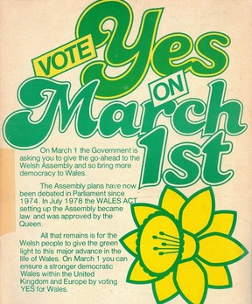
Figure 1 ‘Vote yes on March 1st’
View description - Figure 1 ‘Vote yes on March 1st’

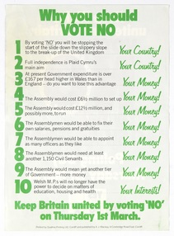
Figure 2 ‘Why you should vote no’
View description - Figure 2 ‘Why you should vote no’

How would you vote? Make your decision, then reveal the discussion below to find out the results.

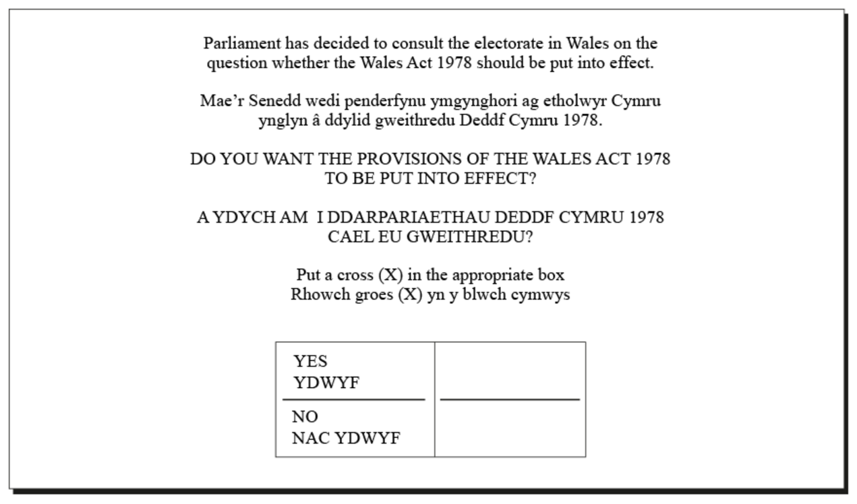
Figure 3 Referendum ballot
View description - Figure 3 Referendum ballot

View discussion - Activity 1 Referendum (1979)

2.3 1997 referendum
Although the result was decisive, the idea of devolution did not go away.
Throughout the 1980s and early 1990s, politics in Wales and Scotland were misaligned with both countries electing mostly Labour MPs while a Conservative government led by Margaret Thatcher was in power at Westminster.
Responding to this, the Labour Party in opposition undertook a further exploration of the possibilities of devolution. It was pursued initially by Labour leader John Smith and taken on by his successor and Labour Prime Minister, Tony Blair.
Blair subsequently acknowledged that he was not a passionate devolutionist but it would have been politically difficult to reverse this position. He addresses this point in an interview with the Institute of Government, marking 20 years of devolution:

The purpose of devolution was to bring about a new settlement between the constituent parts of the UK so that decision making was brought closer to the people who felt a strong sense of identity. And politically, also, to ward off the bigger threat of secession… it was the established Labour Party position [when Blair became Labour leader] but, essentially, I took the view that it was right in principle and necessary politically. And before I became Labour leader it was clear that was the pretty established and settled position of the Labour Party. So frankly, it would have been hard to change it even if I had wanted to, but I had become convinced myself that it was basically the right thing to do and that the previous 100 years had been a series of failed attempts to do devolution. And it was important that we succeeded otherwise I could see a situation, particularly in Scotland, where the support for independence would be unstoppable. And I still think it was basically necessary to prevent that even though it’s a continuing debate as to whether Scotland goes for full independence or not.
(Institute for Government, 2019)

The Labour Party took forward proposals for devolution in two policy documents: Shaping the Vision in 1995 and Preparing for a New Wales in 1996. Progress was rapid. Following Tony Blair’s landslide Labour victory on 2 May 1997, the Referendums (Scotland and Wales) Bill was introduced to the House of Commons on 15 May 1997. Proposals for an Assembly for Wales were published on 22 July 1997 in the A Voice for Wales white paper.
A Voice for Wales envisaged an elected body with 60 members elected under the Additional Member System. It was put to a vote across Wales less than two months later.

Activity 2 Referendum (1997)

The referendum was held on 18 September 1997. Take a look at these campaign materials for both sides.

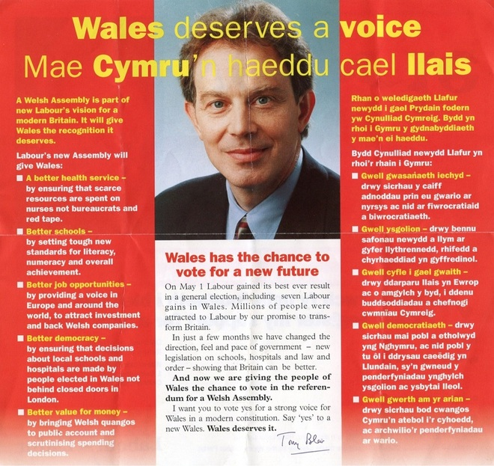
Figure 4 ‘Wales deserves a voice’
View description - Figure 4 ‘Wales deserves a voice’

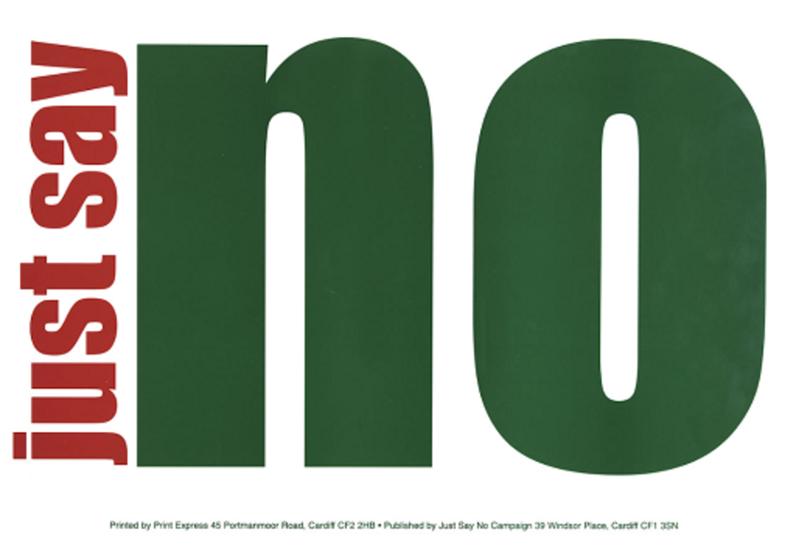
Figure 5 ‘Just say no’
View description - Figure 5 ‘Just say no’

How would you vote this time? Make your decision, then reveal the discussion below to find out the results.

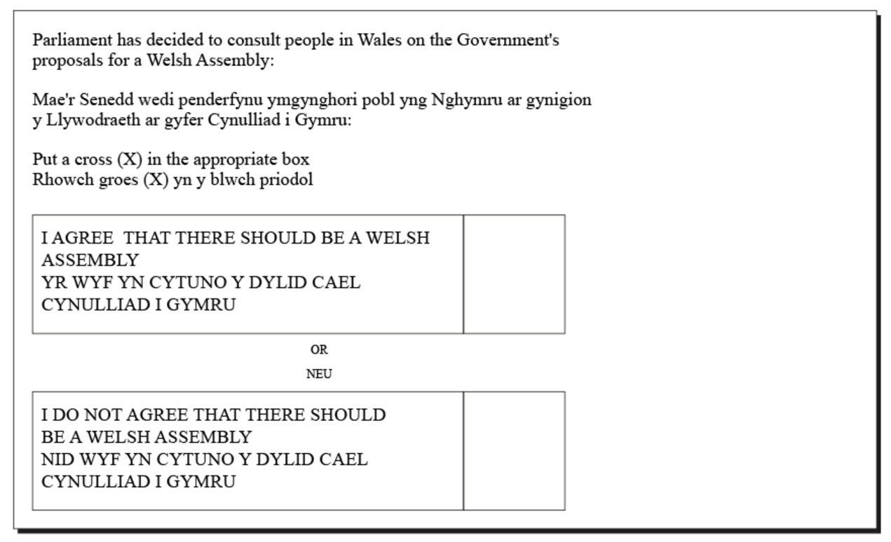
Figure 6 Referendum ballot
View description - Figure 6 Referendum ballot

View discussion - Activity 2 Referendum (1997)

2.4 A very close vote
The Yes vote was carried but by the narrowest of margins – 0.3% or 6700 votes on a turnout of a little over 50%. To put this into context, that’s about the same as the population of Flintshire village, Sandycroft.
Contrast this to Scotland which had gone to the polls two weeks previously, where a 60% turnout had delivered a 74% majority.
This slender margin created difficulties from the very beginning. Unlike colleagues in Scotland, the architects of the early Welsh devolution settlement could not point to an impressive and decisive result to drive forward change. They could only inch forward.
As Martin Shipton argues in his book on the first decade of devolution in Wales, ‘Poor Man’s Parliament’, Wales was created inferior to the bodies proposed for Scotland and Northern Ireland. He attributes this to hostility amongst Welsh Labour MPs to idea of devolution.

The brakes were well and truly applied, and the message was clear: this would be an inferior body that barely deserved to be designated as a legislature.
(Shipton, 2011, p.8)

- Both the 1997 and 1979 referenda were essentially asking the same thing: ‘should there be an elected Assembly to represent Welsh interests?’ but the language used in the questions is very different. Do you think this had an impact on the outcome?
- The Electoral Commission – the body which sets standards for how elections and referenda should be run – says that questions put to voters must be clear, simple and neutral. The nature of the question can influence the outcome. Matt Qvortrup, professor of applied political science at Coventry University, says that long questions can cause voters to become mistrustful. He also says that the nature and timing of the campaign is likely to be more significant than the wording of the question. A short, positive campaign held shortly after an election victory is more likely to be won by the government of the day.

2.5 Devising the new Assembly
Following the yes vote in 1997, work began in earnest to devise the rules which would govern Welsh devolution. Unlike Scotland, where proposals for a Scottish Parliament had been under discussion in a constitutional convention for many years, proposals for the devolved administration in Wales were brought together in a relatively short time.
Labour’s White Paper, A Voice for Wales, set out how the 60-member Assembly for Wales would take on the functions which had previously been carried out by the Secretary of State for Wales. The Assembly would be led by an executive committee comprising the chairs of several subject committees.
Following the affirmative vote, work began on the Government of Wales Bill 1998. The proposals in this were slightly different again. The Bill put forward proposals for a First Secretary to lead an executive committee. The elected body would be known as the ‘National Assembly’. Unusually, the executive and the legislature were not envisaged as separate entities but one ‘corporate body’ which would make secondary legislation or orders in devolved areas. Any primary legislation would be made by at Westminster in both devolved and reserved areas.
The Bill also set out the process for electing Wales’ 60 Assembly Members: 40 in constituencies coterminous with Westminster and a further 20 regional AMs to be elected through a system of proportional representation known as the D’Hondt method.
Funding for the Assembly would be provided by the UK Government through a system known as the ‘block grant’ allocated on the basis of the Barnett formula. You will read more about this later in the course.
Importantly, the Bill also contained a clause which allowed for future transfer of further powers which suggested its authors believed the process would be ongoing.

Further reading - designing Welsh devolution
20 years on, Secretary of State for Wales, Ron Davies reflects on designing Welsh devolution in a lecture hosted by the Wales Governance Centre.
See the Further Reading section for a link to this video.

The Bill passed on 31 July 1998. The first elections to the National Assembly were held on 6 May 1999 with Labour returned as the largest party. On 12 May 1999, the National Assembly for Wales sat for the first time with Presiding Officer, Lord Dafydd Elis-Thomas in the chair. On 1 July 1999, the Welsh Office became the Wales Office.

Video content is not available in this format.
Video 1 The Queen opens the first Welsh Assembly (1999)
View transcript - Video 1 The Queen opens the first Welsh Assembly (1999)

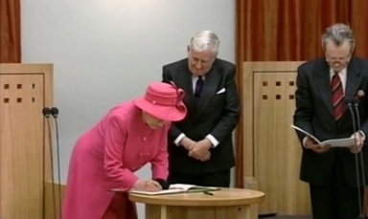

2.6 New politics
At the end of the clip in Section 2.5, reporter David Cornock mentions ‘new politics’. This was a phrase used at the dawn of devolution to describe the different ways in which things would be done in the new institutions in Scotland and Wales. Broadly, it referred to a more straight forward, open and family friendly way of working. It was set in opposition to the old-fashioned, closed and ritualistic practices of Westminster.

Activity 3 Comparing Parliaments

Compare pictures of the Welsh and UK Parliaments. What do you notice?

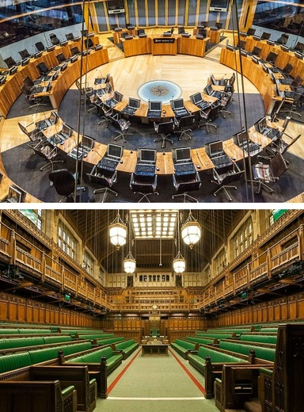
Figure 7 Comparing Parliaments: Welsh (top image) and UK (bottom image)
View description - Figure 7 Comparing Parliaments: Welsh (top image) and UK (bottom image)

View discussion - Activity 3 Comparing Parliaments

In summary:
Transfer of some political power from Westminster to Wales took place gradually over the second half of the twentieth century. An attempt to establish separate political institutions failed in 1979 but narrowly passed in 1997. The initial structures of the Welsh institutions were devised very quickly.

3 The First Assembly (1999-2003)
The new Assembly ran into political difficulties quickly.
Following a compromising personal scandal, Secretary of State for Wales Ron Davies was forced to stand down in 1998. His successor was Alun Michael who became Tony Blair’s preferred choice for First Secretary over the more popular Cardiff West AM Rhodri Morgan. Having won 28 seats in May 1999, Michael was forced to form a minority government. Less than a year later, he faced a vote of no confidence over funding policy. Uncertain of his ability to avoid censure, he stood down and Rhodri Morgan took over as First Minister.
The institution also took time to find its feet. As Martin Shipton (2011) sets out in his detailed account of the first decade of devolution, the first few years of the new Assembly were rocky. Relationships with Westminster took time to settle down, the nature of the devolution settlement was still very much under discussion and there were numerous scandals which undermined the credibility of the fledgling institution.
There were three main criticisms of the operation of devolution in Wales in its early years. These were:
- Structure: Both Ministers and Assembly subject committees had some decision-making powers, blurring the lines between policy development and scrutiny. As Rhodri Morgan later wrote in his memoirs: ‘With each Minister being a Member of the Committee that scrutinised his or her work, it was hard for the public to see a clear chain of command and responsibility for decisions’ (Morgan, 2017, p. 170)
- Powers: The Assembly had to request legislative time at Westminster to get any primary legislation passed. This didn’t happen very often.
- Funding: The formula used to calculate money available to Wales was based on population as opposed to need. This was seen as disadvantaging Wales.

4 The Second Assembly (2003-2007)
The 2003 election saw voter turnout decline from 46% to 38%. Were the voters of Wales becoming less engaged in devolved politics? The first Assembly got off to a rocky start. Attempts to resolve those early challenges would dominate the second.

4.1 Richard Commission
Before its first term had ended, First Minister Rhodri Morgan established the Commission on the Powers and Electoral Arrangements of the National Assembly for Wales, chaired by Lord Richard to address some of these criticisms.
In early 2004, the Commission recommended:
- Primary legislative powers should be conferred on the Assembly and a reserved powers model whereby the Assembly could act in all areas not explicitly reserved to Westminster be adopted.
- The legislature and the executive should be separated out with the executive answerable to the legislature.
- To negate two ‘classes’ of AM, all should be elected via the Single Transferable Vote system.
These recommendations prompted the UK Government to pass the Government of Wales Act (GoWA) (2006). It separated the executive and the legislature, gave the Assembly secondary law-making powers and offered the possibility of a further referendum on primary law-making powers.
The Bill was criticised for retaining significant control at Westminster. Nevertheless, it became law in 2006 and its provisions enacted at the start of the third Assembly in 2007.

4.2 Bonfire of the Quangos
Whilst the Richard Commission undertook its review, Labour First Minister Rhodri Morgan made a surprise announcement on 14 July 2004 which significantly altered the way public services in Wales were run. In a statement to AMs, he announced plans to ‘abolish the quango state’. He said:

The time has come to move forward the devolution project onwards and upwards. We intend to incorporate the major executive quangos directly under the Assembly Government.
(WalesOnline, 2004)

The move saw the functions and staff of multiple public service bodies – including the Welsh Development Agency, the Welsh Tourism Board and curriculum and qualifications authority – merged into the Welsh Assembly Government and made accountable to Ministers.
In addition to giving the Welsh Assembly Government ‘more firepower’ as Rhodri Morgan put it at the time, it was also intended to increase accountability.

5 The Third Assembly (2007-2011)
Attempts to ameliorate the problematic devolution settlement occupied the second Assembly. The third saw significant political change. Plaid Cymru formed a coalition with Labour – and the price of their support was commitment to further development of the settlement.

5.1 One Wales Government
2007 saw Labour returned with 26 seats – their lowest number in the three Assembly elections to date. With Labour in a weakened position, the Conservative, Liberal Democrats and Plaid Cymru briefly considered a ‘rainbow coalition’ but this was rejected by a special conference of the Liberal Democrats.
Rhodri Morgan stood unopposed as leader of a minority government and was elected First Minister. A month later, the One Wales coalition with Plaid Cymru was agreed giving the government a majority of 22. There were two major components of this agreement which drove reform of the devolution settlement: a commitment to a review of the Assembly’s funding and finance and a commitment to a referendum on full law-making powers, as permitted under the GoWA 2006.

5.2 LCOs
With secondary law-making powers, AMs could propose ‘legislative competence orders’ (LCOs) in 20 defined areas of policy and it would then be up to the Houses of Parliament to pass them.
- Areas of policy:
- agriculture, fisheries, forestry and rural development
- ancient monuments and historic buildings
- culture
- economic development
- education and training
- environment
- fire and rescue services and promotion of fire safety
- food
- health and health services
- highways and transport
- housing
- local government
- National Assembly for Wales
- public administration
- social welfare
- sport and recreation
- tourism
- town and country planning
- water and flood defence
- Welsh language
Any areas not listed were considered non-devolved and would be matters on which the UK Parliament would legislate.
This system was not effective as it relied on time being made available at Westminster. In the first two years of operation, only four LCOs passed. Proposals which were politically difficult were delayed or abandoned for example, an attempt by the Assembly to prohibit the ‘right to buy’ council houses.

5.3 All Wales Convention
As part of the One Wales commitment to a referendum on more powers for the Assembly, the All Wales Convention was launched in July 2008. It had two purposes: to explain the current system and prepare the ground for a potential referendum on law-making powers.
The Convention concluded that the majority of voters in Wales did not understand the current law-making arrangements and recommended a move towards primary law-making powers following a referendum as required in GoWA 2006.
In February 2010, the Assembly had endorsed such a referendum. The UK Government scheduled legislation enabling it to be held on 3 March 2011, two months ahead of the fourth Assembly elections.

5.4 Referendum on law making powers
Wales’ third referendum on devolution was described by Guardian Whitehall Editor, Michael White as ‘strikingly low-key’. With just 8 weeks to go until the next set of Assembly elections, the political parties were largely pre-occupied, and campaigning fell to Yes For Wales and True Wales (the no campaign). True Wales decided not to seek official status and funding so Yes For Wales was denied official status and the attached funding.
The arguments were familiar. Yes For Wales claimed primary legislative powers would make the Assembly more efficient and accountable to the people of Wales. True Wales argued that AMs were not up to the task and MPs should remain involved in the process.

Activity 4 Referendum (2011)

The referendum was held on 3 March 2011. Take a look at these campaign materials for both sides.

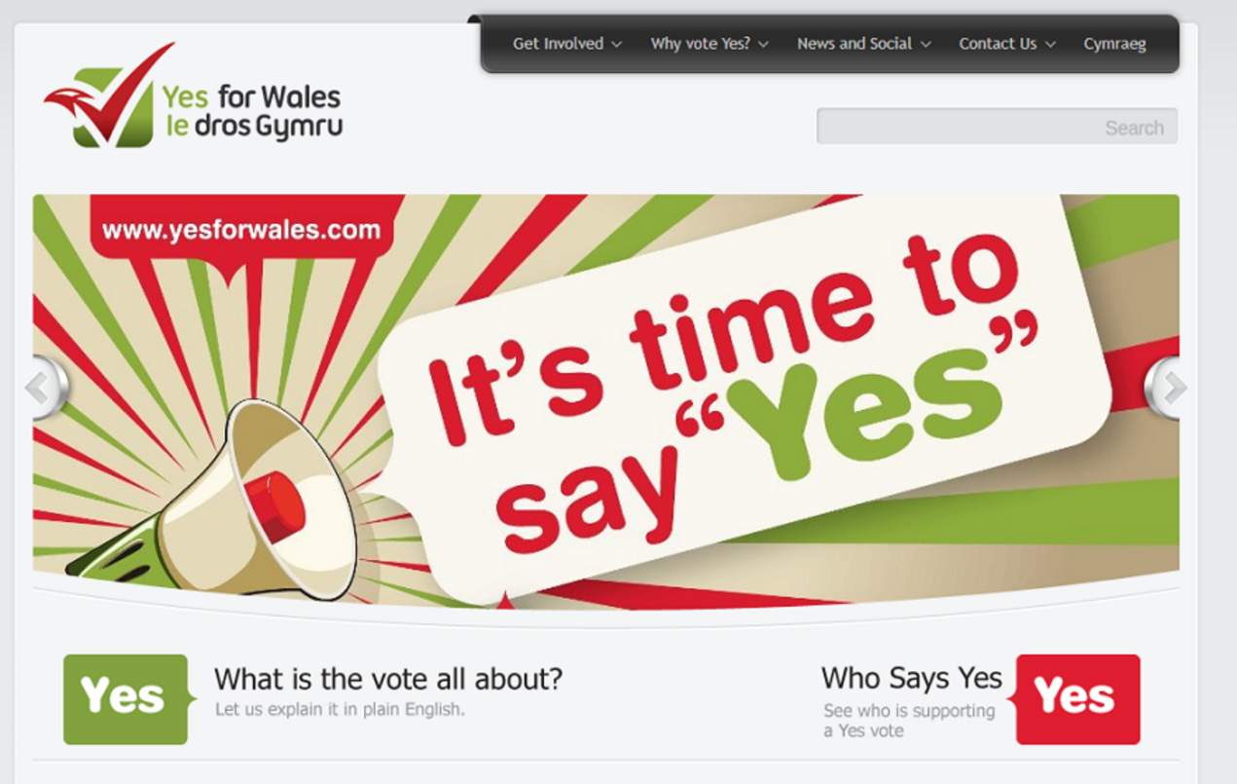
Figure 8 ‘It's time to say “yes”’
View description - Figure 8 ‘It's time to say “yes”’

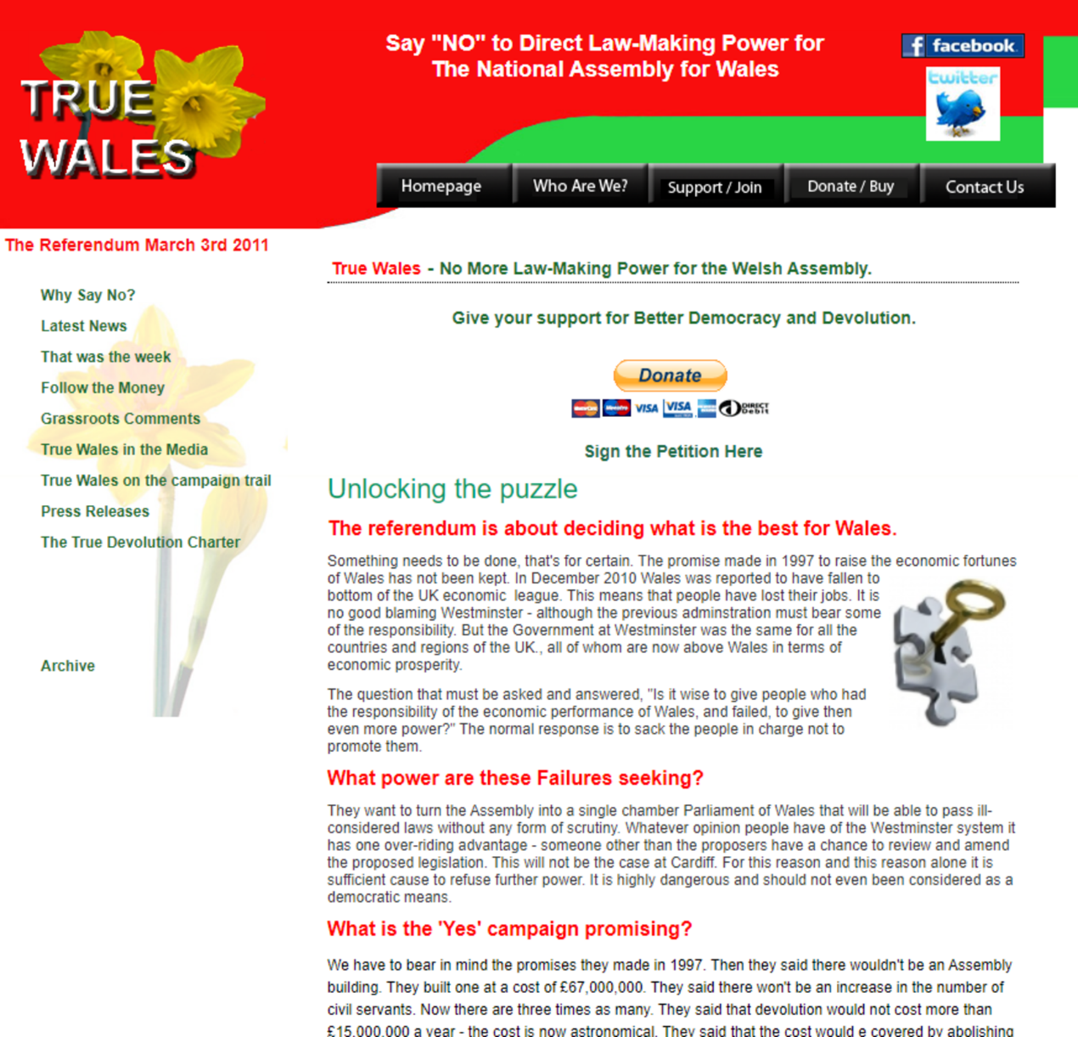
Figure 9 ‘Say “no” to direct law-making power for the National Assembly for Wales’
View description - Figure 9 ‘Say “no” to direct law-making power for the National Assembly for Wale ...

How would you vote? Make your decision, then reveal the discussion below to find out the results.

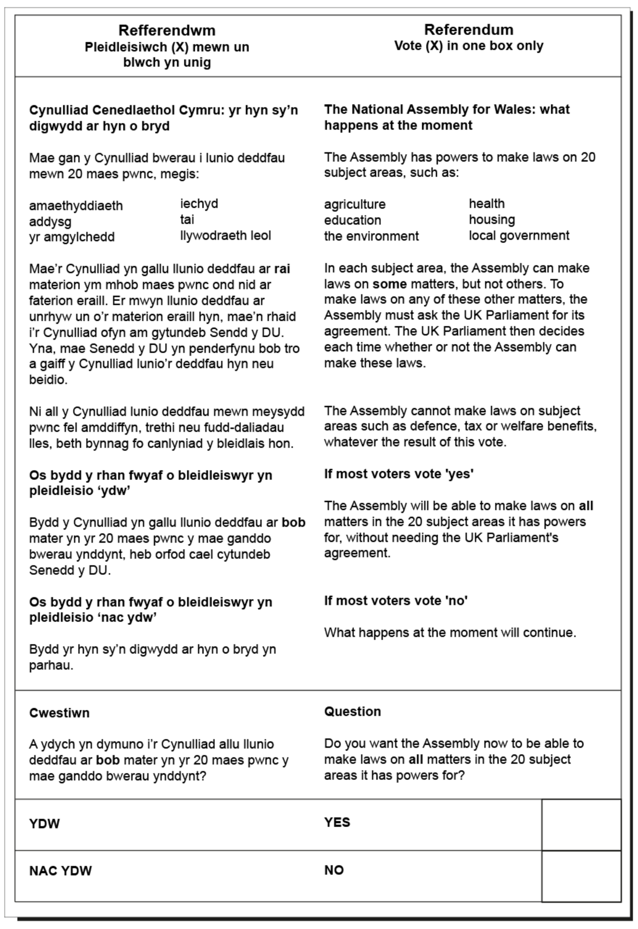
Figure 10 Referendum ballot
View description - Figure 10 Referendum ballot

View discussion - Activity 4 Referendum (2011)

In summary:
Both the financial arrangements and the powers of the Assembly conferred under the 2006 Government of Wales Act were reviewed during the third Assembly and found wanting. There was a referendum on whether the Assembly should be given primary law-making powers which passed. There was still no reform of funding.

6 The Fourth Assembly (2011-2016)
The Fourth Assembly took place against a period of relative political calm. Labour had 30 seats in the Assembly so were able to govern without a coalition partner. The main tensions stemmed from relations with the Westminster government which was formed by a Conservative and Liberal Democrat coalition.
The Assembly assumed primary legislative powers on 5 May 2011. It could now make laws in the 20 areas devolved to Wales without recourse to Westminster. The first piece of legislation passed was the Local Government (Byelaws) Wales Bill in November 2011.

6.1 Referrals to the Supreme Court
The Assembly may have been granted primary law-making powers but that was not the end of the matter. There were a number of grey areas in the Government of Wales Act (2006). Several Welsh Acts passed by the Assembly have ended up in the Supreme Court after the UK Government questioned Cardiff Bay’s legislative competence.
The Agricultural Sector (Wales) – emergency legislation passed by AMs to address the abolition of the Agricultural Wages Board in 2013 – is a good example. Agriculture is largely devolved while workers’ rights are reserved. The Supreme Court held that the legislation was within the competence because ‘agricultural wages’ was not explicitly outside of the Assembly’s powers.
Referrals also worked the other way when the Welsh Government referred the UK Government’s Trade Union Act to the Supreme Court in 2017, claiming it infringed on devolved areas of competence.
These disagreements prompted further calls for a ‘reserved powers model’ whereby those areas in which the UK Government retained control were explicitly stated and everything else was assumed to be in the competence of the Welsh Assembly. It was eventually taken forward by the UK Government in the Wales Act (2017).

6.2 The Silk Commission
In May 2010, the Coalition UK Government formed by the Conservatives and the Liberal Democrats made a commitment to reviewing the Welsh devolution settlement following the referendum on more powers in its programme for government.
On 11 October 2011, then Secretary of State, Cheryl Gillan announced a new Commission on Devolution in Wales to consider the case for devolving fiscal powers and review the powers of the Assembly in general. The review was chaired by former Clerk of the National Assembly for Wales, Paul Silk.
The Commission reported in two parts:
Firstly, on funding, where it recommended the devolution of some minor taxes, some powers over income tax and enhanced borrowing powers.
Secondly, on powers of the Assembly, where it recommended increasing the size of the Assembly, devolving more areas of responsibility and moving to a ‘reserved powers model’.

6.3 Two Wales Bills
The UK Government also responded in two parts.
Firstly, with the Wales Bill 2014, which gave the Assembly some competence in matters of taxation. Stamp duty and landfill tax were both devolved. This Bill offered the Assembly the opportunity to set income tax rates, subject to a referendum. It also made some changes to electoral arrangements.
Secondly, with the far more contentious Wales Bill 2016, which was set out to significantly recast the devolution settlement.
Prior to publication of the 2016 Bill, there had been a period of engagement with key political stakeholders. This was described by the UK Government as the St David’s Day process. When it concluded on 27 February 2015, David Cameron and Nick Clegg made a joint announcement in the Millennium Stadium announcing the St David’s Day Agreement. Powers for a purpose: towards a lasting devolution settlement for Wales was published on the same day.
To give effect to the St David’s Day agreement, the Wales Bill 2016 was published. It was extensively criticised by the House of Commons Welsh Affairs Committee, the Assembly’s Constitutional and Legislative Affairs Committee, the Wales Governance Centre and the Constitution Unit. The consensus was that the Bill did not improve the settlement. In its report, the Assembly’s Constitutional and Legislative Affairs Committee said:

The complexity of the draft Bill has been a recurring theme of the evidence we have received. The necessity tests blur the boundaries of the Assembly’s legislative competence and hinder understanding for citizens rather than aid clarity. The provisions relating to Ministerial consents mean that the settlement is considerably more restrictive, not only adding to the complexity but also maintaining exceptionalism and irregular devolution within the UK.
(National Assembly for Wales, 2015, p.43)

The Welsh Government was so unhappy with the draft that it took the highly unusual step of publishing an alternative draft Government and Laws in Wales bill. Launching it, First Minister Carwyn Jones said it had ‘the potential to avoid years of constitutional wrangling’. He argued that his proposals would better futureproof the devolution settlement.
Responding, the UK paused the legislation and making significant revisions.
When it finally passed, the Wales Act 2017 made the following changes to the devolution settlement:
- move to a reserved powers model
- made the Assembly a permanent institution which could rename itself as a Parliament
- recognised a separate Welsh body of law
- devolved control in a number of areas including Assembly elections, some energy powers, transport and equal opportunities.
Although it finally passed in 2017, this Wales Act was extensively criticised. Plaid Cymru voted against it on the basis that it ‘clawed back’ powers from the Assembly. Constitutional scholar Richard Rawlings told BBC Radio Wales’ Sunday Supplement programme that the Bill ‘was excessively fragmented’ and the Silk Commission's attempt to outline a set of principles for Welsh devolution had been ‘chipped away at through deals, through technicalities and through machinations in the background’ (BBC News, 2017).

- Do you think the Wales Act 2017 provided the ‘clear, lasting and robust settlement for devolution’ Stephen Crabb envisaged in his speech or do you agree with academic Richard Rawlings that it ‘carries the seeds of its own destruction’?
- While the Wales Act 2017 did rectify some of the most bothersome aspects of the Welsh devolution settlement, particularly the move to a conferred powers model, many issues are still outstanding. These include the lack of a formal framework for intergovernmental communication and ongoing concerns over the Welsh legal system and funding for Wales.

7 The Fifth Assembly (2016-2021)
The fifth Assembly took place through a period of massive constitutional and political upheaval.
Six weeks after the Assembly election, the UK held a referendum on membership of the European Union. The UK Government subsequently attempted to navigate the Brexit process, first under Theresa May and then Boris Johnson. There were also increasing calls for a second Scottish independence referendum amid sustained support for the SNP. The Northern Ireland Assembly at Stormont was suspended for three years between 2017 and 2020.
The Assembly itself was unsettled. UKIP won 7 seats, but internal disagreements saw these AMs regroup repeatedly in different arrangements and as different parties. Two members of Plaid defected to sit as independents. Under intense pressure following the death of Welsh Government Minister, Carl Sargeant, First Minister Carwyn Jones announced his resignation in April 2018. Plaid also appointed a new leader in this time. The Welsh Conservatives appointed two.

7.1 Raising taxes for the first time in 800 years
In 2018, the first Welsh taxes in 800 years were levied by the Welsh Government. These were landfill disposals tax and land transaction tax, replacing landfill tax and UK stamp duty land tax respectively.
The levying of these taxes necessitated the creation of the Welsh Revenue Authority which operates independently of the Welsh Government and is scrutinised by the Welsh Parliament.
From April 2019, the Welsh Government set the Welsh rate of income tax. Ministers could choose to vary the rate or keep it the same as the rates in Northern Ireland and England. Taxes are still collected in the same way by HMRC.
In 2018, the Welsh Government began to examine four new tax ideas. These are: vacant land tax, social care levy, disposable plastic tax and tourism tax.

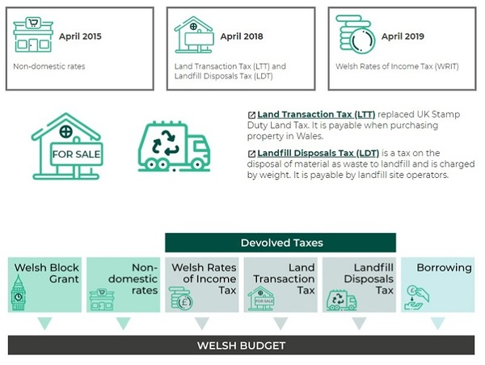
Figure 11 Fiscal devolution (you can find a link to more information in the Further Reading section)
View description - Figure 11 Fiscal devolution (you can find a link to more information in the Further ...

7.2 An Assembly becomes a Parliament
In 2017, an expert panel published a major report calling for significant changes to the size and electoral arrangements of the Assembly. Whilst increasing the number of AMs proved contentious some of the panel’s recommendations proved easier to progress. The Senedd and Elections (Wales) Bill was introduced by the Assembly Commission in February 2019. It had three purposes:
- rename the National Assembly to Senedd
- lower the minimum voting age of National Assembly elections to 16
- deliver other reforms to the National Assembly’s electoral and operational arrangements.
It received the necessary supermajority on 27 November 2019.
On 6 May 2020 – exactly one year before the 2021 Senedd Elections – the National Assembly for Wales officially became known as the Welsh Parliament or Senedd Cymru, commonly known as the Senedd.
Senedd Members became known as Member of the Senedd (MS), and Aelod o’r Senedd (AS) in Welsh.

8 The Internal Market Bill and Brexit
The Brexit process proved fraught for the devolved administrations – this was compounded by an apparent failure to engage by the successive UK Governments.
Difficult relations appeared compounded by governments of different political persuasions: Labour in Cardiff, SNP in Edinburgh and Conservative in London.
These issues came to a head in Autumn 2020 with the UK Internal Market Bill. The UK Government stated the purpose of the Bill was to:

guarantee the continued seamless functioning of the UK's internal market … by enshrining the principle of mutual recognition into law, our proposals will ensure regulations from one part of the UK are recognised across the country.
(Department for Business, Energy & Industrial Strategy, 2020)

However, the devolved nations had significant concerns that the Bill would bring about a recentralisation of power, as it reserved competence over state aid and subsidies to the Westminster parliament and gave the UK Government new spending powers in devolved areas. The devolved nations feared the UK Government would use these powers to fund organisations directly and promote UK Government priorities which may not be aligned with those of the devolved governments.
The Senedd and the Scottish Parliament refused to consent to a request from the UK Government to agree to this course of action. The Bill was passed regardless in December 2020 although the ‘common frameworks’ were proposed as a means of agreeing divergence. The Scottish and Welsh Governments remained unsatisfied and began preparing to take the UK Government to the Supreme Court in 2021.

- Do you believe the UK Government was acting prudently to preserve the functioning of the UK’s internal market or endangering the devolution settlement?
- The answer to this question may take many years to emerge as the UK adapts to life outside the European Union. Undoubtedly the way in which the Conservative government of the day approached this question put untenable strain on relations. Failure to at the very least acknowledge the concerns of the devolved governments fuelled growing movements for constitutional change in all parts of the UK.

In summary:
This was the first session of the Assembly which did not see a wide-ranging review of functions conducted although there was an expert panel on size and electoral arrangements for the Assembly and a Commission on Justice. Many of the significant changes which occurred in this time were realisations of earlier transfers of power.

9 Section 1 summary
Congratulations on reaching the end of this first section. You’ve learned a lot about the evolving nature of devolution in Wales, notably:
- In its first two decades of operation, devolution in Wales went through five phases as set out by David Torrance, from administrative devolution in 1999 to legislative devolution with a reserved powers model in 2018.
- Following a failed referendum on devolution to Wales in 1979, a second vote pushed forward by the New Labour government succeeded.
- This process proved challenging as politicians in London and Cardiff often disagreed on the best way forward.
- The initial devolution settlement was not particularly effective and there were multiple reviews and several pieces of legislation to improve it.
- By 2016, the settlement was more stable and the National Assembly for Wales was renamed the Welsh Parliament in 2020.
You can now move on to Section 2.

Section 2: Ongoing issues for devolved government

Introduction
There are some debates which have been recurring through the duration of devolution: the fairness of the financial settlement Wales receives, how many members the Senedd should have, the quality of scrutiny and the relationships between different parts of the UK.
These issues have been touched upon while examining the repeated attempts to revise the powers of the Welsh Parliament, but this section explores each in more depth.

1 Funding
The devolved government needs money to fund the services it controls such as the NHS in Wales through health boards and education through local authorities.
In 2019/20, the Welsh Government planned to spend about £18bn.
This funding was drawn from three main sources:
- money allocated by the UK Government
- money raised in Wales by means of taxation and other charges
- borrowing

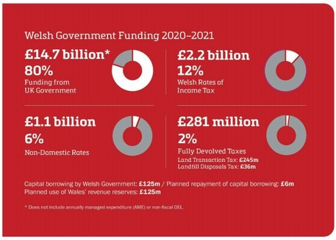
Figure 1 Where does Wales get its money from?
View description - Figure 1 Where does Wales get its money from?

Funding presents two major challenges: ensuring accountability and ensuring fairness.

1.1 Accountability
The UK Government must transfer large sums of money to be used according to decisions made by the Welsh Government. It is possible that this money will be spent in ways which deviate from what the UK Government would prefer.
At the same time, Welsh Government can blame any perceived shortcomings on its part on the inadequacy of the resources from the UK Government. These difficulties are amplified when the governments are made up of different political parties.

Activity 1 Local government discussion

Watch this discussion on local government funding from March 2019. Why would this be confusing to the general public?

Video content is not available in this format.
Video 1 Local government discussion
View transcript - Video 1 Local government discussion

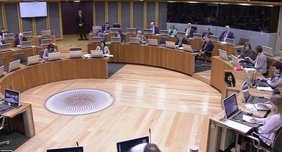

1.2 Fairness
The House of Commons Library explains the Barnett formula as follows:

The devolved administrations in Scotland, Wales and Northern Ireland receive grants from the UK Government that fund most of their spending. The largest such grant is the ‘block grant’.
The Barnett formula calculates the annual change in the block grant. The formula doesn’t determine the total size of the block grant just the yearly change. For devolved services, the Barnett formula aims to give each country the same pounds-per-person change in funding.
The Barnett formula takes the annual change in a UK Government department’s budget and applies two figures that take into account the relative population of the devolved administration (population proportion) and the extent to which the UK department’s services are devolved (comparability percentage). The calculation is carried out for each UK department and the amount reached is added to the devolved administrations’ block grant.
(Keep, 2020)

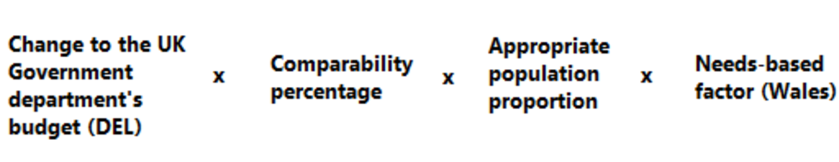
Figure 2 Barnett formula calculation
View description - Figure 2 Barnett formula calculation

The Barnett formula has long been controversial. It was devised in 1978 by Joel Barnett who was then Chief Secretary to the Treasury. It uses a baseline agreed at the time and which has never subsequently been reviewed and is adjusted year-by-year by an amount determined by the Treasury and divided according to the relative proportions of the population in the various devolved nations.
On this basis, Wales gets about 6% and Scotland 10% of each adjustment. The total allocated according to this formula varies according to the budgetary priorities set each year by the UK’s Chancellor of the Exchequer in the Comprehensive Spending Review.
In 2015, following the Holtham Commission review of devolved funding, a ‘funding floor’ was introduced a ‘needs-based’ factor to the Barnett calculation of Welsh funding. This ensures funding for Wales never falls below a needs-related level.
Not surprisingly, there is scope for endless wrangling about the justice of the outcome, and whether it bears enough relation to current needs. This is a matter of interest not just in Wales – the whole population of the UK can take a view on how ‘their’ money is being used and make comparisons with what is happening in other nations.
Politicians in Wales (and Scotland) will often meet spending announcements for England and Wales with calls for this money to be ‘Barnett-ised’ or ‘subject to Barnett consequentials’ – in short, that there should be a dividend for the nations. HM Treasury does not always agree.

1.3 Holtham Commission
Attempts have been made to tackle this problem. The Independent Commission on Funding and Finance for Wales – which became known as the Holtham Commission after its chair, economist Gerald Holtham – began its work in 2008. It was tasked with evaluating the formula used to distribute money to Wales from the UK Government and identify possible alternative funding mechanisms, such as tax raising and borrowing powers.
The Holtham Commission produced two reports. The first focused on the Barnett formula, describing it as out-of-date and existing solely for political convenience. It recommended the formula be replaced with a needs-based calculation. The second report in 2010 repeated this position and called for the Assembly to be granted some powers over tax including the ability to vary income tax by 3p (as was the case in Scotland) and create some new taxes with the UK Government’s consent. There was also a recommendation to allow the Welsh Government some year-end flexibility and greater borrowing powers to cope with economic fluctuations.
Speaking to the Daily Telegraph shortly after the Scottish independence referendum in 2014, the man who devised the formula, Lord Barnett said:

The real problem is that now no politician wants to tackle it. The Barnett Formula saves people trouble. It saves prime ministers worrying. That’s the way with politics… Here we are, about to make the wrong decision again.
(Stanford, 2014)

2 A separate legal jurisdiction
A legal jurisdiction is the authority given by law to a court to try cases and rule on legal matters within a particular geographic area.
Wales shares its legal jurisdiction with England. Both Northern Ireland and Scotland have their own legal systems.
Wales is the only country in the world that has a full law-making legislature operating without a corresponding legal jurisdiction.
In the early stages of devolution, when the Assembly lacked primary law-making powers, this was less of an issue. However, since 2011, it has been rising up the political agenda. In 2016, the Welsh Government Counsel General Theodore Huckle wrote:

An issue previously considered by some to be technical, abstract and unimportant is now central to the debate on how to create coherent, stable and long lasting constitutional arrangements for Wales…The existence of the Welsh legislature, the fundamental divergence in the law, the inaccessibility of that law and that devolved laws in Wales are made in Welsh and English (both having equal status in law) are reasons enough for the creation of a Welsh legal jurisdiction.
(Huckle, 2016)

Those in favour of a separate legal jurisdiction argue that Wales is further disadvantaged by its absence as Welsh policy makers cannot effectively align policy areas such as health, education and social welfare. Those opposed to it argue that full separation would cause further complexities and cost money unnecessarily.

2.1 Thomas Commission
The Commission on Justice in Wales – chaired by Lord Thomas of Cwmgiedd – was established by Carwyn Jones in September 2017 to:

deal with the unfinished business from the Silk Commission, which made a number of carefully reasoned, evidence-based recommendations, in respect of justice - covering the courts, probation, prisons and youth justice. It will also address crucial issues relating to the legal jurisdiction and the challenges facing the legal services sector in Wales.
(Welsh Government, 2017)

Commenting, Mr Jones said:

In Wales, we have had a separate legislature for 6 years but, as yet, we do not have our own jurisdiction. By establishing the Commission on Justice in Wales, we are taking an important first step towards developing a distinctive justice system which is truly representative of Welsh needs.
(Welsh Government, 2017)

The Commission followed the well-rehearsed pattern of gathering and considering evidence before making 78 recommendations in a 556 page long report two years later. The report’s unambiguous conclusion was that ‘the people of Wales are being let down by their legal system’ and there should be legislative devolution of justice to the Assembly including devolution of youth justice, policing and crime reduction policy.
It also recommended:

- to accompany legislative devolution, there should be executive devolution of functions relating to justice in Wales to the Welsh Government
- devolution of justice should also be accompanied by a full transfer of financial resources
- the law applicable in Wales should be formally identified as the law of Wales, distinct from the law of England
- the Assembly should take a more proactive role in the scrutiny of the operation of the justice system.
(The Commission on Justice in Wales, 2019)

In the interim, Mark Drakeford had taken over as First Minister. He set out the main findings of the report to AMs in a statement on 5 November 2019 and committed to making progress where the Welsh Government had the powers to do so, such as developing training and legal education. He also created a Cabinet committee on justice to drive progress forward.
The UK Government did not agree with the Commission’s conclusion that justice should be wholly devolved and a Welsh jurisdiction created. Chris Philp MP, Parliamentary Under-Secretary of State for Justice, said during a Westminster Hall debate on devolving justice to Wales in January 2020 that the UK Government has no intention to ‘produce a full and formal response’ because the report was commissioned by the Welsh Government, not by them.
Philp said the UK Government does not agree with the Commission’s conclusion that justice should be wholly devolved and a Welsh jurisdiction created. In doing so, he set out the reasons for coming to this conclusion, including that the cost could not be justified. However, he also said that the UK Government ‘will work closely with the Welsh Government to ensure justice policies are aligned and to take into consideration distinct Wales needs’.

Video content is not available in this format.
Video 2 The UK Government response
View transcript - Video 2 The UK Government response



2.2 Commissions in review
There have been many reviews of the powers granted to the Welsh institutions. Here’s an overview of the most significant ones:
The Kilbrandon Commission (1969) – Also known as the Royal Commission on the Constitution, this was the first formal consideration of how power could be dispersed across the UK. It ultimately led to the referendum in 1979.
The Richard Commission (2002) – Also known as the Commission on the Powers and Electoral Arrangements of the National Assembly for Wales. It was established by Rhodri Morgan to address the early criticisms of devolution in Wales, notably that there was limited scrutiny and capacity for action. This resulted in the Government of Wales Act (2006) and the separation of executive and legislature.
The Holtham Commission (2008) – Also known as the Independent Commission on Funding and Finance for Wales, this group of economists assessed the Barnett formula and the Assembly’s tax-raising powers.
The All-Wales Convention (2008) – Set up to better explain the devolution settlement and prepare the ground for a referendum on law-making powers which took place in 2011.
The Silk Commission (2011) – Also known as the Commission on Devolution in Wales, this wide-ranging review into the policy competencies and financial powers of the National Assembly for Wales. It resulted in two Wales Acts in 2014 and 2016.
The Thomas Commission (2017) – Also known as the Commission on Justice in Wales, this was established by Carwyn Jones to deal with the ‘unfinished business of the Silk Commission’ relating the devolution of justice.

3 The size of the Senedd
The size of the Senedd has long been a point of contention. Indeed, when the Siambr (Senedd debating chamber) was under construction, Presiding Officer Dafydd Elis-Thomas approved a design with space for an additional 30 seats.
In 2004, having made a recommendation that the Assembly be given primary law-making powers, the Richard Commission also called for the number of AMs to increase from 60 to 80. The UK Government did not accept this recommendation.


Figure 3 Calls for increase in AM numbers
View description - Figure 3 Calls for increase in AM numbers

In 2014, the second report of the Silk Commission also called for an increase from 60 to 80 alongside the devolution of a number of areas of responsibility. The report described the Assembly as being currently “overstretched”. The UK Government said there was insufficient time to legislate on this issue and deferred it to the next Parliament.
In 2017, Cardiff University’s Professor Laura McAllister conducted an in-depth review on the issue. Her Expert Panel on Assembly Electoral Reform recommended the Assembly should be increased to between 80 and 90 members so MSs have sufficient capacity to fulfil scrutiny, representation and campaigning roles. The Panel also called for major reforms to the electoral system to encourage diversity and a lowering of the voting age to 16.
In 2019, having received Professor McAllister’s report, the Presiding Officer established the Committee on Senedd Reform to consider the issues with a view to presenting measures to be enacted before the 2026 Senedd election.
The Committee published an extensive report and called on all parties to integrate its recommendation for increasing the number of MSs to between 80 and 90. However, the Welsh Conservatives and the Brexit Party both boycotted this Committee so any recommendations are unlikely to have party support across the Siambr, and a change to the number of MSs will require a two-thirds majority. This will be an issue for discussion in the sixth Senedd.

3.1 Arguments against more MSs
The arguments against focus on the unpopularity of spending significantly more public money on politicians. Responding to calls for more AMs in 2013, a spokesperson for the Welsh Conservatives said:

Job creation for politicians would rightly be questioned by the public at what remains a challenging time for the Welsh economy. What is urgently needed is more scrutiny of legislation, better engagement with the public and more topical and extensive assembly proceedings.
(BBC News, 2013)

Some who oppose an increase in MSs argue that rearranging the parliamentary timetable would create more opportunities for scrutiny. The Welsh Conservatives and several of the smaller devo-hostile parties such as Abolish the Assembly take this view.

3.2 Arguments for more MSs
This argument was rejected by Professor Laura McAllister, who chaired an expert panel on Senedd reform. Writing in the Western Mail, she said:

Despite actively seeking it out, our expert panel heard no compelling argument, backed up with real, hard evidence or suggestions for further innovations in working, as to why 60 members is sufficient to properly deliver for the people of Wales - and nor have I since.
(McAllister, 2020)

Those who back more MSs claim that rearranging the timetable would not solve the problem of scrutiny. They often cite the wider issue of MS workload and suggest that asking MSs to sit on several subject committees, participate in plenary and support constituents is unrealistic.
Plaid Cymru and Welsh Labour are broadly in favour of more MSs as is campaign group, the Electoral Reform Society which is often cited on this issue.

4 A lack of scrutiny
The political process in Wales has been charged with lacking scrutiny. This in part relates to the number of Senedd Members. A weak indigenous media and a lack of independence in civil society are also cited.

4.1 Media
Any discussion of politics and particularly accountability in Wales will quickly reach a comment about the Welsh media. Unlike Scotland and Northern Ireland, there is little independent Welsh media. Leading Welsh think tank, the Institute of Welsh Affairs keeps this issue under close scrutiny with its media audits – regular deep dives into the state of the sector in Wales. In evidence to the Assembly’s Culture, Welsh Language and Communications Committee inquiry into news journalism in Wales in 2017 it said:

Our most recent Media Audit (November 2015) found that whilst the availability of media communications had significantly improved since the 2008 audit, the position regarding content for audiences across Wales was considerably worse. While there have been substantial increases in Welsh audiences’ ability to access news through a range of digital platforms, this has not compensated for a reduction in the forensic capacity of Welsh Journalism as resources and revenue options continue to shrink. The primary issues relating to news journalism in Wales are sustainability and plurality. It is becoming more difficult for Wales to retain its visibility to itself and portray the reality of relevant issues beyond its borders to the rest of the UK, and further afield.
(Welsh Parliament, 2017)

This means there is little journalistic scrutiny of the actions of Welsh politicians and a poor understanding amongst Welsh voters as to how decisions are taken.
The situation is compounded by the prevalence of London-based media and its failure to differentiate between decisions taken by different governments. A BBC Wales Poll marking 15 years of devolution found that 43% and 31% of respondents thought health and education respectively were the UK government’s responsibility, while 42% of people wrongly believed policing was an Assembly matter (BBC News, 2014).

4.2 Civil society
Civil society is generally recognised as the organisations which are separate from government and business but which play an important role in generating ideas and discussion about public life. They include voluntary organisations, unions, trade bodies and think tanks.
Some of the leading organisations in Welsh civil society include the Wales Council for Voluntary Action, which represents and supports third sector organisation in Wales, and the Institute of Welsh Affairs, a think-tank which states its mission as “to make Wales better”.
These organisations are very important in the policy making process. They present information, ideas and a plurality of views to legislators. However, as many of these bodies receive public funding, it can be argued that this implicitly limits their ability to criticise the government.

4.3 Wales’ Commissioners
Offering some more scrutiny of the Welsh Government are Wales’ Commissioners. Although funded by government, Commissioner appointments are approved by the Senedd.
- Older People’s Commissioner
- Children’s Commissioner
- Welsh Language Commissioner
- Future Generations Commissioner
Each individual is tasked with representing the interests of a particular group within Wales and advising public bodies in what their statutory duties entail. They all have offices and staff to assist them in this duty. They are often statutory consultees on Welsh legislation.
Wales was the first nation in the world to appoint a Future Generations Commissioner – a so-called ‘minister for the future’ – who ensures the policy makers have regard for the impact of their decisions on people who aren’t born yet.
It was also the first of the UK nations to appoint a Children’s Commissioner to protect and promote the rights of children in Wales. This work is underpinned by the United Nations Convention on the Rights of the Child (UNCRC).

- What difference do you think a more active media in Wales would make? Why does ‘forensic scrutiny’ matter?
- The role of the media has historically been to inform the public, criticise the powerful and stimulate debate. Wales lacks a strong, independent media. While BBC Wales offers comprehensive, impartial reporting of politics in Wales, there are no major, well-funded outlets with the power to conduct investigations, “break” big stories or regularly subject politicians to rigorous and in-depth interviews. As such, politicians in Wales do not face the sort of scrutiny which is commonplace in other polities. That is not to say politicians in Wales behave improperly, but it does mean that the shortcomings in their policies and conduct are not always widely known.

5 Inter-institutional relations
The devolution settlements agreed between 1997 and 1999 lacked robust provisions for how the constituent parts of the UK would interact. A system of joint ministerial committees was established to coordinate relationships, however this is a consultative body which convenes at the wish of UK Government, so it is not viewed by the devolved nations as particularly effective. As time has gone on, the lack of robust provisions has become more problematic.

5.1 Lack of a written constitution
A written constitution is a single document setting out the fundamental rules on how major institutions of state relate to each other and how the state relates to the citizen. You might reasonably assume that if there was one, it would set down how the Westminster and devolved governments would communicate and reach decisions.
Along with New Zealand and Israel, the UK is one of the few democracies in the world which does not have one. The reason for this is historical. There has been no revolution or regime change in the UK since 1688 and as such, the moment to draft a constitution has never been obvious. Instead, relationships are set out in a collection of statutes, conventions, judicial decisions and treaties.
Those who argue for a single, codified constitution say this system no longer works as it lacks clarity, fails to protect fundamental rights and creates confusion particularly vis a vis devolution. Those who argue for the status quo claim it is not credible to attempt such an exercise whilst trying to govern a country. They also cast doubt on how effective most written constitutions actually are.

Further reading - The Briefing Room
For an in-depth exploration of the arguments for and against a written constitution, you can find an episode of BBC Radio 4’s The Briefing Room linked in the Further Reading.

5.2 Political differences
For the first few years of devolution, the lack of a written constitution or defined mechanisms for intergovernmental relations was of little consequence. The governments in London, Cardiff and Edinburgh were all Labour or Labour majority administrations and the back channels created by this often smoothed the path.
However, the entry into government of the SNP in Scotland in 2007 and a Conservative-led coalition in Westminster in 2010 created difficulties which persisted through successive Conservative governments.
The breakdown in relations was particularly pronounced through the passage of legislation related to Brexit. There was a sense in the devolved nations that the UK Government was pushing ahead with a course of action which affects the interests of Wales and Scotland – often in areas of devolved competence – without adequate consultation.
This dynamic was complicated by the fact Scotland voted remain and Wales voted leave in the 2016 referendum on EU membership. That said, the Scottish and Welsh Governments regularly engage in informal dialogue and have made joint statements where it is expedient for them to do so.
There are differing opinions to how this problem could be solved. The SNP Government under Nicola Sturgeon argued that the relationship is now broken beyond repair and Scottish independence would lead to better representation for the people of Scotland. Mark Drakeford took a more conciliatory approach, advocating a new constitutional convention.

- Do you think it was the magnitude of events between 2016 and 2021 which placed the devolution settlement under significant strain? Or was it the fact that different parties were in power in Cardiff, Edinburgh and London which created friction between governments? Would a written constitution help?
- The interplay of factors in this time frame was very complex. A common governing party in office in two or more places may have smoothed over some of these cracks but the different make-up of government in the different nations pointed to differing political priorities which the ramshackle nature of the UK political system was ill equipped to deal with. Arguably, a written constitution would improve this situation as it would clarify relationships, however the prospect of an SNP Scottish Government contributing to its drafting seems very unlikely.

5.3 Comparisons with Scotland and Northern Ireland
In 1999, three of the four home nations were granted some form of devolution. This naturally leads to comparisons between the three – although comparisons between Wales and Scotland are far more prevalent given Northern Ireland’s recent history of conflict.
However, comparing Northern Ireland, Wales and Scotland is not always instructive. There are many differences between the three which have led to diverging political situations.

Table 1 Home nation comparisons
 | Scotland | Wales | Northern Ireland
History | Scotland is both peaceful and relatively prosperous however there has been extensive discussion of its constitutional position over the last 50 years. | Although it has seen economic decline, Wales has enjoyed a very stable peace for many decades. Discussion of radical constitutional change has been limited. | Northern Ireland endured thirty years of violent conflict (“The Troubles”). Most of this violence ended with the signing of the Good Friday Agreement in 1998. The devolved political institutions were a cornerstone of this peace.
Border geography | The Scottish border is sparsely populated and commuting between Scotland and England to access work and services is limited. | The Welsh border is populous. There is frequent commuting between Wales and England to access work and public services. | Northern Ireland does not share a land border with the rest of the UK but with the Republic of Ireland. Those who live in border areas often commute to access work and public services.
Economy | Scotland has several high value industries including North Sea oil, whisky and a significant financial services sector based in Edinburgh. | Wales is a post-industrial nation which has struggled to replace the skilled jobs which have been lost in manufacturing and mining over the last century. Cardiff boasts a vibrant creative industries sector. | Like Wales, Northern Ireland has struggled to replace heavy industry. Due to the Troubles, economic investment in NI has been limited historically but it is becoming a growing centre for FinTech and cyber-security.
Politics | Labour were the dominant force in Scottish politics throughout the 20th century but the nationalist SNP won the Scottish Parliament election in 2007 and have increased their vote share at every subsequent election. | Labour dominate Welsh politics. Both the Conservatives and nationalist Plaid Cymru have well established presences but neither has come close to winning Senedd elections. | Party politics are drawn along unionist and nationalist lines. Much of the population identifies with one of these ideologies.
Public institutions | Scotland has always had its own church, education and legal systems. | Many public institutions in Wales are part of a broader ‘England and Wales’ system. For example, the same qualifications are offered in Wales and England. | NI has its own legal and educational systems. Churches (both catholic and protestant) are organised on an all-island basis as the organisation of dioceses predated the formation of Northern Ireland. Similarly some professional bodies operate on an all island basis.

- Why do you think there is such established opposition to devolution in Wales which does not exist in Scotland or Northern Ireland?
- While all three nations were granted a degree of devolved government at the same time, the historical factors which led to that point were very different in all three cases. Support for Welsh devolution has always lagged behind the other two nations. The significant shortcomings in the settlement meant that Welsh politicians spent much of the first few years of devolution engaging in arcane discussions which did not feel relevant to the majority of people. Consequently, anti-devolutionist political positions became entrenched in some quarters.

Further reading - The State of the Union
The complex links between all parts of the British Isles are explored in an Open University video ‘The State of the Union’, which is a conversation between Professor Linda Colley and Professor Richard Wyn Jones. Links can be found in the Further Reading section.

6 Section 2 summary
You’ve now reached the end of this section, in which you have learned about the issues facing politics in Wales today. These issues include:
- ongoing debates on the fairness of the funding settlement
- concerns that the Welsh Parliament is the only primary legislature in the world without its own legal jurisdiction
- arguments over how many Members of the Senedd there should be
- widespread concern that Welsh politics lacks robust scrutiny
- challenging inter-institutional relationships, often exacerbated by differing party politics.
Many of these issues can be traced back to tensions in the original devolution settlement.
You can now move on to Section 3.

Section 3: Understanding Welsh voters

Introduction
In this final section, you will consider the relationship between Welsh voters and devolution. That relationship has not always been an easy one. Remember, the majority in favour of devolution in 1997 was just 6700 votes. Since then, further powers for the Welsh Parliament were endorsed in the 2011 referendum however a significant number of Welsh voters remain very devo-sceptic. In this section, we’ll explore this theme further.

1 Interview with Roger Awan-Scully
Professor Roger Awan-Scully is Professor of Political Science at Cardiff University and Chair of the Political Studies Association. His work focuses on devolution, elections and voting.
He joins course author Valerie Livingston to discuss some major trends in Welsh voting.

Activity 1 Interview

Listen to this interview and make notes on what you think the key points are.

Audio content is not available in this format.
Audio 1 Interview with Roger Awan-Scully
View transcript - Audio 1 Interview with Roger Awan-Scully

View discussion - Activity 1 Interview

- Professor Awan-Scully suggests that voters are ‘largely unimpressed’ by devolution but would like to see more powers devolved to Wales. Can you reconcile these statements?
- This may be explained in part by another statement made in this interview, that the devolution settlement has shifted extensively over time, perhaps leaving people in Wales confused as to what the institutions can achieve. Another possible answer is alluded to when Professor Awan-Scully references the devolution of policing in Scotland and Northern Ireland. It may well be that voters in Wales feel they should have equal powers.

2 Welsh identity
Politics and questions of national identity are closely linked. The 2011 census collected data on national identity for the first time, and Welsh was given as an option. This opened up a rich source of data. 66% of the 3.1m people living in Wales at the time described themselves as Welsh. Of these, around 20% described themselves as British and Welsh. Just under 17% described themselves as British.
As Professor Awan-Scully mentioned in the interview in Section 1, there is a link between identity and voting intention, with individuals who identify as only or mostly Welsh tending to back Plaid Cymru, and those who view themselves as mostly British supporting the Welsh Conservatives.
Welsh Labour have been successful in balancing the two by taking a position which appeals to those with compatible Welsh and British identities. Indeed, Labour First Minister from 2000 to 2009 Rhodri Morgan described this approach as ‘clear, red water’ – taking a Welsh approach as part of the United Kingdom.
Professor Awan-Scully also noted that high levels of immigration into Wales, especially from England, has had an impact on Welsh identity. He observes that some actively embrace Welsh language and culture while many others remain somewhat separate from it, for example not engaging with political developments in Cardiff Bay.
It could be argued that the creation of Welsh political institutions should have increased a sense of ‘Welshness’. On this point, Professor Awan-Scully says there is no observable rise in levels of Welsh identity in tandem with devolution, however what has changed is ‘the implications for identity’ with an increasing desire for identity to be reflected in separate political institutions.

Further reading - Who Speaks for Wales?
In 2003, a collection of writings on the theme of Welsh identity by cultural theorist Raymond Williams was published posthumously. In the book, William considers what makes a nation and the role culture plays in defining it. He asked ‘who speaks for Wales?’ and argued that we should listen to a plurality of voices.
The theme of who speaks for Wales was taken up by actor and activist Michael Sheen, who delivered the 2018 Raymond Williams lecture which was supported by the Open University.
Detailing his experiences of being ‘othered’ due to his Welshness, Sheen reflects on England's historical exertion of power over Wales, covering the disconnect between Welsh people and political institutions outside of Wales. The actor urges politicans to ‘learn how to listen’ and to embed politics in the lives of Welsh people, highlighting systemic flaws with the financial and political relationships between England and Wales.
Another theme woven into Sheen's discourse is the lack of Welsh media, noting the decline of local media in his hometown of Port Talbot over the last few decades. This ‘news void’, as Sheen puts it, is further contributing to the disengagement and disillusionment of communities across Wales, and this culminates in a disinterest in the politics happening on our doorstep as the Welsh people consume more and more news produced in London for those living in England.
Sheen criticises the inaction of Welsh Labour and the British-centric approach of the Tories, as well as Plaid Cymru's failure to strike a balance between often-ineffective civic nationalism and overly-hearty cultural nationalism. The theme of national identity is strong throughout Sheen's lecture as he condemns the dangers of this cultural nationalism, especially in a British context. Repeating Raymond Williams' question again, ‘who speaks for Wales?’, Sheen urges Welsh voices to come together to ‘create a Wales that is our own world’.
You can find a link to the full lecture in the Further Reading section.

3 Attitudes towards devolution
The 1997 vote on devolution was carried by the narrowest of margins, with 49.7% of voters rejecting the idea. However, soon after the vote, opposition to devolution fell to around 20% of Welsh voters and it has remained stable (Public Attitudes to Devolution in Wales, 2017).
In the interview at the beginning of this section, Professor Awan-Scully suggests that Welsh politicians are generally viewed as more interested in the problems affecting people in Wales, and that many people would like to see further powers devolved to Wales, although there is a lack of clarity as to what those powers should be.
In the early 2020s, there was some movement in attitudes to devolution. Support for Welsh independence began to increase slightly, following a period of instability at the UK level. At the same time, political parties with devo-sceptic or devo-hostile positions were gaining traction with Welsh voters.

- What impact do you think pro-independence and devo-sceptic parties securing seats in the Senedd would have?
- The impact of any political party depends very much on its discipline and the events of the day, but a pro-independence party with enough votes in the Senedd could prompt an independence referendum, as we saw in Scotland in 2012. A party opposed to devolution could block any measures to enhance or expand the powers of the Parliament, for example by voting down calls for more MSs.

4 The Welsh Language
Welsh and English are the official working languages of the Welsh Parliament and the Welsh Government. Around 600,000 people living in Wales speak Welsh, and the Welsh Government has ambitions to increase that to 1m by 2050.
The Welsh language has been intrinsic to Welsh politics. It often underpinned national identity and – as such – has long been closely linked with Plaid Cymru, although all four Labour first ministers have been Welsh speakers.
Devolution has had a positive impact on the Welsh language, creating more opportunities for the language to be used in political debate and the drafting of law. Initiatives to support the language, such as the 2050 Agenda and the 2011 Welsh Language Measure, have undoubtedly proven beneficial to it.

5 Low voter turnout
Voter turnout is often viewed as an indicator of the health of a democracy. The lower the numbers of people making the effort to vote, the less interested they are in the activities of the politicians they elected.
Turnout has been declining across the UK since its highest levels of around 80% in the 1950s. Turnout in an election to the Welsh Parliament has never exceeded 60%.
Writing in the British Journal of Political Science in 2004, Roger Scully, Richard Wyn Jones and Dafydd Trystan identified three possible reasons for this: antipathy to the Welsh institutions, apathy to the Welsh institutions or apathy to politics more generally. They suggest apathy – in Wales and to politics more generally – are the most likely reasons. This is borne out in the table below which suggests votes where the stakes feel very high, such as the Brexit referendum, have the highest levels of turnout.

Table 1 Percentage turnout in Wales at all national polls since 1997
Year | Election | Turnout in Wales (%)
1997 | Devolution referendum | 50.22
1999 | National Assembly for Wales | 46.3
1999 | European Parliament | 29
2001 | General Election | 61.6
2003 | National Assembly for Wales | 38.2
2004 | European Parliament | 41.4
2005 | General Election | 62.4
2007 | National Assembly for Wales | 43.7
2009 | European Parliament | 30.4
2010 | General Election | 64.9
2011 | Devolution referendum | 35.6
2011 | National Assembly for Wales | 42.2
2014 | European Parliament | 31.5
2015 | General Election | 65.6
2016 | National Assembly for Wales | 45.3
2016 | EU referendum | 71.7
2017 | General Election | 68.6
2019 | European Parliament | 37.1
2019 | General Election | 66.6

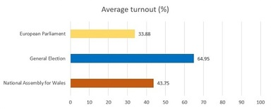
Figure 1 Average turnout by poll type
View description - Figure 1 Average turnout by poll type

6 Votes at 16
As part of an attempt to interest more young people in politics, the franchise was extended in 2019. The Senedd and Elections (Wales) Act granted 16- and 17-year-olds in Wales the right to vote in Senedd elections – although they have to be 18 to vote in local government elections, police and crime commissioner elections and UK parliament elections. It is believed the change will enfranchise up to 70,000 young people in Wales.

- Do you believe giving 16- and 17-year-olds the vote will drive up turnout in future elections?
- The number of 16- and 17-year-olds eligible to vote in an election is relatively small – 70,000 or 3% of the Welsh electorate. Those who oppose giving young people the vote often claim that this group is not interested in politics and would bring down turnout rates even further. The counter argument to this is that giving the vote to younger people could lead to lifelong engagement in politics. This is borne out in data from Austria, where the voting age was lowered in 2007. There is also some evidence to suggest that 16- and 17-year-olds turn out to vote more than 18 to 24-year-olds, and access a wider range of materials to inform their preference.

7 Section 3 summary
You have reached the end of the third and final section of this course. Before moving on to the conclusion, take a moment to reflect on what you have learned about Welsh voters, issues of identity and how these play in to the wider debate about devolution in Wales:
- Voters often express contradictory opinions about the political process in Wales, for example, believing it to have little meaningful impact on their lives while at the same time believing further powers should be devolved.
- A degree of apathy for the Welsh political process is perhaps illustrated by low voter turnout.
- Debates around Welsh politics are not moribund, with ongoing dialogue amongst Welsh voters about the need to abolish the devolved institutions or enhance their power further to the point of Welsh independence.

8 End of course summary
At the time of writing for this course in early 2021, Wales – like the rest of the world – was dealing with the fallout from Brexit and the impact of the Covid-19 pandemic.
Politicians were gearing up for the 2021 Senedd elections. Although neither was the majority view, there were two lively discussions ongoing.

Abolishing the Assembly
Following defections from the UKIP group elected in 2016, the Abolish the Assembly Party gained two Senedd Members. In January 2021, the party’s website stated that it ‘had one policy: Abolish the Assembly’. Its rationale for this position is that devolution has ‘failed to deliver for the people of Wales… standards of education in Welsh schools have fallen well behind other areas of the UK. The Assembly says the solution is to give them MORE powers. We say “never reinforce failure”’ (Abolish the Assembly, 2021).
In early 2021, several Welsh Conservative candidates expressed strong devo-hostile views, committing to reversing the devolution settlement, if elected.

Welsh Independence
Long a niche political position, support for independence increased significantly through 2020, rising to 33% in November of that year. This was attributed to the UK Government’s handling of Brexit and the Covid-19 pandemic, and a sense that an independent Welsh Government would be able to take decisions in the best interests of Wales. The real possibility of Scottish independence has prompted concerns that Wales risks being ‘left behind’.
Plaid Cymru have long called for Welsh independence – although some leaders have been more vocal in its promotion than others. In 2020, the Welsh Green party also backed a motion to support independence.

There is no clear majority consensus behind either view. It appears that a majority of Welsh voters are content with the status quo, choosing to back pro-devolution, unionist parties. However, both of these views are now part of mainstream political discussion. Both pro-independence and anti-devolution candidates are likely to be elected to the sixth Senedd.
Debates on how Wales should be governed look set to continue for many years to come. And what of the middle way, maintaining and perhaps improving the devolution settlement?
Undoubtedly, devolution in Wales is a work in progress and that work is not easy. Political change is difficult at the best of times, but politicians in Cardiff and Westminster are attempting to navigate their own party agendas to strengthen a devolution settlement which was built on unstable foundations.
As you have seen, a lack of enthusiasm from many politicians and the electorate hampered the early years of the Senedd, and it has proven very difficult to reverse that cynicism and spark interest and engagement. The pattern of review, report and reform between 2004 and 2016 sucked the energy out of the ordinary business of government.
That said, the Senedd is now more than 20 years old and it has achieved much to be proud of:
- In 2003, the National Assembly for Wales was the first legislature in the world to elect 50% female and 50% male representation.
- In 2007, Wales was the first part of the UK to introduce free prescriptions for all. This was intended to reduce health inequality.
- In 2011, a 5p levy on carrier bags was introduced. This resulted in an estimated 70% decrease in single use carrier bag consumption between 2011 and 2014.
- In 2013, the Human Transplantation (Wales) Act introduced a system of ‘deemed consent’ meaning that an individual has to opt out of organ donation as opposed to opting in. The aim of the Act is to increase the number of organs and tissues available for transplant.
In the early 2020s, the UK finds itself on a constitutional precipice with relations between the nations sorely tested. Northern Ireland has been caught in the rip-tides of Brexit and Scotland looks set for a second independence referendum. If the UK is redrawn, as seems increasingly likely, the Welsh position may well shift again. After all, devolution is a process and not an event.

Glossary
Barnett formula
The formula that dictates payments made from the UK Government to the Welsh and Scottish governments. The formula takes into account how much money is spent in England, the degree of devolution in particular areas e.g. health and education, and the relative populations of the countries.
D’Hondt method
Also known as ‘highest average’, a system for calculating seats won in an election.
Devo-sceptic
Also devo-hostile. A political position which generally opposes the existence of or extension to the powers of the devolved administrations.
Executive
The branch of government that sets the policy agenda, aiming to get policies passed by the legislature. The current Welsh Government is an example of an executive body – this was made law by the Government of Wales Act 2006.
First Minister
Leader of the Welsh Government. Responsible for policy, appointing ministers, chairing the Welsh Cabinet, and representing Wales at home and abroad. Accountable to the Senedd. Originally known as the First Secretary but this was changed in 2000.
Government of Wales Act (GoWA) (2006)
An act that separated the legislature and the executive in Wales and enabled the Assembly to pass primary law in 20 areas.
Holtham Commission
The Independent Commission on Funding and Finance for Wales, chaired by economist Gerald Holtham and commissioned in 2008. The Commission reported that the Barnett formula is out of date, and that some areas of taxation should be devolved.
Internal Market Bill
A controversial Brexit-related bill passed by the UK Parliament in 2020. The bill aimed to standardise regulations and strengthen the UK's internal market i.e. the way goods move between the four nations. Rejected in the Welsh and Scottish Parliaments, the bill received heavy criticism from many pro-devolution figures.
Legislative competence orders
Known as LCOs. A piece of constitutional legislation that would transfer legislative power from the UK Parliament to the National Assembly for Wales. LCOs had to be approved by the Assembly, both Houses of Parliament and the Secretary of State for Wales.
Legislative
The elected branch of government that scrutinises the executive and votes on laws. Examples of legislatures are Senedd Cymru, the House of Commons, and the US Senate.
MS
Member of the Senedd. Formerly referred to as an AM, or Assembly Member.
One Wales
The One Wales government was the result of a coalition between Labour and Plaid Cymru. In power between 2007 and 2011, with a Labour First Minister and a Plaid Cymru deputy.
Primary legislation
An act passed by a parliament. An act of Senedd Cymru is an example of primary legislation, as is the UK Internal Market Act. Within primary legislation there is a section dictating what changes can be made to the act by secondary legislation.
Quango
An acronym for ‘quasi-autonomous non-governmental organisation’. Examples include the Wales Centre for Public Policy think-tank and Literature Wales.
Rainbow coalition
A government formed of MSs from a range of parties. There were talks of a rainbow coalition between Plaid Cymru, the Conservatives and the Liberal Democrats after the 2007 election but this did not materialise.
Richard Commission
Led by Lord Richard and commissioned by Rhodri Morgan in 2002. The Commission's report recommended changes to the electoral system, the structure of the Assembly, and the powers of Cardiff lawmakers.
Secondary legislation
A piece of legislation that makes changes to an act. Initially, the National Assembly for Wales was only able to pass secondary legislation.
Senedd Cymru
Formerly known as the National Assembly for Wales, this 60-member parliament is elected every five years and is tasked with holding the Welsh Government to account.
Silk Commission
Led by Paul Silk and commissioned by the Secretary of State for Wales, Cheryl Gillan, following the 2010 general election. The first report focused on finance, and the second on the powers of the Assembly. Both reports called for greater devolution to Wales.
St David's Day Agreement
A 2015 policy announcement by the UK coalition government, led by David Cameron. The majority of the recommendations aimed to strengthen the devolution settlement, with many taken directly from the second Silk Commission report.
Supreme Court
The final court of appeal in the UK for civil cases and criminal cases from England, Wales and Northern Ireland. It also hears cases of constitutional importance including disputes between governments.
Third sector
The voluntary and non-profit sector, consisting of charities and organisations such as the Welsh Council for Voluntary Action.
Thomas Commission
The Commission on Justice in Wales, chaired by Lord Thomas and commissioned by Carwyn Jones in 2017. The Commission reported that the present legal system was letting people in Wales down, recommending legislative devolution of justice to the Assembly.
Wales Bill 2014
The bill that made much of the St David's Day Agreement into law. Notably the passing of the bill allowed the Assembly to raise money via taxation for the first time.
Wales Bill 2016
A controversial bill that eventually passed to form the Wales Act 2017. The passing of the bill marked a switch to a reserved powers model of devolution, as well as devolving elections and some powers over energy.
Barnett formula
The formula that dictates payments made from the UK Government to the Welsh and Scottish governments. The formula takes into account how much money is spent in England, the degree of devolution in particular areas e.g. health and education, and the relative populations of the countries.
D’Hondt method
Also known as ‘highest average’, a system for calculating seats won in an election.
Devo-sceptic
Also devo-hostile. A political position which generally opposes the existence of or extension to the powers of the devolved administrations.
Executive
The branch of government that sets the policy agenda, aiming to get policies passed by the legislature. The current Welsh Government is an example of an executive body – this was made law by the Government of Wales Act 2006.
First Minister
Leader of the Welsh Government. Responsible for policy, appointing ministers, chairing the Welsh Cabinet, and representing Wales at home and abroad. Accountable to the Senedd. Originally known as the First Secretary but this was changed in 2000.
Government of Wales Act (GoWA) (2006)
An act that separated the legislature and the executive in Wales and enabled the Assembly to pass primary law in 20 areas.
Holtham Commission
The Independent Commission on Funding and Finance for Wales, chaired by economist Gerald Holtham and commissioned in 2008. The Commission reported that the Barnett formula is out of date, and that some areas of taxation should be devolved.
Internal Market Bill
A controversial Brexit-related bill passed by the UK Parliament in 2020. The bill aimed to standardise regulations and strengthen the UK's internal market i.e. the way goods move between the four nations. Rejected in the Welsh and Scottish Parliaments, the bill received heavy criticism from many pro-devolution figures.
Legislative competence orders
Known as LCOs. A piece of constitutional legislation that would transfer legislative power from the UK Parliament to the National Assembly for Wales. LCOs had to be approved by the Assembly, both Houses of Parliament and the Secretary of State for Wales.
Legislative
The elected branch of government that scrutinises the executive and votes on laws. Examples of legislatures are Senedd Cymru, the House of Commons, and the US Senate.
MS
Member of the Senedd. Formerly referred to as an AM, or Assembly Member.
One Wales
The One Wales government was the result of a coalition between Labour and Plaid Cymru. In power between 2007 and 2011, with a Labour First Minister and a Plaid Cymru deputy.
Primary legislation
An act passed by a parliament. An act of Senedd Cymru is an example of primary legislation, as is the UK Internal Market Act. Within primary legislation there is a section dictating what changes can be made to the act by secondary legislation.
Quango
An acronym for ‘quasi-autonomous non-governmental organisation’. Examples include the Wales Centre for Public Policy think-tank and Literature Wales.
Rainbow coalition
A government formed of MSs from a range of parties. There were talks of a rainbow coalition between Plaid Cymru, the Conservatives and the Liberal Democrats after the 2007 election but this did not materialise.
Richard Commission
Led by Lord Richard and commissioned by Rhodri Morgan in 2002. The Commission's report recommended changes to the electoral system, the structure of the Assembly, and the powers of Cardiff lawmakers.
Secondary legislation
A piece of legislation that makes changes to an act. Initially, the National Assembly for Wales was only able to pass secondary legislation.
Senedd Cymru
Formerly known as the National Assembly for Wales, this 60-member parliament is elected every five years and is tasked with holding the Welsh Government to account.
Silk Commission
Led by Paul Silk and commissioned by the Secretary of State for Wales, Cheryl Gillan, following the 2010 general election. The first report focused on finance, and the second on the powers of the Assembly. Both reports called for greater devolution to Wales.
St David's Day Agreement
A 2015 policy announcement by the UK coalition government, led by David Cameron. The majority of the recommendations aimed to strengthen the devolution settlement, with many taken directly from the second Silk Commission report.
Supreme Court
The final court of appeal in the UK for civil cases and criminal cases from England, Wales and Northern Ireland. It also hears cases of constitutional importance including disputes between governments.
Third sector
The voluntary and non-profit sector, consisting of charities and organisations such as the Welsh Council for Voluntary Action.
Thomas Commission
The Commission on Justice in Wales, chaired by Lord Thomas and commissioned by Carwyn Jones in 2017. The Commission reported that the present legal system was letting people in Wales down, recommending legislative devolution of justice to the Assembly.
Wales Bill 2014
The bill that made much of the St David's Day Agreement into law. Notably the passing of the bill allowed the Assembly to raise money via taxation for the first time.
Wales Bill 2016
A controversial bill that eventually passed to form the Wales Act 2017. The passing of the bill marked a switch to a reserved powers model of devolution, as well as devolving elections and some powers over energy.
Barnett formula
The formula that dictates payments made from the UK Government to the Welsh and Scottish governments. The formula takes into account how much money is spent in England, the degree of devolution in particular areas e.g. health and education, and the relative populations of the countries.
D’Hondt method
Also known as ‘highest average’, a system for calculating seats won in an election.
Devo-sceptic
Also devo-hostile. A political position which generally opposes the existence of or extension to the powers of the devolved administrations.
Executive
The branch of government that sets the policy agenda, aiming to get policies passed by the legislature. The current Welsh Government is an example of an executive body – this was made law by the Government of Wales Act 2006.
First Minister
Leader of the Welsh Government. Responsible for policy, appointing ministers, chairing the Welsh Cabinet, and representing Wales at home and abroad. Accountable to the Senedd. Originally known as the First Secretary but this was changed in 2000.
Government of Wales Act (GoWA) (2006)
An act that separated the legislature and the executive in Wales and enabled the Assembly to pass primary law in 20 areas.
Holtham Commission
The Independent Commission on Funding and Finance for Wales, chaired by economist Gerald Holtham and commissioned in 2008. The Commission reported that the Barnett formula is out of date, and that some areas of taxation should be devolved.
Internal Market Bill
A controversial Brexit-related bill passed by the UK Parliament in 2020. The bill aimed to standardise regulations and strengthen the UK's internal market i.e. the way goods move between the four nations. Rejected in the Welsh and Scottish Parliaments, the bill received heavy criticism from many pro-devolution figures.
Legislative competence orders
Known as LCOs. A piece of constitutional legislation that would transfer legislative power from the UK Parliament to the National Assembly for Wales. LCOs had to be approved by the Assembly, both Houses of Parliament and the Secretary of State for Wales.
Legislative
The elected branch of government that scrutinises the executive and votes on laws. Examples of legislatures are Senedd Cymru, the House of Commons, and the US Senate.
MS
Member of the Senedd. Formerly referred to as an AM, or Assembly Member.
One Wales
The One Wales government was the result of a coalition between Labour and Plaid Cymru. In power between 2007 and 2011, with a Labour First Minister and a Plaid Cymru deputy.
Primary legislation
An act passed by a parliament. An act of Senedd Cymru is an example of primary legislation, as is the UK Internal Market Act. Within primary legislation there is a section dictating what changes can be made to the act by secondary legislation.
Quango
An acronym for ‘quasi-autonomous non-governmental organisation’. Examples include the Wales Centre for Public Policy think-tank and Literature Wales.
Rainbow coalition
A government formed of MSs from a range of parties. There were talks of a rainbow coalition between Plaid Cymru, the Conservatives and the Liberal Democrats after the 2007 election but this did not materialise.
Richard Commission
Led by Lord Richard and commissioned by Rhodri Morgan in 2002. The Commission's report recommended changes to the electoral system, the structure of the Assembly, and the powers of Cardiff lawmakers.
Secondary legislation
A piece of legislation that makes changes to an act. Initially, the National Assembly for Wales was only able to pass secondary legislation.
Senedd Cymru
Formerly known as the National Assembly for Wales, this 60-member parliament is elected every five years and is tasked with holding the Welsh Government to account.
Silk Commission
Led by Paul Silk and commissioned by the Secretary of State for Wales, Cheryl Gillan, following the 2010 general election. The first report focused on finance, and the second on the powers of the Assembly. Both reports called for greater devolution to Wales.
St David's Day Agreement
A 2015 policy announcement by the UK coalition government, led by David Cameron. The majority of the recommendations aimed to strengthen the devolution settlement, with many taken directly from the second Silk Commission report.
Supreme Court
The final court of appeal in the UK for civil cases and criminal cases from England, Wales and Northern Ireland. It also hears cases of constitutional importance including disputes between governments.
Third sector
The voluntary and non-profit sector, consisting of charities and organisations such as the Welsh Council for Voluntary Action.
Thomas Commission
The Commission on Justice in Wales, chaired by Lord Thomas and commissioned by Carwyn Jones in 2017. The Commission reported that the present legal system was letting people in Wales down, recommending legislative devolution of justice to the Assembly.
Wales Bill 2014
The bill that made much of the St David's Day Agreement into law. Notably the passing of the bill allowed the Assembly to raise money via taxation for the first time.
Wales Bill 2016
A controversial bill that eventually passed to form the Wales Act 2017. The passing of the bill marked a switch to a reserved powers model of devolution, as well as devolving elections and some powers over energy.

References
BBC News (2017) ‘Wales Act carries seeds of own destruction, says Rawlings’, BBC News, 5 March [Online]. Available at https://www.bbc.co.uk/news/uk-wales-politics-39159133 (Accessed 18 March 2021).
Department for Business, Energy & Industrial Strategy (2020) UK internal market (Cm 278) [Online]. Available at https://www.gov.uk/government/publications/uk-internal-market (Accessed 18 March 2021).
Institute for Government (2019) Tony Blair: Devolution, Brexit and the future of the Union [Online]. Available at https://www.instituteforgovernment.org.uk/sites/default/files/publications/tony-blair_0.pdf (Accessed 18 March 2021).
National Assembly for Wales (2015) Report on the UK Government’s Draft Wales Bill [Online]. Available at https://senedd.wales/laid%20documents/cr-ld10468/cr-ld10468-e.pdf (Accessed 18 March 2021).
RSHP (n.d.) Senedd Cymru, Welsh Parliament [Online]. Available at https://www.rsh-p.com/projects/national-assembly-for-wales/ (Accessed 18 March 2021).
Shipton, M. (2011) Poor Man's Parliament: Ten Years of the Welsh Assembly, Bridgend, Seren Books.
WalesOnline (2004) ‘Morgan hails “end of quangoland”’, WalesOnline, 14 July [Online]. Available at https://www.walesonline.co.uk/news/wales-news/morgan-hails-end-of-quangoland-2429876 (Accessed 18 March 2021).
BBC News (2013) ‘Increase number of AMs from 60 to 100, says report’, BBC News, 16 October [Online]. Available at https://www.bbc.co.uk/news/uk-wales-24540091 (Accessed 18 March 2021).
BBC News (2014) ‘Fewer than half the population know who runs Welsh NHS, says poll’, BBC News, 9 June [Online]. Available at https://www.bbc.co.uk/news/uk-wales-politics-27739205 (Accessed 29 March 2021).
The Commission on Justice in Wales (2019) Justice in Wales for the People of Wales [Online]. Available at https://gov.wales/sites/default/files/publications/2019-10/Justice%20Commission%20ENG%20DIGITAL_2.pdf (Accessed 18 March 2021).
Huckle, T. (2016) ‘Why Wales needs its own legal jurisdiction’, IWA, 7 April [Online]. Available at https://www.iwa.wales/agenda/2016/04/why-wales-needs-its-own-legal-jurisdiction/ (Accessed 18 March 2021).
Keep, W. (2020) The Barnett formula (House of Commons Library, No. 7386) [Online]. Available at https://commonslibrary.parliament.uk/research-briefings/cbp-7386/ (Accessed 18 March 2021).
McAllister, L. (2020) ‘Backing away from addressing the National Assembly for Wales' size at this moment in our national history is defeatist and dangerous’, WalesOnline, 1 February [Online]. Available at https://www.walesonline.co.uk/news/news-opinion/backing-away-addressing-national-assembly-17667591 (Accessed 18 March 2021).
Morgan, R. (2017) Rhodri: A Political Life in Wales and Westminster, Cardiff, University of Wales Press.
Stanford, P. (2014) ‘Scottish Referendum: “My Barnett Formula needs to be tackled now - but no politician will”’, Telegraph, 19 September [Online]. Available at https://www.telegraph.co.uk/news/uknews/scotland/11108848/Scottish-Referendum-My-Barnett-Formula-needs-to-be-tackled-now-but-no-politician-will.html (Accessed 18 March 2021).
Welsh Parliament (2017) Inquiry into News Journalism in Wales [Online]. Available at https://business.senedd.wales/mgConsultationDisplay.aspx?id=259&RPID=1525114741&cp=yes
Welsh Government (2017) First Minister establishes a Commission on Justice in Wales [Online]. Available at https://gov.wales/first-minister-establishes-commission-justice-wales (Accessed 18 March 2021).
Abolish the Welsh Assembly (2021) About [Online]. Available at https://www.abolishthewelshassembly.co.uk/about/ (Accessed 18 March 2021).
Public Attitudes to Devolution in Wales (2017) YouTube video, added by Cardiff University [Online]. Available at https://www.youtube.com/watch?v=5FjlZnfZrmc (Accessed 22 March 2021).
Scully, R., Wyn Jones, R. and Trystan, D. (2004) ‘Turnout, Participation and Legitimacy in Post-Devolution Wales’, British Journal of Political Science, vol. 34, no. 3, pp. 519-37 DOI: https://doi.org/10.1017/S000712340400016X (Accessed 18 March 2021).
Williams, R. and Williams, D. (ed.) (2003) Who Speaks for Wales?: Nation, Culture, Identity, Cardiff, University of Wales Press.

Further reading
Tony Blair interview: https://www.youtube.com/watch?v=JfDWxdRoQeI
Ron Davies reflects on designing Welsh devolution in a lecture hosted by the Wales Governance Centre: https://www.youtube.com/watch?v=Xsmx6-VSbXQ
Fiscal devolution information from the Welsh Parliament: https://research.senedd.wales/financial-scrutiny/fiscal-devolution-in-wales/
BBC Radio 4’s The Briefing Room 'Britain’s constitutional dilemma: who now runs the country?': https://www.bbc.co.uk/sounds/play/m0008p41
‘The State of the Union’ – Professor Linda Colley and Professor Richard Wyn Jones: https://www.youtube.com/watch?v=Lg8a0OWsU-Y
Want to find out more about devolution in Wales? There are two leading think-tanks in Wales working in this area:
The Institute of Welsh Affairs has an extensive archive containing lectures, book reviews and blogs containing information and commentary on the entire progress of the devolution process in Wales, and much other material relating to the Welsh economic and social context. The Institute’s Director from 1996 to 2013 was John Osmond, himself an influential figure in the campaign for Welsh devolution, and author of numerous books and articles on its progress.
The Bevan Foundation is an organisation concerned with issues of inequality, poverty and exclusion, and social justice in Wales. It produces substantial reports which can be freely downloaded from its website. Recent examples include a study of the future of the voluntary sector in Wales, and the second in a series of essays on the Welsh Senedd, examining the changing role of Assembly committees.
There are also two principal academic institutions carrying out work on Wales, much of which is publicly accessible:
The Wales Governance Centre at Cardiff University, carries out research into the law, politics, government and political economy of Wales, as well as into the wider UK and European contexts of territorial governance. As well as producing academic books and papers its website provides information and material relating to lectures, public meetings and events held by the Centre.
The Wales Institute of Social and Economic Research and Data funded since 2008 by the Economic and Social Research Council UK to carry out social science research and training relevant to Wales. It is a collaboration between five Welsh universities; many publications and reports by its members and associates can be accessed via the website.
The House of Commons Library and the Senedd Research Service both host a wealth of high-quality information and briefing on many aspects of devolution.

Acknowledgements

Introduction
Images
Course Image: (WT-shared) Cardiff at wts wikivoyage

Week 1
Images
Welsh Labour logo: courtesy of Welsh Labour
Plaid Cymru logo: courtesy of Plaid Cymru - Party of Wales
Welsh Conservatives logo: Copyright 2021 The Welsh Conservative Party
Welsh Liberal Democrats logo: courtesy of Liberal Democrats
UKIP Wales logo: courtesy of UKIP Wales
Figure 1: Crown Copyright; http://www.nationalarchives.gov.uk/doc/open-government-licence/version/3/
Figure 2: (c) The National Library of Wales 2015
Figure 4: courtesy of Welsh Labour
Figure 5: Llyfrgell Genedlaethol Cymru/The National Library of Wales 2021; Creative Archive License
Figure 7: top image: Anna Stowe / Alamy Stock Photo; UK Parliament; bottom image: https://www.parliament.uk/site-information/copyright-parliament/open-parliament-licence/
Figure 11: Senedd Cymru; Welsh Parliament
Video
Video 1: The Queen opens the first Welsh Assembly, 1999, BBC Wales Today, 27 May 1999

Week 2
Figure 1: © Crown copyright 2019, Welsh Government, WG39658
Figure 3: adapted from: https://en.wikipedia.org/wiki/File:Senedd_Oct_2020.svg
Video
Video 1: Senedd.tv; Commission copyright
Video 2: UK Parliament; https://www.parliament.uk/site-information/copyright-parliament/open-parliament-licence/

Week 3
Video
Images
This free course was written by Valerie Livingston. It was first published in March 2021.
It was adapted and expanded from a course on OpenLearn Create, The long road to Welsh devolution, written by Graham Day.
Except for third party materials and otherwise stated (see terms and conditions), this content is made available under a Creative Commons Attribution-NonCommercial-ShareAlike 4.0 Licence.
The material acknowledged below is Proprietary and used under licence (not subject to Creative Commons Licence). Grateful acknowledgement is made to the following sources for permission to reproduce material in this free course:
Except for third party materials and otherwise stated (see terms and conditions), this content is made available under a Creative Commons Attribution-NonCommercial-ShareAlike 4.0 Licence.
The material acknowledged below is Proprietary and used under licence (not subject to Creative Commons Licence). Grateful acknowledgement is made to the following sources for permission to reproduce material in this free course:
Every effort has been made to contact copyright owners. If any have been inadvertently overlooked, the publishers will be pleased to make the necessary arrangements at the first opportunity.
Don't miss out
If reading this text has inspired you to learn more, you may be interested in joining the millions of people who discover our free learning resources and qualifications by visiting The Open University – www.open.edu/openlearn/free-courses.

Solutions

Activity 1 Referendum (1979)

Discussion

Do you want the Provisions of the Wales Act 1978 to be put into effect?
Response | Votes | %
Yes | 243,048 | 20.26%
No | 956,330 | 79.74%

The referendum failed.
Back to - Activity 1 Referendum (1979)

Activity 2 Referendum (1997)

Discussion

Do you agree that there should be a Welsh Assembly as proposed by the Government?
Response | Votes | %
I agree that there should be a Welsh Assembly | 559,419 | 50.30%
I do not agree that there should be a Welsh Assembly | 552,698 | 49.70%

Back to - Activity 2 Referendum (1997)

Activity 3 Comparing Parliaments

Discussion
A great deal was made of how transparent the Scottish Parliament and National Assembly buildings would be. Showcasing the building on their website, architects Rogers Stirk Harbour + Partners said the Assembly:

employed the idea of openness and transparency as the driving factor in the design for the National Assembly for Wales, Cardiff. The building was conceived not to be an insular, closed edifice but a transparent envelope, looking outwards to Cardiff Bay and beyond, making visible the inner workings of the Assembly and encouraging public participation in the democratic process.
(RSHP, n.d.)

Back to - Activity 3 Comparing Parliaments

Activity 4 Referendum (2011)

Discussion

Do you want the Assembly now to be able to make laws on all matters in the 20 subject areas it has powers for?
Response | Votes | %
Yes | 517,132 | 63.49%
No | 297,380 | 36.51%

Back to - Activity 4 Referendum (2011)

Activity 1 Interview

Discussion
Key points from the interview:
- Most data suggests Welsh voters do not feel that devolution has made a substantial difference to life in Wales, but the majority believe it to be better than the alternative of no devolution.
- Welsh politicians are generally more trusted than their counterparts in England.
- There is an appetite for further devolution but a lack of clarity over what powers should be devolved – likely due to ongoing confusion as to which powers are devolved now following major changes to the devolution settlement over its first two decades.
- We can observe a link between Welsh identity and voting intention, with those who describe themselves most strongly as Welsh favouring Plaid Cymru, while those with a predominantly British identity are likely to back the Conservatives.
- Labour in Wales have successfully straddled both British and Welsh identities – something Professor Awan-Scully attributes their long-lasting political dominance to, in part.
- The movement of people born elsewhere in the UK into Wales has had an impact on Welsh identity as, while some of these people adopt a degree of Welsh identity, many others eschew it and avoid engagement with the devolved political institutions.
- The creation of Welsh political institutions has not created a greater sense of Welshness per se, but it has led to different expectations of how this identity is expressed, for example, in distinct political institutions.
- There has been an uplift in support for Welsh independence in the very early 2020s, which can be attributed to the concurrent period of instability in the UK Government from the Brexit fallout and the Covid-19 pandemic.
- At the same time, there has been a slight increase in devo-scepticism, with the rise of political parties advocating the abolition of devolution in Wales, and the resurgence of hostility towards devolution within the Welsh Conservatives.
Back to - Activity 1 Interview

Figure 1 ‘Vote yes on March 1st’

Description
This is a poster headlined with 'Vote yes on March 1st' in large colourful writing, with a drawing of a daffodil beneath. Alongside this is the following text: 'On March 1 the Government is asking you to give the go-ahead to the Welsh Assembly and so bring more democracy to Wales. The Assembly plans have now been debated in Parliament since 1974. In July 1978 the WALES ACT setting up the Assembly became law and was approved by the Queen. All that remains is for the Welsh people to give the green light to this major advance in the life of Wales. On March 1 you can ensure a stronger democratic Wales within the United Kingdom and Europe by voting YES for Wales.'
Back to - Figure 1 ‘Vote yes on March 1st’

Figure 2 ‘Why you should vote no’

Description
This is a poster headlined ‘Why you should VOTE NO’ in large green letters. Underneath is a list of 10 reasons, with an exclamation written beside each line as follows. Lines 1-2: ‘Your Country!’ 3-9: ‘Your Money!’ 10: ‘Your Interests!’ The list itself reads as follows: 1: By voting 'NO' you will be stopping the start of the slide down the slippery slope to the break-up of the United Kingdom. 2: Full independence is Plaid Cymru's main aim. 3: At present Government expenditure is over £167 per head higher in Wales than in England – do you want to lose this advantage. 4: The Assembly would cost £6.5 million to set up. 5: The Assembly would cost £12.5 million, and possibly more, to run. 6: The Assemblymen would be able to fix their own salaries, pensions and gratuities. 7: The Assemblymen would be able to appoint as many officers as they like. 8: The Assemblymen would need at least another 1,150 Civil Servants. 9: The Assembly would mean yet another tier of Government – more money. 10: Welsh M.P.s will no longer have the power to decide on matters of education, housing and health. Underneath is the text: ‘Keep Britain united by voting 'NO' on Thursday 1st March.’
Back to - Figure 2 ‘Why you should vote no’

Figure 3 Referendum ballot

Description
This image recreates a referendum ballot, written in both English and Welsh, which reads as follows: Parliament has decided to consult the electorate in Wales on the question whether the Wales Act 1978 should be put into effect. / Mae'r Senedd wedi penderfynu ymgynghori ag etholwyr Cymru ynglyn â ddylid gweithredu Deddf Cymru 1978. DO YOU WANT THE PROVISIONS OF THE WALES ACT 1978 TO BE PUT INTO EFFECT? / A YDYCH AM I DDARPARIAETHAU DEDDF CYMRU 1978 CAEL EU GWEITHREDU? Put a cross (X) in the appropriate box. / Rhowch groes (X) yn y blwch cymwys. YES / YDWYF NO / NAC YDWYF
Back to - Figure 3 Referendum ballot

Figure 4 ‘Wales deserves a voice’

Description
This is an article written in both English and Welsh, titled 'Wales deserves a voice / Mae Cymru'n haeddu cael llais'. There is a photograph of Prime Minister Tony Blair in the centre, with a letter from him underneath. The letter is headed ‘Wales has the chance to vote for a new future’ and reads as follows: ‘On May 1 Labour gained its best ever result in a general election, including seven Labour gains in Wales. Millions of people were attracted to Labour by our promise to transform Britain. In just a few months we have changed the direction, feel and pace of government – new legislation on schools, hospitals and law and order – showing that Britain can be better. And now we are giving the people of Wales the chance to vote in the referendum for a Welsh Assembly. I want you to vote yes for a strong voice for Wales in a modern constitution. Say 'yes' to a new Wales. Wales deserves it.’ It is then signed from Tony Blair. The article is written with the English text on the left, and the Welsh on the right. The English text reads as follows: ‘A Welsh Assembly is part of new Labour's vision for a modern Britain. It will give Wales the recognition it deserves. Labour's new Assembly will give Wales: A better health service – by ensuring that scarce resources are spent on nurses not bureaucrats and red tape. Better schools – by setting tough new standards for literacy, numeracy and overall achievement.. Better job opportunities – by providing a voice in Europe and around the world, to attract investment and back Welsh companies. Better democracy – by ensuring that decisions about local schools and hospitals are made by people elected in Wales not behind closed doors in London. Better value for money – by bringing Welsh quangos to public account and scrutinising spending decisions.’ The Welsh text reads as follows: ‘Rhan o weledigaeth Llafur newydd i gael Prydain fodern yw Cynulliad Cymreig. Bydd yn rhoi i Gymru y gydnabyddiaeth y mae'n ei haeddu. Bydd Cynulliad newydd Llafur yn rhoi'r rhain i Gymru: Gwell gwasanaeth iechyd – drwy sicrhau y caiff adnoddau prin eu gwario ar nyrsys ac nid ar fiwrocratiaid a biwrocratiaeth. Gwell ysgolion – drwy bennu safonau newydd a llym ar gyfer llythrennedd, rhifedd a chyrhaeddiad yn gyffredinol. Gwell cyfle i gael gwaith – drwy ddarparu llais yn Ewrop ac o amgylch y byd, i ddenu buddsoddiadau a chefnogi cwmnïau Cymreig. Gwell democratiaeth – drwy sicrhau mai pobl a etholwyd yng Nghymru, ac nid pobl y tu ôl i ddrysau caeëdig yn Llundain, sy'n gwneud y penderfyniadau ynghylch ysgolion ac ysbytai lleol. Gwell gwerth am yr arian – drwy sicrhau bod cwangos Cymru'n atebol i'r cyhoedd, ac archwilio'r penderfyniadau ar wario.’
Back to - Figure 4 ‘Wales deserves a voice’

Figure 5 ‘Just say no’

Description
This is a poster that reads 'just say no' in very large green and red letters. The 'just say' runs vertically up the side of the 'no' so it doesn't take up much space. The 'no' then takes up approximately 80% of the poster.
Back to - Figure 5 ‘Just say no’

Figure 6 Referendum ballot

Description
This image recreates a referendum ballot, written in both English and Welsh, which reads as follows: Parliament has decided to consult people in Wales on the Government's proposals for a Welsh Assembly. / Mae'r Senedd wedi penderfynu ymgynghori pobl yng Nghymru ar gynigion y Llywodraeth ar gyfer Cynulliad i Gymru. Put a cross (X) in the appropriate box. / Rhowch groes (X) yn y blwch priodol. I AGREE THAT THERE SHOULD BE A WELSH ASSEMBLY / YR WYF YN CYTUNO Y DYLID CAEL CYNULLIAD I GYMRU. OR / NEU. I DO NOT AGREE THAT THERE SHOULD BE A WELSH ASSEMBLY / NID WYF YN CYTUNO Y DYLID CAEL CYNULLIAD I GYMRU.
Back to - Figure 6 Referendum ballot

Figure 7 Comparing Parliaments: Welsh (top image) and UK (bottom image)

Description
This is a composite of two photos comparing the Welsh and UK Parliaments. The Welsh Parliament image shows the siambr or debating room, a round room surrounded by glass. Work stations are arranged on wide curved desks, with all members facing the middle of the room. Each work station has a computer and chair. The UK Parliament image shows the House of Commons, a high-ceilinged rectangular room resembling a chapel. The central aisle separates the two areas of seating, which are wide green benches. These two seating banks face each other across the aisle.
Back to - Figure 7 Comparing Parliaments: Welsh (top image) and UK (bottom image)

Figure 8 ‘It's time to say “yes”’

Description
This is a screenshot from a website set up by Yes for Wales. The banner image shows a cartoon megaphone with a speech bubble: 'It's time to say "Yes"'. Underneath the banner there are buttons linking to other sections of the website, labelled with the text: 'What is the vote all about? Let us explain it in plain English' and 'Who Says Yes? See who is supporting a Yes vote'.
Back to - Figure 8 ‘It's time to say “yes”’

Figure 9 ‘Say “no” to direct law-making power for the National Assembly for Wales’

Description
This is a screenshot from a website set up by True Wales. Its headline is 'No More Law-Making Power for the Welsh Assembly'. Underneath there is a heading 'Unlocking the puzzle' and the following sections: 'The referendum is about deciding what is the best for Wales', 'What power are these Failures seeking?' and 'What is the 'Yes' campaign promising?'
Back to - Figure 9 ‘Say “no” to direct law-making power for the National Assembly for Wales’

Figure 10 Referendum ballot

Description
This image recreates a referendum ballot, written in both English and Welsh. The English version reads as follows: Referendum. Vote (X) in one box only. The National Assembly for Wales: what happens at the moment. The Assembly has powers to make laws on 20 subject areas, such as: agriculture, education, the environment, health, housing, local government. In each subject area, the Assembly can make laws on some matters, but not others. To make laws on any of these other matters, the Assembly must ask the UK Parliament for its agreement. The UK Parliament then decides each time whether or not the Assembly can make these laws. The Assembly cannot make laws on subject areas such as defence, tax or welfare benefits, whatever the result of this vote. If most voters vote 'yes' – the Assembly will be able to make laws on all matters in the 20 subject areas it has powers for, without needing the UK Parliament's agreement. If most voters vote 'no' – what happens at the moment will continue. Question: Do you want the Assembly now to be able to make laws on all matters in the 20 subject areas it has powers for? YES / NO The Welsh version reads as follows: Refferndwm. Pleidleisiwch (X) mewn un blwch yn unig. Cynulliad Cenedlaethol Cymru: yr hyn sy'n digwydd ar hyn o bryd. Mae gan y Cynulliad bwerau i lunio deddfau mewn 20 maes pwnc, megis: amaethyddiaeth, addysg, yr amgylchedd, iechyd, tai, llywodraeth leol. Mae'r Cynulliad yn gallu llunio deddfau ar rai materion ym mhob maes pwnc ond nid ar faterion eraill. Er mwyn llunio deddfau ar unrhyw un o'r materion eraill hyn, mae'n rhaid i'r Cynulliad ofyn am gytundeb Sendd y DU. Yna, mae Senedd y DU yn penderfynu bob tro a gaiff y Cynulliad lunio'r deddfau hyn neu beidio. Ni all y Cynulliad lunio deddfau mewn meysydd pwnc fel amddiffyn, trethi neu fudd-daliadau lles, beth bynnag fo canlyniad y bleidlais hon. Os bydd y rhan fwyaf o bleidleiswyr yn pleidleisio 'ydw' – Bydd y Cynulliad yn gallu llunio deddfau ar bob mater yn yr 20 maes pwnc y mae ganddo bwerau ynddynt, heb orfod cael cytundeb Senedd y DU. Os bydd y rhan fwyaf o bleidleiswyr yn pleidleisio 'nac ydw' – Bydd yr hyn sy'n digwydd ar hyn o bryd yn parhau. Cwestiwn: A ydych yn dymuno i'r Cynulliad allu llunio deddfau ar bob mater yn yr 20 maes pwnc y mae ganddo bwerau ynddynt? YDW / NAC YDW
Back to - Figure 10 Referendum ballot

Figure 11 Fiscal devolution (you can find a link to more information in the Further Reading section)

Description
This is a screenshot of some financial information from the Welsh Government. It shows areas where, on the website, information boxes can be revealed about various tax developments from recent years. A diagram at the bottom of the screenshot shows numerous income streams – Welsh Block Grant, Non-domestic rates, Welsh Rates of Income Tax, Land Transaction Tax, Landfill Disposals Tax, Borrowing – all leading into a block labelled 'Welsh budget'. Within this diagram, Welsh Rates of Income Tax, Land Transaction Tax and Landfill Disposals Tax are specifically labelled as 'Devolved Taxes'.
Back to - Figure 11 Fiscal devolution (you can find a link to more information in the Further Reading section)

Figure 1 Where does Wales get its money from?

Description
This diagram is headed 'Welsh Government Funding 2020-2021', and shows a breakdown of various funding sources. The largest is 'Funding from UK Government' at £14.7 billion* or 80%. The asterisk marks this footnote: '*Does not include annually managed expenditure (AME) or non-fiscal DEL'. The next largest funding segment is 'Welsh Rates of Income Tax' at £2.2 billion or 12%. Next is 'Non-Domestic Rates' at £1.1 billion or 6%. And finally 'Fully Devolved Taxes' at £281 million or 2% – this is broken down into 'Land Transaction Tax' at £245m, and 'Landfill Disposals Tax' at £36m. Underneath this diagram is the text 'Capital borrowing by Welsh Government: £125m / Planned repayment of capital borrowing: £6m. Planned use of Wales' revenue reserves: £125m.'
Back to - Figure 1 Where does Wales get its money from?

Figure 2 Barnett formula calculation

Description
This image shows the Barnett formula calculation as a formula: Change to the UK Government department's budget (DEL) x Comparability percentage x Appropriate population proportion x Needs-based factor (Wales).
Back to - Figure 2 Barnett formula calculation

Figure 3 Calls for increase in AM numbers

Description
This is an animated GIF which visually demonstrates the proportion of the recommended expansion to the Senedd. It begins with 60 shaded circles arranged in a rainbow shape. A row of 20 additional circles then appears around the top.
Back to - Figure 3 Calls for increase in AM numbers

Figure 1 Average turnout by poll type

Description
This graph shows the statistics from Table 1 boiled down to show average turnout by poll type: General Elections have the highest average turnout (64.95%). This is followed by National Assembly for Wales (43.75%), and then European Parliament (33.88%).
Back to - Figure 1 Average turnout by poll type

Video 1 The Queen opens the first Welsh Assembly (1999)

Transcript
NARRATOR
This was a royal rather than a state opening, but the open top carriage procession to Cardiff Bay kept some traditions alive. The Queen has opened countless Parliaments during the past half century, but surely none like this.
DAFYDD ELIS-THOMAS
We invite you all to join with us. You are here in the Chamber of the National Assembly for Wales, to celebrate this historic occasion.
NARRATOR
The Queen said the Assembly would extend a bridge into the future, a beginning and an opportunity.
QUEEN ELIZABETH II
This opening today marks a new and significant direction in the way Wales is governed. It is a moment of renewal, true to the spirit of Wales.
NARRATOR
The Prince of Wales spoke in Welsh of his heartfelt good wishes for the pioneers, the 60 new Assembly Members. The Queen signed a special edition of the Government of Wales Act, the bound volume a symbol of the transfer of powers from Westminster to Wales.
Charlotte Church, the 13-year-old soprano from Cardiff, sang a poem about the Assembly written by a Carmarthen schoolboy, Aaron Pritchard.
For the politicians, a sense of history – and humility.
ALUN MICHAEL
The low turnout in the Assembly elections shows that many people are still at best agnostic about the value of the Assembly. We must convince people – by the way we conduct ourselves, and by the decisions we take – of the value of the Assembly, and our capacity to improve their lives.
DAFYDD WIGLEY
The eyes of Wales are upon us. The people expect us to make a difference to their lives, and to the lives of their children. The eyes of the world are upon us too.
NARRATOR
Two 18-year-olds from Aberystwyth presented the Assembly Twls, a symbol made from the coal and steel of Wales' industrial past. But today was more about the future.
CHILD 1
It's because it's the final chance for Wales to make their own decisions rather than London.
CHILD 2
The Assembly is important because it gives the people of Wales a voice of their own.
CHILD 3
This is a historic day for Wales because we haven't had a government for 600 years.
NARRATOR
And later the Prime Minister arrived to join in the celebrations.
TONY BLAIR
We are proud to have been a government that's delivered it, but I think that this is really a day to celebrate Wales, to celebrate the partnership that we have, and to make sure that that partnership continues to deliver for people.
DAVID CORNOCK
This was a relaxed, informal opening ceremony, far removed from the trappings of Westminster. The 60 new Assembly Members are determined that it will usher in a new type of politics for the 21st century. David Cornock, BBC Wales Today, the National Assembly for Wales.
Back to - Video 1 The Queen opens the first Welsh Assembly (1999)

Video 1 Local government discussion

Transcript
PRESIDING OFFICER
Cwestiwn pump, Lynne Neagle.
LYNNE NEAGLE
Can the Minister provide a statement on funding pressures in local government?
JULIE JAMES
Certainly – the Welsh Government is committed to protecting local government and the services they provide. Local government in all areas of Wales have received the best possible state settlement with the 1% reduction announced at the 2018/19 final budget turning to a 0.2% increase this year.
LYNNE NEAGLE
Minister, due to Tory austerity, Torfaen council has had no option but to increase council tax this year in order to protect vital services, namely social care and education. I'm very proud that in Torfaen we have a Labour council that is prepared to take those decisions to protect our local services. The leader of UKIP knows nothing about the financial pressures facing the local authority in Torfaen, and I am sure that you would agree with me, Minister, that all the low hanging fruit is now gone in local authorities, and they are facing a genuine struggle to survive. Last week, the Leader of Torfaen told the Children, Young People and Education Committee that he had protected education as he believes it is a key preventative service. I very much agree with that view. Do you agree with that view, Minister? And given the very hard-hitting evidence the committee has received about the funding pressures in schools, what steps will you take to ensure that education is prioritised in the next budget round?
JULIE JAMES
Yes, I absolutely welcome the prioritisation which Torfaen and indeed many other authorities are giving to education and social services, in what is indeed a very difficult settlement for most local authorities. We recognise the challenges for authorities and the difficult choices they're making, as I said earlier on savings and changing services, and the decisions they're having to make on council taxes in order to balance the budget. As I said, in between the indicative settlement and the actual settlement we managed to increase the funding for local government to reflect some of the specific priorities that they had stressed to us, around education and social services, and we certainly do welcome that priority. But there's no doubt that austerity is biting deep into local services, and very difficult choices have to be made across all councils.
MOHAMMAD ASGHAR
Minister, the leader of Caerphilly Council said recently that the authority was at the end of their tether after a receiving a real downturn in its funding. As a result, residents of Caerphilly have seen their council tax increase by nearly 7% combined with a £14 million cut in council services. These cuts to services include Pontllanfraith leisure centre which could close by end of June this year, in spite of fierce opposition from the local community. Does the minister accept that her poor local government settlement will have a serious and detrimental effect on Welsh Government strategies for the health, education and wellbeing of people living in Caerphilly, please?
JULIE JAMES
Local authorities will receive £4.2 billion of general funding to spend on services in 2019/20, and core funding will increase by 0.2% on a like-for-like basis compared to 2018/19, and in line with our programme for government commitment to provide funding for a settlement floor, the settlement includes £3.5 million fully funded by the Welsh Government to ensure that no authority has to manage with a reduction more than 0.3% in its aggregate external finance next year. We have done the very best we can to put an umbrella over our local authorities and their services from the incredibly cruel austerity programme implemented by the Conservative government that Mohammad Asghar supports and presumably voted for. The idea that you can separate out a decision to continue with an austerity programme for 9 years from the destruction of local services in your local authority is quite extraordinary, and you really need to look at looking to see what the unintended consequences of your own policies are on the services that you're talking about before you look anywhere else. Because there is absolutely no doubt that, as Lynne Neagle just said, there is no low hanging fruit here, we are cutting into the bone of services which local people, as he has rightly said, really, really value, and they don't want those services closed, and the only way of stopping that happening is to reverse the very cruel austerity programme that your government has been implementing.
Back to - Video 1 Local government discussion

Video 2 The UK Government response

Transcript
CHRIS PHILP
The member moving today's motion made a case for what essentially amounts to full devolution of justice functions to Wales, in line with the recommendations of the report which Lord Thomas recently published. I would like to respectfully disagree with her conclusion that wholesale devolution of justice to Wales would be in the interests of Wales, for, broadly speaking, two or three different reasons.
Let me start with her argument that there should be a congruence between the parliament of Wales and the justice jurisdiction of Wales, so that the justice system matches the laws. I think that argument-- to avoid this jagged edge that Lord Thomas refers to in his report. I don't think that argument is a wholly valid one, because of course many laws, indeed actually most laws that apply in Wales are reserved matters which have been legislated on in this parliament. In fact if you look at the laws that have been passed in the 11 years since 2008, the Welsh parliament has passed 62 new laws, this parliament has passed 600, the vast majority of which do also apply to Wales. And if you look at the law on reserved matters, the very fabric of the legal system, so legal principles such as criminal responsibility and capacity, mental elements of offences, criminal liability, sentencing, the law relating to homicide, sexual offences and offences against the person, are all reserved matters where UK, rather England and Wales law, applies. So, devolving justice in the context of a body of law which remains majority England and Wales would actually in my view exacerbate, it would worsen the jagged edge problem that the right honourable Lady referred to, because it would then apply to these reserved matters which are far larger in number than the matters which have been lesiglated for at the Welsh level, separately. And indeed it would be further exacerbated because the Thomas Report, interestingly, does not recommend that the legal profession and its regulation and its qualifications be separated. It recommends they remain the same. So if you were to devolve justice to Wales, you would have a further incongruity in that you would have a single legal profession with the same qualifications across two different systems, so I think that would be a further exacerbating jagged edge.
Now some members speaking today have referred to the interface between justice and other devolved issues, and in particular education and health, which are obviously devolved matters, they've been mentioned in particular. And I was talking to a very senior official working in the Ministry of Justice's Welsh department, dealing with day-to-day justice matters. And I put this question to that official. And their view was that it would make no real difference whether justice was devolved or not, to that interface between justice and education/health. Whether education and health are being run in Wales and you're talking to them with an England and Wales MoJ, or a Welsh MoJ, that interface between departments would still exist, whether the MoJ sat under an England and Wales umbrella, or a Wales-only umbrella.
This report was commissioned by the Welsh government, in fact by the previous First Minister of Wales. It wasn't commissioned by the UK government, so there is not an intention to produce a full and formal response to the Thomas Report. However, what of course we are going to do, is discuss the issues that it raises in detail with the Welsh government in Cardiff, to see where we can constructively improve our working relationships across some of the issues that are raised. And the honourable Lady has touched on a couple of those already. So we do want to improve the level of cooperation that we have with the Welsh government, we do want to make sure that where there is joint working, and where there is an interface – with for example with the health system that many members have mentioned – that is working as well as it can. That we are cooperating, we are reflecting some of the unique circumstances in Wales. So those conversations will certainly happen, we'll approach them with a constructive and an open mind. But I can say as I said a moment ago, that we don't agree, I'm afraid, with the conclusion that we should wholly devolve justice and create a Welsh jurisdiction. And one of the reasons for that actually is the second point I was about to come on to before the intervention, which is the question of cost. Now the Thomas Report actually doesn't talk about the question of cost at all, and perhaps the reason for that is there is a very significant cost. Now the Silk Commission which reported a few years ago, I think in 2014, did cost the establishment of a separate Welsh jurisdiction, and they estimated – and adjusting for changes that have happened since – the extra cost, the incremental cost of creating a separate jurisdiction would be about £100 million a year. Now that is £100 million which could be spent on more probation officers, more police, all of the things we've been talking about, and we don't feel that the imposition of that extra cost is at all justified. For example, you would have to replicate the Ministry of Justice's own functions at the Welsh level. Wales doesn't have a women's prison, which of course itself is an issue, or a Category A prison. All of these issues will have to be addressed. The MoJ is currently hugely upgrading its IT systems, and there are obviously economies of scale. If a Welsh Ministry of Justice had to do that itself, obviously that would be extremely expensive. And that cost of £100 million a year we don't believe can be justified.
I would also say that devolution in itself is no panacea. It doesn't automatically solve problems. It's obviously been well documented that in areas of for example education, where per capita spending in Wales is much higher than in England, educational outcomes are nonetheless worse, so the idea that devolving something somehow automatically makes it better, I don't think necessarily holds.
I've said already, Mr. Stringer, that we don't concur with the Thomas Report's principal conclusion that justice should be wholly devolved. But we are going to work closely with the Welsh government to ensure justice policies are aligned, and to take into consideration distinct Welsh needs. Taking for example the recent transfer of probation services in Wales to the national probation service, this is a clear example of distinct justice policy in Wales that can be achieved under the current settlement. And joint MoJ–Welsh government blueprints on youth justice and female offenders were published last year. A successful example of co-development of strategies across the devolution boundary. Welsh prisons perform well when compared with their counterparts in England, and Welsh law firms benefit from being part of a world-renowned justice system. The justice landscape in Wales is faring well. That said, we absolutely agree that the administration of justice in Wales requires regular review to ensure the needs of Wales are being met. In addition to ensuring that justice policies are designed with Wales in mind, we regularly evaluate the wider arrangements to ensure they are fit for purpose. Honourable members will be aware that during the passage of the Wales Act 2017, the government committed to undertake a regular review of justice in Wales. An advisory committee was established in 2018 comprising the judiciary, legal profession, legal regulators, operational delivery arms as well as members of the Welsh and UK governments. The committee published a report in July last year which made a number of recommendations about the justice system in Wales, particularly around accessibility of law and the management of divergence, and we are taking those recommendations forward. Mr. Stringer, the Welsh government's decision to commission Lord Thomas to undertake a review was founded on the basis it believed there was ‘unfinished business’ from the Silk Commission, to use their words. On the contrary – the decision that Wales should continue to be part of the single jurisdiction by the Silk Commission was reached after careful consideration of the merits for and against devolution, and it is our firm view that the current settlement works best for Wales.
Back to - Video 2 The UK Government response

Audio 1 Interview with Roger Awan-Scully

Transcript
VALERIE LIVINGSTON
Hello and welcome to the third and final part of this Open University OpenLearn course, Understanding devolution in Wales. I'm Valerie Livingston, course author, and today I'm joined by Professor Roger Awan-Scully. Roger is Professor of Political Science at Cardiff University and Chair of the Political Studies Association. His work focuses on devolution, elections and voting, and in this part of the course we're considering just that: voters in Wales. So Roger, thank you very much for joining us.
ROGER AWAN-SCULLY
Glad to do so.
VALERIE LIVINGSTON
So can I just kick off by asking: are voters in Wales impressed by what has been achieved under devolution?
ROGER AWAN-SCULLY
I think for the most part, if you look at the detailed evidence that's been gathered in various academic studies and other polls, the answer is for the most part, not very impressed. Certainly if you look at voters' evaluations of the performance of the Welsh Government in major policy areas like the economy, health and education, most studies that have asked questions along those lines find that the most popular answer amongst voters is that they don't think devolution's really made any substantial difference. Some people certainly think that devolution's improved things. Some people, normally slightly fewer, think that it's made things worse. But I think when you're thinking about the policy achievements of devolution, we also have to think of the alternative – do people think that things would have been better off without devolution, still under the control of Westminster? – and for the most part the majority of people don't seem to believe that.
VALERIE LIVINGSTON
So is it fair to say that politicians in Cardiff are more trusted than those in London to be focused on Welsh issues?
ROGER AWAN-SCULLY
Yes they are, I mean a number of studies have explored this. In fact, one or two have found at least some tentative evidence that politicians in Cardiff Bay are more trusted than those in London in general, you know slightly more trusted, for instance, to behave with integrity and probity, which may reflect some continuing legacy of scandals like the parliamentary expenses scandal about a decade ago. But I think what is particularly a strength of the devolved institutions in terms of public attitudes towards them, is the broad sense amongst many people in Wales, [inaudible] the majority of people in Wales, that these politicians, they may be more or less good or whatever, but they are at least Welsh politicians in a Welsh institution focused on Welsh problems, which for the most part, people in Wales don't see Westminster as being like that.
VALERIE LIVINGSTON
So with that in mind, are there further powers which voters in Wales would like to see devolved to the Welsh Parliament?
ROGER AWAN-SCULLY
Well, when we ask various forms of questions about attitudes to devolution, we commonly find a large proportion of people in Wales, often a majority, say that they want more powers for the devolved Senedd. When we start to look at which specific powers, though, I think things often get significantly more vague. I think many voters are far from entirely clear, perhaps understandably, about what powers exactly are devolved now. And following from that, fairly logically, is that they may well also be a little bit vague as to what additional powers that they might want to be devolved, so there's a broad sense amongst what a lot of people in Wales, and a majority in some polls, that they'd like further devolution. But exactly what further devolution tends to be much more vague.
Some studies have asked people about specific policy areas, so you know: should this area be controlled by the Senedd and the Welsh government, or Westminster and the UK Government. We've tended to find that – and this has been a consistent finding for a decade and more – the majority of people in the main devolved areas of education and health still want those to be devolved. The majority of people in, I suppose, classic statewide government responsibilities like defense and foreign affairs still want those to stay with the UK level. What you tend to see a rather more interesting picture on is things like policing and criminal justice, which of course are devolved in Scotland and Northern Ireland, but are not devolved in Wales. And those studies have tended to stress a narrow but clear margin of people actually favouring those becoming devolved responsibilities, those powers being shifted from Westminster to the Senedd.
VALERIE LIVINGSTON
So, should Welsh political parties want to see further powers devolved, then that's really incumbent on them to communicate what the current devolution settlement is, and then make the case for those further powers?
ROGER AWAN-SCULLY
Well, I think many voters are, very understandably, quite vague about the shape of the current Welsh devolution settlement. Because in some senses, you know, the term ‘settlement’ is really a misnomer. I mean, the one thing that Welsh devolution hasn't really been since '99 is settled. We've had an evolving series of different dispensations, and the powers that the Senedd and the Welsh government discharges now are very different from what they were two decades ago, so I think you could be very forgiving of voters for being pretty vague as to what is devolved and what isn't. Because I think, you know, it was a common problem, certainly in the first Senedd, that many of the politicians didn't really know what it was that they could do with the powers they had, and what powers were those. So if the politicians didn't know, I think the ordinary people could certainly be forgiven for not having more than the vaguest idea of what devolution actually allowed politicians in Cardiff Bay to do.
VALERIE LIVINGSTON
Indeed, and that process of review and reform and further legislation from the Westminster government is something we considered in some depth in the first part of this course, and perhaps the unsettled nature of the settlement links back to my first question about how impressed voters are by what they've seen under devolution. Moving on to a slightly different topic: is there an observable link between Welsh identity and voting intention?
ROGER AWAN-SCULLY
Yes there is. You can see very clearly that those with a stronger Welsh identity are more likely to vote Plaid Cymru than those without. Similarly you see those in Wales with a strong British identity are significantly more likely to vote Conservative than those without. Possibly the most interesting party in terms of identity is the Labour Party, which has been largely successful for many decades in sort of straddling the identity divide, and being able to be relatively appealing both to those with a predominantly British sense of identity – well, those with a predominately Welsh sense of identity – as well as those for whom strong Welsh and strong British identity are fully compatible, and I think that's a big part of Labour's long-term dominance in Welsh politics, its ability to appeal right across the spectrum of identities. But overall, I mean, there is clearly a significant and quite substantial link between Welsh identity, and those with a strong Welsh identity are substantially less likely in particular to vote Conservative, much more likely to be voters for either the Welsh Labour Party or for Plaid Cymru.
VALERIE LIVINGSTON
And has that shifted at all? Has the creation of Welsh institutions, a parliament and a government over the last 20 years created or maybe contributed to a sense of Welshness?
ROGER AWAN-SCULLY
Well, if you just ask basic questions about what sort of identity do people feel, then the answer that question is no. I think one of the things that many people thought would happen is, you create a Welsh level of government, Welsh institutions, and that leads to a big surge in senses of Welsh identity. And in fact, that is really not observable in the data, I mean, to the extent that we can go back on the very limited data available. In fact, Welsh identity was every bit as strong in the 1970s, when Wales overwhelmingly voted against devolution, as it was say in 2011, when Wales voted to give more powers to the devolved institution, or as it is today, so there's been no really observable overall rise in Welsh identity. What I think has changed is the implications that people, many people feel for their identity, and so I think way back in the 1970s, for instance, most people in Wales who had a Welsh identity did not necessarily see any need for that identity to be reflected in a distinctive level of government or distinctive political institutions. In just the same way, perhaps as many people say, with a Yorkshire identity might not feel the need for that to be embodied in a Yorkshire parliament in Yorkshire government. What started to change I think in the late 1980s, continued to change afterwards, and has changed even further in the years after the Assembly – as it was – was created, has been, far more of those people with a Welsh identity have come to believe that that identity should be reflected in a distinctive autonomous level of Welsh governments, and a representative Welsh Parliament.
VALERIE LIVINGSTON
And have changing demographics in Wales had any impact on this? For example, the increasing numbers of young people in Welsh medium education.
ROGER AWAN-SCULLY
Well, I think one demographic that we certainly do see as having an impact, of course, is the large number of people – of whom I'm one – who come from elsewhere in the United Kingdom and make Wales their home. Some of them, of course ‘go native’ as it were, you know, maybe learn a bit of Welsh, take on some degree of Welsh identity, but those members of the Welsh population who are born elsewhere in the UK, particularly the large proportion of those who are born in England, tend to be particularly likely to be those who don't have a sense of Welsh identity, who often indeed don't particularly engage with Welsh level news, are less likely to turn out to vote in Senedd elections. And overall, among the least likely to really engage with Welsh level politics, with Welsh institutions, and maybe even more broadly, with Welsh culture and language more generally.
VALERIE LIVINGSTON
So at the time of recording of this interview in early 2021, we saw that support for Welsh independence was increasing. What are the reasons for this?
ROGER AWAN-SCULLY
Yeah, we certainly have seen something of an increase in support for Welsh independence, broadly speaking, over the last three years. Now, I think some people have overstated the degree of that rise. Depending on how you ask the question, though, support for Welsh independence has gone up for instance, on a simple ‘would you vote for it in a referendum?’ from about 15, 16% a few years ago, up to the low to mid 20s, and once you take out the ‘don't know’s, it's up to around 30, 33%, which is actually not very far from where support for independence was in Scotland around the time of the start of the campaign for what was the 2014 referendum. Of course, that ended up much closer.
Now why has this happened? I think probably the biggest single reason, frankly, is Brexit. If we think back to the Scottish independence referendum, the strongest, most persuasive arguments that the Better Together campaign against independence had in the final weeks of the referendum were that the UK represented strength and stability and security. But I think in the wake of the Brexit referendum of June 2016, the UK government, indeed the UK political system more generally, spent several years looking anything but strong and stable and secure, and I think effectively undermined some of the best arguments for continued membership of the UK from the non-English nations. And I think that has been the biggest impetus to many people, particularly former Remain voters, supporting or at least becoming interested in the possibility of independence.
I think the Covid epidemic has possibly pushed that a little bit further. We see very clearly in polls for nearly all of the last year, people in Wales much preferring the handling of the pandemic by the Welsh government to that of the UK government, and I think again, as with Brexit, this may have persuaded at least some people in Wales that actually, you know, the UK isn't so great at running things, and maybe we could do a better job of running ourselves.
VALERIE LIVINGSTON
But then, at the same time, are we not also seeing an increase in devo-scepticism? In the run up to the 2021 Welsh Parliament elections, Abolish the Assembly looks set to be the 4th party.
ROGER AWAN-SCULLY
Well, it is possible that Abolish the Assembly may win some seats, and we have seen a very small rise in support for getting rid of devolution altogether in the public opinion polls. Possibly more interesting and maybe more consequential, we've seen something of a resurgence of this attitude within the Welsh Conservative Party. The Welsh Conservatives of course opposed evolution in the '97 referendum, were fairly openly devo-sceptical in the first Assembly election in 1999, but then there was a noticeable change over several years towards being a much more sort of devo-positive party particularly under the leadership of Nick Bourne. But I think the Conservatives, they see that in 2016 they lost quite a lot of votes on the devo-sceptic, euro-sceptic populist right, they lost quite a lot of votes to UKIP, and I think they are very concerned about that being repeated in this year's Senedd election. I think it's also the case that many of the Welsh Conservative grassroots frankly were never that enthusiastic about the evolution, at best came to accept it reluctantly. And I think in the wake of the success of them achieving Brexit, some of them are now looking at possibly the Senedd as, you might say, the next political target or the political objective for them. And so I think we've seen an increase within the Welsh Conservative Party of people quite openly being devo-sceptic, or even devo-hostile, and that may be one of the most important developments in recent Welsh politics.
VALERIE LIVINGSTON
So as you remarked, the devolution settlement in Wales is far from settled. Professor Awan-Scully, thank you so much for your time today. Diolch yn fawr.
ROGER AWAN-SCULLY
Diolch.
Back to - Audio 1 Interview with Roger Awan-Scully

