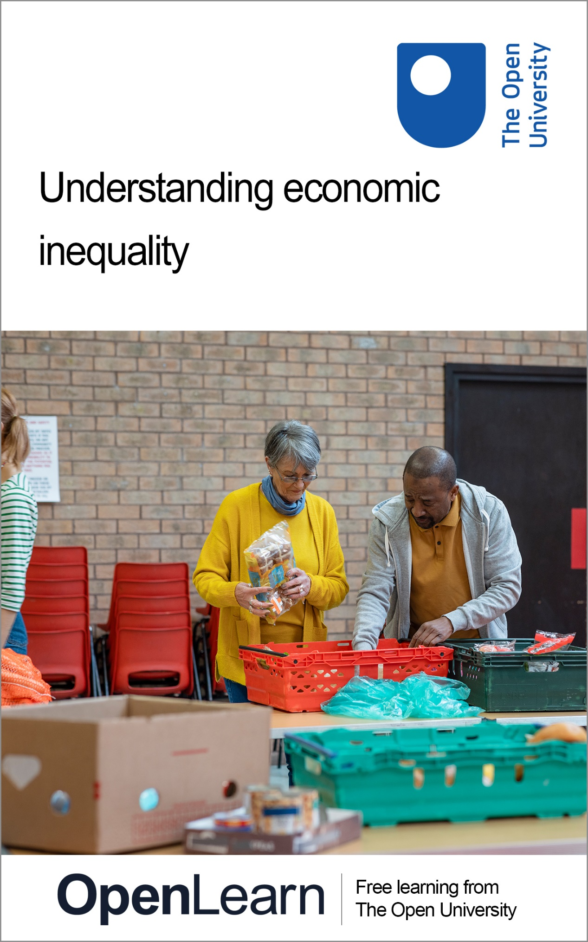

DD126_1

Understanding economic inequality

About this free course
This free course is an adapted extract from the Open University course DD126 Economics in context: www.open.ac.uk/courses/modules/dd126.
This version of the content may include video, images and interactive content that may not be optimised for your device.
You can experience this free course as it was originally designed on OpenLearn, the home of free learning from The Open University –
www.open.edu/openlearn/society-politics-law/understanding-economic-inequality/content-section-0
There you’ll also be able to track your progress via your activity record, which you can use to demonstrate your learning.
Copyright © 2019 The Open University
Intellectual property
Unless otherwise stated, this resource is released under the terms of the Creative Commons Licence v4.0 http://creativecommons.org/licenses/by-nc-sa/4.0/deed.en_GB. Within that The Open University interprets this licence in the following way: www.open.edu/openlearn/about-openlearn/frequently-asked-questions-on-openlearn. Copyright and rights falling outside the terms of the Creative Commons Licence are retained or controlled by The Open University. Please read the full text before using any of the content.
We believe the primary barrier to accessing high-quality educational experiences is cost, which is why we aim to publish as much free content as possible under an open licence. If it proves difficult to release content under our preferred Creative Commons licence (e.g. because we can’t afford or gain the clearances or find suitable alternatives), we will still release the materials for free under a personal end-user licence.
This is because the learning experience will always be the same high quality offering and that should always be seen as positive – even if at times the licensing is different to Creative Commons.
When using the content you must attribute us (The Open University) (the OU) and any identified author in accordance with the terms of the Creative Commons Licence.
The Acknowledgements section is used to list, amongst other things, third party (Proprietary), licensed content which is not subject to Creative Commons licensing. Proprietary content must be used (retained) intact and in context to the content at all times.
The Acknowledgements section is also used to bring to your attention any other Special Restrictions which may apply to the content. For example there may be times when the Creative Commons Non-Commercial Sharealike licence does not apply to any of the content even if owned by us (The Open University). In these instances, unless stated otherwise, the content may be used for personal and non-commercial use.
We have also identified as Proprietary other material included in the content which is not subject to Creative Commons Licence. These are OU logos, trading names and may extend to certain photographic and video images and sound recordings and any other material as may be brought to your attention.
Unauthorised use of any of the content may constitute a breach of the terms and conditions and/or intellectual property laws.
We reserve the right to alter, amend or bring to an end any terms and conditions provided here without notice.
All rights falling outside the terms of the Creative Commons licence are retained or controlled by The Open University.
Head of Intellectual Property, The Open University

Contents
- Introduction
- Learning outcomes
- 1 Introducing inequality
- 2 Everyday inequality
- 3 Inequality in economics
  - 3.1 Income for whom?
  - 3.2 Sources of income
  - 3.3 Measuring income inequality
  - 3.4 Inequality between countries
- 4 What makes us unequal?
  - 4.1 Differences between individuals or households
  - 4.2 Factors affecting the level and distribution of wages
- 5 Why inequality matters
  - 5.1 Economic growth and inequality
  - 5.2 Inequality and economic success
- 6 What can be done about income inequality?
  - 6.1 Redistribution of incomes through the taxation and benefit system
  - 6.2 Provision of goods such as education and healthcare
  - 6.3 The structure of original incomes
- Conclusion
- References
- Acknowledgements
- Solutions

Introduction
In this free course, Understanding economic inequality, you will explore one of the most pressing challenges of our times – inequality. You will explore different debates on the causes, trends and consequences of inequality, and what can be done about it. You will be encouraged to reflect on your personal experiences of inequality before looking at how the issue is approached in economics. You will study some of the different dimensions of economic inequality, and learn about the main debates on its role in achieving economic success. You will also have the opportunity to put yourself in the shoes of a prime minister and explore what can be done to make economies less unequal.
This OpenLearn course is an adapted extract from the Open University course DD126 Economics in context.

Learning outcomes
After studying this course, you should be able to:
- understand what economic inequality is
- know what determines economic inequality
- understand why inequality matters for society
- know some of the proposed solutions to inequality
- understand some of the measures of economic success.

1 Introducing inequality
As a starting point for the discussion of inequality, consider the workings of a simple economy shown in Figure 1.

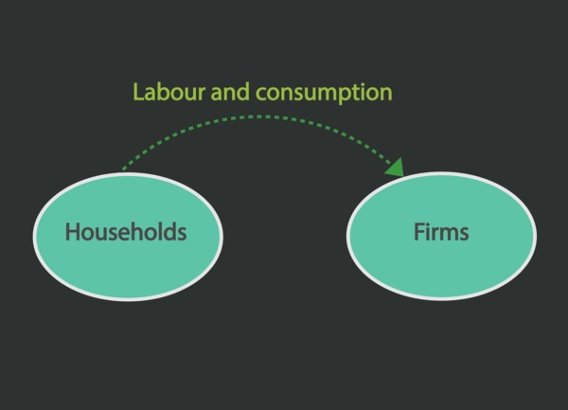
Figure 1 The circular flow of income in a simple economy.
View description - Figure 1 The circular flow of income in a simple economy.

In an economy, firms use labour performed by households to produce goods and services. This is a flow of resources from households to firms as shown by the green arrow in Figure 1. Economic resources are also transferred from households to firms as consumption spending of the former on goods produced by the latter.
In return for this flow of labour and consumption from households to firms there is a corresponding flow of income from firms to households, as shown by the yellow arrow in Figure 2. This income takes the form of wages.

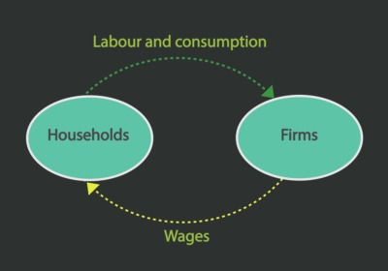
Figure 2 The flow of labour and wages between households and firms.
View description - Figure 2 The flow of labour and wages between households and firms.

Activity 1 Circular flows of income
Allow about 30 minutes

Figure 2 looks at the flow of labour and wages around a simple economy. What other inputs might be used by firms to produce goods and services in an economy?

Provide your answer...
View answer - Part

Figures 1 and 2 portray a very simple model of the economy in that they only include two sectors of the economy: households and firms.
Can you think of another sector inside an economy which might be included in the circular flow diagram to make this a more realistic model of the economy? What additional flows would this new sector generate?

Provide your answer...
View answer - Part

Households, firms and government are all part of a domestic economy. The circular flow diagram can also represent the relationship between income in the domestic economy and rest of the world. How would you introduce the foreign sector into the diagram?

Provide your answer...
View answer - Part

Based on the circular flow diagram with households, firms, government and foreign sector, what are some of the sources of inequalities which you can identify? Choose all relevant statements below.

The distribution of income of an economy between households and firms.
The distribution of income in an economy within the household sector.
The distribution of income between countries.
View answer - Part

2 Everyday inequality
Inequality is a term that you encounter frequently in everyday life. It might refer to many different factors such as gender, social status, health or wealth. In this section you will explore different meanings of inequality.

Activity 2 Inequality in everyday life
Allow about 10 minutes

The images below show some examples of how inequality manifests itself in everyday life.

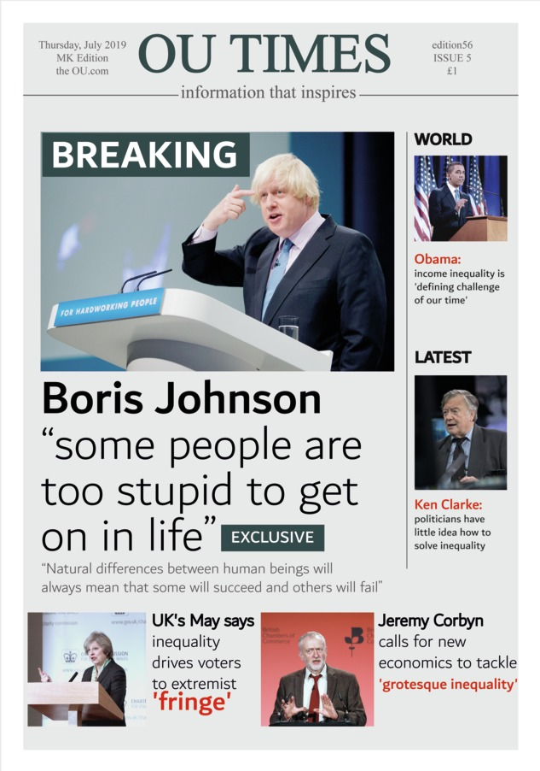
Figure 5
View description - Figure 5

Figure 6
View description - Figure 6

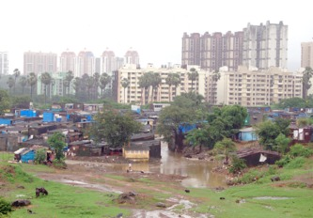
Figure 7
View description - Figure 7

Reflecting on these images and your personal experiences, how do you perceive inequality in your everyday life?

Provide your answer...

In Figure 2 you saw that households were rewarded for their labour by being paid wages. How should these wages be distributed to meet our idea of equality?

Activity 3 Equality of what?
Allow about 20 minutes

Would you expect all households in the economy to receive an equal wage? Can you identify any situations in which it would be fairer for one person to be paid more than another?

Provide your answer...
View answer - Part

What do you think an equal society ought to look like?

Provide your answer...
View answer - Part

What aspects other than income do you think matter for equality?

Provide your answer...
View answer - Part

Although many factors influence equality, economists tend to deal with inequality in terms of income and other monetary resources? Why do you think is that?

Provide your answer...
View answer - Part

While economists care about other meanings of inequality, such as happiness, health, and abilities, they tend to use monetary resources, such as income or wealth, to understand these different meanings of inequality. Inequality in monetary terms is what is called economic inequality. You will explore what it is in more detail in the next section.

3 Inequality in economics
In the previous section you learned that economists think of inequality in terms of monetary resources, that is in terms of income or wealth.
As you saw in Section 1, income is the flow that households receive from employment over a period of time, e.g. an hour, a month, a year. This includes full-time, part-time and self-employment. There will also be income accruing to owning assets, such as capital or land, which is broadly called capital income. For example, landlords receive income from renting property to tenants.
In contrast, wealth refers to the stock of assets held by an individual or household at any given point in time, and to the amount of debt owed. These assets come in various forms: from bank accounts, housing, cars, jewellery to corporate shares, stocks and bonds.

Activity 4 Income and wealth
Allow about 15 minutes

Look at the following examples. Decide which contribute to the flow of income and which contribute to the stock of wealth. Drag each answer so that they are in the correct position below.

Income (flow over time)
Income (flow over time)
Income (flow over time)
Income (flow over time)
Income (flow over time)
Wealth (stock at a given point of time)
Wealth (stock at a given point of time)
Wealth (stock at a given point of time)
Wealth (stock at a given point of time)
Wealth (stock at a given point of time)
Dividends received from shares held in Tesco PLC.
A worker gets paid for working overtime.
The rent received from letting a flat to students.
A teacher receives her monthly income.
The government pays someone without work unemployment benefit.
An increase in the value of shares owned in EasyJet PLC.
Savings account
The ownership of a 3-bedroom house which increases in value
Inheritance
Ownership of a valuable painting.
View answer - Part

Income is earned from working and owning wealth. Based on the options above, name three ways in which a person can build up their stock of wealth.

Provide your answer...
View answer - Part

Income and wealth can affect one another. Higher income allows households to accumulate a greater stock of wealth through saving or buying assets. This higher level of wealth can then lead to a bigger income stream from assets and investments. At low levels of income households may incur debt (negative wealth) so that income is then reduced as households have to pay interest on loans.
In practice, data on income is more readily available than on wealth. Public bodies collect information on earnings for purposes such as tax. The nature of wealth means that it is more difficult to measure: a large part of wealth consists of the assets a household owns. The changing value of an asset is difficult to evaluate; asset prices might be rising but unless the asset is sold it is difficult to determine its actual value.
As a result of these difficulties in measuring wealth, the remainder of this course will focus on income inequality rather than wealth inequality.

3.1 Income for whom?

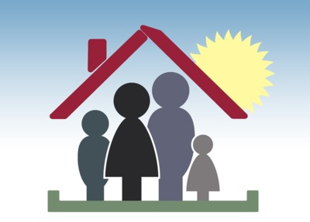
Figure 8 An example of a household.
View description - Figure 8 An example of a household.

Income may be measured at either the individual or household level.
As the members of a household usually pool their resources, measuring income at the household level may be more indicative of living standards for the household as a whole.
For example, if there is a stay-at-home parent in a household their income may be very low or non-existent. However, their partner may receive a high income such that they experience a relatively high standard of living in their household.
But there may also be inequality within a family: household income level does not guarantee that income is distributed equally among the members of a household.

3.2 Sources of income
The picture of inequality also depends on what kind of income is taken into account. Recall from Activity 1 that households earn labour income from employment and capital income from owning assets. Business owners also receive capital income in the form of profits. Such sources of income which are received directly by a person for performing a given economic activity is called original income.
In Figure 3 you also saw that another importance source of income for households comes from government. Some households will receive cash benefits from the government such as pensions, child benefit, etc. Adding this to original income gives the total amount of income a household has to spend and is termed gross income.
After receiving income from these sources households will need to spend some of their money on taxes. These include direct taxes such as income tax, council tax and national insurance. Income that is left for expenditure and saving once taxes have been paid is called disposable income. This amount is generally more representative of the standard of living than their original income as it determines the amount of income available to buy goods and services.

Activity 5 Measuring income
Allow about 20 minutes

Work out the correct labels missing from this diagram for each source of income.

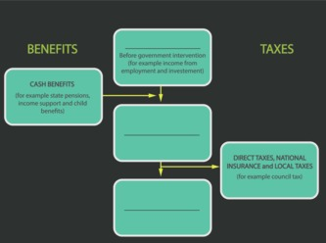

View answer - Part

Data on income are collected by directly asking households about it in surveys, or from government tax returns.
Imagine you are asked the following question in a household survey: What is your monthly income?
Do you think that this would be a straightforward question to answer, and why?

Provide your answer...
View answer - Part

An alternative source of income data is information obtained from the HMRC via tax returns. Can you see any problems there might be with using this data as a source of information on incomes?

Provide your answer...
View answer - Part

3.3 Measuring income inequality
Now that you know better what income is, you’ll turn your attention to understanding how income inequality is measured.
Measurements of inequality are often centred on measures of the spread of incomes across people. One approach often used by economists to consider the spread of incomes is the use of percentiles, deciles or quintiles to divide the population into groups of hundreds, tenths, fifths, respectively in order of income. The income share of each group can then be compared.

Box 1 Percentiles, deciles and quintiles
Percentiles, deciles or quintiles are a useful way of measuring inequality. Suppose that all the individual incomes in the economy are lined up from smallest to highest. This distribution can be divided into groups of equal size to see how income is distributed.
If the individual incomes are divided into ten groups each group is referred to as a decile. The first decile shows those individuals with the lowest 10% of earnings, 90% of the population have a higher income than this group. The tenth decile shows the top 10% earners of the population.
The data may be split into smaller units such as hundredths, called percentiles. An individual at the 99th percentile has a higher income than 99% of the population but less than the top 1% of the population. The earnings of the top 1% of a population are often reported in a discussion of equality.
The data may also be grouped into larger sections. For example a quintile would divide the population into 5 groups. The first quintile will show that section of the population with the lowest 20% of earnings. 80% of the population receive a higher income than this group.
An important point in the distribution of incomes is the median, or the middle part of the income distribution. This occurs at the 50th percentile. At the median, 50% of the population have higher income and 50% have lower income.

3.3.1 What would an equal distribution of income look like?
If incomes were distributed equally between deciles, each decile of households should have 10% of the overall income: the bottom 10% of the population of income earners should receive 10% of total income, the second decile should also receive 10% of total income right up to the top 10% of the population income.
However, this is very rarely the case. Many societies display inequality, which is shown by an unequal distribution of incomes. It may be that the top 10% of households receive 20% of the overall income in the economy while the bottom 10% only receive 7% of overall income.

Activity 6 Inequality and income shares
Allow about 30 minutes

Figure 10 shows the income share from the late 1930s to 2010 for each decile in the UK economy. Each decile shows the share of total income going to that proportion of the population of income earners.

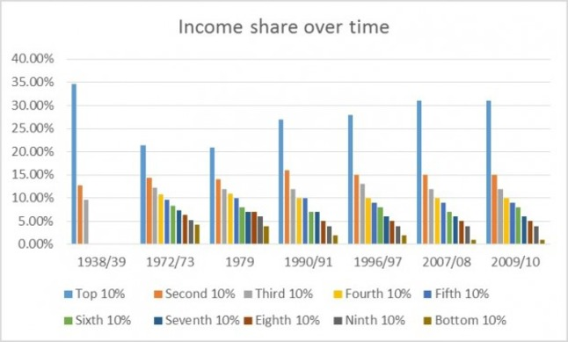
Figure 10 Income share over time in the UK.
View description - Figure 10 Income share over time in the UK.

Notes: 1938/9 and 1972/3: Royal Commission in Income and Wealth; 1979; 1990/1 JRF 1995; 1996/7 onwards HBAI. Data on all deciles are not available in 1938/9. The 1938/9 and 1972/3 figures are not strictly comparable with the later series, and are merely indicative. The figures after 1979 are calculated after housing costs. Figures may not sum to 100 because of rounding.
Based on the graph, answer the following questions.
In which time period is the income share of the top 10% of the population at its lowest? Notice what happens to this share from the end of the 1970s.

Provide your answer...
View answer - Part

Describe what happens to the income share of the bottom 10% over the same time period.

Provide your answer...
View answer - Part

When does inequality seem to be at its lowest?

Provide your answer...
View answer - Part

This pattern of inequality has been observed in countries other than the UK. Well-known work by the French economist Thomas Piketty (2013) considers the income shares across high-income countries. He finds similar trajectory of falling income inequality in the early part of the twentieth century and rising inequality from the late 1970s onwards.

Activity 7 Top income shares across time and space
Allow about 10 minutes

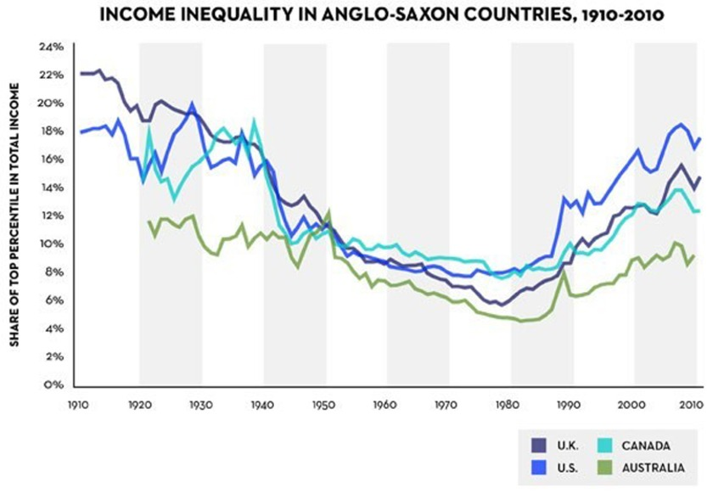
Figure 11 Income inequality in Anglo-Saxon countries, 1910–2010. Source: Piketty (2013), reprinted in Cassidy (2014).
View description - Figure 11 Income inequality in Anglo-Saxon countries, 1910–2010. Source: Piketty ...

Rather than breaking down the distribution of incomes into deciles as in Figure 10, Figure 11 uses percentiles, i.e. the distribution of income across hundred equally-sized groups. The graph shows the share of total income going to the top percentile of the population, that is the top 1%, in UK, US, Canada and Australia.
Figure 11 shows that all 4 countries experienced an initial fall in inequality, measured by the share of income held by the top 1%, until 1980 followed by a rise in inequality since.
Out of the four countries in Figure 11, which one saw the greatest increase in inequality between 1980 and 2010?

Provide your answer...
View answer - Part

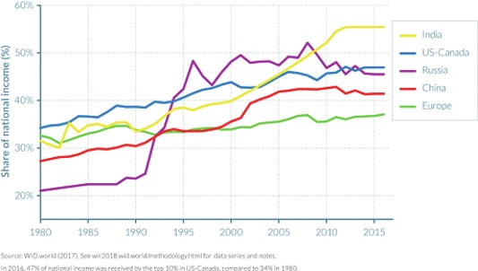
Figure 12 Top 1% income shares in different countries across the world 1980–2016.
View description - Figure 12 Top 1% income shares in different countries across the world 1980–2016 ...

Figure 12 shows the share of income received by the top 1% of income earners in each of the following regions: India, US-Canada, Russia, China and Europe.
Using Figure 12, identify which region has seen the smallest increase in inequality over the time period shown in the graph?
What can you say about inequality in these regions from 2010 onwards?

Provide your answer...

3.4 Inequality between countries
Section 3.2 considered how the flow of income is distributed within the economy. From the circular flow diagram in Figure 4 you saw another dimension of income inequality: inequality between economies. This is referred to as global inequality.
Global inequality may be interpreted in different ways. One approach would be to consider the distribution of incomes across the world as if they were part of one very large income distribution including all the world’s population.
Alternatively, you can take the income earned by the population of one country and compare this to the incomes of the population in another country.
This difference in interpretation of what global inequality is can explain differing opinions on whether global inequality has been rising or falling.

Activity 8 Global inequality between individuals
Allow about 15 minutes

Figure 13 shows the distribution of global income among all people in the world, as if they were part of one big global economy. It compares the share of global income earned by the global top 1% to the share flowing to the bottom 50% of the global population.

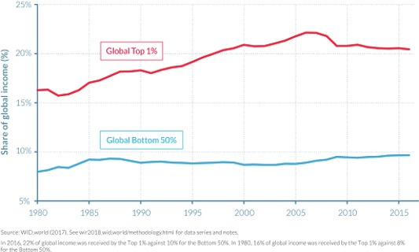
Figure 13 The share of global income, 1980–2016
View description - Figure 13 The share of global income, 1980–2016

Describe how the two series shown in Figure 13 changed between 1980 and 2015.

Provide your answer...
View answer - Part

What has happened to global inequality between 1985 and 2009?

Provide your answer...
View answer - Part

A second dimension of global inequality compares incomes earned in different countries around the world. It has been argued that the gap in incomes between rich and poor countries in the world has fallen: East Asian countries, including China, have seen a sharp growth in incomes while incomes in many developed economies have stagnated (World Inequality Review, 2018).
However there is also evidence to suggest that the gap between countries is growing. For example the share of global income going to sub-Saharan Africa and Latin America has fallen behind the world average in the same time period. As a result, in 1960 ‘people living in the world’s richest country were 33 times richer than people living in the poorest country’, rising to 134 times richer by 2000 (Hickel, 2016).
Figure 14 shows how average incomes have fallen in Latin America and Africa while those in Asia and China have steadily increased.

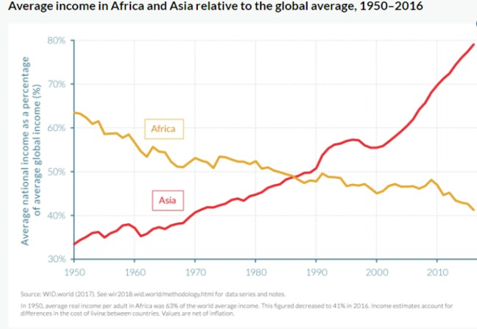
Figure 14 Average income in China, Latin America and in Africa and Asia relative to the global average, 1950–2016.
View description - Figure 14 Average income in China, Latin America and in Africa and Asia relative ...

Activity 9 Challenges in measuring global inequality
Allow about 5 minutes

In Activity 5 you looked at the problems with measuring incomes. What additional problems do you think would present themselves with comparing incomes in different countries?

Provide your answer...
View answer - Activity 9 Challenges in measuring global inequality

4 What makes us unequal?
Section 3 explored income inequality both within countries and between countries. You saw that income inequality, at least within countries, is increasing. In this section you will learn what factors can explain the existence of income inequality and its changes over time.

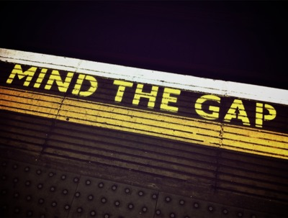
Figure 15 ‘Mind the gap’.
View description - Figure 15 ‘Mind the gap’.

4.1 Differences between individuals or households
These types of explanations for inequality point out that income inequality is shaped by, for example, differences in the level of human capital, parental wealth and type of work between individuals or households in the economy.

Human capital
Human capital refers to the set of skills and knowledge that a worker has. This is acquired through education, training and work experience.
As described in Section 2, some variation in income is expected due to differences in skills and experience among workers.

Activity 10 Human capital and wage inequality
Allow about 5 minutes

Who do you expect to earn more? Stagger the boxes below from the highest to the lowest earning worker.

Highest
Middle
Lowest
A senior worker with ten years of relevant work experience
A junior worker who undertakes a training programme
An unskilled worker
View answer - Activity 10 Human capital and wage inequality
View discussion - Activity 10 Human capital and wage inequality

Parental wealth
Inequalities in income may arise due to differences in the level of wealth owned by the previous generation.
Receiving parental wealth through inheritance or gifts can improve a person’s capital income. It can provide opportunities for better education and healthcare, which can result in differences in incomes among the younger generation.

Changes in working patterns
When comparing income levels across households, changing working patterns can influence levels of inequality. For example, since the 1970s the proportion of women going to work increased substantially in the UK, rising from 53% in 1971 to almost 71% in 2017 (source: ONS). This brought more income into households and contributed to a decline in income inequality across men and women.

4.2 Factors affecting the level and distribution of wages
Both the level and distribution of wages are an important contributor to the overall levels of income inequality in an economy.

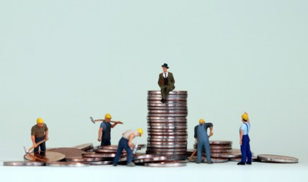
Figure 16 Income inequality arises because labour and capital are compensated differently.
View description - Figure 16 Income inequality arises because labour and capital are compensated di ...

4.2.1 How income is shared between labour and capital
The total income generated in an economy is known as national income. Polish economist Michal Kalecki (1954) describes how national income can be split into income earned by labour and income earned by the owners of capital, or capitalists. This is the same as saying that the total income in the economy is split between wages, or labour income, earned by workers and capital income from profits earned by capitalists.
The share of national income going to labour and capital can vary over time and it is this variation which many argue has been a contributory factor to changing levels of income inequality.
Households may earn income from both labour and capital. But it is labour that is the predominant source of income for households, constituting an average of 70% of total household income in the UK (Department of Work and Pensions 2018).

Activity 11 Inequality between labour and capital
Allow about 40 minutes

Complete the national income equation below by filling in the boxes with the different types of income described by Kalecki.

______ = ______ + ______

Once you have filled in the national income equation correctly, drag and drop the panels below to assign economic agents which are the main recipients of each respective type of income.

National income
Wages/labour income
Capital income/profits
Whole economy
Workers
Capitalists
View answer - Part

Figure 17 shows how the wage share as a percentage of national income has fluctuated since 1948.

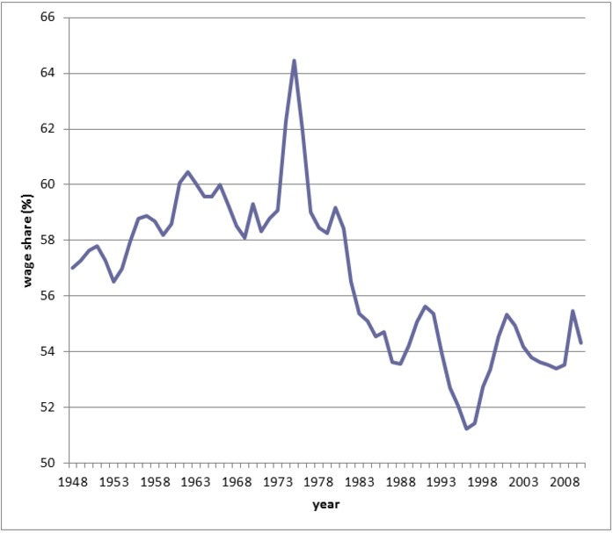
Figure 17 The falling wage share, UK 1948–2011. Source: Lansley (2012) ONS data
View description - Figure 17 The falling wage share, UK 1948–2011. Source: Lansley (2012) ONS data

Briefly describe the trend in the share of wages between the mid-1950s and 1980.

Provide your answer...
View answer - Part

Listen to an extract from an interview with Duncan Weldon, former senior economist at the Trade Unions Congress, an organisation representing UK trade unions. Answer the questions below to explore the causes and changes in inequality between labour and capital in recent years.

Audio content is not available in this format.
Audio 1
View transcript - Audio 1

According to the interview, what have been the main changes in the wage level in the UK and how wage income is shared among all workers in the economy?

Provide your answer...
View discussion - Part

What are the two main reasons give in the discussion for the fall in the share of wages in total income?

Provide your answer...
View discussion - Part

What other reason relating to the relationship between workers and employers are discussed in the interview to explain the fall of the wage share?

Provide your answer...
View discussion - Part

5 Why inequality matters
In the previous sections you saw that income inequality has been increasing in many aspects. But does inequality matter?

Figure 18 An example of inequality.

Many economists, social scientists and politicians believe that inequality is damaging for the wellbeing of society. In this section, you will explore some arguments on why inequality matters.

5.1 Economic growth and inequality
An important measure of society’s wellbeing for economists is economic growth. In Section 4.2.1 you learned about the national income of a country, that is the total income generated in an economy. By calculating the change in the level of the national income in an economy over time, you can determine how much the economy has grown. This is known as economic growth.
If the economy is growing, this means that there are more goods and services for households to consume, which in principle makes everyone in the society better off.
How does income inequality affect economic growth? This has been a topic of a long-standing debate among economists. Complete Activity 12 to explore this debate.

Activity 12 Inequality v growth
Allow about 20 minutes

Have a go at exploring this interactive asset: Inequality: have your say. There, you will be able to take an interactive tour through a fictional country, Economica, to explore various questions about inequality.

After a difficult year for much of the population, all eyes are on the Prime Minister to determine the economic future of the increasingly unequal country. You’re about to get the inside scoop on her plans and the arguments that support and oppose her view.

5.2 Inequality and economic success
Economic growth is not the only way to assess society’s wellbeing. There are other important factors relating to the quality of life, happiness, public health and safety (recall the contribution of Amartya Sen in Activity 3). Many economists and other social scientists have argued that income inequality affects these aspects of economic success. Complete Activity 13 to learn how.

Activity 13 Inequality and society
Allow about 20 minutes

Watch a presentation by Professor Richard Wilkinson about the social costs of inequality and answer the questions below.
How economic inequality harms societies
What is the difference between life expectancy and income in local neighbourhoods in England and Wales?

Provide your answer...
View answer - Part

Name five indicators of health and social problems mentioned by Professor Wilkinson which inequality is likely to exacerbate.

Provide your answer...
View answer - Part

Why does Professor Wilkinson say that Americans chasing the American Dream should go to Denmark?

Provide your answer...
View answer - Part

6 What can be done about income inequality?
In Section 5 you looked at some of the explanations for the rise in income inequality. These included differences between individuals, due to different education and skills, parental wealth and working patterns. Other explanations concern the distribution and level of wages in the economy as a whole, including issues such as technology, globalisation and the changing share of wages in total income. You also learned that inequality can have a damaging impact on societal wellbeing. This section will look at is what can be done to address income inequality.
American economist James Galbraith (2016) identifies three main areas of policy measures that governments can use to tackle inequality (see Figure 19).

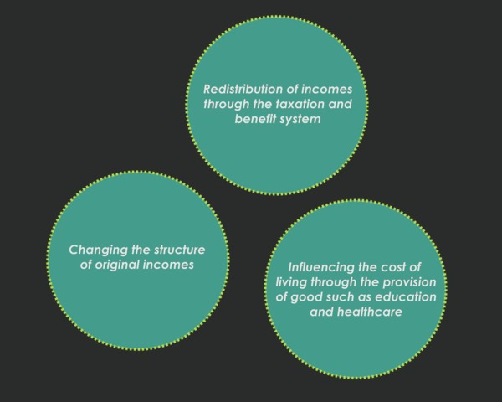
Figure 19 The three main areas of policy measures that government can use to tackle inequality.
View description - Figure 19 The three main areas of policy measures that government can use to tackle ...

6.1 Redistribution of incomes through the taxation and benefit system

Figure 20 The taxation and benefit system can reduce inequality.
View description - Figure 20 The taxation and benefit system can reduce inequality.

If the distribution of incomes in the economy is considered to be unequal in a way that is unfair, the government may use its taxation and spending policies to redistribute incomes to achieve a more equal distribution of incomes.
The government can use a more progressive tax system to redistribute incomes, whereby those on higher incomes pay increased tax rates and those on lower incomes face lower tax rates. This has the effect of transferring part of the higher incomes towards lower income earners.
The government can also increase the income of low income households directly though the payment of social benefits such as the Jobseekers Allowance or Universal Credit.

6.2 Provision of goods such as education and healthcare
Access to education for all income levels enhances equality of opportunity. By undertaking training to learn new skills workers can improve their earning potential by adding to their human capital.
Those on low incomes might not be able to afford to undertake education or training, and so would not have the same opportunities as those on higher incomes. Therefore, provision of universal education by the government would allow greater opportunity for those on low incomes to increase their human capital.
Increased spending by the government on health services also benefits those on low incomes as improved healthcare enables workers to keep working.

Activity 14 Taxes and government spending
Allow about 15 minutes

Figure 21 shows tax payments (below zero on the vertical axis) and benefits (above zero on the vertical axis) as a proportion of disposable income of households in different quintile groups in 2017.

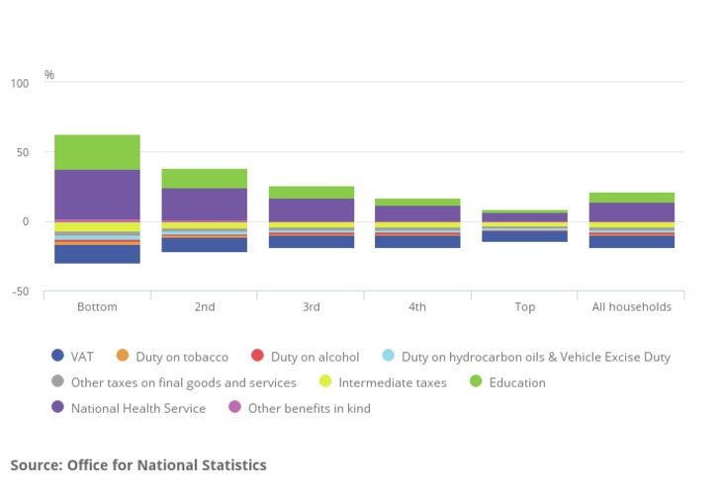
Figure 21 Taxes and benefits across income distribution

Which quintile group benefits the most from state provided education and the NHS?

Provide your answer...
View answer - Part

How do you think this affects inequality?

Provide your answer...
View answer - Part

6.3 The structure of original incomes
In Section 4.2.1 you looked at how the share of total income going to labour in the economy had fallen. Many economists support policies of redressing the falling share of total income in the economy going to labour. Such policies would affect the structure of original income by increasing the share of wages going to labour pre-taxes and benefits (which corresponds to the original income in Figure 9 in Activity 5). For this reason they have been referred to as ‘predistribution’ policies by some economists (in contrast to the redistribution of income through the tax and benefits system), as they would contribute to a more equal distribution of income in the first place.

Activity 15 Workers’ bargaining power and inequality
Allow about 10 minutes

How do you think policy makers can improve workers’ bargaining power?

Provide your answer...
View answer - Part

Conclusion
This free course, Understanding economic inequality, gave you a flavour of one of the most pressing challenges of our times – inequality. You reflected on your personal experiences of inequality and looked at how it is approached in economics.
You explored the different meanings of inequality, and learned how income inequality can be measured using population shares. You then looked at how income inequality has changed in recent decades, looking at the distribution of income between workers, between countries, and between labour and capital.
You looked at some of the causes of economic inequality in modern times and its consequences for success and wellbeing of the economy and society. You even put yourself in the shoes of a prime minister, and explored what can be done to make economies less unequal.
This OpenLearn course is an adapted extract from the Open University course DD126 Economics in context. You might also be interested to look at another OpenLearn course adapted from this OU course: Understanding economics: the secret life of t-shirts.

References
Cassidy, J. (2014) ‘Piketty’s inequality story in six charts’, New Yorker, 26 March. Available at: https://www.newyorker.com/news/john-cassidy/pikettys-inequality-story-in-six-charts (Accessed: 17 July 2019).
Department for Work and Pensions (2018) Family Resources Survey 2016–17. Available at: https://www.gov.uk/government/uploads/system/uploads/attachment_data/file/692771/family-resources-survey-2016-17.pdf (Accessed: 17 July 2019).
The Equality Trust (n.d.) How has inequality changed?. Available at: https://www.equalitytrust.org.uk/how-has-inequality-changed (Accessed: 17 July 2019).
Galbraith, J.K. (2016) Inequality: What Everyone Needs to Know. Oxford: Oxford University Press.
Hickel, J. (2016) ‘Global inequality may be much worse than we think’, The Guardian, 8 April. Available at: https://www.theguardian.com/global-development-professionals-network/2016/apr/08/global-inequality-may-be-much-worse-than-we-think (Accessed: 17 July 2019).
Kalecki, M. (1954) Theory of Economic Dynamics. London: Allen and Unwin.
Lansley, S. (2012) ‘Inequality, the crash and the ongoing crisis’, The Political Quarterly, 83(4), pp. 754–61.
ONS (n.d.) Available at: https://www.ons.gov.uk/ (Accessed: 17 July 2019).
ONS (2018) ONS TU membership: statistical bulletin 2017. Available at: https://www.gov.uk/government/uploads/system/uploads/attachment_data/file/712543/TU_membership_bulletin.pdf (Accessed: 17 July 2019).
Piketty, T. (2014) Capital in the Twenty-First Century. Harvard: Harvard University Press.
Reed, H. (2013) ‘How can the UK boost the wage share? The rebalancing requires, above all, a new social contract with labour’, The London School of Economics and Political Science. Available at https://blogs.lse.ac.uk/politicsandpolicy/how-can-the-uk-boost-the-wage-share/ (Accessed: 29 July 2019).
World Inequality Report (2018) Available at: https://wir2018.wid.world/part-2.html (Accessed: 17 July 2019).

Acknowledgements
This free course was written by Hanna Szymborska and Carol Patrick. It was first published in August 2019.
Except for third party materials and otherwise stated (see terms and conditions), this content is made available under a Creative Commons Attribution-NonCommercial-ShareAlike 4.0 Licence.
The material acknowledged below is Proprietary and used under licence (not subject to Creative Commons Licence). Grateful acknowledgement is made to the following sources for permission to reproduce material in this free course:

Images
Course image: SolStock/Getty Images
Figure 5: Boris Johnson © LEON NEAL/Getty Images; Ken Clarke © Bloomberg/Getty Images; Barack Obama © William Thomas Cain/Stringer/Getty Images; Theresa May © Dan Kitwood/Getty Images.
Figure 6: Dinodia Photos / Alamy Stock Photo
Figure 7: Alex Segre / Alamy Stock Photo
Figure 8: Gerd Altmann from Pixabay.
Figure 10: The Equality Trust
Figure 11: Piketty, T. and Goldhammer, A., Capital in the Twenty-First Century.
Figure 12: Source: WID.world. This file is licensed under the Creative Commons Attribution-NonCommercial-ShareAlike 4.0 International https://creativecommons.org/licenses/by-nc-sa/4.0/
Figure 13: Source: WID.world. This file is licensed under the Creative Commons Attribution-NonCommercial-ShareAlike 4.0 International https://creativecommons.org/licenses/by-nc-sa/4.0/
Figure 14: Source: WID.world. This file is licensed under the Creative Commons Attribution-NonCommercial-ShareAlike 4.0 International https://creativecommons.org/licenses/by-nc-sa/4.0/
Figure 15: Greg Plominski from Pixabay.
Figure 16: Hyekin Kang/Shutterstock.
Figure 17: Source: Lansley (2012) ONS data.
Figure 18: Kirk Fisher from Pixabay.
Figure 20: Mohamed Hassan from Pixabay.
Figure 21: Office for National Statistics. This file is licensed under the https://www.nationalarchives.gov.uk/doc/open-government-licence/version/3/

Audio-visual
Audio 1: © BBC
Every effort has been made to contact copyright owners. If any have been inadvertently overlooked, the publishers will be pleased to make the necessary arrangements at the first opportunity.
Don't miss out
If reading this text has inspired you to learn more, you may be interested in joining the millions of people who discover our free learning resources and qualifications by visiting The Open University – www.open.edu/openlearn/free-courses.

Solutions

Activity 1 Circular flows of income

Part

Answer
As well as labour, firms also use other economic resources, or inputs, such as land and capital. Land includes not only land itself but all natural resources such as minerals and forests. In order to produce an output firms will also need to use machinery, factories etc. These are man-made resources and are referred to as capital. Owners of these inputs receive capital income in the form of interest, profits and rents. Land and capital may be owned by households but might also be financed by other agents in the economy such as banks.
Back to - Part

Part

Answer
To make our model of the economy more realistic a government sector could be included. Like households, the government spends money on goods and services. This results in an income flow from the government to firms and households. As well as spending, the government also collects resources in the form of taxes. As both households and firms pay taxes this results in flows of income from both households and firms to the government.

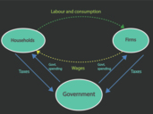
Figure 3 Circular flow diagram with government.
View description - Figure 3 Circular flow diagram with government.

Back to - Part

Part

Answer
A second sector that can be introduced into the circular flow diagram to make it a more representative model of the economy is a foreign sector. The income flows discussed so far take place within our simple economy but income flows may also take place between economies. Some of the income that households earn is spent, not on goods and services from domestic firms, but rather from firms located overseas. This leads to an income flow from domestic households out of the economy to overseas firms. Similarly, the goods and services that firms produce domestically may be bought by overseas households, resulting in a flow of income from overseas households to domestic firms.

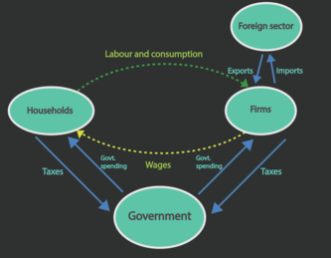
Figure 4 Circular flow diagram with government and the external sector.
View description - Figure 4 Circular flow diagram with government and the external sector.

Although Figure 4 represents only a very simple model of the economy it is a useful starting point for a discussion on economic inequality.
Back to - Part

Part

Answer
Right:
The distribution of income of an economy between households and firms.
The distribution of income in an economy within the household sector.
The distribution of income between countries.
Wrong:
The circular flow diagram helps you identify several sources of income inequality in the economy: how income of an economy is distributed between firms and households; whether some households benefit more from wages and salaries than others; and comparison of one economy with other economies in the world: thinking of the whole world as one global economy, does one country receive more of total global income than other countries?
Last but not least, the circular flow diagram shows an important economic agent which has a role in addressing income inequalities: the government. You will look at how government mitigates inequality in the last section of this course.
Back to - Part

Activity 3 Equality of what?

Part

Answer
The labour provided by households need not all be of the same type or quality. An individual might undertake a university course or other type of training to offer a higher level of skills to an employer. Similarly a worker with a great deal of work experience has more skills to offer than someone new on the job. For example during the course of their career a nurse will acquire experience and maybe more qualifications. As the nurse progresses through their career from auxiliary nurse to sister or to matron you might expect this increase in qualifications and experience to be rewarded with a higher wage.
Back to - Part

Part

Answer
Some say that in an equal society, everyone should receive the same outcome of their efforts. For instance, workers with the same levels of education should be paid the same wage. This is often not the case, and it has been shown that women and people from BAME backgrounds tend to be paid less than men and non-BAME people respectively, even at the same level of skills. Others refer to equality of opportunity: All people should be given the same opportunity, for example to gain education and skills, regardless of where they live, their gender or parental background. In this case, if some people are able to take better advantage of these opportunities, inequality of outcome may be justified.
Back to - Part

Part

Answer
Indian economist Amartya Sen (1985) argues that equality involves other aspects of our well-being apart from income. Happiness is more than just the goods and services that you consume. It also includes the activities that you undertake, your abilities and health, laws that govern our live, freedom of speech, how safe you feel and the type of neighbourhood you live in.
Back to - Part

Part

Answer
In practice it is difficult to measure and quantify many of the aspects related to happiness. Income is a narrower concept of well-being but is much more readily measured and compared across people.
Back to - Part

Activity 4 Income and wealth

Part

Answer
The correct matches are:
Income (flow over time)
Dividends received from shares held in Tesco PLC.
Income (flow over time)
A worker gets paid for working overtime.
Income (flow over time)
The rent received from letting a flat to students.
Income (flow over time)
A teacher receives her monthly income.
Income (flow over time)
The government pays someone without work unemployment benefit.
Wealth (stock at a given point of time)
An increase in the value of shares owned in EasyJet PLC.
Wealth (stock at a given point of time)
Savings account
Wealth (stock at a given point of time)
The ownership of a 3-bedroom house which increases in value
Wealth (stock at a given point of time)
Inheritance
Wealth (stock at a given point of time)
Ownership of a valuable painting.
Back to - Part

Part

Answer
- Save some of their income, which can be held in a savings account.
- Increase in the value of the assets that they already hold. For example if house prices increase this will mean that owners of a three-bedroom house have increased wealth from homeownership.
- Inheritance or gifts from family members, for example a daughter receiving inheritance from her parents.
Back to - Part

Activity 5 Measuring income

Part

Answer
Here is the completed diagram.

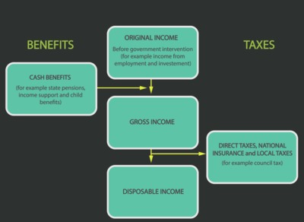
Figure 9 Sources of income.

Back to - Part

Part

Answer
On the face of it this is a seemingly easy question but in practice it may not be as easy as it looks. The answer to this is becoming increasingly difficult as working patterns change and many people don’t work the same hours every month. Someone on a zero-hour contract might experience a very varying monthly income. In addition to this the information on capital income might require time to put together. Individuals earning very high incomes might be reluctant to disclose their income to household surveys. Generally information about incomes may be seen as sensitive with people being reluctant to share the information. You would also need to include any benefits received. These are often underreported.
Back to - Part

Part

Answer
Collecting information on income from taxes also has some drawbacks. Individuals on very low incomes who are below the tax threshold would not be recorded in this system. Additionally not all income will be declared to the HMRC. Again, as with household surveys, there may also be issues with confidentiality when using HMRC data.
Back to - Part

Activity 6 Inequality and income shares

Part

Answer
Figure 10 shows that in the late 1930s the top 10% of the population received almost 35% of total income. This share fell substantially over the following years to just over 20% in the 1970s. However, this trend was reversed from the beginning of the 1980s as the income share of top decile rose to over 30% again over the course of the next three decades.
Back to - Part

Part

Answer
Over the same period the bottom 10% of the population saw a corresponding decrease in the share of total income that they received. The bottom 10% of households saw their highest share of income in the 1970s although it still remained below 5%. The income share that this group receives declines steadily from 1980 to a very low level in 2009/10.
Back to - Part

Part

Answer
Inequality seems to be at its lowest in the 1970s. The bottom 10% has its highest share of total income in 1972/3 while the top 10% simultaneously has its lowest share in 1979, although these values are fairly stable over the 1970s as a whole. Inequality decreased in the 1970s as the share of the richest fell while the share of income going to those on lowest incomes rose. In general in 1979 there appeared to be a more equal spread of incomes.
Back to - Part

Activity 7 Top income shares across time and space

Part

Answer
Figure 11 suggests that since 1980 the USA saw the greatest increase in inequality, followed by the UK, with Australia seeing the smallest increase in the share of income going to the top percentile in the three decades 1980 to 2010.
Back to - Part

Activity 8 Global inequality between individuals

Part

Answer
Globally there has been an increase in the share of income going to the top 1% of the world’s population. It has risen from approximately 16% in 1980 to almost 22% in the first half of the 2000s, before falling back to close to 20% in 2015. There has been less fluctuation in the share of global income accruing to the bottom 50% of the population. Between 1980 and 2016 it was just below 10%.
Back to - Part

Part

Answer
Between 1985 and 2009 the gap between the shares going to the bottom 50% and the top 1% widened. While the top 1% was receiving over 20% of global income, the bottom 50% were receiving less than 9% of global income. From about 2009 onwards the share of income received by the top 1% fell and the 50% share increased, therefore suggesting a fall in global inequality.
Back to - Part

Activity 9 Challenges in measuring global inequality

Answer
Inevitably, international comparisons on inequality can lead to even more measurement problems than within-country comparisons. Incomes in each country will be expressed in their own currency so the figures would need to be converted to a common currency to be compared. The cost of living in countries will also vary so while residents of two countries may have similar incomes they not be able to buy the same basket of goods. The extent of the black market may vary so that the level of unrecorded economic activity and income may be significant in some countries. When looking at wider measures of equality there will be other variations across countries in the provision of social benefits and public services such as education and health.
Back to - Activity 9 Challenges in measuring global inequality

Activity 10 Human capital and wage inequality

Answer
The correct matches are:
Highest
A senior worker with ten years of relevant work experience
Middle
A junior worker who undertakes a training programme
Lowest
An unskilled worker
Back to - Activity 10 Human capital and wage inequality

Discussion
Labour skills may vary due to natural ability, education or work experience. A senior worker with a large amount of relevant work experience would expect to receive a higher wage than someone without that experience. Similarly, a junior worker who has invested in education or training would be paid more than an unskilled worker with more generic skills.
Back to - Activity 10 Human capital and wage inequality

Activity 11 Inequality between labour and capital

Part

Answer
The correct matches are:
National income
Whole economy
Wages/labour income
Workers
Capital income/profits
Capitalists
Back to - Part

Part

Answer
The graph shows that from the mid 1950s to 1980 the share of wages in national income was largely between 59% and 61%. The exception to this was a peak in the mid 1970s when the wage share reached over 64%. Since this peak the wage share steadily declined, remaining below 56% over the next 30 years with a lowest point below 52% during the second half of the 1990s.
Back to - Part

Part

Discussion
In the lead-up to the 2008 recession wages didn’t grow for the low and middle part of the earnings ladder despite 11% of economic growth. Wages for this group have been stagnating since 2003, but already since the 1980s median wages have been failing to keep up with productivity. In the interview, wages are described as being frozen, that is there has been very little wage growth, even before the recession. In particular, wages have not been keeping up with changes in productivity. The increased productivity enables more output to be produced which generates more income. However, much of the income that this extra output has generated since the 1980s, has not been passed on to labour but instead has been paid to capital. References are made in the interview to wages, particularly at the middle and bottom of the income distribution, stagnating at the expense of increased profits. The interviewed worker explains that his firm is making profits yet he has not seen a wage increase in 4 years.
Back to - Part

Part

Discussion
The first reason given in the discussion to explain the fall in the wage share is changing technology. The advancement of technology has resulted in more skilled jobs. At the same time, however, lower skilled jobs have been lost as many of them have been replaced by automation. The same number of employees is therefore chasing fewer lower skilled jobs. This put downward pressure on wages in this sector of the labour market. As there are relatively fewer jobs for the same number of workers it is the employers who saw see a strengthening of their bargaining position, being able to extract more profit.
The second reason given in the discussion is globalisation. While productivity has increased in manufacturing, wages have not increased. The interview describes how the increase in globalisation has meant that there has been an increase in competition for jobs from workers in other countries. In particular, production of the manufacturing sector has in large parts shifted overseas. Many manufacturing processes are outsourced to countries where there are low wages. This again puts downward pressure on wages in the domestic market.
Back to - Part

Part

Discussion
As explained in the interview another reason often given by economists for the falling share of wages in total income is the reduction in the power of trade unions. During the 1980s several acts were passed which reduced the power of trade unions. In 2017 approximately 6.2m employees were union members. This is a sharp contrast to the 13m employees who were union members in 1979 (ONS 2018). This again reduces the worker’s bargaining power and so produces a downward pressure on wages.
A final explanation given for the falling wage share in total income discussed in the interview is the change in corporate behaviour, coinciding with the deregulation of financial markets, which has taken place since the 1980s. In the interview it is argued that there has been an increased emphasis on shareholder value, which boosted profits of firm owners. This happened because a larger share of corporate profits was redistributed to shareholders rather than reinvested in workers, which lowered wages relative to profits.
Back to - Part

Activity 13 Inequality and society

Part

Answer
The poorer the neighbourhood, the lower life expectancy.
Back to - Part

Part

Answer
Worse child wellbeing, life expectancy, mental illness, social distrust, infant mortality, homicides, imprisonment, obesity and lower social mobility.
Back to - Part

Part

Answer
This is because social mobility is lower in the USA than in the more egalitarian Denmark. This means that rich parents are more likely to have rich children, while children of poorer parents are more likely to stay poorer. The American Dream is an idea that everyone has the same opportunities to climb up the social ladder – but evidence shows that this is more likely to be the case not in the USA but in Denmark.
Back to - Part

Activity 14 Taxes and government spending

Part

Answer
The bottom quintile of the population receives in relative terms the highest benefit from education as shown by the green area in Figure 21. This becomes progressively smaller the higher the quintile group. The benefits of the NHS follow a similar pattern.
Back to - Part

Part

Answer
The lower quintiles benefit to a greater extent from state provided health and education. This would have the impact of reducing inequality as the standard of living of the lower quintiles are improved relatively more than the higher quintiles. This helps to produce more equal living standards across society.
Back to - Part

Activity 15 Workers’ bargaining power and inequality

Part

Answer
Changing labour market policy to increase the bargaining power of labour, for example by increasing wages or providing more stable and secure working conditions. In effect, such predistribution policy would include a reversal of many of the government policy changes that have been seen over the last 30 years.
Back to - Part

Figure 1 The circular flow of income in a simple economy.

Description
On the left is a circle containing the word ‘Households’ and on the right is a circle containing the word ‘Firms’. There is an arrow labelled ‘Labour and consumption’ going from households to firms.
Back to - Figure 1 The circular flow of income in a simple economy.

Figure 2 The flow of labour and wages between households and firms.

Description
On the left is a circle containing the word ‘Households’ and on the right is a circle containing the word ‘Firms’. There is an arrow labelled ‘Labour and consumption’ going from households to firms and an arrow labelled ‘Wages’ going from firms to households.
Back to - Figure 2 The flow of labour and wages between households and firms.

Figure 3 Circular flow diagram with government.

Description
On the left is a circle containing the word ‘Households’ and on the right is a circle containing the word ‘Firms’. Underneath is a circle containing the word ‘Government’. There is an arrow labelled ‘Labour and consumption’ going from households to firms and an arrow labelled ‘Wages’ going from firms to households. There are arrows going from households and firms to government labelled ‘Taxes’ and arrows going from government to households and firms labelled ‘Government spending’.
Back to - Figure 3 Circular flow diagram with government.

Figure 4 Circular flow diagram with government and the external sector.

Description
On the left is a circle containing the word ‘Households’ and on the right is a circle containing the word ‘Firms’. Underneath is a circle containing the word ‘Government’. There is an arrow labelled ‘Labour and consumption’ going from households to firms and an arrow labelled ‘Wages’ going from firms to households. There are arrows going from households and firms to government labelled ‘Taxes’ and arrows going from government to households and firms labelled ‘Government spending’. There is also a circle containing the words ‘Foreign sector’ with arrows going to it from firms labelled ‘Exports’ and ‘Imports’.
Back to - Figure 4 Circular flow diagram with government and the external sector.

Figure 5

Description
This is a mock-up of a newspaper front page. There is a photo of Boris Johnson with the headline ‘Some people are too stupid to get on in life’, a photo of Barack Obama with the headline ‘Income inequality is a “defining challenge of our time”’, a photo of Ken Clarke with the headline ‘Politicians have little idea how to solve inequality’, a photo of Theresa May with the headline ‘Inequality drives voters to extremist “fringe”’ and a photo of Jeremy Corbyn with the headline ‘Jeremy Corbyn calls for new economics to tackle “grotesque inequality”’.
Back to - Figure 5

Figure 6

Description
This is a photograph of a busy street with a person begging for money.
Back to - Figure 6

Figure 7

Description
This is a photograph of a slum in Bombay.
Back to - Figure 7

Figure 8 An example of a household.

Description
This is a drawing of a family within a house.
Back to - Figure 8 An example of a household.

Figure 10 Income share over time in the UK.

Description
This is a graph showing income share over time in the UK.
Back to - Figure 10 Income share over time in the UK.

Figure 11 Income inequality in Anglo-Saxon countries, 1910–2010. Source: Piketty (2013), reprinted in Cassidy (2014).

Description
This is a graph showing income inequality in Anglo-Saxon countries, 1910–2010.
Back to - Figure 11 Income inequality in Anglo-Saxon countries, 1910–2010. Source: Piketty (2013), reprinted in Cassidy (2014).

Figure 12 Top 1% income shares in different countries across the world 1980–2016.

Description
This is a graph showing the top 1% of income shares in different countries across the world.
Back to - Figure 12 Top 1% income shares in different countries across the world 1980–2016.

Figure 13 The share of global income, 1980–2016

Description
This is a graph showing the share of income between 1980 and 2016.
Back to - Figure 13 The share of global income, 1980–2016

Figure 14 Average income in China, Latin America and in Africa and Asia relative to the global average, 1950–2016.

Description
This is a graph showing the average income China, Latin America and in Africa and Asia relative to the global average.
Back to - Figure 14 Average income in China, Latin America and in Africa and Asia relative to the global average, 1950–2016.

Figure 15 ‘Mind the gap’.

Description
This is an image of the words ‘mind the gap’.
Back to - Figure 15 ‘Mind the gap’.

Figure 16 Income inequality arises because labour and capital are compensated differently.

Description
This is an image of a man in a suit sitting on a pile of coins while construction workers work below him.
Back to - Figure 16 Income inequality arises because labour and capital are compensated differently.

Figure 17 The falling wage share, UK 1948–2011. Source: Lansley (2012) ONS data

Description
This is a graph showing the falling wage share in the UK between 1948 and 2011.
Back to - Figure 17 The falling wage share, UK 1948–2011. Source: Lansley (2012) ONS data

Figure 19 The three main areas of policy measures that government can use to tackle inequality.

Description
This has three circles. In the first are the words ‘Changing the structure of original incomes’. In the second are the words ‘Influencing the cost of living through the provision of good such as education and healthcare. In the third are the words ‘Redistribution of incomes through the taxation and benefit system’.
Back to - Figure 19 The three main areas of policy measures that government can use to tackle inequality.

Figure 20 The taxation and benefit system can reduce inequality.

Description
This is a cartoon of a magnifying glass hovering over a report.
Back to - Figure 20 The taxation and benefit system can reduce inequality.

Audio 1

Transcript
NARRATOR
The Resolution Foundation is a think tank which focuses on those on low and modest incomes. James Plunkett is the Secretary to its commission on living standards.
JAMES PLUNKETT
This is the thing that's not widely known, that in the lead up to the recession of about '03 to '08, we saw almost no wage growth in the middle and below in the UK economy, despite the fact the economy grew by 11% in that period. Then, clearly, the recession hits and you see people's wages fall. But that fall that has happened post the recession is really a problem on top of a problem.
NARRATOR
Whilst wages for those in the middle and at the bottom of the earnings ladder began to stagnate in 2003, this was just the culmination of a much longer shift in the economy. Since the 1980s, median wages, the wages earned by those in the middle, have been failing to keep up with productivity. That is to say, as the economy has become better at producing output over the last three decades, the gains from this efficiency haven't fed through to those in the middle and below. One way to think about this is to consider the so-called wedge share. Stewart Lansley is a research fellow at Bristol University and the author of The Cost of Inequality.
STEWART LANSLEY
The wage share is basically the share of the total output in the economy that goes to the workforce in the form of wages. And essentially, what has happened over the last 30 years is that share, the wage share, has been shrinking. So the share of the economic pie, if you like, is going to the workforce as a whole. It's smaller now than it was 30 years ago. This is in contrast to what happened in the immediate post-war decades, when that share stayed roughly constant. So the gains from growth in 30 years after the war were divided, more or less, equally since then. Essentially, the workforce have been separated from the process of growth. They haven't shared equally in the process of growth, and at an accelerating rate.
NARRATOR
So what's behind this pressure on wages for most of us, while the rich have got richer? The two most common explanations from economists are globalisation and technology. Many of the gains from increased productivity and economic growth have disproportionately gone into company profits and the pockets of top earners. This challenges those who believe that improving productivity is the best way to ensure higher wages for all.
SPEAKER
It's a fallacy to think that increasing productivity automatically leads to increasing wages. If you look at manufacturing productivity, it's gone up much faster, globally, than service productivity, but that doesn't mean that manufacturing wages have gone up in the West because those jobs are now often done by people earning much less in East Asia.
NARRATOR
Alongside technology, the other major structural change in the economy since the 1970s has been the impact of globalisation.
ROGER BOOTLE
Essentially, what's occurred as a result of the opening up of world economy is that a couple of billion workers have just joined the world economy.
NARRATOR
Roger Bootle is the managing director of Capital Economics.
ROGER BOOTLE
The result of that, not surprisingly, is downward pressure on real incomes. And again, downward pressure on particular sorts of real incomes of people who are in competition, effectively, with unskilled or lowly skilled people in emerging markets.
NARRATOR
But is globalisation as important a factor as some claim it is?
JAMES PLUNKETT
I think people often go straight to globalisation as the kind of key driver of a lot of these trends. I think it can be overstated.
NARRATOR
James Plunkett from the Resolution Foundation.
JAMES PLUNKETT
For example, I'd point to the fact that a lot of the jobs in Britain that we're really worried about in these kind of conversations are in actually non-traded sectors. These are sectors where we're not really talking about competing with China and India. Jobs aren't being outsourced to India.
NARRATOR
You can't get your hair cut in China.
JAMES PLUNKETT
You can't get your hair cut in China. Likewise, hotels, an Indian worker from India cannot change a bed in a hotel room in London. And so these jobs aren't really jobs that are being outsourced to India and China, and yet are huge jobs, are very badly paying jobs. Similarly, social care is a big example. Care for the elderly in Britain is not going to happen from China. And so this is a really big part of the picture, and it's not really just down to globalisation, I think.
NARRATOR
For Stewart Lansley, politics is one missing ingredient.
STEWART LANSLEY
There were a series of acts in the 1980s that weakened the power of unions. And regulations were taken off business, particularly in relation to the labour market, which gave business more power. So effectively, what happened was that balance shifted. Industry had a lot more power.
NARRATOR
Another phrase that keeps cropping up to explain what has happened to wages is the concept of "shareholder value." This idea suggests that in the 1980s, the way corporations were run changed as they became more exposed to pressure from financial markets and concerned by their share price. Stewart Lansley again.
STEWART LANSLEY
In the 1950s and 1960s, we had a very, very different model of capitalism, in which the share price and profits were both key drivers of business activity, but only one of them. So relationships with the staff, relationships with the community, the role they played in society worked hand in hand. But what happened, then, a lot of those extra responsibilities and social responsibilities that companies accepted were all ditched.
Back to - Audio 1

