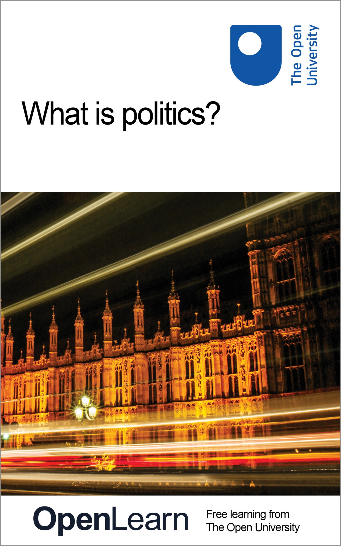

DD211_1

What is politics?

About this free course
This free course is an adapted extract from the Open University course DD211 Understanding politics: ideas and institutions in the mordern world : www.open.ac.uk/courses/modules/dd211.
This version of the content may include video, images and interactive content that may not be optimised for your device.
You can experience this free course as it was originally designed on OpenLearn, the home of free learning from The Open University – www.open.edu/openlearn/http://www.open.edu/openlearn/people-politics-law/politics-policy-people/what-politics/content-section-0
There you’ll also be able to track your progress via your activity record, which you can use to demonstrate your learning.
Copyright © 2016 The Open University
Intellectual property
Unless otherwise stated, this resource is released under the terms of the Creative Commons Licence v4.0 http://creativecommons.org/licenses/by-nc-sa/4.0/deed.en_GB . Within that The Open University interprets this licence in the following way: www.open.edu/openlearn/about-openlearn/frequently-asked-questions-on-openlearn . Copyright and rights falling outside the terms of the Creative Commons Licence are retained or controlled by The Open University. Please read the full text before using any of the content.
We believe the primary barrier to accessing high-quality educational experiences is cost, which is why we aim to publish as much free content as possible under an open licence. If it proves difficult to release content under our preferred Creative Commons licence (e.g. because we can’t afford or gain the clearances or find suitable alternatives), we will still release the materials for free under a personal end-user licence.
This is because the learning experience will always be the same high quality offering and that should always be seen as positive – even if at times the licensing is different to Creative Commons.
When using the content you must attribute us (The Open University) (the OU) and any identified author in accordance with the terms of the Creative Commons Licence.
The Acknowledgements section is used to list, amongst other things, third party (Proprietary), licensed content which is not subject to Creative Commons licensing. Proprietary content must be used (retained) intact and in context to the content at all times.
The Acknowledgements section is also used to bring to your attention any other Special Restrictions which may apply to the content. For example there may be times when the Creative Commons Non-Commercial Sharealike licence does not apply to any of the content even if owned by us (The Open University). In these instances, unless stated otherwise, the content may be used for personal and non-commercial use.
We have also identified as Proprietary other material included in the content which is not subject to Creative Commons Licence. These are OU logos, trading names and may extend to certain photographic and video images and sound recordings and any other material as may be brought to your attention.
Unauthorised use of any of the content may constitute a breach of the terms and conditions and/or intellectual property laws.
We reserve the right to alter, amend or bring to an end any terms and conditions provided here without notice.
All rights falling outside the terms of the Creative Commons licence are retained or controlled by The Open University.
Head of Intellectual Property, The Open University
978-1-4730-1730-6 (.kdl)
978-1-4730-0962-2 (.epub)

Contents
- Introduction
- Learning outcomes
- 1 Politics: the extraordinary and the ordinary
  - 1.1 The extraordinary
  - 1.2 The ordinary
  - 1.3 Politics: a view from the street
- 2 Politics: a contested concept
  - 2.1 The many meanings of politics
  - 2.2 Politics as context- and interpretation-dependent
  - 2.3 The contestability of concepts
  - 2.4 So what is politics?
- 3 Review
- 4 Perspectives on politics
- Conclusion
- Take the next step
- References
- Acknowledgements
- Solutions

Introduction
This course introduces you to the world of politics. It is dedicated primarily to answering the question of what politics is. Although the question might seem rather simple, it elicits various and often contradictory responses. As you will realise, in politics – as in much of the humanities and social sciences – definitive answers are difficult to come by. What politics is – and equally, who does it and where it is done – is hotly debated and highly contested. This course will introduce you to some of these debates, and their implications for the study and practice of politics. It will also explore a second, perhaps equally crucial question: Why is politics important?
This OpenLearn course is an adapted extract from the Open University course DD211 Understanding politics: ideas and institutions in the modern world .

Learning outcomes
After studying this course, you should be able to:
- understand the competing interpretations of what politics is, who does it and where it is done
- grasp the importance of politics and the variety of ways in which politics affects your everyday life
- better understand the contestability of concepts in politics, and the implications of such contestability for the practice and study of politics.

1 Politics: the extraordinary and the ordinary
As you are obviously interested in studying politics, you probably already have a sense that politics is important. You may also have developed some ideas of what politics is all about.

Activity 1
About 5 minutes

Jot down your preliminary thoughts on what politics is and why it is important.

Provide your answer...

Keep these thoughts in mind as you progress through the material in this course. See how they compare with the different definitions of politics and the variety of views you will encounter on why politics is important. You’ll have a chance to revisit and review your thoughts at the end of the course.
Let’s begin by considering the importance of politics. First we’ll look at the ‘extraordinary’ face of politics, at some of the attention- and headline-grabbing global political events. We will then turn to the more ‘ordinary’ face of politics and consider the role politics plays in our everyday lives.

1.1 The extraordinary
Most of us can probably name at least a few extraordinary global events that have taken place in the twentieth and twenty-first centuries. Even those of you fairly new to politics can probably list at least a couple of major events.
- Think about two or three events that would make your list of extraordinary global events, and some reasons why you think they are globally significant.
- Then examine the boxed list below – a compilation of some of the events we thought of. Do any of the events on your list overlap with ours?
- You might also start thinking about what might make these events ‘political’. You will explore various definitions of politics later in the course.

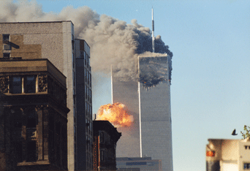
Figure 1 Al-Qaeda attacks on the World Trade Center, New York, on 11 September 2001

Box 1 Some extraordinary global events

The bombing of Hiroshima and Nagasaki
As the Second World War drew to a close, the US dropped atomic bombs over the Japanese cities of Hiroshima and Nagasaki on 6 and 9 August 1945, respectively, killing over 129,000 people. Following the war, Hiroshima was rebuilt as a memorial to peace.

The annexation of Crimea
On 18 March 2014, President Vladimir Putin signed a law to ratify Russia’s takeover of Crimea from Ukraine, Russia’s first territorial expansion since the Second World War. The act was widely condemned by world leaders, as well as by the North Atlantic Treaty Organization (NATO), as an illegal annexation of Ukrainian territory.

The African-American civil rights movement
Nonviolent protest and acts of civil disobedience were the main features of the civil rights movement in the US for over a decade, from 1955 to 1968. These campaigns created a series of crises, which led to significant dialogue between campaigners and government authorities.

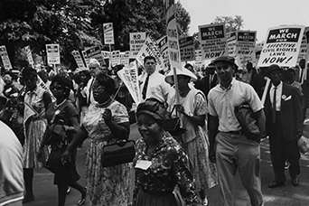
Figure 2 A civil rights march in Washington, DC

The Tiananmen Square protests
Over a million students and residents occupied Beijing’s Tiananmen Square for the largest political protest in China’s history. The protesters were violently suppressed and the country’s communist leaders ordered the military to enforce martial law in the capital.

The Iraq War
The US-led 2003 invasion of Iraq removed the Saddam Hussein regime, but led to ongoing conflict against an insurgency for over ten years. Unrest and armed conflict continue to this day.

The fall of the Berlin Wall
Following weeks of civil unrest in the German Democratic Republic and the consequent relaxation of cross-border visits, East German citizens were finally allowed free access to West Germany on 9 November 1989. This led to the eventual fall of the Berlin Wall and subsequent German reunification, which was formally concluded on 3 October 1990.

September 11
On 11 September 2001, militants affiliated with al-Qaeda, the Islamic terrorist group, hijacked four passenger planes and carried out a series of suicide attacks against the US. Two planes were flown into New York’s World Trade Center, while a third was flown into the Pentagon, close to Washington, DC. Passengers and flight attendants overcame hijackers on the fourth plane, causing it to crash in a field in Pennsylvania.

What do you think of the events we came up with? The list you made might overlap to some degree with the events above. But it might not overlap completely. Some events – like the Second World War or the terrorist attacks against the US on 11 September 2001 (9/11) – altered the global political landscape to such a degree that most people, in most places, would recognise them as extraordinary political events. But there are others that you might not have recognised or thought significant because they did not affect you directly. What you included on your list probably has a lot to do with where you are studying this course, as this will influence your perception of which events were of crucial importance and which were not.

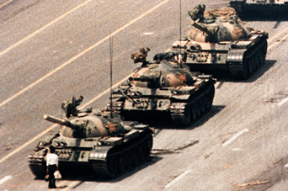
Figure 3 It remains unknown how many people were killed during the Tiananmen Square protests in 1989

You might also have included some events that had a huge impact on your life, but didn’t make our list at all. Or perhaps they didn’t make your list either – you might have thought they were important, but not so important as to make your list. Of course, even if political events are not extraordinary global events, that doesn’t mean they are not significant political events in their own right.

1.2 The ordinary
Few would disagree that most of the events listed in Section 1.1 have had significant direct or indirect impacts on our lives, and hence constitute important political events. For instance:
- the terrorist attacks of 9/11 not only resulted in two major wars – in Iraq and Afghanistan – but also, by precipitating increased security in air travel, irrevocably changed the way we fly
- the civil rights movement in the US, or other ongoing struggles for racial equality, may not have affected you directly – some of you may not even have been born when they were taking place – but have had profound and lasting effects on both US politics and society, and further afield.
However, politics is also much more ordinary – and the more ordinary, perhaps even mundane politics of everyday life can affect us as profoundly as the extraordinary. Politics influences our everyday lives in countless ways, and as you will see more clearly later in the course, we ourselves often engage in politics, perhaps without even realising that we are acting politically. What is more, some seemingly ordinary events can acquire extraordinary political significance.

Activity 2
About 5 minutes

Take a few minutes to think through your typical daily routine. In the box below, jot down some ideas in response to the following:
How does politics impinge on your daily routine? How do ordinary, day-to-day political decisions affect your routine?

Provide your answer...
View discussion - Activity 2

1.3 Politics: a view from the street
As you saw in Activity 2, politics permeates and affects our entire lives – often without us realising just how much of our daily routine is in one way or another affected by politics and informed by political decisions. Yet the importance of politics to everyday life, and the degree to which many of our daily activities are ‘political’, is not always recognised. In fact, for many people, politics still seems like the domain of professionals (such as politicians and political analysts).
This short video, ‘Politics: a view from the street’, introduces you to people’s views on politics.

Video content is not available in this format.
Politics: a view from the street
View transcript - Politics: a view from the street

Activity 3
About 40 minutes

Watch the video, and as you do so, think about some of the recurring answers, and the similarities and differences, in the views expressed. Then, in the boxes below, try jotting down some responses to the following questions.

1. What are the most common associations the people in ‘Politics: a view from the street’ make with politics? Why do you think this is the case?

Provide your answer...
View discussion - Part

2. Do most of those interviewed think politics is important? How do they feel it impacts on their day-to-day lives?

Provide your answer...
View discussion - Part

3. To what extent were most of those interviewed involved in politics? What were the reasons given for those not involved in politics?

Provide your answer...
View discussion - Part

2 Politics: a contested concept
So far, you have had a rather broad introduction to politics and its importance, on both a grand and an ordinary scale. You will now be introduced to some of the ways in which those who study politics have defined it. Through an engagement with various definitions of politics, this section of the course will also introduce you to the idea that many concepts in the social sciences are contested, politics included, and will explore the implications of this for studying and engaging in politics.
For writer Ernest Benn, ‘politics is the art of looking for trouble, finding it whether it exists or not, diagnosing it incorrectly and applying the wrong remedy’ (cited in Rodman, 1946). This view of politics is certainly not uncommon. It is probably representative of how many of us have, at one time or another, felt about politics. Economist Milton Friedman’s remark, ‘If you put the federal government in charge of the Sahara Desert, in five years there’d be a shortage of sand’ (Duronio, 2012) expresses a similar sentiment: leave it to politicians, and they will find a way to empty the desert of sand. Politics is a loaded term, one that evokes strong emotional responses from both critics and champions. Still greater contempt is often reserved for those who practise politics for a living. Politicians are often the butt of jokes and subjects of derision. Even Henry Kissinger, himself a political figure loathed by many, had little to say in defence of his profession when he opined that ‘Ninety per cent of the politicians give the other ten per cent a bad reputation’ (Byrne, 1984).

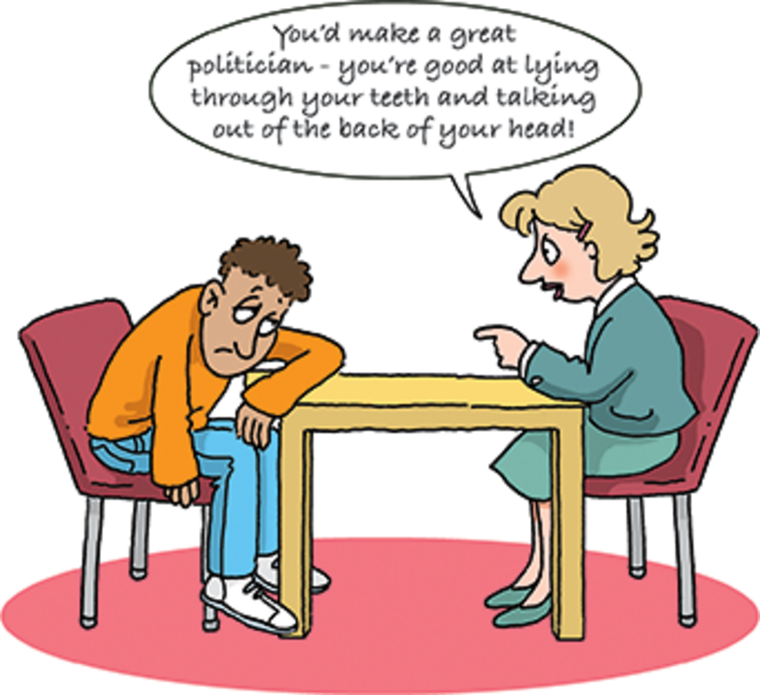
Figure 4 A common, even if inaccurate view of politicians
View description - Figure 4 A common, even if inaccurate view of politicians

If politics does indeed have a bad name, the first question we might ask is: Why? Those disillusioned with politics would have no shortage of evidence: self-interested, deceitful, corrupt and aloof politicians; incompetent or unresponsive governments; the frequent pettiness and absurdity of political debate in both the government and the media. In recent years, political corruption scandals have shaken the Czech Republic, Greece, Ireland, Italy, France, Spain, Russia and Turkey, to name but a few. The UK has certainly not been immune. According to The Independent’s Jonathan Brown, ‘recent British scandals can compete with the best Europe can offer’ (Brown, 2013).
And that is just Europe; political fraud, corruption and nepotism are so commonplace in many parts of the world that more often than not they are no longer considered ‘scandalous’. Add to this the ineptitude of some politicians (the innumerable ‘Bush-isms’ of former US President George W. Bush come to mind), the petty, at times violent brawls that erupt during parliamentary sessions in many parts of the world and the often uninspiring levels of political debate, and it is no wonder that many have lost faith in politics and politicians, and feel apathetic towards and disenfranchised from the political process. It is no wonder that many feel that the world would be a better place if we could just put an end to politicking.
But is this all that politics is about? Is there more to politics than what makes the headlines, notorious for prioritising the shocking and scandalous? Does politics extend beyond the politicians and parties we often distrust, the halls of government most of us have little access to, the ritual of voting that many of us find increasingly inconsequential?
Politics – and by extension, the actors in political dramas and the stages on which politics is enacted – is far more ubiquitous than we might suspect. Yet the questions of what politics is, who it is done by, where it takes place and how we study it elicit contradictory responses. Rather than providing definitive answers, we will introduce you to different perspectives; it is up to you to decide which you find most compelling.
In the following sections, you will be invited to consider a number of distinct definitions of politics. It is useful to conceptualise these definitions as existing along a spectrum, from narrow to broad understandings of politics. As you read on, you will notice that this spectrum, although useful, will itself come under scrutiny, particularly as we consider whether all of the definitions fall squarely towards the narrow or broad side, or whether some definitions are narrow in certain aspects and broad in others, or indeed could have both narrow and broad variations.
Having considered a number of distinct definitions of politics, we will then reflect on what this might mean for the practice and study of politics. We will do so with the help of a term that has been immensely influential both in the study of politics and in the social sciences and humanities more broadly: ‘essentially contested concept’. The phrase, originally coined by the social and political theorist Walter Bryce Gallie, was popularised by William E. Connolly in his seminal book The Terms of Political Discourse, first published in 1974 (Connolly, 1993). As you will see, the idea that the definitions of concepts – such as the concept of politics in general, but also more specific political concepts like freedom or equality – are disputed, and that two or three incompatible definitions could all be equally legitimate, has implications not just for politics, but for the nature of knowledge in the social sciences and humanities more generally.

2.1 The many meanings of politics
What, then, is politics? To this deceptively simple question there is actually no simple answer. Throughout the history of the discipline, political theorists and practitioners have offered multiple, at times contradictory, at times overlapping definitions of what politics involves. It is therefore difficult (if not impossible) to provide a single definition of politics that everyone can agree on. The best we can do is to explore some of the more salient definitions of politics, and see how they compare and contrast. This requires that we develop some sort of framework, some way of organising these definitions. In this section, we locate them on a spectrum that stretches between narrow and broad interpretations of politics. We begin on the narrow side of the spectrum, and consider the implications of defining politics as an activity restricted to specific people and places. We then explore broader definitions of politics and consider the implications of expanding the remit of politics to include less obvious activities, people and places.

2.1.1 Politics as that which concerns the state
Among the narrower definitions of politics is politics defined as that which concerns the state. As distinct from the government, the state comprises the permanent institutions that provide public services, enforce laws, ensure security and thereby provide for the governance of persons and the administration of things. The government, on the other hand, is composed of politicians who temporarily run the state because they have been elected (at least in democracies) to do so. The politicians determine the public services the state should provide, the laws it ought to enforce, the form of security it should ensure and the purposes for which the state should govern people and administer things. Politics defined as that which concerns the state can include: activities that either involve, or in some ways directly affect, the institutions of the state; individuals who are directly involved in the institutions of the state or the business of governance; and places in which these activities and people are present.
In light of this definition, the following could be included in the remit of politics: interactions between states in the international arena; the activities of politicians; and activities such as voting (in national, regional or local elections) through which individual citizens engage with the state. In even more concrete terms, politics that concerns the state might include:
- bilateral (or two-party) meetings between Canadian and Russian foreign ministers to resolve their territorial disputes in the Arctic
- multilateral meetings (between multiple groups) organised under the auspices of the United Nations to discuss issues such as climate change or nuclear non-proliferation
- the day-to-day activities of the European Commission in Brussels, which drafts proposals for new European laws
- debates and votes in the UK Parliament on government policy or proposed legislation
- or citizens voting in the general elections to choose their next government.

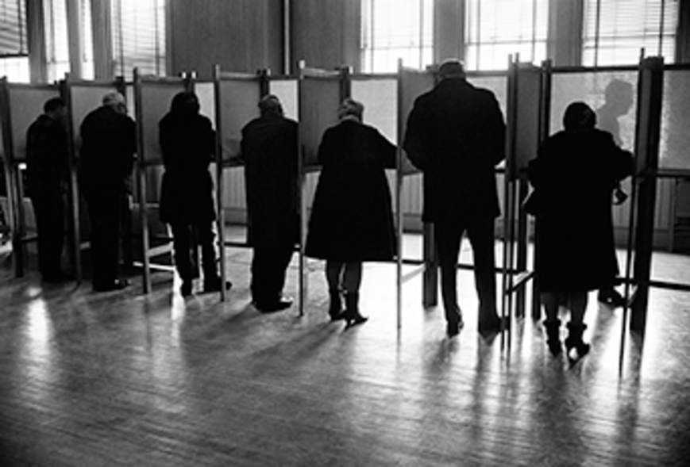
Figure 5 Voters in the US marking election ballots, c.1970

As you can see from this definition, politics, even in a narrow sense, is about much more than the activities (or careers) of politicians. Even when politics is confined to that which concerns the state, it involves a whole host of other activities, actors and spaces (from the more abstract or metaphorical space of the ‘international sphere’ to more concrete places such as the UN headquarters in New York or the Palace of Westminster in London).
Through a variety of state institutions, governments make and enforce laws that govern the conduct of those within their jurisdiction. They raise taxes through which they provide public services such as infrastructure, health care, education, employment and other social services. Of course, not all states provide citizens with the same kinds or quality of services. Likewise, successive governments may not always provide the same kinds of services as their predecessors. While one government may be concerned with the issue of national defence and channel more of its tax revenue towards the armed forces, another may reduce military spending and channel more revenue into infrastructure or health care. A further government may choose to raise levels of taxation in order to afford increased spending in both areas.
In addition to regulating and governing the conduct of those in their jurisdictions (persons, corporations or other entities) and providing public services, governments also interact with other governments in the international arena. In the most extreme situations, they may go to war with each other. More frequently, however, they interact with each other through international or regional organisations that attempt to regulate inter-state affairs, organisations such as the UN, the World Trade Organization or the African Union. Through participation in regional and international organisations, states attempt to cooperate on issues of regional or global scope such as international trade (by establishing tax-free trade zones or principles of fair trade), international crime (for example, drug trafficking or piracy) and global environmental issues (for example, climate change).
Given that all this can fall within the remit of politics, defined as that which concerns the state, you might think that this definition of politics is not actually particularly narrow. It does, after all, seem to include a lot of activities, actors and spaces. Indeed, many would agree with that assessment. But as you will later see, for many others this definition is still too narrow as it excludes or overlooks the myriad political activities that do not directly involve the state. Are anti-war or anti-globalisation protests political? Are boycott campaigns political, such as the global boycott of Nike in the 1990s or the more recent Boycott, Divestment and Sanctions movement against Israel? Are animal rights movements, or even the choice to not consume meat, political? For many of those who argue for a broader interpretation of politics, these can indeed be political. According to such arguments, this first definition, while incorporating a number of different activities, actors and places, is still too narrowly focused on the state.

2.1.2 Politics as conflict resolution
A second definition of politics goes some way towards ameliorating this problem. It removes the state as the focus of politics and defines politics as a particular kind of process. Politics, in this definition, is a particular method for resolving conflict. Among the best-known proponents of such an understanding of politics was the political scientist Bernard Crick (1929–2008). Crick defines politics as ‘the activity by which differing interests within a given unit of rule are conciliated by giving them a share in power in proportion to their importance to the welfare and the survival of the whole community’ (Crick, 1964, p. 21). Later on he defines politics even more broadly, suggesting that politics is a ‘solution to the problem of order which chooses conciliation rather than violence or coercion’ (p. 30).

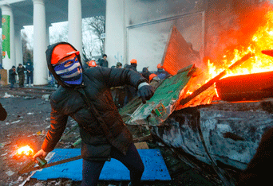
Figure 6 A protester throws a Molotov cocktail during an anti-government protest in Kiev

One important aspect of Crick’s definitions is the distinction he draws between politics and violence or coercion. For Crick, politics is, by definition, distinct from violence. He is by no means alone in drawing this distinction. Hannah Arendt (1906–1975), another influential political theorist, likewise insisted on the distinction between politics and violence. The association of politics with non-violent conflict resolution is also present in everyday language. A ‘political solution’ to a problem – such as the territorial dispute between India and Pakistan in Kashmir, or the Libyan Civil War of 2011 – is one that involves peaceful negotiation and arbitration; by contrast, a ‘military solution’ implies the use of force. Using this definition, politics is not necessarily related to a particular object – as in the first definition we looked at, politics is that which concerns the state – but refers to the process by which problems are solved and decisions are made.
Although a definition of politics as a way of problem solving that is distinct from violence does not necessarily imply that it takes the form of party politics, Crick’s other work, and perhaps his personal involvement in British party politics, have led to criticism that he is indeed biased towards party politics (Heywood, 2013). One might perceive a hint of this bias in the first of Crick’s definitions above – in his focus on proportional power sharing, for instance. Thus, for some, Crick’s interpretation of politics is still too narrowly focused, if not on the state as such, then on a particular kind of political process – one closely related to pluralist democracies and having little relevance in non-democratic or non-pluralist contexts where, as critics might argue, politics is still present.
There is another challenge that proponents of a broader definition of politics could level at Crick’s definition. Are politics and violence mutually exclusive? Or does the rigid separation of politics from violence (and, perhaps even more so, from coercion) exclude a whole host of actions that should be included under the rubric of the political? Is the destruction of property – anti-capitalist protesters smashing bank machines or animal rights activists throwing paint on expensive fur coats – political? Are suicide bombers acting politically? Or are they engaging in violence, pure and simple, entirely eschewing the political process? Are revolutions – generally defined by their violent character – political? For those for whom politics is a non-violent method of conflict resolution, these would probably not qualify as political actions. Yet for many others, the distinction between politics and violence is a lot less straightforward.
An even more fundamental problem raised by the above discussion is that of definition. We might ask, for instance, what constitutes violence or, for that matter, coercion? Does the destruction of property constitute violence? Is verbal or psychological abuse violent? At what point does exerting pressure on someone become coercion or violence? These are all contentious questions, which elicit contentious (and contested) answers. We will attend more closely to the contestability of concepts later on. Yet it is important to flag it here, as the conceptual choices we make – between different definitions of violence or politics, for instance – determine how we interpret the world around us.
If we keep moving from the narrow towards the broad side of the spectrum, the political scientist Andrew Heywood offers a somewhat broader definition of politics. He defines politics as the ‘activity through which people make, preserve and amend the general rules under which they live’ (Heywood, 2013, p. 2). He goes on to characterise politics as a process of conflict resolution, whereby an attempt is made to reconcile rival interests. Although, in the end, the conflict may not be resolved, politics is characterised by a search for such resolution. With its focus on conflict resolution, this definition shares some commonalities with Crick’s, yet there are also some differences. Crick defines politics as a particular way of resolving conflict – the proportional sharing of power by different interests – and narrows its scope by noting that it takes place ‘within a given unit of rule’ (such as the state). Arguably, Heywood’s definition is broader, extending political activity beyond ‘units of rule’, and defining it as a search for conciliation as opposed to its achievement.

Figure 7 Politics, violence or both? Trade union stickers on the broken window of a Madrid restaurant following demonstrations in 2014 against Spanish austerity measures

Let’s scrutinise this definition. We might think about what other definitions Heywood’s understanding of politics depends on. Among the most obvious is the definition of conflict (and, by extension, its resolution). We might ask what would qualify as conflict, or its resolution. For instance, would a resolution of conflict necessarily require consensus (or everyone’s agreement on a particular solution) or simply a majority agreement? For some political theorists, politics is (or at least ought to be) a process of consensus building; others see it as more of an adversarial process, where reconciliation and consensus are not necessarily the desired outcome. This leads us to a second, perhaps even more fundamental question we could ask of this (or any other) definition of politics: On what normative (or value) judgements is it premised?
Both Heywood and Crick define politics as a process whose end goal is the reconciliation of differences and the resolution of conflict. Thus, put very simply, it could be argued that the definitions are premised on the assumption that difference and conflict are undesirable, and their reconciliation and resolution desirable. Without explicitly stating it, both Crick and Heywood start from the normative assumption that difference and conflict are ‘bad’ and their mitigation, reconciliation or resolution ‘good’. Therefore, their definitions of politics, although seemingly merely descriptive, are actually built on certain normative assumptions about what is ‘good’ and ‘bad’, ‘desirable’ and ‘undesirable’. This is important to realise, as political analysis is at least in part about unearthing the often implicit, normative assumptions present in political statements and practices.

2.1.3 Politics as conflict
You might be wondering whether anyone could actually positively value conflict. Aren’t consensus or the reconciliation of difference always a good thing? Would anyone actually argue that conflict is desirable? There are indeed those who do and who, on the basis of this perhaps counterintuitive normative judgement, offer a definition of politics with a somewhat different focus. Among these are theorists who subscribe to a school of thought known as agonism. As a political theory, agonism emphasises the positive aspect of conflict and, as such, does not see the reconciliation of difference or the resolution of conflict as the only desirable outcomes of politics. For instance, a prominent advocate of agonism, political theorist Bonnie Honig, argues for the need to identify ‘the affirmative dimension of contestation’ (Honig, 1993, p. 15).
For agonist political theorists, politics is a process that makes possible the coexistence of difference and conflict. In other words, politics is the process through which we live together with and respect those who are different, without us trying to convince them to become ‘like us’, or them trying to convince us to become ‘like them’. It is also the process through which conflict is organised, and in fact made productive, rather than erased. As another prominent agonist theorist, Chantal Mouffe argues, ‘if we want people to be free we must always allow for the possibility that conflict may appear and... provide an arena where differences can be confronted’ (Castle, 1998).
Agonist definitions of politics share some things in common with definitions of politics such as those put forward by Crick and Heywood. Both make the assumption, for instance, that difference and conflict are fundamental features of society and that politics offers a way of living with such difference and conflict. But arguably there are also some differences. There seems, for instance, to be a normative difference, with agonist theorists placing greater emphasis on the desirability and productive aspects of conflict, as opposed to the search for conciliation. Indeed, for some agonist theorists the persistence of difference and discord is precisely what indicates the existence of freedom.

2.1.4 Politics as the exercise of power
So far we have looked at definitions of politics that compelled us to consider whether politics is an activity related to the state and its institutions, or one that extends beyond it; whether its aim is conflict resolution and consensus building, or the embracing of conflict and dissensus. The next definition of politics we will examine compels us to consider yet another aspect of politics – the relationship between politics and power.
Some define politics quite simply as the exercise of power. This definition most clearly demonstrates two issues alluded to previously: the problem of definitions or, in other words, the issue of the contestability of concepts; and the limitation of the narrow–broad spectrum alluded to at the beginning of the chapter. Let’s attend to the issue of definitions first. Given what you have read about the distinction between politics and violence, you might already be thinking that the definition of politics as the exercise of power very much depends on how we define power. Political theorists have offered various definitions of power. The political scientist Robert A. Dahl (1915–2014) defined power as influence over the actions of others, arguing that, ‘A has power over B to the extent that he can get B to do something that B would not otherwise do’ (Dahl, 1957, pp. 202–3). Others, like the political theorist Steven Lukes, thought such a definition failed to capture additional, less overt dimensions of power, including the power to shape political agendas and preferences more broadly (Lukes, 1974). Still another definition of power, and thus also politics, was offered by the political scientist Harold Lasswell (1902–1978): politics is about ‘who gets what, when and how’ (Lasswell, 1936). Lasswell adds a distinctly economic dimension to politics, whereby politics involves the distribution of resources – or decisions on ‘who gets what’.

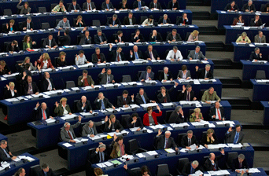
Figure 8 Members of the European Parliament in the chamber of the European Parliament during voting, Strasbourg, France

If politics is defined as the exercise of power, what one means by politics depends on how one defines power. Dahl’s relatively narrow definition of power (as the capacity to influence the actions of others) results in a relatively narrow definition of politics – as a game in which actors try to influence each other to get others to do what they would not otherwise have done. Lukes’ broader definition of power enables a broader definition of politics, whereby politics can also include less observable ways of exercising power such as the setting of agendas – be it parliamentary agendas that determine who gets to speak, for how long and on what issues, or news agendas that determine which issues are ‘newsworthy’ and will appear on the evening news, and which issues will not make the cut.
This brings us to the second problem – the limitation of the analytical framework we established for understanding politics. As you are probably beginning to see, in some cases, a definition of politics does not fit squarely under the ‘narrow’ or ‘broad’ rubric. Such is clearly the case with the definition of politics as the exercise of power. In this case, the exclusivity or inclusivity of politics depends on how we define power. However, it also depends on whether or not we consciously limit the scope of politics to include only particular actors and places. We might arrive at a narrower definition of politics if we limit the actors whose exercise of power we are interested in, or the spaces in which they exercise power. We could, for instance, define politics as the exercise of power by politicians, or as power exercised within the institutions of the state. This would considerably narrow our understanding of politics. Alternatively, we might considerably broaden the definition by arguing that politics takes place whenever and wherever power is exercised. On such a definition, we could point to the politics of playgrounds, where children negotiate who gets to play and with what toys, or politics in the home, when partners negotiate who does which chores or when parents discipline their children.
The point here is this: defining politics as the exercise of power can lead to narrower or broader definitions of politics, depending on our definition of power, but also on the parameters we set – regarding the content of politics (its relationship to the state, for instance, which would considerably narrow its scope), or the actors and spaces involved. Thus, the narrow–broad spectrum, although a useful organisational tool, can only take us so far.

2.1.5 Politics as a social and public activity
Some of the examples cited above, involving the politics of playgrounds or the politics of familial coexistence, prompt us to consider some even broader definitions of politics. The play of children or the interaction of spouses has little to do with states, politicians or political institutions. If you have watched children play, you probably know that the politics of playgrounds does not always involve the peaceful resolution of conflict. It is often about power, but power defined in rather broad terms. Thus, if we agree that there is such a thing as the politics of playgrounds, we might have to stretch our definition of politics quite significantly.
Proponents of narrower definitions of politics often object to such stretching by arguing that if stretched too far politics can lose its meaning, becoming everything and anything one can imagine. That is indeed a legitimate concern, and one that broad definitions of politics must contend with. Keep this in mind as we examine some of these broader definitions of politics; in the end, it will be up to you to decide whether any of these definitions succeed at broadening the scope of politics without diluting it to the extent that it loses its meaning.
Among the broadest ways of defining politics is to understand it as a ‘social activity’ – an activity we engage in together with others, or one through which we engage others. Politics, in this sense, is ‘always a dialogue, and never a monologue’ (Heywood, 2013, p. 1). A similarly broad (or perhaps even broader) definition is offered by Arendt (2005), who argues that politics does not have an ‘essence’ – it does not have an intrinsic nature, or an indispensable element according to which we can definitively, and in all circumstances, identify something as political. Thus, there are no quintessentially political acts, subjects or places. Politics, rather, is the world that emerges between us – the world that emerges through our interactions with each other, or through the ways that our individual actions and perspectives are aggregated into collectivities.

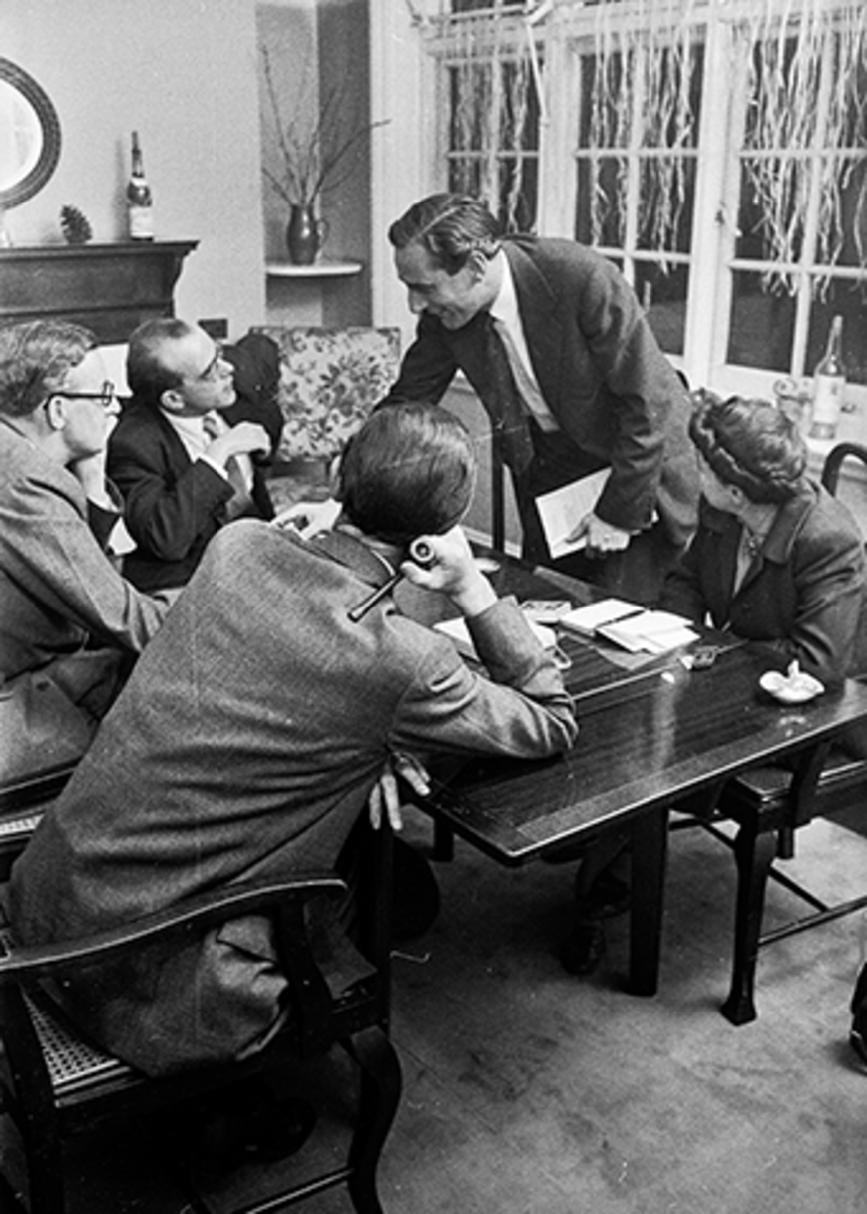
Figure 9 A roundtable discussion on the role and quality of BBC television, 1953

Having consistently critically engaged with the definitions of politics presented thus far, you are probably already asking some critical questions about these newest definitions. You might be asking, for instance, What qualifies as social? Is it simply an activity that is engaged in by more than two people? If so, is everything that is social also political? Is going to a pub or a football game or shopping political? If politics is a dialogue, is every conversation political? Conversely, is politics never a monologue? Must it always be a conversation? And what precisely qualifies as a conversation? Do politicians yelling across each other during a parliamentary debate qualify as a dialogue? Or are they simply shouting, without actually engaging with each other’s ideas, and therefore not actually ‘doing politics’? Or if, as Arendt postulates, there is nothing that is ‘essentially’ political, and politics can appear anywhere, is everything political? Does this stretch politics a bit too thin, diluting its meaning to the point of making it meaningless?
Similar questions could be asked of yet another interpretation of politics, that which defines politics as a public (as opposed to private) endeavour. For some, this has meant that politics occurs exclusively in the public sphere, while that which goes on in private does not merit the label ‘political’. This distinction between the public and private has been problematised and disrupted by feminist political theory, and is well captured by the feminist slogan ‘the personal is political’, or, in other iterations, ‘the private is political’. The phrase originated with second-wave feminism, a period of feminist activism that began in the 1960s and focused on issues like domestic violence and reproductive rights, previously considered matters of ‘private’ as opposed to ‘political’ concern. The phrase has since been used to argue that the narrow association of politics with public institutions or the institutions of the state (from which women have been historically excluded) should be abandoned in favour of a more inclusive definition of politics that recognises the activities of women in the private sphere (within the family structure, for instance) as potentially political. It has also been used to argue that issues such as spousal abuse or reproductive rights (often considered private matters, as opposed to public issues) should in fact be politicised, and considered matters of public concern.
However, the argument that politics is a public endeavour can also be understood more broadly. For something to be public, it need not take place in the public sphere, as defined above. Something can be public in its orientation; it can qualify as public if it is directed outward, into the world, so to speak. On this understanding of publicity, the political-ness of an action does not depend on its location in the public or private sphere, but on its public orientation. Take, for instance, the act of reading a book or watching a film that has been censored or banned by your government. Reading such a book in a coffee shop (a public space) would certainly qualify as a political activity. But so might reading it in your home (a private space), or, indeed, keeping it on your bookshelf. Though done in the privacy of your home, these acts are directed outward, into the world, in the sense of making a (political) statement against censorship. In fact, they might even be considered political in the narrower sense of the term – they do, after all, ‘concern the state’ in the sense of directly challenging its laws.
Let’s stick with this example, and return briefly to the definition of politics as a social activity. Even if we broaden the definition of ‘public’ to include reading a banned book at your kitchen table, reading is surely not a ‘social’ activity or a ‘dialogue’, so it might not qualify as political according to that definition. Yet for some of those advocating a broad interpretation of politics, the concept of ‘dialogue’ is rather fluid. Dialogue, for instance, does not need to be a dialogue with someone specific, but could be a dialogue with (or critique of) prevailing laws or social norms. This would enable us not only to stretch the category of politics to include activities such as reading a banned book, but also to include within the realm of politics individual actions that are ‘directed’ towards others (without necessarily having an identifiable audience) or engaging in a ‘conversation’ in a more metaphorical sense of the term. Literature and art more generally, as well as their consumption (the reading of novels, the watching of films or attendance at an art exhibition, for instance) could, in this sense, be political. And so too, of course, would be the writing of fiction or the production of a film or piece of visual art.

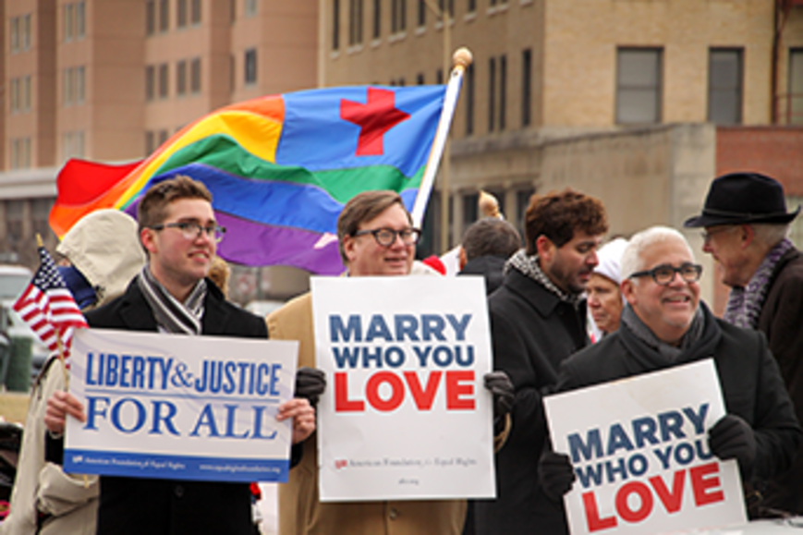
Figure 10 Gay marriage advocates demonstrate in front of the US courthouse in Norfolk, Virginia, 2014

Given the example you just worked through, you might be tempted to think that politics (whether broadly or narrowly defined) is all about critically engaging with or challenging the status quo – the present state of affairs. Protests against dominant social norms or government law do indeed challenge the status quo, but politics also includes attempts to preserve the status quo. Those who have engaged in protests to preserve the definition of marriage as a union between a man and a women have been engaging in politics as much as those lobbying to change it. Thus, while some engage in politics in order to change the present state of affairs, others do so to endorse and conserve that which exists.

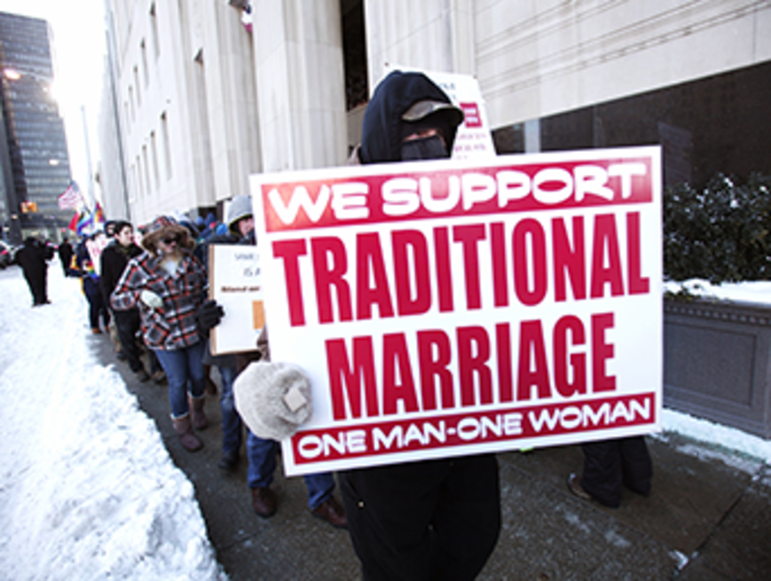
Figure 11 Proponents of traditional marriage protest in front of the US federal courthouse in Detroit, Michigan, 2014

2.2 Politics as context- and interpretation-dependent
We have come a long way from the narrow definition of politics as that which concerns the state to the definition of politics as a social and public activity, in the broadest sense of the terms ‘social’ and ‘public’. Where does this leave us? With politics defined so broadly that it has lost any meaning? With politics including everything but the kitchen sink? Is anything and everything political? Critics of broad definitions of politics argue that this is precisely the problem. But there might be a way of retaining a broader, more inclusive definition of politics without diluting ‘the political’ to the extent that it loses all meaning. One way of doing so is to argue that while not everything is necessarily political, it has the potential to be, depending on its context and interpretation. An example might be useful to clarify how such a definition of politics would work.
Let’s take the example of kissing, which is probably not something that immediately strikes us as political. Kissing your partner at home or giving your children a goodnight kiss is certainly not political. Yet in a different context, kissing could indeed be quite political. In 2013, two Moroccan teenagers were charged with ‘public indecency’ and although eventually acquitted, faced a possible five-year prison sentence after pictures of the couple kissing were posted on Facebook. While it doesn’t seem that the couple saw their kiss as political, the gesture was quickly politicised in the socially conservative kingdom. In protest of the charges, a dozen or so couples staged a public ‘kiss-in’ in front of the Moroccan parliament while others flooded Facebook with pictures of kissing couples. In 2014, public ‘kiss-ins’ were also organised in Turkey to protest the increasingly socially conservative orientation of the government, and in Russia to protest laws that would criminalise public displays of affection between gay and lesbian couples. Thus, while kissing is not in and of itself political (which might mitigate critics’ concern that in broad definitions of politics everything is political and so politics loses its meaning), it has the potential to be political, depending on the context.
In addition to context, we also need to attend to the question of interpretation – that is, whether an act is interpreted as political, either by the actor who performs it or by those who encounter it once it is projected into the world. While it might seem that the intention behind an action (that is, the intention to engage in politics, or to make a political statement through one’s action) is more important than its interpretation, often that is not actually the case. Actions can become politicised – they can become political, generate political debate and so on – without that being the intention of the actors involved. It doesn’t seem, for instance, that the two teenagers in the Moroccan kissing drama intended their kiss to be political, but it quickly became political. Such was also the case when two female athletes kissed on a podium in Russia in the lead-up to the Sochi Olympic Winter Games. The kiss was interpreted as a political statement in defiance of Russia’s anti-gay laws. Despite repeated insistence by the athletes that it was nothing of the sort, the act acquired a life of its own, sparking international debate and controversy. Thus, when it comes to the ‘political-ness’ of an action or situation, interpretation (and, of course, context) can matter more than intention.

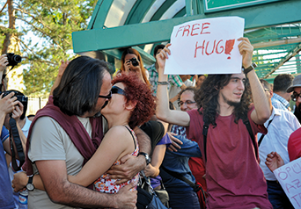
Figure 12 Demonstrators in Ankara, Turkey, stage a kiss-in to protest against increasing moral conservatism, 2014

Let’s take another example, that of graffiti. Is drawing or scribbling something on a wall political? Does it count as political activity? The simple answer is: it depends. It depends on which definition of politics we find most convincing and subscribe to. If we subscribe to definitions tending towards the narrow side of the spectrum – politics as that which concerns the state, or politics as conflict resolution – the production of graffiti might not qualify as a political activity. However, if we subscribe to definitions tending towards the broad side of the spectrum – politics as the exercise of power, or politics as a dialogue or public activity – graffiti might fit the bill.
As a form of expression, graffiti can be a challenge to social norms and laws that dictate what public spaces should look like and to the sanctity of private property. Thus, it can be political in the sense that it is a dialogue with (if not an outright challenge to) prevailing social norms and laws. What is more, in addition to being public in the narrow sense of the term (that is, an intervention into public space), graffiti can also be interpreted as public in the sense of being directed outward, into the world. Some graffiti is not only meant to be seen, but also meant to elicit a reaction, provoke a discussion or cause a debate. In short, it is meant to have an effect. Finally, the location or content of graffiti may also be political. Among the best-known contemporary graffiti artists is Banksy, a British street artist whose epigrams and images (as well as their locations) often contribute to some of the most salient social and political debates of our times.
Yet even if we subscribe to definitions of politics that tend toward the broader side of the spectrum, we might still want to avoid the blanket statement that all graffiti is inherently and necessarily political. Indeed, if nothing is inherently political, but rather has the potential to be political depending on context and interpretation, we need to analyse instances of graffiti in the same way that we analysed kissing in the previous example. We need to ascertain the circumstances under which graffiti can be political. The content of the graffiti, the message it is trying to convey, its location or the way it is being reacted to by those viewing or engaging with it can all help us decide whether or not it is political. Still, as you can probably very well imagine, we might not all come to the same conclusion.

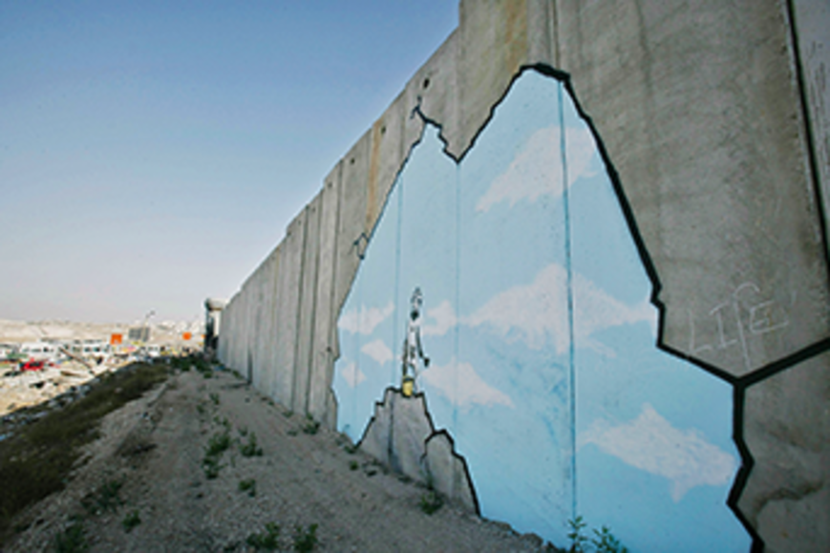
Figure 13 Graffiti by the artist Banksy on the Israeli-constructed wall that separates the West Bank from Israel

As the previous examples illustrate, it seems possible to argue that politics is an activity that extends far beyond the state and its institutions without diluting it to the point that it becomes meaningless. We could indeed argue that while not everything is necessarily political, everything has the potential to be, depending on context and interpretation. Such a definition of politics enables us to transcend the halls of government and institutions of state, and multiply the stages on which politics is enacted. It enables us to recognise, and legitimate as political, acts and actors otherwise excluded from narrower definitions of politics. It also enables us to see conflict, and actions designed to provoke or to challenge the status quo, as legitimate and productive ways of doing politics. Thus, it broadens the definition of politics and multiplies the actors in political dramas, and the stages on which politics is enacted. Yet, through the proviso that not everything is necessarily political but rather has the potential to be, it broadens the political without diluting it to the extent that it loses all meaning.

2.3 The contestability of concepts
Having just been introduced to multiple and at times contradictory definitions of politics, you will already have an idea that politics is something of a contested concept. It is impossible to provide a single definition of politics, as there is no single definition on which everyone agrees – it is, indeed, a contested concept. But what exactly does this mean? To understand what qualifies as a contested concept, we must first understand the term ‘concept’. Andrew Heywood says the following about concepts:

A concept is a general idea about something, usually expressed in a single word or a short phrase. A concept is more than a proper noun or the name of a thing. There is, for example, a difference between talking about a cat (a particular and unique cat) and having a concept of a cat (the idea of a cat). The concept of a cat is not a ‘thing’ but an ‘idea’, an idea composed of the various attributes that give a cat its distinctive character: ‘a furry mammal’, ‘small’, ‘domesticated’, ‘catches rats and mice’, and so on... In the same way, the concept of ‘presidency’ refers not to any specific president, but rather to a set of ideas about the organization of executive power.
(Heywood, 2013, p. 18)

If we apply this definition of concepts to what we have studied thus far, we could say that we have been studying the concept of politics. We have been trying to understand what politics is, as a ‘general idea’: what ‘attributes’ or characteristics it has; what distinguishes it from other concepts (such as violence, for instance); in other words, where politics begins and ends. But how is delineating the boundaries of a concept (be it the concept of a cat, or the concept of politics) useful? Heywood argues that concepts are valuable, as they are the tools through which we engage with the world:

Merely perceiving the external world does not in itself give us knowledge about it. In order to make sense of the world we must... impose meaning upon it, and this we do through the construction of concepts. Quite simply, to treat a cat as a cat, we must first have a concept of what it is. Concepts also help us to classify objects by recognising that they have similar forms or similar properties... It is no exaggeration to say that our knowledge of the political world is built up through developing and refining concepts which help us make sense of that world. Concepts, in that sense, are the building blocks of human knowledge.
(Heywood, 2013, p. 18)

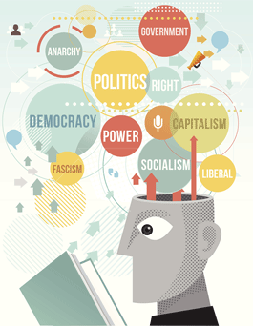
Figure 14

Concepts are abstract ideas (or mental images) that allow us to make sense of a messy world by enabling us to classify, categorise and order the multitude of things we encounter. Having a concept of a cat allows us to recognise that many of the ‘small’, ‘domesticated’, ‘furry mammals’ we encounter belong to a single class of entities we call ‘cat’. Similarly, having a concept of politics allows us to recognise a host of activities we encounter on a daily basis as having similar forms or properties, and thus as belonging to a distinct class of entities called ‘political’.
Concepts allow us to make sense of the world by enabling us to impose form and meaning on what might otherwise appear as formless and meaningless chaos. But what if little agreement exists about the concept itself? What if the concept itself is contested? Wouldn’t the existence of two different concepts of ‘cat’ – whereby according to one concept cats were ‘small’, ‘domesticated’ and ‘furry’ but according to another they were actually ‘small’, ‘winged’ and ‘feathered’ – reduce the utility of the concept, making it more difficult for us to make sense of the animals we were encountering? While you might agree that having two competing concepts of ‘cat’ might reduce the utility of the concept, you might also be thinking that the whole premise of this exercise is rather silly. Cats are cats, and the meaning of cat is universally shared; what qualifies as a cat is not really contested, and no one would actually imagine a cat as ‘winged’ and ‘feathered’.
While that may indeed hold for the concept of ‘cat’, it does not, as you have seen in this section, hold for the concept of politics. Politics is much more of a contested concept than the concept of ‘cat’ and little agreement exists on what ‘counts’ as politics. Some have argued that this is the case for most, if not all, concepts in the social sciences – they are often more fundamentally contested than those in the ‘harder’ sciences such as zoology or physics. Concepts in the social sciences can be ‘slippery customers’ (Heywood, 2013, p. 18). In this section, we have looked at only one concept – politics – and you can already see what a ‘slippery customer’ it can be. There are many more concepts, the meaning of which are, to a greater or lesser extent, contested. Contests over these concepts are not just ‘academic’; they have considerable real-life consequences. As Heywood (2013, p. 20) points out, many have argued, fought and even gone to war ‘claiming to be “defending freedom”, “upholding democracy”, or “having justice on their side”’.
Concepts such as democracy, freedom and justice, and the concept of politics itself, are seen by many to be ‘essentially contested concepts’ – ‘controversy about them runs so deep that no neutral or settled definition can ever be developed’ (Heywood, 2013, p. 20). Walter Bryce Gallie, who originally coined the phrase, offered the following definition of ‘essentially contested concepts’: ‘concepts the proper use of which inevitably involves endless disputes about their proper uses on the part of their users’ (Gallie, 1956, p. 169). In his book, The Terms of Political Discourse, William E. Connolly applied the phrase to politics, arguing that some key political concepts – including the concept of politics itself – are essentially contested. Using democracy as an example, Connolly noted that the commonly accepted criteria of democracy are weighed differently by different parties and:

certain criteria viewed as central by one party are rejected as inappropriate or marginal by others... Thus for some the central criterion of a democracy is the power of citizens to choose their government through competitive elections; for others this factor is less important than the equality of opportunity for all citizens in attaining positions of political leadership; for still others both of these criteria pale in significance if the continuous participation of citizens at various levels of political life is not attained.
(Connolly, 1993, pp. 10–11)

The same, Connolly argues, goes for politics, ‘a concept particularly susceptible to contests about its proper range of application’ (p. 20). What is more, ‘not only is politics an internally complex concept with a broad and variable set of criteria but each criterion itself is relatively complex and open’ (p. 14). Think back to some of the definitions of politics we previously discussed – for instance, politics as a ‘social’ activity or politics as distinct from ‘violence’. It is not only the concept of politics that is contested here. Equally contested are the concepts of ‘social’ and ‘violence’. Remember some of the questions we asked while discussing these definitions of politics, like what qualifies as ‘social’, or what qualifies as ‘violence’? The contested nature of politics is also related to the contested nature of other concepts.
Where does this bring us? Have we again gone too far? If so many crucial political concepts are contested, then what is the use of trying to understand them? For Connolly (1993, p. 6), ‘conceptual contests are central to politics’. Indeed, he adds, ‘To examine and accept, or to examine and revise the prevailing terms of political discourse is not a prelude to politics but a dimension of politics itself’ (p. 3). And so, to the multiple definitions of politics we have already encountered, we can add one more: politics as critical engagement with the prevailing terms of political discourse. As Heywood (2013, p. 20) puts it, ‘politics is, in part, a struggle over the legitimate meaning of terms and concepts’.

2.4 So what is politics?
What is politics? The simple answer to this question is that there is no single answer. Like many political concepts, politics is itself a contested concept. This section has introduced you to the idea that concepts, including the concept of politics, can be ‘essentially contested’, and has explored some of the implications this might have for the study (and practice) of politics, as well as for the nature of knowledge in the social sciences and humanities more generally. The section also introduced you to some competing definitions of politics, organising them along a spectrum from narrower to broader conceptions of what constitutes politics. Starting from the narrower and moving towards the broader side of the spectrum, the section introduced you to the following definitions of politics:
- politics as that which concerns the state
- politics as a (non-violent) method of conflict resolution
- politics as conflict
- politics as the exercise of power
- politics as a social activity
- politics as a public activity
- politics as dependent on context and interpretation
- politics as struggle over the meaning of political concepts.
While these definitions are distinct and in some cases contradictory, they do also overlap, and they certainly don’t correspond to mutually exclusive realms of political activity. Engaging in political activity in the narrower sense, for instance by voting or becoming involved in party politics, does not preclude one from engaging in political activity in the broader sense, for instance, by participating in protests or boycott campaigns. Politics is ubiquitous. Avenues for political involvement are multiple, and there is certainly nothing to prevent you from engaging in as many kinds of politics as you have the time and desire to!
As you studied these distinct definitions of politics, you were encouraged to engage critically with them and to consider whether they did actually fall squarely towards the narrow or broad side of the definitional spectrum. Indeed, while some definitions were certainly narrower (or broader) than others, you also saw that in some cases this depended on how we defined other concepts – such as power, violence or conflict – which can themselves be contested concepts.
Although it might at first appear that debates over the meaning of concepts are quite far removed from our everyday lives, people all over the world and throughout history have sacrificed their lives and livelihoods for concepts such as democracy, equality and freedom. Although wars have not been fought exclusively over the definition of politics, different understandings of who counts as a political being (in other words, as ‘doing politics’) are in no small way related to different understandings of politics. In turn, who counts as a political being has significant implications for whose voices are heard, whose concerns matter and which actions are valued or considered legitimate and which disparaged, trivialised or even criminalised.

3 Review
Since you’ve encountered quite a bit of material thus far, let’s pause and review some of it now. Have a go at the informal quiz below (which isn’t assessed).

Activity 4
About 20 minutes

Match the numbered example of what might constitute the practice of politics to its correct multiplechoice definition.

1. Citizens voting in a national election.

a. Context- and interpretation-dependent.
b. A struggle over the meaning of political concepts.
c. A social activity.
d. A (non-violent) method of conflict resolution.
e. That which concerns the state.
f. The exercise of power.
g. Conflict.
h. A public activity.
View answer - Part
View discussion - Part

2. A negotiated agreement to resolve a territorial dispute between two countries.

a. Context- and interpretation-dependent.
b. A struggle over the meaning of political concepts.
c. A social activity.
d. A (non-violent) method of conflict resolution.
e. That which concerns the state.
f. The exercise of power.
g. Conflict.
h. A public activity.
View answer - Part
View discussion - Part

3. A heated debate over the merits of multiculturalism which does not lead to consensus but concludes in mutual respect of the differences of opinion.

a. Context- and interpretation-dependent.
b. A struggle over the meaning of political concepts.
c. A social activity.
d. A (non-violent) method of conflict resolution.
e. That which concerns the state.
f. The exercise of power.
g. Conflict.
h. A public activity.
View answer - Part
View discussion - Part

4. A newspaper editor deciding which stories will appear in tomorrow’s paper, thereby determining which stories are ‘newsworthy’ and which are not.

a. Context- and interpretation-dependent.
b. A struggle over the meaning of political concepts.
c. A social activity.
d. A (non-violent) method of conflict resolution.
e. That which concerns the state.
f. The exercise of power.
g. Conflict.
h. A public activity.
View answer - Part
View discussion - Part

5. A heated discussion in a pub over the merits of competing political parties.

a. Context- and interpretation-dependent.
b. A struggle over the meaning of political concepts.
c. A social activity.
d. A (non-violent) method of conflict resolution.
e. That which concerns the state.
f. The exercise of power.
g. Conflict.
h. A public activity.
View answer - Part
View discussion - Part

6. Some forms of graffiti.

a. Context- and interpretation-dependent.
b. A struggle over the meaning of political concepts.
c. A social activity.
d. A (non-violent) method of conflict resolution.
e. That which concerns the state.
f. The exercise of power.
g. Conflict.
h. A public activity.
View answer - Part
View discussion - Part

7. Kissing.

a. Context- and interpretation-dependent.
b. A struggle over the meaning of political concepts.
c. A social activity.
d. A (non-violent) method of conflict resolution.
e. That which concerns the state.
f. The exercise of power.
g. Conflict.
h. A public activity.
View answer - Part
View discussion - Part

8. Making a case in a journal article that democracy is about much more than periodic free and fair elctions.

a. Context- and interpretation-dependent.
b. A struggle over the meaning of political concepts.
c. A social activity.
d. A (non-violent) method of conflict resolution.
e. That which concerns the state.
f. The exercise of power.
g. Conflict.
h. A public activity.
View answer - Part
View discussion - Part

To review some of the main points outlined so far, consider each of the following questions, then write your responses in the boxes below. Again, this activity is not assessed.

Activity 5
About 30 minutes

1. What are some of the advantages and disadvantages of narrow and broad definitions of politics?

Provide your answer...
View discussion - Part

2. What is an essentially contested concept? What are the implications for the study and practice of politics of the argument that concepts such as politics, democracy, equality or violence are contested concepts?

Provide your answer...
View discussion - Part

3. Which of the definitions of politics provided in the chapter do you find most persuasive? Why?

Provide your answer...

4 Perspectives on politics
How do conceptual contests over the meaning and practice of politics translate to actual political practice? To try to unpack and answer that question, you will now be introduced to four people who engage in politics more than the average citizen:
- Iain Stewart, the Conservative MP for Milton Keynes South since the 2010 general election
- Matthew Parris, a columnist for The Times and a former Conservative MP
- Bianca Todd of Left Unity, who is also involved with Community Courtyard, an organisation set up in memory of her grandfather, Ron Todd
- Ivor Gaber, professor of journalism at the University of Sussex, teaching politics and political journalism.
The following audio introduces you to their perspectives on what politics is and why it is important. Iain Stewart, Matthew Parris, Bianca Todd and Ivor Gaber responded to two questions. First, they responded to the question of what politics is and why it is important. Click on their photos below to hear what each had to say.

Interactive content is not available in this format.
View transcript - Uncaptioned interactive content

Activity 6
About 30 minutes

When you have listened to the four perspectives, try to answer the following questions:

1. How do each of the four people you listened to define politics? How are their definitions similar?

Provide your answer...
View discussion - Part

2. All four of the people you listened to argue that politics is very important. Why do they believe politics is important?

Provide your answer...
View discussion - Part

Iain Stewart, Matthew Parris, Bianca Todd and Ivor Gaber were then asked something different: to list what they thought were the two most important political events of the twenty-first century. Click on their photos below to hear which events they chose, and why they thought these particular events were of crucial importance. As you hear their choices, think back to the boxed list titled ‘Some extraordinary global events’ in Section 1, and to the list of important political events you made yourself. Is there any overlap? What might explain the similarities and differences between the events chosen?

Interactive content is not available in this format.
View transcript - Uncaptioned interactive content

Conclusion
This course was dedicated to exploring the questions of what politics is and why it’s important. You began to work through these questions by studying a list reflecting some of the more extraordinary political events of the twentieth and twenty-first centuries. You also reflected on the more ordinary side of politics and explored the implications of politics for our day-to-day lives.
In Section 2 of the course you were introduced to various definitions of politics and to the idea that politics is an essentially contested concept.
Finally, you listened to audio interviews with four differently positioned individuals to get their perspectives on what politics is and why it is important, and on what they considered to be the most significant political events of the twenty-first century.

Activity 7
About 15 minutes

During this course, you were introduced to a lot of different interpretations of politics and a variety of views on its importance.
- Has your understanding of politics and its importance changed since you started this course?
- Would you answer the question of what politics is and why it is important differently now than you did when you began your study?
This is the answer you gave at the beginning of this week:
Not available in this format.
How would you answer this same question now?

Provide your answer...

Take the next step

If you enjoyed this course, why not explore the subject further with our paid-for short course, Media, politics and society?
Find out more about Media, politics and society.

References
Arendt, H. (2005) The Promise of Politics, New York, Schocken Books.
Brown, J. (2013) ‘Scandal: just how corrupt is Britain?’, The Independent, 10 May [Online]. Available at www.independent.co.uk/news/uk/crime/scandal-just-how-corrupt-is-britain-8610095.html (Accessed 14 May 2015).
Byrne, R. (1984) The Other 637 Best Things Anybody Ever Said, London, Macmillan.
Castle, D. (1998) ‘Hearts, minds and radical democracy’, red pepper, June [Online]. Available at www.redpepper.org.uk/hearts-minds-and-radical-democracy/ (Accessed 14 May 2015).
Connolly, W. E. (1993) The Terms of Political Discourse, 3rd edn, Princeton, Princeton University Press.
Crick, B. (1964) In Defence of Politics, Baltimore, Penguin Books.
Dahl, R. A. (1957) ‘The concept of power’, Behavioural Science, vol. 2, no. 3, pp. 201–15.
Duronio, B. (2012) ‘9 unforgettable quotes from Milton Friedman’, Business Insider, 31 July [Online]. Available at http://www.businessinsider.com/milton-friedman-quotes-2012-7 (Accessed 14 May 2015).
Gallie, W. B. (1956) ‘Essentially contested concepts’, Proceedings of the Aristotelian Society, vol. 56, pp. 167–98.
Heywood, A. (2013) Politics, 4th edn, London, Palgrave Macmillan.
Honig, B. (1993) Political Theory and the Displacement of Politics, Ithaca, Cornell University Press.
Lasswell, H. (1936) Politics: Who Gets What, When, How, London, Whittlesey House.
Lukes, S. (1974) Power: A Radical View, London, Macmillan Press.
Rodman, F. (1946) ‘Cynics on politics; what some philosophers, statesmen and others have said about the art’, New York Times Magazine, 8 September, p. SM16.

Acknowledgements
This course was written by Agnes Czajka.
Except for third-party materials and otherwise stated in the acknowledgements section, this content is made available under a Creative Commons Attribution-NonCommercial-ShareAlike 4.0 Licence .
The material acknowledged below is Proprietary and used under licence (not subject to Creative Commons Licence). Grateful acknowledgement is made to the following sources for permission to reproduce material in this course:
Course image: Ian Rees in Flickr made available under Creative Commons Attribution-NonCommercial 2.0 Licence .
Images
Figure 1: © Getty Images/Robert J. Fisch
Figure 2: © The Protected Art Archive/Alamy
Figure 3: © Rex Features
Figure 4: © The Open University
Figure 5: © Getty Images/H. Armstrong Roberts
Figure 6: © Alamy
Figure 7: © Getty Images/Dennis Doyle
Figure 8: © Alamy
Figure 9: © Getty Images/George Douglas
Figure 10: © Getty Images/Bill Pugliano
Figure 11: © Getty Images/Jay Paul
Figure 12: © Getty Images/AFP
Figure 13: © artwork © Banksy, photograph © Marco Di Lauro/Getty Images
Figure 14: © exdez/Getty Images
Audio and video
© The Open University
Every effort has been made to contact copyright owners. If any have been inadvertently overlooked, the publishers will be pleased to make the necessary arrangements at the first opportunity.
Don't miss out:
If reading this text has inspired you to learn more, you may be interested in joining the millions of people who discover our free learning resources and qualifications by visiting The Open University - www.open.edu/openlearn/free-courses

Solutions

Activity 2

Discussion
Undoubtedly, all of us have very different daily routines. Yet politics and political decisions affect multiple aspects of all our lives, from the moment we get up in the morning to the moment we go to sleep at night (quite literally, as the implementation of daylight saving time is itself a political and economic decision, and not an entirely uncontroversial one).
Whether we choose to drive a car to work or take public transport might be influenced by a whole host of political decisions, including:
- the cost of fuel (often influenced by the political situation in oil-producing regions such as the Persian Gulf)
- the amount of tax the government imposes on fuel (making driving more or less affordable)
- the amount of public money invested in public transport, making it more or less efficient, convenient and affordable to use
- our own decision to take public transport or use a car pool, perhaps because we are conscious of the environmental damage caused by car emissions.
The amount of tax we pay on our income and the goods we purchase, and the amount and kinds of public services we get in return for our taxes (rubbish collection, roads, parks, hospitals, etc.), are all outcomes of political debates and decisions.
For those of us who are parents, the kinds of schools our children go to, their class sizes and what they are taught there, are all outcomes of political processes. For example, some politicians call for a stronger focus on traditional values and national history, while others advocate the inclusion of social diversity in school curriculums. Thus, as someone aptly points out in the video you will watch in the next section, politics is with us ‘from the cradle to the grave’.
Back to - Activity 2

Activity 3

Part

Discussion
Unfortunately, most people in the video seemed to view politics in a rather negative light. The words ‘corruption’, ‘mistrust’ and ‘lies’ came up quite often. On a more positive note, some people associated politics with representation, governance, leadership and community. Yet on the whole, the perception of politics struck us as rather negative. There are a lot of reasons why this might be the case, some of which were alluded to by the interviewees. These include:
- frustration that promises made by politicians are rarely kept
- frustration at the fact that the political world seems to comprise a lot of talk (and red tape) and very little concrete action
- the feeling that the world of politics (and politicians) is very far removed from, and often inaccessible to, ordinary people.
Most of those interviewed also seemed to associate politics closely with politicians, which might be another reason for a generally negative perception of politics. As you progress through the course, you will see that politics is about much more than politicians – therefore the negative perception many of us have of politicians should not automatically lead to a negative perception of politics.
Although not mentioned in ‘Politics: a view from the street’, the media might also contribute to the generally negative perception of politics – after all, the news we watch and the newspapers we read are full of stories about corruption, lying and scandal. As ‘scandal sells’, people’s negative perceptions of politics are often confirmed or reinforced by the media.
Back to - Part

Part

Discussion
Everyone interviewed thought that politics is of vital importance and that it affects almost all aspects of their lives – ‘from the cradle to the grave’, as one of the interviewees says. Through policy, politics determines and regulates everything, from the way our rubbish is collected to how much things cost at the supermarket to the cost and quality of education and health care.
Back to - Part

Part

Discussion
Although everyone interviewed thought that politics is of crucial importance and has a very tangible effect on their day-to-day lives, only a few people considered themselves to be actively politically involved – as trade union members and representatives, or as members of political parties. Many saw their political involvement as passive rather than active; they voted when called upon to vote, but did not get involved beyond that. Some made the conscious choice to ‘stay away from politics’ entirely, expressing frustration at their lack of power to effect change and indicating cynicism towards politicians.
Interestingly, most of those who were not involved were not apathetic, indifferent to or uninterested in the world of politics; their lack of involvement seemed to originate not in apathy but in frustration and disappointment with politicians. As one of the interviewees points out, ‘We don’t dislike politics, we dislike politicians’. Once again, the close association between politics and politicians seems quite strong. As you progress on this course, you will see that there is a lot more to politics than politicians. And, as you will also see, particularly when you listen to Milton Keynes South MP Iain Stewart (as of May 2015) in ‘Perspectives on politics’, there is a lot more to politicians than what is portrayed in the media.
Back to - Part

Activity 4

Part

Answer
Right:
e. That which concerns the state.
Wrong:
a. Context- and interpretation-dependent.
b. A struggle over the meaning of political concepts.
c. A social activity.
d. A (non-violent) method of conflict resolution.
f. The exercise of power.
g. Conflict.
h. A public activity.
Back to - Part

Discussion
If politics is defined as that which concerns the state, voting in national elections constitutes one of the most direct ways in which citizens engage in politics. It is the moment at which citizens determine who will manage the affairs of the state, and with what priorities.
Back to - Part

Part

Answer
Right:
d. A (non-violent) method of conflict resolution.
Wrong:
a. Context- and interpretation-dependent.
b. A struggle over the meaning of political concepts.
c. A social activity.
e. That which concerns the state.
f. The exercise of power.
g. Conflict.
h. A public activity.
Back to - Part

Discussion
An example of politics as a non-violent method of conflict resolution might be the negotiation of a resolution to a territorial dispute between two countries – often called a diplomatic, or ‘political’ solution, as opposed to a violent, military one.
Back to - Part

Part

Answer
Right:
g. Conflict.
Wrong:
a. Context- and interpretation-dependent.
b. A struggle over the meaning of political concepts.
c. A social activity.
d. A (non-violent) method of conflict resolution.
e. That which concerns the state.
f. The exercise of power.
h. A public activity.
Back to - Part

Discussion
When politics is defined as conflict or contest (rather than its resolution), the aim is not consensus or compromise – focus shifts to the possibility of a coexistence of differing perspectives. An example might thus be a debate that does not conclude in a consensus or resolution of conflicting positions, but rather, with an acceptance of the coexistence of contradiction and difference – an agreement to disagree.
Back to - Part

Part

Answer
Right:
f. The exercise of power.
Wrong:
a. Context- and interpretation-dependent.
b. A struggle over the meaning of political concepts.
c. A social activity.
d. A (non-violent) method of conflict resolution.
e. That which concerns the state.
g. Conflict.
h. A public activity.
Back to - Part

Discussion
An example of politics as the exercise of power might include the power to shape agendas, including the power exercised by editors acting as gatekeepers to political information to determine which stories are ‘newsworthy’.
Back to - Part

Part

Answer
Right:
c. A social activity.
Wrong:
a. Context- and interpretation-dependent.
b. A struggle over the meaning of political concepts.
d. A (non-violent) method of conflict resolution.
e. That which concerns the state.
f. The exercise of power.
g. Conflict.
h. A public activity.
Back to - Part

Discussion
Defined as a social activity – or something we engage in with others – politics might include a heated discussion at a pub over the merits of competing political parties.
Back to - Part

Part

Answer
Right:
h. A public activity.
Wrong:
a. Context- and interpretation-dependent.
b. A struggle over the meaning of political concepts.
c. A social activity.
d. A (non-violent) method of conflict resolution.
e. That which concerns the state.
f. The exercise of power.
g. Conflict.
Back to - Part

Discussion
Some forms of graffiti can exemplify politics as a public activity – for instance, graffiti with an overtly political message elicits a reaction, provokes a discussion or questions an existing state of affairs.
Back to - Part

Part

Answer
Right:
a. Context- and interpretation-dependent.
Wrong:
b. A struggle over the meaning of political concepts.
c. A social activity.
d. A (non-violent) method of conflict resolution.
e. That which concerns the state.
f. The exercise of power.
g. Conflict.
h. A public activity.
Back to - Part

Discussion
If politics is defined as context- and interpretation-dependent, then anything and everything can potentially be political – including, as the chapter has shown, kissing.
Back to - Part

Part

Answer
Right:
b. A struggle over the meaning of political concepts.
Wrong:
a. Context- and interpretation-dependent.
c. A social activity.
d. A (non-violent) method of conflict resolution.
e. That which concerns the state.
f. The exercise of power.
g. Conflict.
h. A public activity.
Back to - Part

Discussion
An example of politics as a struggle over the meaning of political concepts might be a debate between political theorists (such debates often take place in academic journals) over the meaning of the concept of democracy.
Back to - Part

Activity 5

Part

Discussion
Among the advantages of narrower definitions of politics is that they clearly define the scope and parameters of politics as an activity and a field of study. In delimiting the world of politics, narrower definitions enable us to more easily and clearly distinguish between political and other forms of activity – social, cultural or economic, for instance. Critics of narrower definitions of politics, however, argue that they limit the field of politics and political activity. Critics contend that by focusing too narrowly on the state, on particular political actors or particular spaces, narrow definitions of politics exclude or overlook a myriad of other political activities.
An advantage of broader definitions of politics is that they include the activities, actors and spaces excluded by narrower definitions. Critics contend, however, that if extended to too many activities, actors and spaces, politics risks losing any specific meaning – becoming everything and anything, and thus ‘nothing at all’. Critics of broad definitions of politics thus often argue that such definitions dilute the concept of politics to the point of making it a meaningless and rather useless concept.
Back to - Part

Part

Discussion
Concepts are essentially contested if, to paraphrase Walter Bryce Gallie (1956), their proper usage involves endless disputes about their proper usage. A concept is essentially contested, in other words, when disputes about its definition don’t arise from a ‘misunderstanding’ of the concept, but rather, from the absence of a single definition on which everyone can agree. As Andrew Heywood points out, essentially contested concepts do not have a single, ‘correct’ definition – in fact, ‘controversy about them runs so deep that no neutral or settled definition can ever be developed’ (Heywood, 2013, p. 20). Take the concepts of politics and violence as an example. Depending on how both violence and politics are defined, a whole host of practices can be either included in or excluded from what qualifies as legitimate political action.
If politics and violence are essentially contested concepts, then a final and definitive agreement on what counts as violence and what counts as politics will not be reached. For some, violence and politics will always be mutually exclusive while others will argue that violence can be political and politics can be violent. Similarly, if concepts such as democracy and equality are essentially contested concepts, then for some, the presence of free and fair elections may be enough to call a country a democracy, whereas for others, free and fair elections might not be enough and other criteria might also need to be present. The same goes for equality. For some, equality of opportunity is a sufficient marker of equality; for others, equality of opportunity is meaningless, and ‘real’ equality is only achieved if there is an equality of outcome.
All of this affects the study and practice of politics in various ways. For one, as William E. Connolly points out, ‘conceptual contests are central to politics’ (Connolly, 1993, p. 6), because how we define particular concepts has political implications. Thus, as Andrew Heywood puts it, ‘politics is, in part, a struggle over the legitimate meaning of terms and concepts’ (Heywood, 2013, p. 20). Throughout history, people have sacrificed their lives and livelihoods for concepts such as democracy, equality and freedom, and so, while debates over the meaning of terms and concepts might seem removed from our day-to-day lives, they are often not as far removed as it might initially appear. What counts as political also determines which actions are valued or considered legitimate and which are disparaged, trivialised or even criminalised – as in the case of graffiti, for instance.
Back to - Part

Activity 6

Part

Discussion
Both Iain Stewart and Bianca Todd offer quite broad definitions of politics. For Stewart, politics is the interaction of a myriad of local, national and international issues. For Todd, politics is all around us, determining what we can or cannot do on a daily basis. Ivor Gaber offers a more specific, though still broad definition of politics. For him, politics involves decisions about the distribution of scarce resources, and thus is about trying to work out what is ‘fair’ in society. For Matthew Parris, approaching politics from the perspective of a journalist, politics is about stories: of the battles and struggles between political parties; of the rise and fall of personalities; of revenge, backstabbing and all manner of scandal. But it is also about the more mundane, and everyday governance and administration of societies – about the organisation of mass society.
The definitions are similar in at least two ways – all four seem to agree that politics is about a lot more than politicians, and is of crucial importance to our day-to-day lives.
Back to - Part

Part

Discussion
For Iain Stewart, politics is important because it offers a non-violent way of resolving conflicts and disputes at every level of society – local, regional, national and international. For Matthew Parris, the importance of politics lies in its role in organising, administering and governing societies – all societies have to be organised and governed in order to function, and politics provides that governance. For Bianca Todd, politics is important because of the significant effect it has on our day-to-day living, and our access to healthcare, education and other social services. Politics is important because it affects our standard of living, and equally, provides the vehicle for each of us to demand the kind of standard of living we feel we deserve. For Ivor Gaber, as for Parris, politics – and political systems such as representative democracy – are necessary for organising large, complex societies. As Ivor Gaber points out, societies are too large and too complex for each of us to be directly involved in all decisions – and hence the need for a political system where those decisions can be made on our behalf.
Back to - Part

Figure 4 A common, even if inaccurate view of politicians

Description
This hand-drawn, colour cartoon shows a middle-aged, smartly dressed woman sitting across the table from a teenage boy, dressed in jeans and a jumper. The woman (possibly a teacher or parent) is scolding the embarrassed boy. Pointing a finger at him, she says: ‘You’d make a great politician – you’re good at lying through your teeth and talking out of the back of your head.’
Back to - Figure 4 A common, even if inaccurate view of politicians

Politics: a view from the street

Transcript
Which words summarise politics?
Man
Betrayal, mistrust, let downs. That’s not the answer you wanted, is it?
Woman
Corruption, lies, red tape, bureaucracy.
Man
Trust would have to be right up there at the top, because there’s been an awful lot that’s happened recently, which people seem to have been turned off trusting any politicians.
Woman
Governance, leadership, and local politics as well.
Woman
Government.
Man
Chaps going on the television at night arguing.
Woman
Corruption. What else? Disinterest in the local people, and we have no access.
Man
Well, yeah, for me, it’s about campaigning. It’s about representation of people and of individuals and about communities.
Woman
It’s not something that I really kind of like to discuss too much. I think, when it comes to politics, a lot of stuff gets said, but nothing really gets done. And when it does come on the telly, I kind of just switch off, to be honest, because I just feel like the world is going round in circles, and we end up in the same place as we were. So we are.
Man
To my mind, lying is the first thing. Not true to what they say. And what else can we say? They are very polished in what they say, because they’ve been to the best schools.
Woman
Just a lot of people fighting for power. That’s all I think it is.
Man
Not very interesting. I’d have to go for the same answer three times.
Man
Politics, I would think it’s a lot of lies behind it. There’s a lot of people giving fake promises and saying they’re going to do something, but in reality it doesn’t really happen. That’s it really in a nutshell.
Woman
Democratic, biased, and probably not trustworthy?
Interviewer
What three words come to mind?
Man
I can’t repeat them.
Is politics important?
Man
It’s vital. It’s the way that our country’s ruled. It’s how we’re run. How can you put laws into place? How can you govern and police if you don’t have politicians? They’re a necessary evil.
Woman
It is important, but politics has become a game, hasn’t it?
Man
It’s important because politics, it’s every part of everybody’s life from the cradle to the grave, from public sector workers’ pay to children going to school. And the decisions that politicians make regards the education sector, and the NHS as well. It’s important in everybody’s life.
Woman
I don’t know.
Woman
I don’t know. [Inaudible]
Woman
Yes, I think it is.
Woman
Yes [Inaudible].
Interviewer
Tell us why.
Woman
Because the government decides about what money goes to certain places. I don’t know, really.
Man
Well, of course politics is important, but there’s got to be an element of nearer transparency than anything else, I think. Even if it isn’t transparent, it’s got to be quite close to it.
Interviewer
Is politics important?
Woman
Yes.
Woman
Yes.
Woman
Yes, very.
Man
Vastly, yes.
Woman
Oh, yes. My goodness, yes.
Man
Vastly, yes. Guarantees free speech – up to a point.
Woman
I think it’s important, but I don’t think you actually get taught an awful lot about politics at school and things like that. You either pick it up from experience with parents and things like that. So I think you’re naturally biased one way or the other, rather than in a position to make decisions for yourself.
Interviewer
Do you think politics is important?
Man
Yes, of course. From the times of the Romans. But I suppose we don’t dislike politics. We don’t like the politicians.
Man
There’s so much deceit and dishonesty in politics now, and I think people are very cynical about the whole business really. And I don’t think there’s the honesty and integrity that there used to be in politics.
Are you involved in politics?
Woman
No.
Interviewer
Why not?
Woman
Because beyond voting, I try to pay attention to what they all think. But beyond voting, I don’t.
Man
No.
Woman
No. Only as far as voting goes. We always vote.
Man
Getting a bit old for that, I think.
Man
No. Unfortunately, no. But this is something that, in fact, I try to avoid as much as I can, and I’m not feeling very proud of that.
Woman
Yes, very much so.
Interviewer
Would you explain?
Woman
I’m a regional secretary for Unite the Union. I’m a member of the Labour Party, and I’ve been active all my working life.
Man
My involvement in politics is purely as a voter. I’m not actively involved.
Woman
Only out of interest. Not involved, I wouldn’t say. I’d say interested and follow, but not actively involved.
Woman
No, not directly involved, but interested. And we’ll watch most political programmes and discussions.
Man
I’m a regional political office for a trade union. So yes, definitely. My life is surrounded by politics and the things that we do for other people.
Woman
Not really, no. I really don’t get myself involved in politics at all. Kind of stay away from there, because I just get frustrated because of the reason where we are always saying that we’re going to do this, and we’re going to do that. And then, at the end of the day, we are where we were, so a little bit pointless.
Man
No, I don’t. I don’t, no. I’m an outsider.
Interviewer
Do you consider yourself to be involved in politics?
Woman
No.
Woman
No.
Woman
No.
How does politics affect your everyday life?
Man
Through local government legislations, through council tax, through when there’s problems with the bins and strikes, through what people set for taxation. So it affects every aspect of your life – how much things cost, your travel, your health care. So it’s across the board. It affects everything.
Woman
It’s in your day-to-day life, isn’t it? But you kind of don’t notice it, but it’s everything from your bin being collected to the fact that someone runs the market. And so it’s sort of day-to-day life, really. But then, yes, I do sort of feel I only kind of make my point heard once every four years, whenever it is that I’m called upon to vote for someone, really.
Woman
Does it impact on me personally? Yes, it does in fact, how taxes go and the decisions that are made in the local area – building developments and things like that. But I don’t personally get involved in it. So I don’t really... I just let it wash over me.
Woman
Policy affects all our lives in every aspect, every way.
Woman
It worries me about how the impact on daily lives because I often feel that people are making decisions on our behalf that I don’t necessarily agree with.
Woman
Or have been consulted on.
Woman
Or been consulted on. So it’s kind of like, you wonder if you’re a little bit of a puppet sometimes, and strings are being pulled by other people in power. And you perhaps should have a voice, but have you got a loud enough voice?
Back to - Politics: a view from the street

Uncaptioned interactive content

Transcript
Iain Stewart, Matthew Parris, Bianca Todd and Ivor Gaber: ‘What is politics and why is it important?’
Iain Stewart
Hello, I’m Iain Stewart. I’m the Member of Parliament for Milton Keynes South and I’ve been in office since the general election of 2010.
What does politics mean to me? It’s the interaction of lots of different issues that affect how we live. Those are local issues, national issues, international issues. Most issues interact with each other in some way, and when you’re making a decision you have to think through the consequences of each decision. It’s like playing a multi-dimensional game of chess. You have to think what would happen three, four, five moves down the road. Whatever decision you make has implications elsewhere at lots of different levels. And the job of a politician is to try and understand the complexity of the situation and think through the consequences of making a decision. And that might actually lead you to make a different decision from the one that you might have initially thought. And that’s why I find politics fascinating, because it’s the interaction of so many people and arguments, and spaces.
Politics is the safe way of resolving disputes. At every level of society, and globally, people compete for resources, for wealth, for lots of different things, and if you didn’t have politics to resolve these issues, you would have an armed conflict in some way. Now that still sometimes happens with politics, but it would happen a lot more if we didn’t have a civilised parliament or other forum through which to discuss and decide on all these issues.
Matthew Parris
I’m Matthew Parris, Times columnist and former Conservative MP.
As a journalist, politics is about stories, very much about human stories. About battles, about struggles between political parties, about ambition, about the rise of personalities and the fall of personalities, about revenge and backstabbing and all the things that newspapers love. I have to write about that and, to be honest, I enjoy writing about it. But the older I get, the clearer it becomes to me that politics, in the end, should be about administration: the administration of a country. People love to talk about change. I came into politics to bring change. Change is all very well, and sometimes things need to be changed, but a country also simply needs to be governed. Government is mostly about administration: sound administration, efficient administration. It’s about raising taxes, it’s about spending the money wisely, and these aspects of what I think politics really is tend to be rather lost in all the excitement about the warfare of politics.
Politics is what governs us, what governs a country. All human society, in the end, comes down to organisation. Every society must be organised: there must be leadership, there must be roles for people, people must be paid for what they do. Politics is about the organisation of society. Hopefully the good organisation of society. Bad politics brings you the bad organisation of society. But in organising society, what politics has to do is represent different and sometimes competing interests within society, so politics is also about balancing and adjudicating competing interests, hopefully in a fair way.
Bianca Todd
My name’s Bianca Todd and I am the principal speaker of Left Unity [at the time of interview], a new political party of the left brought about by a group of people who felt that there was a shift in politics and a gap for the left brought about by Labour’s move to the right. And I’m also involved with Community Courtyard, which is an organisation set up in memory of my granddad, Ron Todd.
My granddad was the General Secretary of the TGWU, which amalgamated with Amicus and became Unite the Union. So I come from a family where actually the principles of the trade union movement, such as social justice, equality and fairness, were right at our everyday living. They were the values which actually struck the heart of the family and what we had to live our lives by. I wasn’t a trade union member until very recently. However, I’ve been a trade union supporter all of my life.
Politics is everything. I don’t think there is an aspect of our lives that isn’t political. So it’s decisions that we make in our everyday living and what we’re allowed to do. So, for me, politics is about everything I do, and how I’m able to do it. An example might be of how much a pint costs, where I’m allowed to drink; it might be what school my child can go to and what’s in the curriculum. More than that, it might be about who my neighbours are and what benefits they may or may not receive.
Politics is important to me and a big part of my life because of the injustice that I can see occurring in my community, in my family, in, in the UK, and so, for that reason, politics has played a really big part recently, because I feel an urge to do something about the area that I live in.
I didn’t realise until recently how politics had affected me. However, what I now know is that it affects me very significantly. I can relate to the fact that if you want to make an appointment at your doctor’s, years ago you’d get an appointment quite quickly and there was a different process to now. I understand now, in terms of accessing NHS resources, things have changed. So the politics has actually become more important to me because I want my children and my grandchildren, and the great grandchildren who I haven’t met, to have the same level of living that I think we all deserve. So I now realise that politics is the vehicle to demand that.
Ivor Gaber
My name is Ivor Gaber. I am currently professor of journalism at the University of Sussex. I teach politics and political journalism and I teach political subjects, so I am a political scientist.
Many years ago Aneurin Bevan, who was a leading Labour politician, said that politics is the distribution of scarce resources. In other words, politics is how societies make decisions about how it’s going to both spend its money and its resources and distribute them. It’s about trying to work out what is fair.
The classic model of democracy was ancient Greece where people would gather round, men, actually, would gather round – no women, no slaves – and discuss how to run the society. It was pretty simple. In modern democracies, we need politics because we can’t all sit round the village square, the town square, the city square, discussing how to allocate resources, how much to spend on roads, how much to spend on hospitals, how much to spend on education. So we have to develop a political system to make those decisions. In the UK and most other countries of the world, we have what’s called representative democracy. We elect people to make those decisions on our behalf and if we don’t like the decisions that they’ve made, the next time they come up for election we don’t vote for them. So politics is about organising mass society.
Back to - Uncaptioned interactive content

Uncaptioned interactive content

Transcript
Iain Stewart, Matthew Parris, Bianca Todd and Ivor Gaber: 'What do you think are the two most important political events of the twenty-first century?'
Iain Stewart
I've thought about this a lot. I mean, how do you distil down so many important issues? But if I look at the twenty-first century, what's happened in the last 14 years, I think two principal events must stand out. And that is the financial crash that happened in 2008, and the huge shock waves that that sent round the world. And the other would be a collection of events, and that would be the various terrorist attacks on the West: on the twin towers, in London, in Madrid and other places round the world. So, I think, those two events are the ones in recent years that have most shaped political debate around the world.
There was a very painful realisation that the western world was living far beyond its means. We'd allowed at government level, at corporate level and at personal level too much easy credit. And we were spending at a level that we could not sustain. So we have had to seriously rethink how we fund public services, how we encourage economic growth, and that had a huge impact on the tone and terms of political debate. The terrorist attacks in the West, well that's been a very rude awakening, that the conflicts that exist round the world – on a religious basis, on a territorial basis – aren't just conflicts over there, out of our reach, that they can very quickly be on our doorstep and have huge impacts on our way of life. Not just the terrorist incidents themselves, which causes, you know, enormous loss of life and suffering, but the knock-on effects on what level of security do we have to provide. And that can be at one level, what screening happens at airports, before you get on to a plane, how much we should monitor the cyber-traffic, and you get into debates about liberty – to what extent should the state be able to read emails and see who's talking to whom in order to protect our western liberal values, but by doing it in a way which sometimes encroaches on it? So suddenly you get into all these different debates, that stem from one or two – or more than one or two – terrorist actual incidents. It does impact on the whole body politic, and goes into lots of different areas that we have to discuss and decide.
Matthew Parris
It's always difficult singling out one or two events as being the most important, but two that were important was the formation of a coalition government after the 2010 general election, when a lot of people, including me, didn't think that coalition went with the grain of British politics and didn't believe that it could last. And actually, we've had a pretty solid government for five years and it has worked. And that will cast a light forward into the rest of the century, so that whenever anybody suggests coalitions now, we know that we did have one and it did work.
The other, perhaps a rogue event, was the vote by the House of Commons not to intervene militarily in Syria, defeating the government on that issue. I've a feeling that that marked some kind of a turning of the tide, some kind of a dawning of understanding, amongst the people and amongst their representatives, of the limitations of Britain's powers and responsibilities beyond our shores. We are a diminished country, much diminished from what we were a century and two centuries ago. I think there's been a little bit of a delay in our coming to terms with that, but I, that vote seemed to me to suggest that we were coming to terms with it.
Bianca Todd
When you think about the two significant events in the twenty-first century, in terms of politics, for me the two issues are, when Tony Blair came into power with the Labour Party, for too long we had lived under the grey cloud of the Conservative Party, and all of the capitalist idealist policies that they had brought about. So it provided the country with an opportunity to reflect, and think, actually, there's a chance – the song 'Things can only get better' really resonated with the community. However, when we look back at that particular point in history, we realise that actually we were handed a poisoned chalice because Tony Blair did not deliver anything that he said he was going to. I think that one of the best things someone ever said to me was that 'Don't forget that people are human, regardless of their other identities'. And I think that actually this applies very significantly with Tony Blair, that actually, regardless of his Labour politics, he was a human first and actually, it's very few politicians that aren't corruptible. I'm lucky enough to come from a family where my granddad was offered to be a lord three times, as was Jack Jones and Moss Evans before them, and they are the only trade union leaders to not become lords. So I'm very aware of how difficult it is when you're at the top to keep the values that you had when you were at the bottom. So I think the journey of Tony Blair is a very significant one for all of us to reflect on in the left.
The second event that I think is significant links into Tony Blair, and that is when Margaret Thatcher died. And the reason why I think this is significant is because it actually gave people a chance to reflect and to be liberated from the years of misery that they had suffered at her hands. A good example of that is the miners, who in the '70s went through the horrific strike and actually spent such a lot of time fighting and surviving, that what we then saw was a kind of wanting to just move on and ignore what had happened because you just had to get on with your life. So Margaret Thatcher dying gave us on the left an opportunity to reflect and to celebrate our legacy and celebrate our history, and to actually right some of the wrongs that she had actually done.
So those two events are very interesting because they all link right back to the difference between the new kind of politics that I want to get involved in and the old type of politics which is about people and power, rather than grassroots communities and making things better.
Ivor Gaber
The American-led invasion of Iraq in 2003 has had a profound effect on our world. There are some who claim that it stabilised Iraq. It's caused terrible havoc, and we're paying that price.
The other most important event also relates to current affairs because if the world's focus is not on the Middle East, it's on the Ukraine–Russia problem. And that is a direct result of the other most important event which was the fall of the Berlin Wall and the collapse of communism, in 1989, 1990. And in many countries it's proved to be a good thing. Think of the Baltic States, which were part of the Soviet Union, Poland, Hungary, Czech Republic and so forth – all of those countries of eastern Europe have benefited immensely from the fall of the Berlin Wall. But it's also led to huge instability, mainly in the former parts of the Soviet Union which were to the south of Russia, and Russia itself, instability in countries like Uzbekistan, Kazakhstan, or dictatorships rather than instability, but in particular the ongoing problems in relations between Ukraine and Russia.
But on a global scale the fall of the Berlin Wall really brought to an end the big cleavage of twentieth century politics, which was capitalism or communism. That simple division, if you like, between communists and capitalists, was replaced by a period where it looked like the free market reigned supreme and then, linked to that – and I'm afraid I'm going to tell you three important events – was the world economic collapse which led to the global economic crisis of 2008. Which indicated actually the free markets weren't the way forward either. So since 2008 we've had a very complicated world view, that clearly communism had failed as a system, but then unbridled capitalism failed as well.
Back to - Uncaptioned interactive content

