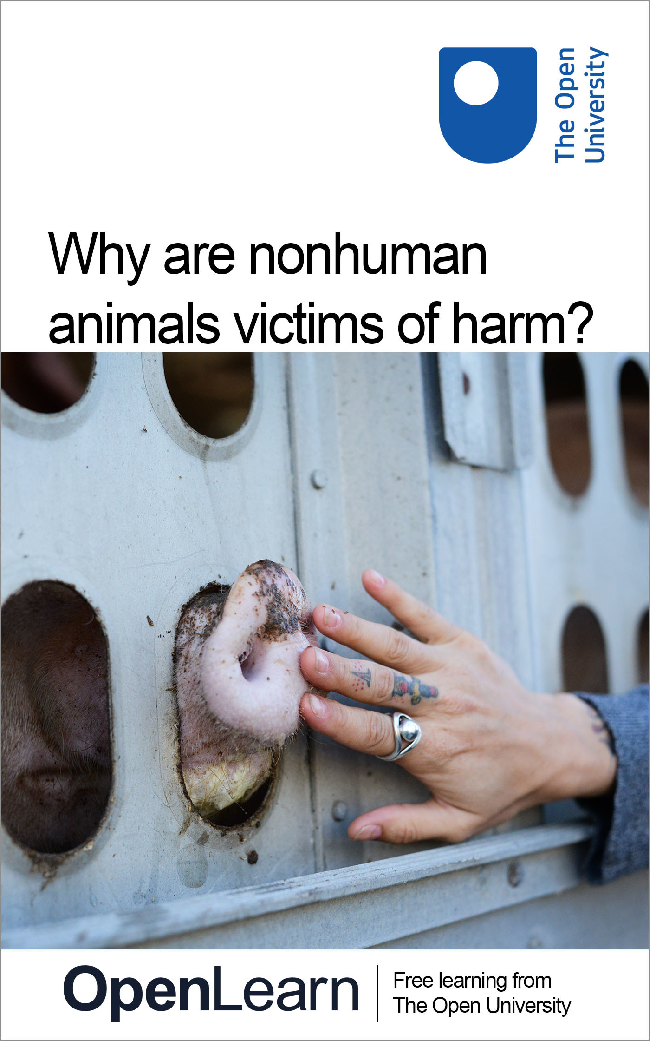

DD311_1

Why are nonhuman animals victims of harm?

About this free course
This free course is an adapted extract from the Open University course DD311 Crime, harm and the state: www.open.ac.uk/courses/modules/dd311 .
This version of the content may include video, images and interactive content that may not be optimised for your device.
You can experience this free course as it was originally designed on OpenLearn, the home of free learning from The Open University –
https://www.open.edu/openlearn/society-politics-law/why-are-nonhuman-animals-victims-harm/content-section-0
There you’ll also be able to track your progress via your activity record, which you can use to demonstrate your learning.
Copyright © 2020 The Open University
Intellectual property
Unless otherwise stated, this resource is released under the terms of the Creative Commons Licence v4.0 http://creativecommons.org/licenses/by-nc-sa/4.0/deed.en_GB. Within that The Open University interprets this licence in the following way: www.open.edu/openlearn/about-openlearn/frequently-asked-questions-on-openlearn. Copyright and rights falling outside the terms of the Creative Commons Licence are retained or controlled by The Open University. Please read the full text before using any of the content.
We believe the primary barrier to accessing high-quality educational experiences is cost, which is why we aim to publish as much free content as possible under an open licence. If it proves difficult to release content under our preferred Creative Commons licence (e.g. because we can’t afford or gain the clearances or find suitable alternatives), we will still release the materials for free under a personal end-user licence.
This is because the learning experience will always be the same high quality offering and that should always be seen as positive – even if at times the licensing is different to Creative Commons.
When using the content you must attribute us (The Open University) (the OU) and any identified author in accordance with the terms of the Creative Commons Licence.
The Acknowledgements section is used to list, amongst other things, third party (Proprietary), licensed content which is not subject to Creative Commons licensing. Proprietary content must be used (retained) intact and in context to the content at all times.
The Acknowledgements section is also used to bring to your attention any other Special Restrictions which may apply to the content. For example there may be times when the Creative Commons Non-Commercial Sharealike licence does not apply to any of the content even if owned by us (The Open University). In these instances, unless stated otherwise, the content may be used for personal and non-commercial use.
We have also identified as Proprietary other material included in the content which is not subject to Creative Commons Licence. These are OU logos, trading names and may extend to certain photographic and video images and sound recordings and any other material as may be brought to your attention.
Unauthorised use of any of the content may constitute a breach of the terms and conditions and/or intellectual property laws.
We reserve the right to alter, amend or bring to an end any terms and conditions provided here without notice.
All rights falling outside the terms of the Creative Commons licence are retained or controlled by The Open University.
Head of Intellectual Property, The Open University

Contents
- Introduction
- Learning outcomes
- 1 Language, imagery and the animal turn
- 2 Nonhuman victims of harm
  - 2.1 ‘Livestock’ farming, fishing and social harm
  - 2.2 Collateral social harm
  - 2.3 ‘Livestock’ farming and environmental harm
- 3 The animal–industrial complex
- 4 Sticks and stones? Power-knowledge, discourse and harm
  - 4.1 Power-knowledge and the ‘disciplining’ of other animals
  - 4.2 Discourse and resistance
- Conclusion
- References
- Acknowledgements
- Solutions

Introduction

We live in a culture that is deeply confused about other animals. Collectively, we may profess to be ‘animal lovers’ but in practice that love is reserved for a lucky few, including those we usually call ‘pets’, or is conditionally reserved for animals who perform for us on racetracks, in films or on TV. ‘Pets’ and nonhuman sporting or media celebrities are by no means safe from the consequences of getting mixed up with us humans, but we deliberately kill many, many more […]
This confusion between killing and caring is so habitual, that we often fail to recognize it, even when it’s right in front of our eyes. Our love for some animals even seems to excuse us from complicity in industrialized killing: In a current KFC TV advertising campaign, pairs of friends undertake the ‘KFC Friendship Bucket Test’: one has to answer a question about their friend, and match their written answer to be rewarded with a piece of a chicken’s body in their shared KFC bucket. Here’s how it pans out between one pair of women friends:
Woman 1: ‘What would you save from a fire?’
Woman 2: (holding a placard with the word ‘Animals’ written on it): laughs.
(Cole and Stewart, 2016)

This extract is from an article for the BSA (British Sociological Society) online magazine, Discover Society. The ‘confusion’ it highlights invites social scientific investigation, because social science has historically been preoccupied with humans, but not other animals. This course explores how that humanocentrism is challenged by the recent social science ‘animal turn’ (Peggs, 2012; Cudworth, 2011). Humanocentrism is the belief that humans are more important than other living things, including other animals. From this perspective, the importance given to other animals varies according to their perceived usefulness to humans. The animal turn means that the social sciences have begun paying increased attention to interconnections between humans and other animals. Most pertinently for criminology, this means an increased critical focus on how human-nonhuman interconnections are riven with inequalities and can produce harms.
This course explains how the animal turn directs criminological attention to nonhuman animals as victims. You will learn about social processes and structures that victimise other animals, and the perpetuation of harms through language and imagery. By the end of the course, you will have seen – and may find inspiration in – the expanding scope for criminological inquiry offered by the animal turn.
This OpenLearn course is an adapted extract from the Open University course DD311 Crime, harm and the state.

Learning outcomes
After studying this course, you should be able to:
- understand the role of language and imagery in shaping recognition of other animals as victims of harm
- understand a range of direct and indirect harms that are inflicted on nonhuman animals, especially through ‘livestock’ farming
- understand how harms against other animals are both legitimised and contested through language and imagery
- understand the concept of the Animal-Industrial Complex.

1 Language, imagery and the animal turn
The animal turn examines why the social sciences have historically largely ignored harms against nonhuman animals. Anthropologist Barbara Noske provides part of the answer: ‘modern animal industries tend to be regarded as technically inevitable and politically neutral, since it is only relations between humans which are considered political’ (1989, p. 22).
If human-nonhuman animal relations are considered merely ‘technical’ (such as techniques for maximising ‘livestock’ growth and therefore profitability), their social and political dimensions are obscured. This is central to understanding the revolutionary impact of the animal turn: it focuses attention on a hitherto overlooked but fundamental facet of society. Another important aspect of the historical dearth of social science attention to nonhuman animals is that the social sciences have tended to represent humans as much more important than other animals (Peggs, 2012), and this has reflected the extent to which humanocentric beliefs are embedded in modern societies more generally.

Activity 1
Allow approximately 10 minutes.

In the course so far, you may have noticed the use of the terms ‘other animals’ or ‘nonhuman animals’ rather than simply ‘animals’. Why do you think this might be?

Provide your answer...
View discussion - Activity 1

The animal turn forces criminologists to think deeply about prior inattention to harms experienced by other animals. This process of critical self-reflection makes studying criminology exciting and challenging. Criminology is dynamic and constantly evolving to help expand awareness of harms, to aid understanding of how and why they occur, and ultimately, to consider ways to reduce or eliminate them. These examples also highlight that understanding harm is profoundly shaped by language. Language does not simply reflect what is known, it actively shapes knowledge. The story extends beyond language: the visual representation of nonhuman animals in the media also profoundly effects individuals’ understanding of them.

Activity 2
Allow approximately 10 minutes.

Look at Figure 1. What ideas do you think the artist was trying to convey in this image? If you find this difficult, think about what masks are used for generally, that is, to hide the face underneath.

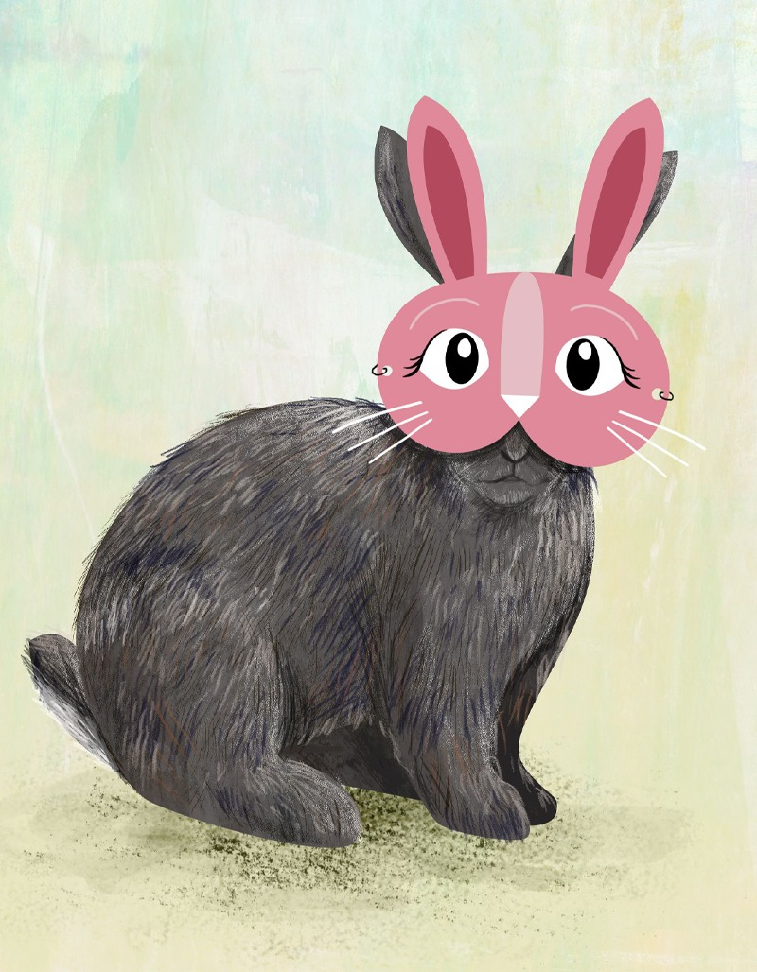
Figure 1 What do you see behind the mask?
View description - Figure 1 What do you see behind the mask?

Provide your answer...
View discussion - Activity 2

So to conclude Section 1:
- The recent animal turn expands the potential for criminology to attend to harms perpetrated by humans against other animals.
- The animal turn is a counterpoint to dominant humanocentric beliefs, which minimise the perceived importance of the victimisation of nonhuman animals.
- Humanocentric beliefs can be communicated, and contested, by the language and imagery used to refer to and represent other animals.

2 Nonhuman victims of harm
The experience of being physically and/or psychologically harmed is unavoidable for all animals, whether human or nonhuman, but for criminologists, an increasing area of concern is avoidable harm generated by social arrangements, in short, social harm. Social harms result from contingent social arrangements – those that are not inevitable but could potentially be restructured to be less harmful.
‘Livestock’ farming is contingent on human consumption of ‘animal products’ such as ‘meat’, ‘dairy’ and eggs. Social harms experienced by nonhuman animals are inflicted as a consequence of the legal, ‘business as usual’ operation of social arrangements or structures, ranging from scientific research, sport and entertainment, to ‘livestock’ farming. Examples are the experimentation on live nonhuman animals in the pharmaceutical industry, which is estimated to involve around 115 million nonhuman animals annually worldwide (Cruelty Free International, 2018) and the more than 2000 deaths since 2007 of horses on UK race courses at time of writing (Animal Aid, 2019). Social harms also afflict other animals as unintended collateral damage. For instance, motorised transport brings about the killing and injuring of other animals (as well as human accident victims), often described as ‘road kill’ (Soron, 2011). There is not enough space in this course to fully document these harms, so the focus will be on ‘livestock’ farming and fishing, the legal activities that kill the largest numbers of nonhuman animals. However, you should bear in mind the general point that many human activities that are currently socially accepted as normal, directly or indirectly harm other animals.

2.1 ‘Livestock’ farming, fishing and social harm
Professor of Communication, Núria Almiron argues that ‘the exploitation of billions of nonhuman animals for food, has always been, and particularly is today, among the most profitable businesses on earth’ (2016, p. 28). The scale of these profits relates to the numbers of ‘livestock’ bred and killed.

Box 1 The big picture – ‘livestock’ and aquatic animals
‘Livestock’ animals
- Three times more ‘livestock’ animals than humans are alive at any given time. This includes 19 billion chickens, 1.5 billion cows, 1 billion pigs and 1 billion sheeps, according to the United Nations Food and Agriculture Organisation (UNFAO) (Economic Forum, 2019).
- 70 billion ‘livestock’ animals are slaughtered for human food globally each year; around 50 billion of them are chickens (Faunalytics, 2018).
Aquatic animals
- Precise numbers of aquatic animals killed for human consumption are unrecorded, but even low estimates dwarf the figures for the killing of land-dwelling ‘livestock’ animals.
- 790–2300 billion free-living fishes were caught for human consumption during the decade 2007–16 according to UNFAO (FishCount, 2019).
- In 2015 alone aquaculture (colloquially called ‘fish farming’) accounted for the killing of 48–160 billion fishes and 220–520 billion crustaceans (Fish Count, 2019).

Different jurisdictions have different laws governing legally permissible harming of farmed animals, but all ‘livestock’ farming necessitates killing. This is obviously so for ‘meat’, but also applies to killing ‘dairy’ cows and laying hens when they are no longer able to produce enough milk or eggs to be profitably kept alive. These harms include slaughterhouse killing but also legal killing on farms in certain cases of serious injury or infectious disease, such as foot and mouth. These deaths are not included in the 70 billion ‘livestock’ animals slaughtered annually cited by Faunalytics (2018).

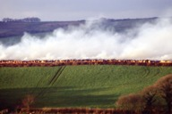
Figure 2 Cows who had been infected with foot and mouth disease being cremated in 2001
View description - Figure 2 Cows who had been infected with foot and mouth disease being cremated in ...

In the dairy industry, some male calves live for a few months before being killed to produce ‘veal’, but many are killed on farms soon after birth, because they are not profitable if raised to provide ‘beef ’. These cows have not been selectively bred to gain weight in the form of saleable flesh, so the male calves do not provide an economic return on the costs of raising them to maturity. In the egg industry, male chicks are also killed soon after hatching. It is unprofitable to raise them for their flesh, because of selective breeding that favours the egg-laying capacity of hens above all. Some of the legal harms other than killing in ‘livestock’ farming are described by Hunt (2015) and Masson (2009):
- confinement of some species of nonhuman animals in cages (such as those used for egg-laying hens and other birds), stalls, or barns, which restrict bodily movement and may cause physical and/or mental distress
- enforced body modifications, such as the amputation of pigs’ tails, the ‘clipping’ of piglets’ teeth, the castration of piglets or the partial amputation of hens’ beaks (sometimes called ‘debeaking’)
- increased incidence of injury or infections resulting from the farm environment, such as mastitis (a painful inflammation of cows’ udders)
- forced insemination of female ‘livestock’ animals, such as ‘dairy’ cows who are kept in a perpetual cycle of pregnancy and lactation until physically unable to produce milk at profitable levels
- separation of kin, such as the removal of calves from their mothers in the dairy industry so that the milk can be appropriated for human use, or the removal of lambs from their mothers to be slaughtered for ‘meat’.
Different jurisdictions regulate to limit some of these harms to different extents, but harm is ubiquitous in all forms of ‘livestock’ farming and harms such as separation of kin are inevitable in order to obtain other animals’ milk, or the flesh of young mammals. These harms are not limited to physical injury or death, but also include mental and emotional distress. ‘Livestock’ farming is also associated with significant environmental harms that impact on free-living nonhuman animals (Hunt, 2015).

2.2 Collateral social harm
In the previous section you saw statistics relating to the massive scale of killing involved by fishing and aquaculture. However, these figures are not comprehensive, as they exclude ‘accidental’ deaths, commonly referred to as ‘bycatch’ (Inoue, 2017). Note that ‘accidental’ is in quotation marks, to indicate that the routine operation of commercial fishing inevitably kills non-target creatures. You may recall that this is a defining feature of legal social harms; they are the outcome of routine practices that are ‘business as usual’, and not exceptional, unforeseeable incidents. To illustrate the scale of ‘bycatch’, Lisa Kemmerer and Bethany Dopp (2015, p. 164) report a 1997 UNFAO estimate that, ‘85 percent of any shrimp haul is bycatch’, the latter including sea turtles, seals and whales. Kemmerer and Dopp (2015) argue that bycatch has driven some non-target aquatic species close to extinction, and common fishing methods, such as the use of longlines (lines with baited hooks, up to 60 miles long) kill around 300,000 sea birds annually.

2.3 ‘Livestock’ farming and environmental harm
All farming requires the use of resources, but ‘livestock’ farming tends to be more resource-intensive than alternatives. Two key farming resources are land and water. In terms of land, ‘livestock’ farming accounts for 70 per cent of all agricultural land worldwide. It also uses a third of all arable land, to provide crops to feed ‘livestock’. Providing this land exacerbates deforestation (Kemmerer, 2015), in turn eroding planetary capacity to absorb carbon dioxide (CO₂). CO₂ is a key greenhouse gas (GHG) responsible for anthropogenic climate change (that is, caused by human activity) (Garnett, 2013). By contrast, a recent research review concluded that plant-based diets could sustain the global human population from half the agricultural land currently in use (Chai et al., 2019). In terms of water, ‘livestock’ farming often depends on irrigation using finite fresh water supplies. Animal-protein production has been calculated to use more than four times as much water as the most intensively-irrigated plant-based protein production (Reynolds et al., 2014). Globally, ‘livestock’ farming is responsible for 29 per cent of agricultural fresh water use (Chai et al., 2019).

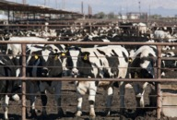
Figure 3 Thousands of cows being raised intensively to produce ‘beef’ in a concentrated animal feeding operation, in California.
View description - Figure 3 Thousands of cows being raised intensively to produce ‘beef’ in a concentrated ...

Pollution is also a consequence of ‘livestock’ farming, particularly the intensive production methods which confine large numbers of nonhuman animals in a small space. For instance, concentrated animal feeding operations (CAFOs), enclose many thousands of animals in one facility, producing vast quantities of waste (manure and urine). Food campaigner Chris Hunt (2015) calculates that a 15,000-cow CAFO generates waste equivalent to a city of 315,000 humans. CAFO waste is discharged into the environment legally, for instance as fertiliser, or illegally as spills from artificial lagoons built to contain it, which can amount to millions of gallons. Spills may be intentional or accidental, for instance caused by storms, but regardless of cause, they directly kill fishes and other aquatic animals. They also cause eutrophication, a process by which the excess nutrients in CAFO waste stimulate the growth of algae on the surface of water. This blocks sunlight, which kills underwater plants eaten by aquatic animals (Hunt, 2015). Intensive ‘livestock’ farming also pollutes the air with hydrogen sulphide and ammonia (toxic to humans and other animals). You will note, these are all also examples of collateral harm.
As you read above in relation to deforestation and CO₂, ‘livestock’ farming is one of the major anthropogenic sources of GHGs. The production of methane and nitrous oxide is also a major contributory factor. ‘Meat and dairy production processes account for 80% of all GHGEs [greenhouse gas emissions] from the food sector and 24% of total GHGEs’ (Chai et al., 2019).
One consequence of humanocentrism, is the tendency to consider humans as being apart from nature, which is treated as an inexhaustible resource for human use. This is especially evident in commercial fishing, where the indiscriminate killing of uncounted numbers of aquatic animals is accepted as routine. However, as the criminologist Gary Potter argues, ‘[f]rom a social science perspective, it becomes clear that the social world cannot be understood in separation from the natural world’ (2016, p. 7). Potter’s argument addresses one of the challenges of exploring environmental harms, which is that from a humanocentric perspective, they can seem rather abstract and remote from the suffering of specific individuals. This means that the exploration of environmental harms is an urgent task for criminology and particularly the emerging sub-discipline of green criminology (Spapens et al., 2016).
Moreover, the scale of the social and environmental harms attendant to ‘livestock’ farming has increased as human consumption of ‘animal products’ has accelerated in recent decades. Globally, the number of other animals slaughtered for human food more than quadrupled in the 40 years between 1974 and 2014 (Ritchie and Roser, 2017), a period in which the human population did not quite double (The World Bank, 2019). This acceleration might be interpreted as an expression of a natural demand for ‘animal products’, but to do so would be to overlook the social processes that not only construct demand, but also make it appear to be ‘natural’, and therefore inevitable, rather than contingent.
So to conclude Section 2:
- Large numbers of nonhuman animals are harmed as a result of the routine operation of many social structures. These can therefore be conceptualised as ‘social harms’.
- ‘Livestock’ farming and fishing harm more nonhuman animals than any other human activity, resulting in hundreds of billions of deaths every year, as well as non-lethal harms that have physical, mental and emotional dimensions.
- ‘Livestock’ farming and fishing generate environmental harms which include depletion of land and water resources; water and air pollution, including GHGEs; and collateral harms such as ‘bycatch’.

3 The animal–industrial complex
The construction of demand for ‘animal products’ and the concomitant social structuring of harm against nonhuman animals can be analysed using the concept of the animal–industrial complex (AIC). This term was coined by Barbara Noske in her book Humans and Other Animals (1989). It refers to the harmful exploitation of nonhuman animals on an industrial scale, and how different industries are inter-related within legal, state-sanctioned frameworks, so that together they form a ‘complex’. More recently, the AIC was defined by sociologist Richard Twine as a ‘partly opaque and multiple set of networks and relationships between the corporate (agricultural) sector, governments, and public and private science. With economic, cultural, social and affective dimensions it encompasses an extensive range of practices, technologies, images, identities and markets’ (2012, p. 23).
The AIC today is dominated by the agrifood industry, which in turn is dominated by transnational corporations (TNCs). TNCs may originate and be formally headquartered in one country, but operate in many, often on a global scale. In her analysis of the political economy of agrifood, Almiron highlights that the world’s two largest TNCs by sales, Cargill (based in the United States) and Nestlé (based in Switzerland), ‘are strongly dependent on “livestock”’ (2016, p. 29), respectively ‘poultry’ and hen’s eggs, and cow’s milk.
Almiron (2016) highlights the close interconnections between agrifood and four other global industries:
- The seed industry and especially producers of genetically modified organism (GMO) seeds, which are primarily used for ‘livestock’ feed crops.
- The chemical industry, including pesticides (targeted at killing other animals who would otherwise consume crops intended for ‘livestock’ feed), fertilisers and herbicides.
- The pharmaceutical industry, which as well as killing tens of millions of nonhuman animals in experiments each year, also produces medicines to prevent or treat ‘livestock’ diseases. These diseases are harms generated by intensive farming conditions, such as crowding ‘livestock’ in confined, unsanitary spaces (Greger, 2006).
- The oil industry, which fuels mechanised farming methods, transportation, irrigation and fertiliser production.
‘Livestock’ farming also depends on state-maintained transport infrastructures to move nonhuman animals to slaughterhouses, and then their body parts or the products of female reproductive processes (milk and eggs) to retail, which are themselves industrialised in the form of supermarket and restaurant chains. In turn, the retail industry depends on the media industry to advertise animal products (Nibert, 2016). However, Twine’s definition emphasises that the AIC is ‘partly opaque’, meaning that some of its components and their interconnections are less obvious. For instance, state involvement includes legislation such as ‘animal welfare’ or food safety laws, and procuring ‘animal products’ to feed hospital patients, school pupils, prison inmates and others in public sector care. States also provide financial subsidies for ‘livestock’ farming.
Almiron (2016, p. 31) argues that ‘animal products’ are the most subsidised sectors of the global agrifood industry, receiving $52 billion in direct government grants in 2012 alone, among industrialised countries. State support also takes the form of establishing organisations to promote ‘animal products’. For example, in the UK, the dairy and egg industries historically received state support through the formation of the Milk Marketing Board (MMB) in 1933 and the British Egg Marketing Board (BEMB) in 1956. The organisations were interconnected with the media through the promotion of advertising slogans such as ‘drinka pinta milka day’ and ‘go to work on an egg’ (Molloy, 2011; Harrison, 2013). Publicly funded media promotion such as this, and direct advertising by agrifood corporations, have proved very successful in stimulating increased ‘animal product’ consumption (Nibert, 2016).

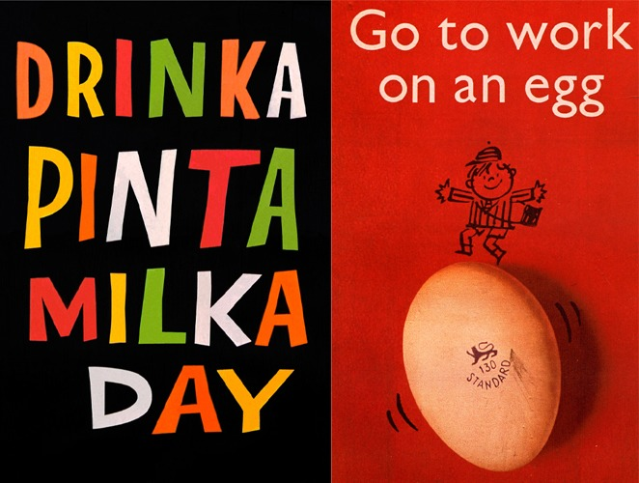
Figure 4 Advertisements for the Milk Marketing Board (1959) (left-hand side) and the British Egg Marketing Board (1957) (right-hand side).
View description - Figure 4 Advertisements for the Milk Marketing Board (1959) (left-hand side) and ...

The advertisements shown in Figure 4 may look simplistic now, 60 or more years after they appeared, but the message they convey is all the more powerful for that. Both sought to normalise the consumption of ‘animal products’ as a daily routine. The routinisation of food practices through cultural representations such as these is crucial to the perpetuation of the AIC.
Part of the inter-related framework that allows the AIC to function involves Twine’s ‘affective’ dimension. This includes emotional attachments to consuming ‘animal products’, which are often deeply felt as core to consumers’ identities. For example, social science research has revealed the persistence of strong cultural associations between masculine identity and the consumption of ‘meat’ (Fiddes, 1991; Adams, 2004; Stewart and Cole, 2018). Images – also referred to by Twine – are central to maintaining these emotional attachments and identities. For instance, they may be triggered by advertising that encourages positive associations between family or romantic relationships and the consumption of ‘animal products’ (Stewart and Cole, 2018). You have seen that even everyday 1950s advertisements contribute to the construction of identities ‘fuelled’ by the consumption of ‘animal products’.
The affective dimension of the AIC is crucial to its survival. The social harms outlined earlier are indeed ‘partly opaque’, in that the plight of ‘livestock’ receives scant media attention (Freeman, 2016), despite these harms being relatively easy to research. Analysing the affective dimension of the AIC is therefore crucial to understanding how it operates relatively unscrutinised, despite the scale of harms that it generates.
So to conclude Section 3:
- The animal–industrial complex (AIC) is a key concept for analysing the interconnecting social structures that construct demand for ‘animal products’.
- The AIC is based around coalitions of transnational corporations (TNCs) whose profitability is dependent on the exploitation of nonhuman animals.
- TNCs in turn depend on state-maintained infrastructure, subsidies and legal frameworks to ensure their smooth operation.
- The AIC also depends on the media construction of positive associations between ‘animal product’ consumption and consumers’ identities and relationships.

4 Sticks and stones? Power-knowledge, discourse and harm
In Section 1 you considered how language and imagery shapes perception of whether or not other animals are worthy of social scientific attention. This section picks up on the affective dimension from Section 3 and develops all these insights in relation to social philosopher Michel Foucault’s theories of power-knowledge and then discourse (1998). Foucault (1926–84) argues that power and knowledge are intimately inter-related.
As an approach to this, consider the phrase ‘sticks and stones may break my bones, but words can never hurt me’. Of course, words can actually be very hurtful. You may have experienced hurtful name-calling – or felt ashamed for joining in with name-calling – in the school playground. The ‘sticks and stones’ phrase is used to reassure and build resilience to being victimised by insulting language. But insults can be psychologically and emotionally damaging, and may accompany, or be a prelude to, physical assault. Insults can ‘put someone down’, as being less worthy of care and concern. So, insulting language can be intrinsically harmful, but it also shapes knowledge of victims and makes them more vulnerable to further harm. This makes harm itself harder to recognise, because the victim is rendered less worthy of concern. For example, in the context of a culture in which other animals are viewed as subordinate to humans, calling people ‘dogs’, or ‘pigs’ attempts to reduce their moral worth and make it seem acceptable to victimise them. At its most extreme, animal-based name-calling has been used to render the victims of genocide as deserving of violence. For example, Nazi propaganda compared Jews with lice or rats, while Tutsi victims of the Rwandan genocide in 1994 were described as ‘cockroaches’ in propaganda prior to the violence erupting (Nguyen, 2019).
Similarly, images can be used to make some groups of people seem less worthy of concern, to the extent of being legitimate targets of physical violence. Playground bullying therefore, shows how knowledge-claims (which translate into knowledge) about others are closely related to behaviour towards them, and vice versa: what is done to others is closely related to what is known about them. In a sense, this is obvious. For example, chickens are known as ‘food animals’ because they are killed to provide food for humans.
By the same token, chickens are killed to provide food for humans because they are known as ‘food animals’ (Cole and Stewart, 2014). Again, this results from imagery as well as language: chickens are commonly represented as ‘food animals’ in the logos of fast food restaurants that sell their body parts. These diverse examples, from playground bullying to the killing of chickens, can therefore be interpreted and analysed within a common theoretical framework: Foucault’s theory of power-knowledge.

4.1 Power-knowledge and the ‘disciplining’ of other animals
Foucault has been profoundly influential in the social sciences. Power is often assumed, argues Foucault (1998), to be repressive. It tends to be conceived as a resource used by powerful people, groups or institutions (such as the state) to stop less powerful people from doing something. By contrast, Foucault argued that power is productive rather than repressive: power does not stop things from happening, but rather it makes things happen. In Discipline and Punish, Foucault applies this insight to the experiences of criminals in nineteenth century prisons, arguing that prisons at that time were not devised to stop criminals from perpetrating criminal acts (this tends to be assumed when power is thought of as a repressive force) but were instead aimed at producing ‘docile bodies’ (1991, p. 138). By ‘docile bodies’, Foucault means that regimes disciplined prisoners to become docile and therefore useful citizens. A prisoner disciplined by a corrective penal regime could be remade into a productive working citizen, and therefore an asset rather than a burden to society. The practices by which prisoners were trained (such as the imposition of a strictly regimented timetable of daily activity) also produced knowledge about them. Prison authorities documented the extent to which prisoner’s behaviour changed in response to the prison regime, and this new knowledge could in turn reshape the treatment of prisoners. That is, power relations could be recalibrated in relation to knowledge produced about each prisoner.
Importantly, Foucault argues that the principles by which prisoners were disciplined – the interconnected application of a training regime (power) and the recording of observations about their behaviour (knowledge) – were transferred outside the prison setting within which they originated. Foucault describes a growing ‘carceral archipelago’ (1991, p. 298), or network of state institutions, such as army barracks, schools and hospitals, in which disciplinary principles were applied to produce, respectively, ‘docile’ soldiers, pupils or patients.
Foucault does not consider the extension of the carceral archipelago to nonhuman animals. However, its implications for how harms against nonhuman animals are understood, are profound (Chrulew and Wadiwel, 2016; Wadiwel, 2015). One of Foucault’s key innovations is the idea that because power is productive, not repressive, disciplinary regimes are focused on creating particular kinds of useful individuals (soldiers who obey officer’s commands, pupils who follow their teacher’s directions, for example). These insights have been applied to ‘factory farms’ as disciplinary institutions aimed at producing ‘docile’ nonhuman bodies (Cole, 2011; Novek, 2005; Coppin, 2003), that is, bodies disciplined so that they gain weight as efficiently as possible and thereby maximise profitability.
To achieve this goal, ‘factory farms’ discipline nonhuman animal behaviour by restricting bodily movement so that food intake is converted into weight gain rather than being expended on locomotion or social interaction. If farms are considered as disciplinary institutions in Foucault’s sense, bodily movement is a ‘waste’ of energy (and therefore of feed and the money used to buy it). The bottom line is that unrestricted movement reduces profitability. Figure 5 shows the disciplining of pigs’ bodies along these lines.

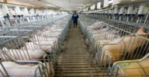
Figure 5 Legally caged pigs in a ‘factory farm’
View description - Figure 5 Legally caged pigs in a ‘factory farm’

Simultaneously, the effects of power relations between the ‘farm’ and its nonhuman captives are recorded, so that a body of knowledge is built up about each animal. This knowledge is highly specific: individual animals in factory farms are ‘known’ according to how successfully they respond to the disciplinary regime – how much they eat, how much and how quickly they gain weight, and so on. This accumulation of knowledge can calibrate power relations to be yet more productive (adjusting the amount and type of feed, medication, temperature, and so on).
However, these nonhuman animals are not ‘known’ in the sense of ‘knowing’ a specific person as a unique individual with their own biography and personality. As a contrast to the ‘factory farmed’ pigs, the image below shows a pig called Teresa photographed at a sanctuary in New York, having been rescued from a slaughterhouse. Teresa is one of the subjects of Isa Leshko’s book Allowed to Grow Old (2019).

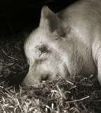
Figure 6 Teresa, a 13-year-old Yorkshire pig. When this photograph was taken she had chosen to lie down on the straw after tiring herself out playing with a beach ball (Leshko, 2019, p. 95)
View description - Figure 6 Teresa, a 13-year-old Yorkshire pig. When this photograph was taken she ...

Activity 3
Allow approximately 10 minutes.

Compare for a moment the two pictures of pigs that you’ve seen in Figures 5 and 6. How would you feel about being asked to put Teresa into one of the farm cages? If that thought makes you feel uneasy, why do you think that might be?

Provide your answer...
View discussion - Activity 3

4.2 Discourse and resistance
Foucault insists that power is always resisted: prisoners or pupils commonly contest disciplinary regimes and do not meekly submit to being ‘reformed’ according to the goals of a prison or school regime. However, as you have already seen with the ‘cute bunny’ image, the representation of other animals is not geared up to sensitise individuals to their resistance to power relations. Language and imagery typically objectify other animals as ‘things’ rather than subjectify them as an individual ‘someone’ (Adams, 2004).

A group of individuals
One way in which other animals are objectified as things is using the same singular and plural forms, for instance the word ‘fish’ to mean a singular individual, as well as a shoal or entire species. In this course, ‘fishes’ is given as the plural of ‘fish’ and ‘sheeps’ as the plural of ‘sheep’. While fishes is a relatively uncommon plural form of fish, and sheeps is, strictly speaking, grammatically incorrect, these forms highlight how language can subtly affect the way we perceive other animals. The use of identical words for the singular and plural forms can obscure the fact that a shoal of fishes or a flock of sheeps, for instance, are comprised of unique individuals. This is especially salient when groups of other animals are victims of harm, because ‘[s]uch usage blurs the victims together, de-emphasizing their individual sufferings and deaths’ (Dunayer, 2004, p. xii).

The disciplining of nonhuman bodies in the AIC is resisted in the ways in which ‘livestock’ express their distress at confinement, pain and overcrowding, or the ways in which fishes attempt to evade or escape capture (Wadiwel, 2015). Some of the harms documented in Section 2.1 are attempts by humans to counteract this resistance. For example, the ‘debeaking’ of hens is a response to closely confined and distressed hens injuring each other. Similarly, the clipping of piglet’s teeth or the amputation of their tails is a response to biting as expressions of distress.
Foucault used another influential concept that aids understanding of how this misrecognition of nonhuman resistance works: discourse.

Discourse defined
Discourse is described by Colin Gordon as ‘identifiable collections of utterances governed by rules of construction and evaluation which determine within some thematic area what may be said, by whom, in what context, and with what effects’ (Gordon, 2002, p. xvi). When it comes to ‘utterances’, this means more than just spoken or written language. With that in mind, discourse can be defined as an authoritative system of communication, encompassing language, images and symbols, about a specific subject. Discourse is a central concept in the analysis of harm. For instance, harm is used to analyse relationships between crime, harm and the state, as well as to explore relationships between power and resistance.

As well as following the application of discourse to the topic of harms against nonhuman animals, you will need to keep in mind the general features of discourse as an analytical tool. In Gordon’s definition ‘utterances’ can be interpreted broadly so that language and imagery, in fact all forms of human communication, are never neutral. By contrast, discourse shapes communication and even habitual patterns of thought.
The reflective activities in this course highlight the pervasiveness of humanocentric discourse in different ways. You have seen examples of:
- language that separates ‘humans’ from ‘animals’
- images, such as the anthropomorphic depictions that distort the lived experience of other animals
- practices, such as the operations of the AIC, including close confinement as a means to the end of cheaper ‘meat’.
All these are taken for granted and considered as normal; they are just the way things are.
The concept of discourse highlights that mundane social processes such as writing about, drawing, or photographing other animals are, in fact, involved in harms that are often mistakenly recognised as ‘natural’ or inevitable.
Humanocentric discourse makes it difficult to recognise nonhuman distress as resistance to the power relations instantiated within the AIC. Instead, humanocentric discourse reduces distress from the subjective expression of suffering individuals to an objective problem that stands in need of technical resolution in order to maintain profitability. The practices of the AIC police the boundaries of humanocentric discourse. That is, the reduction of nonhuman animals to knowable, calculable ‘things’ is enacted by their confinement, slaughter, dismemberment and packaging as commodities. This is reinforced through advertising and more general media representations of other animals. The phrase ‘police the boundaries’, highlights how dominant discourses, such as humanocentrism, exclude counter-discourses.
Finally, an illustration of this, is the ‘KFC friendship bucket test’ that you saw at the beginning of this course. Here, humanocentric discourse is hidden in plain sight: the expression of the woman’s ‘caring’ identity, through the imagined act of saving ‘animals’ from a fire, sits alongside the consumption of other animals, with no morally significant difference between them. Their constructed difference is inherent in their use as companions for those rescued from the fire, or their use as food for the chickens in the bucket.
This incongruity is pointed out in a YouTube comment about the advertisement: ‘The irony is strong in this advert. Saving animals from a fire yet eating them at the same time (after they’ve been cooked on a fire!!!!)’. This comment is followed by the response, ‘oh be quiet you killjoy’ (cited in Cole and Stewart, 2016). Breaking this down, there are three discursive moves at play:
- humanocentric discourse is asserted in the original advertisement, remembering that advertisements are part of the cultural dimension of the AIC
- humanocentric discourse is implicitly resisted by a counter-discourse in the ‘irony’ comment
- the boundaries of humanocentric discourse are policed by the ‘killjoy’ comment, which attempts to shut down the counter-discursive move.
Although these comments may seem trivial, they are indicative of a wider problem: the pervasive reach of dominant discourses into everyday life and the difficulty of countering them. Dominant discourses enrol wide support as they are taken for granted as ‘just the way things are’. In the example above the ‘killjoy’ comment is typical of the mundane defence and reproduction of humanocentric discourse.
So to conclude Section 4:
- According to Foucault, power and knowledge are mutually productive, with practices (power relations) generating knowledge, at the same time as knowledge sanctions those practices.
- Power-knowledge in the AIC reduces nonhuman animals to objects of calculation in relation to profitability: from someone to something.
- Discourse can be used as an analytical tool to illuminate how humanocentrism is perpetuated.

Conclusion
In this course you have read about how the animal turn is stimulating social scientists’ attention to harms against nonhuman animals. This challenges the humanocentric history of the social sciences, and the wider dominance of humanocentrism. You have seen how the animal turn acts as a counter-discourse to the dominance of humanocentric social science discourse. As Foucault argued, discourse is never neutral, and that equally applies to this course, which itself contributes to an anti-humanocentric discourse that underpins the animal turn in the social sciences. This cuts to the heart of debates about what, and indeed who, criminology is for. This course is ‘for’ other animals, that is, it highlights how they are routinely victimised by the AIC and thereby asserts that they are legitimate subjects of criminological concern. A key aspect of the work of criminologists is to counter dominant discourses that deny the existence, magnitude or significance of those harms and their victims and survivors.
This OpenLearn course is an adapted extract from the Open University course DD311 Crime, harm and the state.

References
Adams, C. J. (2004) The sexual politics of meat: a feminist-vegetarian critical theory. 20th Anniversary edn. New York: Continuum.
Almiron, N. (2016) ‘The political economy behind the oppression of other animals: interest and influence’, in Almiron, N., Cole, M. and Freeman, C. P.(eds) Critical animal and media studies: communication for nonhuman animal advocacy. New York: Routledge, pp. 26–41.
Animal Aid (2019) Race horse death watch. Available at: https://www. horsedeathwatch.com/ (Accessed: 17 December 2019).
Chai, B. C., van der Voort, J. R., Grofelnik, K., Eliasdottir, H. G., Klöss, I. and Perez-Cueto, F. J. A. (2019) ‘Which diet has the least environmental impact on our planet? A systematic review of vegan, vegetarian and omnivorous diets’, Sustainability, 11(15), pp. 4110–28. doi:10.3390/su11154110
Chrulew, M. and Wadiwel, D. J. (eds) (2016) Foucault and animals. Leiden, Netherlands: Brill.
Cole, M. (2011) ‘From “animal machines” to “happy meat”? Foucault’s ideas of disciplinary and pastoral power applied to “animal-centred”welfare discourse’, Animals, 1(1), pp. 83–101. doi: 10.3390/ani1010083
Cole, M. and Stewart, K. (2014) Our children and other animals: the cultural construction of human-animal relations in childhood. Aldershot: Ashgate.
Cole, M. and Stewart, K. (2016) Killers or carers – who do we think we are when it comes to other animals? Available at: https://discoversociety.org/2016/05/ 03/viewpoint-killers-or-carers-who-do-we-think-we-are-when-it-comes-to-other-animals/ (Accessed: 17 September 2019).
Coppin, D. (2003) ‘Foucauldian hog futures: the birth of mega-hog farms’, The Sociological Quarterly, 44(4), pp. 597–616. Available at: https://www.jstor.org/stable/4120724?seq=1 (Accessed: 28 October 2020).
Cruelty Free International (2018) Facts and figures on animal testing. Available at: https://www.crueltyfreeinternational.org/why-we-do-it/facts-and-figures-animal-testing (Accessed: 8 September 2019).
Cudworth, E. (2011) Social lives with other animals: tales of sex, death and love. Basingstoke: Palgrave.
Dunayer, J. (2002) Animal equality: language and liberation. New York: Lantern Books.
Dunayer, J. (2004) Speciesism. Derwood, MA: Ryce Publishing.
Faunalytics (2018) Global animal slaughter statistics and charts. Available at: https://faunalytics.org/global-animal-slaughter-statistics-and-charts/ (Accessed: 17 September 2018).
Fiddes, N. (1991) Meat: a natural symbol. London: Routledge.
Fish Count (2019) Fish count estimates. Available at: http://fishcount.org.uk/fish-count-estimates-2 (Accessed: 17 September 2019).
Foucault, M. (1991) Discipline and punish: the birth of the prison. London: Penguin Books.
Foucault, M. (1998) The will to knowledge: the history of sexuality, Volume 1. London: Penguin Books.
Freeman, C. P. (2016) ‘This little piggy went to press: the American news media’s construction of animals in agriculture’, in Almiron, N., Cole, M. and Freeman, C.P. (eds) Critical animal and media studies: communication for nonhuman animal advocacy. New York: Routledge, pp. 169–184.
Garnett, T. (2013) ‘Food sustainability: problems, perspectives and solutions’, Proceedings of the Nutrition Society, 72(1), pp. 29–39. doi:10.1017/S0029665112002947
Gordon, C. (2002) ‘Introduction’, in Faubion, J. (ed.) Power. London: Penguin, pp. xi–xli.
Greger, M. (2006) Bird flu: a virus of our own hatching. Brooklyn, NY: Lantern Books.
Harrison, R. (1964) Animal machines. Wallingford: CABI, 2013.
Hunt, C. (2015) ‘Farm gone factory: industrial animal agriculture, animal welfare, and the environment’, in Kemmerer, L. (ed.) Animals and the environment: advocacy, activism and the quest for common ground. Abingdon: Routledge, pp. 173–85.
Inoue, T. (2017) ‘Oceans filled with agony: fish oppression driven by capitalist commodification’, in Nibert, D. (ed.) Animal oppression and capitalism, Volume 1: The oppression of nonhuman animals as sources of food. Santa Barbara: Praeger, pp. 96–117.
Kemmerer, L. (2015) ‘Eating ecosystems’, in Kemmerer, L. (ed.) Animals and the environment: advocacy, activism and the quest for common ground. Abingdon: Routledge, pp. 186–97.
Kemmerer, L. and Dopp, B. (2015) ‘A fishy business’, in Kemmerer, L. (ed.) Animals and the environment: advocacy, activism and the quest for common ground. Abingdon: Routledge, pp. 163–72.
Leshko, I. (2019) Allowed to grow old: portraits of elderly animals from farm sanctuaries. Chicago: University of Chicago Press.
Masson, J. M. (2009) The face on your plate: the truth about food. New York: Norton.
Molloy, C. (2011) Popular media and animals. London: Palgrave Macmillan.
Nguyen, H. (2019) Tongue tied: breaking the language barrier to animal liberation. Brooklyn, NY: Lantern Books.
Nibert, D. (2016) ‘Origins of oppression, specialist ideology, and the mass media’, in Almiron, N., Cole, M. and Freeman, C.P. (eds) Critical animal and media studies: communication for nonhuman animal advocacy. New York: Routledge, pp. 74–88.
Noske, B. (1989) Humans and other animals. London: Pluto Press.
Novek, J. (2005) ‘Pigs and people: sociological perspectives on the discipline of nonhuman animals in intensive confinement’, Society and animals, 13(3), pp. 221–44.
Peggs, K. (2012) Animals and sociology. Basingstoke: Palgrave Macmillan.
Potter, G. (2016) ‘The criminogenic effects of environmental harm: bringing a “green” perspective to mainstream criminology’, in Spapens, T., White, R. and Kluin, M. (eds) Environmental crime and its victims: perspectives within green criminology. Abingdon: Routledge, pp. 7–21.
Reynolds, C. J., Buckley, J. D., Weinstein, P. and Boland, J. (2014) ‘Are the dietary guidelines for meat, fat, fruit and vegetable consumption appropriate for environmental sustainability? A review of the literature’, Nutrients, 6(6), pp. 2251–65. doi:10.3390/nu6062251
Ritchie, H. and Roser, M. (2017) Meat and dairy production. Available at: https://ourworldindata.org/meat-production#livestock-counts (Accessed: 17 September 2019).
Soron, D. (2011) ‘Road kill: commodity fetishism and structural violence’, in Sanbomatsu, J. (ed.) Critical theory and animal liberation. Lanham, MD: Rowman and Littlefield, pp. 55–69.
Spapens, T., White, R. and Kluin, M. (eds.) (2016) Environmental crime and its victims: perspectives within green criminology. Abingdon: Routledge.
Stewart, K. and Cole, M. (2018) Meat is masculine: how food advertising perpetuates harmful gender stereotypes. Available at: https://theconversation.com/meat-is-masculine-how-food-advertising-perpetuates-harmful-gender-stereotypes-119004 (Accessed: 28 October 2020).
The World Bank, (2019) Population, total. Available at: https://data.worldbank.org/indicator/sp.pop.totl (Accessed: 17 September 2019).
Twine, R. (2012) ‘Revealing the ‘animal-industrial complex’ – a concept and method for critical animal studies?’, Journal for Critical Animal Studies, 10(1), pp. 12–39. Available at: http://www.criticalanimalstudies.org/wp-content/uploads/2012/10/JCAS+Volume+10+Issue+1+2012+FINAL.pdf (Accessed: 25 June 2020).
Wadiwel, D. J. (2015) The war against animals. Leiden, Netherlands: Brill.
World Economic Forum (2019) This is how many animals we eat each year. Available at: https://www.weforum.org/agenda/2019/02/chart-of-the-day-this-is-how-many-animals-we-eat-each-year/ (Accessed: 20 March 2020).

Acknowledgements
This free course was written by Matthew Cole.
Except for third party materials and otherwise stated (see terms and conditions), this content is made available under a Creative Commons Attribution-NonCommercial-ShareAlike 4.0 Licence.
The material acknowledged below is Proprietary and used under licence (not subject to Creative Commons Licence). Grateful acknowledgement is made to the following sources for permission to reproduce material in this free course:
Course image: © Jo-Anne McArthur
Figure 1: Hayley Wells / © Matthew Cole and Kate Stewart
Figure 2: Farlap / Alamy
Figure 3: Jim West / Alamy
Figure 4: 1959 Drink Pinta Milka Day image: M&N / Alamy
Figure 4: 1957 Go to work on an egg image: Pictorial Press Ltd / Alamy
Figure 5: Mark Agnor / Shutterstock.com
Figure 6: © Isa Leshko / All rights reserved
Every effort has been made to contact copyright owners. If any have been inadvertently overlooked, the publishers will be pleased to make the necessary arrangements at the first opportunity.
Don't miss out
If reading this text has inspired you to learn more, you may be interested in joining the millions of people who discover our free learning resources and qualifications by visiting The Open University – www.open.edu/openlearn/free-courses.

Solutions

Activity 1

Discussion
In modern societies, it is usual to think about ‘humans’ and ‘animals’ as being separate categories. In consequence, it can be easy to forget that humans are also animals, of the species homo sapiens (Latin for ‘knowing man’). Using phrases like ‘other animals’, ‘nonhuman animals’ or ‘animals other than humans’ is a reminder that humans are also animals. These phrases interrupt the familiar linguistic separation of humans from animals and may seem jarring at first. This is deliberate: jarring language helps to create pauses to consider what is otherwise taken for granted (Dunayer, 2002). Being reminded of humans’ animality, reasserts common ground across species, including the shared capacity to be harmed and victimised. You might also note the quotation marks around ‘livestock’. This is another jarring technique, destabilising the linguistic reduction of other animals to objects for human use. Likewise with other reductive, objectifying terms such as ‘beef ’ or ‘veal’. The use of language and imagery is an important element of Foucault’s social theory, which you will come to later in the course.
Back to - Activity 1

Activity 2

Discussion
In Figure 1 the rabbit’s face is concealed beneath a ‘cute’ anthropomorphic-style mask. Anthropomorphic images give human-like features to nonhuman animals. Here, the rabbit mask has forward-facing human-like eyes, whereas real rabbits’ eyes are positioned on the sides of their heads. Cute human-like images of other animals are commonplace, especially in children’s films, television programmes and picture books. However, the anthropomorphic masking of a rabbit’s ‘real’ face in Figure 1 is jarring, with the same effect as a destabilising use of written language. This illustration is a critique of how cute images of rabbits are so prevalent that they obscure the real rabbits that they supposedly represent. It therefore comments on how some images can shape knowledge about nonhuman animals and conceal more than they actually reveal. Decoding the meaning of images takes practice and may be contested. In this case, the intended meaning of the image is known, because the artist Hayley Wells was commissioned to create it for my jointly written book, Our Children and Other Animals (Cole and Stewart, 2014).
So, if language and images can profoundly affect knowledge, we, as criminologists, need to take them seriously, even images as apparently trivial as a cute bunny mask. In this example the ‘cute bunny’ itself trivialises real rabbits, making recognition of them as victims of harm more difficult. Trivialisation is important in the context of the harms that humans perpetrate against other animals. It is to some of these harms that the next section turns.
Back to - Activity 2

Activity 3

Discussion
Imagery and language can on the one hand objectify nonhuman animals as something and on the other hand subjectify nonhuman animals as someone. The contrasting elements of Figures 4 and 5, and the differing amounts of biographical information available demonstrate this. To a certain extent, you may feel as you view them that your knowledge about pigs is being challenged or reshaped by the image of Teresa. Seeing Teresa photographed on her own and reading about her as an individual with a unique and detailed biography – her age, her gender implied by the name Teresa, the fact that she was rescued from slaughter – contrasts with the sheer number and apparent uniformity of pigs pictured in Figure 4. These pigs are harder to differentiate, especially as their confinement forces them to adopt a nearly uniform posture (an example of the disciplining of ‘docile bodies’ in Foucault’s sense).
By contrast, Teresa has chosen to lie in a position that she found comfortable. Teresa also appears to be sleepily looking directly at the viewer, giving the illusion of sharing a mutual gaze. None of the caged pigs can look into the camera. The indoor confinement, caging and crowding shown represents a power relation (‘factory farming’) that shapes knowledge about what pigs are (sources of food for humans). The traces of this power relation are absent from the photograph of Teresa, which therefore does not reinforce the ‘pigs-as-food’ power-knowledge relation.
Back to - Activity 3

Figure 1 What do you see behind the mask?

Description
A drawing of a rabbit wearing a mask that covers their eyes and ears. The mask has the features of a rabbit.
Back to - Figure 1 What do you see behind the mask?

Figure 2 Cows who had been infected with foot and mouth disease being cremated in 2001

Description
A photograph of a field with cows who had been infected with foot and mouth disease being cremated in 2001.
Back to - Figure 2 Cows who had been infected with foot and mouth disease being cremated in 2001

Figure 3 Thousands of cows being raised intensively to produce ‘beef’ in a concentrated animal feeding operation, in California.

Description
A photograph of cows being raised intensively to produce ‘beef’ in a concentrated animal feeding operation, in California.
Back to - Figure 3 Thousands of cows being raised intensively to produce ‘beef’ in a concentrated animal feeding operation, in California.

Figure 4 Advertisements for the Milk Marketing Board (1959) (left-hand side) and the British Egg Marketing Board (1957) (right-hand side).

Description
Two images of advertisements. On the left, colourful text that reads: DRINKA PINTA MILKA DAY. On the right there is a cartoon of a child balancing on an image of an egg. The egg appears to be wobbling. Above is the text: Go to work on an egg.
Back to - Figure 4 Advertisements for the Milk Marketing Board (1959) (left-hand side) and the British Egg Marketing Board (1957) (right-hand side).

Figure 5 Legally caged pigs in a ‘factory farm’

Description
A photograph of legally caged pigs in a ‘factory farm’.
Back to - Figure 5 Legally caged pigs in a ‘factory farm’

Figure 6 Teresa, a 13-year-old Yorkshire pig. When this photograph was taken she had chosen to lie down on the straw after tiring herself out playing with a beach ball (Leshko, 2019, p. 95)

Description
A photograph of a pig lying down with their eyes closed on some straw.
Back to - Figure 6 Teresa, a 13-year-old Yorkshire pig. When this photograph was taken she had chosen to lie down on the straw after tiring herself out playing with a beach ball (Leshko, 2019, p. 95)

