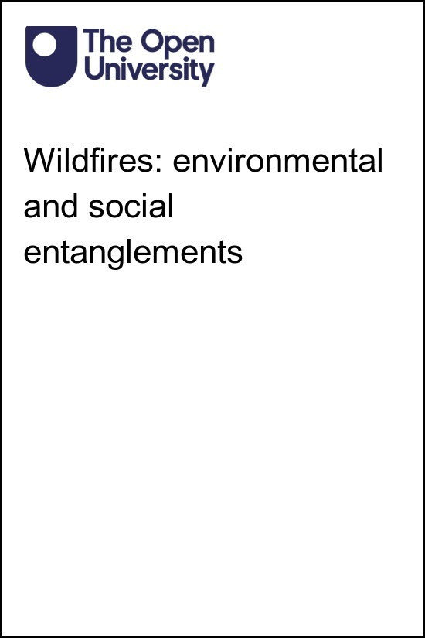

DD213_1

Wildfires: environmental and social entanglements

About this free course
This free course is an adapted extract from the Open University course DD213 Environment and society: https://www.open.ac.uk/courses/modules/dd213.
This version of the content may include video, images and interactive content that may not be optimised for your device.
You can experience this free course as it was originally designed on OpenLearn, the home of free learning from The Open University – Wildfires: environmental and social entanglements: https://www.open.edu/openlearn/society-politics-law/wildfires-environmental-and-social-entanglements/content-section-0
There you’ll also be able to track your progress via your activity record, which you can use to demonstrate your learning.
Copyright © 2023 The Open University
Intellectual property
Unless otherwise stated, this resource is released under the terms of the Creative Commons Licence v4.0 http://creativecommons.org/licenses/by-nc-sa/4.0/deed.en_GB. Within that The Open University interprets this licence in the following way: www.open.edu/openlearn/about-openlearn/frequently-asked-questions-on-openlearn. Copyright and rights falling outside the terms of the Creative Commons Licence are retained or controlled by The Open University. Please read the full text before using any of the content.
We believe the primary barrier to accessing high-quality educational experiences is cost, which is why we aim to publish as much free content as possible under an open licence. If it proves difficult to release content under our preferred Creative Commons licence (e.g. because we can’t afford or gain the clearances or find suitable alternatives), we will still release the materials for free under a personal end-user licence.
This is because the learning experience will always be the same high quality offering and that should always be seen as positive – even if at times the licensing is different to Creative Commons.
When using the content you must attribute us (The Open University) (the OU) and any identified author in accordance with the terms of the Creative Commons Licence.
The Acknowledgements section is used to list, amongst other things, third party (Proprietary), licensed content which is not subject to Creative Commons licensing. Proprietary content must be used (retained) intact and in context to the content at all times.
The Acknowledgements section is also used to bring to your attention any other Special Restrictions which may apply to the content. For example there may be times when the Creative Commons Non-Commercial Sharealike licence does not apply to any of the content even if owned by us (The Open University). In these instances, unless stated otherwise, the content may be used for personal and non-commercial use.
We have also identified as Proprietary other material included in the content which is not subject to Creative Commons Licence. These are OU logos, trading names and may extend to certain photographic and video images and sound recordings and any other material as may be brought to your attention.
Unauthorised use of any of the content may constitute a breach of the terms and conditions and/or intellectual property laws.
We reserve the right to alter, amend or bring to an end any terms and conditions provided here without notice.
All rights falling outside the terms of the Creative Commons licence are retained or controlled by The Open University.
Head of Intellectual Property, The Open University

Contents
- Introduction
- Learning outcomes
- 1 Fire, environment, and society
- 2 The 2007 Greek wildfires
  - 2.1 The burned areas
  - 2.2 Why?
- 3 Wildfires as environment-society entanglements
  - 3.1 Entanglement
  - 3.2 The environmental historian Stephen Pyne
  - 3.3 Stephen Pyne: wildfire as entanglement
  - 3.4 The 2007 Greek wildfires as entanglement
- 4 Preparing for future wildfires
  - 4.1 Greece’s preparedness for future wildfires
  - 4.2 The United Nations recommendations for preparing for future wildfires
- Conclusion
- References
- Acknowledgements
- Solutions

Introduction
Wildfire is fire out of human control. More specifically, the United Nations Environment Programme has defined wildfires as ‘an unusual or extraordinary free-burning vegetation fire which may be started maliciously, accidently, or through natural means, that negatively influences social, economic, or environmental values’ (United Nations Environment Programme (UNEP), 2022).
Wildfire is becoming an increasingly pressing environmental challenge. Wildfires are getting bigger, more intense, and burning in places they have never been seen before. Between 1998 and 2017 there were 254 recorded major wildfires across the world, which resulted in an estimated US$68 billion in economic losses, and contributed to 2398 fatalities caused by wildfires, volcanic activity, and mass movement due to drought (Centre for Research on the Epidemiology of Disasters (CRED) and United Nations Office for Disaster Risk Reduction (UNISDR), 2019). During the rest of the twenty-first century, climate change and changes to land use practices are projected to make wildfires even more frequent and intense. It is predicted that global wildfires will increase by 14 percent by 2030, 30 per cent by 2050, and 50 percent by the end of the century (UNEP, 2022).
Wildfires have long-term effects that last well beyond their flames. They impact communities’ health, drain economic resources, contaminate water supplies, leave significant toxic waste, advance the extinction of plant and animal species, and contribute to climate change (UNEP, 2022). As a result, it is important to understand the complex reasons why wildfires happen and what might be done to reduce their recurrence, intensity, and impact.
This free course, Wildfires: environmental and social entanglements, will explore wildfires as ecological, environmental, cultural, material, and social interactions. Through readings, films, and activities, it will specifically introduce you to wildfires as ‘entanglements’. By doing so, this course will help you understand the many complex relationships that cause wildfires and help you to reflect on how approaching wildfires as entanglements could shape future responses to the major environmental challenges they pose.
This course is split into four sections, in which you will:
- consider fire and its place in human history
- explore the Greek wildfires in 2007, their impact, location, and causes
- be introduced to the geographical concept of entanglement and use it as a tool to develop a detailed understanding of what causes wildfires
- critically reflect on Greece’s preparedness to respond to the ongoing threat of wildfires and explore potential responses to the environmental challenge of wildfires.
This OpenLearn course is an adapted extract from the Open University course DD213 Environment and society.

Learning outcomes
After studying this course, you should be able to:
- understand the complex interactions between environmental and social factors that caused the Greek wildfires of 2007
- critically reflect on Greece’s state of preparedness for future wildfires
- use social science approaches to gain complex understandings of what causes wildfires
- use social science approaches to critically assess existing preparations for the ongoing global environmental challenge of wildfires
- explain and use the geographical concept of entanglement.

1 Fire, environment, and society
To the best of our understanding, the Earth is the only planet which currently has an appropriate environment, atmosphere, and mix of resources which make fire possible. However, fire is much more than a naturally occurring chemical reaction. It is also a tool adapted by humans. Fire can modify environments and serve to shape social interactions between individuals, groups of humans, and the places in which they live. Therefore, fire can be understood as a distinctive property of the Earth and its current environmental conditions and as a defining characteristic of human social organisation and environment–society relationships.

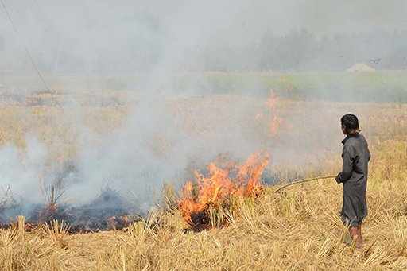
Figure 1: Stubble burning in the Punjab, India
View description - Figure 1: Stubble burning in the Punjab, India

Environmental historians, geologists, and geographers argue that over the past one million years, fire has been – and continues to be - key to environment-society relationships. They refer to the present era of the Earth’s history as the Anthropocene. This is the historical period dating from the commencement of significant human impact on the Earth, its atmosphere, ecosystems, and geology. Fire plays a very important role in defining the Anthropocene. Firstly, fire provided the layers of burned carbonised material (coal) in the geological layers of the Earth’s surface that humans have been able to use to create industrial power. Secondly, by burning carbonised material to make power, fire has changed the composition of the Earth’s atmosphere, introducing large quantities of gasses such as carbon dioxide (CO2) as the waste products of combustion.
Although definitions of the Anthropocene have largely focused on how humans have controlled fire for industrial purposes, this period has also been marked by an increase in wildfires and their intensity. For millions of years many plants and animals have taken advantage of naturally occurring wildfires, triggered for example by lightning strikes on dry vegetation, to forge unique ecological niches and reproductive cycles within complex ecosystems that come to depend on fire. However, as the environment changes as the result of human actions, wildfires are increasingly becoming an environmental challenge rather than an environmental opportunity. As populations increase and city suburbs extend further into savannah and semi-arid environments in places like California and parts of Australia, the danger of wildfires to human lifestyles is becoming an increasing source of public unease associated with climate change and urbanisation.
Therefore, all types of fire are deeply implicated in today’s major environmental issues. However, focusing on wildfires, this course will explore how they are caused by complex and indivisible environmental and social interactions and require equally complex responses.

Activity 1
10 minutes

Think of some of the ways humans have used fire to manage the environments in which they live.
How might human life be different without the ability to manage fire?

View discussion - Activity 1

2 The 2007 Greek wildfires
During the summer of 2007, wildfires raged across Greece. At the time, they were recorded as the worst natural disaster of contemporary Greek history (Koutsias et al., 2012). The first fire started on the 27 June 2007 and the final fire was extinguished in early September 2007. The fires burnt through dry forests and vegetation, often moving quickly through the landscape (Athanaiou and Xanthopoulos, 2010).

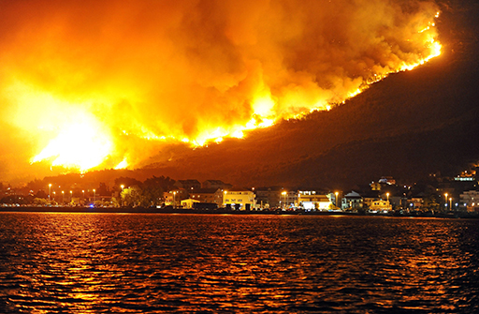
Figure 2: A wildfire threatening the village of Podstrana, near the Adriatic coastal town of Split, Croatia, July 2017
View description - Figure 2: A wildfire threatening the village of Podstrana, near the Adriatic coastal ...

The Greek wildfires of 2007 resulted in a death toll of more than 78 (some estimates are as high as 84 people) including several firefighters. They devastated more than 180,000 hectares of forest and agricultural land, destroyed or effected over 3000 houses, and led to the loss of life of a substantial number of livestock and forest animals (Koutsias et al., 2012).
The most destructive and lethal infernos broke out on 23 August, expanded rapidly, and raged out of control until 27 August, they were finally put out in early September. During August 2007 alone 67 people died as the result of the wildfires.

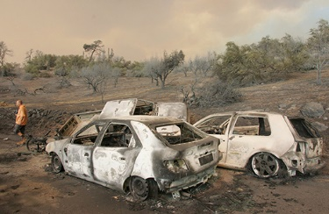
Figure 3: Cars burned by wildfires on the Pelopennesian Peninsula, 2007
View description - Figure 3: Cars burned by wildfires on the Pelopennesian Peninsula, 2007

Like all wildfires, these fires also had a range of long-term effects. Releasing carbon into the atmosphere they contributed to climate change. The damage caused by these wildfires had significant economic consequences for individuals, communities, and the Greek nation. The fires also had long-term physical and mental health impacts. One study has found that victims of the 2007 Greek wildfires had increased symptoms of depression, anxiety, hostility, and paranoia (Adamis et al., 2011). Furthermore, by changing local habitats and ecosystems, the fires had a long-term impact on wildlife.
The next page will explore where these fires were most significant.

2.1 The burned areas
Figure 4 illustrates the areas of Greece affected during the height of the wildfires in August and September 2007. The fires mainly affected western and southern Peloponnese as well as southern Euboea. Extensive fire fronts were created when fires merged, advanced into villages, and could only be put out after several days (Karamichas, 2007, p. 528).

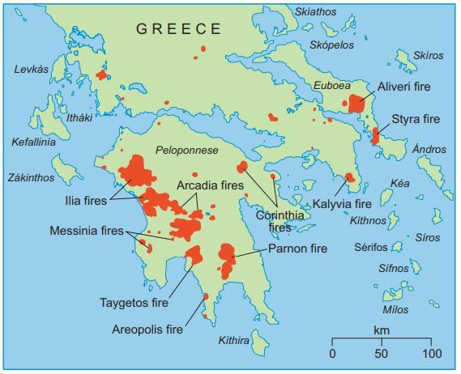
Figure 4: Areas affected at the height of the Greece fires 2007 (Aug 23 – Sept 5, 2007)
View description - Figure 4: Areas affected at the height of the Greece fires 2007 (Aug 23 – Sept 5, ...

The worst affected area of Greece was the regional unit of Ilia (also known as Elis), situated on the Peloponnese Peninsula. Nearly 40% of forest land in the area was burnt and 44 people were killed (Karanikola et al., 2013).
The fires in Ilia generated particular concern. Not only because of their extent and the deaths and devastation they caused, but also because they threatened the archaeological site of ancient Olympia. Olympia is globally renowned as the birthplace of the Olympic Games and it is a United Nations Educational, Scientific and Cultural Organization (UNESCO) World Heritage Site (Bassi & Kettunen, 2008). In the end, the 2007 fires burned right around the edges of the site. None of the ancient ruins were burnt. However, the surrounding landscape and even the culturally significant Kronios Hill, which forms part of the site, were severely affected. The two images below show some of the damage that was done to Kronios and the surrounding hills.

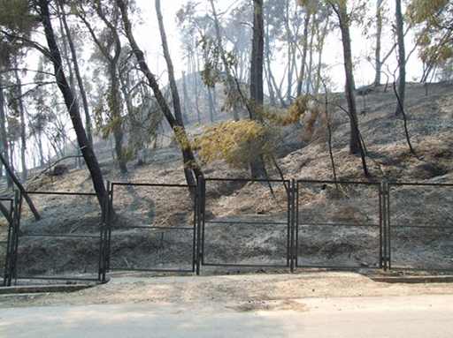
Figure 5: Kronios Hill, Olympia, taken two days after it burned on 26 August 2007 (Institute of Mediterranean Forest Ecosystems)
View description - Figure 5: Kronios Hill, Olympia, taken two days after it burned on 26 August 2007 ...

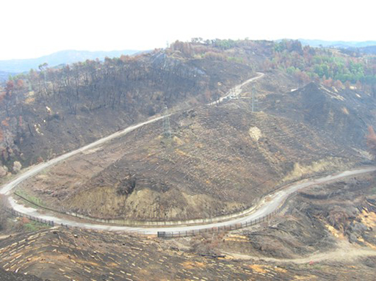
Figure 6: Hills around the Olympia site in the wake of the 2007 fires, showing log dams that were quickly installed to prevent soil erosion after the burning caused a severe loss of vegetation cover (Institute of Mediterranean Forest Ecosystems)
View description - Figure 6: Hills around the Olympia site in the wake of the 2007 fires, showing log ...

In the next section you will begin to consider why these wildfires happened.

2.2 Why?
The rest of this course will explore why wildfires occurred and spread in Greece in more detail. However, it is initially important to appreciate that forest fires are a serious challenge in Mediterranean Europe and some Mediterranean ecosystems are both prone to fire and dependent on it to reproduce and regenerate.
The Mediterranean climate contributes to summer fire danger because:
- wet winters produce abundant fuels, while very dry, hot summers cure those fuels to high levels of flammability (Wainwright & Thornes, 2004)
- in coastal regions during the summer months, strong winds may fan forest fires
- drought recurring on a 3–5-year time scale exacerbates normal summer season fire conditions (Morehouse et al., 353–4).

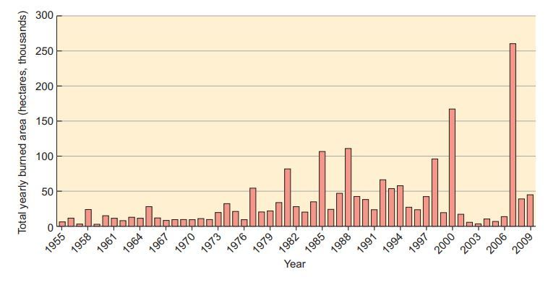
Figure 7: Area of land in Greece subject to wildfires 1955-2009
View description - Figure 7: Area of land in Greece subject to wildfires 1955-2009

As you can see from Figure 7, the number and frequency of fire events has been increasing since the mid-1970s. Though more extreme dry summers may be a factor, evidence suggests that a complex combination of human factors, physical conditions, and ecological processes combine to produce a distinctive form of fire with particular environmental consequences. Significantly more severe than previous events, the Greek wildfires of 2007 exemplify this:
- some but not all of the Greek wildfires of 2007 were set deliberately by humans
- forms of agricultural practice exacerbated the risks
- political organisation and mismanagement undermined responses
- economic and property development opportunities provided incentives for land use change
- climatic, ecological and resourcing issues made environmental restoration difficult.
This range of factors will be explored in more detail in Section 3: Wildfires as environment-society entanglements.

Activity 2
15 minutes

Now you have read about the Greece wildfires of 2007, what happened, where they occurred, and why they happened, answer these questions to check your understanding of some of the key points.
- The 2007 Greece wildfires have been recorded as the worst natural disaster of contemporary Greek history. The wildfires resulted in substantial loss to human and animal life and devasted:

(a) 50,000 hectares of forest and agricultural land (c. equivalent to 35,000 football pitches)
(b) 100,000 hectares of forest and agricultural land (c. equivalent to 70,000 football pitches)
(c) 180,000 hectares of forest and agricultural land (c. equivalent to 130,000 football pitches)
View answer - Part

- Which of Greece’s ancient archaeological sites was affected by the 2007 wildfires?

(a) The Acropolis
(b) Olympia
(c) Delphi
View answer - Part

- Which of the following statements about the Greece wildfires of 2007 are true?

(a) Dry winters produce abundant fuels, while very wet, hot summers cure those fuels to high levels of flammability.
(b) Forms of agricultural practice exacerbated the risks.
(c) Mediterranean ecosystems are both prone to fire and dependent on it to reproduce and regenerate.
(d) The Greek wildfires of 2007 were caused by lightning strikes and other natural causes.
(e) Political organisation and mismanagement undermined responses.
View answer - Part

3 Wildfires as environment-society entanglements
As the number and severity of wildfires increases and wildfires become a significant global environmental challenge, understanding why they occur is imperative.

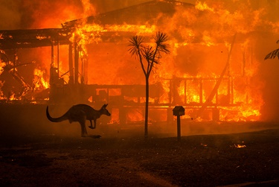
Figure 8: Australian wildfires, 2019-2020
View description - Figure 8: Australian wildfires, 2019-2020

The previous section suggested that the 2007 Greece wildfires were not simply caused by the Mediterranean climate. Rather they were produced by environmental and social interactions. Indeed, the increasing incidence of wildfires on cultivated land, nature reserves, and the peripheries of settlements across the world exemplify many issues posed by contemporary environment-society relationships. On one hand, such fires indicate the penetration of low-density suburban settlements into semi-arid woodland, bush and scrub which is naturally prone to burning. On the other hand, the increasing incidence of fires is often linked to the droughts and higher average and maximum temperatures associated with accelerating global climate change. This section will introduce the geographical concept of entanglement and how it can be used to understand wildfires as both environmental and social events.

3.1 Entanglement
In this course, entanglement can be understood as the many ways in which living systems, environmental processes, humans and flora, fauna and other life forms are connected to each other, mixed up, and more-or-less co-dependent on each other. This suggests a world of things, relationships, and experiences made by connections, influences, exchanges and interdependencies between environmental processes, humans and non-humans. Such chains of relation, mixing, and co-dependence are sometimes obvious and clear, but are often complex and difficult to trace.
Framed this way, entanglement can be understood as the mixing and entwining of environments, humans, physical matter, and other life forms, influencing how things connect and interact, whilst also shaping each as individuals or entities and the world in which they exist.
This concept of entanglement can help us understand wildfires and the challenge they pose. The next few pages of this course will explore how the concept of entanglement can be specifically used to understand wildfires by exploring the ideas and arguments of the environmental historian Stephen Pyne.

3.2 The environmental historian Stephen Pyne

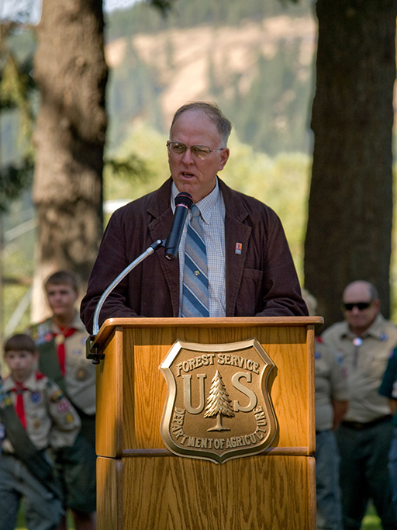
Figure 9: The fire historian Stephen Pyne
View description - Figure 9: The fire historian Stephen Pyne

In his book, Fire: Nature and Culture, the environmental historian Stephen Pyne (2012) argues that the environmental challenge posed by the increasingly frequent, dramatic, and dangerous reappearance of wildfires within recent decades is the result of the nature of fire and human actions. Therefore, he approaches wildfires as an entanglement of intersecting environmental and social factors.

Activity 3
30 minutes

In this video Pyne discusses the nature of fire and its relationship to humans and the environment. He gives an overview of the way he understands the relationships between humans, fire, and the environment and how these have changed over time.

Video content is not available in this format.
Video 1: ‘How fire shapes everything’: a talk by Stephen Pyne
View transcript - Video 1: ‘How fire shapes everything’: a talk by Stephen Pyne

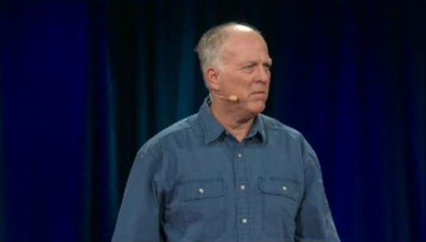

While you watch the video, answer the following questions. You might find it useful to watch the video more than once.
Pyne describes fire as a ‘shape shifter’. What do you think he means by this? What do you think are the consequences of fire being a ‘shape shifter’?

View discussion - Part

What do you think Pyne means by the ‘right’ and ‘wrong’ kinds of fire? Why does he think that too much of the ‘wrong’ kind of fire and not enough of the ‘right’ kind of fire is making the world uninhabitable?

View discussion - Part

Why does Pyne think that the way humans approach the current problem of wildfires is about the relationship between humans and the world?

View discussion - Part

The next page will explore how Pyne has used his approach to fire as an environmental and social entanglement to develop a specific framework for understanding the complex interrelationships that shape and inform wildfires.

3.3 Stephen Pyne: wildfire as entanglement
In his academic writing, Pyne has specifically approached fire as an entanglement of three interrelated processes: physical, ecological, and human. Below is a description of these processes and how they practically contribute to the development of wildfires.

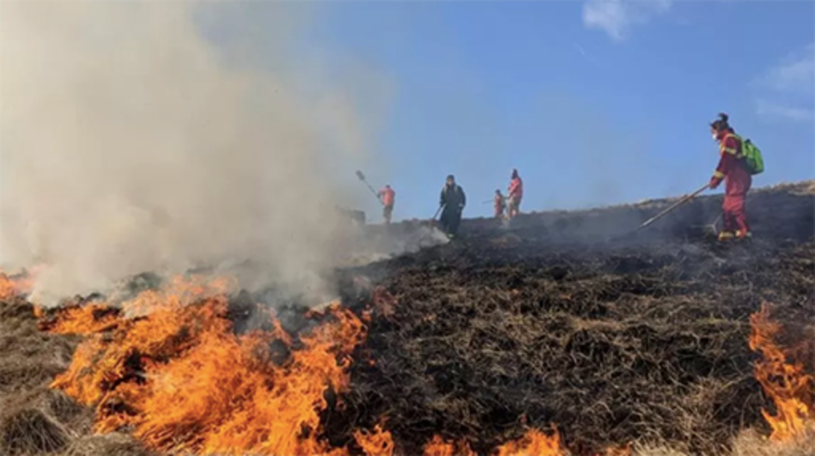
Figure 10: Wildfire in the Peak District, Derbyshire, 2022
View description - Figure 10: Wildfire in the Peak District, Derbyshire, 2022

- Physical processes
Fire is a chemical reaction moulded by the physical characteristics of its environment. Those physical parameters shape the area burning at any one time (the zone of combustion) as it moves about the landscape. Abundant fuel material and hot, dry weather patterns that make these fuels more flammable make wildfires more likely. Therefore, a significant factor in the increase of wildfires is climate change and its effect on fuels.
- Ecological processes
A fire’s environment is primarily organic as the living world provides the fuel for fire’s chemical processes. Where there is no organic material as carbon-based fuel, fire does not exist. Where there is a lot of organic matter, the risk of wildfires is increased. Fire’s ability to adapt to different circumstances means that it can smoulder in the debris close to the ground, race across open scrubland, or burn fiercely through dense wooded areas. The increasing threat of wildfires is partly the result of disrupted ecosystems, neglected forests, abandoned fields, invasive highly combustible plants, and the collapse of internal checks-and-balances within ecosystems.
- Human processes
Humans increasingly control and influence where fires happen and what type of fuel is chosen to be burned. The story of fire on Earth is ever more the story of what people do or don’t do, directly or indirectly, with fire and its setting.
An area can be at high risk of wildfires as the result of a whole range of human actions. Identifying entanglements shows how factors that seem unrelated to fire such as property laws or rural depopulation can have profound effects on the nature, location, and extent of fire. Thinking in terms of entanglements encourages thinking which is alive to those influences that are hidden and difficult to trace, as well as those that are clear and obvious.
Therefore, human decisions about land use, institutional behaviours, political policies, social changes, individuals’ and communities’ perceptions and motivations, and the resulting human actions and inactions can all contribute to allowing fire the space and time to develop out of control (adapted from Pyne, 2012).
By thinking about fires as a set of three entangled processes, Pyne highlights the interrelationships and dependencies that make wildfires the product of environment-society entanglements rather than just an act of nature or the consequences of human action. The next page will demonstrate how this theory can be specifically applied to the 2007 wildfires in Greece.

3.4 The 2007 Greek wildfires as entanglement
Pyne’s approach to fire as the entanglement of interrelated physical, ecological, and human processes (as introduced on the previous page) can be specifically used to help understand the 2007 Greek wildfires.

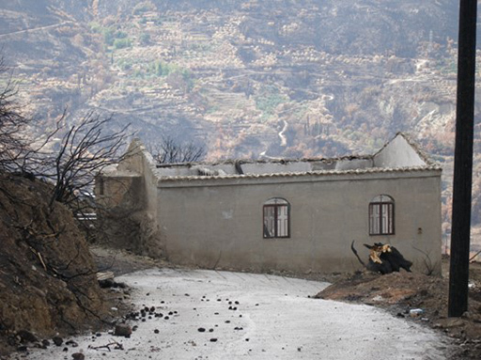
Figure 11: Burnt out house in Ilia
View description - Figure 11: Burnt out house in Ilia

- Physical processes
In 2007, precipitation in Greece lagged behind average. In August, precipitation was almost zero, while maximum temperatures that month surpassed the average for the period between 2000 and 2007 (i.e., over 40°C). A further increase of maximum temperature was observed after the 23rd of August, along with strong winds. These climatic conditions meant that places that were normally wet were dry, creating perfect conditions for wildfires to rush through the landscape and making it extremely difficult for firefighters to combat them (Hovardas, 2015, 411-2)
- Ecological processes
The most badly affected type of land during the 2007 Greek wildfires was agricultural land intermixed with natural vegetation, i.e. abandoned fields (Morehouse et al., 2011, 354). Here, the wildfires developed out of the organic debris left over from wild ecologies and farming.
To a large extent, this was also the result of human processes. Local-scale land use changes associated with rural-to-urban migration have reduced the workforce available to manage high levels of potential fuel build up in agricultural landscapes (Xanthopoulos, 2008). In addition, European Union funding for larger scale commercial olive groves to boost a declining agricultural sector was a contributing factor because under dry conditions such areas of monoculture are prone to spreading fire.
- Human processes
There were other human factors and processes that contributed to the 2007 wildfires.
Firstly, land use and ownership. In Greece, a high proportion of forest lands are nationally owned but lack clear evidence of ownership because historically there has been no systematic Land Registry. Therefore, arson has become a means by which individuals lay claims to property ostensibly under national jurisdiction. This often involves areas located at urban peripheries where demand for land to build on is highest. But it can also occur in scenic areas desired by tourism developers. In any space, such acts of arson can contribute to wildfires.
Secondly, fire prevention methods. From 1948 to 1998, the Forest Service (part of the Ministry of Agriculture, now Ministry of Environment), was instructed to carry out integrated management of forests and forest fire. However, insufficient funding seriously hampered the agency’s effectiveness (Xanthopoulos, 2008). Then, in 1998 the responsibility for wildfire management was transferred to the Fire Service. This was done without adequate advance preparation. There was an ineffective response to fire danger and insufficient coordination in managing fire events during the wildfires of 2007 (Xanthopoulos, 2008; Morehouse et al., 356-7).
Therefore, the wildfires in Greece during 2007 cannot be understood as simply physical, ecological, or human events. Instead, using the concept of entanglement to approach the 2007 Greek wildfires, encourages an understanding of these events that takes into account both environmental and human processes. It suggests looking at how these processes worked together, rather than looking for simple causes and effects taken from either the environmental or human worlds alone. Though each individual wildfire had a distinctive and specific trigger, it was the web of wider processes, circumstances, and events that was key to making this a major environmental event.
In addition, using the concept of entanglement highlights the nature of fire itself as highly adaptable in ways that can easily escape directed attempts to suppress it. This emphasises how simply changing agricultural practices, creating a better formal land ownership registry, or increasing funding to the Greek Forest Service for clearing and maintaining forested land, would and will not necessarily achieve the aim of protecting landscapes, property, and people from fire. When such directed approaches are taken, fire just keeps coming back somewhere else or in a different form triggered by something else. Therefore, thinking about wildfires as entanglements could be really helpful for informing how forestry, ecology, and environmental resources are managed in the future, so that people can find ways to live and work with and around the propensity for Mediterranean landscapes to be subject to wildfires.
In Activity 4, you will be able to test your understanding of the geographical concept of entanglement and how it can be utilised to understand wildfires and their causes. Then the final section of this course will focus on how using entanglement to understand wildfires can also inform how this environmental challenge is both prepared for, and responded to, in the future.

Activity 4
30 minutes

Now you have completed Section 3 of this course (Fire as environment-society entanglement), the following activities will allow you to test your understanding and consolidate your learning.

1. Fill in the missing words from the following description of entanglement.

Interactive content is not available in this format.

View discussion - Part

2. In your own words, describe Pyne’s three interrelated processes of fire.

Provide your answer...
View discussion - Part

4 Preparing for future wildfires
As wildfires become an increasingly regular and destructive environmental challenge, more attention needs to be given to how wildfires are prepared for and responded to. Understanding wildfires as entanglements of environmental and social processes helps to highlight how effective planning for the environmental challenges posed by wildfires requires engagement with nature, communities, local knowledge, scientific understanding, and political systems.

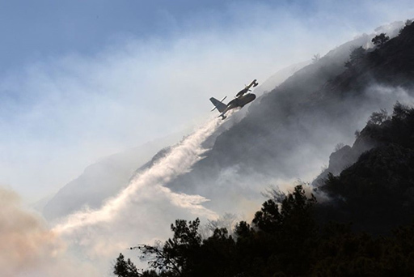
Figure 12: Plane using water to put out wildfires in Turkey
View description - Figure 12: Plane using water to put out wildfires in Turkey

4.1 Greece’s preparedness for future wildfires

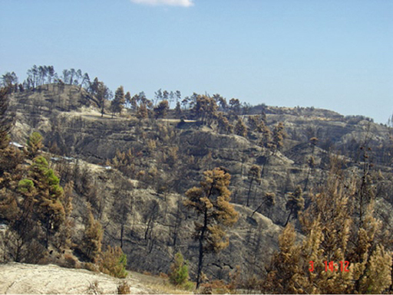
Figure 13: Burned area in Kassandra Peninsula, northern Greece, after the 2007 wildfires
View description - Figure 13: Burned area in Kassandra Peninsula, northern Greece, after the 2007 w ...

In response to the 2007 wildfires, Greece has taken steps to be better prepared for future wildfire threats. However, there are disagreements about the effectiveness of these measures. Some argue that the emphasis should be placed on preventing wildfires. Others think it is best to ensure that there are robust systems for responding to wildfires. The following videos are interviews with stakeholders in these debates. The first interview is with Dr Gavriil Xanthopoulos, from the Institute of Mediterranean Forest Ecosystems in Athens. The second interview is with George Konstantakoplous, Fire Officer of the Pyrgos Fire Service.

Activity 5
60 minutes

As you watch these two videos reflect on the following questions. You may find it useful to watch each video more than once.
- How prepared is Greece now for the hazard of wildfires?
- What has been learned about how the fires were caused in 2007 and how effective the response was?
- If there were shortcomings with the response to the 2007 wildfires, what was behind these and what action has been taken to overcome them since?
- To what extent do Dr Gavriil Xanthopoulous and George Kontantakoplous agree in their discussion of these issues? Why might they have different perspectives?

Video content is not available in this format.
Video 2: Dr Gavrill Xanthopoulos, Institute of Mediterranean Forest Ecosystems, Athens
View transcript - Video 2: Dr Gavrill Xanthopoulos, Institute of Mediterranean Forest Ecosystems, ...

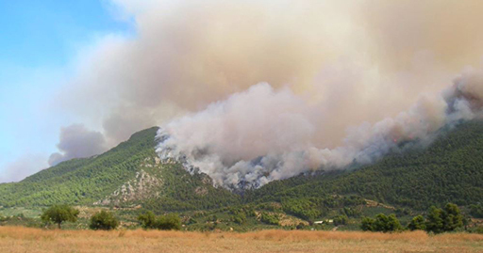

Video content is not available in this format.
Video 3: George Konstantakoplous, Fire Officer, Pyrgos Fire Service
View transcript - Video 3: George Konstantakoplous, Fire Officer, Pyrgos Fire Service

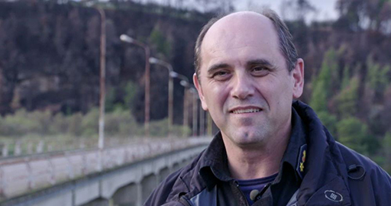

View discussion - Activity 5

4.2 The United Nations recommendations for preparing for future wildfires
In 2022 the United Nations Environment Programme published a report making recommendations for how the environmental challenge of wildfires should be prepared for in the future (UNEP, 2022). The report acknowledged that it is impossible to eradicate the risk of wildfires and undesirable to entirely eliminate wildfires due to their ecological benefits. Nevertheless, emphasising the increasing frequency and intensity of wildfires, it made a series of recommendations for how wildfires and the risk of wildfires could be better managed. These recommendations were grounded in three principles. Firstly, that prevention is more effective than response. Secondly, that policies and practices should be regionally specific and tailored to locations’ specific conditions. Thirdly, that lessons should be learnt from Indigenous peoples who have historically effectively coexisted with fire-prone ecosystems and have used fire as tool for sustainable land-management (Huffman, 2013).

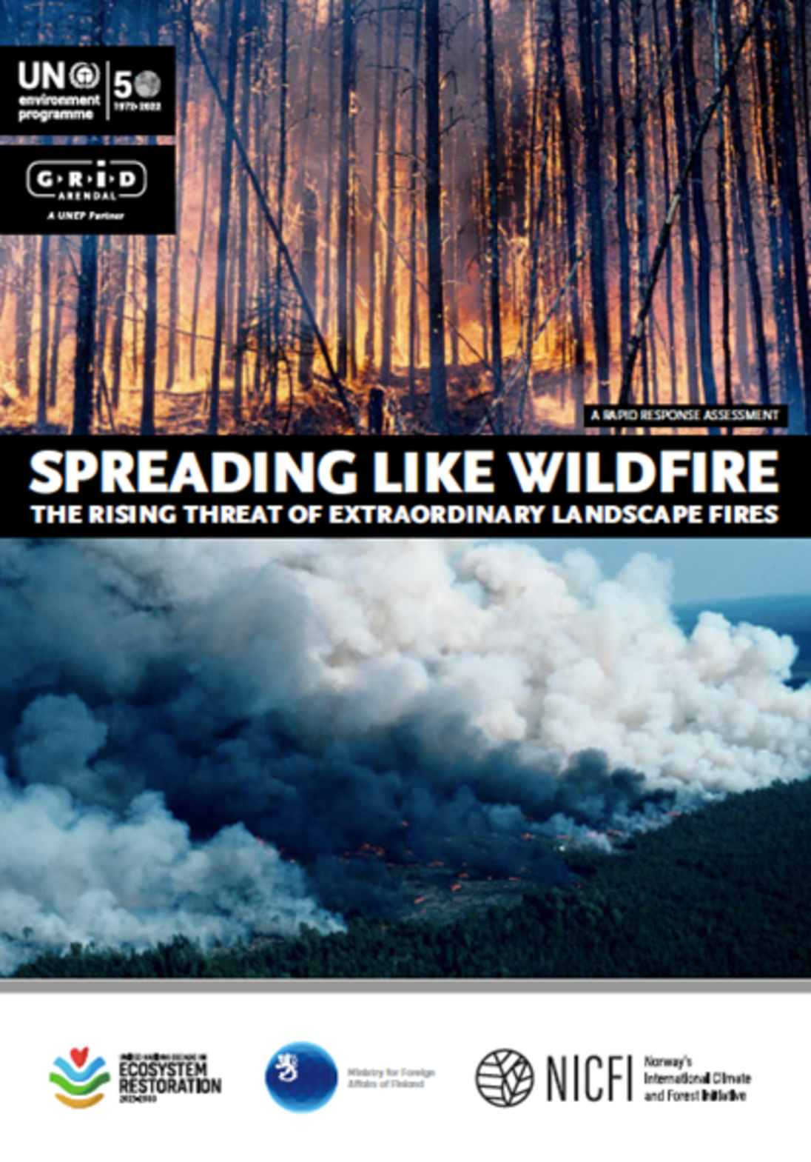
Figure 14: Front page of the UNEP report Spreading Like Wildfire: the rising threat of extraordinary landscape fires (2022)
View description - Figure 14: Front page of the UNEP report Spreading Like Wildfire: the rising threat ...

Activity 6
1 hour

Read through the United Nations’ nine recommendations for how the international community could more effectively prepare for and respond to the environmental challenge of wildfires published in the UNEP report Spreading Like Wildfire.
Once you have read through all the recommendations, select three recommendations that you think are particularly important. Explain why you have chosen these three recommendations with specific reference to wildfires as entanglements of physical, ecological, and human processes.

United Nations’ nine recommendations
- Recognise and respond to the impact of climate change on the prevalence and behaviour of wildfires
Climate change is increasing the likelihood of fire occurrence in many regions. The most recent Intergovernmental Panel on Climate Change (IPCC) report indicates that weather conducive to wildfires (“fire weather” – hot, dry, and windy) is becoming more frequent in some regions and will continue to increase with higher levels of global warming. Countries must meet and exceed their commitments under the Paris Agreement to reduce global warming and the prevalence and behaviour of wildfires globally. This will, in turn, reduce the social, economic, and ecological impact of wildfires.
- Understand wildfire behaviour and improve fuel management and wildfire monitoring
There is a critical need to better understand the behaviour of wildfires in different ecosystems and under a changing climate. This knowledge will support consistent fire data collection and analysis across organisations and countries, thereby improving the management of wildfire fuels, facilitating ignition prevention, and reducing gaps in fire management preparedness and response. Identifying how existing wildfire management practices encourage or discourage harmful wildfires can help improve decision-making and management systems. Improved data collection and analysis will also help monitor changes in fire activity, assess ecosystem response to changing fire regimes, and enhance climate models.
- Promote an integrated fire management approach
While fire is a natural ecological process, changes to our climate and land-use are contributing to more wildfires. Dealing effectively with the increase in wildfires requires policies and incentives that promote integrated fire management approaches. Achieving and sustaining adaptive land and fire management requires a well-designed and balanced combination of policies, a clear legal framework, and incentives that encourage appropriate land and fire use. These approaches maintain and restore healthy ecosystems while meeting the social, economic, and health needs of human populations.
- Support and integrate Indigenous, traditional, and contemporary fire management practices into policy
Globally, there is growing recognition of the important role that Indigenous and traditional knowledge and experience can play in informing land management practices that assist in the prevention and mitigation of wildfires. Indigenous and traditional knowledge of land management in many regions – particularly the use of fire to manage fuel, including for wildfire mitigation – can be an effective way of reducing hazard. It can also ensure that biodiversity, and cultural (including understanding traditional gender roles that can govern burning activities) and ecological values are respected, as well as create livelihood opportunities. Recognising and supporting the inclusion of Indigenous and traditional fire knowledge within government policy, practice, and programmes can have multiple benefits (e.g., vegetation management, cultural, spiritual, social, economic, health and well-being benefits, and political-self-determination).
- Strengthen international and regional cooperation on wildfires
The greatest potential for coherent and consistent improvement in fire management is through continued international interaction and exchange, joint problem solving, and sharing experiences in wildfire management and research. Existing networks and working groups tend to be focused on fire response. These efforts should be encouraged and supported, while expanding their focus to include cooperative work around mitigating fire risk before wildfires occur and building back better following a wildfire. Development of an international standard for wildfire management will facilitate international cooperation and help all wildfire-prone countries build capacity for both domestic application and international assistance.
- Rebalance investments spent on reactive suppression to proactive wildfire mitigation and management
Wildfires become uncontainable when they exceed the limits of suppression. Given the current limitations of fire suppression and a future predicted to have longer fire seasons and more severe fires due to increasingly worse fire weather conditions, making targeted investments in preparedness measures now will yield significant benefits. Wildfire risk reduction activities represent a sound return on investment as they reduce the potential impacts of wildfires. In the long term, they will be more cost effective than relying on reactive firefighting and post-disaster recovery efforts. Auxiliary risk management strategies should also be in place to reduce the likelihood of adverse fire impacts arising.
- Empower communities and local authorities
Enabling communities and local authorities in wildfire-prone areas to understand and accept the residual risk of wildfires will strengthen coordination of key stakeholders and build capacity to prepare for, respond to, and recover from wildfires. Activities include risk reduction (at the dwelling, locally, and regionally), infrastructure hardening, evacuation planning, air quality alerts, and social and infrastructure recovery and rebuilding. Key stakeholders need to be involved throughout the fire management process. This includes involving women and men from local communities so that local needs, concerns, and potential barriers to action can be addressed, and a common understanding and long-term vision for how to live with fire is developed, shared, understood, and acted upon.
- Improve firefighter safety
While firefighting is an essential component of fire management at all scales, the safety and long-term health of firefighters is paramount. The risk of harm to both female and male firefighters, before, during, and after operations must be minimised. Fire management bodies must take measures to ensure safe work practices in all aspects of firefighting, ensuring that they understand and reduce the risks of smoke inhalation, minimise the potential for life-threatening entrapments (i.e., burn-overs), and provide firefighters with access to adequate hydration, nutrition, rest, and recovery between shifts. In many instances, internationally agreed standards for assuring effectiveness of firefighting efforts may also act to minimise the exposure of firefighters to life-threatening situations.
- Promote the collection of data and information on the gender dimension of wildfires
Available research indicates that women and men have different approaches to wildfires, including risk perception and decision making. The collection of sex-disaggregated data will help to identify patterns for further analysis, including national, regional, or global trends. Understanding gendered risk perceptions can help policymakers develop more effective and robust approaches to wildfire management and improve safety for all members of society. Improving gendered knowledge extends to helping firefighting become a more inclusive activity. Women firefighters face various challenges ranging from gender discrimination and sexual harassment to ill-designed equipment and protective clothing that puts them at greater risk of injury.
(Taken from UNEP, 2022)

View discussion - Activity 6

Conclusion
In this free course Wildfires: environmental and social entanglements you have seen how wildfires are becoming an increasingly pressing environmental challenge. You have reflected on the changing role of fire within human history, explored how wildfire differs from other types of fire, and considered the environmental and social benefits and challenges associated with wildfires. You have focused on the wildfires in Greece in 2007, the impact they had, where they were most significant, and why they happened. In particular, you have also used the geographical concept of entanglement to explore how these fires were the product of indivisible related physical, ecological, and social processes. Finally, you have critically reflected on the extent to which Greece is prepared for future wildfires and used recent United Nations recommendations to draw your own conclusions about the most effective ways to manage wildfires in the future.
Wildfires are complex environmental challenges. Caused by the entangled effects of climate change, weather, ecology, land use, human behaviour, and many other factors. Therefore, the risk of wildfires will never be eliminated. However, by approaching wildfires as entanglements you have been able to develop sophisticated approaches to the complex challenges they pose.
Extrapolating out from your application of the concept of entanglement to understand wildfires, you can now use this concept to analyse other global challenges. This will help you assess the complex relationships and co-dependencies that contribute to global challenges. It will also help you to begin to develop sophisticated responses to these complex challenges.
This OpenLearn course is an adapted extract from the Open University course DD213 Environment and society.

References
Adamis, D., Papanikolaou, V., Mellon, R.C., Prodromitis, G. (2011) ‘The impact of wildfires on mental health of residents in a rural area of Greece. A case control population-based study’, European Psychiatry, vol. 26, no. 1, p.1188.
Athanasiou, M. and Xanthopoulos, G. (2010) ‘Fire behaviour of the large fires of the 2007 in Greece’, 6th International Conference on Forest Fire Research. Coimbra, Portugal, November 2010. Available at https://www.researchgate.net/publication/268744517_Fire_behaviour_of_the_large_fires_of_2007_in_Greece (Accessed: 5 June 2023)
Bassi, S. and Kettunen, M. (2008) Forest Fires: Causes and Contributing Factors in Europe, Study IP/A/ENVI/ST/2007-15, PE 401.003, Brussel, European Parliament, Policy Document, Economic and Scientific Policy. Available at https://www.europarl.europa.eu/RegData/etudes/etudes/join/2008/401003/IPOL-ENVI_ET(2008)401003_EN.pdf (Accessed: 5 June 2023)
Centre for Research on the Epidemiology of Disasters (CRED) and United Nations Office for Disaster Risk Reduction (UNISDR) (2019) Economic Losses, Poverty & Disasters 1998-2017. Available at https://www.undrr.org/publication/economic-losses-poverty-disasters-1998-2017 (Accessed: 5 June 2023)
Hovardas, T. (2015) ‘An “asymmetric threat” that should have been anticipated: political discourse on 2007 wildfires in Greece’, Environmental Communication, vol. 9, no. 4, pp. 409-27.
Huffman, M.R. (2013) ‘The many elements of traditional fire knowledge: synthesis, classification, and aids to cross-cultural problem solving in fire-dependent systems around the world’, Ecology and Society, vol. 18, no. 4, article 3.
Karamichas, J. (2007) ‘The impact of the summer 2007 forest fires in Greece: recent environmental mobilisations, cyber-activism and electoral performance’, South European Society and Politics, vol. 12, no. 4, pp.521-33.
Karanikola, P., Tampakis, S., Manolas, E. and Tsantopoulos, G. (2013) ‘Analyzing the impacts of information in the prevention of forest fires in Greece’, Journal of Spatial and Organizational Dynamics, CIEO-Research Centre for Spatial and Organizational Dynamics, University of Algarve, vol. 1, no. 2, pp. 71–81.
Koustsias, N., Ariaoutsou, M., Kallimanis, A.S., Mallinis, G., Halley, J.M. and Dimopoulos, P. (2012) ‘Where did the fires burn in Peloponnisos, Greece the summer of 2007? Evidence for a synergy of fuel and weather’, Agricultural and Forest Meteorology, vol. 156, pp.41-53.
Morehouse, B.J., Henderson, M., Kalabokidis, K. and Iosifides, T. (2011) ‘Wildfire fire governance: perspectives from Greece’, Journal of Environmental Policy and Planning, vol. 13, no. 4, pp.349-71.
Pyne, S. (2012) Fire: Nature and Culture. London: Reaktion Books.
United Nations Environment Programme (UNEP) (2022) Spreading Like Wildfire: the rising thread of extraordinary landscape fires. Available at: https://www.unep.org/resources/report/spreading-wildfire-rising-threat-extraordinary-landscape-fires (Accessed: 2 June 2023).
Wainwright, J. and Thornes, J. B. (2004) Environmental Issues in the Mediterranean. London: Routledge.
Xanthopoulos, G. (2008) ‘Forest fires in Greece 2007’, International Forest Fire News, vol.37, pp. 2-17.

Acknowledgements
This free course was written by Ruth Slatter, using material developed by George Revill and other members of the DD213 module team.
Except for third party materials and otherwise stated (see terms and conditions), this content is made available under a Creative Commons Attribution-NonCommercial-ShareAlike 4.0 Licence.
The material acknowledged below is Proprietary and used under licence (not subject to Creative Commons Licence). Grateful acknowledgement is made to the following sources for permission to reproduce material in this free course:
Course image: George Havlicek This file is licensed under the Creative Commons Attribution-Share Alike Licence http://creativecommons.org/licenses/by-sa/3.0/
Figure 1: NARINDER NANU / AFP / Getty Images
Figure 2: STR / Contributor / Getty Images
Figure 3: Orestis PEPAgiotou / EPA / REX / Shutterstock
Figure 4: Adapted from NASA and MODIS. Taken from Web Fire Mapper: Europe.
Figure 5: Institute of Mediterranean Forest Ecosystems
Figure 6: Institute of Mediterranean Forest Ecosystems
Figure 7: Adapted from Xanthopoulos, G. (2010), ‘Examining the causes of large forest fires in Mediterranean countries’, National Agricultural Research Foundation Institute of Mediterranean Forest Ecosystems and Forest Products Technology. Used by permission.
Figure 8: BBC / MATTHEW ABBOTT / NEW YORK TIMES / REDUX / EYEVINE
Figure 9: © NatPar Collection / Alamy Stock Photo
Figure 10: BBC/ @DERBYSHIREFRS / https://www.bbc.co.uk/news/uk-england-derbyshire-61466634
Figure 11: Vasilis Giakoumis
Figure 12: ADEM ALTAN / Getty Images
Figure 13: Daniel Moya Navarro
Figure 14: United Nations Environment Programme (2022). Spreading like Wildfire – The Rising Threat of Extraordinary Landscape Fires. A UNEP Rapid Response Assessment. Nairobi https://www.unep.org/resources/report/spreading-wildfire-rising-threat-extraordinary-landscape-fires
Video 1: ‘How fire shapes everything | Stephen Pyne’, Stephen Pyne at TED2015 https://youtu.be/LPC7UQyQQhQ, https://creativecommons.org/licenses/by-nc-nd/4.0/
Video 2: Interview with Dr Gavriil Xanthopolous, Head of the Forest Fires Laboratory of the Institute of Mediterranean Forest Ecosystems in Athens.
Video 3: Interview with George Konstantakopoulos, a senior officer in the Fire brigade of Pyrgos in Ilia, Greece.
Every effort has been made to contact copyright owners. If any have been inadvertently overlooked, the publishers will be pleased to make the necessary arrangements at the first opportunity.
Don’t miss out
If reading this text has inspired you to learn more, you may be interested in joining the millions of people who discover our free learning resources and qualifications by visiting The Open University – www.open.edu/openlearn/free-courses.

Solutions

Activity 1

Discussion
Humans have used fire both to manage the immediate environment and to make longer and more enduring changes to the environments in which they live. For example, to:
- keep warm during cold nights and cold seasons
- ward off wild animals, especially predators that threaten livestock or humans themselves
- cook plants and animals for food
- burn vegetation to clear ground and improve soil nutrient levels for agriculture
- to transform earth, rocks, and minerals into products such as lime for agriculture, pots for storage, bricks for building and metals for implements.
In terms of how human life might have been different without fire:
Firstly, without fire it is unlikely that humans would have been able to venture very far beyond the warm tropical savannah regions that nurtured early human populations. Rather than becoming a globally distributed species able to survive on every continent and at almost all latitudes, without fire humans would most likely have been confined to areas of the tropics where the climate is most favourable.
Secondly, without fire enabling humans to both enhance the nutritional value of food and the range of things that become edible with cooking, or the ability to preserve foodstuffs in storage vessels produced through firing, such as pottery, humans would most likely have had to continue to spend most for their time foraging for food. Increasing the range of things humans can eat by cooking and preservation has had a positive impact on human brain size because levels of nutrition are higher and more consistent. The ability to spend time doing things other than finding food has enabled humans to devote time to creating complex social and cultural formations.
Back to - Activity 1

Activity 2

Part

Answer
Right:
(c) 180,000 hectares of forest and agricultural land (c. equivalent to 130,000 football pitches)
Wrong:
(a) 50,000 hectares of forest and agricultural land (c. equivalent to 35,000 football pitches)
(b) 100,000 hectares of forest and agricultural land (c. equivalent to 70,000 football pitches)
Back to - Part

Part

Answer
Right:
(b) Olympia
Wrong:
(a) The Acropolis
(c) Delphi
Back to - Part

Part

Answer
Right:
(b) Forms of agricultural practice exacerbated the risks.
(c) Mediterranean ecosystems are both prone to fire and dependent on it to reproduce and regenerate.
(e) Political organisation and mismanagement undermined responses.
Wrong:
(a) Dry winters produce abundant fuels, while very wet, hot summers cure those fuels to high levels of flammability.
(d) The Greek wildfires of 2007 were caused by lightning strikes and other natural causes.
Wet winters rather than dry winters produce abundant fuels, while very dry hot summers cure those fuels to high levels of flammability. The Greece wildfires of 2007 were caused by a range of human and environmental factors.
Back to - Part

Activity 3

Part

Discussion
Your answer may include some of the following points.
By describing fire as a ‘shape shifter’, Pyne highlights how the nature of fire changes in response to the context and the materials it burns. Depending on the environmental temperature, the amount of oxygen in the atmosphere, and whether the fire is burning through dry wood, chemicals, man-made environments etc., fire will sometimes be a roaring blaze and sometimes be smouldering embers. In this way, fire is made – or shaped - by its circumstances.
If fire is a shape shifter that responds to the conditions in which it burns, as human actions change the environment the nature of fire will change. This could mean that fires are more likely in areas where the weather and farming practices result in lots of dry wood for fire to burn through. It could also mean that there are certain places where fire is carefully controlled. Pyne explicitly emphasises how the lecture theatre in which he gave this talk had been designed to reduce the risk of fire by including fire doors, sprinkler systems, and fire-retardant materials.
Back to - Part

Part

Discussion
Your answer may include some of the following points.
By distinguishing between the ‘right’ and ‘wrong’ kinds of fire, Pyne is emphasising how some wildfire can have positive benefits for ecosystems. This is the ‘right’ kind of fire. However, he is concerned that human attempts to eradicate wildfire in the landscape result in the reduction of its positive benefits to ecosystems that are often attuned to cycles of fire for reproduction and growth. Suppressing wildfire also leads to a build-up of burnable material in the landscape and results in the sorts of catastrophic fires that are experienced today in many semi-arid parts of the world such as the Mediterranean, Australia, California, and other part of western North America. This is the ‘wrong’ kind of fire.
For Pyne, suppressing wildfire has negative impacts on ecosystems. It also makes catastrophic wildfires that have significant impacts on humans, animals, and the environments they live in more likely. He argues that this is contributing to making parts of the world uninhabitable.
Back to - Part

Part

Discussion
Your answer may include some of the following points.
Pyne argues that the key to relationships between humans, fire, and the environment is the way humans understand fire as ‘a technological power’. Human relationships with fire demonstrate how humans have sought mastery and control over the environment and suppressing wildfires is an example of this.
Yet wildfires have an important role to play in environmental sustainability and humans need to recognise this. Pyne says we need to think of fire as a companion, the human relationship with fire is, he says, one of shared stewardship in which humans and wildfire work together to create more diverse and sustainable environments. This means that humans need to move away from attempts to control fire and environments more generally and learn to work constructively and respectfully with the ‘forces of nature’.
Back to - Part

Activity 4

Part

Discussion
The description should read as follows:
In this course, entanglement can be understood as the many ways in which living systems, environmental processes, humans and flora, fauna and other life forms are connected to each other, mixed up, and more or less co-dependent on each other.
This suggests a world of things, relationships and experiences made by the influences, exchanges and inter-dependencies between environmental processes, humans and non-humans.
Such chains of relation, mixing and co-dependence are sometimes obvious and clear, but are often complex and difficult to trace.
Framed this way entanglement can be understood as the mixing and entwining of environments, humans, physical matter and other life forms, influencing how things connect and interact, whilst also shaping each as individuals or entities and the world in which they exist.
Back to - Part

Part

Discussion
Your answer may have included some of the following points:
- Physical processes
  - Fire is a chemical reaction that is informed by specific environmental conditions.
  - Abundant fuel material and hot, dry weather make wildfires more likely
  - Climate change is making an important contribution to the increase in wildfires
- Ecological processes
  - The living world provides the fuel for fire’s chemical processes
  - Fire adapts to different ecological circumstances
  - Disrupted ecosystems, neglected forests, abandoned fields, invasive highly combustible plants, and the collapse of internal checks-and-balances within ecosystems all contribute to the environmental challenge of wildfires
- Human processes
  - Humans influence and (to some extent) control where fires happen and what type of fuel is chosen to be burned
  - Factors that may initially seem unrelated to fire can have profound effects on the nature, location, and extent of fire
  - This could include decisions about land use, institutional behaviours, political policies, and social changes and their impact on individuals’ and communities’ perceptions and motivations
Back to - Part

Activity 5

Discussion
Your answers may have included some of the following points:
Dr Gavriil Xanthopoulous emphasises the importance of prevention over suppression. He acknowledges that the suppression of wildfires has a role to play. However, he emphasises how maintaining forests and agricultural land is a more effective way of preventing large scale wildfires. Dr Gavriil Xanthopoulous thinks that Greece is not sufficiently prepared for future wildfires and that a situation like the 2007 wildfires could easily happen again. He argues that not enough time or resources are being invested in improving the management of the environment and that too much power has been given to the Fire Service in the process of preventing and responding to wildfires. He does identify that new forest maps as a step towards improving forest management, but this alone is not sufficient to prevent more fires like those in 2007. Finally, Dr Gavriil Xanthopoulous identifies the USA National Incident Management System as a good example of how different services can work together to prepare for and respond to environmental challenges.
George Kontantakoplous is more positive about Greek’s preparedness for future fires. He thinks that prevention and suppression are both important in the fight against wildfire. However, as a member of the fire service, he is primarily responsible for improving suppression techniques. He argues that as a result of the 2007 wildfires, lessons have been learnt about the importance of prevention, including effectively educating communities about their civil responsibilities. He also identifies that in response to the 2007 wildfires, the fire service has improved its co-ordination and training methods and has recruited more volunteers. George Kontantakoplous discusses several changes that have been made to fire-fighting practices since the 2007 wildfires. These include a new system for monitoring firefighting vehicles, the use of drones, and finding ways to work across services.
Dr Gavriil Xanthopoulous and George Kontantakoplous have different opinions on the extent to which prevention or suppression should be the focus of steps to prepare for the environmental challenge of future wildfires. However, they also agree about the importance of combining prevention and suppression techniques.
Back to - Activity 5

Activity 6

Discussion
Your answers may have included some of the following points:
Reflecting on how wildfires are entanglements of physical, ecological, and human processes you may have chosen recommendations that respond to the three different aspects of this entanglement. This could have included a recommendation that positions wildfires within the broader context of climate change as an overarching environmental challenge, a recommendation that focuses on managing the ‘fuel’ needed to allow fires to start and spread, and a people-focused recommendation designed to develop more fire-aware human behaviour before, during, and after fires.
The specific recommendations you chose are likely to reflect the extent to which you think it is important to prevent fires, rather than develop more effective ways to respond to them. You may also have considered the extent to which emphasis should be placed on regional, national, or connected international approaches to wildfire management.
Ultimately, all of the recommendations made in the United Nation Environment Programme report are important. Indeed, the variety of approaches to wildfires within the report once again emphasises the importance of understanding wildfire as an entanglement of physical, ecological, and social processes. It is only once wildfires are approached as environmental and social events that effective steps can be taken to manage and prepare for them.
Back to - Activity 6

Figure 1: Stubble burning in the Punjab, India

Description
Colour photograph of a gentle slope covered with golden stubble from a wheat-like crop. In the centre burns a bonfire. It is being tended by an adolescent boy. He has his back to us and is wearing a grey tunic but his legs are bare. He is prodding the fire with a long stick. In the background thick grey, white smoke is rising from a charred and burning field where the stubble has already been burnt.
Back to - Figure 1: Stubble burning in the Punjab, India

Figure 2: A wildfire threatening the village of Podstrana, near the Adriatic coastal town of Split, Croatia, July 2017

Description
Colour photograph of a coastal town taken at night. The town is lit by electric lighting, but the mountain behind the town is illuminated by a wildfire blazing fiercely, it has crept down the silhouetted side of the mountain. Dazzling yellow and white flames leap high in the air and the atmosphere is thick with dense smoke. The flames are reflected in the sea that fronts the coastal town. The water appears as dark brown and orange with yellow flames reflected.
Back to - Figure 2: A wildfire threatening the village of Podstrana, near the Adriatic coastal town of Split, Croatia, July 2017

Figure 3: Cars burned by wildfires on the Pelopennesian Peninsula, 2007

Description
Colour photograph of a landscape destroyed by fire. In the foreground are two cars and a pick-up truck. They are entirely burnt out. They are white with black smoke marks. They have no glass in their windows or tyres on their wheels and their interiors have been burnt out too. Behind them a man walks away from the scene. He is wearing an orange jumper, black shorts, and brown boots. Then there is land on a gentle slope that recedes into the background. The ground is coved in black ash. In the ground stands small trees. They are black and burnt. The sky behind is obscured by orange-tinged smoke.
Back to - Figure 3: Cars burned by wildfires on the Pelopennesian Peninsula, 2007

Figure 4: Areas affected at the height of the Greece fires 2007 (Aug 23 – Sept 5, 2007)

Description
This is a map of Greece showing the distribution of the wildfires as patches of red. The scale on the bottom right-hand of the image indicates that 1 cm is equal to 50 kilometres. At the top of the image, there is a land mass labelled ‘Greece’, scattered across which there are 12 small red patches, the largest of which is located to the south-east corner and is labelled ‘Kalyvia fire’. To the east, there is a relatively small archipelago labelled Euboea, on which there is one small and two larger patches of red, the larger patches are labelled ‘Styra fire’ and ‘Aliveri fire’ respectively. To the south-west of this, there is a much larger archipelago labelled ‘Peloponnese’; from east to west, there are five large patches of red ranging from approximately 0.5 cm to 1 cm across, these are labelled ‘Ilia fires’, ‘Arcadia fires’, ‘Messinia fires, ‘Taygetos fire’ and ‘Pamon fire’ respectively. There are two additional smaller patches of red on this archipelago labelled ‘Areopolis fire’ and ‘Corinthia fires’. There are various smaller Greek islands scattered in the sea all around these land masses.
Back to - Figure 4: Areas affected at the height of the Greece fires 2007 (Aug 23 – Sept 5, 2007)

Figure 5: Kronios Hill, Olympia, taken two days after it burned on 26 August 2007 (Institute of Mediterranean Forest Ecosystems)

Description
Colour photograph of a hilly area with black, charred trees positioned behind a high mesh wire fence. The scene is one of burnt devastation. Between the trees the land is bare and devoid of vegetation. Some limited vegetation has survived in the foreground. There is a concrete area in front of the fence.
Back to - Figure 5: Kronios Hill, Olympia, taken two days after it burned on 26 August 2007 (Institute of Mediterranean Forest Ecosystems)

Figure 6: Hills around the Olympia site in the wake of the 2007 fires, showing log dams that were quickly installed to prevent soil erosion after the burning caused a severe loss of vegetation cover (Institute of Mediterranean Forest Ecosystems)

Description
Colour photograph of a hillside taken from the air. There is a road running up the hill. The bend in the road is central to the photograph. It winds its way down the hillside and divides the landscape into three hilly areas. The hillside is a brown, barren landscape with no vegetation apart from charred trees towards the background. The landscape is strewn with logs. A few pylons cross the central hill.
Back to - Figure 6: Hills around the Olympia site in the wake of the 2007 fires, showing log dams that were quickly installed to prevent soil erosion after the burning caused a severe loss of vegetation cover (Institute of Mediterranean Forest Ecosystems)

Figure 7: Area of land in Greece subject to wildfires 1955-2009

Description
This bar chart is labelled ‘Total yearly burned area (hectares, thousands)’ on the vertical axis. This vertical axis starts at 0 and goes up to 300, in 50 thousand hectare intervals. The horizontal axis is labelled ‘Year’ and goes from 1955 to 2009. In 1955 there were approximately 10 thousand hectares burned by wildfires, but this began to rise significantly from the mid-1970s onwards. Although the number of thousand hectares per year fluctuated significantly throughout this time, there were significant ‘blips’ or higher readings in some years than others. For example: 1977, 55 thousand hectares; 1981, 70 thousand hectares; 1985, 105 thousand hectares; 1988, 110 thousand hectares; 1998, 95 thousand hectares; 2000, 170 thousand hectares; 2007, 260 thousand hectares. Apart from these years with ‘blips’ or higher readings, all years stayed below 50 and fell back to low levels seen only up to 1976 in 2002, 2003, 2004, 2005.
Back to - Figure 7: Area of land in Greece subject to wildfires 1955-2009

Figure 8: Australian wildfires, 2019-2020

Description
Colour photograph of a kangaroo rushing past a burning house. In the foreground there is a single palm tree and mailbox. All the walls, windows and content of the house have been destroyed by the fire that continues to rage with orange flames and black smoke.
Back to - Figure 8: Australian wildfires, 2019-2020

Figure 9: The fire historian Stephen Pyne

Description
Colour photograph of a man who is central and facing the camera. He is a middle-aged white man, balding and with glasses. He is wearing a jacket, shirt, and tie. He stands on a rostrum and is speaking into a microphone. The emblem on the front of the rostrum is a gold shield with a pine tree symbol between the large letters ‘U’ and ‘S’. The words surrounding this are ‘FOREST SERVICE’ and ‘DEPARTMENT OF AGRICULTURE’. In the background appear to be boy scouts.
Back to - Figure 9: The fire historian Stephen Pyne

Figure 10: Wildfire in the Peak District, Derbyshire, 2022

Description
Colour photograph of a grassy slope. The grass in the foreground is brown and straw like. In the centre of the image the grass is black from where it has been burnt and there are orange flames moving towards the unburnt grass. There is smoke rising from the burnt grass. There are five fire fighters walking across the burnt grass. There are dressed in full length protective clothing and are wearing face masks. They are using long metal sticks and rakes to tend to the burnt grass.
Back to - Figure 10: Wildfire in the Peak District, Derbyshire, 2022

Figure 11: Burnt out house in Ilia

Description
Colour photograph. Central to this image is a white, abandoned house, situated on a road descending the hillside. The house has no roof, although the walls and windows remain intact. To the left of the photograph is a bank of earth that borders the road. From this bank protrude the charred, black remains of burnt shrubs. The landscape behind the abandoned dwelling is a mixture of olive plantation and Mediterranean vegetation.
Back to - Figure 11: Burnt out house in Ilia

Figure 12: Plane using water to put out wildfires in Turkey

Description
Colour photograph of the top of a skyline taken from a jaunty angle. The hilltops are silhouetted in front of a blue sky. Above the hill tops flies a prop-plane that is releasing water over the landscape below. The vegetation on the hilltops has white and slightly orangey smoke rising from it.
Back to - Figure 12: Plane using water to put out wildfires in Turkey

Figure 13: Burned area in Kassandra Peninsula, northern Greece, after the 2007 wildfires

Description
Colour photograph of three parallel, tree-covered hills. The hillsides appear brown and burnt. Most of the trees are black and charred. A few trees in the foreground are greenish brown and have retained small amounts of green, or perhaps this is regrowth.
Back to - Figure 13: Burned area in Kassandra Peninsula, northern Greece, after the 2007 wildfires

Figure 14: Front page of the UNEP report Spreading Like Wildfire: the rising threat of extraordinary landscape fires (2022)

Description
Colour front cover of a UN report of managing wildfire. It is a rectangular landscape image split into four sections. The top section is a colour image of a forest on fire. It is a close-up on the trunks of trees positioned close to each other. The trunks have no branches or leaves. There are orange flames rising from the ground and licking all the way up the tree trunks. Some of the trees have fallen over. Imposed over this image at the top left are the logos of the UN Environment Programme and GRID. On a black banner in the middle of the page is the title of the project in white lettering: Spreading Like Wildfire: the rising threat of extraordinary landscape fires. Below the title is a colour photograph of a valley. There is thick, green forest running down one side of the valley. The other side of the valley is obscured by thick white and black smoke rising from fire in the valley. At the bottom of the page there is a white section with the logos of an UN programme and partner organisations involved in the production of the report: United Nations Decade of Ecosystem Restoration 2021-30, Ministry for Foreign Affairs of Finland, and Norway’s International Climate and Forest Initiative.
Back to - Figure 14: Front page of the UNEP report Spreading Like Wildfire: the rising threat of extraordinary landscape fires (2022)

Video 1: ‘How fire shapes everything’: a talk by Stephen Pyne

Transcript
[MUSIC PLAYING]
STEPHEN PYNE
When I was 18, I signed on as a smoke chaser at the North Rim of the Grand Canyon and began a career as a pyromantic. Not a pyromaniac. Important distinction.
On a fire crew, you soon learn how fires shape the season, and how fire seasons can shape a life. And I wondered if the same might be true for humanity. After all, we are a uniquely fire creature on a uniquely fire planet.
So eventually, I traded in my Pulaski for a pencil, and then a PC, and became a scholar on fire. So let’s gather around this figurative campfire called a Ted Talk, and let me tell you the story of fire on earth and of the keystone species that for good or ill, has become the keeper of the planetary flame. And how we’ve created a world with too much of the wrong kind of fire, too little of the right kind of fire, and it’s making our world less habitable.
Well, let’s begin with fire. Among the ancient elements, fire is the odd man out. Earth, air, water all are substances. Fire is a reaction. It synthesises its surroundings. It takes its character from its context, and that makes it a shape shifter.
But it’s also a shape shifter intellectually. You know, all the other ancient elements have got academic disciplines devoted to their study. The only fire department on a university campus is the one that sends emergency vehicles when the alarm sounds.
The fundamental setting for fire is the living world. Life created oxygen. Life created fuel. The fundamental chemistry of fire is a biochemistry. And as soon as plants began colonising land, they burned, and they’ve been burning ever since.
But they burned in a way that was very patchy. Some places, some eras, had lots of fire routinely. Others only episodically or even rarely. And one reason is that life did not control the third element of the fire triangle, namely ignition.
Well, that changed when a creature arrived who could wrest control of ignition away from lightning and fire at will. And at that point, we complete the cycle of fire for the circle of life. But we got a lot, too.
We got small guts and big heads because we could cook food. We went to the top of the food chain because we could cook landscapes. And now we’ve become a geologic force because we’ve begun to cook the planet. It seems we’re intent on turning Earth into a kind of crock-pot.
Well, we hold this particular firepower as a species monopoly. Other animals knock over trees, dig holes in the ground, hunt; we do fire. That’s our unique ecological signature.
But our firepower comes with real limitations. Not every spark spreads. Not every fire is going to behave as we wish. And the reason is that the power to propagate resides in the setting.
So we began changing the setting. We slash woods. We drain peat. We loosed livestock. In a score of ways, we began altering and magnifying the combustibility of the places we inhabit.
But this too has its limitations. You can only coax or coerce so much out of a setting before it begins to degrade. And if we want more power– and it seems most of us always do– we have to find something else to burn.
Well, we found it by exhuming and burning lithic landscapes. Coal, oil, gas and the rest, these are the fossil fallow of an industrial society, and with them, we have begun once more to remake the world. Traditionally, we have thought of fire history as a subset of natural history, particularly climate history. But now it’s becoming clear that natural history, including climates, are subsets of fire history.
This new combustion burns without the old ecological checks and balances. It burns day and night, winter and summer, through drought and deluge. For a long time, the question the human quest for fire concerned, obsessed over sources. Finding enough stuff to burn. But now it’s becoming a problem of sinks. The capacity of land, air and the oceans to absorb all the byproducts of our burning.
Well, when you began industrialising, it’s a huge phase change. And I’m going to call it the pyric transition, by analogy to the better known demographic transition. Because during this initial phase, there’s a real ramping up of burning. There’s a population explosion, and a lot of those fires are really nasty and damaging and abusive.
But then eventually, the new order begins to establish itself. By technological substitution and outright suppression, the population of fires plummets. Good fires as well as bad fires. It falls below replacement values. It can no longer do the ecological work required.
So if the pirate transition begins with a kind of fire orgy, it tends to end with an ecological fire famine. Well, many nations looked over, looked across the spectrum of really wrecked landscapes and adopted a programme of state-sponsored conservation to protect their remaining estates, and in many cases, colonial holdings, from the ravages of axe and fire.
This was a global project. It was pursued from the Northern Rockies of the United States to the central provinces of India. Interesting index of the reach of these ideas. Rudyard Kipling wrote a sequel to The Jungle Book, in which he describes what happens to Mowgli after he grows up. He joins the Indian Forest Service and fights against poaching, and you guessed it, fires.
Only much later would the paradoxes become palpable. That in many cases, setting aside land to shield it from fire only created permanent abodes for fire. And that the effort to suppress all fire only created an ecological insurgency that we could no longer contain.
Well, this phase change runs like a terminator through Earth history and contemporary geography, sub-Saharan Africa, awash with fires. Western Europe, ablaze with lights. Well, not all those lights are powered directly by industrial combustion, but you can bet industrial fire is somewhere fundamental in their chain of creation. And they all substitute for open flames. Or a finer grain but more politically radical example, North Korea, distinctive by the absence of evening lights. But if you look at the daytime, equally distinctive by the concentration of open fires.
So how does it work? Well, it’s all around us. We don’t even see it. Consider the setting we’re now in. At one time, a building like this would be filled with working fires. Flames for lighting, heating, cooking, even entertainment.
They are all gone. We might have an occasional symbolic or ceremonial or token flame, but otherwise, it’s gone. And yet this space continues. It’s always, fire is a kind of dark matter to be shaped by fire. The materials you’re sitting on have all been tested for flammability. This room is equipped with automatic sprinklers and smoke detectors. The design of the seating and its capacity is determined aligned with the exits, all of which have special illuminated signs with their own autonomous power sources.
So apart from those token or ceremonial flames, however, the only fire that might occur here is a wildfire. And that turns out to be a pretty apt metaphor for industrial landscapes generally. So let me see if I can summarise this very brief history of a very big subject.
For aeons, natural fire prevailed, but it was lumpy in space and time. And people come. We increase ignition by orders of magnitude. And we begin rearranging landscapes to make them more combustible. The domain of fire expands vastly, and the pulses and patches are recoded.
And then we come to industrial fire. It competes with all the others. And this time, we have to think about the landscape as thick, because we’re taking stuff out of the geologic past, and we’re lofting it into the geologic future.
So, two grand realms of combustion, seemingly incommensurable, three kinds of fires, none of which play well with the others. How are we going to divide three into two and have something left over? Because if we fail, we simply cede the world to feral fire.
How we cope will depend, however, not only on our technology, but how we imagine ourselves in the world. This is the Aspen fire, boiling over the Santa Catalina Mountains and bearing down on Biosphere 2. Two very different visions of the future.
Biosphere 2, a completely engineered, self-contained entity. Something that in principle could be plopped down on another planet. It has no tolerance. Zero. For fire. Every fire prevented or put out is a problem solved.
For the Santa Catalinas, free burning fire is both inevitable and essential. And here, every fire put out is a problem put off. Interestingly, we can map these two visions onto prevailing images of fire held particularly by Americans.
So here, from the 2000 fire season in the Northern Rockies, a view of fire as a benevolent presence in a kind of pristine nature. And a year later, fire is a malevolent presence in a built landscape. What’s missing in all of these? What’s missing is some image or narrative of ourselves in that scene as constructive agents using fire to make a more habitable world.
So let’s go back to the fundamentals. Fire in the living world, ourselves as holders of the torch, two narratives prevail. One is the Promethean story. It speaks of fire as technological power.
A fire is something abstracted from its setting, perhaps by violence, and certainly held in defiance of an existing order. Well, we need a lot less Promethean fire. We need to find surrogates for combustion as a source of generic energy.
The other narratives are more, let’s call it primeval fire. And it speaks of fire as a companion on our journey and something of our shared stewardship with the world around us. I particularly like the kid with the fire stick. No wonder he’s grinning. But how else is he going to learn to burn properly?
We need a lot more primeval fire, because fire does biological work that nothing else does. So as we enter the future, the earth is shedding its cycle of ice ages for a fire age. Our relationship to fire made that possible. Our past is a record of how we have used our firepower.
Our future will be a record of what we have learned from that experience. But you know, I’ll bet that when the time comes to tell that tale, we choose to do it around a fire. Thank you.
Back to - Video 1: ‘How fire shapes everything’: a talk by Stephen Pyne

Video 2: Dr Gavrill Xanthopoulos, Institute of Mediterranean Forest Ecosystems, Athens

Transcript
INTERVIEWER
In the time that you've been involved, what kind of changes have you seen?
GAVRIIL XANTHOPOULOS
I would say because I have also an experience about most of the Mediterranean countries, prevention is the victim of suppression. Meaning that in general, prevention is something that you don't see the results. Actually, you see no results because you have no fires, and you tend to forget about it.
So there is very little effort and time and money devoted to prevention compared to suppression. Whereas studies have shown, both in Europe and in the United States and in other parts of the world, that roughly $1 or 1 euros spent on prevention saves you roughly 30 plus/minus euros in suppression costs and recovery costs. So it would make sense for any rational approach to move towards prevention. And this is not the case.
Everything is done centred around suppression. That's more obvious to the people, to the politicians. They want to see airplanes, helicopters. And the more technologies we involve in this, we are thinking we are doing a better job, which is not the case. And the disasters we have been facing in Greece and in the rest of Europe exactly signify this problem.
The problem has changed. That is whereas we had more small fires in the past, we are getting in a situation now where because of very strong suppression, we are having fewer fires in easy years. But then we have a sudden blow up when the conditions are such that exceed the capacity of firefighting. And this will happen again and again because the landscapes have become very flammable in the last few years because of the continuous land abandonment that has been taking place. And that's all over Greece and all over the Mediterranean.
If we look, for example, in the 1970s, up to the 1970s, the Forest Service, which was responsible at that time for firefighting, for the whole forest management and fire management and firefighting specifically, these people did not have fire trucks, no question about aerial resources. And still they were able to fight the fires with a few forest guards, some help from the urban fire stations, when it was available and when they could reach the place, very few roads, very few tracks, but mostly with agricultural people who'd go there to save their own property. They did not expect help from anybody.
Then in 1970, they bought the first fire trucks. And they had to employ people to run those fire trucks. And then the public refrained a little bit. OK, now we have professionals doing it. And then we had airplanes. And then even the professional would say, OK, the planes will come. And that's how it worked through the '70s and '80s. And this will happen everywhere, where there is no understanding of the role that fires play in the natural ecosystems of the Mediterranean.
INTERVIEWER
How would you describe the current state of preparedness?
GAVRIIL XANTHOPOULOS
It can happen again. And there is not much we have done in terms of improving the overall management of our land. There is one thing that we are changing lately, which has to do with trying to develop forest maps, which we did not have until now.
We're going to have a [INAUDIBLE] as any normal country should do, and which traditionally has not been, except for some parts of Greece. It has not been all over Greece. And this comes because of the way Greece was liberated in various waves, and they have different ownership patterns and legislatures. But it's time that we solve this problem now. And we hope it will be making our management of the forest and of the land in general better in the future.
INTERVIEWER
Do you think that at the moment, the right people are being given the right responsibilities for this?
GAVRIIL XANTHOPOULOS
My feeling is that having an organisation like the Greek Fire Service, saying that we are responsible for forest fire fighting and leaving everybody else actually outside the decision making, they want them like not equal partners, but like an inferior helper somewhere, is wrong policy. In my view, in modern times, with the capacities that we have of intercommunicating, of understanding, of common training, we could do much better. That is I don't think we should spare anybody out of the problem because it is not possible that you have a forester there waiting and the Fire Service doing the job and them being outside.
Two reasons, first of all, because if he is not involved, we are losing manpower and capacity and knowledge. And second, because that's how the experience has been lost. If nowadays we said to the Forest Service, take the responsibility again, it will not be the same as it was in 1998 because that experience has been lost.
Forest fires have to do with training and with experience and, of course, with some preparation on all the infrastructure that is needed. So I don't want a system that is either/or. I want a system where everybody contributes.
The United States have made inroads in this direction with a National Incident Management System. Formally, it started from the forest fire field, as the national inter-agencies that manage the system. And now it has been applied all over the United States for any kind of disaster, where everybody works together under one, let's say, leadership that has prescribed how this will happen, common terminology, common knowledge, common training, and so on.
Back to - Video 2: Dr Gavrill Xanthopoulos, Institute of Mediterranean Forest Ecosystems, Athens

Video 3: George Konstantakoplous, Fire Officer, Pyrgos Fire Service

Transcript
INTERVIEWER
Can you tell me what lessons have been learned from 2007. And how has it affected what you do today?
[TEXT ON THE SCREEN: GEORGE KONSTANTAKOPOULOS, Fire Officer, Pyrgos Fire Service]
GEORGE KONSTANTAKOPOULOS: [SUBTITLES: Certainly 2007 was a difficult year. Of course the experience we gained was huge, as far as dealing with such huge events. Disasters as large as these are hard to deal with and we gained experience through all the tragic things that happened. Of course we realised other things as well, regarding prevention for example, that we should also pay more attention to prevention. We need to keep the forest roads clear, and realise that individual citizens and state services must all help to ensure that the fires don't get out of control. Everyone must do what they can, to clear their yards, their houses and their fields. Also since 2007 we've seen a greater sense of civic responsibility from local people. We have more teams of volunteers now, people who want to help, who come and offer their help. I believe there is also better coordination between the various services. We realised that big fires need the efforts of all of us and we must be well informed and well trained in order to be more successful.]
INTERVIEWER
Can you tell me what changes there have been in terms of firefighting practice and equipment resources and policy.
GEORGE KONSTANTAKOPOULOS: [SUBTITLES: I'll tell you about something very recent. This year we started a programme which allows us to monitor every firefighting vehicle which takes part in a firefighting operation. We can now follow their positions through GPS, and receive information as to what condition they are in, if they have water, if they are working efficiently. It's a new addition to our efforts to suppress fires. We also have drones. This year in our area we did not have their help, but in Attiki they were valuable for surveillance and also coordination. When you have a picture from above you can see a great deal more. You can see behind the hill, what is at risk from the fire.
What else can we say has changed? Certainly there is better coordination between the services that work to suppress fires. A large fire can't be put out by just one service. We need the assistance of the Forestry, the armed forces, the municipalities and the regional self-government. Meetings of the Municipalities Local Coordinating Body or the Regional Civil Protection Coordinating Body take place more regularly and there we look at the problems and try to come up with solutions.]
INTERVIEWER
How confident are you that if there were another fire next summer, that you would be able to deal with it more successfully perhaps, than you were able to do so in 2007?
GEORGE KONSTANTAKOPOULOS: [SUBTITLES: Fires are affected by many variables, we try each year to improve ourselves, through experience and the use of technology, so that we may have better results. This year for example was a very difficult year. We had a long summer drought for over four months. I believe we did well, there was coordination of the services, we of course are the main axis, we are responsible for coordinating everyone and we will keep trying to improve ourselves. Fires are a dynamic phenomenon that appear not just in our country. They can be very dangerous, with many parameters. We will always try to improve ourselves and I hope that we can deal with another such fire.]
Back to - Video 3: George Konstantakoplous, Fire Officer, Pyrgos Fire Service

