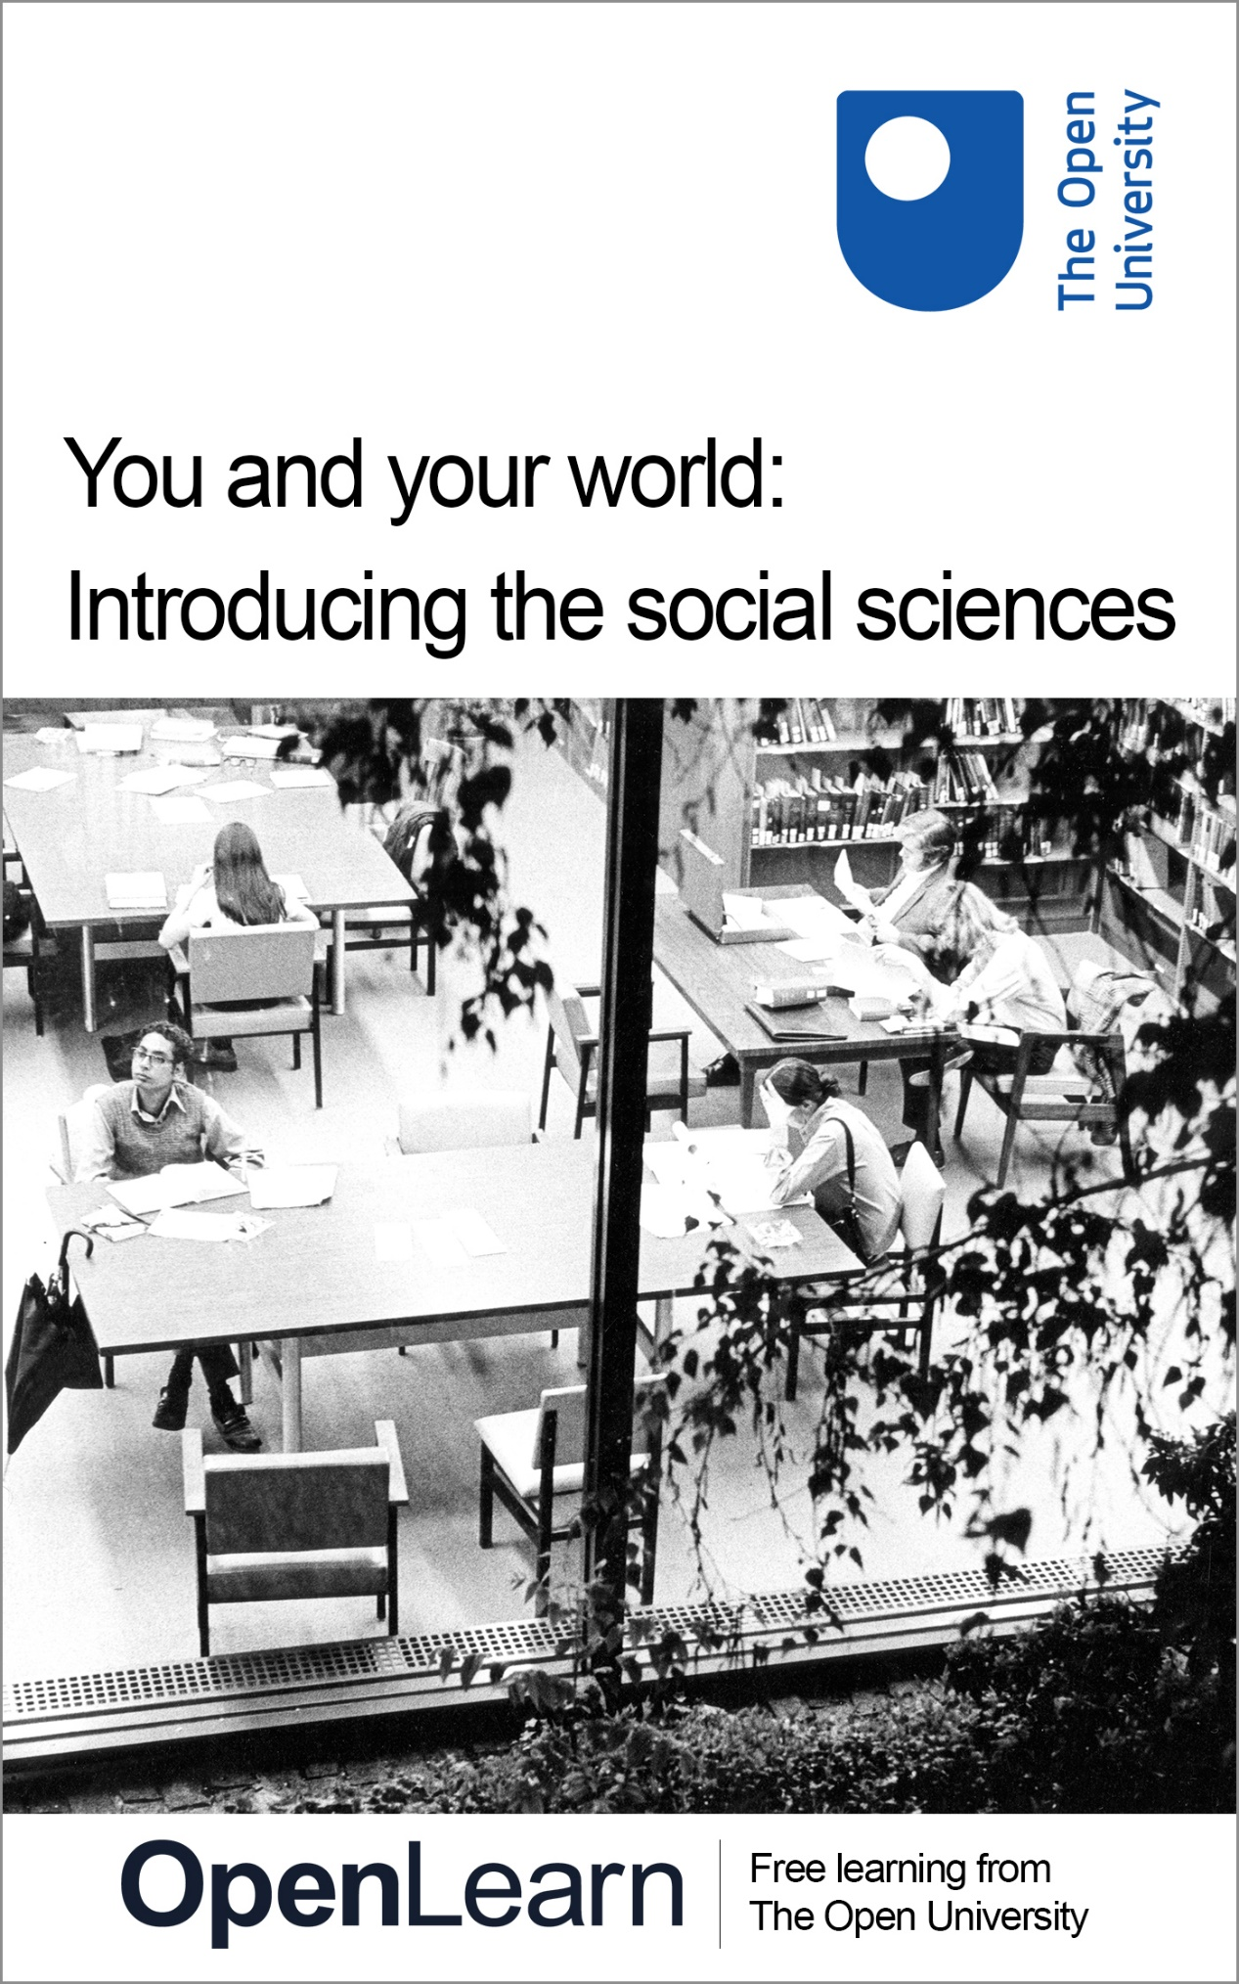

D112_1

You and your world: Introducing the social sciences

About this free course
This free course is an adapted extract from the Open University course D112 You and your world: introducing the social sciences .
This version of the content may include video, images and interactive content that may not be optimised for your device.
You can experience this free course as it was originally designed on OpenLearn, the home of free learning from The Open University – https://www.open.edu/openlearn/society-politics-law/you-and-your-world-introducing-the-social-sciences/content-section-0
There you’ll also be able to track your progress via your activity record, which you can use to demonstrate your learning.
First published 2026.
Unless otherwise stated, copyright © 2026 The Open University, all rights reserved.
Intellectual property
Unless otherwise stated, this resource is released under the terms of the Creative Commons Licence v4.0 http://creativecommons.org/licenses/by-nc-sa/4.0/deed.en. Within that The Open University interprets this licence in the following way: www.open.edu/openlearn/about-openlearn/frequently-asked-questions-on-openlearn. Copyright and rights falling outside the terms of the Creative Commons Licence are retained or controlled by The Open University. Please read the full text before using any of the content.
We believe the primary barrier to accessing high-quality educational experiences is cost, which is why we aim to publish as much free content as possible under an open licence. If it proves difficult to release content under our preferred Creative Commons licence (e.g. because we can’t afford or gain the clearances or find suitable alternatives), we will still release the materials for free under a personal end-user licence.
This is because the learning experience will always be the same high quality offering and that should always be seen as positive – even if at times the licensing is different to Creative Commons.
When using the content you must attribute us (The Open University) (the OU) and any identified author in accordance with the terms of the Creative Commons Licence.
The Acknowledgements section is used to list, amongst other things, third party (Proprietary), licensed content which is not subject to Creative Commons licensing. Proprietary content must be used (retained) intact and in context to the content at all times.
The Acknowledgements section is also used to bring to your attention any other Special Restrictions which may apply to the content. For example there may be times when the Creative Commons Non-Commercial Sharealike licence does not apply to any of the content even if owned by us (The Open University). In these instances, unless stated otherwise, the content may be used for personal and non-commercial use.
We have also identified as Proprietary other material included in the content which is not subject to Creative Commons Licence. These are OU logos, trading names and may extend to certain photographic and video images and sound recordings and any other material as may be brought to your attention.
Unauthorised use of any of the content may constitute a breach of the terms and conditions and/or intellectual property laws.
We reserve the right to alter, amend or bring to an end any terms and conditions provided here without notice.
All rights falling outside the terms of the Creative Commons licence are retained or controlled by The Open University.
Head of Intellectual Property, The Open University

Contents
- Introduction
- Learning outcomes
- 1 Living in a moving world
- 2 What are the social sciences
  - 1.1 Types of social science questions
  - 2.2 Asking good questions
- 3 Inequality and interconnection
  - 3.1 Inequalities and interconnections
  - 3.2 Seeing differently: working with concepts
- 4 Check your knowledge: mid-course quiz
- 5 You and your world
  - 5.1 What makes you curious?
  - 5.2 Feeding your curiosity: finding out more about a subject
  - 5.3 Exploring legitimate resources
- Conclusion
- References
- Acknowledgements
- Solutions
- Descriptions

Introduction
Welcome to an Introduction to the Social Sciences.
This course will explain what the social sciences are; and suggest that learning to think like a social scientist will help you to better understand the world around you. Two ideas that are used extensively in the social sciences are society and the social world. These ideas are related, but distinct.
Society can be thought of as a group of diverse people who share a geographic territory, interact with a common social structure, and follow the same laws or rules. They typically share many similar cultural values and expectations of each other. However, in some highly multicultural societies there may also be many cultural differences.
The social world by contrast refers to the idea that people’s lives and society, more generally, are shaped by a variety of relationships, cultures, communities and institutions. This course asks you to view your world as fundamentally a social world. Think, for example, about the way your life is shaped by the relationships you have with others around you, and the way you shape their lives in turn.
Social scientists are interested in the study of people, how they live together, and how people behave, interact and organise themselves. A good way to think of social science, is as a general academic approach that thinks about human behaviour and social relationships. There are several distinct but related disciplines within the social sciences – including sociology, geography, religious studies, economics and many others. These disciplines all look at the same basic issues but place a different focus and emphasis on various factors – such as the way each would look at culture, individual behaviour, social groups, trends and patterns.
Within this course, you will look at a pair of social concepts: interconnection and inequality to think about how these social science ideas can deepen your understanding of everyday topics in the social world.
This OpenLearn course is an adapted extract from the Open University course D112 You and your world: introducing the social sciences.

Learning outcomes
By the end of this course, you should be able to:
- understand what the social sciences are
- describe how the social sciences can help you make sense of real world examples
- demonstrate the way your own curiosity and imagination can bring something new to the study of the social sciences.

1 Living in a moving world
The introduction explained two important ideas – society and the social world. Throughout this course, you’ll be encouraged to think of both as being fundamentally dynamic. This means that rather than being fixed, society and the social world are constantly changing, moving and evolving. The social world is shaped by our relationships, interactions and connections with people we know personally – like family, friends and colleagues. But it is also shaped by people we don’t know personally – like the wider community, country and world in which we live.
This changeability and interconnection make social science an interesting and exciting subject to study. But the same things that make social science interesting, can also make it potentially complicated and challenging. As you progress through this course, you will see that social scientists have developed a wide range of practices, ideas, methods and tools to aid them in their work.
Video 1 provides some quick snapshots of some of the varied topics, issues and social situations that the social sciences explore. It’s intention is to stimulate your curiosity.

Video content is not available in this format.
Video 1 The social world
View transcript - Video 1 The social world

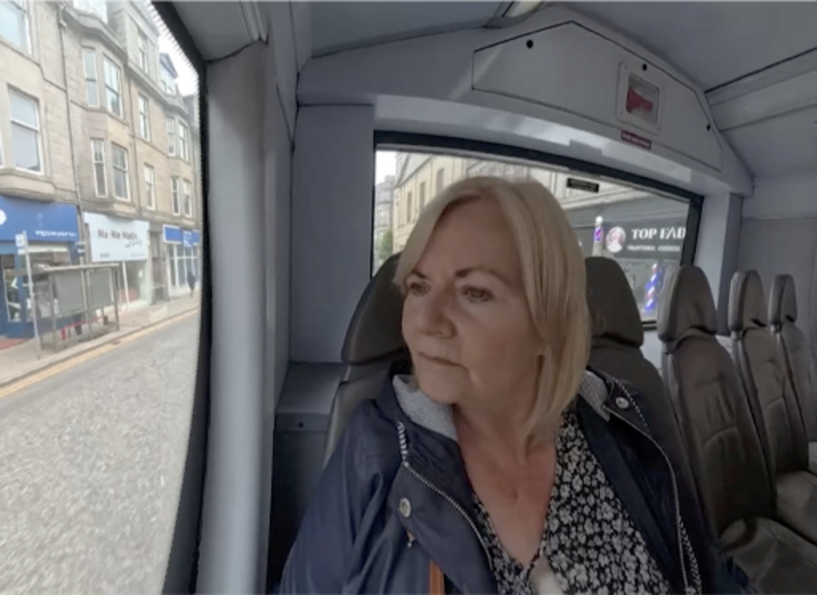

Video 1 shows you a number of very different, but also quite ordinary, everyday events that someone might come across or experience in daily life, for example:
- Someone waiting to catch a bus.
- Parents and kids organising a bike group to go to school.
- Someone giving a blood donation.
- Vegetables and flowers being transported to where they will be sold to people.
You might not immediately think that each of these actions are things that the social sciences are interested in, but they are.
Former Open University professor, social scientist and geographer, Doreen Massey, argued that people can take the familiar world around them for granted. The way you see the world might just feel ‘normal’ or ‘natural’ to you, but what happens when you start to question things that you have always seen as familiar? Massey encouraged social scientists to make the familiar unfamiliar. This means looking at everyday places, practices, or ideas in new ways. Video 1 hints at this, and the content in this brief course is intended to help you to do just that!

2 What are the social sciences
People have thought about how they relate to others, for as long as there have been people. Some of the earliest surviving human artworks are found in caves in Indonesia, Spain and France – and include depictions of people working and living together. The modern, academic study of society is more systematic. Wherever possible, social scientific research also aims to be evidence based – drawing on reliable, careful research rather than assumptions, common-sense or guesswork.


View description - Uncaptioned Figure
View alternative description - Uncaptioned Figure

For this reason, social scientists are deliberate about the kinds of questions they ask, and how they go about trying to answer them. Three basic foundations of social science thinking include:
- Asking questions, particularly those which start with ‘why’.
- Making claims that propose an idea about, or interpretation of, social life or events.
- Looking for or producing evidence that can support (or refute) claims.

1.1 Types of social science questions
The way social scientists ask questions usually involves looking beyond the story or experience of an individual person – no matter how interesting or moving this case might be. The goal of asking questions is often to try to find any patterns, regularities and trends that may occur beneath these individual lives. This helps to find the links between individual experiences and wider society. Although your experience of the social world might be totally different from someone else’s, asking questions can help you to discover things you have in common with others, or to understand the ways that someone else might have a different viewpoint from you.
Asking questions allows social scientists to explore, describe, explain and critique the social world. Consequently, they can understand it more accurately. Questions are a key form of inquiry, with the aim of generating information. Although there are countless types of questions that can be asked and ways that questions can be framed, in this section you’ll be introduced to four important types of questions: empirical, policy, ethical, philosophical.

Interactive content is not available in this format.

In answering the types of questions discussed above, different social scientific disciplines may take contrasting, though complimentary approaches. Consider the example of a social scientist who is interested in researching a recent spike in reports of shoplifting across the country. Researchers from different disciplines may approach this subject in quite different ways.
A geographer might ask empirical questions, in order to consider the way that the built environment of a city influences the likelihood of this type of offence.
A philosopher may approach this problem by asking ethical questions. They may reflect on whether it’s moral for a person to steal in this way. But they may also propose that private property is a form of theft – a social arrangement which is designed to benefit the powerful at the expense of the powerless. Another philosophical way to frame this question is whether stealing to feed one’s family is unethical, if government policy has systematically produced vast disparities of wealth.
A criminologist may look at the problem by asking policy questions. They may draw on official statistics to understand the impact of government programmes and spending, which may have disproportionately affected under-privileged communities, making them more likely to engage in shoplifting out of desperation.
In practice, it’s rare that the approaches taken by different social science disciplines are so clearly distinct. Instead, there is a great deal of compatibility, harmony and overlap between the various disciplines. For example, in designing a research project to look into a national spike in shoplifting, a research team may be formed which includes researchers with specialities in geography, philosophy and criminology (among others). This team might pool their expertise to ask empirical questions, which take into account ethical concerns, with the aim of making policy recommendations which can help to solve the problem.

2.2 Asking good questions
Asking questions can spark curiosity and new ways of thinking about something. A good question tends to be one that is phrased in a manner that will help you deepen your understanding and enhance critical reflection.
‘Good’ questions tend to be clear, concise, and linked to the topic which you are asking about. Unclear questions tend to be too open-ended, leaving too much room for multiple lines of inquiry and may lead to confusion rather than clarity.
For social scientists, good questions tend to be those that ask ‘how’, ’why’, ’what’, or ‘what if’. ‘What if’ questions in social science are a bit different to the others. ‘What if’ questions are, in general, more about using your imagination to think about possibilities of what ‘could be’. ‘How’, ‘why’ and ‘what’ questions, by contrast, usually focus more on the present or the past. In general, ‘good’ questions are more precise questions. Unclear questions tend to be unfocused – they still might begin with ‘how’, ‘why’ and so on, but they often lack clarity and precision.

Activity 1: What makes a question clear or unclear?
10 minutes

Are the following social science questions clear or unclear? Select the correct answer for each question below.

Question 1

How does identity work?

Clear
Unclear
View answer - Question 1

Question 2

What role does culture play in the formation of identity amongst youth subcultures?

Clear
Unclear
View answer - Question 2

Question 3

Among social science students who use social media regularly, how do likes and comments affect their perceptions of their social media identity?

Clear
Unclear
View answer - Question 3

Question 4

Why do people care about their social media profile?

Clear
Unclear
View answer - Question 4
View discussion - Question 4

3 Inequality and interconnection
Video 1, that you watched at the beginning of this course, provided a taster on the way that travel, transport and movement can provide interesting subject matter for social scientists. In this section, you will watch a longer video, which explores these ideas in more detail. The video also tells a story about inequality and interconnection. These are two key ideas that social scientists regularly use to understand the social world. Thinking about inequality and interconnection can help you to reflect broadly and deeply about social topics and can give you ways to think about the world that might not, at first, be completely obvious.

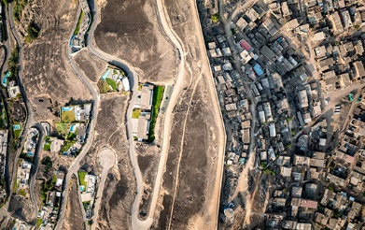
View description - Uncaptioned Figure
View alternative description - Uncaptioned Figure

Inequality refers to the uneven access to or allocation of resources or opportunities within a society. This can result in advantage or disadvantage between individuals or groups.
For instance, in many countries, statistics indicate that women experience inequality in the workplace, where they are paid less on average than men for undertaking the same work. Inequality can also appear in the form of differing opportunities. For example, research indicates that women in Latin America obtain higher educational qualifications than men and yet have much lower labour force participation (Berniell, Fernandez & Krutikova, 2024). Inequality is also evident in the UK where research indicates that people who attend private or fee-paying schools are more likely to secure a range of high-status and high-paying careers, such as law, politics, acting or sport (Sutton Trust, 2019).
Interconnection refers to instances where two or more things are linked, connected or interact in some way.
An example of this is the fact that the education and prison systems are distinct – they are run by different people, largely concerned with different age ranges, and governed by different laws. However, on closer inspection, the people who end up in prison are far more likely to have struggled and perhaps been failed in various ways by the education system. In this way, these two seemingly distinct systems share some connection. You may come to notice that the more you look for interconnections between any two apparently distinct things, the more you can find.
The overlap between inequality and interconnection
Although inequality and interconnection are independent and distinct ideas, in many instances they overlap and inform each another. Indeed, the example of the interconnection between the education and prison systems demonstrates this overlap: inequality in one part of society is interconnected with another, where it is then revealed that significant numbers of people in prison also had poor schooling outcomes.

3.1 Inequalities and interconnections
In the previous section, you considered the relationship between inequalities and interconnections.
These are two important ideas in the social sciences, because once you are introduced to them, you might find that you begin to notice them in many places. Thinking about the social world in terms of inequality and interconnection can help you to see things in a new way.
Activity 2 asks you to watch a video, and to then consider some of the ways that the ideas of inequalities and interconnections can be observed in the videos. While doing this activity, see if you can think of ways that inequality and interconnection are present, but which are not mentioned in the below activity.

Activity 2: Observing inequalities and interconnections
30 minutes

Start by watching Video 2:

Video content is not available in this format.
Video 2 Living in a moving world
View transcript - Video 2 Living in a moving world

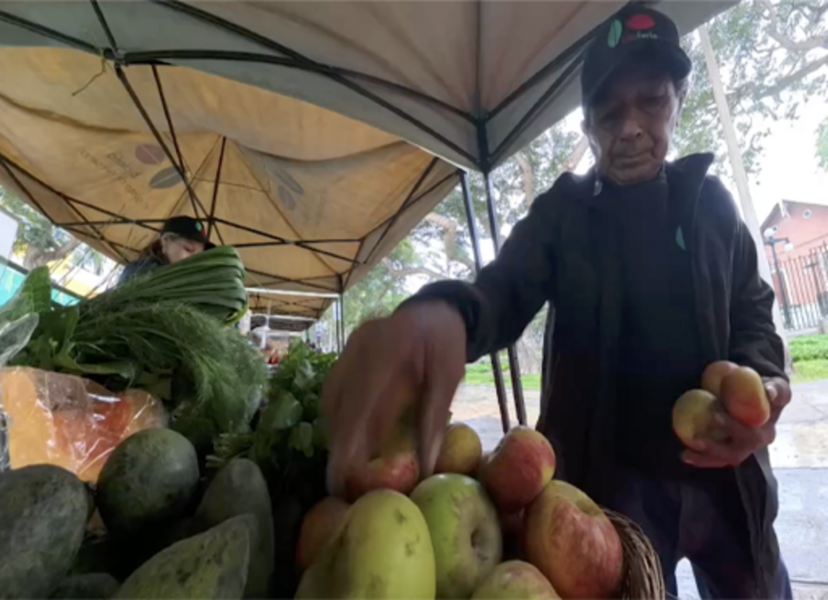

For this activity, read about the characters and their journeys that you saw in Video 2 to reveal the ways that inequalities or interconnections can be observed in their stories:

3.2 Seeing differently: working with concepts
In the previous section, you explored how the key ideas of inequalities and interconnections could be seen in Video 2. These ‘key ideas’ are something that social scientist sometimes refer to as concepts. But what is a concept? In simple terms, a concept is just an idea. But it’s an idea that has been defined in specific ways.
When used in the social sciences, concepts like inequality and interconnection are usually carefully defined. This is because the way social scientists use them, may differ from their use in everyday language.

Activity 3: What do concepts do?
15 minutes

Try and rewrite the following sentences by including the suggested concept. You can remove any of the words in the original sentence as part of editing it or add to it as needed.

Question 1

Sentence: Access to public services shapes everyday life.
Reword the above sentence to include the concept of inequalities.

Reword the sentence here:
View discussion - Question 1

Question 2

Sentence: The transport of fruit around the world relies on global relationships.
Reword the above sentence to include the concept of interconnection (or things that are interconnected).

Reword the sentence here:
View discussion - Question 2

4 Check your knowledge: mid-course quiz
This quiz is designed to help you check your understanding of what you have learned so far. If you find that you’re unsure about any of your answers, you may benefit from going back over the previous sections.

Activity 4: Mid-course quiz
20 minutes

Question 1

At the start of the course, you learned about two key ideas: society and the social world. Read the following statements and decide whether this is an example of society or the social world. Answer in the free response boxes below.

A group of diverse people who share a geographic territory, interact with a common social structure, and follow the same laws or rules. They typically share many similar cultural values and expectations of each other. However, in some highly multicultural societies there may also be many cultural differences. | Provide your answer...
The idea that people’s lives and society, more generally, are shaped by a variety of relationships, cultures, communities and institutions. | Provide your answer...

View answer - Question 1

Question 2

True or false: society and the social world are stable, and always stay the same.

True
False
View answer - Question 2

Question 3

In Section 2, you learned about some of the different types of questions that social scientists ask. What type of question is being described below?
‘This type of question is concerned with the morally right or wrong course of action to take.’

Provide your answer...
View answer - Question 3

Question 4

In Section 3, you were introduced to the concepts of inequality and interconnection. Read the following statements and decide whether this is an example of inequality or interconnection. Answer in the free response boxes below.

The uneven access to or allocation of resources or opportunities within a society. This can result in advantage or disadvantage between individuals or groups. | Provide your answer...
Instances where two or more things are linked, connected or interact in some way. | Provide your answer...

View answer - Question 4

5 You and your world
In the previous sections, you looked at social issues which you may have come across many times in your daily life, but not thought about systematically or with the use of social scientific ideas and concepts. When you spend time thinking about aspects of social life in this manner, you are likely to find that the deeper you look, the more there is to notice – and potentially the more interesting it becomes! Therefore, an important part of starting to think like a social scientist, is developing your curiosity.


View description - Uncaptioned Figure
View alternative description - Uncaptioned Figure

Developing your sense of curiosity can lead you to:
- starting to ask more questions and identify new directions in your thinking that you have not thought of before
- an improvement in your motivation to study and to seek understanding of the world around you
- an improvement in your engagement with, attention to, and memory of what you are learning
- better problem-solving skills – when someone is curious, they will often be driven to explore multiple perspectives and ways of solving problems (this is a key employability skill too)
- the development of critical thinking skills – asking questions and questioning assumptions means you are engaging in active learning, rather than just passively absorbing information without thinking about it much.
To start cultivating these skills, the following activity asks you to begin thinking about what makes you curious.

5.1 What makes you curious?
Regarding the social world – what are you interested in, and curious about?

Activity 5: What makes you curious?
25 minutes

To help you think about this, you might reflect on why you opted to try this course, or any other OpenLearn courses or formal qualifications you may be considering. You might also want to reflect on some of the following questions to help you to figure out what you’re most curious about:
- What drew you to this course?
- Was it a particular subject or discipline? Criminology, development studies, economics, geography, philosophy, politics and international relations, religious studies, sociology, or maybe a combination of several of these?
- If so, what gets you excited about exploring this subject?
- Or was it a particular question? For example: why does inequality exist? Why is there crime? Who’s in charge of society?
Complete the below table. In the left-hand column note down some topics that you’re curious about or just would like to know more about. Some examples of topics you might pick could be identity, the family, the state, poverty, crime. Then, in the right-hand column, add some questions you want to know the answers to, that relate to those topics.

Topic that you are curious about | Questions you’d like to answer
Provide your answer... | Provide your answer...
Provide your answer... | Provide your answer...
Provide your answer... | Provide your answer...
Provide your answer... | Provide your answer...

View discussion - Activity 5: What makes you curious?

5.2 Feeding your curiosity: finding out more about a subject
In the previous activity, you reflected on topics that make you curious, and the questions related to these topics which you would like to have answered.
This moment of your curiosity being stirred, is the same starting point for any student, or social science researcher. This section explores how you can you feed this curiosity.
You will recall from the early sections within this course, that social scientists emphasise the importance of studying a topic in a clear, rigorous and systematic way. In order to gain meaningful knowledge and understanding of a subject, it’s therefore important to consult trustworthy sources. But what are trustworthy, sources, and which should you be cautious of?

Activity 6: Find out more
20 minutes
Imagine that you want to find out about the relationship between poverty and crime.
Look at the below list of potential sources which you could consult to feed your curiosity. Which do you think would be helpful in gaining a clear and reliable understanding of the subject – and which would not be useful for this purpose? Don’t worry if you’re not sure of your answer, just make your best guess.

Tabloid newspaper

Reliable
Unreliable
View answer - Part

BBC Verify

Reliable
Unreliable
View answer - Part

Social media post by a friend

Reliable
Unreliable
View answer - Part

A video posted on social media by a celebrity

Reliable
Unreliable
View answer - Part

Reports and figures provided by the Office for National Statistics

Reliable
Unreliable
View answer - Part

Peer reviewed journal articles

Reliable
Unreliable
View answer - Part

A book written by an expert

Reliable
Unreliable
View answer - Part

A conversation with someone down the pub

Reliable
Unreliable
View answer - Part

Once you become interested in an issue or subject, it’s a great idea to try and find out more about it. However, it’s important to consult reliable and informed sources. Consulting unreliable and ill-informed sources can prevent you from properly understanding a social science issue.
Of course, this shouldn’t stop you from talking to friends about these issues or viewing social media posts. It just means that you should be cautious about distinguishing reliable, well-informed information of a subject.

5.3 Exploring legitimate resources
In the previous activity, you considered the importance of looking at legitimate, unbiased and reliable sources. You saw that impartiality, accuracy, and credentials are important features to look for when learning about a topic.

Activity 7: Exploring legitimate resources
25 minutes

Below is a list of links to trustworthy, reliable sources.
Spend some time searching through these resources. You could either search directly for information about the topic you selected in Activity 5, or simply read about an issue in one of the sources which draws your attention.
- BBC Verify: Search on the BBC Verify website for an issue which has been in the news recently, which sparks your curiosity.
- Office for National Statistics: Look for some of the statistics or reports that draw your curiosity. You may want to start by looking at data from the most recent census, and typing in the area where you live to find out about local conditions.
- Open University ‘Open Research Online’ (ORO): ORO is a repository of peer reviewed and published research, generated by academics at the Open University. You can search for a subject you’re interested in, or alternatively you could browse by research group for something that takes your interest.

Conclusion
Fundamentally, the subject matter of the social sciences is dynamic – because society and the social world are constantly changing, moving and becoming something new. Social science looks systematically and rigorously at familiar aspects of everyday life, and then asks probing questions, such as:
- What ideas and concepts help us to better understand society and the social world? Is there a need to develop fresh ideas and concepts, to suit new developments and changing social conditions?
- What forms does inequality take in society? Who is affected, and in what ways?
- How are issues such as inequality addressed in other societies – and what can we learn and apply from these examples?
- What sources of data and information can we trust in answering these questions?
- What methods help us to generate reliable and meaningful data about the social world?
By asking penetrating questions in this manner, social scientists can begin to understand how society works. Furthermore, social scientists are frequently motivated to go beyond merely understanding these issues, and aspire to use these insights to begin helping to solve social problems. For example, many social scientists are keen to contribute to the reduction of harm, inequality and marginalisation.
This OpenLearn course is an adapted extract from the Open University course D112 You and your world: introducing the social sciences.

References
BBC (2023) ‘Explaining the “how” – the launch of BBC Verify’, written by Deborah Turness, published 22 May 2023. Available at: https://www.bbc.co.uk/news/uk-65650822 (Accessed: 13 April 2026).
Berniell, I., Fernandez, R. & Krutikova, S. (2024) The state of gender inequality in Latin America, VoxEU. Available at: https://ifs.org.uk/articles/state-gender-inequality-latin-america (Accessed: 2 March 2026).
Open Research Online (ORO) Available at: https://university.open.ac.uk/library-research-support/open-access-publishing/open-research-online (Accessed: 18 May 2026).
Sutton Trust (2019) Elitist Britain: The Educational Backgrounds of Britain’s Leading People, Sutton Trust & Crown Copyright. Available at: https://www.suttontrust.com/wp-content/uploads/2019/12/Elitist-Britain-2019.pdf (Accessed: 30 Jan 2026).

Acknowledgements
This free course was written by the D112 Open University course authors.
Except for third party materials and otherwise stated (see terms and conditions), this content is made available under a Creative Commons Attribution-NonCommercial-ShareAlike 4.0 Licence.
The material acknowledged below is Proprietary and used under licence (not subject to Creative Commons Licence). Grateful acknowledgement is made to the following sources for permission to reproduce material in this free course:
Images
Course image: JHU Sheridan Libraries/Gado/Getty Images
Section 2 image: Cahyo from https://commons.wikimedia.org/wiki/File:Hands_in_Pettakere https://creativecommons.org/licenses/by-sa/3.0/deed.en
Section 3 image: courtesy: Johnny Miller Photography
Section 5 image: imaginima/E+/Getty Images
Videos
Video 01: The Social World © The Open University
Video 02: Living in a Moving World © The Open University
Every effort has been made to contact copyright owners. If any have been inadvertently overlooked, the publishers will be pleased to make the necessary arrangements at the first opportunity.
Don’t miss out
If reading this text has inspired you to learn more, you may be interested in joining the millions of people who discover our free learning resources and qualifications by visiting The Open University – www.open.edu/openlearn/free-courses.

Solutions

Activity 1: What makes a question clear or unclear?

Question 1

Answer
Right:
Unclear
Wrong:
Clear
Back to - Question 1

Question 2

Answer
Right:
Clear
Wrong:
Unclear
Back to - Question 2

Question 3

Answer
Right:
Clear
Wrong:
Unclear
Back to - Question 3

Question 4

Answer
Right:
Unclear
Wrong:
Clear
Back to - Question 4

Discussion
The two unclear questions above both lack precision. In one, the word ‘work’ is ambiguous and there’s nothing to indicate what situation the question is referring to. In the other question (about why people care about their social media profile), it is not clear who the question is referring to – ‘people’ is too broad a category. It also assumes that social media profiles are a universal concern of everyone in a given society, which might not be the case.
Back to - Question 4

Activity 3: What do concepts do?

Question 1

Discussion
One way you might have reworded this sentence was to add ‘inequalities’ at the start of the sentence, so the sentence would read: Inequalities in access to public services shape everyday life.
Including the concept of inequality adds focus to the idea because it has a more specific and detailed meaning. In Section 3, inequality was defined as ‘the uneven access to or allocation of resources or opportunities within a society’. This can result in advantage or disadvantage between individuals or groups. As you can see, the inclusion of the concept of inequality adds depth to the sentence.
Back to - Question 1

Question 2

Discussion
In this sentence, you could have just added ‘interconnected’ without removing any words: The transport of fruit around the world relies on interconnected global relationships.
Including the word ‘interconnected’ here can suggest that the relationships are linked and dependent or that they mutually influence each other. The definition of interconnection provided was ‘instances where two or more things are linked, connected or interact in some way’.
Back to - Question 2

Activity 4: Mid-course quiz

Question 1

Answer

A group of diverse people who share a geographic territory, interact with a common social structure, and follow the same laws or rules. They typically share many similar cultural values and expectations of each other. However, in some highly multicultural societies there may also be many cultural differences. | society
The idea that people’s lives and society, more generally, are shaped by a variety of relationships, cultures, communities and institutions. | the social world

Back to - Question 1

Question 2

Answer
Right:
False
Wrong:
True
Section 1.1 suggested that rather than being stable, society and the social world are dynamic. This means that they are in a state of constant change, movement and evolution. This makes social science an interesting subject to study, but can also present challenges.
Back to - Question 2

Question 3

Answer
This is an ethical question. You saw that ethical questions often arise in practical, personal or professional situations, where the person must decide the morally right or wrong course of action. Professions in which people are likely to encounter ethical dilemmas – such as medicine – often have a code of conduct which is directly informed by ethical questions.
Back to - Question 3

Question 4

Answer

The uneven access to or allocation of resources or opportunities within a society. This can result in advantage or disadvantage between individuals or groups. | inequality
Instances where two or more things are linked, connected or interact in some way. | interconnection

Back to - Question 4

Activity 5: What makes you curious?

Discussion
How did you find that activity? You might have come up with many things, or you may have struggled to even come up with one. Either way, it’s okay. You’re still just beginning to explore the social sciences. This activity also got you thinking about questions and about what you are interested in. Becoming comfortable with asking questions is an important part of being a student and of being a social scientist. It’s equally important to learn to ask good social science questions – even if you don’t know how to answer them. This first attempt to ask questions of your own was just the start of your exploration of the social world.
Back to - Activity 5: What makes you curious?

Activity 6: Find out more

Part

Answer
Right:
Unreliable
Wrong:
Reliable
Tabloid journalism tends to voice opinions, but is not necessarily based on any data or research. In many cases, tabloid newspapers have a clear political bias.
Back to - Part

Part

Answer
Right:
Reliable
Wrong:
Unreliable
BBC journalism is well respected internationally as reliable and impartial. BBC journalists use reliable sources and fact-check their reports. This transparency means that readers can trust the accuracy.
BBC Verify was established in 2023 in order to ‘fact-checking, verifying video, countering disinformation, analysing data and – crucially – explaining complex stories in the pursuit of truth’ (BBC, 2023).
Back to - Part

Part

Answer
Right:
Unreliable
Wrong:
Reliable
People posting on social media are not necessarily experts on the subject.
Back to - Part

Part

Answer
Right:
Unreliable
Wrong:
Reliable
People posting on social media are not necessarily experts on the subject.
Back to - Part

Part

Answer
Right:
Reliable
Wrong:
Unreliable
The ONS is the official statistics agency for the UK government, but operates independently. It is therefore widely considered to be impartial. The ONS generates a wide range of reports and datasets each year, which are open to the public.
Back to - Part

Part

Answer
Right:
Reliable
Wrong:
Unreliable
Peer reviewed journal articles are written by experts in the field. The term ‘peer reviewed’ means that other experts have engaged in a dialogue with the author in order to ensure the quality and rigour of the article.
Back to - Part

Part

Answer
Right:
Reliable
Wrong:
Unreliable
Books that are written by experts tend to be well researched and reliable. It is worth checking the qualifications and credentials of the author.
Back to - Part

Part

Answer
Right:
Unreliable
Wrong:
Reliable
The opinions of a person at the pub are not necessary based on research or an expert understanding of the issues.
Back to - Part

Descriptions

Uncaptioned Figure
Prehistoric cave painting, including human hands.
Back to - Uncaptioned Figure

Uncaptioned Figure
Prehistoric cave painting, including human hands.
Back to - Uncaptioned Figure

Uncaptioned Figure
A birds eye view photograph of the ‘The Wall of Shame’ in Lima, a kilometers-long barrier of concrete and barbed wire.
Back to - Uncaptioned Figure

Uncaptioned Figure
A birds eye view photograph of the ‘The Wall of Shame’ in Lima, a kilometers-long barrier of concrete and barbed wire.
Back to - Uncaptioned Figure

Uncaptioned Figure
A graphic showing the representation of a world map formed by a large crowd of people.
Back to - Uncaptioned Figure

Uncaptioned Figure
A graphic showing the representation of a world map formed by a large crowd of people.
Back to - Uncaptioned Figure

Video 1 The social world

Transcript
[Music playing]
[Text on screen]: The social world
[Text on screen]: How is it interconnected?
Cargo bike is going to lead to Langside.
[Music playing]
[Text on screen]: Where is inequality found?
May I get a bit of a push please?
[Text on screen]: If not, they’ll take my money, and there isn’t any money!
But it’s also a way of us gently protesting.
I’m getting emotional.
Back to - Video 1 The social world

Video 2 Living in a moving world

Transcript
Lovely.
Thank you.
Song Las cuatro de la madrugada El chafer esta UN poco tarde yo cutivo palta lucuma chirimoya Y manzana viajo a la vio feria de Mira Flores.
Today I’m making the journey to see my mother-in-law.
I go and see her three days a week.
I take public transport.
I take the bus.
I’m not good at standing in a queue because I’ve got arthritis and I get awful pain.
If I’ve been standing for a long time and sometimes actually in the bus stops, you know, the benches are full, there’s people sitting there and you can’t get a seat.
A bike bus is something that I started with some friends and neighbours 4 years ago.
It’s a way of getting our kids to school on bikes on roads that they otherwise wouldn’t cycle on.
But it’s also a way of us, like I say, gently protesting.
Our roads are not safe and we don’t have enough cycling infrastructure for kids to cycle to school.
When I say bike, you say.
I’m Amanda and I’m joined in the back by my dog Chris.
I’m driving from my home in Barnsley to get to the Meadowhall train station in Sheffield and then from there we’re going to be taking a train to Manchester.
I go to work in Manchester twice a week.
I’ve grown up learning the importance of being able to give to the community, so I’ve been donating blood since I was 17.
None.
Our core business is growing and exporting of flowers, Growberry, we export roughly 44 million terms a year.
The area that we live in, it’s very urban.
We have to get through lots of streets that a lot of space is given up to parked cars on both sides and they’re really narrow streets.
There’s quite a number of schools in the area, so the foot traffic on the pavements is really high.
There’s not enough space given to people to cycle.
If we get segregated cycle lanes, great.
Kids can cycle to school on their own or safely with their families.
We often say the bike bus shouldn’t have to exist, but we love the bike bus and we love the community and we love the joy and the fun and the music and the this thing that we’ve grown.
So I would desperately miss the bike bus if it wasn’t in my life.
Hi there.
You’re going to join us.
How you doing?
I, I live in Nairobi.
I am a professional team building facilitator.
The reason we’re making this journey is we have number of young people who lives and work in Nairobi and they decided they’re going to come to Mombasa so that they can take time off and unwind.
The train has three departures each day.
Today I’m getting the 759 service and I cannot afford to miss it.
The trains are once an hour and if I miss that, that impacts the whole of the rest of my day.
I always leave early because I need to be prepared.
I need to allow time for everything.
You’ll see everyone else is just jumping out their cars and heading to the platform where I’ve got so many things that I need to get put into place.
Estamos entrendo alasia de Lima estamos cusando cerco para de Gara a la via feria de era Flores emos yerao poquito tarde Los avenizasore estan que migiamo.
Here we go trying to get past the car right everyone?
I’ve probably had about 35 kids on the bike bus today.
That is the norm at the moment, especially when the weather is good.
So we’ve got everyone into school safely, Bikes and bike sheds.
Kids are all in the door safely and buzzing and ready for the day.
Song alaciete de la manana estamos UN poco tarde pero novos aponer a trabajar de in mediato ciero cuperar El tiempo perdido.
Morning and the music hole, please.
Lovely.
Thank you.
No acido on grandia ojala en la biaferia de manana novaya mejor.
Back to - Video 2 Living in a moving world

