Activity 6.1 Clarifying my goals through visualisation
We suggest spending around 15 minutes on this activity.
It’s time to think about your own goals!
Take some time to visualise yourself in the future. Where are you? What are you doing? Allow yourself scope to consider that there are possibilities open to you. What are your hopes and plans for the future?
You should just capture an impression of your thoughts and ideas at this stage.
A good way to do this is to try creating a picture of what your future life might look like: either by drawing a picture or a spider-diagram using pen and paper, or by creating a poster – a montage of images and key words. You can do this by tearing images out of newspapers and magazines to add to your drawing. What are you doing in the picture?
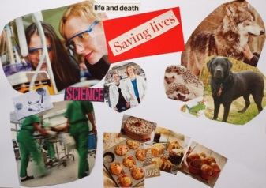
Or, if you prefer, jot down some ideas – a sentence or two – about what your hopes are for your future.
You can share this or keep it to yourself.

