Activity 1.1 Thinking about myself
We suggest spending around 15 minutes on this activity.
The next stage is to start thinking about yourself and your role as a manager. A good way to do this is to ask yourself four questions:
- How do I see myself now? For example how well do I engage with the people I manage?
- What are my strengths?
- What am I most proud of within my management role?
- How would I like to see myself in the future?
You can fill in the boxes for yourself in the table we have provided for you below or, if you prefer, you could take a different approach and use a visual way to sum yourself up. You can do this at any point during the course if you’d like to.
Words aren’t the only way to capture or explore your ideas. Sometimes it helps to use pictures.

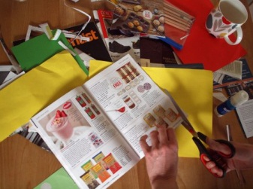

Creating a mood or vision board is a fun and creative way to get insight into your thinking. You’ll need a range of catalogues, magazines and newspapers, some scissors, glue, coloured paper, maybe even some glitter!

Just flick through the magazines until you see images or words that catch your attention. Cut or tear that page out. Before you know it you’ll have gathered pictures and words that summarise some of your thoughts about yourself and your role as a manager.

You might be surprised at the pictures you’ve chosen. Sometimes a creative activity can release thoughts or ideas that you can’t put into words.



Arrange your images into a collage and you have a record of your feelings or your aspirations – whatever you choose to show. You can use it to talk about your thoughts with others if you’d like to.

How do I see myself now? How well do I engage with the people I manage? | What are my strengths?
What am I most proud of within my management role? | How would I like to see myself in the future?

