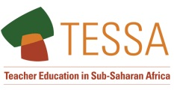
Making Teacher Education relevant for 21st Century Africa

Making the most of ICT

On your own, or with a colleague, complete the table.
Type of technology | Do you have access? | Know how to use? | How do you use this form of ICT in your work as a teacher educator? | How could this be used by a teacher in their own work or in the classroom?
Mobile phone
Camera

Video camera

Hand held recording device
Radio

Laptop computer
Tablet computer

Projector and screen (or white wall)

Television

Computer room with 20 desktops or laptops
20 tablet computers for use in class
Desktop computer

Interactive white board (SMART board)
Access to the internet

