**Introduction to Autism and Inclusive Practice**

**Reflective Log**



|  |  |
| --- | --- |
| **Name** |  |
| **Role** |  |
| **Place of Work** |  |
| **Sector** |  |
| **Line Manager** |  |
| **Local Authority** |  |
| **GTCS Number** |  |

# Introduction to Autism and Inclusive Practice Reflective Log

As you work through this course, what you write in this log forms an important part of the learning process. You will want to revisit the log regularly and you may want to look at it again after you’ve completed the course, use it as evidence of what you’ve achieved, your development and as evidence of your professional development, reflective practice and critical self-evaluation. All of which contribute towards your GTC Scotland professional update.

Make sure that you save this reflective log after you start to fill it in. Use a filename like ‘Introduction to Autism and inclusive Practice Reflective Log’ so that it’s easy to find.

The next time you are prompted to add to the log, you should open the file you saved and add the new material to it. You may choose to save a copy in ‘GLOW Microsoft Office 365’ so you can access it from anywhere you have internet connection. (**All** public-school practitioners in Scotland have a GLOW login account.)

Only the Activities that require to be completed in this log are included.

Tables have been included with the activities to support your written answers; however, you can adapt this log and present your reflections in alternative ways to suit your needs.

A page for additional notes is at the end of this log.

**Activity 1**.

**Use the table below to complete the tasks.**

|  |  |  |  |  |  |
| --- | --- | --- | --- | --- | --- |
| **1** | **On a scale of 1–5 (1 being poor and 5 being very knowledgeable), rate how you feel your knowledge and understanding is of autism and inclusive practice.** | | | | |
|  | **1** | **2** | **3** | **4** | **5** |
|  |  |  |  |  |
| **2** | **What do you hope to achieve in studying this module?** | | | | |
|  |  | | | | |

**3. Complete the Self-evaluation Wheel: Professional Actions in Career–Long Professional Learning on the next page.**

Self-evaluation should support you to:

* reflect on what you have done
* think about what you might do next
* consider your own progress and development
* deeply understand your professional practice, your professional learning and the impact of this on your thinking, professional actions, those you work with/support and the pupils and their learning.

The Self-Evaluation Wheel is a valuable tool for:

* exploring current reality
* supporting self-evaluation
* helping to critically reflect on yourself as a professional and your practice
* completing a simple gap analysis – for example, where are you now and where would you like to be?

The example below highlights how to use the self-evaluation wheel.

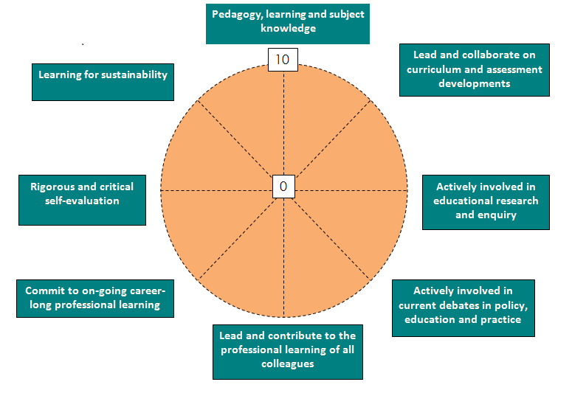

**Using the wheel:**

* Consider each point on the wheel in turn, (see summary or check with full version of Standard if helpful)
* Think about where you might gauge yourself on the wheel:

0 = really not confident/lots of areas to develop or work on

10 = feel very confident/accomplished in this area

Think about ‘why’ you place yourself on that point.

* Looking at areas you have identified, what should/could be your next steps to help take PU forward?

**Self-evaluation Wheel: Professional Actions in Career –Long Professional Learning (CLPL)**

**Pedagogy, learning and subject knowledge**

**Lead and collaborate on curriculum and assessment developments**

**Actively involved in educational research and enquiry**

**Actively involved in current debates in policy, education and practice**

**Lead and contribute to the professional learning of all colleagues**

**Learning for sustainability**

**Rigorous and critical self-evaluation**

**Commit to on-going career-long professional learning**

0

10

|  |
| --- |
| **The Professional Actions in Career-Long Professional Learning – Summary** |
| **Pedagogy, Learning and Subject Knowledge**   * + demonstrate deep subject knowledge and pedagogical leadership.   + lead curriculum development with a deep understanding of the place of subject knowledge and the wider purposes of education.   + demonstrate a critical understanding of approaches to teaching and learning, pedagogy and practice.   + deploy an enhanced understanding of pedagogy and how constructive relationships with learners can be developed.   + demonstrate a critical understanding of digital technologies and how these can be used to support learning.   + understand and develop the most appropriate contexts and environments for learning, including outdoor learning, and be able to apply appropriate pedagogies for these environments. |
| **Curriculum and Assessment**   * understand and apply the principles of curriculum and assessment design to address changing educational needs. * lead and collaborate with others to plan innovative curricular programmes. * lead and work with others to ensure effective practice in the assessment of learning, including a deep knowledge and understanding of the policies and practices of assessment as required by awarding bodies. |
| **Enquiry and Research**   * develop and apply expertise, knowledge and understanding of research and impact on education. * develop and apply expertise, knowledge, understanding and skills to engage in practitioner enquiry to inform pedagogy, learning and subject knowledge. * lead and participate in collaborative practitioner enquiry. |
| **Educational contexts and current debates in policy, education and practice**   * understand and explore the contexts and complexity in which teachers operate and the dynamic and complex role(s) of professionals within the educational community. * actively consider and critically question the development(s) of policy in education. * develop culture where learners meaningfully participate in decisions related to their learning and school. * develop and apply political literacy and political insight in relation to professional practice, educational change and policy development. |
| **Sustaining and Developing Professional Learning**   * develop skills of rigorous and critical self-evaluation, reflection and enquiry including how to investigate and evidence impact on learners and professional practice. * commit to on-going career-long professional learning, including postgraduate study as appropriate. * lead and contribute to the professional learning of all colleagues, including students and probationers. |
| **Learning for Sustainability**   * understand the environmental, social and economic conditions of learners to inform teaching and learning. * have a critical understanding of and engage with the ways in which natural, social, cultural, political and economic systems function and are interconnected. * develop the knowledge, skills and practices needed to take decisions which are compatible with a sustainable future in a just and equitable world. * connect learners to their dependence on the natural world and develop their sense of belonging to both the local and global community. |
| **Professional Values and Personal Commitment**   * How are the Professional Values reflected in my Professional Actions? * How have my professional values been developed and informed by knowledge and experience? * How do I critically reflect on my own assumptions, beliefs and values? * Who am I as a teacher? What has influenced me? What sustains me? |
| **Social Justice Integrity**  **Trust and Respect Professional Commitment** |
| For the full version of Standard for Career-long Professional Learning, please see General Teaching Council Scotland – [www.gtcs.org.uk](http://www.gtcs.org.uk) |

As you complete this module, consider the following reflective questions highlighted above within GTCS Professional Values and Personal Commitment sections, which are applicable to **all** GTCS registered teachers.

|  |
| --- |
| **Professional Values and Personal Commitment**  **Social Justice Trust and Respect Professional Commitment Integrity** |
| **How are the Professional Values reflected in my professional actions?** |
|  |
| **How have my professional values been developed and informed by knowledge and experience?** |
|  |
| **How do I critically reflect on my own assumptions, beliefs and values?** |
|  |
| **Who am I as a teacher?** |
|  |
| **What has influenced me?** |
|  |
| **What sustains me?** |
|  |

**Section 1. Activity 2**

**2. Having watched the film on social disability, consider the following reflective questions and make some notes.**

|  |  |
| --- | --- |
| **a** | In your setting, what barriers are experienced by learners who are disabled? |
|  | |
| **b** | What adjustments can be made to ensure that learners with disabilities are able to participate in all aspects of your setting? |
|  | |

**Section 2. Activity 4**

**What the four key features of inclusion should mean for autistic learners.**

|  |  |
| --- | --- |
| **Key Features of inclusion for learners** | **Reflections** |
| **Present** |  |
| **Participating** |  |
| **Achieving** |  |
| **Supported** |  |

**Section 2. Activity 5**

|  |
| --- |
| 1. **How inclusive do I feel my practice is in, and how do I know?** |
|  |
| 1. **How inclusive do I feel my school community is, and how do we know?** |
|  |

**Section 3. Activity 8**

**How can social communication difficulties impact on an autistic learner’s educational activities and interactions?**

|  |
| --- |
|  |

### Section 3. Activity 10

**Supporting autistic learners in an educational setting – working with in partnership with families, colleagues and, where possible, the learner.**

**What kind of supports that are desirable and regulating for your autistic learner can be built into your inclusive pedagogy and planning to provide, as much as possible, routines and predictability, which will support autistic leaners in your class/setting?**

|  |
| --- |
|  |

**ng whole school inclusive approaches**

### Section 3. Activity 12

**Supporting autistic learners with social anxiety.**

|  |
| --- |
| **1. What is your setting doing to support autistic learners who experience anxiety to reduce their anxiety?** |
|  |
| **2. What further improvements could be made?** |
|  |

**Section 4. Activity 14.**

**Collaboration and professional roles and responsibilities**

|  |  |
| --- | --- |
| 1. **Consider the roles of the staff below and examples of how they support autistic learners within inclusive education.** | |
| **Role** | **Notes** |
| **Senior management** |  |
| **Classroom and early years practitioners** |  |
| **Specialist teachers e.g. ASN or support for learning and outreach teachers** |  |
| **Support assistants** |  |
| **Facilities staff** |  |

|  |
| --- |
| 1. **Consider 2–3 of the five questions in this table and note your reflections.** |
| **What are the roles and responsibilities of any partner services and agencies currently working with any learners that you teach?** |
|  |
| **What works well in current collaborations?** |
|  |
| **How could the reciprocal flow of information between all those involved in supporting a learner be improved in your school?** |
|  |
| **How does communication and collaboration with partner services and agencies take place within your school? How do you contribute to this process?** |
|  |
| **Consider a situation where you collaborate with others. Reflecting on the features of effective collaboration, note strengths and areas for improvement.** |
|  |

**Section 5. Activity 16**

###### **Considerations for educational staff**

Note down what is important for teachers and colleagues to embed into their practice.

|  |
| --- |
|  |

**Section 6. Activity 18**

**Social and emotional wellbeing**

|  |
| --- |
| 1. **How do I know how well I am supporting my autistic learners’ social and emotional wellbeing?** |
|  |
| 1. **How do we know as a school community that our ethos, practice and policies support our autistic learners social and emotional wellbeing?** |
|  |

### Section 7. Activity 19

**Social and emotional wellbeing**

|  |
| --- |
| 1. **How do I know how well I am supporting my autistic learners’ social and emotional wellbeing?** |
|  |
| 1. **How do we know as a school community that our ethos, practice and policies support our autistic learners social and emotional wellbeing?** |
|  |

**Transitions**

|  |
| --- |
| 1. **How well does my planning and support reflect the transitional needs of my autistic learners?** |
|  |
| 1. **How do we know as a school community know that our ethos, practice and policies support the range of transitions our autistic learners experience?** |
|  |

**Section 8. Final Reflective Activity – Next Steps**

1. **Use the table below to complete the tasks A and B.**
2. Complete the self-evaluation wheel, and **compare this version to your initial one and reflect on any changes.**

|  |  |  |  |  |  |
| --- | --- | --- | --- | --- | --- |
| **A** | **On a scale of 1–5 (1 being poor and 5 being very knowledgeable), rate how you feel your knowledge and understanding is of inclusion within the classroom.** | | | | |
|  | **1** | **2** | **3** | **4** | **5** |
|  |  |  |  |  |
| **B** | How has this module impacted on your professional practice? | | | | |
|  |  | | | | |

**Self-evaluation Wheel: Professional Actions in Career –Long Professional Learning (CLPL)**

**Lead and collaborate on curriculum and assessment developments**

**Actively involved in educational research and enquiry**

**Actively involved in current debates in policy, education and practice**

**Lead and contribute to the professional learning of all colleagues**

**Learning for sustainability**

**Rigorous and critical self-evaluation**

**Commit to on-going career-long professional learning**

0

10

**Additional notes**