Introduction to Dyslexia and Inclusive Practice for Community Learning & Development (CLD)
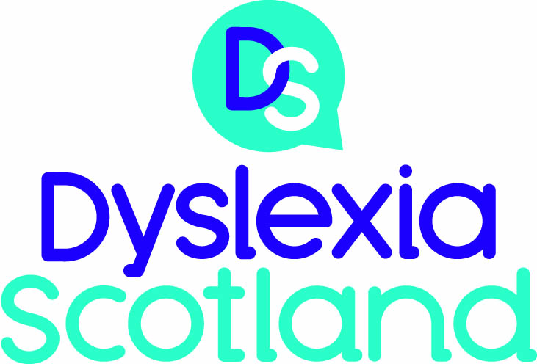

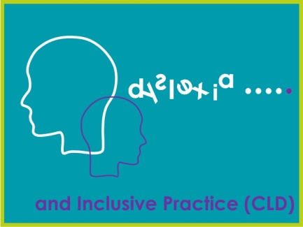

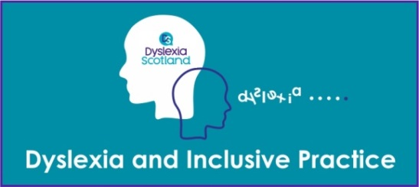

Reflective Log

Name
Role
Place of Work
Sector
Line Manager
Local Authority
(if applicable)
CLD registration Number
(if applicable)

Reflective Log

As you work through this course, what you write in this log forms an important part of the learning process. You will want to revisit the log regularly and you may want to look at it again after you’ve completed the course, or use it as evidence of what you’ve achieved and of your development. You will be able to use the information in this log to as evidence of your professional development, reflective practice and critical self-evaluation.
Make sure that you save this reflection log after you start to fill it in. Use a filename like ‘Dyslexia and Inclusive Practice CLD’ so that it’s easy to find. The next time you are prompted to add to the log, you should open the file you saved and add the new material to it.

Activity 1.
What you hope to achieve in studying this module?

Activity 2

Consider what dyslexia means to you. This could include the following
- What is your understanding of dyslexia?
- Have you experienced supporting individuals who may be or know they are dyslexic, if so, has there been an impact on individuals/ learners you have or are working with?
- Is this an area you feel a comfortable level of knowledge and understanding?

Activity 3

Think about your own experience of working with learners with dyslexia. In your reflective log note down some of the factors that have a positive and negative impact and some which may be both. Do note that these factors are contextual and there is no right or wrong answer.

Creativity | Spatial awareness | Frustration
De-motivation | Social skills | Resilience
Relationship difficulties | Lower achievement and attainment | Isolation
Low self-esteem | Ridicule | Mental health
Attention to detail | Problem solving | Depression
Fewer qualifications | Determination | Stress
Anger | Feeling different

Positive Impact | Negative impact | Positive and Negative impact

Activity 5

Having worked through section 2, consider the following two questions. The first requires a small amount of investigative research and the other requires personal reflection:

1. Where would you go for support at a local and national level regarding assessment for dyslexia?
2. How could you adapt your practice to communicate with someone who felt they may be dyslexic?

Activity 6

The table below provides some helpful approaches used by tutors in a wide range of settings.

Consider which approaches you think you do or could use to support individuals who experience literacy difficulties and dyslexia?
Use the copy of this table in your reflective log to explore which approaches you currently use or could include, and which you cannot use and why?

Support | Currently used or could include | Cannot use | Reason
Seating and grouping – ensure everyone can see the white board and you can see them
Explain and present information many times in various ways (pictures, flow charts, diagrams)
Ensure thinking/processing time is allowed
Provide information, desk-top mats/jotter inserts - word banks, prompts and personal targets
Use of information technology (IT) – for reading and writing
Encourage the use of books in audio/digital format to support access to texts
Match reading resources to reading ability, ensuring that it is age appropriate
Highlight the main points in text to support comprehension, prediction and recall
Use and encourage multi-sensory approaches
Limit the amount of reading/copying from the board. Give copies of notes - electronic versions and examples
Accept alternatives to writing
Limit writing demands
Ensure extra time is provided
Provide writing frames/story skeletons
Use and help learners understand how to use mind maps, spider webs, bullet points
Specify what will be marked
Minimise the number of errors you highlight – perhaps only one of each type. Suggest how to avoid these in the future
Use directed praise

Activity 7

Take a few minutes to review the information in Section 3 on support and resources, you may choose to access the highlighted websites. Note down how you plan how to make use of these resources.

Activity 8
Think of a time when someone you worked with may have needed support with dyslexia and consider the following questions
- How did you initially engage with the individual requiring support?
- How did you become aware of their support needs?
- What support did you put in place?
- Where did you get support?
- What was the outcome/impact?
- Thinking about this experience, is there anything you would change?

Activity 9

Reflect on what you do well and where you could improve in relation to detecting and supporting dyslexia in your setting, learning community and sector in which you volunteer or work. You might like to use the table shown below and printed in your reflective log; or use a mind map or other means of taking notes.
Once you have identified these issues think about how you could improve what you do.

 | In my setting | In our learning community | In our sector
What I /we do well
What needs to improve
How to improve

What Next?

Activity 10

For the final entry in your Reflective Log for this module answer the following questions

- Consider your response in activity 2, would you answer differently or the same?
- How will the completion of this module impact on your professional practice?

