Activity 1.2 Thinking about myself
We suggest spending around 15 minutes on this activity.
You’ve set out your roles and responsibilities, now start thinking about yourself. Think about where you’re at, what makes you happy, what you’re proud of and where you want to be. You can fill in the boxes for yourself in the table we have provided for you.

If you prefer, you could take a different approach and use a visual way to sum yourself up. You can do this at any point during the course if you’d like to.

Words aren’t the only way to capture or explore your ideas. Sometimes it helps to use pictures.

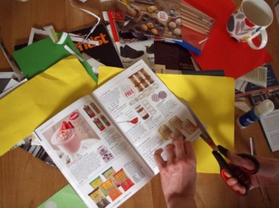

Creating a mood or vision board is a fun and creative way to get insight into your thinking. You’ll need a range of catalogues, magazines and newspapers, some scissors, glue, coloured paper, maybe even some glitter!

Just flick through the magazines until you see images or words that catch your attention. Cut or tear that page out. Before you know it you’ll have gathered pictures and words that summarise some of your thoughts about yourself and your future.

You might be surprised at the pictures you’ve chosen. Sometimes a creative activity can release thoughts or ideas that you can’t put into words.

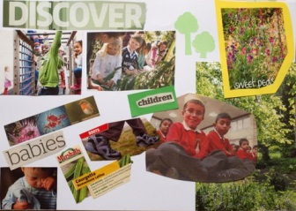

Arrange them into a collage and you have a record of your feelings, or your ambitions - whatever you choose to show. You can put it somewhere prominent to give you a daily visual reminder of your ideas, or you can use it to talk about your thoughts with others if you’d like to.

How do I see myself now? | What makes me happy?
Write your comments here. | Write your comments here.
What am I most proud of? | How would I like to see myself in the future?
Write your comments here. | Write your comments here.

