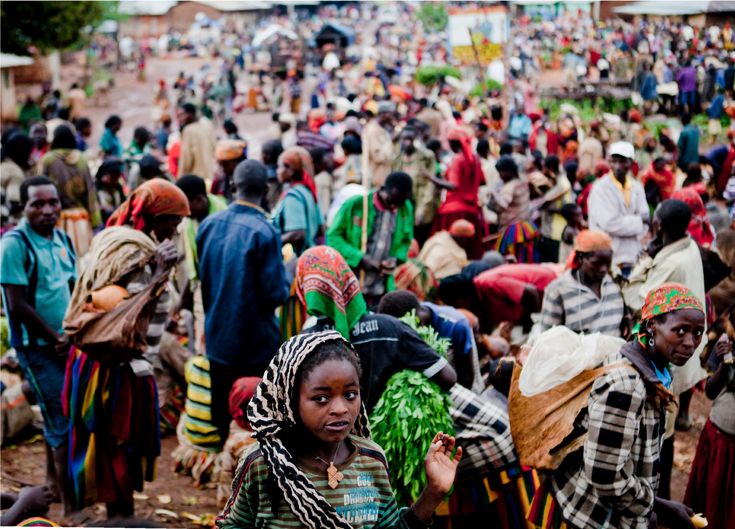
Count me in!
Inclusive WASH in Ethiopia





About OpenWASH
OpenWASH learning resources provide an innovative curriculum of study designed to be used in education and training programmes in the water, sanitation and hygiene (WASH) sector in Ethiopia. They have been written by Ethiopian WASH experts with the support of teaching specialists from The Open University UK (OU). The name
‘OpenWASH’ is derived from this link with the OU and also indicates that the resources are free to use as open educational resources.
The original OpenWASH resources, published in 2016, were the output from a partnership agreement between the OU, World Vision Ethiopia and UNICEF. This new Module, Count me in! Inclusive WASH in Ethiopia, was instigated by WaterAid Ethiopia and has been produced in partnership between WaterAid and the OU.
The OpenWASH modules are designed for people engaged across a range of positions and levels in the WASH sector. The main audience is intended to be students who are training to work in the sector, but the modules may also be used for in-service training of new employees and by more experienced practitioners seeking to improve knowledge and skills in specific areas. The material could also contribute to training of community groups, in schools, etc.
The original OpenWASH resources consist of five modules covering a range of WASH subjects, with an emphasis on WASH in urban settings. This new module provides a valuable addition to the resources. The module titles are:
- Ethiopia’s One WASH National Programme
- WASH: Context and Environment
- Urban Water Supply
- Urban Sanitation and Solid Waste Management
- Urban WASH: Working with People
- NEW Count me in! Inclusive WASH in Ethiopia
The modules are accompanied by the OpenWASH Trainers’ Handbook, which provides guidance on how the modules can be used in a variety of teaching contexts.
Online versions and free downloadable pdfs of all OpenWASH resources are available from http://www.open.edu/openlearncreate/OpenWASH

This Module, Count me in! Inclusive WASH in Ethiopia, was prepared by Ethiopian authors with support from The Open University UK. It was first published in June 2018. The contributors of original material are:
Girma Aboma, Manager, GAA Economic Development Consult
Bethel Shiferaw, SPCC Disability Inclusion Advisor, Ethiopian Center for Disability and Development
The Academic Editor of Count me in! Inclusive WASH in Ethiopia is Pam Furniss, Senior Lecturer in Environmental Systems in the Faculty of Science, Technology, Mathematics and Engineering, The Open University UK.
Additional thanks to:
Tseguereda Abraham, Head of Sector Strengthening, WaterAid Ethiopia Louisa Gosling, Quality Programmes Manager, WaterAid UK Bethlehem Mengistu, Country Director, WaterAid Ethiopia
Manaye Siyoum, Director, Technical Services, WaterAid Ethiopia Priya Nath, Equality, Inclusion and Rights Advisor, WaterAid UK Ellen Scott, OpenWASH Project Manager
Gail Vardy, OpenWASH Project Coordinator

We would also like to thank the following people for their contributions to the development of this module:
Abiy Girma, National WASH Coordination Office Getachew Tikuye, National WASH Coordination Office Arto Suominen, COWASH
Tewodros Shumet, Ministry of Labour and Social Affairs Lewam Abebe, Ministry of Education
Agash Asmamaw, Ministry of Water, Irrigation and Electricity Kalkidan Gugisa, UNICEF
Tamiru Gizaw, World Vision Ethiopia Zinash Kefale, WaterAid Ethiopia Behailu Shiferaw, WaterAid Ethiopia

This Module should be cited as follows:
OpenWASH (2018) Count me in! Inclusive WASH in Ethiopia, The Open University UK/WaterAid.

Contents
Study session | Title | Page
 | Introduction to Count me in! Inclusive WASH in Ethiopia | 7
1 | Understanding Exclusion from WASH in Ethiopia | 9
2 | Including People with Disabilities | 23
3 | Gender Equality and Women’s Empowerment in WASH | 37
4 | Inclusive WASH Facilities | 51
5 | Participation and Partnership | 65
 | Notes on the Self-Assessment Questions (SAQs) | 79
 | Key terms | 85
 | References | 87
 | Acknowledgements | 93

Introduction to Count me in! Inclusive WASH in Ethiopia

Introduction to
Count me in! Inclusive WASH in Ethiopia
In recent years, considerable progress has been made towards achieving the global goal of universal access to water, sanitation and hygiene (WASH). In Ethiopia, although access ‘for all’ is an identified target, there are significant sections of society that have been left behind by developments toward this goal. But these excluded groups have the same rights as everyone else and deserve the same benefits of access to safe water, effective sanitation and hygiene facilities. Everyone should be included and no-one excluded from access to WASH.
One key principle of inclusion is that, although we are all different, we are all part of the same society. This is why we chose ‘Count me in’ as the Module title – ‘me’ could be you, your relative, friend, neighbour, or anyone. We all benefit from inclusive WASH.
This Module aims to raise awareness of the reasons why people are excluded and how this impacts their lives. It offers guidance on what changes and provisions are needed to promote and secure all people’s rights to water and sanitation. The Module consists of five study sessions. The first provides an introduction to inclusive WASH in Ethiopia. The second and third focus on people with disabilities and gender equality respectively. The next study session describes some practical aspects of accessibility. The Module concludes with a session about participation and collaboration in the development of sustainable inclusive WASH services.

Learning Outcomes for this Module
After you have studied this Module you should be able to:
- Identify people who are likely to be excluded from WASH services.
- Describe the barriers to inclusive WASH.
- Design and implement suitable technologies and service provision to ensure all members of society are served.
- Actively engage in methods and tools that promote inclusive WASH services.

How to use this Module
This Module is designed for independent study, although you may in fact be studying in a group with others. Either way, we recommend that you use a Study Notebook that you keep with you as you work through the Module to note down answers to questions and keep a note of any important points.
The Module is divided into five separate study sessions, each expected to take about two hours to study if you are learning on your own. You will see that the study sessions all have a similar structure. Following a brief introduction, each study session has a set of learning outcomes that are linked to self-assessment questions (SAQs) at the end of the session. Within the text, there are in-text questions (ITQs) with answers immediately following. When you come across one of these questions, try to answer it in your head or by noting down your answer in your notebook before you read the response that is given. This will help you to learn.

Each session ends with a summary, which lists the key points that have been made, and the SAQs. Each SAQ tests one or more of the learning outcomes that were stated at the beginning of the session. When you have finished reading, you should work through the SAQs, writing answers in your notebook. Writing your answers, rather than just thinking about them, will reinforce your learning and enable you and anyone else to check how well you have achieved the learning outcome. You can check your answer with the notes on the SAQs, which you will find collected together at the back of this book.
Important terms are highlighted in bold and defined in the text. You will find that the first learning outcome for all study sessions is to be able to understand and use these key terms. All the key terms from this Module are listed alphabetically at the back of this book with a reference to the study session where they are defined.
You will see that the sources of information used in the text are indicated by the name of the author or organisation followed by the date of publication in brackets, for example ‘(Gosling, 2010)’. Full details of these sources are listed alphabetically by author in the list of references at the back of the book.
Please note that we have used UK English spellings rather than US spellings and that all years are according to the Gregorian rather than Ethiopian calendar.

Study Session 1
Understanding Exclusion from WASH in Ethiopia

Introduction
Everyone, whoever they are, should have safe water for drinking, access to a toilet or latrine, and handwashing facilities. These services should be inclusive and available for all but, in practice, this is often not the case and many people are excluded.
In this study session you will be introduced to the key concepts of inclusion and exclusion in relation to water, sanitation and hygiene services. You will learn about the people who are most likely to be excluded in Ethiopia and the reasons why. You will also learn about the policies and programmes at both international and national levels that provide the framework for inclusive WASH in Ethiopia.

Learning Outcomes for Study Session 1
When you have studied this session, you should be able to:
  - Define and use correctly all of the key terms printed in bold. (SAQ 1.1)
  - Identify the people who are most likely to be excluded from WASH services in Ethiopia. (SAQs 1.2 and 1.3)
  - Explain the reasons why people are excluded from WASH services. (SAQs 1.2 and 1.3)
  - Outline the relevant legal frameworks in international and national contexts. (SAQ 1.4)

Exclusion and inclusion in WASH
In Ethiopia, millions of people lack access to water, sanitation and hygiene (WASH) services. Lack of access means insufficient, unsafe or distant water, unimproved latrines or open defecation, and inadequate facilities for washing. The three components of water, sanitation and hygiene combine to have a significant impact on human health (as illustrated in Figure 1.1) and on school attendance, productivity, well-being and general quality of life.

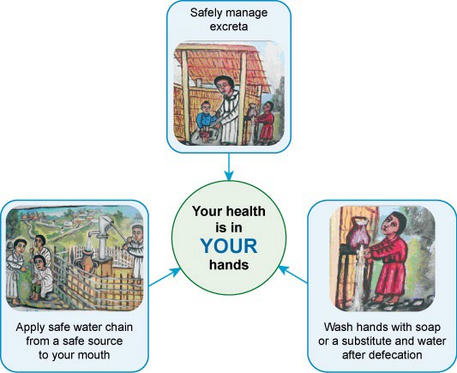

Figure 1.1 Image from the front cover of Ethiopia’s National Hygiene and Sanitation Strategy illustrating the importance of water, sanitation and hygiene for good health (MoH, 2005).
In 2015, less than half the total Ethiopian population of nearly 100 million was reported to have access to a basic water supply and only 7% and 1% respectively to basic sanitation and hygiene facilities (JMP, 2017). These data, for the population as a whole, show that the country has a long way to go to improve the availability of WASH services.
- Imagine you are a young woman living in a rural area who does not have access to WASH services. How could this affect your daily life?
- There are many possible effects but you may have thought of:
  - spending much of your time collecting water for the family and carrying a heavy jerrycan on your back
  - not having enough water for personal or family washing and household chores
  - waiting until dark to go into the fields to find a place to defecate and feeling vulnerable to attack
  - being unable to wash your hands after defecation or before preparing food
  - suffering from frequent diarrhoea caused by contaminated/unsafe water
  - finding it difficult to keep clean and to wash sanitary pads during your monthly period.

An important part of the challenge ahead for Ethiopia is to ensure that improvements in WASH services will reach everyone and that no one is excluded. Exclusion from WASH means a person or group of people are prevented from having access to water, a toilet or handwashing facility, or where access is very difficult for them. Different people have different needs, but this is not always taken into account by planners, designers and decision makers. When we talk about exclusion, we are talking about people who are left behind in terms of getting access to WASH because their needs have not been recognised or considered important.
Inclusion is the opposite of exclusion. Inclusion in WASH means that everyone has access to safe WASH facilities and the needs of all members of a given community, regardless of who they are and their circumstances, are fully addressed in the design, planning and implementation of WASH services. Everyone benefits from inclusive WASH. To give one example, inclusive latrines in a school would have separate blocks for girls and boys, with flat, level paths and handrails for accessibility, with water and basins for handwashing, and appropriate facilities for menstrual hygiene management. Accessibility, in this context, refers to designs, structures and services that are usable (accessible) by people who have limited mobility (the ability to walk) or other disabilities.
It is important to realise, however, that the process of inclusion is not only about making sure that excluded people have access to services but also about helping them to participate fully in the decisions about those services (Gosling, 2010). If they are fully involved in the process their needs will be recognised and they can realise their rights to water, sanitation and hygiene.
There are therefore two aspects to inclusion: access to services and participation in planning and decision-making processes. It follows from this definition that it is possible to be excluded in a number of different ways. For example, some people may not have access because they are physically unable to turn a water tap or walk up steps to a latrine but others may be excluded because their opinions are not considered important and they are ignored by the people who make decisions.

Who is excluded?
The people most likely to be excluded are marginalised groups which are overlooked in the planning and programming of WASH services. Marginalised groups are people who, in the opinion of others, are considered to be insignificant or not important and as a result are confined to the outer limits, or margins, of society. They tend to be the poorest people in a community. You may also come across the terms vulnerable people or disadvantaged people used to describe these groups.
If you were asked the question ‘Who would have difficulty with access to a latrine or a public water point?’ your first answer may well be a person with a physical disability. You may have thought of a person who uses a wheelchair or someone who has poor eyesight. However, these are just two examples of the various types of disability that can lead to exclusion from WASH services. The UN Convention on the Rights of Persons with Disabilities (CRPD) defines persons with disabilities as ‘those who have long-term physical, mental, intellectual or sensory impairments which in interaction with various barriers may hinder their full and effective participation in a society on an equal basis with others’ (UN, 2006, p.4). (This definition and the meaning of ‘impairments’ and ‘barriers’, will be explored in Study Session 2.)

Another ‘group’ of people likely to be excluded actually make up half the population of the world! We are talking of women and girls. Women are frequently excluded from planning and decisions that affect their daily lives, even though they are usually the main users of WASH facilities. Traditional and cultural norms assume that men will be the ones with power and influence and consequently, the needs of women and girls are often overlooked. (The roles of women and men and gender issues in WASH are the focus of Study Session 3.)
In addition to these two main groups, other marginalised groups who may be excluded are:
Elderly people: As they get older, women and men may become gradually less able to walk and have increasing difficulty with high steps. In a latrine, they may be less able to squat over the hole.
Small children: WASH facilities designed for the average adult may not be accessible or safe for small children.
Pregnant women: During pregnancy, women may find it uncomfortable to squat and be unable to walk long distances.
People living with long-term illnesses including HIV/AIDS: As well as being physically weak, sick people may need more frequent washing of themselves, their clothes and bedclothes. People living with HIV/AIDS also often suffer from stigma and discrimination by their community.
People living in geographically remote and/or water-scarce areas: Some parts of Ethiopia, particularly in the east and south, have limited natural water resources. This restricts the availability of water for everyone in these areas including those with a nomadic life style.
People living in informal settlements: This group includes street children, slum dwellers and people living in areas where water and sanitation services are not available.
Government policy makes it illegal to provide services in these settings.
People living in peri-urban areas and new settlement areas: Many towns are expanding rapidly. New settlement areas frequently lack WASH services because buildings have been constructed before the infrastructure of water supply, pipes, etc. has been developed and installed.
People engaged in marginalised occupations: Some activities such as traditional pottery, working with animal skins, and some textile work (locally called ‘shemane’) may be considered sub-standard and discriminated against.
People staying in refugee camps or institutions e.g. prisons: These places may lack adequate water supplies and sanitation services.
A very important point to remember is that people may belong to more than one of these groups, for example, disabled people include boys, girls, men and women of all ages and they may live in any of the disadvantaged areas identified above. Another point is that, for any individual, their situation may change as they get older or their health status changes.

What are the reasons for exclusion?
You will realise from the long list in Section 1.2 that there are many different reasons for exclusion. People can be excluded because of who they are, where they live, socio- cultural reasons, lack of resources – and frequently a combination of these factors, as shown in Figure 1.2. The overlapping circles in the diagram indicate how there may be more than one reason for exclusion of any individual or group. The following sections explain each of these factors in turn.

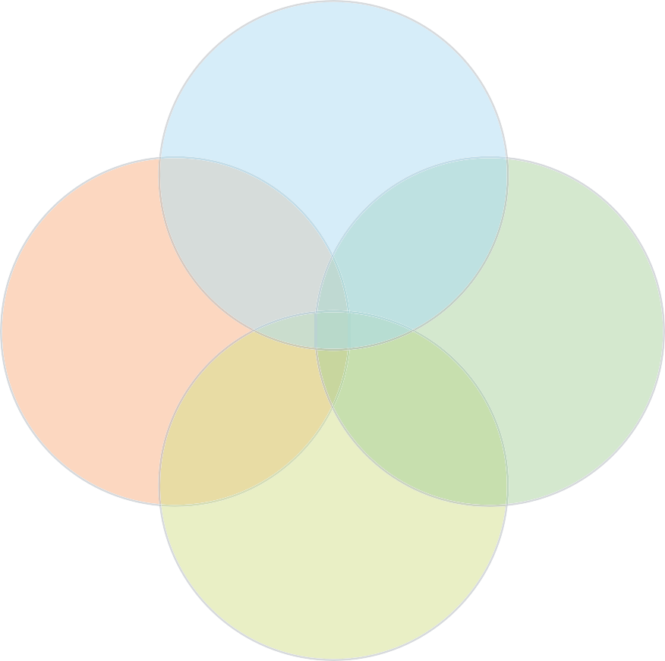
Who you are
(individual and group attributes)
Where you live
(location)
Attitudes of other people
(social, cultural)
Available resources
(for providers and for users)

Figure 1.2 Factors affecting exclusion of people from WASH services.

Individual and group attributes
Many people are excluded from WASH simply because of who they are and the fact that they belong to one or more of the groups identified in Section 1.2.
Design and construction of WASH facilities often does not take the needs of all individuals into account. For example, if you are a wheelchair user, you may be excluded because a latrine entrance has steps, or the door is too narrow, or the space inside is too small. If you are an elderly woman who cannot squat, you would have difficulty using a toilet without a seat. If you are a small child you may not be able to reach the water taps at school if they have been placed too high. There may also be problems with the route that people take when walking to and from a facility. In many cases, when new water and sanitation facilities are built, the path is not made part of the contract and so the builder does not include it in the construction work.

- Consider a water point constructed in a steep-sided gorge with a narrow and uneven path leading to it. Which groups of people would not be able to collect water from this facility?
- Elderly people, persons with disabilities, pregnant women, and people who are ill may not be able to access the water point.
(The reasons how and why personal attributes including ability and gender can lead to lack of accessibility and other forms of exclusion are discussed further in following study sessions.)

Location
The geographical location of the place where you live is a significant factor. People residing in water-scarce areas are excluded mainly because of the unavailability of water resources (surface or ground water). There are also places where there is water resource potential but the site is remote and hard to reach. Lack of appropriate technology and land ownership rights are also important issues in some locations.
The exclusion in these cases affects everyone in that location, not just people with disabilities or other marginalised groups.

Attitudes of other people
One of the reasons for exclusion is associated with social traditions and the cultural beliefs of the wider community. Some of these attitudes are gradually improving but this is an underlying cause of exclusion of several groups and can be challenging to try to change.
Some people believe that a person with a disability is a reward for a family that broke the law of God or man, or that they are possessed by an evil spirit (Lema, 2015). They keep their children away, thinking that the evil spirit could affect them. If someone has a disability, they may be hidden away by their own family in a secret place and kept out of sight for fear of social stigma and prejudice. As a result, persons with disabilities are marginalised, isolated and prevented from joining in with family and community level engagements and social gatherings.
Attitudes to the role of women in society may make it more difficult for them to speak up and express their opinions about the design or implementation of WASH services, so they are not included in decisions that deeply affect them.
People living with HIV/AIDS often suffer from prejudice and stigma for two basic reasons, one is the incorrect assumption that they are engaged in activities not appreciated by the wider community (e.g. people assume they are sex workers); secondly, people are afraid of the disease and ignorant of how it is transmitted from one person to another. Similar prejudice and exclusion also affects people suffering from other diseases, such as leprosy and some skin conditions.

Available resources
Providing new WASH services will always require funds for planning, design and construction. The budget available to the provider (e.g. government, regional bureau, charity) will be limited and costs need to be kept to a minimum. This can lead to intentional exclusion if the additional cost of, say, a handrail or ramp is considered to be too great.
Other limitations apply specifically to civil society organisations (CSOs) and non- governmental organisations (NGOs). The Charities and Societies Proclamation of 2009 (FDRE, 2009a) restricts their role and states they must spend a minimum of 70% of their budget on programmes and no more than 30% on administration. International NGOs are not permitted to engage in rights-based advocacy or work to support the empowerment of vulnerable people and for local NGOs and CSOs this work is considered to be an administrative cost and limited by the 30% rule.
The word ‘resources’ not only refers to budgets and funding but also includes human resources. Sometimes exclusion is a result of lack of knowledge and appropriate training of the people who work for the WASH providers. They may not be aware of the various needs of different people on the one hand, or know about appropriate inclusive design, on the other. Inclusive design (also known as universal design) is design of any product or service that makes it accessible to and usable by as many people as possible, regardless of age, gender and disability. If the design is not inclusive from the outset, this may result in unintentional exclusion where the designed service is inaccessible to some people because the service providers did not have the necessary knowledge and skills.
Financial resources are an issue for service users as well as providers. They may also have limited funds so affordability is another important factor to consider. The majority of rural communities in Ethiopia do not have the resources to cover the construction costs for sanitation or the maintenance costs for water supply for the community as a whole, so inclusion of marginalised groups may not be high on their list of priorities.

Benefits of inclusive WASH
When WASH facilities are inclusive, everyone in the community benefits especially disabled people of all ages, older men and women, pregnant women, sick or injured people, children, and also the carers of these people. There are social benefits such as better health, improved cleanliness, and increased dignity because people do not have to feel the shame and dishonour of open defecation. Educational improvement is another social benefit. Inclusive WASH in schools results in better attendance and therefore improved educational achievements by the pupils. Case Study 1.1 tells the story of the benefits of inclusive WASH experienced by a pupil at a school in Addis Ababa.
Economic benefits such as increased productivity follow on from the improvements to people’s health and well-being. Healthy people are more productive in their work and do not need to spend money on medicines, which also contributes to higher living standards.

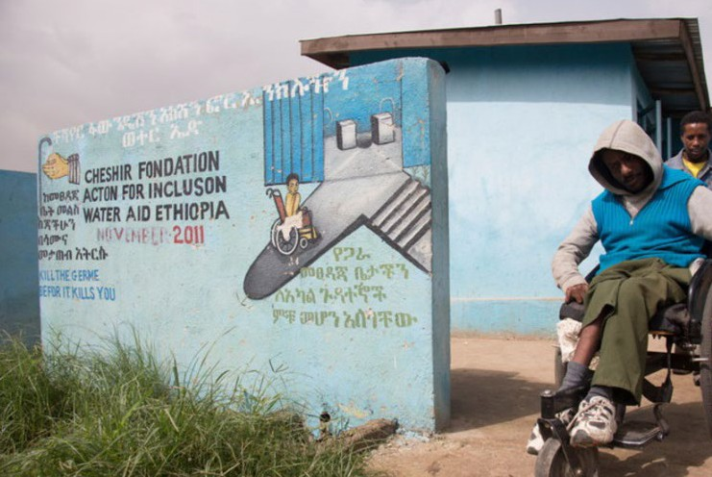
Case Study 1.1 Eniyew Yisma
Eniyew Yisma had polio when he was young which affected his mobility. He uses a wheelchair but can do anything anyone else can do while sitting down. He was a pupil at Bruh Tesfa Primary School in Addis Ababa when new accessible toilet and
handwashing facilities were installed (Figure 1.3). Before the new toilets were built, Eniyew had suffered because he could not use the old traditional latrine by himself and had to go home to use the toilet. Most of the time he would skip his food during the day to avoid the problem while at school but sometimes, if he had diarrhoea, he had to ask his class mates to help him use the toilet. He felt bad about himself and his condition but this all changed when the new facilities were built. He could use the toilet on his own, he did not have to ask for help, he could eat his food when he wanted, he felt more dignified and his self-esteem was greatly improved.

Figure 1.3 Eniyew Yisma outside the school latrine block. Note there are no steps and the entrance is wide so there is plenty of room for his wheelchair.

- Lattu is an old woman who has very poor eyesight. She used to walk to some bushes quite far from her home to find a place for defecation. A family member had to walk with her to guide her but sometimes she would take the risk of going alone. Then a new latrine was built within 15 metres of her home with a path leading to it marked with white stones at the sides. What do you think are the benefits for Lattu?
- She can use the toilet whenever she needs to and can go there by herself without help. She has privacy, added dignity and better quality of life. The time spent looking for a place to defecate is saved and the risks of walking on her own such as tripping over and falling, or possible attack by an animal, are no longer a problem. There are also benefits for her family who no longer have to accompany her.

International frameworks
Awareness of the importance of inclusion in WASH has grown throughout the world in recent years resulting in new initiatives at both international and national levels. At international level, the United Nations (UN) has produced several proclamations, protocols and resolutions that promote the principle of access for all. These UN initiatives provide a framework for policies at national level. If individual countries choose to ratify (approve) a specific international agreement, the government has a responsibility to incorporate its principles within their national policies and programmes.
Two of the most significant UN frameworks are the Sustainable Development Goals and the Convention on the Rights of Persons with Disabilities.

Sustainable Development Goals
The Sustainable Development Goals (SDGs) provide a global agenda for change. They were agreed by the members of the United Nations in 2015 with the aim to achieve them by 2030. There are 17 goals covering different aspects of social and economic development (Figure 1.4).
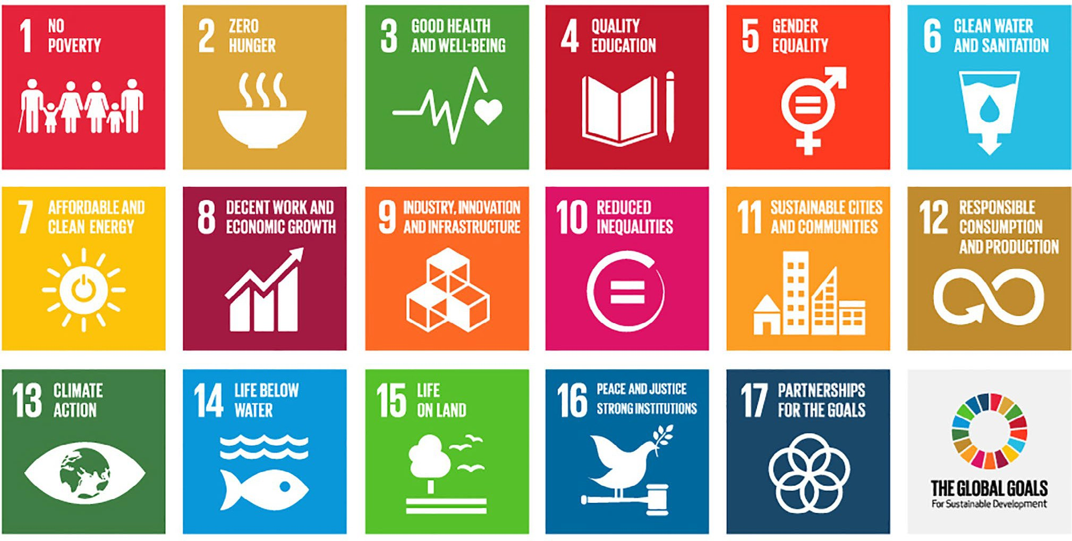
Figure 1.4 Sustainable Development Goals (adapted from UNDP, n.d.).
Many of the goals focus on reaching the vulnerable and emphasise the principle of equality among all people regardless of who they are. As you can see from Figure 1.4, SDG 5 is about gender equality and SDG 6 is about clean water and sanitation. The wording of SDG 6 is to ‘ensure availability and sustainable management of water and sanitation for all’ (UNDP, n.d.). The phrase ‘for all’ makes clear that persons with disabilities and other marginalised groups must be included.

UN Convention on the Rights of Persons with Disabilities
The UN Convention on the Rights of Persons with Disabilities (CRPD) aims:
… to promote, protect and ensure the full and equal enjoyment of all human rights and fundamental freedoms by all persons with disabilities, and to promote respect for their inherent dignity (UN, 2006, p.4).
It recognises the challenges facing persons with disabilities in terms of their social, economic, political and personal life and encourages UN member states to address these challenges so that these people can enjoy every day of their life. Equality and non-discrimination, awareness raising, accessibility, access to information, and access to improved health are among the areas addressed. This convention was adopted by the UN General Assembly in 2006 and ratified by the government of Ethiopia in 2010.

National governance and policy frameworks
It may take several more years to achieve inclusive WASH in Ethiopia, but the country is laying the groundwork with legal and policy frameworks to help reach that goal.

Governance
The Ethiopian Constitution is the guiding legal document for enacting sector policies, strategies and programmes. It incorporates principles of equal access to basic services but also acknowledges provision is linked to the economy. Article 90 states ‘to the extent the country’s resources permit, policies shall aim to provide all Ethiopians access to public health and education, clean water, housing, food and social security’ (FDRE, 1995). There is no explicit reference to persons with disabilities or marginalised groups, but the phrase ‘all Ethiopians’ should be interpreted as inclusive of everyone. However, because of a widespread lack of awareness of the needs and rights of marginalised people, this interpretation is not always used in practice.
The Constitution also establishes the framework for gender equality by stating that the ‘Government shall ensure the participation of women in equality with men in all economic and social development endeavours’.
Responsibility for ensuring the rights of persons with disabilities, as defined by the CRPD, lies with the Ministry of Labour and Social Affair (MoLSA) and its line bureaus and offices at regional and district levels. MoLSA is expected to work with the focal persons in all branches of government to ensure disability mainstreaming in all sectors and programmes. Mainstreaming means ensuring that an issue or topic, in this case disability, is at the centre (in the mainstream) of consideration when developing and implementing policy and not left to one side or ignored. In addition to MoLSA’s leadership role, all ministries and bureaus have a responsibility to ensure inclusion of persons with disabilities in their work and budgets.

Policies and programmes
Many Ethiopian WASH sector policies were developed before inclusion was recognised as a priority. The Water Resources Management Policy, for example, was developed in 1999 and gives little space for inclusion although it does refer to gender issues and the full involvement of women (MoWR, 1999). It expects users to pay for the water

they use and promotes no subsidy for household sanitation. This means that people who cannot afford to construct their own latrine or pay for water facility maintenance are automatically excluded from the service, which particularly affects people with disabilities because of the links between disability and poverty.
In the last decade or so the situation has changed and inclusion has been on the WASH sector agenda. This was reflected in the WASH Implementation Framework of 2011 which expanded on the phrase ‘for all’ by specifying this included ‘disabled, disadvantaged and low-income communities’ (FDRE, 2011). This was followed by the One WASH National Programme (FDRE, 2013) which promotes social inclusion including gender equity and inclusive WASH services.
Policies and proclamations in other sectors have also incorporated principles of inclusion, for example, public buildings and school WASH facilities must be accessible to persons with disabilities (FDRE, 2009b; MoE, 2015). In 2012, under the leadership of MoLSA, a ten-year National Plan of Action of Persons with Disabilities was published (MoLSA, 2012). This aims to promote and protect persons with disabilities and to ensure that they fully enjoy their fundamental rights, public services and any other opportunities for education and jobs. It also aims to ensure that people with disabilities will fully participate in different events and community engagement processes but unfortunately makes no specific mention of access to WASH services.

Summary of Study Session 1
In Study Session 1, you have learned that:
      - All people regardless of their personal attributes and circumstances should be able to access water, sanitation and hygiene services.
      - Inclusion means providing WASH facilities that are accessible to all and involving excluded people in planning and decision processes.
      - Many different groups of people may be excluded from WASH and some people will belong to more than one group. Persons with disabilities face particular challenges with accessibility.
      - Individual attributes, location, social and cultural beliefs, and limited financial and human resources are the major reasons for exclusion. These reasons overlap and some people are excluded for several different reasons.
      - Inclusive WASH brings social and economic benefits to individuals and communities by improving health, well-being and productivity for the whole community.
      - There are global and national frameworks that could be used as guidance to promote inclusive WASH facilities.
      - The Ethiopian Constitution and other national policies require the equal participation of men and women in social and economic developments.
      - The Ministry of Labour and Social Affairs and their regional, zonal and woreda offices have the lead role for matters relating to the rights of people with disabilities.

Self- Assessment Questions (SAQs) for Study Session 1
Now that you have completed this study session, you can assess how well you have achieved its Learning Outcomes by answering these questions. You can check your answers with the Notes on the Self-Assessment Questions at the end of this Module.

SAQ 1.1 (tests Learning Outcome 1.1)
Write the following terms next to their correct definition in the table below:
accessibility; exclusion; inclusion; inclusive design; mainstreaming; marginalised group; persons/people with disability; WASH

people who, in the opinion of others, are considered to be insignificant or not important
when the needs of all members of a given community are fully addressed in WASH services
making sure an issue is given due attention at all times and not left to one side or ignored
design of a product or service that makes it accessible and usable by everyone
characteristics and features of structures and services that defines whether they are usable by people with disabilities
people with long-term physical, mental, intellectual or sensory impairments which in interaction with various barriers may hinder their participation in society
abbreviation used to mean water supply, provision of latrines and facilities for handwashing
when a person or group of people are prevented from having access to water, a toilet or handwashing facility

SAQ 1.2 (tests Learning Outcomes 1.2 and 1.3)
Fill in the spaces in the following sentences using the correct terms from the following list:
adolescent girls; anyone who cannot squat comfortably; informal settlement areas; persons with disabilities and older people; women.
- In schools where there is no facility for menstrual hygiene management,
……………. are largely affected.
- ………………….. are excluded if the water facility has high steps.
- A toilet that lacks seat and handrails is not accessible to ……………….
- In ………………….. WASH facilities are not promoted by the government as it is not legal.
- Planning of WASH facilities often does not take account of the ideas and opinions of …………………..

SAQ 1.3 (tests Learning Outcomes 1.2 and 1.3)
For each of the following people, consider the four main reasons for exclusion and explain in your own words why they might be excluded from WASH.
  - A woman who has very low income and lives in a remote rural community far from a water supply.
  - A man with HIV/AIDS living in a newly-built condominium on the outskirts of a large town.

SAQ 1.4 (tests Learning Outcome 1.4)
Name two international and two national policies or frameworks that support the principles of equality for all people and inclusion for marginalised groups.

Study Session 2
Including People with Disabilities

Introduction
In Study Session 1 you were introduced to the concepts of inclusion and exclusion from WASH and learned about the different groups of people who are frequently excluded.
Now we look more closely at one of these groups, namely people with disabilities and consider how changes in attitudes and practice can create an environment where they are included, rather than excluded.
In this study session you will learn how people with different types of impairment face various barriers in their daily lives that affect their ability to access WASH and other services. You will discover there are several different estimates of the number of people in Ethiopia who have disabilities. The session includes some tips for communicating with and about people with disabilities and concludes with a brief discussion of approaches to collecting data on disability and inclusive WASH.

Learning Outcomes for Study Session 2
When you have studied this session, you should be able to:
  - Define and use correctly all of the key terms printed in bold. (SAQs 2.1 and 2.2)
  - Describe the different types of impairment that affect people with disabilities. (SAQs 2.1 and 2.2)
  - Identify barriers to disability inclusion in WASH services. (SAQs 2.1 and 2.3)
  - Communicate effectively with people with disabilities using positive words. (SAQs 2.1 and 2.4)
  - Outline some approaches to collecting data about disability and inclusion. (SAQ 2.5)

What is disability?
What comes into your mind when you think of the word ‘disability’? Many people associate the concept with restriction and limited potential. They often do not recognise that the restrictions and limitations are frequently caused by the physical environment in which we live and the attitudes and behaviours of other people. The definition of disability therefore has two components. Disability refers to a functional limitation as a result of partial or complete loss of the function of a body part, and the resulting restriction an individual has in society due to the nature of the environment in which they live. In simpler words, if you have a disability it means you are unable to do some things because the place where you live has not been designed for someone like you. (Remember the module title of Count me in.)
The formal definition of persons with disabilities from the UN Convention on the Rights of Persons with Disabilities was introduced in Study Session 1. It stated that persons with disabilities have ‘long-term physical, mental, intellectual or sensory impairments which, in interaction with various barriers, may hinder their full and effective participation

in society on an equal basis with others’ (United Nations, 2006).
This definition uses two important terms: impairments and barriers. Impairment is the loss of a function of the body, for example, when someone is unable to walk or cannot hear properly. Impairments are mostly irreversible and lifelong. Different types of impairment are described in Section 2.2.
A barrier to inclusion is anything that prevents or hinders accessibility or the full participation of persons with disabilities. Different types of barrier are described in Section 2.3.
The UN definition makes clear that disability is not only about the impairment of an individual person but also about how they interact with the world around them and the barriers that they have to deal with. Figure 2.1 illustrates this important relationship.

Impairment
Barrier
Disability

Figure 2.1 Disability results from impairment in a part of someone’s body combined with the barriers created by the environment in which they live.
It is this interaction between different types of impairment and the various barriers that cause a person to be disabled in society. This means that persons with disabilities are not all the same and one person with a disability can have a completely different experience from another. Further variation arises from the use of assistive devices and other aids, if they are available. An assistive device is any device that helps someone to do something that they might not otherwise be able to do. Generally, the term is used for devices that help people overcome impairment. For example, wheelchairs and crutches can improve mobility for some people with physical impairments and hearing aids can help some people with a hearing impairment.

Types of impairment
Impairments can be classified into four main groups: physical, sensory, psychosocial and intellectual. Some are present from birth, while others may be acquired later in life as the result of illness, injury or just from getting old. Remember also that some people may be affected by more than one impairment.

Physical impairments
These are conditions that cause difficulties in walking and other movements such as holding or grasping and may affect coordination and the ability to perform physical activities. Several different diseases can affect joints or muscles of the arms or legs such as polio, which causes paralysis. Other conditions affect the nervous system, for example spinal injury, stroke and leprosy. This group also includes loss of limbs.

Sensory impairments
These are impairments that affect sight, hearing or speech.
- Visual impairments are partial or total loss of the ability to see, and therefore read. Visual impairments can range from low vision, meaning the person has some limited or poor sight, through to total loss of vision.
- Hearing impairment refers to various degrees of loss of hearing. Mild hearing loss means the person has difficulty with very quiet sounds such as whispering. People with moderate hearing loss find it difficult to join in a normal conversation and severe hearing loss means only loud sounds can be heard.
- Speech impairments affect the ability to communicate. People with this type of impairment may have difficulty with the production of sound, for example, they may be unable to produce clear and distinct words with their voice or may stammer.

Psychosocial impairments
Psychosocial impairments include many different mental health conditions that affect a person’s behaviour and their ability to function and participate in society. Examples include anxiety, depression, and schizophrenia. This sort of impairment may be acute (episodes that may be severe but are short-lived) or chronic (continuous or lasting a long time).

Intellectual impairments
Intellectual impairments refer to many different types of lifelong limitation that may affect a person’s ability to understand new or complex information, to communicate with other people or to look after themselves. People affected by this sort of impairment may require supervision from someone else to help them with daily activities.
- Which of these four different types of impairment are most likely to affect inclusion in WASH?
- Physical impairment affecting a person’s ability to walk would limit access to WASH facilities if there are steps or steep slopes; impairments affecting the hands could prevent someone turning a tap or holding a water container. Visual impairment could make it difficult for someone to walk safely to a facility and use it. Intellectual impairments may make it difficult for someone to understand about good hygiene practices. Other types of impairment may not affect accessibility to services directly but they could all prevent someone from participating in discussions and meetings. Remember from Study Session 1 that inclusion means both access to services and participation in processes.

Barriers to inclusion
The other component of disability is the barriers that exist in the world around us. These can be categorised into four main groups, shown in Figure 2.2 and described in the following sections.

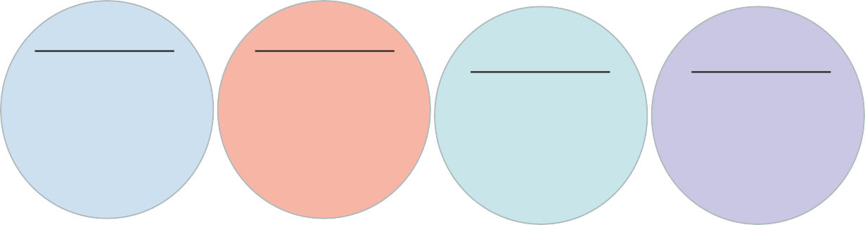
Physical barriers

technical (steps, narrow entrances and slippery floors) and natural (paths, long distances)
Social barriers

prejudice, shame, pity, isolation and overprotection
Institutional barriers
lack of: clear policies and strategies, knowledge, skills, inclusive designs
Communication barriers
lack of: Braille, signposts, interpreter

Figure 2.2 Barriers to inclusive WASH.

Physical barriers
Physical barriers (also known as environmental barriers) can be natural or technical. Natural barriers include uneven, rough or steep paths on muddy ground and long distances that often need to be walked to reach a water source. Technical barriers (also known as infrastructural barriers) such as slippery floors and steps are created by poor, non-inclusive design and construction. Physical barriers are an accessibility problem everywhere, not just for WASH services (Figure 2.3).

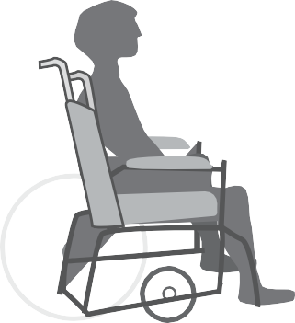









Figure 2.3 A wheelchair user facing a physical barrier.
Physical barriers often force disabled people into unhygienic and dangerous practices. For example, wheelchair users like the young woman in Figure 2.4 have to crawl on the floor of latrines because entrances have steps or are too narrow.

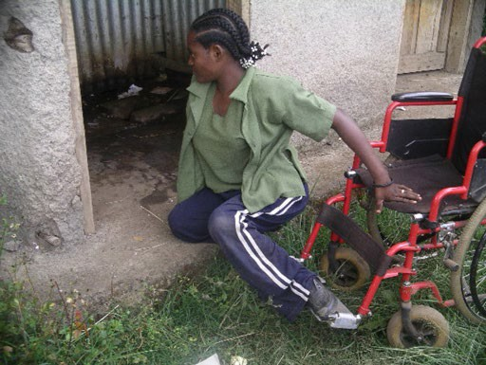

Figure 2.4 This young woman has to leave her wheelchair outside the latrine cubicle and drag herself across the dirty floor because of the physical barrier created by the step at the entrance.
Some physical barriers can be removed with appropriate inclusive design that recognises the importance of accessibility. For example, the problems caused by steps (if there are only a few) can be overcome by constructing a ramp. A ramp is a sloping surface joining two different levels, for example at the entrance of a building. Ramps can be made of cement or wood and must not slope too steeply. Ideally the gradient (slope) of the ramp should be a minimum of 1 in 12 (Figure 2.5).



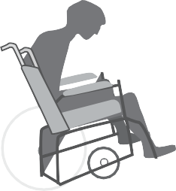


3
2
1
0
6
5
4
10
9
8
7
12
11
1

Figure 2.5 The slope of a ramp should not be steeper than 1 in 12.

- What could you do to remove the physical barrier faced by the young woman in Figure 2.4?
- You could put a wooden ramp over the step so she could wheel her chair to the latrine door. But that still may not solve the problem if the door is too narrow and the space inside the latrine too small for her chair.

Social and attitudinal barriers
You will recall from Study Session 1 that one of the main reasons for exclusion is the attitudes of other people. In Ethiopia, social and attitudinal barriers of shame, fear, prejudice against disabled people and the mistaken belief that disability is a curse cause the greatest problems. Persons with disabilities may be kept hidden at home where
they are separated and isolated. This may be because the family feels ashamed or sometimes because they are overprotective of a disabled family member and want to shield them from the stares and abuse of other people.
Social barriers may prevent people with disabilities from accessing WASH facilities at home and in the community. They may also keep them away from community meetings, often adding to physical barriers if the meeting place is inaccessible. The organisers of the meeting may not be aware of the importance of inclusion and not understand why persons with disabilities should attend these meetings. Or they may not think that people with disabilities have the same WASH needs as everyone else, for example many people believe that girls with disabilities do not menstruate. This excludes them from participation in discussions and decisions about WASH services and other community issues. These social and attitudinal barriers are not only found at the community level, but also in the attitudes of WASH sector actors at all levels (COWASH, 2017).

Institutional barriers
In Study Session 1 you learned that inclusion of marginalised groups has not been a priority in government policy until relatively recently. Institutional barriers refer to policies, programmes and directives that do not include clear statements about inclusion and how it should be achieved. It can also mean a lack of enforcing mechanisms where these statements do exist but are not implemented, for example, there are many public buildings without ramp access even though this is required by legislation.
Institutional barriers also include limited knowledge and skills among the policy makers and designers. (You may recall this was one aspect of lack of resources identified as a reason for exclusion in Study Session 1.) The relevant ministries/bureaus responsible for water and sanitation are rarely aware of the issues of exclusion and inclusion. Many WASH sector actors are unaware of the barriers that prevent participation and access to WASH facilities, and they lack training in inclusive WASH. The COWASH Disability Inclusion Guideline (COWASH, 2017) also suggests that more could be done if the Ministry of Labour and Social Affairs (MoLSA) and the Disabled Persons Organisations (DPOs) strengthened their presence and activity at woreda level and their links with the WASH sector to address issues of inclusive WASH.

Communication barriers
Figure 2.2 shows a fourth group of barriers that prevent effective communication with and by people with disabilities. These barriers vary with different types of impairment. For example, visually impaired people need non-visual resources to receive information such as listening to audio recordings or, if they are able to, reading from Braille.
They face a communication barrier if these alternatives are not available. (Braille is a system of writing using raised dots on a page that represent different letters. The letters are read by running your fingers over the paper so you can feel the dots. The system is named after its inventor, Louis Braille.) Similarly, deaf people rely on visual communication such as signposts to help them find their way. If they are able to use and read sign language they may not be able to communicate effectively if a sign language interpreter is not available. People with intellectual impairments may need messages in a simple or visual format, or communication to come through carers who can help them understand.

2.4 Using positive language to communicate with persons with disabilities
Negative attitudes and mistaken beliefs about disability can influence the language used to talk to or about people with disabilities and this also creates a communication barrier. Language is a powerful tool in any society. It can have a positive influence and make people feel valued, confident and included, or it can be negative and inconsiderate and cause hurt or offence, making someone feel rejected, belittled and excluded.
One important principle to remember for positive terminology is that the person comes first, not the disability. Another is not to assume that everyone with a disability is the same. Table 2.1 shows some of the inappropriate negative terms and acceptable positive terms that can be used when describing persons with disabilities.

Table 2.1 Positive and negative words to describe persons with disabilities (adapted from COWASH 2017).

Negative terms | Positive terms
Disabled, handicapped, crippled, person who is physically challenged, deformed person | Person with a disability
Normal people, able-bodied, healthy | Person without a disability
Mentally handicapped, mentally retarded, mentally defective, mentally challenged, insane, crazy | Person with a mental health illness or disability
Wheelchair confined or bound | Person who uses a wheelchair; wheelchair user
The blind | Person with a visual Impairment; blind person
The deaf | Person with a hearing impairment; deaf person
Mute/dumb | Person with a speech disability

- Look at the two columns in Table 2.1. What do you notice is the main difference between them?
- The positive terms all use the word ‘person’. The negative terms focus only on the disability; the person with the disability is generally ignored.
If you are talking to someone with a disability, you may need to make some adjustments to accommodate their needs. This will vary with different types of impairment. The important point is to treat them with the same respect you would for anyone else. Box
  - has a few tips that will help you positively interact with persons with disabilities in your community.

Box 2.1 Tips for talking to people with disabilities
- Speak directly to the person rather than to their assistant, carer or interpreter, if they have one.
- If you think they may need help, ask them first before you take any action.
- Refer to a person’s disability only when it is related to what you are talking about.
- Be careful to use positive words and phrases (see Table 2.1).
- When talking about toilets or other facilities adapted for people with disabilities, use the term ‘accessible’ rather than ‘disabled’ or ‘handicapped.’
- Don’t invade someone’s personal space by touching their wheelchair, crutches or cane; don’t take hold of the arm of a visually impaired person to guide them without asking if that’s what they would like you to do.
(Adapted from COWASH, 2017 and NYLN, 2006)

Persons with disabilities in Ethiopia
How many people with disabilities are there in Ethiopia? Collecting this sort of data is challenging in any country. One reason is the difficulty of defining what is meant by a disability. You can see from the previous sections that there are many different categories of impairment and disability. Different countries, systems and surveys do not all use the same methods and definitions. Another reason is that, when responding to surveys and questionnaires, people have different understandings of disability and are often reluctant to report that they or a family member is disabled because of negative attitudes and stigma.
In Ethiopia, there have been several estimates of the number of persons with disabilities all giving different results (COWASH, 2017; Metiku, 2008; JICA, 2002; DCDD, n.d.).
Using statistics from the 2007 national census, the National Plan of Action (MoLSA, 2012) estimated that in 2010 there were approximately one million people with disabilities in Ethiopia. Other estimates are much higher. According to the World Report on Disability (WHO/WB, 2011), 17.6% of the adult population in Ethiopia had a disability (data based on a house-to-house survey).
- Ethiopia’s population in 2018 is approximately 106 million of which roughly half are adults over the age of 18. Using the proportion of 17.6%, estimate the number of adults with disabilities in Ethiopia.
Number of adults with disabilities = 106 x 17.6 million
2 100

= 9 million (rounded to the nearest million)
Nine million is a very large number! But even this is not the complete picture. WHO/WB data did not include children and was gathered by house-to-house survey and so did not include homeless people. The actual number could be significantly higher.

Whichever estimate we use, there are certainly millions of people in Ethiopia who live with a disability of some sort. 95% of these people are estimated to live in poverty and many depend on family support and begging for their livelihoods. It is probable that the majority of these people live in rural areas where access to basic services including WASH is limited (MoLSA, 2012; ILO, 2013).

Collecting data about persons with disabilities
There are a number of reasons why data collection about people who have a disability and their access to WASH services has not been a priority in the past. You have already read about some of these reasons:
- Disability issues are not mainstreamed in most government policies and programmes so they are overlooked and funds are not allocated to them.
- Lack of awareness and understanding of disability, impairment, barriers and the adjustments that need to be made to be inclusive.
- Not enough people with appropriate training on methods of data collection.
Undertaking research to collect data about the situation of people with disabilities and their inclusion, or exclusion, in WASH is an important task because the absence of data adds to the invisibility of the problem and the general lack of awareness.

Challenges of measuring inclusion in WASH
Collecting data often requires the use of surveys and questionnaires. Preparing the questionnaire and thinking of the right questions to be asked can be difficult.
- Think back to previous sections in this study session and identify three reasons why trying to collect data by asking ‘Do you have a disability?’ may not give accurate results.
- You may have thought of others but possible reasons include:
  - There are different definitions and understandings of what disability is.
  - There are many different types of impairment with different levels of severity; these variations would not be revealed by this question.
  - People may be reluctant to report that they or a family member are disabled.
Where there are variations within a data set, the data is more informative and useful if it is disaggregated. To aggregate means to combine or group together so disaggregated data are data divided into separate categories. For example, you read above about various estimates of the total number of people with disabilities in Ethiopia. To be useful for planning and implementing inclusive services for all, the total number does not provide sufficient detail and a more specific breakdown is needed. Disaggregated disability data have separate records for different types and degrees of disability among a population. It may be useful to further disaggregate data by sex (separate records for males and females) and by age (separate records for different age groups), in which case the questionnaire would need to include the right questions to produce these data.

Tools for data collection
The need for accurate and comparable disaggregated data led to the development of standardised questions to be used in censuses and surveys. By using the same set of questions, the results of different surveys can be meaningfully compared. This principle was recognised by the United Nations Statistical Commission and led to the development of the Washington Group on Disability Statistics. This group has developed sets of standard questions that can be used in English or translated into other languages. The ‘short set’ on human functioning is shown in Box 2.2. Note the questions ask about difficulties with six core functions but do not use the word ‘disability’.

Box 2.2 Washington Group’s short set of questions on disability
The questions ask about difficulties doing certain activities because of a health problem.
      - Do you have difficulty seeing, even if wearing glasses?
      - Do you have difficulty hearing, even if using a hearing aid?
      - Do you have difficulty walking or climbing steps?
      - Do you have difficulty remembering or concentrating?
      - Do you have difficulty (with self-care such as) washing all over or dressing?
      - Using your usual (customary) language, do you have difficulty communicating, for example understanding or being understood?

For each question, the respondent has a choice of four possible replies:
- No – no difficulty
- Yes – some difficulty
- Yes – a lot of difficulty
- Cannot do at all
(Adapted from Washington Group on Disability Statistics, n.d.)
(Note: For further information about how to use the Washington Group questions including methodology, question sets, implementation guidelines, etc., see http://www.washingtongroup-disability.com/)

The Washington Group questions provide disaggregated data about the number of people with different types of disability but they are not specific to inclusion in WASH. Measuring the inclusiveness of WASH facilities requires additional data collection and, although this was rare in the past, it is gradually being incorporated in data gathering activities. For example, the Ministry of Education published a report in 2017 of a schools’ WASH mapping exercise to collect data from all regions of Ethiopia about the numbers and types of latrine facilities in schools. The survey reported that 35.9% of the 33,232 primary schools in Ethiopia had latrines that were accessible to children with physical disabilities (MoE, 2017a).

The lack of accurate data about people with disabilities and inclusion is likely to change in the future. The Sustainable Development Goals put greater emphasis on inclusion
of people with disabilities in the targets to end poverty and hunger. This will provide an incentive to improve monitoring and reporting about disability and inclusion at national and international levels.

Summary of Study Session 2
In Study Session 2, you have learned that:
- ‘Disability’ refers to a functional limitation as a result of impairment and the interaction with barriers in the environment.
- Impairment is the loss of a function of the body. Types of impairment can be categorised as physical, sensory, psychosocial and intellectual.
- There are several types of barrier that cause exclusion including physical, social/ attitudinal, institutional and communication barriers.
- Care is needed when talking to or about people with disabilities. Disrespectful language can cause offence and can be a barrier to full participation.
- Estimates of the number of people with disabilities in Ethiopia vary but there are at least one million and probably more.
- Collecting data about people with disabilities is challenging. The Washington Group’s short set of six questions are standard questions that provide comparable data
about disability.

Self-Assessment Questions (SAQs) for Study Session 2
Now that you have completed this study session, you can assess how well you have achieved its Learning Outcomes by answering these questions. You can check your answers with the Notes on the Self-Assessment Questions at the end of this Module.

SAQ 2.1 (tests Learning Outcomes 2.1 to 2.4)
Which of the following statements are false? In each case, explain why it is incorrect.
  - The words and language used when communicating with persons with disabilities doesn’t affect their inclusion in WASH initiatives.
  - Many policy makers, regulators and WASH sector actors are unaware of the barriers that prevent participation and access to water and sanitation facilities by persons with disabilities.
  - The words disability and impairment can be used interchangeably because there is no major difference between the two.
  - Persons with disabilities all share problems with accessibility and exclusion. Therefore, when collecting data, it is important to aggregate them all together as one group.

SAQ 2.2 (tests Learning Outcomes 2.1 and 2.2)
Insert the following words into the spaces in the sentences below: assistive devices; barriers; intellectual; physical; psychosocial; sensory
    - Difficulties in walking and other movements are described as ……………. impairments.
    - ……………… impairments include those that affect a person’s ability to communicate with other people or to look after themselves.
    - Some physical ……………….. can be overcome by use of ………………….
    - ………………. impairments affect sight, hearing or speech.
    - Conditions that affect a person’s mental health, behaviour and the ability to function in society are called ……………….. impairments.

SAQ 2.3 (tests Learning Outcome 2.3)
Yeyitu is 17 years old and an elementary school student. Her parents earn an average income from vegetable farming. Yeyitu was born with a visual impairment. She grew up hearing that her impairment happened because her parents were being punished by God. Her parents kept her at home and did not send her to school until she was quite old. While she is at school, it is very difficult for Yeyitu to use the latrine. She frequently falls over when walking to the latrine block because there is no proper path and there are rocks which she finds hard to avoid, even though she has a white cane. When she reaches the latrine, there are no signs in Braille to help her enter so she has to feel along the walls using her hands. There are no handwashing facilities. Being exposed to this unhygienic toilet frequently makes Yeyitu ill with diarrhoea. Using the school latrine is so difficult that Yeyitu prefers to use the toilet at home and for that reason, she avoids eating and drinking during school hours.
Briefly explain the barriers faced by Yeyitu.

SAQ 2.4 (tests Learning Outcome 2.4)
Elsa was born with a physical impairment; both of her legs were paralysed. Her parents were shocked and did not accept the reality of the situation or support Elsa. As a child, Elsa never had the chance to go outside and play with her peers. If she did go out of the house, she usually crawled on her knees using plastic shoes to cover her hands.
People in the community called her a cripple and made a dismissive sound with their mouth when she went out in public. At the age of 10, with support from a local NGO, Elsa fortunately was able to join formal education. The NGO also provided a wheelchair for her which made her life much easier. She is now able to join social activities but community members and her friends still describe Elsa as wheelchair bound. This makes her frustrated because she sees the wheelchair as a benefit but they see it as a problem and don’t understand all the many things she can do.
What are the negative words used to describe Elsa and how could this affect her emotionally?

SAQ 2.5 (tests Learning Outcome 2.5)
What aspects of the Washington Group’s short set of six questions make them a useful tool for collecting data about disability?

Study Session 3
Gender Equality and Women’s Empowerment in WASH

Introduction
In Study Session 1 you read that one of the categories of people most likely to be excluded from WASH are women and girls. This study session examines the issues associated with gender and inequality in society and the traditional roles of women and men, particularly in relation to WASH in Ethiopia. You will also learn about the reasons why the empowerment of women is essential for future development of WASH services.

Learning Outcomes for Study Session 3
When you have studied this session, you should be able to:
  - Define and use correctly all of the key terms printed in bold. (SAQs 3.1 and 3.3)
  - Outline gender equality issues for WASH in Ethiopia. (SAQ 3.1)
  - Define empowerment and give examples of women’s empowerment in WASH. (SAQ 3.2)
  - Explain why monitoring gender equality in WASH is important. (SAQ 3.3)

Gender roles and equality
As you know, men and women have different reproductive organs and also differ in other aspects of anatomy and characteristics such as facial hair. These differences define a person’s sex, but they do not define their gender.
You may think that the terms gender and sex are the same and can be used interchangeably, but this is not the case. Sex is a biological category based on physical differences and different reproductive functions. Gender is not defined by biology but is based on the roles in society, both in public and private life, that are associated with being male or female. It refers to the social and cultural attributes and behaviours that we tend to assume are typical of men or women. The Training Manual on Gender Planning in WASH (MoWIE, 2017) lists some examples of gender-related
assumptions including:
- Girls are gentle/boys are tough
- Men have the power/women do not
- Men are logical/women are emotional
- Women are shy/men are not
- Men should work outside the family/women should work within the family
- Men are leaders/women are not.
These attributes are not predetermined but arise from traditional expectations of individuals and society, which assign these roles and relationships to men and women. From early childhood, girls and boys learn that these are their expected roles and there is often considerable social pressure to conform to these norms. However, it is important to note they are not fixed and can be changed.

These gender-related assumptions about men and women give rise to the traditional roles they are expected to play in society. Typically, men are expected to earn money for the family but not to undertake domestic tasks such as cooking, cleaning and washing clothes, or to help with childcare. If they have community roles, these tend to involve management and leadership.
Women’s roles are more complex. They have the main responsibility for looking after the children and home, and possibly the care of older, sick or disabled relatives. In addition, they undertake paid work or other activities to provide an income, and they frequently participate in community organisations and activities. This combination of responsibility is described as women having a triple role (Moser 1995, cited in Coates, 1999). The three roles are:
- reproductive role – childbearing and caring for children, unpaid domestic tasks to sustain the home (cooking, fetching water, cleaning, washing clothes, etc.)
- productive role – work done to produce goods and services for consumption or trade
- community role – tasks and responsibilities carried out for the benefit of the community, usually voluntary and unpaid.
Some of these tasks are illustrated in Figure 3.1.
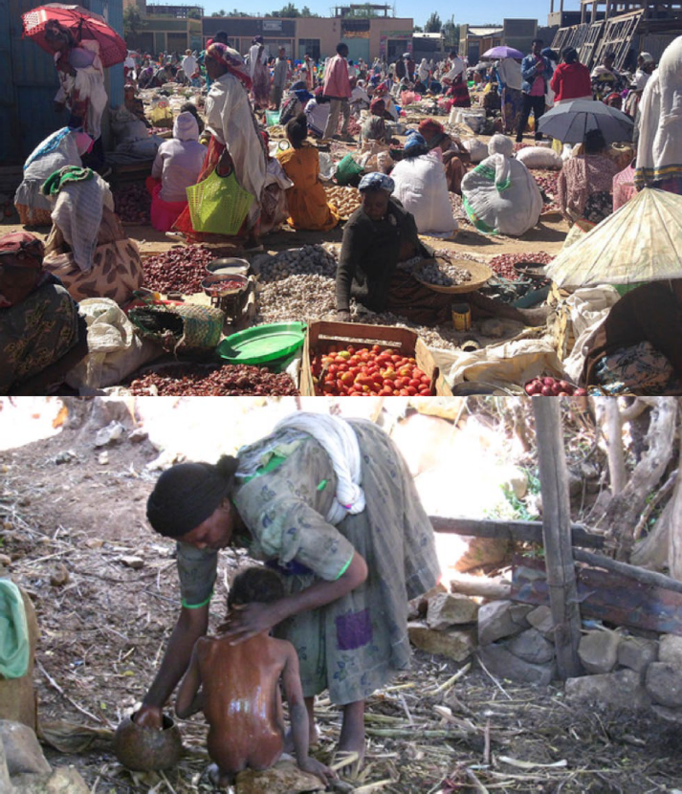
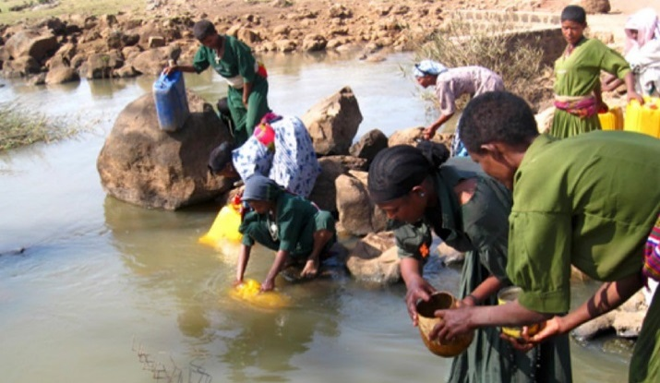
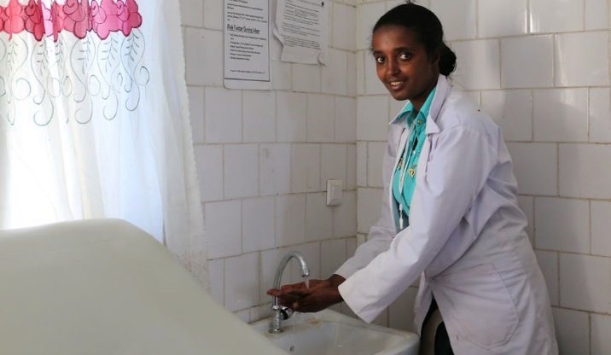
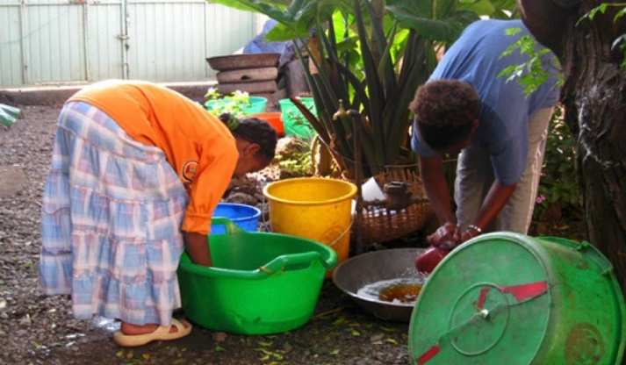
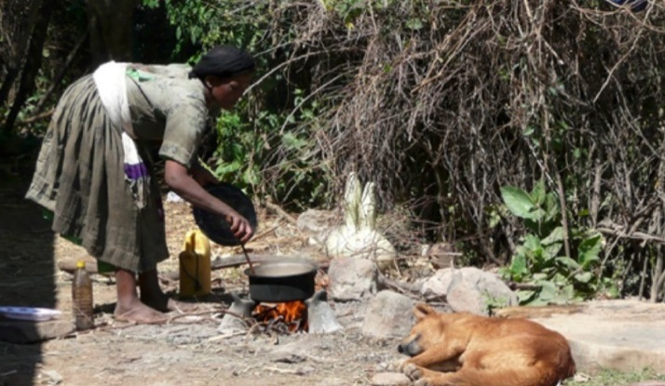
Figure 3.1 The many roles of women.

Case Study 3.1 Womitu’s busy life
Womitu is 21 years old and lives in Derashe town. Her parents believe that girls should get married early, so they organised an arranged marriage for her when she was 15, which meant she had to drop out of school. After a year, Womitu gave birth to a baby boy. Her husband worked as a vegetable farmer and life was not easy for Womitu, as she was economically dependent on her husband. After a while, when she knew her baby was growing well, she decided to sell some fresh vegetables in the village and earn additional money to support her family. Her husband agreed with the idea, and Womitu started the business, leaving her baby at her parents’ house.
After a couple of months, Womitu joined a cooperative so she could access a loan to strengthen her business. As well as her family and business commitments, Womitu is sociable and an active participant in community associations like ekub and edir.

- Read Case Study 3.1 and then briefly describe the different roles played by Womitu.
- Womitu has a reproductive role caring for her son and the family home. She grows and sells vegetables in a productive role that brings in income. And she has a role in the community as a member of the cooperative and the community associations.

Even though both women and men do productive work that brings income into the household, the work of women is typically lower paid and given little recognition.
Women tend to get paid less even if they are doing the same job as a man. In Ethiopia, the National Labour Force Survey of 2013 found that average monthly earnings were nearly 50% more for men than women (CSA, 2014). There is also inequality in unpaid tasks at community level where men typically have leadership roles while women do organising and support work.
These traditional gender roles contribute to the unequal relationship between men and women. Women generally have less access to resources, less power and are excluded from discussions and decisions at all levels of society, from their own household level upwards. The goal for an equal society, therefore, is to acknowledge that women have the same human rights as men. Equality means everyone is treated in the same way, so gender equality means men and women have exactly the same status, rights and opportunities. Working towards gender equality means adopting policies and practices that change the traditional gender roles of men and women in all aspects of life, of which WASH is one of the most important.

Gender and WASH
Part of women’s triple role is having responsibility for domestic tasks and care of the home. Figure 3.2 shows how unequal the allocation of tasks is between men


and women.
Allocation of domestic responsibilities



100
Percentage of households (%)
80
60
40
20
0
Domestic work
Fuel/firewood collection
Domestic work
Fuel/firewood collection
Rural areas Urban areas


Female Male Both




Figure 3.2 Allocation of domestic responsibilities to men and women (data for 2013).
Purchasing goods
Water collection
Purchasing goods
Water collection

- Look at Figure 3.2. What is the proportion of households where women have sole responsibility for water collection?
- Women have sole responsibility for water collection in about 80% of rural households and about 70% of urban households.
Water collection is one of the most time consuming of these domestic tasks. Many women and girls, especially in rural areas, spend hours each day collecting water for the family. This not only prevents them from doing other more productive work or attending school but can also cause physical damage because of the heavy weight of a full jerrycan. There are other disadvantages. Women, especially in rural communities, spend so much time on domestic chores including fetching water that they have no time to get involved in public decision-making processes, so even if social and cultural attitudes that discourage or prevent their participation could be changed, they have no time to take part.
There is also a gender divide when it comes to sanitation. If latrines are inadequate or non-existent, this has a much greater impact on women than men. Women and girls may wait until dark to relieve themselves, which can be dangerous and make them vulnerable to attack. They may also avoid eating and drinking during the day which can damage their health.
Sanitation also affects school attendance. The lack of separate toilet blocks for girls and boys in schools is widely believed to contribute to poor attendance by girls and makes them more likely to drop out of school entirely. Guidelines recommend girls’ and

boys’ blocks with at least 20m between them, and with lockable doors facing in opposite directions (MoE, 2017b). They also require proper facilities for menstrual hygiene management. During their menstrual period, girls and women need access to safe and affordable menstrual absorbents and private facilities for the disposal and/or washing of materials used to absorb menstrual blood, and access to facilities for washing themselves. Despite the guidelines, these requirements are frequently overlooked in the design and construction of school latrine blocks and are also neglected in shared public facilities.
Remember facilities also need to be accessible for women and girls with disabilities.
One of the main reasons for the neglect of women’s needs is their exclusion from discussions about the planning and design of WASH services. You will remember from Study Session 1 that this was part of the definition of exclusion. Usually it is men who make decisions about the allocation of finances and they may not prioritise issues that affect women’s lives but not their own. Women are often excluded from participation in decisions about water supply, sanitation and hygiene, even though they are the ones whose lives are most affected. Social attitudes also affect the way in which WASH professionals address issues like menstruation or fistula which have a lot of stigma in many communities. This has a big impact on women and girls.

The context in Ethiopia
The importance of gender equality has been recognised in Ethiopia since the mid-1990s. The Ethiopian Constitution (1995) and Ethiopian’s Women’s Policy (1993) established the principles of equality of access to opportunity. The Ministry of Women and Children Affairs also dates its origin back to 1993 (MoWCA, 2018). This foundation has been followed in other government policies and strategies. These include the National Action Plan for Gender Equality (NAP-GE), which covered the period from 2006 to 2010 and has since been incorporated in the Plan for Accelerated and Sustainable Development to End Poverty. Similar principles are also part of the Growth and Transformation Plans
I and II, Health Sector Transformation Plan (FMoH, 2015) and the One WASH National Programme (FDRE, 2013), among others.
The NAP-GE worked to achieve the objectives of gender equality expressed in the 1995 Beijing Platform for Action (BPA). The BPA was an international programme that emerged from a United Nations’ Conference on Women held in Beijing, China in 1995. It established the concept of gender mainstreaming, which is now a key component of Ethiopian national policies.
In Study Session 1 you read that mainstreaming can be defined as ensuring that an issue or topic is at the centre of consideration for any plan or project. Gender mainstreaming, therefore, means giving equal priority to the interests of both genders at all stages of a process, including development, planning, implementation and evaluation. The National Gender Mainstreaming Guidelines describe it as:
. ..a strategy for making women’s as well as men’s needs, priorities, concerns and experiences an integral part of the planning, implementation and monitoring and evaluation processes. This helps to ensure that development outcomes benefit men and women equally and that gender disparities are not continued. Gender mainstreaming seeks to ensure that institutions, policies and programs involve women and men equally, and respond to the needs and interests of all members of society. (MoWA, 2010, p. 28)

What practical steps have been taken in Ethiopia to put gender mainstreaming policies into practice? Here are two examples.
In the health sector, since the mid-2000s, more than 38,000 female Health Extension Workers (HEWs) have been deployed in more than 15,000 rural kebele health posts (Haile, 2014). Part of their role is to support their communities in efforts to improve hygiene and public health by installing pit latrines and advising families on good hygiene practices. HEWs are supported by the Women’s Development Army (WDA). The WDA is made up of ‘one-to-five’ networks of women. Each trained woman trains five other women from nearby households, who encourage their neighbours to change their practice by building latrines and setting up separate cooking spaces.
In the WASH sector, there is positive discrimination in favour of women in the membership of community water, sanitation and hygiene committees (WASHCOs). The One WASH National Programme requires that women are well-represented and elected to serve as officers of WASHCOs (FDRE, 2013). Furthermore, it states that 50% of WASHCO members should be women in decision-making positions. Despite this policy, technical and senior positions are still largely held by men. In a comparative study of twenty WASHCOs, researchers found that only six were led by women and, of those six, in two cases it was the husbands of the women who actually led the committee leaving only four out of twenty with genuine female leaders (Haile et al, 2016). Women were more often elected as treasurers because they were believed to be more trustworthy with money but community perceptions were that women did not have time to take on the role of chair because of their domestic duties and because they were not considered to be strong leaders.
There is still a long way to go but gender equality in national policies throughout the world now has further support and incentive with the Sustainable Development Goals and especially Goal 5 (see Figure 1.4 in Study Session 1). The first target of Goal 5 is to ‘End all forms of discrimination against all women and girls everywhere’. The rationale for the goal is explained like this:
Ending all forms of discrimination against women and girls is not only a basic human right, but it is also crucial to accelerating sustainable development. It has been proven time and again that empowering women and girls has a multiplier effect, and helps drive up economic growth and development across the board. (UNDP, n.d.)

Women’s empowerment in WASH
You may have noticed the phrase ‘empowering women and girls’ in the explanation of Goal 5 of the SDGs. This is an essential part of the move towards gender equality. Women’s empowerment means giving power to women and girls so they can play a significant role in society. It means women and girls participating actively in socio- economic and political processes. And it means finding ways to ensure that women are confident, that they are given a voice in society, and their opinions are respected (GADN, 2016). ‘Women’s empowerment is realised when women react to gender discrimination, overcome it and move forward to gain greater control over their own lives’ (MoWA, 2010).

But how do we achieve this goal? There are many activities that can empower women including supporting women’s groups and making sure that women have a chance to discuss WASH issues together so they can have a stronger voice in committees and more influence on decisions. Other ways of moving towards women’s empowerment are:
  - Improve WASH services
  - Challenge traditional gender roles
  - Women role models
  - Improve education
  - Financial support.
Each of these is described in more detail below.

Improve WASH services
Women and girls often spend many hours a day fetching water. Improving WASH services creates opportunity for women to do other things with their time and empowers them by freeing them from the daily drudgery of water collection. It would give them time for other more productive purposes, such as working to bring in income or participating in social, political and community activities.

Challenge traditional gender roles
Unequal power between women and men is closely linked to their traditional gender roles. The assumption that women cannot be leaders and decision makers must be challenged. Changing people’s beliefs and behaviours is a slow process, but it can be achieved with education and training that raises awareness of gender issues.
Case Study 3.2 is a good example of the transformative effect of training in women’s participation in WASH.
Case Study 3.2 AIRWASH project
The objective of the Amhara Integrated Rural Water, Sanitation and Hygiene (AIRWASH) project was to enhance participation of the community, and women in particular, in WASH-related activities. The project was an initiative of the Swiss NGO, HELVETAS.
The novel approach of this project was to train couples together so that husbands and wives gained a better understanding of each other. 26 couples and 3 single women from Meha kebele received training on gender issues and gender mainstreaming. In particular the training focused on the gender division of labour, the burden of water collection on women and girls, and women’s unpaid domestic work. The training was delivered by a combination of structured taught sessions, an exchange visit to a nearby community known to be a model for gender equality, and community discussions.

The project had many positive outcomes including:
- Both men and women changed their perceptions and understood that women can contribute to decision making.
- The women’s self-confidence improved and their sense of ownership of WASH services increased.
- Women got involved in site selection for new water points and worked with the men to set up operation and maintenance systems.
- Three out of the five members of the WASHCO are women; their husbands no longer take over their role on the committee.
- Couples who received the training share the household tasks (Figure 3.3).
- Women participate actively in community meetings and openly express their views. They are no longer just passive receivers of information.
Overall, by training couples together, the project enabled men and women to understand each other’s roles and make changes based on mutual respect within the household.

Figure 3.3 Birhanu Wale and his wife Marie Workie fetching water together from the new hand-dug well.
(Adapted from Mihretu and Gedif, 2016 and Mihretu and Moser, 2017)

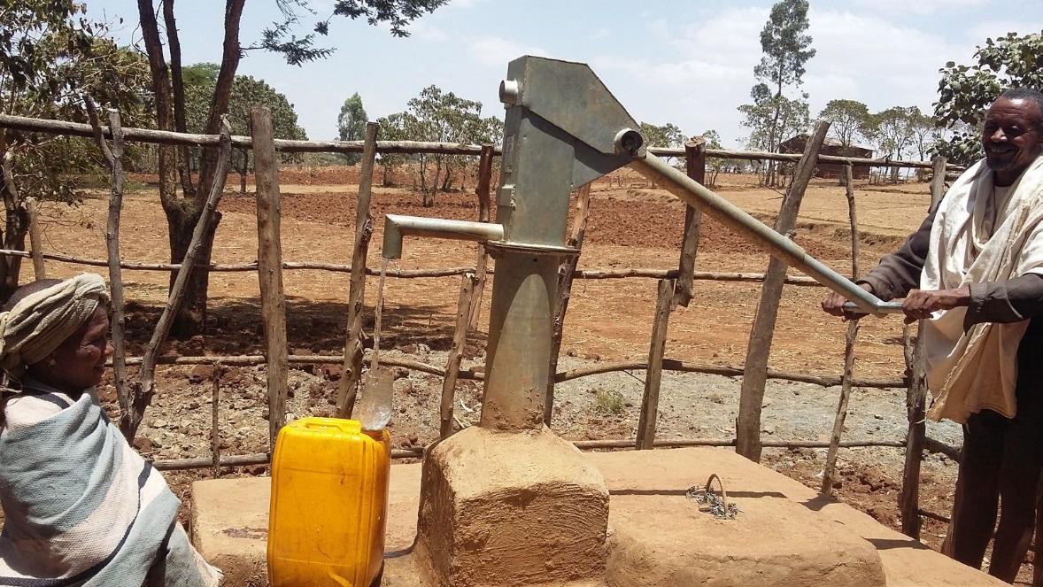
Women role models
Part of the AIRWASH project training was a visit by the couples to a nearby model community where women were already full participants in WASH decision making. This enabled them to see women in leadership positions, which was empowering for the female participants and informative for the men. Female role models give other women confidence to take on similar roles themselves because it encourages them to think ‘if she can do it, then so can I’. WASHCOs can provide examples of women role models where the female members of the committee take on the role of chairperson and not just the supporting roles of treasurer or secretary. Strong female role models may also be found among women in senior positions in government, business and other walks of life.

Improving education
WASH and education for girls are interconnected in several ways. Poor water and sanitation facilities at schools are one reason why girls tend to drop out of education before they have completed their schooling. If all schools had facilities that met the required guidelines this would improve school enrolment and attendance by both girls and boys.
If girls are successful in school and possibly continue to college or university they will be empowered by their education, be more independent in their life choices, have wider employment opportunities, and reach positions in society where they have more influence. Haile (2014) states that ‘educating girls is the single most effective tool for strengthening economic productivity’.

Financial support
The challenges faced by women in society often make it difficult for them to break out of their traditional roles. However, there are many examples in Ethiopia of small-scale enterprises owned and run by women, which have been made possible by receiving financial support at the start. Case Study 3.3 is one such example.
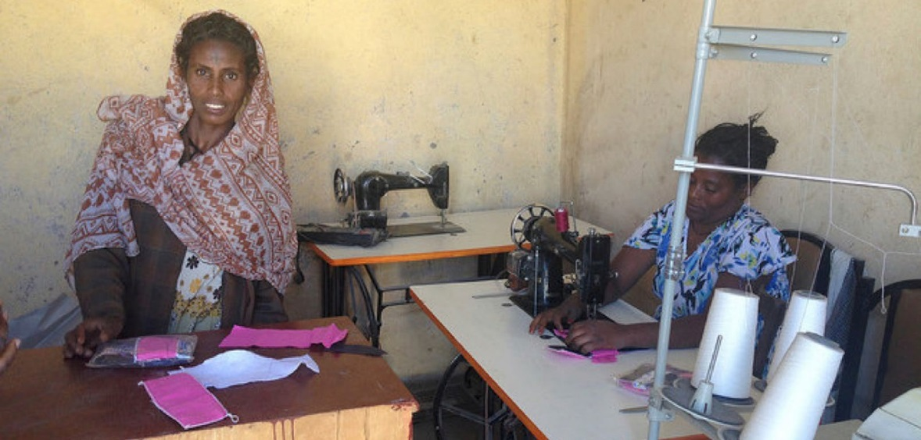
Case Study 3.3 Wukro women in business
In the town of Wukro in the Tigray region, Helen, Meaza and a friend have started up a new business making and selling reusable sanitary pads (Figure 3.4). Their enterprise is supported by a WASH programme implemented by UNICEF with World Vision. The women were chosen by a women’s association, trained by World Vision and then provided with sewing machines and materials. They are supplying seven schools with the washable sanitary pads and also sell them to local women.
The new business has multiple benefits for women. It helps girls and women by providing effective, handmade sanitary pads that can be washed and re-used. It also generates income for the three women entrepreneurs.

Figure 3.4 Meaza, on the left, shows the sanitary pads while Helen, on the right, sews another one.
(Adapted from Carazo, 2017)

Monitoring gender equality and women’s empowerment in WASH
Monitoring means collecting data to find out if progress is being made towards achieving an aim or objective. It is important because it enables evaluation of the success or otherwise of a strategy, project or other activity. People and organisations responsible for monitoring often use indicators as a means to collect useful data. An indicator is something that can be counted, measured or assessed and provides evidence of progress towards achieving a specific goal.
Data and indicators can be classified as either quantitative or qualitative. Quantitative data, as the name suggests, is concerned with measurable quantities such as total numbers, percentages, and averages. Qualitative data is not based on numbers but on assessments of people’s opinions, attitudes, values and beliefs.
Quantitative methods of data collection focus on what can be counted; common sources are censuses, surveys and administrative records. Typical sources of qualitative data are interviews and focus group discussions.

Gender equality indicators
A ‘gender-responsive’, ‘gender-sensitive’ or ‘gender-related’ indicator measures changes relating to gender equality over time (Demetriades, 2009). Gender equality indicators can be quantitative, based on sex disaggregated statistical data or they may be qualitative, for example attitudinal changes to gender equality. Examples of quantitative indicators are male and female wage rates or school enrolment rates for girls and boys. Qualitative indicators might include an assessment of women’s
experiences of lack of sanitation facilities, or men’s and women’s views on the causes and consequences of domestic violence.
- What are ‘sex disaggregated data’?
- Sex disaggregated data are data that are collected and recorded separately for male and female members of a population.
All indicators should be disaggregated by sex wherever possible so that the different experiences of men and women can be known. However, data for gender-related indicators are not readily available (Haile, 2014). Beyene (2015) provides a national assessment of participation of women and girls in the ‘knowledge society’ in Ethiopia. Her study collates quantitative and qualitative data from many sources about variables such as women’s health status, social and economic status, women’s access to resources, access to opportunities, level of political participation and access to science and technology education, among many others. However, for several of the topics Beyene comments that sex disaggregated data is scarce. As we have noted earlier, very little information is available that is disaggregated by both sex and disability even though the experiences of disabled men and women are different.
How can this situation be changed? In accordance with the general policy of gender mainstreaming, gender-related indicators can be incorporated into any policy, programme or project. The National Guidelines (MoWA, 2010) include recommendations for monitoring and evaluating gender mainstreaming for policies, organisations and programmes. Table 3.1 shows a small extract from these guidelines for the activity stage at programme/project level.

Table 3.1 Extract from the National Guidelines for Gender Mainstreaming (MoWA, 2010, p. 56).

Checklist | Indicator
Does the activity planning phase involve both women and men? | Proportion of women and men involved in planning phase
Are there specific activities included to ensure gender equality and women’s empowerment (GEWE)? | Specific activities planned to ensure GEWE
Are the planned activities considering the household workloads of women? | Women's workloads considered in the planned activities
Are the planned activities data sex disaggregated? | Sex disaggregated data incorporated in the planned activities
Do the programme/project implementers receive gender-mainstreaming training so that a gender perspective is sustained throughout the implementations process? | Type and number of gender mainstreaming trainings given to implementers
Do women and men from the community participate equally in the implementation? | Number and proportion of women and men participated from the community

In WASH, the One WASH National Programme has two gender-related indicators within its results framework that are assessments of the proportion of women on WASHCOs/ Hygiene and Sanitation Community Groups and on Water Boards (committees with responsibility for water utilities). In both cases, the indicator is the percentage of committees with 50% of their members being women in decision-making positions (FDRE, 2013).
There are quantitative and qualitative elements to these indicators. The quantitative element is to find out how many committees have women as at least half of their membership. But it is more difficult to assess their role and position. Researchers could ask questions such as ‘what percentage of committee chairpersons are women?’ or ‘what percentage of WASHCOs have all leadership positions filled by women?’ But these questions would not assess the level of participation by all the women members. This is where qualitative indicators can help to show whether women’s participation is just a gesture or is active and meaningful (RWSN, 2016). One approach to improving the monitoring of gender in WASH could be to create more detailed checklists, developed from lists similar to the extract in Table 3.1, but with questions specific to WASH and with qualitative as well as quantitative indicators.

Summary of Study Session 3
In Study Session 3, you have learned that:
- Sex is a natural attribute that identifies a person as male or female. Gender is a social attribute ascribing some characteristics or norms and modes of behaviour to men and women.
- Traditional gender roles result in men and women not being treated equally even though they have the same human rights.
- Gender inequality is a major issue in WASH. Women are usually responsible for fetching water and inadequate sanitation has greater impact on them than men, and yet they are excluded from decision-making processes.
- In Ethiopia, gender mainstreaming is government policy, but this has not had a significant impact in practice.
- Women’s empowerment means enabling women in a number of ways to overcome gender discrimination and take control of their lives.
- Monitoring is important for assessing changes in gender equality. Both quantitative and qualitative data are needed but gender-related data is often lacking.

Self-Assessment Questions (SAQs) for Study Session 3
Now that you have completed this study session, you can assess how well you have achieved its Learning Outcomes by answering these questions. You can check your answers with the Notes on the Self-Assessment Questions at the end of this Module.

SAQ 3.1 (tests Learning Outcomes 3.1 and 3.2)
Rewrite the paragraph below using terms from the list provided to fill in the gaps.
gender; gender equality; gender mainstreaming, menstrual hygiene management; triple role; women’s empowerment
Women have the burden of a …………… in society that expects them to do unpaid work at home, productive work that brings in money, as well as contribute to community life.
In WASH, women are at a disadvantage because traditional …………. roles assume men are the leaders so women are excluded from discussions and decision-making processes about WASH, even though they are the main users. The needs of women and girls are often disregarded in schools where latrine facilities, if they exist at all, are not designed according to guidelines and lack facilities for …………………….. Despite government ……………………… policies and growing awareness of the benefits of
……………………………, there is still some way to go to achieve ………………… in Ethiopia.

SAQ 3.2 (tests Learning Outcome 3.3)
Genet was married at the age of 20. She took care of her family every day, starting at 6 a.m. While looking after her baby girl, she prepared breakfast for her husband before
he went to work. Then she went to fetch water and had to walk more than 3km to reach a source of clean water. When it came to decision making, her husband took the lead in everything.

Her life changed when the woreda administration started working with an NGO to address the challenges for women in the community. They built a water point nearby and provided training in assertiveness skills for women. They also engaged respected religious and community leaders in a dialogue about getting women involved in decision making. These opportunities gave Genet’s life a new dimension. She was able to teach her husband to share responsibilities at home and most importantly could access WASH facilities safely and easily. Community members noticed Genet’s transformative actions and appointed her to the WASH committee with responsibility for empowering other women to participate in meetings, community dialogues and campaigns to support women in the community.
What elements in this story demonstrate Genet’s empowerment?

SAQ 3.3 (tests Learning Outcomes 3.1 and 3.4)
What is the difference between quantitative and qualitative indicators? Explain, with an example, why both are necessary for monitoring gender equality.

Study Session 4 Inclusive WASH Facilities

Introduction
In Study Sessions 1 and 2 you were introduced to the challenges facing people with disabilities and the barriers to inclusion. In Study Session 3 you also learned about the different WASH issues affecting women. You may recall from Study Session 1 that many national policies and programmes state that services should be available ‘for all’ without going into further detail about how this could be achieved. In this study session, we look more closely at practical matters and how to make WASH facilities inclusive for all.
You will learn about the features of appropriate inclusive WASH facilities for households and how to assess the accessibility and safety of existing facilities. The study session concludes with an outline of the process for planning and implementing inclusive WASH.

Learning Outcomes for Study Session 4
When you have studied this session, you should be able to:
  - Define and use correctly all of the key terms printed in bold. (SAQ 4.1)
  - Identify appropriate inclusive WASH facilities for households and institutions. (SAQs 4.2 and 4.3)
  - Carry out an accessibility and safety audit. (SAQ 4.1)
  - Describe the steps in planning and implementing inclusive WASH facilities. (SAQ 4.4)

What is an inclusive WASH facility?
From Study Session 1, you know that inclusive WASH facilities are safe, accessible and usable by everyone in the community.
- Who are the members of the community?
- Communities are made up of people of all ages and types, including persons with disabilities of many different kinds, elderly and frail people, children (who may also have a disability), pregnant women, injured people and people living with long-term illnesses including HIV/AIDS.
Any community is made up of people with different needs, and inclusive facilities are expected to address these needs. Thinking about what the different needs are and how they can be met is part of the process of making WASH facilities inclusive.
- If a public water point has a ramp, does that make it inclusive?
- No. A ramp is not the only feature of an inclusive water facility. A ramp would help wheelchair users and people who have difficulty with steps but this is not enough on its own. The facility would also need an even path leading to it, taps installed at different heights including some that could be reached from a sitting position, and possibly other features to make it usable by everyone in the community.

The practical requirements of appropriate and inclusive WASH facilities vary with the situation. For individual households, it is the needs of the family members that are important but for public facilities the needs of the whole community should be considered. The next two sections look at each of these in turn.

Appropriate and inclusive facilities for households
(Note: This section and Section 4.3 borrow from other sources for recommendations for inclusive WASH facilities. The main source, and recommended further reading, is the Compendium of Accessible WASH Technologies by Jones and Wilbur available from: https://washmatters.wateraid.org/publications/compendium-of-accessible-wash-technologies)

Access to water for households
In Ethiopia, a water connection from town waterlines to individual households is common in larger towns. People in these households have the benefit of a piped water supply on their premises. In rural Ethiopia, house connection is not common and even in urban areas a large number of households use water from communal facilities. This means that when we talk about appropriate, inclusive water facilities for households we are generally talking about communal water facilities including handpumps, protected springs and tap stands. The main features of inclusive communal water facilities are:
- Paths to and from the facility are wide and have a non-slippery surface.
- Concrete ramp (Figure 4.1), wide enough for a wheelchair (minimum 80 cm) and does not slope too steeply (not more than 1 in 12, see Study Session 2, Figure 2.5).
- The concrete apron around a handpump is broad and level, with plenty of room for wheelchair users.
- Fences must not block access.
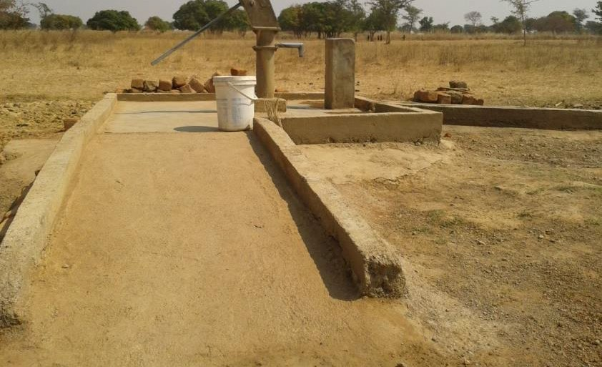
Figure 4.1 A wide ramp at a public water point.

- Apart from the slope and even surface, what other features of the ramp in Figure 4.1 makes it safer for users?
- The raised sides help wheelchair users and visually impaired people be aware of the edges and stop them rolling or falling off the ramp. There is also a pedestal on the right for resting a water container so lifting can be split into two actions by resting
midway through.

Access to sanitation for households
The specific requirements for household latrines will vary with the needs of the family members but it is worth thinking ahead to the future. The circumstances will change over time as babies are born and grow up, people may get sick or suffer injury, and inevitably grow old and may become infirm or have weak eyesight.
Recommendations for household latrines are:
- That they are located within 15 metres of the house with a clear, level path.
- To accommodate a member of the family who is visually impaired, guide string or rope can be stretched from the house to the latrine and to the handwashing facility (Figure 4.2). Alternatively, landmark posts (wood or metal) or large stones can be placed along the edges of the path. These can be painted white to make them more noticeable.
- Many people with physical impairments may need a larger floor area than usual and have handrails and a raised seat (see Section 4.3.2 and Figures 4.4 and 4.5).
- Handwashing facilities (water and soap) should be close to the latrine and positioned so that all household members can reach them.
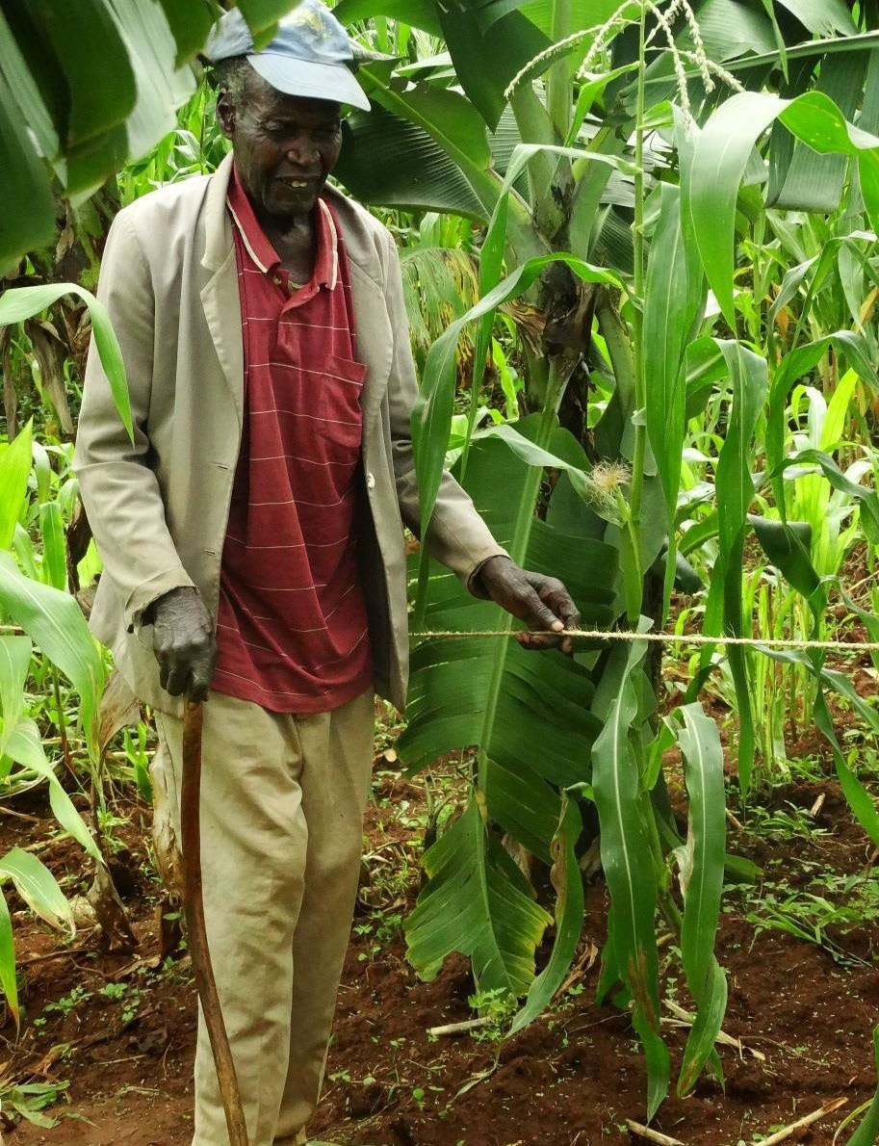
Figure 4.2 The guide string helps this visually impaired man find his way to the latrine.

In some places, if the land is sloping and space is limited, it may be necessary to have steps leading to the facility. As you read in Study Session 2, steps will always be a barrier to wheelchair users but they can be made less of a problem for others. Jones and Wilbur (2014) recommend:
- Steps should be low and deep from front to back.
- They should be regular in size, with height 15–17 cm and depth 28–42 cm.
- Concrete steps can be roughened or marked with cross-hatching while the concrete is still wet to reduce the risk of slipping.
- Steps should have a handrail on one or both sides.
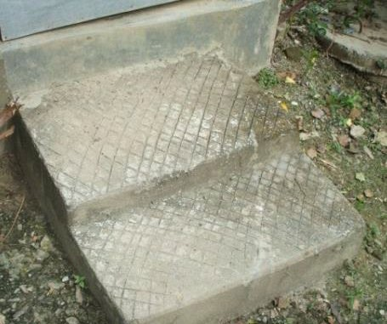
Figure 4.3 Concrete steps.

- Look at Figure 4.3. What features of these steps are good for accessibility? Can you recommend any improvements?
- The steps are low and deep and have cross-hatching in the concrete to make them less slippery. Possible improvements are a handrail to the side and a raised edge at the sides of each step.

Appropriate and inclusive facilities for institutions
Many of the required features for accessibility for institutions are the same as they are for households but it is even more important to include them in public facilities because of the variety of people in the wider community.

Access to water for institutions
Schools and health institutions may get their water from a well or handpump or they may have piped water supply to taps. The general accessibility requirements of a wide, even path, no steps, and gently sloping ramp will be familiar to you by now. In addition, for institutional water facilities, there should be a sufficient number of taps for all the users and these should be installed at different heights to enable persons with physical disabilities and children to reach them. This will allow access for handwashing as well as for drinking and other water uses.

Access to sanitation for institutions
Again, the basic principles of wide paths and level surfaces apply but for latrines in schools and health institutions there are additional requirements. Schools should have separate latrine blocks for boys and girls each with at least one cubicle that is accessible by students with disabilities. The recommended dimensions in the Design and Construction Manual are cubicle width of at least 1.5m with a door at least 90cm wide (Ministries of Health, Education and Water and Energy, 2012). In addition, girls,
including girls with disabilities, need appropriate menstrual hygiene facilities where they can safely and discreetly dispose of sanitary products and wash as required. Health institutions should have similar facilities for menstrual hygiene management. They also need to have facilities that accommodate all the different types of people who may visit including pregnant women, elderly people, people who are sick and may be weak, and people with many different types of impairment. The requirements are:
  - A wide door that can be opened and closed easily (Figure 4.4).
  - Enough space inside the latrine for wheelchair users or someone who uses crutches or someone who needs help from a carer.
  - Handrails at the sides of the toilet and possibly other supporting devices.
  - A seat for those who cannot squat (Figure 4.5).
  - Access to handwashing facilities with a water supply and soap.

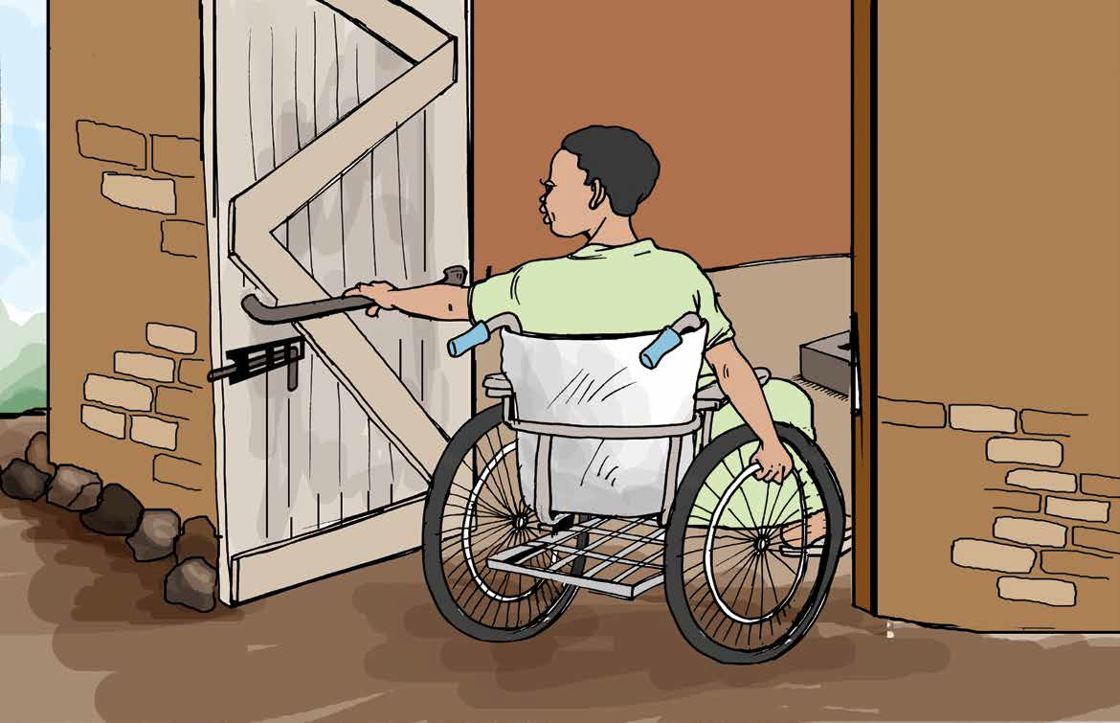

Figure 4.4 This toilet has several features that make it accessible for a wheelchair user. The door is wide, opens outwards, has a bolt for security and an inner handle so it’s easy to pull closed behind you. There is lots of space inside but no handrails are visible.
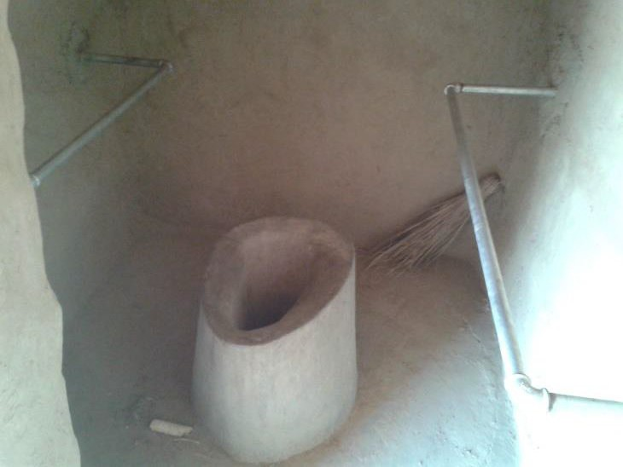

Figure 4.5 An example of a fixed seat with handrails. This would be helpful for many users but there is not enough inside space for a wheelchair user.

Accessibility and safety audit
Many existing institutional and household facilities are not inclusive but it may be possible to adapt them with relatively simple modifications. The first step is to assess the situation. An accessibility and safety audit is a tool used to evaluate water and sanitation facilities and identify possible adjustments and improvements. The audit includes both accessibility questions (how easy or difficult is it for people of all ages and

abilities to get to and use the facility?) and safety questions (is there something about the facility or a place on the path to it that may not be safe for some users, such as people who use crutches, girls, women and small children?).
The audit may be initiated by the service provider (government and non-government), NGOs, Disabled Persons Organisations (DPOs) or other stakeholders. However,
the auditing activity itself should be a participatory process involving the users of the facility as well as the providers. Accessibility and safety audits may be organised in a partnership arrangement between different organisations, for example a water bureau or NGO could partner with a local DPO (WaterAid/DDSP, n.d.). (You will learn more about participation and partnership in Study Session 5.)
The process described in the following sections may appear quite elaborate and require a lot of resources. It’s important to note that this may not be necessary. Auditing is a flexible process and can still be highly effective with a much lighter touch.

Steps in conducting an accessibility and safety audit
Figure 4.6 suggests the main steps to take. Each of these steps is described in more detail below.
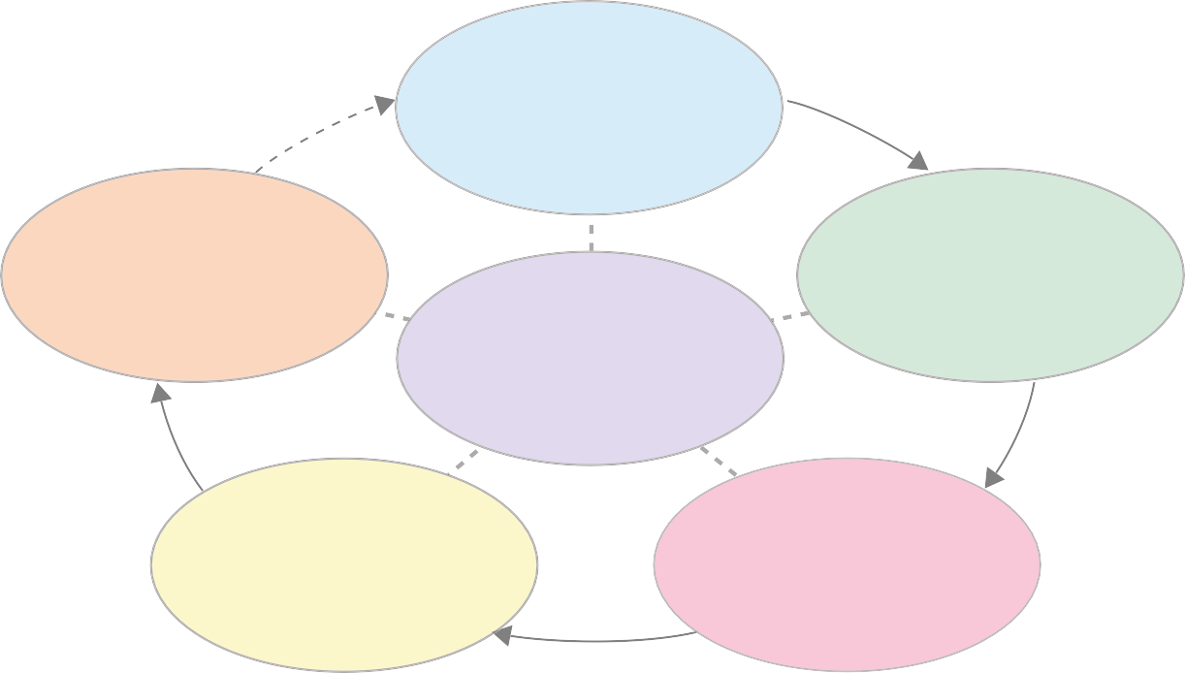
Step 1

Preparation (select facility, form
audit team)
Step 5

Make changes/ develop solutions
Conducting an accessibility and safety audit
Step 2

Assess the path to the facility
Step 4

Analyse problems
Step 3

Assess the facility

Figure 4.6 Steps in an accessibility and safety audit.

Step 1 Preparation for the audit process
The first step in preparation is identifying the facility to be audited, which could be a water point or latrine at household or community level, or within an institution such as a school or health centre/post. You can also use the same basic process to audit accessibility in any public building or office.

Preparation also includes selecting the team of people to conduct the audit and the key aspect is ensuring all the different users are represented. The audit team should include people of different ages, genders and abilities, as appropriate for the facility
being audited. For example, for community facilities this should include men and women of different ages, children, and people with a range of impairments including those who use a wheelchair or crutches, and people with visual impairments. For a school water point, the team could include teachers, other staff, students (boys and girls) with and without disabilities, a representative from the local education office, and the school director. If possible, it may also be helpful to include engineers who have the capacity to design the facility based on the information obtained from the audit process.
- If you were organising an audit team for a rural health post, who would you want to be included in the team?
- You would need to include the health extension workers based at the health post and representative members of the community: men and women, old and young including children, persons with disabilities of different types, and pregnant women. You could also involve engineers and officials from the water or health bureau.
Once the team is decided, they will probably need some training. This need not be complicated but everyone must understand the purpose of the audit and what
they are expected to do. For a larger team, there are specific roles to be allocated, either by asking for volunteers or assigning roles to individuals. The roles include the coordinator (who may be you!), measurer, interviewer, note-taker, drawer of diagrams, and photographer. You may also need to consider asking someone to represent a type of user who is not available for the team. For example, frail older people may not be able to participate in the audit themselves but someone else could have the role of considering their needs.
Table 4.1 shows the items of equipment needed for the roles in a larger team. Some other items may sometimes be useful. For example, if there is no wheelchair user in the team, a wheelchair could be used by a person without a disability for the audit activity.
Table 4.1 Team roles and equipment (WEDC/WaterAid, 2014).

Role of team member | Equipment
Co-ordinator | Notebook and pen
Interviewer | Notebook and pen/voice recorder
Note taker(s) | Notebook and pen each
Measurer | Tape measure
Drawer of diagrams | Notebook, pencil and eraser
Photographer | Camera

Note that a simpler audit can be undertaken by a smaller group without the need for as much equipment. For example, distances can be measured by pacing out or using a stick rather than using a tape measure. A less formal assessment can be very effective if the task is approached by a small group with enquiring and open minds.

- If you are carrying out an audit of a community water point but you don’t have a visually impaired person in your team, how could you identify their accessibility and safety problems?
- You can ask someone from the team to cover their eyes with a cloth (blindfold) so they have a similar experience to someone who cannot see.

Step 2 Assess the path to the facility
The action starts with assessment of the path that leads to the facility. The audit team walk or wheel along the path and make notes about who can access the facility and who cannot, and what the difficulties are. Questions to be considered include:
  - What is the path made of?
  - How wide is it? Is it wide enough for all users?
  - Is the path clean and clear of debris such as fallen branches that could trip people up?
  - Are slopes too steep?
  - Are there parts of the path which make girls, boys or women feel unsafe? If so, what is the cause and what could be done about it?
Notes in answer to the questions are made by the note taker as the team progresses. In assessing the path make sure the challenges for everyone in the team are noted. The measurer, photographer and diagrammer also do their part as the team moves along.
The interviewer can ask questions of users who are not part of the audit team and record their responses too. Any suggestions for improvements should be recorded. It’s important to take a note of suggestions as and when people make them because they may be forgotten later.

Step 3 Assess the facility
In this step everyone in the team checks out how easy or difficult it is for them to use the facility itself. As before, notes, measurements, drawings and photographs should be taken. Questions for this step will be different for water points and latrines and will vary with the needs of the location (school, health centre, etc.). These are some example questions for auditing latrines:
  - If there are steps, are they a manageable height? Is there a handrail for support?
  - Is the entrance flat and wide enough for a wheelchair user to enter?
  - Is there a secure door? Is it easy to open? Does it open inwards or outwards?
  - Inside, is there a raised seat? Are there handrails for support? If yes, are they positioned appropriately? Are they at the right height?
  - What are the dimensions of the space inside each cubicle?
  - Are the latrines clean (floors, walls, doors)?
  - Do all groups of people feel safe when using the latrine? (particularly adolescent girls, women and children of different ages)
  - Are there facilities for girls and women to dispose of sanitary protection waste? And washing facilities for menstrual hygiene?

- Is water available for handwashing? Is there soap? Can water and soap be reached by someone sitting in a wheelchair? And by a small child?
Note that in answer to these and similar questions about physical accessibility problems, it is advisable to be as precise as possible because details will help when identifying solutions for the problem (Jones, 2012). For example, terms like ‘not accessible’ are unhelpful but specific notes such as ‘slope of the ramp is too steep’ or ‘handrails are too high’ are much more useful, and even more so if measurements are included.

Step 4 Analyse the problems
When the assessment is complete, the audit team meet to bring together the various notes and other records. They discuss the results and make a list of all the problems encountered. The team can then move on to the next step of finding solutions.

Step 5 Make changes and develop solutions
Some suggestions for change will have been noted during the audit, other solutions may emerge from discussions afterwards. One thing to keep in mind is whether suggested solutions are feasible. Local circumstances including the nature of the location and the availability of funds may make some options unrealistic, at least at the current time.
One way to manage the process of identifying feasible changes is to group them into short-term, medium-term and long-term options. Short-term solutions are those which can be done immediately or that do not need further planning and allocation of resources. Examples could be removing debris from a path or adding a guide rope leading to a latrine. Medium-term solutions need some planning and resources.
Examples here include putting in a handrail or installing a ramp and, if funds are available, could be more. For projects that are already in progress with a fixed budget, it may be possible to make adjustments by shuffling resources from one budget line to another. Long-term solutions are more substantial and require consultation with the community, planning and allocation of adequate resources.
Conducting accessibility and safety audits can bring other longer-term benefits. The process can change attitudes and awareness among participants, including the service providers. This can encourage change in the policies and procedures of a given organisation and help them shift from conventional service provision to inclusive service provision.
Some time after the audit is completed and changes have been made, it is advisable to return and repeat the process to check that the situation has improved. This is indicated in Figure 4.6 by the dotted arrow from Step 5 back to Step 1.
(Note: This description of accessibility and safety audits is adapted from resources prepared by WaterAid and the Water, Engineering and Development Centre (WEDC) at Loughborough University in the UK. For further details including worksheets for
conducting audits go to https://wedc-knowledge.lboro.ac.uk/collections/equity-inclusion/ general.html)

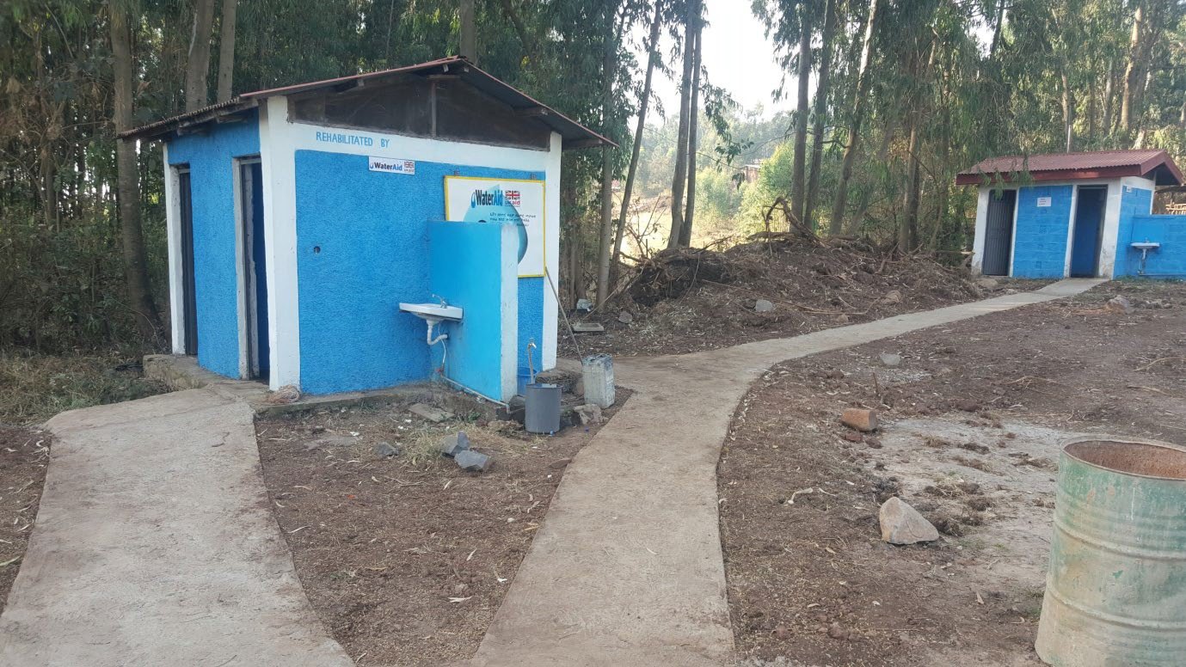
Figure 4.7 Latrine and handwashing facility at a health centre.
- Is the facility in Figure 4.7 inclusive? Explain your answer.
- It has some features of inclusive sanitation, that is, a level concrete path but there appears to be a small step up from the path into the latrine. Also, it would not be convenient for wheelchair users to use the handwashing facility because the path does not extend to the washbasin. In addition, there are no markers on the path to help visually impaired people to follow it.

4.5 Steps in implementation for inclusive WASH
Although there are government guidelines for the design of inclusive WASH facilities for schools and health institutions, these recommendations are frequently not followed. There is a widespread lack of awareness of inclusive designs and why these are needed among WASH sector actors responsible for planning and implementing new WASH services including government offices at all levels and many NGOs. Even if they are aware, these people frequently have a misplaced belief that design modifications
to improve accessibility will be expensive. In fact, if the changes are incorporated into the design from the start, the costs are usually minimised and only a small addition to the total budget may be required. For example, the additional costs of making a school latrine accessible have been found to be less than 3% of total costs (Jones, 2011).
The recommended steps for implementing inclusive WASH are as follows.

Step 1 Planning
Generally, bottom-up approaches to planning will be more inclusive than top-down methods. Top-down means decisions are made at higher levels of governments and organisations, and are largely guided by the availability of resources. A bottom- up approach to planning originates at community level and provides a chance for local demand or development needs to be recognised. Planning offices at all levels
(federal, regional, zonal and woreda) should find ways to enable excluded people, or organisations representing them, to proactively participate in the planning process. For example, a district Finance and Economic Cooperation office may organise a planning team that includes representatives from WASH offices and DPOs.

One tool that can contribute to inclusive planning at community level is the accessibility and safety audit. Findings from these audits can be used to raise awareness among the planners, decision makers and the community at large.

Step 2 Design
At this stage, the WASH service provider should refer to the government guidelines and construction manuals for design specifications for water and sanitation facilities. They should also think of engaging persons with disabilities in their discussions about the design. Again the findings from an accessibility audit would be very helpful to initiate such discussion. With input from suitably trained and qualified designers and engineers, inclusive features like the ones described in Sections 4.2 and 4.3 should be considered at the earliest stage. As noted above, incorporating inclusive design features at this stage will keep costs to a minimum.

Step 3 Procurement and contract
When the design has been decided, the next step is the procurement (buying) of the equipment, materials and services required for construction of the WASH facility. For example, the service provider will identify items to be purchased such as pipes, taps, cement, and slabs and they may need to add handrails, seats and ramp materials to their list.
The procurement team will also prepare the contract to be signed with the construction company. It is important that the contract includes details of all the inclusive features that have been specified under Step 2. The procurement team should also check whether the contractor (staff of the construction company) is fully aware of these features and has previous experience in constructing WASH facilities with inclusive design.

Step 4 Contract management
This step involves overseeing the construction process to ensure compliance with the contract specifications signed under Step 3. Contract management involves frequent and regular checking of the construction process, and if anything compromises the quality or deviates from contract specifications, the procurement team should take prompt action.

Step 5 Monitoring and evaluation
When the facility has been built, its function and accessibility should be monitored so that its effectiveness and the success of any inclusive design features can be evaluated. Joint monitoring visits involving both the provider and users are recommended.
Repeating the accessibility and safety audit of the newly constructed facilities is one of the tools that could be used. Sometimes details that nobody has noticed during the construction process may need to be changed to improve accessibility, for example door handles or gates opening in or out. If it is found that the facility does not meet the
accessibility specifications of the contract it may be necessary to withhold final payment from the contractor.

Summary of Study Session 4
In Study Session 4, you have learned that:
- WASH facilities are inclusive when they are safe to use and accessible to all.
- The main features of accessible WASH facilities are a wide and level path, an entrance with a ramp and enough space for wheelchair users.
- Specific requirements for inclusive water and handwashing facilities include taps positioned at different heights; for toilets they include cubicles with wide doors that open outwards, have sufficient space inside and are fitted with handrails and a seat.
- Healthcare institutions should have facilities suitable for older people and others who may be weak and infirm, for pregnant women and people of all ages with all types of impairment.
- Schools need separate sanitation facilities for boys and girls that are suitable for children of different ages and abilities. They should also include appropriate facilities for menstrual hygiene management by adolescent girls.
- An accessibility and safety audit is a participatory tool used to identify problems associated with WASH facilities and to generate ideas for solving the problems.
- There are five steps in conducting an accessibility and safety audit: preparation, assess the path, assess the facility, analyse problems and make changes or develop solutions.
- Implementation of inclusive WASH should involve all users of the facility. Inclusive design features should be incorporated from the start of the process.

Self- Assessment Questions (SAQs) for Study Session 4
Now that you have completed this study session, you can assess how well you have achieved its Learning Outcomes by answering these questions. You can check your answers with the Notes on the Self-Assessment Questions at the end of this Module.

SAQ 4.1 (tests Learning Outcomes 4.1 and 4.3)
- What is the objective of an accessibility and safety audit?
- Why is it described as a participatory process?
- Outline the steps in conducting an accessibility and safety audit.

SAQ 4.2 (tests Learning Outcome 4.2)
Imagine you are a part of a team that helps communities and institutions conduct accessibility and safety audits and gives advice on possible actions to take.
- The 90-year old grandfather in a family is frail and has lost his sight. The family is planning a new latrine. What features do you advise them to include in the
new facility?
- A health centre plans to modify its sanitation facilities. What is your general advice to make a health institution sanitation facility inclusive?

SAQ 4.3 (tests Learning Outcome 4.2)
Look at the latrine block in Figure 4.8. What features of this facility make it inclusive? Are there any features that are not inclusive?
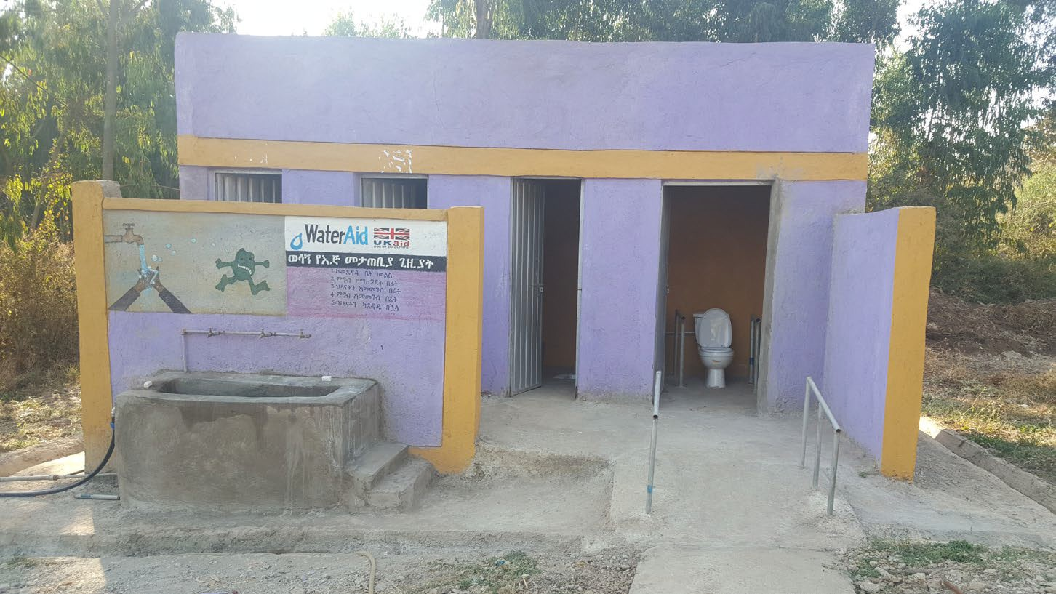

Figure 4.8 Latrine block at a health centre.

SAQ 4.4 (tests Learning Outcome 4.4)
- Imagine you are an advocate for inclusive planning and you got a chance to meet with the water and health planning office. What would you like to discuss
at the meeting?
- Imagine you are a procurement head and it is your responsibility to review the contract documents for a new facility before they are signed. Outline what you should check while reviewing the contract.

Study Session 5 Participation and Partnership

Introduction
You will know from the previous study sessions that one of the most important principles of inclusive WASH is that people who would have been excluded in the past should be fully engaged and involved in all stages of the process of developing WASH services.
In this study session you will learn about some of the ways in which engagement and participation can be achieved.

Learning Outcomes for Study Session 5
When you have studied this session, you should be able to:
  - Define and use correctly all of the key terms printed in bold. (SAQs 5.1 and 5.2)
  - Explain why meaningful participation in decision making is needed. (SAQ 5.2)
  - Describe techniques for including everyone in community engagement processes. (SAQ 5.3)
  - Identify factors affecting the sustainability of inclusive WASH. (SAQ 5.5)

Meaningful participation
In Study Session 1 you learned that inclusion in WASH means not only being able to access WASH services but also being able to participate in decision-making processes about those services. Participation means taking part or being involved in something, usually a decision or activity. Community participation, therefore, is a process of involving a community or its representatives in activities that have direct or indirect consequences on their lives.

Participation and meaningful participation
Why do we need to talk about meaningful participation? Sometimes so-called ‘participation’ does not actually succeed in allowing the people affected to be heard. Even if people are physically present at a meeting it does not mean they will feel confident to speak, or that others will listen to them and respect their views (Figure 5.1). Participation should be more than just passive listening, being the subject of data collection or providing labour.

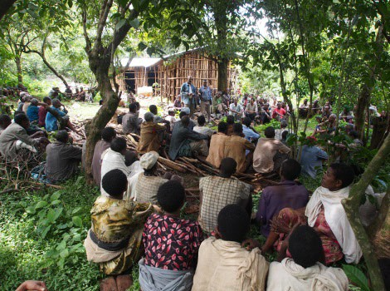
Figure 5.1 Community meetings are one way of sharing information but the people listening are not actively participating.
In the WASH sector (and many others), there are ineffective participatory processes practised by service providers including government and non-government organisations. For example, an NGO may organise a community meeting and present the plans for a new project, but this does not allow the community to actively engage in the planning process. The community is shown the plan but they are not invited to change anything or be involved in decision making.
For changes to have positive impacts, it is a necessary condition that community representatives actively participate in the whole process – from initiating ideas to evaluating the outcomes. The community is in the best position to identify problems and formulate solutions and it may need some extra effort to ensure they are included. For example, you may need to consult separately with women to make sure they feel comfortable discussing their views freely, or make special efforts to seek out the views of people with disabilities. Meaningful participation, therefore, occurs when everyone in the community actively contributes to the planning, decision making, implementation and monitoring of a project.
- Mamitu, 80, has almost given up hope of having a latrine that she can use with comfort and dignity. Fortunately, an NGO supporting old people has come to her village and identified her as one of the beneficiaries. She is told the NGO has a plan for her. What is your advice to the NGO?
- Your advice should be to ensure the NGO involves Mamitu in the process by asking her to identify the problems she has had accessing the existing latrine. She should also be part of the solution, which means participating in designing the new latrine facility so she can access it easily.

Benefits of participation
The benefits of participation are closely linked to the benefits of inclusion that you read about in Study Session 1. If people participate fully in the water and sanitation planning and decision-making process, it will bring about change in them as people and to the community and the country in terms of improving health and productivity.
It also contributes to the sustainability of new services because when you are part of the process, you own it and care for it. Meaningful participation produces better, more successful outcomes, as illustrated in Case Study 5.1.
[
Case Study 5.1 Bayu Muluneh and the borehole for Alefa village
Alefa, a village in rural Amhara, had not had a water supply nearby for nearly a century. Many agencies came to Alefa to develop underground water, but they were not successful; the drilling failed many times because they could not locate a site where water is available. Bayu Muluneh, aged 71, had almost lost hope of seeing safe water flowing through the tap in his village.
Two years ago a team from WaterAid and Water Action came to his village and asked elders, including Bayu, to help them select the site for drilling the borehole. The elders knew about sites where there had been springs many years before, but the springs had dried up because of changes in the climate. Based on this indigenous local knowledge, the team conducted further studies, and when
they drilled the borehole they found a reliable water supply. Without the active participation of the elders in site selection, their efforts would have failed again.

Making community participation inclusive and accessible
Community participation is a common practice in rural areas when a given service provider, be it government or non-government, is planning to implement a project. This participation aims to introduce the project activities and mobilise communities to take part in the implementation process either by providing labour, as shown in Figure 5.2, or by making cash contributions. However, as noted above, this process is not always meaningful participation and frequently, it is not inclusive either. There are a number of possible reasons for this including:
  - It does not involve representatives of all sections of the community.
  - It does not involve community representatives in the planning and decision-making parts of the process.
  - Even if people are present they may not be able to influence decisions because of the attitudes and beliefs of others, for example gender norms that mean women’s views are considered less important than men’s.
  - The meeting place may not be physically accessible to everyone.

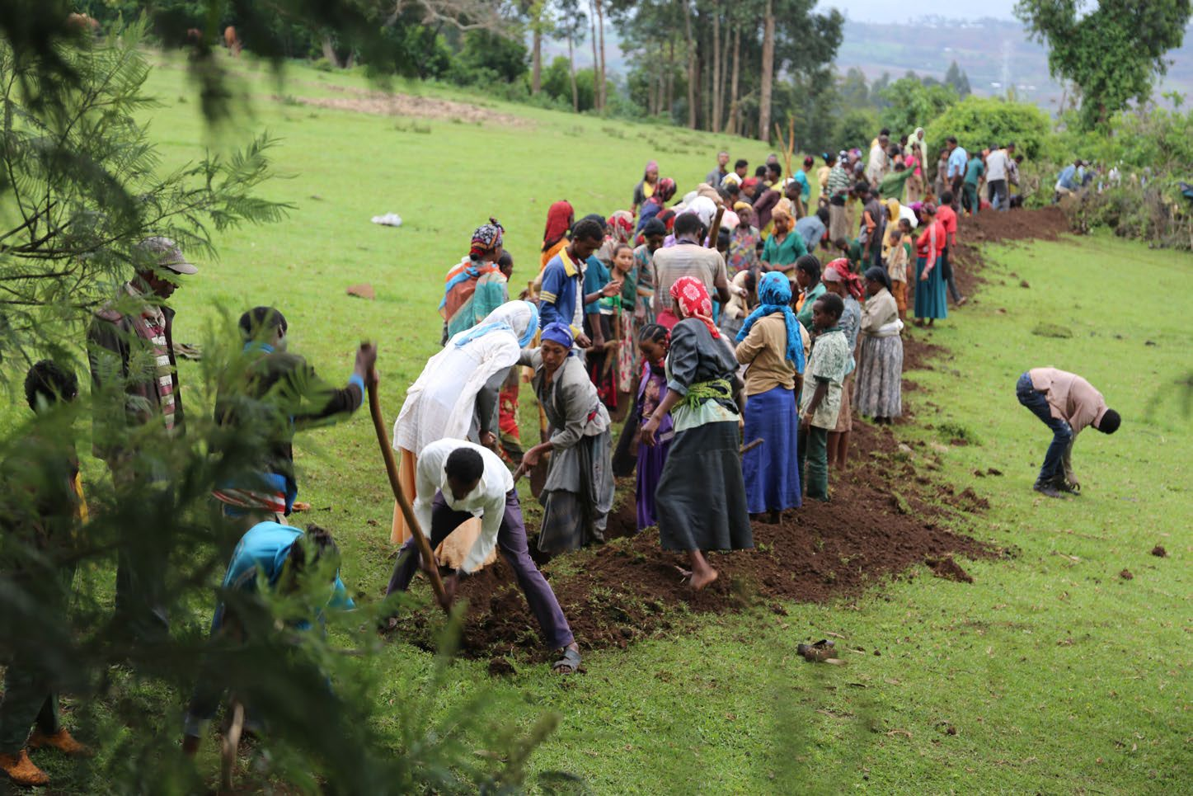
Figure 5.2 Community members provide their labour to dig a trench for their new water supply.
To illustrate how existing community participation practices could be transformed into inclusive participation, we have chosen examples from Ethiopia’s national approaches to promote safe water, sanitation and improved hygiene practices at community and institutional levels. These are Community-Led Total Sanitation and Hygiene (CLTSH), water, sanitation and hygiene committees (WASHCOs) and school WASH clubs. These approaches by their nature involve communities. Working further on these approaches can make community participation inclusive and accessible.

Community-Led Total Sanitation and Hygiene
Ethiopia has adopted Community-Led Total Sanitation and Hygiene (CLTSH) as a national tool to promote total sanitation. It aims to change the behaviour of everyone in a community to stop open defecation and encourage good hygiene practices. The goal is to achieve Open Defecation Free (ODF) status for the community where everyone has access to a latrine and no one defecates in the open at any time. The Federal Ministry of Health has published guidelines for implementing CLTSH. The process, outlined in Box 5.1, should be conducted by trained facilitators.

Box 5.1 CLTSH process
There are three main stages in CLTSH: pre-triggering, triggering and post-triggering (Kar and Chambers, 2008; FMOH, 2012).

Pre-triggering stage
At this stage, community representatives and the CLTSH facilitator discuss and agree a convenient time and place for village triggering and make plans for the whole process.

Triggering stage
The whole community gathers to discuss concerns relating to open defecation (OD). Together, the facilitators and community members make a transect walk. A transect walk entails walking through a village from one side to the other, observing, asking questions, and listening to the replies (Kar and Chambers, 2008). The purpose is to identify sites used for OD, hence the alternative name of shame walk, and to note the locations, types and conditions of any existing sanitation facilities.
Then the facilitators and community together prepare a map of the local area showing households, institutions and OD sites and helps everyone to understand the scale of the OD problem and the associated health risks (Figure 5.3). With the facilitators, they calculate how much human excreta they produce, known as ‘the shit calculation’. Triggering refers to the moment, also known as the ‘ignition moment’, when the whole community shares a sense of disgust and shame about
open defecation. The facilitator helps them to come to the realisation that they quite literally will be eating one another’s faeces if open defecation continues.
The end of the triggering phase is agreement on actions to be taken. The action plan should have an agreed schedule and set of activities that everyone in the community commits to, including the construction of latrines with handwashing facilities and a commitment from everyone that they will use the new facilities at all times. A CLTSH committee of community representatives should be formed to take the process forward.

Post-triggering stage, including verification
The post-triggering stage is when the agreed plan is put into effect. The community may need additional support and training for construction of new facilities and for behaviour change in sanitation and hygiene practices. In this phase, a supervisory team will be formed to conduct routine monitoring and evaluation. They monitor the changes through review meetings, periodic reports, observations and interviews.
Verification is the stage when the village is assessed to find out if everyone is now using a latrine and washing their hands. Confirmation that open defecation has stopped and the certification of ODF status is a cause for celebration for the whole community.

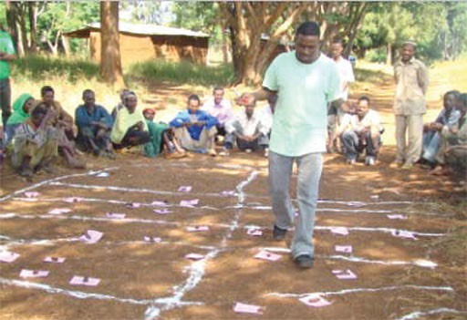
Figure 5.3 Producing a map of defecation areas during the CLTSH process.
In the CLTSH process, all households (men, women and children) and institutions (religious and social institutions) in a village should be included. However, to be truly inclusive it is essential that all members of the community are full participants, including people with disabilities and other marginalised groups (House et al, 2017). Although not specified in the FMoH guidelines, the process should go beyond general community participation and ensure that every group in the community is fairly represented and able to participate from the start.
- For each of the three stages of CLTSH, can you suggest ways the process could be made more inclusive?
- You may have thought of the following:
  - Pre-triggering: (i) Include a deliberate step of considering the needs of different people in the community and agree on how to engage everyone in the whole process. (ii) Discuss the subject with women of different ages separately, without men present, to see if they have specific concerns about safety and privacy, and to find out their perspective.
  - Triggering stage: (i) Transect walks, mapping and other activities must involve representatives of the whole community including persons with disabilities (that is, physical, intellectual and sensory impairments), elderly people (men and women), pregnant women, women and adolescent girls, children, and people with long-term sickness. (ii) Action plans must incorporate the different needs of all marginalised groups. (iii) The CLTSH committee should include persons with disabilities as members.
  - Post-triggering: Persons with disabilities and representatives of any other marginalised groups should be part of the survey team for verification.

WASHCOs
It is a requirement in the One WASH National Programme that women are well represented and elected to serve as officers of WASHCOs (FDRE, 2013). Furthermore, it is stated that 50% of WASHCO members should be women in decision-making positions (Figure 5.4). Despite this national policy requirement, many WASHCOs have not achieved this target.
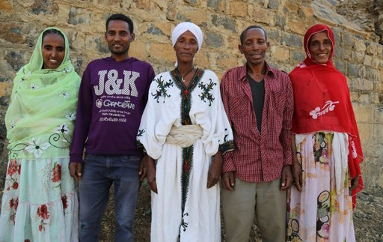
Figure 5.4 WASHCO members: the Chair and Treasurer of this WASHCO are women.
- What reasons for the limited progress towards gender equality in WASHCOs can you think of?
- There are several possible reasons including:
  - The unequal power between men and women and assumed gender roles.
  - Lower levels of literacy and education of women so they may need additional training in literacy or book keeping to be able to play a more significant role.
  - Women do not feel empowered to challenge the system and put themselves forward.
Unlike the policy for women, there is no stated requirement to include persons with disabilities and other marginalised groups as members of WASHCOs. The criteria for establishing WASHCOs should be revised to explicitly include these groups. However, changing policy in this way is not quick or easy, and would need concerted effort by key stakeholders at national and lower levels, as well as increased awareness and changed attitudes among community members.

School WASH clubs
Supported by national policy, school WASH clubs are established by teachers and students to promote safe water and improved sanitation and hygiene practices in schools. They also encourage boys and girls to change their practices and share those changes with their families when they go back to their homes.
Where policy is being implemented effectively, and where there are NGO interventions, the participation of girls in the different clubs including WASH clubs is excellent.

The National School WASH Implementation Guideline specifies that five boys and five girls should serve as leaders for the WASH clubs, of which one boy and one girl should be representatives of students with disabilities (MoE, 2017b). However, this policy is not always adhered to, and greater effort is needed to encourage schools to follow the guidelines.

Changing attitudes to excluded people
From your study of this module you know that changing society’s attitudes to marginalised groups is a fundamental part of making progress towards inclusive WASH. This section looks more closely at how those attitudes might be changed.

Existing attitudes
Planners and decision makers exclude people, partly because their policies and the planning systems lack adequate consideration of marginalised groups, and partly because they lack knowledge of the conditions of these people in terms of access to safe WASH facilities. If considered at all, persons with disabilities are assumed to be insignificant. These negative attitudes are often shared by the wider community.
As you read in Study Session 3, attitudes to women can be dismissive and exclusive, and behaviour towards older women among some communities can be particularly shocking. They may be called witches and dishonoured rather than being supported and cared for, and they may be completely excluded from using communal facilities or participating in community gatherings. In some places menstruating women cannot attend religious meetings, as they are considered impure. This also includes attending community meetings, and therefore they are excluded from decisions that concern them.

Strategies for changing attitudes
Existing attitudes are perpetuated from generation to generation for no other reason than people accept the beliefs of their ancestors without questioning them. Challenging these bad attitudes is difficult, and change may not happen overnight; it requires commitment and persistence. In combination, the following strategies could be employed to try to influence people and change their thinking.

Collect evidence
To increase awareness, you need to have evidence to support the case that people are being excluded. This could be statistical evidence of the number of persons with disabilities of different kinds (i.e. data disaggregated by disability, sex and age), what factors contributed to their exclusion, and recommendations on how they can be included in the planning and decision-making processes that directly affect their lives. Evidence may also be available from an accessibility and safety audit. The output from the audit will provide details of the problems currently faced by persons with disabilities and how they might be resolved.

Raise awareness
Existing attitudes may result from a lack of relevant knowledge or thoughtlessness so a key part of changing them is to make people more aware of the situation of excluded people and the problems they face. This applies to people with disabilities and other marginalised groups and includes challenging assumptions about gender roles. This is where evidence can be helpful to support the argument that exclusion is wrong and inclusive WASH is a priority. There are many different ways to try to raise people’s awareness.
For communities: Evidence like that identified above could be presented to community meetings and included in the training of WASHCOs, CLTSH committees and WASH clubs. In the meeting, members of the local WASH Team (or members of the wider cabinet) could facilitate the discussion to help communities realise that persons with disabilities need safe WASH services for their day-to-day lives but face huge problems in accessing the facilities. It is also important for people with disabilities to be present at community meetings so they are more visible and can share their experiences with their fellow community members. However, they may need support to make sure they are able to be heard, and to make sure others listen to them.
To tackle people’s long-held beliefs about disability you could engage them in activities to convince them there is no link between disability and sin. For example, a woreda WASH Team, with the support of development partners, could identify a family that includes someone with a disability, provide incentives to encourage their participation and educate them that the cause of the disability is not the result of the wrath of God but something that could happen to anyone. Involving religious leaders in this process is of paramount importance.
For planners and decision makers: Studies to assess inclusion in WASH could be commissioned by planners to inform their decisions or can be conducted by development partners.
At public events: Major sector events such as the Multi-Stakeholder Forum and Global Handwashing Day can be used to promote the importance of inclusion in WASH planning and decision-making processes. Individual people with disabilities could be asked to give a speech where they could pass their messages to the wider audience.

Collaboration and partnership
All of the strategies described above are likely to be more successful if conducted in collaboration, either with individual people with disabilities, self-help groups, Disabled Persons Organisations (DPOs), women’s groups, or other organisations. This will ensure the real situation is understood including the problems faced in accessing WASH facilities and their associated risks, and how these affect daily lives. Partnering with like-minded individuals, groups and organisations will strengthen the effort to raise awareness and influence policies at national level, and change practices at lower levels.

Identify relevant stakeholders
How do you set about finding these like-minded individuals, groups and organisations? Working in partnership with others is more likely to succeed than the effort of any individual or organisation on their own, but first there is a need to identify the relevant stakeholders and potential partner organisations.

In Ethiopia there are six registered (DPOs) that belong to the Federation of Ethiopian National Association of Persons with Disabilities (FENAPD). FENAPD is an umbrella organisation that aims to improve coordination and collaboration between DPOs.
FENAPD’s mission statement is to help persons with disabilities to avert disability- related problems and improve their lives (FENAPD, n.d.).The six DPOs in FENAPD are:
- Ethiopian National Association on Intellectual Disabilities (ENAID)
- Ethiopian National Association of Persons Affected by Leprosy (ENAPAL)
- Ethiopian National Association of the Deaf (ENAD)
- Ethiopian National Association of the Deaf-Blind (ENADB)
- Ethiopian Women with Disabilities National Association (EWDNA)
- Ethiopian National Development Association of Persons with Physical Disabilities (ENDAPPD).
These DPOs also operate at regional level and, in addition, there are many CSOs and NGOs active in the regions and at other levels that have programmes and activities to support people with disabilities. One of these is the Ethiopian Center for Disability and Development (ECDD) which works in partnership with other organisations to promote disability mainstreaming in all aspects of life. The main areas of ECDD activities are shown in Figure 5.5.
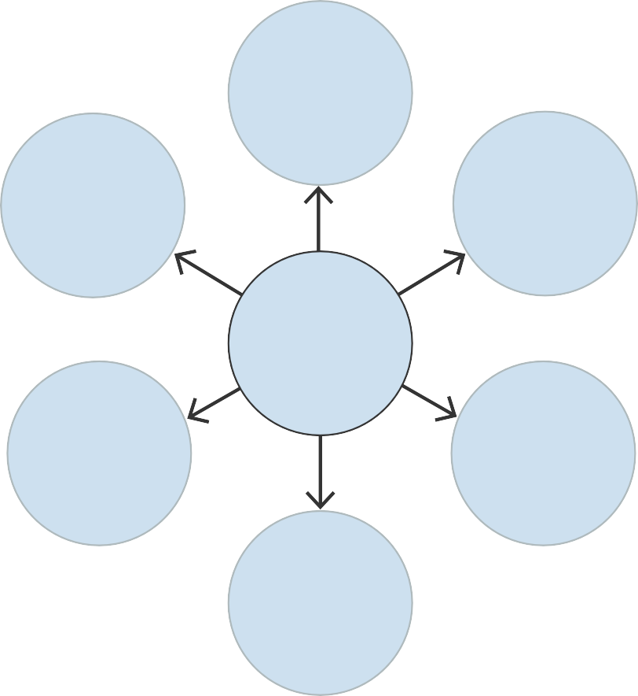
Inclusive employment services
Inclusive credit services
Inclusive representation and voice
ECDD
promotes
Inclusive skills training
Inclusive HIV/AIDS
services
Inclusive support services
Figure 5.5 The ECDD supports people with disabilities and promotes disability inclusion in several areas.

There are also national organisations promoting women’s rights and the empowerment of women. For example, the Organization for Women in Self-Employment (WISE), based in Addis Ababa, provides training, advice, access to micro-finance and other support to help women set up cooperatives and become successful entrepreneurs (WISE, n.d.).

Sustaining inclusive WASH
If and when inclusive WASH provision is achieved, it is important that it is sustainable or, in other words, that the systems and processes in place will continue to be effective into the future. There are many factors that can affect sustainability, many of which apply to all WASH provision. These can be categorised as financial, environmental, institutional, technological and social factors.

Financial factors
WASH services, whether inclusive or not, require some level of financial contribution to ensure their maintenance and sustainability. In Study Session 1 you read that affordability is one of the reasons why some people are excluded. To enable these people to participate in the process of making inclusive WASH facilities durable and long-lasting means providing support for them either to engage in income-generating activities or, if it is appropriate and necessary, exempting them from
financial contribution.

Environmental factors
Environmental factors affecting water facilities include water scarcity, which can result in wells drying up and is more likely if the wells were originally constructed during the rainy season (Addis, 2012). If this is due to poor site selection, the success of future water supply projects could be improved with proper hydrogeological surveys and by involving local people in the selection of sites. This may be older people, as you read in the story of Bayu in Case Study 5.1, and women because they know the water sources in their locality.

Institutional factors
Institutional factors include community management structure (e.g. WASHCOs), the availability of bylaws and guidelines. Most rural communities in Ethiopia have limited knowledge of these things so they require support and training to improve their awareness. WASHCOs need adequate information about how to engage with planning and budgeting processes at regional and woreda levels and how to hold responsible agencies to account.

Technical factors
Responsibilities for the operation and maintenance of water facilities are assigned to different tiers of government: major maintenance by the regional bureau, simple maintenance by the woreda water office and/or by enterprises engaged in water scheme maintenance; and minor preventive maintenance by the WASHCO or its assigned caretaker. Bottom-up reporting systems and accountability mechanisms and top-down management and technical support need to be strengthened to ensure sustainability.

Social factors
Social acceptance is a basic foundation for sustainability. If promotional activities result in acceptance of inclusive WASH among the society or community, it means that there is ownership of the facilities which in turn, contributes towards ensuring sustainability.
Sustainable inclusive WASH for all is the goal that all WASH sector actors should be aiming for. It requires greater knowledge and awareness of the challenges of inclusion, as well as commitment and persistence from all those concerned. We hope that your study of this module will help you contribute to achieving this goal.

Summary of Study Session 5
In Study Session 5, you have learned that:
- Meaningful participation occurs when everyone in the community actively contributes to all stages of a project.
- If people participate fully in WASH planning and decision-making processes, they are more likely to be successful and will bring many benefits including improved health and productivity.
- Community participation is frequently not inclusive because some groups are not represented or not involved in planning and decision making, or because physical or social barriers prevent inclusion of all.
- Nationally adopted community involvement approaches such as CLTSH, WASHCO and WASH clubs can be revised to make community participation more inclusive.
- Changing people’s negative attitudes towards persons with disabilities, women and other marginalised groups requires a range of strategies that include collecting evidence of exclusion, raising awareness of the issues and working with others to effect change.
- There are several organisations that support efforts to change people’s attitudes to excluded groups, including DPOs and organisations that promote women’s empowerment at national, regional and local levels.
- Factors that affect the sustainability of inclusive WASH facilities can be categorised as financial, environmental, institutional, technical and social.

Self-Assessment Questions (SAQs) for Study Session 5
Now that you have completed this study session, you can assess how well you have achieved its Learning Outcomes by answering these questions. You can check your answers with the Notes on the Self-Assessment Questions at the end of this Module.

SAQ 5.1 (tests Learning Outcome 5.1)
Complete the following sentences with the appropriate term:
  - A ………………… entails walking through a village to collect information about the community.
  - …………….. is an approach used in Ethiopia to prevent open defecation.
  - …………….. means taking part or being involved in something, usually a decision or activity.
  - ……………. status is achieved when everyone has access to a latrine and no one defecates in fields or other open spaces.

SAQ 5.2 (tests Learning Outcomes 5.1 and 5.2)
Why do we need to talk about meaningful community participation? What is wrong with existing practices and why are they not inclusive?

SAQ 5.3 (tests Learning Outcome 5.3)
There is a rural community that believes persons with disabilities live with evil spirits which can be passed on to other people. As a result, persons with disabilities are placed in a secure place out of the sight of other people. Imagine that an NGO is planning a new water project and would like to involve the community in the whole process.
What would you advise the NGO to do to change attitudes and make community participation more inclusive?

SAQ 5.4 (tests Learning Outcome 5.4)
Which of the following statements are false? In each case, explain why it is incorrect.
    - Surveyors and planners have all the necessary skills to identify sustainable water sources.
    - WASHCOs need training, information and support to help them understand their role and responsibilities for inclusive WASH.
    - All maintenance of inclusive WASH facilities should be organised by the woreda WASH team.
    - If the whole community understands why inclusion is important and is actively involved in the development of new WASH facilities, it is more likely to be inclusive and sustainable.

Notes on the Self-Assessment Questions (SAQs)

Study Session 1

SAQ 1.1

marginalised group | people who, in the opinion of others, are considered to be insignificant or not important
inclusion | when the needs of all members of a given community are fully addressed in WASH services
mainstreaming | making sure an issue is given due attention at all times and not left to one side or ignored
inclusive design | design of a product or service that makes it accessible and usable by everyone
accessibility | characteristics and features of structures and services that define whether they are usable by people with disabilities
persons/people with disability | people with long-term physical, mental, intellectual or sensory impairments which in interaction with various barriers may hinder their participation in society
WASH | abbreviation used to mean water supply, provision of latrines and facilities for handwashing
exclusion | when a person or group of people are prevented from having access to water, a toilet or handwashing facility

SAQ 1.2
- In schools, where there is no facility for menstrual hygiene management,
adolescent girls are largely affected.
- Persons with disabilities and older people are excluded if the water facility has high steps.
- A toilet that lacks a seat and handrails is not accessible to anyone who cannot squat comfortably.
- In informal settlement areas WASH facilities are not promoted by the government as it is not legal.
- Planning of WASH facilities often does not take account of the ideas and opinions of women.

SAQ 1.3
- The woman could be excluded simply because she is a woman and so not allowed to participate in community processes, such as decision making about WASH services (personal attributes and social attitudes). She has a low income and so may not be able to afford the water tariff or to pay for a pit latrine (affordability). She lives in a remote rural area a long way from a water supply, so fetching water would be difficult and time consuming (location).

- Some new development areas do not have the infrastructure for a water supply and sanitation (available resources) so people have to depend on public water points and toilet blocks (location). A man living with HIV/AIDS is likely to be shunned by neighbours and others in the community which could make it difficult for him to use shared facilities (personal attributes and social attitudes).

SAQ 1.4
International frameworks: Sustainable Development Goals; United Nations Convention on the Rights of Persons with Disabilities.
National policies/frameworks: (any two from) Ethiopian Constitution 1995; WASH Implementation Framework 2011; One WASH National Programme 2013; National Plan of Action of Persons with Disabilities 2012.

Study Session 2

SAQ 2.1
A is false. The language and words used when communicating with persons with disabilities affect their inclusion in society. Disrespectful language can undermine the confidence of persons with disabilities.
C is false. People sometimes use disability and impairment as if they mean the same thing but they do not. Impairment is a limitation in body function, whereas disability results from a combination of limitation in body function and external barriers.
D is false. There are many different types of impairment and disability so, to be useful, data about persons with disabilities needs to be disaggregated (separated) into different categories.

SAQ 2.2
- Difficulties in walking and other movements are described as physical impairments.
- Intellectual impairments include those that affect a person’s ability to communicate with other people or to look after themselves.
- Some physical barriers can be overcome by the use of assistive devices.
- Sensory impairments affect sight, hearing or speech.
- Conditions that affect a person’s mental health, behaviour and the ability to function in society are called psychosocial impairments.

SAQ 2.3
Yeyitu experienced social and attitudinal barriers from her parents followed by physical and institutional barriers at school. The physical barrier is characterised by the inaccessible environment (lack of path and rocks). Institutionally, the school was not following a policy or guidelines to include students with disabilities. Yeyitu also experienced communication barriers because there were no Braille-translated signs at school.

SAQ 2.4
The terms ‘cripple’ and ‘wheelchair bound’ are both negative terms that make Elsa feel frustrated, unappreciated and undervalued. These terms label her by her impairment and do not describe her as a person.

SAQ 2.5
The Washington Group’s questions are a useful tool because they:
  - are a standard set of questions that can be used in any country so produce comparable data
  - provide disaggregated data for different types and degrees of disability
  - are open questions that do not include the word disability.

Study Session 3

SAQ 3.1
Women have the burden of a triple role in society that expects them to do unpaid work at home, productive work that brings in money, as well as contribute to community life. In WASH, women are at a disadvantage because traditional gender roles assume men are the leaders so women are excluded from discussions and decision-making processes about WASH, even though they are the main users. The needs of women and girls are often disregarded in schools where latrine facilities, if they exist at all, are not designed according to guidelines and lack facilities for menstrual hygiene management. Despite government gender mainstreaming policies and growing awareness of the benefits of women’s empowerment, there is still some way to go to achieve gender equality in Ethiopia.

SAQ 3.2
Genet’s life was previously dominated by domestic chores including fetching water, but after the water point was built nearby she had more time for other activities.
Assertiveness training gave her new skills and confidence. She was also able to persuade her husband to help at home, which again gave her more time. The change in attitude of the male community leaders opened up opportunities for Genet. She was appointed to the WASH committee with the important role of helping other women to become involved.

SAQ 3.3
Quantitative indicators are measures that demonstrate change or progress towards a goal and are expressed in numbers. Qualitative indicators also demonstrate change or progress, but are concerned with attitudes and opinions and are usually expressed in words. Both are necessary for effective monitoring because quantitative indicators only tell part of the story. For example, monitoring gender equality in WASHCOs could use the number of women in the role of chair as an indicator, but this would not tell you how active or effective they were in the role.

Study Session 4

SAQ 4.1
- The objective of an accessibility and safety audit is to identify barriers to accessibility to a facility and anything that may make people feel unsafe when using it. The audit is followed by plans and actions that modify the facility so that it is accessible to persons with disabilities and others who have difficulty because of their age or condition.
- The audit is a participatory process because it involves, or should involve, the participation of all types of people from the community, including persons with disabilities, other men and women of all ages, children, etc.
- There are five suggested steps to be followed for an accessibility and safety audit:
  - preparation (select facility, form audit team), (ii) assess the path to the facility,
(iii) assess the facility, (iv) analyse problems and (v) make changes or develop solutions.

SAQ 4.2
- They should dig the new latrine no more than 15 metres from the house and construct a smooth, even path to it. It should have markers along the sides of the path or a guide rope stretched from the house to the latrine. The latrine should have a permanent or moveable seat, and handrails. They should also consider handwashing facilities next to the latrine.
- The health centre team would need to consider all features of inclusive institutional sanitation: an even path to the latrine block, a wide ramp on the entrance, enough space inside, levelled floors, at least one permanent seat, handrails, doors, and handwashing facilities. They should also consider separate facilities for men and women and appropriate arrangements for menstrual hygiene management for female patients and staff.

SAQ 4.3
Inclusive features:
- There is a smooth ramp into the latrine block which also has handrails on both sides of the slope.
- The cubicle on the right has a door that is wider than standard width. It also has handrails inside the cubicle and a raised seat.
Unfortunately, there are also features that make the facility less accessible:
- The cubicle door opens inwards so it would be impossible for a wheelchair user to get into the cubicle and close the door behind them.
- There are steps between the latrines and the water taps on the left so it would not be possible for wheelchair users and some others to wash their hands after using the latrine.

SAQ 4.4
  - There are many topics you might like to discuss including the design and construction guidelines for inclusive WASH in schools and health institutions; the low level of awareness about inclusion; the need to consult with users; and the fear of increased costs for design modifications. You could describe how costs can be minimised if accessible features are incorporated from the start of the design and construction process.
  - As a reviewer, you would check that the contract document specified any inclusive features that had been identified and agreed and also that the contract had sufficient detail to ensure they were constructed correctly. The contractors will be monitored for compliance against these specifications during and after construction, so you would need to check that the requirements were clearly stated.

Study Session 5

SAQ 5.1
- A transect walk entails walking through a village to collect information about the community.
- CLTSH is an approach used in Ethiopia to prevent open defecation.
- Participation means taking part or being involved in something, usually a decision or activity.
- ODF status is achieved when everyone has access to a latrine and no one defecates in fields or other open spaces.

SAQ 5.2
Existing community participation practices usually aim to introduce plans or projects and mobilise the community to contribute to the WASH project implementation. The community is often just expected to listen to what is told to them and/or provide their labour. This cannot be described as meaningful participation and is not inclusive because it does not involve representatives of all sections of the community nor does it involve the community in the planning and decision-making parts of the process. It is also possible that meetings may not be accessible to all and for those who are present, some may not be listened to, nor allowed to speak.

SAQ 5.3
You could advise the NGO to make sure that all community members are fairly represented in the whole process of the project, from start to finish. The NGO could seek out individual people with disabilities, or families with someone who is disabled, or self-help groups or DPOs and work with them to try to convince people in the community that their beliefs about the causes of disability are wrong.

SAQ 5.4
A is false. Specialists such as surveyors and planners should have relevant skills but they may not have the local knowledge that can be very valuable for identifying sustainable water sources.

C is false. The woreda WASH team have an important role to play in maintenance of WASH facilities but they are not solely responsible. Major maintenance tasks may need to be arranged by the regional bureau. Routine preventive maintenance can be undertaken by the WASHCO.

 | Key terms
Key terms
Key term | Study session
accessibility | 1
accessibility and safety audit | 4
assistive devices | 2
barrier (to inclusion) | 2
Braille | 2
CLTSH (community-led total sanitation and hygiene) | 5
communication barriers | 2
community participation | 5
disability | 2
disaggregated data | 2
environmental barrier (see physical barriers) | 2
exclusion (from WASH) | 1
gender | 3
gender equality | 3
gender mainstreaming | 3
impairment | 2
inclusion (in WASH) | 1
inclusive design | 1
indicator | 3
institutional barriers | 2
mainstreaming | 1
marginalised group | 1
meaningful participation | 5
menstrual hygiene management | 3
ODF (open defecation free) | 5
participation | 5
persons/people with disability | 1
physical barriers (or environmental barriers) | 2
qualitative | 3
quantitative | 3
ramp | 2
social and attitudinal barriers | 2
transect walk | 5
triple role | 3
WASH | 1
women’s empowerment | 3

References
Addis, H. (2012) ‘Factors affecting sustainability of rural water supply system: the case of Mecha woreda, Amhara region, Ethiopia’, presented to Faculty of Graduate School of Cornell University [Online]. Available at http://soilandwater.bee.cornell. edu/publications/Hab_Thesistss_formatted.pdf (Accessed 17 May 2018).
Beyene, H. (2015) National Assessment: Ethiopia, Gender Equality and the Knowledge Society, Women in Global Science and Technology (WISAT) [Online]. Available at https://owsd.net/sites/default/files/National%20Assessment%20on%20 Gender%20and%20STI%20-%20Ethiopia.pdf (Accessed 31 March 2018).
Carazo, B. (2017) ‘Markets and menstruation’, UNICEF Ethiopia [Online]. Available at https://unicefethiopia.org/2017/07/14/markets-and-menstruation/ (Accessed 31 March 2018).
Central Statistical Agency (CSA) [Ethiopia] (2014) Analytical Report on the 2013 National Labour Force Survey [Online]. Available at http://www.csa.gov.et/survey- report/category/34-nlfs-2013 (Accessed 31 March 2018).
COWASH (2017) COWASH Disability Inclusion Guideline, CMP [Online]. Av ). Available at https://www.cmpethiopia.org/media/cowash_disability_inclusion_ guideline_1810172 (Accessed 15 February 2018).
Demetriades, J. (2009) ‘Gender equality indicators: what, why and how?’, GENDERNET Practice Notes, DAC Network on Gender Equality, OECD [Online]. Available at https://www.oecd.org/dac/gender-development/44952761.pdf (Accessed 31 March 2018).
Dutch Coalition on Disability and Development (DCDD) (n.d.) ‘Ethiopia: definitions, numbers and types’ [Online]. Available at http://www.dcdd.nl/lobby/definition-and- numbers-and-types/ (Accessed 13 March 2018).
Federal Democratic Republic of Ethiopia (FDRE) (1995) Constitution of the Federal Democratic Republic of Ethiopia [Online]. Available at http://www.parliament.am/ library/sahmanadrutyunner/etovpia.pdf (Accessed 19 February 2018).
Federal Democratic Republic of Ethiopia (FDRE) (2009a) Proclamation to Provide for the Registration and Regulation of Charities and Societies,
No.621/2009 [Online]. Available at https://chilot.files.wordpress.com/2011/02 charities20and20societies20proclamation.pdf (Accessed 19 February 2018).
Federal Democratic Republic of Ethiopia (FDRE) (2009b) Ethiopian Building Proclamation, No. 624/2009 [Online]. Available at http://www.ilo.org/dyn/natlex/ docs/ELECTRONIC/85146/95156/F1697822805/ETH85146.pdf (Accessed 27
February 2018).
Federal Democratic Republic of Ethiopia (FDRE) (2011) The WASH Implementation Framework (Full Document) [Online]. Available at https://www. cmpethiopia.org/page/1030 (Accessed 27 February 2018).

Federal Democratic Republic of Ethiopia (FDRE) (2013) One WASH National Program, Program Document, Final [Online]. Available at http://www.cmpethiopia.org/media/ ownp_project_document (Accessed 19 February 2018).
Federal Ministry of Health (FMoH) (2012) Implementation Guideline for CLTSH Programming [Online]. Available at https://www.cmpethiopia.org/media/cltsh_ implementation_guideline (Accessed 13 March 2018).
Federal Ministry of Health (FMoH) (2015) Health Sector Transformation Plan 2015/16– 2019/20, Federal Democratic Republic of Ethiopia [Online]. Available at https://www. globalfinancingfacility.org/sites/gff_new/files/Ethiopia-health-system-transformation-plan. pdf (Accessed 31 March 2018).
Federation of Ethiopian National Associations of Persons with Disabilities (FENAPD) (n.d.) ‘About FENAPD’ [Online]. Available at http://www.fenapd.org/about.php (Accessed 28 March 2018).
Gender and Development Network (GADN) (2016) ‘Achieving gender equality through WASH’, Briefings, April [Online]. Available at https://static1.squarespace.com/
static/536c4ee8e4b0b60bc6ca7c74/t/56f41cee2fe131a7e0b9651c/1458838767309/Achi eving+gender+equality+through+WASH+-+April+2016.pdf (Accessed 31 March 2018).
Gosling, L. (2010) Equity and Inclusion: A Rights-based Approach, WaterAid Framework report [Online]. Available at https://washmatters.wateraid.org/sites/g/files/jkxoof256/files/ equity%20and%20inclusion%20framework_0.pdf (Accessed 18 June 2018).
Haile, L. (2014) Gender Mainstreaming Information Sheet: The Ethiopian Experience, Ministry of Water, Irrigation and Energy [Online]. Available at https:// www.cmpethiopia.org/media/gender_mainstreaming_in_ethiopia_by_lakech_haile_ dec_8_2014(language)/eng-GB (Accessed 31 March 2018).
Haile, L., Hailegeorgis, M. and Rautiainen, O. (2016) ‘WASHCO Performance and Gender: Case Study on Women’s Role and Inclusion in Water Management through Comparison of WASHCOs in Three COWASH Regions’ [Online]. Available at https:// www.cmpethiopia.org/media/washco_performance_and_gender_case_study (Accessed 4 May 2018).
House, S., Cavill, S. and Ferron, S. (2017) ‘Equality and non-discrimination (EQND) in sanitation programmes at scale, Part 1 of 2’, Frontiers of CLTS: Innovations and Insights 10, IDS [Online]. Available at http://www.communityledtotalsanitation.org/resources/ frontiers/equality-and-non-discrimination-eqnd-sanitation-programmes-scale-part-1 (Accessed 4 May 2018).
International Labour Organization (ILO) (2013) Fact Sheet: Inclusion of people with Disabilities in Ethiopia, International Labour Organization [Online]. Available at http:// www.ilo.org/skills/pubs/WCMS_112299/lang--en/index.htm (Accessed 13 March 2018).
Japan International Cooperation Agency (JICA) (2002) Country Profile on Disability, Federal Democratic Republic of Ethiopia. [Online]. Available at http://siteresources. worldbank.org/DISABILITY/Resources/Regions/Africa/JICA_Ethiopia.pdf (Accessed 13
March 2018).

Joint Monitoring Programme (JMP) (2017) Progress on Drinking Water, Sanitation and Hygiene: 2017 Update and SDG Baselines, World Health Organization (WHO) and the United Nations Children’s Fund (UNICEF) [Online]. Available at http://www.who.int/ water_sanitation_health/publications/jmp-2017/en/ (Accessed 19 February 2018).
Jones, H. (2011) ‘Inclusive design of school latrines – how much does it cost and who benefits?’, Briefing Note 1, WEDC [Online]. Available at https://wedc-knowledge.lboro. ac.uk/resources/briefnotes/BN001_School_Latrines.pdf (Accessed 4 March 2018).
Jones, H. (2012) Accessibility Audit of Water and Sanitation Facilities, Facilitator Notes, WEDC/WaterAid [Online]. Available from https://wedc-knowledge.lboro.ac.uk/resources/ learning/EI_FN2_Accessibiity_Audit_final.pdf (Accessed 4 March 2018).
Jones, H. and Wilbur, J. (2014) Compendium of Accessible WASH Technologies, WEDC/WaterAid/Share [Online] Available from https://washmatters.wateraid.org/ publications/compendium-of-accessible-wash-technologies (Accessed 4 March 2018).
Kar, K. and Chambers, R. (2008) Handbook on Community-Led Total Sanitation, Plan UK and Institute of Development Studies at the University of Sussex [Online]. Available at http://www.communityledtotalsanitation.org/ sites/ communityledtotalsanitation.org/ files/ cltshandbook.pdf (Accessed 13 March 2018).
Lema, A. (2015) The Conception of Disability and Challenges of Person with Disability: in Sebeta Hawass District Southwestern Zone of Oromya Regional State, MA thesis, Addis Ababa University.
Metiku, G. (2008) Notes on Disability in Ethiopia [Online]. Available at https://www. slideshare.net/gmgiorgis/notes-on-disability-in-ethiopia-january-2008 (Accessed 13
March 2018).
Mihretu, N. and Gedif E. (2016) Capacity Building to Couples for Community and Women Empowerment and Effective and Efficient Implementation of WASH
Approaches: The Case of Amhara Integrated Rural Water, Sanitation and Hygiene Project, Ethiopia, RWSN Forum [Online]. Available at https://rwsnforum7.files. wordpress.com/2016/11/full_paper_0169_submitter_0255_mihretu_nigussie.pdf (Accessed 31 March 2018).
Mihretu N. and Moser D. (2017) ‘When couples work together for gender equality’, Helvetas Swiss Intercooperation [Online]. Available at http://waterconsortium.ch/wp- content/uploads/2017/03/ProjectExperience_CoupleTraining_Helvetas_Ethiopia_2017. pdf (Accessed 13 June 2018).
Ministries of Health, Education, and Water and Energy in collaboration with UNICEF (2012) Design and Construction Manual for Water Supply and Sanitary Facilities in Primary Schools [Online]. Available at https://www.unicef.org/wash/schools/files/WASH_ in_Schools_Design_Manual.pdf (Accessed 5 May 2018).
Ministry of Education (MoE) (2015) Education Sector Development Program V 2015/16–2019/20, Federal Democratic Republic of Ethiopia [Online]. Available at https:// www.cmpethiopia.org/media/esdp_v_final/(language)/eng-GB (Accessed 27 February 2018).

Ministry of Education (MoE) (2017a) School WASH Mapping [Online]. Available at https://www.cmpethiopia.org/media/school_wash_mapping (Accessed 13 March 2018).
Ministry of Education (MoE) (2017b) National School Water Supply, Sanitation and Hygiene (SWASH) Implementation Guideline, Federal Democratic Republic of Ethiopia, Addis Ababa.
Ministry of Labour and Social Affairs (MoLSA) (2012) National Plan of Action of Persons with Disabilities, 2012–2021, Federal Democratic Republic of Ethiopia [Online] Available at http://www.ilo.org/dyn/natlex/natlex4.detail%3Fp_lang%3Den%26p_ isn%3D94528%26p_country%3DETH%26p_count%3D141 (Accessed 27 February 2018).
Ministry of Water, Irrigation and Electricity (MoWIE) (2017) Training Manual on Gender Planning in Water Supply, Sanitation and Hygiene (WASH) Program [Online]. Available at https://www.cmpethiopia.org/media/training_manual_on_gender_planning_in_wash2 (Accessed 31 March 2018).
Ministry of Water Resources (MoWR) (1999) Ethiopian Water Resources Management Policy, Federal Democratic Republic of Ethiopia [Online]. Available at: https://www. cmpethiopia.org/page/233 (Accessed 28 March 2018).
Ministry of Women’s Affairs (MoWA) (2010) National Gender Mainstreaming Guidelines [Online]. Available at http://www.mowca.gov.et/-/national-gender-mainstreaming-guidelin es?inheritRedirect=true&redirect=%2Fwomen (Accessed 31 March 2018).
Ministry of Women and Children Affairs (MoWCA) (2018) ‘Organisational structure’ [Online]. Available at http://www.mowca.gov.et/organizational-structure (Accessed 31 March 2018).
Moser, C.O.N (1995) ‘Gender planning and development – theory, practice and training’, in Coates, S. (1999) A Gender and Development Approach to Water, Sanitation and Hygiene Programmes, WaterAid [Online]. Available at https://pdfs.semanticscholar.org/ d956/4d61ca2dc134357c888aa90f709ad7114993.pdf (Accessed 20 February 2018).
National Youth Leadership Network (NYLN) (2006) Respectful Disability Language: Here’s What’s Up!, NYLN and KASA [Online]. Available at http://www.un.org/disabilities/ documents/convention/convoptprot-e.pdf (Accessed 13 March 2018).
Rural Water Supply Network (RWSN) (2016) ‘Gender and rural water services – lessons and experience from RWSN members’, e-discussion summary [Online]. Available
at https://rwsn.blog/2017/11/07/gender-and-rural-water-services-lessons-from-rwsn- members/ (Accessed 31 March 2018).
United Nations (2006) Convention on the Rights of Persons with Disabilities and Optional Protocol [Online]. Available at http://www.un.org/disabilities/documents/ convention/convoptprot-e.pdf (Accessed 27 February 2018).
United Nations Development Programme (UNDP) (n.d.) ‘Sustainable development

goals’, [Online]. Available at http://www.undp.org/content/undp/en/home/sustainable- development-goals.html (Accessed 27 February 2018).
Washington Group on Disability Statistics (n.d.) ‘Short set of disability questions’ [Online]. Available at http://www.washingtongroup-disability.com/washington-group- question-sets/short-set-of-disability-questions/ (Accessed 13 March 2018).
WaterAid/DDSP (n.d.) How to Conduct a WASH Accessibility and Safety Audit, WaterAid Australia and Disability Development Services Program (DDSP) Cambodia [Online]. Available at https://washmatters.wateraid.org/sites/g/files/jkxoof256/files/ Final%20report%20accessible%20and%20safety%20audit_English%20V06.pdf (Accessed 4 March 2018).
WEDC/WaterAid (2014) Equity and Inclusion in Water, Sanitation and Hygiene, Learning materials, Tools: Accessibility and Safety Audits [Online]. Available at https:// wedc-knowledge.lboro.ac.uk/collections/equity-inclusion/general.html (Accessed 6
March 2018).
Women in Self Employment (WISE) (n.d.) Organization for Women in Self- Employment [Online]. Available at http://www.ilo.org/pardev/development-cooperation/ WCMS_228685/lang--en/index.htm (Accessed 18 June 2018).
World Health Organization/World Bank (WHO/WB) (2011) World Report on Disability [Online]. Available at http://www.who.int/disabilities/world_report/2011/en/ (Accessed 13 March 2018).

Acknowledgements

Acknowledgements
This content is an Open Educational Resource created by The Open University and WaterAid. It is published under a Creative Commons Attribution-NonCommercial- ShareAlike Licence (http://creativecommons.org/licenses/by-nc-sa/4.0/). This means you may use or adapt the content for non-commercial purposes, but if you do so you must share it under the same CC-BY-NC-SA Creative Commons Licence.
However, please note that there is some content included in the Module that is not subject to the Creative Commons Licence and is used under a licence granted by the owner. These items are listed below and if you wish to use any of these items you will need to contact the owner.
Grateful acknowledgement is made to the following sources: Cover Image: WaterAid/Mustafah Abdulaziz.
Figure 1.1: adapted from Federal Democratic Republic of Ethiopia (2005) National Hygiene and Sanitation Strategy, Ministry of Health; Figure 1.3: WaterAid/Guilhem Alandry; Figure 1.4: United Nations Development Programme.
Figure 2.2: adapted from WaterAid (2013) Analyzing Policy Blockages to Equitable and Inclusive WASH in Ethiopia; Figure 2.4: WaterAid/Mahlet Mairegu; Figure 2.5: adapted from Chatterton, K., WEDC, Loughborough University, https://wedc-knowledge.lboro. ac.uk.
Figures 3.1 (top left) and 3.4: © UNICEF Ethiopia/2016/Carazo; Figure 3.1 (top right): WaterAid/Behailu Shiferaw; Figure 3.2: adapted from Ethiopia Time Use Survey 2013, December 2014, Central Statistical Agency, Ethiopia, http://www.csa.gov.et/; Figure 3.3:
© Helvetas/Nigussie Mihretu.
Figures 4.1 and 4.5: WaterAid/Jane Wilbur; Figure 4.2: USAID-WASHplus Kenya/Elisha Ratemo; Figure 4.3: Jones et al. (2009); Figure 4.4: WaterAid/Stephen Segawa; Figures
4.7 and 4.8: WaterAid/Denberu Bayelegne.
Figures 5.1 and 5.2: WaterAid/Behailu Shiferaw; Figure 5.3: WaterAid Ethiopia, licensed under the Creative Commons Attribution Licence, https://creativecommons. org/licenses/by-nc-sa/4.0/; Figure 5.4: COWASH/Benti Ejeta; Figure 5.5: adapted from International Labour Organization (2011) Moving Towards Disability Inclusion, Skills and Employability Department, http://www.ilo.org/skills/.
Every effort has been made to contact copyright owners. If any have been inadvertently overlooked the publishers will be pleased to make the necessary arrangements at the first opportunity.

Count me in! Inclusive WASH in Ethiopia

94

