Community Assets Based Learning Facilitator Guide
Train the Trainer (TTT) Written by Gary McKenna and Kate Miller

Erasmus Plus EU Project: July 2018
Assets Based Collaborative Open Educational Resources (COERS)

Contents
Train the Trainer (TTT) 2
SECTION 1: TTT FACILITATOR NOTES 2
1.1 What is included in the Facilitator Guide: An Overview 2
1.2 Overarching Goal(s): Understand the Purposes and Outputs of the COERS 3
1.3 Key Understandings: Understand what the Student should be Able to Learn 6
1.4 Session Objectives: Understand how to View and Interpret Student Progress 8
SECTION 2: TTT FACILITATOR CHECKLIST 9
2.1 About the Target Audience 9
2.2 Pre-Requisite Knowledge, Training and/or Materials 9
2.3 An Introduction and Review of Basic Navigation of the System Hosting the COERS 10
2.4 Modifying Assignments and Building extensions to Activities and Tasks 14
SECTION 3: TTT FACILITATOR GUIDELINES 15
3.1 Overview of Assets Communication COERS Learning Management System 15
3.2 Introduction, Connection, and Overview 16
3.2.1 Differentiating Instruction 18
3.3 Comprehensive Navigation of Assets Communication Website: A Review 20
3.3.1 The Icons, the Navigation Bar and the Content Area 20
3.3.2 Adding and Editing a News Forum 21
3.3.3 Adding a Resource 22
3.3.4 Adding an Activity 23
3.3.5 Editing Section Tabs 24
3.3.6 Editing an Activity 25
3.3.7 Editing Features in Moodle Book 26
3.3.8 The Jump To ... Drop Down Menu 27
3.4 Assigning Curriculum: Assignment and Task Builder 28
3.5 Progress Monitoring and Self-review 29
3.5.1 Facilitator Student review 29
3.5.2 Student Self-review 30
3.6 The Learner and Student Experience 31
3.7 A Final Word 32
References 32
Appendix 34
4.1 Facilitator Survey and Checklist 34
4.2 Learner Self-review Questions 38
4.2 Learner Self-review Questions 39
4.3 Tables and Figures Listing 40

Train the Trainer (TTT)
Use this facilitator guide actively to support your session.

SECTION 1: TTT FACILITATOR NOTES
This facilitation guide will enable you to support learners who use ‘Collaborative Open Educational Resources’ (COERS) online to learn about Asset Based Approaches (A-B-As) and interprofessional working with communities. You will have the opportunity to help practitioners and students develop the skills, techniques and practices used in A-B-As by facilitating reflective activities and tasks which underpin the COERS.

1.1 What is included in the Facilitator Guide: An Overview
This guide is intended for facilitators and trainers to use when delivering COERS in A-B-As to facilitate and foster interprofessionalism in working with communities using Case Based Learning (CBL). In section 1 the facilitator is introduced to the concept of a COER and how it has been used in training and education to keep the curriculum relevant and up-to-date. Details about the Erasmus plus project, which the COERS were developed from, are presented to provide context to COERS and A-B-As developed for the Assets Communication website. Section 1 provides a description of each of the COERS and a synopsis of the topic areas that each COER covers in the website. A brief introduction to the type of reflective thinking facilitators and the students will be expected to understand using the ‘Reflective Cycle’ is also included along with guidelines on how to view and interpret student progress.
In section 2 the facilitator is provided with an overview of what the facilitator should know to be able to provide support and guidance to the learners which includes information about the pre-requisite knowledge on the theory and A-B-As the learners will learn about. This includes details about the ‘Facilitator Survey and Checklist’ of the hardware and the software technology requirements needed for using the Asset Communication website. Section 2 provides a basic introduction on how to login and navigate the system hosting the COERS. Section 2 also includes details about modifying and adapting the educational content using the principle of the ‘The Four Rs of Open Educational Resources for facilitators who wish to contribute to the Assets Communication project or simply want to reuse and modify the content held on the website.
In section 3 the facilitator is provided with an overview of the Assets Communication COERS Learning Management System. This includes details about how to monitor and review the reflective activities and tasks embedded in the Assets Communication website and includes two forms of review: (1) facilitator assessment of the learner’s progress; and (2) self-assessment or self-review undertaken by the learners themselves. The didactic teaching strategy ‘Differentiating Instruction’ (also known as differentiated learning) is introduced as a way of managing, adapting and modifying the educational content for facilitators who wish to: ‘Reuse’, ‘Redistribute’, ‘Revise’, and ‘Remix’ the materials; or to make changes to the educational content to provide different learners with different avenues to learning from. Section 3 also provides a short tutorial on how to edit, modify and add to the educational content in the Assets Communication website and provides further details about how to manage new or adapted educational content and methods for monitoring and reviewing the progress of the learner. Section 3 concludes with some final notes on the student experience and a final word of advice for facilitators to take note of.

1.2 Overarching Goal(s): Understand the Purposes and Outputs of the COERS
It is important that facilitators understand what a COER is in order to support its use in education and training. The acronym COER stand for Collaborative Open Educational Resource and represents any type of educational content that are in the public domain or are made available for use with an open license. Open Educational Resources (OERs) can be used by anyone legally and can be freely copied, used, adapted and re-shared for further use. OERs range from textbooks to curricula, syllabi, lecture notes, assignments, tests, projects and can include audio, video and animation. The benefit to using Open Educational Resources is that they can be remixed and added to collaboratively by professionals to enhance a domain of knowledge and to further training and can be used by scientists, students, educators, practitioners and anyone who has an interest in a particular area online anywhere in the world (unesco, 2018).
The COERS in the Assets Communication website were designed and constructed collaboratively as part of the Erasmus plus project ‘Designing Collaborative Educational Resources (COERS) for Assets-Based Community Participation (ABCP) across Europe’. A key action of the project is to promote cooperation for innovation and the exchange of good practices amongst community workers and practitioners from diverse backgrounds, in order to foster interprofessionalism amongst colleagues.
The C in COER stands for ‘Collaborative’ and is central to promoting interprofessionalism. The Collaborative aspect of the COER is an important feature because it presents the opportunity to develop the materials further by using a continuous collaborative method among practitioners and students for updating and remixing content. The educational content developed for the Asset Communication website used the collaborative method to produce the resources in collaboration with our international HEI partners and community stakeholders to foster interprofessionalism and knowledge exchange.
Five Higher Education Institutions (HEIs) participated in the design and construction of the COERS. Each partner HEI involved in the project nominated a COER lead who was responsible for overseeing the completion of their COER.
Each COER was designed and built by a different country. The country and the institution and the focus of each COER are as follows:
Country | Institution | Stakeholder | COER
Denmark | University of Syddansk (USD) | The Danish Prison and Probation Service | Partnership and Networking
Finland | University of Laurea | Youth services Vantaa and MarjaVerkko NGO | Theory and Praxis
Italy | University of Unibo | The Local Health Service of Forlì and LHC of Parma | Mapping the Context
Scotland | University of the West of Scotland (UWS) | Centrestage, Wheatley Group, and Social Services | Identity and Inter-professional Working
Slovenia | University of Maribor | Sistemski pristop k medvrstniškemu nasilju v VIZ (NasVIZ) and Center otrok, najstnikov in aktivistov (CONA) | Leadership and Management
Table 1 Erasmus Plus Project
Partnership and Networking COER
The overarching purposes and outputs for the Partnership and Networking COER are:

- To share and promote innovative assets based practice between professionals and practitioners.
- To provide students with the ability to reflect upon important aspects of partnership and networking in an organisation.
- To help students identify existing strengths in an organisation and discern new beneficial partnerships.
- To provide students with an understanding of how social capital supports sustainable partnerships and community development.
The overarching purposes and outputs of each of the COERS are as follows:
Partnership and Networking COER (Continued)
The intended learning objectives from working through the COER are:

- Students will study how partnership and networking are structured in asset-based organisations.
- Students will learn how different aspects of these structures provides strengths and limitations and will understand how this can influence organisations.
- Students will develop an understanding of resource-based partnership models and the influence of social capital on both an intra- and extra- organisational level.

Theory and Praxis COER
The overarching purposes and intended learning objectives for the Theory and Praxis COER are:

- Students will become familiar with the concepts of shared expertise in the context of an assets based approach.
- Students will learn from examples of the Finnish youth work context to identify ways to help youths in communities to recognise their assets in equal dialogue with professionals.
The intended learning objectives from working through the COER are:

- Students will be able to understand the theoretical principles of community participation.
- Students will be able to understand the theoretical principles of social inclusion.
- Students will be able to recognise the structures where participation of youth can be promoted.
- Student will be able to recognise the tools and methods that can be used in work with youth.
- Student will be able to apply theory and praxis in their own work.
- Student will be able to understand the meaning of interprofessional work.

Mapping the Context COER
The overarching purposes and intended learning objectives for the Mapping the Context COER are:

- The student will learn about the ‘context concept’, its observation levels and analysis methodologies, with particular reference to those addressing an assets based approach.
- Students will learn from examples of the Dreamcatcher Project case study through the excerpts of interviews made with the operators.
- Students will learn about a best practice method that Dreamcatcher operators use in collaboration with the Network Adolescence of Forlì: the "network map" tool used to analyse the context in which operators work.
- Students will be able to put into practice what they have learned about the network map tool to create a map of the links present in their context that will bring out the resources and potential of the community.
The intended learning objectives from working through the COER are:

- Students will learn the basics of the context analysis through the experimentation of a mapping path to be carried out first individually with the aid of an exemplary case study and then, by involving their working group, they will be able to apply the tool to a specific context (project, intervention, etc.).
- Students will be able to use the tool to highlight the resources and potential present in the context the students are analysing, activate a process of reflection in their working group with respect to the links they have created with the community and to have a graphic scheme that represents their reference network .
- Students will use stimulus material to reflect on the context analysis methodologies based on the exploitation of resources and on the participation of community actors to think and apply them in an original way in other contexts.

Identity and Inter-professional Working COER
The overarching purposes and intended learning objectives for the Identity and Inter-professional Working COER are:

- The students will learn about the benefits of sharing inter-professional practice to support assets based approaches to working with communities.
- The students will think about identity in relation to their personal, family and community and how different aspects of identity relate to professional identity and professional practice.
The intended learning objectives from working through the COER are:

- Students will study an assets-based organisation in Scotland and consider how practitioners use different aspects of their identity when working with young people.
- Students will consider how different aspects of community youth workers' identity impacts on their practice in different European contexts.
- Students will be able to answer critical questions and reflect on their own identity and how that impacts on their own practice.
- Students will gain an understanding of how identify is multifaceted and how different socio-cultural processes shape identity and professional practice.

Leadership and Management COER
The overarching purposes and intended learning objectives for the Leadership and Management (Slovenia) COER are:
- Students will become familiar with the group dynamic that can occur when managing and leading teams that are established within A-B-As.
- Students will learn about multiversity and different ways to manage teams that are comprised of a diverse set of members and the skills, practice, and energy that are needed to properly and effectively run such a team.
The intended learning objectives from working through the COER are:

- Students will gain an understanding of how to conduct and lead management tasks in a team and manage team group dynamics.
- Students will gain an understanding about how A-B-A projects are funded by funds gained from public tenders and how to manage A-B-A administrative project funding related tasks.

1.3 Key Understandings: Understand what the Student should be Able to Learn
It is important that the facilitator understands what the student should be able to know in relation to A-B-As. Facilitators should note that all of the COERS developed for the Assets Communication website are assets based. Assets Based Approaches or A-B-As are becoming an essential part of community development and professional practice because they help to facilitate people and communities in coming together to attain positive change in their lives using their own strengths, and knowledge, skills, talents, abilities and lived experience of the problems they encounter (SCDC, 2018).
The concepts and theories that are discussed in this website that facilitators should be familiar with in relation to Assets Based Approaches to Professional Development and Strength Based Community Work are:
COER | Concepts and Theories
Partnership and Networking (Denmark) | American Inside Out Approach; Social Networks; Social Capital; Human Capital; and Cultural Capital.
Theory and Praxis (Finland) | Performativity Theory; Appreciative Inquiry; Community work; Asset Based Approaches Theory; and Shared Experience.
Mapping the Context (Italy) | Activity Theory.
Identity and Inter-professional Working (Scotland) | Reflective Thinking; Empowerment; Self-regulating Efficacy; Motivational Interviewing; The Reflective Practitioner: Professional knowledge Reflection-in-Action and on-Action (double looped learning); Critical Reflection and Dialogue; and Reflective Cycle Models.
Leadership and Management (Slovenia) | Effective Decision Making; and Group Dynamics.
Table 2 COER Concepts and Theories

Each COER on the Assets Communication website presents the educational content in conformance to the following structure:
Web page Number | COER Webpage Template Structure | Description of the Page
Page. 1 | Welcome/Overview | The Purpose of the resource and what the students will get from working their way through the resource
Page. 2 | Introducing the case | Presents a mini-case study consisting of some or all of the following: textual extracts from audio interviews; video clips; and photographs which students analyse to address a set of critical questions about the content of the mini-case study.
Page. 3 | The Artefact | The selected artefact(s) are presented in this page and might include for example: an extract from a video exemplifying A-B-As accompanied with a transcription of the dialogue form the video.
Page. 4 | The Context of the Artefact | This page provides further information about the artefact for example: the story behind the artefact and/or a literature review of the concepts and theories need to understand the context of the artefact.
Page. 5 | Critical Questions | This page facilitates critical questions that encourage students to think about what they read or observed about A-B-As and how students might apply what they have learned about A-B-As in other contexts.
Page. 6 | Professional Practice | This page encourages students to think about sharing theory and practice to promote interprofessionalism.
Page. 7 | Current Practitioners | This page facilitates the Comparing of International practice and academic perspectives.
Page. 8 | Bringing it all together | This page provides the opportunity for student to compare and contrast their answers they gave to the questions from the previous sections to gain a deeper understanding of the multiple perspectives associated with A-B-As.
Page. 9 | Summary | The summary outlines what the student will have learned and/or will now be able to do after completing the COER
Page. 10 | References | The reference section provides the full source references to the citations referenced in the educational content in the COER.
Table 3 COER Webpage Template Structure

1.4 Session Objectives: Understand how to View and Interpret Student Progress
It is recommended that facilitators understand how to view and interpret student progress within the COER through interpreting the development that has taken place in the student’s Individual Wiki and the Class group Wiki. The students are encouraged to develop their reflective thinking skills both as students and practitioners drawing from the examples of case studies provided in the COERS and their own experience to make comparisons with the theories and approaches they have been introduced to.
The reflective model students are introduced to and encouraged to use, as part of their reflective practice, is the ‘Reflective Cycle’ introduced by Gibbs (1998) and adapted by Ghaye and Lillyman (2006) for Personal Development Planning (PDP) of Further and Higher Education students and as part of Professional Development (PD) training initiatives. The six stages in the cycle can be used to examine the extent to which students have reflected in-action and on-action and to indicate what they have learned from introspecting about their own experiences and practices and contrasting this against the case studies and theory in the COERS. The Reflective Cycle can also be used as a framework to determine the level of learning that has taken place by students in an activity either individually or with students working together in groups to co‐construct knowledge.
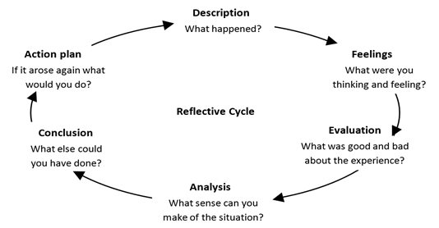
Fig.1 Adapted from (Gibbs, 1988) ‘Reflective Cycle’ in Ghaye and Lillyman (2006, p. 23)
The facilitator can use the Reflective Cycle to ask questions about: what the students got from reflecting on their learning? What responses did the students give to why, and how type questions and what specific decisions were made as a result of undertaking reflection? Have the students produced evidence that they have developed new skills or practices, or built upon existing ones, and reviewed the effectiveness of the changes they have made as a result of reflective thinking and not just carried on doing things as they have always done?
Did the students write reflectively in their Wikis demonstrating analytical practice in which they have described a real or imaginary scene, event, interaction, passing thought, and memory and added a personal reflection on the meaning of the item or incident, thought, feeling, emotion, or situation in the student’s life?

SECTION 2: TTT FACILITATOR CHECKLIST
Section 2 of the facilitation guide will enable you to support learners who need advice and guidance with regards to having the appropriate hardware and software technology requirements needed for using the Asset Communication website. Section 2 will cover the pre-requisite knowledge needed to assist the students when learning and using the theory and Asset Based Approaches embedded within the COERS. Section 2 will cover the basics on how to login and navigate the Assets Communication website and will include the information needed about modifying and adapting educational content using ‘The Four Rs of Open Educational Resources.

2.1 About the Target Audience
This facilitator guide is intended to provide information needed for accessing and running the Asset Communication website. This guide provides evaluation criteria in the form of a ‘Facilitator Survey and Checklist’ of the hardware and the software technology requirements needed for using the Asset Communication website (*note: to use the Facilitator Survey and Checklist please go to the Appendix 4.1 Facilitator Survey and Checklist section of this guide on pages 34-37).

2.2 Pre-Requisite Knowledge, Training and/or Materials
It is recommended that the facilitator have knowledge about the following areas to be able to provide support and guidance for the students:
- Assets-Based-Approaches (A-B-As);
- Open Educational Resources (OERs);
- Case Based Learning (CBL);
- Appreciative Inquiry (AI);
- Motivational Interviewing (MI);
- Self-Identity;
- Theories of Empowerment;
- Self-regulating Efficacy;
- The Reflective Practitioner: Professional knowledge Reflection-in-Action and on-Action (double looped learning);
- Critical Reflection and Dialogue;
- Reflective Cycle Models;
- Activity Theory;
- American Inside Out Approach;
- Social Networks;
- Social Capital;
- Human Capital;
- Cultural Capital;
- Performativity Theory;
- Appreciative Inquiry;
- Community Work Theory;
- Shared Experience;
- Effective Decision Making; and
- Group Dynamics.

2.3 An Introduction and Review of Basic Navigation of the System Hosting the COERS
Facilitators should have a basic familiarity with the website navigation and how to log on to the COER website. The following provides a basic introduction to the features of the website COERS Website.
To access the COERS Website facilitators can copy and paste the following web link into their web browser search bar upon which they will be taken to the UWS Moodle Virtual Learning Environment web page. If you are experiencing problems do a search in your web browser for UWS Moodle.

Web link: http://moodle.uws.ac.uk/

One the welcome web page has loaded click on the Log in icon located at the top right-hand side of the screen – as shown.

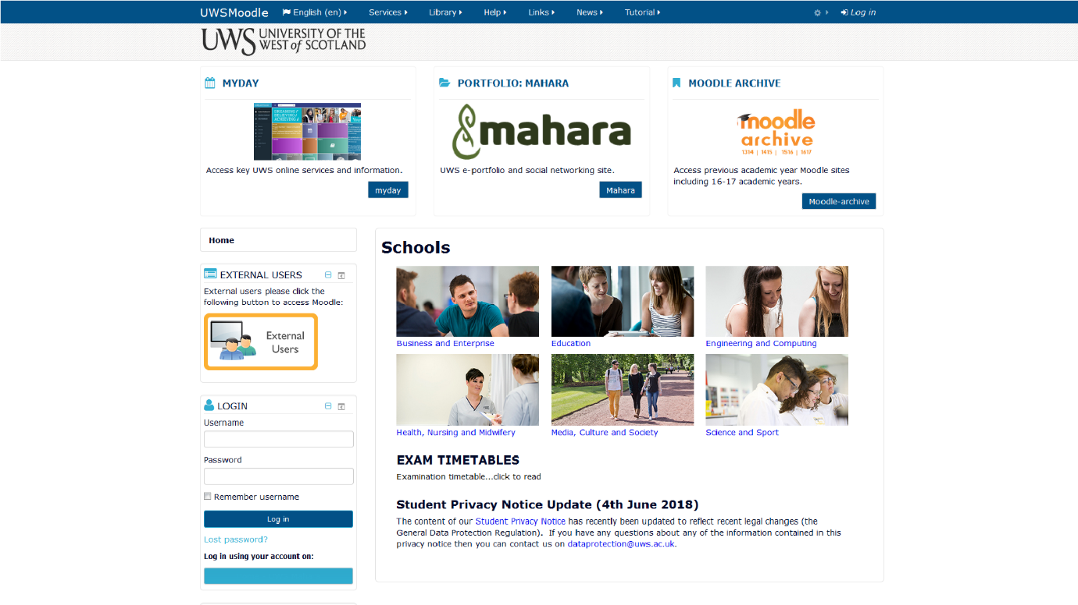
Fig. 2 UWS VLE Moodle Website Welcome Page

Once the facilitator has entered their login name and password they can select the Remember Username checkbox to store their login details for the next time they visit the website or proceed to click the log in button without selecting the Remember username. To do so will result in the facilitator having to re-enter their login details each time they visit the web site.
The UWS VLE Login web page will load the facilitator will enter their login and password to gain entry to the UWS Moodle VLE website – as shown.
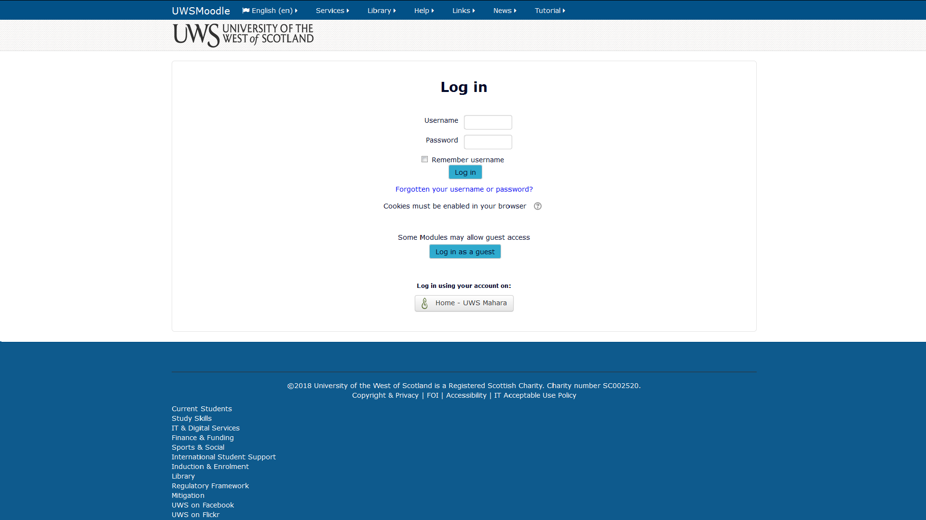
Fig. 3 UWS Moodle VLE Login Screen
The facilitator is now logged in as indicated by their user name now showing at the top right-hand side of the screen. Next the facilitator will click on the more tab – as shown.
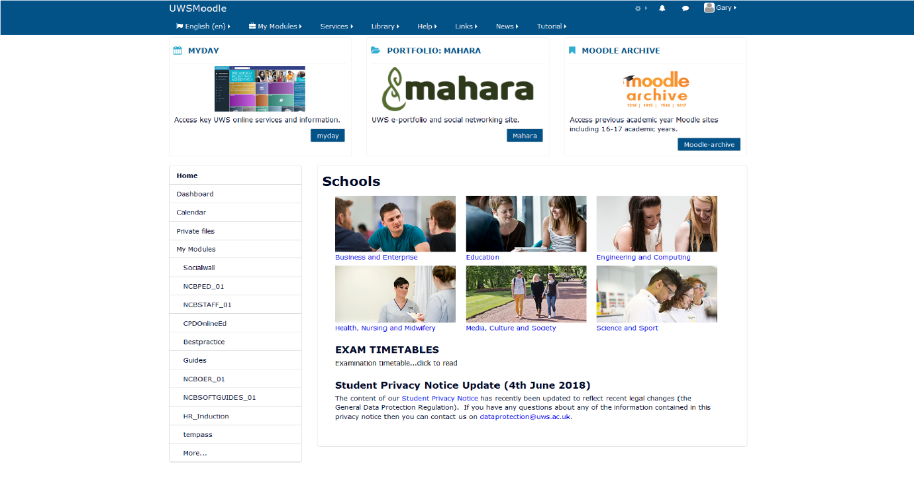
Fig. 4 UWS VLE Main Services Page
Once the Module Search facility web page has loaded enter the following name to find the COERS content. The name of the COERS site is: COERS - Development Site and click go– as shown.
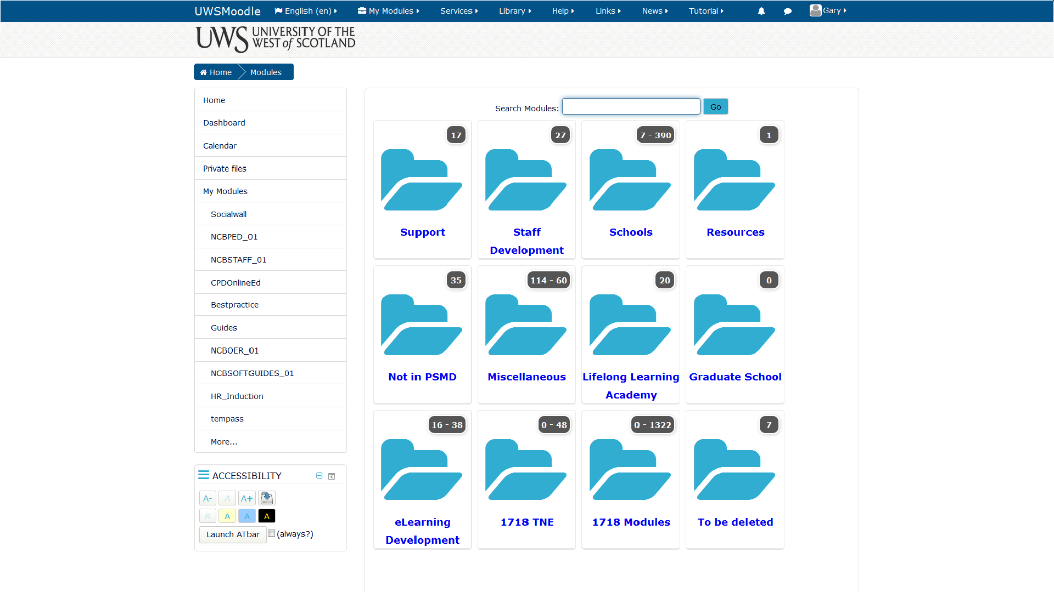
Fig. 5 UWS VLE Module Search Services Page
Once the Module Search facility has found and returned the link to the COERS - Development Site click on the link to enter the COER web site – as shown.
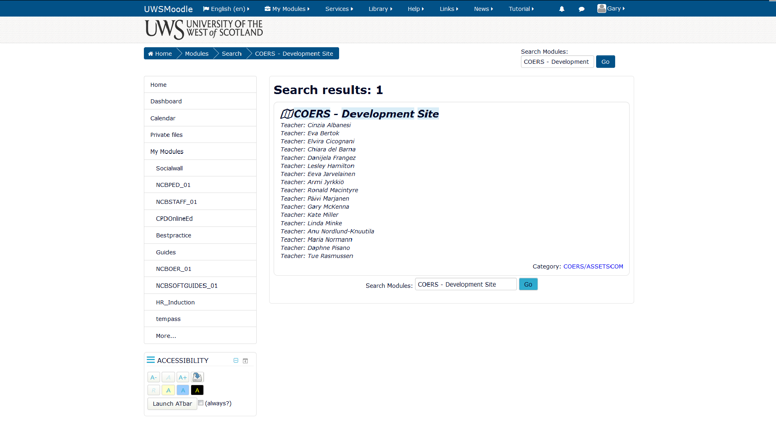
Fig. 6 UWS VLE Results of Module Search Services Page

The facilitator will now be taken to the COERS – Development Site where they can access all five of the COERS. To access a COER click on the tab with the name of the COER you would like to access and a drop down menu will appear below the COER name tab. A COER tab can contain links to the COER learning content, activities, surveys, Wikis and other learning mediums.
To access the COER content in Moodle Book click on the link next to the green book icon – as shown.
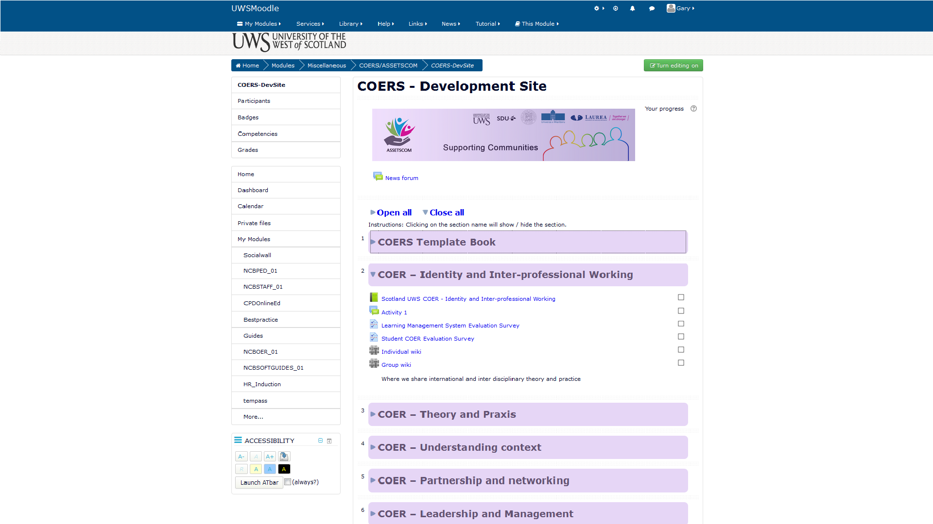
Fig. 7 UWS VLE COERS Development Site Page
The facilitator can now access all of the course content by clicking on the links in the table of contents on the left hand side – as shown.
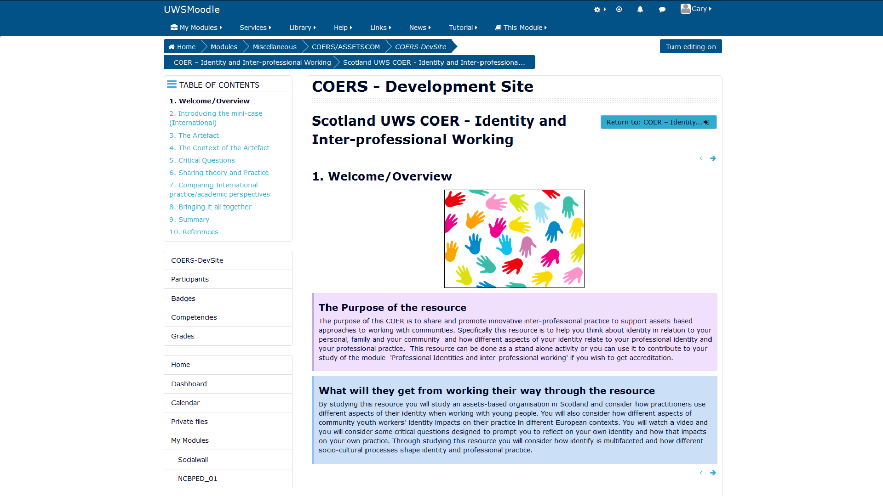
Fig. 8 UWS VLE COER Table of Contents Page

2.4 Modifying Assignments and Building extensions to Activities and Tasks
This section discusses how we support the modification and adaptions needed by organisations, institutions, trainers, teachers and facilitators with regards to responding to student progress and results. We provide information about what the facilitator needs to know to be able to share and modify learning content which is in line with ‘The Four Rs of Open Educational Resources (OERS)’.
The word Open in ‘Open Educational Resources’ (OERS) refers that the resources can be used at no cost by any individual(s) for adaptation and for reuse in various contexts. There are four separate aspects of reuse and different levels of openness. It is important to note that the licensing and technical aspects of open educational resources affect the relative openness of an OER.
The open licenses that are used by OERs are called the Creative Commons Licenses (CCLs). These licenses allow educators to legally and freely share their work. The CCLs work together with copyright to give users a set of usage rights for work created under Creative Commons. The user can also seek the creator’s permission who is the copyright holder and retains the copyright if they want to reuse the work in a way not covered by the license. For more detailed information please visit the creative commons website for a list of the licences https://creativecommons.org/choose/
The definitions found in the academic literature that are most aligned with our philosophy of learning at Assets communication are as follows. OERS are educational resources accessed through information and communication technologies, for consultation, use and adoption by a community of users for non-commercial purposes; freely accessible and open for educators, students, and self-learners to use and reuse for teaching, learning and research (Bissell, 2009, UNESCO, 2002). OERS are resources that reside in the public domain or have been released under an intellectual property license that permits their free use or re-purposing by others (D’Antoni, 2009). An OER may be an entire course, a complete book, or a more concise piece, such as a single learning object (Downes, 2007).
The openness of learning content in relation to the rights a user of the content is granted can be measured using The Four R’s (Wiley, 2009). The 4Rs Framework describes the four most important rights:
- Reuse – the right to reuse the content in its unaltered / verbatim form;
- Revise – the right to adapt, adjust, modify, or alter the content itself;
- Remix – the right to combine the original or revised content with other content to create something new;
- Redistribute – the right to make and share copies of the original content, your revisions, or your remixes with others (opencontent.org, 2009).
Facilitators are permitted to ‘Reuse’, ‘Revise’, ‘Remix’ and ‘Redistribute’ the learning content situated within the Assets Communication website. We could prefer facilitators and students to contribute material and their experience as practitioners to the Assets Communication website to help build a knowledge base of A-B-A content using OERS collaboratively to create COERS. This can be done by expanding upon the theories that underpin practice that can be consider strength based approaches or A-B-As and by altering and/or extending the reflective activities and tasks to generate new practice based educational content. Further information about remixing educational content is provided in the next section in SECTION 3: TTT FACILITATOR GUIDELINES.

SECTION 3: TTT FACILITATOR GUIDELINES
Section 3 of the facilitation guide helps facilitators become familiar with the Assets Communication COERS Learning Management System. It provides a method for monitoring and reviewing the reflective activities and tasks undertaken by students and suggests two ways of reviewing student progress. Section 3 also provides a method for adapting and modifying the educational content for facilitators who seek to make changes to the curriculum. It also provides a short tutorial about how to edit, modify and add to the educational content in the Assets Communication website and how to monitor and review student progress. It finishes with some final notes on the student experience and some advice for facilitators to think about before facilitating the COERS.

3.1 Overview of Assets Communication COERS Learning Management System
The diagram in Fig. 9 provides an overview of the COERS developed for the Assets Communication website of which there are five COERS. Each COER includes educational content about theory and practice based upon case-based learning and theories from the academic literature base linked to working in and with communities. The COERS also include reflective thinking activities which students can record in their individual reflective Wiki and their Group reflective Wiki to keep a record of and demonstrate their progress.
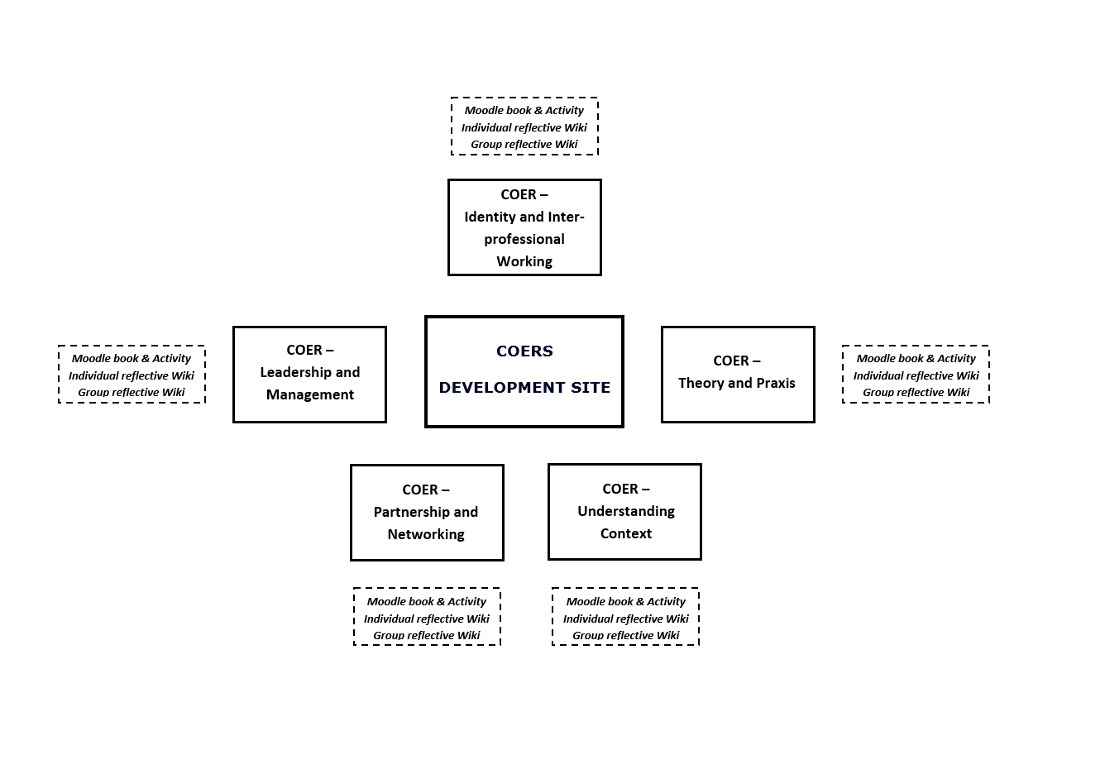

Fig. 9 An Overview of the COERS and Activities in the Assets Communication Website

3.2 Introduction, Connection, and Overview
A key aspect to understand in this section is the importance of self-reflection with respect to becoming a reflective practitioner and developing reflective skills. It is important for students to routinely reflect on what they do in order for them to step outside the ‘single loop’ to: experience, reflect, conceptualise, and apply what they have learned within a ‘second loop,’ to re-frame their ideas and to learn from their experience so that they may change what they do to create different outcomes (see Chris Argyris double-loop learning). Reflection is well aligned with the concept of learning from experience in that individuals think about what they did and what happened and decide from thinking about those previous situations, and the experiences of others presented in the case studies, what they would do differently or similarly next time if that situation were to occur.

It is important that facilitators create exercises where practitioners and students can realise the benefits of reflecting on their practice and situations where they can develop: the critical, constructive and creative thinking that is necessary for improving their practice. Six steps have been suggested that facilitators can use to engage practitioners and students with the reflective process these are:

- Read - around the topics you are learning about or want to learn about and develop;
- Ask - others about the way they do things and why;
- Watch - what is going on around you;
- Feel - pay attention to your emotions, what prompts them, and how you deal with negative ones;
- Talk - share your views and experiences with others in your organisation;
- Think - learn to value time spent thinking about your work (Thompson, 2018).

It is essential for facilitators to encourage practitioners and students to develop an understanding of the theory that other practitioners practice too and to explore those ideas with others to interpret knowledge from multiple perspectives, in order to gain a holistic understanding of a given context.

Facilitators can make use of online Wikis, Blogs and Forums to act as a reflective space, a learning journal or a learning diary. A starting point for practitioners and students to work through is a simple process shown in ‘The Reflective Learning Process’ in Fig 10. This simple process involves five steps that consist of: (1) Identifying a learning incident; (2) Describing the experience; (3) Reflecting upon the experience; (4) Thinking about how the experience links to theory; and (5) Experimenting by trying out new approaches to create or initiate different outcomes.

The Reflective Learning Process
The Learning Incident
Identify a situation you encountered in your work or personal life that you believe could have been dealt with more effectively.
Describe the Experience
What happened? When and where did the situation occur? Any other thoughts you have about the situation?
Reflection
How did you behave? What thoughts did you have? How did it make you feel? Were there other factors that influenced the situation? What have you learned from the experience?
Theorising
How did the experience match with your preconceived ideas, i.e. was the outcome expected or unexpected? How does it relate to any formal theories that you know? What behaviours do you think might have changed the outcome?
Experimentation
Is there anything you could do or say now to change the outcome? What action(s) can you take to change similar reactions in the future? What behaviours might you try out?

Fig. 10 Adopted from Thompson (2018) Skills You Need A Guide to Personal Development

3.2.1 Differentiating Instruction
Facilitators seeking to alter, add to or create their own learning content within the Assets Communication website can use ‘Differentiating Instruction’ which is a framework that can be utilised to provide different routes to learn from with respect to: educational content; the processing of learning materials; approaches to constructing or making sense of ideas; and developing teaching materials and assessment measures so that all students within an educational programme can learn effectively, regardless of their level of experience. Bruner (1963) argued that:
“Our only course as educators – if we elect to honour the diversity of students we must educate – is to develop education that challenge advanced learners without destroying the confidence and will to learn of those who are less advanced”. Differentiation comprises of the attempts of educators to respond to differences among learners participating in an educational programme. Whenever educators make an attempt to engage an individual or a small group of learners by varying the learning content, or their teaching to create the most effective learning experience possible, that educator is differentiating instruction.

It is important to note that facilitators can differentiate at least four pedagogical elements based on the practitioner and student’s readiness, interest, or learning profile. These are:

- Content – what the student needs to learn or how the student will get access to the information;
- Process – activities and tasks in which the student engages to make sense of or master the content;
- Products – culminating projects that ask the student to rehearse, apply, and extend what they have learned; and
- Learning environment – the way the learning environment works and feels (Tomlinson, 2000).

It is helpful for facilitators to note examples of differentiating: content, process, product and learning environment. The following examples are provided to help the facilitator think about how they might differentiate their learning content and instruction when using the COERS.

Content

Examples of differentiating content include the following:

- Using reading materials at varying readability levels;
- Converting text materials to audio;
- Using spelling or vocabulary lists at readiness levels of students;
- Presenting ideas through both auditory and visual means;
- Using reading buddies; and
- Creating learning opportunities to re-teach an idea or skill for struggling learners, or to extend the thinking or skills of advanced learners.

Process

Examples of differentiating process or activities include the following:

- Using tiered activities through which all learners work with the same important understandings and skills, but proceed with different levels of support, challenge, or complexity;
- Providing interest centres that encourage students to explore subsets of the lesson or session topic of particular interest to them;
- Developing personal agendas (task lists written by the educator and containing both in-common work for the whole class and work that addresses individual needs of learners) to be completed either during specified agenda time or as students complete other work early;
- Offering manipulatives or other hands-on supports for students and groups of learners who need them; and
- Varying the length of time, a student may take to complete a task in order to provide additional support for a struggling learner or to encourage an advanced learner to pursue a topic in greater depth.

Products

Examples of differentiating products include the following:

- Giving students options of how to express required learning (e.g., create a montage of learned topics using digitised visual boards to group ideas and themes, write a reflective journal, or develop a new approach to a problem);
- Using rubrics that match and extend students' varied skills levels;
- Allowing students to work alone or in small groups on their products; and
- Encouraging students to create their own product assignments as long as the assignments contain the required elements.

Learning environment

Examples of differentiating learning environment, learning space or learning setting include:

- Making sure there are places in the room to work quietly and without distraction, as well as places that invite student collaboration (creating conducive learning spaces);
- Providing materials that reflect a variety of cultures and home settings;
- Setting out clear guidelines for independent work that matches individual needs;
- Developing routines that allow students to get help when facilitators are busy and cannot help them immediately; and
- Helping students understand that some learners need to move around to learn, while others do better sitting quietly (Tomlinson, 2000).
- Differentiated learning online include making sure that learners have access to suitable ergonomic furniture, a computer workstation, power, connectivity to the internet (wifi), lighting control, and acoustic isolation to minimise unwanted distraction (Brown, 2018).

3.3 Comprehensive Navigation of Assets Communication Website: A Review
For a quick overview of the login screen, creating a user account and logging onto the website, refer to the earlier section about navigation and logging in section 2.3 'An introduction and review of Basic Navigation of the system hosting the COERS' which provides a basic introduction to the features of the website COERS Website.

This section will introduce the facilitator to a Comprehensive Tour of Assets Communication Website and will include the following:

- The Icons, the Navigation bar and the Content area;
- Turning editing on and turning editing off;
- Adding and editing a News Forum;
- The specific site protocol for facilitators to abide by (Online behaviour, Etiquette, and the Terms and Conditions Policy);
- System Requirements: the minimum requirements for running Assets Communication (This is especially important if users will access the Assets Communication website from home);
- How to edit content and add tasks in the Moodle Book.

3.3.1 The Icons, the Navigation Bar and the Content Area
As shown if Fig. 11 before facilitators can add new content, undertake editing and select new features, the ‘Turn editing on’ button must be selected. This button is coloured red when editing is switched on and will change colour to green when set to off.

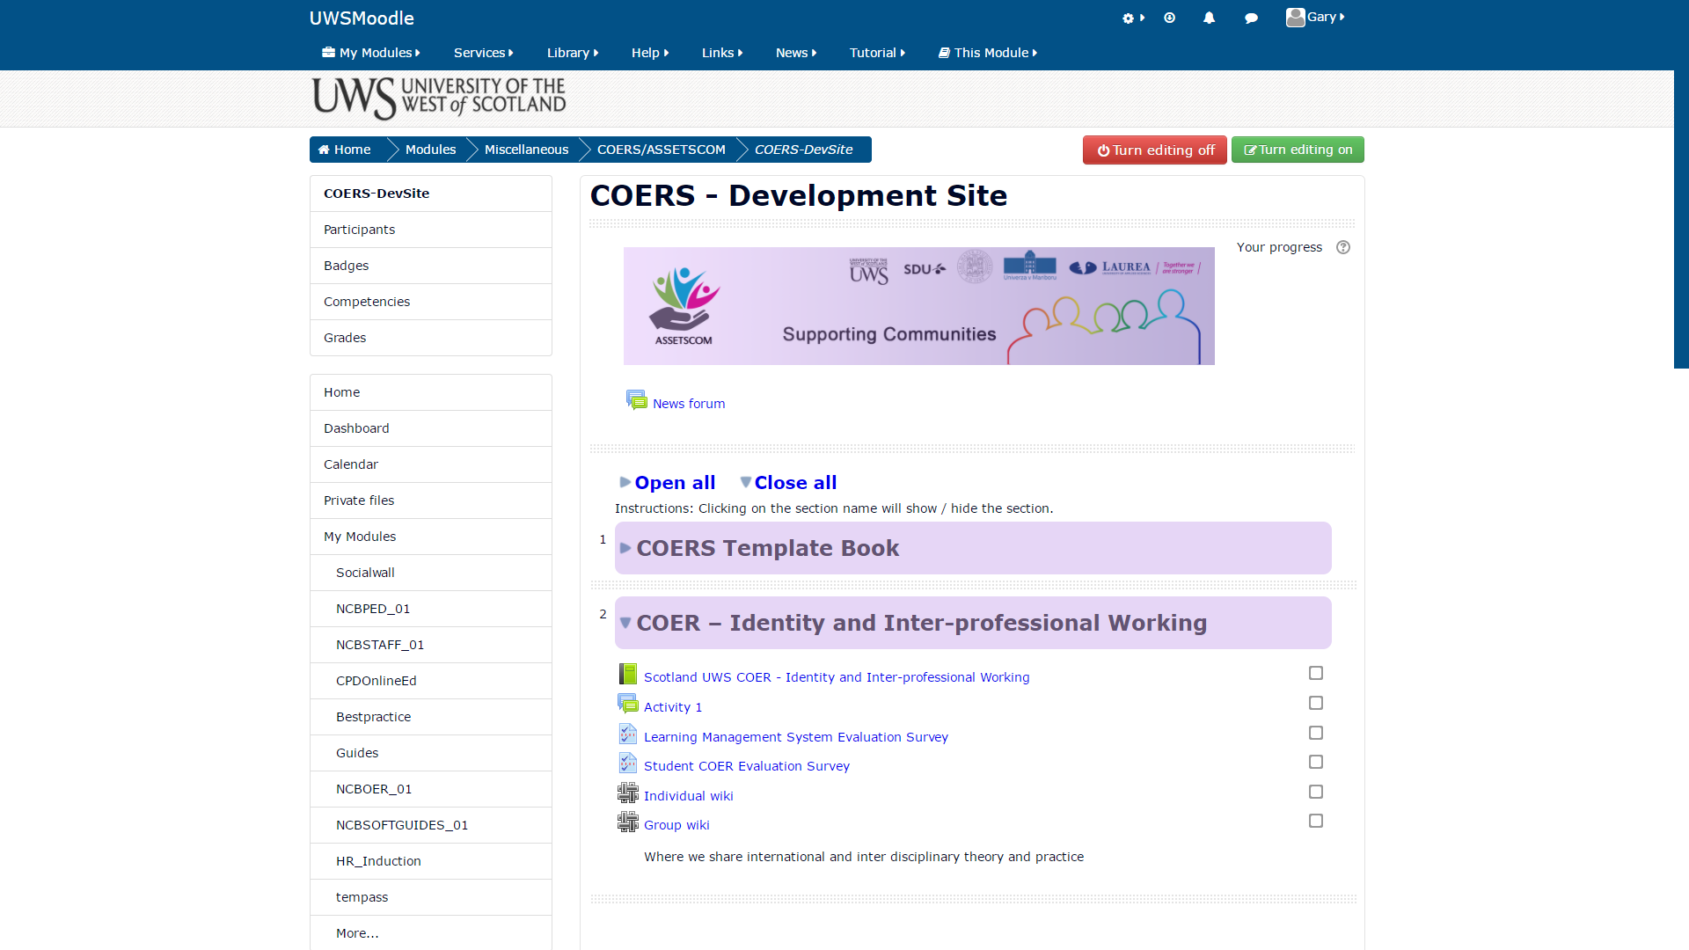
Fig 11. Turning editing on and turning editing off

3.3.2 Adding and Editing a News Forum
The News Forum tab will provide facilitators with access to manage news and message board threads to and from students and will also allow facilitators to create new threads as needed. This feature can be accessed and added from the ‘News Forum’ and edited from the ‘Edit settings’ drop down menu as detailed in Fig. 12.

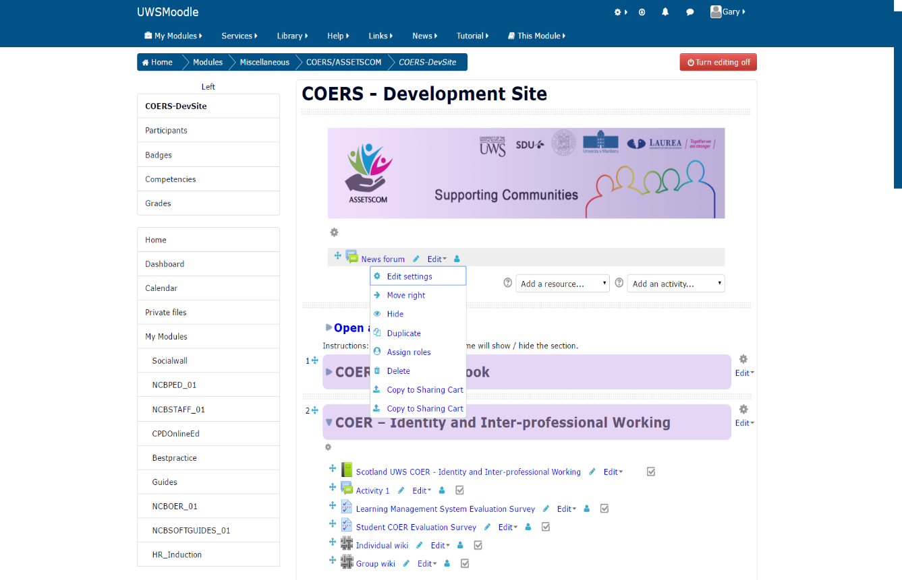
Fig 12. Adding and Editing features for a News Forum

3.3.3 Adding a Resource
Resources can be added from the ‘Add a Resource’ drop down menu for example links to URLs or folders containing additional educational content as illustrated in Fig. 13.

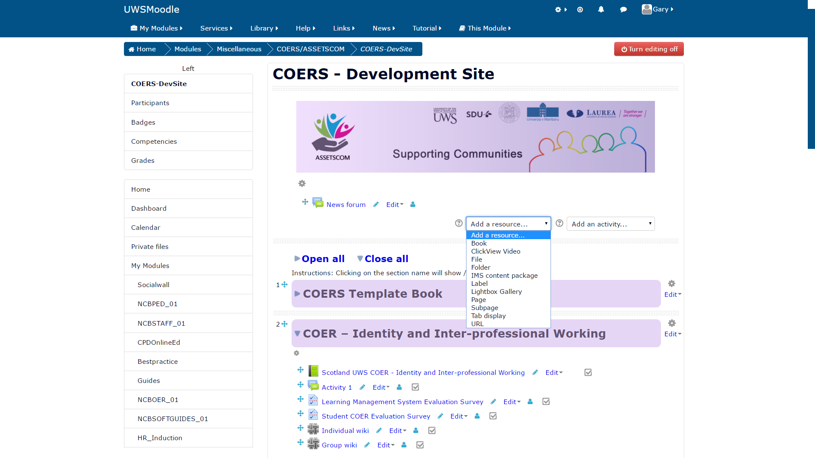
Fig 13. Adding an Educational Resource

3.3.4 Adding an Activity
The Add an Activity feature offers a variety of activities such: Advanced Mind Map, Blog, Wiki, Podcast, Forum, Questionnaires, Surveys and Forums for getting students involved in learning and for gaining feedback from students. This feature can be accessed from the ‘Add an Activity’ drop down menu as shown in Fig. 14.

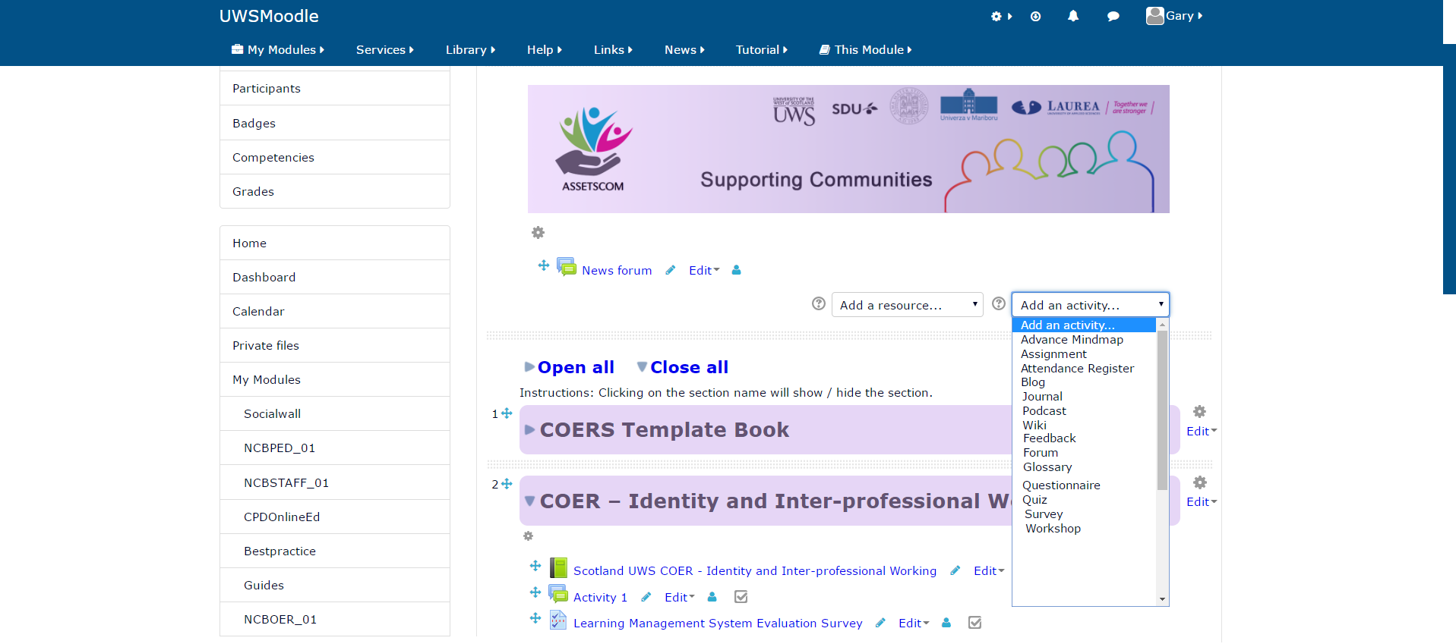

Fig 14. Adding an Educational Activity

3.3.5 Editing Section Tabs
Section tabs can be edited from selecting the edit section drop down menu which will allow facilitators to: highlight the tab; hide the tab from the students; delete the section and copy the section to share cart to share the content contained within the section with others. The ‘Edit section’ can be accessed from drop down menu next to the tab as presented in Fig. 15.

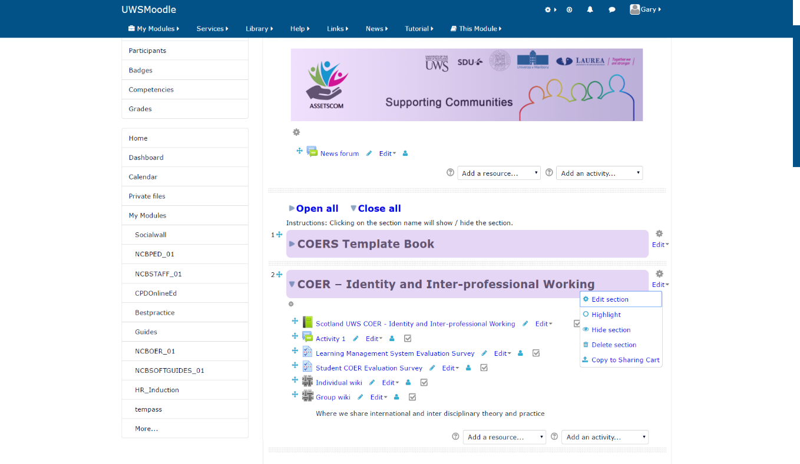
Fig 15. Editing the Section Tabs

3.3.6 Editing an Activity
Any of the activities that have been created can be edited as follows: an activity can be moved to the right; an activity can be hidden from the view of the students; an activity can be duplicated; roles can be assigned to an activity; an activity can be deleted and an activity can be copied to the share cart to be made available and shared with other facilitators. An activity can be edited by selecting the ‘Editing Settings’ drop-down tab as displayed in Fig 16.

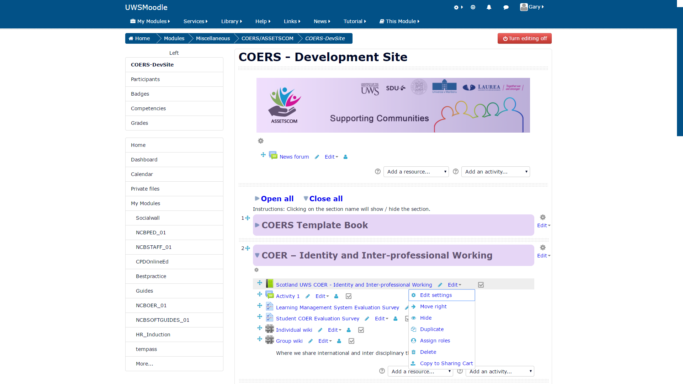
Fig 16. Editing an Activity

3.3.7 Editing Features in Moodle Book
Moodle book is used to host the majority of the educational content in the COERS. The features that can be edited within the Moodle Book can be accessed from the ‘TABLE OF CONTENTS’ section (when editing is switch on). The features available for editing are: Moving the chapter or section up or down to reorient the order or sequence of the education material; editing the text written within Moodle Book chapters; Deleting a chapter; hiding a chapter from the view of the students and adding a new chapter. As shown in the highlighted red text and arrows as outlined in Fig. 17.
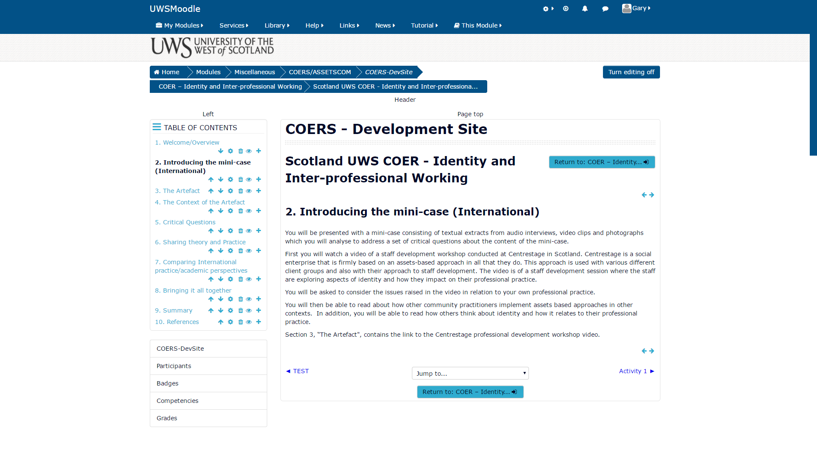
Editing text

Deleting a chapter

Hiding a chapter

Adding a new chapter

Move the chapter order order

Fig 17. The Editing Features in Moodle Book

3.3.8 The Jump To ... Drop Down Menu
The Jump to drop down menu allows the facilitator and students to exit the Moodle Book page they are in and can directly navigate to any of the activities that have been loaded into the Virtual Learning Management system (VLMS). The ‘Jump To’ drop down menu is the fastest way to navigate Moodle Book as demonstrated in Fig 18.

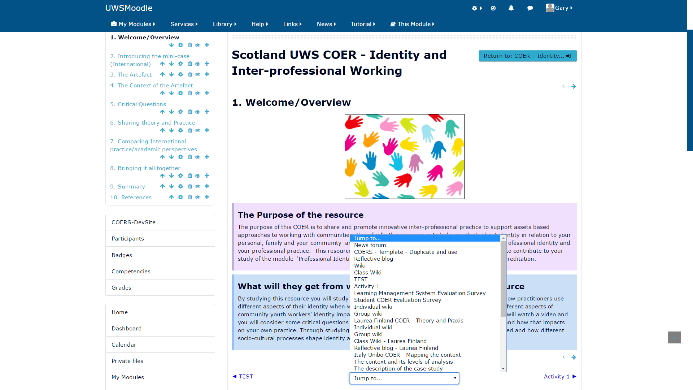
Fig 18. Quick navigation with the Jump to drop down menu

3.4 Assigning Curriculum: Assignment and Task Builder
The first step for facilitators to think about in providing differentiated instruction for a COER is to identify the targeted skills and learning content that should be addressed in developing new group instruction that allows students to learn from assessment goals. The four pedagogical elements content, process, products and learning environment from the previous section can be use (see Tomlinson, 2000). Once facilitators have had the opportunity to explore their student data from for example the student Wikis, the results can be used to make instructional decisions. Facilitators may find that students either need their learning paths adjusted (dependent on the student’s progress) or that they need to build extension assignments for the students to extend the learning content, activities and tasks.

NOTE: Editing learning content, activities and tasks and learning paths is not recommended after students have begun working. Instead, it is recommended that facilitators create a separate assignment to enhance learner engagement or content enrichment.

It is important to stress the importance of facilitator intervention and monitoring of the assigned learning content, activities and tasks. In the instance that students test lower/higher than their actual skill level, facilitators should monitor and adjust the COER activities and tasks accordingly. The ‘Monitoring the Learning Path’ cycle can be used by both facilitators and students to evaluate the progress of the learning and skills being mastered by a student as shown in Fig. 18.

The Monitoring the Learning Path cycle consists of five stages: (1) learning path; (2) monitoring progress; (3) interpret data; (4) build differentiated activities and tasks; and (5) complete differentiated activities and tasks.

The Learning Paths cycle follows the principals outlined by Universal Design for Learning (UDL: Hall, Vue, Strangman and Meyer, 2004) for planning instruction:

(1) Set Goals based on Data;
(2) Determine the avenue for delivery and assessment;
(3) Evaluate the results of the assessment;
(4) Apply differentiated tasks to delivery and assessment; and
(5) Teach planned lesson and evaluate success;

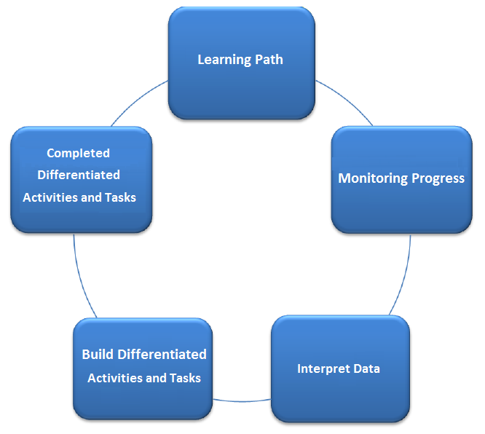
Fig 19. Monitoring the Learning Path

The UDL for planning instruction is student centred and built on the idea that individual students need multiple levels of strategies, materials and assessments. The UDL advocates that the curriculum must adapt so that the student does not have to, thus in turn minimising barriers and maximising access for student growth, as illustrated in Fig. 19 (Hall, Vue, Strangman and Meyer, 2004).

3.5 Progress Monitoring and Self-review
The two progress monitoring tools offered here are: ‘Student Individual Progress’ recoded in the student’s individual Wiki and ‘Student Class Progress’ recorded in the students’ group Wiki to determine their Learning Path Status. Facilitators and students can look at the Student Portfolio of work recorded in both Wikis to determine the students’ progress. In instances where there may not be a facilitator available to monitor a student’s progress a student may use self-assessment to determine their own progress and focus on areas that need to be developed to further progress as outlined in Fig 20. Student progress can be generated on the following:

THE TWO FORMS OF STUDENT PROGRESS MONITORING
Facilitator Student review | Student Self-review
The Individual Student (Individual Wiki) | The Individual Student (Individual Wiki)
The Class Group project (Group Wiki) | The Class Group project (Group Wiki)
Learning Path Status (completed by facilitator) | Student Self-Progress Report (Completed by the student)

Fig 20. Student Progress Monitoring

3.5.1 Facilitator Student review
We recommend that facilitators assess for evidence of practitioners and students having demonstrated the following three forms of reflection in their Individual Wiki and Group Wiki: (1) Reflection in action; (2) Reflection on action; and (3) Reflection for action. These three types of reflection are important for practitioners and students to become familiar with and to master to develop personally and as a professional.

A description of the three kinds of reflective thinking important for facilitators to promote for practitioner and student development are as follows:

(1) Reflection-in-action can be described as ‘action present’ and involves reflecting on an incident when it is occurring to benefit that situation rather than reflecting on how you would do things differently in the future should that situation occur (Schön, 1983). This form of reflection is useful in disciplines where a professional must react to a situation at the time it occurs without being able to think about what just occurred and make changes later.

(2) Reflection-on-action means reflecting on ways in which practice can be developed (changed) after a situation has occurred. Therefore, as practitioners and students: “We reflect on action, thinking back on what we have done in order to discover how our knowing-in-action may have contributed to an unexpected outcome” (Schön, 1983, p. 26).

(3) Reflection-for-action involves thinking about future actions for improving or changing a practice (Killion and Todnem 1991; Grushka et al. 2005). This form of reflection requires practitioners to anticipate what will occur when a particular situation occurs, and to reflect on their past experiences, before that situation occurs to make proper preparations (Farrell, 2013). Facilitators should take note that the main problem learners have in doing reflection-for-action is knowing what they should reflect on to be able to make improvements or changes in their own practice.

Please Ponder these questions:
- Based on duration do I see students providing a real effort to develop higher order thinking skills or just going through the motions to complete the Wikis?
- How can this self-review help to identify students in need of additional support (remediation) or differentiated assignment tasks?
- Do I see evidence of different forms of reflection, for example: evidence of reflecting on previous experiences to learn and develop; instances where reflection has been used in a live situation to divert an incident from occurring; and cases were forward planning has been used to prepare for a situation should it arise based on reflective thinking?

3.5.2 Student Self-review
For students and practitioners to become more effective learners and to improve upon their skills they need to learn the importance of self-review. Many occupations call for workers to become lifelong learners which involves managing their own personal and professional development within and outside of the workplace. When students and practitioners evaluate themselves, they are assessing what they know, do not know, and what they would like to know. In using the process of self-review, they begin to recognise their own strengths and weaknesses by asking the question: “What have I learned?”.

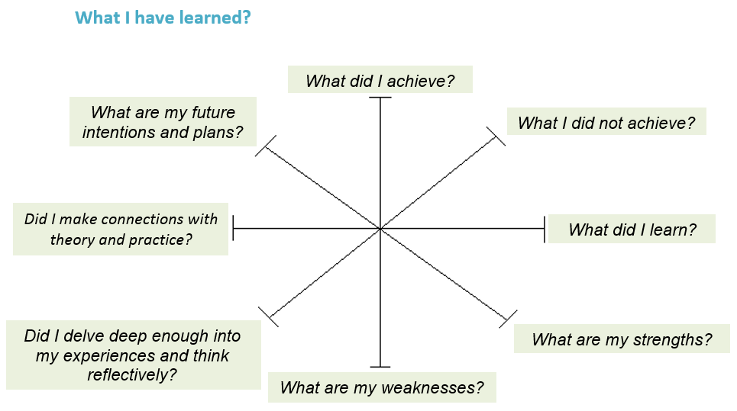

Fig 21. Student Learning Clock (adapted from Castley, 2015)

The student learning clock shown in Fig. 21 can be used by practitioners and students as a form of self-review to ascertain what they have learned during and after completing a course or a project. In the absence of a facilitator students can use the Learning Clock to identify and respond to their own learning needs. The Learning Clock involves answering eight review questions which begins with answering the question: “What did I achieve?” and continues clockwise until the practitioner or student reach the final question “What are my future intentions or plans?” – which is used to encourage the learner to set a goal(s) or to create an action plan to carry out their learning intentions (Castley, 2015). For more self-review questions see Appendix 4.2.

Concept Activity Think and Write:
- Think about the material we just covered what did you like the most about it?
- Summarise how each report you generate on your students can support your curriculum implementation needs?
- What is your action plan for student progress monitoring, summarise it?
- Write down one question you still have and share it with us at Assets Communication.

3.6 The Learner and Student Experience
The student experience must start with an experiential activity (working on their Individual Wiki or the Class Group Wiki). This type of activity allows for “learning through reflection on doing” and makes it clear to participants on what the student role should be. It also allows the student to think about what they have learned from their job role and practice (Reflection on action) and how this fits with the theory they have just learned about and how that contrasts with theory they might have previously learned, as well as how it all compares with the cases-based learning cases they were shown (Reflection in action).

Note: The experiential activity will include a learning activity created for differentiated purposes and model the facilitator direction to the student for the purpose of completing the differentiated learning task.

Note: Students will need explicit direction when given additional differentiated assignments. They will need to know the transparent purpose of the assignment and specifically what skills/content they are focusing on in the individualised activity or task. Some students may not receive additional individualised activity or task through Assets Communication, you need to think about how you as the facilitator will guide these students?

Note: The educators experience of the lessons and activities: facilitators should allow themselves time to explore the learning resources and to use the lessons, activities and tasks assigned to the “student” and time to follow up on offline sources and additional learning resources in order to become acquainted with the learning content to be able to support their students.

3.7 A Final Word
Facilitators should think about how they will you utilise the Assets Communication website and student progress reports to impact their students learning.

Facilitators should set clear expectations for students at the beginning of each learning session.

TTT Note: Session Certificate digital proof of completion of each COER is still in development.

References
Bissell, A. (2009). Permission granted: Open licensing for educational resources. Open Learning, The Journal of Open and Distance Learning, 24, 97-106.
Brown, M. (2018). Educause: Learning Spaces, Dartmouth College. [Accessed: August 17, 2018] https://www.educause.edu/research-and-publications/books/educating-net-generation/learning-spaces
Castley, A. J. (2015). Strengthening your reflective commentary. Learning and Development Centre. Warwick. Retrieved July 26, 2018, from http://aem.cast.org/about/publications/2003/ncac-differentiated-instruction-udl.html#.W1mb69JKiM8
D’Antoni, S. (2009). Open Educational Resources: Reviewing initiatives and issues. Open Learning, The Journal of Open and Distance Learning, 24, 3-10.
Downes, S. (2007). Models for sustainable open educational resources. Interdisciplinary Journal of Knowledge and Learning Objects, 3, 29-44.
Farrell, T. S. (2013). Reflecting on ESL teacher expertise: a case study. System, 41(4), 1070–1082.
Grushka, K., Hinde-McLeod, J., and Reynolds, R. (2005). Reflecting upon reflection: theory and practice in one Australian university teacher education program. Reflective Practice, 6(1), 239–246.
Hall, T., Vue, G., Strangman, N., and Meyer, A. (2004) Differentiated Instruction and Implications for UDL Implementation: Effective Classroom Practices Report. National Center on Accessible Educational Materials. Retrieved July 26, 2018, from http://aem.cast.org/about/publications/2003/ncac-differentiated-instruction-udl.html#.W1mb69JKiM8
Killion, J., and Todnem, G. (1991). A process of personal theory building. Educational Leadership, 48(6), 14–17.
Learning and Development Centre. (2018) Questions to ask yourself. CENTRE FOR ACADEMIC PRACTICE THE UNIVERSITY OF WARWICK. [Accessed: July 20, 2018] https://warwick.ac.uk/services/ldc/resource/evaluation/tools/self/
SCDC. (2018). Encouraging confident, healthy communities: Assets Based Approaches [Accessed online: July 18, 2018] http://www.scdc.org.uk/what/assets-scotland/.
Schön, D. (1983). The Reflective Practitioner: How professionals think in action. London: Temple Smith.
Thompson, N. (2018). The Skills You Need Guide to Personal Development. Skills You Need Ltd.
Tomlinson, C. A. (August, 2000). Differentiation of Instruction in the Elementary Grades. ERIC Digest. ERIC Clearinghouse on Elementary and Early Childhood Education.

UNESCO. (2018). Communication and Information: What are Open Educational Resources (OERs)? [Accessed online: July 18, 2018] http://www.unesco.org/new/en/communication-and-information/access-to-knowledge/open-educational-resources/what-are-open-educational-resources-oers/
UNESCO. (2002). Forum on the impact of open courseware for higher education in developing countries: Final report. Retrieved July 20, 2018, from http://unesdoc.unesco.org/images/0012/001285/128515e.pdf
Wiley, D. (2018). Iterating toward openness, opencontent. [Accessed: July 20, 2018] https://opencontent.org/blog/archives/1123

Appendix

4.1 Facilitator Survey and Checklist
Assets communication aims to make a large set of teaching and learning materials in Inter-professional approaches to assets based community participation freely and openly available to educator, professionals/practitioners, and students anywhere in the world as Open Educational Resources (OERs). The project is funded by Erasmus plus in collaboration with a number of academic institutions and stakeholders across Europe. Your organisation is one of the key partners in the Assets communication project. We would appreciate your time in completing the survey to give us feedback on the OERs produced by the Assets communication team. The results of this questionnaire will inform future policies on Open Educational Resources.
Any information you provide as part of this questionnaire will be used for research purposes only and will be kept confidential in accordance with university ethical policies. We value your time and input.
* Data Protection
All data collected in this survey will be held anonymously and securely. Individual results are strictly confidential, and individuals will not be identified in any way.
Demographic data collected will only be used for the purposes of this survey and cannot be used to identify and individuals.
Please place a cross in the box if you agree with the following statements:
1. I understand that my participation is voluntary and that I am free to withdraw at any time without giving any reason.
2. I agree to take part in the above study.
Please enter your information and details in the boxes provided below.
1. Please print your full name in capital letters clearly in the text box provided if you are willing to fill out this survey.
2. Please enter the date you completed this survey in the boxes provided.
3. Please enter the name of the organisation you are affiliated with.
4. Please select which gender you identify yourself with.
1. Male 2. Female 3. Other
5. Please select the age range you fall between.
Under 20 20-29 30-39 40-59 50-59 Over 60
6. Please enter the name of the country are you currently a resident of.
*Usability of Course Content System and COER
The statements relate to the general technical information given to learners prior to the commencement of engaging with the Moodle learning management system.
Please consider the following statements and rate each one based on the following scale:
1 = Strongly agree | 2 = Agree | 3 = Unsure | 4 = Disagree | 5 = Strongly disagree
 |  | 1 | 2 | 3 | 4 | 5
1. The web browser software version required is specified (i.e. Internet Explorer 11, Firefox 59.0.3 or Opera 15).
2. Online sources to obtain software items required are provided.
3. Web browser software plugins required are specified.
4. Recommended internet bandwidth is specified.
5. Recommended minimum technology hardware is specified.
The statements are designed to ascertain the accessibility of the Moodle learning management system.
Please consider the following statements and rate each one based on the following scale:
1 = Strongly agree | 2 = Agree | 3 = Unsure | 4 = Disagree | 5 = Strongly disagree
 |  | 1 | 2 | 3 | 4 | 5
1. The function of each icon and button are explained or is naturally evident to the learners.
2. Every web page is linked to the previous page for ease of navigating the COER.
3. Page headers or footers identify where the learner is within the COER.
4. Consideration is given to learners who may have visual or auditory challenges.
5. No graphic or multimedia element has been included that causes the video screen to flicker.
6. COER web pages load quickly when navigating and editing content.
The statements relate to the general user information given to learners prior to the commencement of engaging with the COER.
Please consider the following statements and rate each one based on the following scale:
1 = Strongly agree | 2 = Agree | 3 = Unsure | 4 = Disagree | 5 = Strongly disagree
 |  | 1 | 2 | 3 | 4 | 5
1. The level of reading proficiency necessary to complete the COER is at an accessible level for community practitioners.
2. A brief description of the learning objectives in the COER is given.
3. If learners are required to access online databases, the instruction is given.
4. The learning level of the COER content is appropriate.
5. An overview is provided of the COER content.
6. Learners are informed about their right to privacy.
7. Learners are directed to a source of sample answers to questions.
8. Guidelines are provided which show learners how to share content.
9. A copyright statement is presented.

The statements relate to the extent to which COER content is organised and arranged comprehensively for ease of use for learning.
Please consider the following statements and rate each one based on the following scale:
1 = Strongly agree | 2 = Agree | 3 = Unsure | 4 = Disagree | 5 = Strongly disagree
 |  | 1 | 2 | 3 | 4 | 5
1. The table of contents gives an accurate indication of how the Moodle VLE LMS COER material is arranged.
2. The organisation of the COER content is appropriate for the subject matter and the intended audience.
3. Instructions are divided into subunits and subtopics.
4. The organisation of components is consistent throughout the COER.
5. References to external sources of information are accurate.

The statements relate to the wording of the language used in the COER materials with regards to the course material appropriateness for learners.
Please consider the following statements and rate each one based on the following scale:
1 = Strongly agree | 2 = Agree | 3 = Unsure | 4 = Disagree | 5 = Strongly disagree
 |  | 1 | 2 | 3 | 4 | 5
1. The writing style is clear and direct.
2. Numbers are used to identify sequential steps in a task or process.
3. The tone of the writing is supportive and encouraging.
4. Instructions are stated simply and are easy to understand.
5. The writing conveys no bias relative to a learner’s demographic background.
6. Explanations are given for cultural and practitioner specific concepts and language.

The statements relate to the extent to which the course goals and objectives provide details of learning expectations at the beginning of the COER.
Please consider the following statements and rate each one based on the following scale:
1 = Strongly agree | 2 = Agree | 3 = Unsure | 4 = Disagree | 5 = Strongly disagree
 |  | 1 | 2 | 3 | 4 | 5
1. Learning objectives cover COER course content and are related to the subject being studied.
2. Learning objectives are relevant to the subject matter and to the "real world" in which the content may be applied.
3. Learning objectives specify learning outcomes related to skills and competencies.
4. Learning objectives state clearly and concisely what must be done.
5. Different types of learning outcomes are stated including those that call for reflective thinking.

Please provide any comments you have regarding using Collaborative Open Educational Resources in the box.

On completion of the survey please return to: gary.mckenna@uws.ac.uk

4.2 Learner Self-review Questions
Questions for problem solving:
- What would make the situation better?
- What do you want? What else?
- How do you feel about the situation?
- What is most important to you in this situation?
- How do you want to feel about this situation?
- What assumptions are you making about the situation?
- What assumptions are you making about someone else in this situation?
- What could be the cost to you of not solving this problem?
- What does you response to this situation tell you about yourself?
- How do you know this?
- What could you, do differently?
- Where could get help to improve this situation?
- What is positive about the situation?
- What is the most radical thing you could do?
- What is the simplest thing you could do?
- What don't you know about the situation?
- What is the relationship between how things are now and how you want them to be?
- What about this situation would you most like to change?
- What would you like someone else to do differently?
- How does this situation affect you personally?
- Can you explain that further?
- If you get what you want what will this achieve for you?
- What do you need to do first?
- What is stopping you?
- What do you want instead?
- What will happen if you are not successful in getting what you want?
- Why do you believe what you want is reasonable?
- Why do you believe what you want has value?
- Why are you the best person to be doing what you are thinking of doing?
- What about this situation causes you most anxiety or distress?
- If you are successful how will you feel?

4.2 Learner Self-review Questions
(Continued from previous page)
Questions to prompt learning from experience:
- What would have made this better?
- What did you want? What else?
- How did you feel about the situation?
- What from this experience do you most appreciate about yourself?
- How do you feel al out this situation now?
- What result did you want?
- What could you learn about yourself from this experience?
- How do you know this?
- What could you do differently next time?
- What do you remember thinking but not saying?
- What did you feel but not reveal?
- What is the most radical thing you could have done?
- What is the easiest thing you could have done?
- What don't you know about the situation?
- What can this experience tell you about how you 'see' the world?
- What could you definitely not have done?
- What might you have invented or imagined about the situation?
- What surprised you about the situation?
- What surprises you about it now?
- What else?

4.3 Tables and Figures Listing
Listing | Heading
Table 1 | Erasmus Plus project………………………………………………………………………………………. | 3
Table 2 | COER Concepts and Theories………………………………………………………………………….. | 6
Table 3 | COER Webpage Template Structure……………………………………………………………….. | 7
Figure 1 | Reflective Cycle …………………………………………………………………………………………….. | 8
Figure 2 | UWS VLE Moodle Website Welcome Page……………………………………………………… | 10
Figure 3 | UWS Moodle VLE Login Screen……………………………………………………………………….. | 11
Figure 4 | UWS VLE Main Services Page………………………………………………………………………….. | 11
Figure 5 | UWS VLE Module Search Services Page…………………………………………………………… | 12
Figure 6 | UWS VLE Results of Module Search Services Page…………………………………………… | 12
Figure 7 | UWS VLE COERS Development Site Page………………………………………………………… | 13
Figure 8 | UWS VLE COER Table of Contents Page…………………………………………………………… | 13
Figure 9 | An Overview of the COERS and Activities in the Assets Communication Website…………………………………………………………………………………………………………. | 15
Figure 10 | Skills You Need A Guide to Personal Development………………………………………….. | 17
Figure 11 | Turning Editing On and Turning Editing Off……………………………………………………. | 20
Figure 12 | Adding and Editing features for a News Forum……………………………………………….. | 21
Figure 13 | Adding an Educational Resource………………………………………………………………….... | 22
Figure 14 | Adding An Educational Activity………………………………………………………………………. | 23
Figure 15 | Editing the Section Tabs…………………………………………………………………………………. | 24
Figure 16 | Editing an Activity………………………………………………………………………………………….. | 25
Figure 17 | The Editing Features in Moodle Book……………………………………………………………… | 26
Figure 18 | Quick Navigation with the Jump To Drop Down Menu…………………………………… | 27
Figure 19 | Monitoring the Learning Path…………………………………………………………………………. | 28
Figure 20 | Student Progress Monitoring…………………………………………………………………………. | 29
Figure 21 | Student Learning Clock…………………………………………………………………………………… | 30

