Contents

Study Session 4 Human Values and Behaviour 2
Learning outcomes Study Session 4 2
4.1 The physical and the social environment 3
4.2 How does the social environment influence WASH practices? 5
4.2.1 Knowledge of WASH practices is not enough to change behaviour 5
4.2.2 Attitude, beliefs and traditions influence WASH practices 7
4.3 Other influences on WASH practices 9
4.3.1 Economic factors influence WASH practices 9
4.3.2 Gender, privacy and access issues influence WASH practices 10
4.3.3 Caring for the physical environment improves health outcomes 11
4.4 Making WASH practices socially accepted and valued 13
Summary of Study Session 4 15
Answers to in-text questions 16
References 18

Study Session 4
Human Values and Behaviour
In this study session we focus on how human values and behaviour can influence WASH. Human values and behaviour can protect our health and the environment from contamination by human and animal waste, or they can result in exposure to sources of pollution. So, it is important to encourage those human values and behaviour that support WASH.
Our WASH behaviour is influenced by knowledge, beliefs, attitudes and traditions about the causes of disease, our responsibility towards the environment, and also by household economic factors and gender issues.
These aspects of the social environment must be considered to encourage all to use good WASH practices. Only when WASH practices are adopted can infectious diseases and environmental pollution be prevented and successfully controlled.
Learning outcomes Study Session 4
When you have studied this session, you should be able to:
- describe ways in which the social environment of knowledge, beliefs, attitudes and traditions can affect human values and behaviour towards WASH practices.
- give examples of how positive or negative human values and behaviour concerning WASH practices can affect infectious disease transmission and the physical environment.
- explain why it is important to address economic factors and gender issues when devising a communication strategy to promote good WASH practices.

4.1 The physical and the social environment
Everywhere you look, you see people, animals and plants living in fields and forests, streams and hillsides, or in villages, towns and cities. These are all part of the physical environment of the ‘real world’ that we can see with our eyes and touch with our hands.
In your town or village, there are physical structures that humans have built or made, including houses, monasteries, schools, shops, a health centre, administrative unit office or a police station.

In-text question 1.1
Can you identify some other features of the physical environment in town?
(Figure 4.1 gives some clues)

Figure 4.1 The physical environment in an urban community in Myanmar

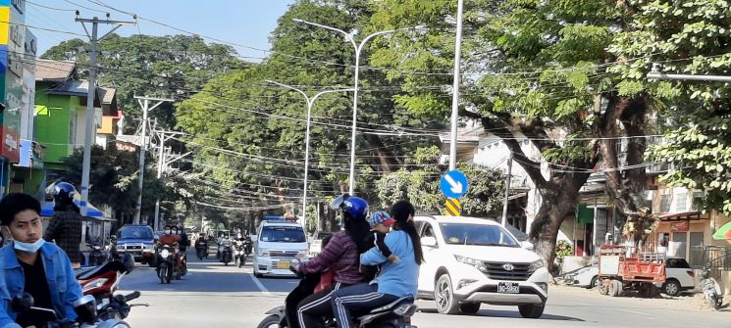

The physical structures we have mentioned also provide the local population with various kinds of social services. For example, a monastery or mosque provides religious services; a school provides education; shops and markets provide access to food and other products; roads provide transport links; and houses provide shelter.

These services contribute to the social environment of the community which are derived from human and social structures and institutions e.g. services provided by schools, religious institutions and shops. The social environment also includes the attitudes, beliefs, practices and traditions that are expressed by the members of a community.
- Attitudes are individual preferences or opinions about what a person likes or dislikes.
- Beliefs are firmly held states of mind about what is true or false.
- Practices are routine actions, doing something in the same way every time.
- Traditions are behaviour that is learned from previous generations and passed on to the next generation.
- Unlike the physical structures, they cannot be seen.
Getting people to adopt good WASH practices is not just about providing latrines, toilets or handwashing facilities – the physical elements for WASH. These can be available, but people still may not be using them. Knowledge and understanding also need to change. People need to want to use these facilities and that can mean changing attitudes, beliefs and values. So, you can see that encouraging WASH practices is quite complex.

4.2 How does the social environment influence WASH practices?
The building blocks of our behaviour lie in our knowledge, practices, attitudes, beliefs and traditions, all of which contribute to our social environment.
Figure 4.2 summarises the interactions between these invisible aspects of the inner personal world of every individual and their community, and shows that they all influence whether good water, sanitation and hygiene practices are adopted.
Figure 4.2 Diagram summarising the interaction between knowledge, beliefs, attitudes, practices and traditions in a community and their influence on valued WASH practices.
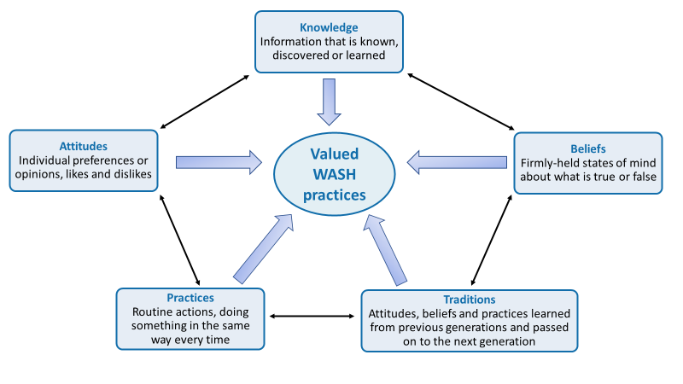

4.2.1 Knowledge of WASH practices is not enough to change behaviour
Knowledge can be defined as all the information we have learned and processed during our growth and development.

In-text question 1.2
We assume you know that people who drink dirty water may get sick because harmful bacteria live in the water. Think for a moment about how you acquired this knowledge?

Figure 4.3 Diagram representing the different levels of influence on a person’s knowledge

Education is a key factor in improving the knowledge of WASH issues in a community. Learning about hygiene and sanitation in school is a particularly important way to change behaviour. If children learn WASH practices from a young age, they will keep them throughout their lives.
For example, they can be taught the correct way to wash their hands at critical times, that is, before and after preparing food or eating, and after urinating, defecating or cleaning a child’s bottom.

In-text question 1.3
Think about where you get your knowledge from today? Do you think the inverted pyramid needs another layer?

In-text question 1.4
Why do you think it is easier to change children’s WASH practices than adults?

4.2.2 Attitude, beliefs and traditions influence WASH practices
There are several reasons why unhealthy WASH practices persist, even if people have been given good information to help them change for the better. One reason for the persistence of bad WASH practices, even when correct knowledge is available, is that people have attitudes and beliefs that make them ignore the facts.

In-text question 1.5
Can you suggest an attitude and a belief that people might express about not using a latrine even when there is one nearby?
Good WASH practices at community level also include handwashing, using clean drinking water, and keeping the physical environment clean and free from waste. Repeating these practices builds our health, improves our lifestyle and helps us all to live longer.

Figure 4.5 Handwashing with soap before eating is a valued WASH practice.

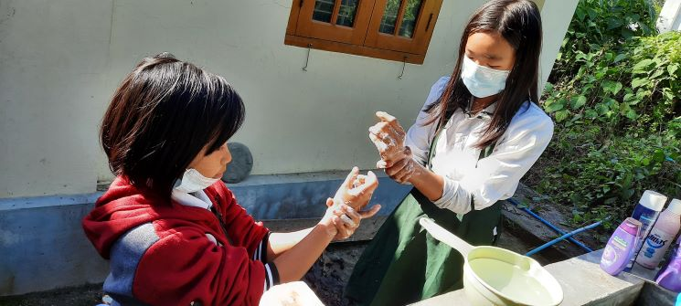

But first, negative attitudes and beliefs must be overcome and replaced with valued behaviour. For example, handwashing with soap before eating is not practised by everyone in Myanmar, even though it prevents transmission of infection from dirty hands to the mouth (Figure 4.5). Also, nearly 10% of people in Myanmar still practice open defecation as you learned in Study Session 3 (Trading Economics, 2020)
The example we gave earlier of the valued practice in rural communities of neighbours helping at times of bereavement can also be termed a tradition, a behaviour that is learned from previous generations and passed on to the next. Some traditions bring positive benefits to the community and also to the environment. But some traditions expose people and the environment to possible harm.
Traditions are very difficult to change because everyone in a community believes it is the right way to behave. Individuals who challenge the tradition are likely to meet opposition from the majority who want to go on doing things in the old way.
If open defecation or not washing the hands at critical times is considered normal and traditional in a community, it will take time and effort to persuade people that using a latrine (Figure 4.6) or handwashing with soap are valued practices that benefit the whole community and also protect the environment.

Figure 4.6 It takes time and effort to convince people that building a covered pit latrine like this one will benefit their family’s health and improve the local environment.
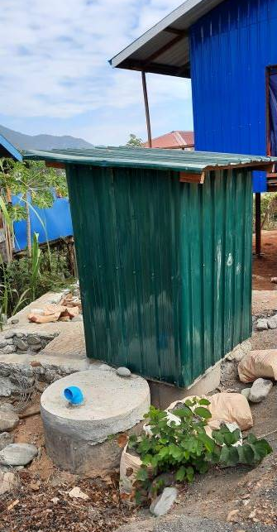

4.3 Other influences on WASH practices
In this section, we discuss three factors that influence whether WASH practices are adopted in a community: economic factors; gender and privacy issues; and caring for the environment.

4.3.1 Economic factors influence WASH practices
The cost of constructing a protected water source, a latrine or handwashing facilities may be too much for some households to pay, especially when purchasing WASH facilities and services is seen as a lower priority than spending limited financial resources on other needs.
Primary priorities for most households, whether urban or rural, include secure housing, food, clothing and education for their children, and possibly also transport costs to take children to school or adults to work. Installing even the most basic latrine or handwashing basin may be unaffordable, but people can still wash their hands with a bowl and a bar of soap (Figure 4.7).

Figure 4.7 Households that cannot afford piped water and a washbasin can use soap, a bucket and a cup for pouring water over the hands.
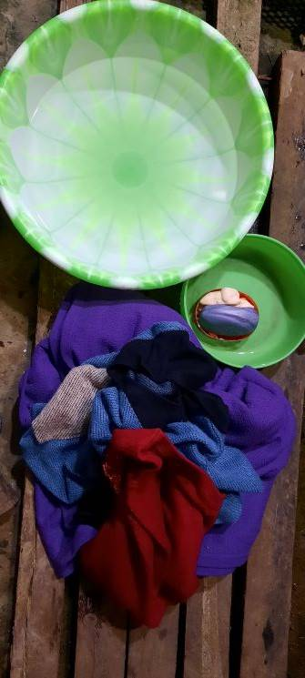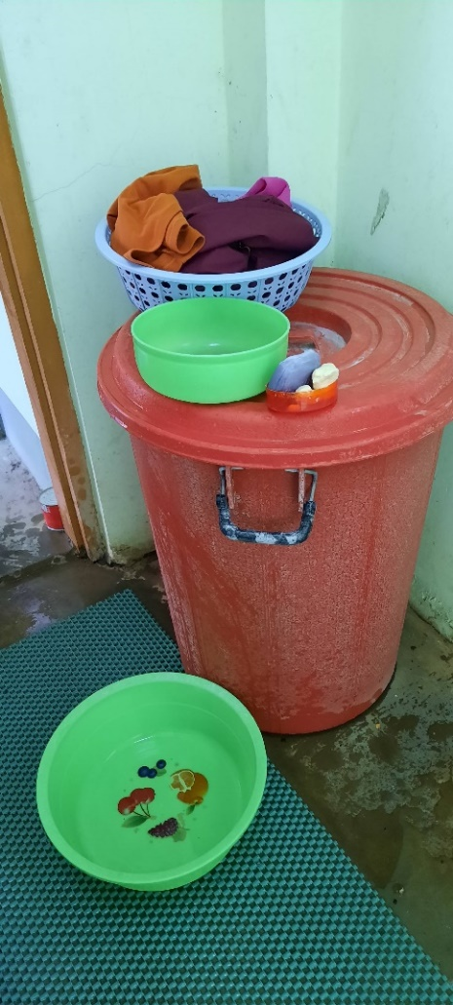
However, constructing a latrine is much more expensive than buying a plastic bucket and some soap. To build a latrine a circular concrete slab is needed, a pit needs to be dug and a shelter built, which means paying a carpenter and bricklayer.
Local government may be able to assist households to obtain loans at low interest rates so that they can install WASH facilities. Community WASH projects may also be funded by local contributions and provide shared labour to build a communal latrine or protect a water source from contamination by human and animal waste.
Although there are costs involved, installing a WASH facility can also save some expenses for a household over time. Diarrhoea, worm infestations and other diseases that can be passed between people resulting from poor WASH practices cost a lot of money for individuals, families, communities, and Myanmar nationally.

In-text question 1.6
Can you think of expenses that the family of a child with severe diarrhoea will have to pay?

4.3.2 Gender, privacy and access issues influence WASH practices
It is against Myanmar culture for women and girls to urinate in public, but it is quite common to see men and boys urinating in the open. Access to a safe and private place for this purpose is therefore a high priority for women, who may suffer great discomfort to avoid urinating or defecating until night-time when they can go without being seen. However, this also exposes them to the risk of rape or robbery. Therefore, the provision of household latrines is a gender issue – it affects males and females differently.
Another difference between the genders in Myanmar is that in most families it is a woman that prepares the food and is primarily responsible for the day-to-day collection and subsequent use of water. If her hands are clean when she touches food items and she washes fruits, vegetables and cooking utensils in clean water, the risk of transmitting infectious organisms to family members is much reduced.
Research has shown that washing the hands with soap at critical times can reduce the incidence of diarrhoeal diseases in families by as much as 44%, and even without soap the reduction is about 30% (Curtis et al., 2011). This is very important in Myanmar, where traditional food is eaten with the hands (Figure 4.8).

Figure 4.8 Handwashing is particularly important because Myanmar food is traditionally eaten with the hands.
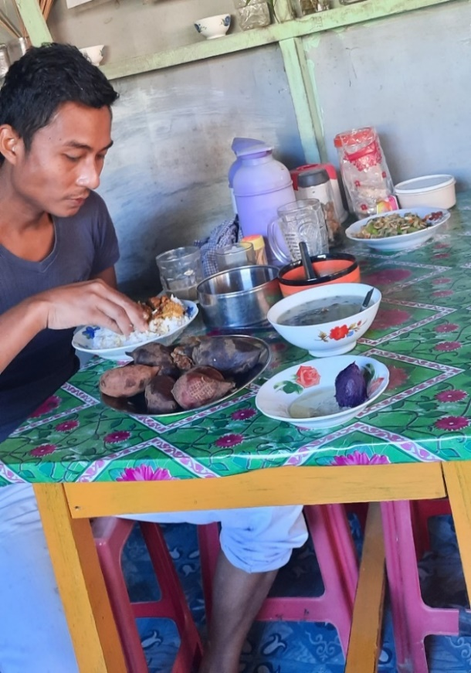
Installing handwashing facilities or building a latrine for the household therefore brings benefits to women in particular, but also improves the health of all family members.

4.3.3 Caring for the physical environment improves health outcomes
Pollution of the environment with human excreta, animal droppings and household rubbish are sources of disease because they attract rats, mice, dogs, flies and mosquitoes that can transmit infectious organisms to people. Bacteria, viruses and worms in rotting food and faeces are washed by rain into the soil and local sources of drinking water; they contaminate crops and get onto the hands of people working on the land or children playing.

Unless hands are washed at critical times, the transmission of infection from soil to hands and into mouths is impossible to prevent. Therefore, keeping the community environment clean and free from waste (Figure 4.9), and persuading people of the health benefits of handwashing and latrine use are key goals for WASH programmes.
In addition to protecting the environment as a way of protecting human health, we should also see the beautiful land, lakes and rivers, animals and plants of Myanmar as our heritage.

Figure 4.9 Street cleaners collect rubbish in a Myanmar street.
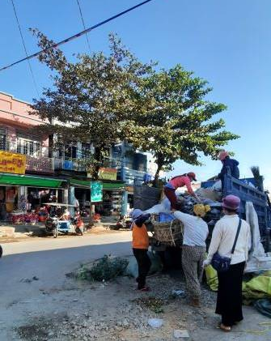

4.4 Making WASH practices socially accepted and valued
WASH practices becoming socially acceptable and the norm in all communities is the goal or WASH programmes. If the majority of community members value and promote WASH practices, social pressure to conform will be felt by any individuals or households who do not behave in accordance with these shared norms.
In model WASH communities, every household will use a latrine, hands are always washed at critical times, homes are kept clean, and the neighbourhood is free from dirt and waste.
Behaviour change communication (BCC) methods have had success in improving WASH behaviour. BCC methods involve consultation and joint learning with individuals and communities about desirable changes to their behaviour. Misconceptions, unhelpful attitudes and factually incorrect beliefs are respectfully challenged and changed in a safe and supportive setting. Through community meetings, local health conferences and community conversations (Figure 4.10), everyone is able to share their views on WASH-related issues and to explore healthy practices.

Figure 4.10 Community conversations can bring neighbours together to agree a plan to improve WASH practices.
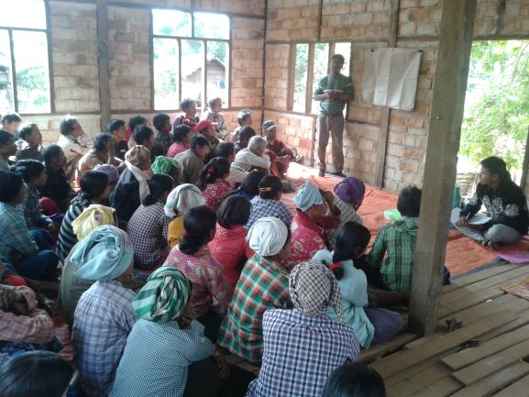

To achieve the national goals for improvement in WASH provision, good hygiene and sanitation, practices need to become the norm for every household.
Caring for the physical environment around us, whether it is the urban world of houses and streets or the natural world of fields and streams, is a responsibility that everyone should value.
Watch this short video about healthy eating which shows the benefits of the BCC approach. It is being used to encourage a change in diet and cooking practices in DaLa and Hlegu townships around Yangon.
https://www.youtube.com/watch?v=3a2k1vO7HmI

In-text question 1.7
Why do you think the conversation with the friend changed the woman’s view on diet and food preparation? Did anyone else try to change the practices of others?

Summary of Study Session 4
In Study Session 4, you have learned that:
- The physical environment is the world we can see around us; the social environment is the invisible world of social interactions between people, their knowledge, attitudes, beliefs, practices, and traditions.
- Provision of WASH facilities alone may not convince people to change traditional practices.
- Misconceptions, unhelpful attitudes and factually incorrect beliefs must be respectfully challenged and changed for WASH improvement.
- Economic factors make it difficult for families to afford WASH facilities or make them a priority; however, repeated episodes of avoidable infections are a financial burden that WASH practices could reduce.
- Gender differences in sanitation behaviour mean that women in particular will be more comfortable, private and safe if they can use a latrine.
- Handwashing at critical times protects everyone from infection.
- Protecting the environment from pollution by faeces and other waste is a responsibility that everyone should share and value.
- Behaviour change communication strategies engage the whole community in developing an action plan, to make WASH facilities more available and good WASH practices the norm.

Answers to in-text questions
1.1 You may have mentioned roads and traffic, pavements, electricity cables and lampposts, or perhaps ditches to catch water and prevent flooding in the rainy season, which are not visible in Figure 4.1.
1.2 You may have been told not to drink dirty water by your parents; or perhaps you learned about bacteria at school; or maybe a health worker made a poster about only drinking clean water to avoid getting diarrhoea; you could have heard about it on the radio or learned from your own experience if you drank dirty water as a child and developed diarrhoea afterwards.
Figure 4.3 summarises the ‘upside-down pyramid’ of sources of knowledge acquired during a lifetime.
1.3 It is likely you answered ‘yes’ to reflect the role of the internet and sites like Facebook.
However, health education programmes are often unable to achieve behaviour change simply by giving adults knowledge of the health risks of poor hygiene or why they should not pollute the physical environment with waste.
Even if people are given accurate information about what causes diarrhoea, this knowledge is generally not enough to persuade them to change poor hygiene and sanitation practices. For example, people whose routine practice is to defecate in the open every day are unlikely to change their behaviour simply because they have been given new knowledge about the risks to their health and the environment.
1.4 Children are learning about the world around them and are responsive to new knowledge and new practices. They also understand that school teaches them knowledge and skills to live good lives when they are adults.
Adults can be more resistant to change because they have been doing what they currently do for a long time, as have others around them. To make change may mean not only breaking a habit but breaking a community tradition.

1.5 Here are our suggestions, but you may have given other good answers:
- Attitudes against using latrines: ‘I dislike using latrines because they smell bad’; or ‘I prefer to empty my bowels in the open because the bad smell is blown away by the fresh air’.
- Beliefs against using latrines: ‘The bad odour collects in the latrine and causes disease if you breathe it into your body’; or ‘It is safer to defecate in the open because there are evil influences in latrines’.
1.6 You may have mentioned the cost of treatment, including transport costs if the child goes to the health centre; and family members may lose income from their employment while caring for the sick child.
These costs could have been reduced by using a latrine, handwashing at critical times and accessing improved water sources. The prevalence of diarrhoea among children in Myanmar is still high with 18% of deaths among children under five due to diarrhoeal diseases even though these can be prevented (Kemp, 2017). If you multiply the costs to a single family with a sick child by the number of illness episodes that could be prevented by good WASH practices, you can see that WASH could bring huge financial benefits to the nation.
1.7 It changed her views because she trusted her friend who didn’t criticise what she did but showed good practice by example. At the end of the video, the woman’s son says that he wants to share what he now knows with his school friends.

References
Curtis, V., Schmidt, W., Luby, S., Florez, R., Touré, O. and Biran, A. (2011) ‘Hygiene: new hopes, new horizons’, The Lancet Infectious Diseases, vol. 11, no. 4, pp. 312–2 [Online]. Available at:
http://www.sciencedirect.com/science/article/pii/S1473309910702243
(Accessed 14 May 2015).

Kemp, K. (2017) ‘Diarrhea among children under five in Myanmar: a systematic review’. Journal of Health Research, Vol. 31 No. 1: January–February 2017. [Online]. Available at: https://he01.tci-thaijo.org/index.php/jhealthres/article/view/78346
(Accessed 24 March 2021)

Trading Economics (2020) ‘Myanmar – People Practicing Open Defecation’. [Online]. Available at: https://tradingeconomics.com/myanmar/people-practicing-open-defecation-percent-of-population-wb-data.html#:~:text=People%20practicing%20open%20defecation%20(%25%20of%20population)%20in%20Myanmar%20was,compiled%20from%20officially%20recognized%20sources (Accessed 24 March 2021)

