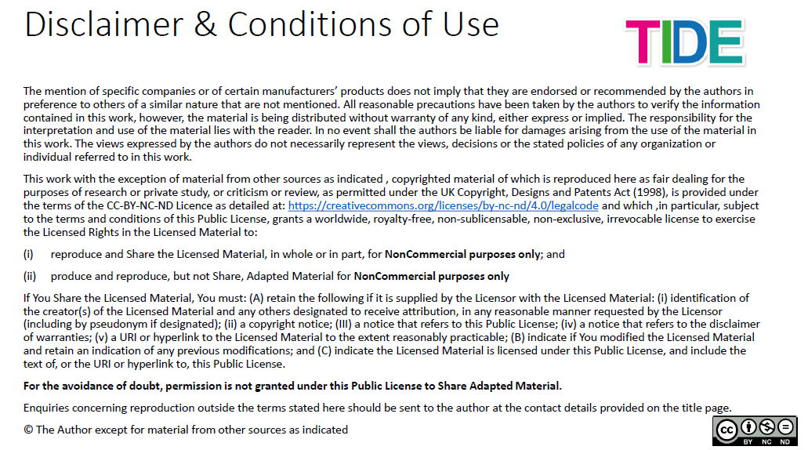
GUIDE NOTES

1. Course:
Climate Change, Food System and Planetary Health - How to mitigate climate change through a sustainable food production and consumption
Lecturer: Dr Alana Kluczkovski, University of Manchester

2. Course Structure:
This course consists of two modules, with three lectures and a two-practical activity at the end of the second lecture and third lectures.
Module #1, of with conceptualizes climate change, greenhouse gases and the relationship with Planetary Health, includes a first lecture is titled “Define the concepts of climate change and greenhouse gases”, the followed by lecture #2 titled “Intersections of Planetary Health and climate change”. The first activity is an analysis of the report XXX.
The second module discusses the socio-cultural and economic effects of climate change and it contains a lecture and a practical activity. Lecture #3 discusses the relationship between food systems and greenhouse gases emissions, followed by a creative activity in which participants are invited to blow up balloons on climate change.

3. Learning Outcomes:
The learning outcomes of this course are as follows:
- Learn about the climate change and greenhouse gases concepts, and the environmental impact of food production and the importance this knowledge to achieving Planetary Health and the Sustainable Development Goals (SDGs).
- Demonstrate the health impact of climate change and propose evidence-based actions that impact Planetary Health.
- Understand the socio-cultural and economic effects of climate change on Planetary Health.

4. Lectures and Activities Notes:
- Lecture #1
Complementary Reading
There are a range of reports and scientific studies discussing the impacts of climate change in Myanmar. Below is a list of additional resources for reading and understanding of this issue.
a) Climate change in Myanmar: impacts and adaptation
b) Climate change, Science and Impacts Factsheets
c) Greenhouse Gas Emissions Factsheet: Burma
d) Assessing Climate Risk in Myanmar: Technical Report

- Lecture #2
Watch the video to visualize the concept of Planetary Health
The below link give you access to a YouTube video called “Planetary Health: The Future is Now”. This video is less than 5 minute-video produced by the Planetary Health Alliance. It discusses the rapid human-caused transformation of our natural environment and its health impacts, as well as the field of planetary health.
Video link: https://youtu.be/atAU0OJWFi0

Explore the Planetary Health Alliance's website and education resources
Visit the Planetary Health Alliance's website and educational resources to explore topics presented in this course more deeply. This includes "Planetary Health Case Studies: An Anthology of Solutions," which come with complementary teaching guides, and the recently published book "Planetary Health: Protecting Nature to Protect Ourselves" co-edited by Dr. Sam Myers and Dr. Howie Frumkin.
Read and subscribe to the PHA newsletter URL
Explore and download Planetary Health Alliance Case Studies
Book: "Planetary Health: Protecting Nature to Protect Ourseleves"

Activity #1
Read the following report “Myanmar - How the people of Myanmar live with climate change and what communication can do”, Anna Colquhoun, Henning Goransson Sandberg and Muk Yin Haung Nyoi, 2015.
This report produced by BBC Media Action’s in 2015, as part of the Building Resilience and Adaptation to Climate Extremes and Disasters (BRACED) project also funded by the UK Department for International Development (DFID). BBC Media Action carried out a survey with people in Myanmar. Researchers interviewed 3,000 people between July and September 2015 in five geographic zones in Myanmar: Coastal, Delta, Dry, Hilly and Plain.
Using findings from the quantitative study, BBC Media Action has built a nationally representative picture of how people in Myanmar live and deal with changes in the weather and environment. Understanding a number of key topics is essential for creating communication that motivates people to take action. These include people’s concerns in life, their perception of changes in the climate, ways of adapting to these changes, preparations for extreme weather events, media access and the most trusted sources on issues relating to changes in the weather and environment.
After reading the report, reflect on the following questions:
How do people in Myanmar live with climate change now?
How will its impacts shape people’s future, and how will they, in turn, shape their environment?
What are the most effective ways to support people to adapt to climate change, and how best can the media, governments, organisations, and businesses communicate with them around this issue?
Then, try to answer the following questions:
How can we enable actions on informing people about climate change? Consider that 49% of people did not feel informed about climate change. Instead of saving food attempt longer-term solutions - making permanent adjustments to their homes.
Are environmental changes connected to central concerns? Consider linking changes in the environment to protect their family income and health – and the importance of individuals taking action now.
How can we encourage people to act? From the survey we can take that people believe that climate issues were outside their sphere of influence - people feel powerless to take action.

- Lecture #3
Measure your ecological footprint
Want to assess the environmental impact of your lifestyle? Test your ecological footprint using this calculator. Think about actionable behaviour changes you can make throughout the duration of this course.
https://www.footprintcalculator.org/

Additional reading
The below reports are important documents that present a detailed picture of the food systems and its relationship with human and environment health.
Food in the Anthropocene: the EAT–Lancet Commission on healthy diets from sustainable food systems. Prof Walter Willett, MD, Prof Johan Rockström, PhD, Brent Loken, PhD , Marco Springmann, PhD, Prof Tim Lang, PhD, Sonja Vermeulen, PhD, et al. 2019. DOI: https://doi.org/10.1016/S0140-6736(18)31788-4
The Global Syndemic of Obesity, Undernutrition, and Climate Change: The Lancet Commission report. Prof Boyd A Swinburn, MD, Vivica I Kraak, PhD, Prof Steven Allender, PhD, Vincent J Atkins, Phillip I Baker, PhD, Jessica R Bogard, PhD, et al. 2019. DOI: https://doi.org/10.1016/S0140-6736(18)32822-8
Healthy Diets from Sustainable Food Systems, Food Planet Health. Summary Report of the EAT-Lancet Commission.

Activity #2
Blowing up balloons for climate change
The more we know about food the most informed will be our food choices. Therefore, the aim of this activity is to learn how different food choices cause very different amounts of greenhouse gas emissions, and so, diets may offer a powerful lever for change.
You may develop this activity on a classroom setting, splitting participants into groups. Each group will receive a set of balloons and food factsheets (attached to this guide).
Groups will determine the number of balloons necessary to produce:
Group 1: 50g meat
Group 2: 50g of cod
Group 3: 50g of salmon
Group 4: 50g of beans
Group 5: 50g of rice
Detail on how to calculate the number of balloons is on each food factsheet.
After calculating the number of balloons for each food, groups with present to their peers and discuss the environmental impact of the foods analysed during the proposed activity.
Red meat or steak (fried) have the highest greenhouse gas emissions due to the enteric fermentation of cattle with 2361g CO2e, 15 g protein, 121 Kcal. Followed by captured cod (321g CO2e, approximately 10 g protein, 99 Kcal), farmed salmon (440g CO₂e, 11 g protein/ 160 Kcal), rice (200g CO2e, 1.5 g protein, 66 Kcal) and beans (52g CO₂e, 4 g protein, approximately 47 Kcal).
It is worth mention that the food fact sheets are a set of sheets with only a photo, name, and quantity of the food. A list of calculation sheets has the total amount of greenhouse gas emissions in g CO2e, protein in grams, and minutes driving for correlation.
The strategy is to give the calculation sheets and allow participants some time to work out the numbers. Then, they would discuss to which food this number of balloons is associated with.
You may make the activity fun by blowing up the number of balloons for each food. Finally, you can give them the correct photo sheet.
Additionally, you can use other resources to help you making people engaged with the nutrition and environmental composition (carbon footprint and water footprint) of food.
The Food Flashcards, a free downloadable resource designed as a fun way to engage with the public and children about the variation of greenhouse gas emissions caused by the production of different foods. These include some useful information on nutritional value, to start conversations about healthy, sustainable diets.​
A Climate Calculator, a free tool to help you add up the climate impacts of different food choices.​
A Climate Food Challenge​, a free online game to learn which food choices have the biggest climate impact.
A book aimed at the general public, about how different foods contribute to climate change. Available from all good booksellers and the e-book can be accessed for free here.

5. List of weblinks and resources used on this course
Lecture#1
Climate Lab Book
IPCC 2013-4
IPCC AR5 WGI
https://blogs.shell.com/2012/04/05/extreme/
http://en.ccchina.org.cn/Detail.aspx?newsId=52289&TId=185
W. Elder, NPS
http://en.wikipedia.org/wiki/Image:Carbon_Dioxide_400kyr-2.png
US EPA
https://www.universityofcalifornia.edu/longform/where-do-greenhouse-gas-emissions-come
https://australianmuseum.net.au/learn/teachers/learning/sustainability/greenhouse-gas-a-hot-topic/
https://ourworldindata.org/co2/country/myanmar
https://www.climatelinks.org/resources/greenhouse-gasemissionsfactsheetburma#:~:text=Burma's%20total%20GHG%20emissions%20in,of%20the%20country's%20total%20emissions
https://www.thelancet.com/infographics/what-is-planetary-health?dgcid=twitter_social_lanpla&sf68454411=1
https://youmatter.world/en/definition/climate-change-meaning-definition-causes-and-consequences
www.rgs.org/schools
https://www.unhcr.org/news/latest/2006/7/44b262dd4/high-commissioner-guterres-unveils-action-plan-protect-rights-migratory.html
https://tolife.org/blog/food-insecurity-and-breast-cancer
https://bit.ly/394SnBo
https://www.thelancet.com/journals/lancet/article/PIIS0140-6736(16)32590-9/fulltext
https://youtu.be/atAU0OJWFi0
https://www.planetaryhealthalliance.org/multimedia
https://www.unbrussels.org/un-information-on-covid-19
https://www.worldwildlife.org/publications/assessing-climate-risk-in-myanmar-technical-report
https://calhoun.nps.edu/bitstream/handle/10945/44672/14Dec_Slagle_John.pdf?sequence=1&isAllowed=y
http://www.braced.org/resources/i/?id=46bb299b-a312-46f0-8899-ae1f4bc24797
https://sethlui.com/foods-eat-myanmar
https://www.ncbi.nlm.nih.gov/pubmed/30704089
https://www.thelancet.com/journals/lancet/article/PIIS0140-6736(18)31788-4/fulltext
https://ccafs.cgiar.org/blog/climate-change-and-farming-what-you-need-know-about-ipcc-report#.XaCDOJO2lZ1
https://doi.org/10.1088/1748-9326/ab5cc0
https://doi.org/10.1073/pnas.1800442115
https://doi.org/10.1016/S0140-6736(18)32822-8
https://doi.org/10.1016/j.scitotenv.2018.10.019
https://www.iaea.org/newscenter/news/myanmars-dairy-farmers-benefit-from-cattle-breeding-programme-using-nuclear-based-techniques
https://www.theguardian.com/environment/2021/mar/18/cows-seaweed-methane-emissions-scientists#:~:text=PhD%20graduate%20student.-,Cows%20produce%20methane%20via%20microbes%20in%20their%20stomachs%20as%20they,it%20a%20major%20greenhouse%20gas.
https://insideclimatenews.org/content/infographic-livestock-produce-large-amounts-methane-gas
https://www.quora.com/How-do-animals-release-methane
https://kxrb.com/which-state-produces-most-of-our-milk
https://www.agriland.ie/farming-news/1-in-10-consumers-consider-carbon-footprint-when-purchasing-food/
https://www.worldatlas.com/articles/top-cows-milk-producing-countries-in-the-world.html
https://commons.wikimedia.org/wiki/File:Curds_and_whey.jpg
https://interactive.carbonbrief.org/what-is-the-climate-impact-of-eating-meat-and-dairy
https://coconuts.co/yangon/news/myanmar-govt-harvest-fields-abandoned-rohingya
https://www.climatechangenews.com/2019/12/07/can-grow-climate-friendly-rice/#:~:text=Accounting%20for%20around%202.5%25%20of,decomposition%20during%20its%20production%20processes
https://cookidoo.thermomix.com/recipes/recipe/en-US/r66939
https://www.stockholmresilience.org/research/research-news/2019-01-17-the-planetary-health-diet.html
https://www.frieslandcampina.com/en/news/milk-products-fit-sustainable-diet
MBOW, C. C. et al. Food Security. In: SHUKLA, P. R. et al Climate Change and Land: an IPCC special report on climate change, desertification, land degradation, sustainable land management, food security, and greenhouse gas fluxes in terrestrial ecosystems. 2019, p. 439-550.

